769 map view compound wall

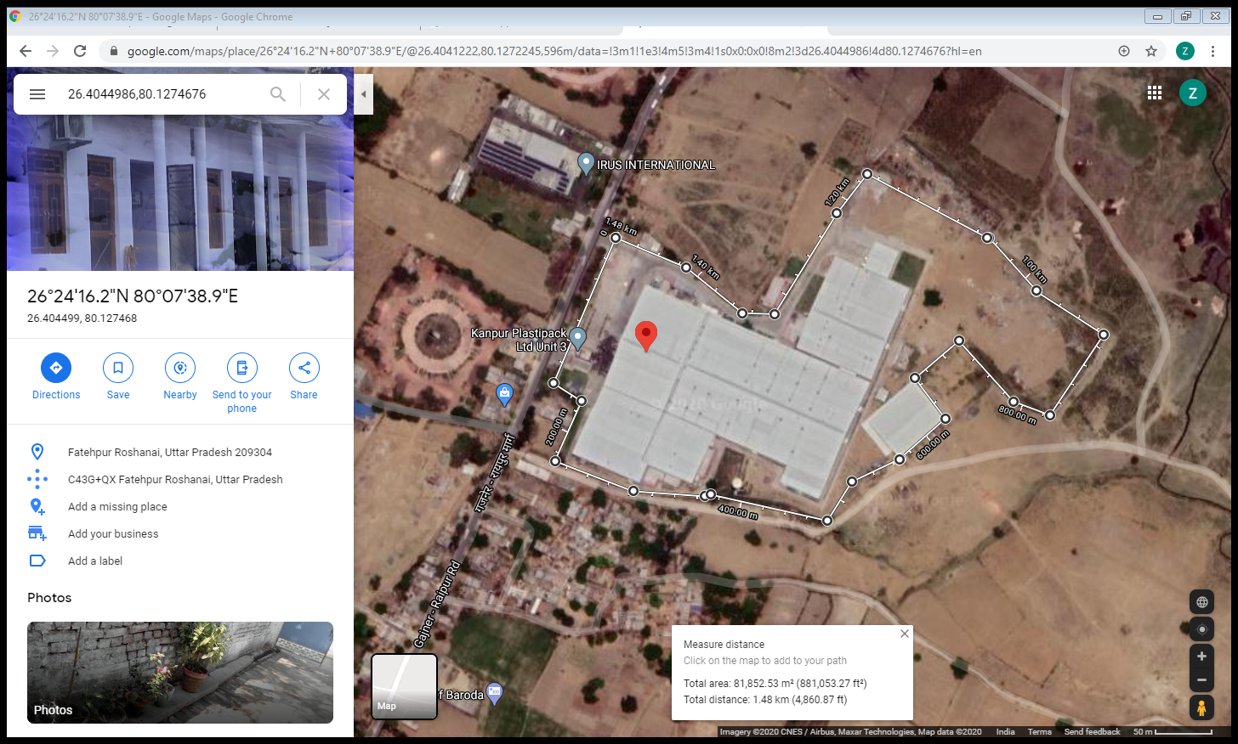

Pavements interlocking

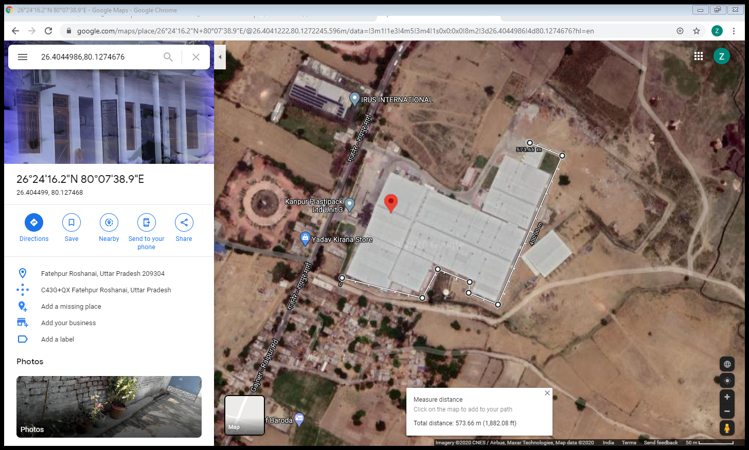

Pavement rcc

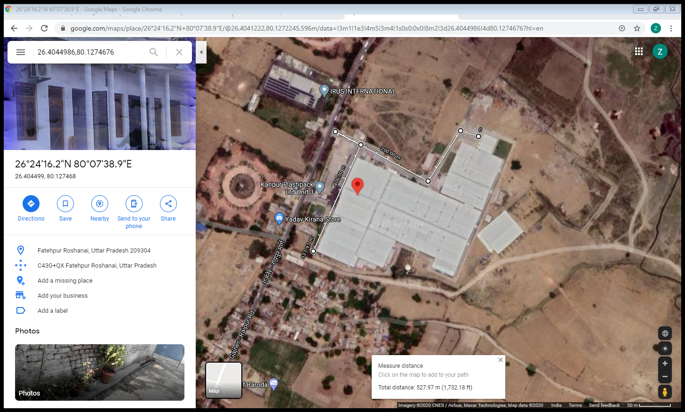

Taking 500 mtr of rcc pavement and 500 mtr of interlocking pavement according to maps above

Rcc pavement price – 2cr/km

Interlocking pavement 60 lakh/km