REPORT FORMAT: CL-1 | Version: 1.0_2018

FILE No.: VIS(2023-24)-PL107-092-107 Date :14/07/2023

- CERTIFICATE NAME: Project revised cost components vetting certificate.
- PREPARED FOR ORGANIZATION: IFCI Venture Capital Funds Ltd.
- BORROWER COMPANY’S NAME: M/s. Teja Innovatives Private Limited (TIPL).
- ASSET TYPE: Project Civil work and Machines required for setting up Precision Engineering manufacturing unit
- CURRENT LOCATION OF THE MACHINES: Proposed to be installed at Part of Survey No. 377/3 and 378/2. Plot No.41, EMC-II, Tirupati, Vikruthamala Village, Yerpedu Mandal, Chittoor District, Andhra Pradesh.
S. NO. | PARTICULARS | DESCRIPTION
 | Date of Work Order | 02-05-2023
 | Documents provided for perusal | Quotations from the market for the Machine/Assets to be installed and Building work, Building Plan, CA Certificate, Land Deeds, Cost Estimate, DPR, Section Drawing etc.
 | Project Location | Part of Survey No. 377/3 and 378/2. Plot No.41, EMC-II, Tirupati, Vikruthamala Village, Yerpedu Mandal, Chittoor District, Andra Pradesh.
 | Borrowing Company | M/s. Teja Innovatives Private Limited.
 | Type of Asset | Project Civil work and Machines required for setting up Precision Engineering manufacturing unit
 | Type of Assessment | Project revised cost components vetting certificate

 | Scope of Assessment | - Project Cost Vetting of the following items attached below.  S. No. Cost Component Original Project Cost (In Lakhs) Revised Project Cost (In Lakhs)  Technical Civil Work 118.90 305.72  Plant & Machinery 641.60 686.06  Machine Erection Expenses 19.00 20.9
 | Nature of Plant | Precision Engineering
 | Total Project Cost | Original /Previous: Rs.950 Lakh (Including GST))  Revised: Rs.1183.18 Lakh (Including GST) (including supply and installation as per the List/ quotations / invoices / Cost Estimate provided by the company of machineries and civil works
 | Comment on Project Cost by consultant | As per our analysis, the revised cost for Civil works and Plant & Machinery found to be in line to Market trend. Please refer to PART A for detailed analysis.
 | Total number of pages with Annexure. | 34

VALUATION ENGINEER | L1/ L2 REVIEWER
Rahul Gupta | Sr.VP Projects

PART A | PROJECT COST VETTING

- EXECUTIVE SUMMARY: M/s Teja Innovative Private Limited is setting up a setting up Precision Engineering manufacturing unit at Part of Survey No. 377/3 and 378/2. Plot No.41, EMC-II, Tirupati, Vikruthamala Village, Yerpedu Mandal, Chittoor District, Andhra Pradesh. In respect to financial assistance of this Project, M/s Teja Innovative Private Limited has approached IFCI Venture Capitals Fund Ltd. As per IFCI the original project cost of the project as shown by the company was Rs.950 Lakhs. However later on company revised the cost to Rs. 1183.18 Lakhs as per the following details:
S. No | Cost Component | Original Cost (In Lakh) | Revised Cost (In Lakh) | Remarks
1 | Land & Land Development | 93.84 | 93.84 | No Change
2 | Technical Civil Work | 118.90 | 305.72 | Change
3 | Plant & Machinery | 641.60 | 686.06 | Change
4 | Machine Erection Expenses | 19.00 | 20.9 | Change
5 | Contingencies | 15.00 | 15 | No Change
6 | Pre-Operative Expenses | 10.00 | 10 | No Change
7 | Interest During Construction Period | 35.66 | 35.66 | No Change
8 | Margin Money for Working Capital | 16.00 | 16 | No Change
Total Project Cost |  | 950.00 | 1183.18

As per IFCI, the company/promoters are now proposing to increase the civil construction cost from Rs.118.90 lakh to Rs.317.73 lakh and the plant and machinery cost from Rs.641.60 Lakh to Rs.686.06 lakh. But in our analysis, the correct breakup of the revised cost is Rs.305.72 Lakh not Rs.317.73 Lakh. Accordingly, the revised project cost needs to be revalidated.

- REVALIDATION OF THE PROJECT COST: Since as per the summary of the original and revised Project cost, the cost has been increased only in 3 components as below:
S. No | Cost Component | Original Cost (In Lakh) | Revised Cost (In Lakh) | Remarks
1 | Technical Civil Work | 118.90 | 305.72 | Change
2 | Plant & Machinery | 641.60 | 686.06 | Change
3 | Machine Erection Expenses | 19.00 | 20.9 | Change
Total Project Cost |  | 779.50 | 1012.68

Therefore in this certificate we have revalidated the Project cost for these components only as per the scope of the work:
- TECHNICAL CIVIL WORK (BUILDING & CIVIL WORKS):

- Original and revised Project cost:
S. No. | Cost Component | Original Project Cost | Revised Project Cost
 | Building & Civil Work | 118.90 | 305.72

Table A:
S. No. | Cost Component | Original Project Cost in INR | Revised Project Cost in INR | Approved Cost in INR | Remarks
 | Foundation, Mud Filling & brick wall upto Plinth Beam | -- | 64,35,000 | 64,35,000 | As per the original /previous the foundation, mud filling & brick wall up to Plinth beam was not considered in the project cost. However the cost is required for constructing the structure. The mentioned cost is reasonable as per market standard. Detailed working for the assessment is shown in Table B below from Sr.No.1 to 3 and Sr.No 6 to 10.
 | Plinth Beam Construction | 26,82,045 | 28,58,625 | 28,58,625 | Cost found to be reasonable. Detailed working for the assessment is shown in Table B below from Sr.No.4 to 5.
 | Floor Construction  (VDF Flooring & Side walls) | 24,83,375 | 72,32,405 | 72,32,405 | As per the original cost estimate, only floor construction cost was considered and no cost have been considered for side walls and painting works.  Due to inclusion of the above components, cost has been increased from Rs.24.83 Lacs to Rs.72.32 Lacs.  Cost found to be reasonable as per market standard.
 | Mezzanine Floor | -- | 12,47,400 | 12,47,400 | As per the original cost quotation there was no plan to construct the mezzanine floor. Therefore this component cost was not considered in it. However, in the revised plan it is included and we have checked it seems to be reasonable as per the revised plan provided.  Company has provided the quotation which is attached in Annexure-A as per which the quantity considered is 1782 sq.ft and rates Rs.700 per sq.ft. Area of the floor as per plan and in the estimate is same. Rates of Rs.700 per sq.ft found to be reasonable as per market trend for RCC slab work and mezzanine structure.
 | PEB shed | 67,24,820 | 1,28,00,202 | 1,28,00,202 | 1. There is a difference in the mild steel cost of the original and revised cost quotation.  2. The mezzanine floor component was not considered in the original cost but it is considered in the revised cost. 13.5 ton mild steel is added for mezzanine and per ton steel cost is revised for the same.  2 (a) The consumption of mild steel is more than the general consumption as mentioned above because the mezzanine height is approx. 30 feet and according to the quotation the live load on the mezzanine is 3KN/M². Considering this factor the 13.5 ton mild steel in mezzanine seems to be reasonable.  Company has considered this cost as per the quotations of Pennar Industries & Kirby. We have considered Pennar Industries and as per quotation the cost comes out to be Rs.710 per sq.ft. Including GST. If we are going with the branded PEB structure then cost is reasonable as per market trend.

Table B: DETAILED WORKING
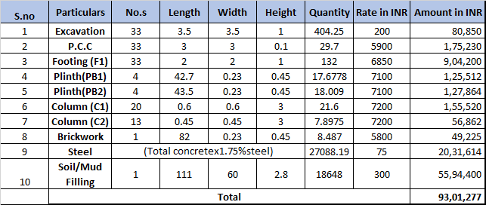
As per Table B attached above we have checked and verify the revised cost and it seems to be reasonable.

Observations Civil Works:
- The estimate of construction up to plinth level is calculated as per Table B. The calculated cost appears to be within range as shown by the company.
- For ascertaining the estimated cost of civil works, we have requested for the Building Map, estimate, BOQ and section drawing. Except BOQ we have received Building Map, estimate and section drawing. Specific item quantities as shown in the table above is considered from these provided documents.
- Rates considered in the cost estimate is found within the market range as per our scrutiny.
- We have vetted the civil works as per the available documents such as building plan, section drawing, cost estimate etc. The built-up area has been considered as per the sanctioned plan provided to us only.

- PLANT & MACHINERY AND MACHINE ERECTION.

- Original and revised Project cost:

S. No. | Cost Component | Original Project Cost | Revised Project Cost
 | Plant and Machinery | 641.60 | 686.06
 | Machine Erection | 19,00,000 | 20,90,000

- Breakup of Revised Cost & Cost Vetting:
DETAILS OF PROJECT MACHINES COST
Sl.No | Machine Name | Supplier's Name | Qty | Price in INR | GST @18 % | Cost/Unit in Lakhs | Amount By Client Total Price in Lakhs | Approved Cost in Lakhs | Consultant Remarks
1 | Fiber CNC Laser Machine 2 Kw | Dener (Noel Machinery / HSG (Suyesha Technology Consulting) | 1 | 255.00 | 45.90 | 300.90 | 300.90 | 300.90 | As per industry analysis, cost of the machines appears to be reasonable. In some of the machines cost by the other vendors are quoted are higher and vice versa as compare the cost shown by the company. However the overall cost of the machines appears to be reasonable.
2 | Laser Machine Accessories |  | 1 | 18.00 | 3.24 | 21.24 | 21.24 | 21.24
3 | CNC Press brake-4 M 175 T |  | 1 | 55.59 | 10.01 | 65.60 | 65.60 | 65.60
4 | CNC Press brake-3.2 M 135 T |  | 1 | 45.00 | 8.10 | 53.10 | 53.10 | 53.10
5 | CNC Press brake 2 M 80 T |  | 1 | 30.00 | 5.40 | 35.40 | 35.40 | 35.40
6 | Desktop Computers lastest configuration | HMK Technologies | 4 | 0.80 | 0.14 | 0.94 | 3.78 | 3.78
7 | 400 A thyristoriesed MIG Welding Machine | Veeditha Engineering / Local Market | 5 | 1.85 | 0.33 | 2.18 | 10.92 | 10.92
8 | 400 A arc welding machine |  | 2 | 0.79 | 0.14 | 0.93 | 1.86 | 1.86
9 | Automated Painting Booth & guns | Innovative machines | 1 | 29.50 | 5.31 | 34.81 | 34.81 | 34.81
10 | Electric Oven |  | 1 | 7.25 | 1.31 | 8.56 | 8.56 | 8.56
11 | Pretreatment Tanks |  | 1 | 8.50 | 1.53 | 10.03 | 10.03 | 10.03
12 | Redial Drilling Machines | Veeditha Engineering/ Indigious market | 2 | 1.25 | 0.23 | 1.48 | 2.95 | 2.95
13 | Sandering Machines |  | 14 | 0.09 | 0.02 | 0.10 | 1.40 | 1.40
14 | Tapping machines |  | 10 | 0.08 | 0.01 | 0.09 | 0.89 | 0.89
15 | Impact Wrenches |  | 10 | 0.19 | 0.03 | 0.22 | 2.24 | 2.24
16 | Pallet Trucks |  | 10 | 0.30 | 0.05 | 0.35 | 3.54 | 3.54
17 | Stanley Tool Sets |  | 10 | 0.38 | 0.07 | 0.44 | 4.43 | 4.43
18 | 5 Ton Capacity Jib Crane | vertex | 1 | 12.45 | 2.24 | 14.69 | 14.69 | 14.69
20 | 125kva DG Set | Powerol ( Mahindra-SK Kailash Enterprises) | 1 | 6.99 | 1.26 | 8.25 | 8.25 | 8.25
21 | Air compressors, Receiver, Dryer | Frank | 1 | 5.46 | 0.98 | 6.44 | 6.44 | 6.44
24 | UPS 40 KVA | CDS | 1 |  | 0.00 | 0.00 | 9.03 | 9.03
25 | UPS 2 KVA | CDS | 1 | 0.53 | 0.10 | 0.63 | 0.63 | 0.63
26 | Power cables, LT Panels and accessories | RJ Solutions | 1 | 20.05 | 3.61 | 23.66 | 23.66 | 23.66
27 | HT Yard | RJ Solutions | 1 | 13.86 | 2.49 | 16.35 | 16.35 | 16.35
28 | HT Meter Yard | RJ Solutions | 1 | 14.95 | 2.69 | 17.64 | 17.64 | 17.64
29 | HIgh Speed Chain Link Fence Machine | Sri Lakshmi Industries / Hindhustan Machines | 1 | 18.00 | 3.24 | 21.24 | 21.24 | 21.24
30 | High Speed Barbed Machine |  | 1 | 5.50 | 0.99 | 6.49 | 6.49 | 6.49
 |  |  |  |  |  | 651.77 | 686.06 | 686.06
 |  |  |  |  | Price in Rupees |  | ₹ 6,86,05,500
S. No. | Cost Component | Original Project Cost in INR | Revised Project Cost in INR | Approved Cost in INR | Remarks
 | Machine Erection as per Drawings | 19,00,000 | 20,90,000 | 20,90,000 | There is a minor difference in the original and revised cost. The revised cost checked and seems to be reasonable.

OBSERVATIONS:

Plant & Machinery and Machine Erection
- We have been provided with the copy of quotations from the market and machines/ equipment to be installed by the borrower company. Please refer to annexures for the quotations.
- As per the information provided by the company officials these items are planned to be installed at the aforesaid address.
- As per the market trend and scrutiny with similar machine suppliers we found that the price given in the list of quotations provided to us is well within the price range of similar items available in the market and seems to be reasonable.
- We have not considered the freight of the assets in this cost vetting certificate as it varies with respect to supplier depending upon their location.
- Market quotations for reference are attached in annexure A.
- Generally the Machine erection cost is 5% to 7% of the total machine cost. Therefore, as per the machine cost available it seems to be reasonable.

- FINAL CONCLUSION:
As per our market trend and our experience, research and the quotes received from the machine suppliers and civil works, we are of the view that rate range for establishing the plant with similar specifications for the requirement of the plant and other general machines considered is fine. The revised cost of the civil construction and plant and machinery appears to be reasonable.

Special Notes:
  - We can’t comment about the current status of machines whether these are purchased, installed or in transit. This cost vetting is done only on the basis of proposed plan by the company and the proposed estimates, Quotations, Bills and Purchase Orders provided to us by the company.
  - The estimated cost verification of item to item can’t exactly match as per our vetting due to several market consideration. In some of the items it is lower while in some of the items price comes to be higher but on an average the price as per list provided to us falls in the range as confirmed by us.
  - The estimated cost may change in case of variation in quantity, specifications or make of any item as assumed in this certificate versus actually implemented in the Project.
  - There can be variation in the estimated price if the specification & make of any items procured is different from the list provided to us during assessment.
  - The estimated cost verification is made based on the third-party information which has been relied upon in good faith.
  - The estimated price may vary at the time of actual procurement because of change in prices in the market for such kind of machinery/items for which we will not have any control. The cost vetting is only limited to the date of Certificate issued. We do not assume any responsibility in change of prices of the said machinery/items after this date.
  - The item cost for same specification and from same supplier/ manufacturer may also change in the range of 5-10% due to changed market condition and scope of negotiation between the parties at the time of final closure of the deal.
  - This certificate doesn’t include any work related to drawing, design, sketch plan, procurement of the machines.
  - Ownership and other legal point of view in respect of the asset is not considered in this report as same is out of scope of this certificate.
  - This certificate doesn’t recommend any sort of recommendation in our Certificate.
  - This certificate is made at the request of the Bank.

DISCLAIMERS

- We have not received BOQ and receipts of material machines procured and contract agreement for site work.
- The client/ owner and its management/ representatives warranted to us that the information they have supplied was complete, accurate and true and correct to the best of their knowledge. All such information provided to us either verbally, in writing or through documents has been relied upon in good faith and we have assumed that it is true & correct without any fabrication or misrepresentation. I/We shall not be held liable for any loss, damages, cost or expenses arising from fraudulent acts, misrepresentations, or willful default on part of the owner, company, its directors, employee, representative or agents.
- Legal aspects for eg. Investigation of title, ownership rights, lien, charge, mortgage, lease, sanctioned maps, and verification of documents provided to us such as title documents, Map, etc. from any concerned Govt. office etc. have to be taken care by legal expert/ Advocate and same is not done at our end. I/ We assume no responsibility for the legal matters including, but not limited to, legal or title concerns.
- Wherever any details are mentioned in the report in relation to any legal aspect of the property such as name of the owner, leases, etc. is only for illustration purpose and should not be construed as a professional opinion. Legal aspects are out of scope of this report. Details mentioned related to legal aspect are only based on the copy of the documents provided to us and whatever we can interpret as a non-legally trained person. This should be cross validated with a legal expert. We do not vouch any responsibility regarding the same.
- We have relied on the data from third party, external sources & information available on public domain to conclude the valuation. These sources are believed to be reliable and therefore, we assume no liability for the truth or accuracy of any data, opinions or estimates furnished by others that have been used in this analysis. Where we have relied on the data, opinions or estimates from external sources, reasonable care has been taken to ensure that such data is extracted from authentic sources, however we still can’t vouch its authenticity, correctness, or accuracy.
- Documents, information, data including title deeds provided to us during the course of this assessment by the client is reviewed only upto the extent required in relation to the scope of the work. No document has been reviewed beyond the scope of the work. These are not reviewed in terms of legal rights for which we do not have expertise. Wherever any information mentioned in this report is mentioned from the documents like owners name, etc., it is only for illustration purpose and may not necessary represent accuracy.

ANNEXURES (A)


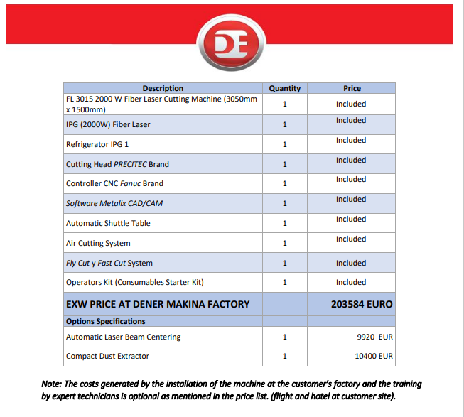
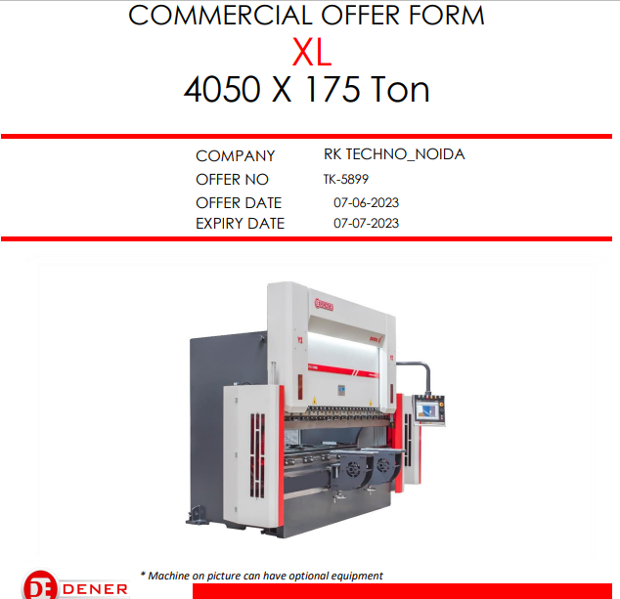
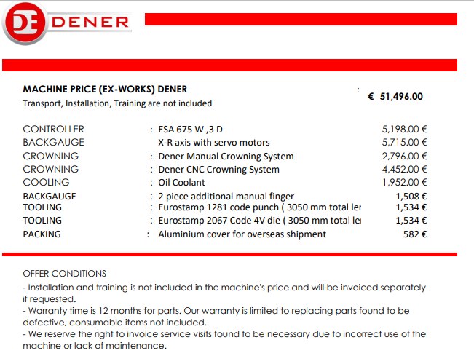

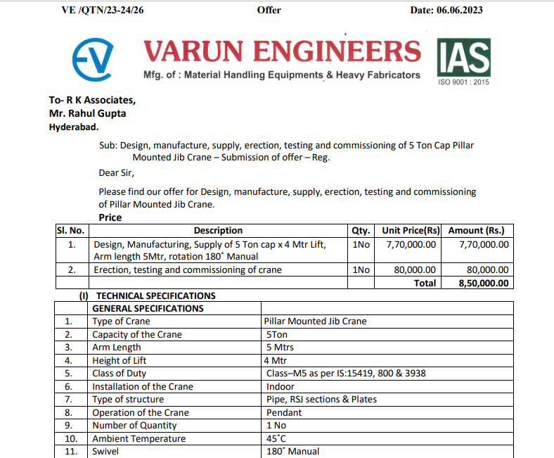
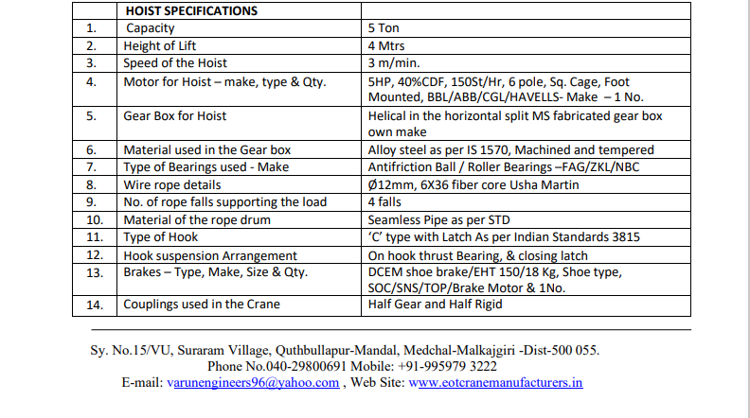

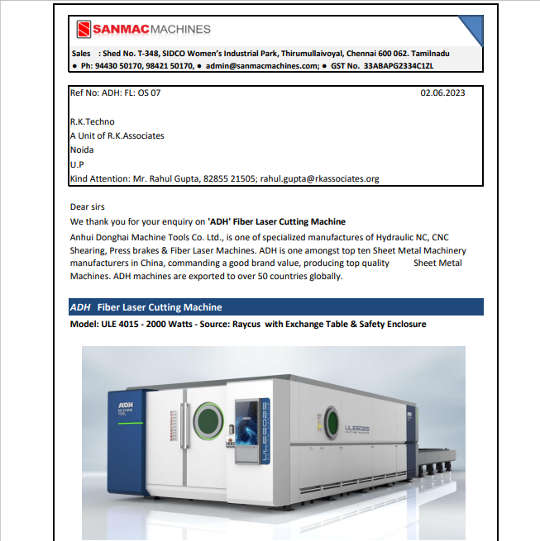
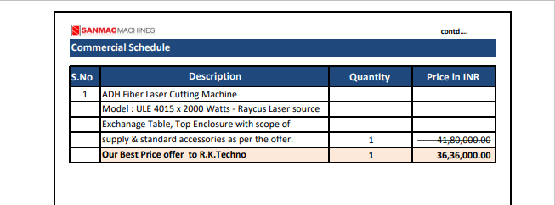
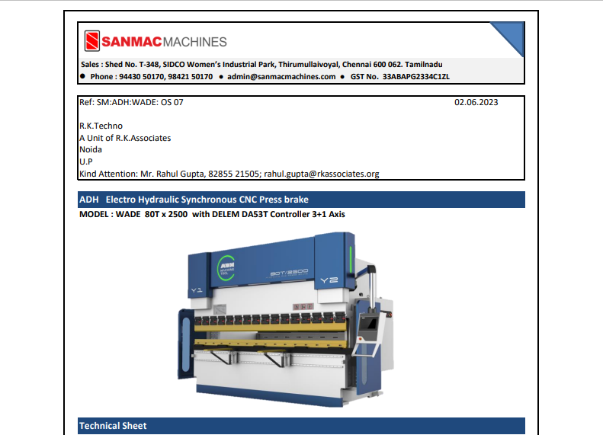
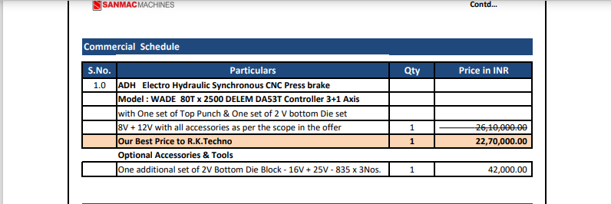
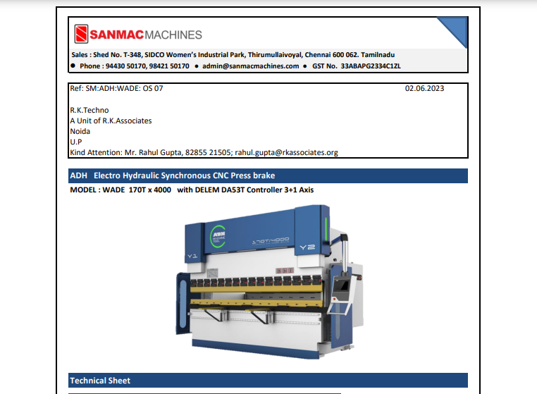
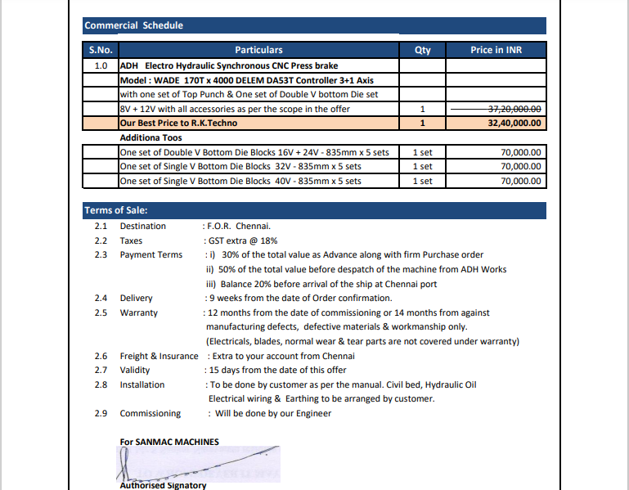

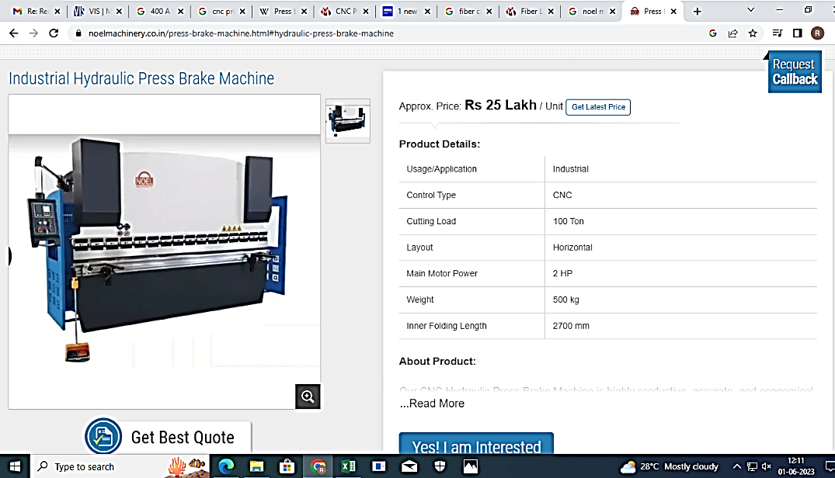
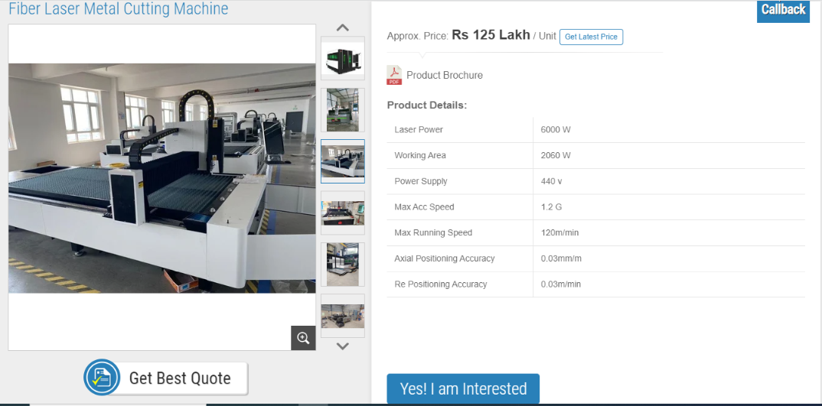
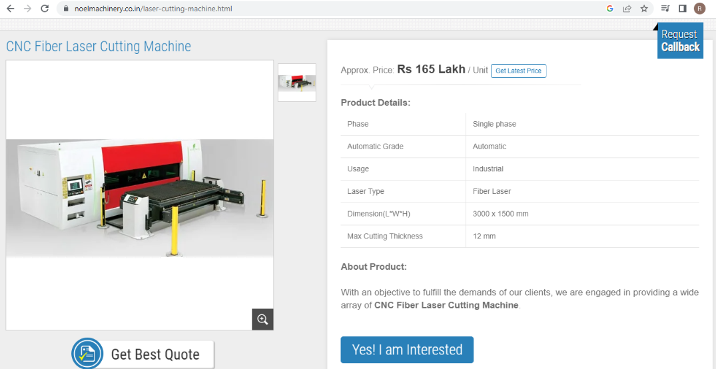

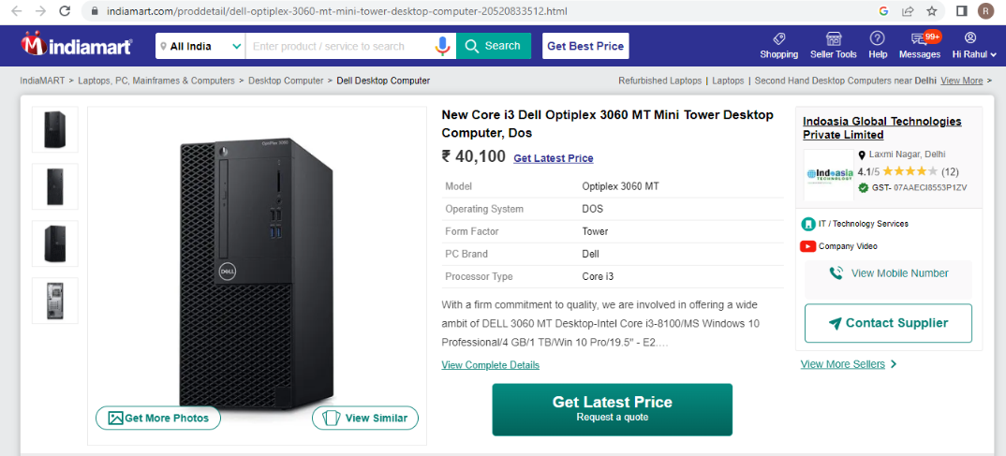


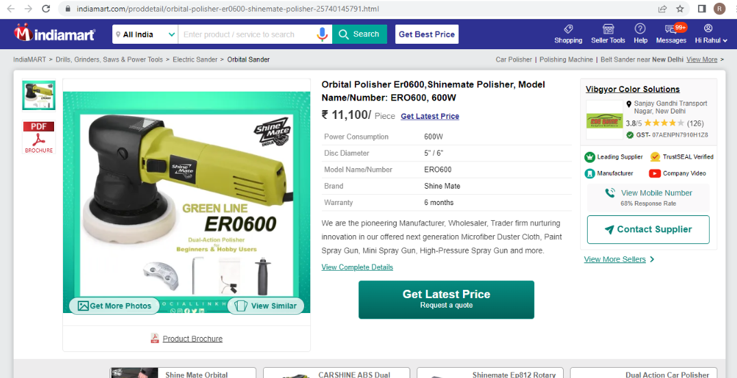
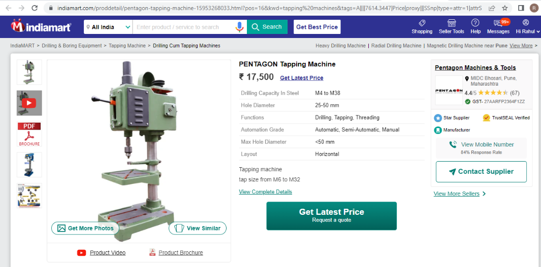
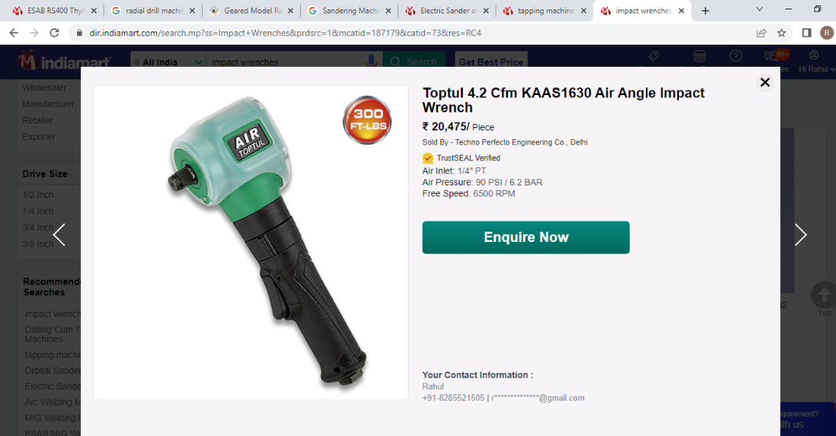
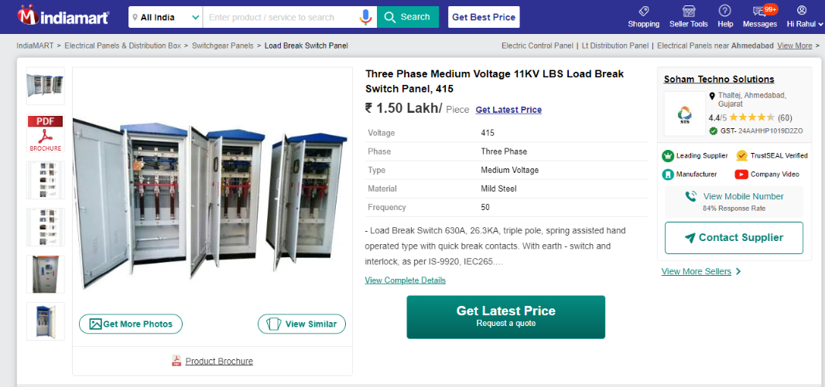

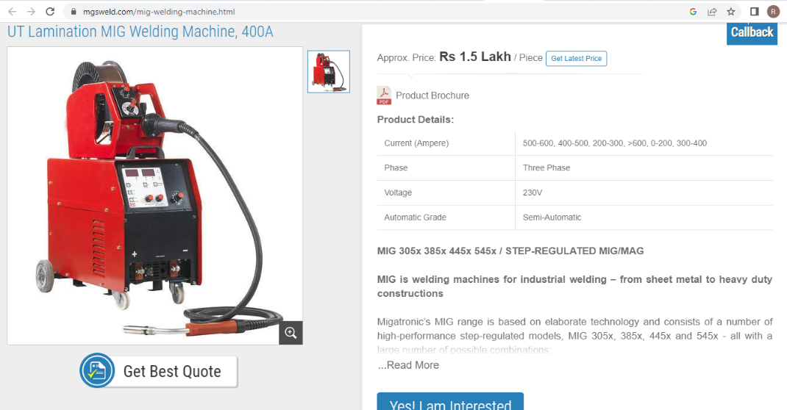

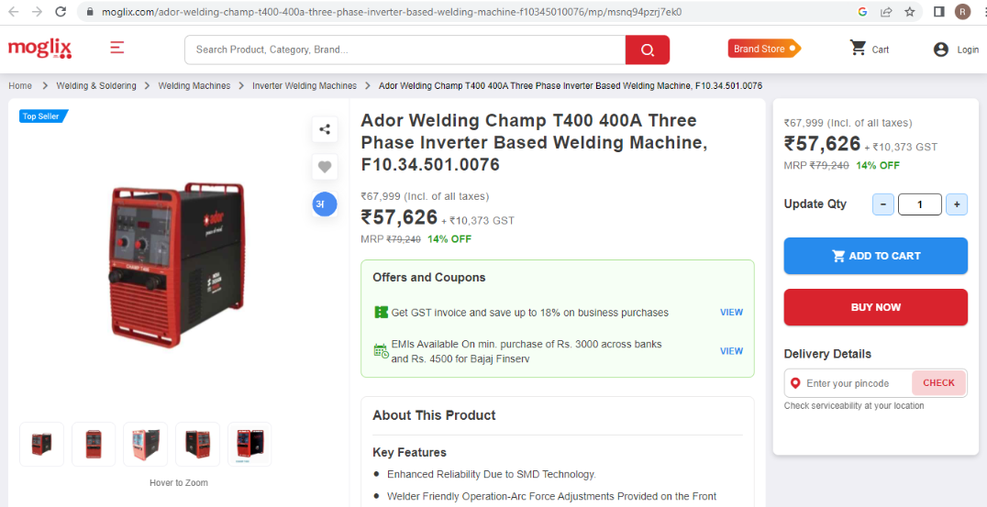

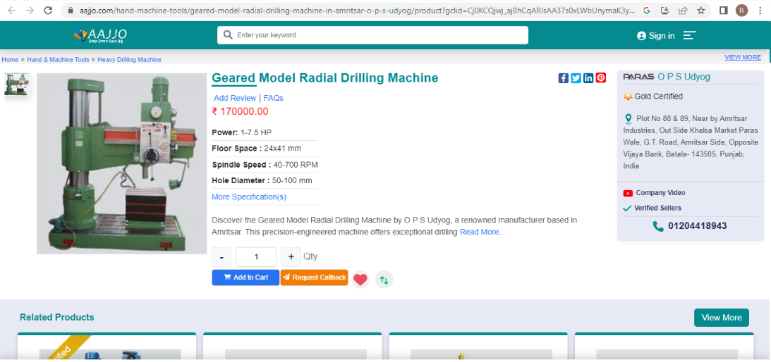
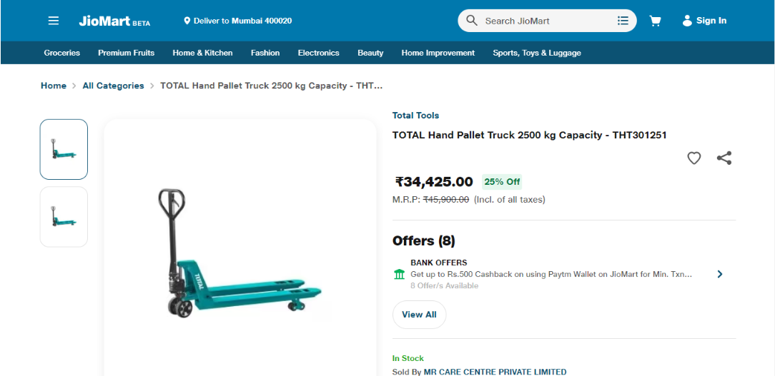
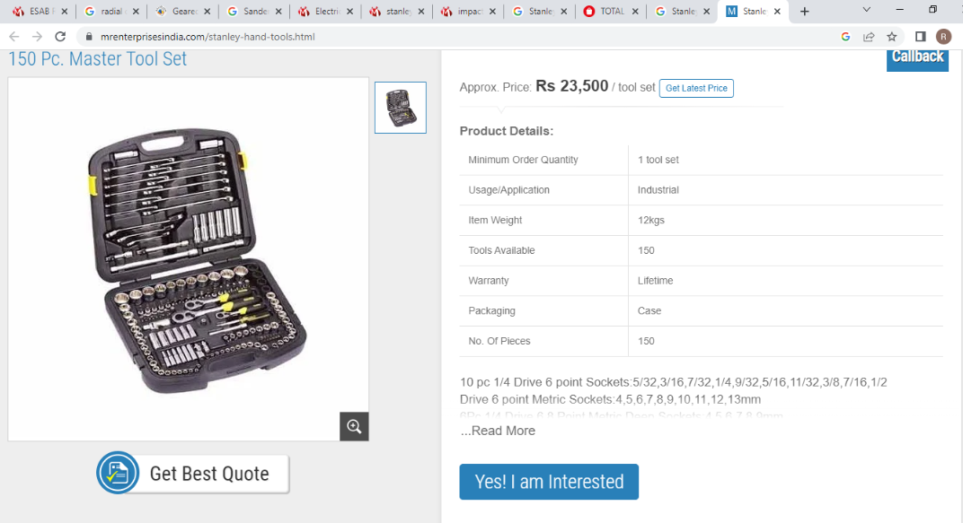
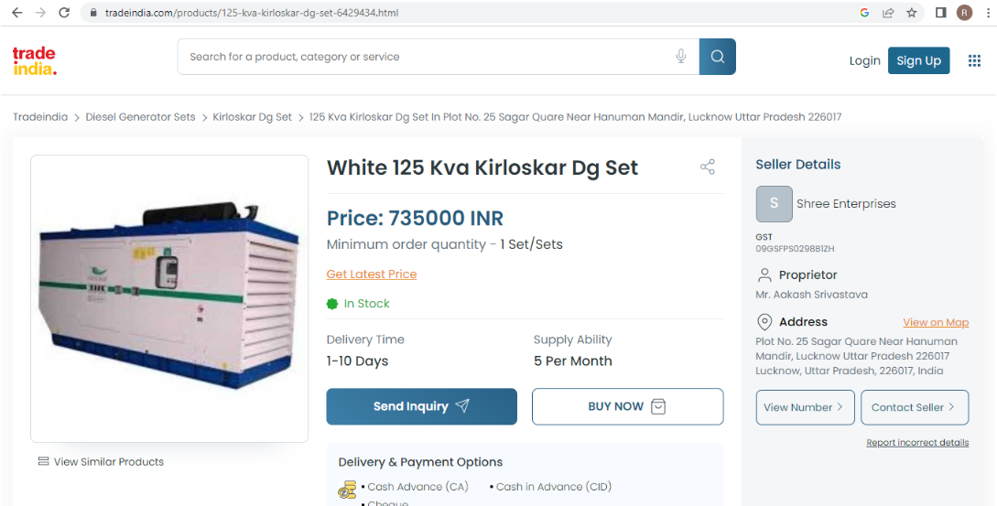
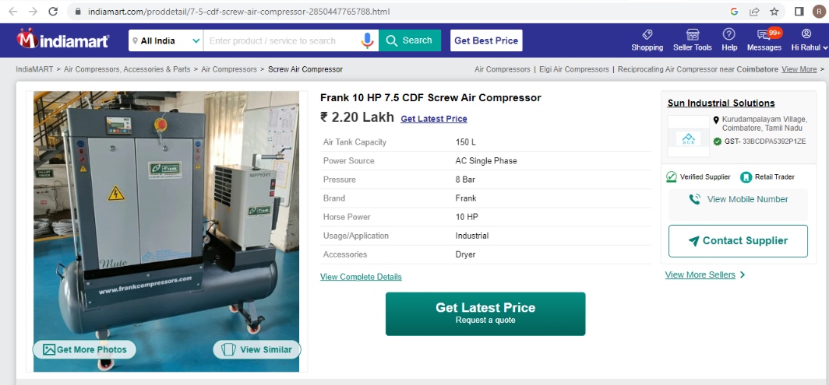
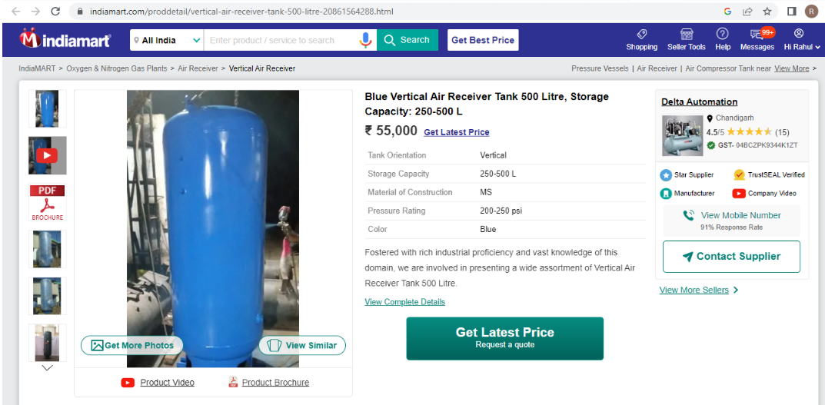
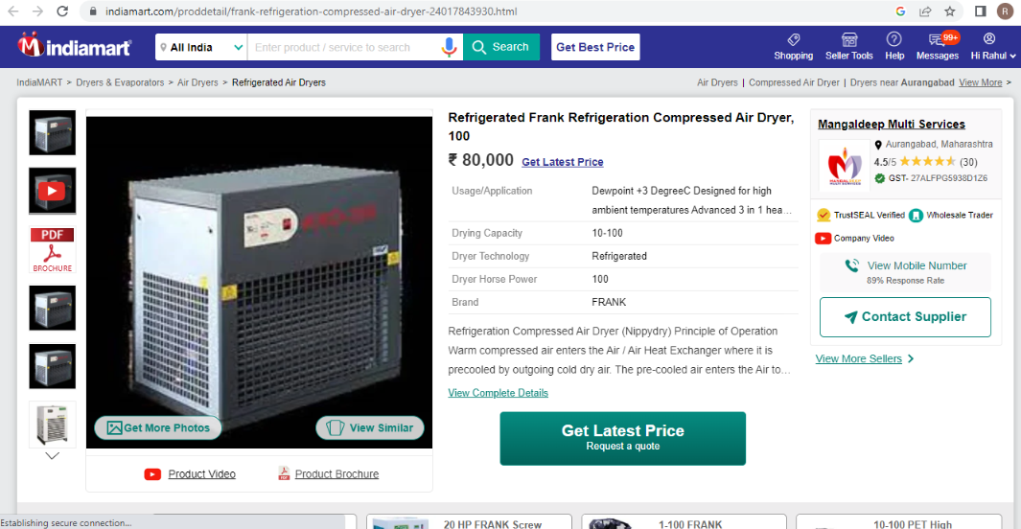
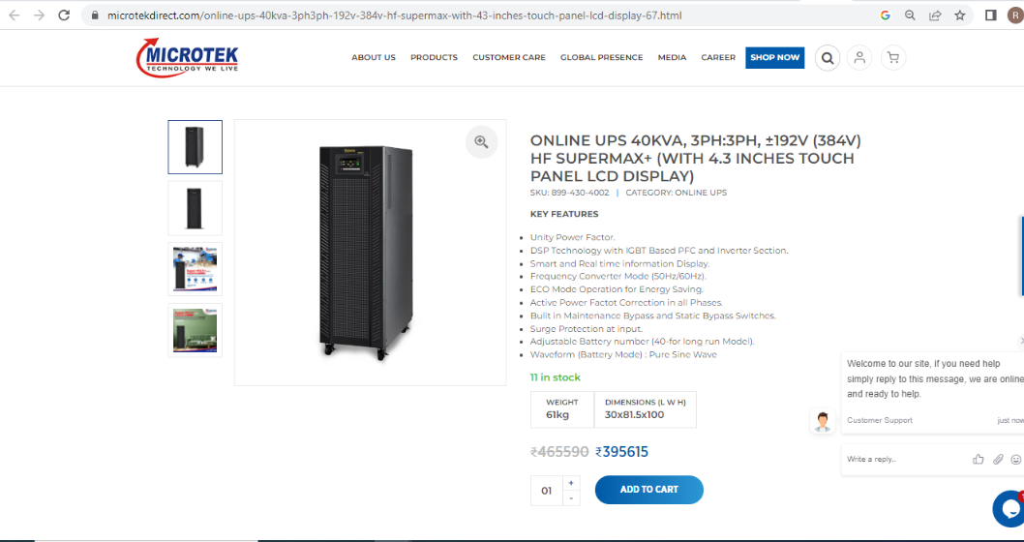
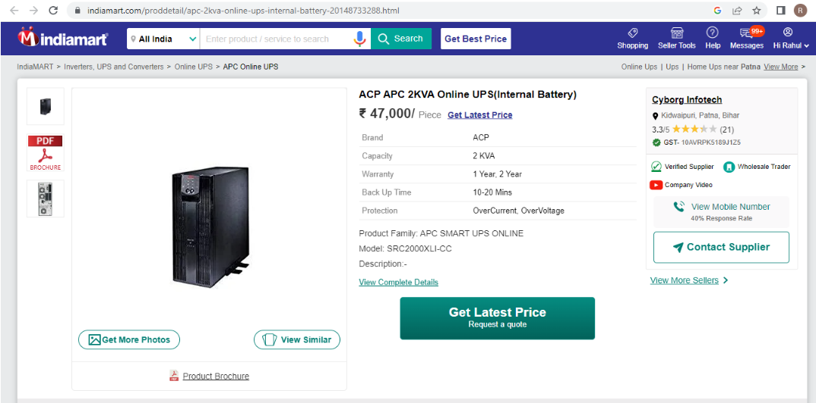
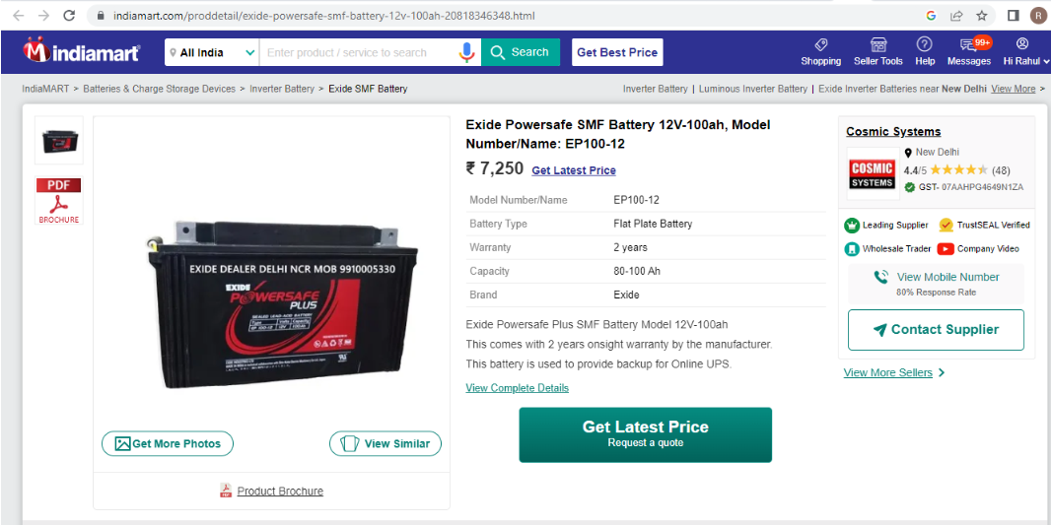
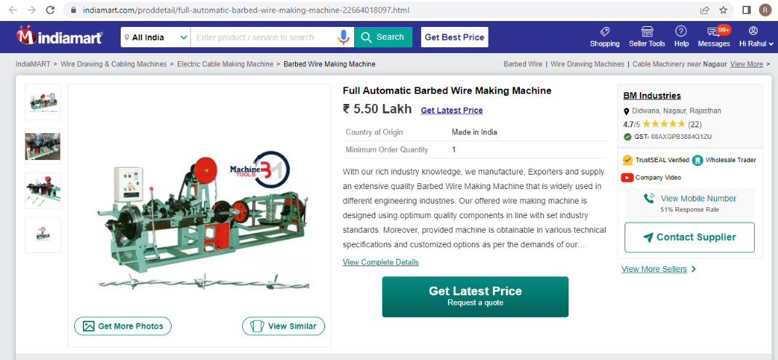
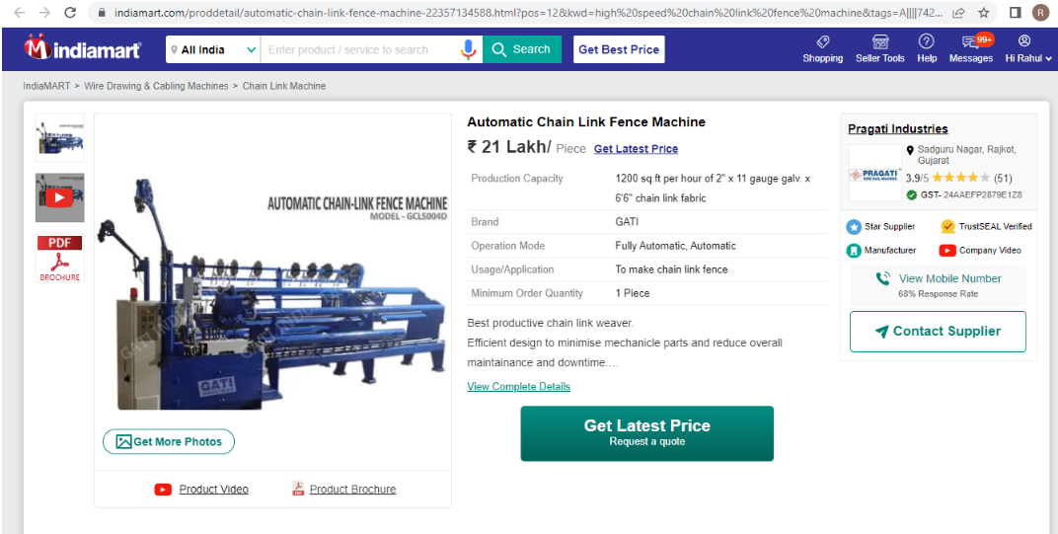
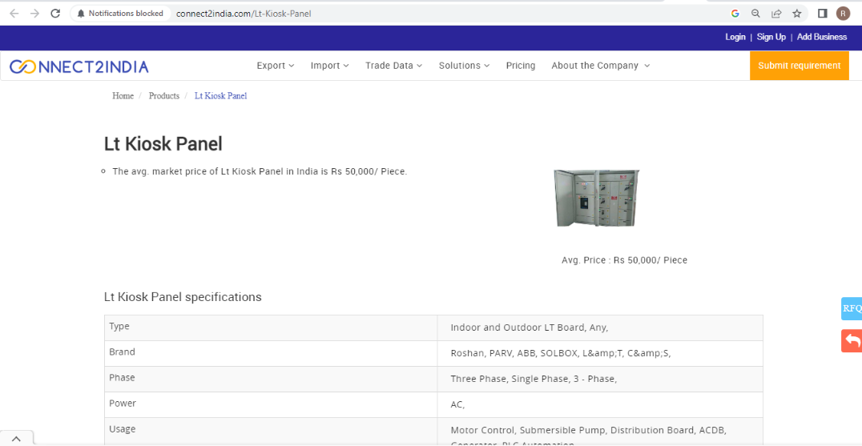
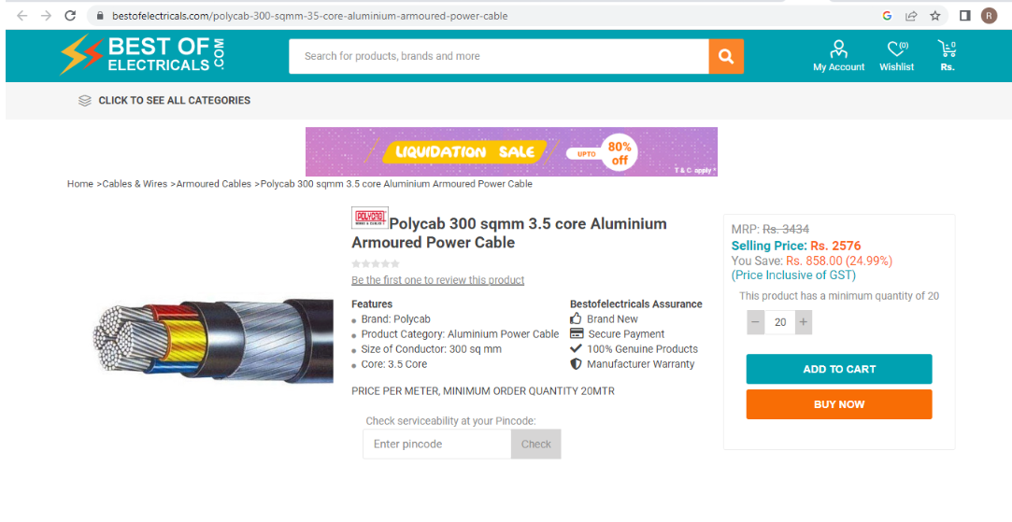
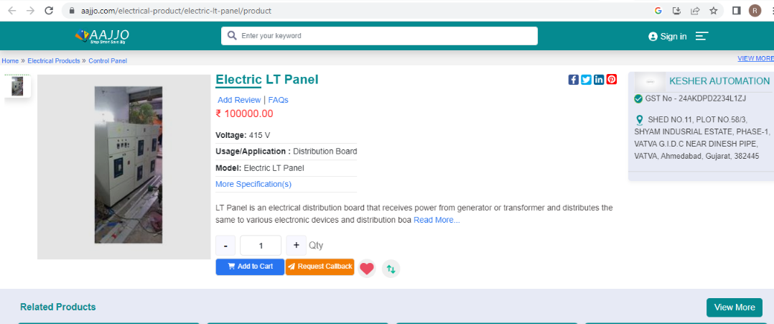
Manufacturing Process:
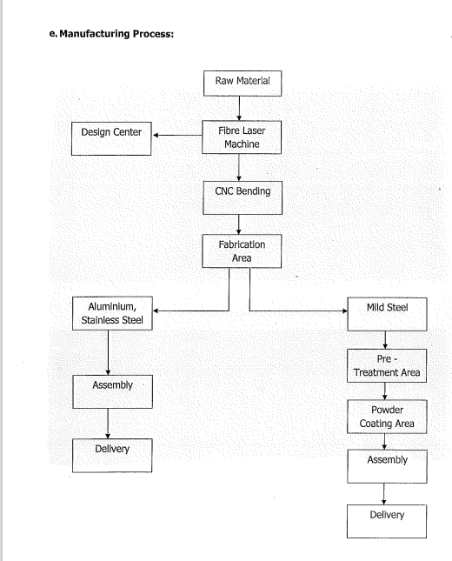

Proposed Civil Works Description
Sanctioned Building Map

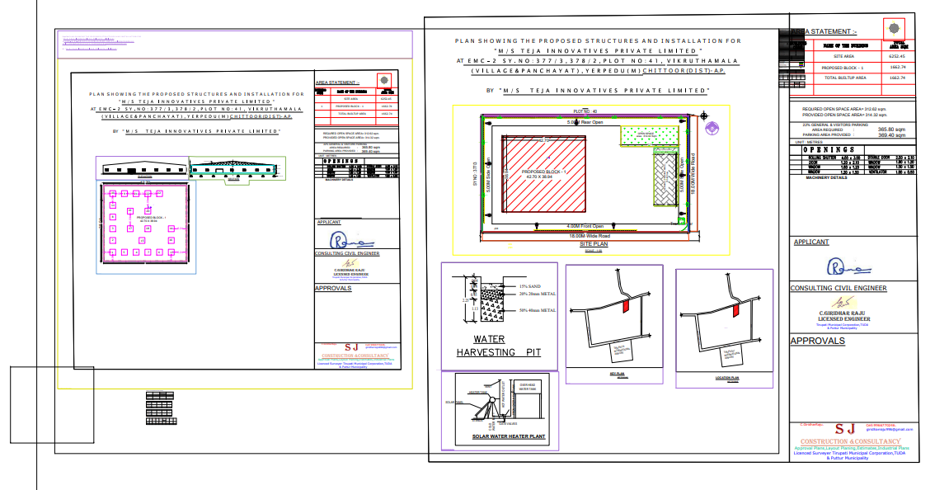
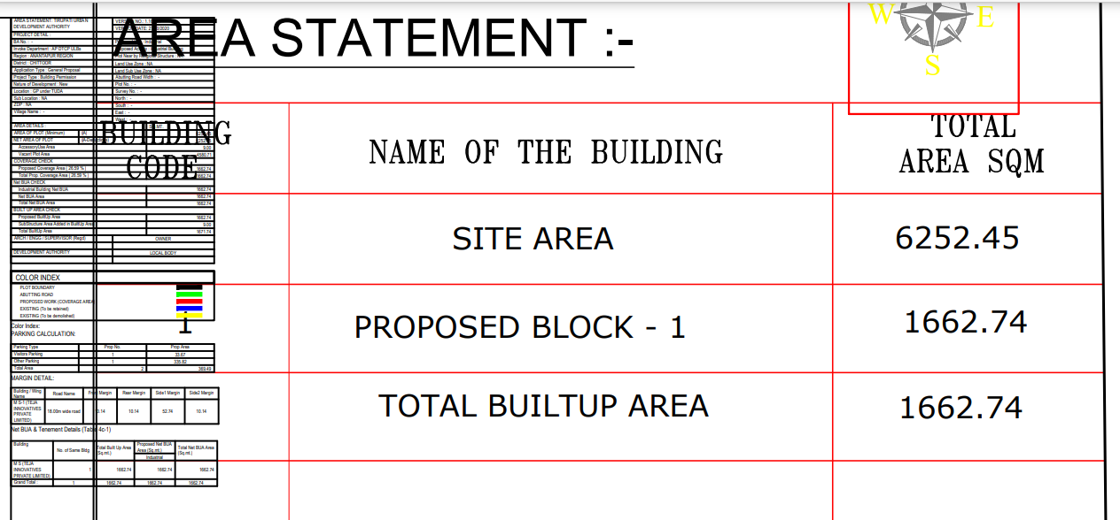

Cost Estimate Revised
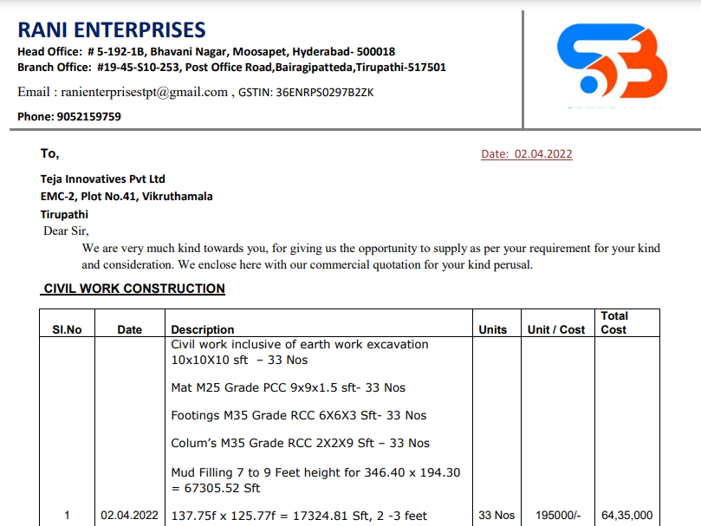
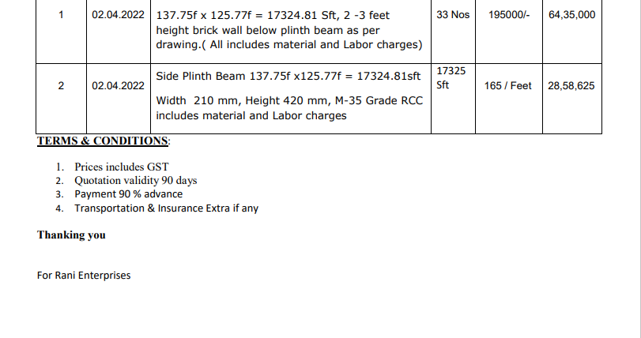

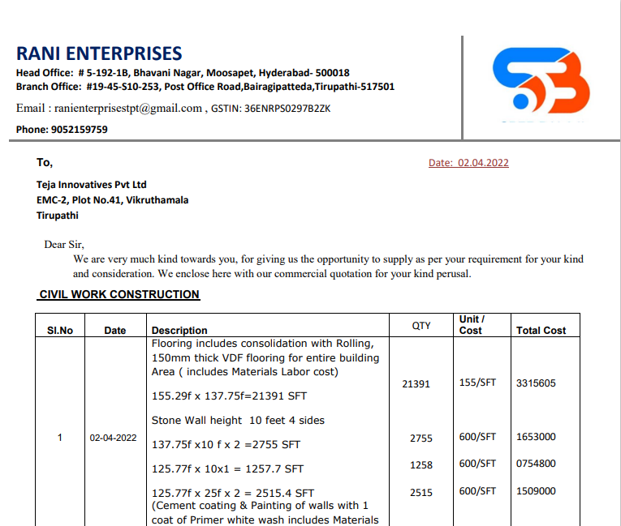
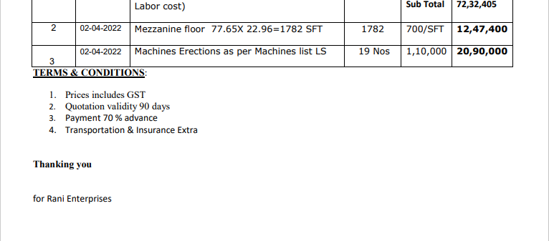
Cost Estimate Previous
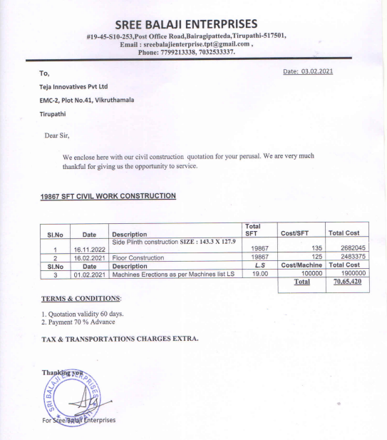

PEB Quotation
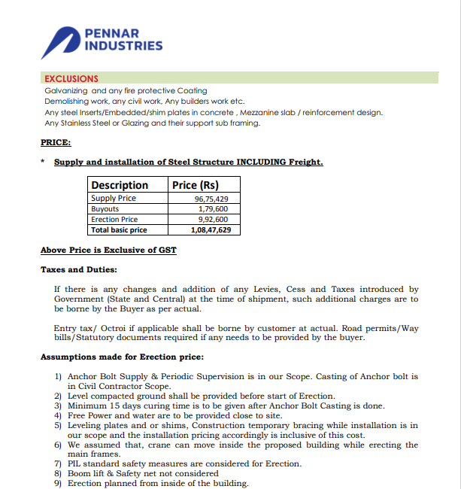
Snapshot of DPR
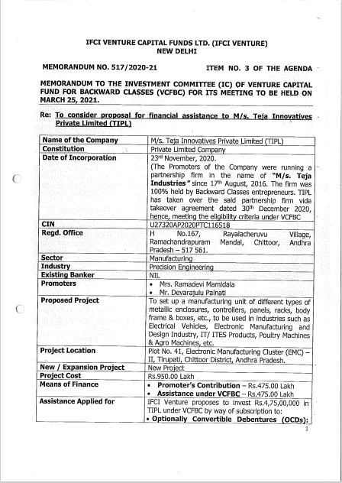
Proposed Production Capacity
