REPORT FORMAT: V-L1 (Basic - SBI) | Version: 12.0_Nov.2022

CASE NO.: VIS(2023-24)-PL109-Q014-110-147 Dated: 26.06.2023

VALUATION REPORT

OF

NATURE OF ASSETS | BUILT-UP UNIT
CATEGORY OF ASSETS | RESIDENTIAL
TYPE OF ASSETS | RESIDENTIAL APARTMENT IN MULTISTORIED BUILDING

SITUATED AT
FLAT NO. 1602, 16th FLOOR, THAKUR JEWEL, THAKUR VILLAGE, KANDIVALI, EAST MUMBAI, MAHARASHTRA

REPORT PREPARED FOR
STATE BANK OF INDIA, CCG BACKBAY RECLAMATION BRANCH, NARIMAN POINT, MUMBAI

**Important - In case of any query/ issue or escalation you may please contact Incident Manager
at valuers@rkassociates.org. We will appreciate your feedback in order to improve our services.

NOTE: As per IBA & Bank’s Guidelines please provide your feedback on the report within 15 days of its submission after which report will be considered to be correct.
Valuation Terms of Services & Valuer’s Important Remarks are available at www.rkassociates.org for reference.

PART A | SNAPSHOT OF THE ASSET/ PROPERTY UNDER VALUATION

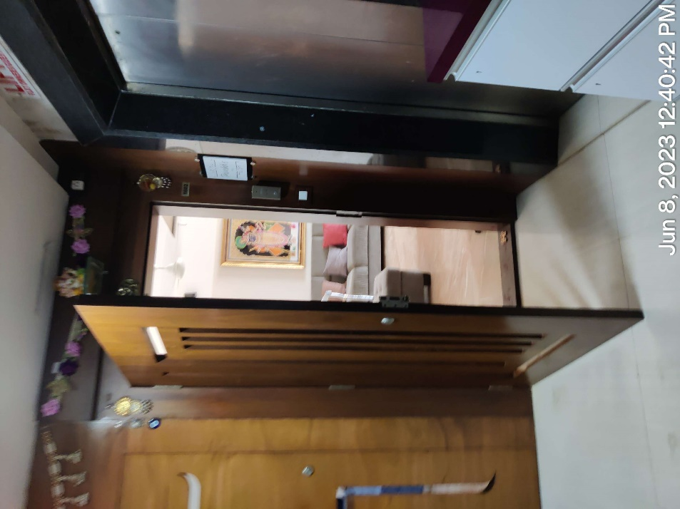
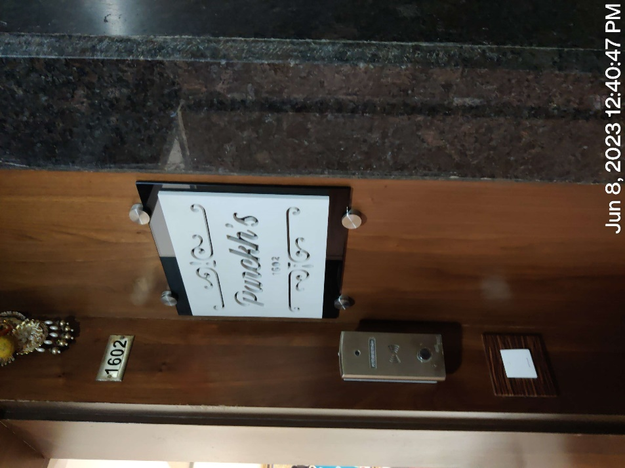
PART B | VALUATION ASSESSMENT AS PER SBI FORMAT

Name & Address of Branch: | State Bank of India, CCG Backbay Reclamation Branch, Nariman Point, Mumbai
Name of Customer (s)/ Borrower Unit | M/s. Sumangal Polymers
Property Shown By | Name | Relationship with Owner | Contact Number
Property Shown By | Mr. Rajesh B. Parekh | Owner himself | +91- 93721 11545
Work Order No. & Date | Dated 29.05.2023

 | CUSTOMER DETAILS
 | Name |  | M/s. Sumangal Polymers  Under the joint ownership of:  Mrs. Bharti Rajesh Parekh;  Mr. Rajesh Balwantrai Parekh;  Mr. Umang Rajesh Parekh; and  Mr. Jigar Rajesh Parekh  (As per copy of documents provided to us)
 | Application No. |  | NA
 | PROPERTY DETAILS
 | Address  (as referred from the copy of the documents provided) |  | Address: Flat No. 1602, 16th Floor, Thakur Jewel, Thakur Village, Kandivali, East Mumbai, Maharashtra  (As per copy of documents provided to us)
 | Nearby Landmark |  | Thakur College, Thakur Jewel
 | Google Map |  | Enclosed with the Report
 |  |  | Coordinates or URL: 19°12'26.6"N 72°52'24.7"E
 | Independent access to the property |  | Clear independent access is available
 | Type of ownership |  | Joint ownership
 | Constitution of the Property |  | Free hold, complete transferable rights
 | Is the property merged or colluded with any other property |  | No. It is an independent single bounded property
 |  |  | Comments: None
 | Document Details |  | Status |  | Name of Approving Auth./ Description of the document |  |  |  |  | Approval/ Document No.
 | Agreement to Sell |  | Available |  | Office of the Sub-Registrar Borivali - Government of Maharashtra |  |  |  |  | Dated: 15.05.2015
 | Copy of TIR |  | Available |  | Rekha Nair & Associates |  |  |  |  | Dated: 11.07.2023
 | Occupancy Certificate |  | Available |  | Municipal Corporation of Greater Mumbai |  |  |  |  | Dated: 12.11.2014
 | Approved Floor Plan |  | Available |  | Office of the Sub-Registrar Borivali - Government of Maharashtra |  |  |  |  | Dated: 11.01.2013
 | Last paid Electricity Bill |  | Available |  | Tata Power Company Limited |  |  |  |  | Dated: 12.05.2023
 | Last paid Municipal Tax Receipt |  | Not available |  | ---- |  |  |  |  | ----
 | Documents provided by |  | Owner
 |  |  | Name |  | Relationship with Owner |  |  |  |  | Contact Number
 |  |  | Mr. Rajesh B. Parekh |  | Owner |  |  |  |  | +91- 93721 11545
 | PHYSICAL DETAILS OF THE PROPERTY
 | Adjoining Properties |  | Directions |  |  | As per Documents |  |  |  |  | Actual found at Site
 |  |  | North |  |  | Not mentioned in the documents |  |  |  |  | Konark Veg. Hotel, Vasundhara CHS
 |  |  | South |  |  | Not mentioned in the documents |  |  |  |  | Flat No. 1603 & 1604, Ram Singh Road
 |  |  | East |  |  | Not mentioned in the documents |  |  |  |  | Rakhee Building
 |  |  | West |  |  | Not mentioned in the documents |  |  |  |  | Shayamnarayan Thakur Road
 | Are Boundaries matched |  | No, boundaries are not mentioned in the documents..
 | Plot demarcation |  | Yes
 | Approved land Use |  | Residential Apartment in multistoried building
 | Type of Property |  | RESIDENTIAL APARTMENT IN MULTISTORIED BUILDING
 | No. of bed rooms | Living/ Dining area |  | Toilets |  |  |  | Kitchen |  |  |  | Other rooms
 | 04 | 01 |  | 04 |  |  |  | 01 |  |  |  | ----
 | Total no. of floors of the property |  | Multistoried Building
 | Floor on which the property is located |  | 16
 | Approx. age of the property |  | Approx. 9 years since 2014
 | Residual age of the property |  | Approx. 55-60 years
 | Type of structure |  | RCC framed pillar, beam, column structure on RCC slab
 | Condition of the Structure |  | Good
 | Finishing of the building |  | Good
 | TENURE/ OCCUPANCY/ POSSESSION DETAILS
 | Status of Tenure |  |  |  |  |  | Occupied
 | Property presently possessed/ occupied by |  |  |  |  |  | Owner
 | No. of years of occupancy |  |  |  |  |  | 09 years
 | Relationship of tenant or owner |  |  |  |  |  | Owner
 | Stage of Construction |  |  |  |  |  | Constructed property in use
 | If under construction then extent of completion |  |  |  |  |  | Remarks: Property already constructed.
 | VIOLATION IF ANY OBSERVED IN THE PROPERTY
 | - Violation if any observed |  | - Nature and extent of violation |  |  |  |  |  | - Any other negativity, defect or drawback in the property
 | No |  | No |  |  |  |  |  | No

 | AREA DETAILS OF THE PROPERTY
Land area
(as per documents/ site survey, whichever is less)
(Not considered since this is a Built-up Dwelling Unit Valuation)
 | Area as per documents | Area as per site survey |  | Area considered for Valuation
 | NA | NA |  | NA
 | Area adopted on the basis of | NA
 | Remarks & Observations | ----
Constructed Carpet Area
(As per IS 3861-1966)
 | Area as per documents |  | Area as per site survey |  | Area considered for Valuation
 | Carpet Area |  | Carpet Area |  | Carpet Area
 | 127.5 sq.mtr. / 1372.4 sq.ft. |  | 1284.60 sq.ft. |  | 127.5 sq.mtr. / 1372.4 sq.ft.
 | Area adopted on the basis of | Property documents & site survey both
 | Remarks & Observations | Area measurements considered in the Valuation Report pertaining to Building is adopted from relevant documents produced to us or sample site measurement, whichever is less. All area measurements are on approximate basis only. Verification of the area measurement of the property is done based on sample random checking only.  As per the copy of “agreement to sale” provided to us, the total carpet area of the property is 127.50 sqm. which is cross checked at the time of physical measurement during the site visit. So, we have considered the area as per the documents provided for the valuation assessment.
 | SUMMARY OF VALUATION
S. No. | Particulars | Govt. Circle/ Guideline Value | Indicative & Estimated Prospective Fair Market Value
 | Land (A) | ---- | ----
 | Flat (B) | Rs.1,58,82,292/- | Rs.4,11,72,000/-
 | Additional Aesthetic Works Value (C) | ---- | ----
 | Indicative Prospective Estimated Fair Market Value (A+B+C) | Rs.1,58,82,292/- | Rs.4,12,00,000/-  (Rounded Off)
 | Expected Estimated Realizable Value  (@ ~15% less) | ---- | Rs.3,50,20,000/-
 | Expected Forced/ Distress Sale Value  (@ ~25% less) | ---- | Rs.3,09,00,000/-
 | Valuation of structure for Insurance purpose | ---- | Rs.28,00,000/-
 | Percentage difference between Circle Rate and Fair Market Value | More than 20%
 | Justification for more than 20% difference in Market & Circle Rate | Circle rates are determined by the District administration as per their own theoretical internal policy for fixing the minimum valuation of the property for property registration tax collection purpose and Market rates are adopted based on prevailing market dynamics found as per the discrete market enquiries which is explained clearly in Valuation assessment factors.

ASSUMPTIONS | REMARKS | LIMITING CONDITIONS
Qualification in TIR/ Mitigation Suggested, if any: NA
Is property SARFAESI compliant: Yes
Whether property belongs to social infrastructure like hospital, school, old age home etc.:No
Whether entire piece of land on which the unit is set up / property is situated has been mortgaged or to be mortgaged: To be Mortgaged
Details of last two transactions in the locality/area to be provided, if available: Authentic and certified details for last 2 transactions could not be gathered. However prospective transaction details as per information available on public domain and gathered during site survey is mentioned in Point 2 of Part D: Procedure of Valuation Assessment of the report and the screenshots of the references are annexed in the report for reference.
Any other aspect which has relevance on the value or marketability of the property:

- Please refer to Part D: Procedure of Valuation Assessment where major factors related to valuation are described.
- Estimated Value is subject to the assumptions, limitations, basis of computation, caveats, information, facts came during valuation within the limited available time & cost.
- This Valuation is guided by Valuation Terms of Service and Valuer’s Important Remarks which can also be found at www.rkassociates.org.
- Please do refer Valuer’s Remark in Part-E of the report.

 | DECLARATION
- The property was inspected by our authorized surveyor on 8 June 2023 by name Shreyash Shetty in the presence of owner’s representative.
- The undersigned does not have any direct/indirect interest in the above property.
- The information furnished herein is true and correct to the best of our knowledge.
- We have submitted Valuation report directly to the Bank.
 | Name & Address of Valuer company | M/s R.K. Associates Valuers & Techno Engineering Consultants Pvt. Ltd. 2nd Floor, D-39, nearby Red FM, Sector 2, Noida, Uttar Pradesh 201301
 | Enclosed Documents | Enclosure No. | Documents | No. of Pages
 | Enclosed Documents |  | Procedure of Valuation Assessment | 10
 | Enclosed Documents |  | References on price trend of the similar related properties available on public domain | 2
 | Enclosed Documents |  | Google Map Location | 1
 | Enclosed Documents |  | Photographs of the property | 2
 | Enclosed Documents |  | Copy of Circle Guideline Rate | 1
 | Enclosed Documents |  | Important Property Documents Exhibit | 9
 | Enclosed Documents |  | Declaration-cum-Undertaking | 4
 | Enclosed Documents |  | Model code of conduct for valuers | 3
 | Enclosed Documents |  | Valuer’s Important Remarks | 4
 | Total Number of Pages in the Report with Enclosures | 42

As a result of our appraisal and analysis, it is our considered opinion that the respective present values as on date of the above property in the prevailing condition with aforesaid specifications is:

S.NO. | TYPE OF VALUES | VALUE IN RS. | VALUE IN WORDS
 | Indicative & Estimated Prospective Fair Market Value | Rs.4,12,00,000/- | Rupees Four Crores Twelve Lakhs Only
 | Expected Market Realizable Value (@ ~15% less) | Rs.3,50,20,000/- | Rupees Three Crores Fifty Lakhs and Twenty Thousand Only
 | Expected Market Distress Value (@ ~25% less) | Rs.3,09,00,000/- | Rupees Three Crores and Nine Lakhs Only
 | Book Value/ Sale Deed Amount | Rs.2,50,00,000/- | Rupees Two Crores and Fifty Lakhs Only

SURVEY ANALYST | VALUATION ENGINEER | L1/ L2 REVIEWER
Shreyash Shetty | Manas Upmanyu | Anil Kumar

Official Seal of the Valuation Company

Place: Noida
Date: 26.06.2023
FOR BANK USE

The undersigned has inspected the property detailed in the Valuation Report dated 26.06.2023 on Tuesday. We are satisfied that the fair and reasonable market value of the property is Rs.4,12,00,000/-

Name:
Signature:

(Name of the Branch Manager with Official seal)

R.K ASSOCIATES IMPORTANT NOTES

DEFECT LIABILITY PERIOD - In case of any query/ issue or escalation you may please contact Incident Manager by writing at valuers@rkassociates.org. We try our level best to ensure maximum accuracy in the Calculations done, Rates adopted and various other data points & information mentioned in the report but still can’t rule out typing, human errors, assessment or any other mistakes. In case you find any mistake, variation, discrepancy or inaccuracy in any data point mentioned in the report, please help us by bringing all such points into our notice in writing at valuers@rkassociates.org within 30 days of the report delivery, to get these rectified timely, failing which R.K Associates shouldn’t be held responsible for any inaccuracy in any manner. Also, if we do not hear back anything from you within 30 days, we will assume that the report is correct in all respect and no further claim of any sorts will be entertained thereafter. We would welcome and appreciate your feedback & suggestions in order to improve our services.
Our DATA RETENTION POLICY is of ONE YEAR. After this period we remove all the concerned records related to the assignment from our repository. No clarification or query can be answered after this period due to unavailability of the data.
COPYRIGHT FORMAT - This report is prepared on the copyright format of R.K Associates to serve our clients in the best possible way. Legally no one can copy or distribute this format without prior approval from R.K Associates. It is meant only for the organization as mentioned on the cover page of this report. Distribution or use of this format or any content of this report wholly or partially other than R.K Associates will be seen as unlawful act and necessary legal action can be taken against the defaulters.

IF REPORT IS USED FOR BANK/ FIs
NOTE: As per IBA Guidelines in case the valuation report submitted by the valuer is not in order, the banks / FIs shall bring the same to the notice of the valuer within 15 days of submission for rectification and resubmission. In case no such communication is received, it shall be presumed that the valuation report has been accepted.
At our end we have not verified the authenticity of any documents provided to us. Bank is advised to verify the genuineness of the property documents before taking any credit decision.
Valuation Terms of Services & Valuer’s Important Remarks are available at www.rkassociates.org for reference.

ENCLOSURE - I
PART C | PROCEDURE OF VALUATION ASSESSMENT

 | GENERAL INFORMATION
 | Important Dates | Date of Appointment |  | Date of Inspection of the Property | Date of Valuation Assessment | Date of Valuation Report
 | Important Dates | 29 May 2023 |  | 8 June 2023 | 26 June 2023 | 26 June 2023
 | Client | State Bank of India, CCG Backbay Reclamation Branch, Nariman Point, Mumbai
 | Intended User | State Bank of India, CCG Backbay Reclamation Branch, Nariman Point, Mumbai
 | Intended Use | To know the general idea on the market valuation trend of the property as per free market transaction. This report is not intended to cover any other internal mechanism, criteria, considerations of any organization as per their own need, use & purpose.
 | Purpose of Valuation | For Value assessment of the asset for creating collateral mortgage for Bank Loan purpose
 | Scope of the Assessment | Non binding opinion on the assessment of Plain Physical Asset Valuation of the property identified to us by the owner or through his representative.
 | Restrictions | This report should not be referred for any other purpose, by any other user and for any other date other then as specified above. This report is not a certification of ownership or survey number/ property number/ Khasra number which are merely referred from the copy of the documents provided to us.
 | Manner in which the proper is identified |  | Identified by the owner
 | Manner in which the proper is identified | ☐ | Identified by owner’s representative
 | Manner in which the proper is identified |  | Done from the name plate displayed on the property
 | Manner in which the proper is identified | ☐ | Cross checked from boundaries or address of the property mentioned in the deed
 | Manner in which the proper is identified | ☐ | Enquired from local residents/ public
 | Manner in which the proper is identified | ☐ | Identification of the property could not be done properly
 | Manner in which the proper is identified | ☐ | Survey was not done
 | Is property number/ survey number displayed on the property for proper identification? | Yes.
 | Type of Survey conducted | Full survey (inside-out with approximate measurements & photographs).

 | ASSESSMENT FACTORS
 | Valuation Standards considered | Mix of standards such as IVS and others issued by Indian authorities & institutions and improvised by the RKA internal research team as and where it is felt necessary to derive at a reasonable, logical & scientific approach. In this regard proper basis, approach, working, definitions considered is defined below which may have certain departures to IVS.
 | Nature of the Valuation | Fixed Assets Valuation
 | Nature/ Category/ Type/ Classification of Asset under Valuation | Nature |  |  |  |  |  | Category |  |  |  |  |  |  |  | Type
 |  | BUILT-UP UNIT |  |  |  |  |  | RESIDENTIAL |  |  |  |  |  |  |  | RESIDENTIAL APARTMENT IN MULTISTORIED BUILDING
 |  | Classification |  |  |  |  |  | Personal use asset
 | Type of Valuation (Basis of Valuation as per IVS) | Primary Basis |  |  |  |  | Market Value & Govt. Guideline Value
 | Type of Valuation (Basis of Valuation as per IVS) | Secondary Basis |  |  |  |  | On-going concern basis
 | Present market state of the Asset assumed (Premise of Value as per IVS) | Under Normal Marketable State
 |  | Reason: Asset under free market transaction state
 | Property Use factor | Current/ Existing Use |  |  |  |  |  |  | Highest & Best Use  (in consonance to surrounding use, zoning and statutory norms) |  |  |  |  |  |  | Considered for Valuation purpose
 | Property Use factor | Residential |  |  |  |  |  |  | Residential |  |  |  |  |  |  | Residential
 | Legality Aspect Factor | Assumed to be fine as per copy of the documents & information produced to us.  However Legal aspects of the property of any nature are out-of-scope of the Valuation Services. In terms of the legality, we have only gone by the documents provided to us in good faith.  Verification of authenticity of documents from originals or cross checking from any Govt. deptt. have to be taken care by Legal expert/ Advocate.
 | Class/ Category of the locality | Upper Middle Class (Good)
 | Property Physical Factors | Shape |  |  |  |  |  |  |  | Size |  |  |  |  | Layout
 | Property Physical Factors | Not Applicable |  |  |  |  |  |  |  | Small |  |  |  |  | Normal Layout
 | Property Location Category Factor | City Categorization |  |  |  | Locality Characteristics |  |  |  |  |  | Property location characteristics |  |  |  |  | Floor Level
 | Property Location Category Factor | Metro City |  |  |  | Good |  |  |  |  |  | Good location within locality |  |  |  |  | Sixteenth Floor
 | Property Location Category Factor | Urban developing |  |  |  | Normal |  |  |  |  |  | Not Applicable |  |  |  |  | Sixteenth Floor
 | Property Location Category Factor |  |  |  |  | Within urban developing zone |  |  |  |  |  | Not Applicable |  |  |  |  | Sixteenth Floor
 | Property Location Category Factor | Property Facing
 | Property Location Category Factor | South Facing
 | Physical Infrastructure availability factors of the locality | Water Supply |  |  |  | Sewerage/ sanitation system |  |  |  |  |  | Electricity |  |  |  |  | Road and Public Transport connectivity
 | Physical Infrastructure availability factors of the locality | Yes from municipal connection |  |  |  | Underground |  |  |  |  |  | Yes |  |  |  |  | Easily available
 | Physical Infrastructure availability factors of the locality | Availability of other public utilities nearby |  |  |  |  |  |  |  |  |  | Availability of communication facilities
 | Physical Infrastructure availability factors of the locality | Transport, Market, Hospital etc. are available in close vicinity |  |  |  |  |  |  |  |  |  | Major Telecommunication Service Provider & ISP connections are available
 | Social structure of the area (in terms of population, social stratification, regional origin, age groups, economic levels, location of slums/ squatter settlements nearby, etc.) | High Income Group
 | Neighbourhood amenities | Good
 | Any New Development in surrounding area | None
 | Any specific advantage in the property | None
 | Any specific drawback in the property | None
 | Property overall usability/ utility Factor | Good
 | Do property has any alternate use? | No
 | Is property clearly demarcated by permanent/ temporary boundary on site | Demarcated with permanent boundary
 | Is the property merged or colluded with any other property | No
 | Is the property merged or colluded with any other property | Comments: ---
 | Is independent access available to the property | Clear independent access is available
 | Is property clearly possessable upon sale | Yes
 | Best Sale procedure to realize maximum Value (in respect to Present market state or premise of the Asset as per point (iv) above) | Fair Market Value
 |  | Free market transaction at arm's length wherein the parties, after full market survey each acted knowledgeably, prudently and without any compulsion.
 | Hypothetical Sale transaction method assumed for the computation of valuation | Fair Market Value
 |  | Free market transaction at arm's length wherein the parties, after full market survey each acted knowledgeably, prudently and without any compulsion.
 | Approach & Method of Valuation Used | Built-up Unit |  |  | Approach of Valuation |  |  |  |  |  |  |  |  | Method of Valuation
 | Approach & Method of Valuation Used |  |  |  | Market Approach |  |  |  |  |  |  |  |  | Market Comparable Sales Method
 | Approach & Method of Valuation Used | Land |  |  | NA |  |  |  |  |  |  |  |  | NA
 | Type of Source of Information | Level 3 Input (Tertiary)
 | Market Comparable
 | References on prevailing market Rate/ Price trend of the property and Details of the sources from where the information is gathered (from property search sites & local information) | 1. |  | Name: |  |  |  |  |  |  |  |  | Mr. Bhupendra
 |  |  |  | Contact No.: |  |  |  |  |  |  |  |  | +91- 97692 28456
 |  |  |  | Nature of reference: |  |  |  |  |  |  |  |  | Property Consultant
 |  |  |  | Size of the Property: |  |  |  |  |  |  |  |  | ~1500 sq.ft.
 |  |  |  | Location: |  |  |  |  |  |  |  |  | Thakur Jewel
 |  |  |  | Rates/ Price informed: |  |  |  |  |  |  |  |  | Around Rs.28,000/- to Rs.35,000/- per sq.ft. (on carpet area)
 |  |  |  | Any other details/ Discussion held: |  |  |  |  |  |  |  |  | As per the discussion with the property dealer of the subject locality we came to know that the rates for a property similar to the subject property are as mentioned above.
 |  | 2. |  | Name: |  |  |  |  |  |  |  |  | Mr. Jatin
 |  |  |  | Contact No.: |  |  |  |  |  |  |  |  | +91- 96999 96990
 |  |  |  | Nature of reference: |  |  |  |  |  |  |  |  | Property Consultant
 |  |  |  | Size of the Property: |  |  |  |  |  |  |  |  | ~1500 sq.ft.
 |  |  |  | Location: |  |  |  |  |  |  |  |  | Thakur Jewel
 |  |  |  | Rates/ Price informed: |  |  |  |  |  |  |  |  | Around Rs.28,000/- to Rs.32,000/- per sq.ft. (on carpet area)
 |  |  |  | Any other details/ Discussion held: |  |  |  |  |  |  |  |  | As per the discussion with the property dealer of the subject locality we came to know that the rates for a property similar to the subject property are as mentioned above.
 |  | 3. |  | Name: |  |  |  |  |  |  |  |  | Mr. Karan
 |  |  |  | Contact No.: |  |  |  |  |  |  |  |  | +91- 98921 51425
 |  |  |  | Nature of reference: |  |  |  |  |  |  |  |  | Property Consultant
 |  |  |  | Size of the Property: |  |  |  |  |  |  |  |  | ~1500 sq.ft.
 |  |  |  | Location: |  |  |  |  |  |  |  |  | Thakur Jewel
 |  |  |  | Rates/ Price informed: |  |  |  |  |  |  |  |  | Around Rs.28,000/- to Rs.35,000/- per sq.ft. (on carpet area)
 |  |  |  | Any other details/ Discussion held: |  |  |  |  |  |  |  |  | As per the discussion with the property dealer of the subject locality we came to know that the rates for a property similar to the subject property are as mentioned above.
 |  | NOTE: The given information above can be independently verified to know its authenticity.
 | Adopted Rates Justification | As per our discussion with the property dealers and habitants of the subject location we have gathered the following information:  Rates for similar type of properties having size around 1,500 sq.ft. will be available within the range of Rs.28,000/ - to Rs.35,000/- per sq.ft. (on carpet area)  Based on the above information and keeping in mind the availability of properties in subject locality we are of the view to adopt a rate of Rs.30,000/- per sq.ft. (on carpet area) for the purpose of this valuation assessment.
NOTE: We have taken due care to take the information from reliable sources. The given information above can be independently verified from the provided numbers to know its authenticity. However due to the nature of the information most of the market information came to knowledge is only through verbal discussion with market participants which we have to rely upon where generally there is no written record.
Related postings for similar properties on sale are also annexed with the Report wherever available.
 | Other Market Factors
 | Current Market condition |  | Normal
 |  |  | Remarks: ---
 |  |  | Adjustments (-/+): 0%
 | Comment on Property Salability Outlook |  | Easily sellable
 |  |  | Adjustments (-/+): 0%
 | Comment on Demand & Supply in the Market |  | Demand |  |  |  |  |  |  |  | Supply
 |  |  | Good |  |  |  |  |  |  |  | Adequately available
 |  |  | Remarks: Good demand of such properties in the market
 |  |  | Adjustments (-/+): 0%
 | Any other special consideration |  | Reason: ----
 |  |  | Adjustments (-/+): 0%
 | Any other aspect which has relevance on the value or marketability of the property |  | NA  Valuation of the same asset/ property can fetch different values under different circumstances & situations. For eg. Valuation of a running/ operational shop/ hotel/ factory will fetch better value and in case of closed shop/ hotel/ factory it will fetch considerably lower value. Similarly, an asset sold directly by an owner in the open market through free market arm’s length transaction then it will fetch better value and if the same asset/ property is sold by any financer or court decree or Govt. enforcement agency due to any kind of encumbrance on it then it will fetch lower value. Hence before financing, Lender/ FI should take into consideration all such future risks while financing.  This Valuation report is prepared based on the facts of the property & market situation on the date of the survey. It is a well-known fact that the market value of any asset varies with time & socio-economic conditions prevailing in the region/ country. In future property market may go down, property conditions may change or may go worse, property reputation may differ, property vicinity conditions may go down or become worse, property market may change due to impact of Govt. policies or effect of domestic/ world economy, usability prospects of the property may change, etc. Hence before financing, Banker/ FI should take into consideration all such future risk while financing.
 |  |  | Adjustments (-/+): 0%
 | Final adjusted & weighted Rates considered for the subject property |  | Rs.30,000/- per sq.ft. (on carpet area)
 | Considered Rates Justification |  | As per the thorough property & market factors analysis as described above, the considered estimated market rates appears to be reasonable in our opinion.
 | Basis of computation & working
- Valuation of the asset is done as found on as-is-where basis on the site as identified to us by client/ owner/ owner representative during site inspection by our engineer/s unless otherwise mentioned in the report.
- Analysis and conclusions adopted in the report are limited to the reported assumptions, conditions and information came to our knowledge during the course of the work and based on the Standard Operating Procedures, Best Practices, Caveats, Limitations, Conditions, Remarks, Important Notes, Valuation TOR and definition of different nature of values.
- For knowing comparable market rates, significant discreet local enquiries have been made from our side based on the hypothetical/ virtual representation of ourselves as both buyer and seller for the similar type of properties in the subject location and thereafter based on this information and various factors of the property, rate has been judiciously taken considering the factors of the subject property, market scenario and weighted adjusted comparison with the comparable properties unless otherwise stated.
- References regarding the prevailing market rates and comparable are based on the verbal/ informal/ secondary/ tertiary information which are collected by our team from the local people/ property consultants/ recent deals/ demand-supply/ internet postings are relied upon as may be available or can be fetched within the limited time & resources of the assignment during market survey in the subject location. No written record is generally available for such market information and analysis has to be derived mostly based on the verbal information which has to be relied upon.
- Market Rates are rationally adopted based on the facts of the property which came to our knowledge during the course of the assessment considering many factors like nature of the property, size, location, approach, market situation and trends and comparative analysis with the similar assets. During comparative analysis, valuation metrics is prepared and necessary adjustments are made on the subject asset.
- The indicative value has been suggested based on the prevailing market rates that came to our knowledge during secondary & tertiary market research and is not split into formal & informal payment arrangements. Most of the deals takes place which includes both formal & informal payment components. Deals which takes place in complete formal payment component may realize relatively less actual transaction value due to inherent added tax, stamp registration liabilities on the buyer.
- Secondary/ Tertiary costs related to asset transaction like Stamp Duty, Registration charges, Brokerage, Commission, Bank interest, Selling cost, Marketing cost, etc. pertaining to the sale/ purchase of this property are not considered while assessing the indicative estimated Market Value.
- This report includes both, Govt. Guideline Value and Indicative Estimated Prospective Market Value as described above. As per the current market practice, in most of the cases, formal transaction takes place for an amount less than the actual transaction amount and rest of the payment is normally done informally.
- Area measurements considered in the Valuation Report pertaining to asset/ property is adopted from relevant approved documents or sample site measurement whichever is less unless otherwise mentioned. All area measurements are on approximate basis only.
- Verification of the area measurement of the property is done based on sample random checking only.
- Area of the large land parcels of more than 2500 sq.mtr or of uneven shape in which there can be practical difficulty in sample measurement, is taken as per property documents which has been relied upon unless otherwise stated.
- Drawing, Map, design & detailed estimation of the property/ building is out of scope of the Valuation services.
- Construction rates are adopted based on the present market replacement cost of construction and calculating applicable depreciation & deterioration factor as per its age, existing condition & specifications based on visual observation only of the structure. No structural, physical tests have been carried out in respect of it. No responsibility is assumed for latent defects of any nature whatsoever, which may affect value, or for any expertise required to disclose such conditions.
- Construction rates are adopted based on the plinth area rates prevailing in the market for the structure as a whole and not based on item wise estimation or Bills of Quantity method unless otherwise stated.
- The condition assessment and the estimation of the residual economic life of the structure are only based on the visual observations and appearance found during the site survey. We have not carried out any structural design or stability study; nor carried out any physical tests to assess structural integrity & strength.
- Any kind of unpaid statutory, utilities, lease, interest or any other pecuniary dues on the asset or on its owners has not been factored in the Valuation.
- This Valuation is conducted based on the macro analysis of the asset/ property considering it in totality and not based on the micro, component or item wise analysis. Analysis done is a general assessment and is neither investigative in nature nor an audit activity.
- Valuation is done for the asset found on as-is-where basis which owner/ owner representative/ client/ bank has shown to us on site of which some reference has been taken from the information/ data given in the copy of documents provided to us which have been relied upon in good faith and we have assumed that it to be true and correct.
 | ASSUMPTIONS
- Documents/ Information/ Data provided by the client/ property owner or his representative both written & verbally is true and correct without any fabrication and has been relied upon in good faith.
- Local verbal enquiries during micro market research came to our knowledge are assumed to be taken on record as true & factual.
- The assets and interests therein have been valued free and clear of any liens or encumbrances unless stated otherwise. No hidden or apparent conditions regarding the subject assets or their ownership are assumed to exist. No opinion of title is rendered in this report and a good title is assumed unless stated otherwise.
- It is assumed that the concerned Lender/ Financial Institution has asked for the valuation of that property after satisfying the authenticity of the documents given to us and for which the legal verification has been already taken and cleared by the competent Advocate before requesting for the Valuation report. I/ We assume no responsibility for the legal matters including, but not limited to, legal or title concerns.
- Payment condition during transaction in the Valuation has been considered on all cash bases which includes both formal & informal payment components as per market trend.
- Sale transaction method of the asset is assumed as Free market transaction without any compulsion unless otherwise mentioned while assessing Indicative & Estimated Fair Prospective Market Value of the asset unless otherwise stated.
- If this Valuation Report is prepared for the Flat/ dwelling unit situated in a Group Housing Society or Integrated Township then approvals, maps of the complete group housing society/ township is out of scope of this report. This valuation report is prepared for the specific unit based on the assumption that complete Group Housing Society/ Integrated Township is approved and complied with all relevant laws and the subject unit is also approved within the Group Housing Society/ Township.
 | SPECIAL ASSUMPTIONS
 | None
 | LIMITATIONS
 | None

 | VALUATION OF BUILT-UP UNIT
S. No. | Particulars | Govt. Circle/ Guideline Value | Indicative & Estimated Prospective Fair Market Value
 | Prevailing Rate range | Rs.1,46,550/- per sq.mtr. (On Built-up area) | Rs.28,000/- to Rs.35,000/- per sq.ft.
 | Rate adopted considering all characteristics of the property | Rs.1,24,567/- per sq.mtr. (On Carpet Area)  (15% Loading Factor) | Rs.30,000/- per sq.ft.
 | Total Built-Up Area considered (documents vs site survey whichever is less) | 127.5 sq.mtr. / 1372.4 sq.ft. | 127.5 sq.mtr. / 1372.4 sq.ft.
 | Total Value of Built-Up Unit (A) | 127.5 sq.mtr. x Rs.1,24,567/- per sq.mtr. | 1372.4 sq.ft. x Rs.30,000/- per sq.ft.  (127.5 sq.mtr. x Rs.3,22,917/-)
 | Total Value of Built-Up Unit (A) | Rs.1,58,82,292/- | Rs.4,11,72,000/-

4. | VALUATION COMPUTATION OF LAND

Not applicable since it is a built-up unit

5. | VALUATION OF ADDITIONAL AESTHETIC/ INTERIOR WORKS IN THE PROPERTY
S. No. | Particulars | Specifications | Depreciated Replacement Value
 | Add extra for Architectural aesthetic developments, improvements  (add lump sum cost) | ---- | ----
 | Add extra for fittings & fixtures  (Doors, windows, wood work, cupboards, modular kitchen, electrical/ sanitary fittings) | ---- | ----
 | Add extra for services  (Water, Electricity, Sewerage, Main gate, Boundary, Lift, Auxiliary power, AC, HVAC, Firefighting etc.) | ---- | ----
 | Add extra for internal & external development  (Internal roads, Landscaping, Pavements, Street lights, Green area development, External area landscaping, Land development, Approach road, etc.) | ---- | ----
 | Depreciated Replacement Value (B) | ---- | ----
Note:
- Value for Additional Building & Site Aesthetic Works is considered only if it is having exclusive/ super fine work specification above ordinary/ normal work. Ordinary/ normal work value is already covered under basic rates above.
- Value of common facilities of society are not included in the valuation of Flat/ Built-up unit.

6. | CONSOLIDATED VALUATION ASSESSMENT OF THE ASSET
S. No. | Particulars | Govt. Circle/ Guideline Value | Indicative & Estimated Prospective Fair Market Value
 | Land Value (A) | --- | ---
 | Total Built-Up Unit Value (B) | Rs.1,58,82,292/- | Rs.4,11,72,000/-
 | Additional Aesthetic Works Value (C) | --- | ---
 | Total Add (A+B+C) | Rs.1,58,82,292/- | Rs.4,11,72,000/-
 | Additional Premium if any | --- | ---
 | Details/ Justification | --- | ---
 | Deductions charged if any | --- | ---
 | Details/ Justification | --- | ---
 | Total Indicative & Estimated Prospective Fair Market Value | --- | Rs.4,11,72,000/-
 | Rounded Off | --- | Rs.4,12,00,000/-
 | Indicative & Estimated Prospective Fair Market Value in words | --- | Rupees Four Crores Twelve Lakhs Only
 | Expected Realizable Value (@ ~15% less) | --- | Rs.3,50,20,000/-
 | Expected Distress Sale Value (@ ~25% less) | --- | Rs.3,09,00,000/-
 | Percentage difference between Circle Rate and Fair Market Value | More than 20%
 | Concluding Comments/ Disclosures if any
- We are independent of client/ company and do not have any direct/ indirect interest in the property.
- This valuation has been conducted by R.K Associates Valuers & Techno Engineering Consultants (P) Ltd. and its team of experts.
- This Valuation is done for the property found on as-is-where basis as shown on the site by the Bank/ customer of which photographs is also attached with the report.
- Reference of the property is also taken from the copies of the documents/ information which interested organization or customer could provide to us out of the standard checklist of documents sought from them and further based on our assumptions and limiting conditions. All such information provided to us has been relied upon in good faith and we have assumed that it is true and correct. However, we do not vouch the absolute correctness of the property identification, exact address, physical conditions, etc. based on the documents provided to us since property shown to us may differ on site Vs as mentioned in the documents or incorrect/ fabricated documents may have been provided to us.
- Legal aspects for eg. investigation of title, ownership rights, lien, charge, mortgage, lease, verification of documents from originals or from any Govt. department, etc. has to be taken care by legal experts/ Advocates and same has not been done at our end.
- The valuation of an asset is an estimate of the worth of that asset which is arrived at by the Valuer in his expert opinion after factoring in multiple parameters and externalities. This may not be the actual price of that asset and the market may discover a different price for that asset.
- This report only contains opinion based on technical & market information which came to our knowledge during the course of the assignment. It doesn’t contain any recommendations.
- This report is prepared following our Standard Operating Procedures & Best Practices and will be subject to Limitations, Conditions, Valuer’s Remarks, Important Notes, Valuation TOS and basis of computation & working as described above.
- The use of this report will become valid only after payment of full fees as per the Payment Terms. Using this report or any part content created in this report without payment of charges will be seen as misuse and unauthorized use of the report.
 | IMPORTANT KEY DEFINITIONS
Fair Value suggested by the competent Valuer is that prospective estimated amount in his expert & prudent opinion of the subject asset/ property without any prejudice after he has carefully & exhaustively evaluated the facts & information came in front of him or which he could reasonably collect during the course of the assessment related to the subject asset on an as-is, where-is basis in its existing conditions, with all its existing advantages & disadvantages and its potential possibilities which is just & equitable at which the subject asset/ property should be exchanged between a willing buyer and willing seller at an arm’s length transaction in an open & unrestricted market, in an orderly transaction after proper marketing, wherein the parties, each acted knowledgeably, prudently without any compulsion on the date of the Valuation.
Fair Value without using the term “Market” in it describes that the value suggested by the Valuer may not mandatorily follow or may not be in complete consonance to the established Market in his expert opinion. It may or may not follow market dynamics. But if the suggested value by the valuer is not within the prevailing Market range or is assessed for an asset is located in an un-established Market then the valuer will give reasonable justification & reasoning that for what reasons the value suggested by him doesn’t follow the prevailing market dynamics.
Fair Market Value suggested by the competent Valuer is that prospective estimated amount in his expert & prudent opinion of the subject asset/ property without any prejudice in consonance to the Market dynamics after he has carefully & exhaustively evaluated the facts & information came in front of him or which he could reasonably collect during the course of assessment related to the subject asset on an as-is, where-is basis in its existing conditions, with all its existing advantages & disadvantages and its potential possibilities which is just & equitable at which the subject asset/ property should be exchanged between a willing buyer and willing seller at an arm’s length transaction in an open & unrestricted market, in an orderly transaction after proper marketing, wherein the parties, each acted knowledgeably, prudently without any compulsion on the date of the Valuation.
Here the words “in consonance to the established Market” means that the Valuer will give opinion within the realms & dynamics of the prevailing market rates after exhaustively doing the micro market research. However due to the element of “Fair” in it, valuer will always look for the factors if the value should be better than the market realms which is just & equitable backed by strong justification and reasoning.
Market Value suggested by the competent Valuer is that prospective estimated amount which is average price of the similar comparable assets prevailing in an open & established market during the near period of the date of valuation at which the subject asset/ property should be exchanged between a willing buyer and willing seller on an as-is, where-is basis in its existing conditions, with all its existing advantages & disadvantages and its potential possibilities at an arm’s length transaction in an open, established & unrestricted market, in an orderly transaction, wherein the parties, each acted without any compulsion on the date of the Valuation.
Using the term “Market Value” without “Fair” omits the elements of proper marketing, acting knowledgeably & prudently.
Market and market participants can be sentimental, inclined towards the transaction without the element of complete knowledge & prudence about facts or due diligence of the asset therefore “each acted knowledgeably, prudently” has been removed from the marker Value definition.
 | Realizable Value is that minimum prospective estimated value of the asset/ property which it may be able to fetch at the time of actual property transaction factoring in the element of discount due to the prospects of deep negotiations between the buyer & seller when the parties in-principally find Fair Market Value reasonable and sits together to close the deal and the transaction across the table. Discount percentage on the Fair Market Value due to negotiation will depend on the nature, size, various salability prospects of the subject asset, the needs of the buyer & the seller and kind of payment terms. In some of the cases Realizable and Fair Market Value may also be equal.
 | Distress Sale Value* is that value when the property is attached with any process such as mortgaged financing, financial or operational dues which is under any stress condition or situation and the stakeholders are under process of finding resolution towards it to save the property from being attached to a formal recovery process. In this type of sale, minimum fetch value assessed will always be less than the estimated Fair Market Value where the discount of percentage will depend upon various circumstances and factors such as nature, size, salability prospects of the property and kind of encumbrance on the property. In this type of sale, negotiation power of the buyer is always more than the seller and eagerness & pressure of selling the property will be more on the seller than the buyer.
 | Liquidation Value is the amount that would be realized when an asset or group of assets are sold due to any compulsion or constraints such as in a recovery process guided by statute, law or legal process, clearance sale or any such condition or situation thereof where the pressure of selling the asset/ property is very high to realize whatever maximum amount can be from the sale of the assets in a limited time for clearance of dues or due to closure of business. In other words, this kind of value is also called as forced sale value.
Difference between Cost, Price & Value: Generally, these words are used and understood synonymously. However, in reality each of these has a completely different meaning, premise and also having different definitions in professional & legal terms. Therefore, it is our professional responsibility to describe the definitions of these words to avoid ambiguity & confusion in the minds of the user of this report.
The Cost of an asset represents the actual amount spend in the construction/ actual creation of the asset.
The Price is the amount paid for the procurement of the same asset.
The Value is defined as the present worth of future rights in the property/ asset and is a hypothetical or notional price that buyers and sellers are most likely to conclude for a good or service. Value is not a fact, but an estimate of the likely price to be paid for a good or service at a given time in accordance with a particular definition of value.
Therefore, in actual for the same asset/ property, cost, price & value remain different since these terms have different usage & meaning.
Enclosures with the Report:
- Enclosure: II- References on price trend of the similar related properties available on public domain
- Enclosure: III-Google Map Location
- Enclosure: IV-Photographs of the property
- Enclosure: V-Copy of Circle Guideline Rate
- Enclosure: VI-Important Property Documents Exhibit
- Enclosure: VII-Declaration-cum-Undertaking
- Enclosure: VIII-Model code of conduct for valuers
- Enclosure: IX-Valuer’s Important Remarks

ENCLOSURE: II - REFERENCES ON PRICE TREND OF THE SIMILAR RELATED PROPERTIES AVAILABLE ON PUBLIC DOMAIN

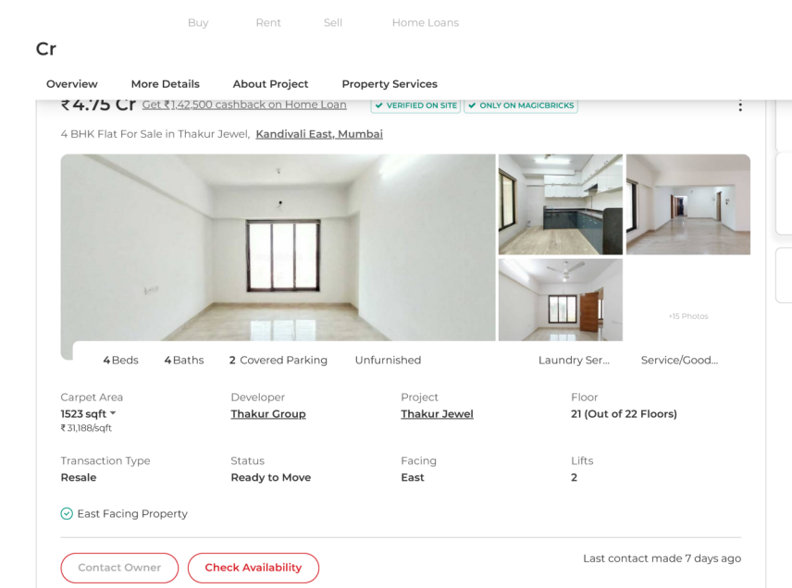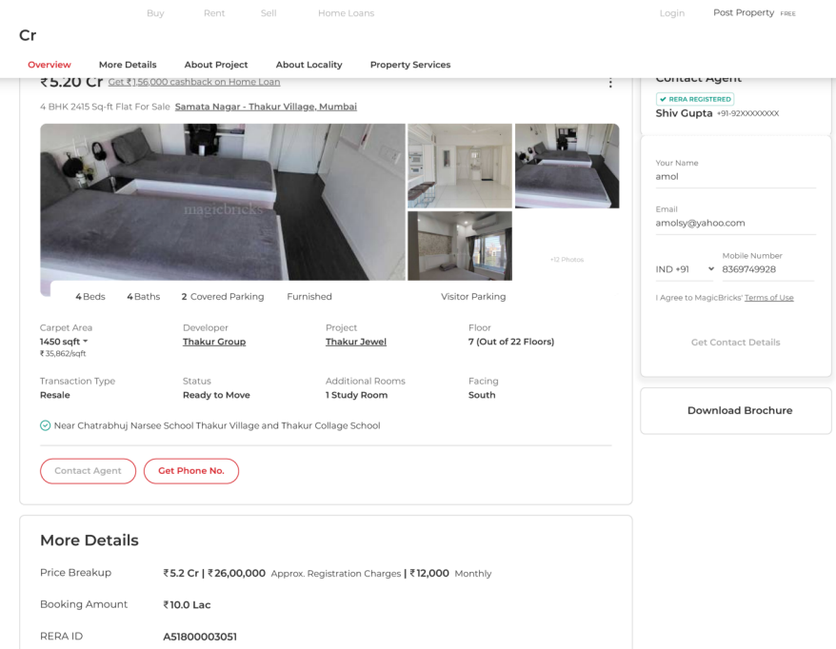
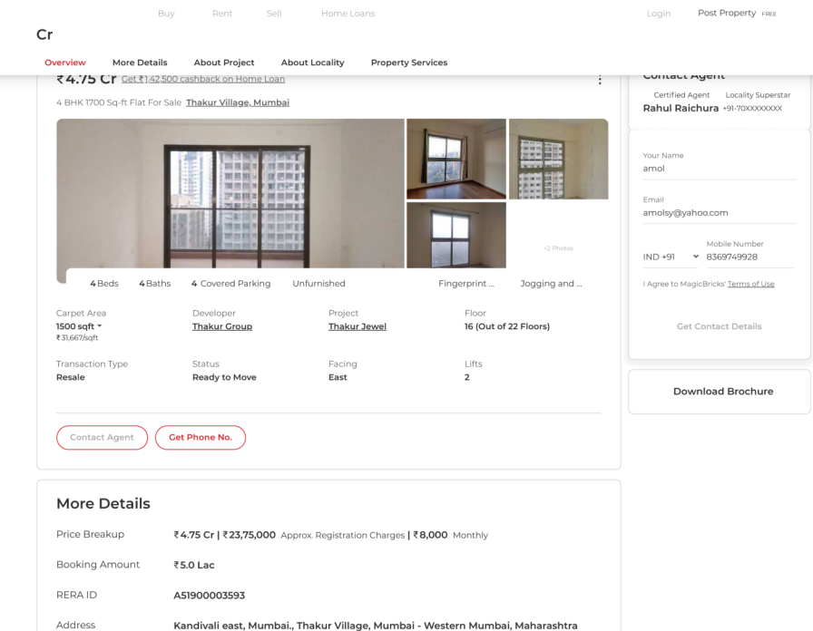
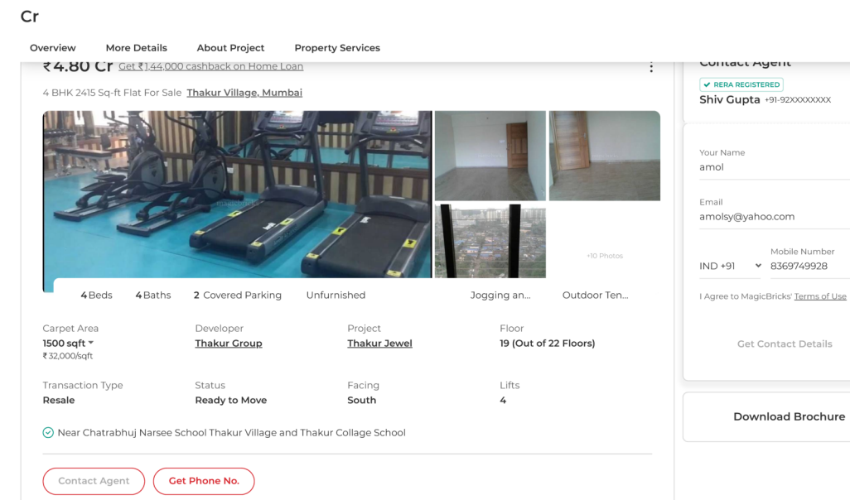
ENCLOSURE: III – GOOGLE MAP LOCATION

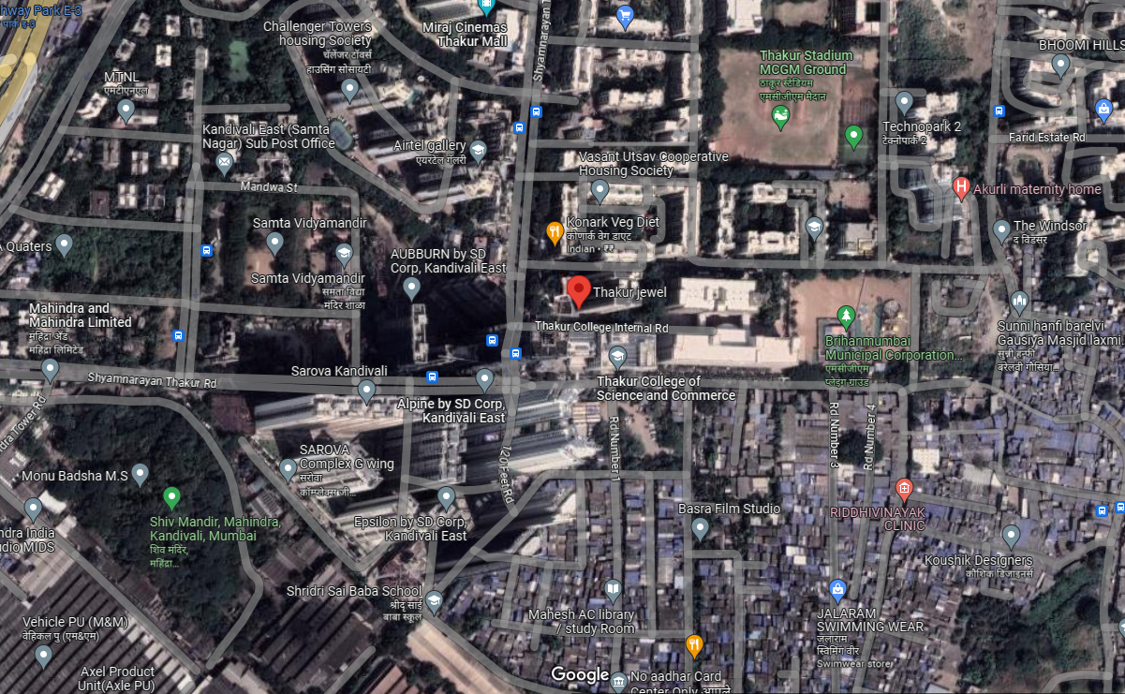
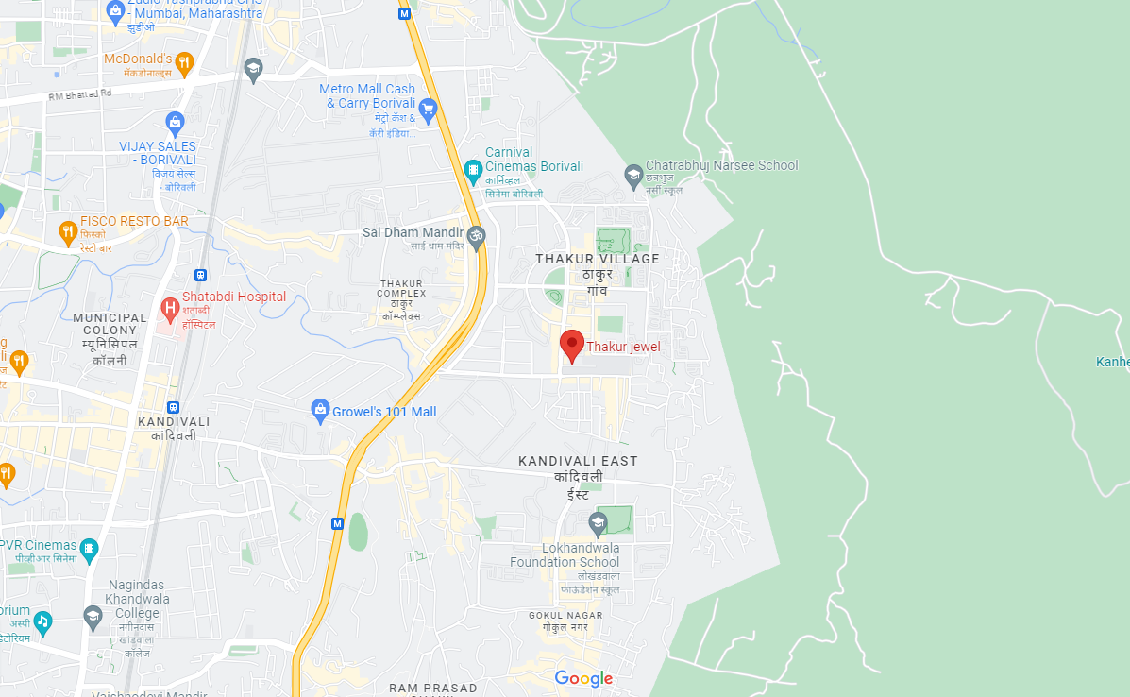

ENCLOSURE: IV – PHOTOGRAPHS OF THE PROPERTY

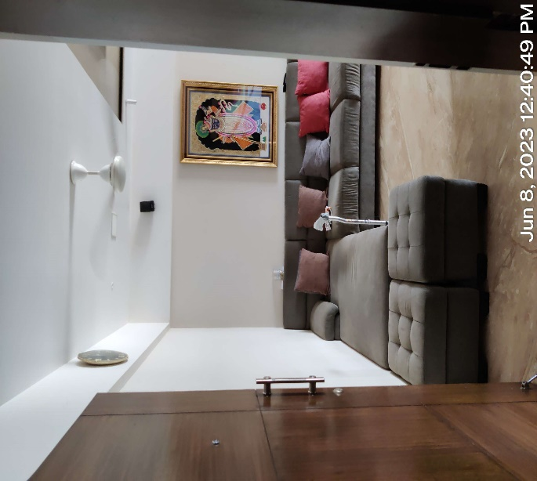 | 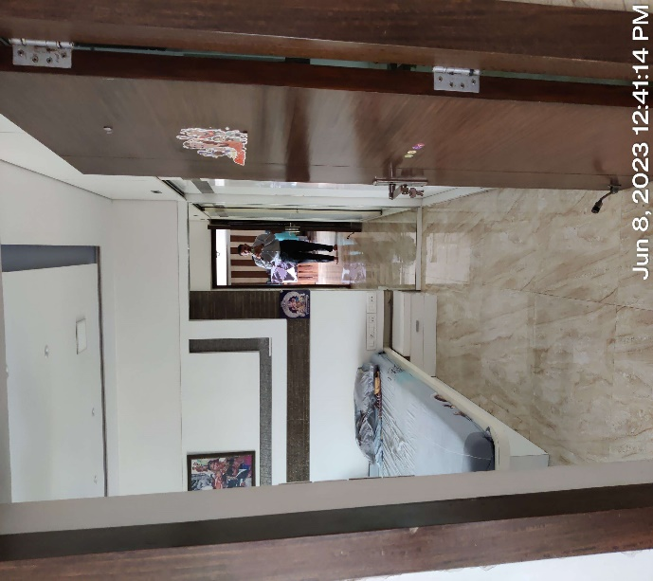
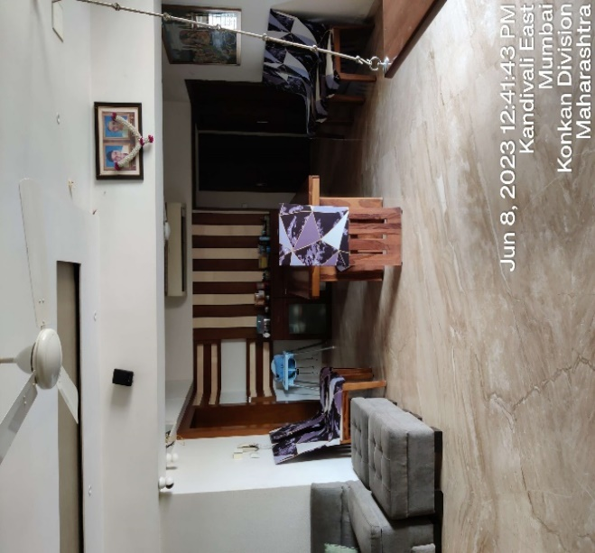 | 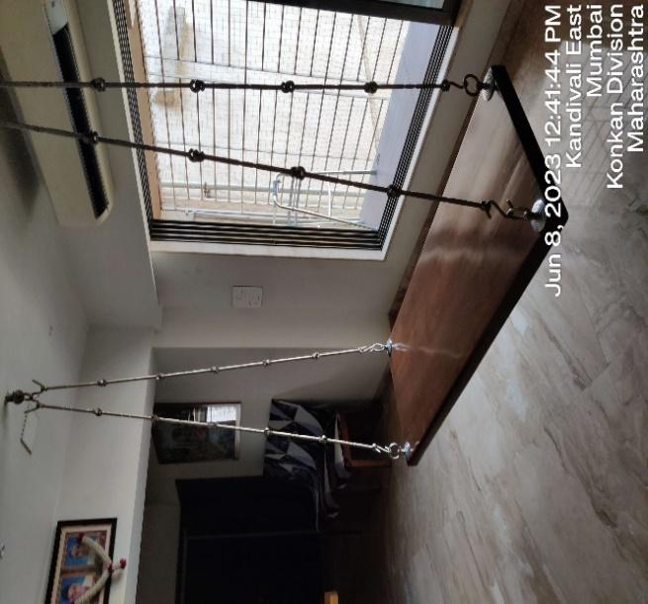
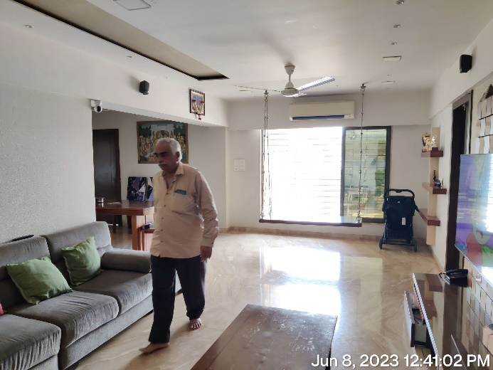 | 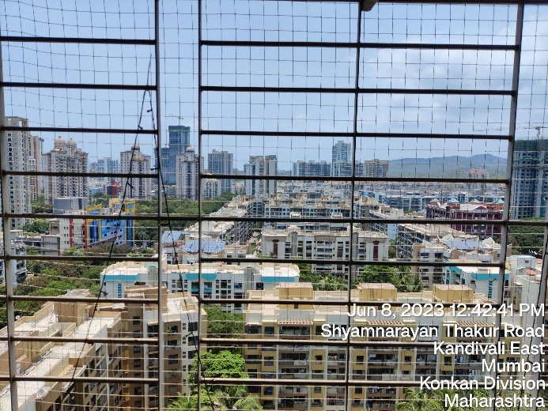
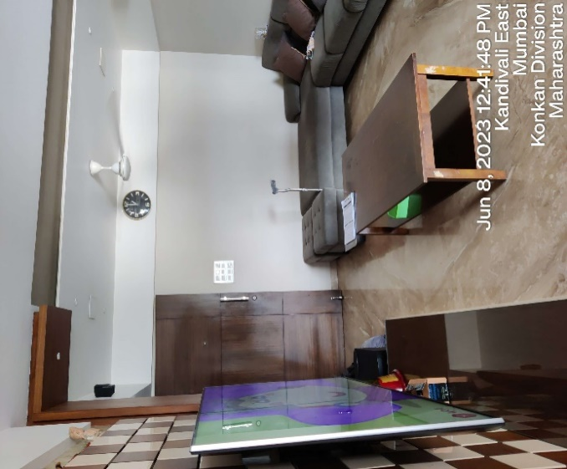 | 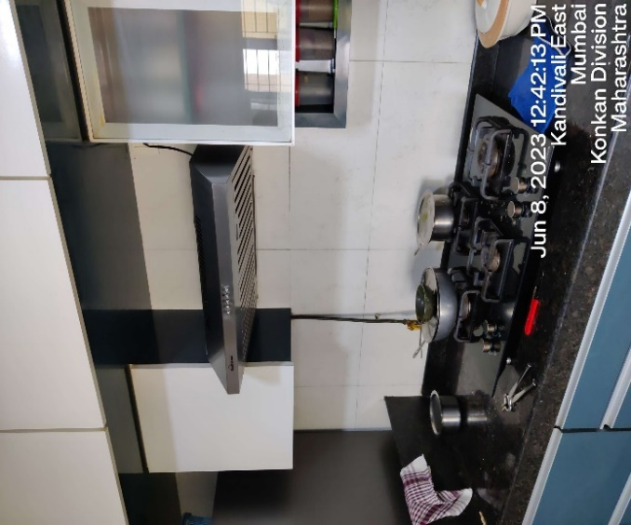
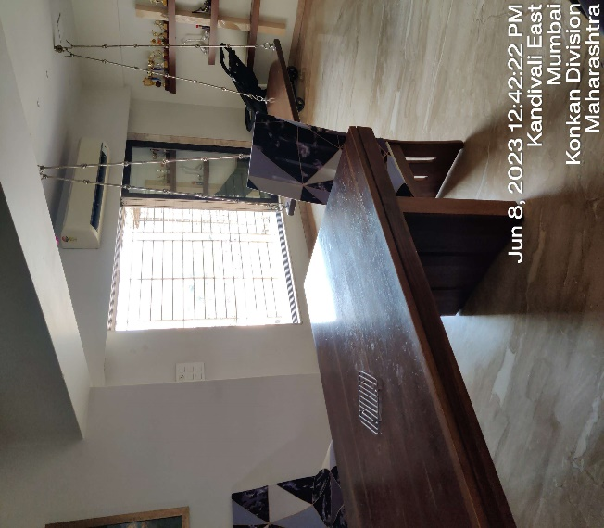 | 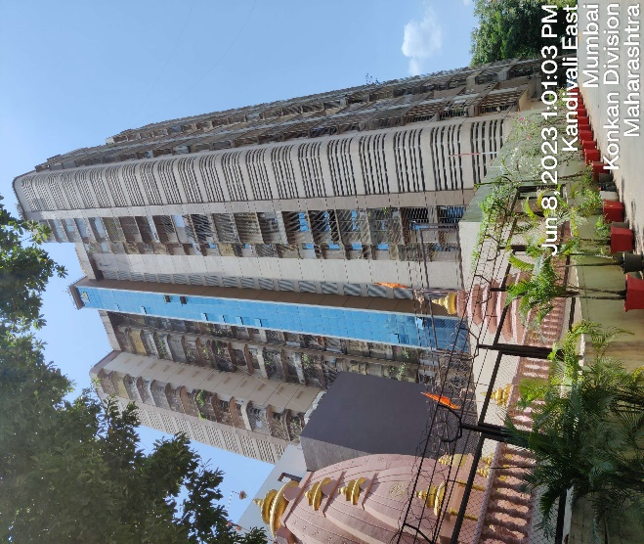
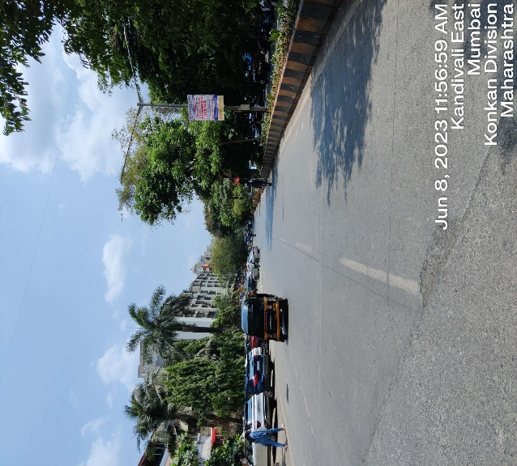 | 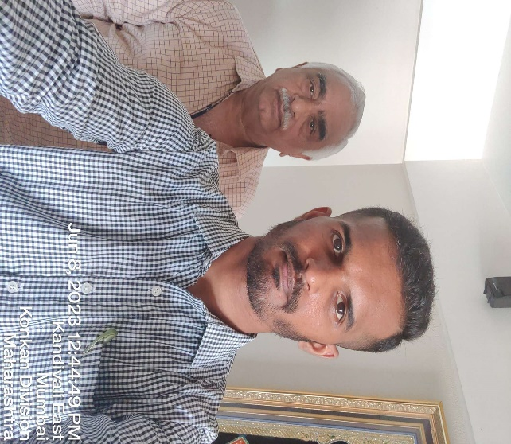
ENCLOSURE: V – COPY OF CIRCLE RATE

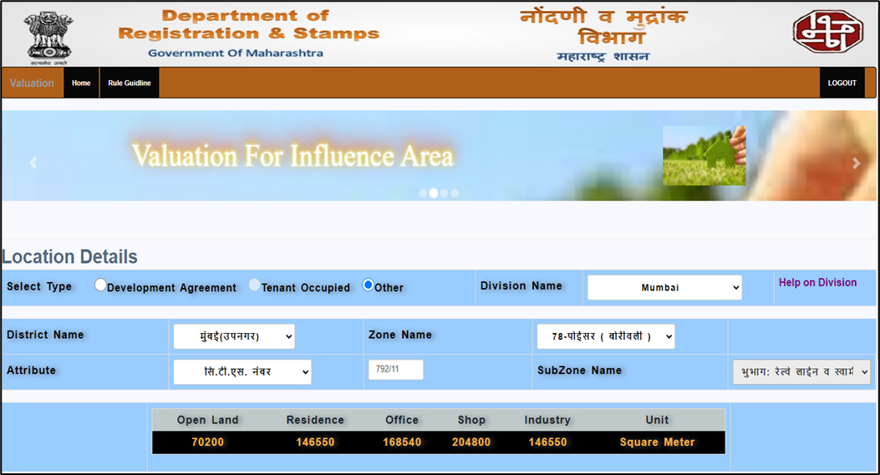

ENCLOSURE: VI: IMPORTANT PROPERTY DOCUMENTS EXHIBIT

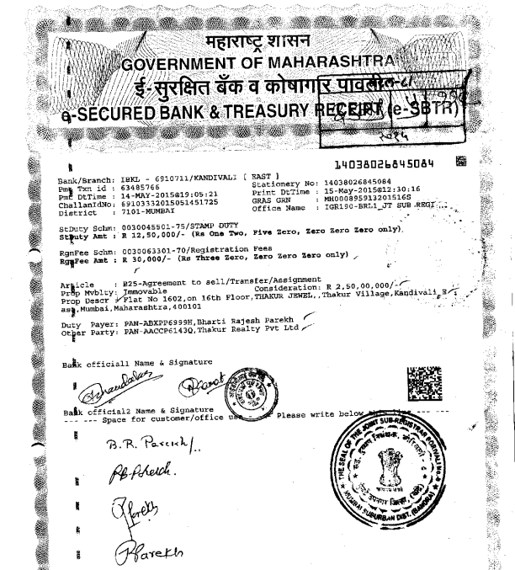
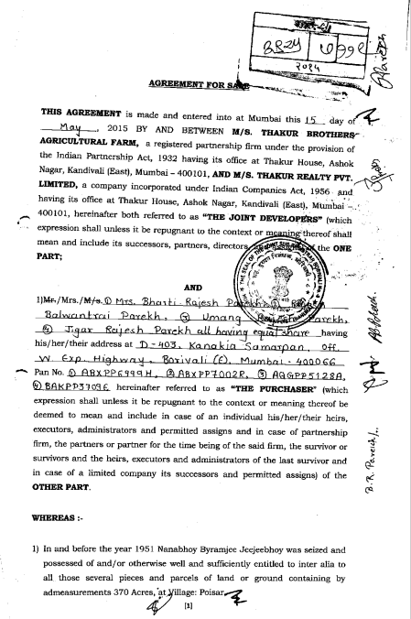
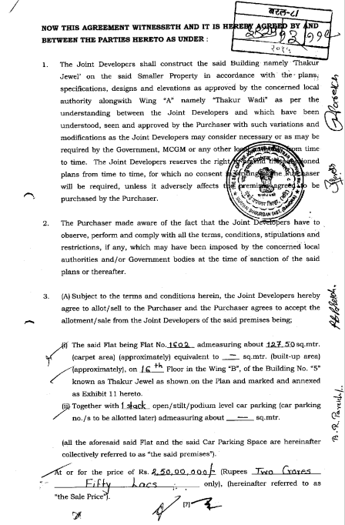
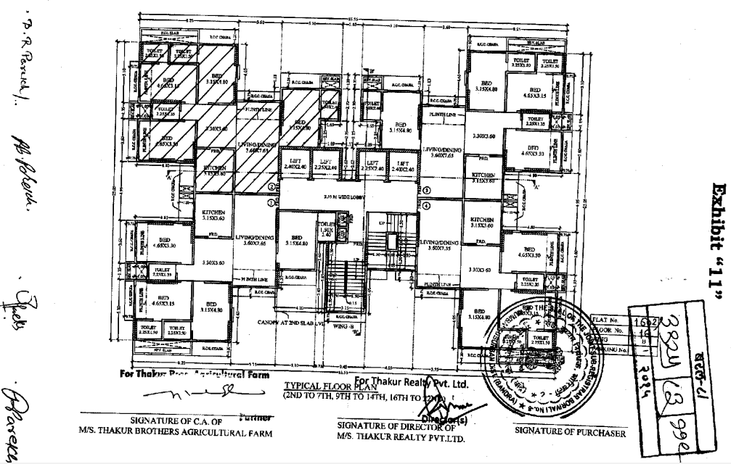
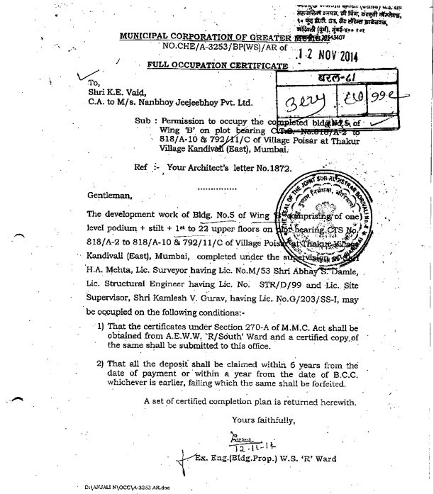
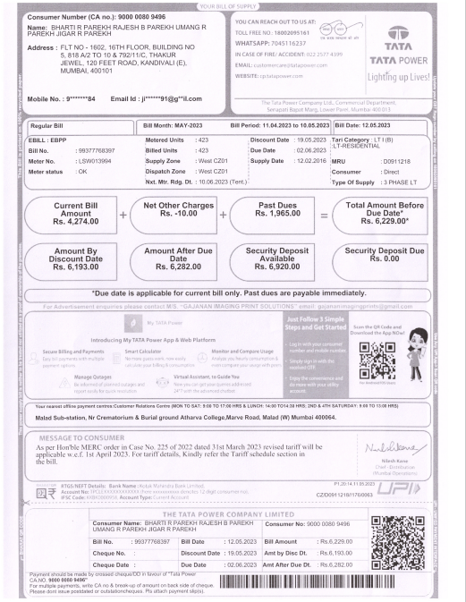
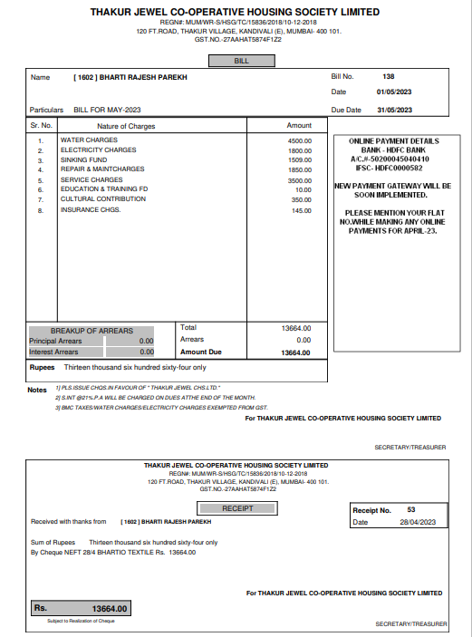

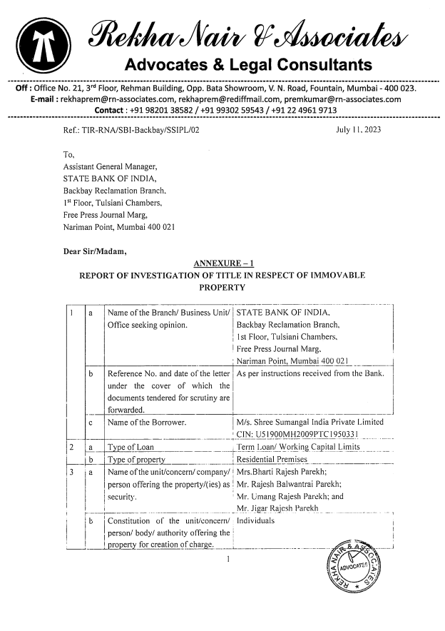
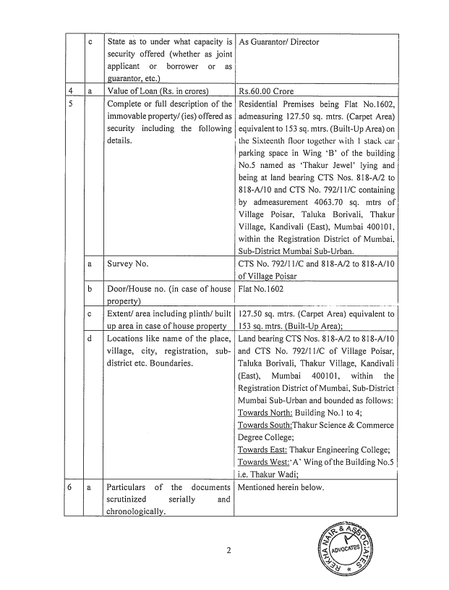

ENCLOSURE: VII - ANNEXURE: II - DECLARATION-CUM-UNDERTAKING

- Persons worked on this report are citizen of India.
- No employee or member of R.K Associates has any direct/ indirect interest in the property or become so interested at any time during a period of three years prior to our appointment as valuer or three years after the valuation of assets was conducted by us.
- The information furnished in our valuation report dated 26/6/2023 is true and correct to the best of our knowledge and belief and we have made an impartial and true valuation of the property.
- Our authorized Engineer/ surveyor Mr. Shreyash Shetty have personally inspected the property on 8/6/2023 the work is not subcontracted to any other valuation firm and is carried out by us.
- We have not been depanelled/ delisted by any other bank and in case any such depanelment by other banks during my empanelment with you, we will inform you within 3 days of such depanelment.
- We have not been removed/ dismissed from service/employment earlier.
- We have not been convicted of any offence and sentenced to a term of imprisonment.
- Company is not found guilty of misconduct in professional capacity.
- Persons worked on this report are not declared to be unsound mind.
- Company is not undischarged bankrupt or has not applied to be adjudicated as a bankrupt.
- Company is not an undischarged insolvent.
- No penalty is levied under section 271J of Income-tax Act, 1961 (43 of 1961) and time limit for filing appeal before Commissioner of Income tax (Appeals) or Income-tax Appellate Tribunal, as the case may be, has expired, or such penalty has been confirmed by Income-tax Appellate Tribunal, and five years have not elapsed after levy of such penalty.
- Company is not been convicted of an offence connected with any proceeding under the Income Tax Act 1961, Wealth Tax Act 1957 or Gift Tax Act 1958 and
- Our PAN Card number/ GST number as applicable is AAHCR0845G/ 09AAHCR0845G1ZP.
- We undertake to keep you informed of any events or happenings which would make us ineligible for empanelment as a valuer.
- We have not concealed or suppressed any material information, facts and records and we have made a complete and full disclosure.
- We have read the Handbook on Policy, Standards and procedure for Real Estate Valuation, 2009 of the IBA and has tried to apply the “Standards” enshrined for valuation in the Part-B of the above handbook to the best of our ability as much as practically possible in the limited time available.
- We have read the International Valuation Standards (IVS) and the report submitted to the Bank for the respective asset class and has tried to apply the “Standards” as enshrined for valuation in the IVS in “General Standards” and “Asset Standards” as applicable to the best of our ability as much as practically possible in the limited time available.
- Procedures and standards adopted in carrying out the valuation and is mentioned in Part-D of the report which may have certain departures to the said IBA and IVS standards in order to provide better, just & fair valuation.
- We abide by the Model Code of Conduct for empanelment of valuer in the Bank.
- The authorized Engineers of the company who has worked on the assignment has signed this valuation report.
- The work is taken on the instructions of the Bank.
- Further, we hereby provide the following information.

S. No. | Particulars | Valuer comment
 | Background information of the asset being valued | This opinion on valuation report is prepared for the residential apartment along with 1 stack car parking situated at the aforesaid address having total built-up area of the apartment admeasuring 127.5 sq.mtr. (1372.4 sq.ft.) as per the copy of the “Agreement to Sell” provided to us by the bank/client.  The subject property comprises of 4 bedrooms (3 master bedrooms), 1 drawing-cum-dining room, 1 kitchen and 4 washrooms.  The subject property is located in Thakur Jewels near Thakur College in Thakur Village, Kandivali, Mumbai, Maharashtra.  This report only contains general assessment & opinion on the Guideline Value and the indicative, estimated Market Value of the property of which Bank/ customer asked us to conduct the Valuation for the property found on as-is-where basis as shown on the site by the Bank/ customer of which photographs is also attached with the report. No legal aspects in terms of ownership or any other legal aspect is taken into consideration. Even if any such information is mentioned in the report it is only referred from the information provided for which we do not assume any responsibility. Due care has been given while doing valuation assessment, but it doesn’t contain any due-diligence or audit or verification of any kind other than the valuation computation of the property shown to us on site. Information/ data/ documents given to us by Bank/ client have been relied upon in good faith. This report doesn’t contain any other recommendations of any sort.  In case of discrepancy in the address/ property number mentioned in the property documents and the property shown to us at the site due to change in zoning or administrative level at the site or the client misled the valuer by providing the fabricated/ incorrect document or information, the valuation should be considered of the property shown to us at the site by the client of which the photographs are also attached. In case of any doubt, best would be to contact the concerned authority/ district administration/ tehsil level for the identification of the property if the property depicted in the photographs in this report is same with the documents pledged.
 | Purpose of valuation and appointing authority | Please refer to Part-D of the Report.
 | Identity of the experts involved in the valuation | Survey Analyst: Shreyash Shetty  Valuation Engineer: Manas Upmanyu  L1/ L2 Reviewer: Anil Kumar
 | Disclosure of valuer interest or conflict, if any | No relationship with the borrower and no conflict of interest.
 | Date of appointment, valuation date and date of report | Date of Appointment: | 29/5/2023
 | Date of appointment, valuation date and date of report | Date of Survey: | 8/6/2023
 | Date of appointment, valuation date and date of report | Valuation Date: | 26/6/2023
 | Date of appointment, valuation date and date of report | Date of Report: | 26/6/2023
 | Inspections and/ or investigations undertaken | Yes, by our authorized Survey Engineer Shreyash Shetty on 8/6/2023. Property was shown and identified by Mr. Rajesh B. Parekh ( +91- 93721 11545).
 | Nature and sources of the information used or relied upon | Please refer to Part-D of the Report. Level 3 Input (Tertiary) has been relied upon.
 | Procedures adopted in carrying out the valuation and valuation standards followed | Please refer to Part-D of the Report.
 | Restrictions on use of the report, if any | Value varies with the Purpose/ Date/ Market & Asset Condition & Situation prevailing in the market. We recommend not to refer the indicative & estimated prospective Value of the asset given in this report if any of these points are different from the one mentioned aforesaid in the Report.  This report has been prepared for the purposes stated in the report and should not be relied upon for any other purpose. Our client is the only authorized user of this report and is restricted for the purpose indicated in this report. I/we do not take any responsibility for the unauthorized use of this report.  During the course of the assignment, we have relied upon various information, data, documents in good faith provided by Bank/ client both verbally and in writing. If at any point of time in future it comes to knowledge that the information given to us is untrue, fabricated, misrepresented then the use of this report at very moment will become null & void.  This report only contains general assessment & opinion on the indicative, estimated Market Value of the property for which Bank has asked to conduct the Valuation for the asset as found on as-is-where basis which owner/ owner representative/ client/ bank has shown/ identified to us on the site unless otherwise mentioned in the report of which some reference has been taken from the information/ data given in the copy of documents provided to us and informed verbally or in writing which has been relied upon in good faith. It doesn’t contain any other recommendations of any sort including but not limited to express of any opinion on the suitability or otherwise of entering into any transaction with the borrower.  This report is not a certification of ownership or survey number/ property number/ Khasra number which are merely referred from the copy of the documents provided to us.
 | Major factors that were taken into account during the valuation | Please refer to Part A, B & C of the Report.
 | Major factors that were not taken into account during the valuation | Please refer to Part A, B & C of the Report.
 | Caveats, limitations and disclaimers to the extent they explain or elucidate the limitations faced by valuer, which shall not be for the purpose of limiting his responsibility for the valuation report. | Please refer to Part E of the Report and Valuer’s Important Remarks enclosed herewith.

Date: 26/6/2023
Place: Noida
Signature
(Authorized Person of R.K Associates Valuers & Techno Engg. Consultants (P) Ltd.)
ENCLOSURE: VIII - ANNEXURE: III - MODEL CODE OF CONDUCT FOR VALUERS

Integrity and Fairness
- A valuer shall, in the conduct of his/its business, follow high standards of integrity and fairness in all his/its dealings with his/its clients and other valuers.
- A valuer shall maintain integrity by being honest, straightforward, and forthright in all professional relationships.
- A valuer shall endeavor to ensure that he/it provides true and adequate information and shall not misrepresent any facts or situations.
- A valuer shall refrain from being involved in any action that would bring disrepute to the profession.
- A valuer shall keep public interest foremost while delivering his services.

Professional Competence and Due Care
- A valuer shall render at all times high standards of service, exercise due diligence, ensure proper care and exercise independent professional judgment.
- A valuer shall carry out professional services in accordance with the relevant technical and professional standards that may be specified from time to time.
- A valuer shall continuously maintain professional knowledge and skill to provide competent professional service based on up-to-date developments in practice, prevailing regulations/guidelines and techniques.
- In the preparation of a valuation report, the valuer shall not disclaim liability for his/its expertise or deny his/its duty of care, except to the extent that the assumptions are based on statements of fact provided by the company or its auditors or consultants or information available in public domain and not generated by the valuer.
- A valuer shall not carry out any instruction of the client in so far as they are incompatible with the requirements of integrity, objectivity and independence.
- A valuer shall clearly state to his client the services that he would be competent to provide and the services for which he would be relying on other valuers or professionals or for which the client can have a separate arrangement with other valuers.

Independence and Disclosure of Interest
- A valuer shall act with objectivity in his/its professional dealings by ensuring that his/its decisions are made without the presence of any bias, conflict of interest, coercion, or undue influence of any party, whether directly connected to the valuation assignment or not.
- A valuer shall not take up an assignment if he/it or any of his/its relatives or associates is not independent in terms of association to the company.
- A valuer shall maintain complete independence in his/its professional relationships and shall conduct the valuation independent of external influences.
- A valuer shall wherever necessary disclose to the clients, possible sources of conflicts of duties and interests, while providing unbiased services.
- A valuer shall not deal in securities of any subject company after any time when he/it first becomes aware of the possibility of his/its association with the valuation, and in accordance with the Securities and Exchange Board of India (Prohibition of Insider Trading) Regulations, 2015 or till the time the valuation report becomes public, whichever is earlier.
- A valuer shall not indulge in “mandate snatching or offering” convenience valuations” in order to cater to a company or client’s needs.
- As an independent valuer, the valuer shall not charge success fee.
- In any fairness opinion or independent expert opinion submitted by a valuer, if there has been a prior engagement in an unconnected transaction, the valuer shall declare the association with the company during the last five years.

Confidentiality
- A valuer shall not use or divulge to other clients or any other party any confidential information about the subject company, which has come to his/its knowledge without proper and specific authority or unless there is a legal or professional right or duty to disclose.

Information Management
- A valuer shall ensure that he/ it maintains written contemporaneous records for any decision taken, the reasons for taking the decision, and the information and evidence in support of such decision. This shall be maintained so as to sufficiently enable a reasonable person to take a view on the appropriateness of his/its decisions and actions.
- A valuer shall appear, co-operate and be available for inspections and investigations carried out by the authority, any person authorised by the authority, the registered valuers organization with which he/it is registered or any other statutory regulatory body.
- A valuer shall provide all information and records as may be required by the authority, the Tribunal, Appellate Tribunal, the registered valuers organization with which he/it is registered, or any other statutory regulatory body.
- A valuer while respecting the confidentiality of information acquired during the course of performing professional services, shall maintain proper working papers for a period of three years or such longer period as required in its contract for a specific valuation, for production before a regulatory authority or for a peer review. In the event of a pending case before the Tribunal or Appellate Tribunal, the record shall be maintained till the disposal of the case.

Gifts and hospitality.
- A valuer or his/its relative shall not accept gifts or hospitality which undermines or affects his independence as a valuer.
Explanation: For the purposes of this code the term ‘relative’ shall have the same meaning as defined in clause (77) of Section 2 of the Companies Act, 2013 (18 of 2013).
- A valuer shall not offer gifts or hospitality or a financial or any other advantage to a public servant or any other person with a view to obtain or retain work for himself/ itself, or to obtain or retain an advantage in the conduct of profession for himself/ itself.

Remuneration and Costs.
- A valuer shall provide services for remuneration which is charged in a transparent manner, is a reasonable reflection of the work necessarily and properly undertaken, and is not inconsistent with the applicable rules.
- A valuer shall not accept any fees or charges other than those which are disclosed in a written contract with the person to whom he would be rendering service.

Occupation, employability and restrictions.
- A valuer shall refrain from accepting too many assignments, if he/it is unlikely to be able to devote adequate time to each of his/ its assignments.
- A valuer shall not conduct business which in the opinion of the authority or the registered valuer organisation discredits the profession.

Miscellaneous
- A valuer shall refrain from undertaking to review the work of another valuer of the same client except under written orders from the bank or housing finance institutions and with knowledge of the concerned valuer.
- A valuer shall follow this code as amended or revised from time to time

Signature of the Authorized Person: ________________
Name of the Valuation company: R.K Associates Valuers & Techno Engg. Consultants (P) Ltd.
Address of the Valuer: D-39, Sector-2, Noida-201301
Date: 26/6/2023
Place: Noida

ENCLOSURE: IX
PART D | VALUER’S IMPORTANT REMARKS

Valuation is done for the asset found on as-is-where basis which owner/ owner representative/ client/ bank has shown/ identified to us on the site unless otherwise mentioned in the report of which some reference has been taken from the information/ data given in the copy of documents provided to us and informed verbally or in writing out of the standard checklist of documents sought from the client & its customer which they could provide within the reasonable expected time out of the standard checklist of documents sought from them and further based on certain assumptions and limiting conditions. The information, facts, documents, data which has become primary basis of the report has been supplied by the client which has been relied upon in good faith and is not generated by the Valuer.
The client/ owner and its management/ representatives warranted to us that the information they have supplied was complete, accurate and true and correct to the best of their knowledge. All such information provided to us either verbally, in writing or through documents has been relied upon in good faith and we have assumed that it is true & correct without any fabrication or misrepresentation. I/We shall not be held liable for any loss, damages, cost or expenses arising from fraudulent acts, misrepresentations, or willful default on part of the owner, company, its directors, employee, representative or agents.
Legal aspects for eg. Investigation of title, ownership rights, lien, charge, mortgage, lease, sanctioned maps, verification of documents provided to us such as title documents, Map, etc. from any concerned Govt. office etc. have to be taken care by legal expert/ Advocate and same is not done at our end. It is assumed that the concerned Lender/ Financial Institution has asked for the valuation of that property after satisfying the authenticity of the documents given to us for which the legal verification has been already taken and cleared by the competent Advocate before requesting for the Valuation report. I/ We assume no responsibility for the legal matters including, but not limited to, legal or title concerns.
In the course of the valuation, we were provided with both written and verbal information. We have however, evaluated the information provided to us through broad inquiry, analysis and review but have not carried out a due diligence or audit of the information provided for the purpose of this engagement. Our conclusions are based on the assumptions and other information provided to us by the client during the course of the assessment.
Getting cizra map or coordination with revenue officers for site identification is a separate activity and is not part of the Valuation services and same has not been done in this report unless otherwise stated.
Wherever any details are mentioned in the report in relation to any legal aspect of the property such as name of the owner, leases, etc. is only for illustration purpose and should not be construed as a professional opinion. Legal aspects are out of scope of this report. Details mentioned related to legal aspect are only based on the copy of the documents provided to us and whatever we can interpret as a non-legally trained person. This should be cross validated with a legal expert. We do not vouch any responsibility regarding the same.
We have made certain assumptions in relation to facts, conditions & situations affecting the subject of, or approach to this exercise that has not been verified as part of the engagement rather, treated as “a supposition taken to be true”. If any of these assumptions prove to be incorrect then our estimate on value will need to be reviewed.
This is just an opinion report based on technical & market information having general assessment & opinion on the indicative, estimated Market Value of the property for which Bank has asked to conduct the Valuation. It doesn’t contain any other recommendations of any sort including but not limited to express of any opinion on the suitability or otherwise of entering into any transaction with the borrower.
We have relied on the data from third party, external sources & information available on public domain to conclude the valuation. These sources are believed to be reliable and therefore, we assume no liability for the truth or accuracy of any data, opinions or estimates furnished by others that have been used in this analysis. Where we have relied on the data, opinions or estimates from external sources, reasonable care has been taken to ensure that such data is extracted from authentic sources, however we still can’t vouch its authenticity, correctness, or accuracy.
Analysis and conclusions adopted in the report are limited to the reported assumptions, conditions and information came to our knowledge during the course of the work and based on the Standard Operating Procedures, Best Practices, Caveats, Limitations, Conditions, Remarks, Important Notes, Valuation TOR and definition of different nature of values.
Value varies with the Purpose/ Date/ Asset Condition & situation/ Market condition, demand & supply, asset utility prevailing on a particular date/ Mode of sale. The indicative & estimated prospective Value of the asset given in this report is restricted only for the purpose and other points mentioned above prevailing on a particular date as mentioned in the report. If any of these points are different from the one mentioned aforesaid in the Report then this report should not be referred.
Our report is meant ONLY for the purpose mentioned in the report and should not be used for any other purpose. The Report should not be copied or reproduced for any purpose other than the purpose for which it is prepared for. I/we do not take any responsibility for the unauthorized use of this report.
We owe responsibility only to the authority/client that has appointed us as per the scope of work mentioned in the report. We will not be liable for any losses, claims, damages or liabilities arising out of the actions taken, omissions or advice given by any other person. In no event shall we be liable for any loss, damages, cost or expenses arising in any way from fraudulent acts, misrepresentations or willful default on part of the client or companies, their directors, employees or agents.
This report is having limited scope as per its fields & format to provide only the general basic idea of the value of the property prevailing in the market based on the site inspection and documents/ data/ information provided by the client. The suggested indicative prospective estimated value should be considered only if transaction is happened as free market transaction.
The sale of the subject property is assumed to be on an all cash basis. Financial arrangements would affect the price at which the property may sell for if placed on the market.
The actual realizable value that is likely to be fetched upon sale of the asset under consideration shall entirely depend on the demand and supply of the same in the market at the time of sale.
While our work has involved an analysis & computation of valuation, it does not include detailed estimation, design/ technical/ engineering/ financial/ structural/ environmental/ architectural/ compliance survey/ safety audit & works in accordance with generally accepted standards of audit & other such works. The report in this work in not investigative in nature. It is mere an opinion on the likely estimated valuation based on the facts & details presented to us by the client and third party market information came in front of us within the limited time of this assignment, which may vary from situation to situation.
Where a sketched plan is attached to this report, it does not purport to represent accurate architectural plans. Sketch plans and photographs are provided as general illustrations only.
Documents, information, data including title deeds provided to us during the course of this assessment by the client is reviewed only upto the extent required in relation to the scope of the work. No document has been reviewed beyond the scope of the work. These are not reviewed in terms of legal rights for which we do not have expertise. Wherever any information mentioned in this report is mentioned from the documents like owners name, etc., it is only for illustration purpose and may not necessary represent accuracy.
The report assumes that the borrower/company/business/asset complies fully with relevant laws and regulations applicable in its area of operations and usage unless otherwise stated, and that the companies/business/assets is managed in a competent and responsible manner. Further, as specifically stated to the contrary, this report has given no consideration to matters of a legal nature, including issues of legal title and compliance with relevant laws, and litigations and other contingent liabilities that are not recorded/reflected in the documents/ details/ information/ data provided to us.
This valuation report is not a qualification for accuracy of land boundaries, schedule (in physical terms), dimensions & identification. For this land/ property survey report can be sought from a qualified private or Govt. surveyor.
This Valuation report is prepared based on the facts of the property on the date of the survey. Due to possible changes in market forces, socio-economic conditions, property conditions and circumstances, this valuation report can only be regarded as relevant as at the valuation date. Hence before financing, Banker/ FI should take into consideration all such future risk and should loan conservatively to keep the advanced money safe in case of the downward trend of the property value.
Valuation of the same asset/ property can fetch different values under different circumstances & situations. For eg. Valuation of a running/ operational shop/ hotel/ factory will fetch better value and in case of closed shop/ hotel/ factory it will have considerable lower value. Similarly, an asset sold directly by an owner in the open market through free market transaction then it will fetch better value and if the same asset/ property is sold by any financer due to encumbrance on it, will fetch lower value. Hence before financing, Lender/ FI should take into consideration all such future risks while financing and take decision accordingly.

Valuation is done for the property identified to us by the owner/ owner representative. At our end we have just visually matched the land boundaries, schedule (in physical terms) & dimensions of the property with reference to the documents produced for perusal. Method by which identification of the property is carried out is also mentioned in the report clearly. Responsibility of identifying the correct property to the Valuer/ its authorized surveyor is solely of the client/ owner for which Valuation has to be carried out. It is requested from the Bank to cross check from their own records/ information if this is the same property for which Valuation has to be carried out to ensure that owner has not misled the Valuer company or misrepresented the property due to any vested interest. Where there is a doubt about the precision position of the boundaries, schedule, dimensions of site & structures, it is recommended that a Licensed Surveyor be contacted.
In India more than 70% of the geographical area is lying under rural/ remote/ non municipal/ unplanned area where the subject property is surrounded by vacant lands having no physical demarcation or having any display of property survey or municipal number / name plate on the property clearly. Even in old locations of towns, small cities & districts where property number is either not assigned or not displayed on the properties clearly and also due to the presence of multiple/ parallel departments due to which ownership/ rights/ illegal possession/ encroachment issues are rampant across India and due to these limitations at many occasions it becomes tough to identify the property with 100% surety from the available documents, information & site whereabouts and thus chances of error, misrepresentation by the borrower and margin of chances of error always persists in such cases. To avoid any such chances of error it is advised to the Bank to engage municipal/ revenue department officials to get the confirmation of the property to ensure that the property shown to Valuer/ Banker is the same as for which documents are provided.
If this Valuation Report is prepared for the Flat/ dwelling unit situated in a Group Housing Society or Integrated Township then approvals, maps of the complete group housing society/ township is out of scope of this report and this report will be made for the specific unit based on the assumption that complete Group Housing Society/ Integrated Township and the subject unit must be approved in all respect.
Due to fragmented & frequent change in building/ urban planning laws/ guidelines from time to time, different laws/ guidelines between regions/ states and no strict enforceability of Building Bye-Laws in India specially in non-metro and scale b & c cities & Industrial areas, property owners many times extend or make changes in the covered area/ layout from the approved/ applicable limits. There are also situations where properties are decades old when there was no formal Building Bye-Laws applicable the time when the construction must have been done. Due to such discrete/ unplanned development in many regions sometimes it becomes tough for the Valuer to determine the exact lawful situation on ground. Unless otherwise mentioned in the report, the covered area present on the site as per site survey will be considered in the Valuation.
Area of the large land parcels of more than 2500 sq.mtr or of uneven shape in which there can be practical difficulty in sample measurement, is taken as per property documents which has been relied upon unless otherwise stated.

Drawing Map, design & detailed estimation of the property/ building is out of scope of the Valuation services.
Valuation is a subjective field and opinion may differ from consultant to consultant. To check the right opinion, it is important to evaluate the methodology adopted and various data point/ information/ factors/ assumption considered by the consultant which became the basis for the Valuation report before reaching to any conclusion.
Although every scientific method has been employed in systematically arriving at the value, there is, therefore, no indisputable single value and the estimate of the value is normally expressed as falling within a likely range.
Value analysis of any asset cannot be regarded as an exact science and the conclusions arrived at in many cases will, of necessity, be subjective and dependent on the exercise of individual judgment. Given the same set of facts and using the same assumptions, expert opinions may differ due to the number of separate judgment decisions, which have to be made. Therefore, there can be no standard formula to establish an indisputable exchange ratio. In the event of a transaction, the actual transaction value achieved may be higher or lower than our indicative analysis of value depending upon the circumstances of the transaction. The knowledge, negotiability and motivations of the buyers and sellers, demand & supply prevailing in the market and the applicability of a discount or premium for control will also affect actual price achieved. Accordingly, our indicative analysis of value will not necessarily be the price at which any agreement proceeds. The final transaction price is something on which the parties themselves have to agree. However, our Valuation analysis can definitely help the stakeholders to take informed and wise decision about the Value of the asset and can help in facilitating the arm’s length transaction.
This Valuation is conducted based on the macro analysis of the asset/ property considering it in totality and not based on the micro, component, or item wise analysis. Analysis done is a general assessment and is not investigative in nature.
This report is prepared on the RKA V-L1 (Basic) Valuation format as per the client requirement and scope of work. This report is having limited scope as per its fields & format to provide only the general estimated & indicative basic idea of the value of the property prevailing in the market based on the information provided by the client. No detailed analysis, audit or verification has been carried out of the subject property. There may be matters, other than those noted in this report, which might be relevant in the context of the transaction and which a wider scope might uncover.
This is just an opinion report and doesn’t hold any binding on anyone. It is requested from the concerned Client/ Bank/ Financial Institution which is using this report for mortgaging the property that they should consider all the different associated relevant & related factors & risks before taking any business decision based on the content of this report.
All Pages of the report including annexures are signed and stamped from our office. In case any paper in the report is without stamp & signature then this should not be considered a valid paper issued from this office.
As per IBA Guidelines & Bank Policy, in case the valuation report submitted by the valuer is not in order, the banks / FIs shall bring the same to the notice of the valuer within 15 days of submission for rectification and resubmission. In case no such communication is received, it shall be presumed that the valuation report has been accepted.
Defect Liability Period is 15 DAYS. We request the concerned authorized reader of this report to check the contents, data, information, and calculations in the report within this period and intimate us in writing at valuers@rkassociates.org within 15 days of report delivery, if any corrections are required or in case of any other concern with the contents or opinion mentioned in the report. If no intimation is received within 15 (Fifteen) days in writing from the date of issuance of the report, then it shall be considered that the report is complete in all respect and has been accepted by the client up to their satisfaction & use and further to which R.K Associates shall not be held responsible in any manner. After this period no concern/ complaint/ proceedings in connection with the Valuation Services will be entertained due to possible change in situation and condition of the property.
Though adequate care has been taken while preparing this report as per its scope, but still we can’t rule out typing, human errors, over sightedness of any information or any other mistakes. Therefore, the concerned organization is advised to satisfy themselves that the report is complete & satisfactory in all respect. Intimation regarding any discrepancy shall be brought into our notice immediately. If no intimation is received within 15 (Fifteen) days in writing from the date of issuance of the report, to rectify these timely, then it shall be considered that the report is complete in all respect and has been accepted by the client upto their satisfaction & use and further to which R.K Associates shall not be held responsible in any manner.
Our Data retention policy is of ONE YEAR. After this period we remove all the concerned records related to the assignment from our repository. No clarification or query can be answered after this period due to unavailability of the data.
This Valuation report is governed by our (1) Internal Policies, Processes & Standard Operating Procedures, (2) R.K Associates Quality Policy, (3) Valuation & Survey Best Practices Guidelines formulated by management of R.K Associates, (4) Information input given to us by the customer and (4) Information/ Data/ Facts given to us by our field/ office technical team. Management of R.K Associates never gives acceptance to any unethical or unprofessional practice which may affect fair, correct & impartial assessment and which is against any prevailing law. In case of any indication of any negligence, default, incorrect, misleading, misrepresentation or distortion of facts in the report then we request the user of this report to immediately or at least within the defect liability period to bring all such act into notice of R.K Associates management so that corrective measures can be taken instantly.
R.K Associates never releases any report doing alterations or modifications by pen. In case any information/ figure of this report is found altered with pen then this report will automatically become null & void.
We are fully aware that based on the opinion of value expressed in this report, we may be required to give testimony or attend court / judicial proceedings with regard to the subject assets, although it is out of scope of the assignment, unless specific arrangements to do so have been made in advance, or as otherwise required by law. In such event, the party seeking our evidence in the proceedings shall bear the cost/professional fee of attending court / judicial proceedings and my / our tendering evidence before such authority shall be under the applicable laws.
The final copy of the report shall be considered valid only if it is in hard copy on the company’s original letter head with proper stamp and sign on it of the authorized official upon payment of the agreed fees. User shall not use the content of the report for the purpose it is prepared for only on draft report, scanned copy, email copy of the report and without payment of the agreed fees. In such a case the report shall be considered as unauthorized and misused.

