**File No.: VIS (2023-24)-PL144-122-161 Dated: 04.10.2023**

**LENDER’S INDEPENDENT ENGINEER REPORT**

**OF**

**M/S AHAD MULTISPECIALTY HOSPITAL PVT. LTD.**

**SITUATED AT**

**PLOT NO. 307, JL-19, KH-386\*1, MOUZA-USUFABAD, VILLAGE-FAGUPUR, NAWABGHAT, NEAR GURUDWARA, BARDHAMAN 713104, WEST BENGAL.**

**COMPANY/PROMOTER**

**M/S AHAD MULTISPECIALTY HOSPITAL PVT. LTD.**

**REPORT PREPARED FOR**

**STATE BANK OF INDIA, SME BRANCH, BARDHAMAN.**

***\*\*Important - In case of any query/ issue or escalation you may please contact Incident Manager at le@rkassociates.org. We will appreciate your feedback in order to improve our services.***

***NOTE: As per IBA Guidelines please provide your feedback on the report within 15 days of its submission after which report will be considered to be correct.***

|  |  |  |
| --- | --- | --- |
| **TABLE OF CONTENTS** | | |
| **SR. NO.** | **DESCRIPTION** | **PAGE NO.** |
| **PART A** | **Report Summary** | **03** |
| **PART B** | **Introduction** | **05** |
|  | 1. The Project | **05** |
|  | 1. Project Executive Summary | **05** |
|  | 1. Location of the Project | **06** |
|  | 1. Scope of the Project During Project Duration | **07** |
|  | 1. Purpose of the Report | **07** |
|  | 1. Methodology Adopted | **07** |
| **PART C** | **Project Cost and Means of Finance** | **08** |
|  | 1. Cost of Project | **08** |
|  | 1. Current Status and Total Expenditure Incurred Till Date | **09** |
|  | 1. Sources of Finance & Utilization of Funds | **09** |
| **PART D** | **Project Infrastructure & Facility Details With Actual Progress** | **10** |
|  | 1. Plant & machinery and other ancillary items to be installed at hospital | **10** |
|  | 1. Current Status of Progress | **12** |
| **PART E** | **Project Schedule & Current Status** | **16** |
| **PART F** | **Disclaimer** | **17** |

# 

# IMPORTANT NOTICE

***COPYRIGHT FORMAT:*** *This report is prepared on the copyright format of R.K Associates, to serve our clients with the best available information and analysis to facilitate them to take rational business decisions. Legally no one can copy or distribute this format without prior approval from R.K Associates. It is meant only for the advisory/ reference purpose for the organization/s as mentioned on the cover page of this report. Distribution or use of this format by any organization or individual other than R.K Associates will be seen as unlawful act and necessary legal action can be taken against the defaulters.*

*This report is intended for the sole use of the intended recipient/s and contain material that is STRICTLY CONFIDENTIAL AND PRIVATE.*

***DEFECT LIABILITY PERIOD:*** *- In case of any query/ issue or escalation you may please contact Incident Manager: le@rkassociates.org. We try our level best to ensure correctness in the calculations done, rates adopted and various other data points & information mentioned in the report but still can’t rule out typing, human errors or any other mistakes. In case you find any such mistake or inaccuracy in any data point of the report please help us by bringing all such points into our notice immediately or within 15 days of the report delivery in writing, to rectify these timely failing after which R.K Associates won’t be held responsible for any such inaccuracy in any manner. We would highly appreciate your feedback in order to improve our services.*

|  |  |
| --- | --- |
| **PART A** | **REPORT SUMMARY** |

|  |  |  |  |
| --- | --- | --- | --- |
| **1.** | **Name of Project:** |  | Ahad Multispecialty Hospital Pvt. Ltd. |
| **2.** | **Project Location:** |  | Plot No. 307, Jl-19, Kh-386\*1, Mouza-Usufabad, Village-Fagupur, Nawabghat, Near Gurudwara, Bardhaman 713104, West Bengal |
| **3.** | **Name of the Company Promoter:** |  | M/s. Ahad Multispecialty Hospital Pvt. Ltd. |
| **4.** | **Prepared for Bank:** |  | State bank of India, SME Branch, Bardhaman. |
| **6.** | **LIE Consultant Firm:** |  | M/s. R.K. Associates Valuers & Techno Engineering Consultants (P) Ltd. |
| **7.** | **Date of Survey:** |  | 27th of June 2023 |
| **8.** | **Date of Report:** |  | 04th of October 2023 |
| **9.** | **Purpose of the Report:** |  | To provide fair detailed analysis report to the Bank based on the “in-scope points” mentioned below for facilitating them to take appropriate credit decision on the Project. |
| **10.** | **Scope of the work provided by the Lender:** |  | 1. Project physical status review 2. Estimated cost of expenditure incurred |
| **11.** | **Documents perused for Proposal:** |  | 1. Copy of CA Certificate 2. Copy of invoices of major items 3. Copies of various NOCs & Approvals 4. Vendor list. 5. Quotation or Purchase Order for machines to be installed. |
| **12.** | **Annexure with the report:** |  | 1. Photographs 2. Other annexures (e.g., CA Certificate, Invoices, and NoCs) |

|  |  |
| --- | --- |
| **PART B** | **INTRODUCTION** |

1. **THE PROJECT:** Multispecialty Hospital by M/s Ahad Multispecialty Hospital Pvt. Ltd. At Plot No. 307, Jl-19, Kh-386/1, Mouza-Usufabad, Village-Fagupur, Nawabghat, Near Gurudwara, Bardhaman 713104, West Bengal.
2. **PROJECT EXECUTIVE SUMMARY:**

## M/s Ahad Multispecialty Hospital Pvt. Ltd. is constructing a 110 bedded (Extendable upto 300 beds) Hospital & Health care unit where patient will have access to well-equipped and modern facilities. As per planning, the company will operate, manage, and maintain hospitals, diagnostic center, blood banks, immunization center, medical and other research center, nursing homes, health center, rehabilitation center, clinics, polyclinics, laboratories, and act and work as consultants in the medical field.

## The subject hospital is located on Grand Truck Road (G.T. Road) outskirt of Bardhaman City & Municipality in the state of West Bengal.

## As per information shared during the site visit, the total land area on which the hospital is built is about 50 Katha or 3345 sq. mtr. With total buil-up area of 1,30,000 sq. mtr.

## As per information provided by the company representative during site visit, the proposed commercial operation date was 27-02-2023. However, the project got delayed due to Covid-19 lockdown and is expected to be completed by 27-07-2023.

1. **PROJECT LOCATION:**

Details about Location of Unit is as below:

|  |  |
| --- | --- |
| **Particulars** | **Description** |
| **Postal Address** | |
| Plot No. 307, Jl-19, Kh-386/1, Mouza-Usufabad, Village-Fagupur, Nawabghat, Near Gurudwara, Bardhaman 713104, West Bengal. | |
| **Location** | |
| The nearest airport from the site is Netaji Subhash Chandra Bose International Airport, Kolkata located at the distance of approx. 108 km. The Project site is also well connected through road network and abutting GT Road. Bardhaman Bus Station is the nearest Bus Station at a distance of approx. 500 m from the hospital. | |
| **Google Coordinates** | |
| Latitude | 23°16'08.6"N |
| Longitude | 87°49'24.2"E |
| **Connectivity Systems** | |
| Road | Abutting GT Road Road |
| Bus | The nearest Bus Station from the site is Bardhaman Bus Station, and is at a distance of approx. 500 meter. |
| Air | The nearest airport from the site is Netaji Subhash Chandra Bose International Airport, Kolkata, and is at the distance of approx. 108 km. |

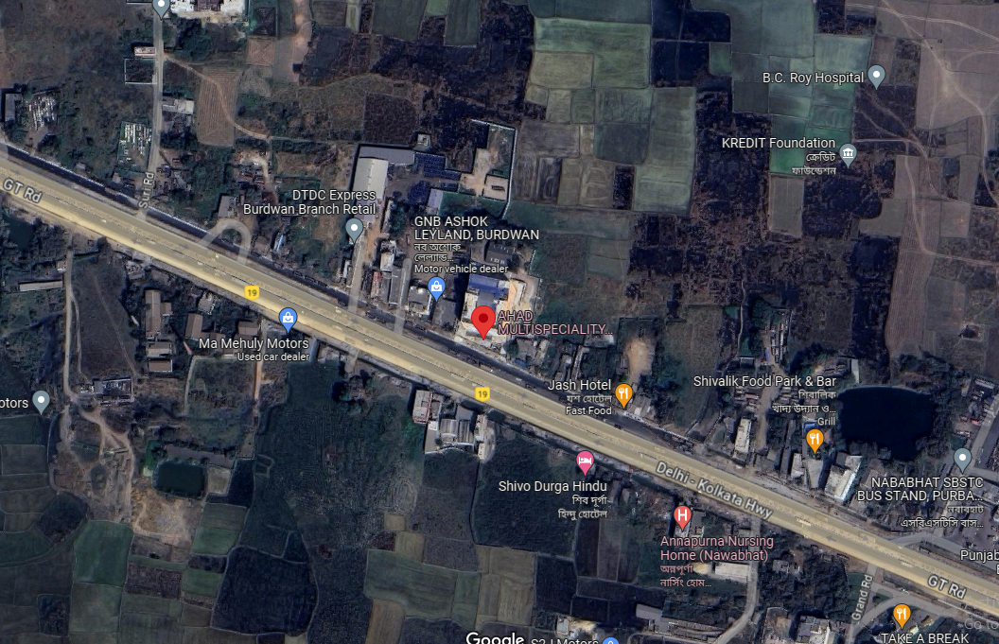

**Figure: Location of Hospital**

1. **SCOPE OF WORK DURING PROJECT DURATION:**
2. Medical/Ancillary Equipment physical status review
3. Estimated cost of expenditure incurred
4. **PURPOSE OF THE REPORT:** To provide fair detailed analysis report to the Bank based on the “in-scope points” mentioned above for facilitating them to take appropriate credit decision on the Project.
5. **METHODOLOGY ADOPTED:**
6. Study of Project Planning documents/ reports to know about the Project.
7. Additional information, data, documents collection from the borrower.
8. Site Inspection.
9. Review and analysis of the documents and information obtained from the borrower and corroborating it with the site inspection status.
10. Information compilation, analysis and reporting.

|  |  |
| --- | --- |
| **PART C** | **PROJECT COST | EXPENDITURE & MEANS OF FINANCE** |

1. **TOTAL PROJECT COST:** As per copy of TEV Report by C Ghosh Consultancy Services Co. Pvt. Ltd. of June 2021, the total cost of the project is Rs. 2,897.04 Lacs.

|  |  |  |
| --- | --- | --- |
| **S. No.** | **Particulars** | **Estimation**  **(In Rs. Lacs)** |
| 1 | Land | 99.29 |
| 2 | land development | 12.1 |
| 3 | civil construction including roof shed | 828.39 |
| 4 | peripherals | 45.85 |
| 5 | electrical installation with generator | 520.7 |
| 6 | electrical connection-WBSEDCL | 10.35 |
| 7 | Lift | 53.85 |
| 8 | other fixed assets | 1,074.81 |
| 9 | ambulance | 30.94 |
| 10 | computer | 11.48 |
| 11 | furniture & fixture | 152.1 |
| 12 | preoperative expenses | 78.97 |
| 13 | Working capital Margin | 34.76 |
| **Total** | | **2,953.59** |

**Note:**

* The above estimation of cost is as per the details provided to us by the Client/Bank and also the TEV report prepared by C Ghosh Consultancy Services Co. Pvt. Ltd.

1. **CURRENT STATUS & TOTAL EXPENDITURE INCURRED TILL DATE:** As per copy of CA Certificate dated 25th May 2023, the details of expenses incurred till date are as follow:-

|  |  |  |
| --- | --- | --- |
| **S. No.** | **Particulars** | **Amount**  **(In Rs. Lacs)** |
| 1 | Land | 111.39 |
| 2 | Civil Construction and Building Shed | 713.16 |
| 3 | Plant & Machinery and Ancillary item for Setting Up Hospital | 1,195.04 |
| 4 | IT Equipment (Software) | 4.95 |
| 5 | Other Operating Expenses | 192.94 |
| 6 | Advance Payment Made to Suppliers of Medical Machinery & Equipment | 89.05 |
| **Total** | | **2,306.53** |

***Note:*** *As per scope defined by the bank, our scope of work is only limited to verification of “Plant & Machinery and Ancillary item for Setting-up Hospital” of Rs. 1195.04/- Lacs.*

1. **SOURCES OF FINANCE & UTILIZATION OF FUNDS:**

The Project cost mentioned above has been planned to be covered from following resources:

|  |  |
| --- | --- |
| (Amount in Rs. And In lacs) | |
| PARTICULARS |  |
| Promoter’s Equity & Unsecured Load | 1603.59 |
| Term Loan from SBI | 1350.00 |
| TOTAL | **2953.59** |

***Source:*** *As per technical vetting report by C Ghosh Consultancy Services Co. Pvt. Ltd, dated June 2021.*

|  |  |
| --- | --- |
| **PART D** | **PROJECT INFRASTRUCTURE & FACILITY DETAILS WITH ACTUAL PROGRESS** |

1. **PLANT & MACHINERY AND OTHER ANCILLARY ITEMS TO BE INSTALLED AT HOSPITAL:**

As per details shared by the bank, Vendor-wise details of Work Order/Quotation and plant & machinery and other ancillary items to be installed at Hospital area tabulated below:-

| **S. No.** | **Work order/quotation No.** | **Date** | **Supplier** | **Amount**  **(In Rs.)** | **GST Component** |
| --- | --- | --- | --- | --- | --- |
| 1 | AMH/BWN/WO/2020-21/007 | 06-02-2021 | priority health care OT sterlite false ceiling corridor | 7,75,100 | 1,39,518 |
| 2 | AMH/BWN/WO/2020-21/005 | 06-02-2021 | priority health care OT, ICU, Pre & Post OT, CCU, OT corridor, Vinyle Flooring | 34,90,000 | 6,28,200 |
| 3 | AMH/BWN/WO/2020-21/006 | 06-02-2021 | priority health care OT, Gynae Complex | 6,33,000 | 1,13,940 |
| 4 | AMH/BWN/WO/2020-21/004 | 13-10-2020 | priority health care modular operation theatre | 7,50,000 | 1,35,000 |
| 5 | AMH/BWN/WO/2020-21/001 | 18-07-2020 | priority health care modular operation-2 | 45,74,950 | 8,23,491 |
| 6 | PHC/Q/006/20-21 | 20-06-2020 | Priority health care-Oxygen system, gas outlet, air receiver tank, different cylinder, pressure alarm digital | 47,82,848 | 8,60,913 |
| 7 | PHC/Q/012/20-21 | 20-06-2020 | Priority health care-Oxygen pipe line | 7,39,800 | 1,33,164 |
| 8 | AL/Q/60/2021-22 OR Carevel Medi System Ltd. | 23-08-2021 | Bed and Other medical furniture & fixture Carevel Medical System Pvt. Ltd./AVL India | 98,11,110 | With GST |
| 9 | DAS Diagnostic Enterprise ISC022488, ISC022484 | 27-01-2021 | DAS Diagnostic Enterprise , Cath Lab and CT Scan | 3,95,00,000 | With GST |
| 10 | RSFI/KOL/199/2020-21 | 16-06-2020 | RS Fire Industries-Hydrant System, sprinkler system, Smoke, Fire Extinguisher, CCTV, Signage etc. | 45,85,400 | 8,25,372 |
| 11 | GAS/233/17-18 | 05-02-2018 | Global AC System JSR Pvt. Ltd. Annex-1 | 1,68,74,620 | 30,37,432 |
| 12 | GAS/233/17-18 | 05-02-2018 | Global AC System JSR Pvt. Ltd. Annex-2 | 1,16,96,000 | 21,05,280 |
| 13 | JL/57/WB01/0110/E/B03 | 09-09-2020 | Johnson Lift 2 (26 person/stretcher) each cost Rs. 2425000 | 48,50,000 | With GST |
| 14 | JL/57/WB01/0110/E/B03 | 09-09-2020 | Johnson Lift (24 person/stretcher) | 23,75,000 | With GST |
| 15 | GATI Motors/Force India |  | Ambulance-2 Number Tata Winger/Force | 31,00,000 | With GST |
| 16 | Delta Brothers |  | Delta Brothers Electrical Installations | 1,66,68,731 | With GST |
| 17 |  | Infinity Computer System | 15,48,000 |  |
| 18 | KS/GST/024/20-21 | 09-09-2020 | Ganpati Enterprises (Krishkon Structural Pvt. Ltd./Prashant Polocraft | 13,03,900 | With GST |
| 19 | AVL INDIA AL/Q/55/2021-22 OR NUOVE | 12-08-2021 | NUOVE/AVL INDIA- Medical Equipment like Dental, ENT, NIC, ICU Pathology, Dialysis, Chamber, Emergency (Multiple Company) | 3,95,38,670 | With GST |
| 20 | AMA/IBNV/97 | 21-01-2021 | Asansol Marketing Agency | 27,73,000 | With GST |
| 21 | AA/IND/108 | 22-01-2021 | Asansol Automation | 2,31,720 | With GST |
| 22 | 155 | 16-02-2021 | Kamola Enterprise | 59,130 | With GST |
| 23 | 156 | 16-02-2021 | Kamola Enterprise | 5,428 | With GST |
| 24 | MC/6068/2021 | 04-03-2021 | Microchip | 11,920 | With GST |
| 25 | 158 | 10-03-2021 | Kamola Enterprise | 12,815 | With GST |
| 26 | 165 | 05-04-2021 | Kamola Enterprise | 30,174 | With GST |
| 27 | 0163/RT/21-22 | 13-04-2021 | Raj Traders | 11,620 | With GST |
| 28 | AA/IND/161 | 12-05-2021 | Asansol Automation | 1,47,864 | With GST |
|  | **Sub-total** | | | **17,06,72,252** | **88,02,309** |
|  | **Sub-total with GST- A** | | | **17,94,74,561** |  |
| **Other Expenditure Items** | | | | | |
| 29 | Arya Healthcare |  | Misc. Item Ultra Sound & Other Items | 42,20,788 |  |
| 30 |  |  | Computer system and Software network related | 37,42,000 |  |
| 31 | RO Water Plant | 27-10-2021 | Ion Exchange | 12,51,925 |  |
| 32 | GAS/WB-75/21-222 |  | Global AC System JSR Pvt. Ltd. | 13,35,000 |  |
|  | **Sub-total – B** | | | **1,05,49,713** |  |
|  | **Grand Total (A+B)** | | | **19,00,24,274** |  |

1. **CURRENT STATUS OF PROGRESS:**

As per observation made and information/ data collected during the site visit, bifurcation of each and every item is not available with company. Vendor-wise verification of work is as follows:-.

| **Name Of Vendors** | **Items Description** | **Amount (In Rs.)**  **(With GST)** | **RKA Remarks** |
| --- | --- | --- | --- |
| Priority Health Care | Non-Medical Equipment (Operation Theatre Materials & Medical Gas Pipeline System) | 9,14,618 | As per information received during site survey, scope of work of Priority Health Care is limited to Medical Gas pipeline system, modular OT inventory, ceiling, other medical equipment etc. most of the items are purchased and installed in the hospital. |
| 41,18,200 |
| 7,46,940 |
| 8,85,000 |
| 53,98,441 |
| 56,43,759 |
| 8,72,964 |
| Carevel Medi Sys |  |  |  |
| New Horizon | Medical & Non-Medical Furniture | 98,11,110 | Not purchased yet |
| Das Diagnostic | Medical Equipment  (CT Scan & Cath Lab) | 3,95,00,000 | Not purchased yet |
| RS Fire | Non-Medical Equipment (Fire Fighting Materials) | 54,10,772 | Purchased & Installed |
| Global AC | Non-Medical Equipment (Air Condition Materials, Electric Materials, Lights Materials, It Related Materials) | 1,99,12,051 | Purchased & Installed |
| Global AC | 1,38,01,280 |
| Global AC | 19,35,000 |
| Global AC (Delta) | 82,18,731 |
| Johnson Lift | Non-Medical Equipment (Lift & Elevators Materials) | 48,50,000 | Purchased & Installed |
| Johnson Lift | 23,75,000 |
| Gati Motor | Non-Medical Equipment (Ambulance) | 31,00,000 | Not purchased yet |
| Delta |  |  |  |
| SBS Technologies (Delta) | Non-Medical Equipment | 20,00,000 | Purchased & Installed |
| Kamala Enterprise (Delta) | Non-Medical Equipment (Electric Materials) | 10,00,000 |
| Ray Enterprise (Delta) | Non-Medical Equipment | 30,00,000 |
| Alutech Façade Solution (Delta) | 24,50,000 |
| A K Furniture | 10,50,000 | Purchased |
| Infinity Computer System | Non-Medical Equipment (It Related Materials) | 2,12,995 | Not purchased yet |
|  |  | 9,50,000 |
| Ganapati/ Krishan | Non-Medical Equipment | 13,03,900 | Purchased & Installed |
| Non-Medical Equipment | 18,50,000 | Not purchased yet |
| AVL India | Medical Equipment | 33,55,751 | Purchased & Installed |
| Nat Steel (AVL India) | 25,00,000 |
| International Scientific And Surgical (AVL INDIA) | 10,00,000 |
| Healthcare Associates Pvt. Ltd. (AVL India) | 98,00,000 |
| Nijove (AVL India) | 64,60,160 |
| Vikas Medical Devices (AVL India) | 53,22,400 |
| United Medi-Equipment Pvt. Ltd. (AVL India) | 6,65,520 |
| Sunshine Enterprises (AVL India) | 3,76,320 | Purchased & Installed |
| Lab Care (AVL India) | 8,14,200 |
| R Elevator (AVL India) | 7,55,200 |
| Brink Surgicals (AVL India) | 19,84,219 | Not Purchased |
| Nextgen Esolution Pvt. Ltd. (AVL India) | 27,39,000 | Not Purchased |
| Balaji Traders | Non-Medical Equipment | 8,72,421 | Purchased |
| Asansol Marketing | Non-Medical Equipment (Electric Machinery) | 27,73,000 |
| Asansol Marketing | 23,172 |
| Kamola | 59,130 | Purchased & Installed. These items are related to Electrical switch & Wires etc. |
| Kamola | 5,428 |
| Kamola | 12,815 |
| Kamola | 30,174 |
| Asansol Automation | 1,47,864 |
| Microchip | Non-Medical Equipment | 11,920 | Purchased |
| Raj Traders | Non-Medical Equipment (Electric Materials) | 11,620 |
|  | 7,25,000 |
| Arya Healthcare | Medical Equipment (USG Machine) | 32,50,000 | Not Purchased |
| Computer System |  |  |
| SD Communications (Computer System) | Non-Medical Equipment (It Related Machinery) | 20,00,000 |
| T M Info Solutions (Computer System) | 17,42,000 |
| Ion Exchange | Non-Medical Equipment | 12,51,925 | RO Plant Purchased & Installed. |
| **Grand Total** | | **19,00,00,000** |  |
| **Total Work done or In-progress** | | **7,25,50,096** | As per information received during site visit, out of total work order amount of Rs. 19.00 Cr., company has completed/in-progress the work of Rs. 7.25 Cr. |
| **Work/machines yet to be purchased** | | **11,74,49,904** | The work of Rs. 11.75 Cr. is yet is to started. |

## **Major Type of Work-wise details are as follows:-**

| **S. No.** | **Type of Work** | **Vendor/ Supplier** | **Work Order Amount** | **Invoices raised** | **Work Status** |
| --- | --- | --- | --- | --- | --- |
| 1 | OT Theatre setup | PHC | 1,85,28,199 | 1,28,28,178 | Pending |
| 2 | Oxygen Plant and piping | PHC | - | 45,61,362 | Pending |
| 3 | AC/ HVAC Work | Global AC System JSR Pvt. Ltd. | 3,54,00,794 | 3,72,74,993 | Done |
| 4 | Vinyl Flooring | PHC | 15,00,000 | 15,00,000 | Installation Pending |
| 5 | Ceiling Work | RAY Enterprises | 33,18,610 | 33,18,610 | Done |
| 6 | Glazing work | AL Glass System | 8,00,000 | 8,00,000 | Done |
| 7 | Firefighting work | RS Fire Industries | 97,88,820 | 82,77,047 | Done |
| 8 | Lead Sheets | Mundhra Metals | 2,38,755 | 2,38,755 | Done |
| 9 | Computers | Infinity | 21,94,000 | 3,500 | Pending |
| 10 | Laptops | Infinity | 15,48,000 | - | Pending |
| 11 | Electric Work | Kamola Enterprise | 25,43,908 | 25,43,908 | Done |
| 12 | Structural Steel | Krishkon Structures Pvt. Ltd. | 15,58,190 | 15,58,190 | Done |
| 13 | Plumbing & Fixtures | Balaji Traders | 10,73,029 | 10,73,029 | Done |
| 14 | USG Machine | Arya Health Care | 42,20,788 | - | Pending |
| 15 | Name Board Signage | SBS Technologies | 36,500 | 36,500 | Done |
| **Total** | | | **8,27,49,593** | **7,40,14,072** |  |

**Notes:**

1. We have been provided with the vendor list by the company which comprises Work Order Amount, Vendor Name, and Type of item (Medical or Non-medical).
2. During the course of our site visit, finishing, painting work was ongoing. Hence, medical equipment were packed in Carton boxes. Thus, verification of medical equipment conducted based upon information provided by the client during site survey.
3. We have physically inspected work done or machine/equipment installed in the Hospital. Work related to Lift, Fire Hydrant Work, HVAC System, Air Conditioners, Oxygen Plant, DG Set, OT Work, Flooring, Computers etc. have been completed.
4. Based on the information provided by the Client, it is certified that the following machines are purchased and installed at the above-mentioned site address.

|  |  |
| --- | --- |
| **PART E** | **PROJECT CONSULTANTS, CONTRACTORS & SUPPLIERS** |

As per copy of invoice/details provided, the company has appointed the following consultants & contractors for the project.

|  |
| --- |
| * A K Furniture |
| * Alutech Façade Solution (Delta) |
| * Arya Healthcare |
| * Asansol Automation |
| * Asansol Marketing |
| * Avl India |
| * Balaji Traders |
| * Brink Surgicals (Avl India) |
| * Das Diagnostic |
| * Ganapati/ Krishan |
| * Gati Motor |
| * Global Ac |
| * Global Ac (Delta) |
| * Healthcare Associates Pvt. Ltd. (Avl India) |
| * Infinity Computer System |
| * International Scientific And Surgical (Avl India) |
| * Ion Exchange |
| * Johnson Lift |
| * Kamala Enterprise (Delta) |
| * Kamola |
| * Lab Care (Avl India) |
| * Microchip |
| * Nat Steel (Avl India) |
| * New Horion |
| * Nextgen Esolution Pvt. Ltd. (Avl India) |
| * Nijove (Avl India) |
| * Priority Health Care |
| * R Elevator (Avl India) |
| * Raj Traders |
| * Ray Enterprise (Delta) |
| * Rs Fire |
| * Sbs Technologies (Delta) |
| * Sd Communications (Computer System) |
| * Sunshine Enterprises (Avl India) |
| * T M Info Solutions (Computer System) |
| * United Medi-Euip Pvt. Ltd. (Avl India) |
| * Vikas Medical Devices (Avl India) |

|  |  |
| --- | --- |
| **PART F** | **DISCLAIMER** |

* + - 1. No employee or member of R.K Associates has any direct/ indirect interest in the Project.
      2. This report is prepared based on the copies of the documents/ information which the Bank/ Borrower has provided to us out of the standard checklist of documents sought from them and further based on our assumptions and limiting conditions. The client/owner and its management/representatives warranted to us that the information they supplied was complete, accurate and true and correct to the best of their knowledge. All such information provided to us has been relied upon in good faith and we have assumed that it is true and correct in all respect. I/We shall not be liable for any loss, damages, cost or expenses arising from fraudulent acts, misrepresentations, or wilful default on part of the owner, borrower, its directors, employee, representative or agents. Verification or cross checking of the documents provided to us from the originals or from any Govt. departments/ Record of Registrar has not been done at our end since this is beyond the scope of our work. If at any time in future, it is found or came to our knowledge that misrepresentation of facts or incomplete or distorted information has been provided to us then this report shall automatically become null & void.
      3. Legal aspects for eg. investigation of title, ownership rights, lien, charge, mortgage, lease, sanctioned maps, verification of documents, etc. have not been done at our end and same has to be taken care by legal expert/ Advocate. It is assumed that the concerned Lender/ Financial Institution has satisfied them with the authenticity of the documents, information given to us and for which the legal verification has been already taken and cleared by the competent Advocate before requesting for this report. I/ We assume no responsibility for the legal matters including, but not limited to, legal or title concerns.
      4. This report is a general analysis of the project based on the scope mentioned in the report. This is not an Audit report, Design document, DPR or Techno feasibility study. All the information gathered is based on the facts seen on the site during survey for the quarter ending June 2023, verbal discussion & documentary evidence provided by the client and is believed that information given by the borrower is true best of their knowledge.
      5. All observations mentioned in the report is only based on the visual observation and the documents/ data/ information provided by the client. No mechanical/ technical tests, measurements or any design review have been performed or carried out from our side during Project assessment.
      6. Bank/FII should ONLY take this report as an Advisory document from the Financial/ Chartered Engineering firm and its specifically advised to the creditor to cross verify the original documents for the facts mentioned in the report which can be availed from the borrowing borrower directly.
      7. In case of any default in loans or the credit facility extended to the borrowing borrower, R.K Associates shall not be held responsible for whatsoever reason may be and any request for seeking any explanation from the employee/s of R.K Associates will not be entertained at any instance or situation.
      8. The documents, information, data provided to us during the course of this assessment by the client is reviewed only up to the extent required in relation to the scope of the work. No document has been reviewed beyond the scope of the work.
      9. This report only contains general assessment & opinion as per the scope of work evaluated as per the information given in the copy of documents, information, data provided to us and/ and confirmed by the owner/ owner representative to us at site which has been relied upon in good faith. It doesn’t contain any other recommendations of any sort including but not limited to express of any opinion on the suitability or otherwise of entering into any transaction with the borrower.
      10. We have relied on data from third party, external sources & information available on public domain also to conclude this report. These sources are believed to be reliable and therefore, we assume no liability for the truth or accuracy of any data, opinions or estimates furnished by others that have been used in this analysis. Where we have relied on data, opinions or estimates from external sources, reasonable care has been taken to ensure that such data has been correctly extracted from those sources and /or reproduced in its proper form and context, however still we can’t vouch its authenticity, correctness or accuracy.
      11. This Report is prepared by our competent technical team which includes Engineers and financial experts & analysts.
      12. This is just an opinion report and doesn’t hold any binding on anyone. It is requested from the concerned Financial Institution which is using this report for taking financial decision on the project that they should consider all the different associated relevant & related factors also before taking any business decision based on the content of this report.
      13. All Pages of the report including annexures are signed and stamped from our office. In case any paper in the report is without stamp & signature then this should not be considered a valid paper issued from this office.
      14. Though adequate care has been taken while preparing this report as per its scope, but still we can’t rule out typing, human errors, over sightedness of any information or any other mistakes. Therefore, the concerned organization is advised to satisfy themselves that the report is complete & satisfactory in all respect. Intimation regarding any discrepancy shall be brought into our notice immediately. If no intimation is received within 15 (Fifteen) days in writing from the date of issuance of the report, to rectify these timely, then it shall be considered that the report is complete in all respect and has been accepted by the client upto their satisfaction & use and further to which R.K Associates shall not be held responsible in any manner.
      15. Defect Liability Period is **15 DAYS**. We request the concerned authorized reader of this report to check the contents, data and calculations in the report within this period and intimate us in writing if any corrections are required or in case of any other concern with the contents or opinion mentioned in the report. Corrections only related to typographical, calculation, spelling mistakes, incorrect data/ figures/ statement will be entertained within the defect liability period. Any new changes for any additional information in already approved report will be regarded as additional work for which additional fees may be charged. No request for any illegitimate change in regard to any facts & figures will be entertained.
      16. R.K Associates encourages its customers to give feedback or inform concerns over its services through proper channel at valuers@rkassociates.org in writing within 15 days of report delivery. After this period no concern/ complaint/ proceedings in connection with the Financial Feasibility Study Services will be entertained due to possible change in situation and condition of the subject Project.
      17. Our Data retention policy is of **ONE YEAR**. After this period, we remove all the concerned records related to the assignment from our repository. No clarification or query can be answered after this period due to unavailability of the data.
      18. This Lender’s Independent Engineer report is governed by our (1) Internal Policies, Processes & Standard Operating Procedures, (2) Information/ Data/ Inputs given to us by the client and (3) Information/ Data/ Facts given to us by our field/ office technical team. Management of R.K Associates never gives acceptance to any unethical or unprofessional practice which may affect fair, correct & impartial assessment and which is against any prevailing law. In case of any indication of any negligence, default, incorrect, misleading, misrepresentation or distortion of facts in the report then it is the responsibility of the user of this report to immediately or at least within the defect liability period bring all such act into notice of R.K Associates management so that corrective measures can be taken instantly.
      19. R.K Associates never releases any report doing alterations or modifications from pen. In case any information/ figure of this report is found altered with pen then this report will automatically become null & void.

|  |  |  |
| --- | --- | --- |
| **SURVEY ANALYST** | **ENGINEERING ANALYST** | **REVIEWER** |
| Rajat Choudhary | Abhinav Chaturvedi | Sr. VP Projects |
|  |  |  |

**For**

**R.K. Associates Valuers and Techno Engineering Consultants Pvt. Ltd**

**Place: Noida**

**Date: 04th October 2023**

***DEFECT LIABILITY PERIOD - In case of any query/ issue or escalation you may please contact Incident Manager by writing at valuers@rkassociates.org. We ensure 100% accuracy in the Calculations done, Rates adopted and various other data points & information mentioned in the report but still can’t rule out typing, human errors or any other mistakes. In case you find any mistake, variation, discrepancy or inaccuracy in any data point of the report, please help us by bringing all such points into our notice in writing at valuers@rkassociates.org within 30 days of the report delivery, to get these rectified timely, failing which R.K Associates Valuers Techno Engineering Consultants (P) Ltd. won’t be held responsible for any inaccuracy in any manner. Also, if we will not hear back anything from you within 30 days, we will assume that report is correct in all respect and no further claim of any sort will be entertained thereafter. We would welcome and appreciate your feedback & suggestions in order to improve our services.***

***COPYRIGHT FORMAT - This report is prepared on the copyright format of R.K Associates Valuers Techno Engineering Consultants (P) Ltd. to serve our clients in the best possible way. Legally no one can copy or distribute this format without prior approval from R.K Associates. It is meant only for the organization as mentioned on the cover page of this report. Distribution or use of this format other than R.K Associates will be seen as unlawful act and necessary legal action can be taken against the defaulter***

**ENCLOSURE 1: IMPORTANT DOCUMENTS EXHIBIT**

**DOCUMENT-1: CA CERTIFICATE**

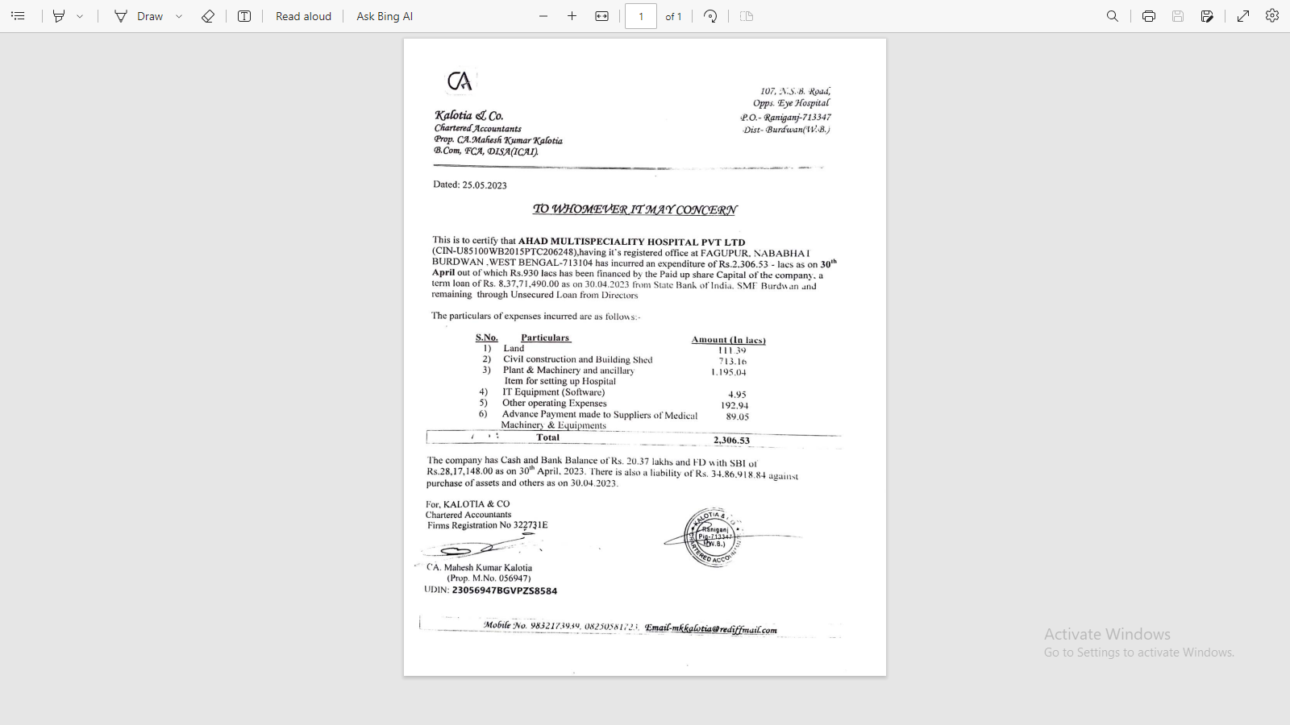

**DOCUMENT- 2: COPY OF TEV REPORT**

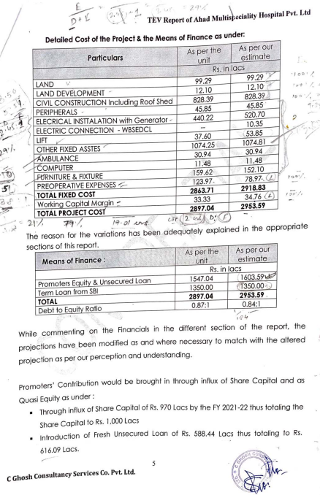

**DOCUMENT-3: FIRE NOC**

**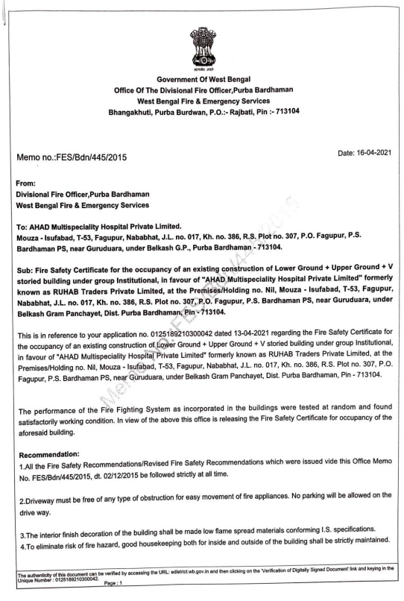**

**DOCUMENT 4: COPY OF MAJOR WORK ORDERS**

**Priority Health Care**

**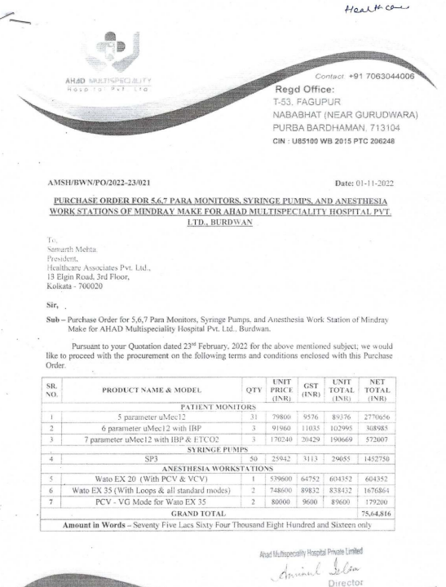**

**Asansol Marketing Agency**

**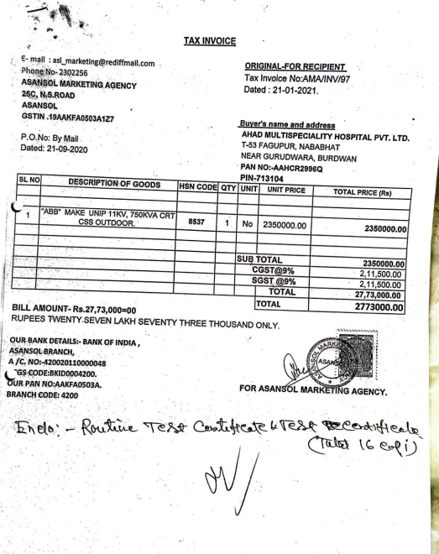**

**Global AC**

**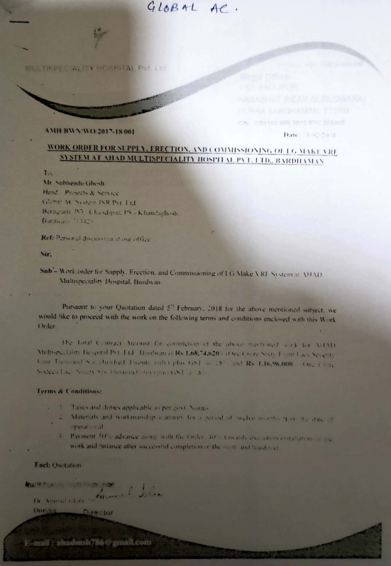**

**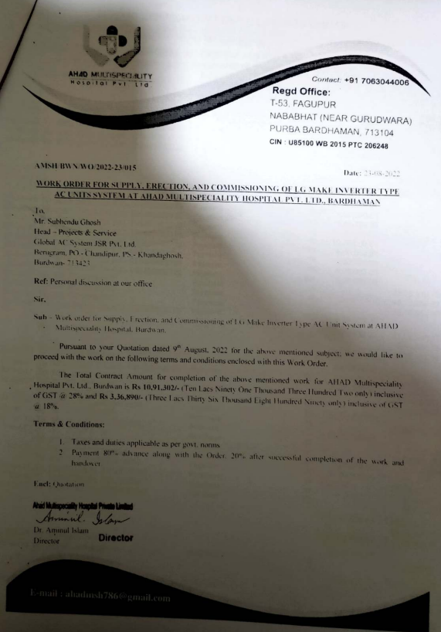**

**Johnson Lift Pvt. Ltd.**

**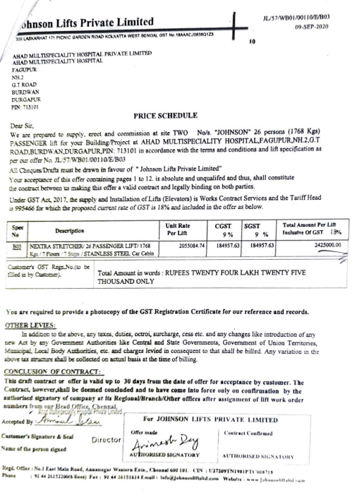**

**ENCLOSURE-2: - SITE PHOTOGRAPHS**

|  |  |
| --- | --- |
| **Z:\In Progress Files\Abhinav Chaturvedi\VIS(2023-24)-PL144-122-161\SiteImage\c_TimePhoto_20230623_115446.jpg** | **Z:\In Progress Files\Abhinav Chaturvedi\VIS(2023-24)-PL144-122-161\SiteImage\c_TimePhoto_20230623_115615.jpg** |
| **Z:\In Progress Files\Abhinav Chaturvedi\VIS(2023-24)-PL144-122-161\SiteImage\c_TimePhoto_20230623_161459.jpg** | **Z:\In Progress Files\Abhinav Chaturvedi\VIS(2023-24)-PL144-122-161\SiteImage\c_TimePhoto_20230623_161657.jpg** |
|  |  |

|  |  |
| --- | --- |
| **Z:\In Progress Files\Abhinav Chaturvedi\VIS(2023-24)-PL144-122-161\SiteImage\c_TimePhoto_20230623_115550.jpg** | **Z:\In Progress Files\Abhinav Chaturvedi\VIS(2023-24)-PL144-122-161\SiteImage\c_TimePhoto_20230623_161241.jpg** |
| **Z:\In Progress Files\Abhinav Chaturvedi\VIS(2023-24)-PL144-122-161\SiteImage\c_TimePhoto_20230623_163506.jpg** | **Z:\In Progress Files\Abhinav Chaturvedi\VIS(2023-24)-PL144-122-161\SiteImage\c_TimePhoto_20230623_163641.jpg** |
| **Z:\In Progress Files\Abhinav Chaturvedi\VIS(2023-24)-PL144-122-161\SiteImage\c_TimePhoto_20230623_163930.jpg** | **Z:\In Progress Files\Abhinav Chaturvedi\VIS(2023-24)-PL144-122-161\SiteImage\c_TimePhoto_20230623_164110.jpg** |

|  |  |
| --- | --- |
| **Z:\In Progress Files\Abhinav Chaturvedi\VIS(2023-24)-PL144-122-161\SiteImage\c_TimePhoto_20230623_164228.jpg** | **Z:\In Progress Files\Abhinav Chaturvedi\VIS(2023-24)-PL144-122-161\SiteImage\c_TimePhoto_20230623_164917.jpg** |
| **Z:\In Progress Files\Abhinav Chaturvedi\VIS(2023-24)-PL144-122-161\SiteImage\c_TimePhoto_20230623_165554.jpg** | **Z:\In Progress Files\Abhinav Chaturvedi\VIS(2023-24)-PL144-122-161\SiteImage\c_TimePhoto_20230623_165533.jpg** |
| **Z:\In Progress Files\Abhinav Chaturvedi\VIS(2023-24)-PL144-122-161\SiteImage\c_TimePhoto_20230623_170028.jpg** | **Z:\In Progress Files\Abhinav Chaturvedi\VIS(2023-24)-PL144-122-161\SiteImage\c_TimePhoto_20230623_170206.jpg** |

|  |  |
| --- | --- |
| **Z:\In Progress Files\Abhinav Chaturvedi\VIS(2023-24)-PL144-122-161\SiteImage\c_TimePhoto_20230623_170148.jpg** | **Z:\In Progress Files\Abhinav Chaturvedi\VIS(2023-24)-PL144-122-161\SiteImage\c_TimePhoto_20230623_170300.jpg** |
| **Z:\In Progress Files\Abhinav Chaturvedi\VIS(2023-24)-PL144-122-161\SiteImage\c_TimePhoto_20230623_170622.jpg** | **Z:\In Progress Files\Abhinav Chaturvedi\VIS(2023-24)-PL144-122-161\SiteImage\c_TimePhoto_20230623_170852.jpg** |
| **Z:\In Progress Files\Abhinav Chaturvedi\VIS(2023-24)-PL144-122-161\SiteImage\c_TimePhoto_20230623_171013.jpg** | **Z:\In Progress Files\Abhinav Chaturvedi\VIS(2023-24)-PL144-122-161\SiteImage\c_TimePhoto_20230623_171521.jpg** |

|  |  |
| --- | --- |
| **Z:\In Progress Files\Abhinav Chaturvedi\VIS(2023-24)-PL144-122-161\SiteImage\c_TimePhoto_20230623_171846.jpg** | **Z:\In Progress Files\Abhinav Chaturvedi\VIS(2023-24)-PL144-122-161\SiteImage\c_TimePhoto_20230623_171941.jpg** |
| **Z:\In Progress Files\Abhinav Chaturvedi\VIS(2023-24)-PL144-122-161\SiteImage\c_TimePhoto_20230623_180901.jpg** | **Z:\In Progress Files\Abhinav Chaturvedi\VIS(2023-24)-PL144-122-161\SiteImage\c_TimePhoto_20230623_181531.jpg** |
| **Z:\In Progress Files\Abhinav Chaturvedi\VIS(2023-24)-PL144-122-161\SiteImage\c_TimePhoto_20230623_182228.jpg** | **Z:\In Progress Files\Abhinav Chaturvedi\VIS(2023-24)-PL144-122-161\SiteImage\c_TimePhoto_20230623_164825.jpg** |