REPORT FORMAT: V-L4 (RKA - Medium) | Version: 11.0_2022

CASE NO.: VIS(2023-24)-PL154-130-189 DATED: 18/10/2023

DESKTOP VALUATION REPORT
OF
NATURE OF ASSETS | VACANT LAND
CATEGORY OF ASSETS | NON AGRICULTURE
TYPE OF ASSETS | NON-AGRICULTURAL VACANT LAND

SITUATED AT

VILLAGE: NALLAVUR, KONDHAMUR &THENKODIPAKKAM, TALUKA: VAANUR, DISTRICT: VILLUPURAM, TAMILNADU

OWNER/S
M/S. IL&FS ENGINEERING & CONSTRUCTION COMPANY LIMITED

REPORT PREPARED FOR
ICICI BANK, 5TH FLOOR, SOBHA PEARL COMMISSARIAT ROAD, BANGALORE, KARNATAKA, INDIA - 560025

**Important - In case of any query/ issue/ concern or escalation you may please contact Incident Manager @ valuers@rkassociates.org. We will appreciate your feedback in order to improve our services.
NOTE: As per IBA Guidelines please provide your feedback on the report within 15 days of its submission after which report will be considered to be accepted & correct.
Valuation Terms of Services & Valuer’s Important Remarks are available at www.rkassociates.org for reference.

PART A | SNAPSHOT OF THE ASSET/ PROPERTY UNDER VALUATION

NO PHOTOGRAPHS ARE AVAILABLE SINCE SITE INSPECTION COULDN’T BE DONE DUE TO UNAVIALABILTY OF OWNER / OWNER’S REPRESENTATIVE AT THE SITE.

PART B | SUMMARY OF THE VALUATION REPORT

S.NO. | CONTENTS | DESCRIPTION
 | GENERAL DETAILS
 | Report prepared for | Bank
 | Work Order No. & Date | ICBK/BLR/CBG/2023-24/015 dated 01/06/2023
 | Name of Borrower unit | M/s. IL&FS Engineering & Construction Company Limited
 | Name of Property Owner | M/s. IL&FS Engineering & Construction Company Limited
 | Address & Phone Number of the owner | Door No 8-2-120/113, Block B, 1st Floor Sanali Info Park, Road No 2,Banjara Hills Hyderabad, Telangana, India - 500034
 | Type of the Property | Non-agricultural Land
 | Type of Valuation Report | Non-agricultural Land Value
 | Report Type | Plain Asset Valuation
 | Date of Inspection of the Property | No site survey was conducted
 | Date of Valuation Assessment | 31 March 2023 & 15 October 2018
 | Date of Valuation Report | 18 October 2023
 | Property Shown By | Name |  |  | Relationship with Owner | Contact Number
 | Property Shown By | No representative was there since site survey was not done
 | Purpose of the Valuation | To Determine Fair Market value & Liquidation Value
 | Scope of the Report | Non Binding Opinion on General Prospective Valuation Assessment of the Property identified by Property owner or through its representative
 | Out-of-Scope of Report | - Verification of authenticity of documents from originals or cross checking from any Govt. dept. is not done at our end.  - Legal aspects of the property are out-of-scope of this report.  - Identification of the property is only limited to cross verification from its boundaries at site if mentioned in the provided documents.  - Getting cizra map or coordination with revenue officers for site identification is not done at our end.  - Measurement is only limited upto sample random measurement.  - Measurement of the property as a whole is not done at our end.  - Drawing Map & design of the property is out of scope of the work.
 | Documents provided for perusal | Documents Requested |  |  | Documents Provided |  | Documents Reference No.
 | Documents provided for perusal | Property Title document |  |  | Multiple Sale Deeds |  | Dated- 02nd November, 2007
 | Documents provided for perusal | Copy of TIR |  |  | Not provided |  | --
 | Documents provided for perusal | Cizra Map |  |  | Not provided |  | --
 | Documents provided for perusal | Certificate of Change of name |  |  | Certificate of Change of name |  | Dated 07/01/2011
 | Documents provided for perusal | Last paid Municipal Tax Receipt |  |  | NA |  | --
 | Identification of the property | ☐ |  | Cross checked from boundaries of the property or address mentioned in the deed
 | Identification of the property | ☐ |  | Done from the name plate displayed on the property
 | Identification of the property | ☐ |  | Identified by the Owner's representative
 | Identification of the property | ☐ |  | Enquired from local residents/ public
 | Identification of the property | ☐ |  | Identification of the property could not be done properly
 | Identification of the property | ☐ |  | Survey was not done
 | VALUATION SUMMARY
 | Total Prospective Fair Market Value |  | Rs.45,65,000/- (as on 31.03.2023)
 |  |  | Rs.31,95,500/- (as on 15.10.2018)
 | Total Expected Liquidation Sale Value |  | Rs.45,65,000/- (as on 31.03.2023)
 |  |  | Rs.31,95,500/- (as on 15.10.2018)
 | ENCLOSURES
 | Part A |  | Snapshot of The Asset/ Property Under Valuation
 | Part B |  | Valuation Report as per RKA Format Annexure-II
 | Part C |  | Characteristics Description of The Asset
 | Part D |  | Area Description of The Property
 | Part E |  | Procedure of Valuation Assessments
 | Enclosure 1 |  | Price Trend references Of The Similar Related Properties Available On Public Domain.
 | Enclosure 2 |  | Google Map
 | Enclosure 3 |  | Photographs
 | Enclosure 4 |  | Copy of Circle Rate
 | Enclosure 6 |  | Copy of important documents
 | Enclosure 6 |  | Valuer’s Important Remarks

PART C | CHARACTERISTICS DESCRIPTION OF THE ASSET

 |  |  | BRIEF DESCRIPTION OF THE PROPERTY UNDER VALUATION
This opinion on valuation report is prepared for the vacant non-agricultural land situated at the aforesaid address having total land area admeasuring 48.77 acres as per the copy of multiple sale deeds & old valuation report. The subject property is a free hold land owned by M/s. Maytas Infra Limited name of which was later changed as M/s. IL&FS Engineering & Construction Company Limited on 2011. Bifurcation with respect of gut no. is attached below in tabular form:
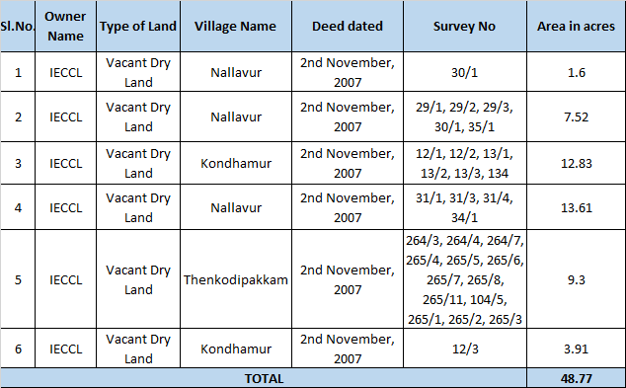
Site survey for the subject property couldn’t be conducted since no representative was available. We had to rely upon the data from the old valuation report which was provided to us by the client. We have cross checked through coordinate in Google map and a plot map provided to us and the location seems to match with each other. Screenshot of the both has been attached below:
Screenshot of the Google satellite view of the subject location:
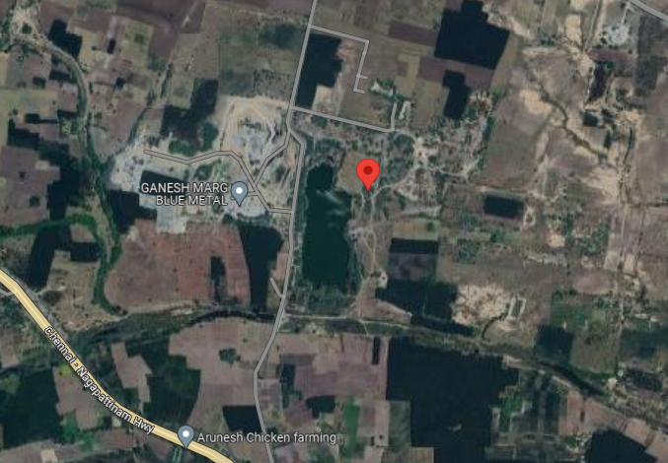
According to the old valuation report, approximately 20 acres of land of the subject property has already been excavated up to a depth of 30 feet below ground level. And the same is water logged. Remaining 28.77 acres of land is also excavated but up to 4-5 ft. depth. However, this portion of the land appears to be dry. Also, this land is lying un-used since year 2014 as per old valuation report. This can be seen from the satellite view as well that the land is excavated below ground level and is water logged. This means that most of its potential must have been already exploited and there will not be much economic potential of this land for quarrying purpose.

The subject property is abutting internal village road which is ~15 ft. wide which further connects to main Chennai Nagpattinam Highway. Other basic amenities like school, market is within close vicinity. But infrastructure like hospital, bus stop, railway station is ~20-22 kms. away from subject property. Few industries like ZF Rane Automotive India Pvt. Ltd., G K Industrial Park has been set up nearby the subject location.

This report only contains general assessment & opinion on the Guideline Value and the indicative, estimated Market Value of the property of which Bank/ customer asked us to conduct the Valuation for the property found on as-is-where basis as shown on the site by the Bank/ customer of which photographs is also attached with the report. No legal aspects in terms of ownership or any other legal aspect is taken into consideration. Even if any such information is mentioned in the report it is only referred from the information provided for which we do not assume any responsibility. Due care has been given while doing valuation assessment, but it doesn’t contain any due-diligence or audit or verification of any kind other than the valuation computation of the property shown to us on site. Information/ data/ documents given to us by Bank/ client have been relied upon in good faith. This report doesn’t contain any other recommendations of any sort.

In case of discrepancy in the address/ property number mentioned in the property documents and the property shown to us at the site due to change in zoning or administrative level at the site or the client misled the valuer by providing the fabricated/ incorrect document or information, the valuation should be considered of the property shown to us at the site by the client of which the photographs are also attached. In case of any doubt, best would be to contact the concerned authority/ district administration/ tehsil level for the identification of the property if the property depicted in the photographs in this report is same with the documents pledged.
 |  | GENERAL DESCRIPTION OF THE PROPERTY
 |  | Names of the Legal Owner/s |  | M/s. IL&FS Engineering & Construction Company Limited
 |  | Constitution of the Property |  | Free hold, complete transferable rights
 |  | Since how long owners owing the Property |  | ~13 years
 |  | Year of Acquisition/ Purchase |  | 2010-2011
 |  | Property presently occupied/ possessed by |  | Legal Owner
*NOTE: Please see point 6 of Enclosure: 5 – Valuer’s Important Remarks.
 | LOCATION CHARACTERISTICS OF THE PROPERTY
 | Nearby Landmark |  |  |  |  |  |  | Hotel Brindavan
 | Postal Address of the Property |  |  |  |  |  |  | Village: Nallavur, Kondhamur &Thenkodipakkam, Taluka: Vaanur, District: Villupuram, Tamilnadu
 | Independent access/ approach to the property |  |  |  |  |  |  | Clear independent access is available
 | Google Map Location of the Property with a neighborhood layout map |  |  |  |  |  |  | Enclosed with the Report
 |  |  |  |  |  |  |  | Coordinates or URL: 12°08'32.1"N 79°43'43.6"E
 | Description of adjoining property |  |  |  |  |  |  | Vacant dry land as per Google satellite image view.
 | Plot No./ Survey No. |  |  |  |  |  |  | Refer to the attached sheet at page no.5
 | Village/ Zone |  |  |  |  |  |  | Nallavur, Kondhamur &Thenkodipakkam
 | Sub registrar |  |  |  |  |  |  | Mayilam
 | District |  |  |  |  |  |  | Villupuram
 | City Categorization |  |  |  |  |  |  | Village |  |  |  |  | Rural
 | Characteristics of the locality |  |  |  |  |  |  | Average |  |  |  |  | Within Remote area
 | Property location classification |  |  |  |  |  |  | Near to Highway |  |  |  | Ordinary location within the locality |  |  |  |  |  | None
 | Property Facing |  |  |  |  |  |  | West Facing
 | Details of the roads abutting the property
 | - Main Road Name & Width |  |  |  |  |  |  | Chennai Nagpattinam Highway |  |  |  |  |  | ~65 ft.
 | - Front Road Name & width |  |  |  |  |  |  | Internal Village Road |  |  |  |  |  | ~15 ft.
 | - Type of Approach Road |  |  |  |  |  |  | Bituminous Road
 | - Distance from the Main Road |  |  |  |  |  |  | ~ 1 km.
 | Is property clearly demarcated by permanent/ temporary boundary on site |  |  |  |  |  |  | No demarcation of the property
 | Is the property merged or colluded with any other property |  |  |  |  |  |  | Yes
 |  |  |  |  |  |  |  | Yes, the subject property is merged with adjoining property.
 | Boundaries schedule of the Property
 | Are Boundaries matched |  |  |  |  |  |  | Cannot comment since site survey was not done
 | Directions |  |  | As per Sale Deed/TIR |  |  |  |  |  |  |  | Actual found at Site
 | East |  |  | Multiple property in multiple deed. Please refer to sale deed |  |  |  |  |  |  |  | Cannot comment since survey was not conducted
 | West |  |  | Multiple property in multiple deed. Please refer to sale deed |  |  |  |  |  |  |  | Cannot comment since survey was not conducted
 | North |  |  | Multiple property in multiple deed. Please refer to sale deed |  |  |  |  |  |  |  | Cannot comment since survey was not conducted
 | South |  |  | Multiple property in multiple deed. Please refer to sale deed |  |  |  |  |  |  |  | Cannot comment since survey was not conducted
 | TOWN PLANNING/ ZONING PARAMETERS
 | Planning Area/ Zone |  |  |  |  |  |  |  | Master Plan could not be found from public domain
 | Master Plan currently in force |  |  |  |  |  |  |  | Master Plan could not be found from public domain
 | Municipal limits |  |  |  |  |  |  |  | Out of municipal limits
 | Developmental controls/ Authority |  |  |  |  |  |  |  | Gram Panchayat of Nallavur, Kondhamur & Thenkodipakkam
 | Zoning regulations |  |  |  |  |  |  |  | Not yet under zoning regulations
 | Master Plan provisions related to property in terms of Land use |  |  |  |  |  |  |  | Master Plan could not be found from public domain
 | Any conversion of land use done |  |  |  |  |  |  |  | No information available to us
 | Current activity done in the property |  |  |  |  |  |  |  | Cannot comment since site survey was not conducted
 | Is property usage as per applicable zoning |  |  |  |  |  |  |  | It is a village area, no zoning regulations defined
 | Any notification on change of zoning regulation |  |  |  |  |  |  |  | NA
 | Street Notification |  |  |  |  |  |  |  | Not notified
 | Status of Completion/ Occupational certificate |  |  |  |  |  |  |  | NA |  |  |  |  | NA
 | Comment on unauthorized construction if any |  |  |  |  |  |  |  | Not applicable
 | Comment on Transferability of developmental rights |  |  |  |  |  |  |  | Complete rights since this is a freehold land
 | Comment on the surrounding land uses & adjoining properties in terms of uses |  |  |  |  |  |  |  | Cannot comment since site survey was not conducted
 | Comment of Demolition proceedings if any |  |  |  |  |  |  |  | NA
 | Comment on Compounding/ Regularization proceedings |  |  |  |  |  |  |  | NA
 | Any information on encroachment |  |  |  |  |  |  |  | NA
 | Is the area part of unauthorized area/ colony |  |  |  |  |  |  |  | NA
 | ECONOMIC ASPECTS OF THE PROPERTY
 | Reasonable letting value/ Expected market monthly rental |  |  |  |  |  |  |  | NA
 | - Is property presently on rent |  |  |  |  |  |  |  | No
 | - Number of tenants |  |  |  |  |  |  |  | NA
 | - Since how long lease is in place |  |  |  |  |  |  |  | NA
 | - Status of tenancy right |  |  |  |  |  |  |  | NA
 | - Amount of monthly rent received |  |  |  |  |  |  |  | NA
 | Taxes and other outgoing |  |  |  |  |  |  |  | NA
 | Property Insurance details |  |  |  |  |  |  |  | NA
 | Monthly maintenance charges payable |  |  |  |  |  |  |  | NA
 | Security charges, etc. |  |  |  |  |  |  |  | NA
 | Any other aspect |  |  |  |  |  |  |  | NA
 | SOCIO - CULTURAL ASPECTS OF THE PROPERTY
 | Descriptive account of the location of the property in terms of social structure of the area in terms of population, social stratification, regional origin, age groups, economic levels, location of slums/squatter settlements nearby, etc. |  |  |  |  |  |  |  | Low Income Group
 | Whether property belongs to social infrastructure like hospital, school, old age homes etc. |  |  |  |  |  |  |  | No
 | FUNCTIONAL AND UTILITARIAN SERVICES, FACILITIES & AMENITIES
 | Drainage arrangements |  |  |  |  |  |  |  | Not applicable
 | Water Treatment Plant |  |  |  |  |  |  | Not applicable
 | Power Supply arrangements |  |  |  |  |  |  | Not applicable
 | HVAC system |  |  |  |  |  |  | Not applicable
 | Security provisions |  |  |  |  |  |  | Not applicable
 | Lift/ Elevators |  |  |  |  |  |  | Not applicable
 | Compound wall/ Main Gate |  |  |  |  |  |  | Not applicable
 | Whether gated society |  |  |  |  |  |  | Not applicable
 | Car parking facilities |  |  |  |  |  |  | Not applicable
 | Ventilation |  |  |  |  |  |  | Not applicable
 | Internal development
 | Garden/ Park/ Land scraping |  | Water bodies |  |  | Internal roads |  |  |  |  | Pavements |  |  |  |  |  | Boundary Wall
 | NA |  | NA |  |  | NA |  |  |  |  | NA |  |  |  |  |  | No
 | INFRASTRUCTURE AVAILABILITY
 | Description of Aqua Infrastructure availability in terms of:
 | - Water Supply |  |  |  |  |  |  | No
 | - Sewerage/ sanitation system |  |  |  |  |  |  | Open
 | - Storm water drainage |  |  |  |  |  |  | No
 | Description of other Physical Infrastructure facilities in terms of:
 | - Solid waste management |  |  |  |  |  |  | No
 | - Electricity |  |  |  |  |  |  | No Electricity connection
 | - Road and Public Transport connectivity |  |  |  |  |  |  | Yes
 | - Availability of other public utilities nearby |  |  |  |  |  |  | Transport, Market, Hospital etc. available in close vicinity
 | Proximity & availability of civic amenities & social infrastructure
 | School | Hospital |  |  | Market |  | Bus Stop |  |  | Railway Station |  |  |  |  |  | Metro |  |  | Airport
 | ~2 km | ~14 kms. |  |  | ~15 kms. |  | ~15 kms.  (Tindivanam Bus Stop) |  |  | ~15.5 kms.  (Tindivanam Railway Station) |  |  |  |  |  | -- |  |  | ~120 kms.  (Chennai International Airport)
 | Availability of recreation facilities (parks, open spaces etc.) |  |  |  |  |  | This is a rural remote area. No recreational facility is available nearby.
 | MARKETABILITY ASPECTS OF THE PROPERTY:
 | Location attribute of the subject property |  |  |  |  |  | Average
 | Scarcity |  |  |  |  |  | Ample vacant land available nearby. There is no issue of land availability in this area.
 | Market condition related to demand and supply of the kind of the subject property in the area |  |  |  |  |  | Demand of such properties is moderate since similar property is abuduntly available
 | Any New Development in surrounding area |  |  |  |  |  | None
 | Any negativity/ defect/ disadvantages in the property/ location |  |  |  |  |  | Water logged land
 | Any other aspect which has relevance on the value or marketability of the property |  |  |  |  |  | Highway abutting property
 | ENGINEERING AND TECHNOLOGY ASPECTS OF THE PROPERTY:
 | Type of construction & design |  |  |  |  |  |  |  | Not Applicable
 | Method of construction |  |  |  |  |  |  |  | Not Applicable
 | Specifications
 | - Class of construction |  |  |  |  |  |  |  | Not Applicable
 | - Appearance/ Condition of structures |  |  |  |  |  |  |  | Internal - Not Applicable
 |  |  |  |  |  |  |  |  | External - Not Applicable
 | - Roof |  |  |  |  |  |  |  | Floors/ Blocks |  |  |  |  |  | Type of Roof
 |  |  |  |  |  |  |  |  | NA |  |  |  |  |  | NA
 |  |  |  |  |  |  |  |  | NA |  |  |  |  |  | NA
 | - Floor height |  |  |  |  |  |  |  | Not Applicable
 | - Type of flooring |  |  |  |  |  |  |  | Not Applicable
 | - Doors/ Windows |  |  |  |  |  |  |  | Not Applicable
 | - Interior Finishing |  |  |  |  |  |  |  | Not Applicable
 | - Exterior Finishing |  |  |  |  |  |  |  | Not Applicable
 | - Interior decoration/ Special architectural or decorative feature |  |  |  |  |  |  |  | Not Applicable
 | - Class of electrical fittings |  |  |  |  |  |  |  | Not Applicable
 | - Class of sanitary & water supply fittings |  |  |  |  |  |  |  | Not Applicable
 | Maintenance issues |  |  |  |  |  |  |  | Not Applicable
 | Age of building/ Year of construction |  |  |  |  |  |  |  | NA |  |  |  |  | NA
 | Total life of the structure/ Remaining life expected |  |  |  |  |  |  |  | NA |  |  |  |  | NA
 | Extent of deterioration in the structure |  |  |  |  |  |  |  | Not Applicable
 | Protection against natural disasters viz. earthquakes etc. |  |  |  |  |  |  |  | NA
 | Visible damage in the building if any |  |  |  |  |  |  |  | NA
 | System of air conditioning |  |  |  |  |  |  |  | NA
 | Provision of firefighting |  |  |  |  |  |  |  | NA
 | Status of Building Plans/ Maps |  |  |  |  |  |  |  | Not Applicable
 | - Authority approving the plan |  |  |  |  |  |  |  | NA
 | - Name of the office of the Authority |  |  |  |  |  |  |  | NA
 | - Is Building as per approved Map |  |  |  |  |  |  |  | Vacant Land/ Plot.
 | - Details of alterations/ deviations/ illegal construction/ encroachment noticed in the structure from the original approved plan |  |  |  |  |  |  |  | Permissible Alterations |  |  |  |  |  | Not Applicable
 |  |  |  |  |  |  |  |  | Not permitted alteration |  |  |  |  |  | Not Applicable
 | - Is this being regularized |  |  |  |  |  |  |  | NA
 | ENVIRONMENTAL FACTORS:
 | Use of environment friendly building materials like fly ash brick, other Green building techniques if any |  |  |  |  |  |  |  | NA
 | Provision of rainwater harvesting |  |  |  |  |  |  |  | NA
 | Use of solar heating and lighting systems, etc. |  |  |  |  |  |  |  | NA
 | Presence of environmental pollution in the vicinity of the property in terms of industries, heavy traffic, etc. if any |  |  |  |  |  |  |  | NA
 | ARCHITECTURAL AND AESTHETIC QUALITY OF THE PROPERTY:
 | Descriptive account on whether the building is modern, old fashioned, etc., plain looking or with decorative elements, heritage value if applicable, presence of landscape elements,  etc. |  |  |  |  |  |  |  | Not Applicable

PART D | AREA DESCRIPTION OF THE PROPERTY

 | Land Area considered for Valuation | 48.77 acres
 | Area adopted on the basis of | Property documents
 | Remarks & observations, if any | Site survey was not conducted for the subject property so we have adopted the land area as per the documents provided to us.
 | Constructed Area considered for Valuation  (As per IS 3861-1966) | Covered Area | NA
 | Area adopted on the basis of | NA
 | Remarks & observations, if any | NA

Note:

- Area measurements considered in the Valuation Report pertaining to Land & Building is adopted from relevant approved documents or actual site measurement whichever is less. All area measurements are on approximate basis only.

- Verification of the area measurement of the property is done based on sample random checking only.

- Area of the large land parcels of more than 2500 sq.mtr or of uneven shape, is taken as per property documents verified with digital survey through google which has been relied upon.

- Drawing Map, design & detailed estimation of the property/ building is out of scope of the Valuation services.

PART E | PROCEDURE OF VALUATION ASSESMENT

 | GENERAL INFORMATION
 | Important Dates | Date of Inspection of the Property |  | Date of Valuation Assessment | Date of Valuation Report
 | Important Dates | No site survey was conducted |  | 15 October 2018 & 31 March 2023 | 18 October 2023
 | Client | ICICI Bank, 5th Floor, Sobha Pearl Commissariat Road, Bangalore, Karnataka, India - 560025
 | Intended User | ICICI Bank, 5th Floor, Sobha Pearl Commissariat Road, Bangalore, Karnataka, India - 560025
 | Intended Use | To know the general idea on the market valuation trend of the property as per free market transaction. This report is not intended to cover any other internal mechanism, criteria, and considerations of any organization as per their own need, use & purpose.
 | Purpose of Valuation | To Determine Fair Market value & Liquidation Value
 | Scope of the Assessment | Non binding opinion on the assessment of Plain Physical Asset Valuation of the property identified to us by the owner or through his representative.
 | Restrictions | This report should not be referred for any other purpose, by any other user and for any other date other then as specified above. This is not a certification of ownership or survey number/ property number/ Khasra number which are merely referred from the copy of the documents provided to us.
 | Manner in which the proper is identified | ☐ | Done from the name plate displayed on the property
 | Manner in which the proper is identified | ☐ | Identified by the owner
 | Manner in which the proper is identified | ☐ | Identified by the owner’s representative
 | Manner in which the proper is identified | ☐ | Enquired from local residents/ public
 | Manner in which the proper is identified | ☐ | Cross checked from the boundaries/ address of the property mentioned in the documents provided to us
 | Manner in which the proper is identified | ☐ | Identification of the property could not be done properly
 | Manner in which the proper is identified | ☐ | Survey was not done
 | Type of Survey conducted | Physical inspection of the site was not conducted
 | ASSESSMENT FACTORS
 | Valuation Standards considered | Mix of standards such as IVS and others issued by Indian authorities & institutions and improvised by the RKA internal research team as and where it is felt necessary to derive at a reasonable, logical & scientific approach. In this regard proper basis, approach, working, definitions considered is defined below which may have certain departures to IVS.
 | Nature of the Valuation | Fixed Assets Valuation
 | Nature/ Category/ Type/ Classification of Asset under Valuation | Nature |  |  |  | Category |  |  |  |  | Type
 |  | VACANT LAND |  |  |  | NON AGRICULTURE |  |  |  |  | NON AGRICULTURE VACANT LAND
 |  | Classification |  |  |  | Non - Income/ Revenue Generating Asset
 | Type of Valuation (Basis of Valuation as per IVS) | Primary Basis |  |  | Market Value & Govt. Guideline Value
 | Type of Valuation (Basis of Valuation as per IVS) | Secondary Basis |  |  | On-going concern basis
 | Present market state of the Asset assumed (Premise of Value as per IVS) | Under Normal Marketable State
 |  | Reason: Asset under free market transaction state
 | Property Use factor | Current/ Existing Use |  |  |  |  | Highest & Best Use  (in consonance to surrounding use, zoning and statutory norms) |  |  |  | Considered for Valuation purpose
 | Property Use factor | Vacant Dry Land |  |  |  |  | Industrial |  |  |  | Vacant Dry Land
 | Legality Aspect Factor | Assumed to be fine as per copy of the documents & information produced to us.  However Legal aspects of the property of any nature are out-of-scope of the Valuation Services. In terms of the legality, we have only gone by the documents provided to us in good faith.  Verification of authenticity of documents from originals or cross checking from any Govt. deptt. have to be taken care by Legal expert/ Advocate.
 | Land Physical Factors | Shape |  |  |  |  |  | Size |  | Layout
 | Land Physical Factors | Irregular |  |  |  |  |  | Medium |  | NA
 | Property Location Category Factor | City Categorization |  | Locality Characteristics |  |  |  |  | Property location characteristics |  |  | Floor Level
 | Property Location Category Factor | Village |  | Average |  |  |  |  | Near to Highway |  |  | Not applicable
 | Property Location Category Factor | Rural |  | Within Remote area |  |  |  |  | None |  |  | Not applicable
 | Property Location Category Factor |  |  | In interiors |  |  |  |  | None |  |  | Not applicable
 | Property Location Category Factor | Property Facing
 | Property Location Category Factor | East Facing
 | Physical Infrastructure availability factors of the locality | Water Supply |  | Sewerage/ sanitation system |  |  |  |  | Electricity |  |  | Road and Public Transport connectivity
 | Physical Infrastructure availability factors of the locality | No |  | Not Available |  |  |  |  | No Electricity connection |  |  | Easily available
 | Physical Infrastructure availability factors of the locality | Availability of other public utilities nearby |  |  |  |  |  |  | Availability of communication facilities
 | Physical Infrastructure availability factors of the locality | Transport, Market, Hospital etc. are available in close vicinity |  |  |  |  |  |  | Major Telecommunication Service Provider & ISP connections are available
 | Social structure of the area (in terms of population, social stratification, regional origin, age groups, economic levels, location of slums/ squatter settlements nearby, etc.) | Low Income Group
 | Neighbourhood amenities | Poor
 | Any New Development in surrounding area | None
 | Any specific advantage/ drawback in the property | Water logged land
 | Property overall usability/ utility Factor | Good
 | Do property has any alternate use? | Yes
 | Is property clearly demarcated by permanent/ temporary boundary on site | No demarcation done and mixed with other adjoining Lands
 | Is the property merged or colluded with any other property | Yes
 | Is the property merged or colluded with any other property | Comments: As per latest Google satellite images the subject property is merged with other properties.
 | Is independent access available to the property | Clear independent access is available
 | Is property clearly possessable upon sale | Yes
 | Best Sale procedure to realize maximum Value (in respect to Present market state or premise of the Asset as per point (iv) above) | Fair Market Value
 |  | Free market transaction at arm's length wherein the parties, after full market survey each acted knowledgeably, prudently and without any compulsion.
 | Hypothetical Sale transaction method assumed for the computation of valuation | Fair Market Value
 |  | Free market transaction at arm's length wherein the parties, after full market survey each acted knowledgeably, prudently and without any compulsion.
 | Approach & Method of Valuation Used | Vacant Land | Approach of Valuation |  |  |  |  |  | Method of Valuation
 | Approach & Method of Valuation Used | Vacant Land | Market value according to Guideline Rate
 | Type of Source of Information | Level 3 Input (Tertiary)
 | Market Comparable
 | References on prevailing market Rate/ Price trend of the property and Details of the sources from where the information is gathered (from property search sites & local information) | 1. | Name: | Due to limitation to carry out a site survey, no references for land rates could be obtained. Additionally, the subject land parcel is located in a rural region, making it difficult to get any information about the current market rate in the public domain.
 |  | 1. | Contact No.:
 |  | 1. | Nature of reference:
 |  | 1. | Size of the Property:
 |  | 1. | Location:
 |  | 1. | Rates/ Price informed:
 |  | 1. | Any other details/ Discussion held:
 | Adopted Rates Justification | We used the market rate in accordance with the Guideline rate of the subject property since no references could be found through consultation with the property consultant or extensive investigation from the public domain.
 | Other Market Factors
 | Current Market condition | Normal
 | Current Market condition | Remarks: NA
 | Current Market condition | Adjustments (-/+): 0%
 | Comment on Property Salability Outlook | Easily sellable
 | Comment on Property Salability Outlook | Adjustments (-/+): 0%
 | Comment on Demand & Supply in the Market | Demand | Supply
 | Comment on Demand & Supply in the Market | Moderate | Abundantly available
 | Comment on Demand & Supply in the Market | Remarks: Moderate demand of such properties in the market
 | Comment on Demand & Supply in the Market | Adjustments (-/+): 0%
 | Any other special consideration | Reason: NA
 | Any other special consideration | Adjustments (-/+): 0%
 | Any other aspect which has relevance on the value or marketability of the property | It has the potential to develop into an industrial site.  Valuation of the same asset/ property can fetch different values under different circumstances & situations. For eg. Valuation of a running/ operational shop/ hotel/ factory will fetch better value and in case of closed shop/ hotel/ factory it will fetch considerably lower value. Similarly, an asset sold directly by an owner in the open market through free market arm’s length transaction then it will fetch better value and if the same asset/ property is sold by any financer or court decree or Govt. enforcement agency due to any kind of encumbrance on it then it will fetch lower value. Hence before financing, Lender/ FI should take into consideration all such future risks while financing.  This Valuation report is prepared based on the facts of the property & market situation on the date of the survey. It is a well-known fact that the market value of any asset varies with time & socio-economic conditions prevailing in the region/ country. In future property market may go down, property conditions may change or may go worse, property reputation may differ, property vicinity conditions may go down or become worse, property market may change due to impact of Govt. policies or effect of domestic/ world economy, usability prospects of the property may change, etc. Hence before financing, Banker/ FI should take into consideration all such future risk while financing.
 |  | Adjustments (-/+): 0%
 | Final adjusted & weighted Rates considered for the subject property | Refer to the Enclosure: 4 at page no. 19 & 20
 | Considered Rates Justification | Refer to the Enclosure: 4 at page no. 19 & 20
 | Basis of computation & working
- Since there was no representative who would accompany for site inspection and identification of the subject property, site survey was not conducted. The valuation was completed using government guidelines rate. Additionally, because the subject property is located in a rural region, market research such as consultations with people who live there and real estate agents couldn't be possible.
- Analysis and conclusions adopted in the report are limited to the reported assumptions, conditions and information came to our knowledge during the course of the work and based on the Standard Operating Procedures, Best Practices, Caveats, Limitations, Conditions, Remarks, Important Notes, Valuation TOR and definition of different nature of values.
- For knowing comparable market rates, significant discreet local enquiries have been made from our side based on the hypothetical/ virtual representation of ourselves as both buyer and seller for the similar type of properties in the subject location and thereafter based on this information and various factors of the property, rate has been judiciously taken considering the factors of the subject property, market scenario and weighted adjusted comparison with the comparable properties unless otherwise stated.
- Area measurements considered in the Valuation Report pertaining to asset/ property is adopted from relevant approved documents or sample site measurement whichever is less unless otherwise mentioned. All area measurements are on approximate basis only.
- Verification of the area measurement of the property is done based on sample random checking only.
- Area of the large land parcels of more than 2500 sq .mtr. or of uneven shape in which there can be practical difficulty in sample measurement, is taken as per property documents which has been relied upon unless otherwise stated.
- Drawing, Map, design & detailed estimation of the property/ building is out of scope of the Valuation services.
- Construction rates are adopted based on the present market replacement cost of construction and calculating applicable depreciation & deterioration factor as per its age, existing condition & specifications based on visual observation only of the structure. No structural, physical tests have been carried out in respect of it. No responsibility is assumed for latent defects of any nature whatsoever, which may affect value, or for any expertise required to disclose such conditions.
- Construction rates are adopted based on the plinth area rates prevailing in the market for the structure as a whole and not based on item wise estimation or Bills of Quantity method unless otherwise stated.
- The condition assessment and the estimation of the residual economic life of the structure are only based on the visual observations and appearance found during the site survey. We have not carried out any structural design or stability study; nor carried out any physical tests to assess structural integrity & strength.
- Any kind of unpaid statutory, utilities, lease, interest or any other pecuniary dues on the asset or on its owners has not been factored in the Valuation.
- This Valuation is conducted based on the macro analysis of the asset/ property considering it in totality and not based on the micro, component or item wise analysis. Analysis done is a general assessment and is neither investigative in nature nor an audit activity.
 | ASSUMPTIONS
- Documents/ Information/ Data provided by the client/ property owner or his representative both written & verbally is true and correct without any fabrication and has been relied upon in good faith.
- The assets and interests therein have been valued free and clear of any liens or encumbrances unless stated otherwise. No hidden or apparent conditions regarding the subject assets or their ownership are assumed to exist. No opinion of title is rendered in this report and a good title is assumed unless stated otherwise.
- It is assumed that the concerned Lender/ Financial Institution has asked for the valuation of that property after satisfying the authenticity of the documents given to us and for which the legal verification has been already taken and cleared by the competent Advocate before requesting for the Valuation report. I/ We assume no responsibility for the legal matters including, but not limited to, legal or title concerns.
- Payment condition during transaction in the Valuation has been considered on all cash bases which includes both formal & informal payment components as per market trend.
- Sale transaction method of the asset is assumed as Free market transaction without any compulsion unless otherwise mentioned while assessing Indicative & Estimated Fair Prospective Market Value of the asset unless otherwise stated.
 | SPECIAL ASSUMPTIONS
 | We are not aware of the current state of the subject property. We had to presume that the current situation was the same as what was described in the previous valuation report which was provided to us for references.
 | LIMITATIONS
 | We are uncertain of the site's present condition. We had to rely on the data obtained from the previous valuation report and the client's submitted property documents.

 | VALUATION OF LAND (as on 31 March 2023)
 | Particulars | Govt. Circle/ Guideline Value | Indicative & Estimated Prospective Fair Market Value  (as per the guideline rate)
 | Prevailing Rate range | Refer to the attached sheet below | Refer to the attached sheet below
 | Deduction on Market Rate | --- | ---
 | Rate adopted considering all characteristics of the property | Refer to the attached sheet below | Refer to the attached sheet below
 | Total Land Area considered (documents vs site survey whichever is less) | 48.77 acres | 48.77 acres
 | Total Value of land (A) | Refer to the attached sheet below | Refer to the attached sheet below
 | Total Value of land (A) | Rs.1,09,27,834/- | Rs.45,65,176/-

 | VALUATION OF LAND (as on 15 October 2018)
 | Particulars | Govt. Circle/ Guideline Value | Indicative & Estimated Prospective Fair Market Value (as per the guideline rate)
 | Prevailing Rate range | Refer to the attached sheet below | Refer to the attached sheet below
 | Deduction on Market Rate | --- | ---
 | Rate adopted considering all characteristics of the property | Refer to the attached sheet below | Refer to the attached sheet below
 | Total Land Area considered (documents vs site survey whichever is less) | 48.77 acres | 48.77 acres
 | Total Value of land (A) | Refer to the attached sheet below | Refer to the attached sheet below
 | Total Value of land (A) | Rs.1,09,27,834/- | Rs.45,65,176/-

Note: Guideline Rate for above mentioned location has been same from 09/06/2017 to 31/03/2023 as per Registration Department of Govt. of Tamilnadu.

RATE CALCULATION FOR LAND VALUATION OF M/S. IL&FS ENGINEERING & CONSTRCUTION COMPANY LIMITED SITUAED AT DIST: VILLUPURAM, TAMILNADU
Sl. No. | Village Name | Survey No | Area in acres | Rate as per Guideline rate per acre | Land Value | Avg. Rate
1 | Nallavur | 30/1, 29/1, 29/2, 29/3, 30/1, 35/1, 31/1, 31/3, 31/4, 34/1 | 22.73 | ₹ 1,94,300 | ₹ 44,16,439 | ₹ 2,26,683
2 | Thenkodipakkam | 264/3, 264/4, 264/7, 265/4, 265/5, 265/6, 265/7, 265/8, 265/11, 104/5, 265/1, 265/2, 265/3 | 9.3 | ₹ 2,17,750 | ₹ 20,25,075 | ₹ 2,26,683
3 | Kondhamur | 12/1, 12/2, 13/1, 13/2, 13/3, 134, 12/3 | 16.74 | ₹ 2,68,000 | ₹ 44,86,320 | ₹ 2,26,683
TOTAL |  |  | 48.77

LAND VALUATION OF M/S. IL&FS ENGINEERING & CONSTRCUTION COMPANY LIMITED SITUAED AT DIST: VILLUPURAM, TAMILNADU
Sl. No. | Land Area (acres) | Rate Adopted (Rs./acre) | Discount | Value In Rs. | Remarks
1 | 20 | 0 | 0 | 0 | According to the old valuation report, approximately 20 acres of land of the subject property has already been excavated up to a depth of 30 feet below ground level. So, the potential of the land has already been used.
2 | 28.77 | 2,26,683 | 30% | 45,65,176 | 30% discount is added since Remaining land is excavated up to 4-5 ft. depth.
Total | 48.77 |  |  | 45,65,176
Note: Average rate of the land have been adopted because it is not clear that which potion of land is submerged under water and which portion is dugged up to 4-5 ft. depth.

Note: Guideline Rate for above mentioned location has been same from 09/06/2017 to 31/03/2023 as per Registration Department of Govt. of Tamilnadu.
- 4. | VALUATION COMPUTATION OF BUILDING STRUCTURE

NOT APPLICABLE

 | CONSOLIDATED VALUATION ASSESSMENT OF THE ASSET
S.No. | Particulars | Indicative & Estimated Prospective Fair Market Value (as on 31.03.2023) | Indicative & Estimated Prospective Fair Market Value (as on 15.10.2018)
 | Land Value (A) | Rs.45,65,176/- | Rs.45,65,176/-
 | Additional Aesthetic Works Value (B) | NA | NA
 | Total Add (A+B) | Rs.45,65,176/- | Rs.45,65,176/-
 | Additional Premium if any | NA | NA
 | Details/ Justification | NA | NA
 | Deductions charged if any | --- | ---
 | Details/ Justification | --- | ---
 | Total Indicative & Estimated Prospective Fair Market Value | Rs.45,65,176/- | Rs.45,65,176/-
 | Rounded Off | Rs.45,65,000/- | Rs.45,65,000/-
 | Indicative & Estimated Prospective Fair Market Value in words | Rupees Forty Five Lakhs Sixty Five Thousand | Rupees Forty Five Lakhs Sixty Five Thousand
 | Expected Liquidation Value (@ ~30% less) | Rs.31,95,500/- | Rs.31,95,500/-
 | Percentage difference between Circle Rate and Fair Market Value | Not applicable
 | Likely reason of difference in Circle Value and Fair Market Value in case of more than 20% | Circle rates are determined by the District administration as per their own theoretical internal policy for fixing the minimum valuation of the property for property registration tax collection purpose and Market rates are adopted based on prevailing market dynamics found as per the discrete market enquiries which is explained clearly in Valuation assessment factors.
 | Concluding Comments/ Disclosures if any
- The subject property is a vacant dry land merged with adjacent properties, cross verified from Google satellite view images.
- Since there was no site inspection, we are not aware of the current state of the subject property. We had to presume that the current situation was the same as what was described in the previous valuation report.
- Since there was no representation on the site, no physical inspection could be done. We had to rely on the data obtained from the previous valuation report and the client's submitted property documents.
- We are independent of client/ company and do not have any direct/ indirect interest in the property.
- This valuation has been conducted by R.K Associates Valuers & Techno Engineering Consultants (P) Ltd. and its team of experts.
- This Valuation is done for the property found on as-is-where basis as shown on the site by the Bank/ customer of which photographs is also attached with the report.
- Reference of the property is also taken from the copies of the documents/ information which interested organization or customer could provide to us out of the standard checklist of documents sought from them and further based on our assumptions and limiting conditions. All such information provided to us has been relied upon in good faith and we have assumed that it is true and correct. However, we do not vouch the absolute correctness of the property identification, exact address, physical conditions, etc. based on the documents provided to us since property shown to us may differ on site Vs as mentioned in the documents or incorrect/ fabricated documents may have been provided to us.
- Legal aspects for e.g. investigation of title, ownership rights, lien, charge, mortgage, lease, verification of documents from originals or from any Govt. department, etc. has to be taken care by legal experts/ Advocates and same has not been done at our end.
- The valuation of an asset is an estimate of the worth of that asset which is arrived at by the Valuer in his expert opinion after factoring in multiple parameters and externalities. This may not be the actual price of that asset and the market may discover a different price for that asset.
- This report only contains opinion based on technical & market information which came to our knowledge during the course of the assignment. It doesn’t contain any recommendations.
- This report is prepared following our Standard Operating Procedures & Best Practices and will be subject to Limitations, Conditions, Valuer’s Remarks, Important Notes, Valuation TOS and basis of computation & working as described above.
- The use of this report will become valid only after payment of full fees as per the Payment Terms. Using this report or any part content created in this report without payment of charges will be seen as misuse and unauthorized use of the report.
 | IMPORTANT KEY DEFINITIONS
Fair Value suggested by the competent Valuer is that prospective estimated amount in his expert & prudent opinion of the subject asset/ property without any prejudice after he has carefully & exhaustively evaluated the facts & information came in front of him or which he could reasonably collect during the course of the assessment related to the subject asset on an as-is, where-is basis in its existing conditions, with all its existing advantages & disadvantages and its potential possibilities which is just & equitable at which the subject asset/ property should be exchanged between a willing buyer and willing seller at an arm’s length transaction in an open & unrestricted market, in an orderly transaction after proper marketing, wherein the parties, each acted knowledgeably, prudently without any compulsion on the date of the Valuation.
Fair Value without using the term “Market” in it describes that the value suggested by the Valuer may not mandatorily follow or may not be in complete consonance to the established Market in his expert opinion. It may or may not follow market dynamics. But if the suggested value by the valuer is not within the prevailing Market range or is assessed for an asset is located in an un-established Market then the valuer will give reasonable justification & reasoning that for what reasons the value suggested by him doesn’t follow the prevailing market dynamics.
Fair Market Value suggested by the competent Valuer is that prospective estimated amount in his expert & prudent opinion of the subject asset/ property without any prejudice in consonance to the Market dynamics after he has carefully & exhaustively evaluated the facts & information came in front of him or which he could reasonably collect during the course of assessment related to the subject asset on an as-is, where-is basis in its existing conditions, with all its existing advantages & disadvantages and its potential possibilities which is just & equitable at which the subject asset/ property should be exchanged between a willing buyer and willing seller at an arm’s length transaction in an open & unrestricted market, in an orderly transaction after proper marketing, wherein the parties, each acted knowledgeably, prudently without any compulsion on the date of the Valuation.
Here the words “in consonance to the established Market” means that the Valuer will give opinion within the realms & dynamics of the prevailing market rates after exhaustively doing the micro market research. However due to the element of “Fair” in it, valuer will always look for the factors if the value should be better than the market realms which is just & equitable backed by strong justification and reasoning.
Market Value suggested by the competent Valuer is that prospective estimated amount which is average price of the similar comparable assets prevailing in an open & established market during the near period of the date of valuation at which the subject asset/ property should be exchanged between a willing buyer and willing seller on an as-is, where-is basis in its existing conditions, with all its existing advantages & disadvantages and its potential possibilities at an arm’s length transaction in an open, established & unrestricted market, in an orderly transaction, wherein the parties, each acted without any compulsion on the date of the Valuation.
Using the term “Market Value” without “Fair” omits the elements of proper marketing, acting knowledgeably & prudently.
Market and market participants can be sentimental, inclined towards the transaction without the element of complete knowledge & prudence about facts or due diligence of the asset therefore “each acted knowledgeably, prudently” has been removed from the marker Value definition.
 | Realizable Value is that minimum prospective estimated value of the asset/ property which it may be able to fetch at the time of actual property transaction factoring in the element of discount due to the prospects of deep negotiations between the buyer & seller when the parties in-principally find Fair Market Value reasonable and sits together to close the deal and the transaction across the table. Discount percentage on the Fair Market Value due to negotiation will depend on the nature, size, various salability prospects of the subject asset, the needs of the buyer & the seller and kind of payment terms. In some of the cases Realizable and Fair Market Value may also be equal.
 | Distress Sale Value* is that value when the property is attached with any process such as mortgaged financing, financial or operational dues which is under any stress condition or situation and the stakeholders are under process of finding resolution towards it to save the property from being attached to a formal recovery process. In this type of sale, minimum fetch value assessed will always be less than the estimated Fair Market Value where the discount of percentage will depend upon various circumstances and factors such as nature, size, salability prospects of the property and kind of encumbrance on the property. In this type of sale, negotiation power of the buyer is always more than the seller and eagerness & pressure of selling the property will be more on the seller than the buyer.
 | Liquidation Value is the amount that would be realized when an asset or group of assets are sold due to any compulsion or constraints such as in a recovery process guided by statute, law or legal process, clearance sale or any such condition or situation thereof where the pressure of selling the asset/ property is very high to realize whatever maximum amount can be from the sale of the assets in a limited time for clearance of dues or due to closure of business. In other words, this kind of value is also called as forced sale value.
Difference between Cost, Price & Value: Generally, these words are used and understood synonymously. However, in reality each of these has a completely different meaning, premise and also having different definitions in professional & legal terms. Therefore, it is our professional responsibility to describe the definitions of these words to avoid ambiguity & confusion in the minds of the user of this report.
The Cost of an asset represents the actual amount spend in the construction/ actual creation of the asset.
The Price is the amount paid for the procurement of the same asset.
The Value is defined as the present worth of future rights in the property/ asset and is a hypothetical or notional price that buyers and sellers are most likely to conclude for a good or service. Value is not a fact, but an estimate of the likely price to be paid for a good or service at a given time in accordance with a particular definition of value.
Therefore, in actual for the same asset/ property, cost, price & value remain different since these terms have different usage & meaning.

Enclosures with the Report:

- Enclosure: 1 – References on price trend of the similar related properties available on public domain
- Enclosure: 2 - Google Map Location
- Enclosure: 3 – Photographs of the property
- Enclosure: 4 – Copy of Circle Guideline Rate
- Enclosure: 5 – Copy Of Important Documents
- Enclosure 6: -- Valuer’s Important Remarks

IMPORTANT NOTES

DEFECT LIABILITY PERIOD - In case of any query/ issue or escalation you may please contact Incident Manager by writing at valuers@rkassociates.org. We try our level best to ensure maximum accuracy in the Calculations done, Rates adopted and various other data points & information mentioned in the report but still can’t rule out typing, human errors, assessment or any other mistakes. In case you find any mistake, variation, discrepancy or inaccuracy in any data point mentioned in the report, please help us by bringing all such points into our notice in writing at valuers@rkassociates.org within 30 days of the report delivery, to get these rectified timely, failing which R.K Associates shouldn’t be held responsible for any inaccuracy in any manner. Also, if we do not hear back anything from you within 30 days, we will assume that the report is correct in all respect and no further claim of any sort will be entertained thereafter. We would welcome and appreciate your feedback & suggestions in order to improve our services.

Our DATA RETENTION POLICY is of ONE YEAR. After this period we remove all the concerned records related to the assignment from our repository. No clarification or query can be answered after this period due to unavailability of the data.

COPYRIGHT FORMAT - This report is prepared on the copyright format of R.K Associates to serve our clients in the best possible way. Legally no one can copy or distribute this format without prior approval from R.K Associates. It is meant only for the organization as mentioned on the cover page of this report. Distribution or use of this format or any content of this report wholly or partially other than R.K Associates will be seen as unlawful act and necessary legal action can be taken against the defaulters.

IF REPORT IS USED FOR BANK/ FIs
NOTE: As per IBA Guidelines in case the valuation report submitted by the valuer is not in order, the banks / FIs shall bring the same to the notice of the valuer within 15 days of submission for rectification and resubmission. In case no such communication is received, it shall be presumed that the valuation report has been accepted.

At our end we have not verified the authenticity of any documents provided to us. Bank is advised to verify the genuineness of the property documents before taking any credit decision.

Valuation Terms of Services & Valuer’s Important Remarks are available at www.rkassociates.org for reference.

SURVEY ANALYST | VALUATION ENGINEER | L1/ L2 REVIEWER
--- | Babul Akhtar Gazi | Anil Kumar

ENCLOSURE: 1 - PRICE TRENDREFERENCES OF THE SIMILAR RELATED PROPERTIES AVAILABLE ON PUBLIC DOMAIN

NO REFERENCE FOR SIMILAR PROPERTY IS AVAILABLE ON THE PUBLIC DOMAIN

ENCLOSURE: 2 – GOOGLE MAP LOCATION

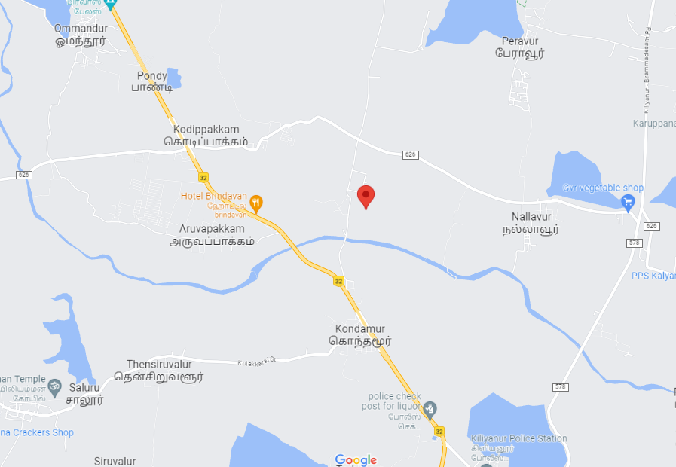
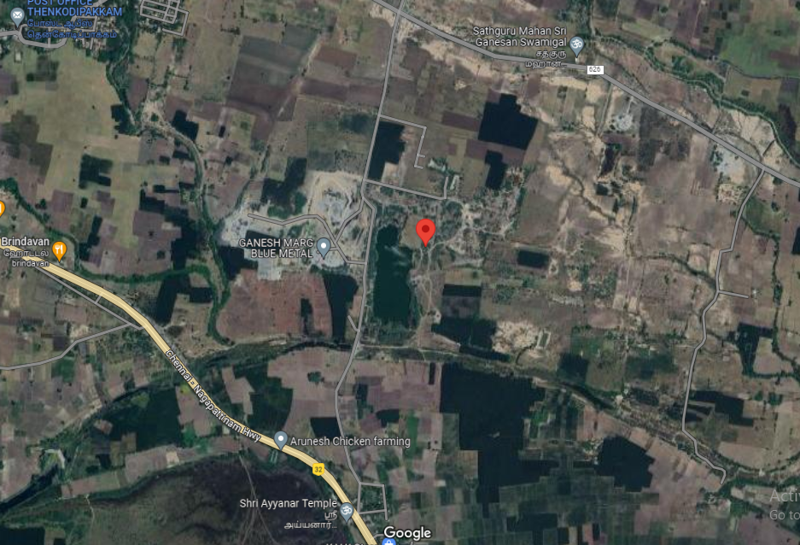

ENCLOSURE: 3– PHOTOGRAPHS OF THE PROPERTY

NO PHOTGRAPHS WERE TAKEN SINCE SITE SURVEY WAS NOT CONDUCTED

ENCLOSURE: 4– COPY OF CIRCLE RATE

CIRCLE RATE FOR KONDAMUR VILLAGE: (09/06/2017 TO 31/03/2023)

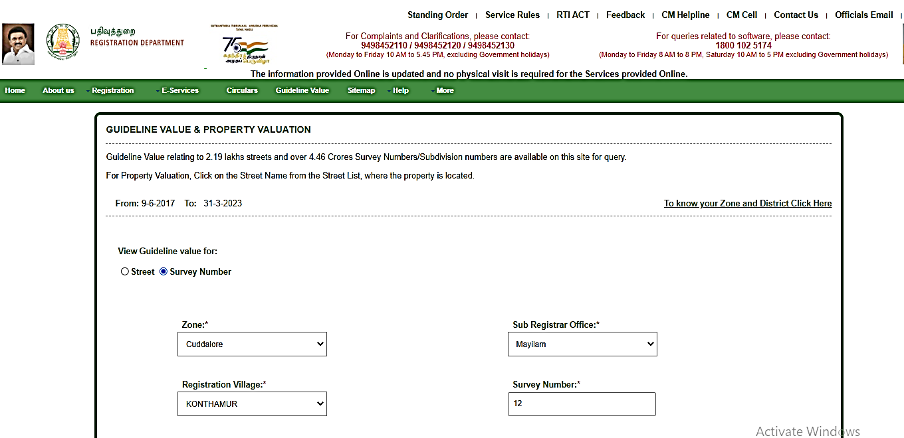
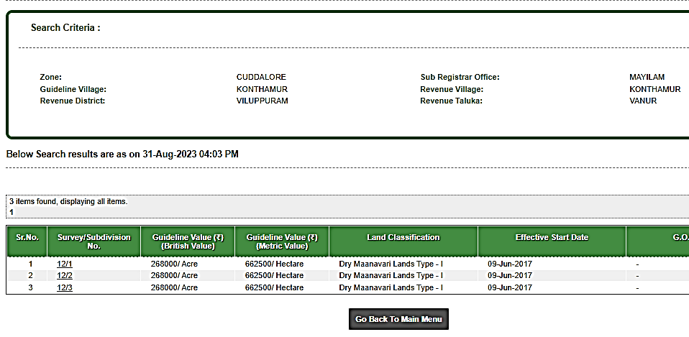

CIRCLE RATE FOR THENKODIPAKKAM VILLAGE: (09/06/2017 TO 31/03/2023)

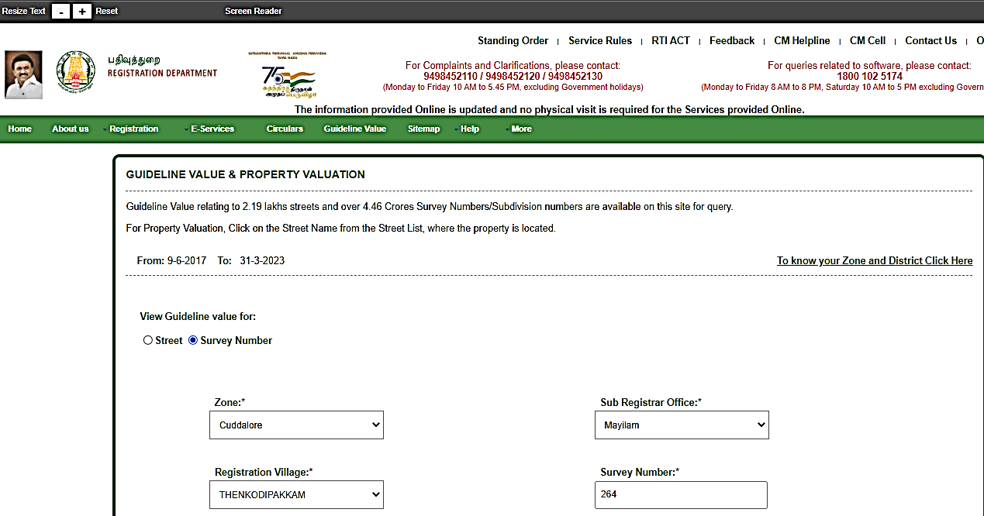

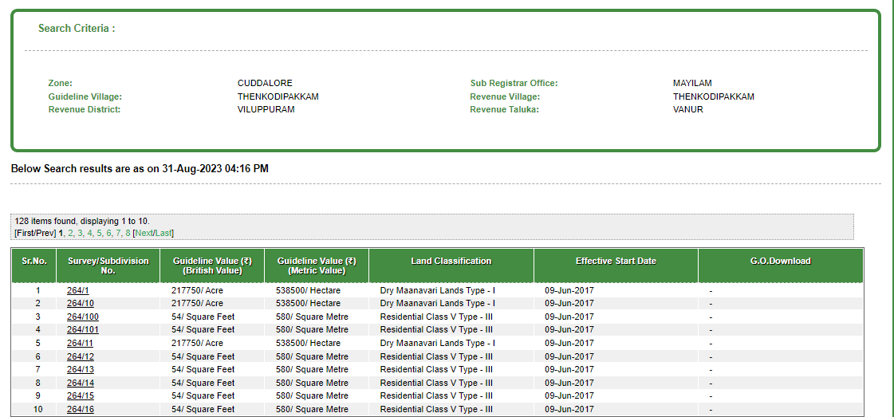

CIRCLE RATE FOR NALLAVUR VILLAGE: (09/06/2017 TO 31/03/2023)

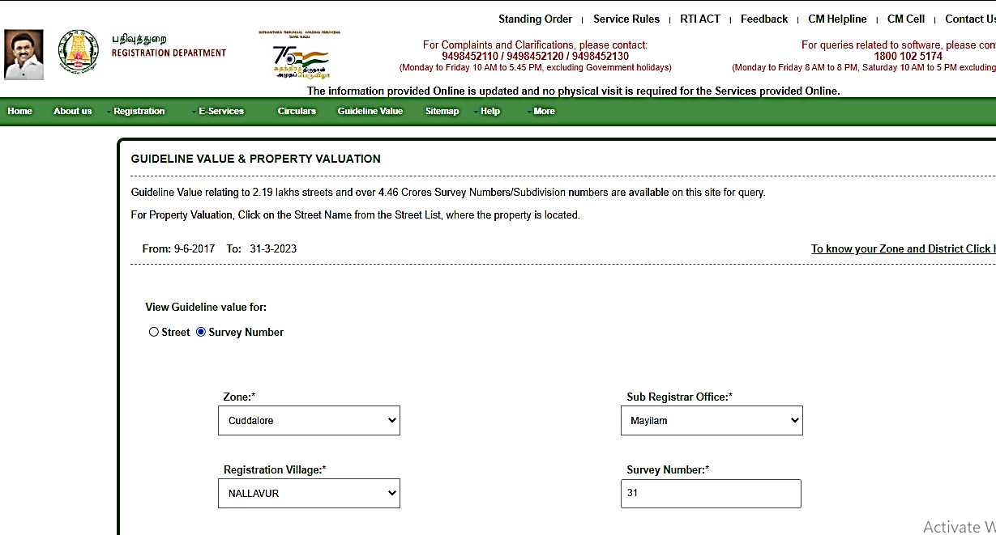

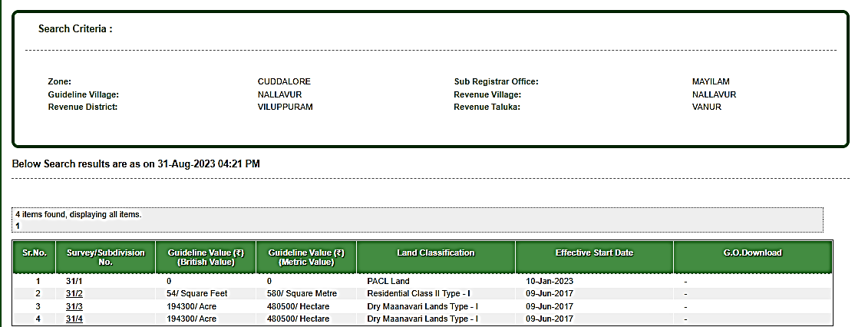
ENCLOSURE: 5– COPY OF IMPORTANT SAMPLE DOCUMENTS

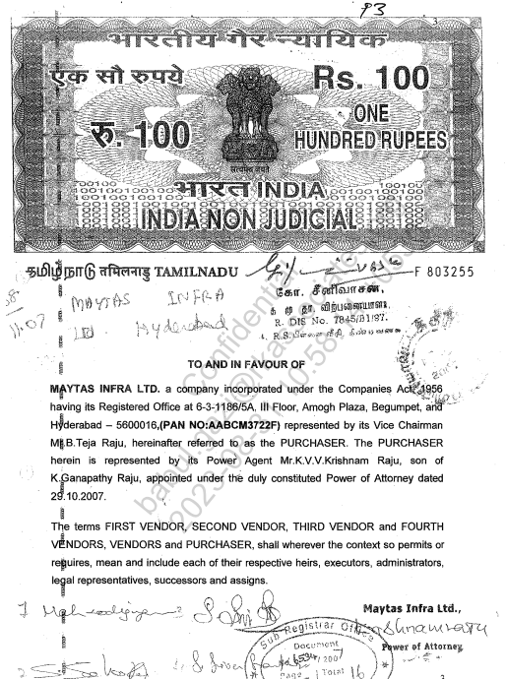

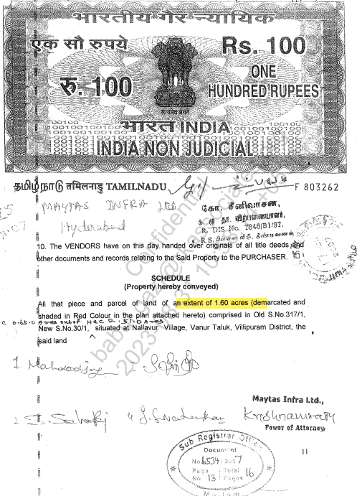

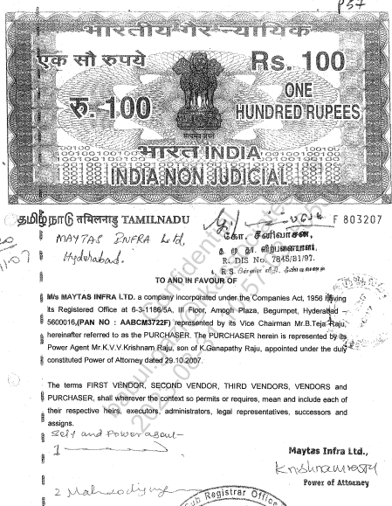

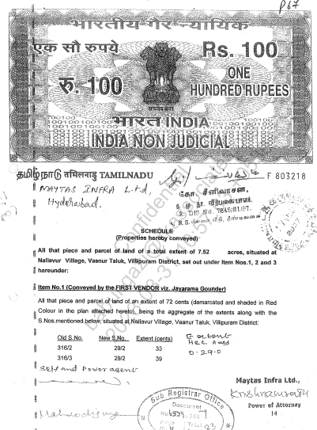

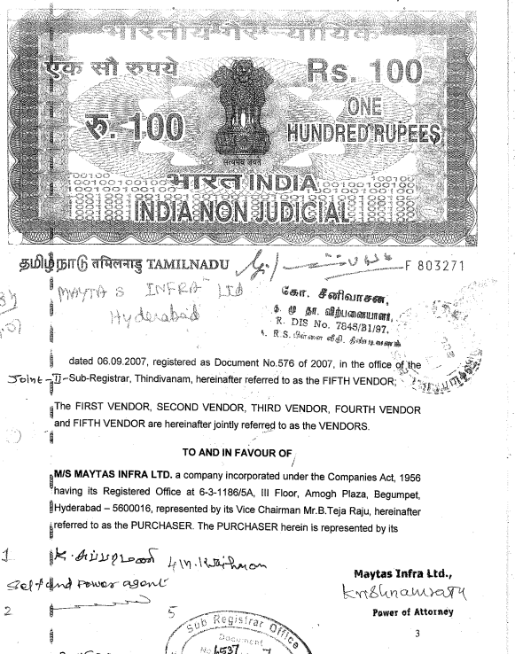

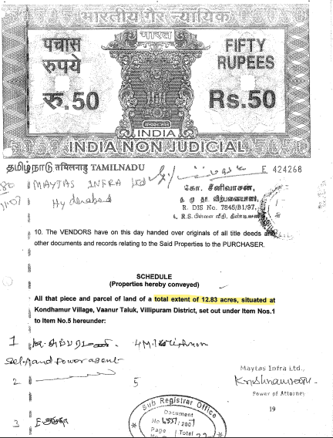

ENCLOSURE: 6 – VALUER’S IMPORTANT REMARKS

Valuation is done for the asset found on as-is-where basis which owner/ owner representative/ client/ bank has shown/ identified to us on the site unless otherwise mentioned in the report of which some reference has been taken from the information/ data given in the copy of documents provided to us and informed verbally or in writing out of the standard checklist of documents sought from the client & its customer which they could provide within the reasonable expected time out of the standard checklist of documents sought from them and further based on certain assumptions and limiting conditions. The information, facts, documents, data which has become primary basis of the report has been supplied by the client which has been relied upon in good faith and is not generated by the Valuer.
The client/ owner and its management/ representatives warranted to us that the information they have supplied was complete, accurate and true and correct to the best of their knowledge. All such information provided to us either verbally, in writing or through documents has been relied upon in good faith and we have assumed that it is true & correct without any fabrication or misrepresentation. I/We shall not be held liable for any loss, damages, cost or expenses arising from fraudulent acts, misrepresentations, or willful default on part of the owner, company, its directors, employee, representative or agents.
Legal aspects for eg. Investigation of title, ownership rights, lien, charge, mortgage, lease, sanctioned maps, verification of documents provided to us such as title documents, Map, etc. from any concerned Govt. office etc. have to be taken care by legal expert/ Advocate and same is not done at our end. It is assumed that the concerned Lender/ Financial Institution has asked for the valuation of that property after satisfying the authenticity of the documents given to us for which the legal verification has been already taken and cleared by the competent Advocate before requesting for the Valuation report. I/ We assume no responsibility for the legal matters including, but not limited to, legal or title concerns.
In the course of the valuation, we were provided with both written and verbal information. We have however, evaluated the information provided to us through broad inquiry, analysis and review but have not carried out a due diligence or audit of the information provided for the purpose of this engagement. Our conclusions are based on the assumptions and other information provided to us by the client during the course of the assessment.
Getting cizra map or coordination with revenue officers for site identification is a separate activity and is not part of the Valuation services and same has not been done in this report unless otherwise stated.
Wherever any details are mentioned in the report in relation to any legal aspect of the property such as name of the owner, leases, etc. is only for illustration purpose and should not be construed as a professional opinion. Legal aspects are out of scope of this report. Details mentioned related to legal aspect are only based on the copy of the documents provided to us and whatever we can interpret as a non-legally trained person. This should be cross validated with a legal expert. We do not vouch any responsibility regarding the same.
We have made certain assumptions in relation to facts, conditions & situations affecting the subject of, or approach to this exercise that has not been verified as part of the engagement rather, treated as “a supposition taken to be true”. If any of these assumptions prove to be incorrect then our estimate on value will need to be reviewed.
This is just an opinion report based on technical & market information having general assessment & opinion on the indicative, estimated Market Value of the property for which Bank has asked to conduct the Valuation. It doesn’t contain any other recommendations of any sort including but not limited to express of any opinion on the suitability or otherwise of entering into any transaction with the borrower.
We have relied on the data from third party, external sources & information available on public domain to conclude the valuation. These sources are believed to be reliable and therefore, we assume no liability for the truth or accuracy of any data, opinions or estimates furnished by others that have been used in this analysis. Where we have relied on the data, opinions or estimates from external sources, reasonable care has been taken to ensure that such data is extracted from authentic sources, however we still can’t vouch its authenticity, correctness, or accuracy.
Analysis and conclusions adopted in the report are limited to the reported assumptions, conditions and information came to our knowledge during the course of the work and based on the Standard Operating Procedures, Best Practices, Caveats, Limitations, Conditions, Remarks, Important Notes, Valuation TOR and definition of different nature of values.
Value varies with the Purpose/ Date/ Asset Condition & situation/ Market condition, demand & supply, asset utility prevailing on a particular date/ Mode of sale. The indicative & estimated prospective Value of the asset given in this report is restricted only for the purpose and other points mentioned above prevailing on a particular date as mentioned in the report. If any of these points are different from the one mentioned aforesaid in the Report then this report should not be referred.
Our report is meant ONLY for the purpose mentioned in the report and should not be used for any other purpose. The Report should not be copied or reproduced for any purpose other than the purpose for which it is prepared for. I/we do not take any responsibility for the unauthorized use of this report.
We owe responsibility only to the authority/client that has appointed us as per the scope of work mentioned in the report. We will not be liable for any losses, claims, damages or liabilities arising out of the actions taken, omissions or advice given by any other person. In no event shall we be liable for any loss, damages, cost or expenses arising in any way from fraudulent acts, misrepresentations or willful default on part of the client or companies, their directors, employees or agents.
This report is having limited scope as per its fields & format to provide only the general basic idea of the value of the property prevailing in the market based on the site inspection and documents/ data/ information provided by the client. The suggested indicative prospective estimated value should be considered only if transaction is happened as free market transaction.
The sale of the subject property is assumed to be on an all cash basis. Financial arrangements would affect the price at which the property may sell for if placed on the market.
The actual realizable value that is likely to be fetched upon sale of the asset under consideration shall entirely depend on the demand and supply of the same in the market at the time of sale.
While our work has involved an analysis & computation of valuation, it does not include detailed estimation, design/ technical/ engineering/ financial/ structural/ environmental/ architectural/ compliance survey/ safety audit & works in accordance with generally accepted standards of audit & other such works. The report in this work in not investigative in nature. It is mere an opinion on the likely estimated valuation based on the facts & details presented to us by the client and third party market information came in front of us within the limited time of this assignment, which may vary from situation to situation.
Where a sketched plan is attached to this report, it does not purport to represent accurate architectural plans. Sketch plans and photographs are provided as general illustrations only.
Documents, information, data including title deeds provided to us during the course of this assessment by the client is reviewed only upto the extent required in relation to the scope of the work. No document has been reviewed beyond the scope of the work. These are not reviewed in terms of legal rights for which we do not have expertise. Wherever any information mentioned in this report is mentioned from the documents like owners name, etc., it is only for illustration purpose and may not necessary represent accuracy.
The report assumes that the borrower/company/business/asset complies fully with relevant laws and regulations applicable in its area of operations and usage unless otherwise stated, and that the companies/business/assets is managed in a competent and responsible manner. Further, as specifically stated to the contrary, this report has given no consideration to matters of a legal nature, including issues of legal title and compliance with relevant laws, and litigations and other contingent liabilities that are not recorded/reflected in the documents/ details/ information/ data provided to us.
This valuation report is not a qualification for accuracy of land boundaries, schedule (in physical terms), dimensions & identification. For this land/ property survey report can be sought from a qualified private or Govt. surveyor.
This Valuation report is prepared based on the facts of the property on the date of the survey. Due to possible changes in market forces, socio-economic conditions, property conditions and circumstances, this valuation report can only be regarded as relevant as at the valuation date. Hence before financing, Banker/ FI should take into consideration all such future risk and should loan conservatively to keep the advanced money safe in case of the downward trend of the property value.
Valuation of the same asset/ property can fetch different values under different circumstances & situations. For eg. Valuation of a running/ operational shop/ hotel/ factory will fetch better value and in case of closed shop/ hotel/ factory it will have considerable lower value. Similarly, an asset sold directly by an owner in the open market through free market transaction then it will fetch better value and if the same asset/ property is sold by any financer due to encumbrance on it, will fetch lower value. Hence before financing, Lender/ FI should take into consideration all such future risks while financing and take decision accordingly.

Valuation is done for the property identified to us by the owner/ owner representative. At our end we have just visually matched the land boundaries, schedule (in physical terms) & dimensions of the property with reference to the documents produced for perusal. Method by which identification of the property is carried out is also mentioned in the report clearly. Responsibility of identifying the correct property to the Valuer/ its authorized surveyor is solely of the client/ owner for which Valuation has to be carried out. It is requested from the Bank to cross check from their own records/ information if this is the same property for which Valuation has to be carried out to ensure that owner has not misled the Valuer company or misrepresented the property due to any vested interest. Where there is a doubt about the precision position of the boundaries, schedule, dimensions of site & structures, it is recommended that a Licensed Surveyor be contacted.
In India more than 70% of the geographical area is lying under rural/ remote/ non municipal/ unplanned area where the subject property is surrounded by vacant lands having no physical demarcation or having any display of property survey or municipal number / name plate on the property clearly. Even in old locations of towns, small cities & districts where property number is either not assigned or not displayed on the properties clearly and also due to the presence of multiple/ parallel departments due to which ownership/ rights/ illegal possession/ encroachment issues are rampant across India and due to these limitations at many occasions it becomes tough to identify the property with 100% surety from the available documents, information & site whereabouts and thus chances of error, misrepresentation by the borrower and margin of chances of error always persists in such cases. To avoid any such chances of error it is advised to the Bank to engage municipal/ revenue department officials to get the confirmation of the property to ensure that the property shown to Valuer/ Banker is the same as for which documents are provided.
If this Valuation Report is prepared for the Flat/ dwelling unit situated in a Group Housing Society or Integrated Township then approvals, maps of the complete group housing society/ township is out of scope of this report and this report will be made for the specific unit based on the assumption that complete Group Housing Society/ Integrated Township and the subject unit must be approved in all respect.
Due to fragmented & frequent change in building/ urban planning laws/ guidelines from time to time, different laws/ guidelines between regions/ states and no strict enforceability of Building Bye-Laws in India specially in non-metro and scale b & c cities & Industrial areas, property owners many times extend or make changes in the covered area/ layout from the approved/ applicable limits. There are also situations where properties are decades old when there was no formal Building Bye-Laws applicable the time when the construction must have been done. Due to such discrete/ unplanned development in many regions sometimes it becomes tough for the Valuer to determine the exact lawful situation on ground. Unless otherwise mentioned in the report, the covered area present on the site as per site survey will be considered in the Valuation.
Area of the large land parcels of more than 2500 sq.mtr or of uneven shape in which there can be practical difficulty in sample measurement, is taken as per property documents which has been relied upon unless otherwise stated.

Drawing Map, design & detailed estimation of the property/ building is out of scope of the Valuation services.
Valuation is a subjective field and opinion may differ from consultant to consultant. To check the right opinion, it is important to evaluate the methodology adopted and various data point/ information/ factors/ assumption considered by the consultant which became the basis for the Valuation report before reaching to any conclusion.
Although every scientific method has been employed in systematically arriving at the value, there is, therefore, no indisputable single value and the estimate of the value is normally expressed as falling within a likely range.
Value analysis of any asset cannot be regarded as an exact science and the conclusions arrived at in many cases will, of necessity, be subjective and dependent on the exercise of individual judgment. Given the same set of facts and using the same assumptions, expert opinions may differ due to the number of separate judgment decisions, which have to be made. Therefore, there can be no standard formula to establish an indisputable exchange ratio. In the event of a transaction, the actual transaction value achieved may be higher or lower than our indicative analysis of value depending upon the circumstances of the transaction. The knowledge, negotiability and motivations of the buyers and sellers, demand & supply prevailing in the market and the applicability of a discount or premium for control will also affect actual price achieved. Accordingly, our indicative analysis of value will not necessarily be the price at which any agreement proceeds. The final transaction price is something on which the parties themselves have to agree. However, our Valuation analysis can definitely help the stakeholders to take informed and wise decision about the Value of the asset and can help in facilitating the arm’s length transaction.
This Valuation is conducted based on the macro analysis of the asset/ property considering it in totality and not based on the micro, component, or item wise analysis. Analysis done is a general assessment and is not investigative in nature.
This report is prepared on the RKA V-L1 (Basic) Valuation format as per the client requirement and scope of work. This report is having limited scope as per its fields & format to provide only the general estimated & indicative basic idea of the value of the property prevailing in the market based on the information provided by the client. No detailed analysis, audit or verification has been carried out of the subject property. There may be matters, other than those noted in this report, which might be relevant in the context of the transaction and which a wider scope might uncover.
This is just an opinion report and doesn’t hold any binding on anyone. It is requested from the concerned Client/ Bank/ Financial Institution which is using this report for mortgaging the property that they should consider all the different associated relevant & related factors & risks before taking any business decision based on the content of this report.
All Pages of the report including annexures are signed and stamped from our office. In case any paper in the report is without stamp & signature then this should not be considered a valid paper issued from this office.
As per IBA Guidelines & Bank Policy, in case the valuation report submitted by the valuer is not in order, the banks / FIs shall bring the same to the notice of the valuer within 15 days of submission for rectification and resubmission. In case no such communication is received, it shall be presumed that the valuation report has been accepted.
Defect Liability Period is 15 DAYS. We request the concerned authorized reader of this report to check the contents, data, information, and calculations in the report within this period and intimate us in writing at valuers@rkassociates.org within 15 days of report delivery, if any corrections are required or in case of any other concern with the contents or opinion mentioned in the report. If no intimation is received within 15 (Fifteen) days in writing from the date of issuance of the report, then it shall be considered that the report is complete in all respect and has been accepted by the client upto their satisfaction & use and further to which R.K Associates shall not be held responsible in any manner. After this period no concern/ complaint/ proceedings in connection with the Valuation Services will be entertained due to possible change in situation and condition of the property.
Though adequate care has been taken while preparing this report as per its scope, but still we can’t rule out typing, human errors, over sightedness of any information or any other mistakes. Therefore, the concerned organization is advised to satisfy themselves that the report is complete & satisfactory in all respect. Intimation regarding any discrepancy shall be brought into our notice immediately. If no intimation is received within 15 (Fifteen) days in writing from the date of issuance of the report, to rectify these timely, then it shall be considered that the report is complete in all respect and has been accepted by the client upto their satisfaction & use and further to which R.K Associates shall not be held responsible in any manner.
Our Data retention policy is of ONE YEAR. After this period we remove all the concerned records related to the assignment from our repository. No clarification or query can be answered after this period due to unavailability of the data.
This Valuation report is governed by our (1) Internal Policies, Processes & Standard Operating Procedures, (2) R.K Associates Quality Policy, (3) Valuation & Survey Best Practices Guidelines formulated by management of R.K Associates, (4) Information input given to us by the customer and (4) Information/ Data/ Facts given to us by our field/ office technical team. Management of R.K Associates never gives acceptance to any unethical or unprofessional practice which may affect fair, correct & impartial assessment and which is against any prevailing law. In case of any indication of any negligence, default, incorrect, misleading, misrepresentation or distortion of facts in the report then we request the user of this report to immediately or atleast within the defect liability period to bring all such act into notice of R.K Associates management so that corrective measures can be taken instantly.
R.K Associates never releases any report doing alterations or modifications by pen. In case any information/ figure of this report is found altered with pen then this report will automatically become null & void.
We are fully aware that based on the opinion of value expressed in this report, we may be required to give testimony or attend court / judicial proceedings with regard to the subject assets, although it is out of scope of the assignment, unless specific arrangements to do so have been made in advance, or as otherwise required by law. In such event, the party seeking our evidence in the proceedings shall bear the cost/professional fee of attending court / judicial proceedings and my / our tendering evidence before such authority shall be under the applicable laws.
The final copy of the report shall be considered valid only if it is in hard copy on the company’s original letter head with proper stamp and sign on it of the authorized official upon payment of the agreed fees. User shall not use the content of the report for the purpose it is prepared for only on draft report, scanned copy, email copy of the report and without payment of the agreed fees. In such a case the report shall be considered as unauthorized and misused.

