**File No.: VIS (2023-24)-PL179-153-215 Dated: 18.08.2023**

**LENDER’S INDEPENDENT ENGINEER REPORT (1st)**

**(FOR QUARTER ENDING JUNE 2023)**

**OF**

**NEW POULTRY LAYER UNIT OF CAPACITY 2 LAKH LAYER BIRDS.**

**SITUATED AT**

**VILLAGE BARANATA, CHAKULIA, PURBI SINGBHUM, JHARKHAND.**

**IMPLEMENTED BY**

**M/S RIYA DIYA AGRO FARMS LLP**

**REPORT PREPARED FOR**

**STATE BANK OF INDIA, SME BRANCH ADITYAPUR JAMSHEDPUR.**

***\*\*Important - In case of any query/ issue or escalation you may please contact Incident Manager at le@rkassociates.org. We will appreciate your feedback in order to improve our services.***

***NOTE: As per IBA Guidelines please provide your feedback on the report within 15 days of its submission after which report will be considered to be correct.***

|  |  |  |
| --- | --- | --- |
| **TABLE OF CONTENTS** | | |
| **SR. NO.** | **DESCRIPTION** | **PAGE NO.** |
| **PART A** | **Report Summary** | **03** |
| **PART B** | **Introduction** | **05** |
|  | 1. The Project | **05** |
|  | 1. About the Borrower | **05** |
|  | 1. Location of the Project | **06** |
|  | 1. Project Overview | **07** |
|  | 1. Scope of the Project During Project Duration | **09** |
|  | 1. Purpose of the Report | **10** |
|  | 1. Methodology Adopted | **10** |
| **PART C** | **Plant Infrastructure Sections & Facility Details with Actual Progress** | **11** |
|  | 1. Building and Structure Details | **11** |
|  | 1. Plant Machinery and Equipment | **15** |
| **PART D** | **Project Consultants, Contractors & Suppliers** | **18** |
| **PART E** | **Project Cost and Means of Finance** | **19** |
|  | 1. Cost of Project | **19** |
|  | 1. Current Status and Total Expenditure Incurred Till Date | **19** |
|  | 1. Sources of Finance & Utilization of Funds | **21** |
| **PART F** | **Statutory & Regulatory Approvals, Clearances & NOC** | **22** |
| **PART G** | **Project Schedule & Current Status** | **23** |
| **PART H** | **Observations and Comments** | **23** |
| **PART I** | **Disclaimer** | **24** |

# 

# IMPORTANT NOTICE

***COPYRIGHT FORMAT:*** *This report is prepared on the copyright format of R.K Associates, to serve our clients with the best available information and analysis to facilitate them to take rational business decisions. Legally no one can copy or distribute this format without prior approval from R.K Associates. It is meant only for the advisory/ reference purpose for the organization/s as mentioned on the cover page of this report. Distribution or use of this format by any organization or individual other than R.K Associates will be seen as unlawful act and necessary legal action can be taken against the defaulters.*

*This report is intended for the sole use of the intended recipient/s and contain material that is STRICTLY CONFIDENTIAL AND PRIVATE.*

***DEFECT LIABILITY PERIOD:*** *- In case of any query/ issue or escalation you may please contact Incident Manager: le@rkassociates.org. We try our level best to ensure correctness in the calculations done, rates adopted and various other data points & information mentioned in the report but still can’t rule out typing, human errors or any other mistakes. In case you find any such mistake or inaccuracy in any data point of the report please help us by bringing all such points into our notice immediately or within 15 days of the report delivery in writing, to rectify these timely failing after which R.K Associates won’t be held responsible for any such inaccuracy in any manner. We would highly appreciate your feedback in order to improve our services.*

|  |  |
| --- | --- |
| **PART A** | **REPORT SUMMARY** |

|  |  |  |
| --- | --- | --- |
| **1.** | **Name of Project:** | To set up a new poultry layer unit of capacity 2 lakh layer birds and also setting up in-house feed making unit along with layer farming business. |
| **2.** | **Project Location:** | Village-Baranata, Chakulia, District- Purbi Singbhum, State- Jharkhand |
| **3.** | **Name of the Borrower:** | M/S Riya Diya Agro Farms LLP. |
| **4.** | **Director’s/Partner’s:** | Mr. Durga Madhav Dagara  Mrs. Kajal Dagara |
| **5.** | **Prepared for Bank:** | State Bank of India Sme Branch Adityapur, Jamshedpur |
| **6.** | **LIE Consultant Firm:** | M/s. R.K. Associates Valuers & Techno Engineering Consultants (P) Ltd. |
| **7.** | **Date of Survey:** | 10th of August 2023 |
| **8.** | **Date of Report:** | 14th of August 2023 |
| **9.** | **Purpose of the Report:** | To provide fair detailed analysis report to the Bank based on the “in-scope points” mentioned below for facilitating them to take appropriate credit decision on the Project. |
| **10.** | **Scope of the work provided by the Lender:** | 1. Periodic Project physical status review 2. Periodic review of expenditure of the Project. |
| **11.** | **Documents perused for Proposal:** | 1. Brief description of the project. 2. TEV Report 3. CA Certificate 4. Project Timelines (Start & End) 5. Vendor list with machine name and cost. 6. Detailed asset list (Machines to be installed). 7. Copy of Invoices for machines already installed. 8. Quotation or Purchase Order for machines to be installed. 9. Other approvals. 10. Sanctioned Building Plan 11. Property Title Documents 12. Plant Layout |
| **12.** | **Annexure with the report:** | 1. Copies of Project Statutory approvals 2. CA Certificate |

|  |  |
| --- | --- |
| **PART B** | **INTRODUCTION** |

1. **THE PROJECT:**

**M/S RIYA DIYA AGRO FARMS LLP** is setting up a new poultry layer unit of capacity 2 lakh layer birds and also setting up in-house feed making unit along with layer farming business at Village Baranata, Chakulia, District- Purbi Singbhum, and State- Jharkhand. The unit is proposed to construct its own in house 5-6 tons per hour Maize Feed Plant having 60-90 days storage capacity silos.

1. **ABOUT THE BORROWER:**

Riya Diya Agro Farms LLP is a Limited Liability Partnership firm incorporated on 11 February 2022 as per MCA. It is registered at Registrar of Companies, Jharkhand. Its total obligation of contribution is Rs.10,00,00,000. Riya Diya Agro Farms LLP's LLP Identification Number is (LLPIN) ABA-5956 and its registered address is 5 And 6, Durga Niwas, Hume Pipe Road, Sakchi, Na Jamshedpur Purba Singhbhum Jharkhand-831001.

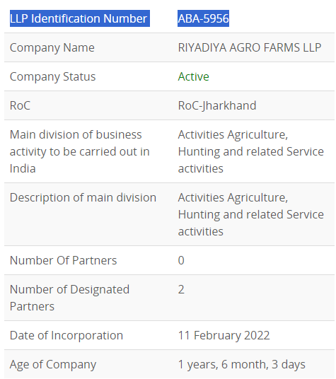

The primary set of directors/partners of “SIPL” as on date are:

* Mr. Durga Madhav Dagara
* Mrs. Kajal Dagara

As per the information available in TEV report, Mr. Durga Madhav Dagara has more than 20 years of experience as a contractor of civil construction and he has experience in rearing goat, poultry and fish in traditional way of rearing.

Information about the borrowers is just for illustration purpose and not to comment on the borrower’s credibility. Details shown above are taken from MCA, public domain and the TEV report provided to us.

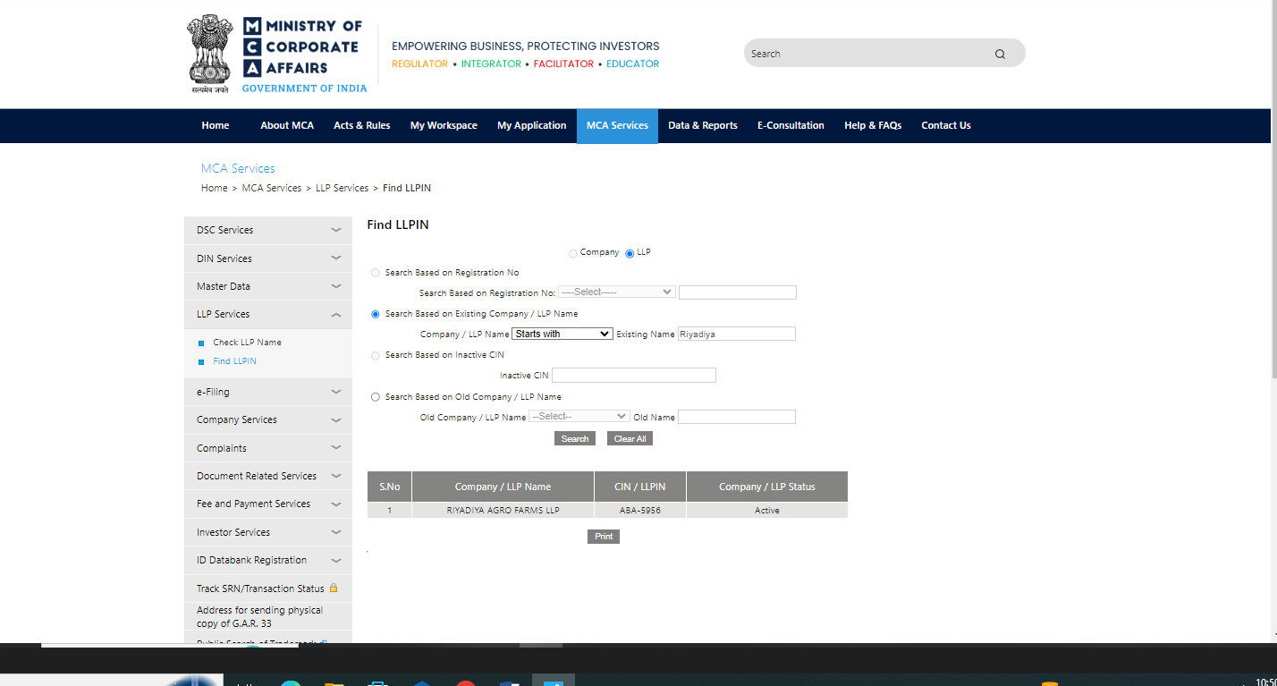

1. **PROJECT LOCATION:**

Details about Location of Unit is as below:

|  |  |
| --- | --- |
| **Particulars** | **Description** |
| **Postal Address** | |
| Village-Baranata, Chakulia, District- Purbi Singbhum, State- Jharkhand | |
| **Location** | |
| The location is in rural area of village area, nearby lands are mostly agricultural area or barren land. It is next to Power Grid Birdho. | |
| **Google Coordinates** | |
| Latitude | 22°33'08.8"N |
| Longitude | 86°44'20.4"E |
| **Connectivity Systems** | |
| Road | The project site of the subject under construction plant has a ~15 feet wide uneven approach road named Baranata Village Road. Chakulia-Belpahadi road is the nearest main road, at distance of 30 km from the subject project. |
| Rail | The Nearest Railway station to the subject locality is Chakulia Railway Station which is about 12 Km from the Subject Project. |
| Air | The nearest Domestic Airport to the subject project is Kazi Nazrul Islam Airport which is about 160 Km from the subject project. |
| **Geographical Conditions On The Site** | |
| Temperature | The area has generally hot climate. The maximum temperature is around 105°F while the minimum is 36°F. |
| Rainfall | The average annual rainfall of this area is about 1200 mm to 1400 mm. |
| Seismic Zone | The above plant site area falls in Seismic Zone II. |

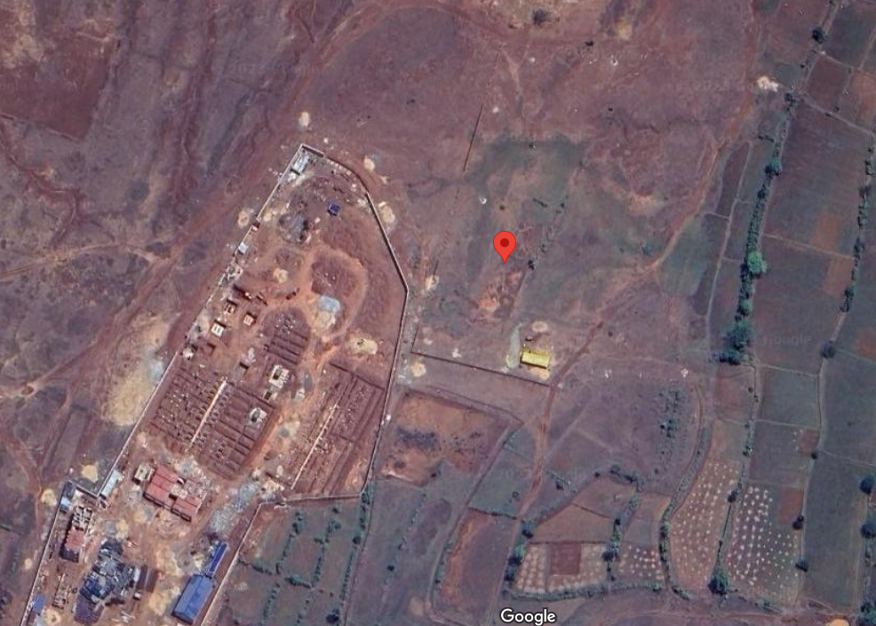

**Figure: Location of Manufacturing Unit**

1. **PROJECT OVERVIEW:**

**M/S RIYA DIYA AGRO FARMS LLP** is setting up a new poultry layer unit of capacity 2 lakh layer birds and also setting up in-house feed making unit along with layer farming business at Village Baranata, Chakulia, District- Purbi Singbhum, and State- Jharkhand. The unit is proposed to construct its own in house 5-6 tons per hour Maize Feed Plant having 60-90 days storage capacity silos.

*Layer birds are egg-laying poultry birds which are raised for the purpose of commercial egg production.*

The cost of project is estimated to be Rs.23.95 Cr. which broadly consists of Rs.11.72 crore in Building & Civil works, and Rs.8.66 crores in Plant & Machinery. Detailed breakup of the same is available in later section of the report.

**Implementation Schedule:**

|  |  |
| --- | --- |
| Start Date | End Date |
| 1/3/2023 | 31/12/2024 |

*Source: Project timeline report provided to us.*

**Status of Implementation:**

1. **Civil Works/Land Development**: The land levelling and boundary wall work is complete. The civil foundation work of grooming house and layer house has been started and is completed till the plinth beam as on the survey, dated 10/08/2023.
2. **Plants/Machines:**

In the Subject unit, M/S Riya Diya Agro Farms LLP has proposed to install following Plant/ Machines as listed below: -

|  |  |  |  |
| --- | --- | --- | --- |
| S. No | Particulars | Supplier/Vendor | Purchase Basic Amount In Rs. (In CR.) |
|
| 1 | Water Plant | Netsol Water Solutions Pvt Ltd | 0.11 |
| 2 | DSI Automatic Cage 4 Row 5 tier (one growing and 4 layer house) | DS ISPAT | 7.72 |
| 3 | Maize feed Plant | Sai Durga Agrotech Industries | 0.24 |
| 4 | Silos | Sai Durga Industries | 0.59 |

As per the information provided by the client representative the unit has received various quotations of the proposed machines and have finalized some out of them. Detailed status is mentioned in later section of the report. The quotation and purchase order of the plants/machines have been attached in the annexure with the report.

**As per the onsite survey visit no machine has been installed/ received at the site yet.**

Since the poultry farm comes under Agricultural sector, therefore it doesn’t requires any major approvals as such.

As per the Demand Note Cum Load Sanction Letter for New HT connection M/S RIYA DIYA AGRO FARMS LLP has demanded 232 KVA load on 11 KV Supply Voltage from Jharkhand Bijli Vitran Nigam Limited, (JBVNL) Jharkhand.

1. **SCOPE OF WORK DURING PROJECT DURATION:**
2. Periodic Project physical status review
3. Periodic review of expenditure of the Project.
4. **PURPOSE OF THE REPORT:** To provide fair detailed analysis report to the Bank based on the “in-scope points” mentioned above for facilitating them to take appropriate credit decision on the Project.
5. **METHODOLOGY ADOPTED:**
6. Study of Project Planning documents/ reports to know about the Project.
7. Additional information, data, documents collection from the borrower.
8. Site Inspection.
9. Review and analysis of the documents and information obtained from the borrower and corroborating it with the site inspection status.
10. Information compilation, analysis and reporting.

|  |  |
| --- | --- |
| **PART C** | **PLANT INFRASTRUCTURE SECTIONS & FACILITY DETAILS WITH ACTUAL PROGRESS** |

1. **LAND DEVELOPMENT AND OTHER STRUCTURE WORK DETAILS:**

The project is developed on total land area 6.15 Acre (as per the information provided to us, during site survey) owned by M/S Riya Diya Agro Farms LLP. Since land was already with the promoters so it is not part of the LIE report as such.

Riya Diya Agro Farms LLP is setting up below mentioned units/ Sections in the Project as sanctioned building plan approved by Pramukh, Chakulia Prakhand, Jharkhand:

|  |  |  |  |  |  |
| --- | --- | --- | --- | --- | --- |
| **Building Sheet For Riya Diya Agro Farms LLP, Village Baranata, Chakulia, Purbi Singbhum, Jharkhand** | | | | | |
| **SR. No.** | **Particulars** | **Floors** | **Type of Structure** | **Area  *(in sq. mt.)*** | **Height *(in feet)*** |
| 1 | Administrative Building | G+1 | R.C.C | 1572 | 10 |
| 2 | Grooming and Breeding Shed | 1 | Tin Shed | 996 | 45 |
| 3 | Layer 1 | 1 | Tin Shed | 1342 | 45 |
| 4 | Layer 2 | 1 | Tin Shed | 1386 | 45 |
| 5 | Layer 3 | 1 | Tin Shed | 1386 | 45 |
| 6 | Layer 4 | 1 | Tin Shed | 1386 | 45 |
| 7 | Food Mill | 1 | Tin Shed | 563 | 45 |

*Note: The above details are taken from the sanctioned building plan provided.*

For setting up/ development of above listed sections and other civil works, Riya Diya Agro Farms LLP has estimated Rs.11.72 crore out of total project cost amounting to Rs.23.95 Crore. Cost is estimated based on the assessment done by L K Suman & Engineers. Breakup of Rs.11.72 Crore is shown below:

|  |  |  |  |  |
| --- | --- | --- | --- | --- |
| **Building Sheet For Riya Diya Agro Farms LLP, Village Baranata, Chakulia, Purbi Singbhum, Jharkhand** | | | | |
| **SR. No.** | **Particulars** | **QTY** | **Rate** | **Amount** |
| 1 | Boundary Wall (RCC Slab Boundary) | 2,250 | 1,200 | 2,700,000 |
| 2 | Land Survey | 1 | LS | 100,000 |
| 3 | Land Dressing | 210,000 | 50 | 10,500,000 |
| 4 | Staff quarters | 4,000 | 2,000 | 8,000,000 |
| 5 | Office | 1,500 | 2,000 | 3,000,000 |
| 6 | Breading And Grooming Shed | 10,500 | 800 | 8,400,000 |
| 7 | Layer Sheds | 60,000 | 800 | 48,000,000 |
| 8 | Labor Huts | 2,000 | 1,500 | 3,000,000 |
| 9 | Boring | 3 | LS | 800,000 |
| 10 | Underground Water storage & Overhead tank | 200,000 | 10 | 2,000,000 |
| 11 | Security Room | 200 | 1,500 | 300,000 |
| 12 | Generator Room | 500 | 1,000 | 500,000 |
| 13 | Food meal storage | 9,000 | 800 | 7,200,000 |
| 14 | Elec Sub Station Room | 320 | 1,250 | 400,000 |
| 15 | Misc. Room | 500 | 1,200 | 600,000 |
| 16 | Lab | 150 | 2,000 | 300,000 |
| 17 | Mess and kitchen | 400 | 2,000 | 800,000 |
| 18 | Silo civil work |  | LS | 1,500,000 |
| 19 | Parking Shed | 800 | 500 | 400,000 |
| 20 | Toilet | 400 | 3,000 | 1,200,000 |
| 21 | Changing Room | 200 | 2,000 | 400,000 |
| 22 | Entry and exit gate |  | LS | 600,000 |
| 23 | Safety tank |  | LS | 1,000,000 |
| 24 | Wastage water storage |  | LS | 500,000 |
| 25 | Temple | 100 | 2,000 | 200,000 |
| 26 | Pump room | 200 | 1,500 | 300,000 |
| 27 | Egg store | 1,000 | 2,000 | 2,000,000 |
| 28 | Guest House | 2,000 | 2,000 | 4,000,000 |
| 29 | First Aid Room | 100 | 2,000 | 200,000 |
| 30 | Green Development | 20,000 | 50 | 1,000,000 |
| 31 | Disinfectant Area |  | LS | 200,000 |
| 32 | Drain for waste water | 1,000 | 1,000 | 1,000,000 |
| 33 | Drain for rain water | 1,000 | 1,000 | 1,000,000 |
| 34 | Internal Boundary | 1,250 | 1,200 | 1,500,000 |
| 35 | Internal road | 40,000 | 75 | 3,000,000 |
| 36 | Chimney |  | LS | 300,000 |
| 37 | Water Purifying Plant |  | LS | 500,000 |
| **Total(Rs.)** | | | | **11,74,00,000** |

**Notes:**

1. The above estimation of cost is as per the details provided to us by the Client/Bank done by L K Suman & Engineers.
2. Building site Plans have been prepared by Suman (Architect and Consultant) and is approved by Pramukh, Chakulia Prakhand, Jharkhand.
3. Site plan provided to us doesn’t exclusively shows all the buildings as shown in the cost estimate.
4. During site visit it was observed that the construction work is in progress, and construction of Labour Hut was in progress and a temporary store has been constructed with tin shed, the same is not been shown in the sanctioned building plan.

**Progress of Building/Civil Structures or other civil works:**

The Physical progress is considered based on approximate observation during our visit on 10th August 2023 of the Subject Plant, during the Course of our visit to the subject Project Site following observations were made:

**Table 01**

|  |  |  |
| --- | --- | --- |
| **Sr. No.** | **Description** | **Remarks** |
| 1. | Land Development | * Mud filling is done. (However the height and quantity of mud to be filled can differ as per requirement) * Proper dressing of soil/earth is not done yet. |
| 2. | Boundary Wall | * The demarcation of subject land boundary is done in two ways:  1. Precast Cement Boundary Wall (With barbed wire) 2. Chain link fencing (With barbed wire)  * The total length of boundary wall is 3552 running feet, further bifurcated into 2478 running feet of Precast Cement Boundary Wall and the rest is Chain link fencing.   *(The measurement is according to the information provided by the representative, as the land area is very vast to be measured manually and also not updated on Google map.)*     * Average height of boundary wall is 6-7 feet, including barbed wire. |
| 3. | Breeding and grooming shed | * Foundation/footing work is in progress, and is completed till plinth beam level. * Dimension according to the site survey measurement were found to be: 253 feet x 44 feet. |
| 4. | Layer Shed-1 | * Foundation/footing work is in progress and more than half of the plinth beam is been casted. * Dimension according to the site survey measurement were found to be: 354 feet x 45 feet. |
| 5. | Silo (Civil Work) | * Excavation work is in progress. |
| 6. | Labour Quarter | * The construction is in progress. * Block work is completed, casting of slab and internal work is left. * Dimension according to the site survey measurement were found to be: 80 feet x 22 feet.   *Note: The following structure has not been shown/mentioned in the sanctioned site plan.* |
| 7. | Store | * Store with tin shed is constructed, however it is informed to be temporary structure by the representative.   *Note: The following structure is not shown/ mentioned in the sanctioned site plan.* |

**The percentage completion of the civil work executed is shown in chart form below:**

1. **MACHINERIES & OTHER EQUIPMENTS AND UTILITIES:**

The total amount envisaged against the purchase of Plant and Machinery amounts to Rs.8.66 cr. Breakup of which is as below:

|  |  |  |  |
| --- | --- | --- | --- |
| **S. No** | **Particulars** | **Supplier/Vendor** | **Purchase Basic Amount In Rs.**  **(In CR.)** |
|
| 1 | Water Plant | Netsol Water Solutions Pvt Ltd | 0.11 |
| 2 | DSI Automatic Cage 4 Row 5 tier(one growing and 4 layer house) | DS ISPAT | 7.72 |
| 3 | Maize feed Plant | Sai Durga Agrotech Industries | 0.24 |
| 4 | Silos | Sai Durga Industries | 0.59 |
|  | **Total** |  | **8.66** |

The above mentioned machines have not yet arrived on site, further detailed status of which is shown below:-

|  |  |  |  |  |  |  |
| --- | --- | --- | --- | --- | --- | --- |
| **S. No** | **Particulars** | **Supplier/Company** | **Status Achieved** | | | |
| **Quotation Received** | **Purchase Order** | **Received on site** | **Installed** |
| 1 | Water Plant | Netsol Water Solutions Pvt Ltd | Z:\In Progress Files\Abhinav Chaturvedi\Check.png | × | × | × |
| 2 | Automatic Cage 4 Row 5 tier(one growing and 4 layer house) | DS ISPAT | Z:\In Progress Files\Abhinav Chaturvedi\Check.png | Z:\In Progress Files\Abhinav Chaturvedi\Check.png | × | × |
| 3 | Maize feed Plant | Sai Durga Agrotech Industries | Z:\In Progress Files\Abhinav Chaturvedi\Check.png | Z:\In Progress Files\Abhinav Chaturvedi\Check.png | × | × |
| 4 | Silos | Sai Durga Industries | Z:\In Progress Files\Abhinav Chaturvedi\Check.png | Z:\In Progress Files\Abhinav Chaturvedi\Check.png | × | × |
| 5 | Transformer  (315 KVA) | Synergy Power Equipment Pvt. Ltd. | Z:\In Progress Files\Abhinav Chaturvedi\Check.png | Z:\In Progress Files\Abhinav Chaturvedi\Check.png | Z:\In Progress Files\Abhinav Chaturvedi\Check.png | Z:\In Progress Files\Abhinav Chaturvedi\Check.png |
| 6 | Silent Diesel Generator  (30 KVA) | Kirloskar | Z:\In Progress Files\Abhinav Chaturvedi\Check.png | Z:\In Progress Files\Abhinav Chaturvedi\Check.png | Z:\In Progress Files\Abhinav Chaturvedi\Check.png | Z:\In Progress Files\Abhinav Chaturvedi\Check.png |

**Technical details and aspect of the above plant/machineries and equipment’s as per the quotation is shown below:**

1. **Water Plant:**

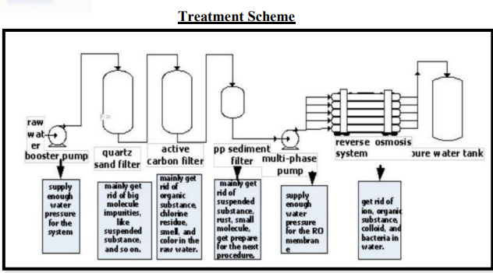

1. **Automatic Cage 4 row 5 tier(one growing and 4 layer house)**

The setup proposed to be installed in the layer house is automated, and it includes feeding trolley, manure removal system, egg collection system, water drinking system etc.

**Parameters:**

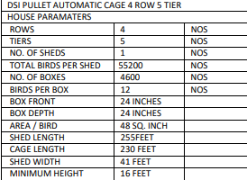

1. **Silos**

GI Corrugated 1500 MT Flat bottom silos with loading and unloading system.

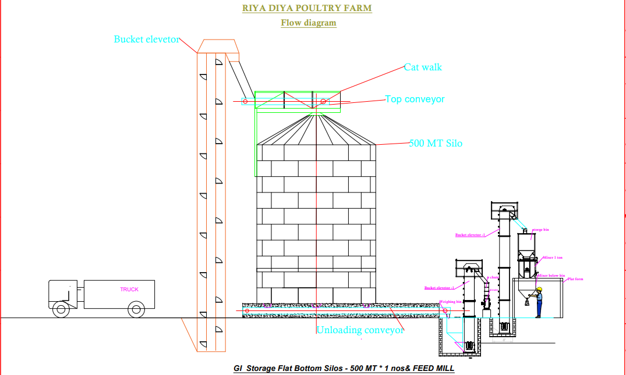

1. **Transformer (315 KVA)**

Company: Synergy Power Equipment Pvt. Ltd.

Voltages: 1100 High Voltage to 433 Low Voltage

Phases: 3 phase

1. **Silent Diesel Generator**

Company: Kirloskar

Load: 30 KVA

Features: Silent Generator

**Note:**

1. The Machineries/ equipment’s mentioned in the above table have not yet arrived on the site on the date of the survey.
2. On the date of the survey only water plant, transformer and generator was found of the site.
3. The total amount envisaged against the purchase of Plant, Machinery and equipment’s amounts to Rs.8.66 cr., according to the documents provided. However as per the purchase orders provided to us, it sums up to be 8.82 Cr. (This does not include the water plant and the transformer and generator found on site).
4. As per purchase orders provided to us by the company the major vendor for the machines, plants and equipment’s is M/s DS ISPAT, Sai Durga Agrotech Industries, Netsol Water Solutions Pvt Ltd etc. Attachment of the purchase orders can be found in annexure.

|  |  |
| --- | --- |
| **PART D** | **PROJECT CONSULTANTS, CONTRACTORS & SUPPLIERS** |

According to the company representative, the Construction Contractor appointed is M/S Amit Construction. However, no relevant documents have been provided to us for it.

As the machines or parts of plant to be established, has not arrived on site. Thus relying on the purchase orders provided, the suppliers for Plant, machines and equipment’s are:

* Netsol Water Solutions Pvt Ltd
* DS ISPAT
* Sai Durga Agrotech Industries
* Synergy Power Equipment Pvt. Ltd.
* Kirloskar

|  |  |
| --- | --- |
| **PART E** | **PROJECT COST & MEANS OF FINANCE** |

1. **TOTAL PROJECT COST:** M/S RIYA DIYA AGRO FARMS LLP has estimated the Total Project Cost amounting to Rs.23.95 Cr.

|  |  |
| --- | --- |
| **Particulars** | **In Rs. (In Cr.)** |
| Land Development/Building/Other Civil Works | 11.72 |
| Plant & Machinery | 8.66 |
| Electrical Installation | 0.41 |
| Furniture & Fixture | 0.06 |
| Security Deposit | 0.02 |
| Others | 1.42 |
| Working Capital Margin | 1.66 |
| **Total** | **23.95** |

1. **CURRENT STATUS & TOTAL EXPENDITURE INCURRED TILL DATE:** Details of the expenditure in the Table below is recordedfor the expenditure incurred up to 30th June 2022 as per CA Certificate dated 10th July 2023 with UDIN No. 23403137BGXMEX9281.

|  |  |  |  |  |  |  |
| --- | --- | --- | --- | --- | --- | --- |
| **PARTICULARS** | **TOTAL ESTIMATED COST (In Rs. In Cr.)** | **EXPENDITURE SHOWN BY COMPANY (In Rs. In Cr.)** | **AMOUNT OF WORK DONE ON SITE** | **ADVANCES PAID** | **AMOUNT INCURRED TILL 30.06.2023** | **REMARKS** |
| Land Development, Building and other civil works. | 11.72 | 2.41 | ~2.42 | No information available | 2.41 | As per the current status of the work on site, we have also calculated the estimated expenditure which must have incurred at site which comes out to be similar to what company is showing. Detailed working on our calculation in this regard is attached below. |
| Plant, Machinery and equipment. | 8.66 | 0.79 | 0.00 | No information available | --- | No machine has come on the site yet. Amount incurred till date is mentioned only as per CA Certificate. |
| Pre-operative Expenses | 0.45 | 0.215 | --- | No information available | --- | --- |
| Interest During Construction | 0.76 | 0.0025 | --- | No information available | --- | Not in scope of LIE. However as per CA Certificate it is Rs.25,000/-. |

|  |  |  |  |  |  |  |
| --- | --- | --- | --- | --- | --- | --- |
| **Construction Cost** | | | | | | |
|  | **Unit** | **L** | **B** | **Qty.** | **Rate** | **Amount** |
| **Earth Work** | m3 |  |  | 37332.28 | 200 | 7466456.7 |
| **Precast(Boundary Wall)** | Sq. ft. | 2478 | 7 | 17346 | 100 | 1734600 |
| **Chain Link Fencing(Boundary Wall)** | Sq. ft. | 1074 | 7 | 7518 | 90 | 676620 |
| **Grooming Shed** | Sq. ft. | 253 | 44 | 11132 | 400 | 4452800 |
| **Layer Shed** | Sq. ft. | 354 | 45 | 15930 | 450 | 7168500 |
| **Silo Excavation** | Sq. ft. |  |  | 0 |  | 300000 |
| **Labour Quarter** | Sq. ft. | 80 | 22 | 1760 | 1000 | 1760000 |
| **Store** | Sq. ft. | 50 | 30 | 1500 | 450 | 675000 |
|  |  |  |  |  | **Total** | **₹ 24,233,976.70** |

**Comments:**

1. We have given a general overview of the project based on expenses shown by chartered accountant in their CA certificate dated 10th July 2023 with UDIN No. 23403137BGXMEX9281 and construction progress up to June 2023 based on the Data/ information gathered from client and the observation made during the site survey.
2. Bills/ Invoices has not been verified at our end.
3. **SOURCES OF FINANCE & UTILIZATION OF FUNDS:**

The Project cost mentioned above has been planned to be covered from following resources:

|  |  |
| --- | --- |
| (Amount in Rs. Crore) | |
| PARTICULARS |  |
| Promoter’s Contribution (Equity) | 10.03 |
| Term Loan (Debt) | 13.92 |
| TOTAL | **23.95** |
| (Amount in Rs. Crore) | |
| Total Loan Requirement | |
| PARTICULARS |  |
| Term Loan (Debt) | 13.92 |
| Working capital requirement | 3.40 |
| BG | 0.20 |
| TOTAL | **17.52** |

***Source:*** *As per technical vetting report dated 7th January 2023.*

|  |  |
| --- | --- |
| **PART F** | **STATUTORY & REGULATORY APPROVALS, CLEARANCES & NOC** |

|  |  |  |  |  |
| --- | --- | --- | --- | --- |
| Sr. No. | NAME OF LICENSE/ REGISTRATION | PURPOSE | DATE OF ISSUE | Current Status |
| **ISSUING AUTHORITY** | **LICENCE NO.** |
| 1. | Sanctioned Building Plan | Approval of building plans | 27/07/2022 | Approval for the Building Plan is obtained by the Company from the competent Authority. |
| Pramukh, Chakulia Prakhand |  |
| 2. | Power Connection | Load Sanction Letter | 09/09/2022 | Load of 11 KV is demanded. |
| Jharkhand Bijli Vitran Nigam Limited | NC36938091HT |
| 3. | Groundwater Abstraction Clearance | NOC for groundwater abstraction | 04/05/2023 | NOC is obtained by the Company from the competent Authority. |
| Central Groundwater Authority | CGWA/NOC/IND/ORIG/2023/18441 |
| 4. | CA Certificate | Money spend till 30th June 2023 | 10/07/2023 | Provided |
| Agrawal M Kumar and associates. | UDIN-23403137BGXMEX9281 |
| *Observations & Comments:*  *All approvals including approvals/consents required under local regulations, building codes and approvals required from the Distribution Utility etc. relating to installation of unit are listed above and their current status, as per the documents provided.* | | | | |

|  |  |
| --- | --- |
| **PART G** | **PROJECT SCHEDULE & CURRENT STATUS** |

|  |  |  |  |  |
| --- | --- | --- | --- | --- |
| **IMPLEMENTATION SCHEDULE OF RIYA DIYA AGRO FARMS LLP** | | | | |
| **S.**  **No.** | **Particular** | **Commencement** | **Completion** | **Current Status** |
| 1. | Construction of grooming shed. | March-23 | July-23 | Refer the Table:- 01 |
| 2. | Construction of 1st layer shed. | March-23 | Nov-23 | Refer the Table:- 01 |
| 3. | Construction of 2nd layer shed. | Not yet Started | Apr-24 | Not yet Started |
| 4. | Construction of 3rd layer shed. | Not yet Started | Aug-24 | Not yet Started |
| 5. | Construction of 4th layer shed. | Not yet Started | Dec-24 | Not yet Started. |

|  |  |
| --- | --- |
| **PART H** | **OBSERVATIONS & COMMENTS** |

* The estimation of cost considered in the report is as per the TEV provided to us by the Bank.
* The Physical progress captured in the report is based on approximate observations of status of structures constructed on site during site inspection in the month of August 2023.
* The Progress of the Plant and machinery is considered as per the Invoices provided by the company.
* As per CA Certificate dated 10th July 2023 with UDIN No. 23403137BGXMEX9281 the borrower has made an expenditure on the project amounting to Rs.3.41Crore out of the total amount of Rs.23.95crore.
* Copies of PO’s is provided to us by the borrower so, we have relied on the invoices for the expenses toward Plant and machinery. Attachment of which can be found in annexure.
* This is the 1st LIE Report of the project.
* The borrower has obtained Building plan approval and Water NOC for the Unit. Attachment of which can be found in annexure.
* As per our observation of the Subject Plant during the visit in the August Month, the Project progress seems to be satisfactory, as the work was in progress. And ~80 labours were informed to be on site. Although there is a delay in construction of breeding and grooming shed, as it was ought to be completed by 31/07/2023, but the construction work is not fully completed yet. Construction of 1st layer shed was in progress and is planned to be completed by November 2023.

|  |  |
| --- | --- |
| **PART I** | **DISCLAIMER** |

* + - 1. No employee or member of R.K Associates has any direct/ indirect interest in the Project.
      2. This report is prepared based on the copies of the documents/ information which the Bank/ Borrower has provided to us out of the standard checklist of documents sought from them and further based on our assumptions and limiting conditions. The client/owner and its management/representatives warranted to us that the information they supplied was complete, accurate and true and correct to the best of their knowledge. All such information provided to us has been relied upon in good faith and we have assumed that it is true and correct in all respect. I/We shall not be liable for any loss, damages, cost or expenses arising from fraudulent acts, misrepresentations, or wilful default on part of the owner, borrower, its directors, employee, representative or agents. Verification or cross checking of the documents provided to us from the originals or from any Govt. departments/ Record of Registrar has not been done at our end since this is beyond the scope of our work. If at any time in future, it is found or came to our knowledge that misrepresentation of facts or incomplete or distorted information has been provided to us then this report shall automatically become null & void.
      3. Legal aspects for eg. investigation of title, ownership rights, lien, charge, mortgage, lease, sanctioned maps, verification of documents, etc. have not been done at our end and same has to be taken care by legal expert/ Advocate. It is assumed that the concerned Lender/ Financial Institution has satisfied them with the authenticity of the documents, information given to us and for which the legal verification has been already taken and cleared by the competent Advocate before requesting for this report. I/ We assume no responsibility for the legal matters including, but not limited to, legal or title concerns.
      4. This report is a general analysis of the project based on the scope mentioned in the report. This is not an Audit report, Design document, DPR or Techno feasibility study. All the information gathered is based on the facts seen on the site during survey for the quarter ending June 2022, verbal discussion & documentary evidence provided by the client and is believed that information given by the borrower is true best of their knowledge.
      5. All observations mentioned in the report is only based on the visual observation and the documents/ data/ information provided by the client. No mechanical/ technical tests, measurements or any design review have been performed or carried out from our side during Project assessment.
      6. Bank/FII should ONLY take this report as an Advisory document from the Financial/ Chartered Engineering firm and its specifically advised to the creditor to cross verify the original documents for the facts mentioned in the report which can be availed from the borrowing borrower directly.
      7. In case of any default in loans or the credit facility extended to the borrowing borrower, R.K Associates shall not be held responsible for whatsoever reason may be and any request for seeking any explanation from the employee/s of R.K Associates will not be entertained at any instance or situation.
      8. The documents, information, data provided to us during the course of this assessment by the client is reviewed only upto the extent required in relation to the scope of the work. No document has been reviewed beyond the scope of the work.
      9. This report only contains general assessment & opinion as per the scope of work evaluated as per the information given in the copy of documents, information, data provided to us and/ and confirmed by the owner/ owner representative to us at site which has been relied upon in good faith. It doesn’t contain any other recommendations of any sort including but not limited to express of any opinion on the suitability or otherwise of entering into any transaction with the borrower.
      10. We have relied on data from third party, external sources & information available on public domain also to conclude this report. These sources are believed to be reliable and therefore, we assume no liability for the truth or accuracy of any data, opinions or estimates furnished by others that have been used in this analysis. Where we have relied on data, opinions or estimates from external sources, reasonable care has been taken to ensure that such data has been correctly extracted from those sources and /or reproduced in its proper form and context, however still we can’t vouch its authenticity, correctness or accuracy.
      11. This Report is prepared by our competent technical team which includes Engineers and financial experts & analysts.
      12. This is just an opinion report and doesn’t hold any binding on anyone. It is requested from the concerned Financial Institution which is using this report for taking financial decision on the project that they should consider all the different associated relevant & related factors also before taking any business decision based on the content of this report.
      13. All Pages of the report including annexures are signed and stamped from our office. In case any paper in the report is without stamp & signature then this should not be considered a valid paper issued from this office.
      14. Though adequate care has been taken while preparing this report as per its scope, but still we can’t rule out typing, human errors, over sightedness of any information or any other mistakes. Therefore, the concerned organization is advised to satisfy themselves that the report is complete & satisfactory in all respect. Intimation regarding any discrepancy shall be brought into our notice immediately. If no intimation is received within 15 (Fifteen) days in writing from the date of issuance of the report, to rectify these timely, then it shall be considered that the report is complete in all respect and has been accepted by the client upto their satisfaction & use and further to which R.K Associates shall not be held responsible in any manner.
      15. Defect Liability Period is **15 DAYS**. We request the concerned authorized reader of this report to check the contents, data and calculations in the report within this period and intimate us in writing if any corrections are required or in case of any other concern with the contents or opinion mentioned in the report. Corrections only related to typographical, calculation, spelling mistakes, incorrect data/ figures/ statement will be entertained within the defect liability period. Any new changes for any additional information in already approved report will be regarded as additional work for which additional fees may be charged. No request for any illegitimate change in regard to any facts & figures will be entertained.
      16. R.K Associates encourages its customers to give feedback or inform concerns over its services through proper channel at valuers@rkassociates.org in writing within 15 days of report delivery. After this period no concern/ complaint/ proceedings in connection with the Financial Feasibility Study Services will be entertained due to possible change in situation and condition of the subject Project.
      17. Our Data retention policy is of **ONE YEAR**. After this period, we remove all the concerned records related to the assignment from our repository. No clarification or query can be answered after this period due to unavailability of the data.
      18. This Lender’s Independent Engineer report is governed by our (1) Internal Policies, Processes & Standard Operating Procedures, (2) Information/ Data/ Inputs given to us by the client and (3) Information/ Data/ Facts given to us by our field/ office technical team. Management of R.K Associates never gives acceptance to any unethical or unprofessional practice which may affect fair, correct & impartial assessment and which is against any prevailing law. In case of any indication of any negligence, default, incorrect, misleading, misrepresentation or distortion of facts in the report then it is the responsibility of the user of this report to immediately or at least within the defect liability period bring all such act into notice of R.K Associates management so that corrective measures can be taken instantly.
      19. R.K Associates never releases any report doing alterations or modifications from pen. In case any information/ figure of this report is found altered with pen then this report will automatically become null & void.

|  |  |  |
| --- | --- | --- |
| **SURVEY ANALYST** | **ENGINEERING ANALYST** | **REVIEWER** |
| Rajat Choudhary | Vishal Singh | Sr. VP Projects |
|  |  |  |

**For**

**R.K. Associates Valuers and Techno Engineering Consultants Pvt. Ltd**

**Place: Noida**

**Date: 18th Aug 2023**

***DEFECT LIABILITY PERIOD - In case of any query/ issue or escalation you may please contact Incident Manager by writing at valuers@rkassociates.org. We ensure 100% accuracy in the Calculations done, Rates adopted and various other data points & information mentioned in the report but still can’t rule out typing, human errors or any other mistakes. In case you find any mistake, variation, discrepancy or inaccuracy in any data point of the report, please help us by bringing all such points into our notice in writing at valuers@rkassociates.org within 30 days of the report delivery, to get these rectified timely, failing which R.K Associates Valuers Techno Engineering Consultants (P) Ltd. won’t be held responsible for any inaccuracy in any manner. Also, if we will not hear back anything from you within 30 days, we will assume that report is correct in all respect and no further claim of any sort will be entertained thereafter. We would welcome and appreciate your feedback & suggestions in order to improve our services.***

***COPYRIGHT FORMAT - This report is prepared on the copyright format of R.K Associates Valuers Techno Engineering Consultants (P) Ltd. to serve our clients in the best possible way. Legally no one can copy or distribute this format without prior approval from R.K Associates. It is meant only for the organization as mentioned on the cover page of this report. Distribution or use of this format other than R.K Associates will be seen as unlawful act and necessary legal action can be taken against the defaulter***

**ENCLOSURE 1: IMPORTANT DOCUMENTS EXHIBIT**

**DOCUMENT-1: CA CERTIFICATE DATED 10/07/2023**

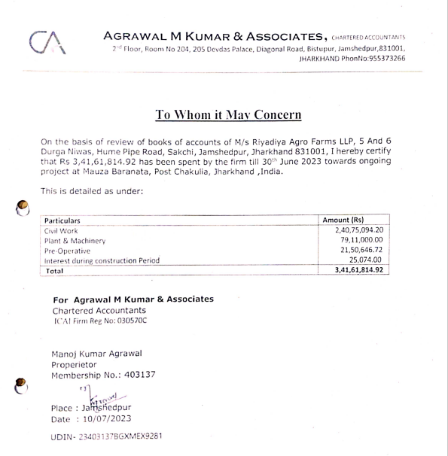

**DOCUMENT- 2: NOC FROM CENTRAL GROUND WATER AUTHORITY**

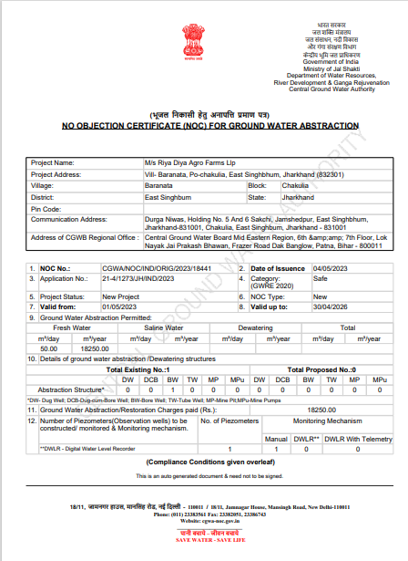

**DOCUMENT-3: ELECTRICITY DEMAND NOTE CUM LOAD SANCTION LETTER**

**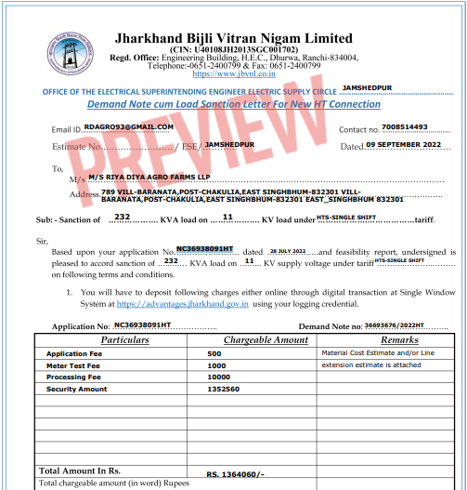**

**DOCUMENT 4: PROJECT TIMELINE**

**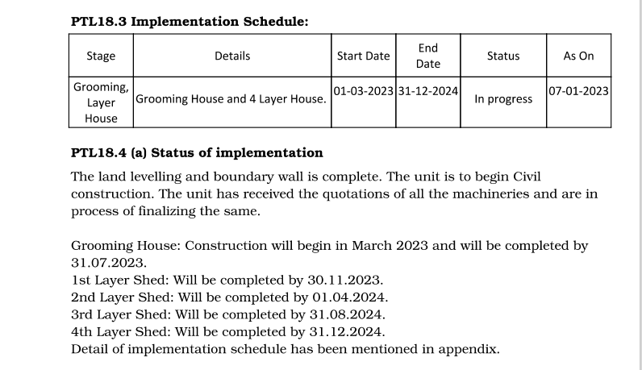**

**DOCUMENT 5: SANCTIONED LAYOUT PLAN**

**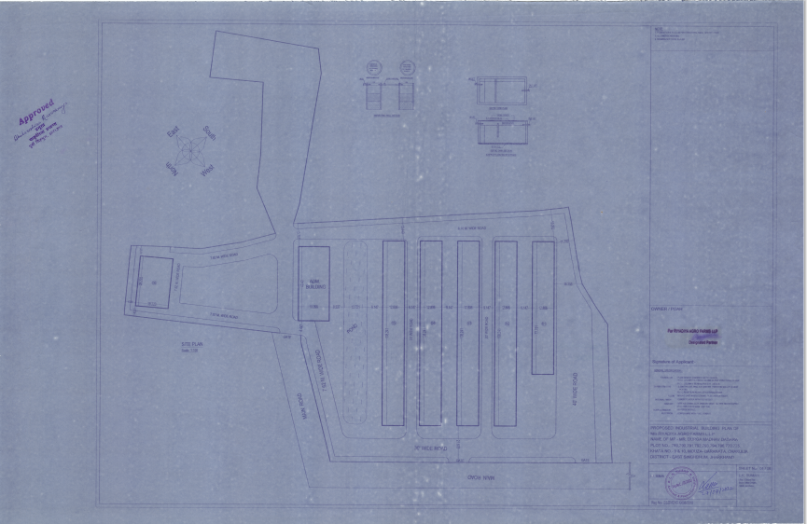**

**DOCUMENT 6: PURCHASE ORDERS OF MACHINERIES OR EQUIPMENTS.**

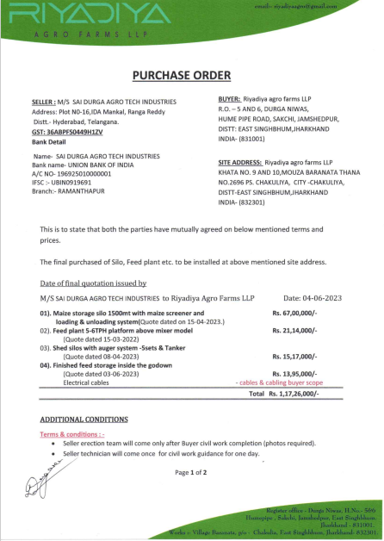

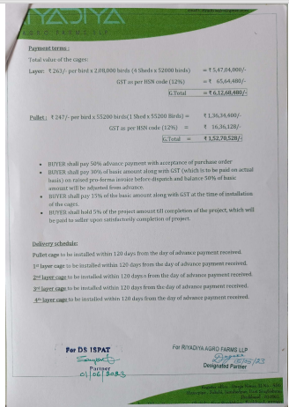

**ENCLOSURE-2: - SITE PHOTOGRAPHS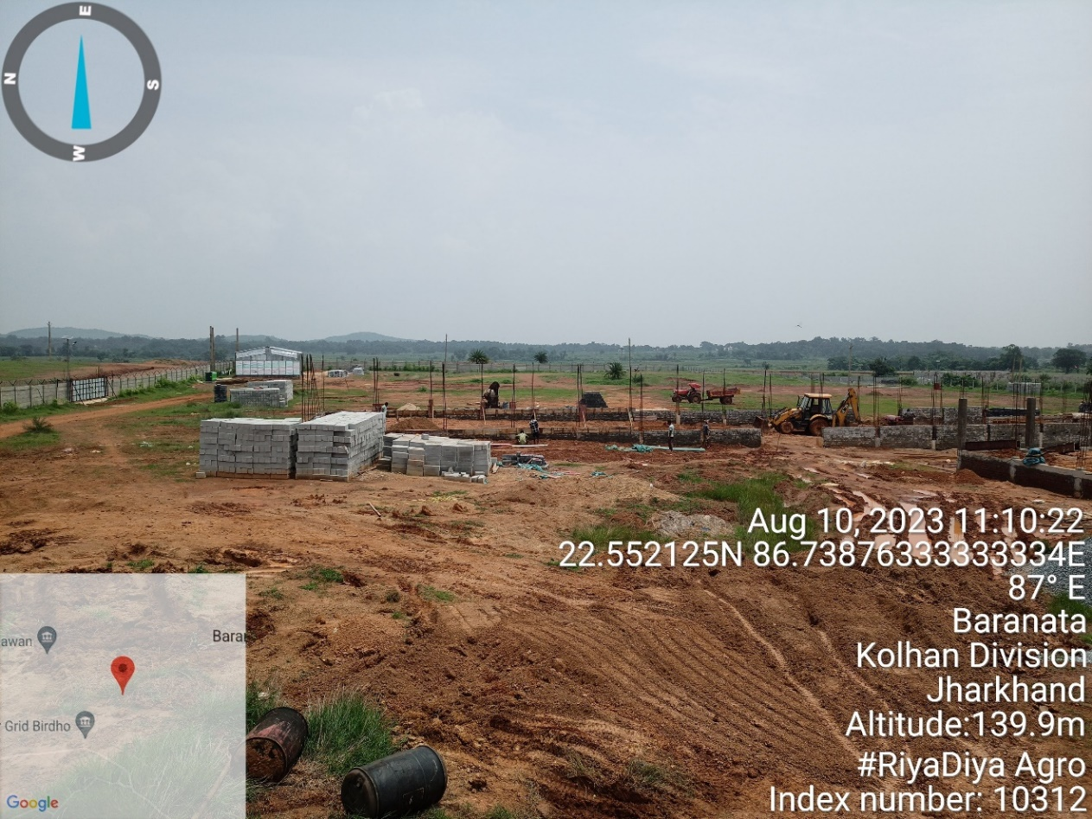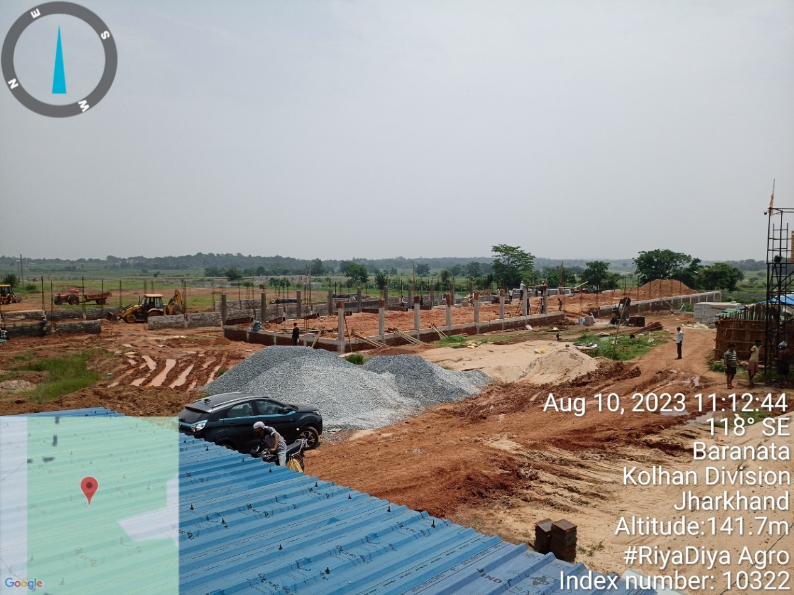**

|  |  |
| --- | --- |
|  |  |
|  |  |
| Z:\In Progress Files\Vishal Singh\WIP\Riyadiya Agro Farms LLP\Site Images\TimePhoto_20230810_112844.jpg | Z:\In Progress Files\Vishal Singh\WIP\Riyadiya Agro Farms LLP\Site Images\TimePhoto_20230810_113528.jpg |

|  |  |
| --- | --- |
|  |  |
|  | Z:\In Progress Files\Vishal Singh\WIP\Riyadiya Agro Farms LLP\Site Images\TimePhoto_20230810_115621.jpg |
| Z:\In Progress Files\Vishal Singh\WIP\Riyadiya Agro Farms LLP\Site Images\TimePhoto_20230810_113936.jpg | Z:\In Progress Files\Vishal Singh\WIP\Riyadiya Agro Farms LLP\Site Images\TimePhoto_20230810_113944.jpg |

|  |  |
| --- | --- |
| **Z:\In Progress Files\Vishal Singh\WIP\Riyadiya Agro Farms LLP\Site Images\TimePhoto_20230810_112128.jpg** | **Z:\In Progress Files\Vishal Singh\WIP\Riyadiya Agro Farms LLP\Site Images\TimePhoto_20230810_112156.jpg** |
| **Z:\In Progress Files\Vishal Singh\WIP\Riyadiya Agro Farms LLP\Site Images\TimePhoto_20230810_114604.jpg** | **Z:\In Progress Files\Vishal Singh\WIP\Riyadiya Agro Farms LLP\Site Images\TimePhoto_20230810_113951.jpg** |

|  |  |
| --- | --- |
| C:\Users\engineer2\AppData\Local\Microsoft\Windows\INetCache\Content.Word\TimePhoto_20230810_120239.jpg | Z:\In Progress Files\Vishal Singh\WIP\Riyadiya Agro Farms LLP\Site Images\TimePhoto_20230810_120233.jpg |
| **C:\Users\engineer2\AppData\Local\Microsoft\Windows\INetCache\Content.Word\TimePhoto_20230810_120229.jpg** | Z:\In Progress Files\Vishal Singh\WIP\Riyadiya Agro Farms LLP\Site Images\TimePhoto_20230810_120502.jpg |
| Z:\In Progress Files\Vishal Singh\WIP\Riyadiya Agro Farms LLP\Site Images\TimePhoto_20230810_142221.jpg | Z:\In Progress Files\Vishal Singh\WIP\Riyadiya Agro Farms LLP\Site Images\TimePhoto_20230810_142217.jpg |