File No.: VIS (2023-24)-PL194-168-238 Dated: 01.08.2023

TECHNO-ECONOMIC VIABILITY
STUDY REPORT

OF

12,700 M^3/DAY BIO GAS PRODUCING PLANT 5,000 KG PER DAY BIO CNG CAPACITY

SETUP BY

M/S SHREE JEE BIO ENERGY

REPORT PREPARED FOR

PUNJAB NATIONAL BANK, MCC HARIDWAR - 628200

**Important - In case of any query/ issue or escalation you may please contact Incident Manager Valuers@rkassociates.org. We will appreciate your feedback in order to improve our services.

NOTE: As per IBA Guidelines please provide your feedback on the report within 15 days of its submission after which report will be considered to be correct.

IMPORTANT NOTICE

COPYRIGHT FORMAT: This report is prepared on the copyright format of R. K. Associates Valuers & Techno Engineering Consultants (P) Ltd. (R. K. Associates) to serve our clients with the best possible information and analysis to facilitate them to take rational business decisions. Legally no one can copy or distribute this format without prior approval from R. K. Associates. It is meant only for the advisory/ reference purpose for the organization/s as mentioned on the cover page of this report. Distribution or use of this format or report or any of its content/ information/ data by any organization or individual other than R.K Associates will be seen as an unlawful act and necessary legal action can be taken against the defaulters.
This report is intended for the sole use of the intended recipient/s and contains material that is STRICTLY CONFIDENTIAL AND PRIVATE.

DEFECT LIABILITY PERIOD: In case of any query/ issue or escalation you may please contact Incident Manager at valuers@rkassociates.org. Though adequate care has been taken while preparing this report as per its scope, but still we can’t rule out typing, human errors, over sightedness of any information or any other mistakes. Therefore, the concerned organization is advised to satisfy themselves that the report is complete & satisfactory in all respect. Intimation regarding any discrepancy shall be brought into our notice immediately. If no intimation is received within 15 (Fifteen) days in writing from the date of issuance of the report, to rectify these timely, then it will be considered that the report is complete in all respect and has been accepted by the client up to their satisfaction & use and further to which R.K Associates shall not be held responsible in any manner.

Part O: R. K. Associates Important Disclaimer and Remarks are integral part of this report and Feasibility assessment is subject to this section. Reader of the report is advised to read all the points mentioned in these sections carefully.

TABLE OF CONTENTS
SECTIONS | PARTICULARS | PAGE NO.
Part A | Report Summary | 4
Part B | INTRODUCTION
 | - About the Report | 6
 | - Executive summary | 6
 | - Purpose of the Report | 12
 | - Scope of the Report | 12
 | - Methodology/ Model Adopted | 13
 | - Data Information received from | 13
 | - Documents/ Data Referred | 13
Part C | Company Profile
 | - Company Overview | 14
 | - Promoters/Directors Profile | 17
Part D | Proposed Unit’s Infrastructure Details
 | - Proposed Plant Location | 19
 | - Layout Plan | 20
 | - Location Map | 22
 | - Land Details | 23
 | - Site pictures | 23
 | - Building & Civil Works | 27
 | - Plant and Machinery/ Equipment details | 28
 | - Miscellaneous Assets | 32
 | - Utilities | 32
Part E | Project Technical details
 | - Capacity of Manufacturing Facility | 36
 | - Process Description | 36
 | - Basic Architecture: Flow Chart Of The Biogas Plant | 38
 | - Technical Specification of the Proposed Manufacturing Facility | 49
 | - Technology Used | 40
 | - Effluent Treatment and Abetment | 56
 | - Testing Standards For Production | 56
 | - Manpower | 56
Part F | Product Profile
 | - Introduction | 59
 | - Product Category | 59
 | - Pricing Strategy | 62
 | - Marketing, Selling & Distribution Plan | 63
Part G | Feedstock Analysis & Supply | 6
Part H | Industry Overview & Analysis | 70
Part I | SWOT Analysis | 79
Part J | Project Cost and Means of Finance | 80
Part K | Project Schedule | 82
Part L | Statutory Approvals | Licences | NOC | 84
Part M | Company’s Financial Feasibility | 86
Part N | Conclusion | 105
Part O | Disclaimer | Remarks | 107

PART A | REPORT SUMMARY

- Name of the Company: | M/s Shree Jee Bio Energy
- Address of the Company: | Shree Jee Bio Energy, Front of Jama, Masjid Kathera Bazaar, Jwalapur, Haridwar, Uttarakhand 249407
- Project Name : | 5,000 Kg per day Bio CNG generating plant along with 30 Ton/Day of solid organic fertilizer, and 90,000 Litre/day of liquid fertilizer.
- Project Location: | Khasra No. 1/16, 1/17, 1/25, 1/27, 1/28, 1/29, Jaswa wala, Bahadrabad, Haridwar, Uttarakhand 249402
- Project Type: | Bio CNG generating plant along with solid and liquid fertilizers
- Project Industry: | Renewable Energy
- Product Type/ Deliverables: | Bio CNG, Solid organic fertilizer and liquid fertilizer
- Report Prepared for Organization: | PNB, MCC, Haridwar
- TEV Consultant Firm: | M/s. R.K Associates Valuers & Techno Engineering Consultants (P) Ltd.
- Report type: | Techno-Economic Viability Report
- Purpose of the Report: | To assess the Project’s Techno-Economic Viability for the purpose of seeking external financial assistance on the Project.
- Scope of the Report: | To assess, evaluate & comment on Techno-Financial Viability of the Project as per data information provided by the client, independent Industry research and data/ information available on public domain.
- Date of Report: | 1st August 2023
- Documents referred for the Project | - PROJECT PLANNING DOCUMENTS:  - Detailed Project Report  - Financial Projections of the Project  - Project proposed Schedule  - Statutory Approval Details  - Process Flow of manufacturing  - PROCUREMEMNT DOCUMENTS:  - High level breakup of Plant & Machinery Cost  - Land details and conversion Certificate  - List of major customers of the company  - Expected Building Details  - Expected manpower details  - Water and Electricity arrangements details
- Means of Finance: | Equity + Debt
- Key Financial Indicators | Key Indicators Value  Average DSCR 2.35  Average EBITDA Margin 49.03%  NPV as on COD INR 1205.85 Lakhs  IRR 17%  Pay Back Period 5.04 Years

Note: Above financial indicators are based on the financial projections of the proposed project provided by the firm and assessment and analysis of the same done by us.

PART B | INTRODUCTION

- ABOUT THE REPORT:
Techno-Economic Viability Study Report of 5,000 Kg/day Bio-CNG from biogas generating plant setup by M/s Shree Jee Bio Energy.

- EXECUTIVE SUMMARY:
M/S. Shree Jee Bio Energy, the Sole prompter of the Project, Joins the mission of “Swachh Bharat Abhiyan “for the Establishment of Waste to Energy Management based on the waste and residual organic substances from Urban, Industrial and Agricultural activities of Rural INDIA, such as Municipal Waste, Farm Residue, Vegetable Food Waste, Cattle Dung, Sugarcane Press mud, Napier Grass etc.
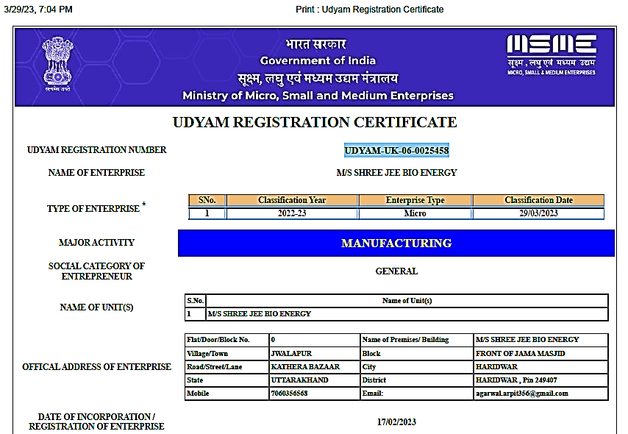

As per Udyam Registration certificate, the company is registered as MSME with Udyam Registration Number UDYAM-UK-06-0025458, established as on 29/03/2023 for the purpose of carrying on business of generating Bio-CNG from the produced Biogas using low cost raw material in the form of Sugarcane Press mud and Cattle Manure or other bio degradable waste stuffs and solid organic & liquid fertilizer. As per information provided by the client, in future company may develop additionally a production facility for bio coal on a commercial scale making bio coal a viable and sustainable alternative to fossil coal, where high-quality bio coal will be produced.
The address of Communication of the company will be Shree Jee Bio Energy, Front of Jama, Masjid Kathera Bazaar, Jwalapur, Haridwar, Uttarakhand 249407, India under the directorship of Mr. Vivek Agarwal and Mr. Arpit Agarwal.
As per data/information provided by the company’s representative during the site visit and as per shared lease deed, currently M/s Shree Jee Bio Energy has taken a 2.1610 Hectare (21610 Sq. Mt.) of land on the lease basis @ INR 50,000 per annum for the proposed project at Khasra No 1/16, 1/17, 1/25, 1/27, 1/28, 1/29 Village - Jaswa Wala, Block- Bahadrabad, District - Haridwar, Uttarakhand -249402.
Proposed Biogas Plant Capacity
Sr. No. | PARTICUALR | Value | Unit
1 | Bio-CNG Plant Design Capacity | 14,100 | M3/Day
2 | Biogas Plant Generation (Design Capacity x 90 %) | 12,700 | M3/Day
3 | Bio-CNG Plant Capacity | 5,000 | kg/Day
4 | Compost Plant Capacity | 30,000 | Kg/day
5 | Liquid Fertilizer Concentrate Capacity | 90,000 | L/day
Source: Information provided by the company
Currently, oil marketing companies (OMC) procure Bio-CNG from plants on a ‘best endeavour’ basis. This leaves plant owners at a disadvantage if their product is left unsold. Instead, long-term agreements with guaranteed 100 per cent off-take of Bio-CNG could ensure potential investors about the favourable product market and promise them financial stability. Furthermore, it could de-risk their investment in technology, installed machinery and maintenance cost.
The slurry or the digestate obtained after the anaerobic digestion process forms a significant fraction of the by-product. It primarily consists of inorganic nutrients and substances such as cellulose and lignin. These substances help to improve the soil’s hygroscopicity and permeability while reducing erosion and enhancing the overall agricultural conditions. India will presumably produce 50 MMTPA of solid organic digestate once the 5,000 Bio-CNG installations are operational. The Bio-CNG plants across the country will have the capacity to manage at least 3,125,000 acres annually, according to a projected digestate application rate of 16 tonnes per acre.
It was estimated that 62 million tonnes of CBG can be produced in India every year from various sources. To tap this, MoPNG announced that 5,000 CBG plants will be set up by 2025 that will produce 15 million tonnes of CBG. SATAT provides central finance assistance at the rate of Rs four crores for setting up a 4800 kg/day output CBG plant with a maximum cap of Rs 10 crore, but even that was discontinued in between.
Their research has found that there is big scope for bio-CNG in India – but that we’re using less than 2.5% of our net bio-CNG potential when it comes to municipal solid waste and wastewater energy alone. Bio-CNG from these sources can replace around 4,000 tonnes of India’s diesel consumption per day. In fact, biogas potential from agricultural residue and livestock dung is around 75 billion cu. m a year – which is around 80,000 tonnes of Bio-CNG per day. “If bio-CNG is produced from all biomass – agricultural residue, livestock dung, municipal solid waste and wastewater – we can replace about 50% of our current total diesel usage in the transport sector. This could also reduce India’s dependence on foreign oil imports.
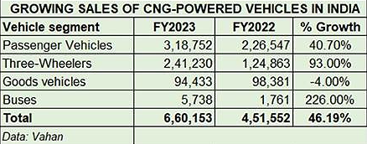
Demand for alternative fuel vehicles in India is on the upswing and clearly seen in the increasing sales of CNG-powered vehicles. Given the favourable price arbitrage of CNG versus petrol and diesel, retail sales of CNG vehicles, across four sub-segments, crossed the 650,000-unit mark for the first time in a fiscal in FY2023. Cumulative sales of 660,153 units (see data table below) translate into strong double-digit YoY growth of 46% (FY2022: 451,552 units). (Ref.: https://www.autocarpro.in/analysis-sales/cng-vehicle-sales-surge-by-46-to-over-650000-units-in-fy2023-114656)

CNG passenger vehicles (PVs), with 318,752 units, account for 48% of the total retail sales in FY2023 and surged by 40.71% year on year (FY2022: 226,547 units) and took an 8.80% share of overall retail sales of 36,20,039 PVs in India. Clearly, the smart increase in consumer demand for CNG vehicles continues to be driven by the lower cost of ownership mantra that the greener fuel offers in the face of high petrol and diesel prices. What will help accelerate demand and sales for CNG vehicles across segments is the steep price cut effective April 8, 2023.
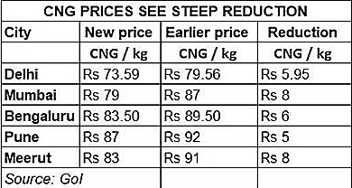

India biogas market is expected to grow from $1.47 billion in 2022 to $2.25 Billion in 2029 at a CAGR of 6.3% in forecast period, 2022-2029 during the forecasted period. The Bio-CNG potential in India is estimated at 62 million metric tonnes (MMT) per annum, of which the Sustainable Alternative towards Affordable Transportation (SATAT) scheme aims to tap 15 MMT. As per SATAT website, 4090 LOIs issued, 46 plants has been commissioned and 16,164 tonnes CBG quantity has been sold as on March, 2023.
India Currently has 30 CBG plants under operation and the sector is about to attract over $ 2 Billion investment in the next 5-7 years under its SATAT scheme, the govt. announced an ambitious plan of touching 15 million metric ton per annum, which is roughly 40,000 ton per Day.
A sum of INR 600 crore has been sanctioned for five years under the ‘Waste to Energy Programme’, released by the Union Ministry of New and Renewable Energy. The scheme aims to incentivise Bio-CNG plants run on urban, industrial and agricultural wastes. This amount is meagre if the envisioned target to install 5,000 large Bio-CNG plants under the SATAT initiative is to be achieved. Instead, a separate Production Linked Incentive Scheme, focussing on Bio-CNG, needs to be launched. Bio-CNG has been included in the list of priority sector lending by the Reserve Bank of India.
Some of the successfully running BCGs are Green Elephant (7920 kg/Day), Spectrum Renewable Energy Limited (CSTR based technology and produces 8000 kg of bio-CNG per day), Carbon Masters (250kgs of bio-CNG (equivalent to its weight in LPG) per day), Primove Engineering, Mahindra World City (400 kg/day of purified CNG), Bharat Biogas Energy Ltd. (6538 kg/day of CBG), Radix Lifespaces (2000 kg/day bio-CNG).
Recently, much attention has been focused on better use of Press Mud and the Government of India has launched a SATAT scheme for procurement of bio-CNG/compressed bio-gas produced from press mud from sugar industries at good prices. Indian sugar industry while crushing around 300 million tonnes of sugarcane and producing about 10 million tonnes of press mud annually can offer compressed bio-methane/bio-CNG to the extent of 0.4 million metric tonnes .
Feedstock | Total accessible amount pan India (tons per day) | Biogas potential per ton (kg) | Bio-CNG potential per ton (kg) | Total bio-CNG potential per day pan India (tons)
Urban food waste, fruit and vegetable waste | 50,000 | 75 | 40 | 2000
Poultry litter | 100,000 | 100 | 60 | 6000
Press mud | 100,000 | 150 | 80 | 8000
Total |  |  |  | 16000
As per the proposed plan for taping the market of Bio-CNG in India and as per the growing demand of the Bio-CNG and organic fertilizers, M/s Shree Jee Bio Energy is planning to setup this 5000 Kg/Day (14,000 Metric Cube Designed Capacity Biogas) capacity Bio-CNG plant, at the said land.
We R.K associate is performing the Techno-Economic Viability study for proposed Biogas plant setup by Shree Jee Bio Energy at Khasra No 1/16, 1/17, 1/25, 1/27, 1/28, 1/29 Village - Jaswa Wala, Block- Bahadrabad, District - Haridwar, Uttarakhand -249402, for taking a term loan of INR 20.00 Crore and cash credit limit of INR 50.00 Lakhs from financial institutions for building construction and Plant & Machinery purchase & installation work.

PROPOSED PROJECT COST: The project will be implemented through EPC consultant, total cost of the project from scratch to trial run is being estimated as INR 28.90 Crore, which is proposed to be funded through equity of INR 8.90 Crore and debt of INR 20.00 Crore.
PROJECT COST AND MEANS OF FINANCE
S. No. | CAPITAL COST HEAD | INR (LAKH)
A | PROJECT COST
1 | Electricity Connection | ₹ 1,00,00,000
2 | Civil Work | ₹ 7,55,82,416
3 | Plant & Machinery | ₹ 18,25,45,156
4 | Miscellaneous Assets | ₹ 6,00,000
5 | Preliminary Expense | ₹ 12,01,500
6 | Working Capital Margin (WCM) | ₹ 16,67,000
7 | Interest During Construction (IDC) | ₹ 1,70,62,500
8 | CONTINGENCIES EXPENSES | ₹ 3,41,428
 | TOTAL | ₹ 28,90,00,000
B | MEANS OF FINACE
 | Equity | ₹ 8,90,00,000
1 | Promoters' Margin | ₹ 8,90,00,000
2 | Loan from Banks | ₹ 20,00,00,000
 | Subsidy (To be Adjusted in Loan Account after Project is Commissioned) | ₹ 4,00,00,000
 | TOTAL | ₹ 28,90,00,000
 | CC Loan | ₹ 50,00,000
 | Total Loan | ₹ 20,50,00,000
As per the discussion with client/company officials, for the proposed Biogas plant the 2.1610 Hectare of land has been taken from the promoter by the company. The major heads in the Total Project Cost will be electricity connection, civil construction and Purchase & installation cost of plant & machinery, for which they are taking a term loan of INR 20.00 Crore. Rest most of the heads will be funded through equity and approximately 0.12% of TPC is considered as contingencies.
The company is planning to fund the project through term loan to initiate the initiate the Biogas plant and approaching the financial institutions to provide the required capital.
CURRENT STATUS OF THE PROJECT: As per the shared lease deed and as per the site survey, construction of boundry wall work has been started, however foundation & plinth work will be initialized soon after loan sanction (Kindly refer the attached site pictures in the report). As per the EPC agreement, the plant will be set through EPC consultant from scratch to trial run.
As per the schedule shared by the client, the company is planning to achieve the COD by June, 2024. Currently, company is in discussion with financial institutions to fund the project through a term loan of INR 20.00 Crore. Company plans to achieve the financial closure by August, 2023 (expected).

Therefore to check and assess the Techno-Economic viability of the Project for submitting the proposal to financial institutions, M/s PNB, MCC HARIDWAR has appointed us as TEV consultant to review technical, commercial and financial viability of the project based on our independent EIC research and information/data provided to us about the project by client/company.

- PURPOSE OF THE REPORT: To assess the Techno-Economic Feasibility of the green field proposed project to take further Project funding decision for the same.

- SCOPE OF THE REPORT: To assess, evaluate & comment on Techno-Financial Feasibility of the proposed 5000 Kg per Day Bio-CNG generating plant being set up by M/s Shree Jee Bio Energy as per the data/information provided by the client/promoter/stakeholder and our independent EIC research.

NOTES:
- Project status is taken as per the information provided by the company/promoter/stakeholder.
- Site inspection has been carried out for the proposed units at proposed land. Operating details regarding the existing unit is taken as per the information provided by the company which has been relied upon.
- Scrutiny about the company, background check, and credibility, credit worthiness of the company or its promoters is out-of-scope of this report.
- This report is only an opinion in respect to Technical and Financial Feasibility of the project as per the future Projections provided by the firm and independent analysis done by us and doesn’t contains any recommendations including taking decision on the financial exposure.
- This is not an audit activity of any kind. We have relied upon the data/ information supplied by the company in good faith that it is true and without any fabrication.
- This is not a Detailed Project Report or a detailed design or architecture document. Land and property details mentioned in the report is only for illustration purpose as per the information provided to us by the client. The same doesn’t tantamount for taking any responsibility regarding its legality, ownership and conforming to statutory norms.

- METHODOLOGY/ MODEL ADOPTED:
- Data/ Information collection as per our standard checklist.
- Review of Data/ Information collected related to TEV study.
- Review and analysis of the Projections as per the market trends and futuristic growth opportunity of the industry and company.
- Independent review & assessment of technology used provided by the company/promoters.
- Projections of Revenue, Expenses, P&L, Balance Sheet, fixed assets, COGS.
- Assessment of Key Financial Metrics.
- Final conclusion.

- DATA/ INFORMATION RECEIVED FROM: All the data/Information has been received from Mr. Arpit Agarwal (Director) and the required details about him shown in the below table:
Particulars | Details
Designation | Director
Company | M/s Shree Jee Bio Energy
Email Address | shreejeebioenergy@gmail.com
Contact No. | +91- 70603 56568

- DOCUMENTS / DATA REFFERED:
- Detailed Project Report & Proposed project cost.
- Financial projections with detailed assumption.
- Director’s details and EPC contractor’s details.
- Manufacturing Process Flow Chart
- List of proposed Plant & Machinery.
- Description of suppliers and buyers of the company.
- Electricity connection, Man power proposal
- Approved Map
- Lease Deed and Partnership Deed
- Single Window clearance form
- Enrolment Certificate.
PART C | COMPANY PROFILE

- COMPANY OVERVIEW:
M/S. SHREE JEE BIO ENERGY, the Sole prompter of the Project, Joins the mission of “Swachh Bharat Abhiyan “for the Establishment of Waste to Energy Management based on the waste and residual organic substances from Urban, Industrial and Agricultural activities of Rural INDIA, such as Municipal Waste, Farm Residue, Vegetable Food Waste, Cattle Dung, Sugarcane Press mud, Napier Grass etc. State Pollution Department has also been worried about the dairy & farm wastes management.
Organisation Details
Particular | Details
Nature of Organisation | Partnership Firm
First Name of Partner | Mr. Vivek Agarwal
PAN No. of Partner | AALPA7087J
Percentage Partner Share Holding | 50
First Name of Partner | Mr. Arpit Agarwal
PAN No. of Partner | DDOPA9007H
Percentage Partner Share Holding | 50
Category of Unit as per MSMED Act is Medium. The main objective of the project is to set up a compressed biogas plant to sale the Bio CNG to the local user at around INR- 70 per Kg. The plant also produces organic manure/Solid Fertiliser in large quantity which can be sold at about INR- 2.0 per Kg in open market.
The produced Bio-CNG and Fermented Organic fertilizer ( 365 days)
S. No. | Product | Per Day Generation | Per Annum Generation
 | Biogas | 12,762 m3 per Day | 46,58,130 M3
 | Bio-CNG | 5,000 Kg per Day | 18,25,000 Kg
 | Solid bio-fertilizer | 30 Ton per Day | 10,950 tons
 | Liquid bio-fertilizer | 100 KL per Day | 36,500 KL
Bio CNG is in good demand. Similarly organic manure is always in short supply. It is needed for fruits and vegetables and horticulture farming. The plant can be set up in a place where Sugarcane press-mud & Cattle dung is available in large quantity or some other source of waste bio material is available.
Composition of purified Bio-CNG
Ingredient | Value | Test Method
CH4(Percentage) | 95-96 % | IS-5130 (Part3)
CO2+ N2 + O2(Percentage) | 4-5 % | IS-15130 (Part3)
Only CO2 | < 4 % | IS-15130 (Part3)
H2S (Mg/M³) | 5 (Mg/M³) | ISO- 6326-3
Moisture (Mg/M³) | 5 (Mg/M³) | IS-15641 (Part2)
The EPC of the Project will be executed by JOG WASTE TO ENERGY PVT. LTD. Registered address- 16/3, Shivbhumi Industrial Easte II, Near Indore Highway, Gatrad Bakrol Road, Bakrol Bujarang 382433. Jog Waste To Energy Private Limited is a Private incorporated on 13 June 2016, Our Corporate Identification Number is (CIN) U40100GJ2016PTC092443, (GST)-24AADCJ7356G1ZJ and its registration number is 92443. JOG Waste to Energy is a company established, with a prime objective of providing cost effective innovative products and services, to cater ever emerging needs of the domain, of solar energy / Biogas and other waste to energy technologies.
The present project is a 14,100 M3/Day Biogas plant design capacity and 12,600 M3/Day Biogas generation plant based on anaerobic digestion of Sugarcane Press mud and Cattle manure Waste or any other suitable wastes which may be available. Project envisages setting up of a state of art upgraded bio-fuels production plant to convert cattle Sugarcane Press mud and Cattle Manure into the following products.
BIOGAS GENERATION ESTIMATION
Material /Substrate | Quantity per day (t) | Quantity per year (t) | DM (Dry matter) (%) | DM (kg/day) | ODM (organic dry matter) (%) | ODM (kg/day) | Biogas yield (m3/kg ODM) | Biogas yield (m³/day) | Biogas yield (m³/year)
Press Mud | 120 | 43,800 | 23 | 27,600 | 80 | 22,080 | 0.55 | 12,144 | 44,32,560
Cattle Dung | 10 | 3,650 | 15 | 1,500 | 75 | 1,125 | 0.55 | 618 | 2,25,570
Total | 130 | 47,450 | - | 29,100 | - | - | - | 12,762 | 46,58,130

5,000 kg (7000 m3)/ day of Bio-CNG, which will be sold as replacement to commercial LPG/CNG or petrol and diesel. 30 Ton/day of solid organic fertilizer and 90 KL/ Day of Liquid Fertilizer, which will be sold as value added by products. Plant operation: 80% is mechanical and 20% is manual. These are CSTR type reactor and operate at mesophilic temperatures. HRT is 28 to 32 days. Feed stock will be stored in open area covered with black colour plastic sheet to protect from direct sunlight and UV Rays. Approx. 200 days of feedstock will be stored in our project premises. It will help us to maintain daily feedstock and smooth process of biogas generation.
Feed tank is fitted with a mixer for making uniform feed slurry and pumped, into digesters through underground pipe line. The digester is also equipped with gas capturing system to hold about 1500 M3 (Balloon Capacity) of Biogas. It is of European make; air inflated double membrane type, to prevent the heat loss from the digester top portion. It is also weather resistant.
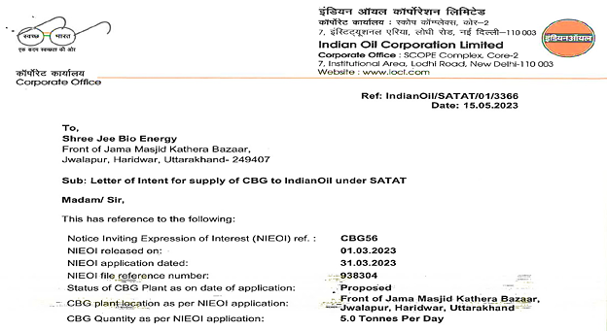
MARKET FOR THE PRODUCTS: Bio-CNG is to be supplied to consumers directly as a replacement for CNG as a fuel in Vehicular Fuel, industrial utilization, or as a cooking fuel in the restaurants at the nearby markets. It can also be used as an automobile fuel using gas dispensers and as high grade industrial fuel for cutting and welding applications. The Bio-CNG produced has to be sold to INDIAN OIL CORPORATION LTD. @ INR 70.00/Kg. We have already secured a purchase agreement/ LOI (Ref No.) IndianOil/SATAT/01/3366. (Change of address consent taken by the company).

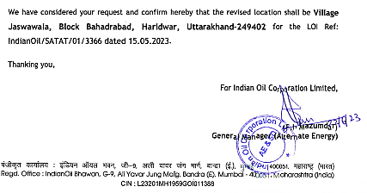

The promoters of the company are Mr. Vivek Agarwal and Mr Arpit Agarwal are also the Directors of the company and are the major shareholders of the company who are holding more than 50%-50% share of the company in total.
- PROMOTERS/DIRECTORS PROFILE: Promotor’s details have been shown in the below table:
TABLE: PROMOTORS DETAILS
Name | Age | Contact Details | Qualifications/Experience
Mr. Vivek Agarwal | 49 Years | +91-9412956568  (shreejeebioenergy@gmail.com) | Mr. Vivek Agarwal (M. Com.) is Committed and motivated business owner with almost a decade of experience in the textile, hotels, catering and in retail sectors He has experience and a solid academic background in accounting and financial management.  Having rich knowledge about the fundamental construction principles, customer service, project management and leadership. Excellent analytical and problem-solving skill, able to handle multiple projects while producing high quality work in a fast-paced, deadline-oriented environment.  Started his own business of sarees and suits from year 1989 later, he has also gain experience in gold and silver jeweller ornaments business at 1998.  As per data/information shared by the client, Mr. Vivek is also having a largest distributorship of UltraTech cement in Uttarakhand and he sell more than 2,25,000 bag of cements per annum on an average and also runs hospitality management business with own 2 hotels at different locations.  He has a proven track of analyzing construction plans and proposals and identifying affordable sources of material and labour.  He also has a position in market research or financial analysis where strong technical skills, mathematical/statistical background and problem-solving abilities can be applied towards the successful achievement of business goals and objectives.
Mr. Arpit Agarwal | 22 years | +91- 70603 56568  (shreejeebioenergy@gmail.com) | Mr. Arpit Agarwal (B.A., LLB) is an enthusiastic, creative and self-motivated personality having strong educational and laboratory-based background of pharmaceutical and formulation, regardless giving the best of knowledge and skilful work to enrich valuable targeted goal of an organization.  As a manufacturer he was responsible to monitoring for the batch-wise manufacture of active pharmaceutical ingredients. Utilizing batch logs, (SOP) standard operation procedures, and work instructions under cGMP guidelines he would double check material calculation, check and prep process lines and equipment prior to charging reactors.  He has experienced in streamlining the drug manufacturing process, in accordance with the safety guidelines and corporate standards. Ensures consistent quality and efficacy of prescription medications. Adept at employing multiple techniques and appropriately modifying protocols, as required, to suit the changing needs of research or development sciences.  He has also strong research skills including observation, analysis, assessment, and reporting and excellent understanding of the integration of quantitative pharmacology and pharmacometrics into clinical drug development.
Source: Data/Information provided by the client

PART D | PROPOSED UNIT’S INFRASTRUCTURE DETAILS

- PROPOSED PLANT LOCATION: The proposed Biogas plant will be set up by M/s Shree Jee Bio Energy at a 2.1610 hectare lease holded land at Khasra No 1/16, 1/17, 1/25, 1/27, 1/28, 1/29 Village - Jaswa Wala, Block- Bahadrabad, District - Haridwar, Uttarakhand -249402., which is spread over an area of 21610 Square meter (2.1610 Hectare).
Bahadrabad is a Town in Bahadrabad Block in Haridwar District of Uttarakhand State, India. It is located 12 KM towards west from District headquarters Haridwar. It is a Block head quarter. Elevation / Altitude: 271 meters above Sea level.
As per data/information provided by the company’s representative during the site visit, company has achieved change of land use certificate by the concerned authority. The land mark for the property is Hanumaan Mandir. Below table shows the adjoining properties details of the proposed plant:
Location | Adjoining Property
East | Road 5 Metre
West | Land of others
North | Land of others
South | Road 6 Metre
Below table shows the connectivity details of the company with the city:
Connectivity | Details
Rail | Haridwar Railway Station – 26 km away
Airport | Jollygrant Airport-64 km
Road | NH 72 -7 Km away

- LAYOUT PLAN: The Company has achieved the approved map and layout plan from the concerned authority as per share data/information to us.

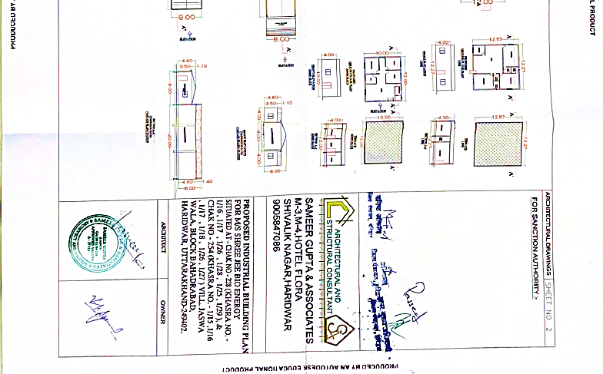
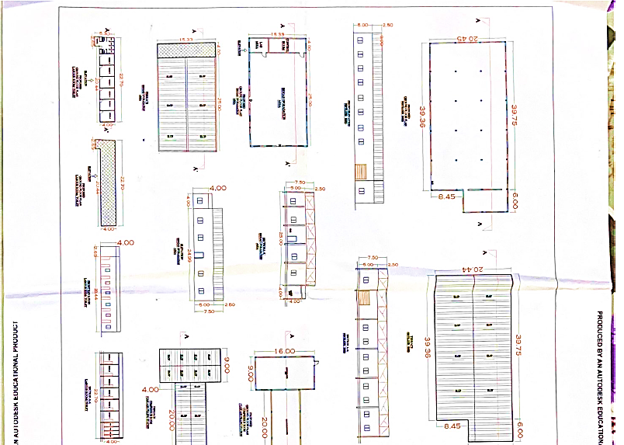
APPROVED ARCHITECT PLAN

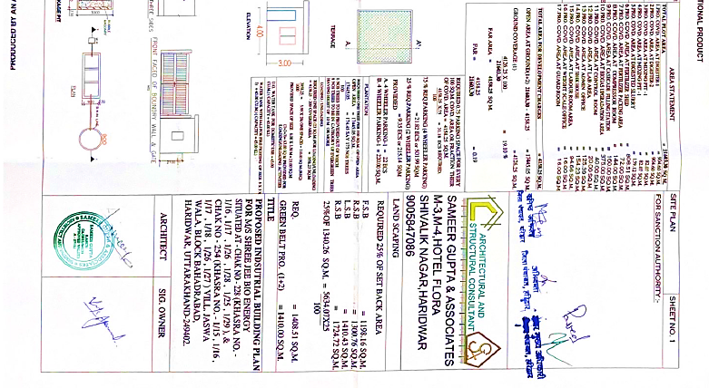
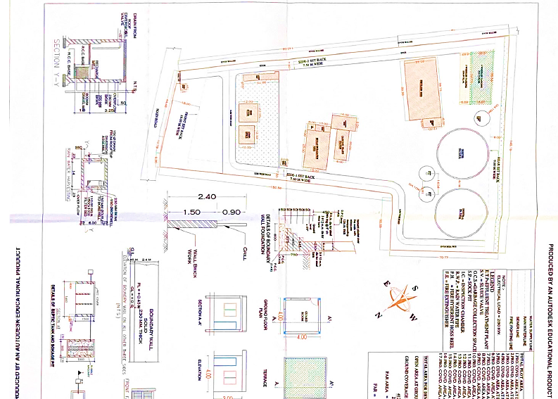
- LOCATION MAP:
- Google Map Location: Project location would be 29°57'58.8" North and 77°57'11.2" East in Kolkata, West Bengal and the location as per the Google map has been attached below with the link.
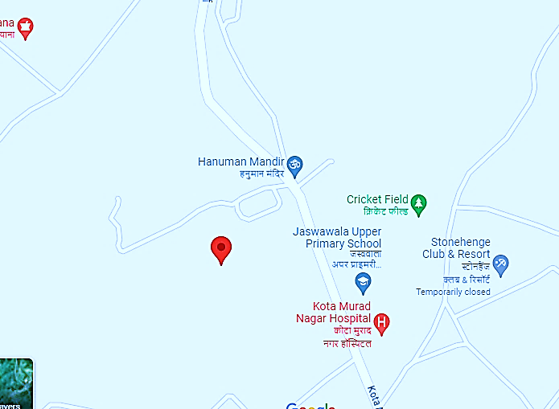
- Google Layout Plan: Demarcation of the land with measurement on the Google map is as shown in the below picture:
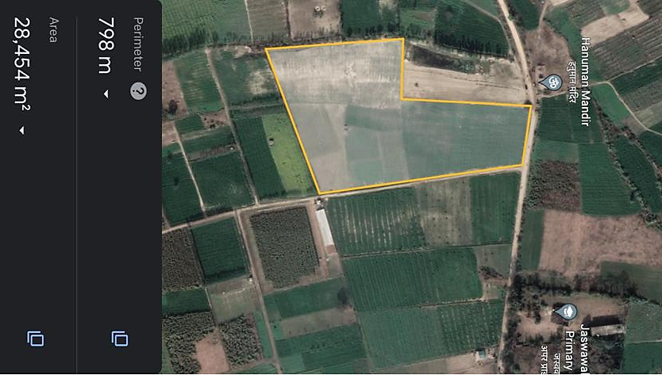

- LAND DETAILS:
M/s. Shree Jee Bio Energy has taken the piece of land, Khasra No 1/16, 1/17, 1/25, 1/27, 1/28, 1/29 Village - Jaswa Wala, Block- Bahadrabad, District - Haridwar, Uttarakhand -249402. As per lease deed shared by the client, approx. 21610 Square meter (2.1610 Hectare) of land has been taken on lease basis by the company from the promoter of the company @ INR 50,000 per annum for 20 years, where the lease rent will be escalated by 10% every 5th year. This is a south-east facing property.
As per the assessment, Biogas to CNG plant needs a total of about 21,609M2 land area for Project implementation, 842 M2 Covered Shed for Fertilizer Processing and storage in off season. 3056 M2of open area for locating the hydrolysis tanks, biogas digester tank, and sludge separator filter, besides connecting roads. About 800 M2 of built up area is required to house the technical buildings including MPSA separation plant and Bio CNG Compressor. About 11,757 M2 is reserved for Green Belt and future expansion.
During the site visit we found that the land is an industrial land as per the land conversion certificate dated 28/04/2023. Land development work has been completed during and the subject land is demarcated with boundary wall till the survey date. The company will initialize the grading and foundation work after loan will be sanctioned. The entry of the premises. Below are the details of land purchased for the proposed project in the tabulated form:
- SITE PICTURES: Some of the site pictures has been taken during the site survey as on 19th July 2023, are attached below:
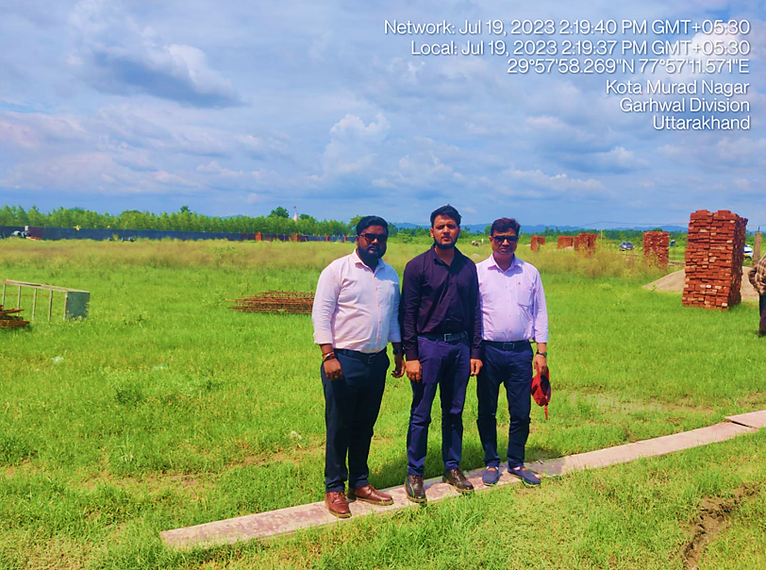
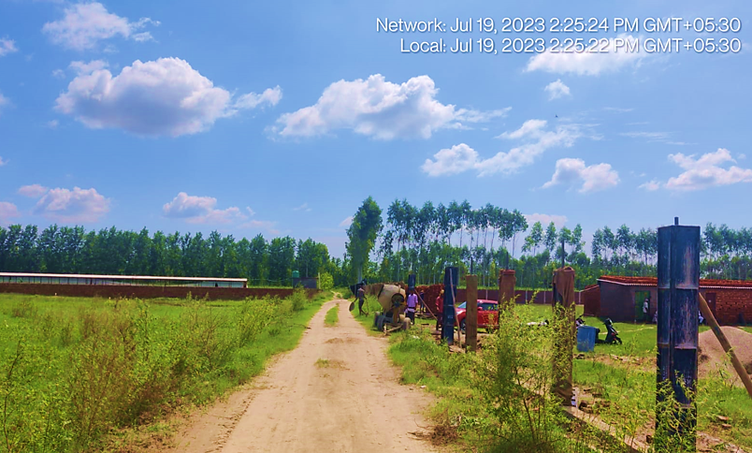
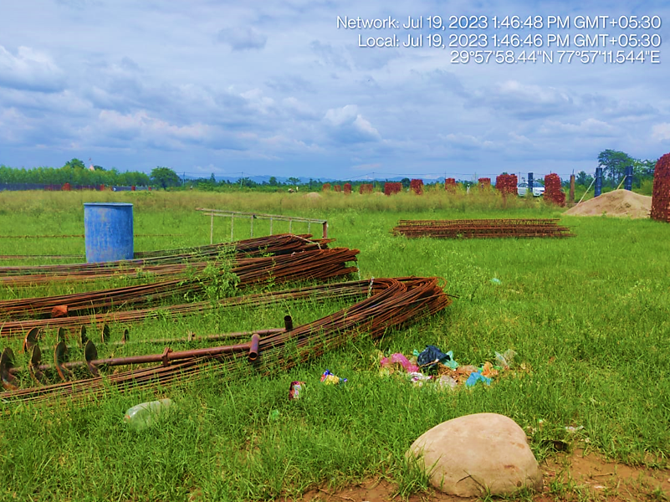
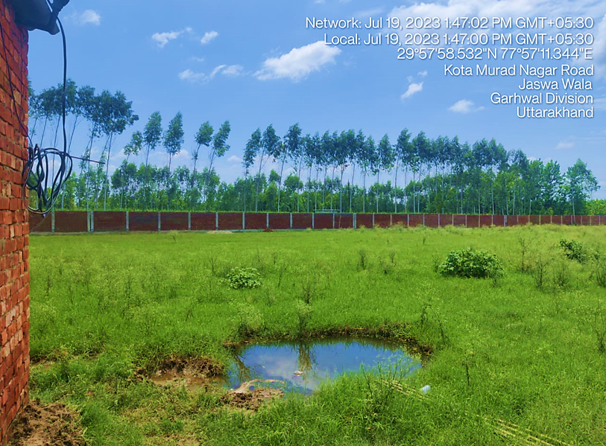
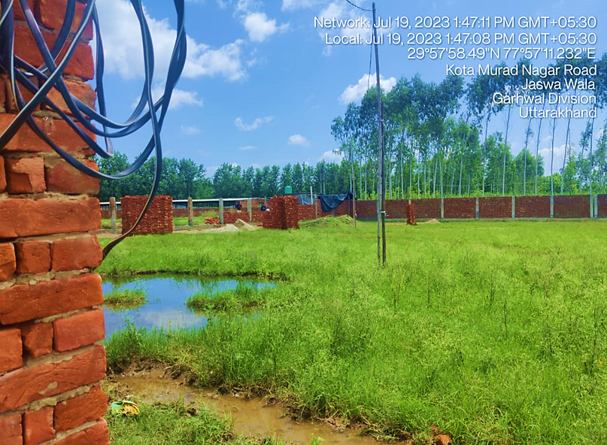
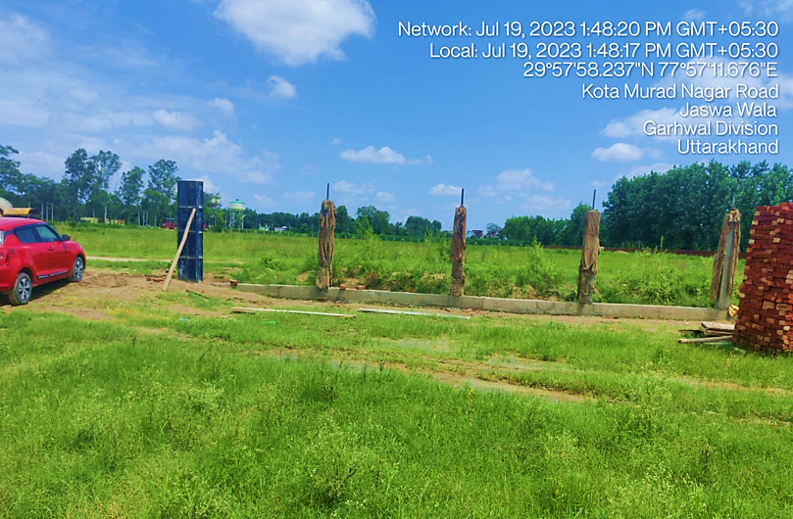
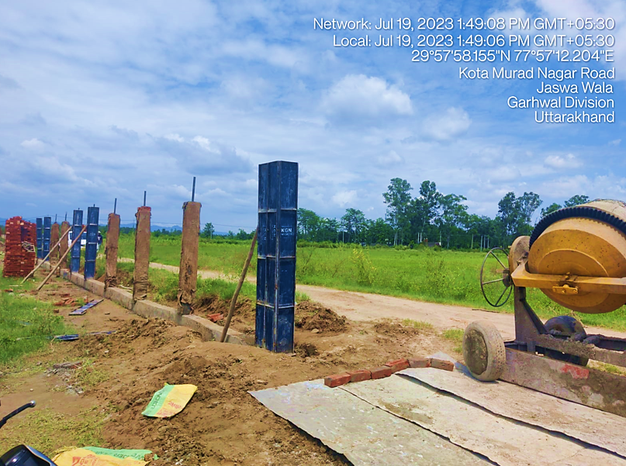
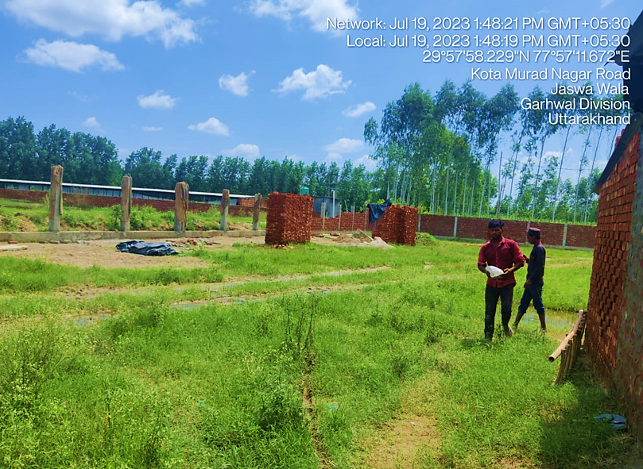
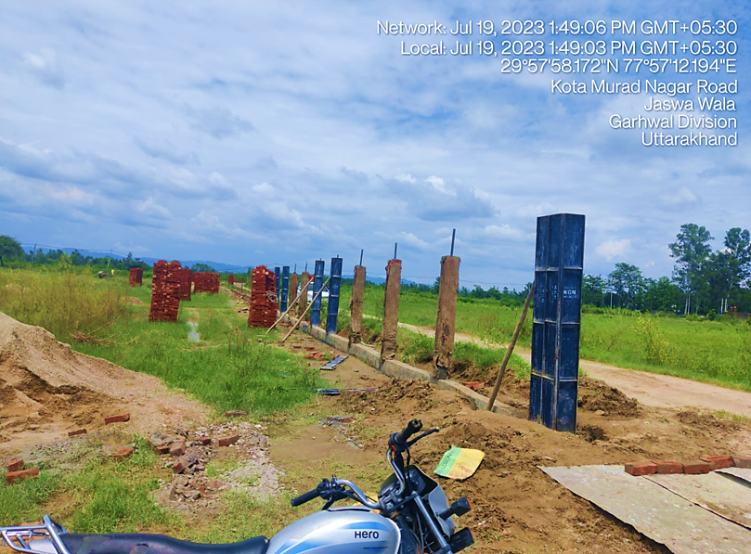
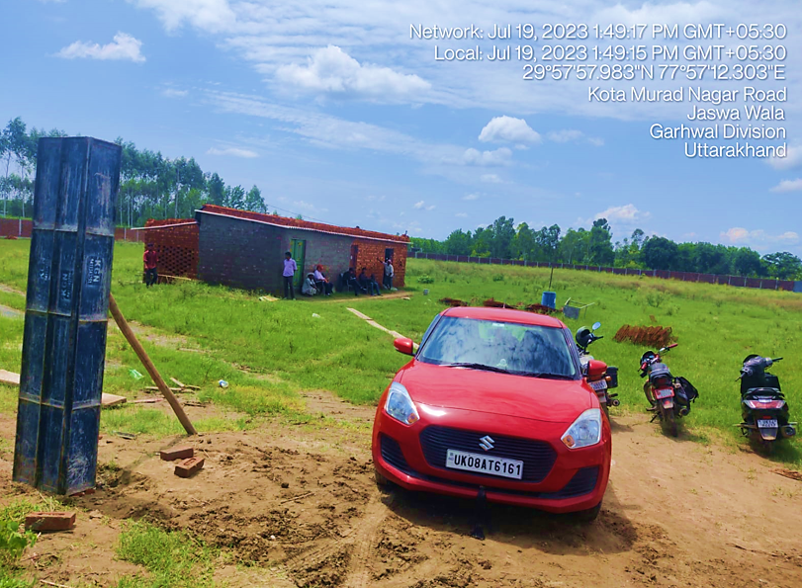
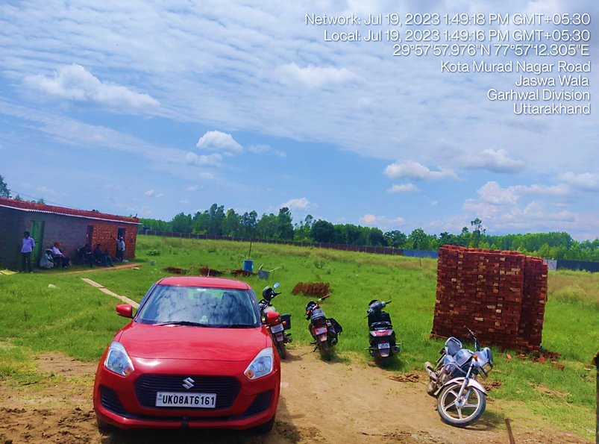
- BUILDING & CIVIL WORKS: As per the current status of the Building and civil works provided by the company and verified during the site visit, boundary wall work is completed and the foundation & plinth work is required to start soon to achieve the expected trial run and COD successfully.
Currently, site development/construction work is going on as on date. During the site visit the construction work of digester was going on (temporarily stopped due to rain). As per communicated by the client, company has taken the Sanction map approval from the respective authority and shared the same with us. Company has appointed M/s Jog Waste to Energy Pvt Ltd as EPC contractor to setup the plant from scratch to successful trial run.
All Civil Work-Building, Digester, Shed, Road etc.(Mixing Pit, Digester, Digested Slurry Tank Solid Liquid separator and shredder Platform, H2S and Moisture Removal System shed and other plant and machinery shed, all foundation, control room etc. will be build (ready to use) by the said EPC contractor.
As per the estimated cost shared by the client done by done by JOGWTE, the total Building and civil works will be costing as INR 7,55,82,416 including 12% applicable GST as per the details provided in the below table:

BUILDING AND CIVIL WORK
1 | BUILDING | Quant. | Units | Per Unit | Amount
A | Admin Office | 120 | SQMT | 12500 | 15,00,000
B | Shed for Filling header with cylinder cascade | 160 | SQMT | 6100 | 9,76,000
C | Way Bridge cum Security Room | 16 | SQMT | 7500 | 1,20,000
D | Gate | 2 | No. | 150000 | 3,00,000
E | Boundary (Total Length 800Mtr.) | 800 | Mtr. | 4550 | 36,40,000
F | Internal Road 8 Mtr Wide) Length- 730 Mtr | 5,840 | SQMT | 700 | 40,88,000
G | Feed Preparation Platform with Pump | 350 | SQMT | 2800 | 9,80,000
H | Feed Mixing Tank (2 x300 CUM) | 600 | CUMT | 4000 | 24,00,000
I | Machinery Shed (Purification and Compressor) | 519 | SQMT | 6100 | 31,65,900
J | Main Digester (Dia 32 Mtr.) | 7,234 | CUMT | 2425 | 1,75,42,450
K | Main Digester (Dia 32 Mtr.) | 7,234 | CUMT | 2425 | 1,75,42,450
L | Underground Water/ Slurry Storage | 100 | CUMT | 4000 | 4,00,000
M | Solid Liquid Separator Platform | 36 | SQMT | 8000 | 2,88,000
N | Fertilizer Shed with Packing | 816 | SQMT | 6100 | 49,77,600
O | Digested Slurry Tank | 400 | CUMT | 4000 | 16,00,000
P | Lagoon | 1,000 | SQMT | 500 | 5,00,000
Q | Technical room/panel room + Lab Area + Security Office | 76 | SQMT | 9500 | 7,22,000
R | Staff Room with Kitchen, Bathroom (3 BHK House) | 144 | SQMT | 16000 | 23,04,000
S | Labours Rooms | 60 | SQMT | 10000 | 6,00,000
T | Toilet Block + packing | 20 | SQMT | 4000 | 80,000
 | Sub-Total |  |  |  | 6,37,26,400
2 | Equipment Foundations
A | Gas Purification & Compressor Unit | 519 | SQMT | 1000 | 5,19,000
B | Agitator | 150 | SQMT | 1000 | 1,50,000
C | Technical Room | 76 | SQMT | 1000 | 76,000
D | Feeding Pump | 100 | SQMT | 1000 | 1,00,000
E | Ladder | 238 | SQMT | 4000 | 9,52,000
F | Heating System | 12 | SQMT | 1500 | 18,000
G | Solid Liquid Separator | 36 | SQMT | 3500 | 1,26,000
H | Drawing, Design, Architectural, Work | 1 | LOT | 100000 | 1,00,000
 | SUB TOTAL |  |  |  | 20,41,000
3 | BUILDING SERVICE
A | Fire Fighting Equipment | 1 | SET | 1450000 | 14,50,000
B | Bore well with Motor, Piping and Pump | 1 | SET | 254900 | 2,54,900
C | Potable Water day Storage (1500 L) | 1000 | Ltr. | 12 | 12,000
 | SUB TOTAL |  |  |  | 17,16,900
4 | GST
A | GST on Bio-Gas plant | 12 | % | 67484300 | 80,98,116
 | TOTAL FOR CIVIL WORKS |  |  |  | 7,55,82,416

- PLANT AND MACHINERY/ EQUIPMENTS DETAILS: As per the cost estimated by EPC contractor, Plant & Machinery will be costing around INR 18.25 Crore including 12% applicable GST as per shown in the below table:
COST ESTIMATION OF MAJOR PLANT & MACHINERY
S. No. | Capital Cost Head | Qty. | Units | Unit Rate | Amount
1 | Biomass Handling Facility
A | Weighbridge & other equip. | 1 | SET | 1125000 | 11,25,000
B | Waste shredder | 1 | SET | 650000 | 6,50,000
 | SUB TOTAL |  |  |  | 17,75,000
2 | Waste and Bio CNG handling Equipment
A | Tractor with loader | 1 | SET | 1050000 | 10,50,000
B | Tractor and trolley | 1 | SET | 950000 | 9,50,000
C | CNG Transport vehicle | 2 | SET | 2050000 | 41,00,000
 | SUB TOTAL |  |  |  | 61,00,000
3 | Equipment/ Machinery For Feed Mixing Tank
A | Top Entry Type Agitator 15 HP/Variable RPM | 15 X 2 | HP | N/A | N/A
B | SS Bar Grill | 2 | SET | N/A | N/A
C | Platform mixing tank | 2 | SET | N/A | N/A
D | Valves | 2 | SET | N/A | N/A
E | Flanges | 4 | SET | N/A | N/A
 | SUB TOTAL | 2 | Nos. | 3514000 | 70,28,000
4 | Pumping Equipment & Grinder
A | Screw Pump for Slurry transfer | 3 | SET | N/A | N/A
B | Grinder | 1 | SET | N/A | N/A
C | Piping & Valves | 1 | SET | N/A | N/A
 | SUB TOTAL |  |  |  | 65,25,000
5 | Equipment/ Machinery For Digester Tank  Equipment
A | Heating System | 2 | SET | N/A | N/A
B | Side Entry Agitators For mixing and circulation | 12 | SET | N/A | N/A
D | Heating System Valves | 2 | SET | N/A | N/A
E | Manual Valves | 4 | SET | N/A | N/A
F | Flanges | 4 | SET | N/A | N/A
G | Wall Flanges | 8 | SET | N/A | N/A
H | Pipes | 2 | SET | N/A | N/A
I | Pipe fittings | 2 | SET | N/A | N/A
J | Inspection Window | 4 | SET | N/A | N/A
K | Other Fitting & Fixtures | 2 | SET | N/A | N/A
 | SUB TOTAL | 2 | SET | 17525000 | 3,50,50,000
6 | Double Membrane Digester Roof/Balloon
A | Spider Ring | 2 | SET | 4140000 | 82,80,000
B | Nylon Belts |  | SET
C | Nylon Rope Net |  | SET
D | Both side PVC coated fabric/Balloon -2 Set |  | SET
E | Under Pressure protection & over pressure Valve-2 Set |  | SET
 | SUB TOTAL |  |  |  | 82,80,000
7 | Equipment/ Machinery For Fertilizer Tank
A | Top Entry Agitator | 1 | SET | N/A | N/A
B | Pump for slurry Transfer | 1 | SET | N/A | N/A
C | Auto Valves | 1 | SET | N/A | N/A
D | Manual Valves | 1 | SET | N/A | N/A
E | Flanges | 2 | SET | N/A | N/A
F | Wall mounting Flanges | 1 | SET | N/A | N/A
G | Fitting Material of Flanges | 2 | SET | N/A | N/A
 | SUB TOTAL |  |  |  | 20,50,000
8 | 700 m3/hr Catalyst Tower based H2S Removal system (H2S <= 1500 ppm)
A | H2S Removal System | 1 | SET | NA | NA
B | Accessories | Lum | Sum | NA | NA
 | SUB TOTAL |  |  |  | 29,50,000
9 | 700 M3 /hr Biogas Up gradation Plant as per given scope of supply 4 Tower Based systems
A | Roots Blower | 1 | SET | N/A | N/A
B | 700 m3/hr Biogas Moisture removal system  Heat exchanger with moisture separator | 1 | SET | N/A | N/A
C | 700 m3/hr Four Towers (Composite bed) VPSA Unit for removal of H2O, CO2 with Surge vessel and inter connected piping and valves & Instruments for safe operation of the plant | 1 | SET | N/A | N/A
D | Vacuum Pump with FLP Motor | 1 | SET | N/A | N/A
E | Bio-CNG Surge tank | 1 | SET | N/A | N/A
F | BIOCNG Storage Tank | 1 | SET | N/A | N/A
 | SUB TOTAL |  |  |  | 2,35,00,000
10 | 350 M3/hr Recovery System - 2 Tower Based System
A | 350 m3 per hr Methane Recovery System | 1 | SET | N/A | N/A
B | Single membrane Balloon/Biogas Tank | 1 | SET | N/A | N/A
 | SUB TOTAL |  |  |  | 85,50,000
11 | 350-400 m3/hr BioCNG Booster compressor
A | 350-400 m3/hr Biogas Booster compressors for Providing 250 bar Pressure at outlet. | 1 | SET | N/A | N/A
B | High pressure Fittings | 1 | SET | N/A | N/A
C | High Pressure line up to Compressor to Cascade | 1 | SET | N/A | N/A
D | Other High pressure accessories | 1 | SET | N/A | N/A
 | SUB TOTAL | 1 |  | 15000000 | 1,50,00,000
12 | BIOCNG Filling header
A | CNG cylinder Filling Header | 1 | SET | N/A | N/A
 | SUB TOTAL |  |  |  | 7,50,000
13 | BIO-CNG STORAGE
A | 40 Cylinder Cascade | 5 | SET | 1850000 | 92,50,000
 | SUB TOTAL |  |  |  | 92,50,000
14 | Electrical ,Instrumentation & Control Panel etc.
A | Electrical Control panel | 1 | SET | N/A | N/A
B | Electrical Wiring, Bus Bar, Joints, Protectors, Earthing etc. | 1 | SET | N/A | N/A
C | PLC Control panel, Power panel, Cable for all these from field to panel room | 1 | SET | N/A | N/A
 | SUB TOTAL |  |  |  | 70,65,000
15 | Automation Elements
A | Pressure & temperature measuring system | 1 | SET | N/A | N/A
B | Flow measuring system | 1 | SET | N/A | N/A
C | Automatic valves for Biogas line and slurry line | 1 | SET | N/A | N/A
D | PH sensor ,Level sensor | 1 | SET | N/A | N/A
E | Methane leak detection and alarm system | 1 | SET | N/A | N/A
 | SUB TOTAL |  |  |  | 55,21,000
16 | Electrical & Electronics Requirements
A | Electrical distribution panel | 1 | SET | N/A | N/A
C | Grid Transformer/LBS/HTMC for Plant | 1 | SET | N/A | N/A
D | DG Set FOR Backup Power 10 kVA | 1 | SET | N/A | N/A
E | Cables | 1 | SET | N/A | N/A
F | Earthing | 20 | SET | N/A | N/A
 | SUB TOTAL |  |  |  | 65,20,000
17 | ORGANIC FERTILIZER PLANT
A | Solid/ Liquid Fertilizer Separator Unit | 2 | SET | 3550000 | 71,00,000
B | Fertilizer Unit bagging system and accessories | 1 | SET | 3250000 | 32,50,000
 | SUB TOTAL |  |  |  | 1,03,50,000
18 | OTHER IMPORTANT ITEMS
A | Product Gas Analysers Online gas Monitoring system with Analyser for H2S,CH4,O2,Co2 Online dew point meter (Optional) | 1 | SET | 1050000 | 10,50,000
B | Laboratory and Analytical Equipment | 1 | SET | 500000 | 5,00,000
C | Annual Operational Spares | 1 | LOT | 1080000 | 10,80,000
D | EOT Single Grinder Crane flame proof As per PESO | 1 | SET | 2050000 | 20,50,000
 | SUB TOTAL |  |  |  | 46,80,000
19 | Clearing Forwarding, Handling & Freight Cost |  |  |  | 20,42,746
 | SUB TOTAL FOR P. & MACHINERY |  |  |  | 16,29,86,746
20 | GST on Plant and Machinery | 12 | % |  | 1,95,58,410
 | TOTAL FOR P. & MACHINERY |  |  |  | 18,25,45,156

All the Plant & Machinery will be installed by EPC contractor from scratch, so the cost of each head is including the cost of installation and other expenses to be incurred. We have cross check the prices of the Plant & Machinery, as per information provided by various vendors/consultants and data information available in public domain, we found that the costs are reasonable and in the line with industrial/sectoral benchmark.

- MISCELLANEOUS ASSETS:
MISCELLANEOUS ASSETS
1 | OFFICE EQUIPMENTS & FURNITURE
A | Computer at factory | 2 | No. | 35000 | 70,000
B | Multifunction laser printer at factory | 1 | No. | 20000 | 20,000
C | AC for factory 1.5 Ton | 2 | No. | 35000 | 70,000
D | CCTV Camera system | 1 | SET | 200000 | 2,00,000
E | Table chair set | 2 | SET | 45000 | 90,000
F | Conference chair and table set | 1 | SET | 125000 | 1,25,000
G | Provision for others | 1 | SET | 25000 | 25,000
 | TOTAL FOR MISC. ASSETS |  |  |  | 6,00,000

- UTILITIES: Details of Water, Electricity and other utilities are describes as below:
- WATER: As per information provided to us, the company, the plant needs about 1, 00,000 Litre/ day of ground water to meet the requirement.
- ELECTRICITY: Supply of AC power 415 V, 50 Hz, 3P & N required for Total plant running, for consumption of different components of the unit as bellow :
Purpose | Power consumption
Raw Material Preparation and Feeding
Shredder & Grinder | 1 x 5 kW
Digester plant and machinery
Mast for Mixer in pit | 2 x 12 kW
Mast for Mixer in digester-1 | 6 x 12 kW
Mast for Mixer in digester-1 | 6 x 12 kW
Screw Pump | 2 x 12 kW
Solid liquid Separator | 2 x 5.5 kW
BIOGAS UPGRADATION SYSTEM
(Biogas purification plant )
Bio-Gas (Roots Blower) | 40 KW
Water Jet Vacuum Pump | 40 KW
Booster Compressor | 120 KW
Other utility | 25 KW

Total Running Load Required 630 KVA, Total Connected Load Required 800 KVA and the total Power consumption per day will be 5000 KWH.

Thus, as per the analysis of infrastructural details above, INR 5.78 Crore per ton from scratch to successful trial run (including GST, pre-operative and preliminary expenses, transportation costs, Operating & Maintenance expenses up to 1 year and laboratory charges, convey vehicle etc.) will be the CAPEX for this proposed plant which is in the line with industrial and sectoral benchmarks as per our tertiary research and information available in the public domain and information provided by the third party consultants/vendors.
For reference, As per information available on Press Information Bureau (PIB: https://pib.gov.in/PressReleasePage.aspx?PRID=1868887) as on 18th Oct, 2022, Asia's largest Compressed Bio Gas plant inaugurated in Sangrur by Union Minister (Ministry of Petroleum & Natural Gas) to reduce stubble burning of 40,000 – 45,000 acres of fields, translating into an annual reduction of 150,000 tons of CO2 emissions, also contribute towards India's COP26 Climate Change targets of total projected carbon emissions by one billion tonnes from now to 2030 Achieving the target of net zero emissions by 2070.
The Plant has been commissioned with an FDI investment of INR 220 crores (approx.) by Verbio AG, one of Germany's leading Bio-energy companies. The CBG Plant at Sangrur, is spread across an area of 20 acres (approx.). The plant's present production is about 6 TPD CBG, but soon this plant will process 300 Tons per Day of paddy straw at max. Capacity to produce 33 TPD of CBG using 8 digesters of 10,000 cubic meters. Thus Per ton CAPEX comes to INR 6.67 Crore.
This Sangrur plant will consume 100,000 tons of paddy straw, which will be procured from 6-8 satellite locations within a 10 km radius of the plant. There shall be daily production of about 600-650 Tons of FOM (Fermented Organic Manure), which can be used for organic farming. Some of the other references are shown in the below table:
S. No. | Name of the Party | Contact details | Remarks
 | Jog Waste to Energy Pvt Ltd | info@jogwte.com  +91 9723269295  www.jogwte.com | - As per JOGWTE, the average installation cost as per EPC basis from scratch to successful trial run would be ranging INR 5-6 Crore per ton including preliminary and pre-operative expenses and other contingent costs.
 | The Global Green Growth Institute, GGGI India office | nishant.bhardwaj@gggi.org | - As per information provided by GGGI, The capital expenditure (CAPEX) for a typical 8-10 TPD Bio-CNG plant varies from INR 32-50 Crore which varies based on the type of biomass feedstock and technology deployed. It has been estimated that the plant and machinery costs contributes ~76% of CAPEX. (Excluding preliminary and pre-operative expenses and excluding all other costs such as engineering, consultancy, installation costs etc. i.e EPC Costs)
 | B-Sustain Energy Projects Private Limited | info@bsustain.in  +91 91766 50001 | - The company offers fixed type digester technology (older technology). Approximate capital cost for the plant is Rs. 25-30 crores for a 10 TPD plant. Area required for B-Sustain technology is 150 m2 for a 2 TPD plant. The technology is flexible for all types of feedstocks such as commercial, industrial and agro wastes. (Excluding preliminary and pre-operative expenses and excluding all other costs such as engineering, consultancy, installation costs etc. i.e. EPC Costs)
 | Others vendors | On the public domain | - CSTR technology which is flexible for all types of organic wastes including mixed wastes. Capital cost for this technology is approximately INR 4-6 Crore per ton including all the costs from scratch to Successful trial run depends on the technology, operational scale etc..

PART E | PROJECT TECHNICAL DETAILS

- CAPACITY OF MANUFACTURING FACILITY: Below table shows the proposed capacity of the Biogas plant along with organic fertilizers:
PLANT CAPACITY | Value | Unit
Bio-CNG Plant Design Capacity | 14,100 | M3/Day
Biogas Plant Generation (Design Capacity x 90 %) | 12,700 | M3/Day
Bio-CNG Plant Capacity | 5,000 | kg/Day
Compost Plant Capacity | 30,000 | Kg/day
Liquid Fertilizer Concentrate Capacity | 90,000 | L/day

- PROCESS DESCRIPTION:
- OVERVIEW: Biogas is formed in a natural process when organic material, such as cattle dung, Sugarcane Press mud, agro-wastes, food wastes, MSW etc. is decomposed by micro- organisms in an anaerobic or oxygen-free environment, biogas is produced in natural environment where the availability of oxygen is limited, for example in bogs and marshes, rice fields and in ruminants stomach.
Anaerobic digestion also takes place in landfills and biogas plants. The present organic waste to biogas system operates in a thermophilic process in continuous stirred tank reactor. The process of bio-methanation can be divided into four steps; viz. Hydrolysis, Acidogenesis, Acetogenesis and Methanogenesis. Biomass in the form of cattle dung, Paddy or Wheat Straw, Napier Grass, Other Agro-Waste and other bio-degradable stuffs are properly mixed in a feed mixer and then sent to a pulper, where it is comminated into fine particles.
- HYDROLYSIS: In the first step (hydrolysis) the pulped material is sent to the Hydrolysis Tank, where the organic matter is enzymolyzed externally by extra cellular enzymes (cellulose, amylase, protease and lipase) of microorganisms. Converting solid waste into liquid form, the pulverizer stimulates this step. Bacteria start decomposition of the long chain of the complex carbohydrates, proteins and lipids into shorter parts. Proteins are split into peptides and amino acids and fats into fatty alcohols. Hydrolysis occurs in the two hydrolysis tanks which are maintained at a high temperature and provided with insulation. Various types of bacteria are involved in the remaining three processes which occur in the two digester tanks, which are likewise maintained at high temperature with insulation and continuously stirred.
- ACEDOGENESIS: Acid-producing bacteria involved in the second step convert the intermediates of fermenting bacteria into volatile fatty acids along with ammonia (NH3) hydrogen sulphide (H2S) and Carbon-dioxide (CO2). The pH of the raw slurry falls from 7.5 to about (4.5 to 5.5) in this stage.
- ACETOGENESIS: In Acetogenesis, bacteria which are aerobic and facultatively anaerobic, and can grow under acidic conditions, produce acetic acid, during which they use the oxygen dissolved in the solution or bounded oxygen. These bacteria largely convert the products of Acidogenesis into acetic acid (CH3COOH) carbon-di-oxide (CO2) hydrogen (H2) and traces of methane. Various zones are formed in fermentation pond and different bacteria dominate these zones.
- METHANOGENESIS: A consortium of archaebacteria belonging to methanococcus group is involved in the fourth step and decomposes compounds with a low molecular weight. These bacterial are naturally present in the alimentary canal of ruminants (cattle). They occur to the extent that anaerobic conditions are provided, for instance under water (in marine sediments), in ruminant’s stomach and in marshes. They are obligate anaerobic and very sensitive to environmental changes.
They have very heterogeneous morphology and a number of common biochemical and molecular-biological properties that distinguish them from all other bacteria. The heat used for maintaining the temperature of the slurry in the hydrolysis tank and the digester tank is recovered in a cooling tank with the help of a heat pump coupled to heat exchangers. The undigested lingo-cellulosic and hemi-cellulosic materials are then passed to the sludge separator which recovers solid organic fertilizer from it. This fertilizer is dried packed and sold to the farming community.
- BIOGAS GENERATION: The biogas produced is a mixture of methane, carbon dioxide water vapour and small quantities of contaminants such as H2S NH3 and N2. The average composition of biogas is as follows:
Particular | Concentration
Methane (CH4) | 50-60 %
Carbon dioxide (CO2) | 36-40 %
Water vapour (H2O) saturated mass | 3- 4 %
Hydrogen sulphide (H2S) | 50-2500 PPM
Ammonia (NH3) | 0-300 PPM
Non-gaseous particulates and oil | Low concentration
- BIOGAS UPGRADATION: Biogas Up gradation is the process of removing impurities like H2S, Moisture and Co2,We are using the process to remove H2S is catalytic removal, moisture removal is in two steps first by chilling process and second by desiccant adsorption process. Removal of CO2 is being done by four tower VPSA system, it’s a versatile and a proven technology for gas separation, in this system we are using four steps for removing CO2, are Adsorption, desorption (evacuation by vacuumed), purging and pressurization.
Adsorption the process of Co2 adsorption on solid surface of porous material called molecular sieve at pressure of 0.7 bra G by Roots type gas Blower, after its saturation this tower will come in desorption in this step the vacuum shall be taken up to minus 0.8 bar by using water ring type vacuum pump, after the completion of the step tower will come in next step call purging during purging the product gas will be purged and final step is depressurization then the tower will be depressurize by equalize with the tower in process and tower purged and then pressurize with product gas.
This process is the cyclic and repeated in cycle of the 5 minutes. System controlled by programmable logical control system through a control panel.
- BASIC ARCHITECTURE: FLOW CHART OF THE BIOGAS PLANT: Basic process flow of the manufacturing process:
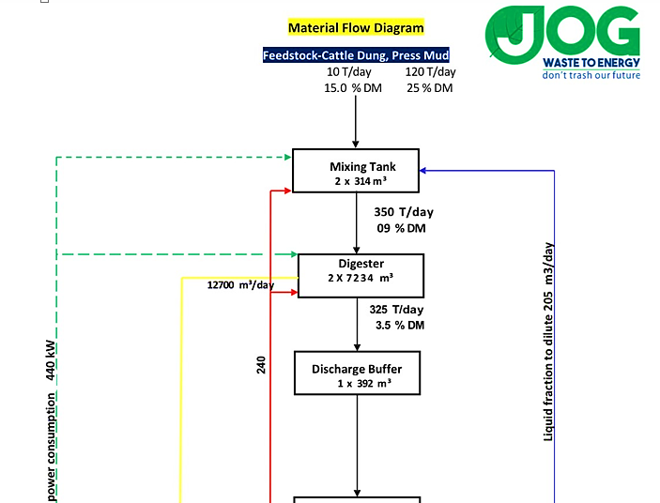
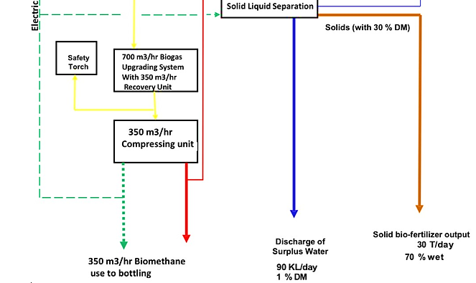

- TECHNICAL SPECIFICATIONS OF THE PROPOSED MAUNUFACTURING FACILITY: Company has planned to set up a Biogas plant to produce 5000 KG per day Bio-CNG and other by-products such as solid and liquid fertilizers. The present Bio-waste to Bio-CNG system operates on a two phase thermophilic process and consists of the following components and equipment
MAJOR PLANT COMPONENT
Weighbridge | Gas Meter
Shredder with Grinder | Associated Liquid Piping System For Conveying Substrates And Liquids
Feed Mixer | Gas Piping System For Conveying Gases To Downstream Equipment
Holding/ Mixing Tanks With Stirring Arrangement | MPSA System with Auxiliaries for Separation of the Biogas into Component Gases of Methane and Carbon Dioxide.
Digester Tank with Stirring and Heating Arrangement | Bio-CNG Compressor with Auxiliaries Capacity for Compressing Methane to 200 Bar and Storing In the Cylinders.
Double membrane biogas Balloon | Storage Cylinder Cascades.
Heat Pump With Heat Exchanger | Solid Fertilizer Packaging Plant.
Sludge Separator | Liquid Fertilizer Filling Plant.
Liquid Fertilizer Tank | Bore well with Motor, Piping and Pump
Solid liquid Separator | Online gas Monitoring system with Analyser
Solid Fertilizer Packaging Plant. | Electrical Equipment, Instruments and control system & Automation
Gas Blower And Gas Flare | Conveyance vehicle
BIOGAS PLANT TECHNICAL PERFORMANCES
S. No. |  | Characteristics |  | Values |  | Figures
1 |  | Quantity of feedstock |  | Tons / day |  | 125 to 130
2 |  | TS% & VS% |  | % |  | As Per Given Data
3 |  | Biogas Plant Design Capacity |  | M3/ day |  | 14,000
4 |  | Biogas yield(Generation) |  | M3/ day |  | 12,762
5 |  | Methane content СН4 |  | % |  | 55-60
6 |  | Calorific value |  | Cal |  | 4500-4708
7 |  | Number of digesters |  | Pcs. |  | 2
8 |  | Digester volume (overall) |  | M3 |  | 7234
9 |  | Number of gasholders |  | Pcs. |  | 2
10 |  | Temperature in the digester |  | 0С |  | 36 - 38
11 |  | Pressure in the digester |  | KPа |  | 0.5
12 |  | Overall dimensions of the digester (diameter / height) Approx. |  | Mtr |  | 32/9
13 |  | Solid fertilizers yield (70-80% wet) |  | T/day |  | 30
14 |  | Liquid fertilizers (99% wet) |  | KL/day |  | 100
Biogas To Bio-CNG plant characteristics
15 | Biogas Upgrading Capacity |  | M3/hr |  | 700
16 | Methane |  | % |  | >95-96
17 | Booster Compressor |  | M3/hr |  | 350-400
18 | electrical power Connected Load (Biogas Project) |  | KW |  | 440
19 | Total Electrical power Running Load |  | kW |  | 345

- TECHNOLOGY USED:
- TECHNOLOGY SUPPLIER, EPC: The EPC of the Project will be executed by M/s JOG WASTE TO ENERGY PVT. LTD. Registered address- 16/3, Shivbhumi Industrial Easte II, Near Indore Highway, Gatrad Bakrol Road, Bakrol Bujarang 382433. Jog Waste To Energy Private Limited is a Private incorporated on 13 June 2016, having Corporate Identification Number is (CIN) U40100GJ2016PTC092443, (GST)-24AADCJ7356G1ZJ and its registration number is 92443.
JOG Waste to Energy is a company established with a prime objective of providing cost effective innovative products and services, to cater ever emerging needs of the domain, of solar energy / Biogas and other waste to energy technologies. JOG Waste to Energy provide cost-effective equipment to expert consulting and training in order to set up own Biogas generation & Up-gradation plant.
JOGWTE has the expertise of all the stages of the upgrading process, focus on every stage starting from Raw Biogas collection, Biogas to power project, Biogas cleaning, Biogas drying, Biogas purification, Biogas compression, and finally Biogas Bottling.
M/s Jog Waste To Energy is an established solar venture concentrated on off-framework and on- lattice (with net metering) Solar Power plant applications. They give renewable vitality source at a moderate cost and the slightest cost control maker on the plant by Solar Energy. JOG Waste To Energy Pvt. Ltd. offer On/Off network PV/Thermal Solar Power Plant on long haul settled value contracts to our clients, at costs which much of the times are at or underneath current choices for the clients.
- PROPOSED TECHNOLOGY:
BIO-METHANATION TECHNOLOGY:
- The CSTR Mesophilic bio-methanation technology along with its purification system as supplied by JOG WASTE TO ENERGY PVT LTD, Ahmadabad based solution provider, having expertise and collaboration with German specialists in biological degradation of organic wastes.
- The manufacturing process uses mesophilic CSTR bio-methanation for ensuring high efficiency in converting substrates to biogas, low environmental footprint and low capital cost of the plant and machinery, and 100% availability of plant independent of local climate and weather conditions.
- The plant has a low physical foot print as the hydraulic residence time of the mesophilic plant is just 28-30 days.
- The plant operates 24 X 7 throughout the year as the temperature is maintained at 36-40°C, and hence has constant output of biogas independent of the external temperature and climatic conditions. This ensures high plant availability throughout the year.
- We do have dedicated team of experts and industry veterans and efficient vendor companies for technology supply and after sale technical support.
- The company has a long experience in developing new biological processes and new components for treatment of solid waste and waste water.
- JOG Waste To Energy Pvt. Ltd. will provide the complete plant on turnkey basis. We here at JOG Waste to Energy Pvt. Ltd. adopt frugal engineering and whole system design as the guiding lights and procure only critical equipment from trusted suppliers, while the balance of plant is procured/ engineered locally, thus saving costs and time for implementation.
BIO-GAS UP-GRADATION TECHNOLOGY:
- The biogas so generated is separated into bio methane and CO2 using PSA system that recover approximately over 96-98% of the methane form biogas at methane purity 95-96%.
- The separated bio methane is compressed to 250 bar g using high efficiency compressor and filled in cascades of standard cylinders of 75 Litre of water capacity. The gas is directly supplied to IOCL CNG Pump Outlets/ consumers as automobile fuel at a retail outlet in the market areas, using state of art gas dispensers.
- The separated CO2 is released to the atmosphere.
- Most of the water used for the process is recovered and recycled from the biogas slurry, to cut down the requirement of make-up water for process requirement, thus reducing the water footprint of the project.
- All the macro and micro nutrients in the feedstock are recovered in the form of solid and liquid fertilizers, with ultra-filtration and reverse osmosis process plants, thus forming a virtuous closed loop.
- PROCESS TECHNOLOGY: Biomass is one of the main resources employed within renewable energy, making use of waste streams from agriculture, industrial processes and municipal wastes. Besides using waste sources, biomass clearly has advantages due to low cost, zero carbon footprint and high plant utilization factors compared to other renewable and conventional energy technologies.
Globally, energy trapped in biomass is more than the combined known reserve of oil, gas and coal. With large quantities of biomass available in INDIA in dispersed and decentralized mode in a wide variety of forms across a range of agro climatic conditions, biomass is expected to become increasingly important over time.
There are three temperature ranges in which bio methanation takes place mesophilic (35-38°C) and thermophilic (40 - 55°C) in this project about 10-15 MT/ day of cattle dung will be co-digested with about 120 MT/ day of Sugarcane Press Mud ,which may be collected from nearby Sugar industries.
The pH and C: N ratios will be adjusted and the entire hydrolyser and digester are thermally insulated and heated to 35-38°C with a heat pump to provide the required temperature for thermophilic bacteria to thrive and maximize biogas output.
The present project proposes to employ two stage thermophilic processes using a continuous stirred tank reactor configuration to optimize plant size and conversion efficiency.
WEIGHT BRIDGE: Weight as a measure of a quantity has several benefits. Unlike volumetric measurement, weight can measure quantity without the use of a correction factor for the material's bulk density, weighing does not require contact with the material and with the correct system weighing is fast, accurate and objective, particularly in long-run situations where errors in individual measurements can be neglected.
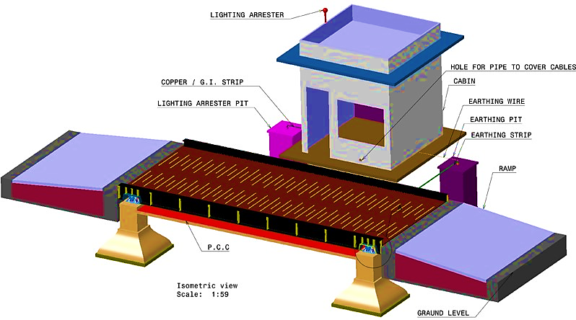
One of the most common weighing systems used in the bulk transportation industry is the weighbridge. Weighbridges are used throughout the world as a way of quickly assessing the weight that a truck or train is carrying.

Their basic configuration is almost the same. All needs sensors, junction box, printer, weighing instrument, nowadays weighbridge can match with computer and weighing software. When a weight is applied to the platform, a portion of the load is transmitted to each load cell. Each load cell sends an electrical signal to the weigh controller via the junction box which sums the signals from a number of cells. The weigh controller converts the summed signals to a weight reading.

PRINCIPLE OF OPERATION
Feeding | Coarse Crushing | Fine-comminution
Feeding devices are applied in case to feed shredders with light or bulky materials. Apart from the standard feeding devices, also special designs are possible that, adapted to the relevant feeding materials, effect an optimal feeding. | The size reduction can be coarse or medium course, in two or four shaft design, as a single- stage or multi-stage system. | Granulating systems for an additional shredding if a fine particle size reduction is to be achieved.

FEEDING PROCESS: The bio mass will be put into a Feed preparation pit. A top mounted mixer, which will mix different feed stocks and bring it to unpacked, fluffy and consistency. From time to time it releases small quantities of feedstock into an open mouth pump. This screw pump joins an additional quantity of liquid with the biomass and pushes it forward. The liquid itself comes in the beginning of the daily preparation period from a Fertilizer pit or sometimes directly from digester. The mixture of feedstock will be pumped into the digester.
The Fertilizer pit and the Feed prep pit are complete of the same design. Digester is comprised of a standing cylindrical tank of reinforced concrete with a net volume of 7,200 M3 of digesters. Digesters are also covered with a double membrane gas roof with inbuilt gas storage capacity. This will reduce emission as well as it increases the gas storage capacity of the whole system.
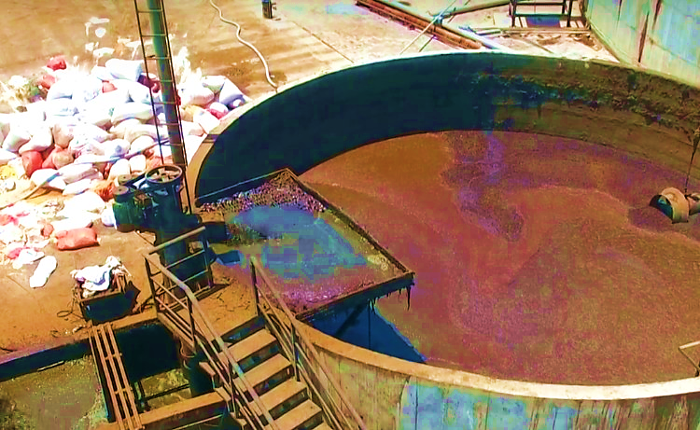
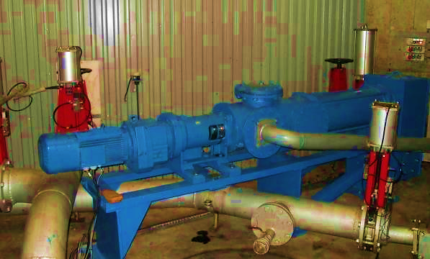
Substrate Supply Pump Preliminary (Mixing) Tank

Feed preparation pit are fully mixed by high quality agitators. Whilst its way from the Feed preparation pit to the digester, the biomass passes through and additional chopper to refine the whole mixture for better pumping, piping and mixing consistence. This way of maintaining an acceptable fluid viscosity even of high dry matter containing. Mixtures will also reduce the demand of electrical self-consumption of the plant.
ANAEROBIC DIGESTER DESIGN AND SIZING SUITABLE FOR MULTI-FEEDSTOCK:
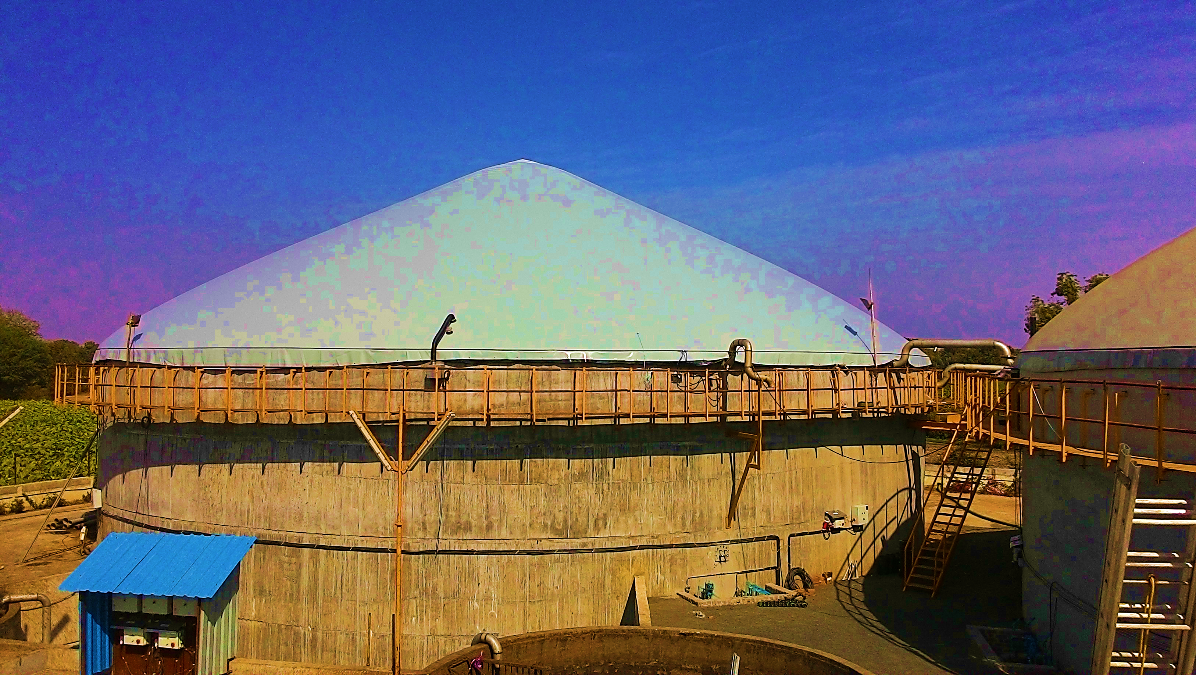
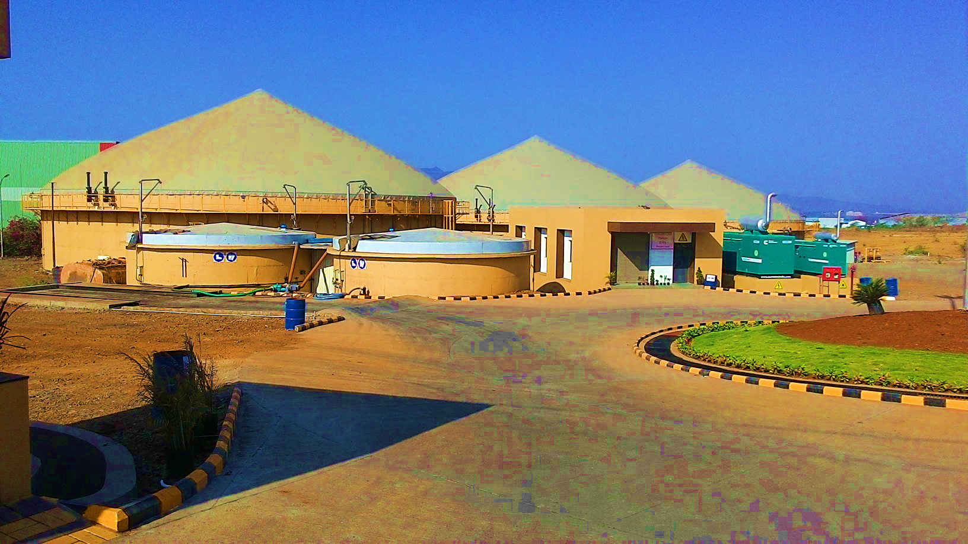
The feeding of the anaerobic digester will work as a semi-automatic storage flow- process, by which the biomass is guided into the digester from the feed prep pit per day. Any process of pumping from, and to any containment will be monitored by level switches.

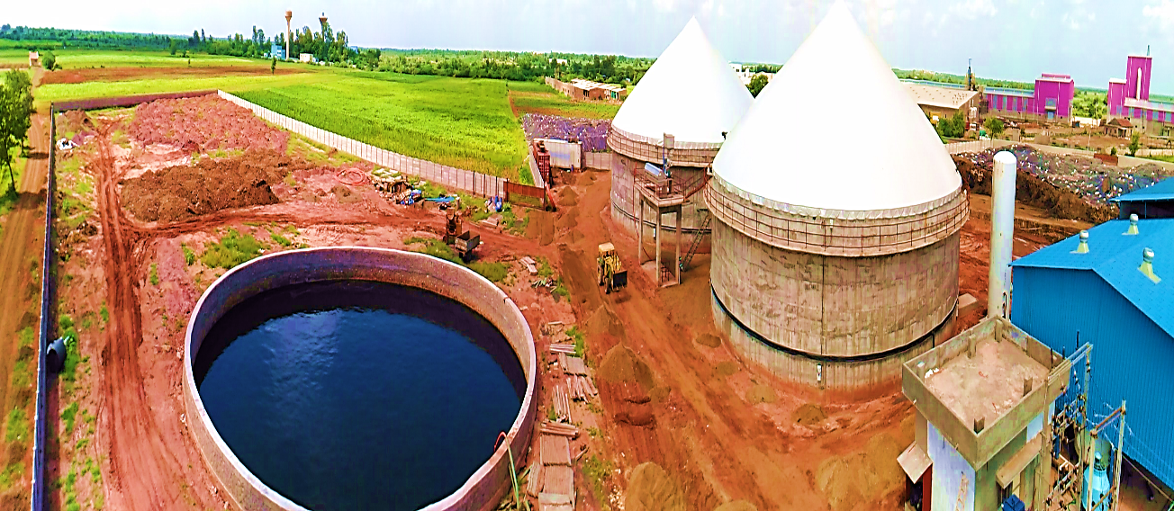

CSTR Technology based Anaerobic Digester
The Digesters are mounted with quality side entry agitators and will be operated in a mesophilic (35˚C ± 2) temperature range. This leads to a stable process and an economical optimized demand for process heat and 30 days of retention time. So, a maximum gas yields.
The digester is comprised of a standing cylindrical tank of reinforced concrete with a net volume of 12,700 M3 including a freeboard head space for gas release. The Digester is covered with a double membrane gas roof.
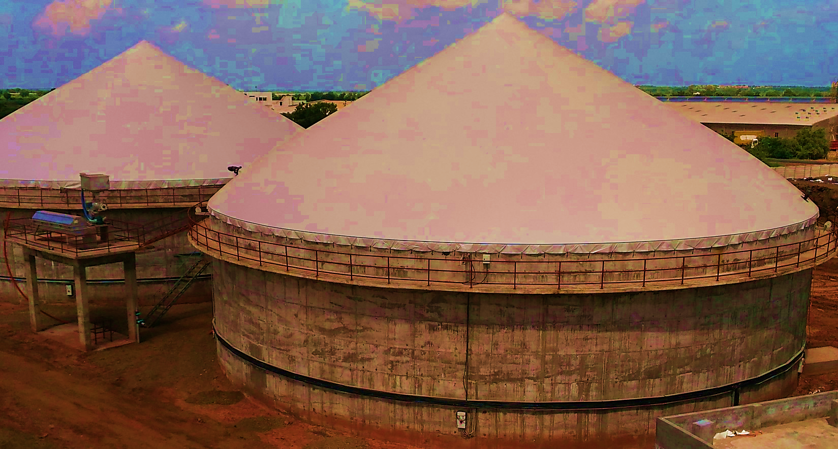
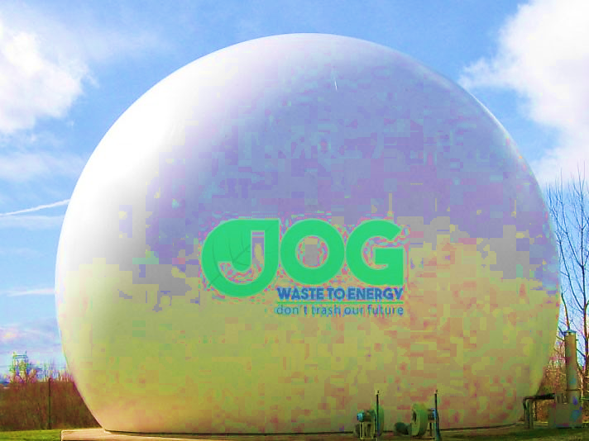
The solids that are fed into the Digestion System for decomposition or degradation of the Volatile Solids (VS) (Organic Dry Matter) present inside the feed substrate (Bio mass). The degradation is done in the digester. Bio mass is guided into digester by the pumping system several times per day. Additionally, re-circulated slurry will be pumped into the digesters. The treated sludge will be pumped to the liquid fertilizer.

Side Entry Type Agitator (Mixer)
As described above, the digester is fully mixed by high quality side entry agitators and will be operated in a mesophilic temperature Range. This combination leads to a stable process with good mechanization results and a minimized effort as far as area requirements and digester volume are concerned. On the other hand, it aims at maximum gas yield which results in maximum greenhouse gas reduction.
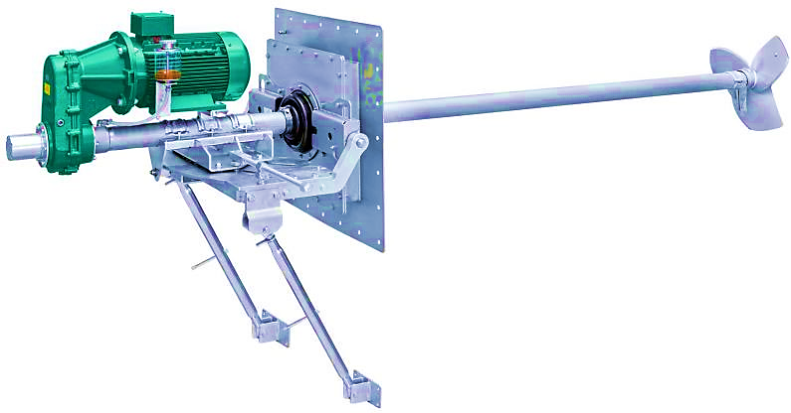

BIO GAS STORAGE: The digester as well as the feed preparation pit is installed with a top dome covering. The digester is covered with Double membrane balloon and an approximate pressure of 4-5 Milli Bar Gas Pressure is maintained. The technology used in CSTR (continuously stirred reactors.) The Agitators will be installed inside the digester to ensure extremely homogenous mixing of the slurry.

Gas Storage -Double membrane Balloon
The digested feed material has VS content in it to produce a gas comprising of maximum pure biogas and the rest of containing of CO2 and H2S. This gas is called biogas. After digestion the feed material is taken for further storage. This technology ensures that the maximum biodegradable feedstock is degraded and maximum efficiency is attained out of the biogas generation plant.
MPSA BASED BIOGAS UP-GRADATION/PURIFICATION TECHNOLOGY: Biogas is the bio fuel having number of impurities in it, which may create problems for man, machine and environments if consume directly for heating, power generation or cylinder filling. So we need to remove all the impurities as per the gas application norms and standards governed by the controlling agencies or equipment manufacturers.
The system which we are going to design for cylinder filling, so we have to follow the Norms of PESO for all constituents present in the final product which will be filled in cylinders. As per given input data of the gas by user, company will process as per the following steps to get the desired quality of product gas.
- Pre cleaning or H2S removal.
- Pressurization and dehydration.
- Co2 removal.
- Methane recovery from exhaust stream.
- Gas analysis and control system

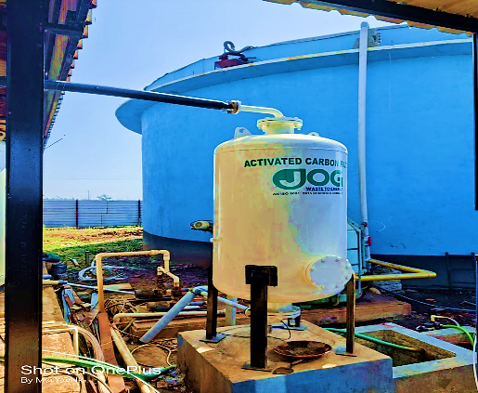
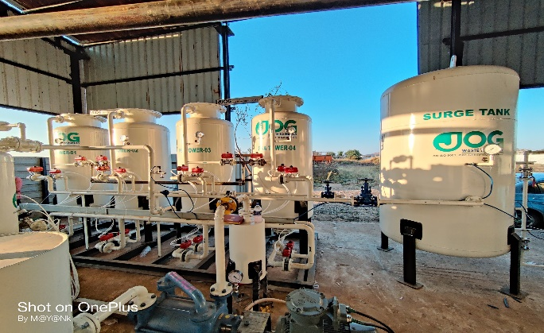
H2S Removal -Biogas cleaning system
Moisture & Co2 Removal

DESIGN BASIS FOR BIOGAS UP-GRADATION UNIT: The composition of biogas and plant load characteristics is indicated in the tables below:

INLET GAS FLOW AND COMPOSITION

INLET GAS SPECIFICATION
B-GAS inlet flow | 700 M³/hr
B-GAS inlet pressure | ATM
B-GAS Pressure by After Blower | Up to 0.8 Bar G
B-GAS COMPOSITION
Methane | 55-60 %
Carbon Dioxide | 35-40 %
Hydrogen Sulphide | 2000 PPM (± 500 PPM)
H20 | Saturated (3 to 4 % )
Nitrogen & Oxygen | < 2 %

OUTLET GAS FLOW AND COMPOSITION

Outlet Gas Specification
B-GAS OUTLET flow | 350 - 400 M3/hr
B-GAS OUTLET pressure | 0.2 - 0.4 Bar G
B-GAS COMPOSITION (As Per BIS STD 16087:2016)
Methane | > 95% (+ -1%)
Carbon Dioxide | < 4%
Hydrogen Sulphide | < 8 PPM (±5 PPM)
H20 | Dew Point (–)65°C or 5 PPM
Nitrogen & Oxygen | Balance

BIO-CNG BOOSTER COMPRESSOR: For transportation and storage, Bio CNG must be compressed up to 250 bars to save space. This application requires compressors and lubricants specifically designed for this use. Air compressors have been used in industry for well over 100 years because air as a resource is safe, flexible, clean and convenient. These machines have evolved into highly reliable pieces of equipment that are almost indispensable in many of the applications they serve.
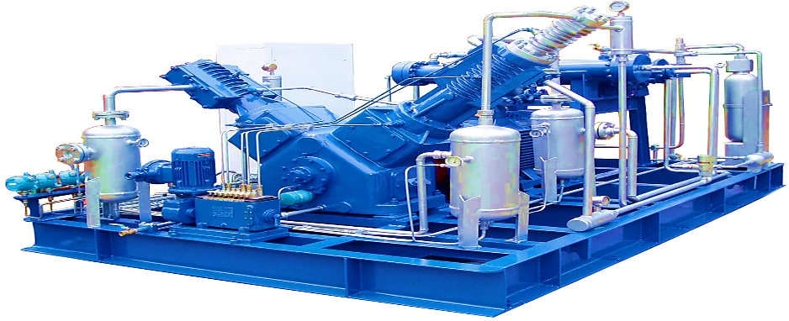
ORGANIC FERTILIZER PLANT (SOLID LIQUID SEPARATION SYSTEM): For each Digester the effluent would be of the order of some amount with 5.5 - 7% TS. The Digester Effluent has wide ranging use as organic fertilizer including for farming. But have preferential applications for, short cycle, forage/energy crops, & horticulture products farming. The effluent from the Biogas Digester is sent to the organic fertilizer unit where the solids & the liquid are separated.
The separated solids can be used as organic fertilizer by further processing such as composting. The Separator separates water from solids. It operates continuously and automatically according to the press screw separator principle and separates thin and viscous compounds. The solid matter / liquid compound are pumped from the inlet chamber by the press screw into the horizontal screen. Some of the water flows due to the force of gravity through the screen.
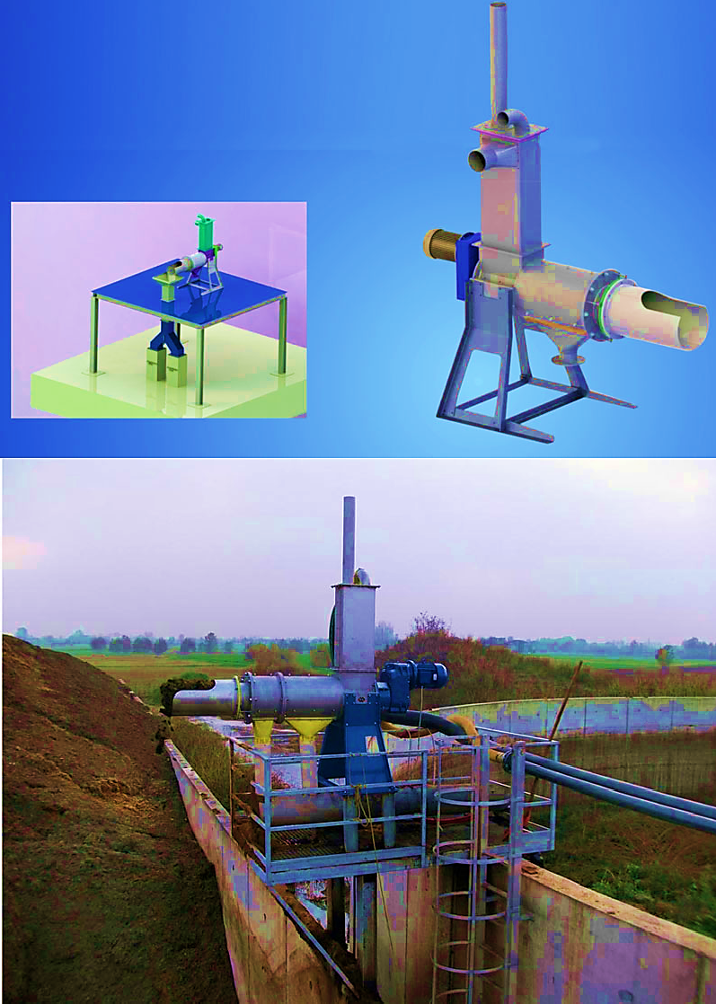
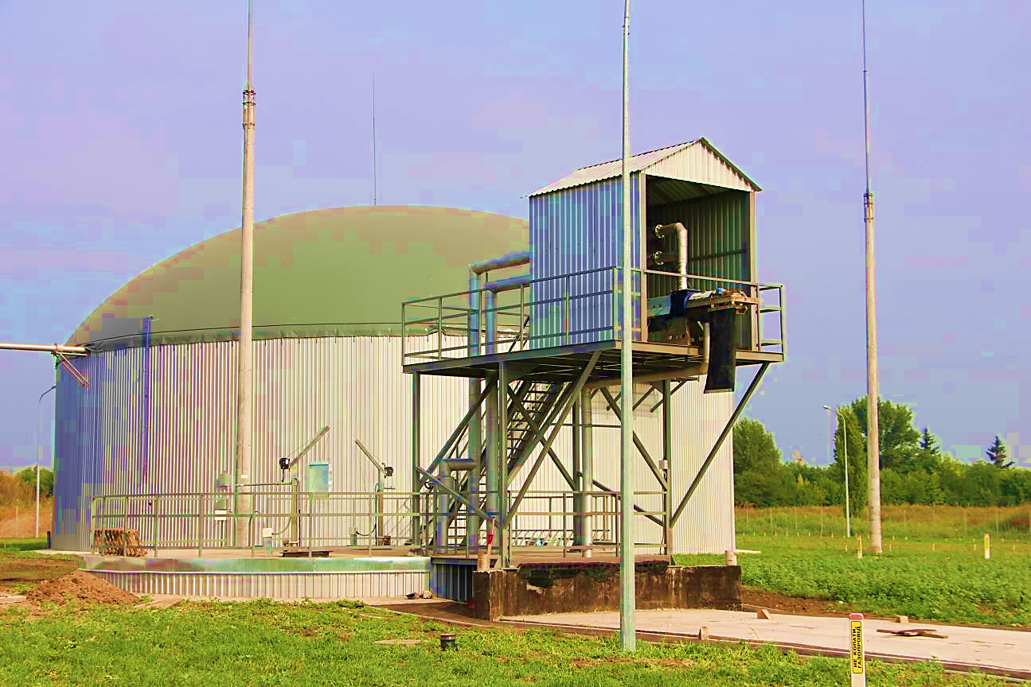
The press screw conveys the rest of the water with solid particles (also smallest particles) into the press zone in the last section of the screen. Here a permanent regenerative, compact solid matter is generated and is then pressed out through the outlet of the machine, which can be easily filled into containers. The separated fluid slows through the outlet underneath the machine. On the grounds of narrow tolerance the inside of the screen is permanently kept clean.

Solid liquid Separator Plant

AUTOMATICS AND ELECTRIC EQUIPMENT: Process control equipment is used for the supervision and regulation of the operation of the plant and for the limitation of damage. In case of emergency, for example, breakdown of the electrical power supply, the biogas plant is automatically transferred to safe operating conditions by the process instrumentation. Necessary electrically driven devices are supplied with emergency power. Automatic system allows to supervise the plant parameters in real time and to recognize and correct aberrations immediately; to run the plant on its optimum and thereby to save resources and costs; to make recordings for the electronic journal of operation parameters. Automatic system consists of control cabinet, sensors for parameter control of technological process and execution devices. Control cabinet is designed on the basis of industrial controller with using periphery distributing system and operator panel Touch with touch-sensitive control. Communications is executed physical interface RS-485.

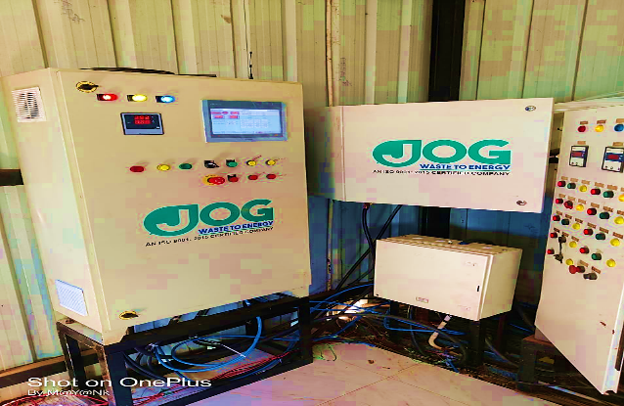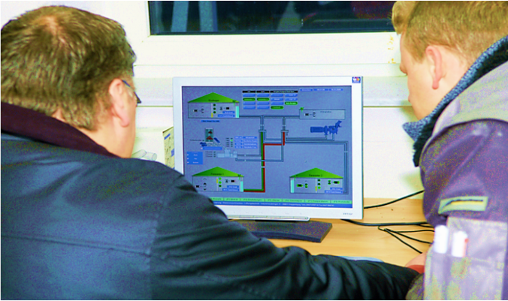
ELECTRIC EQUIPMENT
Upper part has power box, central, and front-end processor. Below periphery distributing system is installed with input – output unit. In lower part the interface relay and clips are installed for connecting execution devices. All plant is operated by 1 or 2 operator.
CNG STORAGE SYSTEM FOR COMPRESSED BIOGAS/BIOCNG: Having more than 10 years of experience and expertise, Jog waste To Energy Pvt Ltd is emerging as one of the leading names in manufacturing, exporting and supplying of CBG Storage Cascades & related equipment’s. Fully equipped with the latest machinery for production with all required safety accessories and necessary approvals as required.
As per information provided to us, Compressed Biogas Cylinder designs are built as per the customer’s requirements and specifications prescribed by the Indian or International Standards. Design calculation and drawings are duly verified by BIS and finally approved by the Petroleum and Explosives Safety Organisation (PESO), Nagpur.
The industrial cylinders for domestic market are manufactured as per IS-7285 standard whereas the CNG cylinders for on-board usage in automobiles are manufactured as per IS-15490, both the standards are duly certified by Bureau of Indian Standards (ISI) and later approved by Petroleum and Explosives Safety Organisation (PESO), Govt. of India.
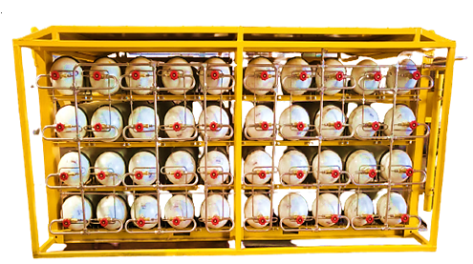
Bio-CNG CASCADE
- TECHNOLOGICAL ASSESSMENT: Below table shows the technology of major equipment of the proposed plant along with specification:
Weighbridge - 40 Ton
- Design, fabrication, supply, installation, testing & commissioning of Fully Welded Modular Type Weighbridge of 40 tons, Indicator, Load Cells, Platform, LED display, suitable software.
- The job shall be undertaken on turnkey basis covering mechanical, Electrical & electronic works including supply of all required material for electrical works including earthing.
- Making of approach ramps to weighbridge shall also be included in the Scope.
TECHNICAL SPECIFICATION OF WEIGHBRIDGE STRUCTURE
The platform of the Weighbridge is of robust construction and is designed to withstand dynamic loads and side loads. The structure will be constructed of rolled steel sections & plates and strong enough to withstand full load without undue deflection. Longitudinal and lateral stoppers are provided to restrain the movement of the platform in the horizontal plane. The top of the platform is covered with anti-skid strips of adequate strength, rigidity and sufficiently strong to carry the maximum load. The structure is designed for an overload capacity of 150% and the
Deflection is <span 450 at its full load.

 | WEIGHBRIDGE STRUCTURE DETAILS
 | Type of Platform |  |  | Fully Welded Modular Type Weighbridge
 | Platform Size |  |  | 7.5 X 3.0 Meter
 | Main U-Beam |  |  | 300 mm X 140 mm - U Beam – 04 NOS
 | Cross Support |  |  | 16 mm Thick Plate Between Two Main Long Beam
 | Top Plate |  |  | 08 mm Top Plate with anti-skid strips
 | Foundation Frame |  |  | 100 mm X 50 mm Long Frame with Fully Welded 350 mm X  350 mm X 16 mm Plane Plate
 | Border Frame |  |  | 100 mm X 50 mm - Both Side Heavy Duty Frame with Side Wall  Mounting
 | Load Cells MS Plates |  |  | 150 mm X 150 mm X 16 mm - Load Cell Top & Bottom Plate
 | Guide Rail |  |  | Round Pipe Based Side Frame - Ø 100 mm - Both Side
 | Fasteners |  |  | As per Required & IS Standard
 | Paint |  |  | 2 coat of ant-corrosive primer and 2 Coat Enamel Paint
 | Material |  |  | All Material will be IS 2062 Standard
 | Computer with printer |  |  | 1 Nos.
 | Civil Work |  |  | Foundation with weighbridge Room
 | Note: It would be a U Beam Type Weighbridge From HT-350 Grade Steel Approved By Weights & Measure Department
No. Equipment |  |  |  |  |  | Descriptions |  | Qty
2 |  | Pumping Equipment and Grinder with Motor
2.1 |  | Substrate supply pumps (2 No.) (1W+1S)-50 m3/hr Separator Supply Pump (1 No.)-40 m3/hr  Progressing cavity screw pumps capacity approx.50 m3/h, Corresponding to dynamic viscosity of media 500-1000 cps), Differential Pressure -2-4 bar,  Rotational Speed -158 rpm, Power -10 HP |  |  |  |  |  | 3  Nos.
2.2 |  | Grinder with strainer -50 m3/hr  Grinder is used for Pump protection from solid foreign objects. It designed specifically for the efficient maceration; it is very effective in capturing irregular shaped objects. The layback cutter shafts are set at an angle to the incoming flow. |  |  | Material of Construction :-  Routing Parts:SS304  Shaft Sealing :mech. seal (Cast Iron) Arrangement: Mechanical seal Housing / End Cover: - Cast Iron, All Rotating Inlet and Outlet Size: DN 150 PN 16 |  |  | 1  No.
MATERIAL |  |  |  |  | PUMP CONSTRUCTION
Pump Housing |  |  | Cast Iron |  | Suction Flange |  | DN150, PN16
Rotating Parts |  |  | SS304 |  | Discharge Flange |  | DN150, PN16
Rotor |  |  | SS 304 |  | Suction Orientation |  | Vertical
Stator |  |  | S62L |  | Discharge Orientation |  | Horizontal
Shaft Seal |  |  | Gland Packing (w) Flushing.Prov |  | Joint Type |  | B Joint
Seal Plan |  |  | 02 |  | CIP Size/Orientation |  | No/No
SM Pin Joint Seal |  |  | S65L |  | Counter Piece-MS/TCL |  | No
O " Rings |  |  | S65L |  | Inspection Port |  | NO
Lantern |  |  | Cast Iron |  | Specific Standards |  | Not applicable
Base Plate |  |  | Mild steel |  |  |  | Not applicable

3 | Mixing Equipment
3.1 | Agitator for Mixing Pit (Feed Mixing Tank) |  |  |  |  |  |  |  |  |  |  |  |  | 2 Nos.
 | Mixing Pit Dimension |  |  |  |  |  |  | 10.0 Mtr x 4.0 Mtr
 | Rating - 15 HP/VARIABLE RPM Max 30rpm/TOP mounted type (1 No.)  Motor 15HP 1450rpm, SC Ind, 3PH, 50 Hz., 415v, IP55, Cl F, V1,Make:CGL/BBL,  Gearbox: Inline helical Gear Box Bonfiglioli/helicon, Couplings Flexible, Impeller Type: Wide Hydrofoil, Lantern support CS Epoxy coated. |  |  |  |  |  |  | Mounting flange to suitable support MS structure epoxy painted, Shaft sealing gland packing  Shaft AISI304, Impeller AISI304, mixed flow axial and radial, bolted, dynamically balanced.
4 | Digester Electrical and Mechanical Package  Side Entry Type Agitator in CSTR Based Digester for Stirring |  |  |  |  |  |  |  |  |  |  |  |  | 2 x 6 Nos.
 | Digester Dimension |  |  |  |  |  |  |  |  |  | - Mtr x 9 Mtr |  |  | 2 Digester
- Digester Tank-RCC with MS railing, Centre column-RCC, inspection platforms, man hole, heating
- pipes, inspection windows, Side entry Mixers with 3-phase-motor 415 V, 50 Hz, Insulation class F individual weather-proof enclosures with soft starter,
- main switch, manual-/ automatic-selection switch, ON/OFF- switch, Heating Setup for heat distribution inside digester at mesophilic range, for connection with external heat source
- Double-Membrane Gas-Storage Roof system with air blower (1W + 1S), deflation flap, over-/under pressure valve, gas level indicator
- All connection nozzle for gas and slurry inlet and outlet, Agitator openings
- All design and structural engineering for Digester tank
 | Rating - 20 HP/380 RPM/AISI304  03 Nos. &  15 HP/380 RPM/AISI304 3 Nos.  Over load protection, Motor 1450rpm, SC Ind, 3PH, 50 Hz., 415v, IP55, Cl F, V1, Make:CGL/BBL  Protection class IP55/Insulation class F with Gear Box or Belt Pully Arrangement , Couplings Flexible, Lantern support CS Epoxy coated. Shaft & Impeller :SS 304 (Graphite Teflon ring)  Bearing : Spherical Roller SKF Impeller :Axial Flow  Blade: Hydrofoil Nozzle : 600 NB  Shaft length 1.5 to 2 meter |  |  |  |  |  |  |  | Mounting flange to suit tank flange, Shaft AISI304, Shaft sealing Stuffing box with gland packing, Impeller AISI304, Axial flow type, bolted, Balancing Dynamic.  HRTTime:28-30 Days  Temperature:36-38 0C
4.1 | Heating Arrangement For Digester |  |  |  |  |  |  |  |  |  |  |  |  |  |  |  | For 2 Digester
Circulation pump, Three-way electric valve for temperature regulation with electric drive, Thermometer, Heat Exchanger Temperature controlled by a circulating Hot water Piping Network, connect the heater to the heating jacket using Piping Network. Set the heater to the appropriate temperature for mesophilic (36-40 0C) digestion. Piping has to be made SS or HDPE, rust proof structure, of appropriate Diameter, conforming the relevant BIS Standards. |  |  |  |  |  |  |  |  | Heater Range: 4 x 36 KW Circulation Pump  Q =10 m3/hr (2 No)  Piping Network Arrangement with Clamp and Related Other Accessories
5 | Equipment /Machinery For Fertilizer Tank |  |  |  |  |  |  |  |  |  |  |  |  |  |  |  | 1 Set
Civil Work (10 Mtr x 5 Mtr) with Below listed equipment for fertiliser tank
- Top Entry Agitator, Pump for slurry Transfer, Auto Valves, Manual Valves, Flanges, Wall Mounting Flanges, Fitting Material of Flanges
6 | Double membrane Balloon |  |  |  |  |  |  |  |  |  |  |  |  |  |  |  | 2 Set
 | Double membrane Balloon and its accessories,  Imported Membrane fabric for inner and outer balloon, Pressure Safety valve for air. Pressure and vacuum Safety valve for biogas. Air blower with hose pipe. All accessories. Like pressure gauge, nrv, fittings, and mounting hose. All companion flanges. Gas level indicator. |  |  |  |  |  | TYPE: Double membrane  - Dimension: As per Digester  - Diameter 32 Mtr.  - shape conical  - PVC Coated Fabric  - Fire Retardant, temperature resistant up to 50 deg c.  - UV protected  - 1100 gsm +/- 50 gsm  - Fabric: Fire Behavior B1 Grade
7 | Horizontal Solid liquid separator |  |  |  |  |  |  |  |  |  |  |  |  |  |  |  | 2 set
 | The separated solid portion and liquid portion can both be simply and economically handled.  - Slide Valve and levers system for separation level adjustment  - Set of hoses for connection to pipeline of Subtract supply and Filtrate discharge |  |  |  |  |  |  |  | Make: Italy,  Model: Q=65 5.5 KW  Simple in operation and cost- saving in spare parts Durable, high performance self-cleaning screen basket Suitable for continuous duty Modular screw design and manufacturing Various types of diaphragm outlet, Polymer screws, basket sizes
 | INCLUDING: Loading hopper in SS304, Body in SS304, Techno polymer Diaphragm Pressor, Support frame in hot dip galvanized steel, Solid Plug shelf support, Modular Screw in techno polymer SINT EC 90 & SS304 Screen in SS304 0.5mm, Round Filter Element
8 | 700 m3/hr Catalyst Tower Based H2S removal System |  |  |  |  |  |  |  |  |  |  |  | 1 Set
 | A bio Catalyst scrubber consists of a Tower Based gas scrubber. In the gas scrubber, to be removed components are absorbed from the gas stream by the Activated Carbon. Shape: Cylindrical Desiccant Activated Carbon MOC Internal parts :S.S 316, MOC shell :C.S./HDPE
9 | 700 m3/hr biogas Upgradation systems with 350 m3 hr |  |  |  |  |  |  |  |  |  |  |  |  |  |  | 1
 | Upgradation of Biogas by Low pressure swing adsorption, using energizer for better separation rate was evaluated to produce fuel grade methane. Three different adsorbents were employed to evaluate the process performance with equilibrium- and kinetic-based adsorbents. |  |  |  |  |  |  |  |  | Capacity : 700 m3/hr Pressure: 150 mmWC to 0.8 Bar  CH4 Purity : >95% H2S: <10 ppm Other: Balance Output Pressure:  - Bar
 | Sand Filter, Roots Blower with FLP Motor(1W +1S) Vacuum Pump with FLP Motor(1W +1S) Double effective Heat exchanger with moisture separator, Biogas Dryer, Cooling tower 30 m3 surge tank, Four Towers system, inter connected piping and valves & Actuated change over valves, Mol sieve and Activated alumina and ceramic ball, 40 m3 surge Tank, Instrumentation package, Control panel PLC base with RS 485
Booster compressor (400 m3/hr) |  |  |  |  |  |  |  |  |  |  |  |  |  |  | 1
Capacity: 400 m3/hr Make: Imported Make  Number of stages:5 Drive: V Belt  Oil lubricated, Air Cooled cylinder with fins on surface, Inter connecting piping from first stage to outlet separator last stage Crankcase with mechanical seal All others specification as per company std |  |  |  |  |  | Inlet Condition  Gas condition at inlet: BIO METHANE Capacity:400 m3/hr  Suction Pressure :1.05 to 1.3 Bar Suction Temperature:40°C  Discharge Condition  Discharge temperature: Ambient + 15°C  Discharge Pressure: 250 Bara
Product gas Biogas analyzer -Combined stationary measuring device |  |  |  |  |  |  |  |  |  |  |  | 1 set
Type |  |  | Combined stationary
Make |  |  | Imported
Measuring port |  |  | 4 ports
Measuring ranges and sensors
Methane |  | 0.0 – 100 % vol. |  |  | Infrared sensor
Oxygen |  | 0.0 – 25 % vol. |  |  | Electro-chemical sensor
Hydrogen sulphide |  | 0 – 5000 ppm |  |  | Electro-chemical sensor
Carbon dioxide |  | 0.0 – 50 or 100 % vol. |  |  | Electro-chemical sensor
Moisture Analyzer (Dew Point meter)
Range |  |  | + 20 to – 110 deg C
With resolution 1 deg C, Make of analyzer with sensor: - GE Sensing Germany
Bio-CNG Cascade
40 Cylinder Cascade  @ 260 Kgf/cm²  Cylinder Cascade Assembling, Testing & Inspection of Cylinder Bank, Fabrication of Structure in  M.S of CNG Cascade of 3000 Ltrs W.C. having 40 Cylinders, Tubing & Fittings: SS 316, Bank: Single Bank, Pressure Gauge: 0-400 bar 4" dial pressure gauge), Manifold: Brass, Bull Nose : Brass Filling arrangement : NZS probe suitable Frame : Square pipe |  |  |  | Specification :- Water Capacity-75.0 Ltrs per Cylinder, Cascade Water Capacity- 3000 Ltrs, Working pressure of 250 Kgf/cm², OD- 267 mm, Dim-3.2 x1.85 x1.90Mtr, Cascade Weight-5.0 Ton Approx.  Note: All cylinders are Hydro static Tested |  |  |  |  |  |  |  |  |  |  |  |  | 5  Nos.
Thus as per the above technical analysis, M/s Shree Jee Bio Energy is using the appropriate Mesophilic (25-400 Degree Celcius) CSTR technology which is a going on, recognized and trending in the market at present. It can be commented positively that the plant will be running smoothly and technology & specification of the plant are matching with the need to run the plant smoothly and achieve the economies of scale.
- EFFLUENT TREATMENT AND ABETMENT:
EFFLUENT TREATMENT APPROACH: The philosophy underlying the effluent treatment system is predicated on the sustainability principles of renew, reuse, recycle and recover. The thrust is to use renewable resources, reuse “wastes” recycle valuable inputs such as water, energy and nutrients and recover through energy efficiency initiatives energy otherwise lost.
PRODUCTION PROCESS: The biogas plant generates about 12,700 m3/ day of biogas, which consists of 55-60 % methane, 36-40% CO2 and 2-5% water vapour, and contains about 1% of contaminants such as hydrogen sulphide (H2S) Ammonia (NH3) and N2 which are removed in the gas cleaning train. The cleaned gases, which contain ppb levels of the contaminants, are injected by the biogas pump into the biogas burners, which are specially designed to operate with biogas and used as cooking fuel, replacing the LPG.
DISPOSAL OF BY-PRODUCTS: Fertilizer by-products: The plant generates about 30,000 Kg/ day of solid organic fertilizer from the sludge separator and about 90,000 Litre/ day of liquid organic fertilizer. This is sold as fertilizer in the market. Recycled Slurry/Water: The digested slurry after process from solid liquid separator 2, 28,000 Litre/ day will be reused in mixing tank as live feedstock. This is mixed with the incoming fed in the hydrolysis holding tanks.
- TESTING STANDARDS FOR PRODUCTION: As per communicated by client, company is having a quality control Laboratory, wherein, they check the entire range on defined parameters like design, quality and finish. The unit is equipped with all the essential tools, machine, and technology in order to manufacture a high-quality range of products.
LAB EQUIPMENT FOR TESTING SLURRY AND GAS CHEMICAL PARAMETER
Hot air oven (up to 200 Deg C), Digital Ph meter, Desiccator, Soil testing kit, Weight Balance, Muffle Furnace up to 1100 Deg C, Analyzer calibration kit, Ch4 and co2 cylinder, Biogas sample collection kit

- MANPOWER: As per information shared by the client/.company, an estimate of manpower requirement allowing for leave, absentecism, sickness and holidays for smooth and for efficient operation of different sections of the plant including its administrative and commercial departments, has been prepared based on technical and management ground primarly to indicate the order of manpower requirement.
For reference, as per information available on Press Information Bureau (PIB: https://pib.gov.in/PressReleasePage.aspx?PRID=1868887) as on 18th Oct, 2022, The Sangrur CBG Plant shall provide direct employment to 390 and indirect employment to 585 people. This is a 33TPD capcity plant, thus it comes out with 12 workers per ton and the proposed plant is using total 92 human resources which comes out with 18 workers per day.
In estimating the manpower requirement, a proper ratio between the administrative, managerial, supervisory and shop foor staff has been maintained with a view to affording proper industrial and professional management at various levels. The basic structure of the manpower will require the following kind of resources to opearte the plant 24*7 for 350 days a year:
MANPOWER DETAILS ALONG WITH ESTIMATES WAGES EXPENSES ANNUALY
FACTORY WAGES & SUPERVISION
a) Workers’ Wages |  | COST (INR) |  | COST (INR)
Category | Number | Average Monthly Salary | No. of months/ year | Total Annual Salary
Skilled Workers | 12 | 25,000 | 12 | 36,00,000
Semi-Skilled Workers | 4 | 20,000 | 12 | 9,60,000
Un-Skilled Worker | 20 | 12,000 | 12 | 28,80,000
Sub Total | 36 |  | 12 | 74,40,000
b) Factory Supervision
Shift Supervisor | 4 | 45,000 | 12 | 21,60,000
Field Officer | 2 | 35,000 | 12 | 8,40,000
Store In-Charge | 2 | 22,000 | 12 | 5,28,000
Store Assistant | 2 | 20,000 | 12 | 4,80,000
Chemist | 2 | 18,500 | 12 | 4,44,000
Sub Total | 12 |  |  | 44,52,000
Total Wages & Salaries | 48 |  |  | 1,18,92,000
II. OFFICE STAFF
General Manager | 1 | 80,000 | 12 | 9,60,000
Accounts Manager | 1 | 50,000 | 12 | 6,00,000
Accounts Assistant | 2 | 35,000 | 12 | 8,40,000
Office Assistant | 2 | 25,000 | 12 | 6,00,000
Office boy | 2 | 10,000 | 12 | 2,40,000
Total for Office Staff | 8 |  |  | 32,40,000

PART F | PRODUCT PROFILE
- INTRODUCTION: BG has calorific value and other properties similar to CNG and hence can be utilized as green renewable automotive fuel. Thus it can replace CNG in automotive, industrial and commercial areas. Ministry of Road Transport and Highways, Government of India had permitted usage of bio-compressed natural gas (bio- CNG) for motor vehicles as an alternate composition of the compressed natural gas (CNG).
Compressed biogas, or Bio-CNG, is likely to play a crucial role in promoting India’s transition to a sustainable energy ecosystem. Bio-CNG is a green renewable automobile fuel with calorific value and other qualities similar to compressed natural gas (CNG).
The main objective of the project is to set up a compressed biogas plant to sale the Bio CNG to the local user at around INR- 70 per Kg. The plant also produces organic manure/Solid Fertiliser in large quantity which can be sold at about INR- 2.0 per Kg in open market. Bio CNG is in good demand. Similarly organic manure is always in short supply. It is needed for fruits and vegetables and horticulture farming. The plant is proposed to be set up in a place where Sugarcane press-mud & Cattle dung is available in large quantity or some other source of waste bio material is available.
- PRODUCT CATEGORY:
- BIO CNG: The plant has a capacity to produce about 5,000 Kg/ day of Bio-CNG which has a gross calorific value of 12,500 Kcal/Kg. Bio-CNG, a clean and renewable fuel, has vast potential in India. It can be a supplement to petroleum products, if used in compressed form in the cylinders. Biogas originates from bacteria in the process of biodegradation of organic material under anaerobic conditions. Methane is the most valuable component under the aspect of using biogas as a fuel; the other components do not contribute to the calorific value and thus are "washed out" in the purification plants in order to obtain a gas with almost 95- 96% CH4. Methane is the flammable compound in biogas.
Composition of Purified Bio-CNG
Ingredient | Value | Test Method
CH4(Percentage) | 95-96 % | IS-5130 (Part3)
CO2+ N2 + O2(Percentage) | 4-5 % | IS-15130 (Part3)
Only CO2 | < 4 % | IS-15130 (Part3)
H2S (Mg/M³) | 5 (Mg/M³) | ISO- 6326-3
Moisture (Mg/M³) | 5 (Mg/M³) | IS-15641 (Part2)
Bio CNG is used as Automobiles Fuel, Industries, Canteens, Restaurant, Hotels, Sweet shop, Dhabas etc.
EQUIVALENT QUANTITY OF FUEL FOR 1 CU M OF BIOGAS
Biogas | 1.00 M³
Kerosene | 0.620 Litre
Fire wood | 3.474 Kg
Charcoal | 1.458 Kg
Butane | 0.433 Kg
LPG | 0.456 Kg
Electricity | - Kwh

- ORGANIC FERTILIZER: The plant has a capacity to produce 30,000 Kg/ day of solid organic fertilizers and 90,000 Litre/ day of liquid organic fertilizers. The material drawn from the digester is called sludge, or effluent. It is rich in nutrients (ammonia, phosphorus, potassium, and more than a dozen trace elements) and is an excellent soil conditioner. It is being used widely as organic fertilizer. Any toxic compounds (pesticides, etc.) that are in the digester feedstock material may become concentrated in the effluent. Therefore, it is important to test the effluent before using it on a large scale.
Waste coming out of the digester can be separated (solid/liquid) to use the solid part as fertilizer and use the liquid part as fertilizing irrigation or to be treated further for rejection in nature. The digested slurry can also be fed directly to the crop through the irrigation channels or it can be stored and used later whenever required. To derive maximum benefits from the stored digested slurry, it is essential to prevent its exposure to the sun as any such exposure would result in loss of ammoniacal nitrogen content of the slurry.
It is advisable to dig, two or three manure pits near the biogas plant. The slurry is then carried and stored in these pits which are covered with solid waste from the farm. The fresh biogas slurry when used by mixing with irrigation water to growing crops gives better yields as compared to other modes of its applications
- QAULITY OF MANURE: The C: N ratio of organic manure is between 12:1 to 16:1. It is a good source of nitrogen, phosphorous. Potassium and Iron. Typical elemental composition of the organic manure and biogas obtained at two of the operating plants based on BARC technology is given below:
ELEMENTAL COMPOSITION OF ORGANIC MANURE
Calcium | 0.39-0.65 %
Iron | 0.18-0.32 %
Magnesium | 0.032-0.01 %
Manganese | 0.0059-0.008 %
Nitrogen | 2.6-3.5 %
Phosphorous | 0.8-0.9 %
Zinc | 0.007-0.009 %
Potassium | 0.8-0.95 %
In other words, one ton of slurry provides 44 kg of nutrients as compared to 19 Kg through farmyard manure and 27 Kg by compost. Micro nutrients such as zinc (Zn), copper (Cu) and manganese (Mn) present in the original material are also recovered in biogas slurry and can proved useful to crops when used as organic manure. The nutrient composition of slurry manure is shown in Table:

Sr. No. | Ingredient | Value
1 | Total Nitrogen (%) | 1.40 – 1.84
2 | Total Phosphorous (%) | 1.10 – 1.72
3 | Total Potash (%) | 0.84 – 1.34
4 | Organic Carbon (%) | 35.0 – 38.4
5 | Zinc (mg/kg) | 103 – 116
6 | Copper (mg/kg) | 51 – 68
7 | Manganese (mg/kg) | 231 – 295
8 | Iron (mg/kg) | 3200 – 3600
9 | Carbon / Nitrogen ratio | 10 – 15
10 | Organic Matter | 65%

The organic manure produces are recommended for following crops:
- Short term crops: Vegetables and Fodder
- Mid-term crops: Wheat, cotton, Rice, Potato, Sugarcane and Maize
- Long term crops: Kinnow, Guava, Grapes, Mango, Lemon and Apple.

Crop | Doses | Time of application
Wheat, Rice, Maize and  Cotton | 200-400 Kg/Acre | During preparation of Land for  Sowing
Sugarcane, Potato | 400-800 Kg/Acre | Half Dose of Manure during preparation of Land and remaining half after two-three months of sowing
Vegetable | 200-400 Kg/Acre | 20-30 Days after plantation
Kinnow, Guava, Grapes, Mango, Lemon and  Apple. | 5-10 Kg/tree | Two times in a year

- BIO COAL: Apart from fertilizer, the company has futuristic plan to get value added product and generate revenue by making an organic Bio coal, for this they are planning for production facilities for Bio coal by Processing of Output Digested and Press mud, where bio coal will be produced and sell on a commercial scale. M/s Shree Jee Bio energy is developing a production facility for bio coal on a commercial scale making bio coal a viable and sustainable alternative to fossil coal, where high-quality bio coal will be produced. This creates a relatively cheap bio fuel with a high energy density.
- PRICING STRATEGY: The Solid and Liquid Bio-Fertilizers are in demand as a premium replacement for chemical fertilizers and are to be directly marketed using appropriate channels to the farming communities and sold @ INR 2.00/Kg and INR 0.10/L respectively.
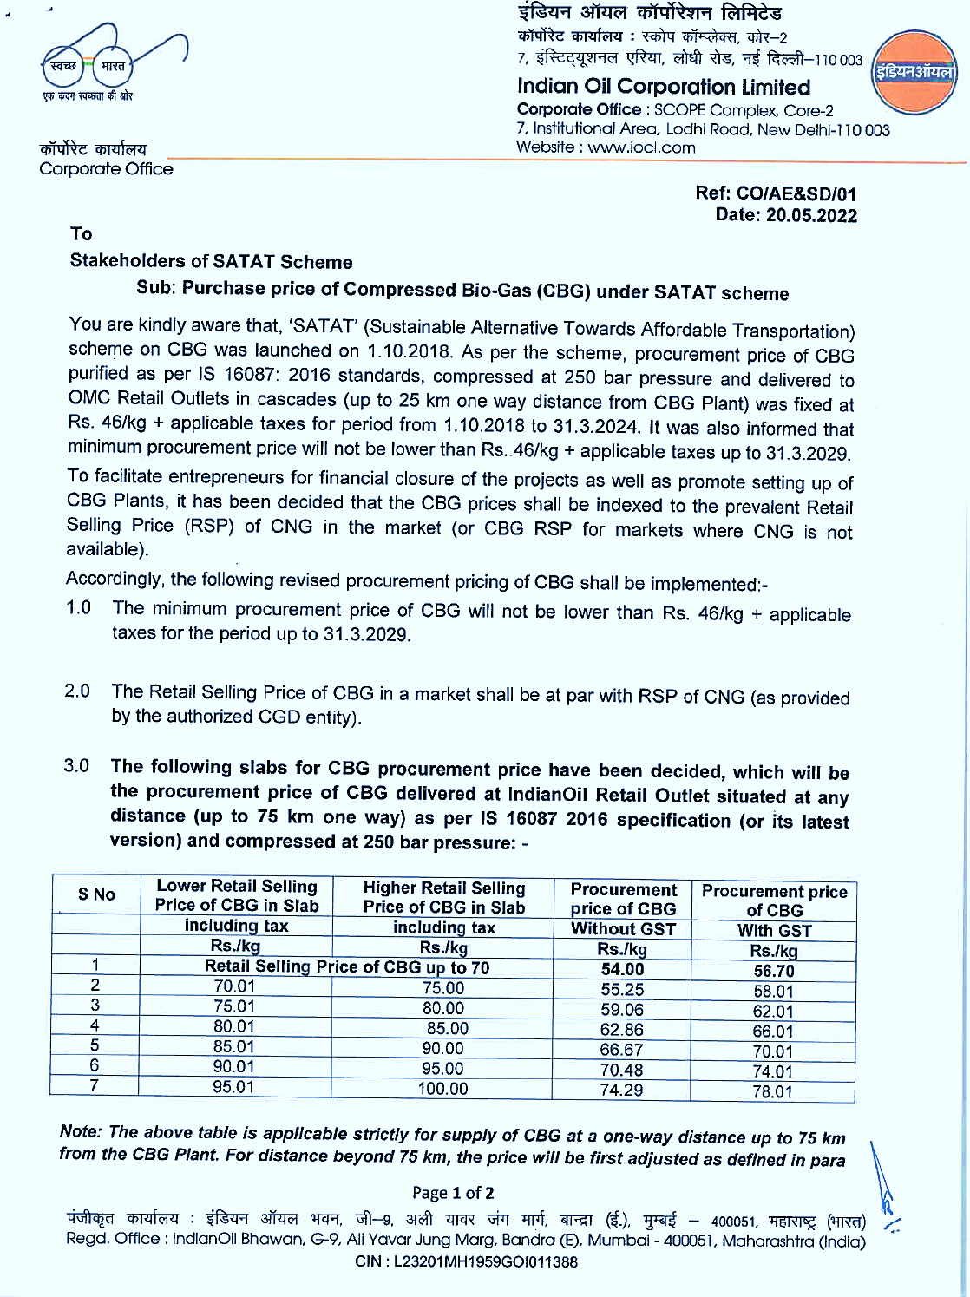

CBG PRICING CIRCULAR – STAKEHOLDERS OF SATAT SCHEME
As per CBG Price circular (SATAT Scheme), the company has decide to sell the Bio CNG @ INR 70.00 per kg. We have studied the Reference document for Revised Circular of CBG Pricing under SATAT scheme in slabs for CBG procurement price. The current retail price of CNG in Haridwar, Uttarakhand is INR 102 per kg (Reference Link: https://hngpl.in/2023/07/14/cng-retail-price-w-e-f-01-07-2023-00-00hrs-retail-selling-price-%e2%82%b984-20-kg/), As per the SATAT CBG pricing document the M/s Shree Jee bio energy has considered lower selling rate of CBG INR 70 per Kg
- MARKETING, SELLING & DISTRIBUTION PLAN: BIO CNG: The project proposes to supply the gas to the regular consumers via retail outlets of INDIAN OIL in the local market area. Bio CNG is to be supplied to consumers directly as a replacement for CNG as a fuel in Vehicular Fuel, industrial utilization, or as a cooking fuel in the restaurants at the nearby markets. It can also be used as an automobile fuel using gas dispensers and as high grade industrial fuel for cutting and welding applications. The Bio-CNG produced has to be sold to INDIAN OIL CORPORATION LTD. @ INR 70.00/Kg. for which the company have already secured a purchase agreement/ LOI (Ref No.) Indian Oil/SATAT/01/3366.
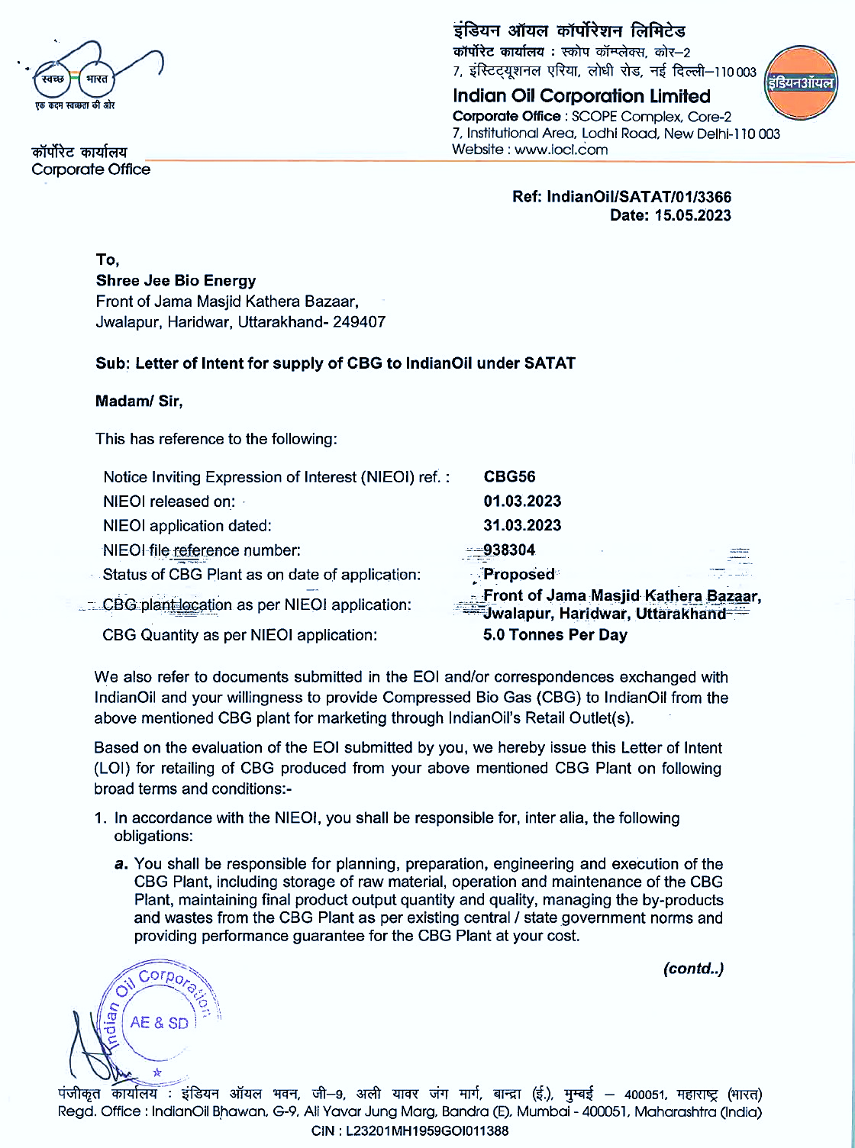
ORGANIC FERTILIZER: Solid OF is to be sold to farmers at the appropriate outlets. @ INR 2.0/Kg. to the farming communities and is deployed for growing crops and Liquid OF which is to be sold to farmers at the appropriate outlets. @ INR 0.10 per Kg. The current market scenario for selling organic fermented solid manure is 5 to 6 Rs per Kg with packing and baging and loose (bulk) INR 3 to 4 per kg. The government is taking initiative to promote organic fertilizer from biogas plant/CBG plant to sell the organic fertilizer as INR 1500 per ton (1.5 Rs. per Kg).
Furthermore Rs. 1451.84 crore has been sanctioned for Market Development Assistance (MDA) to promote organic fertilizers from Gobardhan plants. To support marketing of organic fertilizers i.e. Fermented Organic Manure (FOM) / Liquid FOM / Phosphate Rich Organic Manure (PROM) produced as a by-product from Biogas Plants / Compressed Bio Gas (CBG) Plants set up under Gobardhan initiative 1500 per metric ton as MDA scheme is included. With considering above benifits of subsidy on fertilzer, there is more chances of generating opportunities for new promoter in upcoming future to avail these benefits.

PART G | FEEDSTOCK ANALYSIS & SUPPLY

- BIO-METHANE FROM ANAEROBIC DIGESTERS: Anaerobic processes could either occur naturally or in a controlled environment such as a biogas plant. Organic waste such as livestock manure and various types of bacteria are put in an airtight container called digester so the process could occur. Depending on the waste feedstock and the system design, biogas is typically 55 to 60 percent pure methane. State-of- the-art systems report producing biogas that is more than 95 percent pure methane.
The primary component of an AD system is the anaerobic digester, a waste vessel containing bacteria that digest the organic matter in waste streams under controlled conditions to produce Bio-methane. As an effluent, AD yields nearly all of the liquid that is fed to the digester. This remaining fluid consists of mostly water and is recycled to flush manure from the swine building to the digester.
APPROXIMATE QUANTITY REQUIRED FOR GENERATION OF ONE M3 BIOGAS
Sr. No. | Substance | Quantity (Kg)
1 | Cattle Dung | 20
2 | Paddy Straw | 4
3 | Napier grass | 8
4 | Poultry Waste | 8
5 | Horse/ Mule/ Elephant Dung | 12-15
6 | Food waste: Pre and post cooked leftover food from households, hotels and canteens. | 10-12
7 | Green waste (vegetable market waste): Vegetable  Refuses from Vegetable Markets or kitchens. | 10-12
8 | Paddy straw/ wheat straw/ mushroom spent waste:  Lawn cuttings, leafy biomass, dried flowers, finely chopped and ground straw or bagasse. | 5-8
9 | De-oiled rice bran | 3-4
10 | De-oiled seed cake (Pongamia/ Jatropha) | 3-4
11 | Segregated municipal solid waste (biodegradable) | 12-15
12 | Slaughter house waste (blood, flesh and left over  food in the gut of animal) | 5-10

Approximate Required Quantities of the Substances (Alone)
Sr. No. | Item | Daily Required Quantity (Ton)
1 | Cow Dung | 250
2 | Poultry Droppings | 98-100
3 | Food Waste | 175-180
4 | Sugarcane Press mud | 125
Combination of any of these mentioned above can also work in proportionate quantity. But the present project will be using the following Combination of Raw Materials as per Feed stock analysis:
Sr. No. | Item | Daily Input Quantity (Ton)
1 | Cow Dung Required | 10-15
2 | Sugarcane Press mud | 115-120
Note: Feed stock quantity may very base on Dry matter and volatile matter available in the above mention feed stock
- PRESS MUD: Press mud is a solid residue, obtained from sugarcane juice before crystallization of sugar. Generally press mud is used as manure in India. It is a soft, spongy, lightweight, amorphous, dark brown to black coloured material.
It generally contains 60-85% moisture (w/w); the chemical composition depends on cane variety, soil condition, nutrients applied in the field, process of clarification adopted and other environmental factors. Press mud from sugar factory typically contains 71% moisture, 9% ash and 20% volatile solids, with 74-75% organic matter on solids. Sugar molasses has methane potential (i.e. CH4 per ton of raw material) of 230 m3. Typical composition of press- mud is given below in the table.
COMPOSITION OF PRESS MUD
Components | PERCENTAGE
Cellulose | 11.4%
Hemi cellulose | 10.0%
Lignin | 9.3%
Protein | 15.5%
Wax | 8.4%
Sugar | 5.7%
Na | 0.22%
The present methods for disposal of press mud are not economically suitable and pollute the environment too. As it contains appreciable proportion of biodegradable organic matter, it has very good potential for the production of biogas. Material under anaerobic conditions. Methane is the most valuable component under the aspect of using biogas as a fuel; the other components do not contribute to the calorific ("heating") value and thus are "washed out" in our purification plants in order to obtain a gas with almost 97-100% CH4. Methane is the flammable compound in biogas.
- COW DUNG: In the state of Uttarakhand, million tons of animal dung is produced every year which can be utilized for better purposes. Hence anaerobic digestion becomes a promising technology. The project was to construct an anaerobic processing facility to generate biogas which will be more cost effective and economically friendly.
PERCENTAGE PROXIMATE COMPOSITION AND PH VALUES OF THE DUNG
Parameters | Cow Dung
Moisture % | 18.55 ± 0.28
Ash % | 10.10 ± 0.02
Crude Fiber % | 40.20 ± 0.12
Crude Protein % | 6.80 ± 0.06
Crude Fat % | 4.00 ± 0.42
Carbohydrate % | 20.35 ± 0.34
pH | 7.10 ± 0.01
Fresh cow dung is collected from nearby villages and Cow Farms. The proximate and microbial parameters of the dung were determined. The proximate analysis showed that the energy yielding nutrient values of the cow dung were significantly higher than the fowl dung.
Gas produced from cow dung is 55-65% methane, 30-35% carbon dioxide, with some hydrogen, nitrogen and other traces. Its heating value is around 600 B.T.U. per cubic foot. Cow dung slurry is composed of 1.8-2.4% nitrogen (N2), 1.0-1.2% phosphorus (P2O5), 0.6-0.8% potassium (K2O) and 50-75% organic humus.
About one cubic foot of gas may be generated from one pound of cow manure at around 28°C. This is enough gas to cook a day’s meals for 4-6 people in India. About 1.7 cubic meters of biogas equals one Litre of gasoline. The manure produced by one cow in one year can be converted to methane, which is the equivalent of over 200 Litres of gasoline.
- AVAILABILITY OF RAW MATERIAL:
- SUGARCANE PRESS-MUD: India is the largest consumer and second-largest producer of sugar worldwide with sugarcane grown across India. Uttar Pradesh, Uttarakhand, Maharashtra, Andhra Pradesh, Karnataka, Gujarat, and Tamil Nadu are the primary sugar-producing regions. Sugar processing facilities tend to be located near major sugarcane-producing areas to minimize transportation costs. As a result, Uttar Pradesh, Uttarakhand, Maharashtra, Karnataka, and Tamil Nadu have the highest amount of both sugarcane area and sugarcane production.
As presented above these states make up nearly 85 percent of sugarcane production in India. As per market study, an estimated 75 percent of sugarcane is processed in sugar mills, while the remaining 25 percent is used to produce Jaggery, an unrefined sugar product, which produces no wastewater.
Bahadrabad is a Town in Bahadrabad Block in Haridwar District of Uttarakhand State, India. It is located 12 KM towards west from District headquarters Haridwar. It is a Block head quarter. Elevation / Altitude: 271 meters. Above Sea level. It has a bio- energy potential to fulfil the energy demand. Production of biogas using Press-mud & cattle dung is excellent solution in rural development technology to fulfil energy needs.
Press Mud or Filter Cake is a by-product of sugarcane juice filtration process. In general, 100 tons of sugarcane crushed generates 3.0-3.5 tons (3.0-3.5 % of total cane weight) of Press Mud or Filter Cake. The composition of Press Mud depends on agro- climatic zone, cane variety, milling process and methods of clarification etc.
Sugarcane industries from all over the world produce large amounts of Press Mud every year and the disposal of this by-product is a matter of concern. In general, Press Mud is being dumped as garbage in open fields or sold/given to farmers to use as fertilizer, although in some of the cases it is being used for bio-composting with spent wash obtained from the molasses based distilleries.
However, this disposal method pauses some environmental challenges such as air pollution due to odour, surface and ground water pollution and overall pollution of the environment. Recently, much attention has been focused on better use of Press Mud and the Government of India has launched a SATAT scheme for procurement of bio-CNG/compressed bio-gas produced from press mud from sugar industries at good prices. Indian sugar industry while crushing around 300 million tonnes of sugarcane and producing about 10 million tonnes of press mud annually can offer compressed bio-methane/bio-CNG to the extent of 0.4 million metric tonnes .
- COW DUNG: In the state of Uttarakhand, million tons of animal dung is produced every year which can be utilized for better purposes, Hence anaerobic digestion becomes a promising technology. The project was to construct an anaerobic processing facility to generate biogas which will be more cost effective and economically friendly.
Fresh cow dung is collected from nearby villages and Cow Farms. The proximate and microbial parameters of the dung were determined. The proximate analysis showed that the energy yielding nutrient values of the cow dung were significantly higher than the fowl dung. As per our reference and information available in the public domain, we attached the below benchmark for feedstock:
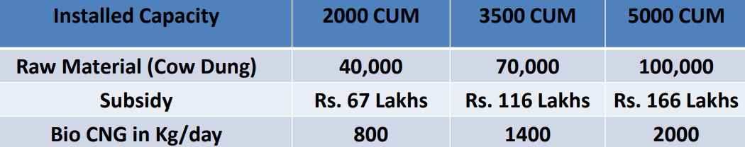

- PRICING: The feedstock is low cost and consists of 10,000-15,000 Kg/ day of cattle dung, 120,000 Kg/day Sugarcane press mud from the said sugar mill and 5,000 Kg/Day other bio- degradable stuff from nearby villages and municipalities. Cattle dung is collected from various dairy farms/ nearby villages @ INR 750/MT and used as inoculants.
The sugarcane press mud is generated in the said sugar mill and made available to the project @ 600/ Ton and supplied to the bio-gas plant sited at the plot adjacent to the sugar mill. Other bio-degradable waste stuff is collected using special vehicles designed for transporting the wastes from nearby municipality and villages in enclosed containers to prevent air pollution by the SPV which also pays the restaurants INR 500/MT for the waste collected.

PART H | INDUSTRY OVERVIEW & ANALYSIS

- INTRODUCTION: Bio-CNG plants get financial and other incentives from the Union government under the Sustainable Alternative towards Affordable Transport (SATAT) Scheme. The scheme, launched in 2018, supports the establishment and expansion of bio-CNG plants that use waste to produce biofuel. Under the scheme, the Union government plans to establish a total of 5,000 bio-CNG plants in India by the end of 2023-24.
Bio-CNG, a renewable source of transport fuel from sugarcane waste, is increasingly being produced in sugar mills in sugarcane-growing states around India. Thirteen Indian states currently have 44 bio-CNG plants with a total production capacity of 218,000 kilograms per day, of this renewable fuel. Experts claim that although the production of bio-CNG from sugar mills is in its nascent stage, with a demand for CNG in the transport sector, rising petrol/diesel prices and an established distribution network, there is potential for the growth of bio-CNG production.
As per government data, Maharashtra is the third largest producer of bio-CNG in India with a daily production capacity of 28,690 kilograms per day across its four operational plants. Gujarat leads the country with its 12 bio-CNG plants and a daily production potential of 49,028 kgs/day, followed by Punjab (35,000 kgs/day).
Bio-CNG is considered a renewable fuel and has also been proven to reduce the emission of greenhouse gasses when used as a transport fuel. Bio-CNG, derived from the filtration of biogas, is also referred to as Compressed Biogas (CBG) and bio-methane. It is derived from biogas after removing impurities like carbon dioxide and hydrogen sulphide.
Studies have shown that bio-CNG offers better environmental benefits compared to other clean transport biofuels like ethanol and biodiesel, as it has the lowest greenhouse gas emissions of any vehicle fuel.
- POTENTIAL AND EXPANSION: In India, around 70 percent of the sugarcane is produced by three major states – Uttar Pradesh, Maharashtra, and Karnataka. Experts working in the sector suggested that these states can help in scaling up bio-CNG production, which is currently at a nascent stage. India produces, on an average, over 300 million metric tonnes of sugarcane per year. Around 3.5 percent of this, can be the amount of press mud produced. At this rate, India has the potential to produce around 10 million metric tonnes of press mud/filter cake per year that could be diverted for producing bio-CNG.
Producing bio-CNG from press mud is set to be a successful proposition in states where there is a good density of sugar mills, such as in Maharashtra, Uttar Pradesh, and Karnataka, because of the easy availability of raw material, which saves transportation and procurement issues. In the last few years, mills in these states have started producing bio-CNG from the sugarcane waste and this is likely to increase in the future.
But round-the-year availability of raw materials still remains a challenge. “Even if it is stored, it (sugarcane waste) slowly starts decomposing and the organic compound in it starts deteriorating. This makes long-term storage a challenge and also increases the cost of production. Also, in case there is a lack of supply of sugarcane-based raw material, you will need other feedstock to keep your bio-CNG plant running.
BENEFITS SUGARCANE MILLS OFFER FOR BIO-CNG:
A recent study analysed the potential of using bagasse instead of press mud to produce bio-CNG in sugar mills. It found that for 10 tonnes per day production of bio-CNG from bagasse the cost was around Rs. 87 per kg. The study also estimated that the cost can come down to Rs. 37 per kg if the bagasse and electricity are given free. If bio-CNG is used as a transport fuel compared to conventional fossil fuel, it could lead to net reduced emission of carbon dioxide up to 3.96 kgs on each kg use of bio-CNG.
To resolve the issue of round-the-year supply of raw materials, some standalone bio-CNG plants or sugar mills can consider using mixed feedstock, like using press mud with municipal or other waste. “There is no compatibility or other issues of even mixing segregated organic wastes with press mud and produce bio-CNG. This can help in managing urban wastes as well as take care of the wastes from sugar mills too, converting both to bio-CNG to pave a way for a cleaner transport regime. In the recent past, fuel from some waste-to-bio-CNG plants in Indian cities has been used to run government-owned buses.
If the scale needs to expand, the production of bio-CNG needs to align with the demand in the market to make it economically more viable. “The penetration of CNG vehicles and CNG stations in India, is mostly confined to certain regions like Delhi NCR, Gujarat, and other leading Indian cities. As the imports of LNG usually come via sea route in Gujarat, its distribution network is more developed.
So, if bio-CNG plants come up in such areas first, which offer the best distribution facilities, it could be a more economically viable plan for the developers, rather than choosing Tier II and Tier III cities. More research and development on technologies for bio-CNG production is needed to scale up the production to cater to the demands of OMCs and make the use of bio-CNG more commercially viable for all stakeholders.
- CHALLENGES: The GOI has formulated various policies and schemes to promote and mitigate challenges associated with the Bio-CNG sector. There are still some operational and technological challenges such as sensitivity towards biomass quality, biogas upgradation process among others which are impeding the uptake of Bio-CNG projects. Below table shows the challenges:
Feedstock Availability | Quality of Feedstock (including multiple feedstocks) | Technology Challenges | Bio-CNG and by- products' Market Challenges | Financing, and Implementation Challenges
- No formal market for trading of feedstock  - Uncertainty of long-term regular supply of feedstock  - Demand supply mismatch - requirement of large storage facility  - Unorganized biomass value chain – lack of suﬃcient collection, processing and transportation facility | - Variation in quality of feedstock throughout the year  - Some projects are designed to take multiple feedstock – optimal operation is a challenge and may also aﬀect the quantity and quality of Bio-CNG  - Source segregation is important – receiving non-segregated waste is an operational challenge | - Technologies are sensitive to the quality of feedstock – slight change in feedstock quality will signiﬁcantly impact the Bio-CNG production rate  - Capital intensive technologies high upfront project cost | - Year-on-year variation in feedstock price – established feedstock pricing mechanism is required.  - Base price of Bio-CNG o ake should be linked with feedstock cost variation mitigates the economic viability risks  - Create market demand for by- products such as Bio manure etc. | - There are schemes by public sector banks to ﬁnance Bio-CNG project, but less private sector banks are ﬁnancing Bio-CNG project that too at high cost of debt.  - Lack of access to infrastructure i.e. road network and CGD network near project sites.  - Large set of approvals are required from PESO, pollution control board, MNRE - subsidy disbursement etc.

- GOVERNMENT INITIATIVES: There is an established market for bio-CNG/CNG and a good network of distribution which can help in the prosperity of bio-CNG in India. Earlier the market was not very well developed because of the lack of government support. “However, after SATAT, there are incentives for setting up such plants and the biggest advantage is the assured buyer in the form of OMCs which have a strong robust distribution network.
Government had been supporting new bio-CNG plants under the waste-to-energy programme and SATAT scheme while it has also included it under the priority sector lending for better financing. He also said that concessions on customs duty are also offered for the import of machinery and other parts for setting up bio-CNG plants.
CENTRAL FINANCIAL ASSISTANCE (CFA) PROVIDED BY MNRE: The objective of the programme is to support setting up of Waste to Energy projects for generation of Biogas/ Bio-CNG/ Power/ producer or syngas from urban, industrial and agricultural wastes/residues. The validity of the programme is from 01.04.2021 to 31.03.2026. The programme provides Central Financial Assistance (CFA) to project developers and service charges to implementing/inspection agencies in respect of successful commissioning of Waste to Energy plants for generation of Biogas, Bio-CNG/enriched Biogas/Compressed Biogas, Power/ generation of producer or syngas.
BELOW ARE THE STEPS TO AVAIL CFA:
STEP-1: Online Registration through BioUrja portal
STEP-2: Submission of application/proposal and uploading of Stage-I documents
STEP-3: Review of Proposal by Implementing agency and recommended by Project Appraisal Committee (PAC).
STEP-4: In-principle approval by MNRE
STEP-5: Commissioning of the plant
STEP-6: Inspection of the plant by Inspection Agency
STEP-7: Submission of Stage-II documents for release of CFA
STEP-8: Review of documents and Release of CFA
WASTE TO ENERGY PROGRAMME HIGHLIGHTS: Applications/Proposals will be accepted through online portal only (https://biourja.mnre.gov.in/). Last date for submitting the applications under these guidelines shall be 31.12.2025. Indian Renewable Energy Development Agency Limited (IREDA) shall be the implementing agency for the Programme. Under this programme, self-funded projects will also be eligible for Central Financial Assistance (CFA). Grant of CFA to plants which intend to add capacity to the existing plants will also be considered. CFA for such plants will be considered only for the enhanced capacity. Phased/milestone-based CFA will be granted for bank financed Bio-CNG projects under SATAT initiative.
Developers shall share plant generation data with MNRE or any other designated agency (except Biomass Gasifiers), through installation of SCADA System/remote monitoring system. Plants installed with new equipment/machinery only shall be eligible for CFA under this programme. Municipal Solid Waste (MSW)/Refused Derived Fuel (RDF) to power projects based thermal technologies (Incineration, Gasification, Pyrolysis etc.) are not supported under this programme. Financial assistance available under the Programme on Energy from Urban, Industrial and Agricultural Wastes/ Residues for setting up Waste to Energy plant is as follows:
- Biogas generation: Rs 0.25 Crore per 12000cum/day
- Bio-CNG generation (including setting of Biogas plant):
    - Rs 4.0 Crore per 4800 kg/day (for Bio-CNG generation from new biogas plant)
    - Rs 3.0 Crore per 4800 kg/day (for Bio-CNG generation from existing Biogas plant)
- Power generation based on Biogas:
    - Rs 0.75 Crore/MW (for power generation from new biogas plant)
    - Rs 0.5 Crore/MW (for power generation from existing Biogas plant)
- Power based on bio & agro-industrial waste (other than MSW): Rs 0.4 Crore/MW
- Biomass Gasifier:
          - Rs. 2,500 per kWe with dual fuel engines for electrical application
- Rs. 15,000 per kWe with 100% gas engines for electrical application
- Rs. 2 lakh per 300 kWth for thermal applications
- 20% higher CFA for special category states (NE Region, Sikkim, Himachal Pradesh and Uttarakhand, Jammu & Kashmir, Ladakh, Lakshadweep, Andaman & Nicobar Islands) and Gaushalas/Shelters.
The amount of CFA for grant of ‘In-Principle Approval’ would be calculated on the basis of installed capacity as per proposal and shall be on pro-data basis to the installed capacity of the plant. The developer may choose any one of the following agencies for inspection of the plant: Concerned State Nodal Agencies for Renewable Energy (SNAs), Sardar Swaran Singh National Institute of Bio-Energy (SSS-NIBE), Biogas Technology Development Centre (BTDC).
Compressed Bio Gas (CBG) produced from the CBG plant will be retailed through the CBG dispensing unit set-up by the Oil Marketing Companies within the radius of 25 kms. CBG supplied under SATAT scheme shall meet IS 16087:2016 specifications of BIS as follows:
BIOGAS | PURIFICATION | COMPRESSION | C-BG
- Biogas is an energy-rich gas produced by anaerobic decomposition of biomass. It is produced from waste / bio-mass sources like agriculture residue, cattle dung, sugarcane press mud, municipal solid waste, sewage treatment plant waste, etc.  - Biogas, a renewable fuel, constitutes mainly of methane (~60%), carbon dioxide (~40%), and traces of hydrogen sulphide.  - It can be burned directly as a fuel or purified & upgraded by removing carbon dioxide (CO2), hydrogen sulphide (H2S) and compressed to make Compressed Bio-Gas (CBG).  - The CBG has methane content of more than 90%, which is similar to the commercially available natural gas in composition and energy potential. | - Production of biogas could be a continuous process. The utilization of biogas as an efficient energy source depends strongly on its methane concentration.  - Therefore, biogas purification is essential in order to have more energy per unit volume of compressed biogas and to get rid of the corrosive effect of H2S.  - Biogas purification process increases the methane concentration and decreases the carbon dioxide concentration in biogas, which in turn would result in higher calorific value.  - The purified biogas is compressed as CBG with methane content of more than 90%, and the CBG shall be complied with IS 16087:2016 specifications of BIS.  - Some of the technologies which are prevalent in removal of carbon dioxide are Pressure Swing Adsorption (PSA), Vacuum Swing Adsorption (VSA), Water scrubbing, Membrane Separation and Chemical scrubbing - Monoethylammine (MEA) system. | - The purified biogas with more than 90% of methane can be compressed at 250 bar, and transported in gas cylinders (cascades) for the end use.  Cascade storage & transportation:  - The compressed biogas will be filled and transported through cascades which is a group of high pressure cylindrical vessel. For delivery of CBG, 3000 litres metal cascades or cascades of higher capacity shall be used.  - Steel cylinder cascades and composite cascades may be used for transportation of CBG. For steel cylinder cascades, IS 7285 shall be applicable. If type-3 or type-4 composite cascades are used, respective BIS specifications like IS 15935 or relevant specifications shall be applicable. | - CBG has calorific value and other properties similar to CNG and hence can be utilized as green renewable automotive fuel.  - Thus it can replace CNG in automotive, industrial and commercial areas. Ministry of Road Transport and Highways, Government of India had permitted usage of bio-compressed natural gas (bio- CNG) for motor vehicles as an alternate composition of the compressed natural gas (CNG).  - Compressed Bio Gas (CBG) produced from the CBG plant will be retailed through the CBG dispensing unit set-up by the Oil Marketing Companies within the radius of 25 kms.  - CBG supplied under SATAT scheme shall meet IS 16087:2016 specifications of BIS as follows:

IS 16087 : 2016 Standard
S No. | Characteristic | Requirement
1 | Methane (CH4), minimum % | 90.0%
2 | Only Carbon Dioxide (CO2), maximum % | 4%
3 | Carbon Dioxide (CO2) + Nitrogen (N2) + Oxygen (O2), maximum % | 10%
4 | Oxygen (O2), maximum % | 0.5%
5 | Total sulphur (including H2S) mg/m3, maximum % | 20 mg/m3
6 | Moisture mg/m3, maximum % | 5 mg/m3

An Expression of Interest (EOI) to procure CBG by Indian Oil was released under the SATAT scheme on 1st October 2018. As per the EOI, the price offered for CBG by Oil & gas companies is as follows:
S. No. | Lower Retail Selling Price of CBG ìn Slab (inclusive of tax)in Rs/kg | Higher Retail Selling Price of CBG ìn Slab (inclusive of tax)in Rs/kg | Procurement Price of CBG(without GST)in Rs/kg | Procurement Price of CBG(with GST)in Rs/kg
1 | Retail Selling Price of CBG up to Rs 70 |  | Rs 54.00 | Rs 56.70
2 | Rs 70.01 | Rs 75 | Rs 55.25 | Rs 58.01
3 | Rs 75.01 | Rs 80 | Rs 59.06 | Rs 62.01
4 | Rs 80.01 | Rs 85 | Rs 62.86 | Rs 66.01
5 | Rs 85.01 | Rs 90 | Rs 66.67 | Rs 70.01
6 | Rs 90.01 | Rs 95 | Rs 70.48 | Rs 74.01
7 | Rs 95.01 | Rs 100 | Rs 74.29 | Rs 78.01

Note: The above table is applicable strictly for supply of CBG at a one-way distance of 75 km from the CBG Plant. For distance beyond 75 km, the price will be defined as per the notification on CBG Procurement Price Revision.
- As part of initiative under the National Biofuel Policy, 2018, Ministry of Petroleum and Natural Gas launched the Sustainable Alternative Towards Affordable Transportation (SATAT) initiative in October, 2018 for promoting use of CBG in the CNG (transport) and PNG (domestic) sector of city gas distribution (CGD) supplies of natural gas.
- In the Budget 2023 INR 35,000 Crore outlay has been provided by the government to achieve energy transition. A central excise duty exemption has also been provided to CBG that’s blended with natural gas. CBG comes under the ambit of the goods and services tax (GST) but companies end up paying central excise duty as well when they blend the biogas with compressed natural gas (CNG) for further sale since natural gas is not covered by GST. This leads to double taxation, which the budget aims to address.
- A program for Restoration, Awareness, Nurturing and Improvement of Fertility of Mother Earth (PM-PRANAM) has been launched to encourage states to promote balanced use of alternative fertilizers and chemical fertilizers" along with INR 1451.84 crore has been sanctioned for Market Development Assistance (MDA) to promote organic fertilizers from Gobardhan plants. To support marketing of organic fertilizers i.e. Fermented Organic Manure (FOM) / Liquid FOM / Phosphate Rich Organic Manure (PROM) produced as a by-product from Biogas Plants / Compressed Bio Gas (CBG) Plants set up under Gobardhan initiative 1500 per metric ton as MDA scheme is included
- In the Budget 2023, government announced “500 new ‘waste to wealth’ plants under GOBARdhan (Galvanizing Organic Bio-Agro Resources Dhan) scheme will be established for promoting circular economy. These will include 200 compressed biogas plants, including 75 plants in urban areas, and 300 community or cluster-based plants a total investment of Rs 10,000 crore.
- Recently, The Union Minister for Jal Shakti, launched the Unified Registration Portal for GOBARdhan which will act as a one stop repository to assess investment and participation in Biogas/CBG sector at pan India level and more importantly streamline the process of setting up CBG/Biogas plants in India. The government has an ambitious target to set up 5,000 commercial (CBG) plants by 2024-25 and produce 15 million metric tonnes of CBG, which will replace other gases which are being used in the country.
- CONCLUSION:
The business of bio CNG gases is in high demand because it is a clean and renewable source of energy. Additionally, it is more cost-effective than traditional sources of energy, and it can be used to power a variety of vehicles. Bio CNG gas is also a versatile fuel that can be used in a variety of applications.
Though there are a few reasons for this increase in demand, the primary one seems to be that environmentalism is becoming more and more popular. As people become more aware of the damaging effects that traditional forms of energy have on the environment, they are searching for alternatives that are cleaner and renewable.
India biogas market is expected to grow from $1.47 billion in 2022 to $2.25 Billion in 2029 at a CAGR of 6.3% in forecast period, 2022-2029. Bio CNG gas is one such alternative, and its popularity is only increasing as time goes on. Bio CNG can be produced from a variety of organic materials, making it a sustainable choice for energy production. Additionally, bio CNG produces fewer emissions than traditional fossil fuels, making it a more environmentally-friendly option. Finally, bio CNG is becoming increasingly cost-competitive as technology advances and production methods improve.

PART I | SWOT ANALYSIS

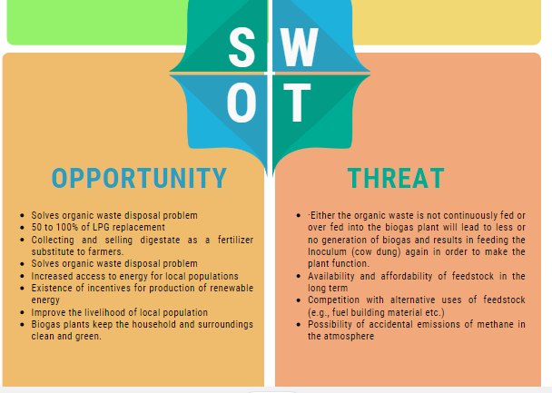
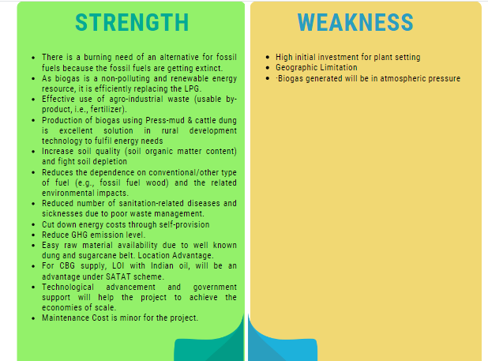
SWOT ANALYSIS OF BIOGAS SECTOR

PART J | PROJECT COST AND MEANS OF FINANCE

As per data/information shared by the client, below are the details of Total project Cost (TPC) and means of finance for the same. Category wise proposed project cost is shown in the below table:
Sr. No. | CAPITAL COST HEAD | AMOUNT (INR)
A | PROJECT COST
1 | Electricity Connection Charge | 1,00,00,000
2 | Civil Work | 7,55,82,416
3 | Plant & Machinery | 18,25,45,156
4 | Miscellaneous Assets | 6,00,000
5 | Preliminary Expense | 12,01,500
6 | Working Capital Margin (WCM) | 16,67,000
7 | Interest During Construction (IDC) | 1,70,62,500
8 | Contingencies Expenses | 3,41,428
 | TOTAL PROJECT COST | 28,90,00,000
Note: Project Cost have been provided by the company.
MEANS OF FINANCE
PARTICULARS | AMOUNT (INR)
Promoters Contribution | 8,90,00,000
Term Loan | 20,00,00,000
Total | 28,90,00,000

Limit Applied For Fund Based Limit | AMOUNT (INR)
Term Loan | 20,00,00,000
Cash Credit (CC) Loan-Working Capital | 50,00,000
Total Loan from Banks | 20,50,00,000
Interest During Construction (IDC) Capitalized | 1,70,62,500
Subsidy From MNRE (To be Adjusted in Loan Account after Project is Commissioned) | 4,00,00,000
Notes:
- Land (2.1610 Hectare) taken on lease basis for 20 years @ INR 50,000 per annum from the promoter of the company.
- As per information available on Uttarakhand Power Corporation Limited website, electricity connection will be costing around INR 1.00 Crore for new connection HT line - non domestic/industrial.
- As per EPC contract the Building and civil works cost will be INR 7, 55, 82,416 including 12% applicable GST.
- As per EPC contract the Plant and Machinery cost will be INR 18,25,45,156 including 12% applicable GST has been considered including transportation, installation and other cost, which is found to be reasonable based on the tertiary research and verbal communication with random vendors and players in this Industry and information available in the public domain.
- Preliminary & Pre-Operative Expenses has been taken as lump sum based on the time period of construction and estimate of company’s resources involvement during this time in supervision & monitoring of the construction as INR 12, 01,500.
- Contingency cost of INR 3-4 Lakhs has been considered as a part of app. 0.12% of total project cost based on general assumption and professional experience.

PART K | PROJECT SCHEDULE

Below is the tabulated presentation of the status of the project showing expected duration shared by the project manager of the company. The project is expected to be complete soon.
S. No. | Particulars | Activity | Expected completion date | Status
 | Land | Land Procurement | 29.03.2023 | As per lease deed. CLU taken from the authority.
 |  | Land Development | July 2023 | Completed
 | Sanction of Rupee Term Loan | Sanction of Rupee Term Loan | August 2023 | Awaiting
 | Building & Civil Works | Appointment of Architect | 15th March 2023 | As per EPC consultant agreement
 |  | Building Plan Preparation | March 2023 | Map approved
 |  | Building Plan Sanction | March 2023 | Map approved
 |  | Appointment of Civil contractor/ developer | 15th March 2023 | As per EPC consultant agreement
 |  | Building & Civil Works completion | December 2023 | -
 | Plant & Machinery | Finalization of P&M suppliers | 15th March 2023 | As per EPC consultant agreement
 |  | Orders to P&M suppliers | 15th March 2023 | As per EPC consultant agreement
 |  | Arrival of P&M | January 2024 | Expected
 |  | Installation of P&M | March 2024 | Expected
 |  | Utility Installation
 | Statutory Approvals, registrations & NOCs | From the respective authorities | 14th July 2023 | As per Single Window Clearance, Govt. of Uttarakhand
 | Finishing & Trail Run | Informed by client | June 2024 | As per proposed plan and timeline
 | Commercial Operation Date | Informed by client | July 2024 | As per proposed plan and timeline

Notes:
- Schedule has been made as per feasibility to achieve different milestones.
- Achievement of Milestone will depend on sanction of term loan as per proposed timeline.
- As per this timeline, expected COD will be 30th June 2024.

PART L | STATUTORY APPROVALS | LICENCES | NOC
Following major approvals are required. However the list are not exhaustive and State / district Authorities may be approached for further clearances required (if any):
S. No. | REQUIRED APPROVALS | REFERENCE NO./ DATE | STATUS  (Approved/ Applied For/ Pending)
 | Certificate of Firm Registration | 31st July 2023 | Approved
 | Land conversion to Industrial/Non agriculture | 29th March 2023 | Approved
 | Building and civil works Plan Sanction Approval  Concerned local development authority | 11th July 2023 | Approved
 | Provisional Fire NOC (pre sanction)  Fire Services Department | - | Apply in due course
 | Fire NOC (on completion)  Fire Services Department | - | Apply in due course
 | Power Load Sanction  Uttarakhand Power Corporation | - | Approved (Security & fees pending)
 | Consent to establish (under Water Act & Air Act)  State Pollution Control Board, UK | - | Apply in due course
 | Permission for extraction of ground water | - | Apply in due course
 | UDYAM REGISTRATION CERTIFICATE (MSME) | 17th Feb 2023 | Approved
 | Biogas cylinders from Petroleum and Explosive Safety Organization, (PESO) (Govt. of India) under Gas Cylinders Rules, 2004 | 27th July 2023 | Approved

Observation Note:
- Company has achieved the land conversion certificate as on 29th March 2023.
- As per discussion with the client, company has taken the approval of map.
- Rest approvals are pending and will be applied in due course as per above schedule.

PART M | COMPANY’S FINANCIAL FEASIBILITY

- PROJECTIONS OF THE FIRM: The projections of the firm are prepared from FY 2024-25 to FY 2034-35 based on the revenue generation capacity of the project and loan repayment period.
Projections has made for the proposed Bio-CNG generation plant having 5,000 KG per day capacity as per the best practice in industry for a Greenfield project to assess the financial feasibility of the project.
- PROJECTED PROFIT & LOSS ACCOUNT (FROM FY 2025 TO FY 2035): Below table shows the Projected Profit & Loss Account of M/s Shree Jee Bio Energy from the period FY 2024-25 to FY 2034-35.
(INR Lakhs)
Particulars | FY 2025 | FY 2026 | FY 2027 | FY 2028 | FY 2029 | FY 2030 | FY 2031 | FY 2032 | FY 2033 | FY 2034 | FY 2035
Year | 9 | 12 | 12 | 12 | 12 | 12 | 12 | 12 | 12 | 12 | 12
Gross Annual Sale | 934.89 | 1539.8 | 1616.8 | 1697.6 | 1782.5 | 1871.6 | 1965.2 | 2063.5 | 2166.6 | 2275.0 | 2388.7
VARIALBLE EXPENSES
1. Raw Material | 177.38 | 292.16 | 306.77 | 322.11 | 338.21 | 355.13 | 372.88 | 391.53 | 411.10 | 431.66 | 453.24
2. Power | 128.44 | 211.55 | 222.13 | 233.24 | 244.90 | 257.15 | 270.00 | 283.50 | 297.68 | 312.56 | 328.19
3. Factory Overheads | 9.31 | 15.33 | 16.10 | 16.90 | 17.75 | 18.63 | 19.57 | 20.54 | 21.57 | 22.65 | 23.78
Total Variable Cost | 315.14 | 519.05 | 545.00 | 572.25 | 600.86 | 630.90 | 662.45 | 695.57 | 730.35 | 766.87 | 805.21
FIXED EXPENSES
1. Office and other Overheads | 149.01 | 245.42 | 257.69 | 270.58 | 284.10 | 298.31 | 313.23 | 328.89 | 345.33 | 362.60 | 380.73
2 Lease Rental | 0.50 | 0.50 | 0.50 | 0.50 | 0.50 | 0.55 | 0.55 | 0.55 | 0.55 | 0.55 | 0.61
3. Bio-CNG Transportation Cost | 13.13 | 18.38 | 19.29 | 20.26 | 21.27 | 22.33 | 23.45 | 24.62 | 25.86 | 27.15 | 28.51
4. Preliminary Expenses Written off | 2.40 | 2.40 | 2.40 | 2.40 | 2.40
Total Fixed Cost | 165.03 | 266.70 | 279.89 | 293.74 | 308.28 | 321.19 | 337.23 | 354.06 | 371.74 | 390.30 | 409.84
TOTAL PRODUCTION COST | 480.17 | 785.74 | 824.89 | 865.99 | 909.14 | 952.10 | 999.68 | 1049.6 | 1102.0 | 1157.1 | 1215.0
EBIDTA | 454.73 | 754.08 | 791.93 | 831.67 | 873.40 | 919.57 | 965.57 | 1013.88 | 1064.60 | 1117.86 | 1173.72
Interest on Term Loan | 157.24 | 202.65 | 189.00 | 172.20 | 155.40 | 136.50 | 115.50 | 92.40 | 67.20 | 39.90 | 9.45
Interest on Working Capital Loan | 5.25 | 5.25 | 5.25 | 5.25 | 5.25 | 5.25 | 5.25 | 5.25 | 5.25 | 5.25 | 5.25
Depreciation | 391.22 | 336.59 | 289.74 | 249.56 | 215.08 | 185.47 | 160.04 | 138.18 | 119.39 | 103.23 | 89.31
PBT | -98.99 | 209.59 | 307.94 | 404.66 | 497.67 | 592.35 | 684.78 | 778.05 | 872.76 | 969.48 | 1069.71
Less : Taxation @ 33.93% | 0.00 | 71.11 | 104.48 | 137.30 | 168.86 | 200.98 | 232.35 | 263.99 | 296.13 | 328.95 | 362.95
PAT | -98.99 | 138.48 | 203.45 | 267.36 | 328.81 | 391.36 | 452.44 | 514.05 | 576.63 | 640.54 | 706.76

- KEY FINANCIAL RATIO:
Particulars | FY 2025 | FY 2026 | FY 2027 | FY 2028 | FY 2029 | FY 2030 | FY 2031 | FY 2032 | FY 2033 | FY 2034 | FY 2035
Year | 9 | 12 | 12 | 12 | 12 | 12 | 12 | 12 | 12 | 12 | 12
EBITDA Margin % | 48.64% | 48.97% | 48.98% | 48.99% | 49.00% | 49.13% | 49.13% | 49.13% | 49.13% | 49.14% | 49.14%
EBIT Margin % | 6.79% | 27.11% | 31.06% | 34.29% | 36.93% | 39.22% | 40.99% | 42.44% | 43.62% | 44.60% | 45.40%
Net Profit Margin | -10.59% | 8.99% | 12.58% | 15.75% | 18.45% | 20.91% | 23.02% | 24.91% | 26.61% | 28.16% | 29.59%
Revenue Growth % (Y.O.Y.) |  | 64.71% | 5.00% | 5.00% | 5.00% | 5.00% | 5.00% | 5.00% | 5.00% | 5.00% | 5.00%
Note: EBITDA Margins are positive and increasing fairly during the estimated period. Net profit margins have increased from -10.59% in FY 2025 (Negative due to 9 operational months only) to 29.59% in FY 2035. Revenue growth rate is constant as 5% during the forecasted period. Net Operating Margin (EBIT) Margins are positive and increasing fairly during the estimated period, however initially it is 6.79%% due to 9 months of operations at 85% capacity utilization.
- GRAPHICAL REPRESENTATION OF KEY RATIOS: Below is the graphical representation of the key financial metrics of the company, showing the efficiency and financial performance of the company throughout the forecasted period:
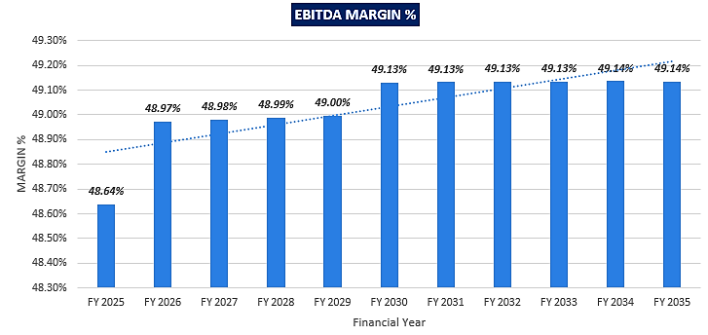
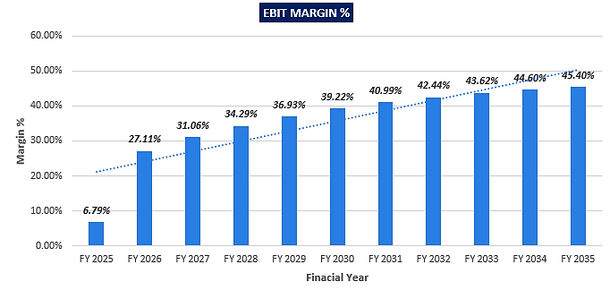
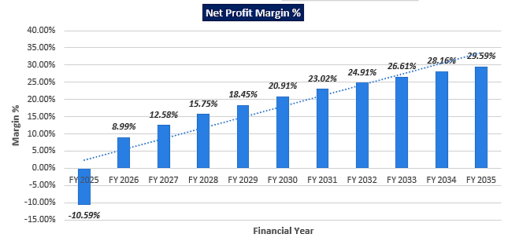
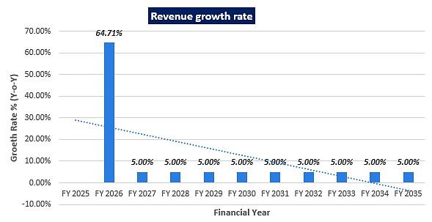
- PROJECTED BALANCE SHEET: Below table shows the Projected Balance Sheet of M/s Shree Jee Bio energy from the period FY 2024-25 to FY 2034-35. Subsidy payment of INR 4.00 Crore is adjusted in Loan Account after Project is commissioned. Thus the inflows of subsidy is adjusted in Reserve and surplus.
Particulars | FY 2024 | FY 2025 | FY 2026 | FY 2027 | FY 2028 | FY 2029 | FY 2030 | FY 2031 | FY 2032 | FY 2033 | FY 2034 | FY 2035
Years | Const. | Const./ 9M | 12 M | 12 M | 12 M | 12 M | 12 M | 12 M | 12 M | 12 M | 12 M | 12 M
LIABILITIES
Equity | 890.0 | 890.0 | 890.0 | 890.0 | 890.0 | 890.0 | 890.0 | 890.0 | 890.0 | 890.0 | 890.0 | 890.0
Reserve & Surplus | 0.00 | 1.01 | 239.4 | 542.9 | 910.3 | 1239.12 | 1630.48 | 2082.92 | 2596.97 | 3173.61 | 3814.14 | 4520.90
Secured Loan | 1980.00 | 1880.00 | 1720.00 | 1560.00 | 1400.00 | 1200.00 | 1000.00 | 760.00 | 520.00 | 240.00 | 0.00 | 0.00
Current Liabilities
Trade Payables | 0.00 | 13.30 | 17.37 | 17.89 | 18.43 | 19.01 | 19.61 | 20.24 | 20.90 | 21.59 | 22.32 | 23.09
Term liabilities payable within one year | 20.00 | 100.00 | 160.00 | 160.00 | 160.00 | 200.00 | 200.00 | 240.00 | 240.00 | 280.00 | 240.00
CC Limit | 0.00 | 50.00 | 50.00 | 50.00 | 50.00 | 50.00 | 50.00 | 50.00 | 50.00 | 50.00 | 50.00 | 50.00
TOTAL | 2890.00 | 2934.31 | 3076.86 | 3220.83 | 3428.74 | 3598.12 | 3790.09 | 4043.15 | 4317.87 | 4655.20 | 5016.46 | 5483.99
Gross Assets
CIVIL WORK | 809.46 | 809.46 | 809.46 | 809.46 | 809.46 | 809.46 | 809.46 | 809.46 | 809.46 | 809.46 | 809.46 | 809.46
PLANT & MACHINERY | 1955.00 | 1955.00 | 1955.00 | 1955.00 | 1955.00 | 1955.00 | 1955.00 | 1955.00 | 1955.00 | 1955.00 | 1955.00 | 1955.00
OTHER FIXED ASSETS | 6.43 | 6.43 | 6.43 | 6.43 | 6.43 | 6.43 | 6.43 | 6.43 | 6.43 | 6.43 | 6.43 | 6.43
ELECTRICITY CONNECTION | 107.10 | 107.10 | 107.10 | 107.10 | 107.10 | 107.10 | 107.10 | 107.10 | 107.10 | 107.10 | 107.10 | 107.10
Total Gross Block | 2877.99 | 2877.99 | 2877.99 | 2877.99 | 2877.99 | 2877.99 | 2877.99 | 2877.99 | 2877.99 | 2877.99 | 2877.99 | 2877.99
Depreciation | 0.00 | 391.22 | 727.81 | 1017.56 | 1267.11 | 1482.19 | 1667.66 | 1827.70 | 1965.89 | 2085.28 | 2188.50 | 2277.81
NET BLOCK | 2877.99 | 2486.76 | 2150.17 | 1860.43 | 1610.87 | 1395.79 | 1210.32 | 1050.28 | 912.10 | 792.71 | 689.48 | 600.17
CURRENT ASSETS | 0.00 | 437.94 | 919.48 | 1355.60 | 1815.46 | 2202.33 | 2579.76 | 2992.87 | 3405.77 | 3862.49 | 4326.98 | 4883.82
Trade Receivables | 0.00 | 57.74 | 95.11 | 99.86 | 104.86 | 110.10 | 115.60 | 121.38 | 127.45 | 133.82 | 140.52 | 147.54
Inventories | 0.00 | 3.65 | 6.02 | 6.32 | 6.63 | 6.96 | 7.31 | 7.68 | 8.06 | 8.46 | 8.89 | 9.33
CASH & BANK | 0.00 | 376.54 | 818.36 | 1249.42 | 1703.98 | 2085.27 | 2456.85 | 2863.81 | 3270.26 | 3720.20 | 4177.58 | 4726.95
PRELIMINARY EXPENSES W/off | 12.02 | 9.61 | 7.21 | 4.81 | 2.40 | 0.00 | 0.00 | 0.00 | 0.00 | 0.00 | 0.00 | 0.00
TOTAL | 2890.00 | 2934.31 | 3076.86 | 3220.83 | 3428.74 | 3598.12 | 3790.09 | 4043.15 | 4317.87 | 4655.20 | 5016.46 | 5483.99

- PROJECTED CASH FLOW STATEMENT: Below table shows the Projected Cash Flow of M/s Shree Jee Bio Energy from the period FY 2024-25 to FY 2034-35:
Particulars | FY 2024 | FY 2025 | FY 2026 | FY 2027 | FY 2028 | FY 2029 | FY 2030 | FY 2031 | FY 2032 | FY 2033 | FY 2034 | FY 2035
Years | Const. | Const./ 9M | 12 M | 12 M | 12 M | 12 M | 12 M | 12 M | 12 M | 12 M | 12 M | 12 M
A. SOURCE OF FUND
Net Profit | 0.00 | -98.99 | 138.48 | 203.45 | 267.36 | 328.81 | 391.36 | 452.44 | 514.05 | 576.63 | 640.54 | 706.76
Increase in Equity / Share Capital | 890.00 | 0.00 | 0.00 | 0.00 | 0.00 | 0.00 | 0.00 | 0.00 | 0.00 | 0.00 | 0.00 | 0.00
Increase in TL | 2000.00 | 0.00 | 0.00 | 0.00 | 0.00 | 0.00 | 0.00 | 0.00 | 0.00 | 0.00 | 0.00 | 0.00
Increase in CC Limit | 0.00 | 50.00
Depreciation | 0.00 | 391.22 | 336.59 | 289.74 | 249.56 | 215.08 | 185.47 | 160.04 | 138.18 | 119.39 | 103.23 | 89.31
Preliminary Exp. w/off | 0.00 | 2.40 | 2.40 | 2.40 | 2.40 | 2.40 | 0.00 | 0.00 | 0.00 | 0.00 | 0.00 | 0.00
Trade payables | 0.00 | 13.30 | 4.07 | 0.52 | 0.54 | 0.57 | 0.60 | 0.63 | 0.66 | 0.69 | 0.73 | 0.77
Subsidy Inflow |  | 100.00 | 100.00 | 100.00 | 100.00
TOTAL | 2890.00 | 457.94 | 581.54 | 596.12 | 619.87 | 546.86 | 577.43 | 613.11 | 652.90 | 696.72 | 744.49 | 796.84
B. APPLICATION OF FUNDS
Capital Expenses | 2877.99 | 0.00 | 0.00 | 0.00 | 0.00 | 0.00 | 0.00 | 0.00 | 0.00 | 0.00 | 0.00 | 0.00
Decrease in Term Loan | 0.00 | 20.00 | 100.00 | 160.00 | 160.00 | 160.00 | 200.00 | 200.00 | 240.00 | 240.00 | 280.00 | 240.00
Trade Receivable | 0.00 | 57.74 | 37.36 | 4.76 | 4.99 | 5.24 | 5.50 | 5.78 | 6.07 | 6.37 | 6.69 | 7.03
Inventory | 0.00 | 3.65 | 2.36 | 0.30 | 0.32 | 0.33 | 0.35 | 0.37 | 0.38 | 0.40 | 0.42 | 0.44
Preliminary Expense | 12.02
TOTAL | 2890 | 81.40 | 139.7 | 165.0 | 165.3 | 165.5 | 205.8 | 206.1 | 246.4 | 246.7 | 287.1 | 247.4
Opening Balance | 0.00 | 0.00 | 376.54 | 818.36 | 1249.42 | 1703.98 | 2085.27 | 2456.85 | 2863.81 | 3270.26 | 3720.20 | 4177.58
Net Surplus/ Deficit | 0.00 | 376.54 | 441.82 | 431.06 | 454.56 | 381.29 | 371.58 | 406.96 | 406.45 | 449.94 | 457.38 | 549.37
Cumulative Balance | 0.00 | 376.5 | 818.3 | 1249 | 1703 | 2085 | 2456 | 2863 | 3270 | 3720 | 4177 | 4726

- REVENUE BUILD-UP: Production has been considered based on the capacity utilization of 85%-100% as a base case (5% escalation has been considered during forecasted period).
Particulars | FY 2025 | FY 2026 | FY 2027 | FY 2028 | FY 2029 | FY 2030 | FY 2031 | FY 2032 | FY 2033 | FY 2034 | FY 2035
Year | 9 | 12 | 12 | 12 | 12 | 12 | 12 | 12 | 12 | 12 | 12
% Production | 85% | 100% | 100% | 100% | 100% | 100% | 100% | 100% | 100% | 100% | 100%
ESCALATION FACTOR (5%) | 1.00 | 1.05 | 1.10 | 1.16 | 1.22 | 1.28 | 1.34 | 1.41 | 1.48 | 1.55 | 1.63
Sale of Bio-CNG | 780.94 | 1286.2 | 1350.5 | 1418.0 | 1489.0 | 1563.4 | 1641.6 | 1723.7 | 1809.8 | 1900.3 | 1995.4
Sale of Solid & Liquid Fertilizer | 153.96 | 253.58 | 266.25 | 279.57 | 293.54 | 308.22 | 323.63 | 339.81 | 356.81 | 374.65 | 393.38
Gross Annual Sale | 934.89 | 1539.8 | 1616.8 | 1697.6 | 1782.5 | 1871.6 | 1965.2 | 2063.5 | 2166.6 | 2275.0 | 2388.7

S. No. | PROJECTIONS | UNIT RATE (INR) | UNIT | ANNUAL QUANTITY | AMOUNT (INR)
A | Sale of Bio-CNG | 70.00 | INR/Kg | 17,50,000 | 12,25,00,000
B | Sale of Compost/ Solid Manure | 2.00 | INR/Kg | 1,05,00,000 | 2,10,00,000
C | Sale of Liquid Fertilizer | 0.10 | INR/Ltr. | 3,15,00,000 | 31,50,000
 | Gross Annual Sale |  |  |  | 14,66,50,000

ESTIMATION OF PRODUCTION
S. No | Particular | Value | Unit
A | Solid Bio Fertilizer Production
1 | Quantity Of Compost Produced From Dry Sludge | 30,000 | Kg/day
B | Liquid Fertilizer Concentrate Generation
2 | Quantity Of Phosphorus Liquid Fertilizer Concentrate | 50,000 | L/day
3 | Quantity Of Potassium & Nitrogen Liquid Fertilizer Concentrate | 40,000 | L/day
4 | Total Quantity Of Liquid Fertilizer Concentrate | 90,000 | L/day
ANNUAL OUTPUT ON 100% BASIS
1 | Maximum Quantity Of Biogas Generated | 44,45,000 | M3
2 | Maximum Quantity Of Bio-CNG Generated | 17,50,000 | Kg
3 | Maximum Quantity Of Compost Produced | 1,05,00,000 | KG
4 | Maximum Quantity Of Liquid Fertilizer Concentrate Generated | 3,15,00,000 | L
UNIT PRICE
1 | HHV Of LPG | 11,950 | Kcal/Kg
2 | HHV Of Bio-CNG | 12,870 | Kcal/Kg
3 | Bio-CNG To LPG Energy Equivalence | 1.08/1 | ratio
4 | Equivalent Price Of CNG | ₹ 102.00 | INR/Kg
5 | Selling Price Of Bio-CNG @ 80% Of Commercial LPG | ₹ 70.00 | INR/Kg
6 | Selling Price Of Solid Organic Fertilizer | ₹ 2.00 | INR/Kg
7 | Selling Price Of Liquid Fertilizer Concentrate | ₹ 0.10 | INR/L

The project will be generating the revenue from the selling of Bio-CNG and Solid & Liquid organic fertilizers @ INR 70 per kg and INR 2 per kg & 0.10 per litre respectively as per the selling, marketing and distribution arrangements discussed above.
- ESTIMATED KEY FINANCIAL METRICS:
DEBT SERVICE COVERAGE RATIO (DSCR)
Particulars | FY 2025 | FY 2026 | FY 2027 | FY 2028 | FY 2029 | FY 2030 | FY 2031 | FY 2032 | FY 2033 | FY 2034 | FY 2035
PAT (Profit After Tax) | -98.99 | 138.48 | 203.45 | 267.36 | 328.81 | 391.36 | 452.44 | 514.05 | 576.63 | 640.54 | 706.76
Depreciation | 391.22 | 336.59 | 289.74 | 249.56 | 215.08 | 185.47 | 160.04 | 138.18 | 119.39 | 103.23 | 89.31
Interest | 157.24 | 202.65 | 189.00 | 172.20 | 155.40 | 136.50 | 115.50 | 92.40 | 67.20 | 39.90 | 9.45
Subtotal | 449.48 | 677.72 | 682.20 | 689.12 | 699.29 | 713.33 | 727.98 | 744.64 | 763.22 | 783.66 | 805.52
Interest | 157.24 | 202.65 | 189.00 | 172.20 | 155.40 | 136.50 | 115.50 | 92.40 | 67.20 | 39.90 | 9.45
Loan Repayment | 20.00 | 100.00 | 160.00 | 160.00 | 160.00 | 200.00 | 200.00 | 240.00 | 240.00 | 280.00 | 240.00
Subtotal | 177.24 | 302.65 | 349.00 | 332.20 | 315.40 | 336.50 | 315.50 | 332.40 | 307.20 | 319.90 | 249.45
DSCR | 2.54 | 2.24 | 1.95 | 2.07 | 2.22 | 2.12 | 2.31 | 2.24 | 2.48 | 2.45 | 3.23
Average DSCR | 2.35
Maximum DSCR | 3.23
As per information provided by client/Company, initial one year will be moratorium period out of total loan repayment period of 10 years. Average DSCR of the project will be 2.35 during the forecasted period.
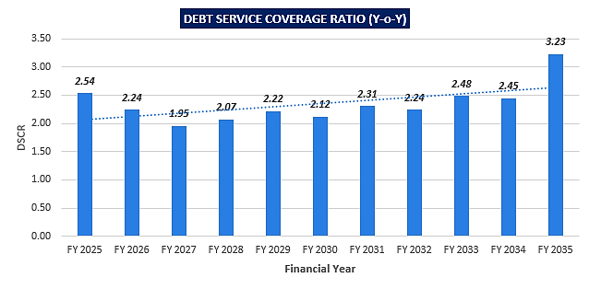
OTHER KEY FINANCIAL RATIOS
Year | FY 2024 | FY 2025 | FY 2026 | FY 2027 | FY 2028 | FY 2029 | FY 2030 | FY 2031 | FY 2032 | FY 2033 | FY 2034 | FY 2035
Return On Capital (%) |  | 2% | 14% | 17% | 18% | 20% | 21% | 21% | 22% | 22% | 21% | 20%
Return On Investment |  | -11% | 16% | 23% | 30% | 37% | 44% | 51% | 58% | 65% | 72% | 79%
Return On Net Worth |  | -11% | 12% | 14% | 15% | 15% | 16% | 15% | 15% | 14% | 14% | 13%
FACR |  | 1.32 | 1.25 | 1.19 | 1.15 | 1.16 | 1.21 | 1.38 | 1.75 | 3.30
Interest Coverage Ratio |  | 2.8 | 3.6 | 4.1 | 4.7 | 5.4 | 6.5 | 8.0 | 10.4 | 14.7 | 24.8 | 79.8
Current Ratio |  | 3.87 | 5.18 | 7.62 | 10.17 | 10.06 | 11.75 | 11.50 | 13.05 | 12.81 | 16.49 | 211.53
Tol / TNW | 2.28 | 2.32 | 1.74 | 1.25 | 0.91 | 0.69 | 0.50 | 0.36 | 0.24 | 0.15 | 0.07 | 0.01
Debt - Equity Ratio | 2.22 | 2.11 | 1.52 | 1.09 | 0.78 | 0.56 | 0.40 | 0.26 | 0.15 | 0.06 | 0.00 | 0.00

- NPV,IRR AND PAYBACK PERIOD OF THE PROJECT:
Particulars | FY 2024 | FY 2025 | FY 2026 | FY 2027 | FY 2028 | FY 2029 | FY 2030 | FY 2031 | FY 2032 | FY 2033 | FY 2034 | FY 2035
EBIT | 0.00 | 63.50 | 417.49 | 502.19 | 582.11 | 658.32 | 734.10 | 805.53 | 875.70 | 945.21 | 1014.63 | 1084.41
Tax Rate | 33.93% | 33.93% | 33.93% | 33.93% | 33.93% | 33.93% | 33.93% | 33.93% | 33.93% | 33.93% | 33.93% | 33.93%
(1-T) | 66.07% | 66.07% | 66.07% | 66.07% | 66.07% | 66.07% | 66.07% | 66.07% | 66.07% | 66.07% | 66.07% | 66.07%
EBIT*(1-T) | 0.00 | 41.95 | 275.84 | 331.79 | 384.60 | 434.95 | 485.02 | 532.22 | 578.57 | 624.50 | 670.37 | 716.47
(+) Dep. & Amortization | 0.00 | 391.22 | 336.59 | 289.74 | 249.56 | 215.08 | 185.47 | 160.04 | 138.18 | 119.39 | 103.23 | 89.31
(+/-) WCC | 0.00 | 48.10 | 35.65 | 4.54 | 4.76 | 5.00 | 5.25 | 5.52 | 5.79 | 6.08 | 6.38 | 6.70
(-) CAPEX | 2877.99 | 0.00 | 0.00 | 0.00 | 0.00 | 0.00 | 0.00 | 0.00 | 0.00 | 0.00 | 0.00 | 0.00
FCFF | (2877.99) | 385.08 | 576.77 | 617.00 | 629.40 | 645.03 | 665.24 | 686.74 | 710.97 | 737.81 | 767.21 | 799.08
payback Period | 5.04
WACC | 9.42%
Company Risk Premium | 1.00%
Discount Rate | 10.42%
Period |  | 0.75 | 1.75 | 2.75 | 3.75 | 4.75 | 5.75 | 6.75 | 7.75 | 8.75 | 9.75 | 10.75
Discount Factor |  | 0.93 | 0.84 | 0.76 | 0.69 | 0.62 | 0.57 | 0.51 | 0.46 | 0.42 | 0.38 | 0.34
PV OF FCFF |  | 357.4 | 484.9 | 469.7 | 434.0 | 402.8 | 376.2 | 351.7 | 329.7 | 309.9 | 291.8 | 275.3
PV Of Cash Inflow | 4083.84
PV of cash outflow | -2877.99
NPV as on COD | INR 1205.85 Lakhs
IRR | 17%

The project will be having a payback period of 5.04 years and NPV & IRR of the project as on COD will INR 1205.85 Lakhs & 17%, which indicated the worthiness of the project.
- BREAK-EVEN ANALYSIS:
Year | FY 2025 | FY 2026 | FY 2027 | FY 2028 | FY 2029 | FY 2030 | FY 2031 | FY 2032 | FY 2033 | FY 2034 | FY 2035
Break Even Point
Total Sales | 934.89 | 1539.8 | 1616.8 | 1697.6 | 1782.5 | 1871.6 | 1965.2 | 2063.5 | 2166.6 | 2275.0 | 2388.7
Variable Cost | 315.14 | 519.05 | 545.00 | 572.25 | 600.86 | 630.90 | 662.45 | 695.57 | 730.35 | 766.87 | 805.21
Contribution | 619.76 | 1020.7 | 1071.8 | 1125.4 | 1181.6 | 1240.7 | 1302.8 | 1367.9 | 1436.3 | 1508.1 | 1583.5
Fixed Cost | 165.03 | 266.70 | 279.89 | 293.74 | 308.28 | 321.19 | 337.23 | 354.06 | 371.74 | 390.30 | 409.84
Interest | 157.24 | 202.65 | 189.00 | 172.20 | 155.40 | 136.50 | 115.50 | 92.40 | 67.20 | 39.90 | 9.45
Depreciation | 391.22 | 336.59 | 289.74 | 249.56 | 215.08 | 185.47 | 160.04 | 138.18 | 119.39 | 103.23 | 89.31
Total Fixed Cost | 713.50 | 805.94 | 758.63 | 715.50 | 678.76 | 643.16 | 612.77 | 584.65 | 558.33 | 533.42 | 508.60
Profit / PBT | -93.74 | 214.84 | 313.19 | 409.91 | 502.92 | 597.60 | 690.03 | 783.30 | 878.01 | 974.73 | 1074.96
PV Ratio | 66% | 66% | 66% | 66% | 66% | 66% | 66% | 66% | 66% | 66% | 66%
Break Even Sales | 248.95 | 402.31 | 422.21 | 443.10 | 465.03 | 484.52 | 508.70 | 534.09 | 560.76 | 588.75 | 618.23
BEP % | 27% | 26% | 26% | 26% | 26% | 26% | 26% | 26% | 26% | 26% | 26%

As per the Break-even analysis, it can be seen that the company will be achieving the break-even sales from the 2nd year during the forecasted period, subject to the assumption & basis and micro & macro economic factors taken into consideration.
- LOAN AMORTIZATION SCHEDULE: As per Loan disbursement and amortization schedule shared by the client, according to the project costs incurred during the estimated period below table shows the closing balance of principle and intrest during the forecasted period.
Inputs for Loan Repayment Schedule
Particulars | Assumptions
1st Disbursement | Jul-23
IDC Start & End Month | July-23 to June-24
IDC Period | 12 Month
Commencement /Operation Start | Jul-24
Moratorium Start & End Month (only interest to pay) | July-24 to Dec-24
Moratorium Period | 6 Month
Repayment of Loan
Repayment Start | Jan-25
Repayment End | Dec-34
Repayment Period | 10 Years (120 Months)
Rate of Interest | 10.50%

Particular (INR Lakhs) | FY 2024 | FY 2025 | FY 2026 | FY 2027 | FY 2028 | FY 2029 | FY 2030 | FY 2031 | FY 2032 | FY 2033 | FY 2034 | FY 2035 | Total
Opening Bal | 0 | 2000 | 1980 | 1880 | 1720 | 1560 | 1400 | 1200 | 1000 | 760 | 520 | 240.00
Disbursement | 2000 | 0 | 0 | 0 | 0 | 0
Repayment | 0 | 20 | 100 | 160 | 160 | 160 | 200 | 200 | 240 | 240 | 280 | 240.00 | 2000
Closing Principal o/s | 2000 | 1980 | 1880 | 1720 | 1560 | 1400 | 1200 | 1000 | 760 | 520 | 240 | 0.00
Interest | 118.13 | 209.74 | 202.65 | 189.00 | 172.20 | 155.40 | 136.50 | 115.50 | 92.40 | 67.20 | 39.90 | 9.45 | 1508
IDC | 118.13 | 52.50 |  |  |  |  |  |  |  |  |  |  | 171
TL Interest | 0.00 | 157.2 | 202.6 | 189.0 | 172.2 | 155.4 | 136.5 | 115.5 | 92.40 | 67.20 | 39.90 | 9.45 | 1337

- DEPRECIATION SCHEDULE: Depreciation schedule is prepared based on the Income tax Act, 1961 by using written down value (WDV) Method. Below table shows the Depreciation Schedule along with applicable rate and allocated pre-opeartional and contingent expenses:
Particulars | Amount | WCM, IDC & Cont. exp. | Total CoP | WDV rate
Civil Work / Construction | 756 | 53.64 | 809 | 10.00%
Plant & Machinery | 1825 | 129.55 | 1955 | 15.00%
Other Misc. Fix Assets | 6.00 | 0.43 | 6 | 15.00%
Electricity connection (Fix Assets) | 100.00 | 7.10 | 107 | 15.00%
Total CoP | 2687 | 190.71 | 2878

DEPRECIATION SCHEDULE
DEPRECIATION DSCHEDULE AS PER INCOME TAX ACT (INR Lakh)
Particular | FY 2025 | FY 2026 | FY 2027 | FY 2028 | FY 2029 | FY 2030 | FY 2031 | FY 2032 | FY 2033 | FY 2034 | FY 2035
Building | 809.46 | 728.52 | 655.67 | 590.10 | 531.09 | 477.98 | 430.18 | 387.16 | 348.45 | 313.60 | 282.24
Less : Depreciation | 80.95 | 72.85 | 65.57 | 59.01 | 53.11 | 47.80 | 43.02 | 38.72 | 34.84 | 31.36 | 28.22
WDV of Building | 728.52 | 655.67 | 590.10 | 531.09 | 477.98 | 430.18 | 387.16 | 348.45 | 313.60 | 282.24 | 254.02
Plant & Machinery | 1,955.00 | 1,661.75 | 1,412.49 | 1,200.61 | 1,020.52 | 867.44 | 737.33 | 626.73 | 532.72 | 452.81 | 384.89
Less : Depreciation | 293.25 | 249.26 | 211.87 | 180.09 | 153.08 | 130.12 | 110.60 | 94.01 | 79.91 | 67.92 | 57.73
WDV of Plant & Machinery | 1,661.75 | 1,412.49 | 1,200.61 | 1,020.52 | 867.44 | 737.33 | 626.73 | 532.72 | 452.81 | 384.89 | 327.16
Other Fix Assets | 6.43 | 5.46 | 4.64 | 3.95 | 3.35 | 2.85 | 2.42 | 2.06 | 1.75 | 1.49 | 1.27
Less : Depreciation | 0.96 | 0.82 | 0.70 | 0.59 | 0.50 | 0.43 | 0.36 | 0.31 | 0.26 | 0.22 | 0.19
WDV of Other Fix Assets | 5.46 | 4.64 | 3.95 | 3.35 | 2.85 | 2.42 | 2.06 | 1.75 | 1.49 | 1.27 | 1.08
Electricity connection | 107.10 | 91.03 | 77.38 | 65.77 | 55.91 | 47.52 | 40.39 | 34.33 | 29.18 | 24.81 | 21.08
Less : Depreciation | 16.06 | 13.65 | 11.61 | 9.87 | 8.39 | 7.13 | 6.06 | 5.15 | 4.38 | 3.72 | 3.16
WDV of Electricity connection | 91.03 | 77.38 | 65.77 | 55.91 | 47.52 | 40.39 | 34.33 | 29.18 | 24.81 | 21.08 | 17.92
Total WDV | 2,395.73 | 2,072.79 | 1,794.66 | 1,554.96 | 1,348.27 | 1,169.93 | 1,015.95 | 882.92 | 767.90 | 668.40 | 582.25
Total WDV Depreciation | 391.22 | 336.59 | 289.74 | 249.56 | 215.08 | 185.47 | 160.04 | 138.18 | 119.39 | 103.23 | 89.31

- WORKING CAPITAL REQUIREMENT: As per the calculation of working capital requirement in the below table, the company will be required for a CC loan of INR 50.00 lakhs from the second year onwards during the frecasted period.
WORKING CAPITAL (INR Lakhs)
Particulars | FY 2025 | FY 202 6 | FY 2027 | FY 2028 | FY 2029 | FY 2030 | FY 2031 | FY 2032 | FY 2033 | FY 2034 | FY 2035
Month | 9 | 12 | 12 | 12 | 12 | 12 | 12 | 12 | 12 | 12 | 12
Sales | 935 | 1,540 | 1,617 | 1,698 | 1,783 | 1,872 | 1,965 | 2,064 | 2,167 | 2,275 | 2,389
Raw Material | 177 | 292 | 307 | 322 | 338 | 355 | 373 | 392 | 411 | 432 | 453
Power | 128.44 | 211.55 | 222.13 | 233.24 | 244.90 | 257.15 | 270.00 | 283.50 | 297.68 | 312.56 | 328.19
Overheads | 149.01 | 245.42 | 257.69 | 270.58 | 284.10 | 298.31 | 313.23 | 328.89 | 345.33 | 362.60 | 380.73
Opening Stock | 0.0 | 3.7 | 6.0 | 6.3 | 6.6 | 7.0 | 7.3 | 7.7 | 8.1 | 8.5 | 8.9
Add - Purchase During the year | 177 | 292 | 307 | 322 | 338 | 355 | 373 | 392 | 411 | 432 | 453
Less - Closing Stock | 3.7 | 6.0 | 6.3 | 6.6 | 7.0 | 7.3 | 7.7 | 8.1 | 8.5 | 8.9 | 9.3
Days | 7 | 7 | 7 | 7 | 7 | 7 | 7 | 7 | 7 | 7 | 7
COGS | 177 | 292 | 307 | 322 | 338 | 355 | 373 | 392 | 411 | 432 | 453
Days
Trade Payables | 3.65 | 6.02 | 6.32 | 6.63 | 6.96 | 7.31 | 7.68 | 8.06 | 8.46 | 8.89 | 9.33
(days) | 7 | 7 | 7 | 7 | 7 | 7 | 7 | 7 | 7 | 7 | 7
Power | 2.64 | 4.36 | 4.57 | 4.80 | 5.04 | 5.29 | 5.56 | 5.84 | 6.13 | 6.44 | 6.76
(days) | 7 | 7 | 7 | 7 | 7 | 7 | 7 | 7 | 7 | 7 | 7
Overheads | 3.07 | 5.05 | 5.31 | 5.57 | 5.85 | 6.14 | 6.45 | 6.77 | 7.11 | 7.47 | 7.84
(days) | 7 | 7 | 7 | 7 | 7 | 7 | 7 | 7 | 7 | 7 | 7
Total Trade Payables | 13.30 | 17.37 | 17.89 | 18.43 | 19.01 | 19.61 | 20.24 | 20.90 | 21.59 | 22.32 | 23.09
Trade Receivables | 57.74 | 95.11 | 99.86 | 104.86 | 110.10 | 115.60 | 121.38 | 127.45 | 133.82 | 140.52 | 147.54
(days) | 21 | 21 | 21 | 21 | 21 | 21 | 21 | 21 | 21 | 21 | 21
Inventories | 3.7 | 6.0 | 6.3 | 6.6 | 7.0 | 7.3 | 7.7 | 8.1 | 8.5 | 8.9 | 9.3
Current Assets | 61.40 | 101.12 | 106.18 | 111.49 | 117.06 | 122.91 | 129.06 | 135.51 | 142.29 | 149.40 | 156.87
Net WC | 48.10 | 83.75 | 88.29 | 93.05 | 98.06 | 103.31 | 108.82 | 114.62 | 120.70 | 127.08 | 133.79
Working Cap Margin | 12.02 | 20.94 | 22.07 | 23.26 | 24.51 | 25.83 | 27.21 | 28.65 | 30.17 | 31.77 | 33.45
CC Loan | 36.07 | 62.81

- KEY ASSUMPTIONS & BASIS:
Sl. No. | Item | Assumptions and Basis
 | General | - The projections of the firm are done for the period from FY 2024-25 to FY 2034-35, 10 years, to cover the term loan period as per the industry best practices.  - Revenue and expense modelling has been done based on the capacity utilization during the respective year.
 | Revenue Build up | - Total income for the financial years during the forecasted period will be generating from selling of Bio-CNG, Solid organic fertilizers and liquid organic fertilizer.  - The plant is assumed to be operational for 350 days for 24 hours annually. However, in the initial year, the plant will be running for 9 months only post achieving COD (June, 2024) in FY 2024-25.  - Below table shows the annual gross sales, which comes to the INR 1466.50 Lakhs.  Products Price /Unit Annual Quantity Amount (INR)  Sale of Bio-CNG 70.00 INR/Kg 17,50,000 12,25,00,000  Sale of Compost/ Solid Manure 2.00 INR/Kg 1,05,00,000 2,10,00,000  Sale of Liquid Fertilizer 0.10 INR/Ltr. 3,15,00,000 31,50,000  Gross Annual Sale 14,66,50,000  - Thus the company will be generating INR 934.89 Lakhs (@ 85% capacity and 9 months operational) in the initial year. Further it has increased up to INR 2388.77 Lakhs till FY 2034-35.  - Therefor the company is achieving a revenue growth rate of 5% Y-o-Y basis which is also in the line with industrial & economic trends and on conservative side.
 | Pricing (Average Price Per Unit) | - As per data/information shared by the client, company has decided to sell its Bio-CNG @ INR 70 per kg as per as per CBG Price Circular (SATAT Scheme).  Products Unit prices  HHV of LPG 11,950 Kcal/Kg  HHV of Bio-CNG 12,870 Kcal/Kg  Bio-CNG to LPG energy equivalence 1.08/1 ratio  Equivalent price of CNG ₹ 102.00 INR/Kg  Selling price of Bio-CNG @ 80% of Commercial LPG ₹ 70.00 INR/Kg  Selling price of solid organic fertilizer ₹ 2.00 INR/Kg  Selling price of liquid fertilizer concentrate ₹ 0.10 INR/L  - Also as per secondary and tertiary research, industry trend and pricing offered by other companies and vendors in this line and data/information available in public domain, we found that the procurement price per kg ranges from INR 56 to INR 78 per kg.  - Price for Organic sloid and liquid fertilizers are decided as INR 2.00 per kg and INR 0.10 per litre respectively. Since these are by-products, and will be sold to the farmers in the open market.  - Thus, justifiably average price has been considered as INR 70.00 per kg, which is reasonable and on conservative side.  - An escalation factor of 5% has been considered in the prices of the sellable products during the forecasted periods considering the micro and macro-economic factors.
 | Capacity Utilization | - The proposed biogas plant will be installed with a Design capacity of 14,100 M3/Day, which will be operating at 90% (12,700 M3/Day) of the designed capacity to fulfil the requirement of 5000 Kg/Day Bio-CNG as per letter of for supply CBG to Indian Oil under SATAT.  PLANT CAPACITY Value Unit  Bio-CNG Plant Design Capacity 14,100 M3/Day  Biogas Plant Generation (Design Capacity x 90 %) 12,700 M3/Day  Bio-CNG Plant Capacity 5,000 kg/Day  Compost Plant Capacity 30,000 Kg/day  Liquid Fertilizer Concentrate Capacity 90,000 L/day  - We have considered the capacity utilisation at 85% in the first year (for 9 months only), 100% from the 2nd year onwards. As per feedstock analysis, the availability of raw material will be smooth to operate the plant due to the location of the plant.  - Uttarakhand and Uttara Pradesh belt is well known for availability of Cattle Dung, chicken (poultry) manure and Sugarcane Press mud. Thus we do not found any problem to achieve the 100% capacity earlier. Bahadrabad, Haridwar is surrounded by top 10 -12 biggest sugarcane industries around 35 to 40 km range area.  - As per information data/information provided by the client, Feed stock will be stored in open area covered with black colour plastic sheet to protect from direct sunlight and UV Rays. Approx. 200 days of feedstock will be stored in the project premises. It will be helpful to maintain daily feedstock and smooth process of biogas generation.  - Thus to start the capacity utilization from 85% is reasonable and on conservative side to keep a mark-up for future market & economic risks in the Project.
 | Capital Expenditure | - As per information provided by the client, 2.1610 Hectare (21, 610 Sq. Mt.) land for the proposed plant is owned by the promoter Mr. Vivek Agarwal at Bhadrabad (Haridwar). The said land has been taken by M/s Shree Jee Bio Energy on a lease basis @ INR 50, 000 per annum for 20 years as per the lease deed. Change of land use is also achieved by the company. The lease rent will be escalated by the 10% after every 5th year.  - As per the EPC contract details shared by the client/company, the plant will set up by EPC company M/s Jog Waste to Energy Pvt Ltd. As per the agreement, all the civil works such as Building, Digester, Shed Road etc. will be costing INR 6, 74, 84,300/- excluding GST.  - As per EPC contract, overall Plant & Machinery will be costing INR 16, 29, 86,746.00 excluding GST. M/s Jog Waste to Energy will hand over the plant after successful trial run and it also include one year technical and project management support with training post COD.  - Capital expenditure also include miscellaneous fixed assets such as office equipment and furniture cost around INR 6, 00,000 lakhs. Thus the total project expenditure will INR 25.87 Crore excluding preliminary and pre-operative expenses.  - Thus INR 5.78 Crore per ton from scratch to successful trial run (including pre-operative and preliminary expenses) will be the capex for this proposed plant which is in the line with industrial and sectoral benchmarks as per our tertiary research and information available in the public domain and information provided by the third party consultants/vendors.
 | Expenses | - Major expenses includes raw material, power and fuel, factory overhead, lease rentals, salaries and wages, transportation cost, SG&A, pre-operative expanses etc.  - The feedstock is low cost and consists of 10,000 Kg/ day of cattle dung, 1,20,000 Kg/day Sugarcane press mud from the nearby sugar mill and other bio-degradable stuff from nearby villages and municipalities.  - Cattle dung is collected from various dairy farms/ nearby villages @ INR 750/MT and used as inoculants. The sugarcane press mud is generated in the said sugar mill and made available to the project @ INR 600/ Ton and supplied to the bio-gas plant sited at the plot adjacent to the sugar mill.  - Other bio-degradable waste stuff is collected using special vehicles designed for transporting the wastes from nearby municipality and villages in enclosed containers to prevent air pollution by the SPV which also pays the restaurants INR 500/MT for the waste collected.  - As per our tertiary research and data available in the public domain, we found the unit rate reasonable. The present project will be using the following Combination of Raw Materials as per Feed stock analysis. Escalation of 5% is considered during forecasted period.  Raw Material Unit Rate Annual Quantity Amount INR  Cattle Dung including Transportation 750 INR/Ton 3,500 26,25,000  Sugarcane Press mud including transportation 600 INR/Ton 42,000 2,52,00,000  TOTAL 2,78,25,000  - The estimated annual consumption of the power will be 20, 14,800 Kwh. As per information available on UK power corporation ltd website, the applicable per unit charges will INR 10 per Kwh. Thus the annual electricity expenses would be INR 2, 01, 48,000. Escalation rate of 5% considered.  - In estimating the manpower requirement, salary and wages, a proper ratio between the administrative, managerial, supervisory and shop floor staff has been maintained with a view to affording proper industrial and professional management at various levels. An escalation of 5% has been taken during the forecasted period.  - Pre-operative and preliminary expenses include Loan processing fee and other professional fees, working capital margin and Interest during construction. INR 1, 99, 31, 00 is estimated.
 | Partial Loan | - As per the discussion with the client, company will apply for a term loan of INR 20.00 Crore from the total project cost of INR 28.90 Crore for the proposed Biogas plant under SATAT scheme for CBG.  - The tenure of the loan will be 10 years in which first 6 months will be considered as moratorium period. Interest rate has been considered as 10.50%.  - Also the loan repayment period will be from FY 2025 to FY 2035.  - As per working capital schedule, the company will be required a Cash Credit Limit of INR 50.00 Lakhs from second year onwards.
Conclusion:
      - DSCR, has achieved more than 1 during the loan repayment period.
      - Average DSCR, EBIDTA margin, EBIT margin is 2.35, 49.03%, and 35.68% respectively during the estimated period.
      - The company is having a positive NPV and IRR as on COD, of INR 1205.85 Lakhs and 17% respectively at the base cases while it may vary with changes in the assumptions & micro and macro-economic trends considered as on date.
      - Based on the above key financial ratios of the proposed Project during the forecast period shows that the project looks financially viable if the Project Company & promoters are able to maintain assumed capacity utilization, revenue and can contain cost as assumed above.
PART N | CONCLUSION

Based on the technological, economical and market analysis done above, various assumptions of sectoral trends taken, product pricing to be adopted by the company, the Project appears to be Techno-commercially viable subject to the risks, threats, weaknesses, limitations of the product as detailed previously.
As per financial projections for the estimated period, Average DSCR, EBITDA Margin and EBIT Margin of the project are 2.35, 49.03% and 35.68% respectively, where higher DSCR is the indicator of the project capability to pay out its outstanding debt and EBITDA margin shows the capability of the project to generate the operating profits over the forecasted period. Also the project is having the payback period of 5.04 Years in the line with sectoral trends.
The proposed Bio-CNG generating facility is having a positive NPV and IRR as INR 1205.85 Lakhs and 17% respectively at a 85%-100% capacity utilization as the industry is expectedly growing at a CAGR of 6.34% during the forecasted period. While it is not avoidable that the future projections may change in the upcoming years due to various factors impacting the operation, managerial, financial efficiency and economies of scale of the project.
While it would be depending on the management’s capability in future that how efficiently company adopts marketing and advertisement strategy, supply chain and carry out inventory & resource management to achieve higher profitability. After considering the foreseen demand of the plastic and by-products domestically and globally, various initiatives taken by government, financial analysis of the project based on the assumptions taken over the projected period, it appears reasonable to comment that the proposed project is “Technically and Economically” Viable subject to current assumptions considered and occurring the same in the upcoming years same as the forecasted period which is dependent on the sincerity and efforts of the management and various micro and macroeconomic & industry situation.
We have tried our level best to analyse the Project techno-economic feasibility of the Project based on the Industry research, Project information and various futuristic assumption taken. However achieving the financial milestones depends on the ability, sincerity and efforts of the company, promoters and its key managerial performance.

Declaration | - The undersigned does not have any direct/indirect interest in the above property.  - The information furnished herein is true and correct to the best of our knowledge, logical and scientific assumptions.  - This TEV Report is carried out by our Financial Analyst team on the request from PNB, MCC, Haridwar, Uttarakhand, 628200  - Meeting of Financial projections will be subject to subject to the market & economy stability factors, judicious business operations and proper & timely implementation of its process & product re-engineering & improvements plans for achieving high productivity, efficiency and achieving cost saving benefits.  - We have submitted TEV report to the Client.
Name & Address of consultant company |  |  | Signature of the authorized person
M/s. R.K. Associates Valuer & Techno Engineering Consultants Pvt. Ltd.
D-39, 2nd Floor. Sector-2, Noida- 201301
Enclosed Documents |  | Disclaimer & Remarks 106-109
Number of Pages in the Report |  | 109
Financial Analyst Team worked on the report |  | PREPARED BY: Mr. Gaurav Kumar
 |  | REVIEWED BY: Mr. Gaurav Kumar

For R.K Associates Valuer & Techno Place: Noida

Engineering Consultants (P) Ltd. Date: 01/08/2023

(Authorized Signatory)

PART O | DISCLAIMER | REMARKS

      - No employee or member of R.K Associates has any direct/ indirect interest in the Project.
      - This report is prepared based on the copies of the documents/ information which the Bank/ Company has provided to us out of the standard checklist of documents sought from them and further based on our assumptions and limiting conditions. The client/owner and its management/representatives warranted to us that the information they supplied was complete, accurate and true and correct to the best of their knowledge. All such information provided to us has been relied upon in good faith and we have assumed that it is true and correct in all respect. I/We shall not be liable for any loss, damages, cost or expenses arising from fraudulent acts, misrepresentations, or wilful default on part of the owner, company, its directors, employee, representative or agents. Verification or cross checking of the documents provided to us from the originals or from any Govt. departments/ Record of Registrar has not been done at our end since this is beyond the scope of our work. If at any time in future, it is found or came to our knowledge that misrepresentation of facts or incomplete or distorted information has been provided to us then this report shall automatically become null & void.
      - Legal aspects for e.g. investigation of title, ownership rights, lien, charge, mortgage, lease, sanctioned maps, verification of documents, etc. have not been done at our end and same has to be taken care by legal expert/ Advocate. It is assumed that the concerned Lender/ Financial Institution has satisfied them with the authenticity of the documents, information given to us and for which the legal verification has been already taken and cleared by the competent Advocate before requesting for this report. I/ We assume no responsibility for the legal matters including, but not limited to, legal or title concerns.
      - This report is a general analysis of the project based on the scope mentioned in the report. This is not an Audit report, Design document, DPR or Techno feasibility study. All the information gathered is based on the facts seen on the site during survey, verbal discussion & documentary evidence provided by the client and is believed that information given by the company is true best of their knowledge.
      - This Techno Economic-Viability study is prepared based on certain futuristic assumption which are intra dependent on economic, market and sectorial growth condition in future and socio-economic, socio-political condition at macro and micro level.
      - Meeting of assumption and financial ratio will entirely depend on the sincerity and efforts of the company, promoters and its key managerial performance.
      - All observations mentioned in the report is only based on the visual observation and the documents/ data/ information provided by the client. No mechanical/ technical tests, measurements or any design review have been performed or carried out from our side during Project assessment.
      - Bank/FII should ONLY take this report as an Advisory document from the Financial/ Chartered Engineering firm and its specifically advised to the creditor to cross verifies the original documents for the facts mentioned in the report which can be availed from the borrowing company directly.
      - In case of any default in loans or the credit facility extended to the borrowing company, R.K Associates shall not be held responsible for whatsoever reason may be and any request for seeking any explanation from the employee/s of R.K Associates will not be entertained at any instance or situation.
      - The documents, information, data provided to us during the course of this assessment by the client are reviewed only up to the extent required in relation to the scope of the work. No document has been reviewed beyond the scope of the work.
      - This report only contains general assessment & opinion as per the scope of work evaluated as per the information given in the copy of documents, information, data provided to us and/ and confirmed by the owner/ owner representative to us at site which has been relied upon in good faith. It doesn’t contain any other recommendations of any sort including but not limited to express of any opinion on the suitability or otherwise of entering into any transaction with the borrower.
      - We have relied on data from third party, external sources & information available on public domain also to conclude this report. These sources are believed to be reliable and therefore, we assume no liability for the truth or accuracy of any data, opinions or estimates furnished by others that have been used in this analysis. Where we have relied on data, opinions or estimates from external sources, reasonable care has been taken to ensure that such data has been correctly extracted from those sources and /or reproduced in its proper form and context, however still we can’t vouch its authenticity, correctness or accuracy.
      - This Report is prepared by our competent technical team which includes Engineers and financial experts & analysts.
      - This is just an opinion report and doesn’t hold any binding on anyone. It is requested from the concerned Financial Institution which is using this report for taking financial decision on the project that they should consider all the different associated relevant & related factors also before taking any business decision based on the content of this report.
      - All Pages of the report including annexure are signed and stamped from our office. In case any paper in the report is without stamp & signature then this should not be considered a valid paper issued from this office.
      - Though adequate care has been taken while preparing this report as per its scope, but still we can’t rule out typing, human errors, over sightedness of any information or any other mistakes. Therefore, the concerned organization is advised to satisfy themselves that the report is complete & satisfactory in all respect. Intimation regarding any discrepancy shall be brought into our notice immediately. If no intimation is received within 15 (Fifteen) days in writing from the date of issuance of the report, to rectify these timely, then it shall be considered that the report is complete in all respect and has been accepted by the client up to their satisfaction & use and further to which R.K Associates shall not be held responsible in any manner.
      - Defect Liability Period is 15 DAYS. We request the concerned authorized reader of this report to check the contents, data and calculations in the report within this period and intimate us in writing if any corrections are required or in case of any other concern with the contents or opinion mentioned in the report. Corrections only related to typographical, calculation, spelling mistakes, incorrect data/ figures/ statement will be entertained within the defect liability period. Any new changes for any additional information in already approved report will be regarded as additional work for which additional fees may be charged. No request for any illegitimate change in regard to any facts & figures will be entertained.
      - R.K Associates encourages its customers to give feedback or inform concerns over its services through proper channel at valuers@rkassociates.org in writing within 15 days of report delivery. After this period no concern/ complaint/ proceedings in connection with the Techno- Economic Viability Study Services will be entertained due to possible change in situation and condition of the subject Project.
      - Our Data retention policy is of ONE YEAR. After this period, we remove all the concerned records related to the assignment from our repository. No clarification or query can be answered after this period due to unavailability of the data.
      - This Techno Economic Viability Study report is governed by our (1) Internal Policies, Processes & Standard Operating Procedures, (2) Information/ Data/ Inputs given to us by the client and (3) Information/ Data/ Facts given to us by our field/ office technical team. Management of R.K Associates never gives acceptance to any unethical or unprofessional practice which may affect fair, correct & impartial assessment and which is against any prevailing law. In case of any indication of any negligence, default, incorrect, misleading, misrepresentation or distortion of facts in the report then it is the responsibility of the user of this report to immediately or at least within the defect liability period bring all such act into notice of R.K Associates management so that corrective measures can be taken instantly.
      - R.K Associates never releases any report doing alterations or modifications from pen. In case any information/ figure of this report is found altered with pen then this report will automatically become null & void.
      - If this report is prepared for the matter under litigation in any Indian court, no official or employee of R.K Associates will be under any obligation to give in person appearance in the court as a testimony. For any explanation or clarification, only written reply can be submitted on payment of charges by the plaintiff or respondent which will be 10% of the original fees charged where minimum charges will be Rs. 15,000/.

