**REPORT FORMAT:** CL-1 | Version: 1.0_2018

# FILE No :VIS (2023-24)-PL206-178-254 Date :28/07/2023

* **CERTIFICATE NAME:** Project/Civil work vetting certificate.
* **PREPARED FOR ORGANIZATION:** SBI SME Ranipur, Haridwar.
* **BORROWER COMPANY’S NAME:** M/s. Jynaty Electric Pvt. Ltd.
* **ASSET TYPE**: Project Civil work required for foundation of Moulding machines upto 200 MT and other additional Civil Building work.
* **CURRENT LOCATION OF THE CIVIL WORK**: M/s Jynaty Electric Pvt. Ltd., Plot No. 6&7, Sector-3A, Integrated Industrial Estate, Haridwar, Uttarakhand

|  |  |  |
| --- | --- | --- |
| **S. NO.** | **PARTICULARS** | **DESCRIPTION** |
|  | Date of Work Order | Via mail dated 20-07-2023 |
|  | Documents provided for perusal | Quotations from the market for the civil work required for foundation of Moulding machines upto 200 MT and other additional Civil Building work from M/s Tanuj Tomer and Construction, dated-23.06.2023. |
|  | Project Location | M/s Jynaty Electric Pvt.Ltd., Plot No.6&7, Sector-3A, Integrated Industrial Estate, Haridwar, Uttarakhand |
|  | Borrowing Company | M/s.Jynaty Electric Pvt. Ltd. |
|  | Type of Asset | Project Civil work required for foundation of Moulding machines upto 200 MT and other additional Civil Building work. |
|  | Type of Assessment | Project/Civil work vetting certificate |
|  | Scope of Assessment | * + Civil work Cost Vetting of the following items attached below.  |  |  |  |  | | --- | --- | --- | --- | | **S. No.** | **Cost Component** | **Original Project Cost** | **Revised Project Cost** | |  | Technical Civil Work | Rs.1,33,34,537/- | Rs.1,23,24,459/- | |
|  | Nature of Plant | Plastic Industry |
|  | Total Project Cost | **Original /Previous: Rs.1,33,34,537/**- **(Including GST)**  **Revised: Rs.1,23,24,459/- (Including GST)** (*including supply and installation as per the List/ quotations / invoices / Cost Estimate provided by the company of civil works* |
|  | Comment on Project Cost by consultant | As per our analysis, the revised cost for Civil works found to be in line to Market trend**.** Please refer to **PART A** for detailed analysis. |
|  | Total number of pages with Annexure. | 12 |

|  |  |
| --- | --- |
| **VALUATION ENGINEER** | **L1/ L2 REVIEWER** |
| Anirban Roy | Abhinav Chaturvedi |
|  |  |

|  |  |
| --- | --- |
| **PART A** | **PROJECT COST VETTING** |

**EXECUTIVE SUMMARY:** M/s Jynaty Electric Private Limited is setting up a Plastic manufacturing unit at Plot No.6&7, Sector-3A, Integrated Industrial Estate, Haridwar, Uttarakhand. In this respect, they required financial assistance for renovation of civil structures and also for construction of new civil structure required for foundation of moulding machine and other additional civil work. In respect to financial assistance of this Project, M/s Jynaty Electric Private Limited has approached SBI, SME Ranipur, Haridwar. As per SBI. SME Ranipur the original project cost of the project as shown by the company is Rs.1,33,34,537/- (Including GST).

| **S. No.** | **Description** | **Original Amount as per company (excluding GST)** | **Amount as per RKA(including GST)** |
| --- | --- | --- | --- |
| 1 | Demolishing RCC Work | ₹ 2,94,500 | ₹ 4,53,856 |
| 2 | Demolishing CC Work | ₹ 1,72,800 | ₹ 1,33,877 |
| 3 | Demolishing Brick Work | ₹ 97,900 | ₹ 93,415 |
| 4 | Cutting Reinforcement | ₹ 1,450 | ₹ 4,736 |
| 5 | Earth work in Excavation | ₹ 2,850 | ₹ 3,082 |
| 6 | Cartage of material building rubbish | ₹ 31,200 | ₹ 37,523 |
| 7 | Brick Work in super structure | ₹ 2,88,000 | ₹ 3,97,841 |
| 8 | PCC (1:4:8) | ₹ 4,95,000 | ₹ 6,95,866 |
| 9 | RMC M-25 up to plinth level | ₹ 7,44,000 | ₹ 9,59,676 |
| 10 | RCC work in beams, suspended floors, roofs | ₹ 9,00,000 | ₹ 12,86,316 |
| 11 | 62 mm thick cement concrete flooring with concrete hardener | ₹ 7,12,500 | ₹ 6,41,925 |
| 12 | Centering & Shuttering-Foundations | ₹ 6,880 | ₹ 6,621 |
| 13 | Centering & Shuttering-Suspended floors | ₹ 59,500 | ₹ 65,157 |
| 14 | Reinforcement | ₹ 8,55,000 | ₹ 8,06,850 |
| 15 | Polioshed Kota Stone | ₹ 2,16,000 | ₹ 3,74,676 |
| 16 | Floor Tile | ₹ 1,41,300 | ₹ 1,68,408 |
| 17 | 12 mm thick plaster | ₹ 79,500 | ₹ 74,730 |
| 18 | Exterior Paint | ₹ 5,13,000 | ₹ 4,75,523 |
| 19 | Oil bound distemper | ₹ 5,76,000 | ₹ 5,85,180 |
| 20 | Scrapping0 | ₹ 1,15,200 | ₹ 58,860 |
| 21 | Powder coated aluminium | ₹ 8,10,000 | ₹ 8,39,340 |
| 22 | Glazing-5mm | ₹ 57,200 | ₹ 86,158 |
| 23 | Pre laminated particle board | ₹ 1,42,500 | ₹ 1,83,369 |
| 24 | Dismantling steel work | ₹ 18,425 | ₹ 15,578 |
| 25 | Steel structure work | ₹ 1,80,000 | ₹ 1,40,760 |
| 26 | Sheet Dismantle | ₹ 1,10,000 | ₹ 1,49,600 |
| 27 | Galvanized iron profile sheeting | ₹ 6,30,000 | ₹ 12,33,396 |
| 28 | Steel structure work-Painting | ₹ 19,800 | ₹ 21,689 |
| 29 | False ceiling with 15 mm thick tegular edged light | ₹ 9,42,500 | ₹ 11,55,375 |
| 30 | Indian Type WC-580 mm | ₹ 18,200 | ₹ 40,469 |
| 31 | Pedestal type Europian WC | ₹ 49,000 | ₹ 48,589 |
| 32 | Range of three urinal basins with 10 ltr. White PVC automatic flushing cistern | ₹ 28,000 | ₹ 37,093 |
| 33 | White vitreous China wash basin size 630x450mm | ₹ 5,600 | ₹ 7,655 |
| 34 | G.I. Pipe 15mm | ₹ 12,150 | ₹ 13,687 |
| 35 | G.I. Pipe 20mm | ₹ 8,750 | ₹ 9,334 |
| 36 | 15 MM ptmt Bibcock | ₹ 1,500 | ₹ 1,433 |
| 37 | Epoxy flooring | ₹ 19,64,250 | ₹ 10,16,820 |
| **Total amount from DSR** | | **₹ 1,13,00,455** | **₹ 1,23,24,459** |
| **GST Extra @ 18%** | | **₹ 20,34,082** | **-** |
| **Total amount** | | **₹ 1,33,34,537** | **₹ 1,23,24,459** |

***As per the BOQ shared by the client, the estimated construction cost for the said civil work is Rs.1,33,34,537/-. However, as per analysis and market research the construction cost of the said civil work should be Rs.1,23,24,459/-. Thus we can say that the BOQ shared by the client is in line with the market trends and is fair & reasonable.***

**REVALIDATION OF THE PROJECT COST:** Since as per the summary of the original and revised cost involved in civil work, the cost has been decreased:

|  |  |  |  |
| --- | --- | --- | --- |
| **S. No.** | **Cost Component** | **Original Civil Cost** | **Revised Civil Cost** |
|  | Technical Civil Work | Rs.1,33,34,537/- | Rs.1,23,24,459/- |

Therefore in this certificate we have revalidated the cost involved in civil work as per the scope of the work mentioned in the provided quotation/BOQ.

**TECHNICAL CIVIL WORK (BUILDING & CIVIL WORKS):** The revised cost involved in the demolishing and renovation of the existing structures, construction of new structures, and other civil work has been calculated from the Delhi Schedule of rates, 2021.

We have also gone through the architect’s plan/Site layout plan and has found that the construction/demolishing/renovation of the said civil work could be possible on the project site.

During site visit our surveyor, Mr. Deepak Joshi has observed that flooring work, shed renovation work, wall putty work and demolishing work was going on.

**As per Table A attached below we have checked and verified the BOQ shared by the client and it seems to be reasonable as per market trends.**

**Observations Civil Works:**

1. The estimate of construction, Demolition, Renovation is calculated as per Table A. The calculated cost appears to be within range as shown by the company.
2. For ascertaining the estimated cost of civil works, we have requested for the Building Map, Estimate, BOQ. Except BOQ we have received Building Map, estimate. Specific item quantities as shown in the table below is considered from these provided documents.
3. Rates considered in the cost estimate is found within the market range as per our scrutiny.
4. We have vetted the civil works as per the available documents such as building plan, section drawing, cost estimate etc. The built-up area has been considered as per the sanctioned plan provided to us only.

**DISCLAIMERS**

1. We have received BOQ/Quotation for renovation and new construction of civil work.
2. The client/ owner and its management/ representatives warranted to us that the information they have supplied was complete, accurate and true and correct to the best of their knowledge. All such information provided to us either verbally, in writing or through documents has been relied upon in good faith and we have assumed that it is true & correct without any fabrication or misrepresentation. I/We shall not be held liable for any loss, damages, cost or expenses arising from fraudulent acts, misrepresentations, or willful default on part of the owner, company, its directors, employee, representative or agents.
3. Legal aspects for eg. Investigation of title, ownership rights, lien, charge, mortgage, lease, sanctioned maps, and verification of documents provided to us such as title documents, Map, etc. from any concerned Govt. office etc. have to be taken care by legal expert/ Advocate and same is not done at our end. I/ We assume no responsibility for the legal matters including, but not limited to, legal or title concerns.
4. Wherever any details are mentioned in the report in relation to any legal aspect of the property such as name of the owner, leases, etc. is only for illustration purpose and should not be construed as a professional opinion. Legal aspects are out of scope of this report. Details mentioned related to legal aspect are only based on the copy of the documents provided to us and whatever we can interpret as a non-legally trained person. This should be cross validated with a legal expert. We do not vouch any responsibility regarding the same.
5. We have relied on the data from third party, external sources & information available on public domain to conclude the valuation. These sources are believed to be reliable and therefore, we assume no liability for the truth or accuracy of any data, opinions or estimates furnished by others that have been used in this analysis. Where we have relied on the data, opinions or estimates from external sources, reasonable care has been taken to ensure that such data is extracted from authentic sources, however we still can’t vouch its authenticity, correctness, or accuracy.
6. Documents, information, data including provided to us during the course of this assessment by the client is reviewed only upto the extent required in relation to the scope of the work. No document has been reviewed beyond the scope of the work. These are not reviewed in terms of legal rights for which we do not have expertise. Wherever any information mentioned in this report is mentioned from the documents like owners name, etc., it is only for illustration purpose and may not necessary represent accuracy.

# ANNEXURES (A)

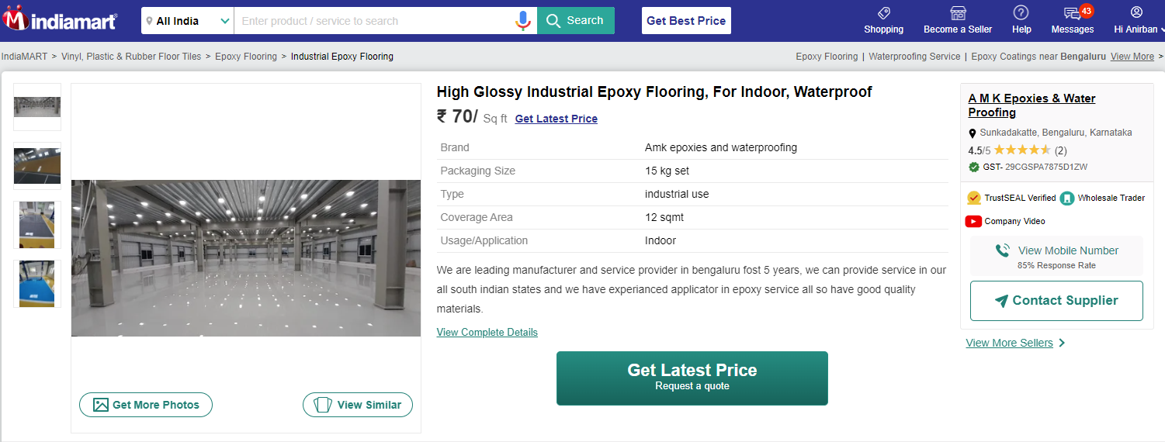

**Layout Plan**

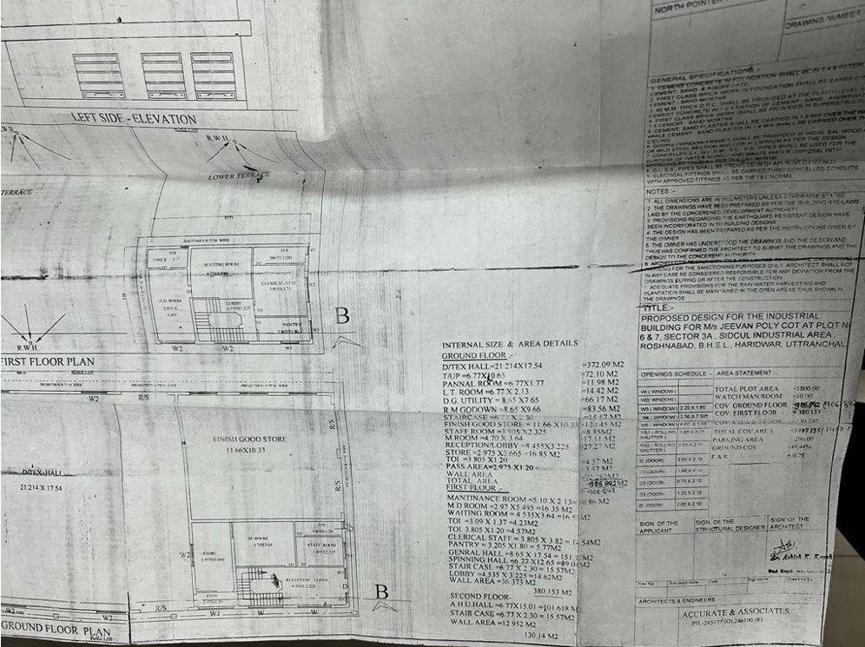

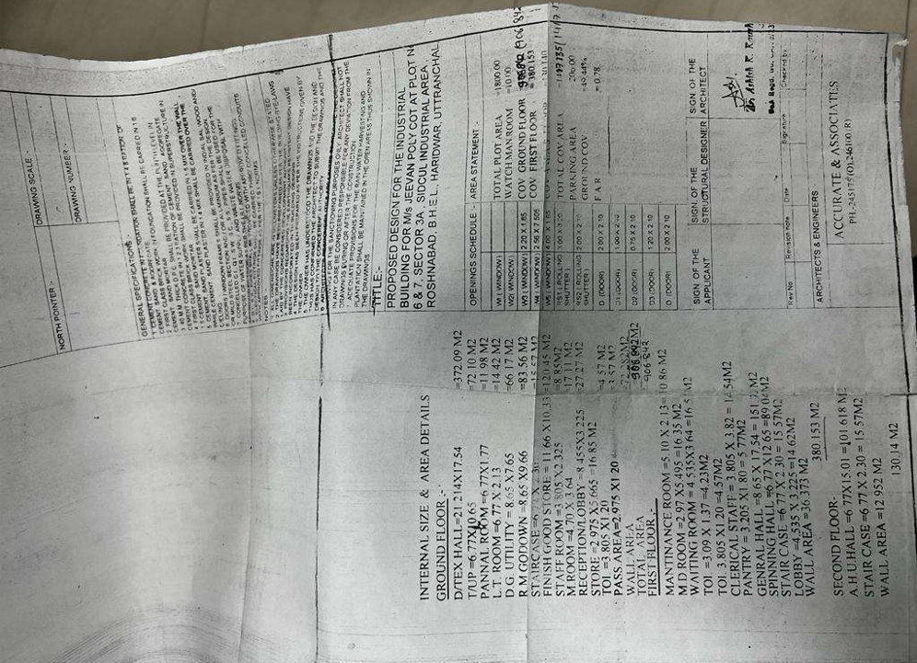**Cost Estimate Previous/Quotation**

