File No.: VIS (2023-24) PL-213-184-259 Dated: 28/08/2023

INDEPENDENT ENGINEERING REPORT

OF

M/S AKM HOTELS PVT. LTD.

SITUATED AT
LAND BEARING KHASRA NO. 218/3/3(1-13), 218/3/2(0-6), 219/1N (4-2), 219/2(2-8), 220 MIN, (3-17), 222/2(1-0), 223/1(0-12), VILLAGE SULTANPUR, TEHSIL MEHRAULI, NEW DELHI

COMPANY/PROMOTER

M/S AKM HOTELS PVT. LTD.

REPORT PREPARED FOR

STATE BANK OF INDIA, SME BRANCH, SECTOR-24, FARIDABAD

**Important - In case of any query/ issue or escalation you may please contact Incident Manager at le@rkassociates.org. We will appreciate your feedback in order to improve our services.

NOTE: Please provide your feedback on the report within 15 days of its submission after which report will be considered to be correct.

IMPORTANT NOTICE

COPYRIGHT FORMAT: This report is prepared on the copyright format of
R.K Associates to serve our clients with the best possible information and analysis to facilitate them to take rational business decisions. Legally no one can copy or distribute this format without prior approval from R.K Associates. It is meant only for the advisory/ reference purpose for the organization/s as mentioned on the cover page of this report. Distribution or use of this format by any organization or individual other than R.K Associates will be seen as an unlawful act and necessary legal action can be taken against the defaulters.

This report is intended for the sole use of the intended recipient/s and contains material that is STRICTLY CONFIDENTIAL AND PRIVATE.

DEFECT LIABILITY PERIOD: - In case of any query/ issue or escalation you may please contact Incident Manager at le@rkassociates.org. We try to ensure maximum accuracy in the calculations done, rates adopted, assumptions taken and various other data points & information mentioned in the report but even still can’t rule out typing, human errors or any other bonafide mistakes. In case you find any such mistake or inaccuracy in any data point of the report, please help us by bringing all such points into our notice immediately or within 15 days of the report delivery in writing, to rectify these timely failing after which R.K Associates won’t be held responsible for any such inaccuracy in any manner. We would highly appreciate your feedback in order to improve our services.

TABLE OF CONTENTS
SECTIONS | PARTICULARS | PAGE NO.
Part A | REPORT SUMMARY | 03
Part B | INTRODUCTION | 05
 | - Name of the Project | 06
 | - Project Overview | 06
 | - Project Location | 08
 | - Scope of the Report | 09
 | - Purpose of the Report | 09
 | - Survey Details | 09
 | - Methodology Adopted | 10
Part C | PROJECT INFRASTRUCTURE SECTIONS & FACILITY DETAILS | 11
 | - Land Details | 11
 | - Building & Structural Details | 11
 | - Interior Fit out and Furnishing  3.1 Equipment Details  3.2 Plant and Machinery Details  3.3 Miscellaneous Fixed Asset  3.4 Contingency  3.5 Preliminary and Expenses  3.6 Interest during construction | 13-17
 | - Invoices | 18
Part D | PROJECT CONSULTANTS, CONTRACTORS & SUPPLIERS | 19
Part E | PROJECT COST & CURRENT STATUS | 20
 | - Total Project Cost | 20
 | - Details Of Expenditure (Hard Cost) Incurred  2.1 Building Cost | 21
 | Site Photographs of the Project | 22-26
 | Other Annexures | 27-35
Part F | DISCLAIMER | 36-38

PART A | REPORT SUMMARY

- Name of the Project : AKM Hotel Pvt. Ltd.

- Project Location : Land Bearing Khasra No.218/3/3(1-13), 218/3/2(0-6), 219/1N (4-2), 219/2(2-8), 220Min, (3-17), 222/2(1-0), 223/1(0-12), Village Sultanpur, Tehsil Mehrauli, New Delhi

Name of the Company Promoter
: M/s. AKM Hotels Pvt. Ltd.

Prepared for Organization : State Bank of India, SME Branch, Sector-24, Faridabad
- Chartered Engineer Firm : M/s. R. K. Associates Valuers & Techno
Engineering Consultants (P) Ltd.

- Date of Survey : 16th August 2023

- Date of Report : 28th August 2023

- Report Type : Lender Independent Engineering Report

- Purpose of the Report : To verify and examine the capital expenditure
status of the Project from starting to 28/08/2023.

- Scope of the Report : To verify and examine capital expenditure status
of the Project.

- Documents produced for Perusal : a) Copy of CA Certificate
  - Copy of invoices of major items.
  - Copy of Approved Building plans
  - Copies of various NOCs & Approvals
  - Copy of TEV report

- Annexure with the Report : a. Tev report
  - Photographs
  - Other annexures (e.g., CA Certificate, Invoices, and Sanctioned plan).

PART B | INTRODUCTION

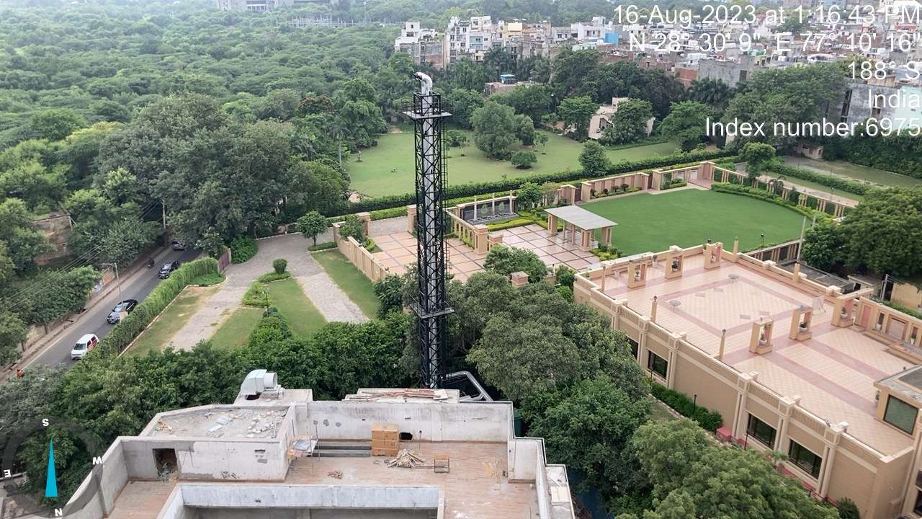

- NAME OF THE PROJECT: AKM Hotels Pvt. Ltd.

PROJECT OVERVIEW:

1. AKMHPL intends to set up a four-star upscale luxury banquet cum hotel based on theme of “Banqueting Hotel” at a plot on the main Mehrauli Gurgaon Road (MG Road), New Delhi. The project will have high end banqueting facilities duly supported by hotel and health club/ Spa/ Saloon activities. The hotel will have 94 standard rooms and 7 suite rooms for lodging. The Proposed hotel have various amenities and latest facilities offered with highest class standards to ensure the satisfaction to the customers.

- The project has already received all the necessary approvals from the competent authority i.e., from Municipal Corporation of Delhi (MCD) and environmental clearance for establishment of four-star hotel.

- The project land admeasuring 2.90 acres (11719.9 sq. m.) is owned by the promoter Mr. Ashwani Kumar Mehra. AKMHPL will take the land and bare. shell building on long term lease from Mr Ashwin Mehra and will invest in plant and equipment, utilities, electrical, furnishings, interiors, cutlery, etc and all the facilities required to operate the banquet and hotel facility.

- The project has 101 rooms for lodging, 5 Banquet Halls, health club, Saloon, etc. with complete furnishing of best possible luxurious and star category standards. The project is expected to achieve commercial operations by January 2024 as per the visual observation.

As per the copy of sanctioned building plan dated 15/10/2018 details of the Project area are tabulated below:
Sr. No. | Particulars | Description | Unit
1. | Total plot area  road widening AREA  Net plot area | 11719  3929.04  7790.86 | Sqm  Sqm  sqm
2. | Total Far area  Total Non-FAR area | 13458.78 | sqm
 |  | 17048.07 | Sq.m
3. | Total covered area (FAR + non-FAR) | 30506.85 | sqm

As on 17.10.2023 the project expense was Rs.23.53Crore as per CA certificate Expense table is attached below.:
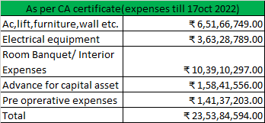

CURRENT STATUS OF THE PROJECT
As per the physical progress observed during site visit carried out on 16.08.2023 the project was in progress and will be completed in 3 or 4 months. The superstructure of the project was completed and finishing work is going on. Particular floor wise status is attached below.
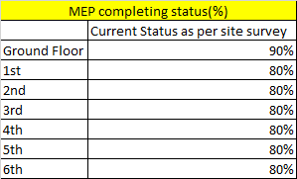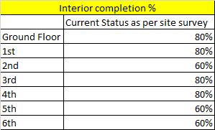

PROJECT LOCATION: -

Land Bearing Khasra No. 218/3/3(1-13), 218/3/2(0-6), 219/1n (4-2), 219/2(2-8), 220 Min,

(3-17), 222/2(1-0), 223/1(0-12), Village Sultanpur, Tehsil Mehrauli, New Delhi.
The nearest airport from the site is IGI Airport, Delhi located at the distance of approx. 11.2 km. The Project site is also well connected through road network and abutting Mehrauli Gurugram Road. Chhatarpur metro station is the nearest metro station at a distance of approx. 500 m from the project.
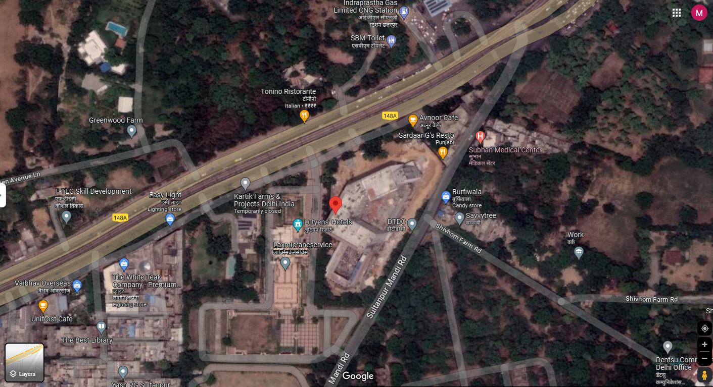

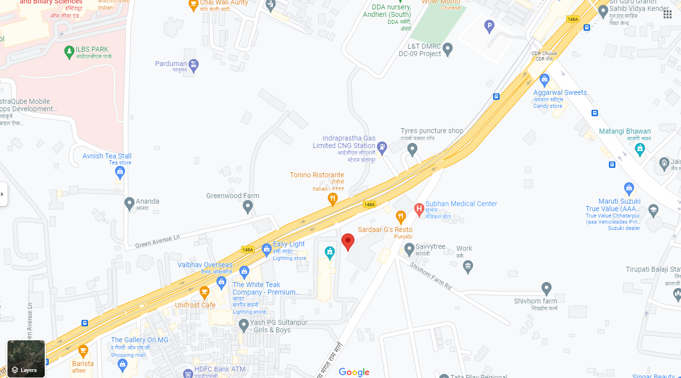

- SCOPE OF THE REPORT: The scope of this report includes the assessment & verification of the capital expenditure incurred on the project from starting to 28th August 2023 by the company.
All the assessment carried out for the Project is done based on the documents & information provided to us by AKMHPL and its correlation by the Engineering team through site inspection and various other discussions with the Project proponents and its able resources and thus forming an opinion out of it.
- PURPOSE OF THE REPORT: To provide a comprehensive overview of the current status of the project in terms of Capital Expenditure incurred of AKMPHL.

- SURVEY DETAILS: The subject plant is inspected by our Engineer Sachin Pandey on 16th August 2023. Site inspection was done in the presence of company’s representatives Mr. Sachin. All the details pertaining to the physical setup of the Project have been cross-checked as per the documents/ information provided to us.

The engineering team visited all the sections of the Hotel and verified most of the major machineries installed on site like Generator, STP, Lift, Plumbing system, Transformer, Distributed Control System, various motors, EOT Crane, DG Set, Cables, Electric Panel etc. The machineries verified at site are found to be in good condition.
The physical verification of the Floors, Banquet Halls, offices, Swimming Pool etc. has been done. Different structure is found on different floors sheet is attached below.
At site survey team checked the completion status of the all floors and same sheet is already attached above.

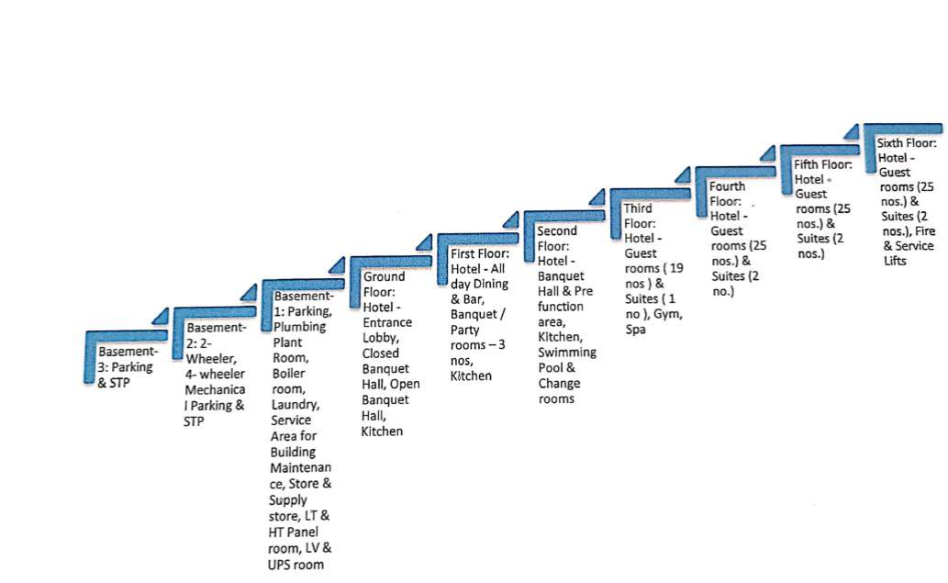

METHADOLOGY ADOPTED:

- Study of TEV report to know the Project proposed plan & estimates.
- Study of Project Contract agreements.
- Site visit by our engineering team to assess the actual status at the site.
- Discussions with the management of the company about the Project details.
- Study and analysis of various documents, information & data collected from the company and their correlation with the observations during the site survey.
- Correlation of the provided information with the industry standards.
- Other information obtained regarding the project from the sources in the public domain.

PART C | PROJECT INFRASTRUCTURE SECTIONS & FACILITY DETA

- LAND DETAILS: As per the copy Title Investigation Reports total land area underneath the subject property is 13 Bigha 18 Biswa. However, as per the copy of approved map the Total Land area is 11,719 sq.mtr. and Road widening area 3,929 sq.mtr so Net plot area is 7790.86 sq.mtr. The satellite measurement of the plot area is attached below.
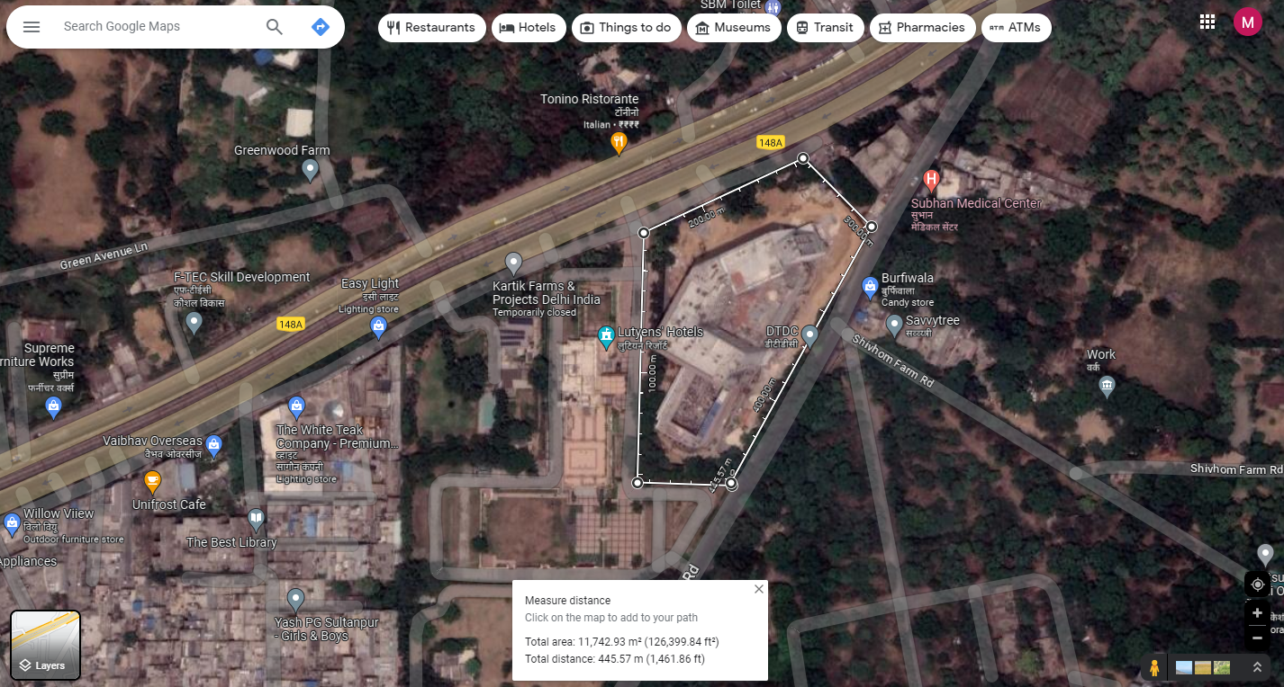

- BUILDING & STRUCTURAL DETAILS: M/s. AKM Hotels Private Limited has decided to construct a four-star upscale luxury banquet cum hotel based on the theme of “Banqueting Hotel” at a plot on the main Mehrauli Gurgaon Road (MG Road), New Delhi. The proposed project is located at Khasra Number 218/3/3,218/3/2, 219/1, 219/2, 220min, 222/2 & 223/1, Mehrauli Gurgaon Road, New Delhi. The land area measuring 2.90 acres is owned by the promoter Mr. Ashwani Kumar Mehra which is transferred on lease to AKMHPL on revenue share with minimum lease rent of @ INR 25 Lakhs per month after one year of hotel operations with an escalation clause of 5% every 3 years post start of payment as per the TEV report. The hotel will have 94 standard rooms and 7 suite rooms for lodging. The building details area attached below.
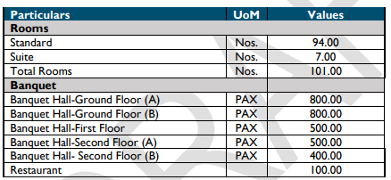
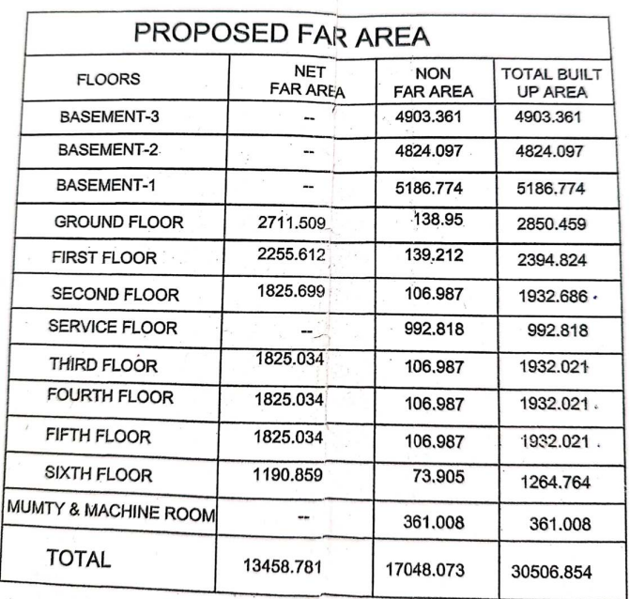

As the building is constructed by the Director Ashwani Kumar so in TEV building value was not included in the entire project cost (86 crore) but we are also calculating the building value as per the bank demand.

3.Interior Fit out and furnishing calculation:

As per the TEV report the interior fitout and furnishing cost of the Project has been estimated at INR 29.49 Crore. The details of the same have been presented in the table below –
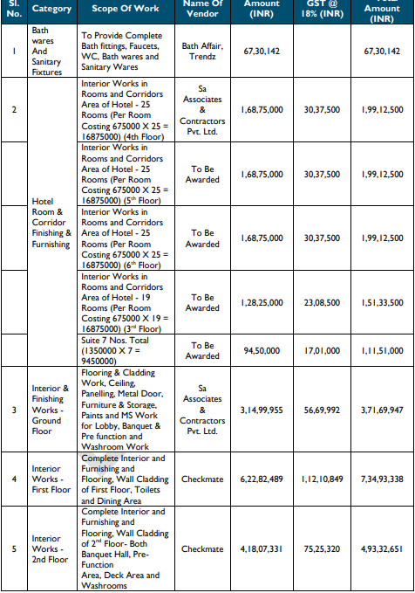

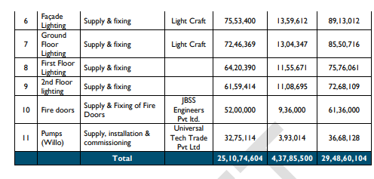
Verification of the cost of Interior: - The total built-up area of the Hotel is 1,35,572 sq.ft. As the interior and finishing of the hotel is good so we have adopted Rs. 2200/- per sq. ft rate for the calculation of the interior work and it is fair in our opinion. As the Interior work is almost done (90% overall) so adopting 90% of the per sq. ft rate, comes Rs.1,980 per sq.ft. and same is adopted for calculation of interior work till now.
1,35,572 sq. ft x Rs.1,980 per sq. ft =Rs. 26,84,32,560/-
4.Equipment Cost: The Company has made a provision of INR 14.03 Crore towards equipment for kitchen, laundry, minibars & tea coffee machines, health club & SPA, and business centre of this, an amount of INR 10.40 Crore is provided for kitchen & BOH equipment, as per the TEV report. As per the site survey observation we did not find the equipment which were proposed like Back of house equipment, Laundry Equipment, Tea Coffee Machines, Health Club instruments, SPA equipment, Business Centre equipment. As we have received the invoice of the Kitchen Suppression system and SS Exhaust Hood with combined cost Rs.65,95,928/- and same is considered for the report.
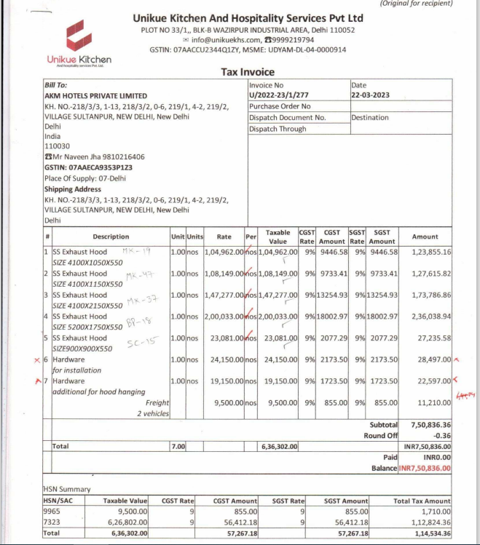

5.Plant & Machinery Details and Cost Verification:

The proposed value of the Plant and Machinery as per the TEV report is 27.88 Crore which is attached below. As this cost is for a total area (hotel + basements) of 2,99,994 sq. ft. is INR 929/- per sq. ft., which is reasonable for the developed at site. The costs also account for the high Air conditioning and lighting loads for the banquets, as well as the associated increase in the electrical and firefighting equipment. As we have not received complete invoices of the items so we have calculated the current plant and machinery cost through the per sq. ft rate of the hotel and it may be varied when we received all proper invoices of the plant and machinery.

In site survey we have verified the Plant and Machinery details and found majorly of the proposed machinery is installed at the site like Generator, CCTV system, AC, VRF system., Ventilation work, Heat Pump, STP, Lifts, Plumbing System, Electrical system and Fire Fighting. By assuming that the installed machinery has same specification and in quantity which is proposed as per the TEV report. The solar panel and pressurization work is not done so we are not considering this amount for the report. The plant and Machinery value is Rs.26.30 Crore
As per the copy of provided invoices the cost of the machinery and equipment is Rs.12,72,52,170/- however the proposed cost for it is 41.91 crore. As we demand for the remaining invoices but we have not provided so we have verified the remaining items or Machinery through the visual observation at site and from the photograph of the property taken at the time of site survey.
Machineries were verified on sample basis based on type and name of machineries as listed in the Tev report.

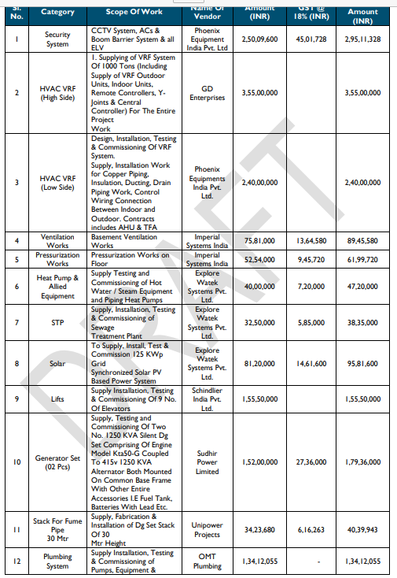

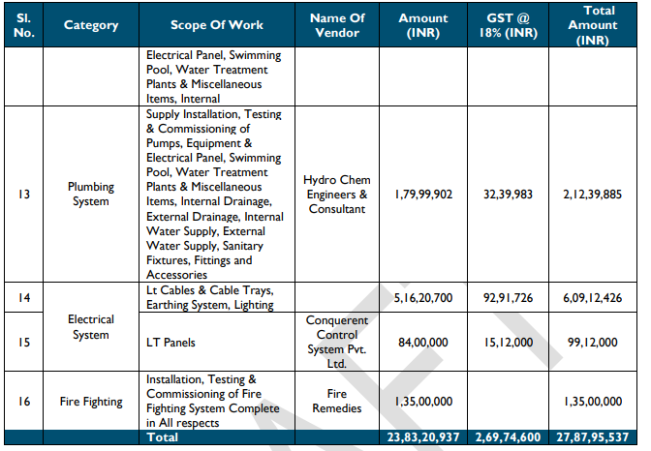

6.Miscellaneous Fixed Asset and Cost Verification
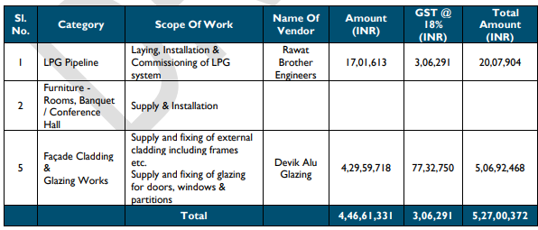

As the proposed cost for the Miscellaneous Fixed cost is Rs.5.27Cr which is checked at the site as per the scope of work mentioned in the TEV report, we found that Major work of included in it has been done like External cladding, frames, glazing for doors, window and partitions so we have adopted all the 5.27 Cr value for the report which is fair in our opinion.

7.Contigency
The contingency for the Project is INR 2.11 Crore, is around 2.4% of the total cost excluding Land and Building which is fair in our opinion.

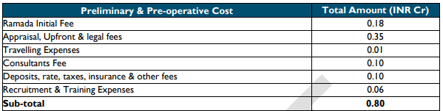
8.Preliminary and Pre-Expenses

No supporting documents have been provided to us against the Preliminary and Pre-Expenses. However, knowing the cost of the project i.e., 86 Cr, the Preliminary and Pre-Expenses comes to be 80 lakhs, which is less than 1%, thus seems to be reasonable.

9.Interest During Construction

The IDC for the project has been estimated at INR 6.42 Crore, which is based on the term loan of INR 50.00 Crore and interest rate of 8.50%, as per the TEV REPORT provided which is reasonable at our end.

Plant & Machinery and Miscellaneous fixed assets
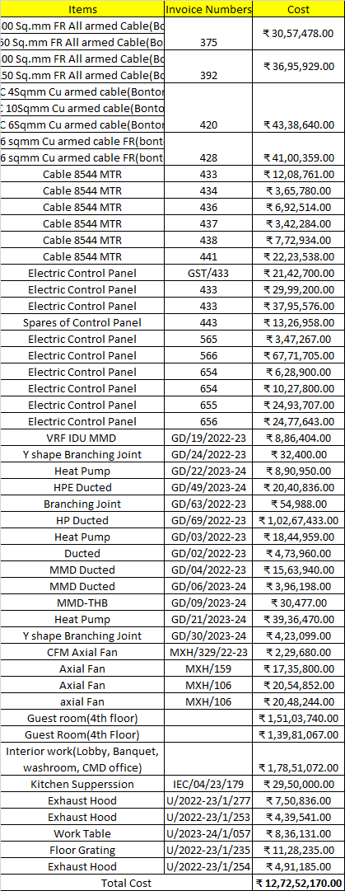

PART D | PROJECT CONSULTANTS, CONTRACTORS & SUPPLIERS

The Company has appointed the following consultants & contractors for the project as per the TEV report
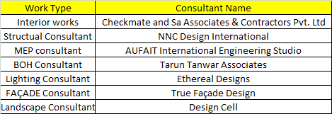

PART E | PROJECT COST & CURRENT STATUS

- TOTAL PROJECT COST: As per the TEV report, the estimated project cost amounts to Rs.86Cr. As per CA certificate with dated 17th October 2022. Rs.23,53,84,593/- has been incurred. The current incurred cost is attached below.
(Amount in Rs. Crore)
Sr. No. | Particulars | Envisaged Cost of Project as per TEV | Cost incurred as per CA certificate till 17 oct 2022 | Cost incurred as per our Assessment
1. | Building and Civil Works | -- | 23.53 | 56.7
2 | Interior Fit out and furnishing | 29.49 |  | 26.84
3 | Equipment Cost | 14.03 |  | 0.65
4 | Plant & Machinery | 27.88 |  | 26.30
5 | Misc. Fixed Assets | 5.27 |  | 5.27
Sub-Total (Hard Cost) |  | 76.67 |  | 115.76
7 | Contingency | 2.11 |  | 2.11
8 | Preliminary & Preoperative Expenses | 0.80 |  | 0.80
9 | Interest During Construction Period | 6.42 |  | 6.42
Sub-Total (Soft Cost) |  | 9.33 | 23.53 | 9.33
Grand Total |  | 86 | 23.53 | 125.09

Note* Envisaged cost of the project 86 Crore is not included the Building and Civil works calculation however we have considered the Building and Civil works as per the Bank requirement but the building is constructed by the Director Ashwani Kumar not by the AKMHPL as per the TEV report.

  - BUILDING COST
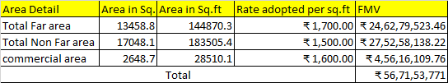

SITE PHOTOGRAPHS OF THE PROJECT

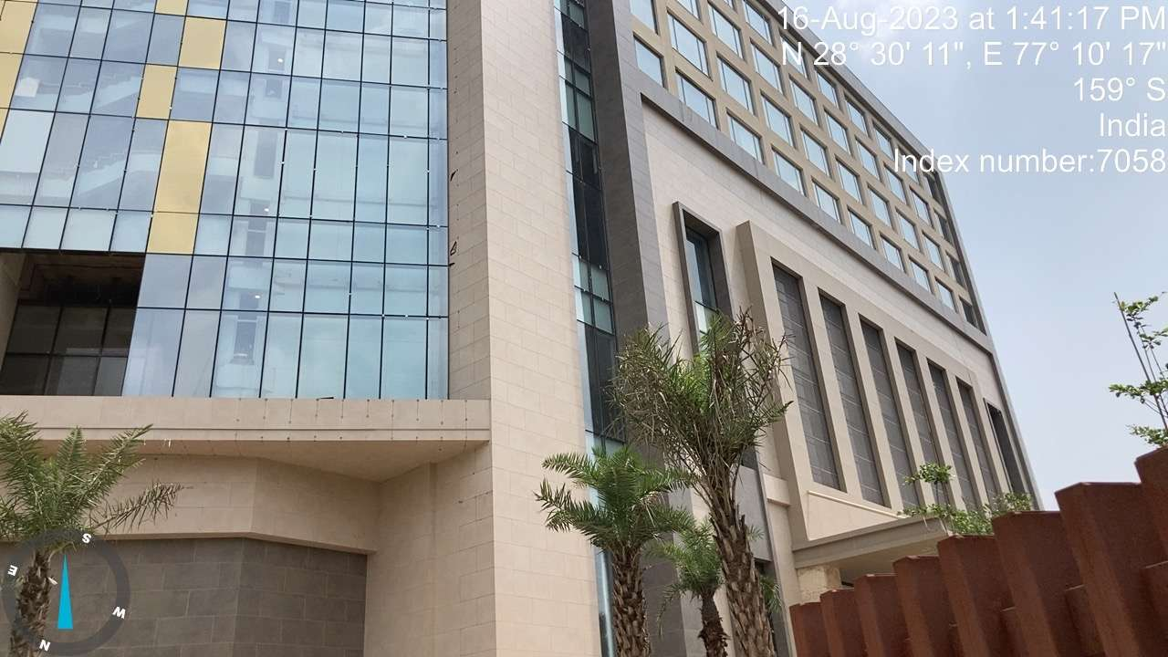 | 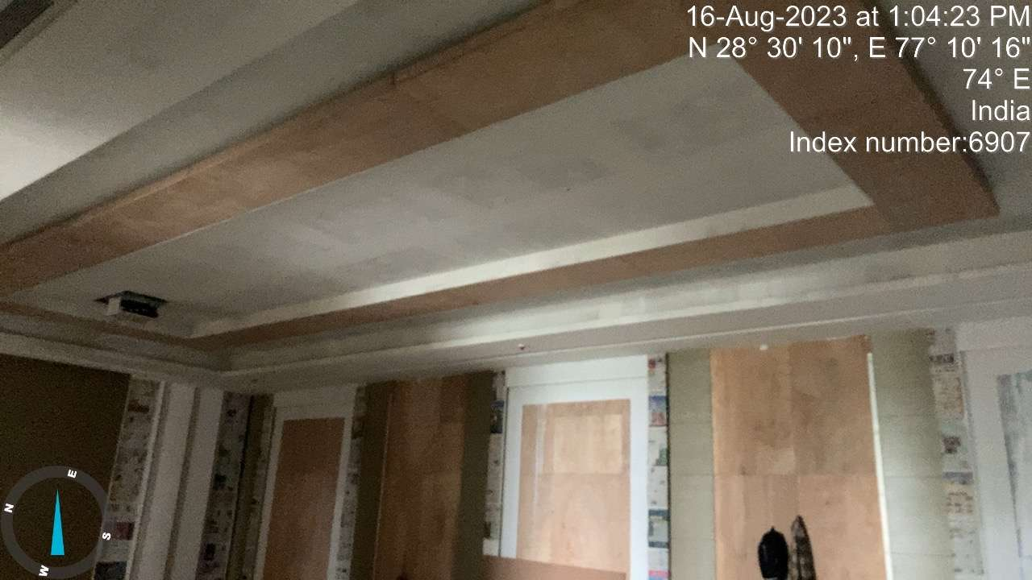
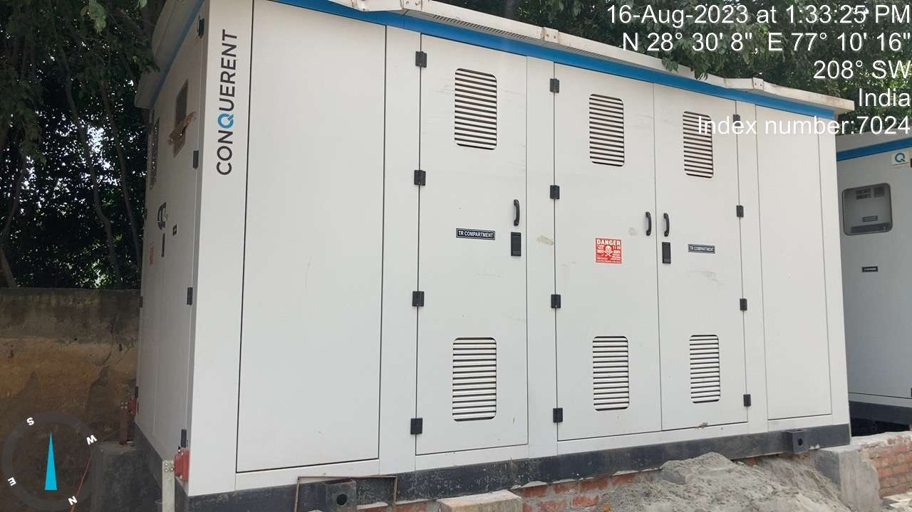 | 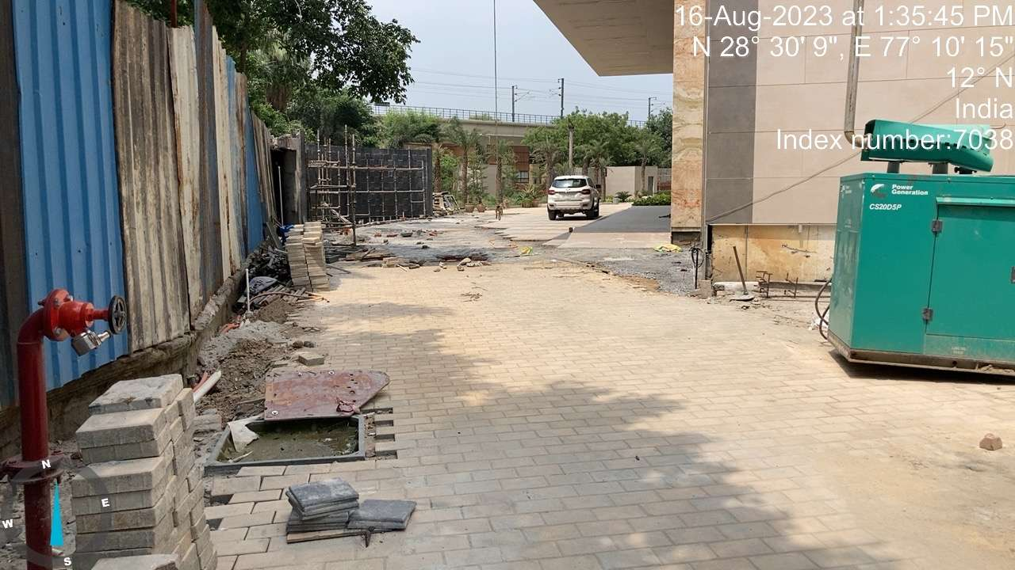
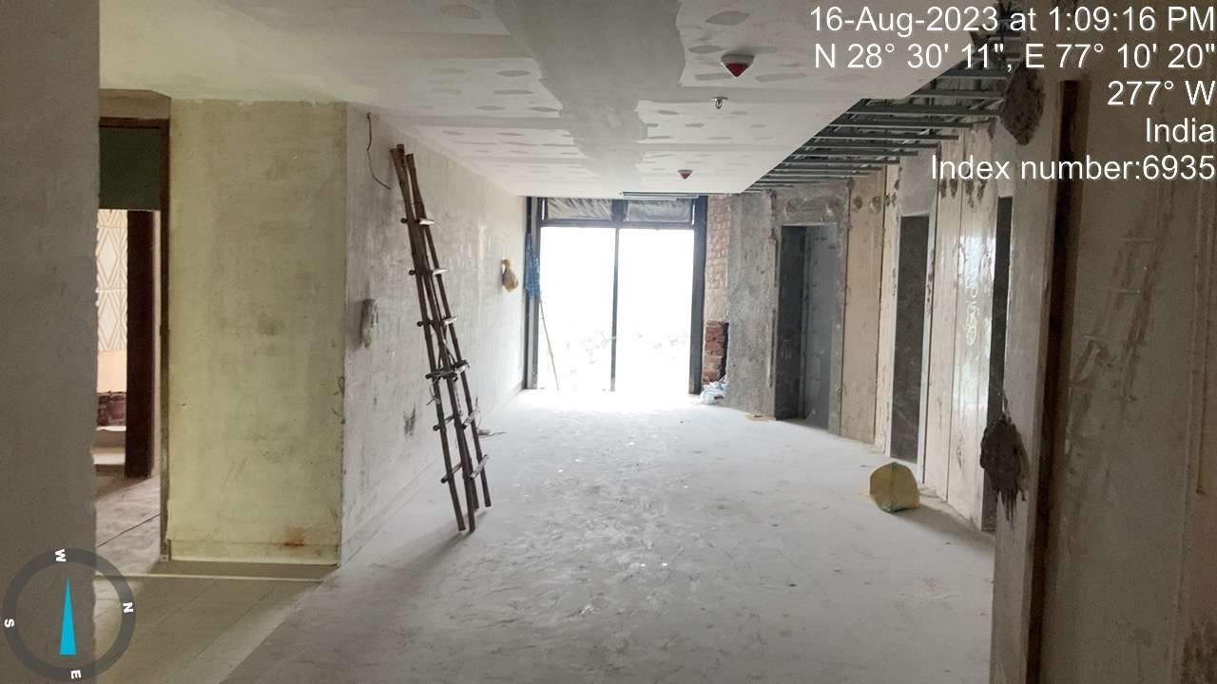 | 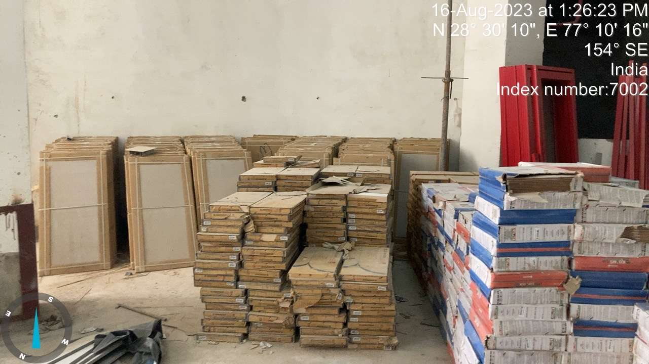
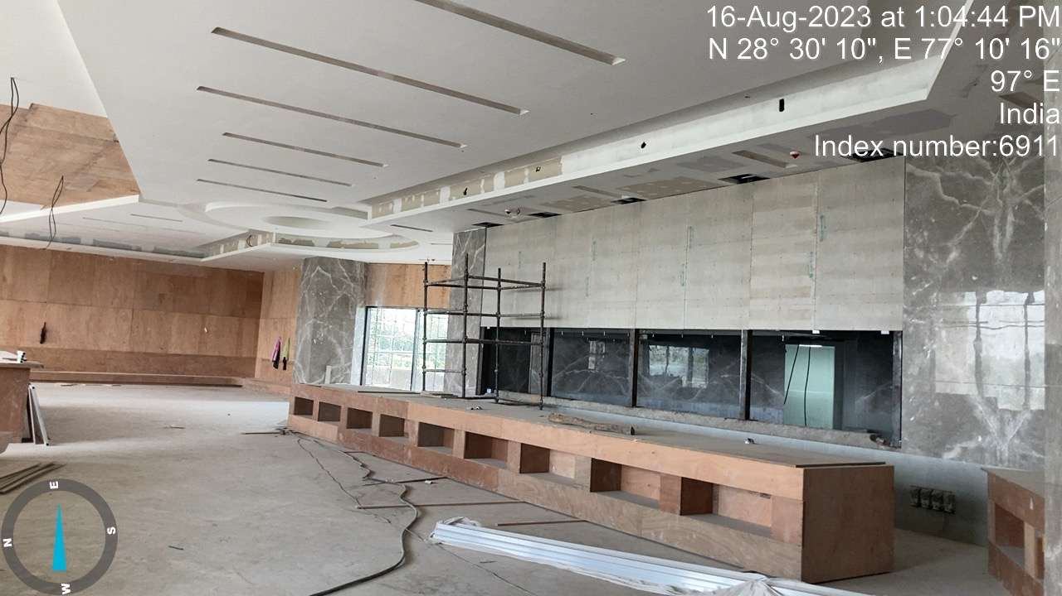 | 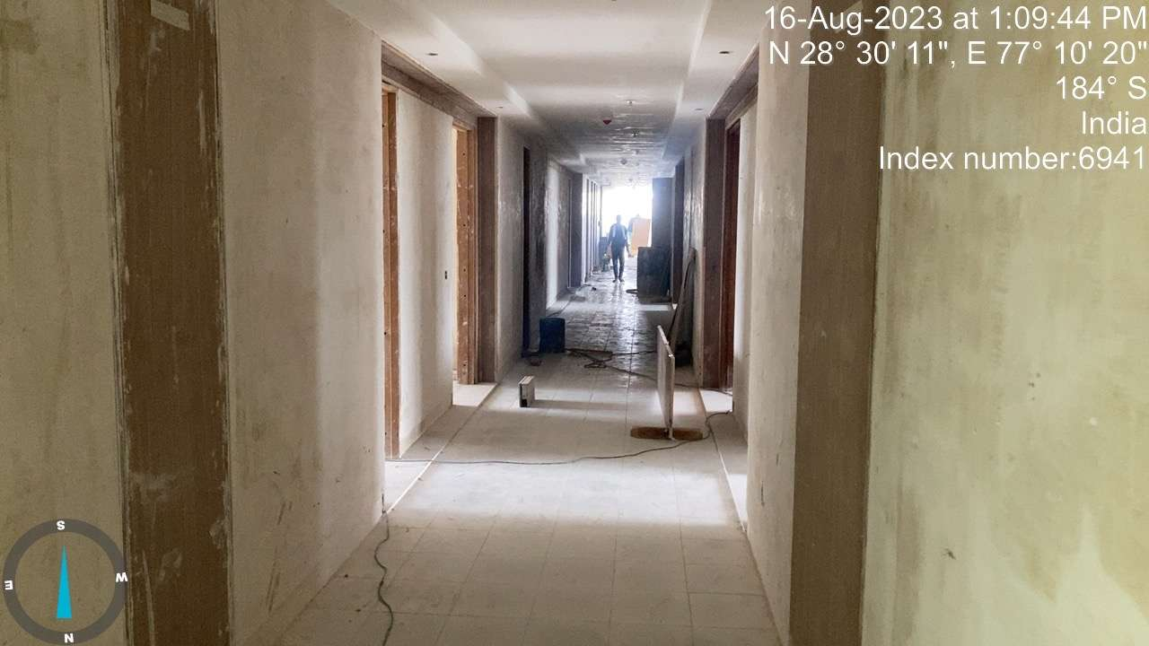

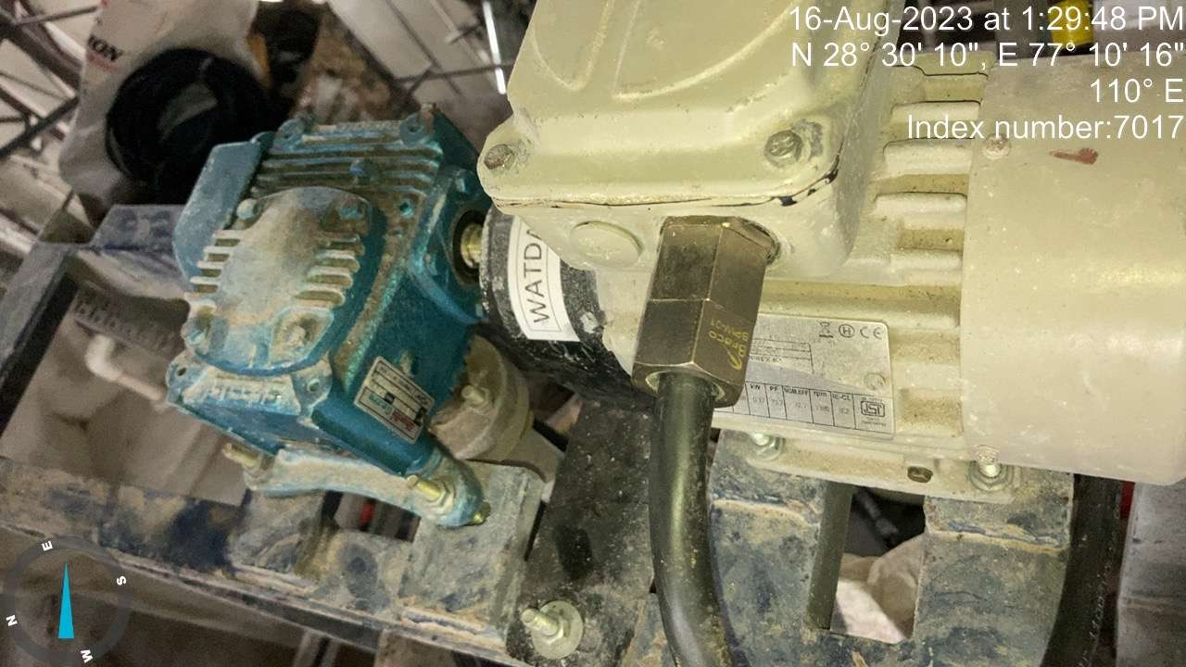 | 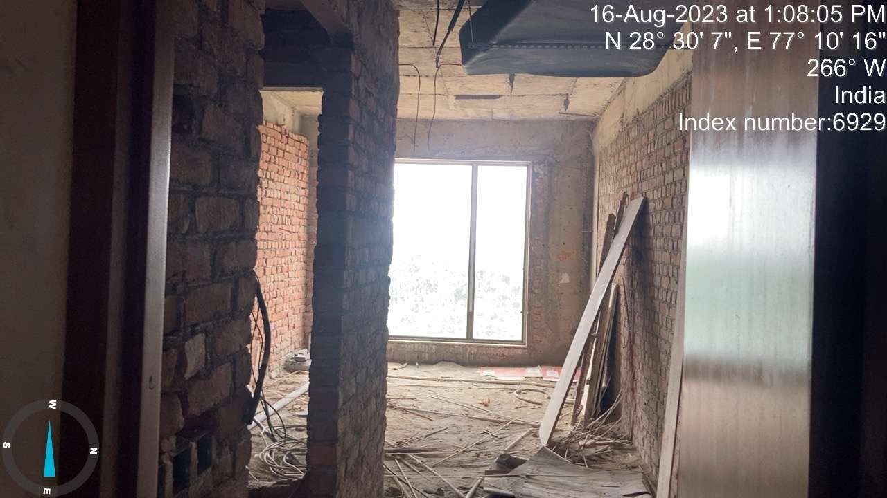
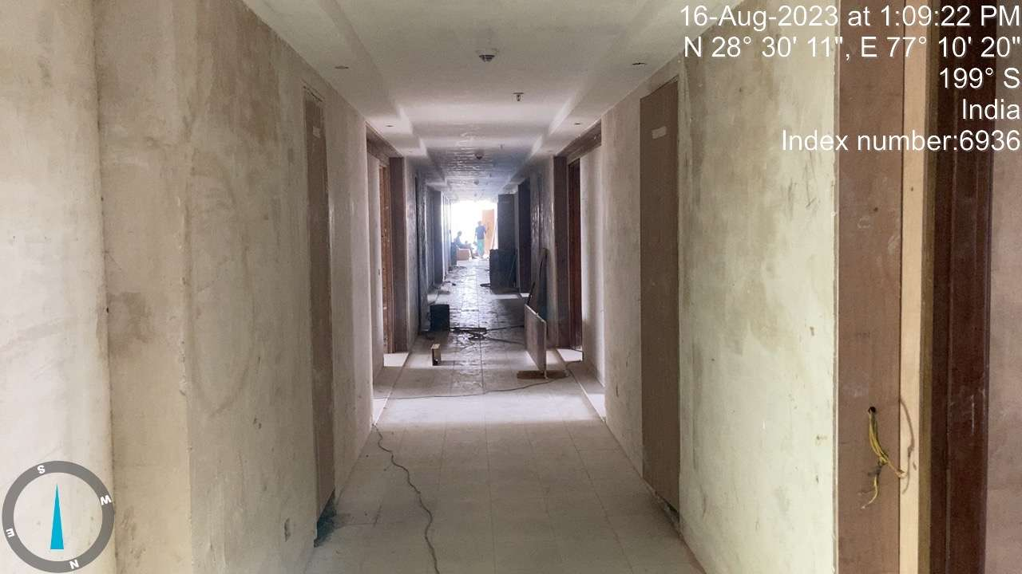 | 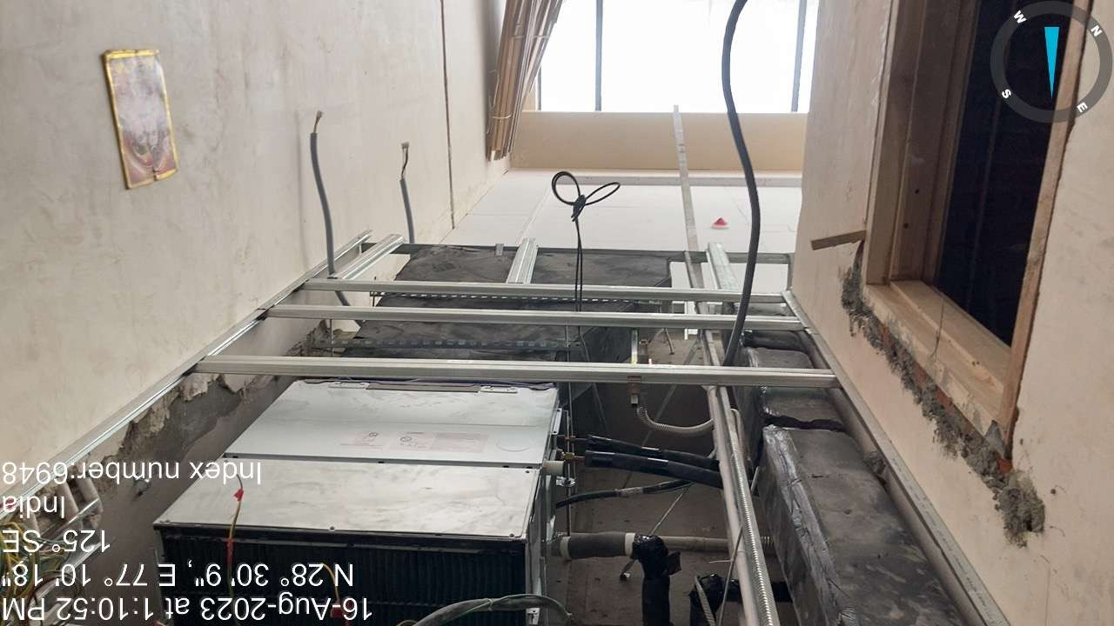
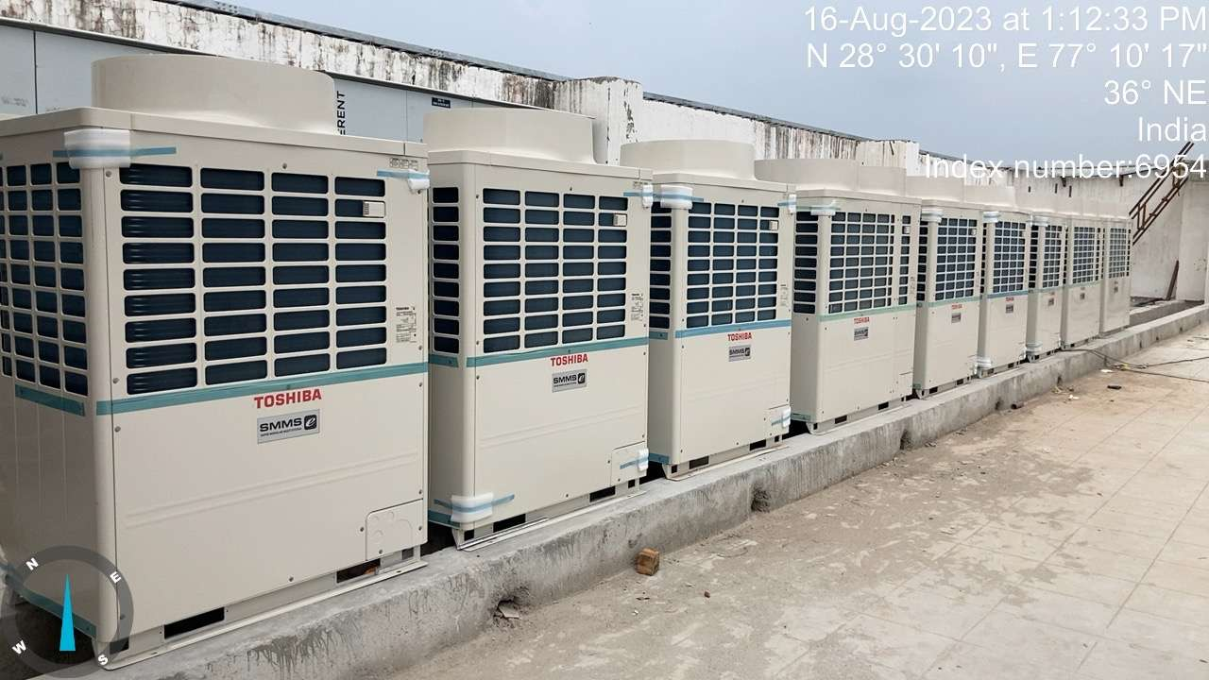 | 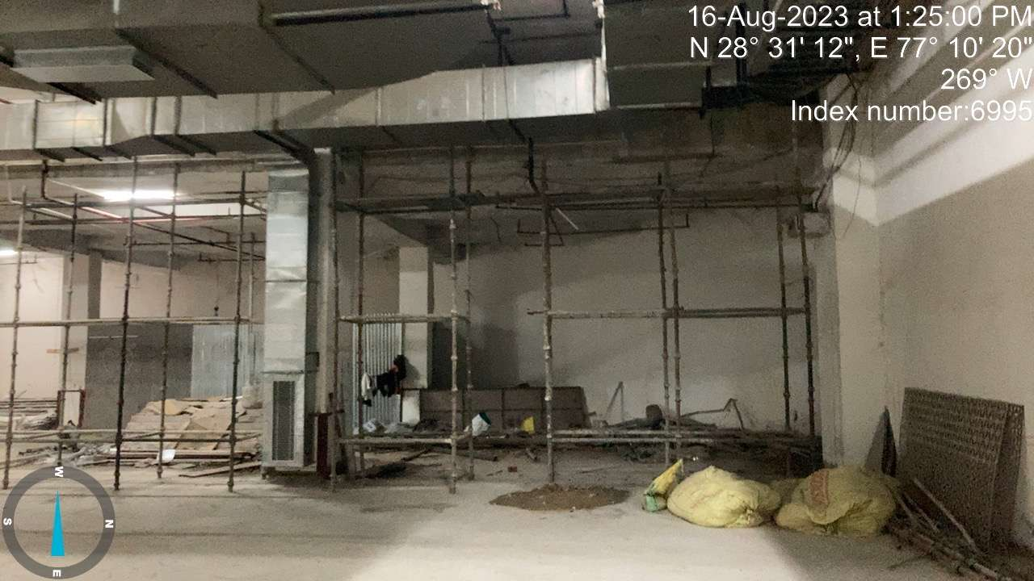
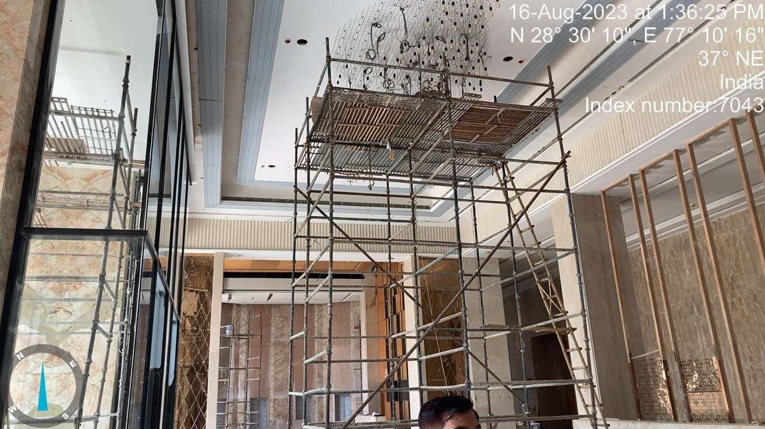 | 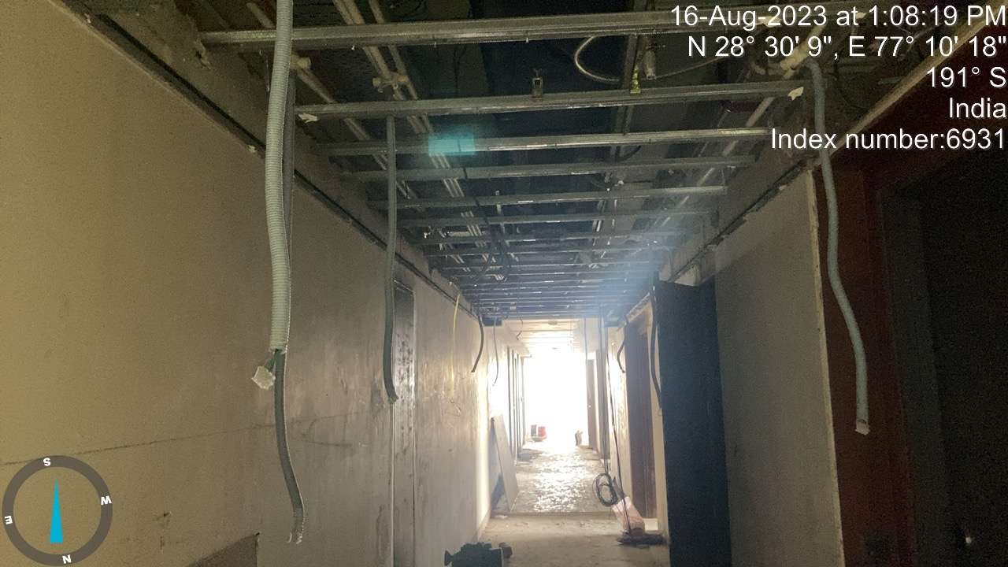

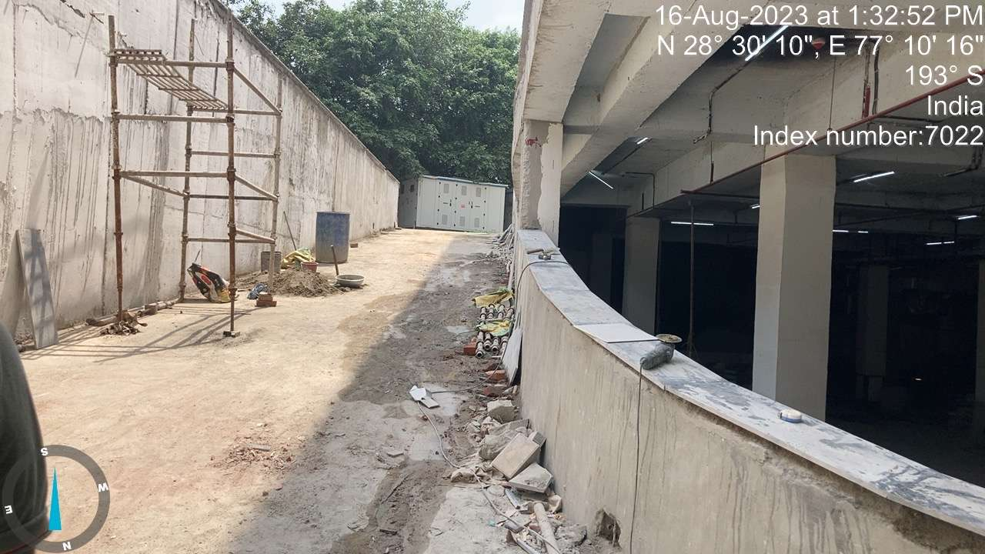 | 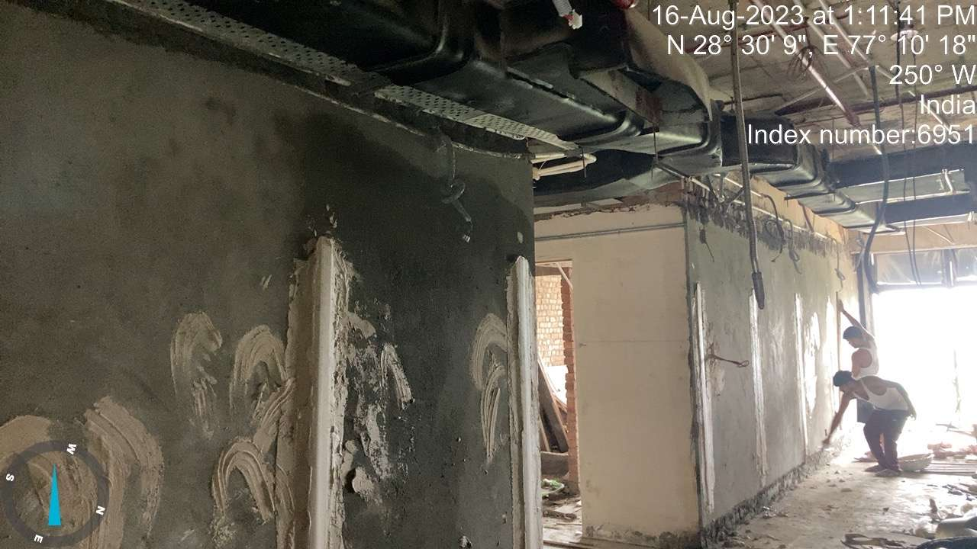
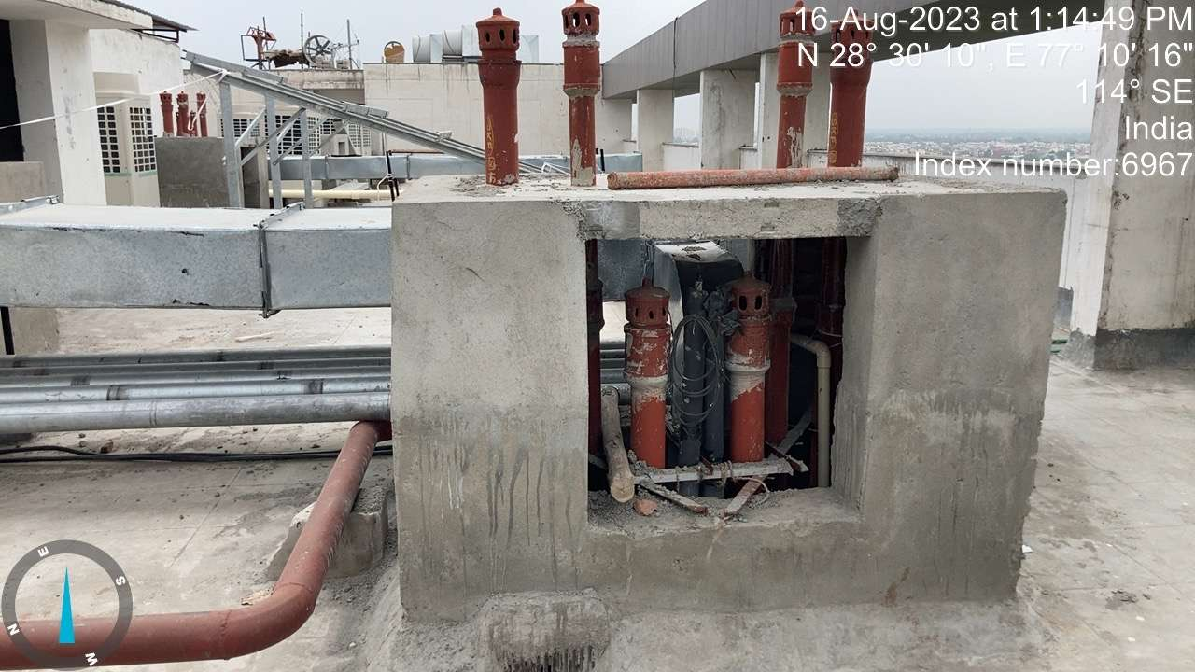 | 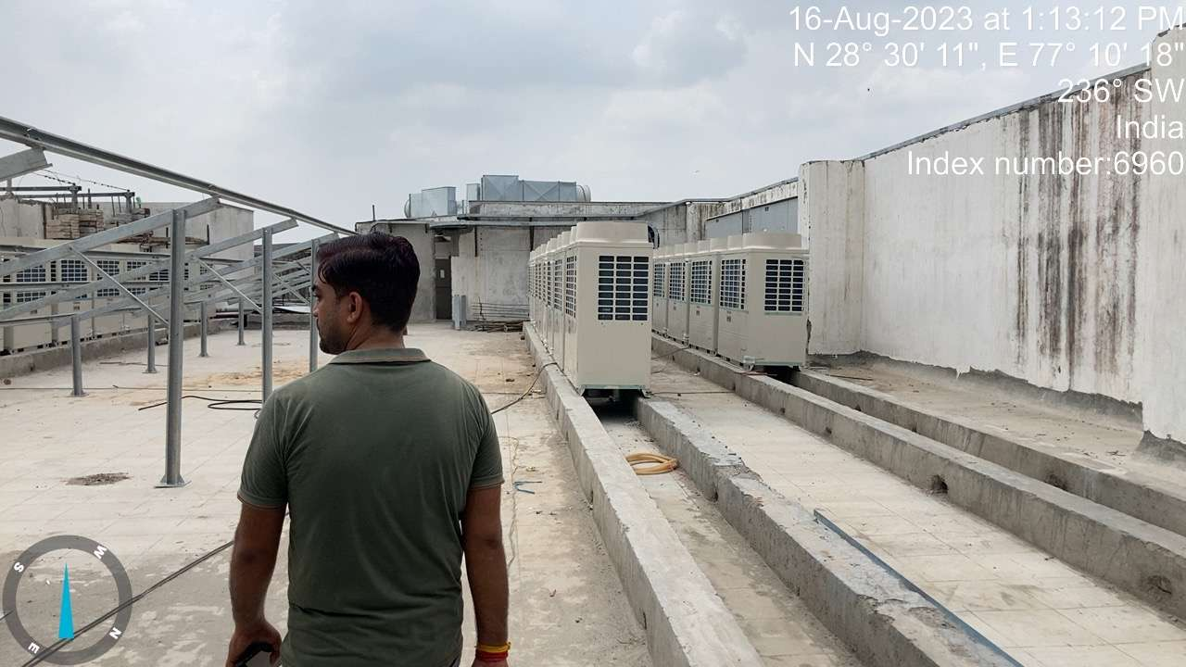
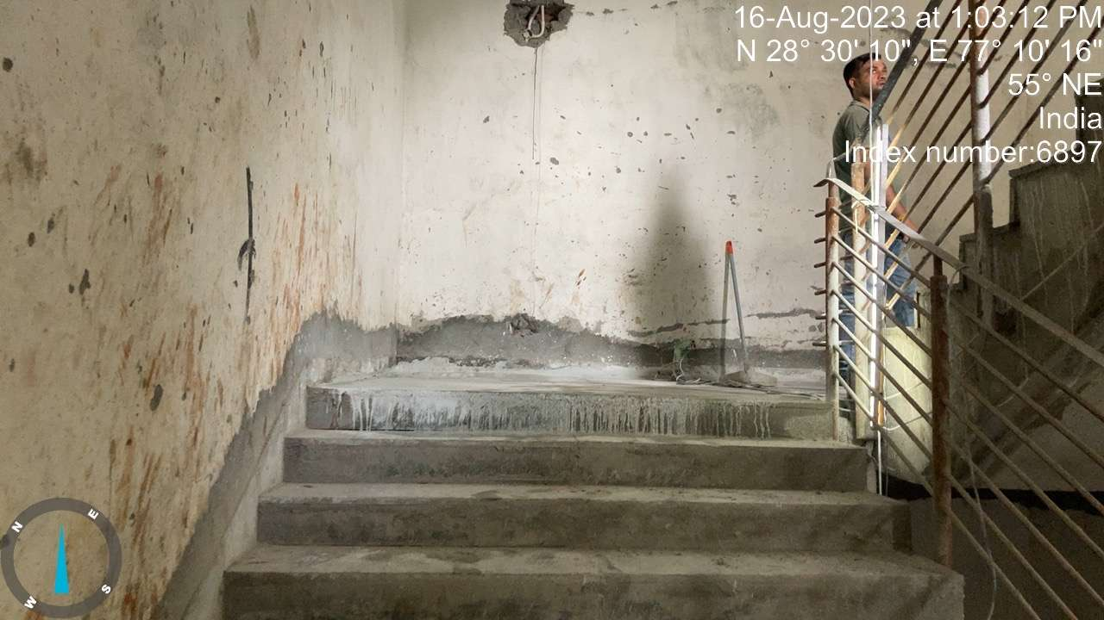 | 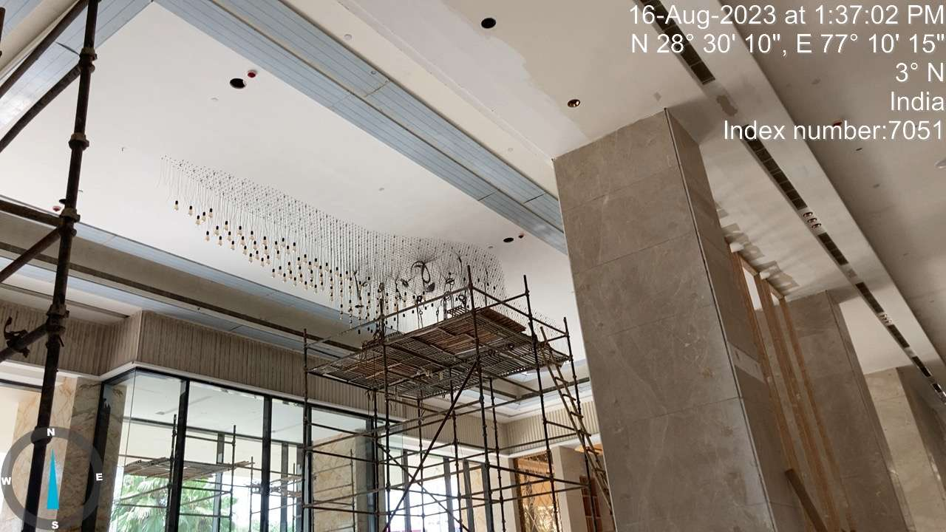
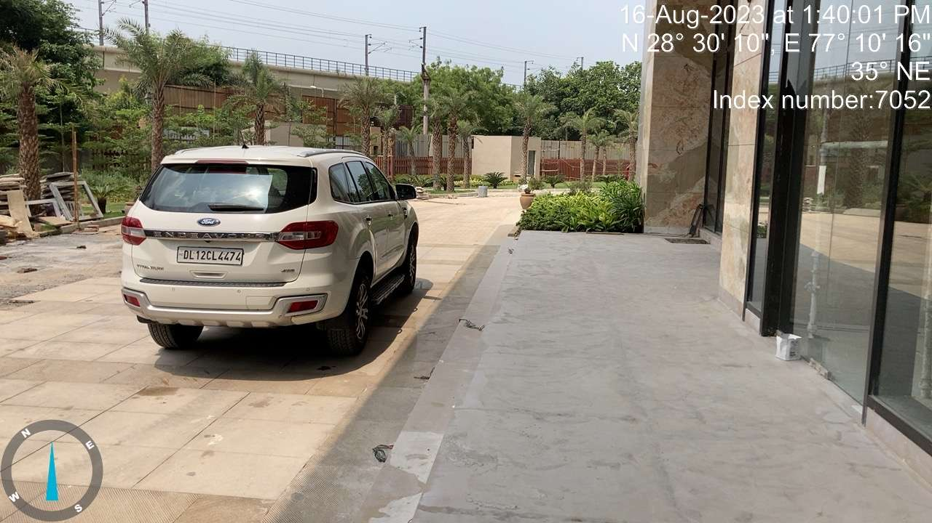 | 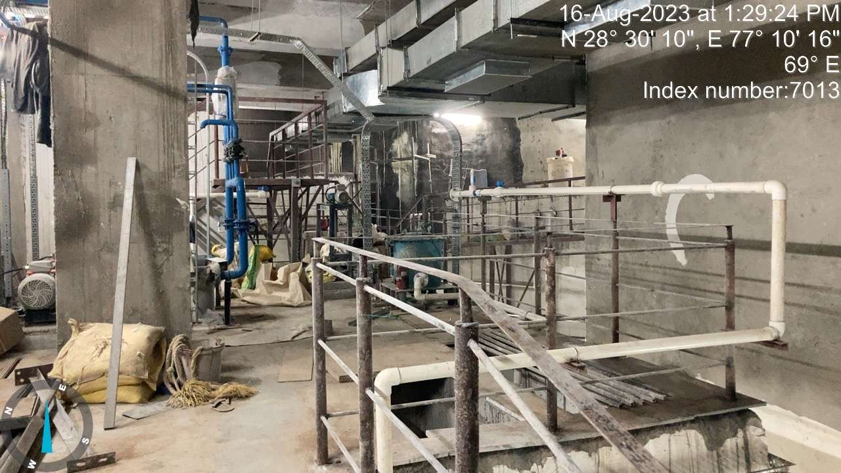

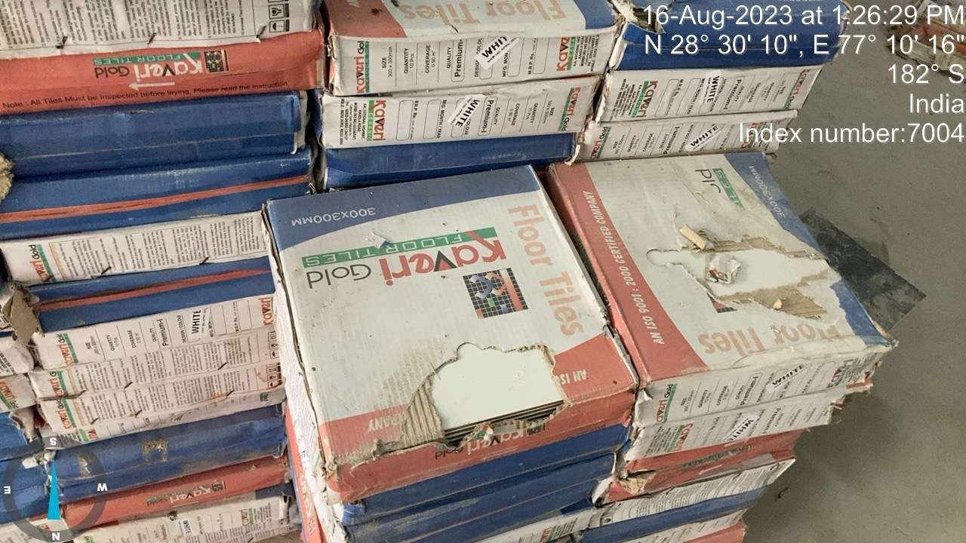 | 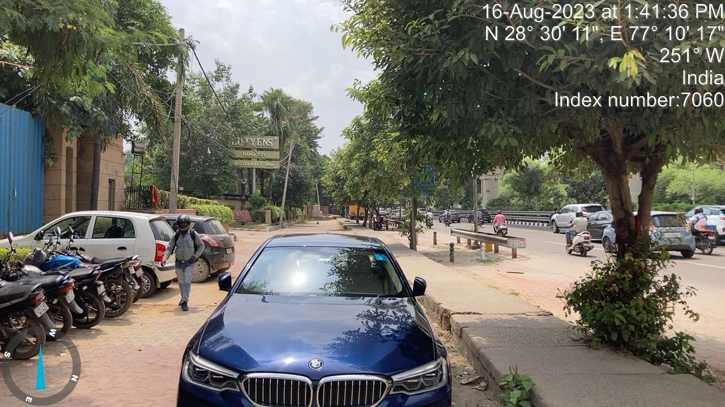
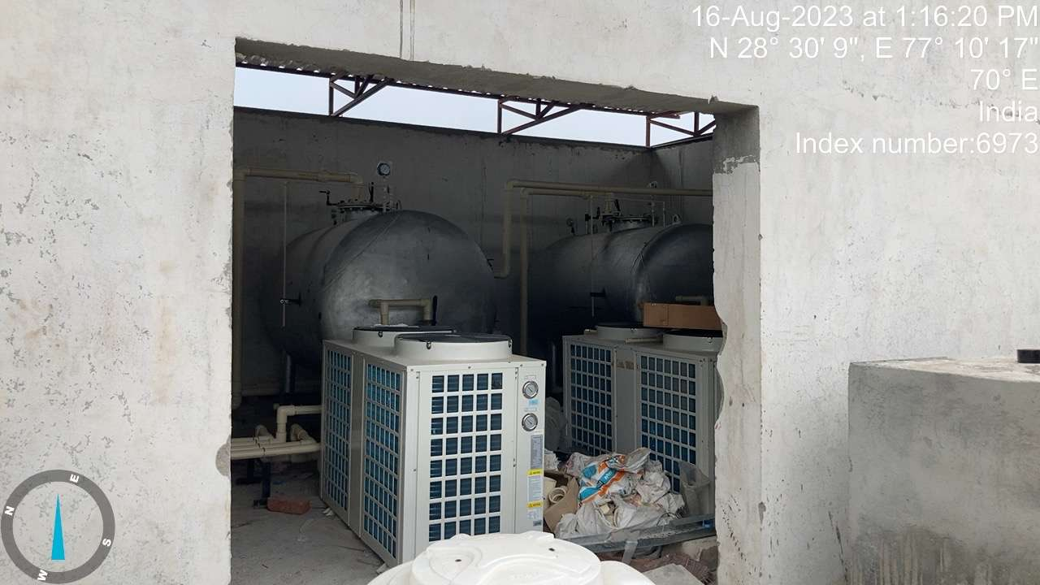
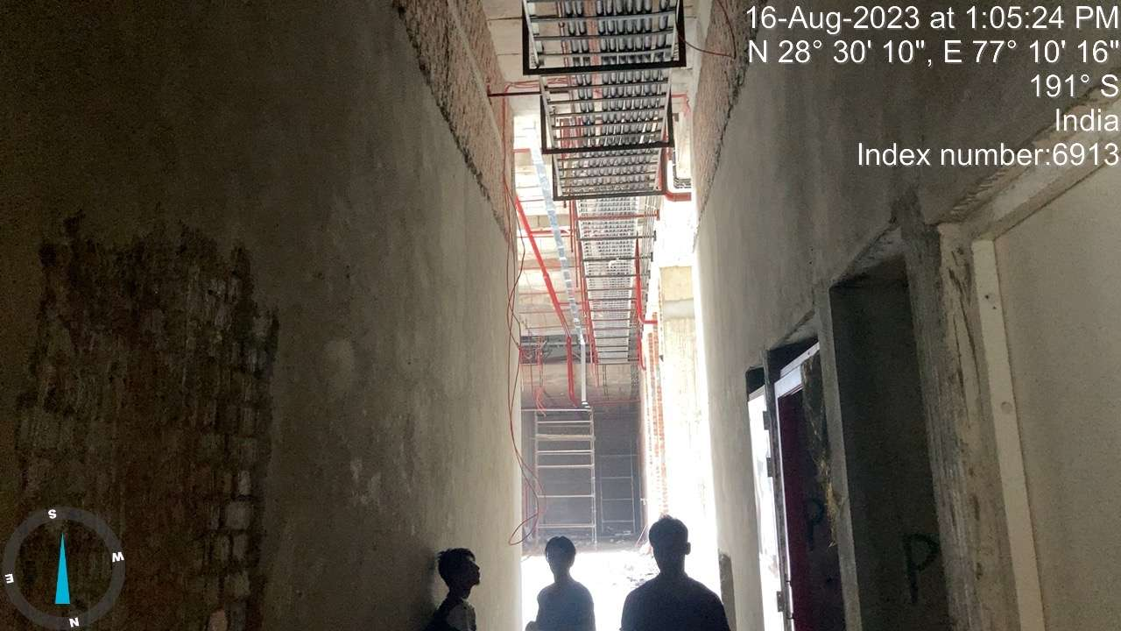 | 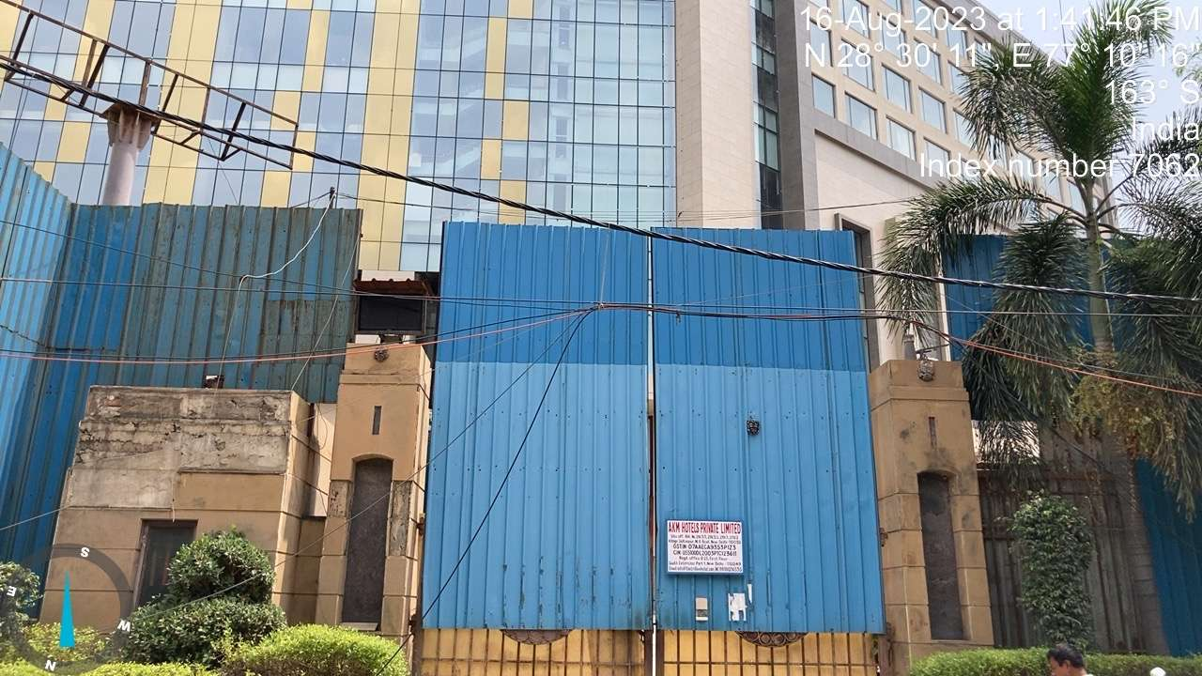
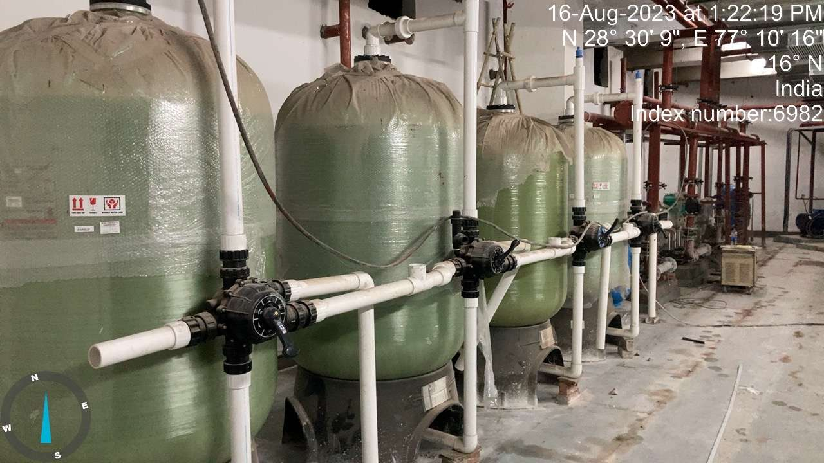 | 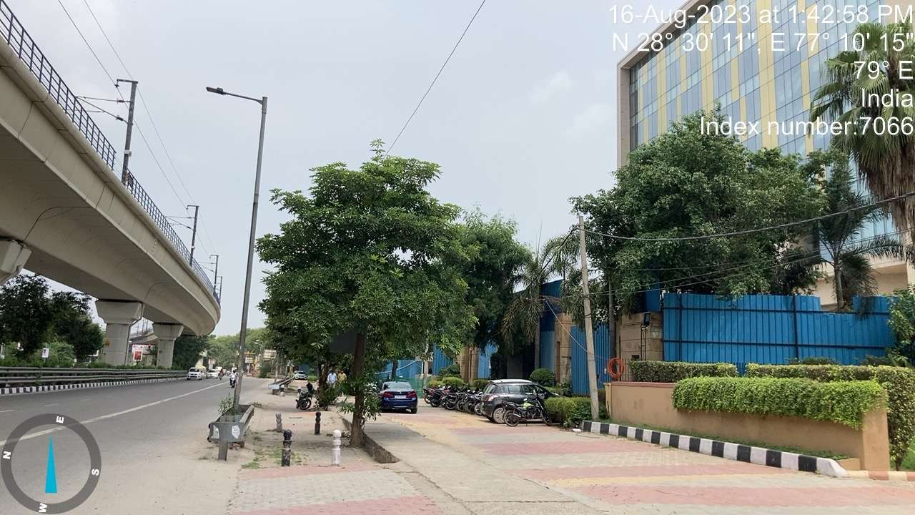

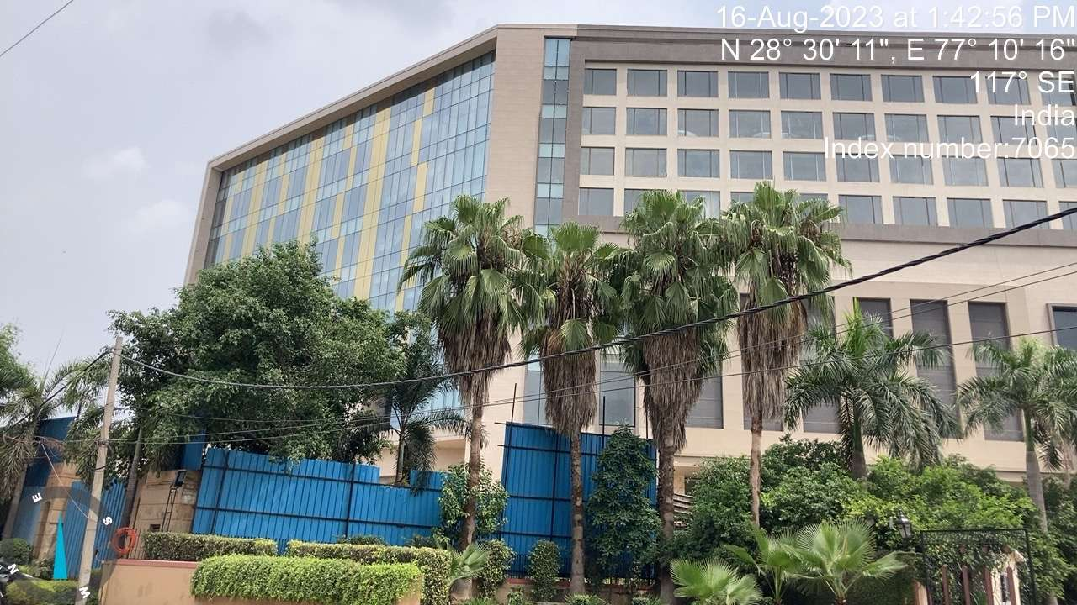 | 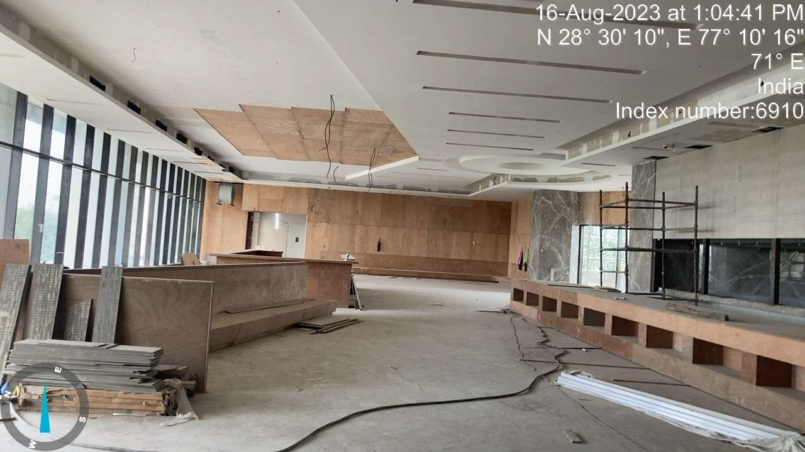
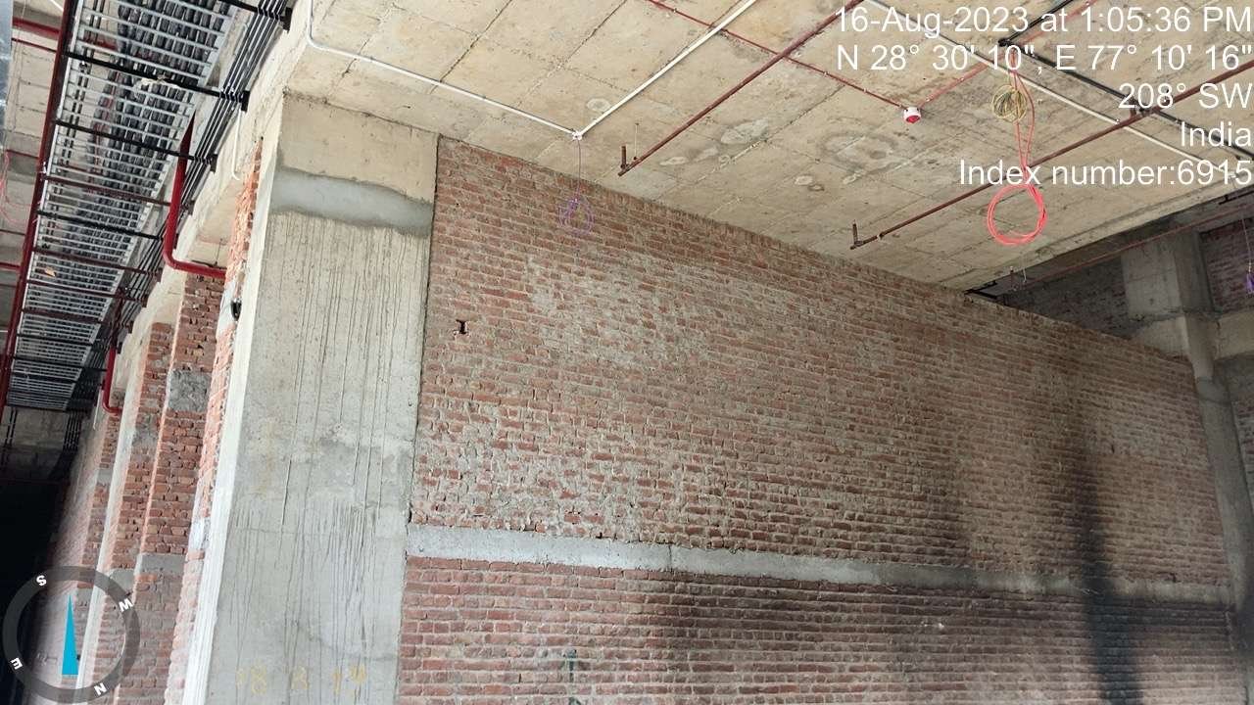 | 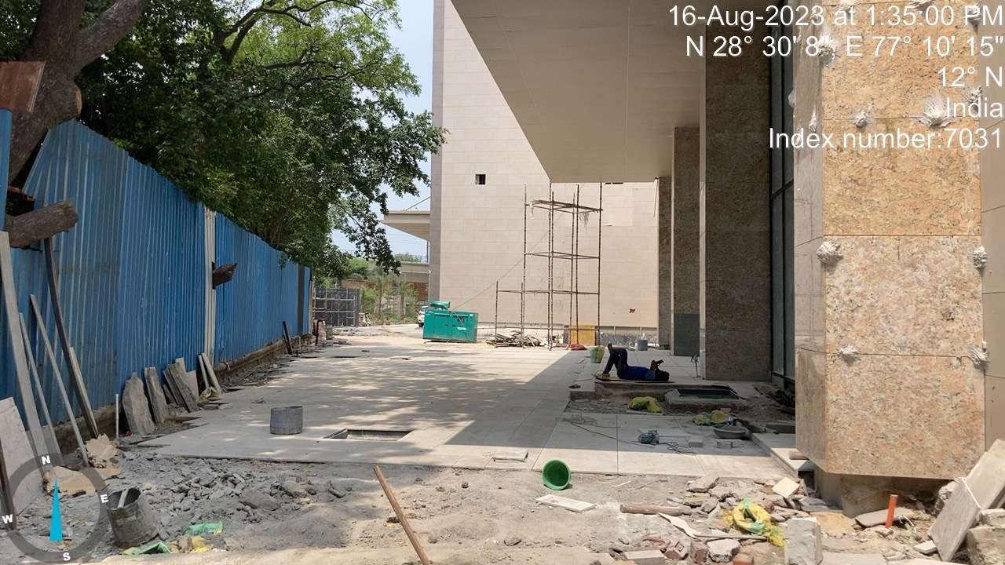
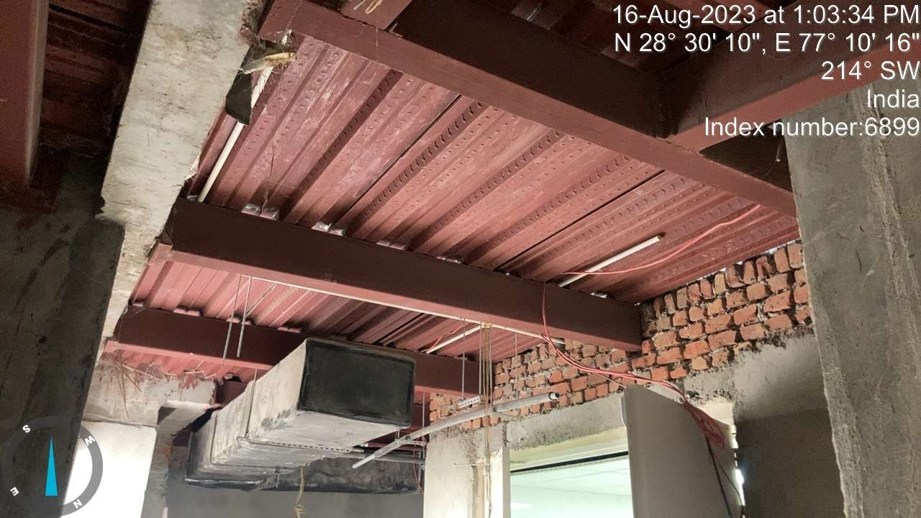 | 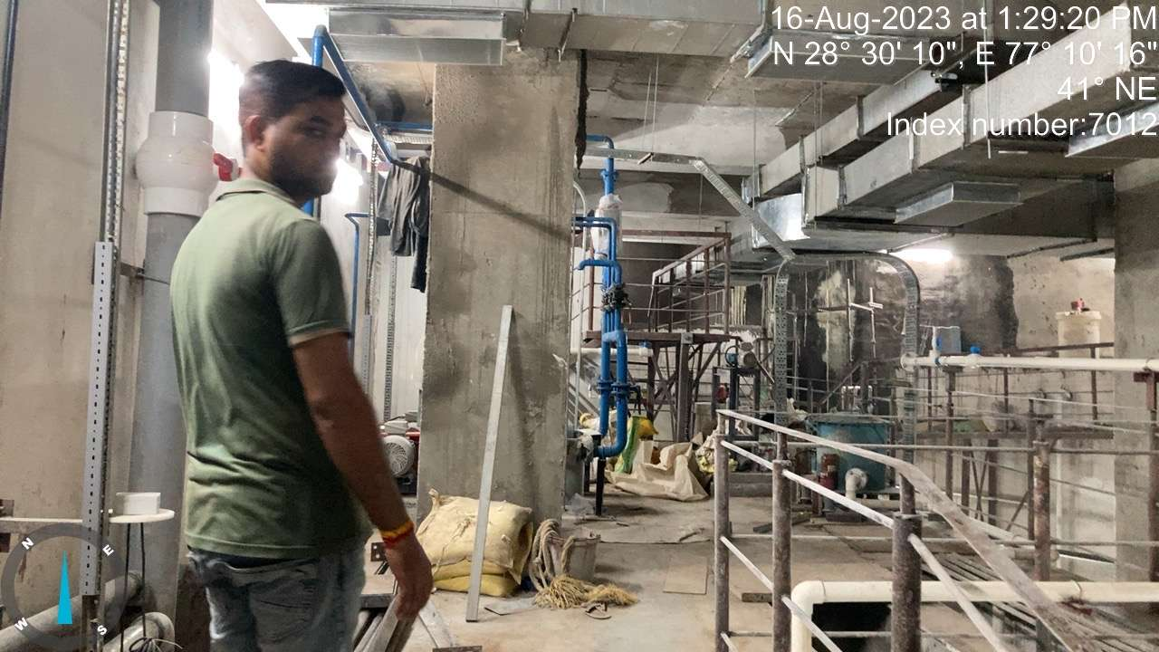
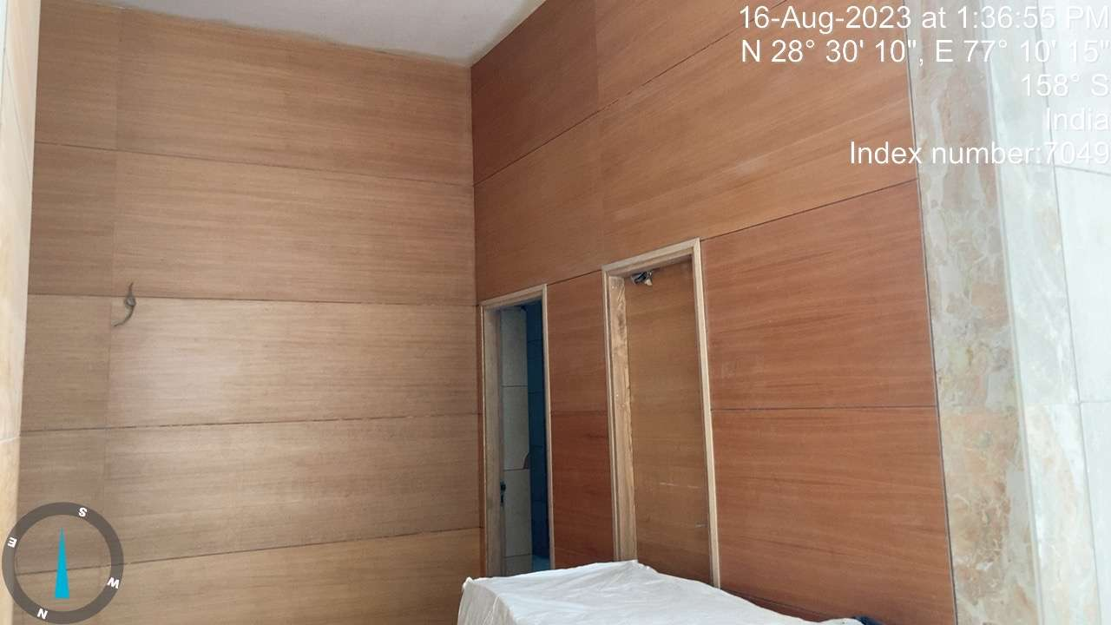 | 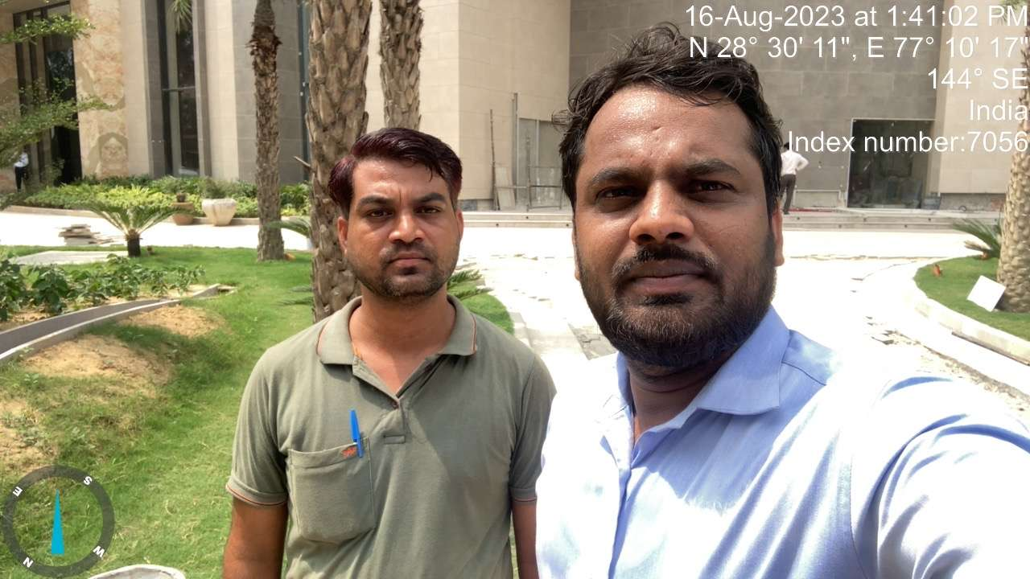

OTHER ANNEXURES

ANNEXURE 1: COPY OF CA CERTIFICATE

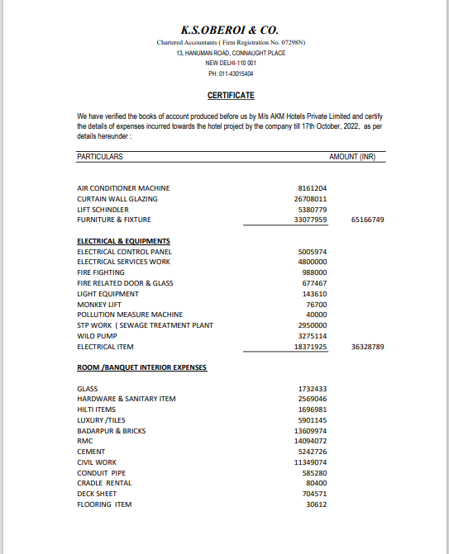

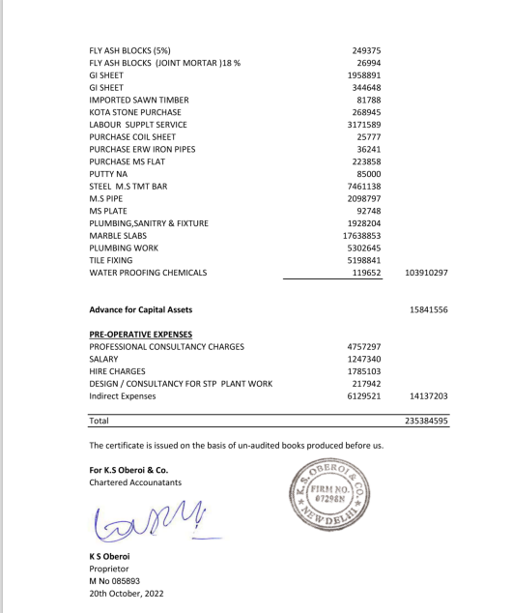

ANNEXURE 2: COPIES OF SOME MAJOR INVOICES

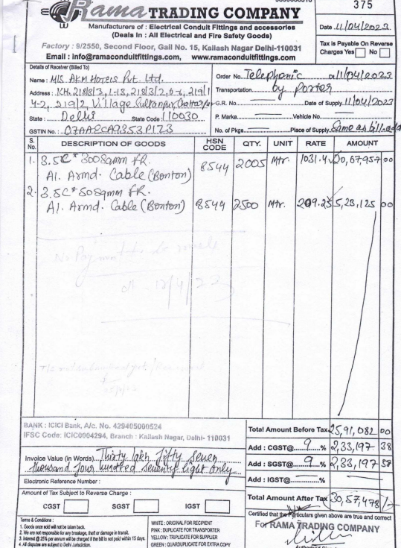

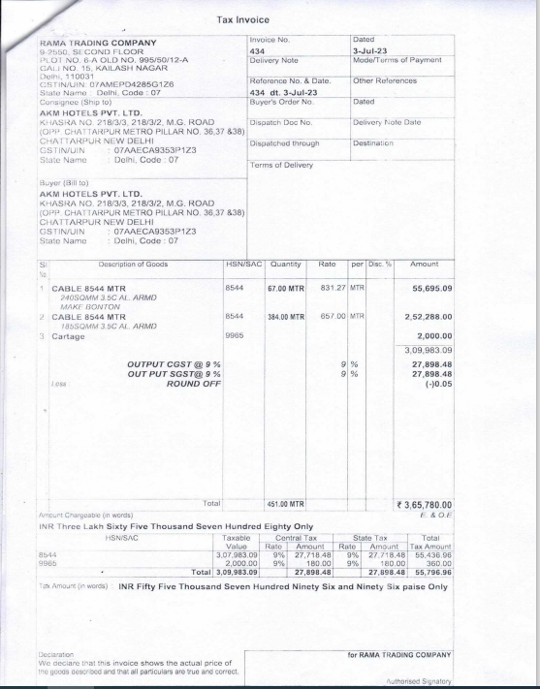

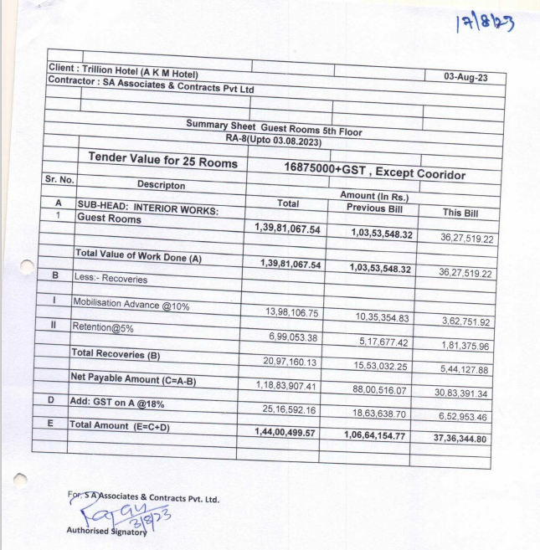

ANNEXURE 3: COPY OF TIR
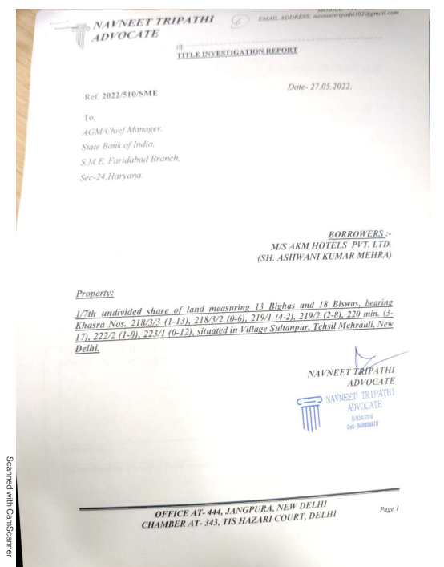

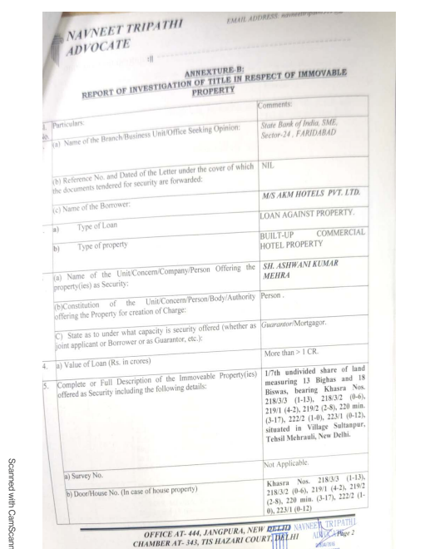
ANNEXURE 4: COPY OF SANCTIONED PLAN

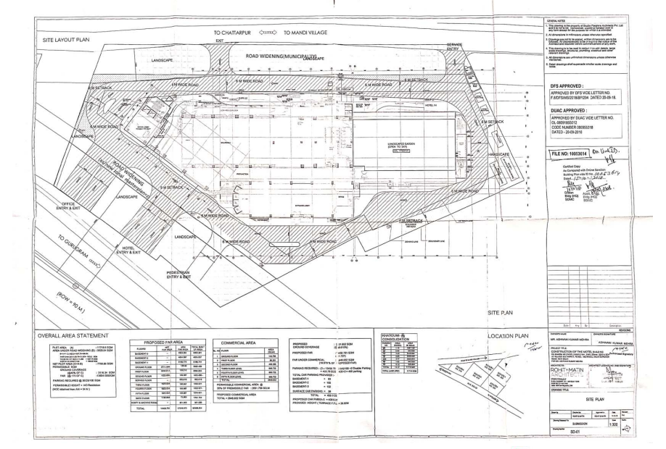

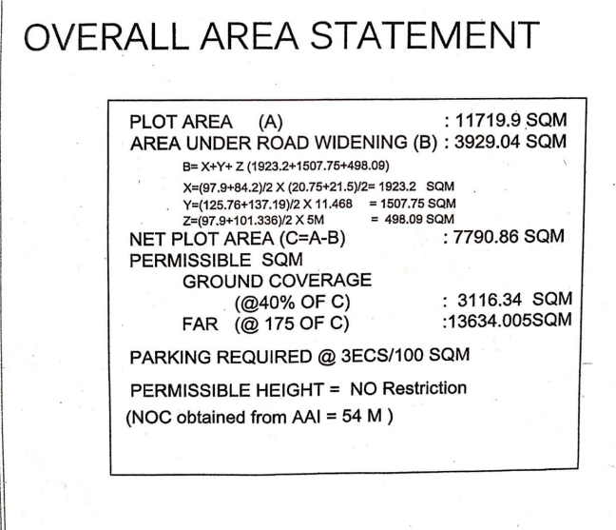

ANNEXURE 4: ELECTRICITY BILL
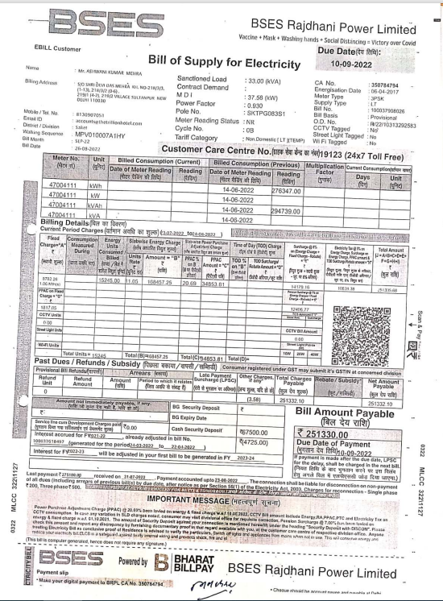

PART F | DISCLAIMER

- No employee or member of R.K Associates has any direct/ indirect interest in the Project.
- This report is prepared based on the copies of the documents/ information which interested organization or customer could provide to us out of the standard checklist of documents sought from them and further based on our assumptions and limiting conditions. All such information provided to us has been relied upon and we have assumed that it is true and correct. Verification or cross checking of the documents provided to us has not been done at our end from the originals. If at any time in the future, it’s found or came to our knowledge that misrepresentation of facts or incomplete or distorted information has been provided to us then this report shall automatically become null & void.
- This report is a general analysis of the project and not an audit report. All the information gathered is based on the facts seen on the site during survey, verbal discussion & documentary evidence provided by the client and is believed that information given by the company is true best of their knowledge.
- All observations mentioned in the report is only based on the visual observation and the documents/ data/ information provided by the client. No mechanical/ technical tests, measurements or any design review have been performed or carried out from our side during Project assessment.
- Interested organization should only take this report as an Advisory document from the Financial/ Chartered Engineering firm and it’s specifically advised to the stakeholder to cross verify the original documents for the facts mentioned in the report which can be availed directly from the subject company directly.
- In case of any default in loans or the credit facility extended to the borrowing company, R.K Associates shall not be held responsible for whatsoever reason may be and any request for seeking any explanation from the employee/s of R.K Associates will not be entertained at any instance or situation.
- This Report is prepared by our competent technical team which includes Engineers and financial experts & analysts.
- This is just an opinion report and doesn’t hold any binding on anyone. It is requested from the concerned Financial Institution which is using this report for taking financial decision on the project that they should consider all the different associated relevant & related factors also before taking any business decision based on the content of this report.

- All Pages of the report including annexures are signed and stamped from our office. In case any paper in the report is without stamp & signature then this should not be considered a valid paper issued from this office.
- Defect Liability Period is 30 DAYS. We request the concerned authorized reader of this report to check the contents, data and calculations in the report within this period and intimate us in writing if any corrections are required or in case of any other concern with the contents or opinion mentioned in the report. Corrections only related to typographical, calculation, spelling mistakes will be entertained within the defect liability period. No request for any illegitimate value revision, date change or any other facts & figures changes will be entertained other than the one mentioned above.
- R.K Associates encourages its customers to give feedback or inform concerns over its services through proper channel at @rkassociates.org in writing within 30 days of report delivery. After this period no concern/ complaint/ proceedings in connection with the Valuation Services can be entertained due to possible change in situation and condition of the property.
- Our Data retention policy is of ONE YEAR. After this period we remove all the concerned records related to the assignment from our repository. No clarification or query can be answered after this period due to unavailability of the data.
- This Valuation report is governed by our (1) Internal Policies, Processes & Standard Operating Procedures, (2) R.K Associates Quality Policy, (3) Valuation & Survey Best Practices Guidelines formulated by management of R.K Associates, (4) Information input given to us by the customer and (4) Information/ Data/ Facts given to us by our field/ office technical team. Management of
R.K Associates never gives acceptance to any unethical or unprofessional practice which may affect fair, correct & impartial assessment and which is against any prevailing law. In case of any indication of any negligence, default, incorrect, misleading, misrepresentation or distortion of facts in the report then it is the responsibility of the user of this report to immediately or at least within the defect liability period bring all such act into notice of R.K Associates management so that corrective measures can be taken instantly.
- R.K Associates never releases any report doing alterations or modifications from pen. In case any information/ figure of this report is found altered with pen then this report will automatically become null & void.
- If this report is prepared for the matter under litigation in any Indian court, no official or employee of R.K Associates will be under any obligation to give in person appearance in the court as a testimony. For any explanation or clarification, only written reply can be submitted on payment of charges by the plaintiff or respondent which will be 10% of the original fees charged where minimum charges will be Rs.15,000/-.

Place : Noida FOR INTERNAL USE
Date : 28/08/2023 SURVEYED BY: Er. Sachin Pandey
Note : This report contains 37 pages PREPARED BY: Er. Mahesh Chandra Joshi
REVIEWED BY: Er.

For R.K Associates Valuers & Techno Engineering Consultants Pvt. Ltd.

Project Engineering Team

R.K ASSOCIATES IMPORTANT NOTES:

- DEFECT LIABILITY PERIOD - In case of any query/ issue or escalation you may please contact Incident Manager by writing at le@rkassociates.org. We ensure 100% accuracy in the Calculations done, Rates adopted and various other data points & information mentioned in the report but still can’t rule out typing, human errors or any other mistakes. In case you find any mistake, variation, discrepancy or inaccuracy in any data point of the report, please help us by bringing all such points into our notice in writing at le@rkassociates.org within 30 days of the report delivery, to get these rectified timely, failing which
R.K Associates Valuers Techno Engineering Consultants (P) Ltd. won’t be held responsible for any inaccuracy in any manner. Also if we do not hear back anything from you within 30 days, we will assume that report is correct in all respect and no further claim of any sort will be entertained thereafter. We would welcome and appreciate your feedback & suggestions in order to improve our services.

- COPYRIGHT FORMAT - This report is prepared on the copyright format of R.K Associates Valuers Techno Engineering Consultants (P) Ltd. to serve our clients in the best possible way. Legally no one can copy or distribute this format without prior approval from R.K Associates. It is meant only for the organization as mentioned on the cover page of this report. Distribution or use of this format other than R.K Associates will be seen as unlawful act and necessary legal action can be taken against the defaulter.

