**File No.: VIS (2023-24) PL-213-184-259 Dated: 15.09.2023**

**LENDER’S INDEPENDENT ENGINEER REPORT**

**(FOR QUARTER ENDING JUNE 2023)**

**OF**

**M/S AKM HOTELS PVT. LTD.**

**SITUATED AT**

**VILLAGE SULTANPUR, TEHSIL MEHRAULI, MEHRAULI GURGAON ROAD (MG ROAD), NEW DELHI.**

**COMPANY/PROMOTER**

**M/S AKM HOTELS PVT. LTD.**

**REPORT PREPARED FOR**

**STATE BANK OF INDIA, SME BRANCH, SECTOR-24, FARIDABAD.**

***\*\*Important - In case of any query/ issue or escalation you may please contact Incident Manager at le@rkassociates.org. We will appreciate your feedback in order to improve our services.***

***NOTE: As per IBA Guidelines please provide your feedback on the report within 15 days of its submission after which report will be considered to be correct.***

|  |  |  |
| --- | --- | --- |
| **TABLE OF CONTENTS** | | |
| **SR. NO.** | **DESCRIPTION** | **PAGE NO.** |
| **PART A** | **Report Summary** | **03** |
| **PART B** | **Introduction** | **05** |
|  | 1. The Project | **05** |
|  | 1. About the Borrower | **05** |
|  | 1. Location of the Project | **06** |
|  | 1. Project Overview | **07** |
|  | 1. Scope of the Project During Project Duration | **09** |
|  | 1. Purpose of the Report | **10** |
|  | 1. Methodology Adopted | **10** |
| **PART C** | **Plant Infrastructure Sections & Facility Details with Actual Progress** | **11** |
|  | 1. Building and Structure Details | **11** |
|  | 1. Plant Machinery and Equipment | **15** |
| **PART D** | **Project Consultants, Contractors & Suppliers** | **18** |
| **PART E** | **Project Cost and Means of Finance** | **19** |
|  | 1. Cost of Project | **19** |
|  | 1. Current Status and Total Expenditure Incurred Till Date | **19** |
|  | 1. Sources of Finance & Utilization of Funds | **21** |
| **PART F** | **Statutory & Regulatory Approvals, Clearances & NOC** | **22** |
| **PART G** | **Project Schedule & Current Status** | **23** |
| **PART H** | **Observations and Comments** | **23** |
| **PART I** | **Disclaimer** | **24** |

# 

# IMPORTANT NOTICE

***COPYRIGHT FORMAT:*** *This report is prepared on the copyright format of R.K Associates, to serve our clients with the best available information and analysis to facilitate them to take rational business decisions. Legally no one can copy or distribute this format without prior approval from R.K Associates. It is meant only for the advisory/ reference purpose for the organization/s as mentioned on the cover page of this report. Distribution or use of this format by any organization or individual other than R.K Associates will be seen as unlawful act and necessary legal action can be taken against the defaulters.*

*This report is intended for the sole use of the intended recipient/s and contain material that is STRICTLY CONFIDENTIAL AND PRIVATE.*

***DEFECT LIABILITY PERIOD:*** *- In case of any query/ issue or escalation you may please contact Incident Manager: le@rkassociates.org. We try our level best to ensure correctness in the calculations done, rates adopted and various other data points & information mentioned in the report but still can’t rule out typing, human errors or any other mistakes. In case you find any such mistake or inaccuracy in any data point of the report please help us by bringing all such points into our notice immediately or within 15 days of the report delivery in writing, to rectify these timely failing after which R.K Associates won’t be held responsible for any such inaccuracy in any manner. We would highly appreciate your feedback in order to improve our services.*

|  |  |
| --- | --- |
| **PART A** | **REPORT SUMMARY** |

|  |  |  |  |
| --- | --- | --- | --- |
| **1.** | **Name of Project:** |  | A four-star upscale luxury banquet cum hotel based on theme of “Banqueting Hotel” Project being setup by AKM Hotel Pvt. Ltd. |
| **2.** | **Project Location:** |  | Village Sultanpur, Tehsil Mehrauli, Mehrauli Gurgaon Road (MG Road), New Delhi |
| **3.** | **Name of the Company Promoter:** |  | M/s. AKM Hotels Pvt. Ltd. |
| **4.** | **Prepared for Bank:** |  | State Bank of India, SME Branch, Sector-24,  Faridabad. |
| **6.** | **LIE Consultant Firm:** |  | M/s. R.K. Associates Valuers & Techno Engineering Consultants (P) Ltd. |
| **7.** | **Date of Survey:** |  | 16th of August 2023 |
| **8.** | **Date of Report:** |  | 28th of August 2023 |
| **9.** | **Purpose of the Report:** |  | To provide fair detailed analysis report to the Bank based on the “in-scope points” mentioned below for facilitating them to take appropriate credit decision on the Project. |
| **10.** | **Scope of the work provided by the Lender:** |  | 1. Project physical status review 2. Estimated cost of expenditure incurred |
| **11.** | **Documents perused for Proposal:** |  | 1. Copy of CA Certificate 2. Copy of invoices of major items 3. Copy of Approved Building plans 4. Copies of various NOCs & Approvals 5. Copy of TEV report 6. Vendor list. 7. Quotation or Purchase Order for machines to be installed. 8. Other approvals. |
| **12.** | **Annexure with the report:** |  | 1. TEV report 2. Photographs 3. Other annexures (e.g., CA Certificate, Invoices, and Sanctioned plan) |

|  |  |
| --- | --- |
| **PART B** | **INTRODUCTION** |

1. **THE PROJECT:** A four-star upscale luxury banquet cum hotel based on theme of “Banqueting Hotel” Project being setup by AKM Hotel Pvt. Ltd. *(hereinafter AKMHPL)* at Village Sultanpur, Tehsil Mehrauli, Mehrauli Gurgaon Road (MG Road), New Delhi
2. **PROJECT EXECUTIVE SUMMARY:**

**AKMHPL** is setting up a four-star upscale luxury banquet cum hotel based on theme of “Banqueting Hotel” at a plot on the main Mehrauli Gurgaon Road (MG Road), New Delhi.

The project has high end banqueting facilities duly supported by hotel and health club/ Spa/ Saloon activities. This is a 101 key room (94 standard rooms and 7 suite rooms) hotel with 4 star standards equipped with modern amenities and latest facilities offered with highest class standards as mentioned in the TEV report. Sanctioned layout plan dated 15/10/2018 is approved for total 13,459 sq.mtr FAR and 30,507 total built-up area as per the layout plan provided to us.

The project has already received all the necessary approvals from the competent authority i.e., from Municipal Corporation of Delhi (MCD) and environmental clearance for establishment of four-star hotel.

The project land admeasuring 2.90 acres (11,719.90 sq. m.) as per approved map is owned by the promoter Mr. Ashwani Kumar Mehra. AKMHPL has taken the land and bare shell building on long term lease from Mr Ashwin Mehra on revenue share with minimum lease rent of @ INR 25 Lakhs per month after one year of hotel operations with an escalation clause of 5% every 3 years post start of payment, as per the TEV report to develop the 4 star hotel as per required and approved specifications and will invest in finishing, plant and equipment, utilities, electrical, furnishings, interiors, cutlery, etc. and all the facilities required to operate the banquet and hotel facility.

The project has 101 rooms (94 standard rooms and 7 suite rooms) for lodging, 5 Banquet Halls, health club, Saloon, etc. with complete furnishing of best possible luxurious and star category standards.

Further AKMHPL has approached State Bank of India for funding of finishing, plant and equipment, utilities, electrical, furnishings, interiors, cutlery, etc. of the hotel other than structure works and accordingly SBI has sanctioned the loan for it. By way of engaging LI, Bank wants to know the current physical status of the Project and Estimated cost of expenditure incurred till date.

Total proposed Project cost as estimated in TEV report is Rs.86 crores distributed in different items such as Interior Fit-outs and Furnishing, Equipment’s, Plant & Machinery and other soft cost.

As per present status, super structure of the building is already completed and within the scope of this report finishing is under progress at various stages. In Plant & Machinery DG set, STP, VRF is installed on the site and other Plant & Machinery and equipment is yet to arrive on the site such as BOH (Back of house or kitchen equipment), etc. Detailed item wise Project status is described in the later section of the report.

As per TEV Report, the proposed date of commercial operations was on July 2024, for project completion, obtaining of completion certificate, permanent connection for water and power, and all other statutory approvals for commencement of operations. As per our observation of the Subject Project during the visit in the August Month, the Project progress seems to be satisfactory, as the work was in progress. Although there is a delay in the interior and furnishing works, due to the Covid and some pollution related issues. As per current status it appears that it may cross this deadline.

1. **PROJECT LOCATION:**

Details about Location of Unit is as below:

|  |  |
| --- | --- |
| **Particulars** | **Description** |
| **Postal Address** | |
| Village Sultanpur Tehsil Mehrauli, MG Road, New Delhi. | |
| **Location** | |
| The nearest airport from the site is IGI Airport, Delhi located at the distance of approx. 11.2 km. The Project site is also well connected through road network and abutting Mehrauli Gurugram Road. Chhatarpur metro station is the nearest metro station at a distance of approx. 500 m from the project. | |
| **Google Coordinates** | |
| Latitude | 28°31'12"N |
| Longitude | 77°10'20"E |
| **Connectivity Systems** | |
| Road | Abutting Mehrauli-Gurugram Road |
| Metro | The nearest metro station from the site is Chhatarpur metro station, and is at a distance of approx. 500 meter. |
| Air | The nearest airport from the site is IGI Airport, Delhi, and is at the distance of approx. 11 km. |

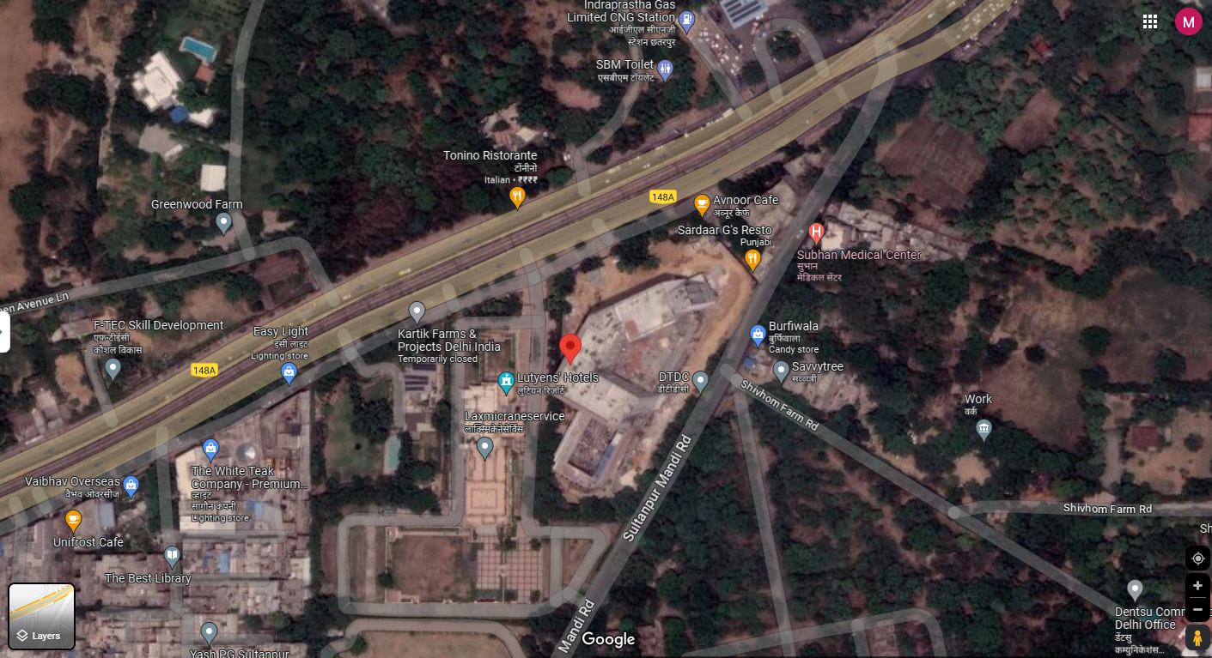

**Figure: Location of Manufacturing Unit**

1. **SCOPE OF WORK DURING PROJECT DURATION:**
2. Periodic Project physical status review
3. Estimated cost of expenditure incurred
4. **PURPOSE OF THE REPORT:** To provide fair detailed analysis report to the Bank based on the “in-scope points” mentioned above for facilitating them to take appropriate credit decision on the Project.
5. **METHODOLOGY ADOPTED:**
6. Study of Project Planning documents/ reports to know about the Project.
7. Additional information, data, documents collection from the borrower.
8. Site Inspection.
9. Review and analysis of the documents and information obtained from the borrower and corroborating it with the site inspection status.
10. Information compilation, analysis and reporting.

|  |  |
| --- | --- |
| **PART E** | **PROJECT COST | EXPENDITURE & MEANS OF FINANCE** |

1. **TOTAL PROJECT COST:** As per TEV Report prepared by D&B total estimated Project Cost is amounting to Rs.86 Cr. The further bifurcation of the total project amount is shown below:

|  |  |
| --- | --- |
| **Particulars** | **In Rs. (In Cr.)** |
| Interior Fit out and Furnishing | 29.49 |
| Equipment’s | 14.03 |
| Plant and Machinery | 27.88 |
| Miscellaneous Fixed Assets | 5.27 |
| Contingency | 2.11 |
| Preliminary & Pre-op Expenses | 0.80 |
| Interest During Construction | 6.42 |
| **Total** | **86.00** |

**Note:**

* The above estimation of cost is as per the details provided to us by the Client/Bank and also the TEV report prepared by Dun & Bradstreet.

1. **CURRENT STATUS & TOTAL EXPENDITURE INCURRED TILL DATE:** Details of the expenditure incurred till date cannot be verified, as we have not been provided the updated CA Certificate. Therefore the expenditure incurred till date is verified/mentioned as per the Tax Invoice and R.A bill provided to us.

Details of the same is shown in the table below:

|  |  |  |  |  |  |  |
| --- | --- | --- | --- | --- | --- | --- |
| **PARTICULARS** | **TOTAL ESTIMATED COST (In Rs. In Cr.)** | **EXPENDITURE SHOWN BY COMPANY (In Rs. In Cr.)** | **AMOUNT OF WORK DONE ON SITE** | **ADVANCES PAID** | **AMOUNT INCURRED TILL DATE**  **(In Rs. In Cr.)**  **(As per Invoices and R.A bills provided)** | **REMARKS** |
| **Interior Fit out and Furnishing** | 29.49 | Can’t Comment as Updated CA Certificate has not been provided. | ~19.17 | Details not available | 5.02 | 1. Amount of work done is estimated from the percentage of work completed on site calculating from the total contract value. 2. Amount incurred till date is taken from the Invoices provided to us. 3. Further detailed Status is shown in Part-C of the report. |
| **Equipment’s** | 14.03 | Can’t Comment as Updated CA Certificate has not been provided. | 0.0 | Details not available | 0.84 | 1. Amount of work done is estimated from the percentage of work completed on site calculating from the total contract value. 2. Amount incurred till date is taken from the Invoices provided to us. 3. Further detailed Status is shown in Part-C of the report. |
| **Plant and Machinery** | 27.88 | Can’t Comment as Updated CA Certificate has not been provided. | ~18.12 | Details not available | 4.92 | 1. Amount of work done is estimated from the percentage of work completed on site calculating from the total contract value. 2. Amount incurred till date is taken from the Invoices provided to us. 3. Further detailed Status is shown in Part-C of the report. |
| **Miscellaneous Fixed Assets** | 5.27 | Can’t Comment as Updated CA Certificate has not been provided. | ~3.69 | Details not available | --- | 1. Amount of work done is estimated from the percentage of work completed on site calculating from the total contract value. 2. No invoice/RA Bill has been provided to us against this particular item. 3. Further detailed Status is shown in Part-C of the report. |
| **Total** | **76.67** |  | **~40.98** |  | **10.78** |  |

Note:

1. As updated CA certificate is not provided to us, thus we can’t ascertain the expenditure made till date.
2. As per the CA certificate dated 20/10/2022, the total expenditure made till that date was Rs. 23,53,84,595/-
3. **SOURCES OF FINANCE & UTILIZATION OF FUNDS:**

The Project cost mentioned above has been planned to be covered from following resources:

|  |  |
| --- | --- |
| (Amount in Rs. And In Crore) | |
| PARTICULARS |  |
| Promoter’s Contribution (Equity) | 7.00 |
| Unsecured Loan (Quasi Equity) | 29.00 |
| Term Loan (Debt) | 50.00 |
| TOTAL | **86.00** |

***Source:*** *As per technical vetting report by Dun & Bradstreet, dated 17th August 2022.*

|  |  |
| --- | --- |
| **PART C** | **PROJECT INFRASTRUCTURE & FACILITY DETAILS WITH ACTUAL PROGRESS** |

1. **INTERIOR FIT OUT AND FURNISHING:**

As per the TEV report the interior fit out and furnishing cost of the Project has been estimated at INR 29.49 Crore (Including Taxes). Breakup details of the same have been presented in the tabular and chart form:

|  |  |  |  |  |  |  |  |  |  |
| --- | --- | --- | --- | --- | --- | --- | --- | --- | --- |
| **Sl. No.** | **Category** | **Scope of Work** | **Name of Vendor** | **Amount As per TEV (Exclusive GST)** | **Total Award Value (exclusive of GST)** | **Reference** | **Percentage of Work Completed** | **Remarks on work completed** | **Remarks As per Invoices/ R.A Bills received.** |
| 1 | Bath wares and Sanitary Fixtures | To Provide Complete Bath fittings, Faucets, WC, Bath wares and Sanitary Wares | Bath Affair, Trendz | 67,30,142 | 67,30,142 | Purchase Order | 50% | The internal piping, diverter and etc. is installed, but the Faucets, WC and other amenities are not yet installed | No RA Bill or Invoice received. |
| 2 | Hotel Room & Corridor Finishing & Furnishing | Interior Works in Rooms and Corridors Area of Hotel - 25 Rooms (Per Room Costing 675000 X 25 = 16875000) (4th Floor) | SA Associates & Contractors Pvt. Ltd. | 1,68,75,000 | 16875000 | Agreement | 70-80% | The initial finishing work such as POP, false ceiling, base of wooden flooring etc. is completed. Installation of beds, and other furniture’s is due. | RA Of 1,24,70,750/- is provided, for 4th floor which is ~74% of contract amount. |
| Interior Works in Rooms and Corridors Area of Hotel - 25 Rooms (Per Room Costing 675000 X 25 = 16875000) (5th Floor) | SA Associates & Contractors Pvt. Ltd. | 1,68,75,000 | Contract agreement not received | Contract agreement not received | RA of 1,18,83,907/- is provided, for 5th floor which is ~70%of contract amount from SA Associates & Contractors Pvt. Ltd., therefore it is presumed that the 5th floor work is also awarded to them. However we have not received copy of agreement for the same. |
| Interior Works in Rooms and Corridors Area of Hotel - 25 Rooms (Per Room Costing 675000 X 25 = 16875000) (6th Floor) | To Be Awarded | 1,68,75,000 | To Be Awarded | To Be Awarded | Interior and furnishing work not started yet. | To Be Awarded | To Be Awarded |
| Interior Works in Rooms and Corridors Area of Hotel - 19 Rooms (Per Room Costing 675000 X 19 = 16875000) (3rd Floor) | To Be Awarded | 1,28,25,000 | To Be Awarded | To Be Awarded | Interior and furnishing work not started yet. | To Be Awarded | To Be Awarded |
| Suite 7 Nos. Total (1350000 X 7 = 9450000) | To Be Awarded | 94,50,000 | To Be Awarded | To Be Awarded | Interior and furnishing work not started yet. | To Be Awarded | To Be Awarded |
| 3 | Interior & Finishing Works - Ground Floor | Flooring & Cladding Work, Ceiling, Paneling, Metal Door, Furniture & Storage, Paints and MS Work for Lobby, Banquet & Pre function and Washroom Work | SA Associates & Contractors Pvt. Ltd. | 3,14,99,955 | 3,14,99,955 | Agreement | 85-90% | The major of the finishing works are completed. The installation of the chandelier and other electrical fittings were in progress during site survey visit. | RA Bills of 2,58,63,901/- is provided, for ground floor which is ~80% of contract amount. |
| 4 | Interior Works - First Floor | Complete Interior and Furnishing and Flooring, Wall Cladding of First Floor, Toilets and Dining Area | Checkmate | 6,22,82,489 | 62282489 | Quotation | 80-85% | Finishing work such as Punning/putty work and cladding on Lift fascia was in progress, while site survey visit. | No RA Bill or Invoice received |
| 5 | Interior Works - 2nd Floor | Complete Interior and Furnishing and Flooring, Wall Cladding of 2nd Floor- Both Banquet Hall, Pre- Function Area, Deck Area and Washrooms | Checkmate | 4,18,07,331 | Copy of Work Order not received | NA | 40-50% | Finishing completed till brickwork status. | No RA Bill or Invoice received |
| 6 | Façade Lighting | Supply & fixing | Light Craft | 75,53,400 | 7553400 | Quotation | 90% | Visually looks to be completed and finished | No RA Bill or Invoice received |
| 7 | Ground Floor Lighting | Supply & fixing | Light Craft | 72,46,369 | 7246369 | Quotation | 75-85% | The installation of the chandelier and other electrical fittings were in progress while site survey visit. | No RA Bill or Invoice received |
| 8 | First Floor Lighting | Supply & fixing | -------- | 64,20,390 | ------ | ------- | 70-80% | Few false ceiling lights were installed and further work was in progress while site survey visit. | No RA Bill or Invoice received |
| 9 | 2nd Floor lighting | Supply & fixing |  | 61,59,414 |  |  | 30-40% | Only Internal conduit work has been completed. | No RA Bill or Invoice received |
| 10 | Fire doors | Supply & Fixing of Fire Doors | JBSS Engineers Pvt ltd. | 52,00,000 | 5200000 | Quotation | 30-40% | Few fire doors were installed, and few were found idle on site. | No RA Bill or Invoice received |
| 11 | Pumps (Willo) | Supply, installation & commissioning | Universal Tech Trade Pvt Ltd | 32,75,114 | 3275114 | Quotation | No information available |  | No RA Bill or Invoice received |
|  |  | **Total** |  | **251,074,604** | **140,662,469** |  |  |  | **RS. 5,02,18,558/-** |

1. **EQUIPMENT’S:**

The Company has made a provision of INR 14.03 Crore (Including Taxes) towards equipment for kitchen, laundry, minibars & tea coffee machines, health club & SPA, and business centre. Out of which amount of INR 10.40 Crore is provided for kitchen & BOH equipment, as per the TEV report.

However as per site survey observation it was found that no equipment’s have been received on site.

|  |  |  |  |  |  |  |  |  |  |
| --- | --- | --- | --- | --- | --- | --- | --- | --- | --- |
| **Sl. No.** | **Category** | **Scope Of Work** | **Name Of Vendor** | **Amount As per TEV (Exclusive of GST)** | **Total Order Value (exclusive of GST)** | **Reference** | **Percentage of Work Completed** | **Remarks on work completed** | **Remarks As per Invoices/ R.A Bills received.** |
| 1 | BOH Equipment | Back of House Equipment – Supply & Installation | A.M.I. Food Service Equipment Solutions Pvt. Ltd. | 8,81,45,630 | 88145630 | Quotation | Cannot Comment | Not arrived on site yet | 1. Invoice Of 29,50,000/- is provided for kitchen equipment’s, but mentioned in name of International Equipment Co. instead of A.M.I. Food Service  Equipment Solutions Pvt.  Ltd.  2. Invoice Of 55,04,178/- is provided for kitchen equipment’s, but mentioned in name of Unikue Kitchen and Hospitality Services Pvt. Ltd. instead of A.M.I. Food Service  Equipment Solutions Pvt.  Ltd. |
| 2 | Laundry Equipment | Supply, installation & Commissioning of Laundry equipment | No details available | 35,00,000 | No details available | No details available | Cannot Comment | Not arrived on site yet | To Be Awarded |
| 3 | Mini Bars / Tea- Coffee Machine | Supply, installation & Commissioning of Mini Bars/Tea-Coffee Machine | No details available |  | No details available | No details available | Cannot Comment | Not arrived on site yet | To Be Awarded |
| 4 | Health Club | Supply, installation & Commissioning of Health Club | No details available | 47,66,950 | No details available | No details available | Cannot Comment | Not arrived on site yet | To Be Awarded |
| 5 | SPA Equipment | Supply, installation & Commissioning of SPA Equipment | No details available | 75,00,000 | No details available | No details available | Cannot Comment | Not arrived on site yet | To Be Awarded |
| 6 | Business Centre/Conf. Equipment | Supply, installation & Commissioning of Business Centre/Conference Equipment | No details available | 1,50,00,000 | No details available | No details available | Cannot Comment | Not arrived on site yet | To Be Awarded |
|  |  | **Total** |  | **11,89,12,580** | **8,81,45,630** |  |  |  | **Rs.83,54,178/-** |

1. **PLANT & MACHINERY:**

The proposed value of the Plant and Machinery as per the TEV report is 27.88 Crore (inclusive taxes). The costs also account for the high Air conditioning and lighting loads for the banquets, as well as the associated increase in the electrical and fire fighting equipment.

As per site survey, it was found that most of the plant/machines like Generator, CCTV system, AC, VRF system, Heat Pump, STP, Lifts, Plumbing System, Electrical system and Fire Fighting is installed at the site.

The detailed status of the plant and machinery is shown in tabular and chart form:

|  |  |  |  |  |  |  |  |  |  |
| --- | --- | --- | --- | --- | --- | --- | --- | --- | --- |
| **Sl. No.** | **Category** | **Scope Of Work** | **Name Of Vendor** | **Amount As per TEV Report (Exclusive of GST)** | **Total Order Value (exclusive of GST)** | **Reference** | **Percentage of Work Completed** | **Remarks on work completed** | **Remarks As per Invoices/ R.A Bills received.** |
| 1 | Security System | CCTV System, ACs & Boom Barrier System & all ELV | Phoenix Equipment India Pvt. Ltd | 2,50,09,600 | 24,556,761 | Quotation | 0% | No cameras installed yet at Project premises | No Bill raised yet |
| 2 | HVAC VRF (High Side) | Supplying of VRF System Of 1000 Tons (Including Supply of VRF Outdoor Units, Indoor Units, Remote Controllers, Y- Joints & Central Controller) For The Entire Project Work | GD Enterprises | 3,55,00,000 | 3,55,00,000 | Agreement | 85-90% | Installed, but was not functional at time of site survey | Tax Invoice of Rs.3,03,10,815 is provided to us, against total order value of Rs. 3,55,00,000 which is ~85% of the total order value. |
| 3 | HVAC VRF (Low Side) | Design, Installation, Testing & Commissioning Of VRF System. Supply, Installation Work for Copper Piping, Insulation, Ducting, Drain Piping Work, Control Wiring Connection Between Indoor and Outdoor. Contracts includes AHU & TFA | Phoenix Equipment’s India Pvt. Ltd. | 2,40,00,000 | 24,000,000 | Agreement | 85-90% | Installed, but was not functional at time of site survey | No Invoice received |
| 4 | Ventilation Works | Basement Ventilation Works | Imperial Systems India | 75,81,000 | 7,581,000 | Agreement | No information available | No information could be gathered in visual observation during site survey. | No Invoice received |
| 5 | Pressurization Works | Pressurization Works on Floor | Imperial Systems India | 52,54,000 | 5,254,000 | Agreement | No information available | No information could be gathered in visual observation during site survey. | No Invoice received |
| 6 | Heat Pump & Allied Equipment | Supply Testing and Commissioning of Hot Water / Steam Equipment and Piping Heat Pumps | Explore Watek Systems Pvt. Ltd. | 40,00,000 | 3,000,000 | Agreement | 85-90% | Installed, but was not functional at time of site survey | No Invoice received |
| 7 | STP | Supply, Installation, Testing & Commissioning of Sewage Treatment Plant | Explore Watek Systems Pvt. Ltd. | 32,50,000 | 2,500,000 | Agreement | 85-90% | Installed, but was not functional at time of site survey | No Invoice received |
| 8 | Solar | To Supply, Install, Test & Commission 125 KWp Grid Synchronized Solar PV Based Power System | Explore Watek Systems Pvt. Ltd. | 81,20,000 | 8,120,000 | Quotation | 20-25% | The frame of solar grid is installed. The installation of solar panel and further works is pending | No Invoice received |
| 9 | Lifts | Supply Installation, Testing & Commissioning Of 9 No. Of Elevators | Schindlier India Pvt. Ltd. | 1,55,50,000 | 15,550,000 | Agreement | 85-90% | Installed, but was not functional at time of site survey | No Invoice received |
| 10 | Generator Set (02 Pcs) | Supply, Testing and Commissioning Of Two No. 1250 KVA Silent Dg Set Comprising Of Engine Model Kta50-G Coupled To 415v 1250 KVA Alternator Both Mounted On Common Base Frame With Other Entire Accessories I.E Fuel Tank, Batteries With Lead Etc. | Sudhir Power Limited | 1,52,00,000 | 15,200,000 | Purchase Order | 90% | Installed, but was not operating at time of site survey | No Invoice received |
| 11 | Stack For Fume Pipe 30 Mtr | Supply, Fabrication & Installation of Dg Set Stack Of 30 Mtr Height | Unipower Projects | 34,23,680 | 3,423,680 | Quotations | No information available | No information | No Invoice received |
| 12 | Plumbing System | Supply Installation, Testing & Commissioning of Electrical Panel, Swimming Pool, Water Treatment Plants & Miscellaneous Items, Internal Pumps, Equipment & | OMT Plumbing | 1,34,12,055 | Order not placed yet | Order not placed yet | 0% | Work not started yet | No Invoice received |
| 14 | Plumbing System | Supply Installation, Testing & Commissioning of Pumps, Equipment & Electrical Panel, Swimming Pool, Water Treatment Plants & Miscellaneous Items, Internal Drainage, External Drainage, Internal Water Supply, External Water Supply, Sanitary Fixtures, Fittings and Accessories | Hydro Chem Engineers & Consultant | 1,79,99,902 | 16,900,000 | Agreement | 30-35% | Internal piping work is done | No Invoice received |
| 15 | Electrical System | Lt Cables & Cable Trays, Earthing System, Lighting |  | 5,16,20,700 | No information available | No information available |  | Tender paper of 6.60 Cr. is provided to us, however it can't be verified as………. | Invoice of 1,89,01,602/- Is provided to us, against the following item, in the name of Rama Trading Company, which is ~37% of the total order value.x |
| 16 | LT Panels | Conquerent Control System Pvt. Ltd. | 84,00,000 | 84,00,000 | Agreement | 100% | In running condition | Invoice of 1,72,50,973 is provided to us, which is ~205% of the total order value.  It is noticed that the invoices provided to us , Is greater than the agreement made with Conquerent Control System Pvt. Ltd. |
| 17 | Fire Fighting | Installation, Testing & Commissioning of Fire Fighting System Complete in All respects | Fire Remedies | 1,35,00,000 | 1,30,00,000 | Letter of award | 100% | Testing Done | No Invoice received |
|  |  | **Total** |  | **23,83,20,937** | **182,985,441.00** |  |  |  | **Rs. 6,64,63,390/-** |

1. **Miscellaneous Fixed Assets:**

As the proposed cost for the Miscellaneous Fixed cost is Rs.5.27 crores (inclusive taxes) as mentioned in the TEV report, we found that Major work included in it has been done like External cladding, frames, glazing for doors, window and partitions.

Further status of the Miscellaneous Fixed Assets is shown in tabular and chart form:

|  |  |  |  |  |  |  |  |  |  |
| --- | --- | --- | --- | --- | --- | --- | --- | --- | --- |
| **Sl. No.** | **Category** | **Scope Of Work** | **Name Of Vendor** | **Amount As per TEV Report (INR)** | **Total Order Value (exclusive of GST)** | **Reference** | **Percentage of Work Completed** | **Remarks on work completed** | **Remarks As per Invoices/ R.A Bills received.** |
| 1 | LPG Pipeline | Laying, Installation & Commissioning of LPG system | Rawat Brother Engineers | 17,01,613 | 1701613 | Quotation | 100% | Major things are internal so couldn’t be visually seen during site survey | No Invoice received |
| 2 | Furniture - Rooms, Banquet / Conference Hall | Supply & Installation | No information available | NA | NA | NA | No work started yet | Not arrived on site yet | No Invoice received |
| 3 | Façade Cladding & Glazing Works | Supply and fixing of external cladding including frames etc. Supply and fixing of glazing for doors, windows & partitions | Devik Alu Glazing | 4,29,59,718 | 42959718 | Agreement | 100% | Visually looks to be completed and finished | No Invoice received |
|  |  | **Total** |  | **4,46,61,331** | **44661331** |  |  |  |  |

**Notes:**

1. Few works such as plumbing piping, electrical wiring, gas pipeline etc. are considered to be done, as these services found to be functional. However it can’t be physically verified because they are internal services.

|  |  |
| --- | --- |
| **PART D** | **PROJECT CONSULTANTS, CONTRACTORS & SUPPLIERS** |

According to the TEV report provided, the company has appointed the following consultants & contractors for the project.

As the machines or parts of plant to be established, has not arrived on site. Thus relying on the purchase orders provided, the suppliers for Plant, machines and equipment’s are:

* Bath Affair, Trendz
* SA Associates & Contractors Pvt. Ltd.
* Checkmate
* Light Craft
* JBSS
* Engineers Pvt ltd.
* Universal Tech Trade Pvt Ltd.
* A.M.I. Food Service Equipment Solutions Pvt. Ltd.
* Phoenix Equipment India Pvt. Ltd.
* GD Enterprises
* Imperial Systems India
* Explore Watek Systems Pvt.
* Schindlier India Pvt. Ltd.
* Sudhir Power Limited
* Unipower Projects
* OMT Plumbing
* Hydro Chem Engineers & Consultant
* Conquerent Control System Pvt. Ltd."
* Fire Remedies
* Rawat Brother Engineers"
* Devik Alu Glazing

|  |  |
| --- | --- |
| **PART F** | **STATUTORY & REGULATORY APPROVALS, CLEARANCES & NOC** |

|  |  |  |  |  |
| --- | --- | --- | --- | --- |
| Sr. No. | NAME OF LICENSE/ REGISTRATION | PURPOSE | DATE OF ISSUE | Current Status |
| **ISSUING AUTHORITY** | **LICENCE NO.** |
| 1. | Sanctioned Plan | Approval of building plans | 15/10/2018 | Approval for the Building Plan is obtained by the Company from the competent Authority. |
| SMDC | SMDC |
| 2. | Electricity Bill | Electricity Bill | Bill of Sept-2022 | --- |
| BSES Rajdhani Power Limited | Bill No. 100037908026 |
| 3. | Grant Of Sanction | South Delhi Municipal Corporation | 15/10/2018 | NOC is obtained by the Company from the competent Authority. |
| For Development | File No. 10053614 |
| 4. | Copy Of TIR | Title Investigation Report | 27/05/2022 | Provided |
| Advocate Naveen Tripathi | Ref- 2022/510/SME |
| *Observations & Comments:*  *Major approvals including approvals/consents required under local regulations, building codes and approvals required from the Distribution Utility etc. relating to installation of unit are listed above and their current status, as per the documents provided. Fire NOC has not been received yet.* | | | | |

|  |  |
| --- | --- |
| **PART I** | **DISCLAIMER** |

* + - 1. No employee or member of R.K Associates has any direct/ indirect interest in the Project.
      2. This report is prepared based on the copies of the documents/ information which the Bank/ Borrower has provided to us out of the standard checklist of documents sought from them and further based on our assumptions and limiting conditions. The client/owner and its management/representatives warranted to us that the information they supplied was complete, accurate and true and correct to the best of their knowledge. All such information provided to us has been relied upon in good faith and we have assumed that it is true and correct in all respect. I/We shall not be liable for any loss, damages, cost or expenses arising from fraudulent acts, misrepresentations, or wilful default on part of the owner, borrower, its directors, employee, representative or agents. Verification or cross checking of the documents provided to us from the originals or from any Govt. departments/ Record of Registrar has not been done at our end since this is beyond the scope of our work. If at any time in future, it is found or came to our knowledge that misrepresentation of facts or incomplete or distorted information has been provided to us then this report shall automatically become null & void.
      3. Legal aspects for eg. investigation of title, ownership rights, lien, charge, mortgage, lease, sanctioned maps, verification of documents, etc. have not been done at our end and same has to be taken care by legal expert/ Advocate. It is assumed that the concerned Lender/ Financial Institution has satisfied them with the authenticity of the documents, information given to us and for which the legal verification has been already taken and cleared by the competent Advocate before requesting for this report. I/ We assume no responsibility for the legal matters including, but not limited to, legal or title concerns.
      4. This report is a general analysis of the project based on the scope mentioned in the report. This is not an Audit report, Design document, DPR or Techno feasibility study. All the information gathered is based on the facts seen on the site during survey for the quarter ending June 2023, verbal discussion & documentary evidence provided by the client and is believed that information given by the borrower is true best of their knowledge.
      5. All observations mentioned in the report is only based on the visual observation and the documents/ data/ information provided by the client. No mechanical/ technical tests, measurements or any design review have been performed or carried out from our side during Project assessment.
      6. Bank/FII should ONLY take this report as an Advisory document from the Financial/ Chartered Engineering firm and its specifically advised to the creditor to cross verify the original documents for the facts mentioned in the report which can be availed from the borrowing borrower directly.
      7. In case of any default in loans or the credit facility extended to the borrowing borrower, R.K Associates shall not be held responsible for whatsoever reason may be and any request for seeking any explanation from the employee/s of R.K Associates will not be entertained at any instance or situation.
      8. The documents, information, data provided to us during the course of this assessment by the client is reviewed only up to the extent required in relation to the scope of the work. No document has been reviewed beyond the scope of the work.
      9. This report only contains general assessment & opinion as per the scope of work evaluated as per the information given in the copy of documents, information, data provided to us and/ and confirmed by the owner/ owner representative to us at site which has been relied upon in good faith. It doesn’t contain any other recommendations of any sort including but not limited to express of any opinion on the suitability or otherwise of entering into any transaction with the borrower.
      10. We have relied on data from third party, external sources & information available on public domain also to conclude this report. These sources are believed to be reliable and therefore, we assume no liability for the truth or accuracy of any data, opinions or estimates furnished by others that have been used in this analysis. Where we have relied on data, opinions or estimates from external sources, reasonable care has been taken to ensure that such data has been correctly extracted from those sources and /or reproduced in its proper form and context, however still we can’t vouch its authenticity, correctness or accuracy.
      11. This Report is prepared by our competent technical team which includes Engineers and financial experts & analysts.
      12. This is just an opinion report and doesn’t hold any binding on anyone. It is requested from the concerned Financial Institution which is using this report for taking financial decision on the project that they should consider all the different associated relevant & related factors also before taking any business decision based on the content of this report.
      13. All Pages of the report including annexures are signed and stamped from our office. In case any paper in the report is without stamp & signature then this should not be considered a valid paper issued from this office.
      14. Though adequate care has been taken while preparing this report as per its scope, but still we can’t rule out typing, human errors, over sightedness of any information or any other mistakes. Therefore, the concerned organization is advised to satisfy themselves that the report is complete & satisfactory in all respect. Intimation regarding any discrepancy shall be brought into our notice immediately. If no intimation is received within 15 (Fifteen) days in writing from the date of issuance of the report, to rectify these timely, then it shall be considered that the report is complete in all respect and has been accepted by the client upto their satisfaction & use and further to which R.K Associates shall not be held responsible in any manner.
      15. Defect Liability Period is **15 DAYS**. We request the concerned authorized reader of this report to check the contents, data and calculations in the report within this period and intimate us in writing if any corrections are required or in case of any other concern with the contents or opinion mentioned in the report. Corrections only related to typographical, calculation, spelling mistakes, incorrect data/ figures/ statement will be entertained within the defect liability period. Any new changes for any additional information in already approved report will be regarded as additional work for which additional fees may be charged. No request for any illegitimate change in regard to any facts & figures will be entertained.
      16. R.K Associates encourages its customers to give feedback or inform concerns over its services through proper channel at valuers@rkassociates.org in writing within 15 days of report delivery. After this period no concern/ complaint/ proceedings in connection with the Financial Feasibility Study Services will be entertained due to possible change in situation and condition of the subject Project.
      17. Our Data retention policy is of **ONE YEAR**. After this period, we remove all the concerned records related to the assignment from our repository. No clarification or query can be answered after this period due to unavailability of the data.
      18. This Lender’s Independent Engineer report is governed by our (1) Internal Policies, Processes & Standard Operating Procedures, (2) Information/ Data/ Inputs given to us by the client and (3) Information/ Data/ Facts given to us by our field/ office technical team. Management of R.K Associates never gives acceptance to any unethical or unprofessional practice which may affect fair, correct & impartial assessment and which is against any prevailing law. In case of any indication of any negligence, default, incorrect, misleading, misrepresentation or distortion of facts in the report then it is the responsibility of the user of this report to immediately or at least within the defect liability period bring all such act into notice of R.K Associates management so that corrective measures can be taken instantly.
      19. R.K Associates never releases any report doing alterations or modifications from pen. In case any information/ figure of this report is found altered with pen then this report will automatically become null & void.

|  |  |  |
| --- | --- | --- |
| **SURVEY ANALYST** | **ENGINEERING ANALYST** | **REVIEWER** |
| Sachin Pandey | Vishal Singh | Sr. VP Projects |
|  |  |  |

**For**

**R.K. Associates Valuers and Techno Engineering Consultants Pvt. Ltd**

**Place: Noida**

**Date: 15th September 2023**

***DEFECT LIABILITY PERIOD - In case of any query/ issue or escalation you may please contact Incident Manager by writing at valuers@rkassociates.org. We ensure 100% accuracy in the Calculations done, Rates adopted and various other data points & information mentioned in the report but still can’t rule out typing, human errors or any other mistakes. In case you find any mistake, variation, discrepancy or inaccuracy in any data point of the report, please help us by bringing all such points into our notice in writing at valuers@rkassociates.org within 30 days of the report delivery, to get these rectified timely, failing which R.K Associates Valuers Techno Engineering Consultants (P) Ltd. won’t be held responsible for any inaccuracy in any manner. Also, if we will not hear back anything from you within 30 days, we will assume that report is correct in all respect and no further claim of any sort will be entertained thereafter. We would welcome and appreciate your feedback & suggestions in order to improve our services.***

***COPYRIGHT FORMAT - This report is prepared on the copyright format of R.K Associates Valuers Techno Engineering Consultants (P) Ltd. to serve our clients in the best possible way. Legally no one can copy or distribute this format without prior approval from R.K Associates. It is meant only for the organization as mentioned on the cover page of this report. Distribution or use of this format other than R.K Associates will be seen as unlawful act and necessary legal action can be taken against the defaulter***

**ENCLOSURE 1: IMPORTANT DOCUMENTS EXHIBIT**

**DOCUMENT-1: CA CERTIFICATE DATED 20/10/2022**

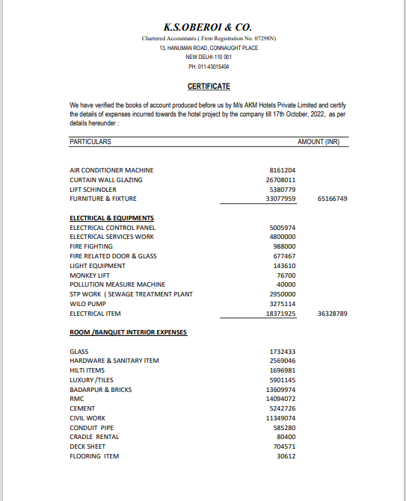

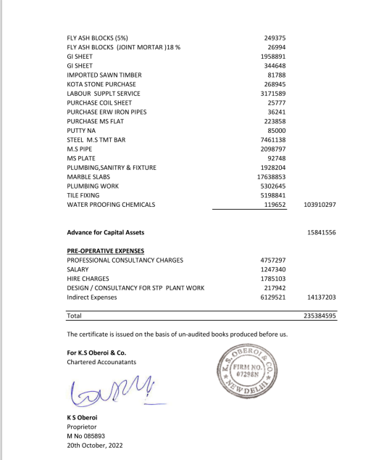

**DOCUMENT- 2: COPY OF TIR**

**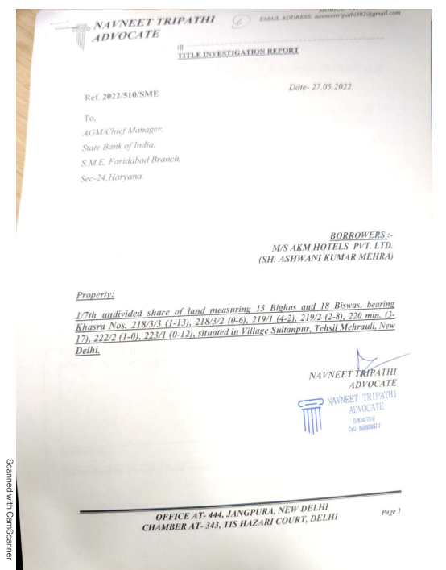**

**DOCUMENT-3: ELECTRICITY BILL**

**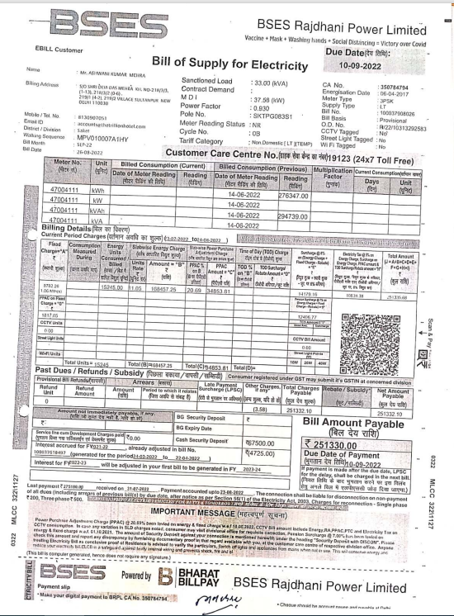**

**DOCUMENT 4: PROJECT TIMELINE**

**DOCUMENT 5: COPY OF SANCTIONED PLAN**

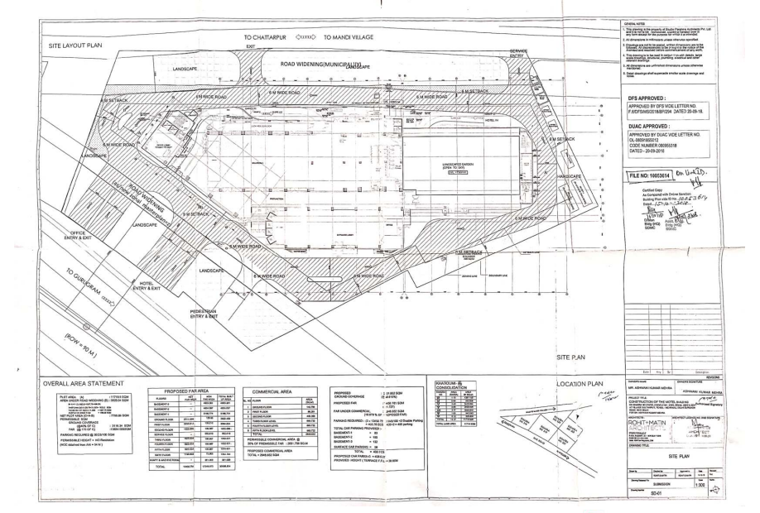

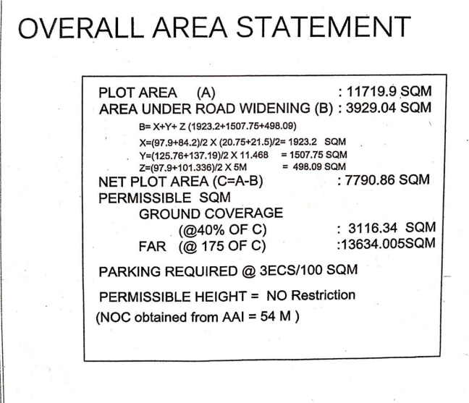

**DOCUMENT 6: PURCHASE ORDERS OF MACHINERIES OR EQUIPMENTS.**

**M/S JBBS Engineers Pvt.Ltd.**

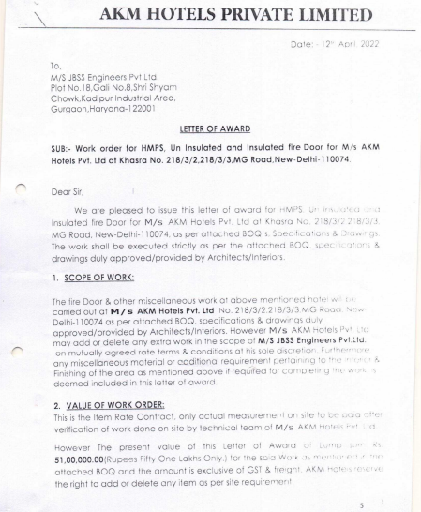

**M/S SUDHIR POWER LTD.**

|  |
| --- |
|  |
|  |

**UNIVERSAL TECH TRADE PVT LTD.**

|  |
| --- |
|  |
|  |

**ENCLOSURE-2: - SITE PHOTOGRAPHS**

|  |
| --- |
| **C:\VIS(2023-24)-PL213-184-259_AKM Hotel\SiteImage\c_9521413A-7048-48AA-A36F-74197C391164.jpeg** |

|  |  |
| --- | --- |
|  |  |
|  |  |
|  |  |
|  |  |

|  |  |
| --- | --- |
|  |  |
|  |  |
|  |  |
|  |  |

|  |  |
| --- | --- |
|  |  |
|  |  |
|  |  |
|  |  |

|  |  |
| --- | --- |
|  |  |
|  |  |
|  |  |
|  |  |
|  |  |
|  |  |
|  |  |
|  |  |