REPORT FORMAT: CL-1 | Version: 1.0_2018

FILE No: VIS (2023-24) - PL222-190-265 Date: 02/08/2023

- CERTIFICATE NAME: Project/Civil work vetting certificate.
- PREPARED FOR ORGANIZATION: SBI SME Ranipur, Haridwar.
- BORROWER COMPANY’S NAME: M/s. Omega Printo Pack Private Ltd.
- ASSET TYPE: Project Civil work required for M/s. Omega Printo Pack Private Ltd.
- CURRENT LOCATION OF THE CIVIL WORK: M/s. Omega Printo Pack Private Ltd., Plot No.134 & 135, Sector-6A, Integrated Industrial Estate, Haridwar, Uttarakhand
S. NO. | PARTICULARS | DESCRIPTION
 | Date of Work Order | Via mail dated 27-07-2023
 | Documents provided for perusal | - Site Plan (Dated- 24/06/2023)  - Bill of quantity (BOQ) (Provided by the bank/client)
 | Project Location | M/s. Omega Printo Pack Private Ltd., Plot No.134 & 135, Sector-6A, Integrated Industrial Estate, Haridwar, Uttarakhand
 | Borrowing Company | M/s. Omega Printo Pack Private Ltd.
 | Type of Asset | Project Civil work required for M/s. Omega Printo Pack Private Ltd.
 | Type of Assessment | Project/Civil work vetting certificate
 | Scope of Assessment | Civil work Cost Vetting of the following items attached below.
  Sr. No. | Description of Work | Amount (Exclusive GST)
  1 | EARTH WORK | 3,098,500.00
  2 | CONCRETE WORK- PLAIN & REINFORCEMENT | 48,232,500.00
  3 | MASONARY WORK | 2,450,000.00
  4 | FINISHING WORK | 1,650,000.00
 | Nature of Plant | Packing Material Manufacturing Industry
 | Total Project/Civil Construction Cost | Rs. 6,54,08,580 /- (Including GST)  (including supply and installation as per the List/ quotations / invoices / Cost Estimate provided by the company of civil works
 | Comment on Project Cost by consultant | As per our analysis, the revised cost for Civil works found to be in line to Market trend. Please refer to PART A for detailed analysis.
 | Total number of pages with Annexure. | 13

VALUATION ENGINEER | L1/ L2 REVIEWER
Vishal Singh | Abhinav Chaturvedi

PART A | PROJECT COST VETTING

EXECUTIVE SUMMARY: M/s. Omega Printo Pack Private Ltd. is setting up a packing material manufacturing unit at Plot No.134 & 135, Sector-6A, Integrated Industrial Estate, Haridwar, Uttarakhand. In this respect, they require financial assistance for construction of civil structures and other additional civil work. In respect to financial assistance of this Project, M/s. Omega Printo Pack Private Ltd has approached SBI, SME Ranipur, Haridwar Branch. As per SBI, SME Ranipur the original project cost of the project as shown by the company is Rs. 6,54,08,580 /- (Including GST).

TABLE-A
Sr.  No. | Particulars/  Description | Unit | Qty. | Rate | Original  Amount | Approved  Rate | GST | Approved  Amount (With GST) | Remarks
1 | Boring | RMT | 1630 | ₹ 450 | ₹ 733,500 | ₹ 500.00 | 18% | ₹ 815,590 | Seems to be reasonable
2 | Back Filling | CUM | 1200 | ₹ 600 | ₹ 720,000 | ₹ 500.00 | 18% | ₹ 600,590 | Seems to be on higher side
3 | Anti-Termite | SQMT | 1250 | ₹ 100 | ₹ 125,000 | ₹ 100.00 | 18% | ₹ 125,118 | Seems to be reasonable
4 | Water Proofing | SQMT | 1900 | ₹ 800 | ₹ 1,520,000 | ₹ 710.00 | 18% | ₹ 1,349,838 | Seems to be on higher side
5 | Concrete(1:4:8) | CUM | 175 | ₹ 5,500 | ₹ 962,500 | ₹ 6,326.05 | Already Included | ₹ 1,107,059 | Seems to be reasonable
6 | Concrete M-25 | CUM | 1250 | ₹ 7,000 | ₹ 8,750,000 | ₹ 7,997.30 | Already Included | ₹ 9,996,625 | Seems to be reasonable
7 | Shuttering | SQMT | 12000 | ₹ 450 | ₹ 5,400,000 | ₹ 537.00 | Already Included | ₹ 6,444,000 | Seems to be reasonable
8 | Steel | KG | 480000 | ₹ 69 | ₹ 33,120,000 | ₹ 90 | Already Included | ₹ 43,200,000 | Seems to be reasonable
9 | Brick Work | CUM | 350 | ₹ 7,000 | ₹ 2,450,000 | ₹ 8,288 | Already Included | ₹ 2,900,923 | Seems to be reasonable
10 | Plaster | SQMT | 5500 | ₹ 300 | ₹ 1,650,000 | ₹ 282 | Already Included | ₹ 1,551,000 | Seems to be reasonable
 |  |  |  |  | ₹ 5,54,31,000 |  |  | ₹ 6,80,90,742
 |  |  |  | GST (18%) | ₹ 99,77,580 |  |  | INCLUDED
 |  |  |  | TOTAL | ₹ 6,54,08,580 |  |  | ₹ 6,80,90,742

*Note: Cost vetting is done on the basis of BOQ and site plan provided to us by bank/client only.
As per the BOQ shared by the client, the estimated construction cost for the said civil work is Rs. 6,54,08,580 /-. However, as per analysis and market research the construction cost of the said civil work comes to be Rs. 6,80,90,742 /-. Thus we can say that the BOQ shared by the client is in line with the market trends and is fair & reasonable.
TECHNICAL CIVIL WORK (BUILDING & CIVIL WORKS): The revised cost involved in the construction of civil structures and other additional civil work has been calculated from various approaches such as the Delhi Schedule of rates (2021), public domain, and market research. For Reference kindly refer to ANNEXURES (A)
We have also gone through the architect’s plan/Site layout plan provided to us, details of which is shown below:
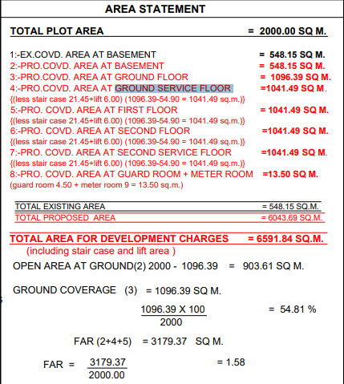

Observations (Civil Works):
- The estimate of construction of civil structures and other additional civil work is calculated as per Table A. The calculated cost appears to be within range as shown by the company.
- For ascertaining the estimated cost of civil structures and other additional civil work, we have requested for the Building Map/Site Plan and BOQ. Specific item quantities as shown in the Annexure (A) below is considered from these provided documents.
- Rates considered in the cost estimate is found within the market range as per our scrutiny.
- We have vetted the civil works as per the available documents such as Building Map/Site Plan and BOQ.
- The quantity has been considered as per the BOQ provided to us bank/client.
- Some of the rates adopted by the client for the civil work seem to be on higher side, and vice versa. However the overall civil work cost seems to be reasonable.
DISCLAIMERS

- We have received BOQ/Quotation for construction of civil structures and other additional civil work.
- The client/ owner and its management/ representatives warranted to us that the information they have supplied was complete, accurate and true and correct to the best of their knowledge. All such information provided to us either verbally, in writing or through documents has been relied upon in good faith and we have assumed that it is true & correct without any fabrication or misrepresentation. I/We shall not be held liable for any loss, damages, cost or expenses arising from fraudulent acts, misrepresentations, or willful default on part of the owner, company, its directors, employee, representative or agents.
- Legal aspects for e.g. Investigation of title, ownership rights, lien, charge, mortgage, lease, sanctioned maps, and verification of documents provided to us such as title documents, Map, etc. from any concerned Govt. office etc. have to be taken care by legal expert/ Advocate and same is not done at our end. I/ We assume no responsibility for the legal matters including, but not limited to, legal or title concerns.
- Wherever any details are mentioned in the report in relation to any legal aspect of the property such as name of the owner, leases, etc. is only for illustration purpose and should not be construed as a professional opinion. Legal aspects are out of scope of this report. Details mentioned related to legal aspect are only based on the copy of the documents provided to us and whatever we can interpret as a non-legally trained person. This should be cross validated with a legal expert. We do not vouch any responsibility regarding the same.
- We have relied on the data from third party, external sources & information available on public domain to conclude the valuation. These sources are believed to be reliable and therefore, we assume no liability for the truth or accuracy of any data, opinions or estimates furnished by others that have been used in this analysis. Where we have relied on the data, opinions or estimates from external sources, reasonable care has been taken to ensure that such data is extracted from authentic sources, however we still can’t vouch its authenticity, correctness, or accuracy.
- Documents, information, data including provided to us during the course of this assessment by the client is reviewed only up to the extent required in relation to the scope of the work. No document has been reviewed beyond the scope of the work. These are not reviewed in terms of legal rights for which we do not have expertise. Wherever any information mentioned in this report is mentioned from the documents like owners name, etc., it is only for illustration purpose and may not necessary represent accuracy.

ANNEXURES (A)
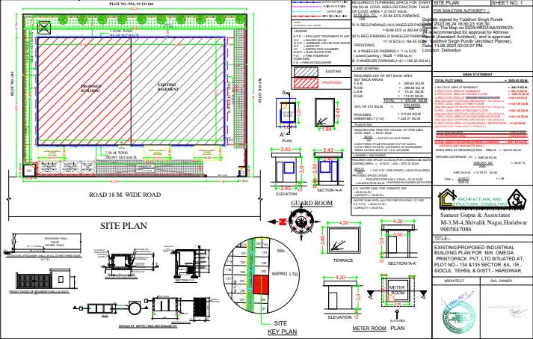
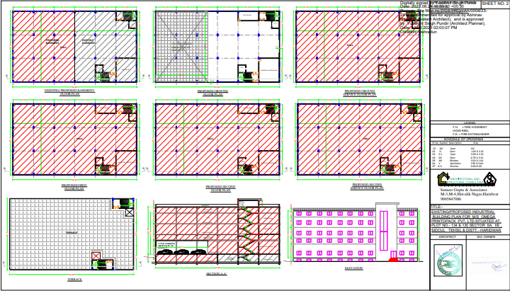

BOQ (Provided by bank/client)
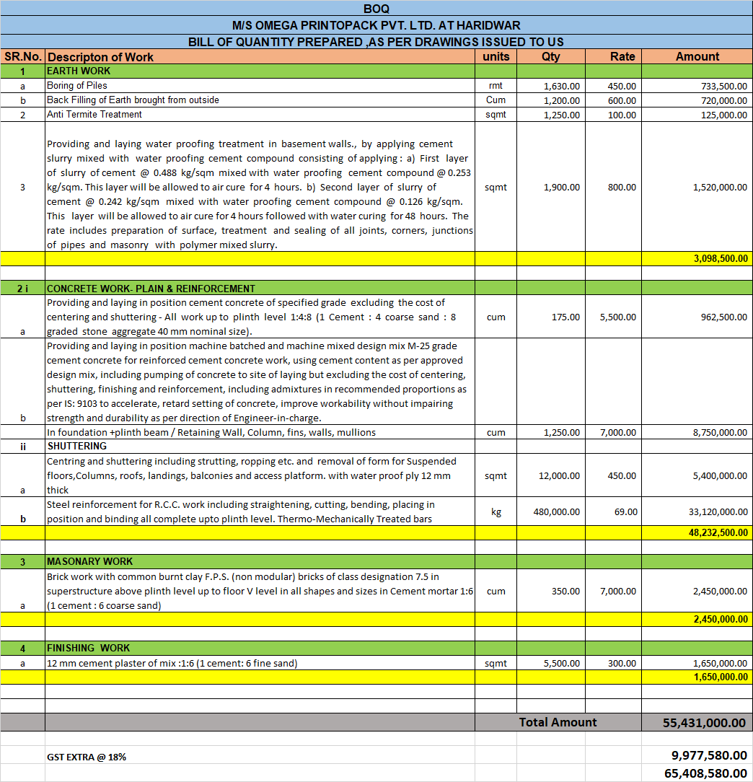
References from DSR-2021
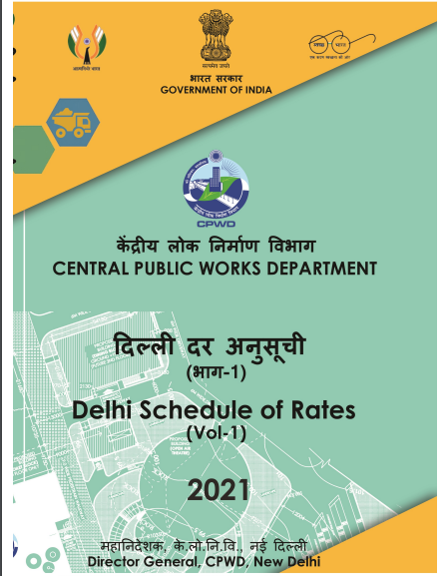

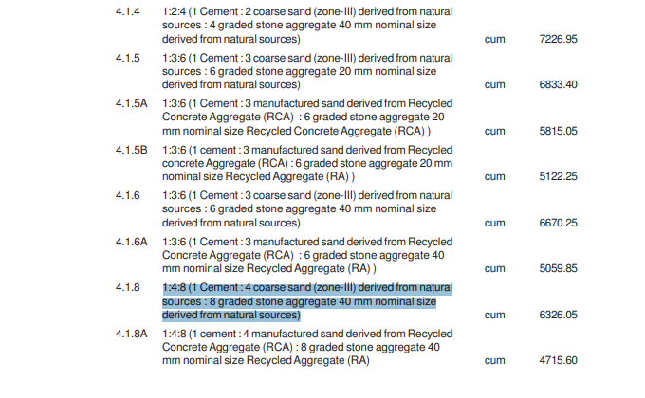
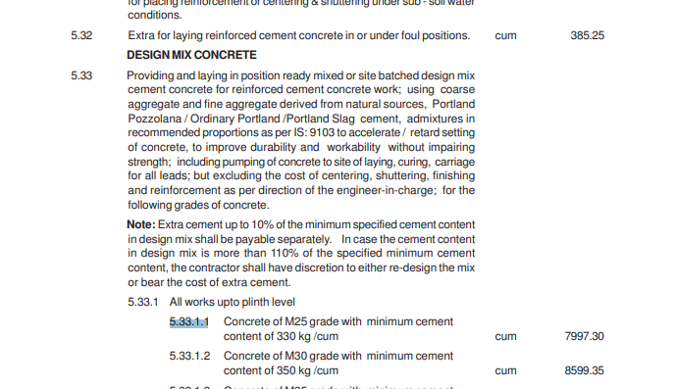

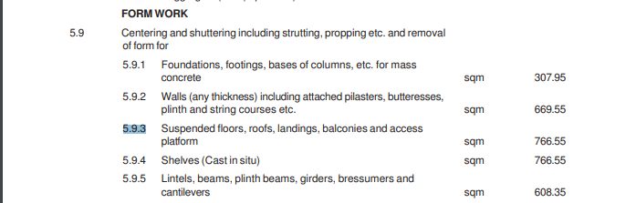
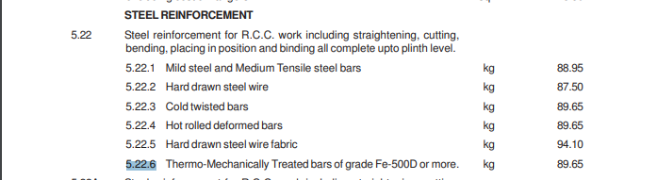
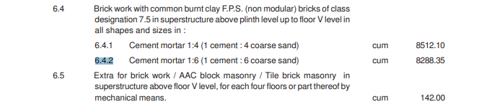
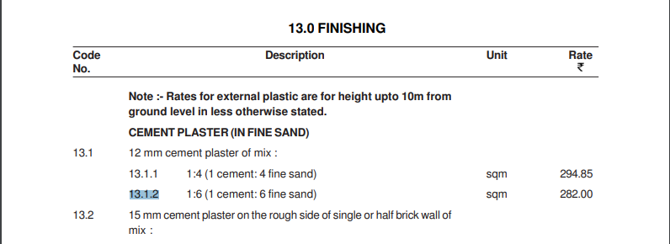

References from Public Domains

