File No.: VIS (2023-24)-PL254-213-316 Dated: 06.02.2024

TECHNO-ECONOMIC
VIABILITY (TEV) STUDY REPORT AND ENTERPRISE VALUATION (EV) REPORT

OF

M/S KOHINOOR FOODS LIMITED

REPORT PREPARED FOR

BOB CAPITAL MARKETS LTD, PARINEE CRESCENZO, 1704, B WING, 17TH FLOOR, BANDRA KURLA COMPLEX, G BLOCK, BANDRA EAST, MUMBAI 400 051

**Important - In case of any query/ issue or escalation you may please contact Incident Manager Valuers@rkassociates.org. We will appreciate your feedback in order to improve our services.

NOTE: As per IBA Guidelines please provide your feedback on the report within 15 days of its submission after which report will be considered to be correct.
IMPORTANT NOTICE

COPYRIGHT FORMAT: This report is prepared on the copyright format of R. K. Associates Valuers & Techno Engineering Consultants (P) Ltd. (R. K. Associates) to serve our clients with the best possible information and analysis to facilitate them to take rational business decisions. Legally no one can copy or distribute this format without prior approval from R. K. Associates. It is meant only for the advisory/ reference purpose for the organization/s as mentioned on the cover page of this report. Distribution or use of this format or report or any of its content/ information/ data by any organization or individual other than R.K Associates will be seen as an unlawful act and necessary legal action can be taken against the defaulters.
This report is intended for the sole use of the intended recipient/s and contains material that is STRICTLY CONFIDENTIAL AND PRIVATE.

DEFECT LIABILITY PERIOD: In case of any query/ issue or escalation you may please contact Incident Manager at valuers@rkassociates.org. Though adequate care has been taken while preparing this report as per its scope, but still we can’t rule out typing, human errors, over sightedness of any information or any other mistakes. Therefore, the concerned organization is advised to satisfy themselves that the report is complete & satisfactory in all respect. Intimation regarding any discrepancy shall be brought into our notice immediately. If no intimation is received within 15 (Fifteen) days in writing from the date of issuance of the report, to rectify these timely, then it will be considered that the report is complete in all respect and has been accepted by the client up to their satisfaction & use and further to which R.K Associates shall not be held responsible in any manner.

Part L: R. K. Associates Important Disclaimer and Remarks are integral part of this report and Feasibility assessment is subject to this section. Reader of the report is advised to read all the points mentioned in these sections carefully.

TABLE OF CONTENTS
SECTIONS | PARTICULARS | PAGE NO.
Part A | REPORT SUMMARY | 4
Part B | INTRODUCTION | 6
 | - About the Report | 6
 | - Executive summary | 6
 | - Purpose of the Report | 19
 | - Scope of the Report | 19
 | - Methodology/ Model Adopted | 20
 | - Data Information received from | 21
 | - Documents/ Data Referred | 21
Part C | COMPANY PROFILE | 22
 | - Company Overview | 22
 | - Debt Snapshot | 23
 | - Shareholding Details | 23
 | - Promoters/Directors Profile | 24
 | - Reasons for Financial Stress | 29
PART D | INFRASTRUCTURE DETAILS | 32
 | - Plant Location | 32
 | - Layout Plan | 33
 | - Location Map | 34
 | - Site pictures | 37
 | - Land Details | 44
 | - Building & Civil Works | 45
 | - Plant and Machinery/ Equipment details | 48
 | - Utilities | 48
PART E | TECHNICAL ASSESSMENT OF THE COMPANY | 49
 | - Capacity of Manufacturing Facility | 49
 | - Process Flow Chart for Rice Plant | 49
 | - Process Flow Chart for Food Plant | 51
 | - Technical Specification/Technology Used | 54
 | - Testing Standards for Production | 61
 | - Manpower | 61
PART F | PRODUCT PROFILE | 64
 | - Introduction | 64
 | - Product Category | 64
 | - Marketing, Selling & Distribution Plan | 69
 | - Raw Material Procurement | 69
PART G | INDUSTRY OVERVIEW & ANALYSIS | 71
PART H | SWOT ANALYSIS | 78
PART I | STATUTORY APPROVALS | LICENCES | NOC | 80
PART J | COMPANY’S FINANCIAL FEASIBILITY | 83
PART K | CONCLUSION | 108
PART L | DISCLAIMER | REMARKS | 110

PART A | REPORT SUMMARY

S. No. | PARTICULARS | DETAILS
 | Name of the Company: | M/s Kohinoor Foods Limited
 | Address of the Company: | Registered Office: Pinnacle Business Tower, 10th Floor, Surajkund, Faridabad, Haryana – 121001
 | Project Name: | Rice Factory with an installed capacity of 2,50,000 MT per annum and a Food Plant with an installed capacity of 18 million processed pouches per annum.
 | Project Location: | - Rice Plant – Murthal: 50-51, Milestone, G.T. Karnal Road, Murthal Sonipat, Haryana  - Food Factory – Bahalgarh: 42-43, Milestone, G.T. Karnal Road, Village Sultanpur, Bahalgarh, Sonipat Haryana
 | Project Type: | Manufacturing, Trading, and Marketing food products
 | Project Industry: | Food Processing Industry
 | Product Type/ Deliverables: | Basmati rice; packaged food products, such as ready to eat food, ready to cook, frozen ready to eat food, dairy products, namkeen savouries, sweets, biscuits and cookies, pickles, dry fruits, and rice brain oil; and food products, including wheat flour, simmer sauces, cooking pastes and spices, seasonings and frozen food, pure ghee, paneer, and ready mixes.
 | Report Prepared for Organization: | BOB Capital Markets Ltd, Parinee Crescenzo, 1704, B Wing, 17th Floor, Bandra Kurla Complex, G Block, Bandra East, Mumbai 400 051.
 | TEV Consultant Firm: | M/s. R.K Associates Valuers & Techno Engineering Consultants (P) Ltd.
 | Report type: | Techno-Economic Viability (TEV) – Cum – Enterprise Valuation (EV) Report
 | Purpose of the Report: | To assess Project’s Techno-Economic Viability and Enterprise Valuation to enable NARCL in making a decision regarding the acquisition of debt.
 | Scope of the Report: | To assess, evaluate & comment on Techno-Economic & Financial Viability of the Company and evaluate Enterprise Value of the company as per data information provided by the client, independent Industry research, data/ information available on public domain and our independent EIC research.
 | Date of Report: | 30th September 2023
 | Documents referred for the Project | - Brief description about the company.  - Financial Model Shared by the client.  - Details of Statutory approvals shared by the client.  - Information provided by client.  - Consortium meeting minutes shared by the Company.  - Unit wise details of Capacity, manpower, Infrastructure details.  - Last 5 year Audited Financial Statements of the company.  - Documents regarding communications held with consortium bank members.
 | Key Financial Indicators: | Key Indicators Value  Average DSCR 1.57  Average EBITDA Margin 6.24%  Average EBIT Margin 5.50%

Note: Above financial indicators are based on the financial projections of M/s Kohinoor Foods Limited provided by the company and assessment and analysis of the same done by us.

PART B | INTRODUCTION

- ABOUT THE REPORT: Techno Economic Viability Study cum Enterprise Valuation Report of M/s Kohinoor Foods Limited having registered office at Pinnacle Business Tower, 10th Floor, Surajkund, Faridabad, Haryana – 121001.

- EXECUTIVE SUMMARY: M/s Kohinoor Foods Limited was incorporated on 26th July, 1989 established for the purpose of manufacturing, trading and marketing of basmati rice under the brand name “Kohinoor”. The company started offering many products like Basmati rice; packaged food products, such as ready to eat food, ready to cook, frozen ready to eat food, dairy products, namkeen savouries, sweets, biscuits and cookies, pickles, dry fruits, and rice brain oil; and food products, including wheat flour, simmer sauces, cooking pastes and spices, seasonings and frozen food, pure ghee, paneer, and ready mixes.
The Company was incorporated as ‘Satnam Overseas Private Limited” in 1989. Subsequently, SOPL was renamed as Satnam Overseas Limited in 1992 and presently as Kohinoor Foods Limited (KFL) since July 2006.The key milestones of the Company are listed in the below table:
Year | Milestones
1976-1978 | - Mr. Jugal Kishore Arora, Mr. Satnam Arora & Mr. Gurnam Arora started as a small rice trading business.
1981 | - Company’s own rice plant successfully commenced operations in Amritsar, Punjab.
1985-1986 | - Company started exporting rice and transformed this small rice trading business into becoming a part of the mainstream of Rice Exports from India.
1989-1992 | - Company was incorporated as a private limited company under the name “Satnam Overseas Private Limited” on 26th July, 1989.  - The company established its second and India’s largest rice processing plant at Murthal, Haryana.  - In December, 1992 the company was converted into a publicly listed company under the name “Satnam Overseas Limited”.  - Satnam Overseas a partnership firm belonging to the same group merged/amalgamated with the company.
1992-1997 | - Company started advertising its product – “Kohinoor” as a ‘brand’  - Brand came out with its first extension – Kohinoor’s Trophy Gold Basmati Rice. Post this extension, the brand was further extended itself into different kinds of Basmati Rice priced at different levels.
2006 | - On 26th July, 2006, the company changed its name to “Kohinoor Foods Limited”.  - Kohinoor diversified into branded packaged convenience foods and took authentic Indian flavour abroad with Ready-to–Eat Indian curries and authentic Indian Ready-Meal preparations.  - During this period, the company established its state-of-art frozen food facility and food processing plant in Bahalgarh, Haryana.  - Kohinoor set the first ever overseas basmati rice processing unit at Felixtowe, UK, which helped in strengthening Kohinoor’s stand in the UK market.
2008 | - This year the brand created a Guinness Record by making “World’s Largest Biryani” in Delhi. It also launched its range of Spices in the Indian market.
2009 | - Launched ‘Limited Edition’ of Kohinoor for the connoisseurs of basmati rice.  - Created three new variants of Kohinoor- Platinum, Gold & Silver.
2011 | - Kohinoor Foods Limited entered into a Joint Venture agreement with M/s McCormick Ingredients Southeast Asia Pvt. Ltd, a leading name globally in Spices & Seasoning and sold its Food Factory, entire rice marketing network in India, etc. and also took the obligation of not marketing our rice in India for a period of seven years (7 years).  - Sold its Brand to McCormick for consideration of approx. Rs. 50 Crores, to increase the cash flow in the year 2011-12
2012 | - Shifted its corporate office to Surajkund, Faridabad, Haryana
2013 | - Kohinoor Foods Limited entered into a Joint Venture agreement with M/s Al-Dahra International Investments LLC, a UAE based company by making a stake sale of 20% for a consideration of INR 112.77 Crores.  - Company has also got the advantage of getting the biggest customer of UAE, who were authorized by the Govt. of UAE for taking care of the Food Security of the Nation
The company is established as a public (Non-govt.) company limited by shares with Registration no. 070351 and Corporate Identification Number L52110HR1989PLC070351 and has directors on board who appears to be well experience in businesses such as Rice, FMCG, Hospitality and Finance industries, and experienced in the areas of Paddy procurement & development, liaisoning with farmers & government officials, supply chain management and operations, marketing the rice overseas market, etc. as per the profile shared to us by the client/company and information available in the public domain.
The company is registered at Registrar of companies, Delhi having registered office at Pinnacle Business Tower, 10th Floor, Surajkund, Shooting Range Road, Faridabad, Haryana - 121001, under the directorship of Mr. Jugal Kishore Arora, Mr. Satnam Arora, Mr. Gurnam Arora, Mr. Sunil Sharma, Mr. Yash Pal Mahajan and Mrs. Mani Chandra Bhandari. As per the audited financials shared by the client, the company is having the authorised share capital of INR 75.00 Crores, and paid-up capital of INR 37.07153 Crores as on 31st March 2023.
As per the information provided by the client/company, currently company is operating a rice mill in Murthal, Sonipat and a food factory at Bahalgarh, Sonipat in the state of Haryana. The details of all both plants along with their capacities are shown in the below table:
Name of Plant | Location | Installed Capacity
Rice Factory | Murthal, Sonipat | 2,50,000 Metric Tonnes
Food Factory | Bahalgarh, Sonipat | 1,80,00,000 pouches
Source: Information provided by the company
Kohinoor Foods Limited, presently, not focusing on Rice Manufacturing due to financial crunch in the organisation. Further, the Company is focusing towards Rice-to-Rice manufacturing (instead of Paddy to Rice Manufacturing, which require substantial investment & other cost associated such as to preservation). The Basmati Rice grown through-out north India are being sold at different mandies; the rate is being shared by the commission agent of these mandies to the procurement Team based on the yield and length. The Procurement and quality team upon verification of the quantity, quality, length and other variable cost (transportation etc.) after negotiation places this order from the various mandis from different commission agents.
The Company usually procure Raw Rice from various Mandis of India (such as Punjab, Haryana, Himachal, Jammu, Delhi etc.) The organisation procurement Team includes the quality experts, whose prime job & responsibility, during the end of crop season (i.e., Sep-Dec) is to identify the best quality raw rice with best price considering the other charges involved towards it in different mandis of India. Once the same is identified as per the order book of the organisation the same is been procured by the Team after approval from the concerned organisation department. The same is followed through the season procurement period in order to be the best and competitive in the Market.
Kohinoor Foods Limited is focused towards selling Basmati Rice all over the World. The selling of Non-basmati Rice is based on the Customer demand in past. During the last Financial Year there was a specific demand from the Country ‘China’ for non-basmati rice (broken). Being one of the star-rated, trusted & renowned export houses, Kohinoor Foods Limited was getting approached by various importers of China to Export non-basmati rice (broken) to them. At present the GOI has imposed ban on non-basmati Rice export. At present Par boiled non-basmati & Organic non-basmati is not under the list of banned non-basmati rice. As per the discussion with the company officials, the company has no plans to discontinue non-basmati exports, but it would be as per the government norms.
As per SOP, raw material sourcing is done by approved vendor by the Company after detailed due diligence made by procurement and quality team. The quality team also visits at regular intervals with these vendors locations, manufacturing units, offices to ensure that the product raw materials obtained from them are of best qualities and matches the quality required of the company for its manufacturing process. Once the registration process of vendors is completed with the company, the company sends it requisition list along with the quote to these vendors. The purchase team compares the best price vis-a-vis quality and after negotiation and order is placed with the approved vendors. The company in view of best price / quality and quantity, prefer not to enter into any purchase agreement with them, as this is the uniform process followed by the Company since its operation commenced.
Kohinoor Foods Limited have territory wise distributors / master distributors throughout the world likewise For US and Canada we have One master distributor in Gulf (divided into territory) we have various distributors, similarly in Australia we have one Distributor etc. The Company sales team assess the distributors/ buyers/ stores/ agents based on their market presence and reputation. The Company do not enter into any written agreement as company switches the distributors/ buyers/ stores/ agents based on the product sale and targets. At present, the majority of companies’ earnings are from export sales, however, the company is presently doing domestic transactions, which might get expanded once the accounts are taken over by any prospective buyer.
The Company is listed on Bombay Stock Exchange (BSE) and National Stock Exchange (NSE) with the following listing details as on 25th September 2023:
Particulars | Value
Current Market Price | INR 35.05
52 weeks high/ low | INR 83.95/ INR 28.35
Market Capital | INR 129.94 Cr
Shares outstanding | 3,70,71,530
As per the information provided by the client/company, details of the Subsidiary companies and joint ventures as on 31 March 2023, are shown in the below table all of which are presently unlisted:
List of Subsidiaries/Associates | Remarks
Subsidiaries
Sachdeva Brothers Private Limited (India) | An Indian private Limited Company, wholly owned subsidiary of Kohinoor Foods Limited, presently having no operations.
Kohinoor Foods USA Inc. (USA) | A U.S.A based Company, wholly owned subsidiary of Kohinoor Foods Limited, presently having no operations.
Joint Venture
Rich Rice Raisers LLC (Dubai) | A UAE based Company is a Joint Venture Company where in KFL has 25% equity. The management consider that the parent company is not in position to exercise control over this entity.

HISTORICAL FINANCIAL PERFORMANCE OF THE COMPANY: Below mentioned table shows the historical performance of the company for past 5 years from FY 2018 to FY 2022:
(Value in INR Crore)
Particular | Mar-18 | Mar-19 | Mar-20 | Mar-21 | Mar-22 | Mar-23
Sales | 859.15 | 404.94 | 31.80 | 40.19 | 98.57 | 82.54
Other Income | 3.25 | 1.64 | 0.48 | 4.16 | 4.92 | 1.71
Total Revenue | 862.40 | 406.58 | 32.27 | 44.35 | 103.48 | 84.25
Material Cost | 712.92 | 498.57 | 19.88 | 17.88 | 65.11 | 31.01
Employee Cost | 36.63 | 25.44 | 19.35 | 17.79 | 5.94 | 5.87
Manufacturing Expenses | 54.62 | 32.99 | 27.41 | 13.51 | 13.45 | 22.05
Administrative Expenses | 33.14 | 111.26 | 17.51 | 17.98 | 5.86 | 7.92
Selling & Distribution Expenses | 54.86 | 48.93 | 7.77 | 3.10 | 10.02 | 4.30
Impairment of Assets | 0.71 | 39.78 | 0.00 | 4.42 | 1.85 | 0.00
Total Expenses | 834.91 | 578.24 | 43.51 | 45.99 | 100.59 | 71.13
EBITDA | 27.49 | -171.66 | -11.24 | -1.64 | 2.89 | 13.12
Depreciation | 15.37 | 12.97 | 10.83 | 9.04 | 7.73 | 6.71
EBIT | 12.12 | -184.63 | -22.07 | -10.68 | -4.83 | 6.41
Finance Cost | 81.70 | 22.98 | 2.83 | 1.11 | 0.67 | 17.99
Net Profit before Exceptional Items & Taxes | -69.58 | -207.60 | -24.90 | -11.79 | -5.51 | -11.58
Exceptional Items | 0.00 | 83.79 | 193.96 | -8.53 | 0.00 | -7.81
Profit before Tax | -69.58 | -291.39 | -218.86 | -3.26 | -5.51 | -4.84
Income Tax | 1.45 | 94.19 | 6.92 | 1.89 | 0.80 | -0.73
Profit after Tax | -71.03 | -385.57 | -225.77 | -5.15 | -6.30 | -4.12
EBITDA Margin | 3.20% | -42.39% | -35.34% | -4.08% | 2.93% | 15.90%
EBIT Margin | 1.41% | -45.59% | -69.41% | -26.58% | -4.90% | 7.77%
Net Profit Margin | -8.27% | -95.22% | -710.08% | -12.81% | -6.40% | -4.99%
Revenue Growth Rate |  | -52.87% | -92.15% | 26.41% | 145.24% | -16.26%
Below is the graphical representation of the key financial metrics of the company:
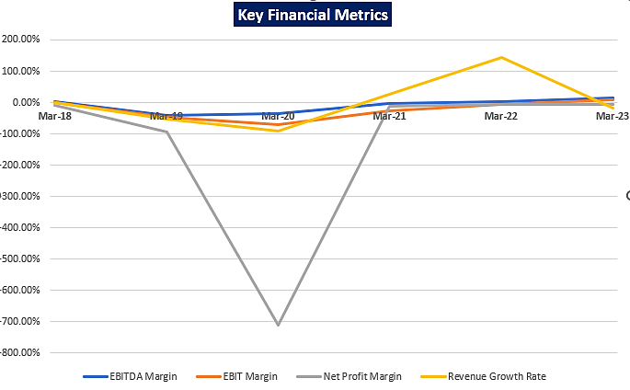
Satnam Overseas (Export) a registered partnership in India. Satnam Overseas (Export) has passed a resolution that till Arora’s are into controlling position in management of Kohinoor Foods Limited, the licence to use Kohinoor Brand is permitted in Kohinoor Foods Limited.
At present Arora Family owns Kohinoor, Charminar, Trophy, Monsoon, Satnam, Durbar, India on Platter, Shehanshah, Almass, Quisine and Green Grown and there is no Trademark/Copyright licence uses agreement between KFL & Arora Family.
The Promoters of M/s Kohinoor Foods Limited are Jugal Kishore Arora, Satnam Arora and Gurnam Arora whereas the partners of Satnam Overseas Exports are Jugal Kishore Arora, Satnam Arora and Gurnam Arora (in both the entitles the promoters of Kohinoor Foods Limited and partners of Satnam Overseas Exports are common). Further, Satnam Overseas Exports, the partnership Firm had permitted Kohinoor Foods Limited to use Brand owned by Arora Family and Arora Family had not charged any royalty or any fee till date for the uses of Brand from Kohinoor Foods Limited. Promoters have not felt any need to enter into executing any license agreement.
As per the information shared by the company, the list of brand name registered under the promoter’s name are as below:
S. No. | Brand Name | Registration Number | Class
1 | KOHINOOR | National Trademark Registration  Registered (April 20, 2017)  Number 1191538 | Nice class 30  Owner Satnam Overseas (Exports)  Designation country Chile
2 | POLO | National Trademark Registration  Registered (January 9, 1998)  Number 785571 | Nice class 30  Owner SATNAM OVERSEAS LTD. (India)  Designation country India
3 | SHEHANSHAH | National Trademark Registration  Registered (June 20, 1994)  Number 631486 | Nice class 32  Owner SATNAM OVERSEAS LIMITED (India)  Designation country India
4 | SATNAM | National Trademark Registration  Registered (June 9, 1995)  Number 668746 | Nice class 32  Owner SATNAM OVERSEAS LIMITED (India)  Designation country India
5 | PUNJABI DHABA | National Trademark Registration  Registered (June 27, 2017)  Number 3579196 | Nice class 30  Owner SATNAM OVERSEAS (EXPORTS) (India)  Designation country India.
6 | KOHINOOR | National Trademark Registration  Registered (January 25, 1996)  Number 695756 | Nice class 30  Owner SATNAM OVERSEAS LTD. (India)  Designation country India
7 | KOHINOOR | National Trademark Registration  Registered (December 23, 2004)  Number 1327746 | Nice class 30  Owner SATNAM OVERSEAS LTD. (India)  Designation country India
8 | KOHINOOR | National Trademark Registration  Registered (February 28, 2002)  Number 644401 | Nice class 31  Owner Satnam Overseas (Exports) (India)  Designation country New Zealand
9 | SATNAM'S ROSE | National Trademark Application  Ended (September 19, 2003)  Number 76338501 | Nice class 29, 30  Owner SATNAM OVERSEAS LIMITED (India)  Designation country USA
10 | KOHINOOR | National Trademark Registration  Registered (September 25, 2014)  Number 446986 | Nice class 30  Owner SATNAM OVERSEAS (EXPORTS) (India)  Designation country Uruguay
11 | KOHINOOR | National Trademark Registration  Registered  Number T9501046A | Nice class 30  Owner SATNAM OVERSEAS (EXPORTS) (India)  Designation country Singapore
12 | PUNJABI DHABA | National Trademark Application  Ended (October 10, 2001)  Number 76173781 | Nice class 9  Owner SATNAM OVERSEAS LIMITED (India)  Designation country USA
13 | LONG GRAIN PREMIUM RICE LEBEL | National Trademark Registration  Registered (December 21, 2004)  Number 1327055 | Nice class 30  Owner SATNAM OVERSEAS LTD. (India)  Designation country India
14 | ROSE BASMATI RICE & DEVICE OF ROSE | National Trademark Registration  Registered (March 12, 2003)  Number 1182760 | Nice class 30  Owner SATNAM OVERSEAS LTD. (India)  Designation country India
15 | SUPER KOHINOOR | National Trademark Registration  Registered (January 25, 1996)  Number 695755 | Nice class 30  Owner SATNAM OVERSEAS LIMITED (India)  Designation country India
16 | SHEIKH BRAND | National Trademark Registration  Registered (December 30, 1993)  Number 615100 | Nice class 30  Owner SATNAM OVERSEAS LTD. (India)  Designation country India
17 | INDIAN MONSOON | National Trademark Registration  Registered (June 12, 2017)  Number 3568680 | Nice class 29  Owner SATNAM OVERSEAS (EXPORTS) (India)  Designation country India
18 | KOHINOOR SINCE 1981 | National Trademark Application  Ended (May 10, 2019)  Number 1068575 | Nice class 29, 30  Owner Satnam Overseas (Exports) (India)  Designation country New Zealand
19 | MONSOON | National Trademark Application  Ended  Number 1813425 | Nice class 30, 30  Owner Satnam Overseas (Exports) (India)  Designation country Canada
20 | TROPHY | National Trademark Application  Ended  Number 1041155 | Nice class 30  Owner SATNAM OVERSEAS LIMITED, (India)  Designation country Canada
21 | KOHINOOR BASMATI RICE & SPICE | National Trademark Application  Ended (March 7, 2014)  Number 76338500 | Nice class 30  Owner SATNAM OVERSEAS LIMITED (India)  Designation country USA
22 | BE SURE BUY PURE | National Trademark Registration  Registered (October 4, 2004)  Number 1312838 | Nice class 30  Owner SATNAM OVERSEAS LTD. (India)  Designation country India
23 | SHEHANSHAH | National Trademark Registration  Registered (June 20, 1994)  Number 631488 | Nice class 29  Owner SATNAM OVERSEAS LIMITED (India)  Designation country India
24 | DURBAR | Regional Trademark Registration  Registered (November 13, 2006)  Number 004698478 | Nice class 29, 30, 31  Owner Satnam Overseas (Exports) (India)  Designation country European Union
25 | KOHINOOR | National Trademark Registration  Registered (January 30, 2001)  Number 2424918 | Nice class 30  Owner Satnam Overseas Limited (India)  Designation country USA
26 | SHEHANSHAH | National Trademark Application  Ended (June 20, 2009)  Number 75863683 | Nice class 30  Owner Satnam Overseas (Exports) (India)  Designation country USA
27 | KOHINOOR | National Trademark Registration  Registered (April 5, 2005)  Number 2938533 | Nice class 29  Owner SATNAM OVERSEAS LIMITED (India)  Designation country USA
28 | KOHINOOR INDIA ON PLATTER | Regional Trademark Registration  Expired (December 23, 2019)  Number 008782013 | Nice class 30  Owner Satnam Overseas (Exports) (India)  Designation country European Union
29 | KOHINOOR | National Trademark  Unknown  Number 139448 | Nice class 30  Owner SATNAM OVERSEAS (EXPORTS) (India)  Designation country Morocco
30 | SATNAM | National Trademark Registration  Registered (September 6, 1995)  Number 668748 | Nice class 31  Owner SATNAM OVERSEAS LIMITED (India)  Designation country India
31 | DURBAR | National Trademark Registration  Registered (November 13, 2006)  Number UK00904698478 | Nice class 29, 30, 31  Owner Satnam Overseas (EXPORTS) (India)  Designation country UK
32 | DURBAR | National Trademark Registration  Registered (April 21, 2017)  Number UK00003204703 | Nice class 30  Owner Satnam Overseas (EXPORTS) (India)  Designation country UK
33 | KOHINOOR | National Trademark Registration  Registered (October 22, 1996)  Number 720099 | Nice class 30  Owner Satnam Overseas (Exports) (India)  Designation country Australia
34 | TROPHY | National Trademark Registration  Registered (April 11, 2001)  Number 1002894 | Nice class 30  Owner SATNAM OVERSEAS LTD. (India)  Designation country India
35 | ALBADR LEBEL | National Trademark Registration  Registered (December 21, 2004)  Number 1327054 | Nice class 30  Owner SATNAM OVERSEAS LTD. (India)  Designation country India
36 | SHEHANSHAH | National Trademark Registration  Registered (June 20, 1994)  Number 631489 | Nice class 31  Owner SATNAM OVERSEAS LTD. (India)  Designation country India
37 | TRIPPLE P PPP (LABLE) | National Trademark Registration  Registered (April 18, 1994)  Number 625504 | Nice class 30  Owner SATNAM OVERSEAS LTD. (India)  Designation country India
38 | ZAHRAT-AL-KHALEEJ | National Trademark Application  Ended (March 18, 2013)  Number 85477984 | Nice class 30  Owner Satnam Overseas (Exports) (India)  Designation country USA
39 | AL SHEIKH | National Trademark Application  Ended (March 20, 2013)  Number 85478039 | Nice class 30  Owner Satnam Overseas (Exports) (India)  Designation country USA
40 | FALCON | National Trademark Application  Ended (January 26, 2003)  Number 76391914 | Nice class 30  Owner SATNAM OVERSEAS LIMITED (India)  Designation country USA
41 | KOHINOOR SINCE 1981 | National Trademark Registration  Registered (September 30, 2016)  Number 1850397 | Nice class 29, 30  Owner Satnam Overseas (Exports) (India)  Designation country Australia
42 | SATNAM | National Trademark Registration  Registered (June 9, 1995)  Number 668747 | Nice class 31  Owner SATNAM OVERSEAS LIMITED (India)  Designation country India
43 | HEY'GO | National Trademark Registration  Registered (July 11, 2017)  Number 3589312 | Nice class 29  Owner SATNAM OVERSEAS (EXPORTS) (India)  Designation country India
44 | ALMASS | National Trademark Registration  Registered (April 23, 2004)  Number UK00002349477 | Nice class 30  Owner Satnam Overseas (EXPORTS) (India)  Designation country UK
45 | SHEHANSHAH | National Trademark Application  Ended (April 19, 1998)  Number T9500832G | Owner SATNAM OVERSEAS LIMITED (India)  Designation country Singapore
46 | TROPHY | National Trademark Registration  Registered (November 26, 2002)  Number 2654741 | Nice class 30  Owner Satnam Overseas Limited (India)  Designation country USA
47 | KOHINOOR SINCE 1981 | International Trademark  International Registration in Force  (September 30, 2016) | Nice class 29, 30  Owner Satnam Overseas (Exports) (India)  Designation country Australia, New Zealand
48 | KOHINOOR | National Trademark Registration  Registered (May 17, 2016)  Number 840572867 | Nice class 30  Owner SATNAM OVERSEAS (EXPORTS) (India)  Designation country Brazil
49 | MONSOON | National Trademark Application  Ended (May 23, 2018)  Number 87220652 | Nice class 30  Owner Satnam Overseas (Exports) (India)  Designation country USA
50 | KOHINOOR | National Trademark Registration  Registered (November 25, 1994)  Number 94516193 | Nice class 29, 30  Owner SATNAM OVERSEAS (EXPORTS), Société inidienne (India)  Designation country France
51 | FALCON | National Trademark Application  Ended  Number 1137751 | Nice class 30  Owner SATNAM OVERSEAS LIMITED, an Indian company (India)  Designation country Canada
52 | MONSOON | National Trademark Application  Ended (July 6, 2018)  Number 79204858 | Nice class 30  Owner SATNAM OVERSEAS (EXPORTS) JUGAL KISHORE ARORA, SATNAM ARORA and GURNAM ARORA (India)  Designation country USA
53 | MONSOON | National Trademark Registration  Registered (August 29, 2017)  Number 1064456 | Nice class 30  Owner SATNAM OVERSEAS (EXPORTS) JUGAL KISHORE ARORA, SATNAM ARORA and GURNAM ARORA (India)  Designation country New Zealand
54 | MONSOON | National Trademark Registration  Registered (June 3, 2018)  Number 293471 | Nice class 30  Owner SATNAM OVERSEAS (EXPORTS) JUGAL KISHORE ARORA, SATNAM ARORA and GURNAM ARORA (India)  Designation country Israel
55 | MONSOON | National Trademark Registration  Registered (September 27, 2016)  Number 1837988 | Nice class 30  Owner SATNAM OVERSEAS (EXPORTS) JUGAL KISHORE ARORA, SATNAM ARORA and GURNAM ARORA (India)  Designation country Australia
56 | MONSOON | National Trademark Registration  Registered (July 15, 2017)  Number V0104398 | Nice class 30  Owner SATNAM OVERSEAS (EXPORTS) JUGAL KISHORE ARORA, SATNAM ARORA and GURNAM ARORA (India)  Designation country Iceland
57 | MONSOON | National Trademark Registration  Registered (September 27, 2016)  Number 11338449 | Nice class 30  Owner SATNAM OVERSEAS (EXPORTS) JUGAL KISHORE ARORA, SATNAM ARORA and GURNAM ARORA (India)  Designation country Ghana
58 | MONSOON | National Trademark Registration  Registered (September 27, 2016)  Number 11338449 | Nice class 30  Owner SATNAM OVERSEAS (EXPORTS) JUGAL KISHORE ARORA, SATNAM ARORA and GURNAM ARORA (India)  Designation country Zimbabwe
59 | MONSOON | National Trademark Registration  Registered (July 19, 2018)  Number KH/M/1338443 | Nice class 30  Owner SATNAM OVERSEAS (EXPORTS) JUGAL KISHORE ARORA, SATNAM ARORA and GURNAM ARORA (India)  Designation country Cambodia
60 | MONSOON | National Trademark Registration  Registered (September22, 2017)  Number 40201706649V | Nice class 30  Owner SATNAM OVERSEAS (EXPORTS) JUGAL KISHORE ARORA, SATNAM ARORA and GURNAM ARORA (India)  Designation country Singapore
61 | MONSOON | National Trademark Application  Pending (September 27, 2016)  Number 1338449 | Nice class 30  Owner SATNAM OVERSEAS (EXPORTS) JUGAL KISHORE ARORA, SATNAM ARORA and GURNAM ARORA (India)  Designation country Philippines
62 | MONSOON | National Trademark Registration  Registered (October 5, 2017)  Number M-1338449 | Nice class 30  Owner SATNAM OVERSEAS (EXPORTS) JUGAL KISHORE ARORA, SATNAM ARORA and GURNAM ARORA (India)  Designation country Mongolia
63 | MONSOON | National Trademark Application  Pending (September 27, 2016)  Number TN/M/100/1338449 | Nice class 30  Owner SATNAM OVERSEAS (EXPORTS) JUGAL KISHORE ARORA, SATNAM ARORA and GURNAM ARORA (India)  Designation country Tunisia
64 | MONSOON | International Trademark  International Registration in Force  (September 27, 2016) | Nice class 30  Owner SATNAM OVERSEAS (EXPORTS), JUGAL KISHORE ARORA, SATNAM ARORA, and GURNAM ARORA (India)  Designation country Antigua and Barbuda, Albania, Armenia, Austria, Australia, Azerbaijan, Bosnia and Herzegovina, Bulgaria, Bahrain, Bonaire, Sint Eustatius and Saba, Bhutan, Botswana, Benelux Office for Intellectual Property, Belarus, Switzerland, China, Colombia, Curacao, Cyprus, Czech Republic, Germany, Denmark, Algeria, Estonia, Egypt, European Union, Austria, Belgium, Bulgaria, Croatia, Cyprus, Czech Republic, Denmark, Estonia, Finland, France, Germany, Greece, Hungary, Ireland, Italy, Latvia, Lithuania, Luxembourg, Malta, Netherlands, Poland, Portugal, Romania, Slovakia, Slovenia, Spain, Sweden, UK, Spain, Finland, France, UK, Georgia, Ghana, Gambia (the), Greece, Croatia, Hungary, Treland, Israel, Iran (Islamic Republic of), Iceland, Italy, Japan, Kenya, Kyrgyzstan, Cambodia, Korea (Democratic People’s Republic of), Korea (Republic of), Kazakhstan, Liechtenstein, Liberia, Lesotho, Lithuania, Latvia, Morocco, Monaco, Moldova (Republic of), Montenegro, Madagascar, Republic of North Macedonia, Mongolia, Mexico, Mozambique, Namibia, Norway, New Zealand, African Intellectual Property Organization, Oman, Philippines, Poland, Portugal, Romania, Serbia, Russian Federation, Rwanda, Sudan, Sweden, Singapore, Slovenia, Slovakia, Sierra Leone, San Marino, Sao Tome and Principe, Sint Maarten (Dutch part), Syrian Arab Republic, Eswatini, Tajikistan, Turkmenistan, Tunisia, Türkiye, Ukraine, USA, Uzbekistan, Viet Nam, Zambia, Zimbabwe.
65 | MONSOON | National Trademark  Unknown  Number BT/M/1338449 | Nice class 30  Owner SATNAM OVERSEAS (EXPORTS) JUGAL KISHORE ARORA, SATNAM ARORA and GURNAM ARORA (India)  Designation country Bhutan
66 | MONSOON | National Trademark Registration  Registered (September 19, 2017)  Number UK00801338449 | Nice class 30  Owner SATNAM OVERSEAS (EXPORTS) JUGAL KISHORE ARORA, SATNAM ARORA and GURNAM ARORA (India)  Designation country UK
67 | MONSOON | National Trademark Application  Ended (September 3, 2020)  Number CM/A/1/1338£49 | Nice class 30  Owner SATNAM OVERSEAS (EXPORTS) JUGAL KISHORE ARORA, SATNAM ARORA AND GURNAM ARORA (India)  Designation country Cuba
68 | TOMY (LOGO) | National Trademark Registration  Registered (March 13, 1987)  Number 469214 | Nice class 34  Owner SATNAM ARORA (India)  Designation country India
Pursuant to the provisions of SEBI Circular No. SEBI/HO/CFD/CMD/CIR/P/2020/12 dated January 22, 2020, the Exchange had suspended the trading in equity shares of Kohinoor Foods Limited for non-compliance with Regulation 17 of SEBI (Listing Obligation and Disclosure Requirement) Regulations, 2015 for the quarters ended December 31, 2019, and March 31, 2020, vide NSE Circular No. NSE/CML/45871 (Ref. No. 0866/2020) dated September 29, 2020.
The Company have paid all the dues to the stock exchanges and applied for revocation of suspension of Trading of Securities of the Company and the Suspension of Trading has been revoked with effect from 6th April 2022 vide Circular ref. No. 0368/2022 Dated 29th March 2022.
On May 3, 2022, Adani Wilmar bought exclusive rights over the “Kohinoor” basmati rice along with “ready-to-cook curries” and meals portfolio under the brand umbrella in India. As far as KFL is concerned, there are no restriction on exports to any country. KFL is only restricted to trade under the brands (Kohinoor, Trophy and Charminar) in India, UK and part of Europe due to sale of these brand to McCormick USA and Herba Foods SLU. (EBRO Group)
Due to financial constraint, the company is not doing non-basmati rice business, once they start the rice division, it would have minute effect on the operation of the company as the core business of the Company is Basmati Rice.
At present, the company is under financial stress and announced as NPA on June 2018. The Banking Facility was disturbed and the support for operation (export obligations) from bank was negative due to classification of accounts as NPA. Further, the company was constantly in worry for taking over of physical possession of their facility by banks and the control of Company may be taken over by the bank through insolvency process. Further, upon declaration of company account as NPA. All these allied factors resulted in squeezing of working capital funds which affected the facility to operate at a very low capacity.
Therefore, to check and assess the Techno-Economic & Financial viability of the Company and to evaluate the Enterprise Valuation of the company to enable NARCL in making a decision regarding the acquisition of debt, BOB Capital Market Ltd. has appointed R K Associates as TEV consultant to review technical, commercial and financial viability of the company based on our independent EIC research and information/data provided to us about the company.
Hence, We R.K associate are performing the Techno-Economic Viability study and Enterprise Valuation for both the rice plant and food factory located in the state of Haryana considering the Debt Acquisition Proposal.
- PURPOSE OF THE REPORT: To assess Project’s Techno-Economic Viability and Enterprise Valuation to enable NARCL in making a decision regarding the acquisition of debt.

- SCOPE OF THE REPORT: To assess, evaluate & comment on Techno-Economic & Financial Viability of the Company and evaluate Enterprise Value of the company based on Income Based Approach (Discounted Cash Flow) method as per data information provided by the client, independent Industry research, data/ information available on public domain and our independent EIC research.

NOTES:
- Project status is taken as per the information provided by the company officials/management.
- Site inspection has been carried out for all the existing Units. Operating details regarding the same is taken as per the information provided by the company which has been relied upon.
- Scrutiny about the company, background check, credibility, credit worthiness of the company or its promoters is out-of-scope of this report.
- This report is only an opinion in respect to Technical and Financial Feasibility of the project as per the future Projections provided by the firm and independent analysis done by us and doesn’t contain any recommendations including taking decision on the financial exposure.
- This is not an audit activity of any kind. We have relied upon the data/ information supplied by the company in good faith that it is true and without any fabrication.
- Existing units’ infrastructural details wherever mentioned has not been correlated with the documentary evidence such as title deeds, Building Map since the same was out of scope of work.
- This is not a Detailed Project Report or a detailed design or architecture document.
- Land and property details mentioned in the report is only for illustration purpose as per the information provided to us by the client. The same doesn’t tantamount for taking any responsibility regarding its legality, ownership and conforming to statutory norms.
- The enterprise valuation of the project is based on the Income generating capacity of the project in future years. This Valuation shall not be construed as the physical asset or should not be related directly to cost approach or Project cost.
- This Enterprise Valuation report doesn't cover vetting of the documents/ financial data/ projections or any other information provided to us by the client.
- This Valuation only covers the cash flow from operation of the company. It does not cover any transaction with the subject company’s subsidiary/ associate/ Joint Venture Companies, as per the requirement by the lender.
- This Valuation is prepared based on the current financial status and projections of the company, financial data/ model, future projections, other facts & information provided by the company/ lender/ Client in writing & verbal discussions held during the course of the assignment and based on independent assessment of certain assumptions which are specifically mentioned in the Valuation section of the Report.
- It doesn't contain the principles of physical asset valuation and is not based on the site inspection of the project.
- We have assumed that the information provided to us is correct and is not manipulated or distorted.
- The Market and Industrial assessment of the given company’s industry/ sector has not been done at our end. So, this valuation doesn’t cover the market & industrial scenario in terms of the product demand & market potential.

- METHODOLOGY/ MODEL ADOPTED:
- For TEV Report
- Data/ Information collection.
- Review of Data/ Information collected related to TEV study.
- Independent review & assessment of technology used and financial projections provided by the company/promoters.
- Review and analysis of the Projections as per the market trends and futuristic growth opportunity of the industry and company.
- Projections of Revenue, Expenses, P&L, Balance Sheet, fixed assets, COGS.
- Assessment of Key Financial Ratios.
- Final conclusion.
- For Enterprise Valuation Report: Income-based Approach (Discounted Cash Flow Model) for the calculation of Enterprise Value of the Company.

- DATA/ INFORMATION RECEIVED FROM: All the data/Information has been received from Mr. Niket Thakkar and the required details about him shown in the below table:
Particulars | Details
Name | Mr. Niket Thakkar
Company | BOB Capital Markets Limited
Email Address | Niket.Thakkar@bobcaps.in
Contact No. | +91 9820217088

- DOCUMENTS / DATA REFFERED:
- Financial Projections of the company for next 8 Years.
- Director’s Details.
- Details gathered during our site visit
- Brief description about the company.
- Financial Model Shared by the client.
- Details of Statutory approvals shared by the client.
- Data and Information provided by client against the queries.
- Consortium meeting minutes shared by the Company.
- Unit wise details of Capacity, manpower, Infrastructure details.
- Last 5 year Audited Financial Statements of the company.
- Documents regarding communications held with consortium bank members.
PART C | COMPANY PROFILE

- COMPANY OVERVIEW: The Company was incorporated as “Satnam Overseas Private Limited” in 1989. Subsequently, the company was converted into a publicly listed company under the name “Satnam Overseas Limited” (SOL). SOL was renamed as Kohinoor Foods Limited (KFL) in 2006.
M/s Kohinoor Foods Limited was established for the purpose of manufacturing, trading and marketing of basmati rice under the brand name “Kohinoor”. The company started offering many products like Basmati rice; packaged food products, such as ready to eat food, ready to cook, frozen ready to eat food, dairy products, namkeen savouries, sweets, biscuits and cookies, pickles, dry fruits, and rice brain oil; and food products, including wheat flour, simmer sauces, cooking pastes and spices, seasonings and frozen food, pure ghee, paneer, and ready mixes.
Currently, KFL has two plants, i.e., Rice Plant at Murthal, Sonipat with an installed capacity of 2,50,000 M. Ton. and a Food Factory at Bahalgarh, Sonipat with an installed capacity of 18 million pouches per year. KFL has its Corporate Office at Pinnacle Business Tower, 10th Floor, Surajkund, Shooting Range Road, Faridabad, Haryana - 121001, under the directorship of Mr. Jugal Kishore Arora, Mr. Satnam Arora, Mr. Gurnam Arora, Mr. Sunil Sharma, Mr. Yash Pal Mahajan and Mrs. Mani Chandra. It is classified as Non-govt Company and is registered at Registrar of Companies, Delhi. the company is having the authorised share capital of INR 75.00 Crores, and paid-up capital of INR 37.07153 Crores as on 31st March 2023.
The promoters of the company are Mr. Jugal Kishore Arora, Mr. Satnam Arora and Mr. Gurnam Arora who are also the Directors of the company having more than three decades of experience in the rice industry. As per the information available in the public domain about them and information provided by the company, they are holding the directorship in several other companies as well such as Satnam International Private Limited, Sachdeva Brothers Private Limited, Adhiraj Buildcon Private Limited, Satnam Haegens Limited and Indraprastha Medical Corporation Limited.
At present, the company is offering its products across the globe - from the USA, Canada, Australia, New Zealand and the UK to the Middle East and South East Asian countries. And they adorn the shelves of reputed retail chains like Booker Cash n Carry, TESCO, Sainsbury’s, ASDA, Morrisons in UK, Krogers, Costco, BJs & Whole Foods in the US, Wal-Mart in Canada, Kobe Bussan in Japan, Coles in Australia, Woolworths & Foodstuff in New Zealand, Mustafa in Singapore, Parknshop in Hong Kong, Shoprite in South Africa and Carrefour, Geant, Lulu, Tamimi & Panda in Middle East.
Kohinoor Foods has all the necessary certifications both in basmati rice and foods manufacturing, which are:
- IFS Certification (International Standard for food safety)
- BRC certified (HACCP based food safety) Global Standard for food safety
- Kosher Certification
- Halal Certification
- ISO 22000: 2005 (Food Safety Standard)
- SQF Certification (HACCP based food safety)
- ISO 9001: 2008 (QMS), Certification
- Fair Trade Certification
- Organic Certification
- USFDA Compliant
- Environment Friendly Business by having all the Pollution Certificate
The company has also received many prestigious and coveted awards - the APEDA award for fourteen consecutive years, Certificate from Guinness Book of World Records for making World's Largest Biryani, The National Award for Export Excellence, the Brand Equity award and a host of others. But the recognition that’s closest to the company is the one awarded by millions of satisfied customers across the globe who vouch for the authentic Indian taste it offers.
- DEBT SNAPSHOT: As per the information shared by the company/client, below table shows the Lender-wise and facility wise debt as on 31 March 2023.
S. No. | Name of the Banks | Cash Credit A/c | EPC A/c | Total INR | Rs. in Lakhs
1 | Punjab National Bank | 83,16,22,299 | 2,05,24,09,014 | 2,88,40,31,313 | 28,840.31
2 | Indian Bank | 51,32,35,847 | 98,02,29,192 | 1,49,34,65,039 | 14,934.65
3 | Bank of India | 27,36,42,318 | 44,80,23,882 | 72,16,66,201 | 7,216.66
4 | ICICI Bank Ltd | 13,14,52,212 | 46,14,26,431 | 59,28,78,643 | 5,928.79
5 | IDBI Bank Ltd | 18,75,57,234 | 26,26,92,512 | 45,02,49,746 | 4,502.50
6 | State Bank of India | 5,17,76,805 | 24,47,80,768 | 29,65,57,572 | 2,965.58
7 | Punjab National Bank - Corporate Guarantee | - | - | 39,28,12,457 | 3,928.12
 | Total | 1,98,92,86,715 | 4,44,95,61,799 | 6,83,16,60,970 | 68,316.61
*EPC = Export Packing credit

- SHAREHOLDING DETAILS: As on 31st March 2023, the Company is having authorized share capital of Rs. 75.00 crores and the total subscribed and paid-up capital is ~ Rs 37.07 crores as per the latest audited financials shared by the client. The shareholding pattern of the company is mentioned below:
Table: Details of Equity Share Capital of the Company

Particulars | As at 31st March, 2023
 | No of Shares | INR Crore
Authorised Share Capital
Equity shares of Rs. 10/- each | 7,50,00,000 | 75.00
Subscribed & fully paid up
Equity Share of Re. 10/- each fully subscribed & paid up | 3,70,71,530 | 37.0715
Source: Data/Information provided by the Client.

Details of Shareholders holding more than 5% shares in the Company

Name of Shareholder | As at 31st March, 2023
 | No. of Shares | % of Holding
Jugal Kishore Arora | 10,53,484 | 2.84%
Satnam Arora | 57,49,191 | 15.51%
Gurnam Arora | 62,89,204 | 16.97%
AL Dahra International Investments LLC | 70,48,306 | 19.01%
Source: Data/Information provided by the Client.
Overall, the promoters are holding 35.32% share of the company as on 31st March 2023.

- PROMOTERS/DIRECTORS PROFILE: Below table shows the details of Directors of M/s BHSL:
DIN | Name | Appointment Date | Qualifications/Experience
00010704 | Mr. Jugal Kishore Arora | 26 July 1989 | Mr. Jugal Kishore Arora is associated with the Organization since its inception and has completed his Graduation from Punjab University. He has been looking after and is in-charge of Procurement as well as the Production of the Company. His vast experiences of more than three decades in the rice industry has been largely responsible for the wide acceptance that the Company's Basmati Brands enjoyed all over the world today. Mr. Arora set up the first rice processing plant at Amritsar followed by rice processing plants at Murthal (Haryana) and Food Processing Plant at Bahalgarh, Sonipat. His major contribution is in the areas of quality standardization. He has pioneered the development of different quality  Parameters for Indian basmati rice by carrying out extensive interactions with the farmers, agro-scientists and research personnel for the betterment of basmati rice, the quality and output at the domestic level. Currently, he is engaged in providing strategic direction to the Company's business; taking the overall charge of procuring raw-material (paddy) and selecting the optimum growing region etc. and setting “QUALITY” standards for the Company's range of rice-offerings.
00010667 | Mr. Satnam Arora | 26 July 1989 | Mr. Satnam Arora has completed his education as a Master in Economics from Punjab University and has been involved in the family business of trading of Basmati Rice right from the beginning. He has vast experience in marketing the rice in overseas market.  He has been looking after Export Marketing as well as he is responsible for Banking, Finance, Taxation, Legal and Secretarial as well. The fact that the Company has taken a Commanding Share of the Basmati Export Market is largely because of the sincere efforts and initiative taken by him.  He strongly believes that success in life can be achieved only with self-confidence and belief. In order to bring significant exposure to his organisation, he has been a part of several Industry association like FICCI, ASSOCHAM, AIREA (All India Rice Exporters Association) and APEDA etc.
00010731 | Mr. Gurnam Arora | 26 July 1989 | Mr. Gurnam Arora has vast experience and skills and has been instrumental in providing a new strategic focus to the rice industry from a commodity driven business to a branded category. After completion of Graduation degree, he joined the family business of rice trading. Over the years, Mr. Gurnam Arora learnt the intricacies of the business and demonstrated his strategic approach & acumen by successfully marketing & promoting Company's products in national & international markets. He has also played a key role in introducing convenient packaging options and many more value additions for the consumers. He has over three decades of experience in rice industry. He has been looking after Domestic Marketing, Purchase, Administration, HR, Quality Control and day to day Corporate Affairs of the Company.  He was the President of All India Rice Exporters Association and a member of the Basmati Development Fund, APEDA and Ministry of Commerce and also associated with various industry associations like FICCI, ASSOCHAM etc.
00387525 | Ms. Mani Chandra Bhandari | 13 February 2020 | Ms. Mani Chandra Bhandari is a Science Graduate and an entrepreneur with rich experience of around four decades in running export organization and experience in Garments Industry and also having sufficient expertise in Management, Designing and Order Procurement.  She is also a Director of Chandramani Private Limited and Chandermani Exports Private Limited.  She is a Chairperson of Audit Committee, Nomination and Remuneration Committee, Stakeholders Relationship Committee and Corporate Social Responsibility Committee of the Kohinoor Foods Limited w.e.f. 20th July 2021.
08699033 | Mr. Sunil Sharma | 13 February 2020 | Mr. Sunil Sharma is a Commerce Graduate with over four decades experience in Hospitality Industry and had served various senior position with organization such as Sudhir Power Limited, Antara Senior Living, Max Healthcare Limited, Sudhir Gensets, Limited, Country Inn and Suits, Satnam Overseas and also having sufficient expertise in Strategic Operational Business, Finance, Operations and People Management.  He started his carrier in the year 1976 to 1989 as department head at various position in Saudi Arabia, Egypt and Washington DC and thereafter also served various region in India with senior position as General Manager / Project Specialist.  He is the member of Audit Committee, Nomination and Remuneration Committee of the Kohinoor Foods Limited.
08699040 | Mr. Yash Pal Mahajan | 13 February 2020 | Mr. Yash Pal Mahajan is a Marine Engineer and an entrepreneur with over four decades experience in Hospitality Industry and had served various senior position in India and abroad such as The OBEROI and Shipping Corporation of India and also having sufficient expertise in Management, Engineering Maintenance, Project Management and Operations.  He started his carrier in the year 1972 to 1976 as Engineer on Ship with the Shipping Corporation of India and had also served as Chief Engineer / Director Engineer with The OBERAI from 1976 to 2008 in Saudi Arabia, Middle East and India and thereafter from 2008 to till date he is an Engineering Consultant and an Entrepreneur as a Partner with a Partnership Firm 'Surya Electro Control' having works at Punjab and Himachal Pradesh.  He is the member of Audit Committee, Nomination and Remuneration Committee of the Kohinoor Foods Limited.
Source: Data/Information provided by the client
To give a brief overview of the background of Directors we have listed down the basic company information as found on public domain in general/ tertiary category research.
(Mr. Jugal Kishore Arora)
S. No. | CIN/FCRN | Company Name | Begin Date
1 | L52110HR1989PLC070351 | KOHINOOR FOODS LIMITED. | 26/07/1989
2 | U74899DL1989PTC037098 | SATNAM INTERNATIONAL PRIVATE LIMITED | 26/07/1989
3 | U15311DL1986PTC222606 | SACHDEVA BROTHERS PRIVATE LIMITED | 05/08/1986
4 | U45300DL2012PTC234949 | ADHIRAJ BUILDCON PRIVATE LIMITED | 30/04/2012
Source: Information extracted from MCA website & public domain

S. No. | LLPIN/FLLPIN | LLP Name | Begin Date | End Date
1 | AAE-5794 | ADHIRAJ BUILDCON LLP | 17/08/2015 | -
Source: Information extracted from MCA website & public domain
(Mr. Satnam Arora)
S. No. | CIN/FCRN | Company Name | Begin Date
1 | L24232DL1988PLC030958 | INDRAPRASTHA MEDICAL CORPORATION LIMITED | 11/08/2006
2 | L52110HR1989PLC070351 | KOHINOOR FOODS LIMITED. | 26/07/1989
3 | U74899DL1989PTC037098 | SATNAM INTERNATIONAL PRIVATE LIMITED | 26/07/1989
4 | U74899DL1993PLC056549 | SATNAM HAEGENS LIMITED | 20/12/1993
5 | U15311DL1986PTC222606 | SACHDEVA BROTHERS PRIVATE LIMITED | 05/08/1986
Source: Information extracted from MCA website & public domain
(Mr. Gurnam Arora)
S. No. | CIN/FCRN | Company Name | Begin Date
1 | L52110HR1989PLC070351 | KOHINOOR FOODS LIMITED. | 26/07/1989
2 | U74899DL1989PTC037098 | SATNAM INTERNATIONAL PRIVATE LIMITED | 26/07/1989
3 | U74899DL1993PLC056549 | SATNAM HAEGENS LIMITED | 20/12/1993
4 | U15311DL1986PTC222606 | SACHDEVA BROTHERS PRIVATE LIMITED | 05/08/1986
Source: Information extracted from MCA website & public domain

S. No. | LLPIN/FLLPIN | LLP Name | Begin Date |  | End Date
1 | AAB-5279 | ADONIS NO. 1 BEAUTY CLINIC LLP |  | 16/05/2013 | -
Source: Information extracted from MCA website & public domain
(Ms. Mani Chandra Bhandari)
S. No. | CIN/FCRN | Company Name | Begin Date
1 | U74899DL1981PTC011455 | CHANDRAMANI PVT LTD | 12/03/1981
2 | L52110HR1989PLC070351 | KOHINOOR FOODS LIMITED. | 30/12/2020
3 | U52100DL2013PTC258134 | CHANDERMANI EXPORTS PRIVATE LIMITED | 19/09/2013
Source: Information extracted from MCA website & public domain
(Mr. Sunil Sharma)
S. No. | CIN/FCRN | Company Name | Begin Date
1 | L52110HR1989PLC070351 | KOHINOOR FOODS LIMITED. | 30/12/2020
Source: Information extracted from MCA website & public domain
(Mr. Yash Pal Mahajan)
S. No. | CIN/FCRN | Company Name | Begin Date
1 | L52110HR1989PLC070351 | KOHINOOR FOODS LIMITED. | 30/12/2020
Source: Information extracted from MCA website & public domain

- REASONS FOR FINANCIAL STRESS: As per the information shared by the company/client, below are some of the reasons for financial stress of the company;
- Losses in Forex Deals paid to Banks: Till 2007, the company had tremendous growth in business but during the year 2007, the company started hedging their Foreign Exchange exposures on long term basis so as to optimize our profits and reduce our cost of interest on the advice of professional experts, some of whom were treasury executives of their consortium banks. The Company was doing well and domestic rate of interest was very high. The company had to keep Rice and paddy stocks for long time to make it older as worldwide buyers prefer to buy aged rice.
The consortium Bank advised them to raise finances through derivatives as the cost of interest would be low and it will add to the profits of the company like in Japan the rate of interest was 1% and the company would profit from the same. Accordingly, the company entered into various structured foreign exchange deals with the following consortium banks:
1. Oriental Bank of Commerce
2. Standard Chartered Bank
3. HDFC Bank
4. Punjab National Bank
5. ICICI Bank
6. State Bank of India
Initially, the products offered by these Banks appeared to be good hedging tools but with the passage of time, the products lost their glory once the market moved in the reverse direction.
These derivative losses considerably impacted the business right from 2006 onwards till 2016. As the company shelled out Rs. 247.20 Crores by way of derivative losses. If the interest component on compounding basis is also reckoned from 2006 onwards on the Forex losses borne by the company, the amount of loss actually suffered by the Company works out to the staggering figure of more than Rs. 573.77 Crores which has been paid by the Company to all the Banks and this fact is acknowledged and known to the Banks after calculation of the interest till date.
- JV with McCormick, USA to raise funds: As the Company was facing cash crunch due to forex losses, the company looked for some willing joint venture partnership and ultimately signed a Joint Venture Agreement (JV) with McCormick of USA at a price of Rs. 273 Crores. It was a slump sale in which they sold the Food Factory, entire rice marketing network in India, etc. and also took the obligation of not marketing their rice in India for a period of seven years (7 years). Kohinoor also sold its Brand to McCormick for consideration of approx. Rs. 50 Crores, to increase the cash flow in the year 2011-12. The basic reason of this big decision was to save the Company and improve its fund flow situation and management thought that aligning with world’s biggest Spice Company, its business strength and growth will be multiplied in India and overseas. Thus, in total, the company received INR 323 Crores from McCormick, this amount was received in OBC only.
- Operational Business Losses: The Company remained under severe pressure of making payment of derivative losses and could somehow sail through. However, during the financial years 2014-15, 2016-17 and 2017-18, the company suffered heavy losses due to the termination of Rice Supply Agreement by McCormick, litigation with the High Court and LCIA, London and certain other factors. The amount of net loss reported in these years is given below.
Financial Year | Loss (Rs. In Crores)
2014-15 | 97.40
2016-17 | 220.86
2017-18 | 69.53
2018-19 (Apr-Sept) | 107.27
As a result of above losses, the financial position was affected adversely and at present, the company is under financial stress and announced as NPA on June 2018. The Banking Facility was disturbed and the support for operation (export obligations) from bank was negative due to classification of accounts as NPA.
Further, the company was constantly in worry for taking over of physical possession of their facility by banks and the control of Company may be taken over by the bank through insolvency process. Further, upon declaration of company account as NPA. All these allied factors resulted in squeezing of working capital funds which affected the facility to operate at a very low capacity, as the company is only doing rice-to-rice business in the Murthal plant (i.e., rice plant).
Therefore, to check and assess the Techno-Economic & Financial viability of the Company and to evaluate the Enterprise Valuation of the company to enable NARCL in making a decision regarding the acquisition of debt, BOB Capital Market Ltd. has appointed R K Associates as TEV consultant to review technical, commercial and financial viability of the company based on our independent EIC research and information/data provided to us about the company.
Hence, We R.K associate are performing the Techno-Economic Viability study and Enterprise Valuation for both the rice plant and food factory located in the state of Haryana considering the Debt Acquisition Proposal.

PART D | INFRASTRUCTURE DETAILS

- PLANT LOCATION:
- MURTHAL PLANT: The Rice Plant of M/s. Kohinoor Foods Limited is situated at 50-51, Milestone, G.T. Karnal Road, Murthal, Sonipat, Haryana, which is spread over an area of 1,23,826 sq. yds. (~25.58 Acres) as per documents provided to us by the company.

Connectivity | Details
Rail | Sonipat Junction, Haryana which is 11.5 km away
Airport | Indira Gandhi International Airport, Delhi which is 61.8 km away
Highway | National Highway no 44 Delhi-Ambala Expressway
PRODUCTION DETAILS: Below table shows the details of production in last 5 years’ for Murthal Plant:
Particulars | Unit | FY 2019 | FY 2020 | FY 2021 | FY 2022 | FY 2023
Installed Capacity | M.T. A. | 2,50,000 | 2,50,000 | 2,50,000 | 2,50,000 | 2,50,000
M.T.A. = Metric Tonne per Annum

- BAHALGARH PLANT: The Food factory of M/s. Kohinoor Foods Limited is situated at 42-43, Milestone, G. T. Karnal Road, Village Sultanpur, Bahalgarh, Sonipat Haryana, at the aforesaid address having total land area admeasuring 12 Kanal 6 Marla / 6,222.03 sq. mt. / 7,435.33 sq. yds. as per the Sale Deed provided to us. However, as per the order of Honorable High Court of Chandigarh and Haryana, dated 12/09/2018, land area of 2 Kanal 18 Marla / 1,466.98 sq. mt. / 1,753.04 sq. yds. has been granted stay and is not considered for valuation. The total area considered for valuation is 9 Kanal 8 Marla / 4755.05 sq. mt. / 5682.29 sq. yds.
Connectivity | Details
Rail | Sonipat Junction, Haryana which is 8.9 km away
Airport | Indira Gandhi International Airport, Delhi which is 51.0 km away
Highway | National Highway no 44 Delhi-Ambala Expressway

PRODUCTION DETAILS: Below table shows the details of production in last 5 years’ for Bahalgarh Plant:

Particulars | Unit | FY 2019 | FY 2020 | FY 2021 | FY 2022 | FY 2023
Installed Capacity |  | 18000000 | 18000000 | 18000000 | 18000000 | 18000000
Number of Operational Days | Days | 301 | 301 | 301 | 301 | 301
Capacity Utilization | % | 26% | 34% | 47% | 31% | 72%
Production In Pouches |  | 4750433 | 6143830 | 8405088 | 5595973 | 12968335

- LAYOUT PLAN:
- MURTHAL PLANT: As per the layout map, below is the layout plan attached:
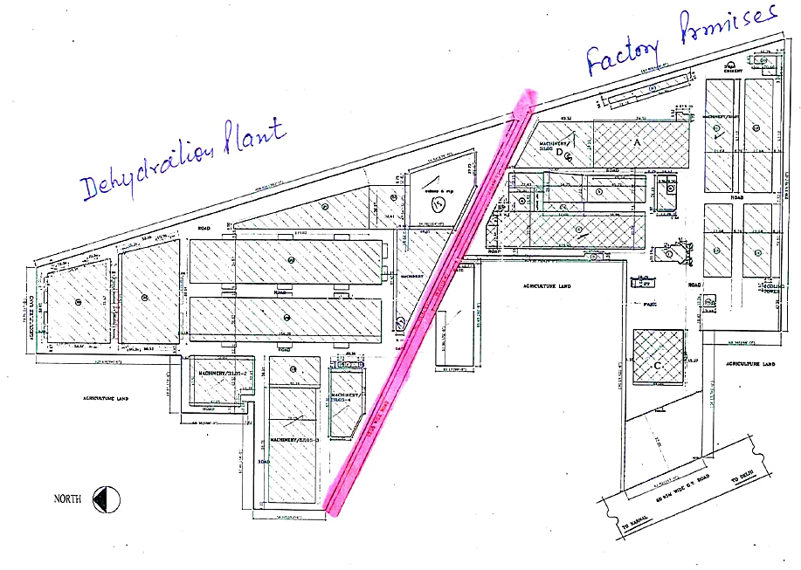
Cirza Map: Below image shows the cirza map shared with us:
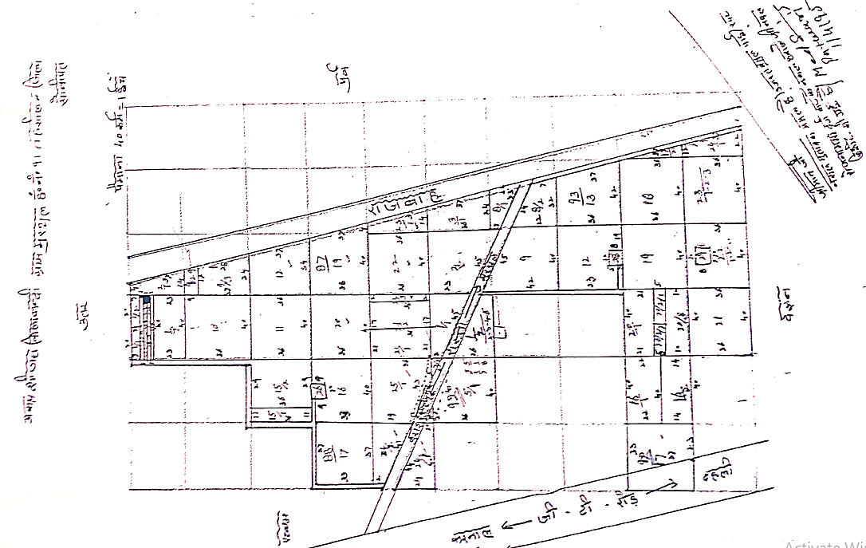
- BAHALGARH PLANT: As per the approved plan shared by the client, below is the layout plan attached:
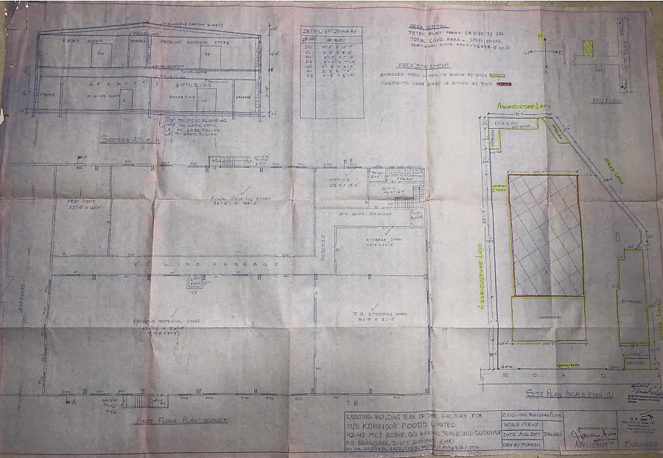

- LOCATION MAP:
- MURTHAL PLANT:
- Google Map: Project location would be 29°02'36.5"N 77°04'10.6"E in Murthal, Sonipat in the state of Haryana and the location as per the Google map has been attached below.
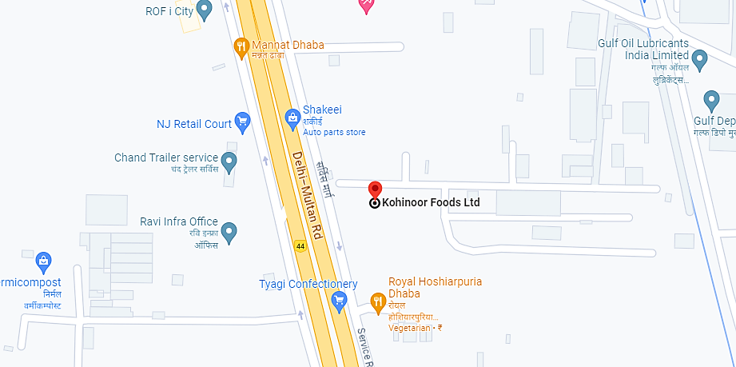
- Google Layout Plan: Demarcation of the land on the Google map is as in the below picture.
Part 1 (referred as Unit I in report)
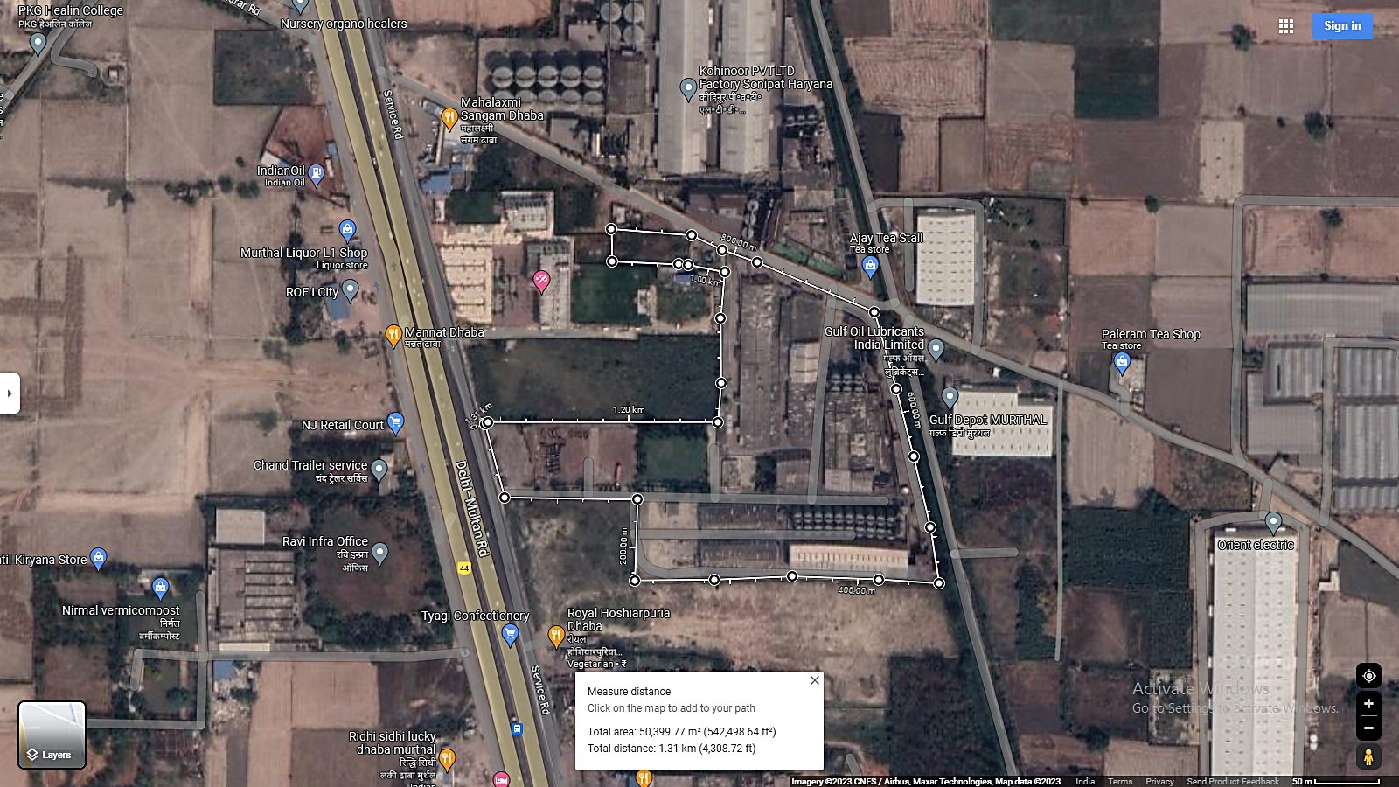
Part 2 (referred as Unit II in report)
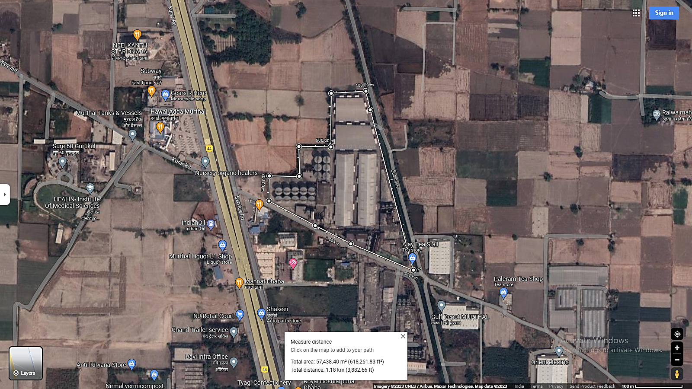
- BAHALGARH PLANT:

- Google Map: Project location would be 28°58'19.1"N 77°05'09.6"E in Bahalgarh, Sonipat in the state of Haryana and the location as per the Google map been attached below.


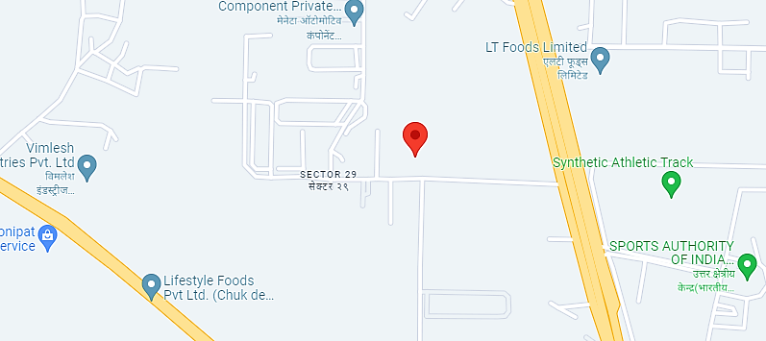
- Google Layout Plan: Demarcation of the land on the Google map is as in the below picture.
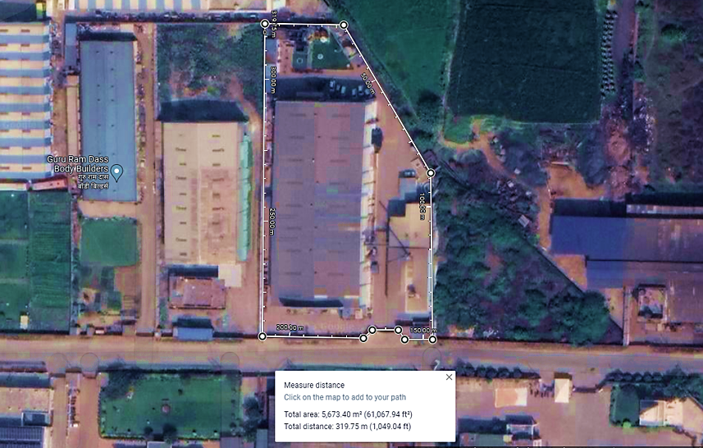

- SITE PICTURES:
- MURTHAL PLANT: Some of the site pictures has been taken during the site survey, are attached below:
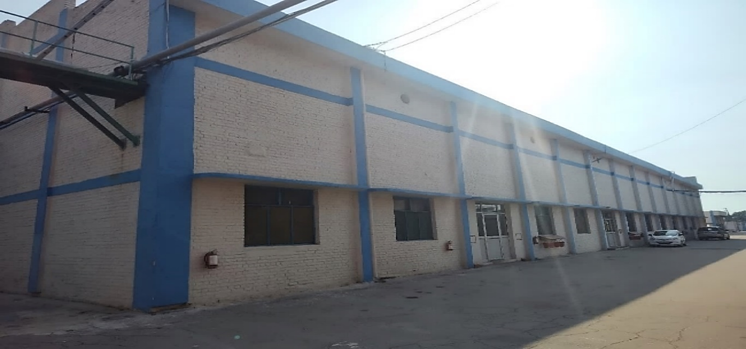 | 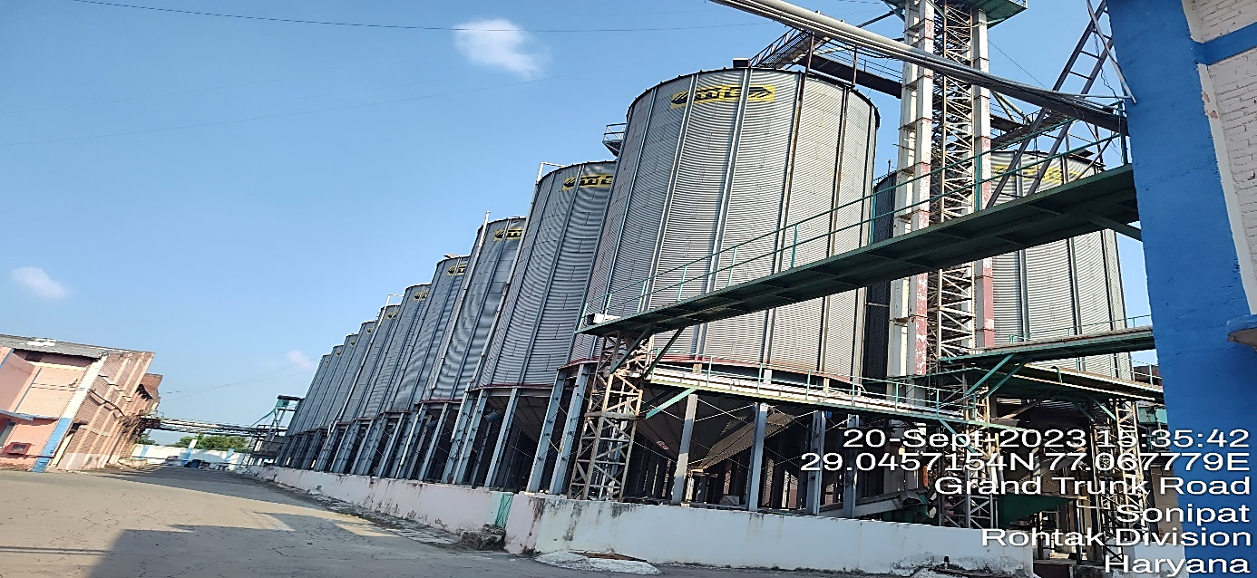
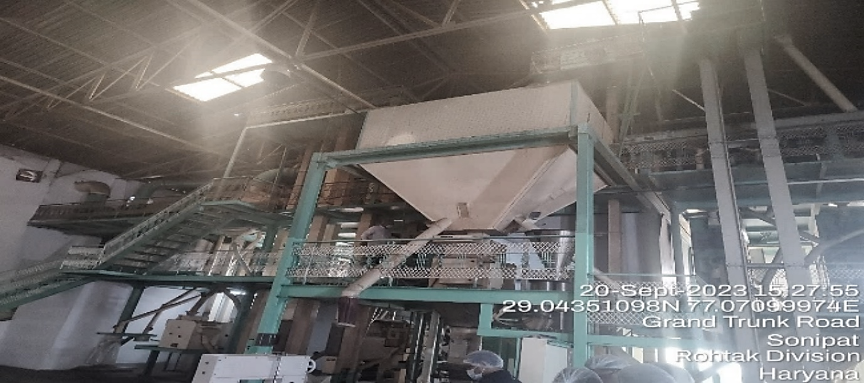 | 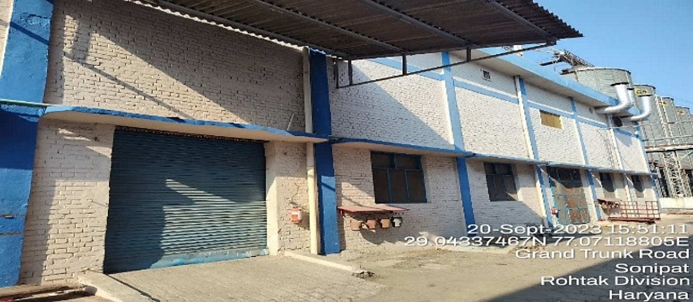
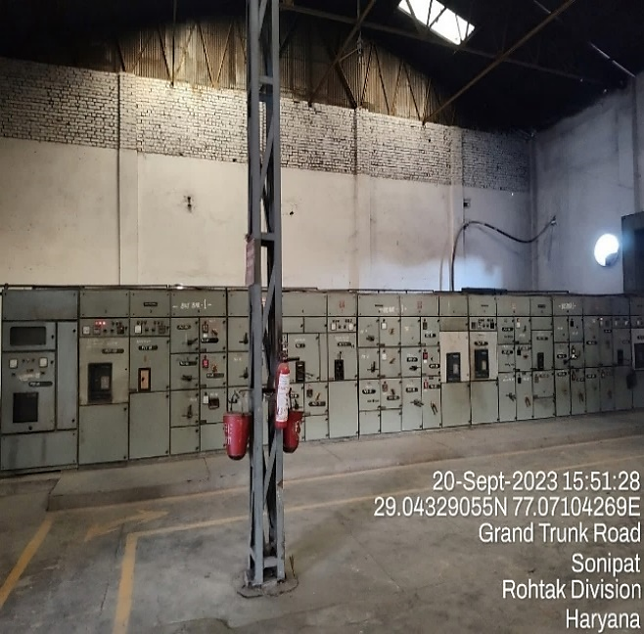 | 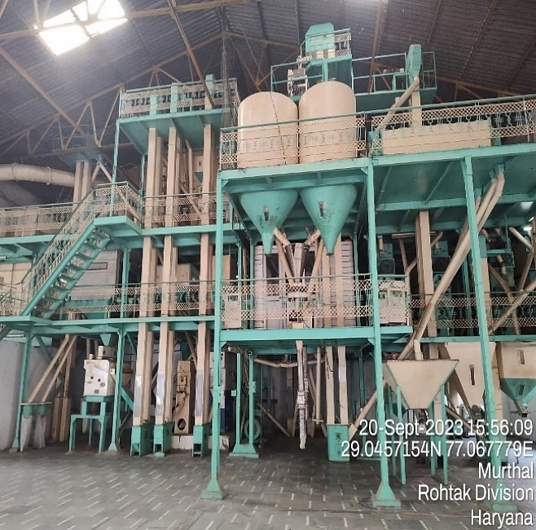
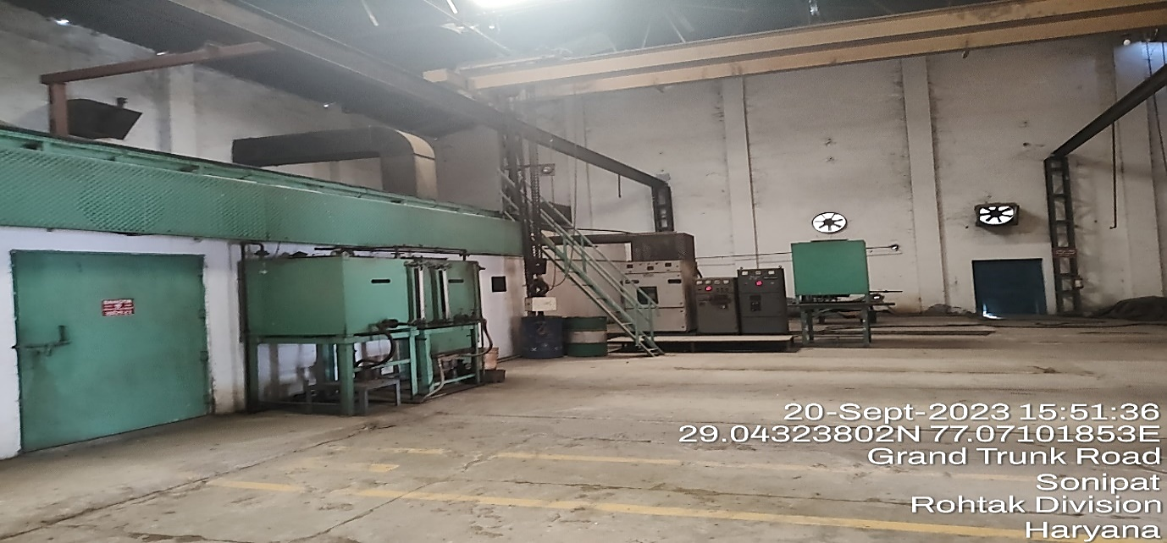 | 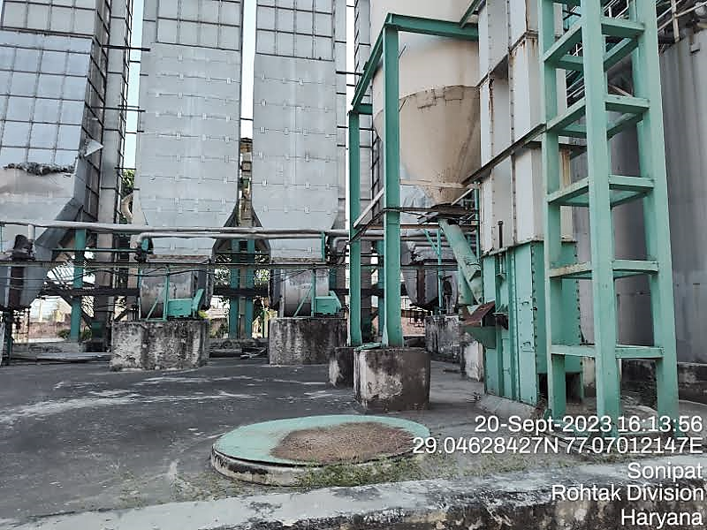
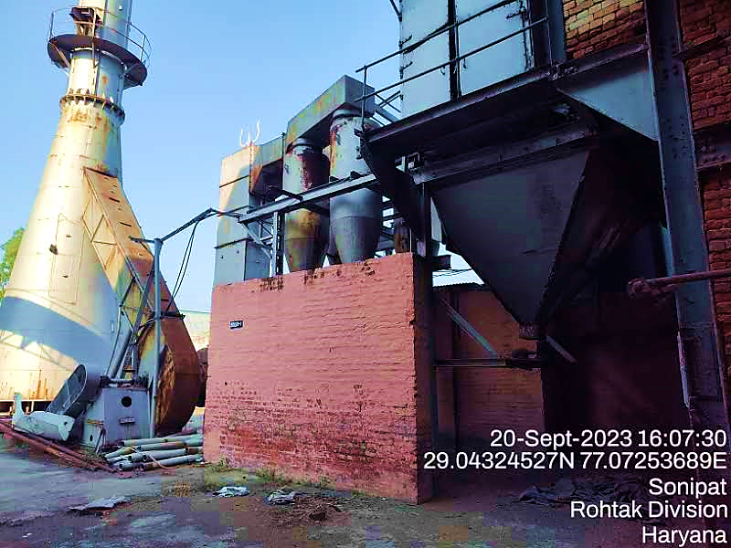 | 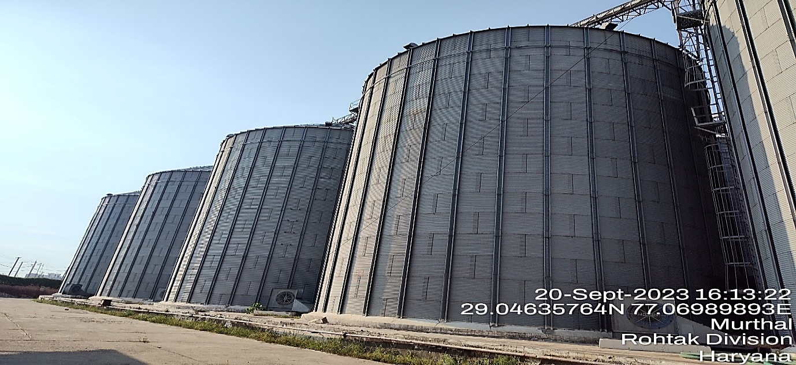
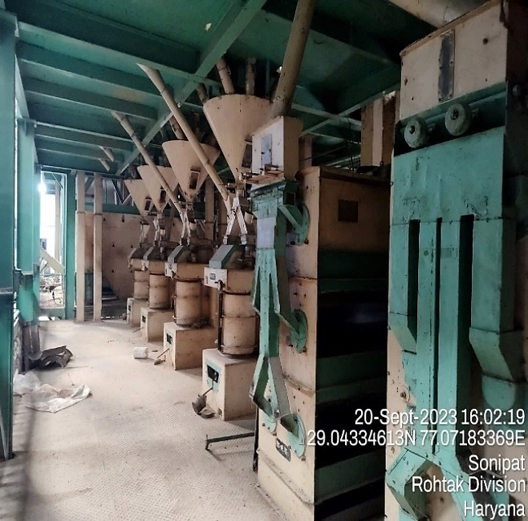 | 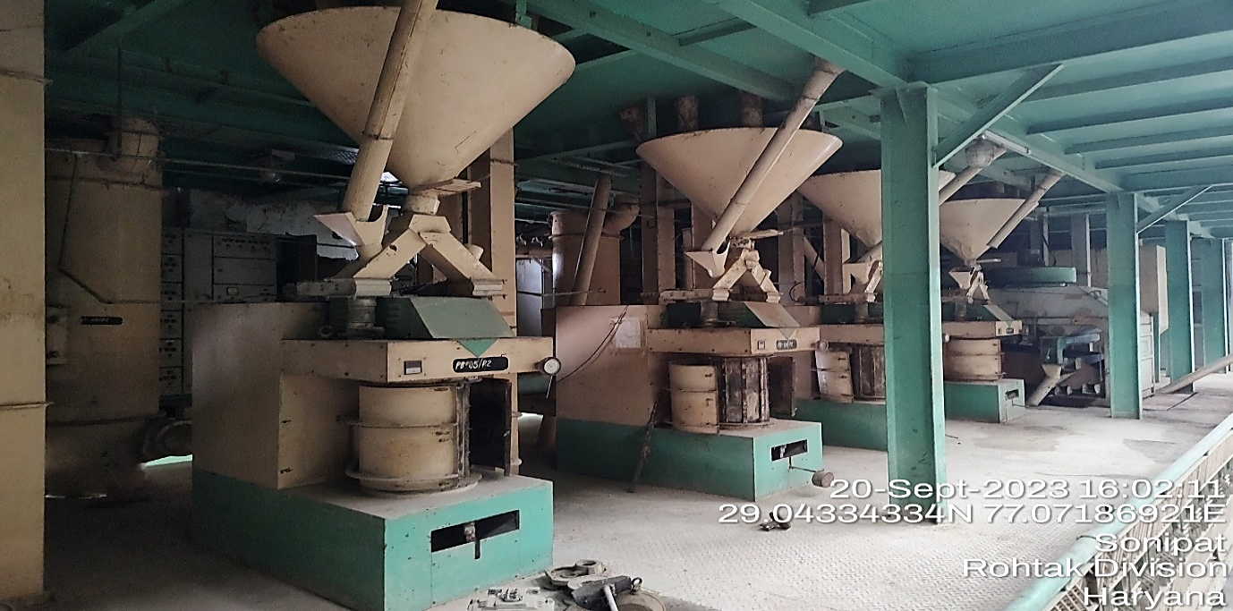
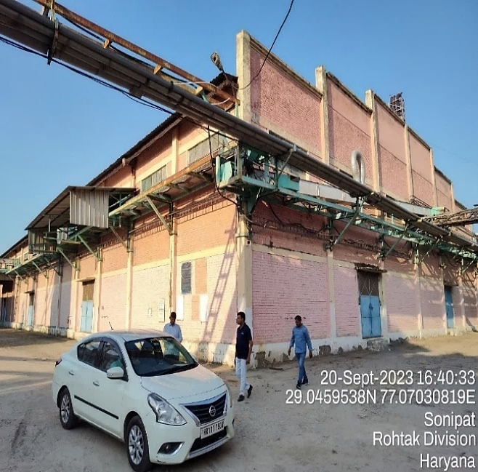 | 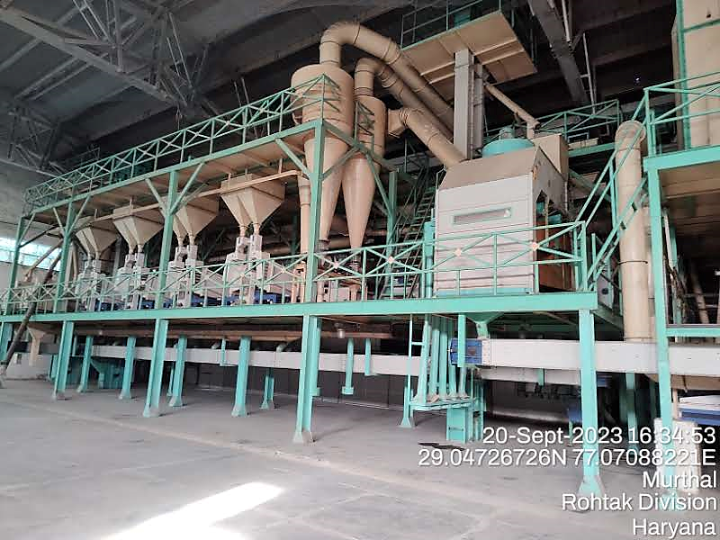
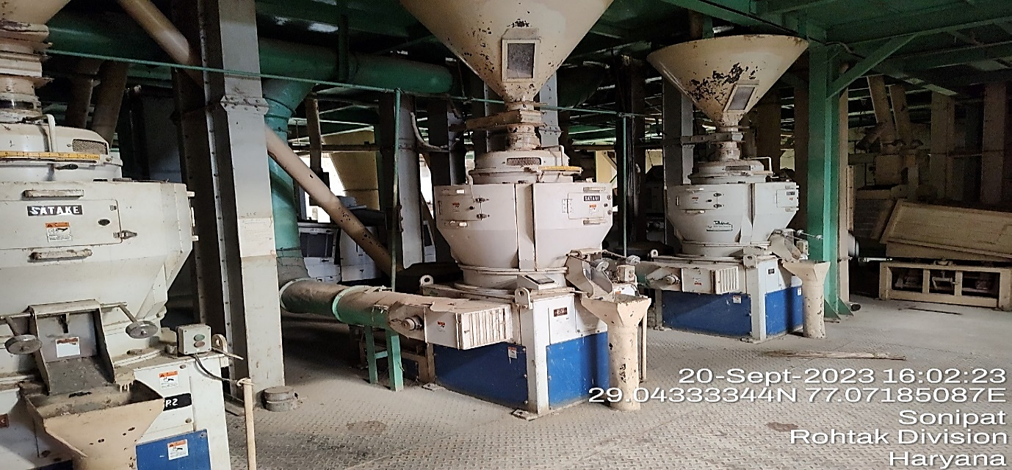 | 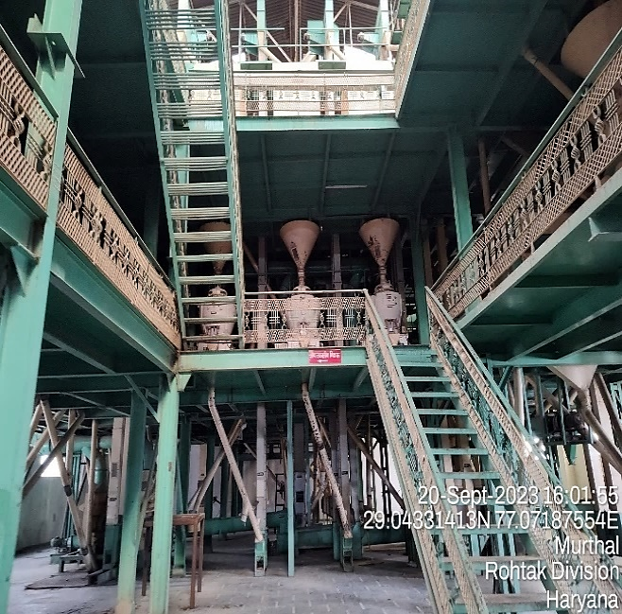
- BAHALGARH PLANT: Some of the site pictures has been taken during the site survey, are attached below:
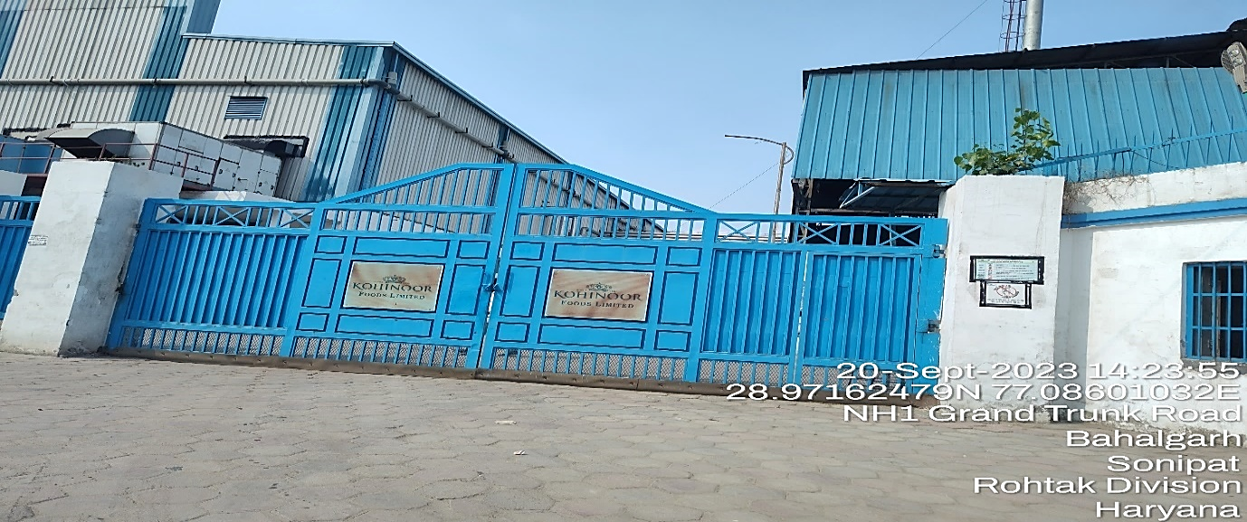 | 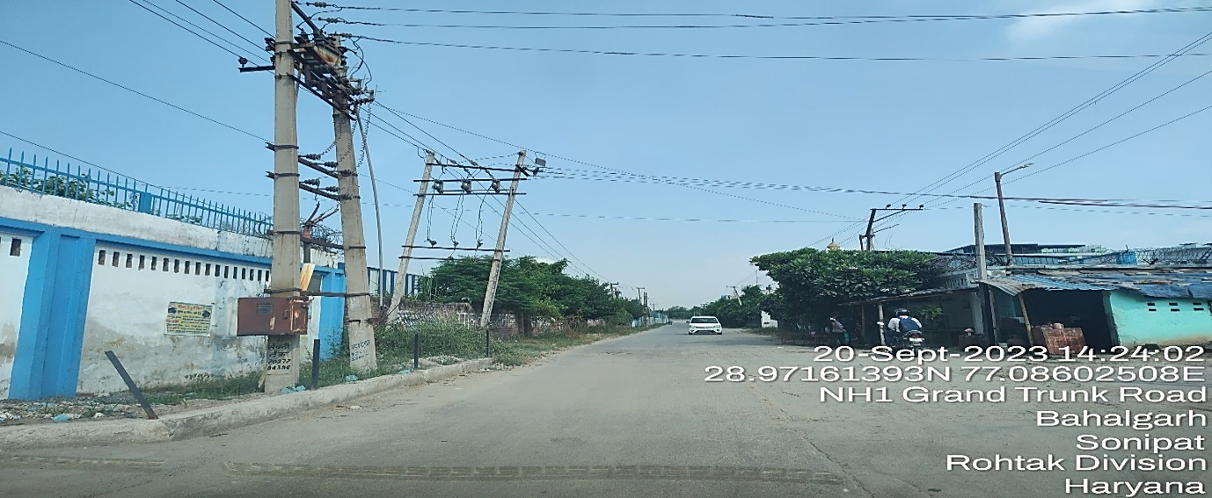
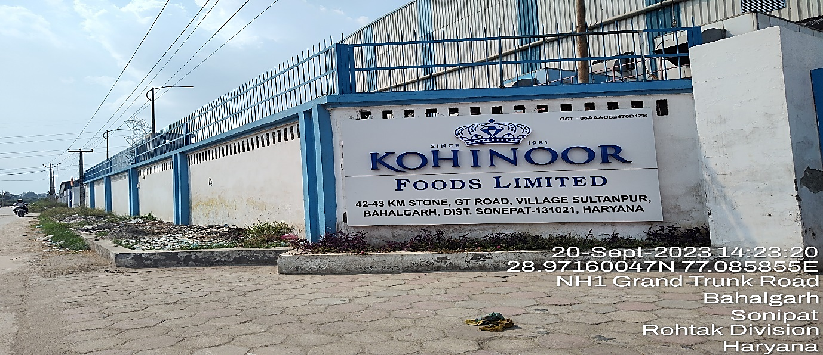 | 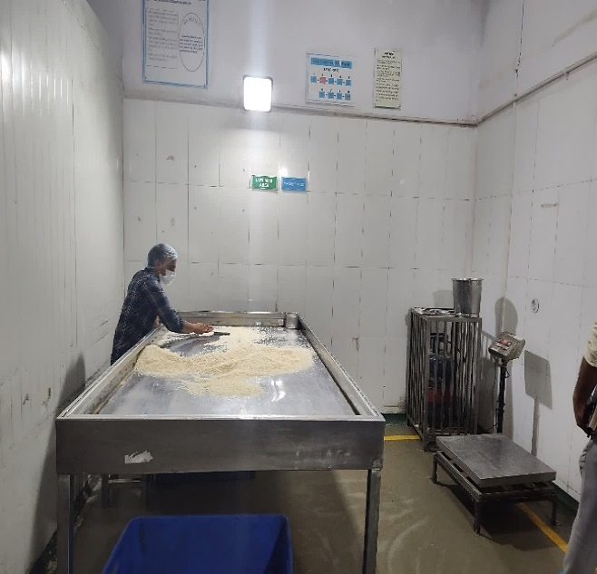
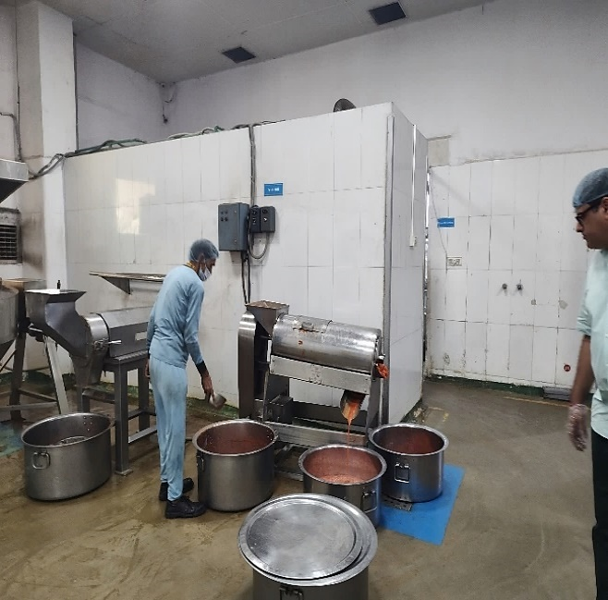 | 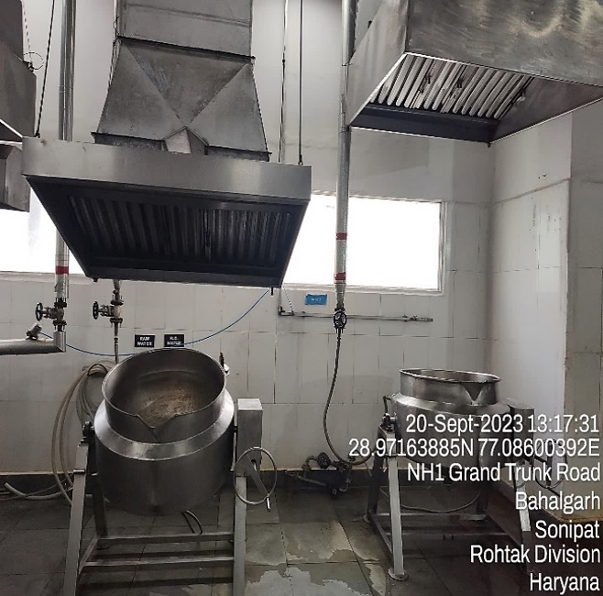
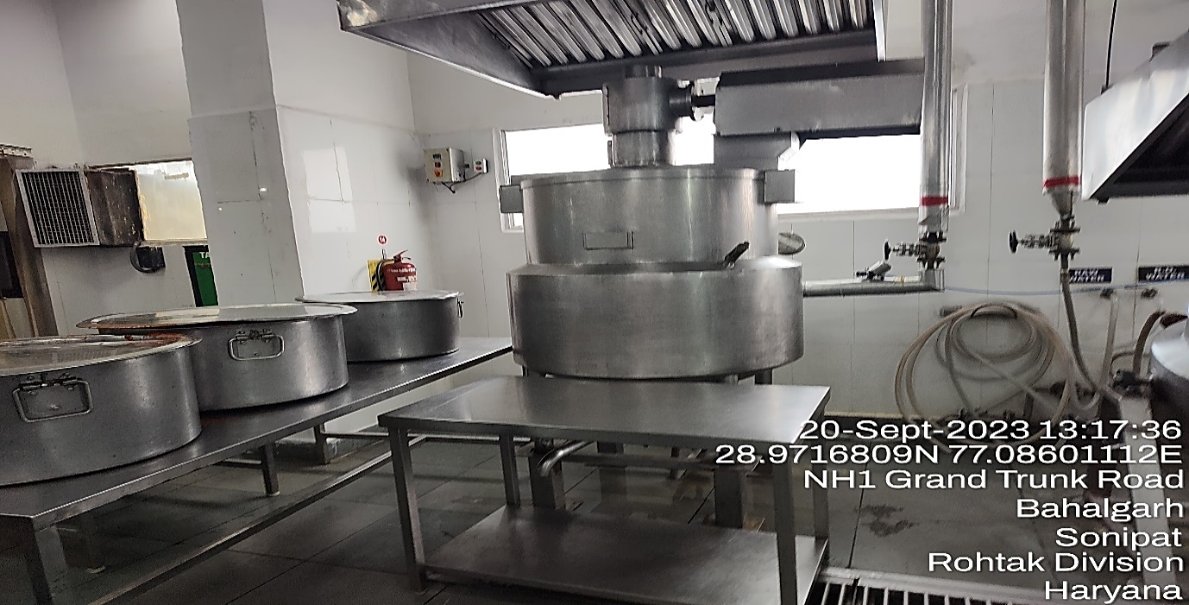 | 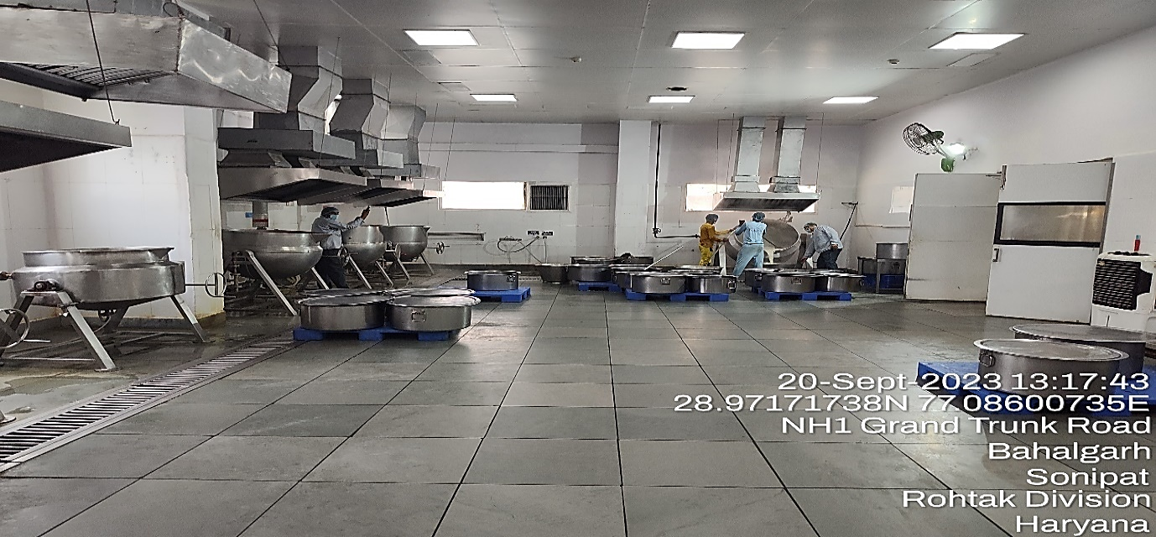
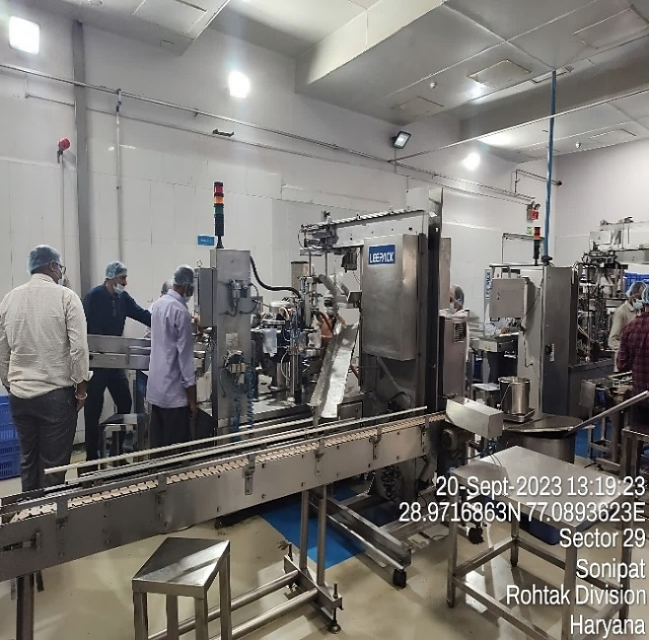 | 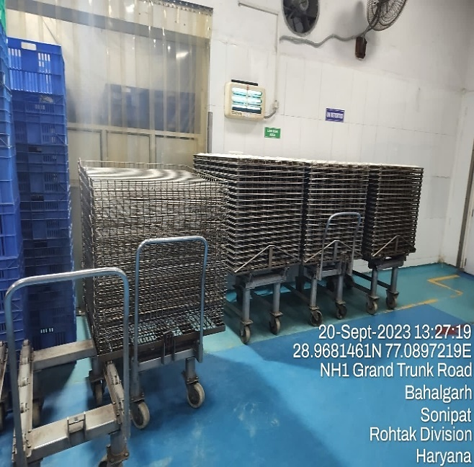
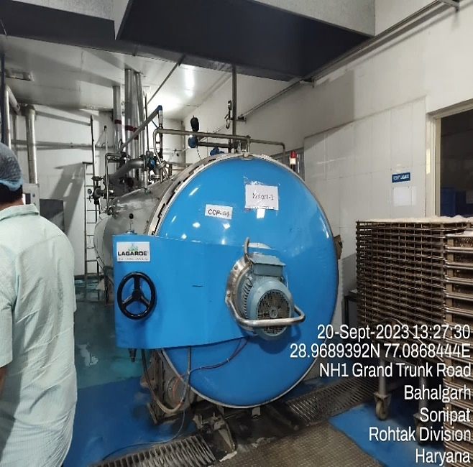 | 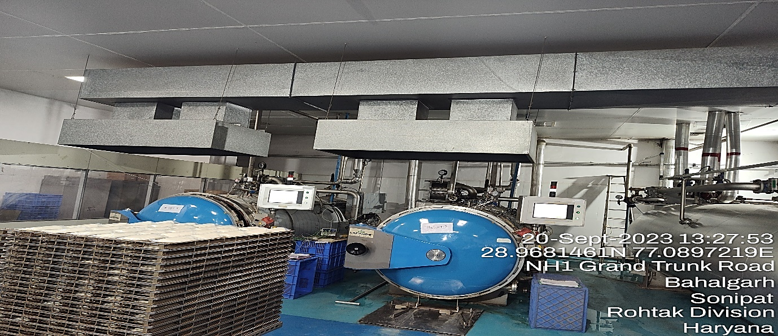
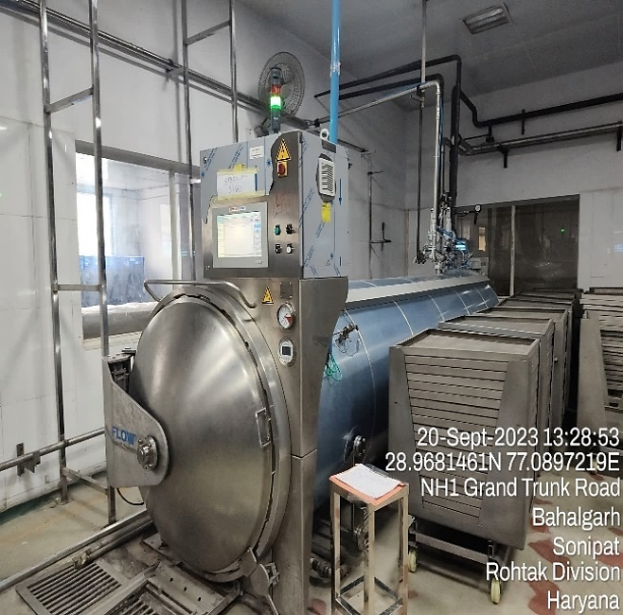 | 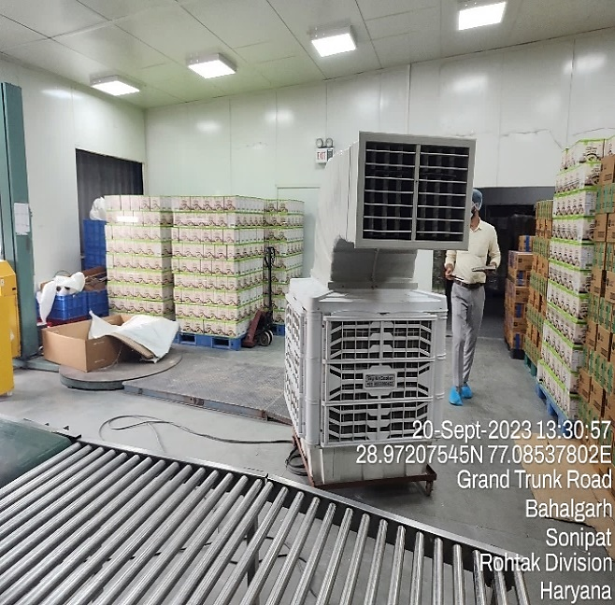
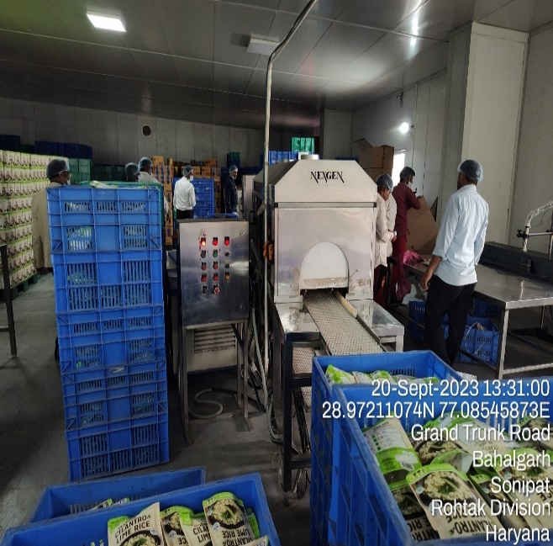 | 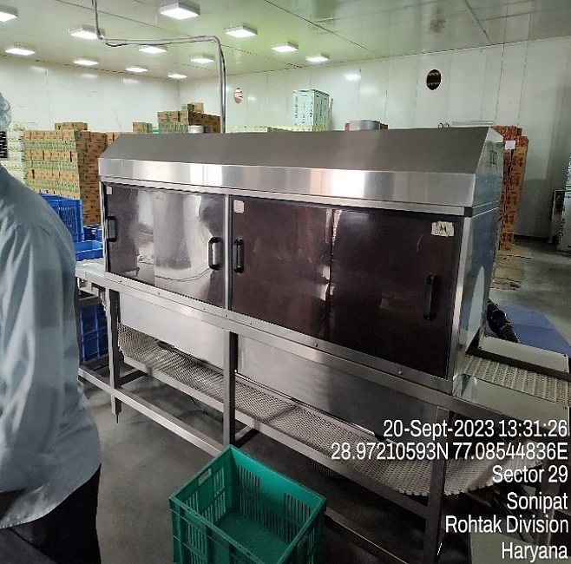
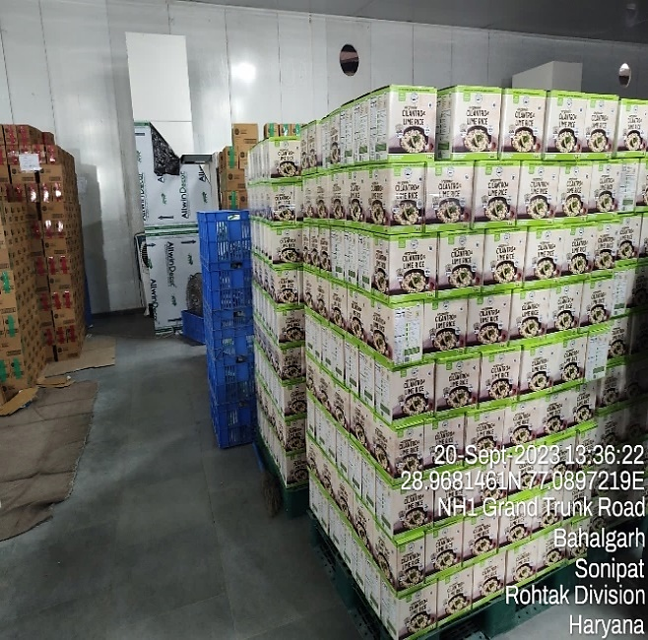 | 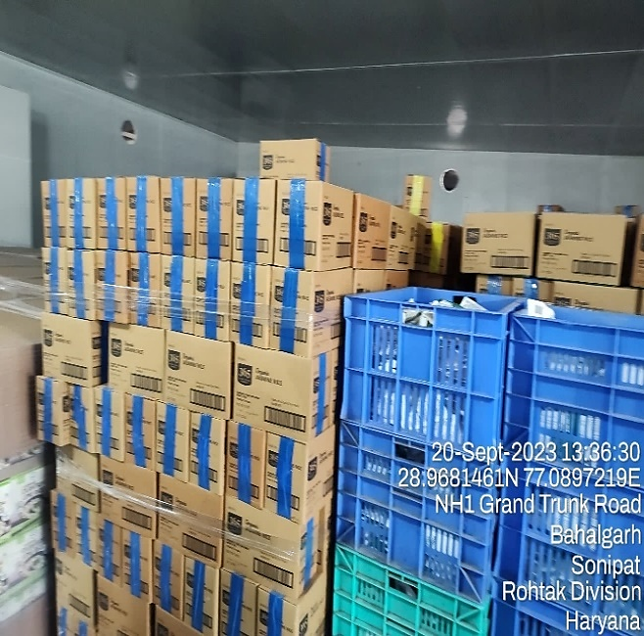
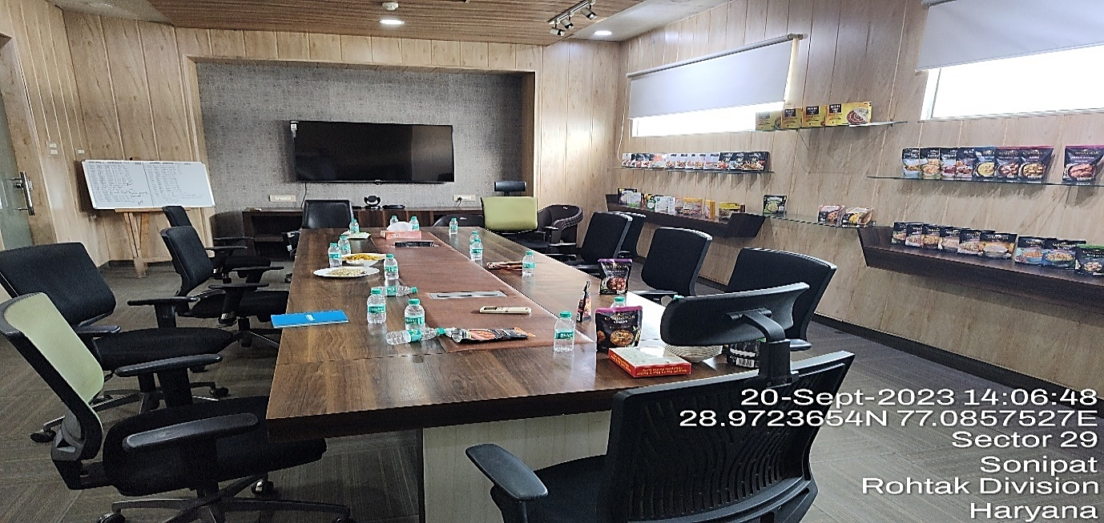 | 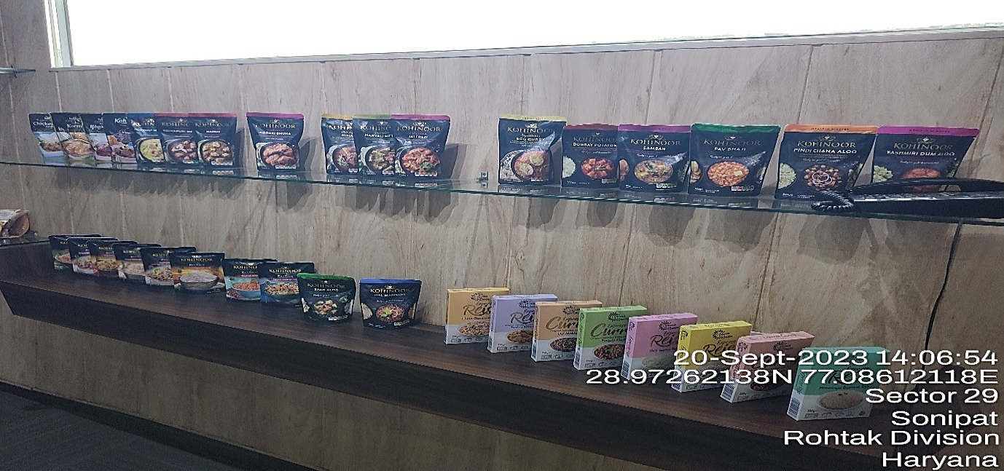
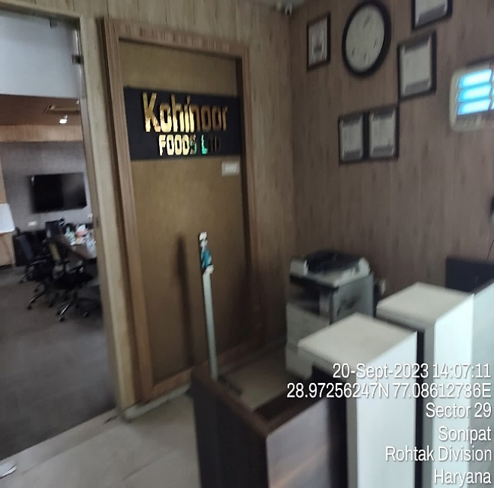 | 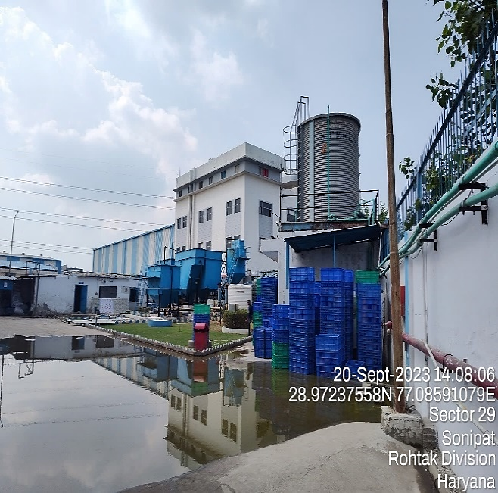
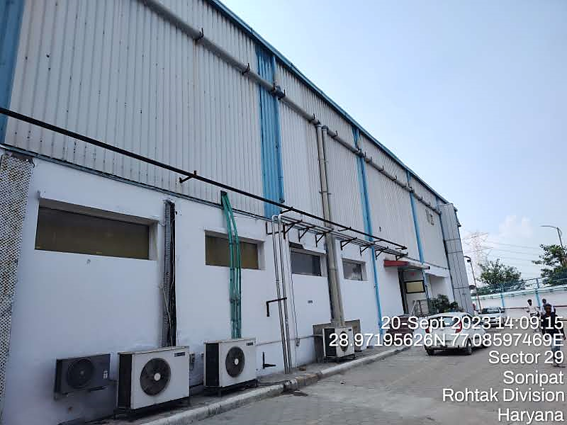 | 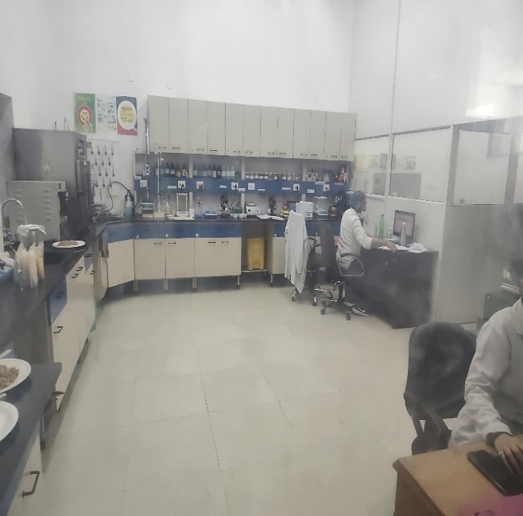

- LAND DETAILS:
- MURTHAL PLANT: The land is freehold in nature having total area admeasuring 25.58 acres purchased by multiple deeds executed since 1990. The subject property is located at M/s Kohinoor Ltd. 50-51 Milestone, G.T. Road, Village: Murthal, District: Sonipat, Haryana in the midst of well-developed area of Murthal, Sonipat. The plant is located on Jammu-Delhi Highway and is about 11 km from Sonipat. Nearest railway station is Sonipat Junction which is about 10.5 km and IGI Airport is about 68 km from the subject property. All other basic civic amenities are within close vicinity.
The fair value of land at Murthal plant is estimated at INR 110.49 Cr. For detailed valuation of the same kindly refer our Fixed Asset Valuation Report (VIS (2023-24)-PL254-213-316).
- BAHALGARH PLANT: The subject property is located at 42-43, Milestone, G. T. Karnal Road, Village Sultanpur, Bahalgarh, Sonipat Haryana, at the aforesaid address having total land area admeasuring 12 Kanal 6 Marla / 6,222.03 sq. mt. / 7,435.33 sq. yds. as per the Sale Deed provided to us. However, as per the order of Honourable High Court of Chandigarh and Haryana, dated 12/09/2018, land area of 2 Kanal 18 Marla / 1,466.98 sq. mt. / 1,753.04 sq. yds. has been granted stay and is not considered for valuation. The total area considered for valuation is 9 Kanal 8 Marla / 4755.05 sq. mt. / 5682.29 sq. yds. The land is located in the midst of Bahalgarh Industrial area. The factory is located ~340 mt. away from Jammu Delhi Road. This property is clearly approached by the internal industrial road. All other basic civic amenities are within close vicinity. This is a free hold land purchased by virtue of a single sale deed dated 21st March, 2018 executed between Mr. Pawan Kumar, Authorized Officer of the Bank of India Consortium (consisting of 9 other banks) & M/s Kohinoor Foods Limited.
The fair value of land at Bahalgarh plant is estimated at INR 8.55 Cr. For detailed valuation of the same kindly refer our Fixed Asset Valuation Report (VIS (2023-24)-PL254-213-317).

- BUILDING & CIVIL WORKS:
- MURTHAL PLANT: The property situated at the aforesaid address having total land area admeasuring 25.58 acre or 1,03,519 sq. mtr. as per documents provided to us. We have also crossed checked the area from google satellite measurement and it seems to match with the area mentioned in the document. As per information received during site survey, it was informed that the land was purchased via multiple sale deeds. Some of the shared sale deeds were illegible. As per copy of CLU the total converted land is 25.58 acre. Thus, the same is considered for valuation purpose. Plant boundary demarcation and accessibility is as follows:
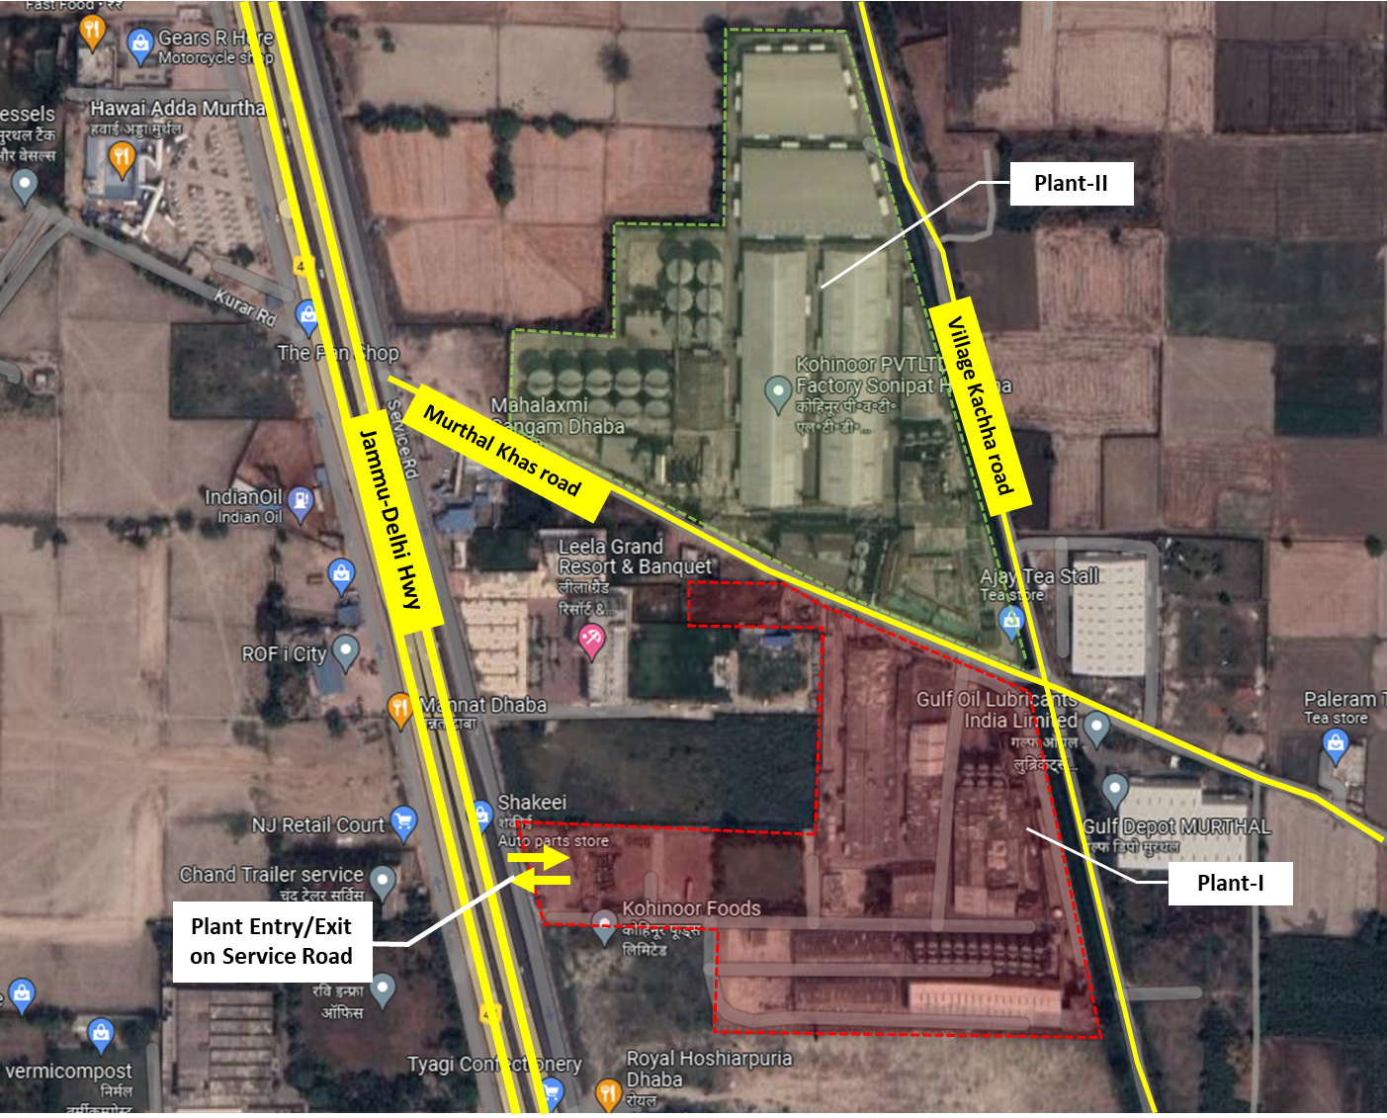
As per observation made during site survey, it was observed that the plant is divided into 2 parts and comprises multiple Shed & Warehouse. Copy of approved sanction plan or building area sheet is not shared with us on request. Thus, we have used satellite measurement tools & physical measurement to determine total built-up area of the plant.
The plant comprises 14 nos. of Rice to Rice and Paddy to Rice plant, warehouses, Admin Office, QA/QC building, etc.
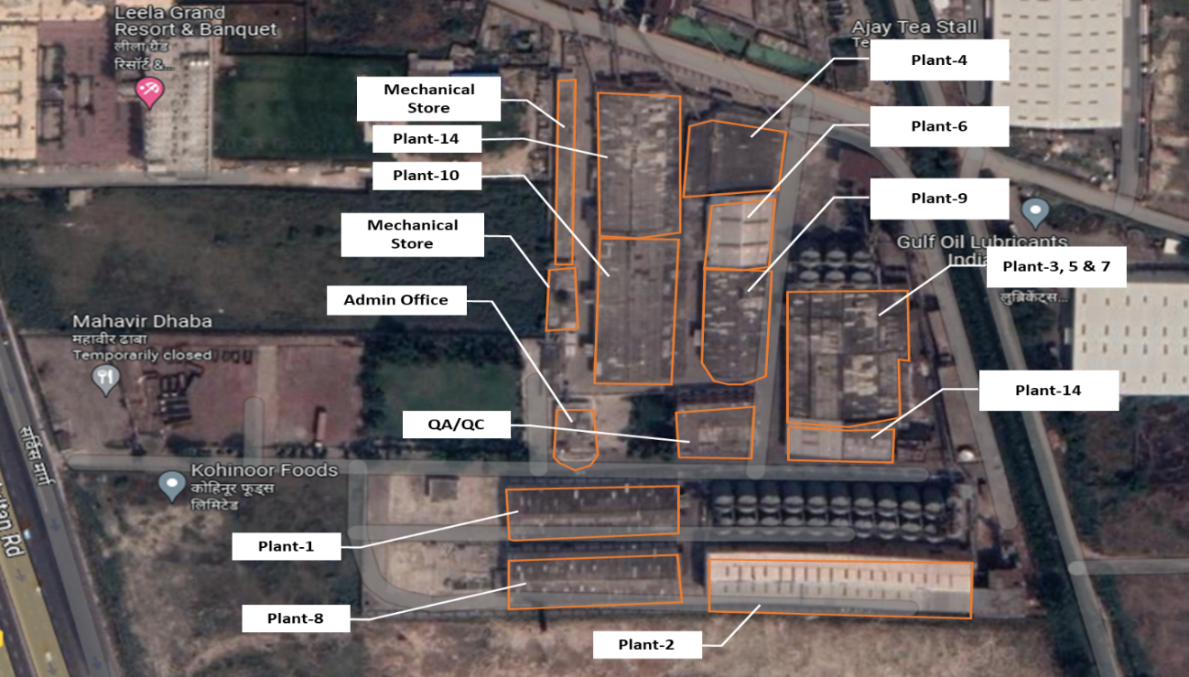
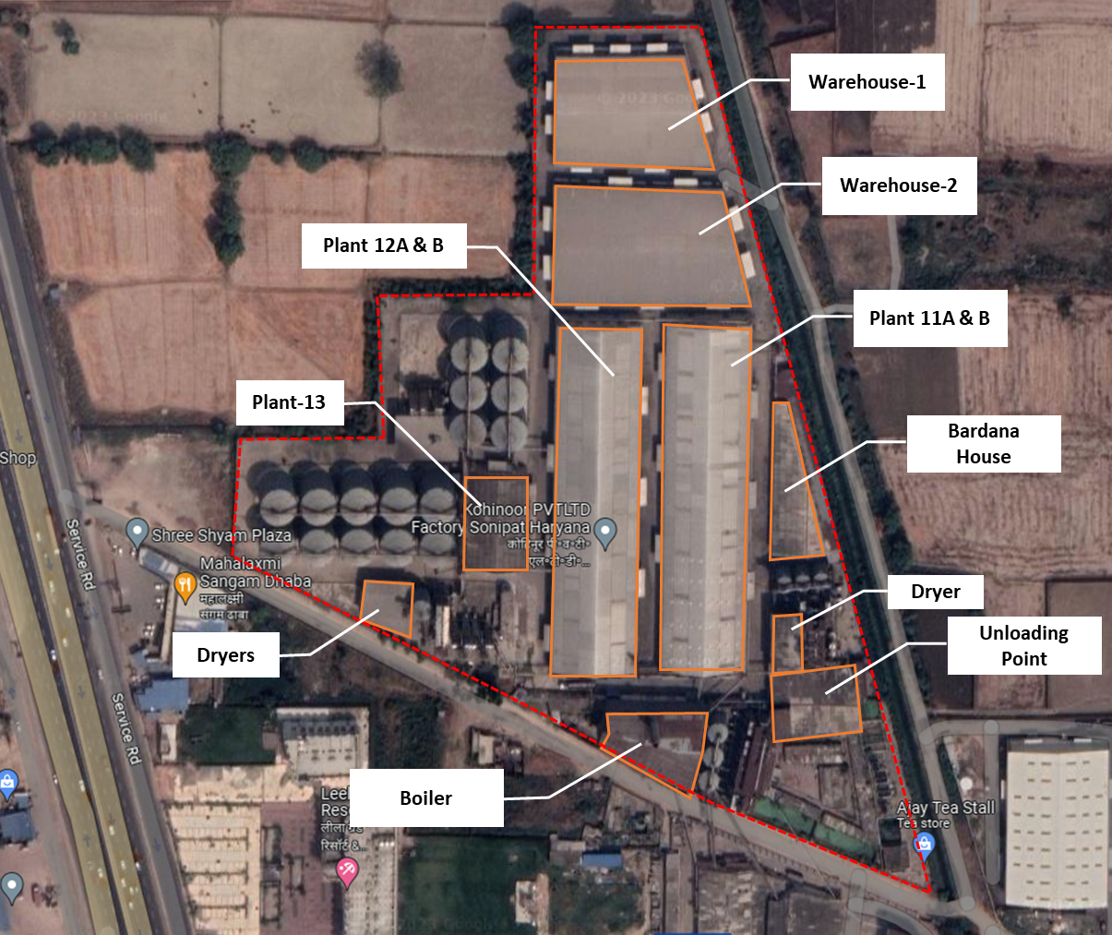
Details of Built-up area of all building/structures measured at site are as follows: -
S. No. | Building Name | Built-up (in sq. ft.) | Type of Structure | Year of Construction  considered | Age  (In Years)
1 | Plant-12 A&B | 64,234 | RCC + Shed | 1990 | 33.00
2 | Plant-11 A&B | 64,234 | RCC + Shed | 1990 | 33.00
3 | Plant-11 | 61,389 | RCC + Shed | 1990 | 33.00
4 | Plant-12 | 61,389 | RCC + Shed | 1990 | 33.00
5 | Warehouse-2 | 44,966 | RCC + Shed | 2010 | 13.00
6 | Warehouse-1 | 33,600 | RCC + Shed | 2010 | 13.00
7 | Plant-3, 5 & 7 | 27,062 | RCC + Shed | 1990 | 33.00
8 | Plant-10 | 22,317 | RCC + Shed | 1990 | 33.00
9 | Plant-2 | 21,303 | RCC + Shed | 2005 | 18.00
10 | Plant-14 | 19,476 | RCC + Shed | 1990 | 33.00
11 | Plant-1 | 13,598 | RCC + Shed | 1990 | 33.00
12 | Plant-8 | 13,598 | RCC + Shed | 1990 | 33.00
13 | Unloading Point | 12,567 | RCC + Shed | 1990 | 33.00
14 | Plant-9 | 12,034 | RCC + Shed | 1990 | 33.00
15 | Boiler | 11,864 | Shed | 1990 | 33.00
16 | Plant-13 | 11,631 | RCC + Shed | 1990 | 33.00
17 | Bardana Store | 11,226 | RCC + Shed | 1990 | 33.00
18 | Plant-4 | 10,513 | RCC + Shed | 1990 | 33.00
19 | Plant-6 | 9,823 | RCC + Shed | 2005 | 18.00
20 | QA/QC | 7,642 | RCC | 2005 | 18.00
21 | Plant-13 | 6,339 | RCC + Shed | 1990 | 33.00
22 | Dryer | 5,369 | Shed | 2010 | 13.00
23 | Store | 4,844 | Shed | 1990 | 33.00
24 | Admin Office | 3,660 | RCC | 2005 | 18.00
25 | Mechanical Store | 2,592 | Shed | 1990 | 33.00
26 | Workshop | 1,475 | Shed | 1990 | 33.00
27 | Weigh Bridge | 969 | RCC | 2005 | 18.00

- BAHALGARH PLANT: The Company has constructed an industrial unit comprised of one main plant, one utility building, one boiler shed and one gate office. The building measurement has been done physically from our end, during site survey. The details of building and civil works at the Bahalgarh location are as follows:
S.  No. | Particulars | Area  (in sq. mt.) | Area  (in sq. ft.) | Type of  Construction | Year of  Construction
1 | Main Plant | 2,243.80 | 24,152 | RCC + Shed | 1999
2 | Utility Building | 193.06 | 2,078 | Shed | 1999
3 | Boiler Shed | 276.21 | 2,973 | Shed | 1999
4 | Gate Office | 41.00 | 441 | RCC | 1999
TOTAL |  | 2,754.07 | 29,645

As per the information shared with us and collected during the survey, the expected remaining useful life of both plants is in the range of 8-12 years subject to the regular repair and maintenance and technological upgradation of both units, if and when needed.

- PLANT AND MACHINERY/ EQUIPMENTS DETAILS: For detailed description of the plant & machinery at both the locations kindly refer to our Fixed Valuation Report (VIS (2023-24)-PL254-213-317 & VIS (2023-24)-PL254-213-316).

- UTILITIES: Details of Water, Electricity and other utilities are describing as below:
- MURTHAL PLANT:
- Electricity: For Unit I, 2820 KW is sanctioned load for the plant and for Unit II, 1050 KW is sanctioned load for the plant. The company also has DG sets for both units, for Unit I, the company has 2 DG sets of 1450 KWH each and 2 DG sets for 380 KWH each. Unit II has 1 DG set of 1450 KWH and 380 KWH each.
- Water: As per the information provided by the company, the murthal plant’s water requirement is 50,000 litres per day.
- ETP (Effluent Treatment Plant): The plant has an effluent treatment plant with a capacity of 5,00,000 Litres installed within its premises.
- STP (Sewage Treatment Plant): The plant has a sewage treatment plant with a capacity of 1,00,000 Litres installed within its premises.
- BAHALGARH PLANT:
- Electricity: The factory located at Bahalgarh, Haryana has sanctioned load of 495 KVA from UHBVN. Apart, from this company also has 1 DG set of 325 KVA and 180 KVA each installed at the location.
- Water: The factory has ground water requirement of 50 KLPD. It has also installed a RO Plant with a capacity of 10,000 KL/hr.
- Cooling System: The Plant has two cooling systems of 120 Tonne Refrigeration (TR) and 80 Tonne Refrigeration (TR).
- ETP (Effluent Treatment Plant): The plant has an effluent treatment plant with a capacity of 40 KLPD installed within its premises.
The utilities at both the plants seems to be adequate for the current operating capacities of the plants, if and when the company will be able to increase its operating capacity levels, it might be required to increase its level of utilities available at both the locations.
PART E | TECHNICAL ASSESSMENT OF THE COMPANY

- CAPACITY OF MANUFACTURING FACILITY: Below table shows the existing capacity for both the Murthal Plant and Bahalgarh Plant:
Plant | Location | Unit | Installed Capacity
Rice Plant | Murthal, Sonipat | M.Ton per Annum | 2,50,000
Food Factory | Bahalgarh, Sonipat | Pouches | 18 million

- PROCESS FLOW CHART FOR RICE PLANT: As per the information shared by the company, below diagram shows the process flow chart for murthal plant:

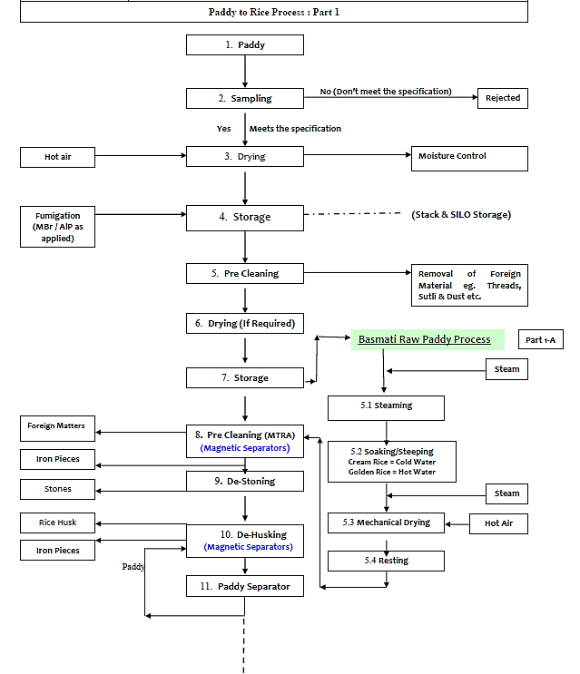
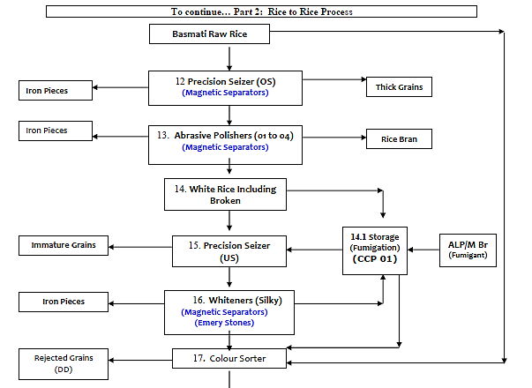

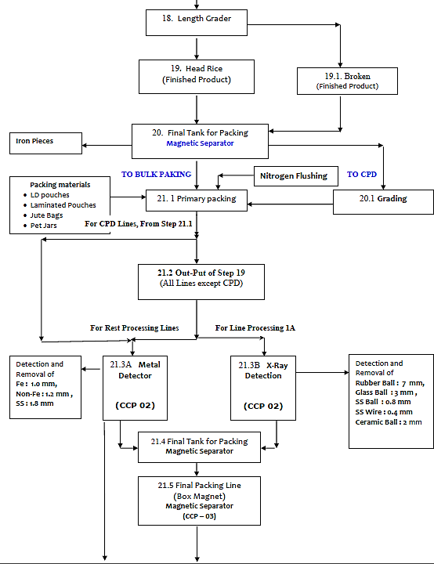
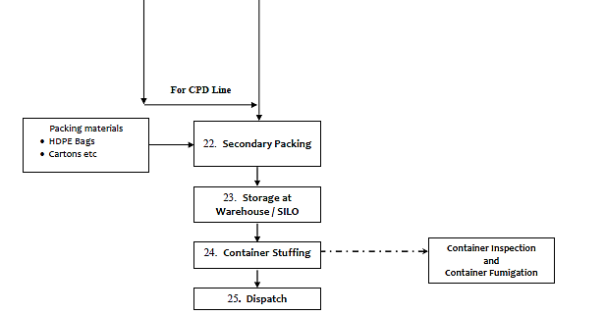

Steps 14.1, 21.3A & 21.3B are critical control points, which are essential to prevent or eliminate a food safety hazard or reduce it to an acceptable level.

- PROCESS FLOW CHART FOR FOOD PLANT: As per the information shared by the company, below diagram shows the process flow chart for bahalgarh plant:
- For RTC Indian Curries:
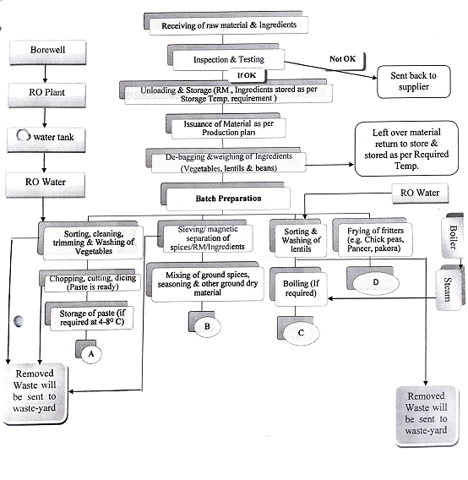
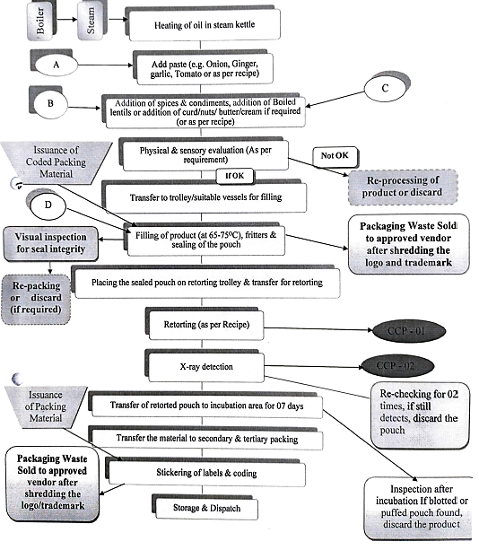
- RTC Micro Rice & Grains:
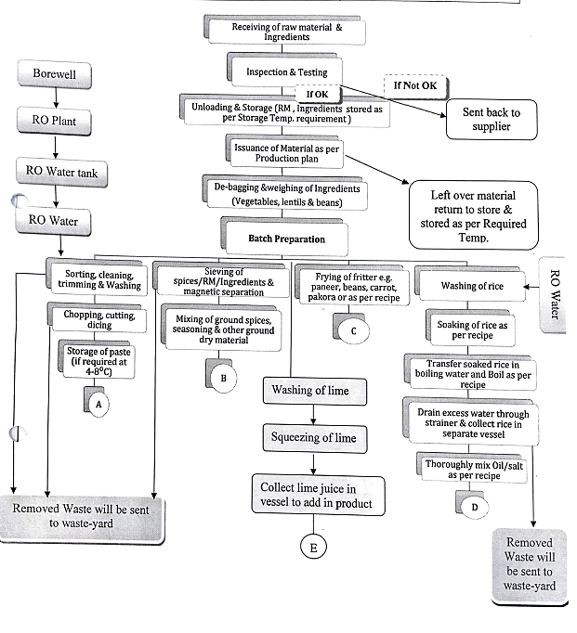
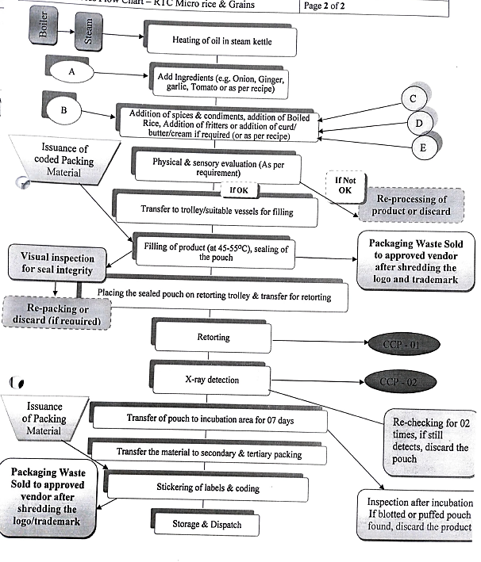

- TECHNICAL SPECIFICATIONS/TECHNOLOGY USED:
- MURTHAL UNIT: The Rice Plant located at Murthal, Sonipat, Haryana which is spread over an area of 25.58 Acres as per the information shared with us. In India, rice milling systems can be a simple one or two-step process, or a multi-stage process.
- One step milling - In this step, husk and bran removal are done in one pass.
- Two-step process - In this step, removing the husk and removing bran are done separately.
- Multistage Milling, which is used in the Murthal Plant in which rice undergoes a number of different processing steps, such as:
- Pre-cleaning: The pre-cleaning process consists of two procedures, cleaning and de-stoning. Paddy cleaner is used to separate all the impurities like dust, straw, sand, clay and heavy particles of even uneven sizes from paddy.
- Dehusking or dehulling: In this step, the husk and bran are removed from the paddy rice.
- Paddy separation: Rice separator separates the unhusked paddy from the brown rice.
- Whitening or polishing: Rice Milling is the process that helps in the removal of hulls and brans from paddy grains to produce polished rice. White rice is the result of further milling by machines that rub the grains together under pressure. The abrasion removes the bran, revealing white or polished rice.
- Grading and separation of white rice: In the step, the immature grains are separated, a more precise adjustment of the huller can also be done here to minimize breakages.
- Mixing: A good rice mill will produce 50−60% head rice (whole kernels), 5−10% large broken and 10−15% small broken kernels. Depending on country standards, rice grades in the market will contain from 5−25% broken kernels. If rice mixing is to be done properly, then a volumetric mixer is necessary
- Mist polishing: Mixing a fine mist of water with the dust retained on the whitened rice improves the luster of rice (polishes) without significantly reducing milling yield. A friction type of whitening machine, which delivers a fine mist of water during the final whitening process, is used for “final” polishing before sale.
- Weighing of rice: Preparing the milled rice for transport to the customer.
In the milling process, produces white rice removes much of the vitamins and minerals which are found primarily in the outer bran layers. Basmati Rice Exporters in India replenished the rice with some important nutrients and vitamins to make it more suitable for consumption.

LATEST/MODERN TECHNOLOGY:
RICE HULLING: Hulling machines and methods can be classified based on the scale of milling and the types of machines used to mill the rice. There are several types of machines that are used to remove the husk. Traditionally the husk was removed using mortar and pestle. This process involves pounding the rice grains using long pole in a basin. This breaks up the husk and dissociates it with the bran. The husk and bran are later separated by winnowing them manually.
The first mechanised milling machine is the Engelberg huller. It was invented by a German Brazilian engineer Evaristo Conrado Engelberg and patented in 1885. This machine was capable of milling and polishing the grains simultaneously. It uses a steel roller to grind the husk away and polish the rice. Due to its poor efficiency, it has been discontinued.
The next development in rice milling is the two-stage milling machine. The first set of wheels hulls the paddy and the second set of steel wheels polish the rice by applying pressure on the rice to remove the bran. Alto precision manufactures highly efficient compact 2 stage mills with 100 kg/hr capacity that can run on solar energy with battery backup.
As volume of rice to be milled increases multistage husking mills are used. These machines are capable of cleaning, husking, polishing grading, bagging and managing the rice and it’s by products. Alto precision manufactures small scale multistage mills that are capable of process white rice, brown rice and semi polished rice.
There are different mechanisms for de-husking paddy. The first type is the steel huller which hulls and polishes the rice. In this machine the grains pass between a revolving steel shaft and a cylindrically shaped fixed metal grate. The second type is the under-runner disc sheller. It consists of two steel discs that have an abrasive coating. The upper disc to the housing and the lower disc is capable of rotating.
Rice is fed through a centrally placed hopper that feeds the between the wheels. The husk is removed by the emery coating through abrasion.
The third type is the rubber roller huller. In this mechanism the rice passes in between two rubber belted wheels the distance between the wheels can be adjusted as per the size and variety of the rice. As the rice passes through the wheels the hull is cracked and removed. An air aspirator sucks and removes the husks from the bran.

RICE POLISHING: There are primarily many types of polishers namely - metal polisher, abrasive polisher, cone polisher and friction polisher.
The metal polisher induces friction between the individual rice grains to remove the bran. This method removes the bran in large flakes when compared to the abrasive polisher. The abrasive material in the abrasive polisher acts like multiple blades that cut away the bran as the grains pass by the polisher.
The horizontal abrasive polisher consists of an abrasive cylinder disc attached to a steel shaft which rotates in a perforated cylindrical metallic screen mounted horizontally. This polisher is also called a primary polisher. Brown rice that is fed into the system passes through the clearance between the silicon carbide abrasive roller and the perforated steel cylinder, towards the discharge end. As the grain passes through the space between the roll and the perforated screen, bran layers are peeled off from the grain. Bran passes out through the screen and the polished rice is discharged through the outlet.
In the vertical up flow abrasive polisher, the rice grains are pushed upwards. The rice grains are transported through a horizontal conveying screw and pushed up with a screw roll into the abrasive section. In the vertical down flow type machines, rice is forced down the machine using gravity. The grains are then polished by a cylindrical emery grindstone. The pressure on the grains is controlled by hanging different weights on the discharge gate. The abrasive cylinder is formed in the same way as that used in the horizontal abrasive mill. Air is sucked through the mill stock as the grains are polished. This prevents heating, reduces breakage, and keeps dust out of the mill.
The vertical friction polisher consists of a cylindrical steel roller rotating inside a perforated screen. Semi-polished rice is fed into the milling chamber by the feed conveyor. The pressure inside the milling chamber (degree of milling) is adjusted by putting loads at the outlet gate. Rice passes from the bottom to the top and is whitened using friction. Polished rice is discharged at the outlet. The bran which is removed is sucked through as it comes out. The high-pressure air lowers the operating temperature at the milling chamber, makes removal of bran easier and reduces breakage.
The horizontal friction polisher consists of a cylindrical steel roller rotating inside a hexagonal perforated screen. The cylinder has a long slit along its length and a hollow shaft for passing air. The clearance between the screen and cylinder is adjustable by opening or closing the screen. The pressure on the rice is further controlled by hanging weights on the discharge gate. A strong stream of air is blown by a centrifugal blower through the hollow shaft and long slit of the cylinder. The air helps in separating the bran and removing the heat generated by the friction between each grain of rice.
There is also a special type of a vertical polisher called the cone polisher. The whitening cone consists of an inverted truncated cast iron conical rotor covered with an abrasive material like emery. Mounted on a vertical spindle, the cone revolves inside a crib. The crib is lined with a steel wire cloth or perforated metal sheets, and is provided with vertically and equally spaced rubber brakes which protrude into the interstitial gap between the cone and the crib. Brown rice that enters at the top of the rotor moves outward, due to the centrifugal force, towards the annular space and is dragged along by the rough surface of the rotating cone.
Grains are scoured by the abrasive surface of the cone, and also by the friction caused as grains are rubbed against the surrounding walls and lining of the grate. The grains revolve around the cone in the gap until their own weight causes them to sink lower and finally the rice is discharged at the bottom of the cone. The bran layers are allowed to pass through the openings in the grate.
Currently automated plants are going on and prominent in the market which are technologically advanced and more efficient in the line. The government started urging that ‘Rice mills must modernize to meet global quality standards. Modern techniques and investments flew in this sector, as believed by experts of the industry. With huge investment followed by huge demand, the government had to create policies favouring modern mills.
With that, ‘modern rice milling machines’ as they were called started showing their magic. The private sector backings had a huge effect on the industry. Some new technologies introduced in today’s milling machines are:
- Use of Rubber roller technology for husking
- Two-stage whitening process
- Use of Paddy separators
- Old stone disk hullers, vertical cone polishers have been replaced by emery-coated cylinders, friction-type whitener polisher, and dry & wet mist polishers.
- Milled rice is now graded
- Automated plants from Germany & Japan are the new market trends.
- Skilled operators, good paddy quality, maintenance of machines set the tone for high-quality outputs.
The use of NUE (Nitrogen Use Efficient) technology has been encouraged. This increases & doubles plant growth and yield. Turbo & extractive milling speed up the process. The biggest feature of the new machines is their ability to save energy.
The latest technology has adopting Rubber roller technology for husking and paddy separators in a 2-stage whitening process, replacing old equipment with emery-coated cylinders, friction-type whitener polisher and dry & wet mist polishers.
Modernisation is necessary and it has improved the milling yield and quality. This latest technology led to better yields and lesser losses. The productivity and efficiency also increase with this technology. This is the latest computer-aided design which enables us to get higher quality rice and earn profit. These machines are based upon the ultra-modern energy saving technologies.
- BAHALGARH UNIT: The food factory located at Bahalgarh, Sonipat, Haryana which is spread over an area of 5,682.29 sq. yds. as per the information shared with us. The food factory mainly uses Thermal Processing which is a method of preserving food through heat treatment in a sealed container/pouch. This process is commonly used for canning various types of food products, including vegetables, fruits, meats, and ready-to-eat meals. The primary goal of thermal/retort processing is to kill or inactivate harmful microorganisms (such as bacteria, yeasts, and molds) that can cause spoilage or foodborne illnesses while also extending the shelf life of the food
The steps followed in the thermal processing process are as follows:
- Preparation: The food is prepared by washing, peeling, cutting, and sometimes blanching or cooking before being placed into containers. The containers used are typically metal cans or glass jars, which are sealed to create a hermetic seal.
- Filling: The prepared food is filled into the flexible multi layered (Aluminium, PET, CPP) retortable pouches, leaving a specific headspace to accommodate expansion during heating. As per the information shared with us during survey, the packaging material is imported from Korea. These packets have 3 layers (Aloxpet / Nylon / CPP) which are microwaveable and are used for every product of the factory except cooking sauces, whose packaging pouches contains an extra layer of Aluminium which makes the packet non-microwaveable.
- Sealing: The pouches are sealed tightly to prevent the entry of air and microorganisms. The sealing method can vary, but it must create an airtight seal.
- Thermal Processing: The sealed pouches are then subjected to heat treatment. This is usually done in a retort chamber, which is a large, pressure-cooker-like vessel. The heat treatment involves heating the pouches to a specific temperature for a predetermined period. The temperature and time parameters depend on the type of food being processed and the desired shelf life. The thermal processing achieves several objectives:
- Killing or inactivating harmful microorganisms.
- Denaturing enzymes that can cause spoilage.
- Expanding the contents, which forces out any remaining air, creating a vacuum seal.
- Cooling: After the thermal treatment, the containers/pouches are cooled rapidly. This prevents overcooking and helps to maintain the quality and texture of the food.
- Packaging: Once the pouches have cooled, they are then packaged in secondary packaging (master cases) for shipment & distribution and sale.
Thermal processing is an effective method for preserving food because it can destroy a wide range of microorganisms, including those that are heat-resistant, and it creates a sealed environment that prevents recontamination. However, the process can sometimes affect the taste, texture, and nutritional content of the food, so quality control is essential in commercial food production. Properly processed and stored pouches can have a long shelf life, making them convenient and practical for both home and commercial use.
LATEST/MODERN TECHNOLOGY: Below are some technology trends in food processing whose adoption can help the industry establish its strong footing in a post COVID world:
RISING INTEREST IN HIGH PRESSURE PROCESSING AMONG COMPANIES: High-Pressure Processing (HPP) is a non-thermal food preservation process that kills harmful microorganisms with the application of intensive pressure in the ranges of 400-600Mpa. In addition to its high pressure, the HPP has minimal effects on flavour, appearance, and nutrition value. The pressure technology is more suitable for liquids and high moisture content solid foods. HPP in the food sector is widely used in the preservation of fruits and vegetable products such as jams, puree, juices, meat products, and fish products.
FROZEN FOOD TECHNOLOGY IS SMALL BUT GROWING: The Individual Quick Freezing (IQF) is a superior freezing technology being introduced by some domestic companies in India. IQF is a quick-freezing process as opposed to block freezing where larger ice crystals affect the quality of the product. IQF is applied to smaller pieces of fruits and vegetables, meat and fish products where the product pieces undergo fast freezing individually, which does not allow larger ice crystals to form.
VACUUM FRYING AND FREEZE DRYING ARE GAINING MOMENTUM: In vacuum frying, the frying temperature is lower than the atmospheric frying due to the low pressure applied. The process of oil adsorption is different in vacuum frying compared to atmospheric frying. The low frying pressure during frying helps in reducing the oil content of the final product.
A vacuum fried chips contain about 50-80 percent less fat than the regular/atmospheric fried chips and retain up to 95 percent of the nutrients. Companies are using vacuum frying or freeze-drying process for retaining the maximum nutrition, original flavour, and original shape of the product. Isochoric freezing, high-voltage atmospheric cold plasma, electro hydrodynamic drying and oxygen isotope modelling are rapidly emerging technologies in the industry.
However, the adoption of technology has dramatically changed so many aspects of our lives, and it’s thrilling to see how the food services sector has witnessed change as a result. It incorporates automated quality control and effective work models to maximise consistency and profitability. The sectors integration of AI and automation, will increase total efficiency, and quickly servicing customers by establishing contemporary solutions like snack portals with heated and locker-styled compartments. With the aid of mobile order-ahead tools, contactless service, and reduced person-to-person interaction, this new strategy will enable labels to serve customers at their leisure.
For rice processing unit, the company is using multistage milling process and for food processing unit, they are using thermal processing (sterilization) for RTE packages, which are recognised and on-going processes in the market/industry. However, technological advancement may occur in the future to run the plants optimally, since automation, artificial intelligence and robotics advancements are taking place and becoming more prominent and environment friendly day-by-day. Also, the government is appreciating and encouraging to reduce the carbon footprint and reduce the technological obsolescence in all the industries.

- TESTING STANDARDS FOR PRODUCTION: The company has achieved all the required certifications for domestic as well as foreign standards like FSSAI, ISO 22000:2005 certification, BRC certification, US FDA certification, Halal, Kosher, etc. for which the company is ensuring the quality of the product as per the pre-requisite norms. The company is having a lab testing available at both the plants.
- MANPOWER: As per the information shared by the company, currently at the Murthal Plant, there are 14 persons are on payroll as the plant is currently running at a very low capacity and are on contractual basis. As and when, the company is able to expand its operations, it will be needed to hire additional manpower to sustain the increased level of operations in the future.

For reference, approximately a manpower of 145 personnels are needed in a proposed 150000 MT rice mill as per the report prepared for Tamil Nadu Civil Supplies Corporation. Thus, keeping it as a benchmark, the company will be needed to increase the manpower in the Murthal Plant, when they will be able to increase its operating levels. Thus, as per the above analysis, the company will require approximately 200 to 220 number of manpower to work efficiently in future considering the fact that an entity is supposed to get the economies of scale at larger operations and dependency on the technology i.e. Manual plant/Semi-Automatic Plant/Fully Automatic.

For Bahalgarh location, following details are shared with us regarding the manpower on payroll at that location.
S. No. | Emp. Code | DESIGNATION | DEPARTMENT | EXP.
1 | KFL-01 | AGM Technical | Maintenance | 7 Years 3 Months
2 | KFL-03 | Executive | Maintenance | 7 Years 2 Months
3 | KFL-04 | Executive | Maintenance | 7 Years 2 Months
4 | KFL-05 | Assistant Manager | Maintenance | 7 Years 2 Months
5 | KFL-06 | Assistant Manager | Maintenance | 7 Years 2 Months
6 | KFL-07 | A.G.M | Purchase | 7 Years 2 Months
7 | KFL-08 | Manager | Accounts | 7 Years 1 Month
8 | KFL-09 | Executive | Maintenance | 12 Years 5 Months
9 | KFL-15 | Head Cook | Production | 7 Years 1 Month
10 | KFL-16 | Manager | Production | 7 Years 1 Month
11 | KFL-17 | Executive QA | Quality | 7 Years 1 Month
12 | KFL-18 | Sr. Executive QA | Production | 7 Years
13 | KFL-23 | Cook | Production | 6 Years 10 Months
14 | KFL-30 | Cook | Production | 6 Years 9 Months
15 | KFL-31 | Sr. Executive Dispatch | Despatch | 6 Years 9 Months
16 | KFL-32 | Sr. Executive Production | Production | 6 Years 9 Months
17 | KFL-37 | Operator | Production-Retort | 6 Years 2 Months
18 | KFL-38 | Manager | Store | 6 Years 1 Month
19 | KFL-39 | Head Cook | Production | 6 Years 1 Month
20 | KFL-41 | Cook | Production | 6 Years 1 Month
21 | KFL-44 | Assistant Manager | Quality | 6 Years 1 Month
22 | KFL-50 | G.M-Operation | Operation/Quality | 10 Years 9 Months
23 | KFL-53 | Executive Accounts | Accounts | 4 Years 8 Months
24 | KFL-55 | Dy. Manager | It | 22 Years 9 Months
25 | KFL-56 | Assistant Manager | Quality | 7 Years 4 Months
26 | KFL-58 | Assistant | Store | 3 Years 6 Months
27 | KFL-59 | Assistant Manager | Maintenance | 3 Years 6 Months
28 | KFL-60 | Sr. Executive | Production | 2 Years 6 Months
29 | KFL-61 | Operator | Production-Retort | 2 Years 6 Months
30 | KFL-62 | Sr. Manager | Purchase | 2 Years 2 Months
31 | KFL-63 | Line Supervisor | Despatch | 2 Years 2 Months
32 | KFL-64 | Executive Chef | Research & Development | 1 Year 11 Months
33 | KFL-65 | Operator | Production | 1 Year 3 Months
34 | KFL-66 | Hr Executive | Human Resource | 1 Years 1 Month
35 | KFL-67 | Operator | Production | 1 Years 1 Month
36 | KFL-68 | Executive | Production | 0 Years 3 Months
As per the information shared by the company and discussion held with management, apart from the above listed employees, the company also hires contractual labour on the need basis, the company pays the contractor who employs these labours. This is a generally accepted market practice done by the most players in the industry. The availability and demand of these kind of manpower is seasonal in nature, e.g., the labours from the Kashmir region migrates to the south of Kashmir during the winter season and goes back to Kashmir, once the winter season is finished.

PART F | PRODUCT PROFILE

- INTRODUCTION: The Company has a rice plant located at Murthal, Sonipat, Haryana and a food factory located at Bahalgarh, Sonipat, Haryana. The rice plant has an annual installed capacity of 2,50,000 metric tonnes, whereas the food factory currently has an annual installed capacity of processing 18 million pouches, although as per the information provided by the company officials, the company is in the process of installing the additional setup which will increase the installed capacity to 30 million pouches per year by the year end.

- PRODUCT CATEGORY:
- RICE PLANT: Below table shows the various category of rice products available at the M/s Kohinoor Foods Limited’s rice plant:
S. No. | Category / Sub-Category | Available Sizes
1 | Kohinoor Premium
a) | Kohinoor Extra Mature - The Authentic Basmati Rice | Metallic Laminate Pouch - 2 Kg & 5 Kg
b) | Kohinoor Extra Flavour - The Authentic Basmati Rice | Metallic Laminate Pouch - 500g, 1 Kg, 2 Kg, 5 Kg, 10 Kg & 20 Kg; Fabric Bag - 10 Kg & 20 Kg
c) | Kohinoor Extra Long | Metallic Laminate Pouch - 500g, 1 Kg, 2 Kg, 5 Kg, 10 Kg & 20 Kg; Fabric Bag - 10 Kg & 20 Kg
2 | Kohinoor Middle
a) | Kohinoor Extra Fine | Metallic Laminate Pouch - 500g, 1 Kg, 2 Kg, 5 Kg, 10 Kg & 20 Kg; Fabric Bag - 10 Kg & 20 Kg
b) | Trophy Basmati Rice - 1121 XL | Metallic Laminate Pouch - 1 Kg & 5 Kg  Fabric Bag - 10 Kg & 25 Kg
3 | Kohinoor Tertiary
a) | Kohinoor Everyday | Metallic Laminate Pouch - 1 Kg & 5 Kg  Fabric Bag - 10 Kg & 25 Kg
b) | Charminar Basmati | Metallic Laminate Pouch - 1 Kg & 5 Kg  Fabric Bag - 10 Kg & 25 Kg
c) | Charminar Exotic | Metallic Laminate Pouch - 1 Kg & 5 Kg  Fabric Bag - 10 Kg & 25 Kg
4 | Monsoon Basmati Rice
a) | Extra Long 1121 XL Basmati Rice | Metallic Laminate Pouch - 1 Kg & 5 Kg  Fabric Bag - 10 Kg & 20 Kg
b) | Extra Fine Basmati Rice | Metallic Laminate Pouch - 1 Kg & 5 Kg  Fabric Bag - 10 Kg & 20 Kg
c) | Everyday Rozana Basmati Rice | Metallic Laminate Pouch - 1 Kg & 5 Kg  Fabric Bag - 10 Kg & 20 Kg
d) | Monsoon Organic Basmati Rice | Plastic Jar - 1 Kg & 5Kg
e) | Monsoon Supreme Basmati Rice | Plastic Jar - 1 Kg & 5Kg
f) | Monsoon Brown Basmati Rice | Plastic Jar - 1 Kg & 5Kg
5 | Brown Basmati Rice
a) | Brown Healthy Basmati Rice | Metallic Laminate Pouch - 1 Kg & 5 Kg
b) | Brown The Taste of Wellness | Metallic Laminate Pouch - 1 Kg  Jute Bag - 1 Kg
6 | Organic Rice
a) | Organic The Taste of Nature | Mono Carton - 500g & 1 Kg  PET Jar - 1 Kg
7 | Exclusive Range
a) | Limited Edition Indulge in the Passion | 3 Kg Jar
b) | Kohinoor's World Rice Series | 1 Kg PET Jars
8 | Others
a) | Taj-e-Hind Extra Long 1121 | Available in 10 Kg & 20 Kg
b) | Taj-e-Hind XXXL | Available in 10 Kg & 20 Kg
c) | Patiala House Super Basmati | Available in 10 Kg & 20 Kg
Apart from the above-mentioned range of rice products, KFL also deals in Private Label products which include both ‘Basmati Rice & ‘Non-Basmati Rice’. Some of the major products which can be provided under the Rice Category are mentioned here-under:
- Basmati Rice
  - Traditional Basmati (Raw, Sela & Brown)
  - 1121 Basmati Rice (Raw, Creamy Sela, Golden Sela)
  - Pusa Basmati Rice (Raw, Creamy Sela, Golden Sela)
  - Organic Basmati
- Non-Basmati Rice
  - Matta Rice (sourced from Indian state of ‘Kerala’)
  - IR-36 Rice (sourced from Indian state of ‘Madhya Pradesh’& other regions)
  - IR-108 Rice (sourced from ‘Gujarat’,)
  - Swarna Rice (sourced from Indian State of ‘West Bengal’)
  - PR-106 (Sourced from ‘Punjab’)
  - Sona Massori (sourced from ‘Andhra Pradesh’)
The rice plant is well equipped to provide flexibility in pack sizes, packaging material, consistent product quality and reliability of deliveries. The various packaging options for Private label are non-Woven bags, Jute bags, Laminate / Pouches & Metallic Laminates.
- Food Factory: Below table shows the various category of rice products available at the M/s Kohinoor Foods Limited’s food factory:
S. No. | Category / Sub-Category | Description | Available Sizes
1 | Microwaveable Rice
a) | Korma Rice | Prepared in Mughlai Style with cream, nuts and traditional Indian spices. | Microwaveable Pouch, Monocarton (Microwaveable Pouch Inside) - 250g
b) | Brown Rice with Quinoa | Combination of Whole grain rice & superfood Red Quinoa | Microwaveable Pouch, Monocarton (Microwaveable Pouch Inside) - 250g
c) | Steamed Basmati Rice |  | Microwaveable Pouch, Monocarton (Microwaveable Pouch Inside) - 250g
d) | Whole Grain Brown Rice |  | Microwaveable Pouch, Monocarton (Microwaveable Pouch Inside) - 250g
2 | Readymade Gravies (Cook-in Sauces)
a) | Mumbai Kolhapuri Masala | Dish from the west coast of India with coconut and red chilli | Printed Pouch - 375 g
b) | Bombay Egg Curry | Tomato and onion sauce with Cashew nut paste and coriander | Printed Pouch - 375 g
c) | New Delhi Nihari | Slowed cooked recipe with a melange of exotic spices | Printed Pouch - 375 g
d) | Lucknowi Adraki Bhuna | Combination of caramelised onions, tomato, ginger and garam masala | Printed Pouch - 375 g
e) | Butter Chicken | Made from farm fresh tomatoes, fresh cream, onions and other aromatic herbs & spices | Printed Pouch - 375 g
f) | Chicken Tikka Lababdar | Made from farm fresh tomatoes, fresh cream, onions, capsicum and exotic Indian spices. | Printed Pouch - 375 g
g) | Mughlai Korma | Made from paste of cashew nuts, onions and fresh cream with exotic herbs and spices. | Printed Pouch - 375 g
h) | Kashmiri Roganjosh | Indian Lamb Curry | Printed Pouch - 375 g
3 | Readymade Paste, Condiments and Chutney
a) | Tandoori Curry Paste | Prepared in North Indian Style and seasoned with Authentic Indian Spices & Herbs | Bottle - 330 g
b) | Tikka Masala Curry Paste | Prepared with exotic blend of farm fresh tomatoes, onions & curd with subtle touch of lemon | Bottle - 330 g
c) | Ginger Garlic Paste |  | Bottle - 200 g
d) | Ginger Paste |  | Bottle - 200 g
e) | Garlic Paste |  | Bottle - 200 g
4 | Heat & Eat Indian Curries
a) | Kashmiri Dum Aloo | Baby Potatoes in a rich aromatic onion, tomato & cashew nut sauce. | Mono Carton - 300g
b) | Dal Makhani | Whole black gram lentils cooked with red kidney beans, Tomato and ginger. | Mono Carton - 300g
c) | Bombay Potatoes | Tender potato chunks in a rich tomato sauce, gently spiced with mustard seeds and cumin. | Mono Carton - 300g
d) | Chana Masala | Wholesome chickpeas in a delicious onion & tomato sauce, delicately spiced with ginger, turmeric & coriander | Mono Carton - 300g
5 | Frozen Breads
a) | Tikona Paratha | Triangular whole wheat flat bread | Laminated Pouch - 300 g
b) | Lachha Paratha | Multi Layered whole wheat flat bread | Laminated Pouch - 400 g
c) | Gobhi Paratha | Whole wheat flat bread stuffed with cauliflower and aromatic spices | Laminated Pouch - 400 g
d) | Aloo Pyaaz Paratha | Whole wheat flat bread stuffed with spiced potatoes and onions | Laminated Pouch - 400 g
e) | Tandoori Naan | Leavened Bread | Laminated Pouch - 400 g
f) | Multigrain Naan | Leavened Bread made from a mix of multigrain | Laminated Pouch - 340 g
g) | Garlic Butter Naan | Leavened Bread made with chopped garlic and butter | Laminated Pouch - 340 g
h) | Amritsari Kulcha | Leavened Bread stuffed with spiced potatoes and onions | Laminated Pouch - 400 g
6 | Frozen Curries
a) | Sarso ka Saag | Mustard Leaves cooked with a touch of butter and Indian spices | Mono Carton - 300 g
b) | rajma | Red Kidney Beans cooked in a gravy of tomatoes, onions, garlic, ginger and Indian spices | Mono Carton - 300 g
c) | Kadhi Pakoda | Gram Flour Dumplings cooked in gravy of yogurt and Indian spices | Mono Carton - 300 g
d) | Dal Makhani | Whole black gram lentils cooked with red kidney beans, Tomato and ginger. | Mono Carton - 300 g
7 | Frozen Snacks
a) | Punjabi Samosa | Flaky Stuffed Vegetable Pastry made with mildly mashed potato, green peas & indian spices. | Mono Carton - 600 g
b) | Aloo Bonda | Mashed Aloo Dumplings seasoned with curry leaves, mustard seeds and deep fried. | Mono Carton - 360 g
c) | Onion Bhaji | Strips of onion dipped in spicy batter and deep fried | Mono Carton - 280 g
d) | Aloo Tikki | Mashed Potatoes, grams infused with spices and herbs | Mono Carton - 320 g
8 | Namkeen
a) | Hing Chana | Roasted grams laced with spices & condiments | Printed Pouch - 200 g
b) | Bikaneri Bhujia | Crispy husked dew gram sprinkled with spices & condiments | Printed Pouch - 200 g
c) | Khatta Meetha | Sweet and sour taste of potpourri of Rice flakes, Pulses & Peanuts | Printed Pouch - 200 g
d) | Moong Dal | Salted husked green gram laced with salt | Printed Pouch - 200 g

Kohinoor Foods Limited is India’s one of the leading exporters of Packaged Food (both for ‘Ready to Eat’ and ‘Ready to Cook’) products and is well equipped to meet Private Label needs of its customers be it Ambient or frozen range. The global range of cuisines like Thai, Mexican, Oriental, Mediterranean & Continental etc. from different parts of the world is liked and appreciated by the food connoisseurs all over. In private label business Kohinoor Packs for its clients (including Leading Supermarkets) based in the countries such as Australia, New Zealand, US, South Africa, Brunei & UAE etc.
The Packaged Food facility has world class infrastructure backed by the best possible technology in ‘Thermal’ and ‘Frozen’ processing that adheres to the international quality Certifications such as
- ISO 22000:2005 certification
- BRC certification
- US FDA certification
- Halal
- Kosher

- MARKETING AND SELLING ARRANGEMENT: As per the information shared by the company and discussion held with management during our survey, Kohinoor Foods Limited have territory wise distributors / master distributors throughout the world (e.g., US and Canada they have One master distributor, in Gulf (divided into territory) they have various distributors, similarly in Australia they have one Distributor etc.) through which they currently do the distribution and these distributors then sell the product further to the chains (like Costco) or to final consumers and the company deals with only their distributors for their payments, which is a practice generally followed in the market. The Company sales team assess the distributors/ buyers/ stores/ agents based on their market presence and reputation. The Company doesn’t have any written agreement as company switches the distributors/ buyers/ stores/ agents based on the product sale and targets.
- RAW MATERIAL PROCUREMENT: At present, KFL is only doing Rice to Rice milling at the Murthal location as per the information provided to us and as was seen during the survey. The raw material currently needed is the Basmati Rice, which is grown through-out north India and is being sold at different mandies.
The rate at which these goods are being traded is shared by the commission agent of these mandies to the procurement Team based on the yield and length. As per the information shared by the company, the Procurement and quality team upon verification of the quantity, quality, length and other variable cost (transportation etc.) after negotiation places these order from the various mandies from different commission agents. The company doesnt have any purchase agreement in writing as such as purchase of raw rice being an unorganised market, which is a generally accepted market practice.
For Ready-to-eat, raw material sourcing is done by approved vendor by the Company after detailed due diligence made by procurement and quality team by visiting at regular intervals with these vendors locations, manufacturing units, offices to ensure that the product raw materials obtained from them are of best qualities and matches the quality required of the company for its manufacturing process.
Once the registration process of vendors are completed with the company, the company sends it requisition list along with the quote to these vendors. The purchase team compares the best price vis-a-vis quality and after negotiation, order is placed with these vendors. The company in view of best price / quality and quantity, prefer not to enter into any purchase agreement with them. As this is the uniform process followed by the Company since its operation commenced.

PART G | INDUSTRY OVERVIEW & ANALYSIS

- MARKET OVERVIEW: India has great potential to become a global processed food export powerhouse as it includes a rich agricultural resource base, strategic geographic location and proximity to food-importing nations, and an extensive network of food processing training, academic, and research facilities. The Indian food processing industry has grown rapidly with an average annual growth rate of 8.3% in the past 5 years. With a market size of US$ 866 billion in 2022, the food industry will play a vital role in the economy's growth. The domestic food market is projected to grow by over 47% between 2022 and 2027, reaching US$ 1,274 billion. In 2023, the food market will generate US$ 963 billion in revenue and the market is anticipated to expand at a CAGR of 7.23% between 2023-27.
Different Techniques of the Food Processing Industry
S. No | Techniques | Details
1. | Preservation | This type of food processing method including canning, freezing, drying, and fermenting is used to increase the shelf life of food products. These methods aid in stopping the development of bacteria and other germs that might ruin food.
2. | Preparation | Techniques used to prepare food products for consumption, such as cooking, baking, and grilling, are included in this type of food processing. These methods can assist in enhancing the flavour, texture, and presentation of food products.
3. | Packaging | Techniques used to prepare food products for consumption, such as cooking, baking, and grilling, are included in this type of food processing. These methods can assist in enhancing the flavour, texture, and presentation of food products.
4. | Enrichment | In this method of food processing, nutrients like vitamins and minerals are added to food products to improve their nutritional value. Foods that are naturally lacking in nutrients, like bread and cereals, are frequently enriched.
5. | Fortification | In this type of food processing, nutrients are added to food products to satisfy specific dietary demands, such as folic acid in flour and iron in breakfast cereals. Fortification is frequently used to address issues with public health or to meet the dietary requirements of populations, such as youngsters or pregnant women.
6. | Extraction | This method of food processing includes separating a component or ingredient from a food product, such as oil extraction from seeds or protein extraction from milk.
7. | Concentration | This method of food processing entails removing water or other ingredients from a food product. Examples include the concentration of fruit juice or the creation of tomato paste.
8. | Processing aids | In this type of food processing, chemicals or other materials are used to enhance the processing or preservation of food products, such as the use of acids or enzymes to enhance the fermentation of foods or the use of preservatives to increase shelf life.
India's agricultural exports surged by nearly one-fifth (19.92%), crossing the US$ 50 billion milestone, covering 50% of the world’s rice market in FY22. Exports of processed food climbed from US$ 8.56 billion in 2020-21 to US$ 10.42 billion in 2021-22. Furthermore, in 2021-22, processed food exports accounted for 22.6% of the overall agri-food exports. The Indian food processing sector has attracted more than US$ 6 billion worth of foreign direct investment (FDI) since 2014-15. Moreover, the food processing industry has attracted FDI equity worth US$ 709.72 million during 2021-22. The total FDI received in the food processing sector is US$ 11.79 billion from April 2000 till December 2022.

- Food Processing Industry in India: India’s food processing sector is one of the largest in the world and it is expected to reach US$ 535 billion by 2025-26. The rise in the preference for processed food is driven by two worldwide consumer mega trends
- The increasing demand for convenience.
- A growing emphasis on health and wellness.
India's food processing sector is a sunrise sector that has gained prominence in recent years. Major processed food products exported from India include processed fruits and juices, pulses, guar gum, groundnuts, milled products, cereals preparations, oil meals and alcoholic beverages. India created history in agriculture and processed food exports by exporting products worth US$ 25.6 billion in FY22. Export of APEDA products stood at US$ 7.4 billion as of April-June 2022, up 31% compared with US$ 5.7 billion over the same period last fiscal, according to the Directorate General of Commercial Intelligence and Statistics. Furthermore, exports of processed fruits and vegetables grew by 59.1%; cereals and miscellaneous processed items grew by 37.66%; meat, dairy and poultry products grew by 9.5%; basmati rice grew by 25.5%; non-basmati rice grew by 5%; and miscellaneous products grew by 50%.
The food sector is currently undergoing a transition in India. The Agricultural and Processed Food Products Export Development Authority (APEDA) forecasts that the sector will grow at a compounded annual growth rate (CAGR) of 3% between 2022 and 2030.
Industry Segments
The food processing industry in India is made up of 5 segments including grains, cereals and pulses, fruits and vegetables, meat and poultry, dairy products and processed foods.
- Grains, cereals, and pulses: India is the largest producer of rice, wheat, and other grains including corn, sorghum, and millets in the world. India has a substantial grain processing sector. with the majority of the nation's grain production going towards food processing. The industry comprises the processing of cereals and pulses into many forms, such as flakes, puffed cereals, and ready-to-eat snacks, as well as the milling of grains to generate flour, rice, and other products.
- Fruits and vegetables: India is a significant producer of a variety of fruits and vegetables, with the industry making up around 28% of the nation's overall agricultural output. These items are highly perishable and have a limited shelf life, hence the food processing industry is essential in processing and preserving them. The sector includes the preparation of fruit and vegetable juices, jams, and pickles, as well as the processing of fresh and frozen fruits and vegetables.
- Meat and poultry: India is a major producer of beef, mutton, and poultry, and the country's meat and poultry industries are expanding quickly. These items, which include the manufacturing of frozen meat, meat products, and poultry products, are processed and preserved with the help of the food processing sector.
- Dairy products: India is the world's largest producer of milk, and the dairy sector is a significant part of the nation's food processing business. The industry involves the transformation of milk into a variety of dairy products, including butter, cheese, yoghurt, and others.
- Processed foods: In India, the processed food sector produces a wide variety of food items, including convenience foods, ready-to-eat meals, and snacks. The industry is supported by a robust supply chain that comprises primary processors and food processing companies.

- EXPORTS IN THE INDIAN FOOD PROCESSING INDUSTRY: The export goal for agricultural and processed food products for the fiscal years 2022–23 was set at US$ 23.6 billion, which is successfully achieved as depicted in the table below:
India's Export of APEDA Product (2022-23)
Rank | APEDA Product | Qty in 000'MT | Value in Rs. Crore | Value in USD Mill | %age Share in Value
1 | Non-Basmati Rice | 17,786.10 | 51,088.70 | 6,355.70 | 23.10
2 | Basmati Rice | 4,559.00 | 38,524.10 | 4,787.50 | 17.40
3 | Buffalo Meat | 1,175.90 | 25,648.10 | 3,194.70 | 11.60
4 | Wheat | 4,693.30 | 11,826.90 | 1,519.70 | 5.50
5 | Maize | 3,453.70 | 8,987.10 | 1,116.20 | 4.10
6 | Miscellaneous Preparations | 826.40 | 8,889.20 | 1,106.40 | 4.00
7 | Groundnuts | 668.90 | 6,735.30 | 831.60 | 3.00
8 | Cereal Preparations | 480.40 | 6,051.60 | 752.10 | 2.70
9 | Pulses | 775.00 | 5,397.90 | 672.30 | 2.40
10 | Processed Vegetables | 410.40 | 4,987.40 | 620.10 | 2.30
11 | Other Products | 9,634.20 | 52,806.60 | 6,570.30 | 23.90
Total India's Export |  | 44,463.30 | 2,20,942.90 | 27,526.60 | 100.00
Source: APEDA
During 2011-12 to 2020-21, the export of goods under the Ready to Eat (RTE), Ready to Cook (RTC), and Ready to Serve (RTS) divisions saw a CAGR of 10.4%. India exported finished food goods worth more than US$ 2.14 billion in 2020-21. The United States, the United Arab Emirates, and Nepal are the top three RTE export destinations in 2020-21. In 2020-21, the primary exporting destinations for RTC are the United States of America, Malaysia, and the United Arab Emirates.
Exports grew despite the ongoing supply chain disruptions. India managed to strengthen its exports, driven by an increase in the production of major products such as milk, meat, fish and food products. Important factors contributing to the increase in exports include the rise in global population and demand for branded foods, climate change and geopolitical tensions. The rise in exports has also been largely attributed to export promotion activities undertaken by the APEDA. Activities included organising B2B exhibitions in different countries; searching new potential markets by conducting various activities associated with Indian embassies; upgrading and strengthening laboratories for export testing; and providing infrastructure and financial assistance for exporters. India's geographic location creates an opportunity to connect with major regions such as the Middle East, Europe, Japan, Singapore and Malaysia, thus enhancing export-related activities. The Middle East is one of India's prime export partners for processed food. Major products exported to Middle East countries, for instance, Saudi Arabia, the UAE and Iraq, are basmati rice, other cereals, meat and dairy products. India exports around 12% of the processed food to the EU. The EU is experiencing severe drought across regions due to heat waves. The ongoing Russia-Ukraine crisis has also elevated energy prices and increased inflation. India can increase processed food exports to Europe as a major export partner. The UN has warned that close to 1.6 billion people across 94 countries are exposed to food and fuel crises. India has the potential to be a world leader in processed food export if the government targets this key sector.
- GROWTH POTENTIAL OF FOOD PROCESSING INDUSTRY IN INDIA:
- The food processing sector in India grew at an average annual growth rate of approximately 8.4% between 2014 and 2018.
- The food processing sector constitutes around 10.7% and 8.8% of the gross value added in the agriculture and manufacturing sector, respectively. As per the Annual Survey of Industries 2018-19, the food products industry accounted for 15.8% of the factories, 8.9% of wages to workers and 11.2% of workers.
- The output of the Indian food industry is forecast to reach US$ 535 billion by FY26. Increasing urbanisation, growth in household income and growth of the organised retail sector are major growth drivers for this industry.
- India ranks first in the production of milk, spices and livestock, and second in the production of food, vegetables, fruits and fish.
- The Indian food processing industry is evolving rapidly. Industry players have encountered several changes due to changing consumption patterns, rising urbanisation, changes in the gender composition of employees and increase in food consumption. Indians now like to experience multiple food cuisines in addition to traditional Indian cuisines. Due to these factors, the food industry in India is expected to reach US$ 1.2 trillion in revenue by FY26.
- The demand for processed food products is being driven by increased urbanisation, higher disposable incomes, the growth of nuclear families, and a preference for convenience food goods. Furthermore, selling food in processed form allows to charge a greater price and hence capture a larger economic value. For instance, according to an estimate by the RBI, manufacturing prepared meals adds 30% value to the product whereas processing meat adds 12.7%.
- POLICY INITIATIVES BY THE GOVERNMENT: Several policy initiatives have been taken from time to time by the Government to promote growth of the food processing sector in the country. Some of these are:
    - Exempting all the processed food items from the purview of licensing under the industries (Development and Regulation) Act, 1951.
    - 100% Foreign Direct Investment (FDI) permitted through automatic route for food processing sector subject to sectoral regulations.
    - 100% Foreign Direct Investment, under Government approval route, for trading, including through ecommerce, in respect of food products manufactured or produced in India.
    - Lower GST for raw and processed product; more than 70% food products are covered in lower tax slab of 0% & 5%.
    - Provision of profit linked tax holiday under Section 80 IB and investment linked deduction under Section 35 AD of Income Tax Act, 1961.
    - Cold Chain and Food Parks covered under Harmonised Master List of Infrastructure Sub-sector.
    - Incentivizing creation of infrastructure, expansion of Processing Capacity and developing technology to convert raw produce into value added products.
    - Setting up of a Special Fund of 2000 crore in National Bank for Agriculture and Rural Development (NABARD) to provide affordable credit for designated Food Parks and agro-processing units.
    - Simplifying Application Forms of all the schemes and minimizing requirement of documents.
    - Assisting creation of skill infrastructure in Food Processing Sector and skill development initiatives through the Sector Skill Council [i.e., Food Industry Capacity and Skill Initiative (FICSI)].
    - In order to create awareness about the potential and prospect of food processing industry in the country, this Ministry provides assistance for Organizing Workshops, Seminars, Exhibitions and Fairs, Commissioning of Studies/ Surveys, etc., Participation in national/international fairs/exhibitions, etc.
    - Creating modern infrastructure for supporting the growth of food processing sector through implementation of the Schemes of Mega Food Parks, Integrated Cold Chain and Value Addition Infrastructure, Agro Processing Cluster, Backward & Forward Linkages, Creation/Expansion of Food Processing and Preservation Capacities etc under PM Kisan Sampada Yojana (PMKSY), PM Formalization of Micro Food Processing Enterprises (PMFME) Scheme and Production Linked Incentive Scheme for food processing Industry (PLISFPI).

- OUTLOOK: The Indian food processing industry is large and evolving. The industry offers several food and beverage products. In recent years, industry players have expanded into categories such as organic food, international and exotic cuisines and ready-to-eat food. Robust supply-side opportunities support the industry. India is among the top producers of several food products such as milk, wheat and fish. The country has a young and talented workforce that can efficiently handle the production, research and development, marketing and other functions of food processing companies. On the demand side, the industry is supported by a large, young, urban population with increasing spending power.
The country is expected to overtake China in terms of population, supporting growth of the industry. The industry is also a major exporter. Despite the pandemic and supply chain restrictions, the food processing industry's exports grew in FY22. Agriculture and food processing exports crossed US$ 25 billion in FY22. The ongoing crises in Europe due to droughts and food shortages caused by the Russia-Ukraine crisis have opened several new opportunities in food processing exports.
Indian food processing companies have grown significantly. Many such companies had humble beginnings, starting production locally and on a small scale. Nevertheless, their success enabled them to reach new heights. Parle is currently one of the largest food processing companies in India. AMUL's success is displayed as an example to follow for cooperatives worldwide, as its efficient execution played a significant part in India being the largest milk producer. The government is keen on the success of the Indian food processing industry.
The MoFPl is the key ministry in formulating policies and reforms to grow and develop the industry. The government also launched several initiatives to promote the industry and incentivise export growth, with support from the government, strong positioning in an attractive market and effective execution, India's food processing industry is bound to reach new heights.
PART H | SWOT ANALYSIS

CONCLUSION: India is one of the world’s largest producers as well as consumer of food products, with the sector playing an important role in contributing to the development of the economy. Food processing industry in India is increasingly seen as a potential source for driving the rural economy as it brings about synergy between the consumer, industry and agriculture. A well-developed food processing industry is expected to increase farm gate prices, reduce wastages, ensure value addition, promote crop diversification, generate employment opportunities as well as export earnings. The challenges for the food processing sector are diverse and demanding, and need to be addressed on several fronts to derive maximum market benefits. A combination of uncontrollable and controllable factors has affected the growth of the sector and has acted as a hindrance in achieving its potential.

PART I | STATUTORY APPROVALS | LICENCES | NOC

As per the information provided by the client below are the unit wise details of statutory approvals/licence/NOC:
- MURTHAL UNIT
S. No. | NAME OF LICENSE/ REGISTRATION | PURPOSE | LICENCE NO. WITH DATE | Current Status
 | ISSUING AUTHORITY
 | Land Conversion | RoC registration | As per copy shared, the company had received CLU for the area measuring 1,23,826 sq. yds. (~25.58 Acres) from Year 1993 to 1999. | Industrial
 | Town and Country Planning, Haryana, Chandigarh
 | Approval of Building/ site Plans | Grant of approval on building plans | RTK/FBP/S-83/2215 dated 12.10.1988 | Approved
 | NOC for fire fighting | NOC under firefighting scheme | Memo No. FS/2020/956 Dated 21.08.2020 | Expired
 | Chief Firefighting Officer, MZN |  | Validity: 1 Year
 | Approval for Ground Water Extraction | NOC for Water & Environment | NA | NA
 | Ground water Dept. UP
 | FSSAI |  | License Number: 10814020000038 dated 15.07.2023 (Renewal) | Valid Upto 02.08.2024
 | Power load sanction/ Electric connection | For Power load sanction | Document Not Provided
 | Factory Registration |  | Issued by Labour Department, Haryana registration no. SPT/S-135/2038 dated 10.03.2023 | Valid till 31.12.2023
 | Registration and grant of license under The Factories Act 1948
 | Boiler License | For establishing and operating Boilers | Document Not Provided
 | Registration of Boilers under Indian Boilers Act 1923
 | Environmental and Pollution control | Environmental clearance | Document Not Provided
 | Consent to Establish & Operate Under Air and Water Act (NOC)
Observations & Comments:
- Company has obtained statutory clearances and approvals except those which are mentioned as in Process or Pending above.
- Documents related to Environmental and Pollution Control, Boiler License and Electricity Sanction Load are not provided to us. Hence, we can’t comment whether or not the company is in breach of any norms. Although as per the information received from the company,
the company has not received any show cause notice or penalty notice w.r.t. environmental and emission norms.
- Fire NOC for the Murthal plant is expired as per the documents received from the company. Hence, the company needs to apply for fresh Fire NOC.
- BAHALGARH UNIT
S. No. | NAME OF LICENSE/ REGISTRATION | PURPOSE | LICENCE NO. WITH DATE | Current Status
 | ISSUING AUTHORITY
 | Sale Deed |  | Deed No. 12580 dated 21.03.2018 | Approved
 | Registrar, Sonipat
 | Approval of Building/ site Plans | Grant of approval on building plans | FW/HEPC/FBP/1347 dated 30.10.2017 | Approved
 | NOC for fire fighting | NOC under firefighting scheme | FS/2023/840 Dated 12.06.2023 | Approved valid upto 11.06.2026
 | Chief Firefighting Officer
 | FSSAI |  | License Number: 10016064000874 dated 22.06.2022 (Renewal) | Valid Upto 21.07.2025
 | Approval for Ground Water Extraction | NOC for Water & Environment | HWRA/NOC/IND/R/2023/78 dated 31.03.2023 (Renewal) | Approved Valid upto 31.03.2024
 | Haryana Water Resources Authority
 | Power load sanction/ Electric connection | For Power load sanction | Memo No. 6281 dated 23.06.2016 for 495.0 KVA
 | UHBVNL
 | Factory Registration |  | Issued by Labour Department, Haryana registration no. UPFA3000036 dated 25.04.2023 | Valid upto 31.12.2027
 | Registration and grant of license under The Factories Act 1948
 | Boiler License | For establishing and operating Boilers | Joint Director-cum-Chief  Inspector of Boilers,  Haryana  Registry no.: HA-1951 Dated 04.07.2023 | Approved upto 03.07.2024
 | Registration of Boilers under Indian Boilers Act 1923
 | Registration Certificate for Importer | For Disposal of MLP & other plastic waste generated | Regn. No. IM-11-HAR-01-AAACS2470D-23 dated 11.01.2023 | Upto 10.01.2024
 | Haryana Pollution Control Board
 | Environmental and Pollution control | Environmental clearance | Ref. No.- HSPCB/Consent/: 313111123SONCTO32086427 dated 16.01.2023 | Valid upto  31.03.2026
 | Consent to Establish & Operate Under Air and Water Act (NOC)
Observations & Comments:
- Company has obtained statutory clearances and approvals except those which are mentioned as in Process or Pending above.

PART J | COMPANY’S FINANCIAL FEASIBILITY

- HISTORICAL FINANCIAL PERFORMANCE OF THE COMPANY: Historical financial performance/analysis has been assessed below:
- Historical Performance of the Company:
(Value in INR Crores)
Particulars | Mar-18 | Mar-19 | Mar-20 | Mar-21 | Mar-22 | Mar-23
Sales | 859.15 | 404.94 | 31.80 | 40.19 | 98.57 | 82.54
Other Income | 3.25 | 1.64 | 0.48 | 4.16 | 4.92 | 1.71
Total Revenue | 862.40 | 406.58 | 32.27 | 44.35 | 103.48 | 84.25
Expenses
Material Cost | 712.92 | 498.57 | 19.88 | 17.88 | 65.11 | 31.01
Employee Cost | 36.63 | 25.44 | 19.35 | 17.79 | 5.94 | 5.87
Manufacturing Expenses | 54.62 | 32.99 | 27.41 | 13.51 | 13.45 | 22.05
Administrative Expenses | 33.14 | 111.26 | 17.51 | 17.98 | 5.86 | 7.92
Selling & Distribution Expenses | 54.86 | 48.93 | 7.77 | 3.10 | 10.02 | 4.30
Impairment of Assets | 0.71 | 39.78 | 0.00 | 4.42 | 1.85 | 0.00
Total Expenses | 834.91 | 578.24 | 43.51 | 45.99 | 100.59 | 71.13
EBITDA | 27.49 | -171.66 | -11.24 | -1.64 | 2.89 | 13.12
Depreciation | 15.37 | 12.97 | 10.83 | 9.04 | 7.73 | 6.71
EBIT | 12.12 | -184.63 | -22.07 | -10.68 | -4.83 | 6.41
Finance Cost | 81.70 | 22.98 | 2.83 | 1.11 | 0.67 | 17.99
Net Profit before Exceptional Items and Tax | -69.58 | -207.60 | -24.90 | -11.79 | -5.51 | -11.58
Exceptional Items | 0.00 | 83.79 | 193.96 | -8.53 | 0.00 | -7.81
Profit before Tax | -69.58 | -291.39 | -218.86 | -3.26 | -5.51 | -4.84
Income Tax | 1.45 | 94.19 | 6.92 | 1.89 | 0.80 | -0.73
Profit after Tax | -71.03 | -385.57 | -225.77 | -5.15 | -6.30 | -4.12

EBITDA Margin | 3.20% | -42.39% | -35.34% | -4.08% | 2.93% | 15.90%
EBIT Margin | 1.41% | -45.59% | -69.41% | -26.58% | -4.90% | 7.77%
Net Profit Margin | -8.27% | -95.22% | -710.08% | -12.81% | -6.40% | -4.99%
Revenue Growth Rate |  | -52.87% | -92.15% | 26.41% | 145.24% | -16.26%

Below is the graphical representation of the key financial metrics of the company:

- PROJECTION OF THE COMPANY: The projections of the company are done From FY 2024 to FY 2035 based on the revenue generation capacity of the project and total expected expenses considering the historical financials/current scenarios are shown as below:
- Projected Profit & Loss Account: Below table shows the Projected Profit & Loss Account of M/s Kohinoor Foods Limited from the period FY 2024 to FY 2035.

(Value in INR Crores)
Particulars | Mar-24 | Mar-25 | Mar-26 | Mar-27 | Mar-28 | Mar-29 | Mar-30 | Mar-31 | Mar-32 | Mar-33 | Mar-34 | Mar-35
Sale of Rice | 49.96 | 260.27 | 678.00 | 989.07 | 1,325.07 | 1,534.14 | 1,598.57 | 1,665.71 | 1,735.67 | 1,808.57 | 1,884.53 | 1,963.68
Sale of Food | 61.87 | 65.71 | 69.78 | 74.11 | 78.70 | 83.58 | 88.76 | 94.27 | 100.11 | 106.32 | 112.91 | 119.91
Total Revenue | 111.83 | 325.98 | 747.78 | 1,063.18 | 1,403.77 | 1,617.72 | 1,687.33 | 1,759.98 | 1,835.78 | 1,914.89 | 1,997.44 | 2,083.59
Cost of Materials Consumed | 64.71 | 234.50 | 570.31 | 820.90 | 1,091.54 | 1,260.74 | 1,314.36 | 1,370.28 | 1,428.58 | 1,489.38 | 1,552.79 | 1,618.91
Rice | 39.96 | 208.22 | 542.40 | 791.26 | 1,060.06 | 1,227.31 | 1,278.86 | 1,332.57 | 1,388.54 | 1,446.85 | 1,507.62 | 1,570.94
Food | 24.75 | 26.28 | 27.91 | 29.64 | 31.48 | 33.43 | 35.51 | 37.71 | 40.04 | 42.53 | 45.16 | 47.96
Employee Cost | 11.00 | 12.10 | 13.31 | 14.64 | 16.11 | 17.72 | 19.49 | 21.44 | 23.58 | 25.94 | 28.53 | 31.38
Rice | 7.28 | 8.01 | 8.81 | 9.69 | 10.66 | 11.73 | 12.90 | 14.19 | 15.61 | 17.17 | 18.88 | 20.77
Food | 3.72 | 4.09 | 4.50 | 4.95 | 5.45 | 5.99 | 6.59 | 7.25 | 7.97 | 8.77 | 9.65 | 10.61
Manufacturing Expenses | 11.18 | 32.60 | 74.78 | 106.32 | 140.38 | 161.77 | 168.73 | 176.00 | 183.58 | 191.49 | 199.74 | 208.36
Rice | 5.00 | 26.03 | 67.80 | 98.91 | 132.51 | 153.41 | 159.86 | 166.57 | 173.57 | 180.86 | 188.45 | 196.37
Food | 6.19 | 6.57 | 6.98 | 7.41 | 7.87 | 8.36 | 8.88 | 9.43 | 10.01 | 10.63 | 11.29 | 11.99
Administrative Expenses | 10.00 | 11.00 | 12.10 | 13.31 | 14.64 | 16.11 | 17.72 | 19.49 | 21.44 | 23.58 | 25.94 | 28.53
Rice | 5.67 | 6.24 | 6.86 | 7.55 | 8.31 | 9.14 | 10.05 | 11.06 | 12.16 | 13.38 | 14.72 | 16.19
Food | 4.33 | 4.76 | 5.24 | 5.76 | 6.33 | 6.97 | 7.66 | 8.43 | 9.27 | 10.20 | 11.22 | 12.34
Selling & Distribution Expenses | 4.47 | 13.04 | 29.91 | 42.53 | 56.15 | 64.71 | 67.49 | 70.40 | 73.43 | 76.60 | 79.90 | 83.34
Rice | 2.00 | 10.41 | 27.12 | 39.56 | 53.00 | 61.37 | 63.94 | 66.63 | 69.43 | 72.34 | 75.38 | 78.55
Food | 2.47 | 2.63 | 2.79 | 2.96 | 3.15 | 3.34 | 3.55 | 3.77 | 4.00 | 4.25 | 4.52 | 4.80
Total Expenses | 101.37 | 303.24 | 700.41 | 997.69 | 1,318.81 | 1,521.04 | 1,587.79 | 1,657.59 | 1,730.61 | 1,806.98 | 1,886.90 | 1,970.52
EBITDA | 10.46 | 22.74 | 47.37 | 65.48 | 84.96 | 96.67 | 99.54 | 102.38 | 105.18 | 107.90 | 110.54 | 113.06
Rice | -9.96 | 1.37 | 25.01 | 42.10 | 60.54 | 71.19 | 72.96 | 74.70 | 76.37 | 77.97 | 79.47 | 80.86
Food | 20.41 | 21.37 | 22.36 | 23.38 | 24.42 | 25.49 | 26.58 | 27.68 | 28.80 | 29.94 | 31.07 | 32.20
Depreciation | 5.84 | 5.13 | 4.53 | 4.00 | 3.55 | 3.15 | 2.80 | 2.50 | 2.23 | 2.00 | 1.79 | 1.60
EBIT | 4.61 | 17.61 | 42.84 | 61.48 | 81.41 | 93.52 | 96.74 | 99.88 | 102.94 | 105.91 | 108.76 | 111.46
Finance Cost | 2.21 | 24.83 | 27.53 | 31.71 | 35.93 | 38.44 | 38.77 | 38.63 | 38.17 | 37.38 | 36.10 | 31.63
Profit before Tax | 2.40 | -7.22 | 15.32 | 29.77 | 45.48 | 55.08 | 57.97 | 61.25 | 64.78 | 68.52 | 72.66 | 79.83
Income Tax | 0.60 | 0.00 | 3.85 | 7.49 | 11.45 | 13.86 | 14.59 | 15.42 | 16.30 | 17.25 | 18.29 | 20.09
Profit after Tax | 1.80 | -7.22 | 11.46 | 22.28 | 34.03 | 41.22 | 43.38 | 45.84 | 48.47 | 51.28 | 54.37 | 59.74

- Projected Balance Sheet: Below table shows the Projected Balance Sheet of M/s Kohinoor Foods Limited from the period FY 2024 to FY 2035.
(Value in INR Crores)
Particulars | Mar-24 | Mar-25 | Mar-26 | Mar-27 | Mar-28 | Mar-29 | Mar-30 | Mar-31 | Mar-32 | Mar-33 | Mar-34 | Mar-35
ASSETS
Non-Current Assets
Property, Plant & Equipment | 153.25 | 148.11 | 143.59 | 139.58 | 136.04 | 132.88 | 130.08 | 127.58 | 125.35 | 123.35 | 121.57 | 119.97
Investments | 0.00 | 0.00 | 0.00 | 0.00 | 0.00 | 0.00 | 0.00 | 0.00 | 0.00 | 0.00 | 0.00 | 0.00
Other Non-Current Assets | 7.41 | 7.41 | 7.41 | 7.41 | 7.41 | 7.41 | 7.41 | 7.41 | 7.41 | 7.41 | 7.41 | 7.41
Deferred Tax Assets (Net) | 3.03 | 3.03 | 3.03 | 3.03 | 3.03 | 3.03 | 3.03 | 3.03 | 3.03 | 3.03 | 3.03 | 3.03
Total non-current assets | 163.70 | 158.56 | 154.03 | 150.03 | 146.49 | 143.33 | 140.53 | 138.03 | 135.80 | 133.80 | 132.02 | 130.42
Current Assets
Inventories | 7.59 | 35.31 | 90.31 | 131.29 | 175.55 | 203.12 | 211.68 | 220.60 | 229.90 | 239.59 | 249.68 | 260.21
Rice | 6.57 | 34.23 | 89.16 | 130.07 | 174.26 | 201.75 | 210.22 | 219.05 | 228.25 | 237.84 | 247.83 | 258.24
Food | 1.02 | 1.08 | 1.15 | 1.22 | 1.29 | 1.37 | 1.46 | 1.55 | 1.65 | 1.75 | 1.86 | 1.97
Trade Receivables | 11.73 | 29.49 | 64.33 | 90.43 | 118.61 | 136.40 | 142.33 | 148.53 | 155.00 | 161.76 | 168.81 | 176.18
Rice | 4.11 | 21.39 | 55.73 | 81.29 | 108.91 | 126.09 | 131.39 | 136.91 | 142.66 | 148.65 | 154.89 | 161.40
Food | 7.63 | 8.10 | 8.60 | 9.14 | 9.70 | 10.30 | 10.94 | 11.62 | 12.34 | 13.11 | 13.92 | 14.78
Cash & Cash Equivalents | 10.02 | 0.19 | 0.81 | 13.76 | 36.04 | 67.99 | 104.24 | 140.13 | 175.47 | 210.47 | 242.62 | 235.73
Other Current & Financial Assets | 21.85 | 21.85 | 21.85 | 21.85 | 21.85 | 21.85 | 21.85 | 21.85 | 21.85 | 21.85 | 21.85 | 21.85
Investments | 0.00 | 0.00 | 0.00 | 0.00 | 0.00 | 0.00 | 0.00 | 0.00 | 0.00 | 0.00 | 0.00 | 0.00
Total Current Assets | 51.19 | 86.84 | 177.30 | 257.33 | 352.05 | 429.36 | 480.10 | 531.11 | 582.22 | 633.66 | 682.97 | 693.97
Total Assets | 214.88 | 245.40 | 331.33 | 407.36 | 498.54 | 572.69 | 620.63 | 669.14 | 718.02 | 767.46 | 814.98 | 824.38
EQUITY AND LIABILITIES
Equity
Equity Share Capital | 37.07 | 37.07 | 37.07 | 37.07 | 37.07 | 37.07 | 37.07 | 37.07 | 37.07 | 37.07 | 37.07 | 37.07
Reserves & Surplus | -552.68 | -559.90 | -548.44 | -526.16 | -492.13 | -450.91 | -407.53 | -361.69 | -313.22 | -261.94 | -207.57 | -147.83
OCD/OCPS (Unsustainable Debt) |  | 502.95 | 502.95 | 502.95 | 502.95 | 502.95 | 502.95 | 502.95 | 502.95 | 502.95 | 502.95 | 502.95
Total Equity | -515.61 | -19.88 | -8.42 | 13.86 | 47.89 | 89.11 | 132.49 | 178.33 | 226.80 | 278.08 | 332.45 | 392.19
Liabilities
Non-Current Liabilities
Borrowing | 2.62 | 2.62 | 2.62 | 2.62 | 2.62 | 2.62 | 2.62 | 2.62 | 2.62 | 2.62 | 2.62 | 2.62
Provisions | 0.80 | 0.80 | 0.80 | 0.80 | 0.80 | 0.80 | 0.80 | 0.80 | 0.80 | 0.80 | 0.80 | 0.80
Total Non-Current Liabilities | 3.41 | 3.41 | 3.41 | 3.41 | 3.41 | 3.41 | 3.41 | 3.41 | 3.41 | 3.41 | 3.41 | 3.41
Current Liabilities
Borrowings | 704.03 | 200.73 | 199.33 | 196.53 | 192.33 | 185.33 | 175.53 | 162.93 | 147.53 | 126.53 | 61.43 | 61.43
Working Capital Loan | 11.06 | 33.25 | 78.29 | 114.07 | 151.58 | 176.26 | 185.06 | 192.99 | 201.27 | 209.91 | 218.93 | 228.33
Rice | 5.14 | 27.17 | 71.84 | 107.22 | 144.30 | 168.53 | 176.85 | 184.28 | 192.02 | 200.09 | 208.49 | 217.25
Food | 5.92 | 6.07 | 6.45 | 6.85 | 7.27 | 7.73 | 8.20 | 8.71 | 9.25 | 9.83 | 10.44 | 11.08
Trade Payables | 4.58 | 20.47 | 50.25 | 69.62 | 92.06 | 104.51 | 107.27 | 111.81 | 116.53 | 121.46 | 126.60 | 131.95
Rice | 3.82 | 19.39 | 49.10 | 68.40 | 90.76 | 103.13 | 105.81 | 110.25 | 114.88 | 119.71 | 124.74 | 129.97
Food | 0.75 | 1.08 | 1.15 | 1.22 | 1.30 | 1.38 | 1.46 | 1.55 | 1.65 | 1.75 | 1.86 | 1.98
Other Financial Liabilities | 0.75 | 0.75 | 1.80 | 3.20 | 4.60 | 7.40 | 10.20 | 13.00 | 15.80 | 21.40 | 65.50 | 0.40
Other Current Liabilities | 6.45 | 6.45 | 6.45 | 6.45 | 6.45 | 6.45 | 6.45 | 6.45 | 6.45 | 6.45 | 6.45 | 6.45
Provisions | 0.21 | 0.21 | 0.21 | 0.21 | 0.21 | 0.21 | 0.21 | 0.21 | 0.21 | 0.21 | 0.21 | 0.21
Total Current Liabilities | 727.08 | 261.86 | 336.34 | 390.09 | 447.23 | 480.16 | 484.72 | 487.40 | 487.80 | 485.97 | 479.12 | 428.78
Total Equity and Liabilities | 214.88 | 245.39 | 331.33 | 407.36 | 498.54 | 572.69 | 620.63 | 669.14 | 718.02 | 767.46 | 814.98 | 824.38

- Projected Cash Flow Statement: Below table shows the Projected Cash Flow statement of M/s Kohinoor Foods Limited from the period FY 2024 to FY 2035.
(Value in INR Crores)
Particulars | Mar-24 | Mar-25 | Mar-26 | Mar-27 | Mar-28 | Mar-29 | Mar-30 | Mar-31 | Mar-32 | Mar-33 | Mar-34 | Mar-35
Cash Flow from Operating Activities
Net Income | 1.80 | -7.22 | 11.46 | 22.28 | 34.03 | 41.22 | 43.38 | 45.84 | 48.47 | 51.28 | 54.37 | 59.74
Depreciation | 5.84 | 5.13 | 4.53 | 4.00 | 3.55 | 3.15 | 2.80 | 2.50 | 2.23 | 2.00 | 1.79 | 1.60
Interest and finance charges | 2.21 | 24.83 | 27.53 | 31.71 | 35.93 | 38.44 | 38.77 | 38.63 | 38.17 | 37.38 | 36.10 | 31.63
Gain on sale of fixed assets | - | - | - | - | - | - | - | - | - | - | - | -
Other miscellaneous items | - | - | - | - | - | - | - | - | - | - | - | -
Cash flow before WC changes | 9.85 | 22.74 | 43.51 | 57.99 | 73.51 | 82.81 | 84.95 | 86.97 | 88.87 | 90.66 | 92.26 | 92.97
Working capital changes | 2.69 | 29.59 | 60.06 | 47.71 | 50.01 | 32.90 | 11.73 | 10.58 | 11.04 | 11.52 | 12.02 | 12.54
Total Cash Flow from Operating activities (A) | 7.17 | -6.85 | -16.55 | 10.28 | 23.51 | 49.91 | 73.22 | 76.38 | 77.83 | 79.14 | 80.24 | 80.43
Cash Flow from Financing Activities
Increase in Working Capital Loan | 11.06 | 22.19 | 45.05 | 35.78 | 37.50 | 24.68 | 8.80 | 7.94 | 8.28 | 8.64 | 9.01 | 9.40
Increase in share capital and premium & reserves | - | - | - | - | - | - | - | - | - | - | - | -
Additional debt | - | - | - | - | - | - | - | - | - | - | - | -
Repayment of long-term borrowings | -7.79 | -0.35 | -0.35 | -1.40 | -2.80 | -4.20 | -7.00 | -9.80 | -12.60 | -15.40 | -21.00 | -65.10
Interest and finance charges | -2.21 | -24.83 | -27.53 | -31.71 | -35.93 | -38.44 | -38.77 | -38.63 | -38.17 | -37.38 | -36.10 | -31.63
Total Cash Flow from Financing activities (B) | 1.06 | -2.99 | 17.17 | 2.67 | -1.23 | -17.96 | -36.97 | -40.49 | -42.49 | -44.14 | -48.09 | -87.33
Cash Flow from Investing Activities
Increase/ decrease in fixed assets | - | - | - | - | - | - | - | - | - | - | - | -
Increase/ decrease in long term investments | - | - | - | - | - | - | - | - | - | - | - | -
Increase/ decrease in other non-current assets | - | - | - | - | - | - | - | - | - | - | - | -
Total Cash Flow from Investing activities (C) | 0.00 | 0.00 | 0.00 | 0.00 | 0.00 | 0.00 | 0.00 | 0.00 | 0.00 | 0.00 | 0.00 | 0.00
Total Cash surplus/deficit | 8.22 | -9.83 | 0.62 | 12.96 | 22.28 | 31.94 | 36.25 | 35.89 | 35.35 | 34.99 | 32.15 | -6.89
Opening cash or bank balance | 1.80 | 10.02 | 0.19 | 0.81 | 13.76 | 36.04 | 67.99 | 104.24 | 140.13 | 175.47 | 210.47 | 242.62
Closing Cash or Bank Balance | 10.02 | 0.19 | 0.81 | 13.76 | 36.04 | 67.99 | 104.24 | 140.13 | 175.47 | 210.47 | 242.62 | 235.73

- ENTERPRISE VALUATION:
- METHODOLOGY/ MODEL ADOPTED: Out of the various models & theories available, we have adopted the most widely used & acceptable approach to calculate the Enterprise Value of the Company, which is, Income based approach (Discounted Cash Flow Model).
- FCFF is more practical when substantial capital changes are expected because weighted average cost of capital (WACC) is less sensitive to the cost of equity.
- In this method, we calculate the free cash flow to firm (FCFF) for the projected period.
- Finally, we calculate the present value of future cash flows by using a required rate of return based on the riskiness of the project, which we determine by using the Weighted Average Cost of Capital (WACC).
- The terminal value is calculated by applying a discount rate to the fair market value of assets at the end of the projected years. Then, the terminal value is discounted back to the present by using the appropriate discount rate.
FCFF Model Formula and Key Inputs:
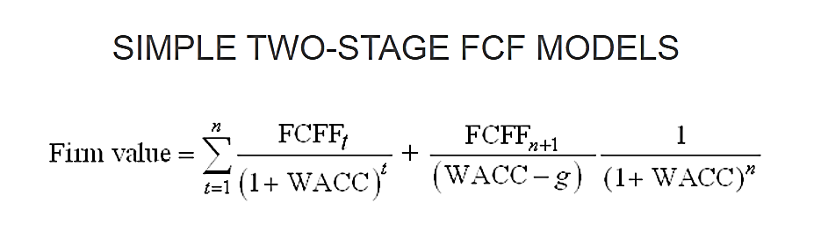
- Free Cash Flow to Firm (FCFF): FCFF is the cash available to pay investors after a company pays its costs of doing business, invests in short-term assets like inventory, and invests in assets like property, plants and equipment.
FCFF = Net Income + Non-Cash Charges + Interest (1 - tax rate) – Working Capital Investment – Fixed Capital Investment.
- CALCULATION OF FREE CASH FLOW TO FIRM:
- KOHINOOR FOODS LIMITED - (RICE + FOOD)
(Value in INR Crores)
Particulars | Mar-24 | Mar-25 | Mar-26 | Mar-27 | Mar-28 | Mar-29 | Mar-30 | Mar-31 | Mar-32 | Mar-33 | Mar-34 | Mar-35
EBITDA | 10.46 | 22.74 | 47.37 | 65.48 | 84.96 | 96.67 | 99.54 | 102.38 | 105.18 | 107.90 | 110.54 | 113.06
Depreciation | 5.84 | 5.13 | 4.53 | 4.00 | 3.55 | 3.15 | 2.80 | 2.50 | 2.23 | 2.00 | 1.79 | 1.60
EBIT | 4.61 | 17.61 | 42.84 | 61.48 | 81.41 | 93.52 | 96.74 | 99.88 | 102.94 | 105.91 | 108.76 | 111.46
Less: Taxes | 0.60 | 0.00 | 3.85 | 7.49 | 11.45 | 13.86 | 14.59 | 15.42 | 16.30 | 17.25 | 18.29 | 20.09
NOPAT | 4.01 | 17.61 | 38.99 | 53.99 | 69.97 | 79.66 | 82.15 | 84.47 | 86.64 | 88.66 | 90.47 | 91.37
ADD: Depreciation | 5.84 | 5.13 | 4.53 | 4.00 | 3.55 | 3.15 | 2.80 | 2.50 | 2.23 | 2.00 | 1.79 | 1.60
Less: Change in WC | 2.69 | 29.59 | 60.06 | 47.71 | 50.01 | 32.90 | 11.73 | 10.58 | 11.04 | 11.52 | 12.02 | 12.54
Unlevered Free Cash Flow (UFCF)/ FCFF | 7.17 | -6.85 | -16.55 | 10.28 | 23.51 | 49.91 | 73.22 | 76.38 | 77.83 | 79.14 | 80.24 | 80.43
Discount Rate (WACC) | 13.0%
Valuation Date | 30th September 2023
Period | 0.50 | 1.50 | 2.50 | 3.50 | 4.50 | 5.50 | 6.50 | 7.50 | 8.50 | 9.50 | 10.50 | 11.50
Discount Factor | 0.94 | 0.83 | 0.74 | 0.65 | 0.58 | 0.51 | 0.45 | 0.40 | 0.35 | 0.31 | 0.28 | 0.25
Terminal Value |  |  |  |  |  |  |  |  |  |  |  | 354.07
PV of FCFF | 6.74 | -5.70 | -12.19 | 6.70 | 13.56 | 25.48 | 33.08 | 30.54 | 27.54 | 24.78 | 22.23 | 19.72
PV of Terminal Value |  |  |  |  |  |  |  |  |  |  |  | 86.82
PV of FCFF + PV of TV | 6.74 | -5.70 | -12.19 | 6.70 | 13.56 | 25.48 | 33.08 | 30.54 | 27.54 | 24.78 | 22.23 | 106.54

- RICE PLANT – MURTHAL
(Value in INR Crores)
Particulars | Mar-24 | Mar-25 | Mar-26 | Mar-27 | Mar-28 | Mar-29 | Mar-30 | Mar-31 | Mar-32 | Mar-33 | Mar-34 | Mar-35
EBITDA | -9.96 | 1.37 | 25.01 | 42.10 | 60.54 | 71.19 | 72.96 | 74.70 | 76.37 | 77.97 | 79.47 | 80.86
Depreciation | 5.26 | 4.62 | 4.07 | 3.60 | 3.19 | 2.84 | 2.52 | 2.25 | 2.01 | 1.80 | 1.61 | 1.44
EBIT | -15.22 | -3.25 | 20.93 | 38.50 | 57.35 | 68.35 | 70.44 | 72.45 | 74.36 | 76.17 | 77.86 | 79.42
Less: Taxes | 0.54 | 0.00 | 3.47 | 6.74 | 10.30 | 12.48 | 13.13 | 13.87 | 14.67 | 15.52 | 16.46 | 18.08
NOPAT | -15.76 | -3.25 | 17.46 | 31.76 | 47.04 | 55.87 | 57.31 | 58.57 | 59.69 | 60.65 | 61.41 | 61.34
ADD: Depreciation | 5.26 | 4.62 | 4.07 | 3.60 | 3.19 | 2.84 | 2.52 | 2.25 | 2.01 | 1.80 | 1.61 | 1.44
Less: Change in WC | 5.64 | 29.38 | 59.56 | 47.17 | 49.44 | 32.30 | 11.10 | 9.90 | 10.32 | 10.75 | 11.20 | 11.68
Unlevered Free Cash Flow (UFCF)/ FCFF | -16.15 | -28.02 | -38.02 | -11.82 | 0.80 | 26.41 | 48.74 | 50.92 | 51.38 | 51.69 | 51.81 | 51.10
Discount Rate (WACC) | 13.0%
Valuation Date | 30th September 2023
Period | 0.50 | 1.50 | 2.50 | 3.50 | 4.50 | 5.50 | 6.50 | 7.50 | 8.50 | 9.50 | 10.50 | 11.50
Discount Factor | 0.94 | 0.83 | 0.74 | 0.65 | 0.58 | 0.51 | 0.45 | 0.40 | 0.35 | 0.31 | 0.28 | 0.25
Terminal Value |  |  |  |  |  |  |  |  |  |  |  | 329.79
PV of FCFF | -15.19 | -23.32 | -28.01 | -7.70 | 0.46 | 13.48 | 22.02 | 20.36 | 18.18 | 16.19 | 14.36 | 12.53
PV of Terminal Value |  |  |  |  |  |  |  |  |  |  |  | 80.87
PV of FCFF + PV of TV | -15.19 | -23.32 | -28.01 | -7.70 | 0.46 | 13.48 | 22.02 | 20.36 | 18.18 | 16.19 | 14.36 | 93.40

- FOOD PLANT – BAHALGARH
(Value in INR Crores)
Particulars | Mar-24 | Mar-25 | Mar-26 | Mar-27 | Mar-28 | Mar-29 | Mar-30 | Mar-31 | Mar-32 | Mar-33 | Mar-34 | Mar-35
EBITDA | 20.41 | 21.37 | 22.36 | 23.38 | 24.42 | 25.49 | 26.58 | 27.68 | 28.80 | 29.94 | 31.07 | 32.20
Depreciation | 0.58 | 0.51 | 0.45 | 0.40 | 0.35 | 0.32 | 0.28 | 0.25 | 0.22 | 0.20 | 0.18 | 0.16
EBIT | 19.83 | 20.86 | 21.91 | 22.98 | 24.07 | 25.17 | 26.30 | 27.43 | 28.58 | 29.74 | 30.89 | 32.04
Less: Taxes | 0.06 | 0.00 | 0.39 | 0.75 | 1.14 | 1.39 | 1.46 | 1.54 | 1.63 | 1.72 | 1.83 | 2.01
NOPAT | 19.77 | 20.86 | 21.53 | 22.23 | 22.92 | 23.79 | 24.84 | 25.89 | 26.95 | 28.01 | 29.06 | 30.03
ADD: Depreciation | 0.58 | 0.51 | 0.45 | 0.40 | 0.35 | 0.32 | 0.28 | 0.25 | 0.22 | 0.20 | 0.18 | 0.16
Less: Change in WC | -2.96 | 0.20 | 0.50 | 0.53 | 0.57 | 0.60 | 0.64 | 0.68 | 0.72 | 0.76 | 0.81 | 0.86
Unlevered Free Cash Flow (UFCF)/ FCFF | 23.31 | 21.17 | 21.48 | 22.10 | 22.71 | 23.50 | 24.48 | 25.46 | 26.45 | 27.45 | 28.43 | 29.33
Discount Rate (WACC) | 13.0%
Valuation Date | 30th September 2023
Period | 0.50 | 1.50 | 2.50 | 3.50 | 4.50 | 5.50 | 6.50 | 7.50 | 8.50 | 9.50 | 10.50 | 11.50
Discount Factor | 0.94 | 0.83 | 0.74 | 0.65 | 0.58 | 0.51 | 0.45 | 0.40 | 0.35 | 0.31 | 0.28 | 0.25
Terminal Value |  |  |  |  |  |  |  |  |  |  |  | 24.28
PV of FCFF | 21.93 | 17.62 | 15.82 | 14.40 | 13.10 | 12.00 | 11.06 | 10.18 | 9.36 | 8.59 | 7.88 | 7.19
PV of Terminal Value |  |  |  |  |  |  |  |  |  |  |  | 5.95
PV of FCFF + PV of TV | 21.93 | 17.62 | 15.82 | 14.40 | 13.10 | 12.00 | 11.06 | 10.18 | 9.36 | 8.59 | 7.88 | 13.15

- CALCULATION OF ENTERPRISE VALUE:
Particulars | Amount (In INR Crore)
Rice Plant – Murthal | 124.21
Food Plant – Bahalgarh | 155.09
Kohinoor Foods Limited | 279.30

ENTERPRISE VALUE OF THE FIRM
INR TWO HUNDRED SEVENTY-NINE CRORES AND THIRTY LAKHS (INR 279.30 CRORES)
NOTES:
- As requested by the client/NARCL, the financial projections for Rice and Food were separately made. However, we view the business of KFL (both Murthal & Bahalgarh Plant) as one sole entity/business.
- As per the requirement of client/NARCL, the value of Amritsar Property is excluded from the calculation of Terminal Value.
- The Company account has been converted to Non-Performing Asset (NPA) since FY 18-19.
- The overall valuation is estimated based on the financial statements up to FY 2022-23 and further it has been projected based on the previous data as reference from 2023-24 onwards.
- No claim amount or tenable claim amount has been considered in the financial projections as the cases are currently ongoing.
- For the projected years, revenue solely encompasses revenue earned from the sale of RICE and RTE (Ready-to-Eat) products undertaken by KFL.

- SENSITIVITY ANALYSIS:
- Sensitivity with respect to rice price growth rate:  Current Rate 4.20%  Rate EV (In Crores)  3.2% 266.55  4.2% 279.30  5.2% 292.64 | - Sensitivity with respect to food price growth rate:  Current Rate 6.2%  Rate EV (In Crores)  5.2% 265.11  6.2% 279.30  7.2% 294.46
- Sensitivity with respect to rice COGS:  Current Rate 80%  Rate EV (In Crores)  75.0% 673.79  80.0% 279.30  85.0% -154.11 | - Sensitivity with respect to food COGS:  Current Rate 40%  Rate EV (In Crores)  35.0% 308.88  40.0% 279.30  45.0% 249.52

- ESTIMATED KEY FINANCIAL METRICES:
Particulars | Mar-24 | Mar-25 | Mar-26 | Mar-27 | Mar-28 | Mar-29 | Mar-30 | Mar-31 | Mar-32 | Mar-33 | Mar-34 | Mar-35
Current Ratio | 4.26 | 3.14 | 3.05 | 3.21 | 3.31 | 3.45 | 3.60 | 3.70 | 3.78 | 3.82 | 3.39 | 4.17
Inventory Turnover Ratio | 12.99 | 13.58 | 10.69 | 8.63 | 8.24 | 7.70 | 7.34 | 7.35 | 7.37 | 7.38 | 7.40 | 7.41
Receivables Turnover Ratio | 9.26 | 15.81 | 15.94 | 13.74 | 13.43 | 12.69 | 12.11 | 12.10 | 12.10 | 12.09 | 12.08 | 12.08
Payables Turnover Ratio | 15.76 | 23.26 | 19.00 | 15.96 | 15.64 | 14.83 | 14.37 | 14.51 | 14.53 | 14.56 | 14.59 | 14.62
Total Assets Turnover Ratio | 0.52 | 1.42 | 2.59 | 2.88 | 3.10 | 3.02 | 2.83 | 2.73 | 2.65 | 2.58 | 2.52 | 2.54
ROCE | 2.33% | 8.94% | 19.27% | 23.81% | 26.85% | 26.75% | 24.85% | 23.45% | 22.26% | 21.33% | 22.21% | 20.14%
Interest Coverage Ratio | 4.73 | 0.92 | 1.72 | 2.07 | 2.36 | 2.51 | 2.57 | 2.65 | 2.76 | 2.89 | 3.06 | 3.57
EBITDA Margin | 9.35% | 6.98% | 6.33% | 6.16% | 6.05% | 5.98% | 5.90% | 5.82% | 5.73% | 5.63% | 5.53% | 5.43%
EBIT Margin | 4.13% | 5.40% | 5.73% | 5.78% | 5.80% | 5.78% | 5.73% | 5.68% | 5.61% | 5.53% | 5.44% | 5.35%
Net Profit Margin | 1.61% | -2.21% | 1.53% | 2.10% | 2.42% | 2.55% | 2.57% | 2.60% | 2.64% | 2.68% | 2.72% | 2.87%
Revenue Growth Rate | 35.48% | 191.50% | 129.40% | 42.18% | 32.04% | 15.24% | 4.30% | 4.31% | 4.31% | 4.31% | 4.31% | 4.31%

- DEBT SERVICE COVERAGE RATIO
Particulars | Mar-25 | Mar-26 | Mar-27 | Mar-28 | Mar-29 | Mar-30 | Mar-31 | Mar-32 | Mar-33 | Mar-34 | Mar-35 | TOTAL
Cash Accruals | -2.09 | 15.99 | 26.28 | 37.58 | 44.37 | 46.18 | 48.34 | 50.71 | 53.27 | 56.16 | 61.34 | 438.13
Int. on Term Loan | 24.83 | 27.53 | 31.71 | 35.93 | 38.44 | 38.77 | 38.63 | 38.17 | 37.38 | 36.10 | 31.63 | 379.12
Total "A" | 22.74 | 43.51 | 57.99 | 73.51 | 82.81 | 84.95 | 86.97 | 88.87 | 90.66 | 92.26 | 92.97 | 817.25
Instalment of T/L | 0.35 | 0.35 | 1.40 | 2.80 | 4.20 | 7.00 | 9.80 | 12.60 | 15.40 | 21.00 | 65.10 | 140.00
Int. on Term Loan | 24.83 | 27.53 | 31.71 | 35.93 | 38.44 | 38.77 | 38.63 | 38.17 | 37.38 | 36.10 | 31.63 | 379.12
Total "B" | 25.18 | 27.88 | 33.11 | 38.73 | 42.64 | 45.77 | 48.43 | 50.77 | 52.78 | 57.10 | 96.73 | 519.12
D.S.C.R. (A/B) | 0.90 | 1.56 | 1.75 | 1.90 | 1.94 | 1.86 | 1.80 | 1.75 | 1.72 | 1.62 | 0.96 | 1.57
Average D.S.C.R. | 1.57

- WORKING CAPITAL FUNDING REQUIREMENT:
- RICE PLANT – MURTHAL
(In INR Crores)
Particulars | Mar-24 | Mar-25 | Mar-26 | Mar-27 | Mar-28 | Mar-29 | Mar-30 | Mar-31 | Mar-32 | Mar-33 | Mar-34 | Mar-35
Total Inventory | 6.57 | 34.23 | 89.16 | 130.07 | 174.26 | 201.75 | 210.22 | 219.05 | 228.25 | 237.84 | 247.83 | 258.24
Receivables | 4.11 | 21.39 | 55.73 | 81.29 | 108.91 | 126.09 | 131.39 | 136.91 | 142.66 | 148.65 | 154.89 | 161.40
Payables | 3.82 | 19.39 | 49.10 | 68.40 | 90.76 | 103.13 | 105.81 | 110.25 | 114.88 | 119.71 | 124.74 | 129.97
Working Capital Gap (A) | 6.85 | 36.23 | 95.79 | 142.97 | 192.41 | 224.71 | 235.80 | 245.71 | 256.03 | 266.78 | 277.99 | 289.66
TCA * 25% | 2.67 | 13.90 | 36.22 | 52.84 | 70.79 | 81.96 | 85.40 | 88.99 | 92.73 | 96.62 | 100.68 | 104.91
Margin required (25%) | 1.71 | 9.06 | 23.95 | 35.74 | 48.10 | 56.18 | 58.95 | 61.43 | 64.01 | 66.70 | 69.50 | 72.42
MPBF whichever is lower (B) | 1.71 | 9.06 | 23.95 | 35.74 | 48.10 | 56.18 | 58.95 | 61.43 | 64.01 | 66.70 | 69.50 | 72.42
(A - B) | 5.14 | 27.17 | 71.84 | 107.22 | 144.30 | 168.53 | 176.85 | 184.28 | 192.02 | 200.09 | 208.49 | 217.25
W.C. Gap Funding Requirement | 5.14 | 22.04 | 44.67 | 35.38 | 37.08 | 24.23 | 8.32 | 7.43 | 7.74 | 8.06 | 8.40 | 8.76

Working Capital Dept Summary | Mar-24 | Mar-25 | Mar-26 | Mar-27 | Mar-28 | Mar-29 | Mar-30 | Mar-31 | Mar-32 | Mar-33 | Mar-34 | Mar-35
Opening Balance | 5.14 | 5.14 | 27.17 | 71.84 | 107.22 | 144.30 | 168.53 | 176.85 | 184.28 | 192.02 | 200.09 | 208.49
Addition | - | 22.04 | 44.67 | 35.38 | 37.08 | 24.23 | 8.32 | 7.43 | 7.74 | 8.06 | 8.40 | 8.76
Repayment | - | - | - | - | - | - | - | - | - | - | - | -
Closing Balance | 5.14 | 27.17 | 71.84 | 107.22 | 144.30 | 168.53 | 176.85 | 184.28 | 192.02 | 200.09 | 208.49 | 217.25
Interest Cost | 1.03 | 5.43 | 8.62 | 12.87 | 17.32 | 20.22 | 21.22 | 22.11 | 23.04 | 24.01 | 25.02 | 26.07
W.C. Gap Funding requirement | 5.14 | 22.04 | 44.67 | 35.38 | 37.08 | 24.23 | 8.32 | 7.43 | 7.74 | 8.06 | 8.40 | 8.76

- FOOD PLANT – BAHALGARH
(In INR Crores)
Particulars | Mar-24 | Mar-25 | Mar-26 | Mar-27 | Mar-28 | Mar-29 | Mar-30 | Mar-31 | Mar-32 | Mar-33 | Mar-34 | Mar-35
Total Inventory | 1.02 | 1.08 | 1.15 | 1.22 | 1.29 | 1.37 | 1.46 | 1.55 | 1.65 | 1.75 | 1.86 | 1.97
Receivables | 7.63 | 8.10 | 8.60 | 9.14 | 9.70 | 10.30 | 10.94 | 11.62 | 12.34 | 13.11 | 13.92 | 14.78
Payables | 0.75 | 1.08 | 1.15 | 1.22 | 1.30 | 1.38 | 1.46 | 1.55 | 1.65 | 1.75 | 1.86 | 1.98
Working Capital Gap (A) | 7.89 | 8.10 | 8.60 | 9.13 | 9.70 | 10.30 | 10.94 | 11.62 | 12.34 | 13.10 | 13.92 | 14.78
TCA * 25% | 2.16 | 2.30 | 2.44 | 2.59 | 2.75 | 2.92 | 3.10 | 3.29 | 3.50 | 3.71 | 3.94 | 4.19
Margin required (25%) | 1.97 | 2.02 | 2.15 | 2.28 | 2.42 | 2.58 | 2.73 | 2.90 | 3.08 | 3.28 | 3.48 | 3.69
MPBF whichever is lower (B) | 1.97 | 2.02 | 2.15 | 2.28 | 2.42 | 2.58 | 2.73 | 2.90 | 3.08 | 3.28 | 3.48 | 3.69
(A - B) | 5.92 | 6.07 | 6.45 | 6.85 | 7.27 | 7.73 | 8.20 | 8.71 | 9.25 | 9.83 | 10.44 | 11.08
W.C. Gap Funding Requirement | 5.92 | 0.15 | 0.38 | 0.40 | 0.42 | 0.45 | 0.48 | 0.51 | 0.54 | 0.57 | 0.61 | 0.65

Working Capital Dept Summary | Mar-24 | Mar-25 | Mar-26 | Mar-27 | Mar-28 | Mar-29 | Mar-30 | Mar-31 | Mar-32 | Mar-33 | Mar-34 | Mar-35
Opening Balance | 5.92 | 5.92 | 6.07 | 6.45 | 6.85 | 7.27 | 7.73 | 8.20 | 8.71 | 9.25 | 9.83 | 10.44
Addition | - | 0.15 | 0.38 | 0.40 | 0.42 | 0.45 | 0.48 | 0.51 | 0.54 | 0.57 | 0.61 | 0.65
Repayment | - | - | - | - | - | - | - | - | - | - | - | -
Closing Balance | 5.92 | 6.07 | 6.45 | 6.85 | 7.27 | 7.73 | 8.20 | 8.71 | 9.25 | 9.83 | 10.44 | 11.08
Interest Cost | 1.18 | 1.21 | 0.77 | 0.82 | 0.87 | 0.93 | 0.98 | 1.05 | 1.11 | 1.18 | 1.25 | 1.33
W.C. Gap Funding requirement | 5.92 | 0.15 | 0.38 | 0.40 | 0.42 | 0.45 | 0.48 | 0.51 | 0.54 | 0.57 | 0.61 | 0.65

- KOHINOOR FOODS LIMITED – (RICE + FOOD)
(In INR Crores)
Particulars | Mar-24 | Mar-25 | Mar-26 | Mar-27 | Mar-28 | Mar-29 | Mar-30 | Mar-31 | Mar-32 | Mar-33 | Mar-34 | Mar-35
Total Inventory | 7.59 | 35.31 | 90.31 | 131.29 | 175.55 | 203.12 | 210.22 | 219.05 | 228.25 | 237.84 | 247.83 | 258.24
Receivables | 11.73 | 29.49 | 64.33 | 90.43 | 118.61 | 136.40 | 131.39 | 136.91 | 142.66 | 148.65 | 154.89 | 161.40
Payables | 4.58 | 20.47 | 50.25 | 69.62 | 92.06 | 104.51 | 105.81 | 110.25 | 114.88 | 119.71 | 124.74 | 129.97
Working Capital Gap (A) | 14.74 | 44.33 | 104.39 | 152.10 | 202.11 | 235.01 | 235.80 | 245.71 | 256.03 | 266.78 | 277.99 | 289.66
TCA * 25% | 4.83 | 16.20 | 38.66 | 55.43 | 73.54 | 84.88 | 85.40 | 88.99 | 92.73 | 96.62 | 100.68 | 104.91
Margin required (25%) | 3.69 | 11.08 | 26.10 | 38.02 | 50.53 | 58.75 | 58.95 | 61.43 | 64.01 | 66.70 | 69.50 | 72.42
MPBF whichever is lower (B) | 3.69 | 11.08 | 26.10 | 38.02 | 50.53 | 58.75 | 58.95 | 61.43 | 64.01 | 66.70 | 69.50 | 72.42
(A - B) | 11.06 | 33.25 | 78.29 | 114.07 | 151.58 | 176.26 | 176.85 | 184.28 | 192.02 | 200.09 | 208.49 | 217.25
W.C. Gap Funding Requirement | 11.06 | 22.19 | 45.05 | 35.78 | 37.50 | 24.68 | 8.80 | 7.94 | 8.28 | 8.64 | 9.01 | 9.40

Working Capital Dept Summary | Mar-24 | Mar-25 | Mar-26 | Mar-27 | Mar-28 | Mar-29 | Mar-30 | Mar-31 | Mar-32 | Mar-33 | Mar-34 | Mar-35
Opening Balance | 11.06 | 11.06 | 33.25 | 78.29 | 114.07 | 151.58 | 176.26 | 185.06 | 192.99 | 201.27 | 209.91 | 218.93
Addition | - | 22.19 | 45.05 | 35.78 | 37.50 | 24.68 | 8.80 | 7.94 | 8.28 | 8.64 | 9.01 | 9.40
Repayment | - | - | - | - | - | - | - | - | - | - | - | -
Closing Balance | 11.06 | 33.25 | 78.29 | 114.07 | 151.58 | 176.26 | 185.06 | 192.99 | 201.27 | 209.91 | 218.93 | 228.33
Interest Cost | 2.21 | 6.65 | 9.40 | 13.69 | 18.19 | 21.15 | 22.21 | 23.16 | 24.15 | 25.19 | 26.27 | 27.40
W.C. Gap Funding requirement | 11.06 | 22.19 | 45.05 | 35.78 | 37.50 | 24.68 | 8.80 | 7.94 | 8.28 | 8.64 | 9.01 | 9.40

Note: Working Capital loan to be taken is calculated as 75% of Working Capital Funding Gap. As per the discussion with the client/company officials, the rate of interest is taken as 20% for the first two years of the forecast period i.e., FY 2024 & FY 2025. Thereafter it has been taken as 12% till the end of forecast period.

- DEBT REPAYMENT SCHEDULE:
Particulars | Mar-25 | Mar-26 | Mar-27 | Mar-28 | Mar-29 | Mar-30 | Mar-31 | Mar-32 | Mar-33 | Mar-34 | Mar-35
Sustainable Debt (In INR Crores)
Opening Balance | - | 139.65 | 139.30 | 137.90 | 135.10 | 130.90 | 123.90 | 114.10 | 101.50 | 86.10 | 65.10
Additions | 140 | - | - | - | - | - | - | - | - | - | -
Principal Repayment | 0.35 | 0.35 | 1.4 | 2.8 | 4.2 | 7 | 9.8 | 12.6 | 15.4 | 21 | 65.1
Closing Balance | 139.65 | 139.30 | 137.90 | 135.10 | 130.90 | 123.90 | 114.10 | 101.50 | 86.10 | 65.10 | 0.00
Interest Repayment | 18.18 | 18.13 | 18.02 | 17.75 | 17.29 | 16.56 | 15.47 | 14.01 | 12.19 | 9.83 | 4.23
Unsustainable Debt (In INR Crores)
Opening Balance | - | 502.95 | 502.95 | 502.95 | 502.95 | 502.95 | 502.95 | 502.95 | 502.95 | 502.95 | 502.95
Additions | 502.95 | - | - | - | - | - | - | - | - | - | -
Principal Repayment | 0 | 0 | 0 | 0 | 0 | 0 | 0 | 0 | 0 | 0 | 0
Closing Balance | 502.95 | 502.95 | 502.95 | 502.95 | 502.95 | 502.95 | 502.95 | 502.95 | 502.95 | 502.95 | 502.95
Interest Repayment | 0.05 | 0.05 | 0.05 | 0.05 | 0.05 | 0.05 | 0.05 | 0.05 | 0.05 | 0.05 | 0.05

- KEY ASSUMPTIONS & BASIS:
S. No. | Item | Assumptions and Basis
1. | General | - The projections of the firm are done for the period from FY 2023-24 to FY 2034-35, to cover the term loan period as per the industry best practices.  - Revenue and expense modelling has been done based on the capacity utilization during the respective year.  - Current revenue model solely encompasses RICE to rice processing and RTE (Ready-to-Eat) undertaken by KFL.  - As per the requirement of NARCL, the financial projections for Rice and Food were separately made. However, we view the business of KFL (both Murthal & Bahalgarh Plant) as one sole entity/business.
2. | Growth Rate in Pricing (Average Price Per Unit) | - Murthal Plant: We have analysed following two trends:  - Wholesale Price Index of paddy across India from FY 2013 to FY 2023.  - Price trend of Basmati Rice export from India.  Year WPI of Paddy (i) Price Per Kg (ii)  FY 13 113.2 56.1  FY 14 129.1 77.98  FY 15 136.6 74.54  FY 16 134.7 56.15  FY 17 143.6 53.98  FY 18 149.4 66.24  FY 19 155.3 74.31  FY 20 160.5 69.65  FY 21 163.5 64.46  FY 22 162.3 66.91  FY 23 170.7 84.5  CAGR 4.19% 4.18%  Source Statista APEDA  Thus, considering the CAGR from the above two trends, we have considered price increase of Sale of Rice at 4.2%.  - Bahalgarh Plant: After analysing the Consumer Price Index numbers for the category code 1.1.12 which is ‘Prepared meals, snacks, sweets etc’ the value for May 2023 Index is 194.2, the base for the same Index is 100 and the base year is 2012 (Source: PIB.gov.in, July 2023). The CAGR for the same comes out to be 6.2% and we have used the same as growth rate for projections in the Revenue from Food Factory.
3. | Capacity Utilization | - Murthal Plant  As per the information shared with us, the rice plant at Murthal, Haryana has an installed capacity of 2.5 Lakhs M. Tons, which will be operating at 2% in the FY 2024 as the plant is currently running at a very low capacity. The capacity utilization rates assumed in the projected years are as follows:  Particulars Mar-24 Mar-25 Mar-26 Mar-27 Mar-28 Mar-29  Capacity Utilization 2% 10% 25% 35% 45% 50%  Particulars Mar-30 Mar-31 Mar-32 Mar-33 Mar-34 Mar-35  Capacity Utilization 50% 50% 50% 50% 50% 50%  - Bahalgarh Plant: As per the historical information available with us, the bahalgarh plant has as annual installed capacity of 18 million pouches which is used as the basis for installed capacity during the projected years. Capacity utilization of food factory has been much better than rice processing over past 3-4 years. Accordingly, historical trend has been followed for this assumption. The capacity utilization rates assumed in the projected years are as follows:  Particulars Mar-24 Mar-25 Mar-26 Mar-27 Mar-28 Mar-29  Capacity Utilization 70% 70% 70% 70% 70% 70%  Particulars Mar-30 Mar-31 Mar-32 Mar-33 Mar-34 Mar-35  Capacity Utilization 70% 70% 70% 70% 70% 70%
4. | Expenses | - Cost of Materials consumed, being variable in nature is taken as % of revenue. Assumption for Cost of Materials consumed for Rice is taken at 80% of Rice revenue (the same has been decided post discussion with company officials and industry practice).  Since, the account of KFL had turned NPA, it faced financial difficulties in paddy to rice processing business and the plant solely did rice-to-rice processing. Hence, we are only assuming that the company will only do rice-to-rice processing in the projected years. For Bahalgarh Plant, the material cost is taken as 40% which is line with the historical average.  - In order to reach the level of production prior to turning in non-performing assets, the company would need to hire more labor, that is why, Employee cost for FY 2024 is considered at Rs. 11.00 Cr, which is higher than its historical average of Rs.9.30 Cr. The escalation factor of 10% is applied till FY 2035. For Rice Plant & Food Plant, the employee expenses are bifurcated on the basis of historical average of 66.19% and 33.81% respectively.  - Manufacturing Expenses is kept at 10% of total revenue throughout the forecast period (FY24 till FY35). This expense head has seen a lot of volatility over the past 6-year trend. As per our discussion with management and observing the historical financials of the company, we have taken an assumption of 10%. For Rice Plant & Food Plant, the manufacturing expenses are bifurcated on the basis of ratio of revenue earned by the respective plant during each projected year.  - Administrative Expenses is taken as Rs. 10 Cr for FY 2024 (close to historical average i.e., FY 9.78 Crore) (close to latest historical year i.e., FY 2023) with an escalation of 10% (close to latest historical year i.e., FY 2023) every year till FY35. For Rice Plant & Food Plant, the administrative expenses are bifurcated on the basis of historical average of FY2022-23 of 56.73% and 43.27% respectively.  - Selling & Distribution Expenses is assumed at 4% of total revenue throughout the forecast period (FY24 till FY35) which is closer to its historical average of 3.47%. For Rice Plant & Food Plant, the selling & distribution expenses are bifurcated on the basis of ratio of revenue earned by the respective plant during each projected year.  - As on 31st March 2023 and on 31st March 2035, the fixed assets are split in the ratio of 90:10 for rice and food plant respectively. Depreciation is bifurcated on the basis of this ratio between the rice and food plant.
5. | Term Loan | - As per the cash flows during the projected years and the discussion with the client, the sustainable term loan is INR 140 Crores (i.e., the level of debt at which the company would be able to meet all its current and future payment obligations without exceptional financial assistance or going into default) and rest of the term loan of INR 502.95 is considered as Unsustainable debt.  - The interest rate for the sustainable debt has been considered as 13%.  - The loan repayment period will be from FY 2025 to FY 2035.
6. | Working Capital | As per the historical trends of the company and the discussion held with the management of the company, the following assumptions are made related to working capital:  Particulars Rice (No. of Days) Food (No. of Days)  Days Sales Outstanding 30.0 Days 45.0 Days  Days Inventory Outstanding 60.0 Days 15.0 Days  Days Payables Outstanding 30.0 Days 15.0 Days  Working Capital Days for Rice Plant are kept at lower than industry average as KFL is only doing rice to rice processing which requires to maintain a lower inventory level as compared to the paddy to rice business.
7. | Discount Rate | As per NARCL Policy, the discount rate for such assets is 13% which is used for the purpose of valuation of M/s Kohinoor Foods Limited.
8. | Terminal Value | The calculation of the Terminal Value at the end of the economic life involves the sum of the salvage value of Net Fixed Assets, the adjusted Net Core Working Capital (adjusted for working capital loan), and the Cash balance.  Fair Value of Fixed Assets as on 31-03-2035  Asset Class Amount  P&M 18,07,67,708.00  Building 50,13,98,867.00  Land 2,13,79,01,239.00  Total 2,82,00,67,813.00  - Land: As per the information available on govt website, the circle rate has been increasing @5% on an annual basis. Since, this is a commercial belt having various industrial and commercial properties. Thus, it is assumed that the value of land will increase @ 5% Y.O.Y. during the projected years. As per sale comparable method, the approx. projected land value in 2035 is INR 282.01 Crores.  As per the requirement of client/NARCL, the value of Amritsar Property is excluded from the calculation of Terminal Value.  - Building: As per the plinth area rates available on CPWD websites, the construction rate has increased by 25% in the last 7-8 years. Thus, we have considered Cost of Construction & DRC/Fair value have been arrived accordingly. As per Cost Approach under depreciated reproduction method, the approx. projected building value in 2035 is INR 13.26 Crores. For Faridabad Office, since, it is a built-up unit and located in a commercial area which shall fetch higher than that of other property, thus we have considered an annual growth rate of 6% to arrive approximate projected value in 2035 as per sale comparable method, which is INR 36.88 Crores. Thus, the approx. total projected building value in FY 2035 is INR 50.14 crores.  - P&M: As per the RBI Index available on the economic advisory, the inflation index has been increased by 5% in the last 7-8 years. Accordingly, GCRC and DRC/FV have been calculated during the projected years. As per Cost Approach under depreciated replacement method, the approx. projected P&M value in 2035 is INR 18.08 Crores.  - Salvage Discount of 50% is applied to Fair Value of Fixed Assets and Net Core Working Capital. For Land, Salvage Factor of 75% (i.e., Discount of 25%) has been considered.  Terminal Value (TV) Is calculated by using the following formulae:  TV = [{Fair Value of Fixed Asset as on FY 2035 + Inventory (2035) + Trade Receivable (2035) – Trade Payables (2035)} * (1 – Salvage Discount)] + [Land (2035) * (1 – Salvage Discount_{Land}) + [Cash (2035) – Outstanding Loan (2035)]
Conclusion:
      - The company has achieved DSCR of more than 1 during the loan repayment period (Only Sustainable Debt).
      - Average DSCR, EBIDTA margin, EBIT margin is 1.57, 6.24%, and 5.50% respectively during the estimated period.
Based on the above key financial ratios of the Project during the forecast period shows that the project looks financially viable if the Project Company & promoters are able to maintain assumed capacity utilization, revenue and can contain cost as assumed above.

PART K | CONCLUSION

Based on the technological, economical and market analysis done above, various assumptions of sectoral trends taken, product pricing to be adopted by the company, the Project appears to be Techno-commercially viable subject to the risks, threats, weaknesses, limitations of the product as detailed previously.
As per financial projections for the estimated period, Average DSCR, EBITDA Margin and EBIT Margin of the project are 1.57, 6.24%, and 5.50% respectively, where DSCR greater than 1 show that the project will be able to pay out its assumed sustainable debt and EBITDA margin shows the capability of the project to generate the operating profits over the forecasted period, which is also in the line with sectoral trends.
While it is not avoidable that the future projections may change in the upcoming years due to various factors impacting the operation, managerial, financial efficiency and economies of scale of the project. It would be depending on the management’s capability in future that how efficiently company adopts marketing and advertisement strategy, supply chain and carry out inventory & resource management to achieve higher profitability. After considering the foreseen demand of the Rice & Ready to eat food products domestically and globally, various initiatives taken by government, financial analysis of the project based on the assumptions taken over the projected period, it appears reasonable to comment that the project is “Technically and Economically” Viable subject to current assumptions considered and occurring the same in the upcoming years same as the forecasted period which is dependent on the sincerity and efforts of the management and various micro and macroeconomic & industry situation.
We have tried our level best to analyse the Project techno-economic feasibility of the Project based on the industry research, Project information and various futuristic assumption taken. However, achieving the financial milestones depends on the ability, sincerity and efforts of the company, promoters and its key managerial performance.

Declaration | - The undersigned does not have any direct/indirect interest in the above property.  - The information furnished herein is true and correct to the best of our knowledge, logical and scientific assumptions.  - This TEV Report is carried out by our Financial Analyst team on the request from BOB Capital Markets Ltd, Parinee Crescenzo, 1704, B Wing, 17th Floor, Bandra Kurla Complex, G Block, Bandra East, Mumbai 400 051.  - Meeting of Financial projections will be subject to subject to the market & economy stability factors, judicious business operations and proper & timely implementation of its process & product re-engineering & improvement plans for achieving high productivity, efficiency and achieving cost saving benefits.  - We have submitted TEV report to the Client.
Name & Address of consultant company |  | Signature of the authorized person
M/s. R.K. Associates Valuer & Techno Engineering Consultants Pvt. Ltd.
D-39, 2nd Floor. Sector-2, Noida- 201301
Number of Pages in the Report |  | 112
Financial Analyst Team worked on the report |  | PREPARED BY: Mr. Rachit Gupta
 |  | REVIEWED BY: Mr. Gaurav Kumar

For R.K Associates Valuer & Techno Place: Noida
Engineering Consultants (P) Ltd. Date: 6th February 2024

(Authorized Signatory)

PART L | DISCLAIMER | REMARKS

      - No employee or member of R.K Associates has any direct/ indirect interest in the Project.
      - This report is prepared based on the copies of the documents/ information which the Bank/ Company has provided to us out of the standard checklist of documents sought from them and further based on our assumptions and limiting conditions. The client/owner and its management/representatives warranted to us that the information they supplied was complete, accurate and true and correct to the best of their knowledge. All such information provided to us has been relied upon in good faith and we have assumed that it is true and correct in all respect. I/We shall not be liable for any loss, damages, cost or expenses arising from fraudulent acts, misrepresentations, or wilful default on part of the owner, company, its directors, employee, representative or agents. Verification or cross checking of the documents provided to us from the originals or from any Govt. departments/ Record of Registrar has not been done at our end since this is beyond the scope of our work. If at any time in future, it is found or came to our knowledge that misrepresentation of facts or incomplete or distorted information has been provided to us then this report shall automatically become null & void.
      - Legal aspects for e.g. investigation of title, ownership rights, lien, charge, mortgage, lease, sanctioned maps, verification of documents, etc. have not been done at our end and same has to be taken care by legal expert/ Advocate. It is assumed that the concerned Lender/ Financial Institution has satisfied them with the authenticity of the documents, information given to us and for which the legal verification has been already taken and cleared by the competent Advocate before requesting for this report. I/ We assume no responsibility for the legal matters including, but not limited to, legal or title concerns.
      - This report is a general analysis of the project based on the scope mentioned in the report. This is not an Audit report, Design document, DPR or Techno feasibility study. All the information gathered is based on the facts seen on the site during survey, verbal discussion & documentary evidence provided by the client and is believed that information given by the company is true best of their knowledge.
      - This Techno Economic-Viability study is prepared based on certain futuristic assumption which are intra dependent on economic, market and sectorial growth condition in future and socio-economic, socio-political condition at macro and micro level.
      - Meeting of assumption and financial ratio will entirely depend on the sincerity and efforts of the company, promoters and its key managerial performance.
      - Bank/FII should ONLY take this report as an Advisory document from the Financial/ Chartered Engineering firm and its specifically advised to the creditor to cross verifies the original documents for the facts mentioned in the report which can be availed from the borrowing company directly.
      - All observations mentioned in the report is only based on the visual observation and the documents/ data/ information provided by the client. No mechanical/ technical tests, measurements or any design review have been performed or carried out from our side during Project assessment.
      - In case of any default in loans or the credit facility extended to the borrowing company, R.K Associates shall not be held responsible for whatsoever reason may be and any request for seeking any explanation from the employee/s of R.K Associates will not be entertained at any instance or situation.
      - The documents, information, data provided to us during the course of this assessment by the client are reviewed only up to the extent required in relation to the scope of the work. No document has been reviewed beyond the scope of the work.
      - This report only contains general assessment & opinion as per the scope of work evaluated as per the information given in the copy of documents, information, data provided to us and/ and confirmed by the owner/ owner representative to us at site which has been relied upon in good faith. It doesn’t contain any other recommendations of any sort including but not limited to express of any opinion on the suitability or otherwise of entering into any transaction with the borrower.
      - We have relied on data from third party, external sources & information available on public domain also to conclude this report. These sources are believed to be reliable and therefore, we assume no liability for the truth or accuracy of any data, opinions or estimates furnished by others that have been used in this analysis. Where we have relied on data, opinions or estimates from external sources, reasonable care has been taken to ensure that such data has been correctly extracted from those sources and /or reproduced in its proper form and context, however still we can’t vouch its authenticity, correctness or accuracy.
      - This Report is prepared by our competent technical team which includes Engineers and financial experts & analysts.
      - This is just an opinion report and doesn’t hold any binding on anyone. It is requested from the concerned Financial Institution which is using this report for taking financial decision on the project that they should consider all the different associated relevant & related factors also before taking any business decision based on the content of this report.
      - All Pages of the report including annexure are signed and stamped from our office. In case any paper in the report is without stamp & signature then this should not be considered a valid paper issued from this office.
      - Though adequate care has been taken while preparing this report as per its scope, but still we can’t rule out typing, human errors, over sightedness of any information or any other mistakes. Therefore, the concerned organization is advised to satisfy themselves that the report is complete & satisfactory in all respect. Intimation regarding any discrepancy shall be brought into our notice immediately. If no intimation is received within 15 (Fifteen) days in writing from the date of issuance of the report, to rectify these timely, then it shall be considered that the report is complete in all respect and has been accepted by the client up to their satisfaction & use and further to which R.K Associates shall not be held responsible in any manner.
      - Defect Liability Period is 15 DAYS. We request the concerned authorized reader of this report to check the contents, data and calculations in the report within this period and intimate us in writing if any corrections are required or in case of any other concern with the contents or opinion mentioned in the report. Corrections only related to typographical, calculation, spelling mistakes, incorrect data/ figures/ statement will be entertained within the defect liability period. Any new changes for any additional information in already approved report will be regarded as additional work for which additional fees may be charged. No request for any illegitimate change in regard to any facts & figures will be entertained.
      - R.K Associates encourages its customers to give feedback or inform concerns over its services through proper channel at valuers@rkassociates.org in writing within 15 days of report delivery. After this period no concern/ complaint/ proceedings in connection with the Techno- Economic Viability Study Services will be entertained due to possible change in situation and condition of the subject Project.
      - Our Data retention policy is of ONE YEAR. After this period, we remove all the concerned records related to the assignment from our repository. No clarification or query can be answered after this period due to unavailability of the data.
      - This Techno Economic Viability Study report is governed by our (1) Internal Policies, Processes & Standard Operating Procedures, (2) Information/ Data/ Inputs given to us by the client and (3) Information/ Data/ Facts given to us by our field/ office technical team. Management of R.K Associates never gives acceptance to any unethical or unprofessional practice which may affect fair, correct & impartial assessment and which is against any prevailing law. In case of any indication of any negligence, default, incorrect, misleading, misrepresentation or distortion of facts in the report then it is the responsibility of the user of this report to immediately or at least within the defect liability period bring all such act into notice of R.K Associates management so that corrective measures can be taken instantly.
      - R.K Associates never releases any report doing alterations or modifications from pen. In case any information/ figure of this report is found altered with pen then this report will automatically become null & void.
      - If this report is prepared for the matter under litigation in any Indian court, no official or employee of R.K Associates will be under any obligation to give in person appearance in the court as a testimony. For any explanation or clarification, only written reply can be submitted on payment of charges by the plaintiff or respondent which will be 10% of the original fees charged where minimum charges will be Rs. 15,000/.

