REPORT FORMAT: V-L1 (Basic) | Version: 6.0_2018

CASE NO. VIS (2023-24)-PL-278-235-340 DATED: 01/09/2023

HISTORICAL DESKTOP VALUATION REPORT

OF

RESIDENTIAL FLAT

SITUATED AT
RESIDENTIAL TYPE -A DWELLING UNIT (FLAT), BEARING NO. F-721, 7TH FLOOR, RAM VIHAR, SECTOR 30, NOIDA, GAUTAM BUDH NAGAR

OWNER/S
MAJ GEN ASHWINI KUMAR SHARMA (RETD)

REPORT PREPARED FOR

MAJ GEN ASHWINI KUMAR SHARMA (RETD)

**Important - In case of any query/ issue/ concern or escalation you may please contact Incident Manager @ valuers@rkassociates.org. We will appreciate your feedback in order to improve our service.
NOTE: As per IBA Guidelines please provide your feedback on the report within 15 days of its submission after which report will be considered to be correct.

ASSET/ PROPERTY UNDER VALUATION

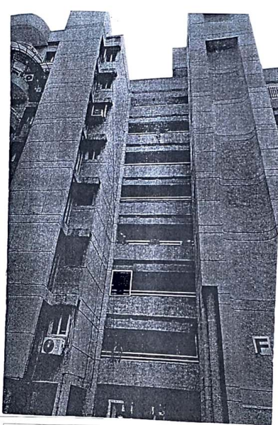

SITUATED AT
RESIDENTIAL TYPE -A DWELLING UNIT (FLAT), BEARING NO. F-721, 7TH FLOOR, RAM VIHAR, SECTOR 30, NOIDA, GAUTAM BUDH NAGAR

GENERAL DETAILS
 | Report prepared for | Individual customer
 | Name & Address of Organization | NA
 | Name of Customer | Maj Gen Ashwani Kumar Sharma (Retd)
 | Credit Analyst | NA
 | Type of Loan | NA
 | Report Format | V-L1 (Basic) | Version: 6.0_2018
 | Date of Valuation | 1 September 2023
 | Date of Survey | Survey was not done.
 | Date of Valuation for Capital Gains | 1 September 2023
 | Type of the Property | Residential Flat
 | Type of Valuation | Historical valuation of property as per client requirement
 | Report Type | Historical valuation of property
 | Surveyed in presence of | Survey was not done |  | Since this is a Historical Desktop Valuation Report, therefore physical survey was not conducted. Historical Valuation report is based on the data/ information/ facts given by the customer about its property and further as per documented information of the various authorities.
 | Purpose of Valuation | Historical valuation of property as per client requirement
 | Scope of the Report | Non Binding Opinion on General Prospective Valuation Assessment of the Property
 | Out-of-Scope of the Report | - Verification of authenticity of documents from originals or cross checking from any Govt. deptt. is not done at our end.  - Legal aspects of the property are out-of-scope of this report.  - Identification of the property is only limited to cross verification from its boundaries at site if mentioned in the provided documents.  - Getting cizra map or coordination with revenue officers for site identification is not done at our end.  - Measurement of the property as a whole is not done at our end.  - Drawing Map & design of the property is out of scope of the work.
 | Documents provided for perusal | Documents Requested |  | Documents Provided |  | Documents Reference No.
 | Documents provided for perusal | Total 03 documents requested. |  | Total 03 documents provided. |  | 03
 | Documents provided for perusal | Property Title document |  | Transfer Deed Cum Sale Deed |  | Dated: 24/06/2023
 |  | Property Title document |  | Sub Lease Deed |  | Dated: 15/03/2023
 |  | Electricity Bill |  | Electricity Bill |  | Dated: 01/01/2023
 | Identification of the property | ☐ | Cross checked from boundaries of the property mentioned in the deed
 | Identification of the property | ☐ | Done from name plate displayed on the property
 | Identification of the property | ☐ | Identified by the owner/ owner representative
 | Identification of the property | ☐ | Enquired from local residents/ public
 | Identification of the property | ☐ | Identification of the property could not be done properly
 | Identification of the property | ☒ | Survey was not done
 | Enclosures | - Valuation Report as per RKA Format Annexure-1  - R.K Associates Important Notes  - Valuer’s Remark - Page No.11  - Screenshot of the Price trend references of the similar related  properties available on public domain - Page No.xx  - Google Map – Page No.13  - Photographs – Pages xx  - Copy of Circle Rate – Pages 02  - Survey Summary Sheet – Pages xx  - Copy of relevant papers from the property documents referred in the  Valuation – Pages xx

VALUATION REPORT AS PER RKA FORMAT – ANNEXURE 1

 | Customer Details
 | Name | Maj Gen Ashwani Kumar Sharma (Retd)
 | Application No. | NA
 | Property Details
 | Address | Residential Type -A Dwelling Unit (Flat), Bearing No. F-721, 7th Floor, Ram Vihar, Sector 30, Noida, Gautam Budh Nagar
 | Nearby Landmark | Survey was not conducted
 | Google Map | Not Available
 | Google Map | Coordinates or URL: Survey was not done
 | Independent access to the property | Clear independent access is available (As per copy of document provided to us)
 | Type of ownership | Single ownership (As per copy of document provided to us)
 | Constitution of the Property | Free Hold
 | Is the property merged or colluded with any other property | No, its an independent singly bounded property (As per copy of document provided to us)
 | Is the property merged or colluded with any other property | NA
 | Document Details | Status | Name of Approving Auth. |  |  |  |  |  |  | Approval No.
 | Typical Floor Plan and Parking Plan | Available | Project manager AWHO Noida |  |  |  |  |  |  | ----
 | Building plan | No information provided | NA |  |  |  |  |  |  | NA
 | Construction Permission | No information provided | NA |  |  |  |  |  |  | NA
 | Legal Documents | Available | Sale Deed |  |  | Sub Lease Deed |  |  |  |  |  | None
 | Physical Details of the Property
 | Adjoining Properties | North |  | South |  |  | East |  |  |  | West
 | Adjoining Properties | Not mentioned in the documents |  | Not mentioned in the documents |  |  | Not mentioned in the documents |  |  |  | Not mentioned in the documents
 | Are Boundaries matched | Cannot comment since survey was not conducted
 | Plot demarcation | Cannot comment since survey was not conducted
 | Approved land Use | Residential as per property documents
 | Type of Property | Residential Flat |  |  |  |  |  |  | --
 | Total no. of floors of the property | Single Floor
 | Floor on which the property is located | On 7th Floor
 | Approx. age of the property | Cannot comment since survey was not done
 | Residual age of the property | Cannot comment since survey was not done
 | Type of structure | RCC framed structure (As per photographs attached in the sale deed)
 | Condition of the Structure | Can not comment since survey was not done
 | Tenure/ Occupancy/ Possession Details
 | Property presently possessed/ occupied by |  |  |  | Property sold by owner dated 24/06/2023, possession must be with current owner.
 | Status of Tenure |  |  |  | NA
 | No. of years of occupancy |  |  |  | NA
 | Relationship of tenant or owner |  |  |  | NA
 | Stage of Construction
 | If under construction then extent of completion |  |  |  | NA
 | Violation in the property
 | - Violation if any observed | - Nature and extent of violation |  |  |  |  |  | - Any other negativity, defect or drawback in the property
 | NA | NA |  |  |  |  |  | NA

 | AREA DETAILS OF THE PROPERTY*
Land area (as per documents/ site survey, whichever is less)
Considered
 | Area as per documents | Area as per site survey | Area considered for Valuation
 | NA | NA | NA
 | Area adopted on the basis of | NA
 | Remarks & Observations | NA
 | Constructed Super Area (As per IS 3861-1966)
 | Area as per documents | Area as per site survey | Area considered for Valuation
 | 151.022 sq.mtr/1625 sq.ft | NA | 151.022 sq.mtr/1625 sq.ft
 | Area adopted on the basis of | Property documents only
 | Remarks & Observations | Super area mentioned in the documents is considered for valuation.
*Please see note in concluding comments.
 | VALUATION ASSESSMENT
 | ASSESSMENT FACTORS
 | Valuation Type | Historical valuation of residential Flat as per client requirement |  |  |  |  |  |  |  | NA
 | Scope of the Valuation | Non Binding Opinion on General Prospective Valuation Assessment of the Property
 | Property Use factor | Current Use |  |  |  |  |  |  | Highest & Best Use
 | Property Use factor | Residential |  |  |  |  |  |  | Residential
 | Legality Aspect Factor  (Refer clauses i & j of Point-10) | Positive as per documents produced to us.
 | Land Physical factors | Shape |  |  | Size |  |  |  | Level |  |  | Frontage to depth ratio
 | Land Physical factors | Irregular |  |  | Small |  |  |  | Cannot comment since survey was not done |  |  | Cannot comment since survey was not done
 | Property location category factor | City Categorization |  |  | Locality Categorization |  |  |  | Property location classification |  |  | Floor Level
 | Property location category factor | Metro City |  |  | Cannot comment since survey was not done |  |  |  | NA |  |  | On 7th Floor  (As per sale deed)
 | Property location category factor | Urban |  |  | NA |  |  |  | NA |  |  | On 7th Floor  (As per sale deed)
 |  |  |  |  |  |  |  |  | NA |  |  | On 7th Floor  (As per sale deed)
 | Property location category factor | Property Facing |  |  | Cannot comment since survey was not done
 | New Development in surrounding area | Cannot comment since no survey was conducted |  |  |  |  | NA
 | Property overall usability Factor | NA
 | Comment on Property Salability Outlook | NA
 | Comment on Demand & Supply in the Market | NA
 | Sale transaction method assumed | NA
 | Best Sale procedure to realize maximum Value | NA
 | Methodology/ Basis of Valuation | Govt. Guideline Value: NA
 | Methodology/ Basis of Valuation | Market Value: Reverse calculation method
 | Methodology/ Basis of Valuation | - As this valuation report is prepared for the Historical valuation of property as per client requirement for the year- 2001. So, for knowing the approximate value prevailing in the year 2001 we have adopted Cost Inflation Index method on the base circle rate.  - Circle rates of 2008 has been considered since we have found the government guideline value of the year 2008. Circle rates are considered since it is a documentary record issued by the Govt. authority and can be considered as a reliable authentic record. The Circle Rate as of 2008 for Residential flat was Rs. 22,000/- per sq.mtr. (Refer Annexure)  - For the calculation of Residential flat circle rate as of 2001, we have reversed calculated the Residential flat Circle rates of 2008 on the basis of Cost inflation index Year wise growth rate of Indian Economy from 2001 to 2008 are as follows.  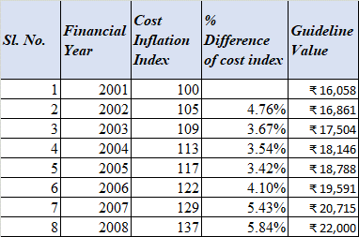  - From the above working we arrive at a rate of Rs. 16,058/- per sq.mtr. for the year 2001.  - Hence, based on this rate total Value of the Land in year 2001 can be calculated.
 | References on prevailing market Rate/ Price trend of the property and Details of the sources from where the information is gathered (from property search sites & local information) |  | Name: |  |  | ---
 |  |  | Contact No.: |  |  | ---
 |  |  | Nature of reference: |  |  | ---
 |  |  | Size of the Property: |  |  | ---
 |  |  | Location: |  |  | ---
 |  |  | Rates/ Price informed: |  |  | ---
 |  |  | Any other details/ Discussion held: |  |  | ---
 | VALUATION CALCULATION
 | GUIDELINE/ CIRCLE VALUE
 | Land Value |  |  | Total Land Area considered as per documents/ site survey (whichever is less) |  |  | Prevailing Rates Range |  |  |  | Rates adopted  (considering all characteristics & assessment factors of the property)
 |  |  |  | NA |  |  | --- |  |  |  | NA
 | Total Land Value (a) |  |  | NA
 |  |  |  | NA
 | Construction Depreciated Replacement Value |  |  | Built-Up unit value
 |  |  |  | Structure Type |  |  | Construction category |  |  |  | Age Factor
 |  |  |  | RCC framed structure |  |  | Can not comment since survey not done |  |  |  | No information available
 |  |  |  | Rate range |  |  | Rate adopted |  |  |  | Covered Area
 |  |  |  | Rs. 16,058/- per sq.mtr |  |  | Rs. 16,058/- per sq.mtr |  |  |  | 151.022 sq.mtr/1625 sq.ft
 | Total Construction Depreciated Replacement Value (b) |  |  | Rs. 24,24,758 /-
 | TOTAL GUIDELINE/ CIRCLE RATE VALUE: (a+b) |  |  | Rs. 24,24,758 /-
PROSPECTIVE MINIMUM FAIR MARKET VALUE
(AS ON 01.04.2001)
 | Land Value |  |  | Total Land Area considered as per documents/ site survey (whichever is less) |  |  | Prevailing Rates Range as on 2001 as per Circle rate |  |  |  | Rate adopted  (considering all characteristics & assessment factors of the property)
 |  |  |  | --- |  |  | --- |  |  |  | ---
 | Total Land Value (a) |  |  | NA
 |  |  |  | NA
 | Construction Depreciated Replacement Value |  |  | Structure cost/ Construction Value
 |  |  |  | Structure Type |  |  | Construction category |  |  |  | Age Factor
 |  |  |  | Not Applicable. |  |  | Not Applicable |  |  |  | Construction older than 15 years and above
 |  |  |  | Rate range |  |  | Rate adopted |  |  |  | Covered Area
 |  |  |  | --- |  |  | --- |  |  |  | ---
 | Total Construction Depreciated Replacement Value Value (b) |  |  | NA
 |  |  |  | NA
 | Add extra for Architectural aesthetic developments, improvements (c)  (add lump sum cost) |  |  |  |  |  |  | NA
 | Add extra for fittings & fixtures (d)  (doors, windows, wood work, cupboards, modular kitchen, electrical/ sanitary fittings) |  |  |  |  |  |  | NA
 | Add extra for services (e)  (water, electricity, sewerage, main gate, boundary, lift, etc.) |  |  |  |  |  |  | NA
 | Guideline value as on 2001 |  |  |  |  |  |  | Rs. 24,24,758 /-
 | TOTAL VALUE: (a+b+c+d+e) |  |  |  |  |  |  | NA
 | Additional Premium if any |  |  |  |  |  |  | NA
 | Details/ Justification |  |  |  |  |  |  | NA
 | Deductions charged if any |  |  |  |  |  |  | NA
 | Details/ Justification |  |  |  |  |  |  | NA
 | TOTAL PROSPECTIVE FAIR MARKET VALUE#: (vi+vii+viii) |  |  |  |  |  |  | NA
 | Round Off |  |  |  |  |  |  | NA
 | EXPECTED REALIZABLE VALUE^ (@ ~15% less) |  |  |  |  |  |  | NA
 | EXPECTED FORCED/ DISTRESS SALE VALUE* (@ ~25% less) |  |  |  |  |  |  | NA
 | VALUE FOR THE INSURANCE PURPOSE |  |  |  |  |  |  | NA
 | Justification for more than 20% difference in Market & Circle Rate |  |  | NA
 | Concluding comments if any |  |  | - This Valuation is carried out for the residential property for year- 2001.  - This report is prepared based on the reported conditions and assumptions taken at our end for the period 2001.  - Since this is a Historical Desktop Valuation Report, therefore physical survey was not conducted. Historical Valuation report is based on the data/ information/ facts given by the customer about its property and further as per documented information of the various authorities.  - Based on the facts of the case and the available information we have tried our best to take come at realistic value through using growth rate of the market in the previous years to reach the realistic assessment of the Value prevailed in year 2001. However, we do not claim or take any responsibility for the arrived historical Valuation due to the limited data/ information available of that period. In case the authorised reader of the report for whom this report is prepared finds any material deficiencies in the assumptions adopted in the report then he is welcome to contradict it based of some evidence & authentic reasoning so that appropriate corrections can be made in the report in case the reasoning is worthwhile to be accepted.  - Valuation is done on the basis of documents provided only since no survey was conducted.  - Any kind of unpaid statutory, utilities, lease, interest or any other pecuniary dues on the asset has not been factored in the Valuation.  - Secondary/ Tertiary costs related to asset transaction like Stamp Duty, Registration charges, Brokerage, Bank interest etc. pertaining to the sale/ purchase of this property are not considered while assessing the Market Value.  - As per the scope of the assignment, Value assessment is subject to Assumptions, Remarks & Limiting Conditions mentioned in Point ‘7’ below, R.K Associates Important Notes and Valuer’s Remarks (Enclosure: 1) & other enclosed documents with the Report which will remain part & parcel of the report. Without these enclosures/ documents report shall stand null & void.  - Area information considered in the Valuation Report adopted from relevant approved documents provided to us.  - This valuation report shall not be used for any mortgage/banking or any other purpose.

ASSUMPTIONS | REMARKS | LIMITING CONDITIONS
Qualification in TIR/Mitigation Suggested, if any: NA
Is property SARFAESI compliant: Yes
Whether property belongs to social infrastructure like hospital, school, old age home etc.: No
Whether entire piece of land on which the unit is set up / property is situated has been mortgaged or to be mortgaged: NA
Details of last two transactions in the locality/area to be provided, if available: Information couldn’t be found.
Any other aspect which has relevance on the value or marketability of the property: NA

- Information of the average market rates is taken based on the verbal market survey in the subject area from the local people, property agents, recent deals, demand-supply, internet postings which has been relied upon. No written record is generally available for such market information and only the verbal information has to be relied upon.
- Forced, compulsion, constraint, obligatory sales transactions data doesn’t form part of the Fair Market Valuation exercise.
- Sale transaction method of the asset is assumed as free market transaction while assessing Prospective Fair Market Value of the asset.
- This Valuation report is prepared based on the facts of the property on the date of the survey. However in future property Market may go down, property conditions may change or may go worse, Property reputation may differ, Property vicinity conditions may go down or become worse, Property market may change due to impact of Govt. policies or effect of World economy, Usability prospects of the property may change, etc. Hence before financing, Banker/ FI should take into consideration all such future risk and should loan conservatively to keep the advanced money safe in case of the downward trend of the property value.
- Valuation of the same asset/ property can fetch different values in different situations. For eg. Valuation of a running/ operational shop/ hotel/ factory will fetch better value and in case of closed shop/ hotel/ factory it will have considerable lower value. Similarly an asset sold directly by an owner in the market will fetch better value and if the same asset/ property is sold by any financer due to encumbrance on it will fetch lower value. Hence before financing, Banker/ FI should take into consideration all such future risks and should loan conservatively to keep the advanced money safe in case of any such situation.
- This report is prepared based on the copies of the documents/ information which interested organization or customer could provide to us out of the standard checklist of documents sought from them and further based on our assumptions and limiting conditions. All such information provided to us has been relied upon and we have assumed that it is true and correct. Verification or cross checking of the documents provided to us from the originals has not been done at our end. If at any time in future it’s found or came to our knowledge that misrepresentation of facts or incomplete or distorted information has been provided to us then this report will automatically become null & void.
- Getting cizra map or coordination with revenue officers for site identification is not done at our end.
- All area measurements are on approximate basis. Verification of the area measurement of the property is done only based on sample random checking and not based on full scale measurement. Area of the large land parcels of more than 2500 sq.mtr or of uneven shape, is taken as per property documents which has been relied upon.
- Legal aspects for eg. ownership rights, lien, charge, mortgage, etc. are not considered in this report. It is assumed and taken into account that the concerned Bank/ Financial Institution has first got the legal verification cleared by the competent Advocate before requesting for the Valuation report. In case Valuation is obtained before taking legal scrutiny or opinion then it is expected from the Bank to inform back the Valuer timely about such change of rights on the property as soon as it comes into the notice of the Bank/ Financer which may affect their charge on the mortgage asset so that accordingly Valuation modification can be done only for that portion for which the Bank has complete charge/ rights.
- Investigation of title of the property and its legal right is beyond the scope of this report. If this property is offered as collateral security, then concerned financial institution is requested to verify & satisfy themselves on the ownership & legality of the property shown in this valuation report with respect to the latest legal opinion.
- Valuation is done for the property identified to us by the owner/ owner representative. Responsibility of identifying the correct property to the Valuer/ its authorized surveyor is solely of the client/ owner for which Valuation has to be carried out. At our end we can just cross verify the identification of the property with reference to the documents produced for perusal. Method by which identification of the property is carried out is also mentioned in the report clearly. It is requested from the Bank to cross check from their own records/ information if this is the same property for which Valuation has to be carried out to ensure that owner has not misled the Valuer company or misrepresented the property due to any vested interest.
- In India more than 70% of the geographical area is lying under rural/ remote/ non municipal/ unplanned area where the subject property is surrounded by vacant lands having no physical demarcation or having any display of property survey or municipal number / name plate on the property clearly. Even in old locations of towns, small cities & districts where property number is either not assigned or not displayed on the properties clearly and also due to the presence of multiple/ parallel departments due to which ownership/ rights/ illegal possession/ encroachment issues are rampant across India and due to these limitations at many occasions it becomes tough to identify the property with 100% surety from the available documents, information & site whereabouts and thus chances of error, misrepresentation by the borrower and margin of chances of error always persists in such cases. To avoid any such chances of error it is advised to the Bank to engage municipal/ revenue department officials to get the confirmation of the property to ensure that the property shown to Valuer/ Banker is the same as for which documents are provided.
- If this Valuation Report is prepared for the Flat/ dwelling unit situated in a Group Housing Society or Integrated Township then it is assumed that the Banker or the concerned organization has satisfied themselves with the approval of the Group Housing Society/ particular floor & building before allotting the Valuation case to the Valuer company.
- Due to fragmented & frequent change in building/ urban planning laws/ guidelines from time to time, different laws/ guidelines between regions/ states and no strict enforceability of Building Bye-Laws in India specially in non-metro and scale b & c cities & Industrial areas, property owners many times extend or make changes in the covered area/ layout from the approved/ applicable limits. There are also situations where properties are decades old when there was no formal Building Bye-Laws applicable when the construction must have been done. Due to such discrete/ unplanned development in many regions sometimes it becomes tough to determine the exact lawful situation on ground for the Valuer. In case nothing specific is noted on the covered built-up area considered in the Valuation Report, the covered area present on the site as per site survey will be considered in the Valuation.
- In case of Valuation of Plant & Machinery or equipment, condition of machines is evaluated by visual observation only. No technical/ mechanical testing of any kind has been carried out at our end to ascertain the condition and efficiency of the machines. Valuation of Plant & Machinery is done on the basis of physical existence of the assets rather than their technical expediency.
- Secondary/ Tertiary costs related to asset transaction like Stamp Duty, Registration charges, Brokerage, Bank interest, etc. pertaining to the sale/ purchase of this property are not considered while assessing the Market Value.
- Any kind of unpaid statutory, utilities, lease, interest or any other pecuniary dues on the asset has not been factored in the Valuation.
- Valuation is a subjective field and opinion may differ from consultant to consultant. To check the right opinion, it is important to evaluate the methodology adopted and various data point/ information/ factors/ assumption considered by the consultant which became the basis for the Valuation report before reaching to any conclusion.
- At the outset, it is to be noted that Value analysis of any asset cannot be regarded as an exact science and the conclusions arrived at in many cases will, of necessity, be subjective and dependent on the exercise of individual judgment. Given the same set of facts and using the same assumptions, expert opinions may differ due to the number of separate judgment decisions, which have to be made. Therefore, there can be no standard formulae to establish an indisputable exchange ratio. In the event of a transaction, the actual transaction value achieved may be higher or lower than our indicative analysis of value depending upon the circumstances of the transaction. The knowledge, negotiability and motivations of the buyers and sellers and the applicability of a discount or premium for control will also affect actual price achieved. Accordingly, our indicative analysis of value will not necessarily be the price at which any agreement proceeds. The final transaction price is something on which the parties themselves have to agree. However our Valuation analysis can definitely help the stakeholders to make them informed and wise decision about the Value of the asset and can help in facilitating the arm’s length transaction.

 | DECLARATION
- Physical survey of the mentioned property was not conducted.
- The undersigned does not have any direct/indirect interest in the above property.
- The information furnished herein is true and correct to the best of our knowledge.
- This valuation report is carried out by our Engineering team on the request from Maj Gen Ashwani Kumar Sharma
 | Name & Address of Valuer company | Wealth Tax Registration No. | Signature of the authorized person
 | M/s R.K. Associates Valuers & Techno Engineering Consultants Pvt. Ltd. G-183, Preet Vihar, Delhi-110092 | 2303/ 1988
 | Enclosed Documents | - Valuer’s Remark - Page No.11  - Screenshot of the price trend references of the similar related properties available on public domain – Page No.x  - Google Map – Page No.13  - Photographs – Pages No.15  - Copy of Circle Rate – Pages No.14  - Survey Summary Sheet – Pages No. xx  - Copy of relevant papers from the property documents referred in the Valuation – Pages No. xx
 | Total Number of Pages in the Report with Enclosures | 18
 | Engineering Team worked on the report | SURVEYED BY: Physical survey was not conducted
 | Engineering Team worked on the report | PREPARED BY: Mahesh Chandra Joshi
 | Engineering Team worked on the report | REVIEWED BY: HOD Valuations

R.K ASSOCIATES IMPORTANT NOTES:

- DEFECT LIABILITY PERIOD - In case of any query/ issue or escalation you may please contact Incident Manager by writing at valuers@rkassociates.org. We ensure 100% accuracy in the Calculations done, Rates adopted and various other data points & information mentioned in the report but still can’t rule out typing, human errors or any other mistakes. In case you find any mistake, variation, discrepancy or inaccuracy in any data point of the report, please help us by bringing all such points into our notice in writing at valuers@rkassociates.org within 30 days of the report delivery, to get these rectified timely, failing which R.K Associates won’t be held responsible for any inaccuracy in any manner. Also if we will not hear back anything from you within 30 days, we will assume that report is correct in all respect and no further claim of any sort will be entertained thereafter. We would welcome and appreciate your feedback & suggestions in order to improve our services.

- COPYRIGHT FORMAT - This report is prepared on the copyright format of R.K Associates to serve our clients in the best possible way. Legally no one can copy or distribute this format without prior approval from R.K Associates. It is meant only for the organization as mentioned on the cover page of this report. Distribution or use of this format other than R.K Associates will be seen as unlawful act and necessary legal action can be taken against the defaulters.

IF REPORT IS USED FOR BANK/ FIs
NOTE: As per IBA Guidelines in case the valuation report submitted by the valuer is not in order, the banks / FIs shall bring the same to the notice of the valuer within 15 days of submission for rectification and resubmission. In case no such communication is received, it shall be presumed that the valuation report has been accepted.
At our end we have not verified the authenticity of any documents provided to us. Bank is advised to verify the genuineness of the property documents before taking any credit decision.

ENCLOSURE: 1 – VALUER’S REMARKS
Fair Market Value# suggested by the competent Valuer is that prospective estimated amount of the subject asset/ property in his expert & prudent opinion without any prejudice after he has carefully & exhaustively evaluated all the facts & information related to the subject asset at which the subject asset/ property should be exchanged between a willing buyer and willing seller at an arm’s length transaction after proper marketing, wherein the parties, each acted knowledgeably, prudently and without any compulsion on the date of the Valuation.
Realizable Value^ is the minimum prospective value of the property which it may be able to realize at the time of actual property transaction factoring in potential prospects of deep negotiations carried out between the buyer & seller for ultimately finalizing the transaction. Realizable value may be 10-20% less of the Fair Market Value depending on the various salability prospects of the subject property.
Forced/ Distress Sale Value* is the value when the property has to be sold due to any compulsion or constraint like financial encumbrances, dispute, as a part of a recovery process, any defect in the property, having unclear title or any such sort of condition or situation. In this type of sale minimum disposable value is assessed which varies from 20-35% less from the Fair Market Value based on the nature, size & salability prospects of the property. In this type of sale negotiation power of the buyer is always more than the seller and eagerness of selling the property is more than buying it. Therefore the Forced/ Distress Sale Value always fetches less value.
Best rates are rationally adopted based on the facts of the case came to our knowledge during the course of the assignment considering many factors like nature of the property, size, location, approach, market situation and trends.
Construction rates are adopted based on present replacement cost of construction and calculating applicable depreciation & deterioration factor as per its existing condition, specifications based on the visual observation of the structure. No structural, physical tests have been carried out in respect of it.
This Valuation report is prepared based on the facts of the property on the date of the survey. However in future property Market may go down, property conditions may change or may go worse, Property reputation may differ, Property vicinity conditions may go down or become worse, Property market may change due to impact of Govt. policies or effect of World economy, Usability prospects of the property may change, etc. Hence before financing, Banker/ FI should take into consideration all such future risk and should loan conservatively to keep the advanced money safe in case of the downward trend of the property value.
Valuation of the same asset/ property can fetch different values in different situations. For eg. Valuation of a running/ operational shop/ hotel/ factory will fetch better value and in case of closed shop/ hotel/ factory it will have considerable lower value. Similarly an asset sold directly by an owner in the market will fetch better value and if the same asset/ property is sold by any financer due to encumbrance on it will fetch lower value. Hence before financing, Banker/ FI should take into consideration all such future risk and should loan conservatively to keep the advanced money safe in case of any such situation.
No employee or member of R.K Associates has any direct/ indirect interest in the property.
Sale transaction method of the asset is assumed as free market transaction while assessing Fair Prospective Market Value of the asset.
Area measurements considered in the Valuation Report pertaining to Land & Building is adopted from relevant approved documents or actual site measurement whichever is less. All area measurements are on approximate basis only.
This report is having limited scope as per its fields to provide only the general basic idea of the value of the property prevailing in the market based on the documents/ data/ information provided by the client. The suggested value should be considered only if transaction is happened as free market transaction.
The condition assessment and the estimation of residual economic life of the structure is based on the visual observations and appearance found during the site survey. We have not carried out any structural design or stability study; nor carried out any physical tests to assess structural integrity & strength.
This report is prepared based on the copies of the documents/ information which interested organization or customer could provide to us out of the standard checklist of documents sought from them and further based on our assumptions and limiting conditions. All such information provided to us has been relied upon and we have assumed that it is true and correct. Verification or cross checking of the documents provided to us from the originals has not been done at our end. If at any time in future it’s found or came to our knowledge that misrepresentation of facts or incomplete or distorted information has been provided to us then this report will automatically become null & void.
Investigation of title of the property and its legal right is beyond the scope of this report. If this property is offered as collateral security, then concerned financial institution is requested to verify & satisfy themselves on the ownership & legality of the property shown in this valuation report with respect to the latest legal opinion.
Value varies with the Purpose/ Date/ Condition of the market. This report should not to be referred if any of these points are different from the one mentioned aforesaid in the Report. The Value indicated in the Valuation Report holds good only upto the period of 3 months from the date of Valuation.
Analysis and conclusions adopted in the report are limited to the reported assumptions, conditions and information came to our knowledge during the course of the work.
This report is prepared on the RKA V-L3 (Medium) Valuation format as per the client requirement, charges paid and the time allotted. This report is having limited scope as per its fields to provide only the general estimated basic idea of the value of the property prevailing in the market based on the information provided by the client. The Valuation assessed in this Valuation Report should hold good only if transaction is happened as per free market transaction. No detailed analysis or verification of the information is carried upon pertaining to the value of the subject property. No claim for any extra information will be entertained whatsoever be the reason. For any extra work over and above the fields mentioned in the report will have an extra cost which has to be borne by the customer.
This is just an opinion report and doesn’t hold any binding on anyone. It is requested from the concerned Client/ Bank/ Financial Institution which is using this report for mortgaging the property that they should consider all the different associated relevant & related factors also before taking any business decision based on the content of this report.
All Pages of the report including annexures are signed and stamped from our office. In case any paper in the report is without stamp & signature then this should not be considered a valid paper issued from this office.
Defect Liability Period is 30 DAYS. We request the concerned authorized reader of this report to check the contents, data and calculations in the report within this period and intimate us in writing if any corrections are required or in case of any other concern with the contents or opinion mentioned in the report. Corrections only related to typographical, calculation, spelling mistakes will be entertained within the defect liability period. No request for any illegitimate value revision, date change or any other change will be entertained other than the one mentioned above.
R.K Associates encourages its customers to give feedback or inform concerns over its services through proper channel at valuers@rkassociates.org in writing within 30 days of report delivery. After this period no concern/ complaint/ proceedings in connection with the Valuation Services can be entertained due to possible change in situation and condition of the property.
Our Data retention policy is of ONE YEAR. After this period we remove all the concerned records related to the assignment from our repository. No clarification or query can be answered after this period due to unavailability of the data.
This Valuation report is governed by our (1) Internal Policies, Processes & Standard Operating Procedures, (2) R.K Associates Quality Policy, (3) Valuation & Survey Best Practices Guidelines formulated by management of R.K Associates, (4) Information input given to us by the customer and (4) Information/ Data/ Facts given to us by our field/ office technical team. Management of R.K Associates never gives acceptance to any unethical or unprofessional practice which may affect fair, correct & impartial assessment and which is against any prevailing law. In case of any indication of any negligence, default, incorrect, misleading, misrepresentation or distortion of facts in the report then it is the responsibility of the user of this report to immediately or atleast within the defect liability period bring all such act into notice of R.K Associates management so that corrective measures can be taken instantly.
R.K Associates never releases any report doing alterations or modifications from pen. In case any information/ figure of this report is found altered with pen then this report will automatically become null & void.
If this report is prepared for the matter under litigation in any Indian court, no official or employee of R.K Associates will be under any obligation to give in person appearance in the court as a testimony. For any explanation or clarification, only written reply can be submitted on payment of charges by the plaintiff or respondent which will be 10% of the original fees charged where minimum charges will be Rs.2500/-.

ENCLOSURE: II – GOOGLE MAP LOCATION

SURVEY WAS NOT CONDUCTED

ENCLOSURE: III – PHOTOGRAPHS
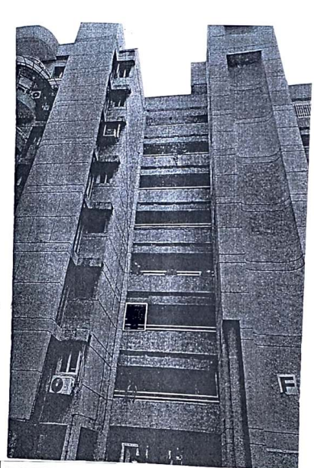

ENCLOSURE: IV – CIRCLE RATE

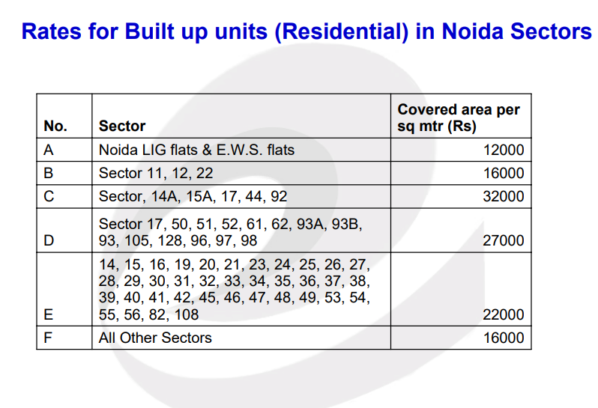

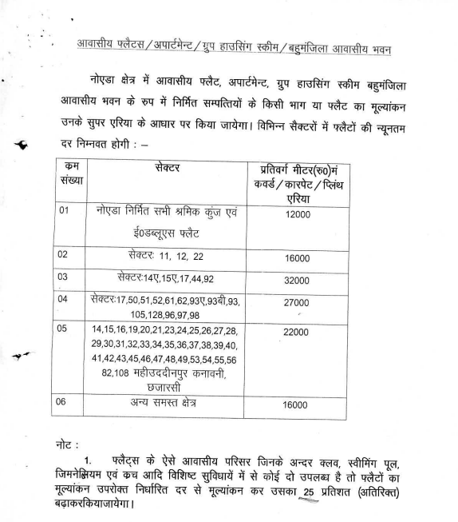

ENCLOSURE: – V. COPY OF RELEVANT PAPERS FROM THE PROPERTY DOCUMENTS REFERRED IN THE VALUATION

