File No.: VIS(2023-24)-PL296-246-353 Dated: 24-11-2023

LENDER’S INDEPENDENT ENGINEER’s REPORT

OF

3.87 (± 10%) MWp GRID CONNECTED ROOF-TOP SOLAR POWER PLANT

PROPOSED TO BE SET-UP AT
11 NOS. OF LOCATIONS IN RAJASTHAN

DEVELOPER:
M/S ASHLYN SOLAR INFRA PVT. LTD.

REPORT PREPARED FOR
STATE BANK OF INDIA, MAKHUPURA BRANCH, AJMER
**Important - In case of any query/ issue or escalation you may please contact Incident Manager
at le@rkassociates.org. We will appreciate your feedback in order to improve our services.
NOTE: As per IBA Guidelines please provide your feedback on the report within 15 days of its submission after which report will be considered to be correct.

IMPORTANT NOTICE

COPYRIGHT FORMAT: This report is prepared on the copyright format of R.K Associates to serve our clients with the best possible information and analysis to facilitate them to take rational business decisions. Legally no one can copy or distribute this format without prior approval from R.K Associates. It is meant only for the advisory/ reference purpose for the organization/s as mentioned on the cover page of this report. Distribution or use of this format by any organization or individual other than R.K Associates will be seen as an unlawful act and necessary legal action can be taken against the defaulters.
This report is intended for the sole use of the intended recipient/s and contains material that is STRICTLY CONFIDENTIAL AND PRIVATE.

DEFECT LIABILITY PERIOD: - In case of any query/ issue or escalation you may please contact Incident Manager at le@rkassociates.org.
Though adequate care has been taken while preparing this report as per its scope, but still we can’t rule out typing, human errors, over sightedness of any information or any other mistakes. Therefore, the concerned organization is advised to satisfy themselves that the report is complete & satisfactory in all respect. Intimation regarding any discrepancy shall be brought into our notice immediately. If no intimation is received within 15 (Fifteen) days in writing from the date of issuance of the report, to rectify these timely, then it shall be considered that the report is complete in all respect and has been accepted by the client upto their satisfaction & use and further to which R.K Associates shall not be held responsible in any manner.

TABLE OF CONTENTS
SECTIONS | PARTICULARS | PAGE NO.
Part A | REPORT SUMMARY | 03
Part B | INTRODUCTION | 04
 | - Name of the Project | 04
 | - Project Overview | 04
 | - Scope of the Report | 06
 | - Purpose of the Report | 06
 | - Methodology Adopted | 06
Part C | PROJECT DETAILS AND KEY TECHNICAL PARAMETERS | 07
Part D | ENERGY YIELD ASSESSMENT | 13
Part E | POWER PURCHASE AGREEMENT TERMS | 19
Part F | CURRENT STATUS OF WORK | 22
Part G | PROJECT COST & EXPENDITURE | 23
Part H | PHOTOGRAPHS | 25
Part I | OTHER DOCUMENTS & REFERENCES | 26
Part J | DISCLAIMER | 38

PART A | REPORT SUMMARY

 | Name of the Project | 3.87 (±10%) MWp Grid Connected Solar Power Plant
 | Project Location | - CattleFeed Plant- Ajmer  - CattleFeed Plant- Bhilwara  - CattleFeed Plant-Bikaner  - Metro Dairy Govindgarh  - CattleFeed Plant-Jodhpur  - CattleFeed Plant- Nadbai  - CattleFeed Plant- Pali  - Pollution Control Board Jaipur  - 5TH RAC Battalion Jaipur  - Satellite Hospital, Ajmer  - State Disaster Relief Force
 | Seller Company | M/s Solar Quest Ashlyn Projects Private Limited
 | Prepared for Organization | State Bank Of India, Makhupura Branch, Ajmer
 | LIE Consultant Firm | M/s. R.K. Associates Valuers & Techno Engineering Consultants (P) Ltd
 | Date of Survey | 23-10-2023 (CattleFeed Plant- Ajmer & Nadbai only)
 | Date of Report | 24-11-2023
 | Details & documents provided by | Mr. Pranjal Dhariwal, Managing Director M/s Solar Quest Ashlyn Projects Pvt. Ltd.
 | Report Type | Lender’s Independent Engineering Report
 | Purpose of the Report | Review of Project cost, CUF and Irradiation Data, current status to facilitate bankers to take business decision on the Project.
 | Scope of the Report | To review Project cost and examine the current status of installation/ Commissioning of the Project.
 | Documents produced for Perusal | - Copy of Power Purchase Agreements (PPAs)  - Copy of Plant Layout  - Copy of PV Syst reports
 | Annexure with the Report | - Benchmark Cost by MNRE  - Market Comparables  - Global Solar Atlas by World Bank Group

PART B | INTRODUCTION

- NAME OF THE PROJECT: 3.87 (± 10%) MWp Grid Connected Solar Power Plant in RESCO Model to be installed at 11 locations which are described in Part A.2 above by M/s Ashlyn Solar Infra Pvt. Ltd.
- PROJECT OVERVIEW: M/s Solar Quest Ashlyn Projects Private Limited (SQAPPL) is an SPV of M/s Solar Quest LLP which is into Manufacturing, supplying, installing and distribution of electric power generation using solar energy.
M/s Solar Quest Ashlyn Projects Private Limited (hereinafter referred to as “Power Producer”) had signed 11 nos. of Power Purchase Agreement (PPAs) with different purchaser for Design, Manufacture, Supply, Erection, Testing and Commissioning including Warranty, Operation & Maintenance of 6 roof-top & 5 ground mounted solar power plants at their respective locations having a total DC capacity of 3.87 (± 10%) MWp for 25 years of plant operation/ PPA tenure.
For the implementation of the subject project, M/s Ashlyn Solar Infra Pvt. Ltd. has engaged its parent company M/s Solar Quest LLP for the design, supply, erection, commissioning of Roof/Ground Mounted Grid Tie Solar PV plant (Subject Project).
As per details shared by the company, the total project cost is estimated at a price of Rs.17.99 Cr. including duties and taxes.
M/s Ashlyn Solar Infra Pvt. Ltd. has approached SBI for credit facility to construct these plants who have in turned appointed M/s R.K Associates Valuers & Techno Engineering Consultants Pvt. Ltd. as Lenders Independent Engineer for a specific scope of work.
As per information shared by the company, presently physical work has begun only on Ajmer & Nadbai Site. Thus, we have physically inspected only these 2 locations and more so our scope of work includes only review & comment on total Project cost, CUF and Irradiation Data.

RESCO Model: -
MNRE had introduced the PPP/RESCO model policy setting tariff rates for solar to be arrived on transparent competitive bidding model through PPP route.

The RESCO model is one of the methods of implementing rooftop solar installations. Under the RESCO model, a renewable energy service company ("RESCO"), (i.e., an energy service company that provides energy to consumers from renewable energy sources), develops, installs, finances, operates and owns the rooftop solar power project ("Project"), and supplies power generated from the Project to the consumer on whose premises the Project is set up ("Customer") or to the grid through net-metering.

'Build, Own, Operate and Transfer' (BOOT) is a special kind of RESCO model in which the RESCO constructs, owns, operates, and transfers the ownership of the Project to the Customer after the expiry of a predefined period. The RESCO and the Customer enter into a long-term power purchase agreement ("PPA") for an agreed tenure, which sets out, among others, the terms at which the power generated from the Project will be sold to the Customer and the tariff at which the power will be sold. Excess power from the Project (if any) could be sold by the Customer to the distribution utility through net metering system – the net metering regulations differ from state to state.

Under the PPA, the RESCO owns the Project and is responsible for its installation as well as its operation and maintenance of the Project throughout the tenure of the Project, and at the end of the PPA term, the ownership of the Project is transferred to the Customer. Thereafter, the Customer may either choose to retain the RESCO for operation and maintenance services or engage a third-party operator.

If the entity on whose premises the Project is located does not intend to buy the power generated from the Project and does not entered into a PPA with the RESCO, that entity can either lease the rooftop premises to the RESCO by means of a lease agreement or enter into a license agreement granting the RESCO the right to use the premises for the limited purpose of setting up and operating the Project. The RESCO then operates the Project and exports the energy generated to the local distribution utility at a predetermined feed-intariff (FiT) approved by the State Electricity Regulator under relevant schemes issued by the relevant state.

- SCOPE OF THE REPORT: To verify and review the Project cost, CUF and Irradiation Data of the Solar Power Plants set-up/ being set-up by M/s Ashlyn Solar Infra Pvt. Ltd.
- Industry/ sector research and demand & supply trend is out of scope of the report.
- Financial feasibility study of the Project is out of scope of the report.
- Providing any kind of design report or map is out-of-scope of the report.
- Scrutiny of contracts, Agreements and arrangement between the parties from legal perspective is out-of-scope of this report.
- Location feasibility is ascertained based on the PVSyst Report provided by the client.
- Any kind of technical & economic feasibility of the Project is out-of-scope of this Report.

All the assessment carried out for the Project is done based on the documents and information provided to us and various other discussions with the Project proponents and thus forming an opinion out of it.

Component wise verification is not carried out.

- PURPOSE OF THE REPORT: To provide fair detailed analysis report to the Bank based on the “in-scope points” mentioned above for facilitating them to take appropriate business decision on the Project.

- METHADOLOGY ADOPTED:
- To gather relevant data/ information/ documents related to Project planning, execution, current status.
- Study of copy of Project Planning documents/ Agreements to know the scope of work of the company.
- To procure, study and analysis of any additional information, data, and documents required/ provided by the company.
- Research about the Project/ sector from the sources in the public domain.
- Correlation of the provided information against Industry/ sector benchmarks/ trend.
- Information compilation, analysis and reporting.

PART C | PROJECT DETAILS AND KEY TECHNICAL PARAMETERS
As per the information and copy of documents shared by the management of the company, details of the subject plants has been tabulated below:
S.  No. | Offtaker | Capacity  DC Power (kWp) | Capacity  AC Power  (kWp) | Roof Type
1 | Cattle Feed Plant- Ajmer | 600 | 500 | Sheet
2 | Cattle Feed Plant- Bhilwara | 460 | 450 | Ground
3 | Cattle Feed Plant-Bikaner | 600 | 400 | Ground
4 | Metro Dairy Govindgarh | 120 | 100 | Ground
5 | Cattle Feed Plant-Jodhpur | 580 | 400 | Sheet
6 | Cattle Feed Plant- Nadbai | 600 | 500 | Sheet
7 | Cattle Feed Plant- Pali | 450 | 360 | Ground
8 | Pollution Control Board Jaipur | 117 | 110 | RCC
9 | 5th RAC Battalion Jaipur | 100 | 100 | RCC
10 | Satellite Hospital, Ajmer | 100 | 80 | RCC
11 | State Disaster Relief Force | 150 | 150 | Ground
Total |  | 3,877 | 3,150

Location Maps(for physicially inspected site): -

Out of total 11 nos. of locations, as per information provided physical work at site is in progress at only 2 locations i.e. Cattle Feed Plant, Ajmer & Nadbai. Location Maps of the same is as follows:-
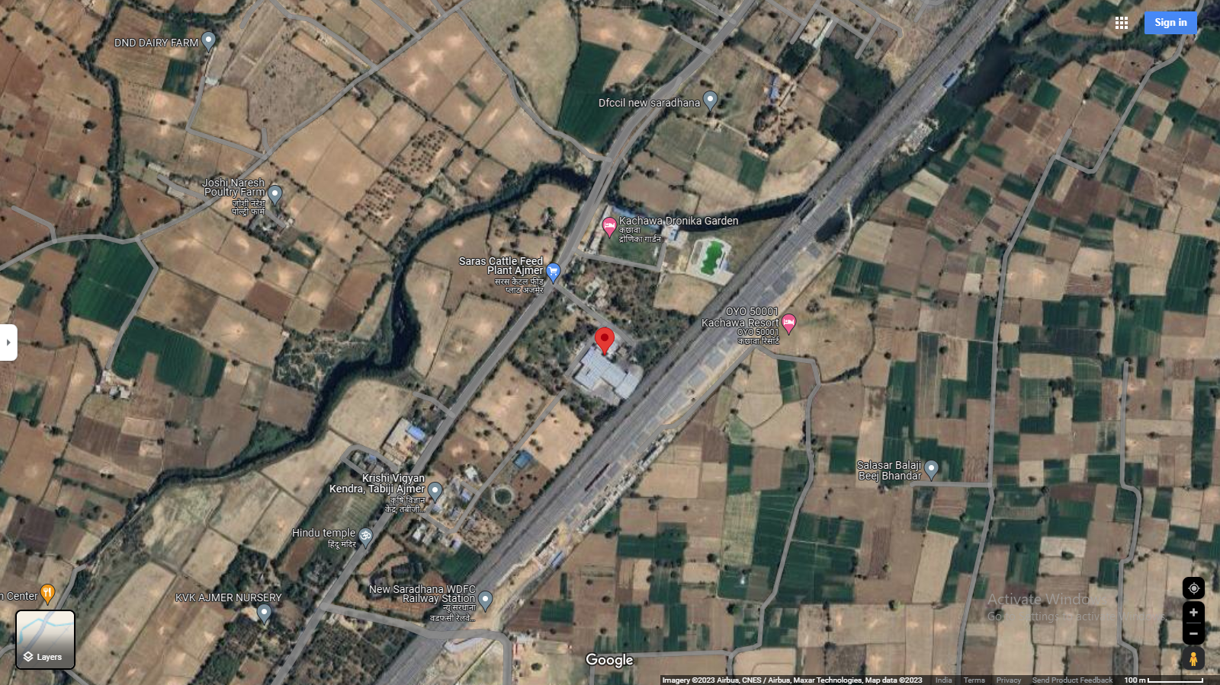
Location: Cattle Feed Plant- Ajmer GPS: 26°22'35.0"N 74°36'14.0"E
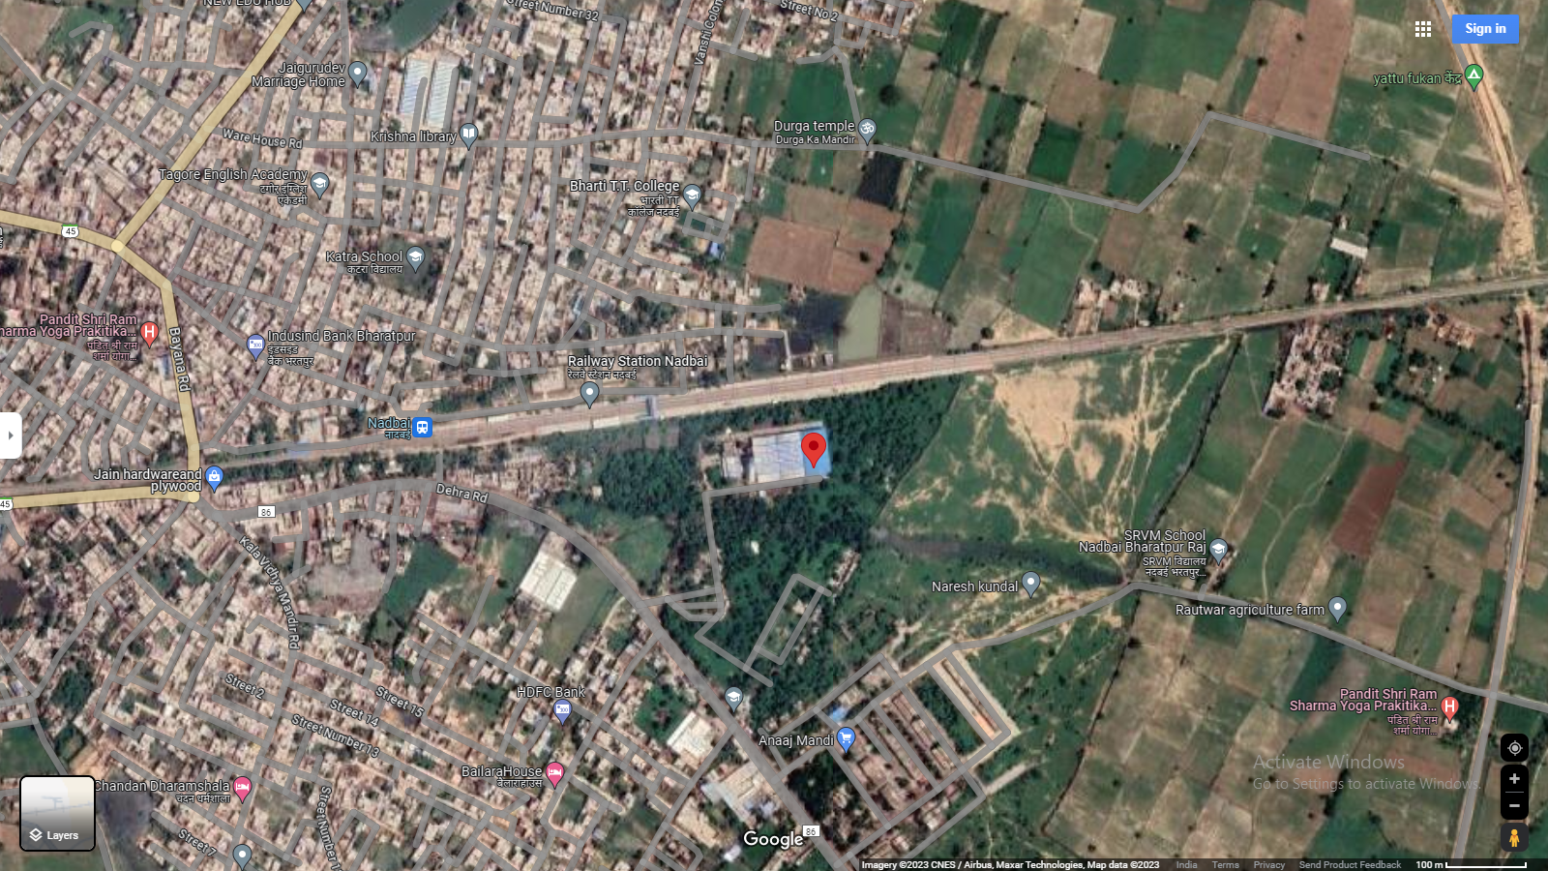
Location: CattleFeed Plant- Ajmer GPS: 27°12'47.6"N 77°12'41.6"E

Technical details as mentioned in proposal
As per copy of proposal shared by the company, the technical details of major component which shall be used for installation of solar plant, are as follows:-
S. No. | Particulars | Rating
1 | Solar Panels  Credence  Navitas  Waaree | 650 Wp  540 Wp  540Wp
2 | Inverters  Sungrow  Growatt  Deye | 50 kW- 125 kW
3 | Structures | Al Rails / GI
4 | Cables | Polycab
5 | Switchgear | Schnider / ABB / Eq
6 | Energy Meters | Secure / HPL
7 | Earthing | Reputed
The above-mentioned installations/parts are provided as per best industrial practice and can be verified after commissioning of the project.

PART D | ENERGY YIELD ASSESSMENT

Company has used PVSyst V7.3.1 to assess energy yield calculation which is the standard Industry practice. The yearly average of main results of irradiation and energy yield from the provided PVSyst is as under:
S. No. | Plant Location | Annual production probability  (MWh) |  | Specific Production  (kWh/kWp/year) |  | Performance  Ratio (%) | CUF (%)
 |  | P50 | P90 | As per PPA | As per PVsyst
1 | Cattle Feed Plant- Ajmer | 902.7 | 834.6 | 1500 | 1506 | 82.93% | 17.12%
2 | Cattle Feed Plant- Bhilwara | 770.3 | 700.9 | 1500 | 1678 | 82.78% | 18.26%
3 | Cattle Feed Plant-Bikaner | 987.2 | 912.7 | 1500 | 1647 | 82.76% | 18.26%
4 | Metro Dairy Govindgarh | 197.42 | 182.53 | 1500 | 1654 | 83.53% | 18.26%
5 | Cattle Feed Plant-Jodhpur | 892.0 | 811.5 | 1500 | 1529 | 81.77% | 18.26%
6 | Cattle Feed Plant- Nadbai | 839.8 | 776.4 | 1500 | 1401 | 85.46% | 17.12%
7 | Cattle Feed Plant- Pali | 774.8 | 704.9 | 1500 | 1722 | 82.75% | 18.26%
8 | Pollution Control Board Jaipur | 189.07 | 174.81 | 1500 | 1621 | 83.18% | 17.12%
9 | 5th RAC Battalion Jaipur | 163.67 | 151.32 | 1500 | 1621 | 83.17% | 17.12%
10 | Satellite Hospital, Ajmer | 153.21 | 141.65 | 1500 | 1603 | 80.72% | 16.55%
11 | State Disaster Relief Force | 250.0 | 231.1 | 1500 | 1653 | 83.20% | 17.12%

Analysis of Irridiation & PV Output data: In respect to Irridiation & PV Output data, company has provided to us PVSyst Report V7.3.1 in which key Irrdidation components and PV Output data is given as enumerated in table below. We have analysed and compared it with other data source points also such as Solar Resource by Global Solar Atlas of World Bank and ISRO Solar Calculator to confirm its legitimacy as mentioned in table below:
Particulars | Cattle Feed Plant- Ajmer |  | Cattle Feed Plant- Bhilwara |  | Cattle Feed Plant- Bikaner
 | As per Global  Solar Atlas | As per PVSyst | As per Global  Solar Atlas | As per PVSyst | As per Global  Solar Atlas | As per PVSyst
Global horizontal Irradiation (kWh/m²) | 1970.1 | 1846.1 | 1979.2 | 1840.9 | 1937.8 | 1810.8
Diffuse horizontal Irradiation (kWh/m²) | 850.7 | 809.9 | 850.2 | 809.9 | 884.5 | 870.5
Direct Normal Irradiation (kWh/m²) | 1690.8 | - | 1700.1 | - | 1592.3 | -
Specific Photovoltaic Power Output | 1696.7 | 1506.0 | 1700.2 | 1678.0 | 1678.2 | 1647.0
Annual Global Insolation (ISRO Solar Calculator) (kWh/m2/year) | 1676 |  | 1707 |  | 1641

Particulars | Metro Dairy Govindgarh |  | Cattle Feed Plant-Jodhpur |  | Cattle Feed Plant- Nadbai
 | As per Global  Solar Atlas | As per PVSyst | As per Global  Solar Atlas | As per PVSyst | As per Global  Solar Atlas | As per PVSyst
Global horizontal Irradiation (kWh/m²) | 1862.9 | 1802.3 | 2023.7 | 1901.1 | 1808.7 | 1668.2
Diffuse horizontal Irradiation (kWh/m²) | 923.1 | 831.8 | 822.6 | 832.5 | 935.8 | 894.8
Direct Normal Irradiation (kWh/m²) | 1378.8 | - | 1826.0 | - | 1290.8 | -
Specific Photovoltaic Power Output | 1581.7 | 1654.0 | 1747.5 | 1529.0 | 1547.7 | 1401
Annual Global Insolation (ISRO Solar Calculator) (kWh/m2/year) | 1616 |  | 1782 |  | 1501

Particulars | Cattle Feed Plant- Pali |  | Pollution Control Board Jaipur |  | 5th RAC Battalion Jaipur
 | As per Global  Solar Atlas | As per PVSyst | As per Global  Solar Atlas | As per PVSyst | As per Global  Solar Atlas | As per PVSyst
Global horizontal Irradiation (kWh/m²) | 2037.0 | 1892.1 | 1892.6 | 1785.5 | 1892.6 | 1785.5
Diffuse horizontal Irradiation (kWh/m²) | 809.7 | 821.5 | 881.8 | 847.6 | 881.8 | 847.6
Direct Normal Irradiation (kWh/m²) | 1868.3 | - | 1524.7 | - | 1524.7 | -
Specific Photovoltaic Power Output | 1752.8 | 1722.0 | 1638.1 | 1621.0 | 1638.1 | 1621.0
Annual Global Insolation (ISRO Solar Calculator) (kWh/m2/year) | 1807 |  | 1617 |  | 1617

Particulars | Satellite Hospital, Ajmer |  | State Disaster Relief Force
 | As per Global  Solar Atlas | As per PVSyst | As per Global  Solar Atlas | As per PVSyst
Global horizontal Irradiation (kWh/m²) | 1970.1 | 1846.1 | 1892.6 | 1804.9
Diffuse horizontal Irradiation (kWh/m²) | 850.7 | 809.9 | 881.8 | 834.0
Direct Normal Irradiation (kWh/m²) | 1690.8 | - | 1524.7 | -
Specific Photovoltaic Power Output | 1696.7 | 1603.0 | 1638.1 | 1653.0
Annual Global Insolation (ISRO Solar Calculator) (kWh/m2/year) | 1676 |  | 1617

Observations and Remarks:
- As per the PVsyst - Simulation reports dated 25th October 2023, the estimated energy that can be produced by the subject plants and their respective performance ratio is almost equal as agreed in the PPA.
- As per comparative analysis, PVSyst Irrdiation and PV Output data is in line to our analysis from Global Solar Atlas of World Bank and ISRO Solar Calculator.
- As per the information provided by the management of the company, the estimated Plant Load Factor (CUF) is about 17.76% for all locations (refer table above for location-wise CUF).

Monthly averages- Direct normal irradiation (kWh/m²)
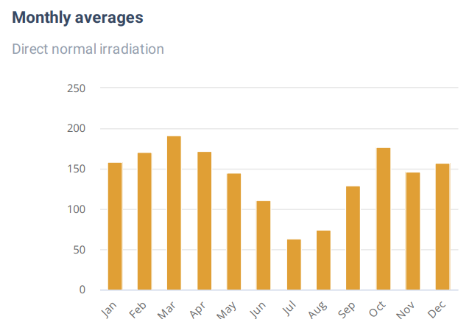  Ajmer | 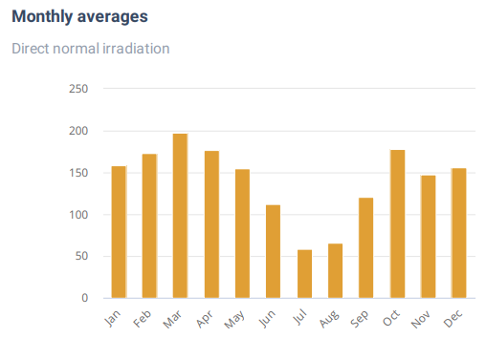  Bhilwara
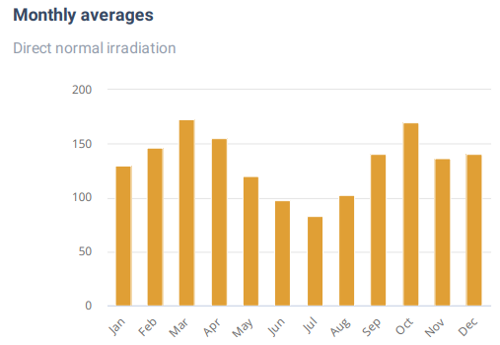  Bikaner | 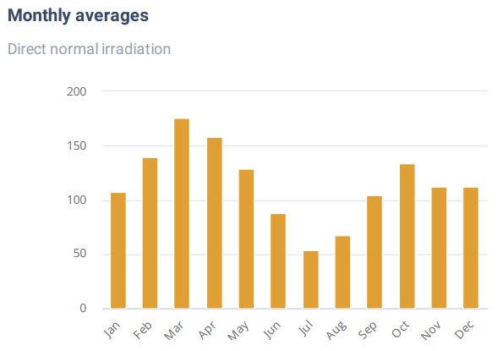  Govindgarh
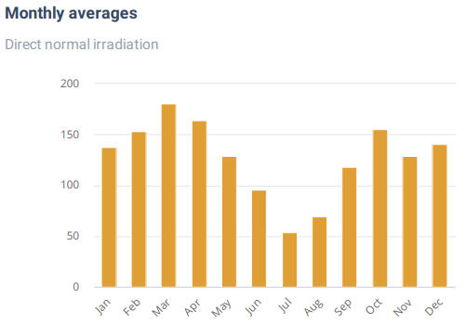  Jaipur | 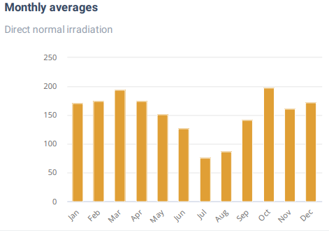  Jodhpur
Source: Global Solar Atlas

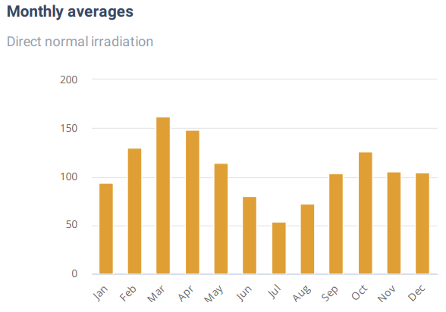  Nadbai | 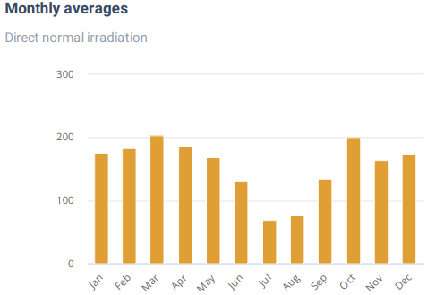  Pali

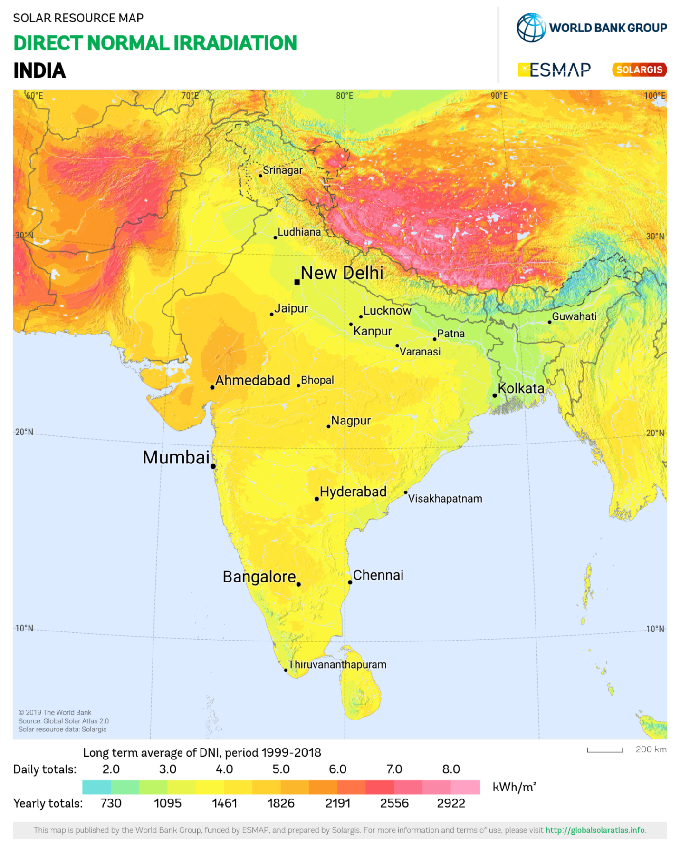

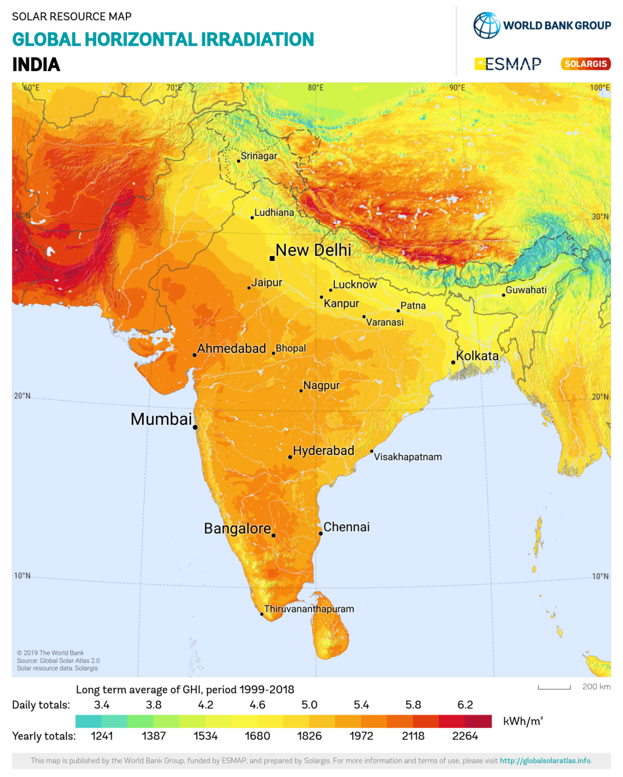

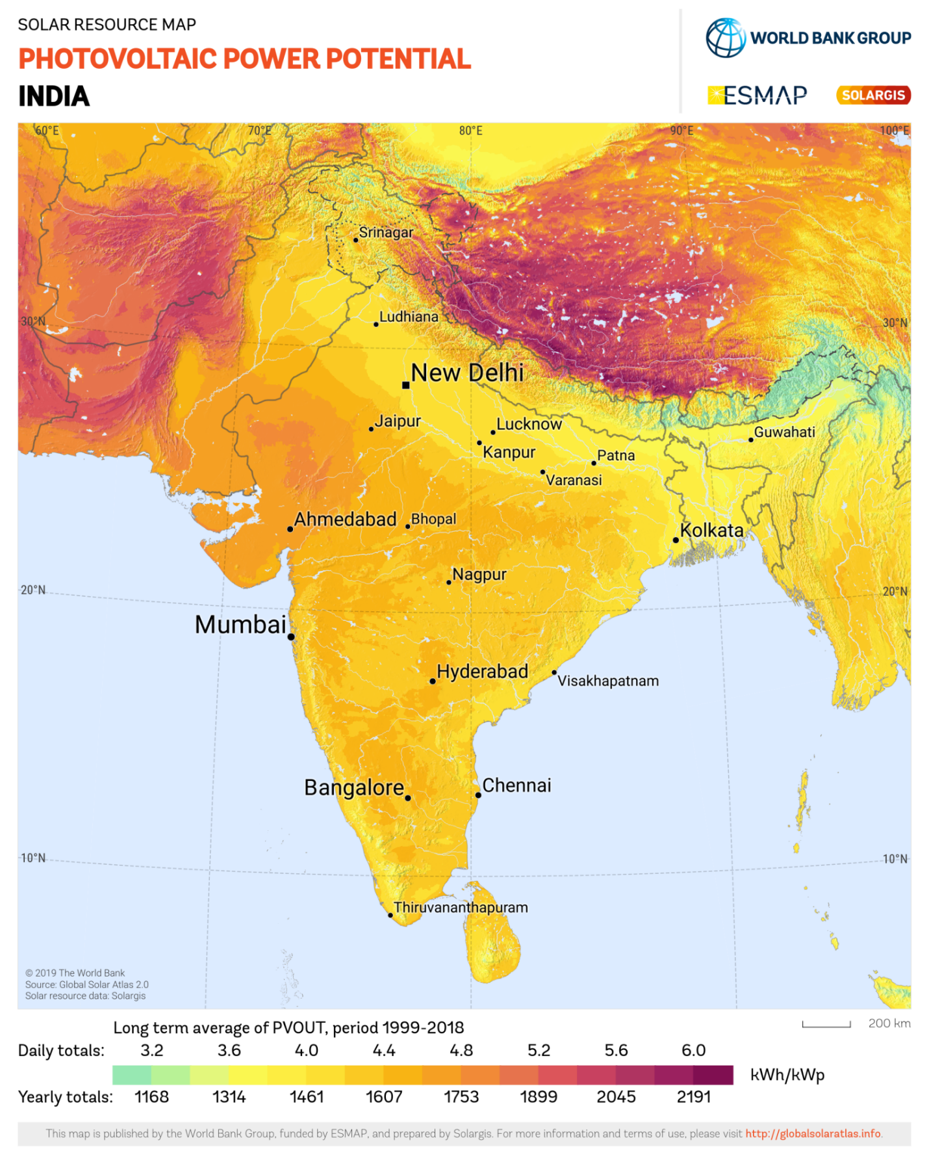

PART E | POWER PURCHASE AGREEMENT TERMS

As per the information provided by the company, the total proposed capacity of the solar power plant is 3.87 MWp (± 10%). As on date, company has signed 11 no. of PPAs to install the power plant and supply power at both the project sites. The PPA had been signed between all the 11 parties and Solar Quest Ashlyn Projects Pvt. Ltd. Details of the same are tabulated below:
S. No. | Offtaker | DC Capacity  (kWp) | Tariff  (Rs./kWh) | PPA Date
1 | Cattle Feed Plant- Ajmer | 600 | 4.05 | 27-09-2022
2 | Cattle Feed Plant- Bhilwara | 460 | 4.05 | 29-09-2022
3 | Cattle Feed Plant-Bikaner | 600 | 4.05 | 29-09-2022
4 | Metro Dairy Govindgarh | 120 | 4.05 | 11-09-2022
5 | Cattle Feed Plant-Jodhpur | 580 | 4.05 | 27-09-2022
6 | Cattle Feed Plant- Nadbai | 600 | 4.05 | 03-11-2022
7 | Cattle Feed Plant- Pali | 450 | 4.05 | 27-09-2022
8 | Pollution Control Board Jaipur | 117 | 4.05 | 25-08-2022
9 | 5th RAC Battalion Jaipur | 100 | 4.05 | 20-09-2022
10 | Satellite Hospital, Ajmer | 100 | 4.05 | 07-05-2022
11 | State Disaster Relief Force | 150 | 4.05 | 15-07-2022
Total |  | 3877
Source: PPAs

PART F | CURRENT STATUS OF WORK

As per information shared by the client, the installation of solar plant is in progress at Cattle Feed Plant, Ajmer & Nadbai. Thus, Out of total 11 nos. of projects, we have physically inspected only 2 nos. of locations i.e. Cattle Feed Plant, Ajmer & Nadbai. The current status of project is as follows:-
Cattle Feed Plant, Ajmer:
- The physical inspection of site was done on 23-10-2023.
- The project was started in May 2023. The DC capapcity of the plant is 600KW.
- All the material have been supplied at site.
- There are total 923 panels to be installed. Out of the same 770 panels have been installed as on date of site visit.
- As on date of site visit, about 85% of total work was completed.
- The was supposed to completed at the First Week of November 2023.

Cattle Feed Plant, Nadbai:
- The physical inspection of site was done on 23-10-2023.
- The project was started in April 2023. The DC capapcity of the plant is 600KW.
- As on date of site visit, the 100% of work was completed in June 2023.
- As as on date of site, the plant was operational.

As per information shared by the company officials, rest of the location was not visit from our end as installation work has not been started yet.

PART G | PROJECT COST & EXPENDITURE

- PROJECT COST: As per details shared by the company, the total project cost for installation of 3.87 MW solar projects in all 11 nos. of location is Rs. 17.99 Cr. however, copy of Agreement between Solar Quest Ashlyn Projects Pvt. Ltd. and M/s Ashlyn Solar Infra Pvt. Ltd. is not shared with us. Project wise cost break-up shared by the company is as follows:-
S. No | Plant Name | DC Capacity (KWP) | Project Cost  (In Rs. Cr.) | Cost  (in Rs. Per KW)
1 | Cattel Feed Plant- Ajmer | 600 | 2.17 | 36,100
2 | Cattel Feed Plant- Bhilwara | 460 | 1.59 | 34,600
3 | Cattel Feed Plant-Bikaner | 600 | 2.32 | 38,600
4 | Metro Dairy Govindgarh | 120 | 0.42 | 34,600
5 | Cattel Feed Plant-Jodhpur | 580 | 1.95 | 33,650
6 | Cattel Feed Plant- Nadbai | 600 | 2.35 | 39,150
7 | Cattel Feed Plant- Pali | 450 | 1.71 | 38,100
8 | Pollution Control Board Jaipur | 117 | 0.49 | 42,150
9 | 5th RAC Battalion Jaipur | 100 | 0.37 | 36,600
10 | Satellite Hospital, Ajmer | 100 | 0.33 | 32,600
11 | State Disaster Relief Force | 150 | 0.49 | 32,600
Total |  | 3877 | 14.18
EPC Margin |  |  | 1.63
GST (13.8%) |  |  | 2.18
Grand Total |  |  | 17.99

Observations and Remarks:
- Project cost calculated on the basis of the Benchmark Cost provided by the MNRE has been tabulated below:
S. No. | Particulars | Benchmark Cost  (In Rs./kW) | Project Capacity  (In MW) | Total Project Cost  (Excluding GST)  (In Rs.) | Total Project Cost  (Including ~14% GST)  (In Rs.)
1 | As per Ministry of New & Renewable Energy | 35,886* | 3,877 | 13,91,30,022 | 15,86,08,225
 |  |  | 3.87 MWp |  | ~Rs. 15.86 Cr.
*Benchmark cost for 2021-22 Excludes GST

- Project cost calculated on the basis of market comparable:
S. No. | Particulars | Excluding GST | Including GST | Remark
 |  | Per KW Cost  (In Rs.) | Per KW Cost  (In Rs.)
1 | Subject project installation cost | - | 46,402 | As per Compnay
Market Research Details
2 | MNRE Benchmark Cost | 35,886 | - | Refer Annexure-1
Market Research
3 | Quotation-1 (250 KW) | 37,740 | 42,500 | Refer Annexure-2
4 | Quotation-2 (150 KW) | 39,037 | 44,000
5 | Quotation-3 (150 KW) | - | 55,000
6 | Quotation-4 (150 KW) | 50,000 | 56,900
7 | Quotation-5 (243 KW) | - | 46,480

- As per our analysis and market research, the installation cost of Solar Power Plant varies from Rs. 42,500/- per KW to Rs. 56,900/- per KW. For the smaller setups the price is higher and for large set-up, price is less.
- The project cost is solely depends upon the project location, contractors profit, type of module and its supporting structures, etc.
- Based upon the above mentioned details, the project cost amounting to Rs. 17.99 Cr. inclusive of GST for the installation of subject solar power plant seems to be reasonable.
- As per the verbal information received from the management of the subject company, installation work is yet to be started.
Note:
- Project cost is analyzed based on lump sum cost only and not item wise.
- Project cost is assessed for the date of this report only and due to price fluctuations it may vary from time to time.

- EXPENDITURE: Details of expenses incurred till date is not shared with us. Thus, we cannot comment upon expenditure incurred till date on the project.

PART H | PHOTOGRAPHS

Cattle Feed Plant, Ajmer:-
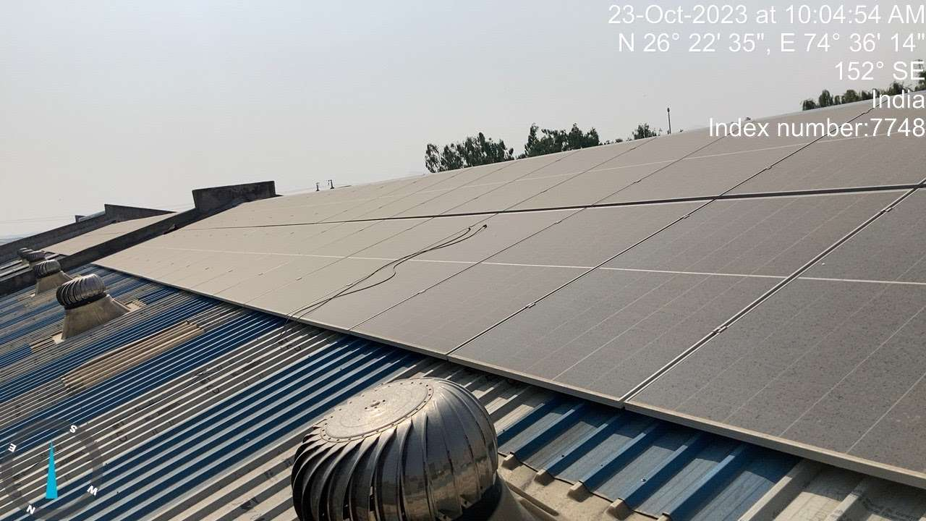 | 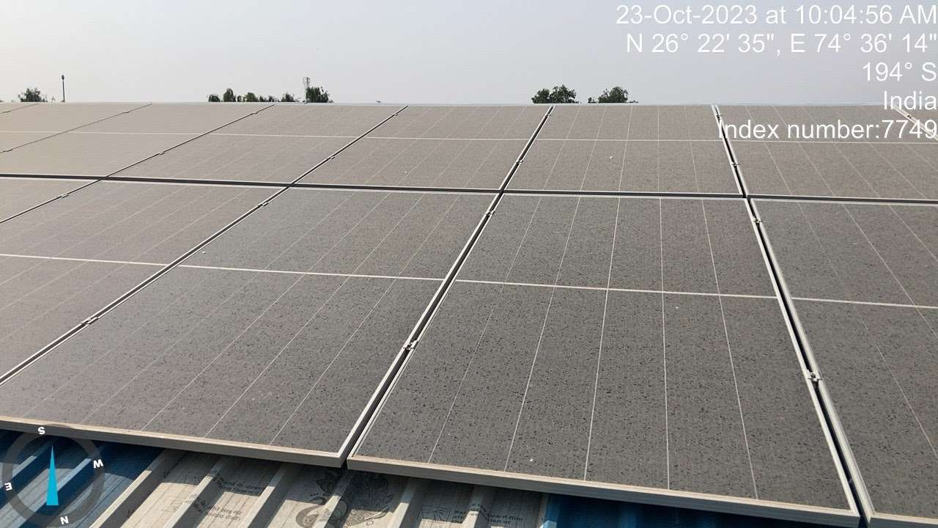
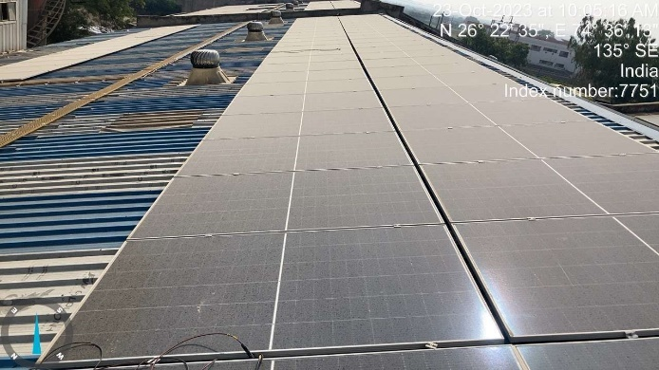 | 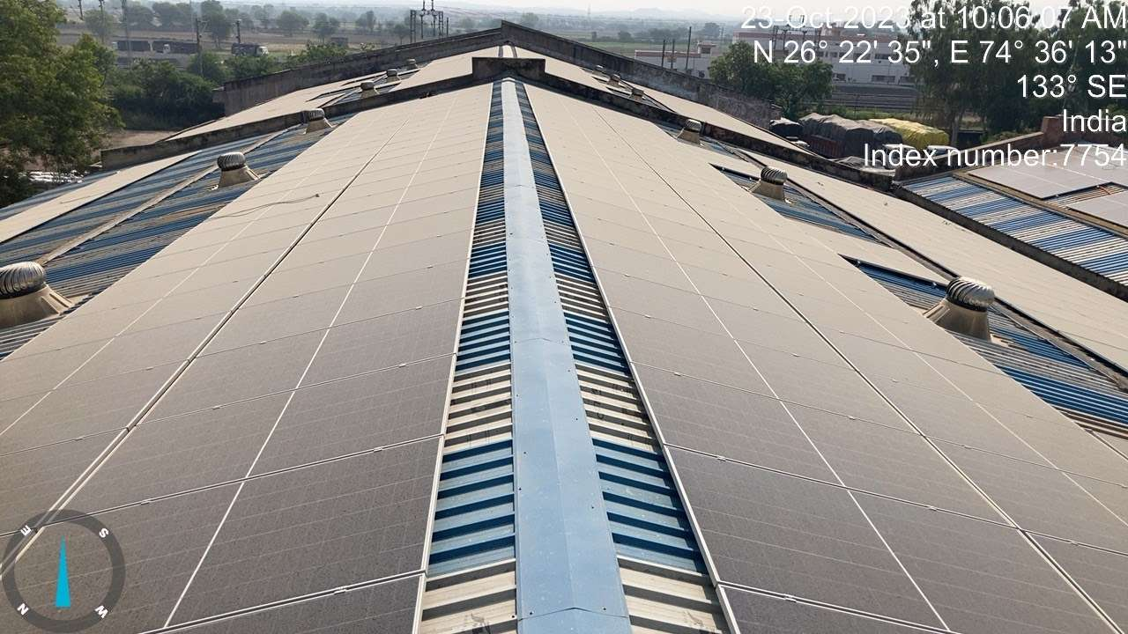
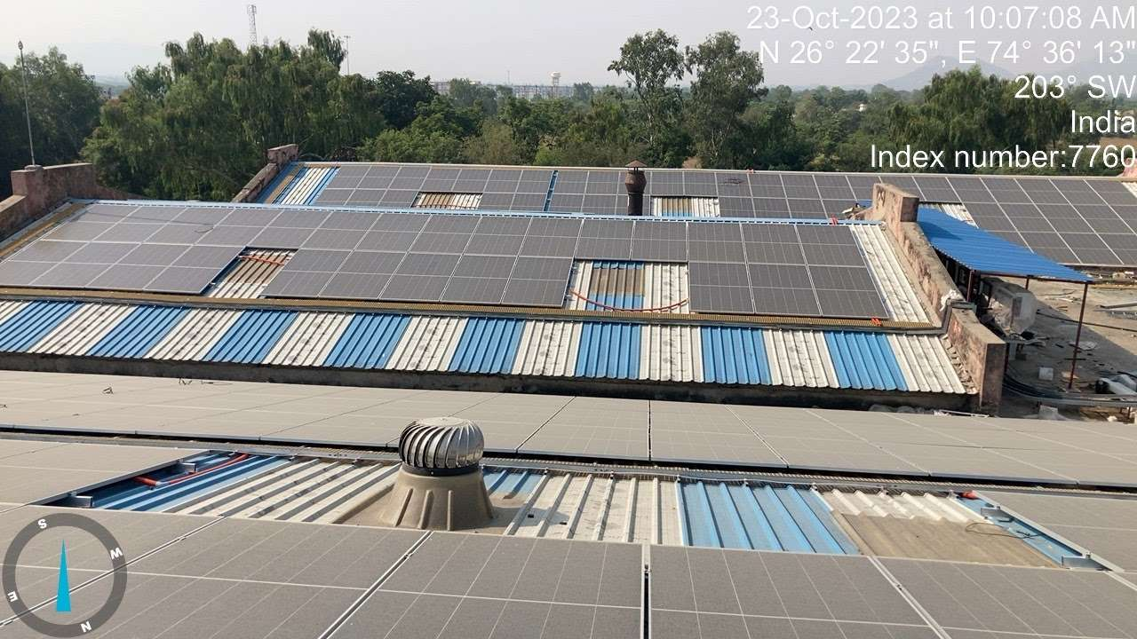 | 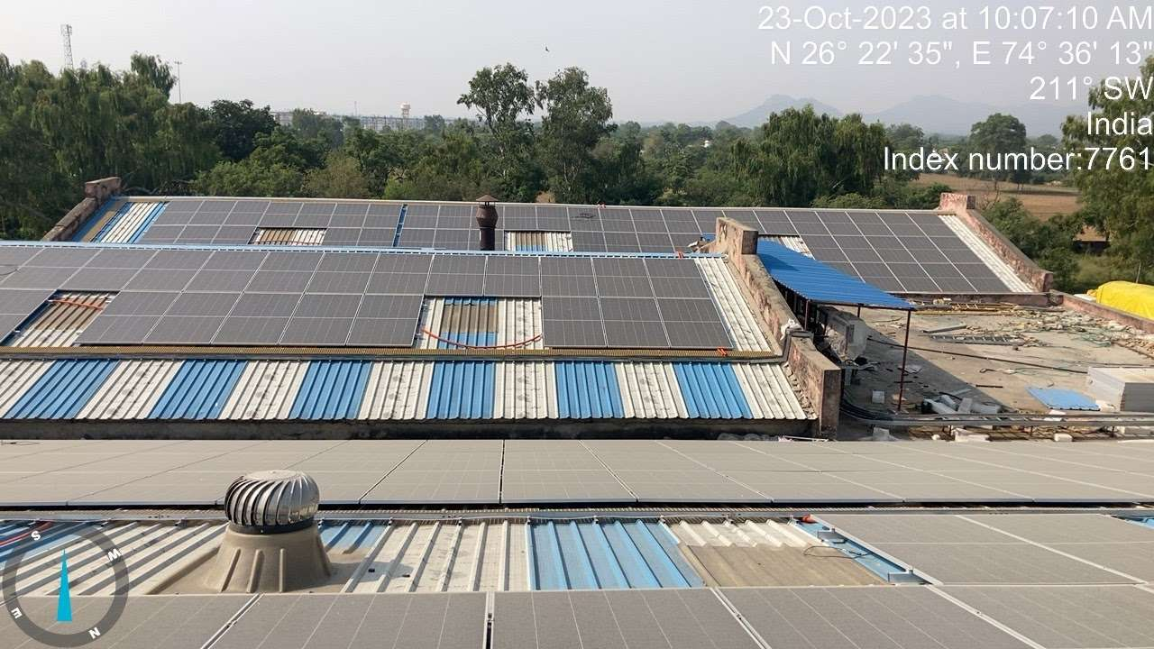
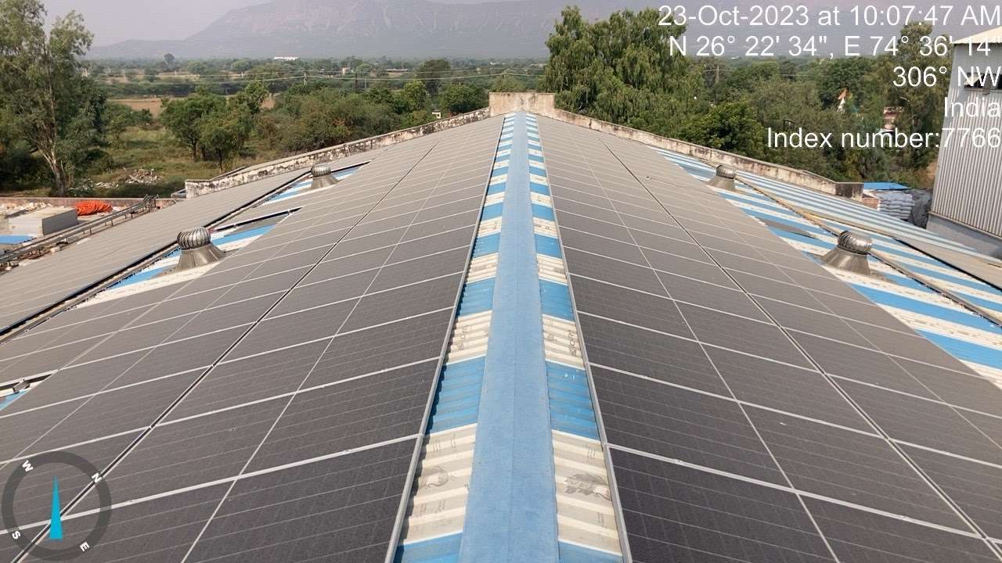 | 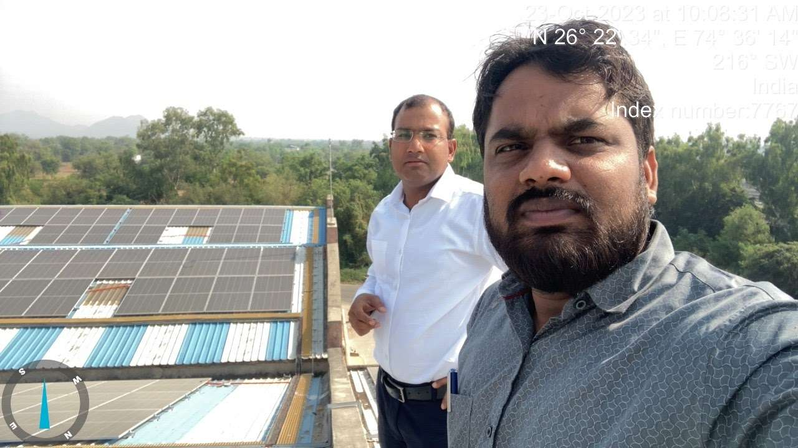

Cattle Feed Plant, Nadbai:-
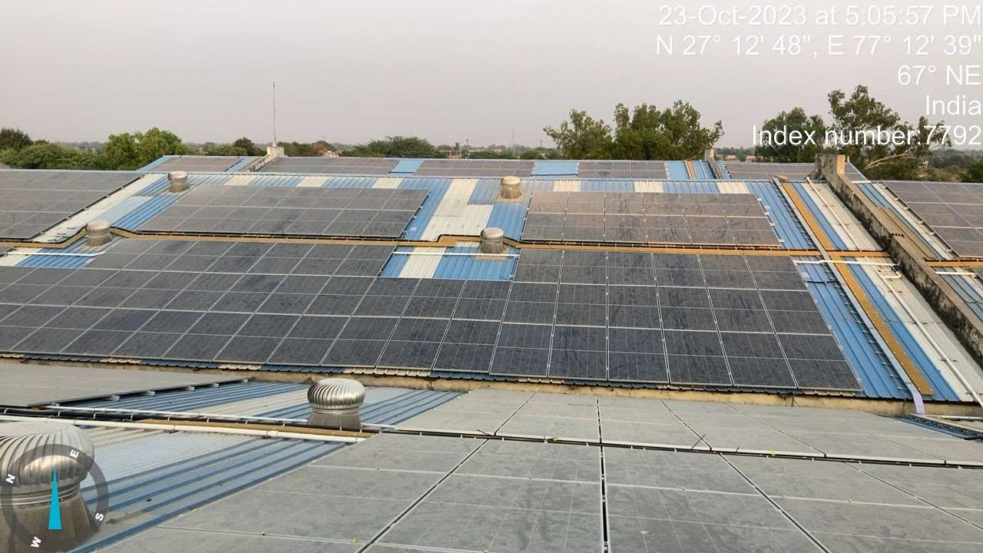 | 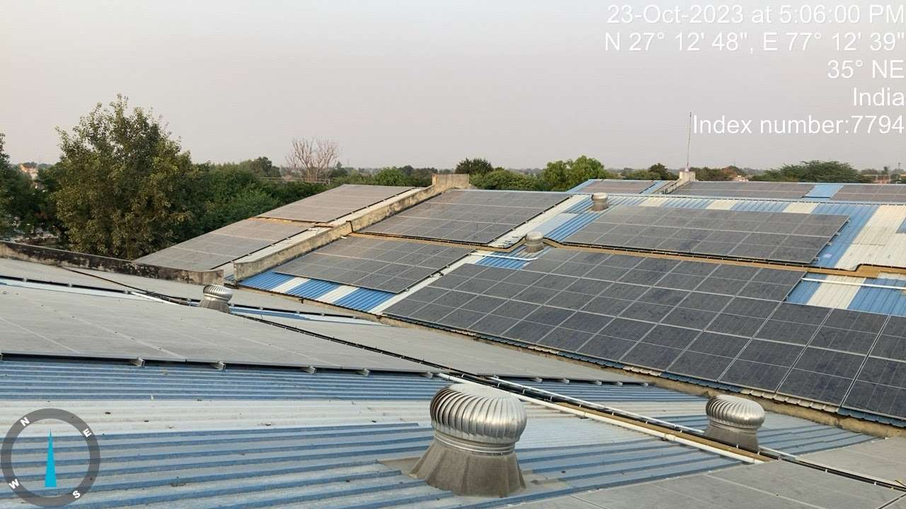
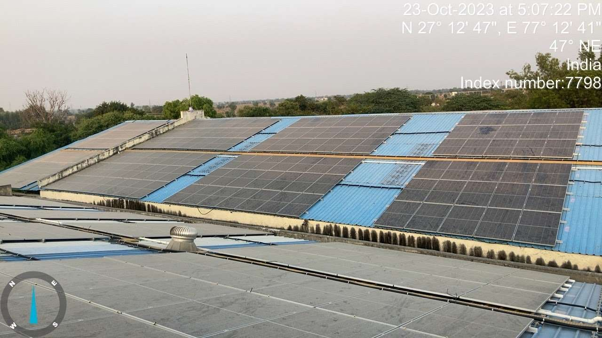
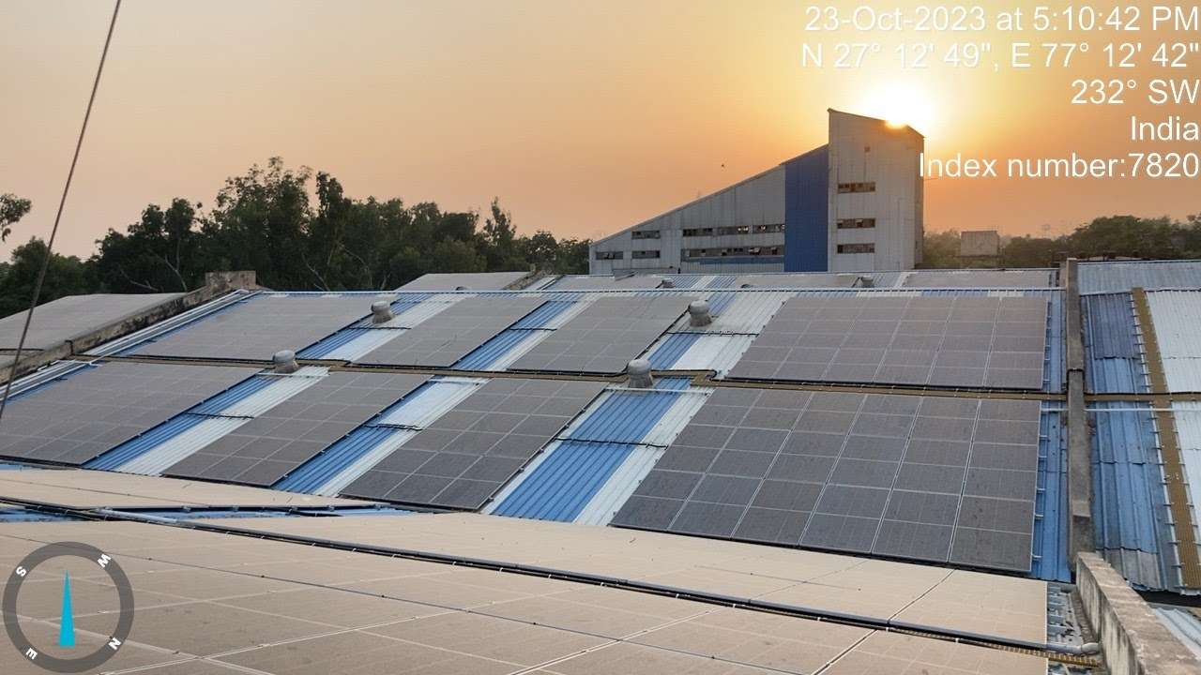 | 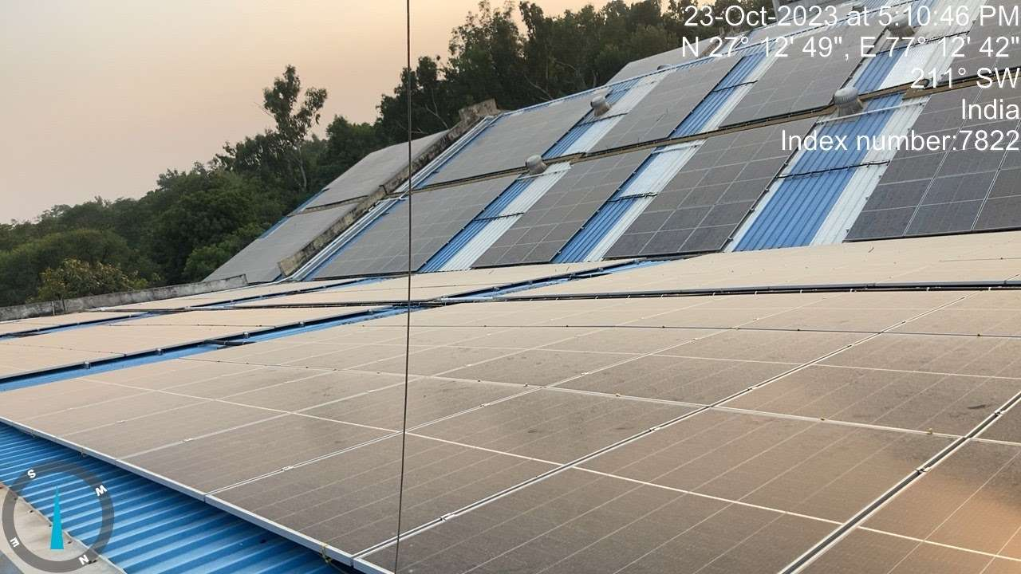
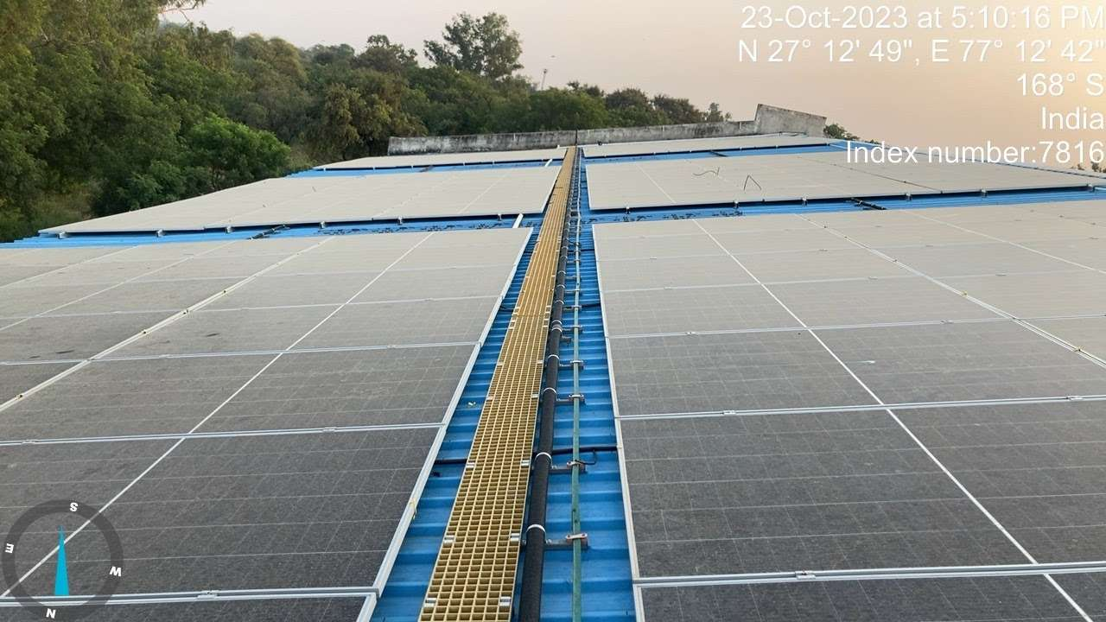 | 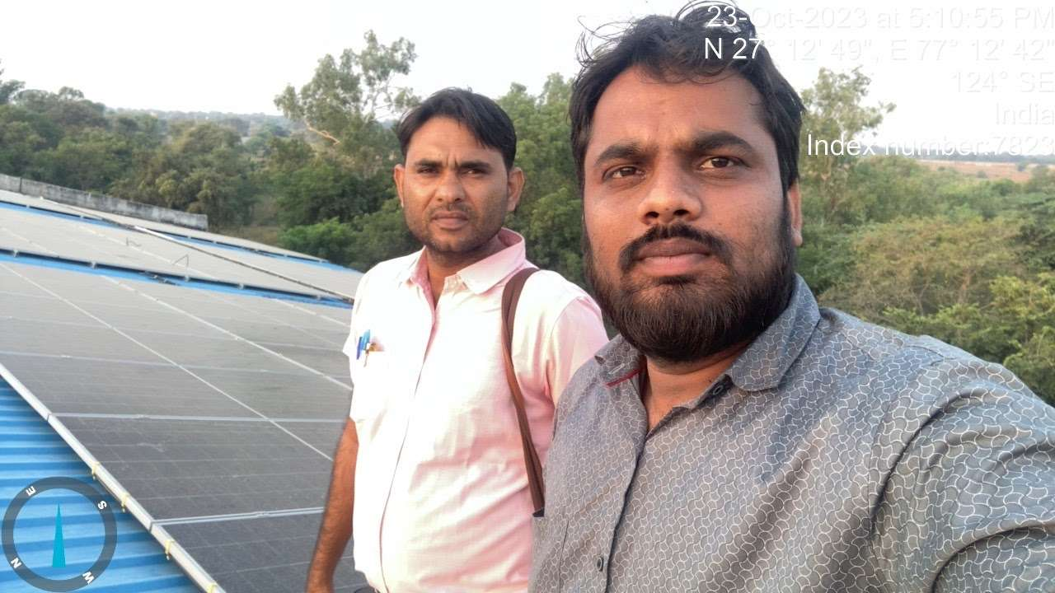

PART I | OTHER DOCUMENTS & REFERENCES

Annexure-1: Benchmark Cost by MNRE:
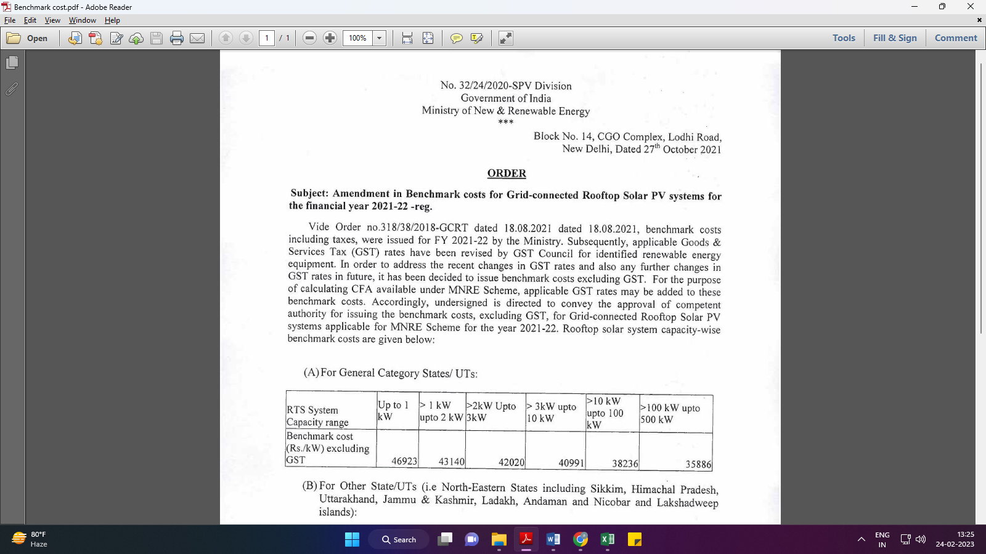
Market Comparables:
Annexure-2
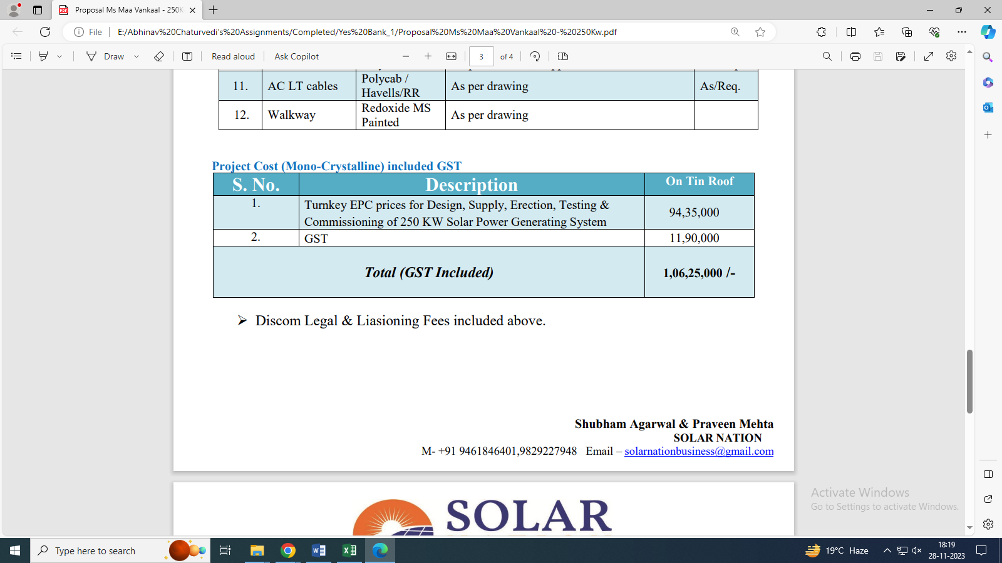

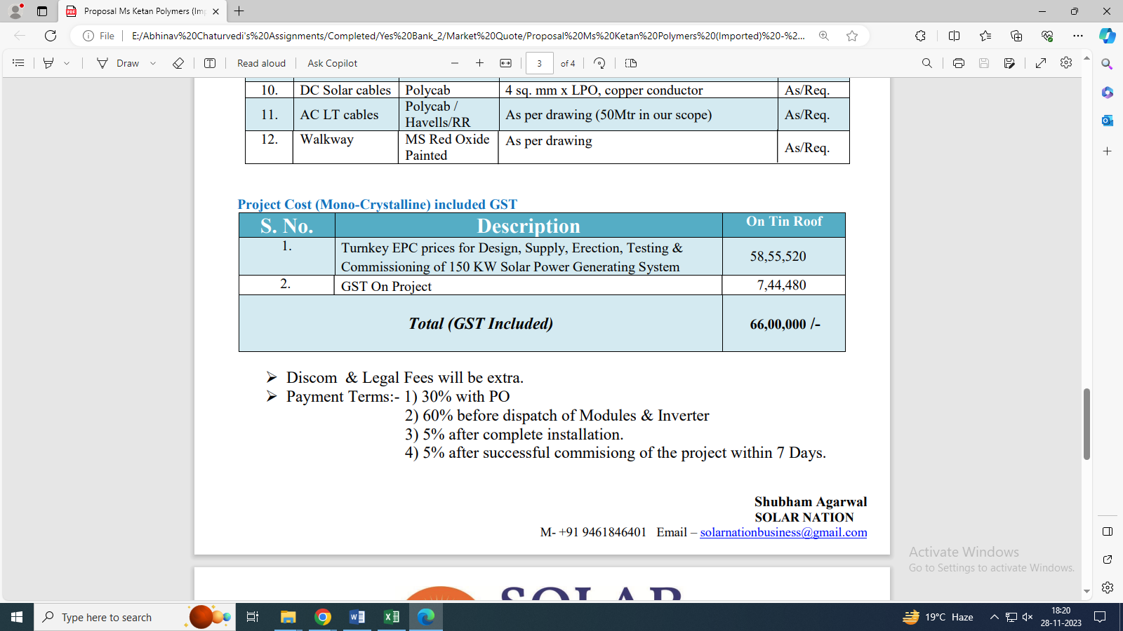

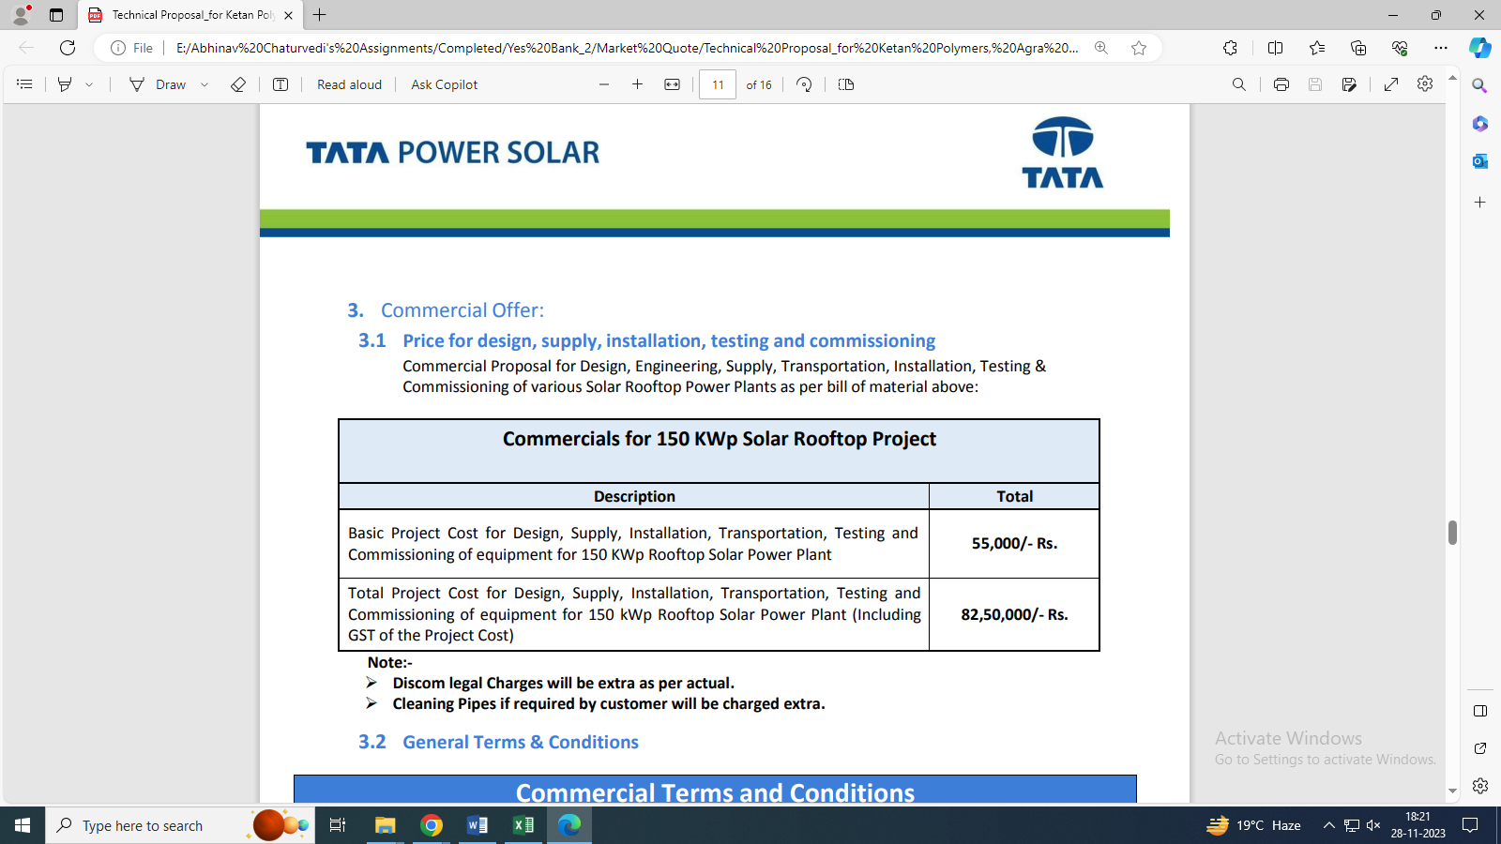

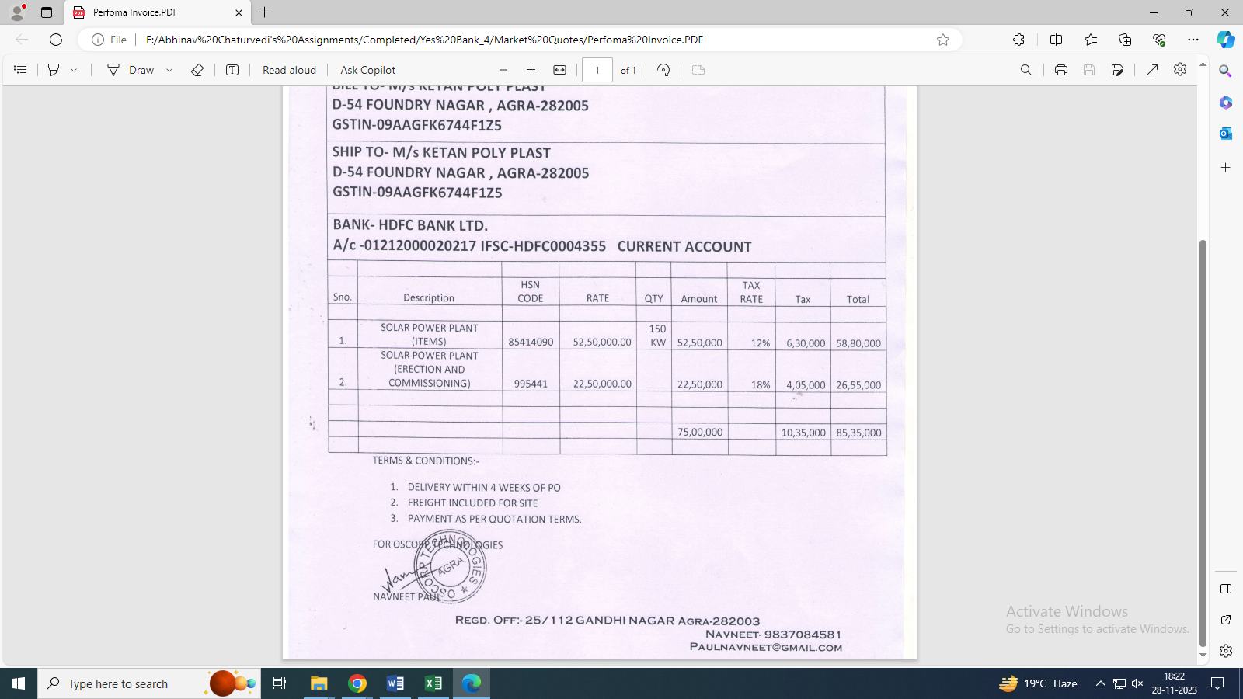

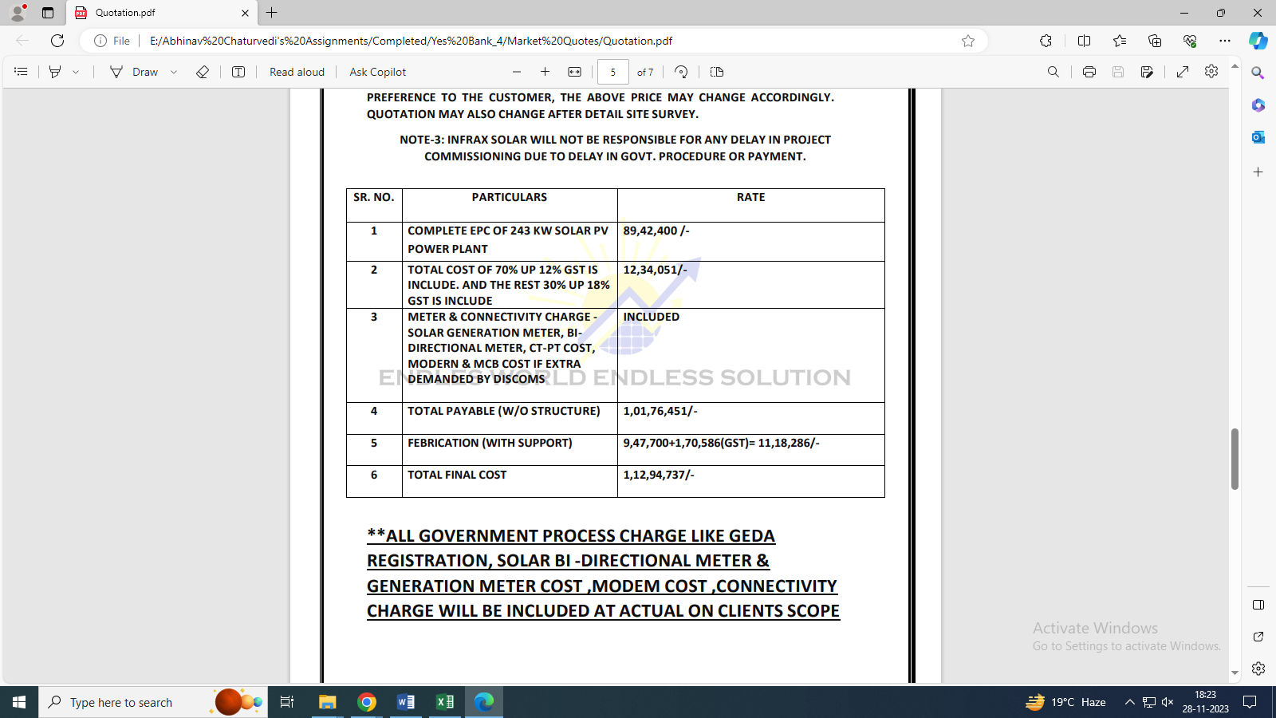

Data by Global Solar Atlas by World Bank Group
- Ajmer
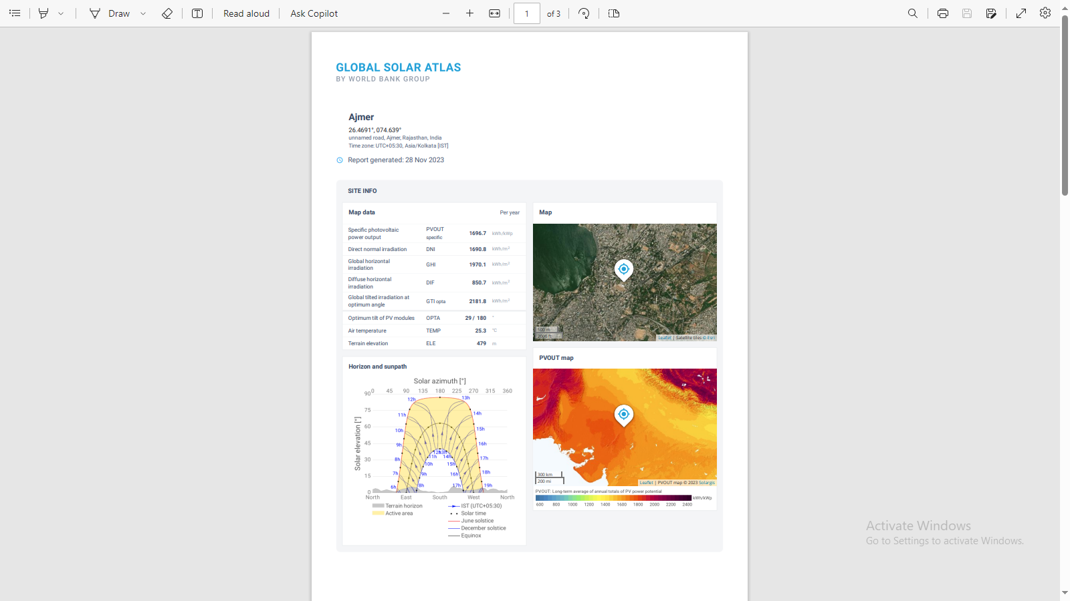

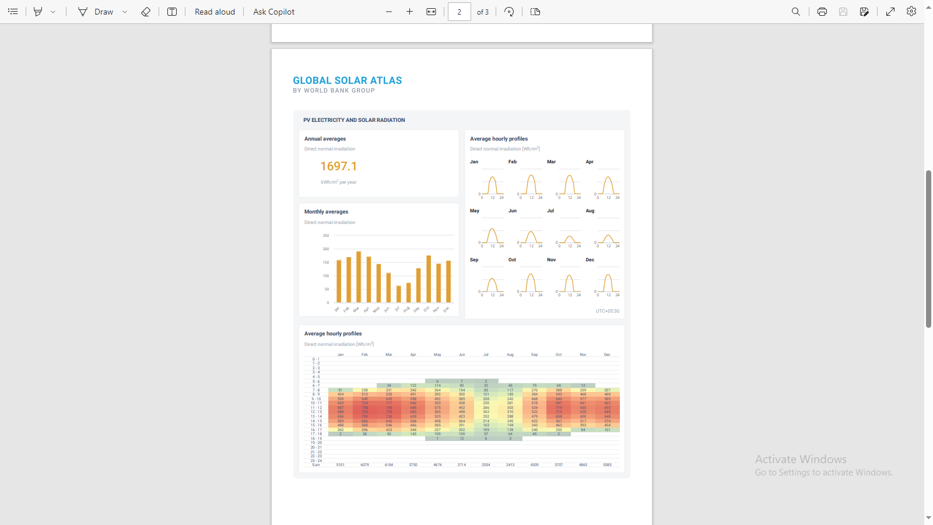

- Bhilwara
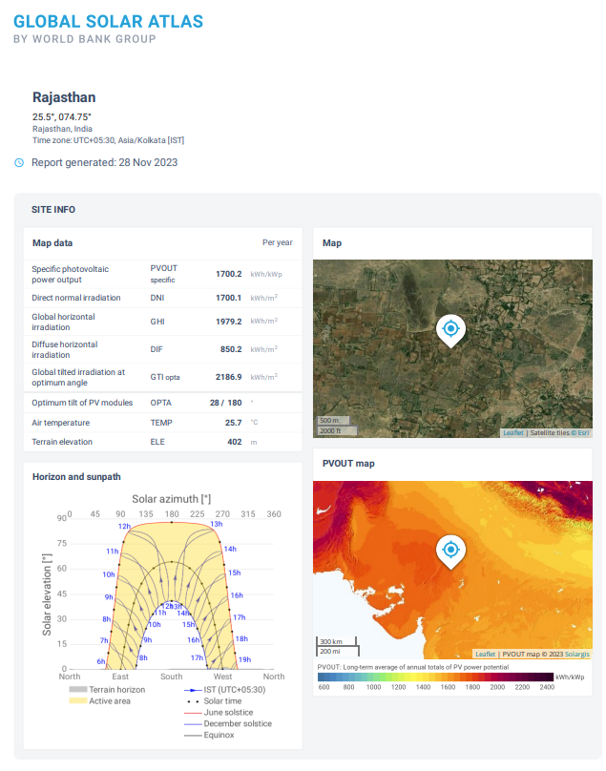

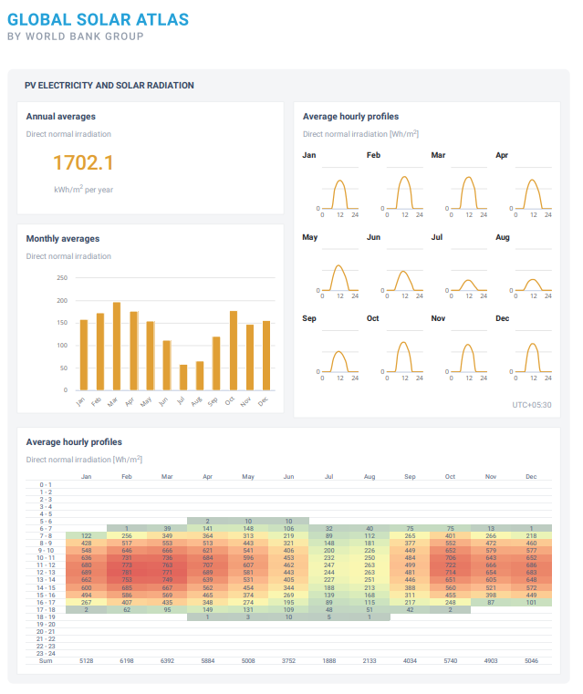

- Bikaner
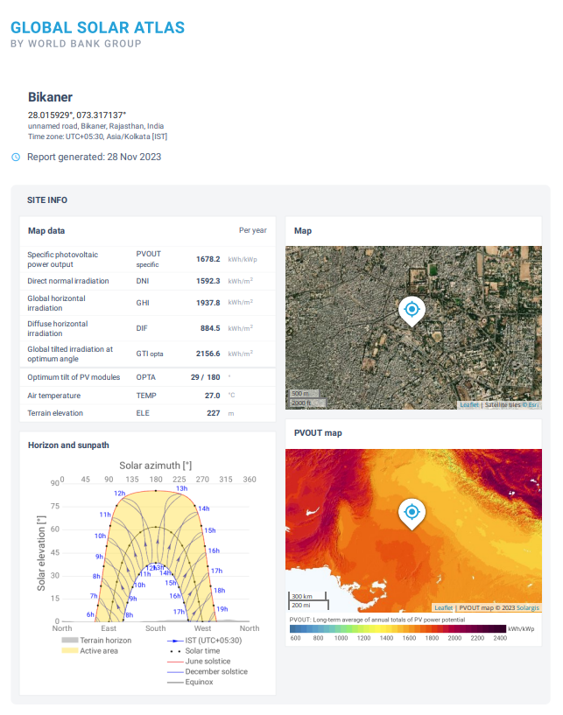

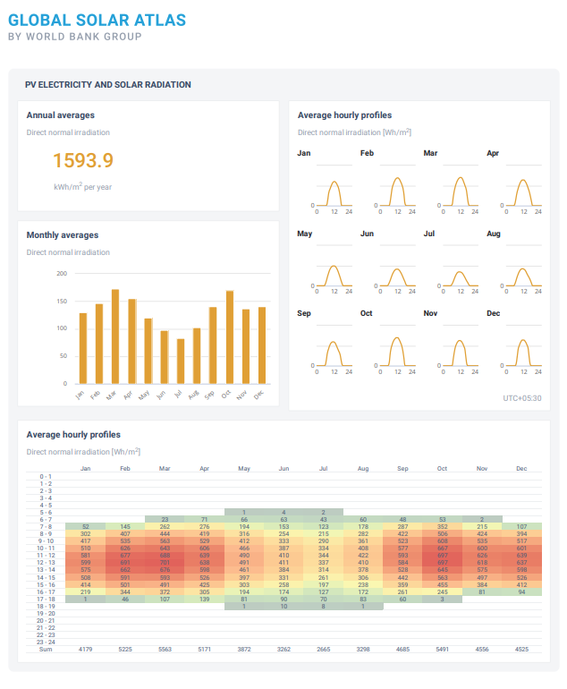

- Govindgarh
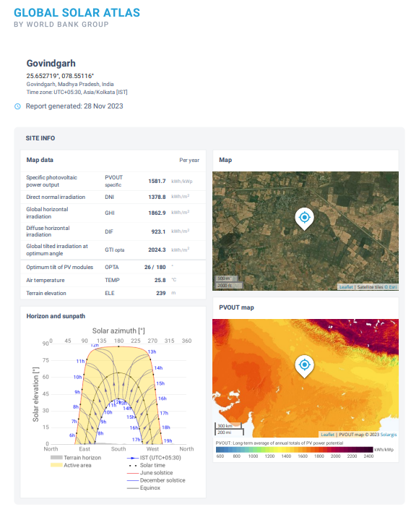

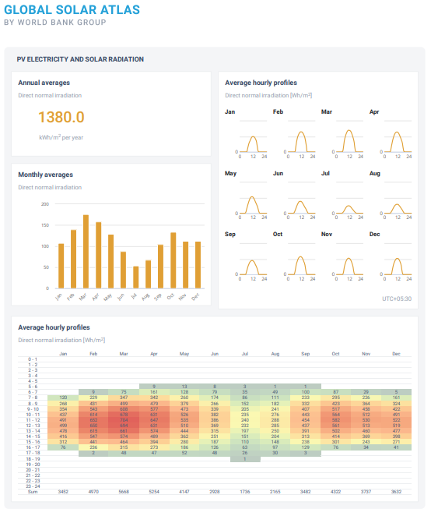

- Jaipur
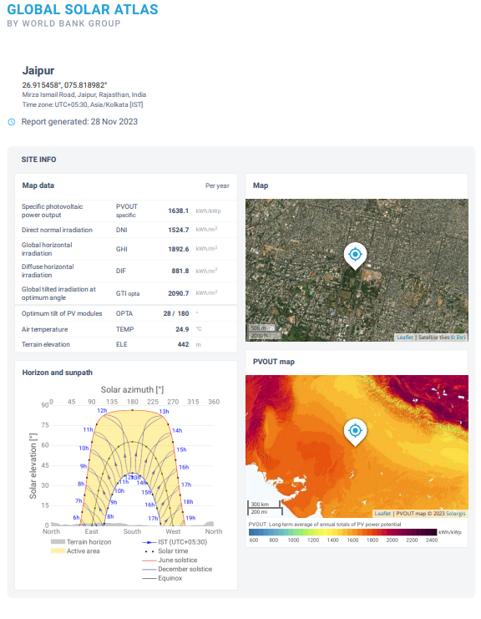

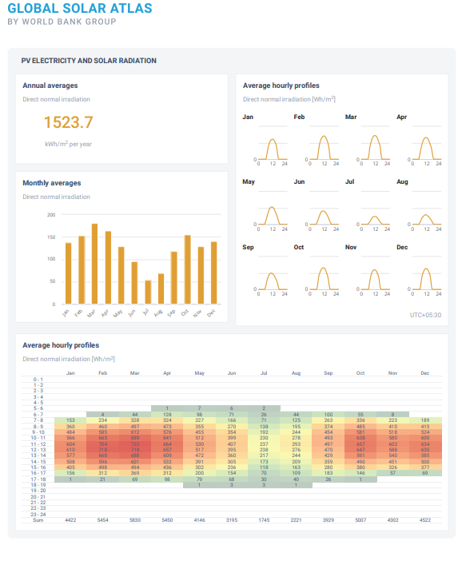

- Jodhpur
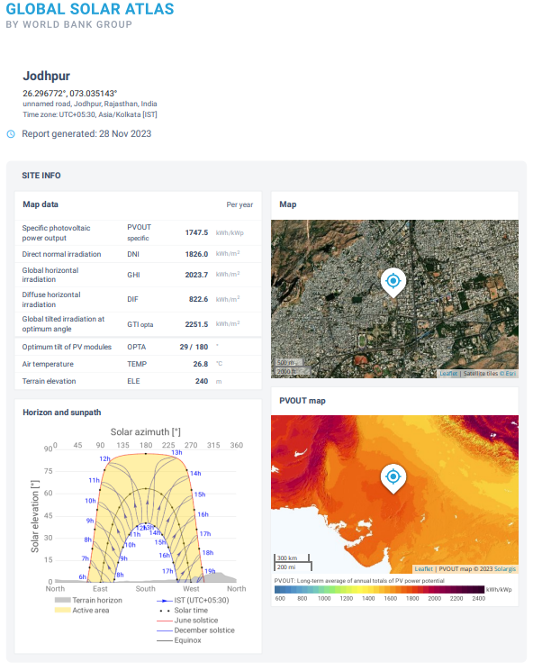

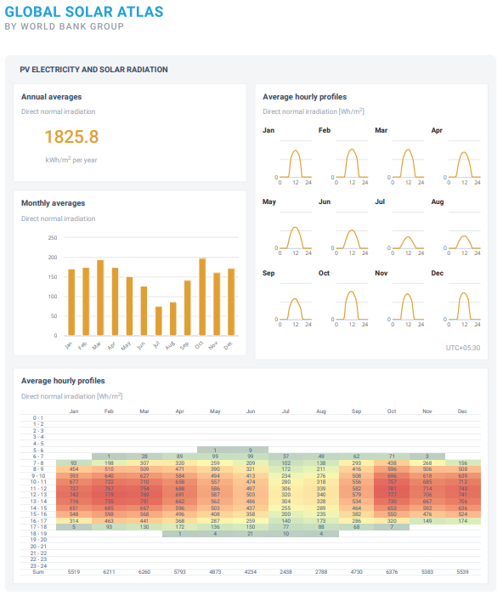

- Nadbai
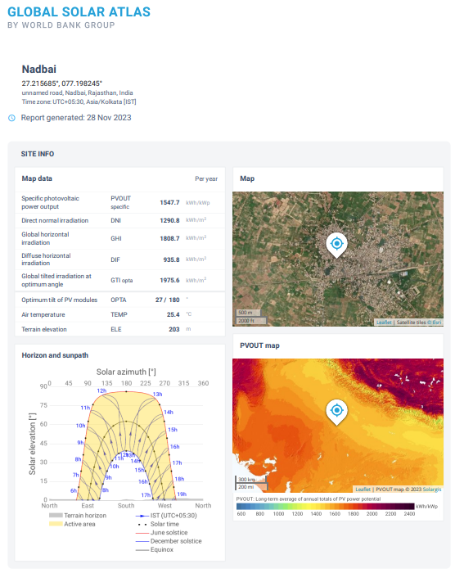

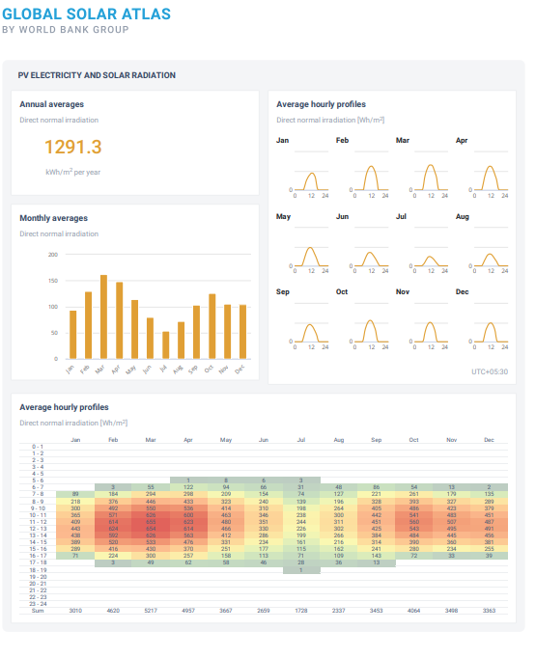

- Pali
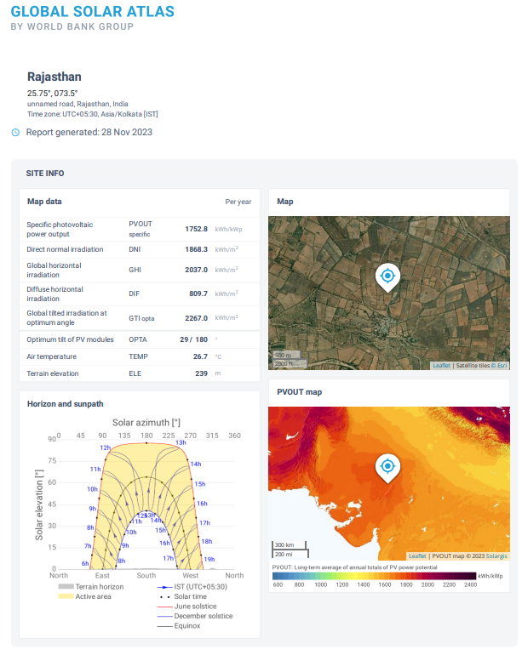

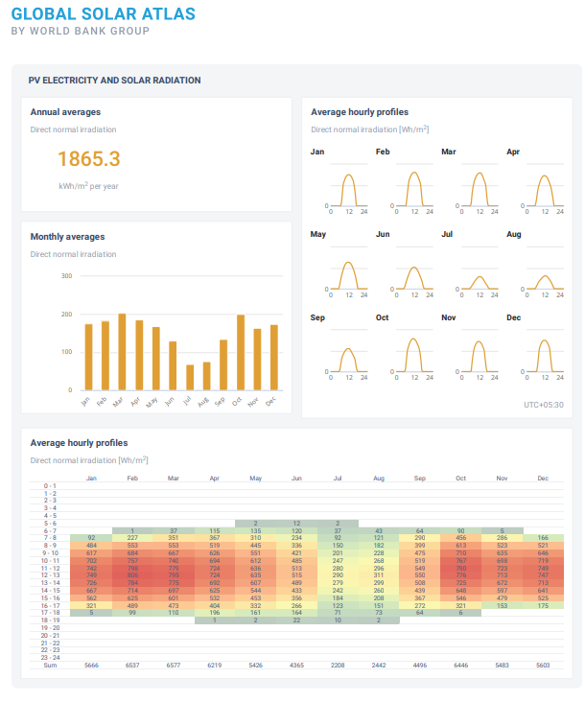

PART J | DISCLAIMER

      - No employee or member of R.K Associates has any direct/ indirect interest in the Project.
      - This report is prepared based on the copies of the documents/ information which the Bank/ Company has provided to us out of the standard checklist of documents sought from them and further based on our assumptions and limiting conditions. All such information provided to us has been relied upon in good faith and we have assumed that it is true and correct in all respect. Verification or cross checking of the documents provided to us has not been done at our end from the originals. If at any time in future, it is found or came to our knowledge that misrepresentation of facts or incomplete or distorted information has been provided to us then this report shall automatically become null & void.
      - This report is a general analysis of the project based on the scope mentioned in the report. This is not an Audit report, Design document, DPR or Techno-financial feasibility study. All the information gathered is based on the facts seen on the site during survey, verbal discussion & documentary evidence provided by the client and is believed that information given by the company is true best of their knowledge.
      - All observations mentioned in the report is only based on the visual observation and the documents/ data/ information provided by the client. No mechanical/ technical tests, measurements or any design review have been performed or carried out from our side during Project assessment.
      - Bank/FII should ONLY take this report as an Advisory document from the Financial/ Chartered Engineering firm and it’s specifically advised to the creditor to cross verify the original documents for the facts mentioned in the report which can be availed from the borrowing company directly.
      - In case of any default in loans or the credit facility extended to the borrowing company, R.K Associates shall not be held responsible for whatsoever reason may be and any request for seeking any explanation from the employee/s of R.K Associates will not be entertained at any instance or situation.
      - This Report is prepared by our competent technical team which includes Engineers and financial experts & analysts.
      - This is just an opinion report and doesn’t hold any binding on anyone. It is requested from the concerned Financial Institution which is using this report for taking financial decision on the project that they should consider all the different associated relevant & related factors also before taking any business decision based on the content of this report.
      - All Pages of the report including annexures are signed and stamped from our office. In case any paper in the report is without stamp & signature then this should not be considered a valid paper issued from this office.
      - Though adequate care has been taken while preparing this report as per its scope, but still we can’t rule out typing, human errors, over sightedness of any information or any other mistakes. Therefore, the concerned organization is advised to satisfy themselves that the report is complete & satisfactory in all respect. Intimation regarding any discrepancy shall be brought into our notice immediately. If no intimation is received within 15 (Fifteen) days in writing from the date of issuance of the report, to rectify these timely, then it shall be considered that the report is complete in all respect and has been accepted by the client upto their satisfaction & use and further to which R.K Associates shall not be held responsible in any manner.
      - Defect Liability Period is 15 DAYS. We request the concerned authorized reader of this report to check the contents, data and calculations in the report within this period and intimate us in writing if any corrections are required or in case of any other concern with the contents or opinion mentioned in the report. Corrections only related to typographical, calculation, spelling mistakes, incorrect data/ figures/ statement will be entertained within the defect liability period. Any new changes for any additional information in already approved report will be regarded as additional work for which additional fees may be charged. No request for any illegitimate change in regard to any facts & figures will be entertained.
      - R.K Associates encourages its customers to give feedback or inform concerns over its services through proper channel at le@rkassociates.org in writing within 30 days of report delivery. After this period no concern/ complaint/ proceedings in connection with the Lender’s Independent Engineering Services will be entertained due to possible change in situation and condition of the subject Project.
      - Our Data retention policy is of ONE YEAR. After this period, we remove all the concerned records related to the assignment from our repository. No clarification or query can be answered after this period due to unavailability of the data.
      - This Lender’s Independent Engineering report is governed by our (1) Internal Policies, Processes & Standard Operating Procedures, (2) Information/ Data/ Inputs given to us by the client and (3) Information/ Data/ Facts given to us by our field/ office technical team. Management of R.K Associates never gives acceptance to any unethical or unprofessional practice which may affect fair, correct & impartial assessment and which is against any prevailing law. In case of any indication of any negligence, default, incorrect, misleading, misrepresentation or distortion of facts in the report then it is the responsibility of the user of this report to immediately or at least within the defect liability period bring all such act into notice of R.K Associates management so that corrective measures can be taken instantly.
      - R.K Associates never releases any report doing alterations or modifications from pen. In case any information/ figure of this report is found altered with pen then this report will automatically become null & void.
FOR INTERNAL USE
Place : Noida  Date : 24.11.2023  Note : This report contains 44 pages | SURVEYED BY:  PREPARED BY:  REVIEWED BY: | Sachin Pandey  Abhinav Chaturvedi  Sr. V.P. Projects

For R.K Associates Valuers & Techno Engineering Consultants (P) Ltd.

DEFECT LIABILITY PERIOD - In case of any query/ issue or escalation you may please contact Incident Manager by writing at valuers@rkassociates.org. We ensure 100% accuracy in the Calculations done, Rates adopted and various other data points & information mentioned in the report but still can’t rule out typing, human errors or any other mistakes. In case you find any mistake, variation, discrepancy or inaccuracy in any data point of the report, please help us by bringing all such points into our notice in writing at valuers@rkassociates.org within 30 days of the report delivery, to get these rectified timely, failing which R.K Associates Valuers Techno Engineering Consultants (P) Ltd. won’t be held responsible for any inaccuracy in any manner. Also if we will not hear back anything from you within 30 days, we will assume that report is correct in all respect and no further claim of any sort will be entertained thereafter. We would welcome and appreciate your feedback & suggestions in order to improve our services.

COPYRIGHT FORMAT - This report is prepared on the copyright format of R.K Associates Valuers Techno Engineering Consultants (P) Ltd. to serve our clients in the best possible way. Legally no one can copy or distribute this format without prior approval from R.K Associates. It is meant only for the organization as mentioned on the cover page of this report. Distribution or use of this format other than R.K Associates will be seen as unlawful act and necessary legal action can be taken against the defaulter

