File No.: VIS(2023-24)-PL298-247-354 Dated: 11-09-2023

LENDER’S INDEPENDENT ENGINEER’s REPORT

OF

3.24 (± 10%) MWp GRID CONNECTED ROOF-TOP SOLAR POWER PLANT

PROPOSED TO BE SET-UP AT
GOVERNMENT MEDICAL COLLEGE, SIROHI, RAJASTHAN
&
RACL GEARTECH LIMITED, UPSIDC INDUSTRIAL AREA, GAJRAULA, U.P.
&
VACANT DDA LAND OPPOSITE MILLENNIUM PARK, SARAI KALE KHAN, NEW DELHI

DEVELOPER:
M/S OPWR DEL SPV PRIVATE LIMITED

REPORT PREPARED FOR
STATE BANK OF INDIA, SME, SOUTH EXTENSION,SOUTH DELHI

**Important - In case of any query/ issue or escalation you may please contact Incident Manager
at le@rkassociates.org. We will appreciate your feedback in order to improve our services.
NOTE: As per IBA Guidelines please provide your feedback on the report within 15 days of its submission after which report will be considered to be correct.

IMPORTANT NOTICE

COPYRIGHT FORMAT: This report is prepared on the copyright format of R.K Associates to serve our clients with the best possible information and analysis to facilitate them to take rational business decisions. Legally no one can copy or distribute this format without prior approval from R.K Associates. It is meant only for the advisory/ reference purpose for the organization/s as mentioned on the cover page of this report. Distribution or use of this format by any organization or individual other than R.K Associates will be seen as an unlawful act and necessary legal action can be taken against the defaulters.
This report is intended for the sole use of the intended recipient/s and contains material that is STRICTLY CONFIDENTIAL AND PRIVATE.

DEFECT LIABILITY PERIOD: - In case of any query/ issue or escalation you may please contact Incident Manager at le@rkassociates.org.
Though adequate care has been taken while preparing this report as per its scope, but still we can’t rule out typing, human errors, over sightedness of any information or any other mistakes. Therefore, the concerned organization is advised to satisfy themselves that the report is complete & satisfactory in all respect. Intimation regarding any discrepancy shall be brought into our notice immediately. If no intimation is received within 15 (Fifteen) days in writing from the date of issuance of the report, to rectify these timely, then it shall be considered that the report is complete in all respect and has been accepted by the client upto their satisfaction & use and further to which R.K Associates shall not be held responsible in any manner.

TABLE OF CONTENTS
SECTIONS | PARTICULARS | PAGE NO.
Part A | REPORT SUMMARY | 03
Part B | INTRODUCTION | 04
 | - Name of the Project | 04
 | - Project Overview | 04
 | - Scope of the Report | 06
 | - Purpose of the Report | 06
 | - Methodology Adopted | 06
Part C | PROJECT DETAILS AND KEY TECHNICAL PARAMETERS | 07
Part D | ENERGY YIELD ASSESSMENT | 13
Part E | POWER PURCHASE AGREEMENT TERMS | 19
Part F | CURRENT STATUS OF WORK | 22
Part G | PROJECT COST & EXPENDITURE | 23
Part H | PHOTOGRAPHS | 25
Part I | OTHER DOCUMENTS & REFERENCES | 26
Part J | DISCLAIMER | 38

PART A | REPORT SUMMARY

 | Name of the Project | 3.24 (±10%) MWp Grid Connected Solar Power Plant
 | Project Location | - DDA, Sarai Kale Khan- Vacant DDA Land opposite Millennium Park, Sarai Kale Khan, New Delhi  GPS Coordinates– 28°35'42.1"N 77°15'32.2"E  - RACL, Gajraula- M/s RACL Geartech Limited, A-3, UPSIDC Industrial Area, Gajraula, Uttar Pardesh  GPS Coordinates– 28°48'55.3"N 78°13'38.8"E  - Sirohi, Rajasthan- Government Medical College, Kolar, Sirohi, Rajasthan 307043  GPS Coordinates– 24°57'31.5"N 72°53'08.8"E
 | Seller Company | M/s OPWR DEL SPV Private Limited
 | Prepared for Organization | State Bank of India, SME, South Extension, New Delhi
 | LIE Consultant Firm | M/s. R.K. Associates Valuers & Techno Engineering Consultants (P) Ltd
 | Date of Survey | Since, our scope of work includes only the verification and Review of total Project cost, CUF and Irradiation Data, site visit is not required.
 | Date of Report | 11-09-2023
 | Details & documents provided by | Mr. Mohit Jangra; Assistance Manager Finance and Accounts M/s Oriana Power Pvt. Ltd.
 | Report Type | Lender’s Independent Engineering Report
 | Purpose of the Report | Verification and Review of Project cost, CUF and Irradiation Data to facilitate bankers to take business decision on the Project.
 | Scope of the Report | To review Project cost and examine the current status of installation/ Commissioning of the Project.
 | Documents produced for Perusal | - Copy of Power Purchase Agreements (PPAs)  - Copy of Techno-Commercial offer from OPPL to OPWR DEL SPV Pvt. Ltd.  - Copy of Plant Layout  - Copy of PV Syst reports
 | Annexure with the Report | - Benchmark Cost by MNRE  - Market Comparables  - Global Solar Atlas by World Bank Group  - Layout Plans

PART B | INTRODUCTION

- NAME OF THE PROJECT: 3.24 (± 10%) MWp Grid Connected Solar Power Plant in RESCO Model to be installed at 3 locations which are described in Part A.2 above by M/s OPWR DEL SPV Pvt. Ltd.
- PROJECT OVERVIEW: M/s OPWR DEL SPV Pvt. Ltd. is a SPV of M/s Oriana Power Private Limited (OPPL) which is an associate company of Trinix Impex & BCS Switchgear Industries. It is a MNRE approved channel partner and into the business of Solar EPC / Design & Supply of BoS (Balance of System – Module Mounting Structure, LT/ ACCB/ ACDB/ DCCB Panel, Weather Monitoring Sensors, LA, Earthing, Cable Tray, etc.) for PV Solar Plants in India.

M/s OPWR DEL SPV Pvt. Ltd. (hereinafter referred to as “Power Producer”) in March, June & July 2023 signed 3 nos. of Power Purchase Agreement (PAAs) with different purchaser for Design, Manufacture, Supply, Erection, Testing and Commissioning including Warranty, Operation & Maintenance of 2 roof-top & 1 ground mounted solar power plants at their respective locations having a total DC capacity of 3.24 (± 10%) MWp for 25 years of plant operation/ PPA tenure.
For the implementation of the subject project, M/s OPWR DEL SPV Pvt. Ltd. has engaged its parent company M/s OPPL for the design, supply, erection, commissioning of Roof Mounted Grid Tie Solar PV plant (Subject Project)
In this respect M/s OPPL has shared a Techno-Commercial offer to M/s OPWR DEL SPV Pvt. Ltd. which is deemed to be accepted, as per the verbal information shared by the management of the subject company. However no contract agreement has been signed between both in this regard. As per the same, the total project cost is estimated at a price of Rs.14.44 Cr. including duties and taxes.
M/s OPWR DEL SPV Pvt. Ltd. has approached SBI for credit facility to construct these plants who have in turned appointed M/s R.K Associates Valuers & Techno Engineering Consultants Pvt. Ltd. as Lenders Independent Engineer for a specific scope of work.
Since, our scope of work includes only the verification and Review of total Project cost, CUF and Irradiation Data, site visit is not required.

RESCO Model: -
MNRE had introduced the PPP/RESCO model policy setting tariff rates for solar to be arrived on transparent competitive bidding model through PPP route.

The RESCO model is one of the methods of implementing rooftop solar installations. Under the RESCO model, a renewable energy service company ("RESCO"), (i.e., an energy service company that provides energy to consumers from renewable energy sources), develops, installs, finances, operates and owns the rooftop solar power project ("Project"), and supplies power generated from the Project to the consumer on whose premises the Project is set up ("Customer") or to the grid through net-metering.

'Build, Own, Operate and Transfer' (BOOT) is a special kind of RESCO model in which the RESCO constructs, owns, operates, and transfers the ownership of the Project to the Customer after the expiry of a predefined period. The RESCO and the Customer enter into a long-term power purchase agreement ("PPA") for an agreed tenure, which sets out, among others, the terms at which the power generated from the Project will be sold to the Customer and the tariff at which the power will be sold. Excess power from the Project (if any) could be sold by the Customer to the distribution utility through net metering system – the net metering regulations differ from state to state.

Under the PPA, the RESCO owns the Project and is responsible for its installation as well as its operation and maintenance of the Project throughout the tenure of the Project, and at the end of the PPA term, the ownership of the Project is transferred to the Customer. Thereafter, the Customer may either choose to retain the RESCO for operation and maintenance services or engage a third-party operator.

If the entity on whose premises the Project is located does not intend to buy the power generated from the Project and does not entered into a PPA with the RESCO, that entity can either lease the rooftop premises to the RESCO by means of a lease agreement or enter into a license agreement granting the RESCO the right to use the premises for the limited purpose of setting up and operating the Project. The RESCO then operates the Project and exports the energy generated to the local distribution utility at a predetermined feed-intariff (FiT) approved by the State Electricity Regulator under relevant schemes issued by the relevant state.

- SCOPE OF THE REPORT: To verify and review the Project cost, CUF and Irradiation Data of the Solar Power Plants set-up/ being set-up by M/s OPWR DEL SPV Pvt. Ltd.
- Industry/ sector research and demand & supply trend is out of scope of the report.
- Financial feasibility study of the Project is out of scope of the report.
- Providing any kind of design report or map is out-of-scope of the report.
- Scrutiny of contracts, Agreements and arrangement between the parties from legal perspective is out-of-scope of this report.
- Location feasibility is ascertained based on the PVSyst Report provided by the client.
- Any kind of technical & economic feasibility of the Project is out-of-scope of this Report.
- Site inspection or present status of the project through site visit is out of scope.

All the assessment carried out for the Project is done based on the documents and information provided to us and various other discussions with the Project proponents and thus forming an opinion out of it.
Component wise verification is not carried out.

- PURPOSE OF THE REPORT: To provide fair detailed analysis report to the Bank based on the “in-scope points” mentioned above for facilitating them to take appropriate business decision on the Project.

- METHADOLOGY ADOPTED:
- To gather relevant data/ information/ documents related to Project planning, execution, current status.
- Study of copy of Project Planning documents/ Agreements to know the scope of work of the company.
- To procure, study and analysis of any additional information, data, and documents required/ provided by the company.
- Research about the Project/ sector from the sources in the public domain.
- Correlation of the provided information against Industry/ sector benchmarks/ trend.
- Information compilation, analysis and reporting.

PART C | PROJECT DETAILS AND KEY TECHNICAL PARAMETERS
As per the information and copy of documents shared by the management of the company, details of the subject plants has been tabulated below:
S.  No. | Offtaker | Capacity  DC Power (kWp) | Capacity  AC Power  (kWp) | Address
1 | DDA, Sarai Kale Khan | 2,000 | 1600 | Vacant DDA Land opposite Millennium Park, Sarai Kale Khan, New Delhi
2 | RACL, Gajraula | 740 | 600 | M/s RACL Geartech Limited, A-3, UPSIDC Industrial Area, Gajraula, Uttar Pardesh 244223
3 | Sirohi, Rajasthan | 500 | 400 | Government Medical College, Kolar, Sirohi, Rajasthan 307043
Total |  | 3,240 | 2600 | (± 10%)

As per the copy of module layout plans of both the sites, Key Technical Parameters & Configuration of the projects like Modules, Inverter, tilt angle, capacity, etc. are tabulated below:
- DDA, Sarai Kale Khan – New Delhi
S. No. | Particular | Figure | UOM
1 | Proposed Capacity | 2000 | kWp
2 | Total No. of PV Modules | 3696 | No.
3 | PV Module Capacity (Mono-Crystalline) | 540 | Wp
4 | Pitch | 8.16 | mtr
5 | PV Module Mounting Orientation | Landscape
6 | Module Mounting Structure Angle | as per surface
- RACL Gajraula – Uttar Pradesh
S. No. | Particular | Figure | UOM
1 | Proposed Capacity | 740.34 | kWp
2 | Total No. of PV Modules | 1371 | No.
3 | PV Module Capacity (Mono-Crystalline) | 540 | Wp
4 | PV Module Dimension | 2080 x 1135 x 35 | mm
5 | PV Module Mounting Orientation | Landscape
6 | Module Mounting Structure Angle | as per Tin Shed
7 | Minimum Height of PV module from Tin Shed | 100 | mm
- Sirohi– Rajasthan
S. No. | Particular | Figure | UOM
1 | Proposed Capacity | 500 | kWp
2 | Total No. of PV Modules | 926 | No.
 | PV Module Capacity (Mono-Crystalline) | 574 | Wp
4 | PV Module Dimension | 2284 x 1137 x 35 | mm
5 | PV Module Mounting Orientation | Portrait & Landscape
6 | Module Mounting Structure Angle | 20⁰ & as per Tin Shed
 | Minimum Height of PV module from Tin Shed | 100 | mm
Location Maps: -

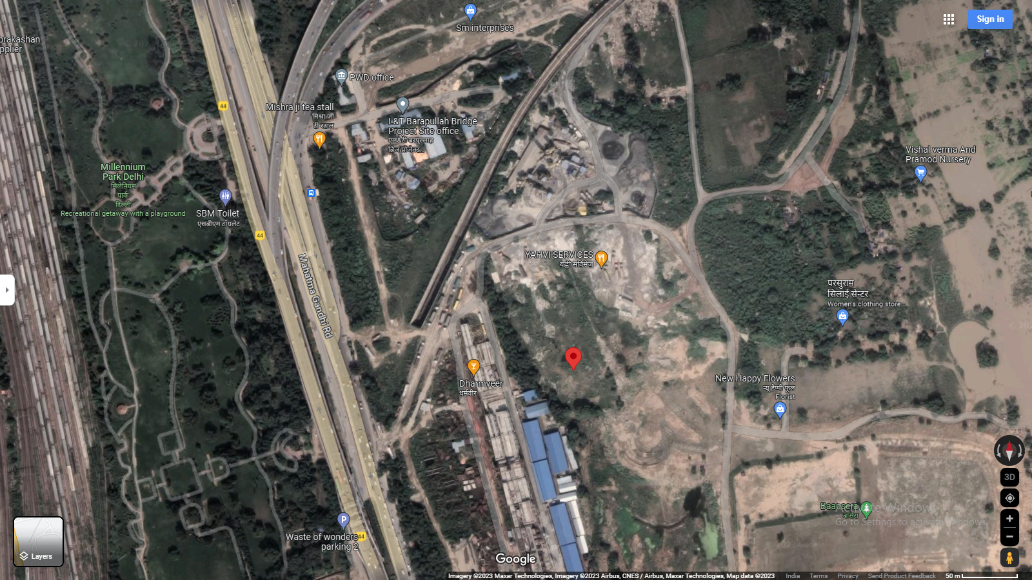
Location: DDA, Sarai Kale Khan GPS: 28°35'42.1"N 77°15'32.2"E

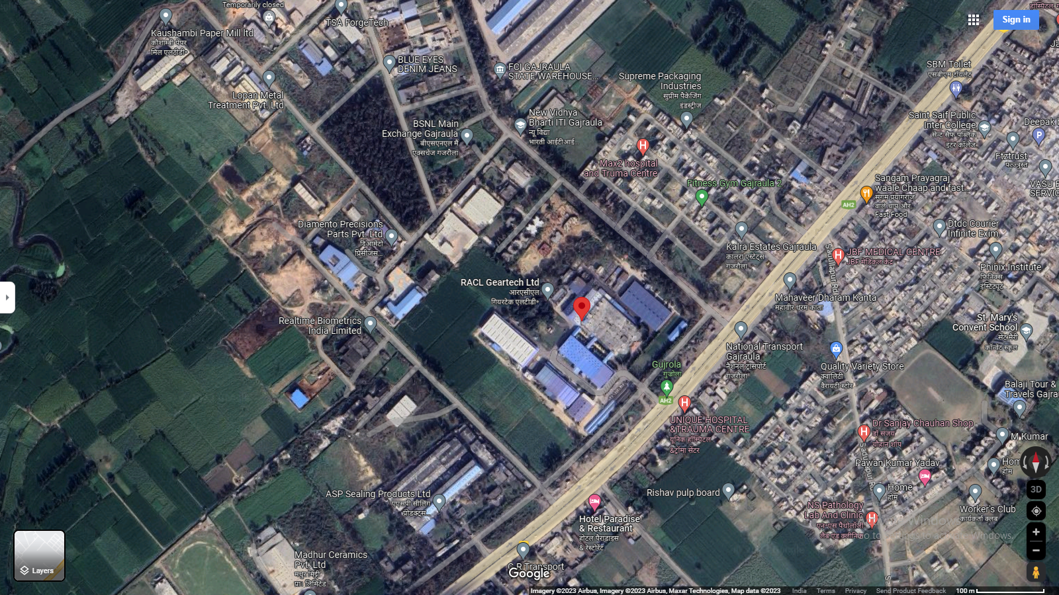
Location: RACL Gajraula GPS: 28°48'55.3"N 78°13'38.8"E
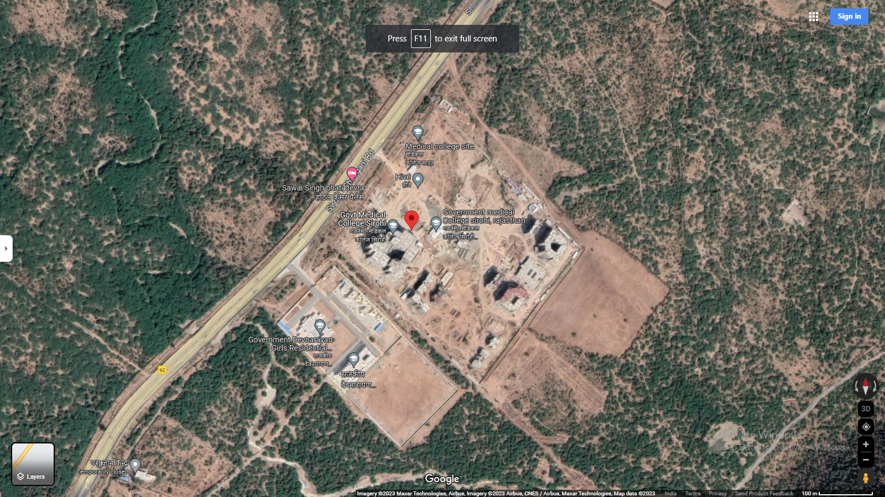
Location: Sirohi, Rajasthan GPS: 24°57'31.5"N 72°53'08.8"E

Technical details as per Techno-Commercial offer from Orient Power
S. No. | Item Description | Technical Specifications | Quantity | Unit | Make
A | PV Section
1 | Solar PV module | 230Wp-550Wp  Mono-PERC/Multi-Si 25yrs. Linear warranty  Certifications:  IEC 61215, IEC 61730 & UL 1703; IEC 62804 (PID) IEC  62716 (Ammonia Resistance), IEC 60068-2-68 (Blowing Sand) IEC 61701 (Salt Mist level 6), , ISO 11925-2 (Class E) ISO 9001: 2015, ISO 14001: 2004,  OHSAS 18001: 2007 | 3.24 | MWp. | ALMM Approved/As per Policy
2 | Connectors (male & female) pair MC4 | Connectors (male & female) pair, MC4 Connector Pin Copper with tin coating Insulation Voltage: 1000V | As per requirement | Nos. | Multi Contact
3 | Solar String Inverter –  50/100/250kVA, 415V | 50/100/250kVA, 415V output, Outdoor type-IP65, Eff. >98% | As per Design | Nos. | Sungrow/ Grow att /Equivalent
B | Structures
1 | Design & Supply of Module Mounting structure supply. | Roof Mounted Ballasted Solar Module Mounting Structure.  Material: MS HDG Grade: E 250 Galvanisation: 80micron  Structure designed at 170kmph wind speed as per IS- 875  Ground Clearance 1 mtr. | As per requirement |  | Oriana Power
2 | Structure & Module Mounting Accessories. | Material: SS Grade: SS 304  Structure designed at 170kmph wind speed as per IS-875 | As per requirement |  | Oriana Power
C | Remote Monitoring System
1 | Ambient Temperature sensor | PT1000 sensor element | 1 | Set | IMT
2 | Module Back Surface Temperature sensor | PT1000 sensor element | 1 | Set | IMT
3 | Solar Irradiation sensor for radiation  measurement | Cell Based sensor with calibration certificate | 1 | Set | IMT
4 | 2 Pair Twisted Un - armoured communication cable, Cu |  | As per Design | Mtr | K-flex/parasheild
5 | HDPE DWC Conduit, Size of 32/26mm & Accessories (PVC bends & couplers etc.) | Double Wall Corrugated HDPE Conduit for communication cable laying over shed. Conduit will be fixed with shed using GI Saddles and aluminum pop rivets. | As per Design | Mtrs | Duraline/ equivalent
6 | 3C 1.5Sq. mm Armored Copper Cable - Data Logger Power cable |  | As per Design | Mtr | Polycab
7 | CAT 6 cable |  | As per Design | Mtr | Dlink
8 | Data logger Installation and IP 65 Box | For Remote monitoring | As per  Design | Nos | Webdyn
9 | SCADA for Solar Plant monitoring and Grid monitoring | Visual inter-facing for plant monitoring and data analysis | As per Design | Lot | Webdyn
D | DC side - Cables & Accessories
1 | 1 Core 4 Sq mm Cu Solar Cable | Solar DC cable, Tin-coated copper cable as per EN standard. UV protected double sheathed XLPO, Halogen free cable. | As per Design | Mtrs | Apar/Siechem/ Equivalent
2 | 1C 2.5 Sq mm Green  Cable (for Earthing), with accessories | 2.5 sqmm. Single core flexible PVC insulated cable for  module to module earthing with SS-304 fasteners, teeth washer and copper thimbles. | As per Design | Mtrs | Polycab/KEI
3 | DC Electrical accessories | (Consumables like Lugs, Glands, Ferrules, Cable Ties, uPVC tape, uPVC saddle, Cable clips etc.) | As per Design | Set | As per Design RFQ
4 | HDPE DWC Conduit, Size of 32/26mm & Accessories (PVC bends  & couplers, T Joints etc.) | Double Wall Corrugated HDPE Conduit for DC cable laying over shed. Conduit will be fixed with shed using GI Saddles and aluminum pop rivets. | As per Design | Mtrs | Apollo/ Duraline/ equivalent
E | AC side - Cables & Accessories
1 | 4 C, 25 Sq.mm Cu PVC Flexible Cable. | 1.1kV insulated, Copper conductor, PVC insulated, PVC outer sheathed cable | As per Design | Mtrs | Polycab/KEI/ Havells
2 | 3.5 C, 150 Sq.mm AL XLPE Arm Cable. | 1.1kV insulated, Aluminum conductor, XLPE insulated, GI strip armoured, PVC outer sheathed  cable as per IS-7098 Part-1 | As per Design | Mtrs | Polycab/KEI/ Havells
3 | Cable for earthing- 1C 10 sq.mm Cu flexible (for Inverter earthing) |  | As per Design | Mtrs | As per Design RFQ
4 | Field ACDB for inverters output | 3 phase, 415 V, 50 Hz ACCB Panel with  - Enclosure material made of CRCA with Powder coated paint  - 4P, MCCB’s - as per requirement  - 4P, Isolator  - 3 phase, 4 W, AL, bus bar.  - IP 65 with canopy  - Panel with double door & lock  - SPD Type 2  - with mounting arrangement | As per Design | Nos | Breakers Make: L&T
5 | Isolator Panel near Metering Panel | 3 phase, 415 V, 50 Hz ACCB Panel with  - Enclosure material made of CRCA with Powder coated paint  - 4P, 700A MCCB’s  - 3 phase, 4 W, AL, bus bar.  - IP 54 with canopy  - Panel with single door & lock  - with mounting arrangement | As per Design | Nos | Breakers Make: L&T
4 | Cable tray for AC cable laying after inverter | 50mmX50mmX2mm Hot dip galvanized cable tray with cover and other accessories i.e. cable tray stand, cable tray cover clamp, cable tray coupler, M8  MS HDG Fasteners, anchor bolts etc. | As per Design | Nos | Oriana Power
F | Civil Works
1 | As per site requirement | Civil work for Structure, electrical panel foundations, Structure Foundation, earthing pit chamber construction. | 1 | Set | As per RFQ
G | Safety & Protections
1 | Fire extinguisher With sand bucket ( 4 Kg ABC type ) | 4 Kg ABC type fire extinguishers with stand | As per design | Set | As per Design RFQ
2 | Earthing Kit for plant AC and DC earthing | Copper Bonded rods 3m, 17.2 mm, chemical bags and other required accessories. Earthing pit chamber will be constructed and Cast iron cover will be installed | 1 | Set | VNT/JMV/GS Electrode
3 | Lightning Arrester for protection of solar power  plant | ESE Type, GI mast, 2 Earthing pit , 1 C 70 mm2 Cu PVC cable, 2 set of earthing for one lightning  arrester, R-109 Meter , Stay Set support. | As per design | Nos. | VNT/JMV/Allied Power
4 | GI Strip 25X3 mm for DC side | Hot dip galvanized earthing strip with minimum 80 micron. Material grade E-250 | As per Site Req | Meter | As per Design RFQ
H | Services
1 | Installation, testing and  Commissioning | Complete plant service work | 5 | MWp | As per Design RFQ
2 | Module cleaning system with uPVC pipe line system and pump. | 1 HP, 230V Centrifugal pump,  CPVC Pipe (1/2 inch) line over roof with shut-off valves, CPVC pipe will be fixed over roof with SS saddles gitti-pench. Flexible Hosepipe (1 inch) of 40 Meter length, Wiper 1.5 Meter length, Extendable Pole Piping for Each Roof, Piping as per detail drawing | 1 | Set | Ashirwad/Astral/  Equivalent
The above-mentioned installations/parts are provided as per best industrial practice and can be verified after commissioning of the project. The specification for the items mentioned in the above Techno Commercial Offer to be inline and with as per government guidelines.
Client’s Scope of work
- Provision of permission to work on site.
- Clear shadow free area / Tin shed for the installation of PV modules & equipment’s.
- Entrance/working permission for local labor for loading/un-loading work.
- Electrical power point nearby to site for electricity requirement during construction.
- Water tap points (minimum 1 inch ) at PV plant site for module cleanings system.
- Internet / SIM card with data packs shall be provided at site for remote monitoring of inverters and other devices.
- Documents required for CEIG approval/DISCOM NOC/Bi-directional Meters.
PART D | ENERGY YIELD ASSESSMENT

Company has used PVSyst V7.2.21 to assess energy yield calculation which is the standard Industry practice. The yearly average of main results of irradiation and energy yield from the provided PVSyst is as under:
S. No. | Plant Location | Annual production probability  (MWh) |  | Specific Production  (kWh/kWp/year) |  | Performance  Ratio (%)
 |  | P50 | P90 | As per PPA | As per PVsyst
1 | DDA, Sarai Kale Khan | 2,869 | 2,803 | 1,314 | 1,435 | 82.77
2 | RACL, Gajraula | 996.7 | 973.7 | 1,036 | 1,346 | 84.69
3 | Sirohi, Rajasthan | 800.9 | 782.4 | 1500 | 1603 | 79.11

Analysis of Irridiation & PV Output data: In respect to Irridiation & PV Output data, company has provided to us PVSyst report V7.2.21 in which key Irrdidation components and PV Output data is given as enumerated in table below. We have analysed and compared it with other data source points also such as Solar Resource by Global Solar Atlas of World Bank and ISRO Solar Calculator to confirm its legitimacy as mentioned in table below:
Particulars | DDA, Sarai Kale Khan |  | RACL, Gajraula |  | Sirohi, Rajasthan
 | As per Global  Solar Atlas | As per PVSyst | As per Global  Solar Atlas | As per PVSyst | As per Global  Solar Atlas | As per PVSyst
Global horizontal Irradiation (kWh/m²) | 1715.7 | 1618.2 | 1750.0 | 1551.6 | 2049.4 | 1869.1
Diffuse horizontal Irradiation (kWh/m²) | 928.6 | 906.4 | 926.1 | 894.9 | 775.8 | 813.7
Direct Normal Irradiation (kWh/m²) | 1159.2 | - | 1224.7 | - | 1936.5 | -
Specific Photovoltaic Power Output | 1469.2 | 1274 | 1502.9 | 1346 | 1749.6 | 1603
Annual Global Insolation (ISRO Solar Calculator) (kWh/m2/year) | 1342 |  | 1378 |  | 1839

Observations and Remarks:
- As per the PVsyst - Simulation reports dated 08th July 2023, the estimated energy that can be produced by the subject plants and their respective performance ratio is almost equal as agreed in the PPA.
- As per comparative analysis, PVSyst Irrdiation and PV Output data is in line to our analysis from Global Solar Atlas of World Bank and ISRO Solar Calculator.
- As per the information provided by the management of the company, the estimated Plant Load Factor (CUF at P90) is 16.00%, 15.00% & 18.27% for DDA-Sarai Kale Khan, RACL-Gajraula & Sirohi-Rajasthan respectively.

Monthly averages- Direct normal irradiation (kWh/m²)
- DDA, Sarai Kale Khan
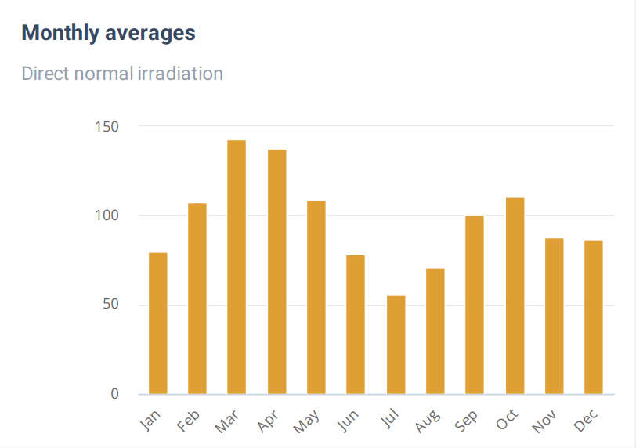
Source: Global Solar Atlas

- RACL- Gajraula
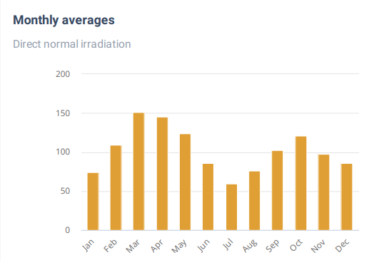
Source: Global Solar Atlas

- Sirohi- Rajasthan
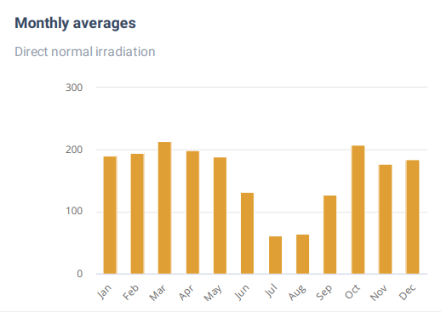
Source: Global Solar Atlas

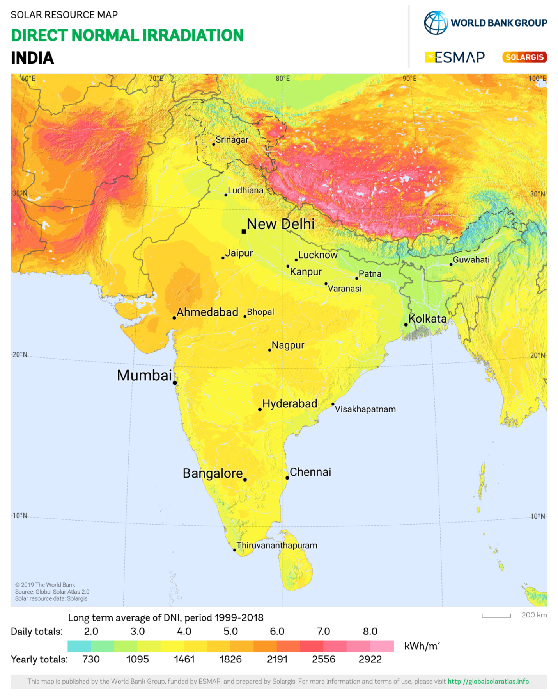
DAA-Satrai Kale Khan lies above 3.0 daily (1095 annually) Kwh/m².
RACL-Gajraula lies above 3.0 daily (1095 annually) Kwh/m².
Sirohi-Rajasthan lies below 6.0 daily (2191 annually) Kwh/m².
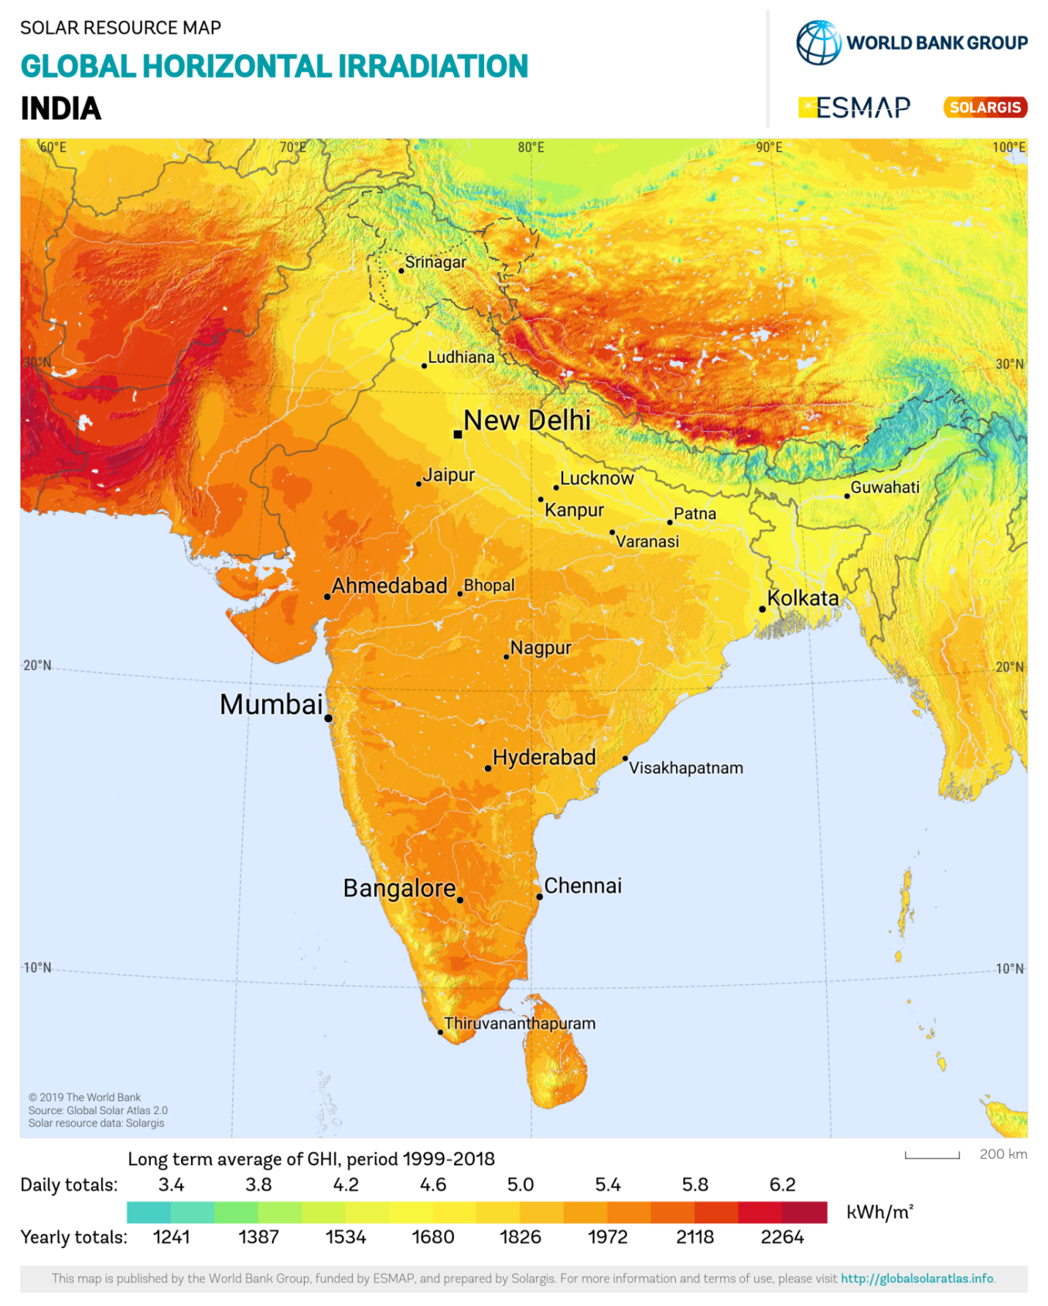
DAA-Satrai Kale Khan lies above 5.0 daily (1826 annually) Kwh/m².
RACL-Gajraula lies above 5.0 daily (1826 annually) Kwh/m².
Sirohi-Rajasthan lies below 5.8 daily (2118 annually) Kwh/m².

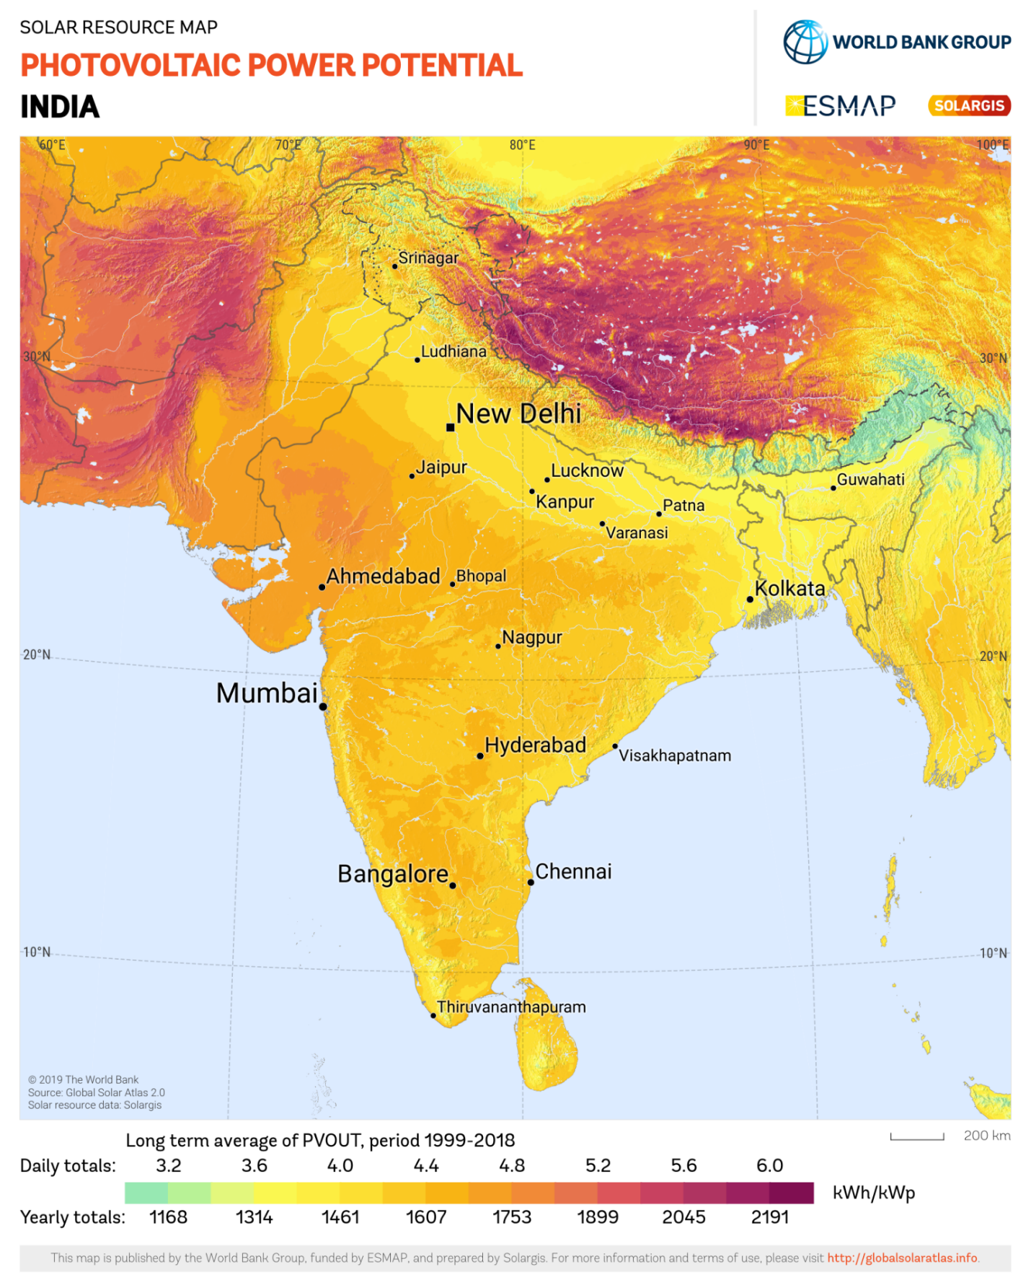
DAA-Satrai Kale Khan lies above 4.0 daily (1461 annually) Kwh/kWp.
RACL-Gajraula lies above 4.0 daily (1461 annually) Kwh/kWp.
Sirohi-Rajasthan lies just above 4.8 daily (11753 annually) Kwh/ kWp.

PART E | POWER PURCHASE AGREEMENT TERMS

As per the information provided by the company, the total proposed capacity of the subject roof-top solar power plant is 3.24 MWp (± 10%). As on date, company has signed 3 no. of PPAs to install the power plant and supply power at both the project sites. Details of the same are tabulated below:
S. No. | Offtaker | DC Capacity  (kWp) | Tariff  (Rs./kWh) | PPA Date
1 | DDA, Sarai Kale Khan | 2,000 | 4.42 | 17-03-2023
2 | RACL, Gajraula | 740 | 4.50 | 05-06-2023
3 | Sirohi, Rajasthan | 500 | 4.05 | 28-07-2023
Total |  | 3,240
Source: PPAs
Important Clauses: All PPA’s are signed for a period of 25 years with fixed tariff as stated above. Some of the important clauses from the signed PPAs are as follows:-
Clause-3: Terms and Termination
  - Term
DDA, Sarai Kale Khan | The term of the Agreement shall commence on the Effective Date and shall continue for twenty- five (25) years from the start of the financial year starting immediately after Commercial Operation Date (the "Term"), unless and until terminated earlier pursuant to the provisions of the Agreement. (i.e. if Commercial Operation Date is any date between 01.04.2022 and 31.03.2023, then the 25- year term shall continue till 31.03.2048. After the term, the Power producer shall vacate the site and hand over the same to purchaser. Payment of the last three months' invoices bills of the power producer shall be released only after handing over the vacant site to DDA. Safe disposal of the Power plant system shall be the responsibility of the power producer. Solar power project construction time shall not be part of commercial operation, PPA is valid of 25 years of commercial operation.
RACL, Gajraula | The term of the Agreement shall commence on the Effective Date and shall continue for Twenty Five (25) years from the Commercial Operation Date (the "Term"), unless and until terminated earlier pursuant to the provisions of the Agreement. After the Term, the ownership of the System shall be transferred to the Purchaser at Rs. 1/-.
Sirohi, Rajasthan | The term of the Agreement shall commence on the Effective Date and shall continue for twenty-five (25) years from the start of the financial year starting immediately after Commercial Operation Date (the "Term"), unless and until terminated earlier pursuant to the provisions of the Agreement. i.e., if Commercial Operation Date is any date between 01.04.2023 and 31.03.2024, then the 25-year term shall continue till 31.03.2048. After the Term, the ownership of the System shall be transferred to the Purchaser free of cost at the discretion of Power Purchaser.

DDA, Sarai Kale Khan | Conditions of the Agreement prior to installation  In the event that any of to the Commercial operation. the following events or circumstances occur prior Operation Date, the Power Producer may terminate the Agreement, in which case neither Party shall have any liability to the other except for any such liabilities that may have accrued prior to such termination.  a) There has been a material adverse change in the rights of Purchaser to occupy the Premises Power Producer to install the System at the Premises.  b) The Power Producer has determined that there are casements, Capacity Cost Recovery (CCRs) or other liens or encumbrances that would materially impair or prevent the installation, operation, maintenance or removal of the System. If any dispute arises before commercial operation date, the same shall be resolved under the clause, 17.7 (c).
RACL, Gajraula | Purchase Option/Purchase Obligation  So long as a Purchaser default shall not have occurred and be continuing, Purchaser has -the option to purchase the System by paying the Power Producer the Purchase price as per Schedule III to this Agreement. To exercise its purchase option, the Purchaser shall not less than Ninety (90) days prior to the proposed Purchase Date, provide written notice to the Power Producer, of Purchaser's intent to exercise its option to purchase the System on such purchase date. In the event Purchaser confirms its intention to exercise the purchase option in writing to the Power Producer, (1) Purchaser shall pay the applicable Purchase Price and any other unpaid dues that have accrued under this agreement to the Power Producer on the Purchase Date, and such payment shall be made in accordance with any written instructions Le. NEFT/RTGS delivered to Purchaser by the Power Producer for payments under the Agreement, and (ii) the Parties shall promptly execute all documents necessary to cause title to the System to pass to Purchaser on the Purchase Date, free and clear of all liens. Upon execution of the documents and payment of the applicable purchase price in each case as described in the preceding sentence, the agreement shall terminate automatically and the Purchaser shall become the owner of the System.
Sirohi, Rajasthan | Purchase Option/Purchase Obligation  So long as a Purchaser default shall not have occurred and be continuing, Purchaser has -the option to purchase the System by paying the Power Producer the Purchase price as per Schedule III to this Agreement. To exercise its purchase option, the Purchaser shall not less than Ninety (90) days prior to the proposed Purchase Date, provide written notice to the Power Producer, of Purchaser's intent to exercise its option to purchase the System on such purchase date. In the event Purchaser confirms its intention to exercise the purchase option in writing to the Power Producer, (i) Purchaser shall pay the applicable Purchase Price to the Power Producer on the Purchase Date, and such payment shall be made in accordance with any written instructions delivered to Purchaser by the Power Producer for payments under the Agreement, and (ii) the Parties shall promptly execute all documents necessary to (A) cause title to the System to pass to Purchaser on the Purchase Date, free and clear of all liens and (B) assign all vendor warranties for the System to Purchaser. Upon execution of the documents and payment of the applicable purchase price in each case as described in the preceding sentence, the agreement shall terminate automatically, and the Purchaser shall become the owner of the System. Upon such termination, the Power Producer shall offer its operations and maintenance ("O&M") services to the Purchaser and the Parties may enter into an O&M agreement in this regard. The terms and conditions of the O&M agreement will be negotiated in good faith between the parties.

  - Installation Work
DDA, Sarai Kale Khan | - The Power Producer will cause the Project to be designed, manufactured, supplied, engineered, erected, tested and commissioned, operated & maintained and constructed substantially in accordance with REIL RFS No REIL/BID/RTS(C)/2019-20/001 DATED 04.10.2019 and the sanction letter issued by REIL subjected to the terms & conditions of PPA. The Power Producer shall provide to the Purchaser a bill of materials listing the major equipment constituting the System. Such a bill of materials shall be provided within 30 days of the Commercial Operation Date.
RACL, Gajraula | - The Power Producer will cause the Project to be designed, manufactured, supplied, engineered, erected, tested and commissioned, operated & maintained and constructed substantially in accordance with this agreement. The Power Producer shall provide to the Purchaser a list of materials listing the major equipment constituting the System. Such list of materials shall be provided within 45 days of execution of this Agreement.
Sirohi, Rajasthan | - The Power Producer will cause the Project to be designed, manufactured, supplied, engineered, erected, tested, and commissioned, operated & maintained, and constructed substantially in accordance with NIT No REIL/BID/RTS(C)/2019-20/001 DATED 04.10.2019. The Power Producer shall provide to the Purchaser a bill of materials listing the major equipment constituting the System. Such a bill of materials shall be provided within 30 days of the Commercial Operation Date.

  - Tariff and Payment
DDA, Sarai Kale Khan | Consideration Purchaser shall pay to the Power Producer a monthly payment (the "Solar Power Payment") for the Solar Power generated by the System as per the Metering clause 5.2 (b) above during each calendar month of the Term equal to the actual Monthly Production as recorded in Joint Meter Reading Report for the System for the relevant month multiplied by the Tariff irrespective of (i) whether any or all units of Solar Power has been drawn, consumed or utilized by Purchaser and / or (ii) whether any Solar Power has been injected, whether inadvertently or otherwise, into the grid of the Distribution Utility. The Power Producer will bill the Purchaser for each KWh metered as above at the Delivery Point, at the Tariff prevailing at that point of time as detailed in Schedule - II, the Tarifl will be equal to Rs. 4.42 /kWh levelized tariff as per REIL allocations. The 'year' considered shall be the financial year which April 1st to 31st March of every year as per REIL. Schedule II provides a detailed year on year tariff schedule.
RACL, Gajraula | Purchaser shall pay to the Power Producer a monthly payment (the "Solar Power Payment") for the Solar Power generated by the System as per the Metering clause 5.2 (b) above during each calendar month of the Term equal to the actual Monthly Production as recorded in Joint Meter Reading Report for the System for the relevant month multiplied by the Tariff irrespective of whether any or all units of Solar Power has been drawn, consumed or utilized by Purchaser and / or (ii) whether any Solar Power has been injected, whether inadvertently or otherwise, into the grid of the Distribution Utility. The Power Producer will bill the Purchaser for each KWh metered as above at the Delivery Point, at the Tariff prevailing at that point of time as detailed in Schedule-II, the Tariff will be equal to Rs. 4.50/kWh (fixed for 25 years).  For the sake of simplicity, the second year shall begin from the first date of month following completion of one year from the commercial operation date so as to maintain a monthly billing cycle. Schedule II provides a detailed year on year tariff schedule.  For the avoidance of doubt, it is clarified the base tariff is exclusive of transmission charges, wheeling charges, cross subsidy charges, electricity duty, generation tax/ duty/cess (or any other nomenclature), taxes levied by government and / or discom and such other charges that may be included or payable from time to time pertaining to the generation and/or supply of electricity from Solar power developer to purchaser by government and / or discom. The same have to be borne by the purchaser. Further, in the event of any change / imposition of statutory charges / levies including but not limited to electricity/ cess/ tax/ wheeling / transmission charges / cross subsidy charges/ additional surcharge/ etc., after execution of this agreement, on the supply of solar power from the power producer to purchaser due to change in law, the impact shall be fully absorbed by purchaser.  The units of power shall be billed to purchase, shall be based on the meter reading installed at the delivery point.
Sirohi, Rajasthan | Consideration Purchaser shall pay to the Power Producer a monthly payment (the "Solar Power Payment") for the Solar Power generated by the System as per the Metering clause 5.2 (b) above during each calendar month of the Term equal to the actual Monthly Production as recorded in Joint Meter Reading Report for the System for the relevant month multiplied by the Tariff irrespective of (i) whether any or all units of Solar Power has been drawn, consumed or utilized by Purchaser and/ or (ii) whether any Solar Power has been injected, whether inadvertently or otherwise, into the grid of the Distribution Utility. The Power Producer will bill the Purchaser for each KWh metered as above at the Delivery Point, at the Tariff prevailing at that point of time as detailed in Schedule - II, the Tariff will be equal to Rs. 4.05/kWh. The year considered shall be the financial year which April 1st to 31st March of every year. Schedule II provides a detailed year on year tarifl' schedule.

Please note that the above main clauses of PPA are mentioned only for illustration purpose of the convenience of the lenders to analyze the Project in terms of technicality. However, this shall not be construed as professional opinion on the contract legality which is out of scope of this report.

PART F | CURRENT STATUS OF WORK

As per information and documents shared by the company’s representative, following are our observations and remarks on the current status of the project:
- As per the verbal information received from the management of the subject company, installation work is yet to be started.
- As per information shared by the company officials, the proposed COD of the entire project is scheduled in the month of October 2024 which seems to be achievable as more than 12 months are enough for project implementation.

PART G | PROJECT COST & EXPENDITURE

- PROJECT COST: Project cost has been taken from the Copy of Techno-Commercial offer from M/s OPPL to M/s OPWR DEL SPV Pvt. Ltd. dated 31st August 2023, for the installation of Roof Mounted Grid Tie Solar PV plant located at Delhi, Rajasthan & Uttar Pradesh. The terms of engagement are tabulated below:
S. No. | Description | Amount  (Including duties and taxes)
1 | Solar Panel: multi/Mono-Si, IEC certification, BIS certification and other relevant standard as per Government | Rs. 7,79,68,800/-
2 | Solar Inverter: String inverter with multiple MPPT provision, Outdoor Mounted, IP65 Protection and all relevant standards as per Government | Rs. 1,15,38,800/-
3 | BOS: Module Mounting Structure, DC Cable, AC Cable, LT Panel, Civil material, Conduit, MCS, RMS, Earthing and Protection Systems, Lightning Arrester, Weather Sensor and monitoring system, Metering Unit, DISCOM approvals etc. | Rs. 4,33,35,500/-
4 | I&C: Supply of civil material, Installation, testing and commissioning of Solar Power plant as per site requirement | Rs. 1,15,43,350/-
Total |  | Rs. 14,43,86,450/-
- Freight & Transit Insurance: Inclusive
- Taxes GST- as per government norms
- Net-metering fee will be paid by consumer
- Any changes in Tax/Duties shall be borne by the Purchase
- Excludes-
Any approval
Anything out of BOQ
Observations and Remarks:
- Project cost calculated on the basis of the Benchmark Cost provided by the MNRE has been tabulated below:
S. No. | Particulars | Benchmark Cost  (In Rs./kW) | Project Capacity  (In MW) | Total Project Cost  (Excluding GST)  (In Rs.) | Total Project Cost  (Including ~14% GST)  (In Rs.)
1 | As per Ministry of New & Renewable Energy | 35,886* | 3,240 | 11,62,70,640 | 13,25,48,530
 |  |  | 3.24 MWp |  | ~Rs. 13.25 Cr.
*Benchmark cost for 2021-22

- Project cost calculated on the basis of market comparable:
S. No. | Particulars | Excluding GST | Including GST | Remark
 |  | Per KW Cost  (In Rs.) | Per KW Cost  (In Rs.)
1 | Subject project installation cost | - | 44,560 | as per Techno-Commercial offer from OPPL
Market Research Details
2 | MNRE Benchmark Cost | 35,886 | - | Refer Annexure-1
 | Market Research
3 | Quotation-1 | 48,700 | 55,400 | Refer Annexure-2
4 | Quotation-2 | 37,740 | 42,500
5 | Quotation-3 | 45,000 | 51,200
6 | Quotation-4 (Tata Solar) | 60,000 | 68,300

- As per our analysis and market research, the installation cost of Rooftop Mounted Solar Power Plant varies from Rs. 45,500/- per KW to Rs. 68,300/- per KW. For the smaller setups the price is higher and for large set-up, price is less.
- The project cost is solely depends upon the project location, contractors profit, type of module and its supporting structures, etc.
- Based upon the above mentioned details, the project cost amounting to Rs. 14.44 Cr. inclusive of GST for the installation of subject rooftop solar power plant seems to be reasonable.
- As per the verbal information received from the management of the subject company, installation work is yet to be started.
Note:
- Project cost is analyzed based on lump sum cost only and not item wise.
- Project cost is assessed for the date of this report only and due to price fluctuations it may vary from time to time.

- Expenditure: As per information/details shared by the company, the installation work related to power plant is yet to start. Thus, the expenditure incurred till date on the project is NIL.

PART H | PHOTOGRAPHS

Since the installation work related to solar panels is yet to start and this is just a Desktop LIE based upon documents provided. Thus, Photographs are not available.

PART I | OTHER DOCUMENTS & REFERENCES

Annexure-1: Benchmark Cost by MNRE:
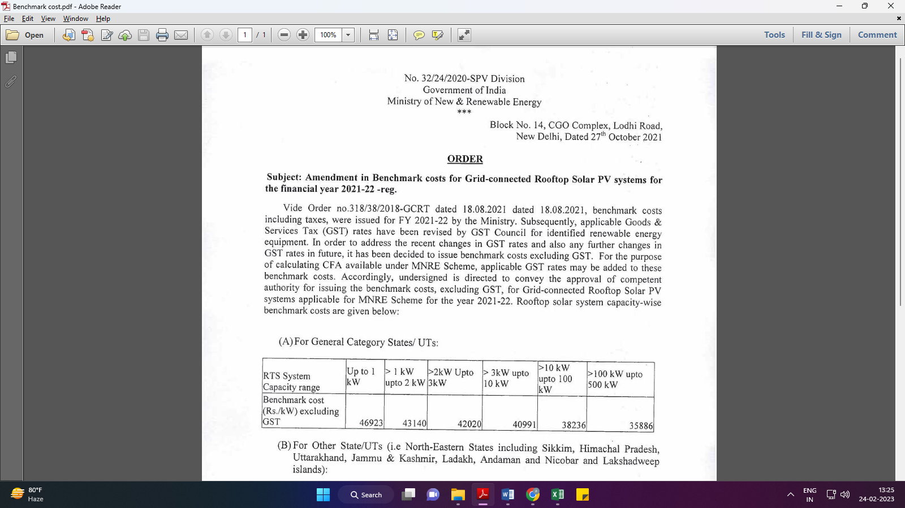
Market Comparables:
Annexure-2
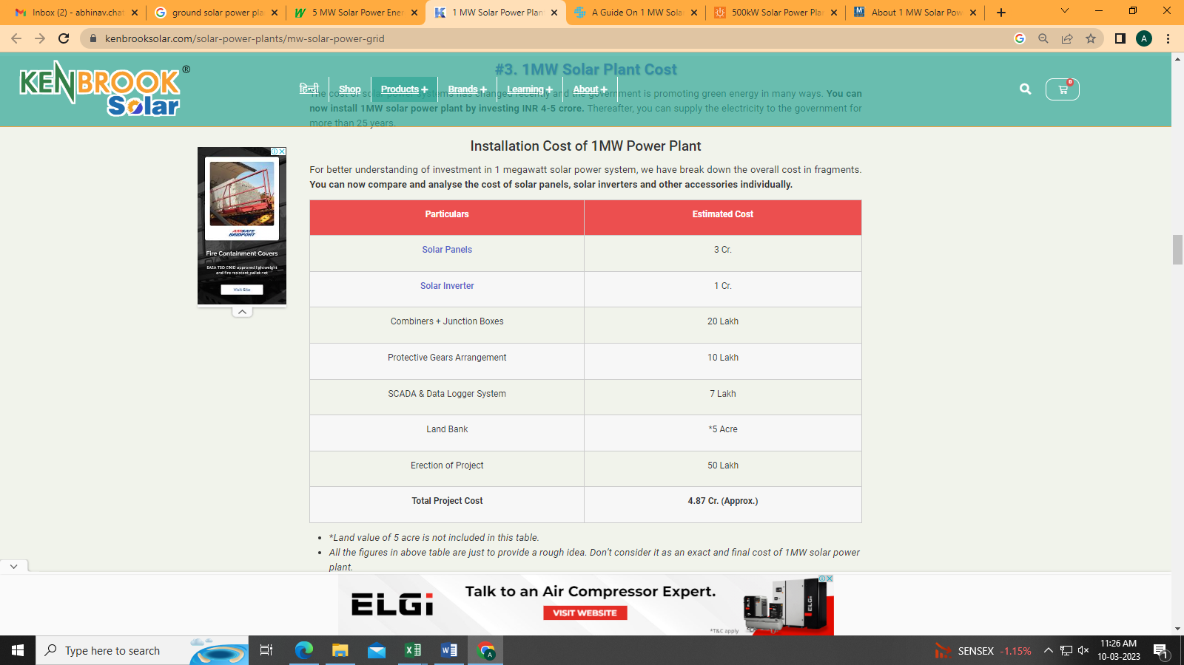

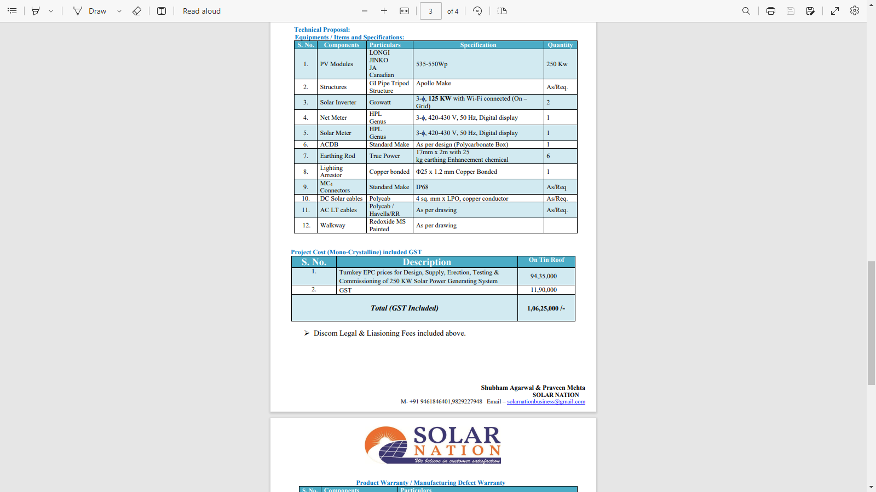

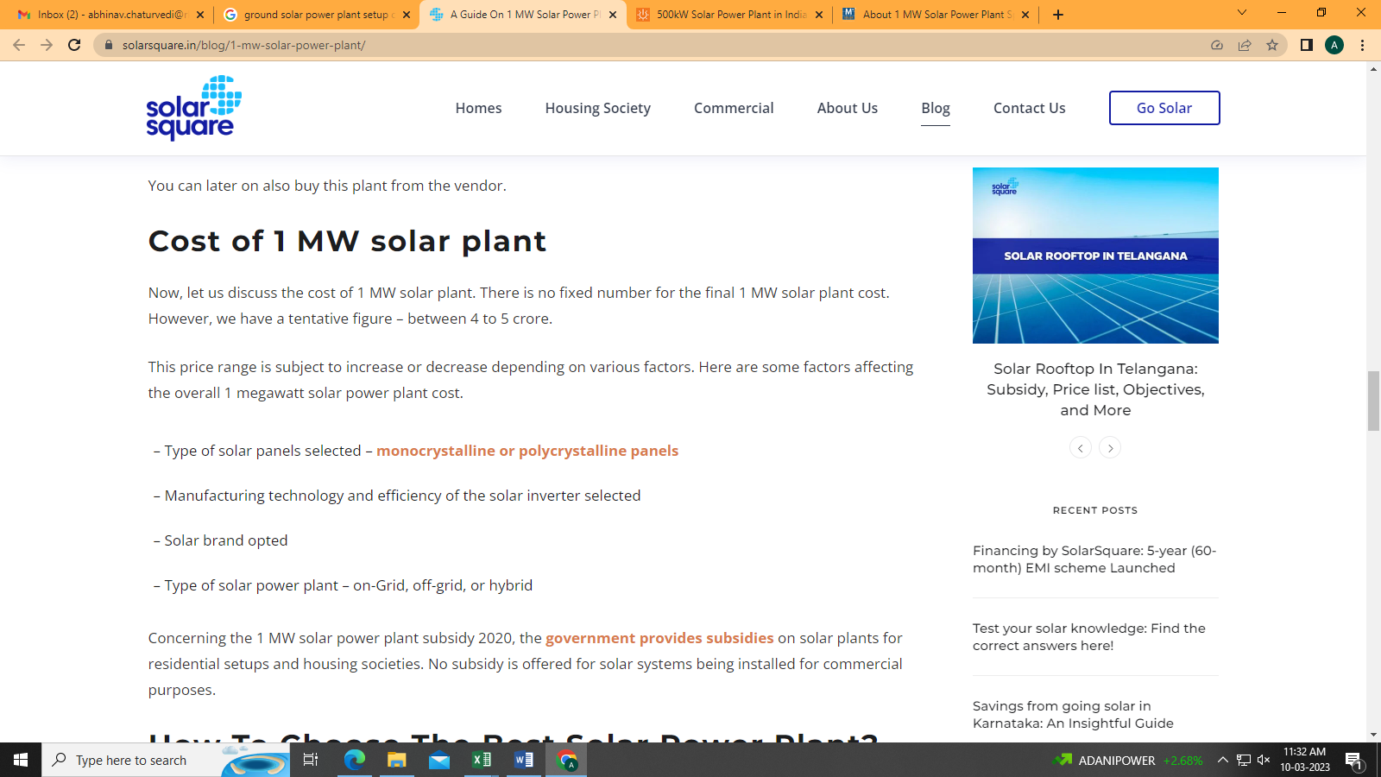
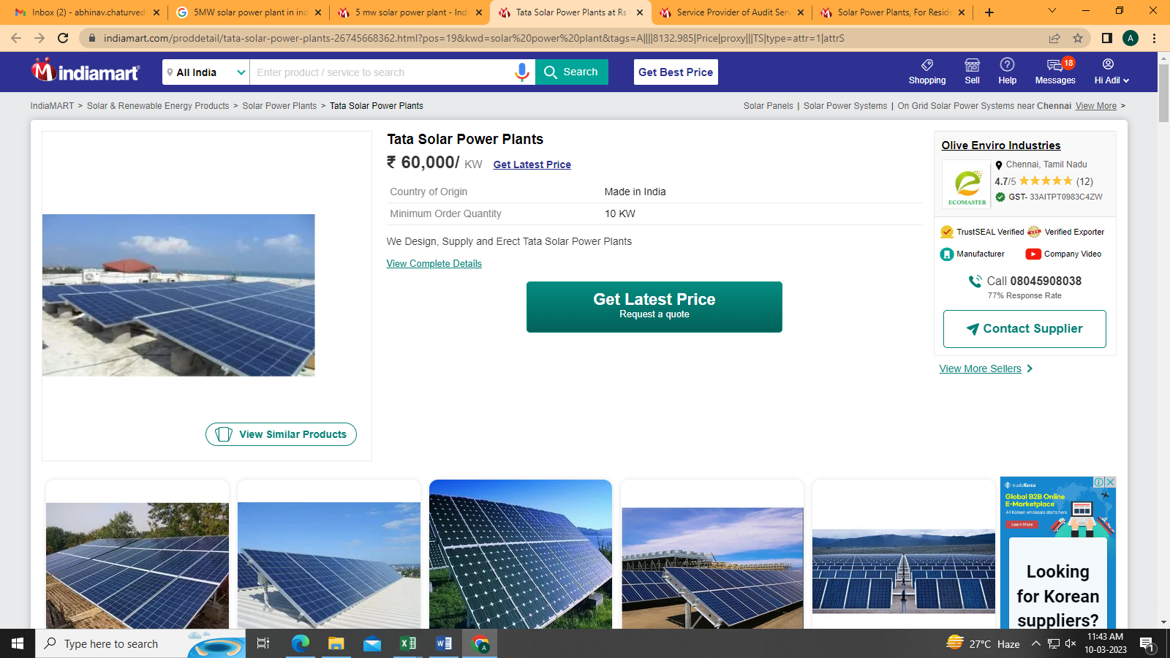

Data by Global Solar Atlas by World Bank Group
- DDA, Sarai Kale Khan
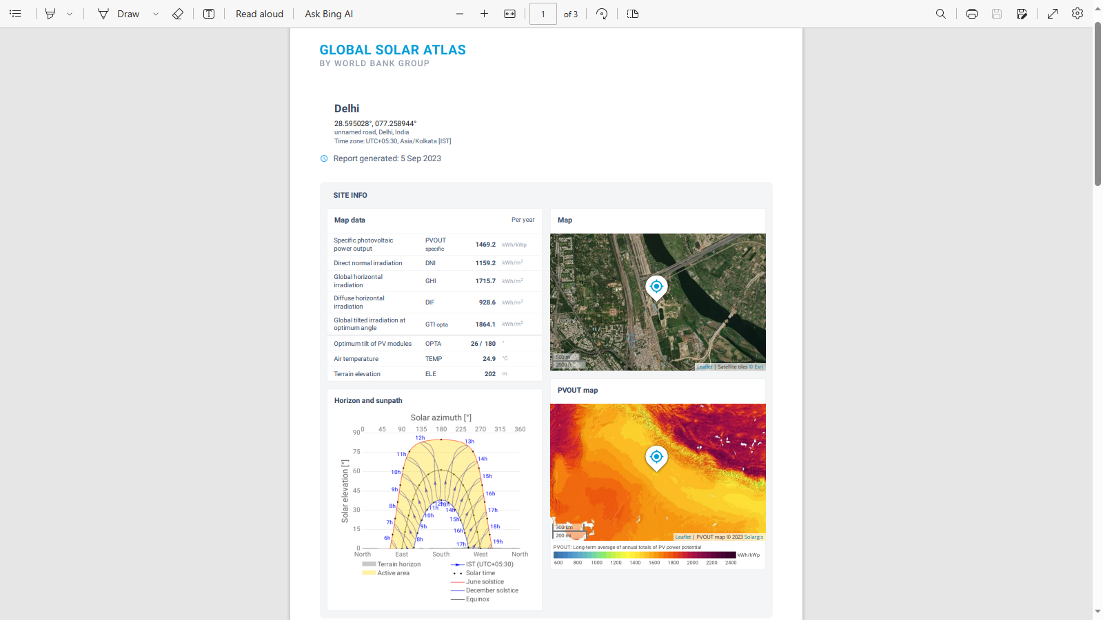
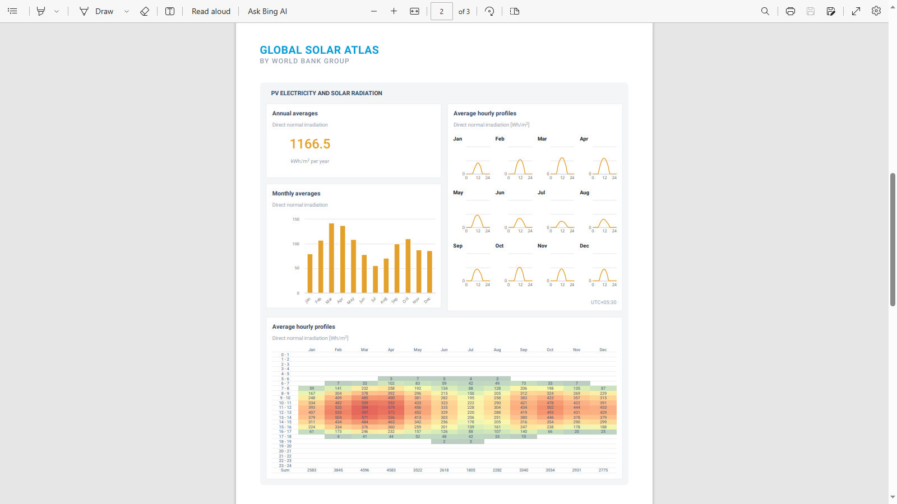

- RACL, Gajraula
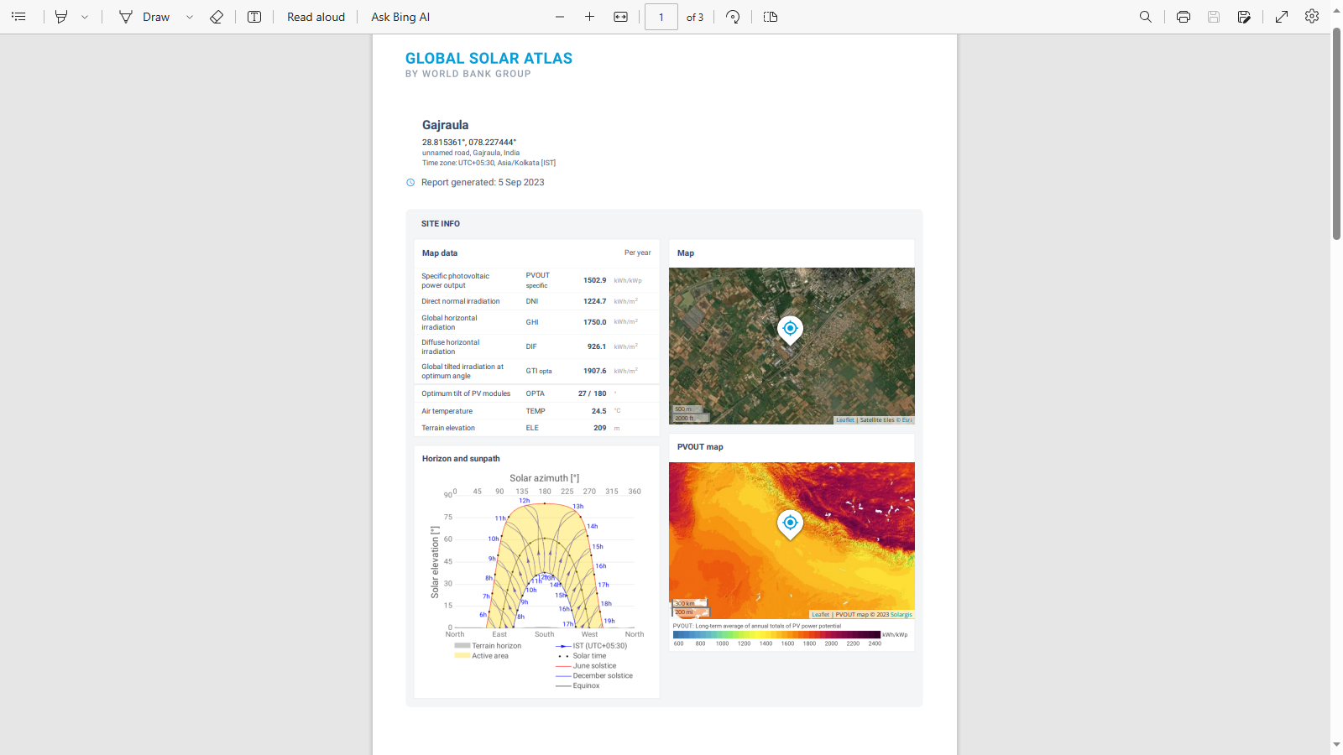

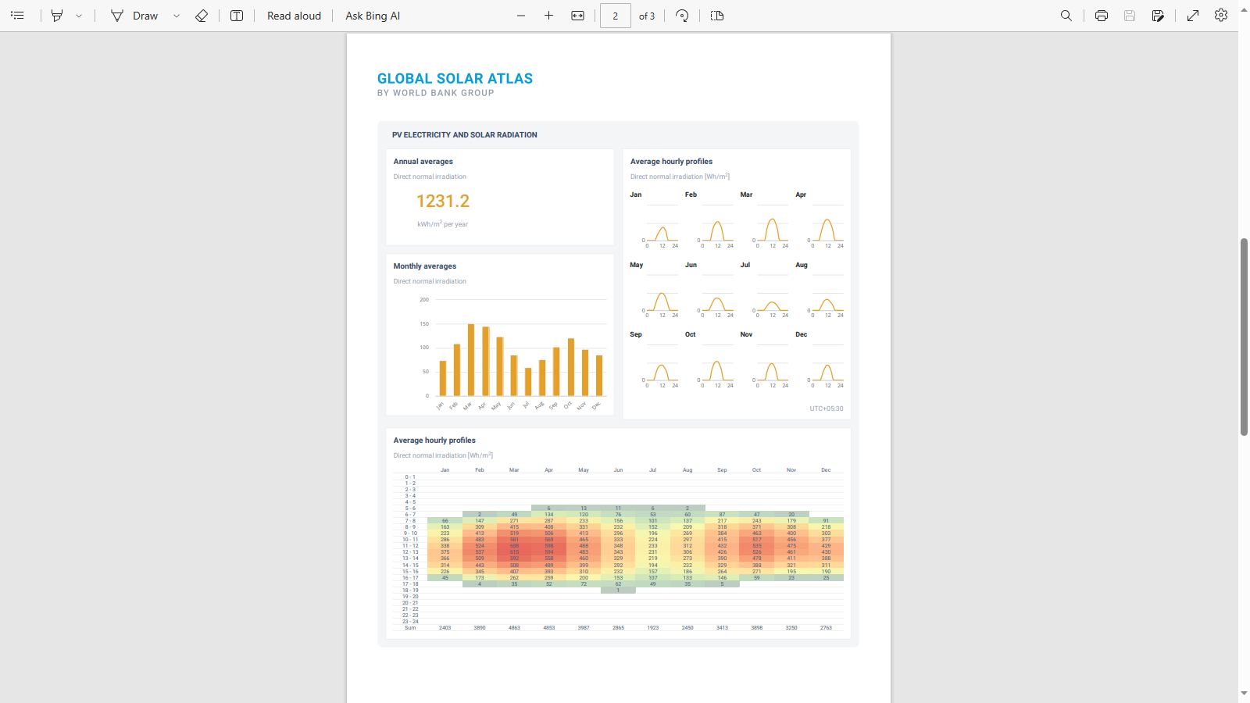

- Sirohi, Rajasthan
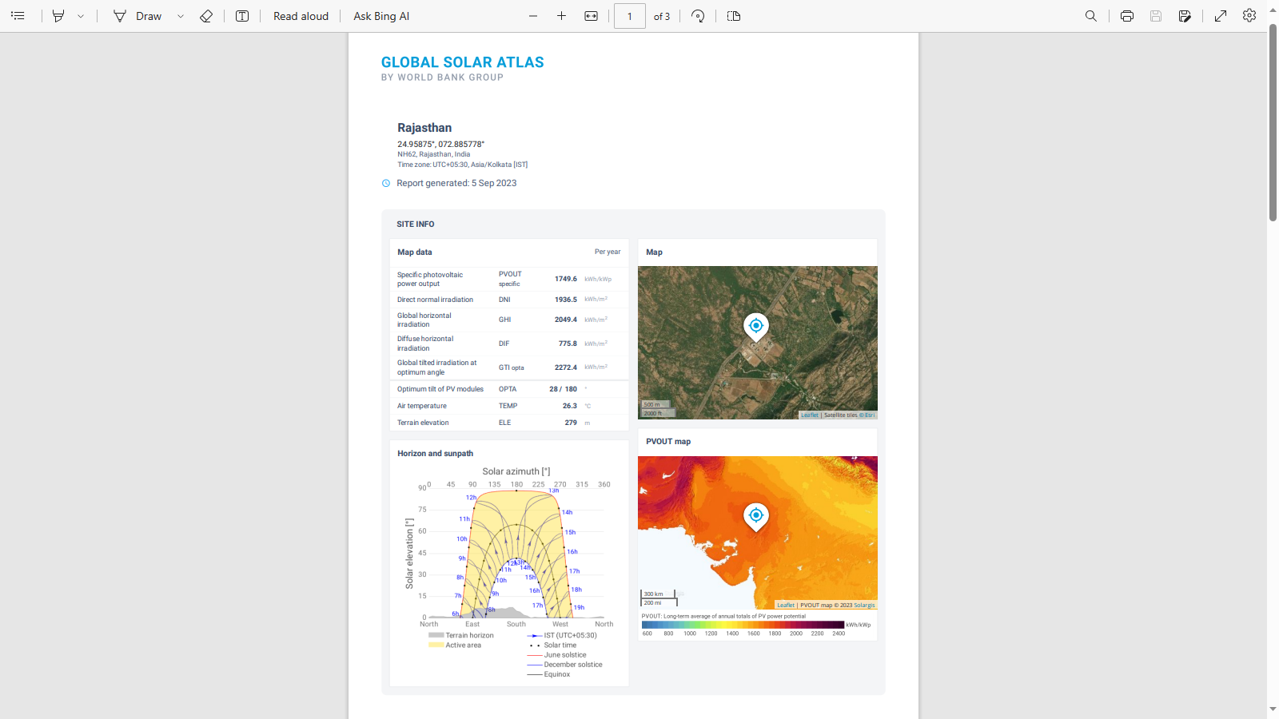

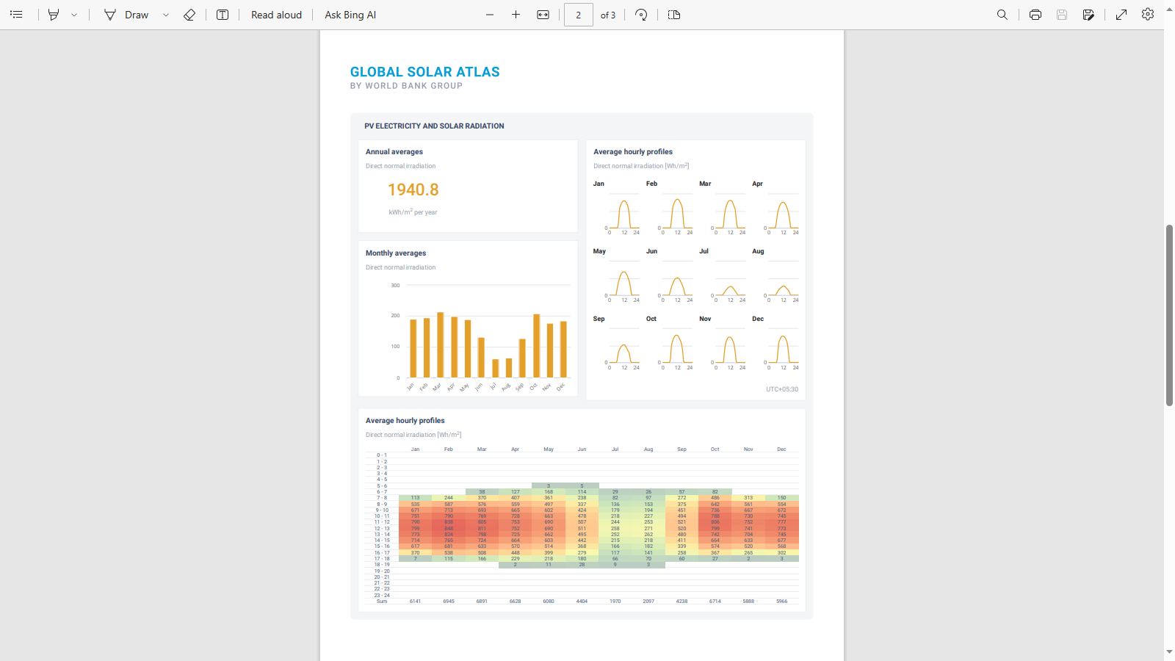

Layout Plans
- DDA, Sarai Kale Khan
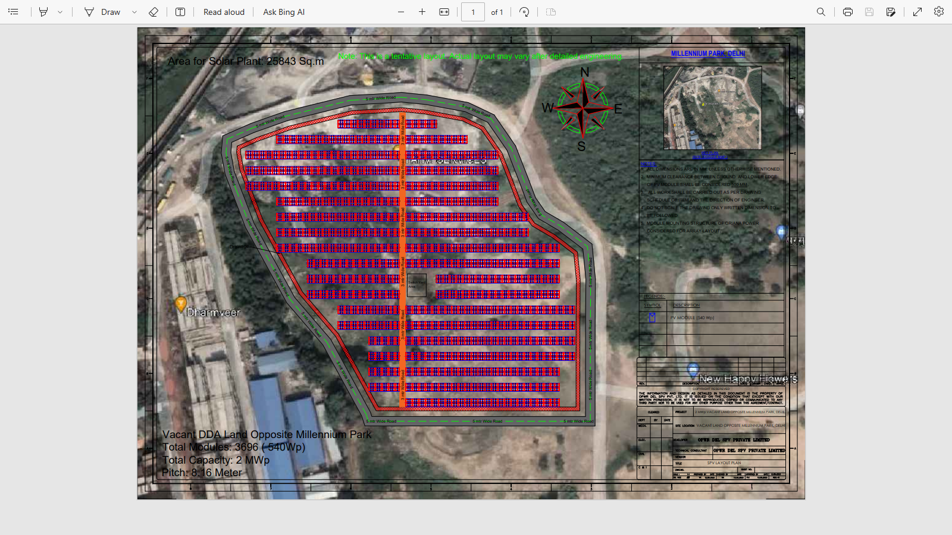

- RACL, Gajraula
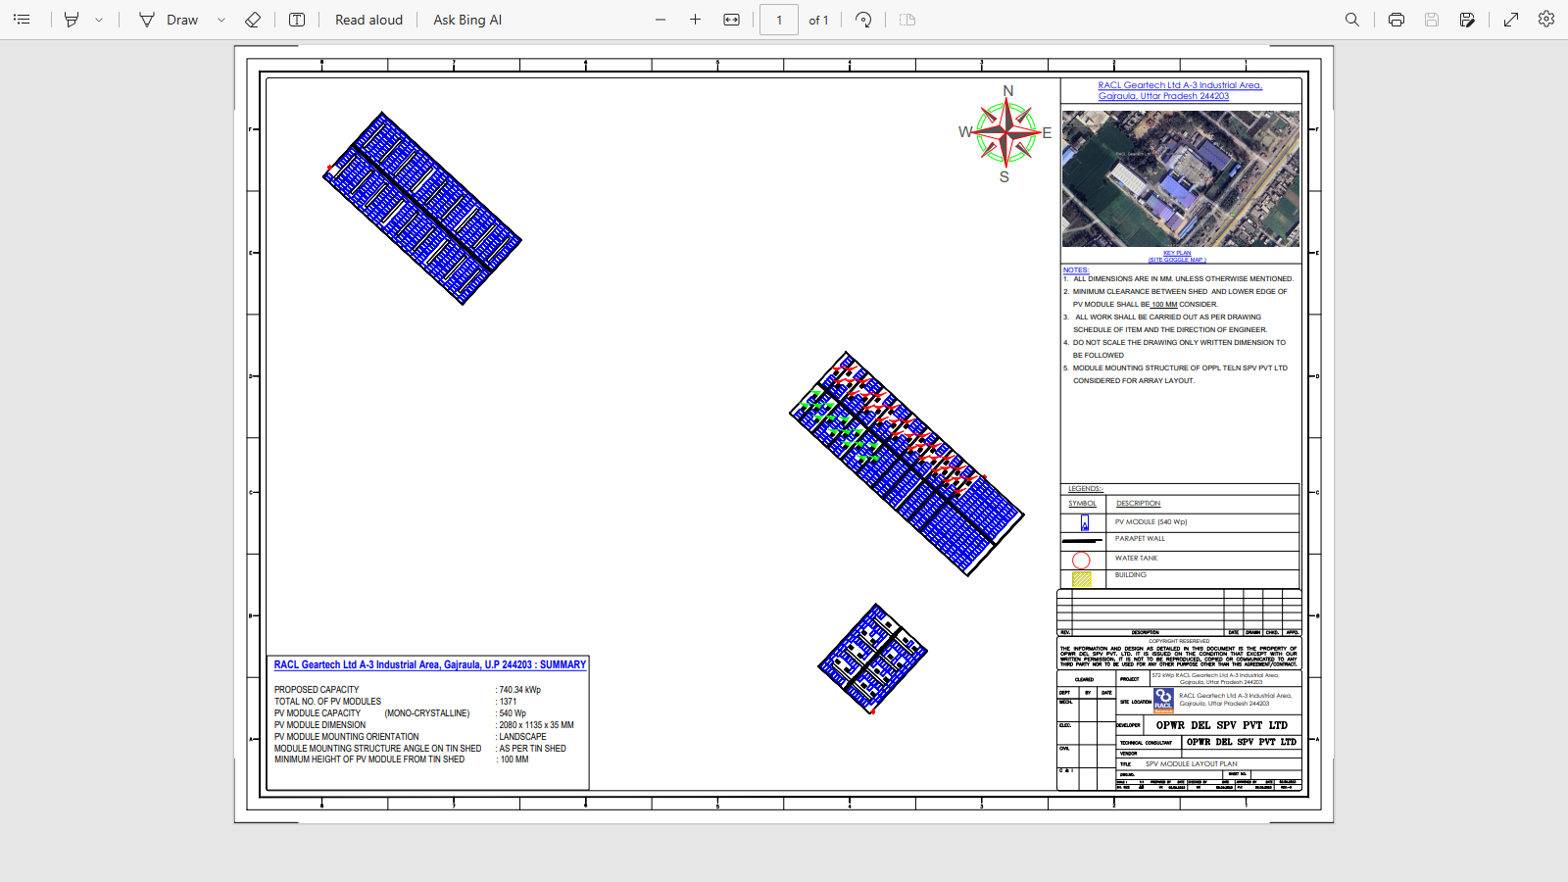

- Sirohi, Rajasthan
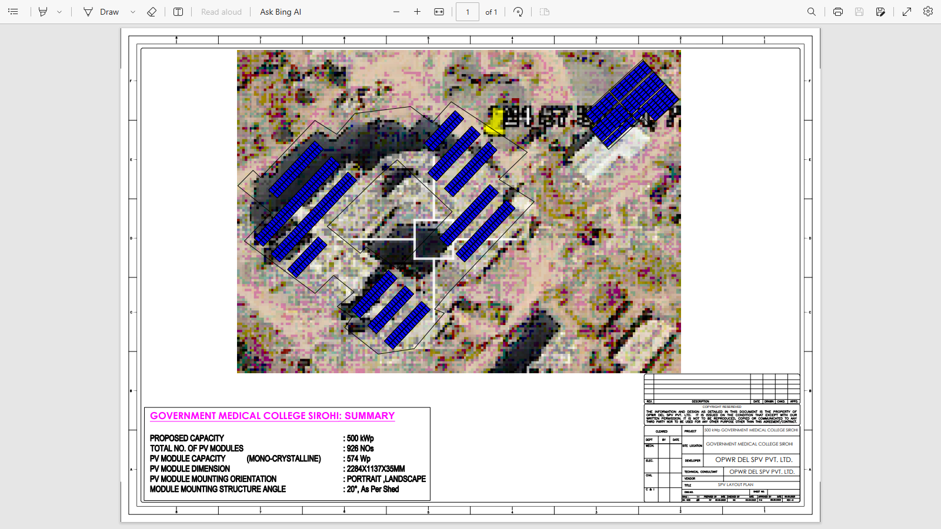
PART J | DISCLAIMER

      - No employee or member of R.K Associates has any direct/ indirect interest in the Project.
      - This report is prepared based on the copies of the documents/ information which the Bank/ Company has provided to us out of the standard checklist of documents sought from them and further based on our assumptions and limiting conditions. All such information provided to us has been relied upon in good faith and we have assumed that it is true and correct in all respect. Verification or cross checking of the documents provided to us has not been done at our end from the originals. If at any time in future, it is found or came to our knowledge that misrepresentation of facts or incomplete or distorted information has been provided to us then this report shall automatically become null & void.
      - This report is a general analysis of the project based on the scope mentioned in the report. This is not an Audit report, Design document, DPR or Techno-financial feasibility study. All the information gathered is based on the facts seen on the site during survey, verbal discussion & documentary evidence provided by the client and is believed that information given by the company is true best of their knowledge.
      - All observations mentioned in the report is only based on the visual observation and the documents/ data/ information provided by the client. No mechanical/ technical tests, measurements or any design review have been performed or carried out from our side during Project assessment.
      - Bank/FII should ONLY take this report as an Advisory document from the Financial/ Chartered Engineering firm and it’s specifically advised to the creditor to cross verify the original documents for the facts mentioned in the report which can be availed from the borrowing company directly.
      - In case of any default in loans or the credit facility extended to the borrowing company, R.K Associates shall not be held responsible for whatsoever reason may be and any request for seeking any explanation from the employee/s of R.K Associates will not be entertained at any instance or situation.
      - This Report is prepared by our competent technical team which includes Engineers and financial experts & analysts.
      - This is just an opinion report and doesn’t hold any binding on anyone. It is requested from the concerned Financial Institution which is using this report for taking financial decision on the project that they should consider all the different associated relevant & related factors also before taking any business decision based on the content of this report.
      - All Pages of the report including annexures are signed and stamped from our office. In case any paper in the report is without stamp & signature then this should not be considered a valid paper issued from this office.
      - Though adequate care has been taken while preparing this report as per its scope, but still we can’t rule out typing, human errors, over sightedness of any information or any other mistakes. Therefore, the concerned organization is advised to satisfy themselves that the report is complete & satisfactory in all respect. Intimation regarding any discrepancy shall be brought into our notice immediately. If no intimation is received within 15 (Fifteen) days in writing from the date of issuance of the report, to rectify these timely, then it shall be considered that the report is complete in all respect and has been accepted by the client upto their satisfaction & use and further to which R.K Associates shall not be held responsible in any manner.
      - Defect Liability Period is 15 DAYS. We request the concerned authorized reader of this report to check the contents, data and calculations in the report within this period and intimate us in writing if any corrections are required or in case of any other concern with the contents or opinion mentioned in the report. Corrections only related to typographical, calculation, spelling mistakes, incorrect data/ figures/ statement will be entertained within the defect liability period. Any new changes for any additional information in already approved report will be regarded as additional work for which additional fees may be charged. No request for any illegitimate change in regard to any facts & figures will be entertained.
      - R.K Associates encourages its customers to give feedback or inform concerns over its services through proper channel at le@rkassociates.org in writing within 30 days of report delivery. After this period no concern/ complaint/ proceedings in connection with the Lender’s Independent Engineering Services will be entertained due to possible change in situation and condition of the subject Project.
      - Our Data retention policy is of ONE YEAR. After this period, we remove all the concerned records related to the assignment from our repository. No clarification or query can be answered after this period due to unavailability of the data.
      - This Lender’s Independent Engineering report is governed by our (1) Internal Policies, Processes & Standard Operating Procedures, (2) Information/ Data/ Inputs given to us by the client and (3) Information/ Data/ Facts given to us by our field/ office technical team. Management of R.K Associates never gives acceptance to any unethical or unprofessional practice which may affect fair, correct & impartial assessment and which is against any prevailing law. In case of any indication of any negligence, default, incorrect, misleading, misrepresentation or distortion of facts in the report then it is the responsibility of the user of this report to immediately or at least within the defect liability period bring all such act into notice of R.K Associates management so that corrective measures can be taken instantly.
      - R.K Associates never releases any report doing alterations or modifications from pen. In case any information/ figure of this report is found altered with pen then this report will automatically become null & void.
FOR INTERNAL USE
Place : Noida  Date : 11.09.2023  Note : This report contains 40 pages | SURVEYED BY:  PREPARED BY:  REVIEWED BY: | NA as Desktop LIE  Abhinav Chaturvedi  Sr. V.P. Projects

For R.K Associates Valuers & Techno Engineering Consultants (P) Ltd.

DEFECT LIABILITY PERIOD - In case of any query/ issue or escalation you may please contact Incident Manager by writing at valuers@rkassociates.org. We ensure 100% accuracy in the Calculations done, Rates adopted and various other data points & information mentioned in the report but still can’t rule out typing, human errors or any other mistakes. In case you find any mistake, variation, discrepancy or inaccuracy in any data point of the report, please help us by bringing all such points into our notice in writing at valuers@rkassociates.org within 30 days of the report delivery, to get these rectified timely, failing which R.K Associates Valuers Techno Engineering Consultants (P) Ltd. won’t be held responsible for any inaccuracy in any manner. Also if we will not hear back anything from you within 30 days, we will assume that report is correct in all respect and no further claim of any sort will be entertained thereafter. We would welcome and appreciate your feedback & suggestions in order to improve our services.

COPYRIGHT FORMAT - This report is prepared on the copyright format of R.K Associates Valuers Techno Engineering Consultants (P) Ltd. to serve our clients in the best possible way. Legally no one can copy or distribute this format without prior approval from R.K Associates. It is meant only for the organization as mentioned on the cover page of this report. Distribution or use of this format other than R.K Associates will be seen as unlawful act and necessary legal action can be taken against the defaulter

