**File No.:VIS(2023-24)-PL306-253-361 Dated: 01.09.2023**

# To,

# Intended Purchaser(s),

1. Mrs. Archana Ramesh W/o Mr. Nitin Chauhan and

2. Mr. Nitin Chauhan S/o Mr. Jagbir Singh Chauhan

**SUB: Cost Estimate for the proposed Renovation works at Unit No. 193, Ground floor, Block-C, Jindal Global City, Phase-III, Sector-35, Sonepat, Haryana**

# Dear Sir,

Cost Estimation for the proposed Renovation works Unit No. 193, Ground floor, Block-C, Jindal Global City, Phase-III, Sector-35, Sonepat, Haryana, having Covered Area of 920.32 sq.ft., Built-up Area of 1143.37 sq.ft & Super Built-up Area of 1450 sq.ft. is as per the table below. The flat in favor of **Mrs. Anju Chauhan W/O Mr. Manmohan Chauhan**.

Our view is in line with the prevailing market rates of the items as per the material specifications and type & quality of work. Quantities taken are on approximate basis and as per the Floor Plan provided to us.

|  |  |  |  |  |
| --- | --- | --- | --- | --- |
| **S. No.** | **Full Description of work** | **Quantity** | **Rate**  **(In Rs. per sq. ft.)** | **Amount**  **(In INR)** |
| 1 | Tiles on outer front and back walls of the flat | 450 sq.ft. | 95 | 42,750 |
| 2 | Floor tiling work | 1,150 sq.ft. | 95 | 1,09,250 |
| 3 | Roof fall ceiling work | 600 sq.ft. | 95 | 57,000 |
| 4 | Room Doors(steel) and chokut replacement(steel) | 8 no. | 10000 | 80,000 |
| 5 | Cupboard and double bed in all 3 rooms | Lumpsum | | 2,00,000 |
| 6 | Sliding mosquito net doors in all the rooms. | Lumpsum | | 75,000 |
| 7 | TV rack in drawing and other 3 rooms | 4 no. | 10,000 | 40,000 |
| 8 | steel grill gate on the main door |  |  | 15,000 |
| 9 | Modular kitchen along with chimney | 100 sq.ft. | 1,800 | 1,80,000 |
| 10 | Bathroom fittings along with toilet seat and washbasin. | Lumpsum | | 2,50,000 |
| 11 | Bathroom floor and walls tiles replacement | 540 sq.ft. | 150 | 81,000 |
| 12 | Glass partition in bathroom | 3 no. | 15,000 | 45,000 |
| 13 | furniture including sofa, dinning table, airconditioner, etc. | Lumpsum | | 3,00,000 |
| 14 | Paint work along with wall seelan work | 4,140 sq.ft. | 35 | 1,44,900 |
| 15 | Construction of 3rd bathroom | Lumpsum | | 2,00,000 |
| **Total** | | | | **18,19,900** |
| **Say In Rs.** | | | | **18,20,000** |

***Disclaimer: Cost Estimate can vary from the final actual construction cost as the actual construction cost comes as per final plans and prevailing market rates for the Material & Labour at that point of time.***

**For R.K Associates Valuers & Techno Engg. Consultants (P) Ltd.**

**Authorized Signatory**

|  |  |  |  |
| --- | --- | --- | --- |
| **1.** | **DECLARATION** | | |
|  | 1. This cost estimate is done based on the documents/ details/ information provided by the customer. 2. The undersigned does not have any direct/indirect interest in the above property. 3. The information furnished herein is true and correct to the best of our knowledge. 4. We have submitted this certificate directly to the Bank. 5. This estimate is carried out by our Engineering team on the request from **Mrs. Archana Ramesh and Mr. Nitin Chauhan.** | | |
| **2.** | **Name & Address of Valuer company** | | **Signature of the authorized person** |
| M/s R.K. Associates Valuers & Techno Engineering  Consultants Pvt. Ltd. D-39, Sector-2, Noida, U.P. | |  |
| **3.** | **Enclosed Documents** | 1. Floor Plan. 2. Allotment Letter 3. Builder Buyer Agreement | |
| **4.** | **Total Number of Pages in the Report with Enclosures** | 06 | |
| **5.** | **Engineering Team worked on the report** | ***SURVEYED BY:*** NA | |
| ***PREPARED BY:*** *Er****. Abhinav Chaturvedi*** | |
| ***REVIEWED BY:*** HoD Engineering | |

**R.K ASSOCIATES IMPORTANT NOTES:**

***DEFECT LIABILITY PERIOD*** *- In case of any query/ issue or escalation you may please contact Incident Manager by writing at* [*valuers@rkassociates.org.*](mailto:valuers@rkassociates.org) *We ensure 100% accuracy in the Calculations done, Rates adopted and various other data points &* information mentioned in the report but still can’t rule out typing, human errors or any other mistakes. In case you find any mistake, variation, discrepancy or inaccuracy in any data point of the report, please help us by bringing all such points into our notice in writing at [valuers@rkassociates.org](mailto:valuers@rkassociates.org)within 30 days of the report delivery, to get these rectified timely, failing which R.K Associates won’t be held responsible for any inaccuracy in any manner. Also if we will not hear back anything from you within 30 days, we will assume that report is correct in all respect and no further claim of any sort will be entertained thereafter. We would welcome and appreciate your feedback & suggestions in order to improve our services.

***COPYRIGHT FORMAT*** *- This report is prepared on the copyright format of R.K Associates to serve our clients in the best possible way. Legally no one can copy or distribute this format without prior approval from R.K Associates. It is meant only for the* Organization as mentioned on the cover page of this report. Distribution or use of this format other than R.K Associates will be seen as unlawful act and necessary legal action can be taken against the defaulters.

***IF REPORT IS USED FOR BANK/ FIs***

**NOTE:** As per IBA Guidelines in case the valuation report submitted by the valuer is not in order, the banks / FIs shall bring the same to the notice of the valuer within 15 days of submission for rectification and resubmission. In case no such communication is received, it shall be presumed that the valuation report has been accepted.

***At our end we have not verified the authenticity of any documents provided to us. Bank is advised to verify the genuineness of the property documents before taking any credit decision.***

***ENCLOSURE:***

***FLOOR PLAN.***

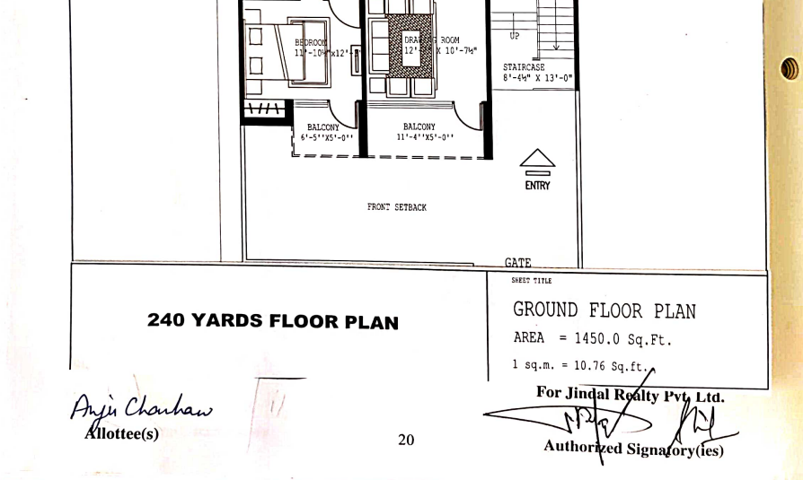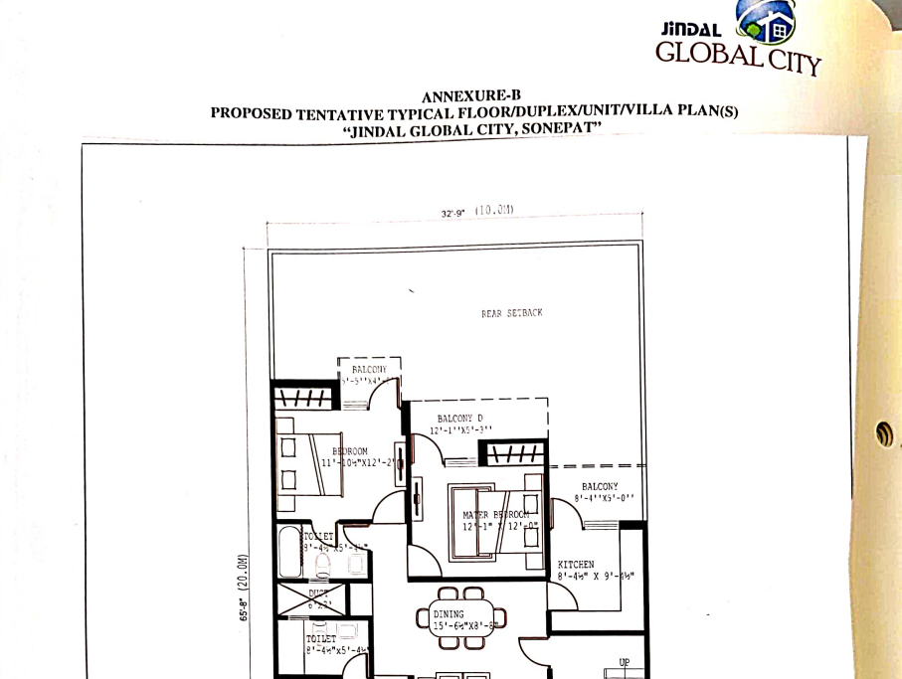

***ALLOTMENT LETTER***

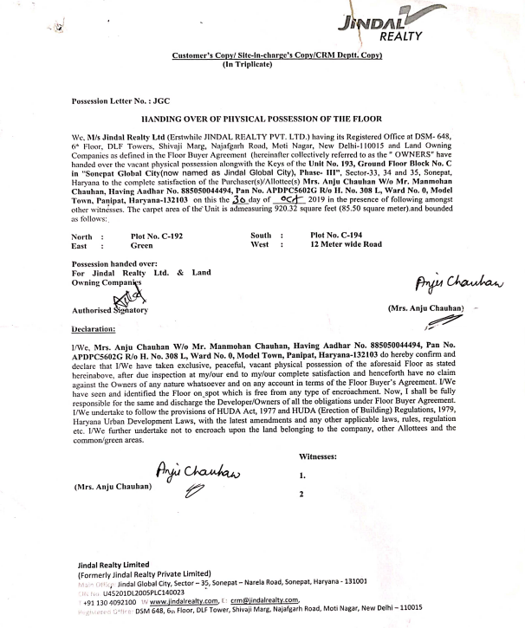

***BUILDER BUYER AGREEMENT***

