**File No.: VIS (2023-24) -** **PL-362-292-460 Dated: 16th October 2023**

**1ST PROJECT LIE REPORT**

**(FOR QUARTER ENDING SEP 2023)**

**OF**

**1.5 MMTPA GRINDING UNIT (GU)**

**SITUATED AT**

**VILLAGE- MADHAVGARH, TEHSIL- GHATIYA, DISTRICT- UJJAIN,**

**MADHYA PRADESH-456003**

**IMPLEMENTED BY**

**JK CEMENT LIMITED**

https://www.jkcement.com/frontTheme/img/jkcemet-logo.png

**REPORT PREPARED FOR**

**INDIAN BANK LCB BRANCH, SANSAD MARG, NEW DELHI**

***\*\*Important - In case of any query/ issue or escalation you may please contact Incident Manager at le@rkassociates.org. We will appreciate your feedback in order to improve our services.***

***NOTE: As per IBA Guidelines please provide your feedback on the report within 15 days of its submission after which report will be considered to be correct.***

|  |  |  |
| --- | --- | --- |
| **TABLE OF CONTENTS** | | |
| **SR. NO.** | **DESCRIPTION** | **PAGE NO.** |
| **PART A** | **Report Summary** | **03** |
| **PART B** | **Introduction** | **05** |
| 1. The Project | **05** |
| 1. About the Borrower | **05** |
| 1. Location of the Project | **06** |
| 1. Project Overview | **07** |
| 1. Scope of the Project During Project Duration | **10** |
| 1. Purpose of the Report | **10** |
| 1. Methodology Adopted | **10** |
| **PART C** | **Plant Infrastructure Sections & Facility Details with Actual Progress** | **11** |
| 1. Land Details | **11** |
| 1. Building and Structure Details | **12** |
| 1. Plant Machinery and Equipment | **16** |
| **PART D** | **Project Consultants, Contractors & Suppliers** | **22** |
| 1. List of Contractors and Agreements | **22** |
| **PART E** | **Project Cost and Means of Finance** | **23** |
| 1. Cost of Project | **23** |
| 1. Current Status and Total Expenditure Incurred Till Date | **24** |
| 1. Sources of Finance & Utilization of Funds | **24** |
| **PART F** | **Statutory & Regulatory Approvals, Clearances & NOC** | **25** |
| **PART G** | **Project Schedule & Current Status** | **26** |
| 1. Project Schedule Chart | **26** |
| **PART H** | **Observations and Comments** | **27** |
| **PART I** | **Disclaimer** | **28** |
| **PART J** | **Enclosure** | **32** |
| **PART K** | **Photographs** | **38-45** |

# 

# IMPORTANT NOTICE

***COPYRIGHT FORMAT:*** *This report is prepared on the copyright format of R.K Associates, to serve our clients with the best available information and analysis to facilitate them to take rational business decisions. Legally no one can copy or distribute this format without prior approval from R.K Associates. It is meant only for the advisory/ reference purpose for the organization/s as mentioned on the cover page of this report. Distribution or use of this format by any organization or individual other than R.K Associates will be seen as unlawful act and necessary legal action can be taken against the defaulters.*

*This report is intended for the sole use of the intended recipient/s and contain material that is STRICTLY CONFIDENTIAL AND PRIVATE.*

***DEFECT LIABILITY PERIOD:*** *- In case of any query/ issue or escalation you may please contact Incident Manager: le@rkassociates.org. We try our level best to ensure correctness in the calculations done, rates adopted and various other data points & information mentioned in the report but still can’t rule out typing, human errors or any other mistakes. In case you find any such mistake or inaccuracy in any data point of the report please help us by bringing all such points into our notice immediately or within 15 days of the report delivery in writing, to rectify these timely failing after which R.K Associates won’t be held responsible for any such inaccuracy in any manner. We would highly appreciate your feedback in order to improve our services.*

|  |  |
| --- | --- |
| **PART A** | **REPORT SUMMARY** |

|  |  |  |
| --- | --- | --- |
| **1.** | **Name of Project:** | JK Cement Limited, herein referred as “JKCL” proposes to set up a 1.50 MMTPA clinker grinding unit (GU) in Ujjain district in the State of Madhya Pradesh. |
| **2.** | **Project Location:** | * Village: Madhavgarh * District: Ujjain * State: Madhya Pradesh * Co-ordinates: 23°15'31.4"N 75°43'28.9"E * Altitude: ~500 m with respect to AMSL |
| **3.** | **Name of the Borrower:** | M/s. JK Cement Ltd. (JKCL). |
| **4.** | **Key management:** | * Sh. Raghavpat Singhania : Managing Director * Sh. Madhavkrishna Singhania : CEO |
| **5.** | **Prepared for Bank:** | Indian Bank LCB Branch, Sansad Marg, New Delhi |
| **6.** | **LIE Consultant Firm:** | M/s. R.K. Associates Valuers & Techno Engineering Consultants (P) Ltd. |
| **7.** | **Date of Survey:** | 08th October and 09th October 2023. |
| **8.** | **Date of Report:** | 16/10/2023 |
| **9.** | **Purpose of the Report:** | To provide fair detailed analysis report to the Bank based on the “in-scope points” mentioned below for facilitating them to take appropriate business decision on the Project. |
| **10.** | **Scope of the work provided by the Lender:** | 1. Review Project details & facilities 2. Project Progress vis-a-vis construction schedule 3. Review Project expenditure in line with construction schedule 4. Review of Project towards Licenses, NOCs, Approvals |
| **11.** | **Documents provided for the Project *(out of documents requested)*:** | 1. Techno economic feasibility report 2. Project Statutory approvals 3. CA certificate 4. List of contractors/Suppliers |
| **12.** | **Annexure with the report:** | 1. Project Statutory approvals 2. CA Certificate 3. List of Contractors/ Suppliers 4. List of PO’s |

|  |  |
| --- | --- |
| **PART B** | **INTRODUCTION** |

1. **THE PROJECT:**

**JK Cement Limited (JKCL)** is establishing a Clinker Grinding Unit (GU) with a capacity of 1.50 million tonnes per annum (MTPA) in the Ujjain district of Madhya Pradesh using Vertical Rolling Mill. The major raw material for this clinker grinding unit which clinker is expected to be sourced from JKCL's Mangrol, Nimbahera and Panna plants in the state of Rajasthan.

1. **ABOUT THE PROMOTER/BORROWER:**

JK Cement Ltd is an affiliate of the multi-disciplinary industrial conglomerate JK Organisation founded by Lala Kamlapat Singhania. The Company has over four decades of experience in cement manufacturing. Their operations commenced with commercial production at their first grey cement plant at Nimbahera in the state of Rajasthan in May 1975. Subsequently the Company also set up 2 more units in Rajasthan at Mangrol and Gotan. In the year 2009 the Company extended its footprint by setting up a green-field unit in Muddapur, Karnataka giving it access to the markets of southwest India.

The Company has made its first international foray with the setting up of a green-field dual process White Cement-cum-Grey Cement Plant in the free trade zone at Fujairah, U.A.E to cater to the GCC and African markets. The plant at Fujairah has a capacity of 0.6 Mn.TPA for White Cement with a flexibility to change over its operation to produce upto 1 Mn.TPA of Grey Cement. Recently, Company has successfully commissioned the Greenfield projects of 2 MnTPA at Panna in Madhya Pradesh, along with a 2 Mn TPA grinding unit at Hamirpur in Uttar Pradesh. In addition, Company has also completed various debottlenecking projects in existing plants taking total installed grey capacity to 20.67 Mn TPA. Company is having white cement and putty manufacturing capacity of 2.81 Mn TPA. The Company has captive power generation capacity of over 213.65 MW which includes 111.15 MW of green power capacity.

Further, company is in the process of installation of another 3.5 MnTPA cement grinding capacity – 1.5 MnTPA at Ujjain, Madhya Pradesh and 2 MnTPA at Prayagraj, Uttar Pradesh, and expected to commission in FY 2023-24 and FY 2024-25 respectively.

1. **PROJECT LOCATION:**

|  |  |
| --- | --- |
| **Particulars** | **Description** |
| **Address** | |
| Village: Madhavgarh, Ujjain, Madhya Pradesh | |
| **Google Coordinates** | |
| Latitude | 23°15'31.4"N |
| Longitude | 75°43'28.9"E |
| **Connectivity Systems** | |
| Road | The project site of the subject under construction plant is connected by a village road, which as per information gathered, is constructed by JK itself.  The main road that leads to the plant is Ujjain-Nagda State Highway (SH17). |
| Rail | The nearest main line railway station is Ujjain Railway Station at a distance of approx. 16 km in South direction. The other smaller railway station is Naikheri Railway Station, at a distance of approx. 10 km |
| Air | The nearest domestic as well as international airport is at Indore at about 70 km distance from the plant site. |

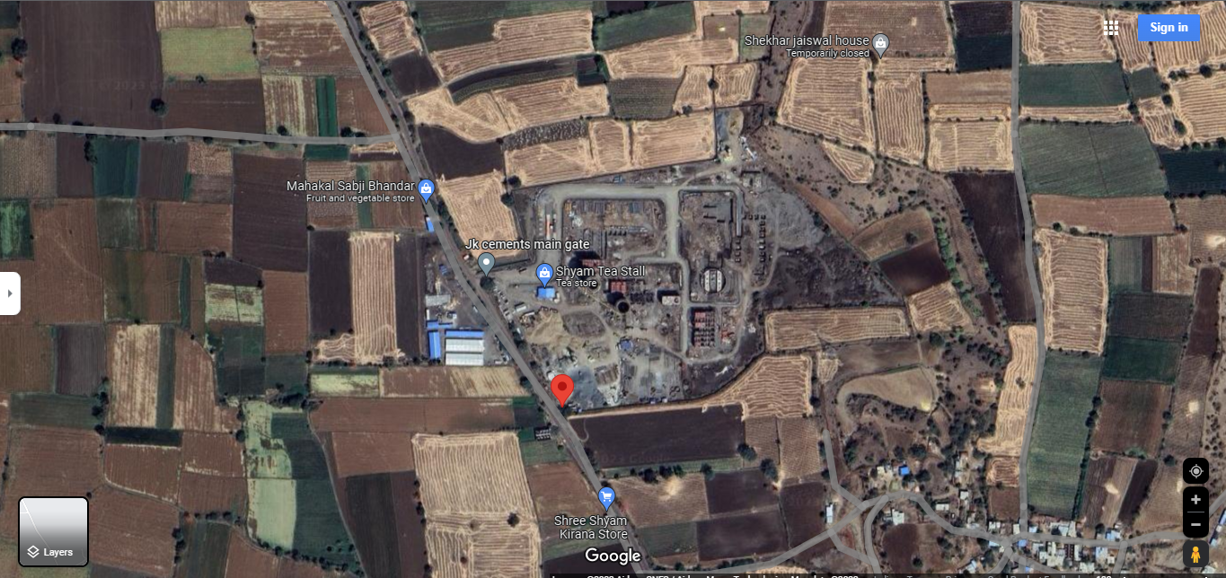

Source: Google Maps as updated on 16/03/2023

**Figure: Location of under construction Grinding Unit**

1. **PROJECT OVERVIEW:**

**JK Cement Limited (JKCL)** is establishing Clinker Grinding Unit (GU) with a capacity of 1.50 million tonnes per annum (MTPA) in the Ujjain district of Madhya Pradesh. The major raw material for this clinker grinding unit is expected to be sourced from JKCL's Mangrol, Nimbahera and Panna plants in the state of Rajasthan.

As per the product mix details provided by the borrower, they have planned to manufacture 100% Portland Pozzolona Cement (PPC), which is the most prevalent cement type consumed in India.

This project is proposed on about total land area about 10.75 hectare or approx. 27 acres located at Village: Madhavgarh, Ujjain, Madhya Pradesh which is about at a distance of 16 Kms from main Ujjain city towards south.

The total proposed Project cost sums approx. 418.96 Crore as per the TEFR report by M/s HOLTEK, which includes major heads such as Land and Site Development, Civil Works, Plant and Machinery, etc. Detailed description of the same can be found further in the report.

The proposed completion date for the Project and the plant are envisaged by June 2024, according to the TEFR by M/s HOLTEK of December 2022. As per the TEFR provided, the construction timeline for the Grinding Unit is expected to be completed within 18 months from the project's commencement that is December 3, 2022 for the subject project. During our site inspection dated 9th October 2023, it was observed that a significant portion of the project work has been successfully completed, with major plant and machinery already tested. The landscape development works, including roads and drains, are currently in progress, as detailed in our report. Overall, the project is on track, aligning with the timeframes, with a minor delay in VRM due to unavailability of parts in it i.e. Mill Gearbox, Coupling and LUB Unit, and is nearing completion, with only the landscape development phase remaining.

The borrower has appointed reputed and well established contractors/Suppliers for completing this project. As per the information available in public domain for these suppliers/Contractors they are having good track record in completion such type of works.

As per Environment Clearance from Ministry of Environment, Forest and Climate Change, Government of India, Integrated unit situated at Ujjain is having approval for setting up of 1.50 MTPA of clinker unit and the water requirement for the plant, will be about 184 KLD (Surface water – 164 KLD & Ground Water – 20 KLD) including domestic requirement, which is planned to be met from underground sources through submersible pump and secondary sources like rainwater harvesting etc.

STP of 10 KLD facility has been proposed for treatment of domestic waste water generated from domestic waste water generated from Plant and Canteen. However, construction/establishment of the same has not been started yet.

Specific power consumption for the subject plant has been estimated as 31.5 kWh/ t. Company has planned two DG set of 1250 KVA and 250 KVA respectively and has also obtained electricity connection of 6480 KVA from MPPKVVCL.

**Company has got Consent to Establish from M.P Pollution Control Board for mining at following capacities:**

|  |  |  |  |
| --- | --- | --- | --- |
| S. No. | Activity/Product | CTE Quantity | Applied Quantity |
| 1. | OPC/PPC/PSC/Composite Cement | 15,00,000 MTPA | 15,00,000 MTPA |
| 2. | Generation of Electricity through DG-Set | 1,250 KVA | 1,250 KVA |
| 3. | Generation of Electricity through DG-Set | 125 KVA | 125 KVA |

**Main Plants/machineries/equipment’s for the project area:**

1. Bulk Loading Unit.
2. Clinker Silo’s
3. Hopper Building
4. Mill (Grinding unit)
5. Bag house
6. Packing Plant
7. Hot air generator
8. Weigh Bridge etc.

During site inspection work progress was satisfactory and it appears that company would be able to meet its COD ahead of the schedule.

1. **SCOPE OF WORK OF THIS REPORT:**
2. To Conduct Site reviews, document reviews and study progress reports on continuous basis specially vis-à-vis Original timelines to avoid sudden shocks of overrun.
3. To determine progress achieved.
4. Deviations in project progress vis-à-vis timelines and amount disbursed.

**Note:**

1. *The scope of work is for the complete duration up to the completion of the project and not for a specific report.*
2. *Carrying out the scope of work will depend on the details/ information/ data provided to us by the borrower from time to time.*
3. **PURPOSE OF THE REPORT:** To provide fair detailed analysis report to the Bank based on the “in-scope points” mentioned above for facilitating them to take appropriate credit decision on the Project.
4. **METHODOLOGY ADOPTED:**
5. Study of Project Planning documents/ reports to know about the Project.
6. Additional information, data, documents collection the borrower.
7. Study and analysis of the documents and information obtained from the borrower.
8. Research about the Project/ sector from the sources in the public domain.
9. Correlation of the provided information against Industry/ sector benchmarks/ trend.
10. Information compilation, analysis and reporting.

|  |  |
| --- | --- |
| **PART C** | **PLANT INFRASTRUCTURE SECTIONS & FACILITY DETAILS WITH ACTUAL PROGRESS** |

1. **LAND & SITE DEVELOPMENT:**

As per TEFR report, the borrower has proposed an expenditure amounting to Rs.21.00 Crore towards land and site development. Breakup of the same is tabulated below:

|  |  |  |
| --- | --- | --- |
| Sr. No. | Particular | Amount |
| 1. | Capital Cost of procured land for setting up the plant | 600 |
| 2. | Site preparation & development | 130 |
| 3. | Site enabling investigations (Topographical, Geotechnical & Hydrological) | 80 |
| 4. | Boundary Wall | 135 |
| 5. | Gates, Security Pickets, etc. | 30 |
| 6. | Approach Road to Plant | 250 |
| 7. | Plant Internal Roads | 370 |
| 8. | Truck Parking & Logistics Office | 340 |
| 9. | Plant Drainage | 145 |
| 10. | Landscaping and Provision of Green Belt | 20 |
|  | **Total(Amount in Rs. Lakhs)** | **2100** |

***Source: TEFR prepared by HOLTEC Consultancy***

As per TEFR Prepared by HOLTEC, JKCL has acquired 10.75 hectare of the earmarked land patch. Total approx. cost incurred by JKCL for acquiring about 10.75 hectare of the earmarked land patch is 600 Lakhs as mentioned in Sr. No. 01 in TABLE: 01 above.

**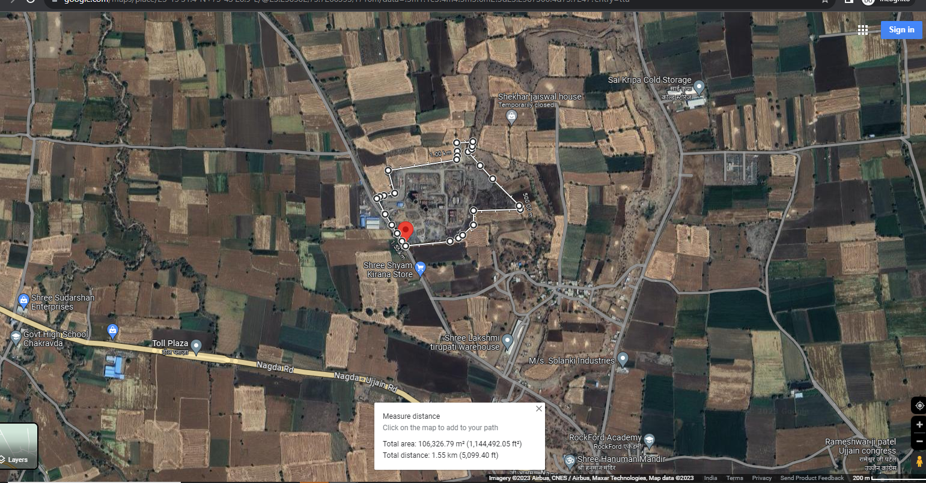**

*Note: We have not undertaken the verification of land ownership in our assessment. This is primarily because we have not been provided with any title documents related to the land, and furthermore, as per present status based on our site inspection, the actual project land was observed to be in possession of the company since no encroachment was visible on site.*

1. **BUILDING & STRUCTURAL DETAILS:**

As per TEFR report, JKCL has planned following Building/ structures as per the requirement of the Plant for development of above listed sections, JKCL has estimated Rs.104.71 Crore in Building/ structures out of total project cost amounting to Rs.418.96 Crore. Bifurcation of Rs.104.71 Crore is as below:

|  |  |  |
| --- | --- | --- |
| Sr. No. | Particular | Amount |
| 1. | Main Factory Buildings | 2,105 |
| 2. | Silos, Hoppers, Storages, Covered Gantry, etc. | 3,930 |
| 3. | Auxiliary Services | 1,870 |
| 4. | Office/ Non-factory buildings | 310 |
| 5. | Equip. Foundations (Machine Foundations) civil cost component | 446 |
| 6. | Indicative GST component on civil works | 1,810 |
|  | **Total** | **10,471** |

**(Amount in Rs. Lakhs)**

* **Detailed breakup of above building sections:**

|  |  |  |
| --- | --- | --- |
| Sr. No. | Particular | Building  Cost |
|  | **Main Factory Buildings** |  |
|  | HAG supporting structure | 230 |
|  | Cement mill house & deducting building | 1190 |
|  | Packing plant, truck loading, bags godown  Packing plant, truck loading, bags godown | 685 |
|  | **Sub Total** | **2,105** |
|  |  |  |
|  | **Silos, Hoppers, Storages, Covered Gantry, etc.** |  |
|  | Additives (Gypsum, Pond ash) covered storage | 350 |
|  | Clinker silo & transport supporting infrastructure | 1630 |
|  | Support structure for cement mill hoppers (hoppers excluded) | 260 |
|  | Dry Fly ash silo | 660 |
|  | Cement silos (2nos. RCC silos) | 1030 |
|  | **Sub Total** | **3,930** |
|  |  |  |
|  | **Auxiliary Services** |  |
|  | Switchyard & Main receiving substation | 105 |
|  | CCU, Technical office, Laboratory, etc. | 385 |
|  | MCC rooms & Load centres | 240 |
|  | M&E Workshop (Not envisaged at this stage) | Future development |
|  | Liquid fuel storage tanks, dyke wall and pump foundations | 195 |
|  | Compressor house (under Packing plant itself) | - |
|  | Plant belt conveyor galleries & transfer towers | 500 |
|  | Water storage (UG+OH) & Water treatment plant | 105 |
|  | Weigh bridges & weigh rooms | 5 |
|  | BRU & truck tippler foundations with common ramp for receiving clinker & gypsum | 180 |
|  | Overhead cable galleries | 135 |
|  | Cable tunnels & trenches, etc. | 20 |
|  | **Sub Total** | **1,870** |
|  |  |  |
|  | **Office/ Non-factory buildings** |  |
|  | Offices (Project, Logistics, Administration, Services) | 100 |
|  | Time, security & dispatch offices block | 20 |
|  | Executives' & workers' canteens | 85 |
|  | General store & yard (Basic provisioning only) | 90 |
|  | Shift units/ washrooms (in general/common areas) | 15 |
|  | **Sub Total** | **310** |
|  |  |  |
|  | **Equip. Foundations (Machine Foundations) civil cost** component | **446** |
|  |  |  |
|  | **Indicative GST component on civil works** | **1,810** |
| Total(Amount in Rs. Lakhs) | | **10,471** |

***Source: TEFR prepared by HOLTEC Consultancy***

**Notes:**

1. The above estimation of cost is as per the TEFR prepared by HOLTEC consultancy.
2. Building Plans have been prepared by HOLTEC consultancy only.
3. The concerned building plans and HOLTEC consultancy TEFR provided to us doesn’t have individual measurements of various structures but consists of estimated Cost to be incurred for the individual buildings and same is considered as basis to analyse the building and structures.
4. Pertaining to our scope of work and unavailability of BOQ of the above buildings and structure, assessment of the cost has not been done in the report. However our team has physically measured some of the buildings as shown below and the cost in terms of the type of structure, area were found to be in-line to industry standard.

|  |  |  |  |  |
| --- | --- | --- | --- | --- |
| **UNIT NAME** | **FLOORS** | **TYPE OF BUILDING** | **AREA (IN SQ. M)** | **HEIGHT (IN FT.)** |
| **Bulk Loading unit** | Shed 1 | Tin Shed | 405 | 45 |
| Shed 2 | Tin Shed | 225 | 10 |
| **CCU** | Ground | R.C.C | 1,008 | 12 |
| First | R.C.C | 1,008 | 12 |
| Second | R.C.C | 756 | 12 |
| **Concrete base of Grinding Unit** | Footing | R.C.C | 289 | --- |
| **Packing Plant** | Ground | R.C.C | 880 | 15 |
| First | R.C.C | 880 | 15 |
| Second | R.C.C | 880 | 15 |
| Third | R.C.C | 308 | 15 |
| Fourth | R.C.C | 308 | 20 |

***Source: Measurement during site survey dated 09th October 2023***

**Progress of Building and Civil Structures as per site visit dated 09th October 2023:**

|  |  |  |  |  |
| --- | --- | --- | --- | --- |
| **Particular** | **Foundation** | **Civil structure** | **Finishing** | **Overall Completion Percentage** |
| **Plant Building and its progress** | | | | |
| Bulk Loading Unit | 100% | 100% | 100% | 100% |
| Clinker Silo | 100% | 100% | 100% | 100% |
| Central Control unit | 100% | 100% | 50% | 83% |
| Hoppers | 100% | 100% | 100% | 100% |
| Grinding Unit(Mill) | 100% | 100% | 100% | 100% |
| Reject Building | 100% | 100% | 100% | 100% |
| Bag House | 100% | 100% | 100% | 100% |
| Cement Silo 1 | 100% | 100% | 85% | 95% |
| Cement Silo 2 | 100% | 100% | 80% | 93% |
| Packing Plant | 100% | 100% | 75% | 92% |
| **Average Completion** | | | | **~95%** |
| **Non-Plant Building and its progress** | | | | |
| Canteen | | | | 20% |
| Transport Office | | | | 0% |
| **Landscape Development** | | | | |
| Road | | | | 60% |
| Drain | | | | 80% |

**Chart representation of progress in building and civil structures:**

**Note:**

1. The Physical progress captured in the above table is based on approximate observations of status of structures constructed on site during our site inspection and our subsequent discussions held with the engineers/ company representatives with whom the site visit was conducted. Thus, the above progress is on approximate basis which may vary from 5%-10% (+-).
2. The project was working on full swing and satisfactory progress was observed during site visit in terms of the planned timelines. Very few civil construction or finishing work is due. Bar representation of the same is shown above.

**Observation:**

In summary, the civil and building construction work is progressing at a satisfactory pace, and currently there is no indication at present that the project will fall behind schedule due to construction work. According to information provided by the company representative, the project is expected to commence commercial operations by the end of December 2023, which is subject to the arrival of part of VRM, which is imported.

1. **PLANT MACHINERY & EQUIPMENT:**

JKCL has estimated Rs.226.98 Crore out of total project cost amounting to Rs.418.96 Crore for installing below listed Machinery/Equipment at the project site:

1. Bulk/ Truck Loading/Feeder Unit
2. Clinker Silo
3. Fly Ash Silo
4. Cement Mill Feed Hoppers
5. Grinding unit (Vertical Roller Mill)
6. Hot Air Generator (HAG)
7. Reject unit
8. Bag House
9. Cement Silo 1
10. Cement Silo 2
11. Packing Plant
12. Truck Loading Unit
13. Central Control unit
14. Weigh Bridge

**Mass Flow Diagram:**

**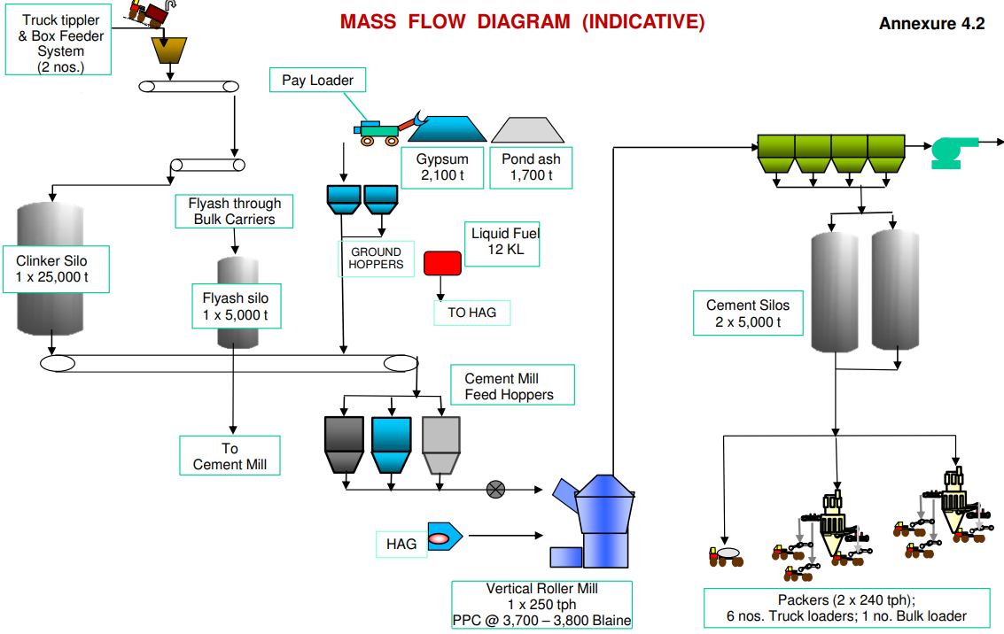**

**SOURCE: TEFR**

**Bulk/ Truck Loading/Feeder Unit:**

*Raw materials, ex. Clinker needed in the manufacturing process, are received from their source, and loaded in the bulk load unit.*

*From bulk load unit, the raw materials are loaded onto a clinker transport belt, this belt system is designed to move materials from one location to another, in this case, from bulk load unit to the clinker silo.*

* 1. **Clinker Silo:**

*Raw materials transported through belts is put and stored in clinker silo, which is made of R.C.C, and has a capacity of 15,000 MT.*

* 1. **Cement Mill Hoppers:**

*The hopper building is equipped with three silos, each storing distinct materials: Fly ash, Additives, and Clinker, delivered through dedicated transport belts. These materials are subsequently conveyed to the Vertical Roller Mill or Grinding Unit for further processing. The ratio of mixing these resources is remotely monitored and controlled from the central control unit (CCU). This system ensures precise blending of the materials, enabling the production of cement with the desired properties and characteristics.*

* 1. **Grinding unit (Vertical Roller Mill):**

*In this process, clinker, additives, and fly ash are obtained from the hopper, according to the specific quality requirements for cement production. These materials are then mixed and ground to achieve the desired size and quality of the final cement product. This blending and grinding process is a crucial step in cement manufacturing to meet the necessary quality standards.*

|  |  |
| --- | --- |
| **Approved product** | **Rejected product** |

|  |  |
| --- | --- |
| * 1. **Cement Silos:** | * 1. **Reject Building:** |

*The cement product, once it meets the required quality standards, is transported to cement silos via an air vent or shoot. These silos serve as storage units for the finished cement product, ready for distribution and use in various applications.*

*Cement products that do not meet the required quality standards are returned to the vertical roller mill for re-grinding and blending. This process allows for the correction of any deviations from the desired product specifications, ensuring that only cement of the specified quality is ultimately stored in the silos for distribution and use*

* 1. **Packing Plant/Bulk Loading:**

*The packing plant is a multi-story structure with five floors (G+5), receiving the finished cement product from the cement silos through an air vent or strip. In this facility, the finished product is packaged using two well-equipped packing machines, each with 16 nozzles for efficient packaging. These packing machines have a capacity of 1.5 metric tons per hour (MTH) each and can simultaneously provide material for loading onto six trucks.*

*For larger bulk orders, a bulk loader is available to load containers directly, facilitating the efficient handling of larger quantities of cement for transportation and distribution.*

**Physical Progress of Plant and Machineries as per site visit dated 09th October 2023:**

|  |  |  |  |  |  |
| --- | --- | --- | --- | --- | --- |
| **Progress of Plant/Machinery and Equipment’s** | | | | | |
| **Particular** | **Machine Installation** | **Testing** | **Production** | **Overall Completion Percentage** | **Remarks** |
| Bulk Loading Unit |  |  | **×** | 100% | All the necessary work for the installation of this unit has been completed, and it is now fully prepared and ready for its intended purpose. |
| Clinker Silo |  |  | **×** | 100% | All the necessary work for the installation of this unit has been completed, and it is now fully prepared and ready for its intended purpose. |
| Central Control unit |  |  | **×** | 75% | During the site survey, it was observed that finishing work was still in progress, and the installation of an elevator was also underway. |
| Hoppers |  |  | **×** | 100% | All the necessary work for the installation of this unit has been completed, and it is now fully prepared and ready for its intended purpose. |
| Grinding Unit(Mill) |  | **×** | **×** | 80% | All the necessary work for the installation of this unit has been completed, but the unit has not yet been tested, because of unviability of gear box of VRM. As per the information gathered on site survey, it is known that the gear box is been imported and will reach site soon. |
| Reject Building |  |  | **×** | 100% | All the necessary work for the installation of this unit has been completed, and it is now fully prepared and ready for its intended purpose. |
| Bag House |  |  | **×** | 100% | All the necessary work for the installation of this unit has been completed, and it is now fully prepared and ready for its intended purpose. |
| Cement Silo 1 |  |  | **×** | 100% | All the necessary work for the installation of this unit has been completed, and it is now fully prepared and ready for its intended purpose. |
| Cement Silo 2 |  | **×** | **×** | 75% | The major construction work for cement silo 2 has been finished, but it is not yet in a functional state similar to cement silo 1. This implies that while the structural aspects of the silo are complete, there may be additional work or components needed before it can be fully operational for its intended purpose. |
| Packing Plant |  |  | **×** | 85% | The installation of the unit, including the packing machine and carriage belt, has been fully completed, and it is now ready for its intended purpose. However, the civil work is not yet complete, and there are pending tasks. These pending tasks were observed to be in progress during the site survey, indicating that some construction or civil work is still underway. |
| Truck Loading Unit |  | **×** | **×** | 85% | The unit was observed to be under the process of installation, at the time of site survey. |
| Weigh Bridge |  |  | **×** | 100% | All the necessary work for the installation of this unit has been completed, and it is now fully prepared and ready for its intended purpose. |
| **Average Completion** | | | | **~90%** | |

**Observations and comments:**

1. In the subject plant, significant progress has been made in completing essential works. These major works likely encompass the construction and installation of various components and machinery necessary for the production except VRM due to the unavailability of parts i.e. Mill Gearbox, Coupling and LUB Unit.
2. Supporting photographs have been attached in the report. These photos serve as visual evidence of the completed works and provide a clear representation of the current status of the unit.
3. In summary, it is observed that most of the essential construction and installation works in the subject plant have been successfully finished, except VRM. The focus is now on completing the installation of the VRM to finalize the unit.
4. The Physical progress captured in the above table is based on approximate observations of status of plant/machineries installed on site during our site inspection and our subsequent discussions held with the engineers/ company representatives with whom the site visit was conducted. Thus, the above progress is on approximate basis which may vary from 5%-10% (+-).
5. The project was working on full swing and satisfactory progress was observed during site visit in terms of the planned timelines.
6. All the major machineries required for effective running of grinding unit and subsequent manufacturing of cement like VRM (Vertical Roller mill), HAG (Hot Air Gas unit), Cement Hoppers, Cement Silos, fly ash silo, Conveyor belt, Switchyard and Packing Plant were physically verified at the site.
7. Apart from the machineries listed above, below listed essential machineries were also observed during site visit:

|  |  |
| --- | --- |
| * Bag filter fans for raw mill * Cooling air fans for raw mill * Chain conveyors and rollers at various location * Small motors at various locations * Parts of cement machineries * Lab equipment’s * Stability chambers in laboratories * Pumps and motors in Water treatment plant * Tower cranes * Other small and miscellaneous machineries * Control panel and switches | * Lift in CCU building * Electrical and automation works * Weigh bridges. * HAG Furnace in Cement mill building * Hot air generator system in cement mill building * A Frames for ACC building * Hot air generator system in Cement mill * Interconnecting chutes in cement mill * Cranes at various locations * Firefighting system and equipment’s * Main power transformer * Distribution transformers |

|  |  |
| --- | --- |
| **PART D** | **PROJECT CONSULTANTS, CONTRACTORS & SUPPLIERS** |

The borrower has provided information about the list of contractors deployed in the project for project site at Ujjain, Madhya Pradesh. However, we are unable to verify the contract amounts due to the unavailability of contract agreements or purchase orders (POs). Brief details of vendors is shown below:

|  |  |  |
| --- | --- | --- |
| Sr. No. | Major Vendor | Description |
| 1. | Kamal Builders | Civil Contractor |
| 2. | Karni Construction | Civil Contractor |
| 3. | Monomark | Mechanical Contractor |
| 4. | Shivansh Infra | Mechanical Contractor |
| 5. | Schneider | Electrical and Lifts |
| 6. | FLSmidth | Plant and Machinery Contractor |

**Note:**

Invoices of some payment done have been shared with us, same is attached below:

|  |  |  |  |
| --- | --- | --- | --- |
| Sr. No. | Description | Vendor | Invoice Amount |
| 1. | Cement Mill | FLSmidth | 14,48,60,848 |
| 2. | Lift Wok | Schneider | 3,15,650 |
| 3. | 33 KV Power transition work | M/S Ramchandra Samriya | 13,54,428 |
| 4. | Dell PowerEdge R840 Server | Cache Digitech Pvt Ltd | 25,32,000 |
| 5. | Server | Cache Digitech Pvt Ltd | 4,55,760 |
| 6. | Cable and Lights | Neutral Atom | 46,79,290 |
| 7. | Hydraulic Pelleting Machine | Verder Scientific Pvt. Ltd. | 38,17,300 |
| 8. | Road and drainage construction work | Karni Design & Construction Pvt Ltd | 1,07,73,840 |
| 9. | Civil and structure Works | Kamal Consbuild Pvt. Ltd | 88,53,355 |
| 10. | Erection Work | Shivansh Infra | 18,95,611 |
| 11. | Lift Wok | Schneider | 28,89,575 |
| 12. | Modular furniture for CCU | Designs Inter Space Pvt. Ltd. | 21,08,284 |
| 13. | Modular furniture for CCU | Designs Inter Space Pvt. Ltd. | 27,96,595 |
| Total | | | **Rs.18,73,32,536/-** |

**Source: List of invoices provided by the client**

|  |  |
| --- | --- |
| **PART E** | **PROJECT COST & MEANS OF FINANCE** |

1. **TOTAL PROJECT COST:** JKCL has estimated the Total Project Cost amounting to Rs.418.96 Crore which has been proposed to be funded in DER of approx. 62% Debt and 38% Equity. Details of Rs.418.96 Crore is as below:

|  |  |  |
| --- | --- | --- |
| Sr. No. | Particulars | Amount (in Rs. Lakh) |
| 1. | Land and Site Development | 2,100 |
| 2. | Civil Works, Buildings and Structures | 10,471 |
| 3. | Plant and Machinery | 22,698 |
| 4. | Expenses on technical know-how & training | 450 |
| 5. | Miscellaneous Fixed Assets | 1,255 |
| 6. | Pre-Operative Expenses  (including Interest During Construction &  Finance charges) | 2,481 |
| 7. | Contingency (@5%) | 1,909 |
| 8. | Margin Money for Working Capital | 532 |
| Estimated Total Project Cost | | **41,896** |

***Source: CA Certificate dated 21/07/2023 UDIN. 23424004BGVNVX9876***

1. **CURRENT STATUS & TOTAL EXPENDITURE INCURRED TILL DATE:** Details of the expenditure in the Table below is recordedfor the expenditure incurred up to 21st July 2023.

|  |  |  |  |
| --- | --- | --- | --- |
| **Particulars** | **Total Estimated Cost (In Rs. Cr.)** | **Amount Incurred Till 30.06.2023** | **Remarks** |
| Land and Site Development. | 21.00 | 5.48 | As per CA Certificate UDIN. 23424004BGVNVX9876 the borrower has shown an expenditure amounting to Rs.5.48 Crore towards land and site development. Due to unavailability of contract agreements, invoices, independent assessment of expenditure is not carried out at our end. |
| Plant, Machinery/ Building & Civil Structures | 344.25 | 143.88 | The amount mentioned is only as per CA Certificate dated 21/07/2023 UDIN. 23424004BGVNVX9876. Since, limited invoices (only of amount Rs.18.73 Cr.) and details are provided to us pertaining to expenditure, therefore independent assessment from LIE is not done. |
| Pre-operative Expenses | 29.31 | 0.44 | --- |
| Contingency | 19.09 | --- | --- |
| Margin Money for Working Capital | 5.32 | ---- | --- |
| **Total** | **418.97** | **149.80** | **Amount as per CA Certificate.** |

**Note:**

*Above amount is as shown in the CA Certificate dated 21/07/2023 UDIN. 23424004BGVNVX9876.*

*The above amount doesn’t include the pending bills or the debtor payments.*

1. **SOURCES OF FINANCE & UTILIZATION OF FUNDS:** The Project cost mentioned above has been planned to be covered from following resources:

|  |  |  |
| --- | --- | --- |
|  | |  |
| PARTICULARS | **ENVISAGED**  **MEANS OF FINANCE** | **AMOUNT INCURRED TILL DATE** |
| Promoter’s Contribution (Equity) | 157.51 | 129.92 |
| Term Loan (Debt) | 261.46 | 19.88 |
| TOTAL (In Rs. In Cr.) | **418.96** | **149.80** |

|  |  |
| --- | --- |
| **PART F** | **STATUTORY & REGULATORY APPROVALS, CLEARANCES & NOC** |

|  |  |  |  |  |
| --- | --- | --- | --- | --- |
| **Sr. No.** | **NAME OF LICENSE/ REGISTRATION** | **PURPOSE/** | **DATE OF ISSUE** | **Current Status** |
| **ISSUING AUTHORITY** | **LICENCE NO.** |
|  | Site Plan | Layout | 22-12-2023 | Digitally signed |
| Chief Factories Inspector |
|  | Fire Plan Approval Certificate | Fire Plan Approval Certificate | Dated- 20-12-2023 | Approved |
| Fire Officer, Ujjain Division |
|  | Environment Clearance | Approval as per environment guidelines in the area | 16/03/2021 | As on date the clearance is valid. |
| Ministry of Environment, Forest and Climate Change | No. 7333/SEIAA |
|  | Consent to Establish | Approval as per Pollution norms applicable in that area | 10/11/2021 | As on date the clearance is valid and will be valid up to 31/10/2026 |
| MP State Pollution control board | CTE-54599 |
|  | Electricity Load Sanction | Approval electricity load sanction | 11-09-2023 | Approved |
| Chief Engineer |
| ***Observations & Comments:***   1. *Above are the major approval, NOCs which company has obtained.* | | | | |

|  |  |
| --- | --- |
| **PART G** | **PROJECT SCHEDULE & CURRENT STATUS** |

|  |  |  |  |  |
| --- | --- | --- | --- | --- |
| **IMPLEMENTATION SCHEDULE** | | | | |
| **S. No.** | **Particulars** | **Start** | **End** | **Current Status** |
|  | Land and Site Development | Land allotment done | | Completed |
|  | Project Statutory Approvals | During Project tenure | | Major approvals like Sanctioned Site Plan, Provisional Fire NOC Environment NOC, Consent letter from Pollution Board, Electric load sanction is completed. |
|  | Building and Civil works | Dec-22 | Dec-23 | Essential Building and civil works for the Production are majorly complete and few left such as CCU is left are anticipated to be completed by December’23 end. Building wise site progress is already shown above and as per visual observation site progress was good and project was progressing in full swing. |
|  | Order of Plant and Machinery | Dec-22 | Dec-23 | As per our discussion with the borrower, they have already ordered all the major machineries except Gear Box for VRM. |
|  | Delivery of Machineries | Dec-22 | Dec-23 | Almost all the machineries are already delivered to the site of the project except Gear Box for VRM. |
|  | Installation of Machinery | Dec-22 | Dec-23 | Almost all the machineries are already delivered to the site of the project except Gear Box for VRM. |
|  | Trial runs and Commissioning of Plant | --- | Dec-23 | All the machines/plants are tested and are ready for use, except VRM and cement silo 2. |

**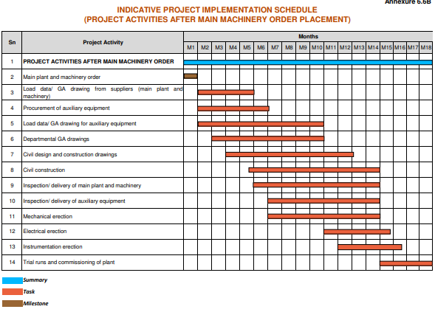**

|  |  |
| --- | --- |
| **PART H** | **CONCLUSION** |

1. The civil and building construction work is progressing at a satisfactory pace, and currently there is no indication that the project will fall behind schedule due to construction work.
2. Major works in the Plant is almost completed except VRM which is awaiting for the parts in it i.e. Mill Gearbox, Coupling and LUB Unit, and is nearing completion, with only the landscape development phase remaining.
3. According to information provided by the company representative, the project is expected to commence commercial operations by the end of December, 2023, which is subject to the arrival of part of VRM, which is imported.
4. Based on visual observation and subsequent discussions held with the engineers from the company accompanying our team during site visit, it appears that approximately 95% construction of the essential civil structures like Raw mills, Cement mill building, Switchyard control room, Clinker Silo, fly ash silos, Cement silos, packing plant, Bag house & De dusting building, Fly ash silo, Cement hopper building, Clinker silo, Additive shed, Bulk reception unit is completed and around 90% of essential machineries required for commercial production were installed. However overall project’s progress may vary due to ancillary works and site development works which are yet to take shape & commence.
5. As per CA certificate dated 21st July 2023 with UDIN. 23424004BGVNX9876 the borrower has made an expenditure on the project amounting to Rs.149.80 Crore, showing Plant & Machinery, Building & Civil works and Miscellaneous fixed assets under single line item without breakup.
6. Due to limited details available to us, the independent verification of expenses at our end could not be done.

|  |  |
| --- | --- |
| **PART I** | **DISCLAIMER** |

* + - 1. No employee or member of R.K Associates has any direct/ indirect interest in the Project.
      2. This report is prepared based on the copies of the documents/ information which the Bank/ Borrower has provided to us out of the standard checklist of documents sought from them and further based on our assumptions and limiting conditions. The client/owner and its management/representatives warranted to us that the information they supplied was complete, accurate and true and correct to the best of their knowledge. All such information provided to us has been relied upon in good faith and we have assumed that it is true and correct in all respect. I/We shall not be liable for any loss, damages, cost or expenses arising from fraudulent acts, misrepresentations, or wilful default on part of the owner, borrower, its directors, employee, representative or agents. Verification or cross checking of the documents provided to us from the originals or from any Govt. departments/ Record of Registrar has not been done at our end since this is beyond the scope of our work. If at any time in future, it is found or came to our knowledge that misrepresentation of facts or incomplete or distorted information has been provided to us then this report shall automatically become null & void.
      3. Legal aspects for eg. investigation of title, ownership rights, lien, charge, mortgage, lease, sanctioned maps, verification of documents, etc. have not been done at our end and same has to be taken care by legal expert/ Advocate. It is assumed that the concerned Lender/ Financial Institution has satisfied them with the authenticity of the documents, information given to us and for which the legal verification has been already taken and cleared by the competent Advocate before requesting for this report. I/ We assume no responsibility for the legal matters including, but not limited to, legal or title concerns.
      4. This report is a general analysis of the project based on the scope mentioned in the report. This is not an Audit report, Design document, DPR or Techno feasibility study. All the information gathered is based on the facts seen on the site during survey, verbal discussion & documentary evidence provided by the client and is believed that information given by the borrower is true best of their knowledge.
      5. All observations mentioned in the report is only based on the visual observation and the documents/ data/ information provided by the client. No mechanical/ technical tests, measurements or any design review have been performed or carried out from our side during Project assessment.
      6. This report doesn’t claim any quality assurance of the Products and the material being used in the Project.
      7. Bank/FII should ONLY take this report as an Advisory document from the Financial/ Chartered Engineering firm and its specifically advised to the creditor to cross verify the original documents for the facts mentioned in the report which can be availed from the borrowing borrower directly.
      8. In case of any default in loans or the credit facility extended to the borrowing borrower, R.K Associates shall not be held responsible for whatsoever reason may be and any request for seeking any explanation from the employee/s of R.K Associates will not be entertained at any instance or situation.
      9. The documents, information, data provided to us during the course of this assessment by the client is reviewed only up to the extent required in relation to the scope of the work. No document has been reviewed beyond the scope of the work.
      10. This report only contains general assessment & opinion as per the scope of work evaluated as per the information given in the copy of documents, information, data provided to us and/ and confirmed by the owner/ owner representative to us at site which has been relied upon in good faith. It doesn’t contain any other recommendations of any sort including but not limited to express of any opinion on the suitability or otherwise of entering into any transaction with the borrower.
      11. We have relied on data from third party, external sources & information available on public domain also to conclude this report. These sources are believed to be reliable and therefore, we assume no liability for the truth or accuracy of any data, opinions or estimates furnished by others that have been used in this analysis. Where we have relied on data, opinions or estimates from external sources, reasonable care has been taken to ensure that such data has been correctly extracted from those sources and /or reproduced in its proper form and context, however still we can’t vouch its authenticity, correctness or accuracy.
      12. This Report is prepared by our competent technical team which includes Engineers and financial experts & analysts.
      13. This is just an opinion report and doesn’t hold any binding on anyone. It is requested from the concerned Financial Institution which is using this report for taking financial decision on the project that they should consider all the different associated relevant & related factors also before taking any business decision based on the content of this report.
      14. All Pages of the report including annexures are signed and stamped from our office. In case any paper in the report is without stamp & signature then this should not be considered a valid paper issued from this office.
      15. Though adequate care has been taken while preparing this report as per its scope, but still we can’t rule out typing, human errors, over sightedness of any information or any other mistakes. Therefore, the concerned organization is advised to satisfy themselves that the report is complete & satisfactory in all respect. Intimation regarding any discrepancy shall be brought into our notice immediately. If no intimation is received within 15 (Fifteen) days in writing from the date of issuance of the report, to rectify these timely, then it shall be considered that the report is complete in all respect and has been accepted by the client up to their satisfaction & use and further to which R.K Associates shall not be held responsible in any manner.
      16. Defect Liability Period is **15 DAYS**. We request the concerned authorized reader of this report to check the contents, data and calculations in the report within this period and intimate us in writing if any corrections are required or in case of any other concern with the contents or opinion mentioned in the report. Corrections only related to typographical, calculation, spelling mistakes, incorrect data/ figures/ statement will be entertained within the defect liability period. Any new changes for any additional information in already approved report will be regarded as additional work for which additional fees may be charged. No request for any illegitimate change in regard to any facts & figures will be entertained.
      17. R.K Associates encourages its customers to give feedback or inform concerns over its services through proper channel at valuers@rkassociates.org in writing within 15 days of report delivery. After this period no concern/ complaint/ proceedings in connection with the Financial Feasibility Study Services will be entertained due to possible change in situation and condition of the subject Project.
      18. Our Data retention policy is of **ONE YEAR**. After this period, we remove all the concerned records related to the assignment from our repository. No clarification or query can be answered after this period due to unavailability of the data.
      19. This Lender’s Independent Engineer report is governed by our (1) Internal Policies, Processes & Standard Operating Procedures, (2) Information/ Data/ Inputs given to us by the client and (3) Information/ Data/ Facts given to us by our field/ office technical team. Management of R.K Associates never gives acceptance to any unethical or unprofessional practice which may affect fair, correct & impartial assessment and which is against any prevailing law. In case of any indication of any negligence, default, incorrect, misleading, misrepresentation or distortion of facts in the report then it is the responsibility of the user of this report to immediately or at least within the defect liability period bring all such act into notice of R.K Associates management so that corrective measures can be taken instantly.
      20. R.K Associates never releases any report doing alterations or modifications from pen. In case any information/ figure of this report is found altered with pen then this report will automatically become null & void.

|  |  |  |
| --- | --- | --- |
| **SURVEYED BY** | **PREPARED BY** | **REVIEWED BY** |
| Vishal Singh and Babul Akhtar Gazi | Vishal Singh | Abhinav Chaturvedi |
| **Date:** 09th October 2023 and 10th October 2023 | **Date:** 16th October 2023 | **Date:** 16th October 2023 |

***DEFECT LIABILITY PERIOD - In case of any query/ issue or escalation you may please contact Incident Manager by writing at valuers@rkassociates.org. We ensure 100% accuracy in the Calculations done, Rates adopted and various other data points & information mentioned in the report but still can’t rule out typing, human errors or any other mistakes. In case you find any mistake, variation, discrepancy or inaccuracy in any data point of the report, please help us by bringing all such points into our notice in writing at*** [**valuers@rkassociates.org**](mailto:valuers@rkassociates.org)***within 30 days of the report delivery, to get these rectified timely, failing which R.K Associates Valuers Techno Engineering Consultants (P) Ltd. won’t be held responsible for any inaccuracy in any manner. Also, if we will not hear back anything from you within 30 days, we will assume that report is correct in all respect and no further claim of any sort will be entertained thereafter. We would welcome and appreciate your feedback & suggestions in order to improve our services.***

***COPYRIGHT FORMAT - This report is prepared on the copyright format of R.K Associates Valuers Techno Engineering Consultants (P) Ltd. to serve our clients in the best possible way. Legally no one can copy or distribute this format without prior approval from R.K Associates. It is meant only for the organization as mentioned on the cover page of this report. Distribution or use of this format other than R.K Associates will be seen as unlawful act and necessary legal action can be taken against the defaulter.***

**ENCLOSURE 1: CA CERTIFICATE DATED 30th June 2023**

**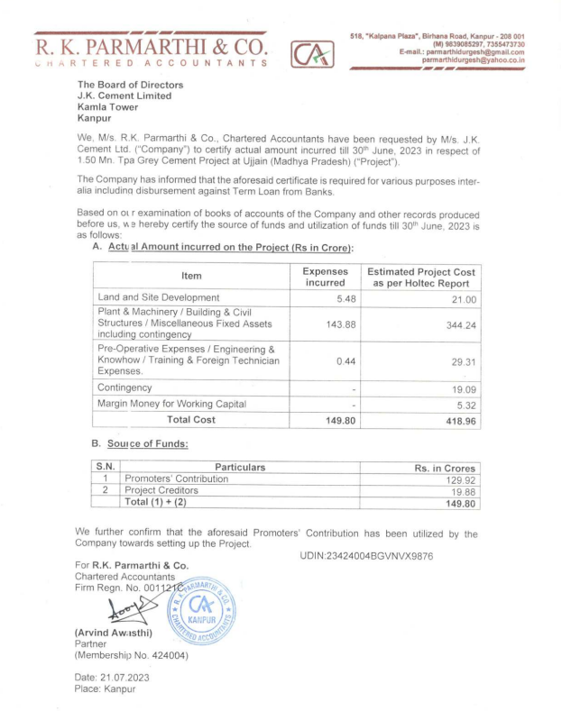**

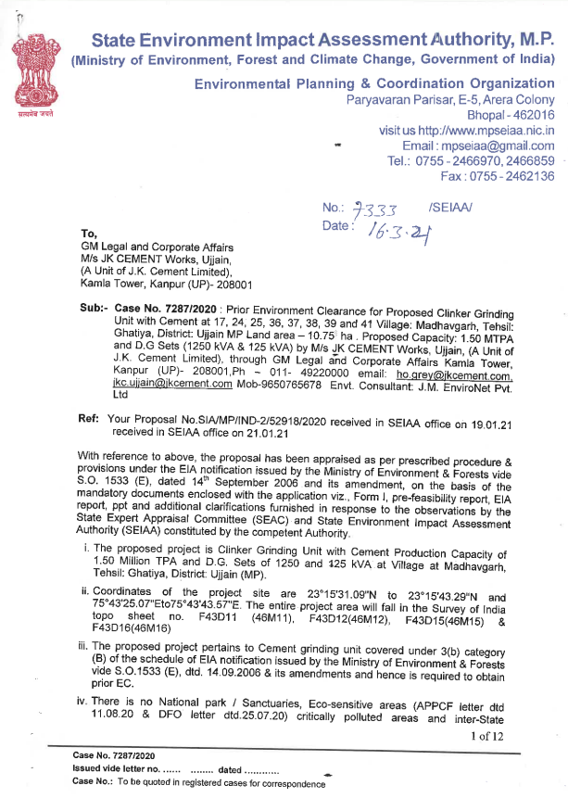

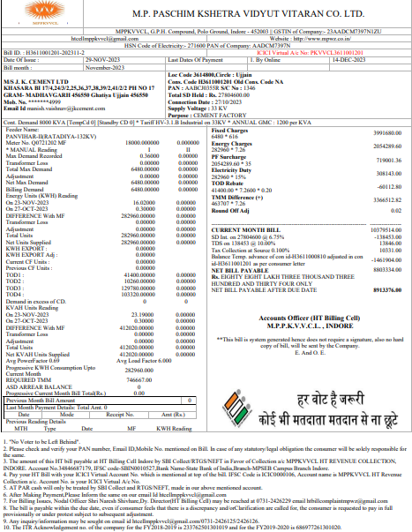

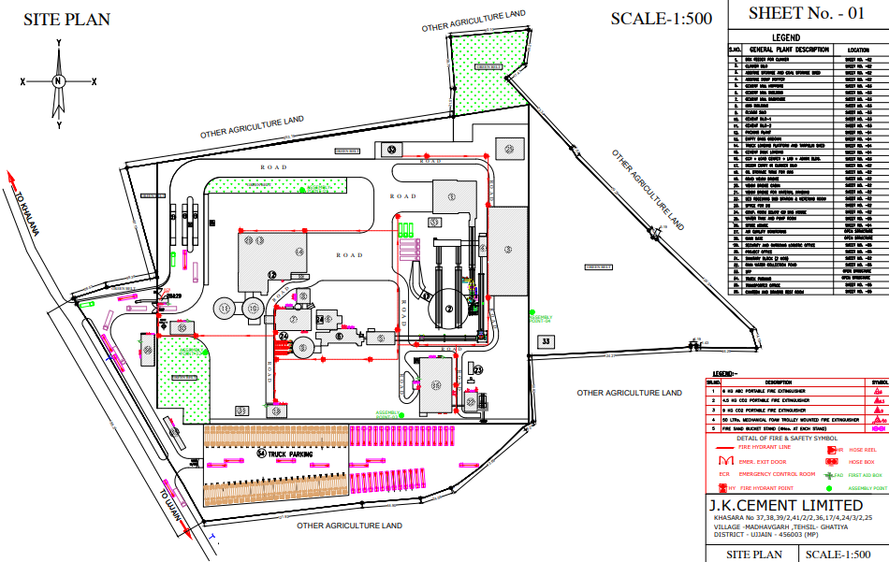

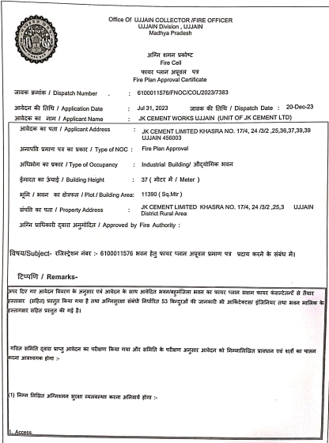

|  |
| --- |
|  |

**SITE PHOTOGRAPHS**

|  |
| --- |
| Z:\In Progress Files\Vishal Singh\WIP\JK Cement\uploads\VIS(2023-24)-PL362-292-460\SiteImage\c_TimePhoto_20231010_121939.jpg |
| Z:\In Progress Files\Vishal Singh\WIP\JK Cement\uploads\VIS(2023-24)-PL362-292-460\SiteImage\c_TimePhoto_20231009_133158.jpg |

|  |  |  |
| --- | --- | --- |
| **BULK LOADING UNIT** | | |
| Z:\In Progress Files\Vishal Singh\WIP\JK Cement\uploads\VIS(2023-24)-PL362-292-460\SiteImage\c_TimePhoto_20231009_123205.jpg | Z:\In Progress Files\Vishal Singh\WIP\JK Cement\uploads\VIS(2023-24)-PL362-292-460\SiteImage\c_TimePhoto_20231009_123229.jpg | |
| **GYPSUM AND POND ASH STORAGE UNIT** | | | |
| Z:\In Progress Files\Vishal Singh\WIP\JK Cement\uploads\VIS(2023-24)-PL362-292-460\SiteImage\c_TimePhoto_20231009_124352.jpg | | Z:\In Progress Files\Vishal Singh\WIP\JK Cement\uploads\VIS(2023-24)-PL362-292-460\SiteImage\c_TimePhoto_20231009_124421.jpg | |

|  |  |  |
| --- | --- | --- |
| **CLINKER SILO** | | |
|  | **Z:\In Progress Files\Vishal Singh\WIP\JK Cement\uploads\VIS(2023-24)-PL362-292-460\SiteImage\c_TimePhoto_20231009_125548.jpg** | |
|  | | | |
|  | |  | |
| **HOPPER** | | | |
|  | |  | |

|  |  |
| --- | --- |
| **GRINDER UNIT / MILL / VRM** | |
| Z:\In Progress Files\Vishal Singh\WIP\JK Cement\uploads\VIS(2023-24)-PL362-292-460\SiteImage\c_TimePhoto_20231009_133402.jpg | Z:\In Progress Files\Vishal Singh\WIP\JK Cement\uploads\VIS(2023-24)-PL362-292-460\SiteImage\c_TimePhoto_20231009_133613.jpg |
| **PACKING MACHINE 1 AND 2** | |
| Z:\In Progress Files\Vishal Singh\WIP\JK Cement\uploads\VIS(2023-24)-PL362-292-460\SiteImage\c_TimePhoto_20231009_151328.jpg | Z:\In Progress Files\Vishal Singh\WIP\JK Cement\uploads\VIS(2023-24)-PL362-292-460\SiteImage\c_TimePhoto_20231009_151259.jpg |

|  |  |
| --- | --- |
| **CEMENT BAG LOADING UNIT** | |
| Z:\In Progress Files\Vishal Singh\WIP\JK Cement\uploads\VIS(2023-24)-PL362-292-460\SiteImage\c_TimePhoto_20231009_151550.jpg | Z:\In Progress Files\Vishal Singh\WIP\JK Cement\uploads\VIS(2023-24)-PL362-292-460\SiteImage\c_TimePhoto_20231009_151805.jpg |
| Z:\In Progress Files\Vishal Singh\WIP\JK Cement\uploads\VIS(2023-24)-PL362-292-460\SiteImage\c_TimePhoto_20231009_152310 - Copy.jpg**BULK CONTAINER** | |

|  |  |
| --- | --- |
| **CEMENT SILO 1 AND 2** | |
| Z:\In Progress Files\Vishal Singh\WIP\JK Cement\uploads\VIS(2023-24)-PL362-292-460\SiteImage\c_TimePhoto_20231010_134138.jpg | Z:\In Progress Files\Vishal Singh\WIP\JK Cement\uploads\VIS(2023-24)-PL362-292-460\SiteImage\c_TimePhoto_20231009_122648.jpg |
| **CENTRAL CONTROL UNIT(CCU)** | |
|  |  |

**TRANSFORMER / PANEL / D.G**

|  |  |
| --- | --- |
| Z:\In Progress Files\Vishal Singh\WIP\JK Cement\uploads\VIS(2023-24)-PL362-292-460\SiteImage\c_TimePhoto_20231009_130214.jpg | Z:\In Progress Files\Vishal Singh\WIP\JK Cement\uploads\VIS(2023-24)-PL362-292-460\SiteImage\c_TimePhoto_20231009_130251.jpg |
| Z:\In Progress Files\Vishal Singh\WIP\JK Cement\uploads\VIS(2023-24)-PL362-292-460\SiteImage\c_TimePhoto_20231009_130032.jpg | Z:\In Progress Files\Vishal Singh\WIP\JK Cement\uploads\VIS(2023-24)-PL362-292-460\SiteImage\c_TimePhoto_20231009_130644.jpg |
| Z:\In Progress Files\Vishal Singh\WIP\JK Cement\uploads\VIS(2023-24)-PL362-292-460\SiteImage\c_TimePhoto_20231009_130648.jpg | Z:\In Progress Files\Vishal Singh\WIP\JK Cement\uploads\VIS(2023-24)-PL362-292-460\SiteImage\c_TimePhoto_20231009_130714.jpg |

|  |  |
| --- | --- |
| Z:\In Progress Files\Vishal Singh\WIP\JK Cement\uploads\VIS(2023-24)-PL362-292-460\SiteImage\c_TimePhoto_20231009_154229.jpg | Z:\In Progress Files\Vishal Singh\WIP\JK Cement\uploads\VIS(2023-24)-PL362-292-460\SiteImage\c_TimePhoto_20231010_121811.jpg |
| Z:\In Progress Files\Vishal Singh\WIP\JK Cement\uploads\VIS(2023-24)-PL362-292-460\SiteImage\TimePhoto_20231010_134210.jpg | Z:\In Progress Files\Vishal Singh\WIP\JK Cement\uploads\VIS(2023-24)-PL362-292-460\SiteImage\TimePhoto_20231010_134146.jpg |
| Z:\In Progress Files\Vishal Singh\WIP\JK Cement\uploads\VIS(2023-24)-PL362-292-460\SiteImage\TimePhoto_20231010_134151.jpg | Z:\In Progress Files\Vishal Singh\WIP\JK Cement\uploads\VIS(2023-24)-PL362-292-460\SiteImage\TimePhoto_20231010_134156.jpg |