**REPORT FORMAT:** CL-1 | Version: 1.0\_2018

# FILE No.: VIS(2022-23)-PL372-302-478 Date: 26-09-2023

* **CERTIFICATE NAME:** Progress Report for the machinery and equipment.
* **FOR ORGANIZATION:** Punjab National Bank, Corporate Banking Branch, Panipat.
* **BORROWER COMPANY’S NAME:** M/s. Kapoor Industries Limited.
* **ASSET TYPE**: Manufacturer and Exporter of Cotton Towels, Bath Towels & Terry Towels.
* **CURRENT LOCATION OF THE MACHINES:** 12th Mile Stone GT Road Village-Mathurawali, Panipat, Haryana

**TO WHOMSOEVER IT MAY CONCERN**

|  |  |  |
| --- | --- | --- |
| **S. NO.** | **PARTICULARS** | **DESCRIPTION** |
| 1. | Date of Survey | 21-09-2023 |
| 2. | Date of Certificate | 26-09-2022 |
| 3. | Documents provided for perusal | List of machines, Invoices/Performa Invoices |
| 4. | Current Location of the Machines | 12th Mile Stone GT Road Village-Mathurawali, Panipat, Haryana |
| 5. | Borrowing Company | M/s. Kapoor Industries Limited |
| 6. | Type of Asset | Machinery & equipment required for Cotton Towels, Bath Towels & Terry Towels manufacturing. |
| 7. | Type of Assessment | Progress of machines purchased, installed |
| 8. | Scope of Assessment | Progress of machines purchased, installed |
| 9. | Nature of Machinery | Machinery & equipment required for Cotton Towels, Bath Towels & Terry Towels manufacturing. |
| 10. | Current Progress of the machines | As per physical inspection made during site visit, company has purchased all the machines as per the list provided. |
| 11. | Condition of Machines | Purchased machines and equipment are new and operational. |

## Status of Machinery & Equipment:-

|  |  |  |  |  |  |
| --- | --- | --- | --- | --- | --- |
| **S. No.** | **Description** | **Supplier** | **Qty** | **Total Value** | **Remark** |
| 1 | Picanol loom-dobby with batching | Picanol NV-Belgium | 26 | 18,29,88,000 | Machines Purchased and Operational |
| 2 | Motored doff trolley | Genkinoer Gmbh | 2 | 37,08,520 |
| 3 | Motorised pile beam trolley | Genkinoer Gmbh | 1 | 60,90,400 |
| 4 | Fabric dyeing 1200KG | Texpro Industry Hongkong Co. Ltd. | 1 | 80,33,250 |
| 5 | Fabric dyeing 2000KG | Texpro Industry Hongkong Co. Ltd. | 1 | 1,20,25,500 |
| 6 | Knotting with frame | Groz Beckert Kg | 1 | 34,86,000 |
| 7 | Schmale length hemming | Carl Schmale Gmbh And Co. | 2 | 1,50,88,000 |
| 8 | Fabric hydroextractor | Sunwin 450+450 Kg | 1 | 38,25,000 |
| **Sub-Total-A** | | | | **23,52,44,670** |  |
| 9 | TFO 240 spindle per machine | Savio | 8 | 2,12,00,000 | Machines Purchased and Operational |
| 10 | Cheese winding spindles | Peass Ind. | 240 | 43,20,000 |
| 11 | Soft winder | Peass Ind. | 240 | 42,00,000 |
| 12 | Cone winder | Peass Ind. | 240 | 40,00,000 |
| 13 | Yarn conditioner | Sieger | 1 | 16,40,000 |
| 14 | Overhead blower | Unirols Airtex | 6 | 9,00,000 |
| 15 | Solar plant 300 kw @43500/- per kw (Schmale Building | Thermax | 450 | 1,95,75,000 |
| 16 | Solar plant 500 kw @43500/- per kw (Printing Building) | Thermax | 680 | 2,95,80,000 |
| 17 | Chiller VAM 200TR | Thermax | 1 | 37,00,000 |
| 18 | LUWA H-plant (26 looms) | LUWA | 1 | 50,00,000 |
| 19 | LUWA H-plant (TFO section) | LUWA | 1 | 35,00,000 |
| 20 | Greige inspection | Shreeji Tech | 1 | 10,00,000 |
| 21 | Generator 1010 kVA | MTU | 2 | 76,00,000 |
| 22 | Compressor 740CFM | Kaeser | 3 | 42,00,000 |
| 23 | Dryer | Kaeser | 4 | 23,40,000 |
| 24 | Compressed air filters | Kaeser | 2 | 4,40,000 |
| 25 | Air receiver | Airman | 1 | 8,75,000 |
| 26 | Beam for sizing (set of 40) | Bharat Beams | 1 | 30,00,000 |
| 27 | Cooling tower 300 TR (for DG & Chiller) | Jyoti | 3 | 7,50,000 |
| 28 | H-plant variable freq. drive | Danfoss | 1 | 20,00,000 |
| 29 | APH for 30TPH boiler | CBL | 1 | 27,00,000 |
| 30 | PDB looms | Shriram | 1 | 8,00,000 |
| 31 | PDB TFO | Shriram | 1 | 8,00,000 |
| 32 | UPS/panel | Emerson | 1 | 10,00,000 |
| 33 | Loom ducting | Alatech | 1 | 40,00,000 |
| 34 | TFO ducting | Alatech | 1 | 30,00,000 |
| 35 | Cables/pipes/lighting | Misc. | 1 | 35,00,000 |
| 36 | Capacitor panel | Coronet | 1 | 60,00,000 | Machines Purchased and Operational |
| 37 | Bus bar DG panel to PCC | Coronet | 1 | 15,00,000 |
| 38 | Elect. Centralize station | Coronet | 1 | 15,00,000 |
| 39 | Material handling tow trucks | Jungheinrich | 4 | 32,00,000 |
| 40 | Material handling stacker | Jungheinrich | 2 | 18,50,000 |
| 41 | Forklift | Promt Packways | 1 | 10,00,000 |
| 42 | Others |  | 1 | 1,05,00,000 |
| **Sub-Total-B** | | | | **16,11,70,000** |  |
| **Grand Total (A+B)** | | | | **39,64,14,670** |  |

## Cost Verification of Machinery & Equipment:-

|  |  |  |  |  |
| --- | --- | --- | --- | --- |
| **S. No.** | **Description** | **Qty** | **Total Value** | **Remark** |
| 1 | Picanol loom-dobby with batching | 26 | 18,29,88,000 |  |
| 2 | Motored doff trolley | 2 | 37,08,520 |  |
| 3 | Motorised pile beam trolley | 1 | 60,90,400 |  |
| 4 | Fabric dyeing 1200KG | 1 | 80,33,250 | Verified, Purchase price is within the range of market comparable available. *(Refer Annexure)* |
| 5 | Fabric dyeing 2000KG | 1 | 1,20,25,500 |
| 6 | Knotting with frame | 1 | 34,86,000 |  |
| 7 | Schmale length hemming | 2 | 1,50,88,000 |  |
| 8 | Fabric hydroextractor | 1 | 38,25,000 |  |
| 9 | TFO 240 spindle per machine | 8 | 2,12,00,000 |  |
| 10 | Cheese winding spindles | 240 | 43,20,000 | Verified, Purchase price is within the range of market comparable available. *(Refer Annexure)* |
| 11 | Soft winder | 240 | 42,00,000 |  |
| 12 | Cone winder | 240 | 40,00,000 |  |
| 13 | Yarn conditioner | 1 | 16,40,000 |  |
| 14 | Overhead blower | 6 | 9,00,000 | Verified, Purchase price is within the range of market comparable available. *(Refer Annexure)* |
| 15 | Solar plant 300 kw @43500/- per kw (Schmale Building | 450 | 1,95,75,000 |
| 16 | Solar plant 500 kw @43500/- per kw (Printing Building) | 680 | 2,95,80,000 |
| 17 | Chiller VAM 200TR | 1 | 37,00,000 |  |
| 18 | LUWA H-plant (26 looms) | 1 | 50,00,000 |  |
| 19 | LUWA H-plant (TFO section) | 1 | 35,00,000 |  |
| 20 | Greige inspection | 1 | 10,00,000 |  |
| 21 | Generator 1010 kVA | 2 | 76,00,000 | Verified, Purchase price is within the range of market comparable available. *(Refer Annexure)* |
| 22 | Compressor 740CFM | 3 | 42,00,000 |
| 23 | Dryer | 4 | 23,40,000 |  |
| 24 | Compressed air filters | 2 | 4,40,000 | Verified, Purchase price is within the range of market comparable available. *(Refer Annexure)* |
| 25 | Air receiver | 1 | 8,75,000 |  |
| 26 | Beam for sizing (set of 40) | 1 | 30,00,000 |  |
| 27 | Cooling tower 300 TR (for DG & Chiller) | 3 | 7,50,000 | Verified, Purchase price is within the range of market comparable available. *(Refer Annexure)* |
| 28 | H-plant variable freq. drive | 1 | 20,00,000 |  |
| 29 | APH for 30TPH boiler | 1 | 27,00,000 |  |
| 30 | PDB looms | 1 | 8,00,000 |  |
| 31 | PDB TFO | 1 | 8,00,000 |  |
| 32 | UPS/panel | 1 | 10,00,000 | Specific details such as length, capacity etc. are not available. Thus, it is assumed that the purchase price is fair & reasonable. |
| 33 | Loom ducting | 1 | 40,00,000 |
| 34 | TFO ducting | 1 | 30,00,000 |
| 35 | Cables/pipes/lighting | 1 | 35,00,000 |
| 36 | Capacitor panel | 1 | 60,00,000 |
| 37 | Bus bar DG panel to PCC | 1 | 15,00,000 |
| 38 | Elect. Centralize station | 1 | 15,00,000 |
| 39 | Material handling tow trucks | 4 | 32,00,000 | Verified, Purchase price is within the range of market comparable available. *(Refer Annexure)* |
| 40 | Material handling stacker | 2 | 18,50,000 |
| 41 | Forklift | 1 | 10,00,000 |
| 42 | Others | 1 | 1,05,00,000 | Specific details such as length, capacity etc. are not available. Thus, it is assumed that the purchase price is fair & reasonable. *(Refer Annexure)* |

## OBSERVATIONS:

1. We have been provided with the list of machines that had been purchased/ installed by the company.
2. Out of total purchase amount Rs. 39.64 Cr., we have randomly verified machines of Rs. 12.60 Cr. which is about 35% of total purchase amount.
3. Based on the information provided by the subject company (M/s. Kapoor Industries Limited), it is certified that the following machines are purchased and installed at the above-mentioned site address.

***Disclaimer:***

* 1. *This progress report is stated on the basis of the site visit by the surveyor and we don’t recommend any sort of recommendation in our Certificate.*
  2. *As per physical inspection and observation made during site visit dated 20th September 2023. Company has installed all the machines mentioned in the provided list.*
  3. *This certificate doesn’t include any work related to drawing, design, sketch plan, and technical specifications of the machines.*
  4. *Ownership and other legal point of view in respect of the asset is not considered in this report as same is out of scope of this certificate.*
  5. *This certificate is made at the request of the Bank.*

**For R.K Associates Valuers & Techno FOR INTERNAL USE Engineering Consultants (P) Ltd.**

***TYPED BY:*** *Er. Abhinav Chaturvedi*

***REVIEWED BY:*** *Er. Manas Upmanyu*

# ANNEXURE: LIST OF MACHINES AS PROVIDED BY THE CLIENT

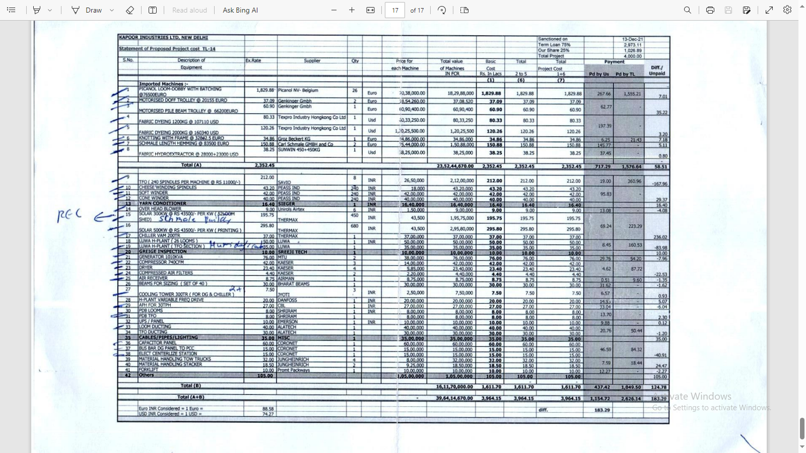

# ANNEXURE: PHOTOGRAPHS

|  |  |
| --- | --- |
| **Z:\In Progress Files\Abhinav Chaturvedi\VIS(2023-24)-PL372-302-478_Kapoor Industries\Site Image\TimePhoto_20230921_163055.jpg** | Z:\In Progress Files\Abhinav Chaturvedi\VIS(2023-24)-PL372-302-478_Kapoor Industries\Site Image\TimePhoto_20230921_163110.jpg |
| **Z:\In Progress Files\Abhinav Chaturvedi\VIS(2023-24)-PL372-302-478_Kapoor Industries\Site Image\TimePhoto_20230921_163147.jpg** | **Z:\In Progress Files\Abhinav Chaturvedi\VIS(2023-24)-PL372-302-478_Kapoor Industries\Site Image\TimePhoto_20230921_163218.jpg** |
| **Z:\In Progress Files\Abhinav Chaturvedi\VIS(2023-24)-PL372-302-478_Kapoor Industries\Site Image\TimePhoto_20230921_164432.jpg** | **Z:\In Progress Files\Abhinav Chaturvedi\VIS(2023-24)-PL372-302-478_Kapoor Industries\Site Image\TimePhoto_20230921_164731.jpg** |

|  |  |
| --- | --- |
| **Z:\In Progress Files\Abhinav Chaturvedi\VIS(2023-24)-PL372-302-478_Kapoor Industries\Site Image\TimePhoto_20230921_165609.jpg** | Z:\In Progress Files\Abhinav Chaturvedi\VIS(2023-24)-PL372-302-478_Kapoor Industries\Site Image\TimePhoto_20230921_171029.jpg |
| **Z:\In Progress Files\Abhinav Chaturvedi\VIS(2023-24)-PL372-302-478_Kapoor Industries\Site Image\TimePhoto_20230921_171523.jpg** | **Z:\In Progress Files\Abhinav Chaturvedi\VIS(2023-24)-PL372-302-478_Kapoor Industries\Site Image\TimePhoto_20230921_171812.jpg** |
| **Z:\In Progress Files\Abhinav Chaturvedi\VIS(2023-24)-PL372-302-478_Kapoor Industries\Site Image\TimePhoto_20230921_173429.jpg** | **Z:\In Progress Files\Abhinav Chaturvedi\VIS(2023-24)-PL372-302-478_Kapoor Industries\Site Image\TimePhoto_20230921_174111.jpg** |

|  |  |
| --- | --- |
| **Z:\In Progress Files\Abhinav Chaturvedi\VIS(2023-24)-PL372-302-478_Kapoor Industries\Site Image\TimePhoto_20230921_174254.jpg** | Z:\In Progress Files\Abhinav Chaturvedi\VIS(2023-24)-PL372-302-478_Kapoor Industries\Site Image\TimePhoto_20230921_174344.jpg |
| **Z:\In Progress Files\Abhinav Chaturvedi\VIS(2023-24)-PL372-302-478_Kapoor Industries\Site Image\TimePhoto_20230921_175005.jpg** | **Z:\In Progress Files\Abhinav Chaturvedi\VIS(2023-24)-PL372-302-478_Kapoor Industries\Site Image\TimePhoto_20230921_172010.jpg** |
| **Z:\In Progress Files\Abhinav Chaturvedi\VIS(2023-24)-PL372-302-478_Kapoor Industries\Site Image\TimePhoto_20230921_163613.jpg** | **Z:\In Progress Files\Abhinav Chaturvedi\VIS(2023-24)-PL372-302-478_Kapoor Industries\Site Image\TimePhoto_20230921_175435.jpg** |

# ANNEXURE: MARKET REFERENCE

