**REPORT FORMAT:** CL-1 | Version: 1.0\_2018

# FILE No.: VIS(2022-23)-PL372-302-478 Date: 26-09-2023

* **CERTIFICATE NAME:** Progress Report for the machinery and equipment.
* **FOR ORGANIZATION:** Punjab National Bank, Corporate Banking Branch, Panipat.
* **BORROWER COMPANY’S NAME:** M/s. Kapoor Industries Limited.
* **ASSET TYPE**: Manufacturer and Exporter of Cotton Towels, Bath Towels & Terry Towels.
* **CURRENT LOCATION OF THE MACHINES:** 12th Mile Stone GT Road Village-Mathurawali, Panipat, Haryana

**TO WHOMSOEVER IT MAY CONCERN**

|  |  |  |
| --- | --- | --- |
| **S. NO.** | **PARTICULARS** | **DESCRIPTION** |
| 1. | Date of Survey | 21-09-2023 |
| 2. | Date of Certificate | 26-09-2022 |
| 3. | Documents provided for perusal | List of machines, Invoices/Performa Invoices |
| 4. | Current Location of the Machines | 12th Mile Stone GT Road Village-Mathurawali, Panipat, Haryana |
| 5. | Borrowing Company | M/s. Kapoor Industries Limited |
| 6. | Type of Asset | Machinery & equipment required for Cotton Towels, Bath Towels & Terry Towels manufacturing |
| 7. | Type of Assessment | Progress of machines purchased, installed |
| 8. | Scope of Assessment | Progress of machines purchased, installed |
| 9. | Nature of Machinery | Machinery & equipment required for Cotton Towels, Bath Towels & Terry Towels manufacturing. |
| 10. | Current Progress of the machines | As per physical inspection made during site visit, company has purchased all the machines as per the list provided. |
| 11. | Condition of Machines | Purchased machines and equipment are new and operational. |

## Status of Machinery & Equipment:-

|  |  |  |  |  |  |
| --- | --- | --- | --- | --- | --- |
| **S. No.** | **Description** | **Supplier** | **Qty** | **Total Value** | **Remark** |
| 1 | Picanol loom-dobby with batching | Picanol NV-Belgium | 26 | 18,29,88,000 | Machines Purchased and Operational |
| 2 | Motored doff trolley | Genkinoer Gmbh | 2 | 37,08,520 |
| 3 | Motorised pile beam trolley | Genkinoer Gmbh | 1 | 60,90,400 |
| 4 | Fabric dyeing 1200KG | Texpro Industry Hongkong Co. Ltd. | 1 | 80,33,250 |
| 5 | Fabric dyeing 2000KG | Texpro Industry Hongkong Co. Ltd. | 1 | 1,20,25,500 |
| 6 | Knotting with frame | Groz Beckert Kg | 1 | 34,86,000 |
| 7 | Schmale length hemming | Carl Schmale Gmbh And Co. | 2 | 1,50,88,000 |
| 8 | Fabric hydroextractor | Sunwin 450+450 Kg | 1 | 38,25,000 |
| **Sub-Total-A** | | | | **23,52,44,670** |  |
| 9 | TFO 240 spindle per machine | Savio | 8 | 2,12,00,000 | Machines Purchased and Operational |
| 10 | Cheese winding spindles | Peass Ind. | 240 | 43,20,000 |
| 11 | Soft winder | Peass Ind. | 240 | 42,00,000 |
| 12 | Cone winder | Peass Ind. | 240 | 40,00,000 |
| 13 | Yarn conditioner | Sieger | 1 | 16,40,000 |
| 14 | Overhead blower | Unirols Airtex | 6 | 9,00,000 |
| 15 | Solar plant 300 kw @43500/- per kw (Schmale Building | Thermax | 450 | 1,95,75,000 |
| 16 | Solar plant 500 kw @43500/- per kw (Printing Building) | Thermax | 680 | 2,95,80,000 |
| 17 | Chiller VAM 200TR | Thermax | 1 | 37,00,000 |
| 18 | LUWA H-plant (26 looms) | LUWA | 1 | 50,00,000 |
| 19 | LUWA H-plant (TFO section) | LUWA | 1 | 35,00,000 |
| 20 | Greige inspection | Shreeji Tech | 1 | 10,00,000 |
| 21 | Generator 1010 kVA | MTU | 2 | 76,00,000 |
| 22 | Compressor 740CFM | Kaeser | 3 | 42,00,000 |
| 23 | Dryer | Kaeser | 4 | 23,40,000 |
| 24 | Compressed air filters | Kaeser | 2 | 4,40,000 |
| 25 | Air receiver | Airman | 1 | 8,75,000 |
| 26 | Beam for sizing (set of 40) | Bharat Beams | 1 | 30,00,000 |
| 27 | Cooling tower 300 TR (for DG & Chiller) | Jyoti | 3 | 7,50,000 |
| 28 | H-plant variable freq. drive | Danfoss | 1 | 20,00,000 |
| 29 | APH for 30TPH boiler | CBL | 1 | 27,00,000 |
| 30 | PDB looms | Shriram | 1 | 8,00,000 |
| 31 | PDB TFO | Shriram | 1 | 8,00,000 |
| 32 | UPS/panel | Emerson | 1 | 10,00,000 |
| 33 | Loom ducting | Alatech | 1 | 40,00,000 |
| 34 | TFO ducting | Alatech | 1 | 30,00,000 |
| 35 | Cables/pipes/lighting | Misc. | 1 | 35,00,000 |
| 36 | Capacitor panel | Coronet | 1 | 60,00,000 | Machines Purchased and Operational |
| 37 | Bus bar DG panel to PCC | Coronet | 1 | 15,00,000 |
| 38 | Elect. Centralize station | Coronet | 1 | 15,00,000 |
| 39 | Material handling tow trucks | Jungheinrich | 4 | 32,00,000 |
| 40 | Material handling stacker | Jungheinrich | 2 | 18,50,000 |
| 41 | Forklift | Promt Packways | 1 | 10,00,000 |
| 42 | Others |  | 1 | 1,05,00,000 |
| **Sub-Total-B** | | | | **16,11,70,000** |  |
| **Grand Total (A+B)** | | | | **39,64,14,670** |  |

## Cost Verification of Machinery & Equipment:-

|  |  |  |  |  |
| --- | --- | --- | --- | --- |
| **S. No.** | **Description** | **Qty** | **Total Value** | **Remark** |
| 1 | Picanol loom-dobby with batching | 26 | 18,29,88,000 |  |
| 2 | Motored doff trolley | 2 | 37,08,520 |  |
| 3 | Motorised pile beam trolley | 1 | 60,90,400 |  |
| 4 | Fabric dyeing 1200KG | 1 | 80,33,250 | Verified, Purchase price is within the range of market comparable available. *(Refer Annexure)* |
| 5 | Fabric dyeing 2000KG | 1 | 1,20,25,500 |
| 6 | Knotting with frame | 1 | 34,86,000 |  |
| 7 | Schmale length hemming | 2 | 1,50,88,000 |  |
| 8 | Fabric hydroextractor | 1 | 38,25,000 |  |
| 9 | TFO 240 spindle per machine | 8 | 2,12,00,000 |  |
| 10 | Cheese winding spindles | 240 | 43,20,000 | Verified, Purchase price is within the range of market comparable available. *(Refer Annexure)* |
| 11 | Soft winder | 240 | 42,00,000 |  |
| 12 | Cone winder | 240 | 40,00,000 |  |
| 13 | Yarn conditioner | 1 | 16,40,000 |  |
| 14 | Overhead blower | 6 | 9,00,000 | Verified, Purchase price is within the range of market comparable available. *(Refer Annexure)* |
| 15 | Solar plant 300 kw @43500/- per kw (Schmale Building | 450 | 1,95,75,000 |
| 16 | Solar plant 500 kw @43500/- per kw (Printing Building) | 680 | 2,95,80,000 |
| 17 | Chiller VAM 200TR | 1 | 37,00,000 |  |
| 18 | LUWA H-plant (26 looms) | 1 | 50,00,000 |  |
| 19 | LUWA H-plant (TFO section) | 1 | 35,00,000 |  |
| 20 | Greige inspection | 1 | 10,00,000 |  |
| 21 | Generator 1010 kVA | 2 | 76,00,000 | Verified, Purchase price is within the range of market comparable available. *(Refer Annexure)* |
| 22 | Compressor 740CFM | 3 | 42,00,000 |
| 23 | Dryer | 4 | 23,40,000 |  |
| 24 | Compressed air filters | 2 | 4,40,000 | Verified, Purchase price is within the range of market comparable available. *(Refer Annexure)* |
| 25 | Air receiver | 1 | 8,75,000 |  |
| 26 | Beam for sizing (set of 40) | 1 | 30,00,000 |  |
| 27 | Cooling tower 300 TR (for DG & Chiller) | 3 | 7,50,000 | Verified, Purchase price is within the range of market comparable available. *(Refer Annexure)* |
| 28 | H-plant variable freq. drive | 1 | 20,00,000 |  |
| 29 | APH for 30TPH boiler | 1 | 27,00,000 |  |
| 30 | PDB looms | 1 | 8,00,000 |  |
| 31 | PDB TFO | 1 | 8,00,000 |  |
| 32 | UPS/panel | 1 | 10,00,000 | Specific details such as length, capacity etc. are not available. Thus, it is assumed that the purchase price is fair & reasonable. |
| 33 | Loom ducting | 1 | 40,00,000 |
| 34 | TFO ducting | 1 | 30,00,000 |
| 35 | Cables/pipes/lighting | 1 | 35,00,000 |
| 36 | Capacitor panel | 1 | 60,00,000 |
| 37 | Bus bar DG panel to PCC | 1 | 15,00,000 |
| 38 | Elect. Centralize station | 1 | 15,00,000 |
| 39 | Material handling tow trucks | 4 | 32,00,000 | Verified, Purchase price is within the range of market comparable available. *(Refer Annexure)* |
| 40 | Material handling stacker | 2 | 18,50,000 |
| 41 | Forklift | 1 | 10,00,000 |
| 42 | Others | 1 | 1,05,00,000 | Specific details such as length, capacity etc. are not available. Thus, it is assumed that the purchase price is fair & reasonable. *(Refer Annexure)* |

## OBSERVATIONS:

1. We have been provided with the list of machines that had been purchased/ installed by the company.
2. As per observation made during site survey, 300KW Roof-top Solar Power Plant, had been installed on Schmale Builfing instead of Loom Building.
3. Plant was fully operational and all the machines were running as per their usage.
4. We have also verified purchase price of some of the equipment in secondary market.
5. Based on the information provided by the subject company (M/s. Kapoor Industries Limited), it is certified that the following machines are purchased and installed at the above-mentioned site address.

***Disclaimer:***

* 1. *This progress report is stated on the basis of the site visit by the surveyor and we don’t recommend any sort of recommendation in our Certificate.*
  2. *As per physical inspection and observation made during site visit dated 20th September 2023. Company has installed all the machines mentioned in the provided list.*
  3. *This certificate doesn’t include any work related to drawing, design, sketch plan, and technical specifications of the machines.*
  4. *Ownership and other legal point of view in respect of the asset is not considered in this report as same is out of scope of this certificate.*
  5. *This certificate is made at the request of the Bank.*

**For R.K Associates Valuers & Techno FOR INTERNAL USE Engineering Consultants (P) Ltd.**

***TYPED BY:*** *Er. Abhinav Chaturvedi*

***REVIEWED BY:*** *Er. Manas Upmanyu*

# ANNEXURE: LIST OF MACHINES AS PROVIDED BY THE CLIENT

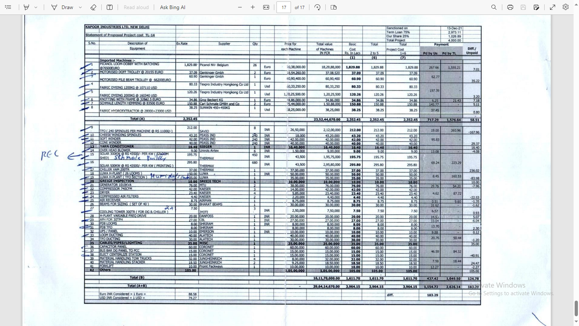

# ANNEXURE: PHOTOGRAPHS

|  |  |
| --- | --- |
| **Z:\In Progress Files\Abhinav Chaturvedi\VIS(2023-24)-PL372-302-478_Kapoor Industries\Site Image\TimePhoto_20230921_163055.jpg** | Z:\In Progress Files\Abhinav Chaturvedi\VIS(2023-24)-PL372-302-478_Kapoor Industries\Site Image\TimePhoto_20230921_163110.jpg |
| **Z:\In Progress Files\Abhinav Chaturvedi\VIS(2023-24)-PL372-302-478_Kapoor Industries\Site Image\TimePhoto_20230921_163147.jpg** | **Z:\In Progress Files\Abhinav Chaturvedi\VIS(2023-24)-PL372-302-478_Kapoor Industries\Site Image\TimePhoto_20230921_163218.jpg** |
| **Z:\In Progress Files\Abhinav Chaturvedi\VIS(2023-24)-PL372-302-478_Kapoor Industries\Site Image\TimePhoto_20230921_164432.jpg** | **Z:\In Progress Files\Abhinav Chaturvedi\VIS(2023-24)-PL372-302-478_Kapoor Industries\Site Image\TimePhoto_20230921_164731.jpg** |

|  |  |
| --- | --- |
| **Z:\In Progress Files\Abhinav Chaturvedi\VIS(2023-24)-PL372-302-478_Kapoor Industries\Site Image\TimePhoto_20230921_165609.jpg** | Z:\In Progress Files\Abhinav Chaturvedi\VIS(2023-24)-PL372-302-478_Kapoor Industries\Site Image\TimePhoto_20230921_171029.jpg |
| **Z:\In Progress Files\Abhinav Chaturvedi\VIS(2023-24)-PL372-302-478_Kapoor Industries\Site Image\TimePhoto_20230921_171523.jpg** | **Z:\In Progress Files\Abhinav Chaturvedi\VIS(2023-24)-PL372-302-478_Kapoor Industries\Site Image\TimePhoto_20230921_171812.jpg** |
| **Z:\In Progress Files\Abhinav Chaturvedi\VIS(2023-24)-PL372-302-478_Kapoor Industries\Site Image\TimePhoto_20230921_173429.jpg** | **Z:\In Progress Files\Abhinav Chaturvedi\VIS(2023-24)-PL372-302-478_Kapoor Industries\Site Image\TimePhoto_20230921_174111.jpg** |

|  |  |
| --- | --- |
| **Z:\In Progress Files\Abhinav Chaturvedi\VIS(2023-24)-PL372-302-478_Kapoor Industries\Site Image\TimePhoto_20230921_174254.jpg** | Z:\In Progress Files\Abhinav Chaturvedi\VIS(2023-24)-PL372-302-478_Kapoor Industries\Site Image\TimePhoto_20230921_174344.jpg |
| **Z:\In Progress Files\Abhinav Chaturvedi\VIS(2023-24)-PL372-302-478_Kapoor Industries\Site Image\TimePhoto_20230921_175005.jpg** | **Z:\In Progress Files\Abhinav Chaturvedi\VIS(2023-24)-PL372-302-478_Kapoor Industries\Site Image\TimePhoto_20230921_172010.jpg** |
| **Z:\In Progress Files\Abhinav Chaturvedi\VIS(2023-24)-PL372-302-478_Kapoor Industries\Site Image\TimePhoto_20230921_163613.jpg** | **Z:\In Progress Files\Abhinav Chaturvedi\VIS(2023-24)-PL372-302-478_Kapoor Industries\Site Image\TimePhoto_20230921_175435.jpg** |

# ANNEXURE: MARKET REFERENCES

