Kohinoor Foods Ltd.  50-51 K.M Stone, GT Road, Murthal, Sonipat, HR, India | PROCESS FLOW DIAGRAM

Paddy

Removal foreign matter
Pre-cleaning

Drying
Reduction of Moisture
Parboiling

Precooking
Steaming
De-stoning
Removal Stones if any

In Hot Water
Soaking /Steeping
Magnetic Separator
Removal any Metallic part

Par-boiling
Steaming
De-husking
Removal of Husk

Mechanical drying
Abrasive polisher
Removal of Bran
layer

Removal of Tips,
Plan sifter
Small broken

Friction polisher

Removal of outer
Layer (silky finish)

Continue

Raw rice

Colour sorter
Removal of Damaged Discolored Grains

Grading
Removal of Broken & Short Grains

Packing
In different kind of packages

Weighing

Truck & Containers
Loading
Fumigation
Dispatch

Disinfestations protection from cross
Contamination

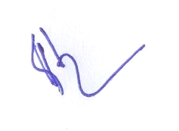

Approved By

Kohinoor Foods Ltd.
50-51 K.M Stone, GT Road, Murthal, Sonipat, HR,

