File No.: VIS(2023-24)- PL398-328-527 Dated: 25-09-2023

LENDER’S INDEPENDENT ENGINEER’s REPORT

OF

3.9 MWp GRID CONNECTED GROUND-BASED SOLAR POWER PLANT

PROPOSED TO BE SET-UP AT
VILLAGE – AUCHANDI, SUB DISTRICT-NARELA, DISTRICT: NORTH WEST DELHI

SELLER:
M/S TALF SAC SOLAR URJA PRIVATE LIMITED

REPORT PREPARED FOR
STATE BANK OF INDIA, SME BRANCH, MG ROAD, GURUGRAM

**Important - In case of any query/ issue or escalation you may please contact Incident Manager
at le@rkassociates.org. We will appreciate your feedback in order to improve our services.
NOTE: As per IBA Guidelines please provide your feedback on the report within 15 days of its submission after which report will be considered to be correct.
IMPORTANT NOTICE

COPYRIGHT FORMAT: This report is prepared on the copyright format of R.K Associates to serve our clients with the best possible information and analysis to facilitate them to take rational business decisions. Legally no one can copy or distribute this format without prior approval from R.K Associates. It is meant only for the advisory/ reference purpose for the organization/s as mentioned on the cover page of this report. Distribution or use of this format by any organization or individual other than R.K Associates will be seen as an unlawful act and necessary legal action can be taken against the defaulters.
This report is intended for the sole use of the intended recipient/s and contains material that is STRICTLY CONFIDENTIAL AND PRIVATE.

DEFECT LIABILITY PERIOD: - In case of any query/ issue or escalation you may please contact Incident Manager at le@rkassociates.org.
Though adequate care has been taken while preparing this report as per its scope, but still we can’t rule out typing, human errors, over sightedness of any information or any other mistakes. Therefore, the concerned organization is advised to satisfy themselves that the report is complete & satisfactory in all respect. Intimation regarding any discrepancy shall be brought into our notice immediately. If no intimation is received within 15 (Fifteen) days in writing from the date of issuance of the report, to rectify these timely, then it shall be considered that the report is complete in all respect and has been accepted by the client upto their satisfaction & use and further to which R.K Associates shall not be held responsible in any manner.

TABLE OF CONTENTS
SECTIONS | PARTICULARS | PAGE NO.
Part A | REPORT SUMMARY | 03
Part B | INTRODUCTION | 04
 | - Name of the Project | 04
 | - Project Overview | 04
 | - Scope of the Report | 06
 | - Purpose of the Report | 06
 | - Methodology Adopted | 06
Part C | PROJECT DETAILS AND KEY TECHNICAL PARAMETERS | 07
Part D | ENERGY YIELD ASSESSMENT | 13
Part E | POWER PURCHASE AGREEMENT TERMS | 19
Part F | CURRENT STATUS OF WORK | 22
Part G | PROJECT COST & EXPENDITURE | 23
Part H | PHOTOGRAPHS | 25
Part I | OTHER DOCUMENTS & REFERENCES | 26
Part J | DISCLAIMER | 38

PART A | REPORT SUMMARY

 | Name of the Project | 3.9 Mwp Grid Connected Ground-Based Solar Power Plants
 | Project Location | Village – Auchandi, Sub District-Narela, District: North West Delhi
 | Seller Company | M/S TALF SAC Solar Urja Private Limited
 | Prepared for Organization | State Bank of India, SME Branch, MG Road, Gurugram
 | LIE Consultant Firm | M/s. R.K. Associates Valuers & Techno Engineering Consultants (P) Ltd
 | Date of Survey | 20-09-2023
 | Date of Report | 25-09-2023
 | Details & documents provided by | Mr. Vikas Jha, from M/S TALF SAC Solar Urja Private Limited
 | Report Type | Lender’s Independent Engineering Report
 | Purpose of the Report | Verification and Review of Project cost, CUF and Irradiation  Data to facilitate bankers to take business decision on the  Project
 | Scope of the Report | To review Project cost and examine the current status of installation/ Commissioning of the Project.
 | Documents produced for Perusal | - Copy of Power Purchase Agreements (PPAs)  - Copy of EPC Contract between M/S TALF SAC Solar Urja Private Limited and TALF Solar India Private Limited  - Copy of Plant Layout  - Copy of PV Syst reports
 | Annexure with the Report | - Benchmark Cost by MNRE  - Market Comparables  - Global Solar Atlas by World Bank Group  - Layout Plans

PART B | INTRODUCTION

- NAME OF THE PROJECT: 3.9 Mwp Grid Connected Ground-Based Solar Power Plant to be installed at aforesaid address by M/s TALF SAC Solar Urja Private Limited.
- PROJECT OVERVIEW: M/s TALF SAC Solar Urja Private Limited a company incorporated under the laws of lndia and having its registered office at B-9, 6428, Vasant Kunj,Delhi is proposing to set-up a 3.9 MWp grid connected ground-based solar power plant at Village–Auchandi, Sub District-Narela, District: North West Delhi, on a land area admeasuring 7.32 acres, which is acquired by M/S TALF SAC Solar Urja Private Limited on lease rent for a period of 27 years from farmers.
M/S TALF SAC Solar Urja Private Limited (hereinafter referred to as “Client”) has made and EPC agreement/contract with M/s TALF Solar India Private Limited (hereinafter referred to as “Contractor”) for design, manufacture, supply, erection, testing and commissioning and warranty. The Contractor provides comprehensive solar solutions to government, corporate houses, villages, industries and other consumers.
M/s TALF SAC Solar Urja Private Limited has signed 6 nos. of Power Purchase Agreement (PPAs) with different purchaser for a tenure of 25 years, details of the purchasers can be found in the report further.

M/s TALF SAC Solar Urja Private Limited has approached SBI for credit facility to construct these plants who have in turned appointed M/s R.K Associates Valuers & Techno Engineering Consultants Pvt. Ltd. as Lenders Independent Engineer for a specific scope of work.

Since, presently no physical work has begun yet on the site and more so our scope of work includes only review of total Project cost, CUF and Irradiation Data.However fencing material and other related materials where stored on site, as observed during site survey.

RESCO Model: -
MNRE had introduced the PPP/RESCO model policy setting tariff rates for solar to be arrived
on transparent competitive bidding model through PPP route.

The RESCO model is one of the methods of implementing ground based solar installations. Under the RESCO model, a renewable energy service company ("RESCO"), (i.e., an energy service company that provides energy to consumers from renewable energy sources), develops, installs, finances, operates and owns the ground based solar power project ("Project"), and supplies power, generated from the Project to the consumer on whose premises the Project is set up ("Customer") or to the grid through net-metering.

'Build, Own, Operate and Transfer' (BOOT) is a special kind of RESCO model in which the
RESCO constructs, owns, operates, and transfers the ownership of the Project to the Customer after the expiry of a predefined period. The RESCO and the Customer enter into a
long-term power purchase agreement ("PPA") for an agreed tenure, which sets out, among
others, the terms at which the power generated from the Project will be sold to the Customer
and the tariff at which the power will be sold. Excess power from the Project (if any) could be
sold by the Customer to the distribution utility through net metering system – the net metering
regulations differ from state to state state.

Under the PPA, the RESCO owns the Project and is responsible for its installation as well as
its operation and maintenance of the Project throughout the tenure of the Project, and at the
end of the PPA term, the ownership of the Project is transferred to the Customer. Thereafter,
the Customer may either choose to retain the RESCO for operation and maintenance services
or engage a third-party operator.

If the entity on whose premises the Project is located does not intend to buy the power generated from the Project and does not entered into a PPA with the RESCO, that entity can either lease the rooftop premises to the RESCO by means of a lease agreement or enter into a license agreement granting the RESCO the right to use the premises for the limited purpose of setting up and operating the Project. The RESCO then operates the Project and exports the energy generated to the local distribution utility at a predetermined feed-intariff (FiT) approved by the State Electricity Regulator under relevant schemes issued by the relevant state.
- SCOPE OF THE REPORT: To verify the Project cost, expenditures and examine the commissioning, installation status of Solar Power Plants set-up/ being set-up by M/s. TALF SAC Solar Urja Pvt. Ltd.
- Industry/ sector research and demand & supply trend is out of scope of the report.
- Financial feasibility study of the Project is out of scope of the report.
- Providing any kind of design report or map is out-of-scope of the report.
- Scrutiny of contracts, Agreements and arrangement between the parties from legal perspective is out-of-scope of this report.
- Location feasibility is ascertained based on the PVSyst Report provided by the client.
- Any kind of technical & economic feasibility of the Project is out-of-scope of this Report.

All the assessment carried out for the Project is done based on the documents and information provided to us and various other discussions with the Project proponents and thus forming an opinion out of it.
Component wise verification is not carried out.

- PURPOSE OF THE REPORT: To provide fair detailed analysis report to the Bank based on the “in-scope points” mentioned above for facilitating them to take appropriate business decision on the Project.

- METHADOLOGY ADOPTED:
- To gather relevant data/ information/ documents related to Project planning, execution, current status.
- Study of copy of Project Planning documents/ Agreements to know the scope of work of the company.
- To procure, study and analysis of any additional information, data, and documents required/ provided by the company.
- Research about the Project/ sector from the sources in the public domain.
- Correlation of the provided information against Industry/ sector benchmarks/ trend.
- Information compilation, analysis and reporting.

PART C | PROJECT DETAILS AND KEY TECHNICAL PARAMETERS
As per the information and copy of documents shared by the management of the company, details of the subject plants has been tabulated below:
S.  No. | Particular | Capacity  DC Power (kWp) | Capacity  AC Power  (kWp) | Address
1 | Ground Mounted Solar Power Plant- Auchandi | 3906 | 2655 | Vacant land at village Auchandi, Sub District-Narela, District: North West Delhi.

As per the copy of module layout plans of both the sites, Key Technical Parameters & Configuration of the projects like Modules, capacity, etc. are tabulated below:
S. No. | Particular | Figure | UOM
1 | Proposed DC Capacity | 3906 | kWp
2 | Total No. of PV Modules Per String | 28 | No.
3 | Proposed AC Capacity | 2655 | Wp
4 | Pitch | 6 | mtr
5 | Module Rating | 540 | Wp
6 | Module Orientation | Protrait
7 | Height of Module Mounting Structure | 2.50 metre
8 | Tilt Angle | 10°
9 | Total no. Invertors | 12 nos. (220 kW each)

Location Map:

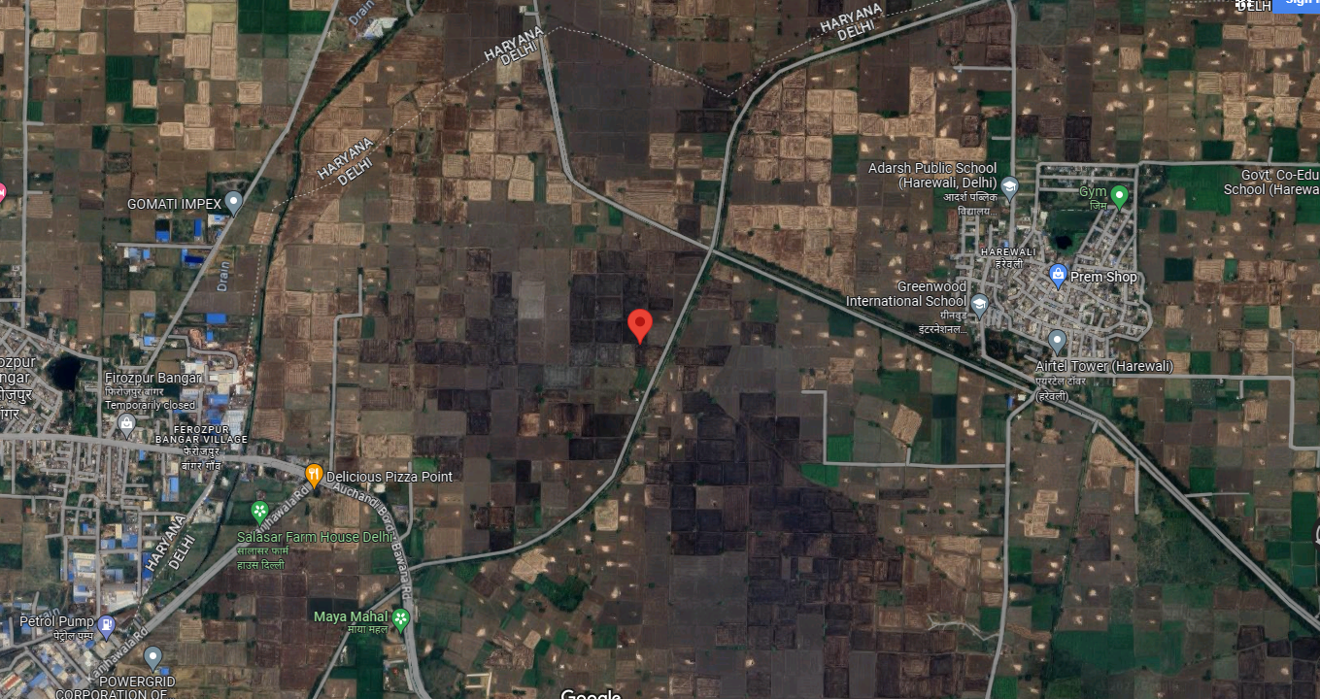
GPS Coordinates:- 28°49'55.1"N 76°59'49.9"E

Land Layout:

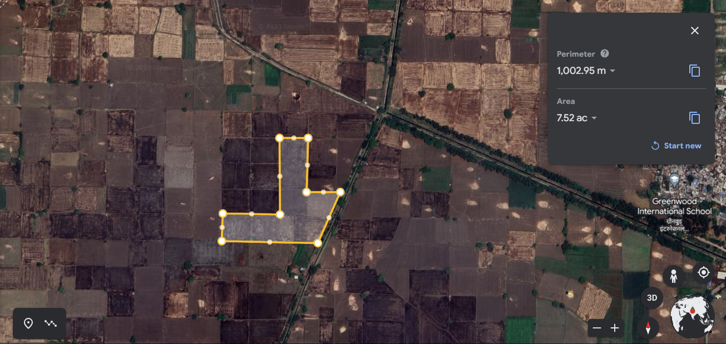

Technical Specifications as per data provided by the client:

S. No. | Item Description | Technical Specifications
A | Genereal coniderations
 | Design Ambient Temp | 50 degree
 | Plant DC Capacity | 3906 Wp
 | Plant AC Capacity | 2655 Wp
 | Module Wp considered | 540 Wp
 | String Configuratiomn | 28 no. module per string
B | Structure Design
 | Pitch Distance | 6 Meter
 | Module clearance | 3000 MM from NGL
 | Pile Foundation details | 2000 MM Depth x 350 MM Dia PCC Piling
C | Roads and Fencing
 | Internal Road (Main Road to the Plant) | Gravel road and 200 mm GSB and compaction
 | Plant Periphery Fencing | Chain Link Fencing using galvanized barbed wire  • Height: 1.5mtr Specs for Chain link fencing  • Mesh Size: 50mm x 50mm  • Column Post: 50x50x5 GI.(IS 800/E250)  • Barbed Wire: 3 rows on top 2.5/2.0mm (IS 278 &IS 280)
 | Plant Switch Yard Fencing | Chain Link Fencing using galvanized barbed wire  • Height: 1.5mtr Specs for Chain link fencing  • Mesh Size: 50mm x 50mm  • Column Post: 50x50x5 GI.(IS 800/E250)  • Barbed Wire: 3 rows on top 2.5/2.0mm (IS 278 &IS 280)
 | Main Gate for Entrance | Chain Link Fencing using galvanized barbed wire  • Height: 1.5mtr Specs for Chain link fencing  • Mesh Size: 50mm x 50mm  • Column Post: 50x50x5 GI.(IS 800/E250)  • Barbed Wire: 3 rows on top 2.5/2.0mm (IS 278 &IS 280)
D | DC side - Cables & Accessories
 | PV Modules | Longi Solar 540wp Bifacial Modules
 | Inverters | Solis brand of String Inverters:  - Type: Compatible with Module Connector, MC4  - Rated Voltage: 1500V dc (as per configuration offered)  - Current Rating: 13A / 26A / as per design requirement
 | PV Connectors | - MC 4 connector without fuse; Current Rating: 15A / 30A / as per design requirement
 | DC Cables (Module to Inverter) | - Insulation: Electron Beam XLPO  - Outer Sheath: Electron Beam XLPO  - Unarmored Cable.
E | AC side - Cables & Accessories
1 | Inverter Duty Transformers | Type: 2 Winding  - 2.7 MVA: Equal to cumulative Inverter kVA (atunity power factor) of block size at 50deg. C  - MV Rating: 11kV  - LV Rating: As per Inverter Output Voltage  - Impedance: As per Inverter Manufacturer's recommendation  - Cooling: ONAN  - Connection: LV side – Star Connection, HV side – Delta Connection  - Winding: Copper  - Insulation: Class A  - Flux Density: 1.8 wb/sqm @ 100% voltage  - Current Density: 3.5 A/sqmm  - Tap Changer: OCTC (Off Circuit Tap Changer)  - Fault Current Withstand: 2 sec
2 | HT Power Cables | - Cross Sectional Area: 185 sq. mm /as per design requirement.  - Rated Voltage: 11 kV  - Voltage Grade: 0.80 / 11 kV (Earth Grade)  - Conductor: Aluminum, 3-Core  - Insulation: XLPE  - Filler and: As per IS/ OEM  - Inner Sheath: PVC ST2 (extruded)  - Outer Sheath: PVC ST2  - Armoring: GS Flat strip
3 | Communication Cable | - RS 485 & CAT 6
4 | Fibre Optic Cables | - Single mode Fiber Optic

Note: The above-mentioned installations/parts are provided as per best industrial practice and gatherd from the technical specification sheet provided. However it can be verified only after commissioning of the project.
PART D | ENERGY YIELD ASSESSMENT

Company has used PVSyst v7.2.4 to assess energy yield calculation which is the standard Industry practice. The yearly average of main results of irradiation and energy yield from the provided PVSyst is as under:
S. No. | Plant Location | Annual production probability  (MWh) |  | Specific Production  (kWh/kWp/year) |  | Performance  Ratio (%)
 |  | P50 | P90 | As per PPA | As per PVsyst
1. | Ground Mounted Solar Power Plant- Auchandi | 6037 | 5798 | Not mentioned | 1510 | 78.44

Analysis of Irridiation & PV Output data: In respect to Irridiation & PV Output data, company has provided to us PVSyst report V7.2.4 in which key Irrdidation components and PV Output data is given as enumerated in table below. We have analysed and compared it with other data source points also such as Solar Resource by Global Solar Atlas of World Bank to confirm its legitimacy as mentioned in table below:
Particulars | As per Global  Solar Atlas | As per PVSyst
Global horizontal Irradiation (kWh/m²) | 1743.6 | 1813.9
Diffuse horizontal Irradiation (kWh/m²) | 938.2 | 865.9
Direct Normal Irradiation (kWh/m²) | 1197.1 | ---
Specific Photovoltaic Power Output (kWh/kWp) | 1496.4 | 1510
Annual Global Insolation (ISRO Solar Calculator) (kWh/m2/year) | 1327

Observations and Remarks:
- As per comparative analysis, PVSyst Irrdiation and PV Output data is in line to our analysis from Global Solar Atlas of World Bank.
Monthly averages- Direct normal irradiation (kWh/m²) 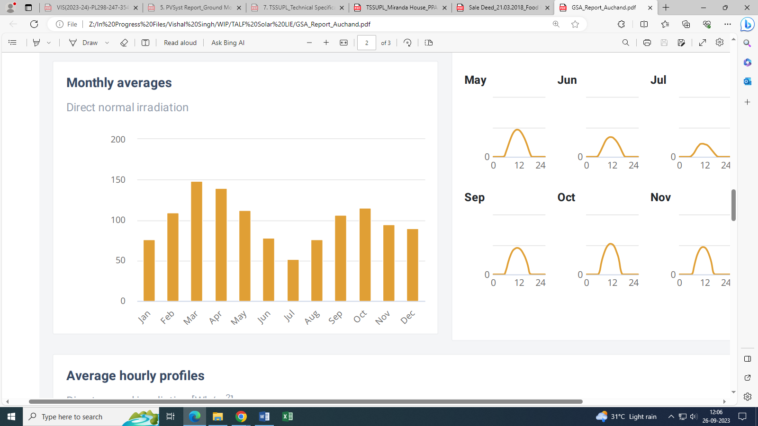
Source: Global Solar Atlas

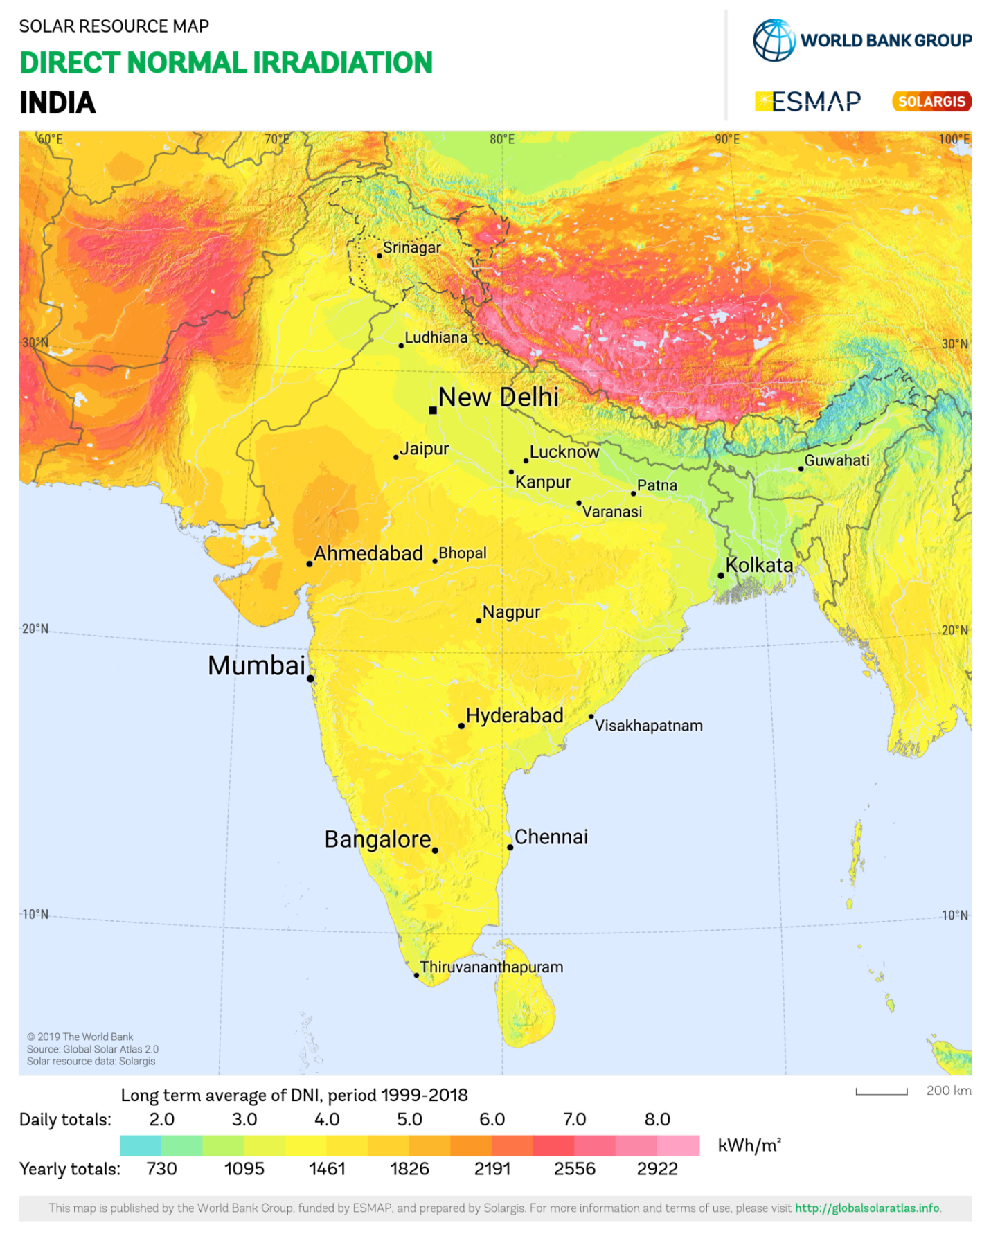
Subject Location lies above 3.0 daily (1095 annually) Kwh/m².
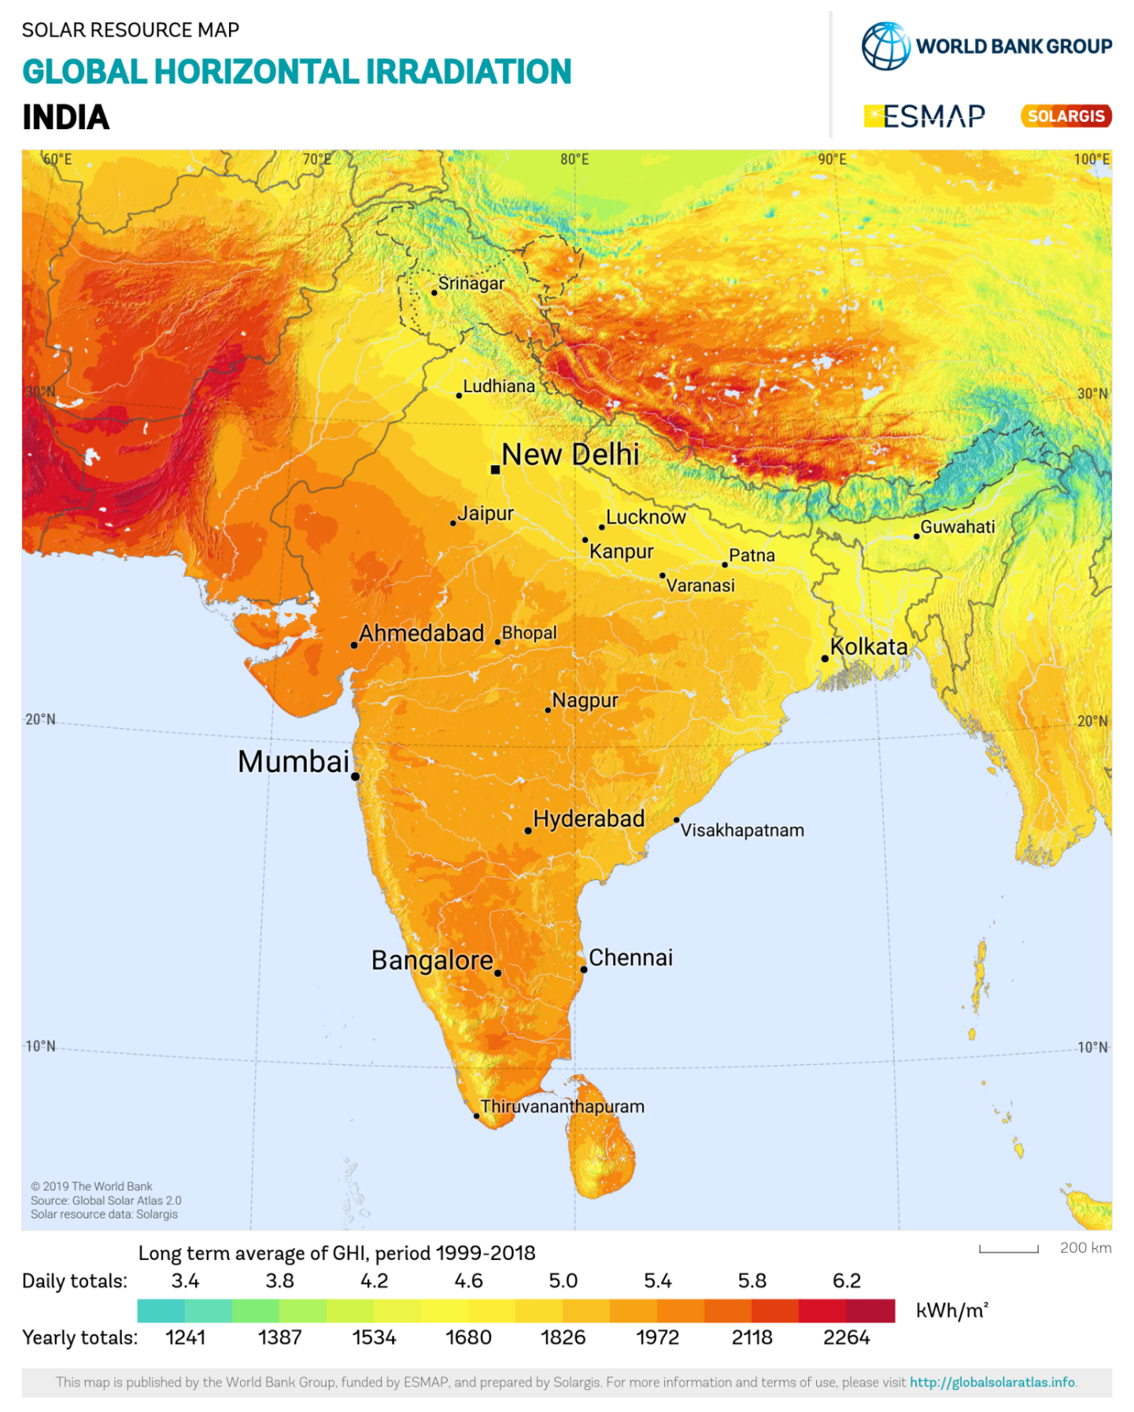
Subject Location lies above 5.0 daily (1826 annually) Kwh/m².

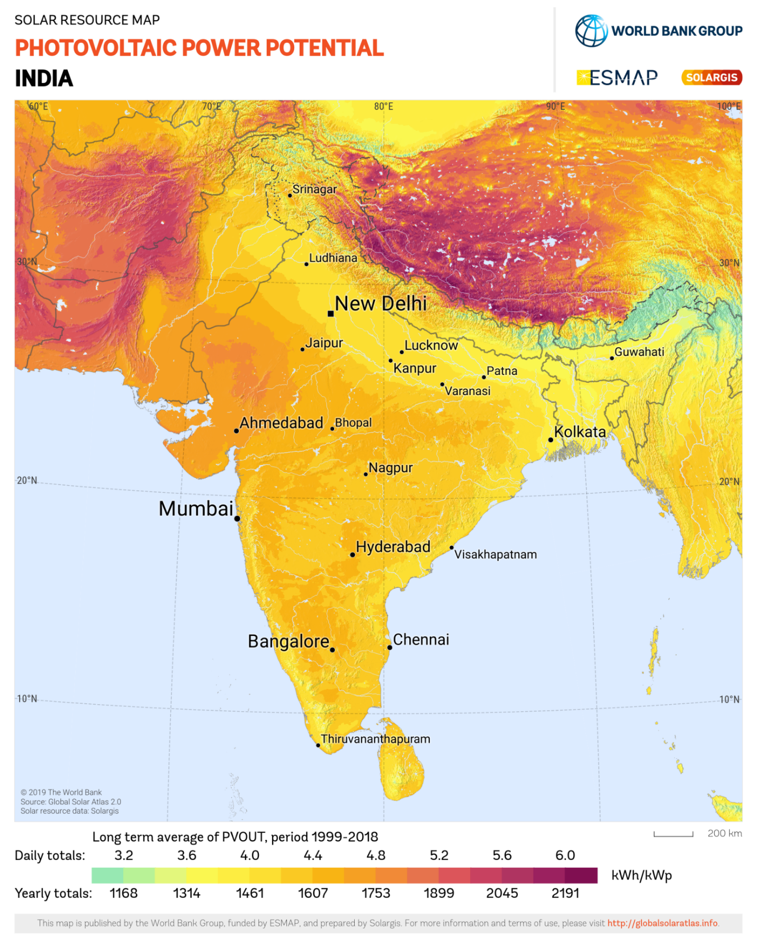
Subject Location lies above 4.0 daily (1461 annually) Kwh/kWp.

PART E | POWER PURCHASE AGREEMENT TERMS

As per copy of PPA provided by the company, the total proposed capacity of the subject ground based solar power plant is 4,100 kWp (± 10%). As on date, company has signed 6 no. of PPAs to supply power for a period of 25 years. Details of the same are tabulated below:
S. No | Power Producer | Power Purchaser | Agreement Date | Proposed Power Supply(KW) | Tariff
1 | TALF SAC Solar Urja Pvt. Ltd. | Ashoka Educational and Welfare Society | 04/7/2023 | 350 | 7.75 RS/KWh
2 |  | Hansraj College University of Delhi | 30/6/2022 | 1,000 | 6.00 RS/KWh
3 |  | Hindu College University of Delhi | 20/05/2022 | 800 | 6.00 RS/KWh
4 |  | IUA Trust | 07/7/2023 | 250 | 7.75 RS/KWh
5 |  | Miranda House University of Delhi | 17/05/2022 | 1,000 | 6.00 RS/KWh
6 |  | Sri Guru Gobind Singh College of Commerce, University of Delhi | 22/11/2022 | 700 | 6.00 RS/KWh
Total |  |  |  | 4,100

Note:- Please note that, as per the PPAs, the total capacity should have been 4,100 KW_{DC}, but based on a generation of generation of 1,450 KWh/KW_{DC}/year and key technological improvements, M/S TALF SAC Solar Urja Private Limited has designed the plant at total capacity of 3,906 KW_{DC}.
Important Clauses: All PPA’s are signed for a period of 25 years with fixed tariff as stated above. Some of the important clauses from the signed PPAs are as follows:-
- Terms: The term of this Agreement will be for a period of 25 (Twenty Five) years from COD.

- Access Rights: The power producer hereby grants the Power Purchaser the right to enter the lnstalled Space for the purposes of observing the solar Power Plant, upon the Power Purchaser submitting a request to the power producer for such a visit at least 5 Business Days ahead of the proposed visit.

- Lease rights: Any lease rights associated with the installed space shall remain solely with the Powe21r Producer.

- CONSTRUCTION AND O&M OF THE SOLAR POWER PLANT

  - lnterconnection: The power producer shall provide and lay the dedicated electrical cables for transmission of Solar power from the Solar Power Plant up to the lnterconnection Point. Transmission or distribution of Solar power beyond this point will be the responsibility of the Distribution Utility.

  - Construction Timelines: The Power Producer shall install, commission and complete the Solar Power Plant and achieve COD within 10 months from the Effective Date.

  - Installation Work: The Power Producer will cause the Project to be designed, manufactured, supplied, engineered, erected, tested and commissioned, operated & maintained and constructed substantially in accordance with this agreement.

- Maintenance:

  - The power producer shall be responsible for the ongoing maintenance of the solar Power Plant and any spares/ replacements so required.
  - The power producer shall be responsible for regular cleaning of the solar Power Plant.

  - The power producer shall be entitled to suspend delivery of Solar Power from the Solar Power Plant for up to 2 days per calendar year for the purpose of major maintenance or repair works. The power Producer must intimate the Power Purchaser of such suspension of supply within 2 Business Days of the end of such suspension, and the Power Purchaser accepts that the Committed Generation for the period in question shall be proportionately reduced.

- Billing and payment:
  - Invoicing:
    - The power producer may begin invoicing the Power Purchaser for Solar Power prior to COD, if it is technically feasible for the Power Producer to partially commission the Solar Power Plant and begin supplying Solar Power to the Power Purchaser prior to COD, and the Power Purchaser receives credit for such Solar Power from the Distribution Utility.
    - There are presently no taxes, duties, or additional charges levied by any govefnment of similar authority for the supply of electricity generated by solar power plants.

  - Payments: The power purchaser shall make payment in favour of the Power Producer in line with an lnvoice, by means of electronic fund transfer or vide a ceque in favour of the Power Producer, by the Due Date.

Note : The above main clauses of PPA are mentioned only for illustration purpose of the convenience of the lenders to analyze the Project in terms of technicality. However, this shall not be construed as professional opinion on the contract legality which is out of scope of this report.

PART F | CURRENT STATUS OF WORK

During our site visit, it was found that the land is currently lying vacant, with no construction or establishment work in progress. However, there is cultivation taking place on the land at present.
Additionally, some sections or materials intended for construction, such as frames, were found stored on the site.
As per the information provided, the date of Commencement of the plant installation work is scheduled/proposed to be 15th October 2023 and the scdeuled COD is 31st March 2024.

PART G | PROJECT COST & EXPENDITURE

- PROJECT COST:
M/S TALF SAC Solar Urja Private Limited (hereinafter referred to as ‘Client’) has signed an EPC contract with TALF Solar India Private Limited ( hereinafter referred to as ‘Contractor’) for the installation of Ground Based Grid Tie Solar plant. The total EPC Cost for the project inclusive of all taxes is Rs. 21.54 Crores for the installation of Ground Based Grid Tie Solar plant located at Village Auchandi, Sub District-Narela, District: North West Delhi. Project cost is obtained from the data received from client.
The agreement includes design, manufacture, supply, erection, testing and commissioning including warranty for ground mounted solar plant at the above mentioned location.
The details of the contact price as per letter of agreement is shown below:
Item | Rs/Wp(DC)  (Base Rate) | GST  Rs/Wp(DC) | Rs/Wp(DC)  (Total Rate) | Total Project Cost
Solar System Supply and Design and Installation  Solar Modules(Pannels) Inverters and DC Supply, MMS, Civil Works, Transport Warehouse, Liaising, PMC, testing and Commisioning. | 43.96 | 6.15 | 50.11 | Rs. 21.54 Cr.
Observations and Remarks:
- The total cost of the project as per the information provided to us is Rs. 21.54 Cr.
- Since, presently no physical work has begun on the site so our scope of work includes only review of total Project cost. Validation or assesement of the same is not done in the report, as there wrere no relevant documents provided for justification of the cost incurred till date, for ex. CA Certificate, etc.

The roles of the contractor is shown below:
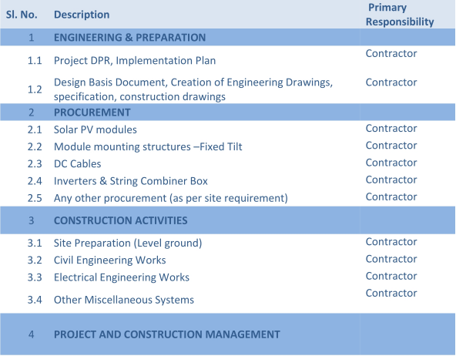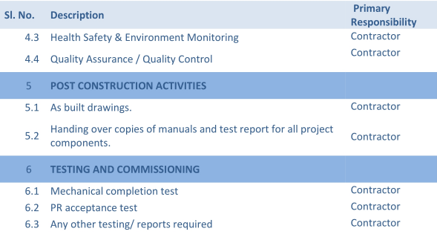

Observations and Remarks:
- Project cost calculated on the basis of the Benchmark Cost provided by the MNRE has been tabulated below:
S. No. | Particulars | Benchmark Cost  (In Rs./kW) | Project Capacity  (In MW) | Total Project Cost  (Excluding GST)  (In Rs.) | Total Project Cost  (Including ~14% GST)  (In Rs.)
1 | As per Ministry of New & Renewable Energy | 35,886/- | 3,909 | 14,02,78,374 | 15,99,17,346
 |  |  | 3.9 MWp |  | ~Rs. 16.00 Cr
*Benchmark cost for 2021-22
- Project cost calculated on the basis of market comparable:
S. No. | Particulars | Excluding GST | Including GST | Remark
 |  | Per KW Cost  (In Rs.) | Per KW Cost  (In Rs.)
1 | Subject project installation cost | - | 50,110 | As per letter of agreement
Market Research Details
2 | MNRE Benchmark Cost | 35,886 | - | Refer Annexure-5
 | Market Research
3 | Quotation-1 | 48,700 | 55,400 | Refer Annexure-6
4 | Quotation-2 | 37,740 | 42,500
5 | Quotation-3 | 45,000 | 51,200

- As per our analysis and market research, the installation cost of Ground based Mounted Solar Power Plant varies from Rs. 37,740/- per KW to Rs. 55,400/- per KW. For the smaller setups the price is higher and for large set-up, price is less.
- The project cost is solely depends upon the project location, contractors profit, type of module and its supporting structures, etc.
- Based upon the above mentioned details, the project cost amounting to Rs. 19.57 Cr. inclusive of GST for the installation of subject ground based solar power plant seems to be reasonable.
- As per observation made suring site survey, installation work of solar plant is yet to be started.
- As per the information provided to us by the client, the proposed height of the project’s moulding structure is elevated at 2.5 metres.

Note:
- Project cost is analyzed based on lump sum cost only and not item wise.
- Project cost is assessed for the date of this report only and due to price fluctuations it may vary from time to time.

- EXPENDITURE: As per information/details shared by the company, the expenditure incurred till date on the project is shown below in tabulated form:
Particulars | Total Expenses (Rs. Lacs)
Advance Lease Rent | 9.20
Lease Deposit | 9.20
Lease Registration Charges | 9.20
Advance + Payment for MMS (Module Mounting Structure) | 20.44
Total | 23.60
Note:- As per information provided to us, no supporting documents have
been provided.

PART H | PHOTOGRAPHS

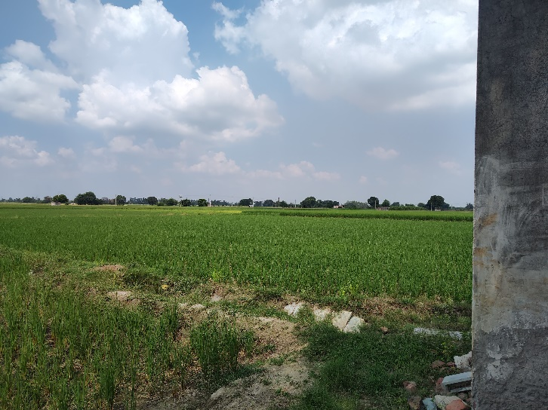 | 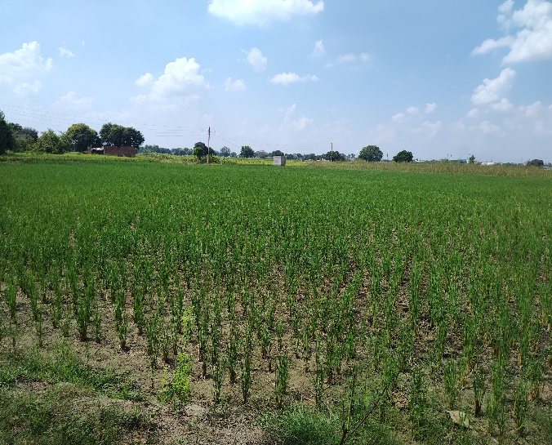
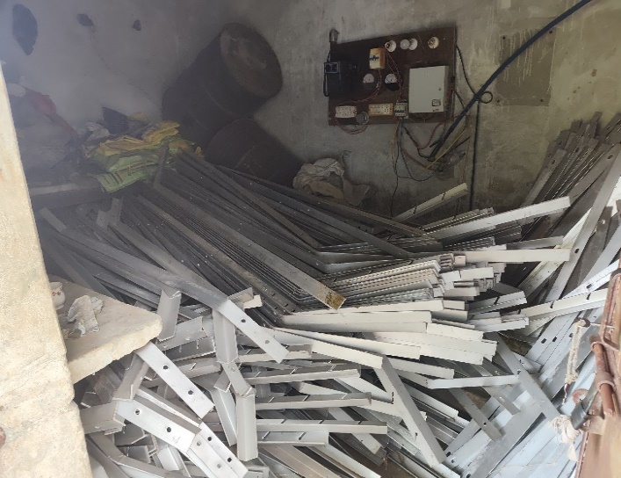 | 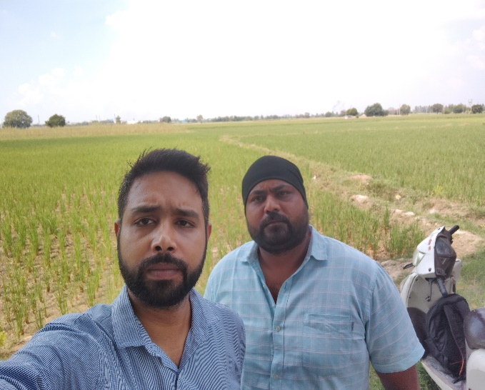
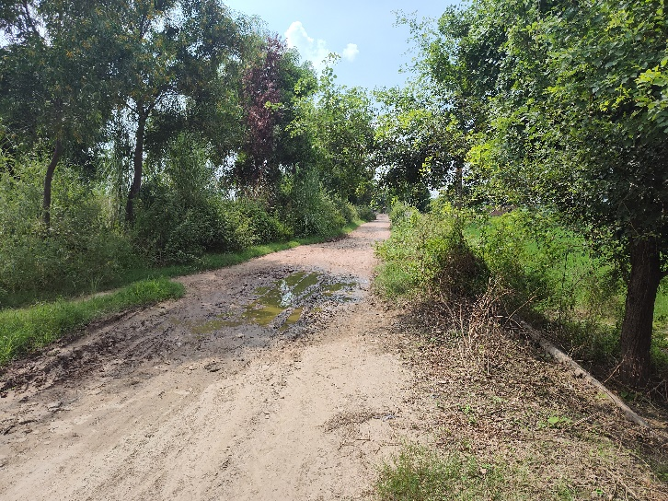 | 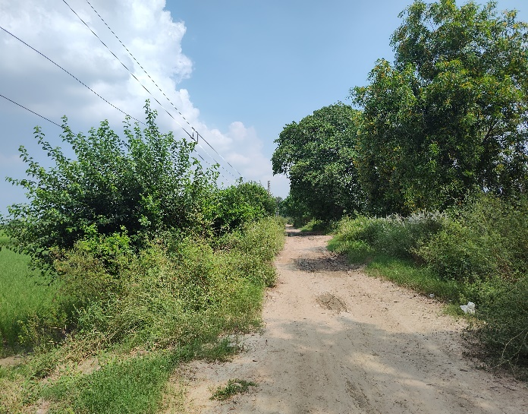

PART I | OTHER DOCUMENTS & REFERENCES

Annexure-1: Lease Deed
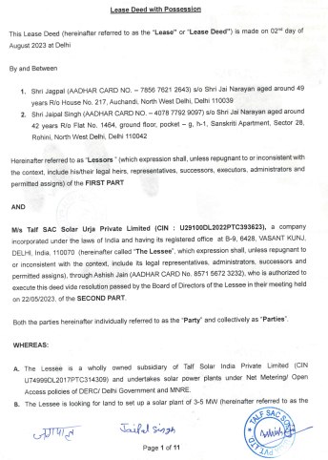 | 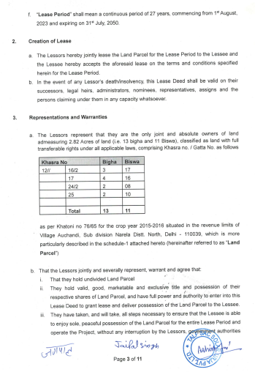
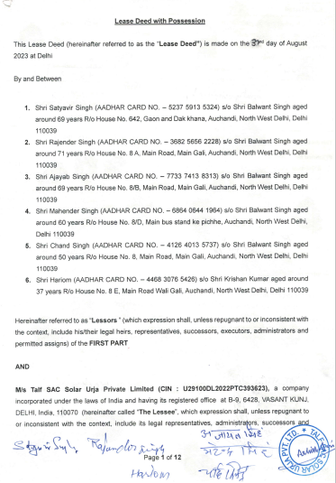 | 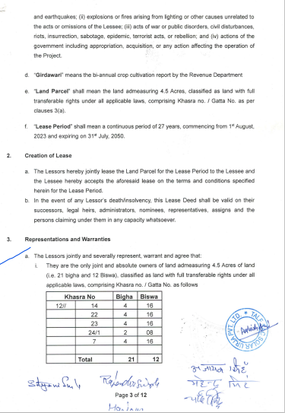
Annexure-2 : PVSYST Report

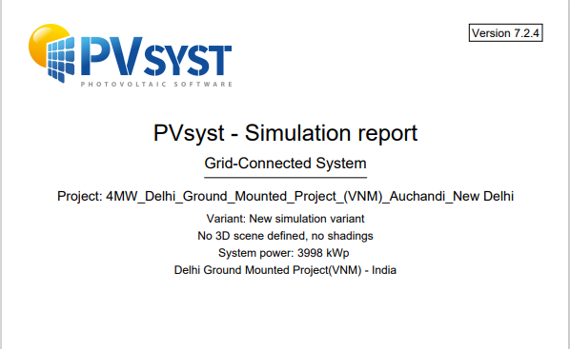

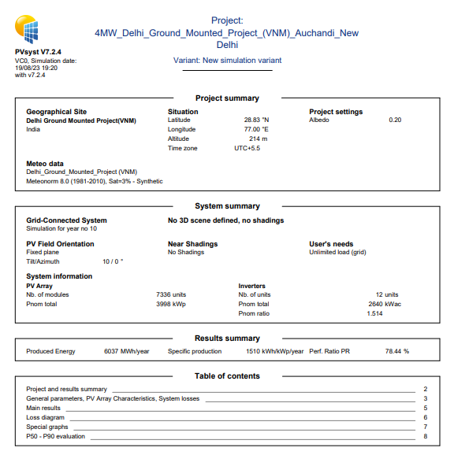

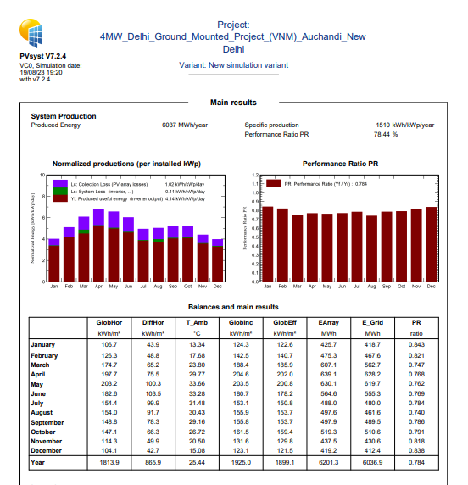

Annexure-3: Layout Plan

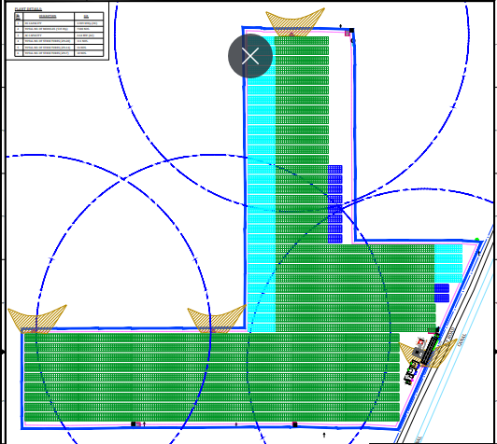

Annexure-4: EPC Contract:

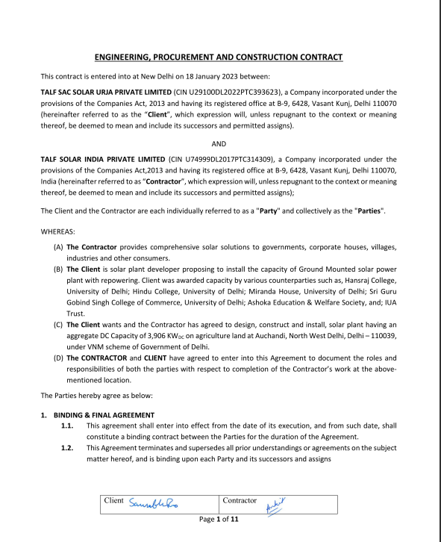

Annexure-5: Benchmark Cost by MNRE

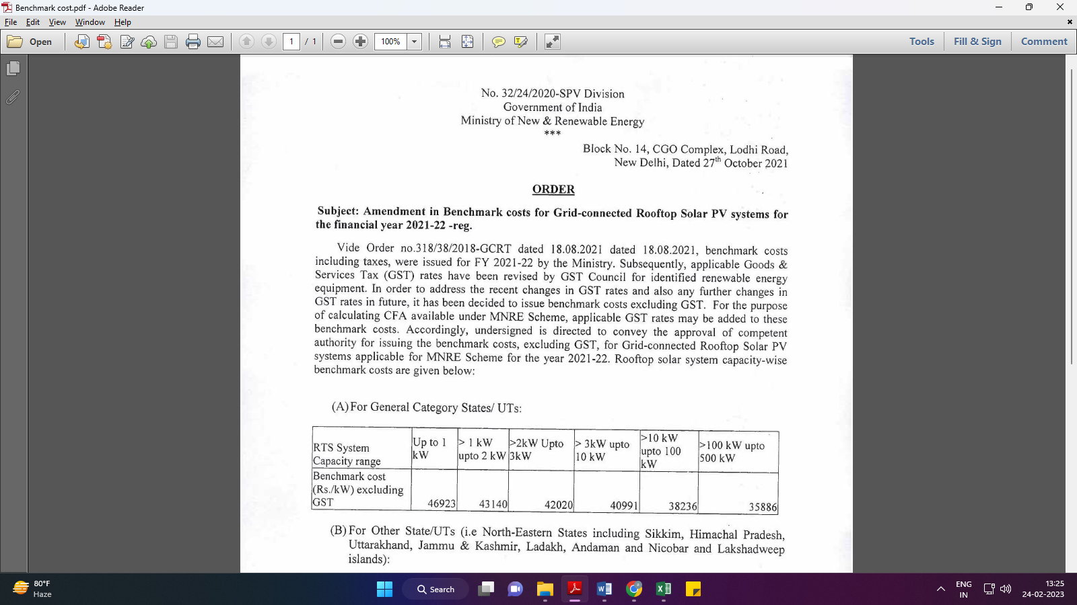

Annexure-6: Market Comparables

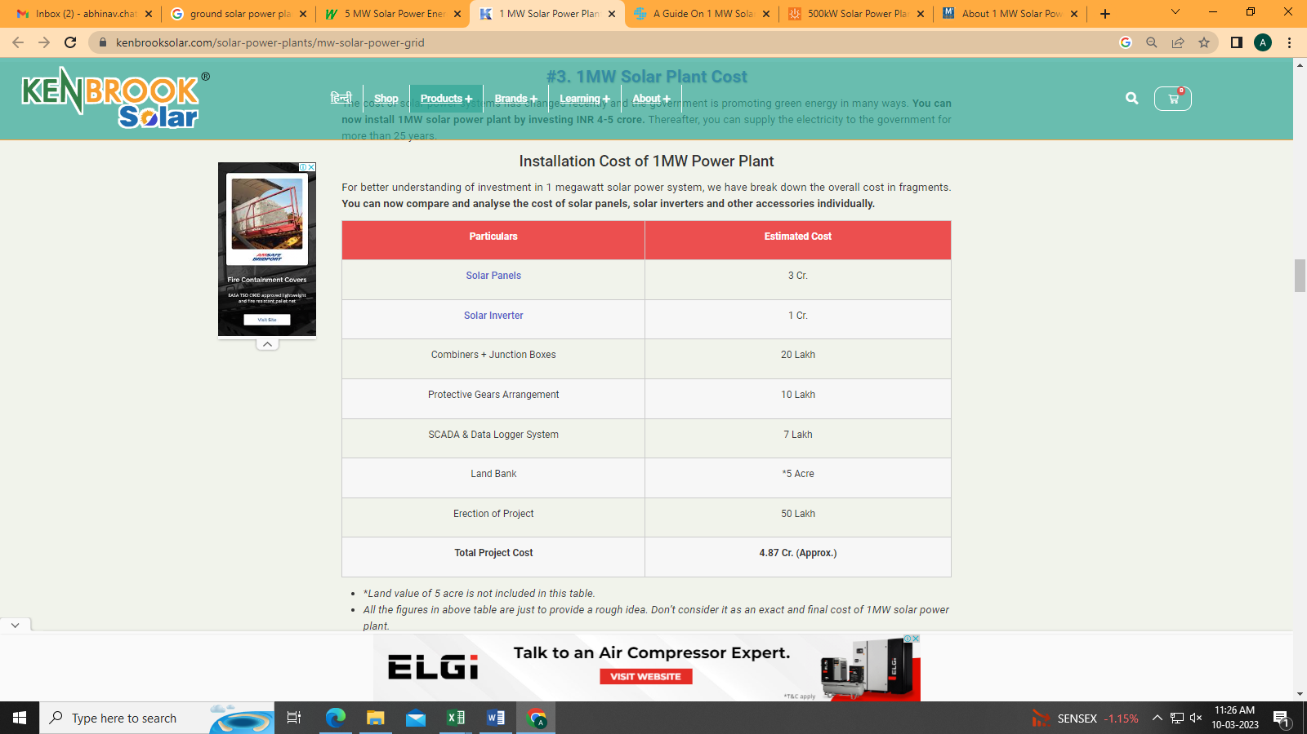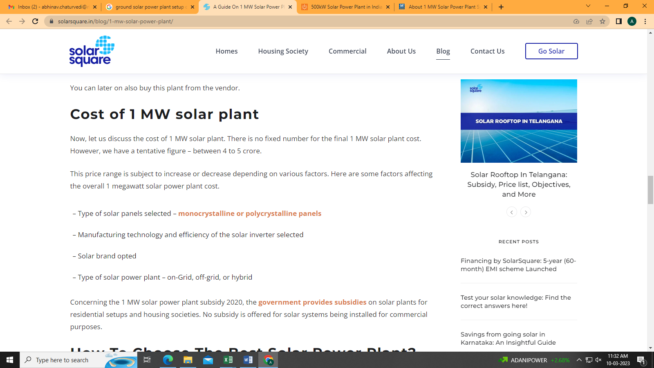
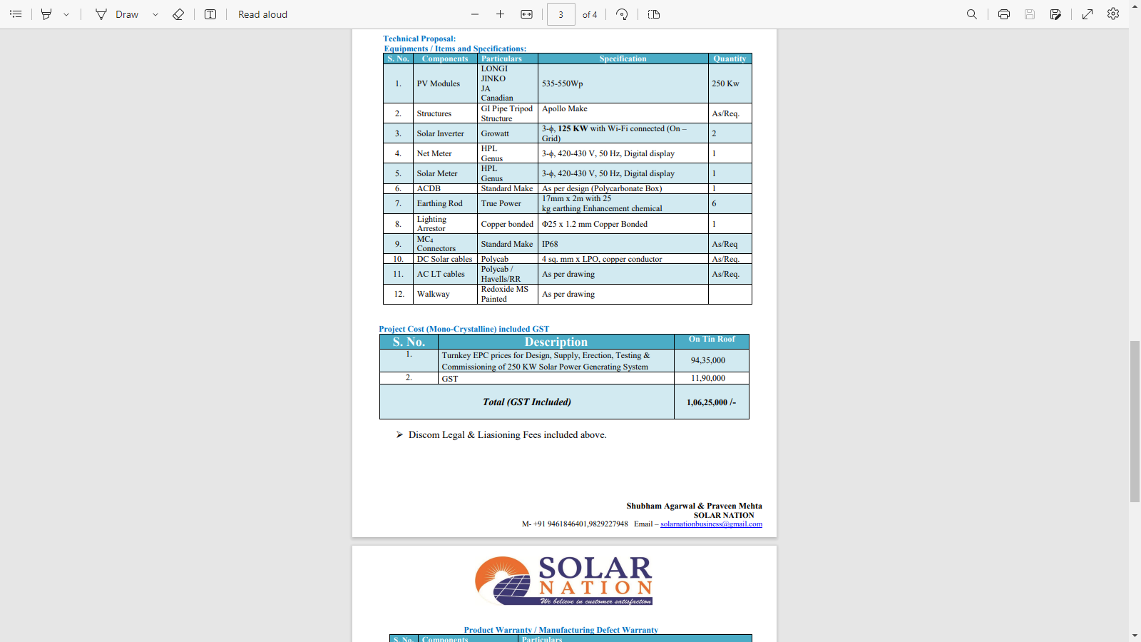

Annexure-6: Data by Global Solar Atlas by World Bank Group
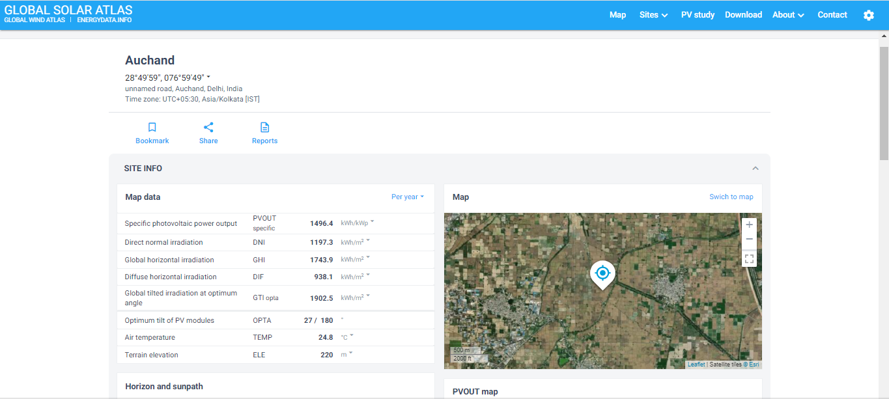
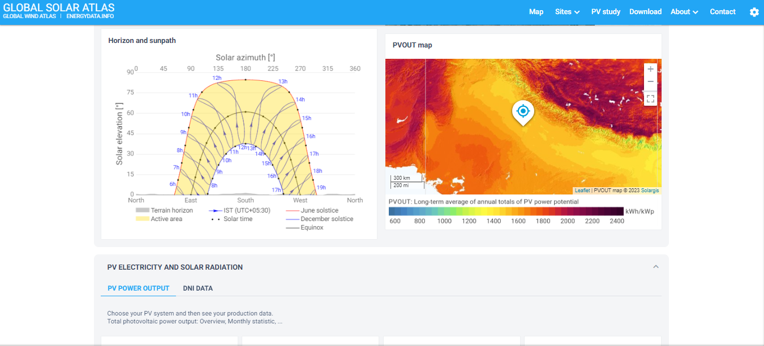
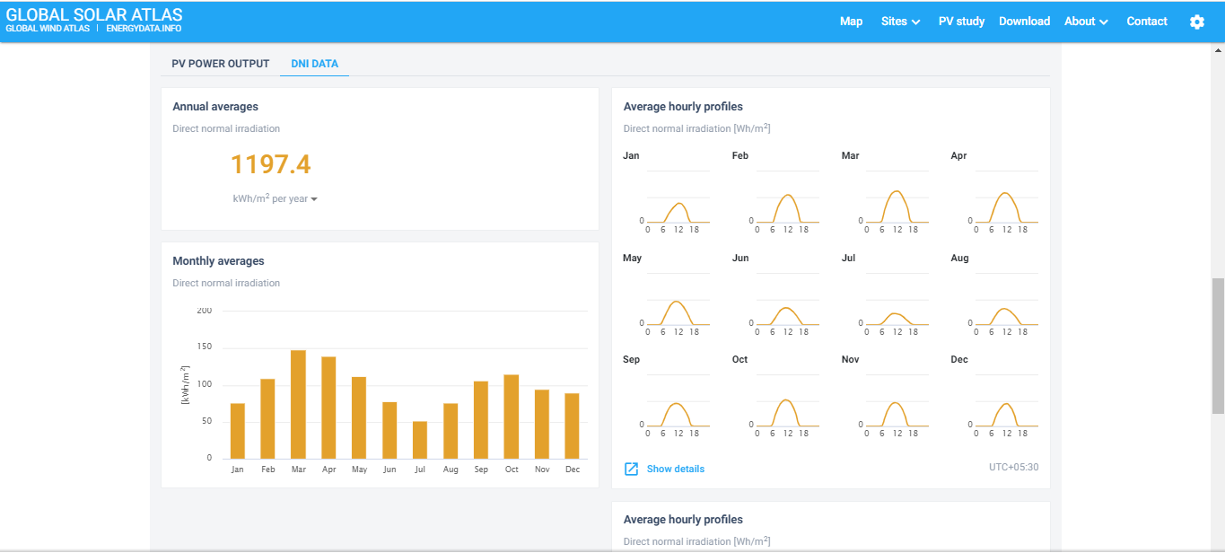
PART J | DISCLAIMER

      - No employee or member of R.K Associates has any direct/ indirect interest in the Project.
      - This report is prepared based on the copies of the documents/ information which the Bank/ Company has provided to us out of the standard checklist of documents sought from them and further based on our assumptions and limiting conditions. All such information provided to us has been relied upon in good faith and we have assumed that it is true and correct in all respect. Verification or cross checking of the documents provided to us has not been done at our end from the originals. If at any time in future, it is found or came to our knowledge that misrepresentation of facts or incomplete or distorted information has been provided to us then this report shall automatically become null & void.
      - This report is a general analysis of the project based on the scope mentioned in the report. This is not an Audit report, Design document, DPR or Techno-financial feasibility study. All the information gathered is based on the facts seen on the site during survey, verbal discussion & documentary evidence provided by the client and is believed that information given by the company is true best of their knowledge.
      - All observations mentioned in the report is only based on the visual observation and the documents/ data/ information provided by the client. No mechanical/ technical tests, measurements or any design review have been performed or carried out from our side during Project assessment.
      - Bank/FII should ONLY take this report as an Advisory document from the Financial/ Chartered Engineering firm and it’s specifically advised to the creditor to cross verify the original documents for the facts mentioned in the report which can be availed from the borrowing company directly.
      - In case of any default in loans or the credit facility extended to the borrowing company, R.K Associates shall not be held responsible for whatsoever reason may be and any request for seeking any explanation from the employee/s of R.K Associates will not be entertained at any instance or situation.
      - This Report is prepared by our competent technical team which includes Engineers and financial experts & analysts.
      - This is just an opinion report and doesn’t hold any binding on anyone. It is requested from the concerned Financial Institution which is using this report for taking financial decision on the project that they should consider all the different associated relevant & related factors also before taking any business decision based on the content of this report.
      - All Pages of the report including annexures are signed and stamped from our office. In case any paper in the report is without stamp & signature then this should not be considered a valid paper issued from this office.
      - Though adequate care has been taken while preparing this report as per its scope, but still we can’t rule out typing, human errors, over sightedness of any information or any other mistakes. Therefore, the concerned organization is advised to satisfy themselves that the report is complete & satisfactory in all respect. Intimation regarding any discrepancy shall be brought into our notice immediately. If no intimation is received within 15 (Fifteen) days in writing from the date of issuance of the report, to rectify these timely, then it shall be considered that the report is complete in all respect and has been accepted by the client upto their satisfaction & use and further to which R.K Associates shall not be held responsible in any manner.
      - Defect Liability Period is 15 DAYS. We request the concerned authorized reader of this report to check the contents, data and calculations in the report within this period and intimate us in writing if any corrections are required or in case of any other concern with the contents or opinion mentioned in the report. Corrections only related to typographical, calculation, spelling mistakes, incorrect data/ figures/ statement will be entertained within the defect liability period. Any new changes for any additional information in already approved report will be regarded as additional work for which additional fees may be charged. No request for any illegitimate change in regard to any facts & figures will be entertained.
      - R.K Associates encourages its customers to give feedback or inform concerns over its services through proper channel at le@rkassociates.org in writing within 30 days of report delivery. After this period no concern/ complaint/ proceedings in connection with the Lender’s Independent Engineering Services will be entertained due to possible change in situation and condition of the subject Project.
      - Our Data retention policy is of ONE YEAR. After this period, we remove all the concerned records related to the assignment from our repository. No clarification or query can be answered after this period due to unavailability of the data.
      - This Lender’s Independent Engineering report is governed by our (1) Internal Policies, Processes & Standard Operating Procedures, (2) Information/ Data/ Inputs given to us by the client and (3) Information/ Data/ Facts given to us by our field/ office technical team. Management of R.K Associates never gives acceptance to any unethical or unprofessional practice which may affect fair, correct & impartial assessment and which is against any prevailing law. In case of any indication of any negligence, default, incorrect, misleading, misrepresentation or distortion of facts in the report then it is the responsibility of the user of this report to immediately or at least within the defect liability period bring all such act into notice of R.K Associates management so that corrective measures can be taken instantly.
      - R.K Associates never releases any report doing alterations or modifications from pen. In case any information/ figure of this report is found altered with pen then this report will automatically become null & void.
FOR INTERNAL USE
Place : Noida  Date : 25.09.2023 | SURVEYED BY:  PREPARED BY:  REVIEWED BY: | Abhinav Chaturvedi  Vishal Singh  Abhinav Chaturvedi

For R.K Associates Valuers & Techno Engineering Consultants (P) Ltd.

DEFECT LIABILITY PERIOD - In case of any query/ issue or escalation you may please contact Incident Manager by writing at valuers@rkassociates.org. We ensure 100% accuracy in the Calculations done, Rates adopted and various other data points & information mentioned in the report but still can’t rule out typing, human errors or any other mistakes. In case you find any mistake, variation, discrepancy or inaccuracy in any data point of the report, please help us by bringing all such points into our notice in writing at valuers@rkassociates.org within 30 days of the report delivery, to get these rectified timely, failing which R.K Associates Valuers Techno Engineering Consultants (P) Ltd. won’t be held responsible for any inaccuracy in any manner. Also if we will not hear back anything from you within 30 days, we will assume that report is correct in all respect and no further claim of any sort will be entertained thereafter. We would welcome and appreciate your feedback & suggestions in order to improve our services.

COPYRIGHT FORMAT - This report is prepared on the copyright format of R.K Associates Valuers Techno Engineering Consultants (P) Ltd. to serve our clients in the best possible way. Legally no one can copy or distribute this format without prior approval from R.K Associates. It is meant only for the organization as mentioned on the cover page of this report. Distribution or use of this format other than R.K Associates will be seen as unlawful act and necessary legal action can be taken against the defaulter

