Collector rates of majra gurdas

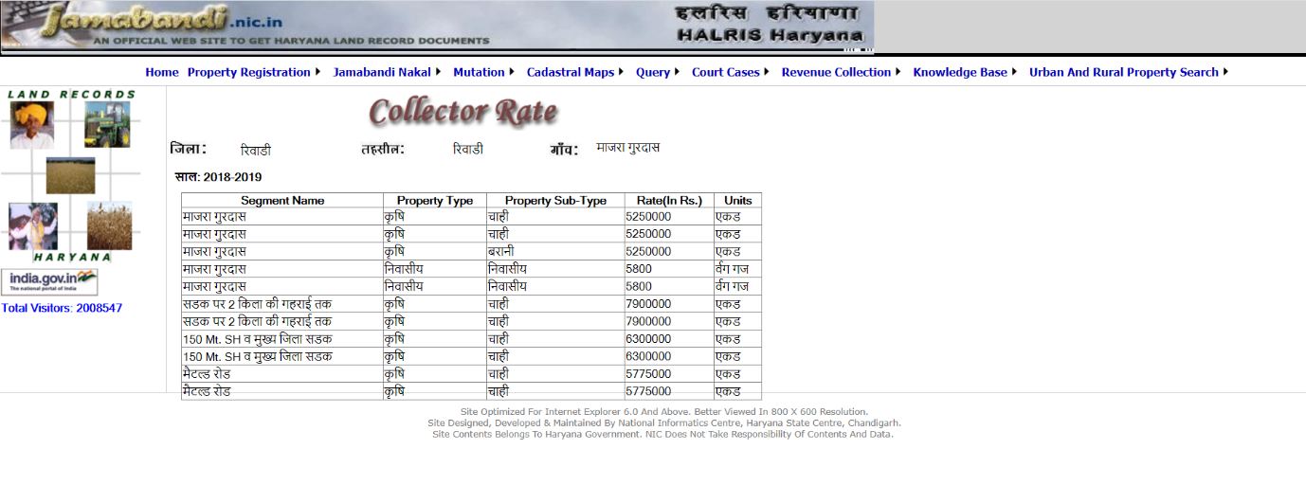

**This valuation report is prepared with no legal documents. The land details along with their ownership has been extracted from Jamabandi. The market rates are confirmed by Gupta Sir & no market reference could be gathered from site or from any public domain. The market rates adopted are Rs.85,00,000/- per acre.**

**Mohit Sir & Shahid Sir insisted on preparing the file & Bhardwaj Sir refused to prepare such files with no legal document.**