File No.: VIS (2023-24)-PL412-Q085-344-548 Dated: 19-10-2023

LENDER’S INDEPENDENT ENGINEER’s REPORT

OF

10 (± 10%) MWp GRID CONNECTED ROOF-TOP SOLAR POWER PLANT

PROPOSED TO BE SET-UP AT
RAJASTHAN, HARYANA & MADHYA PRADESH
DEVELOPER:
M/S TRUERE SPV PRIVATE LIMITED

REPORT PREPARED FOR
STATE BANK OF INDIA, SME, SOUTH EXTENSION,SOUTH DELHI

**Important - In case of any query/ issue or escalation you may please contact Incident Manager
at le@rkassociates.org. We will appreciate your feedback in order to improve our services.
NOTE: As per IBA Guidelines please provide your feedback on the report within 15 days of its submission after which report will be considered to be correct.

IMPORTANT NOTICE

COPYRIGHT FORMAT: This report is prepared on the copyright format of R.K Associates to serve our clients with the best possible information and analysis to facilitate them to take rational business decisions. Legally no one can copy or distribute this format without prior approval from R.K Associates. It is meant only for the advisory/ reference purpose for the organization/s as mentioned on the cover page of this report. Distribution or use of this format by any organization or individual other than R.K Associates will be seen as an unlawful act and necessary legal action can be taken against the defaulters.
This report is intended for the sole use of the intended recipient/s and contains material that is STRICTLY CONFIDENTIAL AND PRIVATE.

DEFECT LIABILITY PERIOD: - In case of any query/ issue or escalation you may please contact Incident Manager at le@rkassociates.org.
Though adequate care has been taken while preparing this report as per its scope, but still we can’t rule out typing, human errors, over sightedness of any information or any other mistakes. Therefore, the concerned organization is advised to satisfy themselves that the report is complete & satisfactory in all respect. Intimation regarding any discrepancy shall be brought into our notice immediately. If no intimation is received within 15 (Fifteen) days in writing from the date of issuance of the report, to rectify these timely, then it shall be considered that the report is complete in all respect and has been accepted by the client upto their satisfaction & use and further to which R.K Associates shall not be held responsible in any manner.

TABLE OF CONTENTS
SECTIONS | PARTICULARS | PAGE NO.
Part A | REPORT SUMMARY | 03
Part B | INTRODUCTION | 04
 | - Name of the Project | 04
 | - Project Overview | 04
 | - Scope of the Report | 06
 | - Purpose of the Report | 06
 | - Methodology Adopted | 06
Part C | PROJECT DETAILS AND KEY TECHNICAL PARAMETERS | 07
Part D | ENERGY YIELD ASSESSMENT | 16
Part E | POWER PURCHASE AGREEMENT TERMS | 22
Part F | CURRENT STATUS OF WORK | 26
Part G | PROJECT COST & EXPENDITURE | 27
Part H | PHOTOGRAPHS | 29
Part I | OTHER DOCUMENTS & REFERENCES | 30
Part J | DISCLAIMER | 62

PART A | REPORT SUMMARY
 | Name of the Project | 10 (±10%) MWp Grid Connected Solar Power Plant
 | Project Location | Project are located majorly at 3 states of india i.e. Rajasthan, Haryana & Madhya Pradesh.  (Please reefer to the table attach below for address of the each project location)
 | Seller Company | M/s TRUERE SPV Private Limited
 | Prepared for Organization | State Bank of India, SME, South Extension, New Delhi
 | LIE Consultant Firm | M/s. R.K. Associates Valuers & Techno Engineering Consultants (P) Ltd
 | Date of Survey | NA (Desktop LIE)
 | Date of Report | 19-10-2023
 | Details & documents provided by | Mr. Shubham Kr. Karn; Sr. Accounts Manager M/s Oriana Power Pvt. Ltd.
 | Report Type | Lender’s Independent Engineering Report
 | Purpose of the Report | Review of Project cost, CUF and Irradiation Data to facilitate bankers to take business decision on the Project.
 | Scope of the Report | To verify and review the Project cost, CUF and Irradiation Data of the Solar Power Plants set-up/ being set-up by M/s TRURE SPV Pvt. Ltd.
 | Documents produced for Perusal | - Copy of Power Purchase Agreements (PPAs)  - Copy of Techno-Commercial offer from OPWR to TRURE SPV Pvt. Ltd.  - Copy of Plant Layout  - Copy of PV Syst reports  - Detailed Project Report
 | Annexure with the Report | - Benchmark Cost by MNRE  - Market Comparables  - Global Solar Atlas by World Bank Group  - Layout Plans

PART B | INTRODUCTION

- NAME OF THE PROJECT: 10 (± 10%) MWp Grid Connected Solar Power Plant based on RESCO Model to be installed at 15 locations by M/s TRURE SPV Pvt. Ltd.
- PROJECT OVERVIEW: M/s TRURE SPV Pvt. Ltd. is a SPV of M/s Oriana Power Private Limited (OPPL) which is an associate company of Trinix Impex & BCS Switchgear Industries. It is a MNRE approved channel partner and into the business of Solar EPC / Design & Supply of BoS (Balance of System – Module Mounting Structure, LT/ ACCB/ ACDB/ DCCB Panel, Weather Monitoring Sensors, LA, Earthing, Cable Tray, etc.) for PV Solar Plants in India.
M/s OPWR DEL SPV Private Limited. (hereinafter referred to as “Power Producer”) in March, April , May, July & September 2023 and February 21 signed 15 nos. of Power Purchase Agreement (PPAs) with different purchaser for Design, Manufacture, Supply, Erection, Testing and Commissioning including Warranty, Operation & Maintenance of 13 roof-top & 2 ground mounted solar power plants at their respective locations having a total DC capacity of 10 (± 10%) MWp for 25 years of plant operation/ PPA tenure.
Further, M/s OPWR DEL SPV Private Limited (Tranferee) has signed Novation Agreement with M/s TRURE SPV Pvt. Ltd. (Transferee). As per Novation Agreement, the Transfree intends to accept the transfer by novation of all the rights, liabilities, duties and obligations of the Tranfereor under and in respect of Pringiple Agreement i.e. PAA. This novation agreement has been signed with all the parties with respect to each location.
As per Detailed Project Report with respect to all 15 nos. of location shared by the company which is submitted with State Bank of India, the total project cost for setting up 10,000 kWp solar plant is Rs. 55.73 Cr. However, no contract agreement has been signed.
M/s TRURE SPV Pvt. Ltd. has approached SBI for credit facility to construct these plants who have in turned appointed M/s R.K Associates Valuers & Techno Engineering Consultants Pvt. Ltd. as Lenders Independent Engineer for a specific scope of work.
Since, presently no physical work has begun yet on the site and more so our scope of work includes only review & comment on total Project cost, CUF and Irradiation Data, therefore site visit has not been carried out.

RESCO Model: -
MNRE had introduced the PPP/RESCO model policy setting tariff rates for solar to be arrived on transparent competitive bidding model through PPP route.

The RESCO model is one of the methods of implementing rooftop solar installations. Under the RESCO model, a renewable energy service company ("RESCO"), (i.e., an energy service company that provides energy to consumers from renewable energy sources), develops, installs, finances, operates and owns the rooftop solar power project ("Project"), and supplies power generated from the Project to the consumer on whose premises the Project is set up ("Customer") or to the grid through net-metering.

'Build, Own, Operate and Transfer' (BOOT) is a special kind of RESCO model in which the RESCO constructs, owns, operates, and transfers the ownership of the Project to the Customer after the expiry of a predefined period. The RESCO and the Customer enter into a long-term power purchase agreement ("PPA") for an agreed tenure, which sets out, among others, the terms at which the power generated from the Project will be sold to the Customer and the tariff at which the power will be sold. Excess power from the Project (if any) could be sold by the Customer to the distribution utility through net metering system – the net metering regulations differ from state to state.

Under the PPA, the RESCO owns the Project and is responsible for its installation as well as its operation and maintenance of the Project throughout the tenure of the Project, and at the end of the PPA term, the ownership of the Project is transferred to the Customer. Thereafter, the Customer may either choose to retain the RESCO for operation and maintenance services or engage a third-party operator.

If the entity on whose premises the Project is located does not intend to buy the power generated from the Project and does not entered into a PPA with the RESCO, that entity can either lease the rooftop premises to the RESCO by means of a lease agreement or enter into a license agreement granting the RESCO the right to use the premises for the limited purpose of setting up and operating the Project. The RESCO then operates the Project and exports the energy generated to the local distribution utility at a predetermined feed-intariff (FiT) approved by the State Electricity Regulator under relevant schemes issued by the relevant state.

- SCOPE OF THE REPORT: To verify and review the Project cost, CUF and Irradiation Data of the Solar Power Plants set-up/ being set-up by M/s TRURE SPV Pvt. Ltd.
- Industry/ sector research and demand & supply trend is out of scope of the report.
- Financial feasibility study of the Project is out of scope of the report.
- Providing any kind of design report or map is out-of-scope of the report.
- Scrutiny of contracts, Agreements and arrangement between the parties from legal perspective is out-of-scope of this report.
- Location feasibility is ascertained based on the PVSyst Report provided by the client.
- Any kind of technical & economic feasibility of the Project is out-of-scope of this Report.

All the assessment carried out for the Project is done based on the documents and information provided to us and various other discussions with the Project proponents and thus forming an opinion out of it.

Component wise verification is not carried out.

- PURPOSE OF THE REPORT: To provide fair detailed analysis report to the Bank based on the “in-scope points” mentioned above for facilitating them to take appropriate business decision on the Project.

- METHADOLOGY ADOPTED:
- To gather relevant data/ information/ documents related to Project planning, execution, current status.
- Study of copy of Project Planning documents/ Agreements to know the scope of work of the company.
- To procure, study and analysis of any additional information, data, and documents required/ provided by the company.
- Research about the Project/ sector from the sources in the public domain.
- Correlation of the provided information against Industry/ sector benchmarks/ trend.
- Information compilation, analysis and reporting.

PART C | PROJECT DETAILS AND KEY TECHNICAL PARAMETERS

- SOLAR PLANT PROJECT LOCATIONS: As per the information and copy of documents shared by the management of the company, details of the subject solar plant locations has been tabulated below:
S.  No. | Purchaser | Capcity (kWp) |  | Address
 |  | DC Power | AC Power
1 | Govt. Medical College, Chittorgarh | 399.6 | 350 | Rithola, Rajasthan  GPS Coordinates– 24°50'35.3"N 74°35'18.1"E
2 | Govt Medical College, Dungarpur | 399.6 | 350 | Dungarpur, Rajasthan  GPS Coordinates– 23°50'30.8"N 73°39'32.2"E
3 | Gurugram University, Gurugram | 226.8 | 195 | RAO TULA RAM COLLEGE, university, Mayfield Garden, Sector 51, Gurugram, Samaspur, Haryana 122003  GPS Coordinates– 28°25'25.4"N 77°03'56.5"E
4 | Jhalwar Hospital And Medical College, Jhalwar | 604.8 | 500 | Vacant Land at 12-16, Kota Rd, Industrial Area, Jhalawar, Rajasthan 326001  GPS Coordinates– 24°35'33.9"N 76°09'03.7"E
5 | Govt Mahila Evam Bal Chikitsalya, Chittorgarh | 97.2 | 80 | Near M.P.P.G. College, Main Road Sethi, Pratap Nagar, Chittorgarh, Rajasthan 312001  GPS Coordinates– 24°52'10.5"N 74°37'03.7"E
6 | Paschimi Rajasthan Dugdh Utpadak Sahkari Sang Limited, Jodhpur | 604.8 | 500 | Chopasani Rd, Baldev Nagar, Jodhpur, Rajasthan 342003  GPS Coordinates- 26°16'43.8"N 72°59'57.2"E
7 | Shree Haridev Joshi General Hospital, Dungarpur | 486 | 400 | Hospital Road, New Colony, Dungarpur, Rajasthan 314001  GPS Coordinates- 23°51'32.6"N 73°42'42.6"E
8 | Shree Sanwaliya Ji Government General Hospital, Chittorgarh | 183.6 | 150 | Nehru Nagar, Chittorgarh, Rajasthan 312001  GPS Coordinates-24°52'12.8"N 74°37'05.4"E
9 | Ravinder Nath Tagore Govt Medical College, Udaipur | 194.4 | 180 | Court Chowk, City's Prime Health Care Area, Udaipur, Rajasthan 313001  GPS Coordinates- 24°35'17.9"N 73°41'42.0"E
10 | Maharana Bhupal Govt Hospital, Udaipur | 194.4 | 180 | New ahinsapuri, fatehpura, Udaipur, Rajasthan 313001  GPS Coordinates-24°35'18.6"N 73°41'33.5"E
11 | Govt Medical College, Barmer | 604.8 | 500 | Barmer, Rajasthan 344001  GPS Coordinates- 25°49'38.0"N 71°24'02.8"E
12 | Shrimati Hira Kuwar Ba Mahila Hospital, Jhalwar | 205.2 | 180 | H5P6+6CF, Medical College, Jhalawar  GPS Coordinates- 24°35'08.2"N 76°09'39.8"E
13 | Govt Medical College, Dholpur | 604.8 | 500 | MVQ5+C67, Bari Rd, Purani Chhawni, Dholpur, Rajasthan 328001  GPS Coordinates- 26°41'19.3"N 77°51'29.0"E
14 | PMO Mch Unit MG Hospital, Bhilwara | 200 | 200 | Bhopal Ganj, Bhilwara, Rajasthan 311001  GPS Coordinates-25°20'53.2"N 74°38'27.7"E
15 | Hindustan Copper Limited, Malanjkhand | 5000 | 4500 | Baihar, Madhya Pradesh 481051  GPS Coordinates- 22°01'21.6"N 80°42'24.5"E
Total |  | 10000 | 8,765 | (± 10%)

S. No. | Purchaser | Transferor  (PPA Holder) | Transferee | Capacity kWp  (DC)
1 | Govt Medical College - Chittorgarh | M/s. OPWR DEL SPV Pvt. Ltd. | TRUERE SPV Pvt. Ltd. | 399.6
2 | Govt Medical College - Dungarpur |  |  | 399.6
3 | Gurugram University - Ggn |  |  | 226.8
4 | Jhalwar Hospital And Medical Colledge - Jhalwar |  |  | 604.8
5 | Govt Mahila Evam Bal Chikitsalya - Chittorgarh |  |  | 97.2
6 | Paschimi Rajasthan Dugdh Utpadak Sahkari Sang Limited - Jodhpur |  |  | 604.8
7 | Shree Haridev Joshi General Hospital - Dungarpur |  |  | 486
8 | Shree Sanwaliya Ji Government General Hospital - Chittorgarh |  |  | 183.6
9 | Ravinder Nath Tagore Govt Medical College - Udaipur |  |  | 194.4
10 | Maharan Bhupal Govt Hospital - Udaipur |  |  | 194.4
11 | Govt Medical College - Barmer |  |  | 604.8
12 | Shrimati Hira Kuwar Ba Mahila Hospital - Jhalwar |  |  | 205.2
13 | Govt Medical College - Dholpur |  |  | 604.8
14 | PMO Mch Unit Mg Hospital - Bhilwara |  |  | 194.4
15 | Hindustan Copper Limited - Malanjkhand | Rooftop Urja Pvt. Ltd. |  | 5,000

- LOCATION WISE KEY TECHNICAL PARAMETERS: As per the copy of module layout plans of both the sites, Key Technical Parameters & Configuration of the projects like Modules, Inverter, tilt angle, capacity, etc. are tabulated below:
S. No. | Location | Proposed capacity (in KWp) | No. of PV Module (in nos.) | PV Module Capacity (in Wp) | PV Module Mounting Orientation | Module Mounting Structure Angle
1 | Govt Medical College - Chittorgarh | 400 | 741 | 540 | -- | As per building
2 | Govt Medical College - Dungarpur | 400 | 741 | 540 | -- | As per building
3 | Gurugram University - Ggn | 226.8 | 420 | 540 | -- | As per building
4 | Jhalwar Hospital And Medical Colledge - Jhalwar | 640.8 | 1120 | 540 | -- | Vacant Land
5 | Govt Mahila Evam Bal Chikitsalya - Chittorgarh | 97.2 | 180 | 540 | -- | As per building
6 | Paschimi Rajasthan Dugdh Utpadak Sahkari Sang Limited - Jodhpur | 604.8 | 1120 | 540 | -- | As per building
7 | Shree Haridev Joshi General Hospital - Dungarpur | 486 | 900 | 540 | -- | As per building
8 | Shree Sanwaliya Ji Government General Hospital - Chittorgarh | 183.6 | 340 | 540 | -- | As per building
9 | Ravinder Nath Tagore Govt Medical College - Udaipur | 194.4 | 360 | 540 | -- | As per building
10 | Maharan Bhupal Govt Hospital - Udaipur | 194.4 | 360 | 540 | -- | As per building
11 | Govt Medical College - Barmer | 604.8 | 1120 | 540 | -- | As per building
12 | Shrimati Hira Kuwar Ba Mahila Hospital - Jhalwar | 205.2 | 380 | 540 | -- | As per building
13 | Govt Medical College - Dholpur | 604.8 | 1120 | 540 | -- | As per building
14 | PMO Mch Unit Mg Hospital - Bhilwara | 194.4 | 360 | 540 | -- | As per building
15 | Hindustan Copper Limited - Malanjkhand | 5000 | 9091 | 5500 | Portrait | 20°

- LOCATION MAPS: -

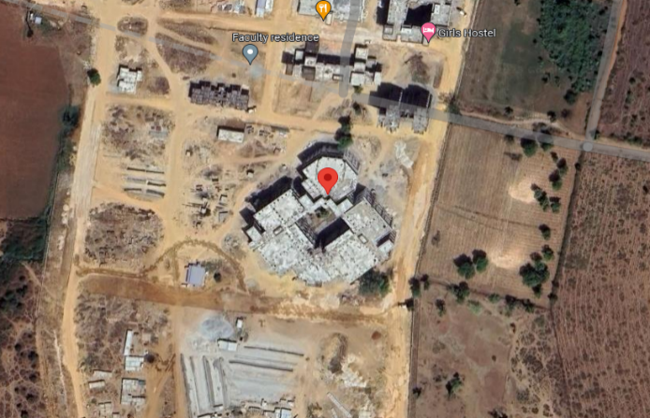  Govt. Medical College, Chittorgarh  24°50'35.3"N 74°35'18.1"E | 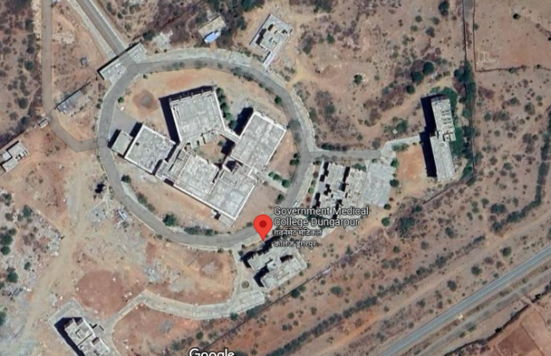  Govt Medical College, Dungarpur  23°50'30.8"N 73°39'32.2"E
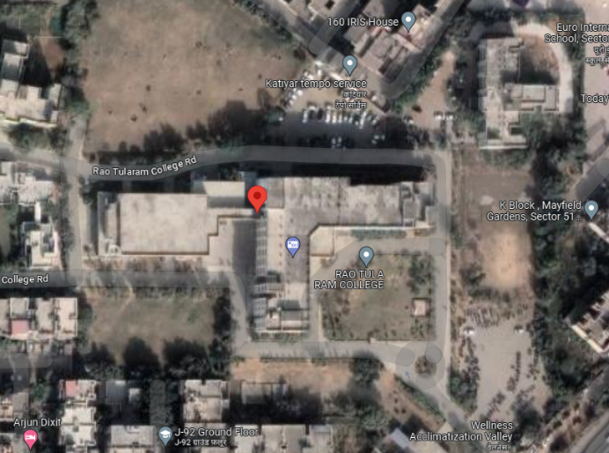  Gurugram University, Gurugram  28°25'25.4"N 77°03'56.5"E | 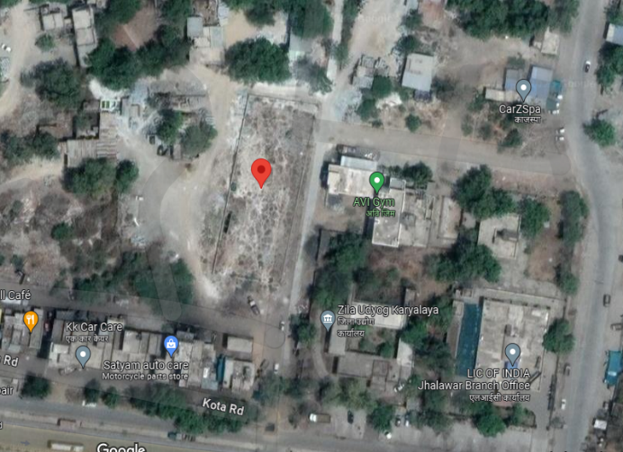  Jhalwar Hospital And Medical College, Jhalwar  24°35'33.9"N 76°09'03.7"E
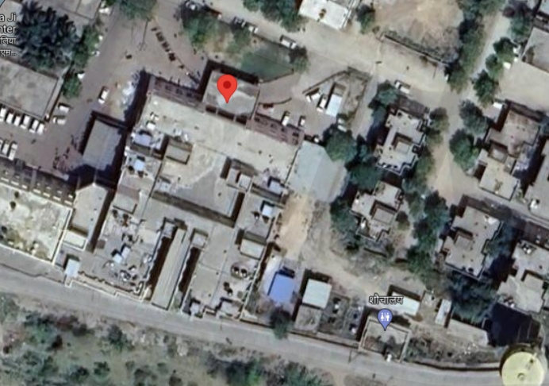  Govt Mahila Evam Bal Chikitsalya, Chittorgarh  24°52'10.5"N 74°37'03.7"E | 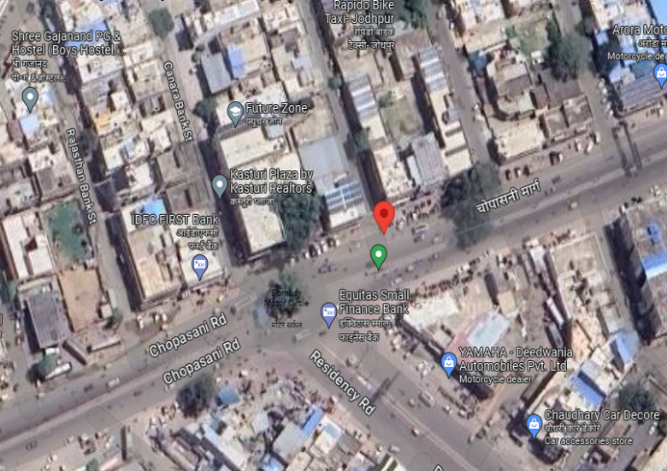  Paschimi Rajasthan Dugdh Utpadak Sahkari Sang Limited, Jodhpur  26°16'43.8"N 72°59'57.2"E

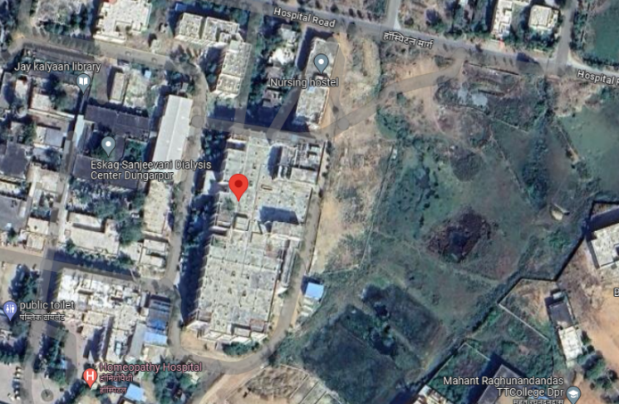  Shree Haridev Joshi General Hospital, Dungarpur  23°51'32.6"N 73°42'42.6"E | 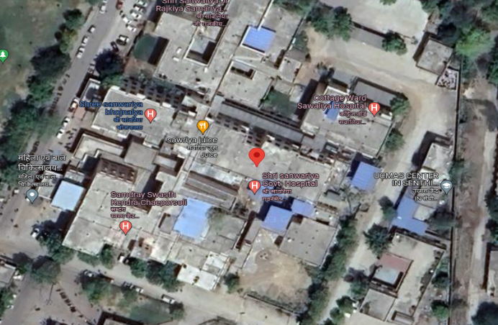  Shree Sanwaliya Ji Government General Hospital, Chittorgarh  24°52'12.8"N 74°37'05.4"E
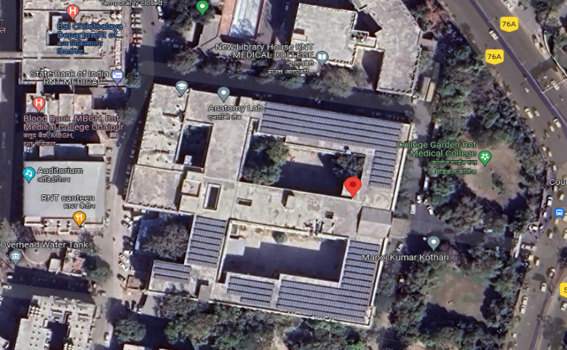  Ravinder Nath Tagore Govt Medical College, Udaipur  24°35'17.9"N 73°41'42.0"E | 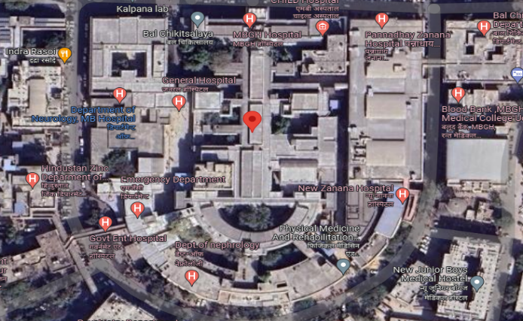  Maharana Bhupal Govt Hospital, Udaipur  24°35'18.6"N 73°41'33.5"E
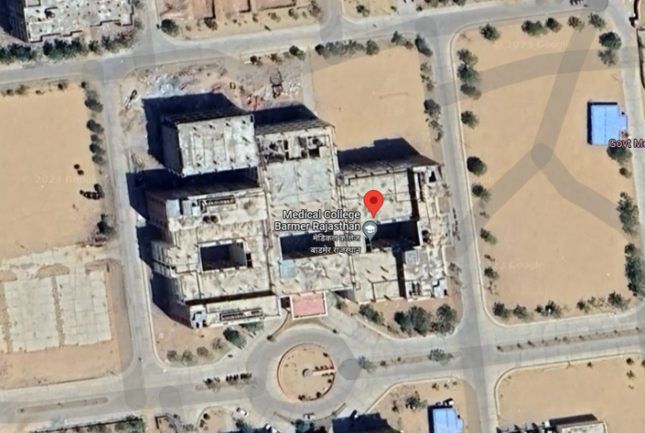  Govt Medical College, Barmer  25°49'38.0"N 71°24'02.8"E | 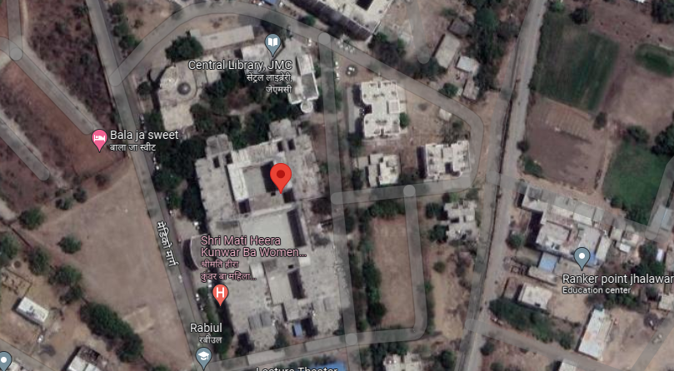  Shrimati Hira Kuwar Ba Mahila Hospital, Jhalwar  24°35'08.2"N 76°09'39.8"E

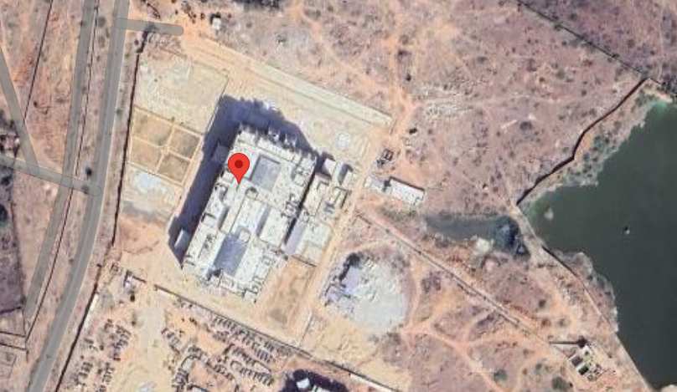  Govt Medical College, Dholpur  26°41'19.3"N 77°51'29.0"E | 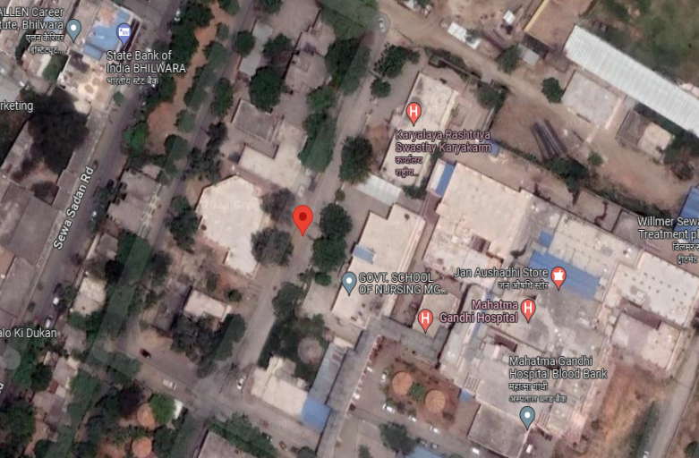  Pmo Mch Unit Mg Hospital, Bhilwara  25°20'53.2"N 74°38'27.7"E
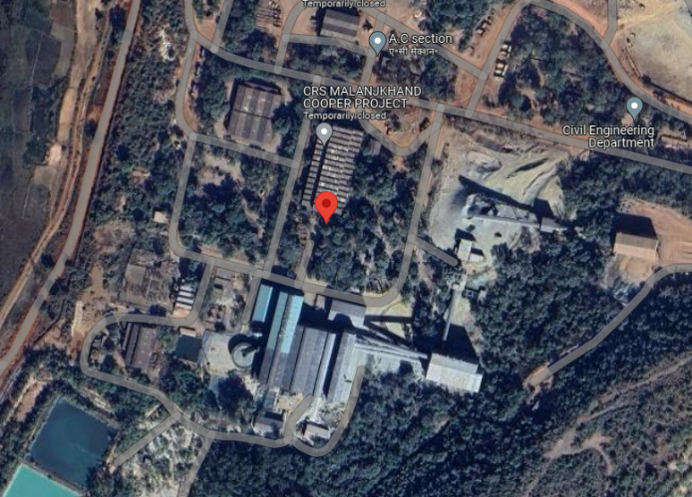
Hindustan Copper Limited, Malanjkhand
22°01'21.6"N 80°42'24.5"E

- CONSOLIDATED TECHNICAL PARAMETERS:
S. No. | Location | Specifications
 | No of Location | 15
 | Mounting Type | Fixed Tilt
 | PV Module Type | Mono-Crystalline
 | PV Module Make | Adani/Equivalent/Goldie
 | PV Module Rating | 335/535+Wp
 | Total No. of Modules* | 18,520 No’s
 | Inverter Type | String Inverter
 | Inverter Make | Sungrow/Growatt
 | Inverter Power | 125 kW & 100 KW 33 KWP & 50KW
 | Total no. of Inverters | 88 No’s
Source: Detailed Project Report
- SUMMARY OF PV POWER ENERGY YIELD AS PER PV SYST:
S. No. | Location | Specifications
 | First Year P50 Energy Yield (MWh/Annum) | 801.1 MWh/year
 | First Year P90 Energy Yield (MWh/Annum) | 782.5 MWh/year
Source: Detailed Project Report

PART D | ENERGY YIELD ASSESSMENT

Company has used PVSyst V7.3.4 to assess energy yield calculation which is the standard Industry practice. Compnay had shared only nos. of PVSyst Report 1 for Gurugram University, 1 for Hindustan Copper and 1 for all locations in Rajasthan. The yearly average of main results of irradiation and energy yield from the provided PVSyst is as under:
S. No. | Plant Location | Annual production probability (MWh) |  | Specific Production  (kWh/kWp/year) |  | Performance  Ratio (%)
 |  | P50 | P90 | As per PPA | As per PVsyst
1 | Gurugram University, Gurugram | 358.8 | 350.5 | 1,386 | 1,582 | 76.33
2 | Hindustan Copper Limited, Malanjkhand | 8201 | 8011 | --- | 1,640 | 81.71
3 | REIL-3 – India (Rajasthan 13 nos. of locations) | 7972 | 7761 | 1500 | 1670 | 83.25

Analysis of Irridiation & PV Output data: In respect to Irridiation & PV Output data, company has provided to us PVSyst report V7.3.4 in which key Irrdidation components and PV Output data is given as enumerated in table below. We have analysed and compared it with other data source points also such as Solar Resource by Global Solar Atlas of World Bank and ISRO Solar Calculator to confirm its legitimacy as mentioned in table below:
Particulars | Gurugram University, Gurugram |  | Hindustan Copper Limited, Malanjkhand |  | REIL-3 – India (Rajasthan 13 nos. of locations)
 | As per Global  Solar Atlas | As per PVSyst | As per Global  Solar Atlas | As per PVSyst | As per Global  Solar Atlas | As per PVSyst
Global horizontal Irradiation (kWh/m²) | 1,735.5 | 1,845 | 1904.0 | 1833.0 | 2002.2 | 1849.4
Diffuse horizontal Irradiation (kWh/m²) | 931.1 | 600.16 | 852.5 | 623.43 | 847.7 | 787.59
Direct Normal Irradiation (kWh/m²) | 1187.0 | - | 1546.3 | - | 1762.7 | -
Specific Photovoltaic Power Output | 1486.9 | - | 1598.6 | - | 1738.3 | -
Annual Global Insolation (ISRO Solar Calculator) (kWh/m2/year) | 1347 |  | 1686 |  | 1691

Observations and Remarks:
- As per the PVsyst - Simulation reports dated 15th September 2023, the estimated energy that can be produced by the subject plants and their respective performance ratio is almost similar as agreed in the PPA.
- As per comparative analysis, PVSyst Irrdiation and PV Output data is in line to our analysis from Global Solar Atlas of World Bank and ISRO Solar Calculator.
- As per the information provided by the management of the company, the estimated Plant Load Factor (CUF at P75) is 18.27%, 17.00% & 18.27% for REIL-3, Gurugram University & Hindustan Copper Limited respectively.

Monthly averages- Direct normal irradiation (kWh/m²)

- Gurugram University, Gurugram
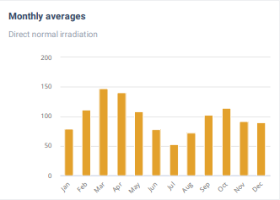
Source: Global Solar Atlas

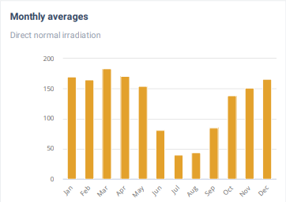
2. Hindustan Copper Limited, Malanjkhand
Source: Global Solar Atlas

3. REIL-3, Rajasthan
Source: Global Solar Atlas

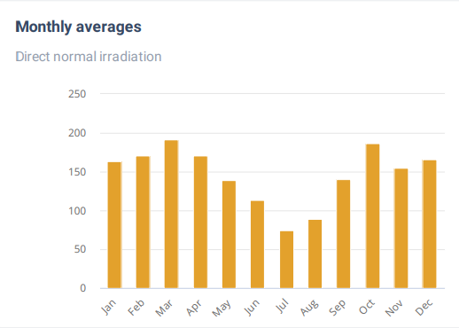

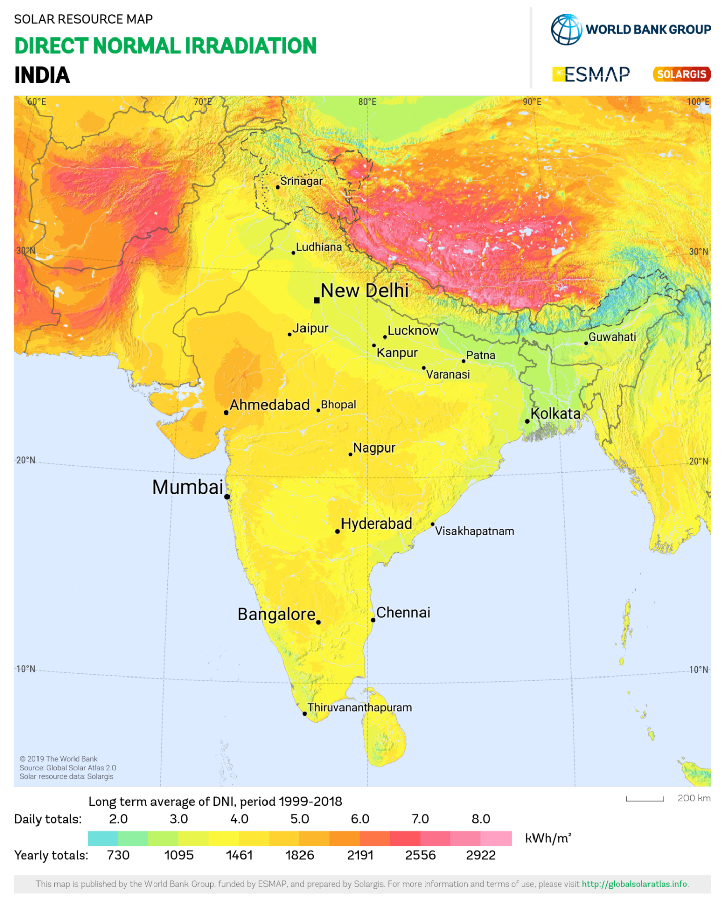
Gurugram University, Gurugram lies above 3.0 daily (1095 annually) Kwh/m².
Hindustan Copper Limited, M.P. lies above 4.0 daily (1461 annually) Kwh/m².
REIL-3, Rajasthan lies below 5.0 daily (1826 annually) Kwh/m².
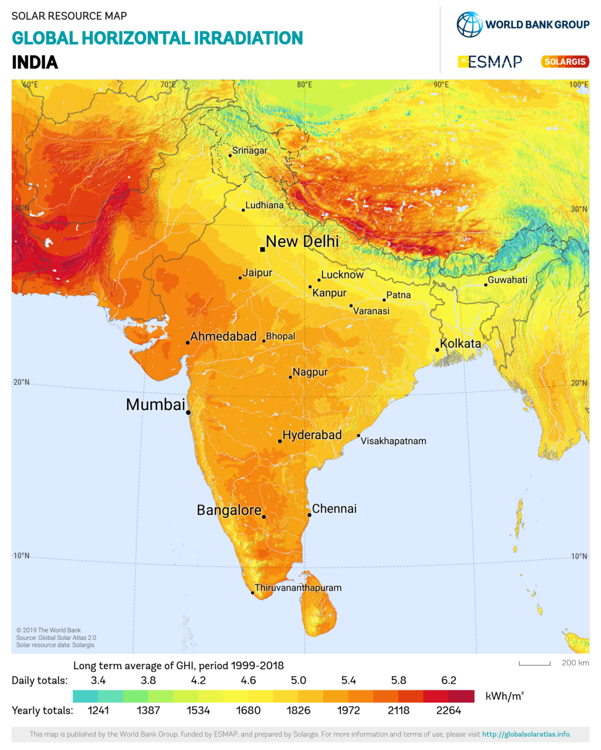
Gurugram University, Gurugram lies below 5.0 daily (1826 annually) Kwh/m2.
Hindustan Copper Limited, M.P. lies above 5.0 daily (1826 annually) Kwh/m2.
REIL-3, Rajasthan lies above 5.0 daily (1826 annually) Kwh/m2.

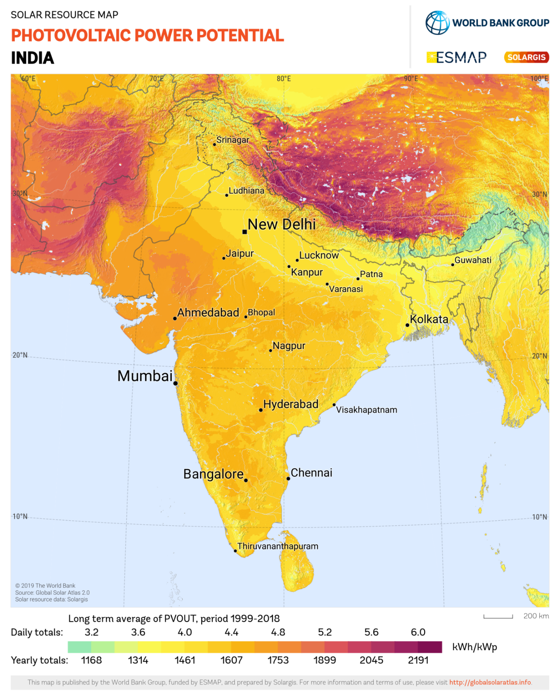
Gurugram University, Gurugram lies above 3.6 daily (1314 annually) Kwh/m2.
Hindustan Copper Limited, M.P. lies above 4.0 daily (1461 annually) Kwh/m2.
REIL-3, Rajasthan lies below 4.8 daily (1753 annually) Kwh/m2.

PART E | POWER PURCHASE AGREEMENT TERMS

As per the information provided by the company, the total proposed capacity of the subject roof-top solar power plant is 10 MWp (± 10%). As on date, company has signed 15 no. of PPAs to install the power plant and supply power at both the project sites. Details of the same are tabulated below:
S. No. | Offtaker | DC Capacity  (kWp) | Tariff  (Rs./kWh) | PPA Date
1 | Govt Medical College - Chittorgarh | 399.6 | 4.05 | 29-04-2023
2 | Govt Medical College - Dungarpur | 399.6 | 4.05 | 12-05-2023
3 | Gurugram University - Ggn | 226.8 | 4.33 | 07-03-2023
4 | Jhalwar Hospital And Medical Colledge - Jhalwar | 604.8 | 4.05 | 01-05-2023
5 | Govt Mahila Evam Bal Chikitsalya - Chittorgarh | 97.2 | 4.05 | 19-04-2023
6 | Paschimi Rajasthan Dugdh Utpadak Sahkari Sang Limited - Jodhpur | 604.8 | 4.05 | 17-04-2023
7 | Shree Haridev Joshi General Hospital - Dungarpur | 486 | 4.05 | 01-05-2023
8 | Shree Sanwaliya Ji Government General Hospital - Chittorgarh | 183.6 | 4.05 | 19-04-2023
9 | Ravinder Nath Tagore Govt Medical College - Udaipur | 194.4 | 4.05 | 28-04-2023
10 | Maharan Bhupal Govt Hospital - Udaipur | 194.4 | 4.05 | 09-08-2023
11 | Govt Medical College - Barmer | 604.8 | 4.05 | 28-07-2023
12 | Shrimati Hira Kuwar Ba Mahila Hospital - Jhalwar | 205.2 | 4.05 | 01-05-2023
13 | Govt Medical College - Dholpur | 604.8 | 4.05 | 28-07-2023
14 | Pmo Mch Unit Mg Hospital - Bhilwara | 194.4 | 4.05 | 07-05-2023
15 | Hindustan Copper Limited - Malanjkhand | 5000 | 3.87 | 02-02-2021
Total |  | 10000.4
Source: PPAs

Important Clauses: All PPA’s are signed for a period of 25 years with fixed tariff as stated above. Some of the important clauses from the signed PPAs are as follows:-
Clause-3: Terms and Termination
  - Term
Gurugram University, Gurugram | The term of the Agreement shall commence on the Effective Date and shall continue for twenty- five (25) years from the start of the financial year starting immediately after Commercial Operation Date (the "Term"), unless and until terminated earlier pursuant to the provisions of the Agreement. (i.e. if Commercial Operation Date is any date between 01.04.2022 and 31.03.2023, then the 25- year term shall continue till 31.03.2048. After the term, the ownership of the system shall be transferred to the purchaser free of cost. Solar power project construction time shall not be part of commercial operation, PPA is valid of 25 years of commercial operation.
Hindustan Copper Limited, M. P. | The term of the Agreement shall commence on the Effective Date and shall continue for Twenty Five (25) years from the Commercial Operation Date (the "Term"), unless and until terminated earlier pursuant to the provisions of the Agreement. After the Term, the ownership of the System shall be transferred to the Purchaser at free of cost.
REIL-3, Rajasthan | The term of the Agreement shall commence on the Effective Date and shall continue for twenty-five (25) years from the start of the financial year starting immediately after Commercial Operation Date (the "Term"), unless and until terminated earlier pursuant to the provisions of the Agreement. i.e., if Commercial Operation Date is any date between 01.04.2023 and 31.03.2024, then the 25-year term shall continue till 31.03.2048. After the Term, the ownership of the System shall be transferred to the Purchaser free of cost at the discretion of Power Purchaser.

  - Purchase Option/Purchase Obligation
Gurugram University, Gurugram | Purchase Option/Purchase Obligation  So long as a Purchaser default shall not have occurred and be continuing, Purchaser has -the option to purchase the System by paying the Power Producer the Purchase price as per Schedule III to this Agreement. To exercise its purchase option, the Purchaser shall not less than Ninety (90) days prior to the proposed Purchase Date, provide written notice to the Power Producer, of Purchaser's intent to exercise its option to purchase the System on such purchase date. In the event Purchaser confirms its intention to exercise the purchase option in writing to the Power Producer, (i) Purchaser shall pay the applicable Purchase Price and any other unpaid dues that have accrued under this agreement to the Power Producer on the Purchase Date, and such payment shall be made in accordance with any written instructions Le. NEFT/RTGS delivered to Purchaser by the Power Producer for payments under the Agreement, and (ii) the Parties shall promptly execute all documents necessary to cause title to the System to pass to Purchaser on the Purchase Date, free and clear of all liens. Upon execution of the documents and payment of the applicable purchase price in each case as described in the preceding sentence, the agreement shall terminate automatically and the Purchaser shall become the owner of the System. Upon such termination, the power producer shall offer’ its operations and maintenance (“O&M”) services to the purchaser and the parties may enter into a O&M agreement in this regard. The terms and conditions of O&M agreement will be negotiated as good faith between the parties.
Hindustan Copper Limited, M. P. | Purchase Option/Purchase Obligation  So long as a Purchaser default shall not have occurred and be continuing, Purchaser has -the option to purchase the System by paying the Power Producer the Purchase price as per Schedule III to this Agreement. To exercise its purchase option, the Purchaser shall not less than Ninety (90) days prior to the proposed Purchase Date, provide written notice to the Power Producer, of Purchaser's intent to exercise its option to purchase the System on such purchase date. In the event Purchaser confirms its intention to exercise the purchase option in writing to the Power Producer, (i) Purchaser shall pay the applicable Purchase Price and any other unpaid dues that have accrued under this agreement to the Power Producer on the Purchase Date, and such payment shall be made in accordance with any written instructions Le. NEFT/RTGS delivered to Purchaser by the Power Producer for payments under the Agreement, and (ii) the Parties shall promptly execute all documents necessary to cause title to the System to pass to Purchaser on the Purchase Date, free and clear of all liens. Upon execution of the documents and payment of the applicable purchase price in each case as described in the preceding sentence, the agreement shall terminate automatically and the Purchaser shall become the owner of the System. Upon such termination, the power producer shall offer’ its operations and maintenance (“O&M”) services to the purchaser and the parties may enter into a O&M agreement in this regard. The terms and conditions of O&M agreement will be negotiated as good faith between the parties.
REIL-3, Rajasthan | Purchase Option/Purchase Obligation  So long as a Purchaser default shall not have occurred and be continuing, Purchaser has -the option to purchase the System by paying the Power Producer the Purchase price as per Schedule III to this Agreement. To exercise its purchase option, the Purchaser shall not less than Ninety (90) days prior to the proposed Purchase Date, provide written notice to the Power Producer, of Purchaser's intent to exercise its option to purchase the System on such purchase date. In the event Purchaser confirms its intention to exercise the purchase option in writing to the Power Producer, (i) Purchaser shall pay the applicable Purchase Price to the Power Producer on the Purchase Date, and such payment shall be made in accordance with any written instructions delivered to Purchaser by the Power Producer for payments under the Agreement, and (ii) the Parties shall promptly execute all documents necessary to (A) cause title to the System to pass to Purchaser on the Purchase Date, free and clear of all liens and (B) assign all vendor warranties for the System to Purchaser. Upon execution of the documents and payment of the applicable purchase price in each case as described in the preceding sentence, the agreement shall terminate automatically, and the Purchaser shall become the owner of the System. Upon such termination, the Power Producer shall offer its operations and maintenance ("O&M") services to the Purchaser and the Parties may enter into an O&M agreement in this regard. The terms and conditions of the O&M agreement will be negotiated in good faith between the parties.

3.3 Condition of the agreement prior to installation
Gurugram University, Gurugram | Condition of the agreement prior to installation  In the event that any of the following events or circumtances occur prior to thr commercial operation date, the Power producer may terminate the Agreeement, in which case neither party shall have any liability to the other except for any such liabilities that may have occurred prior to such termination.  (a) There has been a material adverse change in the rights of purchaser to occupy the premises or the power producer to install the system at the premises.  (b) The power producer has determined that there are easements, Capacity Cost Recovery (CCRs) or other liens or encrumbrances that would materially impaired or prevent the installation, operation , maintenance or removal of the system. If any dispute arises before commercial operation date, the same shall be resolved under the clause, 17.7 (c)
Hindustan Copper Limited, M. P. | Condition of the agreement prior to installation  In the event that any of the following events or circumtances occur prior to thr commercial operation date, the Power producer may terminate the Agreeement, in which case neither party shall have any liability to the other except for any such liabilities that may have occurred prior to such termination.  (a) There has been a material adverse change in the rights of purchaser to occupy the premises or the power producer to install the system at the premises.  (b) The power producer has determined that there are easements, Capacity Cost Recovery (CCRs) or other liens or encrumbrances that would materially impaired or prevent the installation, operation , maintenance or removal of the system. If any dispute arises before commercial operation date, the same shall be resolved under the clause, 17.7 (c)
REIL-3, Rajasthan | Condition of the agreement prior to installation  In the event that any of the following events or circumtances occur prior to thr commercial operation date, the Power producer may terminate the Agreeement, in which case neither party shall have any liability to the other except for any such liabilities that may have occurred prior to such termination.  (a) There has been a material adverse change in the rights of purchaser to occupy the premises or the power producer to install the system at the premises.  (b) The power producer has determined that there are easements, Capacity Cost Recovery (CCRs) or other liens or encrumbrances that would materially impaired or prevent the installation, operation , maintenance or removal of the system. If any dispute arises before commercial operation date, the same shall be resolved under the clause, 17.7 (c)

  - Installation Work
Gurugram University, Gurugram | - The Power Producer will cause the Project to be designed, manufactured, supplied, engineered, erected, tested and commissioned, operated & maintained and constructed substantially in accordance with REIL RFS No REIL/BID/RTS(C)/2019-20/001 DATED 04.10.2019 and the sanction letter issued by REIL. The Power Producer shall provide to the Purchaser a bill of materials listing the major equipment constituting the System. Such a bill of materials shall be provided within 30 days of the Commercial Operation Date.
Hindustan Copper Limited, M. P. | - The Power Producer will cause the Project to be designed, manufactured, supplied, engineered, erected, tested and commissioned, operated & maintained and constructed substantially in accordance with REIL RFS No REIL/BID/RTS(C)/2019-20/001 DATED 04.10.2019 and the sanction letter issued by REIL. The Power Producer shall provide to the Purchaser a bill of materials listing the major equipment constituting the System. Such a bill of materials shall be provided within 30 days of the Commercial Operation Date.
REIL-3, Rajasthan | - The Power Producer will cause the Project to be designed, manufactured, supplied, engineered, erected, tested and commissioned, operated & maintained and constructed substantially in accordance with REIL RFS No REIL/BID/RTS(C)/2019-20/001 DATED 04.10.2019 and the sanction letter issued by REIL. The Power Producer shall provide to the Purchaser a bill of materials listing the major equipment constituting the System. Such a bill of materials shall be provided within 30 days of the Commercial Operation Date.

  - Tariff and Payment
Gurugram University, Gurugram | Consideration Purchaser shall pay to the Power Producer a monthly payment (the "Solar Power Payment") for the Solar Power generated by the System as per the Metering clause 5.2 (b) above during each calendar month of the Term equal to the actual Monthly Production as recorded in Joint Meter Reading Report for the System for the relevant month multiplied by the Tariff irrespective of (i) whether any or all units of Solar Power has been drawn, consumed or utilized by Purchaser and / or (ii) whether any Solar Power has been injected, whether inadvertently or otherwise, into the grid of the Distribution Utility. The Power Producer will bill the Purchaser for each KWh metered as above at the Delivery Point, at the Tariff prevailing at that point of time as detailed in Schedule - II, the Tarifl will be equal to Rs.4.33 /kWh levelized tariff as per REIL allocations. The 'year' considered shall be the financial year which April 1st to 31st March of every year as per REIL. Schedule II provides a detailed year on year tariff schedule.
Hindustan Copper Limited, M. P. | Consideration Purchaser shall pay to the Power Producer a monthly payment (the "Solar Power Payment") for the Solar Power generated by the System as per the Metering clause 5.2 (b) above during each calendar month of the Term equal to the actual Monthly Production as recorded in Joint Meter Reading Report for the System for the relevant month multiplied by the Tariff irrespective of (i) whether any or all units of Solar Power has been drawn, consumed or utilized by Purchaser and / or (ii) whether any Solar Power has been injected, whether inadvertently or otherwise, into the grid of the Distribution Utility. The Power Producer will bill the Purchaser for each KWh metered as above at the Delivery Point, at the Tariff prevailing at that point of time as detailed in Schedule - II, the Tarifl will be equal to Rs.3.87 /kWh + GST levelized tariff as per REIL allocations and MOM dt. 15-01-2021. The 'year' considered shall be the financial year which April 1st to 31st March of every year as per REIL. Schedule II provides a detailed year on year tariff schedule.
REIL-3, Rajasthan | Consideration Purchaser shall pay to the Power Producer a monthly payment (the "Solar Power Payment") for the Solar Power generated by the System as per the Metering clause 5.2 (b) above during each calendar month of the Term equal to the actual Monthly Production as recorded in Joint Meter Reading Report for the System for the relevant month multiplied by the Tariff irrespective of (i) whether any or all units of Solar Power has been drawn, consumed or utilized by Purchaser and / or (ii) whether any Solar Power has been injected, whether inadvertently or otherwise, into the grid of the Distribution Utility. The Power Producer will bill the Purchaser for each KWh metered as above at the Delivery Point, at the Tariff prevailing at that point of time as detailed in Schedule - II, the Tarifl will be equal to Rs.4.05 /kWh levelized tariff as per REIL allocations. The 'year' considered shall be the financial year which April 1st to 31st March of every year as per REIL. Schedule II provides a detailed year on year tariff schedule.
Please note that the above main clauses of PPA are mentioned only for illustration purpose of the convenience of the lenders to analyze the Project in terms of technicality. However, this shall not be construed as professional opinion on the contract legality which is out of scope of this report.

PART F | CURRENT STATUS OF WORK

As per information and documents shared by the company’s representative, following are our observations and remarks on the current status of the project:
- As per the verbal information received from the management of the subject company, installation work is yet to be started.
- As per information shared by the company officials, the proposed COD of the entire project is scheduled in the month of January 2024 to March 2024 as the technical work for mounting of PV panels is started at the project locations.

PART G | PROJECT COST & EXPENDITURE

- PROJECT COST: Project cost has been taken from the Copy of Detailed Project Report from M/s TRURE SPV Pvt. Ltd. for the installation of Roof Mounted Grid Tie Solar PV plant located at Haryana, Rajasthan & Madhya Pradesh. The terms of engagement are tabulated below:
S. No. | Description | Amount (in Cr.)  (Including duties and taxes)
1 | EPC Coost + GST | Rs. 44.50
2 | Channel Partner Fee | Rs. 4.72
3 | Pre-Operational Expenses | Rs. 0.50
4 | Lander Charges | Rs. 0.51
5 | IDC | Rs. 3.88
6 | DSRA | Rs. 1.62
Total |  | Rs. 55.73
Observations and Remarks:
- Project cost calculated on the basis of the Benchmark Cost provided by the MNRE has been tabulated below:
S. No. | Particulars | Benchmark Cost  (In Rs./kW) | Project Capacity  (In MW) | Total Project Cost  (Excluding GST)  (In Rs.) | Total Project Cost  (Including ~14% GST)  (In Rs.)
1 | As per Ministry of New & Renewable Energy | 35,886* | 10,000 | 35,88,60,000 | 40,91,00,400
 |  |  | 10 MWp |  | Rs. 40.91 Cr.
*Benchmark cost for 2021-22

- Project cost calculated on the basis of market comparable:
S. No. | Particulars | Excluding GST | Including GST | Remark
 |  | Per KW Cost  (In Rs.) | Per KW Cost  (In Rs.)
1 | Subject project installation cost | - | 44,500 | as per Detailed Peoject Cost
Market Research Details
2 | MNRE Benchmark Cost | 35,886 | - | Refer Annexure-1
 | Market Research
3 | Quotation-1 | 48,700 | 55,400 | Refer Annexure-2
4 | Quotation-2 | 37,740 | 42,500
5 | Quotation-3 | 45,000 | 51,200
6 | Quotation-4 (Tata Solar) | 60,000 | 68,300

- As per our analysis and market research, the installation cost of Rooftop Mounted Solar Power Plant varies from Rs. 45,500/- per KW to Rs. 68,300/- per KW. For the smaller setups the price is higher and for large set-up, price is less.
- The project cost is solely depends upon the project location, contractors profit, type of module and its supporting structures, etc.
- Based upon the above mentioned details, the project cost amounting to Rs. 55.73 Cr. inclusive of GST and other cost for the installation of subject Solar Power Plant seems to be reasonable.
- As per the verbal information received from the management of the subject company, installation work is yet to be started.
Note:
- Project cost is analyzed based on lump sum cost only and not item wise.
- Project cost is assessed for the date of this report only and due to price fluctuations it may vary from time to time.

- EXPENDITURE: As per information/details shared by the company, the installation work related to power plant is yet to start. Thus, the expenditure incurred till date on the project is NIL.

PART H | PHOTOGRAPHS

Since the installation work related to solar panels is yet to start and this is just a Desktop LIE based upon documents provided. Thus, Photographs are not available.

PART I | OTHER DOCUMENTS & REFERENCES

Annexure-1: Benchmark Cost by MNRE:
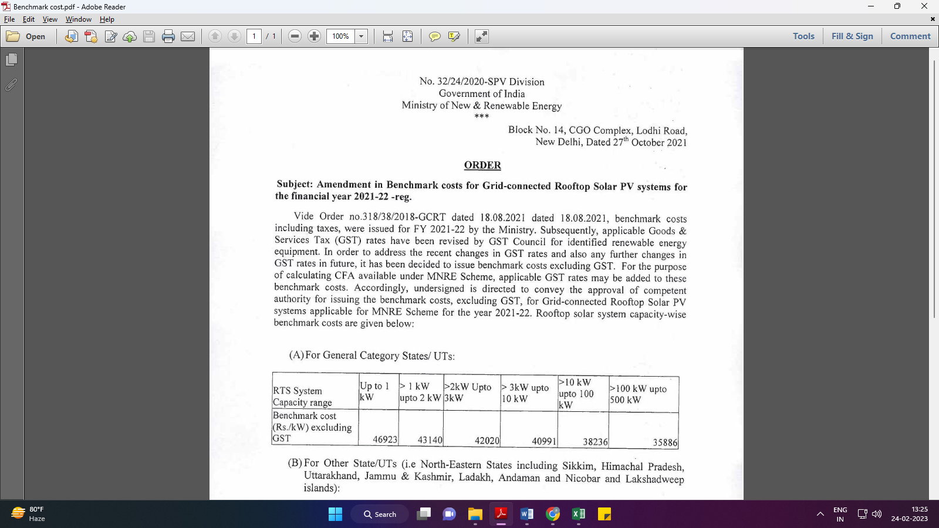
Market Comparables:
Annexure-2
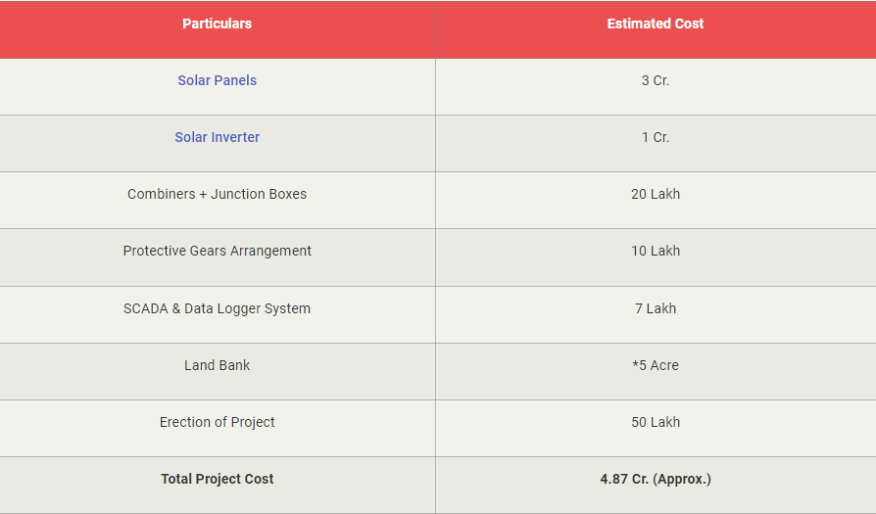

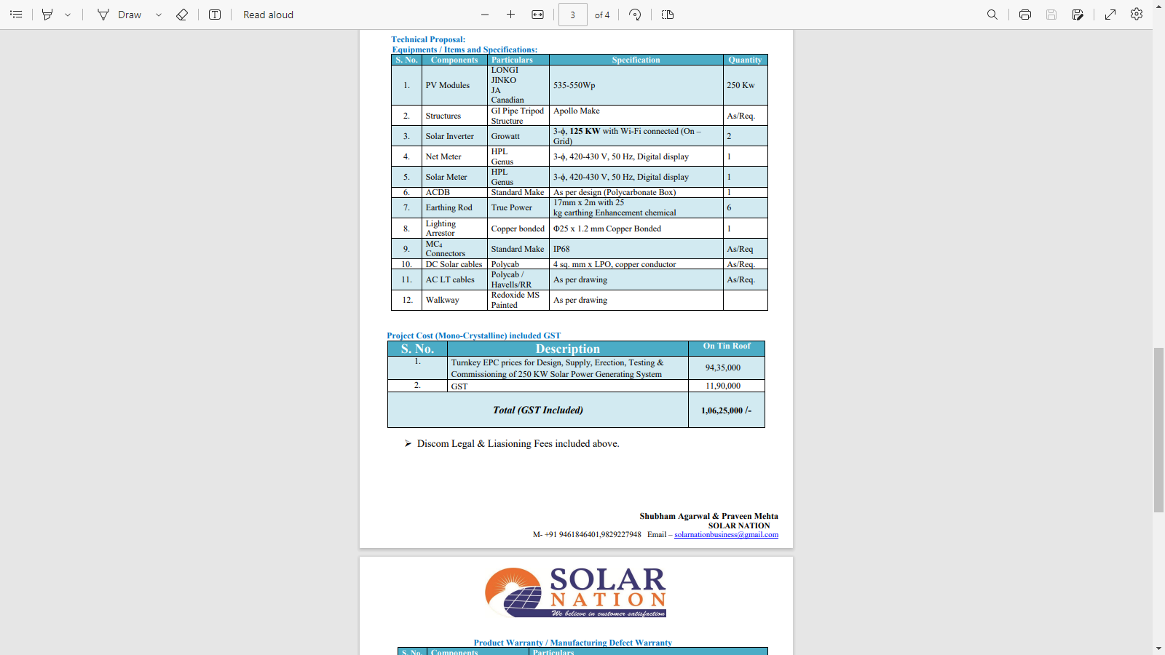

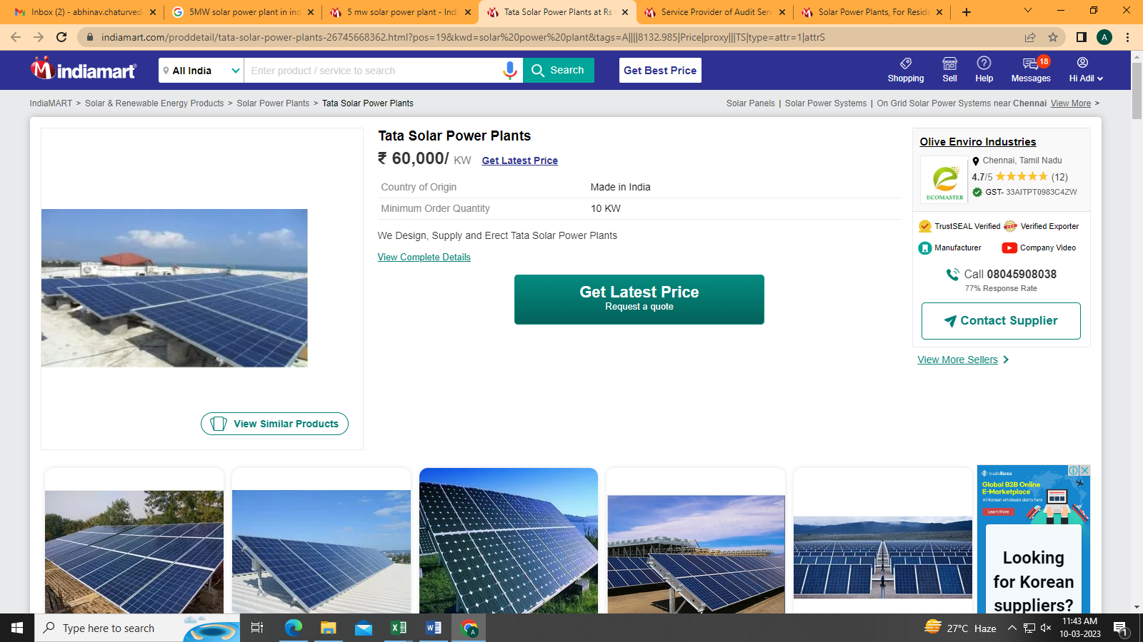
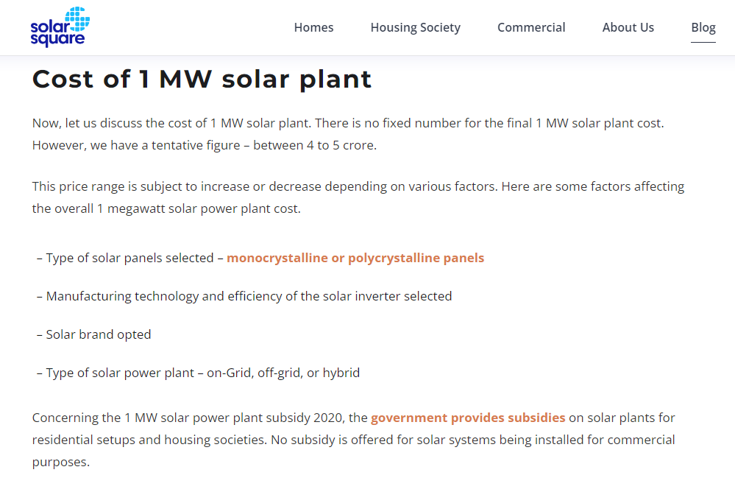

Data by Global Solar Atlas by World Bank Group
- Gurugram University, Gurugram
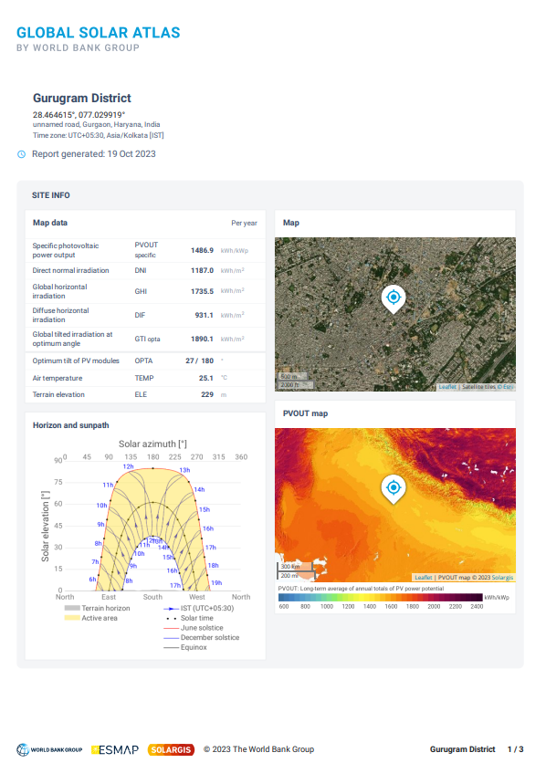
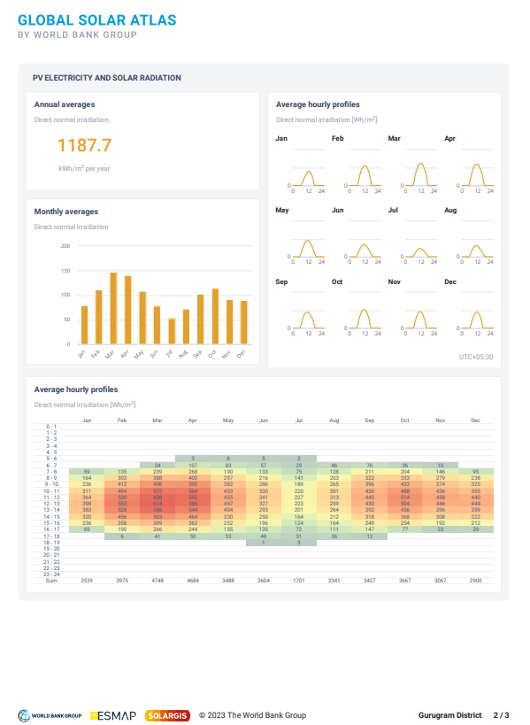
2. Hindustan Copper Limited, Malanjkhand, M.P.
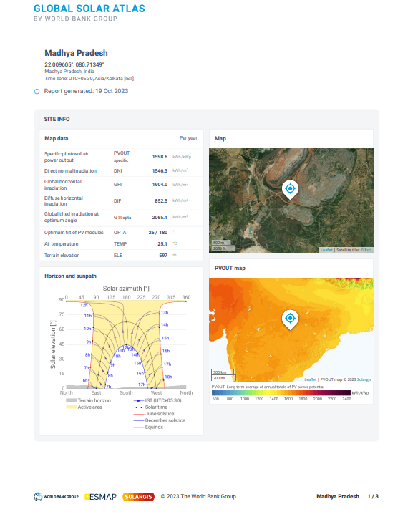

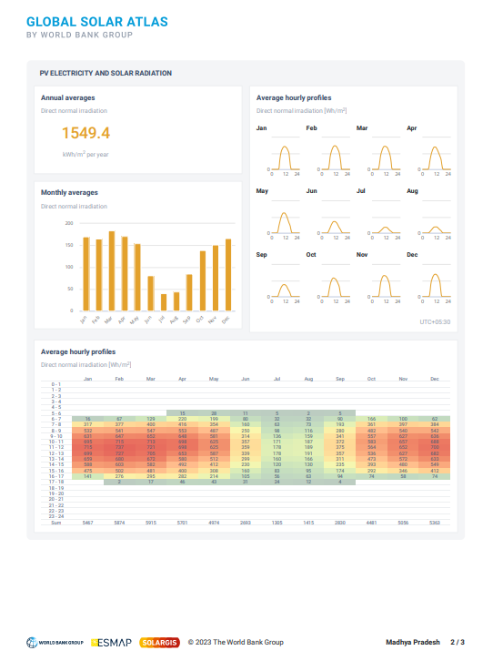

- REIL-3, Rajasthan
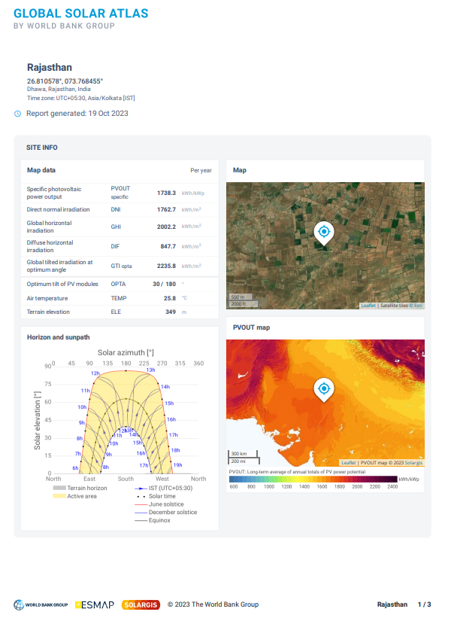

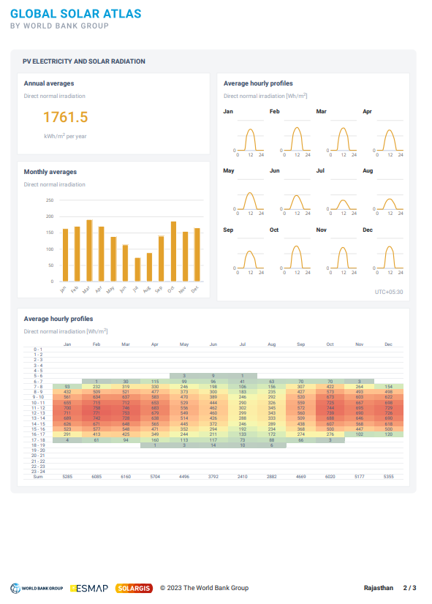

Layout Plans
- Gurugram University, Gurugram
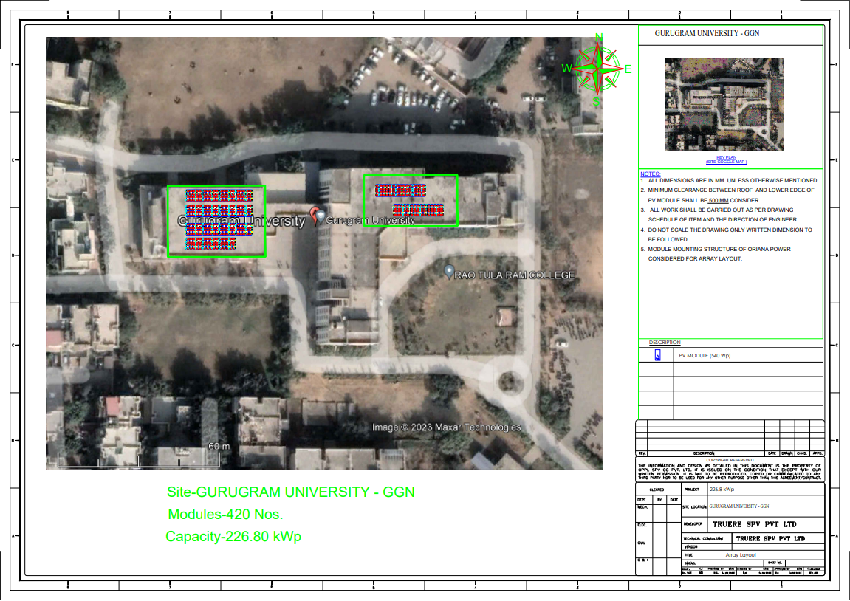
2. Hindustan Copper Limited, Malanjkhand, M.P.

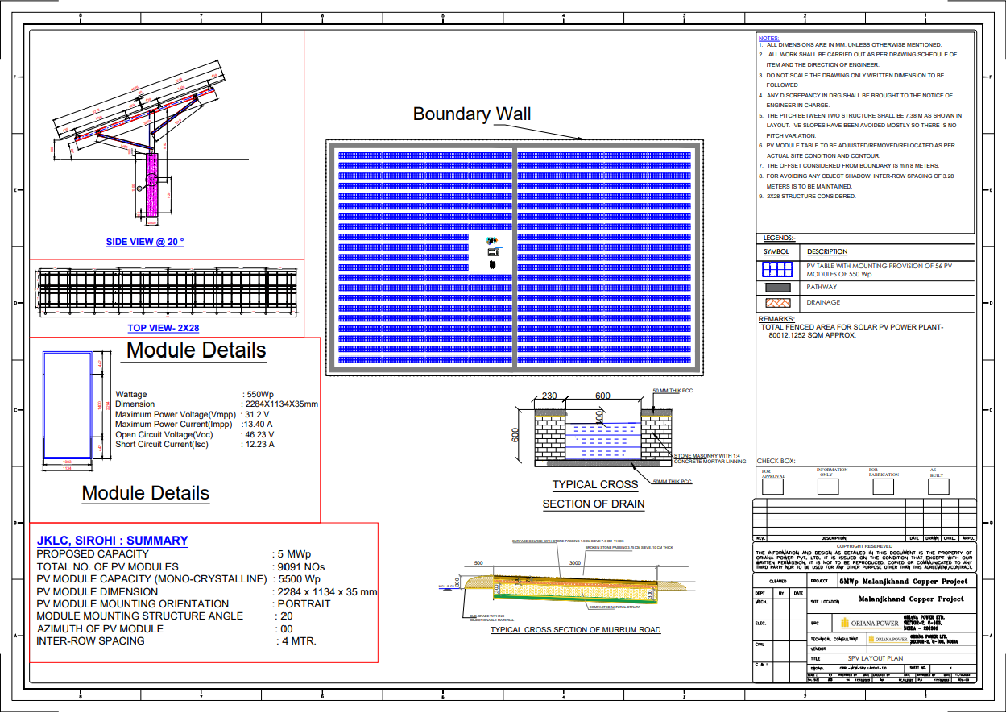
3. GOVT MEDICAL COLLEGE - CHITTORGARH

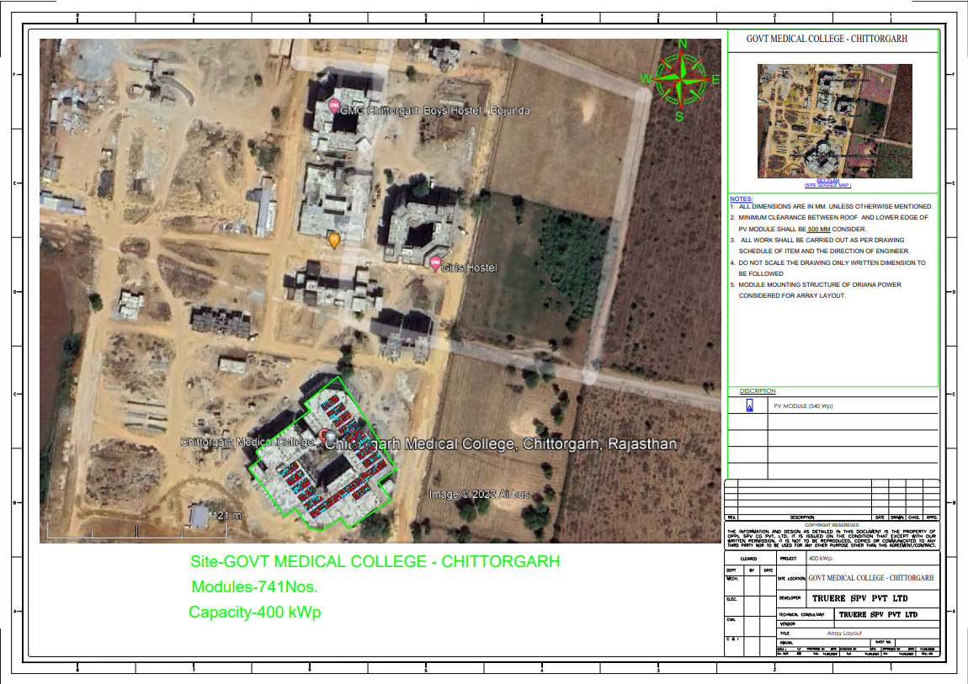

4. GOVT MEDICAL COLLEGE – DUNGARPUR

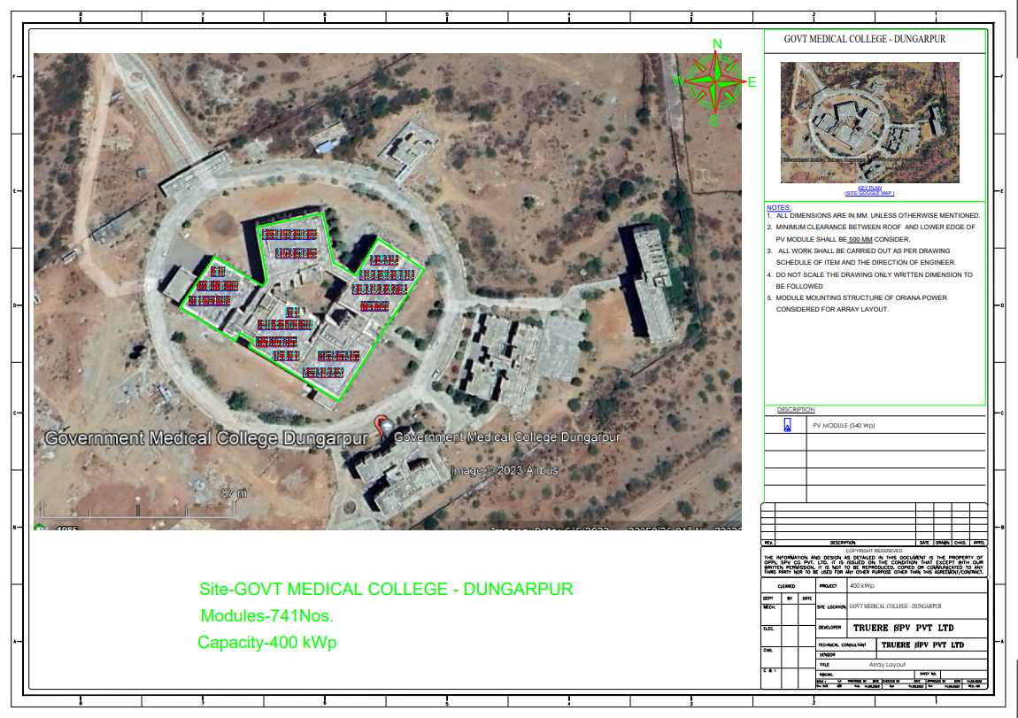
5. JHALWAR HOSPITAL AND MEDICAL COLLEDGE – JHALWAR

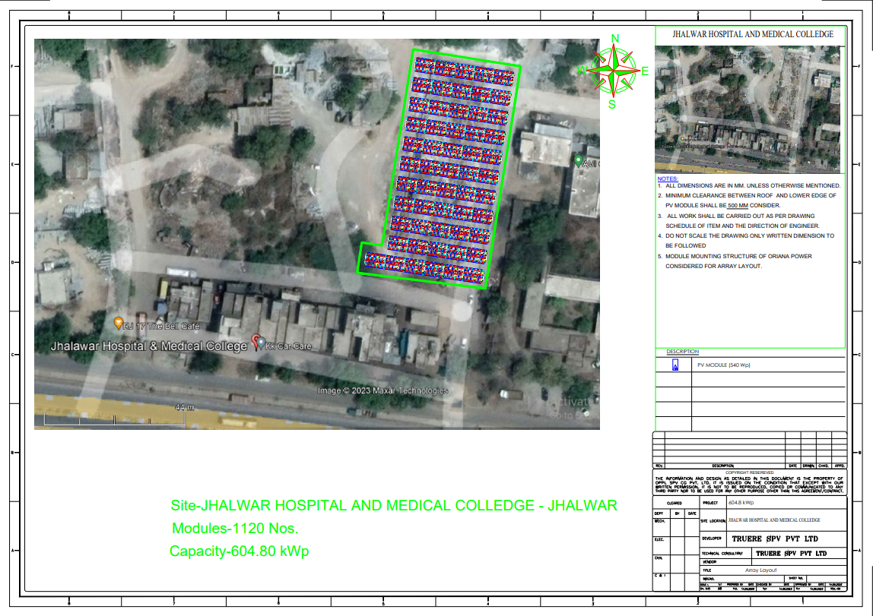

6. GOVT MAHILA EVAM BAL CHIKITSALYA - CHITTORGARH

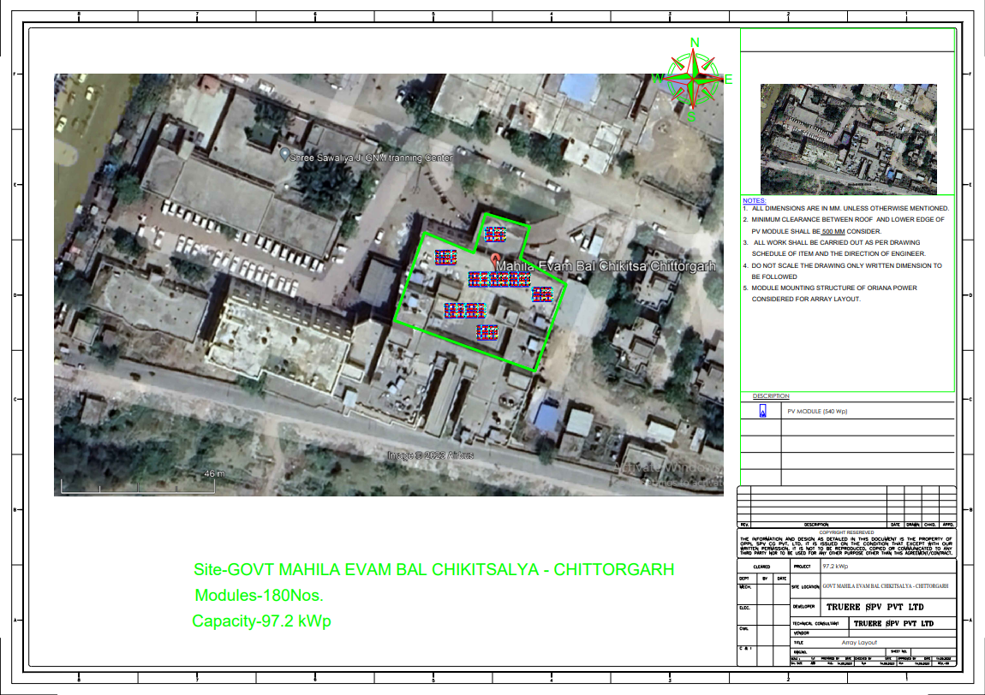
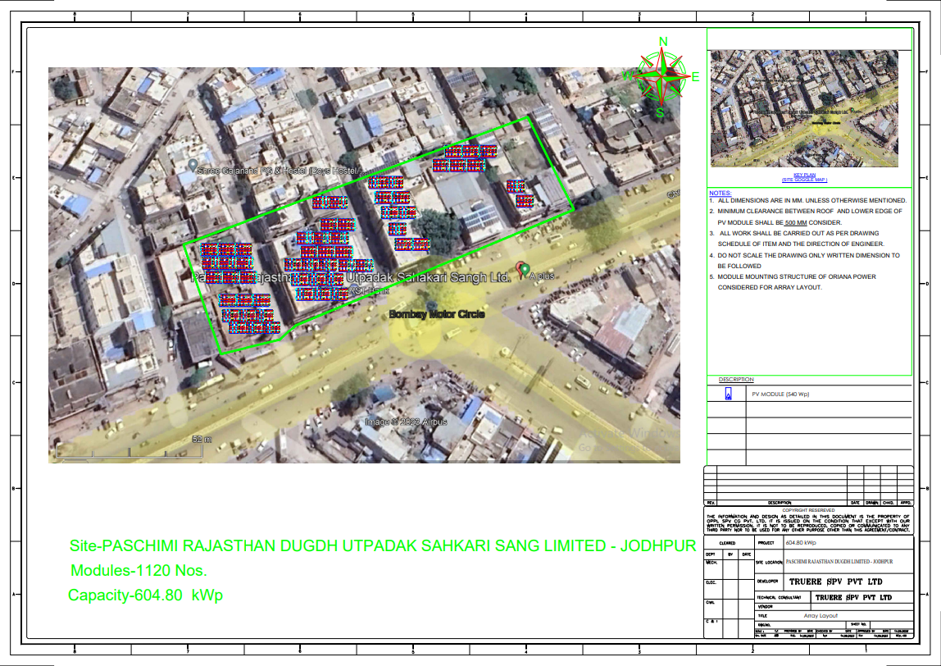
7. PASCHIMI RAJASTHAN DUGDH UTPADAK SAHKARI SANG LIMITED – JODHPUR

8. SHREE HARIDEV JOSHI GENERAL HOSPITAL – DUNGARPUR
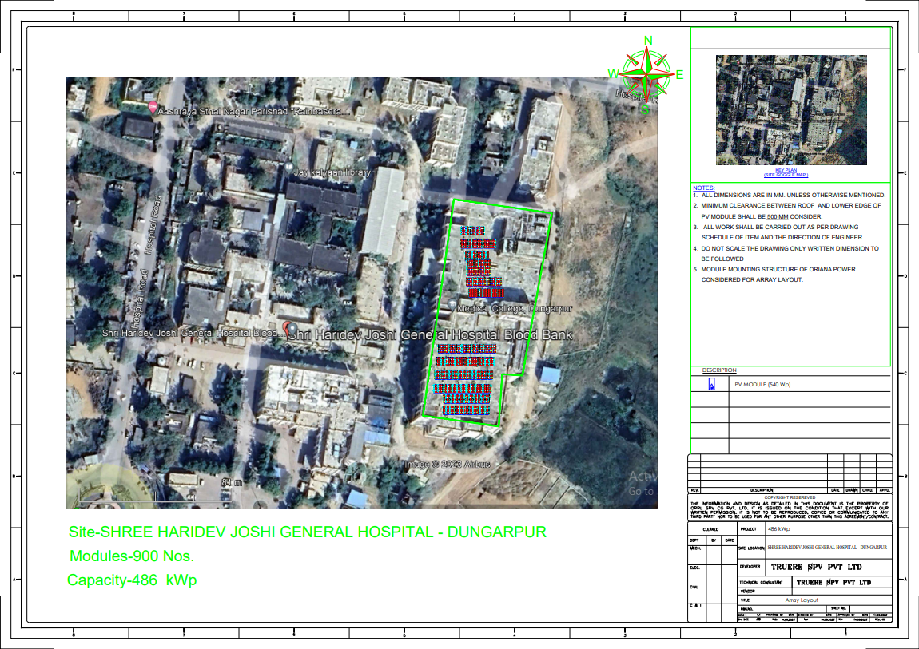
9. SHREE SANWALIYA JI GOVERNMENT GENERAL HOSPITAL - CHITTORGARH

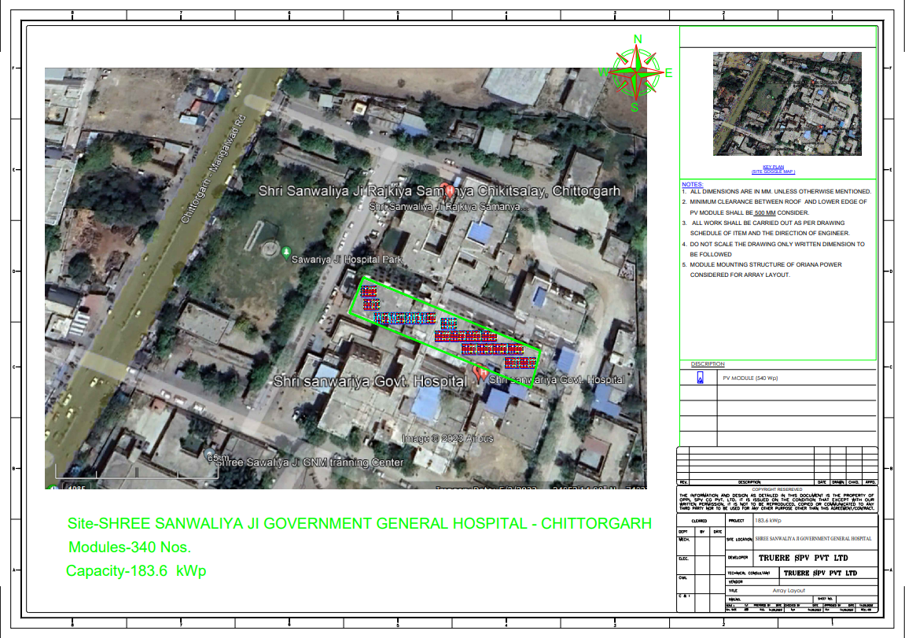

10. RAVINDER NATH TAGORE GOVT MEDICAL COLLEGE – UDAIPUR

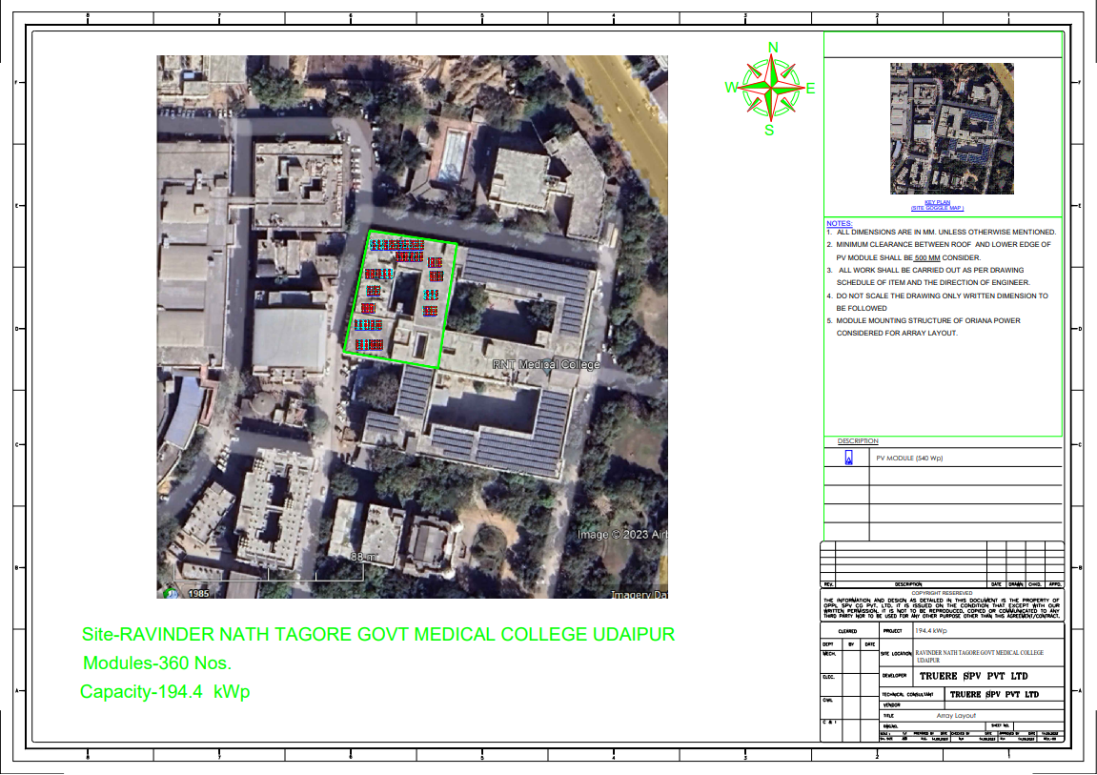

11. MAHARANA BHUPAL GOVT HOSPITAL - UDAIPUR

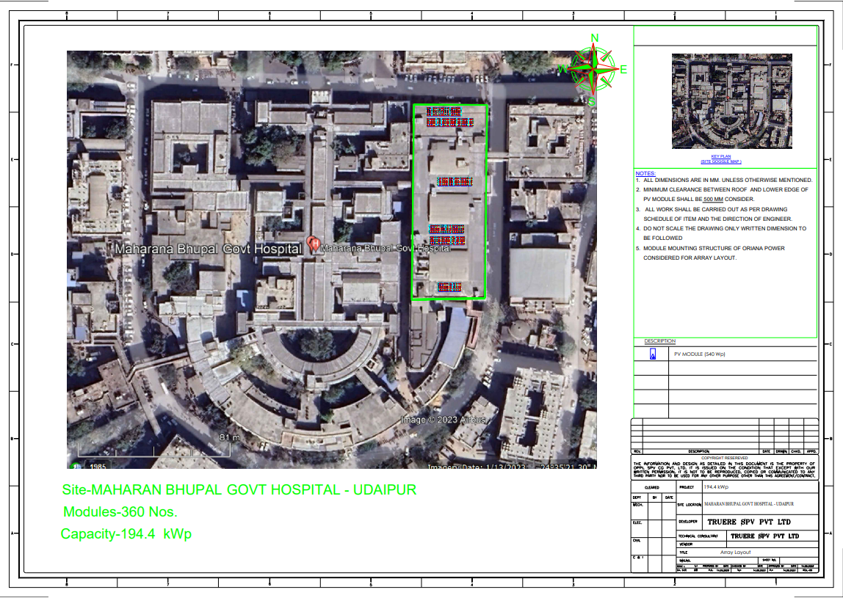

12. GOVT MEDICAL COLLEGE - BARMER

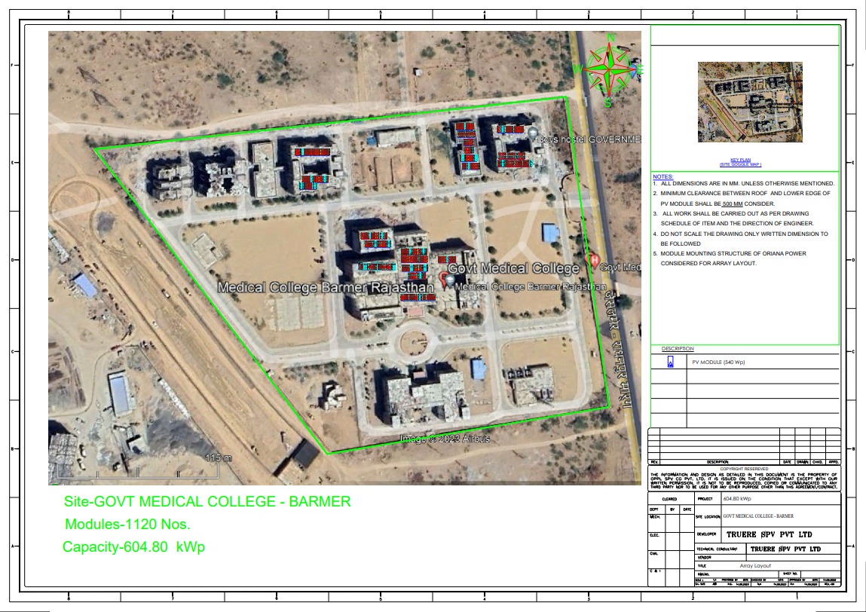
13. SHRIMATI HIRA KUWAR BA MAHILA HOSPITAL – JHALWAR

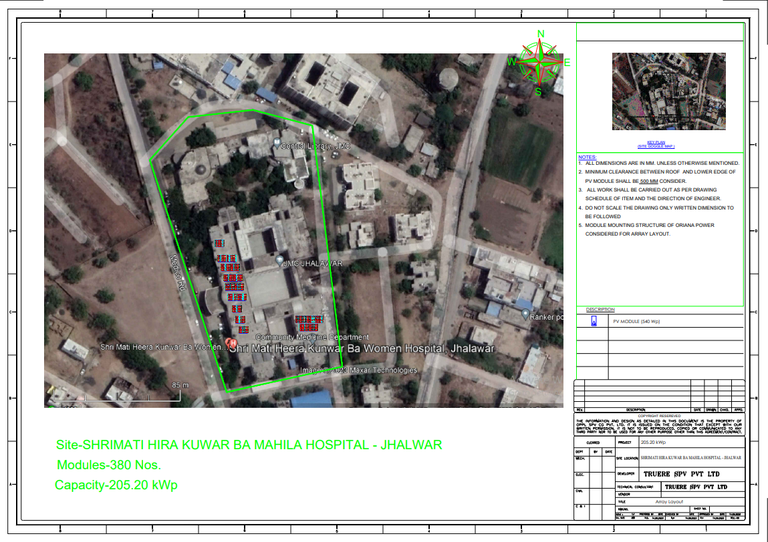

14. GOVT MEDICAL COLLEGE - DHOLPUR

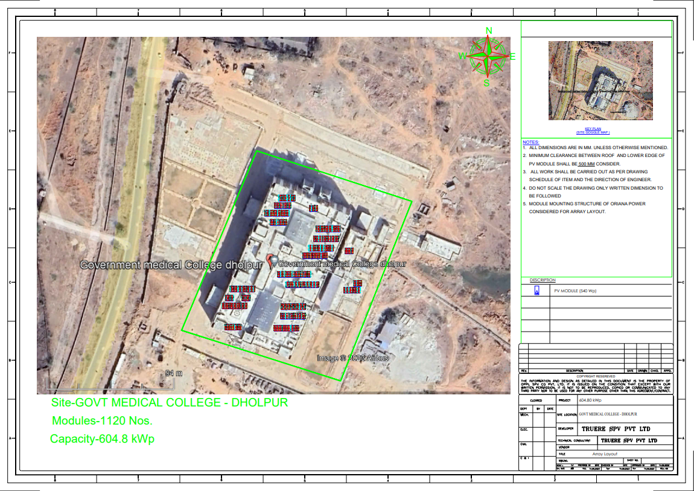
15. PMO MCH UNIT MG HOSPITAL - BHILWARA

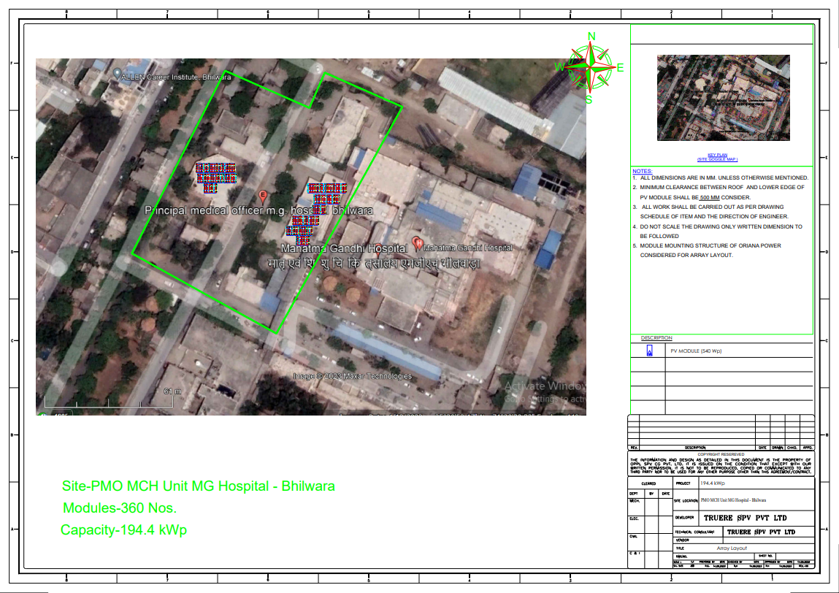

Power Purchase Agreement

1. GOVT MEDICAL COLLEGE - CHITTORGARH
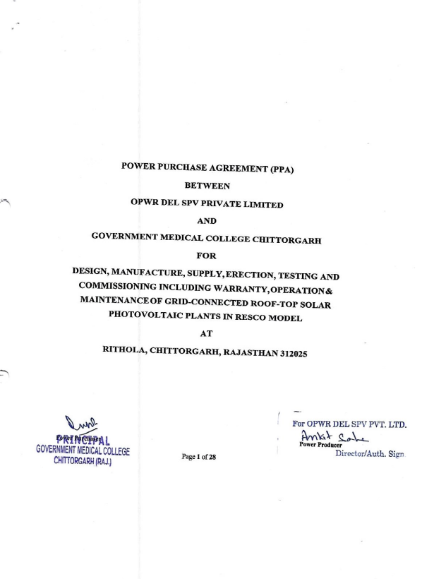

2. GOVT MEDICAL COLLEGE – DUNGARPUR
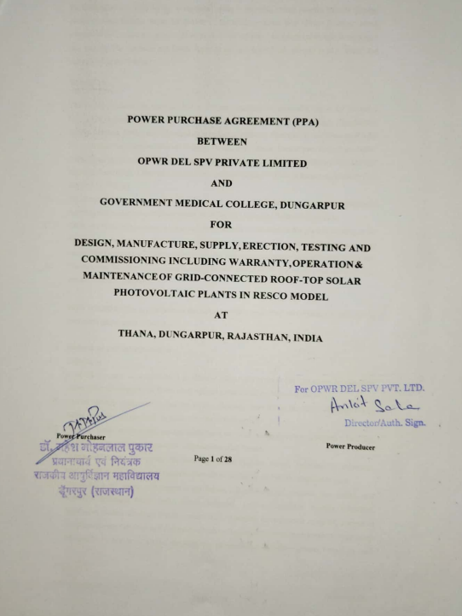

3. GURUGRAM UNIVERSITY - GURUGRAM
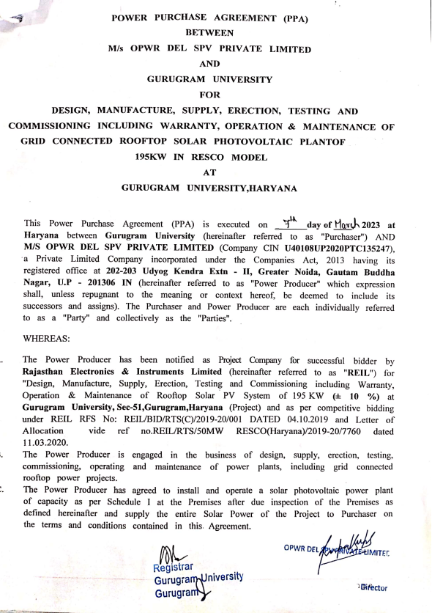

4. JHALWAR HOSPITAL AND MEDICAL COLLEDGE - JHALWAR
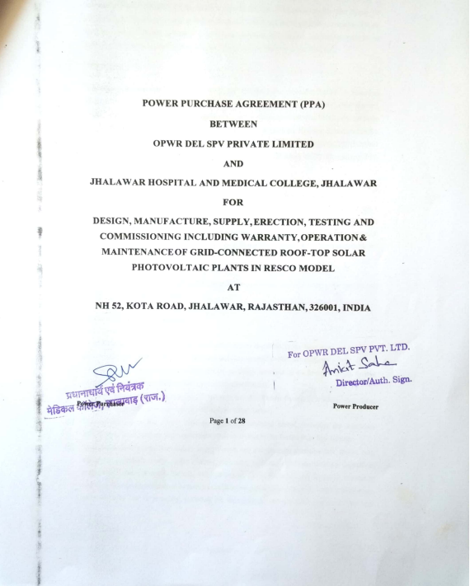

5. GOVT MAHILA EVAM BAL CHIKITSALYA - CHITTORGARH
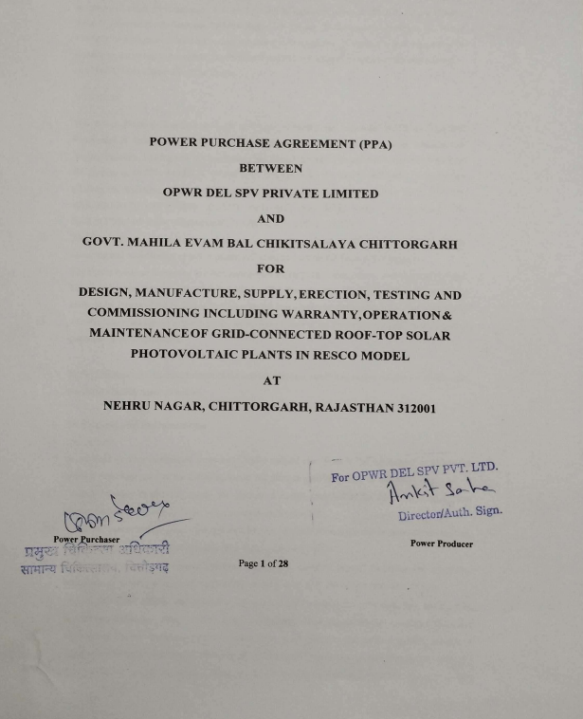

6. PASCHIMI RAJASTHAN DUGDH UTPADAK SAHKARI SANG LIMITED - JODHPUR
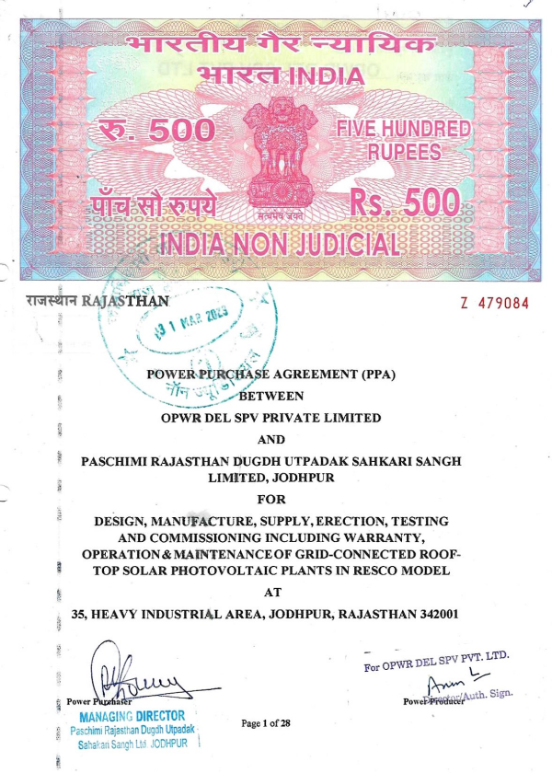

7. SHREE HARIDEV JOSHI GENERAL HOSPITAL – DUNGARPUR
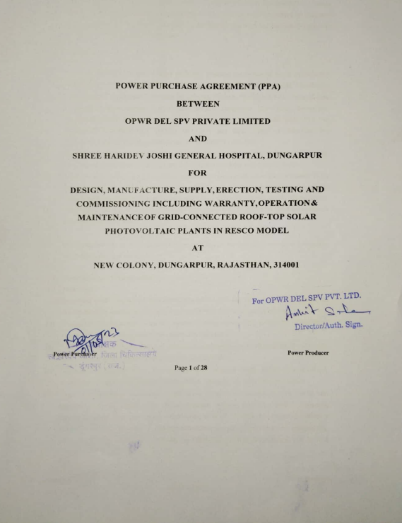

8. SHREE SANWALIYA JI GOVERNMENT GENERAL HOSPITAL - CHITTORGARH
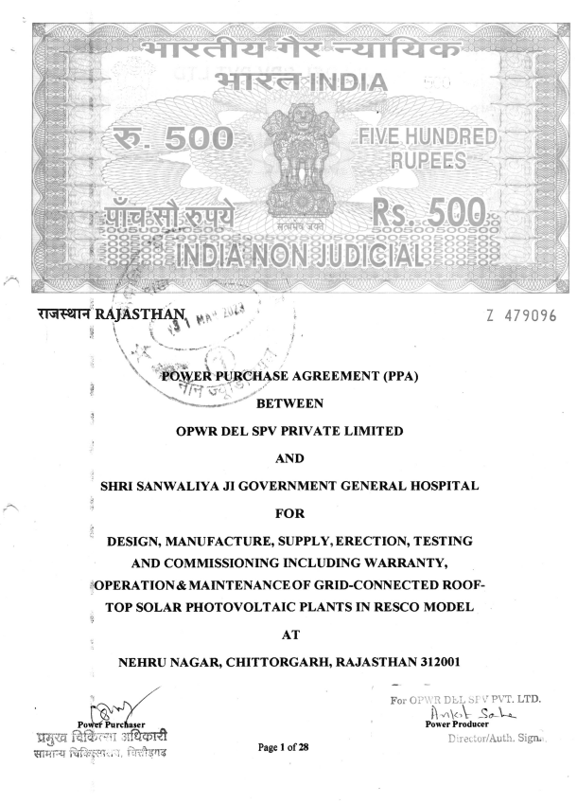

9. RAVINDER NATH TAGORE GOVT MEDICAL COLLEGE – UDAIPUR
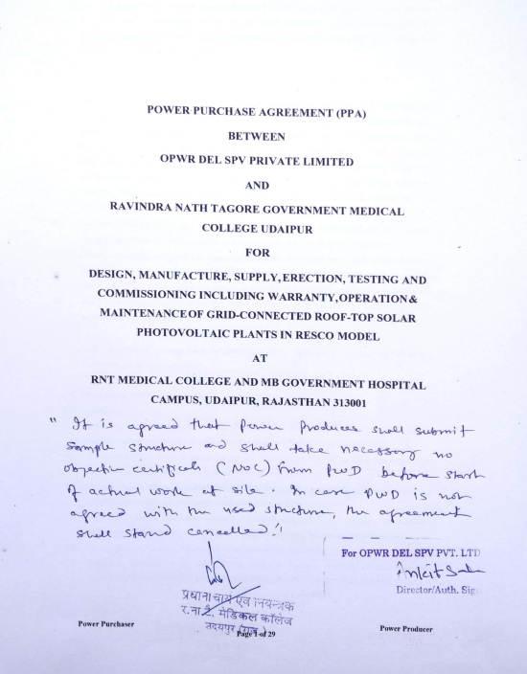

10. MAHARANA BHUPAL GOVT HOSPITAL - UDAIPUR
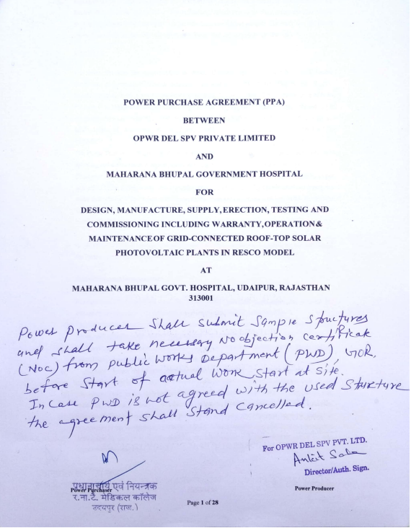

11. GOVT. MEDICAL COLLEGE - BARMER
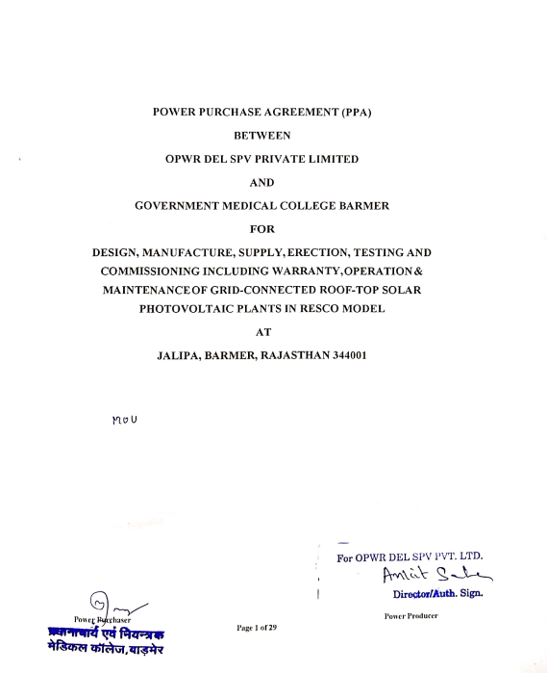

12. SHRIMATI HIRA KUWAR BA MAHILA HOSPITAL – JHALWAR
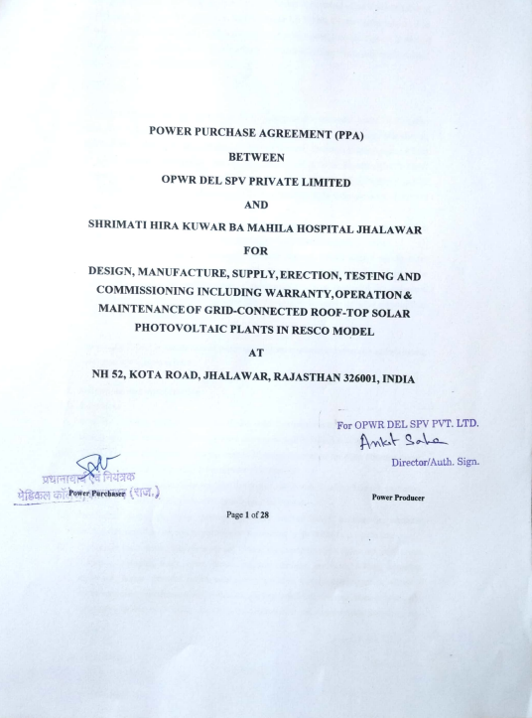
13. GOVT MEDICAL COLLEGE - DHOLPUR
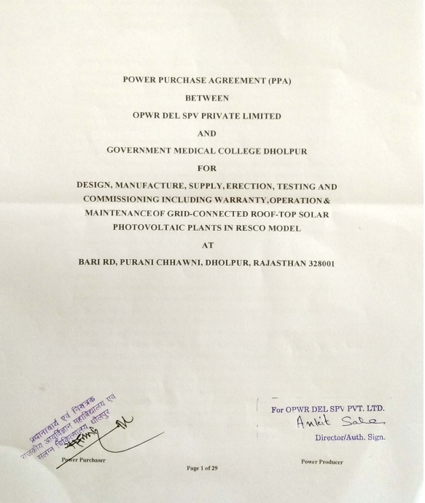

14. PMO MCH UNIT MG HOSPITAL - BHILWARA
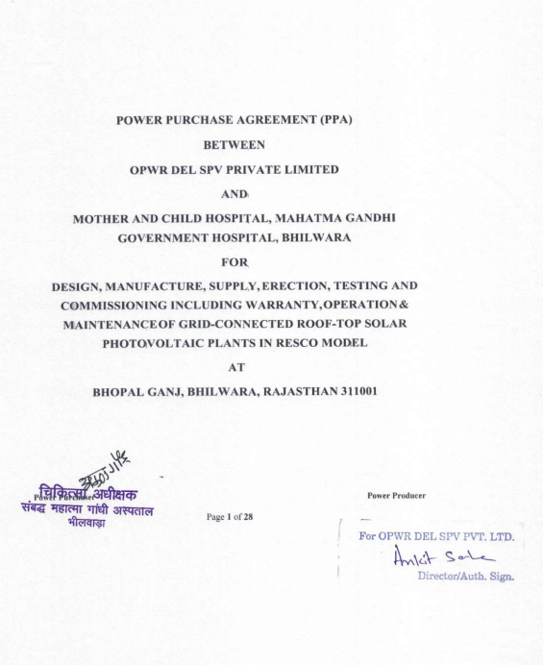

15. HINDUSTAN COPPER LIMITED – MALANJKHAND, M.P.
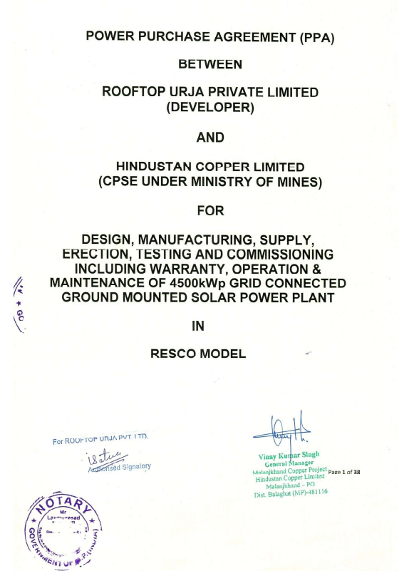
PART J | DISCLAIMER

      - No employee or member of R.K Associates has any direct/ indirect interest in the Project.
      - This report is prepared based on the copies of the documents/ information which the Bank/ Company has provided to us out of the standard checklist of documents sought from them and further based on our assumptions and limiting conditions. All such information provided to us has been relied upon in good faith and we have assumed that it is true and correct in all respect. Verification or cross checking of the documents provided to us has not been done at our end from the originals. If at any time in future, it is found or came to our knowledge that misrepresentation of facts or incomplete or distorted information has been provided to us then this report shall automatically become null & void.
      - This report is a general analysis of the project based on the scope mentioned in the report. This is not an Audit report, Design document, DPR or Techno-financial feasibility study. All the information gathered is based on the facts seen on the site during survey, verbal discussion & documentary evidence provided by the client and is believed that information given by the company is true best of their knowledge.
      - All observations mentioned in the report is only based on the visual observation and the documents/ data/ information provided by the client. No mechanical/ technical tests, measurements or any design review have been performed or carried out from our side during Project assessment.
      - Bank/FII should ONLY take this report as an Advisory document from the Financial/ Chartered Engineering firm and it’s specifically advised to the creditor to cross verify the original documents for the facts mentioned in the report which can be availed from the borrowing company directly.
      - In case of any default in loans or the credit facility extended to the borrowing company, R.K Associates shall not be held responsible for whatsoever reason may be and any request for seeking any explanation from the employee/s of R.K Associates will not be entertained at any instance or situation.
      - This Report is prepared by our competent technical team which includes Engineers and financial experts & analysts.
      - This is just an opinion report and doesn’t hold any binding on anyone. It is requested from the concerned Financial Institution which is using this report for taking financial decision on the project that they should consider all the different associated relevant & related factors also before taking any business decision based on the content of this report.
      - All Pages of the report including annexures are signed and stamped from our office. In case any paper in the report is without stamp & signature then this should not be considered a valid paper issued from this office.
      - Though adequate care has been taken while preparing this report as per its scope, but still we can’t rule out typing, human errors, over sightedness of any information or any other mistakes. Therefore, the concerned organization is advised to satisfy themselves that the report is complete & satisfactory in all respect. Intimation regarding any discrepancy shall be brought into our notice immediately. If no intimation is received within 15 (Fifteen) days in writing from the date of issuance of the report, to rectify these timely, then it shall be considered that the report is complete in all respect and has been accepted by the client upto their satisfaction & use and further to which R.K Associates shall not be held responsible in any manner.
      - Defect Liability Period is 15 DAYS. We request the concerned authorized reader of this report to check the contents, data and calculations in the report within this period and intimate us in writing if any corrections are required or in case of any other concern with the contents or opinion mentioned in the report. Corrections only related to typographical, calculation, spelling mistakes, incorrect data/ figures/ statement will be entertained within the defect liability period. Any new changes for any additional information in already approved report will be regarded as additional work for which additional fees may be charged. No request for any illegitimate change in regard to any facts & figures will be entertained.
      - R.K Associates encourages its customers to give feedback or inform concerns over its services through proper channel at le@rkassociates.org in writing within 30 days of report delivery. After this period no concern/ complaint/ proceedings in connection with the Lender’s Independent Engineering Services will be entertained due to possible change in situation and condition of the subject Project.
      - Our Data retention policy is of ONE YEAR. After this period, we remove all the concerned records related to the assignment from our repository. No clarification or query can be answered after this period due to unavailability of the data.
      - This Lender’s Independent Engineering report is governed by our (1) Internal Policies, Processes & Standard Operating Procedures, (2) Information/ Data/ Inputs given to us by the client and (3) Information/ Data/ Facts given to us by our field/ office technical team. Management of R.K Associates never gives acceptance to any unethical or unprofessional practice which may affect fair, correct & impartial assessment and which is against any prevailing law. In case of any indication of any negligence, default, incorrect, misleading, misrepresentation or distortion of facts in the report then it is the responsibility of the user of this report to immediately or at least within the defect liability period bring all such act into notice of R.K Associates management so that corrective measures can be taken instantly.
      - R.K Associates never releases any report doing alterations or modifications from pen. In case any information/ figure of this report is found altered with pen then this report will automatically become null & void.
FOR INTERNAL USE
Place : Noida  Date : 19.10.2023  Note : This report contains 65 pages | SURVEYED BY:  PREPARED BY:  REVIEWED BY: | NA as Desktop LIE  Amit Jaiswal  Sr. V.P. Projects

For R.K Associates Valuers & Techno Engineering Consultants (P) Ltd.

DEFECT LIABILITY PERIOD - In case of any query/ issue or escalation you may please contact Incident Manager by writing at valuers@rkassociates.org. We ensure 100% accuracy in the Calculations done, Rates adopted and various other data points & information mentioned in the report but still can’t rule out typing, human errors or any other mistakes. In case you find any mistake, variation, discrepancy or inaccuracy in any data point of the report, please help us by bringing all such points into our notice in writing at valuers@rkassociates.org within 30 days of the report delivery, to get these rectified timely, failing which R.K Associates Valuers Techno Engineering Consultants (P) Ltd. won’t be held responsible for any inaccuracy in any manner. Also if we will not hear back anything from you within 30 days, we will assume that report is correct in all respect and no further claim of any sort will be entertained thereafter. We would welcome and appreciate your feedback & suggestions in order to improve our services.

COPYRIGHT FORMAT - This report is prepared on the copyright format of R.K Associates Valuers Techno Engineering Consultants (P) Ltd. to serve our clients in the best possible way. Legally no one can copy or distribute this format without prior approval from R.K Associates. It is meant only for the organization as mentioned on the cover page of this report. Distribution or use of this format other than R.K Associates will be seen as unlawful act and necessary legal action can be taken against the defaulter

