**REPORT FORMAT:** CL-1 | Version: 1.0_2018

# FILE No.: VIS(2023-24)-PL414-339-541 Date: 16-10-2023

* ***CERTIFICATE* NAME:** *Cost Vetting Certificate for Pharmaceutical Machinery which is proposed to be installed in Village- Sirchandi, Bhagwanpur, Haridwar.*
* ***PREPARED FOR ORGANIZATION:*** *State Bank of India, SME Branch, Ranipur, Haridwar.*
* ***BORROWER COMPANY’S NAME:*** *M/s. Nephron Pharmaceuticals Private Limited*
* ***ASSET TYPE****: Pharmaceuticals – Capsule Manufacturing Machineries*
* ***CURRENT LOCATION OF THE MACHINES****: Proposed to be installed at Khasra No. 754, Village- Sirchandi, Pargana & Tehsil Bhagwanpur, Haridwar, Uttarakhand*

**TO WHOM IT MAY CONCERN**

|  |  |  |
| --- | --- | --- |
| **S. NO.** | **PARTICULARS** | **DESCRIPTION** |
| 1. | Date of Survey | Not Applicable |
| 2. | Date of Certificate | 16-10-2023 |
| 3. | Documents provided for perusal | 1. Purchase Orders 2. List of Machines 3. Quotations |
| 4. | Current Location of the Machines | Proposed to be installed at Khasra No. 754, Village- Sirchandi, Pargana & Tehsil Bhagwanpur, Haridwar, Uttarakhand |
| 5. | Borrowing Company | M/s. Nephron PharmaceuticalsPrivate Limited |
| 6. | Type of Asset | Machinery required for installing Pharmaceutical Industry |
| 7. | Type of Assessment | Cost vetting |
| 8. | Scope of Assessment | Cost Vetting of the new equipment which has to be/ already purchased by the company |
| 9. | Nature of Machinery | Machines used in pharmaceutical industry and other general machines. |
| 10. | Year of Manufacturing | Plant is currently being installed. |
| 11. | Total Purchase Cost | **Rs.7.06 Cr.** (*Total project Cost including supply and installation as per the List of machinery / quotations / invoices / purchase orders provided by the company)*. |
| 12. | Current Estimated Market Value | The range of current market rates of such type of machinery & equipments is verified from various suppliers and also from the public domain for the new machinery and equipment’s.  As per quotes received from market, we are of the view that rate range for establishing the machinery of similar kind of machinery are available in the range **Rs.7.05 Cr to Rs.7.12 Cr.**  According to our observation, the rate as per the list of machinery and their total purchase price provided to us by the company/ bank are quite reasonable when compared to the rates of similar machines currently prevailing in the market. |
| 13. | Condition of Machines | All the machines are yet to be purchased or in transit. |

**OBSERVATIONS:**

1. We have been provided with the copy of purchase orders with cost of machines/ equipment by the borrower company.
2. As per the information provided by the company officials these items are already/planned to be installed at Khasra No. 754, Village- Sirchandi, Pargana & Tehsil Bhagwanpur, Haridwar, Uttarakhand.
3. We have contacted several suppliers for similar items and also enquired in the public domain. Accordingly, we have got the quotation from the suppliers and found that the price given in the list of quotations provided to us is well within the price range of similar items available in the market and seems to be reasonable.
4. In this certificate, there can be some difference in the cost of some of the machines due to the auxiliary equipments and accessories as some of the quotations from the market are only for the main machines.
5. Based on the information provided by the company (M/s. Nephron PharmaceuticalsPrivate Limited) and enquiries made by us in the open market and references found in the public domain for similar machines/items, it is certified that total market cost for setting up plants of similar specification should be around **Rs.7.05 Cr to Rs.7.12 Cr** and therefore the total purchase price of **Rs.7,06,49,153/- (Excl. GST)** (as per the list of machines, quotations, bills & purchase orders provided to us by the company) appears to be reasonable.

***Disclaimer:***

* 1. *We can’t comment about the current status of machines whether these are purchased, installed or in transit. This cost vetting is done only on the basis of Purchase Orders provided to us by the company and we don’t recommend any sort of recommendation in our Certificate.*
  2. *The estimated cost verification of item to item can’t exactly match as per our vetting due to several market consideration. In some of the items it is lower while in some of the items price comes to be higher but on an average the price as per list provided to us falls in the range as confirmed by us.*
  3. *There can be variation in the estimated price if the specification & make of any items procured is different from the list provided to us during assessment.*
  4. *The estimated cost verification is made based on the third-party information which has been replied upon in good faith.*
  5. *The estimated price may vary at the time of actual procurement because of change in prices in the market for such kind of machinery/items for which we will not have any control. The cost vetting is only limited to the date of Certificate issued. We do not assume any responsibility in change of prices of the said machinery/items after this date.*
  6. *Market Values of some of the machine’s equipment like Fire system, HVAC work, Electrical wiring & lighting and clean room panel & windows are considered same as the amount shown in the list provided to us due to the unavailability of technical specifications of machines and equipments.*
  7. *This certificate doesn’t include any work related to drawing, design, sketch plan, procurement of the machines.*
  8. *Ownership and other legal point of view in respect of the asset is not considered in this report as same is out of scope of this certificate.*
  9. *This certificate is made at the request of the Bank.*

**For R.K Associates Valuers** **& Techno** **FOR INTERNAL USE Engineering Consultants (P) Ltd. *TYPED BY: Yash Bhatnagar*** ***REVIEWED BY: Manas Upmanyu***

# ANNEXURE: - I (COMPARISON LIST)

# 

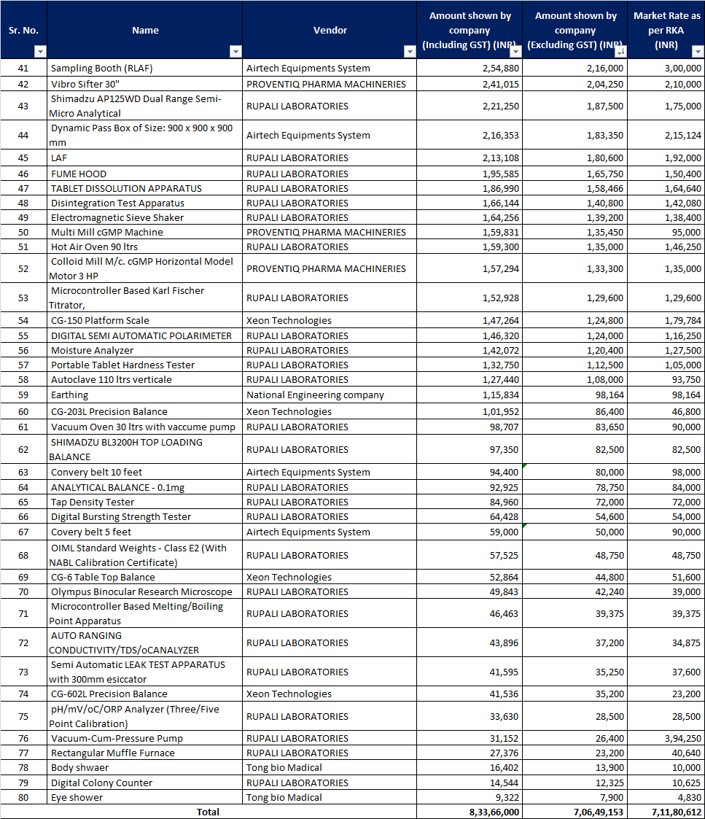

# ANNEXURE: - II (QUOTATIONS/ REFERENCES FROM MARKET)

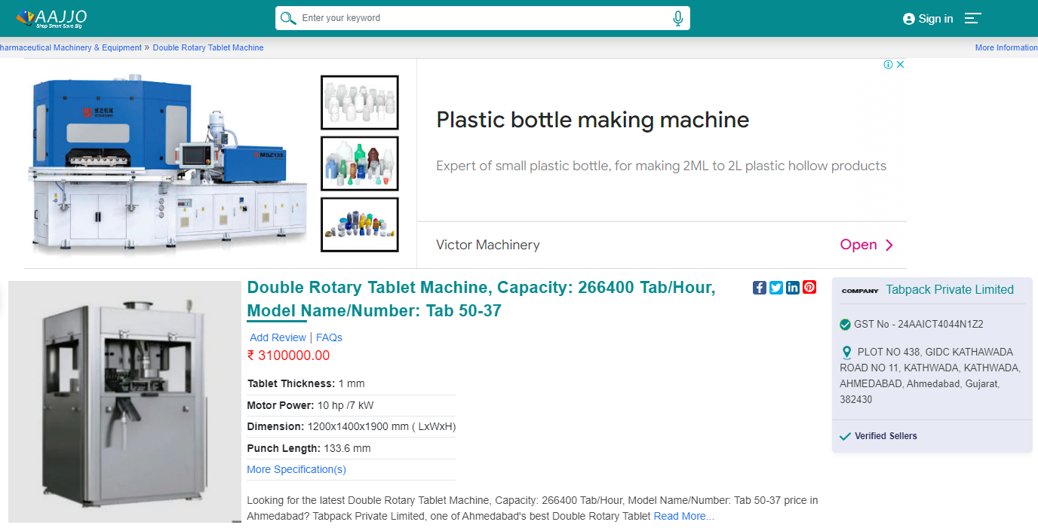



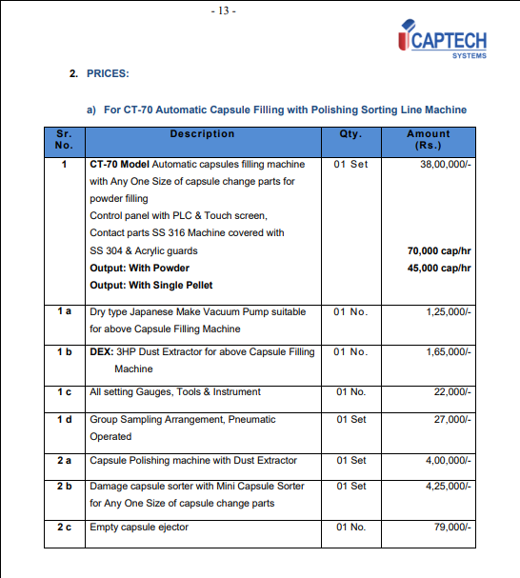

# 

# 

# 

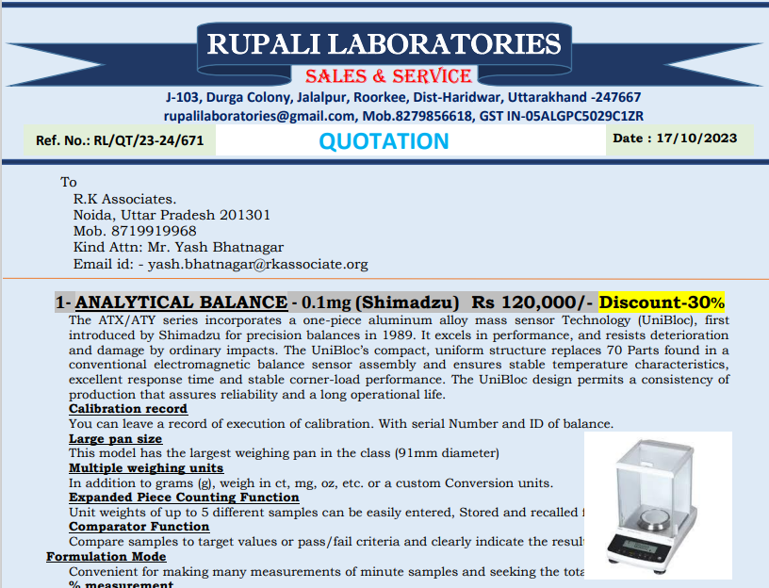

# ANNEXURE: - III (DOCUMNETS PROVIDED BY CLIENT)

