**REPORT FORMAT:** CL-1 | Version: 1.0_2018

# FILE No.: VIS (2023-24)-PL416-341-544 Date: 18-10-2023

* ***CERTIFICATE* NAME:** *Cost Vetting Certificate for machines of M/s Baldeep Pack (I) Pvt. Ltd., which is to be installed at A-15, Ganga Nagari, Shivalik Nagar, Haridwar, Uttarakhand, India.*
* ***PREPARED FOR ORGANIZATION:*** *State Bank of India, SME Branch, Roorkee*
* ***BORROWER COMPANY’S NAME:*** *M/s Baldeep Pack (I) Pvt. Ltd.*
* ***ASSET TYPE****: Packing Machinery*
* ***CURRENT LOCATION OF THE MACHINES****: Proposed to be installed at A-15, Ganga Nagari, Shivalik Nagar, Haridwar, Uttarakhand, India.*

**TO WHOM IT MAY CONCERN**

|  |  |  |
| --- | --- | --- |
| **S. NO.** | **PARTICULARS** | **DESCRIPTION** |
| 1. | Date of Survey | Not Applicable |
| 2. | Date of Certificate | 18-10-2023 |
| 3. | Documents provided for perusal | References/Quotations from the market (and the respective list) |
| 4. | Current Location of the Machines | Proposed to be installed at A-15, Ganga Nagari, Shivalik Nagar, Haridwar, Uttarakhand, India |
| 5. | Borrowing Company | M/s Baldeep Pack (I) Pvt. Ltd. |
| 6. | Type of Asset | Machinery required for installing Packing Industry |
| 7. | Type of Assessment | Cost vetting |
| 8. | Scope of Assessment | Cost Vetting of the new equipment which shall be purchased by the company. |
| 9. | Nature of Machinery | Packing Industry Machinery |
| 10. | Year of Manufacturing | Machines yet to be purchased |
| 11. | Total Purchase Cost | **Approximately from Rs. 6.00 Cr.** To **Rs. 7.00 Cr.** (*Total project Cost including supply and installation as per the List of machinery / quotations / invoices / purchase orders provided by the company)*. |
| 12. | Current Estimated Market Value | The range of current market rates of such type of machinery & equipments is verified from various suppliers and also from the public domain for the new machinery and equipment’s.  As per quotes received from market, we are of the view that rate range for establishing the machinery of similar kind of packing industry should be in the range **Rs. 6.00 Cr. To Rs.7.00 Cr. *(other charges or taxes are not included)***  We have considered the value only for the main machinery list provide while cost for installation and fittings have not been included. Due to this, there can be major differences in some items. |
| 13. | Condition of Machines | The machines are yet to be purchased. |

**OBSERVATIONS:**

1. We have been provided with the copy of quotations from the market with cost of machines/ equipment by the borrower company.
2. As per the information provided by the company officials these items are planned to be installed at A-15, Ganga Nagari, Shivalik Nagar, Haridwar, Uttarakhand, India
3. We have contacted several suppliers for similar items and also enquired in the public domain. Accordingly we have got the quotation from the suppliers and the same has been attached in the report below.
4. Based on the information provided by the company (M/s Baldeep Pack (I) Pvt. Ltd.) and enquiries made by us in the open market and references found in the public domain for similar machines/items, it is certified that total market cost for setting up plants of similar specification should be around **Rs. 6.00 Cr to Rs.7.00 Cr**.
5. In this certificate, we have considered the value only for the main machinery list provide while cost for installation and fittings have not been included. Due to this, there can be major differences in some items.
6. As per enquiry conducted in secondary market and quotation received from different vendors, the market price of machines to be purchased by the company is slightly lower than the quotation shared by the company. The reason behind this could be change in freight charges and manufacturer. Thus, it is advised to the bank to keep in mind the above mentioned factors before financing.

***Disclaimer:***

* 1. *We can’t comment about the current status of machines whether these are purchased, installed or in transit. This cost vetting is done only on the basis of Quotations provided to us by the company and we don’t recommend any sort of recommendation in our Certificate.*
  2. *The estimated cost verification of item to item can’t exactly match as per our vetting due to several market consideration. In some of the items it is lower while in some of the items price comes to be higher but on an average the price as per list provided to us falls in the range as confirmed by us.*
  3. *There can be variation in the estimated price if the specification & make of any items procured is different from the list provided to us during assessment.*
  4. *The estimated cost verification is made based on the third party information which has been replied upon in good faith.*
  5. *The estimated price may vary at the time of actual procurement because of change in prices in the market for such kind of machinery/items for which we will not have any control. The cost vetting is only limited to the date of Certificate issued. We do not assume any responsibility in change of prices of the said machinery/items after this date.*
  6. *This certificate doesn’t include any work related to drawing, design, sketch plan, procurement of the machines.*
  7. *Ownership and other legal point of view in respect of the asset is not considered in this report as same is out of scope of this certificate.*
  8. *This certificate is made at the request of the Bank.*

**For R.K Associates Valuers** **& Techno** **FOR INTERNAL USE Engineering Consultants (P) Ltd. *TYPED BY: Amit Jaiswal***  ***REVIEWED BY: Abhinav Chaturvedi***

# ANNEXURE: - I (COMPARISON LIST)

|  |  |  |  |  |
| --- | --- | --- | --- | --- |
| **S. NO** | **MACHINE NAME** | **QTY** | **COST SHOWN BY CLIENT** | **REMARK** |
| 1 | 5 Ply Automatic Board Making Plant 1800mm | 1 | ₹ 3,90,00,000 | As per enquiry & market research conducted, the market price of 1800 mm Automatic Board Making Plant is in the range of Rs. 3.50 Cr. To Rs. 4.00 Cr. |
| 2 | 4 Ton Boiler And Fitting Charge With Chimney With Electrical Parts. | 1 | ₹ 55,00,000 | As per enquiry & market research conducted, the market price of 4 Ton Boiler is in the range of Rs. 0.45 Cr. To Rs. 0.55 Cr. Depending upon make, model & type of boiler. |
| 3 | Three Colour Large Printer With Rs-4 With Rotary Die Cutter. | 1 | ₹ 85,00,000 | As per enquiry & market research conducted, the market price of Three Colour Printer is in the range of Rs. 0.80 Cr. To Rs. 1.00 Cr. |
| 4 | Two Colour Large Printer With Rs-4 With Rotary Die Cutter | 1 | ₹ 65,00,000 | As per enquiry & market research conducted, the market price of Two Colour Printer is in the range of Rs. 0.45 Cr. To Rs. 0.60 Cr. |
| 5 | Semi-Automatic Double Pin Movable Head Stitching Machine. 120nail/Min | 3 | ₹ 45,00,000 | As per enquiry & market research conducted, the market price of 3 Semi-Automatic Stitching Machine is in the range of Rs. 0.40 Cr. To Rs. 0.50 Cr. |
| 6 | Fork Lifter | 1 | ₹ 15,00,000 | As per enquiry & market research conducted, the market price of lift is in the range of Rs. 0.15 Cr. To Rs. 0.25 Cr. Depending upon lift capacity. |
| 7 | Automatic Folder Gluer Machine With Stacker. Speed 150pc/Min | 1 | ₹ 25,00,000 | As per enquiry & market research conducted, the market price of Automatic Folder Gluer Machine is in the range of Rs. 0.23 Cr. To Rs. 0.25 Cr. |
| **TOTAL** | | | **₹ 6,80,00,000** |  |
| **Notes: -** | | | | |
| 1. The cost given by RKA is as per the market research and quotation received from different sources. | | | | |

# ANNEXURE: - II (QUOTATION/REFERENCES FROM MARKET)

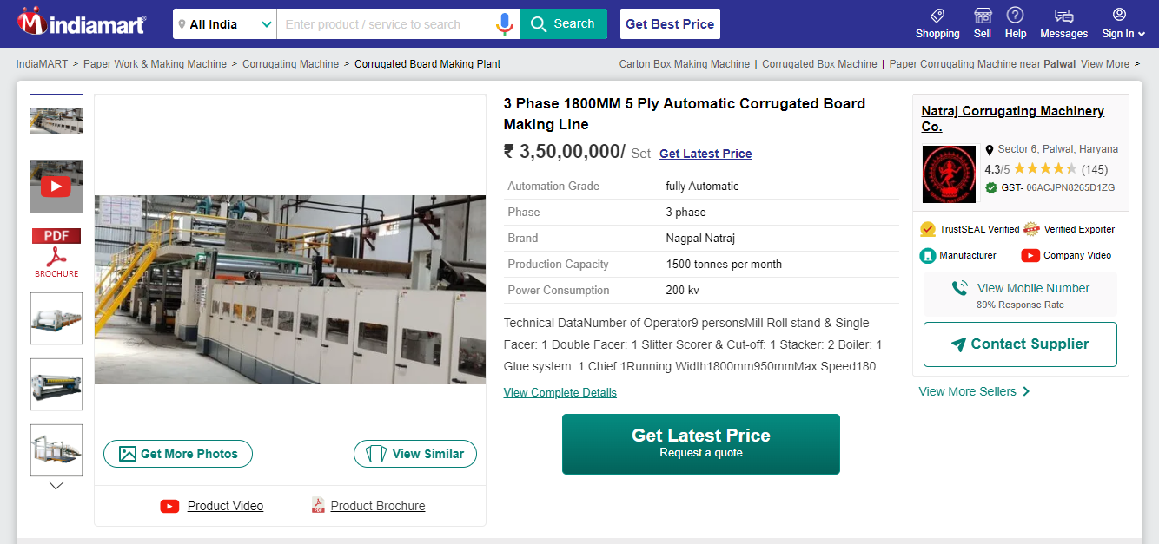

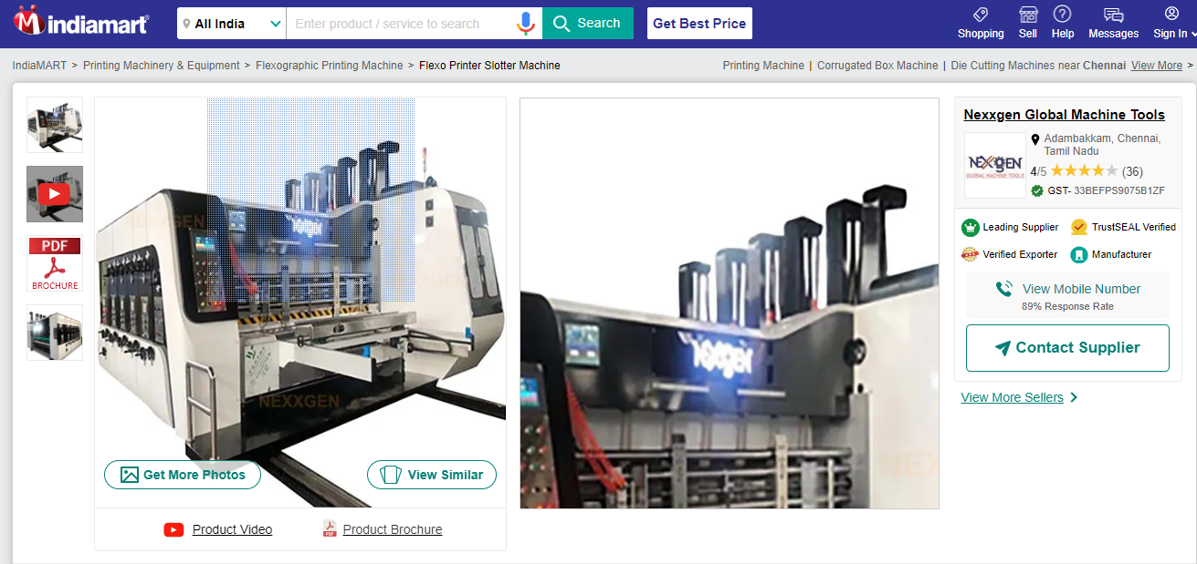

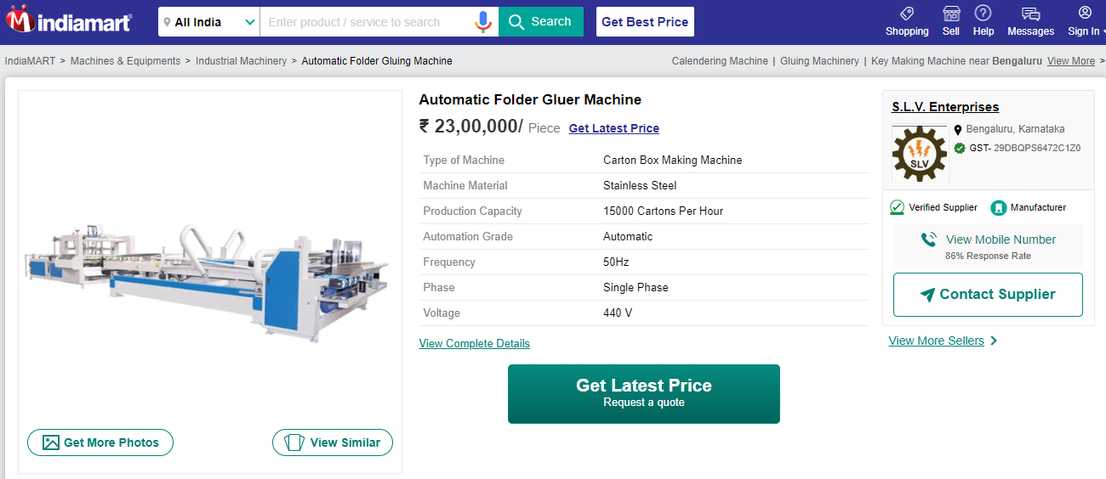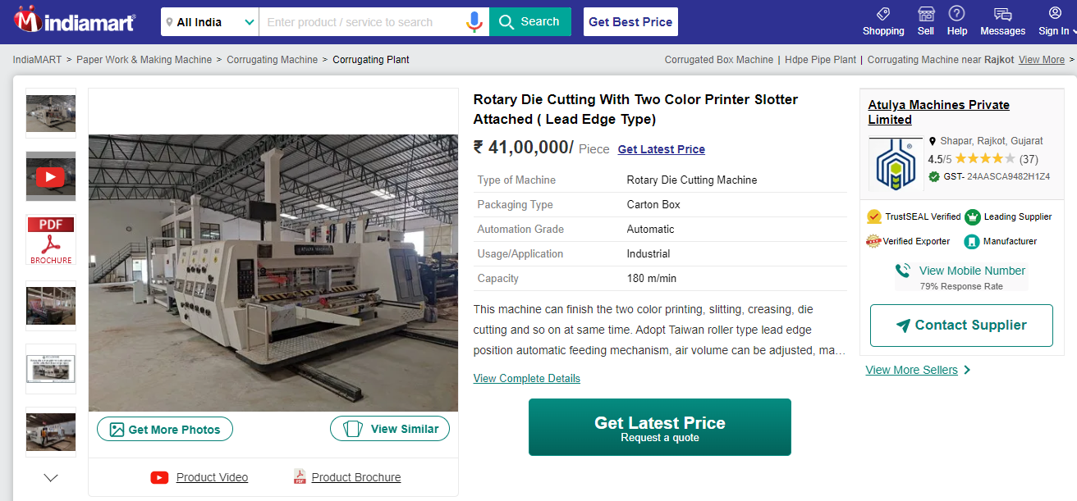

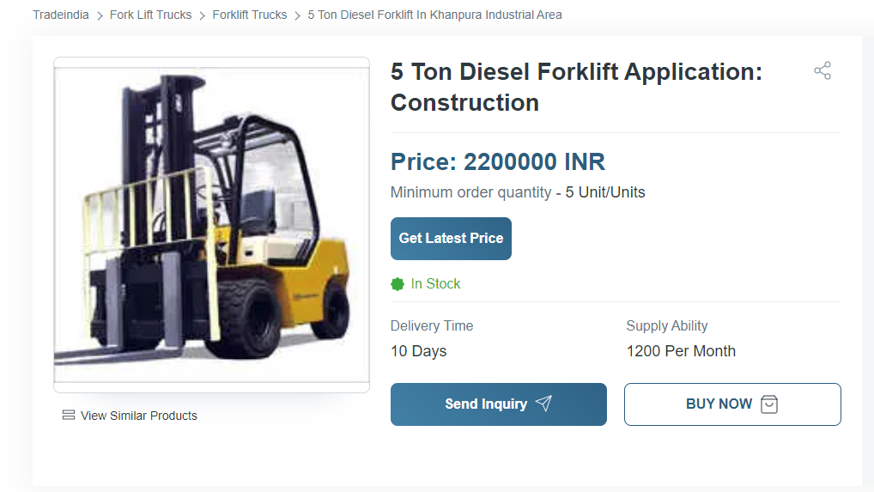

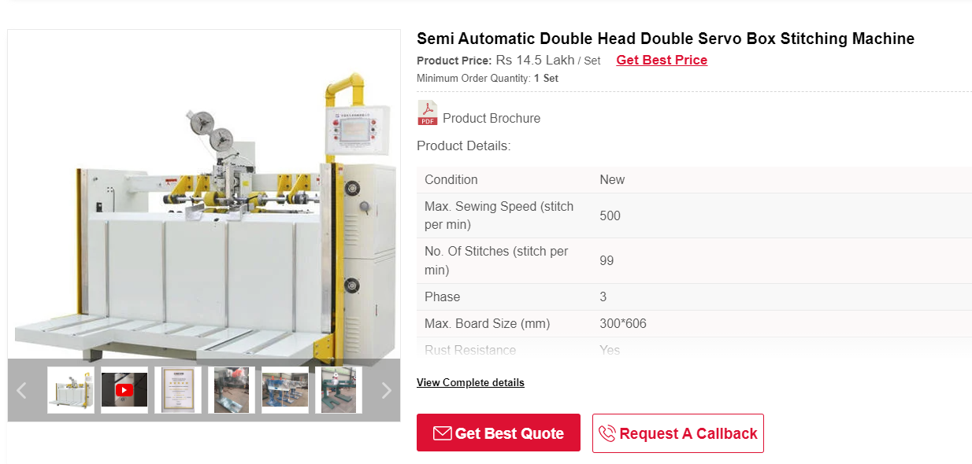

**Boiler**

