**REPORT FORMAT:** CL-1 | Version: 1.0_2018

# FILE No:VIS (2023-24)-PL418-343-546 Date :11/10/2023

* **CERTIFICATE NAME:** Project/Civil work completion certificate
* **PREPARED FOR ORGANIZATION:** State Bank of India, SME Ranipur, Haridwar.
* **BORROWER COMPANY’S NAME:** M/s. Jynaty Electric Pvt. Ltd.
* **ASSET TYPE**: Civil Building work and Electrical Goods installed
* **CURRENT LOCATION OF THE CIVIL WORK**: M/s Jynaty Electric Pvt. Ltd., Plot No. 6&7, Sector-3A, Integrated Industrial Estate, Haridwar, Uttarakhand

|  |  |  |
| --- | --- | --- |
| **S. NO.** | **PARTICULARS** | **DESCRIPTION** |
|  | Date of Work Order | Via mail dated 04-10-2023 |
|  | Documents provided for perusal | Civil Building work from M/s Tanuj Tomer and Construction, dated-16.09.2023. and Electrical Goods Tax Invoice from J.S. Enterprises, dated-03-10-2023 |
|  | Project Location | M/s Jynaty Electric Pvt.Ltd., Plot No.6&7, Sector-3A, Integrated Industrial Estate, Haridwar, Uttarakhand |
|  | Borrowing Company | M/s.Jynaty Electric Pvt. Ltd. |
|  | Type of Asset | Civil Building work and Electrical Goods installed |
|  | Type of Assessment | Project/Civil work completion certificate |
|  | Scope of Assessment | 1. Additional cost of construction work and electrical goods installed. 2. To provide a completion certificate. |
|  | Nature of Plant | Plastic Industry |
|  | Total Project Cost | |  |  |  | | --- | --- | --- | | **Particulars** | **Original As per client (Rs.)** | **Revised Amount As per RKA (Rs.)** | | Civil Work | 23,00,000/- | 21,05,187/- | | Electrical Goods Installed | 15,88,144/- | 9,08,047/- |   (*Including supply and installation as per the List/ quotations / invoices / Cost Estimate provided by the company of civil works and electrical goods installed.* |
|  | Comment on Project Cost by consultant | As per our analysis, the revised cost for Civil works and electrical goods found to be in line to Market trend**.** Please refer to **PART A** for detailed analysis. |
|  | Total number of pages with Annexure. | 13 |

|  |  |
| --- | --- |
| **VALUATION ENGINEER** | **L1/ L2 REVIEWER** |
| Deepak Kumar Singh | Babul Akhtar Gazi |
|  |  |

|  |  |
| --- | --- |
| **PART A** | **PROJECT COST VETTING** |

**EXECUTIVE SUMMARY:** M/s Jynaty Electric Private Limited is setting up a Plastic manufacturing unit at Plot No.6&7, Sector-3A, Integrated Industrial Estate, Haridwar, Uttarakhand. In this report, we are calculating the additional cost spend on the construction of civil works and electrical goods installed in the industry.

During site visit our surveyor, Mr. Deepak Joshi has observed that the construction of the said civil work has been completed and the industry is currently operational.

***Additional cost of construction of civil work as per RKA assessment:***

|  |  |  |  |  |  |  |  |  |
| --- | --- | --- | --- | --- | --- | --- | --- | --- |
| **SL. NO.** | **Description/Particulars** | **No.** | **Area(sq. ft)** | **Height(ft)** | **Rate from CPWD(Rs. per sq. ft)** | **Rate Adopted after applicable discount(Rs. per sq. ft)** | **Amount (in Rs.)** | **Remarks/Reference** |
| 1 | Toilets (First Floor) | 5 | 625 | 8 | 2,430.35 | 1,944.28 | 12,15,172.94 | CPWD Plinth Rate |
| 2 | Toilets (Ground Floor) | 1 | 30 | 8 | 2,430.35 | 1,944.28 | 58,328.30 | CPWD Plinth Rate |
| 3 | Toilets (Ground Floor) | 1 | 20 | 8 | 2,430.35 | 1,944.28 | 38,885.53 | CPWD Plinth Rate |
| 4 | Chiller Room | 1 | 225 | 8 | 800.00 | 800.00 | 1,80,000.00 | Current Market Rate Applicable |
| 5 | Maintenance Room | 1 | 616 | 10 | 800.00 | 800.00 | 4,92,800.00 | Current Market Rate Applicable |
| 6 | Scrap yard | 1 | 150 | 10 | 800.00 | 800.00 | 1,20,000.00 | Current Market Rate Applicable |
| **TOTAL** | | | | | | | **21,05,186.77** |  |
| **Note and Remarks:** | | | | | | | | |
| *1. Rate adopted are tallied from the market standards and CPWD both and applicable discount is applied, considering the quality mentioned in the specifications and the quality observed on site.* | | | | | | | | |
| *2. The following rates are referred from CPWD is inclusive of the applicable taxes.* | | | | | | | | |

***As per the information shared by the client, the estimated construction cost for the said civil work is Rs.23,00,000/-. However, as per analysis and market research the construction cost of the said civil work should be Rs.21,05,187/-. Thus we can say that the information shared by the client is in line with the market trends and is fair & reasonable.***

**REVALIDATION OF THE PROJECT COST:** Since as per the summary of the original and revised cost involved in civil work, the cost has been decreased:

|  |  |  |  |
| --- | --- | --- | --- |
| **S. No.** | **Cost Component** | **As per client** | **As per RKA** |
|  | Additional Civil Work | Rs.23,00,000/- | Rs.21,05,187/- |

Therefore in this certificate we have revalidated the cost involved in civil work as per the scope of the work mentioned in the provided information.

**Observations of cost of construction of civil work :**

1. The calculated cost appears to be within range as shown by the company.
2. Rates considered in the cost estimate is found within the market range as per our scrutiny.
3. We have vetted the civil works as per the available documents and site survey. The built-up area has been considered as per the site survey.

**Cost of Electrical Goods Installed:**

|  |  |  |  |  |  |  |  |  |
| --- | --- | --- | --- | --- | --- | --- | --- | --- |
| **S.No.** | **Description of Goods** | **Unit** | **Quantity** | **Price (Rs./ unit)** | **Amount shown by company including taxes (Rs.)** | **Price as per RKA(Rs. / unit)** | **GST** | **Amount as per RKA (Rs.)** |
| 1 | P/F of 6 mm2 CU Arm. Cable | Mtrs. | 500 | 495 | 2,92,050 | 300 | 18% | 1,77,000 |
| 2 | P/F of DB with MCB | Set | 1 | 48500 | 57,230 | 42,000 | 18% | 49,560 |
| 3 | Steel Support Work | Kgs. | 300 | 120 | 42,480 | 132 | 18% | 46,728 |
| 4 | P/F of 80W LED light | Nos. | 15 | 9350 | 1,65,495 | 8,400 | Tax included | 1,26,000 |
| 5 | P/F of 2X2 LED light | Nos. | 30 | 4200 | 1,48,680 | 3,708 | 18% | 1,31,263 |
| 6 | Point wiring for lights | Nos. | 55 | 1125 | 73,013 | 850 | Tax included | 46,750 |
| 7 | P/F of Ceiling fans | Nos. | 30 | 2050 | 72,570 | 1,739 | Tax included | 52,170 |
| 8 | P/F 0f Cat6 Cable | Mtrs. | 780 | 47 | 43,259 | 24 | Tax included | 19,032 |
| 9 | P/F of switch cabinet | Nos. | 8 | 3450 | 32,568 | 1,738 | Tax included | 13,904 |
| 10 | P/F of Piping Work | Mtrs. | 180 | 1205 | 2,55,942 | 120 | 18% | 25,488 |
| 11 | P/F of Pump for Fire Fighting | Nos. | 2 | 31500 | 74,340 | 31,200 | 18% | 73,632 |
| 12 | P/F of Fire Hydrant with hose rill & box | Sets | 7 | 21300 | 1,75,938 | 5,040 | 18% | 41,630 |
| 13 | Steel support for shade work | Kgs. | 600 | 120 | 84,960 | 90 | 18% | 63,720 |
| 14 | P/F of CCTV | Nos. | 10 | 5900 | 69,620 | 4,117 | Tax included | 41,170 |
| **Total** | | | |  | **15,88,144** |  |  | **9,08,048** |

**Observations of cost of electrical goods installed:**

1. As per the information provided by the company officials these items has been installed in the industry.
2. Based on the information provided by the company (M/s. Jaynaty Electric Private limited) and enquires made by us in the open market and refrences found on the public domain for similar items, it is certified that total market cost for installing similar electrical goods should be around **Rs.9,08,048/-** and the total purchase price is **Rs.15,88,144/-** (as per the quotation invoice provided to us).

**DISCLAIMERS**

1. We have received the estimated cost of construction of civil work and invoice of electrical goods installed.
2. The estimated cost verification of item to item can’t exactly match as per our vetting due to several market consideration. In some of the items it is lower while in some of the items price comes to be higher.
3. There can be variation in the estimated price if the specification & make of any items procured is different from the list provided to us during assessment.
4. The estimated cost verification is made based on the third party information which has been relied upon in good faith.
5. The estimated price may vary at the time of actual procurement because of change in prices in the market for such kind of goods for which we will not have any control. The cost vetting is only limited to the date of certificate issued. We do not assume any responsibility in change of prices of the said goods after this date.
6. The client/ owner and its management/ representatives warranted to us that the information they have supplied was complete, accurate and true and correct to the best of their knowledge. All such information provided to us either verbally, in writing or through documents has been relied upon in good faith and we have assumed that it is true & correct without any fabrication or misrepresentation. I/We shall not be held liable for any loss, damages, cost or expenses arising from fraudulent acts, misrepresentations, or willful default on part of the owner, company, its directors, employee, representative or agents.
7. Legal aspects for eg. Investigation of title, ownership rights, lien, charge, mortgage, lease, sanctioned maps, and verification of documents provided to us such as title documents, Map, etc. from any concerned Govt. office etc. have to be taken care by legal expert/ Advocate and same is not done at our end. I/ We assume no responsibility for the legal matters including, but not limited to, legal or title concerns.
8. Wherever any details are mentioned in the report in relation to any legal aspect of the property such as name of the owner, leases, etc. is only for illustration purpose and should not be construed as a professional opinion. Legal aspects are out of scope of this report. Details mentioned related to legal aspect are only based on the copy of the documents provided to us and whatever we can interpret as a non-legally trained person. This should be cross validated with a legal expert. We do not vouch any responsibility regarding the same.
9. We have relied on the data from third party, external sources & information available on public domain to conclude the valuation. These sources are believed to be reliable and therefore, we assume no liability for the truth or accuracy of any data, opinions or estimates furnished by others that have been used in this analysis. Where we have relied on the data, opinions or estimates from external sources, reasonable care has been taken to ensure that such data is extracted from authentic sources, however we still can’t vouch its authenticity, correctness, or accuracy.
10. Documents, information, data including provided to us during the course of this assessment by the client is reviewed only upto the extent required in relation to the scope of the work. No document has been reviewed beyond the scope of the work. These are not reviewed in terms of legal rights for which we do not have expertise. Wherever any information mentioned in this report is mentioned from the documents like owners name, etc., it is only for illustration purpose and may not necessary represent accuracy.
11. Ownership and other legal point of view in respect of the asset is not considered in this as same is out of scope of this certificate.
12. This certificate is made at the request of the bank.

# ANNEXURES (A)

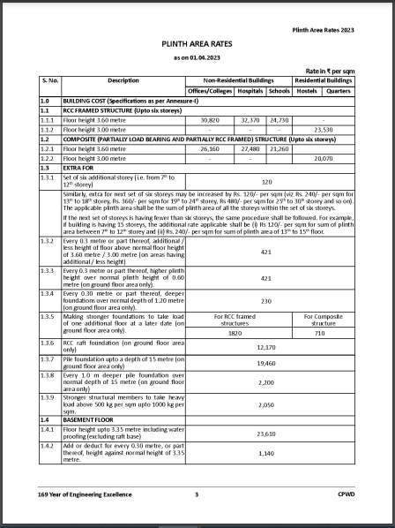

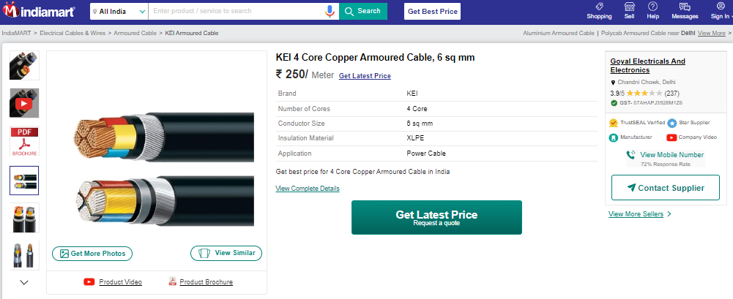

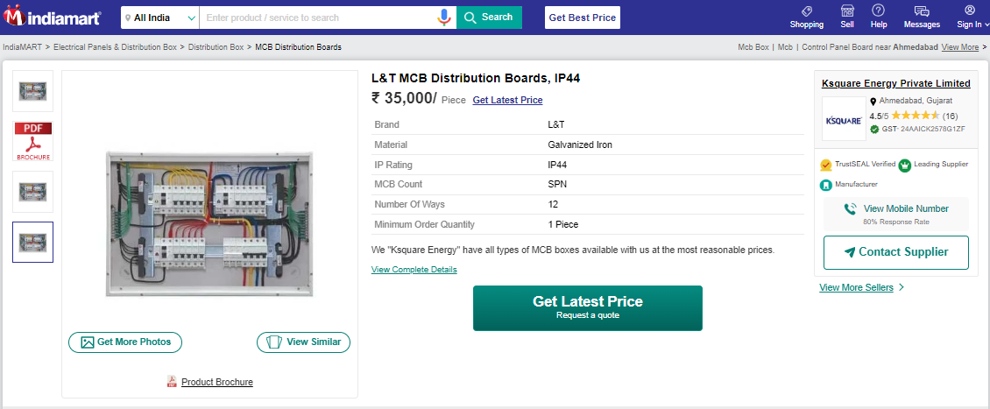

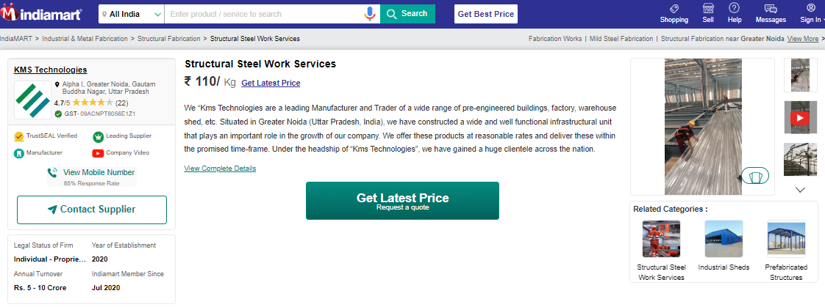

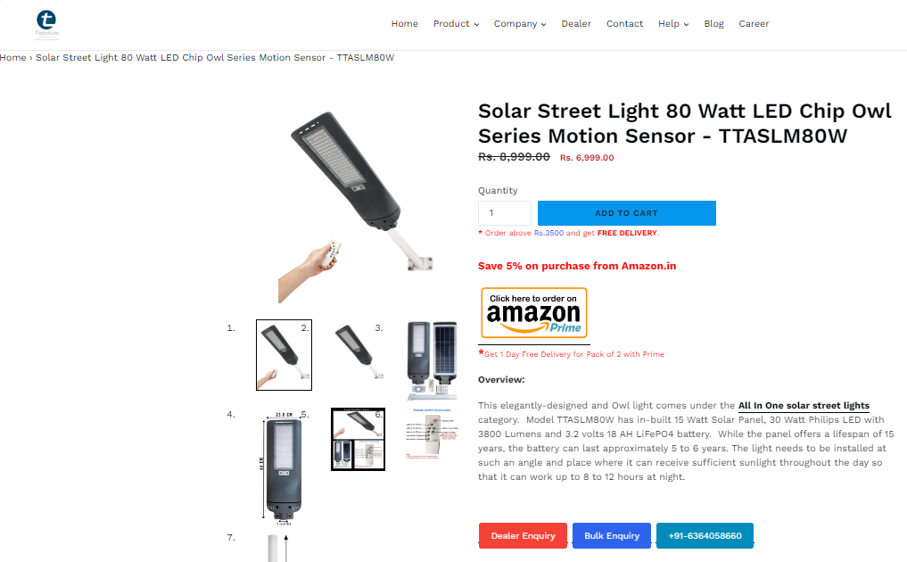

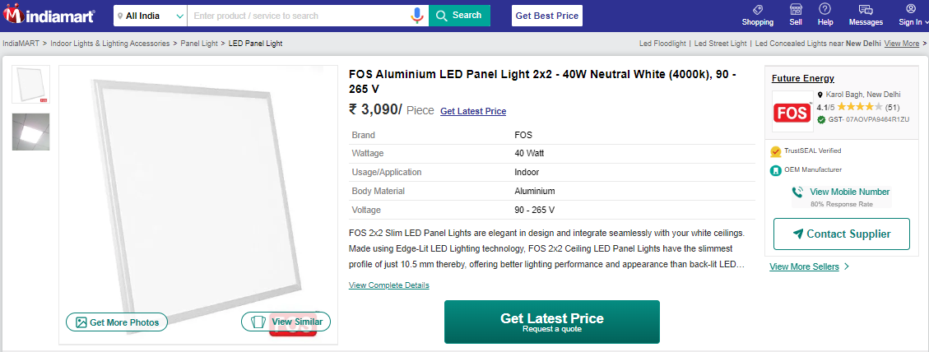

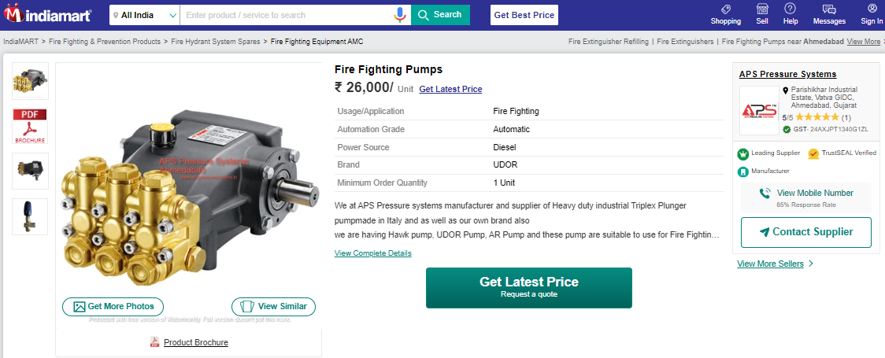

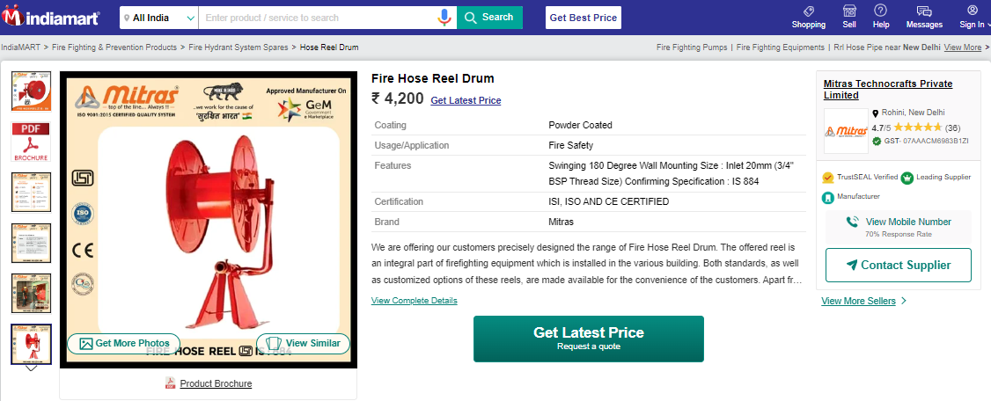

**Cost Estimate Quotation**

