**REPORT FORMAT:** V-L2 (Medium - SBI) | Version: 12.0_Nov.2022

**CASE NO.: VIS(2023-24)-PL429-354-558 Dated: 11.12.2023**

**VALUATION REPORT**

**OF**

|  |  |
| --- | --- |
| **NATURE OF ASSETS** | **VACANT LAND (UNDER CONSTRCUTION)** |
| **CATEGORY OF ASSETS** | **COMMERCIAL** |
| **TYPE OF ASSETS** | **COMMERCIAL VACANT LAND** |

**SITUATED AT**

**PLOT NO.17, VILLAGE: MADHAPUR, MANDAL: SERILINGAMPALLI, HYDERABAD, TELENGANA**

**REPORT PREPARED FOR**

**STATE BANK OF INDIA, COMMERCIAL BRANCH, MUMBAI**

***\*\*Important - In case of any query/ issue or escalation you may please contact Incident Manager***

***At valuers@rkassociates.org. We will appreciate your feedback in order to improve our services.***

***NOTE: As per IBA & Bank’s Guidelines please provide your feedback on the report within 15 days of its submission after which report will be considered to be correct.***

***Valuation Terms of Services & Valuer’s Important Remarks are available at*** [***www.rkassociates.org***](http://www.rkassociates.org) ***for reference.***

|  |  |
| --- | --- |
| **PART A** | **SNAPSHOT OF THE ASSET/ PROPERTY UNDER VALUATION** |

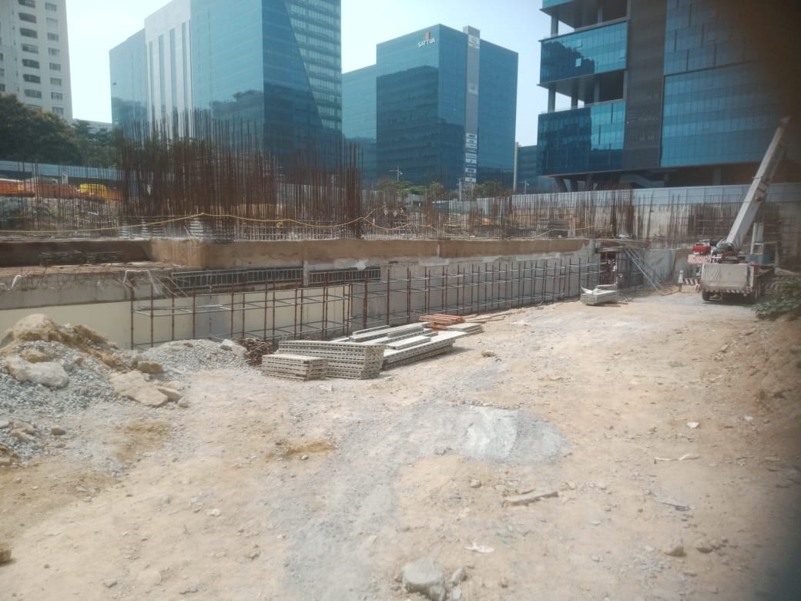

**SITUATED AT:**

**PLOT NO.17, VILLAGE: MADHAPUR, MANDAL: SERILINGAMPALLI, HYDERABAD, TELENGANA**

|  |  |
| --- | --- |
| **PART B** | **SBI FORMAT OF OPINION REPORT ON VALUATION** |

|  |  |
| --- | --- |
| **Name & Address of Branch** | State Bank of India, Commercial Branch, Mumbai |
| **Name of Customer (s)/ Borrower Unit** | M/s. VITP Private Limited |
| **Work Order No. & Date** | Dated 28th September, 2023 |

|  |  |  |  |  |  |  |  |  |  |  |  |  |  |  |  |  |  |  |
| --- | --- | --- | --- | --- | --- | --- | --- | --- | --- | --- | --- | --- | --- | --- | --- | --- | --- | --- |
| **S.NO.** | | **CONTENTS** | | **DESCRIPTION** | | | | | | | | | | | | | | |
|  | | **INTRODUCTION** | | | | | | | | | | | | | | | | |
|  | | Name of the owner | | M/s. VITP Private Limited  *(as per copy of licenses and NOC’S provided to us)* | | | | | | | | | | | | | | |
| Address & Phone Number of the Owner | | Regd. Office: - Plot no. 17, Building D, Software Units Layout, Madhapur, Serilingampalli Municipality, Hyderabad-500033 | | | | | | | | | | | | | | |
|  | | Purpose of the Valuation | | For Value assessment of the asset for bank loan security purpose | | | | | | | | | | | | | | |
|  | | Date of Inspection of the Property | | 17 October 2023 | | | | | | | | | | | | | | |
| Property Shown By | | Name | | | | | Relationship with Owner | | | | | | | | Contact Number | |
| Mr. Pankaj Rathi | | | | | Employee | | | | | | | | +91-9000277073 | |
|  | | Date of Valuation Report | | 11 December 2023 | | | | | | | | | | | | | | |
|  | | Name of the Developer of the Property | | No information | | | | | | | | | | | | | | |
| Type of Developer | | Private developer | | | | | | | | | | | | | | |
|  | **PHYSICAL CHARACTERISTICS OF THE PROPERTY** | | | | | | | | | | | | | | | | | |
|  | **BRIEF DESCRIPTION OF THE PROPERTY UNDER VALUATION**  This valuation report is prepared for the proposed commercial complex (Data Centre) which is currently under construction, situated at aforesaid address. As per the survey report this commercial project will be built on total land admeasuring 2.569 acres which is a part of total combined project area of 19.39 acres. We have also measured the area using Google satellite view tool measurement the area seems to be in line to it.    TSIIC- Madhapur has given the permit no. IIC/0893/2022 dated 19 May, 2023 Haryanato develop a Data Centre to M/s. VITP Private Limited. NOC’s and other license to set up a Data centre has also been taken by the developer from the concerned authority. The developer has proposed to construct a 2 Basement + 1 Ground + 6 floors building for setting up a data center, with a built up area of 30,319.21 Sq. Mts. / 3,26,353.26 Sq. Ft. STP and HSD Building Consisting of Ground Floor (Built Up Area 421.62 Sq. Mts. | 4538.27 Sq. Ft.). Total built up area of The Total Built up Area 30,740.83 Sq. Mts. / 3,30,891.54 sq. ft as per the building permit order no. IIC/0893/2022 dated 19 May, 2023.  Currently construction up to foundation level has been completed so we have not incorporated the value of structures, only land value of the subject property has been assessed in this valuation report. Subject site is demarcated by temporary boundary as of the date of survey. Although it is possible to construct permanent boundary around the subject plot after or during the construction of the building as per survey report.  As per the Municipal Administration and Urban Development Department – Andhra Pradesh Building Rules, 2012 – G.O.Ms.No.168 dated 07/04/2012, The owner is required to hand over 10% of the built-up area in the ground floor or first floor or the second floor, as the case may be, to the sanctioning authority by way of a Notarized Affidavit. The Notarized Affidavit shall be got entered by the sanctioning authority in the Prohibitory Property Watch Register of the Registration Department. Then only the Building sanction will be released. As per the Doc. No. 5711/2023, Dated 13th April, 2023, VITP has already mortgaged 10% of the proposed building area equivalent to o 3,103.79 sq. mtrs. / 33,408.91 sq. fts. (Consisting in First Floor) to "TSllC-IALA” until completion certificate is received from sanctioning authority.  The subject commercial land situated at Madhapur which is one of Hyderabad's upscale, concentrated commercial IT hotspots. Most of the adjoining properties are being used as commercial activies main office and IT parks. The main site is approached by main Durgam Cheruvu Road which is ~90 ft. wide.  This report only contains general assessment & opinion on the Guideline Value and the indicative, estimated Market Value of the property of which Bank/ customer asked us to conduct the Valuation for the property found on as-is-where basis as shown on the site by the Bank/ customer of which photographs is also attached with the report. No legal aspects in terms of ownership or any other legal aspect is taken into consideration. Even if any such information is mentioned in the report it is only referred from the information provided for which we do not assume any responsibility. Due care has been given while doing valuation assessment, but it doesn’t contain any due-diligence or audit or verification of any kind other than the valuation computation of the property shown to us on site. Information/ data/ documents given to us by Bank/ client have been relied upon in good faith. This report doesn’t contain any other recommendations of any sort.  In case of discrepancy in the address/ property number mentioned in the property documents and the property shown to us at the site due to change in zoning or administrative level at the site or the client misled the valuer by providing the fabricated/ incorrect document or information, the valuation should be considered of the property shown to us at the site by the client of which the photographs are also attached. In case of any doubt, best would be to contact the concerned authority/ district administration/ tehsil level for the identification of the property if the property depicted in the photographs in this report is same with the documents pledged. | | | | | | | | | | | | | | | | | |
|  | **Location attribute of the property** | | | | | | | | | | | | | | | | | |
|  | Nearby Landmark | | | Inorbit Mall | | | | | | | | | | | | | | |
|  | Postal Address of the Property | | | Plot No.17, Village: Madhapur, Mandal: Serilingampalli, Hyderabad, Telengana | | | | | | | | | | | | | | |
|  | Type of Land | | | Solid Land/ on road level | | | | | | | | | | | | | | |
|  | Independent access/ approach to the property | | | Clear independent access is available | | | | | | | | | | | | | | |
|  | Google Map Location of the Property with a neighborhood layout map | | | Enclosed with the Report | | | | | | | | | | | | | | |
| Coordinates or URL: 17°26'04.7"N 78°23'04.2"E | | | | | | | | | | | | | | |
|  | Details of the roads abutting the property | | | | | | | | | | | | | | | | | |
|  | 1. Main Road Name & Width | | | Durgam Cheruvu Road | | | | | | | | | | Approx. 90 ft. wide | | | | |
|  | 1. Front Road Name & width | | | Durgam Cheruvu Road | | | | | | | | | | Approx. 90 ft. wide | | | | |
|  | 1. Type of Approach Road | | | Bituminous Road | | | | | | | | | | | | | | |
|  | 1. Distance from the Main Road | | | On road | | | | | | | | | | | | | | |
|  | Description of adjoining property | | | Commercial | | | | | | | | | | | | | | |
|  | Plot No. / Survey No. | | | Plot No. 17 and survey no. 64/2 | | | | | | | | | | | | | | |
|  | Zone/ Block | | | --- | | | | | | | | | | | | | | |
|  | Sub registrar | | | Serilingampalli | | | | | | | | | | | | | | |
|  | District | | | Hyderabad | | | | | | | | | | | | | | |
|  | Any other aspect | | | Valuation is done for the property found as per the information given in the copy of documents provided to us and/ or confirmed by the owner/ owner representative to us at site.  Getting cizra map or coordination with revenue officers for site identification is not covered in this Valuation services. | | | | | | | | | | | | | | |
| 1. List of documents produced for perusal *(Documents has been referred only for reference purpose as provided. Authenticity to be ascertained by legal practitioner)* | | | **Documents Requested** | | | | **Documents Provided** | | | | | | | | | **Documents Reference No.** | |
| Total documents requested. | | | | Total documents provided | | | | | | | | | Total documents provided | |
| Property Title document | | | | Sale Deeds | | | | | | | | | Dated 25th April, 2001 | |
| License to develop commercial complex | | | | Acceptance letter for construction work | | | | | | | | | Ref No. Pearl/ 2023/LOA/21062023 Dated 26th June, 2023 | |
| Environmental Clearance | | | | Environmental Clearance by SEIAA Telengana | | | | | | | | | Order No. SEIAA/ TS/OL/RRD-984/2021 Dated 14th September, 2022 | |
| Approved Site Plan | | | | Approved Site Plan | | | | | | | | | Dated 19th May, 2023 | |
| Building Plan Approval | | | | Building Plan Approval | | | | | | | | | Permit No: IIC/0893/2022 dated 19th May 2022 | |
| Fire NOC | | | | Fire NOC by Govt. Of Telangana  State Disaster Response & Fire Services Department | | | | | | | | | ACK. No. 466910002022 dated 7th December, 2022 | |
| Mortgage deed for 10% built up area | | | | Mortgage deed for 10% built up area | | | | | | | | | Doc. No. 5711/2023, Dated 13th April, 2023 | |
| Survey Job Report | | | | Survey report | | | | | | | | | Dated : 31.01.2024 | |
| 1. Documents provided by | | | **Name** | | | | **Relationship with Owner** | | | | | | | | | **Contact Number** | |
| Punith Kumar Soni | | | | Employee | | | | | | | | | 9701103311 | |
| 1. Identification procedure followed of the property | | | ☐ | Identified by the owner | | | | | | | | | | | | | |
| Z:\In Progress Files\Babul\Check.png | Identified by owner’s representative | | | | | | | | | | | | | |
| Z:\In Progress Files\Babul\Check.png | Done from the name plate displayed on the property | | | | | | | | | | | | | |
| Z:\In Progress Files\Babul\Check.png | Cross checked from boundaries or address of the property mentioned in the survey report | | | | | | | | | | | | | |
| Z:\In Progress Files\Babul\Check.png | Enquired from local residents/ public | | | | | | | | | | | | | |
| ☐ | Identification of the property could not be done properly | | | | | | | | | | | | | |
| ☐ | Survey was not done | | | | | | | | | | | | | |
| 1. Type of Survey | | | Full survey (inside-out with approximate sample random measurements verification & photographs). | | | | | | | | | | | | | | |
| 1. Is property clearly demarcated by permanent/ temporary boundary on site | | | Yes demarcated properly by temporary boundary | | | | | | | | | | | | | | |
| 1. Is the property merged or colluded with any other property | | | Yes | | | | | | | | | | | | | | |
| The subject 2.569 acres of land is a part of whole 19.39 acre where other building structures have already been made | | | | | | | | | | | | | | |
| 1. City Categorization | | | Metro City | | | | | | | | | | Urban Developed | | | | |
| 1. Characteristics of the locality | | | Very Good | | | | | | | | | | Within main city | | | | |
| 1. Property location classification | | | On Highway | | | | | | | Near to Metro Station | | | | | | Road Facing | |
| 1. Property Facing | | | South Facing | | | | | | | | | | | | | | |
|  | **Area description of the Property**  *Also please refer to Part-B Area description of the property. Area measurements considered in the Valuation Report is adopted from relevant approved documents or actual site measurement whichever is less, unless otherwise mentioned. Verification of the area measurement of the property is done only based on sample random checking.* | | | **Land** | | | | | | | | **Construction** | | | | | | |
| Built-up Area | | | | | | |
| 2.569 acres | | | | | | | | Not applicable since under construction | | | | | | |
|  | **Boundaries schedule of the Property** | | | | | | | | | | | | | | | | | |
|  | Are Boundaries matched | | | Yes from the available documents | | | | | | | | | | | | | | |
|  | **Directions** | | **As per Sale Deed/TIR** | | | | | | | | | **Actual found at Site** | | | | | | |
| East | | Orion Building | | | | | | | | | Internal Road / Orion Block | | | | | | |
| West | | Capital land | | | | | | | | | International Tech Park Hyderabad | | | | | | |
| North | | Atria Building | | | | | | | | | Atria Block | | | | | | |
| South | | Road | | | | | | | | | Main Road | | | | | | |
|  | **TOWN PLANNING/ ZONING PARAMETERS** | | | | | | | | | | | | | | | | | |
|  | Master Plan provisions related to property in terms of Land use | | | | | | Commercial | | | | | | | | | | | |
| 1. Any conversion of land use done | | | | | | From Agricultural to Commercial | | | | | | | | | | | |
| 1. Current activity done in the property | | | | | | Used for Commercial purpose | | | | | | | | | | | |
| 1. Is property usage as per applicable zoning | | | | | | Yes | | | | | | | | | | | |
| 1. Any notification on change of zoning regulation | | | | | | Not Applicable | | | | | | | | | | | |
| 1. Street Notification | | | | | | Commercial | | | | | | | | | | | |
|  | Provision of Building by-laws as applicable | | | | | | **PERMITTED**  **(Fire NOC)** | | | | | | | | | **PROPOSED**  **(As per survey report)** | | |
| 1. FAR/FSI | | | | | | --- | | | | | | | | | Not mentioned | | |
| 1. Ground coverage | | | | | | -- | | | | | | | | | Not mentioned | | |
| 1. Number of floors | | | | | | 2 Celler + 1 Ground + 6 floors | | | | | | | | | Not mentioned | | |
| 1. Height restrictions | | | | | | 49 mtr. | | | | | | | | | Not mentioned | | |
| 1. Front/ Back/Side Setback | | | | | | North: 14 mtr.  South: 14 mtr.  East: 14 mtr.  West: 14 mtr. | | | | | | | | | North: 14.71 mtr.  South: 16.05 mtr.  East: 15.10 mtr.  West: 15.13 mtr. | | |
|  | 1. Status of Completion/ Occupational certificate | | | | | | Not applicable as construction is in progress | | | | | | | | | | | |
|  | Comment on unauthorized construction if any | | | | | | None | | | | | | | | | | | |
|  | Comment on Transferability of developmental rights | | | | | | Free hold, complete transferable rights | | | | | | | | | | | |
|  | 1. Planning Area/ Zone | | | | | | Hyderabad Metropolitan Development Authority (HMDA) | | | | | | | | | | | |
| 1. Master Plan Currently in Force | | | | | | Hyderabad Metropolitan Development Authority (HMDA) | | | | | | | | | | | |
| 1. Municipal Limits | | | | | | Greater Hyderabad Muncipal Corporation (GHMC) | | | | | | | | | | | |
|  | Developmental controls/ Authority | | | | | | Hyderabad Metropolitan Development Authority (HMDA) | | | | | | | | | | | |
|  | Zoning regulations | | | | | | Commercial | | | | | | | | | | | |
|  | Comment on the surrounding land uses & adjoining properties in terms of uses | | | | | | All adjacent properties are used for commercial purpose | | | | | | | | | | | |
|  | Comment of Demolition proceedings if any | | | | | | No such incident came to our knowledge | | | | | | | | | | | |
|  | Comment on Compounding/ Regularization proceedings | | | | | | No such incident came to our knowledge | | | | | | | | | | | |
|  | Any other aspect | | | | | | --- | | | | | | | | | | | |
| 1. Any information on encroachment | | | | | | None | | | | | | | | | | | |
| 1. Is the area part of unauthorized area/ colony | | | | | | No | | | | | | | | | | | |
|  | **DOCUMENT DETAILS AND LEGAL ASPECTS OF THE PROPERTY** | | | | | | | | | | | | | | | | | |
|  | Ownership documents provided | | | | | Sale deed | | | | License | | | | | | | | NOC's |
|  | Names of the owner | | | | | M/S VITP Private Limited | | | | | | | | | | | | |
|  | Constitution of the Property | | | | | Free hold, complete transferable rights | | | | | | | | | | | | |
|  | Agreement of easement if any | | | | | Not required | | | | | | | | | | | | |
|  | Notice of acquisition if any and area under acquisition | | | | | No such information came in front of us and could be found on public domain | | | | | | | | | | | | |
|  | Notification of road widening if any and area under acquisition | | | | | No information | | | | | | | | | | | | |
|  | Heritage restrictions, if any | | | | | No | | | | | | | | | | | | |
|  | Comment on Transferability of the property ownership | | | | | Free hold, complete transferable rights | | | | | | | | | | | | |
|  | Comment on existing mortgages/ charges/ encumbrances on the property, if any | | | | | The property is proposed to be charged to State Bank of  India | | | | | | | | | | | | |
|  | Comment on whether the owners of the property have issued any guarantee *(personal or corporate)* as the case may be | | | | | Not Known to us | | | | | | | | | NA | | | |
|  | Building plan sanction: | | | | | | | | | | | | | | | | | |
| 1. Is Building Plan sanctioned | | | | | Sanctioned by competent authority as per copy of Map provided to us | | | | | | | | | | | | |
| 1. Authority approving the plan | | | | | TSIIC- Madhapur | | | | | | | | | | | | |
| 1. Any violation from the approved Building Plan | | | | | Not applicable since construction is in progress | | | | | | | | | | | | |
| 1. Details of alterations/ deviations/ illegal construction/ encroachment noticed in the structure from the original approved plan | | | | | Permissible Alterations | | | | | | | | NA | | | | |
| Not permitted alteration | | | | | | | | NA | | | | |
|  | Whether Property is Agricultural Land if yes, any conversion is contemplated | | | | | No not an agricultural property | | | | | | | | | | | | |
|  | Whether the property SARFAESI complaint | | | | | Yes | | | | | | | | | | | | |
|  | 1. Information regarding municipal taxes *(property tax, water tax, electricity bill)* | | | | | Property Tax | | | | | | | Not Applicable since property is under construction | | | | | |
| Water Tax | | | | | | | Not Applicable since property is under construction | | | | | |
| Electricity Bill | | | | | | | Not Applicable since property is under construction | | | | | |
| 1. Observation on Dispute or Dues if any in payment of bills/ taxes | | | | | No such information came to knowledge on site | | | | | | | | | | | | |
| 1. Is property tax been paid for this property | | | | | Not Applicable | | | | | | | | | | | | |
| 1. Property or Tax Id No. | | | | | -- | | | | | | | | | | | | |
|  | Whether entire piece of land on which the unit is set up / property is situated has been mortgaged or to be mortgaged | | | | | Yes, as informed by owner/ owner representative. | | | | | | | | | | | | |
|  | Qualification in TIR/Mitigation suggested if any | | | | | Can't comment since not a legal expert | | | | | | | | | | | | |
|  | Any other aspect | | | | | This is just an opinion report on Valuation based on the copy of the documents/ information provided to us by the client and has been relied upon in good faith of the property found as per the information given in the documents provided to us and/ or confirmed by the owner/ owner representative to us on site.  Legal aspects, Title verification, Verification of authenticity of documents from originals or cross checking from any Govt. dep’t. of the property have to be taken care by legal expert/ Advocate. | | | | | | | | | | | | |
| 1. Property presently occupied/ possessed by | | | | | Owner | | | | | | | | | | | | |

|  |  |  |  |  |  |  |  |  |  |  |  |  |  |  |  |  |
| --- | --- | --- | --- | --- | --- | --- | --- | --- | --- | --- | --- | --- | --- | --- | --- | --- |
|  | **ECONOMIC ASPECTS OF THE PROPERTY** | | | | | | | | | | | | | | | |
|  | Reasonable letting value/ Expected market monthly rental | | | | | | | Not applicable | | | | | | | | |
|  | Is property presently on rent | | | | | | | No | | | | | | | | |
| 1. Number of tenants | | | | | | | Not applicable | | | | | | | | |
| 1. Since how long lease is in place | | | | | | | Not applicable | | | | | | | | |
| 1. Status of tenancy right | | | | | | | Not applicable | | | | | | | | |
| 1. Amount of monthly rent received | | | | | | | Not applicable | | | | | | | | |
|  | Taxes and other outgoing | | | | | | | NA | | | | | | | | |
|  | Property Insurance details | | | | | | | --- | | | | | | | | |
|  | Monthly maintenance charges payable | | | | | | | Not applicable | | | | | | | | |
|  | Security charges, etc. | | | | | | | Not applicable | | | | | | | | |
|  | Any other aspect | | | | | | | NA | | | | | | | | |
|  | **SOCIO - CULTURAL ASPECTS OF THE PROPERTY** | | | | | | | | | | | | | | | |
|  | Descriptive account of the location of the property in terms of Social structure of the area in terms of population, social stratification, regional origin, age groups, economic levels, location of slums/squatter settlements nearby, etc. | | | | | | | High Income Group | | | | | | | | |
|  | Whether property belongs to social infrastructure like hospital, school, old age homes etc. | | | | | | | No | | | | | | | | |
|  | **FUNCTIONAL AND UTILITARIAN SERVICES, FACILITIES & AMENITIES** | | | | | | | | | | | | | | | |
|  | Description of the functionality & utility of the property in terms of: | | | | | | | | | | | | | | | |
|  | 1. Space allocation | | | | | | | Yes (proposed) | | | | | | | | |
| 1. Storage spaces | | | | | | | Yes (proposed) | | | | | | | | |
| 1. Utility of spaces provided within the building | | | | | | | Yes (proposed) | | | | | | | | |
| 1. Car parking facilities | | | | | | | Yes (proposed) | | | | | | | | |
| 1. Balconies | | | | | | | No | | | | | | | | |
|  | Any other aspect | | | | | | | | | | | | | | | |
|  | 1. Drainage arrangements | | | | | | | Yes (proposed) | | | | | | | | |
| 1. Water Treatment Plant | | | | | | | No | | | | | | | | |
| 1. Power Supply arrangements | | | Permanent | | | | Yes | | | | | | | | |
| Auxiliary | | | | No | | | | | | | | |
| 1. HVAC system | | | | | | | No | | | | | | | | |
| 1. Security provisions | | | | | | | Yes/ Private security guards | | | | | | | | |
| 1. Lift/ Elevators | | | | | | | No | | | | | | | | |
| 1. Compound wall/ Main Gate | | | | | | | Yes | | | | | | | | |
| 1. Whether gated society | | | | | | | Yes (proposed) | | | | | | | | |
| Internal development | | | | | | | | | | | | | | | |
| Garden/ Park/ Land scraping | | Water bodies | | | Internal roads | | | | Pavements | | | | Boundary Wall | | |
| No | | No | | | No | | | | No | | | | Yes | | |
|  | **INFRASTRUCTURE AVAILABILITY** | | | | | | | | | | | | | | | |
|  | Description of Aqua Infrastructure availability in terms of: | | | | | | | | | | | | | | | |
|  | 1. Water Supply | | | | | | | Yes | | | | | | | | |
| 1. Sewerage/ sanitation system | | | | | | | Yes | | | | | | | | |
| 1. Storm water drainage | | | | | | | No | | | | | | | | |
|  | Description of other Physical Infrastructure facilities in terms of: | | | | | | | | | | | | | | | |
|  | 1. Solid waste management | | | | | | | Yes, by the local Authority | | | | | | | | |
| 1. Electricity | | | | | | | Yes | | | | | | | | |
| 1. Road and Public Transport connectivity | | | | | | | Yes | | | | | | | | |
| 1. Availability of other public utilities nearby | | | | | | | Transport, Market, Hospital etc. available in close vicinity | | | | | | | | |
|  | Proximity & availability of civic amenities & social infrastructure | | | | | | | | | | | | | | | |
|  | School | Hospital | | | Market | | Bus Stop | | Railway Station | | | Metro | | | | Airport |
| ~2 km. | ~2 km. | | | ~3 km. | | --- | | ~5 km | | | ~2 kms. | | | | ~20 km |
|  | Availability of recreation facilities (parks, open spaces etc.) | | | | | | Yes | | | | | | | | | |
|  | **MARKETABILITY ASPECTS OF THE PROPERTY** | | | | | | | | | | | | | | | |
|  | Marketability of the property in terms of | | | | | | | | | | | | | | | |
|  | 1. Location attribute of the subject property | | | | | | | Very Good | | | | | | | | |
| 1. Scarcity | | | | | | | Similar kind of properties are not easily available in this area. | | | | | | | | |
| 1. Demand and supply of the kind of the subject property in the locality | | | | | | | Good demand of such properties in the market. | | | | | | | | |
| 1. Comparable Sale Prices in the locality | | | | | | | Please refer to Part D: Procedure of Valuation Assessment | | | | | | | | |
|  | Any other aspect which has relevance on the value or marketability of the property | | | | | | | Property is located on main road. | | | | | | | | |
|  | 1. Any New Development in surrounding area | | | | | | | Few commercial project is in progress | | | | | | | | |
| 1. Any negativity/ defect/ disadvantages in the property/ location | | | | | | | None | | | | | | | | |
|  | **ENGINEERING AND TECHNOLOGY ASPECTS OF THE PROPERTY** | | | | | | | | | | | | | | | |
|  | Type of construction | | | | | | | **Structure** | | | **Slab** | | | | **Walls** | |
| Not applicable since currently the site is under construction | | | Not applicable since currently the site is under construction | | | | Not applicable since currently the site is under construction | |
|  | Material & Technology used | | | | | | | **Material Used** | | | | | **Technology used** | | | |
| Not applicable since currently the site is under construction | | | | | Not applicable since currently the site is under construction | | | |
|  | Specifications | | | | | | | | | | | | | | | |
| 1. Roof | | | | | | | **Floors/ Blocks** | | | | | **Type of Roof** | | | |
| Not applicable since currently the site is under construction | | | | | Not applicable since currently the site is under construction | | | |
| 1. Floor height | | | | | | | Not applicable since currently the site is under construction | | | | | | | | |
| 1. Type of flooring | | | | | | | Not applicable since currently the site is under construction | | | | | | | | |
| 1. Doors/ Windows | | | | | | | Not applicable since currently the site is under construction | | | | | | | | |
| 1. Class of construction/ Appearance/ Condition of structures | | | | | | | Not applicable since currently the site is under construction | | | | | | | | |
| Not applicable since currently the site is under construction | | | | | | | | |
| 1. Interior Finishing & Design | | | | | | | Not applicable since currently the site is under construction | | | | | | | | |
| 1. Exterior Finishing & Design | | | | | | | Not applicable since currently the site is under construction | | | | | | | | |
| 1. Interior decoration/ Special architectural or decorative feature | | | | | | | Not applicable since currently the site is under construction | | | | | | | | |
| 1. Class of electrical fittings | | | | | | | Not applicable since currently the site is under construction | | | | | | | | |
| 1. Class of sanitary & water supply fittings | | | | | | | Not applicable since currently the site is under construction | | | | | | | | |
|  | Maintenance issues | | | | | | | Not applicable since currently the site is under construction | | | | | | | | |
|  | Age of building/ Year of construction | | | | | | | Not applicable since currently the site is under construction | | | | | Not applicable since currently the site is under construction | | | |
|  | Total life of the structure/ Remaining life expected | | | | | | | Not applicable since currently the site is under construction | | | | | Not applicable since currently the site is under construction | | | |
|  | Extent of deterioration in the structure | | | | | | | Not applicable since currently the site is under construction | | | | | | | | |
|  | Structural safety | | | | | | | Not applicable since currently the site is under construction | | | | | | | | |
|  | Protection against natural disasters viz. earthquakes etc. | | | | | | | Not applicable since currently the site is under construction | | | | | | | | |
|  | Visible damage in the building if any | | | | | | | Not applicable since currently the site is under construction | | | | | | | | |
|  | System of air conditioning | | | | | | | Not applicable since currently the site is under construction | | | | | | | | |
|  | Provision of firefighting | | | | | | | Not applicable since currently the site is under construction | | | | | | | | |
|  | Copies of the plan and elevation of the building to be included | | | | | | | Not applicable since currently the site is under construction | | | | | | | | |
|  | **ENVIRONMENTAL FACTORS** | | | | | | | | | | | | | | | |
|  | Use of environment friendly building materials like fly ash brick, other Green building techniques if any | | | | | | | Not applicable since currently the site is vacant | | | | | | | | |
|  | Provision of rainwater harvesting | | | | | | | No | | | | | | | | |
|  | Use of solar heating and lighting systems, etc. | | | | | | | No | | | | | | | | |
|  | Presence of environmental pollution in the vicinity of the property in terms of industries, heavy traffic, etc. if any | | | | | | | Yes, normal air pollution from vehicles | | | | | | | | |
|  | **ARCHITECTURAL AND AESTHETIC QUALITY OF THE PROPERTY** | | | | | | | | | | | | | | | |
|  | Descriptive account on whether the building is modern, old fashioned, etc., plain looking or with decorative elements, heritage value if applicable, presence of landscape elements,  etc. | | | | | | | Not Applicable | | | | | | | | |
|  | **VALUATION** | | | | | | | | | | | | | | | |
|  | Methodology of Valuation – Procedures adopted for arriving at the Valuation | | | | | | | Please refer to ***Part D: Procedure of Valuation Assessment*** of the report. | | | | | | | | |
|  | Prevailing Market Rate/ Price trend of the Property in the locality/ city from property search sites | | | | | | | Please refer to ***Part D: Procedure of Valuation Assessment*** of the report and the screenshot annexure in the report, if available. | | | | | | | | |
|  | Guideline Rate obtained from Registrar’s office/ State Govt. gazette/ Income Tax Notification | | | | | | | Please refer to ***Point 3 of Part D: Procedure of Valuation Assessment*** of the report and the screenshot annexure in the report, if available. | | | | | | | | |
|  | **Summary of Land Valuation** | | | | | | | For detailed Valuation calculation please refer to ***Part D: Procedure of Valuation Assessment*** of the report. | | | | | | | | |
| 1. **Guideline Value** | | | | | | | **Rs.56,50,21,600/-** | | | | | | | | |
| 1. **Indicative Prospective Estimated Fair Market Value** | | | | | | | **Rs.218,00,00,000/-** | | | | | | | | |
| 1. **Expected Estimated Realizable Value** | | | | | | | **Rs.185,30,00,000/-** | | | | | | | | |
| 1. **Expected Forced/ Distress Sale Value** | | | | | | | **Rs.163,50,00,000/-** | | | | | | | | |
| 1. **Valuation of structure for Insurance purpose** | | | | | | | **Not applicable** | | | | | | | | |
|  | 1. Justification for more than 20% difference in Market & Circle Rate | | | | | | | Circle rates are determined by the District administration as per their own theoretical internal policy for fixing the minimum valuation of the property for property registration tax collection purpose and Market rates are adopted based on prevailing market dynamics found as per the discrete market enquiries which is explained clearly in Valuation assessment factors. | | | | | | | | |
| 1. Details of last two transactions in the locality/ area to be provided, if available | | | | | | | No authentic last two transactions details could be known. However prospective transaction details as per information available on public domain and gathered during site survey is mentioned in ***Part D: Procedure of Valuation Assessment*** of the report and the screenshots of the references are annexed in the report for reference. | | | | | | | | |
|  | **Declaration** | | 1. The information provided by us is true and correct to the best of our knowledge and belief. 2. The analysis and conclusions are limited by the reported assumptions, limiting conditions, remarks. 3. Firm have read the Handbook on Policy, Standards and Procedures for Real Estate Valuation by Banks and HFIs in India, 2009 issued by IBA and NHB, fully understood the provisions of the same and followed the provisions of the same to the best of our ability and practically possible and this report is in conformity to the Standards of Reporting enshrined in the above Handbook. 4. No employee or member of R.K Associates has any direct/ indirect interest in the property. 5. Our authorized surveyor **Ram Prasad** has visited the subject property on **17/10/2023** in the presence of the owner's representative with the permission of owner. 6. Firm is an approved Valuer of the Bank. 7. Firm is not depanelled or removed from any Bank/Financial Institution/Government Organization at any point of time in the past. 8. We have submitted the Valuation Report directly to the Bank. | | | | | | | | | | | | | |
|  | **ENCLOSED DOCUMENTS** | | | | | | | | | | | | | | | |
|  | Layout plan sketch of the area in which the property is located with latitude and longitude | | | | | | | Google Map enclosed with coordinates | | | | | | | | |
|  | Building Plan | | | | | | | Not Applicable | | | | | | | | |
|  | Floor Plan | | | | | | | Not Applicable | | | | | | | | |
|  | Photograph of the property (including geo-stamping with date) and owner (in case of housing loans, if borrower is available) including a “Selfie’ of the Valuer representative at the site | | | | | | | Enclosed with the report along with other property photographs | | | | | | | | |
|  | Certified copy of the approved / sanctioned plan wherever applicable from the concerned office | | | | | | | Not Applicable | | | | | | | | |
|  | Google Map location of the property | | | | | | | Enclosed with the Report | | | | | | | | |
|  | Price trend of the property in the locality/city from property search sites viz Magickbricks.com, 99Acres.com, Makan.com etc. | | | | | | | No specific price trends available for this location on property search sites or public domain. | | | | | | | | |
|  | Any other relevant documents/extracts  *(All enclosures & annexures to remain integral part & parcel of the main report)* | | | | | | | 1. Part C: Area Description of the Property 2. Part D: Procedure of Valuation Assessment 3. Google Map 4. References on price trend of the similar related properties available on public domain, if available 5. Photographs of the property 6. Copy of Circle Rate 7. Important property documents exhibit 8. Annexure: VI - Declaration-Cum-Undertaking 9. Annexure: VII - Model Code of Conduct for Valuers | | | | | | | | |
|  | **Total Number of Pages in the Report with enclosures** | | | | | | | **55** | | | | | | | | |

**ENCLOSURE: I**

|  |  |
| --- | --- |
| **PART C** | **AREA DESCRIPTION OF THE PROPERTY** |

|  |  |  |  |
| --- | --- | --- | --- |
|  | Land Area considered for Valuation | 2.569 acres | |
| Area adopted on the basis of | Property documents and measurement through satellite measurement tools | |
| Remarks & observations, if any | The subject 2.569 acres of land parcel is part of the whole 19.39 acres. No separate deed has been executed for this subject land. Although as per the survey report made by the company the Data Centre will be built upon this 2.569 acres of land. We have also crossed checked the land area through Google satellite measurement tool and the area seems to be in line with the subject area and same has been adopted this is valuation report. | |
|  | Constructed Area considered for Valuation  (As per IS 3861-1966) | **Built-up Area** | Not applicable since construction upto foundation level has been completed |
| Area adopted on the basis of | Not applicable since construction upto foundation level has been completed | |
| Remarks & observations, if any | NA | |

**Note:**

1. *Area measurements considered in the Valuation Report pertaining to Land & Building is adopted from relevant approved documents or actual site measurement whichever is less. All area measurements are on approximate basis only.*
2. *Verification of the area measurement of the property is done based on sample random checking only.*
3. *Area of the large land parcels of more than 2500 sq.mtr or of uneven shape, is taken as per property documents verified with digital survey through google which has been relied upon.*
4. *Drawing Map, design & detailed estimation of the property/ building is out of scope of the Valuation services.*

**ENCLOSURE: II**

|  |  |
| --- | --- |
| **PART D** | **PROCEDURE OF VALUATION ASSESSMENT** |

|  |  |  |  |  |  |  |
| --- | --- | --- | --- | --- | --- | --- |
|  | **GENERAL INFORMATION** | | | | | |
|  | Important Dates | **Date of Appointment** | | **Date of Inspection of the Property** | **Date of Valuation Assessment** | **Date of Valuation Report** |
| 28 September 2023 | | 17 October 2023 | 15 November 2023 | 11 December 2023 |
|  | Client | State Bank of India, Commercial Branch, Mumbai | | | | |
|  | Intended User | State Bank of India, Commercial Branch, Mumbai | | | | |
|  | Intended Use | Only for the intended user, purpose of the assignment as per the scope of the assessment. | | | | |
|  | Purpose of Valuation | For Value assessment of the asset for creating collateral mortgage for Bank Loan purpose | | | | |
|  | Scope of the Assessment | For Value assessment of the present land value of the asset. | | | | |
|  | Restrictions | This report should not be referred for any other purpose, by any other user and for any other date other then as specified above. This report is not a certification of ownership or survey number/ property number/ Khasra number which are merely referred from the copy of the documents provided to us. | | | | |
|  | Manner in which the proper is identified |  | Identified by the owner | | | |
| Z:\In Progress Files\Babul\Check.png | Identified by owner’s representative | | | |
| Z:\In Progress Files\Babul\Check.png | Done from the name plate displayed on the property | | | |
| Z:\In Progress Files\Babul\Check.png | Cross checked from boundaries or address of the property mentioned in the survey report. | | | |
| Z:\In Progress Files\Babul\Check.png | Enquired from local residents/ public | | | |
|  | Identification of the property could not be done properly | | | |
|  | Survey was not done | | | |
|  | Is property number/ survey number displayed on the property for proper identification? | No | | | | |
|  | Type of Survey conducted | Full survey (inside-out with approximate sample random measurements verification & photographs). | | | | |

|  |  |  |  |  |  |  |  |  |  |  |  |  |  |  |
| --- | --- | --- | --- | --- | --- | --- | --- | --- | --- | --- | --- | --- | --- | --- |
|  | **ASSESSMENT FACTORS** | | | | | | | | | | | | | |
|  | Valuation Standards considered | Mix of standards such as IVS and others issued by Indian authorities & institutions and improvised by the RKA internal research team as and where it is felt necessary to derive at a reasonable, logical & scientific approach. In this regard proper basis, approach, working, definitions considered is defined below which may have certain departures to IVS. | | | | | | | | | | | | |
|  | Nature of the Valuation | Fixed Assets Valuation | | | | | | | | | | | | |
|  | Nature/ Category/ Type/ Classification of Asset under Valuation | **Nature** | | | | | **Category** | | | | | | **Type** | |
| VACANT LAND | | | | | COMMERCIAL | | | | | | COMMERCIAL LAND | |
| **Classification** | | | | | Only commercial use asset | | | | | | | |
|  | Type of Valuation *(Basis of Valuation as per IVS)* | Primary Basis | | | | Fair Market Value | | | | | | | | |
| Secondary Basis | | | | Asset in use as per its utility | | | | | | | | |
|  | Present market state of the Asset assumed *(Premise of Value as per IVS)* | Under Normal Marketable State | | | | | | | | | | | | |
| **Reason:** Asset under free market transaction state | | | | | | | | | | | | |
|  | Property Use factor | **Current/ Existing Use** | | | | | | **Highest & Best Use**  *(in consonance to surrounding use, zoning and statutory norms)* | | | | | **Considered for Valuation purpose** | |
| Commercial | | | | | | Commercial | | | | | Commercial | |
|  | Legality Aspect Factor | Assumed to be fine as per copy of the documents & information produced to us.  However Legal aspects of the property of any nature are out-of-scope of the Valuation Services. In terms of the legality, we have only gone by the documents provided to us in good faith.  Verification of authenticity of documents from originals or cross checking from any Govt. deptt. have to be taken care by Legal expert/ Advocate. | | | | | | | | | | | | |
|  | Class/ Category of the locality | Upper Middle Class (Good) | | | | | | | | | | | | |
|  | Property Physical Factors | **Shape** | | | | | | | **Size** | | | | **Layout** | |
| Irregular | | | | | | | Medium | | | | Normal Layout | |
|  | Property Location Category Factor | **City Categorization** | | | **Locality Characteristics** | | | | | | **Property location characteristics** | | | **Floor Level** |
| Metro City | | | Very Good | | | | | | On Wide Road | | | Under construction |
| Urban developed | | | High End | | | | | | Near to Metro Station | | |
| Within main city | | | | | | Good location within locality | | |
| **Property Facing** | | | | | | | | | | | | |
| South Facing | | | | | | | | | | | | |
|  | Physical Infrastructure availability factors of the locality | **Water Supply** | | | **Sewerage/ sanitation system** | | | | | | **Electricity** | | | **Road and Public Transport connectivity** |
| Yes from municipal connection | | | Yes | | | | | | Yes | | | Easily available |
| **Availability of other public utilities nearby** | | | | | | | | | **Availability of communication facilities** | | | |
| Transport, Market, Hospital etc. are available in close vicinity | | | | | | | | | Major Telecommunication Service Provider & ISP connections are available | | | |
|  | Social structure of the area (in terms of population, social stratification, regional origin, age groups, economic levels, location of slums/ squatter settlements nearby, etc.) | High end commercial area | | | | | | | | | | | | |
|  | Neighbourhood amenities | Very Good | | | | | | | | | | | | |
|  | Any New Development in surrounding area | Commercial project is in progress | | | | | | | | | | | | |
|  | Any specific advantage in the property | The relevant property is positioned in one of Hyderabad's upscale, concentrated commercial IT hotspots. | | | | | | | | | | | | |
|  | Any specific drawback in the property | No. | | | | | | | | | | | | |
|  | Property overall usability/ utility Factor | Good | | | | | | | | | | | | |
|  | Do property has any alternate use? | No. | | | | | | | | | | | | |
|  | Is property clearly demarcated by permanent/ temporary boundary on site | Demarcated with temporary boundary as of now but there is scope of building separate permanent boundary maintaining proper set back. | | | | | | | | | | | | |
|  | Is the property merged or colluded with any other property | Yes | | | | | | | | | | | | |
| Comments: total land admeasuring 2.569 acres which is a part of total combined project area of 19.39 acres | | | | | | | | | | | | |
|  | Is independent access available to the property | Clear independent access is available | | | | | | | | | | | | |
|  | Is property clearly possessable upon sale | Yes | | | | | | | | | | | | |
|  | Best Sale procedure to realize maximum Value *(in respect to Present market state or premise of the Asset as per point (iv) above)* | Fair Market Value | | | | | | | | | | | | |
| Free market transaction at arm's length wherein the parties, after full market survey each acted knowledgeably, prudently and without any compulsion. | | | | | | | | | | | | |
|  | Hypothetical Sale transaction method assumed for the computation of valuation | Fair Market Value | | | | | | | | | | | | |
| Free market transaction at arm's length wherein the parties, after full market survey each acted knowledgeably, prudently and without any compulsion. | | | | | | | | | | | | |
|  | Approach & Method of Valuation Used | **Land** | | **Approach of Valuation** | | | | | | | **Method of Valuation** | | | |
| **Market Approach** | | | | | | | **Market Comparable Sales Method** | | | |
|  | Type of Source of Information | Level 3 Input (Tertiary) | | | | | | | | | | | | |
|  | **Market Comparable** | | | | | | | | | | | | | |
| References on prevailing market Rate/ Price trend of the property and Details of the sources from where the information is gathered *(from property search sites & local information)* | **1.** | Name: | | | | | | | | | Please refer below references. | | |
| Contact No.: | | | | | | | | |
| Nature of reference: | | | | | | | | |
| Size of the Property: | | | | | | | | |
| Location: | | | | | | | | |
| Rates/ Price informed: | | | | | | | | |
| Any other details/ Discussion held: | | | | | | | | |
| *NOTE: The given information above can be independently verified to know its authenticity.* | | | | | | | | | | | | |
|  | Adopted Rates Justification | The reference we found have been attached below in a tabular form:    Another report from Hindustan times dated 05th August 2023 suggested that Hyderabad Metropolitan Development Authority (HMDA) expected to generate a minimum revenue of ₹1,586.50 crore from the auction of seven plots, ranging from 3.60 acres to 9.71 acres, by fixing an upset price of ₹35 crore per acre, the auction fetched ₹3,319.60 crore at an average of ₹73.23 crore per acre. All the references are from Neopolis, Kokapet, Hyderabad which is ~10-12 kms away so, the premium due to location has been takn accordingly.  We have also found commercial land rate near Madhapur. The rate The reference we found have been attached below in a tabular form:   |  |  |  |  |  |  | | --- | --- | --- | --- | --- | --- | | **COMMERCIAL LAND RATE AT MADHAPUR, HYDERABAD** | | | | | | | **Sl. No.** | **Location** | **Land area (sq. mtr.)** | **Rate / sq. mtr. (in Rs.)** | **Rate / acre**  **(in Rs.)** | **Distance from Subject Prop. in Km.** | | 1 | Madhapur | 319 | 3,38,558 | 1,37,01,44,201 | - | | 2 | Vittal Rao Nagar | 533 | 2,47,655 | 1,00,22,58,912 | 2.2 | | 3 | Hi tech City | 502 | 2,74,900 | 1,11,25,21,912 | 2 | | 4 | Jubilee Hills | 1,171 | 3,41,588 | 1,38,24,08,198 | 5.4 |   All these references are for small size plots. So, the discounts have been taken accordingly.  As per our market research through different article published online in public domain we are of the view to adopt a land rate of **85 Cr. per acre** for commercial land, which is reasonable in our opinion, close to our subject property. | | | | | | | | | | | | |
| ***NOTE:*** *We have taken due care to take the information from reliable sources. The given information above can be independently verified from the provided numbers to know its authenticity. However due to the nature of the information most of the market information came to knowledge is only through verbal discussion with market participants which we have to rely upon where generally there is no written record.*  *Related postings for similar properties on sale are also annexed with the Report wherever available.* | | | | | | | | | | | | | |
|  | **Other Market Factors** | | | | | | | | | | | | | |
| Current Market condition | Normal | | | | | | | | | | | | |
| **Remarks:** --- | | | | | | | | | | | | |
| **Adjustments (-/+):** 0% | | | | | | | | | | | | |
| Comment on Property Salability Outlook | Easily sellable | | | | | | | | | | | | |
| **Adjustments (-/+):** 0% | | | | | | | | | | | | |
| Comment on Demand & Supply in the Market | **Demand** | | | | | | | | **Supply** | | | | |
| High | | | | | | | | Low | | | | |
| **Remarks:** Good demand of such properties in the market | | | | | | | | | | | | |
| **Adjustments (-/+):** 0% | | | | | | | | | | | | |
|  | Any other special consideration | **Reason: ----** | | | | | | | | | | | | |
| **Adjustments (-/+):** 0% | | | | | | | | | | | | |
|  | Any other aspect which has relevance on the value or marketability of the property | Property is located in clustered commercial area  Valuation of the same asset/ property can fetch different values under different circumstances & situations. For eg. Valuation of a running/ operational shop/ hotel/ factory will fetch better value and in case of closed shop/ hotel/ factory it will fetch considerably lower value. Similarly, an asset sold directly by an owner in the open market through free market arm’s length transaction then it will fetch better value and if the same asset/ property is sold by any financer or court decree or Govt. enforcement agency due to any kind of encumbrance on it then it will fetch lower value. Hence before financing, Lender/ FI should take into consideration all such future risks while financing.  This Valuation report is prepared based on the facts of the property & market situation on the date of the survey. It is a well-known fact that the market value of any asset varies with time & socio-economic conditions prevailing in the region/ country. In future property market may go down, property conditions may change or may go worse, property reputation may differ, property vicinity conditions may go down or become worse, property market may change due to impact of Govt. policies or effect of domestic/ world economy, usability prospects of the property may change, etc. Hence before financing, Banker/ FI should take into consideration all such future risk while financing. | | | | | | | | | | | | |
| **Adjustments (-/+):** 0% | | | | | | | | | | | | |
|  | **Final adjusted & weighted Rates considered for the subject property** | **Rs.85 Cr. per acre for commercial land rate** | | | | | | | | | | | | |
|  | Considered Rates Justification | As per the thorough property & market factors analysis as described above, the considered estimated market rates appears to be reasonable in our opinion. | | | | | | | | | | | | |
|  | **Basis of computation & working** | | | | | | | | | | | | | |
| * *Valuation of the asset is done as found on as-is-where basis on the site as identified to us by client/ owner/ owner representative during site inspection by our engineer/s unless otherwise mentioned in the report.* * *Analysis and conclusions adopted in the report are limited to the reported assumptions, conditions and information came to our knowledge during the course of the work and based on the Standard Operating Procedures, Best Practices, Caveats, Limitations, Conditions, Remarks, Important Notes, Valuation TOR and definition of different nature of values.* * *For knowing comparable market rates, significant discreet local enquiries have been made from our side based on the hypothetical/ virtual representation of ourselves as both buyer and seller for the similar type of properties in the subject location and thereafter based on this information and various factors of the property, rate has been judiciously taken considering the factors of the subject property, market scenario and weighted adjusted comparison with the comparable properties unless otherwise stated.* * *References regarding the prevailing market rates and comparable are based on the verbal/ informal/ secondary/ tertiary information which are collected by our team from the local people/ property consultants/ recent deals/ demand-supply/ internet postings are relied upon as may be available or can be fetched within the limited time & resources of the assignment during market survey in the subject location. No written record is generally available for such market information and analysis has to be derived mostly based on the verbal information which has to be relied upon.* * *Market Rates are rationally adopted based on the facts of the property which came to our knowledge during the course of the assessment considering many factors like nature of the property, size, location, approach, market situation and trends and comparative analysis with the similar assets. During comparative analysis, valuation metrics is prepared and necessary adjustments are made on the subject asset.* * *The indicative value has been suggested based on the prevailing market rates that came to our knowledge during secondary & tertiary market research and is not split into formal & informal payment arrangements. Most of the deals takes place which includes both formal & informal payment components. Deals which takes place in complete formal payment component may realize relatively less actual transaction value due to inherent added tax, stamp registration liabilities on the buyer.* * *Secondary/ Tertiary costs related to asset transaction like Stamp Duty, Registration charges, Brokerage, Commission, Bank interest, Selling cost, Marketing cost, etc. pertaining to the sale/ purchase of this property are not considered while assessing the indicative estimated Market Value.* * *This report includes both, Govt. Guideline Value and Indicative Estimated Prospective Market Value as described above. As per the current market practice, in most of the cases, formal transaction takes place for an amount less than the actual transaction amount and rest of the payment is normally done informally.* * *Area measurements considered in the Valuation Report pertaining to asset/ property is adopted from relevant approved documents or sample site measurement whichever is less unless otherwise mentioned. All area measurements are on approximate basis only.* * *Verification of the area measurement of the property is done based on sample random checking only.* * *Area of the large land parcels of more than 2500 sq.mtr or of uneven shape in which there can be practical difficulty in sample measurement, is taken as per property documents which has been relied upon unless otherwise stated.* * *Drawing, Map, design & detailed estimation of the property/ building is out of scope of the Valuation services.* * *Construction rates are adopted based on the present market replacement cost of construction and calculating applicable depreciation & deterioration factor as per its age, existing condition & specifications based on visual observation only of the structure. No structural, physical tests have been carried out in respect of it. No responsibility is assumed for latent defects of any nature whatsoever, which may affect value, or for any expertise required to disclose such conditions.* * *Construction rates are adopted based on the plinth area rates prevailing in the market for the structure as a whole and not based on item wise estimation or Bills of Quantity method unless otherwise stated.* * *The condition assessment and the estimation of the residual economic life of the structure are only based on the visual observations and appearance found during the site survey. We have not carried out any structural design or stability study; nor carried out any physical tests to assess structural integrity & strength.* * *Any kind of unpaid statutory, utilities, lease, interest or any other pecuniary dues on the asset or on its owners has not been factored in the Valuation.* * *This Valuation is conducted based on the macro analysis of the asset/ property considering it in totality and not based on the micro, component or item wise analysis. Analysis done is a general assessment and is neither investigative in nature nor an audit activity.* * *Valuation is done for the asset found on as-is-where basis which owner/ owner representative/ client/ bank has shown to us on site of which some reference has been taken from the information/ data given in the copy of documents provided to us which have been relied upon in good faith and we have assumed that it to be true and correct.* | | | | | | | | | | | | | |
|  | **ASSUMPTIONS** | | | | | | | | | | | | | |
| 1. *Documents/ Information/ Data provided by the client/ property owner or his representative both written & verbally is true and correct without any fabrication and has been relied upon in good faith.* 2. *Local verbal enquiries during micro market research came to our knowledge are assumed to be taken on record as true & factual.* 3. *The assets and interests therein have been valued free and clear of any liens or encumbrances unless stated otherwise. No hidden or apparent conditions regarding the subject assets or their ownership are assumed to exist. No opinion of title is rendered in this report and a good title is assumed unless stated otherwise.* 4. *It is assumed that the concerned Lender/ Financial Institution has asked for the valuation of that property after satisfying the authenticity of the documents given to us and for which the legal verification has been already taken and cleared by the competent Advocate before requesting for the Valuation report. I/ We assume no responsibility for the legal matters including, but not limited to, legal or title concerns.* 5. *Payment condition during transaction in the Valuation has been considered on all cash bases which includes both formal & informal payment components as per market trend.* 6. *Sale transaction method of the asset is assumed as Free market transaction without any compulsion unless otherwise mentioned while assessing Indicative & Estimated Fair Prospective Market Value of the asset unless otherwise stated.* 7. *If this Valuation Report is prepared for the Flat/ dwelling unit situated in a Group Housing Society or Integrated Township then approvals, maps of the complete group housing society/ township is out of scope of this report. This valuation report is prepared for the specific unit based on the assumption that complete Group Housing Society/ Integrated Township is approved and complied with all relevant laws and the subject unit is also approved within the Group Housing Society/ Township.* | | | | | | | | | | | | | |
|  | **SPECIAL ASSUMPTIONS** | | | | | | | | | | | | | |
| NA | | | | | | | | | | | | | |
|  | **LIMITATIONS** | | | | | | | | | | | | | |
| None. | | | | | | | | | | | | | |

|  |  |  |  |
| --- | --- | --- | --- |
|  | **VALUATION OF LAND** | | |
|  | **Particulars** | **Govt. Circle/ Guideline Value** | **Indicative & Estimated Prospective Fair Market Value** |
|  | Prevailing Rate range | Rs.44,900/- per sq. yds. | Rs.85,00,00,000/- per acre |
|  | Rate adopted considering all characteristics of the property | Rs.44,900/- per sq. yds. | Rs.85,00,00,000/- per acre |
|  | Total Land Area considered *(documents vs site survey whichever is less)* | 2.569 acres / 12,584 sq. yds. | 2.569 acres |
|  | **Total Value of land (A)** | Rs.44,900/- per sq. yds. X 12,584 sq. yds. | Rs.85,00,00,000/- per acre x 2.569 acres |
| **Rs.56,50,21,600/-** | **Rs.2,18,36,50,000/-** |

|  |  |  |  |
| --- | --- | --- | --- |
| **4.** | **VALUATION OF ADDITIONAL AESTHETIC/ INTERIOR WORKS IN THE PROPERTY** | | |
| **S.No.** | **Particulars** | **Specifications** | **Depreciated Replacement Value** |
|  | Add extra for Architectural aesthetic developments, improvements  *(add lump sum cost)* | ---- | ---- |
|  | Add extra for fittings & fixtures  *(Doors, windows, wood work, cupboards, modular kitchen, electrical/ sanitary fittings)* | ---- | ---- |
|  | Add extra for services  *(Water, Electricity, Sewerage, Main gate, Boundary, Lift, Auxiliary power, AC, HVAC, Firefighting etc.)* | --- | --- |
|  | Add extra for internal & external development  *(Internal roads, Landscaping, Pavements, Street lights, Green area development, External area landscaping, Land development, Approach road, etc.)* | ---- | ---- |
|  | **ADDITIONAL AESTHETIC/ INTERIOR WORKS VALUE (B)** | ---- | **---** |
|  | ***Note:***   * *Value for Additional Building & Site Aesthetic Works is considered only if it is having exclusive/ super fine work specification above ordinary/ normal work. Ordinary/ normal work value is already covered under basic rates above.* | | |

|  |  |
| --- | --- |
| **5.** | **CONSOLIDATED VALUATION ASSESSMENT OF THE ASSET** |
|  | **(CURRENT MARKET VALUE OF LAND)** |

|  |  |  |  |
| --- | --- | --- | --- |
| **S.No.** | **Particulars** | **Govt. Circle/ Guideline Value** | **Indicative & Estimated Prospective** Fair Market Value |
|  | Land Value (A) | **Rs.56,50,21,600/-** | **Rs.218,36,50,000/-** |
|  | Additional Aesthetic/ Interior Works Value (B) | NA | --- |
|  | **Total Add (A+B)** | **Rs.56,50,21,600/-** | **Rs.218,36,50,000/-** |
|  | Additional Premium if any | **NA** | **NA** |
| Details/ Justification | **NA** | **NA** |
|  | Deductions charged if any | **NA** | **NA** |
| Details/ Justification | **NA** | **NA** |
|  | **Total Indicative & Estimated Prospective** Fair Market Value | **---** | **Rs.218,36,50,000/-** |
|  | **Rounded Off** | **---** | **Rs.218,00,00,000/-** |
|  | **Indicative & Estimated Prospective** Fair Market Value in words | **NA** | **Rupees Two Hundred & Eighteen Crore Sixty Lakhs Only** |
|  | **Expected Realizable Value (@ ~15% less)** | **NA** | **Rs.185,30,00,000/-** |
|  | **Expected Distress Sale Value (@ ~25% less)** | **NA** | **Rs.163,50,00,000/-** |
|  | **Percentage difference between Circle Rate and Fair Market Value** | **More than 20%** | |
|  | **Likely reason of difference in Circle Value and Fair Market Value in case of more than 20%** | There are several reasons why there might be a difference between government guideline rates and market rates in property valuation:   * **Timing Differences**: Government guideline rates are often updated infrequently, while market rates can fluctuate more frequently based on supply and demand dynamics, economic conditions, and other factors. Therefore, there may be a time difference between changes in market rates and updates to government guideline rates. * **Local Market Variations:** Government guideline rates are typically set at a broader level, often at a regional level, and may not accurately reflect local market conditions which can vary significantly. Market rates, on the other hand, are influenced by specific factors such as location, neighborhood amenities, and local economic conditions. * **Property Characteristics**: Government guideline rates may not take into account specific characteristics of individual properties, such as age, condition, size, or unique features, which can affect market value. Market rates are influenced by these factors and can vary based on the perceived value of these attributes. * **Market Sentiment and Investor Behavior**: Market rates can also be influenced by investor sentiment, speculative activity, and other behavioral factors that may not be reflected in government guideline rates. In times of economic uncertainty or speculative bubbles, market rates may deviate significantly from government guideline rates.   Overall, while government guideline rates serve as a reference point for property valuation, market rates are influenced by a wide range of factors and may not always align perfectly with government guidelines | |
|  | **Concluding Comments/ Disclosures if any** | | |
| In the present economic condition prevailing in the country, the demand for such commercial properties in general is good.   1. The liabilities and contingent liabilities are not featured in this valuation report. Therefore, it has to be factored separately to get the transactional value. 2. We are independent of client/ company and do not have any direct/ indirect interest in the property. 3. This valuation has been conducted by R.K Associates Valuers & Techno Engineering Consultants (P) Ltd. and its team of experts. 4. This Valuation is done for the property found on as is where is basis as shown on the site by the Bank/ customer of which photographs is also attached with the report. 5. Reference of the property is also taken from the copies of the documents/ information which interested organization or customer could provide to us out of the standard checklist of documents sought from them and further based on our assumptions and limiting conditions. All such information provided to us has been relied upon in good faith and we have assumed that it is true and correct. However, we do not vouch the absolute correctness of the property identification, exact address, physical conditions, etc. based on the documents provided to us since property shown to us may differ on site Vs as mentioned in the documents or incorrect/ fabricated documents may have been provided to us. 6. Legal aspects for eg. investigation of title, ownership rights, lien, charge, mortgage, lease, verification of documents from originals or from any Govt. department, etc. has to be taken care by legal experts/ Advocates and same has not been done at our end. 7. The valuation of an asset is an estimate of the worth of that asset which is arrived at by the Valuer in his expert opinion after factoring in multiple parameters and externalities. This may not be the actual price of that asset and the market may discover a different price for that asset. 8. This report only contains opinion based on technical & market information which came to our knowledge during the course of the assignment. It doesn’t contain any recommendations. 9. This report is prepared following our Standard Operating Procedures & Best Practices and will be subject to Limitations, Conditions, Valuer’s Remarks, Important Notes, Valuation TOS and basis of computation & working as described above. 10. The use of this report will become valid only after payment of full fees as per the Payment Terms. Using this report or any part content created in this report without payment of charges will be seen as misuse and unauthorized use of the report. 11. During the site visit, the units of the plant was in operational (Maintenance work going on since, it is an off season). Our engineering team visited all the sections and manually inspected the machines and equipment’s on the basis of their physical existence not on the basis technical. | | |
|  | **IMPORTANT KEY DEFINITIONS** | | |
| ***Fair Value*** *suggested by the competent Valuer is that prospective estimated amount in his expert & prudent opinion of the subject asset/ property without any prejudice after he has carefully & exhaustively evaluated the facts & information came in front of him or which he could reasonably collect during the course of the assessment related to the subject asset on an as-is, where-is basis in its existing conditions, with all its existing advantages & disadvantages and its potential possibilities which is just & equitable at which the subject asset/ property should be exchanged between a willing buyer and willing seller at an arm’s length transaction in an open & unrestricted market, in an orderly transaction after proper marketing, wherein the parties, each acted knowledgeably, prudently without any compulsion on the date of the Valuation.*  *Fair Value without using the term “Market” in it describes that the value suggested by the Valuer may not mandatorily follow or may not be in complete consonance to the established Market in his expert opinion. It may or may not follow market dynamics. But if the suggested value by the valuer is not within the prevailing Market range or is assessed for an asset is located in an un-established Market then the valuer will give reasonable justification & reasoning that for what reasons the value suggested by him doesn’t follow the prevailing market dynamics.* | | |
| ***Fair Market Value*** *suggested by the competent Valuer is that prospective estimated amount in his expert & prudent opinion of the subject asset/ property without any prejudice in consonance to the Market dynamics after he has carefully & exhaustively evaluated the facts & information came in front of him or which he could reasonably collect during the course of assessment related to the subject asset on an as-is, where-is basis in its existing conditions, with all its existing advantages & disadvantages and its potential possibilities which is just & equitable at which the subject asset/ property should be exchanged between a willing buyer and willing seller at an arm’s length transaction in an open & unrestricted market, in an orderly transaction after proper marketing, wherein the parties, each acted knowledgeably, prudently without any compulsion on the date of the Valuation.*  *Here the words “in consonance to the established Market” means that the Valuer will give opinion within the realms & dynamics of the prevailing market rates after exhaustively doing the micro market research. However due to the element of “Fair” in it, valuer will always look for the factors if the value should be better than the market realms which is just & equitable backed by strong justification and reasoning.* | | |
| ***Market Value*** *suggested by the competent Valuer is that prospective estimated amount which is average price of the similar comparable assets prevailing in an open & established market during the near period of the date of valuation at which the subject asset/ property should be exchanged between a willing buyer and willing seller on an as-is, where-is basis in its existing conditions, with all its existing advantages & disadvantages and its potential possibilities at an arm’s length transaction in an open, established & unrestricted market, in an orderly transaction, wherein the parties, each acted without any compulsion on the date of the Valuation.*  *Using the term “Market Value” without “Fair” omits the elements of proper marketing, acting knowledgeably & prudently.*  *Market and market participants can be sentimental, inclined towards the transaction without the element of complete knowledge & prudence about facts or due diligence of the asset therefore “each acted knowledgeably, prudently” has been removed from the marker Value definition.* | | |
| ***Realizable Value*** *is that minimum prospective estimated value of the asset/ property which it may be able to fetch at the time of actual property transaction factoring in the element of discount due to the prospects of deep negotiations between the buyer & seller when the parties in-principally find Fair Market Value reasonable and sits together to close the deal and the transaction across the table. Discount percentage on the Fair Market Value due to negotiation will depend on the nature, size, various salability prospects of the subject asset, the needs of the buyer & the seller and kind of payment terms. In some of the cases Realizable and Fair Market Value may also be equal.* | | |
| ***Distress Sale Value\**** *is that value when the property is attached with any process such as mortgaged financing, financial or operational dues which is under any stress condition or situation and the stakeholders are under process of finding resolution towards it to save the property from being attached to a formal recovery process. In this type of sale, minimum fetch value assessed will always be less than the estimated Fair Market Value where the discount of percentage will depend upon various circumstances and factors such as nature, size, salability prospects of the property and kind of encumbrance on the property. In this type of sale, negotiation power of the buyer is always more than the seller and eagerness & pressure of selling the property will be more on the seller than the buyer.* | | |
| ***Liquidation Value*** *is the amount that would be realized when an asset or group of assets are sold due to any compulsion or constraints such as in a recovery process guided by statute, law or legal process, clearance sale or any such condition or situation thereof where the pressure of selling the asset/ property is very high to realize whatever maximum amount can be from the sale of the assets in a limited time for clearance of dues or due to closure of business. In other words, this kind of value is also called as forced sale value.* | | |
| ***Difference between Cost, Price & Value:*** *Generally, these words are used and understood synonymously. However, in reality each of these has a completely different meaning, premise and also having different definitions in professional & legal terms. Therefore, it is our professional responsibility to describe the definitions of these words to avoid ambiguity & confusion in the minds of the user of this report.*  *The* ***Cost*** *of an asset represents the actual amount spend in the construction/ actual creation of the asset.*  *The* ***Price*** *is the amount paid for the procurement of the same asset.*  *The* ***Value*** *is defined as the present worth of future rights in the property/ asset and is a hypothetical or notional price that buyers and sellers are most likely to conclude for a good or service. Value is not a fact, but an estimate of the likely price to be paid for a good or service at a given time in accordance with a particular definition of value.*  *Therefore, in actual for the same asset/ property, cost, price & value remain different since these terms have different usage & meaning.* | | |
|  | ***Enclosures with the Report:***   * *Enclosure: I – Google Map Location* * *Enclosure: II - References on price trend of the similar related properties available on public domain* * *Enclosure: III – Photographs of the property* * *Enclosure: IV – Copy of Circle Guideline Rate* * *Enclosure V: Important property documents exhibit* * *Enclosure VI: Annexure: VI - Declaration-cum-Undertaking* * *Enclosure VII: Annexure: VII - Model code of conduct for valuers* | | |

|  |  |
| --- | --- |
| **6.** | **NET PRESENT VALUE COMPUTATION OF COMMERCIAL PROJECT (DATA CENTRE) BASED ON RENTAL YIELD** |

**Notes for special assumptions:**

**General:**

* We have considered revenue and cost-based model while making the future financial projections.
* These projections are made based on the primary assumptions that a modern data centre will be built on the said land as per the approved plan.
* This is only a future value projection of the project and shall not be construed as present value of the property for any purpose. Presently only vacant land is lying at the site, only foundation work has started as on the date of site survey.
* For projections number of racks are taken from the reference sheet provided by the company. As per the company provided details total number of racks proposed is 3,570. Phase wise rack distribution is given below:

|  |  |  |  |  |
| --- | --- | --- | --- | --- |
| **IT Load Calculation** | **Total** | **Phase 1** | **Phase 2** | **Phase 3** |
| Total IT Load (MW) | 25.0 | 8.6 | 8.0 | 8.4 |
| Average Rack density (KW/Rack) | 7.0 | 7.0 | 7.0 | 7.0 |
| % of Total no. of Racks | 100% | 34.40% | 32.00% | 33.60% |
| Total No of Racks | 3,570 | 1,228 | 1,142 | 1,200 |
| Vacancy (No of racks) | 10% | 123 | 114 | 120 |
| Racks Leased | 3,213 | 1,105 | 1,028 | 1,080 |
| % Leased | 90% | 30.96% | 28.80% | 30.24% |

* The projections are forecasted 20 years which average economic life of data centre i.e. from FY2024 to FY2043, assuming that construction will be over before 1st January 2029 which is the Commercial Operation Date (COD).
* In the subject property, the only source of operational revenue is from rent/lease amount collected from the rented/leased racks.
* Currently the site is under construction. Foundation work is in progress as on the date of site survey. We are assuming that the whole project will take 5 years to complete and will be ready for use from year 01.01.2029.

**Revenue:**

* For revenue projections, as per our market research, information available in public domain and our micro analysis the present market rate for rent/lease of similar set up at present year i.e. FY2023 comes to be ~$90 to $120/- USD / kW / month considering average rack density / IT load is 7 KW / rack for this assignment as per the information given by the client. Market references are enclosed below in the report. Reference for the lease rent based on Indian market has been attached in the report later.

|  |  |  |  |  |
| --- | --- | --- | --- | --- |
| **Lease Rate (in USD)** | **UOM** | **USD** | **UOM** | **INR** |
| Hyperscaler (40% of IT Load capacity) | USD / kW / month | 90 | INR/ kW / month | 7,502 |
| Enterprise: (60% of IT Load capacity) | USD/ kW / month | 110 | INR/ kW / month | 9,169 |

***\*Note: Assuming 1 Dollar = 83.4407 INR as on 30.11.2023***

* Based on the present situation, we are assuming that in year 2029 (first year post COD) the absorption rate would be 90%. Which means vacancy rate will be 10% which will remain throughout the projections year.
* Assumption on lease rent escalation year wise has been taken as mentioned in below table:

|  |  |  |  |
| --- | --- | --- | --- |
| **Lease Escalation rate** | **UOM** | |  |
| Hyperscaler -Escalation in Lease Rate per KW p.a. | | %age | 4.0% |
| Enterprise - Escalation in Lease Rate per KW p.a. | | %age | 3.0% |
| Escalation frequency in Lease Rate | | No. of years | 1.00 |
| Start period for escalation computation | | Date | 01-01-2024 |

**Expenses:**

* Major expenses are shown in the tabular form below:

*\*All the values are in Cr.*

|  |  |  |  |  |  |  |  |  |
| --- | --- | --- | --- | --- | --- | --- | --- | --- |
| Quarter Ending |  | 31-Dec-23 | 31-Mar-24 | 30-Jun-24 | 30-Sep-24 | 31-Dec-24 | 31-Mar-25 | 30-Jun-25 |
| Land | 3.00 | 3.00 | - | - | - | - | - | - |
| Approval Costs | 36.41 | 29.56 | 0.97 | 0.88 | - | 5.00 | - | - |
| Construction cost (C&S) | 380.05 | 59.12 | 49.41 | 57.01 | 57.01 | 57.01 | 57.01 | 18.58 |
| M&E (pre-completion of building) | 489.95 | 6.65 | 9.80 | 9.80 | 24.50 | 71.74 | 73.49 | 73.49 |
| M&E (post-completion of building) | 445.21 | - | - | - | - | - | - | - |
| PM fees | 7.68 | 1.44 | 0.48 | 0.58 | 0.58 | 0.77 | 0.77 | 0.77 |
| PM+DM fees | 30.35 | 0.21 | 0.30 | 0.30 | 0.76 | 2.22 | 2.28 | 2.28 |
| Others | 1.52 | - | - | - | - | - | - | 0.10 |
| **Total Hard Cost (Core Cost)** | **1,394.18** | **99.97** | **60.96** | **68.57** | **82.84** | **136.73** | **133.54** | **95.22** |
| Contingency | 27.82 | 1.94 | 1.22 | 1.37 | 1.66 | 2.73 | 2.67 | 1.90 |
| **Project Cost Sub total** | **1,422.00** | **101.91** | **62.18** | **69.94** | **84.50** | **139.47** | **136.22** | **97.13** |
| Interest During Construction | **363.86** | - | 0.89 | 2.62 | 4.49 | 7.14 | 10.08 | 12.38 |
| Financing Charges | **14.00** | - | 14.00 | - | - | - | - | - |
| **Total Project Cost, Rs. Crore** | **1,799.86** | **101.91** | **77.07** | **72.56** | **88.99** | **146.61** | **146.29** | **109.51** |

|  |  |  |  |  |  |  |  |  |
| --- | --- | --- | --- | --- | --- | --- | --- | --- |
| **Quarter Ending** | **30-Sep-25** | **31-Dec-25** | **31-Mar-26** | **30-Jun-26** | **30-Sep-26** | **31-Dec-26** | **31-Mar-27** | **30-Jun-27** |
| Land | - | - | - | - | - | - | - | - |
| Approval Costs | - | - | - | - | - | - | - | - |
| Construction cost (C&S) | 6.52 | 7.15 | 11.25 | - | - | - | - | - |
| M&E (pre-completion of building) | 73.49 | 73.49 | 73.49 | - | - | - | - | - |
| M&E (post-completion of building) | - | - | 22.26 | 22.26 | 33.39 | 33.39 | 33.39 | 33.39 |
| PM fees | 0.77 | 0.77 | 0.77 | - | - | - | - | - |
| PM+DM fees | 2.28 | 2.28 | 3.04 | 0.76 | 1.14 | 1.14 | 1.14 | 1.14 |
| Others | 0.10 | 0.10 | 0.10 | 0.10 | 0.10 | 0.10 | 0.10 | 0.10 |
| **Total Hard Cost (Core Cost)** | **83.16** | **83.78** | **110.91** | **23.12** | **34.63** | **34.63** | **34.63** | **34.63** |
| Contingency | 1.66 | 1.68 | 2.22 | 0.46 | 0.69 | 0.69 | 0.69 | 0.69 |
| **Project Cost Sub total** | **84.82** | **85.46** | **113.13** | **23.58** | **35.32** | **35.32** | **35.32** | **35.32** |

|  |  |  |  |  |  |  |
| --- | --- | --- | --- | --- | --- | --- |
| **Quarter Ending** | **30-Sep-25** | **31-Dec-25** | **31-Mar-26** | **30-Jun-26** | **30-Sep-26** | **31-Dec-26** |
| Land | - | - | - | - | - | - |
| Approval Costs | - | - | - | - | - | - |
| Construction cost (C&S) | - | - | - | - | - | - |
| M&E (pre-completion of building) | - | - | - | - | - | - |
| M&E (post-completion of building) | 44.52 | 44.52 | 44.52 | 44.52 | 44.52 | 44.52 |
| PM fees | - | - | - | - | - | - |
| PM+DM fees | 1.52 | 1.52 | 1.52 | 1.52 | 1.52 | 1.52 |
| Others | 0.10 | 0.10 | 0.10 | 0.10 | 0.10 | 0.10 |
| **Total Hard Cost (Core Cost)** | **46.14** | **46.14** | **46.14** | **46.14** | **46.14** | **46.14** |
| Contingency | 0.92 | 0.92 | 0.92 | 0.92 | 0.92 | 0.92 |
| **Project Cost Sub total** | **47.06** | **47.06** | **47.06** | **47.06** | **47.06** | **47.06** |

*All the above expenses details has been taken from the information given by the company.*

**Taxation:** Corporate tax rate is considered as 25.17% as per current law.

**Weights of Debt & Equity:**Weights of Debt and Equity are assumed at 78% and 22% respectively. As the information provided by the company, for the consideration of weight of debt, we only considered debt of Rs.1,404.81 Cr. and for weight of equity, we considered Rs.396.23 Cr. (i.e., sum of share capital and share premium).

* **Cost of Equity:** Cost of equity is considered , Ke = 12.00% as per the Nifty 50 Returns (CAGR) in the Last 10 Years.

Source: *https://kunaldesai.blog/nifty-returns/*

* **Cost of Debt:**We have assumed post-tax cost of debt is calculated at 6.92%

|  |  |
| --- | --- |
| **Cost of Debt (Kd)** | |
| **Pre Tax Cost of Debt** | **9.25%** |
| **Tax Rate** | **25.17%** |
| **Post Tax Cost Of Debt (Kd)** | **6.92%** |

* **WACC:** WACC is calculated by multiplying the cost of each capital sources (Debt & Equity) by its relevant weight, then adding the product to determine the total. Below table shows the calculation of WACC: -

|  |  |
| --- | --- |
| **WACC** | |
| **Wd** | **78%** |
| **Kd** | **6.92%** |
| **We** | **22%** |
| **Ke** | **12.00%** |
| **WACC** | **8.04%** |

* **DISCOUNT:** Discount is calculated by adding company risk factor with the WACC. Below table shows the calculation of WACC: -

|  |  |
| --- | --- |
| **Discount Rate** | |
| **WACC** | **8.04%** |
| **Company Risk Premium** | **2.0%** |
| **Discount Rate** | **10.04%** |

|  |  |
| --- | --- |
| **7.** | **NET PRESENT VALUE COMPUTATION OF COMMERCIAL PROJECT (DATA CENTRE) AS ON VALAUTION DATE BASED ON RENTAL YIELD** |

* **Projections & NPV Calculation:**

|  |  |  |  |  |  |  |  |
| --- | --- | --- | --- | --- | --- | --- | --- |
| **Particular (INR Crore)** | **31-Mar-24** | **31-Mar-25** | **31-Mar-26** | **31-Mar-27** | **31-Mar-28** | **31-Mar-29** | **31-Mar-30** |
| EBIT | 0.00 | 0.00 | 0.00 | 0.00 | 19.44 | 78.02 | 95.13 |
| Tax Rate (%) | 0.00% | 0.00% | 0.00% | 0.00% | 25.17% | 12.34% | 0.00% |
| (1-t) | 100.00% | 100.00% | 100.00% | 100.00% | 74.83% | 87.66% | 100.00% |
| NOPAT = EBIT*(1-T) | 0.00 | 0.00 | 0.00 | 0.00 | 14.55 | 68.39 | 95.13 |
| (+) Depreciation & Amortization | 0.00 | 0.00 | 0.00 | 0.00 | 0.00 | 20.68 | 82.73 |
| (+)/(-) WCC | 0.00 | 0.00 | 0.00 | 0.00 | 0.00 | 0.00 | 0.00 |
| (-) CAPEX | -178.98 | -454.45 | -441.37 | -214.19 | -278.86 | -232.00 | 0.00 |
| **FCFF** | **-178.98** | **-454.45** | **-441.37** | **-214.19** | **-264.31** | **-142.93** | **177.87** |
|  |  |  |  |  |  |  |  |
| ***Discount Rate*** | 10.04% |  |  |  |  |  |  |
|  |  |  |  |  |  |  |  |
| ***Growth Rate (g)*** | 1.50% |  |  |  |  |  |  |
|  |  |  |  |  |  |  |  |
| **Valuation Date** | 16-01-2024 |  |  |  |  |  |  |
|  |  |  |  |  |  |  |  |
| Discount Period | 0.20 | 1.20 | 2.20 | 3.20 | 4.20 | 5.20 | 6.20 |
|  |  |  |  |  |  |  |  |
| Discount Factor | 0.98 | 0.89 | 0.81 | 0.74 | 0.67 | 0.61 | 0.55 |
|  |  |  |  |  |  |  |  |
| **PV OF FCFF** | **-175.51** | **-404.97** | **-357.44** | **-157.63** | **-176.77** | **-86.87** | **98.24** |
|  |  |  |  |  |  |  |  |
| Terminal Value |  |  |  |  |  |  |  |
|  |  |  |  |  |  |  |  |
| PV OF TV |  |  |  |  |  |  |  |
|  |  |  |  |  |  |  |  |
| **PV of FCFF +PV of TV** | **-175.51** | **-404.97** | **-357.44** | **-157.63** | **-176.77** | **-86.87** | **98.24** |
|  |  |  |  |  |  |  |  |
| **EV** | **92.91** | **Crore** |  |  |  |  |  |

|  |  |  |  |  |  |  |
| --- | --- | --- | --- | --- | --- | --- |
| **Particular (INR Crore)** | **31-Mar-31** | **31-Mar-32** | **31-Mar-33** | **31-Mar-34** | **31-Mar-35** | **31-Mar-36** |
| EBIT | 109.62 | 121.17 | 137.73 | 149.95 | 163.79 | 167.56 |
| Tax Rate (%) | 0.00% | 0.00% | 0.00% | 0.00% | 0.00% | 0.00% |
| (1-t) | 100.00% | 100.00% | 100.00% | 100.00% | 100.00% | 100.00% |
| NOPAT = EBIT*(1-T) | 109.62 | 121.17 | 137.73 | 149.95 | 163.79 | 167.56 |
| (+) Depreciation & Amortization | 82.73 | 82.73 | 82.73 | 82.73 | 82.73 | 82.73 |
| (+)/(-) WCC | 0.00 | 0.00 | 0.00 | 0.00 | 0.00 | 0.00 |
| (-) CAPEX | 0.00 | 0.00 | 0.00 | 0.00 | 0.00 | 0.00 |
| **FCFF** | **192.36** | **203.90** | **220.46** | **232.68** | **246.53** | **250.29** |
|  |  |  |  |  |  |  |
| ***Discount Rate*** |  |  |  |  |  |  |
|  |  |  |  |  |  |  |
| ***Growth Rate (g)*** |  |  |  |  |  |  |
|  |  |  |  |  |  |  |
| **Valuation Date** |  |  |  |  |  |  |
|  |  |  |  |  |  |  |
| Discount Period | 7.20 | 8.20 | 9.20 | 10.20 | 11.20 | 12.20 |
|  |  |  |  |  |  |  |
| Discount Factor | 0.50 | 0.46 | 0.41 | 0.38 | 0.34 | 0.31 |
|  |  |  |  |  |  |  |
| **PV OF FCFF** | **96.55** | **93.01** | **91.39** | **87.66** | **84.40** | **77.87** |
|  |  |  |  |  |  |  |
| Terminal Value |  |  |  |  |  |  |
|  |  |  |  |  |  |  |
| PV OF TV |  |  |  |  |  |  |
|  |  |  |  |  |  |  |
| **PV of FCFF +PV of TV** | **96.55** | **93.01** | **91.39** | **87.66** | **84.40** | **77.87** |
|  |  |  |  |  |  |  |
| **EV** |  |  |  |  |  |  |

|  |  |  |  |  |  |  |  |
| --- | --- | --- | --- | --- | --- | --- | --- |
| **Particular (INR Crore)** | **31-Mar-37** | **31-Mar-38** | **31-Mar-39** | **31-Mar-40** | **31-Mar-41** | **31-Mar-42** | **31-Mar-43** |
| EBIT | 175.06 | 182.79 | 190.76 | 198.96 | 207.41 | 216.11 | 225.08 |
| Tax Rate (%) | 0.00% | 0.00% | 0.00% | 0.00% | 10.56% | 36.67% | 35.43% |
| (1-t) | 100.00% | 100.00% | 100.00% | 100.00% | 89.44% | 63.33% | 64.57% |
| NOPAT = EBIT*(1-T) | 175.06 | 182.79 | 190.76 | 198.96 | 185.50 | 136.87 | 145.33 |
| (+) Depreciation & Amortization | 82.73 | 82.73 | 82.73 | 82.73 | 82.73 | 82.73 | 82.73 |
| (+)/(-) WCC | 0.00 | 0.00 | 0.00 | 0.00 | 0.00 | 0.00 | 0.00 |
| (-) CAPEX | 0.00 | 0.00 | 0.00 | 0.00 | 0.00 | 0.00 | 0.00 |
| **FCFF** | **257.80** | **265.53** | **273.49** | **281.70** | **268.23** | **219.61** | **228.06** |
|  |  |  |  |  |  |  |  |
| ***Discount Rate*** |  |  |  |  |  |  |  |
|  |  |  |  |  |  |  |  |
| ***Growth Rate (g)*** |  |  |  |  |  |  |  |
|  |  |  |  |  |  |  |  |
| **Valuation Date** |  |  |  |  |  |  |  |
|  |  |  |  |  |  |  |  |
| Discount Period | 13.20 | 14.20 | 15.20 | 16.20 | 17.20 | 18.20 | 19.20 |
|  |  |  |  |  |  |  |  |
| Discount Factor | 0.28 | 0.26 | 0.23 | 0.21 | 0.19 | 0.18 | 0.16 |
|  |  |  |  |  |  |  |  |
| **PV OF FCFF** | **72.89** | **68.22** | **63.86** | **59.77** | **51.72** | **38.48** | **36.32** |
|  |  |  |  |  |  |  |  |
| Terminal Value |  |  |  |  |  |  | 2710.82 |
|  |  |  |  |  |  |  |  |
| PV OF TV |  |  |  |  |  |  | 431.71 |
|  |  |  |  |  |  |  |  |
| **PV of FCFF +PV of TV** | **72.89** | **68.22** | **63.86** | **59.77** | **51.72** | **38.48** | **468.03** |
|  |  |  |  |  |  |  |  |
| **EV** |  |  |  |  |  |  |  |

|  |  |
| --- | --- |
| **8.** | **NET PRESENT VALUE COMPUTATION OF COMMERCIAL PROJECT (DATA CENTRE) AS ON COMMERCIAL OPERATION DATE BASED ON RENTAL YIELD** |

***All the assumptions adopted for calculations are similar to that of the section no. 6 except there will be no expenses shown before COD which is before 01.01.2029.***

* **Projections & NPV Calculation:**

|  |  |  |  |  |  |  |  |  |
| --- | --- | --- | --- | --- | --- | --- | --- | --- |
| **Particular (INR Crore)** |  | **31-Mar-29** | **31-Mar-30** | **31-Mar-31** | **31-Mar-32** | **31-Mar-33** | **31-Mar-34** | **31-Mar-35** |
| EBIT |  | 78.02 | 95.13 | 109.62 | 121.17 | 137.73 | 149.95 | 163.79 |
| Tax Rate (%) |  | 12.34% | 0.00% | 0.00% | 0.00% | 0.00% | 0.00% | 0.00% |
| (1-t) |  | 87.66% | 100.00% | 100.00% | 100.00% | 100.00% | 100.00% | 100.00% |
| NOPAT = EBIT*(1-T) |  | 68.39 | 95.13 | 109.62 | 121.17 | 137.73 | 149.95 | 163.79 |
| (+) Depreciation & Amortization |  | 20.68 | 82.73 | 82.73 | 82.73 | 82.73 | 82.73 | 82.73 |
| (+)/(-) WCC |  | 0.00 | 0.00 | 0.00 | 0.00 | 0.00 | 0.00 | 0.00 |
| (-) CAPEX |  | -232.00 | 0.00 | 0.00 | 0.00 | 0.00 | 0.00 | 0.00 |
| **FCFF** |  | **-142.93** | **177.87** | **192.36** | **203.90** | **220.46** | **232.68** | **246.53** |
|  |  |  |  |  |  |  |  |  |
| **Discount Rate** | ***10.04%*** |  |  |  |  |  |  |  |
|  |  |  |  |  |  |  |  |  |
| **Growth Rate (g)** | ***1.50%*** |  |  |  |  |  |  |  |
|  |  |  |  |  |  |  |  |  |
| **COD** | ***01-01-2029*** |  |  |  |  |  |  |  |
|  |  |  |  |  |  |  |  |  |
| Discount Period |  | 0.25 | 1.25 | 2.25 | 3.25 | 4.25 | 5.25 | 6.25 |
|  |  |  |  |  |  |  |  |  |
| Discount Factor |  | 0.98 | 0.89 | 0.81 | 0.73 | 0.67 | 0.61 | 0.55 |
|  |  |  |  |  |  |  |  |  |
| **PV OF FCFF** |  | **-139.55** | **157.82** | **155.11** | **149.41** | **146.81** | **140.81** | **135.58** |
|  |  |  |  |  |  |  |  |  |
| Terminal Value |  |  |  |  |  |  |  |  |
|  |  |  |  |  |  |  |  |  |
| PV OF TV |  |  |  |  |  |  |  |  |
|  |  |  |  |  |  |  |  |  |
| **PV of FCFF +PV of TV** | **0.00** | **-139.55** | **157.82** | **155.11** | **149.41** | **146.81** | **140.81** | **135.58** |
|  |  |  |  |  |  |  |  |  |
| **EV** | **2193.15** |  |  |  |  |  |  |  |

|  |  |  |  |  |  |  |  |  |
| --- | --- | --- | --- | --- | --- | --- | --- | --- |
| **Particular (INR Crore)** | 31-Mar-36 | 31-Mar-37 | 31-Mar-38 | 31-Mar-39 | 31-Mar-40 | 31-Mar-41 | 31-Mar-42 | 31-Mar-43 |
| EBIT | 167.56 | 175.06 | 182.79 | 190.76 | 198.96 | 207.41 | 216.11 | 225.08 |
| Tax Rate (%) | 0.00% | 0.00% | 0.00% | 0.00% | 0.00% | 10.56% | 36.67% | 35.43% |
| (1-t) | 100.00% | 100.00% | 100.00% | 100.00% | 100.00% | 89.44% | 63.33% | 64.57% |
| NOPAT = EBIT*(1-T) | 167.56 | 175.06 | 182.79 | 190.76 | 198.96 | 185.50 | 136.87 | 145.33 |
| (+) Depreciation & Amortization | 82.73 | 82.73 | 82.73 | 82.73 | 82.73 | 82.73 | 82.73 | 82.73 |
| (+)/(-) WCC | 0.00 | 0.00 | 0.00 | 0.00 | 0.00 | 0.00 | 0.00 | 0.00 |
| (-) CAPEX | 0.00 | 0.00 | 0.00 | 0.00 | 0.00 | 0.00 | 0.00 | 0.00 |
| **FCFF** | **250.29** | **257.80** | **265.53** | **273.49** | **281.70** | **268.23** | **219.61** | **228.06** |
|  |  |  |  |  |  |  |  |  |
| ***Discount Rate*** |  |  |  |  |  |  |  |  |
|  |  |  |  |  |  |  |  |  |
| ***Growth Rate (g)*** |  |  |  |  |  |  |  |  |
|  |  |  |  |  |  |  |  |  |
| **COD** |  |  |  |  |  |  |  |  |
|  |  |  |  |  |  |  |  |  |
| Discount Period | 7.25 | 8.25 | 9.25 | 10.25 | 11.25 | 12.25 | 13.25 | 14.25 |
|  |  |  |  |  |  |  |  |  |
| Discount Factor | 0.50 | 0.45 | 0.41 | 0.38 | 0.34 | 0.31 | 0.28 | 0.26 |
|  |  |  |  |  |  |  |  |  |
| **PV OF FCFF** | **125.09** | **117.09** | **109.60** | **102.59** | **96.02** | **83.09** | **61.82** | **58.34** |
|  |  |  |  |  |  |  |  |  |
| Terminal Value |  |  |  |  |  |  |  | 2710.82 |
|  |  |  |  |  |  |  |  |  |
| PV OF TV |  |  |  |  |  |  |  | 693.51 |
|  |  |  |  |  |  |  |  |  |
| **PV of FCFF +PV of TV** | **125.09** | **117.09** | **109.60** | **102.59** | **96.02** | **83.09** | **61.82** | **751.86** |
|  |  |  |  |  |  |  |  |  |
| **EV** |  |  |  |  |  |  |  |  |

|  |  |  |
| --- | --- | --- |
| **7.** | **CONSOLIDATED VALUATION ASSESSMENT OF THE ASSET** | |
|  | **VALUE AS ON THE VALUATION DATE & COMMERCIAL OPERATION DATE BASED ON RENTAL YIELD** | |
| **Sl. No.** | **Particulars** | **Value in Cr.** |
|  | Enterprise Value/Business Value as on valuation date | **Rs.92.91** |
|  | Enterprise Value/Business Value as on commercial operation date | **Rs.2193.15** |

***Note: The above value (Sl. No.) will hold true only if the modern commercial Project will be completed on site as planned.***

**IMPORTANT NOTES**

***DEFECT LIABILITY PERIOD****- In case of any query/ issue or escalation you may please contact Incident Manager by writing at valuers@rkassociates.org. We try our level best to ensure maximum accuracy in the Calculations done, Rates adopted and various other data points & information mentioned in the report but still can’t rule out typing, human errors, assessment or any other mistakes. In case you find any mistake, variation, discrepancy or inaccuracy in any data point mentioned in the report, please help us by bringing all such points into our notice in writing at* [*valuers@rkassociates.org*](mailto:valuers@rkassociates.org) *within 30 days of the report delivery, to get these rectified timely, failing which R.K Associates shouldn’t be held responsible for any inaccuracy in any manner. Also, if we do not hear back anything from you within 30 days, we will assume that the report is correct in all respect and no further claim of any sort will be entertained thereafter. We would welcome and appreciate your feedback & suggestions in order to improve our services.*

*Our* ***DATA RETENTION POLICY*** *is of* ***ONE YEAR****. After this period we remove all the concerned records related to the assignment from our repository. No clarification or query can be answered after this period due to unavailability of the data.*

***COPYRIGHT FORMAT*** *- This report is prepared on the copyright format of R.K Associates to serve our clients in the best possible way. Legally no one can copy or distribute this format without prior approval from R.K Associates. It is meant only for the organization as mentioned on the cover page of this report. Distribution or use of this format or any content of this report wholly or partially other than R.K Associates will be seen as unlawful act and necessary legal action can be taken against the defaulters.*

***IF REPORT IS USED FOR BANK/ FIs***

***NOTE:*** *As per IBA Guidelines in case the valuation report submitted by the valuer is not in order, the banks / FIs shall bring the same to the notice of the valuer within 15 days of submission for rectification and resubmission. In case no such communication is received, it shall be presumed that the valuation report has been accepted.*

***At our end we have not verified the authenticity of any documents provided to us. Bank is advised to verify the genuineness of the property documents before taking any credit decision.***

***Valuation Terms of Services & Valuer’s Important Remarks are available at*** [***www.rkassociates.org***](http://www.rkassociates.org) ***for reference.***

|  |  |  |
| --- | --- | --- |
| **SURVEY ANALYST** | **VALUATION ENGINEER** | **L1/ L2 REVIEWER** |
| Ram Prasad | Babul Akhtar Gazi | Sr. V.P. Projects |
|  |  |  |

**ENCLOSURE: I – GOOGLE MAP LOCATION**

|  |
| --- |
|  |
|  |

**ENCLOSURE: II – PHOTOGRAPHS OF THE PROPERTY**

|  |  |
| --- | --- |
|  |  |
|  |  |
|  |  |

|  |  |
| --- | --- |
|  |  |
|  |  |
|  |  |

**ENCLOSURE: III – COPY OF CIRCLE RATE**

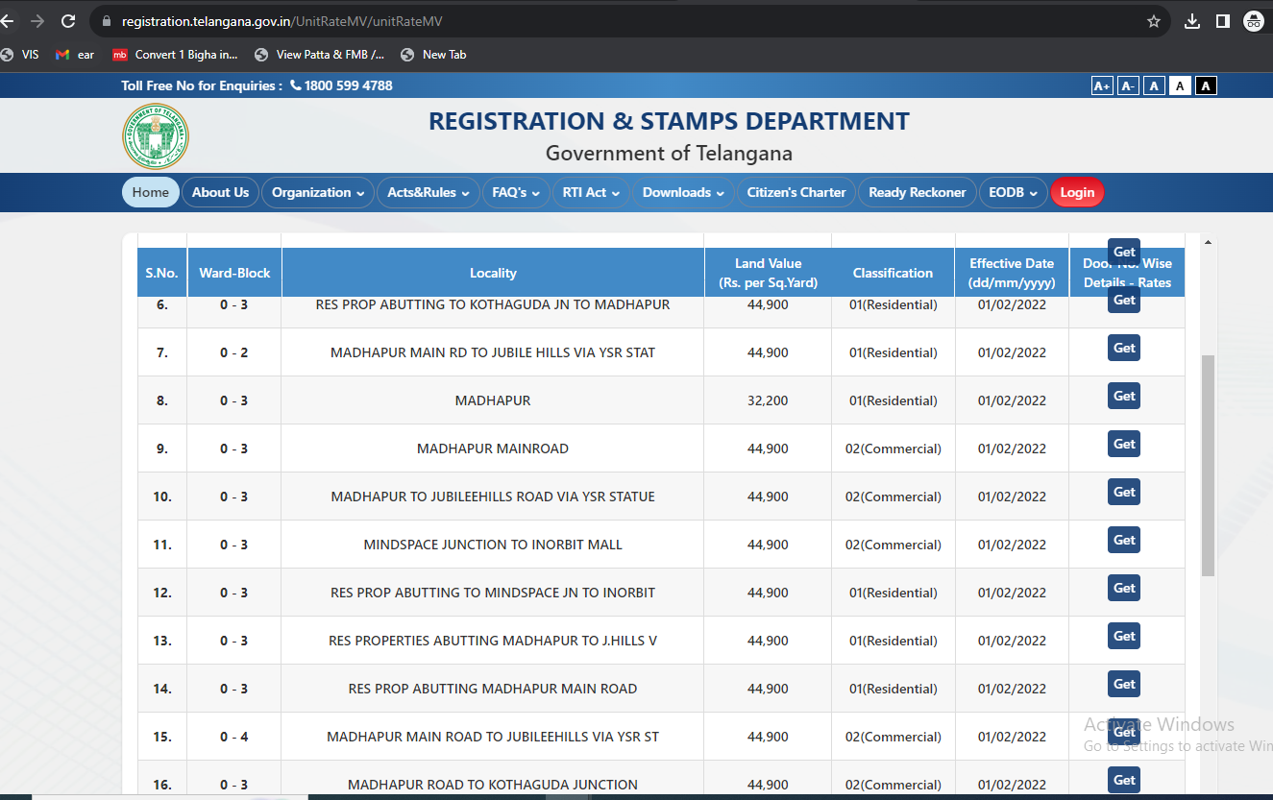

**ENCLOSURE IV: IMPORTANT PROPERTY DOCUMENTS EXHIBIT**

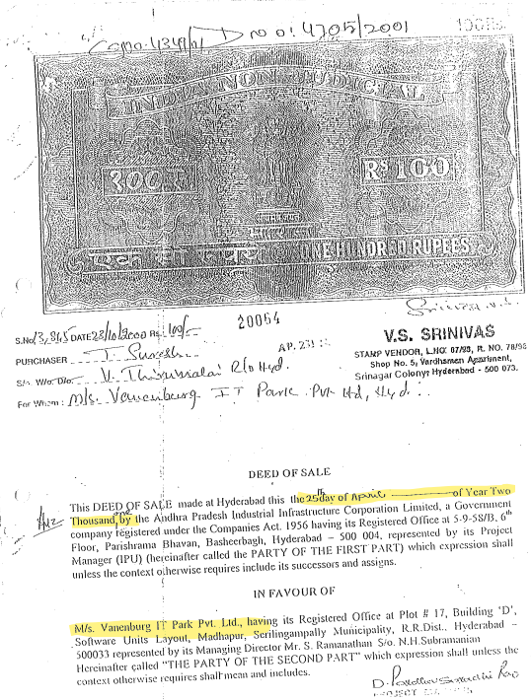

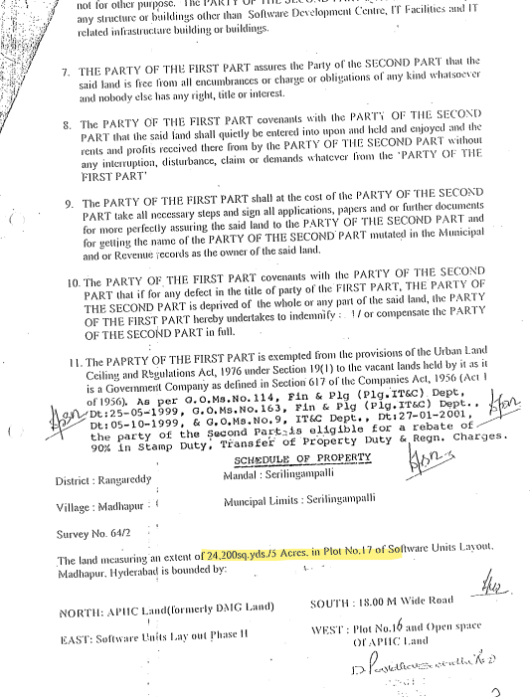

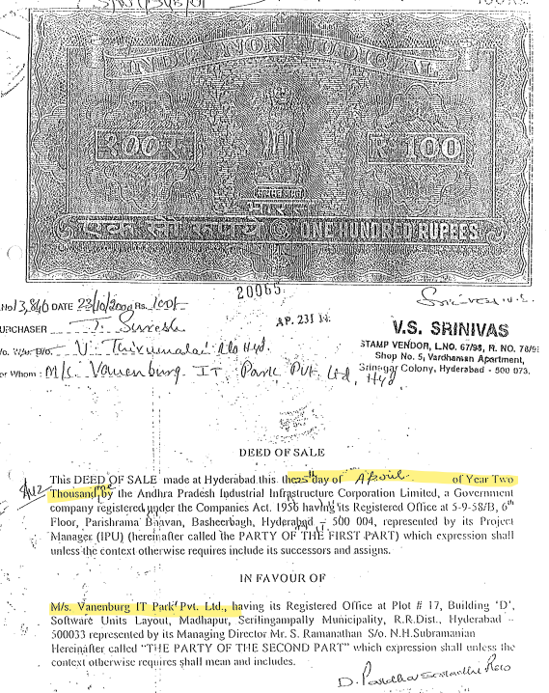

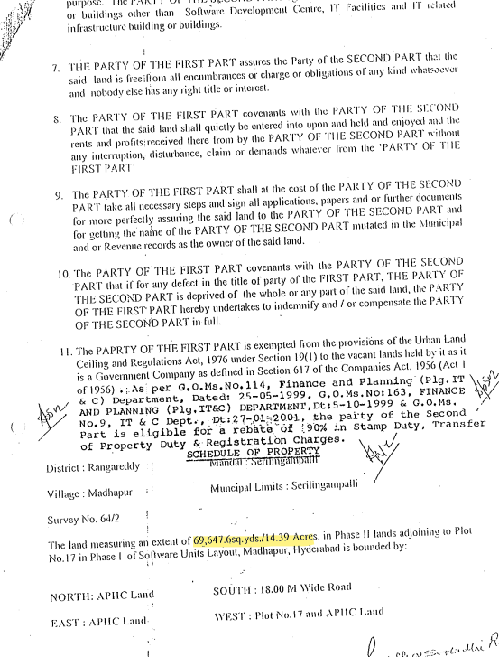

|  |
| --- |
|  |
|  |

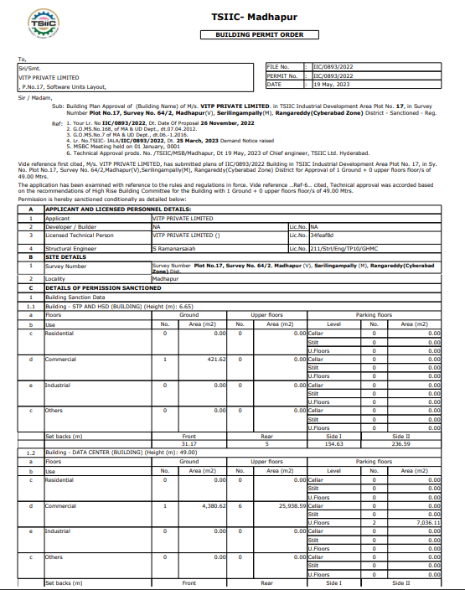

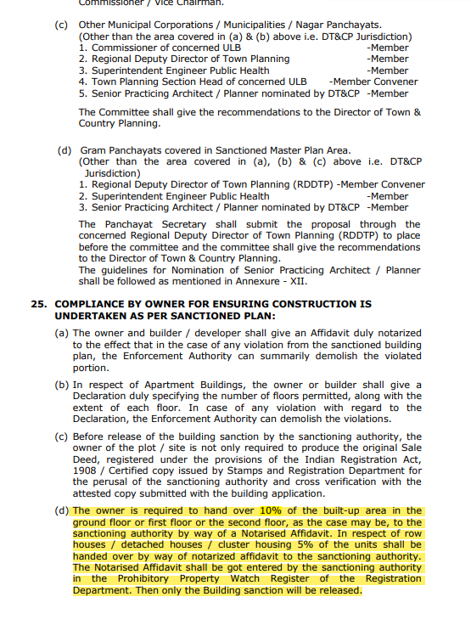

**ENCLOSURE V: REFERENCES ON PRICE TREND OF THE SIMILAR RELATED PROPERTIES AVAILABLE ON PUBLIC DOMAIN**

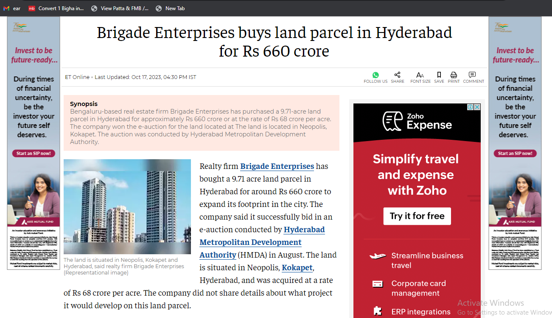

***Source:*** [***https://economictimes.indiatimes.com/industry/services/property-/-cstruction/brigade-enterprises-buys-land-parcel-in-hyderabad-for-rs-660-*crore/articleshow/104496938.cms?from=mdr**](https://economictimes.indiatimes.com/industry/services/property-/-cstruction/brigade-enterprises-buys-land-parcel-in-hyderabad-for-rs-660-crore/articleshow/104496938.cms?from=mdr)

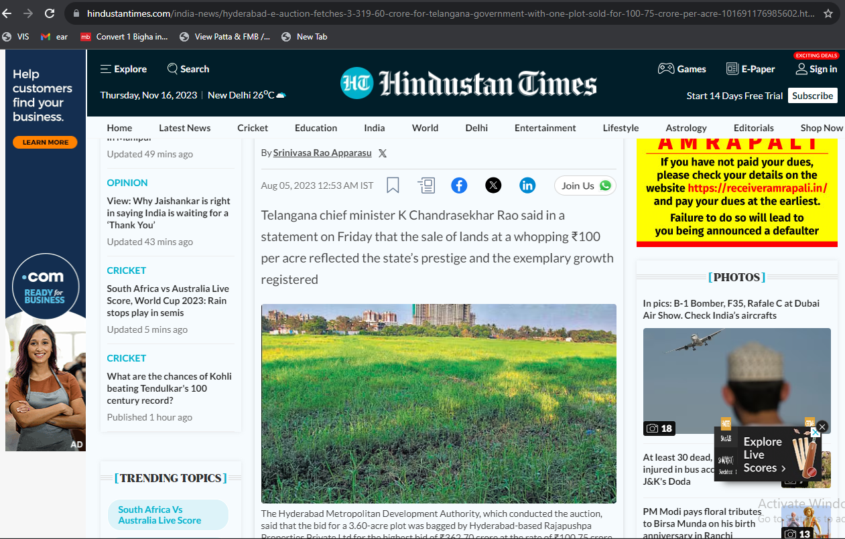

***Source:*** [***https://www.hindustantimes.com/india-news/hyderabad-e-auction-fetches-3-319-60-crore-for-telangana-government-with-one-plot-sold-for-100-75-crore-per-acre-101691176985602.html***](https://www.hindustantimes.com/india-news/hyderabad-e-auction-fetches-3-319-60-crore-for-telangana-government-with-one-plot-sold-for-100-75-crore-per-acre-101691176985602.html)

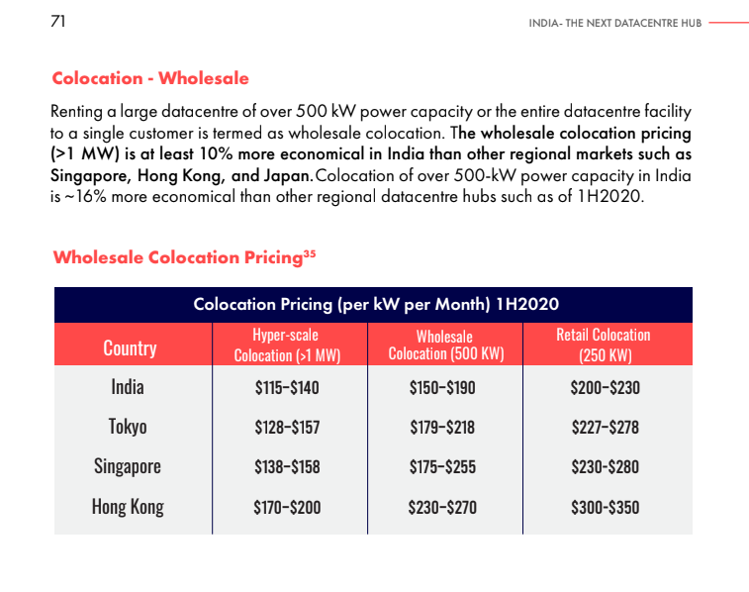

***\*Above reference is taken from a report, India –The Next Datacentre Hub published by NASSCOM on 2021***

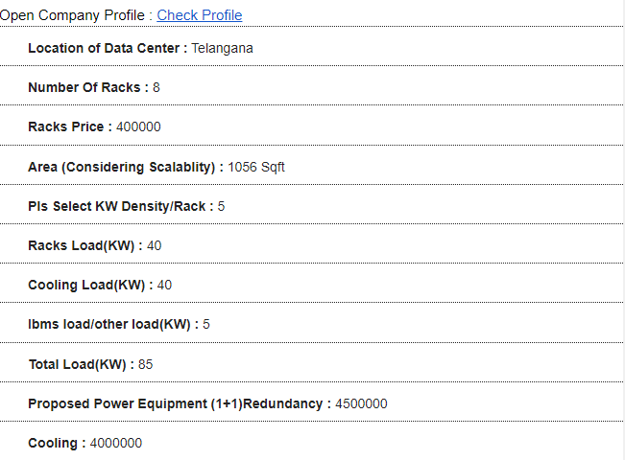

***Source: https://profileits.com/data-center-costing-price-calculator***

**ENCLOSURE VI:** **ANNEXURE: VI - DECLARATION-CUM-UNDERTAKING**

1. Persons worked on this report are citizen of India.
2. No employee or member of R.K Associates has any direct/ indirect interest in the property or become so interested at any time during a period of three years prior to our appointment as valuer or three years after the valuation of assets was conducted by us.
3. The information furnished in our valuation report dated 11/12/2023 is true and correct to the best of our knowledge and belief and we have made an impartial and true valuation of the property.
4. Our authorized Engineer/ surveyor Ram Prasad have personally inspected the property on 17/10/2023 the work is not subcontracted to any other valuation firm and is carried out by us.
5. Valuation report is submitted in the format as prescribed by the bank.
6. We have not been depanelled/ delisted by any other bank and in case any such depanelment by other banks during my empanelment with you, we will inform you within 3 days of such depanelment.
7. We have not been removed/ dismissed from service/employment earlier.
8. We have not been convicted of any offence and sentenced to a term of imprisonment.
9. Company is not found guilty of misconduct in professional capacity.
10. Persons worked on this report are not declared to be unsound mind.
11. Company is not undischarged bankrupt or has not applied to be adjudicated as a bankrupt.
12. Company is not an undischarged insolvent.
13. No penalty is levied under section 271J of Income-tax Act, 1961 (43 of 1961) and time limit for filing appeal before Commissioner of Income tax (Appeals) or Income-tax Appellate Tribunal, as the case may be has expired, or such penalty has been confirmed by Income-tax Appellate Tribunal, and five years have not elapsed after levy of such penalty.
14. Company is not been convicted of an offence connected with any proceeding under the Income Tax Act 1961, Wealth Tax Act 1957 or Gift Tax Act 1958 and
15. Our PAN Card number/ GST number as applicable is **AAHCR0845G/ 09AAHCR0845G1ZP.**
16. We undertake to keep you informed of any events or happenings which would make us ineligible for empanelment as a valuer.
17. We have not concealed or suppressed any material information, facts and records and we have made a complete and full disclosure.
18. We have read the Handbook on Policy, Standards and procedure for Real Estate Valuation, 2009 of the IBA and has tried to apply the “Standards” enshrined for valuation in the Part-B of the above handbook to the best of our ability as much as practically possible in the limited time available.
19. We have read the International Valuation Standards (IVS) and the report submitted to the Bank for the respective asset class and has tried to apply the “Standards” as enshrined for valuation in the IVS in “General Standards” and “Asset Standards” as applicable to the best of our ability as much as practically possible in the limited time available.
20. Procedures and standards adopted in carrying out the valuation and is mentioned in Part-D of the report which may have certain departures to the said IBA and IVS standards in order to provide better, just & fair valuation.
21. We abide by the Model Code of Conduct for empanelment of valuer in the Bank.
22. The authorized Engineers of the company who has worked on the assignment has signed this valuation report.
23. The valuation work is taken on receipt of Letter of Engagement provided by the bank.
24. Further, we hereby provide the following information**.**

|  |  |  |  |
| --- | --- | --- | --- |
| **S. No.** | **Particulars** | **Valuer comment** | |
|  | Background information of the asset being valued | This is a Commercial land located at aforesaid address having total land area as 2.569 acres as found on as-is-where basis which owner/ owner representative/ client/ bank has shown/ identified to us on the site physically unless otherwise mentioned in the report of which some reference has been taken from the information/ data given in the copy of documents provided to us and informed verbally or in writing. | |
|  | Purpose of valuation and appointing authority | Please refer to Part-D of the Report. | |
|  | Identity of the experts involved in the valuation | **Survey Analyst:** Ram Prasad  **Valuation Engineer:** Babul Akhtar Gazi  **L1/ L2 Reviewer:** Sr. V.P. Projects | |
|  | Disclosure of valuer interest or conflict, if any | No relationship with the borrower and no conflict of interest. | |
|  | Date of appointment, valuation date and date of report | **Date of Appointment:** | **28/9/2023** |
| **Date of Survey:** | **17/10/2023** |
| **Valuation Date:** | **15/11/2023** |
| **Date of Report:** | **11/12/2023** |
|  | Inspections and/ or investigations undertaken | Yes, by our authorized Survey Engineer Ram Prasad on17/10/2023. Property was shown and identified by **Mr. Pankaj Rathi** (🕿-9000277073) | |
|  | Nature and sources of the information used or relied upon | Please refer to Part-D of the Report. Level 3 Input (Tertiary) has been relied upon. | |
|  | Procedures adopted in carrying out the valuation and valuation standards followed | Please refer to Part-D of the Report. | |
|  | Restrictions on use of the report, if any | Value varies with the Purpose/ Date/ Market & Asset Condition & Situation prevailing in the market. We recommend not to refer the indicative & estimated prospective Value of the asset given in this report if any of these points are different from the one mentioned aforesaid in the Report.  This report has been prepared for the purposes stated in the report and should not be relied upon for any other purpose. Our client is the only authorized user of this report and is restricted for the purpose indicated in this report. I/we do not take any responsibility for the unauthorized use of this report.  During the course of the assignment, we have relied upon various information, data, documents in good faith provided by Bank/ client both verbally and in writing. If at any point of time in future it comes to knowledge that the information given to us is untrue, fabricated, misrepresented then the use of this report at very moment will become null & void.  This report only contains general assessment & opinion on the indicative, estimated Market Value of the property for which Bank has asked to conduct the Valuation for the asset as found on as-is-where basis which owner/ owner representative/ client/ bank has shown/ identified to us on the site unless otherwise mentioned in the report of which some reference has been taken from the information/ data given in the copy of documents provided to us and informed verbally or in writing which has been relied upon in good faith. It doesn’t contain any other recommendations of any sort including but not limited to express of any opinion on the suitability or otherwise of entering into any transaction with the borrower.  This report is not a certification of ownership or survey number/ property number/ Khasra number which are merely referred from the copy of the documents provided to us. | |
|  | Major factors that were taken into account during the valuation | Please refer to Part A, B, C & D of the Report. | |
|  | Major factors that were not taken into account during the valuation | Please refer to Part A, B, C & D of the Report. | |
|  | Caveats, limitations and disclaimers to the extent they explain or elucidate the limitations faced by valuer, which shall not be for the purpose of limiting his responsibility for the valuation report. | Please refer to Part D of the Report. Also, as per standard IBBI guidelines which can be referred on:  https://www.ibbi.gov.in/uploads/legalframwork/ e5e1300db2dd6a8bebe289ba579a7c14.pdf are also applicable on this. | |

**Date: 15/11/2023**

**Place:** Noida

**Signature**

**(Authorized Person of R.K Associates Valuers & Techno Engg. Consultants (P) Ltd.)**

**ENCLOSURE VII:** **ANNEXURE: VII - MODEL CODE OF CONDUCT FOR VALUERS**

**Integrity and Fairness**

1. A valuer shall, in the conduct of his/its business, follow high standards of integrity and fairness in all his/its dealings with his/its clients and other valuers.
2. A valuer shall maintain integrity by being honest, straightforward, and forthright in all professional relationships.
3. A valuer shall endeavor to ensure that he/it provides true and adequate information and shall not misrepresent any facts or situations.
4. A valuer shall refrain from being involved in any action that would bring disrepute to the profession.
5. A valuer shall keep public interest foremost while delivering his services.

**Professional Competence and Due Care**

1. A valuer shall render at all times high standards of service, exercise due diligence, ensure proper care and exercise independent professional judgment.
2. A valuer shall carry out professional services in accordance with the relevant technical and professional standards that may be specified from time to time.
3. A valuer shall continuously maintain professional knowledge and skill to provide competent professional service based on up-to-date developments in practice, prevailing regulations/guidelines and techniques.
4. In the preparation of a valuation report, the valuer shall not disclaim liability for his/its expertise or deny his/its duty of care, except to the extent that the assumptions are based on statements of fact provided by the company or its auditors or consultants or information available in public domain and not generated by the valuer.
5. A valuer shall not carry out any instruction of the client in so far as they are incompatible with the requirements of integrity, objectivity and independence.
6. A valuer shall clearly state to his client the services that he would be competent to provide and the services for which he would be relying on other valuers or professionals or for which the client can have a separate arrangement with other valuers.

**Independence and Disclosure of Interest**

1. A valuer shall act with objectivity in his/its professional dealings by ensuring that his/its decisions are made without the presence of any bias, conflict of interest, coercion, or undue influence of any party, whether directly connected to the valuation assignment or not.
2. A valuer shall not take up an assignment if he/it or any of his/its relatives or associates is not independent in terms of association to the company.
3. A valuer shall maintain complete independence in his/its professional relationships and shall conduct the valuation independent of external influences.
4. A valuer shall wherever necessary disclose to the clients, possible sources of conflicts of duties and interests, while providing unbiased services.
5. A valuer shall not deal in securities of any subject company after any time when he/it first becomes aware of the possibility of his/its association with the valuation, and in accordance with the Securities and Exchange Board of India (Prohibition of Insider Trading) Regulations, 2015 or till the time the valuation report becomes public, whichever is earlier.
6. A valuer shall not indulge in “mandate snatching or offering” convenience valuations” in order to cater to a company or client’s needs.
7. As an independent valuer, the valuer shall not charge success fee.
8. In any fairness opinion or independent expert opinion submitted by a valuer, if there has been a prior engagement in an unconnected transaction, the valuer shall declare the association with the company during the last five years.

**Confidentiality**

1. A valuer shall not use or divulge to other clients or any other party any confidential information about the subject company, which has come to his/its knowledge without proper and specific authority or unless there is a legal or professional right or duty to disclose.

**Information Management**

1. A valuer shall ensure that he/ it maintains written contemporaneous records for any decision taken, the reasons for taking the decision, and the information and evidence in support of such decision. This shall be maintained so as to sufficiently enable a reasonable person to take a view on the appropriateness of his/its decisions and actions.
2. A valuer shall appear, co-operate and be available for inspections and investigations carried out by the authority, any person authorised by the authority, the registered valuers organization with which he/it is registered or any other statutory regulatory body.
3. A valuer shall provide all information and records as may be required by the authority, the Tribunal, Appellate Tribunal, the registered valuers organization with which he/it is registered, or any other statutory regulatory body.
4. A valuer while respecting the confidentiality of information acquired during the course of performing professional services, shall maintain proper working papers for a period of three years or such longer period as required in its contract for a specific valuation, for production before a regulatory authority or for a peer review. In the event of a pending case before the Tribunal or Appellate Tribunal, the record shall be maintained till the disposal of the case.

**Gifts and hospitality.**

1. A valuer or his/its relative shall not accept gifts or hospitality which undermines or affects his independence as a valuer.

Explanation: For the purposes of this code the term ‘relative’ shall have the same meaning as defined in clause (77) of Section 2 of the Companies Act, 2013 (18 of 2013).

1. A valuer shall not offer gifts or hospitality or a financial or any other advantage to a public servant or any other person with a view to obtain or retain work for himself/ itself, or to obtain or retain an advantage in the conduct of profession for himself/ itself.

**Remuneration and Costs.**

1. A valuer shall provide services for remuneration which is charged in a transparent manner, is a reasonable reflection of the work necessarily and properly undertaken, and is not inconsistent with the applicable rules.
2. A valuer shall not accept any fees or charges other than those which are disclosed in a written contract with the person to whom he would be rendering service.

**Occupation, employability and restrictions.**

1. A valuer shall refrain from accepting too many assignments, if he/it is unlikely to be able to devote adequate time to each of his/ its assignments.
2. A valuer shall not conduct business which in the opinion of the authority or the registered valuer organisation discredits the profession.

**Miscellaneous**

1. A valuer shall refrain from undertaking to review the work of another valuer of the same client except under written orders from the bank or housing finance institutions and with knowledge of the concerned valuer.
2. A valuer shall follow this code as amended or revised from time to time

Signature of the Authorized Person: ________________

Name of the Valuation company: R.K Associates Valuers & Techno Engg. Consultants (P) Ltd.

Address of the Valuer: D-39, Sector-2, Noida-201301

Date: 15/11/2023

Place: Noida