**REPORT FORMAT:** V-L11 (Enterprise Valuation) | Version: 1.0_2018

**File No.: VIS (2022-23)- PL431-356-562 Dated: 20.12.2023**

**ENTERPRISE VALUATION REPORT**

**OF**

**M/S COASTAL ENERGEN PRIVATE LIMITED COAL-FIRED THERMAL POWER PLANT 1200 MW (2x600 MW)**

**SITUATED AT**

**NO.5, MOORES ROAD, CHENNAI, TAMIL NADU, INDIA, 600006**

**OWNER/ PROMOTER**

**COAL AND OIL GROUP**

**REPORT PREPARED FOR**

**STATE BANK OF INDIA, STRESSED ASSETS MANAGEMENT BRANCH, RED CROSS BUILDING, RED CROSS ROAD, EGMORE, CHENNAI - 600008**

***\*\*Important - In case of any query/ issue/ concern or escalation you may please contact Incident Manager @ valuers@rkassociates.org. We will appreciate your feedback in order to improve our services.***

***NOTE: Please provide your feedback on the report within 15 days of its submission after which report will be considered to be accepted & correct. Valuation Terms of Services & Valuer’s Important Remarks are available at*** [***www.rkassociates.org***](http://www.rkassociates.org) ***for reference.***

**IMPORTANT NOTICE**

***COPYRIGHT FORMAT:*** *This report is prepared on the copyright format of R. K. Associates Valuers & Techno Engineering Consultants (P) Ltd. (R. K. Associates) to serve our clients with the best possible information and analysis to facilitate them to take rational business decisions. Legally no one can copy or distribute this format without prior approval from R. K. Associates. It is meant only for the advisory/ reference purpose for the organization/s as mentioned on the cover page of this report. Distribution or use of this format or report or any of its content/ information/ data by any organization or individual other than R.K Associates will be seen as an unlawful act and necessary legal action can be taken against the defaulters.*

*This report is intended for the sole use of the intended recipient/s and contains material that is STRICTLY CONFIDENTIAL AND PRIVATE.*

***DEFECT LIABILITY PERIOD:****In case of any query/ issue or escalation you may please contact Incident Manager at valuers@rkassociates.org. Though adequate care has been taken while preparing this report as per its scope, but still, we can’t rule out typing, human errors, over sightedness of any information or any other mistakes. Therefore, the concerned organization is advised to satisfy themselves that the report is complete & satisfactory in all respect. Intimation regarding any discrepancy shall be brought into our notice immediately. If no intimation is received within 15 (Fifteen) days in writing from the date of issuance of the report, to rectify these timely, then it shall be considered that the report is complete in all respect and has been accepted by the client up to their satisfaction & use and further to which R.K Associates shall not be held responsible in any manner.*

***Part H: R. K. Associates Important Disclaimer and Remarks*** *are integral part of this report and Feasibility assessment is subject to this section. Reader of the report is advised to read all the points mentioned in these sections carefully.*

| **TABLE OF CONTENTS** | | |
| --- | --- | --- |
|  | | |
| **SECTIONS** | **PARTICULARS** | **PAGE NO.** |
| **Part A** | **INTRODUCTION** |  |
| 1. About the Report | 4 |
| 1. Background of the Project | 4 |
| 1. Type of Report | 6 |
| 1. Purpose of the Report | 6 |
| 1. Scope of the Report | 6 |
| 1. Methodology/ Model Adopted | 7 |
| 1. Documents/ Data Referred | 7 |
| **Part B** | **PROJECT COMPANY** |  |
| 1. Brief Description About the Company | 8 |
| 1. Capital Structure | 8 |
| 1. Shareholding Pattern | 8 |
| 1. Snapshot of the Outstanding Debt of the Company | 9 |
| 1. Historical Financial Performance of the Project Company | 10 |
| 1. Current Status of the Project Company | 10 |
| 1. Reasons for Financial Stress | 11 |
| **Part C** | **THE PROJECT** |  |
| 1. Brief Description of the Project | 12 |
| 1. Project Location | 12 |
| 1. Land Details | 13 |
| 1. EPC Contracts & Plant Facilities | 13 |
| 1. Water Requirement and Raw Water Intake System | 14 |
| 1. Coal Linkage or Fuel Supply and Transportation | 14 |
| 1. Power Purchase Agreement | 15 |
| 1. Power Evacuation Arrangement | 16 |
| 1. Operations and Maintenance Agreements | 16 |
| **Part D** | **MARKET OVERVIEW ON POWER SECTOR** |  |
| 1. Introduction | 17 |
| 1. Market Size | 17 |
| 1. Government Initiatives | 18 |
| 1. Recent Investments | 19 |
| 1. Way Forward | 20 |
| **Part E** | **FINANCIAL PERFORMANCE** |  |
| 1. Historical Profit & Loss Statement | 21 |
| 1. Key Financial Ratios | 22 |
| 1. Graphical Representation of the Key Financials of the Company | 22 |
| 1. Projected Profit & Loss Statement | 24 |
| 1. Key Financial Ratios | 24 |
| 1. Graphical Representation of the Key Financials of the Company | 25 |
| **Part F** | **VALUATION OF THE COMPANY** |  |
| 1. Methodology/ Model Adopted | 27 |
| 1. Calculation of Free Cash Flow to Firm | 28 |
| 1. Key Inputs used to discount Cash Flows during the Projection Period | 29 |
| 1. Calculation of Enterprise Value | 30 |
| 1. Sensitivity Analysis | 31 |
| 1. Key Assumptions and Workings | 32 |
| **Part G** | **IMPORTANT DEFINITION** | 38 |
| **Part H** | **DISCLAIMER | REMARKS** | 40 |

|  |  |
| --- | --- |
| **PART A** | **INTRODUCTION** |

1. **ABOUT THE REPORT:** Enterprise Valuation Report of (2 x 600) MW Coal Fired Sub–Critical Thermal Power Plant set by M/s. Coastal Energen Private Limited (ENERGEN) near the Melamaruthur village in the district of Tuticorin of the state of Tamil Nadu.
2. **BACKGROUND OF THE PROJECT:** M/s Coastal Energen Private Limited (ENERGEN) is engaged in the business of generation and sale of power using Imported coal. ENERGEN owns and operates a 1,200 MW (2 x 600 MW) coal based thermal power plant (“Project”) in Tuticorin, Tamil Nadu. The Units are based on sub-critical technology. The Unit-1 of 600MW was commissioned in December 23, 2014 and Unit-2 of 600 MW was commissioned in January 15, 2016.

Energen was promoted by Coal & Oil Group(C&O) through Mutiara Energy Holdings Limited, Mauritius (“MEHL”) and Precious Energy Holdings Limited, BVI (“PEHL”). C&O, an integrated energy and infrastructure company involved in Fuel Management, Shipping, Logistics, Power Generation and Industrial Parks.

The group structure of the M/s Coastal Energen Private Limited is shown below:

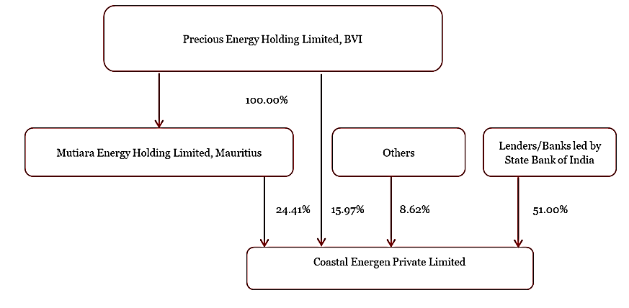

The basic details of the plant are as below:

|  |  |
| --- | --- |
| **Particulars** | **Details** |
| Plant Capacity - Gross | 2*600MW |
| Plant Technology | Subcritical coal fired thermal power plant |
| PPA Agreement | PPA agreement for 558MW generation with Tamil Nadu Generation and Distribution Corporation Limited (TANGEDCO). The remaining output is sold in the merchant market |
| Location | Melamaruthur village, Tuticorin district |
| Land | The total land of 1,089 acres required for the Project is in the possession of the Company and mortgage has been created in favour of the consortium lenders. Out of 1,089 acres of project land, 300 acres is used for green belt development which has been completed. |
| Commercial Operation Date | Unit I: December 23,2014  Unit II: January 15, 2016 |
| Electric Interconnection: | Power is transmitted through a double circuit transmission line to the Power Grid Corporation of India Limited’s (PGCIL) 400kV Bays at Tuticorin Pooling Station. |
| Operational Status: | Both units are operational |
| Boiler / Steam Generator: | The boiler is subcritical, pulverized coal, tangential firing, drum type, assisted circulation, single furnace, balanced draft, single reheat and dry bottom. |
| Steam Turbine: | The steam turbine is subcritical, single reheat, 3-casing, 4-flow, tandem compound, condensing turbine. Each steam turbine generator (STG) unit is rated for 600MW maximum continuous output with throttle steam conditions |
| Environmental Protection Equipment | Electrostatic Precipitator emission control |

**FUEL SUPPLY AGREEMENT:** As per informationprovided by client or company, company doesn’t have long-term FSA for the supply of coal to the plant. As CEPL is a 100% imported coal based thermal power plant, currently it is sourcing imported coal through open markets.

**POWER SALE ARRANGEMENTS:** M/sCoastal Energen Pvt. Ltd signed a Power Purchase Agreement (PPA) with Tamil Nadu Generation and Distribution Company (TANGEDCO), on December 19, 2013 for the sale of 558 MW of the power generated from the Project. This PPA is valid for a period of 15 years starting from 01-06-2014 and ending at 30-09-2028. The remaining output is being sold in open market.

As per the discussions with the CEPL Management, the company is regularly bidding for getting the PPA’s and discussions with various Companies are going on for the sale of the power but it is uncertain when the Company will be getting the long term PPA for the full load i.e. 1200 MW.

As per information provided by the client/company officials, the company is not able to fulfill its financial obligation due to financial stress. The company was announced NPA in 2017 by the lenders. Lenders had filed an application under Section 7 of IBC is admitted to CIRP, NCLT order dated 4th February 2022 and since then company is presently into CIRP.

**Thus, for the purpose of decision making on this stressed account, State Bank of India (SAMB) has assigned R K Associated to assess & determine the Enterprise Value/Fair Market Value of M/s Coastal Energen Private Limited as per scope of work, to execute the appropriate action by the decision makers on this NPA account.**

1. **TYPE OF REPORT:** This report is performed to assess the Enterprise Value of the project.
2. **PURPOSE OF THE REPORT:** To assess & determine Enterprise Value of the Project under implementation as a whole as required by the lenders.
3. **SCOPE OF THE REPORT:** To estimate & determine the Enterprise Value of the Company based on Income Based Approach (Discounted Cash Flow) method.

* *This is just the enterprise valuation of the project based on the Income generating capacity of the project in future years. This Valuation shall not be construed as the physical asset or should not be related directly to cost approach or Project cost.*
* *This Enterprise Valuation report doesn't cover vetting of the documents/ financial data/ projections or any other information provided to us by the Bank.*
* *This Valuation only covers the cash flow from operation of the company. It does not cover any transaction with the subject company’s subsidiary/ associate/ Joint Venture Companies, as per the requirement by the lender.*
* *This Valuation is prepared based on the current financial status and projections of the company, financial data/ model, future projections, other facts & information provided by the company/ lender/ Client in writing & verbal discussions held during the course of the assignment and based on independent assessment of certain assumptions which are specifically mentioned in the Valuation section of the Report.*
* *It doesn't contain the principles of physical asset valuation and is not based on the site inspection of the project.*
* *We have assumed that the information provided to us is correct and is not manipulated or distorted.*
* *The Market and Industrial assessment of the given company’s industry/ sector has not been done at our end. So, this valuation doesn’t cover the market & industrial scenario in terms of the product demand & market potential.*

1. **METHODOLOGY/ MODEL ADOPTED:** Income-based Approach (Discounted Cash Flow Model) for the calculation of Enterprise Value of the Company.
2. **DOCUMENTS / DATA REFFERED:**

* Audited Financial Statements and Notes provided by the Company for last 5 years.
* Provisional Financial Statement dated 31st March 2023.
* Purchase Power Agreement for Unit 1.
* Date wise NCLAT Orders.
* Statutory Approvals.
* List of Creditors.
* Information Memorandum.

|  |  |
| --- | --- |
| **PART B** | **PROJECT COMPANY** |

1. **BRIEF DESCRIPTION ABOUT THE COMPANY:** M/s Coastal Energen Private Limited operates a Coal Based power project in the state of Tamil Nadu. This is a 1200 MW power project comprising 2 units of 600 MW (2 X 600 MW) each. The plant operates on imported coal which is being procured from open market sources and the total coal requirement of the Project is 5.20 MTPA considering the calorific value of 4,070 Kcal/kg. 558 MW (net power) generated from unit 1 of the Project has been tied up with TANGEDCO at a levelised tariff of INR 4.91/kWh for 15 (fifteen) years ending September 30, 2028. Presently, unit 2 of the Project does not have any long-term power purchase agreements.

Coastal Energen Private Limited (the “Company” or “ENERGEN”) is a private limited company incorporated on May 29, 2006 under the erstwhile Companies Act, 1956 and duly existing under the Companies Act, 2013. The incorporation details of the Project Company are provided in the table below:

|  |  |
| --- | --- |
| **INCORPORATION DETAILS OF THE COMPANY** | |
| **Name of the Company** | M/s Coastal Energen Private Limited |
| **CIN** | U40102TN2006PTC060009 |
| **Registered office Address** | No.5, Moores Road, Chennai, Tamil Nadu, India, 600006 |
| **Constitution** | Non-government company / Limited by Shares |
| **Date of Incorporation** | 29th May 2006 |
| **Authorised Capital** | INR 2,25,00,00,000 |
| **Paid up Capital (Equity)** | INR 2,10,90,42,350 |

1. **CAPITAL STRUCTURE:** As per provisional financials for FY 2023 shared by the client/company, below table shows the capital structure of the company as on 31st March 2023:

| **Particulars** | **Amount (In INR Crores)** |
| --- | --- |
| Authorized Share Capital | 225.00 |
| Issued, Subscribed and Paid-up Capital | 210.90 |

1. **SHAREHOLDING PATTERN:** As per provisional financials for FY 2023 shared by the client/company, below are the details of shareholders holding of the outstanding shares along with their percentages:

|  |  |  |
| --- | --- | --- |
| **Shareholders** | **No of shares** | **Shareholding %** |
| **A. Promoter and Promoter’s Group** | **8,51,61,247** | **40.38** |
| Mutiara Energy Holdings Ltd, Mauritius | 5,14,71,157 | 24.41 |
| Precious Energy Holdings Ltd, BVI | 3,36,90,090 | 15.97 |
| **B. Others** | **1,81,81,828** | **8.62** |
| **C. Public Shareholding – (Allotted to Banks on June 23, 2017)** | **10,75,61,160** | **51.00** |
| State Bank of India | 3,90,93,205 | 18.54 |
| Punjab National Bank | 1,21,70,000 | 5.77 |
| Central Bank of India | 1,00,60,000 | 4.77 |
| Indian Overseas Bank | 86,20,000 | 4.09 |
| Indian Bank | 63,60,000 | 3.02 |
| UCO Bank | 61,06,199 | 2.91 |
| IFCI Bank | 57,50,000 | 2.73 |
| Bank of India | 42,20,000 | 2.00 |
| Bank of Baroda | 32,79,792 | 1.55 |
| Corporate Bank | 32,86,120 | 1.56 |
| Andhra Bank | 30,70,000 | 1.45 |
| J&K Bank | 28,80,000 | 1.36 |
| Canara Bank | 26,65,844 | 1.26 |
| **Total Shareholding** | **21,09,04,235** | **100 %** |

1. **SNAPSHOT OF THE OUTSTANDING DEBT OF THE COMPANY:** As per the information shared by the client/company and information available on the company’s website, the amount of the claims of creditors as on 31st March 2023 is as below:

|  |  |  |  |  |  |
| --- | --- | --- | --- | --- | --- |
| **Banks / Financial institution** | **TL O/s** | **WC O/s** | **FB=TL+WC** | **BG O/s** | **FB+BG** |
| State Bank of India | 1552.21 | 525.76 | 2077.97 | 55.00 | 2132.97 |
| Panjab National Bank | 535.15 | 104.28 | 639.43 | 0.00 | 639.43 |
| Central Bank of India | 536.56 | 88.84 | 625.4 | 0.00 | 625.4 |
| Indian Bank | 324.09 | 62.45 | 386.54 | 0.00 | 386.54 |
| Indian Overseas Bank | 470.2 | 86.82 | 557.02 | 0.00 | 557.02 |
| Bank of Baroda | 184.02 | 21.37 | 205.39 | 0.00 | 205.39 |
| Corporation Bank | 224.79 | 20.37 | 245.16 | 0.00 | 245.16 |
| TM Bank | 163.6 | 28.21 | 191.81 | 0.00 | 191.81 |
| J&K Bank | 175.95 | 31.88 | 207.83 | 0.00 | 207.83 |
| Andhra Bank | 151.84 | 24.54 | 176.38 | 0.00 | 176.38 |
| Canara Bank | 167.02 | 33.74 | 200.76 | 0.00 | 200.76 |
| UCO Bank | 415.31 | 0.00 | 415.31 | 0.00 | 415.31 |
| Bank of India | 264.84 | 0.00 | 264.84 | 0.00 | 264.84 |
| HUDCO | 494.15 | 0.00 | 494.15 | 0.00 | 494.15 |
| IFCI Ltd | 439.79 | 0.00 | 439.79 | 0.00 | 439.79 |
| **Total** | **6099.52** | **1028.26** | **7127.78** | **55.00** | **7182.78** |

1. **HISTORICAL FINANCIAL PERFORMANCE OF THE COMPANY:** As per data/information provided by the client, below table shows the historical financial performance of the company from FY 2018-19 to Provisional financials FY 2022-23:

***(Figures in INR Crores as on 31st March)***

|  |  |  |  |  |  |
| --- | --- | --- | --- | --- | --- |
| **Particular** | **2019** | **2020** | **2021** | **2022** | **2023 (P)** |
| **Total Revenue** | 1578.53 | 1573.96 | 1938.94 | 954.61 | 1904.83 |
| **EBITDA** | 292.24 | 223.35 | 895.54 | 121.87 | -22.24 |
| **Depreciation** | 201.57 | 200.79 | 200.30 | 199.75 | 201.49 |
| **EBIT** | 90.67 | 22.56 | 695.24 | -77.88 | -223.73 |
| **Finance Charges** | 1080.08 | 310.31 | 4.30 | 2.22 | 1.59 |
| **PBT** | -988.41 | -287.75 | 690.94 | -80.10 | -225.32 |
| **PAT** | -988.41 | -287.75 | 521.62 | -60.56 | -75.54 |
| ***EBITDA Margin (%)*** | *18.51%* | *14.19%* | *46.19%* | *12.77%* | *-1.17%* |
| ***EBIT Margin*** | *5.74%* | *1.43%* | *35.86%* | *-8.16%* | *-11.75%* |
| ***PAT Margin (%)*** | *-62.62%* | *-18.28%* | *26.90%* | *-6.34%* | *-3.97%* |
| ***Revenue Growth*** |  | *-0.29%* | *23.19%* | *-50.77%* | *99.54%* |

As per the historical analysis, it is observed that EBITDA Margin of the company is showing an upward trend as it has gone up from 18.51% in FY 2018-19 to 46.19% in FY 2020-21. After that till FY 2022-23 it is Negative. EBIT Margin is also showing an upward trend as it has gone up from 5.74% in FY 2018-19 to 35.86% in FY 2020-21. After that it is showing downward trend till FY 2022-23.

Although, Revenues Growth of the company has reached to pre-covid levels in FY 2022-23. As per the historical analysis, it is observed that Net Profit Margin of the company is rising continuously from -62.62% in FY 2018-19 to -3.97% in FY 2022-23.

1. **CURRENT STATUS OF THE PROJECT COMPANY**: M/s Coastal Energen Private Limited is a Public Company domiciled in India and incorporated under the provisions of Companies Act applicable in India. The Company was incorporated to engage in the business of generation and sale of power through its power plant of 2 x 600 MW situated at Melamaruthur village in the district of Tuticorin of the state of Tamil Nadu. Currently both the plants are operational.

The Company is undergoing Corporate Insolvency Resolution Process (CIRP) under the provisions of the Insolvency and Bankruptcy Code, 2016 (IBC) in terms of order of Hon’ble National Company Law Tribunal (NCLT), Tamil Nadu on 04 February 2022.

**Pursuant to the initiation of CIRP, vide aforesaid order, the NCLT had appointed Mr. Radhakrishnan Dharmaranjan, as Resolution Professional (RP) of Coastal Energen Private Limited. The Powers of Board of Directors was suspended by virtue of NCLT order in accordance with Section 17(1) (b) of IBC and the same is being exercised by the RP.**

1. **REASONS FOR FINANCIAL STRESS:** The company is facing continued financial stress since COD mainly due to reason pointed below:
2. Initially project cost was 4297 Crs., then it got increased to 7870 Crs. on account of external factors viz. additional duties due to withdrawal of mega power status, change in plant configuration, etc. The overall cost overrun of ~Rs. 3500 Crore comprised of Infrastructure Development Cost (IDC) (32%), Forex variation (19%), Duties & Taxes (13%), WC margin (8%) and Hard Costs (28%).
3. Non-availability of long term PPA for Unit 2.
4. Low off taken by TANGEDCO from Unit 1.
5. Non-availability of adequate working capital and delay in realization of receivables from TANGEDCO.
6. Tariff reduction of 75 paise per unit under 558 MW PPA by TANGEDCO citing decreasing coal prices in international market (valid from January 01, 2016 to December 31, 2020).

**Hence, State Bank of India (SAMB) has appointed R.K. Associates to determine the Fair Market Value/Enterprise Value of the Business/Company to take appropriate course of action on this stressed account.**

|  |  |
| --- | --- |
| **PART C** | **THE PROJECT** |

1. **BRIEF DESCRIPTION OF THE PROJECT****:** M/s. Coastal Energen Private Limited (hereinafter referred to as CEPL), is setting up a 1200 MW (2x600) pulverized coal fired Sub- Critical Thermal Power Plant at village in the district of Tuticorin of the state of Tamil Nadu in India.

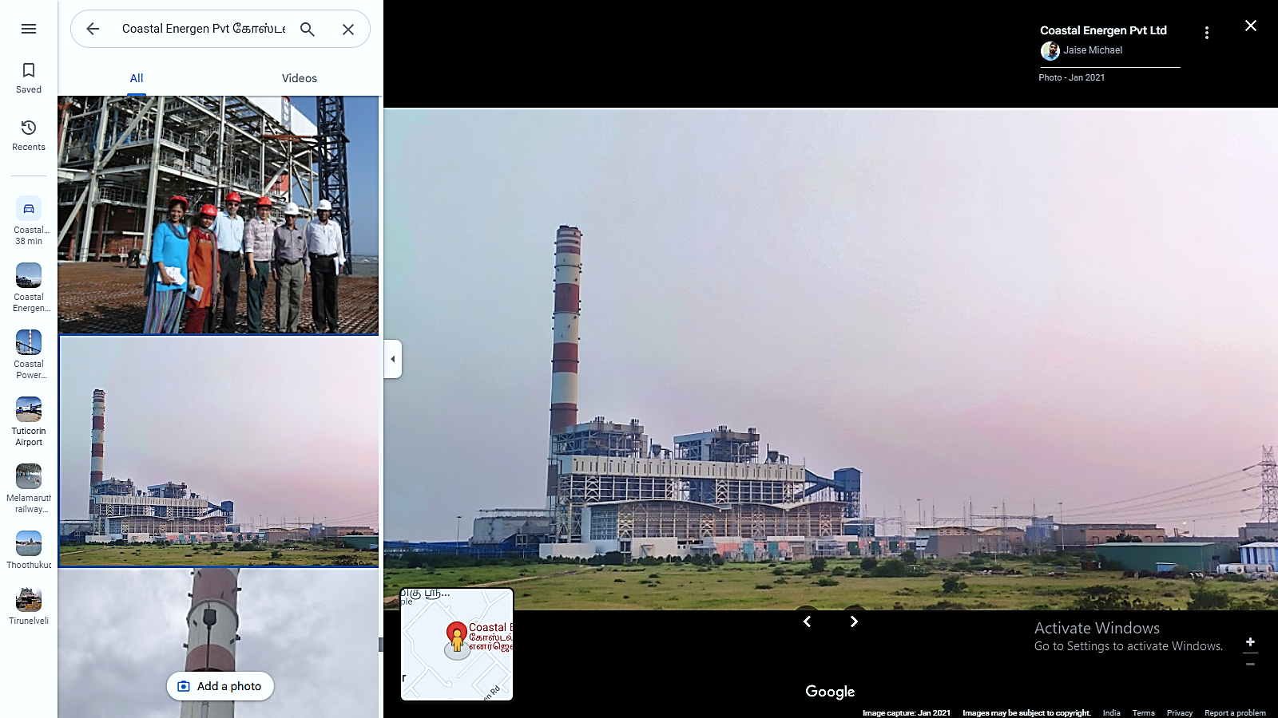

1. **PROJECT LOCATION:** The project site is located on the outskirts of Tuticorin Town, near the eastern coast of South India, off the Bay of Bengal, in Melamaruthur Village, Ottapidaram Taluk, Tuticorin District of Tamil Nadu State. The site lies between NH – 45B and the East – Coast Road (ECR) and can be approached from either of them.

Project Company acquired around 1100 acres, for the main plant, and a separate 100 acres plot, on the nearby sea coast, for establishing sea – water drawl and other on – shore project facilities. The subject plant is located in coastal area of Indian Ocean in Tuticorin District. The plant is located at 23km North to Tuticorin District. Tuticorin Airport & Melamaruthur railway station are at a distance of 32 km & 5 km respectively.

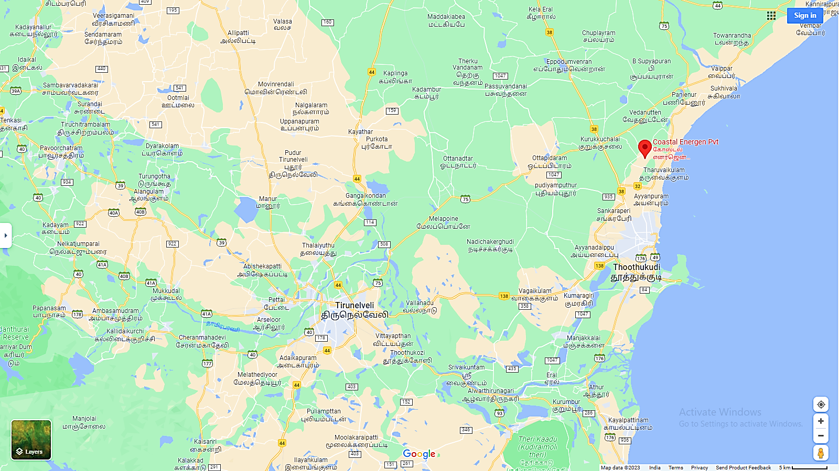

1. **LAND DETAILS:** As per the details provided by the company, initially, the land required for setting up of this power plant was 1050 acres which is submitted to TNPCB/MoEF. Currently, total freehold land acquired for the Project is 1089.04 acres (440.72 hectares) which is directly purchased from the local farmers as per the Statement of Land provided to us by the company which is relied upon. Village-wise land area is as follows:

|  |  |  |
| --- | --- | --- |
| **S. No.** | **Village Name** | **Area in Acre** |
| 1 | Tharuvaikulam | 79.74 |
| 2 | Melamaruthur | 747.73 |
| 3 | D. Duraiswamipuram | 210.3 |
| 4 | Pattinamaruthur | 51.27 |
| **Total** | | **1089.04** |

The land acquired by CEPL is non-agricultural barren land and can be used for Residential, Commercial or Industrial purpose. As per the information given by the CEPL Management and further land conversion is not required. Out of total 1089.04 acres, only a small portion of 30.14 hectares in Village-Tharuvaikulam requires the conversion from agricultural land to industrial use for which application has been made to the concerned authority by CEPL.

The copy of the Application made to the authority is provided to us. The land acquired is primarily dry land/barren and is free from any rehabilitation and resettlement issues. This total land area of 1089.04 acres acquired by CEPL is sufficient for future capacity expansion as Phase-II (2x800 MW) and Phase-III (2x1000 MW) also.

1. **EPC CONTRACTS & PLANT FACILITIES:** This Project was executed through competitive EPC contracts, for BTG and BOP packages. Site enabling & development works are undertaken under non – EPC works. Various systems/ areas are split into multiple packages for cost and time optimization purposes.

The Project was executed through competitive supply contracts for BTG and EPC contracts for BOP packages. The BTG order has been placed with Harbin Power Engineering Company Ltd, China. The BTG contract consists of a ‘Supply Agreement’ for supply of BTG and a ‘Service Agreement’ for providing technical instructions for erection, testing and commissioning of BTG. The Balance of Plant (BOP) packages have been awarded under fixed price contracts, with Tata Consulting Engineers (TCE) as coordinators.

The company has executed the Operations & Maintenance Agreement (O&M) with various contractors for the operations and maintenance of the Plant. Main machinery of the plant includes Boiler, Turbine, Generator, Coal Handling Plant, Ash Handling Plant, Water Treatment Plant, Switchyard, Transmission line, Water pipeline system to bring raw water to the plant, and other auxiliary machinery for running the plant.

Plant is distributed into different blocks comprising of different buildings as per their utility. These mainly comprise of Industrial Structures consisting of massive steel structural members embedded in RCC base and covered by Industrial heavy duty corrugated steel sheets. Also, some buildings are made out of brickwork and RCC with RCC Roofs.

Civil/Structures related to various packages are not shown separately under building and is not considered for the Valuation since these are the part of main asset package and is capitalized in the Plant & Machinery head in the Fixed Asset Register provided to us by the company. Main sections of the Plant include Boiler House, ESP Building, ESP Control Room, Turbine Building, Coal bunker, Switchyard Control room, Control Room, Cable Vault, Fly Ash Silos, Chimney among other buildings & sections.

1. **WATER REQUIREMENT & RAW WATER INTAKE SYSTEM:** The project is projected to use 14,000 m3/hr of water. Seawater serves as the plant's primary water source. Intake Wells are built in the ocean approximately 01 Km out from the coast. Gravity is used to transport the water through HDPE Pipelines to the intake pump house that the Project Company constructed on the seashore. Additionally, special pipelines are used to pump sea water to the Project Site, which is about 5 km from the coast.

Additionally, the company has created a desalination plant using saltwater and reverse osmosis, which will be utilized to meet the plant's whole water needs. Reverse osmosis of seawater is recognized as a long-term, workable remedy for water scarcity. The installed Sea Water Drawl and Discharge System is made so that the marine ecosystem won't be harmed.

1. **COAL LINKAGE OR FUEL SUPPLY AND TRANSPORTATION:** Utilizing imported coal was planned for during the Project's planning phase. When the Project was conceived in 2008–2009, there was a lack of guaranteed domestic coal supply and scarcity at the time. The government of India did not designate long-term fuel links, and its policies were not particularly industry-friendly in this regard. Therefore, the primary fuel for this plant was thought to be imported coal in order to ensure smooth operation.

M/s ENERGEN is currently sourcing imported coal through open markets. However, since the company doesn’t have the long-term FSA with any of the coal blocks, the risk of procurement of coal at higher prices will always loom over this Project if at any time in future, the availability of domestic coal becomes scarce compared to the demand. The USP of this Plant is that it has great connectivity via water & road transport.

The project requires 5.20 MTPA of coal in total. In order to provide coal to the project, the business had executed FSAs for 4 MTPA and 1 MTPA, which were then executed back-to-back with PT Kideco Jaya Agung and PT Permata Fortuna, respectively. Due to a shortage of working capital, the company was unable to operationalize the FSA and had to rely on dealers to purchase coal from overseas markets.

With the help of current lenders, the company has currently negotiated an intermediate working capital solution through suppliers' credit from coal suppliers, which has made it easier to ramp up generation in H2 FY 2020. At the moment, coal is purchased on the open market under the direction of Tata Power, a Project Management Consultant (PMC), and the price is compared to the market.

The coal is transported via truck from Tuticorin port to the Project site. Towards increasing the redundancy, the plant is planning to have one railway siding and or one coal jetty closer to the plant.

1. **POWER PURCHASE AGREEMENT:**
2. **UNIT-1:** The Unit 1 is supplying power to TANGEDCO under the 15 years long term PPA at a levelized tariff of Rs. 4.91 per year. It currently supplies at Rs 5.60 per unit. The PPA with TANGEDCO was signed in December 2013 when the coal price of imported coal was high and is valid till September 20, 2028. As there was fall in coal prices in the international market Vis-a-Vis the same at the time of bid, TANGEDCO insisted for reduction in energy charge for it to offtake the power. The company had to reduce energy charge by Rs. 0.75/unit for a period of five years (01.01.2016 to 31.12.2020) to avoid low offtake. This has been withdrawn effective Jan 2021.
3. **UNIT-2:** Company is pursuing opportunity with TANGEDCO for supply of power on short to medium term basis. Similarly, Company proposes to pursue opportunities for sale of power on short to medium term basis to neighbouring states of Telangana and Andhra Pradesh. In addition, part capacity would be earmarked for sale merchant market to diversify the power sale and revenue sources.

Company also proposes to participate in the future Medium-Term tenders under the central government aggregator schemes. Apart from the above opportunities, Tamil Nadu being the second largest industrial state in India having about 6000 MW industrial load. Large number of consumers (about 1500-2000 MW) are availing power through group captive mode, where the realization for generators are upwards of Rs. 4 per kWh.

The Company is also targeting to capturing this market considering that the current suppliers under group captive are small generator with high cost.

1. **POWER EVACUATION ARRANGEMENT:** The power generated from the project is evacuated through 765/400 kV transmission grid of Power Grid Corporation of India Limited (PGCIL). ENERGEN is connected to the Pooling Station of PGCIL at Tuticorin via the 37 km 400 kV double circuit line from the Plant Switchyard. ENERGEN has entered into a Bulk Power Transmission Agreement (BPTA) with PGCIL for 1100 MW (820 MW in SR, 280 MW in WR). Subsequently, ENERGEN had relinquished part of Long-Term Open Access (LTOA) capacity of 542 MW.
2. **OPERATIONS AND MAINTENANCE (O&M) AGREEMENTS:** Initially company utilizes a hybrid model for plant operation and maintenance (O&M), which includes a combination of in-house and outsourced labor. As a part of restructuring process, the Company outsourced its entire O&M functions to an expert O&M Agency. STEAG has been appointed as O&M contractor and an LOI has been issued in Nov 2020 which has been accepted by them in Feb 2021.

They have started mobilizing the resources and from effective May 2021 STEAG have taken over the O&M activities of the plant. However, they could not successfully execute the contract due to their internal policies and hence the entire contract was awarded to Power Mech Projects Ltd (PMPL), who have taken over the O&M activities since Oct 21. But PMPL is not able to improve the Performance of Plants.

Hence, ENERGEN team has identified an internationally reputed O&M agency through a competitive bid process. The selected entity has proven credentials in improving the Performance of Plants in terms of the Key Performance Indicators such as Plant Availability, Heat Rate, APC, SPC etc. and has offered O&M Price that is reasonable considering the prevailing Industry Standards. The ENERGEN board of directors have accorded its consent for appointing the O&M agency. The O&M contract is expected to be formalized shortly.

|  |  |
| --- | --- |
| **PART D** | **MARKET OVERVIEW ON POWER SECTOR** |

1. **INTRODUCTION:** Indian economy is continuously moving on a higher trajectory since last 2 decades. In last 10 years India has continuously maintained GDP growth rate in the range of 5.5% to 8%. In Union Budget 2023-24, the government allocated US$ 885 million (Rs. 7,327 crore) for the solar power sector including grid, off-grid, and PM-KUSUM projects.

Power is one of the most critical components of infrastructure, crucial for the economic growth and welfare of nations. The existence and development of adequate infrastructure is essential for sustainable growth of the Indian economy.

Electricity demand in the country has increased rapidly and is expected to rise further in the years to come. From past 3 years since 2021-22, power generation through Thermal, has witnessed more than 7% of growth, viz, 7.96%, 8.21%, 10.92% (provisional) in 2021-22, 2022-23, 2023-24 respectively. On the similar lines power consumption also grew around 8% in H1 of 2023-24. Peak power demand also touched a record high of 241 GW during April-September 2023. Electricity demand has witnessed sharp growth this year registering 16.3%, 10.3%, 21% in August, September and October 2023 on year-on-year basis.

In order to meet the increasing demand for electricity in the country, massive addition to the installed generating capacity is required. India ranked sixth in the list of countries to make significant investments in clean energy at US$ 90 billion. India is the only country among the G20 nations that is on track to achieve the targets under the Paris Agreement.

Indian power sector is undergoing a significant change that has redefined the industry outlook. Sustained economic growth continues to drive electricity demand in India. The Government of India’s focus on attaining ‘Power for all’ has accelerated capacity addition in the country. India was ranked fourth in wind power, fifth in solar power and fourth in renewable power installed capacity, as of 2020. India is the only country among the G20 nations that is on track to achieve the targets under the Paris Agreement.

1. **MARKET SIZE:** India is the third-largest producer and consumer of electricity worldwide, with an installed power capacity of 416.59 GW as of April 30, 2023. As of April 30, 2023, India’s installed renewable energy capacity (including hydro) stood at 172.54 GW, representing 41.4% of the overall installed power capacity. Solar energy contributed 67.07 GW, followed by 42.86 GW from wind power, 10.24 GW from biomass, 4.94 GW from small hydropower, 0.55 from waste to energy, and 46.85 GW from hydropower.

The non-hydro renewable energy capacity addition stood at 4.2 GW for the first three months of FY23 against 2.6 GW for the first three months of FY22.

India's power generation witnessed its highest growth rate in over 30 years in FY23. Power generation in India increased by 8.87% to 1,624.15 billion kilowatt-hours (kWh) in FY23. According to data from the Ministry of Power, India's power consumption stood at 130.57 BU in April, 2023. The peak power demand in the country stood at 226.87 GW in April, 2023.

The coal plants registered a PLF of 73.7% for the first nine-months period in FY23 compared to 68.5% in FY22 for the same period. Thermal power plant load is estimated to improve by 63% in FY24, fuelled by strong demand growth along with subdued capacity addition in the sector.

1. **GOVERNMENT INITIATIVES:** The Government of India has identified power sector as a key sector of focus to promote sustained industrial growth. Some initiatives by the Government to boost the Indian power sector are as below:

* 100% FDI allowed in the power sector has boosted FDI inflow in this sector.
* Schemes such as Deen Dayal Upadhyay Gram Jyoti Yojana (DDUGJY) and Integrated Power Development Scheme (IPDS) are expected to augment electrification across the country.
* Under the Union Budget 2022-23, the government announced the issuance of sovereign green bonds, as well as conferring infrastructure status to energy storage systems, including grid-scale battery systems.
* In the Union Budget 2022-23, the government allocated Rs. 19,500 crore (US$ 2.57 billion) for a PLI scheme to boost manufacturing of high-efficiency solar modules.
* As of August 24, 2022, over 36.86 crore LED bulbs, 72.18 lakh LED tube lights and 23.59 lakh energy-efficient fans have been distributed across the country, saving around 48,411 million kWh per year and around Rs. 19,332 crore (US$ 2.47 billion) in cost savings.
* As of November 2022, over 51.62 lakh smart metres have been deployed under the National Smart Grid Mission (NSGM), with a further 61.13 lakh to be deployed.
* Under the Union Budget 2022-23, the government announced the issuance of sovereign green bonds, as well as conferring infrastructure status to energy storage systems, including grid-scale battery systems.
* In the Union Budget 2022-23, the government allocated Rs. 19,500 crore (US$ 2.57 billion) for a PLI scheme to boost manufacturing of high-efficiency solar modules.
* As of August 24, 2022, over 36.86 crore LED bulbs, 72.18 lakh LED tube lights and 23.59 lakh energy-efficient fans have been distributed across the country, saving around 48,411 million kWh per year and around Rs. 19,332 crore (US$ 2.47 billion) in cost savings.
* As of November 2022, over 51.62 lakh smart metres have been deployed under the National Smart Grid Mission (NSGM), with a further 61.13 lakh to be deployed.
* Industries and infrastructure sectors including the power/energy efficiency sectors with in-house R&D centers get a write-off in revenues and capital expenditure incurred on R&D.
* India offers additional incentives for industrial projects in certain states. Incentives are in areas such as rebates in land cost, the relaxation of stamp duty exemption on the sale and lease of land, power tariff incentives, a concessional rate of interest on loans, investment subsidies, tax incentives, backward area subsidies and special incentive packages for mega projects.

1. **RECENT INVESTMENTS:** Total FDI inflow in the power sector reached US$ 16.57 billion between April December 2022. Some major investments and developments in the Indian power sector are as follows:

* India has the potential to attract an investment of over US$ 20 billion in renewables in 2023.
* In May 2023, NTPC commenced its venture into hydrogen and energy storage solutions with the establishment of a hydrogen hub in Andhra Pradesh.
* In May 2023, TP Saurya Tata Power Trading Company Ltd. signed a power purchase agreement to set up a 200 MW solar project at Bikaner, Rajasthan.
* Adani Group is exploring a US$ 3 billion investment in Vietnam’s seaport ecosystem and wind and solar energy projects.
* In February 2023, Tata Power inaugurated ‘Divyang’ a managed customer relations centre in Mumbai, which is a first among Indian power utilities.
* In January 2023, the Union Cabinet (CCEA) approved investment of US$ 315 million (Rs. 2,614 crores) for SJVN’s 382 MW Sunni Dam Hydro Project.
* In January 2023, President of India laid foundation stone of SJVN’s 1000 MW Bikaner Solar Power Project in Rajasthan.
* In January 2023, the President of India dedicated transmission system built by Powergrid for 8.9 GW of solar power in Rajasthan.
* Mumbai headquartered Essar Group has formed the Essar Energy Transition (EET) with the objective to invest a total of US$ 3.6 billion in developing a range of low carbon energy transition projects over the next five years.
* In November 2022, the Maharashtra State Electricity Distribution Corporation Limited (MSEDCL) granted the "Letter of Award" (LoA) to Tata Power Renewable Energy Limited (TPREL), a Tata Power subsidiary, to build a 150 MW solar project in Solapur, Maharashtra.
* In October 2022, SJVN started commissioning its 75 MW Solar Power Project in Parasan Solar Park which is located at Tehsil Kalpi, District Jalaun near Kanpur, Uttar Pradesh.

1. **WAY FORWARD:** In the current decade (2020-29), the Indian electricity sector is likely to witness a major transformation with respect to demand growth, energy mix and market operations. India wants to ensure that everyone has reliable access to sufficient electricity at all times, while also accelerating the clean energy transition by lowering its reliance on dirty fossil fuels and moving toward more environmentally friendly, renewable sources of energy. Future investments will benefit from strong demand fundamentals, policy support and increasing government focus on infrastructure.

India is firmly on a growth path and government’s focus on infrastructure, housing, manufacturing bodes well for the electricity demand in the country in the long run. To reinvigorate the ailing DISCOMS, government has introduced UDAY scheme and most of the states have already joined it. The DISCOMS should be able to gradually improve their performance if they continue to pursue the prescribed operational reforms.

The Government of India is preparing a 'rent a roof' policy for supporting its target of generating 40 GW of power through solar rooftop projects by 2022. It also plans to set up 21 new nuclear power reactors with a total installed capacity of 15,700 MW by 2031.

The Central Electricity Authority (CEA) estimates India’s power requirement to grow to reach 817 GW by 2030. Also, by 2029-30, CEA estimates that the share of renewable energy generation would increase from 18% to 44%, while that of thermal energy is expected to reduce from 78% to 52%. The government plans to establish renewable energy capacity of 500 GW by 2030.

|  |  |
| --- | --- |
| **PART E** | **FINANCIAL PERFORMANCE** |

As per the audited financial statements provided by the company/client, below table shows the historical performance of the company.

1. **HISTORICAL PROFIT & LOSS STATEMENT:**

*(Figures in INR Crores)*

|  |  |  |  |  |  |  |
| --- | --- | --- | --- | --- | --- | --- |
| **Particulars** | **FY 2018 A** | **FY 2019 A** | **FY 2020 A** | **FY 2021 A** | **FY 2022 A** | **FY 2023 P** |
| **Revenue from sale of power** | 1,815.88 | 1,523.48 | 1,550.95 | 1,897.29 | 913.89 | 1,886.48 |
| **Other income** | 99.84 | 55.05 | 23.01 | 41.65 | 40.72 | 18.35 |
| **Total revenue** | **1,915.72** | **1,578.53** | **1,573.96** | **1,938.94** | **954.61** | **1,904.83** |
| Coal Expenses | 1,174.10 | 1,020.59 | 1,049.88 | 707.68 | 587.40 | 1,651.77 |
| Oil Expenses | 6.67 | 10.10 | 11.78 | 8.73 | 10.66 | 15.11 |
| Purchase of energy | 48.22 | 79.13 | 81.81 | 165.35 | - | - |
| O&M Expenses | 62.19 | 61.16 | 67.81 | 66.74 | 149.56 | 115.97 |
| Transmission Expenses | 35.21 | 27.25 | 50.76 | 15.25 | 16.72 | 20.32 |
| **Employee Benefit Expenses** | 19.99 | 18.18 | 17.01 | 16.93 | 12.56 | 12.11 |
| **Administrative Expenses** | 11.09 | 10.61 | 8.56 | 12.52 | 8.34 | 15.32 |
| **Insurance Expenses** | 12.82 | 7.04 | 7.28 | 10.70 | 8.40 | 6.81 |
| **Spares Consumed** | 16.06 | 18.47 | 10.63 | 9.52 | 16.31 | 8.58 |
| **Legal and Professional Charges** | 4.49 | 10.97 | 12.52 | 9.63 | 5.55 | 5.24 |
| **Rent** | 1.19 | 0.73 | 0.74 | 0.68 | 0.70 | 0.52 |
| **Other Expenses** | 3.87 | 21.23 | 30.98 | 19.13 | 15.65 | 74.34 |
| **Total Expenses** | **1,395.90** | **1,285.46** | **1,349.76** | **1,042.86** | **831.85** | **1,926.09** |
| **EBITDA** | **519.82** | **293.07** | **224.20** | **896.08** | **122.76** | **(21.26)** |
| Depreciation | 200.35 | 201.57 | 200.79 | 200.30 | 199.75 | 201.49 |
| **EBIT** | **319.47** | **91.50** | **23.41** | **695.78** | **(76.99)** | **(222.75)** |
| Finance Cost | 974.67 | 1,080.08 | 310.31 | 4.30 | 2.22 | 1.59 |
| PBT | (655.20) | (988.58) | (286.90) | 691.48 | (79.21) | (224.34) |
| Tax | 0.00 | 0.00 | 0.00 | 169.32 | (19.54) | (149.78) |
| PAT | (655.20) | (988.58) | (286.90) | 522.16 | (59.67) | (74.56) |
| Other Comprehensive Income | 0.43 | 0.69 | (0.06) | 0.64 | (0.29) | 0.12 |
| **Total Comprehensive Income** | **(654.77)** | **(987.89)** | **(286.96)** | **522.80** | **(59.96)** | **(74.44)** |

**\*Note:** To calculate the FY 2023’s data**,** we have estimated on the basis of provisional data dated 31st March 2023 to reduce the annual financial numbers.

1. **KEY FINANCIAL RATIOS:**

|  |  |  |  |  |  |  |
| --- | --- | --- | --- | --- | --- | --- |
| Particular | FY2018 A | FY2019 A | FY2020 A | FY2021 A | FY2022 A | FY2023 P |
| EBITDA Margin % | *27.13%* | *18.57%* | *14.24%* | *46.21%* | *12.86%* | *-1.12%* |
| EBIT Margin % | *16.68%* | *5.80%* | *1.49%* | *35.88%* | *-8.07%* | *-11.69%* |
| Net Profit Margin% | *-34.20%* | *-62.63%* | *-18.23%* | *26.93%* | *-6.25%* | *-3.91%* |
| Revenue Growth (Y.O.Y.) | *-* | *-17.60%* | *-0.29%* | *23.19%* | *-50.77%* | *99.54%* |

1. **GRAPHICAL REPRESENTATION OF THE KEY FINANCIALS OF THE COMPANY:**

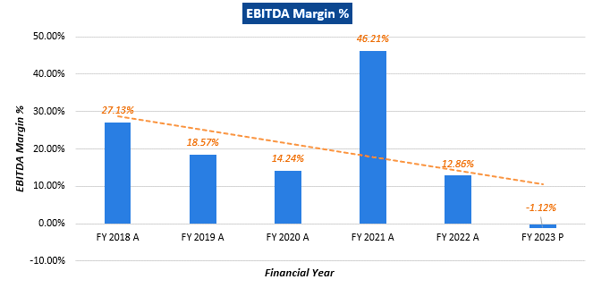

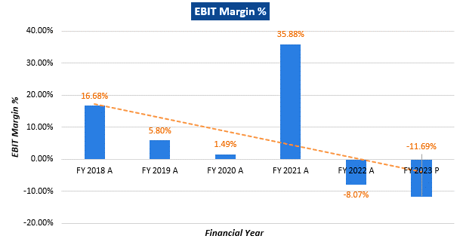

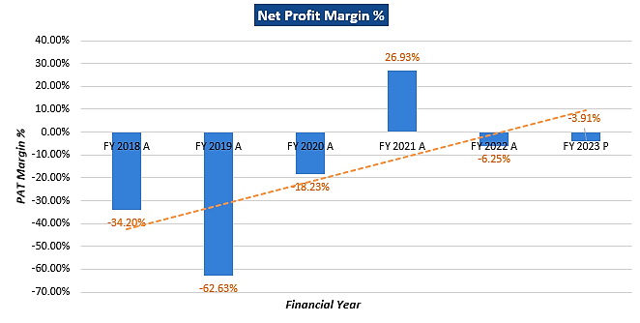

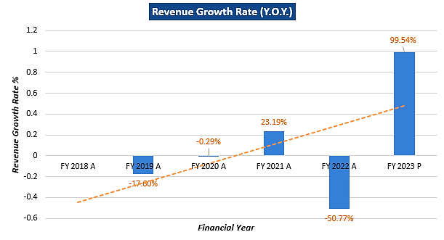

***Notes:*** As per the historical analysis, it is observed that EBITDA Margin of the company is showing an upward trend as it has gone up from 18.51% in FY 2018-19 to 46.19% in FY 2020-21. After that till FY 2022-23 it is Negative. EBIT Margin is also showing an upward trend as it has gone up from 5.74% in FY 2018-19 to 35.86% in FY 2020-21. After that it is showing downward trend till FY 2022-23.

Although, Revenue Growth of the company has reached to pre-covid levels in FY 2022-23. As per the historical analysis, it is observed that Net Profit Margin of the company is rising continuously from -62.62% in FY 2018-19 to -3.97% in FY 2022-23.

Revenue Growth of the company is constantly declining during the past recent years historically but jumped in the FY 2022-23 as per the provisional quarterly numbers shared by the company/client.

1. **PROJECTED PROFIT & LOSS STATEMENT:**

|  |  |  |  |  |  |  |  |  |  |
| --- | --- | --- | --- | --- | --- | --- | --- | --- | --- |
| **Particulars** | **FY-24** | **FY-25** | **FY-26** | **FY-27** | **FY-28** | **FY-29** | **FY-30** | **FY-31** | **FY-32** |
| **Revenue from sale of power** | 3,155.40 | 3,146.78 | 3,146.78 | 3,379.95 | 3,389.21 | 3,601.24 | 3,700.61 | 3,852.28 | 3,862.83 |
| Coal Expenses | 2,524.32 | 2,517.42 | 2,517.42 | 2,703.96 | 2,711.37 | 2,881.00 | 2,960.49 | 3,081.82 | 3,090.27 |
| Oil Expenses | 45.75 | 45.63 | 45.63 | 49.01 | 49.14 | 52.22 | 53.66 | 55.86 | 56.01 |
| O&M Expenses | 203.40 | 213.57 | 224.25 | 235.46 | 247.23 | 259.60 | 272.58 | 286.20 | 300.51 |
| **Total Expenses** | **2,773.47** | **2,776.62** | **2,787.30** | **2,988.43** | **3,007.74** | **3,192.81** | **3,286.72** | **3,423.89** | **3,446.79** |
| **EBITDA** | **381.93** | **370.16** | **359.48** | **391.52** | **381.46** | **408.44** | **413.89** | **428.39** | **416.04** |
| Depreciation | 303.35 | 303.62 | 303.81 | 303.81 | 303.81 | 303.97 | 304.30 | 304.30 | 304.44 |
| **EBIT** | **78.58** | **66.53** | **55.67** | **87.71** | **77.65** | **104.46** | **109.59** | **124.10** | **111.60** |
| Finance Cost | 0 | 971.65 | 914.49 | 857.33 | 800.18 | 743.02 | 685.87 | 628.71 | 571.56 |
| **PBT** | **78.58** | **(905.11)** | **(858.82)** | **(769.63)** | **(722.53)** | **(638.56)** | **(576.28)** | **(504.61)** | **(459.96)** |
| Tax | 0.00 | 0.00 | 0.00 | 0.00 | 0.00 | 0.00 | 0.00 | 0.00 | 0.00 |
| **PAT** | **78.58** | **(905.11)** | **(858.82)** | **(769.63)** | **(722.53)** | **(638.56)** | **(576.28)** | **(504.61)** | **(459.96)** |

|  |  |  |  |  |  |  |  |  |  |
| --- | --- | --- | --- | --- | --- | --- | --- | --- | --- |
| **Particulars** | **FY-33** | **FY-34** | **FY-35** | **FY-36** | **FY-37** | **FY-38** | **FY-39** | **FY-40** | **FY-41** |
| **Revenue from sale of power** | 4,114.81 | 4,204.15 | 4,363.40 | 4,495.50 | 4,574.00 | 4,634.52 | 4,866.25 | 4,270.23 | 2,077.51 |
| Coal Expenses | 3,291.85 | 3,363.32 | 3,490.72 | 3,596.40 | 3,659.20 | 3,707.62 | 3,893.00 | 3,416.19 | 1,662.01 |
| Oil Expenses | 59.66 | 60.96 | 63.27 | 65.18 | 66.32 | 67.20 | 70.56 | 61.92 | 30.12 |
| O&M Expenses | 315.54 | 331.32 | 347.88 | 365.28 | 383.54 | 402.72 | 422.85 | 444.00 | 466.20 |
| **Total Expenses** | **3,667.05** | **3,755.59** | **3,901.87** | **4,026.87** | **4,109.07** | **4,177.54** | **4,386.41** | **3,922.10** | **2,158.33** |
| **EBITDA** | **447.76** | **448.55** | **461.53** | **468.64** | **464.94** | **456.99** | **479.84** | **348.13** | **(80.82)** |
| Depreciation | 304.49 | 304.61 | 305.22 | 305.22 | 305.28 | 305.44 | 305.44 | 306.04 | 306.35 |
| **EBIT** | **143.27** | **143.94** | **156.30** | **163.42** | **159.66** | **151.54** | **174.39** | **42.10** | **(387.17)** |
| Finance Cost | 514.40 | 457.24 | 400.09 | 342.93 | 285.78 | 228.62 | 171.47 | 114.31 | 57.16 |
| **PBT** | **(371.13)** | **(313.30)** | **(243.79)** | **(179.52)** | **(126.12)** | **(77.08)** | **2.93** | **(72.22)** | **(444.33)** |
| Tax | 0.00 | 0.00 | 0.00 | 0.00 | 0.00 | 0.00 | 0.00 | 0.00 | 0.00 |
| **PAT** | **(371.13)** | **(313.30)** | **(243.79)** | **(179.52)** | **(126.12)** | **(88.30)** | **2.93** | **(72.22)** | **(444.33)** |

1. **KEY FINANCIAL RATIOS:**

|  |  |  |  |  |  |  |  |  |  |
| --- | --- | --- | --- | --- | --- | --- | --- | --- | --- |
| **Particulars** | **FY-24** | **FY-25** | **FY-26** | **FY-27** | **FY-28** | **FY-29** | **FY-30** | **FY-31** | **FY-32** |
| **EBITDA Margin %** | 12.10% | 11.76% | 11.42% | 11.58% | 11.26% | 11.34% | 11.18% | 11.12% | 10.77% |
| **EBIT Margin %** | 2.49% | 2.11% | 1.77% | 2.59% | 2.29% | 2.90% | 2.96% | 3.22% | 2.89% |
| **Revenue Growth Rate (Y.O.Y.)** | 2.49% | -28.76% | -27.29% | -22.77% | -21.32% | -17.73% | -15.57% | -13.10% | -11.91% |

|  |  |  |  |  |  |  |  |  |  |
| --- | --- | --- | --- | --- | --- | --- | --- | --- | --- |
| **Particulars** | **FY-33** | **FY-34** | **FY-35** | **FY-36** | **FY-37** | **FY-38** | **FY-39** | **FY-40** | **FY-41** |
| **EBITDA Margin %** | 10.88% | 10.67% | 10.58% | 10.42% | 10.16% | 9.86% | 9.86% | 8.15% | -3.89% |
| **EBIT Margin %** | 3.48% | 3.42% | 3.58% | 3.64% | 3.49% | 3.27% | 3.58% | 0.99% | -18.64% |
| **Net Profit Margin %** | -9.02% | -7.45% | -5.59% | -3.99% | -2.76% | -1.66% | 0.06% | -1.69% | -21.39% |

1. **GRAPHICAL REPRESENTATION OF THE KEY FINANCIALS OF THE COMPANY:**

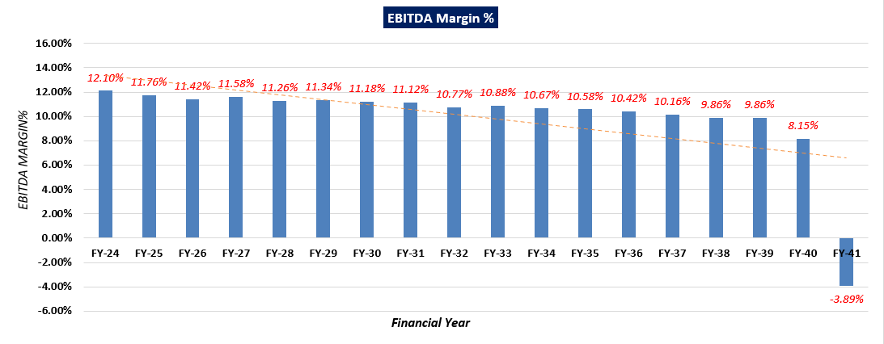

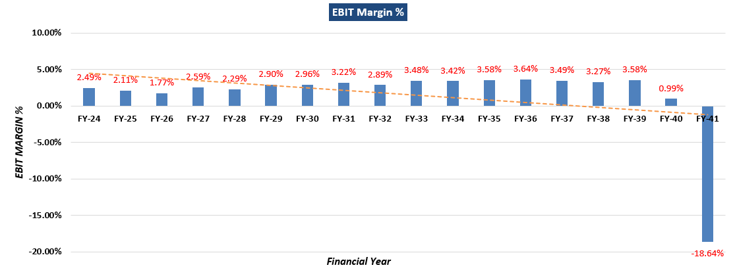

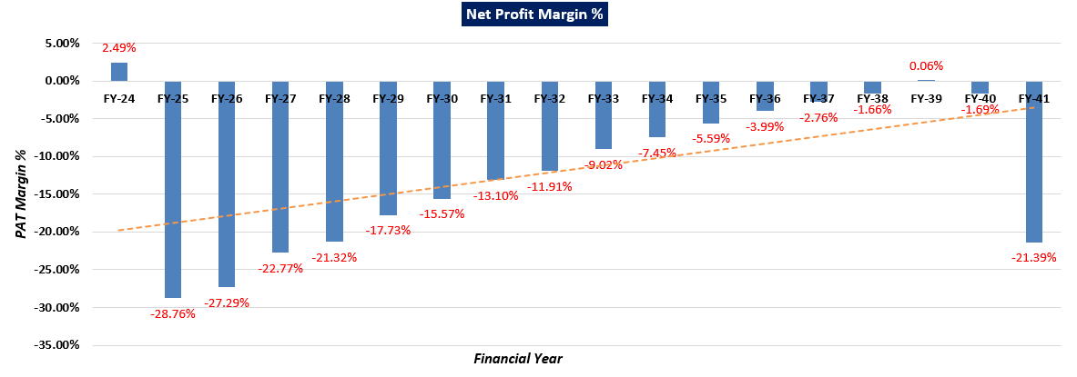

***Notes:*** As per the projections, it is observed that EBITDA Margin of the company is showing a downward trend as it has gone down from 12.10% in FY 2023-24 to 8.15% in FY 2039-40. EBIT Margin is also showing a downward trend as it has gone down from 2.49% in FY 2023-24 to 0.99% in FY 2039-40.

Although, Net Profit Margin of the company is showing an upward trend. As it is constantly increasing during the projected years from -28.76% FY 2024-25 to 0.06% in FY 2038-39.

|  |  |
| --- | --- |
| **PART F** | **VALUATION OF THE COMPANY** |

1. **METHODOLOGY/ MODEL ADOPTED:** Out of the various models & theories available, we have adopted the most widely used & acceptable approach to calculate the Enterprise Value of the Company, which is, Income based approach (Discounted Cash Flow Model).
2. The free cash flow method is similar to the method used for public companies.
3. FCFF is more practical when substantial capital changes are expected because weighted average cost of capital (WACC) is less sensitive to the cost of equity.
4. In this method, we calculate the free cash flow to firm (FCFF) for the projected period.
5. Finally, we calculate the present value of future cash flows by using a required rate of return based on the riskiness of the project, which we determine by using the Weighted Average Cost of Capital (WACC).

**RATIONALE FOR USING DCF METHOD FOR ENTERPRISE VALUATION:**

1. The three broadly used approaches of the company/Business Valuations are – Income based approach (Discounted Cash Flow Model), Asset Based Approach (Net Asset Value Method) and Relative Valuation Approach (Market Multiple method).
2. Asset Based Model is inappropriate as the Company is a going concern and the model is unable to capture the Value of the company.
3. Market Multiple Approach is also not suitable as the company is not listed and no proper similar recent comparable transactions are available.
4. Instead, DCF method is used which determines the value of a business based on its ability to generate desired economic benefit/ cash flows for the owners. Thus, considering the nature of business, we have used DCF method for valuing the Company.
5. The DCF Model gives us a variety of input options to use while calculating the Value of the firm - Dividend, Free Cash Flow to the Firm, Free Cash Flow to Equity, Capitalized Cash Flows and Residual Earnings.
6. Dividends cannot be used as the Company has no history of paying dividends and we don’t foresee any dividend payments to occur in the future due to the high leverage of the firm.
7. The best method input option for the PV Model in the case of M/s Coastal Energen Private Limited will be FCFF as it represents the benefits accruable to all the stakeholders in the Business enterprise.

**FCFF Model Formula and Key Inputs:**

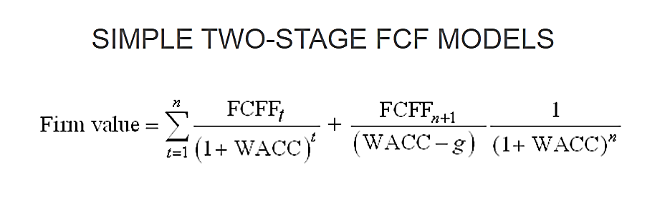

* **Free Cash Flow to Firm (FCFF):** FCFF is the [cash](http://www.investinganswers.com/node/5011) available to pay investors after a company pays its costs of doing business, invests in short-term assets like [inventory](http://www.investinganswers.com/node/2474), and invests in assets like property, plants and equipment.

*FCFF = Net Income + Non-Cash Charges + Interest (1 - tax rate) – Working Capital Investment – Fixed Capital Investment.*

* **Weighted Average Cost of Capital (WACC):**The weighted average cost of capital (WACC) is the rate that a company is expected to pay on average to all its security holders to finance its assets. The WACC is commonly referred to as the firm’s cost of capital. WACC is used as the discount rate to discount FCFF.

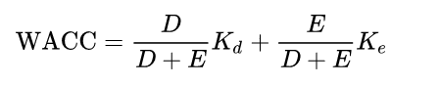

Where D is the total debt, E is the shareholders equity and Kd and Ke are the cost of debt and cost of equity, respectively.

1. **CALCULATION OF FREE CASH FLOW TO FIRM:**

(Value in INR Crores)

|  |  |  |  |  |  |  |  |  |  |
| --- | --- | --- | --- | --- | --- | --- | --- | --- | --- |
| **Particulars** | **Mar-24** | **Mar-25** | **Mar-26** | **Mar-27** | **Mar-28** | **Mar-29** | **Mar-30** | **Mar-31** | **Mar-32** |
| Total revenue | 3,155.40 | 3,146.78 | 3,146.78 | 3,379.95 | 3,389.21 | 3,601.24 | 3,700.61 | 3,852.28 | 3,862.83 |
| Total Expenses | 2,773.47 | 2,776.62 | 2,787.30 | 2,988.43 | 3,007.74 | 3,192.81 | 3,286.72 | 3,423.89 | 3,446.79 |
| **EBITDA** | 381.05 | 370.16 | 359.48 | 391.52 | 381.46 | 408.44 | 413.89 | 428.39 | 416.04 |
| Depreciation | 303.35 | 303.62 | 303.81 | 303.81 | 303.81 | 303.97 | 304.30 | 304.30 | 304.44 |
| **EBIT** | 77.70 | 66.53 | 55.67 | 87.71 | 77.65 | 104.46 | 109.59 | 124.10 | 111.60 |
| Less: Taxes | 0.00 | 0.00 | 0.00 | 0.00 | 0.00 | 0.00 | 0.00 | 0.00 | 0.00 |
| **NOPAT** | 77.70 | 66.53 | 55.67 | 87.71 | 77.65 | 104.46 | 109.59 | 124.10 | 111.60 |
| Add: Depreciation | 303.35 | 303.62 | 303.81 | 303.81 | 303.81 | 303.97 | 304.30 | 304.30 | 304.44 |
| Less: Capex | 0.09 | 0.06 | 0.00 | 0.00 | 0.05 | 0.10 | 0.00 | 0.04 | 0.01 |
| Less: Change in WC | 293.29 | 0.00 | 0.00 | 42.91 | 0.00 | 40.72 | 18.29 | 27.91 | 0.00 |
| **Unlevered Free Cash Flow (UFCF)/ FCFF** | 87.67 | 370.10 | 359.48 | 348.61 | 381.42 | 367.61 | 395.60 | 400.44 | 416.03 |
| **FCFF for Remaining Year** | **24.43** | **370.10** | **359.48** | **348.61** | **381.42** | **367.61** | **395.60** | **400.44** | **416.03** |

|  |  |  |  |  |  |  |  |  |  |
| --- | --- | --- | --- | --- | --- | --- | --- | --- | --- |
| **Particulars** | **Mar-33** | **Mar-34** | **Mar-35** | **Mar-36** | **Mar-37** | **Mar-38** | **Mar-39** | **Mar-40** | **Mar-41** |
| Total revenue | 4,114.81 | 4,204.15 | 4,363.40 | 4,495.50 | 4,574.00 | 4,634.52 | 4,866.25 | 4,270.23 | 2,077.51 |
| Total Expenses | 3,667.05 | 3,755.59 | 3,901.87 | 4,026.87 | 4,109.07 | 4,177.54 | 4,386.41 | 3,922.10 | 2,158.33 |
| **EBITDA** | 447.76 | 448.55 | 461.53 | 468.64 | 464.94 | 456.99 | 479.84 | 348.13 | -80.82 |
| Depreciation | 304.49 | 304.61 | 305.22 | 305.22 | 305.28 | 305.44 | 305.44 | 306.04 | 306.35 |
| **EBIT** | 143.27 | 143.94 | 156.30 | 163.42 | 159.66 | 151.54 | 174.39 | 42.10 | -387.17 |
| Less: Taxes | 0.00 | 0.00 | 0.00 | 0.00 | 0.00 | 0.00 | 0.00 | 0.00 | 0.00 |
| **NOPAT** | 143.27 | 143.94 | 156.30 | 163.42 | 159.66 | 151.54 | 174.39 | 42.10 | -387.17 |
| Add: Depreciation | 304.49 | 304.61 | 305.22 | 305.22 | 305.28 | 305.44 | 305.44 | 306.04 | 306.35 |
| Less: Capex | 0.04 | 0.19 | 0.00 | 0.02 | 0.06 | 0.00 | 0.19 | 0.10 | 0.00 |
| Less: Change in WC | 48.31 | 16.44 | 29.31 | 22.05 | 16.71 | 11.14 | 42.64 | -111.83 | -401.37 |
| **Unlevered Free Cash Flow (UFCF)/ FCFF** | 399.41 | 431.92 | 432.22 | 446.57 | 448.17 | 445.85 | 437.00 | 459.87 | 320.56 |
| **FCFF for Remaining Year** | **399.41** | **431.92** | **432.22** | **446.57** | **448.17** | **445.85** | **437.00** | **459.87** | **320.56** |

1. **KEY INPUTS USED TO DISCOUNT CASH FLOWS DURING THE PROJECTION PERIOD:**

|  |  |
| --- | --- |
| **Inputs** | |
| **Valuation Date** | **20th December 2023** |
| **Discount Rate** | **11.47 %** |
| **Discount Rate Change** | **1%** |
| **Tax Rate** | **34.94 %** |

**Calculation of WACC for M/s CEPL**

|  |  |
| --- | --- |
| **Weighted Average Cost of Capital** | |
| Expected Market Return (Rm) Nifty Fifty 10-year return 2022 | 12.00% |
| Cost of Debt | 13.65% |
| Company Risk Premium | 2.50% |
| **Appropriate Discount Rate** | **11.47%** |

***Note:*** *Discount Rate Change of 1% is used to calculate the Sensitivity of the Enterprise Valuation with +/- changes in discount rate.*

1. **CALCULATION OF ENTERPRISE VALUE:**

(Value in INR Crores)

|  |  |  |  |  |  |  |  |  |  |
| --- | --- | --- | --- | --- | --- | --- | --- | --- | --- |
| **Particulars** | **Mar-24** | **Mar-25** | **Mar-26** | **Mar-27** | **Mar-28** | **Mar-29** | **Mar-30** | **Mar-31** | **Mar-32** |
| Period | 0.28 | 1.28 | 2.28 | 3.28 | 4.28 | 5.28 | 6.28 | 7.28 | 8.28 |
| Discount Factor | 0.97 | 0.87 | 0.78 | 0.70 | 0.63 | 0.56 | 0.51 | 0.45 | 0.41 |
| Terminal Value |  |  |  |  |  |  |  |  |  |
| **PV of FCFF** | **23.70** | **322.12** | **280.68** | **244.19** | **239.67** | **207.23** | **200.06** | **181.67** | **169.32** |
| **PV of FCFF + PV of TV** | **23.70** | **322.12** | **280.68** | **244.19** | **239.67** | **207.23** | **200.06** | **181.67** | **169.32** |

|  |  |  |  |  |  |  |  |  |  |
| --- | --- | --- | --- | --- | --- | --- | --- | --- | --- |
| **Particulars** | **Mar-33** | **Mar-34** | **Mar-35** | **Mar-36** | **Mar-37** | **Mar-38** | **Mar-39** | **Mar-40** | **Mar-41** |
| Period | 9.28 | 10.28 | 11.28 | 12.28 | 13.28 | 14.28 | 15.28 | 16.28 | 17.28 |
| Discount Factor | 0.37 | 0.33 | 0.29 | 0.26 | 0.24 | 0.21 | 0.19 | 0.17 | 0.15 |
| Terminal Value |  |  |  |  |  |  |  |  | 877.08 |
| **PV of FCFF** | **145.83** | **141.47** | **127.01** | **117.72** | **105.98** | **94.59** | **83.17** | **78.52** | **49.10** |
| **PV of Terminal Value** |  |  |  |  |  |  |  |  | **134.34** |
| **PV of FCFF + PV of TV** | **145.83** | **141.47** | **127.01** | **117.72** | **105.98** | **94.59** | **83.17** | **78.52** | **183.44** |

Thus, based on the above factors, assumptions, Enterprise value of M/s Coastal Energen Private Limited is arrived at INR 2,946.38 Crores.

|  |
| --- |
| **ENTERPRISE VALUE OF M/S COASTAL ENERGEN PRIVATE LIMITED** |
| **INR TWO THOUSAND NINE HUNDRED FORTY-SIX CRORES AND THIRTY-EIGHT LAKHS**  **(INR 2,946.38 CRORES)** |

***NOTE:***

* *Since the company is in CIRP so the present operational, technical data of the Plant was very limited. The valuation is done based on the historical financials, Industry trend and our experience with the sector.*
* *This is just the enterprise valuation of the project based on its income generating capacity in future years. This Valuation shall not be construed as the physical asset or should be directly related to cost approach or Project cost.*
* *Currently, the company has signed PPAs of 558 MW out of the installed capacity of 1200 MW and the prospective buyer/investor/company can benefit from signing additional PPAs to use its full installed capacity.*
* *While calculating enterprise value, we have not considered FGD cost and accordingly escalation in tariff rate is also not considered due to this capex, since clarity on its implementation period and cost economics of FGD installation in TPPs at that point of time is not certain.*
* *In absence of the present operational details of the plant, we have relied upon the historical data to forecast the financial projections as per the industry standards.*
* *We are of the viewpoint that the power industry growth and demand for the power consumption will be higher in the future years, which will increase the demand for the thermal power generation plants as a result of it.*

1. **SENSITIVITY ANALYSIS:**
2. **WACC** is the key input which has strong impact on the firm’s value with respect to percentage change. We have considered a change of **1%** to perform the sensitivity analysis.

|  |  |
| --- | --- |
| **Scenario** | **WACC** |
| **Optimistic Case** | 10.47% |
| **Base Case** | 11.47% |
| **Pessimistic Case** | 12.47% |

1. **ENTERPRISE VALUE OF THE FIRM IN THE DIFFERENT SCENARIO:**

|  |  |  |
| --- | --- | --- |
| **Scenario** | **Discount Rate** | **Enterprise Value** |
| **Bull Case** | 10.47% | 3155.77 |
| **Present Case** | **11.47%** | **2946.38** |
| **Bear Case** | 12.47% | 2757.97 |

Thus, in the base case M/s CEPL is having the Enterprise Value **INR 2,946.38 Crores** and it may vary up to **INR 3,155.77 Crores** as optimistic case and **INR 2,757.97 Crores** as the pessimistic case. However, as per sensitivity analysis, the final transaction price will be dependent on the bargaining power of market participants to reach out to a successful outcome for all the concerned parties.

Hence, using two-stage DCF Model, considering as a base case the Enterprise Value of “M/s Coastal Energen Private Limited” is being calculated as **INR 2,946.38 Crores**, subject to the current assumptions and inputs used during the forecasted period, as well as the revenue growth and WACC used to calculate the EV.

*This is only a general assessment of the Enterprise/Business Value of the firm based on the data/ input Company officials could provide to us against our questions/ queries and information available in the public domain. In no manner this should be regarded as an audit activity/ report and NO micro analysis or detailed or forensic audit/ scrutiny of the financial transactions or accounts of any kind has been carried out at our end.*

1. **KEY ASSUMPTIONS AND WORKINGS:** Assumptions in the Valuation assessment have been taken based on data/ information/ documents shared by the Company, Operating History of the Plant, Annual Reports of the company, Market & Industry analysis. Assumptions have been considered after thoroughly reviewing their feasibility.
2. **KEY INPUTS CONSIDERED:** Details of key inputs/assumption during the building of projection are as follows shown in the below table:

|  |  |  |  |
| --- | --- | --- | --- |
| **Coastal Energen Private Limited Details** | | | |
| **Particular** | **Unit** | **Unit-1** | **Unit-2** |
| **Life of Plant** | Years | 25 | 25 |
| **Installed Capacity** | MW | 600 | 600 |
| **COD of the Project** | Date | 23th Dec 2014 | 13th Jan 2016 |

1. **TARIFF RATES:**

* As per information provided by client, Unit 1 is supplying power to TANGEDCO under the 15 years long term PPA at a levelized tariff of INR 4.91 per year. The company is having PPA till September 2028 for Unit 1. Currently it supplies power at Rs 5.60 per unit. Therefore, for unit 1, we have considered Rs 5.60 per unit as a tariff rate till 2028. After that as per information provided by client / company, CEPL will renew its PPA with TANGEDCO, therefore, we have considered a 5% escalation in tariff rate and then after every fifth year the same escalation is considered, keeping in mind the effect of inflation rate.
* For the Unit 2, company does not have long-term Power Purchase Agreement (PPA) but company is supplying power to Power exchange as and when demand comes. For Unit 2, as per recent data/information provided by the client/company, recently company had supplied at exchange at the average rate of INR 9.39/kWh., However since we are forecasting for the longer period upto 2041, we have referred average tariff rates as mentioned on Indian Energy Exchange Ltd and we found the tariff rates INR 5.534/kWh. For Indian Energy exchange tariff rates <https://www.iexindia.com/marketdata/areaprice.aspx>) is referred. We have also added a premium of 50 paisa, considering the effect of marketing expenses for power selling, dealer commission, coal price uncertainty etc. After that we have given a 5% escalation in this tariff rate every fifth year, considering the effect of inflation rate.
* Details of tariff rates assumption while forming projections are shown in the below table:

|  |  |  |  |  |
| --- | --- | --- | --- | --- |
| **Particular** | **FY 2024-28** | **FY 2029-33** | **FY 2034-38** | **FY 2039-41** |
| **UNIT-1 (INR /kWh)** | 5.60 | 5.88 | 6.17 | 6.48 |
| **UNIT-2 (INR /kWh)** | 6.03 | 6.34 | 6.65 | 6.99 |

1. **PLANT LOAD FACTOR (PLF):**

* The company is having PPA till 2028 for Unit 1 only for 558 MW. Thus, for forecasting, it is considered that post completion of PPA the company will grab the open market sale opportunity from unit 1 & 2, however, the PPA revision also available for the company for future due to growing power demand in the country, thus the income inflow would be continued till 2041.
* For Unit 1, considering the historical of last 5 years, and as per the last 7 months operational data provided by client/company, we have assumed a 50% Plant Load Factor (PLF) in the initial projected year. In the subsequent two years we have considered the same PLF, as the company aims to optimize production based on historical trends once sufficient working capital is available. Following this, we have factored 3% incremental increase in PLF every third year to maintain stability. Eventually, the PLF is projected to reach 70% and then constant after that considering a balanced approach (Non availability of PPA post 2028 on one hand but growing power demand in the country on another hand), considering the auxiliary consumption.
* For Unit 2, currently company does not have long-term Power Purchase Agreement (PPA) hence, PLF is totally dependent on the demand of power in the open market and as per data/information provided by company/client, its Plant Load Factor (PLF) is approximately 70% for last 2 months. Therefore, being optimistic due to growing power demand, we have assumed a 60% PLF in the first projected year. Also since company would be more aggressive in selling in open market due to better tariff rates than the PPA. Following this, we have accounted for a 2% escalation in PLF every third year since the company sells power in the open market for Unit 2. Ultimately, the PLF is anticipated to reach 70%, and then constant after that, considering the auxiliary consumption and current status of the company.
* Details of PLF assumption during the projection period are shown in the below tables:

|  |  |  |  |  |  |  |  |  |  |
| --- | --- | --- | --- | --- | --- | --- | --- | --- | --- |
| **Particulars** | **FY24** | **FY25** | **FY26** | **FY27** | **FY28** | **FY29** | **FY30** | **FY31** | **FY32** |
| **UNIT-1** | 50% | 50% | 50% | 53% | 53% | 56% | 56% | 59% | 59% |
| **UNIT-2** | 60% | 60% | 60% | 62% | 62% | 64% | 64% | 66% | 66% |

|  |  |  |  |  |  |  |  |  |  |
| --- | --- | --- | --- | --- | --- | --- | --- | --- | --- |
| **Particulars** | **FY33** | **FY34** | **FY35** | **FY36** | **FY37** | **FY38** | **FY39** | **FY40** | **FY41** |
| **UNIT-1** | 62% | 62% | 65% | 65% | 68% | 68% | 70% | 70% | 70% |
| **UNIT-2** | 68% | 68% | 70% | 70% | 70% | 70% | 70% | 70% | 70% |

1. **REVENUE PROJECTIONS:** Based on the tariff rates and PLF factor, unit wise details of revenue projections are shown in the below tables:

|  |  |  |  |  |  |  |  |  |  |
| --- | --- | --- | --- | --- | --- | --- | --- | --- | --- |
| **Particulars** | **FY24** | **FY25** | **FY26** | **FY27** | **FY28** | **FY29** | **FY30** | **FY31** | **FY32** |
| **Exchange Rate** | 83.13 | 83.13 | 83.13 | 83.13 | 83.13 | 83.13 | 83.13 | 83.13 | 83.13 |
| **Days** | 366 | 365 | 365 | 365 | 366 | 365 | 365 | 365 | 366 |
| **Unit 1** | 600.00 | 600.00 | 600.00 | 600.00 | 600.00 | 600.00 | 600.00 | 600.00 | 600.00 |
| **Gross Generation Units (GWh)** | 2,635.2 | 2,628.0 | 2,628.0 | 2,785.6 | 2,793.3 | 2,943.3 | 2,943.3 | 3,101.0 | 3,109.5 |
| **Auxiliary Consumption Units (GWh)** | 177.88 | 177.39 | 177.39 | 188.03 | 188.55 | 198.68 | 198.68 | 209.32 | 209.89 |
| **Net Generation Units (GWh)** | **2,457.3** | **2,450.6** | **2,450.6** | **2,597.6** | **2,604.7** | **2,744.6** | **2,744.6** | **2,891.7** | **2,899.6** |
| **Revenue from Unit 1** | **1,376.1** | **1,372.3** | **1,372.3** | **1,454.6** | **1,458.6** | **1,613.8** | **1,613.8** | **1,700.3** | **1,704.9** |

|  |  |  |  |  |  |  |  |  |  |
| --- | --- | --- | --- | --- | --- | --- | --- | --- | --- |
| **Particulars** | **FY33** | **FY34** | **FY35** | **FY36** | **FY37** | **FY38** | **FY39** | **FY40** | **FY41** |
| **Exchange Rate** | 83.13 | 83.13 | 83.13 | 83.13 | 83.13 | 83.13 | 83.13 | 83.13 | 83.13 |
| **Days** | 365.00 | 365.00 | 365.00 | 366.00 | 365.00 | 365.00 | 365.00 | 266.00 | 287.00 |
| **Unit 1** | 600.00 | 600.00 | 600.00 | 600.00 | 600.00 | 600.00 | 600.00 | 600.00 |  |
| **Gross Generation Units (GWh)** | 3,258.7 | 3,258.7 | 3,416.4 | 3,425.7 | 3,574.0 | 3,679.2 | 3,679.2 | 2,681.2 |  |
| **Auxiliary Consumption Units (GWh)** | 219.96 | 219.96 | 230.61 | 231.24 | 241.25 | 248.35 | 248.35 | 180.99 |  |
| **Net Generation Units (GWh)** | **3,038.7** | **3,038.7** | **3,185.7** | **3,194.5** | **3,332.8** | **3,430.8** | **3,430.8** | **2,500.2** |  |
| **Revenue from Unit 1** | **1,786.7** | **1,876.1** | **1,966.9** | **1,972.3** | **2,057.6** | **2,118.2** | **2,224.1** | **1,620.8** |  |

|  |  |  |  |  |  |  |  |  |  |
| --- | --- | --- | --- | --- | --- | --- | --- | --- | --- |
| **Particulars** | **FY24** | **FY25** | **FY26** | **FY27** | **FY28** | **FY29** | **FY30** | **FY31** | **FY32** |
| **Exchange Rate** | 83.13 | 83.13 | 83.13 | 83.13 | 83.13 | 83.13 | 83.13 | 83.13 | 83.13 |
| **Days** | 366 | 365 | 365 | 365 | 366 | 365 | 365 | 365 | 366 |
| **Unit 2** | 600.00 | 600.00 | 600.00 | 600.00 | 600.00 | 600.00 | 600.00 | 600.00 | 600.00 |
| **Gross Generation Units (GWh)** | 3,162.2 | 3,153.6 | 3,153.6 | 3,258.7 | 3,267.6 | 3,363.8 | 3,363.8 | 3,468.9 | 3,478.4 |
| **Auxiliary Consumption Units (GWh)** | 213.45 | 212.87 | 212.87 | 219.96 | 220.57 | 227.06 | 227.06 | 234.15 | 234.80 |
| **Net Generation Units (GWh)** | **2,948.7** | **2,940.7** | **2,940.7** | **3,038.7** | **3,047.0** | **3,136.7** | **3,136.7** | **3,234.8** | **3,243.6** |
| **Revenue from Unit 2** | **1,779.3** | **1,774.4** | **1,774.4** | **1,925.2** | **1,930.5** | **1,987.3** | **2,086.7** | **2,151.9** | **2,157.8** |

|  |  |  |  |  |  |  |  |  |  |
| --- | --- | --- | --- | --- | --- | --- | --- | --- | --- |
| **Particulars** | **FY33** | **FY34** | **FY35** | **FY36** | **FY37** | **FY38** | **FY39** | **FY40** | **FY41** |
| **Exchange Rate** | 83.13 | 83.13 | 83.13 | 83.13 | 83.13 | 83.13 | 83.13 | 83.13 | 83.13 |
| **Days** | 365.00 | 365.00 | 365.00 | 366.00 | 365.00 | 365.00 | 365.00 | 266.00 | 287.00 |
| **Unit 2** | 600.00 | 600.00 | 600.00 | 600.00 | 600.00 | 600.00 | 600.00 | 600.00 |  |
| **Gross Generation Units (GWh)** | 3,574.1 | 3,574.1 | 3,679.2 | 3,689.3 | 3,679.2 | 3,679.2 | 3,679.2 | 3,689.3 | 2,892.9 |
| **Auxiliary Consumption Units (GWh)** | 241.25 | 241.25 | 248.35 | 249.03 | 248.35 | 248.35 | 248.35 | 249.03 | 195.27 |
| **Net Generation Units (GWh)** | **3,332.8** | **3,332.8** | **3,430.8** | **3,440.2** | **3,430.8** | **3,430.8** | **3,430.8** | **3,440.2** | **2,697.7** |
| **Revenue from Unit 2** | **2,328.0** | **2,328.0** | **2,396.5** | **2,523.2** | **2,516.3** | **2,516.3** | **2,642.1** | **2,649.4** | **2,077.5** |

1. **COAL EXPENSE:** To forecast coal expenses, we did secondary research and got a sample of coal supply agreement from company website (http://coastalenergen.com/sample-contract-60-KT.pdf). In that sample contract, terms and conditions for coal like: terms of contract, commodity and contracted quantity, Technical Specification of Coal, price and price adjustment etc., are given.

To calculate the coal price, specific data are required like: CIF (INR), Transportation (INR), GST, Cess and Handling charges etc. Therefore, we had asked the data/information from company, to calculate the coal price, but we didn’t get sufficient data for the same. Hence, on the basis of data/information provided by the company, during the projected period, we have considered the coal expense as 80% of the revenue.

As CEPL is a 100% imported coal based thermal power plant. And the company is using Indonesian coal. Hence, to cross verify our assumption, we have check the Indonesian HBA2 index for coal price (https://www.minerba.esdm.go.id/harga_acuan), which is in the line with the average price of the index.

1. **COAL EXPENSE:** To calculate the landed coal price, CIF (INR), Transportation (INR), GST, Cess and Handling charges etc. have to be added. However, coal supply agreements was not available from the company on request. Therefore, for projecting coal expense, historical financials of the company and Indonesian HBA2 index for coal price (<https://www.minerba.esdm.go.id/harga_acuan>) are considered since company is using Indonesian coal. Coal expenses is projected as a percentage of revenue and have been kept in line to current Indonesian coal prices.
2. **OIL/FUEL EXPENSES:** To estimate the Oil/Fuel Expenses during the projection period, we have used historical method with respect to the operating revenues i.e. 1.45%, as per the best practices used in the industry.
3. **O&M EXPENSES:** Currently, Power Mech Projects Ltd (PMPL) has taken care of the O&M activities since October 2021. As per data/information provided by client/company,historically O&M expense per MW comes out 16.95 lakhs per MW, which is in line with the industry. Hence while calculating O&M expense, we have considered the same per MW with an escalation of 5% y-o-y basis, in view of the effect of inflation.

**Hence, the calculated Enterprise Value of Coastal Energen Private Limited is INR 2,946.38 Crores, subject to the current micro & macro-economic assumptions, market, industry trends and inputs used during the forecasted period.**

|  |  |  |
| --- | --- | --- |
| **Declaration** | 1. *Since this is Enterprise Valuation hence no site inspection was carried out by us.* 2. *The undersigned does not have any direct/indirect interest in the above property.* 3. *The information furnished herein is true and correct to the best of our knowledge.* 4. *This valuation work is carried out by our Financial Analyst team on the request from State Bank of India, Stressed Assets Management Branch, Red Cross Building, Red Cross Road, Egmore, Chennai - 600008* 5. *We have submitted Valuation report to the Client.* | |
| **Name & Address of Valuer company** | | **Signature of the authorized person** |
| M/s R.K. Associates Valuers & Techno Engineering Consultants Pvt. Ltd.  D-39, Second Floor, Sector-2, Noida, UP-201301, India. | |  |
| **Number of Pages in the Report** | | **45** |
| **Financial Analyst Team worked on the report** | | ***PREPARED BY: Mrs. Chhavi Toshan*** |
| ***REVIEWED BY: Mr. Gaurav Kumar*** |

**For R.K Associates Valuers & Techno Place: Noida**

**Engineering Consultants (P) Ltd. Engineering Consultants (P) Ltd. Date:20th December 2023**

**(Authorized Signatory)**

**Valuations**

|  |  |
| --- | --- |
| **PART G** | **IMPORTANT DEFINITION** |

***Definitions:***

* ***Enterprise Value:*** *Enterprise value (EV) is the corporate valuation of a company, determined by using market capitalization and total debt. Market cap comprises preference stocks, common stocks, and minority interest; total debt comprises short-term and long-term liabilities of the company. Enterprise value (EV) refers to the overall valuation—equity, debt, cash, and cash equivalents. In other words, it is the cost of acquiring a firm. The EV/EBITDA is an enterprise multiple. It correlates EV with earnings before interest, taxes, depreciation, and amortization. The metric determines whether the firm is undervalued or overvalued.*

*EV is computed using the following formula: EV = (Market Capitalization + Market Value of Debt – Cash and Equivalents).*

* ***Fair Market Value****suggested by the competent Valuer is that prospective estimated amount in his expert & prudent opinion of the subject asset without any prejudice after he has carefully & exhaustively evaluated the facts & information came in front of him related to the subject asset at which the subject asset should be exchanged between a willing buyer and willing seller at an arm’s length transaction in an open & unrestricted market, after proper marketing, wherein the parties, each acted knowledgeably, prudently and without any compulsion on the date of the Valuation.*

*Forced, under compulsion & constraint, obligatory sales transactions data doesn’t indicate the Fair Market Value.*

* ***Realizable Value*** *is the minimum prospective estimated value of the Company which it may be able to realize at the time of actual transaction factoring in the potential prospects of deep negotiations carried out between the buyer & seller for ultimately finalizing the transaction across the table. Realizable value may be 10-20% less than the Fair Market Value depending on the various salability prospects of the subject asset and the needs of the buyer & the seller.*
* ***Forced/ Distress Sale Value*** *is the value when the company has to be sold due to any compulsion or constraint like financial encumbrances, dispute, as a part of a recovery process, legal issues or any such condition or situation. In this type of sale, minimum fetch value is assessed which can be 15-25% less than the estimated Fair Market Value. In this type of sale, negotiation power of the buyer is always more than the seller and eagerness & pressure of selling the asset is more than buying it. Therefore, the Forced/ Distress Sale Value will always fetch significantly less value compare to the estimated Fair Market Value.*
* ***Liquidation Value*** *is the amount that would be realized when an asset or group of assets are sold on a piecemeal basis that is without consideration of benefits (or detriments) associated with a going-concern business. Liquidation value can be either in an orderly transaction with a typical marketing period or in a forced transaction with a shortened marketing period.*
* ***Difference between Costs, Price & Value:*** *Generally, these words are used and understood synonymously. However, in reality each of these has a completely different meaning, premise and also have different definitions in the professional & legal terms. Therefore, to avoid confusion, it is our professional responsibility to describe the definitions of these words to avoid ambiguity & confusion in the minds of the user of this report.*
* *The* ***Cost*** *of an asset represents the actual amount spend in the construction/ actual creation of the asset.*
* *The* ***Price*** *is the amount paid for the procurement of the same asset.*
* *The* ***Value*** *is defined as the present worth of future rights in the asset and depends to a great extent on combination of various factors such as demand and supply, market situation, purpose, situation & needs of the buyer & seller, salability outlook, usability factor, market perception & reputation. Needs of the buyer & seller, salability outlook, usability factor, market perception & reputation.*
* *Therefore, in actual for the same asset, cost, price & value remain different since these terms have different usage & meaning.*

|  |  |
| --- | --- |
| **PART H** | **DISCLAIMER | REMARKS** |

* + - 1. No employee or member of R.K Associates has any direct/ indirect interest in the Project.
      2. This is just an opinion report on Valuation based on the copy of the documents/ information provided to us by the client which has been relied upon in good faith and the assessment and assumptions done by us.
      3. This report is prepared based on the copies of the documents/ information which the Bank/ Company has provided to us out of the standard checklist of documents sought from them and further based on our assumptions and limiting conditions. The client/owner and its management/representatives warranted to us that the information they supplied was complete, accurate and true and correct to the best of their knowledge. All such information provided to us has been relied upon in good faith and we have assumed that it is true and correct in all respect. I/We shall not be liable for any loss, damages, cost or expenses arising from fraudulent acts, misrepresentations, or willful default on part of the owner, company, its directors, employee, representative or agents. Verification or cross checking of the documents provided to us from the originals or from any Govt. departments/ Record of Registrar has not been done at our end since this is beyond the scope of our work. If at any time in future, it is found or came to our knowledge that misrepresentation of facts or incomplete or distorted information has been provided to us then this report shall automatically become null & void.
      4. This Valuation is prepared based on the current financial status of the company, financial data, other facts & information provided by the client in writing & during verbal discussion during the course of the assignment and based on certain assumptions which are specifically mentioned in the Valuation section of the Report.
      5. Key assumptions in the report are taken based on data, information, inputs, financial statements etc. provided by the client to us during the course of the assessment and on the basis of the assessment done by us and we have assumed that all such information is true & factual to the best of the knowledge of the promoter company.
      6. Sale transaction method of the asset is assumed as free market transaction while assessing Prospective Fair Market Value of the asset.
      7. Legal aspects for e.g., investigation of title, ownership rights, lien, charge, mortgage, lease, sanctioned maps, verification of documents, etc. have not been done at our end and same has to be taken care by legal expert/ Advocate. It is assumed that the concerned Lender/ Financial Institution has satisfied them with the authenticity of the documents, information given to us and for which the legal verification has been already taken and cleared by the competent Advocate before requesting for this report. I/ We assume no responsibility for the legal matters including, but not limited to, legal or title concerns.
      8. All observations mentioned in the report is only based on the visual observation and the documents/ data/ information provided by the client. No mechanical/ technical tests, measurements or any design review have been performed or carried out from our side during Project assessment.
      9. Bank/FII should ONLY take this report as an Advisory document from the Financial/ Chartered Engineering firm and its specifically advised to the creditor to cross verify the original documents for the facts mentioned in the report which can be availed from the borrowing company directly.
      10. In case of any default in loans or the credit facility extended to the borrowing company, R.K Associates shall not be held responsible for whatsoever reason may be and any request for seeking any explanation from the employee/s of R.K Associates will not be entertained at any instance or situation.
      11. We have relied on data from third party, external sources & information available on public domain also to conclude this report. These sources are believed to be reliable and therefore, we assume no liability for the truth or accuracy of any data, opinions or estimates furnished by others that have been used in this analysis. Where we have relied on data, opinions or estimates from external sources, reasonable care has been taken to ensure that such data has been correctly extracted from those sources and /or reproduced in its proper form and context, however still we can’t vouch its authenticity, correctness or accuracy.
      12. This Report is prepared by our competent technical team which includes financial experts & analysts. This report is a general analysis of the project based on the scope mentioned in the report. This is not an Audit report, Design document, DPR or Techno feasibility study. All the information gathered is based on the facts seen on the site during survey, verbal discussion & documentary evidence provided by the client and is believed that information given by the company is true best of their knowledge.
      13. Value varies with the Purpose/ Date/ Condition of the market. This report should not to be referred if any of these points are different from the one mentioned aforesaid in the Report.
      14. Analysis and conclusions adopted in the report are limited to the reported assumptions, conditions and information came to our knowledge during the course of the work.
      15. This report is having limited scope as per its fields to provide only the general indication of the Value of Equity of the companies prevailing in the market based on the documents/ data/ information/ financial statements provided by the client and the assessment and assumption taken by us. The suggested value should be considered only if transaction is happened as free market transaction.
      16. Secondary/ Tertiary costs related to transaction like Stamp Duty, Registration charges, Brokerage, etc. pertaining to the sale/ purchase of the company are not considered while assessing the Market Value.
      17. Appropriate methodology & assumptions are rationally adopted based on the facts of the case came to our knowledge during the course of the assignment considering many factors like nature of Industry, current market situation and trends.
      18. Valuation is a subjective field and opinion may differ from consultant to consultant. To check the right opinion, it is important to evaluate the methodology adopted and various factors/ basis considered during the course of assessment before reaching to any conclusion.
      19. At the outset, it is to be noted that Value analysis cannot be regarded as an exact science and the conclusions arrived at in many cases will, of necessity, be subjective and dependent on the exercise of individual judgment. Given the same set of facts and using the same assumptions, expert opinions may differ due to the number of different factors, which have to be made. Therefore, there can be no standard formulae to establish an indisputable exchange ratio. In the event of a transaction, the actual transaction value achieved may be higher or lower than our indicative analysis of value depending upon the circumstances of the transaction. The knowledge, negotiability and motivations of the buyers and sellers and the applicability of a discount or premium for control will also affect actual price achieved. Accordingly, our indicative analysis of value will not necessarily be the price at which any agreement proceeds. The final transaction price is something on which the parties themselves have to agree. However, our Valuation analysis can definitely help the stakeholders to make them informed and wise decision about the Value of the asset and can help in facilitating the arm’s length transaction.
      20. This report is prepared on the Enterprise Valuation format as per the client requirement. This report is having limited scope as per its fields to provide only the indicative Fair value of the company based on the current financial position, future prospects & current Industry trends. The Valuation assessed in this Valuation Report should hold well only if transaction is happened as per free market transaction. No detailed analysis or verification of the information is carried upon pertaining to the value of the shares of the subject companies. No claim for any extra information will be entertained whatsoever be the reason. For any extra work over and above the fields mentioned in the report will have an extra cost which has to be borne by the customer.
      21. As per the scope of the report no site survey has been carried out by us and no thorough vetting of the documents/ information provided to us has been done at our end.
      22. This is just an opinion report and doesn’t hold any binding on anyone. It is requested from the concerned stakeholder which is using this report that they should consider all the different associated relevant & related factors also before taking any business decision based on the content of this report.
      23. Though adequate care has been taken while preparing this report as per its scope, but still, we can’t rule out typing, human errors, over sightedness of any information or any other mistakes. Therefore, the concerned organization is advised to satisfy themselves that the report is complete & satisfactory in all respect. Intimation regarding any discrepancy shall be brought into our notice immediately. If no intimation is received within 15 (Fifteen) days in writing from the date of issuance of the report, to rectify these timely, then it shall be considered that the report is complete in all respect and has been accepted by the client up to their satisfaction & use and further to which R.K Associates shall not be held responsible in any manner.
      24. This Valuation report is prepared based on the facts of the companies provided to us during the course of the assignment. However, in future the assumptions taken may change or may go worse due to impact of Govt. policies or effect of World economy, Industry/ market scenario may change, etc. Hence before taking any business decision the user of this report should take into consideration all such future risk.
      25. The documents, information, data provided to us during the course of this assessment by the client is reviewed only up to the extent required in relation to the scope of the work. No document has been reviewed beyond the scope of the work.
      26. In case of any default in repayment of credit facility extended to the borrowing company, as estimated by us, R.K Associates shall not be held responsible for whatsoever reason may be and any request for seeking any explanation from the employee/s of R.K Associates will not be entertained at any instance or situation.
      27. This report only contains general assessment & opinion as per the scope of work evaluated and based on technical & market information which came to knowledge during course of the assignment as per the information given in the copy of documents, information, data provided to us and/ and confirmed by the owner/ owner representative to us at site which has been relied upon in good faith. It doesn’t contain any other recommendations of any sort including but not limited to express of any opinion on the suitability or otherwise of entering into any transaction with the borrower.
      28. This Valuation is conducted based on the macro analysis of the asset/ property and operations of the companies and not based on the micro, component or item wise analysis. Analysis done is a general assessment and is not investigative in nature.
      29. This report is prepared following our Standard Operating Procedures & Best Practices, Limitations, Conditions, Remarks, Important Notes, Valuation TOR.
      30. Valuation is done based on the industry wide general accepted norms and based on the international standards & best practices for equity valuations.
      31. Any kind of unpaid statutory, utilities, lease, interest or any other pecuniary dues on the asset has not been factored in the Valuation.
      32. All Pages of the report including annexures are signed and stamped from our office. In case any paper in the report is without stamp & signature then this should not be considered a valid paper issued from this office.
      33. Defect Liability Period is **15 DAYS**. We request the concerned authorized reader of this report to check the contents, data and calculations in the report within this period and intimate us in writing if any corrections are required or in case of any other concern with the contents or opinion mentioned in the report. Corrections only related to typographical, calculation, spelling mistakes, incorrect data/ figures/ statement will be entertained within the defect liability period. Any new changes for any additional information in already approved report will be regarded as additional work for which additional fees may be charged. No request for any illegitimate change in regard to any facts & figures will be entertained.
      34. R.K Associates encourages its customers to give feedback or inform concerns over its services through proper channel at valuers@rkassociates.org in writing within 15 days of report delivery. After this period no concern/ complaint/ proceedings in connection with the Financial Feasibility Study Services will be entertained due to possible change in situation and condition of the subject Project.
      35. Our Data retention policy is of **ONE YEAR**. After this period, we remove all the concerned records related to the assignment from our repository. No clarification or query can be answered after this period due to unavailability of the data.
      36. This Enterprise Valuation report is governed by our (1) Internal Policies, Processes & Standard Operating Procedures, (2) R.K Associates Quality Policy, (3) Valuation & Survey Best Practices Guidelines formulated by management of R.K Associates, (4) Information input given to us by the customer and (4) Information/ Data/ Facts given to us by our field/ office technical team. Management of R.K Associates never gives acceptance to any unethical or unprofessional practice which may affect fair, correct & impartial assessment and which is against any prevailing law. In case of any indication of any negligence, default, incorrect, misleading, misrepresentation or distortion of facts in the report then it is the responsibility of the user of this report to immediately or at least within the defect liability period bring all such act into notice of R.K Associates management so that corrective measures can be taken instantly.
      37. R.K Associates never releases any report doing alterations or modifications from pen. In case any information/ figure of this report is found altered with pen then this report will automatically become null & void.
      38. If this report is prepared for the matter under litigation in any Indian court, no official or employee of R.K Associates will be under any obligation to give in person appearance in the court as a testimony. For any explanation or clarification, only written reply can be submitted on the additional payment of charges.