File No.: VIS (2023-24)-PL453-370-582 Dated: 20.11.2023

TECHNO-ECONOMIC VIABILITY
STUDY REPORT

OF

PROPOSED MANUFACTURING FACILITY (CONTRACT MANUFACTURER FOR PHARMACEUTICAL FIRMS)

SITUATED AT

PLOT NO. 11, PHARMACITY SELAQUI, DEHRADUN UTTARAKHAND, 248011

SETUP BY
M/S MANCARE LABORATORIES PVT. LTD.

REPORT PREPARED FOR

PUNJAB NATIONAL BANK, MCC DEHRADUN - 248011

**Important - In case of any query/ issue or escalation you may please contact Incident Manager Valuers@rkassociates.org. We will appreciate your feedback in order to improve our services.

NOTE: As per IBA Guidelines please provide your feedback on the report within 15 days of its submission after which report will be considered to be correct.

IMPORTANT NOTICE

COPYRIGHT FORMAT: This report is prepared on the copyright format of R. K. Associates Valuers & Techno Engineering Consultants (P) Ltd. (R. K. Associates) to serve our clients with the best possible information and analysis to facilitate them to take rational business decisions. Legally no one can copy or distribute this format without prior approval from R. K. Associates. It is meant only for the advisory/ reference purpose for the organization/s as mentioned on the cover page of this report. Distribution or use of this format or report or any of its content/ information/ data by any organization or individual other than R.K Associates will be seen as an unlawful act and necessary legal action can be taken against the defaulters.
This report is intended for the sole use of the intended recipient/s and contains material that is STRICTLY CONFIDENTIAL AND PRIVATE.

DEFECT LIABILITY PERIOD: In case of any query/ issue or escalation you may please contact Incident Manager at valuers@rkassociates.org. Though adequate care has been taken while preparing this report as per its scope, but still we can’t rule out typing, human errors, over sightedness of any information or any other mistakes. Therefore, the concerned organization is advised to satisfy themselves that the report is complete & satisfactory in all respect. Intimation regarding any discrepancy shall be brought into our notice immediately. If no intimation is received within 15 (Fifteen) days in writing from the date of issuance of the report, to rectify these timely, then it will be considered that the report is complete in all respect and has been accepted by the client up to their satisfaction & use and further to which R.K Associates shall not be held responsible in any manner.

Part O: R. K. Associates Important Disclaimer and Remarks are integral part of this report and Feasibility assessment is subject to this section. Reader of the report is advised to read all the points mentioned in these sections carefully.

TABLE OF CONTENTS
SECTIONS | PARTICULARS | PAGE NO.
Part A | Report Summary | 5
Part B | INTRODUCTION | 7
 | - About the Report | 7
 | - Executive summary | 7
 | - Purpose of the Report | 13
 | - Scope of the Report | 13
 | - Methodology/ Model Adopted | 13
 | - Data Information received from | 14
 | - Documents/ Data Referred | 14
Part C | Company Profile
 | - Company Overview | 15
 | - Promoters/Directors Profile | 15
Part D | Proposed Unit’s Infrastructure Details
 | - Proposed Plant Location | 21
 | - Layout Plan | 21
 | - Location Map | 30
 | - Land Details | 31
 | - Site pictures | 32
 | - Building & Civil Works | 36
 | - Plant and Machinery/ Equipment details | 40
Part E | Project Technical details
 | - Capacity of Manufacturing Facility | 54
 | - Technical Specification of the Proposed Manufacturing Facility | 54
 | - Technology Used | 62
 | - Effluent Treatment and Abetment | 63
 | - Testing Standards For Production | 63
 | - Manpower | 63
Part F | Product Profile
 | - Introduction | 66
 | - Product Category | 66
 | - Pricing Strategy | 66
 | - Marketing, Selling & Distribution Plan | 67
Part G | Feedstock Analysis & Supply | 69
Part H | Industry Overview & Analysis | 71
Part I | SWOT Analysis | 78
Part J | Project Cost and Means of Finance | 79
Part K | Project Schedule | 80
Part L | Statutory Approvals | Licences | NOC | 82
Part M | Company’s Financial Feasibility | 84
Part N | Conclusion | 116
Part O | Disclaimer | Remarks | 117
Part P | Annexures | 121

PART A | REPORT SUMMARY

- Name of the Company: | M/s Mancare Laboratories Private Ltd
- Address of the Company: | Plot No. 11, Pharmacity Selaqui, Dehradun Uttarakhand, 248011
- Project Name : | Manufacturing facility to produce Small Volume parenteral (SVP), Aerosol, and External Ointment & Cream.
- Project Location: | Khasra No 2756 MIN, Mauza Shankarpur, Hakumatpur, Sara Industrial area, Tehsil-Vikas Nagar, Distt-Dehrradun Uttrakhand-248011.
- Project Type: | Manufacturing facility to produce Small Volume parenteral (SVP), Aerosol, and External Ointment & Cream.
- Project Industry: | Pharmaceutical Industry
- Product Type/ Deliverables: | Ampoule Liquid Injection, Vial Liquid Injection, Tablet & Ointment.
- Report Prepared for Organization: | PNB, MCC, Dehradun
- TEV Consultant Firm: | M/s. R.K Associates Valuers & Techno Engineering Consultants (P) Ltd.
- Report type: | Techno-Economic Viability Report
- Purpose of the Report: | To assess the Project’s Techno-Economic Viability for the purpose of seeking external financial assistance on the Project.
- Scope of the Report: | To assess, evaluate & comment on Techno-Financial Viability of the Project as per data information provided by the client, independent Industry research and data/ information available on public domain.
- Date of Report: | 20th November 2023
- Documents referred for the Project | - PROJECT PLANNING DOCUMENTS:  - Detailed Project Report  - Financial Projections of the Project  - Project proposed Schedule  - Statutory Approval Details  - Process Flow of manufacturing  - PROCUREMEMNT DOCUMENTS:  - High level breakup of Plant & Machinery Cost  - Land details and conversion Certificate  - List of major customers of the company  - Expected Building Details  - Expected manpower details  - Water and Electricity arrangements details
- Means of Finance: | Equity + Debt
- Key Financial Indicators | Key Indicators Value  Average DSCR 3.03  Average EBITDA Margin 22.84%  NPV INR 14.30 Crore  ADJUSTED IRR 14.93%  Average Current Ratio 1.65

Note: Above financial indicators are based on the financial projections of the proposed project provided by the firm and assessment and analysis of the same done by us.

PART B | INTRODUCTION

- ABOUT THE REPORT:
Techno-Economic Viability Study Report of Small Volume parenteral (SVP), Aerosol, External Ointment & Cream manufacturing company setup by M/s Mancare Laboratories Private Limited.

- EXECUTIVE SUMMARY:
M/S. Mancare Laboratories Pvt. Ltd. a WHO-GMO certified company, is a company limited by shares established in 2006, and the manufacturing unit was started in 2009 at Plot No. 11 Pharmacity, Selaqui, Dehradun, Uttarakhand. As the name suggests, Pharmacity is a special zone created for the Pharma industry where the company occupies a total space of 24755 sq. feet, out of which 36000 sq. feet is the build-up area.
The company is engaged in integrated development of the product including Pre-Formulation studies, formulation development, Cost effective Commercial manufacturing of the finished dosage, Art work Management. Mancare is producing and supplying high-quality standards products for patients/consumers and healthcare professionals.
Whether the storage of the raw material, transfer of these material, and manufacturing, packing or final storage of the finished goods, the company is having a stringent systems for maintaining the QUALITY of the products.
CONTRACT MANUFACTURING, As per data/information provided by the client/company and data available in the public domain, Mancare seeks collaboration with prospective pharmaceutical firms who are looking for manufacturing facilities, As a dedicated TPM (Third Party Manufacturing) Manufacturing a wide range of more than 500 quality products at affordable price for many companies.
List of Categories
Tablet | Capsules | Liquid |  | Dry Powder | Soft Gel | Hormone
Non Beta Lactam | Non Beta Lactam | Syrup |  | Dry Syrup | Soft Gel | Tablets
Beta Lactam | Beta Lactam | Suspension |  |  |  | Soft Gel Capsules
Production Capacity
Product |  |  | Capacity
BETA LACTOM
Tablet |  |  | 25 Million/Month
Capsules |  |  | 15 Million/Month
Dry Syrups |  |  | 800 Thousand Bottles/Month
NON-BETA SECTION
Tablet |  |  | 40 Million/Month
Capsules |  |  | 20 Million/Month
Syrups |  |  | 03 Million Bottle/Month
Soft Gels |  |  | 25 Million Capsules/Month
HARMONAL SECTION
Tablet |  |  | 20 Million/Month
Soft gel Capsules |  |  | 15 Million/Month

The Management Team is led by Mr Mihir Kumar Jha (Managing Director), who brings with him an experience of more than 30 years in corporate management. He is M.Sc. in Bio Chemistry and having experience more than 40 years. Mr. Mihir Jha is having expertise dealing in supply of pharmaceuticals products in different government hospitals, private hospital and retailers in all over Jharkhand state. Day-to-day affairs are looked after by 20 Management & Technical staff as also 135 general staff. Each section has one Supervisor and for ETP operation the Company has 2 additional workers. The company is having a large client base, list of some of the existing buyer is shown in the below table:
CLIENTELE OF THE COMPANY
Medley Pharmaceuticals Ltd. | NAVA HEALTHCARE  PVT. LTD. | Mancare Health Pvt Ltd | LYKA | Alto Healthcare Pvt Ltd | Caventis Pharma Pvt Ltd
Surge Pharmaceuticals Ltd. | Khandelwal  Lifesciences (P) Ltd. | Ashley Pharmatech Pvt Ltd. | Manav Aushadhi Store LLP | Sarv Aushadhi Store Pvt Ltd | Cadiz Life Sciences
Anglo-French Drugs & Industries Pvt Ltd | Anna Pharma | Starmax Life Sciences Pvt Ltd | Lark Laboratories (India) Ltd | Advent Bioceuticals | U Shanto Pharmaceuticals Pvt Ltd.
Abony Healthcare Limited | Abolab Wellness | HelpLab Keep You Well | Destiny Laboratories Private Limted | Secure Healthcare | Cian Healthcare Limited
Avail Healthcare Pvt Ltd | Ontima Lifecare | Yaniaka Healthcare | The Ogen Healthcare Pvt Ltd | Sarthi LifeSciences | Wonder healthcare Ltd
Profile Healthcare Ltd | WinSome Medicare | Adroit Pharma | H&A Healthcare | Swara Healthcare | Isomer Healthcare Pvt Limited
Thus as a part of expansion of existing business, M/s Mancare Laboratories Pvt. Ltd. is proposed to setting up a manufacturing facility to produce Small Volume parenteral (SVP), Aerosol, External Ointment & Cream. The facility will be based at Plot no-11 in Pharmacity, Selaqui, Dehradun of Uttarakhand state in India. The total available plot area for this facility is 2602.82 Sq. Mtr. The Facility will have clean room manufacturing area, Raw material, Primary packing material, finished goods & secondary packing material stores, QC/QA & Micro laboratory area, AHU area etc. The facility will be design to meet and comply with WHO cGMP. Below table shows the product wise proposed capacity of the said manufacturing facility:

Capacities envisaged for this formulation facility (Proposed)
Sr. No. | Formulation Facility | Quantity
1 | Ampoule Liquid Injection | 1 ml to 5 ml 125 Ampoule per minute
 |  | 10 ml to 30 ml 75 vial per minute
 |  | 40 ml to 50 ml 50 vial per minute
2 | Vial Liquid Injection | 10 ml 100/vial per minute
 |  | 20 ml 75 vial per minute
 |  | 30 ml 50 vial per minute
3 | Tablet Line 1 | 300 Pack per minute
4 | Tablet Line 2 | 300 Pack per minute
Source: Information provided by the company
Beta-lactam antibiotics, including penicillins and the non-penicillin classes, share a basic chemical structure that includes a three-carbon, one-nitrogen cyclic amine structure known as the beta-lactam ring. The side chain associated with the beta-lactam ring is a variable group attached to the core structure by a peptide bond; the side chain variability contributes to antibacterial activity.
The pharmaceutical industry in India is currently valued at $50 Bn. India is a major exporter of Pharmaceuticals, with over 200+ countries served by Indian pharma exports. India supplies over 50% of Africa’s requirement for generics, ~40% of generic demand in the US and ~25% of all medicine in the UK. India also accounts for ~60% of global vaccine demand, and is a leading supplier of DPT, BCG and Measles vaccines. 70% of WHO’s vaccines (as per the essential Immunization schedule) are sourced from India. Government incentives including an outlay of INR 21,940 for PLI 1.0 and PLI 2.0. Three bulk drug parks, located in Gujarat, Himachal Pradesh, and Andhra Pradesh should provide a consistent supply of bulk drug active components and will ensure India's drug security.
Medical tourism: Quality services at marginal costs compared to US, Europe, and South Asia. Infrastructure development: India has the highest number of US-FDA compliant plants outside the US. Strong drug manufacturing: Expertise in low cost generic patented drugs as well as end-to-end manufacturing. Strong domestic demand: Launch of the largest National Health Protection Scheme globally. The trend in annual turnover in the sector over the last five years may be seen in the below table:
Pharma Sector’s Growth at Current Prices
Financial Year | Turnover (INR Crore) | Growth Rate %
2017-18 | 2,26,423 | 3.03%
2018-19 | 2,58,534 | 14.18%
2019-20 | 2,89,998 | 12.17%
2020-21 | 3,28,054 | 13.12%
2021-22 | 3,44,125 | 4.89%
Source: Pharmatrac/NPPA/DGCIS, Kolkata
Pharmaceutical formulation, in pharmaceutics, is the process in which different chemical substances, including the active drug, are combined to produce a final medicinal product. The word formulation is often used in a way that includes dosage form. Various industry reports suggest that the pharmaceutical sector in India has been growing consistently at the rate of 13-14 % every year. India enjoys an important position in the global pharmaceuticals sector.
The Indian pharmaceutical market size reached US$ 48.4 Billion in 2022. Looking forward, IMARC Group expects the market to reach US$ 102.7 Billion by 2028, exhibiting a growth rate (CAGR) of 13.01% during 2023-2028. As we look ahead, there are positive signs for the industry. Raw material prices are stabilizing, freight rates are normalising, and pricing pressure in the US generics market is easing. These factors are expected to contribute to an expansion of operating margins by approximately 100 to 150 basis points over FY24-FY25 compared to FY23. Furthermore, the industry's continued focus on launching specialty and niche products in the US market is anticipated to provide further support to the profitability.
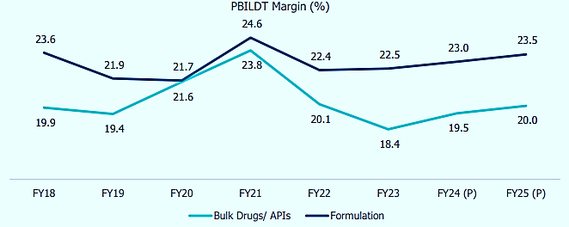
The export of Bulk drug/APIs is likely to grow at around 5-6% over FY24- FY25; in-line with its historical average. Pharma exports largely include formulation products which have grown at a CAGR of 8-9% during FY18-FY23.
As per the proposed plan for taping the market of pharmaceutical industry in India and as per the growing demand of the Indian Bulk Drug/API, M/s Mancare Laboratories Private Limited is planning to setup this new facility as a part of the expansion of existing business, at the said land. It seems that the proposed facility will be getting the synergies from the existing customer base, market and well educated directors/promoters having rich experience in the same industry.
We R.K associate is performing the Techno-Economic Viability study for proposed manufacturing facility setup by Mancare Laboratories Private Limited at at Khasra No 2756 MIN, Mauza Shankarpur, Hakumatpur, Sara Industrial area, Tehsil-Vikas Nagar, Distt-Dehrradun Uttrakhand-248011, for taking a term loan of INR 28.40 Crore from financial institutions for building construction and Plant & Machinery purchase & installation work.

PROPOSED PROJECT COST: The project will be implemented through appointment of a project manager and architect/constructor, total cost of the project from scratch to trial run is being estimated as INR 4192.99 Lakhs, which is proposed to be funded through equity of INR 1352.99 Lakhs including INR 385.28 Lakhs as interest during construction and debt of INR 2840 Lakhs.
TOTAL COST OF PROJECT
Year |  | 2023-24 | 2024-25 | 2025-26 | 2026-27 | 2027-28
Land | Owned | 165.4
Building & Fixtures | 1589.38 | 133 | 266.38 | 0.00
Plant and Machinery | 2218.33 | 34 | 333 | 201.33
Interest during Construction/Implementation Period | 385.28 | 12.80 | 147.36 | 225.12
Total | 4192.99 | 179.80 | 746.74 | 426.45 | 1352.99 | 0.00
Means of Finance
Year |  | 2023-24 | 2024-25 | 2025-26 | 2026-27 | 2027-28
Term Loan- Building, Equipment & Fixture | 1190.00 | 133 | 266.38 | 0
Plant & Machinery | 1650.00 | 34 | 333 | 201.33
Promotor's Contribution | 967.71 | 167.00 | 599.38 | 201.33 | 967.71 | 1352.99
Interest during Construction/Implementation Period | 385.28 | 12.8 | 164.16 | 108
Total | 4192.99 | 179.80 | 746.74 | 426.45 | 1352.99
As per the discussion with client/company officials, for the proposed facility the 2602.82 Square Meter of land has been taken from the promoter by the company. The major heads in the Total Project Cost will be electricity connection, civil construction and Purchase & installation cost of plant & machinery, for which they are taking a term loan of INR 28.40 Crore. Rest most of the heads will be funded through equity.
The company is planning to fund the project through term loan to initiate the proposed manufacturing unit and approaching the financial institutions to provide the required capital.
CURRENT STATUS OF THE PROJECT: As per the shared lease deed and as per the site survey, construction of boundary wall work has been started, however foundation & plinth work will be initialized soon after loan sanction (Kindly refer the attached site pictures in the report). As per informed by the banker, company has applied for map sanction approval with SIDA and shall be obtained in the month of December 2023.
Further Mr. Adnan Ansari (Project Manager, Mancare Laboratories) has been appointed as project lead who will be looking after the installation and run the plant & machinery part and company is in the process to appoint an architect/consultant for construction of building and other structure as per the requirement to run the manufacturing facility smoothly.
As per the schedule shared by the client, the company is planning to achieve the COD by 28th Feb, 2026. Currently, company is in discussion with financial institutions to fund the project through a term loan of INR 28.40 Crore. Company plans to achieve the financial closure by 31st December, 2023 (expected).

Therefore to check and assess the Techno-Economic viability of the Project for submitting the proposal to financial institutions, PNB, MCC DEHRADUN has appointed us as TEV consultant to review technical, commercial and financial viability of the project based on our independent EIC research and information/data provided to us about the project by client/company.

- PURPOSE OF THE REPORT: To assess the Techno-Economic Feasibility of the green field proposed project to take further Project funding decision for the same.

- SCOPE OF THE REPORT: To assess, evaluate & comment on Techno-Financial Feasibility of the proposed manufacturing facility being set up by M/s Mancare Laboratories Pvt. Ltd. as per the data/information provided by the client/promoter/stakeholder and our independent EIC research.

NOTES:
- Project status is taken as per the information provided by the company/promoter/stakeholder.
- Site inspection has been carried out for the proposed units at proposed land. Operating details regarding the existing unit is taken as per the information provided by the company which has been relied upon.
- Projections of Existing Unit has been provided by the client/bank as it was out of scope of work in this TEV study.
- Scrutiny about the company, background check, and credibility, credit worthiness of the company or its promoters is out-of-scope of this report.
- This report is only an opinion in respect to Technical and Financial Feasibility of the project as per the future Projections provided by the firm and independent analysis done by us and doesn’t contains any recommendations including taking decision on the financial exposure.
- This is not an audit activity of any kind. We have relied upon the data/ information supplied by the company in good faith that it is true and without any fabrication.
- This is not a Detailed Project Report or a detailed design or architecture document. Land and property details mentioned in the report is only for illustration purpose as per the information provided to us by the client. The same doesn’t tantamount for taking any responsibility regarding its legality, ownership and conforming to statutory norms.

- METHODOLOGY/ MODEL ADOPTED:
- Data/ Information collection as per our standard checklist.
- Review of Data/ Information collected related to TEV study.
- Review and analysis of the Projections as per the market trends and futuristic growth opportunity of the industry and company.
- Independent review & assessment of technology used provided by the company/promoters.
- Projections of Revenue, Expenses, P&L, Balance Sheet, fixed assets, COGS.
- Assessment of Key Financial Metrics.
- Final conclusion.

- DATA/ INFORMATION RECEIVED FROM: All the data/Information has been received from Chief Manager, PNB MCC Dehradun and the required details about him shown in the below table:
Particulars | Details
Designation | Chief Manager
Company | PNB, MCC Dehradun
Email Address | clpc6281@pnb.co.in
Contact No. | +91- 8126476214

- DOCUMENTS / DATA REFFERED:
- Detailed Project Report & Proposed project cost.
- Financial projections with detailed assumption.
- Director’s details and contractor’s details.
- Manufacturing Process Flow Chart
- List of proposed Plant & Machinery along with quotations.
- Description of suppliers and buyers of the company.
- Electricity connection, Man power proposal
- Proposed Site Map
- Sale Deed for Land
- Statutory approval details
- Enrolment Certificate/Udyam Registration Certificate/GST.
PART C | COMPANY PROFILE

- COMPANY OVERVIEW:
M/S. Mancare Laboratories Private Limited, the Sole prompter of the Project, has planned for the expansion of its existing pharmaceutical business through setting up a new manufacturing facility at at Khasra No 2756 MIN, Mauza Shankarpur, Hakumatpur, Sara Industrial area, Tehsil-Vikas Nagar, Distt-Dehrradun Uttrakhand-248011 having Udyam Registration Number UDYAM-UK-05-0002156. As per information available in the public domain and MCA website about the company, incorporation details of the company is shown in the below table:
Company Information | Description
CIN | U51397JH2006PTC012607
Company Name | MAN CARE LABORATORIES PRIVATE LIMITED
ROC Name | ROC Jharkhand
Registration Number | 012607
Date of Incorporation | 25/08/2006
Email Id | man_care09@yahoo.co.in
Registered Address | SHOP NO 8, 2ND FLOOR BALDEO BHAWAN SHRADHANAND ROAD, UPPER BAZAR, RANCHI, Jharkhand, India, 834001
Address at which the books of account are to be maintained | -
Listed in Stock Exchange(s) (Y/N) | No
Category of Company | Company limited by shares
Subcategory of the Company | Non-government company
Class of Company | Private
ACTIVE compliance | ACTIVE Compliant
Authorised Capital (Rs) | 8,00,00,000
Paid up Capital (Rs) | 5,41,66,800
Date of last AGM | 30/09/2022
Date of Balance Sheet | 31/03/2022
Company Status | Active
Jurisdiction
ROC (name and office) | ROC Jharkhand
RD (name and Region) | RD, Eastern Region

- PROMOTERS/DIRECTORS PROFILE: Promotor’s details have been shown in the below table:
Sr. No | DIN/PAN | Name | Designation | Appointment | Signatory
1 | 05270131 | SUNIL KUMAR MISRA | Director | 06/11/2012 | Yes
2 | 00615157 | SUDHIRA JHA | Director | 15/03/2021 | Yes
3 | 08425017 | CHANDRA BHUSHAN MISHRA | Director | 18/04/2019 | Yes
4 | 00495496 | MIHIR KUMAR JHA | Director | 15/03/2021 | Yes

PROMOTOR’S/DIRECTOR’S DETAILS
Name | Designation/DIN | Mobile No | Identifiers |  | Full Address | Qualification and Experience
 |  |  | PAN | Passport
Mr. Mihir Kumar Jha | Director/00495496 | 8449427800 | ADKPJ3689B | Z3121996  valid upto-18.03.2025 | A-206, Vasundhara Garden, Harihar Singh Road, Morabadi, Ranchi. | - As per information provided by client and information available on MCA website and information available in public domain, Mr. Mihir Kumar Jha is taking care of all selling and marketing plan of the company.  - He is M.Sc. in Bio Chemistry and having experience more than 40 years. Mr. Mihir Jha was dealing in supply of pharmaceuticals products in different government hospitals, private hospital and retailers in all over Jharkhand state.  - He was running a firm in the name of M/s Anand Distributor in which he was a proprietor. Later on in 2006, he decided to enter in manufacturing of pharmaceuticals bulk drugs in 2006.  - The company has been incorporated in 2006 at registered office- Shop no 8, 2nd floor Baldeo Bhawan Shradhanand Road, Upper Bazar, Ranchi, Jharkhand -834001.  - In 2008 he purchased a piece of lance measuring 2230 sq. Mtr. at Plot no 11, Pharma City, Selaqui Industrial Area, Dehradun 248011 and further constructed factory building and installed plant and machinery in 2008 through bank finance. He is having good and long relation in the market and pharma sector.
Ms. Sudhira Jha | Director/00615157 | 8449427800 | ACRPJ1505C | M7518932  valid upto-19.03.2025 | A-206, Vasundhara Garden, Harihar Singh Road, Morabadi, Ranchi. | - Mrs.Sudhira Jha is wife of Mr. Mihir Kumar Jha and is science graduated and she is assisting to her husband in day to day business. Besides, she is also involved in all financial matter of the existing company.
Mr. Sunil Kumar Mishra | Director/05270131 | 7830899378 | AOKPM2687K | Not Available | 7,Rudra Enclave, Shyampur, Prem Nagar, Dehradun. | - Mr. Chandra Bhushan Mishra is a M. A and having 25 years of experience in this field. He is associated with Mr. Mihir Kumar Jha since 1998 and assisting Mr. Jha all accounts related affairs.
Mr. Chandra Bhushan Mishra | Director/08425017 | 8439512545 | ALVPM8092L | Not Available | Thakurpur, Dehradun, Umedpur, Uttrakhand-248007 | - Mr. Sunil Kumar Mishra is a B.Sc passed. He is having 28 year experience in pharma sector. He worked in different pharma manufacturing company for approx. 17 years. In 2012 he joined this company as director and looking after all manufacturing affairs of the company.
Source: Data/Information provided by the client
MRS. SUDHIRA JHA
List of Associated Companies
Sr. No | CIN/FCRN | Company Name | Designation | Original Date of appointment | Date of Appointment at Current Designation | Date of cessation (if applicable)
1 | U51397JH2006PTC012607 | MAN CARE LABORATORIES PRIVATE LIMITED | Director | 15/03/2021 | 15/03/2021 | -
2 | U74110HR2013PTC074800 | SUDHIRA LOGISTICS PRIVATE LIMITED | Director | 20/03/2021 | 20/03/2021 | -
3 | U70200DL2015PTC281386 | PAM BUILDCON PRIVATE LIMITED | Director | 03/04/2018 | 03/04/2018 | -
4 | U51909DL2003PTC122976 | ALTO HEALTHCARE PRIVATE LIMITED | Director | 15/03/2021 | 15/03/2021 | -
5 | U51397JH2006PTC012607 | MAN CARE LABORATORIES PRIVATE LIMITED | Director | - | 26/08/2006 | 20/04/2019
6 | U51909DL2003PTC122976 | ALTO HEALTHCARE PRIVATE LIMITED | Director | - | 23/10/2015 | 09/05/2019
7 | U74110HR2013PTC074800 | SUDHIRA LOGISTICS PRIVATE LIMITED | Director | - | 16/04/2013 | 14/06/2019
8 | U70200DL2015PTC281386 | PAM BUILDCON PRIVATE LIMITED | Director | - | 10/06/2015 | 01/06/2017
9 | U63090DL2013PTC247199 | SPHAIRA LOGISTICS PRIVATE LIMITED | Director | - | 15/07/2016 | 20/04/2022
List of Associated LLPs- No data available

MR. CHANDRA BUSHAN MISHRA
List of Associated Companies
Sr. No | CIN/FCRN | Company Name | Designation | Original Date of appointment | Date of Appointment at Current Designation
1 | U74110HR2013PTC074800 | SUDHIRA LOGISTICS PRIVATE LIMITED | Director | 19/05/2019 | 19/05/2019
2 | U51397JH2006PTC012607 | MAN CARE LABORATORIES PRIVATE LIMITED | Director | 18/04/2019 | 18/04/2019
List of Associated LLPs- No data available

MR. MIHIR KUMAR JHA
List of Associated Companies
Sr. No | CIN/FCRN | Company Name | Designation | Original Date of appointment | Date of Appointment at Current Designation | Date of cessation (if applicable)
1 | U63090DL2013PTC247199 | SPHAIRA LOGISTICS PRIVATE LIMITED | Director | 15/07/2016 | 15/07/2016 | 05/05/2022
2 | U70200DL2015PTC281386 | PAM BUILDCON PRIVATE LIMITED | Director | 03/04/2018 | 03/04/2018 | -
3 | U51397JH2006PTC012607 | MAN CARE LABORATORIES PRIVATE LIMITED | Director | 15/03/2021 | 15/03/2021 | -
4 | U51909DL2003PTC122976 | ALTO HEALTHCARE PRIVATE LIMITED | Director | 15/03/2021 | 15/03/2021 | -
5 | U74110HR2013PTC074800 | SUDHIRA LOGISTICS PRIVATE LIMITED | Director | - | 16/04/2013 | 20/05/2013
6 | U36911DL2014PTC265079 | MANCARE HEALTH PRIVATE LIMITED | Additional Director | - | 02/06/2015 | 30/07/2015
7 | U74110HR2013PTC074800 | SUDHIRA LOGISTICS PRIVATE LIMITED | Managing Director | - | 20/05/2013 | 14/06/2019
8 | U63090DL2013PTC247199 | SPHAIRA LOGISTICS PRIVATE LIMITED | Director | - | 15/07/2016 | 05/05/2022
9 | U70200DL2015PTC281386 | PAM BUILDCON PRIVATE LIMITED | Director | - | 10/06/2015 | 01/06/2017
10 | U51397JH2006PTC012607 | MAN CARE LABORATORIES PRIVATE LIMITED | Director | - | 26/08/2006 | 20/04/2019
11 | U36911DL2014PTC265079 | MANCARE HEALTH PRIVATE LIMITED | Director | - | 30/07/2015 | 24/06/2019
12 | U51909DL2003PTC122976 | ALTO HEALTHCARE PRIVATE LIMITED | Director | - | 14/08/2015 | 09/05/2019

MR. SUNIL KUMAR MISHRA
List of Associated Companies
Sr. No | CIN/FCRN | Company Name | Designation | Original Date of appointment | Date of Appointment at Current Designation | Date of cessation (if applicable)
1 | U51397JH2006PTC012607 | MAN CARE LABORATORIES PRIVATE LIMITED | Director | 06/11/2012 | 06/11/2012 | -
2 | U70200DL2015PTC281386 | PAM BUILDCON PRIVATE LIMITED | Director | - | 23/05/2017 | 03/04/2018
List of Associated LLPs- No data available

PART D | PROPOSED UNIT’S INFRASTRUCTURE DETAILS

- PROPOSED PLANT LOCATION: The proposed Pharmaceutical Manufacturing unit will be set up by M/s Mancare Laboratories Private Limited at a 2602.82 Sq. Mtr. land owned by the promoters of the company, at Khasra No 2756 MIN, Mauza Shankarpur, Hakumatpur, Sara Industrial area, Tehsil-Vikas Nagar, Distt-Dehrradun Uttrakhand-248011. During the site visit we found that the land is an industrial plot which is situated near Sara Industrial Estate which is 15 metre wide. The property is located at semi-urban area having proximity to civic amenities such there is a school at 1.5 km far away from the land, a hospital at 2 km far away and market at 4 km far away. Below table shows the adjoining properties details of the proposed plant:
Location | Adjoining Property
East | Drainage and Land of others
West | 15 Mtr. Wide road
North | Land of Samar & Silver line Pharma Limited
South | Land of others
Below table shows the connectivity details of the company with the city:
Connectivity | Details
Rail | Dehradun Railway Station – 30 km away
Airport | Jollygrant Airport-55 km
Road | SH-7 Chakrata Road 700 meter away

- PROCESS FLOWCHART:
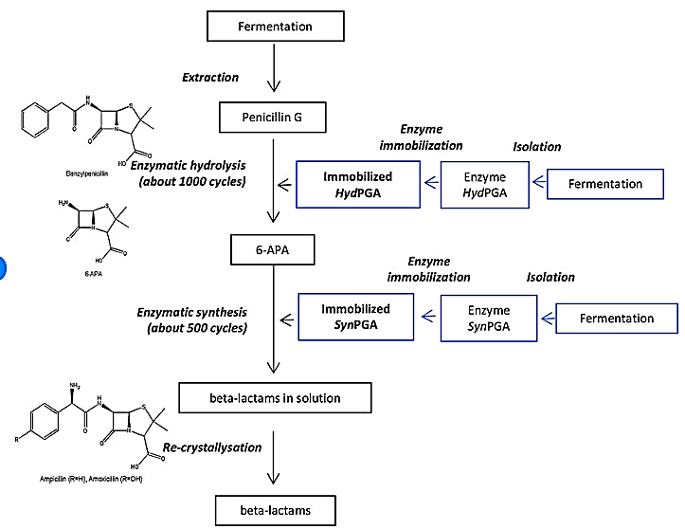
- LAYOUT PLAN: The Company has applied for the approval of map and layout plan from the concerned authority as per share data/information to us.
APPLIED ARCHITECT PLAN FOR APPROVAL

GROUND FLOOR
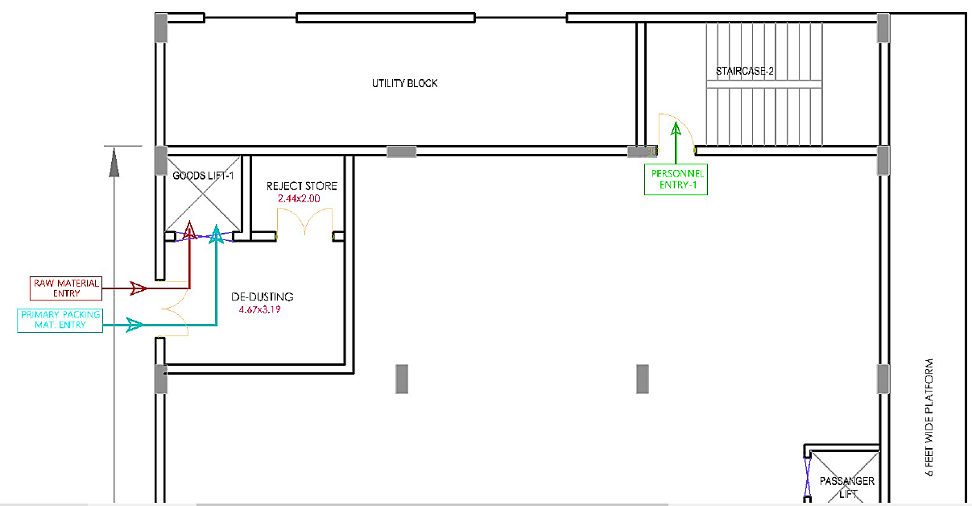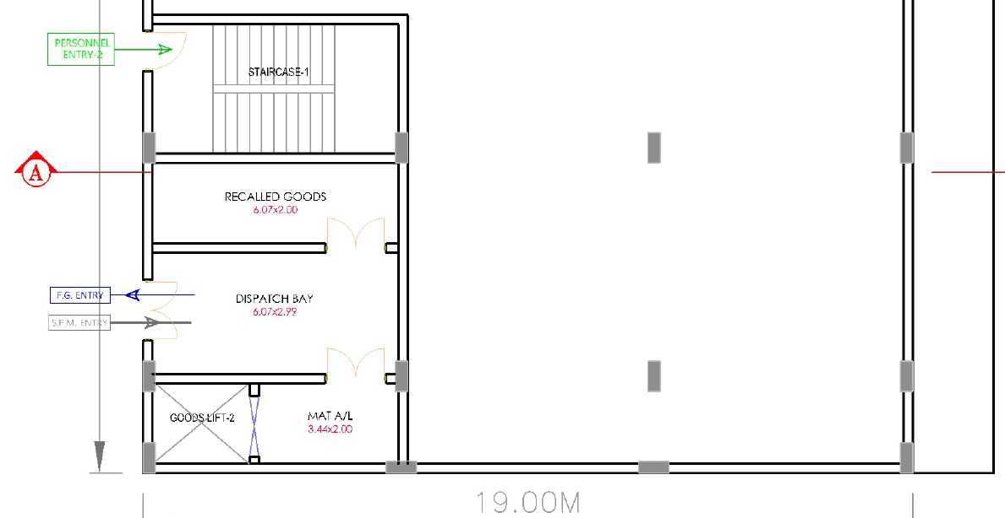
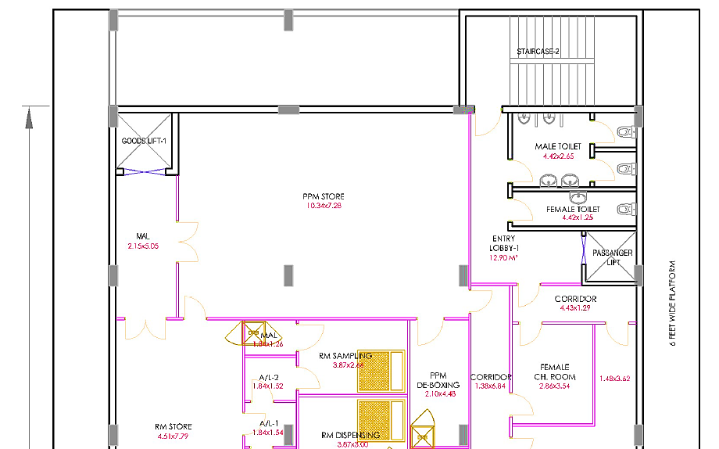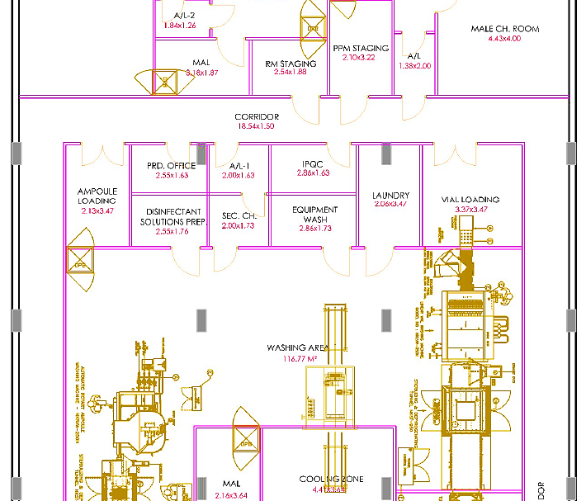
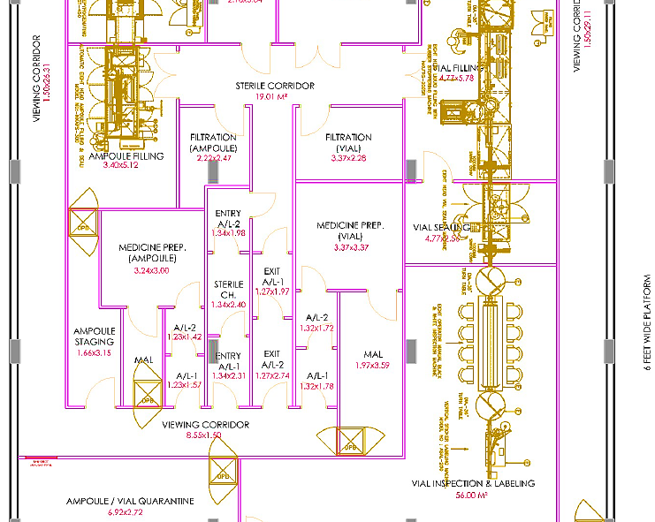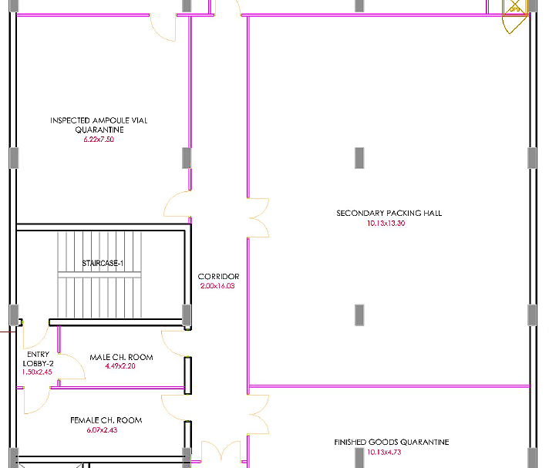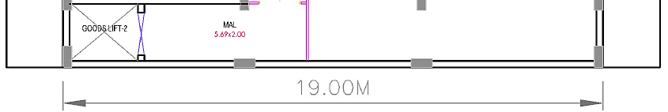
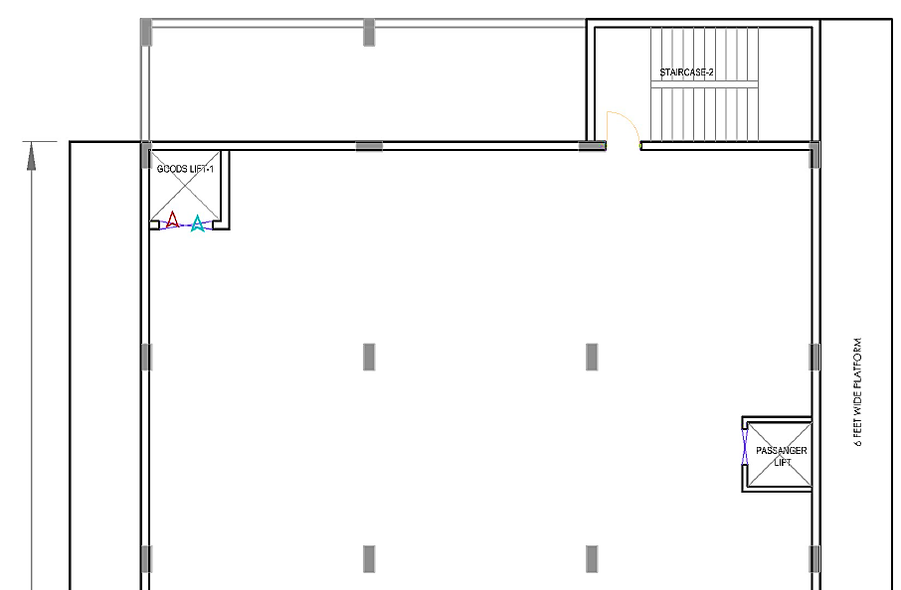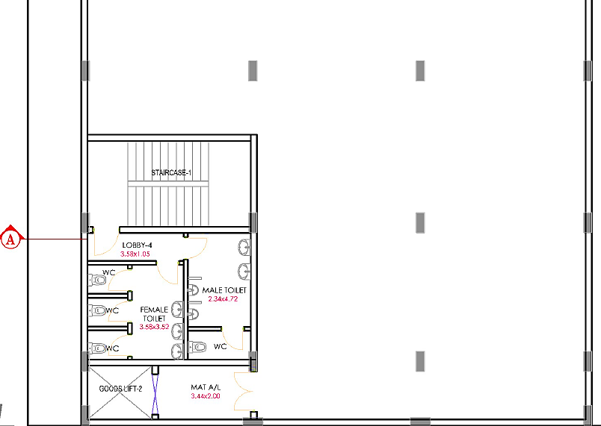
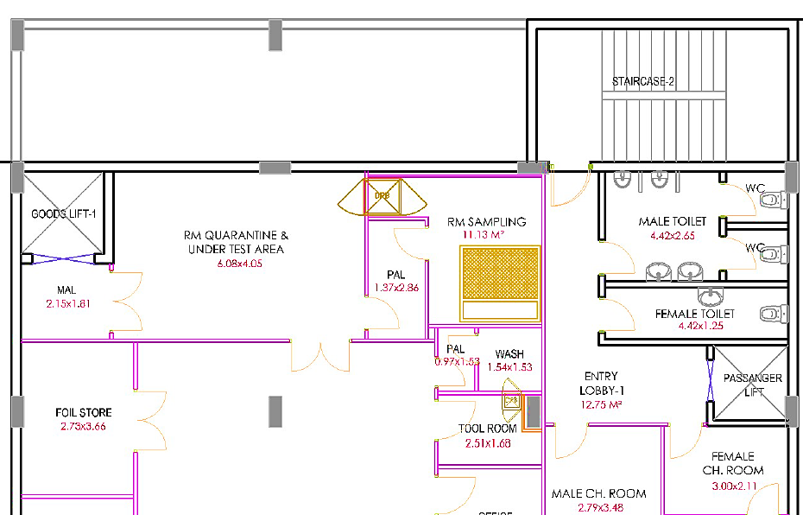
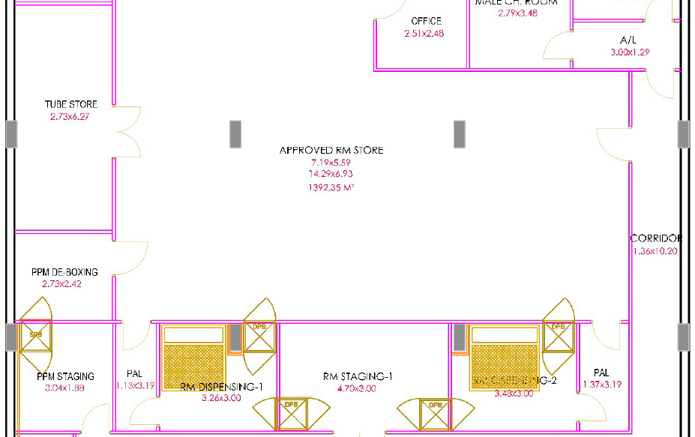
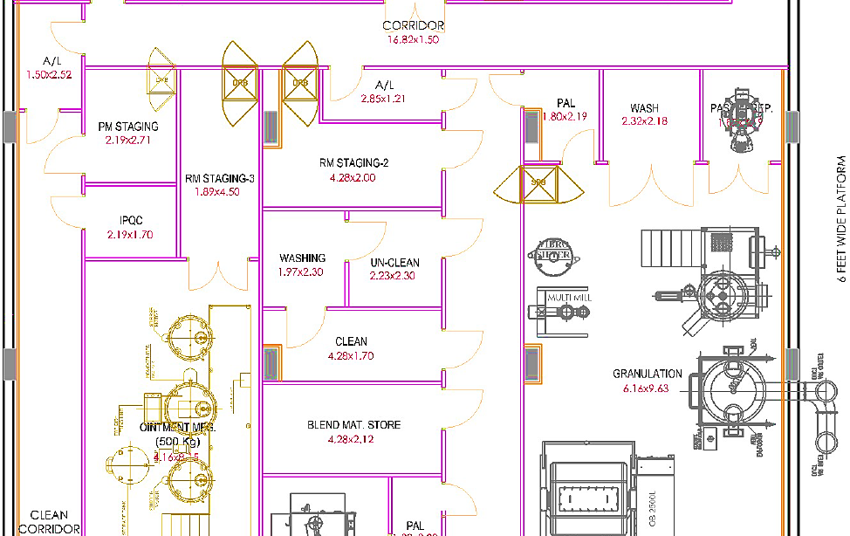
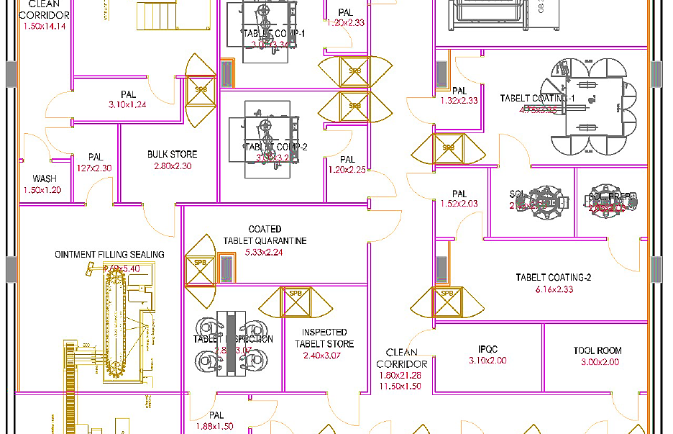
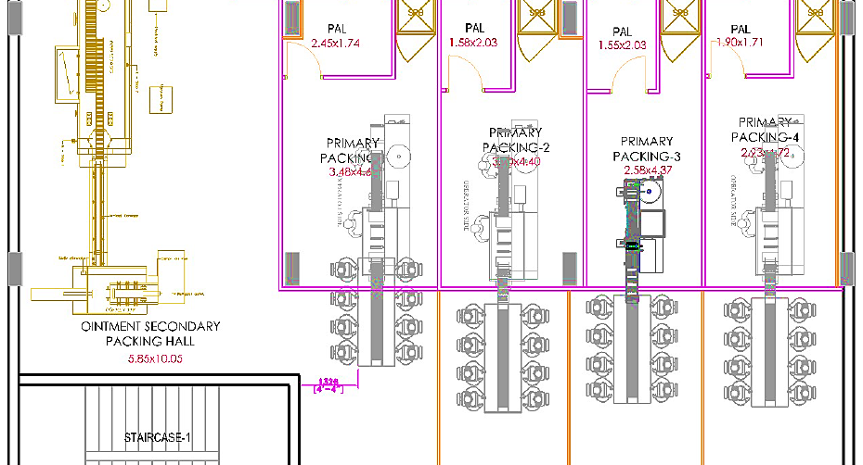
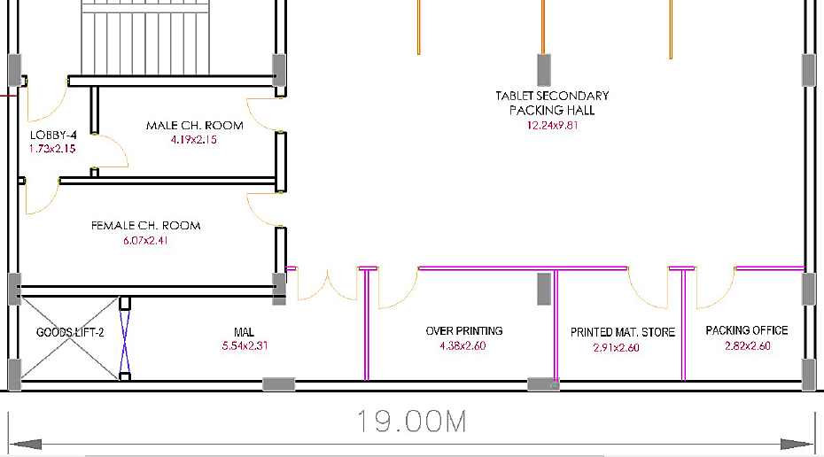
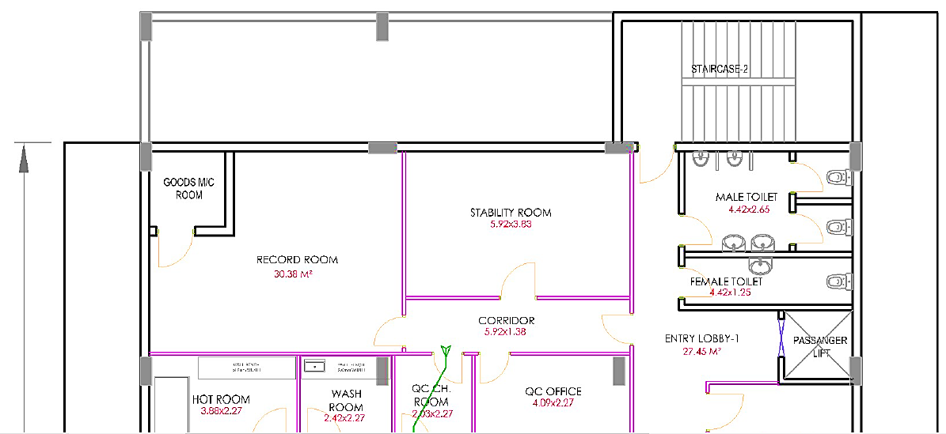
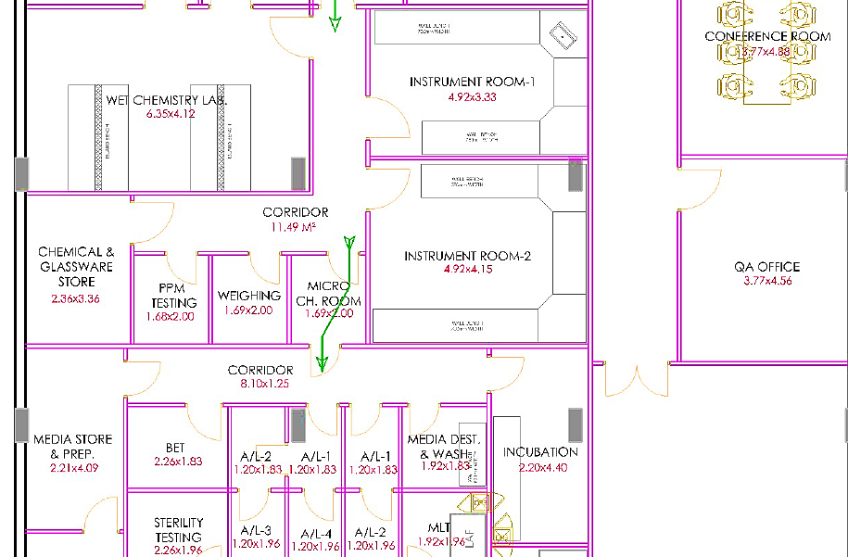
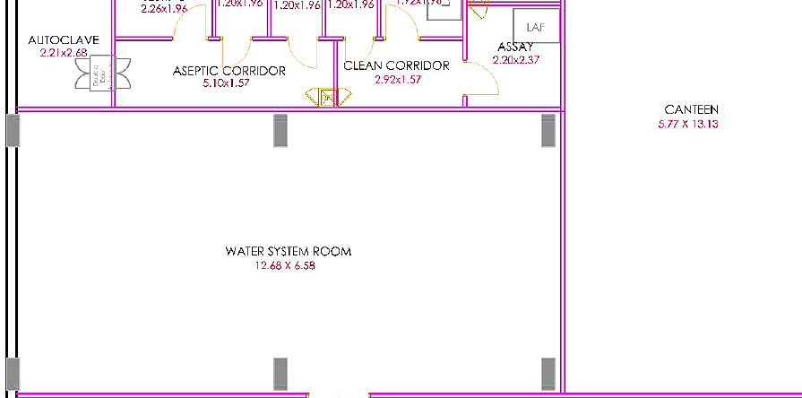
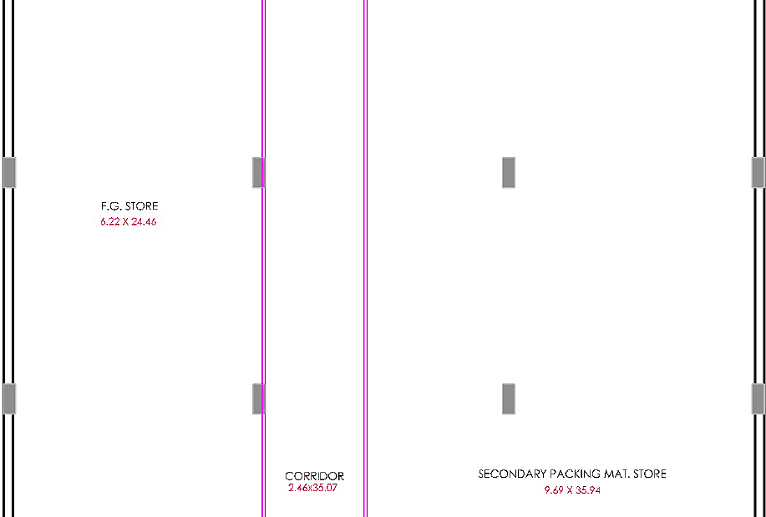
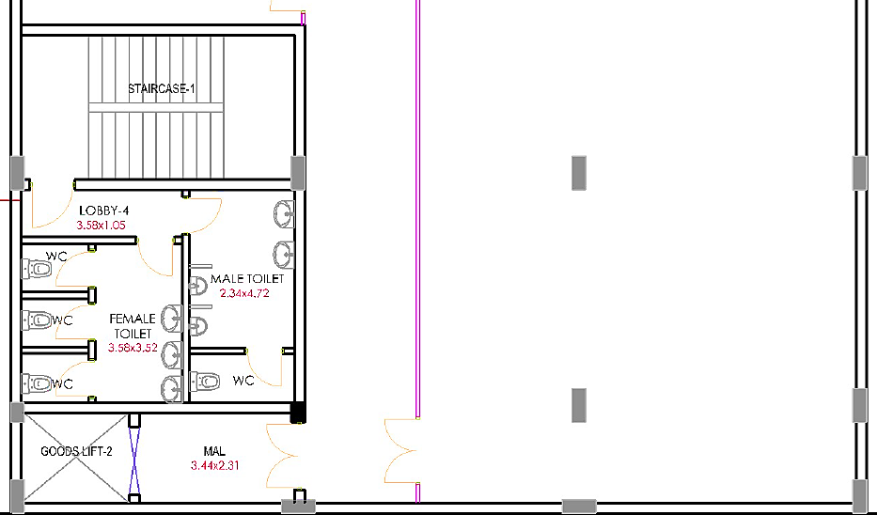

LOCATION MAP:
- Google Map Location: Project location would be 30°22'32.2" North and 77°50'23.5" East in Selaqui, Dehradun and the location as per the Google map has been attached below with the link.
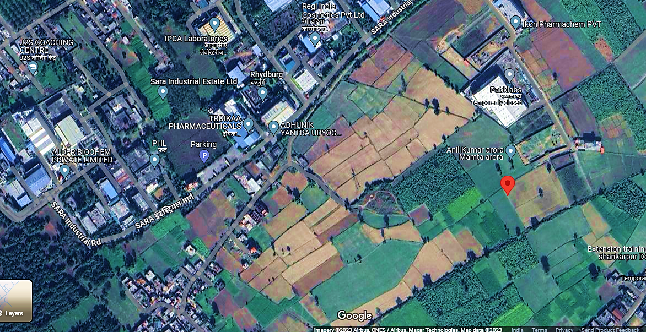
- LAND DETAILS: As per sale deed (Registry Certificate) as on 6th Oct 2022, shared by the client/company, a 2602 Sq. Mtr. of an industrial land is owned by the promoter of the company at at Khasra No 2756 MIN, Mauza Shankarpur, Hakumatpur, Sara Industrial area, Tehsil-Vikas Nagar, Distt-Dehrradun Uttrakhand-248011. for the proposed manufacturing facility as a part of expansion of existing business to meet the supply for their demand in the market.
Land Details as per Sale Deed
Particular | Details
Deed/Article type | Sale (Immovable)
Sub-Deed/Sub-Article | Sale (Industrial)
Khasra & Khatoni | 2756 & 01183
Area | 2602 Sq. Mtr.
Latitude & Longitude | 30.3752570000 & 77.8398070000
Land (Market Value) | INR 1,28,66,890
Transaction Value | INR 1,61,37,360
Stamp duty | INR 4,03,434
Reg. Fees | INR 25,000
Total Cost of Land | INR 1,65,65,794
Seller | Mr. VK Dhawan S/o KL Dhawan  7/1 Pritam Road, Dehradun PAN: AAFPD2762B
Buyer | Mr. Sudhir Jha S/o Mihir Kumar Jha Promoter: Mancare B-06, Sushant Lok-III Sector-57, Gurgaon, Haryana, 122001
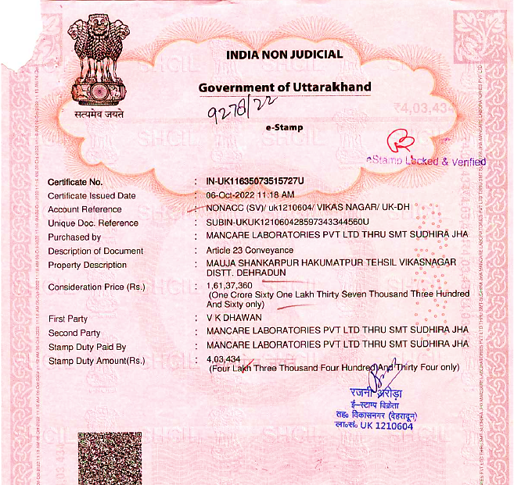
During the site visit we found that the land is an industrial land as per the land deed certificate dated 6th Oct 2022. Land development work has been completed and the subject land is demarcated with boundary wall till the survey date. The company will initialize the grading and foundation work after loan will be sanctioned.
- SITE PICTURES: Some of the site pictures has been taken during the site survey as on 18th Oct, 2023, are attached below:
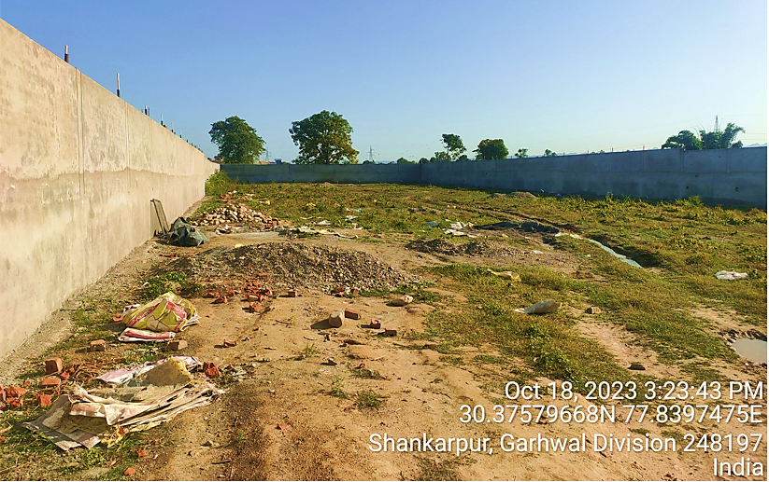
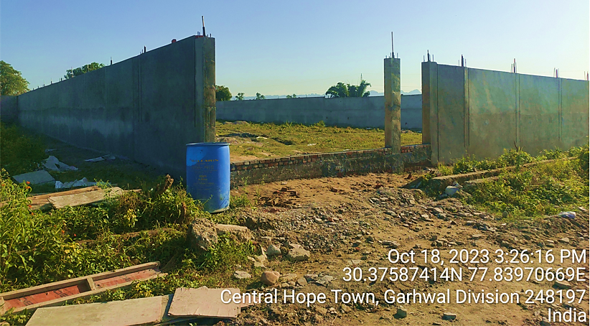
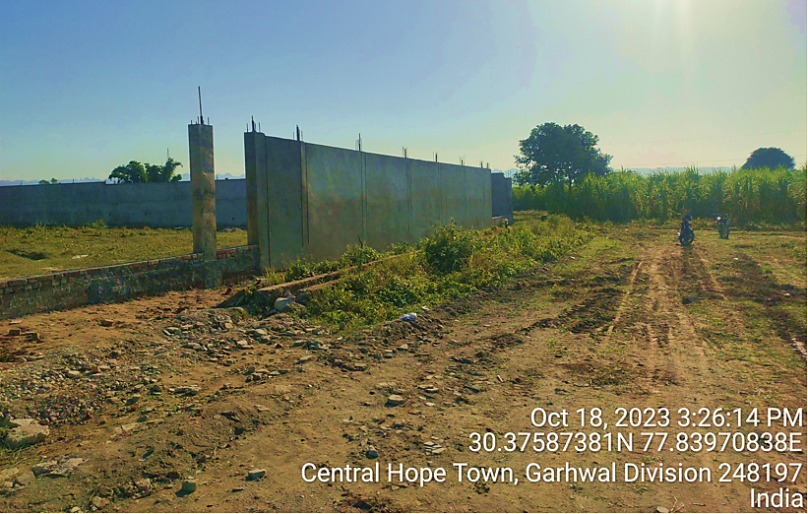
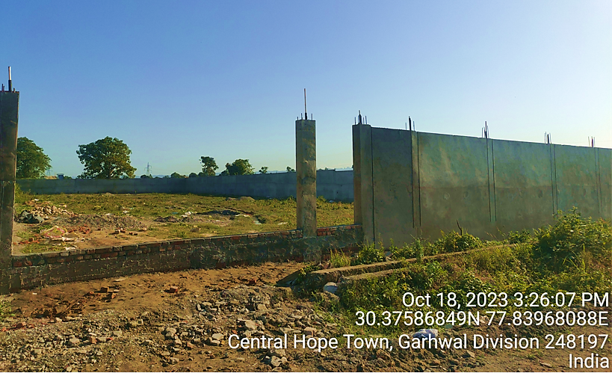
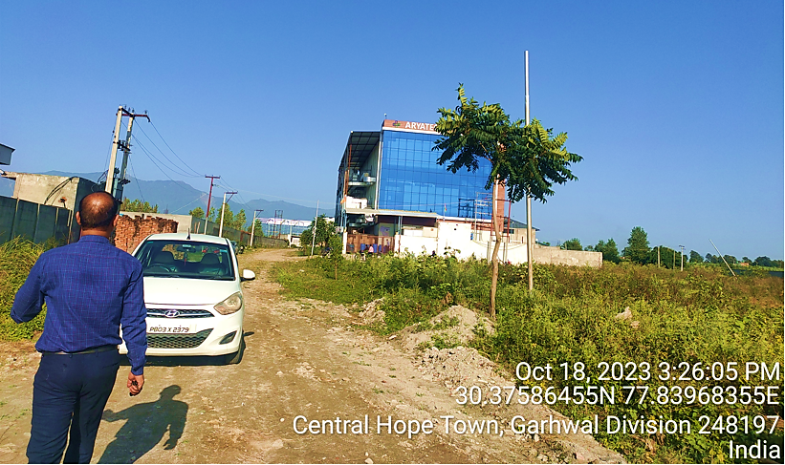
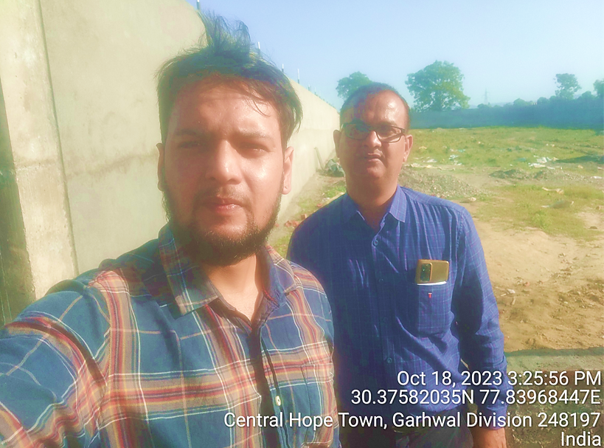
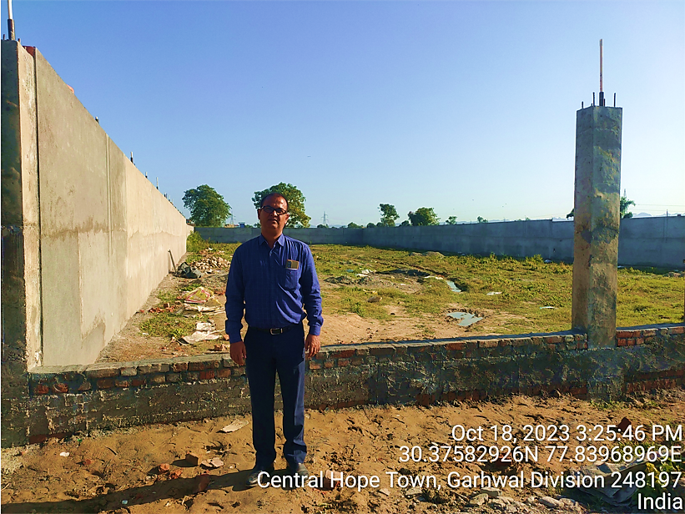
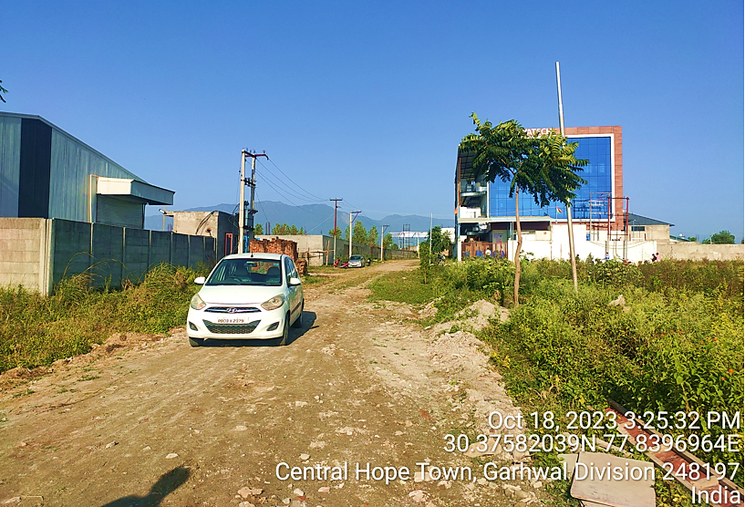
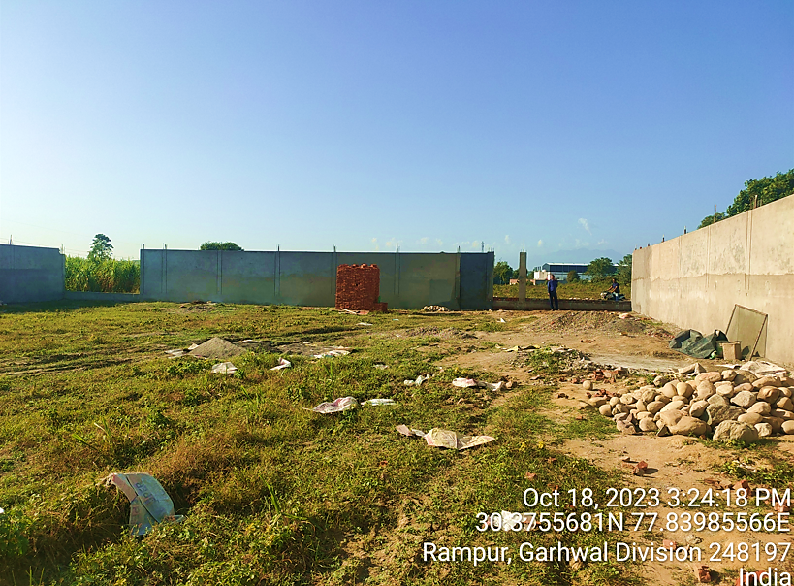
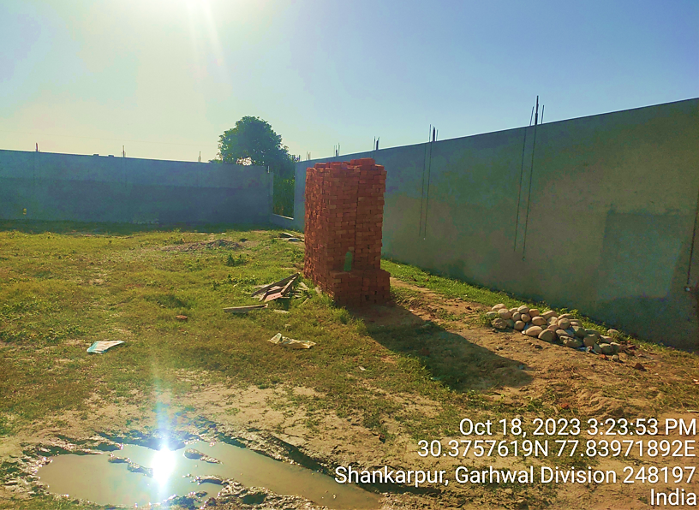
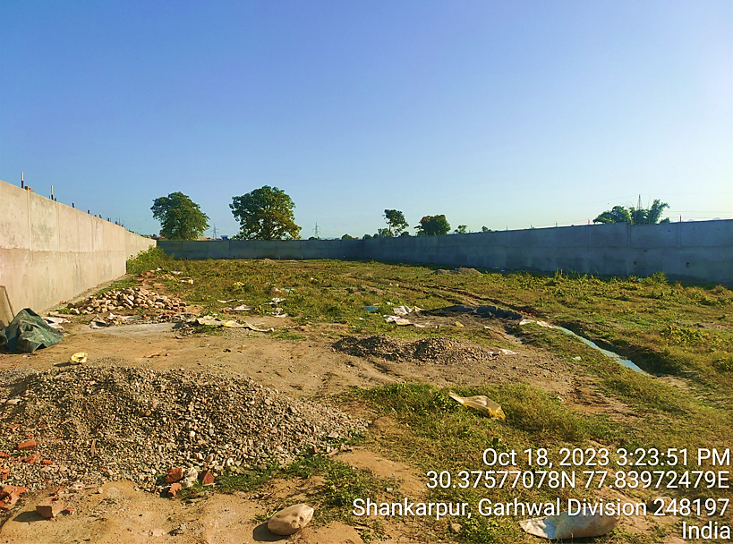
- BUILDING & CIVIL WORKS: As per the current status of the Building and civil works provided by the company and verified during the site visit, boundary wall work is completed and the foundation & plinth work is required to start soon to achieve the expected trial run and COD successfully. Comp any is in the process of finalising the constructor on contract basis for the same. G+3 structure is proposed to be build up and Total build-up area would be 5071.10 Sq. Mtr. Proposed Floor wise area statement has been shown in the below table:
AREA STATEMENT
Land Area | 2602.82 Sqmt
Covered Area
Ground Floor | 1300.55 Sqmt
First Floor | 1300.55 Sqmt
Second Floor | 1235 Sqmt
Third Floor | 1235 Sqmt
Total Built-up area (FAR) | 5071.10 Sqmt
As per data/information provided by the client/company, all Civil Work-Building and other structures will be implemented through appointment of architect/consultant/constructor. At present company have applied for the approval of site map/concept plan prepared by MEP Tech Services (appointed consultant/architect) to the respective authority. As per the estimated cost shared by the client done by done by Akhil Kumar and Associates (Govt. Approved valuer for Immovable properties), the total Building and civil works will be costing as INR 9.36 Crores excluding applicable GST, electric work (INR 2.75 Crore) and Clean Room work (Approx. Area 1200 Sq. Met.) (INR 3.78 Crore) as per the details provided in the below table:
Details of work for Construction
S. No. | Item | Unit | Quantity | Rate | Amount
1 | Earth work in excavation by mechanical means (Hydraulic excavator) / manual means in foundation trenches or drains (not exceeding 1.5 m in width or 10 sqm on plan), including dressing of sides and ramming of bottoms, lift upto 1.5 m, including getting out the excavated soil and disposal of surplus excavated soil as  directed, within a lead of 50 m. | cum | 5128.59 | Rs.252 | Rs.12,92,406
2 | Providing and Laying in position cement concrete of specified grade excluding the cost of centering and shuttering - All work up to plinth level - 1:4:8 (1 Cement  : 4 coarse sand) : 8 graded stone  aggregate 40 mm nominal size) | cum | 375.38 | Rs.  3,665 | Rs.13,75,749
3 | Plinth filling with sand under flooring including compaction all complete | cum | 162.50 | Rs.  1,250 | Rs.2,03,125
4 | Brickwork with F.P.S. Bricks of class designation 75 in foundation and Plinth in cement mortar 1:6 (1 cement:  6 Coarse sand) | cum | 510.00 | Rs.  6,500 | Rs.33,15,000
5 | Providing and laying in position cement concrete of specified grade upto plinth level excluding the cost of centering and shuttering - All work up to plinth level - 1:1.5:3 (1 Cement : 1.5 coarse sand : 3 graded stone aggregate 20 mm nominal size) | cum | 373.75 | Rs.  6,259 | Rs.23,39,301
6 | Centering and shuttering including strutting, propping etc. and removal of form work for Foundations, footings, bases for columns | Sqmt | 2616.25 | Rs.340 | Rs.8,88,217
7 | Columns, piers, abutments, pillars, posts and struts | Sqmt | 3307.5 | Rs.734 | Rs.24,26,713
8 | Reinforced cement concrete work in beams, floors, roofs having balconies, shelves, chajjas, lintels, bands, plain window sills, staircases and above plinth level up to floor five level, excluding the cost of centering, shuttering, finishing and reinforcement with 1:1.5:3 (1 cement: 1.5 coarse sand: 3 graded stone aggregate 20 mm nominal size) including all man power labour, tools and plants all complete. | cum | 1027.58 | Rs.9,763.80 | Rs.1,00,33,037
9 | Centering and shuttering including strutting, propping etc. and removal of form for Suspended floors, roofs, landings, balconies and access platform including all man power labour, tools and plants all complete. | Sqmt | 7208.03 | Rs.693.00 | Rs.49,95,161
10 | Steel reinforcement for R.C.C. work including straightening, cutting, bending, placing in position and binding Hot rolled deformed bars all complete above plinth level. | kg | 126119.25 | Rs.83.50 | Rs.1,05,30,957
11 | Brickwork above Plinth in cement mortar 1:6 | cum | 1729.21 | Rs.7,500.00 | Rs.1,29,69,094
12 | Providing and supplying 12 mm thick internal plaster (1:6) including all man power labour, tools and plants all complete. | Sqmt | 12262.50 | 297.30 | Rs.36,45,641
13 | Providing and supplying 15 mm thick external plaster (1:4) including all man power labour, tools and plants all complete. | Sqmt | 1890.00 | 412.60 | Rs.7,79,814
14 | Providing and supplying 6 mm thick plaster on roof (1:3) including all man power labour, tools and plants all complete. | Sqmt | 6338.75 | 227.35 | Rs.14,41,115
15 | Flooring Works providing and supplying including all man power labour, tools and plants  all complete.
a | Epoxy flooring | Sqmt | 2351.99 | 1750.00 | Rs.41,15,987
b | Granite in washrooms | Sqmt | 836.72 | 2100.00 | Rs.17,57,102
c | Kota Stone on Staircases / Lobby Etc | Sqmt | 2231.24 | 950.00 | Rs.21,19,678
d | Tiling works in Rooms / Corridors etc | Sqmt | 1673.43 | 1450.00 | Rs.23,71,474
16 | Flooring Works providing and supplying Heavy Duty Paving Tiles in parking / open area etc. works including all man power labour, tools and plants all complete. | Sqmt | 293.25 | 1550.00 | Rs.4,54,538
17 | Providing, supplying and installation of false ceiling works etc. works including all man power labour, tools and plants all complete. | Sqmt | 4024.80 | 1750.00 | Rs.70,43,400
18 | Sanitary Fittings / Fixtures- furnishing of toilets,  including of all material and labour | L/S | 1.00 | 1000000.00 | Rs.10,00,000
19 | Providing supplying and fixing Industrial steel  doors | Sqmt | 114.10 | 5500.00 | Rs.6,27,536
20 | Providing supplying and fixing fire resistant with  insulation steel doors | Sqmt | 266.23 | 8500.00 | Rs.22,62,934
21 | Providing supplying and fixing fire resistant with  insulation steel Windows | Sqmt | 380.33 | 9500.00 | Rs.36,13,088
22 | Providing supplying and fixing Industrial steel  windows | Sqmt | 266.23 | 6500.00 | Rs.17,30,479
23 | Providing supplying and fixing fire resistant with  insulation steel Windows | Sqmt | 380.33 | 3023.00 | Rs.11,49,722
24 | Providing, supplying and fixing tin shed on top slab including all materials, manpower,  Tools/plants all complete. | Sqmt | 1300.55 | 5500.00 | Rs.71,53,025
25 | Roof waterproofing with tiling works | Sqmt | 1625.00 | 1250.00 | Rs.20,31,250
Total |  |  |  | Rs.9,36,65,541

Note- The above estimate is for construction of factory building. Further, Rs. 652.72 lakh is proposed to be incurred in interior partition by board & electrification and furnishing. Thus the total cost of completion of plant is Rs. 1589.38 lakh is considered.
- PLANT AND MACHINERY/ EQUIPMENTS DETAILS: All the plant & machinery/equipment procurement, installation, execution and operations will be implemented through appointment of a project manager (Mr. Adnan Ansari, Project lead at Mancare). As per the cost estimated shared by the client/company, Plant & Machinery will be costing around INR 22.18 Crore including 18% applicable GST as per shown in the below table:
Plant & Machinery Details for the Proposed Unit
Sr. |  |  | Capacity |  |  | Unit Price | Total Price
No. | Description | Photo Gallery | /Size | Qty | Unit | (INR) | (INR)
1. | Process Equipment’s for Tablet Formulation
1.1 | Sampling & Dispensing Activity
1.1.1 | Sampling & Dispensing Booth | 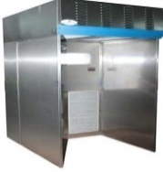 | 2.1x1.8 Mtr | 2 | No | 312053 | 624106
1.1.2 | PPM Dispensing Booth |  | 2.1x1.8 Mtr | 1 | No | 312053 | 312056
1.1.3 | Weighing Balance |  | 300 Kg | 1 | No | 7888 | 7888
1.1.4 | Weighing Balance |  | 100 Kg | 2 | No | 7888 | 15776
1.1.5 | Weighing Balance |  | 6 kg | 2 | No | 3813 | 7626
 | Total |  | 1934904
1.2 | Process Equipment for Tablets
1.3 | Granulation -300 Kg
1.3.1 | Vibro Sifter - 36 " | 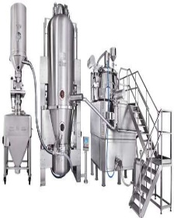 | 100-250 Kg/Hr. | 1 | No | 185000 | 185000
1.3.2 | Extra sieve |  | #100 to #25 | 5 | No | 2800 | 14000
1.3.3 | Rapid Mixer Granulator |  | 800 Liters | 1 | No | 3469000 | 3469000
1.3.4 | Multimill |  | 200-300 Kg/Hr. | 1 | No | 155000 | 155000
1.3.5 | Paste Preperation Vessel |  | 200 Lit | 1 | No | 325000 | 325000
1.3.6 | Fluid Bed Drier (FBD) |  | 150 Kg | 1 | No | 1530000 | 1530000
1.3.8 | Octagonal Blender |  | 750 litres | 1 | No | 640000 | 640000
1.3.9 | Platform Weighing balance |  | 300 kg | 1 | No | 7888 | 7888
 |  |  |  |  |  |  | 6325888
1.4 | Tablet Compression
1.4.1 | Tablet Compression Machine (Double Rotary) + Deduster + Metal Detector | 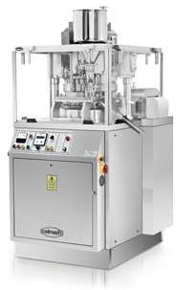 | 45 Stn D Tooling |  |  | 3075000 | 3075000
 |  |  |  | 1 | No
1.4.2 | Tablet Compression Machine (Double Rotary) + Deduster + Metal Detector |  | 27 Stn D Tooling |  |  | 1030000 | 1030000
 |  |  |  | 1 | No
 |  |  |  |  |  |  | 4105000
1.5 | Tablet Coating
1.5.1 | Auto coater | 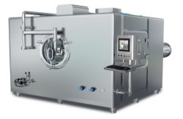 | 48 | 1 | No | 3850000 | 3850000
 | Supply Air AHU & Exhaust blower with Scrubber with Ducting |  | To suit | 1 | No | 375000 | 375000
 | Weighing Balance |  | 100 Kg | 1 | No | 6387 | 6387
 | Coating solution preparation vessel |  | 100 Ltr | 1 | No
 |  |  |  |  |  |  | 4231387
1.5.2 | Coating PAN | 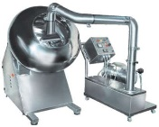 | 48" | 1 | No | 425000 | 425000
 | Exhaust blower with Scrubber with Ducting |  |  | 1 | No
 | Weighing Balance |  | 100 Kg | 1 | No | 6387 | 6387
 | Coating solution preparation vessel |  | 100 Ltr | 1 | No
 |  |  |  |  |  |  | 431387
1.6 | Tablet Inspection
 | Semi-Automatic Tablet Inspection Belt | 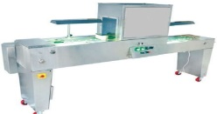 | 6” Wide | 1 | No |  | Quotation pending
1.7 | Primary Packing
1.7.1 | Blister Packing line- Alu-PVC | 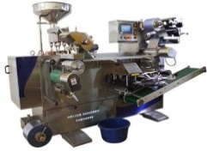 | 240 Bilster/min | 1 | No | 1450000 | 1450000
1.7.2 | Strip-8 Track Packing line |  | 200 Strips/min | 1 | No
1.7.3 | Blister Packing line- Alu-Alu |  | 180 Strips/min | 1 | No | 6000000 | 6000000
1.7.4 | Change Parts |  | Lot | 1 | Set | 960000 | 960000
 |  |  |  |  |  |  | 8410000
1.8 | Secondary Packing
1.8.1 | Tablet Packing Conveyor Belt | 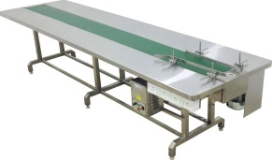 | 10 feet | 3 | No | 100000 | 100000
1.8.2 | Weighing Balance |  | 50 kg | 2 | No | 44067 | 88134
1.8.3 | De-Blistering |  | To Suit | 2 | No
1.8.4 | Overprinting machine |  | To Suit | 1 | No | 200000 | 200000
1.8.5 | Strapping machine |  | To Suit | 1 | No | 60500 | 60500
1.8.6 | Blister Cartonator |  | 100 Pack Per min | 1 | No | 4000000 | 4000000
 |  |  |  |  |  |  | 4448634
1.9 | IPQC Apparatus
1.9.1 | Tablet Hardness tester | 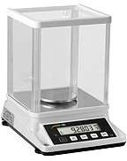  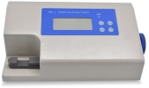  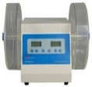  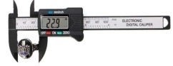  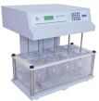  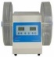  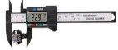  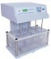 | To Suit
1.9.2 | Vernier Calipers |  | To Suit
1.9.3 | Friability tester |  | To Suit | 1 | NO | 42000 | 42000
1.9.4 | Disintegration tester |  | To Suit |  | NO | 35000 | 35000
1.9.5 | Precision Balance Scale |  | 50gm | 1 | NO | 138000 | 138000
1.9.6 | Printer |  | To Suit | 1 | No
 |  |  |  |  |  |  | 215000
2 | Process Equipments for Liquid Injection Vial, Ampoule & Eye Drop Formulation
2.1 | Sampling & Dispensing Activity
2.1.1 | Walk-in Bio Safety Cabinet |  | 2.1x1.8 Mtr | 1 | No | 299600 | 299600
2.1.2 | PPM Dispensing Booth |  | 2.1x1.8 Mtr | 1 | No | 312053 | 312053
2.1.3 | Weighing Balance |  | 300 Kg | 1 | No | 7888 | 7888
2.1.4 | Weighing Balance |  | 100 Kg | 2 | No | 7888 | 15776
2.1.5 | Weighing Balance |  | 6 kg | 2 | No | 3813 | 7626
 |  |  |  |  |  |  | 642943
2.2 | Washing & Drying Area Equipments
2.2.1 | Autoclave | 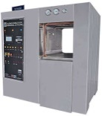 | 500 Ltr. | 2 | No | 2050000 | 2050000
2.2.2 | Bung Processor |  | 30000- 40000 |  |  | 2850000 | 2850000
 |  |  | Rubber Stoppers/Cycle
 |  |  |  |  | No
 |  |  |  | 1
2.2.3 | Laminor Air Flow Unit |  | 2100 x 2300mm | 2 | No | 269950 | 269950
 |  |  |  |  |  |  | 5169950
2.3 | Liquid Injection Ampoule Equipment’s
2.3.1 | Automatic Rotary Ampoule Washing Machine | 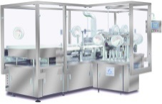 | 250 Ampoule / Min | 1 | No | 3250000 | 3250000
2.3.1.1 | Change part |  |  | 1 | St | 135000 | 135000
2.3.2 | Vial Sterilizing & Dehydrogenating Tunnel |  | 250 Ampoule / Min | 1 | No | 2600000 | 2600000
2.3.3 | Automatic 8 Head Ampoule Fiiling & Sealing Machine With Laminor Air Flow Unit +Change part 1 ml to 5 ml + External Washing |  | 300 Ampoule / Min | 1 | No | 5170000 | 5170000
2.3.3.1 | Automatic High Speed Ampule Rotory Type Sticker Labeling Machine |  | 250 Ampule/Min | 1 | Nos | 685000 | 685000
2.3.4 | Medicine Manufacturing Tanks with CIP & SIP Skind |  | 300 Ltr. | 1 | Set
2.3.5 | Medicine Filtratation & Storage Unit with LAF Unit & Transfer Pump |  | 300 Ltr. | 1 | Set
 |  |  |  |  |  |  | 11840000
2.4 | Liquid Injection Vial Equipments
2.4.1 | Vial Pneumatic Loading Conveyor+Washing+ & Linear Washing Machine | 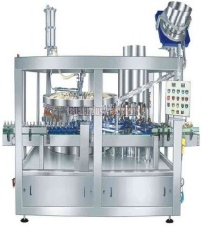 | 250 Vial / Min | 1 | No | 200000 | 200000
2.4.2 | Vial Sterilizing & Depyrogenating Tunnel |  | 250 Vial / Min | 1 | No | 3835000 | 3835000
2.4.3 | 8 Head Liquid Filling & Rubber Stoppering Machine with Laminor Air Flow Unit |  | 250 Vial / Min | 1 | No | 3387500 | 3387500
2.4.3.1 | Infeed Turn Table suitable for machine 36” |  |  | 1 | No | 75000 | 75000
2.4.4 | 8 Head Vial Sealing machine without fieed turn table |  | 250 Vial / Min | 1 | No | 1860000 | 1860000
2.4.5 | 8 Operator Manual Black & White Inspection Machine |  | Std | 1 | No | 340000 | 340000
2.4.6 | Vertical Sticker Labelling Machine |  | 250 Vial / Min | 1 | No | 585000 | 585000
2.4.7 | Medicine Manufacturing Tanks with CIP & SIP Skind |  | 1000 Ltr. | 1 | Set
2.4.8 | Medicine Filtratation & Storage Unit with LAF Unit & Transfer Pump |  | 1000 Ltr. | 1 | Set
 |  |  |  |  |  |  | 10282500
2.5 | Secondary Packing Hall Liquid Injection Vial & Ampoule
2.5.1 | Weighting Scale | 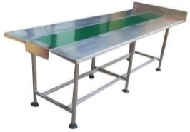 | 0-300 Kg | 1 | No | 7888 | 7888
2.5.2 | Shrink Wrapping machine |  | Std. | 1 | No. | 60500 | 60500
2.5.3 | Strapping machine |  | Std. | 2 | No. | 60500 | 60500
2.5.4 | (Ampoule) Blister Packing machine |  | 300 to 400 pack per |  |  | 4500000 | 4500000
 |  |  | minutes | 1 | No.
2.5.5 | Packing Conveyor Belt |  | 10 feet | 2 | No | 100000 | 100000
 |  |  |  |  |  |  | 4728888
3 | Process Equipment for External Formulation (Ointment, & Aerosol)
3.1 | Sampling & Dispensing Activity
3.1.1 | Sampling & Dispensing Booth | 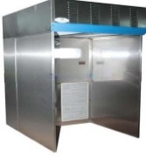 | 2.1x1.8 Mtr | 2 | No | 312053 | 624106
3.1.2 | PPM Dispensing Booth |  | 2.1x1.8 Mtr | 1 | No | 312053 | 312053
3.1.3 | Weighing Balance |  | 300 Kg | 1 | No | 7888 | 7888
3.1.4 | Weighing Balance |  | 100 Kg | 2 | No | 7888 | 15776
3.1.5 | Weighing Balance |  | 6 kg | 2 | No | 3813 | 7626
 |  |  |  |  |  |  | 967449
3.2 | Ointment Process Equipment
3.2.2 | Ointment Mfg. Plant: Water Phase, Wax Phase & Ointment Mfg. Vessel, Lobe |  |  |  |  | 32,90,000 | 32,90,000
 | Transfer Pump, Interconnecting Process piping, Control Panel & Working platform with ladder
 |  |  | 500 Kg | 1 | Set
3.2.3 | Ointment Tube Filling Sealing Machine |  | 100-120 tube/min | 1 | NO. | 2650000 | 2650000
3.2.4 | Ointment Tube Automatic Cartoning Machine |  | 100-120 tube/min | 1 | NO.
3.2.5 | Weighting Scale |  | 0-300 Kg | 1 | No | 7888 | 7888
3.2.6 | Shrink Wrapping machine |  | Std. | 1 | No. | 60500 | 60500
3.2.7 | Strapping machine |  | Std. | 1 | No. | 60500 | 60500
 |  |  |  |  |  |  | 2778888
5 | Civil Works | 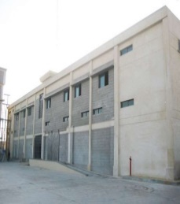 |  | 1 | Lot |  | included in building
 | Producition Along Utility Building (G+3) Level ETP & STP Civil Work
 | Raw Water Under Ground Tank & Pump House Site Development work
 | Utility Shade 400 Sq. Mtr.
6 | 3 mm Thick Epoxy Flooring & Wall to Floor Coving work. Approx. Area 7500 Sq. Mtr. |  |  | 1 | Lot | Included in building construction | Included in building construction
7 | Industrial Drain GMP Construction drain Traps, Internal & External Drain Piping work | 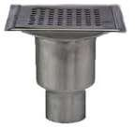 | 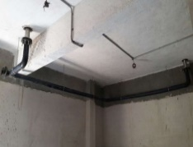 | 30 | Lot | 5200 per pc | 156000
7 | PPGI Clean Room Wall Panels with factory made cut-out for Electrical power sockets including all accessories. | 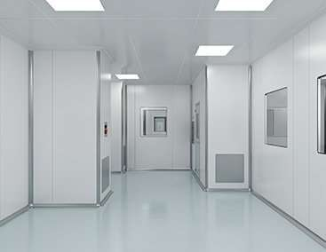 |  | 1 | Lot | 37773400 | 37773400  Part of building
 | PPGI Clean Room Wall Panels with factory fabricated Return Air Riser includes
 | all accessories
 | PCGI Clean Room Non-Walk able ceiling panels with factory made cut-outs for Light fixtures & HEPA boxes includes all accessories
 | Clean Room Doors (Single Leaf & Double Leaf types)
 | Clean Room Windows, View Panels etc. as required Wash area with inside SS304 matt Finish sheet
 | Wall to Wall & Wall to Ceiling Coving work with all accessories
 | Fire Extinguisher Flush Cabinets with SS 304 door, Wall Guard Railing.
 |  |  |  |  |  |  | 37929400
8 | HVAC Work as follows: | 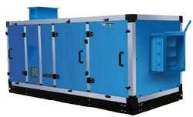  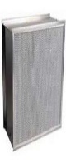  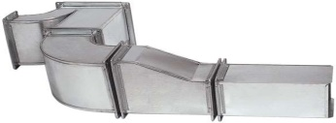  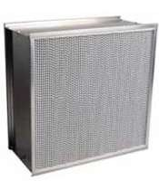 |  | 1 | Lot | 41140740 | 41140740
 | Double Skin Air Handling units & Elect. Heater 45 Nos.(Classified)
 | Double Skin Air Handling units & Elect. Heater 8 Nos. (Comfort Not Classified) Double Skin Forced Draft Ventilation supply & Exhaust Air Units 5 Nos.
 | Ducted AC Units = 5 Nos. Split AC Units = 12 Nos.
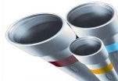
Supply & Return Air Ducting in 24,22 & 20 Swg. =60000 Sq. Feet Supply & Return Air Duct insulation 19 mm & 13 mm = 55000 Sq. Feet
 | HEPA Filter Boxes, Supply & Return Air Grills, Volume Control Dampers, Fire Dampers
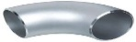
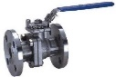
Fresh Air Filter, Pre-Filter, Fine Filters, HEPA Filters
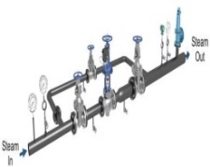
AHU Drain Piping,
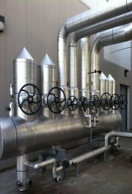
Field Instruments-Thermostat, Humidistat, Pressure Gauges, Temperature Gauges, Differential Pressure gauges
 | Electrical Panel, Control & Power Cables, Earting & Cable Trays
 | Validation and Qualification
9 | Plant Utility Piping includes following work: | 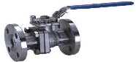 |  | 1 | Lot | 4500000 | 4500000
 | Day Soft Water Tank, Day Fuel Tank.
 | Raw Water & Soft Water Piping work Excluding Pumps & HDPE Overhead water Storage Tanks
 | Compressed Air Piping
 | Chilled & Cooling Water Piping work Excluding Pumps & Water Chiller Boiler Stack, Day Fuel, Day Water & Steam Piping with Accessories Dust Extraction Piping
 | Steel Structure fabrication for pipe rack, platforms and other misc. work
 | Process & Utility Machines unloading - Installation work
10 | Electrical Work includes Following: |  |  | 1 | Lot | 27500000 | 27500000  Part of building
 | LED Light Fixtures, Light Switch boards, Light Wiring, Light Distribution Boards with Incomer ELCB & Outgoing MCBs | 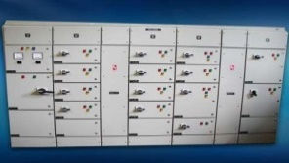  
 | Raw & UPS Electrical Modular & Industrial Power Sockets, Industrial 3 Phase
 | power Sockets, Power Points wiring work, Power Distribution Boards with Incomer MCCB & Outgoing MCBs
 | LT Electrical Panels (PCC, APFCR, Process + Utility Panel)
 | LT Power Cables Alu. & Copper, Flexible Power Cables, Control Cables for Field Instruments, FAS System Cable, CCTV, LAN & Telephone Cables, Door Interlocking Cables
 | Earth Pits, Earting Conductors & Ligtning protection work
 | Electrical Misc. work
11 | Miscellaneous & Change Room Equipments | 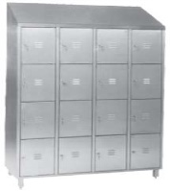  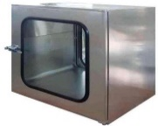  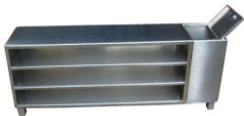  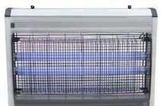  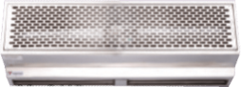
11.1 | Pass Boxes (Dynamic) |  | 1x1x1Mtr | 38 | No | 182000 | 6916000
11.2 | Pass Boxes (Static) |  | 1x1x1Mtr | 15 | No | 105000 | 1575000
11.3 | Pass Boxes (Dynamic) |  | 300x 300x 300 | 8 | No | 77000 | 616000
11.4 | Pass Boxes (Static) |  | 300x 300x 300 | 2 | No | 42000 | 84000
11.5 | Air curtains |  | 1.5 Mtr Long | 4 | No | 4500000 | 4500000
11.6 | Air curtains |  | 1.0 Mtr Long | 6 | No
11.7 | Hand Dryers |  | To Suit | 10 | No
11.8 | Pesto Flash Fitting |  | 1 Mtr long | 10 | No
11.9 | First aid Kit |  | To Suit | 4 | No
11.1 | Cross over bench |  | To Suit | 30 | No
11.11 | Garment Storage Cabinet |  | To Suit | 24 | No
11.12 | Garment Lockers |  | To Suit | 24 | No
11.13 | Sterile Garment Cabnits |  | To Suit | 2 | No
11.14 | Used Garment Bins |  | To Suit | 10 | No
11.15 | SS Scoop, Liquid samplers, Powder samplers, Spoon, Spatula & Mug |  | To Suit | 1 | Lot
11.16 | SS pallets |  | To Suit | 25 | No
11.17 | Ware House Sintex type pallets |  | 1000x1000mm | 300 | No
11.18 | Ware House Racking system for Pallets |  | To Suit | 1 | Lot
11.19 | Material Handing Pallet trucks-Manual |  | To Suit | 6 | No | 88000 | 528000
 |  |  |  |  |  |  | 14219000
12 | Door Interlocking Systems | 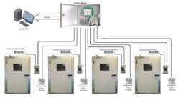 |  | 1 | Lot | 375000 | 375000
13 | Fire Alarm System | 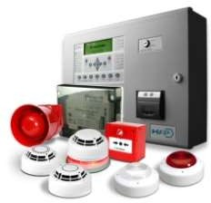 |  | 1 | Lot | Included with fire hydrant | Included with fire hydrant
14 | Purified Water Generation of 5000 Ltr Per hour, PW Distribution System with 6000 Ltr Storage tank & 40mm OD SS316L Distribution pipes & Validation and Qualification. | 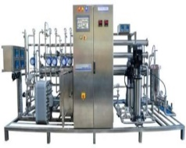 |  | 1 | Lot | 6226080 | 6226080
15 | Water For Injection Generation of 3000 Ltr Per hour, PW Distribution System with 5000 Ltr Storage tank & 40mm OD SS316L Distrubution pipes & Validation and Qualification. |  |  | 1 | Lot | 13854543 | 13854543
16 | Pure Generation of 500 Kg Per hour & Distribution System with 32mm OD SS316L Distrubution pipes & Validation and Qualification. |  |  | 1 | Lot | 2626946 | 2626946
 |  |  |  |  |  |  | 22707569
17 | Steam Boiler 1000Kg/Hr, Day Fuel Tank, Day Water tank & Stack for hot exhaust gas. | 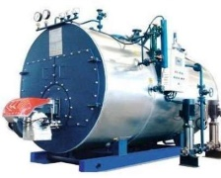 |  | 1 | Lot | 984000 | 984000
18 | Air Cooled Screw Chiller -150TR (Twin Compressor type) | 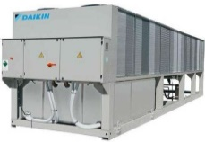 | 100 Tr | 2 | Set | 4000000 | 8000000
19 | Cooling Tower -50TR |  | N/A | 1 | No. | N/A | N/A
20 | Chiller, Cooling Water & Raw Water Pumps |  |  |  |  | Included in utility piping work
20.1 | Chilled Water Pump | 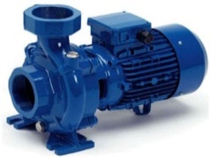 | (1 W + 1 S) | 2 | No.
20.2 | Cooling Water Pump |  | (1 W + 1 S) | 2 | No.
20.3 | Raw Water Pump |  | (1 W + 1 S) | 2 | No.
21 | Screw Air Compressor with Inbuilt Dryer (Air cooled), & Air Receiver (with Pre & Post Filter) 100 CFM at 8 Kg/cm2 | 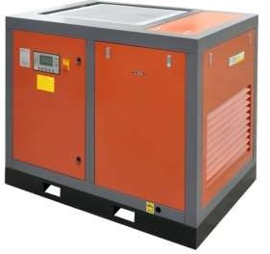 |  | 2 | Set | 25,36,000.00 | 5072000
22 | Quality Control Laboratory Instruments |  |  | 1 | Lot | 9700000 | 9700000
 |  |  |  |  |  |  | 14772000
23 | Quality Control Laboratory Furnitures | 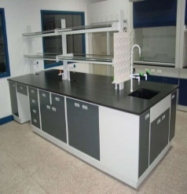 |  | 1 | Lot
24 | Effluent treatment plant -15 KLD | 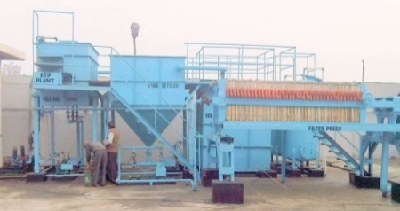 |  | 1 | Lot | Included with plant utility piping | Included with plant utility piping
25 | Yard Fire Hydrand System with 1 no. Fire Main Fire Pump (With Electric motor) + 1 No Jockey Pump (With Electric motor) + 1 No Diesel Pump with |  |  | 1 | Lot | 5500000 | 5500000
 | 10 No. Fire Hydrant Post
26 | Transformer (On load Tap Changer type) |  | 1000 KVA | 1 | No. | 228600 | 2286000
27 | DG Set along with Diesel Tank & Exhaust Stack |  | 500 KVA | 1 | No. | 2740000 | 2740000
 |  |  |  |  |  |  | 10526000
28 | Goods Lifts
28.1 | Good Lifts |  | 1000 Kg | 2 | No
28.2 | Scissor Lift |  | 500 Kg | 1 | No.
29 | Design & Engineering Fees | 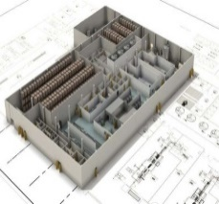 |  | 1 | Lot
TOTAL (INR) |  |  |  |  |  |  | 184860579
GST 18% |  |  |  |  |  |  | 33274904
Transportation 2% |  |  |  |  |  |  | 3697211.6
Grand Total |  |  |  |  |  |  | 221832695
Thus INR 22.18 Crore will be the total cost of the proposed facility excluding Electrical HT Connection Works at Actual, Office Furniture & Fixtures, Computers & Software’s, Pre-Operative Expenses & Working Capital Viz, Raw Material, Workers, Cost of statutory approvals, Transportation, Insurance & GST.
All the Plant & Machinery will be installed by the company from scratch, so the cost of each head is including the cost of installation and other expenses to be incurred. We have cross check the prices of the Plant & Machinery, as per information provided by various vendors/consultants and data information available in public domain, we found that the costs are reasonable and in the line with industrial/sectoral benchmark.

- UTILITIES: Details of Water, Electricity and other utilities are describes as below:
- WATER: As per information provided to us, Water would be tapped from Existing Water distribution. Water for production use is received into a pre-treatment system from the tanks and further it treated in purified water system, store & circulated into production rooms through purified water loop existing distribution system. Following clean utilities envisaged as per required for process in Oral Liquid Syrup manufacturing blocks: Purified Water, WFI and Pure Steam.
- ELECTRICITY: As per informed by the client/company, Supply of AC power 1150 KW required for Total plant running, for consumption of different components of the unit as bellow :
Description | Connected Load (KW)
HVAC SYSTEM | 350
Process Equipment’s & Misc. Load | 300
Utility Equipment | 500
Total Connected Load | 1150 KW

Thus, as per the analysis of infrastructural details above, INR 4192.99 Lakhs will be the total cost from scratch to successful trial run (including GST, pre-operative and preliminary expenses, transportation costs, Operating & Maintenance expenses up to 1 year and laboratory charges, convey vehicle etc.), will be the CAPEX for this proposed manufacturing facility which is in the line with industrial and sectoral benchmarks as per our tertiary research and information available in the public domain and information provided by the third party consultants/vendors.

PART E | PROJECT TECHNICAL DETAILS

- CAPACITY OF MANUFACTURING FACILITY: Below table shows the proposed capacity of the manufacturing facility:
Formulation Facility | Quantity | Quantity per hour | Working Shift | working hour per shift | working hour per day | total working hour | Unit Capacity / annum
Ampoule Liquid Injection | 1 ml to 5 ml 125 Ampoule per minute | 1,875.00 | 3.00 | 6.00 | 18.00 | 5,400.00 | 1,01,25,000.00
 | 10 ml to 30 ml 75 vial per minute | 1,125.00 | 3.00 | 6.00 | 18.00 | 5,400.00 | 60,75,000.00
 | 40 ml to 50 ml 50 vial per minute | 753.00 | 3.00 | 6.00 | 18.00 | 5,400.00 | 40,66,200.00
Vial Liquid Injection | 10 ml 100/vial per minute | 1,500.00 | 3.00 | 6.00 | 18.00 | 5,400.00 | 81,00,000.00
 | 20 ml 75 vial per minute | 1,125.00 | 3.00 | 6.00 | 18.00 | 5,400.00 | 60,75,000.00
 | 30 ml 50 vial per minute | 450.00 | 3.00 | 6.00 | 18.00 | 5,400.00 | 24,30,000.00
Tablet Line 1 | 300 Pack per minute | 4,500.00 | 3.00 | 6.00 | 18.00 | 5,400.00 | 2,43,00,000.00
Tablet Line 2 | 300 Pack per minute | 4,500.00 | 3.00 | 6.00 | 18.00 | 5,400.00 | 2,43,00,000.00

- TECHNICAL SPECIFICATIONS OF THE PROPOSED MAUNUFACTURING FACILITY: Technical specification of major equipment, Plants & Machinery has been shown in this section below:
OINTMENT PLANT - 500 KGS. CAPACITY

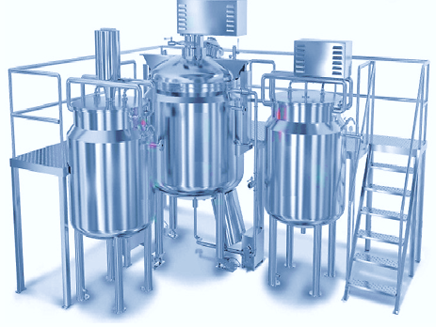
A.WAX PHASE VESSEL (WPV)
Particular | Details
GROSS CAPACITY | 350 Ltrs.
WORKING CAPACITY | 300 Ltrs
DESIGN CONDITIONS | Design pr–Main vessel ATM&Jacket-3kg cm2
SENSOR | PT 100 Sensor
SHELL | 4mm thk -SS 316
TOP LID | Loose type in 2 pieces, 14SWG, SS 316
BOTTOM | 10% TORRISPHERICAL TYPE- 4 MM – SS316
JACKET | 4 mm Thk with spiral stiffeners -SS 304
INSULATION | 50 mm Thk glass wool
CLADDING | SS 304 16 SWG
MAIN VESSEL NOZZELS | 3 NOS
TEMP INDICATOR (PT SENSOR) | 25 MM DIA – 1NO
PRODUCT OUTLET | 40 mm OD TC ball Valve
STIRRER | 2 HP, 960-RPM motor coupled to 30mm SS 316 Shaft with propeller impeller. With VFD
JACKET NOZZLES | 3 Nos.
SAFETY VALVE WITH PRESSURE  GUAGE | ½” bsp
WATER/OIL INLET JACKET | 25 MM Dia
WATER/OIL OUTLET | 25MM Dia
DRAIN WATER OUTLET | 25 MM Dia
SUPPORTING LEGS | 50 OD X 3 THK, 4 NOS. S. S. 304 Pipes with base plate.
ELECTRICAL HEATER | AS PER Design Requirement
FINISH | Internal -Mirror Finish & External – Mirror Finish
B.WATER PHASE VESSEL (WATERPV)
GROSS CAPACITY | 350 Ltrs.
WORKING CAPACITY | 300 Ltrs
DESIGN CONDITIONS | Design pr–Main vessel ATM&Jacket-3kg cm2
SENSOR | PT 100 Sensor
SHELL | 4 mm thk -SS 316
TOP LID | Loose type in 2 pieces, 14SWG, SS 316
BOTTOM | 10% TORRISPHERICAL TYPE- 4 MM – SS316
JACKET | 4 mm Thk with spiral stiffeners -SS 304
INSULATION | 50 mm Thk glass wool
CLADDING | SS 304 16 SWG
MAIN VESSEL NOZZELS | 3 NOS
TEMP INDICATOR (PT SENSOR) | 25 MM DIA – 1NO
PRODUCT OUTLET | 40 mm OD TC ball valve
STIRRER | 2 HP, 960-RPM motor coupled to 30 mm SS 316 Shaft with propeller with impeller with VFD
JACKET NOZZLES | 3 Nos.
SAFETY VALVE WITH PRESSURE GUAGE | ½” BSP
WATER/OIL INLET JACKET | 25 MM Dia
WATER/OIL OUTLET | 25MM Dia
DRAIN WATER OUTLET | 25 MM Dia
SUPPORTING LEGS | 50 OD X 3 THK, 4 NOS. S. S. 304 Pipes with base plate.
ELECTRICAL HEATER | AS PER SIZE REQUIRMENT
FINISH | Internal -Mirror Finish & External – Mirror Finish
C.OINTMENT MANUFACTURING VESSEL (OMV)
GROSS CAPACITY | 700 Ltrs.
WORKING CAPACITY | 600 Ltrs
DESIGN CONDITIONS | Pressure – vessel –ATM to Full Vac.and jacket- 3 kg/cm2
SHELL | 5mm Thk -SS 316
BOTTOM | 10% TORRISPHERICAL TYPE- 5 MM – SS316
TOP DISH END | 10% TORRISPHERICAL TYPE- 5 MM – SS316 with Hydraulic power pack up/down arrangement
JACKET | 5 mm Thk with spiral stiffeners -SS 304
GASKET | Silicon, fitted in groove of top dished end flange
INSULATION | 50 mm Thk glass wool
CLADDING | S. S. 304 14 swg.
SUPPORTING LEGS | 65 OD X 3 THK, 4 NOS. S. S. 304 Pipes with base plate.
NOZZELS FOR VESSEL | 6 Nos.
SIGHT /LIGHT GLASS | 50MM DIA
WATER INLET | 40MMDIA
WAX INLET | 40MM DIA
VACCUM NOZZEL | 25MM DIA
DISCHARGE | 40mm dia with TC end Ball Valve
TEMP INDICATOR (PT SENSOR) | 25 MM DIA – 1NO
NOZZEL FOR JACKET | 3 Nos.
WATER INLET | 25 MM DIA
WATER OUTLET | 25 MM DIA
JACKET VENT | 25MM DIA
GROUND CLEARENCE OF DISCHARGE | 500 mm
SAFTY VALVE | ½ “ B S P CLOSING TYPE
MAIN DRIVE | 5 HP, 3 Phases, 400 V, 1500 RPM Hindustan make electric motor with VFD
GEAR BOX | RATIO 50 : 1 – HOLLOW SHAFT GEAR BOX
ANCHOR SHAFT | 60MMDIA SHAFT WITH ANCHOR TYPE AGITATOR,- S. S.  316,
TEFLON SCRAPPER | BOLTED TO ANCHOR
HOMOGNIZER ASSAMBLY | 5 HP, 3 phase, 440 V, 1440 RPM, TEFC motor, with Mechanical seal with water –  cooling arrangement, mounted on Bottom side
Sensor | PT 100 Sensor for temperature and Top Lid Sensor.
Finish | Internal – Mirror Finish & External –Mirror finished
D.STORAGE VESSELS: 1 NOS.
Gross capacity | 700 Ltrs
Working capacity | 600 Ltrs
Design Condition | ATM
Shell & Bottom Cone | 3 MM Thk- SS 316
Top Lid | Loose type in 2 pieces, 14SWG, SS 316
Inlet | 40 MM Dia
Outlet | 40 MM Dia TC end Ball Valve
Spare | 40 NB DIA with blind TC
Supporting Legs | 50 OD X 3 THK, 4 NOS. S. S. 304 Pipes with Castor Wheel
FINISH | Internal -Mirror Finish & External – Mirror Finish
FEATURES
CONTROL PANEL | DELTA MAKE HMI PLC (OPTIONAL)
LOBE PUMP | 2 HP Lobe pump for transferring finished product from manufacturing vessels to storage tank. All cladded with  SS 304.
 | Vessels to storage tank.
RECIPROCATING PUMP | 1 HP reciprocating pump (Metering pump)to cater the need for transferring the product from storage vessels to filling  Machine hopper.
VACUUM PUMP | 3 HP vacuum pumps with Receiver
PLAT FORM | 50 X 50 X 2 mm thick box pipe and 16 swg Chequerd
PLANT PIPING | From WPV to OMV
 | From WATER PV to OMV
 | From OMV to Bump Pump
 | From Bump Pump to storage vessel.
 | Internally Mirror finished and Externally Matt finished – Necessary in line filters, valves will be provided.

300 KG GRANULATION MACHINERY
- Vibro Sifter – 36”:
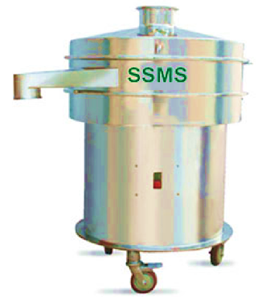

Technical Specification
Particular | Description
Sifter Diameter | 36” (900 MM)
Output | 100 to 300 Kg/Hour (Approx.) depends on mesh and material.
Core Specification | - Vibro sifter works on specially designed unbalance Vibro-motor. Sifter screen diameter 36". Detachable sieve design to accommodate user's requirements.  - Mounted on set of heavy duty spring and metal plate.  - All contact parts are manufactured from SS-316. All non-contact parts are manufactured from SS-304. All the gasket and seals manufactured from food grade sealing.  - Equipment in trolley based design with PU castors for ease of movement.  - Very low noise level. All the cleaning parts can be easily open able without the use of spanner.  - Easy to clean. Material charging hopper will be provided for Manual loading.  - 1 No. Silicon Molded Sieve of 16 # will be supply with basic machine or customer has to mention size in PO. Output will be approximately 100 to 300 Kg/ Hour depending upon the mesh size, material density & characteristics.
Electrical Utility Requirement | 1 HP, 415 V, AC 3 Phase, 5 Wire customized detail to be submitted by customer
- RAPID MIXER GRANULATOR 800 LITRE:
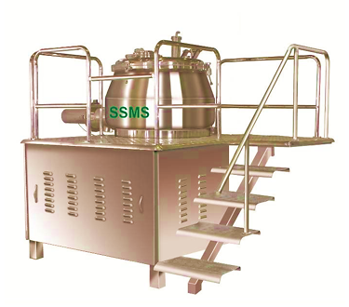
Technical Specification
Particular | Description
Mixing Bowl
Gross Volume of Mixing Bowl | 800 Ltr
Working Volume of Mixing Bowl | 640 Ltr
Optimum Batch Capacity at 0.5 BD | 320 Kg
Minimum and Maximum batch capacity | 200 to 320 Kg (Depends on Material & BD of Product)
Material of Construction
All the Product Contact Parts | SS – 316
All the Non-Contact Parts | SS – 304
Machine Structure of Machine | Made of heavy duty MS Square tube.
Gasket and Other rubber products | Silicon Or Food Grade Material.
Motors | In Non-Flame Proof Standard Make
Gear Box | Standard Make
All the electrical hardware and bought out Components | L & T / Siemens / BCH/ or Any other standard Make.
Bearing, Oil Seals | Standard Make
Surface Finish
All Product Contact Parts | Mirror Finish
All the Non-Contact Parts | Matt Finish
Impeller Drive
Motor Detail | 60 HP, Dual Speed , TEFC Non Flame Proof
Blade RPM through Gearbox | 15 & 150 RPM
Gear Box Ratio | 1 : 10
Chopper Drive
Motor Detail | 12.5 HP, Dual Speed, TEFC Non Flame Proof
Blade RPM through VFD | 150 & 2880 RPM
Utility Requirement
Electrical | 72.5 HP, 415 V, AC, 3 Phase, 5 Wire Customized detail to be submitted by customer.
Compressed Air | 5 to 6 Bar at 200 LPM
- FLUID BED DRYER 150 KG:
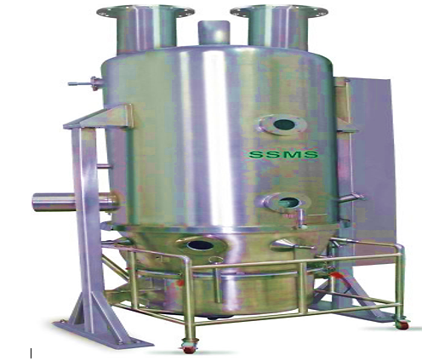
Technical Specification
Container Volume
Working Volume of Mixing Bowl | 150 Kg at 0.5 BD
♦Material of Construction
All the Product Contact Parts | SS – 316
All the Non-Contact Parts | SS – 304
Machine Structure of Machine | Made of heavy duty SS 304 Square tube.
Gasket and Other rubber products | Silicon Or Food Grade Material.
Motors | In Non-Flame Proof Standard Make
All the electrical hardware and bought out components | L & T / Siemens / BCH/ or Any other standard Make.
Bearing, Oil Seals | Standard Make
Pneumatics | Standard Make
Surface Finish
All Product Contact Parts | Mirror Finish
All the Non-Contact Parts | Matt Finish
Utility Requirement
Electrical | 90 HP, 415 V, AC, 3 Phase, 5 Wire Customized detail to be submitted by customer.
Compressed Air | 5 to 6 Bar at 200 LPM

- MULTI MILL:
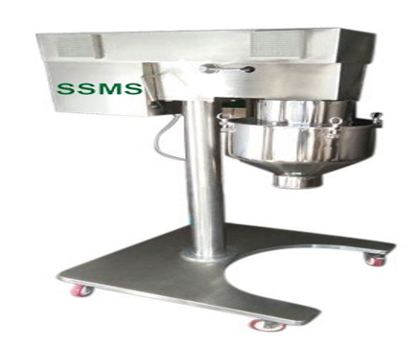
Technical Specification
Particular | Specification
Out Put | 100 to 250 Kg / Hr (It depends on mesh size of Mill and Material.
Material of Construction
All the Product Contact parts | Stainless Steel 316
All the Non-Contact Parts | Stainless Steel 304
Main structure machine | Made of heavy duty SS 304 square tube
Gasket and Other rubber products | Silicon Or Food Grade material
Motor | In Non-Flame Proof Hindustan/ Crompton make  In FLP construction Hindustan / Crompton make
All the electrical hardware and bought out  components | L & T / Siemens / BCH / Or any other standard make
Bearing, Oil Seals | Standard make
Surface Finish
All Product contact parts | Mirror Finish
All the Non-Contact Parts | Matt Finish
Utility Requirement
Electrical | 3 HP 415 VAC 3 Phase, 5 Wire  Customized detail to be submitted by customer

- OCTAGONAL BLENDER 750 LITERS:
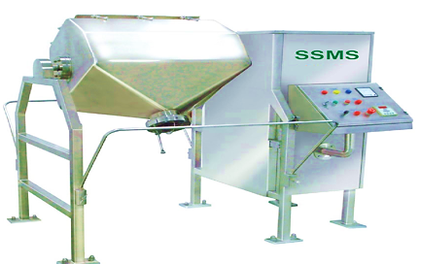
Technical Specification
Basic Machine
Gross Volume | 750Liter.
Working Volume | 600Liter.
Batch capacity | 300Kg @ 0.5 B. D.
Manually operated butter fly valve | 8” Dia.
Material of Construction
All the Product Contact Parts | SS – 316
All the Non-Contact Parts | SS – 304
Main Structure of Machine | Made of heavy duty 3 mm thick SS 304 Square tube.
Blender body | Made of 10 SWG SS 316 sheet
Gasket and Other rubber products | Silicon Or Food Grade Material.
Motors | In Non FLP construction Hindustan make or any equal make In FLP construction Hindustan Make
Variable Frequency Drive | STANDARD Make VFD
Gear Box | STANDARD Make
All the electrical hardware and bought out components | L & T / Siemens / BCH/ or Any other standard Make.
Bearing, Oil Seals | Standard Make
Surface Finish
All Product Contact Parts | Mirror Finish
All the Non-Contact Parts | Matt Finish
Utility Requirement
Electrical | 5 HP, 415 V, AC, 3 Phase, 5 Wire Customized detail to be submitted by customer.
Compressed Air | Only Applicable if you have selected Pneumatically  operated butterfly valve from option (6 Kg/cm2)

- TECHNOLOGY USED: As per data/information and asked quotations shared by the client, currently company is in the process of finalizing Plant & Machinery based on the best fit quotations shared by various supplier/vendors. However as per the technical assessment done based on shared quotation with us, all the Plant & Machinery will be in the line with Indian market Standards and norms for Pharmaceutical Manufacturing Sector.
Since the company don’t have any plan to export the products in abroad in near future, the company will be fulfilling the Indian Standards as of now. Thus it seems to be reasonable to comment that the company will be having an ongoing and prominent technology to run the unit efficiently towards achieving economies of scale in the proposed Pharma Manufacturing facility.
- EFFLUENT TREATMENT AND ABETMENT: As per data/information shared by the client/company, An Effluent treatment palnt of 15 KLD capacity is proposed at the proposed manufacturing facility.
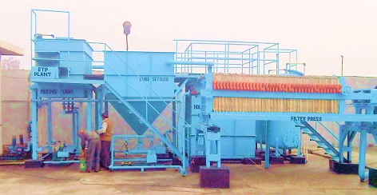
- TESTING STANDARDS FOR PRODUCTION: As per communicated by client, company is having a quality control Laboratory, wherein, they check the entire range on defined parameters like design, quality and finish. The unit is equipped with all the essential tools, machine, and technology in order to manufacture a high-quality range of products.
- MANPOWER: As per information shared by the client/.company, an estimate of manpower requirement allowing for leave, absentecism, sickness and holidays for smooth and for efficient operation of different sections of the plant including its administrative and commercial departments, has been prepared based on technical and management ground primarly to indicate the order of manpower requirement.
As per informed by the client/company, the company will require approx. 165 resources to opearte the manufacturing facility at 100% capacity as shown in the below:
Manpower deployment on 100% capacity
Sr. No. | Area | Man Power
Production Block (First Floor) Dry Powder Injection
1 | Raw Material Store | 3
2 | Formulation Area | 6
3 | Secondary Packing Hall | 15
4 | Secondary packing Material Store | 2
5 | Finished Goods Store | 2
 | Total | 28
QC, QA & Micro Laboratory Area (First Floor)
1 | QA Office | 3
2 | Instrument Rooms | 5
3 | Wet Chemistry Laboratory | 5
4 | Micro testing Laboratory | 2
 | Total | 15
Production Block (Second Floor) Liquid Injection Vial & Ampoule
1 | Raw Material Store | 5
2 | Formulation Area | 12
3 | Secondary Packing Hall | 30
4 | Secondary packing Material Store | 4
5 | Finished Goods Store | 4
 | Total | 55
Production Block (Third Floor) Ointment / Cream & Aerosol
1 | Raw Material Store | 5
2 | Formulation Area | 15
3 | Secondary Packing Hall | 30
4 | Secondary packing Material Store | 4
5 | Finished Goods Store | 4
 | Total | 58
Other Area
1 | Engineering Dept. | 5
2 | Security | 4
 | Total | 9
 | Total Manpower required @ 100% capacity | 165
However, company is planning to procure the manpower with respect to the capacity utilization Y-o-Y basis. Since the proposed manufacturing facility will be running at 25-30% capacity initialy the company will be procure manpower @ 30% capacity as shown in the below table:
The company will employ the following staff personnel at 25% capacity utilization:
Sr. No. | Designation | No. of Persons | Salary p.m. | Salary p.m. | Total Salary p.a
1 | Floor Manager | 1 | 35000 | 35000 | 420000
2 | Line Head | 1 | 25000 | 25000 | 300000
3 | Middle Staff | 2 | 20000 | 40000 | 480000
4 | Operators | 4 | 15000 | 60000 | 720000
5 | Semi-Skilled Worker | 4 | 12000 | 48000 | 576000
6 | Casual Workers | 4 | 10000 | 40000 | 480000
7 | QC Manager | 1 | 30000 | 30000 | 360000
8 | QC Asstt. Manager | 2 | 25000 | 50000 | 600000
9 | QC Chemist | 2 | 20000 | 40000 | 480000
10 | QC Asstt. | 2 | 15000 | 30000 | 360000
11 | QA Manager | 1 | 33000 | 33000 | 396000
12 | QA Asstt. Manager | 2 | 30000 | 60000 | 720000
13 | QA Chemist | 2 | 25000 | 50000 | 600000
14 | QA Asstt. | 3 | 15000 | 45000 | 540000
15 | Utility Manager | 1 | 39750 | 39750 | 477000
16 | Asstt. Manager | 3 | 25000 | 75000 | 900000
17 | Engineering Dept. | 3 | 30000 | 90000 | 1080000
18 | Assistants | 3 | 25000 | 75000 | 900000
19 | Store Manager | 1 | 25000 | 25000 | 300000
20 | Store Asstt. Manager | 2 | 20000 | 40000 | 480000
21 | Store Executives | 1 | 25000 | 25000 | 300000
22 | Store Assistants | 2 | 15000 | 30000 | 360000
23 | Store Casual Workers | 3 | 10000 | 30000 | 360000
 | Total | 50 |  |  | 1,21,89,000
 | @30% capacity |  |  | INR 1,21,89,000 Lakhs
In estimating the manpower requirement, a proper ratio between the administrative, managerial, supervisory and shop foor staff has been maintained with a view to affording proper industrial and professional management at various levels. The basic structure of the manpower will require the following kind of resources to operate the plant in 3 shifts (7.5 hours/shift) for 360 days a year.

PART F | PRODUCT PROFILE

- INTRODUCTION: In the pharmaceutical industry space, Mancare include integrated development of the product including Pre-Formulation studies, formulation development, Cost effective Commercial manufacturing of the finished dosage, and Art work Management. As a part of expansion of its existing business, the company proposed to increase its capacity in terms of meet the market demand.
Company has planned to produce Ampoule Liquid Injection, Vial Liquid Injection, Ointment Cream and tablets through this proposed manufacturing facility.
- PRODUCT CATEGORY & PRICING STRATEGY: As per data/information provided by the client/company, product wise pricing strategy of the company shown below:

- SELLING PRICE AMPOULE LIQUID INJECTION: Company will manufacture generic ampoule of Dyclophenic, Mytholocabalamin & B Complex of 1ml to 50 ml.
Pricing for Liquid Ampoules
Category | Price Per Unit (INR)
1ml-5ml | 4.00-5.00
10ml-30ml | 7.00
40ml-50ml | 9.00
Average Market price as per peers | 6.66

Further company is considering the bulk order of 1 ml to 10 ml from government hospital because these size are required in bulk to government hospital and the average price is arrived at Rs. 5.50. Hence, the Company has fixed the price of Rs. 5.50/- per ampoule if minimum order of 20 lac ampoule is received.
- SELLING PRICE OF VIAL LIQUID INJECTION: The vial liquid injection is the combination of dry powder and liquid in (vial and water ampoule). Further company will manufacture dry powder of Dexona, & Domperidom and processed liquid water ampoule in 10ml to 30ml.
Pricing for VIAL Liquid Injection
Category | Price Per Unit (INR)
10 ml | 12.00
20 ml | 16.00
30 ml | 23.00
Average Market price as per peers | 18.33 Rs./Vial
Further company is considering the bulk order of 10 ml and 20 ml from government hospital because these size are requited in bulk to government hospital and the average price is arrived at Rs. 14.00. Hence, the Company has fixed the price of Rs. 14.000/- for government department if only 10 ml and 20 ml of vial is being ordered for minimum 10 lac vial in each section.
Further the Company has fixed the price of Rs. 18.33/- for other companies if order is being placed to the company in 10 ml, 20ml and 30 ml and minimum order is being placed 5 lac of all size.
- SELLING PRICE OF TABLETS FOR DIFFERENT SALT: The below tabulated price is fixed for all buyer:
Pricing for Tablets
S. No. | Salt | Price
1 | Azithromycin | 8.38
2 | Ciprofloxacin
3 | Oflaxacin
4 | Paracetamol | 11.00
5 | Cobalin
6 | Maphanic Acid
7 | Urodoxilic Acid
8 | Levofloxacin | 13.00
9 | Pregabalin
10 | Aceclophinac
11 | Gabapin

- SELLING PRICE OF OINTMENTS: Price for ointment is fixed for all buyer for Rs. 8.50 per tube.
- MARKETING, SELLING & DISTRIBUTION PLAN:
Name | Marketing, Selling & Distribution Plan/arrangements
Ampoule Liquid Injection | Delhi, Gujrat
Vial Liquid Injection | Delhi, Gujrat
Ointment / Cream | Haryana, Gujrat, Telangana
Tablet Line 1  Tablet Line 2 | Haryana, Maharastra, Gujrat
As per information provided by the client/company, details of some of the prominent and existing buyers of the company are shown in the below table:
DETAILS OF BUYERS OF THE COMPANY
Party Name | Place
Nava Healthcare Pvt Ltd | Delhi
Euro Organics | Haryana
H and A | Uttara Pradesh
Syndrome Pharmaceuticals Pvt Ltd | Bihar
Gurgace Pharmaceuticals | Haryana
Shecue Healthcare | Uttarakhand
Pradeep Dagur Hospital | Rajasthan
Khanna Deddiction Centre | Punjab
Shri Krishana Hospital | Haryana
Nyi Soch Drug Deddiction (II) | Haryana
Advent Bioceuticals LLP | Uttara Pradesh
Kanha Pharma | Uttara Pradesh
Shivam Distributors | Uttara Pradesh
Profile Pharma Pvt. Ltd. | Uttara Pradesh
Paliwal Healthcare | Uttara Pradesh
Vidakem Life Sciences Pvt. Ltd. | Gujrat
Caventis Pharma UP | Uttara Pradesh
Ashley Pharmatech Pvt Ltd | Uttara Pradesh
Avail Healthcare | Uttara Pradesh
Mancare Health Pvt Ltd | Haryana
Manav Aushadhi Store | Haryana
Healthlab Healthcare Pvt Ltd | Delhi
Sinkhai Healthcare Ltd | Uttara Pradesh
Company has also in tie up with Jan ausadhi of different states for direct supply of bulk drugs. Recently company has received order from government of Uttara Pradesh to the tune of Rs. 8.00 crore for direct supply. Company has already bulk drug order from state government of Bihar, Jharkhand, Maharashtra, Madhya Pradesh, Chhattisgarh, and Telangana for direct supply to the tune of Rs. 20.00 Crore. Further company is also in process of tie up with state government of West Bengal, Odisha, Rajasthan, J&K, Haryana and Andhra Pradesh.

PART G | RAW ANALYSIS & SUPPLY

- RAW MATERIAL ARRANGEMENTS: As per data/information shared by the client/company, below table shows the Raw materials details, required to run the manufacturing facility smoothly:
Raw Material | Product | Quantity Required for 100% Capacity | Raw Material details and specifications | Price per unit | Raw material availability/arrangements
 | Ampoule Liquid Injection | 18160 KG | Octreotide acetate  Dobutamine hydrochloride  Tranexamic Acid  L ornithine L aspartate  Labetalol | 6.75 | Existing vendor
 | Vial Liquid Injection | 18160 KG | Tobramycin Sulphate  Heparin Sodium  Piracetam  Lignocaine Hydrochloride  Amikacin Sulphate | 38.25 | Existing vendor
 | Ointment / Cream | 13104 KG | emulsion, consisting of waxes, emollients and lubricants dispersed in an oil phase, | 6.63 | Existing vendor
 | Tablet Line 1  Tablet Line 2 | 10188 KG | API  XCIPIENT | 9.00 | Existing vendor

- MAJOR RAW MATERIAL SUPPLIER: The proposed manufacturing facility will be getting synergies from the existing vendors/suppliers to procure the required raw material to run the operations without any constraints. Below table shows the details of some existing and new suppliers as per informed by the client/company:
DETAILS OF SUPPLIERS OF RAW MATERIAL
Party Name | Place
Rajshi Farma Pvt. Ltd. | Haridwar
Rajshi Enterprises | Delhi
Shri Sai Pharma Trading Company | Sealqui
Prakash Medicine Company | Delhi
ABS Mercantiles (P) Ltd | Roorkee
Neha Pharma Pvt. Ltd. | Mumbai
Mahaswaan Pharma Pvt. Ltd | New Delhi
Shi Shakti Associates | Gaziabaad
HAP Enterprise | Mumbai
Kishan Pharmachem | Bhivandi Maharashtra
Medicine Chamber | Mumbai
Sevanti Lal & Sons | Thane
SMX Pharma | Delhi
Graphic Art | Delhi
Navdurga Agencies | Dehradun
Godawri Drug | Maharashtra
Mahaswan Pharma | Delhi

PART H | INDUSTRY OVERVIEW & ANALYSIS

- INTRODUCTION: India stands as the foremost global provider of generic drugs, renowned for its cost-effective vaccines and medications. The Indian Pharmaceutical industry, now the third-largest in pharmaceutical production by volume, has demonstrated robust growth with a Compound Annual Growth Rate (CAGR) of 9.43% over the past nine years. Its diverse segments include generic drugs, over-the-counter medications, bulk drugs, vaccines, contract research & manufacturing, biosimilar, and biologics.
Notably, India boasts the largest number of pharmaceutical manufacturing facilities compliant with the stringent standards of the US Food and Drug Administration (USFDA). With 500 Active Pharmaceutical Ingredient (API) producers, India commands an 8% share of the global API market. The country's pharmaceutical sector plays a pivotal role in global healthcare, supplying over 50% of global vaccine demand, 40% of generic demand in the US, and a quarter of all medicines in the UK.
The domestic pharmaceutical industry comprises a network of 3,000 drug companies and approximately 10,500 manufacturing units. India's global prominence in the pharmaceutical sector is underscored by its contribution of over 80% of antiretroviral drugs used globally to combat AIDS. Recognized as the "pharmacy of the world," India's pharmaceutical industry is lauded for the combination of low-cost and high-quality medicines.
The sector, currently ranking third in pharmaceutical production by volume and 14th in terms of value, constitutes about 3.71% of the total Foreign Direct Investment (FDI) inflows in the country across various sectors. From April 2000 to September 2022, the Pharma and Medtech sectors attracted total FDI inflows of INR 1,32,568 crore. In the fiscal year 2022-23 (up to December 2022), the Department of Pharmaceuticals approved 13 FDI proposals, paving the way for a foreign investment inflow of INR 2,814 crore in the brownfield projects of the pharmaceutical sector.
- MARKET SIZE: Market size of India pharmaceuticals industry is expected to reach US$ 65 billion by 2024, and ~US$ 130 billion by 2030. According to the government data, the Indian pharmaceutical industry is worth approximately US$ 50 billion with over US$ 25 billion of the value coming from exports. About 20% of the global exports in generic drugs are met by India. India is among the top 12 destinations for biotechnology worldwide and 3rd largest destination for biotechnology in Asia Pacific. In 2022, India's Biotechnology industry crossed US$ 80.12 billion, growing 14% from the previous year. During FY18 to FY23, the Indian pharmaceutical industry logged a compound annual growth rate (CAGR) of 6-8%, primarily driven by an 8% increase in exports and a 6% rise in the domestic market.
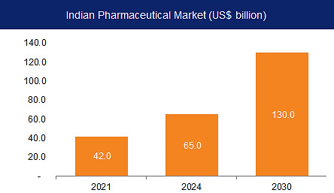
The domestic pharmaceutical industry would likely reach US$ 57 billion by FY25 and see an increase in operating margins of 100-150 basis points (bps). The Indian pharmaceutical industry has seen a massive expansion over the last few years and is expected to reach about 13% of the size of the global pharma market while enhancing its quality, affordability, and innovation.
The biosimilars market in India is estimated to grow at a compounded annual growth rate (CAGR) of 22% to become US$ 12 billion by 2025. This would represent almost 20% of the total pharmaceutical market in India.
India is the 3rd largest producer of API accounting for an 8% share of the Global API Industry. About 500+ different APIs are manufactured in India, and it contributes 57% of APIs to prequalified list of the WHO. The current market size of the medical devices sector in India is estimated to be US$ 11 billion and its share in the global medical device market is estimated to be 1.5%. Indian pharma companies have a substantial share in the prescription market in the US and EU. The largest number of FDA-approved plants outside the US is in India.
According to the Indian Economic Survey 2021, the domestic market is expected to grow 3x in the next decade. India's domestic pharmaceutical market stood at US$ 42 billion in 2021 and is likely to reach US$ 65 billion by 2024 and further expand to reach US$ 120-130 billion by 2030. India's biotechnology industry comprises biopharmaceuticals, bio-services, bio-agriculture, bio-industry, and bioinformatics. The Indian biotechnology industry was valued at US$ 70.2 billion in 2020 and is expected to reach US$ 150 billion by 2025. India's medical devices market stood at US$ 10.36 billion in FY20. The market is expected to increase at a CAGR of 37% from 2020 to 2025 to reach US$ 50 billion.
- EXPORTS: The pharmaceutical sector ranks among the top ten sectors attracting foreign investment in India. India's pharmaceutical exports span over 200 nations, including heavily regulated markets such as the USA, West Europe, Japan, and Australia. Notably, India played a pivotal role by supplying approximately 45 tonnes and 400 million tablets of hydroxychloroquine to 114 countries globally.
According to Pharmexcil data, India's drugs and pharmaceuticals exports reached Rs. 2, 08,231 crore for the fiscal year 2023. The exports of Drugs & Pharmaceuticals for April-June 2023 amounted to US$ 6.59 billion. In March 2023, the estimated exports stood at US$ 2.48 billion, constituting 6.47% of the total exports for that month.
- INVESTMENTS AND RECENT DEVELOPMENTS: The Indian Pharmaceuticals industry plays a prominent role in the global pharmaceuticals industry. India ranks third worldwide for production by volume and 14th by value. In this regard the sector has seen a lot of investments and developments in the recent past.
- Up to 100%, FDI has been allowed through automatic route for Greenfield pharmaceuticals projects. For Brownfield pharmaceuticals projects, FDI allowed is up to 74% through automatic route and beyond that through government approval. The FDI inflows in the Indian drugs and pharmaceuticals sector reached US$ 21.46 billion between April 2000-March 2023. This constitutes almost 3.38% of the total FDI inflow received across sectors.
- In August 2023, Union Minister for Labour & Employment and Environment, Forest and Climate Change Mr. Bhupender Yadav launched Chemotherapy Services in 30 ESIC Hospitals across the country.
- An MoU was signed on June 4, 2023, between the Indian Pharmacopoeia Commission (IPC), Ministry of Health & Family Welfare, Government of India and Ministry of Health, Government of Suriname for Recognition of Indian Pharmacopoeia (IP) in Suriname.
- In May 2023, the Ministry of Minority Affairs and the Ministry of Ayush joined hands to advance the Unani System of Medicine in India.
- Prime Minister Mr. Narendra Modi during his Independence Day 2023 speech said that the government has plans to increase the number of 'Jan Aushadhi Kendras' from 10,000 to 25,000.
- The Department of Pharmaceuticals will soon launch the Scheme for the Promotion of Research and Innovation in Pharma (PRIP) MedTech Sector. The scheme has been approved by the Union Cabinet for a period of five years starting from 2023-24 to 2027-28 with a total outlay of Rs. 5,000 crore.
- Japanese companies have been invited to invest in the Indian Pharmaceutical and Medical Device Industry. The cooperation between Pharmaceutical Traders Association and Japan Federation of Medical Devices Associations of the two countries can contribute to stabilize the global supply-chain especially of APIs and Medical Devices.
- Sun Pharmaceutical Industries Limited announced the successful completion of its acquisition of Concert Pharmaceuticals, Inc. on March 6, 2023, a late-stage clinical biopharmaceutical company that is developing deuruxolitinib, a novel, deuterated, oral JAK1/2 inhibitor, for the potential treatment of adult patients with moderate to severe alopecia areata.
- BDR Pharmaceutical launched the first generic apalutamide (brand name Apatide) in India to treat both metastatic castration sensitive prostate cancer as well as non-metastatic castration resistant prostate cancer. The product will be available across India.
- Anglo French Drugs & Industries Limited (AFDIL), a 99-year-old organization in the pharmaceutical sector, announced that it has entered into the fertility space with the launch of the LYBER range.
- GOVERNMENT INITIATIVES: Some of the initiatives taken by the Government to promote the pharmaceutical sector in India are as follows: As per the Union Budget 2023-24:
- A mission to eliminate sickle cell anemia by 2047 will be launched. It would involve raising awareness, conducting a comprehensive screening of seven crore individuals in the impacted tribal regions between the ages of 0 and 40, and providing counselling through coordinated efforts.
- For innovation in the pharmaceutical sector, through centres of excellence, a new initiative to encourage pharmaceutical research and innovation will be implemented. The government persuades business to spend money on R&D in a few chosen priority fields. At the grassroots level, government has also announced on building 157 nursing colleges in co-location with government medical colleges.
- The Union Cabinet, on April 26, 2023, approved the National Medical Devices Policy, 2023. The National Medical Devices Policy, 2023 is expected to facilitate an orderly growth of the medical device sector to meet the public health objectives of access, affordability, quality and innovation.
AYUSHMAN BHARAT DIGITAL MISSION (ABDM):
- Under the ABDM, citizens will be able to create their ABHA (Ayushman Bharat Health Account) numbers, to which their digital health records can be linked. This will enable creation of longitudinal health records for individuals across various healthcare providers and improve clinical decision making by healthcare providers.
- The pilot of ABDM is completed in the six Union Territories of Ladakh, Chandigarh, Dadra & Nagar Haveli and Daman & Diu, Puducherry, Andaman and Nicobar Islands and Lakshadweep with successful demonstration of technology platform developed by the NHA.
- During the pilot, digital sandbox was created in which more than 774 partner solutions are undergoing integration. As of September 4, 2023, 450,164,619 Ayushman Bharat Health Accounts have been created and 224,967 doctors and 218,602 health facilities have been registered in ABDM.
SCHEME FOR DEVELOPMENT OF PHARMA INDUSTRY - UMBRELLA SCHEME:
- The Department of Pharmaceuticals has prepared an Umbrella Scheme namely 'Scheme for Development of Pharma industry'. Which comprises of the following sub schemes: Assistance to Bulk Drug Industry for Common Facilitation Centres, Assistance to Medical Device Industry for Common Facilitation Centres, Assistance to Pharmaceutical Industry (CDP-PS), Pharmaceutical Promotion and Development Scheme (PPDS), Pharmaceutical Technology Upgradation Assistance Scheme (PTUAS)
AS PER THE UNION BUDGET 2022-23:
- Rs. 3,201 crore has been set aside for research and Rs. 83,000 crore has been allocated for the Ministry of Health and Family Welfare.
- Rs. 37,000 crore has been allocated to the 'National Health Mission' and Rs. 10,000 crore has been allocated to Pradhan Mantri Swasthya Suraksha Yojana. The Ministry of AYUSH has been allocated Rs. 3,050 crore up from Rs. 2,970 crore.
- To achieve self-reliance and minimise import dependency in the country's essential bulk drugs, the Department of Pharmaceuticals initiated a PLI scheme to promote domestic manufacturing by setting up greenfield plants with minimum domestic value addition in four separates 'Target Segments' with a cumulative outlay of Rs. 6,940 crore (US$ 951.27 million) from FY21 to FY30.
- CONCLUSION: The Indian Pharmaceuticals industry plays a prominent role in the global pharmaceuticals industry. Major segments of Indian Pharmaceutical Industry include generic drugs, OTC medicines, bulk drugs, vaccines, contract research & manufacturing, biosimilar and biologics. India is a global leader in the supply of DPT, BCG, and Measles vaccines.
India is one of the biggest suppliers of low-cost vaccines in the world. India accounts for 60 % of global vaccine production, contributing up to 70 % of the WHO demand for Diphtheria, Tetanus and Pertussis (DPT) and Bacillus Calmette–Guérin (BCG) vaccines, and 90% of the WHO demand for the measles vaccine.
The nation is the largest provider of generic medicines globally, occupying a 20% share in global supply by volume, and is the leading vaccine manufacturer globally. India also has the highest number of US-FDA compliant Pharma plants outside of USA and is home to more than 3,000 pharma companies with a strong network of over 10,500 manufacturing facilities as well as a highly skilled resource pool.
There are 500 API manufacturers contributing about 8% in the global API Industry. India is the largest supplier of generic medicines. It manufactures about 60,000 different generic brands across 60 therapeutic categories and accounts for 20% of the global supply of generics.
Access to affordable HIV treatment from India is one of the greatest success stories in medicine. Because of the low price and high quality, Indian medicines are preferred worldwide, making it “pharmacy of the world”.
The India Pharmaceutical Market is expected to register a CAGR of 10.7% over the forecast period. 100% Foreign Direct Investment (FDI) in the pharmaceutical sector is allowed under the automatic route for Greenfield pharmaceuticals. 100% FDI in the pharmaceutical sector is allowed in brownfield pharmaceuticals; wherein 74% is allowed under the automatic route and thereafter through the government approval route.

PART I | SWOT ANALYSIS

PART J | PROJECT COST AND MEANS OF FINANCE

As per data/information shared by the client, below are the details of Total project Cost (TPC) and means of finance for the same. Category wise proposed project cost is shown in the below table:
COST OF PROJECT
Particular |  | 2023-24 | 2024-25 | 2025-26 | 2026-27 | 2027-28
Land | Owned | 165.4
Building & Fixtures | 1589.38 | 133 | 266.38 | 0.00
Plant and Machinery | 2218.33 | 34 | 333 | 201.33
Interest during Construction/Implementation Period | 385.28 | 12.80 | 147.36 | 225.12
 | 4192.99 | 179.80 | 746.74 | 426.45 | 1352.99 | 0.00
MEANS OF FINANCE
Particular |  | 2023-24 | 2024-25 | 2025-26 | 2026-27 | 2027-28
Term Loan- Building, Equipment & Fixture | 1190.00 | 133 | 266.38 | 0
Plant & Machinery | 1650.00 | 34 | 333 | 201.33
Promotor's Contribution | 967.71 | 167.00 | 599.38 | 201.33 | 967.71 | 1352.99
Interest during Construction/Implementation Period | 385.28 | 12.8 | 164.16 | 108
 | 4192.99 | 179.80 | 746.74 | 426.45 | 1352.99
Note: Project Cost have been provided by the company.
Notes:
- Land is owned by the promoter, hence not a part of Project cost.
- Company has approached PNB, MCC Dehradun for a total term loan of INR 11.90 Crore including applicable GST, electric work (INR 2.75 Crore) and Clean Room work (Approx. Area 1200 Sq. Met.) (INR 3.78 Crore) (Out of INR 15.89 Crore) for Building and Civil Works and INR 16.50 Crore (Out of INR 22.18 Crore) for Plant and Machinery.
- Out of total INR 41.92 Crore, INR 9.67 Crore will be infused through promoter’s contribution and INR 3.85 Crore as IDC will also be funded by promoters as a part of TPC.
- It is expected that the company will achieve financial closure by 31st Dec, 2023 as per informed by banker/client

PART K | PROJECT SCHEDULE

Below is the tabulated presentation of the status of the project showing expected duration shared by the project manager of the company. The project is expected to be complete soon.
S. No. | Particulars | Activity | Expected completion date | Status
 | Land | Land Procurement | 6th Oct 2022 | As per land deed land is owned by the promoter of the company.
 |  | Land Development | N/A | As per sale deed it is an industrial plot
 | Sanction of Rupee Term Loan | Sanction of Rupee Term Loan | Dec, 2023 | Company has approached PNB, MCC Dehradun for loan.
 | Building & Civil Works | Appointment of Architect | Oct 2023 | MEP Tech services prepared the concept plan
 |  | Building Plan Preparation | Nov 2023 | Applied for sanction map approval
 |  | Building Plan Sanction | Dec 2023 | Applied to SIDA (Authority)
 |  | Appointment of Civil contractor/ developer | Dec 2023 | In the process to appoint, finalized post sanction map approval.
 |  | Building & Civil Works completion | Jan 2025 | NA
 | Plant & Machinery | Finalization of P&M suppliers | March 2024 | Company is in the process of discussion with various suppliers/vendors as per shared quotations.
 |  | Orders to P&M suppliers | June 2024 | Will be finalized post finalization of supplier at reasonable quote.
 |  | Arrival of P&M | Dec 2024 | Will be arrived one the civil structure will be near finishing.
 |  | Installation of P&M | April 2025 | Post-Civil work completion
 |  | Utility Installation | August 2025 | NA
 | Statutory Approvals, registrations & NOCs | From the respective authorities | Jan 2026 | Single window clearance applied and shall be obtained in due course
 | Finishing & Trail Run | Informed by client | Jan 2026 | NA
 | Commercial Operation Date | Informed by client | Feb, 2026 | NA

Notes:
- Schedule has been made as per feasibility to achieve different milestones.
- Achievement of Milestone will depend on sanction of term loan as per proposed timeline.
- Company has applied to SIDA (Authority) for sanction map approval.
- As per shared quotation, company is in the process of finalized the supplier of plant, machinery & equipment.
- As per this timeline, expected COD will be 28th Feb 2026.

PART L | STATUTORY APPROVALS | LICENCES | NOC
Following major approvals are required. However the list are not exhaustive and State / district Authorities may be approached for further clearances required (if any):
S. No. | REQUIRED APPROVALS | REFERENCE NO./ DATE | STATUS  (Approved/ Applied For/ Pending)
 | Certificate of Firm Registration | UDYAM-UK-05-0002156 | Company is registered as MSME as per shared UDYAM REGISTRATION CERTIFICATE.
 | Land conversion to Industrial/Non agriculture | UKPDE2022045220483  As on 6th Oct. 2022 | As per land deed, Promoter of the company purchased this industrial plot/land in 2022.
 | Building and civil works Plan Sanction Approval  Concerned local development authority | SIDA (Authority) | Company has applied for sanction map approval to the respective authority.
 | Provisional Fire NOC (pre sanction)  Fire Services Department | NA | Applied and will be issued after completion of structure factory
 | Fire NOC (on completion)  Fire Services Department | NA | Applied and will be issued after completion of structure factory
 | Power Load Sanction  Uttarakhand Power Corporation | - | Will be applied after completion of structure
 | Consent to establish (under Water Act & Air Act)  State Pollution Control Board, UK | Application No. 3953104  As on 18/07/2023 | Approval from UK Pollution Control Borad
 | Permission for extraction of ground water |  | Will be applied in due course
 | Sewage trade effluent |  | Applied and shall be issued after installation of Machinery
 | Drug Licence  Department Of Medical Health And Family Welfare  Government Of Uttarakhand |  | Applied and shall be issued after installation of Machinery

Observation Note:
- As per land deed, promoter of the company Mrs. Sudhira Jha owned the industrial land from Oct, 2022.
- As per discussion with the client, company has applied for sanction map approval to SIDA.
- Rest approvals are pending and will be applied in due course as per above schedule.

PART M | COMPANY’S FINANCIAL FEASIBILITY

- PROJECTIONS OF THE FIRM: The projections of the Company are prepared from FY 2023-24 to FY 2035-36 based on the revenue generation capacity of the project and loan repayment period. Projections has made for the proposed Pharma manufacturing facility as per the best practice in industry for a Brownfield project’s expansion to assess the financial feasibility of the project.
- PROJECTED PROFIT & LOSS ACCOUNT (FROM FY 2025-26 TO FY 2035-36): Below table shows the Projected Profit & Loss Account of proposed manufacturing facility of M/s Mancare Laboratories Pvt. Ltd. from the period FY 2025-26 to FY 2035-36 for the proposed unit:
(INR Lakhs)

Particular | 2025-26 | 2026-27 | 2027-28 | 2028-29 | 2029-30 | 2030-31 | 2031-32 | 2032-33 | 2033-34 | 2034-35 | 2035-36
Sales | 351.18 | 5418.2 | 6020.2 | 6622.2 | 7224.2 | 7826.2 | 8428.3 | 9030.3 | 9632.3 | 10234 | 10836
Other Mis. Income | 3.00 | 3.30 | 3.63 | 3.99 | 4.39 | 4.83 | 5.31 | 5.85 | 6.43 | 7.07 | 7.78
Total Receipts | 354.18 | 5421.5 | 6023.8 | 6626.2 | 7228.6 | 7831.1 | 8433.6 | 9036.1 | 9638.7 | 10241 | 10844
Cost of Operation
Purchases | 245.83 | 3792.7 | 4214.1 | 4635.5 | 5056.9 | 5478.4 | 5899.8 | 6321.2 | 6742.6 | 7164.0 | 7585.4
Salaries | 14.22 | 234.98 | 253.63 | 298.80 | 332.48 | 367.39 | 403.57 | 441.04 | 479.85 | 520.04 | 561.64
Electricity & Generator | 8.78 | 135.46 | 150.51 | 165.56 | 180.61 | 195.66 | 210.71 | 225.76 | 240.81 | 255.86 | 270.91
Other Direct Expenses | 3.51 | 56.89 | 63.21 | 69.53 | 75.85 | 82.18 | 88.50 | 94.82 | 101.14 | 107.46 | 113.78
Depreciation | 269.48 | 503.03 | 436.13 | 378.40 | 328.57 | 285.51 | 248.30 | 216.10 | 188.23 | 164.08 | 143.15
Total | 541.82 | 4723.1 | 5117.6 | 5547.8 | 5974.5 | 6409.1 | 6850.8 | 7298.9 | 7752.6 | 8211.5 | 8674.9
Add : Opening Stock of RM | 0.00 | 5.00 | 303.42 | 404.56 | 482.10 | 525.93 | 482.10 | 519.18 | 379.27 | 404.56 | 429.84
Add : Opening Stock of Stores & Spares | 0.00 | 5.00 | 75.85 | 101.14 | 120.52 | 131.48 | 120.52 | 129.80 | 126.42 | 134.85 | 143.28
Add : Opening Stock of WIP | 0.00 | 10.00 | 151.71 | 202.28 | 241.05 | 262.96 | 241.05 | 259.59 | 252.85 | 269.71 | 286.56
Add : Opening Stock of F.G | 0.00 | 15.00 | 227.56 | 303.42 | 361.57 | 394.45 | 361.57 | 389.39 | 379.27 | 404.56 | 429.84
Total | 541.82 | 4758.1 | 5876.1 | 6559.2 | 7179.7 | 7723.9 | 8056.1 | 8596.9 | 8890.5 | 9425.1 | 9964.5
Less : Closing Stock of RM | 5.00 | 303.42 | 404.56 | 482.10 | 525.93 | 482.10 | 519.18 | 379.27 | 404.56 | 429.84 | 455.13
Less : Closing Stock of Stores & Spares | 5.00 | 75.85 | 101.14 | 120.52 | 131.48 | 120.52 | 129.80 | 126.42 | 134.85 | 143.28 | 151.71
Less : Closing Stock of WIP | 10.00 | 151.71 | 202.28 | 241.05 | 262.96 | 241.05 | 259.59 | 252.85 | 269.71 | 286.56 | 303.42
Less : Closing Stock of F.G | 15.00 | 227.56 | 303.42 | 361.57 | 394.45 | 361.57 | 389.39 | 379.27 | 404.56 | 429.84 | 455.13
Total | 506.82 | 3999.5 | 4864.7 | 5354.0 | 5864.9 | 6518.7 | 6758.1 | 7459.0 | 7676.8 | 8135.6 | 8599.1
Gross Profit | -152.64 | 1421.9 | 1159.0 | 1272.2 | 1363.7 | 1312.4 | 1675.4 | 1577.0 | 1961.9 | 2105.8 | 2245.0
Administrative Exp. | 7.02 | 108.36 | 120.40 | 132.44 | 144.49 | 156.53 | 168.57 | 180.61 | 192.65 | 204.69 | 216.73
Profit before Interest & Tax | -159.66 | 1313.5 | 1038.6 | 1139.7 | 1219.2 | 1155.8 | 1506.8 | 1396.4 | 1769.3 | 1901.1 | 2028.3
Interest Term Loan | 22.72 | 269.95 | 252.38 | 230.59 | 206.50 | 180.10 | 151.39 | 120.38 | 87.07 | 52.51 | 39.60
Interest Others | 0.00 | 0.00 | 0.00 | 0.00 | 0.00 | 0.00 | 0.00 | 0.00 | 0.00 | 0.00 | 0.00
Interest C.C. Limit | 3.20 | 38.40 | 38.40 | 38.40 | 38.40 | 38.40 | 38.40 | 38.40 | 38.40 | 38.40 | 38.40
Total Interest Paid | 25.92 | 308.35 | 290.78 | 268.99 | 244.90 | 218.50 | 189.79 | 158.78 | 125.47 | 90.91 | 78.00
Profit before Tax | -185.58 | 1005.23 | 747.88 | 870.79 | 974.35 | 937.39 | 1317.09 | 1237.70 | 1643.84 | 1810.20 | 1950.34
Taxation | 0.00 | 261.36 | 194.45 | 226.40 | 253.33 | 243.72 | 342.44 | 321.80 | 427.40 | 470.65 | 507.09
Profit after Tax | -185.58 | 743.87 | 553.43 | 644.38 | 721.02 | 693.67 | 974.65 | 915.90 | 1216.4 | 1339.5 | 1443.2

- KEY FINANCIAL RATIO FOR PROPOSED FACILITY:
Particular | 2025-26 | 2026-27 | 2027-28 | 2028-29 | 2029-30 | 2030-31 | 2031-32 | 2032-33 | 2033-34 | 2034-35 | 2035-36
Sales | 351.18 | 5418.20 | 6020.22 | 6622.25 | 7224.27 | 7826.29 | 8428.31 | 9030.34 | 9632.36 | 10234.38 | 10836.40
Gross Profit | 125.62 | 2060.44 | 1745.71 | 1816.18 | 1872.90 | 1793.58 | 2134.46 | 2018.95 | 2391.00 | 2525.74 | 2659.13
EBITDA | 109.82 | 1816.62 | 1474.80 | 1518.18 | 1547.81 | 1441.40 | 1755.18 | 1612.58 | 1957.54 | 2065.19 | 2171.49
EBIT | -159.66 | 1313.59 | 1038.67 | 1139.78 | 1219.24 | 1155.88 | 1506.88 | 1396.48 | 1769.31 | 1901.11 | 2028.34
PAT | -185.58 | 743.87 | 553.43 | 644.38 | 721.02 | 693.67 | 974.65 | 915.90 | 1216.44 | 1339.55 | 1443.25
Revenue Growth Rate |  |  | 11.11% | 10.00% | 9.09% | 8.33% | 7.69% | 7.14% | 6.67% | 6.25% | 5.88%
Gross Profit % | 35.77% | 38.03% | 29.00% | 27.43% | 25.93% | 22.92% | 25.32% | 22.36% | 24.82% | 24.68% | 24.54%
EBITDA % | 31.27% | 33.53% | 24.50% | 22.93% | 21.43% | 18.42% | 20.82% | 17.86% | 20.32% | 20.18% | 20.04%
EBIT % | -45.46% | 24.24% | 17.25% | 17.21% | 16.88% | 14.77% | 17.88% | 15.46% | 18.37% | 18.58% | 18.72%
PAT % | -52.84% | 13.73% | 9.19% | 9.73% | 9.98% | 8.86% | 11.56% | 10.14% | 12.63% | 13.09% | 13.32%
Average Gross Profit % |  | 27.34%
Average EBITDA % |  | 22.84%
Average EBIT % |  | 17.94%
Average PAT % |  | 11.22%
Note: EBITDA Margins are positive and ranging from 17-33% during the estimated period. Net profit margins have increased from -52% in FY 2025 (Negative due to 1 operational months only) to 13.32% in FY 2035. Net Operating Margin (EBIT) Margins are positive and increasing fairly during the estimated period, however initially it is -45.46% due to 1 months of operations at 35% capacity utilization.
- GRAPHICAL REPRESENTATION OF KEY RATIOS: Below is the graphical representation of the key financial metrics of the company, showing the efficiency and financial performance of the company throughout the forecasted period:
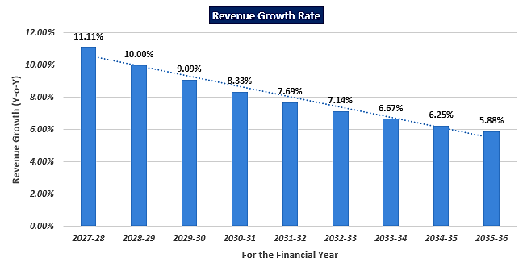
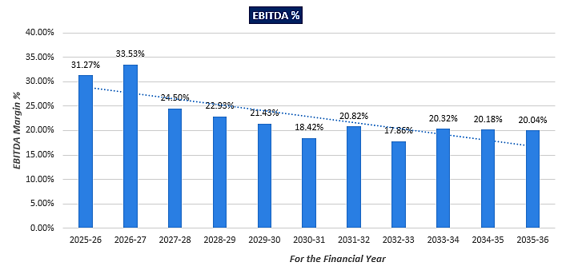
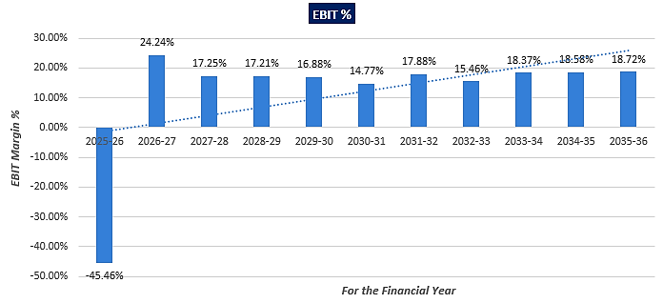
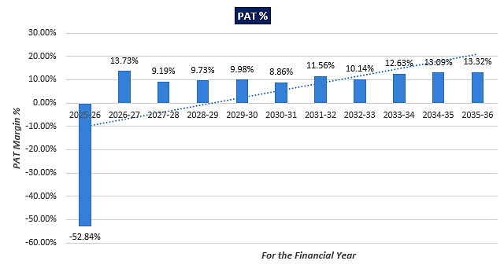
- PROJECTED BALANCE SHEET: Below table shows the Projected Balance Sheet of the proposed unit of M/s Mancare Laboratories Private Limited from the period FY 2023-24 to FY 2035-36:
(INR Lakhs)
Particular | 2023-24 | 2024-25 | 2025-26 | 2026-27 | 2027-28 | 2028-29 | 2029-30 | 2030-31 | 2031-32 | 2032-33 | 2033-34 | 2034-35 | 2035-36
Authorized Capital | 800.00 | 800.00 | 1000.00 | 1200.00 | 1200.00 | 1200.00 | 1200.00 | 1200.00 | 1200.00 | 1200.00 | 1200.00 | 1200.00 | 1200.00
Paid up Capital
Opening Balance | 0.00 | 345.20 | 745.20 | 1000.00 | 1200.00 | 1200.00 | 1200.00 | 1200.00 | 1200.00 | 1200.00 | 1200.00 | 1200.00 | 1200.00
Promotors Contribution | 345.20 | 400.00 | 254.80 | 200.00 | 0.00 | 0.00 | 0.00 | 0.00 | 0.00 | 0.00 | 0.00 | 0.00 | 0.00
Loans from Directors Treated as Quasi Capital | 0.00 | 346.74 | 352.99 | 352.99 | 452.99 | 452.99 | 552.99 | 552.99 | 552.99 | 552.99 | 552.99 | 652.99 | 652.99
Total | 345.20 | 1091.94 | 1352.99 | 1552.99 | 1652.99 | 1652.99 | 1752.99 | 1752.99 | 1752.99 | 1752.99 | 1752.99 | 1852.99 | 1852.99
Reserve & Surplus | 0.00 | 0.00 | -185.58 | 743.87 | 553.43 | 644.38 | 721.02 | 693.67 | 974.65 | 915.90 | 1216.44 | 1339.55 | 1443.25
TNW | 345.20 | 1091.94 | 1167.41 | 2296.86 | 2206.42 | 2297.37 | 2474.01 | 2446.66 | 2727.64 | 2668.89 | 2969.43 | 3192.54 | 3296.24
Loans & Liability
Term Loan (Building) | 500.00 | 1190.00 | 1148.00 | 1064.00 | 968.00 | 860.00 | 740.00 | 608.00 | 464.00 | 308.00 | 152.00 | 0.00 | 0.00
Term Loan (P&M) | 100.00 | 1100.00 | 1580.00 | 1448.00 | 1304.00 | 1148.00 | 980.00 | 800.00 | 608.00 | 404.00 | 200.00 | 0.00 | 0.00
Total Term Loan | 600.00 | 2290.00 | 2728.00 | 2512.00 | 2272.00 | 2008.00 | 1720.00 | 1408.00 | 1072.00 | 712.00 | 352.00 | 0.00 | 0.00
Loans from Directors | 0.00 | 0.00 | 0.00 | 0.00 | 0.00 | 0.00 | 0.00 | 0.00 | 0.00 | 0.00 | 0.00 | 0.00 | 0.00
Current Liability
Cash Credit Limit | 0.00 | 0.00 | 400.00 | 400.00 | 400.00 | 400.00 | 400.00 | 400.00 | 400.00 | 400.00 | 400.00 | 400.00 | 400.00
Sundry Creditors | 0.00 | 0.00 | 46.71 | 948.19 | 1053.54 | 1158.89 | 1264.25 | 1369.60 | 1474.95 | 1580.31 | 1550.81 | 1647.74 | 1744.66
Other Liability | 0.00 | 0.00 | 50.00 | 52.37 | 52.37 | 54.87 | 57.62 | 60.64 | 80.59 | 50.30 | 75.00 | 75.00 | 175.00
TL Instalment within 12 Months | 0.00 | 0.00 | 112.00 | 216.00 | 240.00 | 264.00 | 288.00 | 312.00 | 336.00 | 360.00 | 360.00 | 352.00 | 0.00
Total Current Liability | 0.00 | 0.00 | 608.71 | 1616.56 | 1745.91 | 1877.76 | 2009.87 | 2142.24 | 2291.54 | 2390.61 | 2385.81 | 2474.74 | 2319.66
Total Liability & Equity | 945.20 | 3381.94 | 4504.12 | 6425.42 | 6224.33 | 6183.14 | 6203.87 | 5996.90 | 6091.18 | 5771.50 | 5707.24 | 5667.27 | 5615.90
Fixed Assets | 945.20 | 3381.94 | 4088.91 | 3585.88 | 3149.75 | 2771.35 | 2442.78 | 2157.27 | 1908.97 | 1692.87 | 1504.64 | 1340.56 | 1197.40
Investment
Security Deposit | 0.00 | 0.00 | 25.00 | 25.00 | 25.00 | 25.00 | 25.00 | 25.00 | 25.00 | 25.00 | 25.00 | 25.00 | 25.00
Fixed Deposit | 0.00 | 0.00 | 0.00 | 0.00 | 25.00 | 50.00 | 75.00 | 75.00 | 75.00 | 75.00 | 75.00 | 75.00 | 75.00
Total Investment | 0.00 | 0.00 | 25.00 | 25.00 | 50.00 | 75.00 | 100.00 | 100.00 | 100.00 | 100.00 | 100.00 | 100.00 | 100.00
Current Assets
Sundry Debtors | 0.00 | 0.00 | 105.35 | 1354.55 | 1324.45 | 1324.45 | 1444.85 | 1565.26 | 1685.66 | 1986.67 | 2119.12 | 2353.91 | 2384.01
Stock in Hand | 0.00 | 0.00 | 35.00 | 758.55 | 1011.40 | 1205.25 | 1314.82 | 1205.25 | 1297.96 | 1137.82 | 1213.68 | 1289.53 | 1365.39
Cash and Bank Balance | 0.00 | 0.00 | 87.91 | 330.97 | 158.49 | 244.35 | 234.54 | 297.06 | 377.09 | 397.99 | 458.52 | 468.50 | 488.08
Advance to Supplier | 0.00 | 0.00 | 134.78 | 126.61 | 125.30 | 162.93 | 279.32 | 246.97 | 271.67 | 116.25 | 113.99 | 35.67 | 35.97
Other Current Assets | 0.00 | 0.00 | 27.17 | 243.87 | 404.94 | 399.81 | 387.56 | 425.09 | 449.83 | 339.89 | 197.30 | 79.10 | 45.05
Total Current Assets | 0.00 | 0.00 | 390.21 | 2814.54 | 3024.58 | 3336.78 | 3661.09 | 3739.63 | 4082.22 | 3978.63 | 4102.61 | 4226.71 | 4318.50
Total Assets | 945.20 | 3381.94 | 4504.12 | 6425.42 | 6224.33 | 6183.13 | 6203.87 | 5996.90 | 6091.18 | 5771.50 | 5707.24 | 5667.27 | 5615.90

- REVENUE BUILD-UP: Production has been considered based on the capacity utilization of 35%-90% as a base case (5% escalation has been considered during forecasted period). Below table shows the Revenue generation @ 100% capacity considering the fact that company will be operating in 3 shifts of 7.5 hours ( 22.50 hours a day)each a day for 360 days in a year:
Sr. No. | Formulation Facility | Quantity | Quantity/ hour | total working hour | Unit Capacity / annum | Price per unit | Sales
1 | Ampoule Liquid Injection | 1 ml to 5 ml 125 Ampoule per minute | 1,875.00 | 6,750.00 | 1,26,56,250 | 5.00 | 6,32,81,250
 |  | 10 ml to 30 ml 75 vial per minute | 1,125.00 | 6,750.00 | 75,93,750 | 7.00 | 5,31,56,250
 |  | 40 ml to 50 ml 50 vial per minute | 753.00 | 6,750.00 | 50,82,750 | 9.00 | 4,57,44,750
2 | Vial Liquid Injection | 10 ml 100/vial per minute | 1,500.00 | 6,750.00 | 1,01,25,000 | 12.00 | 12,15,00,000
 |  | 20 ml 75 vial per minute | 1,125.00 | 6,750.00 | 75,93,750 | 16.00 | 12,15,00,000
 |  | 30 ml 50 vial per minute | 450.00 | 6,750.00 | 30,37,500 | 23.00 | 6,98,62,500
3 | Tablet Line 1 | 300 Pack per minute | 4,500.00 | 6,750.00 | 3,03,75,000 | 11.00 | 33,41,25,000
4 | Tablet Line 2 | 300 Pack per minute | 4,500.00 | 6,750.00 | 3,03,75,000 | 13.00 | 39,48,75,000
 | Total |  |  |  |  | 1,20,40,44,750.00

Proposed Sales | 2025-26 | 2026-27 | 2027-28 | 2028-29 | 2029-30 | 2030-31 | 2031-32 | 2032-33 | 2033-34 | 2034-35 | 2035-36
Capacity | 35% | 45.0% | 50.00% | 55.00% | 60.00% | 65.00% | 70.00% | 75.00% | 80.00% | 85.00% | 90.00%
Sales | 351.18 | 5418.20 | 6020.22 | 6622.25 | 7224.27 | 7826.29 | 8428.31 | 9030.34 | 9632.36 | 10234.3 | 10836.4

- ESTIMATED KEY FINANCIAL METRICS OF THE PROPOSED UNIT:
DEBT SERVICE COVERAGE RATIO (DSCR)
Particular | 2025-26 | 2026-27 | 2027-28 | 2028-29 | 2029-30 | 2030-31 | 2031-32 | 2032-33 | 2033-34 | 2034-35 | 2035-36
Cash Accruals | 83.90 | 1246.91 | 989.56 | 1022.79 | 1049.58 | 979.18 | 1222.95 | 1132.00 | 1404.67 | 1503.63 | 1586.40
Int. on Term Loan | 22.72 | 269.95 | 252.38 | 230.59 | 206.50 | 180.10 | 151.39 | 120.38 | 87.07 | 52.51 | 39.60
Total "A" | 106.62 | 1516.86 | 1241.95 | 1253.38 | 1256.08 | 1159.28 | 1374.34 | 1252.38 | 1491.74 | 1556.14 | 1626.00
Instalment of T/L | 0.00 | 112.00 | 216.00 | 240.00 | 264.00 | 288.00 | 312.00 | 336.00 | 360.00 | 360.00 | 352.00
Int. on Term Loan | 22.72 | 269.95 | 252.38 | 230.59 | 206.50 | 180.10 | 151.39 | 120.38 | 87.07 | 52.51 | 39.60
Total "B" | 22.72 | 381.95 | 468.38 | 470.59 | 470.50 | 468.10 | 463.39 | 456.38 | 447.07 | 412.51 | 391.60
D.S.C.R. (A/B) | 4.69 | 3.97 | 2.65 | 2.66 | 2.67 | 2.48 | 2.97 | 2.74 | 3.34 | 3.77 | 4.15
Average D.S.C.R. | 3.03
Min. DSCR | 2.48
Max. DSCR | 3.77

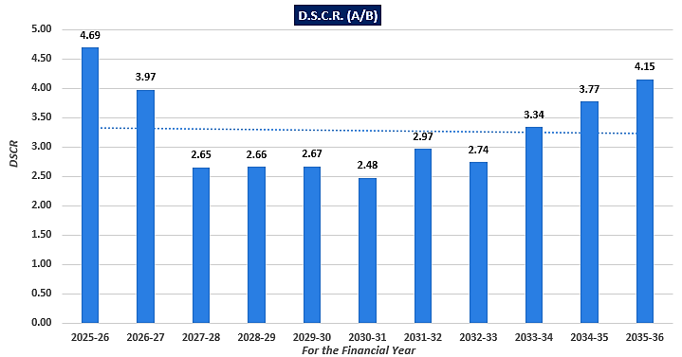
As per information provided by client/Company, initial one year will be moratorium period out of total loan repayment period of 10 years. Thus calculated from FY 2025-26 to FY 2035-36, the Average DSCR of the project will be 3.03 during the forecasted period.
DEBT-SERVICE COVERAGE RATIO IF REVENUE DECREASED BY 5%
Particular | 2025-26 | 2026-27 | 2027-28 | 2028-29 | 2029-30 | 2030-31 | 2031-32 | 2032-33 | 2033-34 | 2034-35 | 2035-36
Cash Accruals | 66.19 | 975.83 | 688.37 | 691.47 | 688.15 | 587.63 | 801.26 | 680.19 | 922.73 | 991.56 | 1044.19
Int. on Term Loan | 22.72 | 269.95 | 252.38 | 230.59 | 206.50 | 180.10 | 151.39 | 120.38 | 87.07 | 52.51 | 39.60
Total "A" | 88.91 | 1245.78 | 940.75 | 922.07 | 894.65 | 767.72 | 952.66 | 800.57 | 1009.81 | 1044.07 | 1083.79
Instalment of T/L | 0.00 | 112.00 | 216.00 | 240.00 | 264.00 | 288.00 | 312.00 | 336.00 | 360.00 | 360.00 | 352.00
Int. on Term Loan | 22.72 | 269.95 | 252.38 | 230.59 | 206.50 | 180.10 | 151.39 | 120.38 | 87.07 | 52.51 | 39.60
Total "B" | 22.72 | 381.95 | 468.38 | 470.59 | 470.50 | 468.10 | 463.39 | 456.38 | 447.07 | 412.51 | 391.60
D.S.C.R. (A/B) | 3.91 | 3.26 | 2.01 | 1.96 | 1.90 | 1.64 | 2.06 | 1.75 | 2.26 | 2.53 | 2.77
Average D.S.C.R. | 2.15
Min. DSCR | 1.64
Max. DSCR | 2.53

DEBT-SERVICE COVERAGE RATIO IF EXPENDITURE INCREASED BY 5%
Particular | 2025-26 | 2026-27 | 2027-28 | 2028-29 | 2029-30 | 2030-31 | 2031-32 | 2032-33 | 2033-34 | 2034-35 | 2035-36
Cash Accruals | 58.56 | 1046.93 | 746.32 | 755.09 | 756.34 | 653.25 | 885.04 | 759.04 | 1020.83 | 1096.85 | 1156.45
Int. on Term Loan | 22.72 | 269.95 | 252.38 | 230.59 | 206.50 | 180.10 | 151.39 | 120.38 | 87.07 | 52.51 | 39.60
Total "A" | 81.28 | 1316.88 | 998.71 | 985.68 | 962.83 | 833.34 | 1036.43 | 879.43 | 1107.90 | 1149.36 | 1196.05
Instalment of T/L | 0.00 | 112.00 | 216.00 | 240.00 | 264.00 | 288.00 | 312.00 | 336.00 | 360.00 | 360.00 | 352.00
Int. on Term Loan | 22.72 | 269.95 | 252.38 | 230.59 | 206.50 | 180.10 | 151.39 | 120.38 | 87.07 | 52.51 | 39.60
Total "B" | 22.72 | 381.95 | 468.38 | 470.59 | 470.50 | 468.10 | 463.39 | 456.38 | 447.07 | 412.51 | 391.60
D.S.C.R. (A/B) | 3.58 | 3.45 | 2.13 | 2.09 | 2.05 | 1.78 | 2.24 | 1.93 | 2.48 | 2.79 | 3.05
Average D.S.C.R. | 2.33
Min. DSCR | 1.78
Max. DSCR | 2.79

OTHER KEY FINANCIAL RATIOS
Particular | 2023-24 | 2024-25 | 2025-26 | 2026-27 | 2027-28 | 2028-29 | 2029-30 | 2030-31 | 2031-32 | 2032-33 | 2033-34 | 2034-35 | 2035-36
Current Ratio | - | - | 0.64 | 1.74 | 1.73 | 1.78 | 1.82 | 1.75 | 1.78 | 1.66 | 1.72 | 1.71 | 1.86
Quick Ratio | - | - | 0.58 | 1.27 | 1.15 | 1.14 | 1.17 | 1.18 | 1.22 | 1.19 | 1.21 | 1.19 | 1.27
DE ratio | 1.74 | 2.41 | 2.64 | 1.25 | 1.24 | 1.07 | 0.92 | 0.80 | 0.60 | 0.47 | 0.30 | 0.20 | 0.20
TOL/ Adj. TNW | 1.74 | 2.10 | 2.86 | 1.80 | 1.82 | 1.69 | 1.51 | 1.45 | 1.23 | 1.16 | 0.92 | 0.78 | 0.70
Asset Coverage Ratio | 1.58 | 1.48 | 1.50 | 1.43 | 1.39 | 1.38 | 1.42 | 1.53 | 1.78 | 2.38 | 4.27 | - | -
Interest Coverage Ratio | - | - | 4.24 | 5.04 | 4.40 | 4.80 | 5.29 | 5.48 | 7.44 | 8.13 | 12.2 | 17.5 | 21.3

- NPV & IRR OF THE PROJECT:
Particular | 2023-24 | 2024-25 | 2025-26 | 2026-27 | 2027-28 | 2028-29 | 2029-30 | 2030-31 | 2031-32 | 2032-33 | 2033-34 | 2034-35 | 2035-36
EBIT | 0.00 | 0.00 | 159.66 | 1313.5 | 1038.6 | 1139.7 | 1219.2 | 1155.8 | 1506.8 | 1396.4 | 1769.3 | 1901.1 | 2028.3
Tax Rate | 26% | 26% | 26% | 26% | 26% | 26% | 26% | 26% | 26% | 26% | 26% | 26% | 26%
(1-T) | 74% | 74% | 74% | 74% | 74% | 74% | 74% | 74% | 74% | 74% | 74% | 74% | 74%
EBIT*(1-T) | 0.00 | 0.00 | -118.1 | 972.05 | 768.61 | 843.44 | 902.24 | 855.35 | 1115.0 | 1033.4 | 1309.2 | 1406.8 | 1500.9
Dep & Amortization | 0.00 | 0.00 | 269.48 | 503.03 | 436.13 | 378.40 | 328.57 | 285.51 | 248.30 | 216.10 | 188.23 | 164.08 | 143.15
WCC | 0.00 | 0.00 | (205.6) | 1277 | 277 | 118.5 | (226.0 | (92.36) | (137.2) | 199.55 | -68.25 | -17.20 | 124.72
CAPEX | (945.2) | (2436.) | (976.4) | 0.00 | 0.00 | 0.00 | 0.00 | 0.00 | 0.00 | 0.00 | 0.00 | 0.00 | 0.00
FCCF | (945.2) | (2436) | (103) | 197.66 | 927.59 | 1103.3 | 1004.8 | 1233.2 | 1226.1 | 1449.0 | 1429.2 | 1553.7 | 1768.8
WACC | 9.00%
Company Risk Premium | 1.00%
Discount Rate | 10.00%
Period | 0.5 | 1.5 | 2.5 | 3.5 | 4.5 | 5.5 | 6.5 | 7.5 | 8.5 | 9.5 | 10.5 | 11.5 | 12.5
Discount Factor | 0.95 | 0.87 | 0.79 | 0.72 | 0.65 | 0.59 | 0.54 | 0.49 | 0.44 | 0.40 | 0.37 | 0.33 | 0.30
PV OF FCFF | (901.21) | (2112.13) | (812.19) | 141.59 | 604.07 | 653.21 | 540.79 | 603.39 | 545.38 | 585.94 | 525.40 | 519.22 | 537.38
NPV | 1430.84
IRR | 14.93%
Thus the proposed project is having a positive NPV of INR 1430.84 Lakhs and IRR of 14.93% (Approx. 15%). IRR is lower due to higher CAPEX in initial 3 year while there is no any cash inflow for the company. Thus a positive decision is suggested be taken for the pupose of funds infusion/investment in the proposed expansion of the company.
- BREAK-EVEN ANALYSIS: As per industry standarad, we have considered a 80:20 ratio to calculate the break-even slaes for variable and fixed costs:
Particular | 2025-26 | 2026-27 | 2027-28 | 2028-29 | 2029-30 | 2030-31 | 2031-32 | 2032-33 | 2033-34 | 2034-35 | 2035-36
Capacity Utilization | 35% | 45% | 50% | 55% | 60% | 65% | 70% | 75% | 80% | 85% | 90%
Total Sales | 354.18 | 5421.50 | 6023.85 | 6626.24 | 7228.66 | 7831.12 | 8433.63 | 9036.18 | 9638.79 | 10241.45 | 10844.18
Closing stock in process | 10.00 | 151.71 | 202.28 | 241.05 | 262.96 | 241.05 | 259.59 | 252.85 | 269.71 | 286.56 | 303.42
Closing Stock of Finishing Good | 15.00 | 227.56 | 303.42 | 361.57 | 394.45 | 361.57 | 389.39 | 379.27 | 404.56 | 429.84 | 455.13
Total ( A) | 379.18 | 5800.78 | 6529.55 | 7228.86 | 7886.07 | 8433.75 | 9082.61 | 9668.31 | 10313.05 | 10957.86 | 11602.73
Variable Cost
Raw Material ( incl. stores) | 5.00 | 303.42 | 404.56 | 482.10 | 525.93 | 482.10 | 519.18 | 379.27 | 404.56 | 429.84 | 455.13
Store & Spares (80%) | 4.00 | 60.68 | 80.91 | 96.42 | 105.19 | 96.42 | 103.84 | 101.14 | 107.88 | 114.63 | 121.37
Power & Fuel (80%) | 7.02 | 108.36 | 120.40 | 132.44 | 144.49 | 156.53 | 168.57 | 180.61 | 192.65 | 204.69 | 216.73
Direct Labour (80%) | 11.38 | 187.98 | 202.90 | 239.04 | 265.99 | 293.91 | 322.85 | 352.83 | 383.88 | 416.03 | 449.32
Repair & Maint. (60%) | 0.84 | 13.65 | 15.17 | 16.69 | 18.21 | 19.72 | 21.24 | 22.76 | 24.27 | 25.79 | 27.31
Interest on working capital | 3.20 | 38.40 | 38.40 | 38.40 | 38.40 | 38.40 | 38.40 | 38.40 | 38.40 | 38.40 | 38.40
other Financial charges (1% of sales) | 3.54 | 10 | 11 | 12.1 | 13.31 | 14.64 | 16.11 | 17.72 | 19.49 | 21.44 | 23.58
Selling Expenses (80%) | 405.45 | 3199.64 | 3891.83 | 4283.21 | 4691.95 | 5214.97 | 5406.54 | 5967.27 | 6141.46 | 6508.53 | 6879.29
Tax | 0.00 | 261.36 | 194.45 | 226.40 | 253.33 | 243.72 | 342.44 | 321.80 | 427.40 | 470.65 | 507.09
Total B | 440.44 | 4183.51 | 4959.62 | 5526.81 | 6056.77 | 6560.41 | 6939.18 | 7381.81 | 7740.00 | 8230.00 | 8718.21
Contribution ( A-B) | -61.26 | 1617.27 | 1569.93 | 1702.06 | 1829.29 | 1873.33 | 2143.43 | 2286.50 | 2573.06 | 2727.86 | 2884.52
Fixed Cost
Store & Spares (20%) | 1.00 | 15.17 | 20.23 | 24.10 | 26.30 | 24.10 | 25.96 | 25.28 | 26.97 | 28.66 | 30.34
Power & Fuel (20%) | 1.76 | 27.09 | 30.10 | 33.11 | 36.12 | 39.13 | 42.14 | 45.15 | 48.16 | 51.17 | 54.18
Direct Labour (20%) | 2.84 | 47.00 | 50.73 | 59.76 | 66.50 | 73.48 | 80.71 | 88.21 | 95.97 | 104.01 | 112.33
Repair & Maintenance (40%) | 0.21 | 3.41 | 3.79 | 4.17 | 4.55 | 4.93 | 5.31 | 5.69 | 6.07 | 6.45 | 6.83
Depreciation | 269.48 | 503.03 | 436.13 | 378.40 | 328.57 | 285.51 | 248.30 | 216.10 | 188.23 | 164.08 | 143.15
Interest on Term Loan | 22.72 | 269.95 | 252.38 | 230.59 | 206.50 | 180.10 | 151.39 | 120.38 | 87.07 | 52.51 | 39.60
Selling Expenses (20%) | 101.36 | 799.91 | 972.96 | 1070.80 | 1172.99 | 1303.74 | 1351.64 | 1491.82 | 1535.37 | 1627.13 | 1719.82
Total -C | 399.37 | 1665.57 | 1766.32 | 1800.95 | 1841.52 | 1911.00 | 1905.45 | 1992.64 | 1987.84 | 2034.01 | 2106.25
BEP at utilised capacity | 112.76% | 30.72% | 29.32% | 27.18% | 25.48% | 24.40% | 22.59% | 22.05% | 20.62% | 19.86% | 19.42%
BEP at installed capacity | 90.68% | 39.81% | 35.61% | 32.59% | 30.40% | 29.13% | 27.46% | 26.99% | 25.68% | 24.71% | 24.16%
BEP in sales volume | 399.37 | 1665.57 | 1766.32 | 1800.95 | 1841.52 | 1911.00 | 1905.45 | 1992.64 | 1987.84 | 2034.01 | 2106.25

As per the Break-even analysis, it can be seen that the company will be achieving the break-even sales from initial year during the forecasted period, subject to the assumption & basis and micro & macro economic factors taken into consideration.
- LOAN DISBURSEMENT SCHEDULE: As per data/information shared by the client, below table shows the Draw Down Schedule (Yearly/Half yearly/Quarter/Month wise) during the forecasted period:
- Draw Down schedule of TL for construction of Building & Fixtures amounting Rs 11.90 crore.
Period | Amount in Cr | Cumulative amount
Quarter Ended December 2023 | 2.00 | 2.00
Quarter Ended March 2024 | 3.00 | 5.00
Quarter Ended June 2024 | 3.00 | 8.00
Quarter Ended Sept 2024 | 2.00 | 10.00
Quarter Ended Dec 2024 | 1.50 | 11.50
Quarter Ended March 2025 (Jan 2025) | 0.40 | 11.90
Total | 11.90 | 11.90

- Draw Down schedule of TL for purchase of Plant & Machinery amounting Rs 16.50 crore.
Period | Amount in Cr | Cumulative amount
Quarter Ended March 2024 | 1.00 | 1.00
Quarter Ended June 2024 | 3.00 | 4.00
Quarter Ended Sept 2024 | 2.00 | 6.00
Quarter Ended Dec 2024 | 2.00 | 8.00
Quarter Ended March 2025 | 3.00 | 11.00
Quarter Ended June 2025 | 1.50 | 12.50
Quarter Ended Sept 2025 | 1.00 | 13.50
Quarter Ended Dec 2025 | 2.00 | 15.50
Quarter Ended March 2026 (Feb 2026) | 1.00 | 16.50
Total | 16.50 | 16.50

- DEPRECIATION SCHEDULE: Depreciation schedule is prepared based on the Income tax Act, 1961 by using written down value (WDV) Method. Below table shows the Depreciation Schedule along with applicable rate and allocated pre-opeartional and contingent expenses:
(INR Lakhs)
WDV OF FIXED ASSETS
Particulars | 2023-24 | 2024-25 | 2025-26 | 2026-27 | 2027-28 | 2028-29 | 2029-30 | 2030-31 | 2031-32 | 2032-33 | 2033-34 | 2034-35 | 2035-36 | 2036-37
LAND | 165.40 | 165.40 | 165.40 | 165.40 | 165.40 | 165.40 | 165.40 | 165.40 | 165.40 | 165.40 | 165.40 | 165.40 | 165.40 | 165.40
BUILDING | 645.00 | 1695.1 | 1709.8 | 1538.8 | 1384.9 | 1246.4 | 1121.8 | 1009.6 | 908.69 | 817.82 | 736.04 | 662.44 | 596.19 | 536.57
PLANT & MACHINERY | 134.80 | 1521.4 | 2213.6 | 1881.6 | 1599.3 | 1359.4 | 1155.5 | 982.21 | 834.88 | 709.64 | 603.20 | 512.72 | 435.81 | 370.44
SOLAR PLANT | 0.00 | 0.00 | 0.00 | 0.00 | 0.00 | 0.00 | 0.00 | 0.00 | 0.00 | 0.00 | 0.00 | 0.00 | 0.00 | 0.00
TOTAL | 945.20 | 3381.9 | 4088.9 | 3585.8 | 3149.7 | 2771.3 | 2442.7 | 2157.2 | 1908.9 | 1692.8 | 1504.6 | 1340.5 | 1197.4 | 1072.4

DEPRECIATION SCHEDULE
YEAR WISE DEPRECIATION
Particulars | DEP.  RATE | 2023-24 | 2024-25 | 2025-26 | 2026-27 | 2027-28 | 2028-29 | 2029-30 | 2030-31 | 2031-32 | 2032-33 | 2033-34 | 2034-35 | 2035-36 | -
LAND | 0.00% | 0.00 | 0.00 | 0.00 | 0.00 | 0.00 | 0.00 | 0.00 | 0.00 | 0.00 | 0.00 | 0.00 | 0.00 | 0.00 | 0.00
BUILDING | 10.00% | 0.00 | 0.00 | 89.99 | 170.9 | 153.8 | 138.5 | 124.6 | 112.1 | 100.9 | 90.87 | 81.78 | 73.60 | 66.24 | 59.62
PLANT & MACHINERY | 15.00% | 0.00 | 0.00 | 179.4 | 332.0 | 282.2 | 239.9 | 203.9 | 173.3 | 147.3 | 125.2 | 106.4 | 90.48 | 76.91 | 65.37
SOLAR PLANT | 15.00% | 0.00 | 0.00 | 0.00 | 0.00 | 0.00 | 0.00 | 0.00 | 0.00 | 0.00 | 0.00 | 0.00 | 0.00 | 0.00 | 0.00
TOTAL |  | 0.00 | 0.00 | 269.4 | 503.0 | 436.1 | 378.4 | 328.5 | 285.5 | 248.3 | 216.1 | 188.2 | 164.0 | 143.1 | 124.9

- COMBINED FINANCIALS: As per data data/information provided by the client/bank, below table shows the historical & projected financial Statement of the combined (Existing + Proposed) company.
- PROFIT & LOSS STATEMENT (COMBINED):
(INR Lakhs)

Particular | 2022-23 | 2023-24 | 2024-25 | 2025-26 | 2026-27 | 2027-28 | 2028-29 | 2029-30 | 2030-31 | 2031-32 | 2032-33 | 2033-34 | 2034-35 | 2035-36
Sales | 5074.8 | 6000.0 | 6600.0 | 7611.2 | 13404 | 148 | 162 | 17853 | 19518 | 21289 | 23178 | 25194 | 27353 | 29667
Other Mis. Income | 0.1 | 5.0 | 5.5 | 9.1 | 10.0 | 11.0 | 12.0 | 13.3 | 14.6 | 16.0 | 17.6 | 19.4 | 21.3 | 23.5
Total Receipts (A) | 5075.0 | 6005.0 | 6605.5 | 7620.2 | 13414 | 14815 | 16297 | 17866 | 19533 | 21305 | 23195 | 25214 | 27374 | 29690
Cost of Operation
Purchases | 4026.0 | 4800.0 | 5280.0 | 6053.8 | 10181 | 11241 | 12366 | 13560 | 14832 | 16189 | 17639 | 19192 | 20859 | 22649
Salaries | 211.5 | 360.0 | 396.0 | 449.8 | 714.1 | 780.7 | 878.6 | 970.2 | 1068.9 | 1175.3 | 1289.9 | 1413.6 | 1547.2 | 1691.5
Electricity & Generator | 71.9 | 90.0 | 99.0 | 117.7 | 255.2 | 282.3 | 310.5 | 340.0 | 371.0 | 403.6 | 438.0 | 474.2 | 512.6 | 553.4
Other Direct Expenses | 115.7 | 105.0 | 115.5 | 130.6 | 196.6 | 216.9 | 238.6 | 261.9 | 286.8 | 313.6 | 342.4 | 373.5 | 407.0 | 443.3
Depreciation | 91.4 | 92.9 | 82.5 | 342.8 | 568.2 | 494.1 | 430.0 | 374.6 | 326.5 | 284.8 | 248.7 | 217.3 | 190.0 | 166.3
Total | 4516.4 | 5447.9 | 5973.0 | 7094.7 | 11915 | 13015 | 14223 | 15507 | 16885 | 18366 | 19958 | 21671 | 23515 | 25504
Add : Opening Stock of RM | 480.8 | 247.0 | 200.0 | 220.0 | 247.0 | 569.6 | 697.4 | 804.2 | 880.2 | 871.8 | 947.9 | 850.9 | 923.3 | 1000.5
Add : Opening Stock of Stores & Spares | 0.0 | 0.0 | 0.0 | 0.0 | 5.0 | 75.9 | 101.1 | 120.5 | 131.5 | 120.5 | 129.8 | 126.4 | 134.9 | 143.3
Add : Opening Stock of WIP | 0.0 | 0.0 | 200.0 | 220.0 | 252.0 | 417.9 | 495.1 | 563.2 | 617.3 | 630.8 | 688.3 | 724.4 | 788.5 | 857.2
Add : Opening Stock of F.G | 0.0 | 269.7 | 300.0 | 330.0 | 378.0 | 626.9 | 742.6 | 844.7 | 925.9 | 946.2 | 1032.5 | 1086.7 | 1182.7 | 1285.8
Total | 4997.3 | 5964.5 | 6673.0 | 7864.7 | 12797 | 14706 | 16260 | 17839 | 19440 | 20935 | 22756 | 24459 | 26545 | 28791
Less : Closing Stock of RM | 247.0 | 200.0 | 220.0 | 247.0 | 569.6 | 697.4 | 804.2 | 880.2 | 871.8 | 947.9 | 850.9 | 923.3 | 1000.5 | 1082.8
Less : Closing Stock of Stores & Spares | 0.0 | 0.0 | 0.0 | 5.0 | 75.9 | 101.1 | 120.5 | 131.5 | 120.5 | 129.8 | 126.4 | 134.9 | 143.3 | 151.7
Less : Closing Stock of WIP | 0.0 | 200.0 | 220.0 | 252.0 | 417.9 | 495.1 | 563.2 | 617.3 | 630.8 | 688.3 | 724.4 | 788.5 | 857.2 | 931.1
Less : Closing Stock of F.G | 269.7 | 300.0 | 330.0 | 378.0 | 626.9 | 742.6 | 844.7 | 925.9 | 946.2 | 1032.5 | 1086.7 | 1182.7 | 1285.8 | 1396.7
Total | 4480.6 | 5264.5 | 5903.0 | 6982.7 | 11107 | 12669 | 13927 | 15284 | 16871 | 18137 | 19968 | 21430 | 23258 | 25228
Gross Profit | 594.4 | 740.5 | 702.5 | 637.5 | 2306.6 | 2145.9 | 2369.9 | 2582.0 | 2662.1 | 3168.7 | 3227.2 | 3783.9 | 4115.9 | 4461.6
Administrative Exp. | 347.5 | 360.0 | 396.0 | 442.6 | 587.5 | 647.5 | 712.2 | 782.2 | 858.1 | 940.3 | 1029.5 | 1126.4 | 1231.8 | 1346.6
Profit before Interest & Tax | 246.8 | 380.5 | 306.5 | 194.9 | 1719.1 | 1498.4 | 1657.7 | 1799.7 | 1804.0 | 2228.4 | 2197.8 | 2657.5 | 2884.1 | 3115.0
Interest Term Loan | 43.5 | 27.7 | 24.8 | 38.7 | 278.2 | 254.8 | 230.6 | 206.5 | 180.1 | 151.4 | 120.4 | 87.1 | 52.5 | 39.6
Interest Others | 0.4 | 0.0 | 0.0 | 0.0 | 0.0 | 0.0 | 0.0 | 0.0 | 0.0 | 0.0 | 0.0 | 0.0 | 0.0 | 0.0
Interest C.C. Limit | 52.8 | 76.8 | 76.8 | 80.0 | 115.2 | 115.2 | 115.2 | 115.2 | 115.2 | 115.2 | 115.2 | 115.2 | 115.2 | 115.2
Total Interest Paid | 96.6 | 104.5 | 101.6 | 118.7 | 393.4 | 370.0 | 345.8 | 321.7 | 295.3 | 266.6 | 235.6 | 202.3 | 167.7 | 154.8
Profit before Tax | 150.2 | 276.0 | 204.9 | 76.2 | 1325.7 | 1128.4 | 1311.9 | 1478.1 | 1508.8 | 1961.8 | 1962.2 | 2455.2 | 2716.4 | 2960.2
Taxation | 42.2 | 71.8 | 53.3 | 0.0 | 412.7 | 293.4 | 341.1 | 384.3 | 392.3 | 510.1 | 510.2 | 638.4 | 706.3 | 769.7
Profit after Tax | 108.0 | 204.2 | 151.6 | 76.2 | 913.0 | 835.0 | 970.8 | 1093.8 | 1116.5 | 1451.7 | 1452.0 | 1816.9 | 2010.1 | 2190.6

- KEY FINANCIAL RATIOS (COMBINED):
Particular | 2022-23 | 2023-24 | 2024-25 | 2025-26 | 2026-27 | 2027-28 | 2028-29 | 2029-30 | 2030-31 | 2031-32 | 2032-33 | 2033-34 | 2034-35 | 2035-36
Revenue | 5075.0 | 6005.0 | 6605.5 | 7620.2 | 13414 | 14815 | 16297 | 17866 | 19533 | 21305 | 23195 | 25214 | 27374 | 29690
EBITDA | 338.2 | 473.3 | 389.0 | 537.7 | 2287.3 | 1992.6 | 2087.7 | 2174.3 | 2130.5 | 2513.2 | 2446.4 | 2874.8 | 3074.2 | 3281.4
EBIT | 246.8 | 380.5 | 306.5 | 194.9 | 1719.1 | 1498.4 | 1657.7 | 1799.7 | 1804.0 | 2228.4 | 2197.8 | 2657.5 | 2884.1 | 3115.0
PAT | 108.0 | 204.2 | 151.6 | 76.2 | 913.0 | 835.0 | 970.8 | 1093.8 | 1116.5 | 1451.7 | 1452.0 | 1816.9 | 2010.1 | 2190.6
EBITDA Margin % | 6.66% | 7.88% | 5.89% | 7.06% | 17.05% | 13.45% | 12.81% | 12.17% | 10.91% | 11.80% | 10.55% | 11.40% | 11.23% | 11.05%
EBIT Margin % | 4.86% | 6.34% | 4.64% | 2.56% | 12.82% | 10.11% | 10.17% | 10.07% | 9.24% | 10.46% | 9.47% | 10.54% | 10.54% | 10.49%
PAT Margin % | 2.13% | 3.40% | 2.30% | 1.00% | 6.81% | 5.64% | 5.96% | 6.12% | 5.72% | 6.81% | 6.26% | 7.21% | 7.34% | 7.38%
Revenue Growth Rate | - | 18.33% | 10.00% | 15.36% | 76.03% | 10.45% | 10.00% | 9.63% | 9.33% | 9.08% | 8.87% | 8.70% | 8.57% | 8.46%

- BALANCE SHEET (COMBINED):
(INR Lakhs)
Particular | 2022-23 | 2023-24 | 2024-25 | 2025-26 | 2026-27 | 2027-28 | 2028-29 | 2029-30 | 2030-31 | 2031-32 | 2032-33 | 2033-34 | 2034-35 | 2035-36
Authorized Capital | 300 | 800 | 1200 | 1500 | 1500 | 1500 | 1500 | 1500 | 1500 | 1500 | 1500 | 1500 | 1500 | 1500
Paid Up Capital
Opening Balance | 191.2 | 284.5 | 629.7 | 1029.7 | 1284.5 | 1484.5 | 1484.5 | 1484.5 | 1484.5 | 1484.5 | 1484.5 | 1484.5 | 1484.5 | 1484.5
Promotors Contribution | 93.3 | 345.2 | 400.0 | 254.8 | 200.0 | 0.0 | 0.0 | 0.0 | 0.0 | 0.0 | 0.0 | 0.0 | 0.0 | 0.0
Total Paid Up Capital | 284.5 | 629.7 | 1029.7 | 1284.5 | 1484.5 | 1484.5 | 1484.5 | 1484.5 | 1484.5 | 1484.5 | 1484.5 | 1484.5 | 1484.5 | 1484.5
Loans From Directors (Quasi Capital) | 124.4 | 124.4 | 471.1 | 477.3 | 477.3 | 577.3 | 577.3 | 677.3 | 677.3 | 677.3 | 677.3 | 677.3 | 777.3 | 777.3
Total | 408.9 | 754.1 | 1500.8 | 1761.9 | 1961.9 | 2061.9 | 2061.9 | 2161.9 | 2161.9 | 2161.9 | 2161.9 | 2161.9 | 2261.9 | 2261.9
Reserve & Surplus | 400.0 | 604.2 | 755.8 | 832.0 | 1930.5 | 2021.7 | 2439.0 | 2888.4 | 3283.8 | 4041.9 | 4519.3 | 5420.3 | 6214.0 | 7065.0
TNW | 808.8 | 1358.3 | 2256.6 | 2593.9 | 3892.4 | 4083.5 | 4500.9 | 5050.2 | 5445.7 | 6203.8 | 6681.1 | 7582.1 | 8475.8 | 9326.8
Share Premium | 47.8 | 47.8 | 47.8 | 47.8 | 47.8 | 47.8 | 47.8 | 47.8 | 47.8 | 47.8 | 47.8 | 47.8 | 47.8 | 47.8
Loans & Liability (Existing)
Term Loan (Building) | 163.4 | 123.4 | 83.4 | 43.4 | 3.4 | 0.0 | 0.0 | 0.0 | 0.0 | 0.0 | 0.0 | 0.0 | 0.0 | 0.0
Term Loan (P&M) | 94.2 | 64.2 | 34.2 | 4.2 | 0.0 | 0.0 | 0.0 | 0.0 | 0.0 | 0.0 | 0.0 | 0.0 | 0.0 | 0.0
GECL | 47.9 | 23.9 | 0.0 | 0.0 | 0.0 | 0.0 | 0.0 | 0.0 | 0.0 | 0.0 | 0.0 | 0.0 | 0.0 | 0.0
Loans & Liability (Proposed)
Term Loan (Building) | 0.0 | 500.0 | 1190.0 | 1148.0 | 1064.0 | 968.0 | 860.0 | 740.0 | 608.0 | 464.0 | 308.0 | 152.0 | 0.0 | 0.0
Term Loan (P&M) | 0.0 | 100.0 | 1100.0 | 1580.0 | 1448.0 | 1304.0 | 1148.0 | 980.0 | 800.0 | 608.0 | 404.0 | 200.0 | 0.0 | 0.0
Total | 0.0 | 600 | 2290 | 2728 | 2512 | 2272 | 2008 | 1720 | 1408 | 1072 | 712 | 352 | 0.0 | 0.0
Loan From Directors
Existing | 0.0 | 240.0 | 198.0 | 363.0 | 0.0 | 0.0 | 0.0 | 0.0 | 0.0 | 0.0 | 0.0 | 0.0 | 0.0 | 0.0
Proposed | 0.0 | 0.0 | 0.0 | 0.0 | 0.0 | 0.0 | 0.0 | 0.0 | 0.0 | 0.0 | 0.0 | 0.0 | 0.0 | 0.0
Total | 0.0 | 240 | 198 | 363 | 0.0 | 0.0 | 0.0 | 0.0 | 0.0 | 0.0 | 0.0 | 0.0 | 0.0 | 0.0
Differed Tax Liability | 0.0 | 0.0 | 0.0 | 0.0 | 0.0 | 0.0 | 0.0 | 0.0 | 0.0 | 0.0 | 0.0 | 0.0 | 0.0 | 0.0
Current Liability
Cash Credit Limit | 486.5 | 800.0 | 800.0 | 1200.0 | 1200.0 | 1200.0 | 1200.0 | 1200.0 | 1200.0 | 1200.0 | 1200.0 | 1200.0 | 1200.0 | 1200.0
Sundry Creditors | 1405.5 | 1200.0 | 1320.0 | 1498.7 | 2545.4 | 2810.5 | 2859.6 | 3050.0 | 3240.4 | 3429.9 | 3617.6 | 3667.3 | 3838.9 | 4004.3
Other Liability | 214.4 | 89.2 | 72.4 | 103.9 | 123.1 | 63.6 | 131.6 | 116.3 | 99.5 | 190.7 | 100.3 | 152.8 | 160.6 | 269.2
TL Instalment within 12 Months | 94.0 | 94.0 | 93.9 | 182.0 | 260.2 | 243.4 | 264.0 | 288.0 | 312.0 | 336.0 | 360.0 | 360.0 | 352.0 | 0.0
Total Current Liability | 2200.4 | 2183.2 | 2286.2 | 2984.6 | 4128.7 | 4317.4 | 4455.2 | 4654.3 | 4851.9 | 5156.6 | 5277.9 | 5380.1 | 5551.5 | 5473.5
Total Equity & Liabilities | 3362.5 | 4640.7 | 7196.3 | 8764.9 | 10584.3 | 10720.7 | 11011.9 | 11472.3 | 11753.4 | 12480.2 | 12718.8 | 13362.0 | 14075.1 | 14848.1
Fixed Assets | 965.0 | 1662.3 | 4025.7 | 4667.5 | 4106.4 | 3618.7 | 3194.3 | 2824.7 | 2502.7 | 2221.8 | 1976.7 | 1762.5 | 1575.2 | 1411.4
Investment
Security Deposit | 26.9 | 28.7 | 28.7 | 53.7 | 53.7 | 53.7 | 53.7 | 53.7 | 53.7 | 53.7 | 53.7 | 53.7 | 53.7 | 53.7
Fixed Deposit | 0.0 | 36.4 | 40.0 | 45.0 | 50.0 | 125 | 150 | 225 | 225 | 275 | 275 | 325 | 375 | 475
Total Investment | 26.9 | 65.1 | 68.8 | 98.7 | 103 | 178 | 203 | 278 | 278 | 328 | 328 | 378 | 428 | 528
Current Assets
Sundry Debtors | 1742.0 | 2040.0 | 2178.0 | 2682.7 | 3750.4 | 3959.8 | 4223.4 | 4633.7 | 5072.9 | 5544.1 | 6231.0 | 6787.9 | 7489.5 | 8033.2
Stock in Hand | 516.7 | 700.0 | 770.0 | 882.0 | 1690.2 | 2036.3 | 2332.6 | 2554.9 | 2569.4 | 2798.5 | 2788.4 | 3029.3 | 3286.7 | 3562.3
Cash and Bank Balance | 36.4 | 35.5 | 51.5 | 151.5 | 421.0 | 258.5 | 314.3 | 334.5 | 417.1 | 497.1 | 528.0 | 598.5 | 618.5 | 663.1
Advance to Supplier | 0.0 | 35.0 | 38.0 | 186.3 | 198.3 | 189.1 | 248.7 | 384.7 | 362.4 | 393.7 | 241.3 | 264.0 | 210.7 | 236.0
Other Current Assets | 75.6 | 102.8 | 64.3 | 96.2 | 314.2 | 479.7 | 494.9 | 461.1 | 550.1 | 696.2 | 624.8 | 541.1 | 465.7 | 413.5
Total Current Assets | 2370.7 | 2913.3 | 3101.8 | 3998.6 | 6374.1 | 6923.3 | 7613.9 | 8368.9 | 8971.9 | 9929.6 | 10413.4 | 11220.8 | 12071.1 | 12908.0
Total Asset | 3362.5 | 4640.7 | 7196.3 | 8764.9 | 10584.3 | 10720.7 | 11011.9 | 11472.4 | 11753.4 | 12480.2 | 12718.8 | 13362.0 | 14075.1 | 14848.1

- OTHER BALANCE SHEET RATIOS (COMBINED):
Particular | 2022-23 | 2023-24 | 2024-25 | 2025-26 | 2026-27 | 2027-28 | 2028-29 | 2029-30 | 2030-31 | 2031-32 | 2032-33 | 2033-34 | 2034-35 | 2035-36
Current Ratio | 1.08 | 1.33 | 1.36 | 1.34 | 1.54 | 1.60 | 1.71 | 1.80 | 1.85 | 1.93 | 1.97 | 2.09 | 2.17 | 2.36
Quick Ratio | 0.84 | 1.01 | 1.02 | 1.04 | 1.13 | 1.13 | 1.19 | 1.25 | 1.32 | 1.38 | 1.44 | 1.52 | 1.58 | 1.71
DE ratio | 0.38 | 0.60 | 1.07 | 1.07 | 0.65 | 0.56 | 0.45 | 0.34 | 0.26 | 0.17 | 0.11 | 0.05 | 0.00 | 0.00
TOL/ Adj. TNW | 2.98 | 2.33 | 2.14 | 2.34 | 1.70 | 1.61 | 1.43 | 1.26 | 1.15 | 1.00 | 0.90 | 0.76 | 0.66 | 0.59
Asset Coverage Ratio | 3.16 | 2.05 | 1.67 | 1.68 | 1.63 | 1.59 | 1.59 | 1.64 | 1.78 | 2.07 | 2.78 | 5.01 | -
Interest Coverage Ratio | 3.06 | 3.84 | 3.30 | 4.53 | 4.77 | 4.59 | 5.05 | 5.56 | 5.89 | 7.51 | 8.22 | 11.0 | 14.1 | 16.2

- DEBT SERVICE COVERAGE RATIOS (COMBINED):
DEBT SERVICE COVERAGE RATIO
Particular | 2025-26 | 2026-27 | 2027-28 | 2028-29 | 2029-30 | 2030-31 | 2031-32 | 2032-33 | 2033-34 | 2034-35 | 2035-36
Cash Accruals | 418.97 | 1481.21 | 1329.14 | 1400.82 | 1468.31 | 1442.96 | 1736.57 | 1700.69 | 2034.16 | 2200.18 | 2356.90
Int. on Term Loan | 38.75 | 278.17 | 254.84 | 230.62 | 206.50 | 180.10 | 151.39 | 120.38 | 87.07 | 52.51 | 39.60
Total "A" | 457.72 | 1759.37 | 1583.98 | 1631.44 | 1674.81 | 1623.06 | 1887.96 | 1821.07 | 2121.23 | 2252.69 | 2396.50
Instalment of T/L | 93.87 | 182.00 | 260.22 | 243.43 | 264.00 | 288.00 | 312.00 | 336.00 | 360.00 | 360.00 | 352.00
Int. on Term Loan | 38.75 | 278.17 | 254.84 | 230.62 | 206.50 | 180.10 | 151.39 | 120.38 | 87.07 | 52.51 | 39.60
Total "B" | 132.62 | 460.17 | 515.06 | 474.05 | 470.50 | 468.10 | 463.39 | 456.38 | 447.07 | 412.51 | 391.60
D.S.C.R. (A/B) | 3.45 | 3.82 | 3.08 | 3.44 | 3.56 | 3.47 | 4.07 | 3.99 | 4.74 | 5.46 | 6.12
Average D.S.C.R. | 2.74
Min. DSCR | 1.77
Max. DSCR | 5.46

DEBT-SERVICE COVERAGE RATIO IF REVENUE DECREASED BY 5%
Particular | 2025-26 | 2026-27 | 2027-28 | 2028-29 | 2029-30 | 2030-31 | 2031-32 | 2032-33 | 2033-34 | 2034-35 | 2035-36
Cash Accruals | 37.96 | 1052.94 | 780.95 | 797.81 | 807.24 | 720.24 | 948.25 | 842.45 | 1101.23 | 1187.33 | 1258.35
Int. on Term Loan | 38.75 | 278.17 | 254.84 | 230.62 | 206.50 | 180.10 | 151.39 | 120.38 | 87.07 | 52.51 | 39.60
Total "A" | 76.71 | 1331.10 | 1035.79 | 1028.43 | 1013.73 | 900.33 | 1099.64 | 962.83 | 1188.30 | 1239.84 | 1297.95
Instalment of T/L | 93.87 | 182.00 | 260.22 | 243.43 | 264.00 | 288.00 | 312.00 | 336.00 | 360.00 | 360.00 | 352.00
Int. on Term Loan | 38.75 | 278.17 | 254.84 | 230.62 | 206.50 | 180.10 | 151.39 | 120.38 | 87.07 | 52.51 | 39.60
Total "B" | 132.62 | 460.17 | 515.06 | 474.05 | 470.50 | 468.10 | 463.39 | 456.38 | 447.07 | 412.51 | 391.60
D.S.C.R. (A/B) | 0.58 | 2.89 | 2.01 | 2.17 | 2.15 | 1.92 | 2.37 | 2.11 | 2.66 | 3.01 | 3.31
Average D.S.C.R. | 2.37
Min. DSCR | 1.92
Max. DSCR | 3.01

DEBT-SERVICE COVERAGE RATIO IF EXPENDITURE INCREASED BY 5%
Particular | 2025-26 | 2026-27 | 2027-28 | 2028-29 | 2029-30 | 2030-31 | 2031-32 | 2032-33 | 2033-34 | 2034-35 | 2035-36
Cash Accruals | 69.84 | 1067.31 | 860.35 | 885.50 | 902.77 | 818.73 | 1065.49 | 961.86 | 1241.23 | 1339.62 | 1423.43
Int. on Term Loan | 38.75 | 278.17 | 254.84 | 230.62 | 206.50 | 180.10 | 151.39 | 120.38 | 87.07 | 52.51 | 39.60
Total "A" | 108.58 | 1345.47 | 1115.19 | 1116.12 | 1109.27 | 998.83 | 1216.88 | 1082.24 | 1328.31 | 1392.13 | 1463.03
Instalment of T/L | 93.87 | 182.00 | 260.22 | 243.43 | 264.00 | 288.00 | 312.00 | 336.00 | 360.00 | 360.00 | 352.00
Int. on Term Loan | 38.75 | 278.17 | 254.84 | 230.62 | 206.50 | 180.10 | 151.39 | 120.38 | 87.07 | 52.51 | 39.60
Total "B" | 132.62 | 460.17 | 515.06 | 474.05 | 470.50 | 468.10 | 463.39 | 456.38 | 447.07 | 412.51 | 391.60
D.S.C.R. (A/B) | 0.82 | 2.92 | 2.17 | 2.35 | 2.36 | 2.13 | 2.63 | 2.37 | 2.97 | 3.37 | 3.74
Average D.S.C.R. | 2.59
Min. DSCR | 2.13
Max. DSCR | 3.37

- BREAK-EVEN POINT (COMBINED):
Particular | 2025-26 | 2026-27 | 2027-28 | 2028-29 | 2029-30 | 2030-31 | 2031-32 | 2032-33 | 2033-34 | 2034-35 | 2035-36
Capacity Utilization | 35% | 45% | 50% | 55% | 60% | 65% | 70% | 75% | 80% | 85% | 90%
Total Sales | 7620.23 | 13414.16 | 14815.77 | 16297.35 | 17866.88 | 19533.17 | 21305.88 | 23195.66 | 25214.21 | 27374.42 | 29690.45
Closing stock in process | 252.00 | 417.91 | 495.10 | 563.15 | 617.28 | 630.79 | 688.31 | 724.44 | 788.45 | 857.19 | 931.10
Closing Stock of Finishing Good | 378.00 | 626.86 | 742.65 | 844.73 | 925.91 | 946.19 | 1032.46 | 1086.66 | 1182.68 | 1285.78 | 1396.66
Total ( A) | 8250.23 | 14458.93 | 16053.52 | 17705.23 | 19410.07 | 21110.15 | 23026.65 | 25006.76 | 27185.35 | 29517.39 | 32018.21
Variable Cost
Raw Material (incl. stores) | 247.00 | 569.62 | 697.38 | 804.20 | 880.24 | 871.84 | 947.90 | 850.86 | 923.31 | 1000.47 | 1082.81
Store & Spares (80%) | 4.00 | 60.68 | 80.91 | 96.42 | 105.19 | 96.42 | 103.84 | 101.14 | 107.88 | 114.63 | 0.00
Power & Fuel (80%) | 94.14 | 204.20 | 225.82 | 248.40 | 272.04 | 296.83 | 322.90 | 350.38 | 379.40 | 410.11 | 442.69
Direct Labour (80%) | 359.86 | 571.31 | 624.56 | 702.87 | 776.20 | 855.15 | 940.21 | 1031.92 | 1130.88 | 1237.73 | 1353.18
Repair & Maint. (60%) | 23.50 | 35.40 | 39.05 | 42.95 | 47.14 | 51.62 | 56.44 | 61.63 | 67.23 | 73.27 | 79.80
Interest on WC | 80.00 | 115.20 | 115.20 | 115.20 | 115.20 | 115.20 | 115.20 | 115.20 | 115.20 | 115.20 | 115.20
other Financial charges (1% of sales) | 76.20 | 134.14 | 148.16 | 162.97 | 178.67 | 195.33 | 213.06 | 231.96 | 252.14 | 273.74 | 296.90
Selling Expenses (80%) | 8514.87 | 10407.16 | 11600.47 | 12853.11 | 14187.20 | 15609.33 | 17126.92 | 18748.31 | 20482.82 | 22340.83 | 24333.87
Tax | 0.00 | 182.76 | 117.01 | 134.57 | 293.84 | 355.92 | 417.90 | 480.10 | 542.96 | 606.80 | 671.78
Total B | 9399.57 | 12280.47 | 13648.56 | 15160.69 | 16855.71 | 18447.65 | 20244.37 | 21971.50 | 24001.82 | 26172.78 | 28376.25
Contribution ( A-B) | -1149.34 | 2178.46 | 2404.96 | 2544.54 | 2554.36 | 2662.51 | 2782.28 | 3035.26 | 3183.53 | 3344.60 | 3641.96
Fixed Cost
Store & Spares (20%) | 166.00 | 139.32 | 129.09 | 124.08 | 126.34 | 146.68 | 151.42 | 166.88 | 173.54 | 180.87 | 310.27
Power & Fuel (20%) | 23.54 | 51.05 | 56.45 | 62.10 | 68.01 | 74.21 | 80.73 | 87.59 | 94.85 | 102.53 | 110.67
Direct Labour (20%) | 219.45 | 141.29 | 178.50 | 199.31 | 234.54 | 274.45 | 319.46 | 370.04 | 426.72 | 490.03 | 560.59
Repair & Maint. (40%) | 1.57 | 2.36 | 2.60 | 2.86 | 3.14 | 3.44 | 3.76 | 4.11 | 4.48 | 4.88 | 5.32
Depreciation | 600.09 | 521.67 | 453.85 | 395.16 | 344.33 | 300.28 | 262.08 | 228.93 | 200.14 | 175.11 | 153.34
Interest on Term Loan | 38.75 | 278.17 | 254.84 | 230.62 | 206.50 | 180.10 | 151.39 | 120.38 | 87.07 | 52.51 | 39.60
Selling Expenses (20%) | 2128.72 | 2601.79 | 2900.12 | 3213.28 | 3546.80 | 3902.33 | 4281.73 | 4687.08 | 5120.70 | 5585.21 | 6083.47
Total -C | 3178.11 | 3735.64 | 3975.45 | 4227.41 | 4529.66 | 4881.49 | 5250.57 | 5665.02 | 6107.50 | 6591.14 | 7263.26
BEP(Utilised capacity) | 41.71% | 27.85% | 26.83% | 25.94% | 25.35% | 24.99% | 24.64% | 24.42% | 24.22% | 24.08% | 24.46%
BEP Installed capacity | 33.81% | 30.42% | 29.13% | 27.88% | 26.87% | 26.46% | 25.94% | 25.78% | 25.45% | 25.18% | 25.60%
BEP in sales volume | 3178.11 | 3735.64 | 3975.45 | 4227.41 | 4529.66 | 4881.49 | 5250.57 | 5665.02 | 6107.50 | 6591.14 | 7263.26

- NPV & IRR (COMBINED):
Particular | 2023-24 | 2024-25 | 2025-26 | 2026-27 | 2027-28 | 2028-29 | 2029-30 | 2030-31 | 2031-32 | 2032-33 | 2033-34 | 2034-35 | 2035-36
EBIT | 380.47 | 306.50 | 194.91 | 1719.0 | 1498.4 | 1657.6 | 1799.7 | 1804.0 | 2228.4 | 2197.7 | 2657.4 | 2884.1 | 3115.0
Tax Rate | 26% | 26% | 26% | 26% | 26% | 26% | 26% | 26% | 26% | 26% | 26% | 26% | 26%
(1-T) | 74% | 74% | 74% | 74% | 74% | 74% | 74% | 74% | 74% | 74% | 74% | 74% | 74%
EBIT*(1-T) | 281.55 | 226.81 | 144.24 | 1272.1 | 1108.8 | 1226.6 | 1331.8 | 1334.9 | 1649.0 | 1626.3 | 1966.5 | 2134.2 | 2305.1
Dep & Amortization | 92.87 | 82.50 | 342.80 | 568.24 | 494.14 | 430.04 | 374.55 | 326.49 | 284.82 | 248.68 | 217.30 | 190.03 | 166.33
WCC | -874.28 | -69.29 | -586.64 | -1040.1 | -506.13 | -517.45 | -559.72 | -346.97 | -596.92 | -355.62 | -634.63 | -650.97 | -518.31
CAPEX | -945.20 | -2436.7 | -976.45 | 0.00 | 0.00 | 0.00 | 0.00 | 0.00 | 0.00 | 0.00 | 0.00 | 0.00 | 0.00
FCCF | -1445.0 | -2196.7 | -1076.0 | 800.21 | 1096.8 | 1139.2 | 1146.6 | 1314.5 | 1336.9 | 1519.4 | 1549.2 | 1673.3 | 1953.1
WACC | 9.00%
Company Risk Premium | 1.00%
Discount Rate | 10.00%
Period | 1.5 | 2.5 | 3.5 | 4.5 | 5.5 | 6.5 | 7.5 | 8.5 | 9.5 | 10.5 | 11.5 | 12.5 | 13.5
Discount Factor | 0.87 | 0.79 | 0.72 | 0.65 | 0.59 | 0.54 | 0.49 | 0.44 | 0.40 | 0.37 | 0.33 | 0.30 | 0.28
PV OF FCFF | -1252.5 | -1730.9 | -770.83 | 521.12 | 649.35 | 613.16 | 561.03 | 584.69 | 540.60 | 558.53 | 517.72 | 508.36 | 539.43
NPV | INR 1869.03 Lakhs
ADJUSTED IRR | 16.56%

- KEY ASSUMPTIONS & BASIS:
S. No. | Item | Assumptions and Basis
 | General | - The projections of the proposed manufacturing facility are done for the period from FY 2025-26 to FY 2035-36, 10 years, to cover the term loan period as per the industry best practices.  - Revenue and expense modelling has been done based on the capacity utilization during the respective year.
 | Revenue Build up | - Total income for the financial years during the forecasted period will be generating from selling of Ampoule Liquid Injection, Vial Liquid Injection and Beta & Non-Beta Lactam Tablets.  - The manufacturing unit is assumed to be operating in 3 shifts (7.5 hours per shift) for 360 days. However, in the initial year, the plant will be running for 1 months only post achieving COD as on 28th Feb 2026 in FY 2025-26.  - Below table shows the annual gross sales @100% capacity, which comes to the INR 12040.45 Lakhs.  Formulation Facility Quantity Unit Capacity / annum Price per unit Sales  Ampoule Liquid Injection 1 ml to 5 ml 125 Ampoule per minute 1,26,56,250.00 5.00 6,32,81,250.00  10 ml to 30 ml 75 vial per minute 75,93,750.00 7.00 5,31,56,250.00  40 ml to 50 ml 50 vial per minute 50,82,750.00 9.00 4,57,44,750.00  Vial Liquid Injection 10 ml 100/vial per minute 1,01,25,000.00 12.00 12,15,00,000.00  20 ml 75 vial per minute 75,93,750.00 16.00 12,15,00,000.00  30 ml 50 vial per minute 30,37,500.00 23.00 6,98,62,500.00  Tablet Line 1 300 Pack per minute 3,03,75,000.00 11.00 33,41,25,000.00  Tablet Line 2 300 Pack per minute 3,03,75,000.00 13.00 39,48,75,000.00  Total 1,20,40,44,750.00  - Initially the company will be operating @35% (1 month) only since the company will be achieving its COD as on 28th Feb 2026.  - The first full operating year would be FY 2026-27, from where the proposed unit will be operating @ 45% and generating a revenue of INR 37.92 Crore. Up to the end of projected period, revenue will be growing @ 8.02% on an average basis.  - Therefor the company is achieving a revenue growth rate of 8.02% on an average basis which is also in the line with industrial & economic trends and on conservative side since the sector is also expected to grow at a CAGR of ~10% during the forecasted period..
 | Pricing (Average Price Per Unit) | - As per data/information shared by the client, below table shows the proposed product to be produced along with selling price per unit:  Formulation Facility Quantity Selling Cost per unit  Ampoule Liquid Injection 1 ml to 5 ml 125 Ampoule per minute 5.00  10 ml to 30 ml 75 vial per minute 7.00  40 ml to 50 ml 50 vial per minute 9.00  Vial Liquid Injection 10 ml 100/vial per minute 12.00  20 ml 75 vial per minute 16.00  30 ml 50 vial per minute 23.00  Tablet Line 1 300 Pack per minute 11.00  Tablet Line 2 300 Pack per minute 13.00  - Company will manufacture generic ampoule of Dyclophenic, Mytholocabalamin & B Complex of 1ml to 50 ml, Average Market price as per peers comes to Rs. 6.66/- per Ampoule, Further company is considering the bulk order of 1 ml to 10 ml from government hospital because these size are requited in bulk to government hospital and the average price is arrived at Rs. 5.50/. Hence, the Company has fixed the price of Rs. 5.50/- per ampoule if minimum order of 20 lac ampoule is received.  - The vial liquid injection is the combination of dry powder and liquid in (vial and water ampoule), company will manufacture dry powder of Dexona, & Domperidom and processed liquid water ampoule in 10ml to 30ml. Average market price as per peers comes to Rs. 18.33/- per vial  - Further company is considering the bulk order of 10 ml and 20 ml from government hospital because these size are requited in bulk to government hospital and the average price is arrived at Rs. 14.00/-. Hence, the Company has fixed the price of Rs. 14.000/- for government department if only 10 ml and 20 ml of vial is being ordered for minimum 10 lac vial in each section.  - Further the Company has fixed the price of Rs. 18.33/- for other companies if order is being placed to the company in 10 ml, 20ml and 30 ml and minimum order is being placed 5 lac of all size.  - Selling price for tablet for different salts are shown in the below table:  S. No. Salt Price  1 Azithromycin 8.38  2 Ciprofloxacin  3 Oflaxacin  4 Paracetamol 11.00  5 Cobalin  6 Maphanic Acid  7 Urodoxilic Acid  8 Levofloxacin 13.00  9 Pregabalin  10 Aceclophinac  11 Gabapin  - Selling price for ointment is fixed for all buyer for Rs. 8.50 per tube.  - Also as per secondary and tertiary research, industry trend and pricing offered by other companies and vendors in this line and data/information available in public domain, we found that the prices for the offered product portfolio is considered as reasonable and on conservative side.
4. | Capacity Utilization | - The proposed unit will be operating @ 35% initially during FY 2025-26, since as per the proposed plan the manufacturing facility will be achieving it COD as on 28th Feb 2026 and will be operational for one month only.  - First full operating year would be FY 2026-27, and the company operate at a capacity utilization rate of 45%.  - In the later years, an escalation rate of 5% have been considered, till the end of projected period the facility is expected to run @90% capacity utilization in FY 2035-36.  - Thus to start the capacity utilization from 35% is reasonable and on conservative side to keep a mark-up for future market & economic risks in the Project.
5. | Capital Expenditure | - As per land deed, the industrial plot is owned by the promoter of the company, hence it is not a part of the total project cost.  - As per information provided by the client, Rs. 1589.38 lakh will be the total cos of Building & Civil works including INR Rs. 652.72 lakh is proposed to be incurred in interior partition by board & electrification and furnishing.  - All the plant & machinery/equipment procurement, installation, execution and operations will be implemented through appointment of a project manager (Mr. Adnan Ansari, Project lead at Mancare). As per the cost estimated shared by the client/company, Plant & Machinery will be costing around INR 22.18 Crore including 18% applicable GST  - Interest during Construction (IDC) of INR 385.28 Lakhs as a part of TPC will be bearing by the promoters.  - Thus INR 41.92 Crore per scratch to successful trial run (including pre-operative and preliminary expenses) will be the capex for this proposed pharma manufacturing facility which is in the line with industrial and sectoral benchmarks as per our tertiary research and information available in the public domain and information provided by the third party consultants/vendors.
6. | Expenses | - Major expenses includes raw material, power and fuel, factory overhead, lease rentals, salaries and wages, transportation cost, SG&A, pre-operative expanses etc.  - Raw material cost has been considered as 70% of revenue Y-o-Y basis during the forecasted period, which is in the line with sectoral and historical trends of the existing unit of the company.  - As per informed by the client/company, the company will employee 50 human resources (@25% capacity) and will be increasing manpower according to the operational scale during the forecasted period. A 2% escalation rate in the salary has been considered during the forecasted period.  - Electricity and fuel expenses has been considered as 2.50% of the sales based on the historical and industrial trends.  - Other direct expenses such as Repair & Maintenance has been considered as 1% of the sales during the forecasted period.  - Administrative expenses has been considered as 2% of the sales during the forecasted period considering the historical and sectoral benchmarks.
7. | Partial Loan | - As per the discussion with the client/banker, company will apply for a term loan of INR 28.40 Crore for Building & Civil works and Plant & Machinery.  - Out of INR 28.40 Crore, INR 11.90 Crore will be for civil works and INR 16.50 Crore will be Plant & Machinery.  - PNB, MCC Dehradun has decided to provide the loan @9.60% and thus the applicable interest rate has been considered during the repayment period of loan.  - Initial 1 year will be the moratorium period.

Conclusion:
      - DSCR is more than 1 during the loan repayment period from FY 2025-26 to FY 2034-35.
      - Average DSCR, EBIDTA margin, EBIT margin of the proposed manufacturing facility is 3.03, 22.84%, and 17.94% respectively during the estimated period.
      - The proposed project of the company is having a positive NPV and IRR as on COD, of INR 1430.84 Lakhs and 14.93% respectively at the base cases while it may vary with changes in the assumptions & micro and macro-economic trends considered as on date.
      - Based on the above key financial ratios of the proposed Project during the forecast period shows that the project looks financially viable if the Project Company & promoters are able to maintain assumed capacity utilization, revenue and can contain cost as assumed above.
PART N | CONCLUSION

Based on the technological, economical and market analysis done above, various assumptions of sectoral trends taken, product pricing to be adopted by the company, the Project appears to be Techno-commercially viable subject to the risks, threats, weaknesses, limitations of the product as detailed previously.
As per financial projections for the estimated period, Average DSCR, EBITDA Margin and EBIT Margin of the project are 3.03, 22.84% and 17.94% respectively, where higher DSCR is the indicator of the project capability to pay out its outstanding debt and EBITDA margin shows the capability of the project to generate the operating profits over the forecasted period which is in the line with sectoral trends.
The proposed Pharma Manufacturing facility is having a positive NPV and IRR as INR 1430.84 Lakhs and 14.93% respectively at a 35%-90% capacity utilization as the industry is expectedly growing at a CAGR of 10.7% during the forecasted period. While it is not avoidable that the future projections may change in the upcoming years due to various factors impacting the operation, managerial, financial efficiency and economies of scale of the project.
While it would be depending on the management’s capability in future that how efficiently company adopts marketing and advertisement strategy, supply chain and carry out inventory & resource management to achieve higher profitability. After considering the foreseen demand of the Ampoule & Vial Liquid Injection and beta lactam antibiotics and Non-beta lactam domestically and globally, various initiatives taken by government, financial analysis of the project based on the assumptions taken over the projected period, it appears reasonable to comment that the proposed project is “Technically and Economically” Viable subject to current assumptions considered and occurring the same in the upcoming years same as the forecasted period which is dependent on the sincerity and efforts of the management and various micro and macroeconomic & industry situation.
We have tried our level best to analyse the Project techno-economic feasibility of the Project based on the Industry research, Project information and various futuristic assumption taken. However achieving the financial milestones depends on the ability, sincerity and efforts of the company, promoters and its key managerial performance.

Declaration | - The undersigned does not have any direct/indirect interest in the above property.  - The information furnished herein is true and correct to the best of our knowledge, logical and scientific assumptions.  - This TEV Report is carried out by our Financial Analyst team on the request from PNB, MCC, Dehradun, Uttarakhand, 248001  - Meeting of Financial projections will be subject to subject to the market & economy stability factors, judicious business operations and proper & timely implementation of its process & product re-engineering & improvements plans for achieving high productivity, efficiency and achieving cost saving benefits.  - We have submitted TEV report to the Client.
Name & Address of consultant company |  |  | Signature of the authorized person
M/s. R.K. Associates Valuer & Techno Engineering Consultants Pvt. Ltd.
D-39, 2nd Floor. Sector-2, Noida- 201301
Enclosed Documents |  | Disclaimer & Remarks 117-120
Number of Pages in the Report |  | 126
Financial Analyst Team worked on the report |  | PREPARED BY: FINANCIAL ANALYST
 |  | REVIEWED BY: Mr. Gaurav Kumar

For R.K Associates Valuer & Techno Place: Noida

Engineering Consultants (P) Ltd. Date: 20/11/2023

(Authorized Signatory)

PART O | DISCLAIMER | REMARKS

      - No employee or member of R.K Associates has any direct/ indirect interest in the Project.
      - This report is prepared based on the copies of the documents/ information which the Bank/ Company has provided to us out of the standard checklist of documents sought from them and further based on our assumptions and limiting conditions. The client/owner and its management/representatives warranted to us that the information they supplied was complete, accurate and true and correct to the best of their knowledge. All such information provided to us has been relied upon in good faith and we have assumed that it is true and correct in all respect. I/We shall not be liable for any loss, damages, cost or expenses arising from fraudulent acts, misrepresentations, or wilful default on part of the owner, company, its directors, employee, representative or agents. Verification or cross checking of the documents provided to us from the originals or from any Govt. departments/ Record of Registrar has not been done at our end since this is beyond the scope of our work. If at any time in future, it is found or came to our knowledge that misrepresentation of facts or incomplete or distorted information has been provided to us then this report shall automatically become null & void.
      - Legal aspects for e.g. investigation of title, ownership rights, lien, charge, mortgage, lease, sanctioned maps, verification of documents, etc. have not been done at our end and same has to be taken care by legal expert/ Advocate. It is assumed that the concerned Lender/ Financial Institution has satisfied them with the authenticity of the documents, information given to us and for which the legal verification has been already taken and cleared by the competent Advocate before requesting for this report. I/ We assume no responsibility for the legal matters including, but not limited to, legal or title concerns.
      - This report is a general analysis of the project based on the scope mentioned in the report. This is not an Audit report, Design document, DPR or Techno feasibility study. All the information gathered is based on the facts seen on the site during survey, verbal discussion & documentary evidence provided by the client and is believed that information given by the company is true best of their knowledge.
      - This Techno Economic-Viability study is prepared based on certain futuristic assumption which are intra dependent on economic, market and sectorial growth condition in future and socio-economic, socio-political condition at macro and micro level.
      - Meeting of assumption and financial ratio will entirely depend on the sincerity and efforts of the company, promoters and its key managerial performance.
      - All observations mentioned in the report is only based on the visual observation and the documents/ data/ information provided by the client. No mechanical/ technical tests, measurements or any design review have been performed or carried out from our side during Project assessment.
      - Bank/FII should ONLY take this report as an Advisory document from the Financial/ Chartered Engineering firm and its specifically advised to the creditor to cross verifies the original documents for the facts mentioned in the report which can be availed from the borrowing company directly.
      - In case of any default in loans or the credit facility extended to the borrowing company, R.K Associates shall not be held responsible for whatsoever reason may be and any request for seeking any explanation from the employee/s of R.K Associates will not be entertained at any instance or situation.
      - The documents, information, data provided to us during the course of this assessment by the client are reviewed only up to the extent required in relation to the scope of the work. No document has been reviewed beyond the scope of the work.
      - This report only contains general assessment & opinion as per the scope of work evaluated as per the information given in the copy of documents, information, data provided to us and/ and confirmed by the owner/ owner representative to us at site which has been relied upon in good faith. It doesn’t contain any other recommendations of any sort including but not limited to express of any opinion on the suitability or otherwise of entering into any transaction with the borrower.
      - We have relied on data from third party, external sources & information available on public domain also to conclude this report. These sources are believed to be reliable and therefore, we assume no liability for the truth or accuracy of any data, opinions or estimates furnished by others that have been used in this analysis. Where we have relied on data, opinions or estimates from external sources, reasonable care has been taken to ensure that such data has been correctly extracted from those sources and /or reproduced in its proper form and context, however still we can’t vouch its authenticity, correctness or accuracy.
      - This Report is prepared by our competent technical team which includes Engineers and financial experts & analysts.
      - This is just an opinion report and doesn’t hold any binding on anyone. It is requested from the concerned Financial Institution which is using this report for taking financial decision on the project that they should consider all the different associated relevant & related factors also before taking any business decision based on the content of this report.
      - All Pages of the report including annexure are signed and stamped from our office. In case any paper in the report is without stamp & signature then this should not be considered a valid paper issued from this office.
      - Though adequate care has been taken while preparing this report as per its scope, but still we can’t rule out typing, human errors, over sightedness of any information or any other mistakes. Therefore, the concerned organization is advised to satisfy themselves that the report is complete & satisfactory in all respect. Intimation regarding any discrepancy shall be brought into our notice immediately. If no intimation is received within 15 (Fifteen) days in writing from the date of issuance of the report, to rectify these timely, then it shall be considered that the report is complete in all respect and has been accepted by the client up to their satisfaction & use and further to which R.K Associates shall not be held responsible in any manner.
      - Defect Liability Period is 15 DAYS. We request the concerned authorized reader of this report to check the contents, data and calculations in the report within this period and intimate us in writing if any corrections are required or in case of any other concern with the contents or opinion mentioned in the report. Corrections only related to typographical, calculation, spelling mistakes, incorrect data/ figures/ statement will be entertained within the defect liability period. Any new changes for any additional information in already approved report will be regarded as additional work for which additional fees may be charged. No request for any illegitimate change in regard to any facts & figures will be entertained.
      - R.K Associates encourages its customers to give feedback or inform concerns over its services through proper channel at valuers@rkassociates.org in writing within 15 days of report delivery. After this period no concern/ complaint/ proceedings in connection with the Techno- Economic Viability Study Services will be entertained due to possible change in situation and condition of the subject Project.
      - Our Data retention policy is of ONE YEAR. After this period, we remove all the concerned records related to the assignment from our repository. No clarification or query can be answered after this period due to unavailability of the data.
      - This Techno Economic Viability Study report is governed by our (1) Internal Policies, Processes & Standard Operating Procedures, (2) Information/ Data/ Inputs given to us by the client and (3) Information/ Data/ Facts given to us by our field/ office technical team. Management of R.K Associates never gives acceptance to any unethical or unprofessional practice which may affect fair, correct & impartial assessment and which is against any prevailing law. In case of any indication of any negligence, default, incorrect, misleading, misrepresentation or distortion of facts in the report then it is the responsibility of the user of this report to immediately or at least within the defect liability period bring all such act into notice of R.K Associates management so that corrective measures can be taken instantly.
      - R.K Associates never releases any report doing alterations or modifications from pen. In case any information/ figure of this report is found altered with pen then this report will automatically become null & void.
      - If this report is prepared for the matter under litigation in any Indian court, no official or employee of R.K Associates will be under any obligation to give in person appearance in the court as a testimony. For any explanation or clarification, only written reply can be submitted on payment of charges by the plaintiff or respondent which will be 10% of the original fees charged where minimum charges will be Rs. 15,000/.

PART P | ANNEXURES
- EXISTING UNIT: As per data data/information provided by the client/bank, below table shows the historical & projected financial Statement of the existing unit.
- PROFIT & LOSS STATEMENT (EXISTING UNIT):
(INR Lakhs)
Particular | 2022-23 | 2023-24 | 2024-25 | 2025-26 | 2026-27 | 2027-28 | 2028-29 | 2029-30 | 2030-31 | 2031-32 | 2032-33 | 2033-34 | 2034-35 | 2035-36
Sales | 5074.8 | 6000.0 | 6600.00 | 7260.00 | 7986.00 | 8784.60 | 9663.06 | 10629.3 | 11692.3 | 12861.5 | 14147.6 | 15562.4 | 17118.7 | 18830
Other Income | 0.14 | 5.00 | 5.50 | 6.05 | 6.66 | 7.32 | 8.05 | 8.86 | 9.74 | 10.72 | 11.79 | 12.97 | 14.27 | 15.69
Total Receipts | 5074.9 | 6005.0 | 6605.50 | 7266.05 | 7992.66 | 8791.92 | 9671.11 | 10638.2 | 11702.0 | 12872.2 | 14159.4 | 15575.4 | 17132.9 | 18846
Cost of Operation
Purchases | 4025.9 | 4800.0 | 5280.00 | 5808.00 | 6388.80 | 7027.68 | 7730.45 | 8503.49 | 9353.84 | 10289.2 | 11318.1 | 12449.9 | 13694.9 | 15064
Salaries | 211.50 | 360.00 | 396.00 | 435.60 | 479.16 | 527.08 | 579.78 | 637.76 | 701.54 | 771.69 | 848.86 | 933.75 | 1027.12 | 1129.8
Electricity & Generator | 71.92 | 90.00 | 99.00 | 108.90 | 119.79 | 131.77 | 144.95 | 159.44 | 175.38 | 192.92 | 212.22 | 233.44 | 256.78 | 282.46
Other Direct Expenses | 115.68 | 105.00 | 115.50 | 127.05 | 139.76 | 153.73 | 169.10 | 186.01 | 204.62 | 225.08 | 247.58 | 272.34 | 299.58 | 329.53
Depreciation | 91.36 | 92.87 | 82.50 | 73.33 | 65.21 | 58.01 | 51.64 | 45.99 | 40.97 | 36.52 | 32.57 | 29.07 | 25.95 | 23.18
Total | 4516.4 | 5447.8 | 5973.00 | 6552.88 | 7192.71 | 7898.27 | 8675.92 | 9532.70 | 10476.3 | 11515.4 | 12659.3 | 13918.5 | 15304.3 | 16829
Add : Opening Stock of RM | 480.82 | 247.01 | 200.00 | 220.00 | 242.00 | 266.20 | 292.82 | 322.10 | 354.31 | 389.74 | 428.72 | 471.59 | 518.75 | 570.62
Add : Opening Stock of Stores & Spares | 0.00 | 0.00 | 0.00 | 0.00 | 0.00 | 0.00 | 0.00 | 0.00 | 0.00 | 0.00 | 0.00 | 0.00 | 0.00 | 0.00
Add : Opening Stock of WIP | 0.00 | 0.00 | 200.00 | 220.00 | 242.00 | 266.20 | 292.82 | 322.10 | 354.31 | 389.74 | 428.72 | 471.59 | 518.75 | 570.62
Add : Opening Stock of F.G | 0.00 | 269.65 | 300.00 | 330.00 | 363.00 | 399.30 | 439.23 | 483.15 | 531.47 | 584.62 | 643.08 | 707.38 | 778.12 | 855.94
Total | 4997.2 | 5964.5 | 6673.00 | 7322.88 | 8039.71 | 8829.97 | 9700.79 | 10660.0 | 11716.4 | 12879.5 | 14159.9 | 15569.1 | 17120.0 | 18826
Less : Closing Stock of RM | 247.01 | 200.00 | 220.00 | 242.00 | 266.20 | 292.82 | 322.10 | 354.31 | 389.74 | 428.72 | 471.59 | 518.75 | 570.62 | 627.69
Less : Closing Stock of Stores & Spares | 0.00 | 0.00 | 0.00 | 0.00 | 0.00 | 0.00 | 0.00 | 0.00 | 0.00 | 0.00 | 0.00 | 0.00 | 0.00 | 0.00
Less : Closing Stock of WIP | 0.00 | 200.00 | 220.00 | 242.00 | 266.20 | 292.82 | 322.10 | 354.31 | 389.74 | 428.72 | 471.59 | 518.75 | 570.62 | 627.69
Less : Closing Stock of F.G | 269.65 | 300.00 | 330.00 | 363.00 | 399.30 | 439.23 | 483.15 | 531.47 | 584.62 | 643.08 | 707.38 | 778.12 | 855.94 | 941.53
Total | 4480.6 | 5264.5 | 5903.00 | 6475.88 | 7108.01 | 7805.10 | 8573.43 | 9419.96 | 10352.3 | 11379.0 | 12509.3 | 13753.5 | 15122.8 | 16629
Gross Profit | 594.35 | 740.47 | 702.50 | 790.17 | 884.64 | 986.82 | 1097.68 | 1218.26 | 1349.70 | 1493.22 | 1650.14 | 1821.92 | 2010.14 | 2216.5
Administrative Exp. | 347.54 | 360.00 | 396.00 | 435.60 | 479.16 | 527.08 | 579.78 | 637.76 | 701.54 | 771.69 | 848.86 | 933.75 | 1027.12 | 1129.8
Profit before Interest & Tax | 246.81 | 380.47 | 306.50 | 354.57 | 405.48 | 459.75 | 517.90 | 580.50 | 648.16 | 721.53 | 801.28 | 888.18 | 983.02 | 1086.6
Interest Term Loan | 43.45 | 27.66 | 24.79 | 16.03 | 8.21 | 2.46 | 0.03 | 0.00 | 0.00 | 0.00 | 0.00 | 0.00 | 0.00 | 0.00
Interest Others | 0.39 | 0.00 | 0.00 | 0.00 | 0.00 | 0.00 | 0.00 | 0.00 | 0.00 | 0.00 | 0.00 | 0.00 | 0.00 | 0.00
Interest C.C. Limit | 52.77 | 76.80 | 76.80 | 76.80 | 76.80 | 76.80 | 76.80 | 76.80 | 76.80 | 76.80 | 76.80 | 76.80 | 76.80 | 76.80
Total Interest | 96.61 | 104.46 | 101.59 | 92.83 | 85.01 | 79.26 | 76.83 | 76.80 | 76.80 | 76.80 | 76.80 | 76.80 | 76.80 | 76.80
Profit before Tax | 150.20 | 276.01 | 204.91 | 261.74 | 320.47 | 380.49 | 441.07 | 503.70 | 571.36 | 644.73 | 724.48 | 811.38 | 906.22 | 1009.89
Taxation | 42.22 | 71.76 | 53.28 | 0.00 | 151.38 | 98.93 | 114.68 | 130.96 | 148.55 | 167.63 | 188.37 | 210.96 | 235.62 | 262.57
Profit after Tax | 107.98 | 204.25 | 151.63 | 261.74 | 169.09 | 281.56 | 326.39 | 372.74 | 422.81 | 477.10 | 536.12 | 600.42 | 670.60 | 747.32

- KEY FINANCIAL RATIOS (EXISTING UNIT):
Particular | 2022-23 | 2023-24 | 2024-25 | 2025-26 | 2026-27 | 2027-28 | 2028-29 | 2029-30 | 2030-31 | 2031-32 | 2032-33 | 2033-34 | 2034-35 | 2035-36
EBITDA | 338.17 | 473.34 | 389.00 | 427.90 | 470.69 | 517.76 | 569.53 | 626.49 | 689.14 | 758.05 | 833.86 | 917.24 | 1008.97 | 1109.86
EBIT | 246.81 | 380.47 | 306.50 | 354.57 | 405.48 | 459.75 | 517.90 | 580.50 | 648.16 | 721.53 | 801.28 | 888.18 | 983.02 | 1086.69
PAT | 107.98 | 204.25 | 151.63 | 261.74 | 169.09 | 281.56 | 326.39 | 372.74 | 422.81 | 477.10 | 536.12 | 600.42 | 670.60 | 747.32
EBITDA Margin % | 6.66% | 7.88% | 5.89% | 5.89% | 5.89% | 5.89% | 5.89% | 5.89% | 5.89% | 5.89% | 5.89% | 5.89% | 5.89% | 5.89%
EBIT Margin % | 4.86% | 6.34% | 4.64% | 4.88% | 5.07% | 5.23% | 5.36% | 5.46% | 5.54% | 5.61% | 5.66% | 5.70% | 5.74% | 5.77%
PAT Margin % | 2.13% | 3.40% | 2.30% | 3.60% | 2.12% | 3.20% | 3.37% | 3.50% | 3.61% | 3.71% | 3.79% | 3.85% | 3.91% | 3.97%
Revenue Growth Rate | - | 18.33% | 10.00% | 10.00% | 10.00% | 10.00% | 10.00% | 10.00% | 10.00% | 10.00% | 10.00% | 10.00% | 10.00% | 10.00%

- BALANCE SHEET (EXISTING UNIT):
Particular | 2022-23 | 2023-24 | 2024-25 | 2025-26 | 2026-27 | 2027-28 | 2028-29 | 2029-30 | 2030-31 | 2031-32 | 2032-33 | 2033-34 | 2034-35 | 2035-36
Authorized Capital | 300.0 | 800.0 | 800.0 | 800.0 | 800.0 | 1000.0 | 1000.0 | 1000.0 | 1000.0 | 1000.0 | 1000.0 | 1000.0 | 1000.0 | 1000.0
Paid up Capital
Opening Balance | 191.2 | 284.5 | 284.5 | 284.5 | 284.5 | 284.5 | 284.5 | 284.5 | 284.5 | 284.5 | 284.5 | 284.5 | 284.5 | 284.5
Add : Capital Introduced | 93.3 | 0.0 | 0.0 | 0.0 | 0.0 | 0.0 | 0.0 | 0.0 | 0.0 | 0.0 | 0.0 | 0.0 | 0.0 | 0.0
Total Paid up Capital | 284.5 | 284.5 | 284.5 | 284.5 | 284.5 | 284.5 | 284.5 | 284.5 | 284.5 | 284.5 | 284.5 | 284.5 | 284.5 | 284.5
Reserve & Surplus | 400.0 | 604.2 | 755.8 | 1017.6 | 1186.7 | 1468.2 | 1794.6 | 2167.4 | 2590.2 | 3067.3 | 3603.4 | 4203.8 | 4874.4 | 5621.7
Loans from Directors trated as Quasi Capital | 124.4 | 124.4 | 124.4 | 124.4 | 124.4 | 124.4 | 124.4 | 124.4 | 124.4 | 124.4 | 124.4 | 124.4 | 124.4 | 124.4
TNW | 808.8 | 1013.1 | 1164.7 | 1426.4 | 1595.5 | 1877.1 | 2203.5 | 2576.2 | 2999.0 | 3476.1 | 4012.3 | 4612.7 | 5283.3 | 6030.6
Share Premium | 47.8 | 47.8 | 47.8 | 47.8 | 47.8 | 47.8 | 47.8 | 47.8 | 47.8 | 47.8 | 47.8 | 47.8 | 47.8 | 47.8
Loans & Liability
Term Loan (Building) | 163.4 | 123.4 | 83.4 | 43.4 | 3.4 | 0.0 | 0.0 | 0.0 | 0.0 | 0.0 | 0.0 | 0.0 | 0.0 | 0.0
Term Loan (P&M) | 94.2 | 64.2 | 34.2 | 4.2 | 0.0 | 0.0 | 0.0 | 0.0 | 0.0 | 0.0 | 0.0 | 0.0 | 0.0 | 0.0
GECL | 47.9 | 23.9 | 0.0 | 0.0 | 0.0 | 0.0 | 0.0 | 0.0 | 0.0 | 0.0 | 0.0 | 0.0 | 0.0 | 0.0
Total Term Loan | 305.5 | 211.5 | 117.7 | 47.7 | 3.4 | 0.0 | 0.0 | 0.0 | 0.0 | 0.0 | 0.0 | 0.0 | 0.0 | 0.0
Loan From Directors | 0.0 | 240.0 | 198.0 | 363.0 | 0.0 | 0.0 | 0.0 | 0.0 | 0.0 | 0.0 | 0.0 | 0.0 | 0.0 | 0.0
Differed Tax Liability | 0.0 | 0.0 | 0.0 | 0.0 | 0.0 | 0.0 | 0.0 | 0.0 | 0.0 | 0.0 | 0.0 | 0.0 | 0.0 | 0.0
Current Liability
Cash Credit Limit | 486.5 | 800.0 | 800.0 | 800.0 | 800.0 | 800.0 | 800.0 | 800.0 | 800.0 | 800.0 | 800.0 | 800.0 | 800.0 | 800.0
Sundry Creditors | 1405.5 | 1200.0 | 1320.0 | 1452.0 | 1597.2 | 1756.9 | 1700.7 | 1785.7 | 1870.8 | 1955.0 | 2037.3 | 2116.5 | 2191.2 | 2259.7
Other Liability | 214.4 | 89.2 | 72.4 | 53.9 | 70.7 | 11.2 | 76.8 | 58.7 | 38.9 | 110.1 | 50.0 | 77.8 | 85.6 | 94.2
TL Instalment within 12 Months | 94.0 | 94.0 | 93.9 | 70.0 | 44.2 | 3.4 | 0.0 | 0.0 | 0.0 | 0.0 | 0.0 | 0.0 | 0.0 | 0.0
Total Current Liability | 2200.4 | 2183.2 | 2286.2 | 2375.9 | 2512.1 | 2571.5 | 2577.5 | 2644.5 | 2709.7 | 2865.1 | 2887.3 | 2994.3 | 3076.8 | 3153.8
Total Equity & Liabilities | 3362.5 | 3695.5 | 3814.4 | 4260.7 | 4158.9 | 4496.4 | 4828.7 | 5268.5 | 5756.5 | 6389.0 | 6947.3 | 7654.8 | 8407.8 | 9232.2
Fixed Assets | 965.0 | 717.1 | 643.8 | 578.6 | 520.6 | 468.9 | 422.9 | 382.0 | 345.4 | 312.9 | 283.8 | 257.8 | 234.7 | 214.0
Investment
Security Deposit | 26.9 | 28.7 | 28.7 | 28.7 | 28.7 | 28.7 | 28.7 | 28.7 | 28.7 | 28.7 | 28.7 | 28.7 | 28.7 | 28.7
Fixed Deposit | 0.0 | 36.4 | 40.0 | 45.0 | 50.0 | 100.0 | 100.0 | 150.0 | 150.0 | 200.0 | 200.0 | 250.0 | 300.0 | 400.0
Total Investment | 26.9 | 65.1 | 68.8 | 73.7 | 78.7 | 128.7 | 128.7 | 178.7 | 178.7 | 228.7 | 228.7 | 278.7 | 328.7 | 428.7
Current Assets
Sundry Debtors | 1742.0 | 2040.0 | 2178.0 | 2577.3 | 2395.8 | 2635.4 | 2898.9 | 3188.8 | 3507.7 | 3858.5 | 4244.3 | 4668.7 | 5135.6 | 5649.2
Stock in Hand | 516.7 | 700.0 | 770.0 | 847.0 | 931.7 | 1024.9 | 1127.4 | 1240.1 | 1364.1 | 1500.5 | 1650.6 | 1815.6 | 1997.2 | 2196.9
Cash and Bank Balance | 36.4 | 35.5 | 51.5 | 63.6 | 90.0 | 100.0 | 70.0 | 100.0 | 120.0 | 120.0 | 130.0 | 140.0 | 150.0 | 175.0
Advance to Supplier | 0.0 | 35.0 | 38.0 | 51.6 | 71.7 | 63.8 | 85.8 | 105.4 | 115.5 | 122.0 | 125.0 | 150.0 | 175.0 | 200.0
Other Current Assets | 75.6 | 102.8 | 64.3 | 69.0 | 70.4 | 74.7 | 95.1 | 73.5 | 125.1 | 246.4 | 284.9 | 343.8 | 386.6 | 368.4
Total Current Assets | 2370.7 | 2913.3 | 3101.8 | 3608.4 | 3559.6 | 3898.8 | 4277.1 | 4707.8 | 5232.3 | 5847.4 | 6434.8 | 7118.2 | 7844.4 | 8589.5
Total Assets | 3362.5 | 3695.5 | 3814.4 | 4260.7 | 4158.9 | 4496.4 | 4828.7 | 5268.5 | 5756.5 | 6389.0 | 6947.3 | 7654.8 | 8407.8 | 9232.2

- OTHER BALANCE SHEET RATIOS (EXISTING UNIT):
Particular | 2022-23 | 2023-24 | 2024-25 | 2025-26 | 2026-27 | 2027-28 | 2028-29 | 2029-30 | 2030-31 | 2031-32 | 2032-33 | 2033-34 | 2034-35 | 2035-36
Current Ratio | 1.08 | 1.33 | 1.36 | 1.52 | 1.42 | 1.52 | 1.66 | 1.78 | 1.93 | 2.04 | 2.23 | 2.38 | 2.55 | 2.72
Quick Ratio | 0.84 | 1.01 | 1.02 | 1.16 | 1.05 | 1.12 | 1.22 | 1.31 | 1.43 | 1.52 | 1.66 | 1.77 | 1.90 | 2.03
DE ratio | 0.53 | 0.33 | 0.21 | 0.12 | 0.08 | 0.07 | 0.06 | 0.05 | 0.04 | 0.04 | 0.03 | 0.03 | 0.02 | 0.02
TOL/ Adj. TNW | 3.10 | 2.60 | 2.23 | 1.95 | 1.58 | 1.37 | 1.17 | 1.03 | 0.90 | 0.82 | 0.72 | 0.65 | 0.58 | 0.52
Asset Coverage Ratio | 3.16 | 3.39 | 5.47 | 12.14 | 151.77 | - | - | - | - | - | - | - | - | -
Interest Coverage Ratio | 3.06 | 3.84 | 3.30 | 4.61 | 3.76 | 5.28 | 5.92 | 6.45 | 7.04 | 7.69 | 8.40 | 9.20 | 10.07 | 11.03

