File No.: VIS(2023-24)-PL461-378-592 Dated: 6th December 2023

COST VERIFICATION OF CIVIL WORK

OF

THAPAR INSTITUTE OF ENGG. & TECHNOLOGY



SITUATED AT

BHADSON ROAD, ADARSH NAGAR,
PATIALA, PUNJAB-147004

REPORT PREPARED FOR

THAPAR INSTITUTE OF ENGG. & TECHNOLOGY
**Important - In case of any query/ issue or escalation you may please contact Incident Manager at le@rkassociates.org. We will appreciate your feedback in order to improve our services.
NOTE: As per IBA Guidelines please provide your feedback on the report within 15 days of its submission after which report will be considered to be correct.

TABLE OF CONTENTS
SR. NO. | DESCRIPTION | PAGE NO.
PART A | Report Summary | 03
PART B | Introduction | 04
 | - About The Assignment | 04
 | - The Institute/ University | 04
 | - Location of the Project | 05
 | - Scope of work for this report | 06
 | - Purpose of the Report | 06
 | - Methodology Adopted | 06
PART C | University Buildings, Infrastructure & Facility Details | 07
 | - Building and Infrastructure | 07
 | - Detailed description of buildings | 08-38
PART D | Furniture’s And Ancillary Items | 39-40
PART E | Project Consultants, Contractors & Suppliers | 41
PART F | Cost Verification & Assessment | 42
 | - Scope Of Items | 42
 | - Methodology Of Cost Assessment | 42
 | - Basis Of Rate Adopted | 43
 | - Calculation & Computation | 45-50
PART G | Disclaimer | 51-54

IMPORTANT NOTICE

COPYRIGHT FORMAT: This report is prepared on the copyright format of R.K Associates, to serve our clients with the best available information and analysis to facilitate them to take rational business decisions. Legally no one can copy or distribute this format without prior approval from R.K Associates. It is meant only for the advisory/ reference purpose for the organization/s as mentioned on the cover page of this report. Distribution or use of this format by any organization or individual other than R.K Associates will be seen as unlawful act and necessary legal action can be taken against the defaulters.

This report is intended for the sole use of the intended recipient/s and contain material that is STRICTLY CONFIDENTIAL AND PRIVATE.

DEFECT LIABILITY PERIOD: - In case of any query/ issue or escalation you may please contact Incident Manager: @ le@rkassociates.org. We try our level best to ensure correctness in the calculations done, rates adopted and various other data points & information mentioned in the report but still can’t rule out typing, human errors or any other mistakes. In case you find any such mistake or inaccuracy in any data point of the report please help us by bringing all such points into our notice immediately or within 15 days of the report delivery in writing, to rectify these timely failing after which R.K Associates won’t be held responsible for any such inaccuracy in any manner. We would highly appreciate your feedback in order to improve our services.

PART A | REPORT SUMMARY

1. | Name of Institute: | Thapar Institute of Eng. & Technology formerly Thapar University, herein referred as “TIET”.
2. | Project Location: | - Village: Adarsh Nagar  - District: Patiala  - State: Punjab  - Co-ordinates: 30°21'27.4"N 76°21'53.6"E
3. | Name of the Borrower: | M/s. Thapar Institute Of Engg. & Technology (TIET).
5. | Prepared for: | M/s. Thapar Institute Of Engg. & Technology (TIET)
6. | Valuation Firm: | M/s. R.K. Associates Valuers & Techno Engineering Consultants (P) Ltd.
7. | Date of Survey: | 23rd and 24th November 2023.
8. | Date of Report: | 06/12/2023
9. | Scope of the work: | Detailed cost verification of civil work & other ancillary items of the building.
10. | Purpose of the Report: | For internal management assessment in respect to cost incurred.
11. | Documents perused for Proposal: | - List of contractors/Suppliers.  - Purchase orders/Copies of Invoices.  - Sanctioned building plan/ Floor plan.  - Elevation drawing.  - Building sheet mentioning capitalized cost and building specifications.  - List of furniture’s.
12. | Annexure with the report: | - NOC’s.  - Property Tax Receipt.  - Structure Stability Certificate  - List of contractors/Suppliers.  - Purchase orders/Copies of Invoices.

PART B | INTRODUCTION

- ABOUT THE ASSIGNMENT:
Cost verification report of the various building/blocks of Thapar Institute of Eng. & Technology (TIET). TIET is having a vibrant campus spread across 250 Acres has constructed some building/blocks in the institution premises from time to time since 2016 for which cost verification report is prepared. The building/blocks comprises of hostels, laboratories, library, faculty residence, etc. TIET for their internal assessment has appointed M/S R.K Associates Valuers & Techno Engineering Consultants (P) Ltd. for the verification of the cost of the buildings and infrastructure.

- ABOUT THE INSTITUTE/ UNIVERSITY:
“TIET” is a deemed-to-be-university, founded in 1956 by Karam Chand Thapar of Thapar Group of companies. Thapar Group of companies is a renowned industrial group of India that owned powerhouses such as Crompton Greaves, BILT and JCT Mills. Thapar University has a vibrant campus spread across 250 Acres with 11000+ Students, 7 Schools and Campuses at Patiala and Dera Bassi, India. The university offers wide range of courses including Engineering Courses, Computer Applications and IT, Animation and Design, Management and Business Administration, Sciences and Arts and Humanities, etc.

University comprises of various institutional buildings/blocks for the purpose of smooth and hassle-free functioning of the university. The buildings/blocks in the university covered in our scope of report is shown below:

- Hostel L (G+2) | - TSLAS
- Hostel – N (G+6) | - CEEMS Lab/ SAI Lab
- Hostel-B | - Block C: Electronics Lab
- Hostel-C | - CS Extension
- Hostel-D | - Learning Laboratory CS (G+5),
- Hostel K(G+2) | - Lecture (G+3),
- Hostel – M (G+8) | - Library (G+4)
- Hostel-O (G+8) Boys Hostel | - FRD
- Hostel-Q | - FRE
- LMTSOM Boys Hostel (Chandigarh)

Buildings/ structures are constructed from time to time since 2016. The sprawling campus includes modern architecture, buildings and infrastructure.

- PROJECT LOCATION:
Particulars | Description
Address: Village: Adarsh Nagar, District: Patiala, State: Punjab
Google Coordinates
Latitude | 30°21'19.3"N
Longitude | 76°22'13.4"E
Connectivity Systems
Road | The subject property is connected by Bhadson Road and the main road that leads to the university is Nabha-Patiala Highway.
Rail | Patiala Railway Station, at a distance of approx. 05 km from Institute.
Air | International airport, Chandigarh at about 70 km from the Institute.

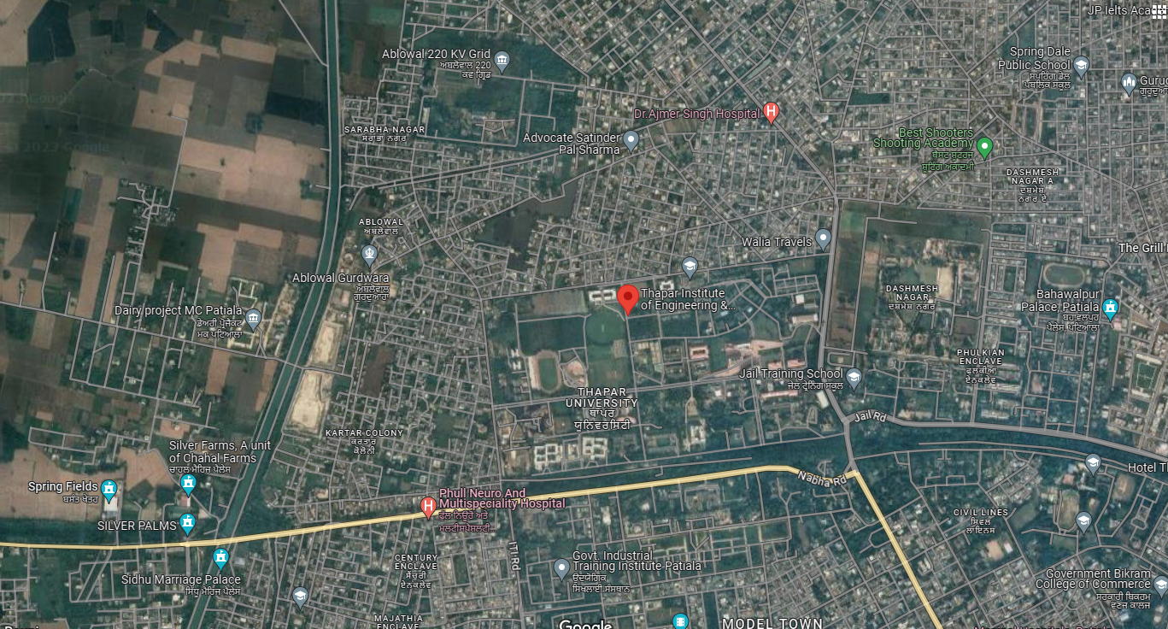
Source: Google Maps as updated on February 2023

Figure: Location of TIET (Patiala)

- SCOPE OF WORK OF THIS REPORT: Detailed cost verification of civil work & other ancillary/ value added items of the building and of furniture and fixtures.

Note: The cost verification report does not include assessment of Machinery, Lab Equipment’s, Projectors, Teaching equipment’s, or any other equipment’s.

- PURPOSE OF THE REPORT: To provide fair detailed analysis report to the client based on the “in-scope points” mentioned above for internal management assessment of TIET.

- METHODOLOGY ADOPTED:
- Collection of documents and information
- Study and analysis of the documents and information obtained from the client.
- Site Inspection
- Additional information, data, documents collection from the client.
- Correlation of the provided information against sector benchmarks/ trend.
- Information compilation, analysis and reporting.

PART C | UNIVERSITY BUIDINGS, INFRASTRUCTURE & FACILITY DETAILS

- BUILDINGS & INFRASTRUCTURE:

S. No. | Building Name | Year of Construction | Area  (Sq. Ft) | Type of Structure
 | PEB 300 Building (G+2) | 2016 | 85,716 | Pre-Engineering Building (PEB)
 | PEB 600 Building (G+2) | 2016 | 1,62,093 | Pre-Engineering Building (PEB)
 | Hostel – M (G+8) | 2017 | 5,98,894 | RCC Structure Frame Work
 | Hostel – N (G+6) | 2017 | 2,17,281 | RCC Structure Frame Work
 | Learning Block (G+5)  Lecture (G+3)  Library (G+4) | 2019 | 7,35,946 | RCC Structure Frame Work
 | FRD (Faculty Residence D Block) | 2019 | 69,900 | RCC Structure Frame Work
 | FRE (Faculty Residence E Block) | 2019 | 69,900 | RCC Structure Frame Work
 | Hostel-O (G+8) Boys Hostel | 2021 | 2,13,618 | RCC Frame Work Structure
 | LMTSOM (G+2) Boys Hostel (Chandigarh) | 2022 | 47,000 | RCC Frame Work Structure
 | TSLAS (G+2) | 2021 | 61,192 | RCC Frame Work Structure & LGFS on roof
 | CEEMS Lab/ SAI Lab (G+2) | 2021 | 8,441 | RCC Structure with LGFS Roof
 | Block-C: Electronics Lab | 2021 | 23,200 | RCC Structure with LGFS Roof
 | CS Extension | 2022 | 19,443 | RCC Structure with LGFS Roof
 | Hostel-Q (G+8) Girls Hostel | 2022 | 2,09,000 | RCC Frame Work Structure
 | Hostel-D (G+8) Boys Hostel | 2023 | 2,20,135 | RCC Frame Work Structure
 | Hostel-B (G+2) | 2022 | 1,47,406 | RCC Frame Work Structure
 | Hostel-C (G+1) | 2022 | 92,861 | RCC Frame Work Structure

- DETAILED DESCRIPTION OF BUILDINGS:

HOSTEL-L

CATEGORY | DETAILS
Construction Year | 2016
Purpose | Girls Hostel
Capacity | 300 beds
Number Of Floors | Ground + Two Upper Floors
Built-Up Area | 85,716 sq. ft.
Building Design | Pre-Engineering Building (PEB)
Flooring | Hostel rooms: Vitrified tiles
 | Common areas: Full Body Tiles
 | Staircase: Granite
Walls | Plastered and painted
 | Wooden wall panels at specific places
Ceilings | Grid False Ceiling
 | Gypsum false ceilings
HVAC/AC System | Split AC units in respective rooms
Doors | Individual rooms: Wooden shutter doors
 | Main entry (reception): Glass door
Windows | Glass and UPVC windows
Facade | Glass Fibre Reinforced Concrete (GRFC/GRC)
Safety Measures | Fire extinguishers for fire protection

DEMARCATION OF HOSTEL - L
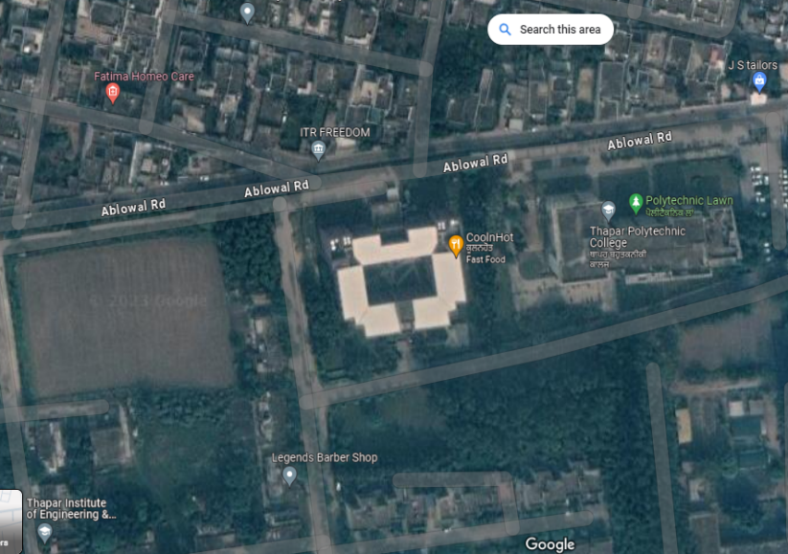
PHOTOGRAPHS OF HOSTEL - L

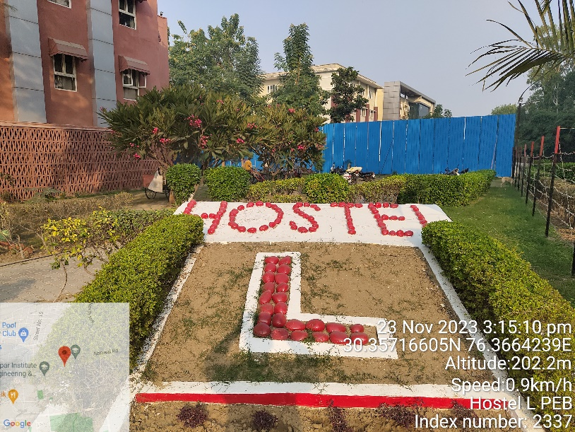 | 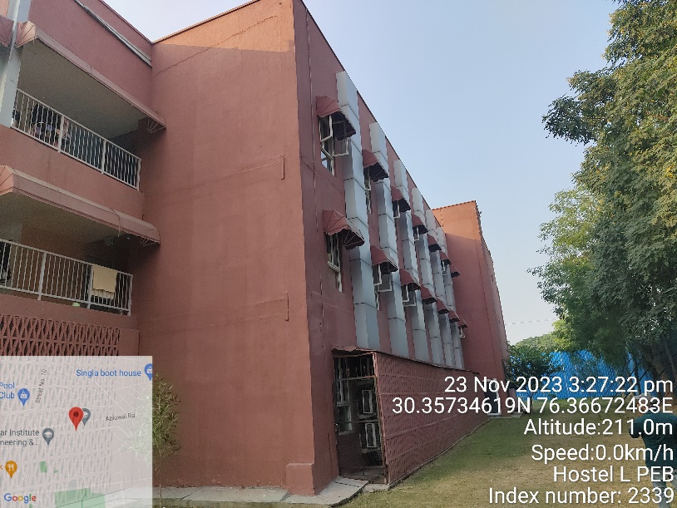
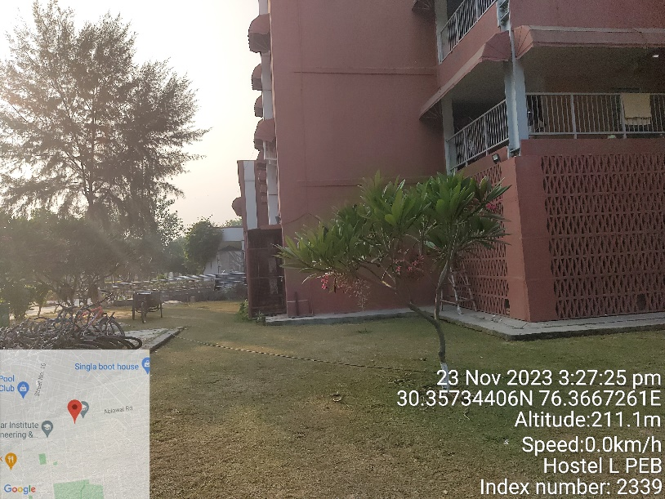 | 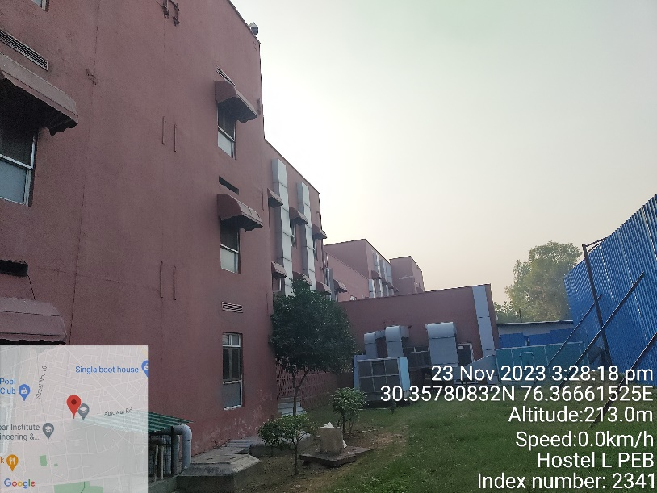
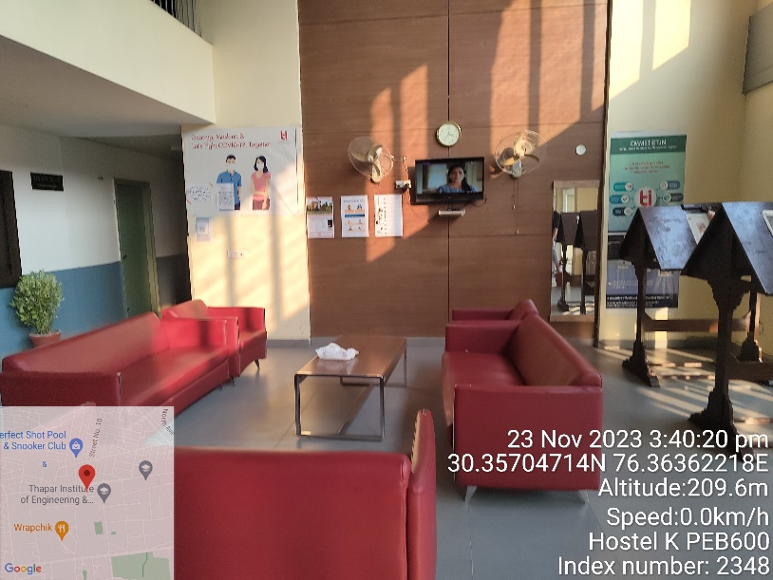 | 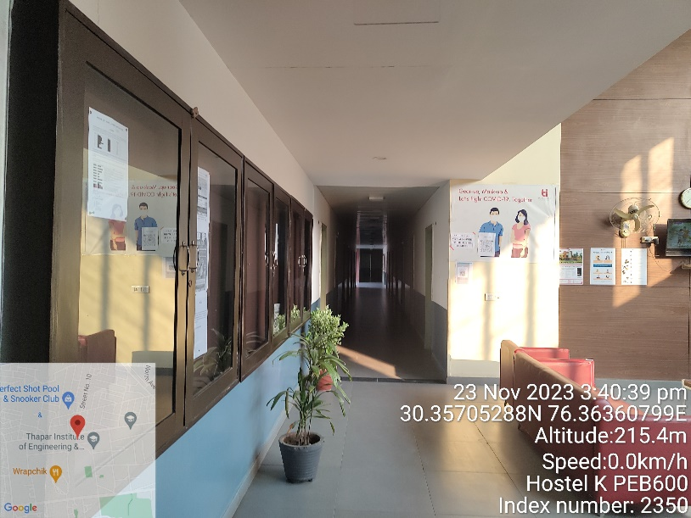

HOSTEL-K

CATEGORY | DETAILS
Construction Year | 2016
Purpose | Boys Hostel
Capacity | 600 beds
Number Of Floors | Ground + Two Upper Floors
Built-Up Area | 1,62,093 sq. ft.
Building Design | Pre-Engineering Building (PEB)
Flooring | Hostel rooms: Vitrified tiles
 | Common areas: Full Body Tiles
 | Staircase: Granite
Walls | Plastered and painted
 | Wooden wall panels at specific places
Ceilings | Grid False Ceiling
 | Gypsum false ceilings
HVAC/AC System | Split AC units in respective rooms
Doors | Individual rooms: Wooden shutter doors
 | Main entry (reception): Glass door
Windows | Glass and UPVC windows
Facade | Glass Fibre Reinforced Concrete (GRFC/GRC)
Safety Measures | Fire extinguishers for fire protection

DEMARCATION OF HOSTEL - K

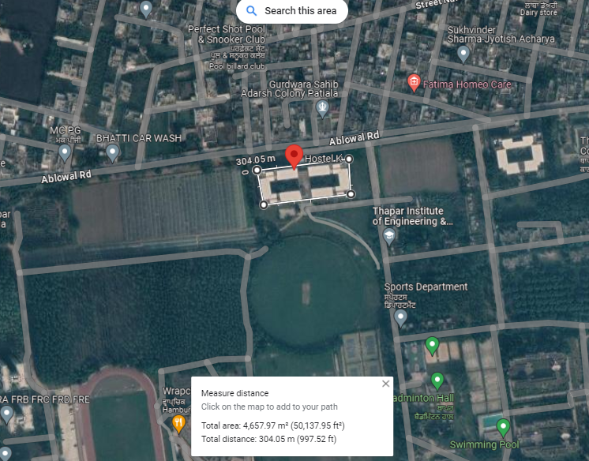
PHOTOGRAPHS OF HOSTEL - K

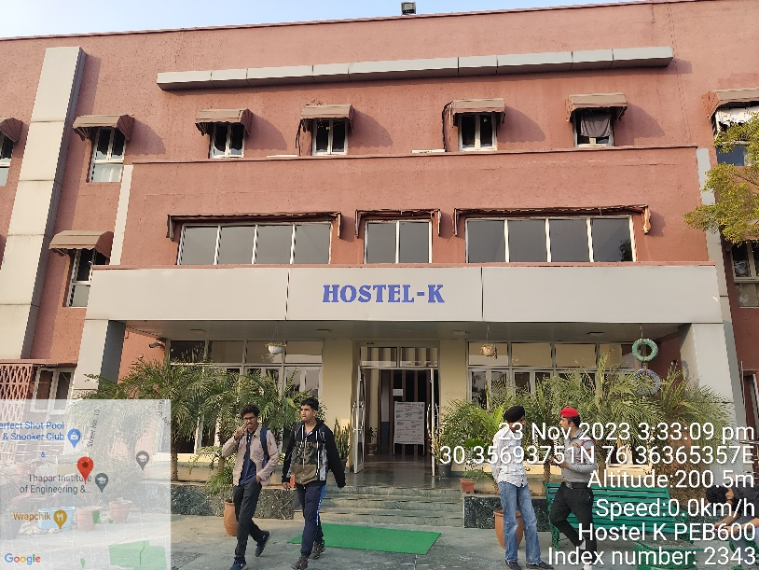 | 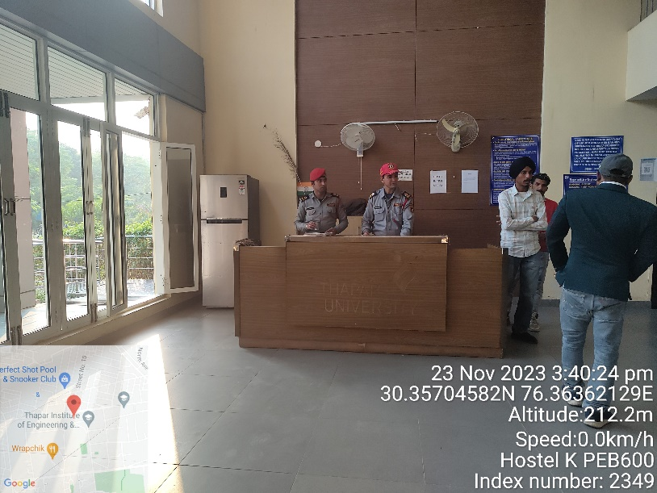
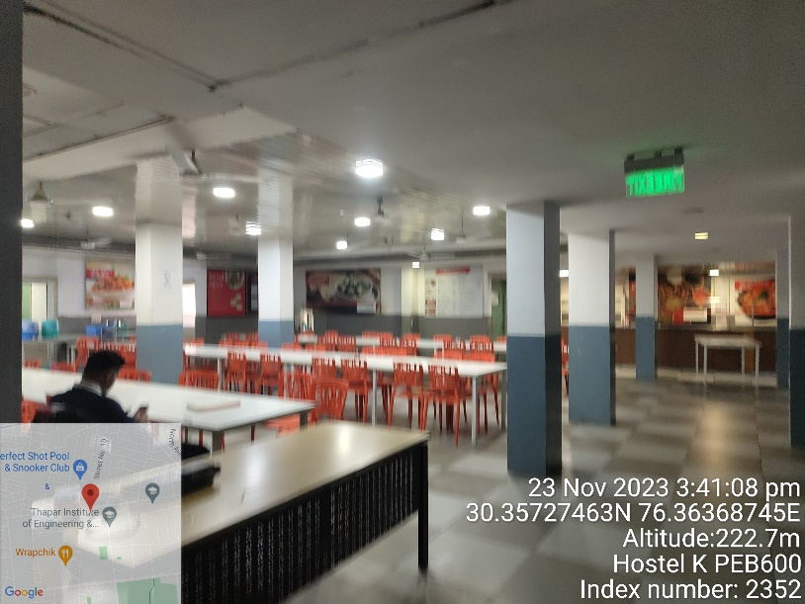 | 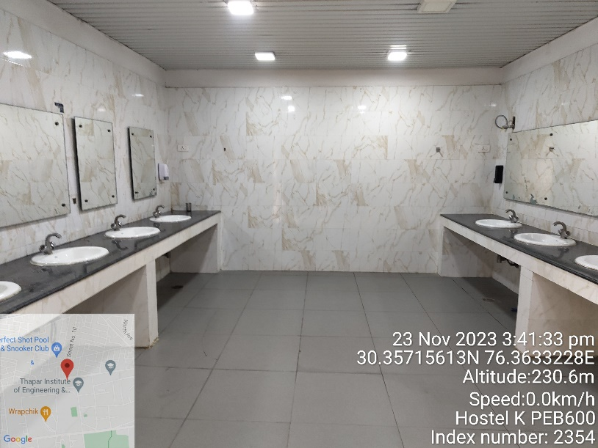
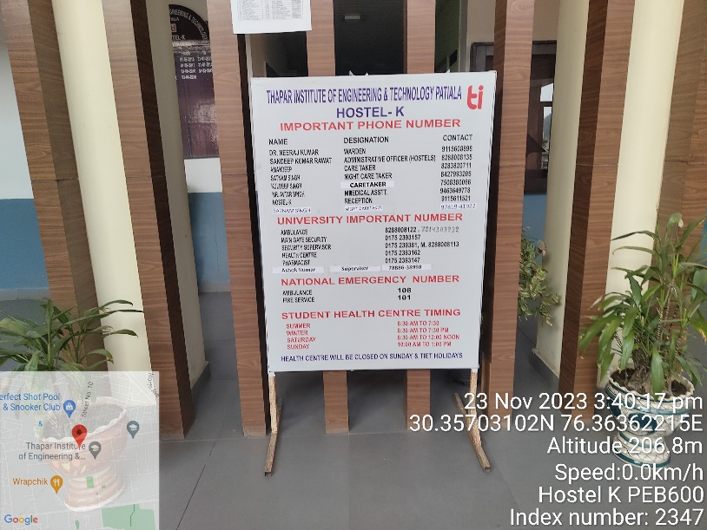 | 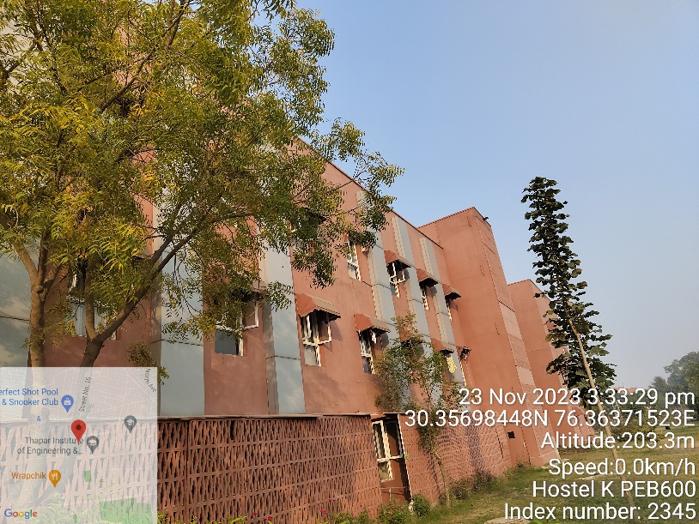
HOSTEL-M

CATEGORY | DETAILS
Construction Year | 2017
Purpose | Boys Hostel
Number Of Floors | Ground + Eight Upper Floors
Built-Up Area | 5,98,894 sq. ft.
Building Design | RCC Structure Frame Work
Flooring | Hostel rooms: Vitrified tiles
 | Common areas: Full Body Tiles
 | Staircase: Granite
Walls | Plastered and painted
 | Wooden wall panels at specific places
Ceilings | Grid False Ceiling
 | Gypsum false ceilings
HVAC/AC System | HVAC and Split AC in respective rooms
Doors | Individual rooms: Wooden shutter doors
 | Main entry (reception): Glass door
Windows | Glass and UPVC windows
Facade | Glass Fibre Reinforced Concrete (GRFC/GRC)
Safety Measures | Fire extinguishers and FHC for fire protection

DEMARCATION OF HOSTEL - M
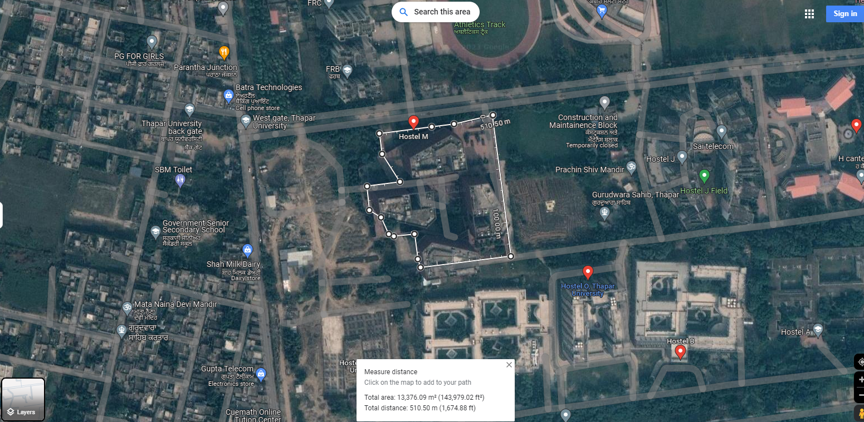

PHOTOGRAPHS OF HOSTEL - M

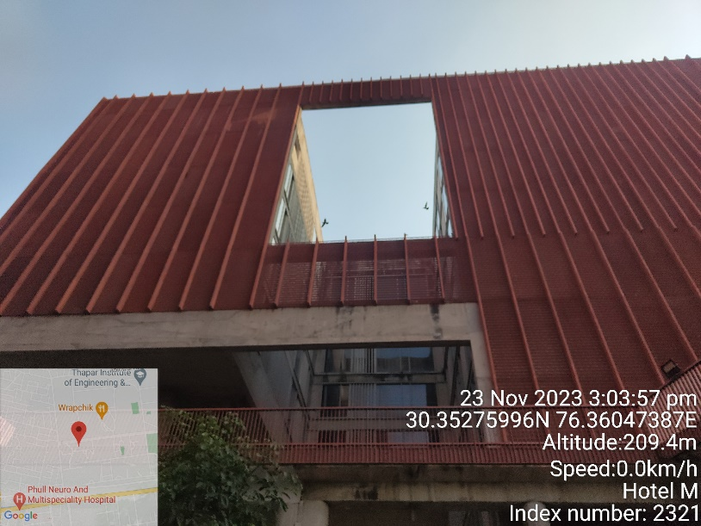 | 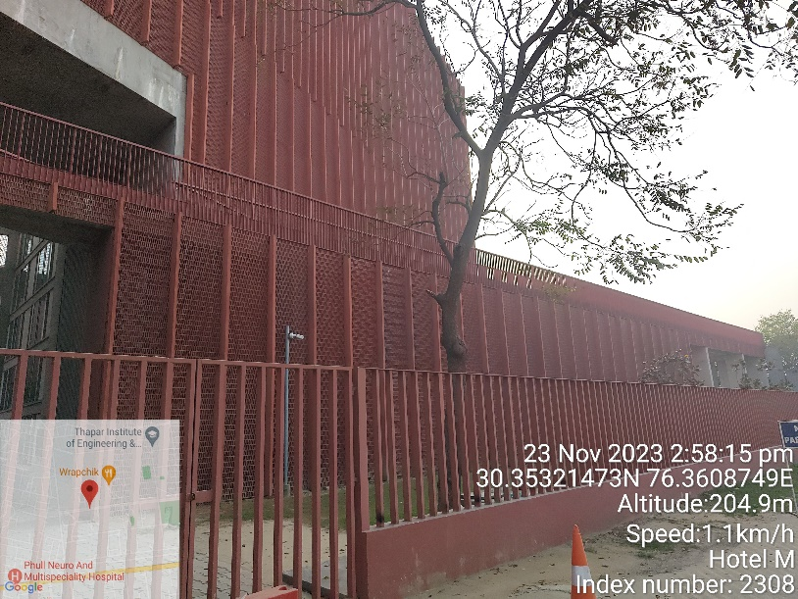
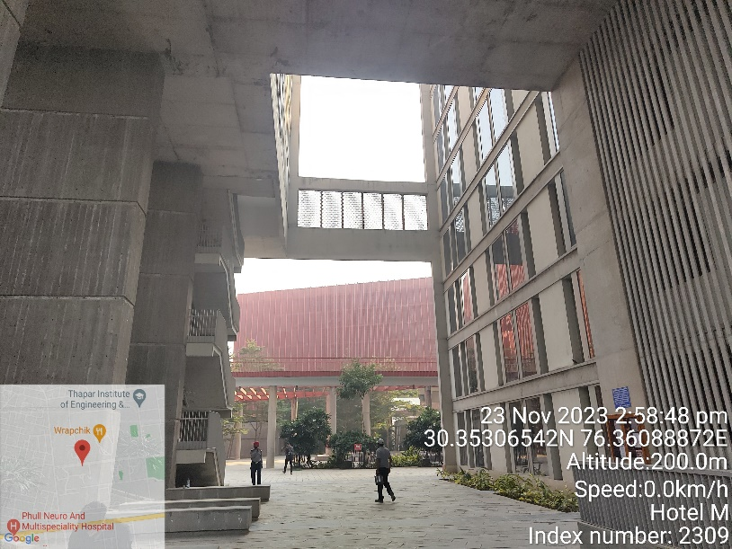 | 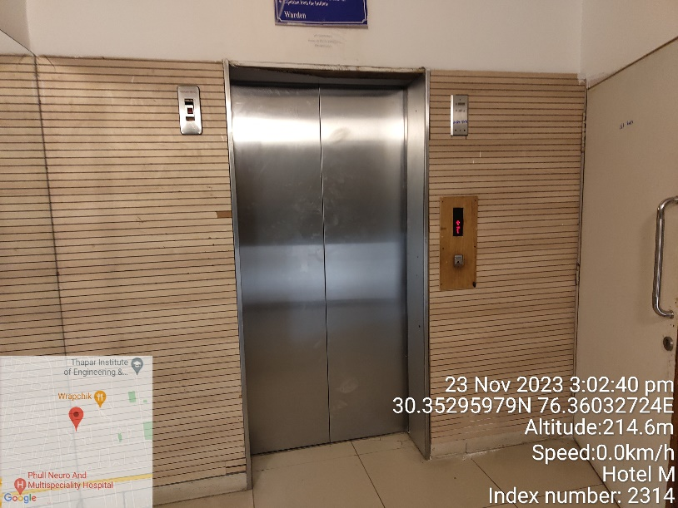
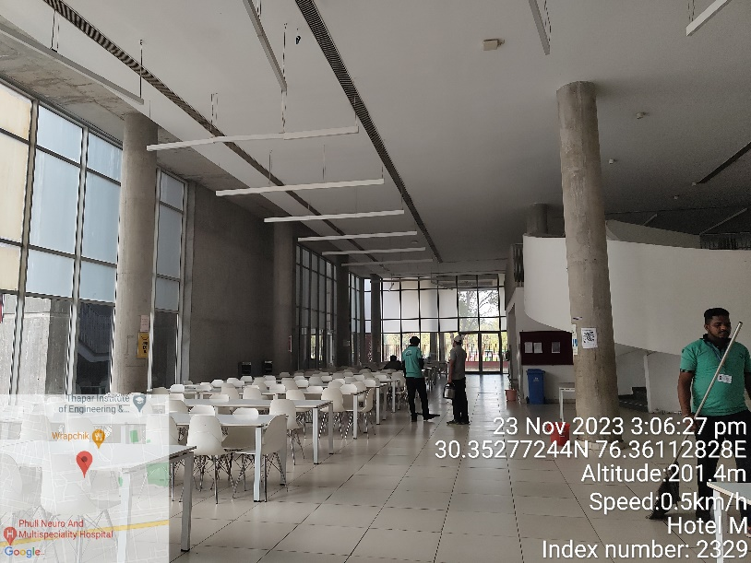 | 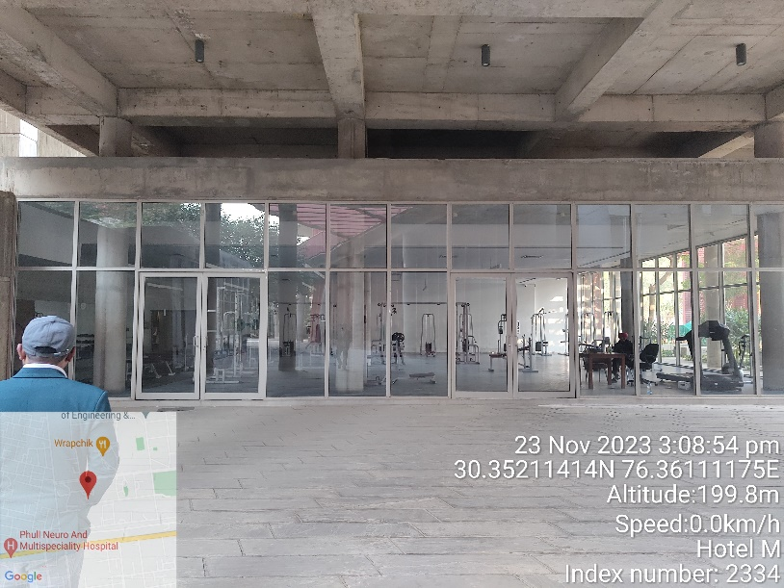

HOSTEL-N

CATEGORY | DETAILS
Construction Year | 2017
Purpose | Girls Hostel
Number Of Floors | Ground + Six Upper Floors
Built-Up Area | 2,17,281 sq. ft.
Building Design | RCC Structure Frame Work
Flooring | Hostel rooms: Vitrified tiles
 | Common areas: Full Body Tiles
 | Staircase: Granite
Walls | Concrete exposed walls, plastered and painted
 | Wooden wall panels at specific places
Ceilings | Grid False Ceiling
 | Gypsum false ceilings
HVAC/AC System | HVAC and Split AC in respective rooms
Doors | Individual rooms: Wooden shutter doors
 | Main entry (reception): Glass door
Windows | Glass and UPVC windows
Facade | Stone Cladding, Glass Façade, Glass Fibre Reinforced Concrete (GRFC/GRC)
Safety Measures | Fire extinguishers and FHC for fire protection

DEMARCATION OF HOSTEL - N

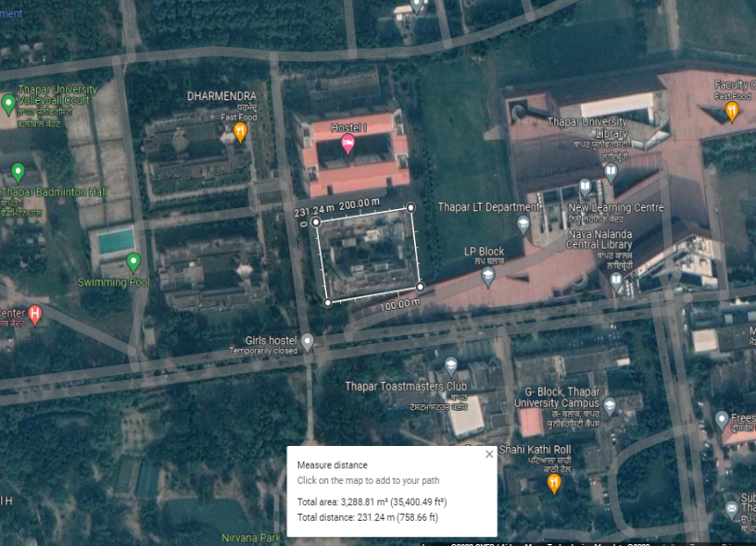
PHOTOGRAPHS OF HOSTEL - N

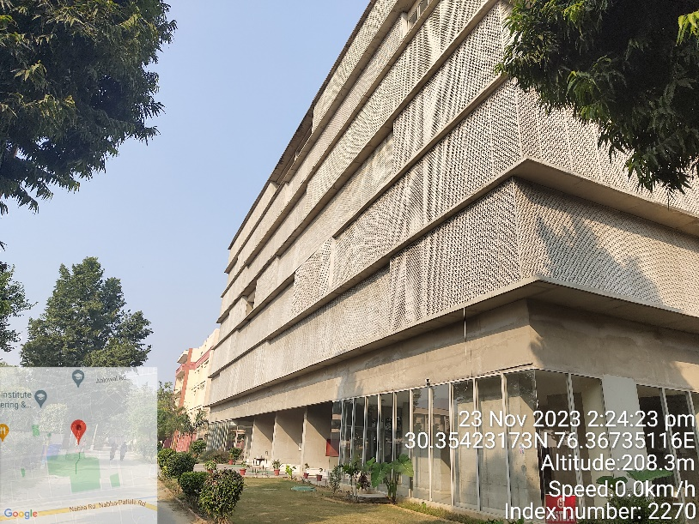 | 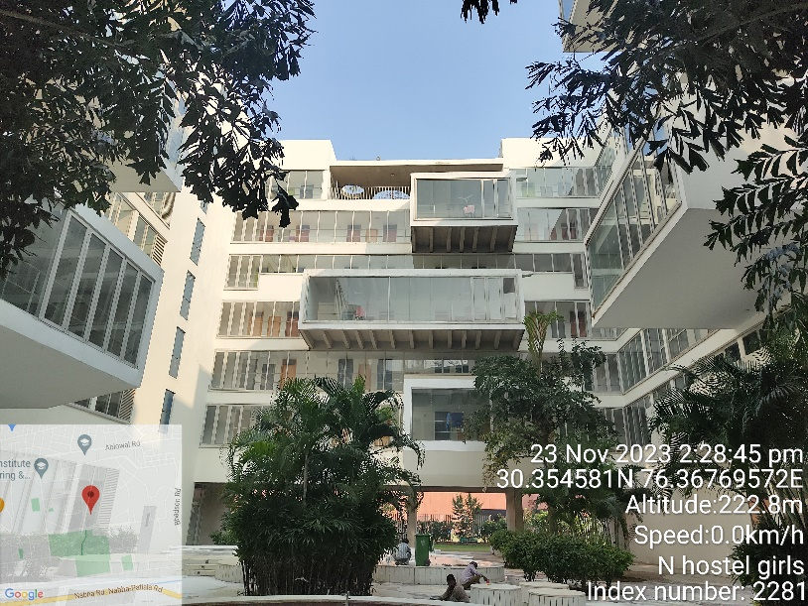
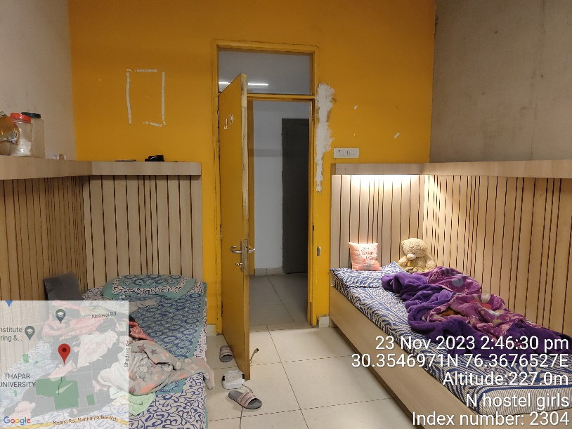 | 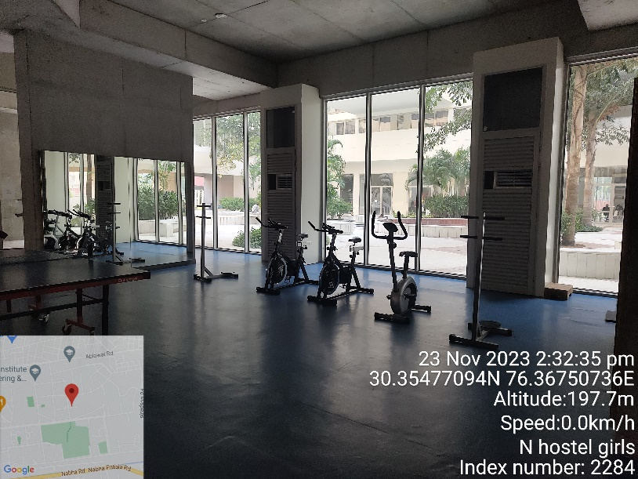
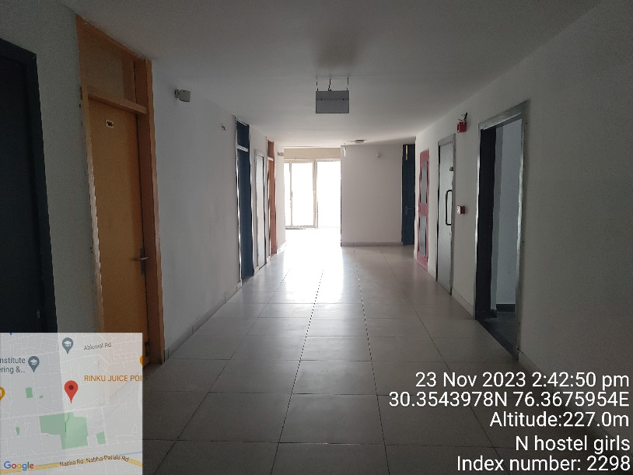 | 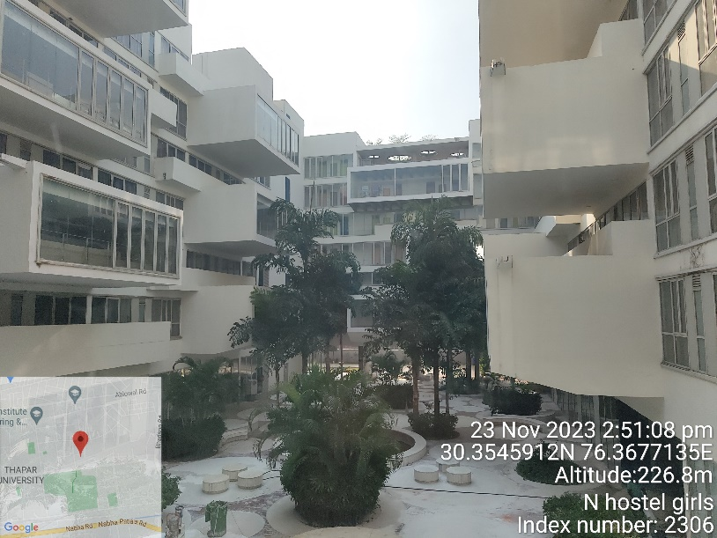

HOSTEL-O

CATEGORY | DETAILS
Construction Year | 2021
Purpose | Boys Hostel
Number Of Floors | Ground + Eight Upper Floors
Built-Up Area | 2,13,618 sq. ft.
Building Design | RCC Structure Frame Work
Flooring | Hostel rooms: Vitrified tiles
 | Common areas: Full Body Tiles, Terrazzo Flooring
 | Staircase: Granite
Walls | Plastered and painted
 | Wooden wall panels at specific places
Ceilings | Gypsum false ceilings
HVAC/AC System | HVAC and Split AC in respective rooms
Doors | Individual rooms: Wooden shutter doors
 | Main entry (reception): Glass door
Windows | Glass and UPVC windows
Facade | Glass Façade and Glass Fibre Reinforced Concrete (GRFC/GRC)
Safety Measures | Fire extinguishers and FHC for fire protection

DEMARCATION OF HOSTEL - O

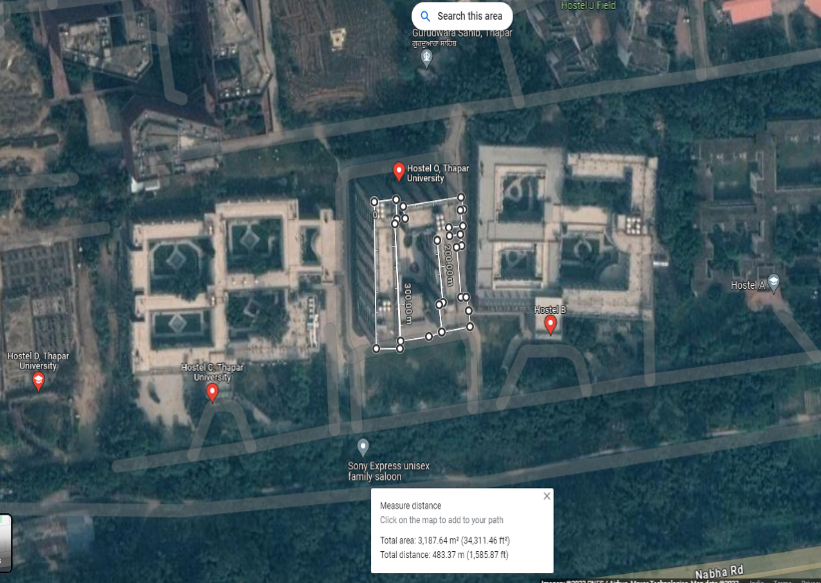
PHOTOGRAPHS OF HOSTEL - O

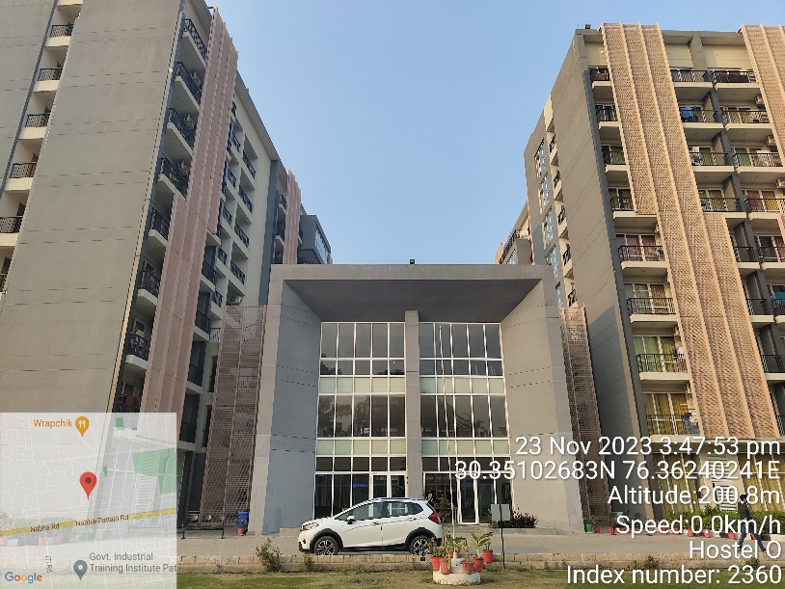 | 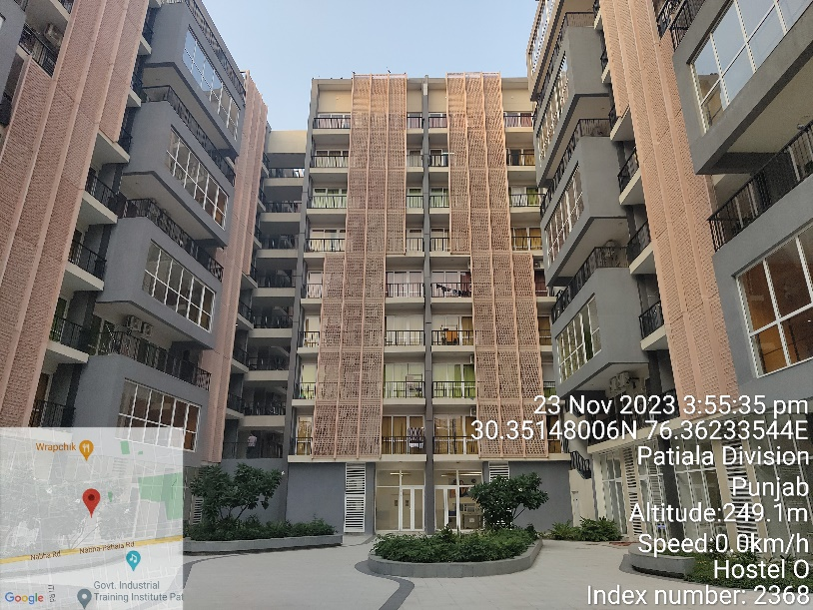
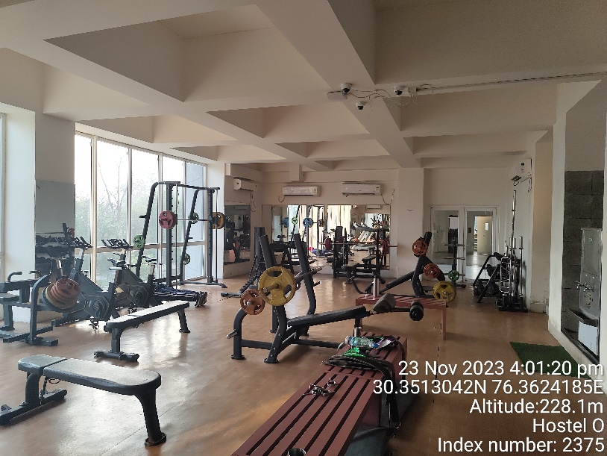 | 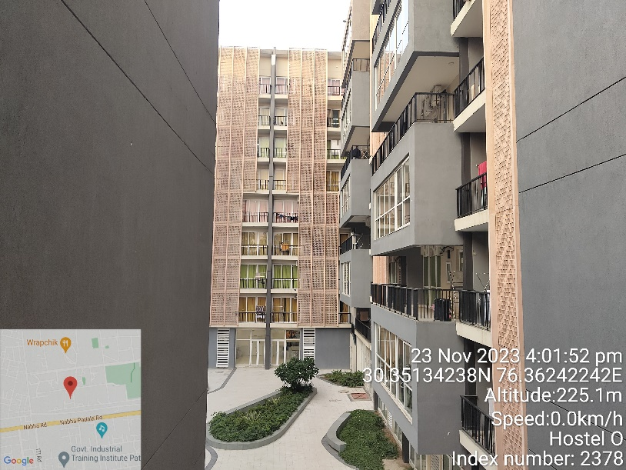
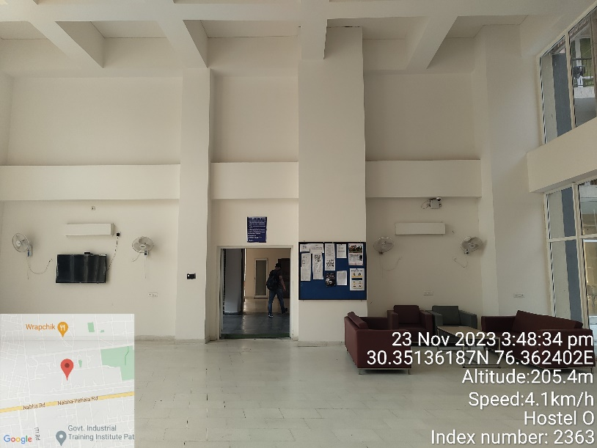 | 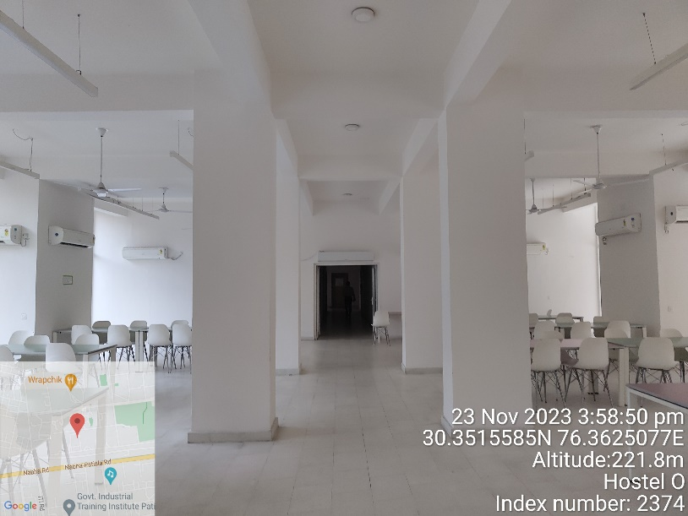

HOSTEL-D

CATEGORY | DETAILS
Construction Year | 2023
Purpose | Boys Hostel
Number Of Floors | Ground + Eight Upper Floors
Built-Up Area | 2,20,135 sq. ft.
Building Design | RCC Structure Frame Work
Flooring | Hostel rooms: Vitrified tiles
 | Common areas: Full Body Tiles, Terrazzo Flooring
 | Staircase: Granite
Walls | Plastered and painted
 | Wooden wall panels at specific places
Ceilings | Gypsum false ceilings
HVAC/AC System | HVAC and Split AC in respective rooms
Doors | Individual rooms: Wooden shutter doors
 | Main entry (reception): Glass door
Windows | Glass and UPVC windows
Facade | Glass Façade and Glass Fibre Reinforced Concrete (GRFC/GRC)
Safety Measures | Fire extinguishers and FHC for fire protection

DEMARCATION OF HOSTEL – D

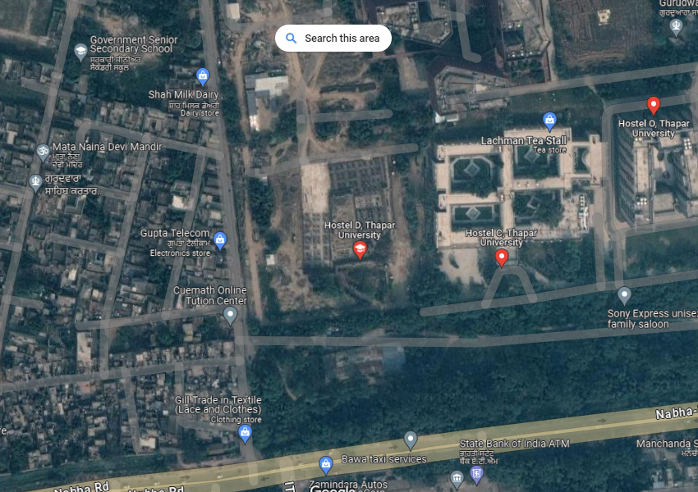
PHOTOGRAPHS OF HOSTEL - D

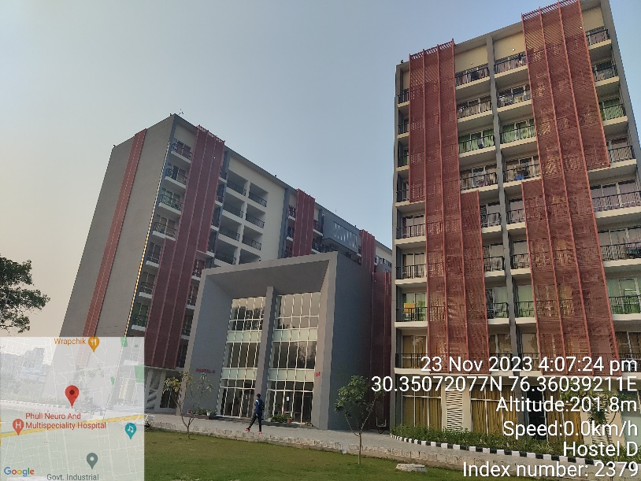 | 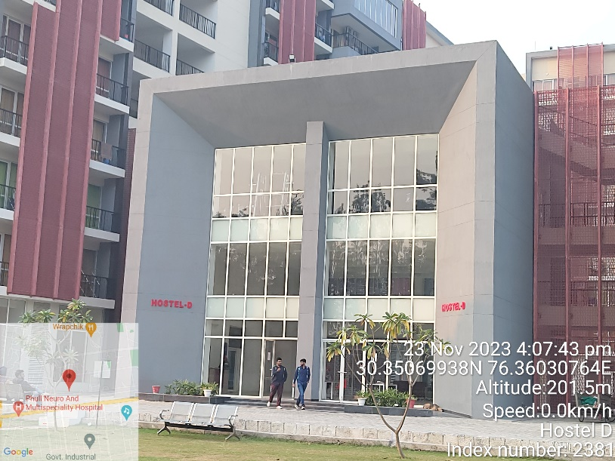
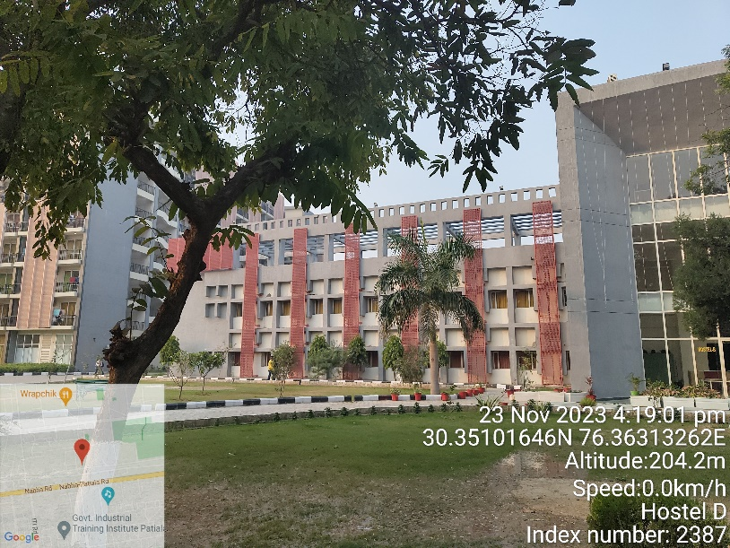 | 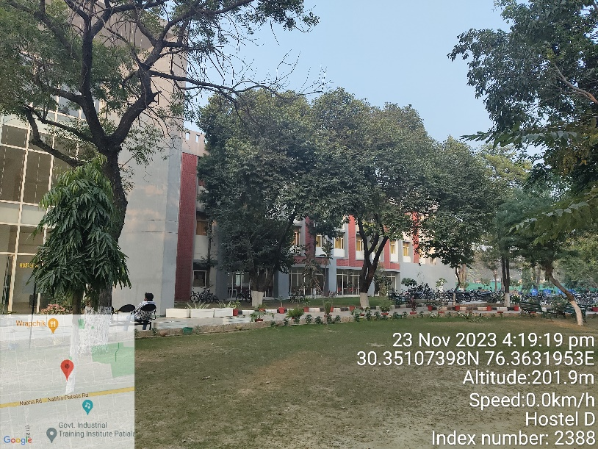

HOSTEL-Q

CATEGORY | DETAILS
Construction Year | 2023
Purpose | Boys Hostel
Number Of Floors | Ground + Eight Upper Floors
Built-Up Area | 2,09,000 sq. ft.
Building Design | RCC Structure Frame Work
Flooring | Hostel rooms: Vitrified tiles
 | Common areas: Full Body Tiles, Terrazzo Flooring
 | Staircase: Granite
Walls | Plastered and painted
 | Wooden wall panels at specific places
Ceilings | Gypsum false ceilings
HVAC/AC System | HVAC and Split AC in respective rooms
Doors | Individual rooms: Wooden shutter doors
 | Main entry (reception): Glass door
Windows | Glass and UPVC windows
Facade | Glass Façade and Glass Fibre Reinforced Concrete (GRFC/GRC)
Safety Measures | Fire extinguishers and FHC for fire protection

DEMARCATION OF HOSTEL - Q
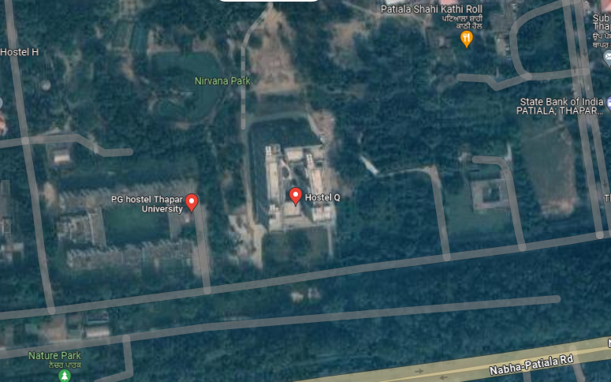

PHOTOGRAPHS OF HOSTEL - Q

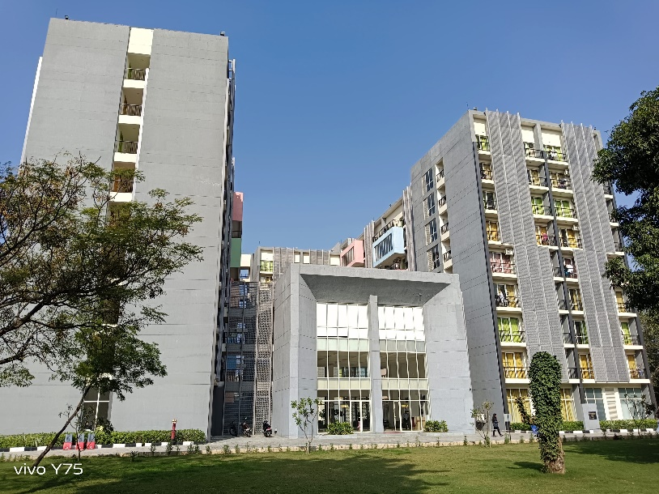 | 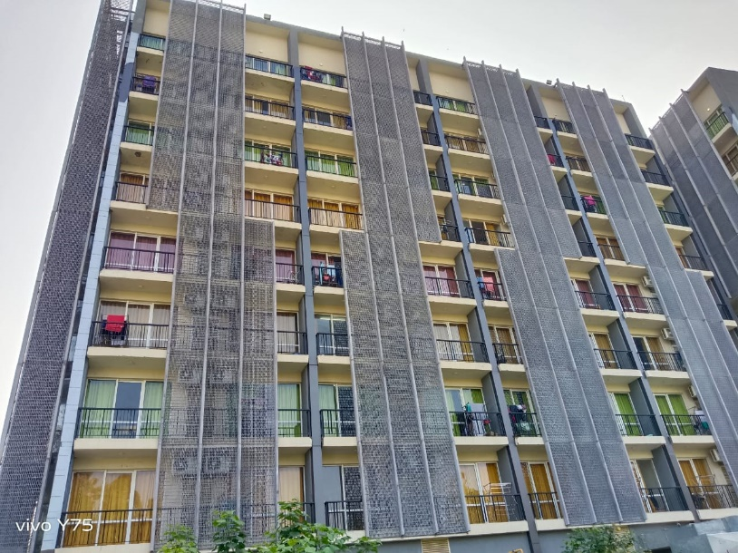
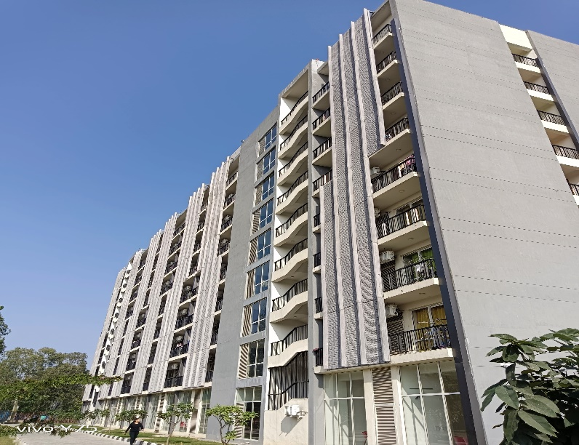 | 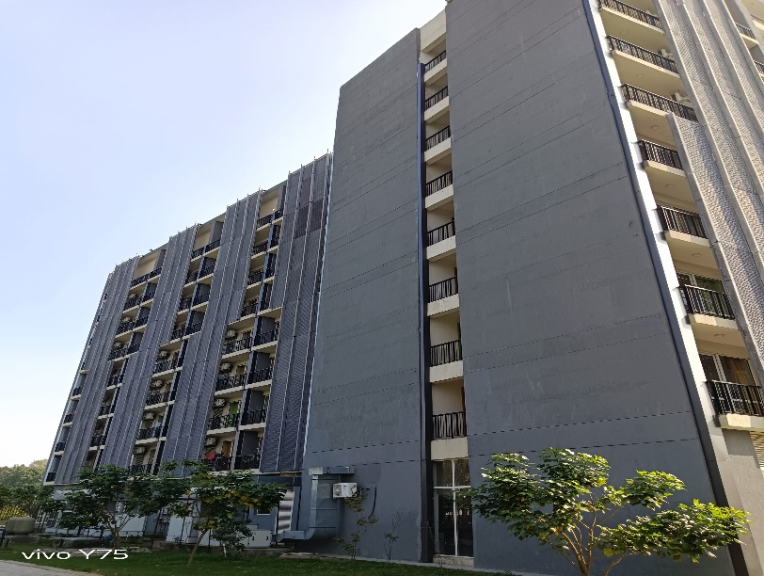

HOSTEL-B & C

CATEGORY | DETAILS
Construction Year | 2022
Purpose | Hostel
Number Of Floors | Ground + Two Upper Floors (HOSTEL-B)
 | Ground + One Upper Floor (HOSTEL-C)
Built-Up Area | 1,47,406 sq. ft. (HOSTEL-B)
 | 92,861 sq. ft. (HOSTEL-C)
Building Design | RCC Structure Frame Work
Flooring | Hostel rooms: Vitrified tiles
 | Common areas: Full Body Tiles
 | Gym: Wooden Synthetic Finish
 | Staircase: Granite
Walls | Plastered and painted
 | Wooden wall panels at specific places
Ceilings | Gypsum false ceilings
HVAC/AC System | HVAC and Split AC in respective rooms
Doors | Individual rooms: Wooden shutter doors
 | Main entry (reception): Glass door
Windows | Glass and UPVC windows
Facade | Glass Façade and Glass Fibre Reinforced Concrete (GRFC/GRC)
Safety Measures | Fire extinguishers and FHC for fire protection

DEMARCATION OF HOSTEL – B & C

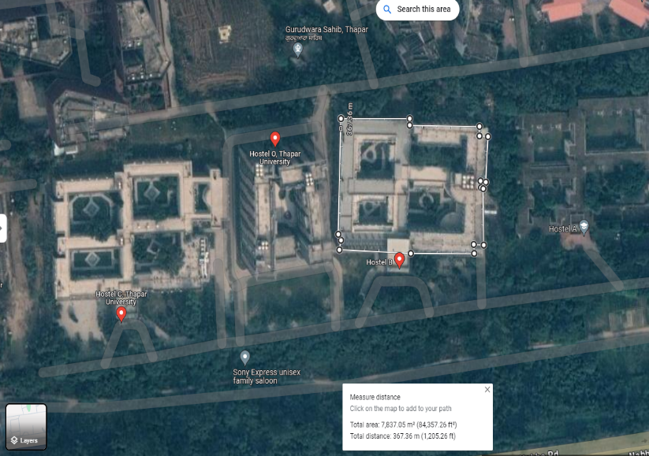 | 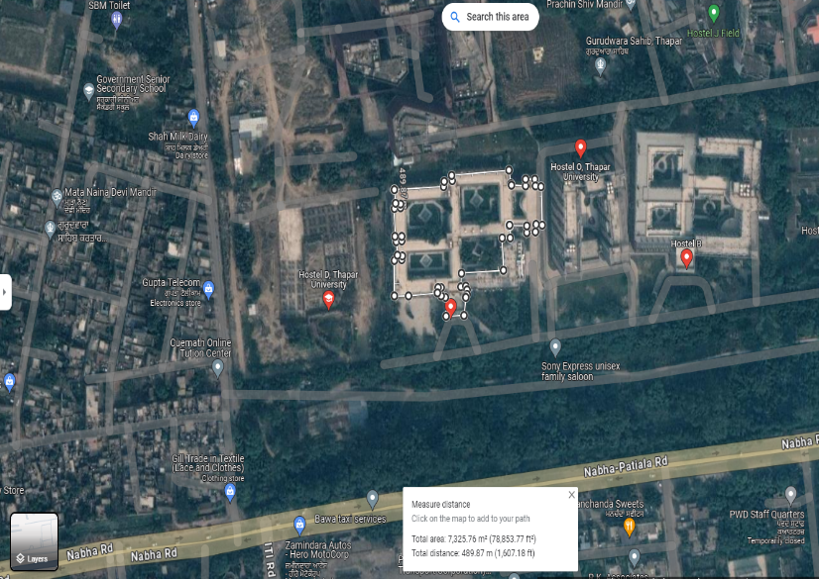

PHOTOGRAPHS OF HOSTEL – B & C

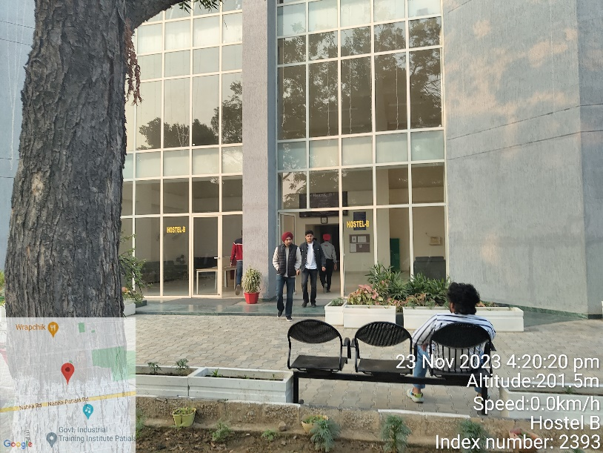 | 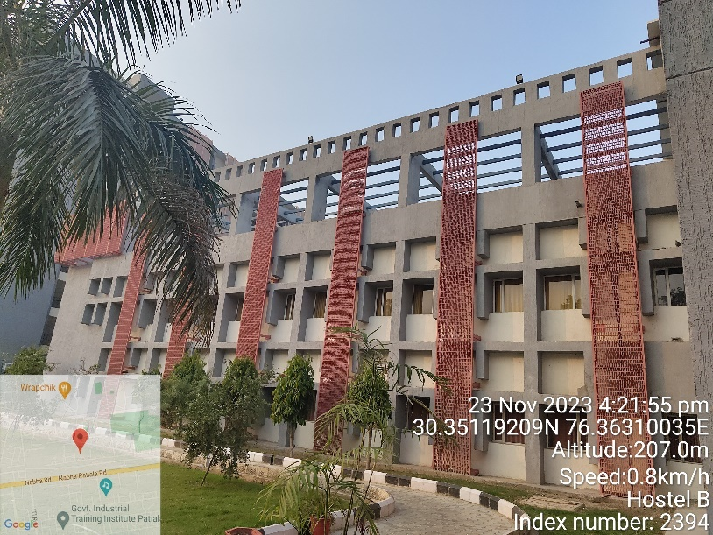
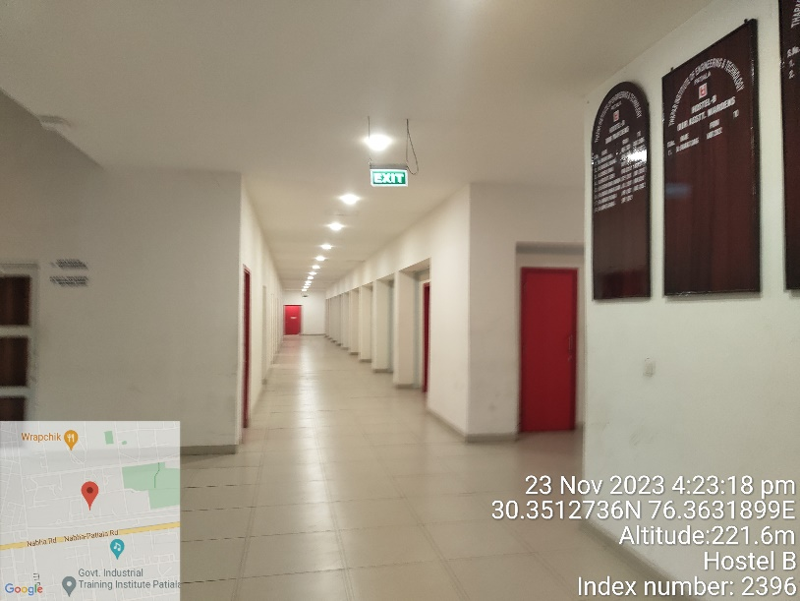 | 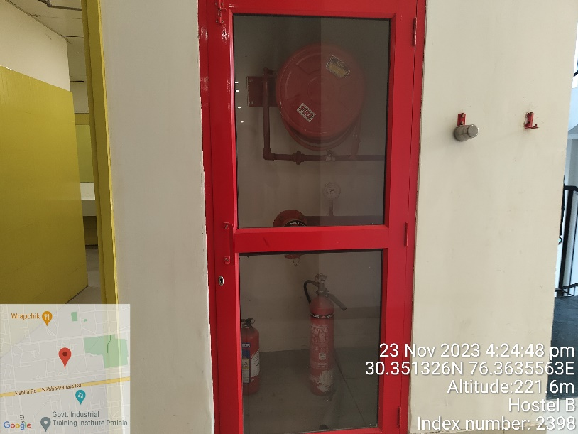
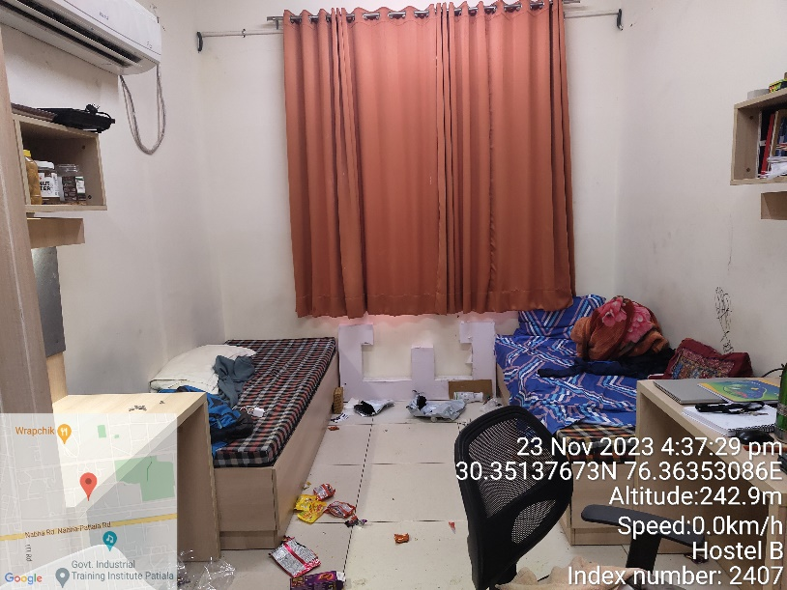 | 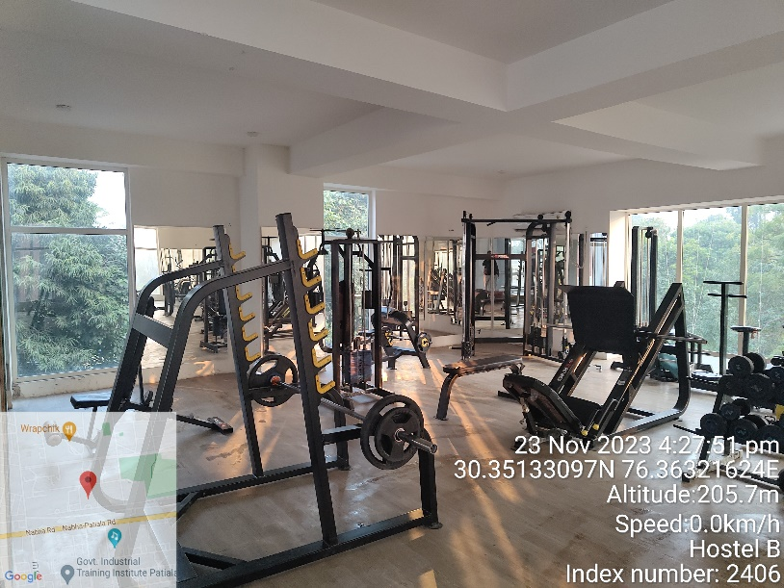

FRE & FRD (Faculty Residence)

CATEGORY | DETAILS
Construction Year | 2019 (Same for both)
Purpose | Faculty Residence
Number Of Floors | Stilt + Eight Upper Floors (Same for both)
Built-Up Area | 69,900 sq. ft. (Same for both)
Building Design | RCC Structure Frame Work
Flooring | Flats: Vitrified tiles
 | Common areas: Vitrified tiles
 | Staircase: Granite
Walls | Plastered and painted
Ceilings | As per individual flat owner requirement
HVAC/AC System | Split Ac In respective flats
Doors | Individual rooms: Wooden shutter doors
Windows | Glass and UPVC windows
Facade | Glass Fibre Reinforced Concrete (GRFC/GRC)
Safety Measures | Fire Sprinklers, FAPA and Fire extinguishers

DEMARCATION OF FRE & FRD
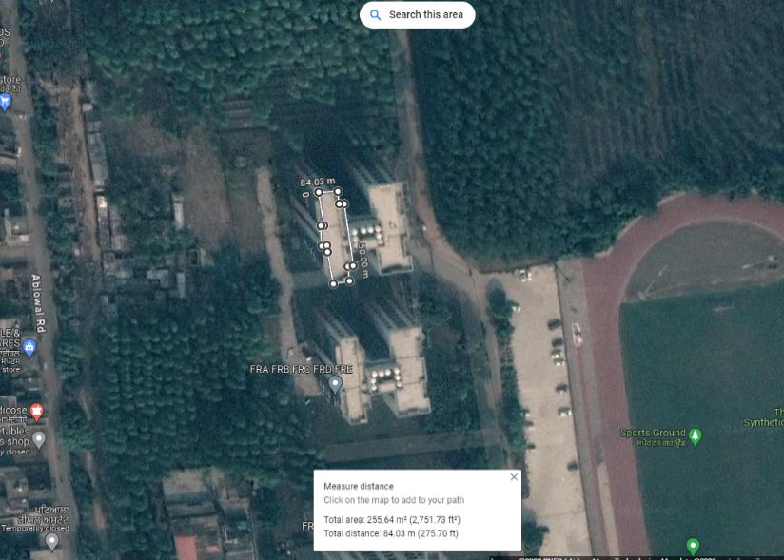

PHOTOGRAPHS OF FRE & FRD

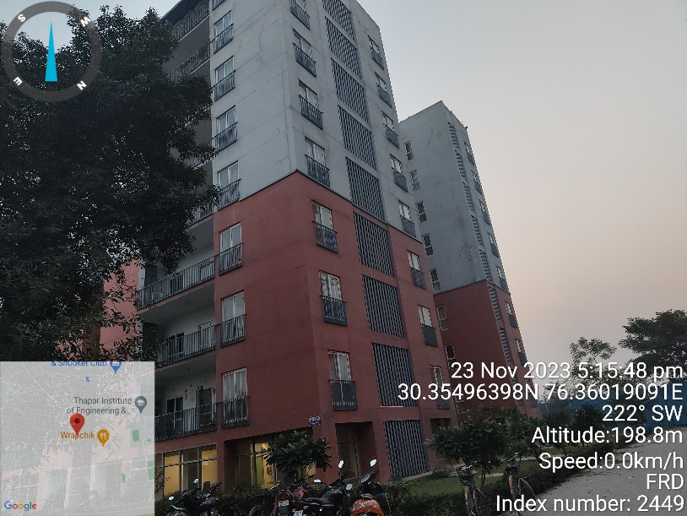 | 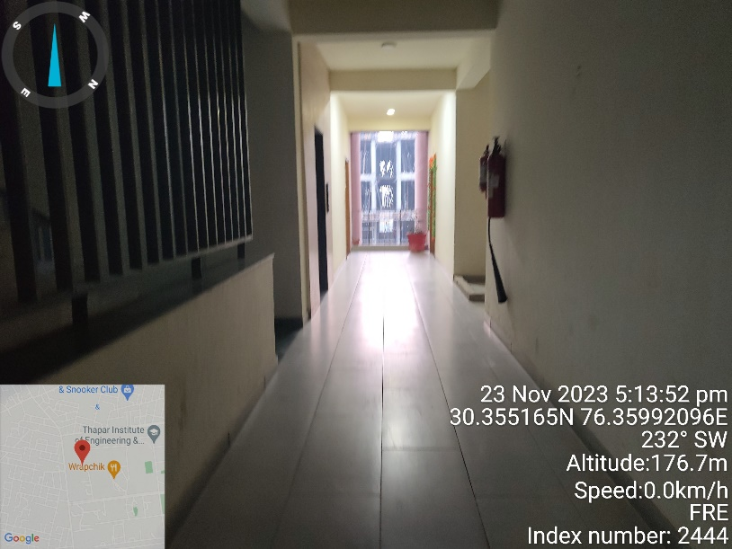
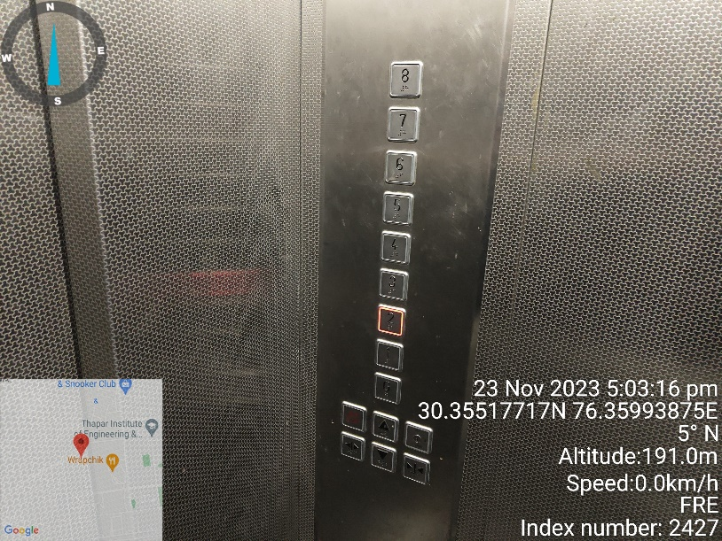 | 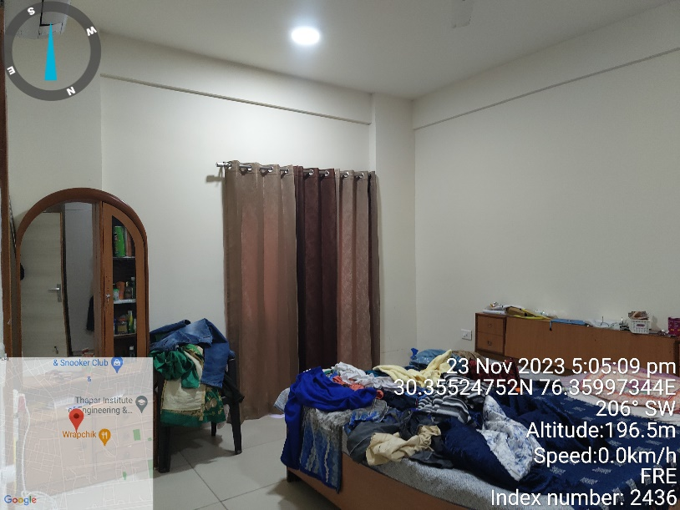
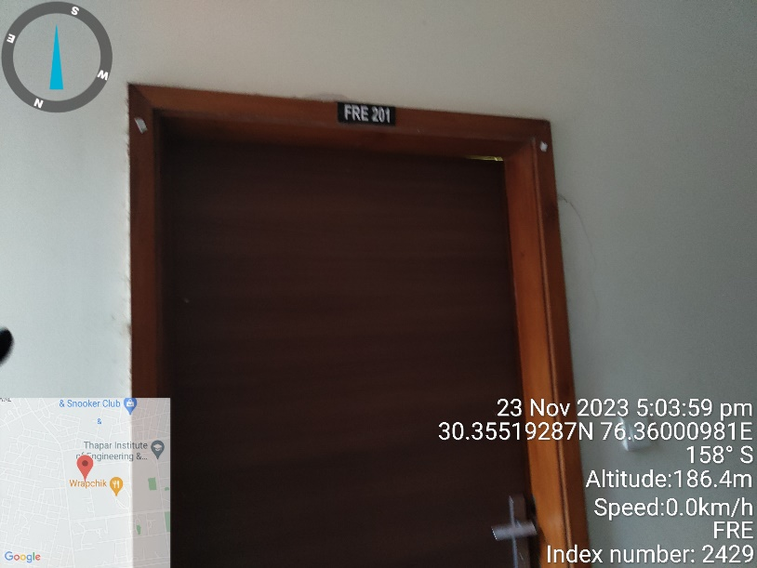 | 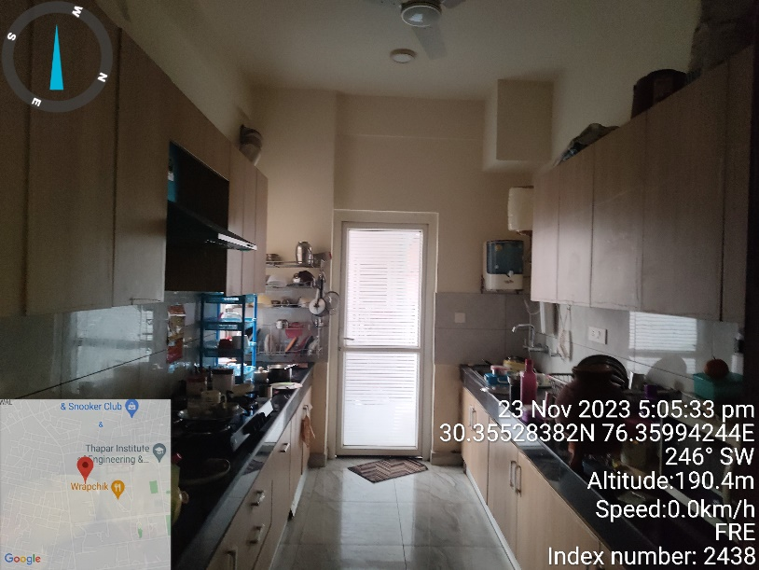

CEEMS LAB(SAI LAB)

CATEGORY | DETAILS
Construction Year | 2021
Purpose | Laboratory
Number Of Floors | Ground + Two Upper Floors
Built-Up Area | 8,441 sq. ft.
Building Design | RCC Structure Frame Work, with LGFS Room
Flooring | Classes/Labs : Vinyl Flooring
 | Common areas: Full Body Tiles
 | Staircase: Granite
Walls | Painted, Wooden Cladding Work, Acoustic panels on class/lab walls, Sound Proof walls.
Ceilings | Grid and Gypsum False Ceiling
HVAC/AC System | HVAC and Split Ac
Doors | Veneer coated Wooden frame doors
Windows | Glass and UPVC windows
Facade | Textured Walls
Safety Measures | Fire Sprinklers, FAPA and Fire extinguishers

DEMARCATION OF CEEMS LAB (SAI LAB)
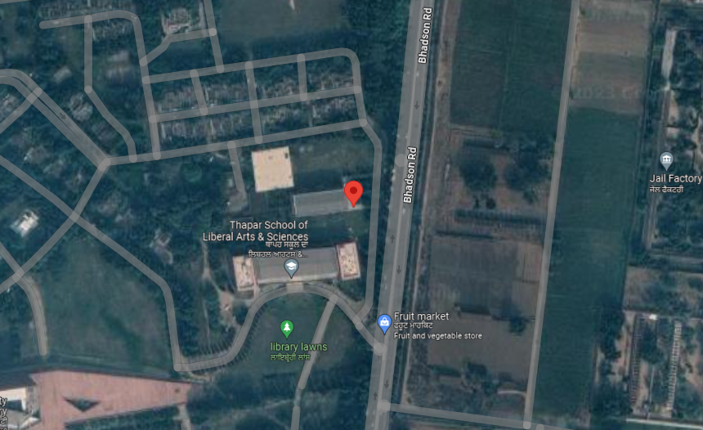

PHOTOGRAPHS OF CEEMS LAB (SAI LAB)

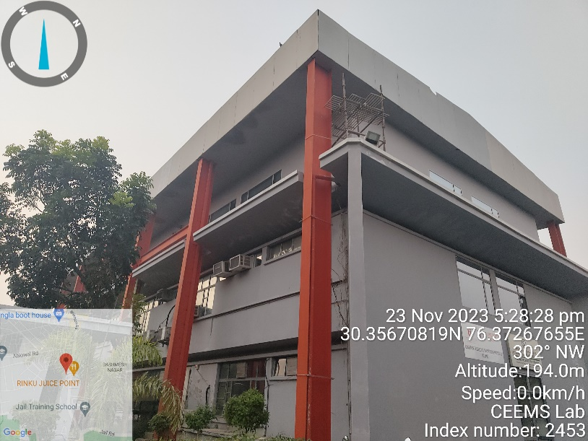 | 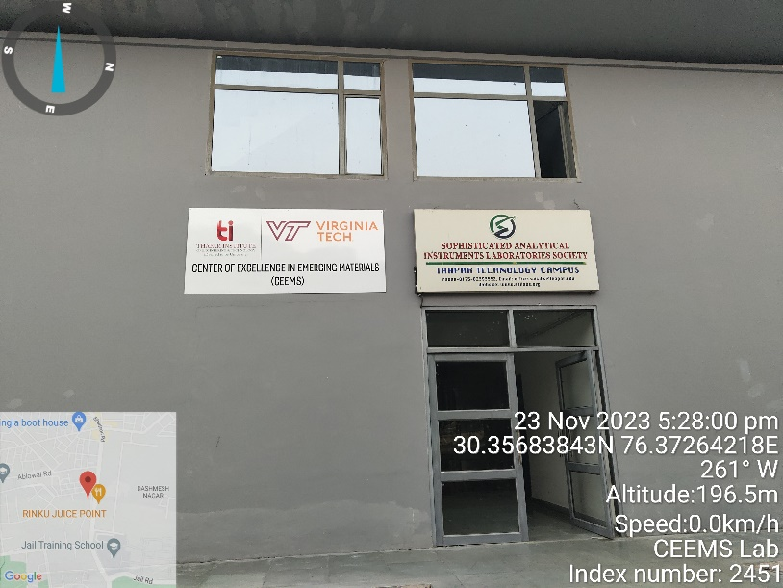
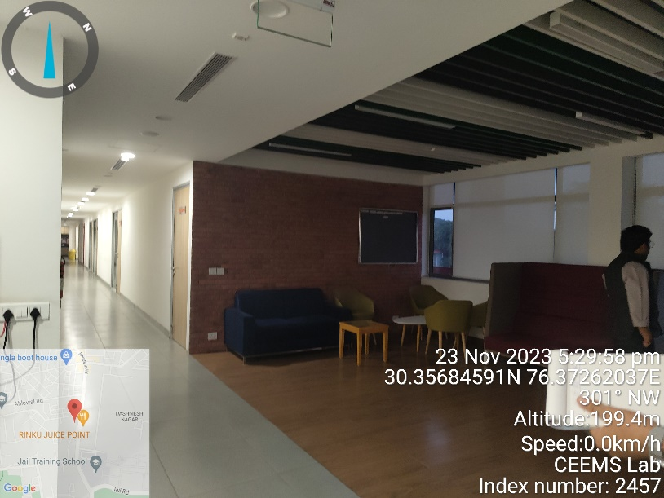 | 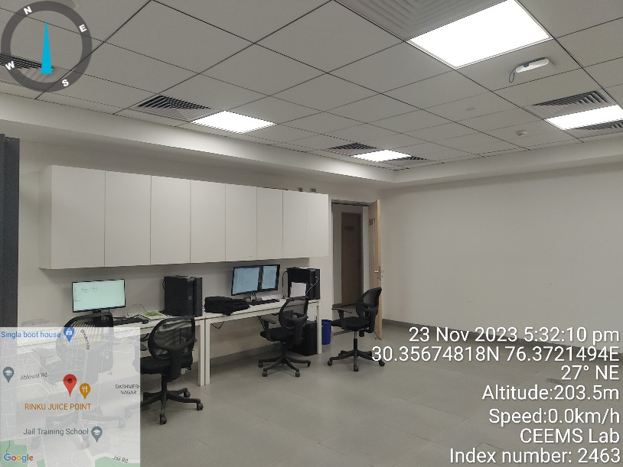
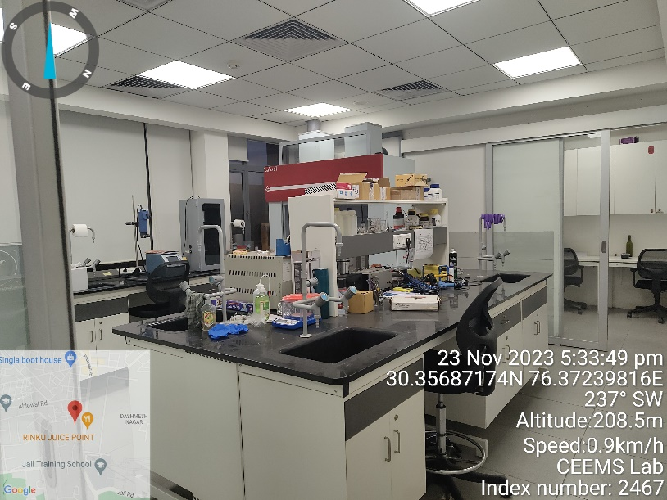 | 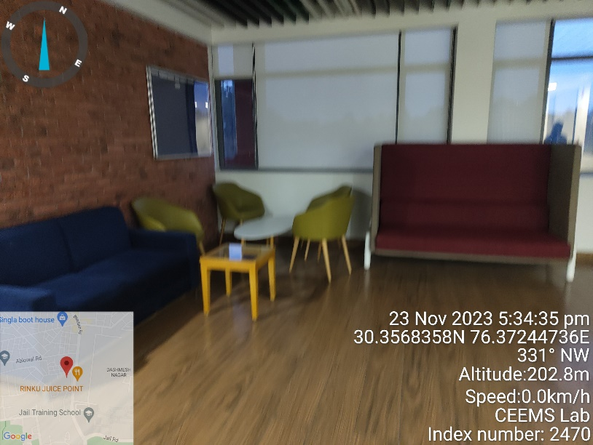

TSLAS

CATEGORY | DETAILS
Construction Year | 2021
Purpose | School Of Liberal Arts and Science
Number Of Floors | Ground + Two Upper Floors
Built-Up Area | 61,192 sq. ft.
Building Design | RCC Structure Frame Work, with LGFS Room
Flooring | Classes: Vinyl Flooring
 | Common areas: Full Body Tiles, Terrazzo flooring
 | Staircase: Granite
Walls | Painted, Wooden Cladding Work, Acoustic panels on class/lab walls, Sound Proof walls.
Ceilings | Grid and Gypsum False Ceiling
HVAC/AC System | HVAC and Split Ac
Doors | Veneer coated Wooden frame doors
Windows | Glass and UPVC windows
Facade | Glass Facade
Safety Measures | Fire Sprinklers, FAPA and Fire extinguishers

DEMARCATION OF TSLAS

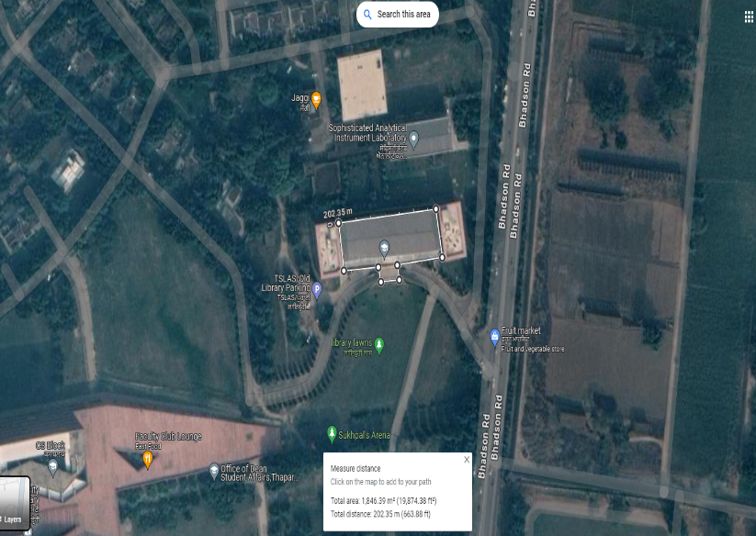

PHOTOGRAPHS OF TSLAS

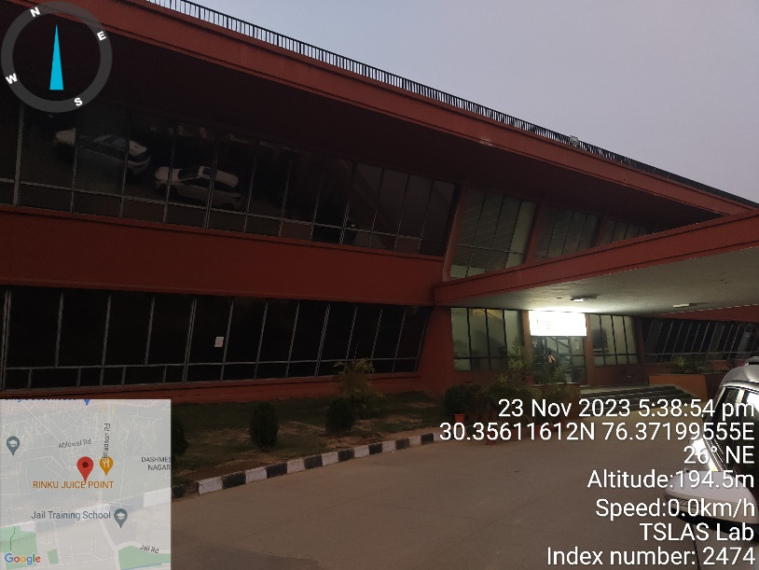 | 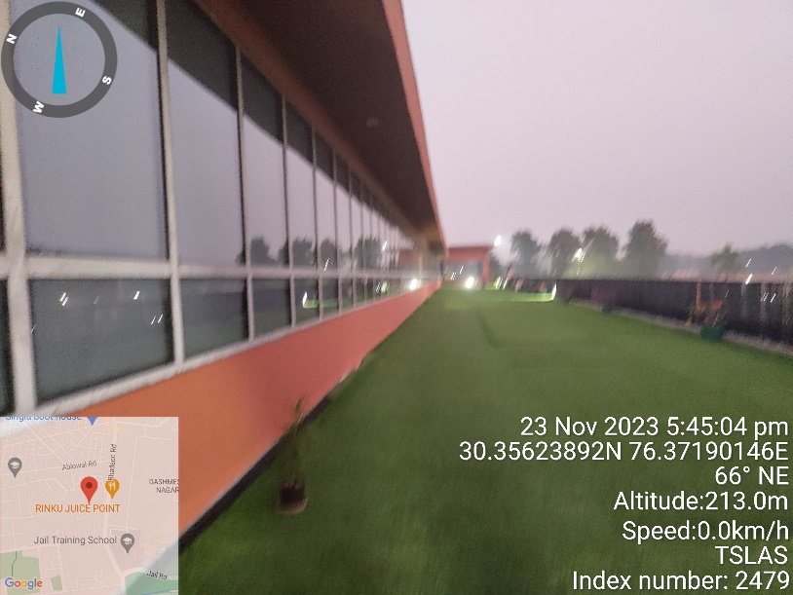
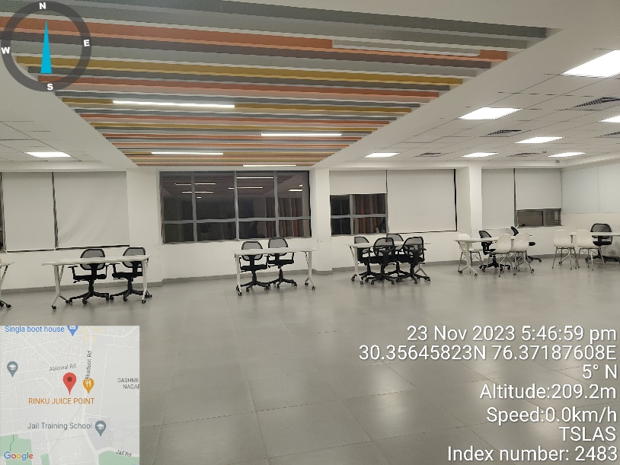 | 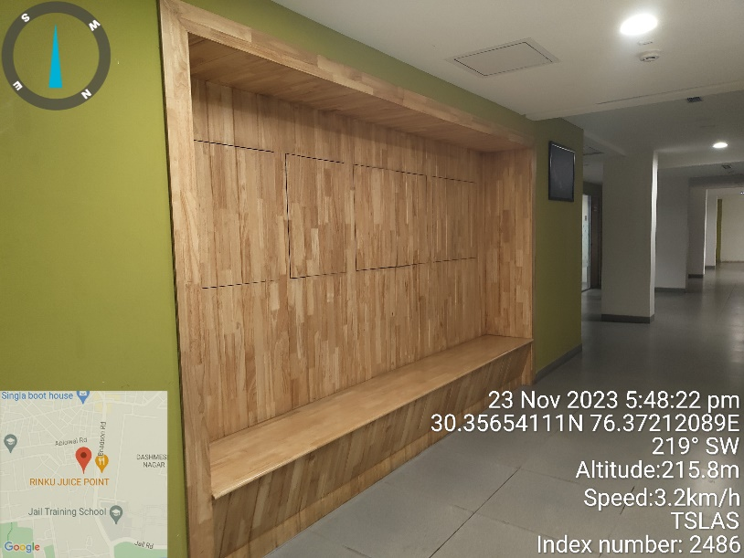
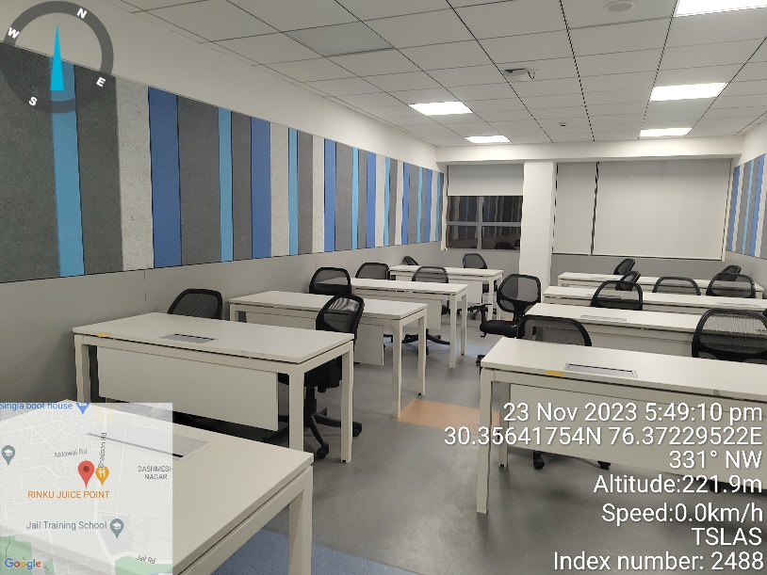 | 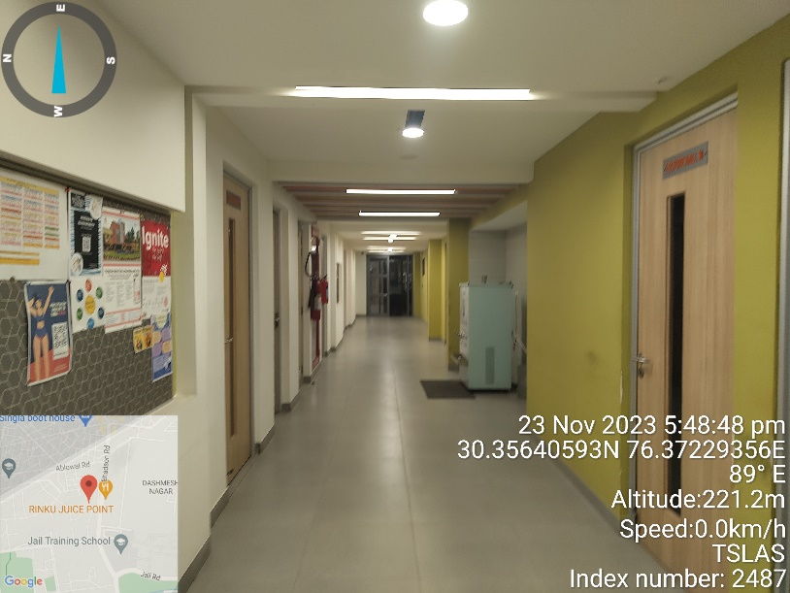

BLOCK-C ELECTRONICS LAB

CATEGORY | DETAILS
Construction Year | 2021
Purpose | Electronics Lab
Number Of Floors | Ground + Two Upper Floors
Built-Up Area | 23,200 sq. ft.
Building Design | RCC Structure Frame Work, with LGFS Room
Flooring | Classes: Wooden Flooring
 | Common areas: Full Body Tiles
 | Staircase: Granite
Walls | Painted, Textured walls, Tiles on walls.
Ceilings | Grid and Gypsum False Ceiling
HVAC/AC System | HVAC and Split Ac
Doors | Veneer coated Wooden frame doors
Windows | Glass and UPVC windows
Facade | Glass Fibre Reinforced Concrete (GRFC/GRC)
Safety Measures | Fire Sprinklers, FAPA and Fire extinguishers

DEMARCATION OF ELECTRONICS LAB
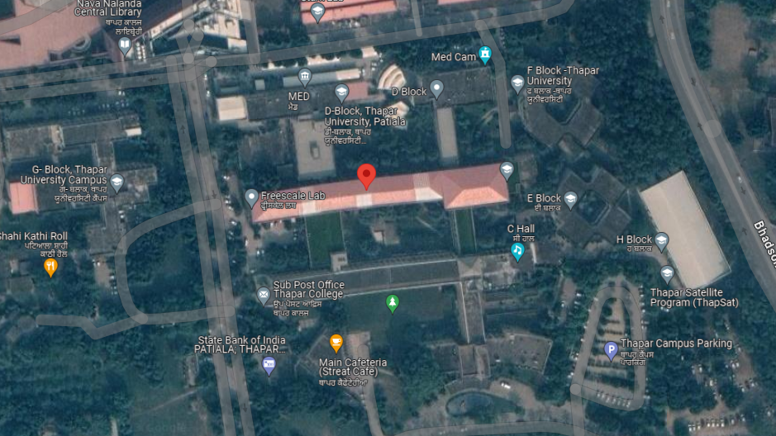

PHOTOGRAPHS OF ELECTRONICS LAB

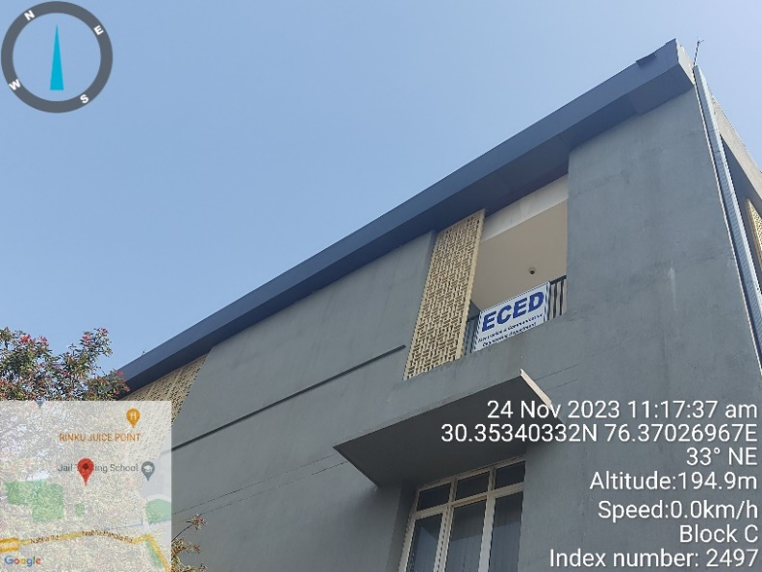 | 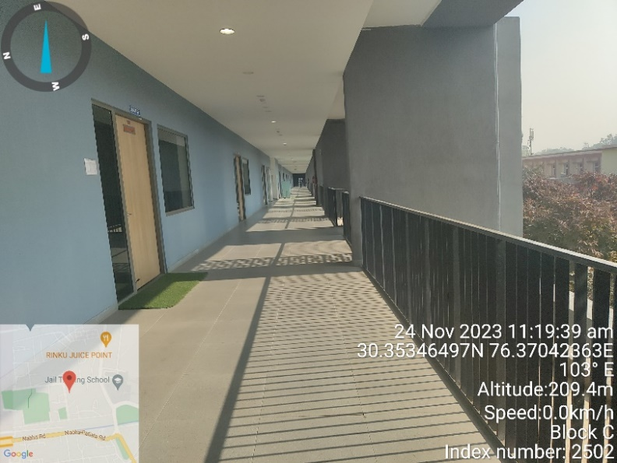
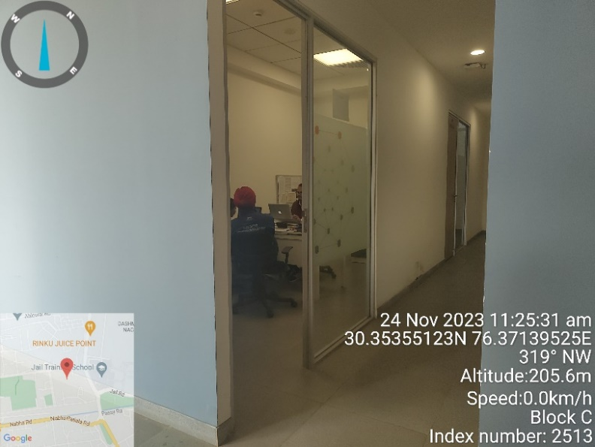 | 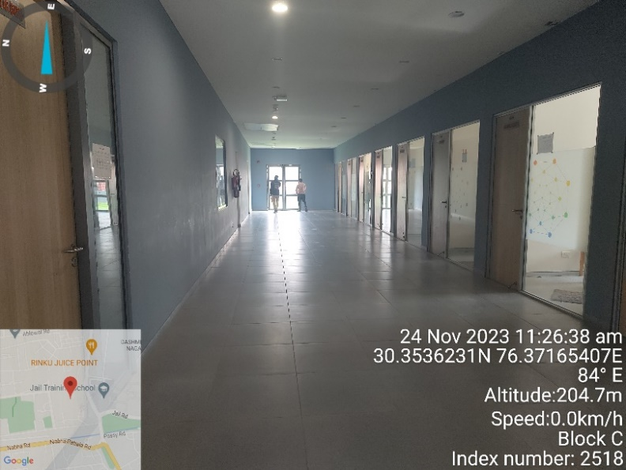
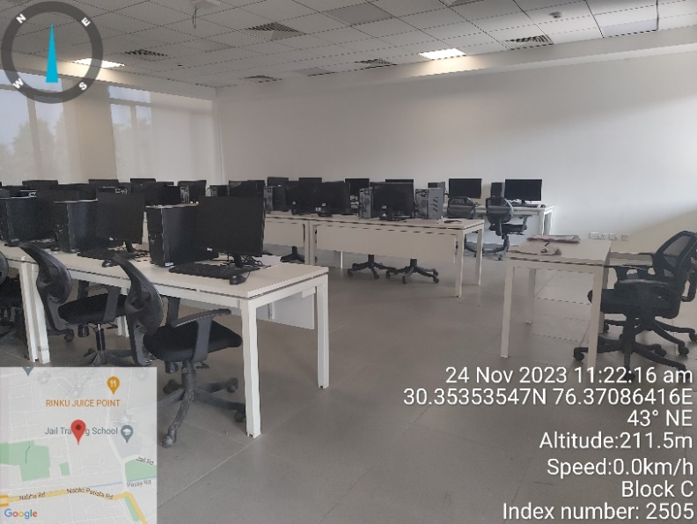 | 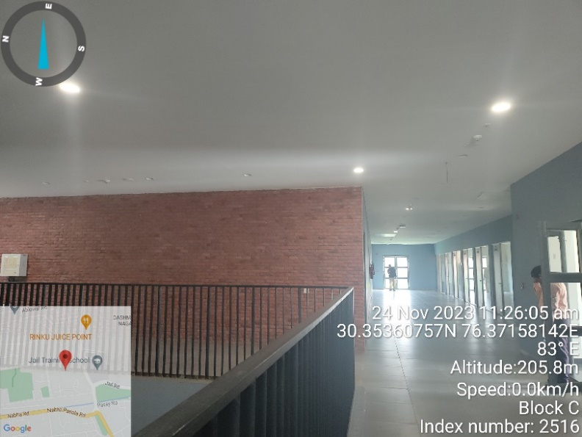

LEARNING BLOCK, LECTURE, LIBRARY AND CS EXTENSION

CATEGORY | DETAILS
Construction Year | 2019(For Learning Block, Lecture, Library)
 | 2022(For CS Extension)
Purpose | Institutional Purpose
Number Of Floors | Various for various blocks
Built-Up Area | 7,35,946 sq. ft. (For Learning Block, Lecture, Library)
 | 19,443 sq. ft. (For CS Extension)
Building Design | RCC Structure Frame Work
Flooring | Wooden Flooring, Terrazzo flooring, Granite, Marble
Walls | Veneer wooden cladding
Ceilings | Grid and Gypsum False Ceiling
HVAC/AC System | Radiant Cooling System with fresh air blowers
Doors | Wooden, Glass and UPVC
Windows | Glass and UPVC windows
Facade | Stone cladding, GRC Facade and glass facade
Safety Measures | Fire Sprinklers, FAPA and Fire extinguishers

DEMARCATION OF LEARNING BLOCK, LECTURE, LIBRARY AND CS EXTENSION
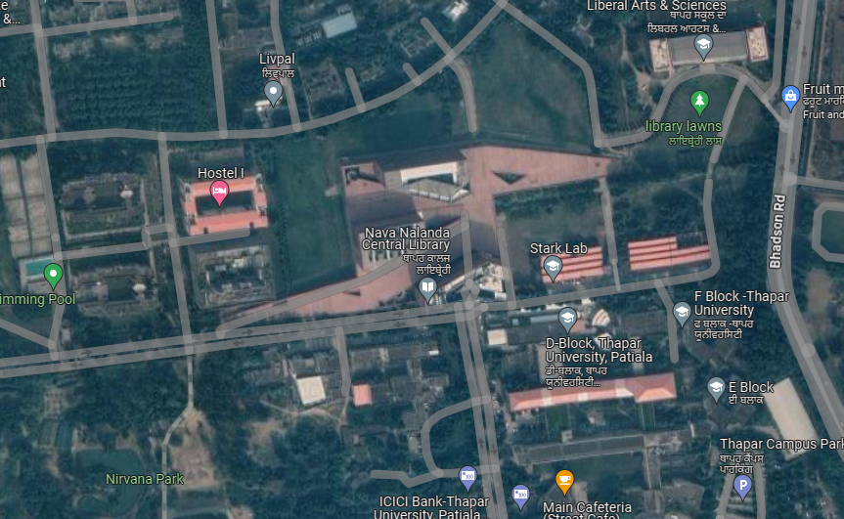

PHOTOGRAPHS OF LEARNING BLOCK, LECTURE, LIBRARY AND CS EXTENSION

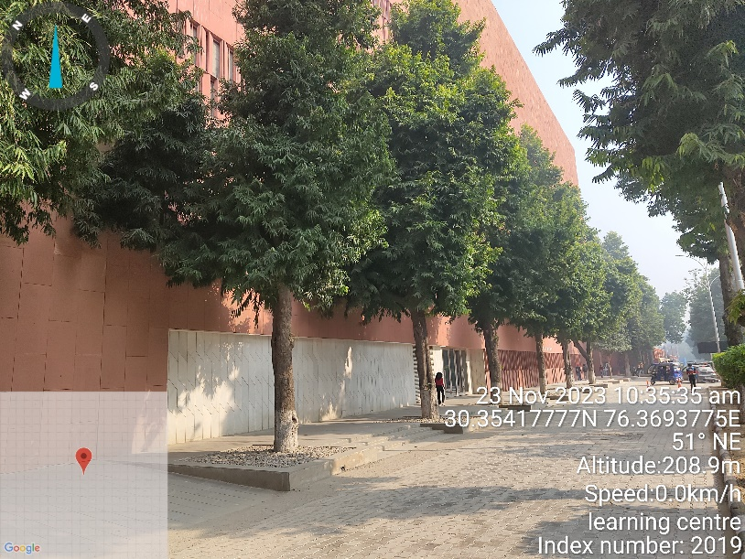 | 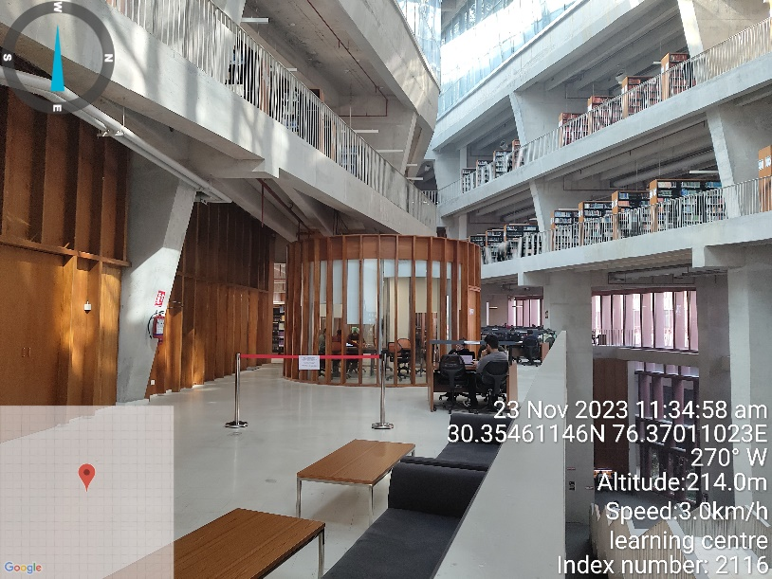
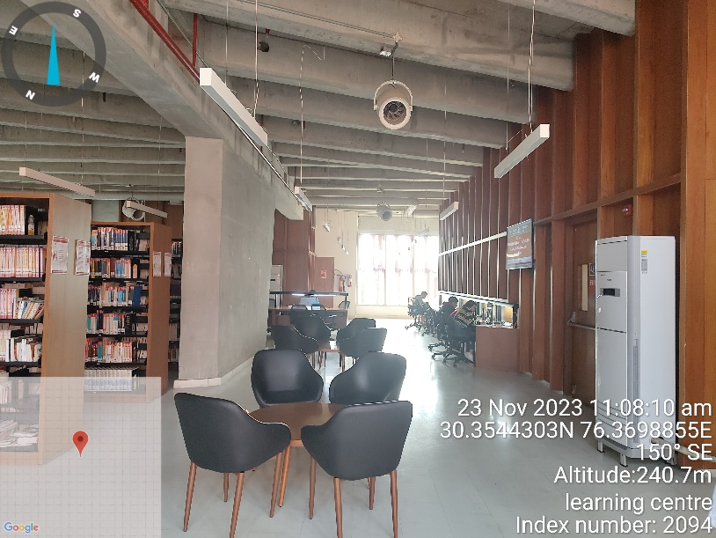 | 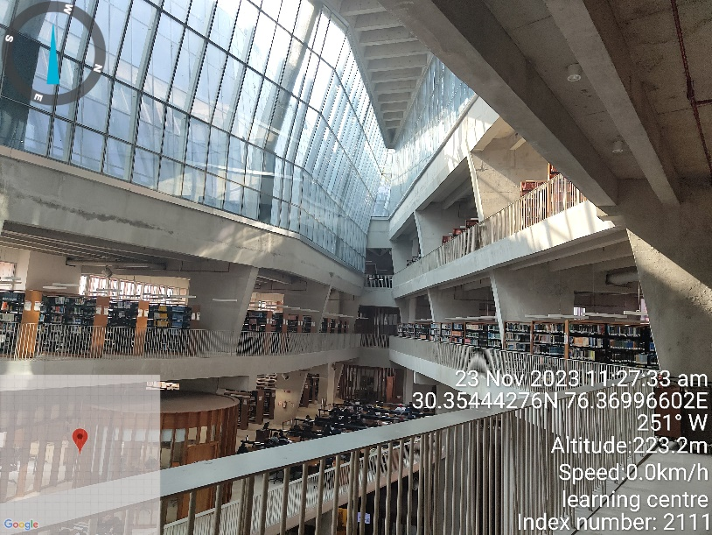
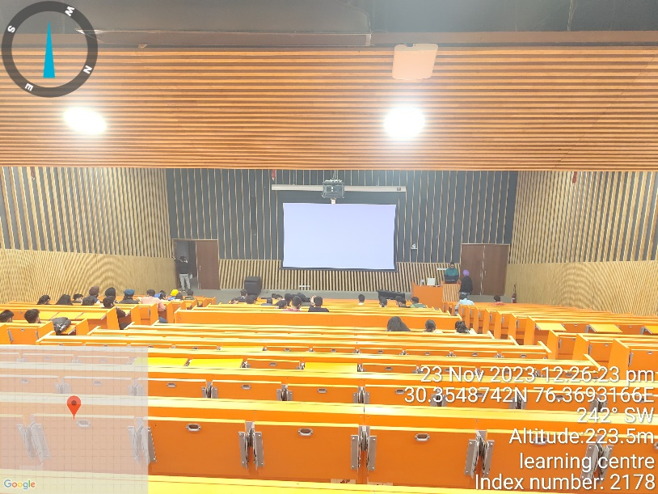 | 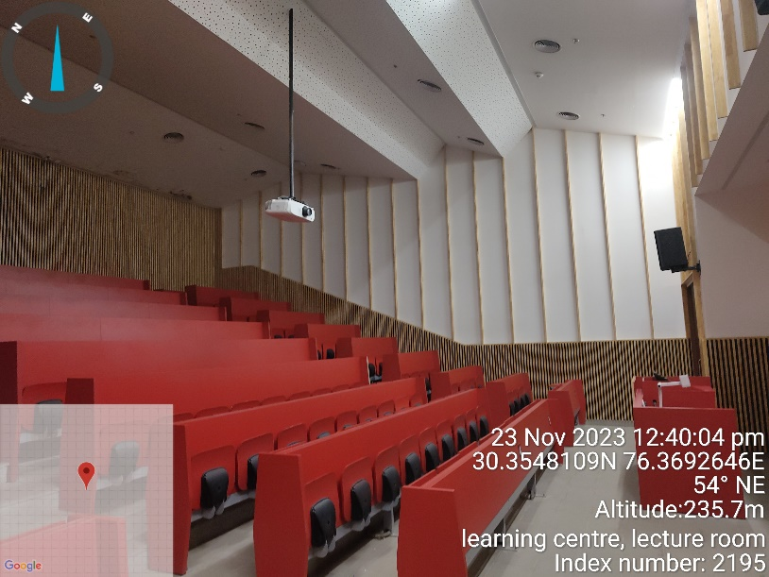
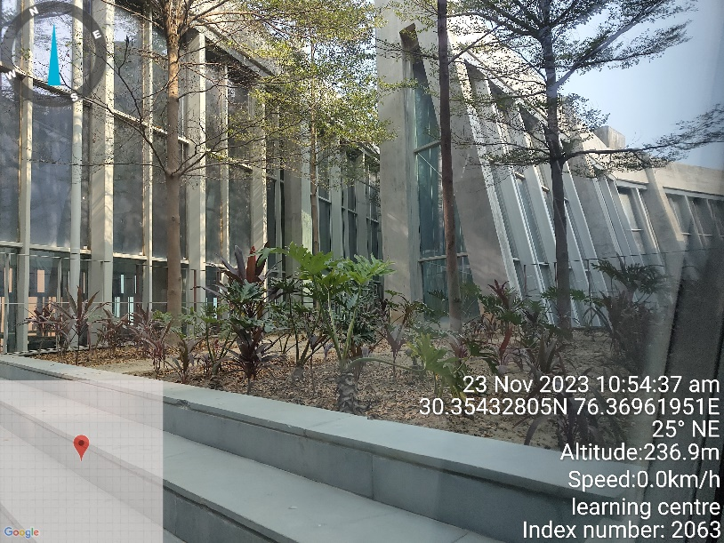 | 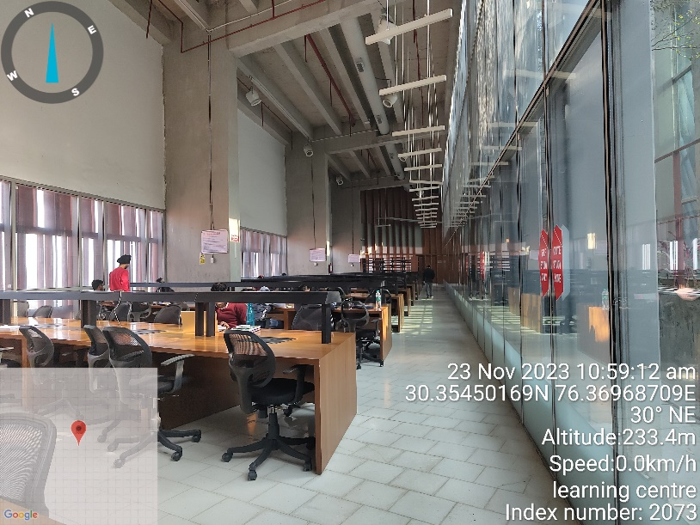
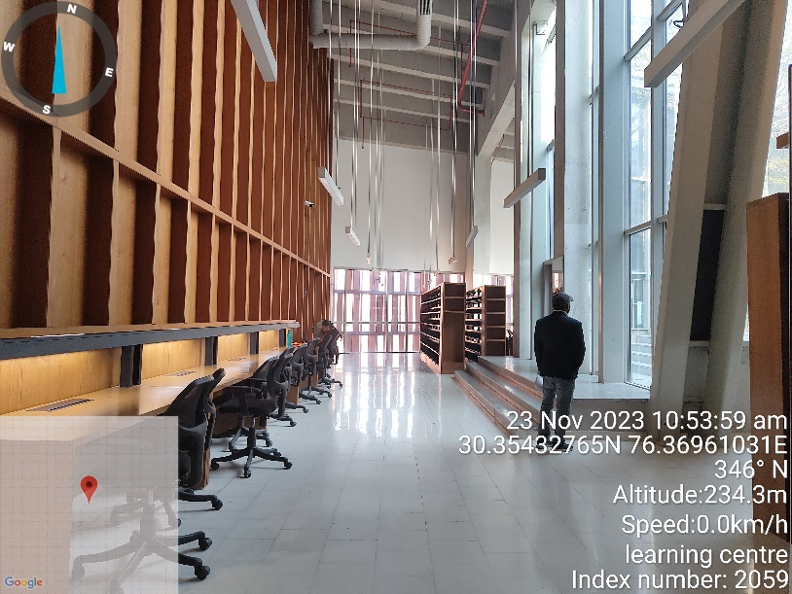 | 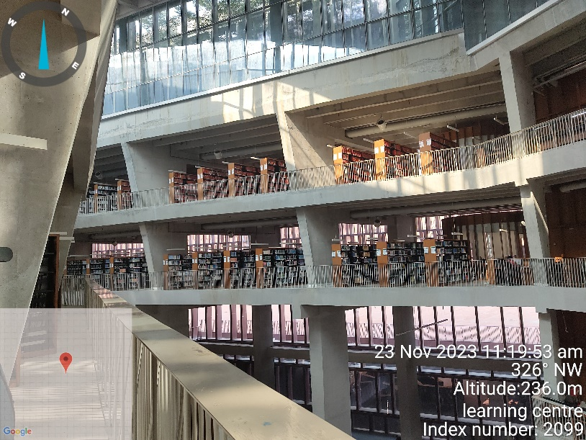
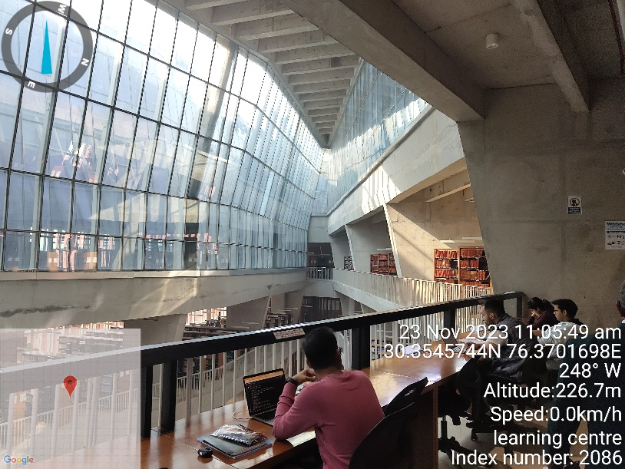 | 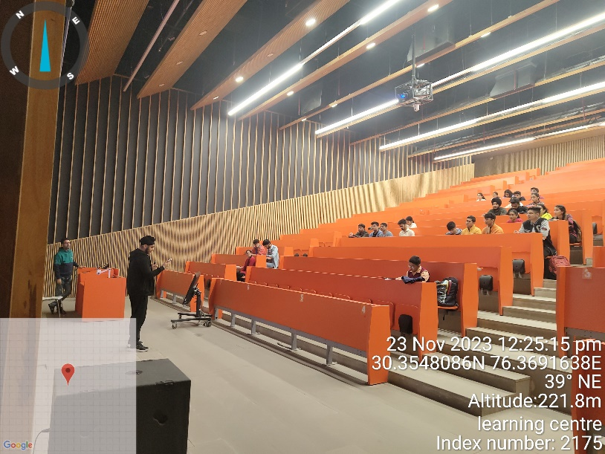
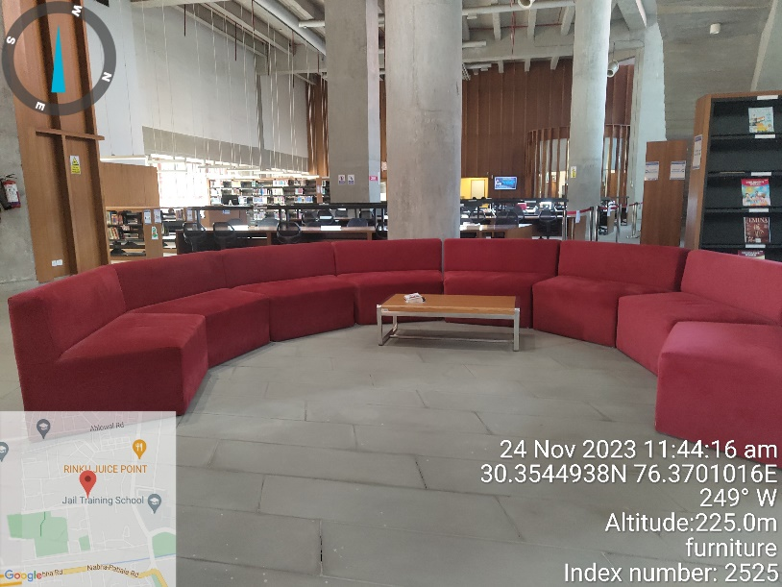 | 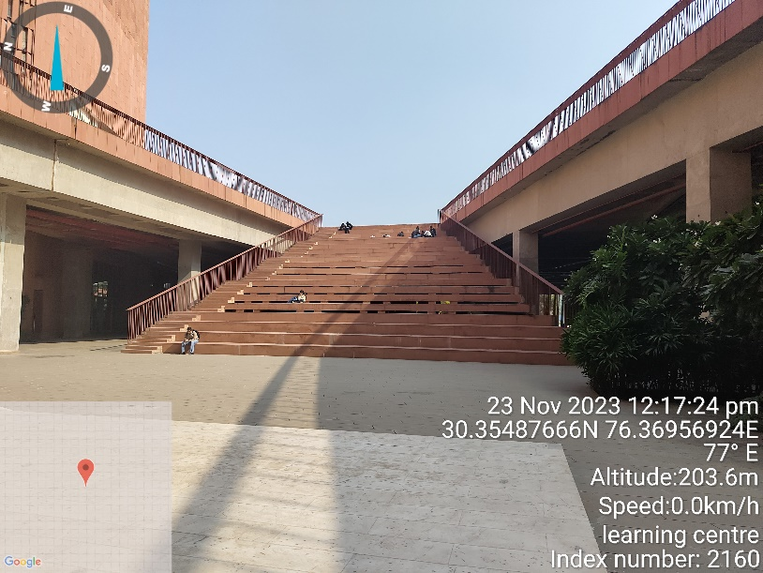
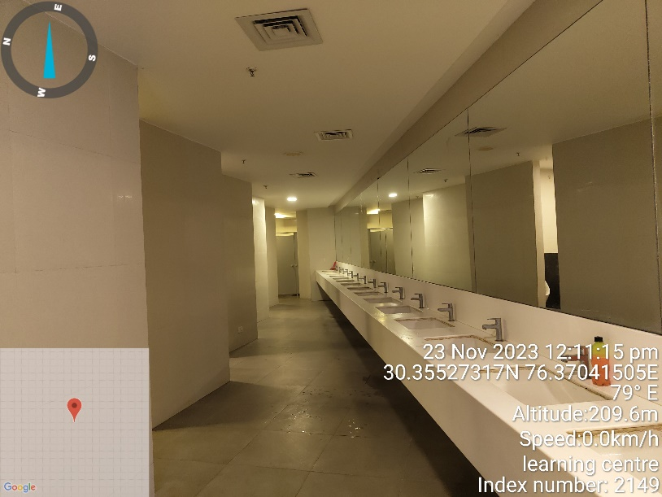 | 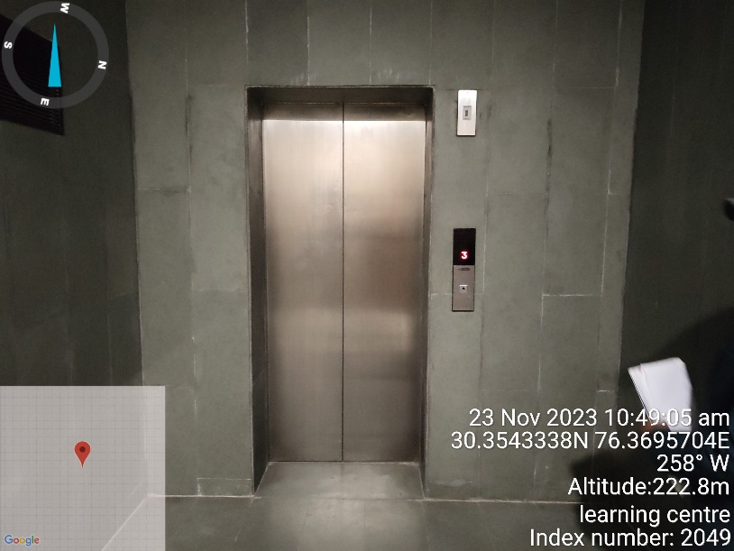
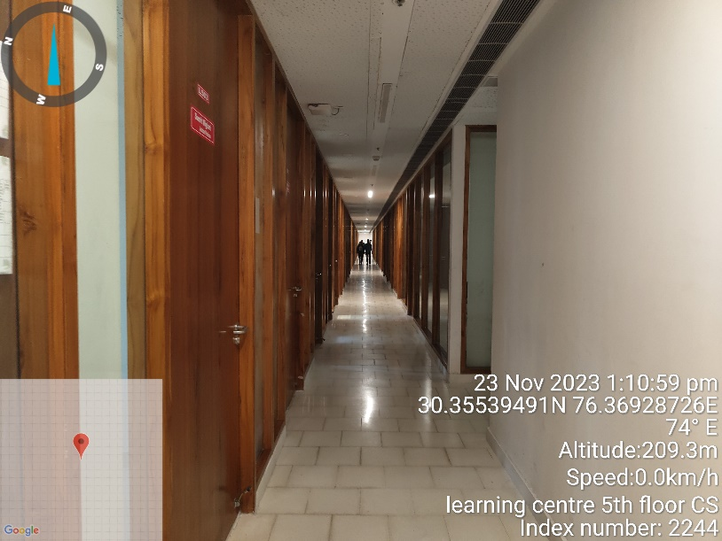 | 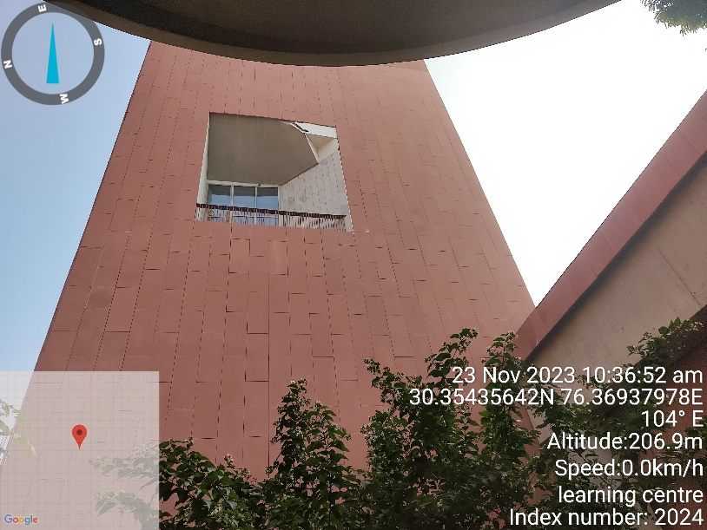

LMTSOM (CHANDIGARH)

CATEGORY | DETAILS
Construction Year | 2022
Purpose | Boys Hostel
Number Of Floors | Ground + Two Upper Floors
Built-Up Area | 47,000 sq. ft.
Building Design | RCC Structure Frame Work
Flooring | Hostel rooms: Vitrified tiles
 | Common areas: Matt Finish Tiles
 | Staircase: Granite
Walls | Plastered and painted
Ceilings | Gypsum false ceilings
HVAC/AC System | Split AC in respective rooms
Doors | Individual rooms: Wooden shutter doors
 | Main entry (reception): Glass door
Windows | Glass and UPVC windows
Facade | Glass Fibre Reinforced Concrete (GRFC/GRC)
Safety Measures | Fire extinguishers and FHC for fire protection

DEMARCATION OF LMTSOM (CHANDIGARH)

PHOTOGRAPHS OF LMTSOM(CHANDIGARH)

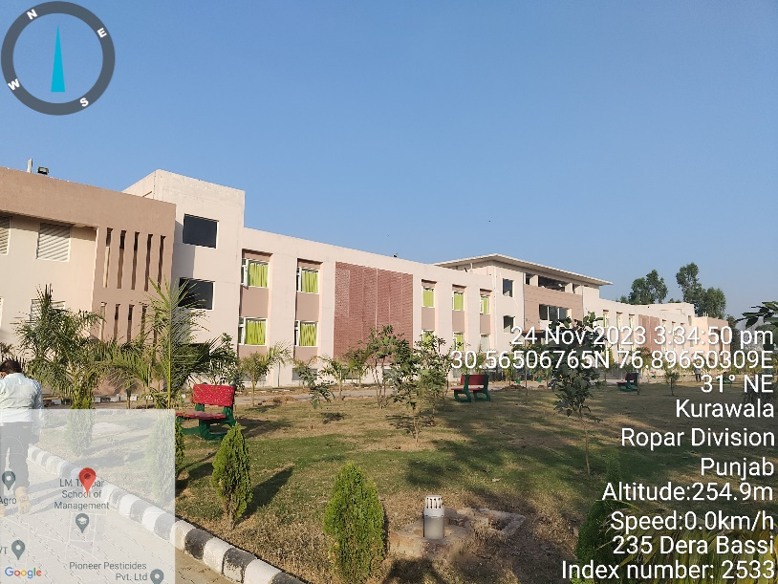 | 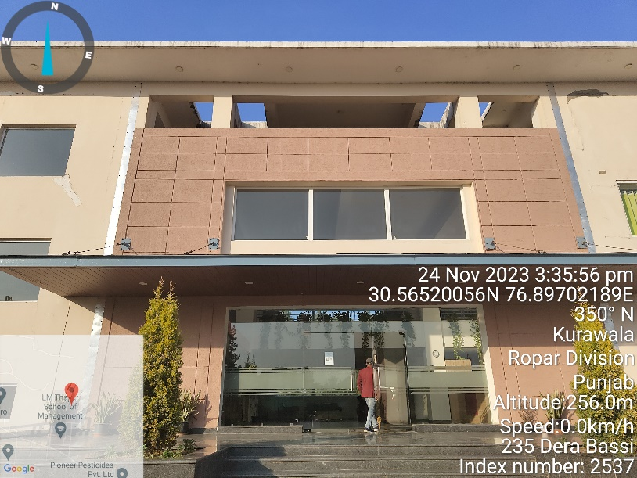
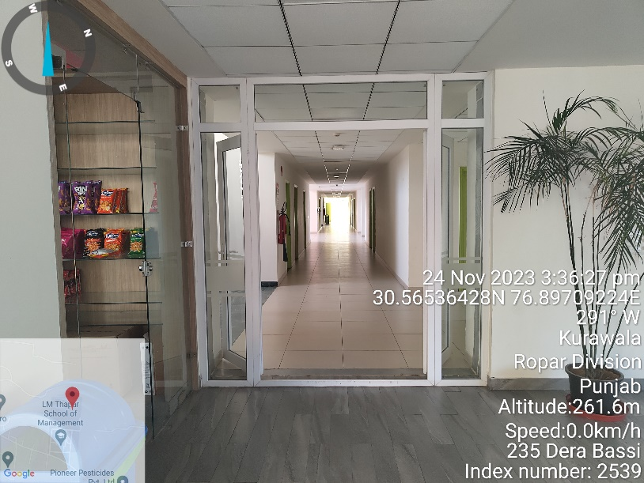 | 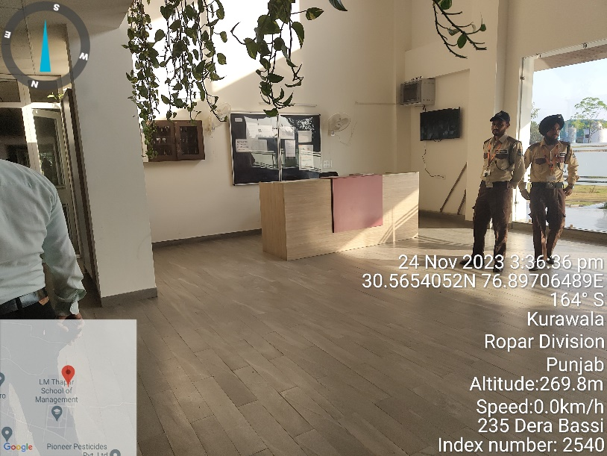
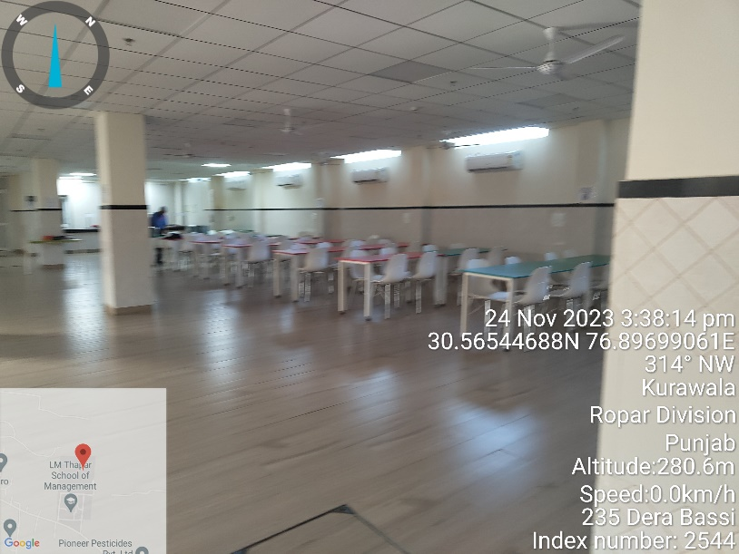 | 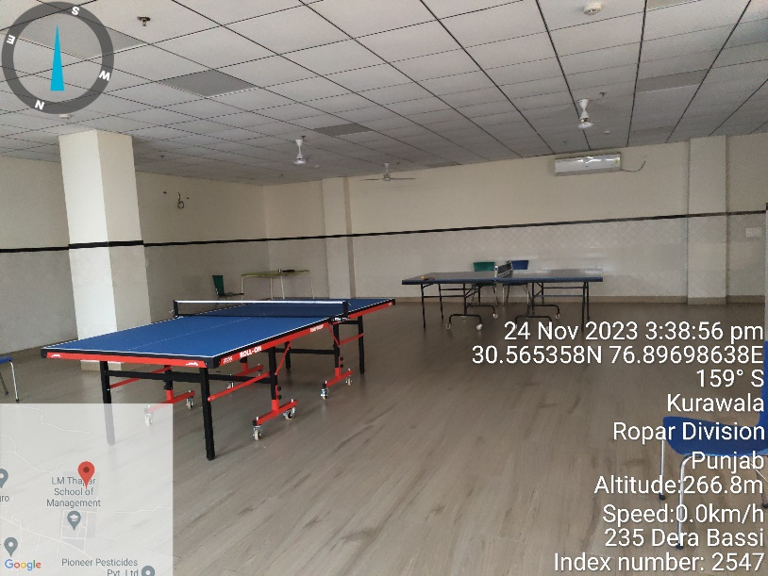
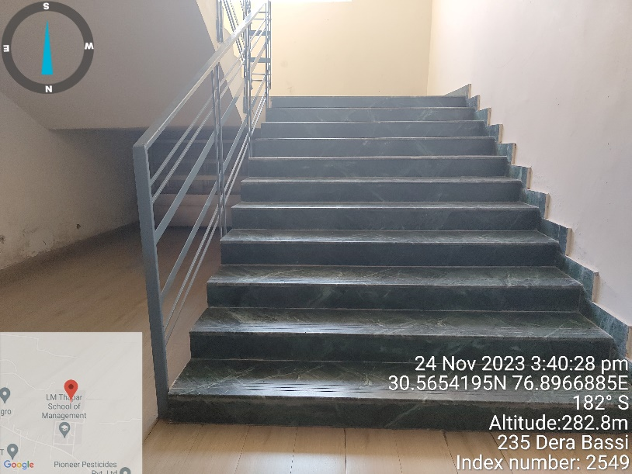 | 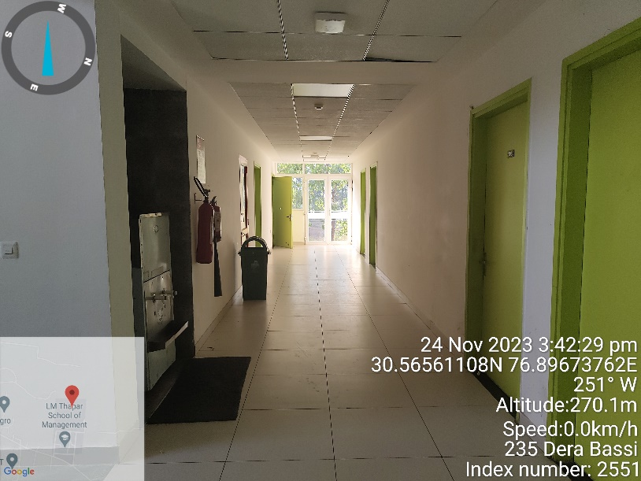
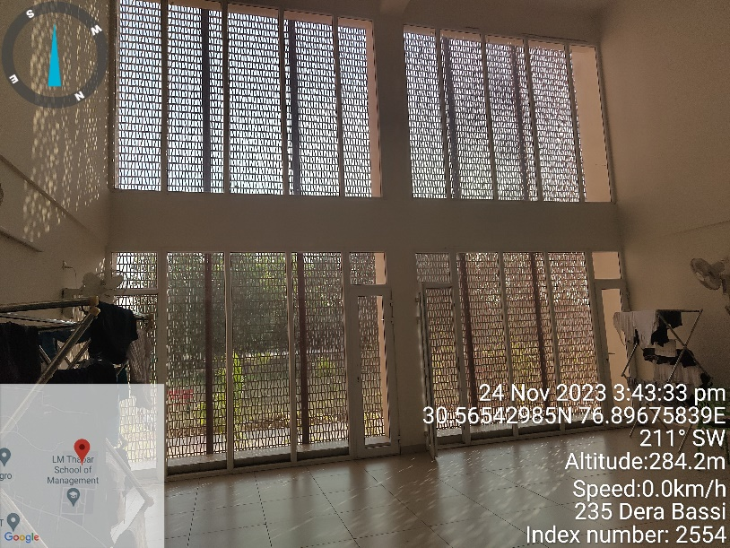 | 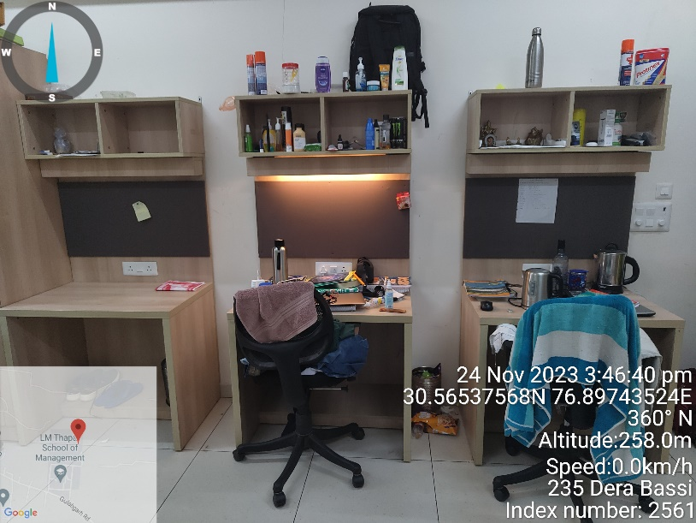
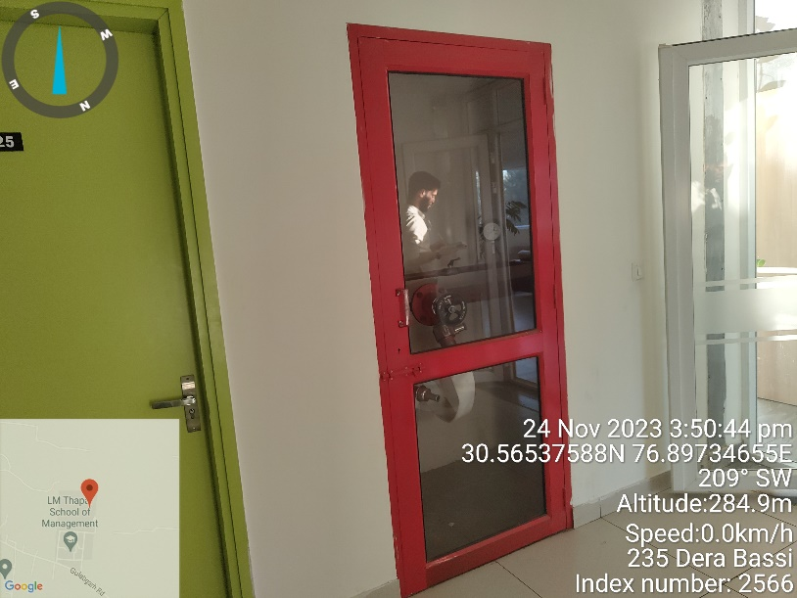 | 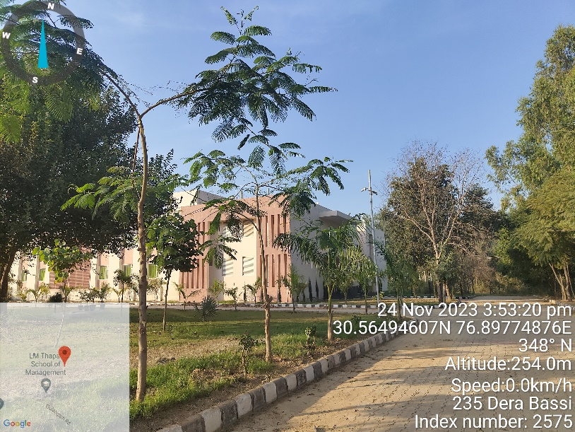

PART D | FURNITURE AND ANCILLARY ITEMS

Sl. No. | Description | Total | Unit | Year
 | Bed | 3,442 | No. | 2015-2019
 | Office Chairs | 24 | No. | 2015-2019
 | Café Chair | 16 | No. | 2015-2019
 | Chairs | 398 | No. | 2015-2019
 | Chair for student room | 1,161 | No. | 2015-2019
 | Dining chairs | 1,238 | No. | 2015-2019
 | Workstation Chairs | 56 | No. | 2015-2019
 | Chairs | 198 | No. | 2015-2019
 | Meeting Room Chairs | 8 | No. | 2015-2019
 | Dining room chairs | 504 | No. | 2015-2019
 | Lounge Chair | 90 | No. | 2015-2019
 | Sledge base chair | 20 | No. | 2015-2019
 | Study Chairs | 1,659 | No. | 2015-2019
 | Laminated file storage | 6 | No. | 2015-2019
 | Adjustable Mid back chairs | 11 | No. | 2015-2019
 | Supplying and fixing of rectangular Shape study table size | 600 | No. | 2015-2019
 |  | 636 | No. | 2015-2019
 |  | 200 | No. | 2015-2019
 | Table with Modesty Panel | 60 | No. | 2015-2019
 | Table | 90 | No. | 2015-2019
 | Table | 24 | No. | 2015-2019
 | Side Table | 24 | No. | 2015-2019
 | Side Table | 10 | No. | 2015-2019
 | Meeting Tables | 1 | No. | 2015-2019
 | Centre Tables | 2 | No. | 2015-2019
 | Reception table | 7 | No. | 2015-2019
 | Workstation table with storage unit | 30 | No. | 2015-2019
 | L shaped table | 4 | No. | 2015-2019
 | Centre table | 11 | No. | 2015-2019
 | Lounge tables | 18 | No. | 2015-2019
 | Desktop: White Laminate | 6 | No. | 2015-2019
 | Desktop: White Laminate of size 600mm deep and 1500mm length. | 8 | No. | 2015-2019
 | Coffee Tables | 1 | No. | 2015-2019
 | Dining table | 255 | No. | 2015-2019
 | Circular table | 17 | No. | 2015-2019
 | L shaped table of size 1500 x 1800 | 2 | No. | 2015-2019
 | Cabin Table (2000*750) | 2 | No. | 2015-2019
 | Study tables | 180 | No. | 2015-2019
 | Rectangular Shape study table | 750 | No. | 2015-2019
 |  | 2 | No. | 2015-2019
 |  | 1,326 | No. | 2015-2019
 | Mounted book rack | 532 | No. | 2015-2019
 |  | 32 | No. | 2015-2019
 |  | 200 | No. | 2015-2019
 | Wall mounted book rack in size 900mm width x300 mm depth x 400mm | 286 | No. | 2015-2019
 |  | 286 | No. | 2015-2019

 | Book rack in size 600mm width x 300mm depth x 530mm | 4 | No. | 2015-2019
 |  | 176 | No. | 2015-2019
 | Wall mounted book rack in size 600mm width x450 mm depth x 400mm | 4 | No. | 2015-2019
 | Book Rack/ Shelf | 180 | No. | 2015-2019
 | Wardrobe of size 850 mm (W) x 2050mm (H) x 600mm (D) | 272 | No. | 2015-2019
 |  | 176 | No. | 2015-2019
 | Wardrobe of size 900 mm (W) x 2100mm (H) x 600mm (D) | 1,350 | No. | 2015-2019
 |  | 368 | No. | 2015-2019
 |  | 1,150 | No. | 2015-2019
 | Easy chair with look of sofa | 48 | No. | 2015-2019
 | L-Shape 10 seater sofa | 1 | No. | 2015-2019
 | U Shape Sofa(600mm wide) | 1 | No. | 2015-2019
 | Sofa in leather finish 3 seater | 16 | No. | 2015-2019
 | Sofa in leather finish 2 seater | 24 | No. | 2015-2019
 | Sofa in leather finish 1 seater | 2 | No. | 2015-2019
 | Sofa 1720x1027mmx 600mm depth | 76 | No. | 2015-2019
 | Sofa 1143x450mm x 600mm depth | 76 | No. | 2015-2019
 | Sofa 1720x1027mmx 600mm depth, without back | 38 | No. | 2015-2019
 | Sofa 693x693x693mm | 76 | No. | 2015-2019
 | Sofa 1720x1027mmx 600mm depth | 38 | No. | 2015-2019
 | Laminated file storage | 67 | No. | 2015-2019
 | Laminated finish Lockers for Gymnasium | 3 | No. | 2015-2019
 | Laminated finish Lockers with lock for Male Staff Changing | 4 | No. | 2015-2019
 | Laminated finish Lockers with lock for Female Changing | 2 | No. | 2015-2019
 | Bench | 0 | No. | 2015-2019
 | Laminated bench | 4 | No. | 2015-2019
 | Laminated bench 1200x450x450mm high | 13 | No. | 2015-2019
 | A4 Acrylic Panel | 260 | No. | 2015-2019

PART E | PROJECT CONSULTANTS, CONTRACTORS & SUPPLIERS
Client has provided information about the list of contractors deployed in the construction of buildings/blocks in the University at Patiala, Punjab. Same has been shown below:

S. No. | Consultant Name | Core Responsibility | Building Name
1 | M/S MCM | Design Architect | Hostel-K, L M, N & Learning Laboratory
2 | Aroop International | Structural Design Architect | Hostel M,N & Learning Lab
3 | M/S DPA | Executive Architect | Hostel-K, L M, N & Learning Laboratory
4 | M/S Integral Design | Landscape Consultant | Hostel-K, L M, N & Learning Laboratory
5 | M/S Colliers International | Project Management | Hostel-K, L M, N & Learning Laboratory
6 | M/S Vincom | Cost Management | Hostel-K, L M, N & Learning Laboratory
7 | Optimal Consultancy Services | Design Value Engineering | Hostel-K, L M, N & Learning Laboratory
8 | Axis Facade | Facade Designing | Hostel-K, L M, N & Learning Laboratory
9 | Prof V S Raju | Soil Testing Consultant For Geotechnic Service & Foundation Recommendation (Raju) | Hostel-K, L M, N & Learning Laboratory
10 | Egis | Lead Consultant For Library | Library

Note:
It is just an illustration of the data provided by the client. However this shall not be construed as any verification of the bills/ invoices/ contract agreements of the contractors and their work. We assume no responsibility in this regard..

PART F | COST VERIFICATION & ASSESSMENT

- SCOPE OF ITEMS: All University Buildings & Facilities along with ancillary & value added items complimenting the Buildings & Facilities such as HVAC, Lifts, Landscaping, Internal development works, etc. and Furniture & Fixtures as already shown in Part C & D of the Report above.

- METHODOLOGY OF COST ASSESSMENT: For the cost assessment & verification, following approach is adopted:
  - Building & facility wise capitalised cost, area and specification details was sought from the client and review was done.
  - Building & facility wise specific contractor/ suppliers/ consultants work orders was sought.
  - Site inspection and verification of the Building & facility wise details provided.
  - Building & facility wise cost analysis referring CPWD plinth area rates, Market rates, type of specifications, Work Orders/ BOQ, type of contractors/ consultants engaged.
  - Base rate for super structure is calculated and according to the specific building/ structure/ facility appropriate discount/ premium is applied considering its specifications.
  - Price/ rates/ cost assessment is done considering the period of construction of specific Building & facility.
  - Structure and civil base cost includes MEP works.
  - In Civil & structure head, façade, fire & interior works are added separately as per their specification.
  - As per client data, the buildings capitalised cost includes external development works also done in the periphery of each building such as roads, street lightening and landscaping work. However same is not considered in our assessment since details of the same was not available.
  - In our assessment, Lift cost is not covered.
- BASIS OF RATE ADOPTED:

RATES ADOPTED FROM PLINTH AREA RATES (PAR), CPWD 2019,2021 & 2023
 | PAR, CPWD (2019) |  | PAR, CPWD (2021) |  | PAR, CPWD (2023)
Base Rate | Rate  (Sq. Mt. / Ft.) | Reference | Rate  (Sq. Mt. / Ft.) | Reference | Rate  (Sq. Mt. / Ft.) | Reference
College buildings | 25,500/ 2,369 | 1.1.1 | 27,090/ 2,517 | 1.1.1 | 30,820/ 2,863 | 1.1.1
Hostel buildings | 19,500/ 1,812 | 1.1.2 | 20,685/ 1,922 | 1.1.2 | 23,530/ 2,186 | 1.1.2
For R.C.C raft Foundations | 5,150/ 479 | 1.3.7 | 10,700/ 994 | 1.3.6 | 12,170/1,131 | 1.3.6
For Resisting Earthquake forces | 1,200/ 111 | 1.3.6 | 1,200/ 111 | Same as  PAR 2019 | 1,200/ 111 | Same as  PAR 2019
Wet Riser + Sprinkler | 1,200/ 111 | 1.5.2 | 1,200/111 | 1.5.3 | 1,200/111 | 1.5.3
With Wet Riser only | 800/ 74 | 1.5.1 | 800/ 74 | 1.5.2 | 890/ 83 | 1.5.2
Automatic Fire Alarm System | 600/ 56 | 1.6.2 | 600/ 56 | 1.6.2 | 600/ 56 | 1.6.2
VRV/VRF AC System | 55,000 HP  x 0.8  = 44,000 TR | 6.0 | 55,000 HP  x 0.8  = 44,000 TR | 6.6.1 | 58,480 HP  x 0.8  = 46,784 TR | 6.6.1

PREMIUM APPLICABLE
Year | Blocks | Base Rate  (Sq. Ft.) | Add for extra Height and strong structure  (Sq. Ft.) | Add for better Facade  (Sq. Ft.) | Add for Fire Provision | Add for superior Interior | Add for services | Rate Derived | Discount applied | Rate Derived
2019 | Learning Centre and CS Extension | 2,369 | 633 | 118 | 167 | 1,000 | 604 | 4,891 | 20% | 3,913
2016 | Hostel L | 1,812 | 111 | 90 | 74 | 100 | 534 | 2,610 | 20% | 2,088
2016 | Hostel K | 1,812 | 111 | 90 | 74 | 100 | 534 | 2,610 | 20% | 2,088
2017 | Hostel M Ground Area | 1,400 | 137 | --- | --- | --- |  | --- | --- | 1,537
2017 | Hostel M Tower Area | 1,812 | 633 | 110 | 74 | 400 | 534 | 3,563 | 20% | 2,850
2017 | Hostel N Ground Area | 1,400 | 137 | --- | --- | --- |  | --- | --- | ---
2017 | Hostel N Tower Area | 1,812 | 633 | 110 | 74 | 400 | 534 | 3,563 | 20% | 2,850
2022 | Hostel Q | 1,922 | 147 | 110 | 74 | 350 | 567 | 3,170 | 20% | 2,536
2021 | Hostel O | 1,922 | 147 | 110 | 74 | 350 | 567 | 3,170 | 20% | 2,536
2023 | Hostel D | 2,186 | 147 | 110 | 74 | 350 | 567 | 3,434 | 20% | 2,747
2022 | Derra Bassi | 1,922 | --- | 110 | 74 | 350 | 567 | 3,023 | 20% | 2,418
2021 | TSLAS | 2,517 | 111 | 80 | 167 | 500 | 566 | 3,942 | 20% | 3,153
2021 | CEEMS | 2,517 | 111 | 80 | 167 | 500 | 566 | 3,942 | 20% | 3,153
2021 | Block C Electronics | 2,517 | 111 | 80 | 167 | 500 | 566 | 3,942 | 20% | 3,153
2022 | Hostel B | 1,922 | --- | 110 | 74 | 350 | 567 | 3,023 | 20% | 2,418
2022 | Hostel C | 1,922 | --- | 110 | 74 | 350 | 567 | 3,023 | 20% | 2,418
2019 | FRD | 1,812 | 147 | 90 | 167 | 200 | 534 | 2,950 | 20% | 2,360
2019 | FRE | 1,812 | 147 | 90 | 167 | 200 | 534 | 2,950 | 20% | 2,360

Note:
- Discount is applied to bring the rates in parity to market contracting rates. In CPWD rates, the overhead expenses are generally incorporated and differs from market rates.
- Interiors and superior design cost is added as premium on base rate obtained, based on finishing contract agreements wherever available and for others based on our internal assessment.

- CALCULATION & COMPUTATION:

  - Civil & Structure Work Cost Computation
SR. No. | Particulars | Area  (in sq. ft) | Year of Const. | Plinth Area Rate  (per sq.ft) | Amount  (In Rupees) | Remarks & Special features in addition to standard structure specifications
 | Hostel L | 85,716 | 2016 | 2,088 | 17,89,99,611 | - Landscape and hardscape development.
 | Hostel K | 1,62,093 | 2016 | 2,088 | 33,84,96,710 | - Landscape and hardscape development.
 | Hostel - M Ground | 87,771 | 2017 | 1,537 | 13,49,04,027 | ---
 | Hostel - M 1st to 8th | 5,98,894 | 2017 | 2,850 | 170,71,01,403 | - Facade work executed, internally and also on exterior face.  - Landscape and hardscape development.
 | Hostel - N Ground | 36,036 | 2017 | 1,537 | 5,53,87,332 | ---
 | Hostel - N 1st to 6th | 2,17,281 | 2017 | 2,850 | 61,93,42,822 | - Facade work executed, internally and also on exterior face.  - Landscape and hardscape development.
 | Learning Laboratory CS, Lecture, Library | 7,35,946 | 2019 | 3,913 | 287,98,92,026 | - Foldable sliding puff walls.  - Light gauge framing system used at top floor slab.  - Radiant cooling system.  - Exceptional Interior and construction benchmark adopted.  - Sound proof remedial setups done.
 | FRD | 69,900 | 2019 | 2,360 | 16,49,85,230 | - Facade work.  - AC and other furnishing works in respective flats.  - Landscape and hardscape development.
 | FRE | 69,900 | 2019 | 2,360 | 16,49,85,230 | - Facade work  - Landscape and hardscape development.
 | Hostel-O | 2,13,618 | 2021 | 2,536 | 54,17,81,215 | - Glass & GRC Facade work.  - Landscape and hardscape development.
 | LMTSOM  Derra Bassi | 47,000 | 2022 | 2,418 | 11,36,62,003 | - Facade work.  - HVAC  - Landscape and hardscape development.
 | TSLAS | 61,192 | 2021 | 3,153 | 19,29,61,530 | - Facade work.  - HVAC  - Landscape and hardscape development.  - Light gauge framing system used at top floor slab.  - Sound proof remedial setups done.
 | CEEMS Lab/ SAI Lab | 8,441 | 2021 | 3,153 | 2,66,17,667 | - Facade work.  - HVAC  - Landscape and hardscape development.  - Light gauge framing system used at top floor slab.  - Sound proof remedial setups done.
 | Block-C: Electronics Lab | 23,200 | 2021 | 3,153 | 7,31,58,379 | - Facade work.  - HVAC  - Landscape and hardscape development.  - Light gauge framing system used at top floor slab.  - Sound proof remedial setups done.
 | CS Extension | 19,443 | 2022 | 3,913 | 7,60,84,034 | - Foldable sliding puff walls.  - Light gauge framing system used at top floor slab.  - Radiant cooling system.  - Exceptional Interior and construction benchmark adopted.  - Sound proof remedial setups done.
 | Hostel-D | 2,20,135 | 2023 | 2,747 | 7,31,58,379 | - Glass & GRC Facade work.  - Landscape and hardscape development.
 | Hostel-B | 1,47,406 | 2022 | 2,418 | 7,60,84,034 | - Glass & GRC Facade work.  - Landscape and hardscape development.
 | Hostel-Q | 2,09,000 | 2022 | 2,536 | 7,31,58,379 | - Glass & GRC Facade work.  - Landscape and hardscape development.
 | Hostel-C | 92,861 | 2022 | 2,418 | 7,60,84,034 | - Glass & GRC Facade work.  - Landscape and hardscape development.
TOTAL(A) |  |  |  |  | Rs.898,42,32,353

  - HVAC/ Air Conditioning
SR. No. | Particulars | Capacity/ Specifications | Amount as per company  (In Rupees)
 | Hostel L | 1 TR, 1.5 TR, 2TR | 1,04,81,560
 | Hostel K | 1 TR, 1.5 TR, 2TR
 | Hostel – M | 1.05TR, 1.55TR, 1.65TR, 2.07TR, 3TR, 4TR, 6.5TR, 8.19TR | 4,12,54,623
 | Hostel – N | 1 TR, 1.5 TR, 2TR, 4.5 TR | 1,18,33,305
 | Learning Centre |  | 6,96,91,737
 | FRD | 1 TR, 1.5 TR, 2TR | 4,58,862
 | FRE
 | Hostel-O | 1 TR, 2TR | 1,65,37,301
 | Derra Bassi | 1 TR, 1.5 TR | 30,86,140
 | TSLAS | 3 TR, 2 TR, 1.5 TR | 50,52,654
 | CEEMS Lab/ SAI Lab | 8.5 TR, 5.5 TR, 1.5 TR | 18,92,329
 | Block-C: Electronics Lab | 8.5 TR, 5.5 TR, 1.5 TR | 35,27,360
 | Cs Extension | 1 TR, 1.5 TR | 26,44,042
 | Hostel-D | 1.5 TR, 2TR | 1,46,74,920
 | Hostel-B | 1 TR, 1.5 TR, 2TR | 1,16,51,789
 | Hostel-Q | 1.5 TR, 2TR | 1,77,53,855
 | Hostel-C | 1 TR, 1.5 TR, 2TR | 65,09,599
TOTAL |  |  | Rs.21,70,50,076

NOTE:
- The expenditure shown by the client appears to be in line with our assessment and prevailing market rates.
- Our assessment is done as per the CPWD rates, on which a discount of 25% is applied, to match the market rates for the bulk installation as the same is applicable on the subject property.

  - Furniture’s and Ancillary Items
DESCRIPTION | TOTAL | UNIT | YEAR
Bed made of 16mm thick commercial Ply board | 1,350 | No. | 2015-2019
 | 368 | No. | 2015-2019
 | 1,090 | No. | 2015-2019
Bed made of 18 mm plywood | 272 | No. | 2015-2019
 | 176 | No. | 2015-2019
Bed Back Rest (Head Board) for Guest Bed Room Only | 2 | No. | 2015-2019
 | 2 | No. | 2015-2019
 | 900 | No. | 2015-2019
 | 2 | No. | 2015-2019
Single Bed (Boxed) | 1,080 | No. | 2015-2019
Office Chairs | 24 | No. | 2015-2019
Café Chair | 16 | No. | 2015-2019
Chairs | 398 | No. | 2015-2019
Chair for student room | 1,161 | No. | 2015-2019
Dining chairs | 1,538 | No. | 2015-2019
Workstation Chairs | 56 | No. | 2015-2019
Chairs | 198 | No. | 2015-2019
Meeting Room Chairs | 8 | No. | 2015-2019
Dining room chairs | 504 | No. | 2015-2019
Lounge Chair | 90 | No. | 2015-2019
Sledge base chair | 44 | No. | 2015-2019
Study Chairs | 2,559 | No. | 2015-2019
Laminated file storage | 22 | No. | 2015-2019
Adjustable Mid back chairs | 42 | No. | 2015-2019
Supplying and fixing of rectangular Shape study table size | 600 | No. | 2015-2019
 | 636 | No. | 2015-2019
 | 200 | No. | 2015-2019
Table with Modesty Panel | 60 | No. | 2015-2019
Table | 93 | No. | 2015-2019
Table | 24 | No. | 2015-2019
Side Table | 24 | No. | 2015-2019
Side Table | 10 | No. | 2015-2019
Meeting Tables | 1 | No. | 2015-2019
Centre Tables | 2 | No. | 2015-2019
Reception table | 11 | No. | 2015-2019
Workstation table with storage unit | 46 | No. | 2015-2019
L shaped table | 13 | No. | 2015-2019
Centre table | 15 | No. | 2015-2019
Lounge tables | 18 | No. | 2015-2019
Desktop: White Laminate | 6 | No. | 2015-2019
Desktop: White Laminate of size 600mm deep and 1500mm length. | 8 | No. | 2015-2019
Coffee Tables | 1 | No. | 2015-2019
Dining table | 295 | No. | 2015-2019
Circular table | 17 | No. | 2015-2019
L shaped table of size 1500 x 1800 | 2 | No. | 2015-2019
Cabin Table (2000*750) | 2 | No. | 2015-2019
Study tables | 1,080 | No. | 2015-2019
Rectangular Shape study table | 750 | No. | 2015-2019
 | 2 | No. | 2015-2019
 | 1,326 | No. | 2015-2019
Mounted book rack | 532 | No. | 2015-2019
 | 32 | No. | 2015-2019
 | 200 | No. | 2015-2019
Wall mounted book rack in size 900mm width x300 mm depth x 400mm | 286 | No. | 2015-2019
 | 286 | No. | 2015-2019
Book rack in size 600mm width x 300mm depth x 530mm | 4 | No. | 2015-2019
 | 176 | No. | 2015-2019
Wall mounted book rack in size 600mm width x450 mm depth x 400mm | 4 | No. | 2015-2019
Book Rack/ Shelf | 1,096 | No. | 2015-2019
Wardrobe of size 850 mm (W) x 2050mm (H) x 600mm (D) | 1,172 | No. | 2015-2019
 | 176 | No. | 2015-2019
Wardrobe of size 900 mm (W) x 2100mm (H) x 600mm (D) | 1,350 | No. | 2015-2019
 | 368 | No. | 2015-2019
 | 1,150 | No. | 2015-2019
Easy chair with look of sofa | 48 | No. | 2015-2019
L-Shape 10 seater sofa | 1 | No. | 2015-2019
U Shape Sofa(600mm wide) | 1 | No. | 2015-2019
Sofa in leather finish 3 seater | 22 | No. | 2015-2019
Sofa in leather finish 2 seater | 26 | No. | 2015-2019
Sofa 1720x1027mmx 600mm depth | 76 | No. | 2015-2019
Sofa 1143x450mm x 600mm depth | 76 | No. | 2015-2019
Sofa 1720x1027mmx 600mm depth, without back | 38 | No. | 2015-2019
Sofa 693x693x693mm | 76 | No. | 2015-2019
Sofa 1720x1027mmx 600mm depth | 38 | No. | 2015-2019
Laminated file storage | 67 | No. | 2015-2019
Laminated finish Lockers for Gymnasium | 3 | No. | 2015-2019
Laminated finish Lockers with lock for Male Staff Changing | 4 | No. | 2015-2019
Laminated finish Lockers with lock for Female Changing | 2 | No. | 2015-2019
Laminated bench | 4 | No. | 2015-2019
Laminated bench 1200x450x450mm high | 13 | No. | 2015-2019
A4 Acrylic Panel | 260 | No. | 2015-2019
Total Expense Shown By Client Against Furniture And Ancillary Items |  |  | Rs.36,39,87,965

NOTE:
- While assessing and going through the various Work Orders and the rates mentioned in the attached BOQ of the work orders, in our opinion the cost is found to be in line with the prevailing market rates.

CONSOLIDATED COMPUTATION
SR. No. | Particulars | Civil & structure Work Cost Computation | HVAC/ Air Conditioning | Furniture’s & Ancillary Items
 |  | (A) | (B) | (C)
 | Hostel L | 17,89,99,611 | 1,04,81,560 | ---
 | Hostel K | 33,84,96,710 |  | ---
 | Hostel - M Ground | 13,49,04,027 | --- | ---
 | Hostel - M 1st to 8th | 170,71,01,403 | 4,12,54,623 | ---
 | Hostel - N Ground | 5,53,87,332 | --- | ---
 | Hostel - N 1st to 6th | 61,93,42,822 | 1,18,33,305 | ---
 | Learning Laboratory CS, Lecture, Library | 287,98,92,026 | 6,96,91,737 | ---
 | FRD | 16,49,85,230 | 4,58,862 | ---
 | FRE | 16,49,85,230 |  | ---
 | Hostel-O | 54,17,81,215 | 1,65,37,301 | ---
 | Derra Bassi | 11,36,62,003 | 30,86,140 | ---
 | TSLAS | 19,29,61,530 | 50,52,654 | ---
 | CEEMS Lab/ SAI Lab | 2,66,17,667 | 18,92,329 | ---
 | Block-C: Electronics Lab | 7,31,58,379 | 35,27,360 | ---
 | Cs Extension | 7,60,84,034 | 26,44,042 | ---
 | Hostel-D | 7,31,58,379 | 1,46,74,920 | ---
 | Hostel-B | 7,60,84,034 | 1,16,51,789 | ---
 | Hostel-Q | 7,31,58,379 | 1,77,53,855 | ---
 | Hostel-C | 7,60,84,034 | 65,09,599 | ---
 | TOTAL | Rs.898,42,32,353 | Rs.21,70,50,076 | Rs.36,39,87,965

(A) | Total Cost estimated against Civil & structure Work | Rs.898,42,32,353
(B) | Total Cost estimated against HVAC/ Air Conditioning | Rs.21,70,50,076
(C) | Total Cost estimated against Furniture’s and Ancillary Items | Rs.36,39,87,965
(A+B+C) | Cumulative Cost estimated for Building and other ancillary items  (As per the scope of report) | Rs.956,52,70,394
 | Total Capitalised Cost  (As per details provided by client) | Rs.1007,55,25,715

Note:
- The estimated cost by us may have 5-10% deviation towards lower or upper side due to several market factors and negotiation skills of individuals.
PART G | DISCLAIMER

      - No employee or member of R.K Associates has any direct/ indirect interest in the Project.
      - This report should not be referred as a BOQ/Estimate.
      - The assessment/working of the report is not as per BOQ, it is an assessment based on general benchmark cost of different type of works.
      - The report shouldn’t be considered as a valuation report or a document to certify the cost of the buildings, it is just the general assessment of the cost of the buildings and infrastructure based on the benchmark cost as per the requirement of the internal management assessment of TIET.
      - This report is prepared based on the copies of the documents/ information which the Borrower has provided to us out of the standard checklist of documents sought from them and further based on our assumptions and limiting conditions. The client/owner and its management/representatives warranted to us that the information they supplied was complete, accurate and true and correct to the best of their knowledge. All such information provided to us has been relied upon in good faith and we have assumed that it is true and correct in all respect. I/We shall not be liable for any loss, damages, cost or expenses arising from fraudulent acts, misrepresentations, or wilful default on part of the owner, borrower, its directors, employee, representative or agents. Verification or cross checking of the documents provided to us from the originals or from any Govt. departments/ Record of Registrar has not been done at our end since this is beyond the scope of our work. If at any time in future, it is found or came to our knowledge that misrepresentation of facts or incomplete or distorted information has been provided to us then this report shall automatically become null & void.
      - Legal aspects for eg. investigation of title, ownership rights, lien, charge, mortgage, lease, sanctioned maps, verification of documents, etc. have not been done at our end and same has to be taken care by legal expert/ Advocate. It is assumed that the concerned Lender/ Financial Institution has satisfied them with the authenticity of the documents, information given to us and for which the legal verification has been already taken and cleared by the competent Advocate before requesting for this report. I/ We assume no responsibility for the legal matters including, but not limited to, legal or title concerns.
      - This report is a general analysis of the project based on the scope mentioned in the report. This is not an Audit report, Design document, DPR or Techno feasibility study. All the information gathered is based on the facts seen on the site during survey, verbal discussion & documentary evidence provided by the client and is believed that information given by the borrower is true best of their knowledge.
      - All observations mentioned in the report is only based on the visual observation and the documents/ data/ information provided by the client. No mechanical/ technical tests, measurements or any design review have been performed or carried out from our side during Project assessment.
      - This report doesn’t claim any quality assurance of the Products and the material being used in the Project.
      - In case of any default in loans or the credit facility extended to the borrowing borrower, R.K Associates shall not be held responsible for whatsoever reason may be and any request for seeking any explanation from the employee/s of R.K Associates will not be entertained at any instance or situation.
      - The documents, information, data provided to us during the course of this assessment by the client is reviewed only up to the extent required in relation to the scope of the work. No document has been reviewed beyond the scope of the work.
      - This report only contains general assessment & opinion as per the scope of work evaluated as per the information given in the copy of documents, information, data provided to us and/ and confirmed by the owner/ owner representative to us at site which has been relied upon in good faith. It doesn’t contain any other recommendations of any sort including but not limited to express of any opinion on the suitability or otherwise of entering into any transaction with the borrower.
      - We have relied on data from third party, external sources & information available on public domain also to conclude this report. These sources are believed to be reliable and therefore, we assume no liability for the truth or accuracy of any data, opinions or estimates furnished by others that have been used in this analysis. Where we have relied on data, opinions or estimates from external sources, reasonable care has been taken to ensure that such data has been correctly extracted from those sources and /or reproduced in its proper form and context, however still we can’t vouch its authenticity, correctness or accuracy.
      - This Report is prepared by our competent technical team which includes Engineers and financial experts & analysts.
      - This is just an opinion report and doesn’t hold any binding on anyone. It is requested from the concerned Financial Institution which is using this report for taking financial decision on the project that they should consider all the different associated relevant & related factors also before taking any business decision based on the content of this report.
      - All Pages of the report including annexures are signed and stamped from our office. In case any paper in the report is without stamp & signature then this should not be considered a valid paper issued from this office.
      - Though adequate care has been taken while preparing this report as per its scope, but still we can’t rule out typing, human errors, over sightedness of any information or any other mistakes. Therefore, the concerned organization is advised to satisfy themselves that the report is complete & satisfactory in all respect. Intimation regarding any discrepancy shall be brought into our notice immediately. If no intimation is received within 15 (Fifteen) days in writing from the date of issuance of the report, to rectify these timely, then it shall be considered that the report is complete in all respect and has been accepted by the client up to their satisfaction & use and further to which R.K Associates shall not be held responsible in any manner.
      - Defect Liability Period is 15 DAYS. We request the concerned authorized reader of this report to check the contents, data and calculations in the report within this period and intimate us in writing if any corrections are required or in case of any other concern with the contents or opinion mentioned in the report. Corrections only related to typographical, calculation, spelling mistakes, incorrect data/ figures/ statement will be entertained within the defect liability period. Any new changes for any additional information in already approved report will be regarded as additional work for which additional fees may be charged. No request for any illegitimate change in regard to any facts & figures will be entertained.
      - R.K Associates encourages its customers to give feedback or inform concerns over its services through proper channel at le@rkassociates.org in writing within 15 days of report delivery. After this period no concern/ complaint/ proceedings in connection with the Financial Feasibility Study Services will be entertained due to possible change in situation and condition of the subject Project.
      - Our Data retention policy is of ONE YEAR. After this period, we remove all the concerned records related to the assignment from our repository. No clarification or query can be answered after this period due to unavailability of the data.
      - This Lender’s Independent Engineer report is governed by our (1) Internal Policies, Processes & Standard Operating Procedures, (2) Information/ Data/ Inputs given to us by the client and (3) Information/ Data/ Facts given to us by our field/ office technical team. Management of R.K Associates never gives acceptance to any unethical or unprofessional practice which may affect fair, correct & impartial assessment and which is against any prevailing law. In case of any indication of any negligence, default, incorrect, misleading, misrepresentation or distortion of facts in the report then it is the responsibility of the user of this report to immediately or at least within the defect liability period bring all such act into notice of R.K Associates management so that corrective measures can be taken instantly.
      - R.K Associates never releases any report doing alterations or modifications from pen. In case any information/ figure of this report is found altered with pen then this report will automatically become null & void.
SURVEY ANALYST | ENGINEERING ANALYST | L1 REVIEWER | L2 REVIEWER
Vishal Singh and Amit Jaiswal | Vishal Singh | Anil Kumar | Sr. V.P Projects

DEFECT LIABILITY PERIOD - In case of any query/ issue or escalation you may please contact Incident Manager by writing at valuers@rkassociates.org. We ensure 100% accuracy in the Calculations done, Rates adopted and various other data points & information mentioned in the report but still can’t rule out typing, human errors or any other mistakes. In case you find any mistake, variation, discrepancy or inaccuracy in any data point of the report, please help us by bringing all such points into our notice in writing at valuers@rkassociates.orgwithin 30 days of the report delivery, to get these rectified timely, failing which R.K Associates Valuers Techno Engineering Consultants (P) Ltd. won’t be held responsible for any inaccuracy in any manner. Also, if we will not hear back anything from you within 30 days, we will assume that report is correct in all respect and no further claim of any sort will be entertained thereafter. We would welcome and appreciate your feedback & suggestions in order to improve our services.

COPYRIGHT FORMAT - This report is prepared on the copyright format of R.K Associates Valuers Techno Engineering Consultants (P) Ltd. to serve our clients in the best possible way. Legally no one can copy or distribute this format without prior approval from R.K Associates. It is meant only for the organization as mentioned on the cover page of this report. Distribution or use of this format other than R.K Associates will be seen as unlawful act and necessary legal action can be taken against the defaulter.

