**REPORT FORMAT:** Brand Valuation | Version: 2.0_2019

**File No.: VIS (2023-24)-PL495-410-624 Dated: 15.04.2024**

**BRAND VALUATION REPORT**

**OF**

**KARA**

**OWNER/ PROMOTER**

**M/S FUTURE CONSUMER LIMITED (FCL)**

**REGISTERED AT**

**KNOWLEDGE HOUSE, SHYAM NAGAR, OFF JOGESHWARI VIKHROLI LINK ROAD, JOGESHWARI(EAST), MUMBAI, MAHARASHTRA – 400060**

**REPORT PREPARED FOR**

**STATE BANK OF INDIA, STRESSED ASSET MANAGEMENT BRANCH - 3, 112/115, 1ST FLOOR, WEST WING, TULSIANI CHAMBERS, FREE PRESS JOURNAL MARG, NARIMAN POINT, MUMBAI - 400021**

***\*\*Important - In case of any query/ issue or escalation you may please contact Incident Manager***

***at ibcvaluations@rkassociates.org. We will appreciate your feedback in order to improve our services.***

***NOTE: Please provide your feedback on the report within 15 days of its submission after which report will be considered to be accepted & correct. Valuation Terms of Services & Valuer’s Important Remarks are available at*** [***www.rkassociates.org***](http://www.rkassociates.org) ***for reference.***

**IMPORTANT NOTICE**

***COPYRIGHT FORMAT:*** *This report is prepared on the copyright format of R. K. Associates Valuers & Techno Engineering Consultants (P) Ltd. (R. K. Associates) to serve our clients with the best possible information and analysis to facilitate them to take rational business decisions. Legally no one can copy or distribute this format without prior approval from R. K. Associates. It is meant only for the advisory/ reference purpose for the organization/s as mentioned on the cover page of this report. Distribution or use of this format or report or any of its content/ information/ data by any organization or individual other than R.K Associates will be seen as an unlawful act and necessary legal action can be taken against the defaulters.*

*This report is intended for the sole use of the intended recipient/s and contains material that is STRICTLY CONFIDENTIAL AND PRIVATE.*

***DEFECT LIABILITY PERIOD:****In case of any query/ issue or escalation you may please contact Incident Manager at valuers@rkassociates.org. Though adequate care has been taken while preparing this report as per its scope, but still, we can’t rule out typing, human errors, over sightedness of any information or any other mistakes. Therefore, the concerned organization is advised to satisfy themselves that the report is complete & satisfactory in all respect. Intimation regarding any discrepancy shall be brought into our notice immediately. If no intimation is received within 15 (Fifteen) days in writing from the date of issuance of the report, to rectify these timely, then it shall be considered that the report is complete in all respect and has been accepted by the client up to their satisfaction & use and further to which R.K Associates shall not be held responsible in any manner.*

***Part F: R. K. Associates Important Disclaimer and Remarks*** *are integral part of this report and Feasibility assessment is subject to this section. Reader of the report is advised to read all the points mentioned in these sections carefully.*

| **TABLE OF CONTENTS** | | |
| --- | --- | --- |
|  | | |
| **SECTIONS** | **PARTICULARS** | **PAGE NO.** |
| **Part A** | **INTRODUCTION** | **3** |
| 1. About the Report | 3 |
| 1. Executive Summary | 3 |
| 1. Type of Report | 5 |
| 1. Purpose of the Report | 5 |
| 1. Scope of the Report | 5 |
| 1. Methodology/ Model Adopted | 6 |
| 1. Documents/ Data Referred | 6 |
| **Part B** | **ABOUT THE COMPANY** | **7** |
| 1. Incorporation Details | 7 |
| 1. Shareholding Pattern | 8 |
| 1. Directors/Signatory Details | 8 |
| **Part C** | **ABOUT THE BRAND** | **10** |
| 1. Introduction | 10 |
| 1. Intellectual Property Rights | 13 |
| **Part D** | **FINANCIAL PERFORMANCE AND VALUATION OF BRAND** | **25** |
| 1. Historical Financial Performance | 25 |
| 1. Methodology/ Model Adopted | 25 |
| 1. Calculation of Brand Earnings | 27 |
| 1. Key Inputs used to Discount Brand Earnings | 28 |
| 1. Calculation of Brand Value | 28 |
| 1. Sensitivity Analysis | 29 |
| 1. Key Assumptions and Workings | 30 |
| **Part E** | **Important Definition** | **33** |
| **Part F** | **Disclaimer | Remarks** | **35** |

|  |  |
| --- | --- |
| **PART A** | **INTRODUCTION** |

1. **ABOUT THE REPORT:**

Brand valuation report of KARA, a brand established by M/s Future Consumers Limited (FCL) having its’ registered office at Knowledge House, Shyam Nagar, Off Jogeshwari Vikhroli Link Road, Jogeshwari (East), Mumbai Maharashtra 400060, India.

1. **EXECUTIVE SUMMARY:**

As per the data/information provided to us by the client, Kara is a high-end brand under the ownership of M/s Future Consumer Ltd at present, which was owned by the Aditya Birla Group previously, who divested its consumer products business to Kishore Biyani's Future Consumer Ltd.

Future Group is a privately-owned Indian business headquartered in Mumbai, having its significant presence in the Indian retail and fashion sectors. The conglomerate operates popular supermarket chains such as Big Bazaar and Food Bazaar, lifestyle stores including Brand Factory and Central, and has a notable footprint in Fast-Moving Consumer Goods (FMCG) manufacturing. Company is continuously expanding its portfolio of established Food and FMCG brands.

Future Consumer Ltd, formerly known as Future Consumer Enterprise Ltd, is primarily involved in the wholesale distribution of groceries and related products. As a subsidiary of Future Group, M/s Future Consumer Limited (FCL), specializes in the Food and FMCG sectors, offering a diverse array of 30 brands across more than 65 categories. Currently, FCL is serving in various categories, including Basic Foods, Ready-to-Eat Meals, Snacks, Beverages, Personal Hygiene Care, and Home Care.

Company has established a Food Park (spanning 110 acres) in Tumkur, Karnataka in collaboration with the Ministry of Food Processing Industries. This cutting-edge food park enables comprehensive food processing throughout the value chain, encompassing activities such as grading, sorting, pulping, packaging, and distribution, from farm to market.

As per the data/information provided by the client, Kara lies in promoting inner beauty and celebrating women who embrace their natural beauty without excessive adornment. It aids in rejuvenating one's beauty by infusing the goodness of natural skincare ingredients while effectively removing dirt, grime, and sweat.

The name 'Kara' finds its roots in the Punjabi word “kara”, signifying purity and flawlessness. Kara wipes are produced at the conversion plant located in Kharach. As company claims, these wipes are exceptionally gentle as crafted from pure viscose fiber, a 100% natural and biodegradable material. After production these wipes undergo dermatological testing and are free from parabens and alcohol, ensuring both hygiene and skin-friendliness, leaving no traces of lint on the skin.

One of the process in developing and promoting a brand involves its designing, packaging and looks. Companies secure the Brand Name and its designs by securing the Intellectual Property Rights by registering the same with relevant government authorities. Future Consumer Ltd. has got its brands registered with the Trademark Authority.

As per the data/information provided by the client, Kara has strong presence and popularity in modern trade outlets, more than 35,000 general trade stores, and leading online marketplaces such Amazon and Nykaa. It has partnered with the Femina Miss India beauty pageant and built its own fan following.

Kara has also matured on digital media as a brand, with more than 25,000 followers. As per latest selling data shared with us by the client, Channel-wise revenue earned from the FY 2017-18 up to January 2023 by the KARA brand are as presented in the below table:

***(INR Lakhs)***

|  |  |  |  |  |  |  |
| --- | --- | --- | --- | --- | --- | --- |
| **Channel-wise Sales (Historical)** | | | | | | |
| **Particulars** | **2017 -18** | **2018-19** | **2019 -20** | **2020 -21** | **2021 -22** | **Jan 2023** |
| Aadhar | 64 | 6 | 2 | 0 | 2 | - |
| Amazon/Cloudtail | 3 | - | 5 | 10 | - | - |
| CSD | 9 | 37 | 49 | 16 | 55 | 58 |
| EASY Day | 20 | 3 | 6 | 2 | 0 | - |
| FLFL | 44 | 135 | 24 | 0 | 0 | - |
| Foodhall | 1 | 0 | 2 | 0 | - | - |
| FRL | 1,214 | 908 | 735 | 127 | 6 | 0 |
| GT/MT | 1,544 | 1,294 | 860 | 277 | 339 | 277 |
| Hypercity | 5 | 14 | 1 | 0 | - | - |
| Nilgiri | 23 | 34 | 2 | 1 | 1 | 0 |
| Online | 35 | 48 | 56 | 12 | 30 | 26 |
| RRL | - | - | - | 85 | 492 | 30 |
| Wh Smith/Relay | 11 | 27 | 10 | 0 | 3 | 2 |
| **Total** | **2,973** | **2,505** | **1,752** | **531** | **928** | **393** |

As per the data/information shared by the client, the account of M/s Future Consumer Limited, is being classified as Non-Performing Asset (NPA), which is a holding company of Kara. As a result, the brand is unable to receive any financial assistance for its operations. Hence, there is no activity in the KARA brand post 31st January 2023.

In this regard, State Bank of India, SAMB Branch Mumbai has appointed R.K Associates to assess the Brand Valuation of KARA as required by the lender.

1. **TYPE OF REPORT:** Brand Valuation report.
2. **PURPOSE OF THE REPORT:**

To estimate & determine the Fair market value of the Brand by using appropriate methodology as required by the lender/bank.

1. **SCOPE OF THE REPORT:**

To only estimate & determine the Fair market Value of the Brand of the Company by using Income based approach.

* *This Report does not look into the business/commercial reasons behind the transaction nor the likely benefits arising out of the same. In addition, we express no opinion or recommendation, and the shareholders are expected to exercise their own discretion.*
* *By its very nature, valuation work cannot be regarded as an exact science and given the same set of facts and using the same assumptions, expert opinions may differ due to the number of separate judgment decisions, which have to be made. There can therefore be no standard formulae to establish an indisputable value, although certain appropriate formulae are useful in establishing reasonableness.*
* *This is just the valuation of the Brand of the Company based on Income generating (“Relief from Royalty” method) capacity by the brand alone for future years. This Valuation shall not be construed as the Value calculated on the basis of Cost Approach or Market Approach.*
* *This Valuation under Income Approach only covers the cash flow generated from the Brand of the Company.*
* *This Valuation is prepared based on the current financial status and projections of the company, financial data of similar companies, other facts & information provided by the client/company in writing & verbal discussions held during the course of the assignment and based on certain assumptions which are specifically mentioned in the Valuation section of the Report.*
* *We have assumed that the information provided to us is correct and is not manipulated or distorted.*

1. **METHODOLOGY/ MODEL ADOPTED:**

Income based Approach for the calculation of Fair Value of the Brand of the Company. (Relief from Royalty Method is used to evaluate the future earnings attributable to the brand name)

1. **DOCUMENTS / DATA REFFERED:**
2. Month-wise and Channel-wise historical Kara Brand Sales and Gross Margin.
3. Profile of Kara Brand.
4. Intellectual Property Right Certificate/ document related to KARA Brand.
5. Market Research about Brand Valuation.
6. Other data/information available in public domain

|  |  |
| --- | --- |
| **PART B** | **ABOUT THE COMPANY** |

1. **INCORPORATION DETAILS:**

As per the data/information provided to us by the client, Kara is a high-end brand under the ownership of M/s Future Consumer Limited formerly known as M/s Future Consumer Enterprise Limited which is engaged in the business of sourcing manufacturing branding marketing and distribution of fast moving consumer goods (FMCG) Food and Processed Food Products in Urban and Rural India.

As a subsidiary of Future Group, M/s Future Consumer Limited (FCL), specializes in the Food and FMCG sectors, offering a diverse array of 30 brands across more than 65 categories. As per the data/information provided by the client and data extracted from MCA website, the incorporation details of M/s Future Consumer Limited is as follows:

|  |  |
| --- | --- |
| **Particular** | **Description** |
| **CIN** | L52602MH1996PLC192090 |
| **Company / LLP Name** | M/s Future Consumer Ltd. |
| **Registered Address** | Knowledge House, Shyam Nagar, Off Jogeshwari Vikhroli Link Road, Jogeshwari (East), Mumbai, Maharashtra, 400060. |
| **Date of Incorporation** | 10th July 1996 |
| **ROC Name** | ROC Mumbai |
| **Registration Number** | 192090 |
| **Category of Company** | Company limited by shares |
| **Subcategory of the Company** | Non-government company |
| **Class of Company** | Public |
| **Date of last AGM** | 04/11/2023 |
| **Date of Balance Sheet** | 31/03/2023 |
| **Whether listed or not** | Listed |
| **Authorized Capital (Rs)** | INR 50,73,36,00,000 |
| **Paid up Capital (Rs)** | INR 11,98,22,07,858 |

***Source:*** *As per the data extracted from MCA and information provided by the client*

Company offers nourishment and flavour items under the brands, Fresh and Pure, Golden Harvest, Sangi's Kitchen and Karmiq, tidbits and refreshments under Tasty Treat and Sunkist brands, home consideration items under Clean Mate and Pratha brands, and individual cleanliness care items under brands, for example, Care Mate, Sach, Kara, Swiss Tempelle and Think Skin.

1. **SHAREHOLDING PATTERN:**

As per the information shared by the client, the shareholding pattern of M/s Future Consumer Limited (FCL) is presented in the below table as on 31st December 2022:

|  |  |  |  |
| --- | --- | --- | --- |
| **S. No.** | **Category** | **No. of shares** | **% holding** |
| 1 | Corporate Bodies (Promoter Co) | 6,95,19,663 | 3.48 |
| 2 | Clearing Members | 3,88,198 | 0.02 |
| 3 | Other Bodies Corporate | 26,33,25,958 | 13.18 |
| 4 | Foreign Company | 25,41,03,116 | 12.72 |
| 5 | Hindu Undivided Family | 2,12,09,991 | 1.06 |
| 6 | Non-Nationalized Banks | 250 | 0.00 |
| 7 | Non-Resident Indians | 2,98,86,625 | 1.50 |
| 8 | Office Bearers | 4,52,407 | 0.02 |
| 9 | Public | 1,17,44,00,638 | 58.81 |
| 10 | Trusts | 500 | 0.00 |
| 11 | Other Directors/Relatives | 5,11,750 | 0.03 |
| 12 | Employee Welfare Trust / ESOP | 1,34,52,793 | 0.67 |
| 13 | Relatives Of Promoters | 1,66,788 | 0.01 |
| 14 | Insurance Companies | 5,10,000 | 0.03 |
| 15 | Body Corporate - Ltd Liability Partnership | 11,40,594 | 0.06 |
| 16 | Foreign Portfolio Investors (Corporate) | 16,77,78,772 | 8.40 |
| 17 | NBFCs registered with RBI | 1 | 0.00 |
| 18 | Directors and their relatives (excluding independent Directors and nominee Directors) | 1,83,999 | 0.01 |
| 19 | Key Managerial Personnel | 2,600 | 0.00 |
|  | **Total** | **1,99,70,34,643** | **100.00** |

1. **DIRECTORS/SIGNATORY DETAILS:**

As per the data/information available on MCA on 31st March 2024, Key Personnel Details of M/s Future Consumer Limited is as follows:

|  |  |  |  |  |
| --- | --- | --- | --- | --- |
| **Details of Key Director/Signatory** | | | | |
| **Sr. No** | **DIN/PAN** | **Name** | **Designation** | **Date of appointment** |
| 1 | *****5724P | MANOJ PRATAPRAI GAGVANI | Company Secretary | 30/06/2008 |
| 2 | 07523995 | SAMSON CHARUVIL SAMUEL | Managing Director | 23/10/2023 |
| 3 | *****6650J | RAJENDRA BABULAL BAJAJ | CFO | 12/08/2022 |
| 4 | 08671795 | RAVI SHANKAR VIJAY SHANKAR SHRIVASTAVA | Director | 29/12/2023 |
| 5 | 03270607 | SHIVANGI SHARMA | Additional Director | 09/02/2024 |
| 6 | 00553111 | BIRENDRA KUMAR AGRAWAL | Director | 05/08/2023 |
| 7 | 07901400 | LYNETTE ROBERT MONTEIRO | Director | 05/08/2023 |

|  |  |
| --- | --- |
| **PART C** | **ABOUT THE BRAND** |

1. **INTRODUCTION:**

Kara is a skin and beauty care brand from Future Consumer, which offers premium quality products at affordable prices. As per the data/information provided by the client, each Kara Wipe is made by blending water and skin friendly natural ingredients with a precise functionality that results in a distinctly superior product experience on application.

Kara's management has introduced specialized skincare wipes designed for different seasons, setting it apart in the market. Kara holds the distinction of being the first brand to introduce beauty wet wipes in India. Their products are uniquely formulated to combine beauty and skincare benefits, offering disposable wipes for instant cleansing and refreshment.

These wipes are free from parabens and alcohol, enriched with ingredients like aloe vera, cucumber, neem, and mint for a cooling and cleansing effect. They are also infused with Vitamin E and argan oil, making them suitable for effortless nail paint removal without harming the nails. Kara boasts a robust national distribution network, and its wipes effectively remove stubborn dirt, oil, and grime while restoring the skin's pH balance.

As company claims, Kara wipes are dermatologically tested, pure, soft and have high moisture absorption capacity, manufactured using viscose fibre which is 100% natural. They are hygienic, skin-friendly and do not leave lint on the skin. This premium wet wipes brand also offers a unique range of innovative beauty products targeting different consumer segments and expectations. As per the data/information provided by the client, Kara's wipes are differentiated based on their intended use as shown in the below table:

|  |  |  |
| --- | --- | --- |
| **S. No.** | **Type** | **Specification** |
|  | Refreshing | These wipes offer a refreshing experience with options like neem and tea tree oil, aloe vera and cucumber, and aloe vera and mint oil. |
|  | Skincare | Kara offers skincare wipes for toning, moisturizing, and cleansing, as well as those with sunscreen for a complete beauty regimen. Different variants are available for various seasons. |
|  | Remover | Kara provides wipes for removing nail paint (available in rose, orange, strawberry, and lemon fragrances) and makeup on the go. |
|  | Sanitising | In lieu of traditional sanitizers, Kara offers sanitizing wipes that are also suitable for baby care, ensuring a fresh and happy experience with their baby cleansing wipes. |



As per the information available on the public domain, Kara Wipes are the hand purifying wipes that clean and sterilize hands more successfully than fluids. The variants of Kara Wipes are shown in the table below:

|  |  |  |
| --- | --- | --- |
| **LOGO/IMAGE** | **VARIANTS** | **DESCRIPTION** |
|  | Deep Pore Cleansing Wipes | Kara Deep Pore Cleansing is a gentle, effective way to clean your skin of dirt, grime and excess of oil. Enriched with Jojoba and Avocado extracts, it unclogs pores, detoxifies and thoroughly exfoliates dead skin. |
|  | Sunscreen Wipes | Kara sunscreen wipes has a formulation of SPF 20 which protects the skin from the adverse effects of UV A and UV B sun rays. It is enriched with antioxidants like plum extract with vitamin E that nourishes the skin. |
|  | Moisturizing Wipes | Kara Moisturizing wipes is enriched with the goodness of almond and honey for beautiful radiant and glowing skin. It is also fortified with vitamins for skin conditioning and is suitable for use right throughout the year. |
|  | Toning Wipes | Kara Toning Wipes is enriched with Rose and Thyme extract that tighten the skin and maintain the normal balance. |
|  | Make Up Removal Wipes | Kara Make-Up Removal Wipes are enriched with Lavender and Seaweed extracts that removes the make-up in just one swipe. |
|  | Refreshing Facial Wipes | Kara Refreshing Wipes are enriched with Aloe Vera for skin nourishment and mint oil for effective freshening & Neem wipes for skin protection. It ensures effective cleansing to remove dirt & excess oil. |

As per informed by client, Kara has also introduced skin friendly Kara Face Mask in four variants in the collaboration with Korean expertise at just INR 100 during April, 2019. Kara Radiance & Lifting - Gold, Purifying & Sebum Control - Charcoal, Hydration & Oil Control - Aloevera and Anti-Ageing & Moisturising - Blueberry face masks.

|  |  |
| --- | --- |
| **Face mask variant** | **Specification** |
| Kara Radiance & Lifting Face Mask – Gold | It helps renew and rejuvenate the facial skin cells and give a youthful look, helps remove toxins and brightens up tired skin.  Enriched with colloidal gold this formulation penetrates deep into the skin to nourish and brighten skin from within. |
| Kara Purifying & Sebum Control Face Mask – Charcoal | It preserve the skin from pollution, smoke, dust and sun which damages face and make it dull. Activated charcoal helps rid the skin of impurities, dirt and excess oil.  Loaded with the goodness of grapefruit, honeysuckle and witch hazel extracts this mask nourishes the skin with vitamins, antioxidants and anti-inflammatory properties which help fight dull and damaged skin. |
| Kara Hydration & Oil Control Face Mask - Aloe vera | It is a beauty face mask with natural flower and plant extracts to help revitalize the gentle skin on the face. Enhanced with aloe vera, water lily and hollyhock extracts that hydrates and conditions the skin while honeysuckle, grapefruit and opuntia extracts have anti-inflammatory and anti-irritant properties.  This mask helps to soothe the skin while reducing wrinkles, fine lines and spots. |
| Kara Anti-Ageing & Moisturising Face Mask – Blueberry | It is a beautiful blend of blueberry and herbal extracts. The mask helps fight early signs of ageing and helps smoothen wrinkles, reduce spots and even out skin discolouration. The intense moisturising formula ensures that the skin is well hydrated and nourished. |

According to the data/information provided by the company, Kara has established a strong presence and popularity in modern trade outlets, more than 35,000 general trade stores, and leading online marketplaces such as Amazon and Nykaa. Kara has also partnered with the Femina Miss India beauty pageant, garnering its own loyal following.

The brand has successfully cultivated a digital presence, with more than 25,000 followers. Kara face mask and other products are available at Big Bazaar, Big Bazaar GEN NXT, Hyper City, Easy day Club, Nilgiris, Heritage Club, Nykaa.com and your nearest general store in the country.

1. **INTELLECTUAL PROPERTY RIGHTS:**

Establishing a brand is a comprehensive, time-intensive, and strategically driven undertaking. It requires several years for businesses to construct, market, and sustain their brand. Part of the brand development and promotion process entails crafting its visual identity, packaging, and aesthetics. Companies safeguard their brand name and design elements by securing intellectual property rights through registration with the appropriate government authorities.

M/s Future Consumer Ltd. has successfully registered its brands with the Trademark Authority*. (https://tmrsearch.ipindia.gov.in/eregister/eregister.aspx).* As per the information shared by the client/company, the following is a list of the trademarks that have been officially registered:

|  |  |  |  |  |  |
| --- | --- | --- | --- | --- | --- |
| **S. No.** | **Trademark** | **Application No.** | **Class** | **Validity/Application Date** | **Status** |
| 1 | Kara | 1594120 | 24 | 23/08/2027 | Registered |
| 2 | KARA | 3446510 | 24 | 28/12/2026 | Registered |
| 3 | Kara | 1594117 | 3 | 23/08/2027 | Registered |
| 4 | Kara | 1594119 | 3 | 23/08/2027 | Registered |
| 5 | Kara | 1594118 | 24 | 23/08/2027 | Registered |
| 6 | Kara (Device) New | 3446509 | 3 | 28/12/2026 | Registered |

(*Ref: tmrsearch.ipindia.gov.in/tmrpublicsearch/tmsearch.aspx?tn=382575561&st=Wordmark)*

1. **Application Number – 1594120:**

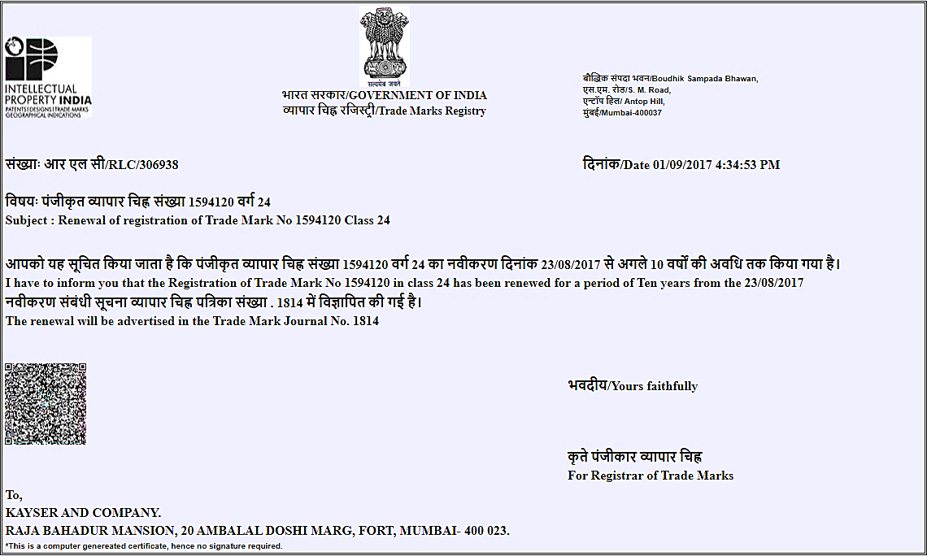

|  |  |
| --- | --- |
| **Particular** | **Details** |
| **TM Application No.** | 1594120 |
| **Class** | 24 |
| **Date of Application** | 23-08-2007 |
| **Appropriate Office** | Mumbai |
| **State** | Maharashtra |
| **Country** | India |
| **Filing Mode** | Branch Office |
| **TM Applied For** | KARA (LABEL) |
| **TM Category** | TRADE MARK |
| **Trade Mark Type** | DEVICE |
| **User Detail** | 01-08-2007 |
| **Certificate Detail** | Certificate No. 1167659    Dated: 06/05/2014 |
| **Valid up to/ Renewed up to** | 23-08-2027 |
| **Proprietor name** | Future Consumer Limited |
| **Proprietor Address** | Knowledge House, Shyam Nagar, Off Jogeshwari Vikhroli Link Road, ‘Jogeshwari (East), Mumbai- 400060 |
| **Email Id** | kayserco@gmail.com |
| **Agent name** | Kayser And Company.[239] |
| **Agent Address** | Raja Bahadur Mansion, 20 Ambalal Doshi Marg, Fort, Mumbai- 400 023. |
| **Goods & Service Details** | [CLASS: 24] Textiles And Textile Goods, Not Included in Other Classes; Bed and Table Covers. |
| **Publication Details** | Published in Journal No.: 1429-0     Dated: 01/12/2009 |
| **History/PR Details** | Grasim Industries Limited (Staple Fibre Division), Century Bhavan, Dr. A. B. Road, Worli, Mumbai 400 030., a company incorporated under the Indian Companies Act 1956., manufacturers and merchants., (body incorporate) |
| Registration renewed for a period of 10 years from 23/08/2017 advertised in journal no. 1814 |
| Pursuant to a request on form tm-50 dated 04/12/2015 and order thereon dated 13/08/2019 the address for service is altered to Kayser and Company., Raja Bahadur Mansion, 20 Ambalal Doshi Marg, Fort, Mumbai- 400 023., kayserco@gmail.com |
| Pursuant to a request on form tm-24 dated 08/10/2015 and order thereon dated 04/10/2019 Future Consumer Enterprise Limited. Has been brought on record as subsequent proprietor in respect of the said registered trade mark vide assignment deed dated 22/05/2015. |
| Pursuant to a request on form tm-p dated 20/07/2017 and order thereon dated 04/10/2019 registered proprietor's name/trading style is altered to Future Consumer Limited. |

1. **Application Number – 3446510:**

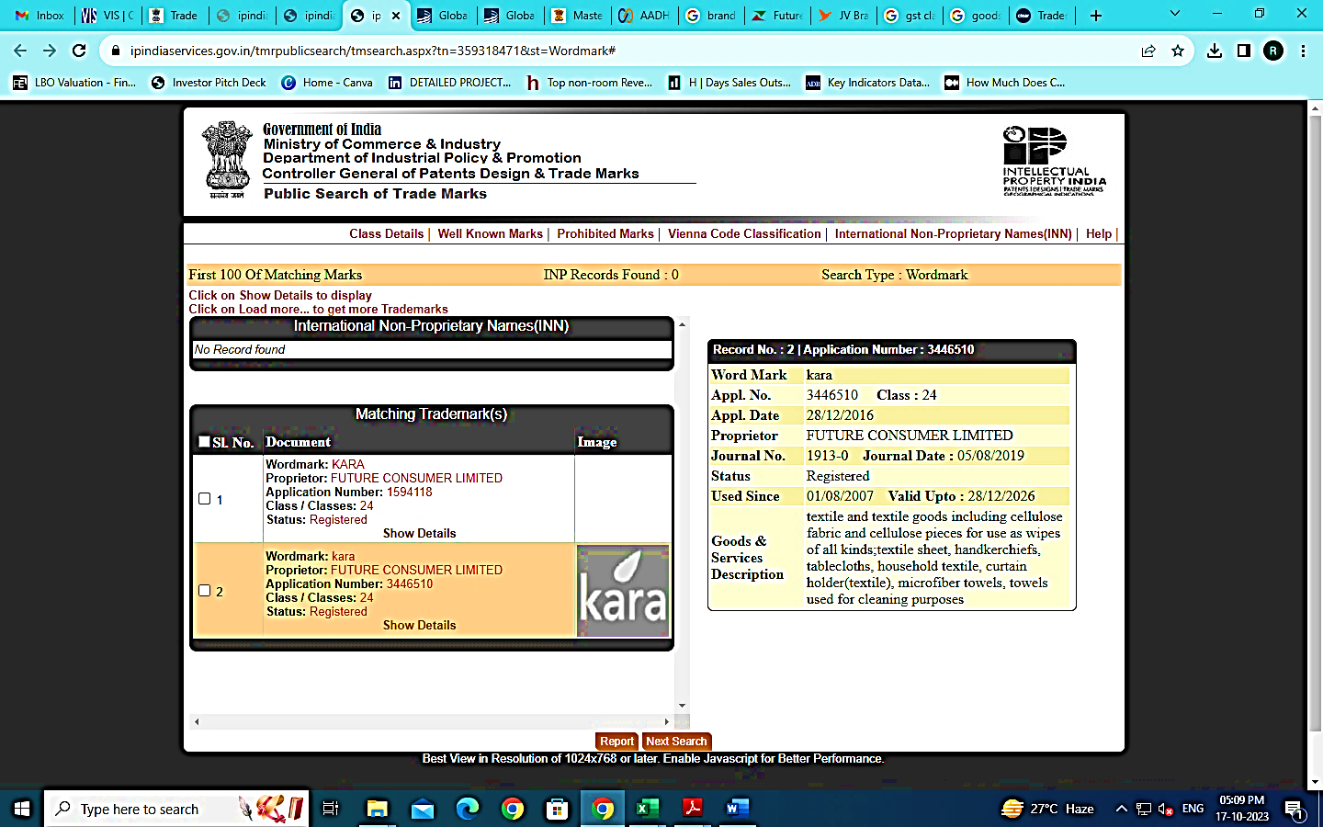

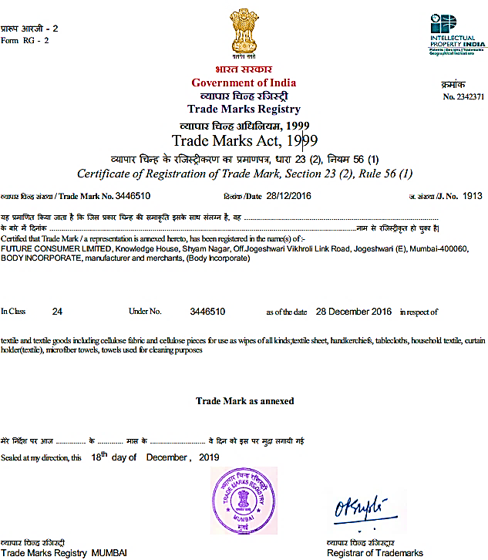

|  |  |
| --- | --- |
| **Particular** | **Details** |
| **TM Application No.** | 3446510 |
| **Class** | 24 |
| **Date of Application** | 28-12-2016 |
| **Appropriate Office** | MUMBAI |
| **State** | MAHARASHTRA |
| **Country** | India |
| **Filing Mode** | e-Filing |
| **TM Applied For** | Kara |
| **TM Category** | TRADE MARK |
| **Trade Mark Type** | DEVICE |
| **User Detail** | 01-08-2007 |
| **Certificate Detail** | Certificate No. 2342371    Dated: 18/12/2019 |
| Notified in Journal No: 1934 |
| **Valid up to/ Renewed up to** | 28-12-2026 |
| **Proprietor name** | Future Consumer Limited |
| Body Incorporate |
| **Proprietor Address** | Knowledge House, Shyam Nagar, off. Jogeshwari Vikhroli Link Road, Jogeshwari (E), Mumbai-400060 |
| **Email Id** | kayserco@gmail.com |
| **Agent name** | Kayser and Company.[239] |
| **Agent Address** | Raja Bahadur Mansion, 20 Ambalal Doshi Marg, Fort, Mumbai- 400 023. |
| **Goods & Service Details** | [CLASS: 24] |
| Textile and textile goods including cellulose fabric and cellulose pieces for use as wipes of all kinds; textile sheet, handkerchiefs, tablecloths, household textile, curtain holder(textile), microfiber towels, towels used for cleaning purposes |
| **Restrictions** | THIS IS SUBJECT TO ASSOCIATION WITH REGISTERED/PENDING REGISTRATION NO.1594120. |
| **Publication Details** | Published in Journal No.: 1913-0     Dated: 05/08/2019 |
| **History/PR Details** | Future Consumer Limited, Knowledge House, Shyam Nagar, off. Jogeshwari Vikhroli Link Road, Jogeshwari (E), Mumbai-400060, BODY INCORPORATE, Manufacturer and Merchants, (Body Incorporate) |

1. **Application Number – 1594117:**

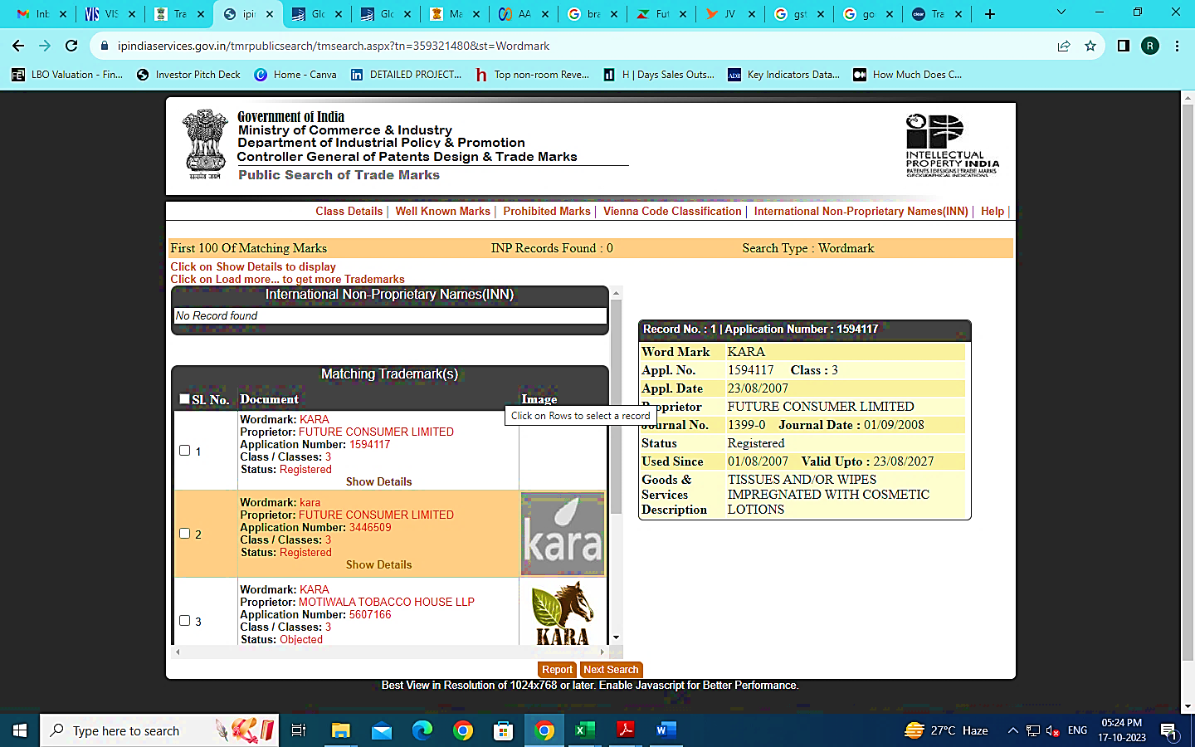

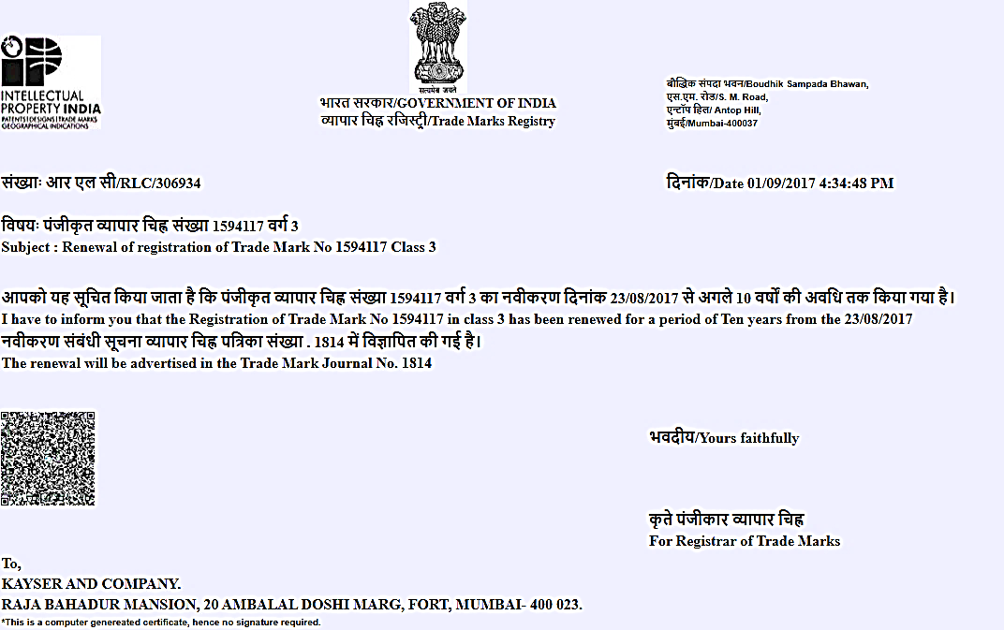

|  |  |
| --- | --- |
| **Particular** | **Details** |
| **TM Application No.** | 1594117 |
| **Class** | 3 |
| **Date of Application** | 23-08-2007 |
| **Appropriate Office** | Mumbai |
| **State** | Maharashtra |
| **Country** | India |
| **Filing Mode** | Branch Office |
| **TM Applied For** | KARA |
| **TM Category** | TRADE MARK |
| **Trade Mark Type** | WORD |
| **User Detail** | 01-08-2007 |
| **Certificate Detail** | Certificate No. 1128412    Dated: 30/10/2013 |
| **Valid up to/ Renewed up to** | 23-08-2027 |
| **Proprietor name** | FUTURE CONSUMER LIMITED  Body Incorporate |
| **Proprietor Address** | Knowledge House, Shyam Nagar, Off Jogeshwari Vikhroli Link Road, ‘Jogeshwari (East), Mumbai- 400060 |
| **Email Id** | kayserco@gmail.com |
| **Agent name** | KAYSER AND COMPANY.[239] |
| **Agent Address** | Raja Bahadur Mansion, 20 Ambalal Doshi Marg, Fort, Mumbai- 400 023. |
| **Goods & Service Details** | [CLASS: 3]  Tissues And/or Wipes Impregnated with Cosmetic Lotions |
| **Publication Details** | Published in Journal No.: 1399-0 Dated: 01/09/2008 |
| **History/PR Details** | * Grasim Industries Limited (Staple Fibre Division), Century Bhavan, Dr. A. B. Road, Worli, Mumbai 400 030., a company incorporated under the Indian Companies Act 1956., Manufacturers And Merchants., (Body Incorporate). * Registration renewed for a period of 10 years from 23/08/2017 advertised in journal no. 1814. * Pursuant to a request on form TM-34 dated 10/12/2013 and order thereon dated 29/01/2018 registered proprietor(s) trade or business address is altered to 3rd Floor, Century Bhavan, Dr. Annie Besant Road, and Worli Mumbai-400 030. * Pursuant to a request on form TM-50 dated 04/12/2015 and order thereon dated 13/08/2019 the address for service is altered to Kayser and Company, Raja Bahadur Mansion, 20 Ambalal Doshi Marg, Fort, Mumbai- 400 023. [Kayserco@gmail.Com](mailto:Kayserco@gmail.Com). * Pursuant to a request on form TM-24 dated 08/10/2015 and order thereon dated 04/10/2019 future consumer enterprise limited. Has been brought on record as subsequent proprietor in respect of the said registered trade mark vide assignment deed dated 22/05/2015. * Pursuant to a request on form tm-p dated 20/07/2017 and order thereon dated 04/10/2019 registered proprietor's name/trading style is altered to Future Consumer Limited. |

1. **Application Number – 1594119:**

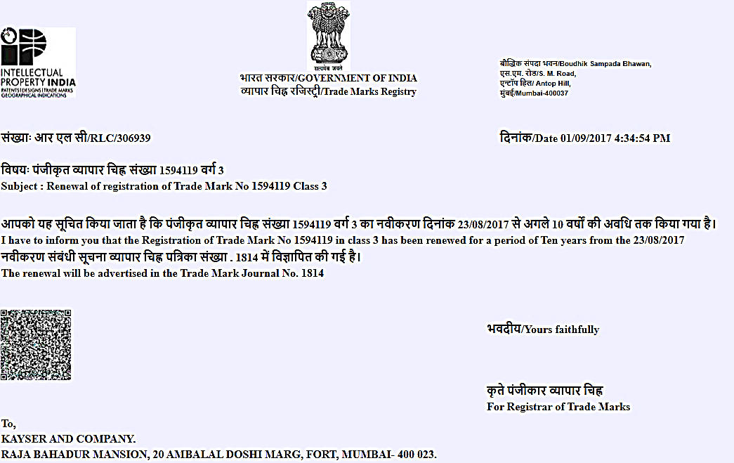

|  |  |
| --- | --- |
| **Particular** | **Details** |
| **TM Application No.** | 1594119 |
| **Class** | 3 |
| **Date of Application** | 23-08-2007 |
| **Appropriate Office** | Mumbai |
| **State** | Maharashtra |
| **Country** | India |
| **Filing Mode** | Branch Office |
| **TM Applied For** | KARA (LABEL) |
| **TM Category** | TRADE MARK |
| **Trade Mark Type** | DEVICE |
| **User Detail** | 01-08-2007 |
| **Certificate Detail** | Certificate No. 1162339    Dated: 28/03/2014 |
| **Valid up to/ Renewed up to** | 23-08-2027 |
| **Proprietor name** | FUTURE CONSUMER LIMITED Body Incorporate |
| **Proprietor Address** | Knowledge House, Shyam Nagar, Off Jogeshwari Vikhroli Link Road, Jogeshwari (East), Mumbai- 400060 |
| **Email Id** | kayserco@gmail.com |
| **Agent name** | KAYSER AND COMPANY.[239] |
| **Agent Address** | Raja Bahadur Mansion, 20 Ambalal Doshi Marg, Fort, Mumbai- 400 023. |
| **Goods & Service Details** | [CLASS: 3] Tissues and / or wipes impregnated with cosmetics lotion |
| **Conditions** | Registration Of This Trade Mark Shall Give No Right to The Exclusive Use of Word "Skincare Wipes". |
| **Publication Details** | Published in Journal No.: 1399-0     Dated: 01/09/2008 |
| **History/PR Details** | * Grasim Industries Limited (Staple Fibre Division), Century Bhavan, Dr. A. B. Road, Worli, Mumbai 400 030., a company incorporated under the Indian Companies Act 1956., Manufacturers and Merchants., (Body Incorporate). * Registration renewed for a period of 10 years from 23/08/2017 advertised in journal no. 1814. * Pursuant to a request on form tm-50 dated 04/12/2015 and order thereon dated 13/08/2019 the address for service is altered to Kayser and Company, Raja Bahadur Mansion, 20 Ambalal Doshi Marg, Fort, Mumbai- 400 023, [Kayserco@gmail.com](mailto:Kayserco@gmail.com). * Pursuant to a request on form TM-24 dated 08/10/2015 and order thereon dated 04/10/2019 Future Consumer Enterprise Limited. Has been brought on record as subsequent proprietor in respect of the said registered trade mark vide assignment deed dated 22/05/2015.Pursuant to a request on Form Tm-P dated 20/07/2017 and order thereon dated 04/10/2019 registered proprietor's name/trading style is altered to Future Consumer Limited. |

1. **Application Number – 1594118:**

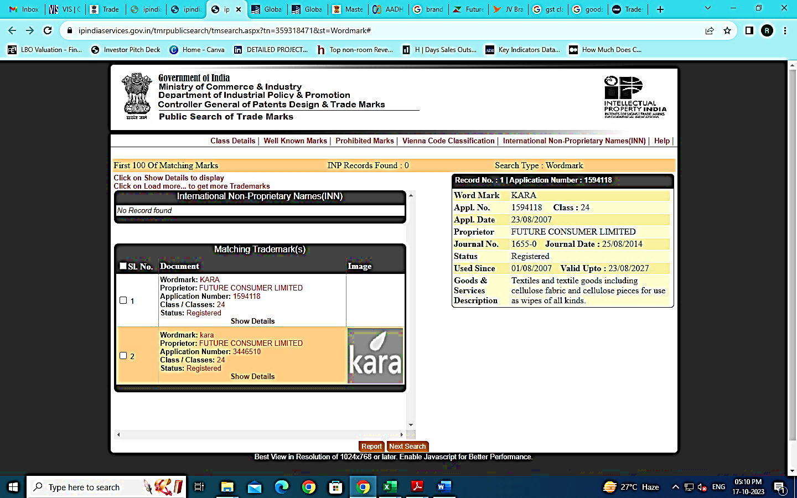

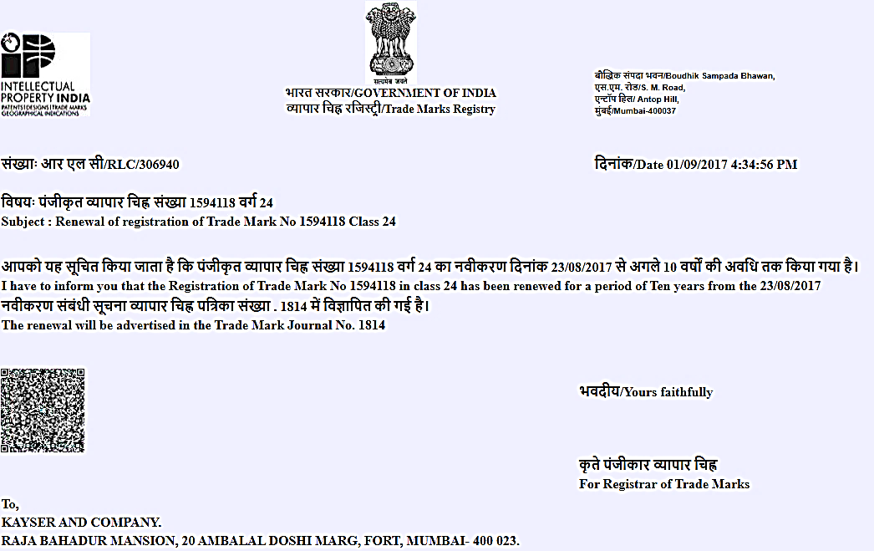

|  |  |
| --- | --- |
| **Particular** | **Details** |
| **TM Application No.** | 1594118 |
| **Class** | 24 |
| **Date of Application** | 23-08-2007 |
| **Appropriate Office** | MUMBAI |
| **State** | MAHARASHTRA |
| **Country** | India |
| **Filing Mode** | Branch Office |
| **TM Applied For** | KARA |
| **TM Category** | TRADE MARK |
| **Trade Mark Type** | WORD |
| **User Detail** | 01-08-2007 |
| **Certificate Detail** | Certificate No. 1205248    Dated: 10/04/2015 |
| **Valid up to/ Renewed up to** | 23-08-2027 |
| **Proprietor name** | FUTURE CONSUMER LIMITED |
| Body Incorporate |
| **Proprietor Address** | Knowledge House, Shyam Nagar, Off Jogeshwari Vikhroli Link Road, Jogeshwari (East), Mumbai- 400060 |
| **Email Id** | kayserco@gmail.com |
| **Agent name** | KAYSER AND COMPANY.[239] |
| **Agent Address** | Raja Bahadur Mansion, 20 Ambalal Doshi Marg, Fort, Mumbai- 400 023. |
| **Goods & Service Details** | [CLASS: 24] |
| Textiles and textile goods including cellulose fabric and cellulose pieces for use as wipes of all kinds. |
| **Publication Details** | Published in Journal No.: 1655-0     Dated: 25/08/2014 |
| **History/PR Details** | * Grasim Industries Limited (Staple Fibre Division), Century Bhavan, Dr. A. B. Road, Worli, Mumbai 400 030., a company incorporated under The Indian Companies Act 1956., Manufacturers and Merchants., (Body Incorporate). * Registration renewed for a period of 10 years from 23/08/2017 advertised in journal no. 1814. Pursuant to a request on form tm-50 dated 04/12/2015 and order thereon dated 13/08/2019 the address for service is altered to Kayser and Company, Raja Bahadur Mansion, 20 Ambalal Doshi Marg, Fort, Mumbai- 400 023, [Kayserco@gmail.com](mailto:Kayserco@gmail.com). * Pursuant to a request on form TM-24 dated 08/10/2015 and order thereon dated 04/10/2019 future consumer enterprise limited. Has been brought on record as subsequent proprietor in respect of the said registered trade mark vide assignment deed dated 22/05/2015. Pursuant to a request on form TM-P dated 20/07/2017 and order thereon dated 04/10/2019 registered proprietor's name/trading style is altered to Future Consumer Limited. |

1. **APPLICATION NUMBER – 3446509**

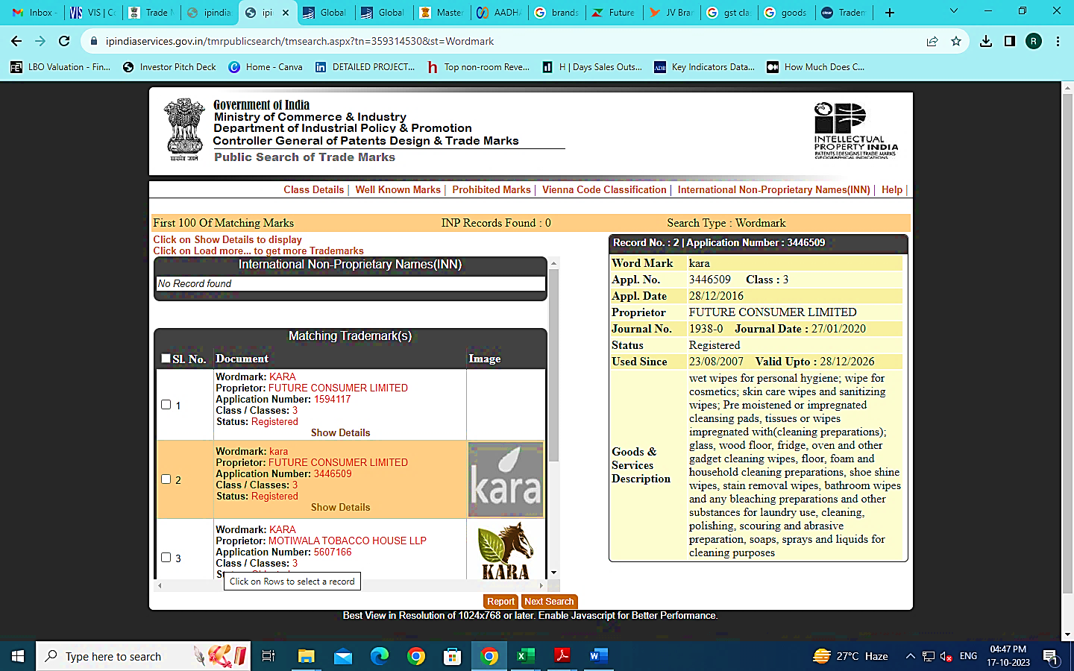

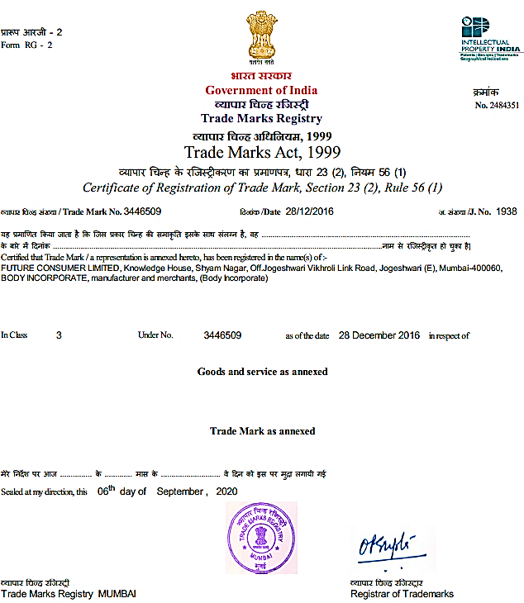

|  |  |
| --- | --- |
| **Particular** | **Details** |
| **TM Application No.** | 3446509 |
| **Class** | 3 |
| **Date of Application** | 28-12-2016 |
| **Appropriate Office** | Mumbai |
| **State** | Maharashtra |
| **Country** | India |
| **Filing Mode** | e-Filing |
| **TM Applied For** | Kara |
| **TM Category** | TRADE MARK |
| **Trade Mark Type** | DEVICE |
| **User Detail** | 23-08-2007 |
| **Certificate Detail** | Certificate No. 2484351    Dated: 06/09/2020 Notified in Journal No: 1965 |
| **Valid up to/ Renewed up to** | 28-12-2026 |
| **Proprietor name** | FUTURE CONSUMER LIMITED Body Incorporate |
| **Proprietor Address** | Knowledge House, Shyam Nagar, off. Jogeshwari Vikhroli Link Road, Jogeshwari (E), Mumbai-400060 |
| **Email Id** | kayserco@gmail.com |
| **Agent name** | KAYSER AND COMPANY.[239] |
| **Agent Address** | Raja Bahadur Mansion, 20 Ambalal Doshi Marg, Fort, Mumbai- 400 023. |
| **Goods & Service Details** | [CLASS: 3]  Wet wipes for personal hygiene; wipe for cosmetics; skin care wipes and sanitizing wipes; Pre moistened or impregnated cleansing pads, tissues or wipes impregnated with(cleaning preparations); glass, wood floor, fridge, oven and other gadget cleaning wipes, floor, foam and household cleaning preparations, shoe shine wipes, stain removal wipes, bathroom wipes and any bleaching preparations and other substances for laundry use, cleaning, polishing, scouring and abrasive preparation, soaps, sprays and liquids for cleaning purposes |
| **Restrictions** | This is subject to association with registered/pending registration no. 1594117. |
| **Publication Details** | Published in Journal No.: 1938-0     Dated: 27/01/2020 |
| **History/PR Details** | Future Consumer Limited, Knowledge House, Shyam Nagar, off. Jogeshwari Vikhroli Link Road, Jogeshwari (E), Mumbai-400060, Body Incorporate, Manufacturer and Merchants, (Body Incorporate) |

|  |  |
| --- | --- |
| **PART D** | **FINANCIAL PERFORMANCE AND VALUATION OF THE BRAND** |

1. **HISTORICAL FINANCIAL PERFORMANCE:**

As per the data/information provided by the client, the month-wise revenue earned by the KARA brand from the F.Y.2017-18 up to January 2023 are as presented in the below table:

***(INR Lakhs)***

| **Particulars** | **2017 -18** | **2018-19** | **2019 -20** | **2020 -21** | **2021 -22** | **Jan 2023** |
| --- | --- | --- | --- | --- | --- | --- |
| April | 272 | 298 | 215 | 38 | 82 | 86 |
| May | 307 | 308 | 173 | 53 | 4 | 53 |
| June | 242 | 256 | 194 | 59 | 143 | 33 |
| July | 195 | 200 | 177 | 43 | 47 | 33 |
| August | 187 | 193 | 170 | 33 | 67 | 31 |
| September | 228 | 185 | 167 | 31 | 42 | 40 |
| October | 217 | 180 | 134 | 24 | 28 | 28 |
| November | 225 | 157 | 105 | 13 | 24 | 35 |
| December | 200 | 181 | 132 | 17 | 166 | 27 |
| January | 198 | 187 | 126 | 48 | 155 | 28 |
| February | 198 | 160 | 88 | 75 | 38 | - |
| March | 505 | 200 | 69 | 98 | 132 | - |
| **Total** | **2,974** | **2,505** | **1,750** | **532** | **928** | **394** |
| **Gross Margin** | **49.60%** | **44.10%** | **42.70%** | **18.90%** | **39.40%** | **43.50%** |

***Source:*** *As per the data/information provided to us by the client.*

1. **METHODOLOGY/ MODEL ADOPTED:**

Brand valuation constitutes a robust and systematic process for quantifying the present and future value of a brand. It serves as a valuable instrument for comprehending how a brand generates value and aligns with the motivations driving consumer purchases. Moreover, brand valuation serves as a mechanism for articulating brand and marketing strategies in the context of shareholder value, both within the organization and to external stakeholders.

Out of the various models & theories available, we have adopted **Relief from Royalty Method**. The Relief from Royalty Method is a widely recognized approach used in the field of intellectual property and brand valuation. The basic idea behind the Relief from Royalty Method is to assess the economic benefit or value that the ownership of the intangible asset provides to the business. The notional price paid by the operating company to the brand company expressed as a royalty rate. The NPV of the forecasted royalties represents the value of the brand to the business. In this method, the royalties are discounted by the discount rate to arrive at the fair market value of the intangible asset. 

**PROCESS OF BRAND VALUE CALCULATION:**

1. **Establishing the Notional Royalty Rate:**

The determination of royalty rate ranges is significantly influenced by the fundamental profitability within each industrial sector. In the licensing industry, there exists a practical guideline, often referred to as the 'Rule of 25,' which suggests that, on average, a licensee should anticipate allocating 25% of their projected profits for the privilege of accessing licensed intellectual property. To illustrate, if the operating margin stands at 20%, an appropriate royalty rate would equate to 25% multiplied by 20%, resulting in 5%.

It is important to note that this rule is founded on heuristic evidence demonstrating a connection between market royalty rates and the earnings margins realized by licensee businesses. Actual royalty rates may deviate from this 25% guideline, depending on a multitude of quantitative and qualitative factors that can influence commercial negotiations. In the process of ascertaining the appropriate royalty rate, the 'Rule of 25' serves as a valuable reference point for estimating the royalty rate range pertinent to each specific industrial sector.

Additionally, another method for establishing royalty rates is through a "Benchmarking study," which involves a comprehensive examination of publicly available license agreements and their associated royalty rates. This study aids in determining the arm's length (market) royalty rate range applicable to particular products or services.

As per the information shared by the client/company, average historical gross margin of KARA brand is 39.70%, the royalty rate would equate to 25% multiplied by 39.70%, resulting in 9.925%, which would not be an appropriate royalty rate as the operating margin would mirror a more realistic royalty rate in comparison to the gross margin. Given that the management of Future Consumer Limited cannot supply a specific operating margin exclusively for the Kara brand, a conservative approach has been adopted, and the royalty rate has been conservatively set at 5%.

1. Determine the projected revenue from which the company will earn royalties. Since the company has not generated any revenue since January 31, 2023, it is assumed that revenue generation will commence in the fiscal year 2024-25, contingent upon the company's infusion of working capital into the business. With this assumption, the projected annual revenue has been estimated, featuring an annual growth rate of 5.50%. This growth rate aligns with the economy's inflation rate, to be on the conservative side.
2. Determine the projected revenue from which the company will earn royalties. As the company is not earning any revenue since 31st January 2023, we have assumed that the company will start earning the revenue from the FY 2024-25, subject to infusion of working capital in the business by the company. By keeping this assumption in mind, we have projected the expected annual revenue earned with an annual growth rate of 5.50%, which is kept in line with the inflation rate of the economy to be on the conservative side.
3. Compute the Gross Royalty Income by multiplying the calculated royalty rate by the revenue generated from royalties.
4. Subtract Tax Expenses from the Net Royalty Income, which is determined after deducting Branding Expenses from the Gross Royalty Income. In this calculation, an effective tax rate of 25.17% is applied.
5. Apply the Discounting Factor to the Net Royalty Income after taxes to ascertain the Present Value of the net Royalty Income for the Projection Period.
6. To derive the Terminal value, a growth rate of 2.50% has been considered. This choice of growth rate is deemed reasonable, taking into account the Company's projected growth and the industry's anticipated expansion.
7. **CALCULATION OF BRAND EARNINGS:**

***(INR Lakhs)***

|  |  |  |  |  |  |
| --- | --- | --- | --- | --- | --- |
| **Particulars** | **Projected** | **Projected** | **Projected** | **Projected** | **Projected** |
| **Mar-25** | **Mar-26** | **Mar-27** | **Mar-28** | **Mar-29** |
| Revenue | **438.53** | **462.65** | **488.10** | **514.94** | **543.26** |
| **Net Royalty Savings** | **21.93** | **23.13** | **24.40** | **25.75** | **27.16** |
| Income Tax | 5.52 | 5.82 | 6.14 | 6.48 | 6.84 |
| **After-tax Royalty Savings** | **16.41** | **17.31** | **18.26** | **19.27** | **20.33** |
| **Perpetual Growth Rate** | **2.50%** | | | | |
| **Discount Rate** | **16.78%** | | | | |
| **Valuation Date** | **1st March 2024** | | | | |
| Time Period | 1.08 | 2.08 | 3.08 | 4.08 | 5.08 |
| PVF | 0.85 | 0.72 | 0.62 | 0.53 | 0.45 |
| **Terminal Value** |  |  |  |  | **145.90** |
| **PV of CF** | **13.87** | **12.53** | **11.32** | **10.23** | **9.24** |
| **PV of TV** |  |  |  |  | **66.33** |
| **PV of CF+ PV of TV** | **13.87** | **12.53** | **11.32** | **10.23** | **75.57** |
| **Brand Value of KARA** | **INR 123.53 Lakhs** | | | | |

1. **KEY INPUTS USED TO DISCOUNT BRAND EARNINGS:**

|  |  |
| --- | --- |
| **Key Inputs** | |
| **Valuation Date** | 1st March 2024 |
| **Discount Rate** | 16.78% |
| **Terminal Growth Rate** | 2.50% |
| **Discount Rate Change** | 1.00% |

|  |  |
| --- | --- |
| **Discount Rate** | |
| **Particulars** | **Discount Rate** |
| Expected Market Return (Rm) Nifty Fifty 10-year return 2024 | 12.78% |
| Risk Premium | 4.00% |
| **Appropriate Discount Rate** | **16.78%** |

1. **CALCULATION OF BRAND VALUE:**

|  |
| --- |
| **FAIR VALUE OF THE KARA BRAND** |
| **INR ONE CRORE TWENTY- THREE LAKHS AND FIFTY-THREE THOUSAND (INR 123.53 lakhs)** |

**NOTE:**

* *This is just the valuation of the brand based on its income generating capacity in future years. This Valuation shall not be construed as the physical asset or should be directly related to cost approach or Project cost.*
* *The brand has not generated any revenue since January 31, 2023, it is assumed that revenue generation will commence in the fiscal year 2024-25, contingent upon the company's ability to infuse the working capital into the business. With this assumption in consideration, the annual revenue in the projected years from FY 2024-25 to FY 2028-29 have been estimated.*
* *We have relied upon the historical data to forecast the financial projections as per the industry standards.*
* *This brand valuation report serves as a snapshot of “KARA” brand and market position as of the current assessment date. The brand's value may evolve over time in response to market dynamics and brand management strategies.*
* *We have not considered any contingent Dues / Liability/ Payables / Receivables / Pendency on or of the company in future years, which should be assessed separately by the parties, wanting to enter in the transaction, unless otherwise mentioned.*

1. **SENSITIVITY ANALYSIS:**
2. WACC is the key input which has strong impact on the firm’s value with respect to percentage change. We have considered a change of 1% to perform the sensitivity analysis.

|  |  |
| --- | --- |
| **Scenario** | **WACC** |
| **Optimistic Case** | 15.78% |
| **Base Case** | 16.78% |
| **Pessimistic Case** | 17.78% |

1. **TERMINAL GROWTH RATE:**

Perpetual growth rate is the key input to calculate the Brand Value during assessing the firm’s value. We have considered a change of **0.50%** to perform the sensitivity analysis.

|  |  |
| --- | --- |
| **Scenario** | **Growth Rate** |
| **Optimistic Case** | 3.00% |
| **Base Case** | 2.50% |
| **Pessimistic Case** | 2.00% |

1. **BRAND VALUE OF THE FIRM IN THE DIFFERENT SCENARIO:**

|  |  |  |  |  |
| --- | --- | --- | --- | --- |
| **INR 123.53 Lakhs** | | **Terminal Growth Rate** | | |
| **2.00%** | **2.50%** | **3.00%** |
| **Discount Rate** | **15.78%** | 130.09 | 133.15 | 136.44 |
| **16.78%** | 120.97 | **123.53** | 126.27 |
| **17.78%** | 113.01 | 115.17 | 117.48 |

Thus, in the base case, ‘KARA’ is having the Brand Value of **INR 123.53 Lakhs** as per the using two-stage DCF Model subject to the current assumptions and inputs used during the forecasted period, as well as the terminal growth rate and WACC used to calculate the brand value.

As per the sensitivity analysis, the Brand value may vary up to **INR 136.44 Lakhs** as optimistic case and INR **113.01 Lakhs** as the pessimistic case. However, the final transaction price will be dependent on the bargaining power of market participants to reach out to a successful outcome for all the concerned parties.

*This is only a general assessment of the value of the brand based on the data/ input Company officials could provide to us against our questions/ queries and information available in the public domain. In no manner this should be regarded as an audit activity/ report and NO micro analysis or detailed or forensic audit/ scrutiny of the financial transactions or accounts of any kind has been carried out at our end.*

1. **KEY ASSUMPTIONS AND WORKINGS:**

Assumptions in the Valuation assessment have been taken based on data/ information/ documents shared by the Company, Operating History of the Company, Annual Reports of the company, Market & Industry analysis. Assumptions have been considered after thoroughly reviewing their feasibility.

1. **REVENUE:**

As per the information provided to us, the brand has not generated any revenue since January 31, 2023, it is assumed that revenue generation will commence in the fiscal year 2024-25, contingent upon the company's ability to infuse the working capital into the business. With this assumption, the annual revenue in the projected years from FY 2024-25 to FY 2028-29 have been estimated.

1. **GROWTH RATE:**

**PROJECTED PERIOD:** The annual growth rate for the projected years’ revenue is considered as 5.50% keeping in mind the historical inflation rate is ranging between 5.00% to 6.50% in the past five years. We have considered the growth rate as 5.50% which is in the line and on conservative side in comparison with the respective sector and industry. It takes into account the potential impact of inflation on the business; this adjustment helps provide a more realistic and accurate estimate of the future revenue growth rate.

**PERPETUAL GROWTH:** Perpetual Growth rate has been considered as 2.50%, which is in the line and on conservative side in comparison with the respective sector and industry.

1. **TAXATION:** Corporate tax rate is 25.17%.
2. **COMPANY RISK PREMIUM:**

As the holding company has been declared NPA, which restricts the brand (KARA) to expand its operations as per the information shared by the company. The historical performance of the company is also under stress as per the details shared by the client/company, which makes this brand a risky prospect for any prospective investor.

Further various other factors such as presence of the brand, lack of visibility of the product, higher price, etc. can hit the profitability or revenue generation from the brand.

Due to these reasons, we have assumed a company-wide risk premium of 4.00%, which covers all the associated expected risks.

1. **TERMINAL VALUE:**

Terminal value (TV) is used to estimate the value of a project beyond the forecast period. It is the present value of the sum of all future cash flows to the project or company and assumes the cash flow will grow at a constant rate of 2.50% in this case. The formula for calculating the terminal value is as follows:

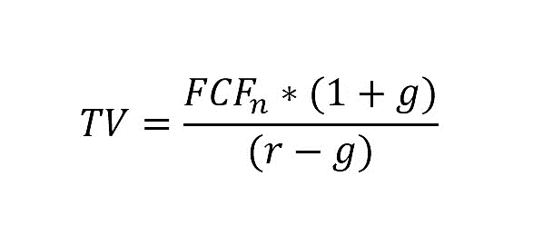

To calculate the terminal value, we have used the financial data of the last projected year, i.e., FY 2027-28 and multiplied it with (1 + Perpetual Growth Rate of 2.50%) and then divide the Free Cash Flow of the terminal period with the difference of required rate of return (WACC) and Perpetual Growth Rate (g) i.e., (WACC - g).

**Hence, the calculated Brand Value of KARA is INR 126.73 Lakhs, subject to the current micro & macro-economic assumptions, market, industry trends and inputs used during the forecasted period, as well as the growth rate and WACC used to calculate the brand value.**

|  |  |
| --- | --- |
| **Declaration** | 1. The undersigned does not have any direct/indirect interest in the above property. 2. The information furnished herein is true and correct to the best of our knowledge, logical and scientific assumptions. 3. This Brand Valuation Report is carried out by our Financial Analyst team on the request from State Bank of India, Stressed Asset Management Branch - 3, 112/115, 1st Floor, West Wing, Tulsiani Chambers, Free Press Journal Marg, Nariman Point, Mumbai, 400021. 4. As a brand valuation assignment, any site visit/inspection is out of scope of work of this report. 5. We have submitted the Brand Valuation report to the SBI, SAMB Branch. |
| **Number of Pages in the Repost** | 40 |
| **Enclosed Documents** | Disclaimer & Remarks 35-40 |
| **Place** | Noida |
| **Date** | 15th April 2024 |

|  |  |
| --- | --- |
| **FOR ON BEHALF OF**  **M/S. R.K. ASSOCIATES VALUER & TECHNO ENGINEERING CONSULTANTS PVT. LTD.** | |
| **PREPARED BY** | **REVIEWED BY** |
| **Mr. Rachit Gupta** | **Mr. Gaurav Kumar** |
|  |  |

|  |  |
| --- | --- |
| **PART E** | **IMPORTANT DEFINITION** |

***Definitions:***

* ***Enterprise Value:*** *Enterprise value (EV) is the corporate valuation of a company, determined by using market capitalization and total debt. Market cap comprises preference stocks, common stocks, and minority interest; total debt comprises short-term and long-term liabilities of the company. Enterprise value (EV) refers to the overall valuation—equity, debt, cash, and cash equivalents. In other words, it is the cost of acquiring a firm. The EV/EBITDA is an enterprise multiple. It correlates EV with earnings before interest, taxes, depreciation, and amortization. The metric determines whether the firm is undervalued or overvalued.*

*EV is computed using the following formula: EV = (Market Capitalization + Market Value of Debt – Cash and Equivalents).*

* ***Fair Market Value****suggested by the competent Valuer is that prospective estimated amount in his expert & prudent opinion of the subject asset without any prejudice after he has carefully & exhaustively evaluated the facts & information came in front of him related to the subject asset at which the subject asset should be exchanged between a willing buyer and willing seller at an arm’s length transaction in an open & unrestricted market, after proper marketing, wherein the parties, each acted knowledgeably, prudently and without any compulsion on the date of the Valuation.*

*Forced, under compulsion & constraint, obligatory sales transactions data doesn’t indicate the Fair Market Value.*

* ***Realizable Value*** *is the minimum prospective estimated value of the Company which it may be able to realize at the time of actual transaction factoring in the potential prospects of deep negotiations carried out between the buyer & seller for ultimately finalizing the transaction across the table. Realizable value may be 10-20% less than the Fair Market Value depending on the various salability prospects of the subject asset and the needs of the buyer & the seller.*
* ***Forced/ Distress Sale Value*** *is the value when the company has to be sold due to any compulsion or constraint like financial encumbrances, dispute, as a part of a recovery process, legal issues or any such condition or situation. In this type of sale, minimum fetch value is assessed which can be 15-25% less than the estimated Fair Market Value. In this type of sale, negotiation power of the buyer is always more than the seller and eagerness & pressure of selling the asset is more than buying it. Therefore, the Forced/ Distress Sale Value will always fetch significantly less value compare to the estimated Fair Market Value.*
* ***Liquidation Value*** *is the amount that would be realized when an asset or group of assets are sold on a piecemeal basis that is without consideration of benefits (or detriments) associated with a going-concern business. Liquidation value can be either in an orderly transaction with a typical marketing period or in a forced transaction with a shortened marketing period.*
* ***Difference between Costs, Price & Value:*** *Generally, these words are used and understood synonymously. However, in reality each of these has a completely different meaning, premise and also have different definitions in the professional & legal terms. Therefore, to avoid confusion, it is our professional responsibility to describe the definitions of these words to avoid ambiguity & confusion in the minds of the user of this report.*
* *The* ***Cost*** *of an asset represents the actual amount spend in the construction/ actual creation of the asset.*
* *The* ***Price*** *is the amount paid for the procurement of the same asset.*
* *The* ***Value*** *is defined as the present worth of future rights in the asset and depends to a great extent on combination of various factors such as demand and supply, market situation, purpose, situation & needs of the buyer & seller, salability outlook, usability factor, market perception & reputation. Needs of the buyer & seller, salability outlook, usability factor, market perception & reputation.*
* *Therefore, in actual for the same asset, cost, price & value remain different since these terms have different usage & meaning.*

|  |  |
| --- | --- |
| **PART F** | **DISCLAIMER | REMARKS** |

* + - 1. No employee or member of R.K Associates has any direct/ indirect interest in the Project.
      2. This is just an opinion report on Valuation based on the copy of the documents/ information provided to us by the client which has been relied upon in good faith and the assessment and assumptions done by us.
      3. This report is prepared based on the copies of the documents/ information which the Bank/ Company has provided to us out of the standard checklist of documents sought from them and further based on our assumptions and limiting conditions. The client/owner and its management/representatives warranted to us that the information they supplied was complete, accurate and true and correct to the best of their knowledge. All such information provided to us has been relied upon in good faith and we have assumed that it is true and correct in all respect. I/We shall not be liable for any loss, damages, cost or expenses arising from fraudulent acts, misrepresentations, or willful default on part of the owner, company, its directors, employee, representative or agents. Verification or cross checking of the documents provided to us from the originals or from any Govt. departments/ Record of Registrar has not been done at our end since this is beyond the scope of our work. If at any time in future, it is found or came to our knowledge that misrepresentation of facts or incomplete or distorted information has been provided to us then this report shall automatically become null & void.
      4. This Valuation is prepared based on the current financial status of the company, financial data, other facts & information provided by the client in writing & during verbal discussion during the course of the assignment and based on certain assumptions which are specifically mentioned in the Valuation section of the Report.
      5. Key assumptions in the report are taken based on data, information, inputs, financial statements etc. provided by the client to us during the course of the assessment and on the basis of the assessment done by us and we have assumed that all such information is true & factual to the best of the knowledge of the promoter company.
      6. Sale transaction method of the asset is assumed as free market transaction while assessing Prospective Fair Market Value of the asset.
      7. Legal aspects for e.g., investigation of title, ownership rights, lien, charge, mortgage, lease, sanctioned maps, verification of documents, etc. have not been done at our end and same has to be taken care by legal expert/ Advocate. It is assumed that the concerned Lender/ Financial Institution has satisfied them with the authenticity of the documents, information given to us and for which the legal verification has been already taken and cleared by the competent Advocate before requesting for this report. I/ We assume no responsibility for the legal matters including, but not limited to, legal or title concerns.
      8. All observations mentioned in the report is only based on the visual observation and the documents/ data/ information provided by the client. No mechanical/ technical tests, measurements or any design review have been performed or carried out from our side during Project assessment.
      9. Bank/FII should ONLY take this report as an Advisory document from the Financial/ Chartered Engineering firm and its specifically advised to the creditor to cross verify the original documents for the facts mentioned in the report which can be availed from the borrowing company directly.
      10. In case of any default in loans or the credit facility extended to the borrowing company, R.K Associates shall not be held responsible for whatsoever reason may be and any request for seeking any explanation from the employee/s of R.K Associates will not be entertained at any instance or situation.
      11. We have relied on data from third party, external sources & information available on public domain also to conclude this report. These sources are believed to be reliable and therefore, we assume no liability for the truth or accuracy of any data, opinions or estimates furnished by others that have been used in this analysis. Where we have relied on data, opinions or estimates from external sources, reasonable care has been taken to ensure that such data has been correctly extracted from those sources and /or reproduced in its proper form and context, however still we can’t vouch its authenticity, correctness or accuracy.
      12. This Report is prepared by our competent technical team which includes financial experts & analysts. This report is a general analysis of the project based on the scope mentioned in the report. This is not an Audit report, Design document, DPR or Techno feasibility study. All the information gathered is based on the facts seen on the site during survey, verbal discussion & documentary evidence provided by the client and is believed that information given by the company is true best of their knowledge.
      13. Value varies with the Purpose/ Date/ Condition of the market. This report should not to be referred if any of these points are different from the one mentioned aforesaid in the Report.
      14. Analysis and conclusions adopted in the report are limited to the reported assumptions, conditions and information came to our knowledge during the course of the work.
      15. This report is having limited scope as per its fields to provide only the general indication of the Value of Equity of the companies prevailing in the market based on the documents/ data/ information/ financial statements provided by the client and the assessment and assumption taken by us. The suggested value should be considered only if transaction is happened as free market transaction.
      16. Secondary/ Tertiary costs related to transaction like Stamp Duty, Registration charges, Brokerage, etc. pertaining to the sale/ purchase of the company are not considered while assessing the Market Value.
      17. Appropriate methodology & assumptions are rationally adopted based on the facts of the case came to our knowledge during the course of the assignment considering many factors like nature of Industry, current market situation and trends.
      18. Valuation is a subjective field and opinion may differ from consultant to consultant. To check the right opinion, it is important to evaluate the methodology adopted and various factors/ basis considered during the course of assessment before reaching to any conclusion.
      19. At the outset, it is to be noted that Value analysis cannot be regarded as an exact science and the conclusions arrived at in many cases will, of necessity, be subjective and dependent on the exercise of individual judgment. Given the same set of facts and using the same assumptions, expert opinions may differ due to the number of different factors, which have to be made. Therefore, there can be no standard formulae to establish an indisputable exchange ratio. In the event of a transaction, the actual transaction value achieved may be higher or lower than our indicative analysis of value depending upon the circumstances of the transaction. The knowledge, negotiability and motivations of the buyers and sellers and the applicability of a discount or premium for control will also affect actual price achieved. Accordingly, our indicative analysis of value will not necessarily be the price at which any agreement proceeds. The final transaction price is something on which the parties themselves have to agree. However, our Valuation analysis can definitely help the stakeholders to make them informed and wise decision about the Value of the asset and can help in facilitating the arm’s length transaction.
      20. This report is prepared on the Brand Valuation format as per the client requirement. This report is having limited scope as per its fields to provide only the indicative Fair value of the company based on the current financial position, future prospects & current Industry trends. The Valuation assessed in this Valuation Report should hold well only if transaction is happened as per free market transaction. No detailed analysis or verification of the information is carried upon pertaining to the value of the shares of the subject companies. No claim for any extra information will be entertained whatsoever be the reason. For any extra work over and above the fields mentioned in the report will have an extra cost which has to be borne by the customer.
      21. As per the scope of the report no site survey has been carried out by us and no thorough vetting of the documents/ information provided to us has been done at our end.
      22. This is just an opinion report and doesn’t hold any binding on anyone. It is requested from the concerned stakeholder which is using this report that they should consider all the different associated relevant & related factors also before taking any business decision based on the content of this report.
      23. Though adequate care has been taken while preparing this report as per its scope, but still, we can’t rule out typing, human errors, over sightedness of any information or any other mistakes. Therefore, the concerned organization is advised to satisfy themselves that the report is complete & satisfactory in all respect. Intimation regarding any discrepancy shall be brought into our notice immediately. If no intimation is received within 15 (Fifteen) days in writing from the date of issuance of the report, to rectify these timely, then it shall be considered that the report is complete in all respect and has been accepted by the client up to their satisfaction & use and further to which R.K Associates shall not be held responsible in any manner.
      24. This Valuation report is prepared based on the facts of the companies provided to us during the course of the assignment. However, in future the assumptions taken may change or may go worse due to impact of Govt. policies or effect of World economy, Industry/ market scenario may change, etc. Hence before taking any business decision the user of this report should take into consideration all such future risk.
      25. The documents, information, data provided to us during the course of this assessment by the client is reviewed only up to the extent required in relation to the scope of the work. No document has been reviewed beyond the scope of the work.
      26. In case of any default in repayment of credit facility extended to the borrowing company, as estimated by us, R.K Associates shall not be held responsible for whatsoever reason may be and any request for seeking any explanation from the employee/s of R.K Associates will not be entertained at any instance or situation.
      27. This report only contains general assessment & opinion as per the scope of work evaluated and based on technical & market information which came to knowledge during course of the assignment as per the information given in the copy of documents, information, data provided to us and/ and confirmed by the owner/ owner representative to us at site which has been relied upon in good faith. It doesn’t contain any other recommendations of any sort including but not limited to express of any opinion on the suitability or otherwise of entering into any transaction with the borrower.
      28. This Valuation is conducted based on the macro analysis of the asset/ property and operations of the companies and not based on the micro, component or item wise analysis. Analysis done is a general assessment and is not investigative in nature.
      29. This report is prepared following our Standard Operating Procedures & Best Practices, Limitations, Conditions, Remarks, Important Notes, Valuation TOR.
      30. Valuation is done based on the industry wide general accepted norms and based on the international standards & best practices for equity valuations.
      31. Any kind of unpaid statutory, utilities, lease, interest or any other pecuniary dues on the asset has not been factored in the Valuation.
      32. All Pages of the report including annexures are signed and stamped from our office. In case any paper in the report is without stamp & signature then this should not be considered a valid paper issued from this office.
      33. Defect Liability Period is 15 DAYS. We request the concerned authorized reader of this report to check the contents, data and calculations in the report within this period and intimate us in writing if any corrections are required or in case of any other concern with the contents or opinion mentioned in the report. Corrections only related to typographical, calculation, spelling mistakes, incorrect data/ figures/ statement will be entertained within the defect liability period. Any new changes for any additional information in already approved report will be regarded as additional work for which additional fees may be charged. No request for any illegitimate change in regard to any facts & figures will be entertained.
      34. R.K Associates encourages its customers to give feedback or inform concerns over its services through proper channel at valuers@rkassociates.org in writing within 15 days of report delivery. After this period no concern/ complaint/ proceedings in connection with the Financial Feasibility Study Services will be entertained due to possible change in situation and condition of the subject Project.
      35. Our Data retention policy is of ONE YEAR. After this period, we remove all the concerned records related to the assignment from our repository. No clarification or query can be answered after this period due to unavailability of the data.
      36. This Brand Valuation report is governed by our (1) Internal Policies, Processes & Standard Operating Procedures, (2) R.K Associates Quality Policy, (3) Valuation & Survey Best Practices Guidelines formulated by management of R.K Associates, (4) Information input given to us by the customer and (4) Information/ Data/ Facts given to us by our field/ office technical team. Management of R.K Associates never gives acceptance to any unethical or unprofessional practice which may affect fair, correct & impartial assessment and which is against any prevailing law. In case of any indication of any negligence, default, incorrect, misleading, misrepresentation or distortion of facts in the report then it is the responsibility of the user of this report to immediately or at least within the defect liability period bring all such act into notice of R.K Associates management so that corrective measures can be taken instantly.
      37. R.K Associates never releases any report doing alterations or modifications from pen. In case any information/ figure of this report is found altered with pen then this report will automatically become null & void.
      38. If this report is prepared for the matter under litigation in any Indian court, no official or employee of R.K Associates will be under any obligation to give in person appearance in the court as a testimony. For any explanation or clarification, only written reply can be submitted on the additional payment of charges.