File No.: VIS(2023-24)-PL497-412-631 Dated: 26-10-2023

LENDER’S INDEPENDENT ENGINEER’S REPORT

OF

7.16 (± 10%) MWp GRID CONNECTED ROOF-TOP SOLAR POWER PLANT

PROPOSED TO BE SET-UP AT
Shahjahanpur, Chennai, Noida, Dehradun, Rudrapur, Andhra Pradesh, Faridabad

DEVELOPER:
M/S SOLUXE POWER SPV PVT LTD.

REPORT PREPARED FOR
STATE BANK OF INDIA, SME, SOUTH EXTENSION,SOUTH DELHI

**Important - In case of any query/ issue or escalation you may please contact Incident Manager
at le@rkassociates.org. We will appreciate your feedback in order to improve our services.
NOTE: As per IBA Guidelines please provide your feedback on the report within 15 days of its submission after which report will be considered to be correct.
IMPORTANT NOTICE

COPYRIGHT FORMAT: This report is prepared on the copyright format of R.K Associates to serve our clients with the best possible information and analysis to facilitate them to take rational business decisions. Legally no one can copy or distribute this format without prior approval from R.K Associates. It is meant only for the advisory/ reference purpose for the organization/s as mentioned on the cover page of this report. Distribution or use of this format by any organization or individual other than R.K Associates will be seen as an unlawful act and necessary legal action can be taken against the defaulters.
This report is intended for the sole use of the intended recipient/s and contains material that is STRICTLY CONFIDENTIAL AND PRIVATE.

DEFECT LIABILITY PERIOD: - In case of any query/ issue or escalation you may please contact Incident Manager at le@rkassociates.org.
Though adequate care has been taken while preparing this report as per its scope, but still we can’t rule out typing, human errors, over sightedness of any information or any other mistakes. Therefore, the concerned organization is advised to satisfy themselves that the report is complete & satisfactory in all respect. Intimation regarding any discrepancy shall be brought into our notice immediately. If no intimation is received within 15 (Fifteen) days in writing from the date of issuance of the report, to rectify these timely, then it shall be considered that the report is complete in all respect and has been accepted by the client upto their satisfaction & use and further to which R.K Associates shall not be held responsible in any manner.

TABLE OF CONTENTS
SECTIONS | PARTICULARS | PAGE NO.
Part A | REPORT SUMMARY | 03
Part B | INTRODUCTION | 04
 | - Name of the Project | 04
 | - Project Overview | 04
 | - Scope of the Report | 06
 | - Purpose of the Report | 06
 | - Methodology Adopted | 06
Part C | PROJECT DETAILS AND KEY TECHNICAL PARAMETERS | 07
Part D | ENERGY YIELD ASSESSMENT | 11
Part E | POWER PURCHASE AGREEMENT TERMS | 21
Part F | CURRENT STATUS OF WORK | 24
Part G | PROJECT COST & EXPENDITURE | 25
Part H | PHOTOGRAPHS | 27
Part I | OTHER DOCUMENTS & REFERENCES | 28
Part J | DISCLAIMER | 47

PART A | REPORT SUMMARY
 | Name of the Project | 7.16 (±10%) MWp Grid Connected Roof Mounted Solar Power Plant
 | Project Location | Projects are located at 9 locations, i.e.  - Shahjahanpur  - Chennai (x2 Locations)  - Noida  - Dehradun  - Rudrapur  - Andhra Pradesh  - Faridabad (x2 Locations)  (Please reefer to the table attach below for address of the each project location)
 | Seller Company | M/s Soluxe Power SPV Pvt Ltd.
 | Prepared for Organization | State Bank of India, SME, South Extension, New Delhi
 | LIE Consultant Firm | M/s. R.K. Associates Valuers & Techno Engineering Consultants (P) Ltd
 | Date of Survey | NA (Desktop Analysis)
 | Date of Report | 26-10-2023
 | Details & documents provided by | Mr. Monu Prajapati; Finance Manager  M/s Oriana Power Pvt. Ltd.
 | Report Type | Lender’s Independent Engineering Report
 | Purpose of the Report | To verify and review the Project cost, CUF and Irradiation Data of the Solar Power Plants set-up/ being set-up by M/s Soluxe Power SPV Pvt Ltd.
 | Scope of the Report | To verify and review the Project cost, CUF and Irradiation Data of the Solar Power Plants set-up/ being set-up by M/s TRURE SPV Pvt. Ltd.
 | Documents produced for Perusal | - Copy of Power Purchase Agreements (PPAs)  - Copy of Techno-Commercial offer between Amber Enterprises India Limited and Oriana Power Ltd.  - Copy of Plant Layout  - Copy of PV Syst reports
 | Annexure with the Report | - Benchmark Cost by MNRE  - Market Comparables  - Global Solar Atlas by World Bank Group  - Layout Plans

PART B | INTRODUCTION

- NAME OF THE PROJECT: 7.16 (± 10%) MWp Grid Connected Solar Power Plant based on RESCO Model to be installed at 11 different locations by M/s Soluxe Power SPV Pvt Ltd.
- PROJECT OVERVIEW: M/s Soluxe Power SPV Pvt Ltd. is a SPV of M/s Oriana Power Private Limited (OPPL) which is an associate company of Trinix Impex & BCS Switchgear Industries. It is a MNRE approved channel partner and into the business of Solar EPC / Design & Supply of BoS (Balance of System – Module Mounting Structure, LT/ ACCB/ ACDB/ DCCB Panel, Weather Monitoring Sensors, LA, Earthing, Cable Tray, etc.) for PV Solar Plants in India.
M/s Soluxe Power SPV Pvt Ltd. (hereinafter referred to as “Power Producer”) at various dates have signed 5 nos. of Power Purchase Agreement (PPAs) with different purchaser for Design, Manufacture, Supply, Erection, Testing and Commissioning including Warranty, Operation & Maintenance of 11 roof-top solar power plants at their respective locations having a total DC capacity of 7.16 (± 10%) MWp for 25 years of PPA tenure.
As per Techno-Commercial offer with respect to all 11 nos. of location shared by the company which is submitted with State Bank of India, the total project cost for setting up 7.16 (± 10%) MWp solar plant is Rs. 34.02 Cr. However, no contract agreement has been signed.
M/s Soluxe Power SPV Pvt Ltd. has approached SBI for credit facility to construct these plants who have in turned appointed M/s R.K Associates Valuers & Techno Engineering Consultants Pvt. Ltd. as Lenders Independent Engineer with a limited scope of work as mentioned in the report.
As of the present, no physical work has commenced on the project site. Our current scope of work is primarily centered around the review and assessment of the total project cost, the Capacity Utilization Factor (CUF), and the accuracy of irradiation data. While we have not conducted a site visit thus far, our responsibilities include scrutinizing the project's budget, assessing the projected CUF, and verifying the reliability of irradiation data.

RESCO Model: -
MNRE had introduced the PPP/RESCO model policy setting tariff rates for solar to be arrived on transparent competitive bidding model through PPP route.

The RESCO model is one of the methods of implementing rooftop solar installations. Under the RESCO model, a renewable energy service company ("RESCO"), (i.e., an energy service company that provides energy to consumers from renewable energy sources), develops, installs, finances, operates and owns the rooftop solar power project ("Project"), and supplies power generated from the Project to the consumer on whose premises the Project is set up ("Customer") or to the grid through net-metering.

'Build, Own, Operate and Transfer' (BOOT) is a special kind of RESCO model in which the RESCO constructs, owns, operates, and transfers the ownership of the Project to the Customer after the expiry of a predefined period. The RESCO and the Customer enter into a long-term power purchase agreement ("PPA") for an agreed tenure, which sets out, among others, the terms at which the power generated from the Project will be sold to the Customer and the tariff at which the power will be sold. Excess power from the Project (if any) could be sold by the Customer to the distribution utility through net metering system – the net metering regulations differ from state to state.

Under the PPA, the RESCO owns the Project and is responsible for its installation as well as its operation and maintenance of the Project throughout the tenure of the Project, and at the end of the PPA term, the ownership of the Project is transferred to the Customer. Thereafter, the Customer may either choose to retain the RESCO for operation and maintenance services or engage a third-party operator.

If the entity on whose premises the Project is located does not intend to buy the power generated from the Project and does not entered into a PPA with the RESCO, that entity can either lease the rooftop premises to the RESCO by means of a lease agreement or enter into a license agreement granting the RESCO the right to use the premises for the limited purpose of setting up and operating the Project. The RESCO then operates the Project and exports the energy generated to the local distribution utility at a predetermined feed-intariff (FiT) approved by the State Electricity Regulator under relevant schemes issued by the relevant state.

- SCOPE OF THE REPORT: To verify and review the Project cost, CUF and Irradiation Data of the Solar Power Plants set-up/ being set-up by M/s Soluxe Power SPV Pvt Ltd.
- Industry/ sector research and demand & supply trend is out of scope of the report.
- Financial feasibility study of the Project is out of scope of the report.
- Providing any kind of design report or map is out-of-scope of the report.
- Scrutiny of contracts, Agreements and arrangement between the parties from legal perspective is out-of-scope of this report.
- Location feasibility is ascertained based on the PVSyst Report provided by the client.
- Any kind of technical & economic feasibility of the Project is out-of-scope of this Report.

All the assessment carried out for the Project is done based on the documents and information provided to us and various other discussions with the Project proponents and thus forming an opinion out of it.

Component wise verification is not carried out.

- PURPOSE OF THE REPORT: To provide fair detailed analysis report to the Bank based on the “in-scope points” mentioned above for facilitating them to take appropriate business decision on the Project.

- METHADOLOGY ADOPTED:
- To gather relevant data/ information/ documents related to Project planning, execution, current status.
- Study of copy of Project Planning documents/ Agreements to know the scope of work of the company.
- To procure, study and analysis of any additional information, data, and documents required/ provided by the company.
- Research about the Project/ sector from the sources in the public domain.
- Correlation of the provided information against Industry/ sector benchmarks/ trend.
- Information compilation, analysis and reporting.

PART C | PROJECT DETAILS AND KEY TECHNICAL PARAMETERS

- SOLAR PLANT PROJECT LOCATIONS: As per the information and copy of documents shared by the management of the company, details of the subject solar plant locations has been tabulated below:
S.  No. | Purchaser | Capcity (kWp) |  | Seller | Address
 |  | DC Power | AC Power
1 | Amber PR Technoplast India Pvt. Ltd. | 219 | 175 | Soluxe Power SPV Private Limited | Plot No. F-109 & F-110, RIICO Industrial Area, Shahjahanpur, Distt. Alwar, Rajasthan-301706
2 | Iljin Electronics India Pvt. Ltd. | 999 | 800 | Soluxe Power SPV Private Limited | ILJIN Electronics India Pvt. Ltd. Value Logistics & Industrial Park- Pollivakkam SH-57, Village 104, Pollivakkam Chathiram.  Survey No.-850/1 Sriperumbudur High Road, Thiruvallur- 602002.
3 | Iljin Electronics India Pvt. Ltd. | 500 | 500 | Soluxe Power SPV Private Limited | ILJIN Plot no. 27&28, Ecotech-3, Extension-2, Udyog Kendra 2, Ecotech III, Greater Noida, Uttar Pradesh 201306.
4 | Amber Enterprises India Ltd. | 999 | 800 | Soluxe Power SPV Private Limited | Survey No. 583/1, 584/1B1, Singadivakkam Village, Kancheepuram, Tamil Nadu- 631561
5 | Amber Enterprises India Ltd. | 158 | 1375 | Soluxe Power SPV Private Limited | Plot No. H-23, Integrated Industrial Estate, Selaqui, Dehradun, Uttarakahnd-248011
 | Amber Enterprises India Ltd. | 999 |  | Soluxe Power SPV Private Limited | Plot No. A-1/1A, UPSIDC, Industrial Area, Selaqui, Dehradun, Uttarakahnd-248011
 | Amber Enterprises India Ltd. | 564 |  | Soluxe Power SPV Private Limited | Plot No. D-36-38, Industrial Area, Selaqui, Dehradun, Uttarakahnd-248011
6 | Amber Enterprises India Ltd. | 999 | 800 | Soluxe Power SPV Private Limited | Khasra No. 623 & 624 Shimla Pistor, Lalpur, Rudrapur
7 | Amber Enterprises India Ltd. | 1000 | 800 | Soluxe Power SPV Private Limited | Survey No. 395, 397, EMC 3rd Cross, SRI City, Vill- Cherivi- AP.
8 | PICL India Pvt. Ltd. | 238 | 185 | Soluxe Power SPV Private Limited | Industrial Model Township, Plot No. 619, Sector 69, Faridabad, Haryana- 121009
9 | Hind Terminals Pvt. Ltd. | 486 | 339 | Soluxe Power SPV Private Limited | Faridabad
Total |  | 7,175 | 5,774 | (± 10%)

- LOCATION WISE KEY TECHNICAL PARAMETERS: As per the copy of module layout plans of both the sites, Key Technical Parameters & Configuration of the projects like Modules, Inverter, tilt angle, capacity, etc. are tabulated below:
S. No. | Buyer | Location | Proposed capacity (in KWp) | No. of PV Module (in nos.) | PV Module Capacity (in Wp) | PV Module Mounting Orientation | Module Mounting Structure Angle
1 | Amber PR Technoplast India Pvt. Ltd. | Shahjahanpur | 219 | 399 | 550 | Portrait | ---
2 | Iljin Electronics India Pvt. Ltd. | Chennai | 999 | 1852 | 550 | Portrait | ---
3 | Iljin Electronics India Pvt. Ltd. | Noida | 500 | 910 | 550 | Portrait | ---
4 | Amber Enterprises India Ltd | Chennai | 999 | 1852 | 550 | Portrait | ---
5 | Amber Enterprises India Ltd | Dehradun | 158 | 293 | 550 | Portrait | ---
6 | Amber Enterprises India Ltd | Dehradun | 999 | 1852 | 550 | Portrait | ---
7 | Amber Enterprises India Ltd | Dehradun | 564 | 1026 | 550 | --- | ---
8 | Amber Enterprises India Ltd, | Rudrapur | 999 | 1852 | 550 | Portrait | ---
9 | Amber Enterprises India Ltd | Andhra Pradesh | 1000 | 1852 | 550 | Portrait | ---
10 | PICL India Pvt. Ltd. | Faridabad | 238 | 433 | 550 | Portrait | 00
11 | Hind Terminals Pvt. Ltd. | Faridabad | 486 | --- | --- | --- | ---

- LOCATION MAPS: -

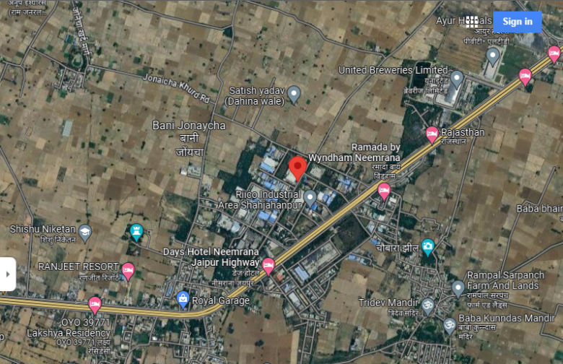  Shahjahanpur, Rajasthan  28.01°N 76.46°E | 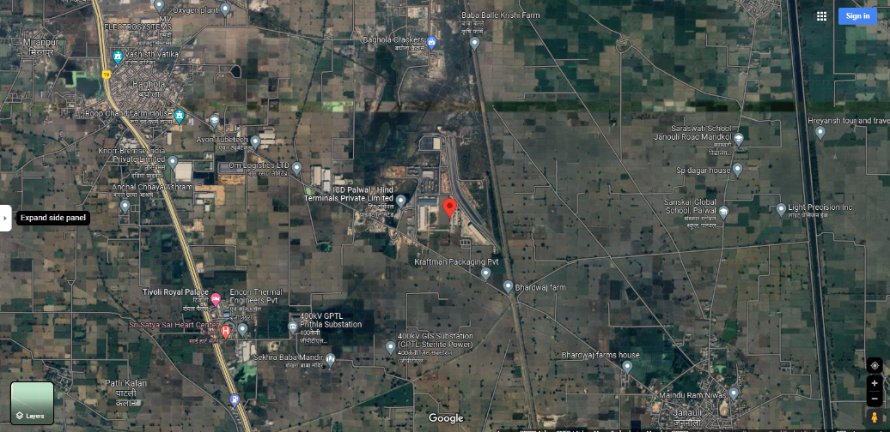  Faridabad, Haryana  28.20°N 77.33°E
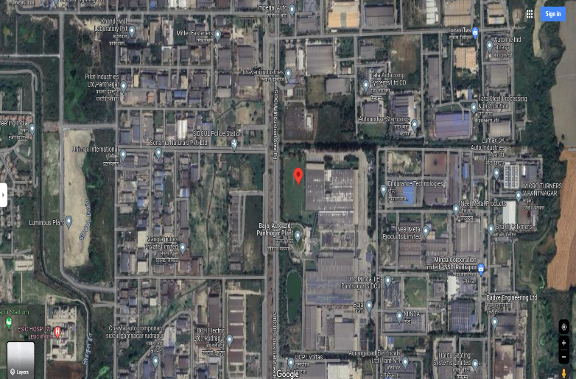  Rudrapur, Uttarakhand  29.00°N 79.42°E | 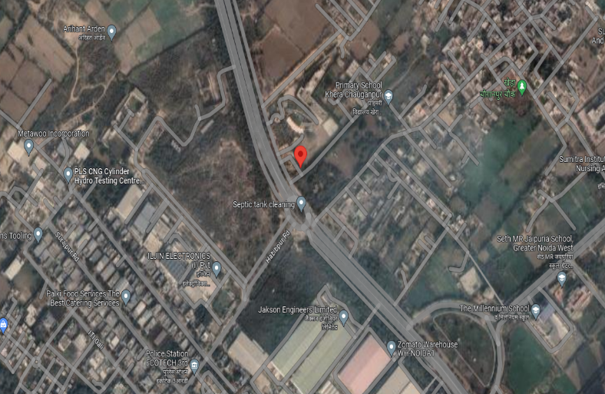  Noida, UP  28.55°N 77.46°E
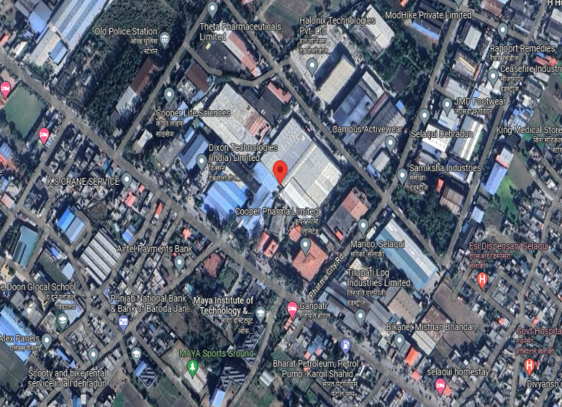  Dehradun Uttarakhand  30.36°N 77.85°E | 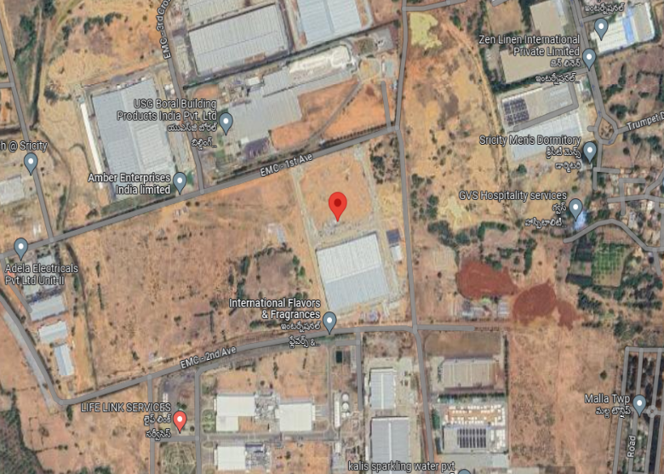  Sri City, Andhra Pradesh  13.51°N 79.99°E

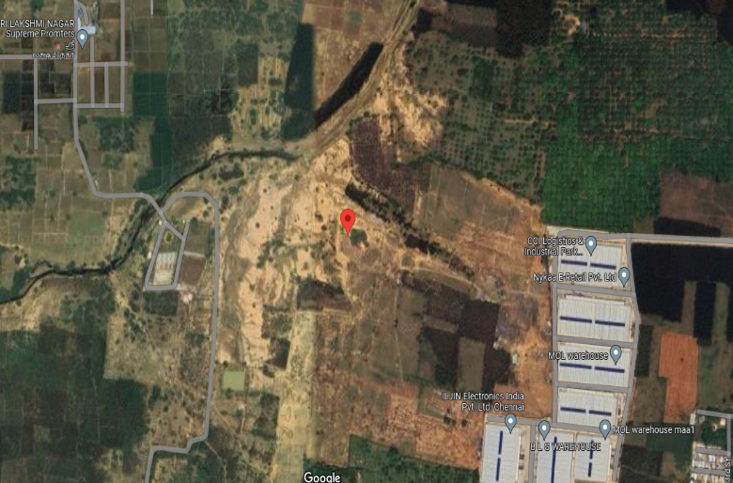  Chennai  13.06°N 79.90°E | 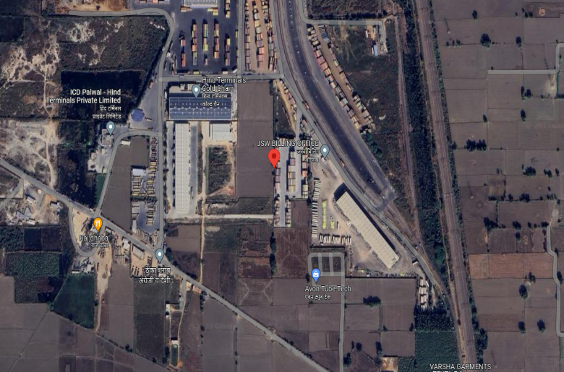  Faridabad Haryana  28.20°N 77.33°E

CONSOLIDATED TECHNICAL PARAMETERS:

S. No. | Location | Specifications
 | No of Location | 11
 | Type of Module Mounting | Roof Top -TinShed
 | Material of Module | Aluminium
 | Fixed Tilt | As per tinshed
 | PV Module Rating | 335/535+Wp
 | Total No. of Modules* | 12,321 No’s
 | Inverter Type | String Inverter
 | Inverter Make | Sungrow/Growatt
 | Inverter Power | Total 6000 kW
Source: Techno-Commercial offer by TurRE

PART D | ENERGY YIELD ASSESSMENT

Company has used PVSyst V7.3.4 to assess energy yield calculation which is the standard Industry practice. The yearly average of main results of irradiation and energy yield from the provided PVSyst is as under:
S. No. | Buyer | Location | Annual production probability (MWh) |  | Specific Production  (kWh/kWp/year) |  | Performance  Ratio (%)
 |  |  | P50 | P90 | As per PPA | As per PVsyst
1 | Amber PR Technoplast India Pvt. Ltd. | Shahjahanpur | 323.9 | 315.3 | 1,165 | 1,476 | 81.92
3 | Iljin Electronics India Pvt. Ltd. | Noida | 758.1 | 700.9 | 1,105 | 1,515 | 82.00
2 | Iljin Electronics India Pvt. Ltd. | Chennai | 3130 | 3048 | 1,233 | 1,567 | 81.39
4 | Amber Enterprises India Ltd
5 | Amber Enterprises India Ltd | Dehradun | 2477 | 2411 | 1,131 | 1,439 | 82.80
6 | Amber Enterprises India Ltd
7 | Amber Enterprises India Ltd
8 | Amber Enterprises India Ltd, | Rudrapur | 1450.8 | 1341.3 | 1,148 | 1,452 | 82.69
9 | Amber Enterprises India Ltd | Andhra Pradesh | 1560.1 | 1466.8 | 1,233 | 1,559 | 82.13
10 | PICL India Pvt. Ltd. | Faridabad | 343.7 | 334.6 | 1,105 | 1,443 | 75.92
11 | Hind Terminals Pvt. Ltd. | Faridabad | 723.7 | 704.5 | 1,300 | 1,489 | 77.89

Analysis of Irridiation & PV Output data: In respect to Irridiation & PV Output data, company has provided to us PVSyst report V7.3.4 in which key Irrdidation components and PV Output data is given as enumerated in table below. We have analysed and compared it with other data source points also such as Solar Resource by Global Solar Atlas of World Bank and ISRO Solar Calculator to confirm its legitimacy as mentioned in table below:
Particulars | Shahjahanpur |  | Noida |  | Chennai
 | As per Global  Solar Atlas | As per PVSyst | As per Global  Solar Atlas | As per PVSyst | As per Global  Solar Atlas | As per PVSyst
Global horizontal Irradiation (kWh/m²) | 1,805.2 | 1,803 | 1,755.5 | 1,845 | 1929.1 | 1,926.2
Diffuse horizontal Irradiation (kWh/m²) | 931.9 | 923.3 | 944.3 | 600.16 | 954.6 | 952.40
Direct Normal Irradiation (kWh/m²) | 1307.0 | - | 1,204.1 | - | 1314.7 | -
Specific Photovoltaic Power Output | 1554.9 | - | 1508.9 | - | 1538.2 | -
Annual Global Insolation (ISRO Solar Calculator) (kWh/m2/year) | 1473 |  | 1351 |  | 1849

Particulars | Dehradun |  | Rudrapur |  | Andhra Pradesh
 | As per Global  Solar Atlas | As per PVSyst | As per Global  Solar Atlas | As per PVSyst | As per Global  Solar Atlas | As per PVSyst
Global horizontal Irradiation (kWh/m²) | 1741.0 | 1,739.1 | 1784.8 | 1,756.2 | 1904.2 | 1900.5
Diffuse horizontal Irradiation (kWh/m²) | 858.3 | 849.50 | 873.0 | 890.5 | 942.5 | 940.60
Direct Normal Irradiation (kWh/m²) | 1385.0 | - | 1366.5 | - | 1304.9 | -
Specific Photovoltaic Power Output | 1544.5 | - | 1535.2 | - | 1525.2 | -
Annual Global Insolation (ISRO Solar Calculator) (kWh/m2/year) | 1475 |  | 1424 |  | 1817

Particulars | PICL India Pvt. Ltd.  Faridabad |  | Hind Terminals Pvt. Ltd.  Faridabad
 | As per Global  Solar Atlas | As per PVSyst | As per Global  Solar Atlas | As per PVSyst
Global horizontal Irradiation (kWh/m²) | 1766.9 | 1754.7 | 1766.9 | 1764.2
Diffuse horizontal Irradiation (kWh/m²) | 946.0 | 935.2 | 946.0 | 938.1
Direct Normal Irradiation (kWh/m²) | 1213.7 | - | 1213.7 | -
Specific Photovoltaic Power Output | 1514.0 | - | 1514.0 | -
Annual Global Insolation (ISRO Solar Calculator) (kWh/m2/year) | 1360 |  | 1360

Observations and Remarks:
- As per the PVsyst - Simulation reports, the estimated energy that can be produced by the subject plants and their respective performance ratio is almost similar as agreed in the PPA.
- As per comparative analysis, PVSyst Irrdiation and PV Output data is in line to our analysis from Global Solar Atlas of World Bank and ISRO Solar Calculator.
- As per the information provided by the management of the company, the estimated Plant Load Factor (CUF at P75) is as shown in table below:

S. No. | Buyer | Location | Module Mounting Structure Angle
1 | Amber PR Technoplast India Pvt. Ltd. | Shahjahanpur | 16.45%
2 | Iljin Electronics India Pvt. Ltd. | Chennai | 17.42%
3 | Iljin Electronics India Pvt. Ltd. | Noida | 16.00%
4 | Amber Enterprises India Ltd | Chennai | 17.42%
5 | Amber Enterprises India Ltd | Dehradun | 15.98%
6 | Amber Enterprises India Ltd | Dehradun | 15.98%
7 | Amber Enterprises India Ltd | Dehradun | 15.98%
8 | Amber Enterprises India Ltd, | Rudrapur | 15.33%
9 | Amber Enterprises India Ltd | Andhra Pradesh | 14.67%
10 | PICL India Pvt. Ltd. | Faridabad | 15.99%
11 | Hind Terminals Pvt. Ltd. | Faridabad | 15.99%

Monthly averages- Direct normal irradiation (kWh/m²)

- Shahjahanpur, Rajasthan
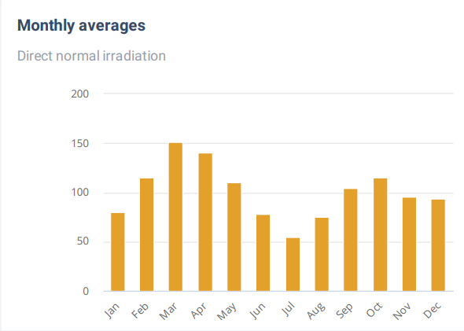
Source: Global Solar Atlas

- Faridabad, Haryana
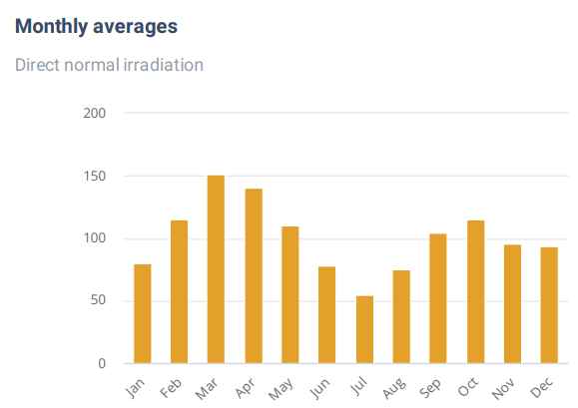
Source: Global Solar Atlas

3. Rudrapur, Uttarakhand
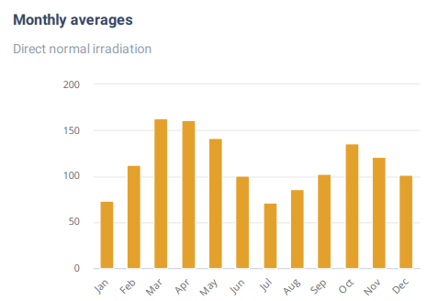
Source: Global Solar Atlas

- Noida, UP
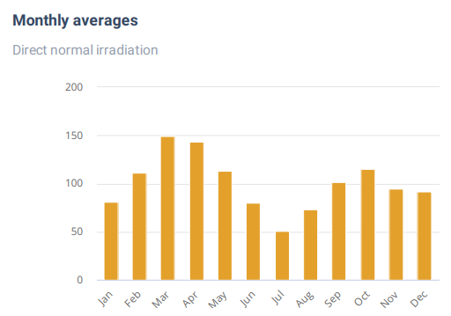
Source: Global Solar Atlas

- Dehradun Uttarakhand
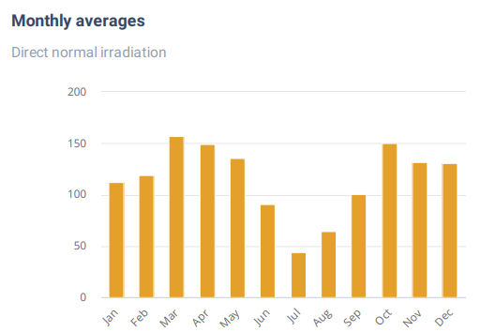
Source: Global Solar Atlas

- Sri City, Andhra Pradesh

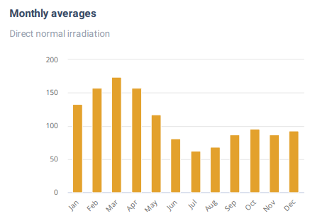
Source: Global Solar Atlas

- Chennai
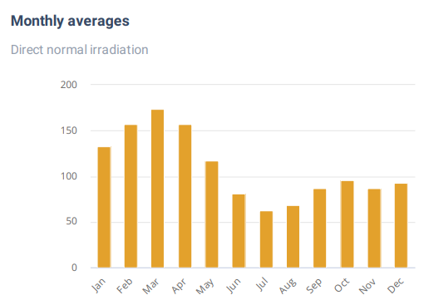
Source: Global Solar Atlas

- Faridabad Haryana
Source: Global Solar Atlas

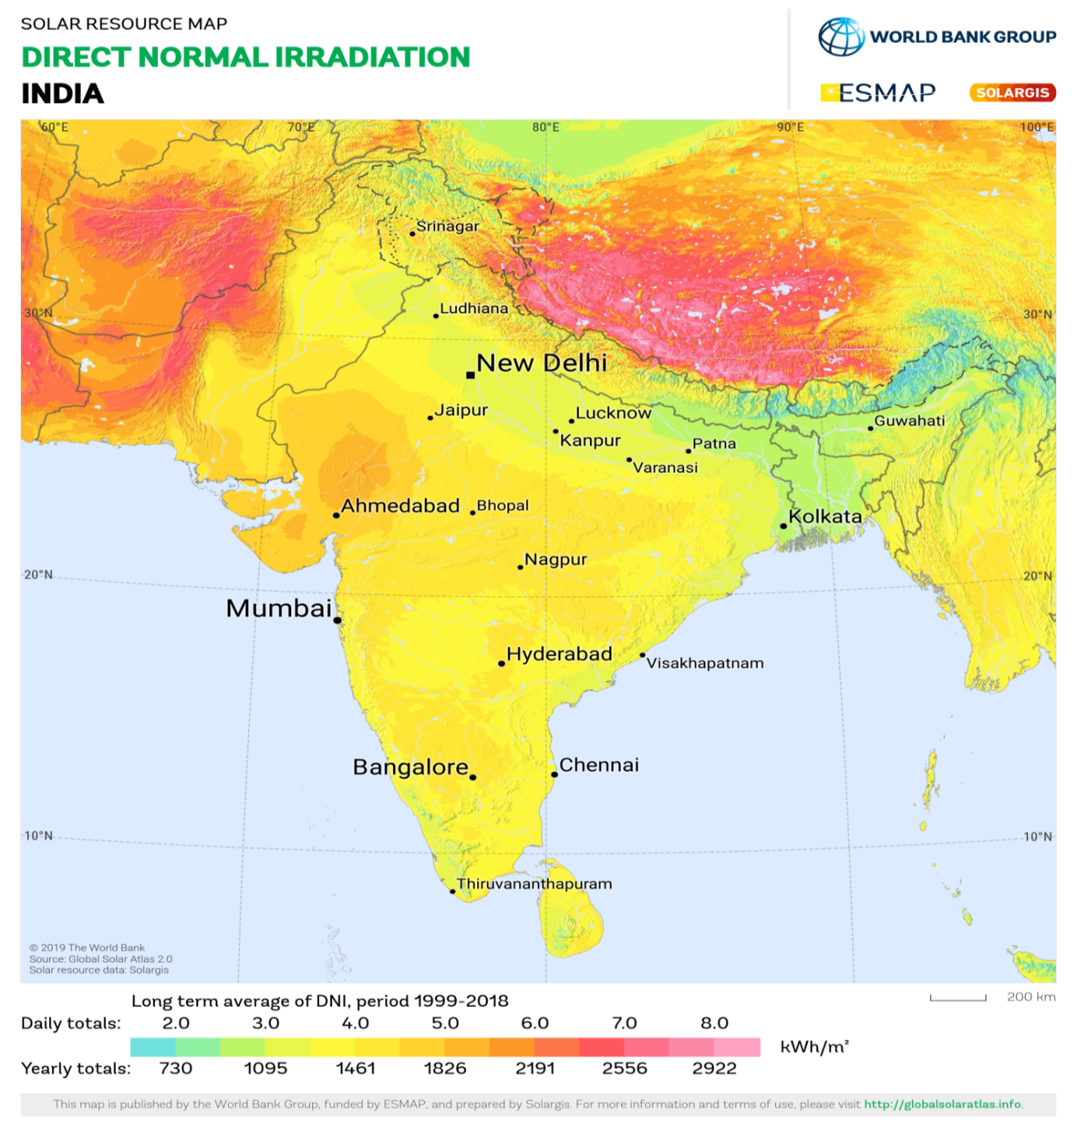
Shahjahanpur, Rajasthan lies above 3.0 daily (1307.0 annually) Kwh/m².
Faridabad, Haryana lies above 3.0 daily (1213.7 annually) Kwh/m².
Rudrapur, Uttarakhand lies above 3.0 daily (1366.5 annually) Kwh/m².
Noida, UP lies above 3.0 daily (1204.1 annually) Kwh/m².
Dehradun, Uttarakhand lies above 3.0 daily (1385.0 annually) Kwh/m².
Sri City, Andhra Pradesh lies above 3.0 daily (1304.9 annually) Kwh/m².
Chennai, Tamil Nadu lies above 3.0 daily (1314.7 annually) Kwh/m².
Faridabad, Haryana above 3.0 daily (1213.7 annually) Kwh/m².
Power output of PV modules is rated on standard test conditions (STC) of 1000 Kw/m2 of radiation.
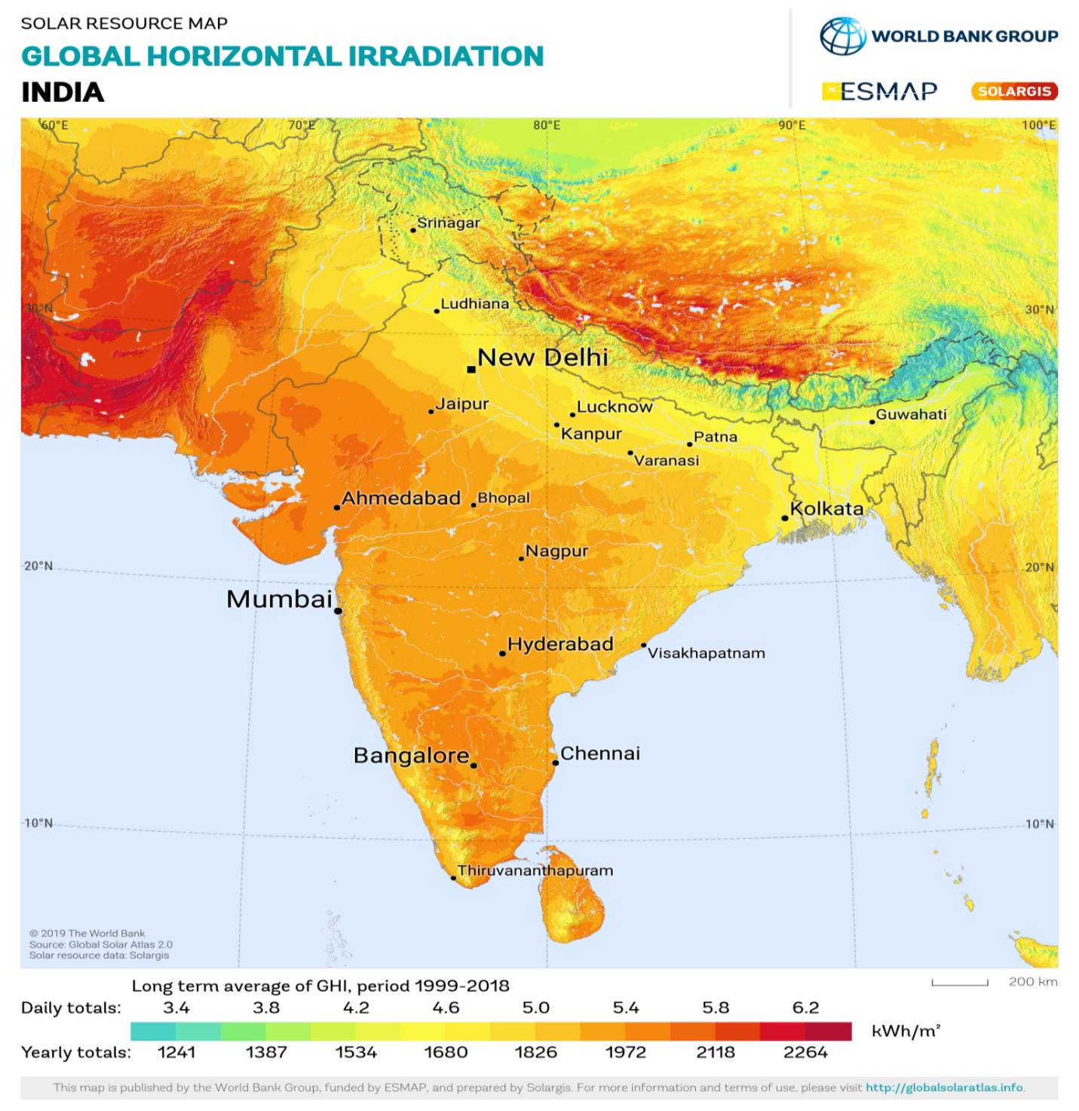
Shahjahanpur, Rajasthan lies above 4.6 daily (1805.2 annually) Kwh/m².
Faridabad, Haryana lies above 4.6 daily (1766.9 annually) Kwh/m².
Rudrapur, Uttarakhand lies above 4.6 daily (1784.8 annually) Kwh/m².
Noida, UP lies above 4.6 daily (1755.5 annually) Kwh/m².
Dehradun, Uttarakhand lies above 4.6 daily (1741.0 annually) Kwh/m².
Sri City, Andhra Pradesh lies above 5.0 daily (1904.2 annually) Kwh/m².
Chennai, Tamil Nadu lies above 5.0 daily (1929.1 annually) Kwh/m².
Faridabad, Haryana lies above 4.6 daily (1766.9 annually) Kwh/m².
Power output of PV modules is rated on standard test conditions (STC) of 1000 Kw/m2 of radiation.
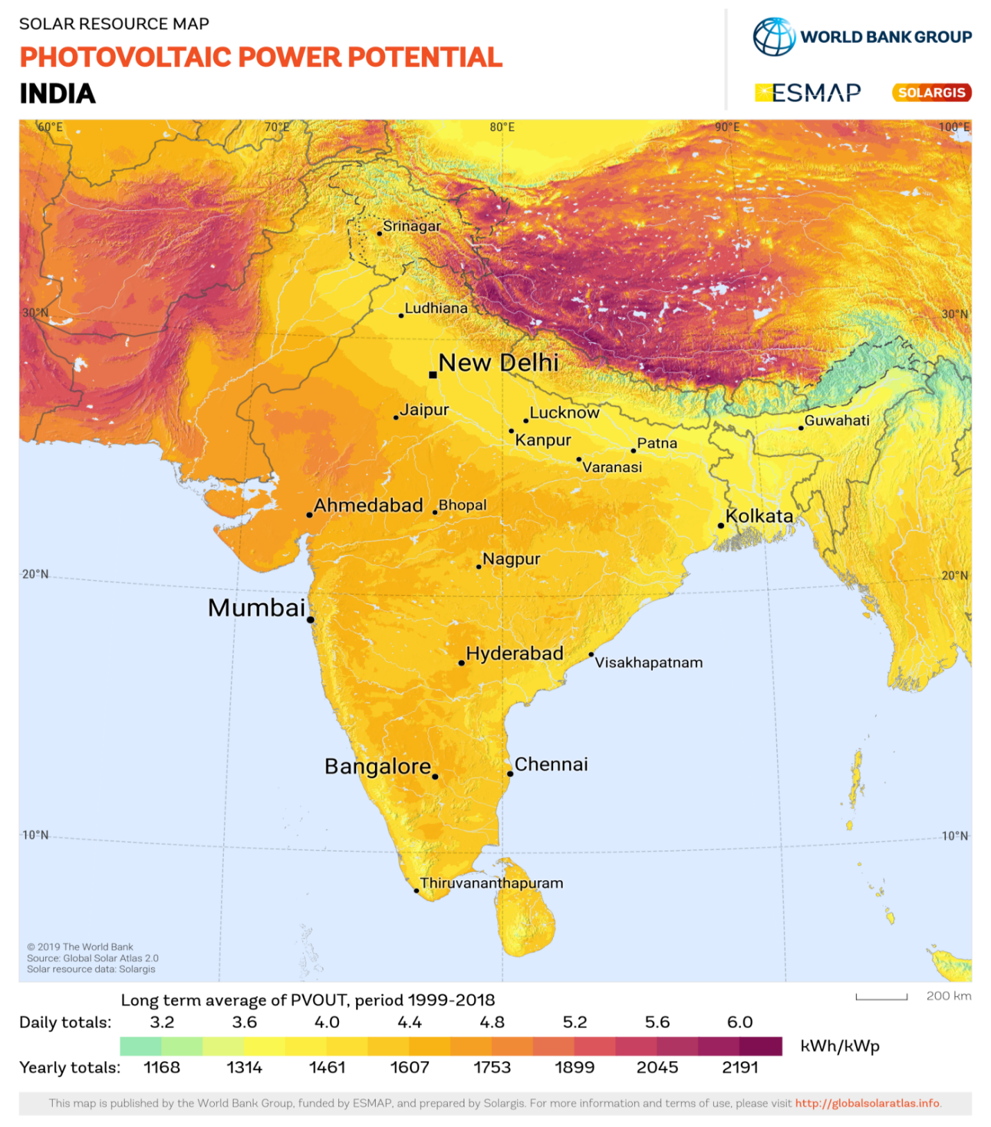
Shahjahanpur, Rajasthan lies above 4.0 daily (1554.9 annually) Kwh/m².
Faridabad, Haryana lies above 4.0 daily (1514.0 annually) Kwh/m².
Rudrapur, Uttarakhand lies above 4.0 daily (1535.2 annually) Kwh/m².
Noida, UP lies above 4.0 daily (1508.9 annually) Kwh/m².
Dehradun, Uttarakhand lies above 4.0 daily (1544.5 annually) Kwh/m².
Sri City, Andhra Pradesh lies above 4.0 daily (1525.2 annually) Kwh/m².
Chennai, Tamil Nadu lies above 4.0 daily (1538.2 annually) Kwh/m².
Faridabad, Haryana lies above 4.0 daily (1514.0 annually) Kwh/m².
PART E | POWER PURCHASE AGREEMENT TERMS

As per the information provided by the company, the total proposed capacity of the subject roof-top solar power plant is 7.16 MWp (± 10%). As on date, company has signed PPAs to install the power plant and supply power at various project sites. Details of the same are tabulated below:
S. No. | Buyer | Location | Proposed capacity (in KWp) | Tariff  (Rs./kWh) | PPA Date
1 | Amber PR Technoplast India Pvt. Ltd. | Shahjahanpur | 219 | 4.35 | 10/10/23
2 | Iljin Electronics India Pvt. Ltd. | Chennai | 999 | 4.25 | 10/10/23
3 | Iljin Electronics India Pvt. Ltd. | Noida | 500 | 4.5 | 10/10/23
4 | Amber Enterprises India Ltd | Chennai | 999 | 4.25 | 10/10/23
5 | Amber Enterprises India Ltd | Dehradun | 158 | 4.45 | 10/10/23
6 | Amber Enterprises India Ltd | Dehradun | 999 | 4.45 | 10/10/23
7 | Amber Enterprises India Ltd | Dehradun | 564 | 4.45 | 10/10/23
8 | Amber Enterprises India Ltd, | Rudrapur | 999 | 4.4 | 10/10/23
9 | Amber Enterprises India Ltd | Andhra Pradesh | 1000 | 4.25 | 10/10/23
10 | PICL India Pvt. Ltd. | Faridabad | 238 | 4.5 | 10/10/23
11 | Hind Terminals Pvt. Ltd. | Faridabad | 486 | 4.4 | 20/10/23
Source: PPAs

Important Clauses: All PPA’s are signed for a period of 25 years with fixed tariff as stated above. Some of the important clauses from the signed PPAs are as follows:-
- Clause-:
  - Term
- Chennai  - Dehradun (x3 locaions)  - Rudrapur  - Sri City AP  - Shahjanpur, Rajasthan,  - Chennai  - Noida  - PICL India Pvt. Ltd. (Faridabad) | The Term of this Agreement shall commence as of the Effective Date and shall expire at 23:59 hours on the date of the last day of the Term, unless extended for a period mutually agreed upon by the Parties through an amendment to this Agreement. The last day of the Term shall be the day prior to the twenty fifth (25) anniversary of the Operation Date.
- Hind Terminals Private Limited(Faridabad) | The term of the Agreement shall commence on the Effective Date and shall continue for Twenty Five(25) years from the Commercial Operation Date (the "Term"), unless and until terminated earlier pursuant to the provisions of the Agreement. After the Term, the ownership of the System shall be transferred to the Purchaser at Rs. 1/-.

  - Purchase Option/Purchase Obligation
- Chennai  - Dehradun (x3 locaions)  - Rudrapur  - Sri City AP  - Shahjanpur, Rajasthan,  - Chennai  - Noida  - PICL India Pvt. Ltd. (Faridabad) | Beginning with the effective date of the solar Energy Facility and continuing throughout the Term, Seller shall deliver and sell the Buyer and Buyer shall accept deliveryand purchase from Seller the entire output of the Electricity Price.
- Hind Terminals Private Limited(Faridabad) | So long as a Purchaser default shall not have occurred and be continuing, Purchaser has the option to purchase the System by paying the Power Producer the Purchase price as per Schedule III to this Agreement. To exercise its purchase option, the Purchaser shall not less than Ninety (90) days prior to the proposed Purchase Date, provide written notice to the Power Producer, of Purchaser's intent to exercise its option to purchase the System on such purchase date. In the event Purchaser confirms its intention to exercise the purchase option in writing to the Power Producer, (1) Purchaser shall pay the applicable Purchase Price and any other unpaid dues that have accrued under this agreement to the Power Producer on the Purchase Date, and such payment shall be made in accordance with any written instructions i.c. NEFT/RTGS delivered to Purchaser by the Power Producer for payments under the Agreement, and (ii) the Parties shall promptly execute all documents necessary to cause title to the System to pass to Purchaser on the Purchase Date, free and clear of all liens. Upon execution of the documents and payment of the applicable purchase price in each case as described in the preceding sentence, the agreement shall terminate automatically and the Purchaser shall become the owner of the System.
  - Installation Work
- Chennai  - Dehradun (x3 locaions)  - Rudrapur  - Sri City AP  - Shahjanpur, Rajasthan,  - Chennai  - Noida  - PICL India Pvt. Ltd. (Faridabad) | Buyer hereby consents to the installation and unconditional operation of the Solar Energy Facility at the Site, including, without limitation, solar modules, mounting structures or supports, wiring and connections, power inverters, service equipment, metering equipment and other interconnections. In co section with the installation and operation of the Solar Energy Facility. Buyer acknowledges that a reasonable level of construction noise and movement of materials and personnel is to be expected at the Site for such duration that installation, maintenance or operational work is being performed on the Solar Energy Facility.
- Hind Terminals Private Limited(Faridabad) | The Power Producer will cause the Project to be designed, manufactured, supplied, engineered, erected, tested and commissioned, operated & maintained and constructed substantially in accordance with this agreement. The Power Producer shall provide to the Purcher a list of materials listing the major equipment constituting the System. Such list of materials shall be provided within 30 days of the Commercial Operation Date for technological information

Please note that the above main clauses of PPA are mentioned only for illustration purpose of the convenience of the lenders to analyze the Project in terms of technicality. However, this shall not be construed as professional opinion on the contract legality which is out of scope of this report.

PART F | CURRENT STATUS OF WORK

As per information and documents shared by the company’s representative via mail, following are our observations and remarks on the current status of the project:
- The installation work has not commenced in any of the 11 specified locations.
- The proposed Commercial Operation Date (COD) for all 11 projects is scheduled for the month of March 2024.
- Proposed COD in March 2024 will be possible if the installation work starts latest by November’23 now.

PART G | PROJECT COST & EXPENDITURE

- PROJECT COST: Project cost has been taken from the Techno-Commercial offer from M/s TRURE SPV Pvt. Ltd. for EPC of Solar Rooftop 7161 kWp Solar PV Power Plant located at aforesaid various locations.Project Cost of the same is shown to be Rs. 34.02 Cr. (@ INR 47.51 Rs per Wp Including GST and 5 Years O&M)
S. No. | Description | Amount  (Including duties and taxes)
1 | 7161 kWp Rooftop capacity solar power plant Design,  Supply, Installation, Testing & Commissioning with  - Monocrystalline pv panels  - String inverter | Rs. 34,02,00,000/-
Total |  | Rs. 34,02,00,000/-

Note: The above cost is inclusive of Freight & Transit Insurance, GST and O&M for 5 years.
Observations and Remarks:
- Project cost calculated on the basis of the Benchmark Cost provided by the MNRE has been tabulated below:
S. No. | Particulars | Location | Benchmark Cost  (In Rs./kW) | Project Capacity  (In MW) | Total Project Cost  (Excluding GST)  (In Rs.) | Total Project Cost  (Including ~14% GST)  (In Rs.)
1 | As per Ministry of New & Renewable Energy | For General Category States/ UTs | 35,886 | 4,455 | 15,98,72,130 | 18,22,54,228
1 | As per Ministry of New & Renewable Energy | For Other State/UTs  (Which Includes Uttarakhand) | 39,467 | 2,720 | 10,73,50,240 | 12,23,79,274
(± 10%) |  |  |  | 7.17 kWp |  | Rs. 30.46 Cr.
*Benchmark cost for 2021-22

- Project cost calculated on the basis of market comparable:
S. No. | Particulars | Excluding GST | Including GST | Remark
 |  | Per KW Cost  (In Rs.) | Per KW Cost  (In Rs.)
 | Subject project installation cost | - | 47,507 | As per Techn-Commercial by TrueRE
Market Research Details
 | MNRE Benchmark Cost | 35,886 | - | Refer Annexure-1
 | MNRE Benchmark Cost | 39,467 | - | Refer Annexure-1
 | Market Research
 | Quotation-1 | 48,700 | 55,400 | Refer Annexure-2
 | Quotation-2 | 37,740 | 42,500
 | Quotation-3 | 45,000 | 51,200
 | Quotation-4 (Tata Solar) | 60,000 | 68,300

- As per our analysis and market research, the installation cost of Rooftop Mounted Solar Power Plant varies from Rs. 45,500/- per KW to Rs. 68,300/- per KW. For the smaller setups the price is higher and for large set-up, price is less.
- The project cost is solely depends upon the project location, contractors profit, type of module and its supporting structures, etc.
- Based upon the above mentioned details, the project cost amounting to Rs. 34.02 Cr. inclusive of GST and operations and maintainances for 5 years, of subject solar power plant, which comes out to be Rs. 47,507 per KW (including GST +5 Years O & M) which seems to be reasonable.
- As per the mail received from the management of the subject company, installation work is yet to be started.
Note:
- Project cost is analyzed based on lump sum cost only and not item wise.
- Project cost is assessed for the date of this report only and due to price fluctuations it may vary from time to time.

- EXPENDITURE: As per information/details shared by the company, the installation work related to power plant is yet to start. Thus, the expenditure incurred till date on the project is NIL.

PART H | PHOTOGRAPHS

Since the installation work related to solar panels is yet to start and this is just a Desktop Analysis based upon documents provided. Therefore, site visit was not done, thus Photographs are not available.

PART I | OTHER DOCUMENTS & REFERENCES

Annexure-1: Benchmark Cost by MNRE:
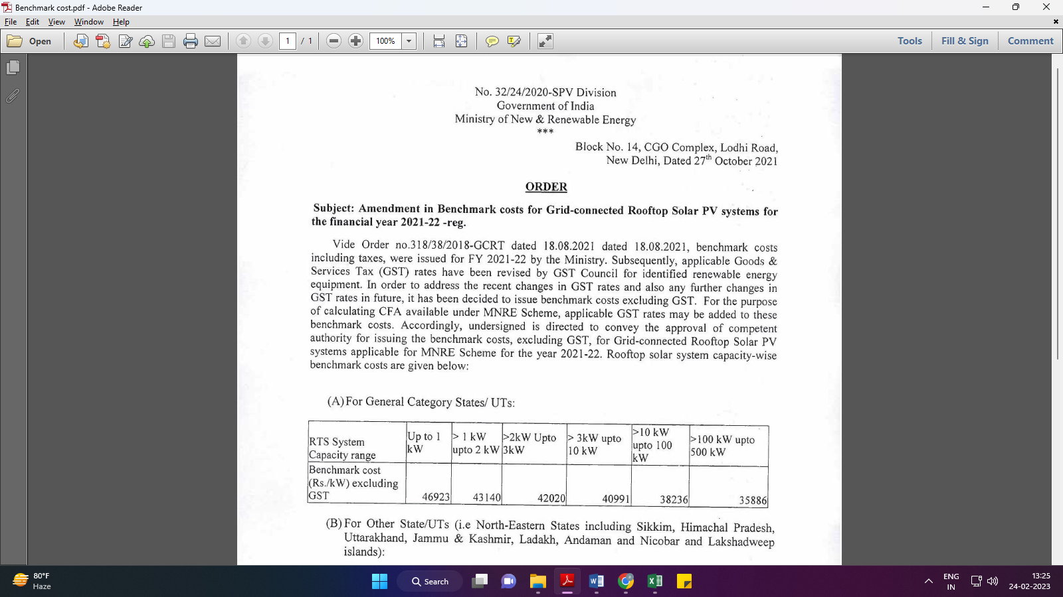
Market Comparables:
Annexure-2
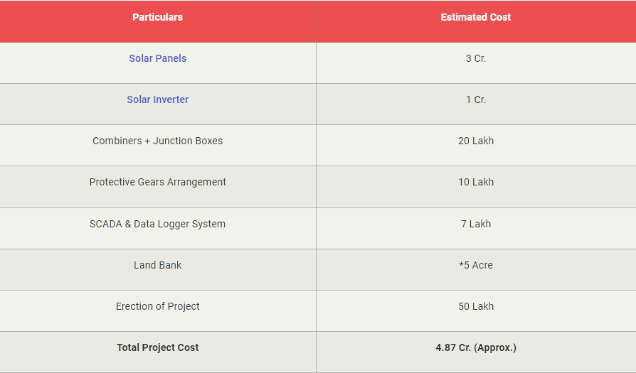

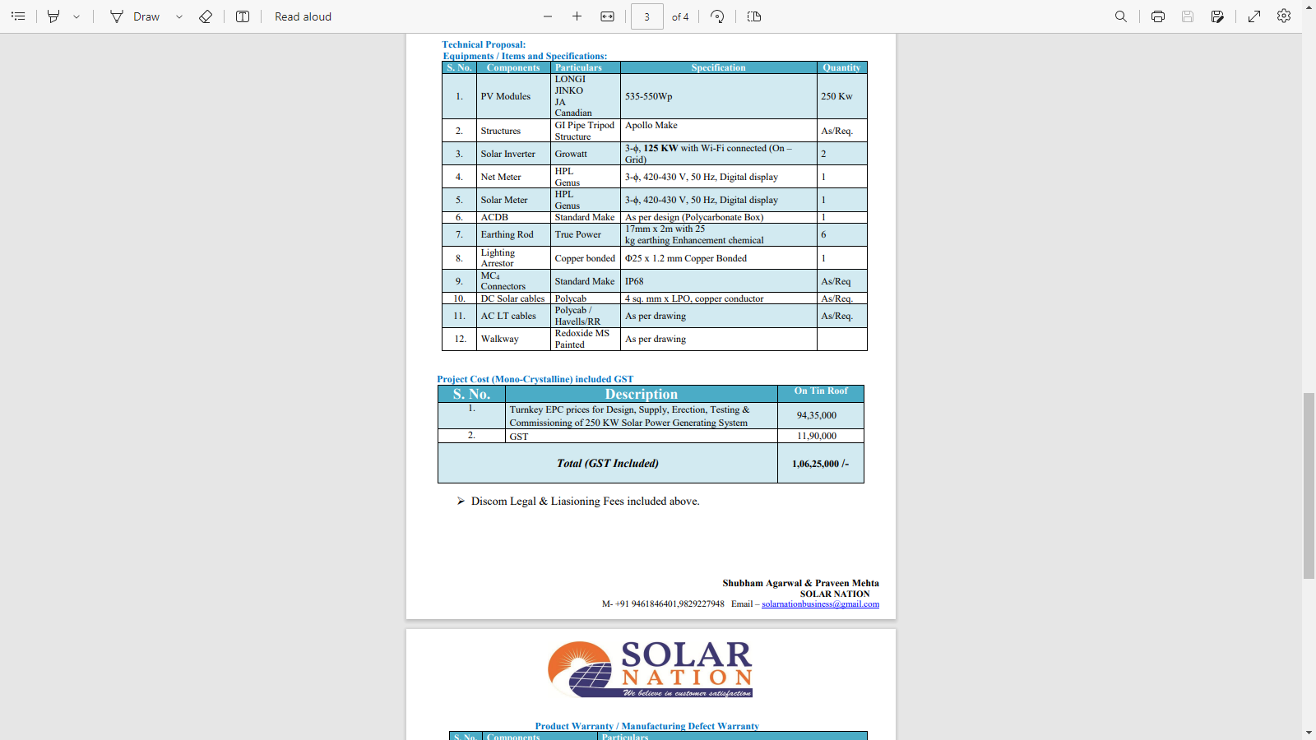

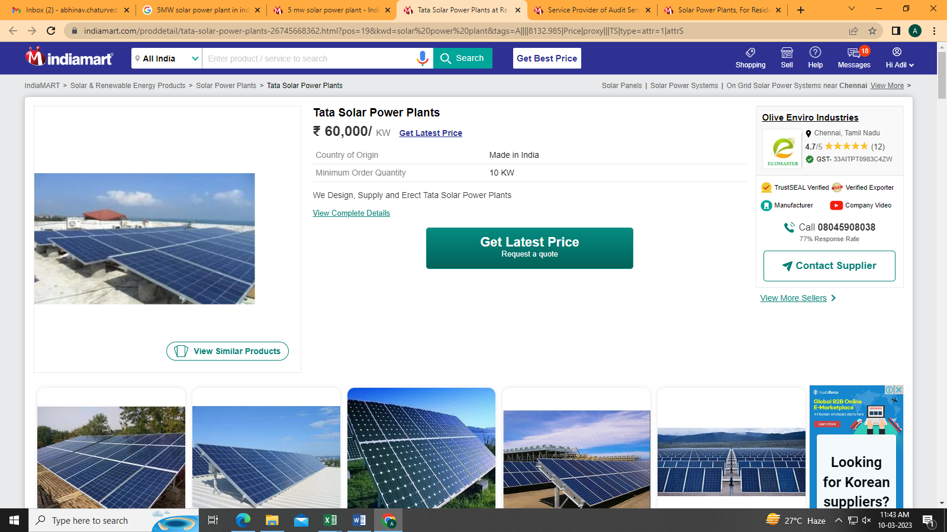
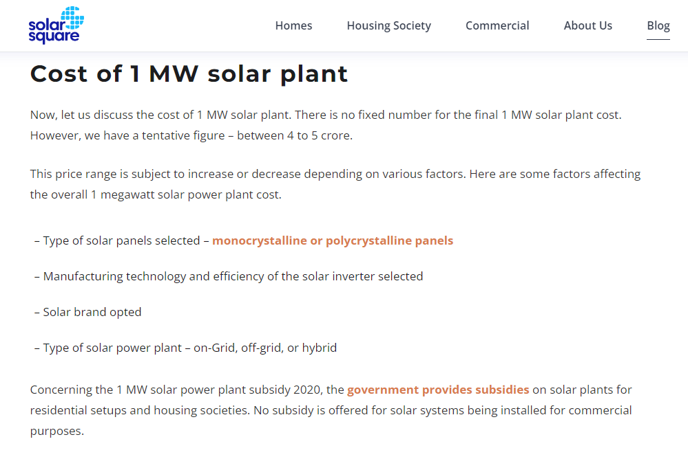

Data by Global Solar Atlas by World Bank Group
- SR City Andra Pradesh

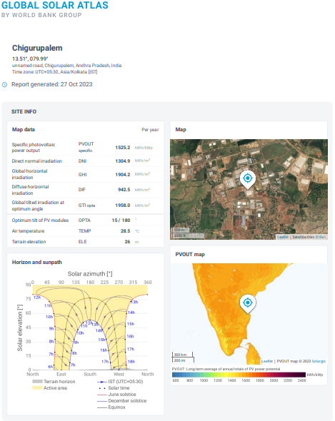

2. Noida, UP

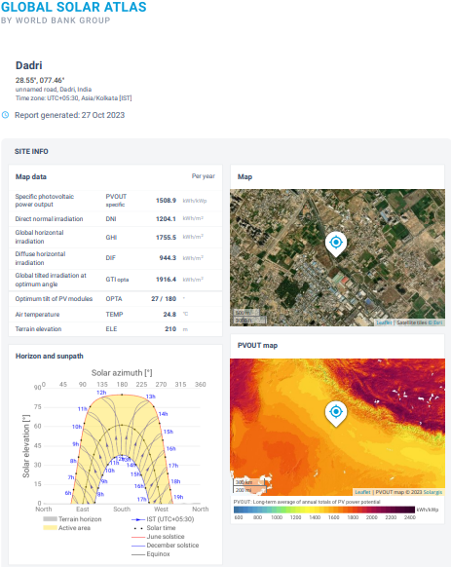

- Faridabad

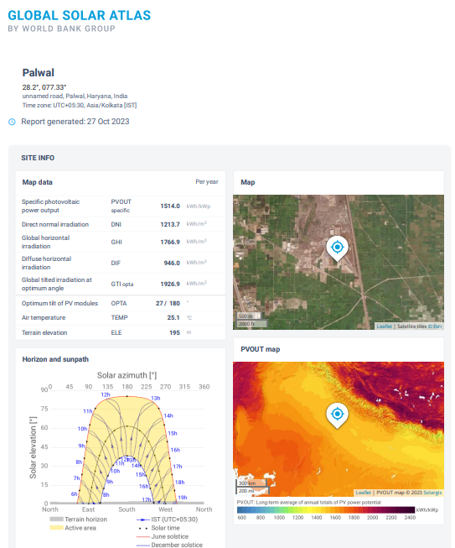

- Rudrapur, UK
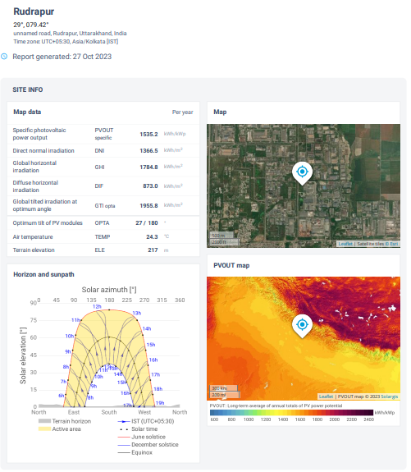

- Dehradun, UK
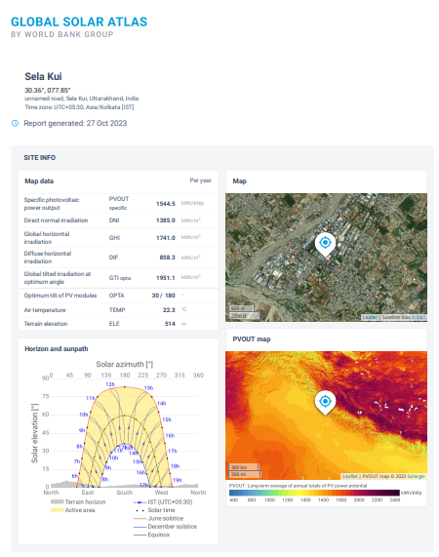
- Shahjahanpur, Rajasthan
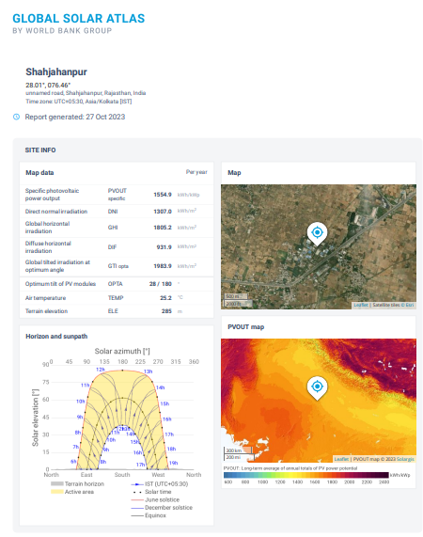

- Chennai
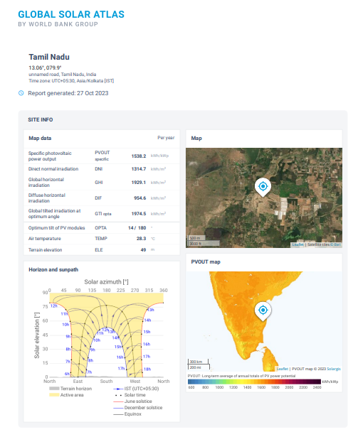
Layout Plans
- SR City Andra Pradesh
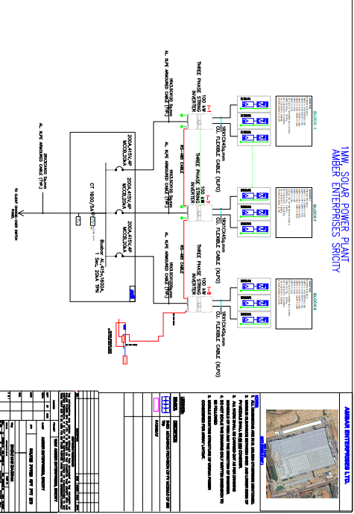
2. Noida, UP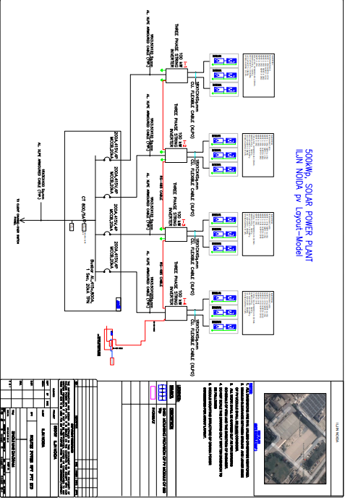

3. Faridabad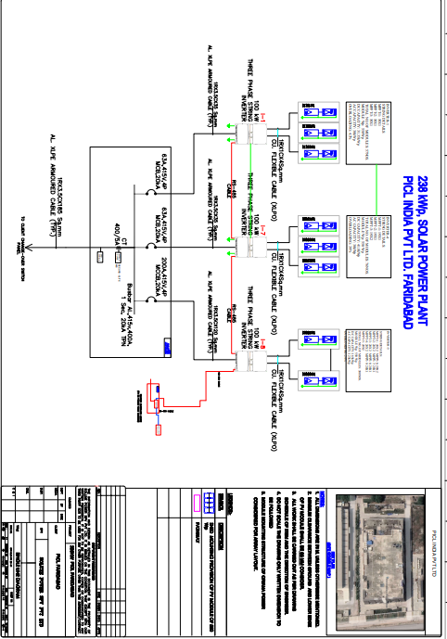

4. Rudrapur, UK 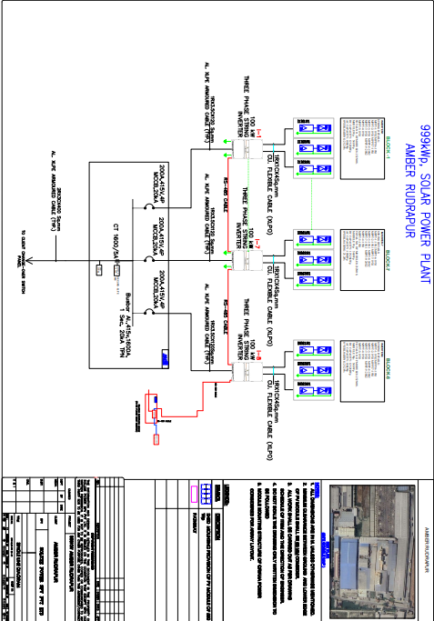

Purchase Agreement

1. CHENNAI, DEHRADUN (X3 LOCATIONS), RUDRAPUR, ANDRA PRADESH
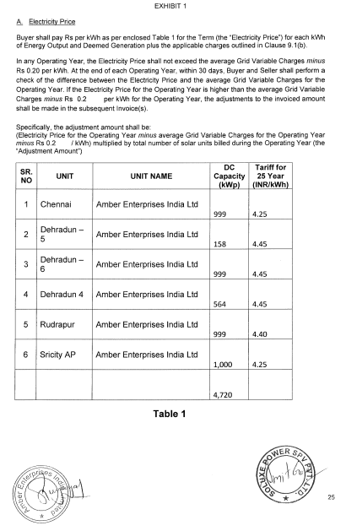 | 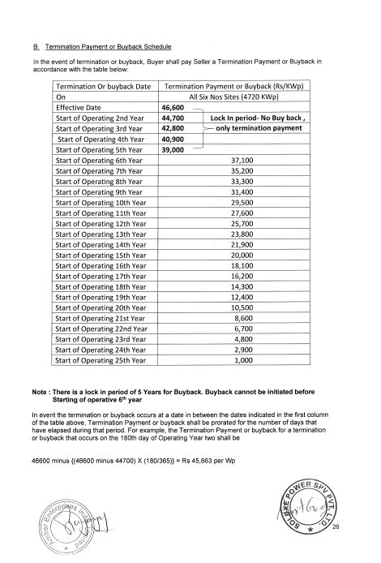
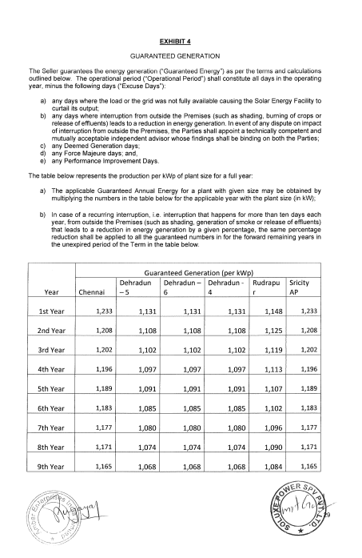 | 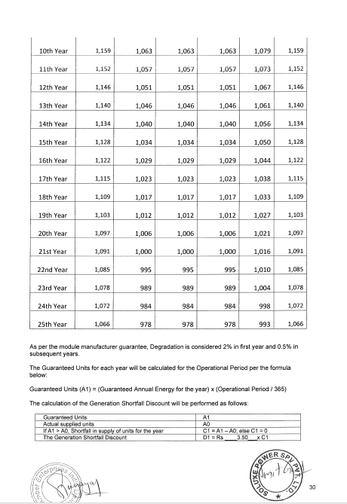

- HIND TERMINAL (FARIDABAD)
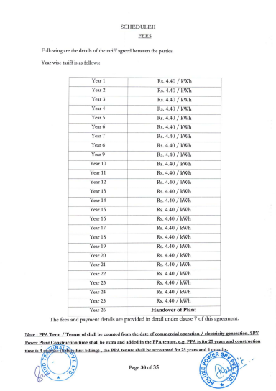 | 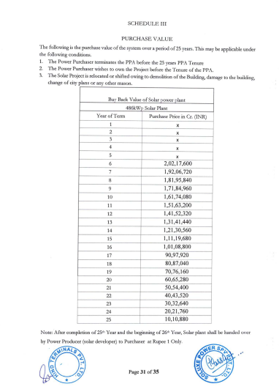
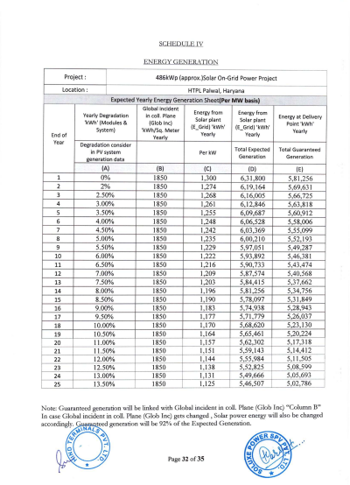 | 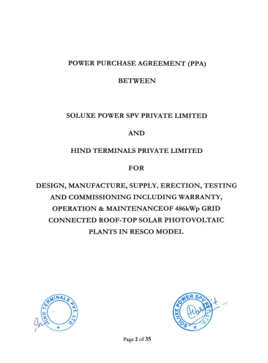

3. SHAHJANPUR, RAJASTHAN
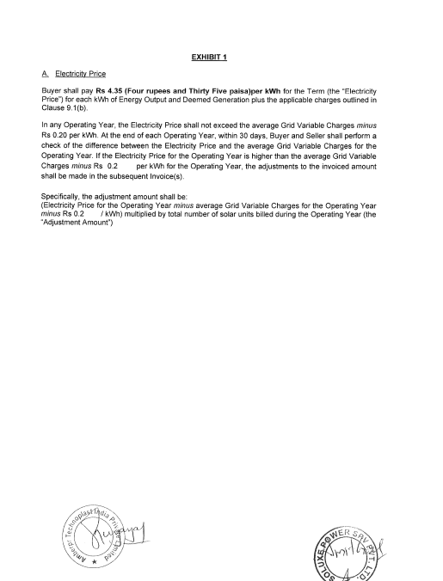 | 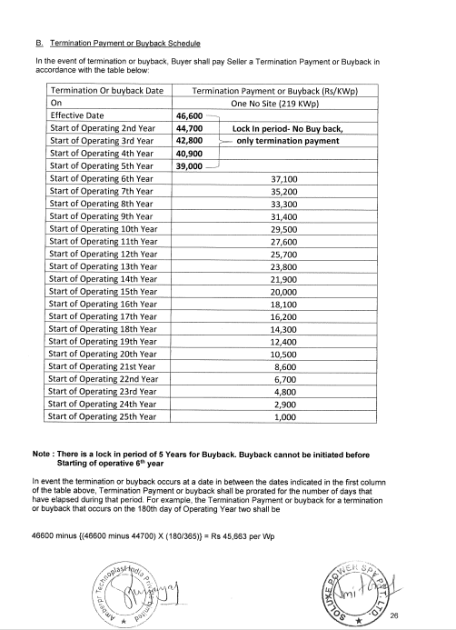
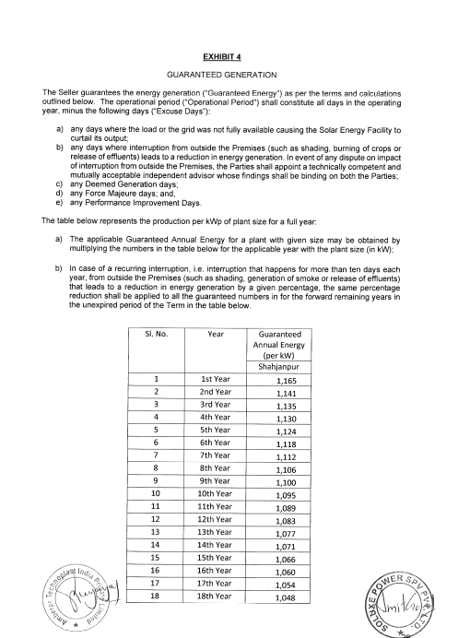 | 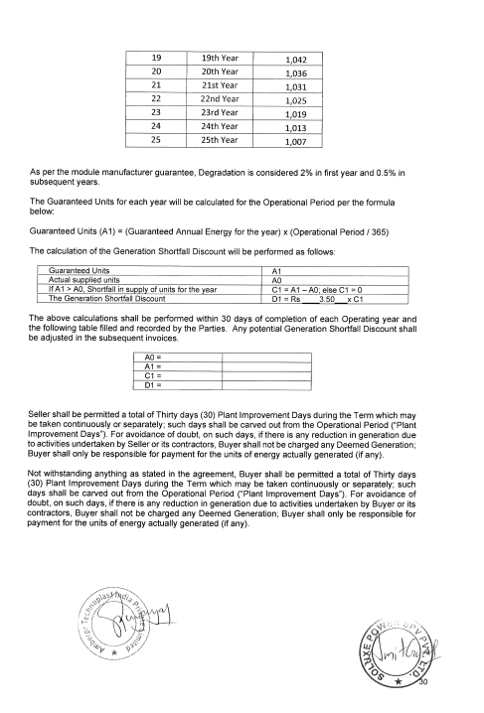

4. CHENNAI AND NOIDA
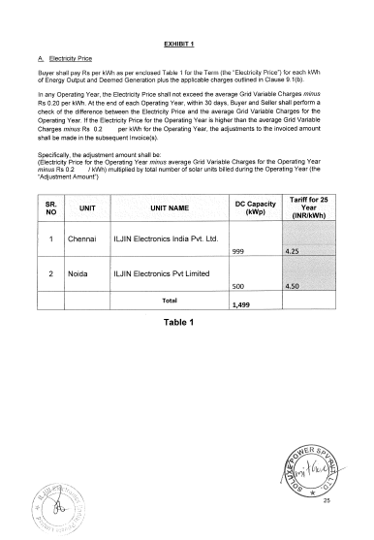 | 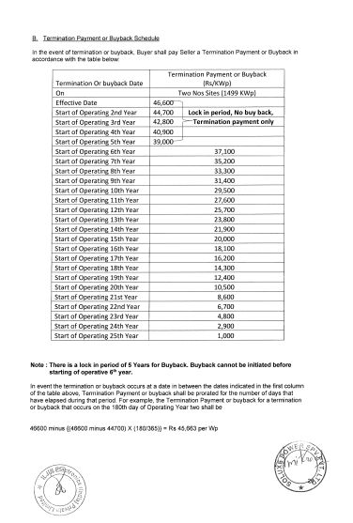
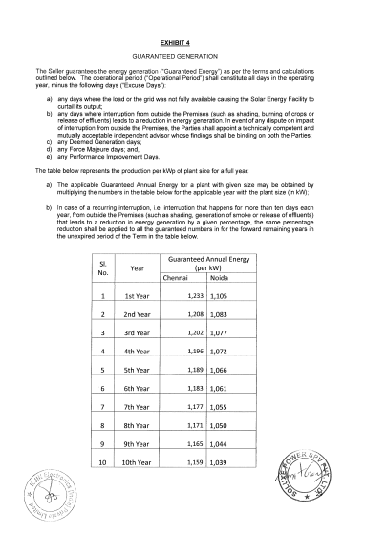 | 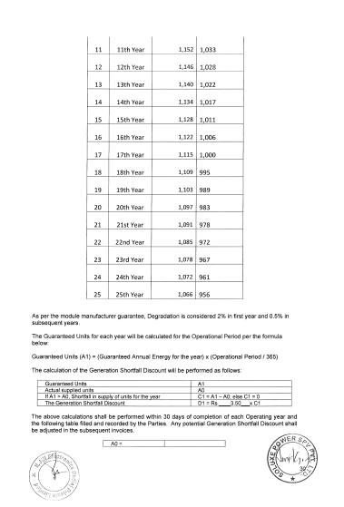

5. PICL Faridabad

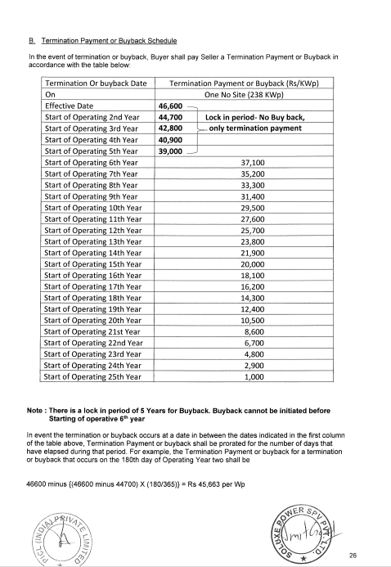 | 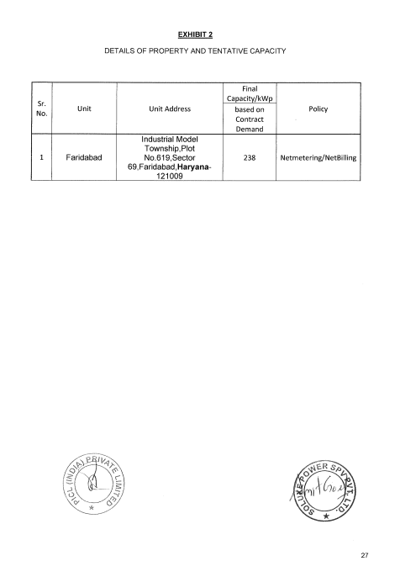
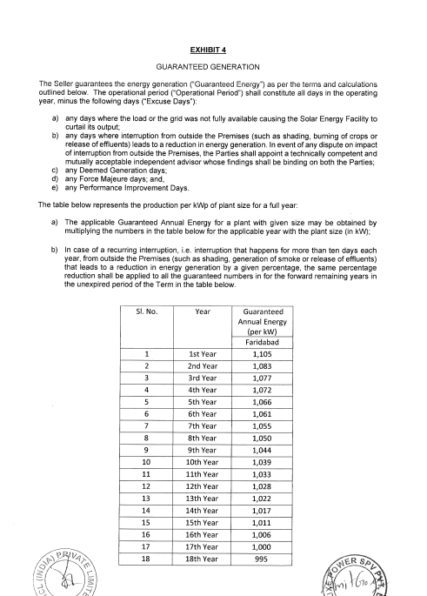 | 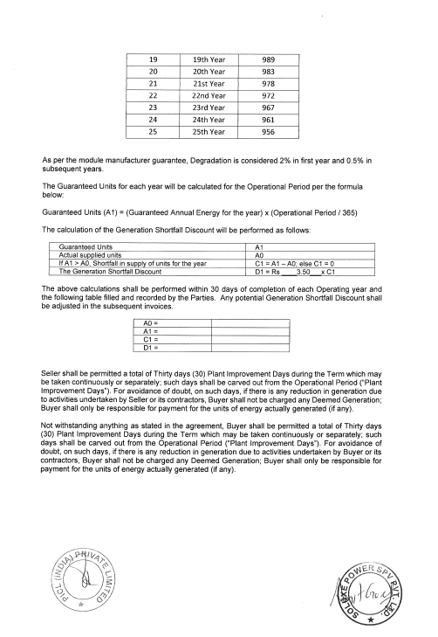

PART J | DISCLAIMER

      - No employee or member of R.K Associates has any direct/ indirect interest in the Project.
      - This report is prepared based on the copies of the documents/ information which the Bank/ Company has provided to us out of the standard checklist of documents sought from them and further based on our assumptions and limiting conditions. All such information provided to us has been relied upon in good faith and we have assumed that it is true and correct in all respect. Verification or cross checking of the documents provided to us has not been done at our end from the originals. If at any time in future, it is found or came to our knowledge that misrepresentation of facts or incomplete or distorted information has been provided to us then this report shall automatically become null & void.
      - This report is a general analysis of the project based on the scope mentioned in the report. This is not an Audit report, Design document, DPR or Techno-financial feasibility study. All the information gathered is based on the facts seen on the site during survey, verbal discussion & documentary evidence provided by the client and is believed that information given by the company is true best of their knowledge.
      - All observations mentioned in the report is only based on the visual observation and the documents/ data/ information provided by the client. No mechanical/ technical tests, measurements or any design review have been performed or carried out from our side during Project assessment.
      - Bank/FII should ONLY take this report as an Advisory document from the Financial/ Chartered Engineering firm and it’s specifically advised to the creditor to cross verify the original documents for the facts mentioned in the report which can be availed from the borrowing company directly.
      - In case of any default in loans or the credit facility extended to the borrowing company, R.K Associates shall not be held responsible for whatsoever reason may be and any request for seeking any explanation from the employee/s of R.K Associates will not be entertained at any instance or situation.
      - This Report is prepared by our competent technical team which includes Engineers and financial experts & analysts.
      - This is just an opinion report and doesn’t hold any binding on anyone. It is requested from the concerned Financial Institution which is using this report for taking financial decision on the project that they should consider all the different associated relevant & related factors also before taking any business decision based on the content of this report.
      - All Pages of the report including annexures are signed and stamped from our office. In case any paper in the report is without stamp & signature then this should not be considered a valid paper issued from this office.
      - Though adequate care has been taken while preparing this report as per its scope, but still we can’t rule out typing, human errors, over sightedness of any information or any other mistakes. Therefore, the concerned organization is advised to satisfy themselves that the report is complete & satisfactory in all respect. Intimation regarding any discrepancy shall be brought into our notice immediately. If no intimation is received within 15 (Fifteen) days in writing from the date of issuance of the report, to rectify these timely, then it shall be considered that the report is complete in all respect and has been accepted by the client upto their satisfaction & use and further to which R.K Associates shall not be held responsible in any manner.
      - Defect Liability Period is 15 DAYS. We request the concerned authorized reader of this report to check the contents, data and calculations in the report within this period and intimate us in writing if any corrections are required or in case of any other concern with the contents or opinion mentioned in the report. Corrections only related to typographical, calculation, spelling mistakes, incorrect data/ figures/ statement will be entertained within the defect liability period. Any new changes for any additional information in already approved report will be regarded as additional work for which additional fees may be charged. No request for any illegitimate change in regard to any facts & figures will be entertained.
      - R.K Associates encourages its customers to give feedback or inform concerns over its services through proper channel at le@rkassociates.org in writing within 30 days of report delivery. After this period no concern/ complaint/ proceedings in connection with the Lender’s Independent Engineering Services will be entertained due to possible change in situation and condition of the subject Project.
      - Our Data retention policy is of ONE YEAR. After this period, we remove all the concerned records related to the assignment from our repository. No clarification or query can be answered after this period due to unavailability of the data.
      - This Lender’s Independent Engineering report is governed by our (1) Internal Policies, Processes & Standard Operating Procedures, (2) Information/ Data/ Inputs given to us by the client and (3) Information/ Data/ Facts given to us by our field/ office technical team. Management of R.K Associates never gives acceptance to any unethical or unprofessional practice which may affect fair, correct & impartial assessment and which is against any prevailing law. In case of any indication of any negligence, default, incorrect, misleading, misrepresentation or distortion of facts in the report then it is the responsibility of the user of this report to immediately or at least within the defect liability period bring all such act into notice of R.K Associates management so that corrective measures can be taken instantly.
      - R.K Associates never releases any report doing alterations or modifications from pen. In case any information/ figure of this report is found altered with pen then this report will automatically become null & void.
FOR INTERNAL USE
Place : Noida  Date : 26.10.2023  Note : This report contains 51 pages | SURVEYED BY:  PREPARED BY:  REVIEWED BY: | Desktop Analysis  VISHAL SINGH  Sr. V.P. Projects

For R.K Associates Valuers & Techno Engineering Consultants (P) Ltd.

DEFECT LIABILITY PERIOD - In case of any query/ issue or escalation you may please contact Incident Manager by writing at valuers@rkassociates.org. We ensure 100% accuracy in the Calculations done, Rates adopted and various other data points & information mentioned in the report but still can’t rule out typing, human errors or any other mistakes. In case you find any mistake, variation, discrepancy or inaccuracy in any data point of the report, please help us by bringing all such points into our notice in writing at valuers@rkassociates.org within 30 days of the report delivery, to get these rectified timely, failing which R.K Associates Valuers Techno Engineering Consultants (P) Ltd. won’t be held responsible for any inaccuracy in any manner. Also if we will not hear back anything from you within 30 days, we will assume that report is correct in all respect and no further claim of any sort will be entertained thereafter. We would welcome and appreciate your feedback & suggestions in order to improve our services.

COPYRIGHT FORMAT - This report is prepared on the copyright format of R.K Associates Valuers Techno Engineering Consultants (P) Ltd. to serve our clients in the best possible way. Legally no one can copy or distribute this format without prior approval from R.K Associates. It is meant only for the organization as mentioned on the cover page of this report. Distribution or use of this format other than R.K Associates will be seen as unlawful act and necessary legal action can be taken against the defaulter

