File No.: VIS (2023-24)-PL498-413-632 Dated: 26-10-2023

LENDER’S INDEPENDENT ENGINEER’S REPORT

OF

6 MWp GRID CONNECTED ROOF-MOUNTED SOLAR POWER PLANTS

PROPOSED TO BE SET-UP AT
CAVENDISH INDUSTRIES LIMITED, LAKSAR, HARIDWAR

SELLER:
M/S SOLARITHIC POWER SPV PRIVATE LIMITED

REPORT PREPARED FOR
STATE BANK OF INDIA, SME, SOUTH EXTENSION, NEW DELHI

**Important - In case of any query/ issue or escalation you may please contact Incident Manager
at le@rkassociates.org. We will appreciate your feedback in order to improve our services.
NOTE: As per IBA Guidelines please provide your feedback on the report within 15 days of its submission after which report will be considered to be correct.
IMPORTANT NOTICE

COPYRIGHT FORMAT: This report is prepared on the copyright format of R.K Associates to serve our clients with the best possible information and analysis to facilitate them to take rational business decisions. Legally no one can copy or distribute this format without prior approval from R.K Associates. It is meant only for the advisory/ reference purpose for the organization/s as mentioned on the cover page of this report. Distribution or use of this format by any organization or individual other than R.K Associates will be seen as an unlawful act and necessary legal action can be taken against the defaulters.
This report is intended for the sole use of the intended recipient/s and contains material that is STRICTLY CONFIDENTIAL AND PRIVATE.

DEFECT LIABILITY PERIOD: - In case of any query/ issue or escalation you may please contact Incident Manager at le@rkassociates.org.
Though adequate care has been taken while preparing this report as per its scope, but still we can’t rule out typing, human errors, over sightedness of any information or any other mistakes. Therefore, the concerned organization is advised to satisfy themselves that the report is complete & satisfactory in all respect. Intimation regarding any discrepancy shall be brought into our notice immediately. If no intimation is received within 15 (Fifteen) days in writing from the date of issuance of the report, to rectify these timely, then it shall be considered that the report is complete in all respect and has been accepted by the client upto their satisfaction & use and further to which R.K Associates shall not be held responsible in any manner.

TABLE OF CONTENTS
SECTIONS | PARTICULARS | PAGE NO.
Part A | REPORT SUMMARY | 03
Part B | INTRODUCTION | 04
 | - Name of the Project | 04
 | - Project Overview | 04
 | - Scope of the Report | 06
 | - Purpose of the Report | 06
 | - Methodology Adopted | 06
Part C | PROJECT DETAILS AND KEY TECHNICAL PARAMETERS | 07
Part D | ENERGY YIELD ASSESSMENT | 13
Part E | POWER PURCHASE AGREEMENT TERMS | 19
Part F | CURRENT STATUS OF WORK | 22
Part G | PROJECT COST & EXPENDITURE | 23
Part H | PHOTOGRAPHS | 25
Part I | OTHER DOCUMENTS & REFERENCES | 26
Part J | DISCLAIMER | 38

PART A | REPORT SUMMARY

 | Name of the Project | 6 (±10%) Mwp Grid Connected Roof-Mounted Solar Power Plants
 | Project Location | Cavendish Industries Limited, Laksar, Haridwar
 | Seller Company | M/S Solarithic Power SPV Private Limited
 | Prepared for Organization | State Bank of India, SME, South Extension, New Delhi
 | LIE Consultant Firm | M/s. R.K. Associates Valuers & Techno Engineering Consultants (P) Ltd
 | Date of Survey | NA (Desktop Analysis)
 | Date of Report | 26-10-2023
 | Details & documents provided by | Mr. Monu Prajapati; Finance Manager M/s Oriana Power Pvt. Ltd.
 | Report Type | Lender’s Independent Engineering Report
 | Purpose of the Report | Review of Project cost, CUF and Irradiation Data to facilitate bankers to take business decision on the Project.
 | Scope of the Report | To verify and review the Project cost, CUF and Irradiation Data of the Solar Power Plants set-up/ being set-up by M/s Solarithic Power SPV Pvt. Ltd.
 | Documents produced for Perusal | - Copy of Power Purchase Agreements (PPAs)  - Copy of Techno-Commercial offer from OPPL to Cavendish Industries Limited  - Copy of Plant Layout  - Copy of PV Syst reports
 | Annexure with the Report | - Benchmark Cost by MNRE  - Market Comparables  - Global Solar Atlas by World Bank Group  - Layout Plans

PART B | INTRODUCTION

- NAME OF THE PROJECT: 6 Mwp Grid Connected Roof-Mounted Solar Power Plants in RESCO Model to be installed at aforesaid by M/S Solarithic Power SPV Private Limited
- PROJECT OVERVIEW: M/S Solarithic Power SPV Private Limited is a SPV of M/s Oriana Power Private Limited (OPPL) which is an associate company of Trinix Impex & BCS Switchgear Industries. It is a MNRE approved channel partner and into the business of Solar EPC / Design & Supply of BoS (Balance of System – Module Mounting Structure, LT/ ACCB/ ACDB/ DCCB Panel, Weather Monitoring Sensors, LA, Earthing, Cable Tray, etc.) for PV Solar Plants in India.
M/s Sorithic Power SPV Private Limited. (hereinafter referred to as “Power Producer”) in 26 September 2023 signed 1 nos. of Power Purchase Agreement (PPAs) with Cavendish Industries Limited, Laksar, Haridwar for Design, Manufacture, Supply, Erection, Testing and Commissioning including Warranty, Operation & Maintenance of 1 roof-top solar power plants at their respective locations having a total DC capacity of 6 (± 10%) MWp for 15 years of plant operation/ PPA tenure.
As per Techno-Commercial-Offer with respect to 1 nos. of location shared by the company which is submitted with State Bank of India, the total project cost for setting up 6,000 kWp solar plant is Rs. 29.61 Cr.
M/s. Solarithic Power SPV Pvt. Ltd. has approached SBI for credit facility to construct these plants who have in turned appointed M/s R.K Associates Valuers & Techno Engineering Consultants Pvt. Ltd. as Lenders Independent Engineer with a limited scope of work as mentioned in the report.
Since, presently no physical work has begun yet on the site and more so our scope of work includes only review & comment on total Project cost, CUF and Irradiation Data, therefore site visit has not been carried out

RESCO Model: -
MNRE had introduced the PPP/RESCO model policy setting tariff rates for solar to be arrived on transparent competitive bidding model through PPP route.

The RESCO model is one of the methods of implementing rooftop solar installations. Under the RESCO model, a renewable energy service company ("RESCO"), (i.e., an energy service company that provides energy to consumers from renewable energy sources), develops, installs, finances, operates and owns the rooftop solar power project ("Project"), and supplies power generated from the Project to the consumer on whose premises the Project is set up ("Customer") or to the grid through net-metering.

'Build, Own, Operate and Transfer' (BOOT) is a special kind of RESCO model in which the RESCO constructs, owns, operates, and transfers the ownership of the Project to the Customer after the expiry of a predefined period. The RESCO and the Customer enter into a long-term power purchase agreement ("PPA") for an agreed tenure, which sets out, among others, the terms at which the power generated from the Project will be sold to the Customer and the tariff at which the power will be sold. Excess power from the Project (if any) could be sold by the Customer to the distribution utility through net metering system – the net metering regulations differ from state to state.

Under the PPA, the RESCO owns the Project and is responsible for its installation as well as its operation and maintenance of the Project throughout the tenure of the Project, and at the end of the PPA term, the ownership of the Project is transferred to the Customer. Thereafter, the Customer may either choose to retain the RESCO for operation and maintenance services or engage a third-party operator.

If the entity on whose premises the Project is located does not intend to buy the power generated from the Project and does not enter into a PPA with the RESCO, that entity can either lease the rooftop premises to the RESCO by means of a lease agreement or enter into a license agreement granting the RESCO the right to use the premises for the limited purpose of setting up and operating the Project. The RESCO then operates the Project and exports the energy generated to the local distribution utility at a predetermined feed-in tariff (Fit) approved by the State Electricity Regulator under relevant schemes issued by the relevant state.

- SCOPE OF THE REPORT: To verify and review the Project cost, CUF and Irradiation Data of the Solar Power Plants set-up/ being set-up by M/s. Solarithic Power SPV Pvt. Ltd.
- Industry/ sector research and demand & supply trend is out of scope of the report.
- Financial feasibility study of the Project is out of scope of the report.
- Providing any kind of design report or map is out-of-scope of the report.
- Scrutiny of contracts, Agreements and arrangement between the parties from legal perspective is out-of-scope of this report.
- Location feasibility is ascertained based on the PVSyst Report provided by the client.
- Any kind of technical & economic feasibility of the Project is out-of-scope of this Report.

All the assessment carried out for the Project is done based on the documents and information provided to us and various other discussions with the Project proponents and thus forming an opinion out of it.

- PURPOSE OF THE REPORT: To provide fair detailed analysis report to the Bank based on the “in-scope points” mentioned above for facilitating them to take appropriate business decision on the Project.

- METHADOLOGY ADOPTED:
- To gather relevant data/ information/ documents related to Project planning, execution, current status.
- Study of copy of Project Planning documents/ Agreements to know the scope of work of the company.
- To procure, study and analysis of any additional information, data, and documents required/ provided by the company.
- Research about the Project/ sector from the sources in the public domain.
- Correlation of the provided information against Industry/ sector benchmarks/ trend.
- Information compilation, analysis and reporting.

PART C | PROJECT DETAILS AND KEY TECHNICAL PARAMETERS
- SOLAR PLANT PROJECT LOCATION: As per the information and copy of documents shared by the management of the company, details of the subject plants has been tabulated below:
S.  No. | Offtaker | Capacity  DC Power (kWp) | Capacity  AC Power  (kWp) | Address
1 | Roof- Mounted Solar Power Plant | 6000 | 4400 | Cavendish Industries Limited, Laksar, Haridwar

As per the copy of module layout plans of both the sites, Key Technical Parameters & Configuration of the projects like Modules, Inverter, tilt angle, capacity, etc. are tabulated below:
- CAVENDISH INDUSTRIES LIMITED, LAKSAR, HARIDWAR
S. No. | Particular | Figure | UOM
 | Proposed Capacity | 6000 | kWp
 | Total No. of PV Modules Per String | 11116 | No.
 | PV Module Capacity (Multi-Crystalline) | 540 | Wp
 | PV Module Dimension | 2278*1133*35 | mm
 | Azimuth of PV Module | 35°
 | PV Module Mounting Orientation | Portrait
 | Module Mounting Structure Angle | As per Tin Shed
 | Minimum height of PV Module from Shed | 100 | mm

Location Maps: -
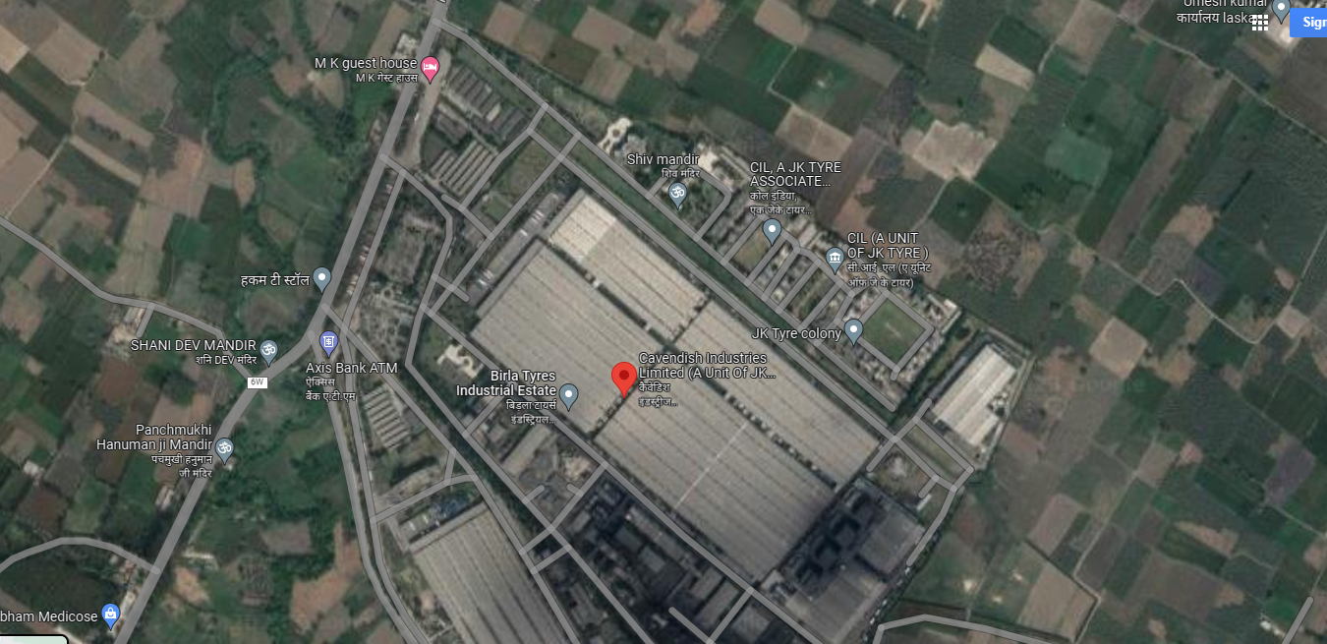
- Technical details as per Techno-Commercial offer from Orient Power
S. No. | Item Description | Technical Specifications | Quantity | Unit | Make
A | PV Section
1 | Solar PV module | Model: Mono Perc  Half cut shell: (144 cells/Module)  Module Efficiency: ≥21%  Maximum Power-PMax: ≥540 Wp  IP: 68 | 6.0 | MWp. | a. Trina Solar  b. Longi  c. Renew sys  d. Adani solar  e. similar
2 | Connectors (male & female) pair MC4 | 1800V max connectors  IP: 68 | 1 | Lot | a. Bizlink  b. Staubli
3 | Solar String Inverter | Output Voltage: xxV  Outdoor Type - IP: 66  Output Power: 295 kVA @ 50⁰C  Inverter Efficiency: ≥98%  Protection:  Over Voltage,  Under Voltage,  Frequency,  DC reverse Polarity,  Anti-islanding | 5000 | KW | Sungrow/ Grow att /Similar
B | Structures
1 | Module Mounting Structures | Type of Module Mounting: Rooftop - Tinshed  Material: Aluminium  Fasteners: SS304 (With Plain & Serrated Washer)  Fixed Tilt: As per tinshed  Wind Load: 120 kmph  Minimum Distance between Module Frame & Shed: 50mm | 6.0 | MWp | Reputed
C | Remote Monitoring System & Accessories (SCADA with WMS)
1 | Global Tilt Irradiance Sensor (GTI) | --- | 1 | No’s | Suryalogix/equivalent
2 | Module Temperature Sensor | --- | 1 | No’s | Suryalogix/equivalent
3 | Ambient Temperature Sensor | --- | 1 | No’s | Suryalogix/equivalent
4 | RS485 Communication Cable | --- | 1 | Lot | Parasheild/equivalent
5 | CAT 6 Cable | --- | 1 | Lot | D-Link/ equivalent
6 | Data Logger with Battery Back-up | --- | 1 | Set | Suryalogix
7 | Sensor Mounting System/Junction Box | --- | 1 | Set | Reputed
8 | HDPE DWC Conduit, Size: 32/26mm & Accessories (Bends,  Couplers etc.) | --- | 1 | Lot | Tirupati / Duralline/  Equivalent
D | LT PANEL
1 | Field ACDB | I/C - ( 1 no XXX Amp breaker, and individual breaker  for each inverter input )  - Mounting stand with locking arrangement & shading  from rainwater.  - IP 65 indoor Enclosure CRC Powder Coated  - SPD Type 2 surge Arrester, All Input and Output lugs | 1 | No’s | Breaker make  a. L&T  b. Schneider  c. Siemens  d. Reputed
2 | 11KV HT Panel with 630A breaker | n O/V, O/C, E/F Protection, OTI, WTI,  MOG & Buchholz relay (Common infra) | 1 | Set | a. Siemens  b. Schneider  c. ABB  similar
E | DC side - Cables & Accessories
1 | 1 Core 4 / 6 Sq.mm.  1 Core, xx Sqmm | (UV protected double sheathed XLPO)  solar cable (module to inverter) | 1 Lot | Mtrs | a. Siechem  b. Apar  c. KEI  d. Similar
2 | 1 Core 2.5 Sq.mm | Green Cable, 1.1 KV Grade (Flexible PVC  Insulated Cable) | 1 Lot | Mtrs | a. Polycab  b. KEI  c. RR  d. Havells  e. Similar
3 | DC Electrical accessories | (Ferrules, Cable Ties, uPVC Tape,  etc.) | 1 | Lot | Reputed
4 | HDPE DWC Conduit, Size of 32/26mm & Accessories (PVC bends  & couplers, T Joints etc.) | Double Wall Corrugated HDPE Conduit for DC cable laying over shed. Conduit will be fixed with shed using GI Saddles and aluminum pop rivets. | 1 Lot | Mtrs | Tirupati & Similar
F | AC side - Cables & Accessories
1 | 3.5 C X xx Sq.mm alu. XLPE armoured for -- Inverter to ACDB | 3.1 KV Insulation, Class: 2, Extruded sheathed Cable.  Extruded FRLS Outer sheath (UV Protected)  Size: xxx sqmm | 1 Lot | Mtrs | a. Polycab  b. KEI  c. Universal  Similar
2 | 3.5 C X xxSq.mm Al. XLPE Galvanized Steel Strip/Round  Wire Armoured | – ACDB to client feeder  Extruded Inner sheath  Extruded FRLS Outer sheath (UV Protected)  Size: xxxsqmm | 1 Lot | Mtrs | a. Polycab  b. KEI  c. Universal  Similar
3 | AC Electrical Accessories | Canopy  Lugs  Glands,  Ferrules,  Cable Ties,  uPVC Tape,  uPVC Saddle,  Cable Clips etc. | 1 Lot | -- | Agreed Make
4 | Inverter Transformer | Rating: 5 MVA  Voltage Ratio: 0.8/11KV  Phase Connections: 3 phase | 1 | Lot | a. Hammand  b. Voltamp  c. Electrotherm  d. Raychem RPG  Similar

G | Civil Works
1 | Foundation for Mounting Structure | Civil work for Structure, electrical panel foundations, Structure Foundation, earthing pit chamber construction. | 1 | Lot
2 | Inverter Mounting Structure |  | 1 | Lot
3 | Electrical Panel Foundation |  | 1 | Lot
H | Safety & Protections
1 | Fire extinguisher With sand bucket ( 4 Kg ) | 4 Kg fire extinguishers with stand | 1 | Lot | As per Standard
2 | DC & AC Earthing | Chemical Earthing-Earth Pits (3 Mtrs Cu. Bonded rod) &  Module Earthing  Carbon Based Ground Enhancing Material | 1 | Lot | Allied Power (LPI) /  SGI
3 | GI Strip for LT Earthing | HDG min. 80 micron | 1 | Lot | Reputed
4 | Earthing Wire | -- | 1 | Lot | a. Polycab  b. KEI
5 | Lighting Arrester | Earthing-ESE type | 1 | Lot | Allied Power (LPI)
6 | Safety & Danger Boards | Tags | 1 | Lot | Agreed standard
7 | Walkway & lifeline | -- | 1 | Lot | Reputed
I | MISCELLANEOUS
1 | Manual Module Cleaning System | UPVC/HDPE Pipe, Valves and flexible hose pipe | 1 Lot | No’s | Apollo make
2 | 0.5 HP, 230V/415 AC Pump |  | 1 Lot | No’s | Kirloskar/Similar
J | Services
1 | Installation & Commissioning | Complete plant service work | 1 Lot | No’s | Oriana
The above-mentioned installations/parts are provided as per best industrial practice and can be verified after commissioning of the project. The specification for the items mentioned in the above Techno Commercial Offer to be inline and with as per government guidelines.
Client’s (site owner) Scope of work
- Provision of permission to work on site for I&C. 24x7 – 7 days a week.
- Access to the Roof shall be in client scope.
- Provision of Internet connection using SIM cards/Lan for remote monitoring of Solar Power Plant.
- Levelled and cleared land shall be provided for installation of solar power plant.
- Secure area for keeping tools and tackles.
- Construction power and water has to be provided by client.
- Statutory fees (direct or indirect cost) required for any approval/ permissions pertaining to power evacuation
- from solar plant shall be in client’s scope however liasoning will be done by Oriana Power limited
PART D | ENERGY YIELD ASSESSMENT

Company has used PVSyst V7.3.4 to assess energy yield calculation which is the standard Industry practice. The yearly average of main results of irradiation and energy yield from the provided PVSyst is as under:
S. No. | Plant Location | Annual production probability  (MWh) |  | Specific Production  (kWh/kWp/year) |  | Performance  Ratio (%)
 |  | P50 | P90 | As per PPA | As per PVsyst
1 | Cavendish Industries Limited, Laksar, Haridwar - India | 8904 | 8669 | -- | 1483 | 82.45

Analysis of Irradiation & PV Output data: In respect to Irradiation & PV Output data, company has provided to us PVSyst report V7.3.4 in which key Irradiation components and PV Output data is given as enumerated in table below. We have analysed and compared it with other data source points also such as Solar Resource by Global Solar Atlas of World Bank and ISRO Solar Calculator to confirm its legitimacy as mentioned in table below:
Particulars | Cavendish Industries Limited
 | As per Global  Solar Atlas | As per PVSyst
Global horizontal Irradiation (kWh/m²) | 1736.1 | 1732.7
Diffuse horizontal Irradiation (kWh/m²) | 895.3 | 888
Direct Normal Irradiation (kWh/m²) | 1265.2 | -
Specific Photovoltaic Power Output (kWh/kWp/year) | 1499.8 | 1483
Annual Global Insolation (ISRO Solar Calculator) (kWh/m2/year) | 1450

Observations and Remarks:
- As per the PVsyst - Simulation reports dated 12th October 2023, the estimated energy that can be produced by the subject plants and their respective performance ratio is almost equal as agreed in the PPA.
- As per comparative analysis, PVSyst Irradiation and PV Output data is in line to our analysis from Global Solar Atlas of World Bank and ISRO Solar Calculator.
- As per the information provided by the management of the company, the estimated Plant Load Factor (CUF at P90) is 16.50%
Monthly averages- Direct normal irradiation (kWh/m²)
- CAVENDISH INDUSTRIES LIMITED, LAKSAR, HARIDWAR – INDIA
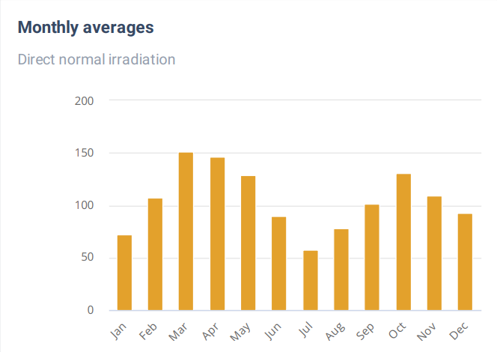
Source: Global Solar Atlas

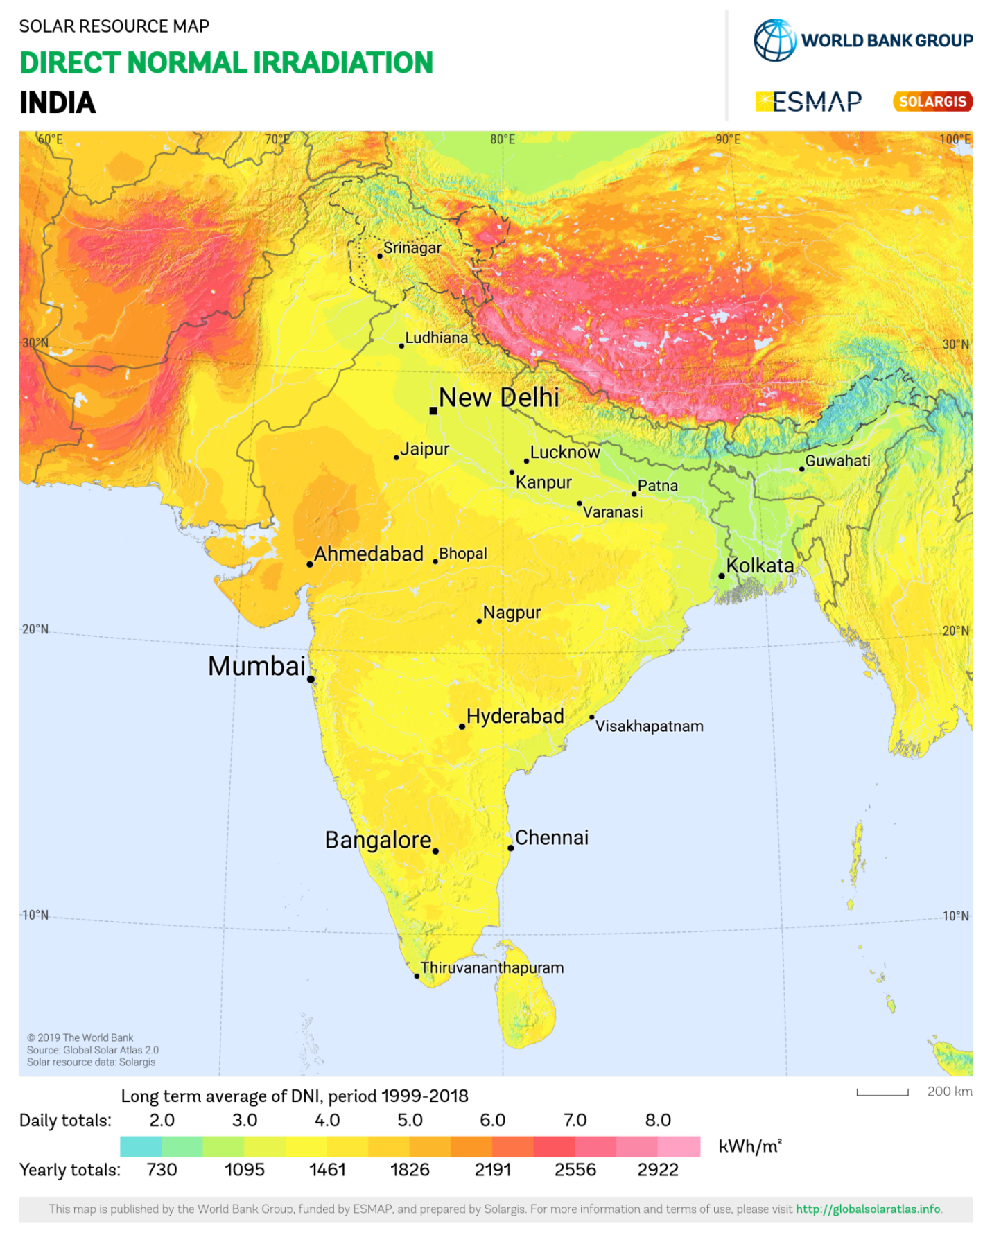
Cavendish Industries Limited, Laksar, Haridwar lies above 3.0 daily (1095 annually) Kwh/m².

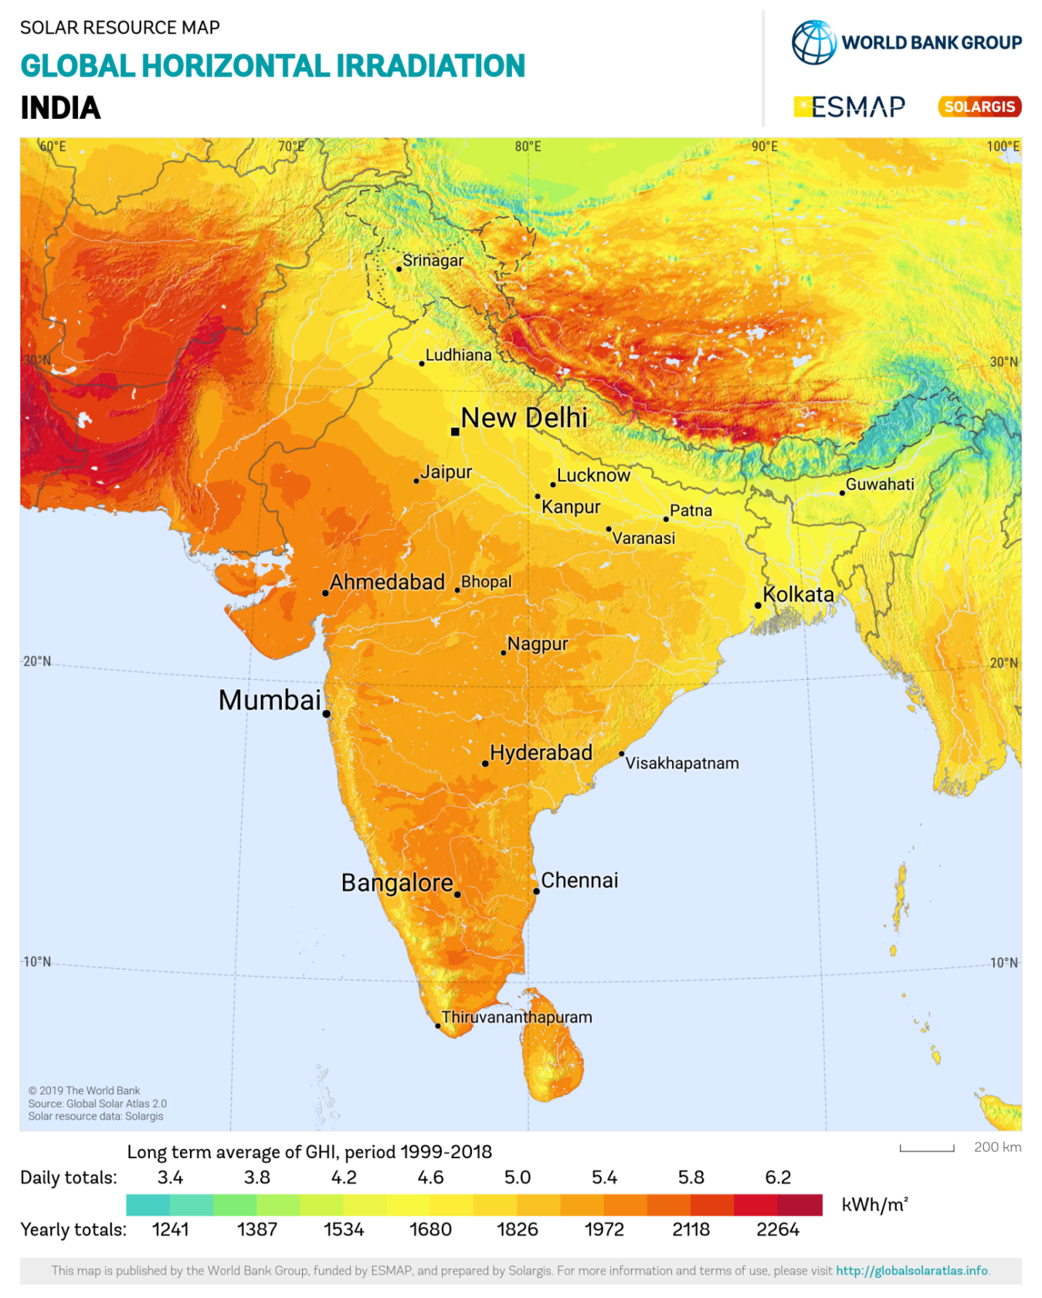
Cavendish Industries Limited, Laksar, Haridwar lies below 5.0 daily (1826 annually) Kwh/m².

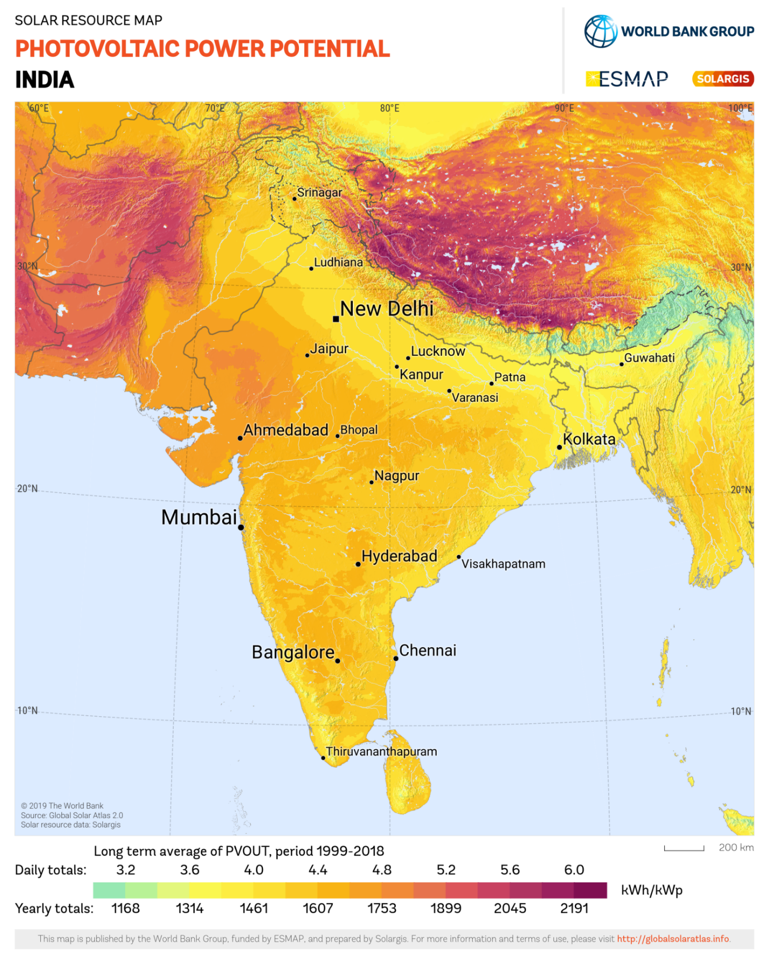
Cavendish Industries Limited, Laksar, Haridwar lies above 4.0 daily (1461 annually) Kwh/kWp.

PART E | POWER PURCHASE AGREEMENT TERMS

As per the information provided by the company, the total proposed capacity of the subject roof-mounted solar power plant is 6 MWp (± 10%). As on date, company has signed 1 no. of PPAs to install the power plant and supply power at the project site. Details of the same are tabulated below:
S. No. | Offtaker | DC Capacity  (kWp) | Tariff  (Rs./kWh) | PPA Date
1 | Cavendish Industries Limited, Laksar, Haridwar | 6,000 | 4.91 | 25-09-2023
Total |  | 6,000
Source: PPAs
Important Clauses: The PPA is signed between Cavendish Industries Ltd. & Solarithic Power SPV Private Limited for a period of 15 years with fixed tariff as stated above. Some of the important clauses from the signed PPAs are as follows: -
Clause-2: CONSTRUCTION, COMMISSIONING, OPERATION & MAINTENANCE OF THE POWER PLANT

2.1. CIL hereby grants to SPSPL permission to use the Site for installation, operation, and maintenance of the power plant pursuant to the terms of this agreement.
2.2. CIL Shall allow the access to the site to SPSPL within 5 days of the execution date and shall, at its cost and for the term of this agreement.;
- Provide construction and auxiliary power for construction and operation of the power plant at nearest existing point available at site.
- Provide a water tapping point with access to clean water at nearest existing point available at site.
- Provide 24/7 internet connectivity.
- Ensure that all arrangements and infrastructure for receiving electricity beyond the delivery point are ready on or prior to the COD and is maintained in such state in accordance with applicable law through the term of agreement.
- Allow integration of power plant with DG set at the Facility to SPSPL.

2.5 In the event SPSPL fails to Commission the Power Plant on or before the SCOD, SPSPL shall be entitled to a cure period of 30 (thirty) days during which SPSPL shall be required to Commission the Power Plant, failing which SPSPL shall be liable to pay CIL delay liquidated damages accruing on a monthly basis for an amount equal to the difference between the Energy Charges and Landed Cost of Electricity from Power Plant to CIL, multiplied by the monthly pro- rata Guaranteed Energy till the month in which Commissioning takes place (hereinafter referred to as "Delay Liquidated Damages"). SPSPL agrees and acknowledges that the Delay Liquidated Damages represent an accurate pre-estimate of damages likely to be suffered by CIL due to non-delivery of the Guaranteed Energy for the period between the SCOD and the actual date of Commissioning.

Illustration:

Scheduled Commissioning Date = 1st November 2023
Actual Date of Commissioning = 31st December 2023

Compensation payable to CIL on account of delay in Commissioning = (31st December 2023-1st November 2023-30) / 30X Guaranteed Energy/ 12X (Energy Charges-Landed cost of Electricity from Power Plant to CIL).

3.7 DEEMED GENERATION
In case CIL has not enough load during any period, or for any reasons attributable to CIL, CIL is not able to consume the entire quantum of electricity from the Power Plant (limited to 8.178 MUS/Contract Year adjusted for applicable degradation factor) which the Power Plant would be capable to generate, there shall be a loss of generation, and CIL shall compensate SPSPL for such loss of generation at applicable Tariff (the loss of generation due to reasons attributable to CIL hereinafter to be referred to as the "Deemed Generation").

Deemed Generation shall also be billed in case of following events:

- If it is established by SPSPL that the Power Plant is damaged by any acts of negligence by CIL, or any of its employees, agents, contractors, or affiliates etc.;
- The temporary relocation of the Power Plant due to Site repairs or for any other reason either at the request of CIL or due to acts of negligence or omission of CIL or its employees, agents or contractors or affiliates. It is agreed between the Parties that CIL shall pay to SPSPL for all work required by the SPSPL to disassemble or move the power Plant and re-assemble the same after completion of such repair work.
- Shading resulting from structures constructed after the execution date, not being structures created by SPSPL.
- Non synchronization of DG set to the power plant or temporary / permanent disconnection of the same.

5. VALIDITY AND TENURE
This Agreement shall be valid and effective from the Effective Date and shall remain in force till the completion of 15 (fifteen) years from COD (hereinafter referred to as "Term of the Agreement").

- The Parties shall mutually decide on the renewal and the terms and conditions of renewal of this Agreement at least 3 (three) months prior to the expiry of this Agreement.
- Upon the expiry of Term of the Agreement, SPSPL shall transfer the Power Plant to CIL at a value of Rs. 1.
- During the Term of the Agreement, CIL may also opt to buyback the Power Plant at predefined buyback value as mentioned in Schedule C.

- The Parties may discuss, before the expiry or termination of this Agreement, entering into an operation and maintenance agreement under which SPSPL shall perform all the operation and maintenance activities of the Power Plant, at mutually agreed price, terms and conditions.

6. TARIFF, RIGHTS TO BENEFITS, MINIMUM GUARANTEE

- SPSPL shall bill CIL for the Billable Units on a monthly basis at INR 4.91 per Unit (hereinafter referred to as "Tariff). The Tariff shall, remain fixed for the Term of the Agreement.
- SPSPL represents to CIL that currently there are no charges, losses, duties, cross subsidy surcharge, additional surcharge, taxes, cess and any other nature of cost/expense/overhead being levied to supply of electricity from an on-site solar power plant.
- During the term of the Agreement, all taxes/cess/levies / surcharge / duties etc. on account of delivery or consumption of electricity from the Power Plant (hereinafter referred to as "Overheads"), shall be borne by CIL, subject to Minimum Differential of Tariff. Currently, electricity duty, green cess and parallel operation charges are applicable as per the Applicable Law but not being levied.
- In the event of introduction of any new unforeseen Overheads, which are currently not mentioned as per Applicable Law, during the term of the Agreement, the same shall be borne by CIL, subject to Minimum Differential of Tariff.
- SPSPL guarantees to CIL a "Minimum Differential of Tariff as mentioned below, from applicable Energy Charges. In the event "Differential of Tariff for CIL, as determined below, due to changes in Overheads or introduction of any new Overheads, during the Term of the Agreement, breaches Rs. 0.55 per Unit, SPSPL shall protect CIL and ensure Minimum Differential of Tariff of Rs. 0.55 per Unit by reducing the Tariff.

Please note that the above main clauses of PPA are mentioned only for illustration purpose of the convenience of the lenders to analyze the Project in terms of technicality. However, this shall not be construed as professional opinion on the contract legality which is out of scope of this report.

PART F | CURRENT STATUS OF WORK

As per information and documents shared by the company’s representative, following are our observations and remarks on the current status of the project:
- As per the verbal information received from the management of the subject company, installation work is yet to be started.
- As per information shared over the mail by the company officials, the installation work is yet to start and the proposed COD of the project is scheduled in the month of March 2024.

PART G | PROJECT COST & EXPENDITURE

- PROJECT COST: Project cost has been taken from the Copy of Techno-Commercial offer from M/s OPPL to M/s Cavendish Industries Limited dated 12th October 2023, for the installation of Roof Mounted Grid Tie Solar PV plant located at Haridwar. The terms of engagement are tabulated below:
S. No. | Description | Amount  (Including duties and taxes)
1 | 6000 kWp Rooftop capacity solar power plant Design,  Supply, Installation, Testing & Commissioning with  - Monocrystalline pv panels  - String inverter | Rs. 29,61,00,000/-
Total |  | Rs. 29,61,00,000/-

NOTES:

- Freight & Transit Insurance: Inclusive.
- Statutory fees (direct or indirect cost) required for any approval/ permissions pertaining to power evacuation from solar
- plant shall be in client’s scope however liasoning will be done by Oriana Power limited.
- GST Extra – as per government norms
- Any change in Tax/ Duties shall be borne by the Purchaser. During order finalization and order project execution any duty
- being applied by government shall be charged to client.
- We have ESI & EPF for our employees / project team, to cover 3rd party subcontractor we have EAR Policy to cover
- subcontractor manpower and daily wages manpower also
Observations and Remarks:
- Project cost calculated on the basis of the Benchmark Cost provided by the MNRE has been tabulated below:
S. No. | Particulars | Benchmark Cost  (In Rs./kW) | Project Capacity  (In MW) | Total Project Cost  (Excluding GST)  (In Rs.) | Total Project Cost  (Including ~14% GST)  (In Rs.)
1 | As per Ministry of New & Renewable Energy | 39,467* | 6,000 | 23,68,02,000 | 26,99,54,280
 |  |  | 6.0 MWp |  | ~Rs. 26.99 Cr.
*Benchmark cost for 2021-22

- Project cost calculated on the basis of market comparable:
S. No. | Particulars | Excluding GST | Including GST | Remark
 |  | Per KW Cost  (In Rs.) | Per KW Cost  (In Rs.)
1 | Subject project installation cost | - | 49,350 | as per Techno-Commercial offer from OPPL
Market Research Details
2 | MNRE Benchmark Cost | 35,886 | - | Refer Annexure-1
 | Market Research
3 | Quotation-1 | 48,700 | 55,400 | Refer Annexure-2
4 | Quotation-2 | 37,740 | 42,500
5 | Quotation-3 | 45,000 | 51,200
6 | Quotation-4 (Tata Solar) | 60,000 | 68,300

- As per our analysis and market research, the installation cost of Rooftop Mounted Solar Power Plant varies from Rs. 45,500/- per KW to Rs. 68,300/- per KW. For the smaller setups the price is higher and for large set-up, price is less.
- The project cost is solely depending upon the project location, contractors profit, type of module and its supporting structures, etc.
- Based upon the above-mentioned details, the project cost amounting to Rs. 29.61 Cr. inclusive of GST and operation and maintenance for 5 years of subject Solar Power Plant which comes out to be Rs.49,350 per KW (including GST+ 5 Years O&M) which seems to be reasonable.
- As per the verbal information received from the management of the subject company, installation work is yet to be started.
Note:
- Project cost is analyzed based on lump sum cost only and not item wise.
- Project cost is assessed for the date of this report only and due to price fluctuations, it may vary from time to time.

- EXPENDITURE: As per information/details shared by the company, the installation work related to power plant is yet to start. Thus, the expenditure incurred till date on the project is NIL.

PART H | PHOTOGRAPHS

Since the installation work related to solar panels is yet to start and this is just a Desktop LIE based upon documents provided. Thus, Photographs are not available.

PART I | OTHER DOCUMENTS & REFERENCES

Annexure-1: Benchmark Cost by MNRE:
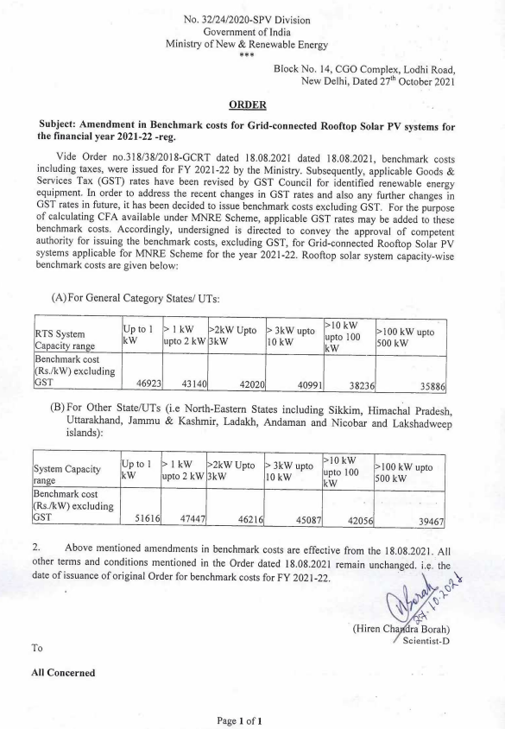
Market Comparables:
Annexure-2
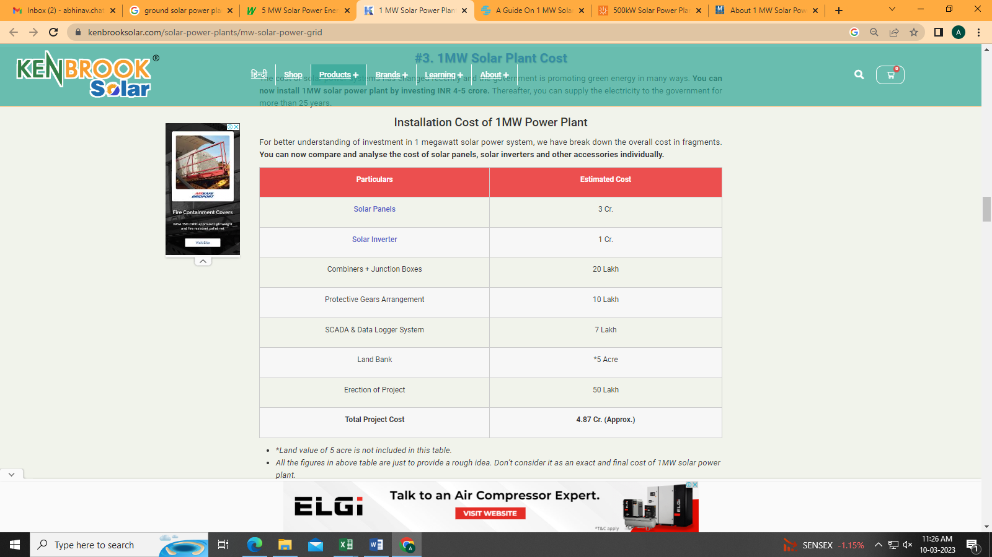

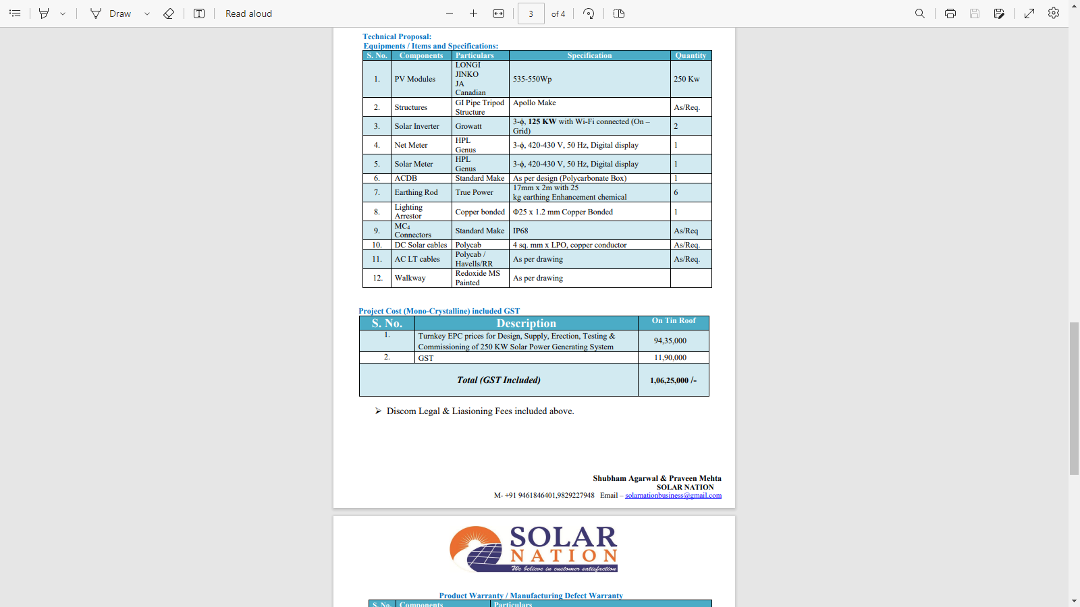

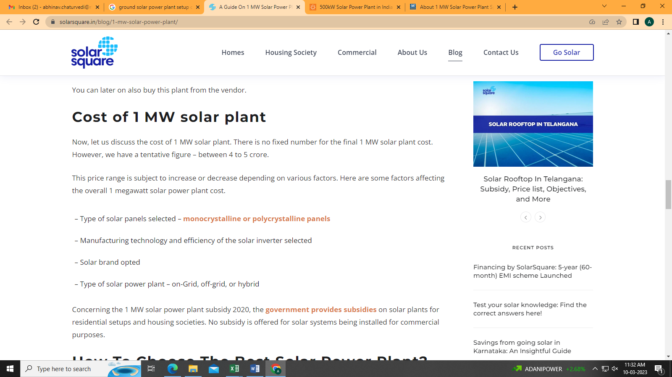
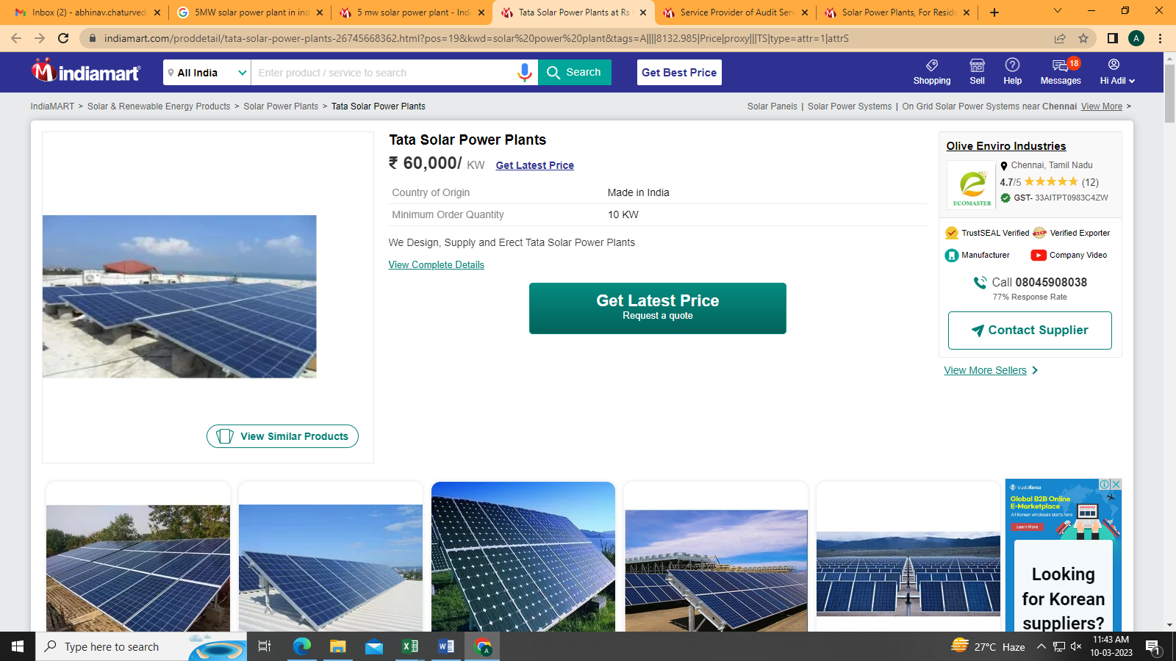

Data by Global Solar Atlas by World Bank Group
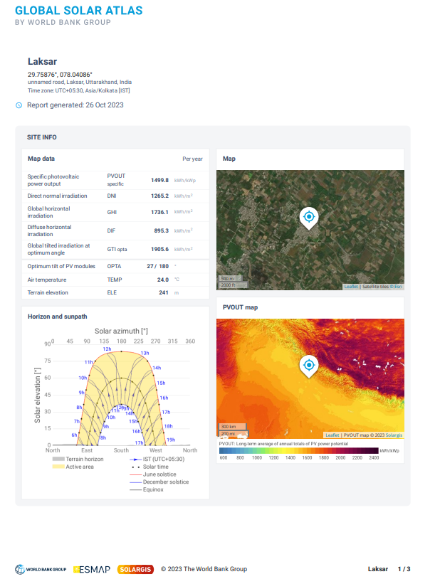
- CAVENDISH INDUSTRIES LIMITED, LAKSAR, HARIDWAR
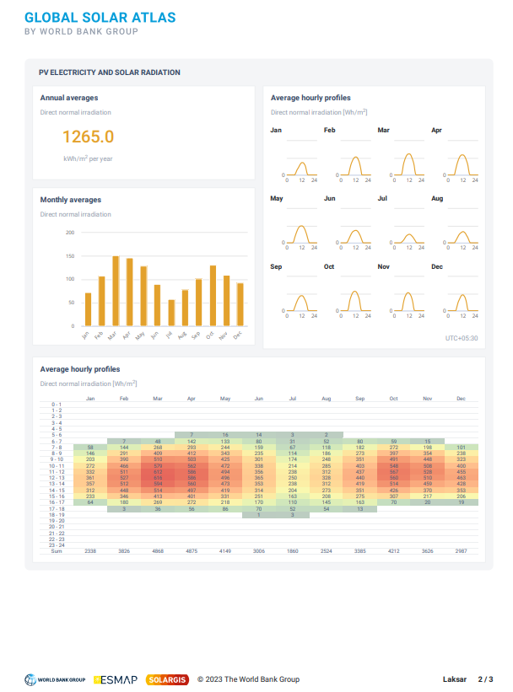
Layout Plans
1. CAVENDISH INDUSTRIES LIMITED, LAKSAR, HARIDWAR
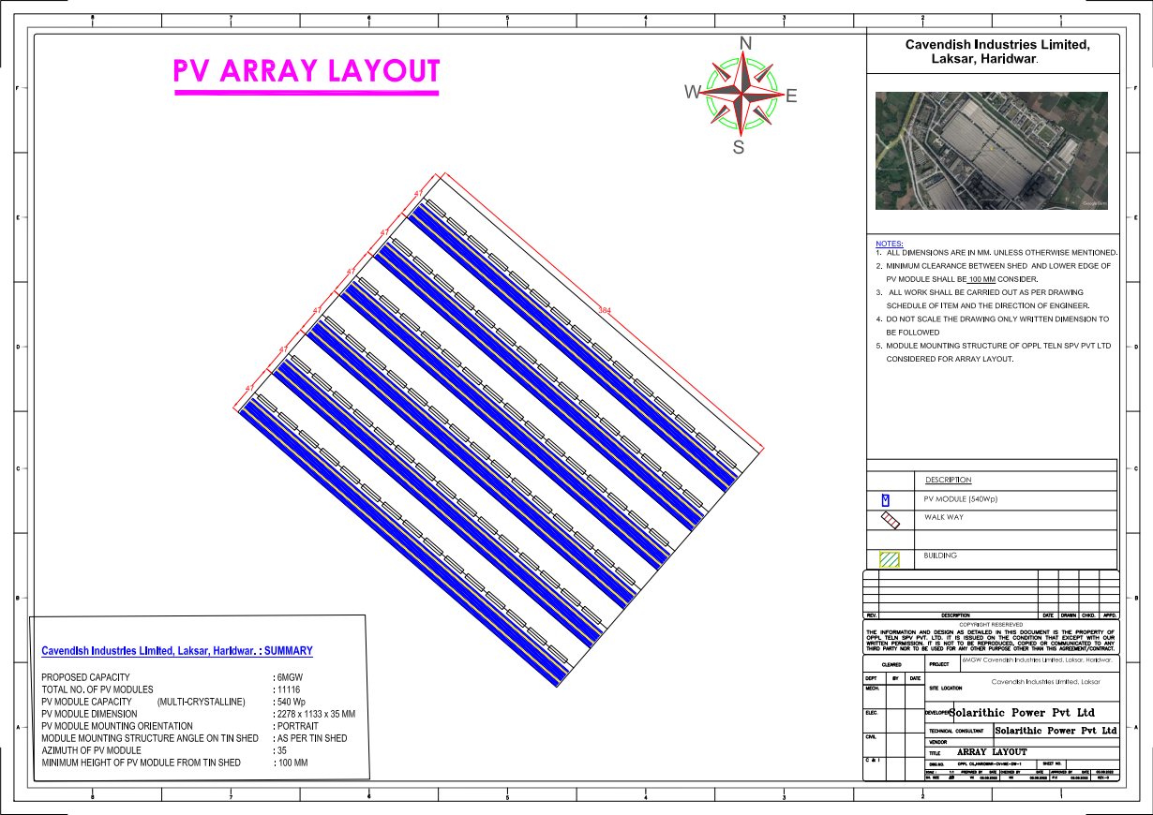
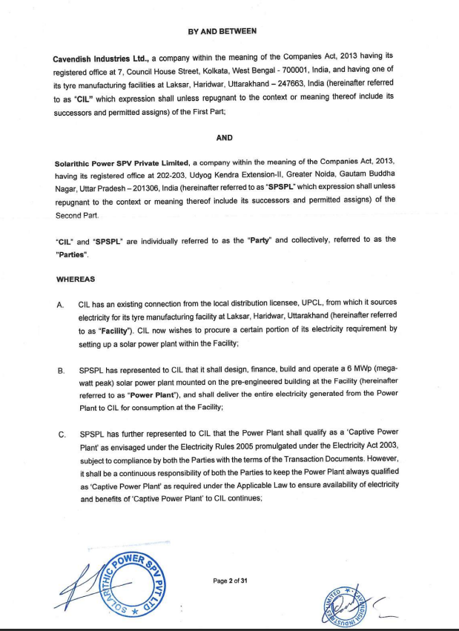
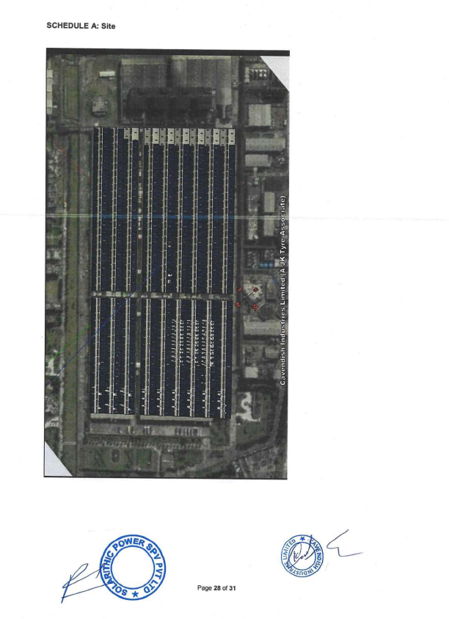
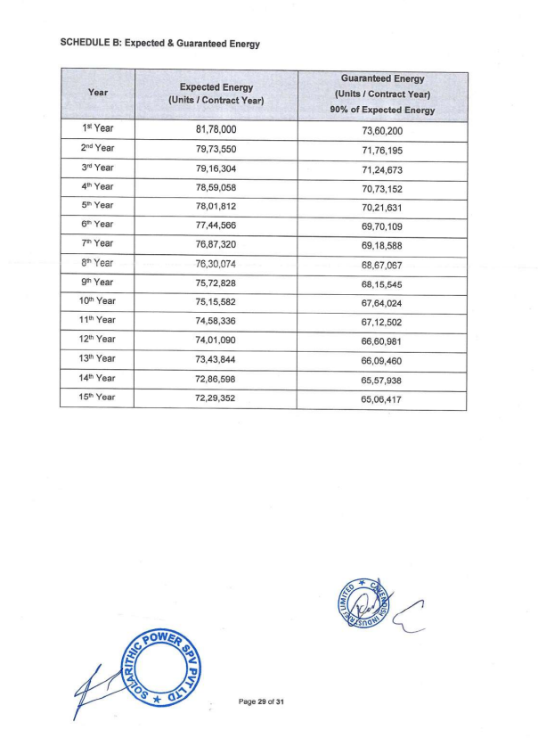
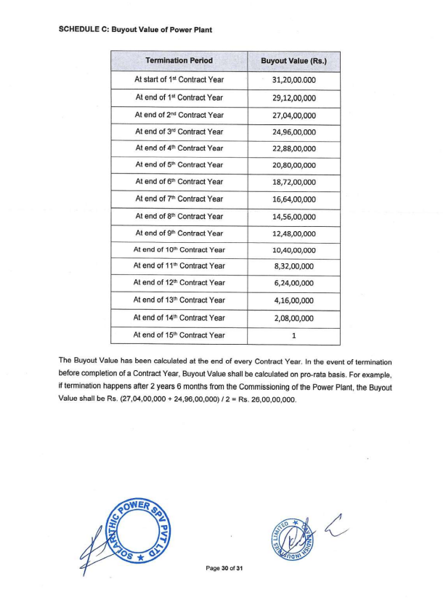
PART J | DISCLAIMER

      - No employee or member of R.K Associates has any direct/ indirect interest in the Project.
      - This report is prepared based on the copies of the documents/ information which the Bank/ Company has provided to us out of the standard checklist of documents sought from them and further based on our assumptions and limiting conditions. All such information provided to us has been relied upon in good faith and we have assumed that it is true and correct in all respect. Verification or cross checking of the documents provided to us has not been done at our end from the originals. If at any time in future, it is found or came to our knowledge that misrepresentation of facts or incomplete or distorted information has been provided to us then this report shall automatically become null & void.
      - This report is a general analysis of the project based on the scope mentioned in the report. This is not an Audit report, Design document, DPR or Techno-financial feasibility study. All the information gathered is based on the facts seen on the site during survey, verbal discussion & documentary evidence provided by the client and is believed that information given by the company is true best of their knowledge.
      - All observations mentioned in the report is only based on the visual observation and the documents/ data/ information provided by the client. No mechanical/ technical tests, measurements or any design review have been performed or carried out from our side during Project assessment.
      - Bank/FII should ONLY take this report as an Advisory document from the Financial/ Chartered Engineering firm and it’s specifically advised to the creditor to cross verify the original documents for the facts mentioned in the report which can be availed from the borrowing company directly.
      - In case of any default in loans or the credit facility extended to the borrowing company, R.K Associates shall not be held responsible for whatsoever reason may be and any request for seeking any explanation from the employee/s of R.K Associates will not be entertained at any instance or situation.
      - This Report is prepared by our competent technical team which includes Engineers and financial experts & analysts.
      - This is just an opinion report and doesn’t hold any binding on anyone. It is requested from the concerned Financial Institution which is using this report for taking financial decision on the project that they should consider all the different associated relevant & related factors also before taking any business decision based on the content of this report.
      - All Pages of the report including annexures are signed and stamped from our office. In case any paper in the report is without stamp & signature then this should not be considered a valid paper issued from this office.
      - Though adequate care has been taken while preparing this report as per its scope, but still we can’t rule out typing, human errors, over sightedness of any information or any other mistakes. Therefore, the concerned organization is advised to satisfy themselves that the report is complete & satisfactory in all respect. Intimation regarding any discrepancy shall be brought into our notice immediately. If no intimation is received within 15 (Fifteen) days in writing from the date of issuance of the report, to rectify these timely, then it shall be considered that the report is complete in all respect and has been accepted by the client upto their satisfaction & use and further to which R.K Associates shall not be held responsible in any manner.
      - Defect Liability Period is 15 DAYS. We request the concerned authorized reader of this report to check the contents, data and calculations in the report within this period and intimate us in writing if any corrections are required or in case of any other concern with the contents or opinion mentioned in the report. Corrections only related to typographical, calculation, spelling mistakes, incorrect data/ figures/ statement will be entertained within the defect liability period. Any new changes for any additional information in already approved report will be regarded as additional work for which additional fees may be charged. No request for any illegitimate change in regard to any facts & figures will be entertained.
      - R.K Associates encourages its customers to give feedback or inform concerns over its services through proper channel at le@rkassociates.org in writing within 30 days of report delivery. After this period no concern/ complaint/ proceedings in connection with the Lender’s Independent Engineering Services will be entertained due to possible change in situation and condition of the subject Project.
      - Our Data retention policy is of ONE YEAR. After this period, we remove all the concerned records related to the assignment from our repository. No clarification or query can be answered after this period due to unavailability of the data.
      - This Lender’s Independent Engineering report is governed by our (1) Internal Policies, Processes & Standard Operating Procedures, (2) Information/ Data/ Inputs given to us by the client and (3) Information/ Data/ Facts given to us by our field/ office technical team. Management of R.K Associates never gives acceptance to any unethical or unprofessional practice which may affect fair, correct & impartial assessment and which is against any prevailing law. In case of any indication of any negligence, default, incorrect, misleading, misrepresentation or distortion of facts in the report then it is the responsibility of the user of this report to immediately or at least within the defect liability period bring all such act into notice of R.K Associates management so that corrective measures can be taken instantly.
      - R.K Associates never releases any report doing alterations or modifications from pen. In case any information/ figure of this report is found altered with pen then this report will automatically become null & void.

FOR INTERNAL USE
Place : Noida  Date : 26.10.2023  Note : This report contains 35 pages | SURVEYED BY:  PREPARED BY:  REVIEWED BY: | NA as Desktop Analysis  Amit Jaiswal  Sr. V.P. Projects

For R.K Associates Valuers & Techno Engineering Consultants (P) Ltd.

DEFECT LIABILITY PERIOD - In case of any query/ issue or escalation you may please contact Incident Manager by writing at valuers@rkassociates.org. We ensure 100% accuracy in the Calculations done, Rates adopted and various other data points & information mentioned in the report but still can’t rule out typing, human errors or any other mistakes. In case you find any mistake, variation, discrepancy or inaccuracy in any data point of the report, please help us by bringing all such points into our notice in writing at valuers@rkassociates.org within 30 days of the report delivery, to get these rectified timely, failing which R.K Associates Valuers Techno Engineering Consultants (P) Ltd. won’t be held responsible for any inaccuracy in any manner. Also if we will not hear back anything from you within 30 days, we will assume that report is correct in all respect and no further claim of any sort will be entertained thereafter. We would welcome and appreciate your feedback & suggestions in order to improve our services.

COPYRIGHT FORMAT - This report is prepared on the copyright format of R.K Associates Valuers Techno Engineering Consultants (P) Ltd. to serve our clients in the best possible way. Legally no one can copy or distribute this format without prior approval from R.K Associates. It is meant only for the organization as mentioned on the cover page of this report. Distribution or use of this format other than R.K Associates will be seen as unlawful act and necessary legal action can be taken against the defaulter

