**File No. : VIS (2023-24)-PL542-456-686 Dated: 18-01-2024**

**CAPITAL EXPENDITURE VERIFICATION REPORT**

**OF**

****

**SITUATED AT**

**3KM MILE STONE, NEXT TO NATH FARM, BHOPA ROAD, MUZAFFARNAGAR, U.P. 251001**

**PROMOTER**

**M/S. BDJ ENTERPRISES**

**REPORT PREPARED FOR**

**UTTAR PRADESH TOURISM**

***\*\*Important - In case of any query/ issue or escalation you may please contact Incident Manager***

***at le@rkassociates.org. We will appreciate your feedback in order to improve our services.***

***NOTE: Please provide your feedback on the report within 15 days of its submission after which report will be considered to be correct***

**IMPORTANT NOTICE**

***COPYRIGHT FORMAT:*** *This report is prepared on the copyright format of R.K Associates to serve our clients with the best possible information and analysis to facilitate them to take rational business decisions. Legally no one can copy or distribute this format without prior approval from R.K Associates. It is meant only for the advisory/ reference purpose for the organization/s as mentioned on the cover page of this report. Distribution or use of this format by any organization or individual other than R.K Associates will be seen as an unlawful act and necessary legal action can be taken against the defaulters.*

*This report is intended for the sole use of the intended recipient/s and contains material that is STRICTLY CONFIDENTIAL AND PRIVATE.*

***DEFECT LIABILITY PERIOD:*** *- In case of any query/ issue or escalation you may please contact Incident Manager at le@rkassociates.org. We try to ensure maximum accuracy in the calculations done, rates adopted, assumptions taken and various other data points & information mentioned in the report but even still can’t rule out typing, human errors or any other bonafide mistakes. In case you find any such mistake or inaccuracy in any data point of the report, please help us by bringing all such points into our notice immediately or within 15 days of the r0eport delivery in writing, to rectify these timely failing after which R.K Associates won’t be held responsible for any such inaccuracy in any manner. We would highly appreciate your feedback in order to improve our services.*

|  |  |  |
| --- | --- | --- |
| **TABLE OF CONTENTS** | | |
|  | | |
| **SECTIONS** | **PARTICULARS** | **PAGE NO.** |
| **Part A** | **REPORT SUMMARY** | 03 |
| **Part B** | **INTRODUCTION** | 04 |
|  | 1. Name of the Project | 04 |
| 1. Project Overview | 05 |
| 1. Project Location | 09 |
| 1. Scope of the Report | 09 |
| 1. Purpose of the Report | 09 |
| 1. Survey Details | 09 |
| 1. Methodology Adopted | 10 |
| **Part C** | **PLANT INFRASTRUCTURE SECTIONS & FACILITY DETAILS** | 11 |
| 1. Building & Structural Details | 11 |
| 1. Plant & Equipment Details | 13 |
| **Part D** | **PROJECT CAPITAL EXPENDITURE EVALUATION** | 15 |
| **Part E** | **PHOTOGRAPHS FROM THE SURVEY** | 21 |
| **Part F** | **DISCLAIMER** | 23 |

|  |  |
| --- | --- |
| **PART A** | **REPORT SUMMARY** |

|  |  |  |  |  |  |  |
| --- | --- | --- | --- | --- | --- | --- |
| **1.** | | **Name of the Project** | | **:** | Palasa Hotel & Resort | |
| **2.** | | **Project Location** | | **:** | “Palasa Hotel & Resort”, 3km Mile Stone, Next To Nath Farm, Bhopa Road, Muzaffarnagar, U.P. 251001 | |
| **3.** | | **Name of the Promoter** | | **:** | M/s BDJ Enterprises | |
| **4.** | | **Prepared for Organization** | | **:** | 1. Uttar Pradesh Tourism | |
| **5.** | | **Chartered Engineer Firm** | | **:** | M/s. R. K. Associates Valuers & TechnoEngineering Consultants (P) Ltd. | |
| **6.** | | **Date of Survey** | | **:** | 10th January 2024 | |
| **7.** | | **Date of Report** | | **:** | 18th January 2024 | |
| **8.** | | **Report Type** | | **:** | Capital Expenditure Report | |
| **9.** | | **Purpose of the Report** | | **:** | To verify and examine capital expenditure status of the Project in regard to the special facilities & incentives given to Hotel projects as per Uttar Pradesh Tourism Policy-2018. | |
| **10.** | | **Scope of the Report** | | **:** | To verify and examine capital expenditure status of the Project. | |
| **11.** | | **Documents produced for Perusal** | | **:** | 1. Detailed Project Report 2. Break-up of the cost heads 3. Copy of Invoices of Items 4. Copy of CA Certificate 5. Copies of various NOCs & Approvals 6. Information received on e-mail | |
| **12.** | | **Annexure with the Report** | | **:** | 1. Photographs | |
| **PART B** | | **INTRODUCTION** | | |

1. **NAME OF THE PROJECT: “**Palasa Hotel and Resort” situated at Bhopa Road, Dist.: Muzaffarnagar, Uttar Pradesh-251001 developed by M/s BDJ Enterprises.

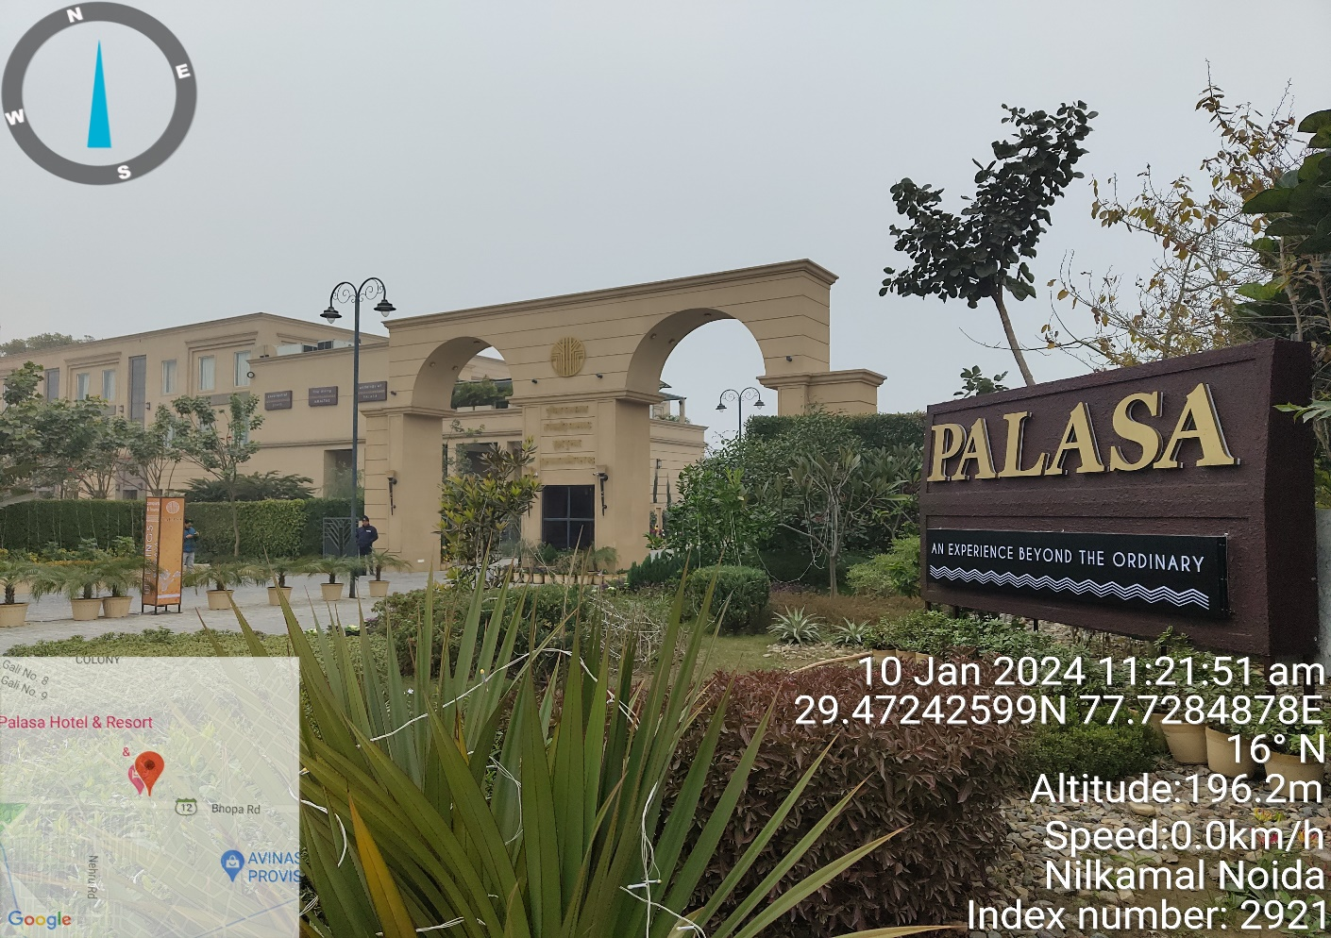

1. **PROJECT OVERVIEW:** This Budget hotel cum resort is established by M/s BDJ Enterprises located in District Muzaffarnagar, Uttar Pradesh near Nath Farms. As per the Registration Certificate No. MUZ/0000277, the subject company got incorporated on 31.05.2018 having its registered office at Palasa, Bhopa Road, Muzaffarnagar.

As per the site layout plan, the company owned land parcel of area measuring 12,774.59 sq. mtr. Out of which land area admeasuring 139.01 sq. mtr. Had been omitted for road widening. Therefore, the net plot area under the subject resort remains 12,635.58 sq. mtr. Screenshot of the same has been attached below:

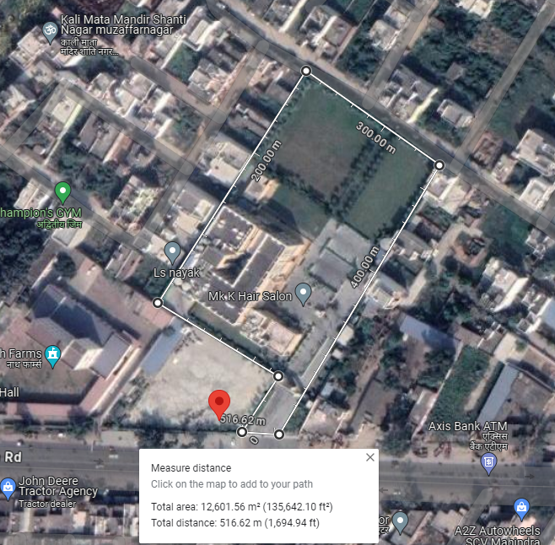

As per the copy of site plan, the subject resort comprises a Ground + 2 storey RCC framed structure with RCC slab roofing with a total built-area of 4,775.66 sq. mtr. or 51,405.20 sq. ft. The construction of the resort began in 2019 and from 25th April 2022 commercial operations has started.

To promote Tourism & Hospitality Industry in the state, UP State Government has offered capital subsidy and financial assistance as per Uttar Pradesh Tourism Policy-2018 on the capital investment on hotels, resorts, heritage hotels, motels, theme parks, etc. in the state. As the subject project has been successfully completed and is commercially operational since 25th April 2022, therefore, the subject promoter has applied for the subsidy under Uttar Pradesh Tourism Policy-2018.

For the purpose of verifying capital investment done by the M/s BDJ Enterprises in the construction of the subject resort, Department of Tourism, UP Government has appointed us as a consultant to provide an opinion on the capital investment incurred by the promoter under the eligible heads.

As per the ‘Operational Guidelines for Implementation of Uttar Pradesh Tourism Policy 2018’, below listed are the eligible and ineligible capital investments in the tourism units:

1. **Eligible Capital Investments**

The eligible capital investment shall be expenditure incurred on the following:

1. Permanent structure for the project under the ownership and for use of the tourism unit, erected on land owned by the tourism unit and which is essential for its commercial operation;
2. Boundary wall;
3. Internal roads, drainage, entrance gate/s;
4. Swimming pool/s;
5. Store/s;
6. Kitchen/s;
7. Water supply system (pipeline, tanks, pump house, water treatment plant etc.);
8. Boiler room and chimney;
9. Sewerage treatment plant and waste management system;
10. Centralized air conditioning;
11. Power sub-station, transformer, electric line, electric pole;
12. D.G Power back up for self-use;
13. Telecommunication tower (self-established for own use);
14. Hot & cold-water supply system, gas / steam supply line;
15. Establishment of sound, light, public address, internet system and network of fixed nature;
16. Installation of fire detection and fire-fighting system;
17. Installation of non-shift able plant & machinery for the infrastructure such as kitchen, laundry, health club, spa, convention hall, exhibition hall, etc.;
18. Establishment of stationery swing sets, climbing walls, amusement/ playing structure, permanent tents, etc. in play areas and parks;
19. Other fixed structures, plant & machinery that are essential for commercial operation of the unit;
20. Fees paid for obtaining technical know-how;
21. Installation charges of machinery / equipment / services;
22. Approach road, expenditure incurred for power supply including construction of sub-station, pipeline laid, water supply, water tank, pipeline for discharge of waste water & sewerage (on land where ownership is with the hotel);
23. Fixed residential tents for tourists, meant for use round the year and not for temporary use like mela, events or seasonal camps, etc.
24. Solar / Bio energy system;
25. Rain water harvesting system.
26. **Ineligible Capital Investments**

The following expenditures with respect to the unit shall not be eligible for incentives:

1. Working Capital;
2. Pre-operative expenses and preliminary expenses;
3. Second-hand plant machinery purchased or shifted from within or outside country;
4. Interest capitalized;
5. Vehicles, furniture and fixtures, cutlery, crockery and utensils
6. Consumable stores; inventories for maintenance or repairs;
7. Investment on land required for setting up the unit, inclusive of the cost of the land;
8. Any construction which is in the nature of real estate transactions, e.g., shops, flats, offices, etc. meant for sale/lease/rent.

As per the copy of application form for ‘Capital Investment Subsidy to Eligible Tourism Units’ (Form 10.1), the promoter had informed to the Govt. of U.P that the total capital expenditure in the project is Rs.14,00,98,899.98/-. Out of the same, the eligible capital expenditure on which the subsidy is to be claimed is Rs.11,94,10,235.77/- as per the CA certificate dated 14th June 2023; UDIN: 23075902BGUUTY5636. The same has been tabulated below:

|  |  |  |
| --- | --- | --- |
| **Sl. No.** | **Heads of Capital Expenditure** | **Amount (in Rs.)** |
| 1.1 | Permanent structure for the project under the ownership and for use of the tourism unit, erected on land owned by the tourism unit and which is essential for its commercial operation | **₹ 7,14,50,092.75** |
| 1.2 | Boundary wall/s | **With In the Building** |
| 1.3 | Internal roads, drainage & entrance gate/s | **With In the Building** |
| 1.4 | Swimming pool | **NA** |
| 1.5 | Store/s | **With In the Building** |
| 1.6 | Kitchen/s | **₹ 67,88,108.62** |
| 1.7 | Water supply system (pipeline, tanks, pump house, water treatment plant, etc.) | **₹ 8,22,290.84** |
| 1.8 | Boiler room & chimney | **Not Applicable** |
| 1.9 | Sewerage treatment plant and waste management system | **₹ 7,19,800.00** |
| 1.10 | Centralized air conditioning system | **₹ 1,60,52,952.50** |
| 1.11 | Power supply system including sub-station, transformer, distribution system and electrification | **₹ 28,43,364.00** |
| 1.12 | D.G. power backup (for self-use) | **Rented** |
| 1.13 | Telecommunication tower (self-established for own use) | **Not Applicable** |
| 1.14 | Hot and Cold water Supply System | **₹ 4,40,000.00** |
| 1.15 | Establishment of sound, light, public address, internet system and network of fixed nature | **₹ 24,20,183.46** |
| 1.16 | Installation of fire detection and fire-fighting system | **₹ 23,89,367.00** |
| 1.17 | Installation of non-shift able plant & machinery for the infrastructure such as kitchen, laundry, health club, spa, convention hall, exhibition hall, etc. | **Not Applicable** |
| 1.18 | Establishment of stationary swing set, climbing walls, amusement / playing structure, permanent tents, etc. in play areas & parks. | **Not Applicable** |
| 1.19 | Other fixed structures and plant & machinery that are essential for the commercial operation of the tourism unit | **₹ 1,54,84,076.60** |
| 1.20 | Fees paid for obtaining technical know-how | **-** |
| 1.21 | Installation charges of machines / equipment / services | **-** |
| 1.22 | Approach road, expenditure incurred for power supply including construction of substation pipeline laid, water supply, water tank, pipeline for discharge of waste water & sewerage | **-** |
| 1.23 | Fixed residential tents for tourists meant for use round the year and not for temporary use like mela, events or seasonal camps etc. | **Not Applicable** |
| 1.24 | Solar / Bio energy system | **Not Applicable** |
| 1.25 | Rain water harvesting system | **-** |
| **Total** |  | **₹ 11,94,10,235.77** |

1. **PROJECT LOCATION:** The subject hotel is addressed as 3KM Mile Stone, Near Nath Farms, Bhopa Road, Muzaffarnagar, Uttar Pradesh-251001. It is well connected by Bhopa, road. The nearest railway station from the site is Muzaffarnagar railway station located at the distance of ~2 Km. It is also well connected via Delhi-Haridwar Road which approx. 2.5 Km far from the subject property.
2. **SCOPE OF THE REPORT:** To verify and examine the capital expenditure of the eligible investment of the project in regard to avail subsidy & incentives given to Hotel Projects development under Uttar Pradesh Tourism Policy-2018.

*All the assessment carried out for the Project is done based on the documents provided to us and its correlation by the Engineering team through site inspection, various other discussions with the Project proponents and its resources and Industry standards and benchmark cost and thus forming an opinion out of it.*

1. **PURPOSE OF THE REPORT:**  To provide opinion on the Capital Expenditure incurred by the promoter in the development of the Hotel to help Directorate of Tourism, Government of Uttar Pradesh to take informed business decision on the project in relation to avail subsidy and incentives.
2. **SURVEY DETAILS:** This Hotel has been surveyed by our engineers Mr. Babul Akhtar Gazi and Mr. Amit Jaiswal on 10th January 2024. Site inspection was done in the presence of the following people:

|  |  |  |
| --- | --- | --- |
| **S. No.** | **Name** | **Designation** |
| 1 | Mr. Shubh Jindal | Partner |
| 2 | Mr. Mayank Goel | Accounts Department |

All the details pertaining to physical setup and progress of the hotel have been cross checked as per the documents provided to us.

1. During the site visit we have found that the structure of the hotel has been completely built and the commercial operation date has been achieved on 25th April 2024.
2. All the required machinery & assets mentioned in the list (group wise) provided to us by the client were present at the site and seems to be in good condition.
3. As per our visual observations, the main structure of the hotel was found to be built as per the copy of approved map provided to us. As per the copy of approved plan, the hotel was proposed to have a total of 57 rooms & 3 Halls named as Ashmira, Arana & Anaya and the same is verified at the time of site survey.
4. Completion certificate of the hotel issued by the competent authority was received as on date 30th September 2022.
5. Photographs of various sections of the hotel along with machinery have been taken to give a clear visual representation of the hotel establishment. At the time of site survey we have found the hotel and restaurant is in operation.
6. Some of the photographs has been annexed with the report.
7. **METHADOLOGY ADOPTED:**
8. Study of the report shared with the Detailed Project Report to know the Project proposed plan & estimates.
9. Correlation of the capital expenditure of different section with Civil, P&M based industry benchmark with the provided copy of bills & invoices.
10. Site visit by our engineers Mr. Babul Akhtar Gazi and Mr. Amit Jaiswal to assess the project execution status on the ground as actual at the site.
11. Discussions with the Owner’s representative on the site.
12. Correlation of the provided information with the Industry standards, CPWD SOR, etc.
13. Other information obtained regarding the project from the sources in the public domain.

|  |  |
| --- | --- |
| **PART C** | **PROJECT INFRASTRUCTURE SECTIONS & FACILITY DETAILS** |

1. **BUILDING & STRUCTURAL DETAILS:** This Hotel project is a Ground + 2 floor RCC roofed structure with total built up area of 4,775.66 sq. mtr as per approved Map. The construction of the hotel began in July 2017 and achieved Commercial Operations on 25th April 2022. M/s. BDJ Enterprises has shown to have incurred Rs.7,14,50,092.75/-. in Building & Civil works of the Hotel.

As per the copy of site plan, it was proposed to have 1 Hall on the Ground Floor and 24 rooms, 1 hall on the 1st and 33 rooms, 1 hall on 2nd floor, totaling to 57 rooms & 3 Hall. Details of the same has been tabulated below:

|  |  |  |  |
| --- | --- | --- | --- |
| **Floor** | **Guest Rooms** | | **Occupancy** |
| **Proposed** | **Actual** |
| Ground Floor | 0 | 0 | Restaurant, Kitchen, Entrance Lobby, Sitting Lounge, Toilets, Luggage Room, Hall |
| 1st Floor | 24 | 24 | Guest Rooms, House Keeping Rooms and Service Room, Hall, Open Bar |
| 2nd Floor | 33 | 33 | Guest Rooms, House Keeping Rooms and Service Room, Hall |
| **Total** | **57** | **57** |  |

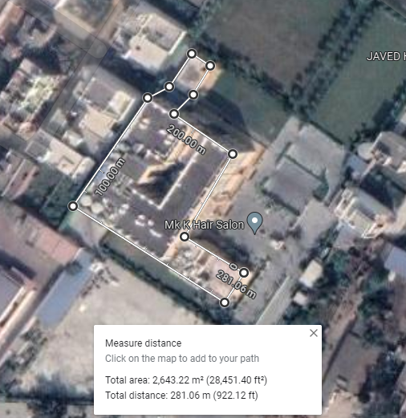

M/s. BDJ Enterprises has engaged Local masons and laborers for the building and Civil works. The hotel construction is done by workers on daily wages which are monitored by the promoters.

**Table: 5**

|  |  |
| --- | --- |
| **BUILDING DETAILS** | |
| **1.** | **Main Hotel Building** |

1. **PLANT & EQUIPMENT DETAILS:** In machinery section promoter has shown various equipment’s which have been installed that are needed for day to day smooth operations of the hotel. Details of major heads with their cost is shown in the table below. Breakup of expenses under each head is annexed in the later section of the report. Cost has been taken based on the item wise breakup and their bills/ invoices provided by the promoter and found installed on the site.

**Table: 6**

|  |  |  |
| --- | --- | --- |
| **S. No.** | **Heads of Capital Expenditure** | **Amount  (in Rs.)** |
| 1.7 | Water supply system (pipeline, tanks, pump house, water treatment plant, etc.) | ₹ 8,22,290.84 |
| 1.9 | Sewerage treatment plant and waste management system | ₹ 7,19,800.00 |
| 1.10 | Centralized air conditioning system | ₹ 1,60,52,952.50 |
| 1.11 | Power supply system including sub-station, transformer, distribution system and electrification | ₹ 28,43,364.00 |
| 1.12 | D.G. power backup (for self-use) | Rented |
| 1.14 | Hot and Cold water Supply System | ₹ 4,40,000.00 |
| 1.15 | Establishment of sound, light, public address, internet system and network of fixed nature | ₹ 24,20,183.46 |
| 1.16 | Installation of fire detection and fire-fighting system | ₹ 23,89,367.00 |
| 1.17 | Installation of non-shiftable plant & machinery for the infrastructure such as kitchen, laundry, health club, spa, convention hall, exhibition hall, etc. | Not Applicable |
| 1.19 | Other fixed structures and plant & machinery that are essential for the commercial operation of the tourism unit | ₹ 1,54,84,076.60 |
| **Total** | | **₹ 4,11,72,034.40** |

|  |  |
| --- | --- |
| **PART D** | **PROJECT CAPITAL EXPENDITURE EVALUATION** |

**Table: 7** *(All Figures in Lakhs)*

| **S. No.** | **PARTICULARS** | **TOTAL INCURRED AMOUNT**  *(As per CA certificate)* | **TOTAL INCURRED**  **AMOUNT**  *(As Approved by IE)* |
| --- | --- | --- | --- |
|  | **Permanent structure for the project under the ownership and for use of the tourism unit, erected on land owned by the tourism unit and which is essential for its commercial operation. (1.1)** | **Rs.7,14,50,092/-** | **Rs.7,14,50,092/-** |
| **CURRENT STATUS OF WORK AND REMARKS:**   * The Promoter has shown Rs.7,14,50,092/- for the complete construction of the civil structure as per format of UP Tourism for applying subsidy. * Total built-up area of the hotel is 4,775.66 sq. mtr. Including the area of Kitchen. We have also considered the water supply system and power supply system in this head for the plinth area rate calculation which translates to Rs.14,961.30/- per sq. mtr. or Rs. 1,389.94/- per sq. ft. So, the total construction cost considered is Rs.7,14,50,092/-. * This is a budget hotel, built-up on RCC structure, modern design & architecture using good quality material and specifications such as Italian/ granite tiles/ marble in common areas inside the hotel * Based on the benchmarking cost as per construction industry standards and CPWD norms, the similar type of construction of same type of quality of construction having similar built-up area cost around Rs.2,000/- to Rs.2,400/- per sq. ft. As per UPPWD SOR 2020 Plinth area rate for non-residential is Rs.21,650/- per sq. mtr. or Rs.2,011/- per sq. ft. * Based on the above analysis the incurred cost appears to be way less than the benchmark norms. As discussed with the owner for the same, it is informed that the construction of the Hotel has started back in the 2019 and the basic frame structure of the building was completed by 2022 the rate of the raw material back then was low as compared to 2020 for which UPPWD rates are known. Further, the material was directly sourced from the factory which conceded them additional discount. * As per IE review it is found that the cost incurred in the Buildings & Civil works is in the market range. Hence, cost of **Rs.7,14,50,092/-** in this head is assumed to be fair and reasonable. Cost for the power system, Kitchen and the water system are approved in their respective heads. | | |
|  | **Boundary wall/s (1.2)** | **Within the Building** | **Within the Building** |
| **CURRENT STATUS OF WORK AND REMARKS:**   * Value of the boundary wall is already incorporated with the value of the building. | | |
|  | **Internal Road, Drainage, Entrance gate (1.3)** | **Within the Building** | **Within the Building** |
| **CURRENT STATUS OF WORK AND REMARKS:**   * Value of the Internal Road, Drainage and Entrance gate is already incorporated with the value of the building. | | |
|  | **Kitchen/s (1.6)** | **Rs.67,88,108.62/-** | **Rs.67,88,108.62/-** |
| **CURRENT STATUS OF WORK AND REMARKS:**   * Based upon the invoices/bills shared with us, it is found that the cost incurred in the purchase of kitchen equipment is well within the market range. Hence, the amount of **Rs.67,88,108.62/-** is assumed to be fair and reasonable. | | |
|  | **Water supply system (pipeline, tanks, pump house, water treatment plant, etc.) (1.7)** | **Rs.8,22,290.84/-** | **Rs.8,22,290.84/-** |
| **CURRENT STATUS OF WORK AND REMARKS:**   * Based upon the invoices/bills shared with us, it is found that the cost incurred in the purchase of Water supply system (pipeline, tanks, pump house, water treatment plant, etc. is well within the market range. Hence, the amount of **Rs.8,22,290.84/-** is assumed to be fair and reasonable. | | |
|  | **Sewerage treatment plant and waste management system (1.9)** | **Rs.7,19,800.00/-** | **Rs.7,19,800.00/-** |
| **CURRENT STATUS OF WORK AND REMARKS:**   * Based upon the invoices/bills shared with us, it is found that the cost incurred in the purchase and design of STP Plant 30 KLD is well within the market range. Hence, the amount of **Rs.7,19,800.00/-** is assumed to be fair and reasonable. | | |
|  | **Centralized air conditioning system (1.10)** | **Rs.1,60,52,952.50/-** | **Rs.1,60,52,952.50/-** |
| **CURRENT STATUS OF WORK AND REMARKS:**   * Based upon the invoices/bills shared with us, it is found that the cost incurred in the purchase and design of Centralized air conditioning system is well within the market range. Hence, the amount of **Rs.1,60,52,952.50/-** is assumed to be fair and reasonable. | | |
|  | **Power supply system including sub-station, transformer, distribution system and electrification (1.11)** | **Rs.28,43,364.00/-** | **Rs.28,43,364.00/-** |
| **CURRENT STATUS OF WORK AND REMARKS:**   * Based upon the invoices/bills shared with us, it is found that the cost incurred under this head is well within the market range. Hence, the amount of **Rs.28,43,364.00/-** is assumed to be fair and reasonable. | | |
|  | **D.G. power backup (for self-use). (1.12)** | **Rented** | **Rented** |
| **CURRENT STATUS OF WORK AND REMARKS:**   * D.G. is rented so cost under this head will not include in our assessment. | | |
|  | **Hot and Cold water Supply System (1.14)** | **Rs.4,40,000.00/-** | **Rs.4,40,000.00/-** |
| **CURRENT STATUS OF WORK AND REMARKS:**   * Based upon the invoices/bills shared with us, it is found that the cost incurred under this head is well within the market range. Hence, the amount of **Rs.4,40,000.00/-** is assumed to be fair and reasonable. | | |
|  | **Establishment of sound, light, public address, internet system and network of fixed nature (1.15)** | **Rs.24,20,183.46/-** | **Rs.24,20,183.46/-** |
| **CURRENT STATUS OF WORK AND REMARKS:**   * Based upon the invoices/bills shared with us, it is found that the cost incurred under this head is well within the market range. Hence, the amount of **Rs.24,20,183.46/-** is assumed to be fair and reasonable. | | |
|  | **Installation of fire detection and fire-fighting system. (1.16)** | **Rs.23,89,367.00/-** | **Rs.23,89,367.00/-** |
| **CURRENT STATUS OF WORK AND REMARKS:**   * As per UPPWD, plinth area rates defined are @ 640 per sq. mtr. for the firefighting system which turns out to be Rs.30,56,422/- for the subject project and considering the fact that the fire provision are meant only for the usable space out of the total built-up area, the amount specified in the CA certificate seems fair and reasonable. * As per the copy of invoices/bills provided, it is found that cost incurred in this head is well within the market range. Hence, the amount of **Rs.23,89,367.00/-** is assumed to be fair and reasonable. | | |
|  | **Other fixed structures and plant & machinery that are essential for the commercial operation of the tourism unit. (1.19)** | **Rs.1,54,84,076.60/-** | **Rs.1,54,84,076.60/-** |
| **CURRENT STATUS OF WORK AND REMARKS:**   * Based upon the invoices/bills shared with us, it is found that the cost incurred under this head is well within the market range. Hence, the amount of **Rs.1,54,84,076.60/-** is assumed to be fair and reasonable. | | |

|  |  |  |  |
| --- | --- | --- | --- |
| **Total** | | **Rs.11,94,10,235.77/-** | **Rs.11,94,10,235.77/-** |
|  | **CURRENT STATUS OF WORK AND REMARKS:**   * All the expenditure shown above is cross checked with the work done on site and from the respective Invoices / Bills / PO / ledger statements. * Industry benchmark & standards are applied for the verification of Civil works cost as no Bills/ Invoices have been provided for the same due to involvement of petty contractors. * In case of Plant & Machinery, no specific benchmark cost standard is available. Therefore, the cost verification is conducted as per the individual invoices, bills for the particular items. * We have cross-checked the copy of bills/ invoices provided to us under different heads to match the amount provided in the CA certificate. | | |

**Note: -**

1. There is No expenditure shown in below mentioned eligible head/s, hence not shown in the above table of Expenditure: -

* 1.2 Boundary Wall
* 1.3 Internal Roads & drainages
* 1.4 Swimming Pool/s
* 1.5 Store/s
* 1.8 Boiler Room and Chimney
* 1.12 D.G. Power Backup
* 1.13 Telecommunication tower (Self-established for own use)
* 1.17 Installation of non-shiftable plant & machinery for the infrastructure such as kitchen, laundry, health club, spa, convention hall, exhibition hall, etc.
* 1.18 Establishment of stationary swing sets, climbing walls, amusement / playing structure, permanent tents, etc. in play areas and parks
* 1.20 Fees paid for obtaining technical know-how
* 1.21 Installation charges of machinery/equipment/services
* 1.22 Approach road, expenditure incurred for power supply including construction of sub-station, pipeline laid, water supply, water tank, pipeline for discharge of waste water & sewerage (On land where ownership is with the tourism unit)
* 1.23 Fixed residential tents for tourists, meant for use round the year and not for temporary use like mela, events or seasonal camps, etc.
* 1.24 Solar/Bio energy system
* 1.25 Rain water harvesting system

|  |  |
| --- | --- |
| **PART E** | **PHOTOGRAPHS** |

|  |  |
| --- | --- |
| Z:\In Progress Files\Amit Jaiswal\VIS(2023-24)-PL542-456-686 Palasa Hotel & Resort\Palasa\TimePhoto_20240110_112151.jpg | Z:\In Progress Files\Amit Jaiswal\VIS(2023-24)-PL542-456-686 Palasa Hotel & Resort\Palasa\TimePhoto_20240110_112351.jpg |
| Z:\In Progress Files\Amit Jaiswal\VIS(2023-24)-PL542-456-686 Palasa Hotel & Resort\Palasa\TimePhoto_20240111_091259.jpg | Z:\In Progress Files\Amit Jaiswal\VIS(2023-24)-PL542-456-686 Palasa Hotel & Resort\Palasa\TimePhoto_20240110_170248.jpg |
| Z:\In Progress Files\Amit Jaiswal\VIS(2023-24)-PL542-456-686 Palasa Hotel & Resort\Palasa\TimePhoto_20240110_125012.jpg | Z:\In Progress Files\Amit Jaiswal\VIS(2023-24)-PL542-456-686 Palasa Hotel & Resort\Palasa\TimePhoto_20240110_164938.jpg |
| Z:\In Progress Files\Amit Jaiswal\VIS(2023-24)-PL542-456-686 Palasa Hotel & Resort\Palasa\TimePhoto_20240110_124501.jpg | Z:\In Progress Files\Amit Jaiswal\VIS(2023-24)-PL542-456-686 Palasa Hotel & Resort\Palasa\TimePhoto_20240110_120838.jpg |
| Z:\In Progress Files\Amit Jaiswal\VIS(2023-24)-PL542-456-686 Palasa Hotel & Resort\Palasa\TimePhoto_20240110_121147.jpg | Z:\In Progress Files\Amit Jaiswal\VIS(2023-24)-PL542-456-686 Palasa Hotel & Resort\Palasa\TimePhoto_20240110_121211.jpg |
| Z:\In Progress Files\Amit Jaiswal\VIS(2023-24)-PL542-456-686 Palasa Hotel & Resort\Palasa\TimePhoto_20240110_123857.jpg | Z:\In Progress Files\Amit Jaiswal\VIS(2023-24)-PL542-456-686 Palasa Hotel & Resort\Palasa\TimePhoto_20240110_123626.jpg |
| Z:\In Progress Files\Amit Jaiswal\VIS(2023-24)-PL542-456-686 Palasa Hotel & Resort\Palasa\TimePhoto_20240110_115806.jpg | Z:\In Progress Files\Amit Jaiswal\VIS(2023-24)-PL542-456-686 Palasa Hotel & Resort\Palasa\TimePhoto_20240110_115817.jpg |
| Z:\In Progress Files\Amit Jaiswal\VIS(2023-24)-PL542-456-686 Palasa Hotel & Resort\Palasa\TimePhoto_20240110_120509.jpg | Z:\In Progress Files\Amit Jaiswal\VIS(2023-24)-PL542-456-686 Palasa Hotel & Resort\Palasa\TimePhoto_20240110_120644.jpg |
| Z:\In Progress Files\Amit Jaiswal\VIS(2023-24)-PL542-456-686 Palasa Hotel & Resort\Palasa\TimePhoto_20240110_170809.jpg | Z:\In Progress Files\Amit Jaiswal\VIS(2023-24)-PL542-456-686 Palasa Hotel & Resort\Palasa\TimePhoto_20240111_091312.jpg |

|  |  |
| --- | --- |
| **PART F** | **DISCLAIMER** |

* + - 1. No employee or member of R.K Associates has any direct/ indirect interest in the Project.
      2. This report is prepared based on the copies of the documents/ information which interested organization or customer could provide to us out of the standard checklist of documents sought from them and further based on our assumptions and limiting conditions. All such information provided to us has been relied upon and we have assumed that it is true and correct. Verification or cross checking of the documents provided to us has not been done at our end from the originals. If at any time in future it’s found or came to our knowledge that misrepresentation of facts or incomplete or distorted information has been provided to us then this report shall automatically become null & void.
      3. This report is a general analysis of the project and not an audit report. All the information gathered is based on the facts seen on the site during survey, verbal discussion & documentary evidence provided by the client and is believed that information given by the Promoter is true best of their knowledge.
      4. All observations mentioned in the report is only based on the visual observation and the documents/ data/ information provided by the client. No mechanical/ technical tests, measurements or any design review have been performed or carried out from our side during Project assessment.
      5. Interested organization should ONLY take this report as an Advisory document from the Financial/ Chartered Engineering firm and it’s specifically advised to the stakeholder to cross verify the original documents for the facts mentioned in the report which can be availed directly from the subject Promoter directly.
      6. In case of any default in loans or the credit facility extended to the borrowing Promoter, R.K Associates shall not be held responsible for whatsoever reason may be and any request for seeking any explanation from the employee/s of R.K Associates will not be entertained at any instance or situation.
      7. This Report is prepared by our competent technical team which includes Engineers and financial experts & analysts.
      8. This is just an opinion report and doesn’t hold any binding on anyone. It is requested from the concerned Financial Institution which is using this report for taking financial decision on the project that they should consider all the different associated relevant & related factors also before taking any business decision based on the content of this report.
      9. All Pages of the report including annexures are signed and stamped from our office. In case any paper in the report is without stamp & signature then this should not be considered a valid paper issued from this office.
      10. Defect Liability Period is **30 DAYS**. We request the concerned authorized reader of this report to check the contents, data and calculations in the report within this period and intimate us in writing if any corrections are required or in case of any other concern with the contents or opinion mentioned in the report. Corrections only related to typographical, calculation, spelling mistakes will be entertained within the defect liability period. No request for any illegitimate value revision, date change or any other facts & figures changes will be entertained other than the one mentioned above.
      11. R.K Associates encourages its customers to give feedback or inform concerns over its services through proper channel at valuer[@rkassociates.org](mailto:ers@rkassociates.org) in writing within 30 days of report delivery. After this period no concern/ complaint/ proceedings in connection with the Valuation Services can be entertained due to possible change in situation and condition of the property.
      12. Our Data retention policy is of **ONE YEAR**. After this period we remove all the concerned records related to the assignment from our repository. No clarification or query can be answered after this period due to unavailability of the data.
      13. This Valuation report is governed by our (1) Internal Policies, Processes & Standard Operating Procedures, (2) R.K Associates Quality Policy, (3) Valuation & Survey Best Practices Guidelines formulated by management of R.K Associates, (4) Information input given to us by the customer and (4) Information/ Data/ Facts given to us by our field/ office technical team. Management of R.K Associates never gives acceptance to any unethical or unprofessional practice which may affect fair, correct & impartial assessment and which is against any prevailing law. In case of any indication of any negligence, default, incorrect, misleading, misrepresentation or distortion of facts in the report then it is the responsibility of the user of this report to immediately or atleast within the defect liability period bring all such act into notice of R.K Associates management so that corrective measures can be taken instantly.
      14. R.K Associates never releases any report doing alterations or modifications from pen. In case any information/ figure of this report is found altered with pen then this report will automatically become null & void.
      15. If this report is prepared for the matter under litigation in any Indian court, no official or employee of R.K Associates will be under any obligation to give in person appearance in the court as a testimony. For any explanation or clarification, only written reply can be submitted on payment of charges by the plaintiff or respondent which will be 10% of the original fees charged where minimum charges will be Rs.15,000/-.

|  |  |
| --- | --- |
| Place : New Delhi  Date : 18.01.2024  Note : This report contains 24 pages | **FOR INTERNAL USE**  ***SURVEYED BY: ER. Babul Akhtar Gazi and***  ***A.E. Amit Jaiswal***  ***PREPARED BY: Engg. Team***  ***REVIEWED BY: MA*** |

**For R.K Associates Valuers & Techno**

**Engineering Consultants Pvt. Ltd.**

**Project Engineering Team**

***R.K ASSOCIATES IMPORTANT NOTES:***

1. ***DEFECT LIABILITY PERIOD - In case of any query/ issue or escalation you may please contact Incident Manager by writing at le@rkassociates.org. We ensure 100% accuracy in the Calculations done, Rates adopted and various other data points & information mentioned in the report but still can’t rule out typing, human errors or any other mistakes. In case you find any mistake, variation, discrepancy or inaccuracy in any data point of the report, please help us by bringing all such points into our notice in writing at*** [***le@rkassociates.org***](mailto:le@rkassociates.org) ***within 30 days of the report delivery, to get these rectified timely, failing which R.K Associates Valuers Techno Engineering Consultants (P) Ltd. won’t be held responsible for any inaccuracy in any manner. Also if we do not hear back anything from you within 30 days, we will assume that report is correct in all respect and no further claim of any sort will be entertained thereafter. We would welcome and appreciate your feedback & suggestions in order to improve our services.***
2. ***COPYRIGHT FORMAT - This report is prepared on the copyright format of R.K Associates Valuers Techno Engineering Consultants (P) Ltd. to serve our clients in the best possible way. Legally no one can copy or distribute this format without prior approval from R.K Associates. It is meant only for the organization as mentioned on the cover page of this report. Distribution or use of this format other than R.K Associates will be seen as unlawful act and necessary legal action can be taken against the defaulter.***