**File No. : VIS (2023-24)-PL542-456-686 Dated: 18-01-2024**

**CAPITAL EXPENDITURE VERIFICATION REPORT**

**OF**

****

**SITUATED AT**

**3KM MILE STONE, NEXT TO NATH FARM, BHOPA ROAD, MUZAFFARNAGAR, U.P. 251001**

**PROMOTER**

**M/S. BDJ ENTERPRISES**

**REPORT PREPARED FOR**

**UTTAR PRADESH TOURISM**

***\*\*Important - In case of any query/ issue or escalation you may please contact Incident Manager***

***at le@rkassociates.org. We will appreciate your feedback in order to improve our services.***

***NOTE: Please provide your feedback on the report within 15 days of its submission after which report will be considered to be correct***

**IMPORTANT NOTICE**

***COPYRIGHT FORMAT:*** *This report is prepared on the copyright format of R.K Associates to serve our clients with the best possible information and analysis to facilitate them to take rational business decisions. Legally no one can copy or distribute this format without prior approval from R.K Associates. It is meant only for the advisory/ reference purpose for the organization/s as mentioned on the cover page of this report. Distribution or use of this format by any organization or individual other than R.K Associates will be seen as an unlawful act and necessary legal action can be taken against the defaulters.*

*This report is intended for the sole use of the intended recipient/s and contains material that is STRICTLY CONFIDENTIAL AND PRIVATE.*

***DEFECT LIABILITY PERIOD:*** *- In case of any query/ issue or escalation you may please contact Incident Manager at le@rkassociates.org. We try to ensure maximum accuracy in the calculations done, rates adopted, assumptions taken and various other data points & information mentioned in the report but even still can’t rule out typing, human errors or any other bonafide mistakes. In case you find any such mistake or inaccuracy in any data point of the report, please help us by bringing all such points into our notice immediately or within 15 days of the r0eport delivery in writing, to rectify these timely failing after which R.K Associates won’t be held responsible for any such inaccuracy in any manner. We would highly appreciate your feedback in order to improve our services.*

|  |  |  |
| --- | --- | --- |
| **TABLE OF CONTENTS** | | |
|  | | |
| **SECTIONS** | **PARTICULARS** | **PAGE NO.** |
| **Part A** | **REPORT SUMMARY** | 03 |
| **Part B** | **INTRODUCTION** | 04 |
|  | 1. Name of the Project | 04 |
| 1. Project Overview | 05 |
| 1. Project Location | 09 |
| 1. Scope of the Report | 09 |
| 1. Purpose of the Report | 09 |
| 1. Survey Details | 09 |
| 1. Methodology Adopted | 10 |
| **Part C** | **PROJECT INFRASTRUCTURE SECTIONS & FACILITY DETAILS** | 11 |
| 1. Building & Structural Details | 11 |
| 1. Plant & Equipment Details | 12 |
| **Part D** | **PROJECT CAPITAL EXPENDITURE EVALUATION** | 13 |
| **Part E** | **PHOTOGRAPHS FROM THE SURVEY** | 17 |
| **Part F** | **DISCLAIMER** | 20 |

|  |  |
| --- | --- |
| **PART A** | **REPORT SUMMARY** |

|  |  |  |  |
| --- | --- | --- | --- |
| **1.** | **Name of the Project** | **:** | Palasa Hotel & Resort |
| **2.** | **Project Location** | **:** | “Palasa Hotel & Resort”, 3km Mile Stone, Next To Nath Farms, Bhopa Road, Muzaffarnagar, U.P. 251001 |
| **3.** | **Name of the Promoter** | **:** | M/s BDJ Enterprises |
| **4.** | **Prepared for Organization** | **:** | 1. Uttar Pradesh Tourism |
| **5.** | **Chartered Engineer Firm** | **:** | M/s. R. K. Associates Valuers & TechnoEngineering Consultants (P) Ltd. |
| **6.** | **Date of Survey** | **:** | 10th January 2024 |
| **7.** | **Date of Report** | **:** | 18th January 2024 |
| **8.** | **Report Type** | **:** | Capital Expenditure Report |
| **9.** | **Purpose of the Report** | **:** | To verify and examine capital expenditure status of the Project in regard to the special facilities & incentives given to Hotel projects as per Uttar Pradesh Tourism Policy-2018. |
| **10.** | **Scope of the Report** | **:** | To verify and examine capital expenditure status of the Project. |
| **11.** | **Documents produced for Perusal** | **:** | 1. Break-up of the cost heads 2. Copy of Invoices of Items 3. Copy of CA Certificate 4. Copies of various NOCs & Approvals 5. Information received on e-mail |
| **12.** | **Annexure with the Report** | **:** | 1. Photographs |

|  |  |
| --- | --- |
| **PART B** | **INTRODUCTION** |

1. **NAME OF THE PROJECT: “PALASA HOTEL AND RESORT”**

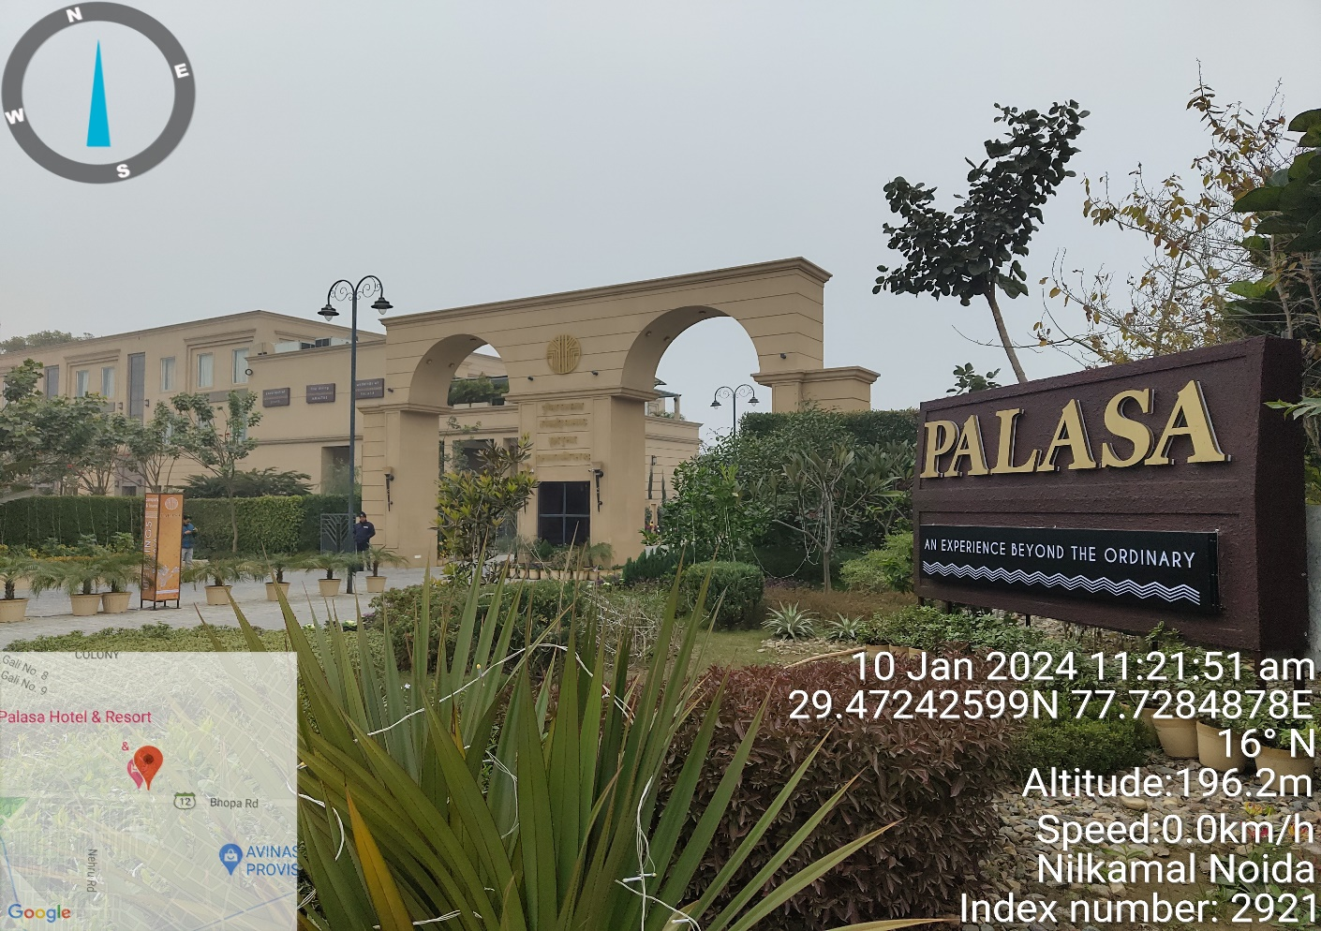

1. **PROJECT OVERVIEW:** This hotel cum resort is established by M/s BDJ Enterprises located at 3 KM. mile stone on Bhopa road, District Muzaffarnagar, Uttar Pradesh near Nath Farms. As per subsidy application filed by the promoters to U.P Tourism, the hotel is categorized as budget hotel.

As per the site layout plan, the company took on lease land parcel of area measuring 12,774.59 sq. mtr. Out of which land area admeasuring 139.01 sq. mtr. area comes under road widening as per the map. Therefore, the net plot area under the subject hotel remains 12,635.58 sq. mtr. Screenshot of the Land area is attached below:

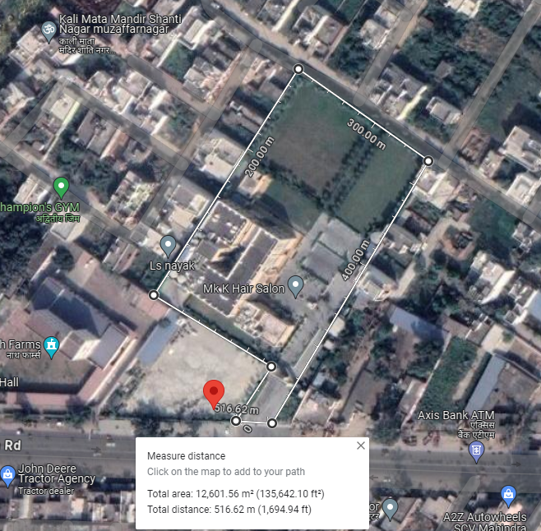

As per the subsidy application filed by the project proponents, the subject land is shown as leased and hence no cost of it has not been taken into consideration. Since this is only a cost verification report of the project, therefore land lease has not been referred and details pertaining to land as mentioned in the report is taken only from the sanctioned & compounding map for illustration purpose only.

Company has obtained sanctioned on 17/01/2019 and further got the compounding map on 12/12/2023 Area mentioned in all 2 is mentioned below:

|  |  |  |
| --- | --- | --- |
| **Floor/ Section** | **Sanctioned Map** | **Compounding Map** |
| Ground Floor | 1868.27 sq. mtr. | 2070.45 sq. mtr. |
| First Floor | 1264.60 sq. mtr. | 1229.90 sq. mtr. |
| Second Floor | 1622.14 sq. mtr. | 1556.03 sq. mtr. |
|  | **4755.01 sq. mtr.** | **4856.38 sq. mtr.** |

For the purpose of this report, we have considered the area mentioned in compounding map. As per the copy of sanctioned compounding plan, the subject resort is built on Ground + 2 storey RCC framed structure with RCC slab roofing with a total built-area of 4856.38 sq. mtr. / 52,274.07 sq. ft. But as per the application, the built-up area is 4,775.66 sq. mtr. or 51,405.20 sq. ft. As per information provided by the company, construction of the resort began on 19th January 2019 and commercial operations had started from 25th April 2022 as per the document provided however the first GST has been filed on dated 08/04/2022 hence we are considering the date 08/04/2022 as the COD for the Hotel. This is a 57 key room hotel with 3 banquet halls, one on each floor, restaurant with name Amaltas, an open-air bar on first floor. There are 4 category of rooms, Parthiv (Standard room, single and double bed), Vyom (suite), Falak (Luxurious suite) & Ananda (Presidential suite).

To promote Tourism & Hospitality Industry in the State, UP State Government has offered capital subsidy and financial assistance as per Uttar Pradesh Tourism Policy-2018 on the capital investment on hotels, resorts, heritage hotels, motels, theme parks, etc. in the State. As the subject project has been successfully completed and is commercially operational since 25th April 2022, therefore, the company had applied for the subsidy under Uttar Pradesh Tourism Policy-2018.

For the purpose of verifying capital investment done by the M/s BDJ Enterprises on the construction of Hotel, Department of Tourism, UP Government had appointed us as a consultant to provide an opinion on the capital investment incurred by the promoter under the eligible heads.

As per the ‘Operational Guidelines for Implementation of Uttar Pradesh Tourism Policy 2018’, below are the eligible and ineligible capital investments in the tourism units:

1. **Eligible Capital Investments**

The eligible capital investment shall be expenditure incurred on the following:

1. Permanent structure for the project under the ownership and for use of the tourism unit, erected on land owned by the tourism unit and which is essential for its commercial operation;
2. Boundary wall;
3. Internal roads, drainage, entrance gate/s;
4. Swimming pool/s;
5. Store/s;
6. Kitchen/s;
7. Water supply system (pipeline, tanks, pump house, water treatment plant etc.);
8. Boiler room and chimney;
9. Sewerage treatment plant and waste management system;
10. Centralized air conditioning;
11. Power sub-station, transformer, electric line, electric pole;
12. D.G Power back up for self-use;
13. Telecommunication tower (self-established for own use);
14. Hot & cold-water supply system, gas / steam supply line;
15. Establishment of sound, light, public address, internet system and network of fixed nature;
16. Installation of fire detection and fire-fighting system;
17. Installation of non-shift able plant & machinery for the infrastructure such as kitchen, laundry, health club, spa, convention hall, exhibition hall, etc.;
18. Establishment of stationery swing sets, climbing walls, amusement/ playing structure, permanent tents, etc. in play areas and parks;
19. Other fixed structures, plant & machinery that are essential for commercial operation of the unit;
20. Fees paid for obtaining technical know-how;
21. Installation charges of machinery / equipment / services;
22. Approach road, expenditure incurred for power supply including construction of sub-station, pipeline laid, water supply, water tank, pipeline for discharge of waste water & sewerage (on land where ownership is with the hotel);
23. Fixed residential tents for tourists, meant for use round the year and not for temporary use like mela, events or seasonal camps, etc.
24. Solar / Bio energy system;
25. Rain water harvesting system.
26. **Ineligible Capital Investments**

The following expenditures with respect to the unit shall not be eligible for incentives:

1. Working Capital;
2. Pre-operative expenses and preliminary expenses;
3. Second-hand plant machinery purchased or shifted from within or outside country;
4. Interest capitalized;
5. Vehicles, furniture and fixtures, cutlery, crockery and utensils
6. Consumable stores; inventories for maintenance or repairs;
7. Investment on land required for setting up the unit, inclusive of the cost of the land;
8. Any construction which is in the nature of real estate transactions, e.g., shops, flats, offices, etc. meant for sale/lease/rent.

As per the copy of application form for ‘Capital Investment Subsidy to Eligible Tourism Units’ (Form 10.1), the company had informed to the Govt. of U.P that the total capital expenditure done in the project is Rs.14,00,98,899.98/-. Out of that the eligible capital expenditure on which the subsidy had been claimed is Rs.11,94,10,235.77/- as per the CA certificate dated 14th June 2023; UDIN: 23075902BGUUTY5636. The same has been tabulated below:

|  |  |  |
| --- | --- | --- |
| **Sl. No.** | **Heads of Capital Expenditure** | **Amount  (in Rs.)** |
| 1.1 | Permanent structure for the project under the ownership and for use of the tourism unit, erected on land owned by the tourism unit and which is essential for its commercial operation | **₹ 7,14,50,092.75** |
| 1.2 | Boundary wall/s | **Within the Building** |
| 1.3 | Internal roads, drainage & entrance gate/s | **Within the Building** |
| 1.4 | Swimming pool | **NA** |
| 1.5 | Store/s | **Within the Building** |
| 1.6 | Kitchen/s | **₹ 67,88,108.62** |
| 1.7 | Water supply system (pipeline, tanks, pump house, water treatment plant, etc.) | **₹ 8,22,290.84** |
| 1.8 | Boiler room & chimney | **Not Applicable** |
| 1.9 | Sewerage treatment plant and waste management system | **₹ 7,19,800.00** |
| 1.10 | Centralized air conditioning system | **₹ 1,60,52,952.50** |
| 1.11 | Power supply system including sub-station, transformer, distribution system and electrification | **₹ 28,43,364.00** |
| 1.12 | D.G. power backup (for self-use) | **Rented** |
| 1.13 | Telecommunication tower (self-established for own use) | **Not Applicable** |
| 1.14 | Hot and Cold water Supply System | **₹ 4,40,000.00** |
| 1.15 | Establishment of sound, light, public address, internet system and network of fixed nature | **₹ 24,20,183.46** |
| 1.16 | Installation of fire detection and fire-fighting system | **₹ 23,89,367.00** |
| 1.17 | Installation of non-shift able plant & machinery for the infrastructure such as kitchen, laundry, health club, spa, convention hall, exhibition hall, etc. | **Not Applicable** |
| 1.18 | Establishment of stationary swing set, climbing walls, amusement / playing structure, permanent tents, etc. in play areas & parks. | **Not Applicable** |
| 1.19 | Other fixed structures and plant & machinery that are essential for the commercial operation of the tourism unit | **₹ 1,54,84,076.60** |
| 1.20 | Fees paid for obtaining technical know-how | **-** |
| 1.21 | Installation charges of machines / equipment / services | **-** |
| 1.22 | Approach road, expenditure incurred for power supply including construction of substation pipeline laid, water supply, water tank, pipeline for discharge of waste water & sewerage | **-** |
| 1.23 | Fixed residential tents for tourists meant for use round the year and not for temporary use like mela, events or seasonal camps etc. | **Not Applicable** |
| 1.24 | Solar / Bio energy system | **Not Applicable** |
| 1.25 | Rain water harvesting system | **-** |
|  | **Total** | **₹ 11,94,10,235.77** |

1. **PROJECT LOCATION:** The subject hotel is located at 3 KM Mile Stone, Near Nath Farms, Bhopa Road, Muzaffarnagar, Uttar Pradesh-251001. The nearest railway station from the hotel is Muzaffarnagar railway station located at the distance of ~2 Km. It is also well connected via Delhi-Haridwar Road which approx. 2.5 Km away from the subject property.
2. **SCOPE OF THE REPORT:** To verify and examine the capital expenditure of the eligible investment of the project in regard to avail subsidy given to Hotel Projects development under Uttar Pradesh Tourism Policy-2018.

*All the assessment carried out for the Project is done based on the documents provided to us and its correlation by the Engineering team through site inspection, various other discussions with the Project proponents and its resources and Industry standards and benchmark cost and thus forming an opinion out of it.*

*This report doesn’t cover any ownership rights of the property.*

1. **PURPOSE OF THE REPORT:**  To provide opinion on the Capital Expenditure incurred by the promoter in the development of the Hotel to help Directorate of Tourism, Government of Uttar Pradesh to take informed decision on the project in relation to grant subsidy.
2. **SURVEY DETAILS:** This Hotel has been surveyed by our engineers Mr. Babul Akhtar Gazi and Mr. Amit Jaiswal on 10th January 2024. Site inspection was done in the presence of the following people:

**Table: 3**

|  |  |  |
| --- | --- | --- |
| **S. No.** | **Name** | **Designation** |
| 1 | Mr. Shubh Jindal | Partner |
| 2 | Mr. Mayank Goel | Accounts Department |

All the details pertaining to physical setup and progress of the hotel have been cross checked as per the documents provided to us.

1. During the site visit we found that the construction of the hotel had been built more or less as per the copy of sanctioned & compounding map provided to us and the commercial operation date has been achieved.
2. All the required machinery & assets mentioned in the list (group wise) provided to us by the client were found available at the site and seems to be in good condition.
3. As per our visual observations, the main structure of the hotel was found to be built as per the copy of sanctioned and compounding map provided to us. As per the copy of approved plan, the hotel was proposed to have a total of 57 rooms & 3 Halls and the same is verified at the time of site survey.
4. Completion certificate of the hotel issued by the competent authority was received as on date 19th February 2024.
5. Photographs of various sections of the hotel along with machinery have been taken to give a clear visual representation of the hotel establishment. At the time of the site survey we found that the hotel and restaurant is operational.
6. Some of the photographs have been annexed with the report.
7. **METHADOLOGY ADOPTED:**
8. Documents, data and information collection of the Project.
9. Review of the provided information & documents.
10. Site visit by our engineers to assess the project execution status on ground comparing with the available documents.
11. Discussions with the Owner’s representative on the site.
12. Assessment of the capital expenditure of different section with Civil, P&M based industry benchmark with the provided copy of bills & invoices.
13. Assessment of the provided information with the Industry standards, CPWD Plinth Area rates, etc.
14. Other information obtained regarding the project from the sources in the public domain.
15. Computation and compilation in the report.

|  |  |
| --- | --- |
| **PART C** | **PROJECT INFRASTRUCTURE SECTIONS & FACILITY DETAILS** |

1. **BUILDING & STRUCTURAL DETAILS:** This Hotel project is a Ground + 2 floor RCC roofed structure with total built up area of 4,856.38 sq. mtr as per compounding Map. M/s. BDJ Enterprises had shown an expenditure of Rs.7,14,50,092.75/- in Building & Civil works of the Hotel.

As per the copy of sanctioned map and site inspection, hotel comprises as per the details given in the table below:

**Table: 4**

|  |  |  |  |
| --- | --- | --- | --- |
| **Floor** | **Guest Rooms** | | **Occupancy** |
| **Proposed** | **Actual** |
| Ground Floor | 0 | 0 | Restaurant, Kitchen, Entrance Lobby, Sitting Lounge, Toilets, Luggage Room, Hall |
| 1st Floor | 24 | 24 | Guest Rooms, House Keeping Rooms and Service Room, Hall, Open Bar |
| 2nd Floor | 33 | 33 | Guest Rooms, House Keeping Rooms and Service Room, Hall |
| **Total** | **57** | **57** |  |

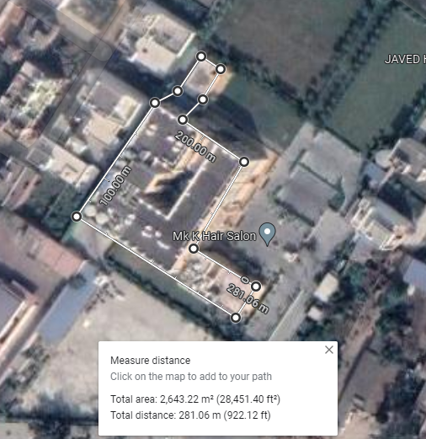

M/s. BDJ Enterprises has engaged local masons and laborers for the building and Civil works. Project architect was Ar. Aanchal Sharma.

1. **PLANT & EQUIPMENT DETAILS:** In machinery section promoter has shown various equipment’s which have been installed which are needed for day to day operations of the hotel. Details of major heads with their cost is shown in the table below. Breakup of expenses under each head is annexed in the later section of the report. Cost has been taken based on the item wise breakup and their bills/ invoices provided by the promoter and found installed on the site.

**Table: 5**

|  |  |  |
| --- | --- | --- |
| **S. No.** | **Heads of Capital Expenditure** | **Amount  (in Rs.)** |
| 1.7 | Water supply system (pipeline, tanks, pump house, water treatment plant, etc.) | ₹ 8,22,290.84 |
| 1.9 | Sewerage treatment plant and waste management system | ₹ 7,19,800.00 |
| 1.10 | Centralized air conditioning system | ₹ 1,60,52,952.50 |
| 1.11 | Power supply system including sub-station, transformer, distribution system and electrification | ₹ 28,43,364.00 |
| 1.12 | D.G. power backup (for self-use) | Rented |
| 1.14 | Hot and Cold water Supply System | ₹ 4,40,000.00 |
| 1.15 | Establishment of sound, light, public address, internet system and network of fixed nature | ₹ 24,20,183.46 |
| 1.16 | Installation of fire detection and fire-fighting system | ₹ 23,89,367.00 |
| 1.17 | Installation of non-shiftable plant & machinery for the infrastructure such as kitchen, laundry, health club, spa, convention hall, exhibition hall, etc. | Not Applicable |
| 1.19 | Other fixed structures and plant & machinery that are essential for the commercial operation of the tourism unit *(attached in annexure)* | ₹ 1,54,84,076.60 |
| **Total** | | **₹ 4,11,72,034.40** |

|  |  |
| --- | --- |
| **PART D** | **PROJECT CAPITAL EXPENDITURE EVALUATION** |

**Table: 6** *(All Figures in Rs.)*

| **S. No.** | **PARTICULARS** | **TOTAL AS SHOWN BY PROMOTER**  **(***As per CA certificate)* | **TOTAL APPROVED**  **AMOUNT BY IE** | **REMARKS** |
| --- | --- | --- | --- | --- |
|  | **Permanent structure for the project under the ownership and for use of the tourism unit, (1.1)** | **Rs.7,14,50,092/-** | **Rs.7,08,70,675/-** | * Based on the benchmarking cost as per construction industry standards and CPWD norms, the similar type of construction of same type of quality of construction having similar built-up area cost around Rs.2,000/- to Rs.2,500/- per sq. ft. As per CPWD Plinth Area Rates 2023 Plinth area rate for non-residential is Rs.30,820/- per sq. mtr. or Rs.2,863.24/- per sq. ft. * Rs.5,79,417/- cost shown by the company is beyond the COD date i.e. 08/04/2022 hence it is ineligible as per the policy 2018. * As per our assessment the eligible cost under this head will be Rs.7,08,70,675/- |
|  | **Boundary wall/s (1.2)** | **Within the Building** | **Within the Building** | * Value of the boundary wall is already included in the value of the building |
|  | **Internal Road, Drainage, Entrance gate (1.3)** | **Within the Building** | **Within the Building** | * Value of Internal Road, Drainage, Entrance gate is already incorporated with the value of the building |
|  | **Kitchen/s (1.6)** | **Rs.67,88,108/-** | **Rs.3,62,000/-** | * As per the UP Tourism Guidelines 2018 the cost incurred in the purchase of kitchen equipment is not eligible hence the ineligible items worth Rs.64,26,108/- is deducted from the cost provide to us. * As per our assessment the eligible cost under this head will be Rs.3,62,000/- |
|  | **Water supply system (pipeline, tanks, pump house, water treatment plant, etc.) (1.7)** | **Rs.8,22,290/-** | **Rs.8,06,579/-** | * As per the UP Tourism Guidelines 2018 the cost incurred in the purchase of Water supply system (pipeline, tanks, pump house, water treatment plant is not eligible hence the ineligible items worth Rs.15,711/- is deducted from the cost provide to us. * As per our assessment the eligible cost under this head will be Rs.8,06,579/- |
|  | **Sewerage treatment plant and waste management system (1.9)** | **Rs.7,19,800/-** | **Rs.7,19,800/-** | * Based upon the invoices/bills shared with us, it is found that the cost incurred in the purchase and design of STP Plant 30 KLD is well within the market range. Hence, the amount of Rs.7,19,800/- is assumed to be fair and reasonable |
|  | **Centralized air conditioning system (1.10)** | **Rs.1,60,52,952/-** | **Rs.1,59,50,321/-** | * As per the UP Tourism Guidelines 2018 the cost incurred in the purchase of Centralized air conditioning system is not eligible hence the ineligible items worth Rs.1,02,630/- is deducted from the cost provide to us. * As per our assessment the eligible cost under this head will be Rs.1,59,50,321/- |
|  | **Power supply system including sub-station, transformer, distribution system and electrification (1.11)** | **Rs.28,43,364/-** | **Rs.25,29,192/-** | * As per the UP Tourism Guidelines 2018 the cost incurred in the purchase of Power supply system including sub-station, transformer, distribution system and electrification is not eligible hence the ineligible items worth Rs.3,14,172/- is deducted from the cost provide to us. * As per our assessment the eligible cost under this head will be Rs.25,29,192/- |
|  | **D.G. power backup (for self-use). (1.12)** | **Rented** | **Rented** | * D.G. is rented so cost under this head neither claimed nor included in our assessment. |
|  | **Hot and Cold water Supply System (1.14)** | **Rs.4,40,000/-** | **Rs.4,40,000/-** | * Based upon the invoices/bills shared with us, it is found that the cost incurred under this head is well within the market range. Hence, the amount of Rs.4,40,000/- is assumed to be fair and reasonable. |
|  | **Establishment of sound, light, public address, internet system and network of fixed nature (1.15)** | **Rs.24,20,183/-** | **Rs.15,14,790/-** | * As per the UP Tourism Guidelines 2018 the cost incurred in the purchase of Establishment of sound, light, public address, internet system and network of fixed nature is not eligible as per the UP Tourism Guidelines 2018 hence the ineligible items worth Rs.9,05,392/- is deducted from the cost provide to us. * As per our assessment the eligible cost under this head will be Rs.15,14,790/- |
|  | **Installation of fire detection and fire-fighting system. (1.16)** | **Rs.23,89,367/-** | **Rs.23,89,367/-** | * As per the copy of invoices/bills provided, it is found that cost incurred in this head is well within the market range. Hence, the amount of Rs.23,89,367/- is assumed to be fair and reasonable. |
|  | **Other fixed structures and plant & machinery that are essential for the commercial operation of the tourism unit. (1.19)** | **Rs.1,54,84,076/-** | **Rs.9,60,114/-** | * As per the UP Tourism Guidelines 2018 the cost incurred in the purchase of other fixed structures and plant & machinery that are essential for the commercial operation of the tourism unit is not eligible. Hence the ineligible items worth Rs.1,45,23,962/- is deducted from the cost provide to us. * As per our assessment the eligible cost under this head will be Rs.9,60,114/- |
|  | **Total** | **Rs.11,94,10,235/-** | **Rs.9,65,42,838/-** | * As per the UP Tourism Guidelines 2018 the capital expenditure of Rs.2,28,67,394/- is ineligible hence it is deducted from the cost shown by the company. |
|  | **CURRENT STATUS OF WORK AND REMARKS:**   * All the expenditure shown above is cross checked with the work done on site and from the respective Invoices / Bills provided to us. * In case of Plant & Machinery, no specific benchmark cost standard is available. Therefore, the cost verification is conducted as per the individual invoices, bills for the particular items. * We have cross-checked the copy of bills/ invoices provided to us under different heads to match the amount provided in the CA certificate. | | | |

**Note: -**

1. There is No expenditure shown in below mentioned eligible head/s, hence not shown in the above table of Expenditure: -

* 1.2 Boundary Wall
* 1.3 Internal Roads & drainages
* 1.4 Swimming Pool/s
* 1.5 Store/s
* 1.8 Boiler Room and Chimney
* 1.12 D.G. Power Backup
* 1.13 Telecommunication tower (Self-established for own use)
* 1.17 Installation of non-shiftable plant & machinery for the infrastructure such as kitchen, laundry, health club, spa, convention hall, exhibition hall, etc.
* 1.18 Establishment of stationary swing sets, climbing walls, amusement / playing structure, permanent tents, etc. in play areas and parks
* 1.20 Fees paid for obtaining technical know-how
* 1.21 Installation charges of machinery/equipment/services
* 1.22 Approach road, expenditure incurred for power supply including construction of sub-station, pipeline laid, water supply, water tank, pipeline for discharge of waste water & sewerage (On land where ownership is with the tourism unit)
* 1.23 Fixed residential tents for tourists, meant for use round the year and not for temporary use like mela, events or seasonal camps, etc.
* 1.24 Solar/Bio energy system
* 1.25 Rain water harvesting system

|  |  |
| --- | --- |
| **PART E** | **PHOTOGRAPHS** |

|  |  |
| --- | --- |
| Z:\In Progress Files\Amit Jaiswal\VIS(2023-24)-PL542-456-686 Palasa Hotel & Resort\Palasa\TimePhoto_20240110_112151.jpg | Z:\In Progress Files\Amit Jaiswal\VIS(2023-24)-PL542-456-686 Palasa Hotel & Resort\Palasa\TimePhoto_20240110_112351.jpg |
| Z:\In Progress Files\Amit Jaiswal\VIS(2023-24)-PL542-456-686 Palasa Hotel & Resort\Palasa\TimePhoto_20240111_091259.jpg | Z:\In Progress Files\Amit Jaiswal\VIS(2023-24)-PL542-456-686 Palasa Hotel & Resort\Palasa\TimePhoto_20240110_170248.jpg |
| Z:\In Progress Files\Amit Jaiswal\VIS(2023-24)-PL542-456-686 Palasa Hotel & Resort\Palasa\TimePhoto_20240110_125012.jpg | Z:\In Progress Files\Amit Jaiswal\VIS(2023-24)-PL542-456-686 Palasa Hotel & Resort\Palasa\TimePhoto_20240110_164938.jpg |
| Z:\In Progress Files\Amit Jaiswal\VIS(2023-24)-PL542-456-686 Palasa Hotel & Resort\Palasa\TimePhoto_20240110_124501.jpg | Z:\In Progress Files\Amit Jaiswal\VIS(2023-24)-PL542-456-686 Palasa Hotel & Resort\Palasa\TimePhoto_20240110_120838.jpg |
| Z:\In Progress Files\Amit Jaiswal\VIS(2023-24)-PL542-456-686 Palasa Hotel & Resort\Palasa\TimePhoto_20240110_121147.jpg | Z:\In Progress Files\Amit Jaiswal\VIS(2023-24)-PL542-456-686 Palasa Hotel & Resort\Palasa\TimePhoto_20240110_121211.jpg |
| Z:\In Progress Files\Amit Jaiswal\VIS(2023-24)-PL542-456-686 Palasa Hotel & Resort\Palasa\TimePhoto_20240110_123857.jpg | Z:\In Progress Files\Amit Jaiswal\VIS(2023-24)-PL542-456-686 Palasa Hotel & Resort\Palasa\TimePhoto_20240110_123626.jpg |
| Z:\In Progress Files\Amit Jaiswal\VIS(2023-24)-PL542-456-686 Palasa Hotel & Resort\Palasa\TimePhoto_20240110_115806.jpg | Z:\In Progress Files\Amit Jaiswal\VIS(2023-24)-PL542-456-686 Palasa Hotel & Resort\Palasa\TimePhoto_20240110_115817.jpg |
| Z:\In Progress Files\Amit Jaiswal\VIS(2023-24)-PL542-456-686 Palasa Hotel & Resort\Palasa\TimePhoto_20240110_120509.jpg | Z:\In Progress Files\Amit Jaiswal\VIS(2023-24)-PL542-456-686 Palasa Hotel & Resort\Palasa\TimePhoto_20240110_120644.jpg |
| Z:\In Progress Files\Amit Jaiswal\VIS(2023-24)-PL542-456-686 Palasa Hotel & Resort\Palasa\TimePhoto_20240110_170809.jpg | Z:\In Progress Files\Amit Jaiswal\VIS(2023-24)-PL542-456-686 Palasa Hotel & Resort\Palasa\TimePhoto_20240111_091312.jpg |

|  |  |
| --- | --- |
| **PART F** | **DISCLAIMER** |

* + - 1. No employee or member of R.K Associates has any direct/ indirect interest in the Project.
      2. This report is prepared based on the copies of the documents/ information which interested organization or customer could provide to us out of the standard checklist of documents sought from them and further based on our assumptions and limiting conditions. All such information provided to us has been relied upon and we have assumed that it is true and correct. Verification or cross checking of the documents provided to us has not been done at our end from the originals. If at any time in future it’s found or came to our knowledge that misrepresentation of facts or incomplete or distorted information has been provided to us then this report shall automatically become null & void.
      3. This report is a general analysis of the project and not an audit report. All the information gathered is based on the facts seen on the site during survey, verbal discussion & documentary evidence provided by the client and is believed that information given by the Promoter is true best of their knowledge.
      4. All observations mentioned in the report is only based on the visual observation and the documents/ data/ information provided by the client. No mechanical/ technical tests, measurements or any design review have been performed or carried out from our side during Project assessment.
      5. Interested organization should ONLY take this report as an Advisory document from the Financial/ Chartered Engineering firm and it’s specifically advised to the stakeholder to cross verify the original documents for the facts mentioned in the report which can be availed directly from the subject Promoter directly.
      6. In case of any default in loans or the credit facility extended to the borrowing Promoter, R.K Associates shall not be held responsible for whatsoever reason may be and any request for seeking any explanation from the employee/s of R.K Associates will not be entertained at any instance or situation.
      7. This Report is prepared by our competent technical team which includes Engineers and financial experts & analysts.
      8. This is just an opinion report and doesn’t hold any binding on anyone. It is requested from the concerned Financial Institution which is using this report for taking financial decision on the project that they should consider all the different associated relevant & related factors also before taking any business decision based on the content of this report.
      9. All Pages of the report including annexures are signed and stamped from our office. In case any paper in the report is without stamp & signature then this should not be considered a valid paper issued from this office.
      10. Defect Liability Period is **30 DAYS**. We request the concerned authorized reader of this report to check the contents, data and calculations in the report within this period and intimate us in writing if any corrections are required or in case of any other concern with the contents or opinion mentioned in the report. Corrections only related to typographical, calculation, spelling mistakes will be entertained within the defect liability period. No request for any illegitimate value revision, date change or any other facts & figures changes will be entertained other than the one mentioned above.
      11. R.K Associates encourages its customers to give feedback or inform concerns over its services through proper channel at valuer[@rkassociates.org](mailto:ers@rkassociates.org) in writing within 30 days of report delivery. After this period no concern/ complaint/ proceedings in connection with the Valuation Services can be entertained due to possible change in situation and condition of the property.
      12. Our Data retention policy is of **ONE YEAR**. After this period we remove all the concerned records related to the assignment from our repository. No clarification or query can be answered after this period due to unavailability of the data.
      13. This Valuation report is governed by our (1) Internal Policies, Processes & Standard Operating Procedures, (2) R.K Associates Quality Policy, (3) Valuation & Survey Best Practices Guidelines formulated by management of R.K Associates, (4) Information input given to us by the customer and (4) Information/ Data/ Facts given to us by our field/ office technical team. Management of R.K Associates never gives acceptance to any unethical or unprofessional practice which may affect fair, correct & impartial assessment and which is against any prevailing law. In case of any indication of any negligence, default, incorrect, misleading, misrepresentation or distortion of facts in the report then it is the responsibility of the user of this report to immediately or atleast within the defect liability period bring all such act into notice of R.K Associates management so that corrective measures can be taken instantly.
      14. R.K Associates never releases any report doing alterations or modifications from pen. In case any information/ figure of this report is found altered with pen then this report will automatically become null & void.
      15. If this report is prepared for the matter under litigation in any Indian court, no official or employee of R.K Associates will be under any obligation to give in person appearance in the court as a testimony. For any explanation or clarification, only written reply can be submitted on payment of charges by the plaintiff or respondent which will be 10% of the original fees charged where minimum charges will be Rs.15,000/-.

|  |  |
| --- | --- |
| Place : New Delhi  Date : 18.01.2024  Note : This report contains 23 pages | **FOR INTERNAL USE**  ***SURVEYED BY: ER. Babul Akhtar Gazi and***  ***A.E. Amit Jaiswal***  ***PREPARED BY: Engg. Team***  ***REVIEWED BY: Anil Kumar*** |

**For R.K Associates Valuers & Techno**

**Engineering Consultants Pvt. Ltd.**

**Project Engineering Team**

***R.K ASSOCIATES IMPORTANT NOTES:***

1. ***DEFECT LIABILITY PERIOD - In case of any query/ issue or escalation you may please contact Incident Manager by writing at le@rkassociates.org. We ensure 100% accuracy in the Calculations done, Rates adopted and various other data points & information mentioned in the report but still can’t rule out typing, human errors or any other mistakes. In case you find any mistake, variation, discrepancy or inaccuracy in any data point of the report, please help us by bringing all such points into our notice in writing at*** [***le@rkassociates.org***](mailto:le@rkassociates.org) ***within 30 days of the report delivery, to get these rectified timely, failing which R.K Associates Valuers Techno Engineering Consultants (P) Ltd. won’t be held responsible for any inaccuracy in any manner. Also if we do not hear back anything from you within 30 days, we will assume that report is correct in all respect and no further claim of any sort will be entertained thereafter. We would welcome and appreciate your feedback & suggestions in order to improve our services.***
2. ***COPYRIGHT FORMAT - This report is prepared on the copyright format of R.K Associates Valuers Techno Engineering Consultants (P) Ltd. to serve our clients in the best possible way. Legally no one can copy or distribute this format without prior approval from R.K Associates. It is meant only for the organization as mentioned on the cover page of this report. Distribution or use of this format other than R.K Associates will be seen as unlawful act and necessary legal action can be taken against the defaulter.***