**REPORT FORMAT:** V-L11 (Enterprise Valuation) | Version: 1.0_2018

**File No.: VIS (2022-23)- PL431-356-562 Dated: 19.04.2024**

**ENTERPRISE AND EQUITY VALUATION REPORT**

**OF**

**M/S NSL TEXTILES LIMITED**

**SITUATED AT**

**3rd FLOOR, 'EMGEE HOUSE', 4th LANE, CHANDRAMOULI NAGAR, RING ROAD,**

**GUNTUR, ANDHRA PRADESH (AP) INDIA, 522007**

**OWNER/ PROMOTER**

**NSL GROUP**

**REPORT PREPARED FOR**

**STATE BANK OF INDIA, STRESSED ASSETS RESOLUTION GROUP, 21st FLOOR, MAKER TOWER ‘E, CUFFE PARADE, MUMBAI - 400005**

***\*\*Important - In case of any query/ issue/ concern or escalation you may please contact Incident Manager @ valuers@rkassociates.org. We will appreciate your feedback in order to improve our services.***

***NOTE: Please provide your feedback on the report within 15 days of its submission after which report will be considered to be accepted & correct. Valuation Terms of Services & Valuer’s Important Remarks are available at*** [***www.rkassociates.org***](http://www.rkassociates.org) ***for reference.***

**IMPORTANT NOTICE**

***COPYRIGHT FORMAT:*** *This report is prepared on the copyright format of R. K. Associates Valuers & Techno Engineering Consultants (P) Ltd. (R. K. Associates) to serve our clients with the best possible information and analysis to facilitate them to take rational business decisions. Legally no one can copy or distribute this format without prior approval from R. K. Associates. It is meant only for the advisory/ reference purpose for the organization/s as mentioned on the cover page of this report. Distribution or use of this format or report or any of its content/ information/ data by any organization or individual other than R.K Associates will be seen as an unlawful act and necessary legal action can be taken against the defaulters.*

*This report is intended for the sole use of the intended recipient/s and contains material that is STRICTLY CONFIDENTIAL AND PRIVATE.*

***DEFECT LIABILITY PERIOD:****In case of any query/ issue or escalation you may please contact Incident Manager at valuers@rkassociates.org. Though adequate care has been taken while preparing this report as per its scope, but still, we can’t rule out typing, human errors, over sightedness of any information or any other mistakes. Therefore, the concerned organization is advised to satisfy themselves that the report is complete & satisfactory in all respect. Intimation regarding any discrepancy shall be brought into our notice immediately. If no intimation is received within 15 (Fifteen) days in writing from the date of issuance of the report, to rectify these timely, then it shall be considered that the report is complete in all respect and has been accepted by the client up to their satisfaction & use and further to which R.K Associates shall not be held responsible in any manner.*

***Part G: R. K. Associates Important Disclaimer and Remarks*** *are integral part of this report and Feasibility assessment is subject to this section. Reader of the report is advised to read all the points mentioned in these sections carefully.*

| **TABLE OF CONTENTS** | | |
| --- | --- | --- |
|  | | |
| **SECTIONS** | **PARTICULARS** | **PAGE NO.** |
| **Part A** | **INTRODUCTION** |  |
| 1. About the Report | 4 |
| 1. Background of the Project | 4 |
| 1. Type of Report | 6 |
| 1. Purpose of the Report | 6 |
| 1. Scope of the Report | 6 |
| 1. Methodology/ Model Adopted | 7 |
| 1. Documents/ Data Referred | 7 |
| **Part B** | **Project Company** |  |
| 1. Brief Description About the Company/ Promoters | 8 |
| 1. Capital Structure | 8 |
| 1. Shareholding Pattern | 9 |
| 1. Snapshot of the Outstanding Debt of the Company | 9 |
| 1. Reasons for Financial Stress and Current Status of the Project | 10 |
| **Part C** | **Market Overview on Power Sector** |  |
| 1. Introduction | 11 |
| 1. Market Size | 11 |
| 1. Government Initiatives | 12 |
| 1. Recent Investments | 13 |
| 1. Way Forward | 14 |
| **Part D** | **Financial Performance** |  |
| 1. Historical Profit & Loss Statement | 15 |
| 1. Key Financial Ratios | 15 |
| 1. Graphical Representation of the Key Financials of the Company | 16 |
| 1. Projected Profit & Loss Statement | 17 |
| 1. Key Financial Ratios | 18 |
| 1. Graphical Representation of the Key Financials of the Company | 18 |
| **Part E** | **Valuation of the Company** |  |
| 1. Methodology/ Model Adopted | 20 |
| 1. Calculation of Free Cash Flow to Firm | 21 |
| 1. Key Inputs used to discount Cash Flows during the Projection Period | 22 |
| 1. Calculation of Enterprise Value and Equity Value | 22 |
| 1. Sensitivity Analysis | 24 |
| 1. Key Assumptions and Workings | 25 |
| **Part F** | **Important Definition** | **29** |
| **Part G** | **Disclaimer | Remarks** | **31** |

|  |  |
| --- | --- |
| **PART A** | **INTRODUCTION** |

1. **ABOUT THE REPORT:** Enterprise Valuation Report of largest and fully integrated Textile Company M/s. NSL Textiles Limited (NTL), manufactures and distributes textile products, near Ring Road, Guntur, Andhra Pradesh, India.
2. **BACKGROUND OF THE PROJECT:** M/s NSL Textiles Limited (NTL) is vertically integrated clothing manufacturing company. NTL’s value chain covers all the operations from the extraction of cotton lint to garment manufacturing. Company facilities for ginning, spinning, yarn dyeing, weaving, fabric processing and garmenting are equipped with latest technology machineries and manned by experienced workforce.

NSL Textiles Ltd. is one of the largest and fully integrated Textile company in the country, equipped with state-of-art machinery and promoted with the concept of "Cotton to Clothing" having its manufacturing operations spread over Andhra Pradesh and providing largest employment in Textile sector with 7000 workforces in the State of Andhra Pradesh. The following are manufacturing/ processing Units in the state of Andhra Pradesh for NTL.

|  |  |  |  |
| --- | --- | --- | --- |
| **S. No.** | **Location** | **Address** | **Activity** |
| 1. | Inkollu | Inkollu Village, Prakasam District – 523167. AP. | Ginning, Spinning, Weaving |
| 2. | Edlapadu | Edlapadu Village Guntur District – 522 233 – AP. | Ginning, Spinning, Weaving |
| 3. | Veeravalli | Survey No.237, Kommuru Road, Veeravalli, Rangannagudem Post, Krishna District – 521110. AP | Ginning, Spinning |
| 4. | Pulivendula | ThondurMandal, Pulivendula, Cuddapah District, AP. | Spinning |
| 5. | Gurjala | D.No. 8-239, Survey No. 1336, Gurjala Village, Guntur District, AP. | Ginning |
| 6. | Chandole | Survey Nos. 371-379, Kunachalavaripalem Village, CherukupalliMandal, Guntur AP | Weaving, Yarn Dyeing, Processing |
| 7. | Budampadu | Survey No. 253, Budampadu, Guntur District – 522017 – AP. | Garmenting |

NTL is a part of multi-dimensional NSL Group. The NSL group has over 40 years of experience in multiple sectors viz. agriculture seeds production, textiles, renewable power, sugar and realty etc. The Organisational structure of the M/s NSL Textiles Limited is shown below:

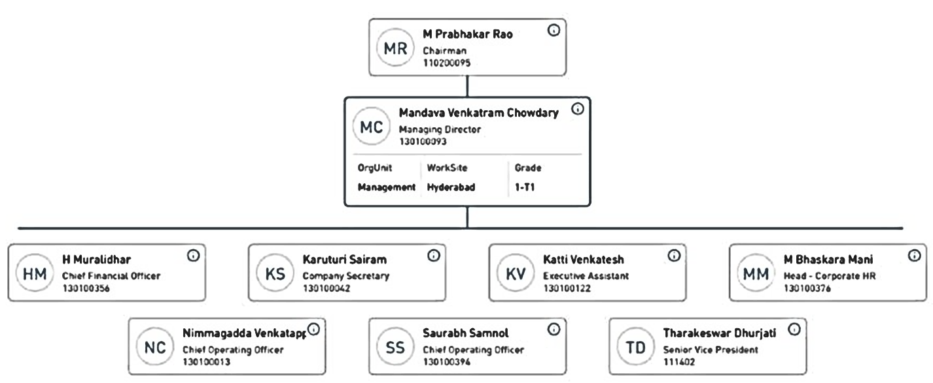

NTL aspires to become one of the leading innovative, eco-friendly and entrepreneurial company in the "Natural Fiber to Affordable Fashion" domain. NTL’s mission is to be the preferred and large share supplier of shirting fabrics, bottom weight fabrics and garments sourced in and from India or other strategic locations for discerning customers worldwide. And also, to be among the top garment producers in India and to market major portion of the fabric capacity as garment packages.

Committed to the environment, the company has taken special care to preserve and upgrade the natural surroundings. Zero discharge at all the manufacturing plants, energy efficient machineries, water harvesting and energy recovery systems are only some of the steps which has been taken in this direction by NTL.

As per data/information provided by the client, below table shows the historical financial performance of the company from FY 2019-20 to financials FY 2022-23:

***(Figures in INR Crores)***

|  |  |  |  |  |
| --- | --- | --- | --- | --- |
| **Particulars** | **FY 2020 A** | **FY 2021 A** | **FY 2022 A** | **FY 2023 A** |
| Revenue from Operations | 936.94 | 697.47 | 1242.71 | 984.16 |
| Other income | 7.41 | 4.61 | 4.01 | 7.74 |
| **Total Income** | **944.35** | **702.08** | **1246.72** | **991.9** |
| **Total expenses** | 887.84 | 651.97 | 1143.23 | 976.50 |
| **EBITDA** | **56.51** | **50.11** | **103.49** | **15.4028** |
| Depreciation and Amortization | 54.01 | 50.4 | 47.95 | 46.65 |
| **EBIT** | **2.5** | **-0.29** | **55.54** | **-31.2472** |
| Finance Costs | 37.79 | 30.91 | 28.22 | 22.84 |
| **Profit/(Loss) before tax** | **-35.29** | **-31.2** | **27.32** | **-54.0872** |
| Current Tax | 0 | 0.41 | 0 | 0.22 |
| **Profit (Loss) after Tax for the period** | **-35.29** | **-31.61** | **27.32** | **-54.3072** |
| **EBITDA Margin %** | 5.98% | 7.14% | 8.30% | 1.55% |
| **EBIT Margin %** | 0.26% | -0.04% | 4.45% | -3.15% |
| **Net Profit Margin %** | -3.74% | -4.50% | 2.19% | -5.48% |
| **Revenue Growth Rate (Y.O.Y.)** |  | -25.65% | 77.58% | -20.44% |

As per the historical analysis, it is observed that EBITDA Margin of the company is showing an upward trend as it has gone up from 5.98% in FY 2019-20 to 8.30% in FY 2021-22. After that in FY 2022-23 it gone down to 1.55%. EBIT Margin is also showing an upward trend as it has gone up from 0.26% in FY 2019-20 to 4.45% in FY 2021-22. After that in FY 2022-23 it is negative.

As per the historical analysis, it is observed that Net Profit Margin of the company is continuously showing downward trend, from -3.74% in FY 2019-20 to -5.48% in FY 2022-23. Although, Revenues Growth of the company has continuously improved till FY 2022-23.

As per information provided by the client/company officials and information, the company is not able to fulfill its financial obligation due to financial stress. The company was announced NPA in October 2012 by the landers.

**Thus, for the purpose of decision making on this stressed account, State Bank of India (SARG) has assigned R K Associated to assess & determine the Enterprise Value and Equity Value of M/s NSL Textiles Limited as per scope of work, to execute the appropriate action by the decision makers on this NPA account.**

1. **TYPE OF REPORT:** This report is performed to assess the Enterprise Value and Equity Value of the project.
2. **PURPOSE OF THE REPORT:** To assess & determine Enterprise Value and Equity Value of the Project under implementation as a whole as required by the lenders.
3. **SCOPE OF THE REPORT:** To estimate & determine the Enterprise Value and Equity Value of the Company based on Income Based Approach (Discounted Cash Flow) method.

* *This is just the enterprise valuation of the project based on the Income generating capacity of the project in future years. This Valuation shall not be construed as the physical asset or should not be related directly to cost approach or Project cost.*
* *This Enterprise Valuation report doesn't cover vetting of the documents/ financial data/ projections or any other information provided to us by the Bank.*
* *This Valuation only covers the cash flow from operation of the company. It does not cover any transaction with the subject company’s subsidiary/ associate/ Joint Venture Companies, as per the requirement by the lender.*
* *This Valuation is prepared based on the current financial status and projections of the company, financial data/ model, future projections, other facts & information provided by the company/ lender/ Client in writing & verbal discussions held during the course of the assignment and based on independent assessment of certain assumptions which are specifically mentioned in the Valuation section of the Report.*
* *It doesn't contain the principles of physical asset valuation and is not based on the site inspection of the project.*
* *We have assumed that the information provided to us is correct and is not manipulated or distorted.*
* *The Market and Industrial assessment of the given company’s industry/ sector has not been done at our end. So, this valuation doesn’t cover the market & industrial scenario in terms of the product demand & market potential.*

1. **METHODOLOGY/ MODEL ADOPTED:** Income-based Approach (Discounted Cash Flow Model) for the calculation of Enterprise Value and Equity Value of the Company.
2. **DOCUMENTS / DATA REFFERED:**

* *Audited Financial Statements and Notes provided by the Company for last 5 years.*
* *Provisional Financial Statement dated 31st March 2023.*
* *7 years Forecasted Financial Model*
* *Organizational Structure*
* *Shareholding structure*
* *List of Creditors and Debtors.*
* *TEV Study*

|  |  |
| --- | --- |
| **PART B** | **PROJECT COMPANY** |

1. **BRIEF DESCRIPTION ABOUT THE COMPANY:** M/s NSL Textiles Limited is one of the largest and fully integrated Textile Companies in the country, equipped with state-of-art machinery and promoted with the concept of "Cotton to Clothing" having its manufacturing operations spread over Andhra Pradesh and providing largest employment in Textile sector with 7000 workforces in the State of Andhra Pradesh. The company's history and key milestones are as follows:

NSL Textiles Ltd, a part of multi-dimensional NSL Group, is a fully integrated textile player having manufacturing units in districts of Guntur, Krishna-Prakasham, Kadapa of Andhra Pradesh. The Company offers entire textile value chain products from the cotton seed to cotton, yarn, fabrics and garments.

NSL Textiles Limited is an unlisted public company incorporated on 12 February, 2002. It is classified as a public limited company and is located in Krishna, Andhra Pradesh. Its authorized share capital is INR 241.00 cr and the total paid-up capital is INR 193.26 cr. The incorporation details of the Project Company are provided in the table below:

|  |  |
| --- | --- |
| **NCORPORATION DETAILS OF THE COMPANY** | |
| **Name of the Company** | M/s NSL Textiles Limited |
| **CIN** | U15429AP2002PLC038489 |
| **Registered office Address** | 3rd Floor, 'EMGEE House', 4th Lane, Chandramouli Nagar, Ring Road, Guntur, Andhra Pradesh (AP)-522007. |
| **Constitution** | Non-government company / Limited by Shares |
| **Date of Incorporation** | 12th February 2002 |
| **Authorised Capital** | INR 2,41,00,00,000 |
| **Paid up Capital (Equity)** | INR 1,93,25,66,000 |

1. **CAPITAL STRUCTURE:** As per provisional financials for FY 2023 shared by the client/company, below table shows the capital structure of the company as on 31st March 2023:

| **Particulars** | **Amount (In INR Crores)** |
| --- | --- |
| Authorized Share Capital | 241.00 |
| Issued, Subscribed and Paid-up Capital | 193.26 |

1. **SHAREHOLDING PATTERN:** As per provisional financials for FY 2023 shared by the client/company, below are the details of shareholders holding of the outstanding shares along with % of total shares:

|  |  |  |  |
| --- | --- | --- | --- |
| **S. No.** | **Name** | **No of Share** | **% of Total share** |
| 1 | Mandhana Holding Pvt ltd | 6,83,68,394 | 35.38 |
| 2 | SBI | 2,74,25,507 | 14.19 |
| 3 | Canara bank | 2,40,51,626 | 12.45 |
| 4 | Union bank of India | 1,41,68,920 | 7.33 |
| 5 | Jupitor City Developers (India) Ltd | 1,34,20,000 | 6.94 |
| 6 | Mr. Prabharkar Rao | 1,16,63,512 | 6.04 |
| 7 | Central Bank of India | 69,08,537 | 3.57 |
| 8 | Punjab National Bank | 91,17,919 | 4.72 |
| 9 | Indian Bank | 55,32,151 | 2.86 |
| 10 | Bank of Maharashtra | 29,45,580 | 1.52 |
| 11 | Asha Priya | 29,47,515 | 1.53 |
| 12 | Venkataram Chowdary | 12,473 | 0.01 |
| 13 | Mandava Cold Storage Private Ltd | 25,00,000 | 1.29 |
| 14 | Krishnaprasad k | 41,94,444 | 2.17 |
|  | **Total** | **19,32,56,578** | **100** |

1. **SNAPSHOT OF THE OUTSTANDING DEBT OF THE COMPANY:** As per the information shared by the client/company and information available on the company’s website, the amount of the claims of creditors as on 31st Oct 2023 is as below:

|  |  |  |  |  |  |  |  |
| --- | --- | --- | --- | --- | --- | --- | --- |
| **Bank** | **FUND BASED** | | **NON-FUND BASED** | | **FB Debt converted to OCDs** |  | **FB Debt converted to Equity** |
| **Amount Sanctioned** | **O/s as on 31st Oct 2023** | **Amount Sanctioned** | **O/s as on 31st Oct 2023** | **Total Outstanding Debt** |
| Canara Bank | 331.15 | 41.68 | 19.80 | 15.09 | 98.83 | 155.59 | 33.28 |
| State Bank of India | 377.24 | 70.55 | 53.13 | 1.77 | 112.48 | 184.80 | 37.96 |
| Andhra Bank | 189.11 | 30.91 | 5.94 | - | 58.23 | 89.14 | 19.61 |
| Central Bank of India | 95.23 | 13.92 | 4.86 | - | 28.39 | 42.31 | 9.56 |
| Punjab National Bank | 78.81 | 18.17 | 7.92 | - | 25.25 | 43.42 | 8.51 |
| Indian Bank | 74.94 | 11.76 | 1.98 | - | 22.73 | 34.50 | 7.67 |
| Bank of Maharashtra | 50.90 | 2.27 | - | - | 12.18 | 14.45 | 4.08 |
| Oriental Bank of Commerce | 50.90 | 2.35 | - | - | 12.26 | 14.61 | 4.11 |
| **Total** | **1,248.28** | **191.60** | **93.63** | **16.86** | **370.35** | **578.81** | **124.78** |

It is clear from above table that total outstanding Debt from banks is 587.81 Crores and converted equity is 124.78 Crores. Apart from that short-term and long-term debt includes Optionally converted debentures held by related parties, compulsorily convertible debenture held by related parties and inter corporate deposits due to related parties. Hence as per company’s financials, total debt as on 31st October 2023 is 926.034 Crs.

1. **REASONS FOR FINANCIAL STRESS AND CURRENT STATUS**: M/s NSL Textiles Limited is a Public Company domiciled in India and incorporated under the provisions of Companies Act applicable in India. NSL Textiles Limited (NTL) is a group company of NSL Group. In FY 2013, NTL debt was restructured under CDR mechanism due to strained cash flow and liquidity crunch. However, company cash flows and profitability were not on projected lines and financial difficulties persisted.

In May 2017, NTL debt was restructured again under RBIs S4A (Scheme for Sustainable Structuring of Stressed Assets) guidelines (implemented on 23.05.2017). However, company was not able to come out of financial stress due to:

a) non-achievement of estimated sales and EBIDTA

b) delayed receipt of power incentives and TUFS (Technology Upgradation Fund Scheme) subsidy

c) delay in equity infusion of 45 crores.

Due to failure of S4A, NTL was classified NPA by majority of lenders w.e.f. 1st October 2012. NTL proposed restructuring of debt in terms of RBIs prudential framework for resolution of stressed assets dated 7th June 2019 and submitted a Resolution Plan (RP) to lead Bank. Account has been restructured and implemented on 22.07.2021. Currently, NTL has paid 10% of outstanding principal debt to all lenders.

**Hence, to determine the Equity Value and Enterprise Value of the Business/Company, State Bank of India (SAMB) has appointed R.K. Associates to take appropriate course of action on this stressed account.**

|  |  |
| --- | --- |
| **PART C** | **MARKET OVERVIEW ON TEXTILE SECTOR** |

1. **INTRODUCTION:** The textiles sector in India holds a rich historical significance, dating back several centuries, and is considered one of the oldest industries in the country's economy. This industry exhibits a remarkable diversity, ranging from traditional hand-spun and hand-woven textiles to modern and capital-intensive mills. The Indian textile industry's core strength lies in its robust production base, encompassing a wide range of fibers and yarns, including natural ones like cotton, jute, silk, and wool, as well as synthetic and man-made fibers such as polyester, viscose, nylon, and acrylic.

To foster private investments and generate employment opportunities, the government has implemented several schemes. These include the Scheme for Integrated Textile Parks (SITP), which aims to establish integrated textile parks, the Technology Upgradation Fund Scheme (TUFS), which supports the modernization of textile machinery and technology, and the Mega Integrated Textile Region and Apparel (MITRA) Park scheme, which promotes the development of large-scale textile and apparel manufacturing regions.

Overall, the Indian textiles sector holds a significant position in the country's economy, owing to its historical legacy, diverse production capabilities, and its potential to attract investments and create employment opportunities through government initiatives and schemes.

1. **MARKET SIZE:** The Indian textile and apparel industry is anticipated to witness a compound annual growth rate (CAGR) of 10% from 2019-20, projecting a market value of US$ 190 billion by 2025-26. India holds a 4.6% share in the global trade of textiles and apparel, making it the world's third-largest exporter in this sector.

The Indian market for technical textiles exhibits substantial potential, with a growth rate of 10%, an increased penetration level of 9-10%, and ranking as the fifth-largest technical textiles market globally. Furthermore, India's sportech industry is estimated to reach around US$ 1.17 million in 2022-23. In the medical textiles segment, the market for drapes and gowns in India was approximately US$ 9.71 million in 2022, with an expected growth rate of 15% to reach US$ 22.45 million by 2027.

The Indian composites market is projected to attain a value of approximately US$ 1.9 billion by 2026, with a CAGR of 16.3% from 2021 to 2026. Additionally, the consumption of composite materials in India is expected to reach 768,200 tonnes in 2027.

India holds the position of being the largest producer of cotton globally, with an estimated production of 343.4 lakh bales during the cotton season of 2022-23. The domestic consumption of cotton in India is expected to reach 5.29 million metric tonnes in 2022-23. For the 2021-22 cotton season, domestic consumption was estimated at 338 lakh bales. The production of cotton in India is projected to reach 7.2 million tonnes (equivalent to approximately 43 million bales of 170 kg each) by 2030, driven by rising consumer demand.

In FY23, the exports of readymade garments (RMG), including accessories, accounted for US$ 16.2 billion. It is predicted to surpass US$ 30 billion by 2027, capturing an estimated 4.6-4.9% share in the global market.

1. **GOVERNMENT INITIATIVES:** The textiles sector in India has received significant support from the government through various export promotion policies. Also, 100% foreign direct investment (FDI) has been allowed in the sector under the automatic route. Here are some notable initiatives taken by the Government of India:

* Ministry of Textiles has outlined a roadmap to achieve the targets of US$ 250 billion in textiles production and US$ 100 billion in exports by 2030.
* In July 2023, the SAMARTH scheme enlisted 43 new implementing partners, with a target to train approximately 75,000 beneficiaries.
* Under the SAMARTH scheme, 183,844 beneficiaries have been trained across 1,880 centers.
* In June 2023, the government approved research and development (R&D) projects worth US$ 7.4 million (Rs. 61.09 crore) in the textile sector.
* In February 2023, the union government approved 1,000 acres of land for the establishment of a textile park in Lucknow.
* As per the Union Budget 2023-24, the textile sector received a total allocation of Rs. 4,389.24 crore (US$ 536.4 million). This includes Rs. 900 crore (US$ 109.99 million) for the Amended Technology Upgradation Fund Scheme (ATUFS), Rs. 450 crore (US$ 54.99 million) for the National Technical Textiles Mission, and Rs. 60 crore (US$ 7.33 million) for the Integrated Processing Development Scheme.
* The government also approved the establishment of seven PM Mega Integrated Textile Region and Apparel (PM MITRA) Parks with a total investment of US$ 541.82 million (Rs. 4,445 crore) until 2027-28.
* Under the National Technical Textile Mission (NTTM), 74 research projects for specialty fiber and technical textiles, valued at US$ 28.27 million (Rs. 232 crore), were approved.
* The Ministry of Textiles has been implementing the Handloom Marketing Assistance (HMA) as part of the National Handloom Development Programme (NHDP) across India.
* Government announced the establishment of a mega handloom cluster in Manipur and a handloom and handicraft village in Moirang, Bishnupur. The mega cluster will be set up at an estimated cost of Rs. 30 crore (US$ 4.03 million) under the National Handloom Development Programme (NHDP).

These initiatives reflect the government's commitment to promoting and supporting the growth of the textiles sector in India.

1. **RECENT INVESTMENTS:** From April 2000-June 2023, the textile industry in India, including dyed and printed textiles, attracted a substantial foreign direct investment (FDI) totaling US$ 4.31 billion. Notably, there has been a significant increase in investment in the sector over the past five years. Here are some noteworthy developments and events:

* In September 2023, the Khadi and Village Industries Commission signed three Memorandums of Understanding (MoUs) to promote Khadi products.
* Grasim Industries has outlined plans to expand its retail presence by opening approximately 120 stores in smaller cities and towns over the next two years.
* Reliance Retail Ventures Ltd. (RRVL) announced in September 2023 its acquisition of a 51% stake in Ed-a-Mamma.
* Shadowfax inaugurated a state-of-the-art fulfillment center in Surat in September 2023, covering an extensive area of 1.5 lakh sq. ft. and boasting a processing capacity of 10 lakh orders per day.
* In August 2023, the Ministry of Textiles granted approval to 26 engineering institutions for the introduction of Technical Textiles as part of the National Technical Textiles Mission.
* The PM MITRA Park in Amravati, expected to attract an investment of Rs. 10,000 crore (equivalent to US$ 1.20 billion), holds the potential to create employment opportunities for 300,000 individuals.
* In May 2023, significant investments are anticipated, with approximately Rs. 6,850 crore (US$ 824.25 million) expected in the PM MITRA Park in Madhya Pradesh and Rs. 8,675 crore (US$ 1.04 billion) in other parts of the state.
* Aditya Birla Fashion and Retail Ltd. made an announcement in May 2023 regarding its acquisition of TCNS Clothing, with the deal valued at US$ 198.54 million.
* India is set to host the 81st Plenary Meeting of the International Cotton Advisory Committee (ICAC) in Mumbai from December 2nd to 5th, 2023. The meeting will focus on the theme of "Cotton Value Chain - Local Innovations for Global Prosperity."
* The Cott-Ally mobile app has been developed to assist farmers by increasing awareness about minimum support price (MSP) rates, providing information on the nearest procurement centers, facilitating payment tracking, and promoting best farming practices.
* In April 2023, Godrej Consumer Products Ltd (GCPL) announced its acquisition of Raymond Consumer Care Ltd (RCCL) for Rs. 2,825 crore (US$ 339.93 million).

These developments illustrate the dynamic and progressive landscape of the Indian textile industry, showcasing investments, acquisitions, technological advancements, and initiatives aimed at promoting the growth and prosperity of the sector.

1. **WAY FORWARD:** The outlook for the Indian textiles industry appears promising, driven by robust domestic consumption and export demand. The country is actively pursuing various significant initiatives to bolster its technical textile sector.

The COVID-19 pandemic has escalated the need for technical textiles such as PPE suits and equipment, resulting in increased demand. The government is providing support to the sector through funding assistance and machinery sponsorship.

Leading players in the industry are prioritizing sustainability by manufacturing textiles that utilize natural and recyclable materials.

The retail sector has witnessed rapid growth over the past decade, fueled by rising consumerism and disposable income. The Indian market has seen the entry of renowned international players like Marks & Spencer, Guess, and Next.

The textile industry's expansion will be driven by growing household income, a rising population, and increasing demand from sectors such as housing, hospitality, and healthcare. The automotive textiles market within the technical textiles segment is projected to reach US$ 3.7 billion by 2027, up from US$ 2.4 billion in 2020. Similarly, the industrial textiles market is expected to grow at an 8% compound annual growth rate (CAGR) from US$ 2 billion in 2020 to US$ 3.3 billion in 2027. Overall, the Indian textiles market is anticipated to exceed US$ 209 billion by 2029.

|  |  |
| --- | --- |
| **PART D** | **FINANCIAL PERFORMANCE** |

As per the audited financial statements provided by the company/client, below table shows the historical performance of the company.

1. **HISTORICAL PROFIT & LOSS STATEMENT:**

*(Figures in INR Crores)*

|  |  |  |  |  |  |
| --- | --- | --- | --- | --- | --- |
| **Particular** | **FY 2020 A** | **FY 2021 A** | **FY 2022 A** | **FY 2023 A** | **FY 2024 Prov.** |
| Revenue from Operations | 936.94 | 697.47 | 1242.71 | 984.16 | 1097.40 |
| Other income | 7.41 | 4.61 | 4.01 | 7.74 | 4.46 |
| **Total Income** | **944.35** | **702.08** | **1246.72** | **991.9** | **1101.86** |
| **Total expenses** | 887.84 | 651.97 | 1143.23 | 976.50 | **1101.84** |
| **EBITDA** | **56.51** | **50.11** | **103.49** | **15.40** | **0.02** |
| Depreciation and Amortization | 54.01 | 50.4 | 47.95 | 46.65 | 77.70 |
| **EBIT** | **2.5** | **-0.29** | **55.54** | **-31.25** | **(77.68)** |
| Finance Costs | 37.79 | 30.91 | 28.22 | 22.84 | 23.58 |
| **Profit/(Loss) before tax** | **-35.29** | **-31.2** | **27.32** | **-54.09** | **(101.26)** |
| Current Tax | 0.00 | 0.41 | 0.00 | 0.22 | 0.00 |
| **Profit (Loss) after Tax** | **-35.29** | **-31.61** | **27.32** | **-54.31** | **(101.26)** |

1. **KEY FINANCIAL RATIOS:**

|  |  |  |  |  |  |
| --- | --- | --- | --- | --- | --- |
| Particular | FY 2020 A | FY 2021 A | FY 2022 A | FY 2023 A | FY 2024 Prov. |
| EBITDA Margin % | 5.98% | 7.14% | 8.30% | 1.55% | 0.00% |
| EBIT Margin % | 0.26% | -0.04% | 4.45% | -3.15% | -7.05% |
| Net Profit Margin% | -3.74% | -4.50% | 2.19% | -5.48% | -9.19% |
| Revenue Growth (Y.O.Y.) |  | -25.65% | 77.58% | -20.44% | 11.09% |

1. **GRAPHICAL REPRESENTATION OF THE KEY FINANCIALS OF THE COMPANY:**

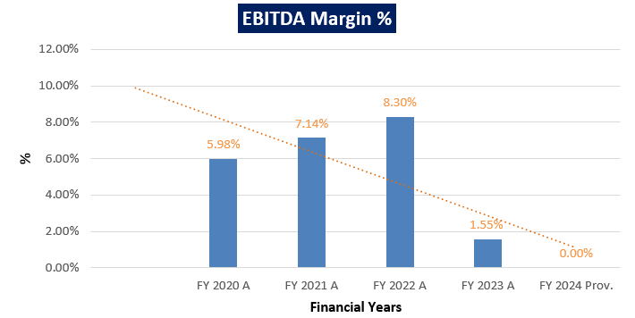

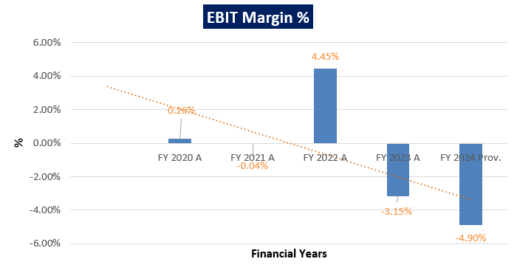

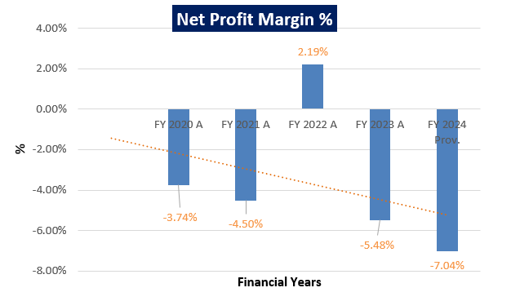

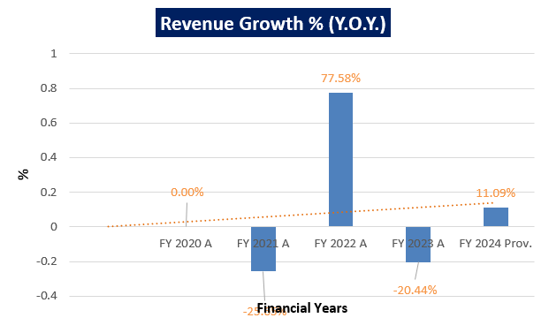

***Notes:*** As per the historical analysis, it is observed that EBITDA Margin of the company is showing a downward trend as it has gone down from 5.98% in FY 2019-20 to 1.55% in FY 2022-23. In FY 2023-24 EBITDA margin is 0.00%. EBIT Margin is also showing a downward trend as it has gone down from 0.26% in FY 2019-20 to -4.90% in FY 2023-24. As per the historical analysis, it is observed that Net Profit Margin of the company is continuously decreasing except from FY 2021-22.

Although, Revenues Growth of the company has reached to pre-covid levels in FY 2022-23. Revenues Growth of the company is constantly improving during the past recent years historically but jumped in the FY 2023-24 as per the provisional quarterly numbers shared by the company/client.

1. **PROJECTED PROFIT & LOSS STATEMENT:**

*(Figures in INR Crores)*

|  |  |  |  |  |  |  |
| --- | --- | --- | --- | --- | --- | --- |
| **Particular** | **FY 2025 E** | **FY 2026 E** | **FY 2027 E** | **FY 2028 E** | **FY 2029 E** | **FY 2030 E** |
| **Revenue from Operations** | 1153.26 | 1211.96 | 1273.65 | 1338.48 | 1406.60 | 1478.20 |
| **Other Income** | 4.69 | 4.93 | 5.18 | 5.44 | 5.72 | 6.01 |
| **Total Income** | **1157.94** | **1216.88** | **1278.82** | **1343.92** | **1412.32** | **1484.21** |
| Total expenses | 1024.01 | 1088.40 | 1156.52 | 1228.58 | 1304.83 | 1385.50 |
| **EBITDA** | **126.36** | **127.20** | **128.03** | **128.83** | **129.60** | **130.34** |
| Depreciation and Amortization | 78.13 | 81.32 | 81.41 | 81.41 | 81.41 | 81.41 |
| **EBIT** | **48.23** | **45.89** | **46.62** | **47.42** | **48.20** | **48.94** |
| Finance Costs | 17.41 | 14.27 | 14.27 | 14.26 | 14.25 | 14.25 |
| **Profit/(Loss) before tax** | **30.82** | **31.61** | **32.36** | **33.16** | **33.94** | **34.69** |
| Current Tax | 10.29 | 10.55 | 10.80 | 11.07 | 11.33 | 11.58 |
| **Profit (Loss) after Tax for the period** | **20.54** | **21.06** | **21.56** | **22.09** | **22.61** | **23.11** |

1. **KEY FINANCIAL RATIOS:**

|  |  |  |  |  |  |  |
| --- | --- | --- | --- | --- | --- | --- |
| **Particulars** | **FY 2025 E** | **FY 2026 E** | **FY 2027 E** | **FY 2028 E** | **FY 2029 E** | **FY 2030 E** |
| **EBITDA Margin %** | 10.91% | 10.45% | 10.01% | 9.59% | 9.18% | 8.78% |
| **EBIT Margin %** | 4.17% | 3.77% | 3.65% | 3.53% | 3.41% | 3.30% |
| **Net Profit Margin %** | 1.77% | 1.73% | 1.69% | 1.64% | 1.60% | 1.56% |

1. **GRAPHICAL REPRESENTATION OF THE KEY FINANCIALS OF THE COMPANY:**

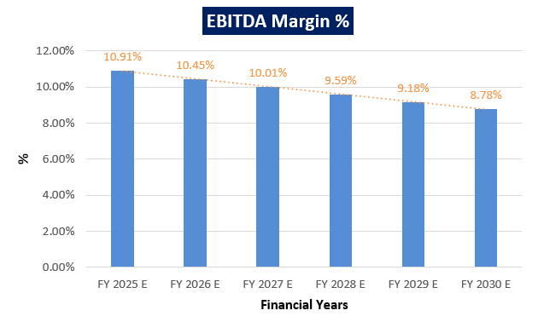

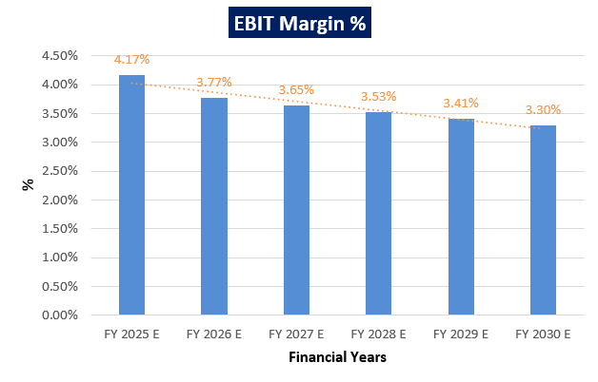

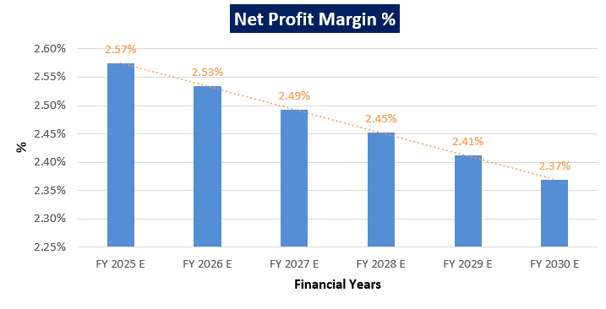

***Notes:*** As per the projections, it is observed that EBITDA Margin of the company is showing an upward trend as it has gone up from 10.91% in FY 2024-25 to 8.78% in FY 2029-30. EBIT Margin is also showing a downward trend as it has gone down from 4.17% in FY 2024-25 to 3.30% in FY 2029-30. As per the projections, it is observed that Net Profit Margin of the company is also showing a downward trend from 2.57% in FY 2024-25 to 2.37% in FY 2029-30.

As per the projections, the NTL is showing steady growth and development. Despite facing several challenges, such as increasing competition and fluctuating raw material prices, the company has shown resilience and adaptability through projections. This can be attributed to various factors, including favorable government policies, technological advancements, and a skilled workforce.

|  |  |
| --- | --- |
| **PART E** | **VALUATION OF THE COMPANY** |

1. **METHODOLOGY/ MODEL ADOPTED:** Out of the various models & theories available, we have adopted the most widely used & acceptable approach to calculate the Enterprise Value of the Company, which is, Income based approach (Discounted Cash Flow Model).
2. The free cash flow method is similar to the method used for public companies.
3. FCFF is more practical when substantial capital changes are expected because weighted average cost of capital (WACC) is less sensitive to the cost of equity.
4. In this method, we calculate the free cash flow to firm (FCFF) for the projected period.
5. Finally, we calculate the present value of future cash flows by using a required rate of return based on the riskiness of the project, which we determine by using the Weighted Average Cost of Capital (WACC).

**RATIONALE FOR USING DCF METHOD FOR ENTERPRISE VALUATION:**

1. The three broadly used approaches of the company/Business Valuations are – Income based approach (Discounted Cash Flow Model), Asset Based Approach (Net Asset Value Method) and Relative Valuation Approach (Market Multiple method).
2. Asset Based Model is inappropriate as the Company is a going concern and the model is unable to capture the Value of the company.
3. Market Multiple Approach is also not suitable as the company is not listed and no proper similar recent comparable transactions are available.
4. Instead, DCF method is used which determines the value of a business based on its ability to generate desired economic benefit/ cash flows for the owners. Thus, considering the nature of business, we have used DCF method for valuing the Company.
5. The DCF Model gives us a variety of input options to use while calculating the Value of the firm - Dividend, Free Cash Flow to the Firm, Free Cash Flow to Equity, Capitalized Cash Flows and Residual Earnings.
6. Dividends cannot be used as the Company has no history of paying dividends and we don’t foresee any dividend payments to occur in the future due to the high leverage of the firm.
7. The best method input option for the PV Model in the case of M/S NSL Textile Limited will be FCFF as it represents the benefits accruable to all the stakeholders in the Business enterprise.

**FCFF Model Formula and Key Inputs:**

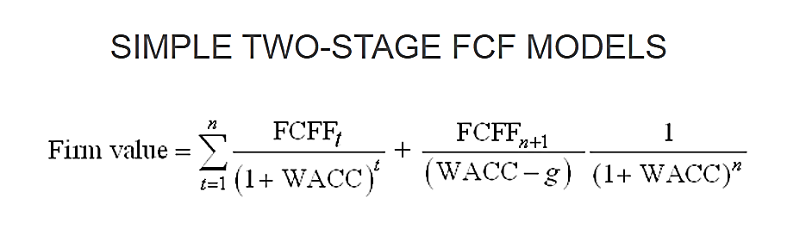

* **Free Cash Flow to Firm (FCFF):** FCFF is the [cash](http://www.investinganswers.com/node/5011) available to pay investors after a company pays its costs of doing business, invests in short-term assets like [inventory](http://www.investinganswers.com/node/2474), and invests in assets like property, plants and equipment.

*FCFF = Net Income + Non-Cash Charges + Interest (1 - tax rate) – Working Capital Investment – Fixed Capital Investment.*

* **Weighted Average Cost of Capital (WACC):**The weighted average cost of capital (WACC) is the rate that a company is expected to pay on average to all its security holders to finance its assets. The WACC is commonly referred to as the firm’s cost of capital. WACC is used as the discount rate to discount FCFF.

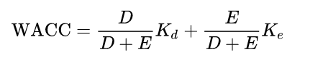

Where D is the total debt, E is the shareholders equity and Kd and Ke are the cost of debt and cost of equity, respectively.

1. **CALCULATION OF FREE CASH FLOW TO EQUITY:**

(Value in INR Crores)

|  |  |  |  |  |  |  |
| --- | --- | --- | --- | --- | --- | --- |
| **Particulars** | **Mar-25** | **Mar-26** | **Mar-27** | **Mar-28** | **Mar-29** | **Mar-30** |
| Total Revenue | 1157.94 | 1216.88 | 1278.82 | 1343.92 | 1412.32 | 1484.21 |
| Total Expenses | 1031.58 | 1089.68 | 1150.80 | 1215.09 | 1282.72 | 1353.87 |
| EBITDA | 126.36 | 127.20 | 128.03 | 128.83 | 129.60 | 130.34 |
| Less: Interest | 17.41 | 14.27 | 14.27 | 14.26 | 14.25 | 14.25 |
| Less: Increase/(Decrease) in Working Capital | 8.82 | 4.38 | 4.60 | 4.56 | 5.35 | 5.34 |
| Less: TAX@33.38% | 10.29 | 10.55 | 10.80 | 11.07 | 11.33 | 11.58 |
| Less: Capex | 30.00 | 30.00 | 30.00 | 30.00 | 20.00 | 20.00 |
| Less: (Increase)/Decrease in Borrowings | 57.48 | 57.48 | 57.48 | 57.48 | 57.48 | 57.48 |
| **Free Cash Flow to Equity & CCD** | **2.37** | **10.52** | **10.88** | **11.46** | **21.19** | **21.70** |

1. **KEY INPUTS USED TO DISCOUNT CASH FLOWS DURING THE PROJECTION PERIOD:**

|  |  |
| --- | --- |
| **Inputs** | |
| **Valuation Date** | **31st March 2024** |
| **Discount Rate** | **17.16 %** |
| **Discount Rate Change** | **1%** |
| **Tax Rate** | **33.38 %** |

**Calculation of COE**

|  |  |
| --- | --- |
| **Cost of Equity** | |
| Expected Market Return (Rm) Nifty Fifty 10-year return 2023 | 14.16% |
| Company Risk Premium | 3.00% |
| **Appropriate Discount Rate** | **17.16%** |

***Note:*** *Discount Rate Change of 1% is used to calculate the Sensitivity of the Enterprise Valuation with +/- changes in discount rate.*

1. **CALCULATION OF ENTERPRISE VALUE:**

(Value in INR Crores)

|  |  |  |  |  |  |  |
| --- | --- | --- | --- | --- | --- | --- |
| **Particulars** | **Mar-25** | **Mar-26** | **Mar-27** | **Mar-28** | **Mar-29** | **Mar-30** |
| Period | 1.00 | 2.00 | 3.00 | 4.00 | 5.00 | 6.00 |
| Discount Factor | 0.85 | 0.73 | 0.62 | 0.53 | 0.45 | 0.39 |
| Terminal Value |  |  |  |  |  | **130.88** |
| **PV of FCFF** | **2.02** | **7.67** | **6.77** | **6.08** | **9.60** | **8.39** |
| **PV of Terminal Value** |  |  |  |  |  | **50.61** |
| **PV of FCFF + PV of TV** | **2.02** | **7.67** | **6.77** | **6.08** | **9.60** | **59.00** |

|  |  |
| --- | --- |
| **Particulars** | **Amount** |
| **Total PV of FCFE and TV** | **91.13** |
| Less: Present Value of balance OCD repayment after 31st March 2030 | 22.22 |
| **Equity Value of the Firm** | **68.90** |
| No of outstanding Equity shares of the company | 19.33 |
| **Per Share price of NSL textile** | **3.56** |

|  |  |
| --- | --- |
| **Particulars** | **Amount** |
| **Equity Value of the Firm** | **68.90** |
| Less: Cash & Cash Equivalent | 13.68 |
| Add: Debt and Debt equivalents | 722.652 |
| **Enterprise Value of the Firm** | **777.88** |

Thus, M/s NSL Textile Limited is having an Enterprise Value of INR **777.88** Crores and Equity value of INR **68.90** Crores, while all the assumptions according to company’s financials have been considered. To calculate per share value, we need diluted number of shares on 31st march 2023, i.e. 19,32,56,578 shares (as per FY 2022-23). Hence per share price of NSL Textile Limited is:

|  |
| --- |
| **PER SHARE PRICE OF M/S NSL TEXTILE LIMITED** |
| **INR THREE RUPEES AND FIFTY-SIX PAISE**  **(INR 3.56)** |

***NOTE:***

* *The valuation is done based on the historical financials, Industry trend and our experience within the sector.*
* *The enterprise valuation and equity valuation of the project are just the reflection of the present value of its cash flow generating capacity in future years.*
* *We have not considered any contingent Dues / Liability/ Payables / Receivables / Pendency on or of the company in future years, which should be assessed separately by the parties, wanting to enter in the transaction, unless otherwise mentioned.*
* *This is just the equity/enterprise valuation of the project based on its income generating capacity in future years. This Valuation shall not be construed as the physical asset or should be directly related to cost approach or Project cost.*
* *Currently, the company is operational and its revenue is showing positive trend historically. Hence, the prospective buyer/investor/company can benefit from investing in textile sector.*
* *We have relied upon the data / information provided by the client / company, to forecast the financial projections.*
* *We are of the viewpoint that the textile industry growth and demand for the textile consumption will be higher in the future years, which will increase the demand for the textile related products.*

1. **SENSITIVITY ANALYSIS:**
2. **Cost of Equity** is the key input which has strong impact on the firm’s value with respect to percentage change. We have considered a change of **1%** to perform the sensitivity analysis.

|  |  |
| --- | --- |
| **Scenario** | **WACC** |
| **Optimistic Case** | 16.16% |
| **Base Case** | **17.16%** |
| **Pessimistic Case** | 18.16% |

1. **ENTERPRISE VALUE OF THE FIRM IN THE DIFFERENT SCENARIO:**

|  |  |  |
| --- | --- | --- |
| **Scenario** | **Discount Rate** | **Enterprise Value (INR Cr.)** |
| **Optimistic Case** | 16.16% | 784.18 |
| **Base Case** | **17.16%** | **777.88** |
| **Pessimistic Case** | 18.16% | 772.40 |

1. **SHARE PRICE OF THE FIRM IN THE DIFFERENT SCENARIO:**

|  |  |  |
| --- | --- | --- |
| **Scenario** | **Enterprise Value (INR Cr)** | **Share Price (INR)** |
| **Optimistic Case** | 784.18 | 3.89 |
| **Base Case** | **777.88** | **3.56** |
| **Pessimistic Case** | 772.40 | 3.28 |

Thus, in the base case scenario, M/s NTL is having the Enterprise Value **INR 777.88 Crores** and it may vary up to **INR 784.18 Crores** as optimistic case and **INR 772.40 Crores** as the pessimistic case. However, as per sensitivity analysis, the final transaction price will be dependent on the bargaining power of market participants to reach out to a successful outcome for all the concerned parties.

Similarly, in the base case scenario, M/s NTL is having the share price of **INR 3.56** and it may vary up to **INR 3.89** as optimistic case and **INR 3.28** as a pessimistic case.

Hence, using two-stage DCF Model, considering as a base case the Enterprise Value of “M/s NSL Textile Limited” is being calculated as **INR 777.88 Crores and** per share price will be **INR 3.56**, subject to the current assumptions and inputs used during the forecasted period, as well as the revenue growth and Cost of equity used to calculate the Equity value as well as enterprise value.

*This is only a general assessment of the Enterprise/Equity Value of the firm based on the data/ input Company officials could provide to us against our questions/ queries and information available in the public domain. In no manner this should be regarded as an audit activity/ report and NO micro analysis or detailed or forensic audit/ scrutiny of the financial transactions or accounts of any kind has been carried out at our end.*

1. **KEY ASSUMPTIONS AND WORKINGS:** Assumptions in the Valuation assessment have been taken based on data/ information/ documents shared by the Company, Operating History of the Plant, Annual Reports of the company, Market & Industry analysis. Assumptions have been considered after thoroughly reviewing their feasibility.
2. **PROJECTION PERIOD:** The enterprise value and equity value of the company are calculated based on a projection period of 6 years from FY 2024-25 to FY 2029-30.
3. **REVENUE PROJECTIONS:** We have considered revenue and cost-based model while making the future financial projection, the projections are forecasted for next six years up to FY 2030. NTL historical trend for revenue growth is very uncertain. As per information provided by the client/company, NSLTL’s operating profitability has been impacted in fiscal 2023 and first half of fiscal 2024 due to low-capacity utilization driven by muted demand. Though, operating profitability in the second half of fiscal 2024 is expected to improve supported by increased orders and capacity utilization. However, material improvement in profitability will depend on recovery in demand and optimal capacity utilization.

The financial risk profile remains constrained on account of the sizeable debt level of the company. It remains high because of the large debt-funded capex undertaken in the past as well as in future, and losses registered in fiscal 2023, which will impact the net worth of the company. Debt protection metrics such as interest coverage ratio and net cash accruals to debt ratio (NCATD) were weak in fiscal 2023, are expected to remain weak in fiscal 2024 as well.

On the other hand, NTL is a complete textile player, with presence across the value chain including ginning, spinning, weaving, and fabric processing and dyeing. Integrated manufacturing facilities enhance the flexibility in NSLTL’s operations, allowing it to strategically plan and control raw material procurement and production policies resulting in healthy operational efficiencies.

Therefore, after considering all the facts discussed above, income have been calculated. For operational income and other income basis figure provided in 6 months data by provisional financials (From 1st April 2023 to 30th September 2023), the resultant figure for the entire FY 24 have been calculated on pro-rata basis. To forecast for all the years revenue growth assumption from FY 25 to FY30, is taken as per the rate of inflation.

1. **EXPENSES PROJECTIONS:** As per information available in the audited financial statements major expenses includes Cost of material Consumed, Employees benefit Expenses and Other Operating and General Expenses.

All the expenses are estimated based on previous years' expenses during the projected period and calculated as the average of historical expenses with respect to revenue, following industry best practice. This results in an annual expected growth rate of 60%, 8% and 29% for Cost of material Consumed, Employees benefit Expenses and Other Operating and General Expenses respectively for the projected period.

1. **TAXATION:** Corporate tax rate is 33.38%.
2. **DEPRECIATION:** Depreciation rate has been considered as per the Companies Act 2013, which seems to be reasonable to keep a mark-up for future market & economic risks in the Project.
3. **CAPITAL EXPENDITURE**: As per information provided by company for forecasted period an estimated CAPEX information has been provided, which is based on the historical trend of the company and it seems to be reasonable to keep a mark-up for future market & economic risks in the Project.
4. **WORKING CAPITAL:** Trade Receivables: For all the forecast years, it has been calculated basis Average Trade receivables days (Average of FY 21, FY 22 & FY 23) i.e. 35.71 Days

Inventories: For all the forecast years, it has been calculated basis Average Inventory days (Average of FY 21, FY 22 & FY 23) i.e. 91.07 Days

Trade Payables: For all the forecast years, it has been calculated basis Average Trade receivables days (Average of FY 21, FY 22 & FY 23) i.e. 118 Days.

1. **DEPRECIATION:** Depreciation rate has been considered as per the Companies Act 2013, which seems to be reasonable to keep a mark-up for future market & economic risks in the Project.
2. **COST OF EQUITY:** Due to unavailability of comparable and sensitivity of company with respect to the market we cannot determine the cost of equity easily**,** hence in this scenario we have considered the Nifty Fifty 10-Year Return as a proxy for cost of equity (required rate of return for an unbiased investor), which is 14.16%.
3. **COMPANY RISK PREMIUM:** As the NTL was classified NPA by majority of lenders w.e.f. 1st October 2012. Hence, we have considered 3% as company risk premium to determine the appropriate discount rate.

|  |  |
| --- | --- |
| **Declaration** | 1. *Since this is Enterprise Valuation hence no site inspection was carried out by us.* 2. *The undersigned does not have any direct/indirect interest in the above property.* 3. *The information furnished herein is true and correct to the best of our knowledge.* 4. *This valuation work is carried out by our Financial Analyst team on the request from State Bank of India, Stressed Assets Management Branch, Red Cross Building, Red Cross Road, Egmore, Chennai - 600008* 5. *We have submitted Valuation report to the Client.* |
| **Number of Pages in the Repost** | 36 |
| **Enclosed Documents** | Disclaimer & Remarks 31-36 |
| **Place** | Noida |
| **Date** | 19th April 2024 |

|  |  |  |
| --- | --- | --- |
| **FOR ON BEHALF OF**  **M/S. R.K. ASSOCIATES VALUER & TECHNO ENGINEERING CONSULTANTS PVT. LTD.** | | |
| **SURVEYED BY** | **PREPARED BY** | **REVIEWED BY** |
| **--** | **Mr. Chhavi Toshan** | **Mr. Gaurav Kumar** |
|  |  |  |

|  |  |
| --- | --- |
| **PART F** | **IMPORTANT DEFINITION** |

***Definitions:***

* ***Enterprise Value:*** *Enterprise value (EV) is the corporate valuation of a company, determined by using market capitalization and total debt. Market cap comprises preference stocks, common stocks, and minority interest; total debt comprises short-term and long-term liabilities of the company. Enterprise value (EV) refers to the overall valuation—equity, debt, cash, and cash equivalents. In other words, it is the cost of acquiring a firm. The EV/EBITDA is an enterprise multiple. It correlates EV with earnings before interest, taxes, depreciation, and amortization. The metric determines whether the firm is undervalued or overvalued.*

*EV is computed using the following formula: EV = (Market Capitalization + Market Value of Debt – Cash and Equivalents).*

* ***Fair Market Value****suggested by the competent Valuer is that prospective estimated amount in his expert & prudent opinion of the subject asset without any prejudice after he has carefully & exhaustively evaluated the facts & information came in front of him related to the subject asset at which the subject asset should be exchanged between a willing buyer and willing seller at an arm’s length transaction in an open & unrestricted market, after proper marketing, wherein the parties, each acted knowledgeably, prudently and without any compulsion on the date of the Valuation.*

*Forced, under compulsion & constraint, obligatory sales transactions data doesn’t indicate the Fair Market Value.*

* ***Realizable Value*** *is the minimum prospective estimated value of the Company which it may be able to realize at the time of actual transaction factoring in the potential prospects of deep negotiations carried out between the buyer & seller for ultimately finalizing the transaction across the table. Realizable value may be 10-20% less than the Fair Market Value depending on the various salability prospects of the subject asset and the needs of the buyer & the seller.*
* ***Forced/ Distress Sale Value*** *is the value when the company has to be sold due to any compulsion or constraint like financial encumbrances, dispute, as a part of a recovery process, legal issues or any such condition or situation. In this type of sale, minimum fetch value is assessed which can be 15-25% less than the estimated Fair Market Value. In this type of sale, negotiation power of the buyer is always more than the seller and eagerness & pressure of selling the asset is more than buying it. Therefore, the Forced/ Distress Sale Value will always fetch significantly less value compare to the estimated Fair Market Value.*
* ***Liquidation Value*** *is the amount that would be realized when an asset or group of assets are sold on a piecemeal basis that is without consideration of benefits (or detriments) associated with a going-concern business. Liquidation value can be either in an orderly transaction with a typical marketing period or in a forced transaction with a shortened marketing period.*
* ***Difference between Costs, Price & Value:*** *Generally, these words are used and understood synonymously. However, in reality each of these has a completely different meaning, premise and also have different definitions in the professional & legal terms. Therefore, to avoid confusion, it is our professional responsibility to describe the definitions of these words to avoid ambiguity & confusion in the minds of the user of this report.*
* *The* ***Cost*** *of an asset represents the actual amount spend in the construction/ actual creation of the asset.*
* *The* ***Price*** *is the amount paid for the procurement of the same asset.*
* *The* ***Value*** *is defined as the present worth of future rights in the asset and depends to a great extent on combination of various factors such as demand and supply, market situation, purpose, situation & needs of the buyer & seller, salability outlook, usability factor, market perception & reputation. Needs of the buyer & seller, salability outlook, usability factor, market perception & reputation.*
* *Therefore, in actual for the same asset, cost, price & value remain different since these terms have different usage & meaning.*

|  |  |
| --- | --- |
| **PART G** | **DISCLAIMER | REMARKS** |

* + - 1. No employee or member of R.K Associates has any direct/ indirect interest in the Project.
      2. This is just an opinion report on Valuation based on the copy of the documents/ information provided to us by the client which has been relied upon in good faith and the assessment and assumptions done by us.
      3. This report is prepared based on the copies of the documents/ information which the Bank/ Company has provided to us out of the standard checklist of documents sought from them and further based on our assumptions and limiting conditions. The client/owner and its management/representatives warranted to us that the information they supplied was complete, accurate and true and correct to the best of their knowledge. All such information provided to us has been relied upon in good faith and we have assumed that it is true and correct in all respect. I/We shall not be liable for any loss, damages, cost or expenses arising from fraudulent acts, misrepresentations, or willful default on part of the owner, company, its directors, employee, representative or agents. Verification or cross checking of the documents provided to us from the originals or from any Govt. departments/ Record of Registrar has not been done at our end since this is beyond the scope of our work. If at any time in future, it is found or came to our knowledge that misrepresentation of facts or incomplete or distorted information has been provided to us then this report shall automatically become null & void.
      4. This Valuation is prepared based on the current financial status of the company, financial data, other facts & information provided by the client in writing & during verbal discussion during the course of the assignment and based on certain assumptions which are specifically mentioned in the Valuation section of the Report.
      5. Key assumptions in the report are taken based on data, information, inputs, financial statements etc. provided by the client to us during the course of the assessment and on the basis of the assessment done by us and we have assumed that all such information is true & factual to the best of the knowledge of the promoter company.
      6. Sale transaction method of the asset is assumed as free market transaction while assessing Prospective Fair Market Value of the asset.
      7. Legal aspects for e.g., investigation of title, ownership rights, lien, charge, mortgage, lease, sanctioned maps, verification of documents, etc. have not been done at our end and same has to be taken care by legal expert/ Advocate. It is assumed that the concerned Lender/ Financial Institution has satisfied them with the authenticity of the documents, information given to us and for which the legal verification has been already taken and cleared by the competent Advocate before requesting for this report. I/ We assume no responsibility for the legal matters including, but not limited to, legal or title concerns.
      8. All observations mentioned in the report is only based on the visual observation and the documents/ data/ information provided by the client. No mechanical/ technical tests, measurements or any design review have been performed or carried out from our side during Project assessment.
      9. Bank/FII should ONLY take this report as an Advisory document from the Financial/ Chartered Engineering firm and its specifically advised to the creditor to cross verify the original documents for the facts mentioned in the report which can be availed from the borrowing company directly.
      10. In case of any default in loans or the credit facility extended to the borrowing company, R.K Associates shall not be held responsible for whatsoever reason may be and any request for seeking any explanation from the employee/s of R.K Associates will not be entertained at any instance or situation.
      11. We have relied on data from third party, external sources & information available on public domain also to conclude this report. These sources are believed to be reliable and therefore, we assume no liability for the truth or accuracy of any data, opinions or estimates furnished by others that have been used in this analysis. Where we have relied on data, opinions or estimates from external sources, reasonable care has been taken to ensure that such data has been correctly extracted from those sources and /or reproduced in its proper form and context, however still we can’t vouch its authenticity, correctness or accuracy.
      12. This Report is prepared by our competent technical team which includes financial experts & analysts. This report is a general analysis of the project based on the scope mentioned in the report. This is not an Audit report, Design document, DPR or Techno feasibility study. All the information gathered is based on the facts seen on the site during survey, verbal discussion & documentary evidence provided by the client and is believed that information given by the company is true best of their knowledge.
      13. Value varies with the Purpose/ Date/ Condition of the market. This report should not to be referred if any of these points are different from the one mentioned aforesaid in the Report.
      14. Analysis and conclusions adopted in the report are limited to the reported assumptions, conditions and information came to our knowledge during the course of the work.
      15. This report is having limited scope as per its fields to provide only the general indication of the Value of Equity of the companies prevailing in the market based on the documents/ data/ information/ financial statements provided by the client and the assessment and assumption taken by us. The suggested value should be considered only if transaction is happened as free market transaction.
      16. Secondary/ Tertiary costs related to transaction like Stamp Duty, Registration charges, Brokerage, etc. pertaining to the sale/ purchase of the company are not considered while assessing the Market Value.
      17. Appropriate methodology & assumptions are rationally adopted based on the facts of the case came to our knowledge during the course of the assignment considering many factors like nature of Industry, current market situation and trends.
      18. Valuation is a subjective field and opinion may differ from consultant to consultant. To check the right opinion, it is important to evaluate the methodology adopted and various factors/ basis considered during the course of assessment before reaching to any conclusion.
      19. At the outset, it is to be noted that Value analysis cannot be regarded as an exact science and the conclusions arrived at in many cases will, of necessity, be subjective and dependent on the exercise of individual judgment. Given the same set of facts and using the same assumptions, expert opinions may differ due to the number of different factors, which have to be made. Therefore, there can be no standard formulae to establish an indisputable exchange ratio. In the event of a transaction, the actual transaction value achieved may be higher or lower than our indicative analysis of value depending upon the circumstances of the transaction. The knowledge, negotiability and motivations of the buyers and sellers and the applicability of a discount or premium for control will also affect actual price achieved. Accordingly, our indicative analysis of value will not necessarily be the price at which any agreement proceeds. The final transaction price is something on which the parties themselves have to agree. However, our Valuation analysis can definitely help the stakeholders to make them informed and wise decision about the Value of the asset and can help in facilitating the arm’s length transaction.
      20. This report is prepared on the Enterprise Valuation format as per the client requirement. This report is having limited scope as per its fields to provide only the indicative Fair value of the company based on the current financial position, future prospects & current Industry trends. The Valuation assessed in this Valuation Report should hold well only if transaction is happened as per free market transaction. No detailed analysis or verification of the information is carried upon pertaining to the value of the shares of the subject companies. No claim for any extra information will be entertained whatsoever be the reason. For any extra work over and above the fields mentioned in the report will have an extra cost which has to be borne by the customer.
      21. As per the scope of the report no site survey has been carried out by us and no thorough vetting of the documents/ information provided to us has been done at our end.
      22. This is just an opinion report and doesn’t hold any binding on anyone. It is requested from the concerned stakeholder which is using this report that they should consider all the different associated relevant & related factors also before taking any business decision based on the content of this report.
      23. Though adequate care has been taken while preparing this report as per its scope, but still, we can’t rule out typing, human errors, over sightedness of any information or any other mistakes. Therefore, the concerned organization is advised to satisfy themselves that the report is complete & satisfactory in all respect. Intimation regarding any discrepancy shall be brought into our notice immediately. If no intimation is received within 15 (Fifteen) days in writing from the date of issuance of the report, to rectify these timely, then it shall be considered that the report is complete in all respect and has been accepted by the client up to their satisfaction & use and further to which R.K Associates shall not be held responsible in any manner.
      24. This Valuation report is prepared based on the facts of the companies provided to us during the course of the assignment. However, in future the assumptions taken may change or may go worse due to impact of Govt. policies or effect of World economy, Industry/ market scenario may change, etc. Hence before taking any business decision the user of this report should take into consideration all such future risk.
      25. The documents, information, data provided to us during the course of this assessment by the client is reviewed only up to the extent required in relation to the scope of the work. No document has been reviewed beyond the scope of the work.
      26. In case of any default in repayment of credit facility extended to the borrowing company, as estimated by us, R.K Associates shall not be held responsible for whatsoever reason may be and any request for seeking any explanation from the employee/s of R.K Associates will not be entertained at any instance or situation.
      27. This report only contains general assessment & opinion as per the scope of work evaluated and based on technical & market information which came to knowledge during course of the assignment as per the information given in the copy of documents, information, data provided to us and/ and confirmed by the owner/ owner representative to us at site which has been relied upon in good faith. It doesn’t contain any other recommendations of any sort including but not limited to express of any opinion on the suitability or otherwise of entering into any transaction with the borrower.
      28. This Valuation is conducted based on the macro analysis of the asset/ property and operations of the companies and not based on the micro, component or item wise analysis. Analysis done is a general assessment and is not investigative in nature.
      29. This report is prepared following our Standard Operating Procedures & Best Practices, Limitations, Conditions, Remarks, Important Notes, Valuation TOR.
      30. Valuation is done based on the industry wide general accepted norms and based on the international standards & best practices for equity valuations.
      31. Any kind of unpaid statutory, utilities, lease, interest or any other pecuniary dues on the asset has not been factored in the Valuation.
      32. All Pages of the report including annexures are signed and stamped from our office. In case any paper in the report is without stamp & signature then this should not be considered a valid paper issued from this office.
      33. Defect Liability Period is **15 DAYS**. We request the concerned authorized reader of this report to check the contents, data and calculations in the report within this period and intimate us in writing if any corrections are required or in case of any other concern with the contents or opinion mentioned in the report. Corrections only related to typographical, calculation, spelling mistakes, incorrect data/ figures/ statement will be entertained within the defect liability period. Any new changes for any additional information in already approved report will be regarded as additional work for which additional fees may be charged. No request for any illegitimate change in regard to any facts & figures will be entertained.
      34. R.K Associates encourages its customers to give feedback or inform concerns over its services through proper channel at valuers@rkassociates.org in writing within 15 days of report delivery. After this period no concern/ complaint/ proceedings in connection with the Financial Feasibility Study Services will be entertained due to possible change in situation and condition of the subject Project.
      35. Our Data retention policy is of **ONE YEAR**. After this period, we remove all the concerned records related to the assignment from our repository. No clarification or query can be answered after this period due to unavailability of the data.
      36. This Enterprise Valuation report is governed by our (1) Internal Policies, Processes & Standard Operating Procedures, (2) R.K Associates Quality Policy, (3) Valuation & Survey Best Practices Guidelines formulated by management of R.K Associates, (4) Information input given to us by the customer and (4) Information/ Data/ Facts given to us by our field/ office technical team. Management of R.K Associates never gives acceptance to any unethical or unprofessional practice which may affect fair, correct & impartial assessment and which is against any prevailing law. In case of any indication of any negligence, default, incorrect, misleading, misrepresentation or distortion of facts in the report then it is the responsibility of the user of this report to immediately or at least within the defect liability period bring all such act into notice of R.K Associates management so that corrective measures can be taken instantly.
      37. R.K Associates never releases any report doing alterations or modifications from pen. In case any information/ figure of this report is found altered with pen then this report will automatically become null & void.
      38. If this report is prepared for the matter under litigation in any Indian court, no official or employee of R.K Associates will be under any obligation to give in person appearance in the court as a testimony. For any explanation or clarification, only written reply can be submitted on the additional payment of charges.