File No. : VIS (2023-24)-PL567-480-737 21st Dec 2023

QUANTITY VERIFICATION
FOR
CIVIL & FINISHING WORKS
OF
SPARK MINDA
AT
NOIDA, UTTAR PRADESH



SITUATED AT
NOIDA, UTTAR PRADESH

REPORT PREPARED FOR
Unit SSD Noida, BV-1
SPARK MINDA
D7, D Block, Sector 59, Noida, Uttar Pradesh-201301
TABLE OF CONTENTS
Sr. No. | DESCRIPTION | PAGE NO.
PART A | Report Summary | 03
PART B | Introduction | 04
 | - Project Name | 04
 | - Project Brief Background | 04
 | - Scope of the Report | 04
 | - Purpose of the Report | 04
 | - Methodology Adopted | 04
PART C | Civil, Finishing & Other Ancillary Items Specifications | 05
PART D | Measurement/Calculation & Observation | 06-10
PART E | Disclaimer | 11
PART F | Photographs | 12-13

PART A | REPORT SUMMARY

 | Project Name | Verification of the works as per Invoices provided by Spark Minda Corporation Noida as Owner’s Engineer.
 | Project Location | Noida, Uttar Pradesh-201301
 | Name of the Client | SSD Noida, BV-1  Spark Minda Corporation, Noida
 | Address and Phone Number | Spark Minda Corporation, D7, D Block, Sector 59, Noida, Uttar Pradesh-201301
 | Prepared for Organization | Minda Corporation Ltd.
 | Independent Engineer Company | M/S R.K Associates Valuers & Techno Engineering Consultants (P) Ltd.
 | Date of Survey | 12th December 2023
 | Date of Report | 21st December 2023
 | Purpose of the Report | Quantity verification of work done, as per invoices provided from Spark Minda.
 | Scope of the Report | Preparing detailed report which includes Quantity verification of work done, as per invoices provided.
 | Documents produced for perusal | Bill of Quantity and Invoices
 | Annexure with the Report | Bill of Quantity and Invoices

PART B | INTRODUCTION

- PROJECT NAME: Quantity Verification of different works at Spark Minda Corporation, Noida.

- PROJECT BRIEF BACKGROUND: This verification report is prepared for Spark Minda Corporation, Noida. Spark Minda (MINDA Group) has allotted different works during the time period from September 2022 to October 2023, for civil works, renovation, internal works, etc. For their internal audit and settling the vendors account, company has appointed R.K Associates as Independent Engineer for verifying its quantity and specifications as Owner’s Engineer. The subject location is D7, D Block, Sector 59, Noida, Uttar Pradesh-201301.

- SCOPE OF THE REPORT: Preparing report which includes quantity verification of different works at Spark Minda Corporation, Noida.

- PURPOSE OF THE REPORT: To verify the quantity of work done in the subject location, according to the invoices provided to us.

- METHODOLOGY ADOPTED:
- Engineering Survey including works measurement as per Bills.
- Consolidation of observation in report.

PART C | CIVIL, FINISHING & OTHER ANCILLARY ITEMS SPECIFICATIONS

PARTICULAR | SPECIFICATIONS MENTIONED IN BOQ | SPECIFICATIONS FOUND ON SITE
Office
MDF | 12 mm thick | Same as BOQ
Wooden Panelling | Sanmica | Same as BOQ
Pin Board | Pin board, with cloths | Same as BOQ
Writing Glass | Writing glass with wood panelling | Same as BOQ
TV Panelling | Wooden Panelling | Same as BOQ
Production
Puff Panel | 50 mm puff panel | Same as BOQ
Door | Specification not mentioned in BOQ | Puff Panel door
False Ceiling | Slot Ceiling | Same as BOQ
Clear Glass | 5mm thick | Same as BOQ
External Development
Kerb Stone | Specification not mentioned in BOQ | Kerb stone of  300 mm height.
Internal Road | R.C.C Road | Same as BOQ
Working Hall
False ceiling in washrooms | Specification not mentioned in BOQ | 8 mm water proof false ceiling
False ceiling in Main Hall | Armstrong Open Cell GI Lay-in ceiling with border panels.  (600mm x 600mm x 15mm) | - 12 mm false ceiling of unknown brand  - Same as BOQ
False ceiling in manufacturing room | Armstrong Open Cell GI Lay-in ceiling with border panels.  (600mm x 600mm x 15mm) | 12 mm false ceiling  of unknown brand
Gypsum Ceiling | Gypsum False Ceiling | Same as BOQ
Flushing Cistern and plumbing parts | Hindware | Hindware
Tiles | Size- 600 x 600 mm | Same as BOQ
 | Spec-Anti-Skid Vitrified Tiles | Same as BOQ
 | Make-Kajaria/Orientbell | Cannot be verified  after laying

PART D | MEASURMENT/CALCULATION & OBSERVATION

S. No. | Particulars | Unit | Qty. In BOQ | Qty. As on Site | Difference if any | Diff in % | Remarks
For Invoice No. LIA/UP/07 Dated: 08/06/2023 for Bill of amount Rs.2,87,686
1 | Ply Board at back (MDF)  (51.3+7.8+15.9-2.985) | Sq. ft. | 182.50 | 180.04 | 2.46 | 1% | Quantity found on site is in line with BOQ
2 | Sanmaica Board | Sq. ft. | 70.74 | 56.48 | 14.26 | 20% | Significant difference found in site survey measurement.
3 | Sanmaica Board | Sq. ft. | 259.00 | 271.83 | 12.83 | 5% | Minor difference found in site survey measurement.
4 | Pin Board | Sq. ft. | 70.74 | 67.50 | 3.24 | 5% | Minor difference found in site survey measurement.
5 | White Board | Sq. ft. | 70.74 | 56.48 | 14.26 | 20% | Significant difference found in site survey measurement.
6 | T.V Panelling (Front) | Sq. ft. | 73.02 | 75.96 | 2.94 | 4% | Quantity found on site is in line with BOQ
7 | T.V Panelling (Back)  (4+4+2.5+2.5) | Sq. ft.
8 | T.V Panelling (Patti)  (4+4+2.5+2.5)+(4+4+6) | Sq. ft.
- Note: The assessment of Silicon application, Gypsum Dismantling, and Paint Repair work has been excluded from this report due to their current invisibility.

S. No. | Particulars | Unit | Qty. In BOQ | Qty. As on Site | Difference if any | Diff in % | Remarks
For Invoice No. LIA/UP/15 Dated: 05/10/2023 for Bill of amount Rs.3,49,986
1 | Supply and installation of puff panel | Sqm. | 76.64 | 76.74 | 0.10 | 0.1% | - Deduction of door has not been done in BOQ.  - Quantity found on site is in line with BOQ.
2 | False Ceiling(Grid) | Sqm. | 59 | 57.60 | 1.40 | 2% | Quantity found on site is in line with BOQ
3 | Door | Nos. | The particular item is awarded job wise to the contractor, hence quantity couldn’t be verified. However the job is executed, i.e. door was installed.
4 | 5 mm clear glass | Nos. | The particular item is awarded job wise to the contractor, hence quantity couldn’t be verified. However the job is executed.
5 | Glass | Nos. | The particular item is awarded job wise to the contractor, hence quantity couldn’t be verified. However the job is executed.
- Note: Installation of door is provided on Job basis separately, but the measurement of the same has not been deducted from the PUFF panel quantity.

S. No. | Particulars | Unit | Qty. In BOQ | Qty. As on Site | Difference if any | Diff in % | Remarks
For Invoice No. LIA/UP/05 Dated: 23/05/2023 for Bill of amount Rs.6,45,339
1 | Glass door with floor machine | No. | 5 | 5 | 0 | 0% | Numbers counted and verified.
2 | Grid Ceiling | Sqm. | 77.77 | 75.96 | 1.81 | 2% | Minor difference found in site survey measurement.
3 | Gypsum Ceiling | Sqm. | 192.38 | 184.49 | 7.88 | 4% | Minor difference found in site survey measurement.
4 | Window glass | Sqm. | 2.97 | 2.52 | 0.44 | 15% | Significant difference found in site survey measurement.
- Note: The assessment of aluminium window/partition dismantling, brickwork dismantling, New 9” Brick work, plaster, P.O.P on wall, R.C.C and such items in the bill has been excluded from this report due to their current invisibility.

S. No. | Particulars | Unit | Qty. In BOQ | Qty. As on Site | Difference if any | Diff in % | Remarks
For Invoice No. LIA/UP/10 Dated: 15/09/2022 for Bill of amount Rs.16,31,196
1 | Re fixing of kerb stone | Rmt. | 112.00 | 105.80 | 3.29 | 6% | Minor difference found in site survey measurement.
2 | Dismantling of existing kerb stone | Rmt. | 112.00 | 105.80 | 3.29 | 6% | Minor difference found in site survey measurement.
3 | Painting of kerb stone | Sqm. | 112.00 | 105.80 | 3.29 | 6% | Minor difference found in site survey measurement.
4 | 1:1.5:3 R.C.C Road | Cum | 102.51 | 105.80 | 3.29 | 3% | Minor difference found in site survey measurement.
5 | PCC | Cum | 9.10 | 9.10 | 0 | 0% | No difference
6 | Providing and fixing of paver blocks | Sqm. | 35 | 35 | 0 | 0% | No difference
- Note: The assessment of soil testing, excavation near corporate office, backfilling, P.C.C, reinforcements and such items in the bill has been excluded from this report due to their current invisibility.

S. No. | Particulars | Unit | Qty. In BOQ | Qty. As on Site | Difference if any | Diff in % | Remarks
For Invoice No. LIA/UP/15 Dated: 25/10/2022 for Bill of amount Rs.70,80,000
1 | Dismantling of toilet | Cannot be ascertained due to its current invisibility.
2 | Excavation works | Cum. | 182 | 164.83 | 17.17 | 9% | Only the length is measured on site, width and depth is as per BOQ, as the same were not visible, as of now.
3 | PCC and RCC works | Cum. | Cannot be ascertained as width and depth is neither visible on site, nor mentioned on BOQ.
S. No. | Particulars | Unit | Qty. In BOQ | Qty. As on Site | Difference if any | Diff in % | Remarks
4 | Cement concrete flooring | Sq. ft. | 449.77 | 419.79 | 29.98 | 7% | Minor difference found in site survey measurement.
5 | Antiskid tiles | Sq. ft. | 511.10 | 497.93 | 13.17 | 3% | Minor difference found in site survey measurement.
6 | Wall tiles | Sq. ft. | 841.86 | 828.73 | 13.13 | 2% | Minor difference found in site survey measurement.
7 | Water proofing | Sq. ft. | 511.10 | 497.93 | 13.17 | 3% | Minor difference found in site survey measurement.
8 | Brickworks and plastering works | Cu. ft. | 2078.54 | 2054.23 | 24.31 | 1% | Minor difference found in site survey measurement.
9 | Plaster | Sq. ft. | 3023.72 | 3012.39 | 11.33 | 0% | No difference
10 | Drainage and water pipe works | Cannot be ascertained due to their current invisibility.
11 | Primer | Sq. ft. | 800 | 788 | 12 | 2% | Minor difference found in site survey measurement.
12 | Putty works | Sq. ft. | 800 | 788 | 12 | 2% | Minor difference found in site survey measurement.
13 | Gypsum ceiling | Sq. ft. | 180 | 186.90 | -6.9 | -4% | Minor difference found in site survey measurement.
14 | Grid ceiling | Sq. ft. | 192 | 184.39 | 7.61 | 4% | Minor difference found in site survey measurement.
15 | Water closets | Each | 7 | 7 | 0 | 0% | No difference
16 | Wash basins | Each | 4 | 4 | 0 | 0% | No difference
17 | Mirror for toilet | Sq. ft. | 32 | 24 | 8 | 25% | Significant difference found in site survey measurement.
18 | Faucets for wash basin | Each | 7 | 7 | 0 | 0% | No difference
19 | Water closet cubicles | Each | 7 | 7 | 0 | 0% | No difference
20 | Toilet flush door | Each | 1 | 1 | 0 | 0% | No difference
21 | Excavation works | Cannot be ascertained due to their current invisibility.
22 | Cement Concrete Flooring 40 mm Thick In 1:2:4 | Cannot be ascertained due to their current invisibility.
23 | Supplying & laying of wall tiles of size 300 mm x 600 mm x 10 mm | Sq. ft. | 633 | 624.52 | 8.48 | 1% | Minor difference found in site survey measurement.
24 | Providing and laying water-proofing | Sq. ft. | 332.5 | 330.75 | 1.75 | 1% | Minor difference found in site survey measurement.
25 | Providing And Fixing Armstrong Cello Open | Sq. ft. | 204 | 207.44 | -3.44 | -2% | Minor difference found in site survey measurement.
26 | Urinals | Each | 6 | 6 | 0 | 0% | No difference
27 | Water Closets With Water Jets | Each | 6 | 6 | 0 | 0% | No difference
S. No. | Particulars | Unit | Qty. In BOQ | Qty. As on Site | Difference if any | Diff in % | Remarks
28 | Wash Basins | Each | 3 | 3 | 0 | 0% | No difference
29 | Long body faucets | Each | 14 | 14 | 0 | 0% | No difference
30 | Mirror For Toilet | Sq. ft. | 24 | 24 | 0 | 0% | No difference
31 | Water Closet Cubicles | Each | 6 | 6 | 0 | 0% | No difference
32 | Toiler flush door | Each | 1 | 1 | 0 | 0% | No difference
33 | Plant head cabin table | Each | 4 | 4 | 0 | 0% | No difference
34 | Office Workstation Tables | Each | 24 | 24 | 0 | 0% | No difference
35 | Workstation movable drawer unit | Each | 24 | 24 | 0 | 0% | No difference
36 | Workstation table | Each | 8 | 8 | 0 | 0% | No difference
37 | Internal partition | Sqm. | 8 | 8 | 0 | 0% | No difference
38 | Providing And Fixing Armstrong Cello | Sq. ft. | 6,587.25 | 12,108.41  Notably there’s a vast difference between the measurements taken during site survey (as shown by the representative) and the quantity specified in the Bill of Quantities (BOQ). The difference can be seen because of absence of any sanctioned drawing for the repair work.
39 | PVC Matte flooring | Sq. ft. | 6,133.20 | Notably there’s a vast difference between the measurements taken during site survey (as shown by the representative) and the quantity specified in the Bill of Quantities (BOQ). The difference can be seen because of absence of any sanctioned drawing for the repair work.
40 | Providing And Fixing Partition 50mm Thick | Sq. ft. | 1,301.98 | 1228.66 | 73.32 | 6% | Minor difference found in site survey measurement.
41 | Sub grade to an average of 0.5 m depth | Cum | 204 | 228.25 | -24.25 | -12% | Only the length is measured on site, width and depth is as per BOQ, as the same were not visible, as of now.
42 | Construction of granular sub-base (GSB) | Cum | 137.7 | 136.95 | 0.75 | 1% | Only the length is measured on site, width and depth is as per BOQ, as the same were not visible, as of now.
43 | Laying 300 micron HDPE sheet | Sq. ft. | 4,941.25 | 4,913.72 | 27.53 | 1% | Minor difference found in site survey measurement.
44 | Providing and laying C.C of mix M-25 | Cum | 61.2 | 57.06 | 4.14 | 7% | Minor difference found in site survey measurement.
45 | Reinforcement steel | Cannot be ascertained due to their current invisibility.
46 | Controlled Joints - 5mm X 40 mm | Rmt. | 80 | 78 | 2 | 3% | Minor difference found in site survey measurement.

S. No. | Particulars | Unit | Qty. In BOQ | Qty. As on Site | Difference if any | Diff in % | Remarks
47 | Construction Joints - 5mm X 20 mm | Rmt. | 80 | 78 | 2 | 3% | Minor difference found in site survey measurement.
48 | Trench excavation for the side drain | Cum | 550 | 550 | 0 | 0% | No difference
50 | PCC for drain | Cum | 12.15 | 13 | -0.85 | -7% | Minor difference found in site survey measurement.
51 | 9"brick for drain | Cu. ft. | 502.5 | 485.72 | 16.78 | 3% | Minor difference found in site survey measurement.
52 | 4" brick for drain | Sq. ft. | 502.5 | 496.28 | 6.22 | 1% | Minor difference found in site survey measurement.
53 | Plaster for drain | Sq. ft. | 1624.75 | 1400 | 224.75 | 14% | Significant difference found in site survey measurement.
54 | Drain cover | Cannot be ascertained due to large number of drain covers.
55 | Kerb stone | Rmt. | 65 | 65 | 0 | 0% | No difference

Note:
- Standard measuring instrument is used during site measurement.
- During measurement and in different measurement devices 2-3% error of margin may be possible.

PART E | DISCLAIMER

      - No employee or member of R.K Associates has any direct/ indirect interest in the property.
      - This report is prepared based on the documents/ information provided to us by the client and we assume that all such information is true and correct. If at any time it is found that the customer has provide misrepresentation of facts then this report should be considered cancelled.
      - This report is a general analysis of the project and not an audit report. All the information gathered is based on the facts seen on the site during survey, verbal discussion & documentary evidence provided by the client and is believed that information given by the client is true best of their knowledge.
      - Bank/ FII should ONLY take this report as an Advisory document from the Chartered Engineering firm and it is specifically advised to the creditor to cross check the original documents for the facts mentioned in the report which can be availed from the borrowing company directly.
      - In case of any default in loans by the borrowing company, R.K Associates wouldn’t be held responsible for whatsoever reason may be and any request for seeking any explanation from the employee/s of R.K Associates wouldn’t be entertained at any instance or situation.
      - This Report is prepared by our competent technical team which includes Engineers and financial experts & analysts.

FOR INTERNAL USE

Place :Noida | SURVEYED BY: Vishal , Ashil
Date : 21st December 2023 | PREPARED BY: Vishal Singh
Note : This report contains 12 pages | REVIEWED BY: Sr. VP Projects

For R.K Associates Valuer & Techno
Engineering Consultants Pvt. Ltd.

PART F | PHOTOGRAPHS

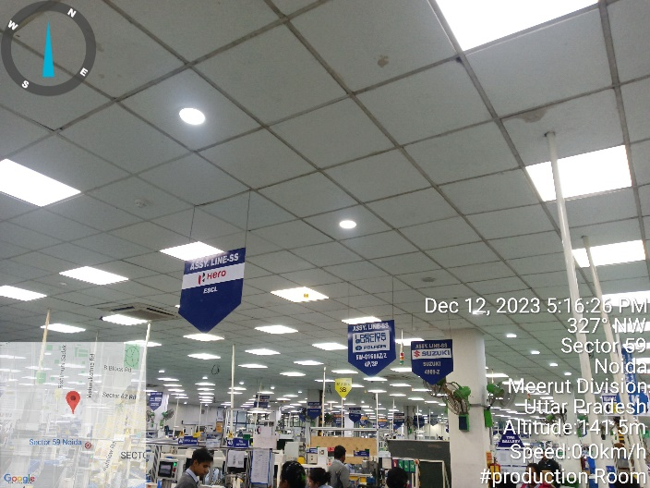 | 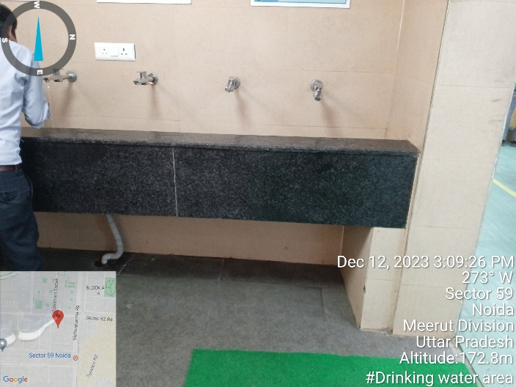
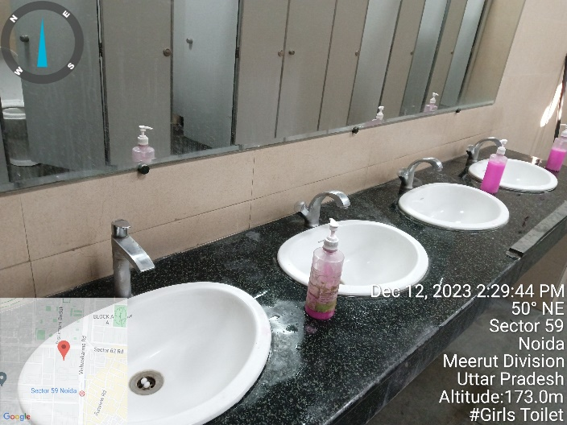 | 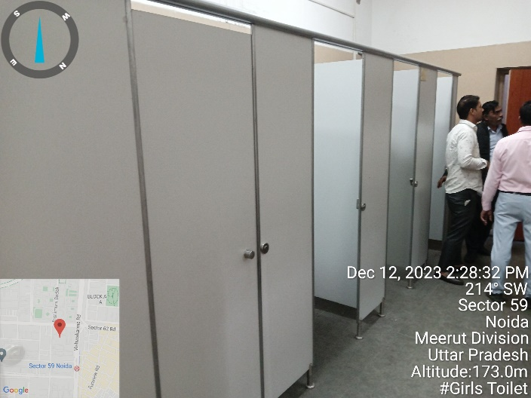
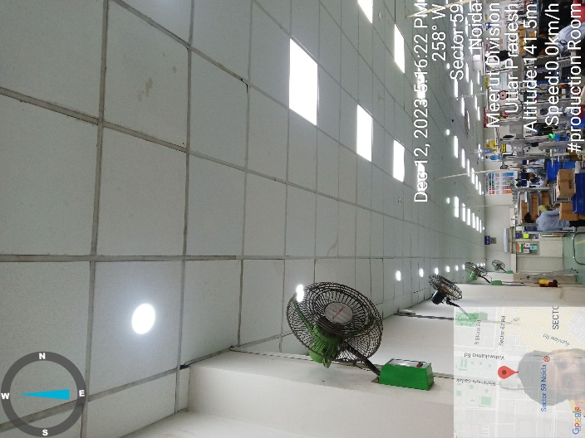 | 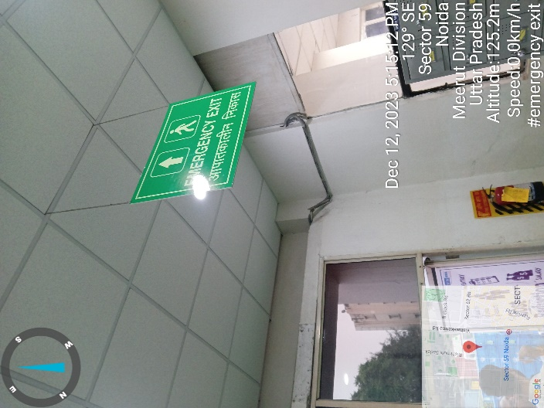

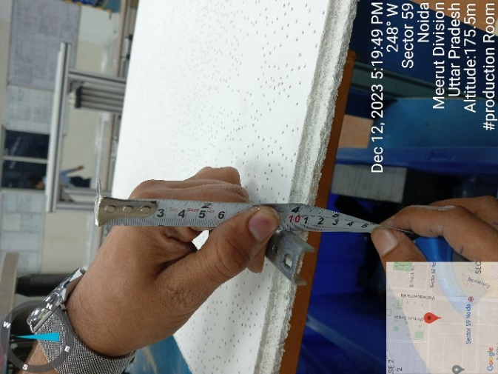 | 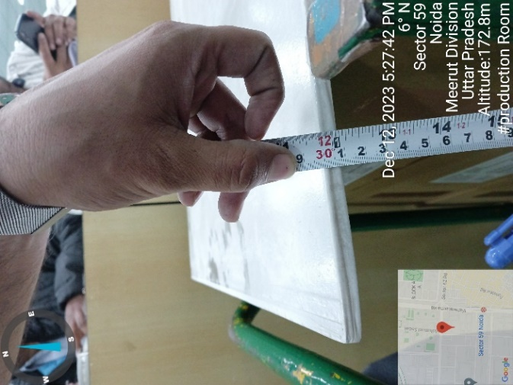 | 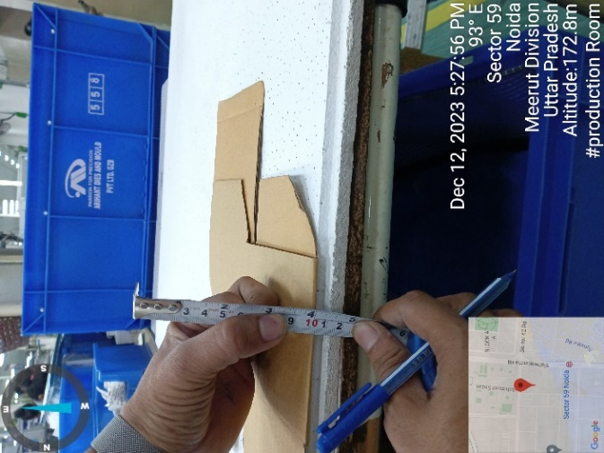
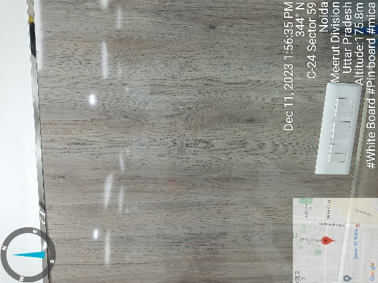 | 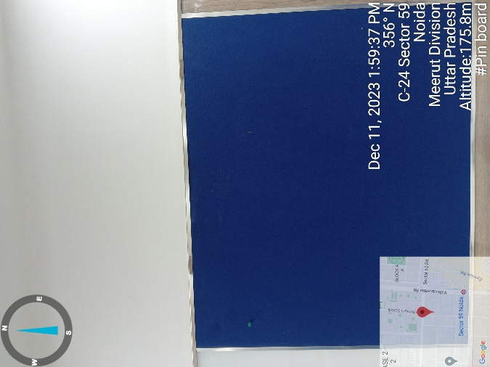 | 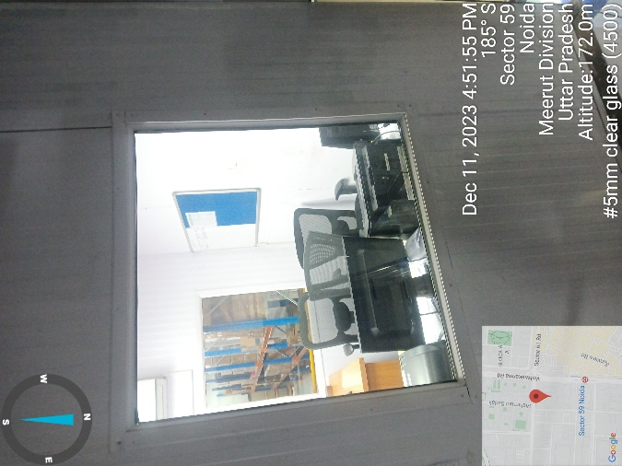
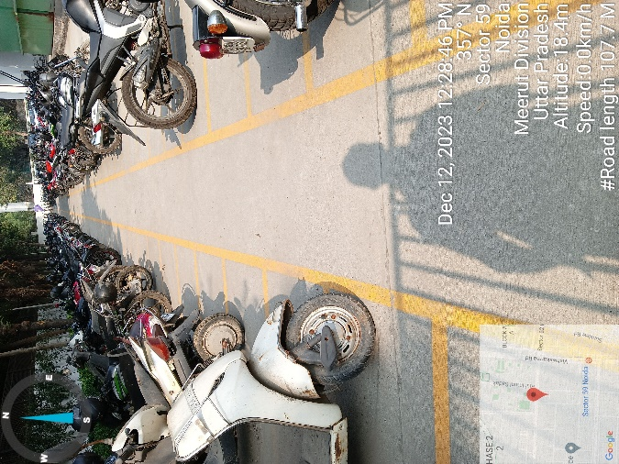 | 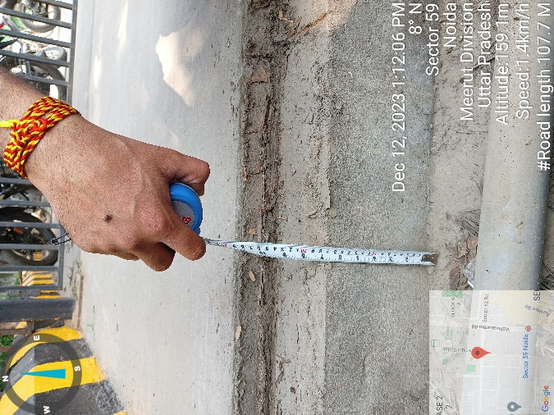 | 