File No.: VIS (2023-24) - PL567-480-737 Dated: 21st Dec 2023

QUANITY VERIFICATION OF CIVIL WORK

OF

SPARK MINDA



SITUATED AT

NOIDA, UTTAR PRADESH
D7, D BLOCK, SECTOR 59, NOIDA,
UTTAR PRADESH-201301

REPORT PREPARED FOR

UNIT SSD NOIDA, BV-1, SPARK MINDA,
NOIDA, UTTAR PRADESH

**Important - In case of any query/ issue or escalation you may please contact Incident Manager at le@rkassociates.org. We will appreciate your feedback in order to improve our services.

TABLE OF CONTENTS
Sr. No. | DESCRIPTION | PAGE NO.
PART A | Report Summary | 03
PART B | Introduction | 04
 | - Project Name | 04
 | - Project Brief Background | 04
 | - Scope of the Report | 04
 | - Purpose of the Report | 04
 | - Methodology Adopted | 04
PART C | Measurement/Calculation & Observation | 05-11
PART D | Civil, Finishing & Other Ancillary Items Specifications | 12
PART E | Disclaimer | 13-14
PART F | Photographs | 15-16

PART A | REPORT SUMMARY

 | Project Name | Verification of the works as per Invoices provided by Spark Minda Corporation Noida as Owner’s Engineer.
 | Project Location | Noida, Uttar Pradesh-201301
 | Name of the Client | SSD Noida, BV-1  Spark Minda Corporation, Noida
 | Address and Phone Number | Spark Minda Corporation, D7, D Block, Sector 59, Noida, Uttar Pradesh-201301
 | Prepared for Organization | Minda Corporation Ltd.
 | Independent Engineer Company | M/S R.K Associates Valuers & Techno Engineering Consultants (P) Ltd.
 | Date of Survey | 12th December 2023
 | Date of Report | 21st December 2023
 | Purpose of the Report | For company’s internal assessment
 | Scope of the Report | Preparing detailed report which includes Quantity verification of the work done, as per invoices provided.
 | Documents produced for perusal | Invoices with BOQ attached
 | Annexure with the Report | Invoices with BOQ attached

PART B | INTRODUCTION

- PROJECT NAME: Quantity Verification of different civil, renovation and finishing works at Spark Minda Corporation, Noida.

- PROJECT BRIEF BACKGROUND: This verification report is prepared for Spark Minda Corporation, Noida. Spark Minda (MINDA Group) has allotted different works during the time period from September 2022 to October 2023, for civil works, renovation, internal works, etc. For their internal audit and settling the vendors account, company has appointed R.K Associates as Independent Engineer for verifying its quantity and specifications as Owner’s Engineer. The subject location where work verification has to be carried out is D7, D Block, Sector 59, Noida, Uttar Pradesh-201301.

- SCOPE OF THE REPORT: Preparing report which includes quantity verification of different civil, renovation and finishing works at Spark Minda Corporation, Noida.

- PURPOSE OF THE REPORT: To verify the quantity of work done in the subject location, according to the invoices provided to us for company’s internal requirement.

- METHODOLOGY ADOPTED:
- Engineering Survey including works measurement as per Bills.
- Consolidation of observation in report.

PART C | MEASURMENT/ CALCULATION & OBSERVATION

S. No. | Particulars | Unit | Qty. In BOQ | Qty. As on Site | Diff if any | Diff in % | Remarks | Location
For Invoice No. LIA/UP/07 Dated: 08/06/2023 for Bill of amount Rs.2,87,686
1 | Ply Board at back (MDF)  (51.3+7.8+15.9-2.985) | Sq. ft. | 182.50 | 180.04 | 2.46 | 1% | Quantity found on site is in line with BOQ | Office
2 | Sanmaica Board | Sq. ft. | 70.74 | 56.48 | 14.26 | 20% | Significant difference found in site survey measurement. | Office
3 | Sanmaica Board | Sq. ft. | 259.00 | 271.83 | 12.83 | 5% | Minor difference found in site survey measurement. | Office
4 | Pin Board | Sq. ft. | 70.74 | 67.50 | 3.24 | 5% | Minor difference found in site survey measurement. | Office
5 | White Board | Sq. ft. | 70.74 | 56.48 | 14.26 | 20% | Significant difference found in site survey measurement. | Office
6 | T.V Panelling (Front) | Sq. ft. | 73.02 | 75.96 | 2.94 | 4% | Quantity found on site is in line with BOQ | Office
7 | T.V Panelling (Back)  (4+4+2.5+2.5) | Sq. ft. |  |  |  |  |  | Office
8 | T.V Panelling (Patti)  (4+4+2.5+2.5)+(4+4+6) | Sq. ft. |  |  |  |  |  | Office
Note: The assessment of Silicon application, Gypsum Dismantling, and Paint Repair work has been excluded from this report due to their current invisibility.

S. No. | Particulars | Unit | Qty. In BOQ | Qty. As on Site | Diff if any | Diff in % | Remarks | Location
For Invoice No. LIA/UP/15 Dated: 05/10/2023 for Bill of amount Rs.3,49,986
1 | Supply and installation of puff panel | Sqm. | 76.64 | 76.74 | 0.10 | 0.1% | - Deduction of door has not been done in BOQ.  - Quantity found on site is in line with BOQ. | Store Shed
2 | False Ceiling(Grid) | Sqm. | 59 | 57.60 | 1.40 | 2% | Quantity found on site is in line with BOQ | Store Shed
3 | Door | Nos. | The particular item is awarded job wise to the contractor, hence quantity couldn’t be verified. However the job is executed, i.e. door was installed. |  |  |  |  | Store Shed
4 | 5 mm clear glass | Nos. | The particular item is awarded job wise to the contractor, hence quantity couldn’t be verified. However the job is executed. |  |  |  |  | Store Shed
5 | Glass | Nos. | The particular item is awarded job wise to the contractor, hence quantity couldn’t be verified. However the job is executed. |  |  |  |  | Store Shed
Note: Installation of door is provided on Job basis separately, but the measurement of the same has not been deducted from the PUFF panel quantity.

S. No. | Particulars | Unit | Qty. In BOQ | Qty. As on Site | Diff if any | Diff in % | Remarks | Location
For Invoice No. LIA/UP/05 Dated: 23/05/2023 for Bill of amount Rs.6,45,339
1 | Glass door with floor machine | No. | 5 | 5 | 0 | 0% | Numbers counted and verified. | Office
2 | Grid Ceiling | Sqm. | 77.77 | 75.96 | 1.81 | 2% | Minor difference found in site survey measurement. | Office
3 | Gypsum Ceiling | Sqm. | 192.38 | 184.49 | 7.88 | 4% | Minor difference found in site survey measurement. | Office
4 | Window glass | Sqm. | 2.97 | 2.52 | 0.44 | 15% | Significant difference found in site survey measurement. | Office
Note: The assessment of aluminium window/partition dismantling, brickwork dismantling, New 9” Brick work, plaster, P.O.P on wall, R.C.C and such items in the bill has been excluded from this report due to their current invisibility.

S. No. | Particulars | Unit | Qty. In BOQ | Qty. As on Site | Diff if any | Diff in % | Remarks | Location
For Invoice No. LIA/UP/10 Dated: 15/09/2022 for Bill of amount Rs.16,31,196
1 | Re fixing of kerb stone | Rmt. | 112.00 | 105.80 | 3.29 | 6% | Minor difference found in site survey measurement. | Setback Area(Road)
2 | Dismantling of existing kerb stone | Rmt. | 112.00 | 105.80 | 3.29 | 6% | Minor difference found in site survey measurement. | Setback Area(Road)
3 | Painting of kerb stone | Sqm. | 112.00 | 105.80 | 3.29 | 6% | Minor difference found in site survey measurement. | Setback Area(Road)
4 | 1:1.5:3 R.C.C Road | Cum | 102.51 | 105.80 | 3.29 | 3% | Minor difference found in site survey measurement. | Setback Area(Road)
5 | PCC | Cum | 9.10 | 9.10 | 0 | 0% | No difference | Setback Area(Road)
6 | Providing and fixing of paver blocks | Sqm. | 35 | 35 | 0 | 0% | No difference | Setback Area(Road)
Note: The assessment of soil testing, excavation near corporate office, backfilling, P.C.C, reinforcements and such items in the bill has been excluded from this report due to their current invisibility.

S. No. | Particulars | Unit | Qty. In BOQ | Qty. As on Site | Diff if any | Diff in % | Remarks | Location
For Invoice No. LIA/UP/15 Dated: 25/10/2022 for Bill of amount Rs.70,80,000
1 | Dismantling of toilet | Cannot be ascertained due to its current invisibility.
2 | Excavation works | Cum. | 182 | 164.83 | 17.17 | 9% | Only the length is measured on site, width and depth is as per BOQ, as the same were not visible, as of now. | Production House
3 | PCC and RCC works | Cum. | Cannot be ascertained as width and depth is neither visible on site, nor mentioned on BOQ.
4 | Cement concrete flooring | Sq. ft. | 449.77 | 419.79 | 29.98 | 7% | Minor difference found in site survey measurement. | Production House
5 | Antiskid tiles | Sq. ft. | 511.10 | 497.93 | 13.17 | 3% | Minor difference found in site survey measurement. | Production House
6 | Wall tiles | Sq. ft. | 841.86 | 828.73 | 13.13 | 2% | Minor difference found in site survey measurement. | Production House
S. No. | Particulars | Unit | Qty. In BOQ | Qty. As on Site | Diff if any | Diff in % | Remarks | Location
7 | Water proofing | Sq. ft. | 511.10 | 497.93 | 13.17 | 3% | Minor difference found in site survey measurement. | Production House
8 | Brickworks and plastering works | Cu. ft. | 2078.54 | 2054.23 | 24.31 | 1% | Minor difference found in site survey measurement. | Production House
9 | Plaster | Sq. ft. | 3023.7 | 3012.3 | 11.33 | 0% | No difference | Production House
10 | Drainage and water pipe works | Cannot be ascertained due to their current invisibility.
11 | Primer | Sq. ft. | 800 | 788 | 12 | 2% | Minor difference found in site survey measurement. | Production House
12 | Putty works | Sq. ft. | 800 | 788 | 12 | 2% | Minor difference found in site survey measurement. | Production House
13 | Gypsum ceiling | Sq. ft. | 180 | 186.90 | -6.9 | -4% | Minor difference found in site survey measurement. | Production House
14 | Grid ceiling | Sq. ft. | 192 | 184.39 | 7.61 | 4% | Minor difference found in site survey measurement. | Production House
15 | Water closets | Each | 7 | 7 | 0 | 0% | No difference | Production House
16 | Wash basins | Each | 4 | 4 | 0 | 0% | No difference | Production House
17 | Mirror for toilet | Sq. ft. | 32 | 24 | 8 | 25% | Significant difference found in site survey measurement. | Production House
18 | Faucets for wash basin | Each | 7 | 7 | 0 | 0% | No difference | Production House
19 | Water closet cubicles | Each | 7 | 7 | 0 | 0% | No difference | Production House
20 | Toilet flush door | Each | 1 | 1 | 0 | 0% | No difference | Production House
21 | Excavation works | Cannot be ascertained due to their current invisibility.
22 | Cement Concrete Flooring 40 mm Thick In 1:2:4 | Cannot be ascertained due to their current invisibility.
23 | Supplying & laying of wall tiles of size 300 mm x 600 mm x 10 mm | Sq. ft. | 633 | 624.52 | 8.48 | 1% | Minor difference found in site survey measurement. | Production House

S. No. | Particulars | Unit | Qty. In BOQ | Qty. As on Site | Diff if any | Diff in % | Remarks | Location
24 | Providing and laying water-proofing | Sq. ft. | 332.5 | 330.75 | 1.75 | 1% | Minor difference found in site survey measurement. | Production House
25 | Providing And Fixing Armstrong Cello Open | Sq. ft. | 204 | 207.44 | -3.44 | -2% | Minor difference found in site survey measurement. | Production House
26 | Urinals | Each | 6 | 6 | 0 | 0% | No difference | Production House
27 | Water Closets With Water Jets | Each | 6 | 6 | 0 | 0% | No difference | Production House
28 | Wash Basins | Each | 3 | 3 | 0 | 0% | No difference | Production House
29 | Long body faucets | Each | 14 | 14 | 0 | 0% | No difference | Production House
30 | Mirror For Toilet | Sq. ft. | 24 | 24 | 0 | 0% | No difference | Production House
31 | Water Closet Cubicles | Each | 6 | 6 | 0 | 0% | No difference | Production House
32 | Toiler flush door | Each | 1 | 1 | 0 | 0% | No difference | Production House
33 | Plant head cabin table | Each | 4 | 4 | 0 | 0% | No difference | Production House
34 | Office Workstation Tables | Each | 24 | 24 | 0 | 0% | No difference | Production House
35 | Workstation movable drawer unit | Each | 24 | 24 | 0 | 0% | No difference | Production House
36 | Workstation table | Each | 8 | 8 | 0 | 0% | No difference | Production House
37 | Internal partition | Sqm. | 8 | 8 | 0 | 0% | No difference | Production House
38 | Providing and Fixing Armstrong Cello | Sq. ft. | 6,587.25 | 12,108.41  Notably there’s a vast difference between the measurements taken during site survey (as shown by the representative) and the quantity specified in the Bill of Quantities (BOQ). The difference can be seen because of absence of any sanctioned drawing for the repair work.
39 | PVC Matte flooring | Sq. ft. | 6,133.20 | Notably there’s a vast difference between the measurements taken during site survey (as shown by the representative) and the quantity specified in the Bill of Quantities (BOQ). The difference can be seen because of absence of any sanctioned drawing for the repair work.
40 | Providing And Fixing Partition 50mm Thick | Sq. ft. | 1,301.98 | 1228.66 | 73.32 | 6% | Minor difference found in site survey measurement. | Production House

S. No. | Particulars | Unit |  | Qty. In BOQ | Qty. As on Site | Diff if any | Diff in % | Remarks | Location
41 | Sub grade to an average of 0.5 m depth | Cum |  | 204 | 228.25 | -24.25 | -12% | Only the length is measured on site, width and depth is as per BOQ, as the same were not visible, as of now. | Production House
42 | Construction of granular sub-base (GSB) | Cum |  | 137.7 | 136.95 | 0.75 | 1% | Only the length is measured on site, width and depth is as per BOQ, as the same were not visible, as of now. | Production House
43 | Laying 300 micron HDPE sheet | Sq. ft. |  | 4,941.25 | 4,913.72 | 27.53 | 1% | Minor difference found in site survey measurement. | Production House
44 | Providing and laying C.C of mix M-25 | Cum |  | 61.2 | 57.06 | 4.14 | 7% | Minor difference found in site survey measurement. | Production House
45 | Reinforcement steel | Cannot be ascertained due to their current invisibility.
46 | Controlled Joints - 5mm X 40 mm | Rmt. |  | 80 | 78 | 2 | 3% | Minor difference found in site survey measurement. | Production House
47 | Construction Joints - 5mm X 20 mm |  | Rmt. | 80 | 78 | 2 | 3% | Minor difference found in site survey measurement. | Production House
48 | Trench excavation for the side drain |  | Cum | 550 | 550 | 0 | 0% | No difference | Production House
50 | PCC for drain |  | Cum | 12.15 | 13 | -0.85 | -7% | Minor difference found in site survey measurement. | Production House
51 | 9"brick for drain |  | Cu. ft. | 502.5 | 485.72 | 16.78 | 3% | Minor difference found in site survey measurement. | Production House
52 | 4" brick for drain |  | Sq. ft. | 502.5 | 496.28 | 6.22 | 1% | Minor difference found in site survey measurement. | Production House
53 | Plaster for drain |  | Sq. ft. | 1624.7 | 1400 | 224.75 | 14% | Significant difference found in site survey measurement. | Production House
54 | Drain cover |  | Could not be ascertained due to large number of drain covers.
55 | Kerb stone |  | Rmt. | 65 | 65 | 0 | 0% | No difference | Production House

Note:
- Standard measuring instrument (Distometer & 5 mtr. measurement tape) is used during site measurement.
- For verification photos are taken which are attached with the report.
- 2-3% error of margin may be possible due to difference in measurement devices.
- Works in which items were not visible from outside such as soil testing, excavation near corporate office, backfilling, P.C.C, reinforcements are not assessed in this report.

PART D | CIVIL, FINISHING & OTHER ANCILLARY ITEMS SPECIFICATIONS

PARTICULAR | SPECIFICATIONS AS IN BOQ | SPECIFICATIONS FOUND ON SITE |  | INVOICE REFERENCE
Office
MDF | 12 mm thick |  | Found same as BOQ | Invoice No. LIA/UP/07
Wooden Panelling | Sanmica |  | Found same as BOQ | Invoice No. LIA/UP/07
Pin Board | Pin board, with cloths |  | Found same as BOQ | Invoice No. LIA/UP/07
Writing Glass | Writing glass with wood panelling |  | Found same as BOQ | Invoice No. LIA/UP/07
TV Panelling | Wooden Panelling |  | Found same as BOQ | Invoice No. LIA/UP/07
Production
Puff Panel | 50 mm puff panel |  | Found same as BOQ | Invoice No. LIA/UP/15
Door | Specification not mentioned in BOQ |  | Puff Panel door | Invoice No. LIA/UP/15
False Ceiling | Slot Ceiling |  | Found same as BOQ | Invoice No. LIA/UP/15
Clear Glass | 5mm thick |  | Found same as BOQ | Invoice No. LIA/UP/15
External Development
Kerb Stone | Specification not mentioned in BOQ |  | Kerb stone of  300 mm height. | Invoice No. LIA/UP/10
Internal Road | R.C.C Road |  | Found same as BOQ | Invoice No. LIA/UP/10
Working Hall
False ceiling in washrooms | Specification not mentioned in BOQ |  | 8 mm water proof false ceiling | Invoice No. LIA/UP/15
False ceiling in Main Hall | Armstrong Open Cell GI Lay-in ceiling with border panels.  (600mm x 600mm x 15mm) |  | - 12 mm false ceiling of unknown brand  - Same as BOQ | Invoice No. LIA/UP/15
False ceiling in manufacturing room | Armstrong Open Cell GI Lay-in ceiling with border panels.  (600mm x 600mm x 15mm) |  | 12 mm false ceiling  of unknown brand | Invoice No. LIA/UP/15
Gypsum Ceiling | Gypsum False Ceiling |  | Found same as BOQ | Invoice No. LIA/UP/15
Flushing Cistern and plumbing parts | Hindware |  | Hindware | Invoice No. LIA/UP/15
Tiles | Size- 600 x 600 mm |  | Found same as BOQ | Invoice No. LIA/UP/15
 | Spec-Anti-Skid Vitrified Tiles |  | Found same as BOQ | Invoice No. LIA/UP/15
 | Make-Kajaria/Orientbell |  | Cannot be verified  after laying | Invoice No. LIA/UP/15

PART E | DISCLAIMER

      - No employee or member of R.K Associates has any direct/ indirect interest in the property.
      - This report is prepared based on the documents/ information provided to us by the client and we assume that all such information is true and correct. If at any time it is found that the customer has provide misrepresentation of facts then this report should be considered cancelled.
      - This report is a quantity and quality verification of the invoices provided by the client and not an audit report. All the information gathered is based on the facts seen on the site during survey, verbal discussion & documentary evidence provided by the client and is believed that information given by the client is true best of their knowledge.
      - Client should ONLY take this report as an advisory document from the Chartered Engineering firm.
      - In case of any default in loans by the borrowing company, R.K Associates wouldn’t be held responsible for whatsoever reason may be and any request for seeking any explanation from the employee/s of R.K Associates wouldn’t be entertained at any instance or situation.
      - This Report is prepared by our competent technical team which includes Engineers and financial experts & analysts.
      - While our work has involved an analysis & computation of valuation, it does not include detailed estimation, design/ technical/ engineering/ financial/ structural/ environmental/ architectural/ compliance survey/ safety audit & works in accordance with generally accepted standards of audit & other such works. The report in this work in not investigative or forensic in nature. It is mere technical based on the site inspection came in front of us.
      - This is just an opinion report based on technical assessment. It doesn’t contain any recommendations of any sort including but not limited to express of any opinion on the suitability or otherwise of entering into any transaction with any party.

IMPORTANT NOTES

DEFECT LIABILITY PERIOD - In case of any query/ issue or escalation you may please contact Incident Manager by writing at valuers@rkassociates.org. We try our level best to ensure maximum accuracy in the Calculations done, Rates adopted and various other data points & information mentioned in the report but still can’t rule out typing, human errors, assessment or any other mistakes. In case you find any mistake, variation, discrepancy or inaccuracy in any data point mentioned in the report, please help us by bringing all such points into our notice in writing at valuers@rkassociates.org within 30 days of the report delivery, to get these rectified timely, failing which R.K Associates shouldn’t be held responsible for any inaccuracy in any manner. Also, if we do not hear back anything from you within 30 days, we will assume that the report is correct in all respect and no further claim of any sort will be entertained thereafter. We would welcome and appreciate your feedback & suggestions in order to improve our services.

Our DATA RETENTION POLICY is of ONE YEAR. After this period, we remove all the concerned records related to the assignment from our repository. No clarification or query can be answered after this period due to unavailability of the data.

COPYRIGHT FORMAT - This report is prepared on the copyright format of R.K Associates to serve our clients in the best possible way. Legally no one can copy or distribute this format without prior approval from R.K Associates. It is meant only for the organization as mentioned on the cover page of this report. Distribution or use of this format or any content of this report wholly or partially other than R.K Associates will be seen as unlawful act and necessary legal action can be taken against the defaulters.

Valuation Terms of Services & Valuer’s Important Remarks are available at www.rkassociates.org for reference.

SURVEY ANALYST | VALUATION ENGINEER | L1/ L2 REVIEWER
Vishal Singh, Ashil Baby | Vishal Singh | Sr. V. P Projects

PART F | PHOTOGRAPHS

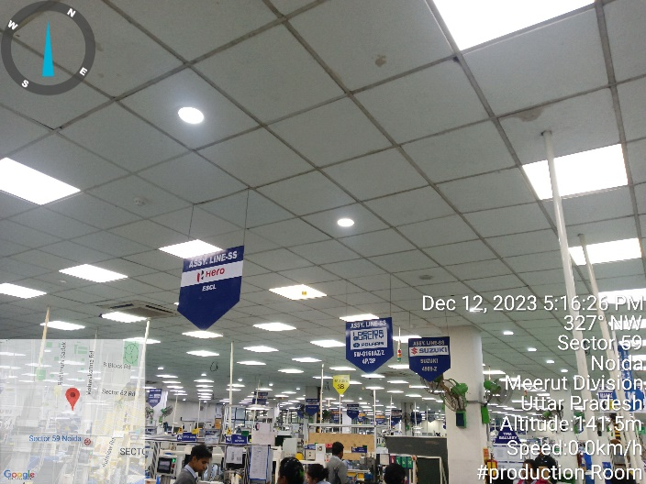 | 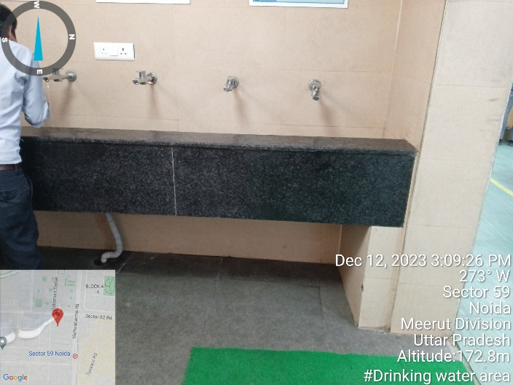
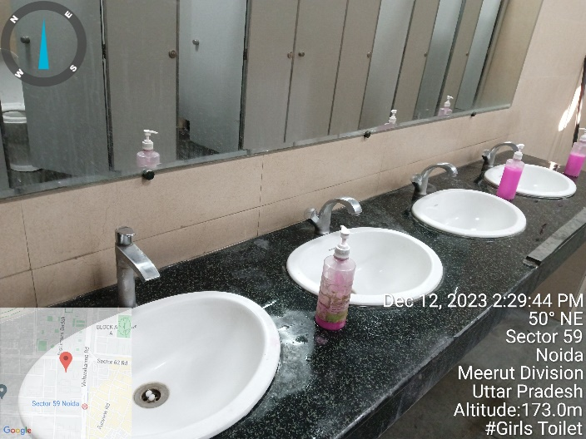 | 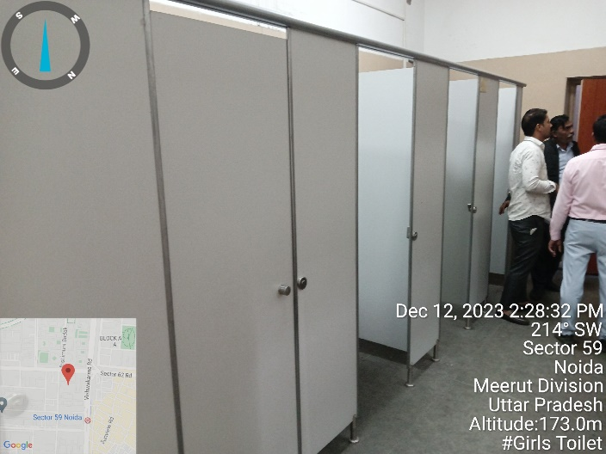
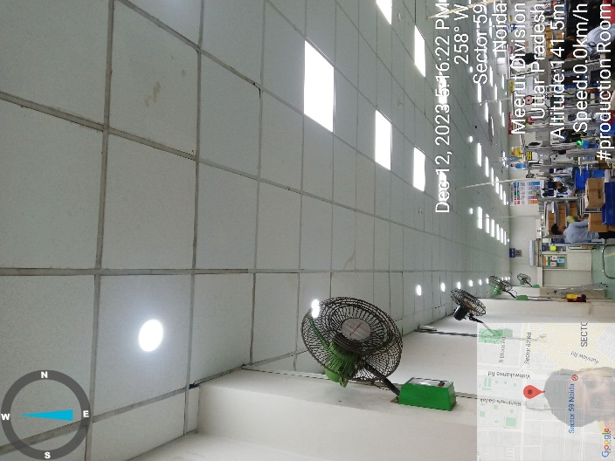 | 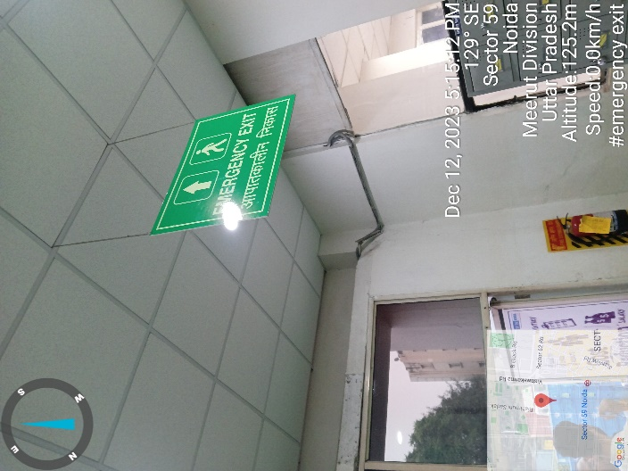

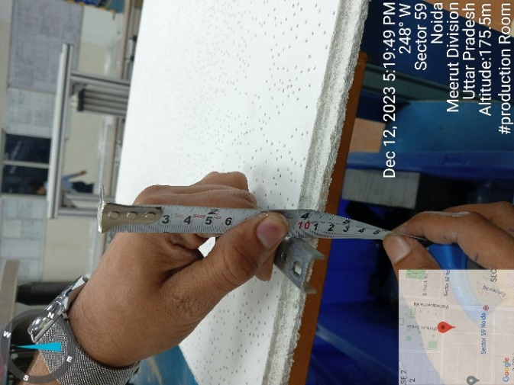 | 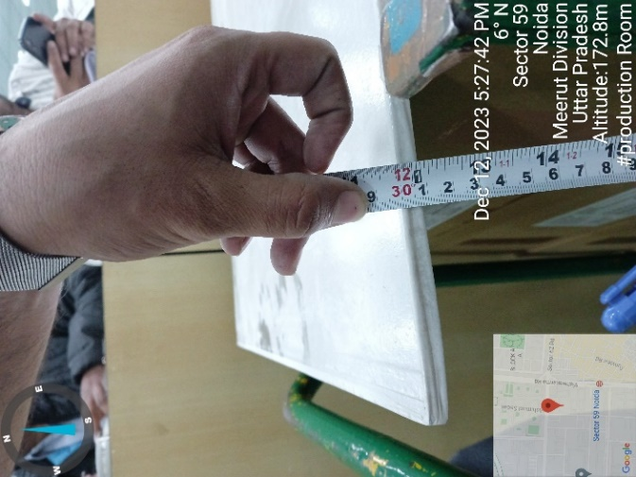 | 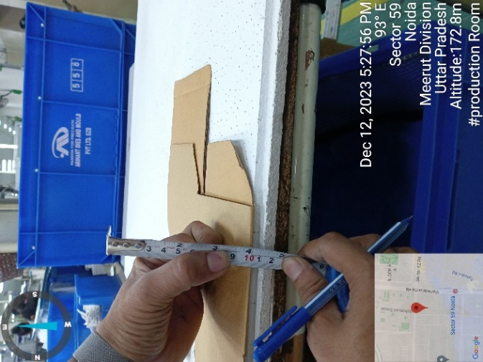
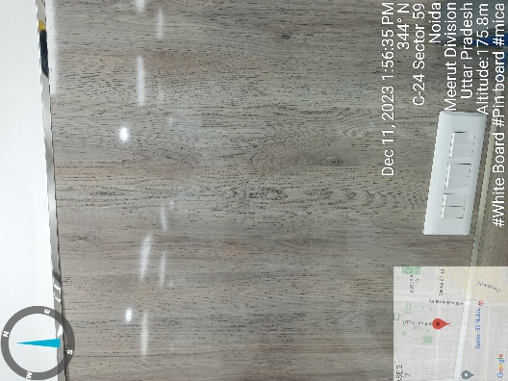 | 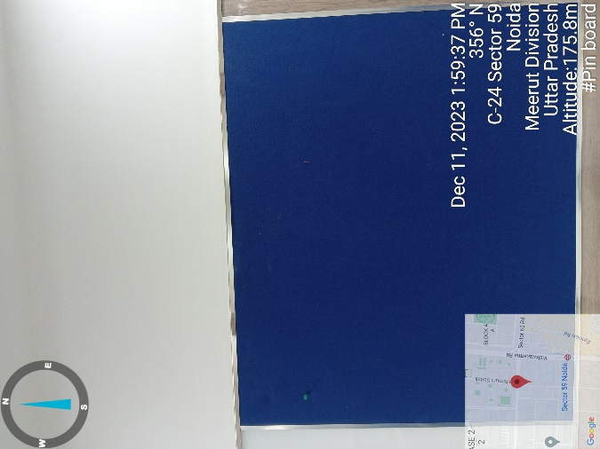 | 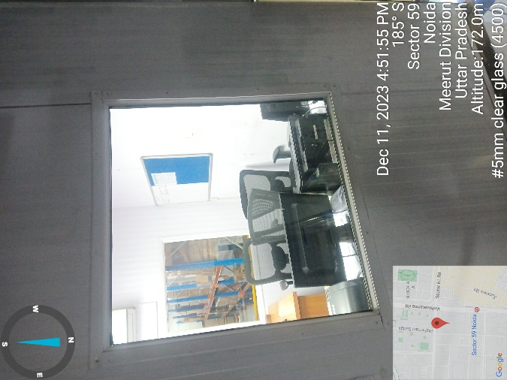
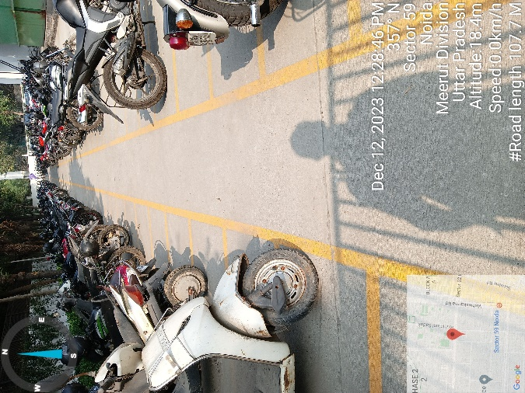 | 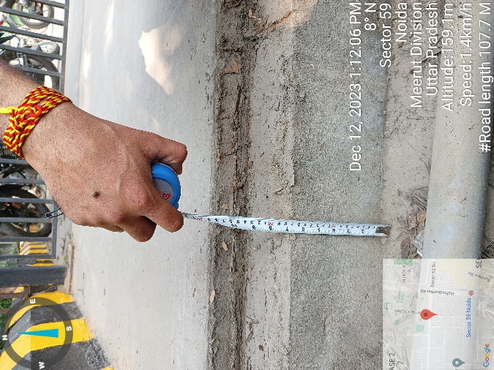 | 