REPORT FORMAT: CL-1 | Version: 1.0_2018

FILE No.: VIS(2023-24)-PL574-485-742 Date: 15-12-2023

- CERTIFICATE NAME: Certificate of Installation of Plant & Machinery.
- FOR ORGANIZATION: M/s Nuflower Foods and Nutrition Pvt. Ltd.
- INDUSTRY TYPE: Manufacturer of Energy Dense Nutritious Foods
- CURRENT LOCATION OF THE MACHINES: Plot No. 303, Sector-7-II, IMT Manesar, Gurugram, Haryana

TO WHOMSOEVER IT MAY CONCERN

S. NO. | PARTICULARS | DESCRIPTION
 | Date of Certificate | 15-12-2022
 | Date of Survey | 14-12-2023
 | Work Order Reference No. | Via E-mail dated: 13-12-2023
 | Documents provided for perusal | - List of Machines  - Copy of Machine Invoices  - Process Flow Chart
 | Current Location of the Machines | Plot No. 303, Sector-7-II, IMT Manesar, Gurugram, Haryana
 | Company Name | M/s. Nuflower Foods and Nutrition Pvt. Ltd.
 | Type of Industry | Machines for manufacturing of Energy Dense Nutritious Foods
 | Type of Assessment | Verification of physical presence of installed machines as per list shared by the company
 | Scope of Assessment | Verification of physical presence of installed machines as per list shared by the company
 | Purpose of Certificate | For Karnataka Government Tender purpose
 | Nature of Machinery | Machines related to Food Industry
 | Current Status of the machines | All the machines found to be installed & operational as per the list provided to us
 | Condition of Machines | Physical condition of all the machines are good & operational
 | Coordinating Person details from the company providing the details | Mr. Saday Singh (+91 99717 89969)
 | Final Conclusion | All the machines found to be installed & operational as per the list provided to us as mentioned in Part-A of the Certificate.
PART A | ASSESSMENT OF PLANT & MACHINERY

STATUS OF MACHINERY & EQUIPMENT:

Sr. | Equipment Description | Qty | Unit | Working Capacity | Gross Capacity | Supplier Name | Status/Remarks
1 | Oil Tanker Unloading Pump | 1 | Nos. | 20000 KG/H | 20000 KG/H | DI engineers | Installed & Operational
2 | Oil Silo | 2 | Nos. | 20000 KG | 40000 KG | Nu tech | Installed & Operational
3 | Oil Transfer Pump (Main Oil Tank to Buffer Oil Tank) | 1 | Nos. | 4000 KG/H | 4000 KG/H | DI engineers | Installed & Operational
4 | Buffer Oil Tank | 1 | Nos. | 400 KG | 400 KG | Nu tech | Installed & Operational
5 | Buffer Oil Transfer Pump | 1 | Nos. | 2000 KG/H | 2000 KG/H | DI engineers | Installed & Operational
6 | Emulsifier Tank | 1 | Nos. | 400 KG | 400 KG | Nu tech | Installed & Operational
7 | Wheel Mounted Buggy Trolley | 15 | Nos. | 200 KG | 200 KG | Prime Sol | Installed & Operational
8 | Buggy Lift and assembly | 1 | Nos. | 300 KG / cycle | 300 KG / cycle | Prime Sol | Installed & Operational
9 | Ribbon Blender | 1 | Nos. | 1800 kg | 2000 KG | Prime Sol | Installed & Operational
10 | Collection Tank | 1 | Nos. | 1800 KG | 2000 KG | Prime Sol | Installed & Operational
11 | Scrapped Surface Heater (Heating Contherm) | 2 | Nos. | 1000 KG/H | 2000 KG/H | Aman Entp | Installed & Operational
12 | Holding Tank | 2 | Nos. | 1800 KG | 4000 KG | Nu tech | Installed & Operational
13 | Scrapped Surface Heater (Cooling Contherm) | 2 | Nos. | 1000 KG/H | 2000 KG/H | Aman Entp | Installed & Operational
14 | Buffer Tank | 1 | Nos. | 1800 KG | 2000 KG | Nu tech | Installed & Operational
15 | Transfer Pump (Twin Screw Type) - 20 Bar | 2 | Nos. | 3000 KG/ Hour | 3000 KG/ Hour | Ascent Tech | Installed & Operational
16 | Transfer Pump (Twin Screw Type) - 10 Bar | 3 | Nos. | 3000 KG/ Hour | 3000 KG/ Hour | Ascent Tech | Installed & Operational
17 | Inline Metal Detector | 2 | Nos. | 2000 KGH | 4000 KG/H | Unique Equipment | Installed & Operational
18 | Pouch Packing Machine with online batch code printer | 3 | Nos. | 750 KG/H | 2250 KG/H | Akash Pack | Installed & Operational
19 | X-Ray Metal Detector | 3 | Nos. | 1000 KG /H | 3000 KG/H | Meci Tech (Economy) | Installed & Operational
20 | Belt Conveyor | 3 | Nos. | 1000 KG/H | 3000 KG/H |  | Installed & Operational
21 | Carton Tape Sealer - Double Side | 1 | Nos. | 2500 KG/H | 2500 KG/H |  | Installed & Operational
22 | Carton Coder | 1 | Nos. | 2500 KG/H | 2500 KG/H | Dominos Printer | Installed & Operational
23 | Core Mill (Paste Making) | 2 | Nos. | 600 KG/H | 1200 KG/H | VK Machines | Installed & Operational
24 | Chiller for SSHE - 25 TR | 1 | Set | 200 TR | 2000 TR | Blue Star | Installed & Operational
25 | Chiller for AHU - 100X2 TR | 2 | Nos. | 100 TR | 200 TR | Blue Star | Installed & Operational
26 | Air Compressor 125 CFM & 1 m3 Receiver 0.5 m3 | 1 | Nos. | 125 CFM | 125 CFM | Ateom Eng. | Installed & Operational
27 | Air Compressor 70 CFM ( Stand by) | 1 | Nos. | 70 CFM | 70 CFM | Ateom Eng. | Installed & Operational
28 | Gas Fired Thermic Fluid Heater - 2,00,000 Kcal/hr | 1 | Set | 2,00,000 Kcal/hr | 2,00,000 Kcal/hr | Ateom Eng. | Installed & Operational
29 | Hot Water Boiler | 1 | Nos. | 1,00,000 Kcal/hr | 12,00,000 Kcal/hr | Ateom Eng. | Installed & Operational
30 | Transformer - 1000 KVA | 1 | Nos. | 1000 KVA | 1000 KVA | Jindal (Poja) | Installed & Operational
31 | DG Set - 500 KVA | 2 | Nos. | 500 KVA | 1000 KVA | Kerolsker & Cummins | Installed & Operational
32 | Nitrogen Plant | 1 | Set | 12 NM3 per hour | 12 NM3 per hour | Nuberg | Installed & Operational
33 | RO plant with ULF | 1 | Set | 500 Ltr per hour | 500 Ltr per hour | Aetom | Installed & Operational

OBSERVATIONS:

- We have been provided with the list of machines, copy of bills & process flow chart of the machines purchased/installed by the company.
- As per observation made during site survey, all the machine as mentioned in the list, were found to be installed.
- Plant was fully operational and all the machines were running as per their usage.
- The subject plant is involved in manufacturing of “Ready-to-use Therapeutic Food” (RUTF), Ready-to-Use Supplementary Food (RUSF) and Lipid-based Nutrient Supplement (LNS) which are being exported majorly to African Countries.
- Based on the information provided and Observation made during site visit, it is certified that the above machines are installed at the above-mentioned site address.

METHODOLOGY/ APPROACH ADOPTED:

On site physical verification of the Plant & Machines against the list of Machines provided to us by the company as shown above.

During visit related Invoices/ Bills are also procured from the company.

Photographs taken of the machines installed which are also attached with the certificate.

Disclaimer:

  - During the course of the assessment, several information/ data/ inputs is referred made available to us by the company and in the event this is found to be incorrect then this certificate would be null & void.
  - This Installation Certificate is stated on the basis of the site visit by the surveyor on 14-12-2023 and we don’t recommend any other sort of recommendation in our Certificate.
  - This certificate doesn’t include any work related to drawing, design, sketch plan, and technical specifications of the machines.
  - Ownership and other legal point of view in respect of the asset is not considered in this report as same is out of scope of this certificate.
  - This certificate is made at the request of the Company.
  - We shall not be responsible in case of any removal of the machine from the site post our survey.
  - We have not commented upon whether the machines are new or old.
  - This certificate should not be used for any other purpose except as specified.
  - Level 1 (Primary) scrutiny approach is applied within the limited time to the best of the possibility using specified best practices. However chances of error can’t be ruled out which may require detailed verification & scrutiny.

SURVEY ANALYST | ENGINEER | REVIEWER
Manas Upmanyu &  Mohd. Shahid | Abhinav Chaturvedi | Sr. V.P. Projects

ANNEXURE: PHOTOGRAPHS

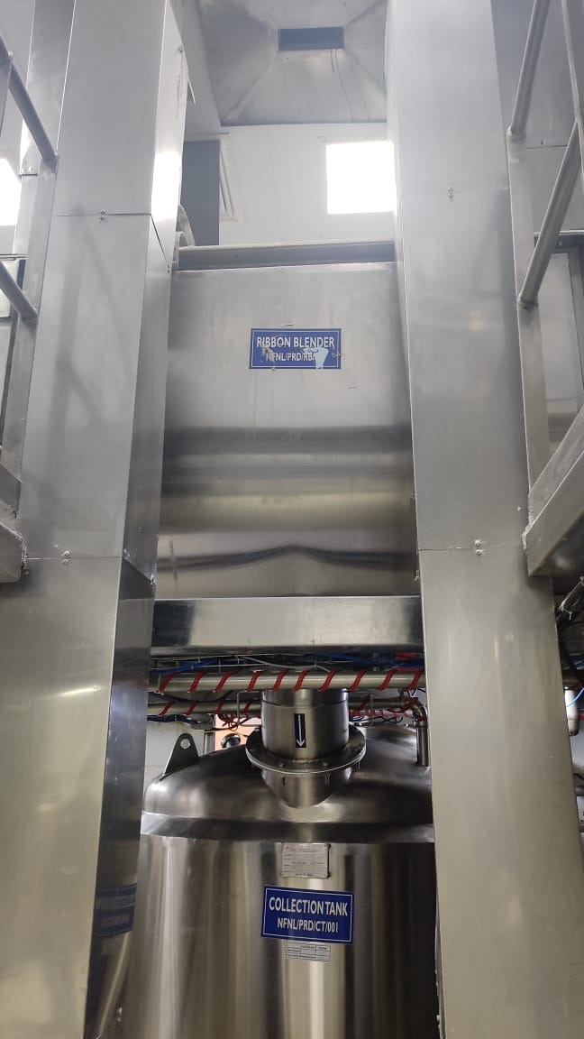 | 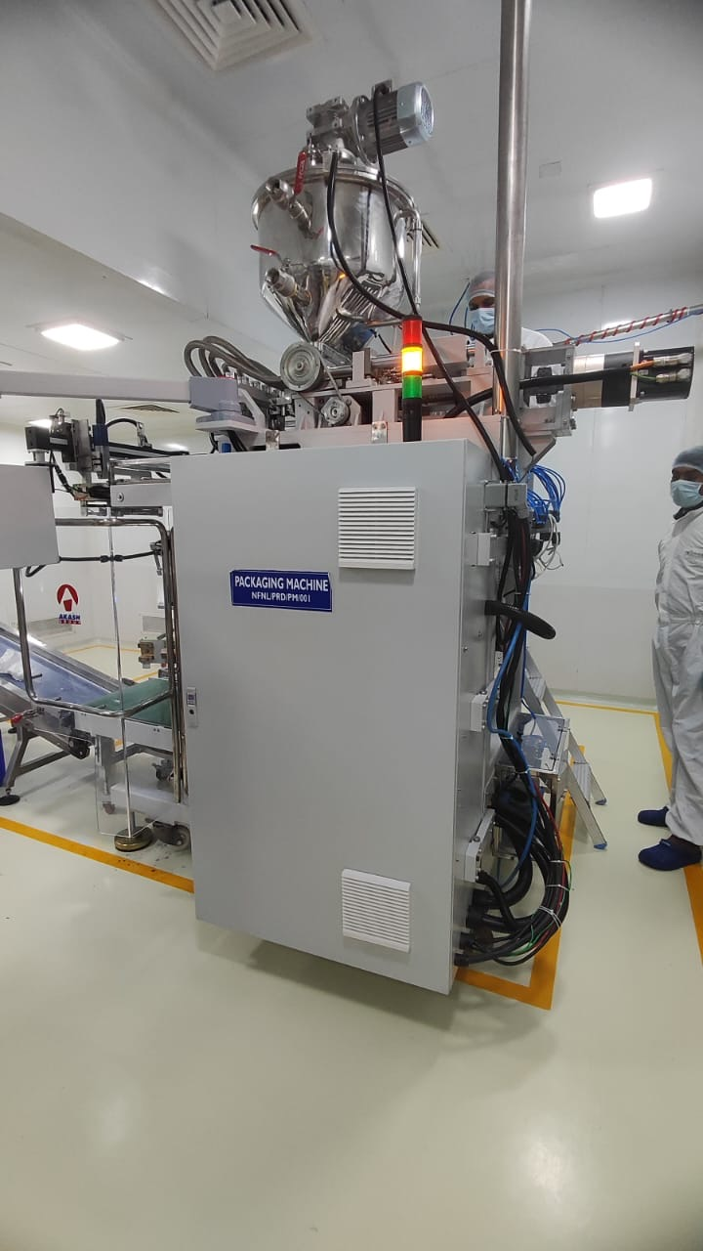 | 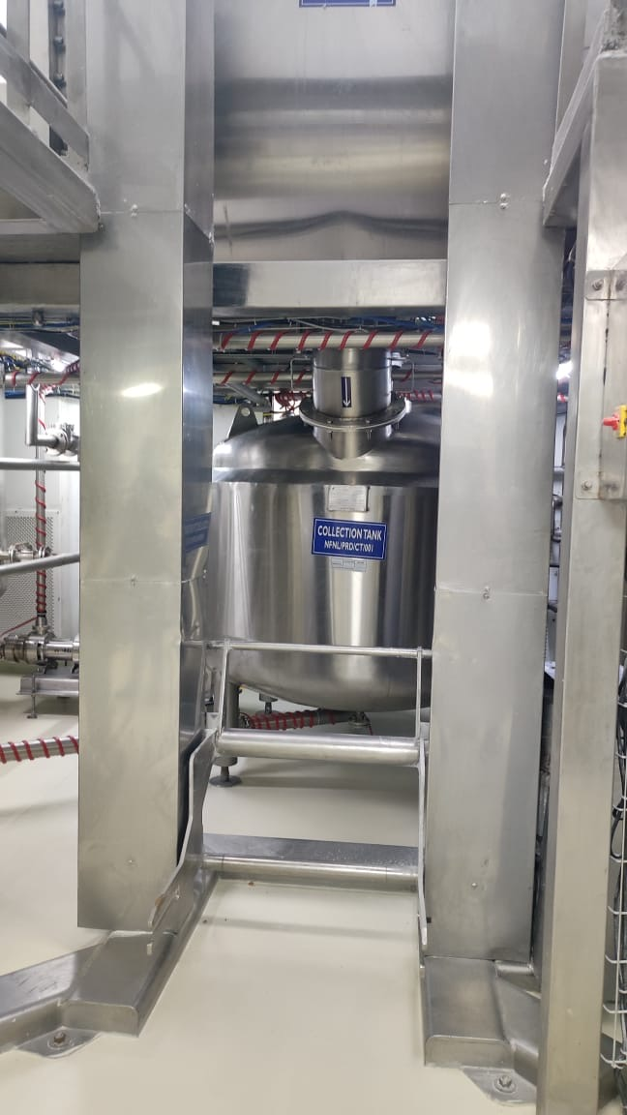
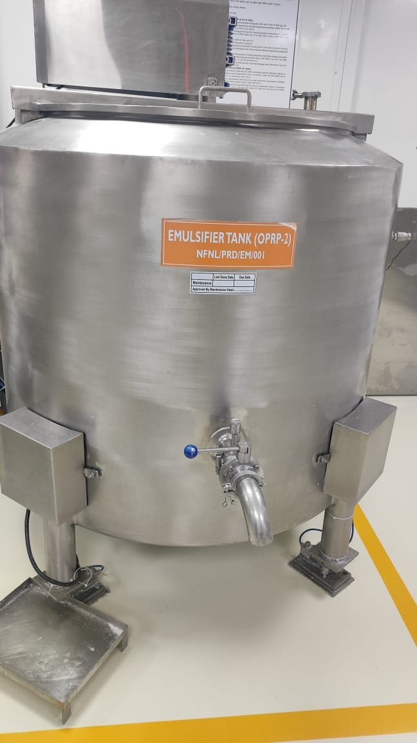 | 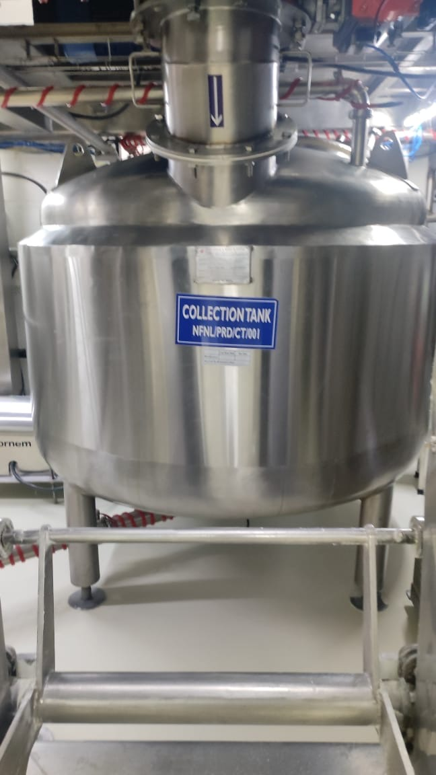 | 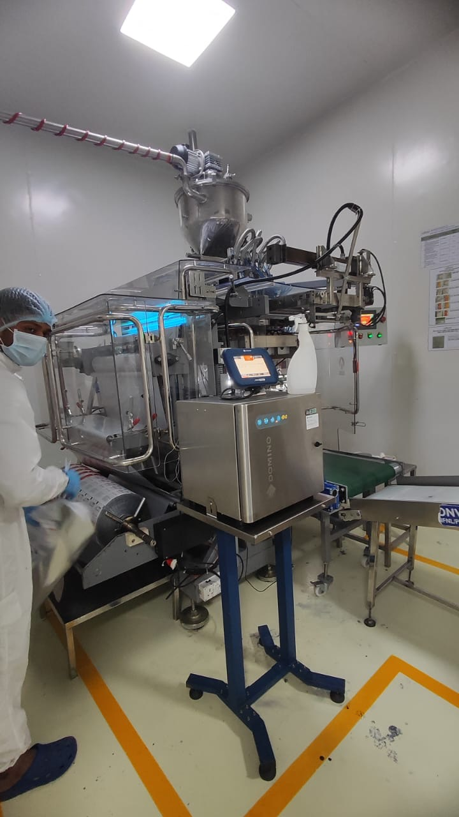

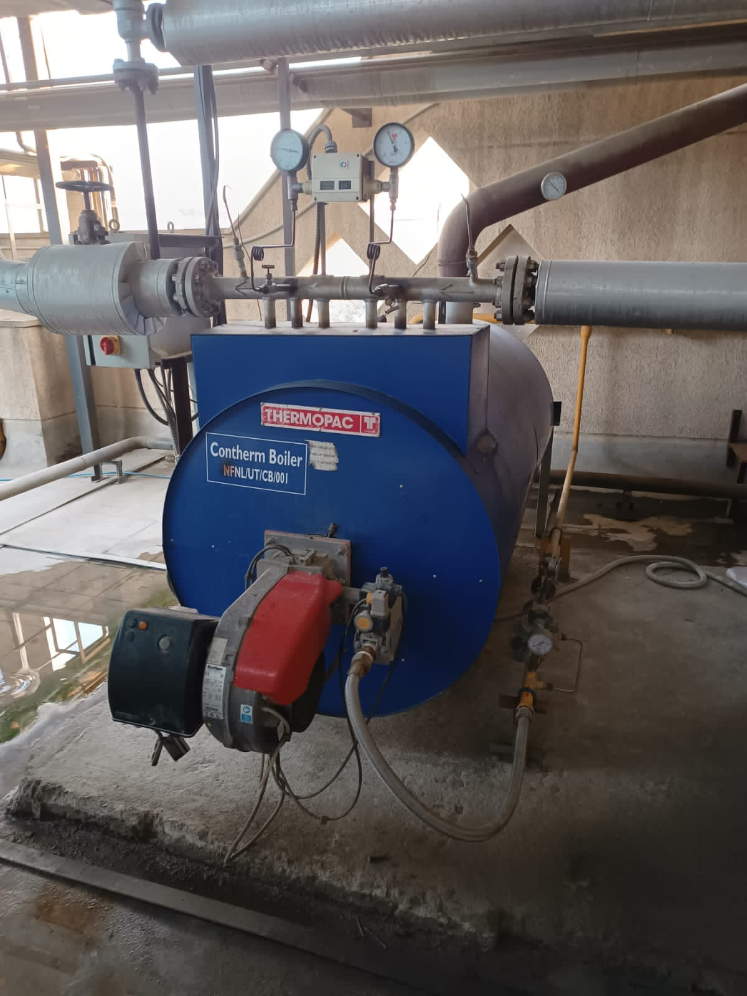 | 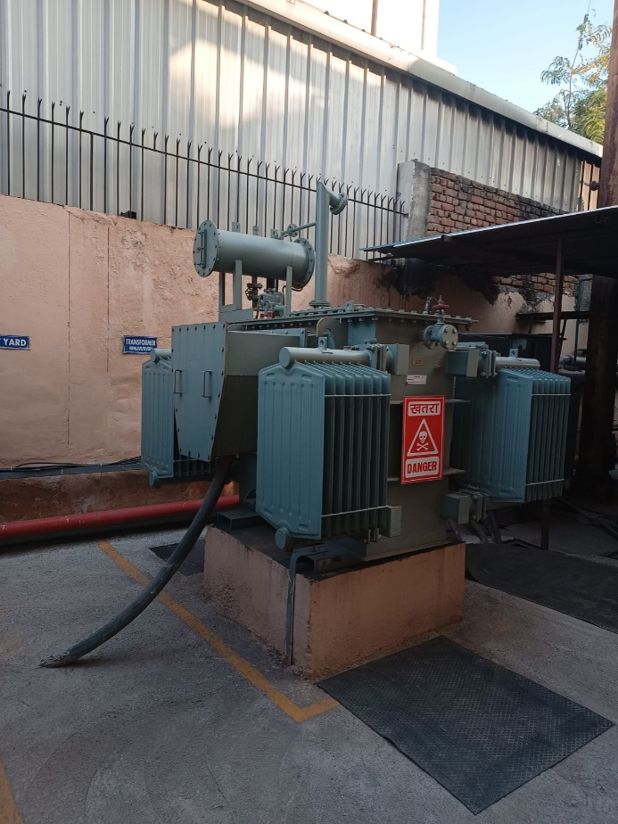
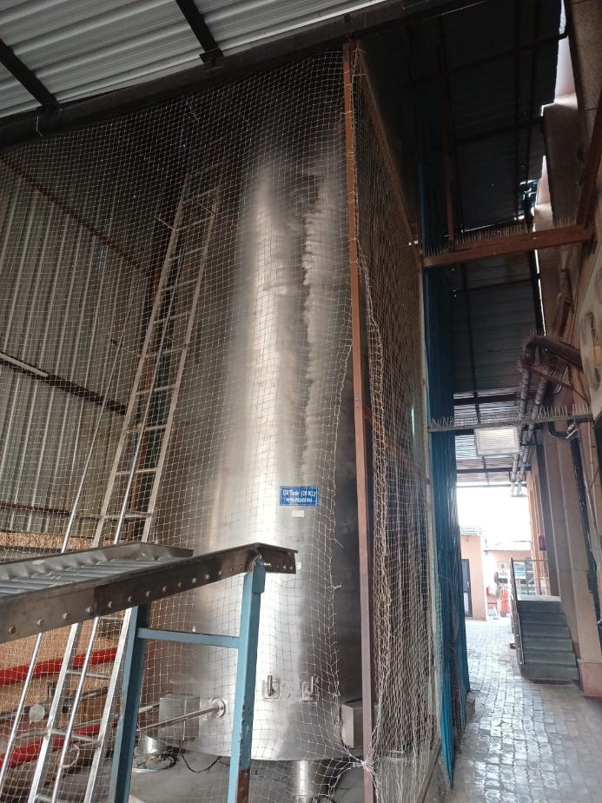 | 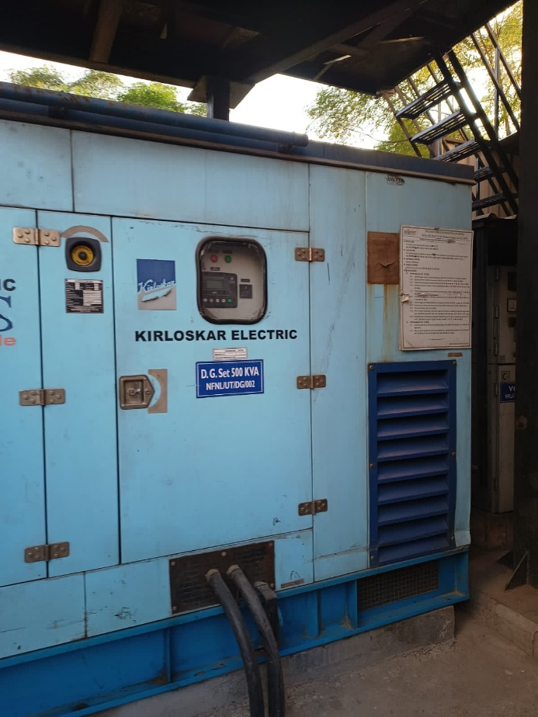

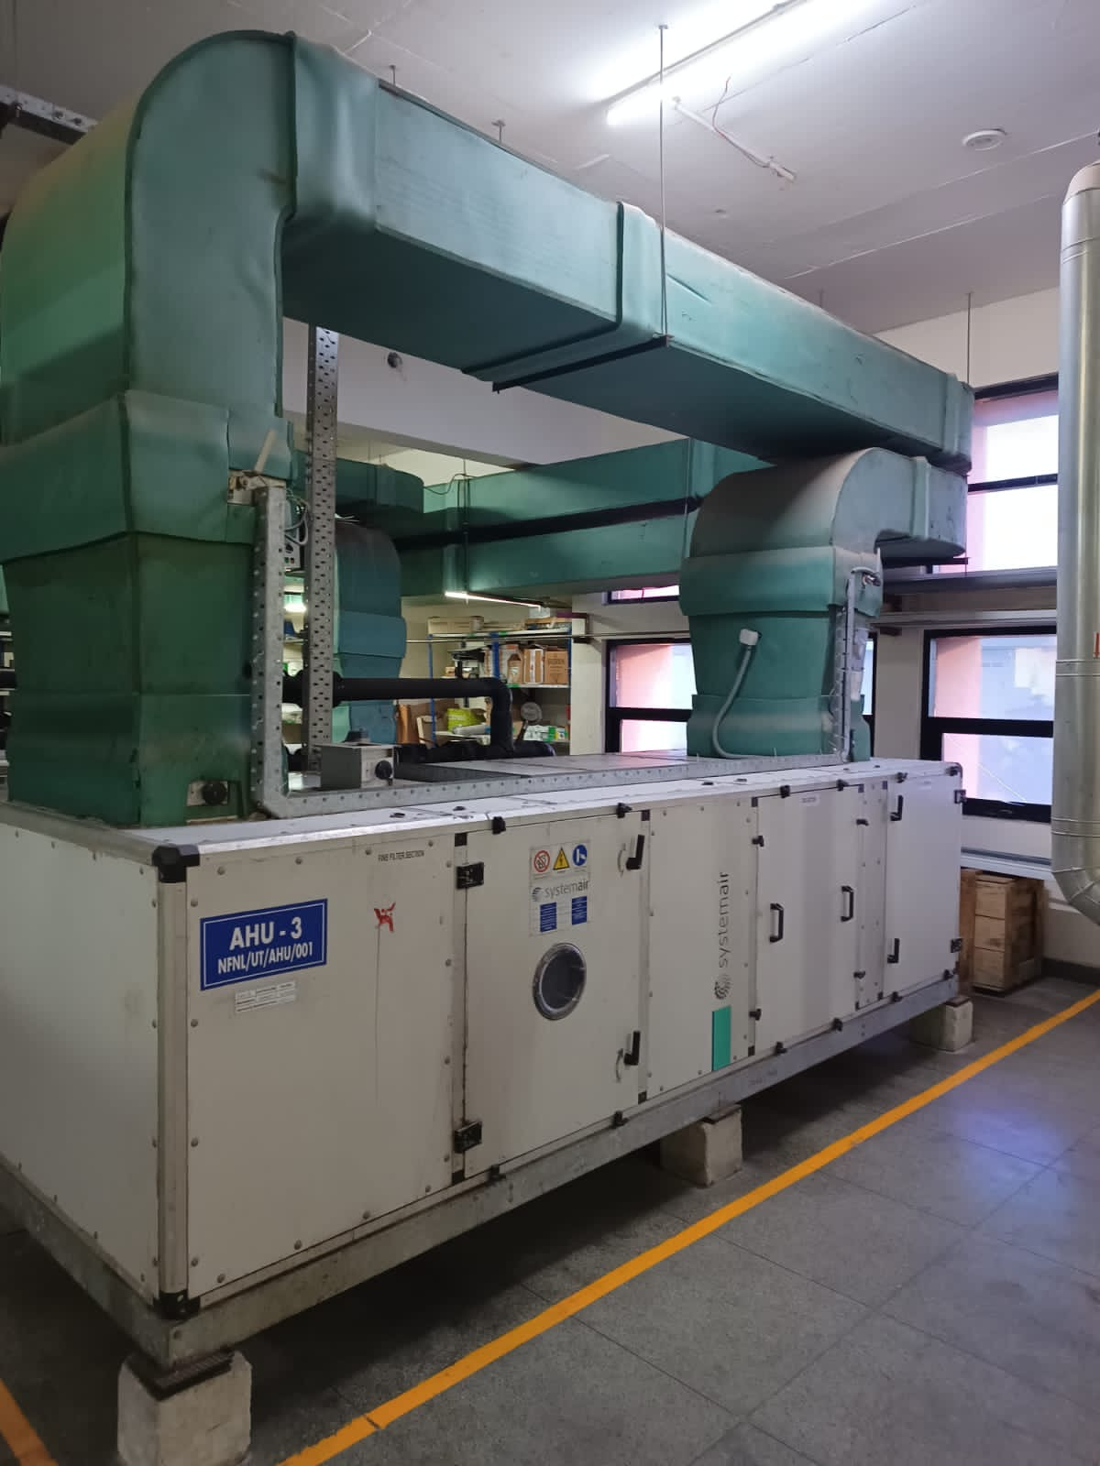 | 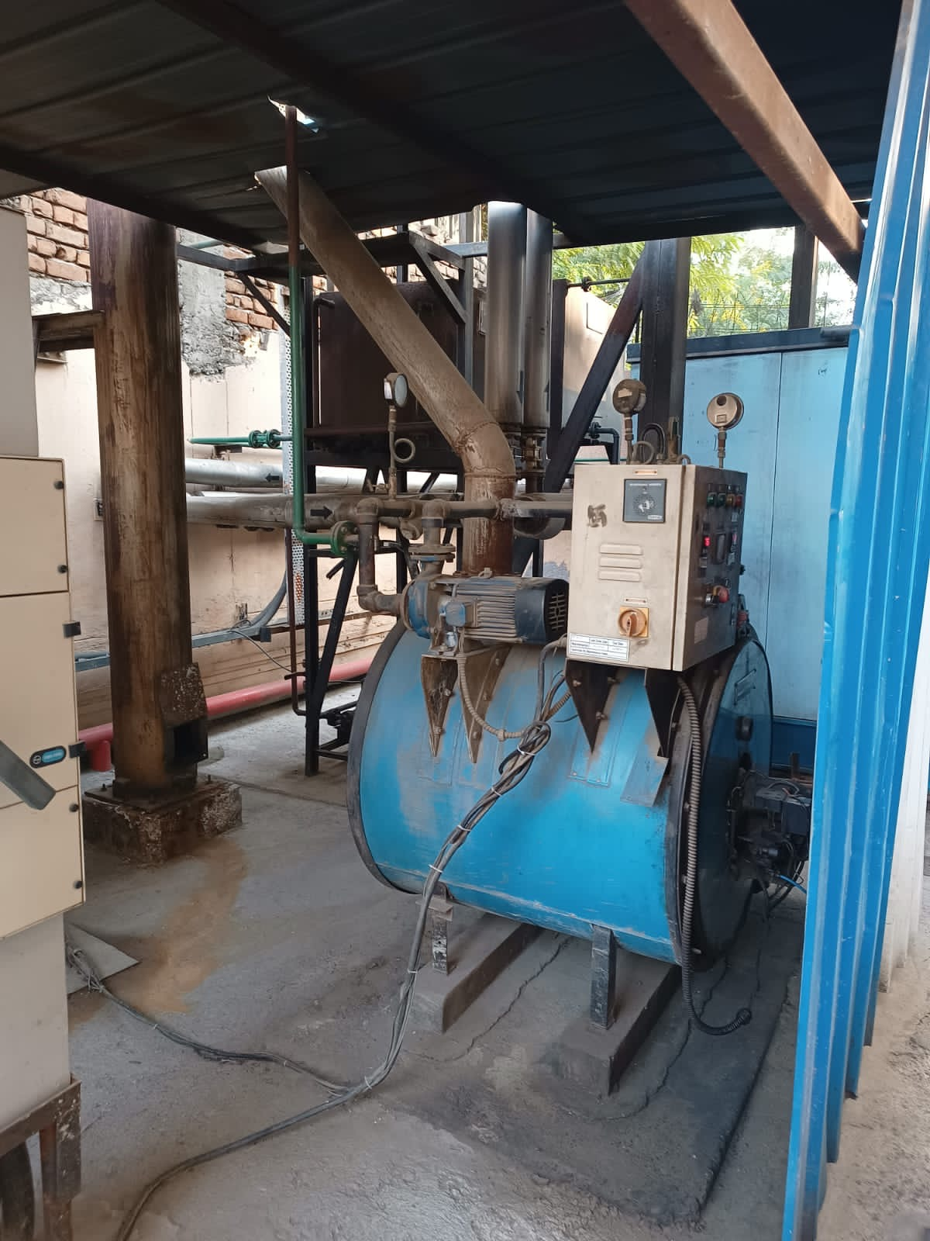
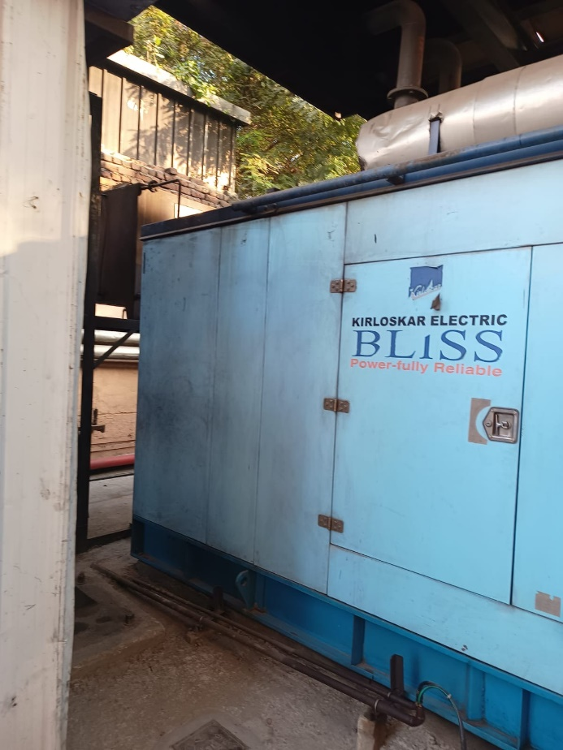 | 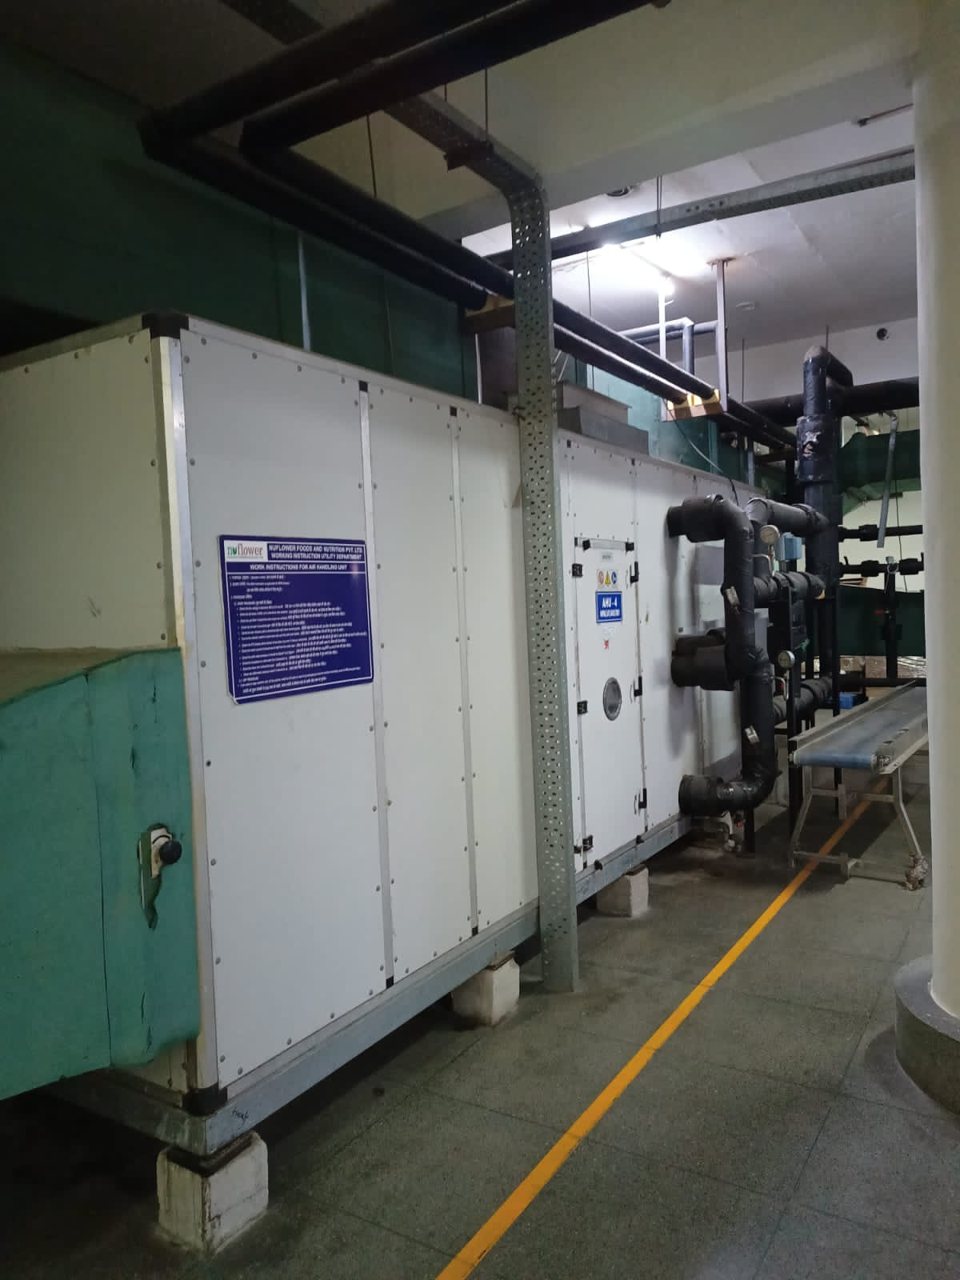

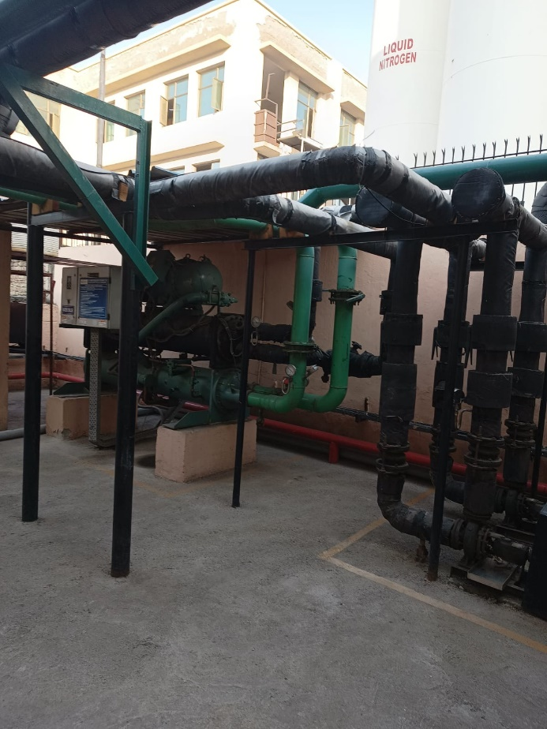 | 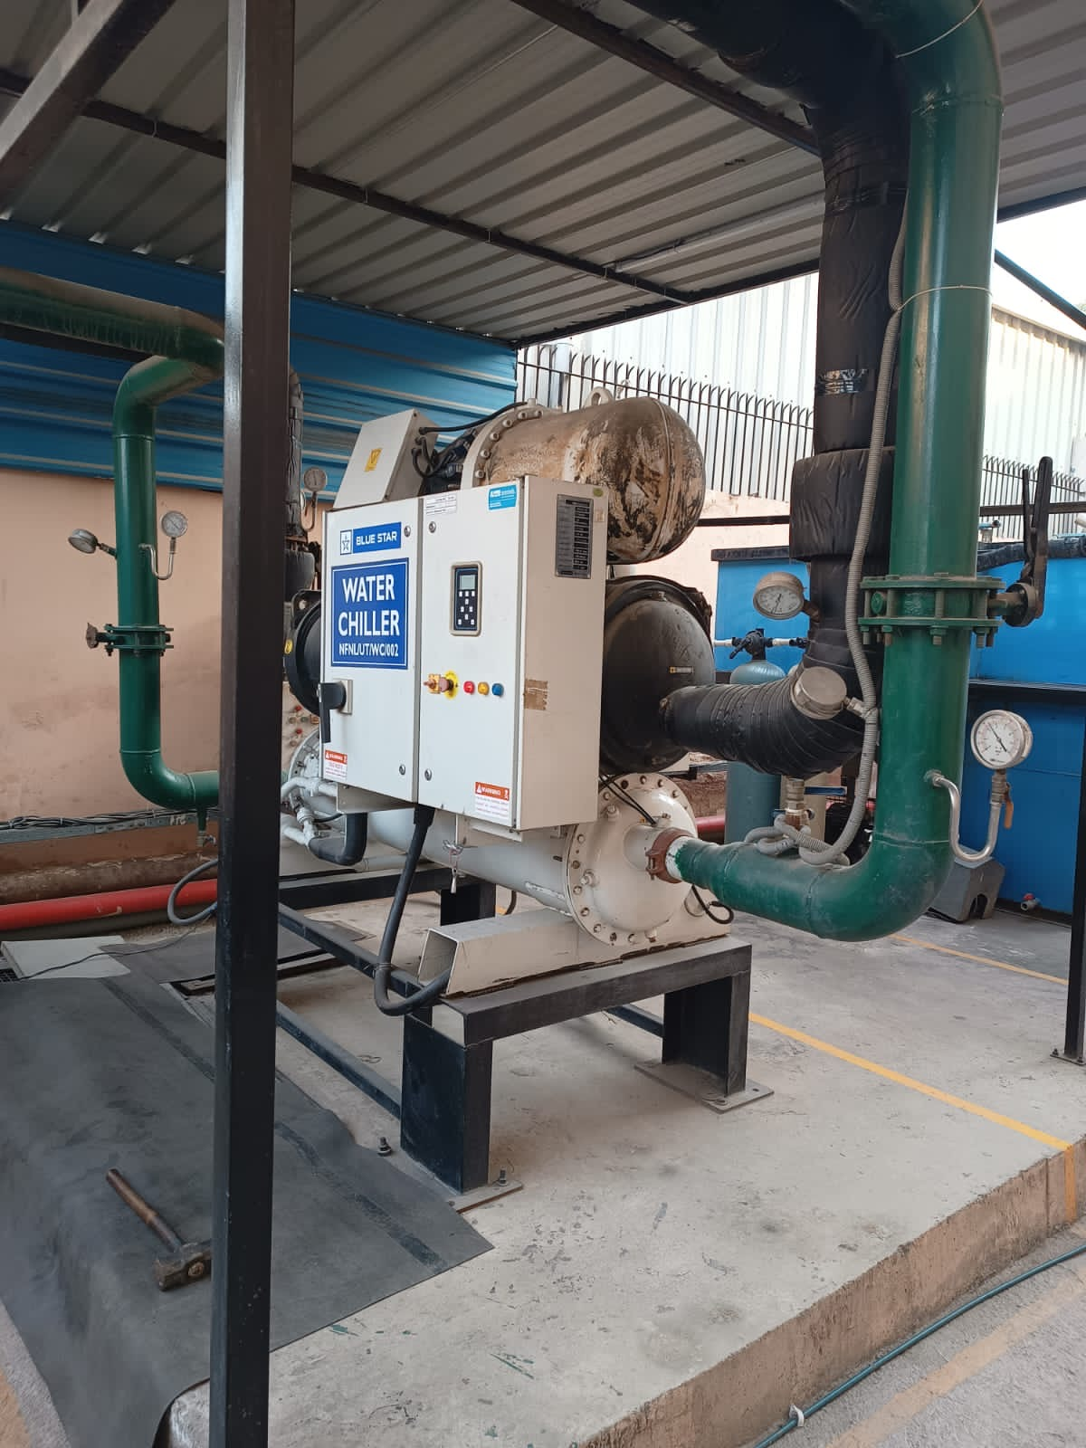
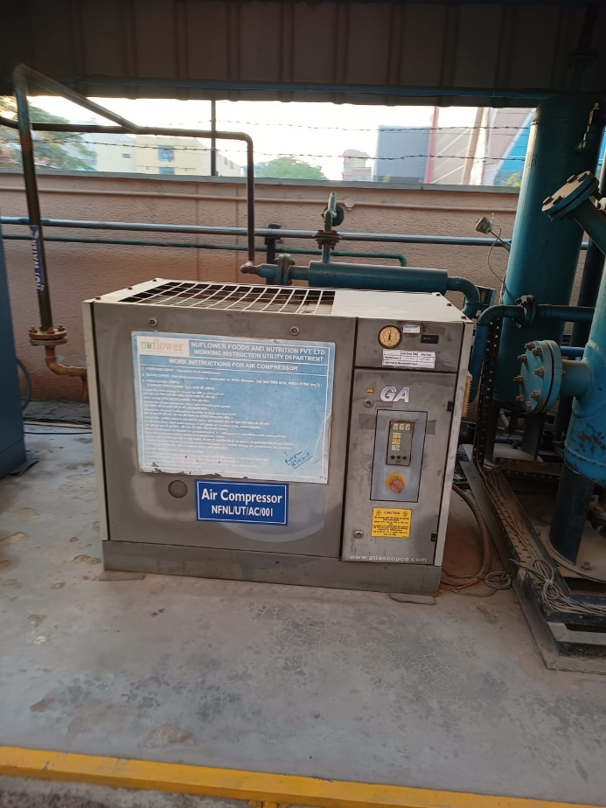 | 