REPORT FORMAT: CL-1 | Version: 1.0_2018

FILE No.: VIS(2023-24)-PL578-489-764 Date: 18-01-2024

- CERTIFICATE NAME: Completion and Installation Certificate for the machines/equipment and other civil related work
- PREPARED FOR ORGANIZATION: State Bank of India, SME Branch, Roorkee, District- Haridwar, Uttarakhand
- BORROWER COMPANY’S NAME: M/s Shakumbari Automobiles Pvt Ltd
- CURRENT LOCATION OF THE MACHINES: Installed at properties at various location of Uttarakhand & Uttar Pradesh (Dehradun, Lambgaon, Banswara (Near Chandrapuri), Pauri, Laksar, Noorpur, Narendra Nagar)

TO WHOM IT MAY CONCERN

S. NO. | PARTICULARS | DESCRIPTION
1. | Date of Survey | 08-01-2024 & 19-12-2023
2. | Date of Certificate | 18-01-2024
3. | Work Order Reference No. | Via email dated 15-12-2023
4. | Documents provided for perusal | - Invoices of the machines/equipment installed and other civil related work  - Summary of the amount
5. | Current Location of the machines/equipment | M/s Shakumbari Automobiles Pvt Ltd, at various location of Uttarakhand & Uttar Pradesh (Dehradun, Lambgaon, Banswara(Near Chandrapuri), Pauri, Laksar, Noorpur, Narendra Nagar)
6. | Company Name | M/s Shakumbari Automobiles Pvt Ltd
7. | Co-ordinates of the property where machines/equipment are installed | 29°45'19.8"N 78°01'57.1"E - Laksar  30°08'01.0"N 78°47'10.3"E - Pauri  30°27'13.4"N 79°04'25.6"E - Banswara(Near Chandrapuri)  30.50563712N 78.49957001E - Lambgaon  29°07'46.5"N 78°25'54.4"E - Noorpur  30°09'43.1"N 78°17'31.4"E - Narender Nagar  30°16'24.8"N 77°59'17.7"E – True Value Dehradun  30°16'25.8"N 77°59'17.5"E - Dehradun
8. | Scope of Assessment | Completion and Installation Certificate for the machines/equipment and other civil related work which is installed at properties located at various location of Uttarakhand & Uttar Pradesh (Dehradun, Lambgaon, Banswara(Near Chandrapuri), Pauri, Laksar, Noorpur, Narendra Nagar)
9. | Nature of Machinery | Machines/ equipment installed for Automobile Service Centre
10. | Current Status of the machines/equipment | All the machines/equipment found to be installed & operational as per the list provided to us
11 | Condition of machines/equipment | Physical condition of all the machines is good & operational
12 | Coordinating person details from the company providing the details | Mr. Deepak Sharma(+91- 98370 18945) - Laksar  Mr.Pravesh Singh(+91- 7037932309) - Lambgaon  Mr. Avneesh Kumar(+91-8755998054) - Banswara(Near Chandrapuri)  Mr. Pankaj Anthwal(+91- 8979696269)- Pauri  Mr. Deepak Sharma(+91- 98370 18945) – Noorpur  Mr. Girish Nautiyal(+91- 9756200900) – Narendra Nagar  Mr. Suraj Sexena(+91- 9760240655) – True Dehradun  Mr. Suraj Sexena(+91- 9760240655) – Dehradun
13 | Final conclusion | All the machines found to be installed & operational as per the list provided to us as mentioned in Part-A of the Certificate.

LAKSAR SITE
S. No. | Particulars | Amount  (INR) | Remarks
1 | Building | 1,84,589 | Office Flooring work 25' x 17' area, Workshop Flooring 10' x 32' area, paint work on complete building with area 40' x 85'
2 | Machinery & Equipment | 13,14,133 | 3-Car lifting machine, 1-Balancing Machine, 1-Alloyment, 1-Compressor, 1-Car washing Machine, 3-Tool kit trolley, 1-Gear Oil Change Machine, 1-engine oil change machine spare parts,
3 | Electrical Installation | 80,331 | 1-Invertor with 2 batteries, 1-AC, 5-wall fan, 4-roof fan, Home UPS V-Guard 1650
4 | Office Equipment | 2,53,091 | 1-sofa (three-seater), 8-chairs, 5-tables
5 | Computers | 19,068 | 2-Personal Computers (Desktops), 2-Printer (HP MFP M126nw), 1-Laptop (Lenovo), 1-UPS (60 VA Enter)
6 | D.G. Set | 1,00,000 | 1-Generator 25 KVA III-Phase 415 Volt Make Tata 407 Open Genset with Battery
7 | Fire Extinguisher | 14,300 | 4-fire extinguishers (ABC Type Capacity- 6 kg, Co2 type Capacity- 4.5 kg, M/Foam type Capacity- 9 Litre)
Total |  | 19,65,512

LAMBGAON SITE
S. No. | Particulars | Amount  (INR) | Remarks
1 | Machinery & Equipment | 59,655 | 1-Lift Machine, 1- Tool Kit, 1-Engine Oil Changer, 1- Balancing Machine, Battery Charger Machine, 1- Compressor Machine, 1- Automatic tyre Inflator Machine.
2 | Furniture & Fixtures | 4,73,040 | 6- Black Chair, 3- Table, 2- Grey Chair
3 | Office Equipment | 72,890 | 6- Black Chair, 3- Table, 2- Grey Chair
Total |  | 6,05,585

BANSWARA (NEAR CHANDRAPURI) SITE
S. No. | Particulars | Amount  (INR) | Remarks
1 | Building | 72,508 | Flooring work at lower ground floor(13’X26’)  Tin shed at upper ground floor(30’X26’)  Ceiling at office room(11’X22’)
2 | Machinery & Equipment | 4,83,740 | 1-Tool Kit, 1-Car Lifting Machine, 1-Compressor,1-Automatic tyre Inflator, 1-battery Charger, 1- Balancing Machine, 1-Engine Oil Changer
4 | Office Equipment | 69,745 | 5-Black Chair, 3-Table,
 | Furniture & Fixtures | 1,16,788 | 5-Racks, 2-Grey Chair
Total |  | 7,42,781

PAURI SITE
S. No. | Particulars | Amount  (INR) | Remarks
1 | Building | 1,39,476 | Ceiling Work- 24’x24’ & 12’x10’
2 | Machinery & Equipment | 4,01,855 | 4-Air Gun, 1-Compressor, 1-Vaccum Cleaner, 1-Engine oil Changer, 1-Tool kit, 1-Air automatic tyre Inflator, 1- Car lifting Machine, 1- Balancing Machine, 1-Battery Changer, 1Numatic Machine, 1-Car washing machine, 1- Inverter with battery
3 | Office Equipment | 1,42,296 | 1-Room Heater, 1-Office small Almirah, 3-Fire Fighting, 1- Wifi, 2-Desktop, 1-Laptop, 1-Printer
4 | Furniture & Fixtures | 1,42,296 | 4-Tables, 2- Round table with six chair, 12-Black Chair, 1- Two Seater Sofa Black, 1-Center Table
Total |  | 11,08,898

NOORPUR SITE

S. No. | Particulars | Amount  (INR) | Remarks
1 | Building | 7,71,673 | 30’x38’-Tiles, 70’x40’- Shed in body Shop, Tiles in Office Space-46’x38’, PCC Flooring-38’x101’
2 | Machinery & Equipment | 25,04,352 | 3-Car Lift, 3- Tool Box, 1- Allotment Machine, 1- Air Filling Machine, 1-Vacuum Cleaner, 1-Bench Grinder, 1-Oil Changer, 1-Balancing Machine, 1-Air pressure Machine, 1-Gun Machine, 1-Air Blower, 1-Compressor, 1-Cutter plasma, 1-Washing Machine, 1-Iron Table, 1-Gas Cylinder, 1-Gas Chulha, 1-Water cooler
3 | Electrical Installation | 7,18,714 | 1-Inverter, 4-Battery
4 | Office Equipment | 5,95,764 | , 1-Plastic Table, 3-Round Table, 29-Chair, 4-Monitor, 5-Mouse, 4-key Board, 4-CPU, 2-Printer, 1-Camera LED, 2-AC, , 9-Nitrogen Cylinder
5 | D.G. Set | 3,81,356 | 1-Generator RT 40-40 KVA Silent DG Set 3 Phase
6 | Fire Extinguisher | 32,300 | Fire Extinguishers M/Foam Type Cap 9 Ltr.
7 | Furniture & Fixtures | 2,76,458 | 6-Wall Fan, 27-Roof Fan, 62-Lights, 2-Sofa, 1-Table Mirror, 7-Wooden Table
Total |  | 52,80,617

NARENDRA NAGAR SITE
S. No. | Particulars | Amount  (INR) | Remarks
1 | Building | 5,42,581 | Tin Shed & 11ft High of Ceiling – (30’x21’), Shed- (24’x30’), Complete paint work
2 | Machinery & Equipment | 4,85,496 | 1-Car Lifting Machine, 1-Automatic Tyre Inflator Machine, 1-Tool Box, 1-Balancing Machine, 1-Engine Oil Changer Machine, 1-Numatic Machine, 1-Compressor
3 | Electrical Installation | 83,265 | 1-Inverter with Two Battery, 1-Battery Charging Machine
4 | Office Equipment | 3,76,556 | 2-Round Table with 6 Chair
7 | Furniture & Fixtures | 1,84,816 | 2-Table Fan, 1-Two Seater sofa
Total |  | 16,72,714

TRUE VALUE DEHRADUN SITE
S. No. | Particulars | Amount  (INR) | Remarks
1 | Building | 22,43,438 | Office Flooring work 25' x 17' area, Workshop Flooring 10' x 32' area, paint work on complete building with area 40' x 85'
2 | Electrical Installation | 20,044 | 4-car lifting machine, 2-alligment machine,1- balancing machine, 1-Gas filling machine, 1-Tyre changer machine, 1-Engine jack machine, 5-Tool Kit,1-Nitrogen Filling Machine, 4-Oil Cane, 1-Hydraulic jack, 1-Gear oil Filling Machine , 1-Soccer Puller machine, 1-Smart Diagnostic tester, 1-Vacuum cleaner, 1-Machine Gun
3 | Office Equipment | 2,83,929 | 1-sofa (three-seater), 8-chairs, 5-tables
4 | Furniture & Fixtures | 7,98,095 | 1-sofa (three-seater), 8-chairs, 5-tables
5 | Air Conditioners | 2,15,030 | 1.5 ton Air Conditioners
Total |  | 35,60,536

DEHRADUN SITE

S. No. | Particulars | Amount  (INR) | Remarks
1 | Building | 2,48,35,565 | Office Flooring work 25' x 17' area, Workshop Flooring 10' x 32' area, paint work on complete building with area 40' x 85'
2 | Machinery & Equipment | 31,33,363 | 4-car lifting machine, 2-alligment machine,1- balancing machine, 1-Gas filling machine, 1-Tyre changer machine, 1-Engine jack machine, 5-Tool Kit,1-Nitrogen Filling Machine, 4-Oil Cane, 1-Hydraulic jack, 1-Gear oil Filling Machine , 1-Soccer Puller machine, 1-Smart Diagnostic tester, 1-Vacuum cleaner, 1-Machine Gun
3 | Electrical Installation | 56,12,887 | 1-DG Set 16KVA , Electric Panel, Control Panel, Compressor
4 | Office Equipment | 31,54,499 | 1-sofa (three-seater), 8-chairs, 5-tables
6 | Fire Extinguisher | 10,49,835 | 4-fire extinguishers (ABC Type Capacity- 6 kg, Co2 type Capacity- 4.5 kg, M/Foam type Capacity- 9 Litre)
7 | Computer | 15,43,321 | 2-Personal Computers (Desktops), 2-Printer (HP MFP M126nw), 1-Laptop (Lenovo), 1-UPS (60 VA Enter)
8 | Furniture & Fixture | 80,89,604 | 1-sofa (three-seater), 8-chairs, 5-tables
Total |  | 4,99,67,177

OBSERVATIONS:

- We have been provided with the list of machines, copy of invoices of the machines purchased/installed and civil related work by the company.
- As per observation made during site survey, all the machines as mentioned in the list, were found to be installed and operational in the automobile service centers in 4 different locations mentioned above.
- Based on the information provided and observation made during site visit, it is certified that the above machines are installed and are operational at the above-mentioned site addresses.

METHODOLOGY/ APPROACH ADOPTED:

- On site physical verification of the machines / equipment and other civil related work against the list provided to us by the company as shown above.
- During visit related Invoices/ Bills are also procured from the company.
- Photographs taken of the machines/equipment installed which are also attached with the certificate.

Disclaimer:

  - During the course of the assessment, several information/ data/ inputs is referred made available to us by the company/ client/ bank and in the event, this is found to be incorrect then this certificate would be null & void.
  - This Installation Certificate is stated on the basis of the site visit by the surveyor on 08-01-2024 and 19-12-2023 and we don’t recommend any other sort of recommendation in our Certificate.
  - This certificate doesn’t include any work related to drawing, design, sketch plan, and technical specifications of the machines.
  - Ownership and other legal point of view in respect of the asset is not considered in this report as same is out of scope of this certificate.
  - This certificate is made at the request of the Bank.
  - We shall not be responsible in case of any removal of the machine from the site post our survey.
  - We have not commented upon whether the machines are new or old.
  - This certificate should not be used for any other purpose except as specified.
  - Level 1 (Primary) scrutiny approach is applied within the limited time to the best of the possibility using specified best practices. However, chances of error can’t be ruled out which may require detailed verification & scrutiny.

SURVEY ANALYST | ENGINEER | REVIEWER
Deepak Joshi | Nischay Gautam | Abhinav Chaturvedi

ANNEXURE: - I (LIST OF MACHINES/EQUIPMENT – LAKSAR UNIT)
S. No. | Invoice Date | Description of Machine | Invoice Amount  (INR)
1 | 13-02-2023 | Wheel Alignment Machine | 4,20,000
2 | 28-09-2022 | Endura White Plus 300x300-10 | 3,06,000
3 | 28-09-2022 | Spacer 4 mm New | 1,95,000
4 | 13-02-2023 | Two Post Lift | 1,67,000
5 | 02-12-2022 | Steelage Racks | 1,61,206
6 | 28-09-2022 | Yellow- 300x300-10 | 1,17,640
7 | 19-04-2023 | Generator 25 KVA III-Phase 415 Volt Make Tata 407 Open Genset with Battery | 1,00,000
8 | 27-09-2022 | Two Post Lift | 83,500
9 | 27-09-2022 | Wheel Balancer | 80,000
10 | 26-04-2023 | Car Washer | 65,000
11 | 28-09-2022 | Spacer 3 mm | 60,000
12 | 27-09-2022 | Car Washer | 59,000
13 | 27-09-2022 | Air Compressor | 59,000
14 | 13-02-2023 | Vaccum Cleaner | 48,000
15 | 26-04-2023 | Tool Trolley with Tools | 42,000
16 | 08-06-2023 | Battery | 39,063
17 | 29-09-2022 | GI Pipe - 25mm | 35,700
18 | 28-09-2022 | Dhulai, Utrai, Chadhai, and Chatta Lagai | 32,000
19 | 28-09-2022 | 4 mm x 4 core Copper Flexible Wire | 25,760
20 | 26-04-2023 | Impact Wrench 1/2" | 25,000
21 | 21-11-2022 | Dhulai, Utrai, Chadhai, and Chatta Lagai | 23,400
22 | 16-02-2023 | Solar Power Generating System | 23,200
23 | 02-12-2022 | Socket, Pallet, Elbow Etc. | 21,729
24 | 27-09-2022 | Tool Trolley with Tools | 18,500
25 | 19-01-2023 | Printer | 17,203
26 | 06-01-2023 | RP 1/2" Impact Wrench (Twin Hammer) | 17,000
27 | 08-06-2023 | UPS JM SW 4000/48W | 15,678
28 | 28-09-2022 | 2.5 mm x single core copper flexible wire | 14,040
29 | 28-09-2022 | 1.5 mm x single core copper flexible wire | 13,179
30 | 13-02-2023 | Packing Charges for P&M machinery | 12,860
31 | 28-09-2022 | 12 way VTPN DB | 12,114
32 | 27-09-2022 | Installation Charges for P&M machinery | 10,000
33 | 13-02-2023 | Installation Charges for P&M machinery | 10,000
34 | 29-09-2022 | Airtac FRL 1/2" Semiautomatic | 9,980
35 | 28-09-2022 | 25 mm PVC Conduit Pipes | 9,600
36 | 02-12-2022 | Pipe,Clip,Nipple& others | 9,399
37 | 27-09-2022 | Packing Charges for P&M machinery | 9,120
38 | 29-09-2022 | GI Pipe - 15mm | 8,910
39 | 29-09-2022 | Al 15 0073 00 Ball Valve-15mm | 8,700
40 | 13-02-2023 | Fastners | 8,000
41 | 16-03-2023 | Fire Extinguishers | 7,400
42 | 26-04-2023 | Socket Set 1/2" | 7,000
43 | 26-03-2023 | Home UPS V.Guard | 6,186
44 | 06-12-2023 | Pipe | 5,900
45 | 16-03-2023 | Fire Extinguishers | 4,850
46 | 29-09-2022 | PU Coiled House(8x12mm) - 10 mtr. long blue | 4,600
47 | 29-09-2022 | Rubber Support with Tie Rod-25mm | 4,500
48 | 27-09-2022 | Fastners | 4,000
49 | 29-09-2022 | MS Angle Support | 3,900
50 | 29-09-2022 | Hyd. R1 Hose Pipe-25mm Dia. | 3,000
51 | 29-09-2022 | Coupler 40 SPA (plastic) | 2,975
52 | 23-02-2023 | Jumper Cable 3mtr. | 2,950
53 | 23-02-2023 | Trolley Mounted Oiler 16 Ltr. | 2,885
54 | 29-09-2022 | PU Coiled Hose (5x8mm) - 10mtrs long blue | 2,600
55 | 26-04-2023 | Packing Charges for P&M machinery | 2,220
56 | 16-03-2023 | Fire Extinguishers | 2,050
57 | 29-09-2022 | Airtac FRL Size 1/2" Semiautomatic | 1,995
58 | 29-09-2022 | Rubber Support with Tie Rod-20mm | 1,875
59 | 19-01-2023 | UPS 60 VA Enter | 1,864
60 | 23-02-2023 | Coil Spring Pullar 270mm | 1,850
61 | 29-09-2022 | Leader Hose-0.5 mtrs long with Brass end fitting | 1,750
62 | 28-09-2022 | 4 way MCB Box | 1,680
63 | 29-09-2022 | Air Blown Gun (plunger based) | 1,625
64 | 29-09-2022 | PU Hose Pipe 8mm (ID) x 12mm (OD) | 1,500
65 | 06-12-2023 | FRT & Courier | 1,250
66 | 29-09-2022 | PT Oil | 1,190
67 | 29-09-2022 | Hex Nipple 1/2" | 1,125
68 | 29-09-2022 | TEE 1/2" Female | 1,050
69 | 28-09-2022 | 25 mm PVC Band | 1,008
70 | 29-09-2022 | Rubber Support with Tie Rod-15mm | 1,000
71 | 23-02-2023 | Crimping Plier | 875
72 | 23-02-2023 | Digital Multimeter | 780
73 | 29-09-2022 | Plug 1/4" Female (Nitto Hi Cupla) | 750
74 | 29-09-2022 | Brass Fitting 12x1/2" Male | 625
75 | 28-09-2022 | 25 mm PVC Flexible Pipe | 560
76 | 23-02-2023 | Digital Thermometer | 550
77 | 29-09-2022 | Brass Fitting 8x1/2" Male | 500
78 | 28-09-2022 | 6 Modular MS Box | 450
79 | 29-09-2022 | Brass Fitting 8x1/4" Male | 375
80 | 29-09-2022 | Hex Nipple 1/2" | 375
81 | 23-02-2023 | Vice Grip Plier | 375
82 | 29-09-2022 | Spring Guard | 250
83 | 29-09-2022 | Brass Fitting 12x1/2" Male | 250
84 | 23-02-2023 | Hydrometer (PVC) | 220
85 | 29-09-2022 | Hyd. Hex Nipple- 1" x 1/2"M | 200
86 | 29-09-2022 | Hyd. Hex Nipple-1" | 200
87 | 29-09-2022 | Brass Fitting 12x1/4" Male | 200
88 | 06-12-2023 | Packing Charges for P&M machinery | 177
89 | 29-09-2022 | GI Reducer 1" Female x 1/2" Female | 150
90 | 29-09-2022 | GI Socker - 25mm | 150
91 | 28-09-2022 | 12 modular MS Box | 140
92 | 28-09-2022 | Wooden Screw | 130
93 | 23-02-2023 | T Socket 12mm | 130
94 | 28-09-2022 | PVC Gitti | 125
95 | 29-09-2022 | Teflon Tape | 125
96 | 23-02-2023 | T Socket 10mm | 125
97 | 23-02-2023 | T Socket 8mm | 107
98 | 23-02-2023 | Long Socket 1/2" 10mm | 82
99 | 28-09-2022 | 2 Modular MS Box | 45
100 | 29-09-2022 | GI Butt Elbow-25mm
101 | 29-09-2022 | U Bend-15mm
102 | 29-09-2022 | GI Butt Elbow-15mm
103 | 29-09-2022 | Fastner-10mm with Bolt
104 | 29-09-2022 | Fastner-10mm without Bolt
105 | 29-09-2022 | Washer for 10mm nut
106 | 29-09-2022 | Nut for 10mm tie rod
107 | 29-09-2022 | Flange-25 mm
108 | 29-09-2022 | Gasket-25 mm
109 | 29-09-2022 | Nut & Bolt for Flanges
110 | 29-09-2022 | Dhagha
111 | 29-09-2022 | Teflon Tape
112 | 29-09-2022 | Tie Rod-10mm
Total |  |  | 24,90,280

ANNEXURE: - I (LIST OF MACHINES/EQUIPMENT – PAURI UNIT)
S. No. | Invoice Date | Description of Machine | Invoice Amount
1 | 04-02-2023 | Sofa colambia 2 seater | 11,489
2 | 04-02-2023 | Center Table cliff (4' x 2') | 7,271
3 | 04-02-2023 | Nexa visitor chair | 19,344
4 | 04-02-2023 | Manager Table € | 12,500
5 | 04-02-2023 | Packing & Forwarding charges | 1,012
6 | 04-02-2023 | Transit Insurance Expenses | 126
7 | 04-02-2023 | Chair GA 517 | 23,220
8 | 04-02-2023 | Discussion chair M | 25,050
9 | 04-02-2023 | Discussion Table (Dia 750 mm) | 9,900
10 | 04-02-2023 | Manager Table E | 25,500
11 | 04-02-2023 | Packing & Forwarding charges | 1,673
12 | 04-02-2023 | Transit Insurnace Expenses | 209
13 | 04-02-2023 | Transportation Charges | 5,000
14 | 03-02-2023 | Two post lift | 78,490
15 | 03-02-2023 | Fasteners | 3,760
16 | 03-02-2023 | Wheel Balancer | 75,200
17 | 03-02-2023 | Tool Trolley with Tools | 17,390
18 | 03-02-2023 | Air compressor | 79,900
19 | 03-02-2023 | Impact wrench 1/2" | 8,930
20 | 03-02-2023 | Digital Tyre Inflator | 23,500
21 | 03-02-2023 | Battery Charger | 23,030
22 | 03-02-2023 | Waste Oil Drain Trolley | 4,747
23 | 03-02-2023 | Vacuum Cleaner | 36,660
24 | 03-02-2023 | Packing Charges | 10,548
25 | 03-02-2023 | Installation Charges | 7,000
26 | 06-02-2023 | Brand Wall | 24,280
27 | 06-02-2023 | S-Logo with LED | 8,500
28 | 06-02-2023 | TV Unit | 13,837
29 | 06-02-2023 | Freight | 31,000
30 | 16-02-2023 | Steelage rack SM2 | 10,950
31 | 16-02-2023 | Steelage rack SM2 | 27,000
32 | 16-02-2023 | Steelage rack SM2 | 10,950
33 | 16-02-2023 | Steelage rack SM2 | 12,475
34 | 16-02-2023 | Steelage rack SM2 | 29,880
35 | 16-02-2023 | Discount | -4,562
36 | 16-02-2023 | Transit Insurance | 138
41 | 27-02-2023 | M.S Pipe 2" x 1" | 11,900
42 | 27-02-2023 | Pipe | 17,680
43 | 27-02-2023 | ACP Seat | 51,520
44 | 27-02-2023 | Plastic Sheet | 9,100
45 | 27-02-2023 | 12mm Glass | 28,000
46 | 31-05-2023 | Super Power 1700 24 V DG | 6,779
47 | 31-05-2023 | Batter AMTT 2000 60 M | 20,312
48 | 22-04-2023 | G. I. pipe 15 mm | 5,940
49 | 22-04-2023 | G.I. Pipe 25 mm | 28,560
50 | 22-04-2023 | AI15 0073 00 Ball Valve - 15 mm | 8,700
51 | 22-04-2023 | Tee 1/2" female | 900
52 | 22-04-2023 | G.I. Socket - 25 mm | 125
53 | 22-04-2023 | G.I. Reducer - 25 mm (F) X 15 mm (M) | 200
54 | 22-04-2023 | Hex nipple - 1"M X 1/2" M | 1,125
55 | 22-04-2023 | Hyd. Hex nipple - 1"M X 1/2"M | 250
56 | 22-04-2023 | Hyd. Hex nipple - 1" M | 250
57 | 22-04-2023 | Rubber Support with tie rod fitting - 15 mm | 1,000
58 | 22-04-2023 | Rubber Support with tie rod fitting - 20 mm | 1,875
59 | 22-04-2023 | Rubber Support with tie rod fitting - 25 mm | 3,750
60 | 22-04-2023 | Hyd. R1 Hose - 25mm | 3,000
61 | 22-04-2023 | Filter Regulator lubricator 1/2" | 9,980
62 | 22-04-2023 | Filter Regulator 1/2" | 1,995
63 | 22-04-2023 | P. U. Coiled Hose (8X12 mm) - 1o mtrs.long blue | 3,680
64 | 22-04-2023 | Brass fitting 12 X 1/2" male | 500
65 | 22-04-2023 | Spring guard | 200
66 | 22-04-2023 | Coupler 40 SPA(plastic) | 2,380
67 | 22-04-2023 | Plug 1/4" Female (Nitto) | 600
68 | 22-04-2023 | Leader Hose - 0.5 mtrs. | 1,400
69 | 22-04-2023 | Air Blown Gun (plunger based) | 1,300
70 | 22-04-2023 | Recoil hose 5/8 mm (10 mtrs.) | 2,200
71 | 22-04-2023 | Brass fittings 8 x 1/2" male | 400
72 | 22-04-2023 | Brass fittings 8 x 1/4" male | 300
73 | 22-04-2023 | P.T. Oil | 1,190
74 | 22-04-2023 | Hex nipple - 1/2" M | 450
75 | 22-04-2023 | Teflon Tape | 150
76 | 22-04-2023 | P. U. Pipe (8x12 mm) | 1,500
77 | 22-04-2023 | Brass fittings 12 x 1/2" male | 250
78 | 22-04-2023 | Brass fittings 12 x 1/4" male | 200
79 | 22-04-2023 | Flange 25 mm | -
80 | 22-04-2023 | Gasket for flange - 25 mm | -
81 | 22-04-2023 | Nut & Bolt for flanges | -
82 | 22-04-2023 | G. I. Butt Elbow - 25mm | -
83 | 22-04-2023 | G. I. Butt Elbow - 15mm | -
84 | 22-04-2023 | G. I. Bend - 15 mm | -
85 | 22-04-2023 | Welding Rod 10 No. | -
86 | 22-04-2023 | Tie / Thread rod - 10 mm | -
87 | 22-04-2023 | Nut 10 mm for tie rod | -
88 | 22-04-2023 | Washer for 10 mm nut | -
89 | 22-04-2023 | Teflon Tape | -
90 | 22-04-2023 | Dhagha | -
91 | 22-04-2023 | Fastener without bolt - 10 mm | -
92 | 22-04-2023 | Cutting Wheel | -
93 | 22-04-2023 | Packing, Forwarding & Freight Charges | 4,217
TOTAL |  |  | 10,39,416

ANNEXURE: - I (LIST OF MACHINES/EQUIPMENT – BANSWARA(NEAR CHANDRAPURI) UNIT)
S. No. | Invoice Date | Description of Machines | Invoice Amount  (INR)
1 | 16-09-2023 | 6907 / Not mentioned | 43,288
2 | 16-09-2023 | 69072100 / Not mentioned | 18,159
3 | 21-09-2023 | Chair GA 517 | 22,680
4 | 21-09-2023 | Manager Table E | 25,500
5 | 21-09-2023 | Chair reception A-A (Arena) | 6,250
6 | 21-09-2023 | Packing & Forwarding Charges | 1,088
7 | 21-09-2023 | Transit Insurance Charges | 136
8 | 21-09-2023 | Transportation Charges | 4,500
9 | 25-09-2023 | Steelage rack SM3 | 8,900
10 | 25-09-2023 | Steelage rack SM7 | 8,450
11 | 25-09-2023 | Steelage rack SM9 | 22,200
12 | 25-09-2023 | Discount | -1,977
13 | 25-09-2023 | Transit Insurance Charges | 60
14 | 23-09-2023 | Two post lift | 83,500
15 | 23-09-2023 | Fasteners | 4,000
16 | 23-09-2023 | Wheel balancer | 90,000
17 | 23-09-2023 | Tool Trolley with tools | 24,000
18 | 23-09-2023 | Air compressor | 89,000
19 | 23-09-2023 | Impact wrench 1/2" | 12,500
20 | 23-09-2023 | Digital Tyre Inflator | 25,000
21 | 23-09-2023 | Battery Charger with Trolley | 24,500
22 | 23-09-2023 | Waste Oil drain Trolley | 7,500
23 | 23-09-2023 | Vacuum Cleaners | 58,000
24 | 23-09-2023 | Packing Charges | 12,540
25 | 23-09-2023 | Installation Charges | 10,000
26 | 22-09-2023 | Maruti Suzuki Sales & Service Signage | 42,590
27 | 22-09-2023 | Location Name - MSSSP | 155
28 | 22-09-2023 | Transportation Charges | 27,000
TOTAL |  |  | 6,69,519

ANNEXURE: - I (LIST OF MACHINES/EQUIPMENT – LAMBGAON UNIT)
S. No. | Invoice Date | Description of Machines | Invoice Amount  (INR)
1 | 28-07-2023 | Chair GA-517 | 22,680
2 | 28-07-2023 | Manager Table E | 25,500
3 | 28-07-2023 | Chair Reception A-A (Arena) | 6,250
4 | 28-07-2023 | Packing & Forwarding charges | 1,088
5 | 28-07-2023 | Transit Insurances Expenses | 136
6 | 28-07-2023 | Transportation Charges | 4,000
7 | 28-07-2023 | Two post lift | 83,500
8 | 28-07-2023 | Fasteners | 4,000
9 | 28-07-2023 | Wheel Balancer | 90,000
10 | 28-07-2023 | Tool trolley with Tools | 24,000
11 | 28-07-2023 | Air Compressor | 89,000
12 | 28-07-2023 | Impact Wrench 1/2" | 12,500
13 | 28-07-2023 | Digital Tyre Inflator | 25,000
14 | 28-07-2023 | Battery Charger with Trolley | 24,500
15 | 28-07-2023 | Waste Oil Drain Trolley | 7,500
16 | 28-07-2023 | Vacuum Cleaner | 58,000
17 | 28-07-2023 | Packing Charges | 12,540
18 | 28-07-2023 | Installation Charges | 10,000
19 | 10-08-2023 | Maruti Suzuki Sales & Service Signage | 50,735
20 | 10-08-2023 | Location Name - MSSSP | 155
21 | 10-08-2023 | Transportation Charges | 22,000
TOTAL |  |  | 5,73,084

ANNEXURE: - I (LIST OF MACHINES/EQUIPMENT – NOORPUR UNIT)
S. No. | Invoice Date | Description of Machines | Invoice Amount  (INR)
1 | 21-11-2023 | Abbal | 11,000
2 | 22-11-2022 | Abbal | 44,000
3 | 27-11-2022 | 12mm Tafan Glass | 67,680
4 | 27-11-2022 | WPC Sheet | 16,800
5 | 27-11-2022 | APC Sheet | 61,600
6 | 27-11-2022 | Alluminium Senser | 6,703
7 | 26-11-2022 | Abbal | 16,500
8 | 30-11-2022 | Ambuja Cement | 40,000
9 | 04-12-2022 | 200 Bage Conical | 35,600
10 | 04-12-2022 | 50 Raket Spaser | 3,060
11 | 13-12-2022 | 10x5 Epoxy | 20,540
12 | 16-12-2022 | Dune Microlook(16mm) | 1,10,880
13 | 16-12-2022 | Silk main wall angle | 17,500
14 | 16-12-2022 | Silk Gross Tee 38mm | 29,748
15 | 20-12-2022 | 1/R Marble Sal | 28,632
16 | 20-12-2022 | car | 322
17 | 20-12-2022 | Labour | 400
18 | 25-12-2022 | 1/R Marble Silk Powder | 48,000
19 | 01-01-2023 | Brick Work | 17,500
20 | 01-01-2023 | PCC Work | 12,000
21 | 01-01-2023 | Plaster Work | 3,156
22 | 04-01-2023 | Wonder Cement | 42,000
23 | 07-06-2023 | PUC Pipe Work | 23,120
24 | 16-12-2022 | 50x3mtr GI Electrode Jel Earthing | 65,000
25 | 16-12-2022 | 100x40mm GI Cable Tray | 14,580
26 | 16-12-2022 | 12 Way VTPN Double Door Db Make-Abb | 36,342
27 | 16-12-2022 | 4way MCB Box ISS | 6,000
28 | 16-12-2022 | 50watt Led Flood Light | 49,500
29 | 16-12-2022 | LED Light | 66,250
30 | 16-12-2022 | 8way Spn Double Door Db Make-Abb | 2,960
31 | 16-12-2022 | 4mmxsingle Core Copper Wire | 35,440
32 | 16-12-2022 | 1.5mmxSingle Copper Wire | 59,200
33 | 16-12-2022 | 2.5mmxSingle Core Copper Wire | 48,800
34 | 16-12-2022 | 30511 06 Moulder Pvc Box Make Roma | 2,100
35 | 16-12-2022 | 25MM PVC CONDUIT PIPE | 14,400
36 | 16-12-2022 | 325mm Pvc Band | 576
37 | 16-12-2022 | 460313WH 6module Matrix Plate Woods | 1,950
38 | 16-12-2022 | 5/60013 10A 1 Way Switch Woods | 5,280
39 | 16-12-2022 | 1660058 20amp Switch Woods | 5,940
40 | 16-12-2022 | 7/60018 6amp Socket Woods | 4,700
41 | 16-12-2022 | 60109 20A & 10A UNI SOCKET 25A-WOODS | 3,565
42 | 16-12-2022 | 930704 8 Moulder Pvc Box Make Roma | 376
43 | 16-12-2022 | 10 60316WH 8 Module Matrix Plate Woods | 652
44 | 16-12-2022 | 11/60304WH 2 Module Matrix Plate Woods | 128
45 | 16-12-2022 | 12/2 Modular Pvc Box | 80
46 | 16-12-2022 | 43/12MODULAR PVC BOX | 480
47 | 16-12-2022 | 14/60322WH 12 Module Matrix Plate Woods | 828
48 | 16-12-2022 | 15/2.5mmx4core Copper Flexible Wire | 20,865
49 | 16-12-2022 | 16 SH203M-C 63A 3P MCB MAKE-ABB | 8,029
50 | 16-12-2022 | 17/SH203M-C 40A 3P MCB MAKE-ABB | 28,675
51 | 16-12-2022 | 18/SH203 M-C 32A 3P MCB MAKE-ABB | 28,538
52 | 16-12-2022 | 19 SH201M-C 16A 1PCB MAKE-ABB | 14,580
53 | 16-12-2022 | 20 25mm Pvc Bettan | 3,120
54 | 16-12-2022 | 21-20MM PVC FLEXIBLE PIPE | 1,250
55 | 16-12-2022 | 22/ PVC GITI | 200
56 | 16-12-2022 | 2335X8 Wooden Screw | 390
57 | 16-12-2022 | 24-36watt 2x2 Led Panel Light Havells | 49,950
58 | 16-12-2022 | 25/2.5mmxsingle Core Copper Flexible Wire Kei | 13,500
59 | 16-12-2022 | 26 125 Amp 3 Pole MCCB Make ABB | 21,033
60 | 16-12-2022 | 27 Cat-6 Lan Cable | 17,080
61 | 02-01-2023 | 48" Celling Fan | 46,400
62 | 02-01-2023 | Fan Rod | 3,360
63 | 02-01-2023 | Fan Rod | 240
64 | 02-01-2023 | Street Light Pole | 19
65 | 02-01-2023 | 25MM PVC CONDUIT PIPE | 7,200
66 | 02-01-2023 | 32mm Pvc Saddle | 750
67 | 02-01-2023 | 35mmx3.5core Allu Armoured Cable | 5,500
68 | 02-01-2023 | 35mm ALLU. Lug | 9
69 | 02-01-2023 | 32MM SC GLAND | 152
70 | 02-01-2023 | 70mmx3.5core Allu Armoured Cable | 7,092
71 | 02-01-2023 | 20 WATT LED BATTEN | 660
72 | 02-01-2023 | 70mm Allu LUG | 128
73 | 02-01-2023 | 38MM SC GLAND | 292
74 | 02-01-2023 | ROUND SHEET PVC | 24
75 | 02-01-2023 | BRASS SCREW | 80
76 | 02-01-2023 | 2 2 JIPSOM SCREW | 160
77 | 02-01-2023 | 3 BATTEN KEEL | 76
78 | 02-01-2023 | 4 25mm Pvc Saddle | 540
79 | 02-01-2023 | 5 32mm Ms Saddle | 560
80 | 22-12-2022 | Chair Ga 502C | 16,800
81 | 22-12-2022 | Discussion Chair M | 35,260
82 | 22-12-2022 | Discussion Table M | 14,850
83 | 22-12-2022 | Manager Table (M) | 8,500
84 | 22-12-2022 | Chair Reception A-A (Areana) | 3,125
85 | 22-12-2022 | Sofa Colambia 3 Seater | 14,729
86 | 22-12-2022 | Center Table | 7,271
87 | 22-12-2022 | Nexa Visitor Cliff | 36,746
88 | 22-12-2022 | Manager Table (E) | 50,029
89 | 22-12-2022 | Fixed Drawer Unit | 23,029
90 | 23-12-2022 | Brand Wall (Per Sqm) | 24,280
91 | 23-12-2022 | S-Logo with LED | 8,500
92 | 23-12-2022 | TV Unit | 13,838
93 | 27-12-2022 | G.I. Pipe (15MM) | 29,700
94 | 27-12-2022 | G.I. Pipe (25MM) | 1,07,100
95 | 27-12-2022 | Al15 007300 BALL VALVE-15MM | 23,200
96 | 27-12-2022 | HEX NIPPLE 1/2" | 3,000
97 | 27-12-2022 | TEE 1/2" (FEMALE) | 3,000
98 | 27-12-2022 | G.I. SOCKET-25MM | 150
99 | 27-12-2022 | HYD. HEX NIPPLE - 1"M X 1/2"M | 400
100 | 27-12-2022 | HYD. HEX NIPPLE - 1" | 400
101 | 27-12-2022 | HEX NIPPLE 1"M X 3/4"M | 400
102 | 27-12-2022 | HYD. HEX NIPPLE - 1/2" | 300
103 | 27-12-2022 | RUBBER SUPPORT WITH TIE ROD - 15MM | 3,000
104 | 27-12-2022 | RUBBER SUPPORT WITH TIE ROD - 20MM | 6,250
105 | 27-12-2022 | RUBBER SUPPORT WITH TIE ROD - 25MM | 13,500
106 | 27-12-2022 | HYD. R1 HOSE PIPE - 15MM DIA | 2,000
107 | 27-12-2022 | HYD. R1 HOSE PIPE - 25MM DIA | 6,000
108 | 27-12-2022 | FLANGE - 25MM | -
109 | 27-12-2022 | GASKET - 25MM | -
110 | 27-12-2022 | NUT & BOLT FOR FLANGES | -
111 | 27-12-2022 | NUT & WASHER-10MM | -
112 | 27-12-2022 | FASTNER - 10M WITH BOLT | -
113 | 27-12-2022 | FASTNER-10MM WITHOUT BOLT | -
114 | 27-12-2022 | TIE ROD-10MM | -
115 | 27-12-2022 | G.I. BUTT ELBOW-15MM | -
116 | 27-12-2022 | U BEND-15MM | -
117 | 27-12-2022 | G.1. BUTT ELBOW - 25MM | -
118 | 27-12-2022 | TEFLON TAPE | -
119 | 27-12-2022 | DHAGHA | -
120 | 27-12-2022 | WELDING ROD | -
121 | 27-12-2022 | CUTTING WHEEL -4" | -
122 | 27-12-2022 | GRINDING WHEEL - 4" | -
123 | 29-12-2022 | TWO POST LIFT | 2,35,470
124 | 29-12-2022 | 2 FASTENERS | 11,280
125 | 29-12-2022 | 3 WHEEL BALANCER | 75,200
126 | 29-12-2022 | 4 TOOL TROLLEY WITH TOOLS | 34,780
127 | 29-12-2022 | 5 IMPACT WRENCH/2" | 26,790
128 | 29-12-2022 | S NITROGEN INFLATOR MACHINE | 65.800.00
129 | 29-12-2022 | ✔BATTERY CHARGER WITH TROLLEY | 23,030
130 | 29-12-2022 | 8 WASTE OIL DRAIN TROLLEY | 14,241
131 | 29-12-2022 | 9 VACCUM CLEANER | 36,660
132 | 29-12-2022 | 10 PACKING CHARGES | 15,698
133 | 29-12-2022 | 11 INSTALLATION CHARGES | 7,500
134 | 29-12-2022 | TOOL TROLLEY WITH TOOLS | 17,390
135 | 29-12-2022 | 2 AIR COMPRESSOR | 1,31,600
136 | 29-12-2022 | 3 AIR DRYER | 61,100
137 | 29-12-2022 | 4 WORK BENCH WITH VICE & GRINDER | 17,390
138 | 29-12-2022 | 5 WHEEL ALIGNMENT MACHINE | 3,94,800
139 | 29-12-2022 | 6 MIG WELDING MACHINE | 79,900
140 | 29-12-2022 | SPOT WELDING MACHINE | 75,200
141 | 29-12-2022 | PLASMA CUTTER | 75,003
142 | 29-12-2022 | 9 PACKING CHARGES | 25,571
143 | 29-12-2022 | AIRTAC F.R.L 1/2" SEMIAUTOMATIC | 24,950
144 | 29-12-2022 | AIRTAC F.R SIZE 1/2" SEMIAUTOMATIC | 3,990
145 | 29-12-2022 | P.U. COILED HOSE (8X12MM) - 10MTRS | 11,040
146 | 29-12-2022 | LONG...BLUE BRASS FITTING 12 X 1/2" MALE | 1,500
147 | 29-12-2022 | SPRING GAURD | 600
148 | 29-12-2022 | COUPLER 40 SPA (PLASTIC) | 7,140
149 | 29-12-2022 | PLUG 1/4" FEMALE (NITTO HI CUPLA) | 1,800
150 | 29-12-2022 | LEADER HOSE 0.5 MTRS LONG WITH BRASS END FITTING | 4,200
151 | 29-12-2022 | AIR BLOWN GUN (PLUNGER BASED) | 3,250
152 | 29-12-2022 | P.U. COILED HOSE (5X8MM) - 10MTRS LONG...BLUE | 5,200
153 | 29-12-2022 | 11 BRASS FITTING 8 X 1/2" MALE | 1,000
154 | 29-12-2022 | BRASS FITTING 8 X 1/4" MALE | 750
155 | 29-12-2022 | P.T. OIL | 2,380
156 | 29-12-2022 | HEX NIPPLE 1/2" | 1,125
157 | 29-12-2022 | TEFLON TAPE | 375
158 | 29-12-2022 | PRE FILTER - PF 21 | 16,478
159 | 29-12-2022 | CARBON FILTER - CF21 | 16,478
160 | 29-12-2022 | AIRTAC F.R SIZE 1/2" SEMIAUTOMATIC | 1,995
161 | 29-12-2022 | SPRAY PAINT GUN HOSE PIPE 10 MTRS LONG | 4,990
162 | 29-12-2022 | P.U. HOSE PIPE 8MM (I.D) X 12MM (O.D.) | 3,750
163 | 29-12-2022 | BRASS FITTING 12 X 1/2" MALE | 625
164 | 29-12-2022 | BRASS FITTINGS 12 X 1/4" MALE | 500
165 | 29-12-2022 | COUPLER 1/4" FEMALE (NITTO) | 1,390
166 | 29-12-2022 | PLUG 1/4" MALE (NITTO HI CUPLA) | 300
167 | 29-12-2022 | RP 7430 1/2" IMPACT WRENCH (TWIN HAMMER) | 42,500
168 | 29-12-2022 | IMPACT SOCKET SET - 10 PCS xshot | 9,750
169 | 30-12-2022 | Car Washer | 65,000
170 | 02-12-2022 | Steelage Rack SM1 | 12,950
171 | 02-12-2022 | Steelage Rack SM2 | 10,950
172 | 02-12-2022 | Steelage Rack SM3 | 27,000
173 | 02-12-2022 | Steelage Rack SM4 | 10,950
174 | 02-12-2022 | Steelage Rack SM6 | 12,475
175 | 02-12-2022 | Steelage Rack SM9 | 52,290
176 | 02-12-2022 | Steelage Rack SM 11 | 10,970
177 | 02-12-2022 | Steelage Rack B3 Starter | 23,400
178 | 02-12-2022 | Steelage Rack B4 Starter | 24,500
179 | 02-12-2022 | Steelage Rack B7 Starter | 21,000
180 | 23-12-2022 | Size of letter; S Logo ; 450mm Maruti Suzuki Arena | 91,335
181 | 23-12-2022 | Blue Labour Ribs | 68,680
182 | 23-12-2022 | Service Letter 300mm Acrylic Letter | 35,000
183 | 10-02-2023 | Mobile Service Van Box with Equipment | 6,17,786
184 | 10-02-2023 | Packing Charges | 2,808
185 | 10-02-2023 | Installation Charges | 9,406
186 | 28-02-2023 | RT 40-40 KVA Silent DG Set 3 Phase | 3,81,356
187 | 11-03-2023 | Fire Extinguishers M/Foam Type Cap 9 Ltr. | 4,100
188 | 11-03-2023 | Fire Extinguishers Co2 Type Cap 4.5 KG. | 9,700
189 | 11-03-2023 | Fire Extinguishers ABC Type Cap 6 Kg. | 18,500
190 | 15-05-2023 | Battery Red Charge 25000 | 50,000
191 | 15-05-2023 | UPS JM SM 4000/48 W | 15,677
192 | 16-06-2023 | AG Green Pure Chill 80 PSS UV | 86,357
193 | 24-07-2023 | Cat 6 Cable | 930
194 | 24-07-2023 | Cp Plus 32 Ch Nvr | 13,700
195 | 24-07-2023 | 4TB HDD | 15,200
196 | 24-07-2023 | HDMI PORT 10 MTR | 750
197 | 24-07-2023 | PVC JUNCTOIN BOX 25MM | 1,045
198 | 24-07-2023 | STAND Cctv | 2,960
199 | 24-07-2023 | 16+2 1000M POE SWITCH WITH SFP/ | 12,500
200 | 24-07-2023 | 8+2 1000M POE SWITCH | 4,150
201 | 24-07-2023 | COMRACK 4 U WALL MOUNT RACK | 3,000
202 | 24-07-2023 | RJ 45 CONNECTOR | 350
Total |  |  | 50,61,110

ANNEXURE: - I (LIST OF MACHINES/EQUIPMENT – NARENDER UNIT)
S. No. | Invoice Date | Description of Machines | Invoice Amount  (INR)
1 | 23-12-2022 | Plastic Sheet | 56,320
2 | 23-12-2022 | ACP Sheet | 20,160
3 | 23-12-2022 | MS Pipe | 52,800
4 | 23-12-2022 | Rolling Shutter | 32,450
5 | 20-02-2023 | Dune Misc.(16mm) | 64,680
6 | 20-02-2023 | Ceiling Mail Wall ArmStrong(38mm) | 17,500
7 | 20-02-2023 | Ceiling Grosstee(38mm) | 23,100
8 | 06-01-2023 | Plastic Sheet | 4,224
9 | 06-01-2023 | ACP Sheet | 10,080
10 | 06-01-2023 | Alluminium Rod | 6,000
11 | 06-01-2023 | Rolling Shutter | 1,10,000
12 | 06-01-2023 | Glass(12mm) | 62,500
13 | 11-01-2023 | 1.5mmxsingle Core Copper Flexible Wire | 17,488
14 | 11-01-2023 | 2.5mmxsingle Core Copper Flexible Wire Kei | 14,784
15 | 11-01-2023 | Cat-6 Lan Cable | 9,150
16 | 11-01-2023 | 4way VTPN DB Make-Abb | 7,571
17 | 11-01-2023 | 100amp 4pole Mcb | 6,850
18 | 11-01-2023 | 2.5mmx4core Copper Flexible Wire | 11,000
19 | 11-01-2023 | SH203 M-C 32A 3P MCB MAKE-ABB | 3,340
20 | 11-01-2023 | Pvc Tape | 300
21 | 11-01-2023 | 6 Module Surface Boxes White | 476
22 | 11-01-2023 | 10 6modular Plate | 784
23 | 11-01-2023 | 8modul Pvc Box Roma | 110
24 | 11-01-2023 | 8modular Plate Make-Penta | 146
25 | 11-01-2023 | 46AMP SWITCH PENTA | 600
26 | 11-01-2023 | 14 16AMP SWITCH MAKE-PENTA | 768
27 | 11-01-2023 | 4516amp Socket | 1,160
28 | 11-01-2023 | 166AMP SOCKET PEΝΤΑ | 720
29 | 11-01-2023 | 1720MM PVC FLEXIBLE PIPE | 500
30 | 14-01-2023 | 20watt Led Betttan | 660
31 | 14-01-2023 | 100amp 4pole Isolator Make-Anchor | 2,726
32 | 14-01-2023 | 6 Module Surface Boxes White | 140
33 | 14-01-2023 | 46inodular Plate | 254
34 | 14-01-2023 | 4WAY MCB BOX MS | 780
35 | 14-01-2023 | 6 A9N4P63C 63A 44 MCB MAKE-SCHNEIDER | 2,958
36 | 30-12-2022 | Sofa Colambia 2 Seater Nexa Visitor Chair | 11,328
37 | 30-12-2022 | Manager Table (E) | 12,252
38 | 30-12-2022 | Size - 1200 x 600 x 750 MM 4 Fixed | 25,017
39 | 30-12-2022 | Drawer Unit (M) | 11,517
40 | 30-12-2022 | Chair GA 517 | 11,030
41 | 30-12-2022 | Discussion Chair M | 23,798
42 | 30-12-2022 | Discussion Table (Di 750mm | 9,405
43 | 30-12-2022 | Manager Table (E) | 8,075
44 | 31-12-2022 | Brand Wall | 24,280
45 | 31-12-2022 | S-Lojo with LED | 8,500
46 | 31-12-2022 | TV | 46,618
47 | 30-12-2022 | TWO POST LIFT | 78,490
48 | 30-12-2022 | FASTENERS | 3,760
49 | 30-12-2022 | WHEEL BALANCER | 75,200
50 | 30-12-2022 | TOOL TROLLEY WITH TOOLS | 17,390
51 | 30-12-2022 | AIR COMPRESSOR | 79,900
52 | 30-12-2022 | IMPACT WRENCH 1/2" | 8,930
53 | 30-12-2022 | DIGITAL TYRE INFLATOR WITH HOSE PIPE | 23,500
54 | 30-12-2022 | BATTERY CHARGER CUM TESTER WITH ROLLY | 23,030
55 | 30-12-2022 | WASTE OIL DRAIN TROLLEY | 4,747
56 | 30-12-2022 | VACCUM CLEANER | 36,660
57 | 30-12-2022 | PACKING CHARGES | 10,548
58 | 30-12-2022 | INSTALLATION CHARGES | 7,000
59 | 08-01-2023 | CPVC PIPE | 4,746
60 | 08-01-2023 | CPVC FITTING | 4,483
61 | 08-01-2023 | Water Tank | 1,864
62 | 08-01-2023 | Cement | 1,375
63 | 08-01-2023 | 5 PVC FITTING | 1,559
64 | 08-01-2023 | PVC PIPE | 4,280
65 | 08-01-2023 | CPVC SOLVENT 250ML | 339
66 | 13-01-2023 | English Sheet one Piece | 6,300
67 | 13-01-2023 | Wall vision | 1,600
68 | 13-01-2023 | Digital clock | 1,600
69 | 13-01-2023 | Pilkar clock | 530
70 | 13-01-2023 | PVC Connection 2 | 240
71 | 13-01-2023 | Health foucal | 525
72 | 13-01-2023 | West Juli | 100
73 | 13-01-2023 | West Pipe | 80
74 | 13-01-2023 | C.P Jali | 80
75 | 13-01-2023 | C.P Nibble | 240
76 | 13-01-2023 | Tabelene Tab | 100
77 | 13-02-2023 | Car Washer | 65,000
78 | 31-12-2022 | S Logo, 450 Maruti suzuki Arena | 91,335
79 | 31-12-2022 | Blue Labour Ribs | 58,751
80 | 31-12-2022 | Frifght Charges Material Send to Zara factory | 4,000
81 | 12-01-2023 | Light Pole Box | 600
82 | 12-01-2023 | 15watt Led Panel Light Eveready | 550
83 | 12-01-2023 | 50watt Led Flood light | 3,300
84 | 12-01-2023 | Led Street Light | 5,300
85 | 12-01-2023 | Led Light | 1,450
86 | 12-01-2023 | 10mmX4core Allu Cable | 2,340
87 | 14-01-2023 | Steelage Rack SM2 | 10,950
88 | 14-01-2023 | Steelage Rack SM3 | 18,000
89 | 14-01-2023 | Steelage Rack SM4 | 10,950
90 | 14-01-2023 | Steelage Rack SM5 | 12,475
91 | 14-01-2023 | Steelage Rack SM6 | 8,450
92 | 14-01-2023 | Steelage Rack SM9 | 29,880
93 | 22-04-2023 | G.I.PIPE-15MM | 5,940
94 | 22-04-2023 | G.I.PIPE-25MM | 21,420
95 | 22-04-2023 | Al15 0073 00 BALL VALVE-15MM | 5,800
96 | 22-04-2023 | TEE 1/2" FEMALE | 600
97 | 22-04-2023 | G.I. SOCKET-25MM | 125
98 | 22-04-2023 | HEX NIPPLE 1/2" MALE | 600
99 | 22-04-2023 | HYD. HEX NIPPLE - 1"M X 1/2"M | 250
100 | 22-04-2023 | HYD. HEX NIPPLE-1" MALE | 250
101 | 22-04-2023 | RUBBER SUPPORT WITH TIE ROD FITTING-15MM | 1,000
102 | 22-04-2023 | RUBBER SUPPORT WITH TIE ROD FITTING - 20 MM | 1,250
103 | 22-04-2023 | RUBBER SUPPORT WITH TIE ROD FITTING-25 MM | 3,000
104 | 22-04-2023 | HYD. R1 HOSE 25MM | 3,000
105 | 22-04-2023 | FILTER REGULATOR LUBRICATOR 1/2" | 7,485
106 | 22-04-2023 | FILTER REGULATOR 1/2" | 1,995
107 | 22-04-2023 | P.U. COILED HOSE (8 X 12MM) 10MTRS LONG...BLUE | 2,760
108 | 22-04-2023 | BRASS FITTING 12X1/2" MALE | 375
109 | 22-04-2023 | SPRING GUARD | 150
110 | 22-04-2023 | COUPLER 40 SPA (PLASTIC) | 1,785
111 | 22-04-2023 | LEADER HOSE-0.5 MTRS | 1,050
112 | 22-04-2023 | AIR BLOWN GUN (PLUNGER BASED) | 975
113 | 22-04-2023 | RECOIL HOSE 5/8MM (10 MTRS) 22 BRASS FITTINGS 8X1/2" MALE | 1,650
114 | 22-04-2023 | 23 BRASS FITTINGS 8X1/4" MALE | 300
115 | 22-04-2023 | 24 P.T. OIL | 225
116 | 22-04-2023 | 25 HEX NIPPLE 1/2" MALE | 1,190
117 | 22-04-2023 | 2 TEFLON TAPE | 375
118 | 22-04-2023 | 27 P.U. PIPE (8 X12MM) | 125
119 | 22-04-2023 | 28. BRASS FITTING 12X1/2" MALE | 1,500
120 | 22-04-2023 | BRASS FITTING 12X1/4" MALE | 250
121 | 22-04-2023 | 3 PLUG 1/4" FEMALE (NITTO) | 200
122 | 22-04-2023 | FLANGE-25MM | 450
123 | 22-04-2023 | GASKET FOR FLANGE-25MM | -
124 | 22-04-2023 | NUT & BOLT FOR FLANGES | -
125 | 22-04-2023 | GL BUTT ELBOW 25MM | -
126 | 22-04-2023 | GE BUTT ELBOW-15AMM | -
127 | 22-04-2023 | GLU BEND 15MM | -
128 | 22-04-2023 | FASTNER WITHOUT BOLT FOMAI | -
129 | 22-04-2023 | TEFLON TAPE | -
130 | 22-04-2023 | DHAGHA | -
131 | 22-04-2023 | TIE/Thread Rod-10mm | -
132 | 22-04-2023 | Welding Rod 10No. | -
133 | 22-04-2023 | Cutting Wheel 4' | -
134 | 22-04-2023 | Nut 10mm for TIE Rod | -
135 | 22-04-2023 | Washer for 10mm Nut | -
136 | 16-04-2023 | Packing, Forwarding & Fright Charges | 3,304
137 | 08-06-2023 | Super Power 1700 14V DG | 6,780
138 | 08-06-2023 | Battery AMTT 2000 60m | 20,313
139 | 26-10-2023 | Fire Extinguishers M/Foam Type cap.9 Ltr | 2,050
140 | 26-10-2023 | Fire Extinguishers Co2 Type cap.4.5Kg | 4,850
141 | 26-10-2023 | Fire Extinguishers ABC Type cap.6 Kg | 9,250
Total |  |  | 15,70,045

ANNEXURE: - I (LIST OF MACHINES/EQUIPMENT – TRUE VALUE DEHRADUN UNIT)
S. No. | Invoice Date | Description of Machines | Invoice Amount  (INR)
1 | 01-11-2023 | Mistubisi Electric Akabishi Ductable AC 11TR | 2,15,030
2 | 23-08-2023 | INSTALLATIONS  DURLUM S4 LINER PLAIN HOOK-ON CEILING SYSTEM  DURLUM LIGHT BOX  C-TRIM  AC GRILL  DURLUM LUMEO Q LIGHT  DURLUM LUMEO Q LIGHT SUBFRAME | 61,191
3 | 01-09-2023 | STE107021 Ext Pillar cock | 3,305
4 | 09-09-2023 | WASTE PIPE 50MM | 1,000
5 | 09-09-2023 | ALD727L130 CLICK CLACK WASTE 32MM SIZE FULL | 958
6 | 09-09-2023 | PVC CONNECTION 30" | 150
7 | 09-09-2023 | AEC1121 TOWEL RING | 1,016
8 | 09-09-2023 | ACN1135N SOAP DISPENSER WTH GLASS BOTTLE | 2,254
9 | 10-09-2023 | MS JOIST (HSN-72163200) | 84,080
10 | 10-09-2023 | MS SHAPESEC, ANGLE CHANNEL (HSN-72165000) | 59,920
11 | 10-09-2023 | MB SHAPESEC, ANGLE, CHANNEL(HSN-72165000) | 2,700
12 | 10-09-2023 | MS SHAPESEC, ANGLE, CHANNEL(HSN-72165000) | 23,100
13 | 10-09-2023 | MS JOIST (HSN-72163200) | 67,630
14 | 10-09-2023 | 6 MS PIPE/ERW/GI/MS STEEL TUBE/ (HSN-73086100) | 60,320
15 | 10-09-2023 | MS PIPE/ERW/GI/MS STEEL TUBE/ (HSN-73068100) M3 PIPE/ERW/GI/MS STEEL TUBE/ (H8N-73066100) | 16,280
16 | 10-09-2023 | 9 MS TMT BAR | 36,960
17 | 10-09-2023 | 10 MB TMT BAR | 28,080
18 | 10-09-2023 | 11 MS TMT BAR | 24,300
19 | 10-09-2023 | 13 MB FLAT (HSN-72111410) | 9,900
20 | 10-09-2023 | TREIGHT CHARGES ON IRON OUTWARD (998599) | 763
21 | 13-09-2023 | Sika Chapdur (30 KG) | 26695.2
22 | 19-09-2023 | Sika Chapdur (30 KG) | 11,441
23 | 17-09-2023 | JOHNSON PEN 600*600 BENAULIM PLUS | 9,884.00
24 | 17-09-2023 | JOHNSON PEN 600*600 -4 DONAPAULA | 46,748.00
25 | 17-09-2023 | Frost White 600*600 | 27,202.50
26 | 17-09-2023 | Pavit 600*600*16mm Earthen Gritty Branca Inti-2 | 6,486.75
27 | 17-09-2023 | 5 Pavit-600*600*16mm Earthen Gritty Crust Intl-2 | 1,65,772.50
28 | 17-09-2023 | 742-Filler Powder Platinum 3.75kg | 5,500
29 | 17-09-2023 | Epoxy 1.25Kg Resin Kit | 22,000
30 | 17-09-2023 | 3 Spacers-3mm-100 Nos | 800
31 | 17-09-2023 | MTS CUSTOM G 00680691 | 73,497.60
32 | 17-09-2023 | Suprafine 32 Main Runner( 00688450) | 4,200.00
33 | 17-09-2023 | Suprafine 32 1200mm Cross Tee(00688536) | 15,120.00
34 | 17-09-2023 | Classic Axiom 50MM Trim Channel-00690134 | 15,530.04
35 | 17-09-2023 | Axiom Trim Splice Mate 00727256 | 600.00
36 | 17-09-2023 | Axiom Corner Splice Plate 00727240 | 240
37 | 17-09-2023 | Axiom Tee Bar Connector Clips | 2,100
38 | 17-09-2023 | Axiom Hanging Clip 00727255 | 675
39 | 19-09-2023 | Ms Tin Shed work | 1,69,400
40 | 29-09-2023 | Cement | 34,766
41 | 02-10-2023 | I Shape 30mm Cement Tiles | 20,625
42 | 03-10-2023 | I Shape 30mm Cement Tiles | 20,625
43 | 07-10-2023 | Cement | 34,766
44 | 12-10-2023 | Nitofloor Hardtop standard (25 Kg) | 4,767
45 | 12-11-2023 | Oslo Ocre Matt | 34,170
46 | 12-10-2023 | RCC Rediment Saftic Tank | 30,000
47 | 19-11-2023 | SWR PIPE TYPE A S/S 3MTR 110MM SUPREME | 4,661
48 | 19-11-2023 | SWR PIPE TYPE A S/S 3MTR 075MM SUPREME | 1,441
49 | 19-11-2023 | CPVC PIPE 20MM X 3MT AST | 4,373
50 | 19-11-2023 | PVC MAINHOLE COVER(18X18) | 1,653
51 | 19-11-2023 | SWR BEND 87.5.110 MM SUPREME SWR BEND | 847
52 | 19-11-2023 | SWR BEND 87.5.75 MM SUPREME SWR BEND | 356
53 | 19-11-2023 | SWR SINGLE TEE 110 MM SUPREME | 305
54 | 19-11-2023 | SWR SINGLE TEE 75MM FIX O RING SUPREME | 189.84
55 | 19-11-2023 | SWR COUPLER 110 MM FIX O RING SUPR | 664.4
56 | 19-11-2023 | 0 SWR COUPLER 75 MM FIX O RING | 474.56
57 | 19-11-2023 | 1 SWR NAHANI TRAP W/O JALI 3.5"X 75MM ONE PCS | 698.32
58 | 19-11-2023 | 2 PVC CEMENT REGULAR BODIED 500ML | 279.66
59 | 19-11-2023 | 3 PIPE CLIP 110MM | 100
60 | 19-11-2023 | PIPE CLIP 75MM | 80
61 | 19-11-2023 | 5 SWR PIPE TYPE A S/S 3 MTR 160 MM SUPREME | 2,288.14
62 | 19-11-2023 | 16 PIPE HOOK | 285
63 | 19-11-2023 | 7 CPVC ELBOW 20 MM | 678
64 | 19-11-2023 | 18 TAFLONE TAPE | 762.6
65 | 19-11-2023 | CPVC COUPLER 20MM | 237.2
66 | 19-11-2023 | CPVC BRASS ELBOW 20 X15 | 1,525.50
67 | 19-11-2023 | CPVC SOLVENT 237ML | 1,152.56
68 | 19-11-2023 | 22 FREIGHT | 250
69 | 20-10-2023 | Interlocking Block | 6300
70 | 20-10-2023 | Konkreto Azul | 6813.55
71 | 23-10-2023 | Interlocking Block | 6300
72 | 24-10-2023 | Interlocking Block | 6300
73 | 25-10-2023 | Vura Fastile Grey | 23728.81
74 | 26-10-2023 | JCS2400 SINGLE PIECE SLIM CONCEALED CISTERN | 6,864.40
75 | 26-10-2023 | ALD083 CONCLEAD STOP COCK REGULAR BODY | 1,691.52
76 | 26-10-2023 | CPVC MABT 20X15MM | 559.32
77 | 26-10-2023 | CPVC BALL VALVE 20MM | 237.28
78 | 26-10-2023 | PVC CEMENT REGULAR BODIED 500ML | 279.66
79 | 26-10-2023 | 40 MM PVC PIPE 6MT*6KG | 317.8
80 | 26-10-2023 | AGRI ELBOW 90D PN06 040 MM | 169.52
81 | 26-10-2023 | SLS6951 WALL HUNG WC WITH PP SFT CLS RACK BOLT | 8,059.32
82 | 26-10-2023 | URS13253N URINAL WITH FIX ASS. | 322.03
83 | 26-10-2023 | 1 SNR51083 SENSOTRONIC MINI URINAL FIV INST | 5,458.47
84 | 26-10-2023 | 2 FREIGHT | 6,398.31
85 | 25-10-2023 | Fastile Grey | 23,728.81
86 | 29-10-2023 | Fastile Grey | 23,728.81
87 | 29-10-2023 | Fastile Grey | 23,728.81
88 | 31-10-2023 | Granite Slab | 53,435.00
89 | 31-10-2023 | Granite Slab | 52,500.00
90 | 06-11-2023 | Tiles 2X2 Vetrified | 29,712.71
91 | 25-11-2023 | SLS6953BIUFSM RIMLESS BLIND INSTALLATION WALL HUNG | 17,711.86
92 | 25-11-2023 | 2 JCP152415 CONTROL PLATE | 2,152.54
93 | 25-11-2023 | DRS37601 COUNTER TOP BASIN | 9,113.54
94 | 25-11-2023 | 4 SINK 16X18 L | 1,600.00
95 | 25-11-2023 | OPP15083K EXP CONCEALED PART KIT | 966
96 | 25-11-2023 | 6 ALD573 HEALTH FAUTH | 2,288.14
97 | 25-11-2023 | SS FRAME JALI | 120
98 | 25-11-2023 | 8 PVC WASTE PIPE | 50
99 | 25-11-2023 | 9 ALD705L130 WASTE COUPLING 32MM F. THREAD 130MM | 949.14
100 | 25-11-2023 | EXTENSION PEC 1" | 381.4
101 | 25-11-2023 | 11 TAFLONE TAPE | 508.4
102 | 25-11-2023 | 12 ALD769L250X190 BOZTEL TRAP | 2,779.66
103 | 25-11-2023 | 13 OPP15021PM PILLAR COCK WTH 200M EXTN | 4,266.10
104 | 25-11-2023 | 14 OPP15053PM ANGULAR STOP COCK WTH WALL FLNG. | 5,074.56
105 | 25-11-2023 | 16 FREIGHT | 1,677.96
106 | 01-12-2023 | Rack Bolt Zinc | 932.20
107 | 01-12-2023 | ALE593 Hand Shower Health Faucent | 881.36
108 | 27-09-2023 | Pvc Pipe Roll | 12,530.00
109 | 27-09-2023 | 1" PVC Band | 2,160.00
110 | 27-09-2023 | 1" Juction Box Pvc | 1,800.00
111 | 27-09-2023 | 1" GI Sadal Pkt | 440
112 | 27-09-2023 | 35/8 Screw Pkt | 360
113 | 27-09-2023 | Pvc Gitti | 500
114 | 27-09-2023 | PVC Tape Roll | 54
115 | 27-09-2023 | 3/4" Pvc Flaxible Pice Fright with Gst 18% | 200
116 | 27-09-2023 | Fright | 2,000.00
117 | 05-10-2023 | Plywood 8 X4 X18 MM WP GREEN ECOTECH WP | 44,745.76
118 | 05-10-2023 | 2 Plywood 8X4 X 19 MM WP GREEN ECOTECH | 29,830.50
119 | 05-10-2023 | 3 Plywood 8X4 X 12 MM WP GREEN ECOTECH | 20,067.80
120 | 05-10-2023 | HDHMR BOARD 8X4 X6 MM HDMR DT PLAIN | 1,166.10
121 | 05-10-2023 | ADHESIVE FEVICOL SH 20 KG | 3,483.05
122 | 05-10-2023 | 6 Mloa | 5,042.40
123 | 05-10-2023 | ADHESIVE PROBOND 1 KG | 569.5
124 | 05-10-2023 | Screw 3/4" GYPSUM | 224.68
125 | 05-10-2023 | Screw 1 1/2" GYPSUM | 228.81
126 | 05-10-2023 | Screw 2- GYPSUM | 279.66
127 | 05-10-2023 | Screw 1 1/4" GYPSUM | 190.68
128 | 05-10-2023 | 12 Nails | 70.34
129 | 05-10-2023 | Nails | 70.34
130 | 05-10-2023 | Nails 3/4 X 20 NO | 47.88
131 | 05-10-2023 | utter Blades | 288.14
132 | 05-10-2023 | Masking Tape | 406.8
133 | 05-10-2023 | DRILL BIT STAR BIT | 339
134 | 05-10-2023 | Fright | 1,200
135 | 25-10-2023 | Main Signage True Vlalue 500 X4653-100 Thickness | 1,11,854.00
136 | 25-10-2023 | Pylon Signage True Value 230 X2140 50 mm Thickness | 42,296.00
137 | 25-10-2023 | S Maruti Suzuki 470 & 230 X4179-50 Thickness 1 | 39,642.00
138 | 25-10-2023 | Location Signage 230x2875 - 50 thickness | 22,775.00
139 | 25-10-2023 | Location Signage 150x1875 - 50 thickness | 15,908.00
140 | 25-10-2023 | S Maruti Suzuki logo & Corian top | 13,422.00
141 | 25-10-2023 | GM Partition as por design by MSIL | 31,250
142 | 25-10-2023 | Double LCD Partiton as per design my MSIL | 22,908
143 | 25-10-2023 | General Manager Table as per design by MSIL | 15,991.00
144 | 25-10-2023 | 0 Customer Table as per design by MSIL F | 14,012.00
145 | 25-10-2023 | 1 Internal Signage | 5,495.00
146 | 25-10-2023 | 2 He/She Internal Signage | 500
147 | 25-10-2023 | 3 Directional Signage | 2,500.00
148 | 25-10-2023 | 4 Car Stopper | 10,500.00
149 | 25-10-2023 | 5 Reception High Table | 14,910.00
150 | 25-10-2023 | 16 GST PLATE | 1,700.00
151 | 25-10-2023 | 7 Frieght & Pcking Charges | 15,000.00
152 | 25-10-2023 | Packing Charges | 850.00
153 | 04-11-2023 | Chair Breeze | 21,625.00
154 | 04-11-2023 | Chair GS | 1,23,120.00
155 | 04-11-2023 | Chair GC | 11,800.00
156 | 07-11-2023 | Insulation Sheet | 6,355.93
157 | 07-11-2023 | Cutter Blades | 127.12
158 | 07-11-2023 | Nails | 35.17
159 | 07-11-2023 | Screw | 202.16
160 | 18-11-2023 | Door 93X37 FLUSH DOORS UNBEST | 2,800.00
161 | 18-11-2023 | Doors 13 X 33 FLUSH DOORS UNIBEST | 2,200.00
162 | 18-11-2023 | 3 Doors 93 X 24 FLUSH DOORS UNIBEST | 1,600.00
163 | 18-11-2023 | 4 Doors 93 X 28 FLUSH DOORS UNBIEST | 4,000.00
164 | 18-11-2023 | 5 Doors 40 X 28 FLUSH DOORS UNIBEST | 1,750.00
165 | 18-11-2023 | 6 Mica 262 SUO MICA GREY | 40,550.70
166 | 18-11-2023 | 7 Plywood 8X4X 12MM WP MAJOR PLY | 10,033.90
167 | 18-11-2023 | 8 Hardware (Set) MINGES CRANK SOFT CLOSING | 2,084.70
168 | 18-11-2023 | 9 Hardware (Set) HINGES CRANK SOFT CLOSING | 1,347.48
169 | 18-11-2023 | 10 Hardware (Set) HINGES SCRANK SOFT CLOSING | 969.32
170 | 18-11-2023 | Hardware (Set) TELE 18" SAMSUNG | 1,474.66
171 | 18-11-2023 | Hardware (Set) TELE 12 SAMSUNG | 1,091.52
172 | 18-11-2023 | 13 Pvo Edge Band Tape | 1,366.00
173 | 18-11-2023 | 14 Hardware TBOLT 18" | 1,220.35
174 | 18-11-2023 | 15 Hinges | 1,262.35
175 | 18-11-2023 | 16 Bprew 35 X6 SS SCREW | 495.76
176 | 18-11-2023 | 17 Gorew (Pos) SOS SCREW | 65
177 | 18-11-2023 | 18 Gorew (Pos) | 21.25
178 | 18-11-2023 | 10 Nalls | 70.34
179 | 18-11-2023 | 112 NAILS 14 NO. | 43.66
180 | 18-11-2023 | 21 ADHESIVE PVC ROBOND IKG | 284.76
181 | 18-11-2023 | 22 Masking Tape MSKING TAPE | 1,017.00
182 | 18-11-2023 | 20 DRILL BIT STAR B | 339
183 | 18-11-2023 | 2 Beading Ft | 2,034.00
184 | 18-11-2023 | 25 Cutter Blades | 127.12
185 | 18-11-2023 | 26 Hardware HANDLE LOCK | 11,953.40
186 | 18-11-2023 | 27 Sorew (Pos) CHIP SCREW 3/4" | 205
187 | 18-11-2023 | 28 HDHMR BOARD 8 X 4 X 17MM BSB HDHMR DT | 6,867.62
188 | 18-11-2023 | DHMR BOARD | 2,414.41
189 | 18-11-2023 | Screw (Pcs) | 112
190 | 18-11-2023 | 31 Screw (Pos) | 92
191 | 18-11-2023 | 32 Hardware LEGS 4" | 922
192 | 18-11-2023 | 33 Freight | 1,000.00
193 | 22-11-2023 | Bubble Roll | 847.46
194 | 22-11-2023 | Drill Bit | 59.32
195 | 22-11-2023 | Mloa | 3495.76
196 | 22-11-2023 | Hardware | 161.36
197 | 22-11-2023 | Hardware | 715.25
198 | 22-11-2023 | Vall Panel 1200x75x2400mm | 39,200.00
199 | 22-11-2023 | Drawer Units -800X400X325mm | 17,400.00
200 | 22-11-2023 | 3 Corner Drawer Unit -800X800X325mm 4 Bottom Runner - 1200X400X100mm | 6,220.00
201 | 22-11-2023 | Bottom Runner | 7,400.00
202 | 22-11-2023 | 5 Bracket for Glass Shelf | 5,400.00
203 | 22-11-2023 | 6 Acc H/W L Bracket for Glass unit & audio unit -SS 304 | 600
204 | 22-11-2023 | 7 25mm Dia SS 304 Face Cut Out for Alloy Wheel | 2,700.00
205 | 22-11-2023 | B Acc Hiw 8mm thk Glass shelf -1150X300mm | 5,508.00
206 | 22-11-2023 | 9 Audio Unit | 15,000.00
207 | 25-11-2023 | Hardware (Set) | 1,400.00
208 | 25-11-2023 | 2 Hardware | 88.12
209 | 25-11-2023 | 3 Regmark (Pce) REGMARK GONO | 136.6
210 | 25-11-2023 | 4 Hardware ANDLE 6" | 1,642.32
211 | 25-11-2023 | screw | 47.88
212 | 25-11-2023 | 6 Hardware L BUTTON | 745.6
213 | 25-11-2023 | 7 Beading Ft MARGIN 1.1/2" 10MM | 661.2
214 | 25-11-2023 | WPC Board WPC BOARD 8X4X18MM 170/- | 4,610.17
215 | 25-11-2023 | 9 Freight | 300
216 | 01-12-2023 | Plywood 8 x 4 x 12mm Major Wp @74 | 20,067.80
217 | 01-12-2023 | 2 Plywood 8 x 4 x 18mm Wp Major @110 | 74,576.25
218 | 01-12-2023 | 3 Mica Wooden Mica | 12,245.80
219 | 01-12-2023 | 4 Mloa 0.8mm Off White Mica | 20,974.60
220 | 01-12-2023 | 5 plywood 3 x 4 x 19mm Wp Major @110 | 23,864.40
221 | 01-12-2023 | Pvc Edge Band Tape Off White | 1,356.00
222 | 01-12-2023 | 7 Pvc Edge Band Tape Wooden Tape | 1,864.00
223 | 01-12-2023 | 8 ADHESIVE Fevicol Sh 20kg | 3,483.05
224 | 01-12-2023 | 9 Masking Tape 1- Masking Tape | 101.7
225 | 01-12-2023 | 10 Cutter Blades | 284.24
226 | 01-12-2023 | 11 DRILL BIT Star Bit | 339
227 | 01-12-2023 | 12 Nalls 2" 14no. Nails | 140.68
228 | 01-12-2023 | 13 Nalls 1.1/2* Nails 14no. | 140.68
229 | 01-12-2023 | 14 Nails 3/4" Nails | 47.88
230 | 01-12-2023 | 15 Screw (Pos) Chip Screw 3/4" | 206
231 | 01-12-2023 | 16 Hardware (Sat) Thiges & Crack Samang Soff Coup | 6,284.10
232 | 01-12-2023 | Hardware (Sot) Hinges Bno & Biliart | 3,368.70
233 | 01-12-2023 | Hardware | 1,199.16
234 | 01-12-2023 | freight | 1,000.00
235 | 19-12-2023 | Fastile Grey | 11864.4
Total |  |  | 29,16,572

ANNEXURE: - I (LIST OF MACHINES/EQUIPMENT – DEHRADUN UNIT)
S. No. | Invoice Date | Description of Machines | Invoice Amount  (INR)
1 | 12-09-2022 | Doors 84 x 39 (30mm)Kit Doors | 5,824
2 | 12-09-2022 | Doors 84 x 27 (30mm)Kit Doors | 2,016
3 | 12-09-2022 | 3 Doors 93 x 36(30mm)Kit | 3,072
4 | 12-09-2022 | 4 Plywood 8/x4 X 6mm Ecotech Wp | 1,437
5 | 12-09-2022 | 5 Hardware (Set) Taly 10 (Samsung) | 3,102
6 | 12-09-2022 | 6 Hardware (Set) Hinges Soft Chee 0 Crant (Samsung) 7 Hardware (Set) | 1,220
7 | 12-09-2022 | Hardware Hinges Soft Chae & Crank (Samsung) | 1,220
8 | 12-09-2022 | 8 ADHESIVE Fevicol Heatex 5 ka | 1,954
9 | 12-09-2022 | 9 Hardware | 6,644
10 | 12-09-2022 | 10 Nalls Nails 2 14 Nd | 147
11 | 12-09-2022 | 11 Nails Nalle 3/4 20 No. H | 59
12 | 12-09-2022 | 12 Masking Tape | 68
13 | 12-09-2022 | 13 Hardware L Button | 746
14 | 12-09-2022 | Hardware Handle 8 | 1,688
15 | 12-09-2022 | Hardware | 887
16 | 12-09-2022 | Hardware Hinges 4 | 1,085
17 | 12-09-2022 | 17 Hardware Mp Lock | 1,266
18 | 12-09-2022 | 18 Hardware C Board Look | 672
19 | 12-09-2022 | Hardware Magnet | 148
20 | 12-09-2022 | 12way Spn Double Door Db Abb | 3,712
21 | 12-09-2022 | 6way Spn Double Door Db | 4,017
22 | 12-09-2022 | 32MM PVC BATTEN | 6,300
23 | 12-09-2022 | 12MODULAR PVC BOX | 600
24 | 12-09-2022 | Celing Rose | 288
25 | 12-09-2022 | Street Light Pole | 3,360
26 | 12-09-2022 | 24" Celling Fan | 1,650
27 | 22-08-2022 | Wheel Balancer Digital | 80,000
28 | 30-06-2022 | TCW-BV & New Gen UCW- BV | 5,30,000
29 | 06-10-2022 | Hardware | 1,808
30 | 06-10-2022 | Hardware | 1,410
31 | 06-10-2022 | Aluminum Ladder | 6,475
32 | 09-10-2022 | Distribution Electrical Panel | 2,23,800
33 | 09-10-2022 | Copper Flexible Wire | 9,700
34 | 09-10-2022 | Pvc Tape | 270
35 | 08-10-2022 | HEX NIPPLE 32MM | 480
36 | 08-10-2022 | GI REDUCER 40X32MM | 76
37 | 08-10-2022 | REDUCER 32X20 MM | 68
38 | 08-10-2022 | ELBOW 32MM NEW | 136
39 | 08-10-2022 | GI ELBOW 20MM | 373
40 | 08-10-2022 | ELBOW 15 MM | 237
41 | 08-10-2022 | GI SOCKET 15 MM | 102
42 | 08-10-2022 | SOCKET 20MM HBI | 169
43 | 08-10-2022 | UNION 20MM HBI | 133
44 | 08-10-2022 | CPVC MABT 25 MM | 449
45 | 08-10-2022 | R. TEE 20X15MM | 127
46 | 08-10-2022 | TEE 20MM HBI | 191
47 | 08-10-2022 | HEX NIPPLE 20MM | 520
48 | 08-10-2022 | BUSH 20X20MM | 80
49 | 08-10-2022 | STEEL TUBE 20MM | 1,949
50 | 08-10-2022 | WATER STORAGE TANK 200LTR | 1,017
51 | 08-10-2022 | CPVC TANK ADAPTER 25MM | 137
52 | 08-10-2022 | PVC CONECTION 24" | 200
53 | 08-10-2022 | FREIGHT | 200
54 | 05-08-2022 | AC Recovery Unit | 1,20,000
55 | 05-08-2022 | TPP Safety Valve Model | 44,000
56 | 15-08-2022 | CRM | 21,600
57 | 15-08-2022 | CRM | 18,540
58 | 15-08-2022 | CRM | 23,040
59 | 14-08-2022 | CRM | 22,903
60 | 14-08-2022 | CRM | 23,760
61 | 14-08-2022 | CRM | 19,440
62 | 13-08-2022 | CRM | 18,720
63 | 13-08-2022 | CRM | 20,160
64 | 13-08-2022 | CRM | 18,720
65 | 12-08-2022 | CRM | 17,280
66 | 12-08-2022 | CRM | 23,760
67 | 12-08-2022 | CRM | 23,040
68 | 11-08-2022 | CRM | 20,880
69 | 11-08-2022 | CRM | 18,720
70 | 11-08-2022 | CRM | 21,600
71 | 10-08-2022 | CRM | 24,480
72 | 10-08-2022 | CRM | 23,760
73 | 10-08-2022 | CRM | 25,920
74 | 09-08-2022 | CRM | 20,160
75 | 18-05-2023 | Zebra Blind Premium Shade | 39,616
76 | 18-05-2023 | Somfy Roman Track 5 ft With mo | 51,686
77 | 18-05-2023 | Somfy 40mm Section | 16,192
78 | 18-05-2023 | Somfy Remote Situ 01 | 19,702
79 | 18-05-2023 | SIDE TABLE | 25,960
80 | 18-05-2023 | SOFA | 84,960
81 | 18-05-2023 | Centre Table | 82,600
82 | 18-05-2023 | SIDE TABLE | 51,920
83 | 18-05-2023 | Console | 64,900
84 | 18-05-2023 | Mirror | 29,500
85 | 18-05-2023 | Console | 76,700
86 | 18-05-2023 | Chairs | 66,080
87 | 18-05-2023 | Chairs | 66,080
88 | 18-05-2023 | Chairs | 89,680
89 | 18-05-2023 | Chester | 1,15,640
90 | 18-05-2023 | Buddha Fountain | 93,220
91 | 18-05-2023 | 1. SIDE TABLE | 99,120
92 | 18-05-2023 | 2. Centre Table | 99,120
93 | 18-05-2023 | 3. Table (GM) | 2,24,200
94 | 18-05-2023 | 4. Table (MD) | 2,06,500
95 | 18-05-2023 | S. Table (CONF) | 1,94,700
96 | 16-05-2023 | 81165-4 Wallpaper Ruam | 18,408
97 | 16-05-2023 | 81171-4 Wallpaper Ruam | 6,933
98 | 17-05-2023 | Plumbing laben Charge | 1,27,119
99 | 02-05-2023 | Ms Calar Cotidsit | 8,20,800
100 | 16-05-2023 | PVC Tee 25mm | 64
101 | 22-05-2023 | Rack Bolt | 466
102 | 22-05-2023 | Waste Pipe 50mm | 271
103 | 23-05-2023 | Daikin Split AC 1.5 ton | 74,220
104 | 19-07-2023 | Plywood | 51,675
105 | 19-07-2023 | Plywood | 5,966
106 | 19-07-2023 | Plywood | 827
107 | 19-07-2023 | Mica | 2,097
108 | 19-07-2023 | Hardware | 3,867
109 | 19-07-2023 | 3 Hardware (Set) O Crank Hinges Soft Closing | 1,525
110 | 19-07-2023 | 4 Hardware (Set) 8 Crank Hinges Soft Closing | 95
111 | 19-07-2023 | 5 Hardware (Set) 0 Crank Hinges Samsung | 2,034
112 | 19-07-2023 | 6 Pvc Edge Band Tape Edge Band Tape | 847
113 | 19-07-2023 | 7 Pvc Edge Band Tapo Edge Band Tape | 2,892
114 | 19-07-2023 | 8 ADHESIVE | 1,876
115 | 19-07-2023 | 9 ADHESIVE 5kg Sr Healex | 555
116 | 19-07-2023 | Hardware | 1,526
117 | 19-07-2023 | Masking Tape | 105
118 | 19-07-2023 | Hardware Handle Lock | 1,430
119 | 19-07-2023 | 15 Hardware Mp Lock Godrej | 607
120 | 19-07-2023 | 14 Hardware Cb Lock | 534
121 | 19-07-2023 | 16 Hardware 1 Bolt 4 | 262
122 | 19-07-2023 | 17 Hardware | 71
123 | 19-07-2023 | 18 Hardware Hinges 4 | 68
124 | 19-07-2023 | 19. Hardware | 34
125 | 19-07-2023 | 20. Hardware Handle | 97
126 | 19-07-2023 | 21 Hardware Hinges 5 | 428
127 | 19-07-2023 | 22 Hardware (Set) Channel 12 | 4,093
128 | 19-07-2023 | Screw (Pcs) Gypsum Scrive 1.1/2" | 460
129 | 19-07-2023 | Screw (Pcs) Gypsum | 875
130 | 19-07-2023 | 25 Screw (Pcs) 2 1/2 Stew Gypsum | 1,290
131 | 19-07-2023 | 26 Hardware | 778
132 | 19-07-2023 | 27 Hardware | 249
133 | 19-07-2023 | hardware | 1,034
134 | 19-07-2023 | hardware | 4,869
135 | 19-07-2023 | Screw | 448
136 | 19-07-2023 | Hardware | 944
137 | 06-06-2023 | Cement | 16,797
138 | 19-06-2023 | Cement | 16,797
139 | 11-08-2023 | Hardware | 3,655
140 | 11-08-2023 | Hardware | 414
141 | 11-08-2023 | Hardware | 339
142 | 11-08-2023 | Side Table | 28,320
143 | 14-08-2023 | Hardware | 13,220
144 | 08-07-2023 | Cement | 16,797
145 | 29-08-2023 | Interior Design | 90,000
146 | 01-07-2023 | CRM | 22,176
147 | 01-07-2023 | CRM | 22,176
148 | 01-07-2023 | CRM | 7,200
149 | 02-07-2023 | CRM | 21,888
150 | 02-07-2023 | CRM | 21,456
151 | 02-07-2023 | CRM | 21,456
152 | 24-07-2023 | 1.0 mm Copper Wire Blue Polycab 100 M | 16,350
153 | 24-07-2023 | 1.5 mm Copper Wire Make Polycab- 100 Red/10, Black/10 | 31,140
154 | 24-07-2023 | 2.5 mm Copper Wire Red Polycab 100 Mtr Red/5 Black/5 | 25,740
155 | 24-07-2023 | 4.0 mm Copper Wire Red Polycab 100 Mtr Red/2, Black/3 | 19,735
156 | 24-07-2023 | 95 mm X3.5 Core Allu Armed Cable Polycab | 43,200
157 | 24-07-2023 | 50 mm X3.5 Core Allu Armed Cable Polycab | 20,800
158 | 24-07-2023 | 7 2.5 mm X4 Core Copper Flaxible Cable | 22,800
159 | 24-07-2023 | 1.5 mm X2 Core Copper Flaxible Wire | 7,680
160 | 24-07-2023 | 12 Watt Led Panel Round Girish | 5,500
161 | 24-07-2023 | 23 Watt Led Bulb Girish | 9,280
162 | 24-07-2023 | 48" Ceiling Fan Infinity Rich Brown Usha | 5,000
163 | 24-07-2023 | 10 Amp. SP MCB Schneider | 4,080
164 | 24-07-2023 | 32 Amp. SP MCB Schneider | 4,080
165 | 24-07-2023 | 32 Amp. FP MCB Schneider | 1,880
166 | 24-07-2023 | 63 Amp Fp Mcb | 5,112
167 | 24-07-2023 | 63 Amp. FP Isolator Schneider | 2,490
168 | 24-07-2023 | 16 1750 mm Allu Lugs Ring Type | 120
169 | 24-07-2023 | 95 mm Allu Lugs Ring Type | 180
170 | 24-07-2023 | 20 Watt Led Batten 4 Feat Girish | 3,800
171 | 24-07-2023 | Farrata Fan 500 mm RR | 16,102
172 | 24-07-2023 | 4 Way Tpn Legrand 601326 | 9,064
173 | 24-07-2023 | PVC Tape Roll | 135
174 | 02-07-2023 | CRM | 21,456
175 | 24-05-2023 | 1.0 mm copper wire Blue polycan 100M | 16,350
176 | 24-05-2023 | 1.5 mm copper wire Blue polycan 100M | 31,140
177 | 24-05-2023 | 2.5 mm copper wire red polycab 100 mtr. | 25,740
178 | 24-05-2023 | 4.0 mm copper wire red polycab 100 mtr. | 19,735
179 | 24-05-2023 | 95mm x 3.5core Allu armed cable polycab | 43,200
180 | 24-05-2023 | 50mm x 3.5core Allu armed cable polycab | 20,800
181 | 24-05-2023 | 2.5mm x 4core copper flexible cable | 22,800
182 | 24-05-2023 | 1.5mm x 2core copper flexible wire | 7,680
183 | 24-05-2023 | 12 watt Led Panel Round Girish | 5,500
184 | 24-05-2023 | 23 watt Led Buld Girish | 9,280
185 | 24-05-2023 | 48" Celling Fan Infinity Rich Brown Usha | 5,000
186 | 24-05-2023 | 10 Amp SP MCB Schneider | 4,080
187 | 24-05-2023 | 32 Amp SP MCB Schneider | 4,080
188 | 24-05-2023 | 32 Amp FP MCB Schneider | 1,880
189 | 24-05-2023 | 63 Amp Fp Mcb | 5,112
190 | 24-05-2023 | 63 Amp FP Isolator Schneider | 2,490
191 | 24-05-2023 | 50 mm Allu Lugs Ring Type | 120
192 | 24-05-2023 | 95 mm Allu Lugs Ring Type | 180
193 | 24-05-2023 | 20 watt Led Batten 4 Feet Girish | 3,800
194 | 24-05-2023 | Farrata Fan 500mm RR | 16,102
195 | 24-05-2023 | 4 Way Tpn Legrand 601326 | 9,064
196 | 24-05-2023 | PVC Tape Roll | 135
197 | 01-10-2022 | Cordless Drill Driver GSR 120 (Double Battery) | 13,500
198 | 10-09-2022 | I Shape Tiles 80mm | 31,875
199 | 09-09-2022 | I Shape Tiles 80mm | 31,875
200 | 09-09-2022 | I Shape Tiles 80mm | 31,875
201 | 07-10-2022 | Chaka | 63,500
202 | 06-10-2022 | Chaka | 12,700
203 | 27-09-2022 | Chaka | 50,800
204 | 26-09-2022 | Chaka | 50,800
205 | 29-09-2022 | HP Pavilion Laptop 14-DV2016TU | 71,186
206 | 29-09-2022 | Carry Case | 847
207 | 28-09-2022 | D-Link Cat6 Patch Panel - 24 Port Loaded | 7,350
208 | 28-09-2022 | Cable Manager | 900
209 | 22-09-2022 | D-Link DGS-1016A - Port Giga Switch | 5,400
210 | 22-09-2022 | Cable Manager | 900
211 | 22-09-2022 | D-Link RJ45 Connector | 400
212 | 22-09-2022 | Fan for Rack | 1,200
213 | 22-09-2022 | Rack GU - Comp rack | 6,000
214 | 22-09-2022 | Face Plate D-Link | 4,900
215 | 22-09-2022 | Cat-6 Keystone D-link | 8,400
216 | 22-09-2022 | PDU 6 Socket | 1,300
217 | 22-09-2022 | Cannon LJP LBP 2900 | 13,898
218 | 14-01-2023 | Chair GC-919 | 80,542
219 | 14-01-2023 | Table GC - 948 | 54,534
220 | 16-08-2022 | CPVC MABT 32MM | 503
221 | 16-08-2022 | CPVC Reducing Bush 50x32 | 92
222 | 13-07-2022 | Chemical 305 | 1,83,048
223 | 27-06-2022 | MSIL A1 | 1,78,311
224 | 27-06-2022 | MSIL A10 | 11,703
225 | 27-06-2022 | MSIL A12 | 30,292
226 | 27-06-2022 | MSIL A3 | 2,44,403
227 | 27-06-2022 | MSIL 11 | 7,573
228 | 27-06-2022 | Desert grey | 1,10,842
229 | 27-06-2022 | Square 3mm | 3,150
230 | 13-07-2022 | Epoxy Platinum | 2,95,275
231 | 13-07-2022 | Specer | 2,996
232 | 13-07-2022 | Desert verde | 22,031
233 | 06-08-2022 | Chemical 305 | 28,601
234 | 31-08-2022 | JCB Bracker | 4,500
235 | 31-08-2022 | JCB Bracker | 2,250
236 | 31-08-2022 | JCB Bracker | 6,750
237 | 31-08-2022 | JCB Bracker | 4,000
238 | 31-08-2022 | JCB Work | 6,000
239 | 31-08-2022 | JCB Work | 6,400
240 | 31-08-2022 | JCB Work | 6,800
241 | 31-08-2022 | JCB Work | 12,400
242 | 31-08-2022 | JCB Work | 4,000
243 | 31-08-2022 | JCB Work | 5,600
244 | 09-09-2022 | JCB Work | 4,400
245 | 09-09-2022 | JCB Work | 4,000
246 | 09-09-2022 | JCB Work | 6,000
247 | 09-09-2022 | JCB Work | 6,400
248 | 09-09-2022 | JCB Work | 2,400
249 | 09-09-2022 | JCB Work | 2,800
250 | 29-07-2022 | Verve Wall Hung AM White - C022FIC | 35,243
251 | 29-07-2022 | Grand Hi-Jet Rlmles wall Hung - WT-C893446 | 6,731
252 | 29-07-2022 | Linea Plus Concealed Cistern - E812099 | 17,993
253 | 29-07-2022 | Whiz Regular Urinal - White- C05801C | 17,203
254 | 29-07-2022 | Maestro BC Basin - UW-C04251C | 6,134
255 | 29-07-2022 | Trusense E Sensor Taps AC and DC-T7185A1 | 31,420
256 | 29-07-2022 | VIBgyor Bowl Basin (550) - White - C042K10 | 1,335
257 | 29-07-2022 | Sensor Swan NeckPillar Cockac/ DC-T4703A1 | 5,027
258 | 29-07-2022 | Omega Paper Holder with Cover - T6514A1 | 7,241
259 | 02-08-2022 | Omega Soap Dispensor - T6513A1 | 2,661
260 | 02-08-2022 | Linea Plus Push Plates sq shape - Chr-E8221A1 | 5,559
261 | 02-08-2022 | Whiz Urial Aseembly Kit - C812399 | 2,717
262 | 02-08-2022 | Trusense E Sensor Taps AC and DC-T7185A1 | 12,568
263 | 02-08-2022 | ADS Gun , SS 20z Hose 1 Meter With Hook- 1960541 | 2,976
264 | 12-12-2022 | Hardware (Set), Hinges | 6,737
265 | 12-12-2022 | Hardware (Set), Hinges | 4,169
266 | 12-12-2022 | Screw (Pcs), 18mm | 1,230
267 | 12-12-2022 | Screw (Pcs), 1" | 1,380
268 | 12-12-2022 | Screw (Pcs), 35/8 | 2,550
269 | 12-12-2022 | Screw (Pcs), 3" | 4,720
270 | 12-12-2022 | Hardware (Set), 12" | 4,093
271 | 12-12-2022 | Hardware (Set), 16" | 4,869
272 | 12-12-2022 | Pvc Edge Band Tape | 2,755
273 | 12-12-2022 | Harware , Bolt 6" | 1,068
274 | 12-12-2022 | Mlcs | 12,257
275 | 12-12-2022 | Adhesive , SR Heatex 5 kg | 7,417
276 | 12-12-2022 | Masking Taps, 1" | 2,034
277 | 12-12-2022 | Pvc Roll Plug 1/2" | 409
278 | 12-12-2022 | Adhesive, PVC Probnd 5 kg | 2,849
279 | 12-12-2022 | Pywood, 8x4x12mm Ply unibest ISI | 1,07,390
280 | 28-11-2022 | Hardware (Set), Hinges , 8 Crenk | 885
281 | 28-11-2022 | Hardware (Set), Hinges , 0 Crenk | 854
282 | 28-11-2022 | Hardware | 2,593
283 | 28-11-2022 | Hardware, 4" | 1,661
284 | 28-11-2022 | Screw , Tile Spacer | 763
285 | 28-11-2022 | Hardware, CB Lock | 2,856
286 | 28-11-2022 | Mics, Mica | 10,085
287 | 28-11-2022 | Mica, Mica Wp 127 Sr | 4,915
288 | 28-11-2022 | Hardware (Set), Hinges | 95
289 | 28-11-2022 | Hardware , Hinges | 98
290 | 28-11-2022 | Nails , 2" 14 No. | 74
291 | 28-11-2022 | Nails, 1, 1/4", 17 No HI | 55
292 | 28-11-2022 | Nails, 1, 17 No HI | 55
293 | 28-11-2022 | Drill Bit, Star bit | 170
294 | 28-11-2022 | Drill Bit, Star bit 6mm | 153
295 | 28-11-2022 | Drill Bit, Star bit 3mm | 51
296 | 21-11-2022 | 1.5mm x single core copper flexible wire | 15,782
297 | 21-11-2022 | 4mmx single core copper wire | 14,176
298 | 21-11-2022 | Street Light Pole | 3,600
299 | 21-11-2022 | 35x8mm wooden screw | 325
300 | 21-11-2022 | PVC Giti | 125
301 | 21-11-2022 | Batten Kill | 150
302 | 21-11-2022 | 25mm Pvc saddle | 540
303 | 21-11-2022 | 6 Module surface boxes white | 490
304 | 21-11-2022 | 8 modul pvc box roma | 470
305 | 21-11-2022 | 8 modular plate make - Penta | 730
306 | 21-11-2022 | Pvc Tape | 300
307 | 21-11-2022 | 20 watt led bettan | 1,540
308 | 21-11-2022 | 16 amp socket | 1,284
309 | 21-11-2022 | 6 amp socket penta | 864
310 | 21-11-2022 | 16 amp switch make - penta | 1,240
311 | 21-11-2022 | 12 modular pvc box | 360
312 | 21-11-2022 | 6 amp switch penta | 960
313 | 21-11-2022 | 12 modular pvc plate penta | 525
314 | 21-11-2022 | 6 modular plate | 777
315 | 21-11-2022 | 2 pair telephone wire | 4,400
316 | 21-11-2022 | 25mm pvc conduit pipe | 4,800
317 | 21-11-2022 | Celling rose make - anchor | 110
318 | 21-11-2022 | Batten holder make - anchor | 300
319 | 21-11-2022 | Pvc fan sheet | 72
320 | 21-11-2022 | Brass screw, 1.5 & 2 | 90
321 | 21-11-2022 | Round sheet Pvc | 120
322 | 21-11-2022 | 48" ceiling fan | 8,700
323 | 21-11-2022 | 25x5 mm copper strip | 18,000
324 | 21-11-2022 | 16" wall Mount Fan | 3,700
325 | 22-11-2022 | Hardware, CB Lock | 485
326 | 22-11-2022 | Screw, gypsume 1 1/2' | 229
327 | 22-11-2022 | Screw, gypsume 1/2' | 195
328 | 22-11-2022 | Hardware , Hinges 4" | 136
329 | 22-11-2022 | Cutter Blades, Mica cutter | 2
330 | 22-11-2022 | Measuring Tape 3 mtr | 42
331 | 22-11-2022 | Measuring Tape 1" | 102
332 | 22-11-2022 | Araldite, Fast 90 gm, | 450
333 | 22-11-2022 | Feviquick | 305
334 | 24-11-2022 | SWR Nahani trap w/o jali 3.5" x 75mm one pcs | 559
335 | 24-11-2022 | SWR Single tee 75mm fix o ring supreme | 407
336 | 24-11-2022 | SWR pipe type A s/s 3 mtr 075mm supreme | 1,085
337 | 24-11-2022 | SWR Reducer 110x75 mm fix o ring supreme | 175
338 | 24-11-2022 | PVC cement regular boadied 250 ml | 195
339 | 24-11-2022 | SWR Bend 87.5.75 mm supreme | 254
340 | 24-11-2022 | Steel tube 15mm | 1,119
341 | 24-11-2022 | Ball valve 15mm new | 576
342 | 24-11-2022 | Ball valve 20mm new | 881
343 | 24-11-2022 | Hex Nipple | 100
344 | 24-11-2022 | Hex Nipple 15mm | 150
345 | 24-11-2022 | Taflone Tape | 102
346 | 24-11-2022 | R. Tee 20x15 mm New | 64
347 | 24-11-2022 | Elbow 15mm new | 178
348 | 24-11-2022 | Freight | 200
349 | 01-10-2022 | I shape 80mm tile | 14,025
350 | 28-09-2022 | I shape 80mm tile | 28,943
351 | 17-10-2022 | ACP sit 4mm with fixing | 5,74,200
352 | 17-10-2022 | 12mm …. Cloth work | 8,96,000
353 | 17-10-2022 | aluminium glas …. | 12,00,000
354 | 04-10-2022 | work contact , swarm parishan dot | 3,25,952
355 | 13-10-2022 | Labour charge for tiles | 5,08,473
356 | 13-10-2022 | Plumber labour charge | 2,25,000
357 | 27-08-2022 | 1/2", Impact wrench ( cp7741) | 29,000
358 | 03-09-2022 | GI pipe (1239) with butt 15mm elbow | 8,100
359 | 03-09-2022 | GI pipe (1239) with butt 25mm elbow | 37,950
360 | 01-10-2022 | CRM | 25,776
361 | 01-10-2022 | CRM | 21,881
362 | 02-10-2022 | CRM | 25,733
363 | 02-10-2022 | CRM | 22,248
364 | 03-10-2022 | CRM | 25,488
365 | 01-10-2022 | CRM | 21,672
366 | 04-10-2022 | CRM | 25,344
367 | 04-10-2022 | CRM | 22,176
368 | 05-10-2022 | CRM | 25,848
369 | 05-10-2022 | CRM | 21,960
370 | 06-10-2022 | CRM | 25,632
371 | 06-10-2022 | CRM | 22,032
372 | 07-10-2022 | CRM | 25,272
373 | 07-10-2022 | CRM | 22,176
374 | 13-12-2022 | CRM | 21,560
375 | 13-12-2022 | CRM | 21,448
376 | 14-12-2022 | CRM | 24,206
377 | 27-10-2022 | Point ….. | 4,00,000
378 | 27-10-2022 | Punocem wait | 1,08,500
379 | 18-10-2022 | Ist | 37,700
380 | 04-12-2022 | Ist | 27,720
381 | 04-12-2022 | Ist | 35,280
382 | 04-08-2022 | CRM | 23,760
383 | 04-08-2022 | CRM | 30,960
384 | 21-07-2022 | MS Pipe | 2,23,746
385 | 21-07-2022 | MS Channel | 11,681
386 | 21-07-2022 | MS Bar | 2,525
387 | 22-07-2022 | TMT / ROUND/ SQUARE / BARS | 80,028
388 | 22-07-2022 | M.S. wire | 424
389 | 22-07-2022 | Welding Rods | 2,458
390 | 24-07-2022 | TMT / ROUND/ SQUARE / BARS | 32,293
391 | 28-07-2022 | TMT / ROUND/ SQUARE / BARS | 23,464
392 | 29-07-2022 | TMT / ROUND/ SQUARE / BARS | 1,08,134
393 | 29-07-2022 | M.S. wire | 3,390
394 | 28-07-2022 | Profile sheet | 2,59,608
395 | 25-06-2022 | Ontario Nero 16mm 600x600 | 50,685
396 | 25-06-2022 | Luserna Nero 16mm 600x600 | 1,14,886
397 | 23-11-2022 | Granite Slabs | 63,033
398 | 15-10-2022 | Lenovo 82RK0062IN Notebook | 45,924
399 | 10-10-2022 | KDI 2050 20 HP Momo block fire pump | 82,500
400 | 10-10-2022 | KDI 852 7.5 HP Momo block fire pump | 48,500
401 | 16-12-2022 | DELPHI Crema Polish (600x600mm) PRM | 82,820
402 | 12-10-2022 | Canon Multifunction inkjet printer GM4070 | 14,831
403 | 08-10-2022 | Canon LJP LBP 2900 | 41,695
404 | 21-07-2022 | size of letters S logo 900mm marutisuzuki atena | 1,83,026
405 | 21-07-2022 | Blue loubers ribs | 1,07,444
406 | 21-07-2022 | Main Pylon | 2,35,234
407 | 21-07-2022 | Transportation charges | 17,000
408 | 08-08-2022 | CRM | 28,800
409 | 08-10-2022 | CRM | 22,176
410 | 09-10-2022 | CRM | 25,848
411 | 09-10-2022 | CRM | 12,787
412 | 15-10-2022 | Hardware | 5,727
413 | 30-08-2022 | SWR pipe type A s/s 3 mtr 075mm supreme | 5,254
414 | 30-08-2022 | SWR pipe type A s/s 3 mtr 075mm supreme | 644
415 | 30-08-2022 | SWR Bend 87.5.110 mm supreme | 1,458
416 | 30-08-2022 | CPVC Pipe 20mm x 3MT Ast | 4,491
417 | 30-08-2022 | Plug 40mm | 30
418 | 30-08-2022 | CPVC Solvent 118ML | 356
419 | 30-08-2022 | PVC cement regular boadied 250 ml | 339
420 | 30-08-2022 | CPVC Metal strap 50mm | 678
421 | 30-08-2022 | CPVC Mabt 20x15 mm | 200
422 | 30-08-2022 | CPVC Fabt 20x15 | 136
423 | 30-08-2022 | S.S. Drain Jali | 100
424 | 30-08-2022 | Freight | 200
425 | 15-08-2022 | CPVC Pipe 20mm x 3MT Ast | 3,369
426 | 15-08-2022 | SWR pipe type A s/s 3 mtr 075mm supreme | 644
427 | 15-08-2022 | Freight | 150
428 | 08-08-2022 | CRM | 37,440
429 | 08-08-2022 | CRM | 31,579
430 | 28-07-2022 | Antartic Wh Tw - 600x600-4 | 3,40,750
431 | 28-07-2022 | Endura white plus- 300x300-10 | 1,00,801
432 | 28-07-2022 | Ivory Plus 300x300 - 10 | 63,393
433 | 28-07-2022 | Yellow 300x300 - 10 | 9,411
434 | 17-08-2022 | Plain white - 300x200 - 15 | 55,000
435 | 17-08-2022 | Endura white plus- 300x300-10 | 32,640
436 | 17-08-2022 | Yellow 300x300 - 10 | 11,764
437 | 15-08-2022 | Rack Bolt | 3,475
438 | 12-07-2022 | Durlum S4 Liner plain hook - on ceiling system | 3,73,309
439 | 12-07-2022 | Durlum light box, 2200x300mm | 44,925
440 | 12-07-2022 | Durlum light box, 1100x300mm | 7,750
441 | 12-07-2022 | C-Trim | 48,675
442 | 12-07-2022 | AC Grill | 23,625
443 | 12-07-2022 | AC Grill | 4,125
444 | 12-07-2022 | Durlum lumeo Q light | 3,84,847
445 | 12-07-2022 | Durlum lumeo Q light subframe | 42,120
446 | 12-07-2022 | Freight charge | 24,000
447 | 14-06-2022 | 4 mm ACP work | 6,00,600
448 | 14-06-2022 | 12mm tafon glass with fixing | 6,72,000
449 | 19-02-2023 | MS Tin sed work | 8,47,485
450 | 15-02-2023 | work contact , swarm parishan dot | 2,56,200
451 | 10-03-2023 | Paint work with mterial | 3,00,000
452 | 14-02-2023 | 50x3mtr copper earthing | 29,000
453 | 14-02-2023 | 50x3 mtr GI electrode Jel Earthing | 13,000
454 | 14-02-2023 | 50x6 mm GI Strip | 3,726
455 | 14-02-2023 | 25x5 mm copper strip | 17,385
456 | 31-01-2023 | Chemical 305 | 24,576
457 | 29-01-2023 | Timber Oak (200x1200mm) | 58,059
458 | 29-01-2023 | Scan dinavian forest (200x1200mm) | 26,797
459 | 29-01-2023 | Oslo bronze matt (600x1200mm ) 3 Pcs | 2,876
460 | 29-01-2023 | Thyon Marfil (300x600mm) (5 pcs) | 5,710
461 | 30-01-2023 | K-4020D (400x400mm) | 31,875
462 | 08-02-2023 | 50mmx3core 11kv Ht allu armd. Cable | 7,922
463 | 08-02-2023 | 50mmx 3core 11kv indoor kit | 6,000
464 | 08-02-2023 | 185mm allu lug | 240
465 | 08-02-2023 | 95mm allu lug | 40
466 | 08-02-2023 | 70mm allu lug | 30
467 | 08-02-2023 | 50mm DC Gland | 673
468 | 08-02-2023 | 25mm pvc conduit pipe | 6,534
469 | 08-02-2023 | pvc tape | 180
470 | 08-02-2023 | 25mm pvc band | 336
471 | 08-02-2023 | 25mm pvc j.box | 528
472 | 08-02-2023 | 8 way spn double door db Make - Abb | 1,481
473 | 08-02-2023 | Sh201M-C 16A 1P MCB Make - ABB | 977
474 | 08-02-2023 | 6 AMP socket anchor | 212
475 | 08-02-2023 | 6 amp switch make - anchr | 576
476 | 08-02-2023 | 6 modular plate | 452
477 | 08-02-2023 | 25mm pvc saddle | 360
478 | 08-02-2023 | 200mm cable tei | 140
479 | 08-02-2023 | 200mm pvc flexible pipe | 230
480 | 08-02-2023 | 1.5mm x single core copper flexible wire 100m | 20,715
481 | 08-02-2023 | Led street light | 53,000
482 | 08-02-2023 | street light pole | 6,000
483 | 08-02-2023 | 63amp 2 pole isolator | 472
484 | 03-02-2023 | Chemical 305 | 7,864
485 | 03-02-2023 | specer | 2,712
486 | 06-02-2023 | Chemical 305 | 1,02,965
487 | 30-11-2022 | Lofost battey, 150 AH Jumpo | 7,813
488 | 23-01-2023 | Hardware | 4,179
489 | 24-11-2023 | Paint work achunglic | 1,00,000
490 | 24-11-2023 | Bnamil Paint | 69,498
491 | 19-01-2023 | Service charge of ………… cable laying | 1,50,000
492 | 19-01-2023 | service charg of as per po | 60,000
493 | 09-01-2023 | voltas split AC - 1.5tr 3 star inverte | 1,04,063
494 | 09-01-2023 | voltas split AC - 3.0tr mega split | 2,61,719
495 | 06-01-2023 | Scotland taupe (600x1200mm) - 3 Pcs | 46,894
496 | 13-01-2022 | JCB Hiring charge | 12,150
497 | 13-01-2022 | Crone hiring | 20,500
498 | 13-01-2022 | JCB Hiring charge | 12,150
499 | 13-01-2022 | Crane Hiring | 20,500
500 | 15-12-2022 | G.I. pipe Jindal "B" class with Bend 15mm | 2,700
501 | 15-12-2022 | G.I. pipe Jindal "B" class with Bend 25mm | 4,600
502 | 15-12-2022 | Ball valve , 15mm | 1,120
503 | 25-11-2022 | Chemical 305 | 24,576
504 | 24-11-2022 | Chemical 305 | 24,576
505 | 08-10-2022 | Kyocera - Ecosys - M-2040dn | 30,000
506 | 18-11-2022 | JCB Hiring charge | 26,550
507 | 27-10-2022 | Hardware, 4" | 1,410
508 | 27-10-2022 | Hardware, door closer | 1,808
509 | 13-09-2022 | 80mm paints | 29,125
510 | 13-09-2022 | 80mm paints | 29,125
511 | 19-12-2022 | Hardware , Aldrop 8" OK ISI MS | 132
512 | 19-12-2022 | Nails 1' 17 No Head | 110
513 | 19-12-2022 | Nails, 2" 10 No. | 339
514 | 19-12-2022 | Nails, 2" 14 No. | 68
515 | 19-12-2022 | Screw, Gypsum 1" | 1,229
516 | 19-12-2022 | Regmark (Pcs), 50 No. Gol | 68
517 | 19-12-2022 | Regmark (Pcs), 80 No. Gol | 68
518 | 19-12-2022 | Plywood, 8x4x6 mm flexi Ply | 4,434
519 | 19-12-2022 | Plywood, 8x4x8 mm | 1,708
520 | 19-12-2022 | Screw, Gypsum 1 1/2" | 458
521 | 19-12-2022 | Bubble sheet, 8x4 | 2,161
522 | 19-12-2022 | Chemical Compound | 2,536
523 | 17-12-2022 | DELPHI Crema Polish (600x600mm) PRM | 27,322
524 | 17-12-2022 | DELPHI COTTO (600x600mm) PRM | 53,799
525 | 08-11-2022 | Hardware, CB Lock | 1,212
526 | 09-10-2022 | Fire Exyinguihers Co2 Cap 4.5kg | 9,700
527 | 09-10-2022 | Fire Exyinguihers ABC Cap 6 kg | 27,000
528 | 09-10-2022 | Fire Exyinguihers AFFF Cap 9 ltr | 3,900
529 | 09-10-2022 | Fire Exyinguihers ABC Stand | 1,600
530 | 09-10-2022 | Fire Exyinguihers CO2 Stand | 1,400
531 | 10-10-2022 | Hose Pipe with male female ss | 24,300
532 | 11-11-2022 | Installations and commissioning for Fire Line and Fire Hydrant System etc. | 1,72,750
533 | 11-11-2022 | MS Pipe 100mm dia | 1,35,700
534 | 11-11-2022 | MS Pipe 80mm dia | 81,600
535 | 11-11-2022 | MS Pipe 50mm dia | 14,400
536 | 11-11-2022 | MS Pipe 25mm dia | 36,560
537 | 11-11-2022 | MS Pipe 150mm dia | 4,125
538 | 11-11-2022 | Butterfly valve 100mm | 7,600
539 | 11-11-2022 | Butterfly valve 80mm | 5,700
540 | 11-11-2022 | Non return valve 100mm | 4,650
541 | 11-11-2022 | Non return valve 80mm | 3,050
542 | 11-11-2022 | Structural steel for sports etc. | 14,000
543 | 11-11-2022 | MS Socket | 5,250
544 | 11-11-2022 | Sprinkler 68* | 15,750
545 | 11-11-2022 | Flexibel Pipe 1000 mm | 24,300
546 | 11-11-2022 | Flexibel wire 1.5 mm 2 core | 99,600
547 | 11-11-2022 | MCB | 3,750
548 | 11-11-2022 | Hooter DC | 5,250
549 | 11-11-2022 | Respons Indcoter | 1,250
550 | 11-11-2022 | Advanced Micro Processor Fire Control Panel | 21,500
551 | 11-11-2022 | Smoke Detector | 91,350
552 | 11-11-2022 | Electric Panel 20 HP & 7.5 HP | 66,500
553 | 10-10-2022 | Hose Box | 7,950
554 | 10-10-2022 | Hydrant Valve SS | 17,550
555 | 10-10-2022 | Branch Pipe | 5,550
556 | 10-10-2022 | Two Way FBC | 5,250
557 | 27-10-2022 | Adhesive, fevicol SH 60KH | 9,885
558 | 27-10-2022 | Adhesive, Heatex 5 kg | 1,854
559 | 27-10-2022 | Hardware, Handle 4" | 831
560 | 27-10-2022 | Hardware, C B Lock | 1,218
561 | 27-10-2022 | Hardware, Buffer | 102
562 | 27-10-2022 | Cutter Biedes, 4* wooden | 636
563 | 27-10-2022 | Drill Bit, Star bit | 170
564 | 27-10-2022 | Hardware , door stopper | 102
565 | 27-10-2022 | Hardware (set), Hinges crank soft close samsung | 4,169
566 | 27-10-2022 | Hardware (set), Telescopic 16* samsung | 1,623
567 | 01-11-2022 | ……. Off white | 7,584
568 | 01-11-2022 | Plywood, 8x4x12mm wp major | 29,895
569 | 01-11-2022 | Screw, 3/4* Gysum screw | 225
570 | 01-11-2022 | Mica , Q33 MT wood stock | 11,123
571 | 04-08-2022 | CMR | 27,360
572 | 04-08-2022 | CMR | 23,760
573 | 05-08-2022 | CMR | 29,520
574 | 05-08-2022 | CMR | 34,560
575 | 05-08-2022 | CMR | 31,680
576 | 06-08-2022 | CMR | 32,400
577 | 06-08-2022 | CMR | 31,680
578 | 06-08-2022 | CMR | 33,120
579 | 07-08-2022 | CMR | 31,680
580 | 07-08-2022 | CMR | 34,560
581 | 07-08-2022 | CMR | 30,960
582 | 15-08-2022 | FLR5011N PILLAR COCK | 1,344
583 | 15-08-2022 | PVC CONECTION 18" | 900
584 | 15-08-2022 | FLR5083NK EXPOSED PART KIT OF CNCLD | 2,390
585 | 15-08-2022 | PVC WASTE PIPE | 300
586 | 15-08-2022 | 15 POP UP WASTE BRASS 3" | 4,500
587 | 15-08-2022 | BS.S DRAIN JALI | 425
588 | 15-08-2022 | 7 EXTENSION PEC 1" | 900
589 | 15-08-2022 | TAFLONE TAPE | 400
590 | 15-08-2022 | FLR5063N ANGULAR STOP COCK | 12,624
591 | 15-08-2022 | CPVC BALL VALVE 20MM | 458
592 | 15-08-2022 | CPVC BALL VALVE 50мм | 2,311
593 | 15-08-2022 | 12 CPVC BALL VALVE 40MM | 1,233
594 | 15-08-2022 | CPVC BALL VALVE 25MM | 440
595 | 15-08-2022 | CPVC COUPLER 20MM | 381
596 | 15-08-2022 | S PIPE HOOK | 120
597 | 15-08-2022 | CPVC MABT 50MM | 1,193
598 | 15-08-2022 | PVC CEMENT REGULAR BOADIED 250 ML | 169
599 | 15-08-2022 | ELBOW 32MM NEW | 100
600 | 15-08-2022 | ELBOW 40MM NEW | 123
601 | 15-08-2022 | 20GI SOCKET 50MM | 123
602 | 15-08-2022 | AGRI END CAP PN06 040MM SUPREME | 364
603 | 15-08-2022 | 23 AGRI END CAP PNOG 050MM SUPREME | 369
604 | 20-07-2022 | WHE183L SMART SNGL FLUSH WALL | 2,288
605 | 20-07-2022 | AIS1018518220SPPSM SINGLE PIECE WC WITH PP SOFT C | 15,288
606 | 20-07-2022 | APR101037 BIB COCK | 2,415
607 | 20-07-2022 | APR101053 ANGULAR STOP COCK | 1,119
608 | 20-07-2022 | APR101001 PILLAR COCK | 3,178
609 | 20-07-2022 | ALE593 HAND SHOWER HEALTH FAUCET | 1,797
610 | 20-07-2022 | AIS101801 WALL HUNG BASIN | 3,966
611 | 20-07-2022 | AIS101301 FULL PEDESTAL | 2,720
612 | 20-07-2022 | WASTE COUPLING | 636
613 | 20-07-2022 | PVC CONECTION 18" | 1,017
614 | 20-07-2022 | SS DRAIN JALI | 191
615 | 20-07-2022 | 2 TAFLONE TAPE | 339
616 | 20-07-2022 | EXTENSION PEC 1" | 763
617 | 20-07-2022 | SPREADER | 500
618 | 20-07-2022 | 5 URINAL BRACKET | 160
619 | 20-07-2022 | 6 PVC WASTE PIPE | 254
620 | 20-07-2022 | 724X18 MIRROR | 1,500
621 | 20-07-2022 | 8 SS SOAPDISH | 636
622 | 20-07-2022 | 9 CI CASTING | 2,800
623 | 20-07-2022 | FREIGHT | 250
624 | 20-07-2022 | CPVC REDUCER TEE 40X20 | 2,524
625 | 20-07-2022 | CPVC REDUCER TEE 40X20 | 166
626 | 20-07-2022 | APR101037 BIB COCK | 805
627 | 02-09-2022 | TALSA | 16,250
628 | 30-07-2022 | ALD083 CONCEALED STOP COCK REGULAR BODY | 6,766
629 | 30-07-2022 | GARDEN PIPE | 550
630 | 01-08-2022 | CRM | 33,120
631 | 01-08-2022 | CRM | 33,120
632 | 02-08-2022 | CRM | 29,520
633 | 02-08-2022 | CRM | 24,480
634 | 03-08-2022 | CRM | 33,120
635 | 03-08-2022 | CRM | 28,800
636 | 04-08-2022 | TYRE CHANGER STANDARD | 75,000
637 | 04-08-2022 | VACUUM CLEANER | 19,000
638 | 04-08-2022 | INTELLI PLASMA 40 | 72,000
639 | 10-08-2022 | TOOLS TROLLEY WITH TOOLS | 28,000
640 | 19-08-2022 | ELGI HOIST LUBE12 LT | 21,455
641 | 19-08-2022 | BOLT FIXING CHEMICAL INJECTION MORTAR | 11,770
642 | 19-08-2022 | COURIER CHARGE | 590
643 | 24-08-2022 | 1/2 IMPACT WRENCH | 1,16,000
644 | 24-08-2022 | 1/2 FRL | 19,600
645 | 24-08-2022 | COILED HOSE 10LTR | 12,800
646 | 24-08-2022 | QRC WITH PLUG | 6,800
647 | 24-08-2022 | AIR BLOWER WITH 10 MTR HOSE | 10,800
648 | 24-08-2022 | IMPACT SOCKET SET | 20,650
649 | 22-08-2022 | G.I. PIPE WITH BUTT 15MM | 16,200
650 | 22-08-2022 | BALL VALUE BRASS | 93,150
651 | 22-08-2022 | HEX NIPPLE | 15,680
652 | 22-08-2022 | TEE(FEMALE) | 1,580
653 | 22-08-2022 | G.I. SOCKET | 1,680
654 | 22-08-2022 | RUBBER SUPPORT WITH TIE ROD | 1,440
655 | 22-08-2022 | HYD R1 HOSE | 8,100
656 | 20-08-2022 | CPU FAN | 186
657 | 20-08-2022 | ZEBRONICS USB WIFI MINI ADAPTER | 635
658 | 25-08-2022 | LENOVO NOTEBOOK 13 BG81208 | 41,900
659 | 25-08-2022 | 2 LENOVO NOTEBOOK 81208 | 54,700
660 | 25-08-2022 | LENOVO CARRY CASE | 800
661 | 25-08-2022 | LENOVO CARRY CASE | 800
662 | 25-08-2022 | D LINK GANG BOX | 3,000
663 | 25-08-2022 | D-LINK CAT 6 1 MTH PATCH CORD | 12,000
664 | 25-08-2022 | CANON IJ PRINTER FIXMA G3010 | 13,135
665 | 25-08-2022 | 8 CAT-6 KEYSTONE D-LINK | 6,000
666 | 25-08-2022 | FACE PLATE D-LINK | 3,500
667 | 13-10-2022 | 1 Maruti Suzuki arena wooden work | 89,913
668 | 13-10-2022 | Bil 2 wooden work | 42,180
669 | 13-10-2022 | Bil 3 wooden work | 1,08,684
670 | 13-10-2022 | Bil 4 wooden work | 30,936
671 | 14-07-2022 | PRODUCT VISION STAND 65 Inches | 35,000
672 | 14-07-2022 | BRAND WALL | 41,750
673 | 14-07-2022 | S-Logo with LED | 10,000
674 | 14-07-2022 | VALUE VISION 4 TV's (43 inch Ceiling Mounted) | 38,790
675 | 14-07-2022 | Cone 1000 mm | 7,150
676 | 14-07-2022 | Extra Pipe (Rmt) | 2,613
677 | 14-07-2022 | FRAME (1X2) (Philips/Havells / Wipro) | 1,65,600
678 | 14-07-2022 | LIGHT LIGHT FRAME (1X1) (Philips / Havells /Wipro) | 5
679 | 14-07-2022 | Accessories Island - 1050 x 1050 x 850mm ht | 34,000
680 | 14-07-2022 | Peg Hook 400mm | 688
681 | 14-07-2022 | Glass Shelf Bracket(Single Piece) | 6,501
682 | 14-07-2022 | Glass shelf (width 600mm) | 4,400
683 | 14-07-2022 | Glass shelf (width 1100mm) | 6,800
684 | 14-07-2022 | Glass shelf (width 1700mm) | 2,764
685 | 14-07-2022 | Hang Bar (width 600 | 5,200
686 | 14-07-2022 | Alloy Wheel Bracket | 9
687 | 14-07-2022 | Accessory Signage in 3mm thick per Set | 2,200
688 | 23-07-2022 | plywood 8x4x18mm Ply | 44,800
689 | 23-07-2022 | wood 4 x 12 mm Ply | 12,640
690 | 23-07-2022 | Mywood 3 x 4 x 6 mm Ply | 3,920
691 | 23-07-2022 | Mica | 9,900
692 | 23-07-2022 | ADHESIVE avicol 20 Kg | 3,520
693 | 23-07-2022 | NAILS | 74
694 | 23-07-2022 | 8 Nails | 148
695 | 23-07-2022 | 3 Roll Plog 35 x 6 Wall Plug | 74
696 | 23-07-2022 | 10 Screw | 96
697 | 23-07-2022 | 11 Screw 60 x 10 | 234
698 | 23-07-2022 | 12 Serow Black Gypsum 2" | 214
699 | 23-07-2022 | 13 Screw Black Gypsum 1.5° 500 Pcs | 280
700 | 23-07-2022 | 14 Screw 3/4 Black Gypsum 500 Pcs | 228
701 | 23-07-2022 | 4 Scrow Black Gypsum 3° 100 Pcs | 132
702 | 23-07-2022 | Masking Tape | 141
703 | 23-07-2022 | Plywood | 64
704 | 23-07-2022 | U x 4 x 19mm Board | 26,880
705 | 27-07-2022 | Hardware (Sot) | 1,953
706 | 27-07-2022 | ADHESIVE | 1,832
707 | 27-07-2022 | Masking Tape | 34
708 | 27-07-2022 | Screw (Pcs) GYPSUM SCREWS 1/2" | 92
709 | 27-07-2022 | Hardware MP LOCK (GOODREJ) | 622
710 | 27-07-2022 | Hardware HANDLE 4* | 975
711 | 27-07-2022 | Cutter Blades | 237
712 | 27-07-2022 | DRILL BIT STAR BIT | 68
713 | 27-07-2022 | BUFFER | 127
714 | 27-07-2022 | 10 Nails NAILS 3/4" 17 NO HL | 22
715 | 27-07-2022 | Nails NAILS 3/4" 20 NO. HL | 24
716 | 27-07-2022 | Screw (Pcs) METAL SCREWS 19/6 STAR | 1,068
717 | 27-07-2022 | Hardware TEKORA 5 | 47
718 | 27-07-2022 | 14 Hardware DOOR BLADE | 8
719 | 28-07-2022 | MICA | 42,000
720 | 28-07-2022 | bitter Blades | 237
721 | 20-07-2022 | 2 Hardware T BOLT 8- | 142
722 | 20-07-2022 | HARDWARE HANDLE LOCK (CRETA) B DOR | 1,744
723 | 20-07-2022 | 4 Hardware HINGES | 271
724 | 20-07-2022 | 5 Doors 96" X 36 X 30 DOOR SATELITE | 21,504
725 | 20-07-2022 | 6 Plywood 8 X 4 X 18 PLY (ECOTECH) | 29,288
726 | 20-07-2022 | 7 HDHMR BOARD NOHMB PLAIN DTBXAX.17 | 24,949
727 | 20-07-2022 | 8 HDHMR BOARD | 11,525
728 | 20-07-2022 | 9 Pvc Edge Band Tape EDGE BAND TAPE | 651
729 | 20-07-2022 | 10 Hardware (Set) HINGES SOFTCLOSE & CRANK (SAMSUNG | 206
730 | 20-07-2022 | 11 Screw GYPSUM SCREWS 1 | 246
731 | 20-07-2022 | 12 Screw SOLO SCREWS 75/10 | 120
732 | 01-08-2022 | NANEX | 67,500
733 | 01-08-2022 | Adhesive | 3,813
734 | 01-08-2022 | HDHMR BOARD | 27,932
735 | 30-07-2022 | MS PIPE | 30,098
736 | 04-08-2022 | PVC EDGE BAND TAPE | 847
737 | 04-08-2022 | MEASURING TAPE | 161
738 | 04-08-2022 | DRILL BIT | 254
739 | 04-08-2022 | DRILL BIT | 59
740 | 14-07-2022 | CUSTOMER CARE STATION 2400 L | 1,30,000
741 | 14-07-2022 | ACCESSORIES COUNTER 2400x3900 | 1,04,825
742 | 14-07-2022 | ACCESSORIES COUNTER 2400x2460 | 1,67,962
743 | 14-07-2022 | NAVIGATION TABLE 2400 L | 31,500
744 | 14-07-2022 | NAVIGATION CEILING 2400 L (Philips/Havells/Wipro) | 17,500
745 | 14-07-2022 | Audio Wall | 63,512
746 | 14-07-2022 | Bar Stool | 19,200
747 | 14-07-2022 | Valet Podium | 18,000
748 | 14-07-2022 | Installation Charges | 38,500
749 | 12-08-2022 | HARDWARE | 8,122
750 | 12-08-2022 | PVC EDGE BAND TAPE | 551
751 | 27-08-2022 | Plywood | 79,186
752 | 27-08-2022 | Plywood | 29,016
753 | 27-08-2022 | PVC EDGE BAND TAPE | 847
754 | 27-08-2022 | Screw (Pcs) METAL SCREWS 19/6 STAR | 677
755 | 25-08-2022 | mica | 40,032
756 | 25-08-2022 | ADHESIVE avicol 20 Kg | 3,686
757 | 25-08-2022 | NALLS | 147
758 | 25-08-2022 | ADHESIVE | 1,854
759 | 25-08-2022 | PVC EDGE BAND TAPE | 8,475
760 | 02-08-2022 | Linea PlusPushPlateSqShape-Chr-E8221A1 | 5,559
761 | 02-08-2022 | Whiz Urinal Aseembly Kit-C812399 | 2,716
762 | 02-08-2022 | Trusense E Sensor Taps AC And DC-T7185A1 | 12,568
763 | 02-08-2022 | ABS Gun, SS 202 Hose MeterWithHook-T9805A1 | 2,976
764 | 02-08-2022 | EFS 2K DC(Concealed)-C826599 | 34,792
765 | 10-09-2022 | TMT/Round/Square/Bars | 57,609
766 | 30-08-2022 | HR SHEET (72083940) | 5,156
767 | 30-08-2022 | M.S.ANGLE (72165000) | 6,190
768 | 30-08-2022 | M.S.PIPE (73066100) | 3,910
769 | 30-08-2022 | M.S.PIPE (73066100) | 9,938
770 | 30-08-2022 | M.S.FLAT (72111910) | 25,613
771 | 30-08-2022 | TMT/ROUND/SQUARE/BARS | 25,276
772 | 30-08-2022 | HR SHEET (72083940) | 5,156
773 | 30-08-2022 | M.S.ANGLE (72165000) | 6,190
774 | 30-08-2022 | M.S.PIPE (73066100) | 3,910
775 | 30-08-2022 | M.S.PIPE (73066100) | 9,938
776 | 30-08-2022 | M.S.FLAT (72111910) | 25,613
777 | 30-08-2022 | TMT/ROUND/SQUARE/BARS | 25,276
778 | 23-08-2022 | TMT/Round/Square/Bars | 36,435
779 | 23-08-2022 | TMT/Round/Square/Bars | 29,267
780 | 22-08-2022 | TMT/Round/Square/Bars | 78,888
781 | 03-08-2022 | Granite Slabs | 37,747
782 | 25-08-2022 | Granite Slabs | 26,000
783 | 21-07-2022 | APR101053 ANGULAR STOP COCK | 5,593
784 | 14-08-2022 | TMT/Round/Square/Bars | 61,247
785 | 13-08-2022 | M.S.CHANNEL (72165000) | 8,351
786 | 13-08-2022 | M.S.ANGLE (72165000) | 20,688
787 | 13-08-2022 | M.S.ANGLE (72165000) | 15,318
788 | 13-08-2022 | M.S.ANGLE (72165000) | 9,032
789 | 13-08-2022 | M.S.FLAT (72111910) | 17,924
790 | 13-08-2022 | M.S.FLAT (72111910) | 1,869
791 | 13-08-2022 | M.S.CHANNEL (72165000) | 61,246
792 | 13-08-2022 | M.S.PIPE (73066100) | 26,025
793 | 16-08-2022 | PROFILE SHEET | 77,337
794 | 16-08-2022 | PROFILE SHEET | 12,622
795 | 23-08-2022 | TMT/Round/Square/Bars | 27,544
796 | 01-08-2022 | SOMANY CERAMIC TILE | 99,790
797 | 26-07-2022 | CORFIT DWC PIPES 200MM SN-8 | 75,936
798 | 26-07-2022 | CORFIT OWC PIPES 300MM SN-8 | 1,00,560
799 | 26-07-2022 | CORFIT DWC PIPES 500MM SN-8 | 3,43,020
800 | 26-07-2022 | CORFIT DWC PIPES 200MM SN-8 | 75,936
801 | 26-07-2022 | CORFIT OWC PIPES 300MM SN-8 | 1,00,560
802 | 26-07-2022 | CORFIT DWC PIPES 500MM SN-8 | 3,43,020
803 | 04-08-2022 | CRM | 27,360
804 | 11-08-2022 | 1. STEETAGE RACK SM1 | 25,900
805 | 11-08-2022 | 2. STEELAGE RACK SM2 | 43,800
806 | 11-08-2022 | 3. STEELAGE RACK SM3 | 45,000
807 | 11-08-2022 | 4. STEELAGE RACK SM4 | 21,900
808 | 11-08-2022 | 5. STEELAGE RACK SM6 | 12,475
809 | 11-08-2022 | 6. STEELAGE RACK SM7 | 16,900
810 | 11-08-2022 | 7. STEELAGE RACK SM9 | 37,350
811 | 11-08-2022 | 8. STEELAGE ACCESSORY RACK SM9 | 79,500
812 | 11-08-2022 | STEELAGE ACCESSORY RACK SM 6 | 9,700
813 | 11-08-2022 | STEELAGE ACCESSORY RACK SM10 | 12,650
814 | 11-08-2022 | 1 STEELAGE ACCESSORY SUS START | 24,300
815 | 11-08-2022 | 12 STEELAGE ACCESSORY RACK SUS AD | 20,450
816 | 02-09-2022 | Vinyl Branding | 185
817 | 02-09-2022 | LD54-351-03640BLMA_L-1 (Single Phase Track Mounted Projector as per approval) | 92,620
818 | 02-09-2022 | 2 LD06-151-XXX-30-XL-3 ( Recessed Mounted Downlighter as Per approval 13) | 52,800
819 | 02-09-2022 | 3 LD06-221-XXX-40-XX_L-4 ( Recessed Mounted Downlighter as Per approvalm) | 34,500
820 | 02-09-2022 | 4 LD56-501-060-40-MA_L-5 ( Recessed Mounted Downlighter as Per approval 15) | 9,540
821 | 02-09-2022 | 5 LD56-351-05040BLMA_L-6 ( Recessed Mounted Downlighter as Per approval 16) | 1,48,390
822 | 02-09-2022 | 6 XTS5100B 1Mtr (Single Phase Track 1 Mtr) | 25,750
823 | 02-09-2022 | 7 XTS5200B_2Mtr (Single phase Track 2 Mtr) | 45,080
824 | 02-09-2022 | 8 LS06-005-120-30-50 | 2,500
825 | 28-06-2022 | LG40-024 | 700
826 | 14-06-2022 | Pendant Light | 6,600
827 | 14-06-2022 | LED BULB | 300
828 | 03-08-2022 | LD06-211-xxx_L-4 | 2,87,500
829 | 18-08-2022 | Air Aroma Diffusser | 59,063
830 | 18-08-2022 | Maruti Suzuki 450ml Cartriage | 6,367
831 | 04-09-2022 | Water Cooler | 79,660
832 | 27-08-2022 | Cooler Palette | 34,000
833 | 27-08-2022 | Paper Cup | 2,500
834 | 25-09-2022 | 7.5 KVA 120V Cruze Sinewave | 52,966
835 | 25-09-2022 | ILTT 18036 | 1,21,093
836 | 19-07-2022 | Colour Palatte, Set paper Cup, Name Palte Niche | 41,400
837 | 15-04-2023 | Granite Slabs | 30,864
838 | 08-10-2022 | CRM | 25,344
839 | 05-03-2022 | Gypsum Cieling | 6,97,500
840 | 30-07-2022 | 3MODULAR PLATE MAKE-PENTA | 700
841 | 30-07-2022 | 8modular Plate Male-Penta | 1,168
842 | 30-07-2022 | 16amp Modular Socket | 2,016
843 | 30-07-2022 | 16amp Modular Switch | 1,860
844 | 30-07-2022 | 6amp Modular Socket | 2,190
845 | 30-07-2022 | 6AMP SWITCH PENTA | 720
846 | 30-07-2022 | 2modular Plate | 980
847 | 30-07-2022 | RJ45 RECEPTOR, 1 MODULE - PINTA MOD | 2,100
848 | 30-07-2022 | RJ11 Tel Jack Make;-Penta | 1,360
849 | 30-07-2022 | 63amp 4pole Isolater | 12,210
850 | 30-07-2022 | 160amp 3pole Mccb Make-Abb | 18,018
851 | 30-07-2022 | SH201M-C 16A 1P MCB MAKE-ABB | 14,670
852 | 30-07-2022 | ANCHOR FASTNER | 700
853 | 30-07-2022 | FAN CLAMPS | 1,200
854 | 30-07-2022 | 250MM CABLE TIE | 950
855 | 30-07-2022 | 300 MM CABLE TEI | 1,200
856 | 30-07-2022 | Pvc Tape | 270
857 | 20-02-2023 | Print work | 2,54,400
858 | 14-03-2023 | 1.5mm Single Core Copper Flexible wire | 26,092
859 | 14-03-2023 | 25mm PVC Conduct Pipe | 2,400
860 | 14-03-2023 | 25mm Ms Saddle | 432
861 | 20-12-2022 | Model kitchen | 33,600
862 | 20-12-2022 | Almari 3 door | 12,480
863 | 20-12-2022 | Nexa washroom vanity s | 2,340
864 | 20-12-2022 | Man counter Arena white color | 6,240
865 | 20-12-2022 | Table counter | 4,680
866 | 20-12-2022 | Flush door nexa | 1,070
867 | 20-12-2022 | Door frame | 700
868 | 20-12-2022 | Pillar box for construction 4 pic | 1,500
869 | 20-12-2022 | MS window pack ply | 1,000
870 | 23-02-2023 | Scandinavian Forest | 7,816
871 | 23-02-2023 | Timber Oak | 17,864
872 | 13-03-2023 | 16 Amp Switch Myrlus Legrand 673000 | 13,400
873 | 13-03-2023 | 26 Amp Socket Myrius Legrand | 11,200
874 | 13-03-2023 | 16 Amp Switch Myrius Legrand 673010 16 Amp Socket Myrius Legrand 679230 | 3,540
875 | 13-03-2023 | 12 Modular Sheet Mylus Legrand 673212 | 4,400
876 | 13-03-2023 | 8 Modular Sheet Myrias Legrand 673208 6 Modular Sheet Myrius Legrand 673206 | 3,430
877 | 13-03-2023 | 84 Modular Sheet Myrius Legrand 673204 | 1,410
878 | 13-03-2023 | 48" Ceiling Fan Infinity Rich Brown Usha | 2,070
879 | 13-03-2023 | 2.5 mm Copper Wire FR Polycab 300 Mtr 1.5 mm Copper Wire FR Polycab 300mtr | 920
880 | 13-03-2023 | 21.0 mm Copper Wire Red Polycab 90 095 mm X3.5 Core Allu Armed Cable Polycab | 93,900
881 | 13-03-2023 | 16 mm X4 Core Allu Armed Cable Polycab | 61,200
882 | 13-03-2023 | 4.0 mm X4 Core Copper Flaxible Cable Empair | 93,400
883 | 13-03-2023 | 1.5 mm X3 Core Copper Flexible Wire Polycab 100 | 34,300
884 | 13-03-2023 | 16 mm Copper Flexible Wire | 95,950
885 | 13-03-2023 | 25X3 GI Strip | 31,200
886 | 13-03-2023 | 12" Perforatted Cable Tray GI | 24,800
887 | 13-03-2023 | 28" Perforatted Cable Tray GI | 7,260
888 | 13-03-2023 | 4" Perforatted Cable Tray GI 125 Amp Fp MCCB Havells 25k A | 12,960
889 | 13-03-2023 | 212 Way Load Line DB Havells | 9,500
890 | 13-03-2023 | MCCB Box Havells | 16,800
891 | 13-03-2023 | 20 Amp Tp MCB Havells | 19,600
892 | 13-03-2023 | 63 Amp Fp Mcb Havells | 7,875
893 | 13-03-2023 | 10 Amp Sp Mcb Havells | 9,580
894 | 13-03-2023 | PVC Tape Roll | 11,234
895 | 18-11-2022 | 1.5mmxsingle Copper Wire | 11,840
896 | 18-11-2022 | 2 2.5mmxsingle Core Copper Wire | 7,320
897 | 18-11-2022 | 3 2.5mmxsingle Core Flexible Copper Wire | 8,100
898 | 18-11-2022 | 4 1.5mmxsingle Core Copper Flexible Wire | 3,288
899 | 18-11-2022 | 5 185MM ALLU. LUG | 320
900 | 18-11-2022 | 6 6 Module Surface Boxes White | 840
901 | 18-11-2022 | 76MODULAR PLATE PENTA | 1,456
902 | 18-11-2022 | 8 6AMP SOCKET PENTA | 828
903 | 18-11-2022 | 9 6AMP SWITCH PENTAS | 288
904 | 18-11-2022 | 10 16AMP SWITCH MAKE-PENTA | 744
905 | 18-11-2022 | 11 16amp Socket Make-Penta | 1,344
906 | 18-11-2022 | 48 WATT LED STREET LIGHT HAVELLS | 31,800
907 | 24-08-2022 | WINMAX WHITE TEA PORT | 1,250
908 | 24-08-2022 | Wooden Bowl with White Stone | 1,276
909 | 24-08-2022 | Glass Jar for Coffee Beans | 849
910 | 24-08-2022 | Bodum Coffee Maker | 1,950
911 | 24-08-2022 | Bonsal Plant | 1,224
912 | 24-08-2022 | Bonsal Plant | 918
913 | 24-08-2022 | MUG Ceramic Mason Jar-Blue Color | 255
914 | 24-08-2022 | MUG Ceramic Coffee Mug-Brown Color | 306
915 | 24-08-2022 | Book 1set 4book | 6,542
916 | 24-08-2022 | PHOTO FRAME(4202 | 1,914
917 | 16-03-2023 | BD 43/40 C EP | 1,39,350
918 | 16-03-2023 | PAD DISK COMPLETE D43 | 6,500
919 | 16-03-2023 | PAD RED | 6,800
920 | 16-03-2023 | RM 69 20L INDUSTRIAL CLEANER | 8,078
921 | 15-04-2022 | Sofa Colambia 3 sater | 1,47,280
922 | 15-04-2022 | Centre table Cliff | 21,583
923 | 15-04-2022 | Nexa Visitor Chair | 64,450
924 | 22-11-2022 | Wooden counter low height low | 20,000
925 | 22-11-2022 | Wooden door Wardrobe size 6x8= 48 naxa showroom | 12,480
926 | 22-11-2022 | Flush door nexa showroom | 6,480
927 | 22-11-2022 | Low height table | 10,000
928 | 22-11-2022 | Ballupur maintenance work nexa | 1,500
929 | 22-11-2022 | Dehradun nexa and arena maintenance work | 5,500
930 | 22-11-2022 | Arena HR room wardrobe | 12,480
931 | 22-11-2022 | Wooden table size 6x3 5 pic | 18,000
932 | 22-11-2022 | Wooden counter 12x3 3pc | 15,600
933 | 09-01-2023 | 11KV unipacked compact sub station | 11,25,000
934 | 07-03-2023 | all Bathroom Complete fitting | 24,000
935 | 07-03-2023 | 20mm Dia CPVC PIPE | 7,500
936 | 07-03-2023 | Motor + Washing area machinefitting | 500
937 | 07-03-2023 | water tank fitting | 3,000
938 | 07-03-2023 | sewer lane laying & Fitting 100mm dia pipe | 10,000
939 | 18-02-2023 | Adhesive | 5,400
940 | 18-02-2023 | Epoxy | 15,500
941 | 18-02-2023 | Epoxy | 16,500
942 | 06-10-2022 | Oil Filtter Spanner Clip Type (Big) | 480
943 | 06-10-2022 | Spark Plug Socket 16mm | 400
944 | 06-10-2022 | Long Socket 1/2" 12mm(Ambitec/De Neers) | 380
945 | 06-10-2022 | T-Handle 1/2" (Ambitec/De Neers) | 800
946 | 06-10-2022 | T Socket 10mm (Ambitec/De Neers) | 1,160
947 | 06-10-2022 | T Socket 14mm | 1,320
948 | 06-10-2022 | Screw Driver 863No (Taparia) | 408
949 | 06-10-2022 | Screw Driver 827No(Taparia) | 600
950 | 06-10-2022 | Screw Driver 904No(Taparia) | 216
951 | 06-10-2022 | Clutch Center | 1,360
952 | 06-10-2022 | Lock Plier 7" (External) Ambitec/De Neers | 1,800
953 | 06-10-2022 | Trolley Mounted Oiler 16 Ltr (Groz) | 2,885
954 | 06-10-2022 | Hydraulic Transmission Jack | 15,500
955 | 06-10-2022 | Manual Oil Pump | 6,550
956 | 06-10-2022 | Bench Vice 6"(Orcan) | 9,300
957 | 06-10-2022 | Jumper Cable (Snapon) | 1,500
958 | 06-10-2022 | Master Ball Joint Adaptor Kit | 6,550
959 | 06-10-2022 | Ball Joint Remover | 850
960 | 06-10-2022 | Funnel (PVC) | 280
961 | 06-10-2022 | Washing Tray Set | 500
962 | 06-10-2022 | Digital Thermometer | 500
963 | 30-07-2022 | MODULAR PLATE MAKE-PENTA | 700
964 | 30-07-2022 | 2 8modular Plate Make-Penta | 1,168
965 | 30-07-2022 | 3 16amp Modular Socket | 2,016
966 | 30-07-2022 | 4 16amp Modular Switch | 1,860
967 | 30-07-2022 | > 6amp Modular Socket | 2,190
968 | 30-07-2022 | 6 6AMP SWITCH PENTA | 720
969 | 30-07-2022 | / 2modular Plate | 980
970 | 30-07-2022 | 8 RJ45 RECEPTOR, 1 MODULE - PENTA MOD | 2,100
971 | 30-07-2022 | 9 RJ11 Tel Jack Make;-Penta | 1,360
972 | 30-07-2022 | 10 63amp 4pole Isolater | 12,210
973 | 30-07-2022 | 11 160amp 3pole Mccb Make-Abb | 18,018
974 | 30-07-2022 | 12 SH201M-C 16A 1P MCB MAKE-ABB | 14,670
975 | 30-07-2022 | 13 ANCHOR FASTNER | 700
976 | 30-07-2022 | 14 FAN CLAMPS | 1,200
977 | 30-07-2022 | 15 250MM CABLE TIE | 950
978 | 30-07-2022 | 16 300 MM CABLE TEI | 1,200
979 | 30-07-2022 | 17 Pvc Tape | 270
980 | 30-07-2022 | 1.5mmxsingle Copper Wire | 52,740
981 | 30-07-2022 | 22.5mmxsingle Core Copper Wire | 93,600
982 | 30-07-2022 | PVC GITI | 450
983 | 30-07-2022 | 35X8MM WODDEN SCREW | 520
984 | 30-07-2022 | Cat-6 Lan Cable | 61,000
985 | 30-07-2022 | 2PAIR TELEPHON WIRE MAKE-ANCHOR | 8,500
986 | 30-07-2022 | 32mm Ms Saddle | 1,120
987 | 30-07-2022 | ✔ Pvc Tape | 300
988 | 30-07-2022 | 2.5mmxsingle Core Copper Flexible Wire Kei | 13,000
989 | 30-07-2022 | 25MM PVC FLEXIBLE PIPE | 1,400
990 | 30-07-2022 | 250MM CABLE TIE | 475
991 | 30-07-2022 | 12 150MM CABLE TIE | 325
992 | 30-07-2022 | 12MM FASHNER | 1,200
993 | 23-08-2022 | 2 VE SVTDBM12 T1 12WAY VTPN DB MAKE-ABB | 12,114
994 | 23-08-2022 | 3SDA067409R1 125AMP 4POLE MCCB MAKE-ABB | 7,556
995 | 23-08-2022 | 470mmx3.5core Allu Armoured Cable | 24,180
996 | 23-08-2022 | 535mmx3.5core Allu Armoured Cable 68H203M-C 63A 3P MCB MAKE-ABB | 10,971
997 | 23-08-2022 | SH203M-C 16A 3P MCB MAKE-ABB | 11,480
998 | 23-08-2022 | Pvc Tape | 7,520
999 | 23-08-2022 | Cat-6 Lan Cable | 270
1000 | 23-08-2022 | 10 100X25MM GI CABLE TRAY | 17,080
1001 | 23-08-2022 | 4MMX4core Copper Flexible Wire | 12,600
1002 | 23-08-2022 | 10" Exhaust Fan | 32,200
1003 | 23-08-2022 | 2.5mmx4core Copper Flexible Wire | 6,250
1004 | 23-08-2022 | 50x3mtr Gi Electrode Jel Earthing | 9,630
1005 | 23-08-2022 | Batch Primary Batch | 97,500
1006 | 23-08-2022 | 35mm ALLU. Lug | 64
1007 | 23-08-2022 | 70mm Allu LUG | 144
1008 | 23-08-2022 | GI NUT BOLT | 260
1009 | 19-08-2022 | 50watt Led Light | 49,500
1010 | 19-08-2022 | 2 8modular Plate Make-Penta | 730
1011 | 19-08-2022 | 3 Ceiling Rose | 276
1012 | 19-08-2022 | 4 20 WATT LED BATTEN | 2,500
1013 | 19-08-2022 | 5 50MM ALLU. LUG | 200
1014 | 19-08-2022 | 6 35mm ALLU. Lug | 150
1015 | 19-08-2022 | 12way VTPN Double Door Db Make-Abb | 15,800
1016 | 19-08-2022 | 1SDA116249R1 125amp 4pole Mccb Abb | 8,059
1017 | 19-08-2022 | 9 16amp Single Pole Mcb | 2,752
1018 | 16-12-2023 | Drill | 170
1019 | 16-12-2023 | Screw | 13
1020 | 16-12-2023 | Screw | 20
1021 | 16-12-2023 | Hardware | 2,305
1022 | 16-12-2023 | Adhesive | 4,384
1023 | 11-12-2023 | 1-INCH-17NO-NAILX-X | 71
1024 | 11-12-2023 | 125-INCH-17NO-NAILX-X | 71
1025 | 11-12-2023 | 150-INCH-GITTIX-X | 150
1026 | 11-12-2023 | 16-INCH-HETTICH-CHANNELX-X | 5087 98
1027 | 11-12-2023 | BUBBLE-SHEETX-X | 1,500
1028 | 11-12-2023 | DURO-PLYX12mmX2 44X1 22 | 72,320
1029 | 11-12-2023 | LAMINATE MIRAJX1mmX2 44X1 22 | 60,000
1030 | 11-12-2023 | LAMINATEX 8mmX2 44X1 22 | 7,650
1031 | 11-12-2023 | TAPEX | 1,584
1032 | 11-12-2023 | X-FREIGHTX-X | 2,714
1033 | 23-12-2023 | Service Brandwall with S Logo | 46,580
1034 | 23-12-2023 | Service Brandwall with S Logo | 46,580
1035 | 16-12-2023 | Adhesive | 3,483
1036 | 16-12-2023 | Hardware | 2,308
1037 | 16-12-2023 | Chair King | 36,000
1038 | 16-12-2023 | Chair King | 16,000
1039 | 16-12-2023 | Chair 6008 | 17,900
1040 | 16-12-2023 | Chair 6040 | 17,900
1041 | 16-12-2023 | Chair 6097 | 12,000
1042 | 16-12-2023 | Sofa | 30,000
1043 | 16-12-2023 | Sofa | 34,000
1044 | 18-07-2023 | DRS37953BIUFSM RIMLESS WALL HUNG WC WITH UF SOFT | 14,572
1045 | 18-07-2023 | 2 DRS37601 COUNTER TOP BASIN | 4,797
1046 | 18-07-2023 | 3 FLR5053N ANGULAR STOP COCK | 6,312
1047 | 18-07-2023 | SNR51449 BLUSS TALL BOY DECK MOUNT | 7,496
1048 | 18-07-2023 | 5 ALD573 HEALTH FAUTH | 2,339
1049 | 18-07-2023 | 6 BOTTLE TRAP PIPE 12" | 500
1050 | 18-07-2023 | 7 S.S DRAIN JALI | 360
1051 | 18-07-2023 | 8 EXTENSION PEC 1" | 450
1052 | 18-07-2023 | 9 TAFLONE TAPE | 254
1053 | 18-07-2023 | ALD705L130 WASTE COUPLING 32MM F. THREAD 130мм | 475
1054 | 18-07-2023 | ALD705 WASTE COUPLING | 831
1055 | 18-07-2023 | FLR5083NK EXPOSED PART KIT OF CNCLD BIB COCK WITH WALL FLANGE FLR5047N | 797
1056 | 18-07-2023 | AKP35753PS TOILET ROLL HOLDER WITH STAINLESS | 2,593
1057 | 18-07-2023 | SINK 16X18 H W.C CONNECTOR | 2,695
1058 | 18-07-2023 | JCP352415 CNTRL PLT KUBIX | 2,000
1059 | 18-07-2023 | 3 25MM PVC PIPE 8KG 3 MTR AST | 119
1060 | 18-07-2023 | 19 PVC ELBOW 25MM (ASTRAL) | 1,195
1061 | 18-07-2023 | 20 RACK BOLT | 2,712
1062 | 18-07-2023 | FREIGHT | 85
1063 | 12-07-2023 | ALD083 CONCLEAD STOP COCK REGULAR BODY | 1,691
1064 | 12-07-2023 | 2 JCS2400 SINGLE PIECE SLIM CONCEALED CISTERN | 3,501
1065 | 12-07-2023 | 3 CPVC MABT 20X15MM | 373
1066 | 12-07-2023 | 4 CPVC SOLVENT 118 ML | 177
1067 | 12-07-2023 | 5 PVC SOLVENT 100 ML | 76
1068 | 05-07-2023 | FLR5357N SINK COCK TABLE MOUNTED WTH | 1,847
1069 | 05-07-2023 | 2 FLR5001B S/L/B/M WITHOUT POP WASTE | 2,796
1070 | 05-07-2023 | 3 TAFLONE TAPE | 101
1071 | 05-07-2023 | 4 SEAT COVER HINGES | 423
1072 | 16-05-2023 | HU 634 | 68,040
1073 | 15-05-2023 | 1. 22MM 160MM*2.90M (WPC PANEL)ML | 59,918
1074 | 15-05-2023 | 2. 14MM 200MM*2.90M (WPC PANEL) | 56,470
1075 | 15-05-2023 | 3. Louver Cip | 5,380
1076 | 15-05-2023 | 4. L-PVC Accessories | 359
1077 | 18-05-2023 | Side Storage | 1,07,380
1078 | 18-05-2023 | Side Storage | 1,77,000
1079 | 18-05-2023 | Laminated Sheet | 2,737
1080 | 20-05-2023 | 22MM 160MM*2.90M (WPC PANEL)ML | 14,595
1081 | 20-05-2023 | L-PVC Accessories | 1,439
1082 | 20-05-2023 | Louver Clip | 778
1083 | 20-05-2023 | 4. FEVICOL 280ML WHITE | 826
1084 | 20-05-2023 | . 14MM 200MM*2.90M (WPC PANEL) | 4,705
1085 | 11-05-2023 | Cement | 16,797
1086 | 18-05-2023 | Paint work | 2,46,000
1087 | 22-05-2023 | Granite Slabs | 7,599
1088 | 17-05-2023 | Flooring Profile | 2,186
1089 | 17-05-2023 | Cutter Blades | 127
1090 | 17-05-2023 | Nails | 8
1091 | 18-05-2023 | Cement Interlocking | 34,375
1092 | 17-05-2023 | Interlocking tiles | 37,125
1093 | 17-05-2023 | Cement Interlocking | 37,125
1094 | 16-05-2023 | Cement Interlocking | 37,125
1095 | 15-05-2023 | I shape Cement | 37,125
1096 | 15-05-2023 | Cement Interlocking | 37,125
1097 | 15-05-2023 | Cement Interlocking | 37,125
1098 | 14-05-2023 | I shape Cement | 37,125
1099 | 14-05-2023 | I shape Cement | 37,125
1100 | 13-05-2023 | I shape Cement | 37,125
1101 | 13-05-2023 | I shape Cement | 37,125
1102 | 19-05-2023 | Screw | 330
1103 | 19-05-2023 | Screw | 366
1104 | 09-08-2022 | CRM | 23,760
1105 | 09-08-2022 | CRM | 21,600
1106 | 18-09-2022 | CPVC BRASS ELBOW 20 X15 | 1,017
1107 | 18-09-2022 | CPVC ELBOW 20 MM | 542
1108 | 18-09-2022 | CPVC PIPE SOMMX3MT | 14,305
1109 | 18-09-2022 | CPVC COUPLER 50MM | 890
1110 | 18-09-2022 | SWR PIPE TYPE A S/S 3MTR 110MM SUPREME | 8,009
1111 | 18-09-2022 | TAFLONE TAPE | 750
1112 | 18-09-2022 | CPVC PIPE 25MM 3 MTR AST | 5,382
1113 | 18-09-2022 | FREIGHT | 200
1114 | 18-09-2022 | BALL VALVE BOMM NEW | 15,969
1115 | 18-09-2022 | 2 NIPPLE 80MMX4 | 560
1116 | 18-09-2022 | HEX NIPPLE 80MM NEW | 761
1117 | 18-09-2022 | 4 CI BIB COCK 15MM | 150
1118 | 31-08-2022 | ceiling Fan | 58,000
1119 | 22-09-2022 | 2 MODULER PLATE MAKE;- ROMA | 4,620
1120 | 22-09-2022 | 6modular Plate | 5,520
1121 | 22-09-2022 | 21011 10 Amp Switch Make Roma | 4,200
1122 | 22-09-2022 | 21066 20 Amp Switch Make Roma | 4,850
1123 | 22-09-2022 | 30373 10amp Socket Make Roma | 4,600
1124 | 22-09-2022 | 30828 20amp Socket Make-Roma | 15,000
1125 | 22-09-2022 | 2.5mmxsingle Core Copper Flexible Wire 90m Akg | 18,720
1126 | 22-09-2022 | Pvc Tape | 270
1127 | 22-09-2022 | 120MM ALLU. LUG | 300
1128 | 22-09-2022 | 95MM ALLU. LUG | 72
1129 | 22-09-2022 | 1 Cat-6 Lan Cable | 8,540
1130 | 23-09-2022 | Hardware Hinges4" | 642
1131 | 23-09-2022 | bading Ft | 403
1132 | 23-09-2022 | 3 Screw (Pcs) | 13
1133 | 23-09-2022 | 4 Masking Tape | 203
1134 | 23-09-2022 | 5 Pvc Edge Band Tape | 1,102
1135 | 23-09-2022 | 6 Hardware Handle Lock (B. Decor 2747 N.S) | 10,409
1136 | 23-09-2022 | 7 Mica 107 Sud | 67,585
1137 | 23-09-2022 | 8 Plywood 8 x 4 x 18 mm WP Green Ecolek Pty | 87,864
1138 | 23-09-2022 | 9 Plywood 8 x 4 x 4 mm Unibest Ply | 1,193
1139 | 23-09-2022 | 10 Mica | 4,055
1140 | 23-09-2022 | 11 Doors 75 x 30 x 30 mm Black Peart | 4,778
1141 | 23-09-2022 | 12 Doors 75 x 36 x 30 mm Black Peart | 1,911
1142 | 23-09-2022 | 13 Doors 93 x 36 x 30 mm Black Peart | 2,362
1143 | 23-09-2022 | 14 Doors 81 x 30 x 30 mm Black Peart | 1,716
1144 | 17-09-2022 | STEEL TUBE 18MM | 3,017
1145 | 17-09-2022 | ELBOW 18 MM | 445
1146 | 17-09-2022 | TEE 18MM | 76
1147 | 17-09-2022 | SOCKET 16MM HBI | 153
1148 | 17-09-2022 | HEX NIPPLE | 210
1149 | 17-09-2022 | BALL VALVE 15MM NEW | 580
1150 | 17-09-2022 | R. SOCKET 25X15MM NEW | 119
1151 | 17-09-2022 | CPVC MABT 20X15MM | 373
1152 | 17-09-2022 | FREIGHT | 200
1153 | 13-09-2022 | Plywood | 29,288
1154 | 13-09-2022 | Heading Fit | 428
1155 | 13-09-2022 | Plywood | 1,152
1156 | 13-09-2022 | Masking Tape | 510
1157 | 01-09-2022 | Chemical 305 | 40,728
1158 | 30-11-2022 | 4MODULAR PVC BOX | 364
1159 | 30-11-2022 | 2.5mmxsingle Core Copper Wira/ GMODULAR MS BOX | 19,520
1160 | 30-11-2022 | 6 Modular Ms box | 996
1161 | 30-11-2022 | 4 MODULAR PLATE MAKE-PENTA | 1,140
1162 | 30-11-2022 | 95MM ALLU. LUGA | 68
1163 | 30-11-2022 | 120MM ALLU. LUG | 276
1164 | 30-11-2022 | 2 Modular Pvc Box | 152
1165 | 30-11-2022 | 48watt Led Street Light Havells | 21,200
1166 | 30-11-2022 | 185MM ALLU, LUG | 320
1167 | 30-11-2022 | 150MM ALLU LUG | 64
1168 | 30-11-2022 | 12watt Led Bulb | 2,040
1169 | 30-11-2022 | Cat-6 Lan Cablo | 8,540
1170 | 30-11-2022 | 15watt Led Panel Light Eveready | 17,600
1171 | 30-11-2022 | BATTEN KEEL | 150
1172 | 30-11-2022 | 4mnixsingle Core Copper Wire | 28,352
1173 | 30-11-2022 | 16"wall Mount Fan | 5,550
Total |  |  | 3,41,78,807

Total Consolidated Invoices for All Sites
S. No. | Sites | Invoice Amount
1 | Laksar | 19,65,512
2 | Lambgaon | 6,05,585
3 | Banswara(Near Chandrapuri) | 7,42,781
4 | Pauri | 11,08,898
5 | Noorpur | 52,80,617
6 | Narendra Nagar | 16,72,714
7 | True Value Dehradun | 35,60,536
8 | Dehradun | 4,99,67,177
Total |  | 6,49,03,820

ANNEXURE: - II (PHOTOGRAPHS OF THE ASSETS – LAKSAR UNIT)

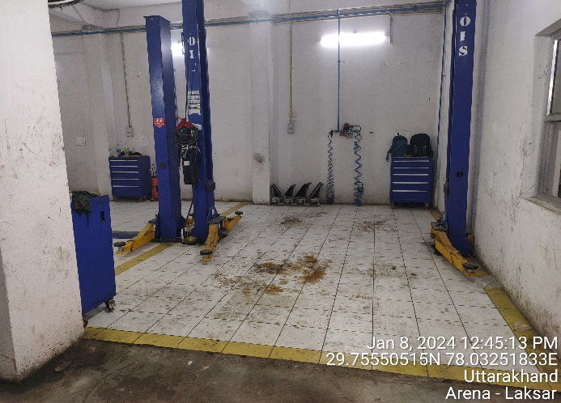 | 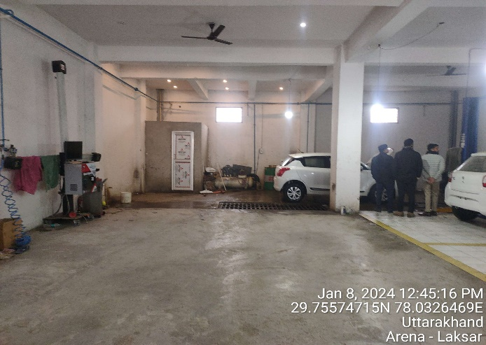
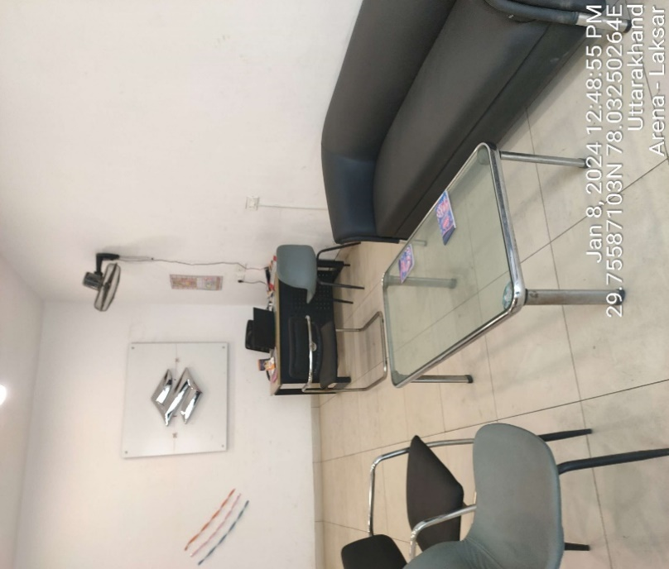 | 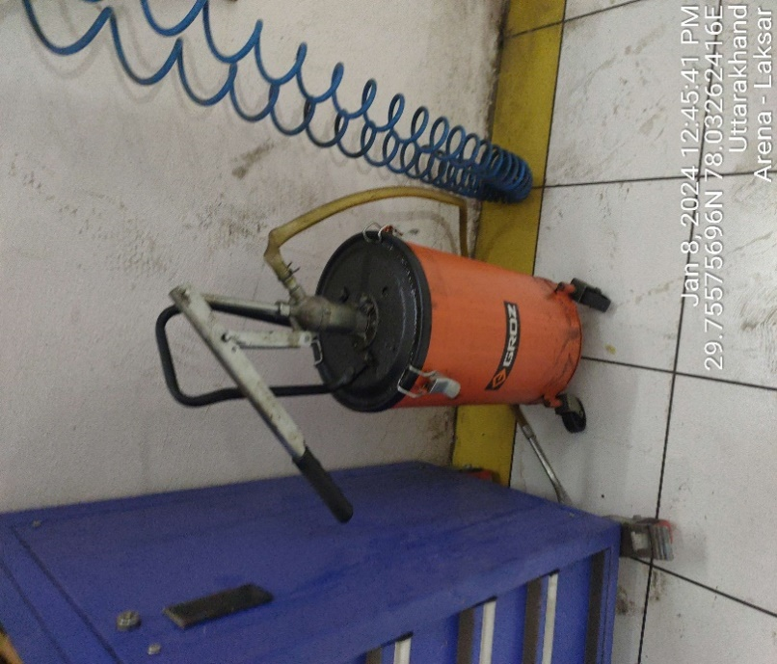
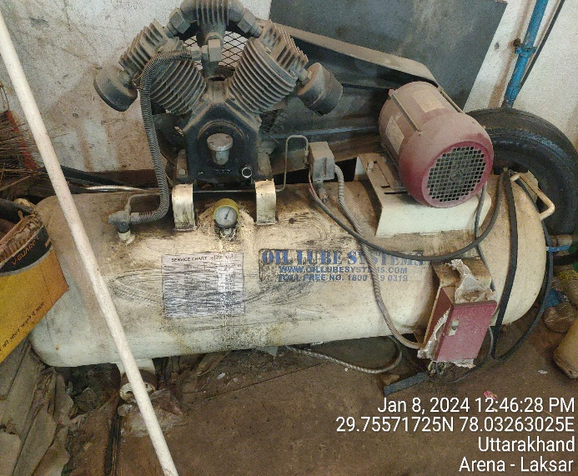 | 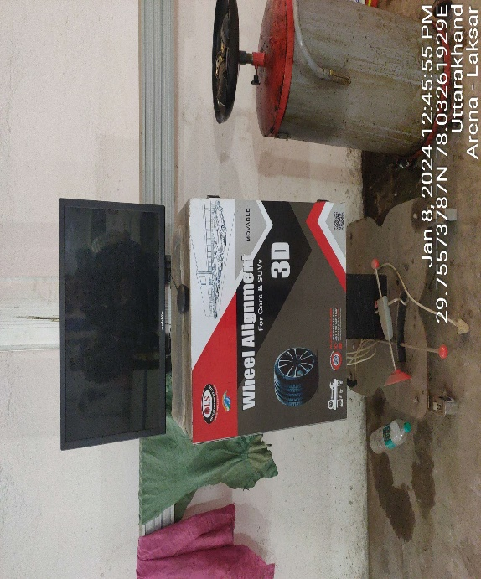
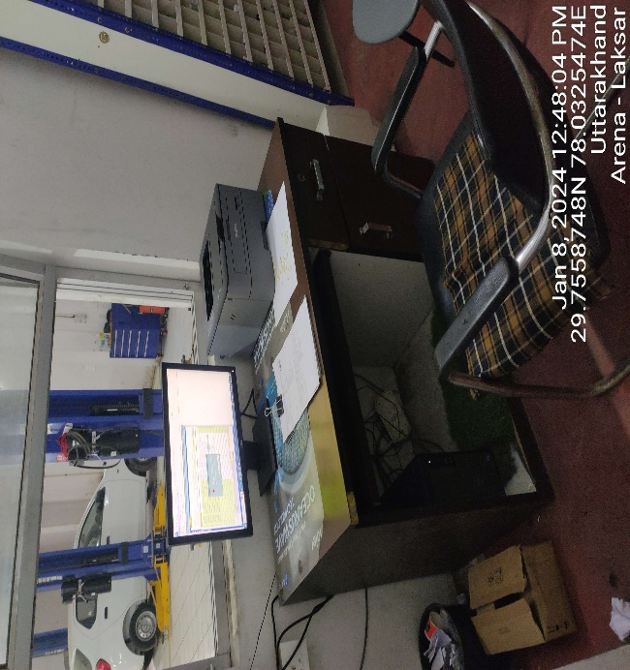 | 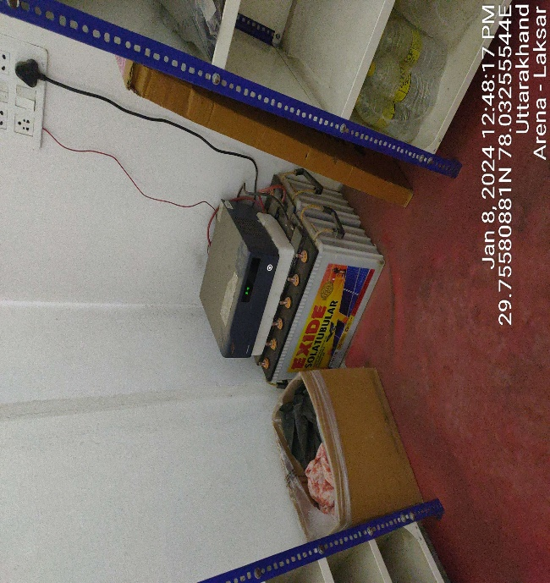
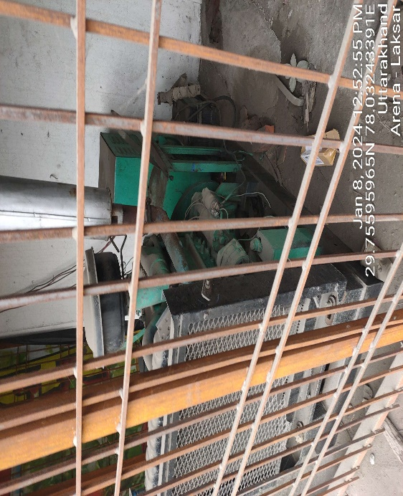 | 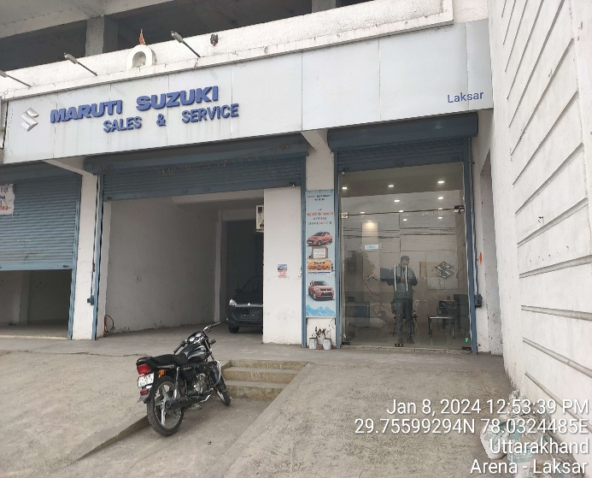
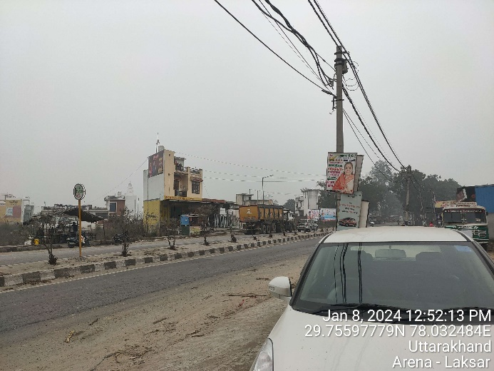 | 

ANNEXURE: - II (PHOTOGRAPHS OF THE ASSETS – PAURI UNIT)
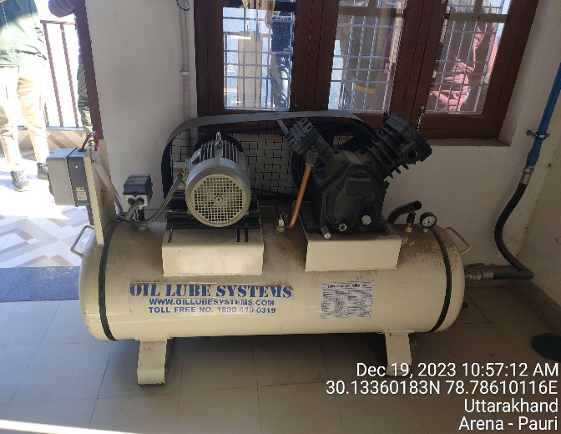 | 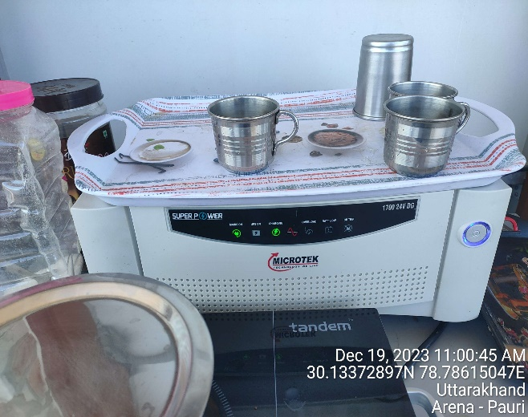
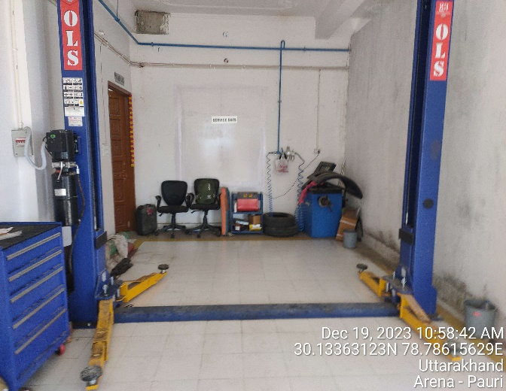 | 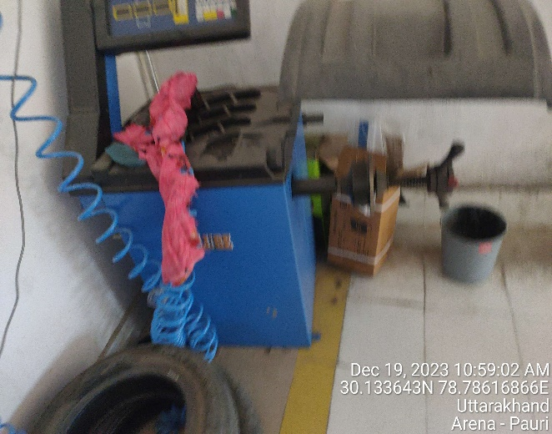
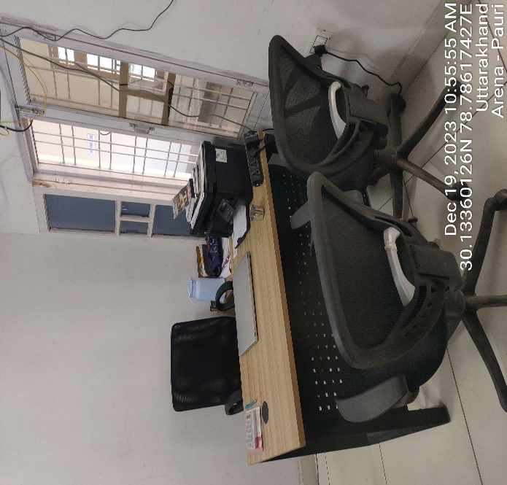 | 

ANNEXURE: - II BANSWARA (NEAR CHANDRAPURI) UNIT
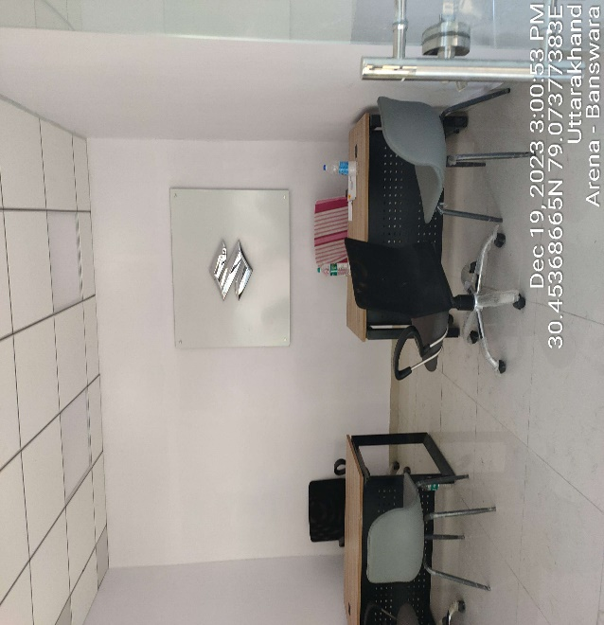 | 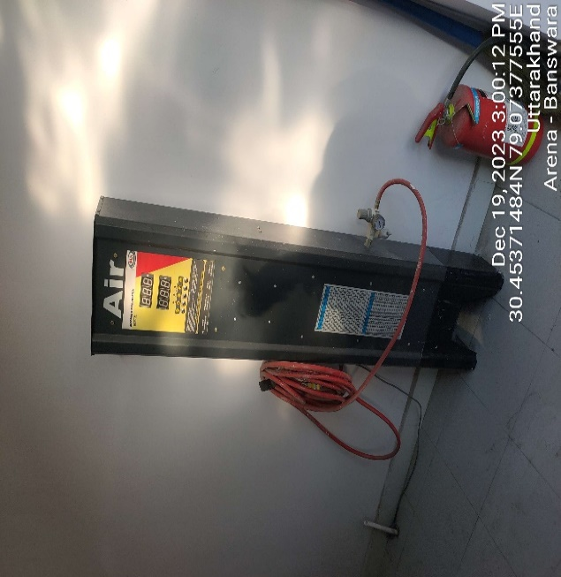
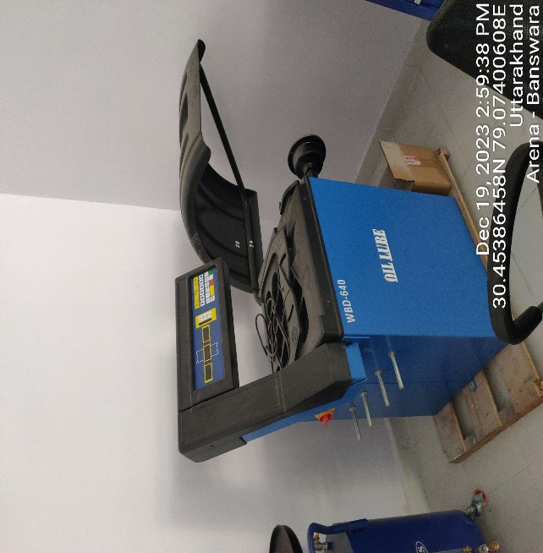 | 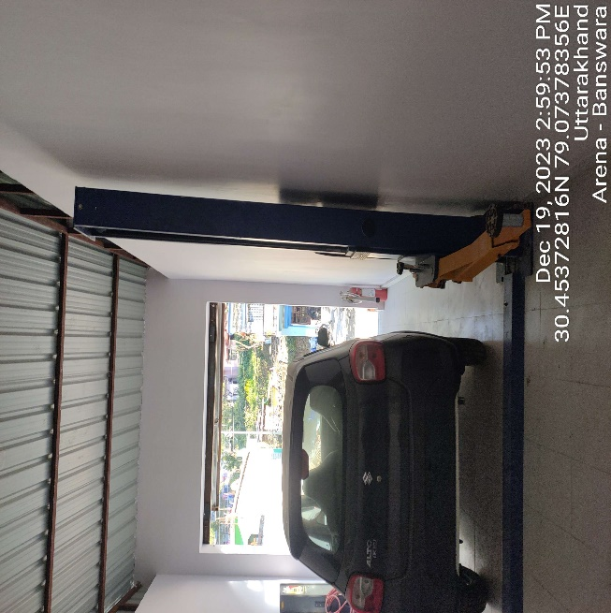
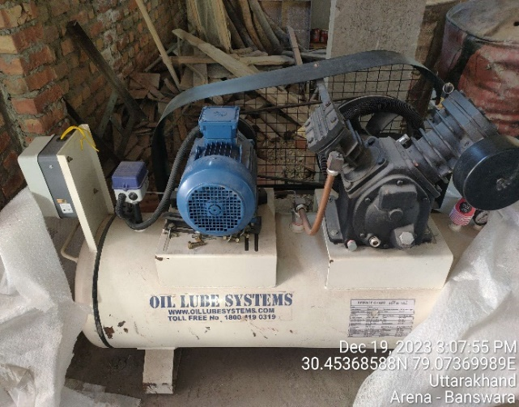 | 

ANNEXURE: - II (PHOTOGRAPHS OF THE ASSETS – LAMBGAON UNIT)
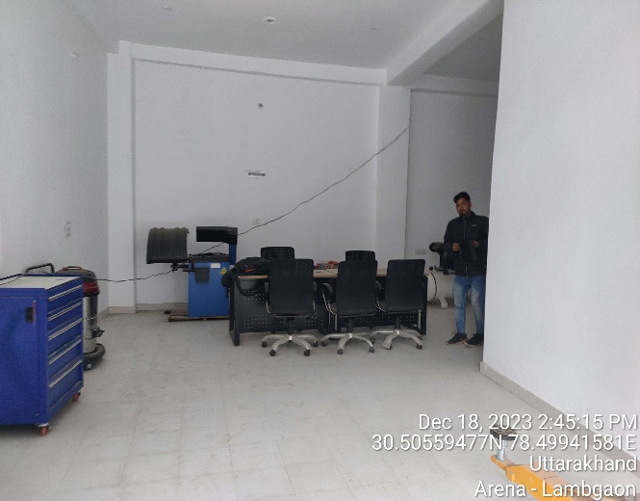 | 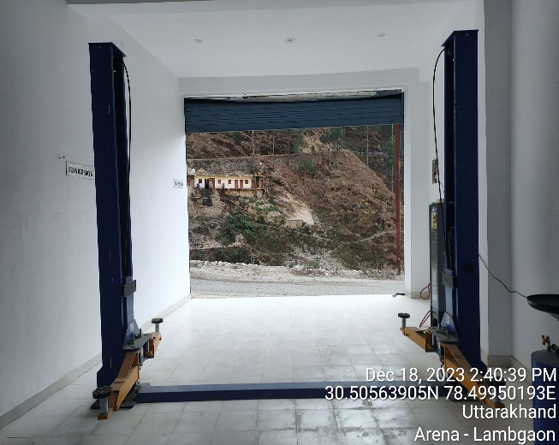
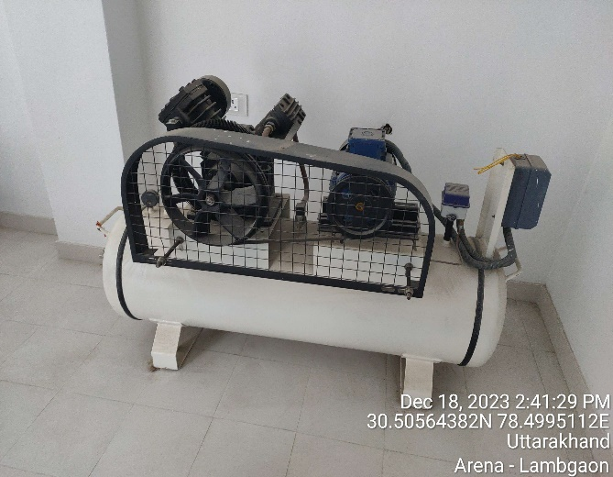 | 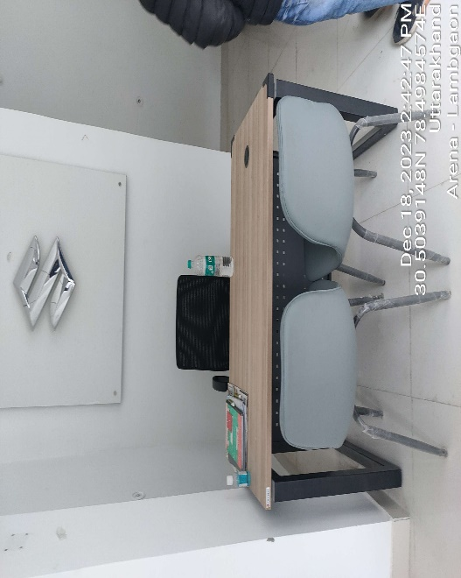
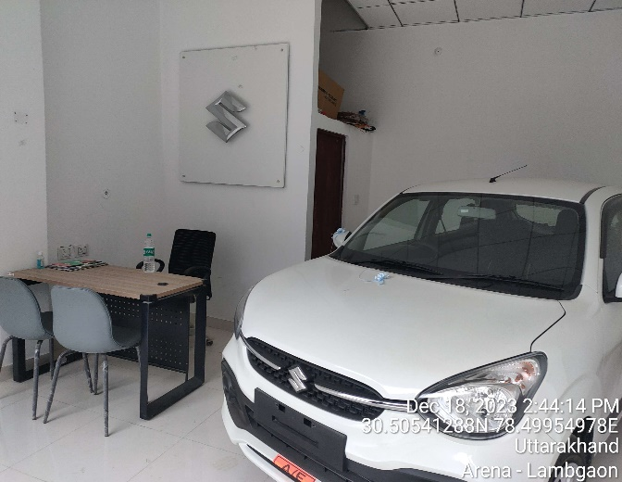 | 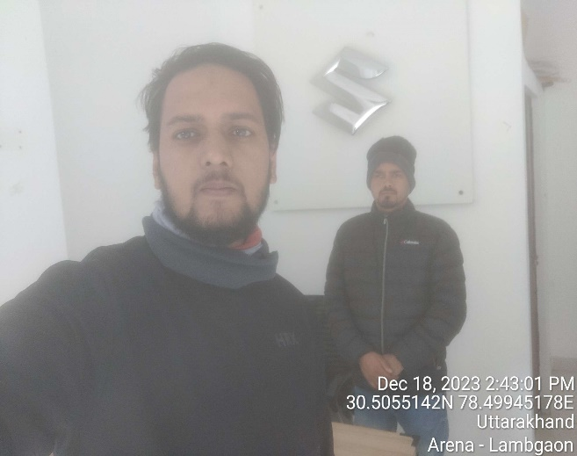

ANNEXURE: - II (PHOTOGRAPHS OF THE ASSETS – NOORPUR UNIT)
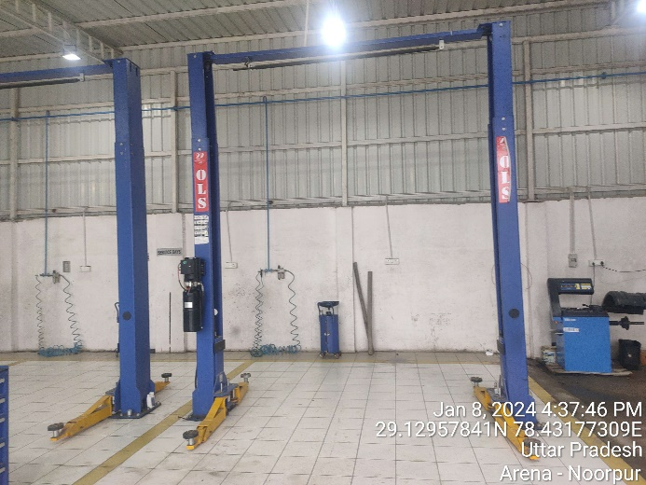 | 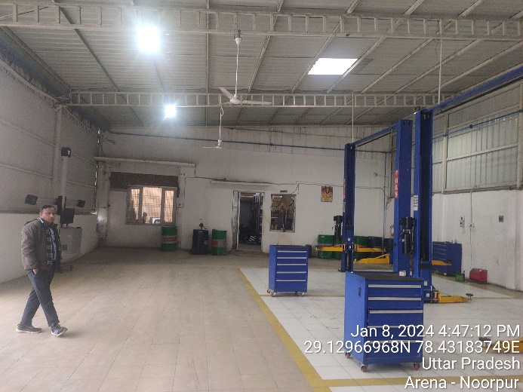
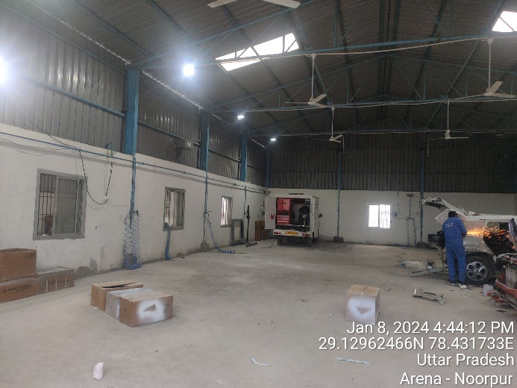 | 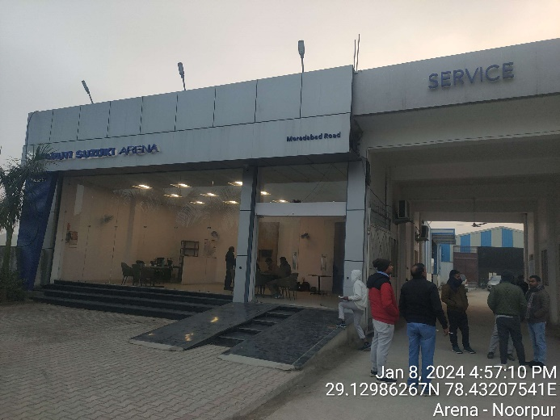
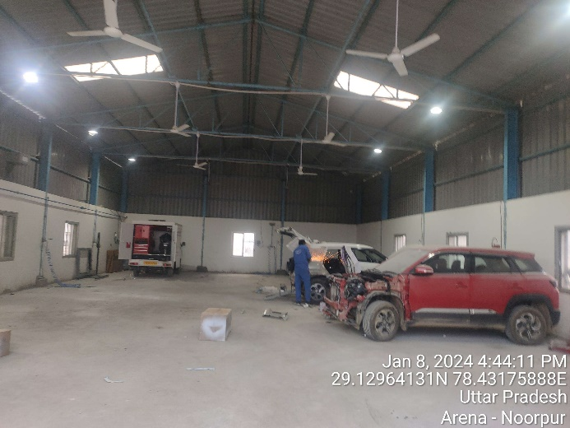 | 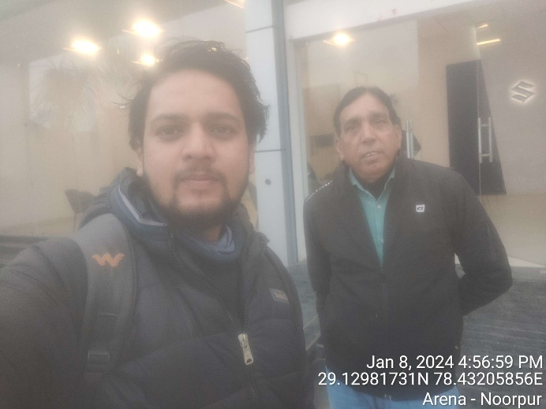

ANNEXURE: - II (PHOTOGRAPHS OF THE ASSETS- NARENDRA NAGAR UNIT)
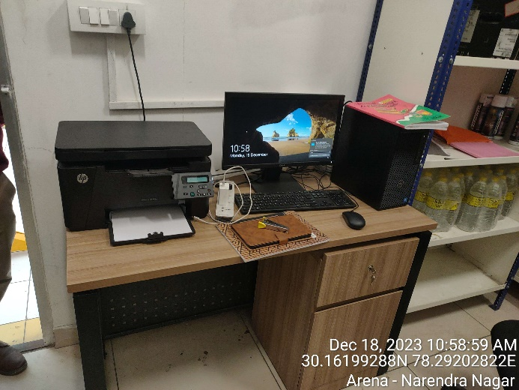 | 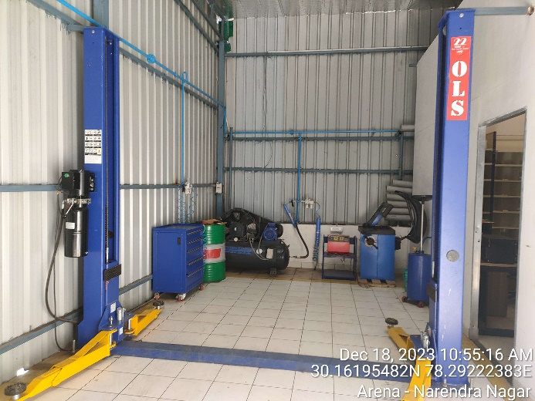
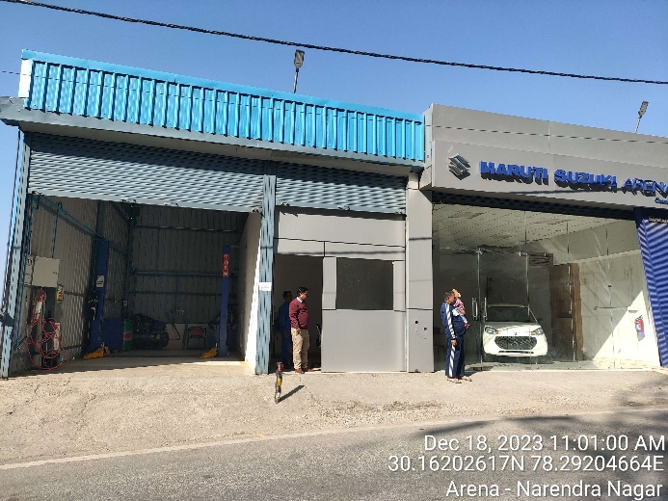 | 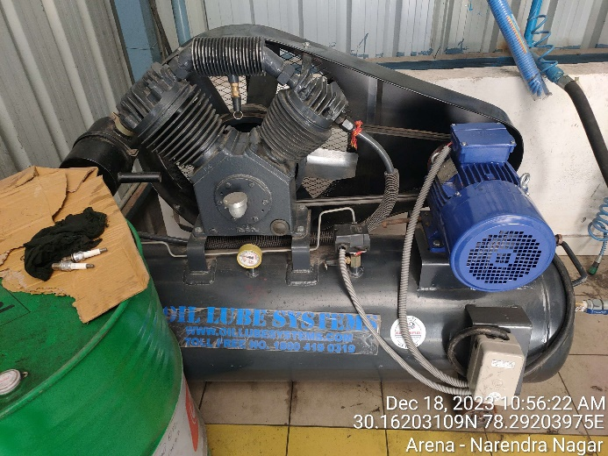
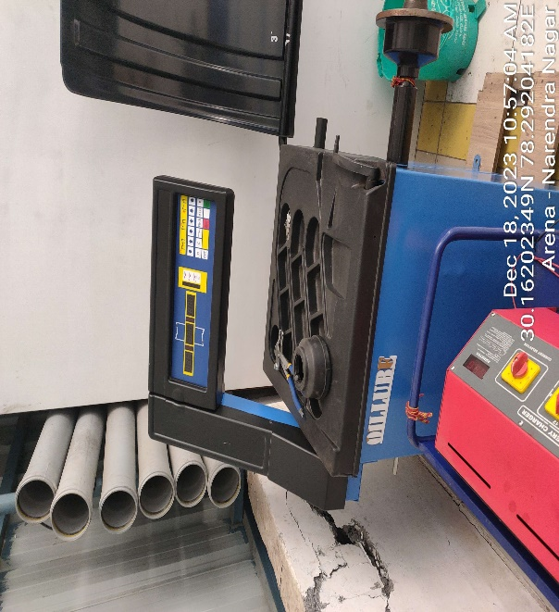 | 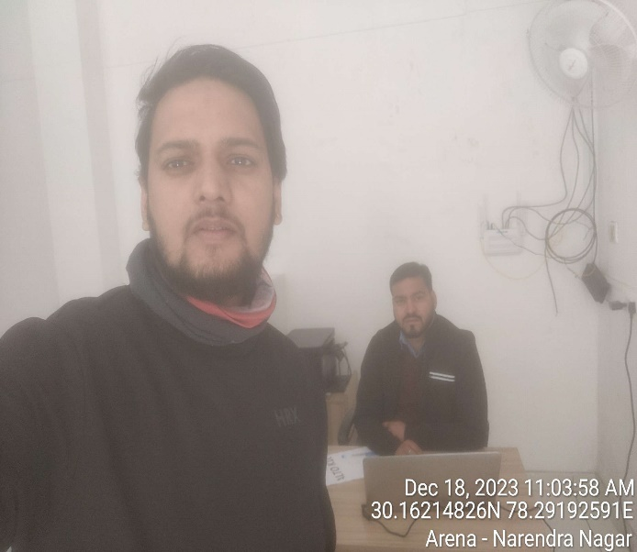

ANNEXURE: - II (PHOTOGRAPHS OF THE ASSETS- TRUE VALUE DEHRADUN UNIT)
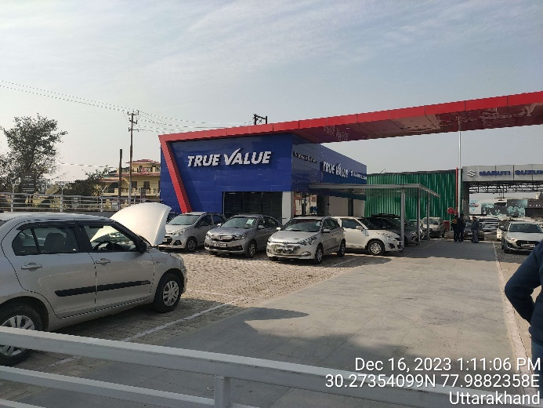 | 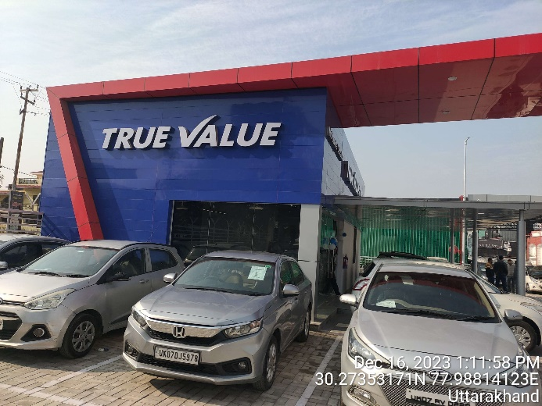
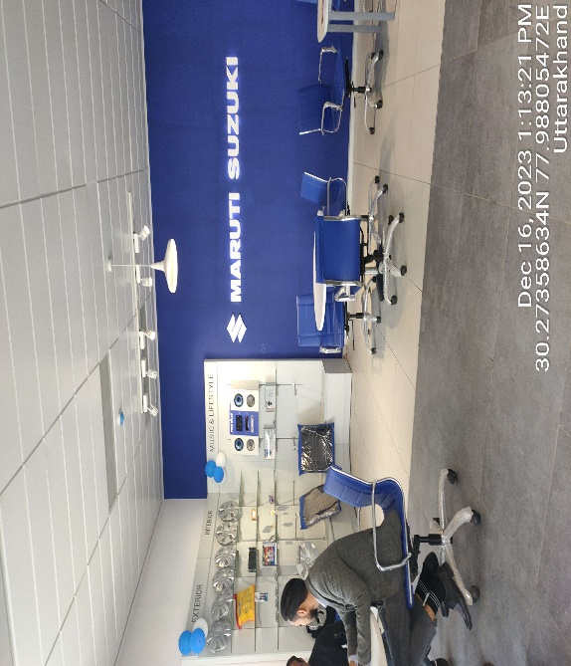 | 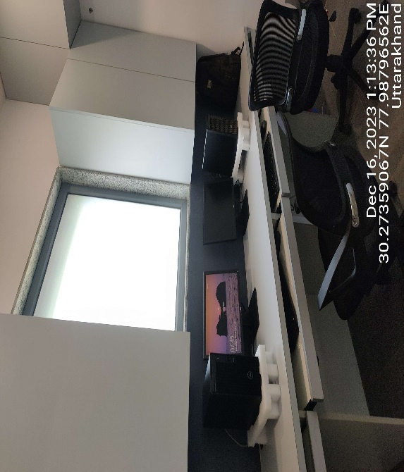
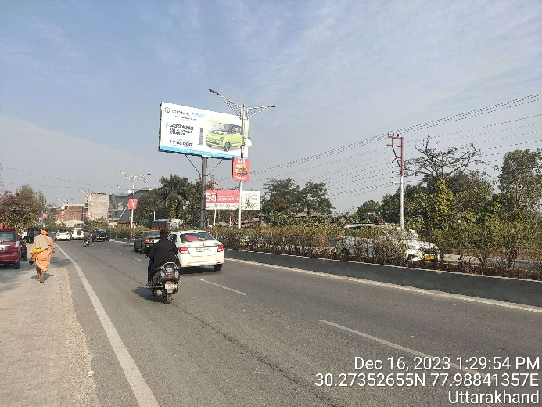 | 

ANNEXURE: - II (PHOTOGRAPHS OF THE ASSETS- DEHRADUN UNIT)
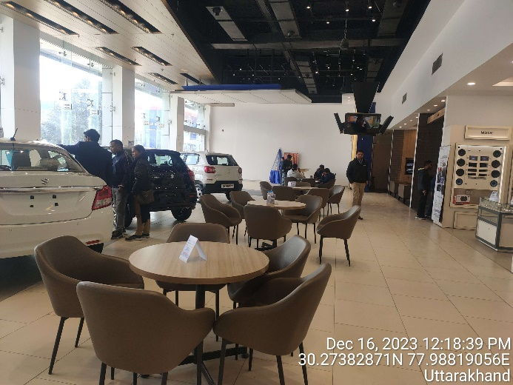 | 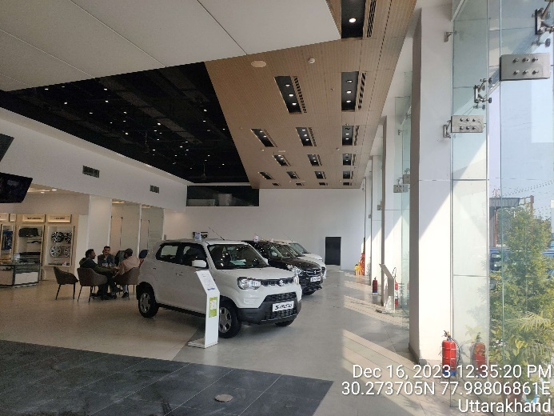
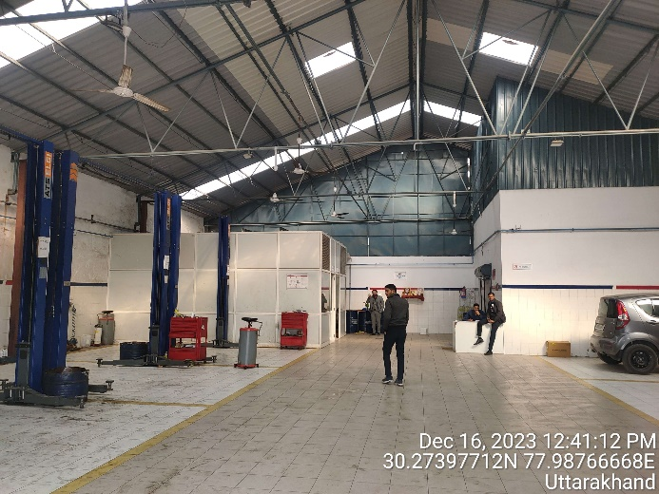 | 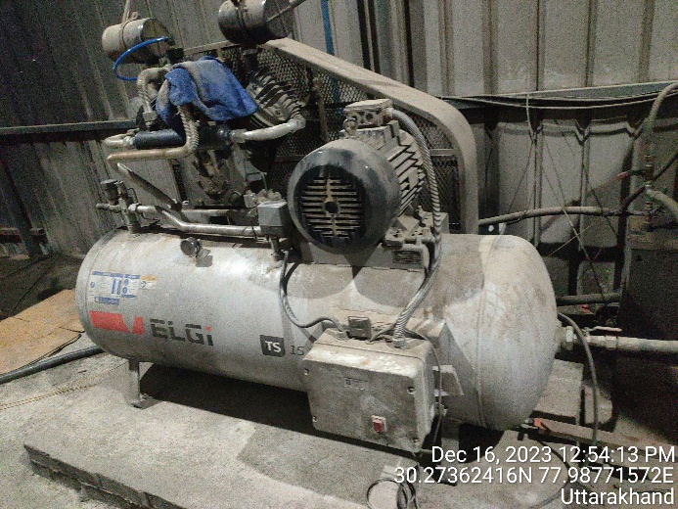
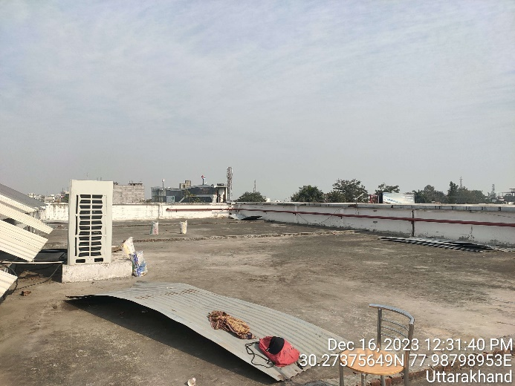 | 

