REPORT FORMAT: CL-1 | Version: 1.0_2018

FILE No.: VIS(2023-24)-PL578-489-771 Date: 09-02-2024

- CERTIFICATE NAME: Completion and Installation Certificate for the machines/equipment and other civil related work
- PREPARED FOR ORGANIZATION: State Bank of India, SME Branch, Roorkee, District- Haridwar
- BORROWER COMPANY’S NAME: M/s. Shakumbari Automobiles Pvt. Ltd.
- CURRENT LOCATION OF THE MACHINES: Installed at a property on 4 KM Milestone, Delhi Road, Bijnor, Uttar Pradesh.

TO WHOM IT MAY CONCERN

S. NO. | PARTICULARS | DESCRIPTION
1. | Date of Survey | 08-01-2024
2. | Date of Certificate | 09-02-2024
3. | Work Order Reference No. | Via email dated 15-12-2023
4. | Documents provided for perusal | - Invoices of the machines/equipment installed and other civil related work  - Summary of the amount
5. | Current Location of the machines/equipment | M/s Shakumbari Automobiles Pvt Ltd, Haridwar Road, Laksar, Uttarakhand
6. | Company Name | M/s Shakumbari Automobiles Pvt Ltd
7. | Co-ordinates of the property where machines/equipment are installed | 29°23'07.5"N 78°06'05.1"E
8. | Scope of Assessment | Completion and Installation Certificate for the machines/equipment and other civil related work which is installed at a property on 4 KM Milestone, Delhi Road, Bijnor, Uttar Pradesh.
9. | Nature of Machinery | Machines/ equipment installed for Automobile Service Centre
10. | Current Status of the machines/equipment | All the machines/equipment found to be installed & operational as per the list provided to us.
11 | Condition of machines/equipment | Physical condition of all the machines is good & operational.
12 | Coordinating person details from the company providing the details | Mr. Deepak Sharma (+91- 98370 18945)
13 | Final conclusion | All the machines found to be installed & operational as per the list provided to us as mentioned in Part-A of the Certificate.

S. No. | Particulars | Amount  (INR) | Remarks
 | Furniture & fixtures | 22,88,263 | Kitchen accessories, Table, Chair, Sofa sets etc.
 | Electrical Installation | 32,95,446 | Electrical works done including the wiring work completed.
 | Office Equipment | 39,67,424 | Interaction digital board, CCTV cameras, LED TVs etc.
 | Building & civil works | 1,63,76,293 | Construction of building structure has been done. Other finishing work like brick work, wall finishing, flooring, painting, false ceiling, railing work,
 | Computers | 1,66,284 | Desktop, CPU and computer accessories etc.
 | Air conditioner | 15,19,813 | Split AC installed
 | Fire Extinguisher | 15,05,406 | Fire Line and fire hydrant system has been installed. Fire extinguisher (Foam Type, CO₂ type, ABC type), refilled fire extinguisher (6 kg.), valve is there in the showroom.
Total |  | 2,91,18,929

OBSERVATIONS:

- We have been provided with the list of machines, copy of invoices of the machines purchased/installed and civil related work by the company.
- As per observation made during site survey, all the machines as mentioned in the list, were found to be installed and operational in the automobile service center.
- As per observation the service center is operational. Lights, displays have been installed. Customers were availing services from center.
- Based on the information provided and observation made during site visit, it is certified that the above machines are installed and are operational at the above-mentioned site address.

METHODOLOGY/ APPROACH ADOPTED:

- On site physical verification of the machines / equipment and other civil related work against the list provided to us by the company as shown above.
- During visit related Invoices/ Bills are also procured from the company.
- Photographs taken of the machines/equipment installed which are also attached with the certificate.

Disclaimer:

  - During the course of the assessment, several information/ data/ inputs is referred made available to us by the company/ client/ bank and in the event, this is found to be incorrect then this certificate would be null & void.
  - This Installation Certificate is stated on the basis of the site visit by the surveyor on 08-01-2024 and we don’t recommend any other sort of recommendation in our Certificate.
  - This certificate doesn’t include any work related to drawing, design, sketch plan, and technical specifications of the machines.
  - Ownership and other legal point of view in respect of the asset is not considered in this report as same is out of scope of this certificate.
  - This certificate is made at the request of the Bank.
  - We shall not be responsible in case of any removal of the machine from the site post our survey.
  - We have not commented upon whether the machines are new or old.
  - This certificate should not be used for any other purpose except as specified.
  - Level 1 (Primary) scrutiny approach is applied within the limited time to the best of the possibility using specified best practices. However, chances of error can’t be ruled out which may require detailed verification & scrutiny.

SURVEY ANALYST | ENGINEER | REVIEWER
Deepak Joshi | Babul Akhtar Gazi | Abhinav Chaturvedi

ANNEXURE: - I (PARTICULAR WISE INVOICES DETAILS)

1. ELECTRICAL INSTALATION:
Sl. No. | Date | Party Name | Invoice No. | Taxable Amount (In Rs.)
1 | 03-09-2023 | National Electricals & Works | NEW/696/2023-24 | 5,23,200.00
2 | 12-03-2023 | National Electricals & Works - RKE | NEW/1807/2022-23 | 4,92,380.00
3 | 24-03-2023 | Kumar Electricals - New Delhi | KE/2022-23/4125 | 4,55,145.00
4 | 31-12-2023 | National Electricals & Works | NEW/1217/2023-24 | 4,23,736.00
5 | 20-04-2023 | National Electricals & Works - RKE | NEW/064/2023-24 | 4,23,728.00
6 | 26-06-2023 | National Electricals & Works | NEW/346/2023-24 | 3,00,000.00
7 | 20-04-2023 | National Electricals & Works - RKE | NEW/065/2023-24 | 2,19,088.00
8 | 24-05-2023 | National Electricals & Works | NEW/218/2023-24 | 1,69,498.00
9 | 13-03-2023 | National Electricals & Works - RKE | NEW/1809/2022-23 | 1,13,651.00
10 | 21-03-2023 | Banarsi Dass Enterprises - Delhi | GST/22-23/3841 | 72,270.00
11 | 27-03-2023 | Rameshwaram Traders - Gurgaon | 2207 | 49,113.00
12 | 13-09-2023 | Durlum India Pvt. Ltd. - Haryana | INS2324SH-088 | 44,005.00
13 | 07-04-2023 | Kumar Electricals | KE/2023-24/0073 | 9,632.00
TOTAL |  |  |  | 32,95,446.00

2. AIR CONDITIONER:
Sl. No. | Date | Party Name | Invoice No. | Taxable Amount (In Rs.)
1. | 24-02-2023 | Budh Air System - RKE | 132 | 6,41,591.00
2. | 09-01-2023 | Nucon Engineers Faridabad | NUCON/22-23/JAN/06 | 5,75,781.00
3. | 13-03-2023 | Budh Air System - RKE | 134 | 3,02,441.00
TOTAL |  |  |  | 15,19,813.00
3. BUILDING AND CIVIL WORK:

Sl. No. | Date | Party Name | Invoice No. | Taxable Amount  (In Rs.)
1 | 20-04-2023 | Bharat Glass Trading - Rke | 7 | 17,97,347.00
2 | 20-04-2023 | Bharat Glass Trading - Rke | 6 | 15,05,200.00
3 | 20-04-2023 | Bharat Glass Trading - Rke | 5 | 13,46,838.00
4 | 13-03-2023 | Bharat Glass Trading | 72 | 11,82,124.00
5 | 09-10-2023 | Bharat Glass Trading - Rke | 30 | 10,00,640.00
6 | 21-10-2023 | Bharat Glass Trading - Rke | 33 | 10,00,640.00
7 | 03-09-2023 | Bharat Glass Trading - Rke | 21 | 10,00,286.00
8 | 08-04-2023 | Tikraiwal Trading Company -Gurugram | TTC/2023-24/111 | 5,41,858.00
9 | 25-10-2023 | Kayyum Contractor - Mbd | 23 | 5,00,010.00
10 | 04-04-2023 | N.A Enterprises - Rke | 2 | 3,78,582.00
11 | 17-03-2023 | Hardev Dass Tiles and Sanitary World - Bhagwanpur | 22-23/A000824 | 3,76,000.00
12 | 31-03-2023 | Gyan Dev Rahul Kumar - Bijnore |  | 3,60,002.00
13 | 17-03-2023 | Tikraiwal Trading Company -Gurugram | TTC/2022-23/4685 | 3,48,534.00
14 | 14-04-2023 | Neelkanth Steel Corporation - Bij | 4 | 3,15,544.00
15 | 21-04-2023 | Kayyum Contractor - Mbd | 21 | 2,99,999.00
16 | 11-05-2023 | Tikraiwal Trading Company -Gurugram | TTC/2023-24/449 | 2,51,694.00
17 | 06-04-2023 | N.A Enterprises - Rke | 3 | 2,27,947.00
18 | 17-03-2023 | Elegant Tiles and Sanitary Ware - Rke | ELT/22-23/1586 | 2,10,366.00
19 | 29-09-2023 | Bharat Glass Trading - Rke | 28 | 2,00,305.00
20 | 03-09-2023 | Bharat Glass Trading - Rke | 22 | 2,00,152.00
21 | 20-09-2023 | Bharat Glass Trading - Rke | 25 | 2,00,081.00
22 | 21-04-2023 | New India Paint Hardware Store -Roorkee | 1 | 2,00,000.00
23 | 21-04-2023 | Kayyum Contractor - Mbd | 22 | 2,00,000.00
24 | 16-04-2023 | Naseem - Supplier |  | 1,92,924.00
25 | 15-04-2023 | JVS Traders - Bijnor |  | 1,78,710.00
26 | 11-05-2023 | A.D.S Corporation - Bijnor | 18 | 1,71,000.00
27 | 09-05-2023 | Naseem - Supplier | CORSAND & BAJRI | 1,60,427.00
28 | 25-11-2023 | TBK Florance Ceramics Pvt. Ltd.- Noida | 22-23/2655 | 1,55,882.00
29 | 16-03-2023 | N.A Enterprises - Rke | 174 | 1,35,381.00
30 | 27-03-2023 | SSS Techno Marketing -Gurugram | SSSTM/0365/22-23 | 1,32,116.00
31 | 14-04-2023 | JVS Traders - Bijnor | 4 | 1,20,960.00
32 | 30-05-2023 | New Bharat Traders - Bij | 106 | 1,07,381.00
33 | 05-04-2023 | Naseem - Supplier |  | 97,410.00
34 | 03-03-2023 | Ganga Marbles - Rishikesh | 00966/22-23 | 97,055.00
35 | 11-05-2023 | JVS Traders - Bijnor | 9 | 95,800.00
36 | 15-04-2023 | JVS Traders - Bijnor | 6 | 57,750.00
37 | 16-03-2023 | Naseem - Supplier | 114 | 56,470.00
38 | 17-08-2023 | JVS Traders - Bijnor | 10 | 54,400.00
39 | 21-03-2023 | A R Traders - Creditors | 632 | 49,848.00
40 | 20-03-2023 | A R Traders - Creditors | 630 | 49,600.00
41 | 01-04-2023 | A.R. Traders - Creditors | 651 | 48,000.00
42 | 25-08-2023 | Salim Khan - D. Dun | 169 | 47,200.00
43 | 01-05-2023 | Bharat Brick Field - Mzn | 30 | 46,875.00
44 | 02-05-2023 | Bharat Brick Field - Mzn | 31 | 46,875.00
45 | 20-04-2023 | Shri Krishna Corian Work - Gzb | 1 | 46,728.00
46 | 03-04-2023 | A.R. Traders - Creditors | 654 | 46,000.00
47 | 24-03-2023 | New Bharat Marble Traders -Creditors | 805 | 42,952.00
48 | 28-03-2023 | New Bharat Marble Traders -Creditors | 813 | 38,904.00
49 | 24-03-2023 | New Bharat Marble Traders -Creditors | 806 | 36,580.00
50 | 27-03-2023 | Tikraiwal Trading Company -Gurugram | TTC/2022-23/5130 | 35,666.00
51 | 08-09-2023 | A.D.S Corporation - Bijnor | 44 | 35,400.00
52 | 26-03-2023 | New Bharat Marble Traders -Creditors | 809 | 33,866.00
53 | 11-06-2023 | Welcome Sanitary House - Noorpur | 117 | 32,462.00
54 | 04-03-2023 | Kisan Bricks Field - Sre | 181 | 32,450.00
55 | 04-03-2023 | Kisan Bricks Field - Sre | 180 | 32,450.00
56 | 10-03-2023 | Bharat Brick Field - Mzn | 177 | 32,450.00
57 | 11-03-2023 | Kisan Bricks Field - Sre | 186 | 32,450.00
58 | 11-03-2023 | Kisan Bricks Field - Sre | 185 | 32,450.00
59 | 11-03-2023 | Bharat Brick Field - Mzn | 178 | 29,500.00
60 | 25-03-2023 | New Bharat Marble Traders -Creditors | 808 | 25,771.00
61 | 04-03-2023 | Jayarch Solutions - Delhi | 914 | 25,417.00
62 | 15-09-2023 | New Bharat Marble Traders -Creditors | 369 | 22,078.00
63 | 04-03-2023 | Ganga Marbles - Rishikesh | 00968/22-23 | 5,900.00
64 | 27-09-2023 | Cash Bijnor |  | 5,650.00
65 | 20-08-2023 | JVS Traders - Bijnor | 11 | 4,956.00
TOTAL |  |  |  | 1,63,76,293.00

4. COMPUTER:
Sl. No. | Date | Party Name | Invoice No. | Taxable Amount (In Rs.)
1. | 02-05-2023 | Team Computers Pvt. Ltd. - Delhi | GST2324DL-01893 | 1,46,030.00
2. | 02-05-2023 | Team Computers Pvt. Ltd. - Delhi | GST2324DL-01930 | 20,254.00
 | TOTAL |  |  | 1,66,284.00

5. FIRE EXTINGUISER:
Sl. No. | Date | Party Name | Invoice No. | Taxable Amount
1 | 29-03-2023 | Amit Fire Fighter - HDR | AFF/22-23/758 | 5,58,608.00
2 | 15-03-2023 | Amit Fire Fighter - HDR | AFF/22-23/727 | 4,68,620.00
3 | 29-03-2023 | Amit Fire Fighter - HDR | AFF/22-23/759 | 1,76,528.00
4 | 08-07-2023 | Amit Fire Fighter - HDR | AFF/2324/153 | 1,60,000.00
5 | 09-05-2023 | Amit Fire Fighter - HDR | AFF/23-24/55 | 40,900.00
6 | 08-09-2023 | Amit Fire Fighter - HDR | AFF/22-23/51 | 32,300.00
7 | 08-07-2023 | Amit Fire Fighter - HDR | AFF/2324/152 | 30,000.00
8 | 08-05-2023 | Amit Fire Fighter - HDR | AFF/23-24/50 | 15,590.00
9 | 08-05-2023 | Amit Fire Fighter - HDR | AFF/23-24/52 | 10,600.00
10 | 21-10-2023 | Amit Fire Fighter - HDR | AFF/23-24/349 | 7,160.00
11 | 12-10-2023 | Amit Fire Fighter - HDR | AFF/23-24/332 | 2,900.00
12 | 08-07-2023 | Amit Fire Fighter - HDR | AFF/23-24/151 | 2,200.00
TOTAL |  |  |  | 15,05,406.00

6. FURNITURE & FIXTURES:
Sl.No. | Date | Party Name | Invoice No. | Taxable Amount
1 | 23-03-2023 | Entasis India Pvt.Ltd. - New Delhi | EIPL/22-23/691 | 9,45,074.00
2 | 17-03-2023 | Adish Traders - Alwar | 1253 | 3,99,915.00
3 | 21-03-2023 | Kwality Hardware Agencies - Dehradun | CRM/2022/22900 | 1,99,294.00
4 | 14-05-2023 | Kohinoor Interior Deigner - Amroha | 4 | 1,58,453.00
5 | 17-03-2023 | Adish Traders - Alwar | 1254 | 1,56,936.00
6 | 07-04-2023 | Kohinoor Interior Deigner - Amroha | 1 | 1,25,530.00
7 | 23-03-2023 | Entasis India Pvt.Ltd. - New Delhi | EIPL/22-23/692 | 1,10,000.00
8 | 17-04-2023 | Kwality Hardware Agencies - Dehradun | CRM/2023/01097 | 80,410.00
9 | 10-05-2023 | Kwality Hardware Agencies - Dehradun | CRM/2023/02339 | 36,802.00
10 | 11-05-2023 | Kwality Hardware Agencies - Dehradun | CRM/2023/02393 | 36,330.00
11 | 21-03-2023 | Kwality Hardware Agencies - Dehradun | CRM/2022/22901 | 21,968.00
12 | 11-05-2023 | Kwality Hardware Agencies - Dehradun | CRM/2023/02421 | 17,551.00
TOTAL |  |  |  | 22,88,263.00

6. FURNITURE & FIXTURES:
Sl. No. | Date | Party Name | Invoice No. | Taxable Amount (In Rs.)
1 | 17-03-2023 | Durlum India Pvt. Ltd. - Haryana | EX2223SH-709 | 8,24,026.00
2 | 27-04-2023 | Panasonic Life Solutions India Pvt. Ltd. - Gurgaon | 810823100239 | 5,94,600.00
3 | 21-03-2023 | NM Advertiser Pvt. Ltd. - Noida | MSIL-156-2022-23 | 5,34,684.00
4 | 30-12-2023 | National Electricals & Works | NEW/1208/2023-24 | 3,92,350.00
5 | 21-03-2023 | NM Advertiser Pvt. Ltd. - Noida | MSIL-157-2022-23 | 3,66,513.00
6 | 27-06-2023 | Welcome Sanitary Systems - Rke | GST/23-24/59 | 2,96,610.00
7 | 27-04-2023 | Panasonic Life Solutions India Pvt. Ltd. - Gurgaon | 810823100239 | 1,13,900.00
8 | 12-03-2023 | National Electricals & Works - RKE | NEW/1807/2022-23 | 1,01,725.00
9 | 16-06-2023 | Anant Enterprises - Hdr (Cre) | A045 | 86,357.00
10 | 31-12-2023 | National Electricals & Works | NEW/1220/2023-24 | 84,750.00
11 | 27-04-2023 | Panasonic Life Solutions India Pvt. Ltd. - Gurgaon | 820123100818 | 84,650.00
12 | 04-04-2023 | Valley Electro Vision Pvt. Ltd. - New Delhi | VE/DL/23-24/03 | 83,790.00
13 | 01-05-2023 | Valley Electro Vision Pvt. Ltd. - New Delhi | VE/DL/23-24/53 | 65,502.00
14 | 03-04-2023 | Intercare Cleaning & Hygiene Services Pvt. Ltd. - Del | INT/2023-24/19 | 65,430.00
15 | 27-04-2023 | Panasonic Life Solutions India Pvt. Ltd. - Gurgaon | 840623100181 | 55,500.00
16 | 30-03-2023 | Shanti Enterprises - Delhi | SE/GST/1272/2223 | 39,755.00
17 | 17-03-2023 | Shanti Enterprises - Delhi | SE/GST/1165/2223 | 39,470.00
18 | 20-04-2023 | National Electricals & Works - RKE | NEW/065/2023-24 | 35,150.00
19 | 08-08-2023 | Shakumbari Multi Expert Pvt. Ltd. - Sre | SMEPL000227 | 29,531.00
20 | 13-03-2023 | National Electricals & Works - RKE | NEW/1809/2022-23 | 23,475.00
21 | 26-06-2023 | Welcome Sanitary Systems - Rke | GST/23-24/58 | 17,373.00
22 | 31-05-2023 | Banarsi Dass Enterprises | GST/23-24/57 | 15,800.00
23 | 01-03-2023 | Shanti Enterprises - Delhi | SE/GST/1282/2223 | 8,130.00
24 | 31-03-2023 | Shanti Enterprises - Delhi | SE/GST/1282/2223 | 6,542.00
25 | 31-03-2023 | Shanti Enterprises - Delhi | SE/GST/1282/2223 | 1,811.00
TOTAL |  |  |  | 39,67,424.00

ANNEXURE: - II (PHOTOGRAPHS OF THE ASSETS)
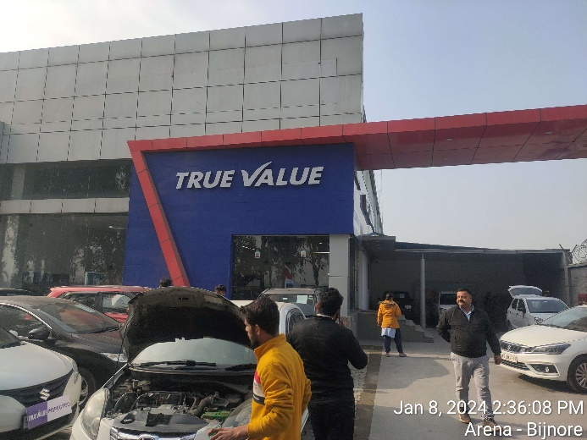 | 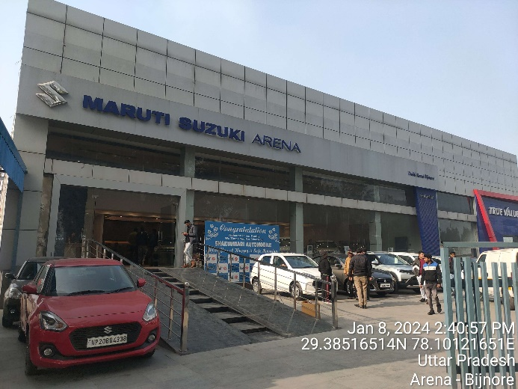
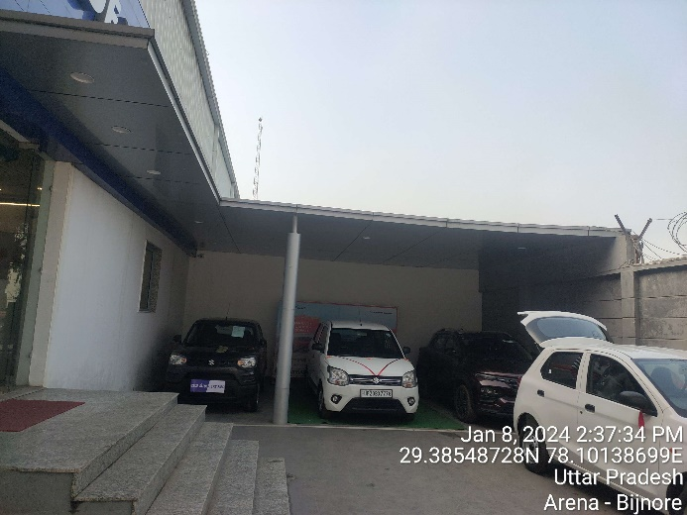 | 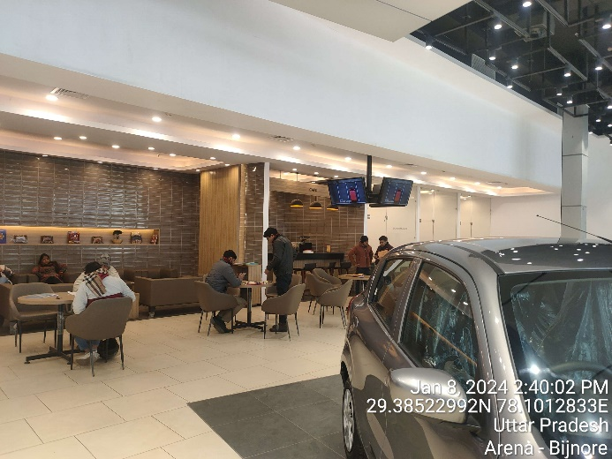
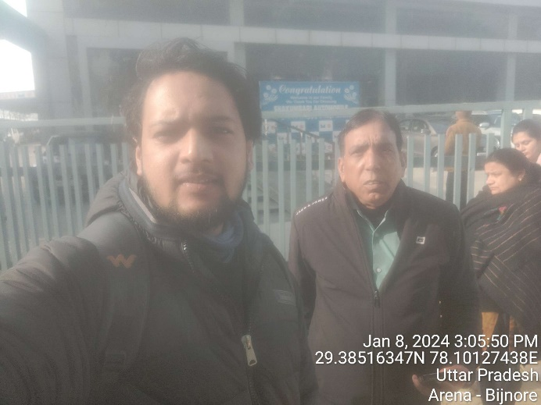 | 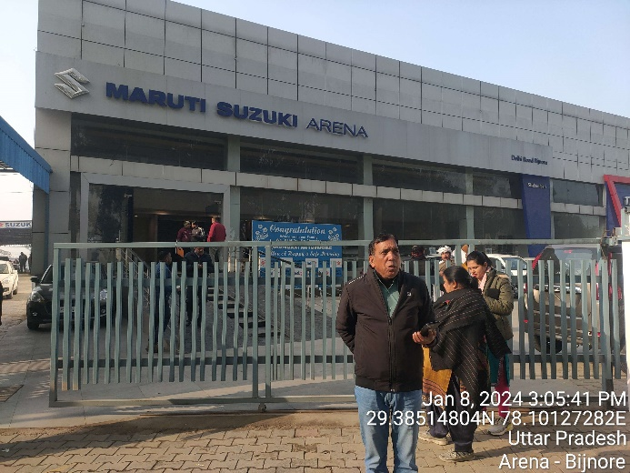
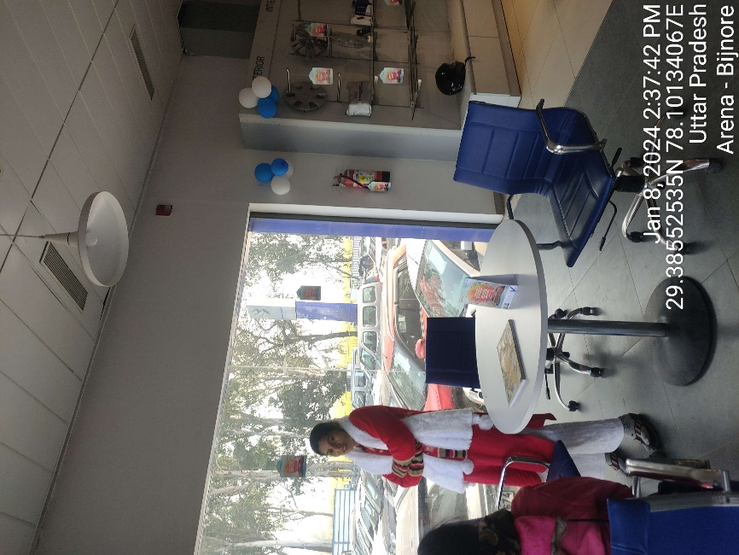 | 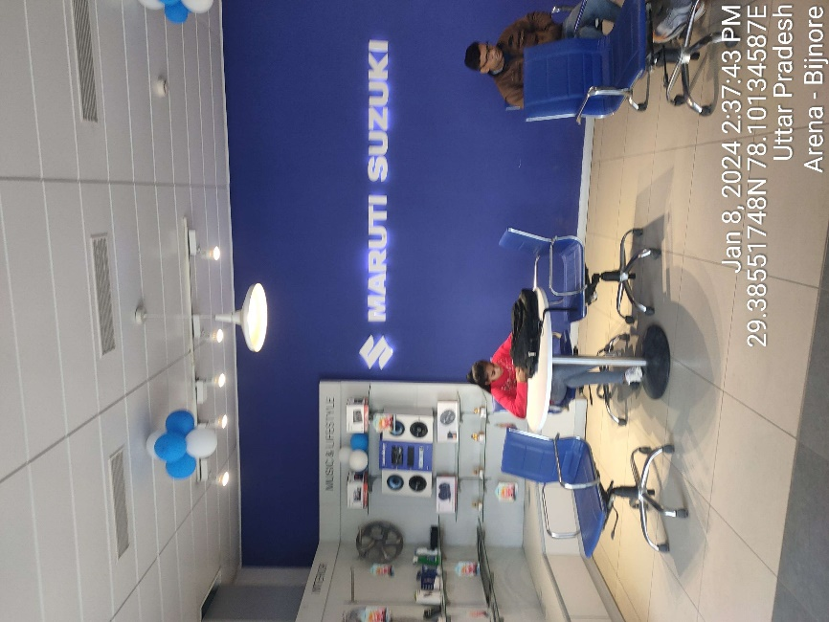
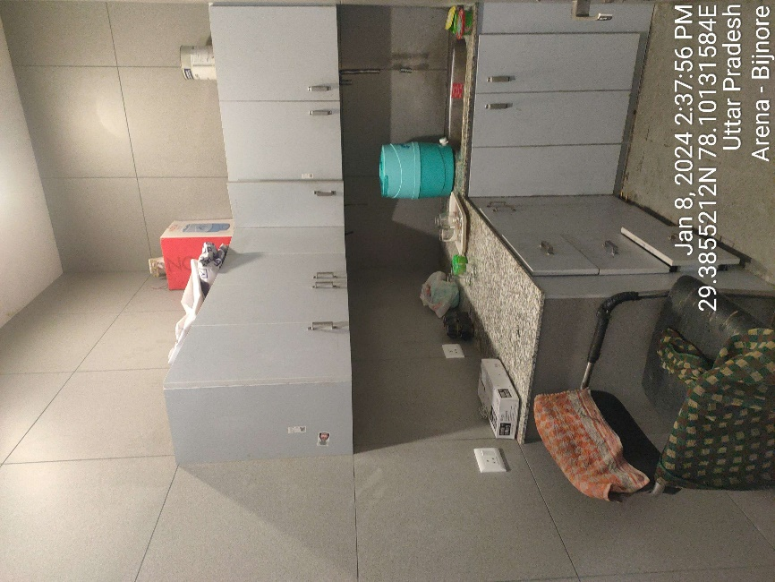 | 