REPORT FORMAT: V-L5 | Version: 4.2_2017

File No.: VIS (2023-24)-PL582-493-774 Dated: 19.02.2024

ENTERPRISE VALUATION REPORT

OF

M/S CCCL INFRASTRUCTURE LIMITED

(SOLAR POWER PLANT OF 5 MW)

SITUATED AT

VILLAGE – VADAKUKARCHERI, SRIVAIKUNDAM, DISTRICT – TUTICORIN,

TAMIL NADU-628104

HOLDING COMPANY/PROMOTER

M/S CONSOLIDATED CONSTRUCTION CONSORTIUM LIMITED

REPORT PREPARED FOR

STATE BANK OF INDIA, STRESSED ASSET MANAGEMENT BRANCH, “RED CROSS BUILDING”, 32, RED CROSS ROAD, EGMORE, CHENNAI - 600008

**Important - In case of any query/ issue or escalation you may please contact Incident Manager
at valuers@rkassociates.org. We will appreciate your feedback in order to improve our services.

NOTE: As per IBA Guidelines please provide your feedback on the report within 15 days of its submission after which report will be considered to be correct.

IMPORTANT NOTICE

COPYRIGHT FORMAT: This report is prepared on the copyright format of R. K. Associates Valuers & Techno Engineering Consultants (P) Ltd. (R. K. Associates) to serve our clients with the best possible information and analysis to facilitate them to take rational business decisions. Legally no one can copy or distribute this format without prior approval from R. K. Associates. It is meant only for the advisory/ reference purpose for the organization/s as mentioned on the cover page of this report. Distribution or use of this format or report or any of its content/ information/ data by any organization or individual other than R.K Associates will be seen as an unlawful act and necessary legal action can be taken against the defaulters.
This report is intended for the sole use of the intended recipient/s and contains material that is STRICTLY CONFIDENTIAL AND PRIVATE.

DEFECT LIABILITY PERIOD: In case of any query/ issue or escalation you may please contact Incident Manager at valuers@rkassociates.org. Though adequate care has been taken while preparing this report as per its scope, but still, we can’t rule out typing, human errors, over sightedness of any information or any other mistakes. Therefore, the concerned organization is advised to satisfy themselves that the report is complete & satisfactory in all respect. Intimation regarding any discrepancy shall be brought into our notice immediately. If no intimation is received within 15 (Fifteen) days in writing from the date of issuance of the report, to rectify these timely, then it shall be considered that the report is complete in all respect and has been accepted by the client up to their satisfaction & use and further to which R.K Associates shall not be held responsible in any manner.

Part H: R.K Associates Important Notes and Enclosure: 1–Valuer’s Remarks are integral part of this report and Value is assessment is subject to both of these sections. Reader of the report is advised to read all the points mentioned in these sections carefully.

TABLE OF CONTENTS
SECTIONS | PARTICULARS | PAGE NO.
Part A | INTRODUCTION | 4
Part A | - About the Report | 4
Part A | - Executive Summary | 4
Part A | - Type of Report | 6
Part A | - Purpose of the Report | 6
Part A | - Scope of the Report | 6
Part A | - Methodology/ Model Adopted | 7
Part A | - Documents/ Data Referred | 7
Part B | PROJECT COMPANY | 8
Part B | - Incorporation details of the company | 8
Part B | - Details of Promoters/Directors | 8
Part B | - Snapshot of the Outstanding Debt of the Company | 10
Part B | - Capital Structure | 11
Part B | - Shareholding Pattern | 11
Part B | - Current Status & Reason for Financial Stress | 12
Part C | THE PROJECT | 14
Part C | - Brief Description about the Project | 14
Part C | - Organizational Structure | 14
Part C | - Project Location | 15
Part C | - Operation & Maintenance | 15
Part C | - Key Approval & Clearance | 16
Part D | ASSESSMENT OF SOLAR ENERGY SECTOR | 17
Part D | - Introduction | 17
Part D | - Market Size | 17
Part D | - Major Investments | 18
Part D | - Government Initiatives | 19
Part D | - Way Forward | 20
Part E | FINANCIAL PERFORMANCE | 21
Part E | - Historical P&L Statement | 21
Part E | - Historical Ratio Analysis | 21
Part E | - Graphical Representation of Historical Ratios | 22
Part E | - Projected P&L Statement | 23
Part E | - Projected Ratio Analysis | 24
Part E | - Graphical Representation of Projected Ratios | 25
Part F | VALUATION OF THE COMPANY | 27
Part F | - Methodology/ Model Adopted | 27
Part F | - Calculation of Free Cash Flow to Firm | 29
Part F | - Key Inputs | 30
Part F | - Calculation Of Enterprise Value | 31
Part F | - Sensitivity Analysis | 31
Part F | - Assumptions for Financial Projections | 32
 | DECLARATION | 36
Part G | IMPORTANT DEFINITIONS | 37
Part H | DISCLAIMER/REMARKS | 39

PART A | INTRODUCTION

- ABOUT THE REPORT:
Enterprise Valuation Report of 5 MW Solar Power Plant set up by M/s CCCL Infrastructure Limited (CIL), located at Village – Vadakukarcheri, Srivaikundam, District – Tuticorin, Tamil Nadu, 628104.
- EXECUTIVE SUMMARY:
M/s CCCL Infrastructure Ltd is engaged in the business of generating electricity by using solar energy (Photo Voltaic Technology) as a 100% subsidiary company of M/s. Consolidated Construction Consortium Ltd which is having its registered office at 8/33, Padmvathiyar Road, Jeypore Colony, Gopalapuram, Chennai, 600086.
M/s CCCL Infrastructure Limited was incorporated on 9th May 2007 for the development of 5 MW solar power project in the Tuticorin District, Tamil Nadu, under Jawaharlal Nehru National Solar Mission (JNNSM) Phase I, Batch-I, Public Sector Undertaking, Government of India.
As per the data/information provided by the client, the Solar PV Power generation project was commissioned on 29th March 2012 with 33,600 number of solar panels of 150 V. As per the data shared by the client, solar panels were purchased from Japan based company Solar Frontier. 10 inverters (500 kva) were purchased from Powerone Company (USA/Italy based).
Company has to supply the 5 MW Solar power on long term basis to NTPC Vidyut Vyapar Nigam Ltd. (NVVN) as per the Power Purchase Agreement (PPA) signed on 10th January 2011. The long term PPA is valid for a period of 25 years i.e. up to March 2037.
As per the PPA shared by the client, the Solar Power Developer (CIL) has to generate the maximum and minimum units as 9.198 million kWh (MU) and 5.256 million kWh (MU) respectively. NTPC Vidyut Vyapar Nigam Ltd will be paying @ INR 12.70 per unit for the entire tenure of the agreement according to the agreed tariff in PPA.
As per the clause 4.4.1 of the agreement, M/s CIL will be accountable to compensate to NVVN @ 25% of the applicable tariff of INR 12.70 per unit if CIL has not been able to generate minimum energy of 5.256 million kwh (MU) during any particular contract year. This compensation shall be applied to the shortfall in generation during the contract year.
Further the PPA was amended on 14th October 2014 as Amendment No. 2 to PPA which is an integral part of the old PPA. According to which, any energy generated in excess of the maximum CUF limit specified in PPA will be purchased by NVVN at APPC rate or INR 3 per unit whichever is lower subject to the concerned utility’s willingness to purchase the power. Brief description about the project is presented in the below table:

Key Details of the project
Particular | Details
Promoters/Holding Company | M/s Consolidated Construction Consortium Limited
Name of the Project | M/s CCCL Infrastructure Limited
Project Capacity | 5 MW
Location | Vadakukarcheri, Srivaikundam, District – Tuticorin, Tamil Nadu
Type of Power Plant | Solar Power Plant (Photo Voltaic Technology)
PPA | 25 years PPA with NVVN @ INR 12.70/Unit
Project Commissioned Date | 29th March 2012
Maximum Generation to Grid as per Agreement | 91,98,000 units p.a.
Minimum Generation to Grid as per Agreement | 52,56,000 units p.a.
Total Land extent of Plant | 38.57 Acres
Total other land extent (Non-Contiguous) | - Acres
The company was generating on an average ~72 lakh units per annum till FY 2019-20. Since FY 2020-21, the plant faced multiple issues which led to steep fall in units’ generation of the plant. Due to extensive flooding in the region during December 2023, major components of the solar power plant were damaged including outdoor breaker, one inverter, String Combiner box, underground (HT UG) cable, relays etc. and the plant had been shut down for the concerned period.
As per the data/information provided to us by the client, the extent of damage is being assessed by the company. Company is already a NPA account and do not have enough funds. Hence solar plant quality and power unit’s generation is continuously deteriorating.
As per the discussion with client/company and verified during the site visit, the plant was found running with a capacity utilization of 1.7 MW out of the installed capacity of 5 MW due to the damages in the plant. Below table represents the historical financial performance of the company from FY 2018-19 to H1 FY 2023-24:
Particular | FY 2018 A | FY 2019 A | FY 2020 A | FY 2021 A | FY 2022 A | FY 2023 A | Sep, 2023 A
EBITDA Margin % | 87.90% | 136.91% | 88.15% | 49.47% | 80.00% | 80.33% | 70.14%
EBIT Margin % | 46.40% | 97.67% | 47.90% | -79.79% | 28.48% | 30.84% | 16.91%
Net Profit Margin% | -149.25% | -8.18% | -66.42% | -502.67% | -175.50% | -199.49% | -265.1%
Revenue Growth % |  | -5.66% | -13.27% | -72.28% | 129.37% | -7.39% | -58.65%

At present, the company is having a total outstanding liability of INR 108.26 Crore including interest. The company had defaulted in the repayment of the short-term borrowings and the account has been classified as Non-Performing Asset (NPA) by the Bank (SBI).
Hence, State Bank of India, SAMB-Chennai has appointed R. K Associates to determine the Fair Market Value/Enterprise Value of the Business/Company for decision making purpose.

- TYPE OF REPORT:
Enterprise Valuation Report of M/s CCCL Infrastructure Limited.

- PURPOSE OF THE REPORT:
To estimate & determine Enterprise Value of the Company to enable the lenders/client to evaluate the further course of action on this account.

- SCOPE OF THE REPORT:
To only determine the Enterprise Value of the Company based on Income based approach by using Discounted Cash Flow method.
Notes:
- This is just the enterprise valuation of the project based on its income generating capacity/ projections in future years. This Valuation shall not be construed as the physical asset valuation or should be directly related to cost approach or Project cost.
- This Valuation only covers the cash flow generated from the solar power project of the Company. It does not cover any transaction with the subject company’s subsidiary/ associate/ Joint Venture Companies.
- This Enterprise Valuation report doesn’t cover vetting of the documents/ financial data/ projections or any other information provided to us by the Bank.
- It doesn’t contain the principles of physical asset valuation and is not based on the site inspection of the project.
- Scrutiny about the company, background check, and credibility, credit worthiness of the company or its promoters is out-of-scope of this report.
- This exercise is neither an audit activity nor investigative in nature. We have relied on the data provided by the Bank and the Company in good faith.
- The Market and Industrial assessment of the given company’s industry has not been done at our end. So, this valuation doesn’t cover the Market & industrial scenario in terms of the product demand & market potential.

- METHODOLOGY/ MODEL ADOPTED:
Based on the projected free cash flow generating capacity of the project, Discounted Cash Flow (DCF) Method is being used to calculate the Enterprise Value of the Company.
- DOCUMENTS / DATA REFFERED:
- Detailed Project Report (DPR).
- Last six year’s audited Financial Statements of the company.
- Provisional Financial Statement of the company for the period April - September 2023.
- Long term Purchasing Power Agreement
- Detailed Description and Current Status of the project Shared by client/company.
- Lender wise bifurcation of outstanding debt.
- Detail of Directors and shareholding pattern of the company.
- Other required information shared by the client.
- Information available in the public domain.
.
PART B | THE PROJECT COMPANY

- INCORPORATION DETAILS OF THE COMPANY:
As per the data information available on MCA, M/s. CCCL Infrastructure Limited was incorporated on 9th May 2007, for the development of 5 MW solar power project in the Tuticorin District, Tamil Nadu, under JNNSM Phase I, Batch-I, Public Sector Undertaking, Government of India. Below table represents the incorporation details of the company:
Incorporation Details of the Company
Particular | Description
Company Name | M/s CCCL Infrastructure Limited
Corporate Identity Number | U45300TN2007PLC063417
Incorporation Date | 9th May 2007
ROC Name | ROC-Chennai (Reg. No. – 063417)
Constitution | Non-Government Company/Company limited by Shares
Sector | Renewable Power Generation
Registered / Corporate Office Address | - Registered Address: 8/33, Padmavathiyar Road, Jeypore Colony, Gopalapuram, Chennai, Tamil Nadu - 600086.  - Plant Location: Village – Vadakukarcheri, Srivaikundam, District – Tuticorin, Tamil Nadu-628104.
Authorized Share Capital | INR 25,00,00,000/-
Issued, Subscribed And Paid-Up Capital | INR 22,91,00,060/-
Source: Ministry of Corporate Affairs.
The company is registered as MSME on 22nd July 2021 with Udyam Registration number UDHYAM No. TN-02-0070597 under the category “Medium”.
- DETAIL OF PROMOTERS/DIRECTORS:
As per the data/information available on MCA website, Mr. Ramaswamy Sarabeswar, Mr. Vakati Govindareddy Janarthanam and Mr. Sivaramakrishnan Subramoney are the appointed Directors of M/s CCCL Infrastructure Limited at present as shown in the below table:

Directors Profile
Name | DIN/DOA | Designation | Profile
Ramaswamy Sarabeswar | 00435318  29th May 2019 | Additional Director | - As per data/information provided by the client, Mr. R. Sarabeswar is graduated with a bachelor’s degree in civil engineering from the Regional Engineering College, Tiruchirappalli and holds a Management Degree in strategy from London University. He was a gold medallist.  - He is having ~40 years of experience in the construction sector and has previously worked with Larsen and Toubro Limited, SPIC, SMO division and the Shobhakshi Group, Saudi Arabia.  - He has been associated with CIL, since the inception and is currently responsible for overall management of our Company
Vakati Govindareddy Janarthanam | 00426422  9th May 2007 | Director | - Mr. V.G. Janarthanam has bachelor's degree in civil engineering from Government College of Engineering - Salem, University of Madras.  - He had served as manager with Larsen and Toubro Limited and has over 40 years of experience in the construction sector with special emphasis on tendering and contract management.  - He has been associated with CIL since inception and is currently serving as operations head.
Sivaramakrish--nan Subramoney | 00431791  9th May 2007 | Director | - Mr. S. Sivaramakrishnan has bachelor’s degree in civil engineering from the Coimbatore Institute of Technology, University of Madras, Coimbatore.  - He was a gold medallist and holds a post graduate degree in structural engineering from College of Engineering Guindy, Chennai also holds a Master’s Degree in Business Administration from the University of Madras.  - He has over 40 years of experience in the construction sector and has served as Engineer with the ECC division of Larsen and Toubro Limited and the Design Department of SPIC Limited.  - He has been associated with CIL since inception and is currently responsible for the overall administration of the Company.
Source: Information extracted from MCA & Data/Information provided by the client
- SNAPSHOT OF OUTSTANDING LIABILITIES OF THE COMPANY:
As per data/information provided by the client, the total outstanding liabilities of INR 108.26 Crore as presented in the below table:
(INR Crore)
S. No. | Particulars | Agency | Demand (incl. interest) | Yearly Recurring demand
1 | Demand for payment towards short collection of Infrastructure development charges | TANGEDCO | 1.79
2 | Demand from NTPC Vidyut Vyapar Nigam Limited (NVVN) for generation less than that committed energy as per article 4.4.1. of Power purchase agreement signed with NVVN Dt 10-01-2011 | NVVN | 2.72 | 0.91
3 | Tarred Road access to Solar Plant 5-meter width road with 5 feet filing and fencing on both sides for 1.1 km. |  | 1.86
4 | Equipment replacement in Solar Plant - Panels, inverters, and brakers to improve generation. |  | 5.15
5 | Shifting to new TNEB Substation at Ottapidaram from Kumbukaranatham to enhance distribution capacity since the existing substation is running to its full capacity. | TNEB | 5.50
6 | Probable appeal by M/s. Staten Solar on sole arbitrator award denying their claim on CCCL Infra | STATEN SOLAR | 6.21
7 | CC Loan outstanding from SBI with interest | SBI | 75.03
8 | DTCP approval costs for, SOLAR and balance lands totalling around 502 acres and approval for buildings | DTCP | 10.00
9 | Regular overheads including salaries, security, labour etc. - Per annum |  |  | 0.60
10 | Regular future maintenance of solar plant with rotational replacement of equipment. - Per annum |  |  | 0.75
Grand Total |  |  | 108.26 | 2.26

- CAPITAL STRUCTURE:
As per the audited financial statements for FY 2022-23, the authorized share capital of the company is INR 25.00 Crores divided into 2.50 crores equity shares of INR 10/- each and the paid-up share capital of the company is INR 22.91 Crores divided into 2,29,10,006 equity shares of INR 10/- each fully paid up.
- SHAREHOLDING PATTERN:
As per data/information shared by the client, Company is the wholly owned Subsidiary of M/s Consolidated Construction Consortium Limited. The shareholding pattern of M/s CCCL Infrastructure Ltd. as on 8th January 2024 is shown in the below tables:

Shareholding Pattern as on 8th Jan 2024
S. No. | Name of Shareholder | Percentage | No. of shares
1. | M/s Consolidated Construction Consortium Ltd. | 100.00% | 2,29,10,000
2. | R. Sarabeswar | 0.00% | 1
3. | S. Sivaramakrishnan | 0.00% | 1
4. | V.G.Janarthanam | 0.00% | 1
5. | T.R.Seetharaman | 0.00% | 1
6. | E.Viswanathan | 0.00% | 1
7. | S. Kaushik Ram | 0.00% | 1

- CURRENT STATUS & REASON FOR FINANCIAL STRESS:
As per the PPA executed between the company and NVVN, Company is accountable to generate Maximum and minimum 9.198 million kWh (MU) and 5.256 million kWh (MU) respectively and supply the solar power with tariff of INR 12.70 per unit. The company was generating on an average ~72 lakh units per annum till Financial Year 2019-20.
At present, the company is operating with the capacity utilization of 1.75 MW out of the installed capacity of 5 MW. As per the information shared by the client/company, the plant faced multiple issues which led to steep fall in units’ generation due to the following reason:
- The fall in generation was mainly due to harmonics issues in TNEB supply. The IEEE standards 519 for harmonic control in electric power systems lays down the harmonic voltage distortion limits to reduce potential adverse effect on user and system equipment.
Due to adjoining steel mill operations, the harmonic distortion in the plant was much higher at 7.8% against the laid down standards for 110 KV at 2.5%. Yet TNEB standard is for average distortion and not spikes and the company had represented to TNEB to change their policy to align with the said standards. After repeated representations to TNEB, CIL was advised to relocate their substations from Vagaikulam to Kombukaranatham, Tuticorin which were implemented during 2020.
- Out of total 10 Nos. invertors of 500 KV each, 6 Nos. were damaged and waiting for replaced/repaired. Further, Out of total 33,360 panel modules of 150 Watts capacity each, 5000 Panel modules supposed to be replaced. Since 150 Watts are not available now in market, around 3000 panel modules of 330 Watts are to be purchased for replacement.
- Existing 16 MVA TNEB Transformer, connected to Solar is damaged completely. For any additional power feeding, the company has to enhance their transformer capacity through TNEB. Further TNEB has confirmed that they do not have distribution requirement for generation beyond 16 MVA under their current connectivity.
Hence, the enhanced generation has to be connected to a new TNEB substation which has power distribution requirements. Although TNEB has informed CIL that in a 15 KM radius, all TNEB Substations are running at full capacity and do not have power distribution requirements.
- Major components including outdoor breaker, one inverter, String Combiner box, underground (HT UG) cable, relays, etc. are damaged due to extensive flooding during December, 2023 and the extent of damage is being assessed. The plant was shut down during the concerned period. Also, Internal Roads are not fully formed and facing damages in many places.
- CIL is already classified as a NPA and do not have funds to address above issues. Hence, the quality of the solar plant and power units’ generation is continuously deteriorating.

PART C | THE PROJECT

  - BRIEF DESCRIPTION ABOUT THE PROJECT:
As a Solar Power Developer, the Company, M/s CIL has commissioned the Grid-Connected 5 MWp Solar Photovoltaic Power Generation plant in Tamil Nadu, India with a total investment of INR 844.99 Million. The design and installation of the project is done on a turnkey basis.
As per the data/information provided by the client, the Solar PV Power generation project was commissioned on 29th March 2012 with 33,600 number of solar panels of 150 V. As per the data shared by the client, solar panels were purchased from Japan based company Solar Frontier. 10 inverters (500 kva) were purchased from Powerone Company (USA/Italy based).
Company has to supply the 5 MW Solar power on long term basis to NTPC Vidyut Vyapar Nigam Ltd. (NVVN) as per the Power Purchase Agreement (PPA) signed on 10th January 2011. The long term PPA is valid for a period of 25 years i.e. up to March 2037.
As per the PPA shared by the client, the Solar Power Developer (CIL) has to generate the maximum and minimum units as 9.198 million kWh (MU) and 5.256 million kWh (MU) respectively. NTPC Vidyut Vyapar Nigam Ltd will be paying @ INR 12.70 per unit for the entire tenure of the agreement according to the agreed tariff in PPA.
  - ORGANIZATIONAL STRUCTURE:
As per the information shared by the client/company, the Organization Structure of the CIL is shown below:
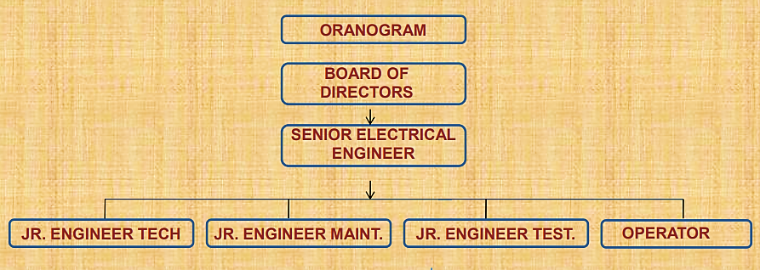
  - PROJECT LOCATION:
The project is situated in Tuticorin District in the state of Tamil Nadu with the google coordinates as 8°46'38" North and 77°56'56" East. The location of the same is shown in the images below:
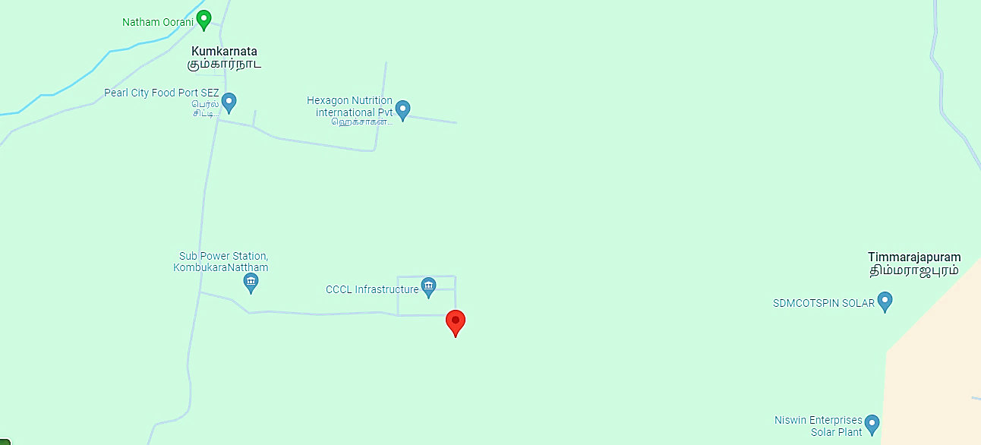
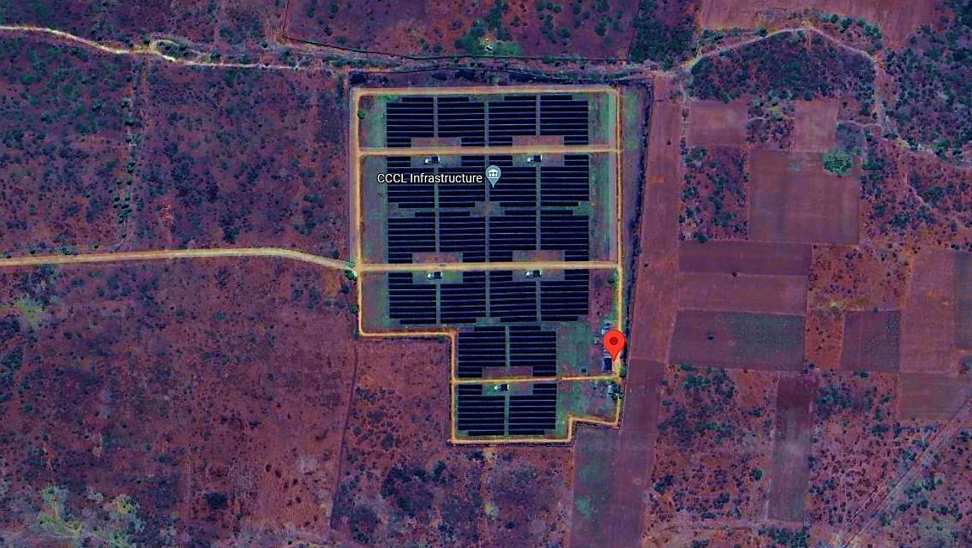

  - OPERATION & MAINTENANCE:
The Plant Manager would have the primary responsibility for the O&M of the solar power plant. The organization will compromise of four broad functional areas viz. Operation, Maintenance, Technical and Administration. The basic structure and the broad functional area within the O&M parameters would be as follows:
- OPERATION:
- Operation of main generating equipment, switch yard and other auxiliary plant.
- Except for the Power Station Superintendent all other operating personnel works on one shift basis. The day-to-day operation of the power plant is controlled by the Manager who is assisted by the Control room operators and engineers.
- MAINTENANCE:
- Maintenance of mechanical and electrical plant, control systems, buildings, roads, drainages and sewage systems etc.
- Operation of the plant, planning and scheduling maintenance works and deciding the requirement of spare parts.
- The Plant Manager is assisted by departmental engineers, who take care of the maintenance aspects of all mechanical, electrical and I&C requirement. Trained technicians are employed to assist the maintenance group in day-to-day maintenance of the plant.
- ADMINISTRATION:
The main responsibilities of this department are Purchase, Plant Security, Stores Management, Liaison with local labor officers, Medical Services and Transport Services.

  - KEY APPROVAL & CLEARENCE:
Project sanction for allotment of 5 MW capacity by Tamil Nadu Generation & Distribution Corporation Limited has been transferred in favour of the company. Project does not require environmental clearance as it is a solar project. Further, no forest land is involved in the Project and hence no forest clearance is required.

PART D | ASSESSMENT OF SOLAR ENERGY SECTOR

- INTRODUCTION:
In the upcoming decades, India is poised to experience a substantial surge in energy demand, surpassing that of any other nation, owing to its vast size and immense prospects for expansion and progress. Consequently, a predominant portion of this heightened energy requirement must be fulfilled through the utilization of low-carbon, renewable sources.
A significant milestone in the worldwide endeavor to address climate change is India's declaration of its commitment to attain net zero carbon emissions by 2070. Furthermore, the pledge to derive 50% of its electricity from renewable sources by 2030 underscores a pivotal moment in the global initiative to combat climate change.
India secured the fourth position globally in both wind power and solar power capacity, along with being fourth in overall renewable energy installed capacity. The growth trajectory of installed renewable power generation capacity has been rapid in recent years, exhibiting a Compound Annual Growth Rate (CAGR) of 15.4% from FY16 to FY23.
As of Dec 2023, Renewable energy sources, including large hydropower, have a combined installed capacity of 180.79 GW. It stands out as the market experiencing the swiftest expansion in renewable electricity, and projections indicate a doubling of new capacity additions by the year 2026.
The sector has gained heightened appeal to investors due to enhanced governmental support and improved economic viability. With India striving to fulfill its burgeoning energy demand, projected to reach 15,820 TWh by 2040, renewable energy is poised to assume a pivotal role in meeting these requirements.
- MARKET SIZE:
India’s installed non-fossil fuel capacity has increased 396% in the last 8.5 years and stands at more than 179.57 GW (including large Hydro and nuclear), about 42% of the country’s total capacity (as of November 2023). India saw the highest year-on-year growth in renewable energy additions of 9.83% in 2022.
The installed solar energy capacity has increased by 30 times in the last 9 years and stands at 74.30 GW as of January 2024. India’s solar energy potential is estimated to be 748 GWp as estimated by National Institute of Solar Energy (NISE). The installed Renewable energy capacity (including large hydro) has increased by around 128% since 2014.
India has set a target to reduce the carbon intensity of the nation’s economy by less than 45% by the end of the decade, achieve 50 percent cumulative electric power installed by 2030 from renewables, and achieve net-zero carbon emissions by 2070. India aims for 500 GW of renewable energy installed capacity by 2030.
India aims to produce five million tonnes of green hydrogen by 2030. This will be supported by 125 GW of renewable energy capacity. 50 solar parks with an aggregate capacity of 37.49 GW have been approved in India. Wind Energy has an off-shore target of 30 GW by 2030, with potential sites identified.
- MAJOR INVESTMENTS:
According to the data released by the Department for Promotion of Industry and Internal Trade (DPIIT), the country has received a total FDI Equity investment amounting to USD 6,137.39 Million in the renewable energy sector, during the last three financial years and the current financial year (till 30th September 2023). Some major investments and developments in the Indian solar energy sector are as follows:
- 59 solar parks with an aggregate capacity 40 GW have been approved in India.
- Solar Parks in Pavagada (2 GW), Kurnool (1 GW) and Bhadla-II (648 MW) are included in the top 5 operational solar parks of 7 GW capacity in the country.
- The world’s largest renewable energy park of 30 GW capacity solar-wind hybrid project is under installation in Gujarat.
- The Honourable Prime Minister of India has laid foundation stone of the 300 MW Solar Power Plant located at Karnisar-Bhatiyan village, in Poogal Tehsil, Bikaner, Rajasthan through video conferencing mode on 16th February, 2024.
- In August 2022, Norfund, who manages the Norwegian Climate Investment Fund, and KLP, Norway’s biggest pension company, signed an agreement to buy a 49% share of a 420 MW solar power plant in Rajasthan for Rs. 2.8 billion (US$ 35.05 million).
- In November 2023, AmpIn Energy Transition announced an investment of Rs. 3,100 crore (US$ 372.6 million) to establish renewable energy projects exceeding 600 MW and an integrated manufacturing facility for solar cells and modules across the Eastern region. The funding will be focused in West Bengal, Bihar, Odisha, Jharkhand, Chhattisgarh, and the North-eastern States.
- GOVERNMENT INITIATIVE:
In order to achieve the above target, Government of India have launched various schemes to encourage generation of solar power in the country like Solar Park Scheme, VGF Schemes, CPSU Scheme, Defence Scheme, Canal bank & Canal top Scheme, Bundling Scheme, Grid Connected Solar Rooftop Scheme etc. Government has taken several steps for promotion of solar energy in the country. These include:
- Permitting Foreign Direct Investment (FDI) up to 100 percent under the automatic route,
- Waiver of Inter State Transmission System (ISTS) charges for inter-state sale of solar and wind power for projects to be commissioned by 30th June 2025,
- Declaration of trajectory for Renewable Purchase Obligation (RPO) up to the year 2029-30,
- Notification of standards for deployment of solar photovoltaic system/devices,
- Setting up of Project Development Cell for attracting and facilitating investments,
- Standard Bidding Guidelines for tariff based competitive bidding process for procurement of Power from Grid Connected Solar PV and Wind Projects.
- Government has issued orders that power shall be dispatched against Letter of Credit (LC) or advance payment to ensure timely payment by distribution licensees to RE generators.
- Notification of Promoting Renewable Energy through Green Energy Open Access Rules 2022.
- Notification of “The electricity (Late Payment Surcharge and related matters) Rules 2002 (LPS rules).
- Launch of Green Term Ahead Market (GTAM) to facilitate sale of Renewable Energy power including solar power through exchanges.
As per the MNRE website, India now stands 5th in solar PV deployment across the globe at the end of 2022 (Ref. REN21’s Global Status Report 2023 & IRENA’s Renewable Capacity Statistics 2023). Solar power installed capacity has reached around 70.10 GW as on 30-06-2023.

- WAY FORWARD:
India aims to decrease the carbon intensity of its economy by over 45% by the close of the decade, attain a 50% cumulative share of renewable energy in its electric power capacity by 2030, and accomplish net-zero carbon emissions by the year 2070. The adoption of low-carbon technologies has the potential to generate a market valued at up to $80 billion in India by 2030.
By the year 2040, it is expected that approximately 49% of the total electricity will be produced from renewable sources, propelled by the utilization of more efficient batteries for electricity storage. This advancement is projected to reduce solar energy costs by 66% compared to the current expenses. Substituting renewables for coal is expected to result in annual savings of INR 54,000 crore for India.
As per the Central Electricity Authority (CEA) estimates, by 2029-30, the share of renewable energy generation would increase from 18% to 44%, while that of thermal is expected to reduce from 78% to 52%. The CEA also estimates India’s power requirement to grow to reach 817 GW by 2030.
The International Energy Agency (IEA) forecasts a monumental rise, predicting India's solar capacity to reach a staggering 800 GW by 2050. This would constitute nearly half of the country's electricity generation

PART E | FINANCIAL PERFORMANCE

As per the audited financial statements provided by the company/client, below table shows the historical performance of the company from FY 2018-19 to FY H1 2023-24.
- HISTORICAL PROFIT & LOSS STATEMENT: (FY 2018-19 to FY H1 2023-24)
(INR Crores)
Particular | FY 2018 A | FY 2019 A | FY 2020 A | FY 2021 A | FY 2022 A | FY 2023 A | Sep, 2023 A
Revenue | 9.18 | 8.66 | 7.51 | 2.08 | 4.77 | 4.42 | 1.83
Other Income | 0.00 | 3.98 | 0.00 | 0.00 | 0.00 | 0.01 | 0.00
Total Revenue | 9.18 | 12.64 | 7.51 | 2.08 | 4.77 | 4.43 | 1.83
Operational & Maintenance | 0.46 | 0.07 | 0.20 | 0.09 | 0.33 | 0.22 | 0.15
Employee Benefit Expenses | 0.21 | 0.25 | 0.26 | 0.26 | 0.21 | 0.20 | 0.10
Other Expenses | 0.44 | 0.47 | 0.44 | 0.71 | 0.42 | 0.46 | 0.30
Total Expenses | 1.11 | 0.78 | 0.89 | 1.05 | 0.95 | 0.87 | 0.55
EBITDA | 8.07 | 11.85 | 6.62 | 1.03 | 3.82 | 3.55 | 1.28
Depreciation & Amortization | 3.81 | 3.40 | 3.02 | 2.69 | 2.46 | 2.19 | 0.97
EBIT | 4.26 | 8.46 | 3.60 | -1.66 | 1.36 | 1.36 | 0.31
Finance cost | 8.11 | 9.24 | 6.72 | 8.91 | 9.88 | 10.31 | 5.16
Profit Before Exceptional Item and Taxes | -3.85 | -0.78 | -3.12 | -10.57 | -8.52 | -8.95 | -4.85
Exceptional Item | -8.90 | 0.00 | -1.95 | 0.00 | -0.01 | 0.00 | 0.00
Profit Before Taxes | -12.75 | -0.78 | -5.07 | -10.57 | -8.53 | -8.95 | -4.85
Tax | 0.94 | -0.07 | -0.08 | -0.11 | -0.15 | -0.13 | 0.00
Profit After Taxes | -13.70 | -0.71 | -4.99 | -10.46 | -8.38 | -8.82 | -4.85
Source: Audited Financials shared by the client/company except Sep, 2023 which are unaudited.
- HISTORICAL KEY FINANCIAL RATIOS:
Particular | FY 2018 A | FY 2019 A | FY 2020 A | FY 2021 A | FY 2022 A | FY 2023 A | Sep, 2023 A
EBITDA Margin % | 87.90% | 136.91% | 88.15% | 49.47% | 80.00% | 80.33% | 70.14%
EBIT Margin % | 46.40% | 97.67% | 47.90% | -79.79% | 28.48% | 30.84% | 16.91%
Net Profit Margin % | -149.25% | -8.18% | -66.42% | -502.67% | -175.50% | -199.49% | -265.17%
Revenue Growth % (Y.O.Y.) |  | -5.66% | -13.27% | -72.28% | 129.37% | -7.39% | -58.65%

- GRAPHICAL REPRESENTATION OF THE KEY FINANCIALS OF THE COMPANY:
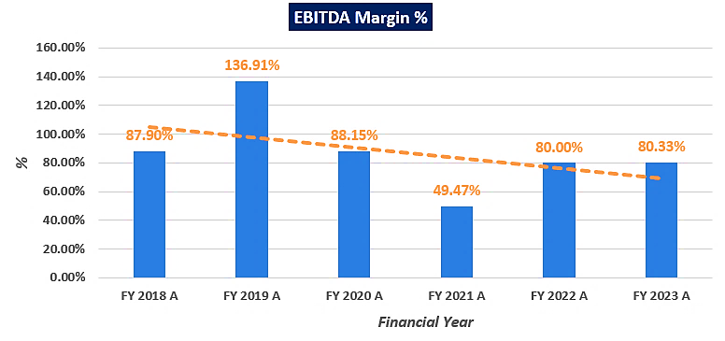
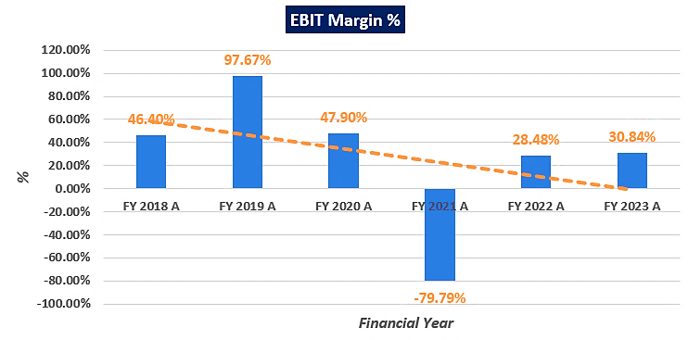
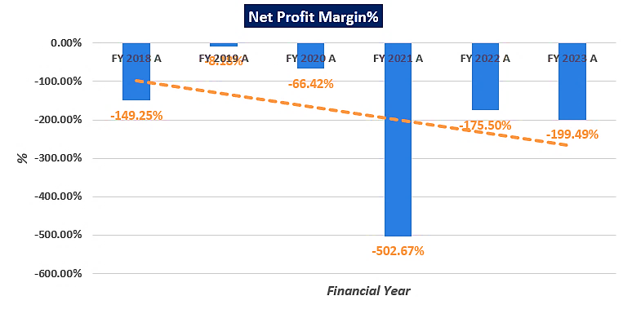
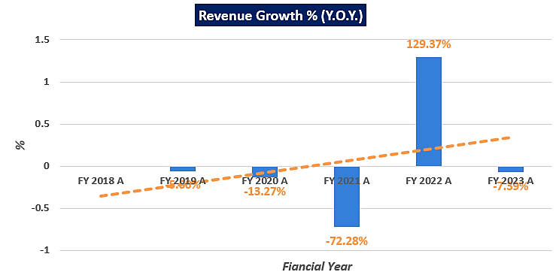

- PROJECTED PROFIT & LOSS STATEMENT (From FY 2024 to FY 2037):
Based on the data/ information/ inputs provided by the Client/ company, projected P&L is shown in the below table:
(INR crore, except unit generated)
Particular (INR Crore) | FY 2024 E | FY 2025 E | FY 2026 E | FY 2027 E | FY 2028 E | FY 2029 E | FY 2030 E
Units generated per years (KWh) | 2357247 | 6935582 | 6880098 | 6825057 | 6789006 | 6716293 | 6662562
Tariff Revenue | 2.99 | 8.81 | 8.74 | 8.67 | 8.62 | 8.53 | 8.46
Insurance Claim | 0.00 | 3.30 | 0.00 | 0.00 | 0.00 | 0.00 | 0.00
Total Revenue | 2.99 | 12.11 | 8.74 | 8.67 | 8.62 | 8.53 | 8.46
Operational Expense | 1.07 | 1.13 | 1.20 | 1.27 | 1.34 | 1.42 | 1.50
Employee Benefit expenses | 0.26 | 0.28 | 0.31 | 0.34 | 0.37 | 0.41 | 0.45
Major components replacement | 0.00 | 3.30 | 0.00 | 0.00 | 0.00 | 0.00 | 0.00
Penalty- NVVN | 0.92 | 0.00 | 0.00 | 0.00 | 0.00 | 0.00 | 0.00
Other Expenses | 0.45 | 1.32 | 1.31 | 1.30 | 1.29 | 1.28 | 1.27
Total Expenses | 2.70 | 6.03 | 2.82 | 2.91 | 3.01 | 3.11 | 3.22
EBITDA | 0.30 | 6.07 | 5.92 | 5.76 | 5.62 | 5.42 | 5.24
D & A | 1.99 | 2.14 | 1.90 | 1.68 | 1.49 | 1.33 | 1.18
EBIT | -1.70 | 3.93 | 4.02 | 4.08 | 4.12 | 4.10 | 4.07
Finance cost (Interest) | 11.59 | 11.59 | 11.59 | 11.59 | 11.59 | 11.59 | 11.59
Profit Before Taxes | -13.29 | -7.66 | -7.57 | -7.52 | -7.47 | -7.49 | -7.52
Tax @25.17% | 0.00 | 0.00 | 0.00 | 0.00 | 0.00 | 0.00 | 0.00
Profit After Taxes | -13.29 | -7.66 | -7.57 | -7.52 | -7.47 | -7.49 | -7.52

(Continue)
Particular (INR Crore) | FY 2031 E | FY 2032 E | FY 2033 E | FY 2034 E | FY 2035 E | FY 2036 E | FY 2037 E
Units generated per years (KWh) | 6609262 | 6574350 | 6503937 | 6451905 | 6400290 | 6366482 | 6298295
Tariff Revenue | 8.39 | 8.35 | 8.26 | 8.19 | 8.13 | 8.09 | 8.00
Insurance Claim | 0.00 | 0.00 | 0.00 | 0.00 | 0.00 | 0.00 | 0.00
Total Revenue | 8.39 | 8.35 | 8.26 | 8.19 | 8.13 | 8.09 | 8.00
Operational Expense | 1.58 | 1.67 | 1.77 | 1.87 | 1.98 | 2.09 | 2.21
Employee Benefit expenses | 0.50 | 0.55 | 0.60 | 0.66 | 0.73 | 0.80 | 0.88
Major components replacement | 0.00 | 0.00 | 0.00 | 0.00 | 0.00 | 0.00 | 0.00
Penalty- NVVN | 0.00 | 0.00 | 0.00 | 0.00 | 0.00 | 0.00 | 0.00
Other Expenses | 1.26 | 1.25 | 1.24 | 1.23 | 1.22 | 1.21 | 1.20
Total Expenses | 3.34 | 3.47 | 3.61 | 3.76 | 3.92 | 4.10 | 4.29
EBITDA | 5.06 | 4.88 | 4.65 | 4.43 | 4.20 | 3.98 | 3.71
Depreciation & Amortization | 1.04 | 0.93 | 0.82 | 0.73 | 0.65 | 0.57 | 0.51
EBIT | 4.01 | 3.95 | 3.83 | 3.70 | 3.56 | 3.41 | 3.20
Finance cost (Interest) | 11.59 | 11.59 | 11.59 | 11.59 | 11.59 | 11.59 | 11.59
Profit Before Taxes | -7.58 | -7.64 | -7.76 | -7.89 | -8.03 | -8.18 | -8.39
Tax @25.17% | 0.00 | 0.00 | 0.00 | 0.00 | 0.00 | 0.00 | 0.00
Profit After Taxes | -7.58 | -7.64 | -7.76 | -7.89 | -8.03 | -8.18 | -8.39

- KEY PROJECTED FINANCIAL RATIOS:
Particular | FY 2024 E | FY 2025 E | FY 2026 E | FY 2027 E | FY 2028 E | FY 2029 E | FY 2030 E
EBITDA Margin % | 9.92% | 68.95% | 67.75% | 66.47% | 65.14% | 63.58% | 61.97%
EBIT Margin % | -56.67% | 44.64% | 46.02% | 47.03% | 47.80% | 48.04% | 48.07%
Net Profit Margin % | -443.89% | -86.96% | -86.65% | -86.70% | -86.64% | -87.86% | -88.93%
Revenue Growth % (Y.O.Y.) | - | 194.22% | -0.80% | -0.80% | -0.53% | -1.07% | -0.80%

Particular | FY 2031 E | FY 2032 E | FY 2033 E | FY 2034 E | FY 2035 E | FY 2036 E | FY 2037 E
EBITDA Margin % | 60.22% | 58.41% | 56.31% | 54.11% | 51.73% | 49.25% | 46.37%
EBIT Margin % | 47.80% | 47.33% | 46.37% | 45.22% | 43.78% | 42.16% | 40.01%
Net Profit Margin % | -90.31% | -91.51% | -93.98% | -96.26% | -98.84% | -101.21% | -104.91%
Revenue Growth % (Y.O.Y.) | -0.80% | -0.53% | -1.07% | -0.80% | -0.80% | -0.53% | -1.07%

- GRAPHICAL REPRESENTATION OF THE KEY FINANCIALS OF THE COMPANY:
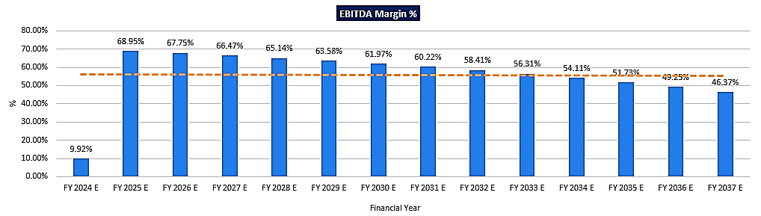
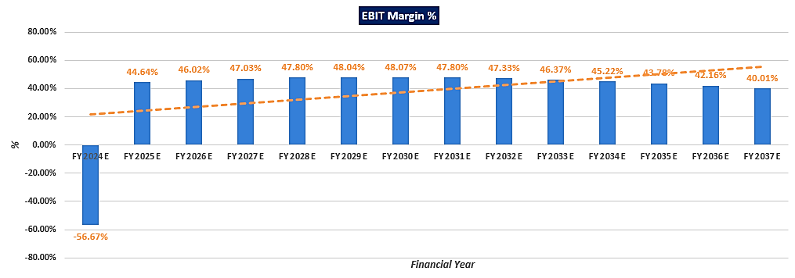
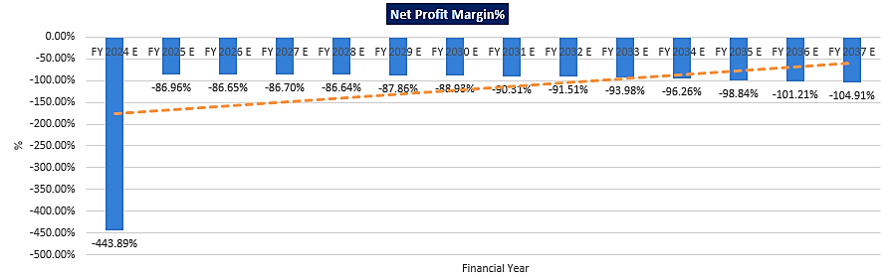

PART F | VALUATION OF THE COMPANY

- METHODOLOGY/ MODEL ADOPTED:
Out of the various models & theories available, we have adopted the most widely used & acceptable Discounted Cash Flow Method under Income based approach to calculate the Enterprise Value of the Company for the reason being:
- The free cash flow method is similar to the method used for public companies.
- FCFF is more practical when substantial capital changes are expected because weighted average cost of capital (WACC) is less sensitive to the cost of equity.
- In this method, we calculate the free cash flow to firm (FCFF) for the projected period.
- Finally, we calculate the present value of future cash flows by using a required rate of return based on the riskiness of the project, which we determine by using the Weighted Average Cost of Capital (WACC).
RATIONALE FOR USING DCF METHOD FOR ENTERPRISE VALUATION:
- The three broadly used approaches of the company/Business Valuations are – Income based approach (Discounted Cash Flow Model), Asset Based Approach (Net Asset Value Method) and Relative Valuation Approach (Market Multiple method).
- Asset Based Model is inappropriate as the Company/project is a going concern and the model is unable to capture the Value of the company.
- Market Multiple Approach is also not suitable approach as the company/project/business is not a listed and no proper similar recent comparable transactions are available.
- Instead, DCF method is used which determines the value of a business based on its ability to generate desired economic benefit/ cash flows for the owners. Thus, considering the nature of business, we have used DCF method for valuing the Company.
- The DCF Model gives us a variety of input options to use while calculating the Value of the firm - Dividend, Free Cash Flow to the Firm, Free Cash Flow to Equity, Capitalized Cash Flows and Residual Earnings.
- Dividends cannot be used as the Company has no history of paying dividends and we don’t foresee any dividend payments to occur in the future due to the high leverage of the firm.
- The best method input option for the PV Model in the case of M/s CCCL Infrastructure Limited will be FCFF as it represents the benefits accruable to all the stakeholders in the Business enterprise.
- Further, the valuation is conducted based on the data/information provided by the company/client and based on our independent analysis.
FCFF Model Formula and Key Inputs:

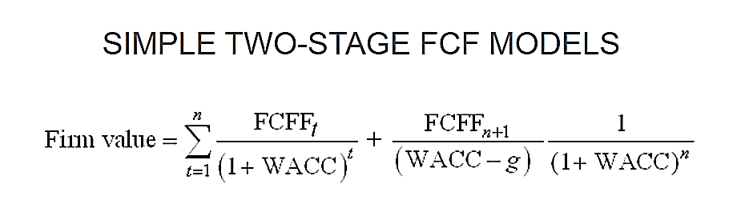

- Free Cash Flow to Firm (FCFF):
FCFF is the cash available to pay investors/stakeholders after a company pays its costs of doing business, invests in short-term assets like inventory, and invests in assets like property, plants and equipment.

FCFF = Net Income + Non-Cash Charges + Interest (1 - tax rate) – Working Capital Investment – Fixed Capital Investment.

- Weighted Average Cost of Capital (WACC):
The weighted average cost of capital (WACC) is the rate that a company is expected to pay on average to all its security holders to finance its assets. The WACC is commonly referred to as the firm’s cost of capital. WACC is used as the discount rate to discount FCFF.

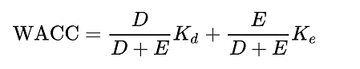

Where D is the total debt, E is the shareholders equity and Kd and Ke are the cost of debt and cost of equity, respectively.
- CALCULATION OF FREE CASH FLOW TO FIRM:
(INR Crore)
Particulars | Mar-24 | Mar-25 | Mar-26 | Mar-27 | Mar-28 | Mar-29 | Mar-30
EBITDA | 0.30 | 6.07 | 5.92 | 5.76 | 5.62 | 5.42 | 5.24
Depreciation | 1.99 | 2.14 | 1.90 | 1.68 | 1.49 | 1.33 | 1.18
EBIT | -1.70 | 3.93 | 4.02 | 4.08 | 4.12 | 4.10 | 4.07
Less: Taxes | 0.00 | 0.00 | 0.00 | 0.00 | 0.00 | 0.00 | 0.00
NOPAT | -1.70 | 3.93 | 4.02 | 4.08 | 4.12 | 4.10 | 4.07
Add: Depreciation | 1.99 | 2.14 | 1.90 | 1.68 | 1.49 | 1.33 | 1.18
Less: Capex | 0.00 | 0.00 | 0.00 | 0.00 | 0.00 | 0.00 | 0.00
Less: Change in WC | 0.00 | 0.00 | 0.00 | 0.00 | 0.00 | 0.00 | 0.00
Unlevered Free Cash Flow (UFCF)/ FCFF | 0.30 | 6.07 | 5.92 | 5.76 | 5.62 | 5.42 | 5.24
FCFF for Remaining Year | 0.03 | 6.07 | 5.92 | 5.76 | 5.62 | 5.42 | 5.24
Discount Rate | 15.73%
Valuation Date | 19th February 2024
Period | 0.11 | 1.11 | 2.11 | 3.11 | 4.11 | 5.11 | 6.11
Discount Factor | 0.98 | 0.85 | 0.73 | 0.63 | 0.55 | 0.47 | 0.41
PV of FCFF | 0.03 | 5.16 | 4.35 | 3.66 | 3.08 | 2.57 | 2.15

(INR Crore)
Particulars | Mar-31 | Mar-32 | Mar-33 | Mar-34 | Mar-35 | Mar-36 | Mar-37
EBITDA | 5.06 | 4.88 | 4.65 | 4.43 | 4.20 | 3.98 | 3.71
Depreciation | 1.04 | 0.93 | 0.82 | 0.73 | 0.65 | 0.57 | 0.51
EBIT | 4.01 | 3.95 | 3.83 | 3.70 | 3.56 | 3.41 | 3.20
Less: Taxes | 0.00 | 0.00 | 0.00 | 0.00 | 0.00 | 0.00 | 0.00
NOPAT | 4.01 | 3.95 | 3.83 | 3.70 | 3.56 | 3.41 | 3.20
Add: Depreciation | 1.04 | 0.93 | 0.82 | 0.73 | 0.65 | 0.57 | 0.51
Less: Capex | 0.00 | 0.00 | 0.00 | 0.00 | 0.00 | 0.00 | 0.00
Less: Change in WC | 0.00 | 0.00 | 0.00 | 0.00 | 0.00 | 0.00 | 0.00
Unlevered Free Cash Flow (UFCF)/ FCFF | 5.06 | 4.88 | 4.65 | 4.43 | 4.20 | 3.98 | 3.71
FCFF for Remaining Year | 5.06 | 4.88 | 4.65 | 4.43 | 4.20 | 3.98 | 3.71
Discount Rate | 15.73%
Valuation Date | 19th February 2024
Period | 7.11 | 8.11 | 9.11 | 10.11 | 11.11 | 12.11 | 13.11
Discount Factor | 0.35 | 0.31 | 0.26 | 0.23 | 0.20 | 0.17 | 0.15
PV of FCFF | 1.79 | 1.49 | 1.23 | 1.01 | 0.83 | 0.68 | 0.55

- KEY INPUTS:
Key Inputs for WACC
Particulars | Value
Valuation Date | 19-Feb-24
Cost of Equity (Nifty 50 20-year Return) | 15.43%
Cost of Debt | 15.45%
Discount Rate | 15.73%
Discount Rate Change | 1%
Tax Rate | 25.17%

(INR Lakhs)
Weighted Average Cost of Capital
Particular | Amount | Weightage | Discount Rate
Equity | 335.40 | 4.28% | 15.43%
Debt* | 7,503.00 | 95.72% | 15.45%
Total | 7,838.40 |  | 11.73%
Company Risk Premium |  |  | 4.00%
Appropriate Discount Rate |  |  | 15.73%
Notes:
- Nifty-50 20 year return is taken as proxy for Cost of Equity, which is 15.43% (Ref: https://kunaldesai.blog/nifty-returns/).
- The company has an outstanding CC Loan from SBI for INR 75.03 Crore with an interest rate of 15.45%. Apart from CC Loan, the company has an unsecured loan from the holding company for INR 1373.02 Lakhs and another loan of INR 20.09 Lakhs from fellow subsidiary, which are not considered to form the part of weight of debt as these debts have no interest paying obligations.
- As per the degree of riskiness, operational efficiencies & legal aspects of the company, a 4.00% company risk premium has been added to the WACC to calculate the appropriate discount rate of the company, considering the fact that the company is financially stressed, not able to repayment on time, legal issues between the respective parties, uncertainty and Management efficiency etc.

- CALCULATION OF ENTERPRISE VALUE:
Enterprise value is calculated by taking summation of Present Value of Free Cash Flow to Firm:
ENTERPRISE VALUE OF THE COMPANY
INR 28.57 CRORE (INR TWENTY-EIGHT CRORE AND FIFTY-SEVEN LAKH)

NOTE:
- The operations and futuristic projections are completely dependent on the company’s ability to restore the damages at the plant and replace the defected parts for the solar power plant. The projected cash flows for the power plant are dependent on the insurance company pay out for the claim filed by the company.
- Revenue increase can only be achieved by utilising the Insurance Claim of approx. Rs.3.30 crores in upgradation of Plant Operations.
- As per the agreement between NVVN and the company, if the expected output is less than the PPA agreement, the penalties will be levied by NVVN.
- We have not considered any contingent Dues / Liability/ Payables / Receivables / Pendency on or of the company in future years, which should be assessed separately by the parties, wanting to enter in the transaction, unless otherwise mentioned.
- The enterprise valuation of the project is just the reflection of the present value of its cash flow generating capacity in future years

- SENSITIVITY ANALYSIS:
WACC is the key input which has strong impact on the firm’s value with respect to percentage change. We have considered a change of 1% to perform the sensitivity analysis.

Scenario | Discount Rate | Enterprise Value (In INR Crore)
Bull Case | 14.73% | 29.79
Present Case | 15.73% | 28.57
Bear Case | 16.73% | 27.44

Thus, the Enterprise Value of M/s CCCL Infrastructure Limited is INR 28.57 Crore subject to the current assumptions and inputs used during the forecasted period and it may vary up to INR 29.79 Crore as optimistic case and INR 27.44 Crore as the pessimistic case. However, as per sensitivity analysis, the final transaction price will be dependent on the bargaining power of market participants to reach out to a successful outcome for all the concerned parties.
This is only a general assessment of the Enterprise/Business Value of the firm based on the data/ input that the client/company officials could provide to us against our questions/ queries and information available in the public domain. In no manner this should be regarded as an audit activity/ report and NO micro analysis or detailed or forensic audit/ scrutiny of the financial transactions or accounts of any kind has been carried out at our end.

- ASSUMPTIONS FOR FINANCIAL PROJECTIONS:
Assumptions in the Valuation assessment have been taken based on data/ information/ documents shared by the Client/Company, Project Cost Figures, and Operating History of the Project. Assumptions have been considered after thoroughly reviewing their feasibility.
        - KEY ASSUMPTION OF THE PROJECT:
Details of key inputs/assumption during the building of projection are as follows shown in the below table:
CCCL Infrastructure Limited Details
Particular | Unit | CIL | Remarks
Life of Plant | Years | 25
Installed Capacity of CIL | MW | 5
COD of the Project | Date | 29th March 2012
Selling price as per Agreement | INR per unit | 12.70
PLF of CIL | % | 17.80% | As per information shared by client/company
Annual Degradation | % | 0.80% | As per information shared by client/company
Auxiliary Power Consumption | % | 0.75% | As per CERC guidelines dated 07th July 2020
Transformation Losses | % | 0.50% | As per CERC guidelines dated 07th July 2020

        - REVENUE/ INCOME:
The project company is having Purchasing Power Agreement with state. Thus, according to PPA the selling price is constant for 25 years. Revenue is being calculated by adjusting the annual generated units with the annual degradation factor and auxiliary power consumption factor during the forecasted period.
Below table shows the total revenue earned during the estimated period:
Particular | FY 2024 E | FY 2025 E | FY 2026 E | FY 2027 E | FY 2028 E | FY 2029 E | FY 2030 E
Capacity (MW) | 1.70 | 5 | 5 | 5 | 5 | 5 | 5
PLF | 17.80% | 17.80% | 17.80% | 17.80% | 17.80% | 17.80% | 17.80%
Generation in KWh | 2357247 | 6935583 | 6880098 | 6825057 | 6789006 | 6716293 | 6662563
Tariff | 12.70 | 12.70 | 12.70 | 12.70 | 12.70 | 12.70 | 12.70
Revenue Crore | 2.99 | 8.81 | 8.74 | 8.67 | 8.62 | 8.53 | 8.46

Particular | FY 2031 E | FY 2032 E | FY 2033 E | FY 2034 E | FY 2035 E | FY 2036 E | FY 2037 E
Capacity (MW) | 5 | 5 | 5 | 5 | 5 | 5 | 5
PLF | 17.80% | 17.80% | 17.80% | 17.80% | 17.80% | 17.80% | 17.80%
Generation in KWh | 6609262 | 6574351 | 6503937 | 6451906 | 6400290 | 6366483 | 6298295
Tariff | 12.70 | 12.70 | 12.70 | 12.70 | 12.70 | 12.70 | 12.70
Revenue Crore | 8.39 | 8.35 | 8.26 | 8.19 | 8.13 | 8.09 | 8.00

Note:
- Projections have been made for remaining 1 month for FY 2023-24, thus the first full operating year would be FY 2024-25 as on valuation date.
- For FY 2023-24, the units generated is estimated on the basis of the current years’ export output provided by the company/client.
- As per the information provided by the client/company, the plant is running at the PLF of 17.80% which is assumed to be constant for the projected years.
        - OPERATING & MAINTENANCE EXPENSES:
As per the provision made by CERC in respect of O&M Expenses in the Terms and Conditions for determination of tariff from Renewable Energy Sources Regulations 2012, is INR 11 Lakhs/ MW for the 1st year of operation with escalation of 5.72% per annum thereafter.
Particular (INR Crore) | 1MW | 5MW
O&M Cost per MW as per CERC for 1st year of operation | 0.11 | 0.55
Annual Escalation | 5.72%

        - EMPLOYEE BENEFIT EXPENSES & OTHER EXPENSES:
Employee Benefit Expenses are estimated based on the average of previous years’ expenses (from FY 2019-20 to FY 2022-23), i.e. INR 23 Lakhs with an annual expected growth rate of 10% is estimated for the projections.
In the absence of the relevant information available with us, we have estimated the other expenses during the projection period by using the average of the historical expenses with respect to the operating revenues (from FY 2019-20 to FY 2022-23) as per the best practices in the industry, which comes to ~15%. Hence, we have taken the other expenses as 15.00% of the operating revenues.
        - DEPRECIATION SCHEDULE:
As per historical trend, we have calculated depreciation by using Written down Value Method (WDV) till FY 2037.
        - ESTIMATED COSTS FOR REPAIR / REPLACEMENT:
As per the information shared by the client/company, the estimated cost to repair the damages and the amount of insurance claim filed is as per the table below:
S. No. | Description | Unit Price | Quantity | Total Estimated Cost (Excl. GST & Transport)
1 | Inverter Make: FIMER | 26,00,000 | 6 | 1,56,00,000
2 | Solar Panel | 9,000 | 1000 | 90,00,000
3 | HT Breaker Make: ABB | 8,00,000 | 2 | 16,00,000
4 | HT UG Cable | 1,600/Meters + GST | 2 Roll(2000Mtrs) | 37,76,000
5 | LT Cable, Combiner Box | Lump Sum | 2.5 Sqmm,6Sqm each 1 roll | 5,00,000
6 | Civil work all Control Room patch work | Lump Sum |  | 15,00,000
7 | Solar fencing work | Lump Sum |  | 10,00,000
Grand Total |  |  |  | 3,29,76,000

        - TAXATION:
Effective tax rate has been considered as 25.17% as per applicability of taxation for fiscal year FY 2023-24 and onwards. Information for DTL and related information is not available with us. As such it is presumed that there will not be tax liabilities in view of the unabsorbed depreciation and carry forward losses. Determination of effective tax rate is shown in the below table:
Effective Tax Rates
Particular | Description
Basic rate | 25%
(+) Cess/Health & education | 4.00%
(+) Surcharge | 7%
Effective tax rate | 25.17%

        - CHANGE IN WORKING CAPITAL:
In the absence of relevant information to estimate the working capital, we have assumed that the working capital will remain constant during the forecasted period, hence the changes in working capital is considered as zero.
Hence, Enterprise Value of M/s CCCL Infrastructure Limited is INR 28.57 Crore, subject to the current micro & macro-economic assumptions, market, industry trends and inputs used during the forecasted period, as well as the WACC used to calculate the EV. We have used DCF to calculate the EV of Solar Power project, It is highly depends on the Management’s capability to maintain the Free cash flow as projected.
Declaration | - Since this is Enterprise Valuation hence no site inspection was carried out by us.  - The undersigned does not have any direct/indirect interest in the above property.  - The information furnished herein is true and correct to the best of our knowledge.  - This valuation work is carried out by our Financial Analyst team on the request from State Bank of India, Stressed Asset Management Branch, “Red Cross Building”, 32, Red Cross Road, Egmore, Chennai – 600008.  - We have submitted Valuation report to the Client.
Number of Pages in the Repost | 44
Enclosed Documents | Disclaimer & Remarks 39-44
Place | Noida
Date | 19th February 2024

FOR ON BEHALF OF
M/S. R.K. ASSOCIATES VALUER & TECHNO ENGINEERING CONSULTANTS PVT. LTD.
SURVEYED BY | PREPARED BY | REVIEWED BY
Mr. Yash Bhatnagar  Mr. Anirban Roy | Mr. Rachit Gupta | Mr. Gaurav Kumar

PART G | IMPORTANT DEFINITION

Definitions:
- Enterprise Value: Enterprise value (EV) is the corporate valuation of a company, determined by using market capitalization and total debt. Market cap comprises preference stocks, common stocks, and minority interest; total debt comprises short-term and long-term liabilities of the company. Enterprise value (EV) refers to the overall valuation—equity, debt, cash, and cash equivalents. In other words, it is the cost of acquiring a firm. The EV/EBITDA is an enterprise multiple. It correlates EV with earnings before interest, taxes, depreciation, and amortization. The metric determines whether the firm is undervalued or overvalued.
- Fair Market Value suggested by the competent Valuer is that prospective estimated amount in his expert & prudent opinion of the subject asset without any prejudice after he has carefully & exhaustively evaluated the facts & information came in front of him related to the subject asset at which the subject asset should be exchanged between a willing buyer and willing seller at an arm’s length transaction in an open & unrestricted market, after proper marketing, wherein the parties, each acted knowledgeably, prudently and without any compulsion on the date of the Valuation.
Forced, under compulsion & constraint, obligatory sales transactions data doesn’t indicate the Fair Market Value.
- Realizable Value is the minimum prospective estimated value of the Company which it may be able to realize at the time of actual transaction factoring in the potential prospects of deep negotiations carried out between the buyer & seller for ultimately finalizing the transaction across the table. Realizable value may be 10-20% less than the Fair Market Value depending on the various salability prospects of the subject asset and the needs of the buyer & the seller.
- Forced/ Distress Sale Value is the value when the company has to be sold due to any compulsion or constraint like financial encumbrances, dispute, as a part of a recovery process, legal issues or any such condition or situation. In this type of sale, minimum fetch value is assessed which can be 15-25% less than the estimated Fair Market Value. In this type of sale, negotiation power of the buyer is always more than the seller and eagerness & pressure of selling the asset is more than buying it. Therefore, the Forced/ Distress Sale Value will always fetch significantly less value compare to the estimated Fair Market Value.
- Liquidation Value is the amount that would be realized when an asset or group of assets are sold on a piecemeal basis that is without consideration of benefits (or detriments) associated with a going-concern business. Liquidation value can be either in an orderly transaction with a typical marketing period or in a forced transaction with a shortened marketing period.
- Difference between Costs, Price & Value: Generally, these words are used and understood synonymously. However, in reality each of these has a completely different meaning, premise and also have different definitions in the professional & legal terms. Therefore, to avoid confusion, it is our professional responsibility to describe the definitions of these words to avoid ambiguity & confusion in the minds of the user of this report.
- The Cost of an asset represents the actual amount spend in the construction/ actual creation of the asset.
- The Price is the amount paid for the procurement of the same asset.
- The Value is defined as the present worth of future rights in the asset and depends to a great extent on combination of various factors such as demand and supply, market situation, purpose, situation & needs of the buyer & seller, salability outlook, usability factor, market perception & reputation. Needs of the buyer & seller, salability outlook, usability factor, market perception & reputation.
- Therefore, in actual for the same asset, cost, price & value remain different since these terms have different usage & meaning.

PART H | DISCLAIMER | REMARKS

      - No employee or member of R.K Associates has any direct/ indirect interest in the Project.
      - This is just an opinion report on Valuation based on the copy of the documents/ information provided to us by the client which has been relied upon in good faith and the assessment and assumptions done by us.
      - This report is prepared based on the copies of the documents/ information which the Bank/ Company has provided to us out of the standard checklist of documents sought from them and further based on our assumptions and limiting conditions. The client/owner and its management/representatives warranted to us that the information they supplied was complete, accurate and true and correct to the best of their knowledge. All such information provided to us has been relied upon in good faith and we have assumed that it is true and correct in all respect. I/We shall not be liable for any loss, damages, cost or expenses arising from fraudulent acts, misrepresentations, or willful default on part of the owner, company, its directors, employee, representative or agents. Verification or cross checking of the documents provided to us from the originals or from any Govt. departments/ Record of Registrar has not been done at our end since this is beyond the scope of our work. If at any time in future, it is found or came to our knowledge that misrepresentation of facts or incomplete or distorted information has been provided to us then this report shall automatically become null & void.
      - This Valuation is prepared based on the current financial status of the company, financial data, other facts & information provided by the client in writing & during verbal discussion during the course of the assignment and based on certain assumptions which are specifically mentioned in the Valuation section of the Report.
      - Key assumptions in the report are taken based on data, information, inputs, financial statements etc. provided by the client to us during the course of the assessment and on the basis of the assessment done by us and we have assumed that all such information is true & factual to the best of the knowledge of the promoter company.
      - Sale transaction method of the asset is assumed as free market transaction while assessing Prospective Fair Market Value of the asset.
      - Legal aspects for e.g., investigation of title, ownership rights, lien, charge, mortgage, lease, sanctioned maps, verification of documents, etc. have not been done at our end and same has to be taken care by legal expert/ Advocate. It is assumed that the concerned Lender/ Financial Institution has satisfied them with the authenticity of the documents, information given to us and for which the legal verification has been already taken and cleared by the competent Advocate before requesting for this report. I/ We assume no responsibility for the legal matters including, but not limited to, legal or title concerns.
      - All observations mentioned in the report is only based on the visual observation and the documents/ data/ information provided by the client. No mechanical/ technical tests, measurements or any design review have been performed or carried out from our side during Project assessment.
      - Bank/FII should ONLY take this report as an Advisory document from the Financial/ Chartered Engineering firm and its specifically advised to the creditor to cross verify the original documents for the facts mentioned in the report which can be availed from the borrowing company directly.
      - In case of any default in loans or the credit facility extended to the borrowing company, R.K Associates shall not be held responsible for whatsoever reason may be and any request for seeking any explanation from the employee/s of R.K Associates will not be entertained at any instance or situation.
      - We have relied on data from third party, external sources & information available on public domain also to conclude this report. These sources are believed to be reliable and therefore, we assume no liability for the truth or accuracy of any data, opinions or estimates furnished by others that have been used in this analysis. Where we have relied on data, opinions or estimates from external sources, reasonable care has been taken to ensure that such data has been correctly extracted from those sources and /or reproduced in its proper form and context, however still we can’t vouch its authenticity, correctness or accuracy.
      - This Report is prepared by our competent technical team which includes financial experts & analysts. This report is a general analysis of the project based on the scope mentioned in the report. This is not an Audit report, Design document, DPR or Techno feasibility study. All the information gathered is based on the facts seen on the site during survey, verbal discussion & documentary evidence provided by the client and is believed that information given by the company is true best of their knowledge.
      - Value varies with the Purpose/ Date/ Condition of the market. This report should not to be referred if any of these points are different from the one mentioned aforesaid in the Report.
      - Analysis and conclusions adopted in the report are limited to the reported assumptions, conditions and information came to our knowledge during the course of the work.
      - This report is having limited scope as per its fields to provide only the general indication of the Value of the company prevailing in the market based on the documents/ data/ information/ financial statements provided by the client and the assessment and assumption taken by us. The suggested value should be considered only if transaction is happened as free market transaction.
      - Secondary/ Tertiary costs related to transaction like Stamp Duty, Registration charges, Brokerage, etc. pertaining to the sale/ purchase of the company are not considered while assessing the Market Value.
      - Appropriate methodology & assumptions are rationally adopted based on the facts of the case came to our knowledge during the course of the assignment considering many factors like nature of Industry, current market situation and trends.
      - Valuation is a subjective field and opinion may differ from consultant to consultant. To check the right opinion, it is important to evaluate the methodology adopted and various factors/ basis considered during the course of assessment before reaching to any conclusion.
      - At the outset, it is to be noted that Value analysis cannot be regarded as an exact science and the conclusions arrived at in many cases will, of necessity, be subjective and dependent on the exercise of individual judgment. Given the same set of facts and using the same assumptions, expert opinions may differ due to the number of different factors, which have to be made. Therefore, there can be no standard formulae to establish an indisputable exchange ratio. In the event of a transaction, the actual transaction value achieved may be higher or lower than our indicative analysis of value depending upon the circumstances of the transaction. The knowledge, negotiability and motivations of the buyers and sellers and the applicability of a discount or premium for control will also affect actual price achieved. Accordingly, our indicative analysis of value will not necessarily be the price at which any agreement proceeds. The final transaction price is something on which the parties themselves have to agree. However, our Valuation analysis can definitely help the stakeholders to make them informed and wise decision about the Value of the asset and can help in facilitating the arm’s length transaction.
      - This report is prepared on the Enterprise Valuation format as per the client requirement. This report is having limited scope as per its fields to provide only the indicative Fair value of the company based on the current financial position, future prospects & current Industry trends. The Valuation assessed in this Valuation Report should hold well only if transaction is happened as per free market transaction. No detailed analysis or verification of the information is carried upon pertaining to the value of the shares of the subject companies. No claim for any extra information will be entertained whatsoever be the reason. For any extra work over and above the fields mentioned in the report will have an extra cost which has to be borne by the customer.
      - As per the scope of the report no site survey has been carried out by us and no thorough vetting of the documents/ information provided to us has been done at our end.
      - This is just an opinion report and doesn’t hold any binding on anyone. It is requested from the concerned stakeholder which is using this report that they should consider all the different associated relevant & related factors also before taking any business decision based on the content of this report.
      - Though adequate care has been taken while preparing this report as per its scope, but still, we can’t rule out typing, human errors, over sightedness of any information or any other mistakes. Therefore, the concerned organization is advised to satisfy themselves that the report is complete & satisfactory in all respect. Intimation regarding any discrepancy shall be brought into our notice immediately. If no intimation is received within 15 (Fifteen) days in writing from the date of issuance of the report, to rectify these timely, then it shall be considered that the report is complete in all respect and has been accepted by the client up to their satisfaction & use and further to which R.K Associates shall not be held responsible in any manner.
      - This Valuation report is prepared based on the facts of the companies provided to us during the course of the assignment. However, in future the assumptions taken may change or may go worse due to impact of Govt. policies or effect of World economy, Industry/ market scenario may change, etc. Hence before taking any business decision the user of this report should take into consideration all such future risk.
      - The documents, information, data provided to us during the course of this assessment by the client is reviewed only up to the extent required in relation to the scope of the work. No document has been reviewed beyond the scope of the work.
      - In case of any default in repayment of credit facility extended to the borrowing company, as estimated by us, R.K Associates shall not be held responsible for whatsoever reason may be and any request for seeking any explanation from the officials/employee/s of R.K Associates will not be entertained at any instance or situation. This report, in any way does not confirm the repayment or capability of the repayment by the borrower.
      - This report only contains general assessment & opinion as per the scope of work evaluated and based on technical & market information which came to knowledge during course of the assignment as per the information given in the copy of documents, information, data provided to us and/ and confirmed by the owner/ owner representative to us at site which has been relied upon in good faith. It doesn’t contain any other recommendations of any sort including but not limited to express of any opinion on the suitability or otherwise of entering into any transaction with the borrower.
      - This Valuation is conducted based on the macro analysis of the asset/ property and operations of the companies and not based on the micro, component or item wise analysis. Analysis done is a general assessment and is not investigative in nature.
      - This report is prepared following our Standard Operating Procedures & Best Practices, Limitations, Conditions, Remarks, Important Notes, Valuation TOR.
      - Valuation is done based on the industry wide general accepted norms and based on the international standards & best practices for equity valuations.
      - Any kind of unpaid statutory, utilities, lease, interest or any other pecuniary dues on the asset has not been factored in the Valuation.
      - All Pages of the report including annexures are signed and stamped from our office. In case any paper in the report is without stamp & signature then this should not be considered a valid paper issued from this office.
      - Defect Liability Period is 15 DAYS. We request the concerned authorized reader of this report to check the contents, data and calculations in the report within this period and intimate us in writing if any corrections are required or in case of any other concern with the contents or opinion mentioned in the report. Corrections only related to typographical, calculation, spelling mistakes, incorrect data/ figures/ statement will be entertained within the defect liability period. Any new changes for any additional information in already approved report will be regarded as additional work for which additional fees may be charged. No request for any illegitimate change in regard to any facts & figures will be entertained.
      - R.K Associates encourages its customers to give feedback or inform concerns over its services through proper channel at valuers@rkassociates.org in writing within 15 days of report delivery. After this period no concern/ complaint/ proceedings in connection with the Financial Feasibility Study Services will be entertained due to possible change in situation and condition of the subject Project.
      - Our Data retention policy is of ONE YEAR. After this period, we remove all the concerned records related to the assignment from our repository. No clarification or query can be answered after this period due to unavailability of the data.
      - This Enterprise Valuation report is governed by our (1) Internal Policies, Processes & Standard Operating Procedures, (2) R.K Associates Quality Policy, (3) Valuation & Survey Best Practices Guidelines formulated by management of R.K Associates, (4) Information input given to us by the customer and (4) Information/ Data/ Facts given to us by our field/ office technical team. Management of R.K Associates never gives acceptance to any unethical or unprofessional practice which may affect fair, correct & impartial assessment and which is against any prevailing law. In case of any indication of any negligence, default, incorrect, misleading, misrepresentation or distortion of facts in the report then it is the responsibility of the user of this report to immediately or at least within the defect liability period bring all such act into notice of R.K Associates management so that corrective measures can be taken instantly.
      - R.K Associates never releases any report doing alterations or modifications from pen. In case any information/ figure of this report is found altered with pen then this report will automatically become null & void.
      - If this report is prepared for the matter under litigation in any Indian court, no official or employee of R.K Associates will be under any obligation to give in person appearance in the court as a testimony. For any explanation or clarification, only written reply can be submitted on the additional payment of charges.

