File No. : VIS (2023-24)-PL586-497-779 Dated: 09-03-2024

VALUATION REPORT

FOR

FIXING SALVAGE VALUE OF EXISTING INDIAN MEDICAL ASSOCIATION, HEAD QUARTER
AT
ITO, DELHI

SITUATED AT
ITO, NEW DELHI-110002

REPORT PREPARED FOR
NATIONAL BUILDINGS CONSTRUCTION CORPORATION
(NBCC INDIA LIMITED)
BHAWAN, LODHI RD, NEW DELHI-110003

TABLE OF CONTENTS
Sr. No. | DESCRIPTION | PAGE NO.
PART A | Report Summary | 03
PART B | Introduction | 04
 | - Project Name | 04
 | - Project Brief Summary | 04
 | - Scope of the Report | 05
 | - Purpose of the Report | 05
 | - Methodology Adopted | 05
PART C | Buildings Specifications | 06
PART D | Summary Of Calculation & Estimation | 10
PART E | Calculation | 11
PART F | Photographs | 17
PART H | Disclaimer | 23

PART A | REPORT SUMMARY

 | Project Name | To prepare the valuation report in respect to the Salvage value of the civil structure, furniture’s and fixtures of IMA Head Quarters at ITO, New Delhi.
 | Project Location | ITO, New Delhi
 | Name of the Client | Indian Medical Association, Head Quarter, ITO, New Delhi
 | Address and Phone Number | Indian Medical Association, Head Quarter, ITO, New Delhi, Indraprashta Marg, IP Estate, New Delhi-110002
 | Prepared for Organization | National Buildings Construction Corporation (NBCC LIMITED).
 | Valuation Company | M/S R.K Associates Valuers & Techno Engineering Consultants (P) Ltd.
 | Date of Survey | 07-03-2024
 | Date of Report | 09-03-2024
 | Report type | Estimation as per CPWD guidelines.
 | Purpose of the Report | To assess the Salvage value of the civil structure at DTC Colony, New Delhi.
 | Scope of the Report | Preparing detailed report which includes Salvage value of the civil structure, furniture’s and fixtures of IMA Head Quarters at ITO, New Delhi.
 | Documents produced for perusal | Site Plan & Building Details
 | Annexure with the Report | Site Plan & Building Details

PART B | INTRODUCTION

- PROJECT NAME: Indian Medical Association, Head Quarter, ITO, Delhi.

- PROJECT BRIEF SUMMARY: This estimation cum valuation report is prepared for National Buildings Construction Corporation (NBCC LIMITED).

NBCC is headquartered in New Delhi, India and it has 31 regional offices across India. The projects undertaken by the company are located across India and in other countries such as Iraq, Libya, Nepal, Mauritius, Turkey, Botswana, Maldives, Yemen, Oman, UAE, Dubai and Africa. The organization has executed several landmark projects that include re-development of government properties, construction of roads, railway stations, hospitals and medical colleges, institutions, offices, bridges, and industrial & environmental structures.

The subject client is Indian Medical Association, and the subject location is Indian Medical Association (IMA) Head Quarter, ITO-New Delhi. The Indian Medical Association (IMA) is a national voluntary organisation of physicians in India. It was established in 1928. It is a society registered under The Societies Act of India.

NBCC (India) Limited has been entrusted with the redevelopment of the Indian Medical Association (IMA) Head Quarter in ITO, New Delhi, covering approximately 22,500 square feet. The building features office spaces, auditoriums, and conference rooms on the ground through the third floor, with residence guest houses of high standards located on the fourth and fifth floors.

For the purpose of redevelopment, NBCC (INDIA) LIMITED has to demolish & dismantle the existing structure/ buildings of the subject building, to construct the new buildings. Hence NBCC (INDIA) LIMITED requires the Salvage Value of civil structures.

This estimation cum valuation report is to work out reasonable Salvage Value of the structures to be demolished.

- SCOPE OF THE REPORT: Preparing detailed report which includes assessment of Salvage value of dismantled/demolished structures and furniture’s of Indian Medical Association, Head Quarter situated at ITO, Delhi.

- PURPOSE OF THE REPORT: To assess the approximate Salvage value of the existing structures of Indian Medical Association, Head Quarter situated at ITO, Delhi.

- METHODOLOGY ADOPTED:
- Engineering Survey.
- Measurement of building blocks.
- Calculate the scrap/Salvage value by replacement method as per CPWD norms & specifications for different civil structures.

PART C | BUILDING, FURNITURE & OTHER ANCILLARY ITEMS SPECIFICATIONS

Sr. No. | TITLE | DESCRIPTION
GROUND FLOOR
 | Common area | - Reception area  - Courier room  - Staircase  - Lift
 | Washrooms | Gents Toilet  - Close 2 no.  - Wash basin 1 no.  - Floors are tile finished.  - Walls with ceramic tiles.  Ladies Toilet  - Close 2 no.  - Wash basin 1 no.  - Floors are tile finished.  - Walls with ceramic tiles.
 | Joint secretary room | - Double window 2 nos.  - Wooden door 1 no.  - Gypsum false ceiling  - Wooden flooring  - PVC panel on wall
 | Office Space | - 3 rooms used for office purpose.  - Wooden frame and shutter  - UPVC windows  - False Ceiling
FIRST FLOOR
 | Conference Room | - Wooden door 3 no.  - UPVC single windows 4 no.  - Wooden flooring  - False ceiling  - Walls are finished with wooden cladding
 | Dining Room | - Wooden door 1 no.  - UPVC windows 2 no.  - Wooden flooring  - False ceiling  - Putty finished walls
 | Secretary room | - Wooden door 1 no.  - UPVC windows 2 no.  - Wooden flooring  - False ceiling  - Putty finished walls

 | Corridor | - UPVC double window 1 no.  - Floor is finished with vitrified tiles  - Walls are finished partially with putty and rest with wooden panels  - Lift 1 no.  - Double wooden doors 1 no.  - Fire exit door 1.
 | Store room 1 | - 1 wooden door.  - Walls are unevenly plastered and in poor condition  - Floor is granite finished
 | Washroom 1 | - Double door wooden 1 no.  - Walls are finished with ceramic tiles.  - Floors are finished with vitrified tiles.  - Urinal 1 no. (Parry ware)  - Wash basin 1 no. (Parry ware)  - One closet in separate room  - False ceiling
 | National President Room | - UPVC windows 4 no.  - Single wooden door 1 no.  - Well-furnished room with Wooden finished flooring  - Putty finished walls
 | National president suite | - UPVC single window 3 no.  - UPVC Double window 2 no.  - Wooden Double window 1 no.  - False ceiling(PVC)  - Putty finished walls  - Washroom attached – well furnished with separate dry and wet area.  - Closet 1  - Wash basin 1 no.
 | Gallery | - Tiles finished floors  - 1 staircase marble finished and wooden hand rail  - Walls are average in condition. Dampness is present on the walls
 | AN Sinha Auditorium | - Single UPVC windows 8 no.  - Putty finished walls.  - Walls are covered with plywood on the four sides.
 | Dr. Ketan Desai Auditorium | - Double wooden door 2 no.  - Fire exit door 1 no.  - Tile finished floor  - False ceiling  - SS finished staircase to the platform on 2 sides.  - Brick wall 2 sides.  - Wooden partitioned walls on 2 sides.  - Wooden platform of size 10.4x34x3.5 cubic feet.
 | Washroom 2 | Gents  - Urinals 5 no.  - Wash basin 2 no.  - Walls are tile finished.  - Floors are tile finished.  - Closet 2 no.  Ladies  - Wash basin 1 no.  - Walls are tile finished.  - Floors are tile finished.  - Closet 2 no.
 | Green room | - Double window 6 no.  - Single window 1 no.  - Wooden paneled wall on four sides.  - Wooden finished floors.  - Gypsum False ceiling  - Wooden finished cabinet with granite on top  - One concrete stair with marble finished floor and wooden handrails.
 | Sub room | - Granite finished floor.  - Double window 2 no.  - Glazed window 1 no.  - One stair case, Mosaic finished steps and wooden hand rails
 | Store room 2 | - Wooden finished floor  - Poorly finished walls  - Grid ceiling  - Glazed window.
 | Store room 3 | - P.C.C flooring  - Poorly finished walls  - Poorly finished concrete ceiling.
 | Canteen | - Well furnished with three sides brickwork 1 side glasswork.  - Floors are tile finished.  - Glazed doors 3 no.  - Double UPVC Windows 12 no.
 | Pantry | - Double windows 2 no.  - Tile finished floors  - Fire exit door 1 no.  - Well maintained walls.
SECOND FLOOR
 | Washroom 3 | - Closet 2 no.  - Urinals 5 no.  - Washbasin 1 no.
 | Second floor passage | - Lift 1 no.  - Glazed Door 3 no.  - Staircase concrete 1 no.  - Floors are tiles finished
 | Election room | - Tiles finished flooring  - Glazed door 1 no.  - Double window 2 no.  - Single window 2 no.  - Wardrobe 2 no.  - Gypsum False ceiling

 | Office room | - Single windows 8 no.  - Gypsum false ceiling.  - Tile finished floors.  - Putty finished walls.  - Cabinets for each staffs are present.
THIRD FLOOR
 | 3rd floor Hall | - UPVC Single windows 3 no.  - UPVC Double windows 12 no.  - Glazed door 4 no.  - Lift 1 no.  - Partially completed grid ceiling.
 | Sub room Of the hall | - UPVC Single window 2 no.  - Double window 1 no.  - Fire exit 1 no.
 | Washroom | Gents Toilet  - Close 2 no.  - Wash basin 1 no.  - Floors are tile finished.  Ladies Toilet  - Close 2 no.  - Wash basin 1 no.  - Floors are tile finished.
FOURTH FLOOR
 | IMA Guest room number 404  (SAMPLE OBSERVATION OF ONE FLAT) | - Wooden door 1 no.  - Double window 2 no.  - Putty finished walls.  - Tile finished floor.  - Gypsum ceiling.
 | Gym | - Glazed door 1  - Glazed window small 1 no.  - Glazed window large 1 no.  - Granite finished floor.  - Glazed door 1 no.  - Gypsum False ceiling  - Putty finished walls
FIFTH FLOOR
 | Guest room number 501 | - Double window 2 no.  - Wooden finished Flooring.  - Gypsum False ceiling.  - Attached toilet 1 no.  - Three walls putty finished  - One wall is wallpaper finished.
 | Common area | - Lift 1 no.  - Staircase concrete 1 no.  - Floors are tiles finished

PART D | SUMMARY OF CALCULATION & ESTIMATION

- Summary of Salvage/Scrap value of the materials in structure along with furniture and ancillary items is shown in tabulated form below :

SUMMARY
Particular | Unit | Total Measured Area | Total Usable Quantity | Rate Per Unit | Amount  (In Rs.)
Brickwork | Nos. | 2,42,548 | 2,42,548 | 7 | 16,97,835
Brickwork | Cum | 970 | 582 | 1,059 | 6,16,722
MS Steel | Kg | 37,255 | 29,804 | 40 | 11,92,169
Doors | No. | 89 | 214 | 1,500 | 3,21,000
Windows | No. | 1,421 | 711 | 700 | 4,97,434
Concrete | Cum | 2,861 | 2,146 | 1,236 | 26,52,027
TMT | Kg | 2,80,717 | 1,12,287 | 40 | 44,91,477
Furniture |  |  |  |  | 16,99,931
Relocation of LIFT, extra for parts, equipment’s required during refurbishing of the lift (LUMP SUM) |  |  |  |  | 13,00,000
Total (In Rs.) |  |  |  |  | 1,44,68,595/-
Note:
- The measured quantity adopted for the assessment is as per the site survey measurement.
- The useable quantity is as calculated/derived from the utilization factor of the respective item in comparison with the current state & condition of the respective item.
- Relocation amount of 2 nos. lift is considered on a lump sum basis, which might change, as per the Lift make company norms and policies.

The summary provided above outlines the fair salvage or scrap value associated with the mentioned items. For a more thorough understanding of these items, including detailed working and measurement information, please refer to the annexures provided below.

PART E | CALCULATION

Name |  |  | Particular |  | Floor |  |  | No. |  |  | Length |  | Breadth |  |  | Height |  | Qty.(Sq. Ft.)
Brickwork
Ground Floor
Secretary general office |  |  | Wall |  | Ground |  |  | 2.0 |  |  | 22.1 |  |  |  |  | 10.0 |  | 442.4
Secretary general office |  |  | Wall |  | Ground |  |  | 2.0 |  |  | 11.1 |  |  |  |  | 10.0 |  | 222.6
Secretary room |  |  | Wall |  | Ground |  |  | 1.0 |  |  | 22.1 |  |  |  |  | 10.0 |  | 221.2
Secretary room |  |  | Wall |  | Ground |  |  | 2.0 |  |  | 11.1 |  |  |  |  | 10.0 |  | 222.6
Secretary room |  |  | Window |  | Ground |  |  | -1.0 |  |  | 14.3 |  |  |  |  | 3.0 |  | -42.9
Secretary room |  |  | Window |  | Ground |  |  | -2.0 |  |  | 3.6 |  |  |  |  | 3.0 |  | -21.6
Secretary room |  |  | Door |  | Ground |  |  | -2.0 |  |  | 3.3 |  |  |  |  | 6.8 |  | -44.9
Office Room 1 |  |  | Wall |  | Ground |  |  | 1.0 |  |  | 22.1 |  |  |  |  | 10.0 |  | 221.2
Office Room 1 |  |  | Wall |  | Ground |  |  | 2.0 |  |  | 11.1 |  |  |  |  | 10.0 |  | 222.6
Office Room 1 |  |  | Window |  | Ground |  |  | -1.0 |  |  | 14.3 |  |  |  |  | 3.0 |  | -42.9
Office Room 1 |  |  | Window |  | Ground |  |  | -2.0 |  |  | 3.6 |  |  |  |  | 3.0 |  | -21.6
Office Room 1 |  |  | Door |  | Ground |  |  | -2.0 |  |  | 3.3 |  |  |  |  | 6.8 |  | -44.9
Office Room 2 |  |  | Wall |  | Ground |  |  | 1.0 |  |  | 22.1 |  |  |  |  | 10.0 |  | 221.2
Office Room 2 |  |  | Wall |  | Ground |  |  | 2.0 |  |  | 11.1 |  |  |  |  | 10.0 |  | 222.6
Office Room 2 |  |  | Window |  | Ground |  |  | -2.0 |  |  | 3.6 |  |  |  |  | 3.0 |  | -21.6
Office Room 2 |  |  | Door |  | Ground |  |  | -2.0 |  |  | 3.3 |  |  |  |  | 6.8 |  | -44.9
Office Room 3 |  |  | Wall |  | Ground |  |  | 1.0 |  |  | 22.1 |  |  |  |  | 10.0 |  | 221.2
Office Room 3 |  |  | Wall |  | Ground |  |  | 2.0 |  |  | 11.1 |  |  |  |  | 10.0 |  | 222.6
Office Room 3 |  |  | Window |  | Ground |  |  | -2.0 |  |  | 3.6 |  |  |  |  | 3.0 |  | -21.6
Office Room 3 |  |  | Door |  | Ground |  |  | -2.0 |  |  | 3.3 |  |  |  |  | 6.8 |  | -44.9
Joint & Finance secretary |  |  | Wall |  | Ground |  |  | 1.0 |  |  | 22.1 |  |  |  |  | 10.0 |  | 221.2
Joint & Finance secretary |  |  | Wall |  | Ground |  |  | 1.0 |  |  | 22.9 |  |  |  |  | 10.0 |  | 229.1
Joint & Finance secretary |  |  | Window |  | Ground |  |  | -2.0 |  |  | 3.6 |  |  |  |  | 3.0 |  | -21.6
Joint & Finance secretary |  |  | Door |  | Ground |  |  | -2.0 |  |  | 3.3 |  |  |  |  | 6.8 |  | -44.9
Conference room |  |  | Wall |  | Ground |  |  | 2.0 |  |  | 12.6 |  |  |  |  | 10.0 |  | 252.2
Conference room |  |  | Wall |  | Ground |  |  | 2.0 |  |  | 14.7 |  |  |  |  | 10.0 |  | 294.0
Store |  |  | Wall |  | Ground |  |  | 2.0 |  |  | 7.0 |  |  |  |  | 10.0 |  | 140.0
Store |  |  | Wall |  | Ground |  |  | 1.0 |  |  | 12.6 |  |  |  |  | 10.0 |  | 126.1
Secretary washroom |  |  | Wall |  | Ground |  |  | 2.0 |  |  | 8.3 |  |  |  |  | 10.0 |  | 166.8
Common Washroom |  |  | Wall |  | Ground |  |  | 2.0 |  |  | 22.0 |  |  |  |  | 10.0 |  | 440.0
Common Washroom |  |  | Wall |  | Ground |  |  | 2.0 |  |  | 11.3 |  |  |  |  | 10.0 |  | 226.0
Cooler area + Lift Area |  |  | Wall |  | Ground |  |  | 2.0 |  |  | 18.6 |  |  |  |  | 10.0 |  | 372.0
Cooler area + Lift Area |  |  | Wall |  | Ground |  |  | 1.0 |  |  | 12.3 |  |  |  |  | 10.0 |  | 123.0
Reception |  |  | Wall |  | Ground |  |  | 1.0 |  |  | 12.3 |  |  |  |  | 10.0 |  | 123.0
Sofa area + Courier Room |  |  | Wall |  | Ground |  |  | 2.0 |  |  | 23.1 |  |  |  |  | 10.0 |  | 461.8
Sofa area + Courier Room |  |  | Wall |  | Ground |  |  | 1.0 |  |  | 39.1 |  |  |  |  | 10.0 |  | 390.8
Outer Room |  |  | Wall |  | Ground |  |  | 2.0 |  |  | 56.0 |  |  |  |  | 10.0 |  | 1120.4
Outer Room |  |  | Wall |  | Ground |  |  | 1.0 |  |  | 83.0 |  |  |  |  | 10.0 |  | 830.0
Outer Room |  |  | Wall |  | Ground |  |  | 1.0 |  |  | 43.9 |  |  |  |  | 10.0 |  | 439.2
1st Floor
Conference Room |  | Wall |  | 1st |  |  | 2.0 |  |  | 23.0 |  |  |  |  | 10.0 |  | 460.0
Conference Room |  | Wall |  | 1st |  |  | 2.0 |  |  | 15.3 |  |  |  |  | 10.0 |  | 306.0
Conference Room |  | Door |  | 1st |  |  | -3.0 |  |  | 2.8 |  |  |  |  | 6.7 |  | -56.9
Conference Room |  | Window |  | 1st |  |  | -4.0 |  |  | 3.0 |  |  |  |  | 3.7 |  | -44.4
Dinning |  | Wall |  | 1st |  |  | 1.0 |  |  | 15.7 |  |  |  |  | 10.0 |  | 157.0
Dinning |  | Wall |  | 1st |  |  | 2.0 |  |  | 11.5 |  |  |  |  | 10.0 |  | 230.2
Dinning |  | Door |  | 1st |  |  | -3.0 |  |  | 2.8 |  |  |  |  | 6.7 |  | -56.9
Dinning |  | Window |  | 1st |  |  | -2.0 |  |  | 3.0 |  |  |  |  | 3.7 |  | -22.2
Secretariat Room |  | Wall |  | 1st |  |  | 1.0 |  |  | 15.6 |  |  |  |  | 10.0 |  | 156.0
Secretariat Room |  | Wall |  | 1st |  |  | 2.0 |  |  | 11.4 |  |  |  |  | 10.0 |  | 228.0
Secretariat Room |  | Door |  | 1st |  |  | -2.0 |  |  | 2.8 |  |  |  |  | 6.7 |  | -37.9
Secretariat Room |  | Window |  | 1st |  |  | -2.0 |  |  | 3.0 |  |  |  |  | 3.7 |  | -22.2
President Room |  | Wall |  | 1st |  |  | 2.0 |  |  | 23.6 |  |  |  |  | 10.0 |  | 471.4
President Room |  | Wall |  | 1st |  |  | 1.0 |  |  | 15.6 |  |  |  |  | 10.0 |  | 156.0
President Room |  | Window |  | 1st |  |  | -4.0 |  |  | 3.0 |  |  |  |  | 3.7 |  | -44.4
President Room |  | Door |  | 1st |  |  | -1.0 |  |  | 4.4 |  |  |  |  | 7.0 |  | -30.8
President Room |  | Door |  | 1st |  |  | -2.0 |  |  | 2.8 |  |  |  |  | 6.7 |  | -37.9
President Rest Room |  | Wall |  | 1st |  |  | 2.0 |  |  | 15.6 |  |  |  |  | 10.0 |  | 312.0
President Rest Room |  | Wall |  | 1st |  |  | 1.0 |  |  | 11.0 |  |  |  |  | 10.0 |  | 110.0
President Rest Room |  | Door |  | 1st |  |  | -2.0 |  |  | 2.8 |  |  |  |  | 6.7 |  | -37.9
President Rest Room |  | Window |  | 1st |  |  | -2.0 |  |  | 3.0 |  |  |  |  | 3.7 |  | -22.2
President Rest Room |  | Window |  | 1st |  |  | -3.0 |  |  | 2.0 |  |  |  |  | 3.8 |  | -22.4
Washroom |  | Wall |  | 1st |  |  | 2.0 |  |  | 7.3 |  |  |  |  | 10.0 |  | 146.0
Washroom |  | Wall |  | 1st |  |  | 1.0 |  |  | 10.2 |  |  |  |  | 10.0 |  | 102.0
Washroom |  | Door |  | 1st |  |  | -2.0 |  |  | 2.8 |  |  |  |  | 6.7 |  | -37.9
Aisle |  | Wall |  | 1st |  |  | 2.0 |  |  | 82.6 |  |  |  |  | 10.0 |  | 1652.4
Aisle |  | Wall |  | 1st |  |  | 1.0 |  |  | 5.9 |  |  |  |  | 10.0 |  | 58.6
Aisle |  | Window |  | 1st |  |  | -4.0 |  |  | 2.8 |  |  |  |  | 6.7 |  | -75.8
Aisle |  | Lift |  | 1st |  |  | -1.0 |  |  | 2.6 |  |  |  |  | 7.0 |  | -18.2
Aisle |  | Door |  | 1st |  |  | -1.0 |  |  | 4.8 |  |  |  |  | 7.0 |  | -33.6
Aisle |  | Door |  | 1st |  |  | -1.0 |  |  | 2.9 |  |  |  |  | 7.0 |  | -20.3
Aisle |  | Door |  | 1st |  |  | -1.0 |  |  | 3.0 |  |  |  |  | 7.0 |  | -21.0
Aisle |  | Door |  | 1st |  |  | -1.0 |  |  | 4.6 |  |  |  |  | 3.9 |  | -17.9
Gallery In front of washrooms |  | Wall |  | 1st |  |  | 1.0 |  |  | 13.3 |  |  |  |  | 10.0 |  | 133.0
Gallery In front of washrooms |  | Door |  | 1st |  |  | -1.0 |  |  | 2.8 |  |  |  |  | 6.7 |  | -19.0
Washroom |  | Wall |  | 1st |  |  | 1.0 |  |  | 7.0 |  |  |  |  | 10.0 |  | 70.0
Washroom |  | Wall |  | 1st |  |  | 2.0 |  |  | 6.0 |  |  |  |  | 10.0 |  | 120.0
Washroom |  | Door |  | 1st |  |  | -1.0 |  |  | 2.8 |  |  |  |  | 6.7 |  | -19.0
Hall |  | Wall |  | 1st |  |  | 1.0 |  |  | 21.5 |  |  |  |  | 10.0 |  | 215.3
Hall |  | Wall |  | 1st |  |  | 1.0 |  |  | 20.9 |  |  |  |  | 10.0 |  | 209.4
Hall |  | Door |  | 1st |  |  | -1.0 |  |  | 5.3 |  |  |  |  | 6.8 |  | -35.8
Hall |  | Window |  | 1st |  |  | -1.0 |  |  | 6.1 |  |  |  |  | 3.9 |  | -24.0
Lift & Stair Area |  | Wall |  | 1st |  |  | 1.0 |  |  | 17.4 |  |  |  |  | 10.0 |  | 174.4
Lift & Stair Area |  | Wall |  | 1st |  |  | 1.0 |  |  | 10.3 |  |  |  |  | 10.0 |  | 102.6
Audi 1 |  | Wall |  | 1st |  |  | 2.0 |  |  | 28.7 |  |  |  |  | 13.0 |  | 746.2
Audi 1 |  | wall |  | 1st |  |  | 2.0 |  |  | 49.0 |  |  |  |  | 13.0 |  | 1274.0
Audi 1 |  | Window |  | 1st |  |  | -8.0 |  |  | 4.0 |  |  |  |  | 1.8 |  | -57.6
Audi 1 |  | Door |  | 1st |  |  | -1.0 |  |  | 5.3 |  |  |  |  | 6.8 |  | -35.8
Audi 1 |  | Door |  | 1st |  |  | -1.0 |  |  | 3.0 |  |  |  |  | 7.0 |  | -21.0
Audi 2 |  | Wall |  | 1st |  |  | 2.0 |  |  | 60.1 |  |  |  |  | 13.0 |  | 1563.4
Audi 2 |  | Wall |  | 1st |  |  | 2.0 |  |  | 48.2 |  |  |  |  | 13.0 |  | 1251.9
Audi 2 |  | Door |  | 1st |  |  | -1.0 |  |  | 4.7 |  |  |  |  | 6.8 |  | -32.0
Audi 2 |  | Door |  | 1st |  |  | -1.0 |  |  | 4.4 |  |  |  |  | 6.8 |  | -29.9
Audi 2 |  | Door |  | 1st |  |  | -1.0 |  |  | 2.8 |  |  |  |  | 6.8 |  | -18.8
Wall |  | Wall |  | 1st |  |  | 1.0 |  |  | 23.4 |  |  |  |  | 10.0 |  | 234.0
Wall |  | Door |  | 1st |  |  | -2.0 |  |  | 2.8 |  |  |  |  | 6.7 |  | -37.9
Green room |  | Wall |  | 1st |  |  | 2.0 |  |  | 41.8 |  |  |  |  | 10.0 |  | 836.0
Green room |  | Wall |  | 1st |  |  | 2.0 |  |  | 19.4 |  |  |  |  | 10.0 |  | 388.0
Green room |  | Window |  | 1st |  |  | -1.0 |  |  | 4.7 |  |  |  |  | 3.7 |  | -17.1
Green room |  | Window |  | 1st |  |  | -2.0 |  |  | 2.7 |  |  |  |  | 3.7 |  | -20.1
Green room |  | Window |  | 1st |  |  | -5.0 |  |  | 3.1 |  |  |  |  | 3.7 |  | -57.6
Green room |  | Door |  | 1st |  |  | -2.0 |  |  | 3.3 |  |  |  |  | 6.8 |  | -44.9
Store Room 1 |  | Wall |  | 1st |  |  | 2.0 |  |  | 7.6 |  |  |  |  | 10.0 |  | 152.0
Store Room 1 |  | Wall |  | 1st |  |  | 1.0 |  |  | 6.5 |  |  |  |  | 10.0 |  | 65.0
Store Room 1 |  | Wall |  | 1st |  |  | 2.0 |  |  | 41.4 |  |  |  |  | 10.0 |  | 828.0
Store Room 1 |  | Wall |  | 1st |  |  | 2.0 |  |  | 10.5 |  |  |  |  | 10.0 |  | 210.0
Store Room 1 |  | Window |  | 1st |  |  | -1.0 |  |  | 4.8 |  |  |  |  | 3.8 |  | -18.2
Store Room 1 |  | Door |  | 1st |  |  | -1.0 |  |  | 3.1 |  |  |  |  | 6.6 |  | -20.5
2nd Floor
Store Room 2 |  | Wall |  | 2nd |  |  | 2.0 |  |  | 41.4 |  |  |  |  | 10.0 |  | 828.0
Store Room 2 |  | Wall |  | 2nd |  |  | 2.0 |  |  | 19.5 |  |  |  |  | 10.0 |  | 390.0
Cafeteria |  | Wall |  | 2nd |  |  | 2.0 |  |  | 71.0 |  |  |  |  | 10.0 |  | 1420.0
Cafeteria |  | Wall |  | 2nd |  |  | 1.0 |  |  | 22.0 |  |  |  |  | 10.0 |  | 220.0
Cafeteria |  | Window |  | 2nd |  |  | -11.0 |  |  | 3.1 |  |  |  |  | 3.8 |  | -129.6
Cafeteria |  | Door |  | 2nd |  |  | -2.0 |  |  | 6.7 |  |  |  |  | 4.8 |  | -64.3
Kitchen |  | Wall |  | 2nd |  |  | 1.0 |  |  | 36.4 |  |  |  |  | 10.0 |  | 364.0
Kitchen |  | Wall |  | 2nd |  |  | 1.0 |  |  | 14.7 |  |  |  |  | 10.0 |  | 147.0
Kitchen |  | Wall |  | 2nd |  |  | 1.0 |  |  | 11.2 |  |  |  |  | 10.0 |  | 112.0
Kitchen |  | Wall |  | 2nd |  |  | 1.0 |  |  | 24.5 |  |  |  |  | 10.0 |  | 245.0
Kitchen |  | Wall |  | 2nd |  |  | 1.0 |  |  | 6.0 |  |  |  |  | 10.0 |  | 60.0
Kitchen |  | Wall |  | 2nd |  |  | 1.0 |  |  | 7.5 |  |  |  |  | 10.0 |  | 75.0
Kitchen |  | Door |  | 2nd |  |  | -2.0 |  |  | 2.8 |  |  |  |  | 6.8 |  | -38.1
Kitchen |  | Window |  | 2nd |  |  | -2.0 |  |  | 3.1 |  |  |  |  | 3.8 |  | -23.6
Election Commission Room |  | Wall |  | 2nd |  |  | 1.0 |  |  | 11.5 |  |  |  |  | 10.0 |  | 115.0
Election Commission Room |  | Wall |  | 2nd |  |  | 1.0 |  |  | 22.4 |  |  |  |  | 10.0 |  | 224.2
Election Commission Room |  | Window |  | 2nd |  |  | -2.0 |  |  | 3.0 |  |  |  |  | 3.1 |  | -18.6
Election Commission Room |  | Window |  | 2nd |  |  | -2.0 |  |  | 1.1 |  |  |  |  | 3.1 |  | -7.0
Election Commission Room |  | Door |  | 2nd |  |  | -1.0 |  |  | 3.7 |  |  |  |  | 6.8 |  | -25.2
Open area |  | Wall |  | 2nd |  |  | 1.0 |  |  | 11.1 |  |  |  |  | 10.0 |  | 110.5
Open area |  | Wall |  | 2nd |  |  | 1.0 |  |  | 22.5 |  |  |  |  | 10.0 |  | 225.0
Office |  | Wall |  | 2nd |  |  | 2.0 |  |  | 29.0 |  |  |  |  | 13.0 |  | 753.2
Office |  | Wall |  | 2nd |  |  | 2.0 |  |  | 49.9 |  |  |  |  | 13.0 |  | 1297.4
Office |  | Wall |  | 2nd |  |  | 2.0 |  |  | 12.0 |  |  |  |  | 13.0 |  | 312.0
Office |  | Wall |  | 2nd |  |  | 2.0 |  |  | 8.2 |  |  |  |  | 13.0 |  | 213.2
Office |  | Window |  | 2nd |  |  | -8.0 |  |  | 1.1 |  |  |  |  | 3.1 |  | -28.0
Election commission room(-) |  | Wall |  | 2nd |  |  | -1.0 |  |  | 11.1 |  |  |  |  | 10.0 |  | -110.5
Lift and Stair Area |  | Wall |  | 2nd |  |  | 1.0 |  |  | 17.4 |  |  |  |  | 10.0 |  | 174.4
Lift and Stair Area |  | Wall |  | 2nd |  |  | 1.0 |  |  | 10.3 |  |  |  |  | 10.0 |  | 102.6
Gallery In front of washrooms |  | Wall |  | 2nd |  |  | 1.0 |  |  | 13.3 |  |  |  |  | 10.0 |  | 133.0
Gallery In front of washrooms |  | Door |  | 2nd |  |  | -1.0 |  |  | 2.8 |  |  |  |  | 6.7 |  | -19.0
Washroom |  | Wall |  | 2nd |  |  | 1.0 |  |  | 7.0 |  |  |  |  | 10.0 |  | 70.0
Washroom |  | Wall |  | 2nd |  |  | 2.0 |  |  | 6.0 |  |  |  |  | 10.0 |  | 120.0
Washroom |  | Door |  | 2nd |  |  | -1.0 |  |  | 2.8 |  |  |  |  | 6.7 |  | -19.0
3rd Floor
Hall |  | Wall |  | 3rd |  |  | 2.0 |  |  | 82.0 |  |  |  |  | 10.0 |  | 1640.0
Hall |  | Wall |  | 3rd |  |  | 2.0 |  |  | 22.1 |  |  |  |  | 10.0 |  | 442.0
Hall |  | Window |  | 3rd |  |  | -3.0 |  |  | 3.8 |  |  |  |  | 2.6 |  | -29.6
Hall |  | Window |  | 3rd |  |  | -1.0 |  |  | 6.0 |  |  |  |  | 3.9 |  | -23.4
Hall |  | Window |  | 3rd |  |  | -9.0 |  |  | 7.0 |  |  |  |  | 3.9 |  | -245.7
Hall |  | Door |  | 3rd |  |  | -2.0 |  |  | 3.8 |  |  |  |  | 3.1 |  | -23.6
Hall |  | Door |  | 3rd |  |  | -2.0 |  |  | 2.5 |  |  |  |  | 6.8 |  | -34.0
Open Area |  | Wall |  | 3rd |  |  | 2.0 |  |  | 22.3 |  |  |  |  | 10.0 |  | 446.0
Open Area |  | Wall |  | 3rd |  |  | 1.0 |  |  | 18.5 |  |  |  |  | 10.0 |  | 185.0
Lift & Stair Area |  | Wall |  | 3rd |  |  | 1.0 |  |  | 17.4 |  |  |  |  | 10.0 |  | 174.4
Lift & Stair Area |  | Wall |  | 3rd |  |  | 1.0 |  |  | 10.3 |  |  |  |  | 10.0 |  | 102.6
Aisle |  | Wall |  | 3rd |  |  | 1.0 |  |  | 14.2 |  |  |  |  | 10.0 |  | 141.7
Aisle |  | Wall |  | 3rd |  |  | 1.0 |  |  | 6.0 |  |  |  |  | 10.0 |  | 60.0
Washroom |  | Wall |  | 3rd |  |  | 1.0 |  |  | 14.2 |  |  |  |  | 10.0 |  | 141.7
Washroom |  | Wall |  | 3rd |  |  | 1.0 |  |  | 16.8 |  |  |  |  | 10.0 |  | 168.0
Stairs |  | Wall |  | 3rd |  |  | 1.0 |  |  | 14.0 |  |  |  |  | 10.0 |  | 140.0
Server Room |  | Wall |  | 3rd |  |  | 1.0 |  |  | 10.0 |  |  |  |  | 10.0 |  | 100.0
Server Room |  | Wall |  | 3rd |  |  | 1.0 |  |  | 10.0 |  |  |  |  | 10.0 |  | 100.0
Shaft |  | Wall |  | 3rd |  |  | 1.0 |  |  | 10.0 |  |  |  |  | 10.0 |  | 100.0
Shaft |  | Wall |  | 3rd |  |  | 1.0 |  |  | 10.0 |  |  |  |  | 10.0 |  | 100.0
Room |  | Wall |  | 3rd |  |  | 1.0 |  |  | 12.0 |  |  |  |  | 10.0 |  | 120.0
Room |  | Wall |  | 3rd |  |  | 1.0 |  |  | 14.0 |  |  |  |  | 10.0 |  | 140.0
4th Floor
Corridor and outer wall |  | Wall |  | 4th |  |  | 4.0 |  |  | 82.0 |  |  |  |  | 10.0 |  | 3280.0
Corridor and outer wall |  | Wall |  | 4th |  |  | 2.0 |  |  | 44.4 |  |  |  |  | 10.0 |  | 888.0
Room Partition wall  (For 9 room+ shaft wall) |  | Wall |  | 4th |  |  | 10.0 |  |  | 17.0 |  |  |  |  | 10.0 |  | 1700.0
Room Partition wall(402&401) |  | Wall |  | 4th |  |  | 1.0 |  |  | 11.2 |  |  |  |  | 10.0 |  | 112.0
Deduct door |  | Door |  | 4th |  |  | -18.0 |  |  | 2.3 |  |  |  |  | 6.7 |  | -277.4
Deduct window |  | Window |  | 4th |  |  | -18.0 |  |  | 2.0 |  |  |  |  | 3.8 |  | -136.8
5th Floor
Corridor and outer wall | Wall |  |  | 5th |  |  | 3.0 |  |  | 82.0 |  |  |  |  | 10.0 |  | 2460.0
Corridor and outer wall | Wall |  |  | 5th |  |  | 3.0 |  |  | 44.4 |  |  |  |  | 10.0 |  | 1332.0
Room Partition wall  (For 5 room) | Wall |  |  | 5th |  |  | 5.0 |  |  | 17.5 |  |  |  |  | 10.0 |  | 875.0
Deduct door | Door |  |  | 5th |  |  | -18.0 |  |  | 2.3 |  |  |  |  | 6.7 |  | -277.4
Deduct window | Window |  |  | 5th |  |  | -18.0 |  |  | 2.0 |  |  |  |  | 3.8 |  | -136.8
Shaft | Wall |  |  | 5th |  |  | 1.0 |  |  | 10.0 |  |  |  |  | 10.0 |  | 100.0
Shaft | Wall |  |  | 5th |  |  | 1.0 |  |  | 10.0 |  |  |  |  | 10.0 |  | 100.0
Lift and Stair Area | Wall |  |  | 5th |  |  | 1.0 |  |  | 17.4 |  |  |  |  | 10.0 |  | 174.4
Lift and Stair Area | Wall |  |  | 5th |  |  | 1.0 |  |  | 10.3 |  |  |  |  | 10.0 |  | 102.6
Gym | Wall |  |  | 5th |  |  | 1.0 |  |  | 17.7 |  |  |  |  | 11.8 |  | 208.9
Mumty
Mumty | Wall |  |  | Terrace |  |  | 2.0 |  |  | 30.0 |  |  |  |  | 10.0 |  | 600.0
Mumty | Wall |  |  | Terrace |  |  | 2.0 |  |  | 15.0 |  |  |  |  | 10.0 |  | 300.0
Boundary Wall
Front and back | Wall |  |  | Ground |  |  | 2.0 |  |  | 155.0 |  |  |  |  | 5.0 |  | 1550.0
Sides | Wall |  |  | Ground |  |  | 2.0 |  |  | 135.0 |  |  |  |  | 5.0 |  | 1350.0
TOTAL |  |  |  |  |  |  |  |  |  |  |  |  |  |  |  |  | 45,404.5
MS Sections
Mezzanine
Weight on one section (Column to column) |  |  |  |  |  | No. of section |  |  | No. of floor |  |  |  |  | total wt.(KG)
 |  |  |  |  |  | 7 |  |  | 3 |  |  |  |  | 20,475
Hand Rail
For two FT. |  |  |  |  |  | For 105 ft |  |  | For 3 floors
32.566 |  |  |  |  |  | 1709.715 |  |  | 5129.145 |  |  |  |  | 5,129
Staircase
 |  |  |  |  |  |  |  |  |  |  |  |  |  | 703
Additional ISMB
For one beam |  |  |  |  |  | for 8 beam
188 |  |  |  |  |  | 1504 |  |  |  |  |  |  |  | 1,504
Boundary wall
Total RFT |  |  |  |  |  | For two feet |  |  | For 580 feet |  |  |  |  | Weight
580 |  |  |  |  |  | 32.566 |  |  | 9444.14 |  |  |  |  | 9,444
 |  |  |  |  |  |  |  |  | Total KG |  |  |  |  | 37,255
 |  |  |  |  |  |  |  |  | Total Useable |  |  |  |  | 29,804

PART F | PHOTOGRAPHS

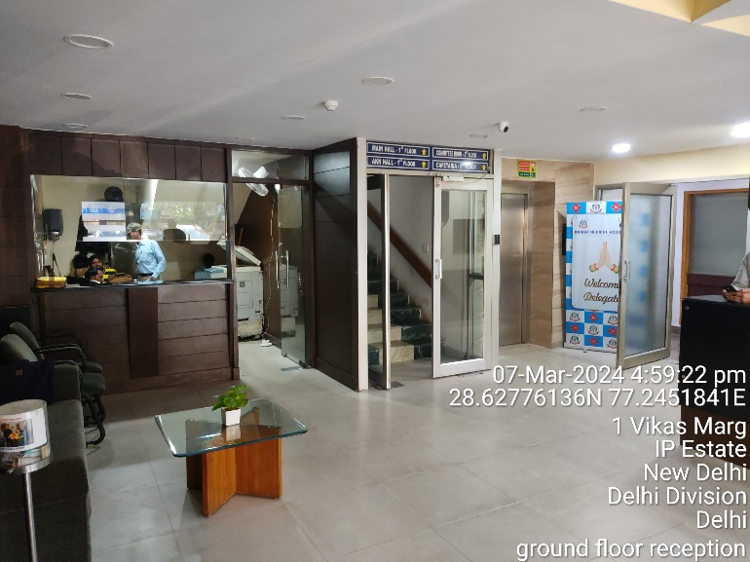 | 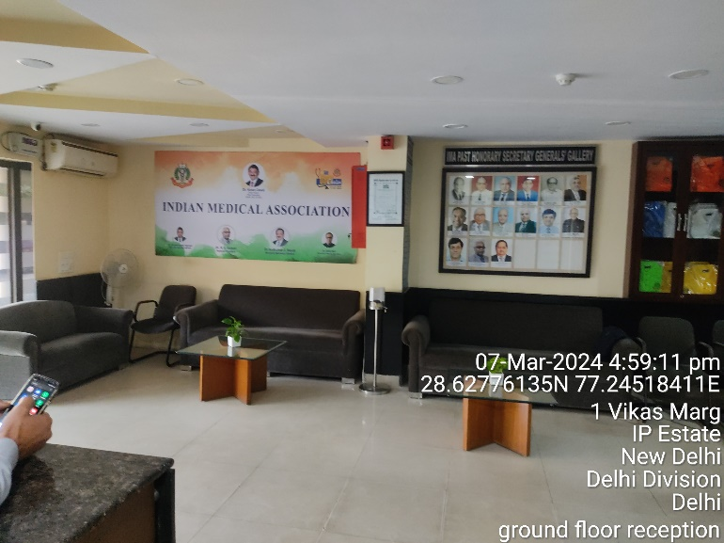
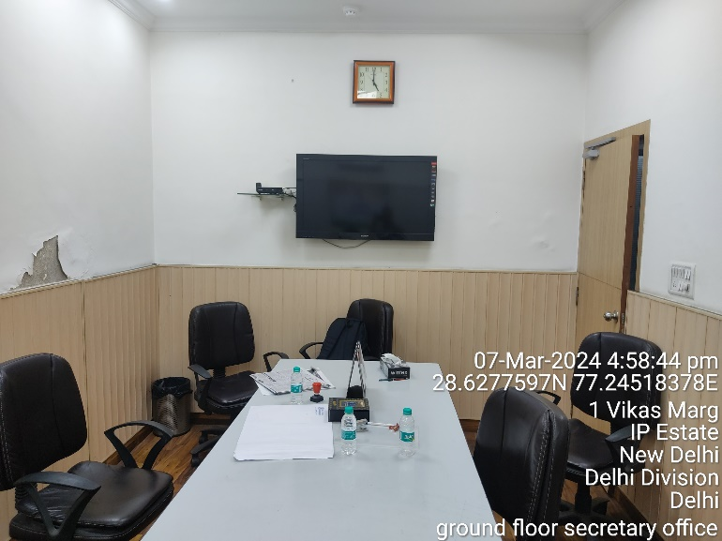 | 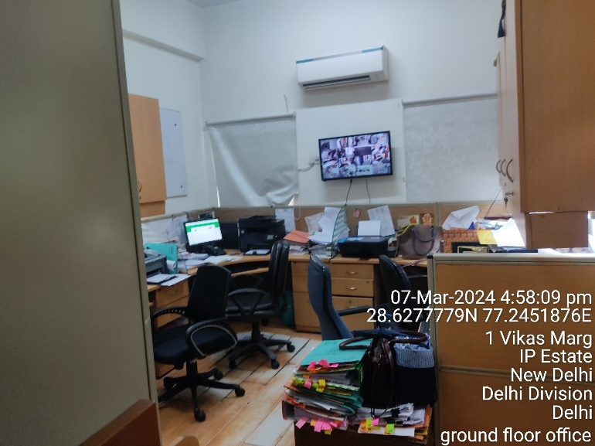
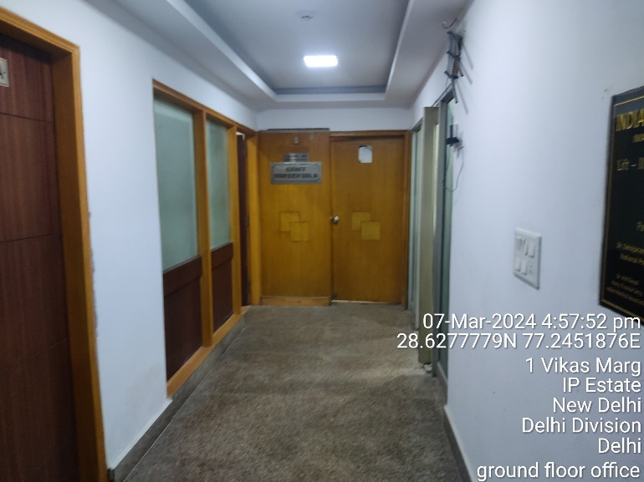 | 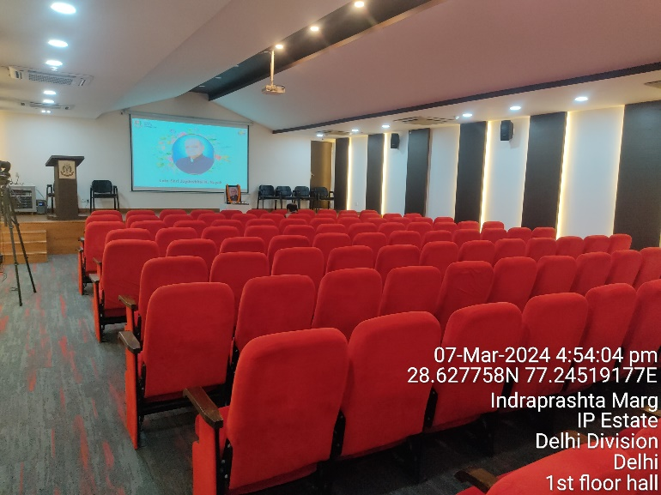

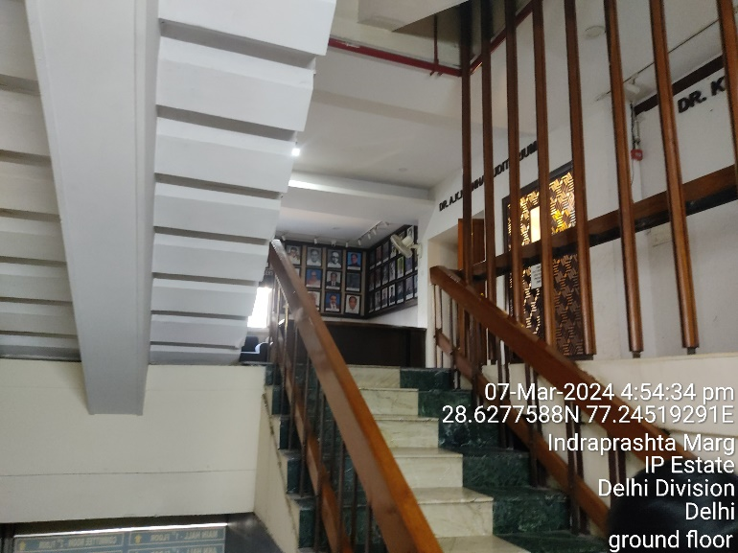 | 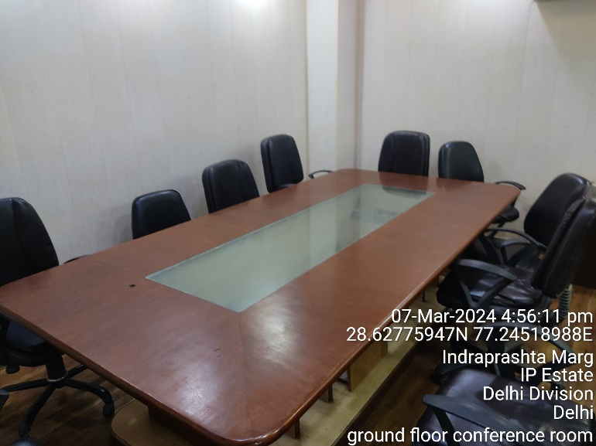
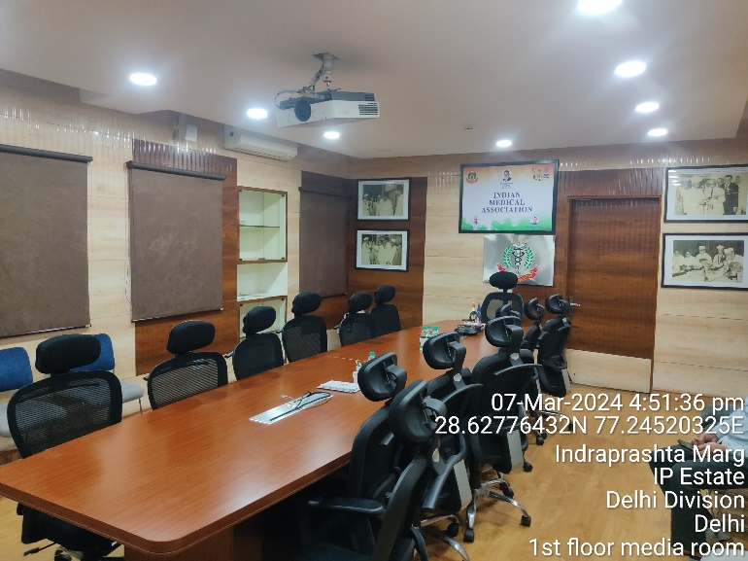 | 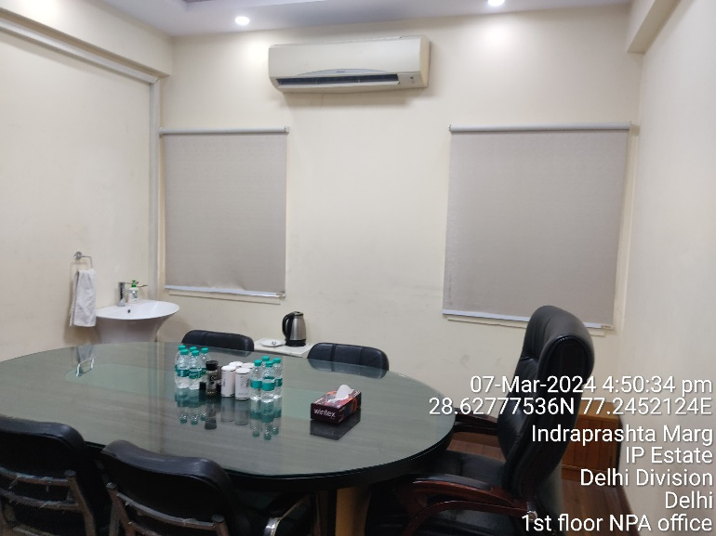
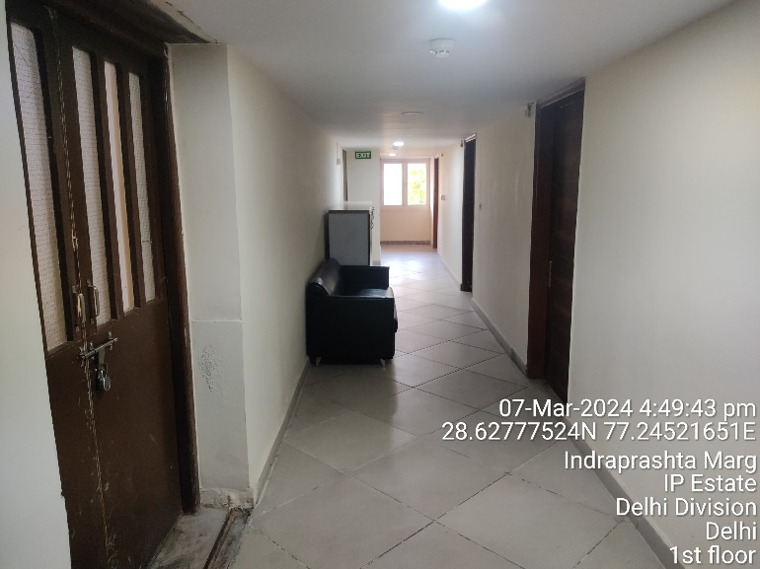 | 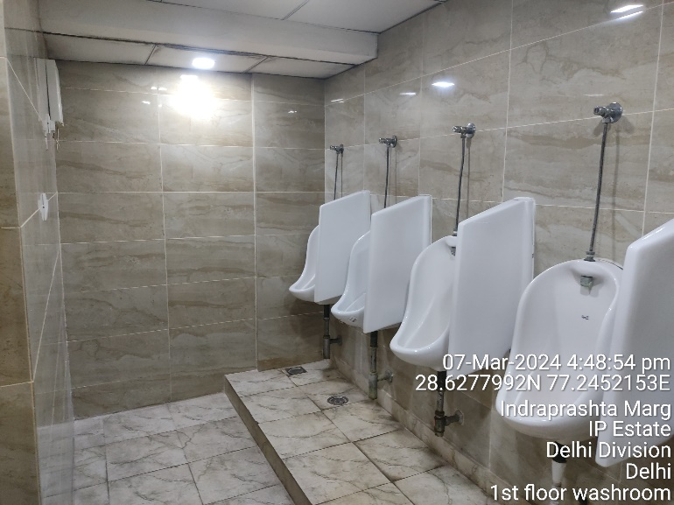

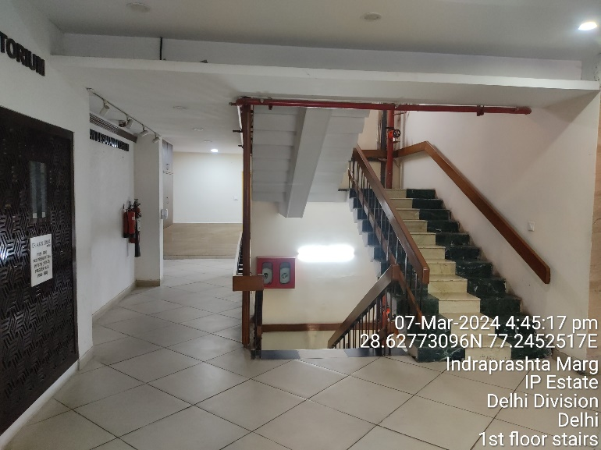 | 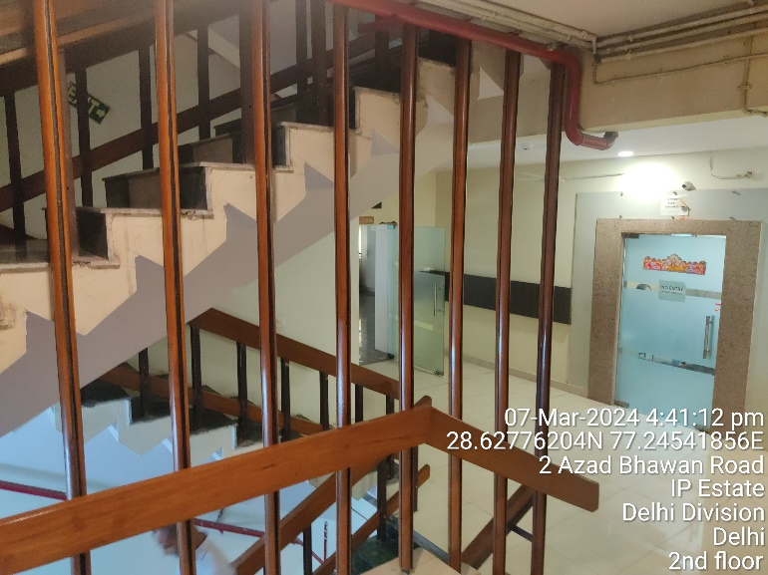
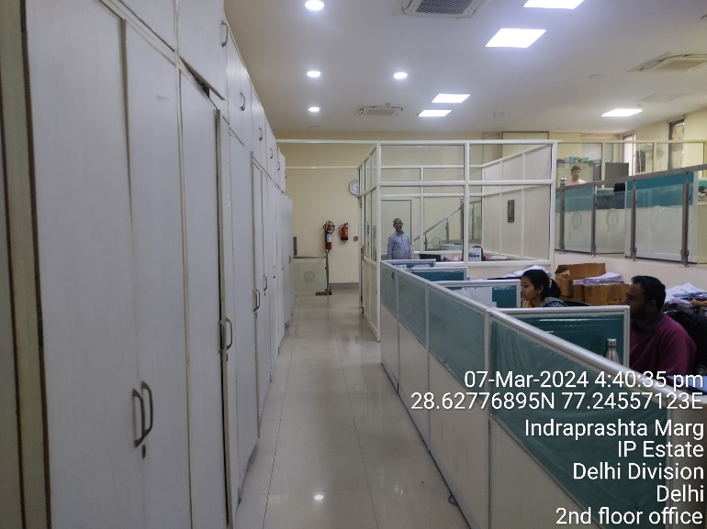 | 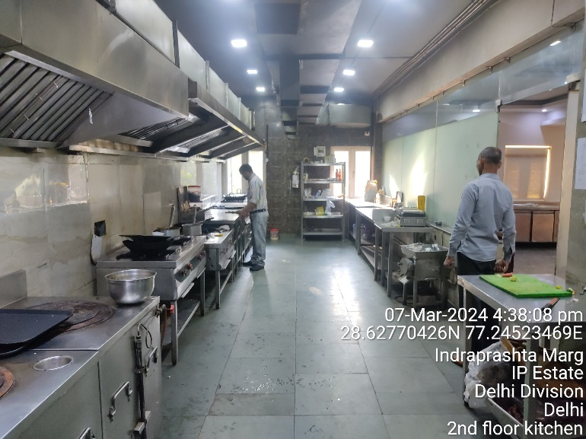
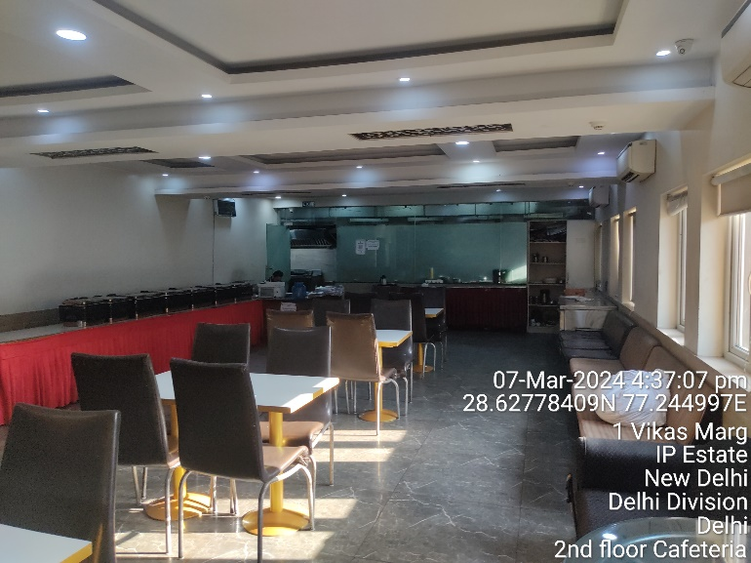 | 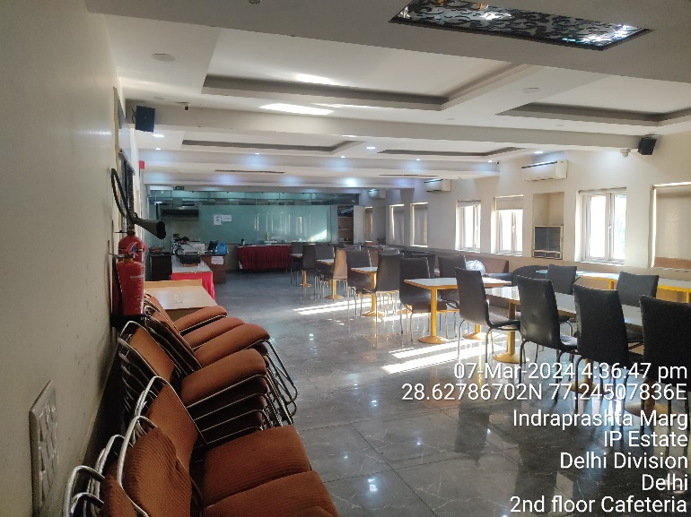

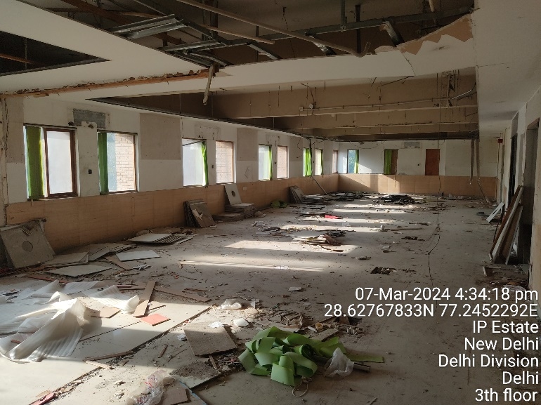 | 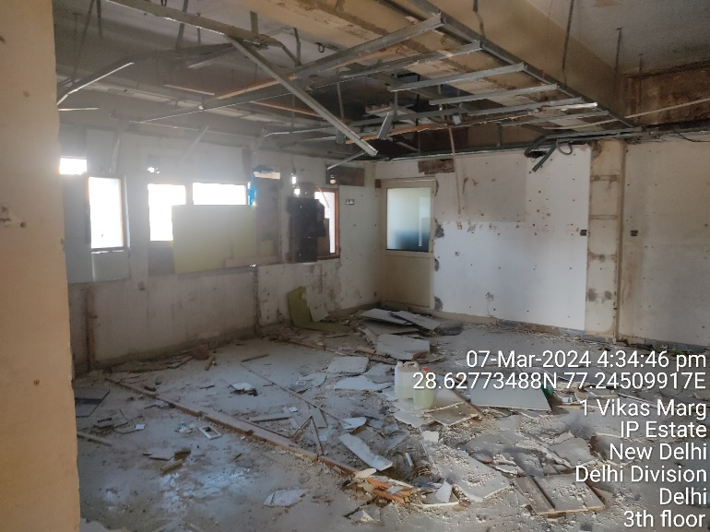
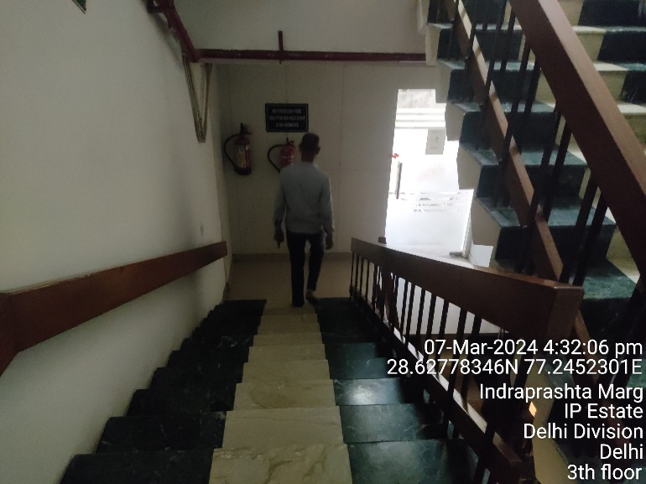 | 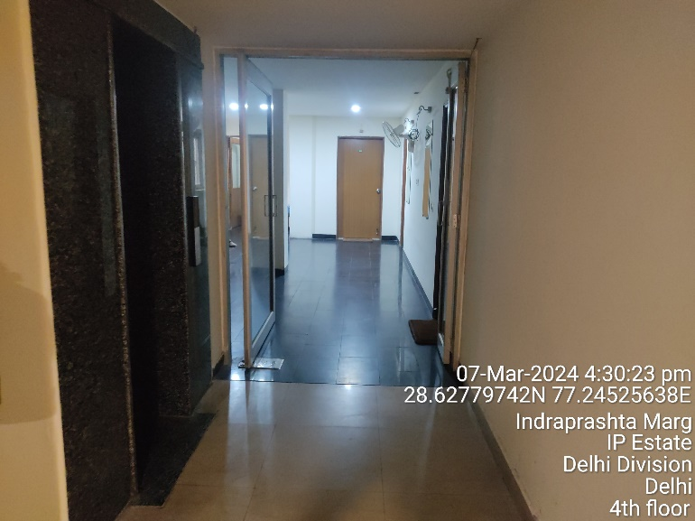
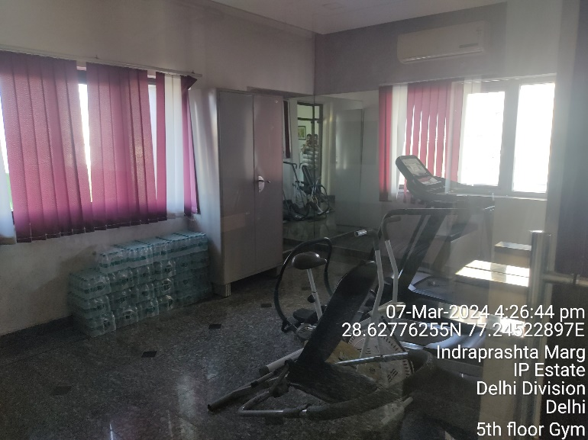 | 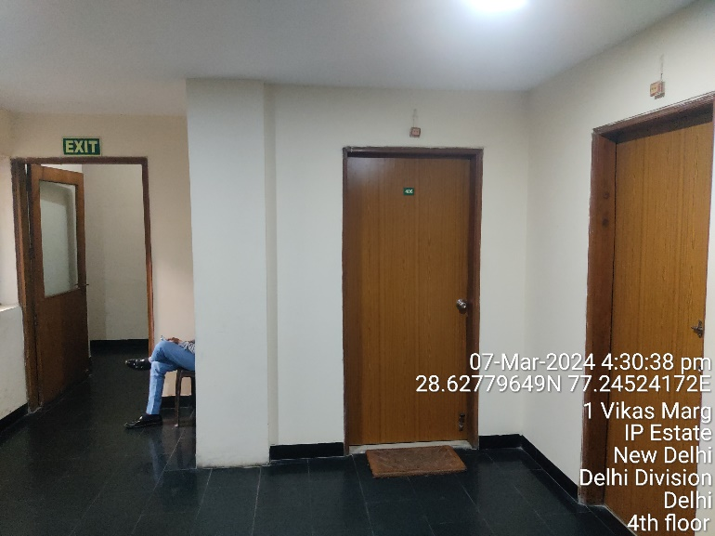

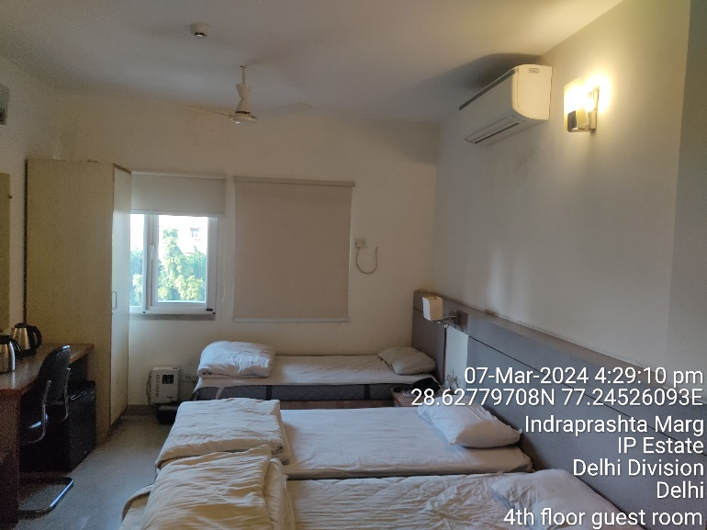 | 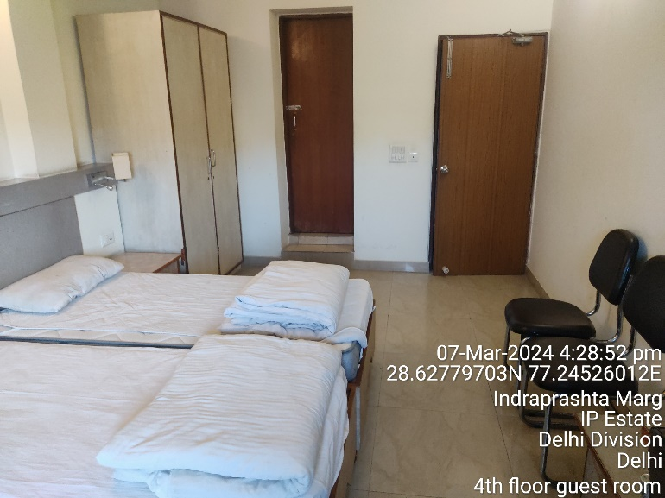
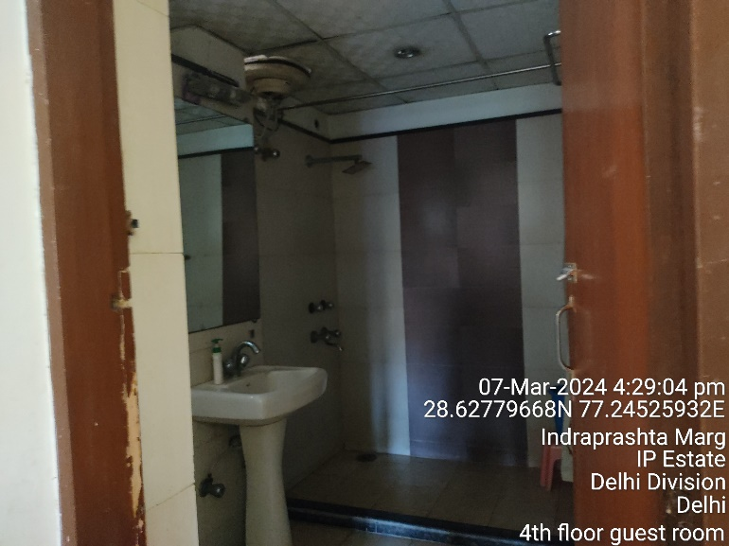 | 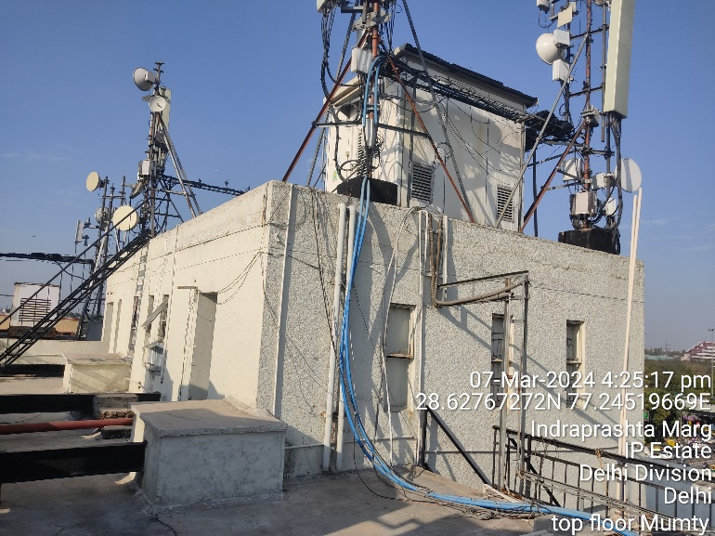
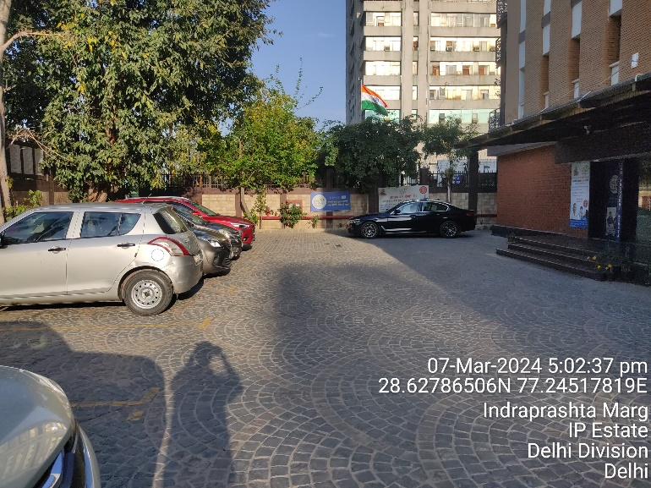 | 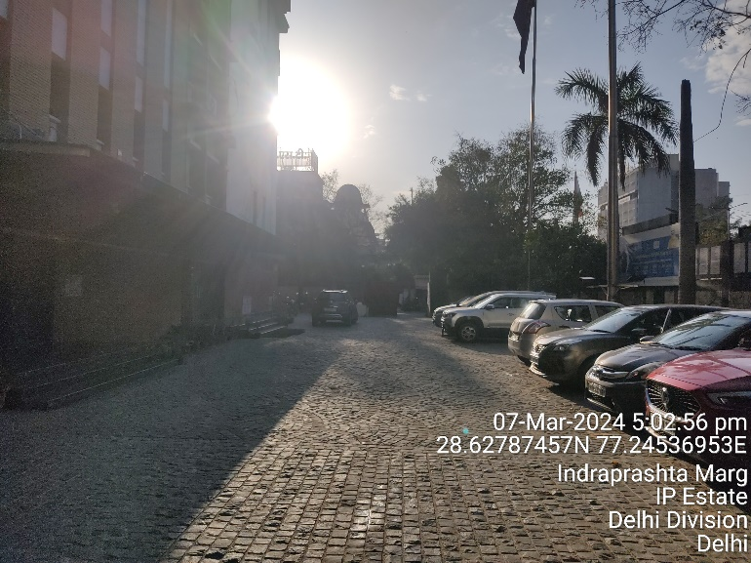

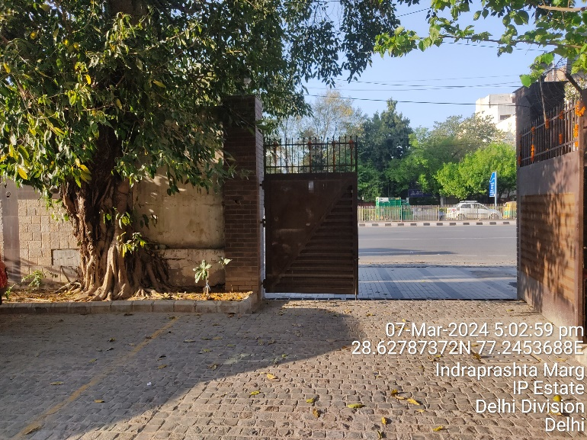 | 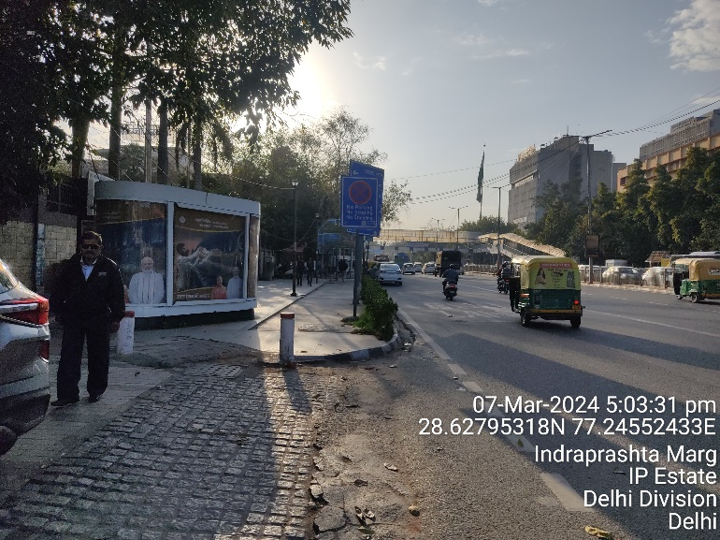
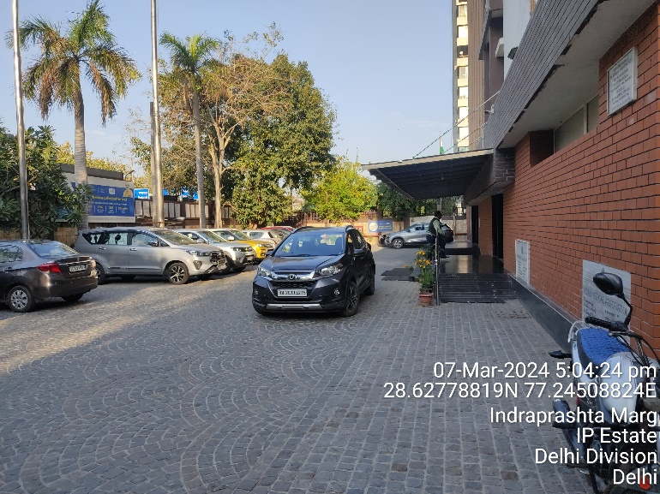 | 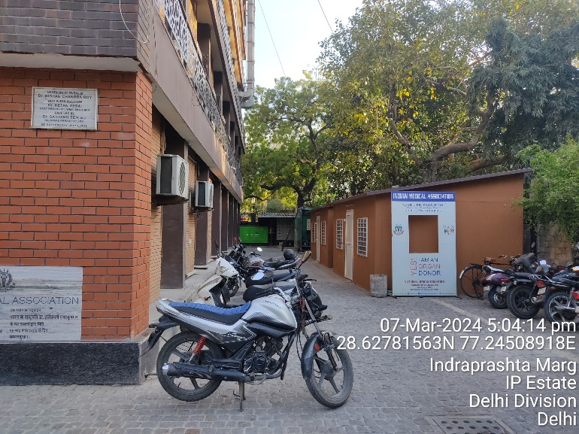
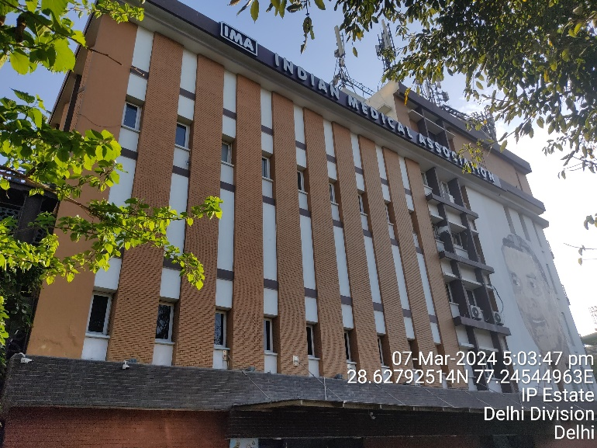 | 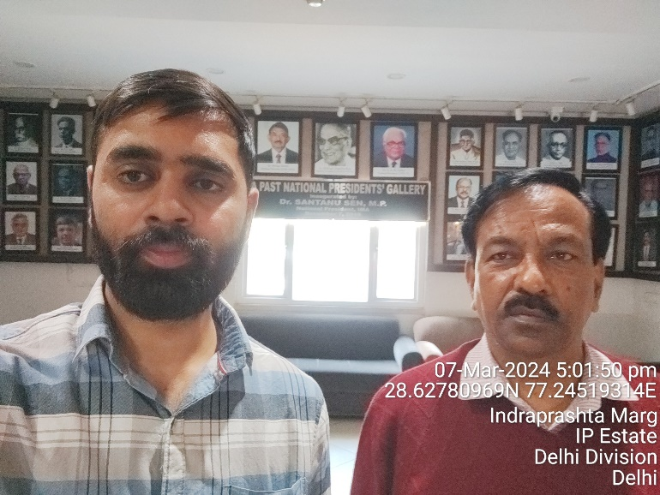

PART G | DISCLAIMER

      - No employee or member of R.K Associates has any direct/ indirect interest in the property.
      - This report is prepared based on the documents/ information provided to us by the client and we assume that all such information is true and correct. If at any time it is found that the customer has provide misrepresentation of facts then this report should be considered cancelled.
      - This report is a general analysis of the project and not an audit report. All the information gathered is based on the facts seen on the site during survey, verbal discussion & documentary evidence provided by the client and is believed that information given by the client is true best of their knowledge.
      - Bank/ FII should ONLY take this report as an Advisory document from the Chartered Engineering firm and it is specifically advised to the creditor to cross check the original documents for the facts mentioned in the report which can be availed from the borrowing company directly.
      - In case of any default in loans by the borrowing company, R.K Associates wouldn’t be held responsible for whatsoever reason may be and any request for seeking any explanation from the employee/s of R.K Associates wouldn’t be entertained at any instance or situation.
      - This Report is prepared by our competent technical team which includes Engineers and financial experts & analysts.

FOR INTERNAL USE

Place :Noida | SURVEYED BY: Vishal, Nischay, Ashil
Date : 09.03.2024 | PREPARED BY: Vishal Singh
Note : This report contains 23 pages | REVIEWED BY: Anil Kumar

For R.K Associates Valuer & Techno
Engineering Consultants Pvt. Ltd.

