File No.: VIS (2023-24)-PL593-503-785 Dated: 27.01.2024

TECHNO-ECONOMIC VIABILITY STUDY REPORT

OF

100 ROOM’S LUXURY SEGMENT HOTEL

OWNER/PROMOTER

M/S MAHECHA BOUTIQUE HOTELS PRIVATE LIMITED

REPORT PREPARED FOR

PUNJAB NATIONAL BANK, MID CORPORATE CENTER, 4-5 KALPATRU APARTMENT, OPPOSITE OLD INCOME TAX OFFICE, NEW FATEHPURA, UDAIPUR - 313001

**Important - In case of any query/ issue or escalation you may please contact Incident Manager Valuers@rkassociates.org. We will appreciate your feedback in order to improve our services.

NOTE: As per IBA Guidelines please provide your feedback on the report within 15 days of its submission after which report will be considered to be correct.

IMPORTANT NOTICE

COPYRIGHT FORMAT: This report is prepared on the copyright format of R. K. Associates Valuers & Techno Engineering Consultants (P) Ltd. (R. K. Associates) to serve our clients with the best possible information and analysis to facilitate them to take rational business decisions. Legally no one can copy or distribute this format without prior approval from R. K. Associates. It is meant only for the advisory/ reference purpose for the organization/s as mentioned on the cover page of this report. Distribution or use of this format or report or any of its content/ information/ data by any organization or individual other than R.K Associates will be seen as an unlawful act and necessary legal action can be taken against the defaulters.
This report is intended for the sole use of the intended recipient/s and contains material that is STRICTLY CONFIDENTIAL AND PRIVATE.

DEFECT LIABILITY PERIOD: In case of any query/ issue or escalation you may please contact Incident Manager at valuers@rkassociates.org. Though adequate care has been taken while preparing this report as per its scope, but still, we can’t rule out typing, human errors, over sightedness of any information or any other mistakes. Therefore, the concerned organization is advised to satisfy themselves that the report is complete & satisfactory in all respect. Intimation regarding any discrepancy shall be brought into our notice immediately. If no intimation is received within 15 (Fifteen) days in writing from the date of issuance of the report, to rectify these timely, then it will be considered that the report is complete in all respect and has been accepted by the client up to their satisfaction & use and further to which R.K Associates shall not be held responsible in any manner.

Part M: R. K. Associates Important Disclaimer and Remarks are integral part of this report and Feasibility assessment is subject to this section. Reader of the report is advised to read all the points mentioned in these sections carefully.

TABLE OF CONTENTS
SECTIONS | PARTICULARS | PAGE NO.
Part A | Report Summary | 4-5
Part B | Introduction
Part B | - About the Report | 6
Part B | - Executive summary | 6-8
Part B | - Purpose of the Report | 8
Part B | - Scope of the Report | 8
Part B | - Methodology/ Model Adopted | 9
Part B | - Data Information received from | 9
Part B | - Documents/ Data Referred | 10
Part C | Company Profile
Part C | - Company Overview | 11
Part C | - Proposed Shareholding Details | 11-12
Part C | - Promoters/Directors Profile | 12
Part D | Infrastructure Details
Part D | - Project Overview | 13-15
Part D | - Proposed Location | 15
Part D | - Location Map | 16
Part D | - Land Details | 17
Part D | - Layout Plan | 17
Part D | - Building & Civil Works | 18-20
Part D | - Equipment and Plant & Machinery | 20-22
Part D | - Furniture and Fixtures | 22-23
Part D | - Site pictures | 24-26
Part D | - Utilities | 26-27
Part D | - Manpower | 27-28
Part D | - Marketing Strategy | 28-29
Part E | Industry Overview & Analysis | 30-33
Part F | SWOT Analysis | 34-35
Part G | Risk Assessment &n Mitigation | 36-37
Part H | Project Cost and Means of Finance | 38-39
Part I | Project Schedule | 40-41
Part J | Statutory Approvals | Licences | NOC | 42-43
Part K | Company’s Financial Feasibility
Part K | - Projection of Company | 44-52
Part K | - Graphical Representation of Key Financial Metrics | 53-54
Part K | - Loan Amortization Schedule | 54-55
Part K | - Depreciation Schedule | 55-56
Part K | - Key assumptions & Basics | 57-65
Part L | Conclusion | 66-67
Part M | Disclaimer | Remarks | 69-72

PART A | REPORT SUMMARY

- Name of the Company: | M/s Mahecha Boutique Hotels Pvt Ltd
- Address of the proposed unit: | Khasra No. 795/10, 796 / 10, 799 / 10 & 803 / 10, Village: Sinya, Gram Panchyat: Kariya, Tehsil: Kumbhalgarh, Dist.: Rajsamand, Rajasthan - 313325.
- Registered Office: | Flat No. 102, Prestige Apartment, Plot No. P-11, Sahdev Marg, C-scheme, Jaipur, Rajasthan-302001
- Project Location: | Kumbhalgarh, Rajsamand, Rajasthan
- Project Type: | Luxury Segment Hotel [100 Guest Room]
- Project Industry: | Hospitality Industry
- Product Type / Deliverables: | 100 Guest rooms (room type: Suite and Deluxe Rooms) with Banquet Hall facility
- Report Prepared for Organization: | Punjab National Bank, Mid Corporate Center, 4-5 Kalpatru Apartment, Opposite Old Income Tax Office, New Fatehpura, Udaipur - 313001.
- TEV Consultant Firm: | M/s. R.K Associates Valuers & Techno Engineering Consultants (P) Ltd.
- Report type: | Techno-Economic Viability Report
- Purpose of the Report: | To assess Project’s Technical, Economical & Commercial Viability for the purpose of seeking external financial assistance to start a green field Project.
- Scope of the Report: | To assess, evaluate & comment on Technical, Economical & Commercial Viability of the Project as per data information provided by the client, independent Industry research and data/ information available on public domain.
- Date of Report: | 27th January, 2024
- Documents referred for the Project: | - PROJECT INITIATION DOCUMENTS:  - Project Report  - Financial Projections of the Project  - Project proposed Schedule  - Statutory Approval Details  - Layout and Master Plan  - PROCUREMENT DOCUMENTS:  - High level breakup of Construction Cost  - Sanction/tentative/proposed map of the sites  - Land purchase deeds  - Land Conversion Orders
- Means of Finance: | Equity & Debt
- Key Financial Indicators:
  Key Indicators | Value
  Average DSCR | 1.79
  Maximum DSCR | 2.96
  Average EBITDA Margin | 46.91%
  Average Net Profit Margin | 16.91%

Note: Above financial indicators are based on the initial financial projections of the proposed project provided by the firm/client and assessment and analysis of the same is done by us.

PART B | INTRODUCTION

- ABOUT THE REPORT: Techno-Economic Viability Study Report of the Mahecha Boutique Hotels Private Limited to develop a 100 rooms luxury segment hotel.

- EXECUTIVE SUMMARY: The proposed green-field project is a luxury boutique hotel being developed at Khasra No. 795 / 10, 796 / 10, 799 / 10 & 803 / 10, Village - Sinya, Gram Panchayat - Kariya, Tehsil - Kumbhalgarh, District - Rajsamand, Rajasthan - 313325.
The company is registered on 12th October 2018 for the purpose to enter into hotel industry. For this purpose, company has purchased approx. 52,650 Sq.mtr (~13 acres) of land in November, 2018. Out of this land, company has planned to utilize 19,573 sq.mtr of land for the hotel purpose for which the plan was approved. Company obtained building plan approval from the Sarpanch of Gram Panchayat Kediya, Kumbhalgarh, Rajsamand, Rajasthan and various other approvals and NOCs such as, Forest, Gram Panchayat and Road Cut Permission to start the construction in April 2022.
The proposed hotel is planned for 100 rooms in total comprising of all modern in-room facilities such as attached bathrooms, shower cubicles, air- conditioners, minibars, LCD TVs, room safes, tea & coffee makers, hair dryers, etc. As per the plan, the project will also have amenities such as multi cuisine restaurant, bar, banquet area, activity area, swimming pool, spa, full power backup etc. Being a boutique hotel, it will also provide activities like village walks, trekking in the nearby reserve forest and visits to the mountains for sunrise and sunset view, etc. to attract the tourists.
Boutique hotels are themed hotels on a specific theme that provide more personalised services than typical hotel. The present hotel is planned on nature, environment and local cultural theme.
As per the plan, the proposed green-field project would also implement eco-friendly practices such as recycling of the waste water, water harvesting, energy conservation etc. The project would generate direct employment of more than 80 persons apart from generating indirect employment for at least 100 more persons. The commencement of the hotel would provide exposure to the local art, craft, businesses, etc.
This hotel lies within Kumbhalgarh tehsil and is approximately 6 km from famous Kumbhalgarh fort. The subject location has a hilly terrain (westerly range of Aravalli Hills) and thus offers a positive aspect with scenic views. It is conveniently located approx. 500 mtrs inside of Sayra Road. The internal road is part of land owned by the company and the internal road has also been developed by the company as also shown in the site plan below. Because of Kumbhalgarh fort, Kumbhalgarh wildlife sanctuary and other attractions this area attracts lakhs of tourists annually. Kumbhalgarh is also known as the Great Wall of India, featuring a 36 km wall, the second-largest after The Great Wall of China, as a major tourist attraction. It is about ~62 km from Rajsamand city. It is a World Heritage Site included in Hill Forts of Rajasthan. Other attractions include jungle safaris, adventure camps, helicopter rides, sunset points, Ranakpur Jain Temple, and various other temples. The peak tourist season spans from October to March, and local tourists visiting prefer weekends for their visits.
As per data/information provided by the client, the total cost of the project for developing a 100 rooms bouquet Hotel is being estimated as INR 43.89 Crores, which is proposed to be funded through term loan of INR 30.00 Crores, INR 6.89 Crs. from unsecured loan and INR 7.00 Crs. as promoter’s equity.
Total Project Cost (TPC)
Particulars | Cost (In INR Lakhs)
Land [owned] | 44.63
Building | 3220.00
Equipments | 430.00
Furniture & Fixtures | 350.00
Tie-up / Franchise Fees to Operator Company and other cost | 344.50
Total Project Cost | 4389.13

The project falls under the Gram Panchayat region and has received building plan approval from the Sarpanch of Gram Panchayat Kediya, Kumbhalgarh, Rajsamand, Rajasthan, as it is not under the Urban Improvement Trust (UIT) region.
Hotel buildings mainly comprises of three blocks, namely Block A, Block B & Clusters of special category rooms as shown in the site plan below. Block-A would include amenities like Spa, Sports Lounge/Gym, Deck, Bar, Multipurpose Hall, Special rooms, Pool, BOH area, Wating area., etc., Block-B would include rooms only & the third part would contain special category rooms with 6 different size clusters.

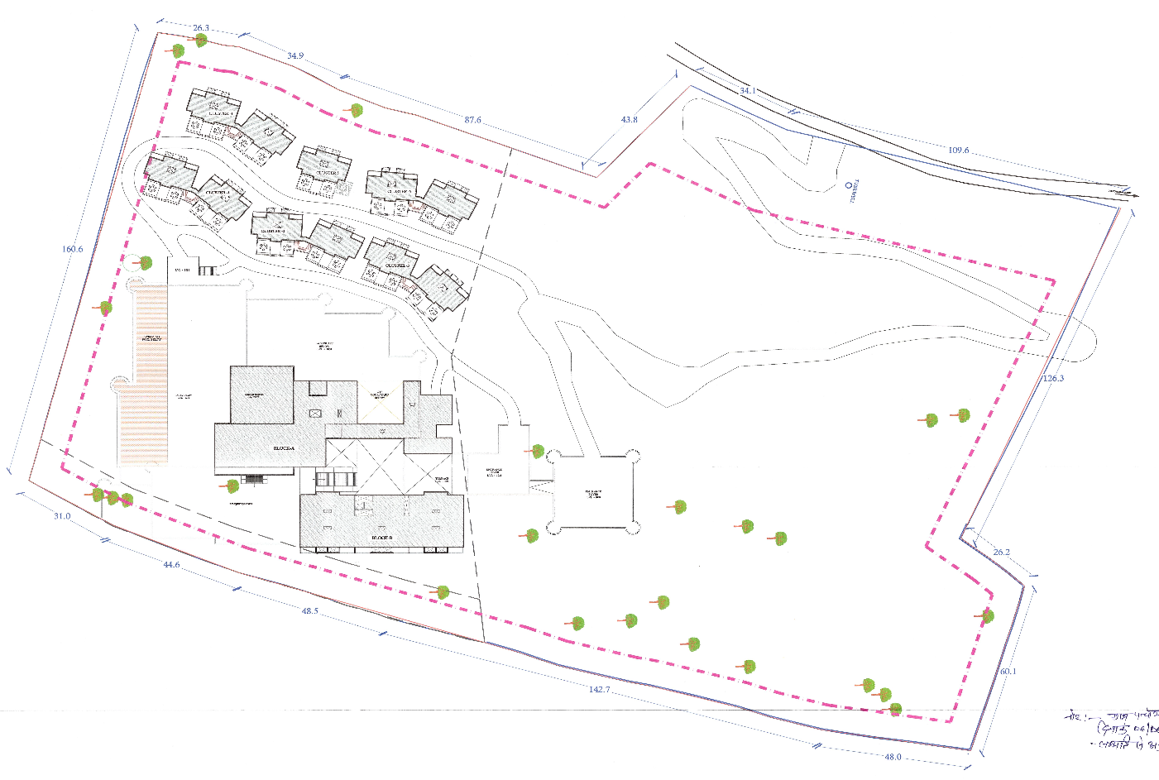
As per our site inspection dated: 4th January 2024, estimated around 30% of the structure work is completed. In Block A, super structure of Bar, Multipurpose Hall, pool and special rooms are completed and finishing work is in progress. Other structures in Block-A like: Spa, Sports lounge, Service Area and Entry Lobby, Dining area and Kitchin work is in progress. Only banquet Hall work has not been started yet. Block-B is proposed to be of G+5 floors. Presently North side portion of Block B (approx. 30%) superstructure is constructed upto 5th floor. Balance portion of Block-B is yet to start. Out of 6 clusters, super structure of cluster 1 & 2 is completed and finishing work is in progress, Cluster 3 plinth work is in progress. Cluster 4, 5 & 6 work is not started yet.
The intended hotel is situated on the hills, therefore to start the construction of building, requires both time and financial resources for site development which include mountain crushing, clearing site for construction and site readiness. During site visit construction was seen in progress.
The superstructure is scheduled to be completed by the end of FY 2025, with parallel finishing, while the entire project is anticipated to be finished by the end of FY 2026. Company is planning to form operational partnerships with luxury hotel chains, after completion of the superstructure.
To procure the funding of INR 30.00 Crores through debt, the company approached the Punjab National bank for financial assistance. Further, the Punjab National Bank, Udaipur has appointed R.K. associates to perform the Techno-Economic Viability study for the proposed luxury segment Hotel at Kumbhalgarh, Rajsamand, Rajasthan.

- PURPOSE OF THE REPORT: To assess the Techno-Economic Feasibility of the green field Hotel project for financial assistance purpose.

- SCOPE OF THE REPORT: To assess, evaluate & comment on the Techno-Financial Feasibility of the proposed luxury hotel to be set up by Mahecha Boutique Hotel Private Limited, as per the data/information provided by the client/promoter/stakeholder and our independent research.
NOTES:
- Independent scrutiny about the promoters, background check, credibility, credit worthiness is not covered under this report. Wherever any such information is mentioned in the report, is based on the details provided by the company.
- This is not an audit activity of any kind. We have relied upon the data/ information supplied by the company in good faith that it is true and without any fabrication.
- This report is only an opinion in respect to Technical and Financial Feasibility of the project as per the future projections provided by the firm and independent analysis done by us but doesn’t contain any recommendations including taking decision on the financial exposure.
- Any changes in the current business plan/total project cost/factors effecting future revenue generations/force majeure etc. will be out of scope of this assignment.
- Total Project and head wise Cost is considered as provided by the company. During the assessment, RKA team has given due care to check the unusual higher or under cost as per their experience and general market benchmarks/ indices, wherever available. However, this can’t be construed as detailed item wise cost vetting of Project cost heads which is out of scope of the work as agreed upon.
- We have relied upon the data/information and justifications provided by banker/client in good faith based on the estimated costs done by appointed parties by bank and company.
- This is a techno economic viability study report to assess the technical, economic and commercial viability of the project (Luxury segment hotel) limited to the assigned scope of work.
- Land and property details mentioned in the report is only for illustration purpose as per the information provided to us by the client. The same doesn’t tantamount for taking any responsibility regarding its legality, ownership and conforming to statutory norms.

- METHODOLOGY/ MODEL ADOPTED:
- Data/ Information collection.
- Review of Data/ Information collected related to TEV study.
- Independent review & assessment of financial projections provided by the company/promoters.
- Review and analysis of the Projections as per the market trends and futuristic growth opportunity of the industry and company.
- Projections of Revenue, Expenses, P&L, Balance Sheet, cash flow.
- Key Financial Ratios and assumptions.
- Final conclusion.

- DATA/ INFORMATION RECEIVED FROM: Preliminary data/Information has been received from Mr. Rajendra Singh and his associates and other required information has been considered from the market survey.
Particulars | Details
Name | Mr. Rajendra Singh
Company | Mahecha Boutique Hotel Private Limited
Contact No. | +91 9982000900

- DOCUMENTS / DATA REFFERED:
- Financial Projections of the proposed project up to FY 2034.
- Project report of the company
- GST Certificate, PAN Card, Udyam Registration Certificate etc.
- Promoters and shareholding details of the company.
- Proposed Total project cost.
- Land Purchase Deed and Conversion Orders of the land.
- Statutory Approvals.
- Sanctioned map of the proposed Hotel Project.
- Electricity Bill.
PART C | COMPANY PROFILE

- COMPANY OVERVIEW: M/s. Mahecha Boutique Hotel Private Limited was incorporated on 12th October, 2018 with CIN: U55101RJ2018PTC062696 is a non-govt unlisted company limited by shares, having its Registered Office at Flat No. 102, Prestige Apartment, Plot No. P-11, Sahdev Marg, C-scheme, Jaipur, Rajasthan, 302001, India.
Under this entity, company has taken up to set up a luxury hotel initially with 100 rooms equipped with modern amenities & facilities as its first Project/ establishment at Village - Sinya, Gram Panchayat - Kariya, Tehsil - Kumbhalgarh, District - Rajsamand, Rajasthan – 313325.
INCORPORATION DETAILS OF THE COMPANY
Name of the Company | M/s Mahecha Boutique Hotel Private Limited
CIN | U55101RJ2018PTC062696
Registered office Address | Flat No. 102, Prestige Apartment, Plot No. P-11, Sahdev Marg, C-scheme, Jaipur, Rajasthan, 302001
Constitution | Non-government company / Limited by Shares
Date of Incorporation | 12th October 2018
Authorised Capital | INR 5,00,00,000
Paid up Capital (Equity) | INR 4,87,20,000
Date of Last BS filed | 31.03.2022
As per previous financials, presently there is no revenue of the company as this is the first project of the company.

- PROPOSED SHAREHOLDING DETAILS: As per the information shared by the client, the company is having authorised capital of INR 5,00,00,000 and paid-up capital is INR 4,87,20,000, as per the data available on the MCA website. Proposed shareholding will be 7,00,000,000 comprising of equity and security. The shareholding details of the company is mentioned below:
Shareholding Details of the Company
Particulars | No of Shares | (in Rs)
Authorised Share Capital
Equity Share of Rs. 10/- each | 50,00,000 | 5,00,00,000
Total | 50,00,000 | 5,00,00,000
Issued, subscribed & fully paid up
Equity Share of Rs. 10/- each fully paid up | 48,72,000 | 4,87,20,000
Total | 48,72,000 | 4,87,20,000
Source: Data/Information from MCA website.
Details of Shareholders in the Company
S. No. | Name of the Shareholder | Type of Shares | No. of Shares held | % Of Holding
1 | Chandra Kanwar | Equity | 3,000 | 0.06%
2 | Chandraveer Singh | Equity | 3,50,000 | 7.18%
3 | Rajendra Singh | Equity | 41,69,000 | 85.57%
4 | Shrishty Singh | Equity | 3,000 | 0.06%
5 | Vikram Pratap Singh | Equity | 3,47,000 | 7.13%
 | Total |  | 48,72,000 | 100.00%
Source: Data/Information provided by the Client.

- PROMOTERS/DIRECTORS PROFILE: Director’s details have been shown in the below table:
Director’s Profile
DIN | NAME | Appointment Date | Qualifications/Experience
09539626 | Mr. Mahendra Singh Rathore | 16th March, 2022 | Mr. Mahendra Singh Rathore is a commerce graduate and has 10 Years of experience in the Hotel industry & has the knowledge of current business/industry trends prevailing worldwide as well as deep insight of future needs of the Hospitality sector. His expertise in hotel sector remains undisputed. He had joined the company as a non-shareholder Executive Director.
09539785 | Mr. Rajendra Singh | 16th March, 2022 | Mr. Rajendra Singh is a commerce graduate. and presently engaged in the businesses of marble, mining & hotel with a good and long business experience. He has sound network in the tourism industry and also financially very sound thus providing financial stability to the project. He has joined as the Executive Director.
Source: Data/Information provided by the client/company
PART D | INFRASTRUCTURE DETAILS OF THE PROPOSED PROJECT

- PROJECT OVERVIEW: The proposed hotel Project is a 100-room luxury boutique hotel. The project mainly comprises of three blocks, namely Block A, Block B & Clusters of special category rooms. Block-A would include amenities like Spa, Sports Lounge/Gym, Deck, Bar, Multipurpose Hall, Special rooms, Pool, BOH area, Wating area., etc., Block-B would include rooms only & the third part would contain special category rooms with 6 different size clusters.
Building: - "Block A" | Sq. Mtr
Upper Ground Floor | 2,294.82
Ground Floor | 1,687.66
First Floor | 936.67
Terrace Floor | 57.08
Building: - "Block B"
Ground Floor | 994.07
First Floor | 1,023.53
Second Floor | 1,023.53
Third Floor | 1,023.53
Fourth Floor | 1,023.53
Terrace Floor | 93.73
Building: - "Cluster-1"
Ground Floor | 326.76
First Floor | 326.76
Building: - "Cluster-2"
Ground Floor | 326.76
Building: - "Cluster-3"
Ground Floor | 326.76
First Floor | 326.76
Building: - "Cluster-4"
Lower Ground Floor | 326.76
Ground Floor | 326.76
First Floor | 326.76
Building: - "Cluster-5"
Lower Ground Floor | 157.83
Ground Floor | 157.83
First Floor | 157.83
Building: - "Cluster-6"
Lower Ground Floor | 326.76
Ground Floor | 326.76
First Floor | 326.76
Total Area | 14,226.00
The construction of the hotel was started during April 2022. The proposed hotel is located on the hilly areas near the Kumbhalgarh Fort, which requires the time and funds to develop the site for the construction of the proposed hotel. Currently, approximately 30% of the superstructure of the hotel is completed, which is verified by us during the site inspection. Also, right to independent access is available on the proposed project site.
The company will generate its revenue from four main broad categories i.e. Room sale, Food sale, Bar sale and Conference/Banquet receipts. Apart from these, the company will also earn revenue from other sources such as income from taxi rentals, commission fees from booking, site seen etc.
Below table shows the appointed architect and designer for the proposed Luxury hotel:
Particular | Architecture | Structural Designer
Name | Mr. Ravi Kumar Gupta | Mr Sandeep Garg
Experience & Background | As per informed by client, he has professional experience of working with various institutions like Rajasthan small industries corporation, Rajasthan tourism development corporation, the University of Rajasthan, and with various charitable institutions.  He is also having exposure to designed Delhi emporium, Exhibition pavilion and industrial sheds, midways, tourist bungalows, information centres and environmental development works, the Gandhi Bhawan, auditorium for department of zoology, staff housing, department of fine arts, department of geology, hostels and multi-purpose hall as informed by client to us. | As per informed by client, he is a Gold Medallist while pursuing Bachelor’s degree in Civil Engineering from Malaviya National Institute of Technology (MNIT) Jaipur and Master’s degree in Structural Engineering from the same institute.  He served Rajasthan Housing Board for 34 years as chief Engineer
Source: Data/Information provided by the client/company

- PROPOSED LOCATION: The company proposes to establish a luxury Hotel at Khasra No. 795 / 10, 796 / 10, 799 / 10 & 803 / 10, Village - Sinya, Gram Panchayat - Kariya, Tehsil - Kumbhalgarh, District - Rajsamand, Rajasthan - 313325, which is spread over an area of ~13.01 acres (52,650 square meter) as per the information shared by client/company.
Connectivity | Details
Airport | Udaipur Airport – 110km
Railway Station | - Udaipur Railway Station – 90 km  - Falna Railway Station – 60 km
Bus Stop | 12 km from property
Highway | 70 km from property

Below table shows the nearby tourist places and their distances from the site of the proposed hotel:
Places | Distance from Proposed project
Kumbhalgarh Fort | 6 KM
Heritage Hotels | 3-5 KM
Wildlife Sanctuary Kumbhalgarh | 7 KM
Old Temples and Havelis | 6-7 KM
Traditional Art & craft Shops | 6 KM
Neelkanth Mahadeo Temple | 7 KM
Parshuram Temple | 5 KM
Vedi Temple | 7 KM
Ranakpur Jain Temple | 25 KM

- LOCATION MAP:
Google Map: Project location would be 25°06'31.0"N and 73°32'39.1"E East in Kumbhalgarh, Rajsamand, Rajasthan and the location as per the Google map is attached below.
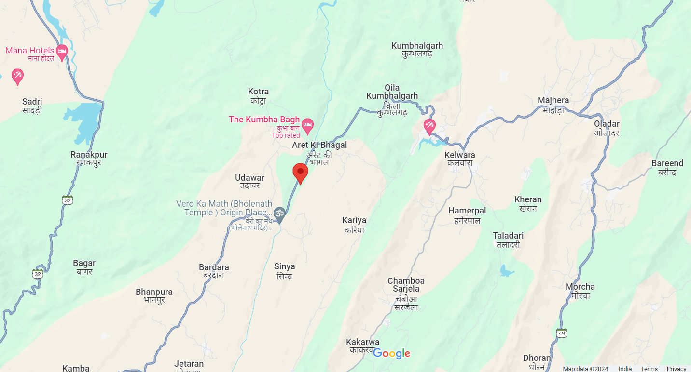

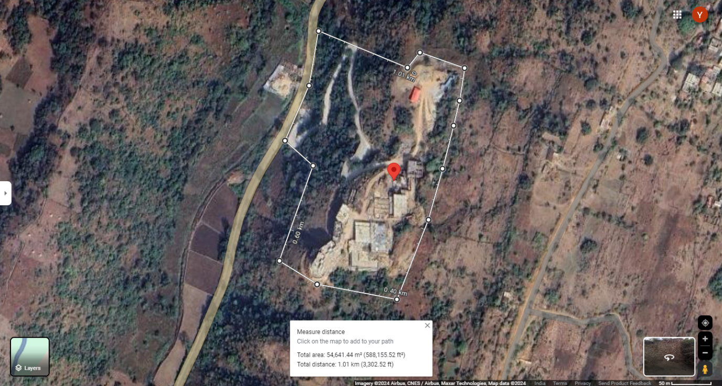
- LAND DETAILS: For the purpose of developing a luxury hotel, the land was purchased by Mr. Rajendra Singh in the year 2018 at Khasra No. 795 / 10, 796 / 10, 799 / 10 & 803 / 10, Village - Sinya, Gram Panchayat - Kariya, Tehsil - Kumbhalgarh, District - Rajsamand, Rajasthan - 313325. The total land is spread over an area of 52,650 Square meter as per the deeds shared with us. However, as the information shared with us, only Khasra No. 795/10 & 799/10 will be utilized for the development of the proposed hotel, which is spread over an area of 19,573 Sq. Meters, which includes 19,440 Sq. Mts for construction of the building and 133 Sq. Mts for commercial purpose. As per the information provided by the company, the conversion of land has also been completed.
S. No. | Particular | Description
1 | Area (Sq. Mtr.) | 24 bigha, 7 biswa & 10 biswansi, i.e., 52,650 sq. mtrs.
2 | Whether owned or leased | Owned
3 | Cost of Land including Registration & Stamp duty | INR 44.63 Lakhs

As per data/information provided by the client/company, below table shows the details of conceptual master plan with break-up:
Conceptual Master Plan
Khasra No. 796/10 (Old 10/13) | 10,800 Sq. Meter | Industrial purpose
Khasra No. 799/10 (Old 10/13) | 8,802 Sq. Meter | Industrial purpose
Khasra No. 799/10 (Old 10/13) | 1,998 Sq. Meter | Commercial Guest House & Restaurant purpose
Khasra No. 795/10 (Old 10/13) | 2,160 Sq. Meter | Industrial purpose
Khasra No. 795/10 (Old 10/13) | 19,440 Sq. Meter | Tourist Unit & Resort purpose
Khasra No. 803/10 (Old 10/13) | 9,450 Sq. Meter | Industrial purpose
Total Land Area as per the deeds | 52,650 Sq. Meter
Total area of the land to be used for the proposed project
  Khasra No. | Area (Sq. Mts.) | Conversion Status
  795/10 | 19,440 | Tourism
  799 / 10 | 133 | Commercial
  Total | 19,573

The land was purchased via two deeds in the month of November in 2018 for INR 44,63,000/-, which is INR 1,85,958/- per Bigha. At the time of survey, our surveyor found that the rates of commercial land near to main road is in the range of Rs. 25 to 35 lakhs per Bigha and Rs. 15 to 20 lakhs per bigha for the land situated 1 km away from the main road. Hence, the decision made by the owner to purchase the land seems to be an economically viable decision.
- LAYOUT PLAN: The approved layout plan for the proposed site has been attached below:
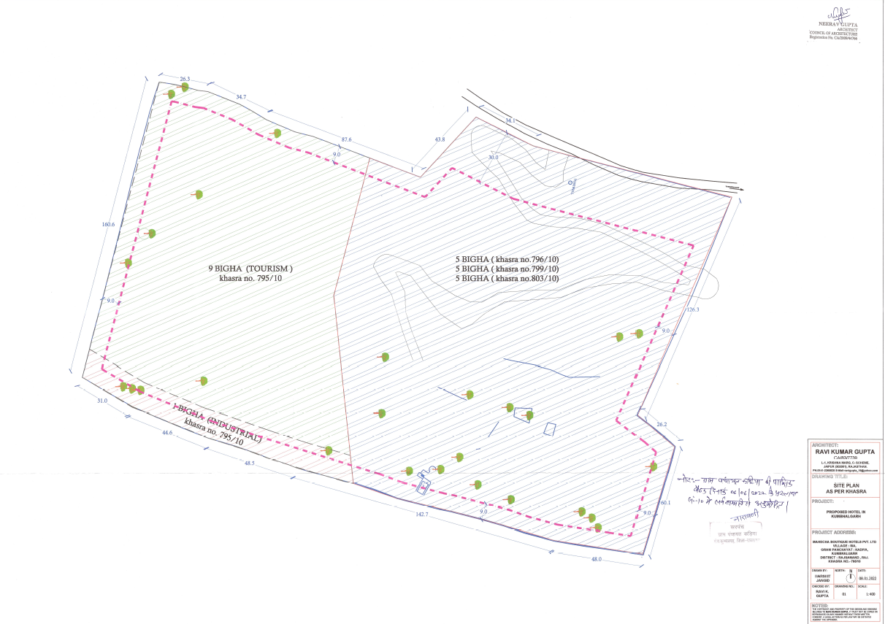
- BUILDING & CIVIL WORKS: As per the information shared by the client/company, the planning of the building structures and infrastructure facilities has been done keeping in view the major attributes like entrance to the hotel, vehicular movement inside the hotel and other functional requirements for hotel business. As per information provided by the company/client, the building and the civil work have been done according to the layout plan which has been approved by the competent Authority – Gram Panchyat: Kariya, Tehsil: Kumbhalgarh, Dist.: Rajsamand, Rajasthan.
As per information provided by client, Company had appointed Mr. Ashok Tagaya as a civil contractor. He is a business management graduate in the year 1996 and done diploma in Architectural and Interior Designing in the year 2000. He has 23 years of experience in the industry. His expertise in high rise apartments, residential / commercial buildings, showrooms, high end bungalows, rowhouses, retails or warehouses etc.
Mr. Tagaya has been associated with various institutions like Mojika Real Estate and Developers Pvt Ltd, Ramawat Infraprojects Pvt Ltd, The Grand Anukampa, Volume Architects, Arch Achadmey Apperial Unit, Sat Guru Group, Height Consultants, Ruj Sram Swiss Precision Unit, Asian Paints, Maa Infra Pvt Ltd, Bhama Shah Data Centre, India Bulls, Mistry and Company Mumbai, CM Mundra and Company.
As informed by client/company, other contractor who is associated with proposed project is Nathu Ram Rohit Kumar, which is a partnership Firm between Mr. Nathu Ram and Mr. Rohit Kumar. The partnership firm had completed various projects, like: Bhawani Niketan Shiksha Samiti, Jaipur, Windsor Plasa, Jaipur, Balika Public School, Jaipur, Bhawani Niketan, Jaipur, Janki Devi Public School, Jaipur, Akashardham Mandir, Jaipur, Akashardham Mandir, Dausa, Shri Kumawat Shiksha Samiti, Jaipur, V2 Mall, Gurar Ki Thadi, Jaipur, BHU Eye Hospital, UP etc.
Below table shows the bifurcation of the cost of construction provided by the client/company:
COST OF CONSTRUCTION
S. No. | Description | Estimated Cost (In INR Lakhs)
1 | Civil Work - Hotel consisting of 100 rooms (Area 1,65,718 Sq. ft) with all related facilities as per area statement and cost estimate of architect attached | 2744.68
2 | Landscaping of Gardens & Horticulture | 90.00
3 | Swimming pool | 40.00
4 | Internal paths | 80.00
5 | Fencing and boundary wall | 29.21
6 | Water Tanks | 16.11
7 | Administrative Exp. during the construction Period | 20.00
8 | Architect/Project Consultancy Fees | 25.00
9 | Misc/ Contingency | 175.00
 | Total | 3220.00
At the time of survey, approximately 30% of the total construction area has been achieved. Below are some observations:
Section | Structures | Area as per Map  (sq.mtr.) | Area Achieved (sq.mtr.) | Status
Special Category Rooms | Cluster 1 | 653 | 653 | Structure is Completed Flooring and pop work is done; rest work is in progress
Special Category Rooms | Cluster 2 | 326 | 326 | Structure is completed, rest work is in progress
Special Category Rooms | Cluster 3 | 653 | 125 | Footing and plinth work is in progress
Special Category Rooms | Cluster 4 | 980 | - | Approach road is in progress
Special Category Rooms | Cluster 5 | 473 | - | Approach road is in progress
Special Category Rooms | Cluster 6 | 980 | - | Approach road is in progress
Block A | Special rooms | 225 | 225 | Structure completed
Block A | Spa, Sports lounge, Service Area and Entry Lobby | 1215 | 1075 | Work in Progress
Block A | Bar, Multipurpose Hall | 850 | 850 | Structure completed
Block A | Dining area, Kitchen and Store | 1520 | 975 | Work in progress
Block A | Banquet Hall and Kitchen | 745 | - | Excavation work is in progress
Block A | Pool | 425 | 425 | Structure work is completed, other work is in progress
Block B | Rooms | 5181 | 1125 | Work in progress
 | Total | 14226 | 5779

The project site is situated in an area with varying contours, depicting the shape and elevation of the land through contour lines. Consequently, during excavation, adhering strictly to the drawings of the approved map is impractical due to the presence of hard rocks. Therefore, before financing the proposed hotel, financial institutions should conduct a site visit to verify the conditions against the approved map.

- EQUIPMENTS AND PLANT & MACHINERY: The proposed hotel unit will use equipment, which are marketed for easy to control, operate, install and maintain like washers, dryers, ironers, modern stoves and refrigerators, frozen cells, self-service elements, dishwashers, bar and stainless-steel furniture and fittings use by customers and guests. As per information provided by company, below table shows the list of equipment and plant & machinery, quantity and estimated cost:
S. No | Particulars | QTY | Rate | Estimated Cost (In INR lakhs)
1 | Air Conditioner (100 for rooms & 15 for public area) | 115 | 55000 | 63.25
2 | Fans | 350 | 3000 | 10.50
3 | Geysers | 100 | 12000 | 12.00
4 | LED TVS | 110 | 50000 | 55.00
5 | Mini Bars for the rooms | 100 | 11000 | 11.00
6 | Safes for the rooms | 100 | 12000 | 12.00
7 | Hair Dryers | 100 | 2000 | 2.00
8 | Electric Kettles for the rooms | 100 | 1500 | 1.50
9 | Front office equipment | - | L.S | 15.00
10 | Housekeeping Equipment | - | L.S | 20.00
11 | Computer Hardware & Software | - | L.S | 15.00
12 | Firefighting system | - | L.S | 25.00
13 | Intercom and Wi Fi System | - | L.S | 5.00
14 | Gardening Tools and equipment | - | L.S | 8.00
15 | Solar Water Heater | - | L.S | 10.00
16 | CCTV & Camera | - | L.S | 10.00
17 | Electric connection including transformer | - | L.S | 35.00
18 | DG set-850 KVA each | 2 | L.S | 25.00
19 | STP plant & connection + Water harvesting pipelines etc | - | L.S | 15.00
20 | Kitchen equipment | - | L.S | 25.00
21 | Crockery & Cutlery for Restaurant & Bar | - | L.S | 20.00
22 | Lift | 2 | L.S. | 18.00
23 | Miscellaneous | - | L.S | 16.75
 | TOTAL |  |  | 430.00

As per the information provided by company, below are the quotations, proposed hotel received from different vendors:
Quotation For | INR | Quotation From
Desktop & Laptop | 7,93,900 | Vijay Infotech
Rack Moutable hot standby communication server, Telephone instrument and supply, installation, testing & commissioning of IEEE (WIFI system) | 5,00,000 | Vijay Infotech
IP-CCTV System | 9,97,000 | Vijay Infotech
Fire hydrant system, Fire pumps, valves & accessories, Portable chemical fire extinguishers | 25,10,100 | MDM Fire Services
Supply of AC units and low site work charges | 63,28,300 | Yogesh Refrigeration Engineers
Windows Server | 7,69,183 | Vijay Infotech
Total | 111,04,583

As per our independent tertiary research, and data/information available in the public domain, we found that all the vendors are known players. We have also inspected the cost range of the equipment, which seems to be reasonable.

- FURNITURE AND FIXTURES: The list of furniture to be utilized at the proposed hotel includes items such as beds, chairs, tables, desks, wardrobes and sofas. The furniture chosen should be comfortable, functional and durable. It should also align with the hotel’s design aesthetic and brand image. Fixtures refer to items that are attached to the walls or floors of the hotel, such as mirrors, towel racks, lighting fixtures, etc. These items are crucial in creating a comfortable and functional space for guests. Accordingly, proposed hotel management shared the details of furniture and fixtures with quantity, rate and estimated cost:
S. No. | Description | Qty | Rate (In INR lakhs) | Estimated Cost (In INR lakhs)
1 | Furniture | 100 | 2.25 | 225.00
2 | Restaurant | 1 | L.S | 30.00
3 | Banquet | 1 | L.S | 20.00
4 | Bar | 1 | L.S | 15.00
8 | Stores | 1 | L.S | 5.00
9 | Kitchen | 1 | L.S | 15.00
10 | Pantry | 1 | L.S | 3.00
11 | Time Office | 1 | L.S | 4.00
12 | Security Office | 1 | L.S | 3.00
13 | Administration Office | 1 | L.S | 2.50
14 | Laundry Room | 1 | L.S | 3.00
15 | Staff Changing room | 1 | L.S | 3.00
16 | Front office furniture | 1 | L.S | 4.00
17 | Furniture of garden | 1 | L.S | 5.00
18 | Misc. Furniture |  | L.S | 12.00
 | Total |  |  | 350.00

Mehta & Sons send its Quote for furniture around INR 3.50/- Crs. As per our independent tertiary research, and data/information available in the public domain, we found that Mehta & Sons is a known player. We have also inspected the cost range of the furniture and fixtures, which seems to be reasonable.

- SITE PICTURES: Some of the site pictures has been taken during the site survey, are attached below:
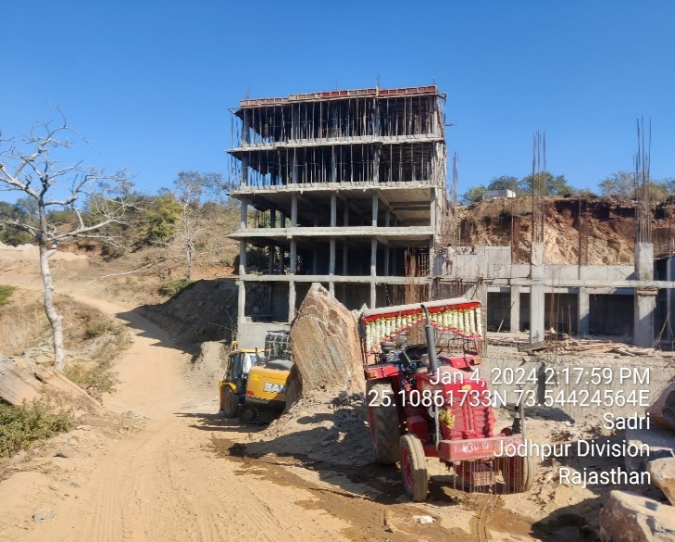 | 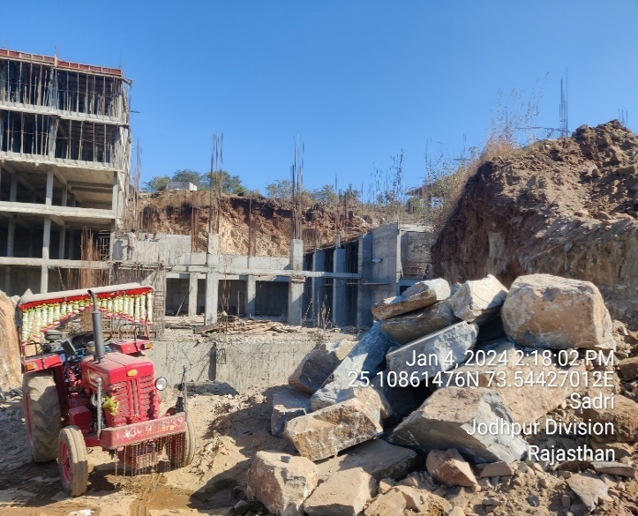
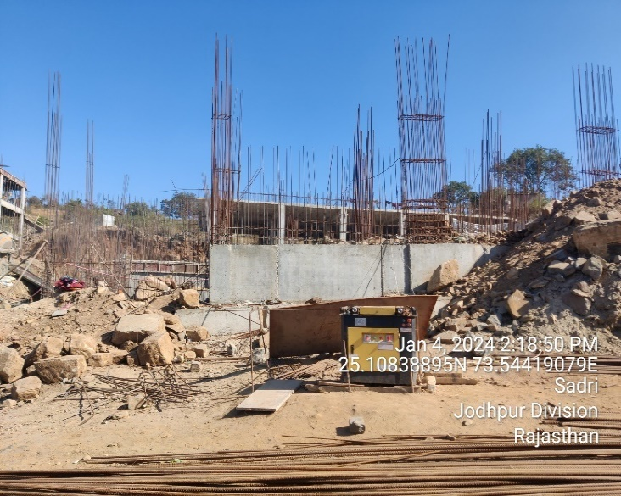 | 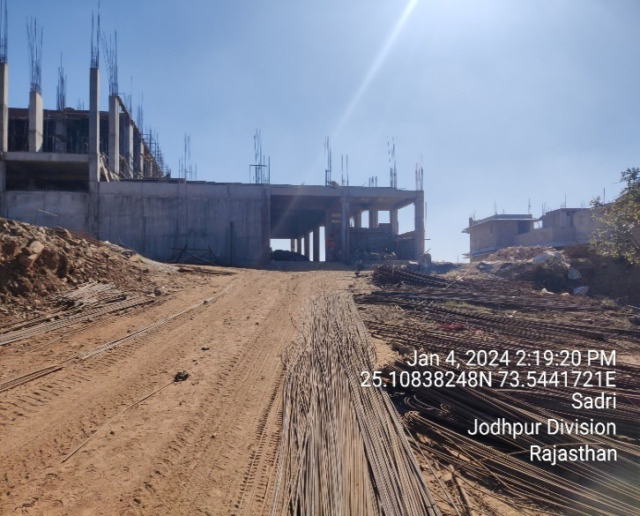
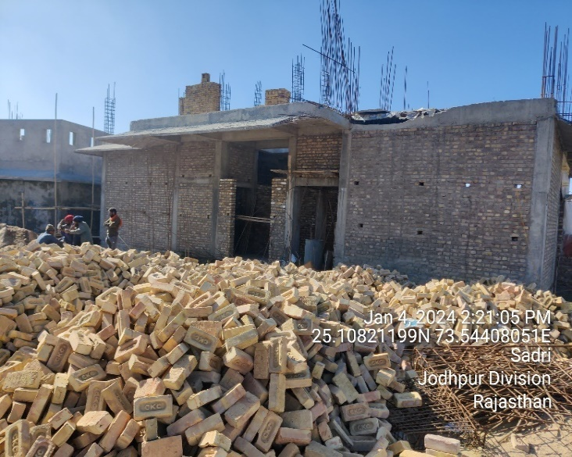 | 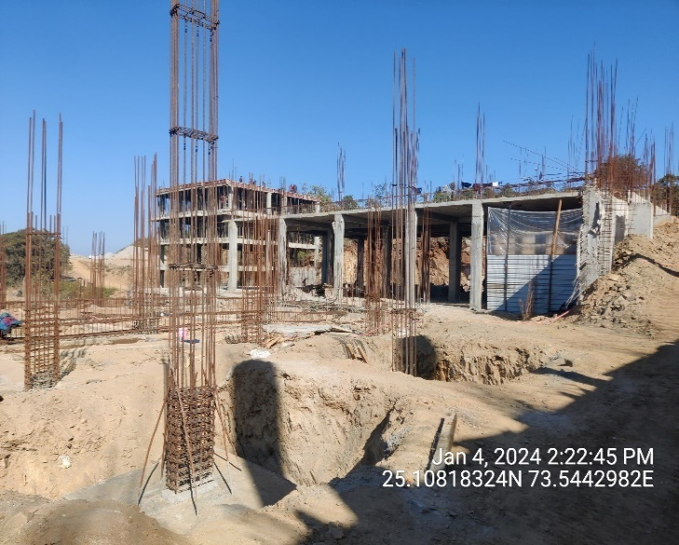
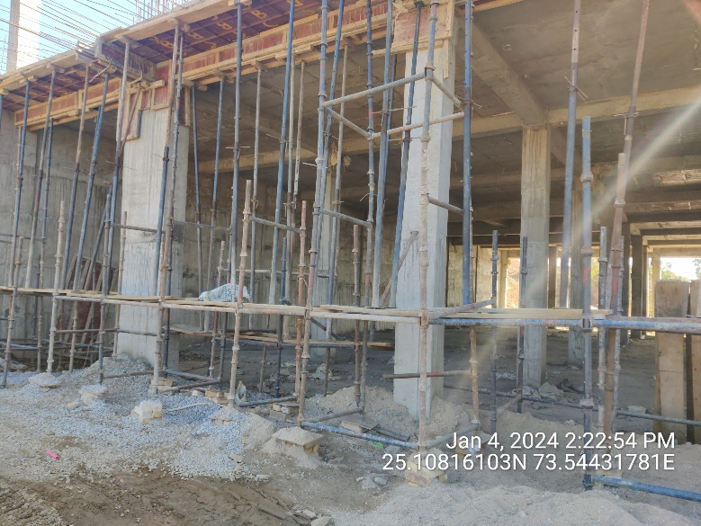 | 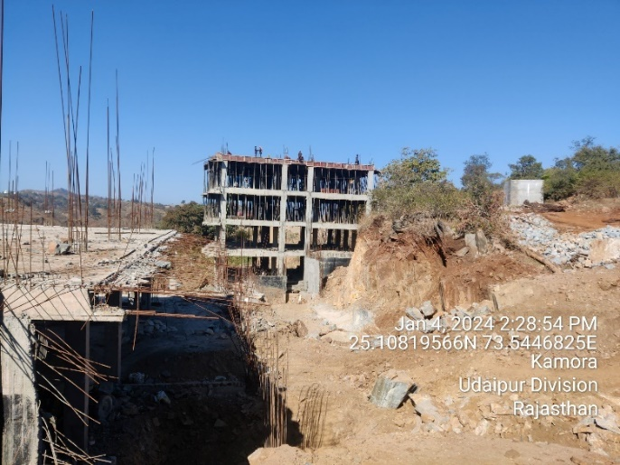
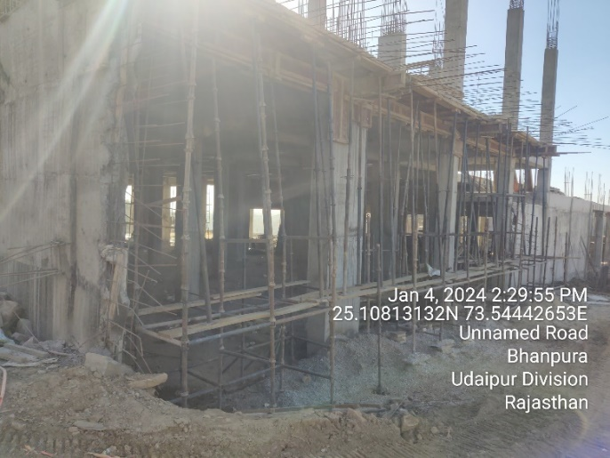 | 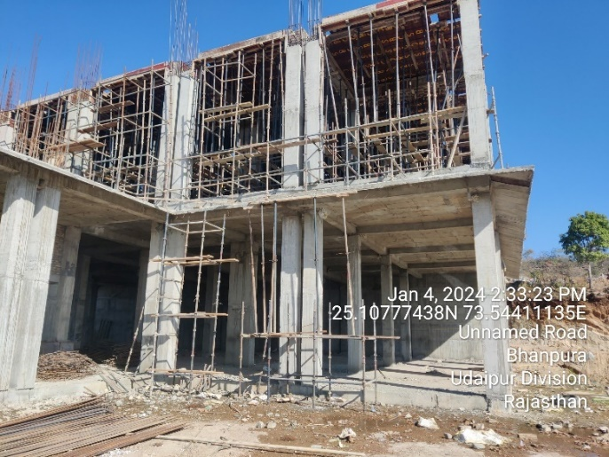
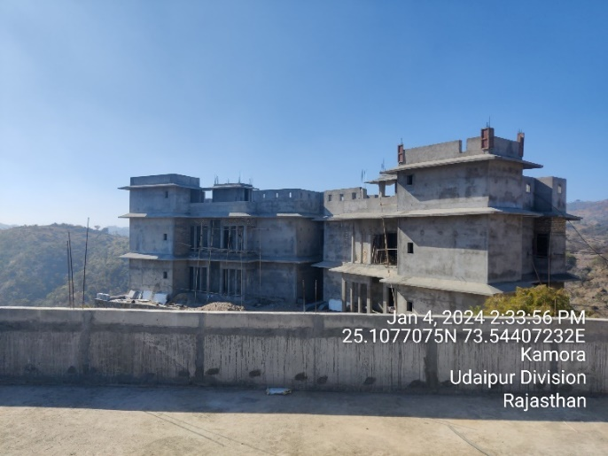 | 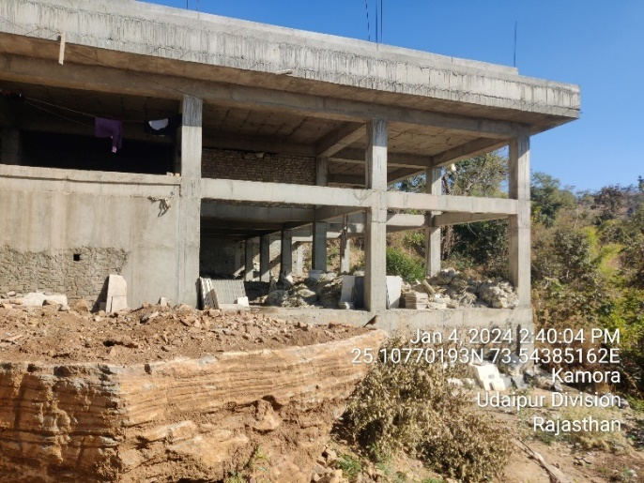
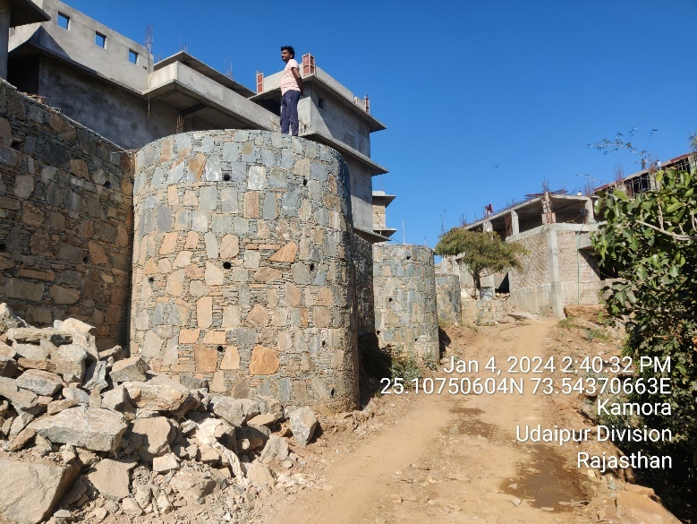 | 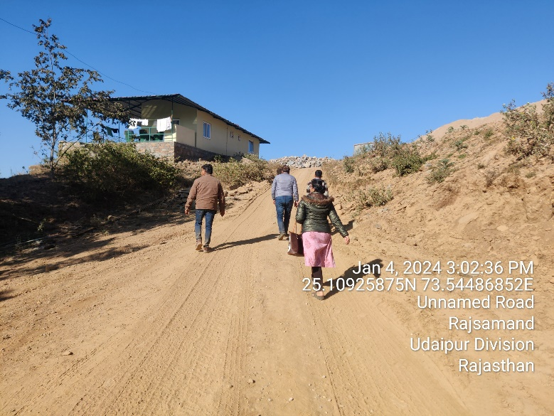
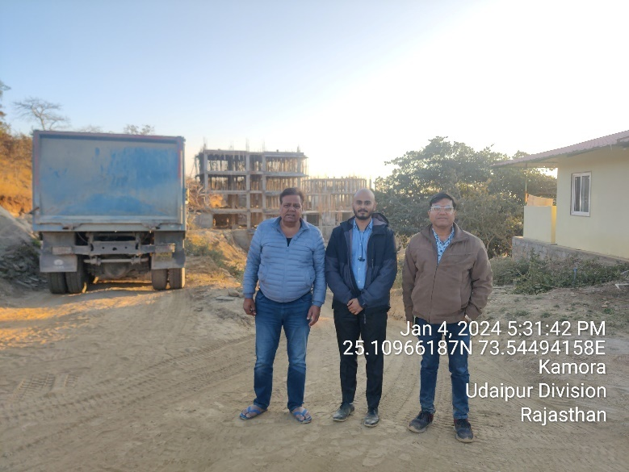 | 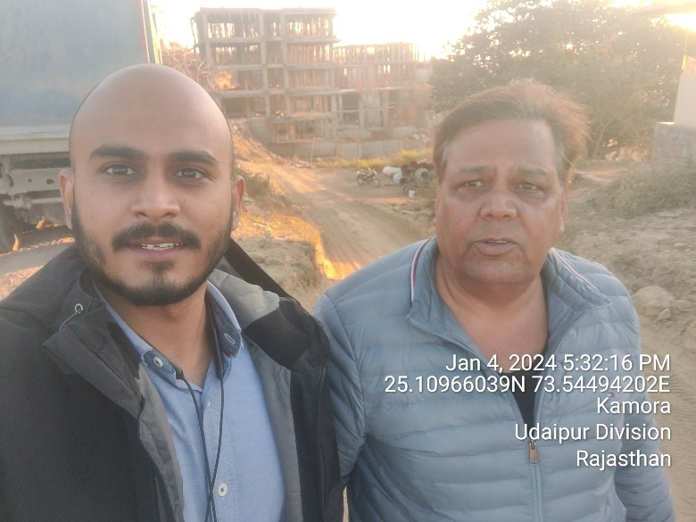

- UTILITIES: Details of Water, Electricity and transportation are describing as below:
- Water: As per the information shared by the client, both the groundwater and bore well are already in place at the site location. Company has proposed to establish standard water treatment plant as per industry norms using STP technology. After the treatment of water, there will be an abundant water supply for bathrooms, cleaning and cooking. Bottled water will be provided for guests' drinking purposes. Additionally, water recycling measures will be implemented, utilizing bathroom wastewater for toilet flushing and irrigation of lawns and plants. Rainwater harvesting will also be incorporated at the site in the future.
- Electricity: As per the information shared by the client, sufficient electric supply is available in the area. Electrical connections are available on demand for hotels. For the green-field project, commercial electric connection from the Ajmer Vidhyut Vitran Nigam Limited has been taken and currently company have 18 KW load approval for construction work and the load would be extended once the hotel becomes operational. For backup support, DG would also be provided. Solar Power plant and Bio Gas plants would also be installed to use the renewable sources of energy.
- Transportation: The proposed hotel is conveniently located on the main Nathdwara-Kumbhalgarh Road, offering excellent connectivity via road and rail networks. Kumbhalgarh enjoys excellent transportation links to various parts of the country, including Jaipur, Delhi, Mumbai, Chennai, Bangalore, and Kolkata. This easy accessibility ensures enhanced business opportunities for the hotel.

- MANPOWER: As per information shared by the client/company, an estimate of manpower requirement allowing for leave, absenteeism, sickness and holidays for smooth and for efficient operation of different sections of the proposed hotel including its administrative departments, has been prepared based on technical and management ground primarily to indicate the order of manpower requirement.
In estimating the manpower requirement, a proper ratio between the administrative, managerial, supervisory and floor staff has been maintained with a view to affording proper industrial and professional management at various levels.
As per informed by client, company have estimated around 79 workers will be required at the time of commencement of commercial operations which is in the line with the industry. The basic structure of the manpower will require for the proposed project are:
Designation | No. of Persons
General Manager | 1
Assistant Manager | 1
Accountant | 1
Accounts / Stores Assistant | 2
Security Guards | 5
Plumber / electrician / carpenter | 3
Gardner | 3
Sweepers | 4
Front Office Manager | 1
Front Office Assistant | 2
Shift In-charge | 2
Housekeeping In Charge | 1
Housekeeping Supervisors | 4
Bell Boys | 6
Room Boys | 15
Food & Beverage Manager | 1
Chef | 1
Assistant Chef | 4
Kitchen Staff | 7
Restaurant / Banquets Staff | 15
Total Salary Paid | 79

In general the state of Rajasthan has a lot of trained manpower which is required for the hotel industry, as the area has been catering to the tourism industry. Hence, the lower level staff would be hired locally. The senior and additional staff requirements would be met from the management company with whom marketing tie up/agreement will be entered by the company.
- MARKETING STRATEGIES: As per information provided by the client/company, marketing strategies for proposed luxury hotels typically focus on promoting the luxury and exclusivity of the hotel, targeting high-end clientele, and creating a unique and memorable guest experience. Based on our expertise and general market practices of the hospitality industry, here are five key marketing strategies which will be used by proposed luxury hotel:
- Branding and Positioning: Establishing a strong brand identity and positioning the hotel as a premier luxury destination is crucial. The proposed hotel will explore future Tie-up with luxury hotel chains, after the completion of the super-structure, which will further add to a big advantage to the hotel.
- Targeted Advertising: Implementing targeted advertising campaigns to reach the desired audience is essential for a new hotel at one of the developing tourist places like Kumbhalgarh. This includes advertising in high-end lifestyle magazines, digital advertising on premium websites, and strategic partnerships with luxury travel agencies & tie-ups with big brands.
- Online Presence and Digital Marketing: Maintaining an engaging and visually appealing website is vital for showcasing the hotel's facilities, amenities, and services. As per discussion with the company officials, the hotel management will be utilizing search engine optimization (SEO) and investing in online advertising, including social media marketing and influencer collaborations which will help in generating awareness and attract potential guests.
- Personalized Guest Experience: Positive guest experiences can lead to word-of-mouth recommendations and repeat business. To provide a personalized and tailored experience to guests will be the hallmark of the proposed luxury hotel. This includes anticipating and meeting guest needs and preferences, offering custom amenities, and providing exceptional customer service throughout the stay.
- Unique Selling Proposition (USP): Highlighting the hotel's unique features and offerings is critical. This could include specialized spa and wellness facilities, exclusive access to events or tie-ups with big brands. Emphasizing these unique selling points helps differentiate the hotel from competitors and attracts discerning travellers seeking exceptional experiences.
It is important to note that marketing strategies may vary depending on the specific market, location, and target audience. Hence, it is very essential for the proposed green-field project to conduct market research, analyse consumer behaviour, and adapt their marketing strategies accordingly to stay competitive and meet the evolving demands of the luxury travellers.

PART E | HOSPITALITY AND TOURISM INDUSTRY OVERVIEW

- INTRODUCTION: India has become one of the most sought-after travel destinations worldwide, resulting in the tourism and hospitality industry emerging as a major growth driver in the services sector. Similar to many other countries, tourism in India plays a pivotal role in generating foreign exchange earnings. Foreign exchange earnings experienced a Compound Annual Growth Rate (CAGR) of 7%.
The tourism and hospitality sector, encompassing travel services and establishments such as hotels and restaurants, is widely recognized as a catalyst for socioeconomic growth, a promoter of development, and a significant source of foreign exchange revenue in numerous countries. In India, tourism showcases the nation's rich history, vibrant culture, and remarkable diversity while also delivering substantial economic benefits.
Thanks to the concerted efforts of the central and state governments, the tourism industry has been able to recover from the shock of the COVID-19 pandemic and is gradually returning to pre-pandemic levels of operation. These efforts have been instrumental in revitalizing the sector and ensuring its continued growth.
- MARKET SIZE: As per the Ministry of Tourism, Foreign Tourist Arrivals (FTAs) in March 2023 were 7,95,827 as compared to 3,42,308 in March 2022 with a positive growth rate of 132.5%. FTAs during the period January-March 2023 were 25,29,766 as compared to 7,84,750 in January-March, 2022 and 31,79,792 in January-March 2019 registering a growth of 222.4% and -20.4% with respect to 2023 and 2019 respectively.
In 2021, the travel and tourism industry's contribution to India's GDP was valued at US$ 178 billion, and it is projected to reach US$ 512 billion by 2028. The industry's direct contribution to India's GDP is expected to grow annually at a rate of 7-9% between 2019 and 2030. In 2020, the travel and tourism industry contributed US$ 121.9 billion to India's GDP. By 2022, the contribution of the travel and tourism industry to India's economy reached US$ 15.7 trillion.
The travel market in India is expected to reach US$ 125 billion by FY27, an increase from an estimated US$ 75 billion in FY20. The Indian airline travel market, valued at approximately US$ 20 billion, is projected to double in size by FY27 due to improvements in airport infrastructure and increased passport accessibility. The Indian hotel market, including domestic, inbound, and outbound segments, was estimated at around US$ 32 billion in FY20 and is expected to reach approximately US$ 52 billion by FY27. This growth will be driven by the rising demand from travellers and the ongoing efforts of travel agents to stimulate the market.
By 2028, international tourist arrivals are projected to reach 30.5 billion, generating revenue of over US$ 59 billion. However, the growth in the tourism sector is expected to be primarily driven by domestic tourists in the post-pandemic period. International hotel chains are expanding their presence in India and it reached approximately 50% of the country's tourism and hospitality sector.
- RECENT INVESTMENTS/ DEVELOPMENTS: The Ministry of Tourism received an investment of Rs. 2,400 crore (US$ 289.89 million) as the tourism sector presents significant opportunities for youth employment and entrepreneurship. To promote the establishment of new hotels, an investment-linked deduction is available under Section 35 AD of the Income Tax Act. This allows a 100% deduction for capital expenditures incurred in setting up hotels of 2-star category and above across India.
In the Union Budget 2023-24, the Ministry of Tourism was allocated US$ 290.64 million to leverage the sector's potential for job creation, youth entrepreneurship, and tourism promotion. The focus is on active state participation, government program convergence, and public-private partnerships.
An app will be developed to cover all relevant aspects of tourism. Additionally, states will be encouraged to set up Unity Malls in their capital cities, serving as prominent tourism centers to promote local products, including One District One Product, Geographical Indication (GI) products, handicrafts, and products from other states. Below are some investments and developments:
- The Indian government has set a target to create 220 new airports by 2025, aiming to enhance connectivity and facilitate tourism growth.
- The Emergency Credit Line Guarantee Scheme (ECLGS) has been expanded to include tourism and hospitality stakeholders, providing financial support to micro, small, and medium enterprises (MSMEs). Exhibition-cum-convention centers have been granted infrastructure status.
- A separate liquidity window of Rs. 15,000 crore (US$ 1.8 billion) has been established for the tourism sector to address financial challenges.
- As of September 2022, a total of 48,775 accommodation units (classified and unclassified) have been registered on the National Integrated Database of Hospitality Industry (NIDHI) portal. Additionally, 11,220 units have self-certified for SAATHI standards, ensuring quality and safety.
- In May 2022, hospitality unicorn OYO acquired Europe-based vacation rental company Direct Booker for US$ 5.5 million.
- The Medical Tourism sector is projected to grow at a Compound Annual Growth Rate (CAGR) of 21.1% from 2020 to 2027.
- The Indian government estimates that India will have a market size of 1.2 million cruise visitors by 2030-31. Dream Hotel Group plans to invest approximately US$ 300 million in the next 3-5 years to develop India's cruise sector.
- India is at the forefront of digital travel, with its population utilizing digital tools for travel planning, booking, and experiences. The growing middle class and increasing disposable income have contributed to the growth of domestic and outbound tourism.
- GOVERNMENT INITIATIVES: The Indian government has recognized the immense potential of the tourism industry and has implemented various measures to position India as a global tourism hub. Here are some of the key initiatives planned by the Government of India to boost the tourism and hospitality sector:
In the Union Budget 2023-24, the Ministry of Tourism has been allocated a budget of US$ 290.4 million. Within this budget, an allocation of US$ 170.85 million has been made for the Swadesh Darshan Scheme. This scheme aims to develop a comprehensive package of 50 tourist destinations, focusing on enhancing physical, digital, and virtual connectivity, as well as ensuring the availability of tourist guides and improving tourist security. Since its inception, the Ministry of Tourism has approved 76 projects under the Swadesh Darshan Scheme, covering 13 different themes. The revised sanctioned cost for these projects amounts to US$ 668.95 million, with a total release of US$ 534.9 million as of December 31, 2021.
Under the Budget 2023-24, an allocation of US$ 30.25 million has been made for the development of tourist circuits under the PRASHAD scheme. Since its launch in January 2015, the Ministry has sanctioned 37 projects in 24 states, with an estimated expenditure of US$ 146.4 million. A cumulative amount of US$ 91.6 million has been released for these projects. As of March 31, 2022, 68 destinations/sites have been identified in 30 states/union territories for development under the PRASHAD scheme.
The Government of India, has collaborated with the Quality Council of India (QCI) for an initiative called SAATHI (System for Assessment, Awareness, and Training for the Hospitality Industry). This initiative aims to assist the hospitality industry in operating safely and mitigating risks arising from the COVID-19 pandemic. Hotels and units undergo the SAATHI framework and, upon compliance, receive a self-certification. Webinars are conducted to address any questions or concerns, and QCI-accredited agencies can conduct site assessments based on the SAATHI framework, providing assessment reports with improvement opportunities.
To support the tourism service sector affected by COVID-19, the government introduced the Loan Guarantee Scheme for Covid Affected Tourism Service Sector (LGSCATSS). This scheme provides loans of up to US$ 12,110 to approved and recognized tour operators, travel agents, and tourist transport operators under the Ministry of Tourism.
Furthermore, guarantees for skill development loans, up to Rs. 1.5 lakh (US$ 1,801), are being extended by member banks of the Indian Banks' Association (IBA) to eligible borrowers without collateral or third-party guarantee. This initiative aims to promote skill development within the tourism sector.
- ROAD AHEAD: Staycation has emerged as a popular trend where individuals seek relaxation and relief from stress by staying at luxurious hotels for a peaceful getaway. Recognizing this demand, major hotel chains like Marriott International, IHG Hotels & Resorts, and Oberoi Hotels are introducing enticing staycation offers, providing guests with a range of curated experiences within the hotel premises. The potential for growth in India's travel and tourism industry is substantial. Furthermore, the industry eagerly anticipates the expansion of the e-Visa scheme, which is expected to double the number of tourists visiting India. A joint study conducted by Assocham and Yes Bank highlights that India's travel and tourism industry has the capacity to expand by 2.5% due to increased budgetary allocation and the availability of cost-effective healthcare facilities.
Undeniably, the tourism industry has become a significant economic force and a catalyst for development. Not only does it drive economic growth, but it also enhances people's quality of life by creating a wide range of employment opportunities. Additionally, it promotes environmental preservation, celebrates diverse cultural heritage, and fosters international peace. By 2028, it is projected that Indian tourism and hospitality will generate US$ 50.9 billion through visitor exports, compared to the US$ 28.9 billion recorded in 2018.

PART F | SWOT ANALYSIS OF M/S MAHECHA BOUTOQUE HOTELS PRIVATE LIMITED

SWOT ANALYSIS
STRENGTHS | - M/s Mahecha Boutique is located on highest peak of Kumbhalgarh, which is famous for its surroundings due to hilly view and origin of Banas River. Thus, the proposed project is supposed to get the location advantages/synergies.  - As per our tertiary research, The Hospitality Industry in India is expected to grow at a CAGR of 4.73% during the forecast period (2024-2029) and tourism sector is also expected to grow at a CAGR of 21.1% (2020-27).  - As per data/information provided by the client, M/s Mahecha is having a plan to hire a hotel management company resulting: a well-trained/Knowledgeable staff in future, customer centric services provider, better marketing strategy with respect to occupancy to increase the operational and auxiliary revenues.  - Government support such as 100 % FDI is allowed through automatic route and “Incredible India”.  - It’s a worthy investment as the cost of labour is lower, and the profit margins are higher.  - Land is owned by the owner/promoter itself who purchased it in past at lower cost, at present it just ~1% of the total project cost. Thus, lesser capital will be required comparatively to establish the proposed luxury hotel.
WEAKNESSES | - Proposed hotel is a luxury segment hotel and GST slabs for luxury hotel room rates are very high. The outcome of this is huge set-up cost and high room rates.  - Hotel industry is highly dependent on tourism & seasons and external factors like geopolitical events or natural disasters, which can impact visitor numbers.  - Due to luxury nature of proposed hotel, it limits the potential customer base compared to more budget-friendly accommodations.
OPPORTUNITIES | - M/s Mahecha is a green field project hence expanding the hotel's reach by opening new branches or entering new markets within India can be an opportunity for growth.  - Proposed hotel is planning to provide Personalized products/services with the help of hotel management company.  - Increasing trend of co-working staycation & bleisure travel in India, which will be a futuristic opportunity for the proposed hotel.  - Travel and tourism are two of the largest industries in India, with a total contribution of about US$ 178 billion to the country’s GDP.
THREATS | - M/s Mahecha is a green field project, hence there would be fund risk, which involves the potential challenges associated with securing and managing financial resources.  - M/s Mahecha will face challenges associated with standing out and thriving in a competitive market. Thus, increasing competition is a big threat for the company  - The proposed hotel may encounter demand risk, which signify the unpredictability and possible variations in the market demand for the services it offers to its customers.  - At present, M/s Mahecha is undergoing the construction phase, hence cost and time overrun risk are the major challenges faced by the company.  - Acquiring statutory approvals is a pivotal component in the development of a new luxury hotel. Any delays or complications in securing these approvals can present a notable risk to the project.

PART G | RISK ASSESSMENT & MITIGATION

Key Risks | Proposed Mitigation of Risk
Experience and Capability | - M/s Mahecha Boutique hotel is a green field project and assemble a team with a proven track record in hotel development, architecture, and project management are potential challenges associated with the expertise and capabilities of the individuals and entities involved in the development and operation of proposed hotel.  - Mitigating these risks involves careful planning, hiring the right people, and establishing robust systems.  - Company had hired an experienced construction management team with a history of successfully delivering projects on time and within budget.  - Before hiring anyone, company had conducted due diligence on the experience of hired member and also check successful completion of various projects by key team members.  - Company will also hire a hotel management team to provide comprehensive training programs for staff to ensure company understand and adhere to high-quality service standards.
Funding Risk | - Funding risk is a significant consideration for the development of a green field hotel, as it involves the potential challenges associated with securing and managing financial resources.  - To mitigate funding risks, company have a comprehensive financial strategy and risk management plan.  - Proposed hotel had a mix of funding sources, including equity and loans. Hence, company is not dependent on single funding source.  - Promoters of the company are financially strong. Hence, unplanned financial requirement will be met through the support of the promoters (Quasi equity).  - Proposed hotel Opted for long-term financing options to provide stability and avoid the risk of interest rate fluctuations.  - Proposed hotel implements robust financial monitoring and reporting systems to track expenditures, revenue, and overall financial health to mitigate Inadequate monitoring of financial performance and deviations from the budget.
Cost/Time Overrun Risk | - Cost and time overrun risks are common challenges at the time of the construction of the proposed project.  - Proposed hotel conducts a detailed feasibility study and project planning to identify potential challenges and accurately estimate costs and timelines.  - Proposed hotel regularly monitoring and reporting of project progress against the planned schedule and budget.  - Company had established strong relationships with reliable suppliers and vendors. And they are regularly inspecting and assessing the quality of workmanship throughout the construction phase.
Statutory Approvals | - Statutory approvals, also known as regulatory approvals, are a critical aspect of the development process for a new luxury hotel. Delays or complications in obtaining these approvals can pose a significant risk to the project.  - Proposed hotel management had stablished early and open communication with local planning authorities, municipal bodies, and other relevant agencies. They had already taken required approvals to start the construction of the proposed hotel.  - As per the requirement, proposed hotel is planning for getting the statutory approvals.  - Only those approvals are pending which will require after Date of Commencement of Commercial Operations (DCCO).
Competition Risk | - Competition risk is a significant concern for the proposed hotel, as it involves the challenges associated with standing out and thriving in a competitive market.  - Mahua Bagh Resort, Fateh Safari Resort, Kumbhalgarh Forest Retreat, Renest Kumbhalgarh and The Wild Retreat Kumbhalgarh are some of the competitors of the proposed hotel.  - To mitigate competition risk, proposed hotel is planning for careful market analysis like branding and positioning, targeted advertising, online presence and digital marketing, personalized guest experience.  - Proposed hotel is planning to develop a clear and compelling differentiation strategy that highlights unique features, services, or experiences offered to customers.  - Proposed hotel will also implement feedback mechanisms to continuously improve service based on customer input.
Demand Risk | - It is crucial for hotel developers and operators to understand and address this risk to ensure the long-term success of the establishment.  - For the proposed hotel demand risk refers to the uncertainty and potential fluctuations in the market demand for the services provided.  - Mitigation strategies considered by the proposed hotel for demand risk are thorough market research, diversification of target markets, flexible pricing strategies, strategic alliances and partnerships, event and group booking strategies, customer loyalty programs, adaptability to industry trends and customer feedback and reviews
Pricing Level and Sustainability | - Pricing level and sustainability risk in the context of a new hotel involve challenges related to determining the appropriate pricing strategy while ensuring the long-term sustainability of the business.  - To mitigate this risk proposed hotel had conduct market research to identify competitors pricing strategies, customer expectations, and overall market trends. And also analyze local and global economic conditions to make informed pricing decisions.  - Proposed hotel utilizes dynamic pricing strategies that allow for adjustments based on demand fluctuations, seasonality, and other factors. They also implement revenue management systems to optimize pricing and maximize revenue during peak periods.

PART H | PROJECT COST AND MEANS OF FINANCE

As per data/information provided by the company/client, category wise proposed project cost is shown in the below table:

Particulars | Proposed Cost (INR Lakhs)
Land (Owned) | 44.63
Building | 3220.00
Equipment’s | 430.00
Furniture & Fixtures | 350.00
Tie up / Franchise Fees to Operator Company and other cost | 344.50
Total Project Cost | 4,389.13
Note: Cost projections have been provided by the client/company
MEANS OF FINANCE
Particulars | Proposed Cost (In Lakhs) | Already Invested Amount till 31.12.2023
Term Loan | 3000.00 | 0.00
Unsecured Loan | 689.13 | 281.00
Equity and Security Capital | 700.00 | 473.08
Total | 4,389.13

Notes:
- The cost of the land is INR 44.63 lakhs, including registration and stamp duty.
- The cost of construction has been estimated at INR 3000.00 lakhs, including development of all the support infrastructure, civil work, gardens and horticultures, swimming pool, internal paths, water tanks, fencing and boundary walls.
- The Company has estimated the administration cost, architect fees and miscellaneous expenses at INR 220 lakhs.
- The cost of equipment and plant & machinery for the project at an estimated cost of INR 430 lakhs and furniture and fixtures at INR 350 Lakhs.
- The Company has estimated the interest, capitalization and other soft cost at INR 344.50 lakhs.
- Promoter contribution was ₹ 7 crores by way of share capital and 6.89 crores by way of unsecured loans, out of which they have already contributed ₹4.73 crores share capital and 2.81 crores as unsecured loans thus the remaining total 6.35 crores is to be invested which will be out of sale of present investment in other properties.

MEANS OF FINANCE: Out of the total project cost of INR 4,389.13 lakhs, it is proposed that the INR 700 lakhs will be from equity holders of the company in the form of equity and security premium, INR 3,000.00 lakhs will be met through a bank term loan and the remaining amount of INR 689.13 lakhs will be funded from the unsecured loan (Quasi Equity). Promoters net worth certificates, indicate that the promoters possess ample assets to fund the project whenever necessary. Promoters of the company are financially strong. Hence, unplanned financial requirement will be met through the support of the promoters.
PART I | PROJECT SCHEDULE

Below is the tabulated presentation of the status of the project showing expected duration shared by the project manager of the company:

S. No. | Particulars | Activity | Start Date | Expected Completion Date | Status
1. | Acquisition of Land | Land Procurement | November 2018 | - | Owned
1. | Acquisition of Land | Land Development | April 2022 | - | Scheduled
2. | Sanction of Rupee Term Loan | Sanction of Rupee Term Loan | - | January 2024 | Scheduled
3. | Building & Civil Works | Appointment of Architect | January 2022 | - | Already Appointed
3. | Building & Civil Works | Building Plan Preparation | January 2022 | - | Done
3. | Building & Civil Works | Building Plan Sanction | June 2022 | - | Approved
3. | Building & Civil Works | Appointment of Civil contractor/ developer | March 2022 | - | Already Done
3. | Building & Civil Works | Building & Civil Works | April 2022 | March 2026 | Site Development Work Started
4. | Plant & Machinery | Finalization of P&M suppliers | - | Last Quarter of 2024 | Scheduled
4. | Plant & Machinery | Orders to P&M suppliers | - | First Quarter of 2025 | Scheduled
4. | Plant & Machinery | Arrival of P&M | - | Mid of 2025 | Scheduled
4. | Plant & Machinery | Installation of P&M | - | Mid of 2025 | Scheduled
4. | Plant & Machinery | Utility Installation | - | Mid To 3rd Quarter of 2025 | Scheduled
5. | Furniture and Fixtures | Purchase of other Fixed Assets/ Furniture & Fixtures | - | March-April 2024 | For Cluster No 01 already purchased.  Later on as and when Required company will purchase.
6. | Statutory Approvals, registrations & NOCs | Most of the approvals are taken from the respective authorities. | - | Last quarter of 2025 | As and when requirement of approval arises at all the stages of finishing of construction Site
7. | Trail Run | - | - | March 2026 | Scheduled
8. | Commercial Operation Date | - | - | April 2026 | Scheduled
Notes:
- Schedule has been made as per feasibility to achieve different milestones.
- Achievement of Milestone will depend on sanction of term loan as per proposed timeline.

PART J | STATUTORY APPROVALS | LICENCES | NOC
As per the information provided by the client below is the list of approvals required for the proposed project:
S. No. | Name Of License/ Registration  Issuing Authority | Purpose | Licence No. With Date | Current Status
1. | Registration Certificate from GST REG-06, Government of India | To get legal evidence of the company’s identification and existence | GST Reg. Number: 08AAMCM1621J1ZE | Already Taken
1. |  |  | Reg. Date: 27th April, 2022 | Already Taken
2. | Certificate of Incorporation from Ministry of Corporate Affairs, Government of India | To affirms the company’s formation | PAN: AAMCM1621J  TAN: JDHM14651A | Already Taken
2. |  | To affirms the company’s formation | Incorp. Date: 12th October, 2018 | Already Taken
3. | Business Registration Number (BRN) From Department of Statistics, Government of Rajasthan | To get a unique identification number assigned to a business or a company. | BRN: 8005220026002550 | Already Taken
3. |  |  | Reg. Date: 15th August, 2022 | Already Taken
4. | Udyam Registration Certificate from Ministry of Micro, Small and Medium Enterprises, Government of India | To get a business license in India for businesses to register under the Ministry of MSME | UDYAM Registration Number: UDYAM-RJ-17-0169079 | Already Taken
4. |  |  | Reg. Date: 28th June, 2022 | Already Taken
5. | Land Conversion Certificate, from Kumbhalgarh, Rajsamand, Rajasthan | Change of land use from agricultural to non-agricultural purposes | Issuance Date: 1st January, 2016 | Already Taken
6. | Site Plan approved by Gram Panchyat: Kariya, Kumbhalgarh, Rajsamand, Rajasthan | A legal agreement for obtaining government approval for construction. | 1st August 2022 | Already Taken
7. | Pollution Certificate from Rajasthan State Pollution Control Board, Rajsamand (Kumbhalgarh) Rajanthan | To get pollution under control | F(Tech)/Rajsamand(Kumbhalgarh)/6832(1)/2022-2023/6642-6644 | Valid up to 31st January 2028
7. |  | To get pollution under control | Dispatch Date: 13th February, 2023 | Valid up to 31st January 2028
8. | No Objection Certificate (NOC) For Ground Water Abstraction, Ministry of Jal Shakti, Government of India | Ensuring that precious groundwater resources are neither misused nor depleted but are harnessed sustainably. | NOC Number: CGWA/NOC/INF/ORIG/2023/17839 | Valid up to 26th February 2028
8. |  |  | Issuance Date: 27th February, 2023 | Valid up to 26th February 2028
9. | Fire Safety Permit | To get permission to conduct certain activities that may pose a fire risk. | - | Pending
10. | Trade License from Department of the Municipal Corporation | To ensure that bar and restaurant adhere to all of the health department’s guidelines | - | Pending
11. | Bar License from Excise Department, Government of Rajasthan | To serve alcoholic drinks to the consumer | - | Pending
12. | License under prevention of Food Adulteration Act (FASSAI License) | To ensure the safety and quality of food products being produced, processed, distributed, and sold in India. | - | Pending

Observations & Comments:
- Company has obtained preliminary statutory clearances and approvals except those which are mentioned as in Process or Pending above.

PART K | COMPANY’S FINANCIAL FEASIBILITY

- PROJECTIONS OF THE PROPOSED HOTEL: As a greenfield project, the projections of the proposed luxury hotel are prepared from the commencement of commercial operations i.e. FY 2026-27 to FY 2033-34 based on the revenue generation capacity from room rent, food, beverage and bar sale and banquet sale and total expected expenses are shown as below:
- PROJECTED PROFIT & LOSS ACCOUNT: Below table shows the Projected Profit & Loss Account of M/s Mahecha Boutique Hotel Private Limited from the period FY 2026-27 to FY 2033-34.
(INR Lakhs)
Particulars | 2026-27 P | 2027-28 P | 2028-29 P | 2029-30 P | 2030-31 P | 2031-32 P | 2032-33 P | 2033-34 P
Room Sale | 803.00 | 883.30 | 1,093.08 | 1,202.39 | 1,322.63 | 1,454.89 | 1,778.20 | 1,956.02
Food Sale | 438.00 | 481.80 | 596.23 | 655.85 | 721.44 | 793.58 | 969.93 | 1,066.92
Bar Sale | 131.40 | 144.54 | 178.87 | 196.76 | 216.43 | 238.07 | 290.98 | 320.08
Conference/Banquet receipts | 82.50 | 86.63 | 90.96 | 95.50 | 100.28 | 105.29 | 110.56 | 116.09
Revenue from Open Garden Events | 30.00 | 31.50 | 33.08 | 34.73 | 36.47 | 38.29 | 40.20 | 42.21
Misc. Income | 7.00 | 7.35 | 7.72 | 8.10 | 8.51 | 8.93 | 9.38 | 9.85
Total Income | 1,491.90 | 1,635.12 | 1,999.93 | 2,193.33 | 2,405.75 | 2,639.06 | 3,199.25 | 3,511.17
Housekeeping Exp. (% of Room Sale) | 64.24 | 70.66 | 87.45 | 96.19 | 105.81 | 116.39 | 142.26 | 156.48
Food Expenses (% of food, Banquet & Bar sale) | 313.17 | 344.49 | 426.30 | 468.93 | 515.83 | 567.41 | 693.50 | 762.85
Sales & Marketing Exp. (% of Total Sales) | 29.84 | 32.70 | 40.00 | 43.87 | 48.12 | 52.78 | 63.99 | 70.22
Banquet Expenses (% of Banquet Sale) | 24.75 | 25.99 | 27.29 | 28.65 | 30.08 | 31.59 | 33.17 | 34.83
Royalty & Marketing Service Fees to Hotel Management Company | 64.24 | 70.66 | 87.45 | 96.19 | 105.81 | 116.39 | 142.26 | 156.48
Salary & Wages | 169.20 | 186.12 | 204.73 | 225.20 | 247.72 | 272.49 | 299.74 | 329.71
Repairs & Maintenance | 12.00 | 25.80 | 29.67 | 34.12 | 39.24 | 45.13 | 51.90 | 59.69
Power & Fuel | 48.00 | 52.80 | 58.08 | 63.89 | 70.28 | 77.31 | 85.04 | 93.54
Quality Circle Fee | 29.84 | 32.70 | 40.00 | 43.87 | 48.12 | 52.78 | 63.99 | 70.22
Other Admin. Exp. | 9.50 | 10.45 | 11.50 | 12.65 | 13.92 | 15.31 | 16.84 | 18.52
Depreciation | 421.50 | 376.13 | 335.77 | 299.86 | 267.90 | 239.42 | 214.05 | 191.43
Preliminary/pre-operative Expenses | 68.90 | 68.90 | 68.90 | 68.90 | 68.90 | - | - | -
Term Loan Interest | 289.50 | 275.63 | 246.20 | 211.09 | 172.01 | 129.07 | 82.63 | 30.04
Total Expenses | 1,544.68 | 1,573.03 | 1,663.34 | 1,693.41 | 1,733.73 | 1,716.07 | 1,889.36 | 1,974.01
Profit before tax | -52.78 | 62.09 | 336.59 | 499.92 | 672.02 | 922.99 | 1309.89 | 1537.16
Income Tax | - | 2.59 | 93.64 | 139.08 | 186.96 | 256.78 | 364.41 | 427.64
Profit after Tax | (52.78) | 59.50 | 242.95 | 360.84 | 485.06 | 666.21 | 945.48 | 1,109.52

Above Projected P & L is built as per the revenue and cost recognition in which the recognised cost has been considered from FY 2026-27 since the revenue has been recognised from FY 2026-27. Tax rate has been considered as applicable to companies.

- PROJECTED BALANCE SHEET: Below table shows the Projected Balance Sheet of M/s Mahecha Boutique Hotel Private Limited from the period FY 2026-27 to FY 2033-34.
(INR Lakhs)
Particulars | 2026-27 P | 2027-28 P | 2028-29 P | 2029-30 P | 2030-31 P | 2031-32 P | 2032-33 P | 2033-34 P
Equity & Liability
Share Capital a/c | 700.00 | 647.22 | 706.72 | 949.67 | 1310.51 | 1795.57 | 2461.78 | 3407.26
Net Profit after tax transferred to Capital a/c | -52.78 | 59.50 | 242.95 | 360.84 | 485.06 | 666.21 | 945.48 | 1109.52
Net Capital a/c | 647.22 | 706.72 | 949.67 | 1310.51 | 1795.57 | 2461.78 | 3407.26 | 4516.78
Term Loan | 2900.00 | 2600.00 | 2240.00 | 1840.00 | 1400.00 | 920.00 | 420.00 | 0.00
Unsecured Loan from Directors/Relatives | 689.13 | 689.13 | 689.13 | 689.13 | 689.13 | 689.13 | 689.13 | 689.13
Current Liabilities | 69.47 | 76.77 | 90.11 | 98.54 | 107.82 | 112.30 | 132.72 | 146.05
Total Equity & Liability | 4305.82 | 4072.62 | 3968.91 | 3938.18 | 3992.52 | 4183.21 | 4649.11 | 5351.96
Assets
Fixed Assets | 3623.13 | 3247.01 | 2911.23 | 2611.37 | 2343.47 | 2104.05 | 1890.00 | 1698.57
Deposit & Advances | 45.00 | 45.00 | 45.00 | 45.00 | 45.00 | 45.00 | 45.00 | 45.00
Pre-Operative Expenses Not Written Off | 275.60 | 206.70 | 137.80 | 68.90 | 0.00 | 0.00 | 0.00 | 0.00
Sundry Debtors | 103.42 | 227.52 | 281.55 | 309.71 | 340.68 | 374.75 | 458.02 | 503.82
Stock | 43.38 | 47.37 | 57.27 | 62.61 | 68.48 | 74.91 | 90.04 | 98.58
Cash & Bank Balance | 215.30 | 299.03 | 536.07 | 840.59 | 1194.89 | 1584.50 | 2166.05 | 3005.98
Total Assets | 4305.82 | 4072.62 | 3968.91 | 3938.18 | 3992.52 | 4183.21 | 4649.11 | 5351.96

- PROJECTED CASH FLOW STATEMENT: Below table shows the Projected Cash Flow Statement of M/s Mahecha Boutique Hotel Private Limited from the period FY 2026-27 to FY 2033-34.
(INR Lakhs)
Particulars | 2026-27 P | 2027-28 P | 2028-29 P | 2029-30 P | 2030-31 P | 2031-32 P | 2032-33 P | 2033-34 P
Sources of Funds
Profit before tax | -52.78 | 62.09 | 336.59 | 499.92 | 672.02 | 922.99 | 1309.89 | 1537.16
Depreciation | 421.50 | 376.13 | 335.77 | 299.86 | 267.90 | 239.42 | 214.05 | 191.43
Preliminary Expenses Written Off | 68.90 | 68.90 | 68.90 | 68.90 | 68.90 | 0.00 | 0.00 | 0.00
Increase in Current Liabilities | 69.47 | 7.30 | 13.34 | 8.42 | 9.28 | 4.48 | 20.43 | 13.32
Total | 507.09 | 514.41 | 754.60 | 877.11 | 1018.10 | 1166.89 | 1544.37 | 1741.91
Application of Funds
Capital Expenditure | 45.00 | 0.00 | 0.00 | 0.00 | 0.00 | 0.00 | 0.00 | 0.00
Increase in Current Assets | 146.80 | 128.09 | 63.93 | 33.51 | 36.83 | 40.50 | 98.40 | 54.34
Repayment of Term Loan | 100.00 | 300.00 | 360.00 | 400.00 | 440.00 | 480.00 | 500.00 | 420.00
Taxation | 0.00 | 2.59 | 93.64 | 139.08 | 186.96 | 256.78 | 364.41 | 427.64
Total | 291.80 | 430.68 | 517.57 | 572.59 | 663.79 | 777.28 | 962.82 | 901.98
Opening Balance | 0.00 | 215.29 | 299.02 | 536.05 | 840.57 | 1194.88 | 1584.49 | 2166.04
Surplus | 215.29 | 83.73 | 237.03 | 304.52 | 354.31 | 389.61 | 581.55 | 839.93
Closing Balance | 215.29 | 299.02 | 536.05 | 840.57 | 1194.88 | 1584.49 | 2166.04 | 3005.97

- REVENUE BUILD-UP: The analysis is based on assumptions with regards to current financial environment, construction period, whereas at the time of actual implementation the situation might be different altogether.
However, it is pertinent to note that the assumptions may vary, and any different assumption may produce different financial results. We have assumed that revenue generation will begin from FY 2026-27.
As per the discussions/assumptions & information shared by the client/company, below are the details of expected revenue from the project for first year of the projection i.e. FY 2026-27:
Revenue Projections for FY 2026-27
No. of Rooms | 100
No. of days hotel is in operation | 365
Particular | Amount
Estimated Revenue
At a capacity utilisation of | 40%
Average Room Rent [Net]
Room Rent | 5,500.00
Max. Room Nights [ No. of Rooms * 365] | 36500
Max. No. of Guests [ Room nights * 2 ] | 73000
Food & Beverage sale per person per day | 1,500.00
Bar Sale per person per day | 450.00
Income
Room Sale | 803.00
Food Sale | 438.00
Bar Sale | 131.40
Conference receipts/Banquet [ 10 events x 750 pax @ Rs. 1100/- per pax] | 82.50
Revenue from Open Garden Events | 30.00
Misc. Income [ Net ] | 7.00
TOTAL | 1491.90

After FY2026-27, for the rest of the projected financials we have considered escalation rate of 10% to calculate Room sale, food sale and bar sale. And to calculate revenue from banquet, open garden event and miscellaneous we have considered an escalation rate of 5%.

Particular | 2026-27 P | 2027-28 P | 2028-29 P | 2029-30 P | 2030-31 P | 2031-32 P | 2032-33 P | 2033-34 P
Total Rooms | 100 | 100 | 100 | 100 | 100 | 100 | 100 | 100
Max. Room Nights [ No. of Rooms * 365] | 36,500 | 36,500 | 36,500 | 36,500 | 36,500 | 36,500 | 36,500 | 36,500
Max. No. of Guests [Room nights * 2] | 73000 | 73000 | 73000 | 73000 | 73000 | 73000 | 73000 | 73000
Capacity Utilised | 40% | 40% | 45% | 45% | 45% | 45% | 50% | 50%
Average Room Rent
Rooms | 5,500 | 6,050 | 6,655 | 7,321 | 8,053 | 8,858 | 9,744 | 10,718
Food & Beverage sale per person per day | 1,500 | 1,650 | 1,815 | 1,997 | 2,196 | 2,416 | 2,657 | 2,923
Bar Sale per person per day | 450 | 495 | 545 | 599 | 659 | 725 | 797 | 877
Room Sale | 803.00 | 883.30 | 1,093.0 | 1,202.3 | 1,322.6 | 1,454.8 | 1,778.2 | 1,956.0
Food Sale | 438.00 | 481.80 | 596.23 | 655.85 | 721.44 | 793.58 | 969.93 | 1,066.9
Bar Sale | 131.40 | 144.54 | 178.87 | 196.76 | 216.43 | 238.07 | 290.98 | 320.08
Conference/Banquet receipts | 82.50 | 86.63 | 90.96 | 95.50 | 100.28 | 105.29 | 110.56 | 116.09
Revenue from Open Garden Events | 30.00 | 31.50 | 33.08 | 34.73 | 36.47 | 38.29 | 40.20 | 42.21
Misc. Income | 7.00 | 7.35 | 7.72 | 8.10 | 8.51 | 8.93 | 9.38 | 9.85
Total Income | 1,491.9 | 1,635.1 | 1,999.9 | 2,193.3 | 2,405.7 | 2,639.0 | 3,199.2 | 3,511.1

- ESTIMATED KEY FINANCIAL METRICS: For revenue earning & recognition period:
Particular | 2026-27 P | 2027-28 P | 2028-29 P | 2029-30 P | 2030-31 P | 2031-32 P | 2032-33 P | 2033-34 P
Revenue | 1491.9 | 1635.12 | 1999.93 | 2193.33 | 2405.75 | 2639.06 | 3199.25 | 3511.17
EBITDA | 658.22 | 713.84 | 918.56 | 1010.88 | 1111.93 | 1291.48 | 1606.57 | 1758.62
EBITDA Margin % | 44.12% | 43.66% | 45.93% | 46.09% | 46.22% | 48.94% | 50.22% | 50.09%
EBIT | 236.72 | 337.72 | 582.79 | 711.01 | 844.03 | 1052.06 | 1392.52 | 1567.20
EBIT Margin % | 15.87% | 20.65% | 29.14% | 32.42% | 35.08% | 39.86% | 43.53% | 44.63%
Net profit | -52.78 | 59.50 | 242.95 | 360.84 | 485.06 | 666.21 | 945.48 | 1109.52
--Net Profit Margin % | -3.54% | 3.64% | 12.15% | 16.45% | 20.16% | 25.24% | 29.55% | 31.60%
Revenue | 1491.9 | 1635.12 | 1999.93 | 2193.33 | 2405.75 | 2639.06 | 3199.25 | 3511.17
Revenue Growth Rate % |  | 9.60% | 22.31% | 9.67% | 9.68% | 9.70% | 21.23% | 9.75%

- IRR AND BREAK EVEN POINT:
Particular | Construction Period | 2026-27 P | 2027-28 P | 2028-29 P | 2029-30 P | 2030-31 P | 2031-32 P | 2032-33 P | 2033-34 P | Terminal Value
EBIT |  | 236.7 | 337.7 | 582.8 | 711.0 | 844.0 | 1052.1 | 1392.5 | 1567.2
NOPAT |  | -52.8 | 59.5 | 243.0 | 360.8 | 485.1 | 666.2 | 945.5 | 1109.5
Depreciation + Exp Written Off |  | 490.4 | 445.0 | 404.7 | 368.8 | 336.8 | 239.4 | 214.1 | 191.4
CAPEX | 4389.1 | 0.0 | 0.0 | 0.0 | 0.0 | 0.0 | 0.0 | 0.0 | 0.0
Investment in WC |  | 77.3 | 120.8 | 50.6 | 25.1 | 27.6 | 36.0 | 78.0 | 41.0
FCFF | (4389.1) | 360.3 | 383.7 | 597.0 | 704.5 | 794.3 | 869.6 | 1081.5 | 1259.9 | 1698.6
IRR | 10.15%

Break Even Analysis
Particulars | 2026-27 P | 2027-28 P | 2028-29 P | 2029-30 P | 2030-31 P | 2031-32 P | 2032-33 P | 2033-34 P
Sales | 1491.9 | 1635.12 | 1999.93 | 2193.33 | 2405.75 | 2639.06 | 3199.25 | 3511.17
Capacity Utilisation | 40% | 40% | 45% | 45% | 45% | 45% | 50% | 50%
Variable Cost
Total Variable Cost | 591.72 | 654.568 | 790.082 | 868.174 | 954.114 | 1048.656 | 1256.588 | 1381.444
Contribution | 900.18 | 980.552 | 1209.848 | 1325.156 | 1451.636 | 1590.404 | 1942.662 | 2129.726
Contribution Margin | 60% | 60% | 60% | 60% | 60% | 60% | 61% | 61%
Fixed Cost
Total Fixed Cost | 952.958 | 918.4575 | 873.2535 | 825.2404 | 779.6194 | 667.4179 | 632.7757 | 592.5642
PV Ratio | 60.34% | 59.97% | 60.49% | 60.42% | 60.34% | 60.26% | 60.72% | 60.66%
Break Even Point Sales | 1579.371 | 1531.574 | 1443.525 | 1365.895 | 1292.038 | 1107.49 | 1042.079 | 976.9303
Breakeven Point % of Sales | 106% | 94% | 72% | 62% | 54% | 42% | 33% | 28%
- DEBT SERVICE COVERAGE RATIO (DSCR):
(INR Lakhs)
Particular | 2026-27 P | 2027-28 P | 2028-29 P | 2029-30 P | 2030-31 P | 2031-32 P | 2032-33 P | 2033-34 P
Profit after tax | -52.78 | 59.50 | 242.95 | 360.84 | 485.06 | 666.21 | 945.48 | 1109.52
Add: Depreciation for the year | 421.50 | 376.13 | 335.77 | 299.86 | 267.90 | 239.42 | 214.05 | 191.43
Preliminary/pre-operative Expenses Written off | 68.90 | 68.90 | 68.90 | 68.90 | 68.90 | 0.00 | 0.00 | 0.00
Add: Interest on Term Loan | 289.50 | 275.63 | 246.20 | 211.09 | 172.01 | 129.07 | 82.63 | 30.04
Total "A" | 727.12 | 780.15 | 893.82 | 940.70 | 993.87 | 1,034.71 | 1,242.16 | 1,330.99
Repayment of Term Loan | 100.00 | 300.00 | 360.00 | 400.00 | 440.00 | 480.00 | 500.00 | 420.00
Interest on Term Loan | 289.50 | 275.63 | 246.20 | 211.09 | 172.01 | 129.07 | 82.63 | 30.04
Total "B" | 389.5 | 575.63 | 606.20 | 611.09 | 612.01 | 609.07 | 582.63 | 450.04
D.S.C.R. | 1.87 | 1.36 | 1.47 | 1.54 | 1.62 | 1.70 | 2.13 | 2.96
Average D.S.C.R. | 1.79

- SENSITIVITY ANALYSIS:
WHEN THERE IS A DECREASE IN ROOM RENT BY 05%
(INR Lakhs)
Particular | 2026-27 P | 2027-28 P | 2028-29 P | 2029-30 P | 2030-31 P | 2031-32 P | 2032-33 P | 2033-34 P
INCOME
Net Sales | 1,451.75 | 1,590.95 | 1,945.27 | 2,133.21 | 2,339.62 | 2,566.31 | 3,110.34 | 3,413.36
EXPENDITURE
Running Expenses Variable | 591.72 | 654.57 | 790.08 | 868.17 | 954.11 | 1,048.66 | 1,256.59 | 1,381.44
Running Expenses Fixed | 173.06 | 197.80 | 222.39 | 245.38 | 270.81 | 298.93 | 336.10 | 371.10
Finance Expenses | 289.50 | 275.63 | 246.20 | 211.09 | 172.01 | 129.07 | 82.63 | 30.04
Depreciation | 421.50 | 376.13 | 335.77 | 299.86 | 267.90 | 239.42 | 214.05 | 191.43
Preliminary Expenses | 68.90 | 68.90 | 68.90 | 68.90 | 68.90 | - | - | -
Total Expenditure | 1,544.68 | 1,573.03 | 1,663.34 | 1,693.41 | 1,733.73 | 1,716.07 | 1,889.36 | 1,974.01
Income before Tax | (92.93) | 17.92 | 281.94 | 439.80 | 605.89 | 850.24 | 1,220.98 | 1,439.36
Taxation (27.82%) | - | - | 57.57 | 122.35 | 168.56 | 236.54 | 339.68 | 400.43
Income after Tax | (92.93) | 17.92 | 224.37 | 317.45 | 437.33 | 613.70 | 881.30 | 1,038.93
Cash Accruals | 397.47 | 462.95 | 629.04 | 686.21 | 774.13 | 853.13 | 1,095.35 | 1,230.36
Interest on T/L | 289.50 | 275.63 | 246.20 | 211.09 | 172.01 | 129.07 | 82.63 | 30.04
Instalment of T/L | 100.00 | 300.00 | 360.00 | 400.00 | 440.00 | 480.00 | 500.00 | 420.00
DSCR | 1.76 | 1.28 | 1.44 | 1.47 | 1.55 | 1.61 | 2.02 | 2.80
Average DSCR | 1.71

WHEN THERE IS INCREASE IN VARIABLE COST BY 05%
(INR Lakhs)
Particular | 2026-27 P | 2027-28 P | 2028-29 P | 2029-30 P | 2030-31 P | 2031-32 P | 2032-33 P | 2033-34 P
INCOME
Net Sales | 1,491.90 | 1,635.12 | 1,999.93 | 2,193.33 | 2,405.75 | 2,639.06 | 3,199.25 | 3,511.17
EXPENDITURE
Running Expenses Variable | 621.31 | 687.30 | 829.59 | 911.58 | 1,001.82 | 1,101.09 | 1,319.42 | 1,450.52
Running Expenses Fixed | 173.06 | 197.80 | 222.39 | 245.38 | 270.81 | 298.93 | 336.10 | 371.10
Finance Expenses | 289.50 | 275.63 | 246.20 | 211.09 | 172.01 | 129.07 | 82.63 | 30.04
Depreciation | 421.50 | 376.13 | 335.77 | 299.86 | 267.90 | 239.42 | 214.05 | 191.43
Preliminary Expenses | 68.90 | 68.90 | 68.90 | 68.90 | 68.90 | - | - | -
Total Expenditure | 1,574.26 | 1,605.75 | 1,702.84 | 1,736.82 | 1,781.44 | 1,768.51 | 1,952.19 | 2,043.08
Income before Tax | (82.36) | 29.37 | 297.09 | 456.51 | 624.31 | 870.55 | 1,247.06 | 1,468.09
Taxation (27.82%) | - | - | 67.91 | 127.00 | 173.68 | 242.19 | 346.93 | 408.42
Income after Tax | (82.36) | 29.37 | 229.18 | 329.51 | 450.63 | 628.37 | 900.13 | 1,059.67
Cash Accruals | 408.04 | 474.39 | 633.86 | 698.27 | 787.42 | 867.79 | 1,114.18 | 1,251.10
Interest on T/L | 289.50 | 275.63 | 246.20 | 211.09 | 172.01 | 129.07 | 82.63 | 30.04
Instalment of T/L | 100.00 | 300.00 | 360.00 | 400.00 | 440.00 | 480.00 | 500.00 | 420.00
DSCR | 1.79 | 1.30 | 1.45 | 1.49 | 1.57 | 1.64 | 2.05 | 2.85
Average DSCR | 1.73

WHEN THERE IS INCREASE IN INTEREST RATE BY 1.00%
(INR Lakhs)
Particular | 2026-27 P | 2027-28 P | 2028-29 P | 2029-30 P | 2030-31 P | 2031-32 P | 2032-33 P | 2033-34 P
INCOME
Net Sales | 1,491.90 | 1,635.12 | 1,999.93 | 2,193.33 | 2,405.75 | 2,639.06 | 3,199.25 | 3,511.17
EXPENDITURE
Running Expenses Variable | 591.72 | 654.57 | 790.08 | 868.17 | 954.11 | 1,048.66 | 1,256.59 | 1,381.44
Running Expenses Fixed | 173.06 | 197.80 | 222.39 | 245.38 | 270.81 | 298.93 | 336.10 | 371.10
Finance Expenses | 319.50 | 304.19 | 271.71 | 232.97 | 189.84 | 142.44 | 91.19 | 33.15
Depreciation | 421.50 | 376.13 | 335.77 | 299.86 | 267.90 | 239.42 | 214.05 | 191.43
Preliminary Expenses | 68.90 | 68.90 | 68.90 | 68.90 | 68.90 | - | - | -
Total Expenditure | 1,574.68 | 1,601.59 | 1,688.85 | 1,715.29 | 1,751.56 | 1,729.45 | 1,897.93 | 1,977.12
Income before Tax | (82.78) | 33.53 | 311.08 | 478.04 | 654.19 | 909.61 | 1,301.32 | 1,534.05
Taxation (27.82%) | - | - | 72.84 | 132.99 | 182.00 | 253.05 | 362.03 | 426.77
Income after Tax | (82.78) | 33.53 | 238.24 | 345.05 | 472.20 | 656.56 | 939.30 | 1,107.28
Cash Accruals | 407.62 | 478.56 | 642.91 | 713.81 | 808.99 | 895.98 | 1,153.35 | 1,298.71
Interest on T/L | 319.50 | 304.19 | 271.71 | 232.97 | 189.84 | 142.44 | 91.19 | 33.15
Instalment of T/L | 100.00 | 300.00 | 360.00 | 400.00 | 440.00 | 480.00 | 500.00 | 420.00
DSCR | 1.73 | 1.30 | 1.45 | 1.50 | 1.59 | 1.67 | 2.11 | 2.94
Average DSCR | 1.74

WHEN THERE IS DECREASE IN OCCUPANCY RATE BY 05%
(INR Lakhs)
Particular | 2026-27 P | 2027-28 P | 2028-29 P | 2029-30 P | 2030-31 P | 2031-32 P | 2032-33 P | 2033-34 P
INCOME
Occupancy Rate | 35% | 35% | 40% | 40% | 40% | 40% | 45% | 45%
Net Sales | 1,320.36 | 1,446.42 | 1,792.35 | 1,965.00 | 2,154.59 | 2,362.78 | 2,895.34 | 3,176.87
EXPENDITURE
Running Expenses Variable | 533.08 | 590.08 | 719.13 | 790.12 | 868.24 | 954.23 | 1,152.70 | 1,267.17
Running Expenses Fixed | 169.63 | 194.03 | 218.24 | 240.82 | 265.79 | 293.40 | 330.02 | 364.41
Finance Expenses | 289.50 | 275.63 | 246.20 | 211.09 | 172.01 | 129.07 | 82.63 | 30.04
Depreciation | 421.50 | 376.13 | 335.77 | 299.86 | 267.90 | 239.42 | 214.05 | 191.43
Preliminary Expenses | 68.90 | 68.90 | 68.90 | 68.90 | 68.90 | - | - | -
Total Expenditure | 1,482.61 | 1,504.76 | 1,588.23 | 1,610.80 | 1,642.84 | 1,616.12 | 1,779.40 | 1,853.05
Income before Tax | (162.25) | (58.34) | 204.12 | 354.20 | 511.75 | 746.66 | 1,115.94 | 1,323.82
Taxation (27.82%) | - | - | - | 93.96 | 142.37 | 207.72 | 310.46 | 368.29
Income after Tax | (162.25) | (58.34) | 204.12 | 260.25 | 369.38 | 538.94 | 805.49 | 955.53
Cash Accruals | 328.15 | 386.68 | 608.79 | 629.01 | 706.18 | 778.36 | 1,019.54 | 1,146.96
Interest on T/L | 289.50 | 275.63 | 246.20 | 211.09 | 172.01 | 129.07 | 82.63 | 30.04
Instalment of T/L | 100.00 | 300.00 | 360.00 | 400.00 | 440.00 | 480.00 | 500.00 | 420.00
DSCR | 1.59 | 1.15 | 1.41 | 1.37 | 1.43 | 1.49 | 1.89 | 2.62
Average DSCR | 1.59
From the above sensitivity analysis, it is observed that the business plan of the company is sensitive to decrease in the room rent, increase in variable cost, increase in the interest rate and decrease in occupancy rate.
The Company will have to ensure that all the plans of the Company as envisaged in the proposed business plan are implemented in letter and spirit to achieve the targeted projections and due funding by way of equity infusion and deferment of loan is arranged for to address any cash shortage during the projected period. The same is essential for the long-term viability of the business plan.
- GRAPHICAL REPRESENTATION OF KEY FINANCIAL METRICS:
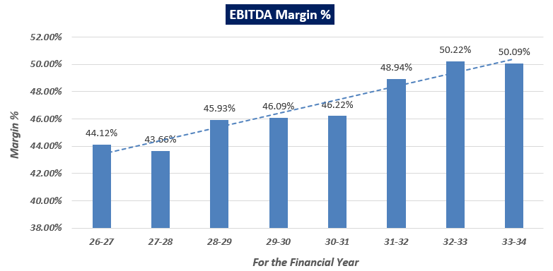
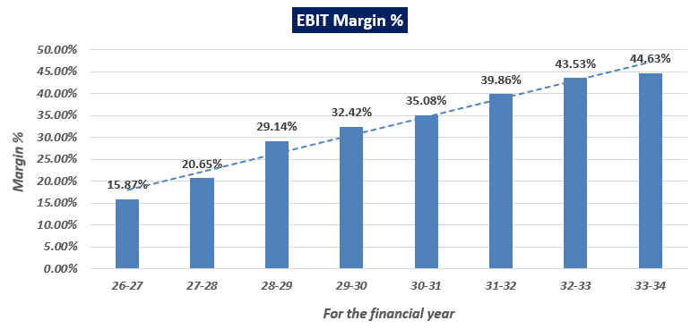
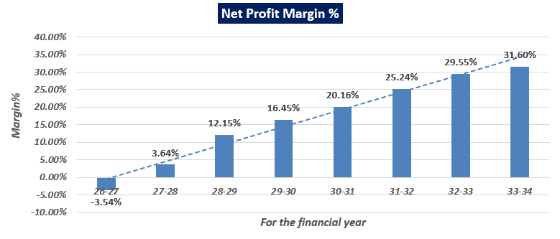
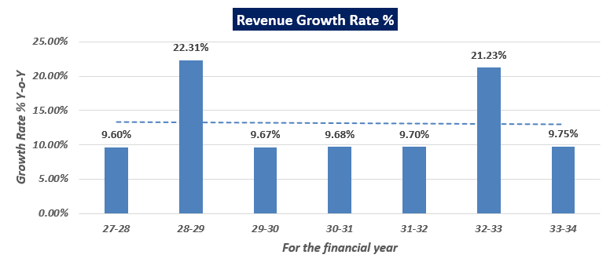
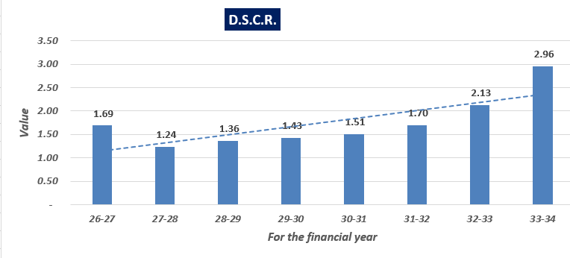

- LOAN AMORTIZATION SCHEDULE: As per Loan disbursement and amortization schedule shared by the client/company, according to the project costs incurred during the estimated period below table shows the balance of principle and intrest during the projected period.
(INR Lakhs)
Dates | Payment Number | Repayment | Principal for Interest | Interest | Balance | Yearly Principal Repayment | Yearly Interest
Jun 2026 | 0 | ₹ 0.00 | ₹ 3,000.00 | ₹ 72.38 | ₹ 3,000.00 | ₹ 100.00 | ₹ 289.50
Sep 2026 | 0 | ₹ 0.00 | ₹ 3,000.00 | ₹ 72.38 | ₹ 3,000.00 | ₹ 100.00 | ₹ 289.50
Dec  2026 | 1 | ₹ 50.00 | ₹ 3,000.00 | ₹ 72.38 | ₹ 2,950.00 | ₹ 100.00 | ₹ 289.50
Mar  2027 | 2 | ₹ 50.00 | ₹ 2,950.00 | ₹ 72.38 | ₹ 2,900.00 | ₹ 100.00 | ₹ 289.50
Jun  2027 | 3 | ₹ 75.00 | ₹ 2,900.00 | ₹ 71.17 | ₹ 2,825.00 | ₹ 300.00 | ₹ 275.63
Sep  2027 | 4 | ₹ 75.00 | ₹ 2,825.00 | ₹ 69.96 | ₹ 2,750.00 | ₹ 300.00 | ₹ 275.63
Dec  2027 | 5 | ₹ 75.00 | ₹ 2,750.00 | ₹ 68.15 | ₹ 2,675.00 | ₹ 300.00 | ₹ 275.63
Mar  2028 | 6 | ₹ 75.00 | ₹ 2,675.00 | ₹ 66.34 | ₹ 2,600.00 | ₹ 300.00 | ₹ 275.63
Jun  2028 | 7 | ₹ 90.00 | ₹ 2,600.00 | ₹ 64.53 | ₹ 2,510.00 | ₹ 360.00 | ₹ 246.20
Sep  2028 | 8 | ₹ 90.00 | ₹ 2,510.00 | ₹ 62.73 | ₹ 2,420.00 | ₹ 360.00 | ₹ 246.20
Dec  2028 | 9 | ₹ 90.00 | ₹ 2,420.00 | ₹ 60.55 | ₹ 2,330.00 | ₹ 360.00 | ₹ 246.20
Mar  2029 | 10 | ₹ 90.00 | ₹ 2,330.00 | ₹ 58.38 | ₹ 2,240.00 | ₹ 360.00 | ₹ 246.20
Jun  2029 | 11 | ₹ 100.00 | ₹ 2,240.00 | ₹ 56.21 | ₹ 2,140.00 | ₹ 400.00 | ₹ 211.09
Sep  2029 | 12 | ₹ 100.00 | ₹ 2,140.00 | ₹ 54.04 | ₹ 2,040.00 | ₹ 400.00 | ₹ 211.09
Dec  2029 | 13 | ₹ 100.00 | ₹ 2,040.00 | ₹ 51.63 | ₹ 1,940.00 | ₹ 400.00 | ₹ 211.09
Mar  2030 | 14 | ₹ 100.00 | ₹ 1,940.00 | ₹ 49.22 | ₹ 1,840.00 | ₹ 400.00 | ₹ 211.09
Jun  2030 | 15 | ₹ 110.00 | ₹ 1,840.00 | ₹ 46.80 | ₹ 1,730.00 | ₹ 440.00 | ₹ 172.01
Sep  2030 | 16 | ₹ 110.00 | ₹ 1,730.00 | ₹ 44.39 | ₹ 1,620.00 | ₹ 440.00 | ₹ 172.01
Dec  2030 | 17 | ₹ 110.00 | ₹ 1,620.00 | ₹ 41.74 | ₹ 1,510.00 | ₹ 440.00 | ₹ 172.01
Mar  2031 | 18 | ₹ 110.00 | ₹ 1,510.00 | ₹ 39.08 | ₹ 1,400.00 | ₹ 440.00 | ₹ 172.01
Jun  2031 | 19 | ₹ 120.00 | ₹ 1,400.00 | ₹ 36.43 | ₹ 1,280.00 | ₹ 480.00 | ₹ 129.07
Sep  2031 | 20 | ₹ 120.00 | ₹ 1,280.00 | ₹ 33.78 | ₹ 1,160.00 | ₹ 480.00 | ₹ 129.07
Dec  2031 | 21 | ₹ 120.00 | ₹ 1,160.00 | ₹ 30.88 | ₹ 1,040.00 | ₹ 480.00 | ₹ 129.07
Mar  2032 | 22 | ₹ 120.00 | ₹ 1,040.00 | ₹ 27.99 | ₹ 920.00 | ₹ 480.00 | ₹ 129.07
Jun  2032 | 23 | ₹ 125.00 | ₹ 920.00 | ₹ 25.09 | ₹ 795.00 | ₹ 500.00 | ₹ 82.63
Sep  2032 | 24 | ₹ 125.00 | ₹ 795.00 | ₹ 22.20 | ₹ 670.00 | ₹ 500.00 | ₹ 82.63
Dec  2032 | 25 | ₹ 125.00 | ₹ 670.00 | ₹ 19.18 | ₹ 545.00 | ₹ 500.00 | ₹ 82.63
Mar  2033 | 26 | ₹ 125.00 | ₹ 545.00 | ₹ 16.16 | ₹ 420.00 | ₹ 500.00 | ₹ 82.63
Jun  2033 | 27 | ₹ 140.00 | ₹ 420.00 | ₹ 13.15 | ₹ 280.00 | ₹ 420.00 | ₹ 30.04
Sep  2033 | 28 | ₹ 140.00 | ₹ 280.00 | ₹ 10.13 | ₹ 140.00 | ₹ 420.00 | ₹ 30.04
Dec  2033 | 29 | ₹ 140.00 | ₹ 140.00 | ₹ 6.76 | ₹ 0.00 | ₹ 420.00 | ₹ 30.04

- DEPRECIATION SCHEDULE: Depreciation schedule is prepared based on the Income Tax Act. Below table shows the Depreciation Schedule along with applicable rate and allocated expenses:

Year | Particular | Land | Building @ 10 % | Plant & Machinery and equipment @ 15 % | Furniture & Fixtures @ 10 % | Total
Construction  Period | Addition | 44.63 | 3220.00 | 430.00 | 350.00 | 4044.63
Construction  Period | Total | 44.63 | 3220.00 | 430.00 | 350.00 | 4044.63
26 - 27  (12 Months) | Op. Balance | 44.63 | 3220.00 | 430.00 | 350.00 | 4044.63
26 - 27  (12 Months) | Addition | 0.00 | 0.00 | 0.00 | 0.00 | 0.00
26 - 27  (12 Months) | Depreciation | 0.00 | 322.00 | 64.50 | 35.00 | 421.50
26 - 27  (12 Months) | Balance | 44.63 | 2898.00 | 365.50 | 315.00 | 3623.13
27-28 | Op. Balance | 44.63 | 2898.00 | 365.50 | 315.00 | 3623.13
27-28 | Addition | 0.00 | 0.00 | 0.00 | 0.00 | 0.00
27-28 | Depreciation | 0.00 | 289.80 | 54.83 | 31.50 | 376.13
27-28 | Balance | 44.63 | 2608.20 | 310.68 | 283.50 | 3247.01
28-29 | Op. Balance | 44.63 | 2608.20 | 310.68 | 283.50 | 3247.01
28-29 | Addition | 0.00 | 0.00 | 0.00 | 0.00 | 0.00
28-29 | Depreciation | 0.00 | 260.82 | 46.60 | 28.35 | 335.77
28-29 | Balance | 44.63 | 2347.38 | 264.07 | 255.15 | 2911.23
29-30 | Op. Balance | 44.63 | 2347.38 | 264.07 | 255.15 | 2911.23
29-30 | Addition | 0.00 | 0.00 | 0.00 | 0.00 | 0.00
29-30 | Depreciation | 0.00 | 234.74 | 39.61 | 25.52 | 299.86
29-30 | Balance | 44.63 | 2112.64 | 224.46 | 229.64 | 2611.37
30-31 | WDV | 44.63 | 2112.64 | 224.46 | 229.64 | 2611.37
30-31 | Addition | 0.00 | 0.00 | 0.00 | 0.00 | 0.00
30-31 | Depreciation | 0.00 | 211.26 | 33.67 | 22.96 | 267.90
30-31 | Balance | 44.63 | 1901.38 | 190.79 | 206.67 | 2343.47
31-32 | WDV | 44.63 | 1901.38 | 190.79 | 206.67 | 2343.47
31-32 | Addition | 0.00 | 0.00 | 0.00 | 0.00 | 0.00
31-32 | Depreciation | 0.00 | 190.14 | 28.62 | 20.67 | 239.42
31-32 | Balance | 44.63 | 1711.24 | 162.17 | 186.00 | 2104.05
32-33 | WDV | 44.63 | 1711.24 | 162.17 | 186.00 | 2104.05
32-33 | Addition | 0.00 | 0.00 | 0.00 | 0.00 | 0.00
32-33 | Depreciation | 0.00 | 171.12 | 24.33 | 18.60 | 214.05
32-33 | Balance | 44.63 | 1540.12 | 137.85 | 167.40 | 1890.00
33-34 | WDV | 44.63 | 1540.12 | 137.85 | 167.40 | 1890.00
33-34 | Addition | 0.00 | 0.00 | 0.00 | 0.00 | 0.00
33-34 | Depreciation | 0.00 | 154.01 | 20.68 | 16.74 | 191.43
33-34 | Balance | 44.63 | 1386.10 | 117.17 | 150.66 | 1698.57

- KEY ASSUMPTIONS & BASIS:
S. No. | Item | Assumptions and Basis
 | General | - The projections of the firm are done for the period from FY 2026-27 to FY 2033-34 and door to door tenor is from January 2024 to December 2033 (10 years) to cover the term loan period.  - We have considered Revenue and cost recognition-based model while making the future financial projections.
 | Occupancy Rate | - Key factors that affect hotel occupancy rate are location, seasonality, pricing, competitor, guest reviews etc. Apart from above It's important to note that occupancy rates can also fluctuate based on the factors, like overall state of the global economy, political stability, natural disasters, and other unforeseen circumstances like covid-19.  - At the time of survey, we have checked occupancy rate from nearby hotels.  - Based on our industry research and analysis, as well as the information provided by the client/company, we have formulated revenue forecasts for the proposed 100-room luxury hotel. We have considered an initial occupancy rate of 40% for the first and second years. Subsequently, we have projected a 5% increase in occupancy rate, resulting in a rate of 45% for the following four years. In the last two years, we anticipate another 5% escalation, bringing the occupancy rate to 50%.  - The peak tourist season spans from October to March, and local tourists visiting prefer weekends for their visits. Therefore, keeping in mind, the peak seasons and slack seasons, we have considered occupancy rate constant at 50%.  - Also, the proposed luxury hotel is located in the outskirts of Udaipur city, hence, we have taken a conservative approach by setting a maximum occupancy rate of 50%. This cautious estimate accounts for the hotel's location and ensures a realistic projection.
  S.No. | Particulars | Occupancy rate
  1. | Renest Kumbhalgarh Resort (34 Rooms) | 50% to 65%
  2. | Fateh Safari Resort (35 Rooms) | 50% to 60%
  3. | Mahua Bagh Resort (72 rooms) | 45% to 60%
 | Room Rent | - At the time of survey, we have checked per room rent from the nearby hotels. Below are some observations:  - The hotel is situated on the outskirts of Udaipur city, and as it is a greenfield project, we have taken a conservative approach to the room rates. For the first year, we have considered a per-night room rent of INR 5,500/-. From there, for the subsequent forecasted financial years, we have projected a 10% escalation rate annually. This leads to a final projected room rate of INR 10,718/- in the last year of the forecast.
  S.No. | Particulars | Per Night Room Rent
  1. | Renest Kumbhalgarh Resort | Rs. 8000/- to Rs. 25000/-
  2. | Fateh Safari Resort | Rs. 5500/- to Rs. 9000/-
  3. | Mahua Bagh Resort | Rs. 9,809/- to 13,799/-
 | Food & Beverage sale per person per day | - The average Food & Beverage (F&B) sale per person per day in a luxury hotel can be depending on the location, hotel reputation, dining options, and the preferences and spending habits of guests. It's important to note that there can be significant variations in F&B sales between different hotels and regions.  - The proposed luxury hotel is located 6 km away from Kumbhalgarh Fort, a popular tourist destination that attracts approximately 3.5 lakh visitors annually. Due to the significant number of tourists visiting Kumbhalgarh, there are several hotels available for accommodation. Additionally, the hotel's location is in the outskirts of Udaipur city.  - On digital booking platforms, hotels and resorts often offer packages and discounts to attract customers. Some guests may choose not to dine at a luxury hotel due to the higher prices associated with such establishments.  - Taking into account all these factors and considering the competitive nature of the location, we have determined a rate of INR 1,500/- per person per day for the proposed hotel.
 | Bar Sale per person per day | - The average bar sale per person per day can vary significantly depending on factors, including the type of establishment, location, clientele, pricing, and the popularity of the bar. It's important to note that the actual figures can vary widely and are influenced by local market conditions and consumer preferences.  - Hence, based on our independent research and information provided by company, we have considered INR 450/- per persons per day.
 | Revenue Build up | - Total revenue for the financial years during the forecasted period will be generating from Room sale, food sale and bar sale, banquet receipt, open garden event and miscellaneous. Below are the basic assumptions to calculate revenue:  - Here, miscellaneous income includes income from rentals or leases, resort fees and taxi rentals tie-up, commission fees, cancellation fees etc.  - After FY2026-27, for the rest of the projected financials we have incorporated an escalation rate of 10% for projecting revenue from room sales, food sales, and bar sales. Additionally, for revenue generated from banquets, open garden events, and miscellaneous sources, we have considered an escalation rate of 5%. This decision takes into account the growing trend of tourism in India and the potential increase in demand for such services.
  Revenue Projections for FY 2026-27
  No. of Rooms | 100
  No. of days hotel is in operation | 365
  Particular | Amount
  Estimated Revenue
  At a capacity utilisation of | 40%
  Average Room Rent [Net]
  Room Rent | 5,500.00
  Max. Room Nights [ No. of Rooms * 365] | 36500
  Max. No. of Guests [Room nights * 2] | 73000
  Food & Beverage sale per person per day | 1,500.00
  Bar Sale per person per day | 450.00
  Income
  Room Sale | 803.00
  Food Sale | 438.00
  Bar Sale | 131.40
  Conference receipts/Banquet [ 10 events x 750 pax @ Rs. 1100/- per pax] | 82.50
  Revenue from Open Garden Events | 30.00
  Misc. Income [Net] | 7.00
  TOTAL | INR 1491.90 Lakhs
 | Housekeeping Expenses | - When forecasting housekeeping expenses as a percentage of room sales, it is crucial to consider various factors such as industry benchmarks, occupancy rate, property size and layout, room quantity and type, guest service expectations, and specific amenities or offerings that may impact housekeeping needs.  - Based on the analysis conducted and the information provided by the client/company, we have determined that housekeeping expenses should be set at 8% of room sales, which seems to be reasonable.
 | Food Expenses | - When forecasting food expenses as a percentage of food and bar sales, we take into account industry benchmarks. Typically, food expenses as a percentage of food and bar sales in hotels fall within a range of 40% to 65%.  - However, it's important to recognize that this range is broad, and percentages outside this range can occur due to various factors. These factors include the hotel's location, the hotel's menu offerings, pricing strategy, changes in customer preferences, market trends, inflation, and other factors that may influence food expenses.  - Considering a comprehensive analysis of all these factors, we have determined that food expenses should be set at 55% of the food and bar sales. This percentage reflects a careful consideration of industry benchmarks and the specific circumstances of the hotel.
 | Sales and Marketing Expenses | - We've examined the proportion of Sales and Marketing expenses relative to total sales, recognizing that this ratio may differ among various in the hospitality industry. The specific percentage is contingent on factors such as category of hotel, marketing approach, market competitiveness, nature of amenities/services, and the stability of the business.  - Consequently, having scrutinized all relevant factors for the envisioned hotel, we have determined that allocating 2% of the total sales to sales and marketing expenses aligns with industry standards.
 | Banquet Expenses | - We've assessed banquet expenses relative to banquet receipts, and for the proposed hotel, we have considered it as 30% of the banquet receipt, consistent with industry norms, which varies between 25% to 35% for the luxury segment hotels.
 | Salary & Wages | - As per data information provided by client/company, below table shows the details of number of employees and their salary:  - As per our tertiary research, industry benchmark varies from 15% to 20% of the total revenue for the hotels in India. It depends on various factors such as location, category of the hotel, demand-supply gap/work force availability (skilled, unskilled) etc. Proposed hotel in located in outskirts of Udaipur city, Rajasthan. Workforce availability is better, due to which manpower available at lower cost. Therefore, in the forecasted financials salary and wages varies from 9% to 11% of the total revenue.  - As per sensitivity analysis, if variable cost increase by 5%, even then Average DSCR of the project would be greater than 1 throughout the projected period.
  Designation | No. of Persons | Salary p.m. | Amount
  General Manager | 1 | 75,000.00 | 75,000.00
  Assistant Manager | 1 | 35,000.00 | 35,000.00
  Accountant | 1 | 35,000.00 | 35,000.00
  Accounts / Stores Assistant | 2 | 20,000.00 | 40,000.00
  Security Guards | 5 | 12,000.00 | 60,000.00
  Plumber / electrician / carpenter | 3 | 12,000.00 | 36,000.00
  Gardner | 3 | 10,000.00 | 30,000.00
  Sweepers | 4 | 8,000.00 | 32,000.00
  Front Office Manager | 1 | 40,000.00 | 40,000.00
  Front Office Assistant | 2 | 20,000.00 | 40,000.00
  Shift In-charge | 2 | 40,000.00 | 80,000.00
  Housekeeping In Charge | 1 | 50,000.00 | 50,000.00
  Housekeeping Supervisors | 4 | 25,000.00 | 1,00,000.00
  Bell Boys | 6 | 12,000.00 | 72,000.00
  Room Boys | 15 | 10,000.00 | 1,50,000.00
  Food & Beverage Manager | 1 | 50,000.00 | 50,000.00
  Chef | 1 | 75,000.00 | 75,000.00
  Assistant Chef | 4 | 40,000.00 | 1,60,000.00
  Kitchen Staff | 7 | 10,000.00 | 70,000.00
  Restaurant / Banquets Staff | 15 | 12,000.00 | 1,80,000.00
  Total Salary Paid | 79 |  | 14,10,000.00
 | Other Operating and admin. expenses | - This category encompasses expenses related to repair and maintenance, power and fuel, postage & telegraph, legal & professional services, insurance premiums, traveling & conveyance, printing, stationary, and miscellaneous costs. The assumption details for the initial projected year (FY 2026-27) are provided below:  To estimate the aforementioned expenses for the subsequent forecasted years, a 10% escalation has been applied, aligning with industry standards.
  Particulars | Amount (In Lakhs)
  Repairs & Maintenance | 12.00
  Power & Fuel | 48.00
  Postage & Telegraph | 0.50
  Legal & Professional | 2.00
  Insurance Premium | 2.00
  Travelling & Conveyance | 1.50
  Printing & Stationery | 1.00
  Miscellaneous Expenses | 2.50
 | Quality Circle Fee payable to Hotel Management Company | - Quality Circle (QC) stands as an employee participation method, signifying the enhancement of individuals' skills, capabilities, confidence, and creativity through a continuous process involving education, training, work experience, and active participation.  - Industry standards indicate that the expense associated with Quality Circle typically falls within the range of 2%-3% of the total revenue. Consequently, we have allocated 2% of the total revenue for this expense.
 | Working Capital | - The Company has not proposed for separate working capital requirement from bank. As informed by the Company the working capital gap will be raised from Long Term equity Fund (LTF) in the form of capital, quasi equity as and when require and in later years the cash accruals will be adequate to fund the working capital requirement.  - While assessing the adequacy of working capital we have checked the current ratio of the forecasted financials which come out more than 1. It indicates that company has more current assets than current liabilities, suggesting a potentially healthy working capital position.  - Managing working capital effectively involves maintaining a balance between liquidity, profitability and inventory. Therefore, once the proposed hotel will be operational, they need to ensure that they have enough cash and equivalent to cover short-term obligations without holding excessive levels of idle capital.  - Thus, during the projected period we have not considered any working capital loan.
 | Term Loan | - According to the information supplied by the client/company, the proposed hotel intends to seek a term loan amounting to INR 3,000 Lakhs for the construction of the hotel infrastructure. The following are the benchmark dates for all the loan-related activities.  - The interest rate, determined to be 9.65% based on the latest information from the client/company, will apply for the entire duration of the term loan.
  Activity | Bench Mark Dates
  Financial Closure [Loan sanction by Bank] | January 2024
  First Disbursement | March 2024
  Date of Commencement of Commercial Operations | 1st April 2026
  Implementation Period | Two year & 03 months (From January 2024 to March 2026)
  Moratorium including Implementation | Two year & 09 months (From January 2024 to September 2026)
  Repayment of loan to start in Quater Ending | October – December 2026
  Last instalment to be paid in Quater Ending | October – December 2033
  Door to Door Tenor from January 2024 to December 2033 | 120 Months

Conclusion:
      - DSCR, EBITDA, EBIT and Net Profit margin are positive in all the projected years. The company has achieved DSCR of more than 1 during the loan repayment period.
      - Average DSCR, EBIDTA margin, EBIT margin, Net Profit margin and Revenue Growth rate are 1.79, 46.91%, 32.65%, 16.91% and 13.13% respectively during the estimated period.
      - As per the information shared by the client and as per the projections, the project is generating enough cash surplus that the contingencies would be met through the surplus, if needed.
      - Based on the above key financial ratios of the Project during the forecast period for the proposed project shows that the project looks financially and economically viable if the Project Company & promoters are able to maintain sales phasing, revenue and also able to contain cost as assumed above. However, the above-mentioned projections are calculated on the basis of the plan shared by the client/company. If the company differs from the approved plan during the implementation, the projections may differ resulting to altered concluded viability.

PART L | CONCLUSION

Based on the economic and market analysis done above, various Industry assumptions taken, pricing to be adopted by the company, the proposed hotel project appears to be technically feasible and economically viable subject to the risks, threats, weaknesses, limitations of the services and equipment as detailed previously. Due to prime location and future tie-ups with big brands it will be beneficial for all current and future stakeholders. This can also be used as one of the key attributes while promoting the project.
In India, higher average room rates (ARR) and hotel room occupancy lifts profitability of the domestic hotel industry, with EBITDA margins around 34% this fiscal against the 24% growth seen in FY20, the pre-pandemic year. Currently there are hotels that make more than 50% EBITDA, if they are luxurious and located in developing countries where the expenses for labour are low and the room rates are high like India, Thailand, Philippines, Vietnam, Indonesia, China etc.
As per financial projections for the estimated period, Average DSCR, EBITDA Margin of the project are 1.79%, and 46.91% respectively, where higher DSCR is the indicator of the project capability to pay out its outstanding debt and EBITDA margin shows the capability of the project to generate the operating profits over the forecasted period, which are in line with the industry. The proposed hotel is having a positive IRR as 10.15%. While it is not avoidable that the future projections may change in the upcoming years due to various factors impacting the operation, managerial, financial efficiency and economies of scale of the project.
It would be depending on the management’s capability in future that how efficiently company adopts marketing and advertisement strategy, hotel's unique features and offerings specialized spa and wellness facilities, Michelin-starred restaurants, exclusive access to events or experiences, or partnerships with luxury brands, to achieve higher profitability. Emphasizing these unique selling points helps differentiate the hotel from competitors and attracts discerning travellers seeking exceptional experiences.
It's important to note that marketing strategies may vary much depending on the specific market, location, and target audience. Hence, it is very essential for the proposed luxury segment hotel to conduct market research, analyse consumer behaviour, and adapt their marketing strategies accordingly to stay competitive and meet the evolving demands of luxury travellers, which remains major concerns for the hotel management. Bank/ Financial Institution is advised to take firm plan from the company in this regard before taking any decision.
After considering the high demand of luxury travels and financial analysis of the project based on the assumptions taken over the projected period, it appears reasonable to comment that the proposed project is “Technically, Economically and Commercially” viable subject to current assumptions considered and occurring the same in the upcoming years same as the forecasted period which is dependent on the sincerity and efforts of the management and various micro and macroeconomic & industry situation.
We have tried our level best to analyse the economic feasibility of the Project based on the industry research, Project information and various futuristic assumption taken. However, achieving the financial milestones depends on the ability, sincerity and efforts of the company, promoters and its key managerial performance.
Declaration | - The undersigned does not have any direct/indirect interest in the above property.  - The information furnished herein is true and correct to the best of our knowledge, logical and scientific assumptions.  - This TEV Report is carried out by our Financial Analyst team on the request from Punjab National Bank, Mid Corporate Center, 4-5 Kalpatru Apartment, Opposite Old Income Tax Office, New Fatehpura, Udaipur - 313001.  - Meeting of Financial projections will be subject to subject to the market & economy stability factors, judicious business operations and proper & timely implementation of its process & product re-engineering & improvements plan for achieving high productivity, efficiency and achieving cost saving benefits.  - We have submitted TEV report to the Client.
Name & Address of consultant company |  |  | Signature of the authorized person
M/s. R.K. Associates Valuer & Techno Engineering Consultants Pvt. Ltd.
D-39, 2nd Floor, Sector-2, Noida- 201301
Enclosed Documents |  | Disclaimer & Remarks 69-72
Number of Pages in the Report |  | 72
Financial Analyst Team worked on the report |  | PREPARED BY: Mrs. Chhavi Toshan
 |  | REVIEWED BY: Mr. Gaurav Kumar

For R.K Associates Valuer & Techno Place: Noida

Engineering Consultants (P) Ltd. Date: 27/01/2024

(Authorized Signatory)

PART M | DISCLAIMER | REMARKS

      - No employee or member of R.K Associates has any direct/ indirect interest in the Project.
      - This report is prepared based on the copies of the documents/ information which the Bank/ Company has provided to us out of the standard checklist of documents sought from them and further based on our assumptions and limiting conditions. The client/owner and its management/representatives warranted to us that the information they supplied was complete, accurate and true and correct to the best of their knowledge. All such information provided to us has been relied upon in good faith and we have assumed that it is true and correct in all respect. I/We shall not be liable for any loss, damages, cost or expenses arising from fraudulent acts, misrepresentations, or wilful default on part of the owner, company, its directors, employee, representative or agents. Verification or cross checking of the documents provided to us from the originals or from any Govt. departments/ Record of Registrar has not been done at our end since this is beyond the scope of our work. If at any time in future, it is found or came to our knowledge that misrepresentation of facts or incomplete or distorted information has been provided to us then this report shall automatically become null & void.
      - Legal aspects for e.g. investigation of title, ownership rights, lien, charge, mortgage, lease, sanctioned maps, verification of documents, etc. have not been done at our end and same has to be taken care by legal expert/ Advocate. It is assumed that the concerned Lender/ Financial Institution has satisfied them with the authenticity of the documents, information given to us and for which the legal verification has been already taken and cleared by the competent Advocate before requesting for this report. I/ We assume no responsibility for the legal matters including, but not limited to, legal or title concerns.
      - This report is TEV study of the project based on the scope mentioned in the report. This is not an Audit report, Design document. All the information gathered is based on the facts seen on the site during survey, verbal discussion & documentary evidence provided by the client and is believed that information given by the company is true best of their knowledge.
      - This Techno Economic-Viability study is prepared based on certain futuristic assumption which are intra dependent on economic, market and sectorial growth condition in future and socio-economic, socio-political condition at macro and micro level.
      - Meeting of assumption and financial ratio will entirely depend on the sincerity and efforts of the company, promoters and its key managerial performance.
      - All observations mentioned in the report is only based on the visual observation and the documents/ data/ information provided by the client. No mechanical/ technical tests, measurements or any design review have been performed or carried out from our side during Project assessment.
      - Bank/FII should ONLY take this report as an Advisory document from the Financial/ Chartered Engineering firm and its specifically advised to the creditor to cross verifies the original documents for the facts mentioned in the report which can be availed from the borrowing company directly.
      - In case of any default in loans or the credit facility extended to the borrowing company, R.K Associates shall not be held responsible for whatsoever reason may be and any request for seeking any explanation from the employee/s of R.K Associates will not be entertained at any instance or situation.
      - The documents, information, data provided to us during the course of this assessment by the client are reviewed only up to the extent required in relation to the scope of the work. No document has been reviewed beyond the scope of the work.
      - This report only contains general assessment & opinion as per the scope of work evaluated as per the information given in the copy of documents, information, data provided to us and/ and confirmed by the owner/ owner representative to us at site which has been relied upon in good faith. It doesn’t contain any other recommendations of any sort including but not limited to express of any opinion on the suitability or otherwise of entering into any transaction with the borrower.
      - We have relied on data from third party, external sources & information available on public domain also to conclude this report. These sources are believed to be reliable and therefore, we assume no liability for the truth or accuracy of any data, opinions or estimates furnished by others that have been used in this analysis. Where we have relied on data, opinions or estimates from external sources, reasonable care has been taken to ensure that such data has been correctly extracted from those sources and /or reproduced in its proper form and context, however still we can’t vouch its authenticity, correctness or accuracy.
      - This Report is prepared by our competent technical team which includes Engineers and financial experts & analysts.
      - This is just an opinion report and doesn’t hold any binding on anyone. It is requested from the concerned Financial Institution which is using this report for taking financial decision on the project that they should consider all the different associated relevant & related factors also before taking any business decision based on the content of this report.
      - All Pages of the report including annexure are signed and stamped from our office. In case any paper in the report is without stamp & signature then this should not be considered a valid paper issued from this office.
      - Though adequate care has been taken while preparing this report as per its scope, but still we can’t rule out typing, human errors, over sightedness of any information or any other mistakes. Therefore, the concerned organization is advised to satisfy themselves that the report is complete & satisfactory in all respect. Intimation regarding any discrepancy shall be brought into our notice immediately. If no intimation is received within 15 (Fifteen) days in writing from the date of issuance of the report, to rectify these timely, then it shall be considered that the report is complete in all respect and has been accepted by the client up to their satisfaction & use and further to which R.K Associates shall not be held responsible in any manner.
      - Defect Liability Period is 15 DAYS. We request the concerned authorized reader of this report to check the contents, data and calculations in the report within this period and intimate us in writing if any corrections are required or in case of any other concern with the contents or opinion mentioned in the report. Corrections only related to typographical, calculation, spelling mistakes, incorrect data/ figures/ statement will be entertained within the defect liability period. Any new changes for any additional information in already approved report will be regarded as additional work for which additional fees may be charged. No request for any illegitimate change in regard to any facts & figures will be entertained.
      - R.K Associates encourages its customers to give feedback or inform concerns over its services through proper channel at valuers@rkassociates.org in writing within 15 days of report delivery. After this period no concern/ complaint/ proceedings in connection with the Techno- Economic Viability Study Services will be entertained due to possible change in situation and condition of the subject Project.
      - Our Data retention policy is of THREE YEARS, as per regulatory norms. After this period, we remove all the concerned records related to the assignment from our repository. No clarification or query can be answered after this period due to unavailability of the data.
      - This Techno Economic Viability Study report is governed by our (1) Internal Policies, Processes & Standard Operating Procedures, (2) Information/ Data/ Inputs given to us by the client and (3) Information/ Data/ Facts given to us by our field/ office technical team. Management of R.K Associates never gives acceptance to any unethical or unprofessional practice which may affect fair, correct & impartial assessment and which is against any prevailing law. In case of any indication of any negligence, default, incorrect, misleading, misrepresentation or distortion of facts in the report then it is the responsibility of the user of this report to immediately or at least within the defect liability period bring all such act into notice of R.K Associates management so that corrective measures can be taken instantly.
      - R.K Associates never releases any report doing alterations or modifications from pen. In case any information/ figure of this report is found altered with pen then this report will automatically become null & void.
      - If this report is prepared for the matter under litigation in any Indian court, no official or employee of R.K Associates will be under any obligation to give in person appearance in the court as a testimony. For any explanation or clarification, only written reply can be submitted on payment of charges by the plaintiff or respondent which will be 10% of the original fees charged where minimum charges will be Rs. 15,000/.

