File No.: VIS (2023-24)–PL-643-546-863 Dated: 18th April 2024

2nd PROJECT LIE REPORT
(FOR QUARTER ENDING Dec 2023)

OF

1.5 MMTPA GRINDING UNIT (GU)

SITUATED AT

VILLAGE- MADHAVGARH, TEHSIL- GHATIYA, DISTRICT- UJJAIN,
MADHYA PRADESH-456003

IMPLEMENTED BY
JK CEMENT LIMITED



REPORT PREPARED FOR
INDIAN BANK LCB BRANCH, SANSAD MARG, NEW DELHI

**Important - In case of any query/ issue or escalation you may please contact Incident Manager at le@rkassociates.org. We will appreciate your feedback in order to improve our services.
NOTE: As per IBA Guidelines please provide your feedback on the report within 15 days of its submission after which report will be considered to be correct.

TABLE OF CONTENTS
SR. NO. | DESCRIPTION | PAGE NO.
PART A | Report Summary | 03
PART B | Introduction | 05
PART B | - The Project | 05
PART B | - Location of the Project | 05
PART B | - Project Overview | 06
PART B | - Scope of the Project During Project Duration | 07
PART B | - Purpose of the Report | 07
PART B | - Methodology Adopted | 07
PART C | Plant Infrastructure Sections & Facility Details with Actual Progress | 09
PART C | - Land Details | 09
PART C | - Building and Structure Details | 10
PART C | - Plant Machinery and Equipment | 13
PART D | Project Consultants, Contractors & Suppliers | 20
PART D | - List of Contractors and Agreements | 20
PART E | Project Cost and Means of Finance | 21
PART E | - Cost of Project | 21
PART E | - Current Status and Total Expenditure Incurred Till Date | 22
PART E | - Sources of Finance & Utilization of Funds | 22
PART F | Statutory & Regulatory Approvals, Clearances & NOC | 23
PART G | Project Schedule & Current Status | 24
PART H | Conclusion | 25
PART I | Disclaimer | 26
PART J | Enclosure | 30
PART K | Photographs | 38-44

IMPORTANT NOTICE

COPYRIGHT FORMAT: This report is prepared on the copyright format of R.K Associates, to serve our clients with the best available information and analysis to facilitate them to take rational business decisions. Legally no one can copy or distribute this format without prior approval from R.K Associates. It is meant only for the advisory/ reference purpose for the organization/s as mentioned on the cover page of this report. Distribution or use of this format by any organization or individual other than R.K Associates will be seen as unlawful act and necessary legal action can be taken against the defaulters.

This report is intended for the sole use of the intended recipient/s and contain material that is STRICTLY CONFIDENTIAL AND PRIVATE.

DEFECT LIABILITY PERIOD: - In case of any query/ issue or escalation you may please contact Incident Manager: le@rkassociates.org. We try our level best to ensure correctness in the calculations done, rates adopted and various other data points & information mentioned in the report but still can’t rule out typing, human errors or any other mistakes. In case you find any such mistake or inaccuracy in any data point of the report please help us by bringing all such points into our notice immediately or within 15 days of the report delivery in writing, to rectify these timely failing after which R.K Associates won’t be held responsible for any such inaccuracy in any manner. We would highly appreciate your feedback in order to improve our services.

PART A | REPORT SUMMARY

1. | Name of Project: | JK Cement Limited, herein referred as “JKCL” has set up a 1.50 MMTPA clinker grinding unit (GU) in Ujjain district in the State of Madhya Pradesh.
2. | Project Location: | - Village: Madhavgarh  - District: Ujjain  - State: Madhya Pradesh  - Co-ordinates: 23°15'31.4"N 75°43'28.9"E  - Altitude: ~500 m with respect to AMSL
3. | Name of the Borrower: | M/s. JK Cement Ltd. (JKCL).
4. | Key management: | - Sh. Raghavpat Singhania : Managing Director  - Sh. Madhavkrishna Singhania : CEO
5. | Prepared for Bank: | Indian Bank LCB Branch, Sansad Marg, New Delhi
6. | LIE Consultant Firm: | M/s. R.K. Associates Valuers & Techno Engineering Consultants (P) Ltd.
7. | Date of Survey: | 09th April 2024
8. | Date of Report: | 18th April 2024
9. | Purpose of the Report: | To provide fair detailed analysis report to the Bank based on the “in-scope points” mentioned below to know the current status of the Project.
10. | Scope of the work provided by the Lender: | - Review Project details & facilities  - Project Progress vis-a-vis construction schedule  - Review of Project towards Licenses, NOCs, Approvals
11. | Documents provided for the Project (out of documents requested): | - Techno economic feasibility report  - Project Statutory approvals  - CA certificate  - Cement Dispatch Report  - Invoices of cement dispatched.
12. | Annexure with the report: | - Project Statutory approvals  - CA Certificate  - Last 3 months electricity Bills  - List of invoices of cement dispatched  - First 3 pages of dispatch report

PART B | INTRODUCTION

- THE PROJECT:
JK Cement Limited (JKCL) has established a Clinker Grinding Unit (GU) with a capacity of 1.50 million tonnes per annum (MTPA) in district Ujjain, Madhya Pradesh using Vertical Rolling Mill. To know the Project progress bank has appointed M/s R.K Associates Valuers & Techno Engineering Consultants (P) Ltd. to review the Quarterly physical status of the project. This is 2nd LIE Report for Quarter ending Dec.’23 in continuation to previous inception LIE Report submitted on 16/10/2023. This report primarily captures physical status of the Project as per the survey conducted on 09th April 2024.

- PROJECT LOCATION:
Particulars | Description
Address
Village: Madhavgarh, Ujjain, Madhya Pradesh
Google Coordinates
Latitude | 23°15'31.4"N
Longitude | 75°43'28.9"E
Connectivity Systems
Road | The project site is connected through a village road, which as per information gathered, is constructed by JK itself. The main road that leads to the plant is Ujjain-Nagda State Highway (SH17).
Rail | The nearest main line railway station is Ujjain Railway Station at a distance of approx. 16 km in South direction. The other smaller railway station is Naikheri Railway Station, at a distance of approx. 10 km
Air | The nearest domestic as well as international airport is at Indore at about 70 km distance from the plant site.

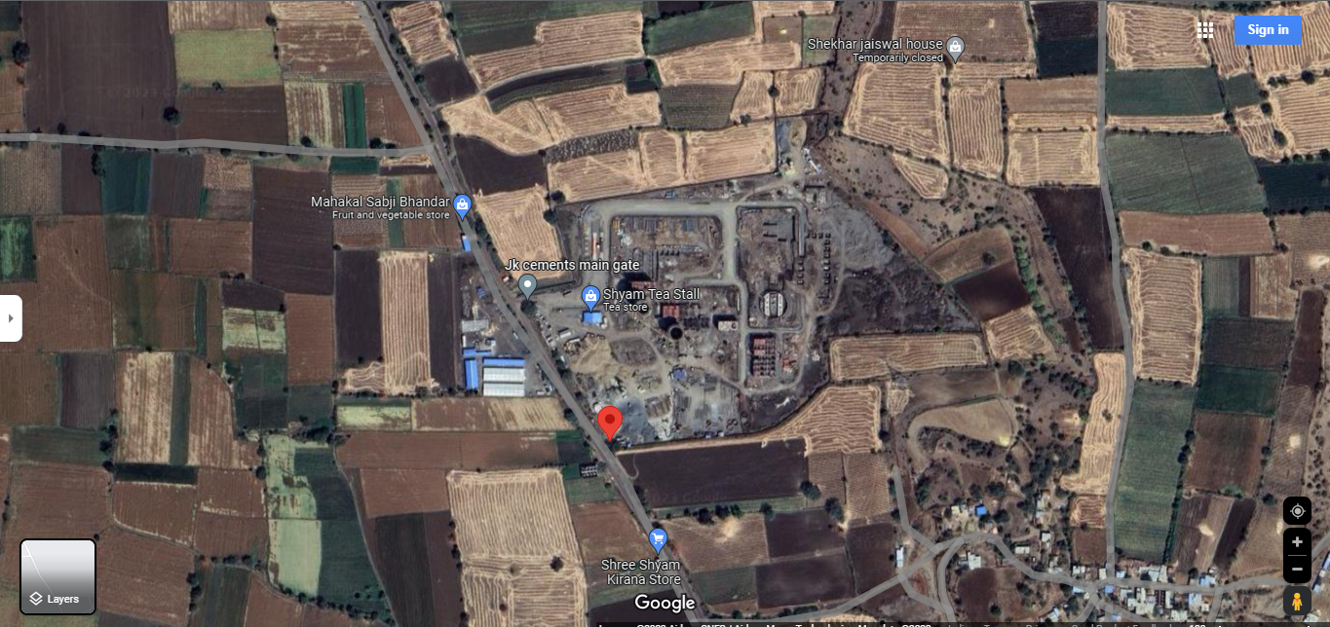
Source: Google Maps
Figure: Location of aforesaid Grinding Unit

- PROJECT OVERVIEW:
As stated in the previous report, JK Cement Limited (JKCL) is establishing a Clinker Grinding Unit (GU) with a capacity of 1.50 million tonnes per annum (MTPA) in the Ujjain district of Madhya Pradesh. The major raw material for this clinker grinding unit is to be sourced from JKCL's Mangrol, Nimbahera and Panna plants in the state of Rajasthan.

This project is on about total land area of 10.75 hectare or approx. 27 acres located at Village: Madhavgarh, Ujjain, Madhya Pradesh which is about at a distance of 16 Kms from main Ujjain city towards south.

The total project cost is approx. 418.96 Crore as per the TEFR report by M/s HOLTEC, which includes major heads such as Land and Site Development, Civil Works, Plant and Machinery, etc. Detailed description of the same can be found further in the report.

The proposed completion date for the Project and the plant was envisaged by June 2024.

However, as per our site visit on 09th March 2024, the construction work was observed to be completed and cement production has also been started. As per the information provided the representative, the plant achieved its commercial operation on 24th November 2023.

As per Environment Clearance from Ministry of Environment, Forest and Climate Change, Government of India, Integrated unit situated at Ujjain is having approval for setting up of 1.50 MTPA of clinker unit and the water requirement for the plant, will be about 184 KLD (Surface water – 164 KLD & Ground Water – 20 KLD) including domestic requirement, which is planned to be met from underground sources through submersible pump and secondary sources like rainwater harvesting etc.

Specific power consumption for the subject plant has been estimated at 31.5 kWh/ t. Company has planned two DG set of 1250 KVA and 250 KVA respectively and has also obtained electricity connection of 6480 KVA from MPPKVVCL.

Company has got Consent to Establish from M.P Pollution Control Board for mining at following capacities:

S. No. | Activity/Product | CTE Quantity | Applied Quantity
1. | OPC/PPC/PSC/Composite Cement | 15,00,000 MTPA | 15,00,000 MTPA
2. | Generation of Electricity through DG-Set | 1,250 KVA | 1,250 KVA
3. | Generation of Electricity through DG-Set | 125 KVA | 125 KVA

As per the status on the date of survey, finished cement unloading from cement silos through chutes to packing section was operational. However grinding Mills was not operational since at that point of time demand for the cement wasn’t there in the Plant.

- SCOPE OF WORK OF THIS REPORT:
- Project Periodic physical status review.

Note:
- Carrying out the scope of work will depend on the details/ information/ data provided to us by the borrower from time to time.

- PURPOSE OF THE REPORT: To provide fair detailed analysis report to the Bank based on the “in-scope points” mentioned above for facilitating them to know the current Project status.

- METHODOLOGY ADOPTED:
- Study of Project Planning documents/ reports to know about the Project.
- Additional information, data, documents collection the borrower.
- Site Inspection.
- Review and analysis of the documents and information obtained from the borrower and corroborating it with the site inspection status.
- Information compilation, analysis and reporting.

PART C | PLANT INFRASTRUCTURE & FACILITY DETAILS WITH ACTUAL PROGRESS

- LAND & SITE DEVELOPMENT: As per TEFR Prepared by HOLTEC, JKCL has acquired 10.75 hectare of the earmarked land patch. As per google measurement as shown below the Plant site bounded by a permanent boundary is also found to be more or less 10.34 hectare.

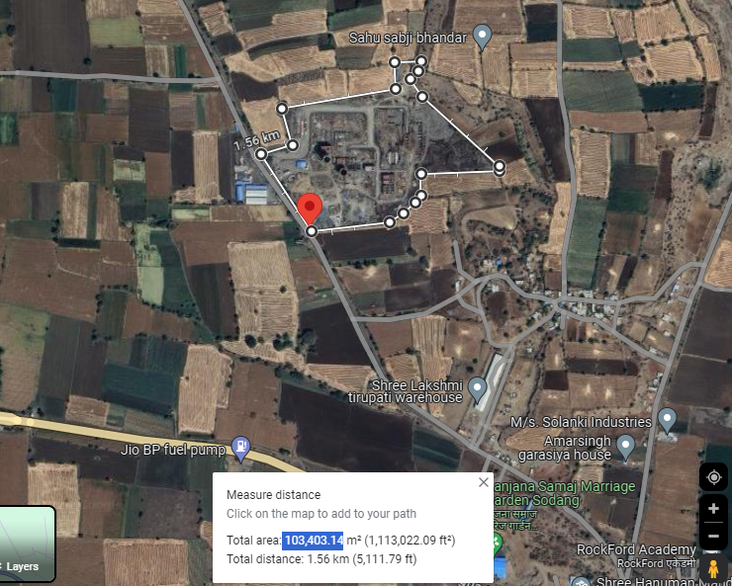

As per TEFR report, the borrower has proposed an expenditure amounting to Rs.21.00 Crore towards land and site development. Breakup of the same is tabulated below:

Sr. No. | Particular | Amount
1. | Capital Cost of procured land for setting up the plant | 600
2. | Site preparation & development | 130
3. | Site enabling investigations (Topographical, Geotechnical & Hydrological) | 80
4. | Boundary Wall | 135
5. | Gates, Security Pickets, etc. | 30
6. | Approach Road to Plant | 250
7. | Plant Internal Roads | 370
8. | Truck Parking & Logistics Office | 340
9. | Plant Drainage | 145
10. | Landscaping and Provision of Green Belt | 20
 | Total(Amount in Rs. Lakhs) | 2100
Source: TEFR prepared by HOLTEC Consultancy

Note:
- Land is bounded by a permanent boundary wall.
- As per present status based on our site inspection, the actual project land was observed to be in possession of the company since no encroachment was visible on site.
- Any ownership and legal verification is out of scope of this report.
- Title documents related to the land have not been provided to us.

- BUILDING & STRUCTURAL DETAILS:

JKCL has constructed following Building/ structures as per the requirement of the Plant for development of above listed sections, JKCL has estimated Rs.104.71 Crore in Building/ structures out of total project cost amounting to Rs.418.96 Crore. Bifurcation of Rs.104.71 Crore is as below:

Sr. No. | Particular | Amount
1. | Main Factory Buildings | 2,105
2. | Silos, Hoppers, Storages, Covered Gantry, etc. | 3,930
3. | Auxiliary Services | 1,870
4. | Office/ Non-factory buildings | 310
5. | Equip. Foundations (Machine Foundations) civil cost component | 446
6. | Indicative GST component on civil works | 1,810
 | Total | 10,471
(Amount in Rs. Lakhs)
- Detailed breakup of above building sections:

Sr. No. | Particular | Building  Cost
 | Main Factory Buildings
 | HAG supporting structure | 230
 | Cement mill house & deducting building | 1190
 | Packing plant, truck loading, bags godown  Packing plant, truck loading, bags godown | 685
 | Sub Total | 2,105
 | Silos, Hoppers, Storages, Covered Gantry, etc.
 | Additives (Gypsum, Pond ash) covered storage | 350
 | Clinker silo & transport supporting infrastructure | 1630
 | Support structure for cement mill hoppers (hoppers excluded) | 260
 | Dry Fly ash silo | 660
 | Cement silos (2nos. RCC silos) | 1030
 | Sub Total | 3,930
 | Auxiliary Services
 | Switchyard & Main receiving substation | 105
 | CCU, Technical office, Laboratory, etc. | 385
 | MCC rooms & Load centres | 240
 | M&E Workshop (Not envisaged at this stage) | Future development
 | Liquid fuel storage tanks, dyke wall and pump foundations | 195
 | Compressor house (under Packing plant itself) | -
 | Plant belt conveyor galleries & transfer towers | 500
 | Water storage (UG+OH) & Water treatment plant | 105
 | Weigh bridges & weigh rooms | 5
 | BRU & truck tippler foundations with common ramp for receiving clinker & gypsum | 180
 | Overhead cable galleries | 135
 | Cable tunnels & trenches, etc. | 20
 | Sub Total | 1,870
 | Office/ Non-factory buildings
 | Offices (Project, Logistics, Administration, Services) | 100
 | Time, security & dispatch offices block | 20
 | Executives' & workers' canteens | 85
 | General store & yard (Basic provisioning only) | 90
 | Shift units/ washrooms (in general/common areas) | 15
 | Sub Total | 310
 | Equip. Foundations (Machine Foundations) civil cost component | 446
 | Indicative GST component on civil works | 1,810
Total(Amount in Rs. Lakhs) |  | 10,471
Source: TEFR prepared by HOLTEC Consultancy

Notes:

- The above estimation of cost is as per the TEFR prepared by HOLTEC consultancy.
- Building Plans have been prepared by HOLTEC consultancy only.
- The concerned building plans and HOLTEC consultancy TEFR provided to us doesn’t have individual measurements of various structures but consists of estimated Cost to be incurred for the individual buildings.
- Pertaining to our scope of work and unavailability of BOQ of the above buildings and structure, assessment of the cost has not been done in the report. However our team has physically measured some of the buildings as shown below and the cost in terms of the type of structure, area were found to be in-line to industry standard.

UNIT NAME | FLOORS | TYPE OF BUILDING | AREA (IN SQ. M) | HEIGHT (IN FT.)
Bulk Loading unit | Shed 1 | Tin Shed | 405 | 45
Bulk Loading unit | Shed 2 | Tin Shed | 225 | 10
CCU | Ground | R.C.C | 1,008 | 12
CCU | First | R.C.C | 1,008 | 12
CCU | Second | R.C.C | 756 | 12
Concrete base of Grinding Unit | Footing | R.C.C | 289 | ---
Packing Plant | Ground | R.C.C | 880 | 15
Packing Plant | First | R.C.C | 880 | 15
Packing Plant | Second | R.C.C | 880 | 15
Packing Plant | Third | R.C.C | 308 | 15
Packing Plant | Fourth | R.C.C | 308 | 20
Source: Measurements done during site survey

Progress Of Building And Civil Structures As Per Site Visit On 09th October 2023
Particulars | Type of Structure | Progress reported as on September 2023 | Progress as on December 2023
Plant Building and its progress
Bulk Loading Unit | G.I Shed over steel structure | 100% | 100%
Clinker Silo | R.C.C Structure | 100% | 100%
Central Control unit | R.C.C Framed Structure | 83% | 100%
Hoppers | Steel structure | 100% | 100%
Grinding Unit(Mill) | Steel structure | 100% | 100%
Reject Building | Steel structure | 100% | 100%
Bag House | G.I Shed over steel structure | 100% | 100%
Cement Silo 1 | R.C.C Structure | 95% | 100%
Cement Silo 2 | R.C.C Structure | 93% | 100%
Packing Plant | R.C.C Framed Structure | 92% | 100%
Average Completion |  | ~95% | 100%
Non-Plant Building and its progress
Canteen | R.C.C Framed Structure | 20% | 100%
Transport Office | R.C.C Framed Structure | 0% | 100%
Landscape Development
Road | Concrete Roads | 60% | 80%  (Minor Road work near the water treatment plant and some landscape development is due)
Drain | --- | 80% | 100%

Chart representation of progress in building and civil structures:

Note:

- The Physical progress captured in the above table is based on approximate observations of status of structures constructed on site during our site inspection and our subsequent discussions held with the engineers/ company representatives with whom the site visit was conducted. Thus, the above progress is on approximate basis which may vary from 5%-10% (+-).
- As per our site visit on 09th March 2024, the construction work was observed to be complete and cement production has also been started.

Observation:

The plant has achieved its commercial operation on 24th November 2023 as informed by the company. However during site observation one of the two packing unit was observed to be running and the other major units such as grinding unit and mill was observed to be temporarily shut down at that instance of time, subject to the requirement.

- PLANT MACHINERY & EQUIPMENT:
JKCL has estimated Rs.226.98 Crore for plant and machinery, out of total project cost amounting to Rs.418.96 Crore for installing below listed Machinery/Equipment at the project site:

- Bulk/ Truck Loading/Feeder Unit
- Clinker Silo
- Fly Ash Silo
- Cement Mill Feed Hoppers
- Grinding unit (Vertical Roller Mill)
- Hot Air Generator (HAG)
- Reject unit
- Bag House
- Cement Silo 1
- Cement Silo 2
- Packing Plant
- Truck Loading Unit
- Central Control unit
- Weigh Bridge
Mass Flow Diagram:
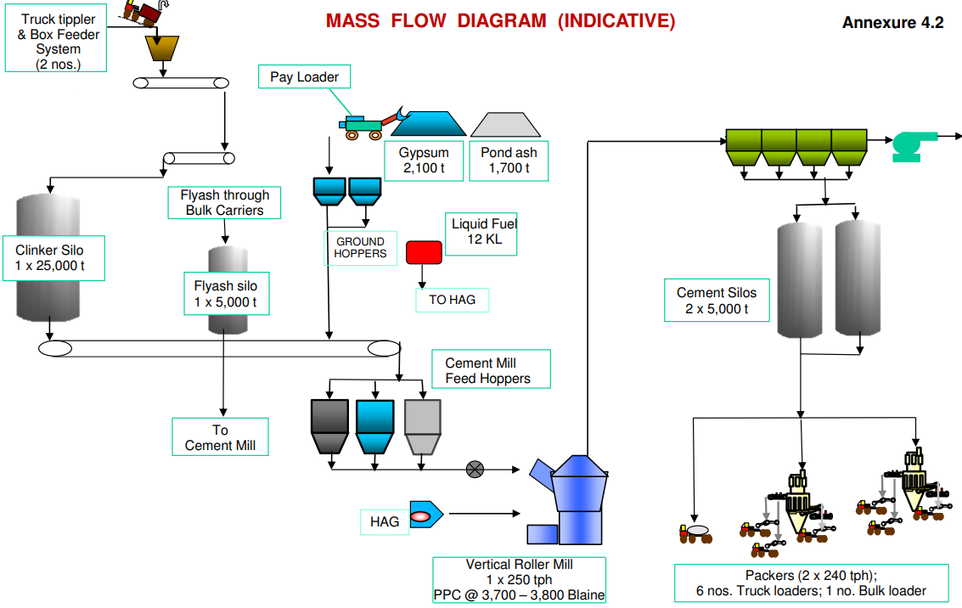
SOURCE: TEFR

- Bulk/ Truck Loading/Feeder Unit:
Raw materials, ex. Clinker needed in the manufacturing process, are received from their source, and loaded in the bulk load unit.

From bulk load unit, the raw materials are loaded onto a clinker transport belt, this belt system is designed to move materials from one location to another, in this case, from bulk load unit to the clinker silo.

- Clinker Silo:
Raw materials transported through belts is put and stored in clinker silo, which is made of R.C.C, and has a capacity of 15,000 MT.

- Cement Mill Hoppers:
The hopper building is equipped with three silos, each storing distinct materials: Fly ash, Additives, and Clinker, delivered through dedicated transport belts. These materials are subsequently conveyed to the Vertical Roller Mill or Grinding Unit for further processing. The ratio of mixing these resources is remotely monitored and controlled from the central control unit (CCU). This system ensures precise blending of the materials, enabling the production of cement with the desired properties and characteristics.
- Grinding unit (Vertical Roller Mill):
In this process, clinker, additives, and fly ash are obtained from the hopper, according to the specific quality requirements for cement production. These materials are then mixed and ground to achieve the desired size and quality of the final cement product. This blending and grinding process is a crucial step in cement manufacturing to meet the necessary quality standards.
Approved product | Rejected product

- Cement Silos: | - Reject Building:
The cement product, once it meets the required quality standards, is transported to cement silos via an air vent or shoot. These silos serve as storage units for the finished cement product, ready for distribution and use in various applications.
Cement products that do not meet the required quality standards are returned to the vertical roller mill for re-grinding and blending. This process allows for the correction of any deviations from the desired product specifications, ensuring that only cement of the specified quality is ultimately stored in the silos for distribution and use

- Packing Plant/Bulk Loading:
The packing plant is a multi-story structure with five floors (G+5), receiving the finished cement product from the cement silos through an air vent or strip. In this facility, the finished product is packaged using two well-equipped packing machines, each with 16 nozzles for efficient packaging. These packing machines have a capacity of 1.5 metric tons per hour (MTH) each and can simultaneously provide material for loading onto six trucks.

For larger bulk orders, a bulk loader is available to load containers directly, facilitating the efficient handling of larger quantities of cement for transportation and distribution.
Progress of Plant/Machinery and Equipment’s as per site visit dated 09th April 2024
Particular | Progress as on Sep 2023 |  | Progress as on Dec 2023
Particular | % | Remarks | % | Remarks
Bulk Loading Unit | 100% | All the necessary work for the installation of this unit has been completed, and it is now fully prepared and ready for its intended purpose. | 100% | Operational, and currently is being used.
Clinker Silo | 100% | All the necessary work for the installation of this unit has been completed, and it is now fully prepared and ready for its intended purpose. | 100% | Operational, and currently is being used.
Central Control unit | 75% | During the site survey, it was observed that finishing work was still in progress, and the installation of an elevator was also underway. | 100% | Operational, and currently is being used.
Hoppers | 100% | All the necessary work for the installation of this unit has been completed, and it is now fully prepared and ready for its intended purpose. | 100% | Operational, and currently is being used.
Grinding Unit(Mill) | 80% | All the necessary work for the installation of this unit has been completed, but the unit has not yet been tested, because of unviability of gear box of VRM. As per the information gathered on site survey, it is known that the gear box is been imported and will reach site soon. | 100% | Operational, and currently is being used. Was not operating at the time of visit due to not having demand.
Reject Building | 100% | All the necessary work for the installation of this unit has been completed, and it is now fully prepared and ready for its intended purpose. | 100% | Operational, and currently is being used.
Bag House | 100% | All the necessary work for the installation of this unit has been completed, and it is now fully prepared and ready for its intended purpose. | 100% | Operational, and currently is being used.
Cement Silo 1 | 100% | All the necessary work for the installation of this unit has been completed, and it is now fully prepared and ready for its intended purpose. | 100% | Operational, and currently is being used.
Cement Silo 2 | 75% | The major construction work for cement silo 2 has been finished, but it is not yet in a functional state similar to cement silo 1. This implies that while the structural aspects of the silo are complete, there may be additional work or components needed before it can be fully operational for its intended purpose. | 100% | Operational, and currently is being used.
Packing Plant | 85% | The installation of the unit, including the packing machine and carriage belt, has been fully completed, and it is now ready for its intended purpose. However, the civil work is not yet complete, and there are pending tasks. These pending tasks were observed to be in progress during the site survey, indicating that some construction or civil work is still underway. | 100% | Operational, and currently is being used.
Truck Loading Unit | 85% | The unit was observed to be under the process of installation, at the time of site survey. | 100% | Operational, and currently is being used.
Weigh Bridge | 100% | All the necessary work for the installation of this unit has been completed, and it is now fully prepared and ready for its intended purpose. | 100% | Operational, and currently is being used.
Overall Completion | ~90% |  | ~100%

Observations and comments:
- Supporting photographs have been attached in the report. These photos serve as visual evidence of the completed works and provide a clear representation of the current status of the unit.
- The plant has achieved its commercial operation on 24th November 2023 as per information provided by the company and dispatch report shown by them, i.e. 7 months before its scheduled commercial operational date in June, 2024. However during site observation one of the two packing unit was observed to be running and the other major units such as grinding unit mill was observed to be temporarily shut down at that instance of time, subject to the requirement.
- The Physical progress captured in the above table is based on approximate observations of status of plant/machineries installed on site during our site inspection and our subsequent discussions held with the engineers/ company representatives with whom the site visit was conducted. Thus, the above progress is on approximate basis which may vary from 5%-10% (+-).
- Apart from the machineries listed above, below listed essential machineries were also observed during site visit:

- Bag filter fans for raw mill  - Cooling air fans for raw mill  - Chain conveyors and rollers at various location  - Small motors at various locations  - Parts of cement machineries  - Lab equipment’s  - Stability chambers in laboratories  - Other small and miscellaneous machineries | - Lift in CCU building  - Electrical and automation works  - Weigh bridges.  - Hot air generator system in Cement mill  - Interconnecting chutes in cement mill  - Firefighting system and equipment’s  - Pumps and motors in Water treatment plant  - Control panel and switches

PART D | PROJECT CONSULTANTS, CONTRACTORS & SUPPLIERS
The borrower has provided information about the list of contractors engaged in the project for project site at Ujjain, Madhya Pradesh. However, we are unable to verify the contract amounts due to the unavailability of contract agreements or purchase orders (POs). Brief details of vendors is shown below:
Sr. No. | Major Vendor | Description
1. | Kamal Builders | Civil Contractor
2. | Karni Construction | Civil Contractor
3. | Monomark | Mechanical Contractor
4. | Shivansh Infra | Mechanical Contractor
5. | Schneider | Electrical and Lifts
6. | FLSmidth | Plant and Machinery Contractor

PART E | PROJECT COST & MEANS OF FINANCE

- TOTAL PROJECT COST: JKCL has estimated the Total Project Cost amounting to Rs.418.96 Crore which has been proposed to be funded in DER of approx. 62% Debt and 38% Equity. Details of Rs.418.96 Crore is as below:

Sr. No. | Particulars | Amount (in Rs. Lakh)
1. | Land and Site Development | 2,100
2. | Civil Works, Buildings and Structures | 10,471
3. | Plant and Machinery | 22,698
4. | Expenses on technical know-how & training | 450
5. | Miscellaneous Fixed Assets | 1,255
6. | Pre-Operative Expenses  (including Interest During Construction & Finance charges) | 2,481
7. | Contingency (@5%) | 1,909
8. | Margin Money for Working Capital | 532
Estimated Total Project Cost |  | 41,896
Source: TEFR prepared by HOLTEC Consultancy

- CURRENT STATUS & TOTAL EXPENDITURE INCURRED TILL DATE: Details of the expenditure in the Table below is recorded for the expenditure incurred up to 31st December 2023.

Particulars | Total Estimated Cost (In Rs. Cr.) | Amount Incurred Till 30.06.2023  (As per CA Cert.) | Amount Incurred Till 31.12.2023  (As per CA Cert.) | Remarks
Land and Site Development. | 21.00 | 5.48 | 5.48 | As per CA Certificate UDIN. 23424004BKAQCO4950 the borrower has shown an expenditure amounting to Rs.5.48 Crore towards land and site development. Due to unavailability of contract agreements, invoices, independent assessment of expenditure is not carried out at our end.
Plant, Machinery/ Building & Civil Structures | 344.24 | 143.88 | 293.90 | The amount mentioned is only as per CA Certificate dated 29/03/2024 UDIN. 23424004BKAQCO4950 Since limited invoices and details are provided to us pertaining to expenditure, therefore independent assessment from LIE is not done.
Pre-operative Expenses | 29.31 | 0.44 | --- | ---
Contingency | 19.09 | --- | --- | ---
Margin Money for Working Capital | 5.32 | --- | --- | ---
Total | 418.96 | 149.80 | 299.38 | Amount as per CA Certificate.

Note:
            - Above amount is as shown in the CA Certificate dated 29/03/2024 UDIN. 23424004BKAQCO4950 only for illustration purpose.
            - The above amount doesn’t include the pending bills or the debtor payments.

- SOURCES OF FINANCE & UTILIZATION OF FUNDS: The Project cost mentioned above has been planned to be covered from following resources:
PARTICULARS | ENVISAGED  MEANS OF FINANCE | AMOUNT INCURRED TILL DATE Amount Incurred Till 30.06.2023  (As per CA Cert.) | AMOUNT INCURRED TILL DATE Amount Incurred Till 31.12.2023  (As per CA Cert.)
Promoter’s Contribution (Equity) | 157.51 | 143.88 | 118.12
Term Loan (Debt) | 261.46 | 19.88 | 139.61
Others(Project Creditors) | --- | --- | 41.65
TOTAL (In Rs. In Cr.) | 418.96 | 149.80 | 299.38
PART F | STATUTORY & REGULATORY APPROVALS, CLEARANCES & NOC

Sr. No. | NAME OF LICENSE/ REGISTRATION | PURPOSE/ | DATE OF ISSUE | Current Status
Sr. No. | ISSUING AUTHORITY | PURPOSE/ | LICENCE NO. | Current Status
 | Site Plan | Layout | 22-12-2023 | Digitally signed
 | Chief Factories Inspector | Layout | 22-12-2023 | Digitally signed
 | Fire Plan Approval Certificate | Fire Plan Approval Certificate | Dated- 20-12-2023 | Approved
 | Fire Officer, Ujjain Division | Fire Plan Approval Certificate | Dated- 20-12-2023 | Approved
 | Environment Clearance | Approval as per environment guidelines in the area | 16/03/2021 | As on date the clearance is valid.
 | Ministry of Environment, Forest and Climate Change | Approval as per environment guidelines in the area | No. 7333/SEIAA | As on date the clearance is valid.
 | Consent to Establish | Approval as per Pollution norms applicable in that area | 10/11/2021 | As on date the clearance is valid and will be valid up to 31/10/2026
 | MP State Pollution control board | Approval as per Pollution norms applicable in that area | CTE-54599
 | Electricity Load Sanction | Approval electricity load sanction | 11-09-2023 | Approved
 | Chief Engineer | Approval electricity load sanction | 11-09-2023 | Approved
Observations & Comments:
- The approvals shown are the same as taken previously, no new approval has been taken by the company during the assessment period.
- Only major approvals are shown above as obtained by the company.

PART G | PROJECT IMPLEMENTATION SCHEDULE & STATUS

IMPLEMENTATION SCHEDULE
S. No. | Particulars | Start | Status
 | Land and Site Development | Land allotment done
 | Project Statutory Approvals | During Project tenure
 | Building and Civil works | Dec-22 | Achieved
 | Order of Plant and Machinery | Dec-22 | Achieved
 | Delivery of Machineries | Dec-22 | Achieved
 | Installation of Machinery | Dec-22 | Achieved
 | Trial runs and Commissioning of Plant | --- | Achieved

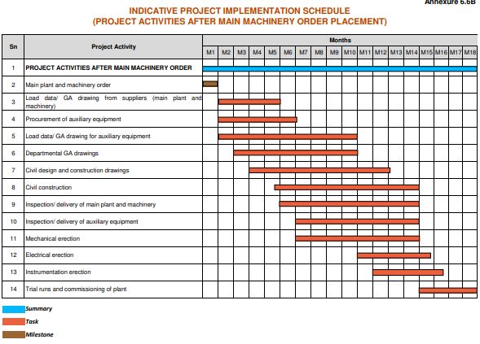

PART H | CONCLUSION

- As per our site visit on 09th March 2024, the plant construction work was observed to be complete and cement production has also been started. As per the information provided the company’s representative, the plant achieved its commercial operation on 24th November 2023 i.e. before its scheduled commercial operational date. To corroborate the same, we have checked the material dispatch report, finished product bills, electricity bills which are also annexed with the report.

- During site observation one of the two packing unit was observed to be running and the other major units such as grinding unit mill was observed to be temporarily shut down at that instance of time, subject to the requirement.

- The above progress is based on visual observation and subsequent discussions held with the engineers from the company accompanying our team during site visit.

- As per CA Certificate with UDIN. 23424004BKAQCO4950 the borrower has made an expenditure on the project amounting to Rs.299.38 Crore up to Dec.’23, showing Plant & Machinery, Building & Civil works and Miscellaneous fixed assets.

- Due to limited details available to us, the independent verification of expenses at our end is not done.

PART I | DISCLAIMER

      - No employee or member of R.K Associates has any direct/ indirect interest in the Project.
      - This report is prepared based on the copies of the documents/ information which the Bank/ Borrower has provided to us out of the standard checklist of documents sought from them and further based on our assumptions and limiting conditions. The client/owner and its management/representatives warranted to us that the information they supplied was complete, accurate and true and correct to the best of their knowledge. All such information provided to us has been relied upon in good faith and we have assumed that it is true and correct in all respect. I/We shall not be liable for any loss, damages, cost or expenses arising from fraudulent acts, misrepresentations, or wilful default on part of the owner, borrower, its directors, employee, representative or agents. Verification or cross checking of the documents provided to us from the originals or from any Govt. departments/ Record of Registrar has not been done at our end since this is beyond the scope of our work. If at any time in future, it is found or came to our knowledge that misrepresentation of facts or incomplete or distorted information has been provided to us then this report shall automatically become null & void.
      - Legal aspects for eg. investigation of title, ownership rights, lien, charge, mortgage, lease, sanctioned maps, verification of documents, etc. have not been done at our end and same has to be taken care by legal expert/ Advocate. It is assumed that the concerned Lender/ Financial Institution has satisfied them with the authenticity of the documents, information given to us and for which the legal verification has been already taken and cleared by the competent Advocate before requesting for this report. I/ We assume no responsibility for the legal matters including, but not limited to, legal or title concerns.
      - This report is a general analysis of the project based on the scope mentioned in the report. This is not an Audit report, Design document, DPR or Techno feasibility study. All the information gathered is based on the facts seen on the site during survey, verbal discussion & documentary evidence provided by the client and is believed that information given by the borrower is true best of their knowledge.
      - All observations mentioned in the report is only based on the visual observation and the documents/ data/ information provided by the client. No mechanical/ technical tests, measurements or any design review have been performed or carried out from our side during Project assessment.
      - This report doesn’t claim any quality assurance of the Products and the material being used in the Project.
      - Bank/FII should ONLY take this report as an Advisory document from the Financial/ Chartered Engineering firm and its specifically advised to the creditor to cross verify the original documents for the facts mentioned in the report which can be availed from the borrowing borrower directly.
      - In case of any default in loans or the credit facility extended to the borrowing borrower, R.K Associates shall not be held responsible for whatsoever reason may be and any request for seeking any explanation from the employee/s of R.K Associates will not be entertained at any instance or situation.
      - The documents, information, data provided to us during the course of this assessment by the client is reviewed only up to the extent required in relation to the scope of the work. No document has been reviewed beyond the scope of the work.
      - This report only contains general assessment & opinion as per the scope of work evaluated as per the information given in the copy of documents, information, data provided to us and/ and confirmed by the owner/ owner representative to us at site which has been relied upon in good faith. It doesn’t contain any other recommendations of any sort including but not limited to express of any opinion on the suitability or otherwise of entering into any transaction with the borrower.
      - We have relied on data from third party, external sources & information available on public domain also to conclude this report. These sources are believed to be reliable and therefore, we assume no liability for the truth or accuracy of any data, opinions or estimates furnished by others that have been used in this analysis. Where we have relied on data, opinions or estimates from external sources, reasonable care has been taken to ensure that such data has been correctly extracted from those sources and /or reproduced in its proper form and context, however still we can’t vouch its authenticity, correctness or accuracy.
      - This Report is prepared by our competent technical team which includes Engineers and financial experts & analysts.
      - This is just an opinion report and doesn’t hold any binding on anyone. It is requested from the concerned Financial Institution which is using this report for taking financial decision on the project that they should consider all the different associated relevant & related factors also before taking any business decision based on the content of this report.
      - All Pages of the report including annexures are signed and stamped from our office. In case any paper in the report is without stamp & signature then this should not be considered a valid paper issued from this office.
      - Though adequate care has been taken while preparing this report as per its scope, but still we can’t rule out typing, human errors, over sightedness of any information or any other mistakes. Therefore, the concerned organization is advised to satisfy themselves that the report is complete & satisfactory in all respect. Intimation regarding any discrepancy shall be brought into our notice immediately. If no intimation is received within 15 (Fifteen) days in writing from the date of issuance of the report, to rectify these timely, then it shall be considered that the report is complete in all respect and has been accepted by the client up to their satisfaction & use and further to which R.K Associates shall not be held responsible in any manner.
      - Defect Liability Period is 15 DAYS. We request the concerned authorized reader of this report to check the contents, data and calculations in the report within this period and intimate us in writing if any corrections are required or in case of any other concern with the contents or opinion mentioned in the report. Corrections only related to typographical, calculation, spelling mistakes, incorrect data/ figures/ statement will be entertained within the defect liability period. Any new changes for any additional information in already approved report will be regarded as additional work for which additional fees may be charged. No request for any illegitimate change in regard to any facts & figures will be entertained.
      - R.K Associates encourages its customers to give feedback or inform concerns over its services through proper channel at valuers@rkassociates.org in writing within 15 days of report delivery. After this period no concern/ complaint/ proceedings in connection with the Financial Feasibility Study Services will be entertained due to possible change in situation and condition of the subject Project.
      - Our Data retention policy is of ONE YEAR. After this period, we remove all the concerned records related to the assignment from our repository. No clarification or query can be answered after this period due to unavailability of the data.
      - This Lender’s Independent Engineer report is governed by our (1) Internal Policies, Processes & Standard Operating Procedures, (2) Information/ Data/ Inputs given to us by the client and (3) Information/ Data/ Facts given to us by our field/ office technical team. Management of R.K Associates never gives acceptance to any unethical or unprofessional practice which may affect fair, correct & impartial assessment and which is against any prevailing law. In case of any indication of any negligence, default, incorrect, misleading, misrepresentation or distortion of facts in the report then it is the responsibility of the user of this report to immediately or at least within the defect liability period bring all such act into notice of R.K Associates management so that corrective measures can be taken instantly.
      - R.K Associates never releases any report doing alterations or modifications from pen. In case any information/ figure of this report is found altered with pen then this report will automatically become null & void.

SURVEY ANALYST | VALUATION ENGINEER | L1/ L2 REVIEWER
Vishal Singh | Vishal Singh | Sr. V.P Projects

DEFECT LIABILITY PERIOD - In case of any query/ issue or escalation you may please contact Incident Manager by writing at valuers@rkassociates.org. We ensure 100% accuracy in the Calculations done, Rates adopted and various other data points & information mentioned in the report but still can’t rule out typing, human errors or any other mistakes. In case you find any mistake, variation, discrepancy or inaccuracy in any data point of the report, please help us by bringing all such points into our notice in writing at valuers@rkassociates.orgwithin 30 days of the report delivery, to get these rectified timely, failing which R.K Associates Valuers Techno Engineering Consultants (P) Ltd. won’t be held responsible for any inaccuracy in any manner. Also, if we will not hear back anything from you within 30 days, we will assume that report is correct in all respect and no further claim of any sort will be entertained thereafter. We would welcome and appreciate your feedback & suggestions in order to improve our services.

COPYRIGHT FORMAT - This report is prepared on the copyright format of R.K Associates Valuers Techno Engineering Consultants (P) Ltd. to serve our clients in the best possible way. Legally no one can copy or distribute this format without prior approval from R.K Associates. It is meant only for the organization as mentioned on the cover page of this report. Distribution or use of this format other than R.K Associates will be seen as unlawful act and necessary legal action can be taken against the defaulter.

ENCLOSURE
CA CERTIFICATE DATED 29th March 2024
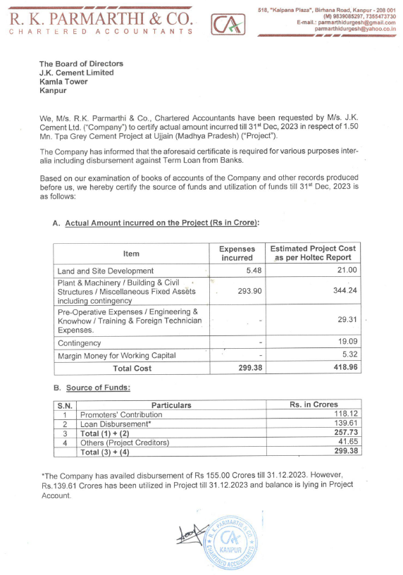
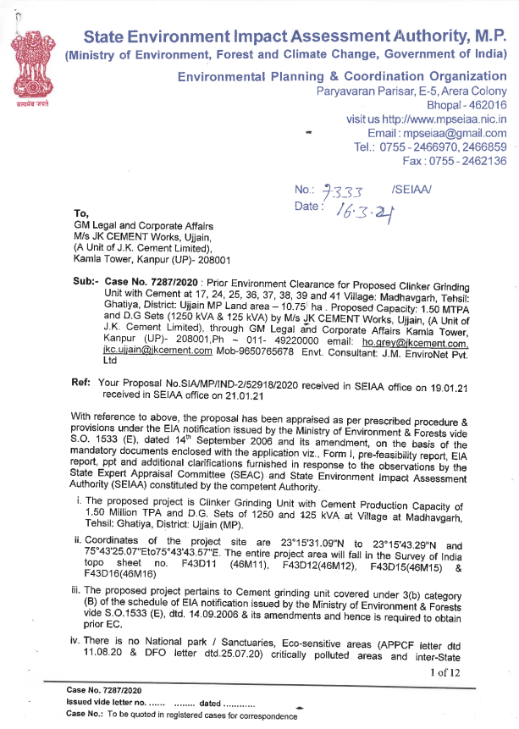

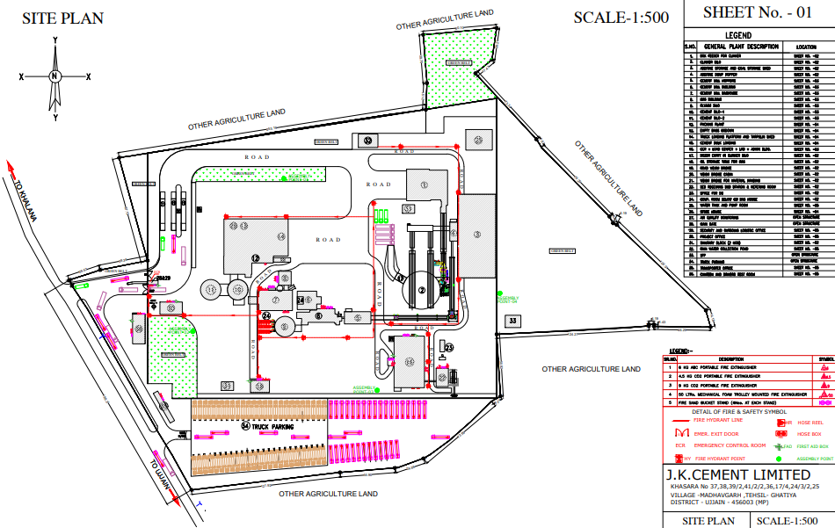
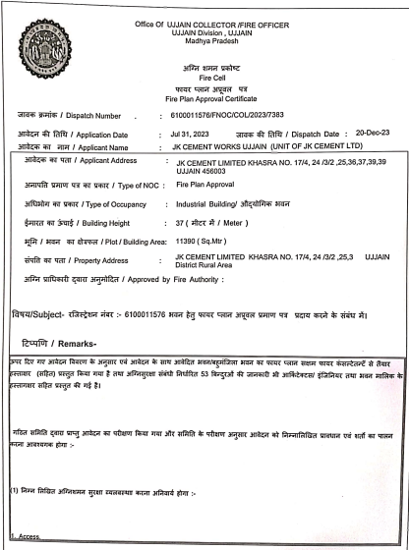
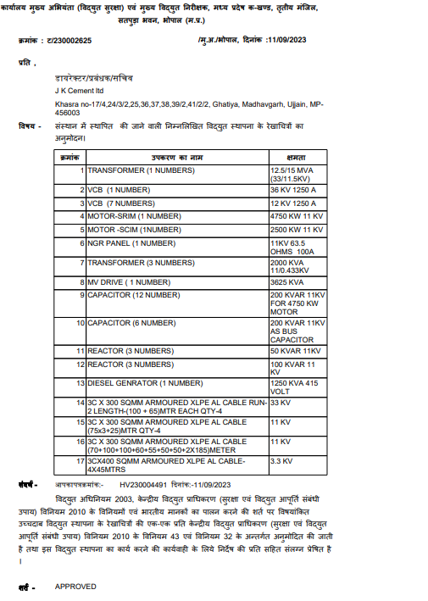

Electricity bill of November 2023, December 2023 and January 2024
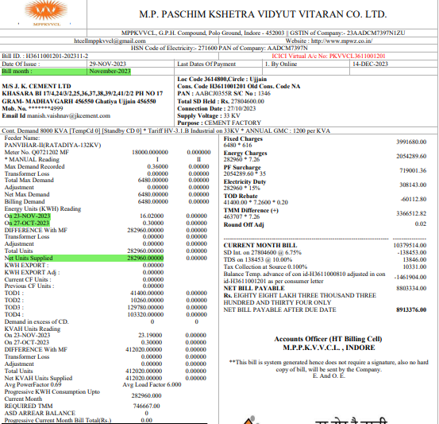 | 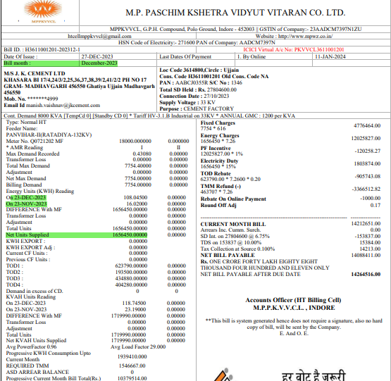
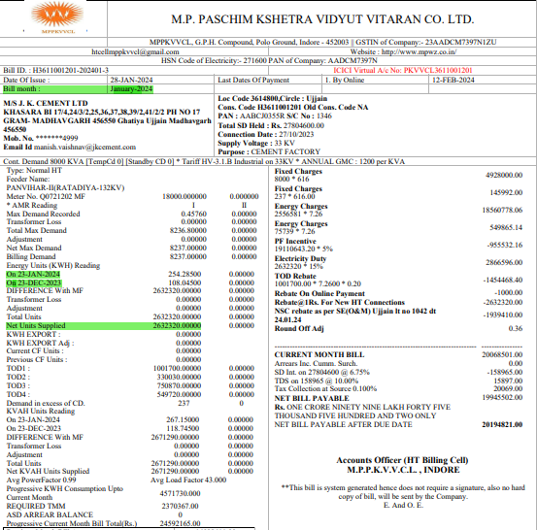

Invoices of cement dispatched
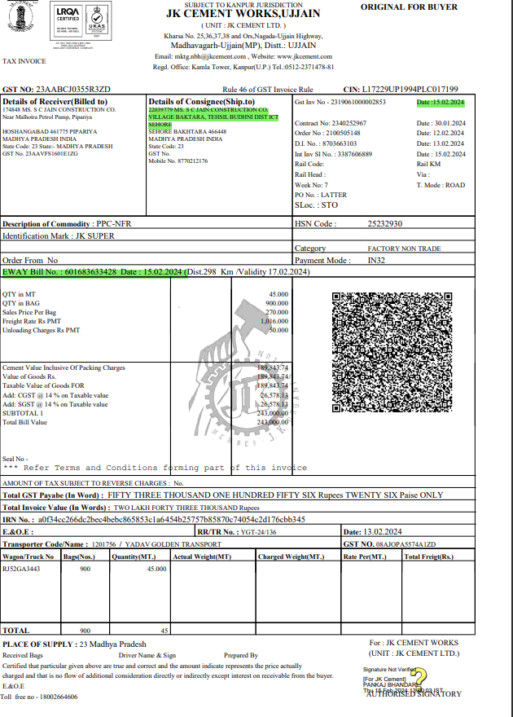 | 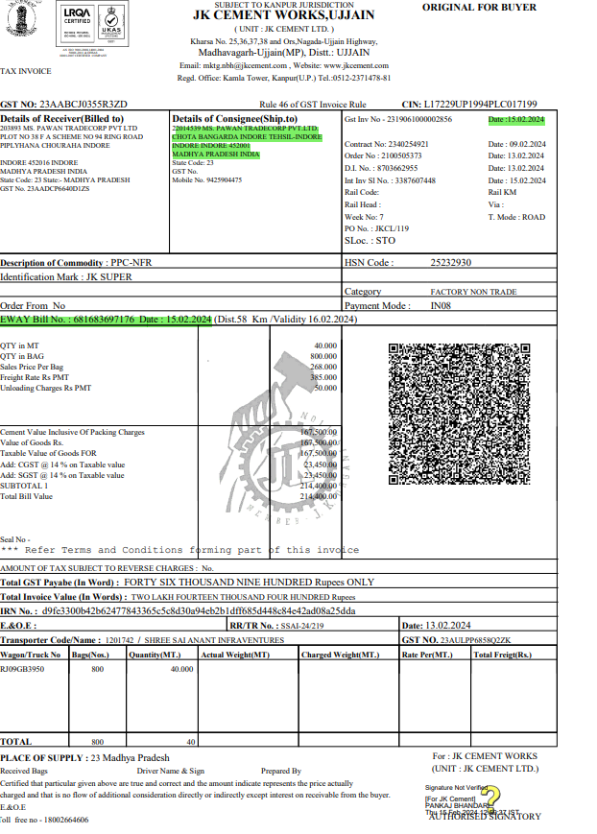
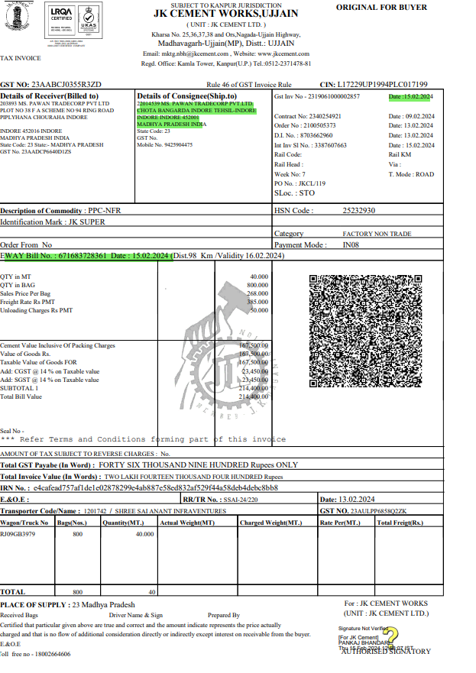 | 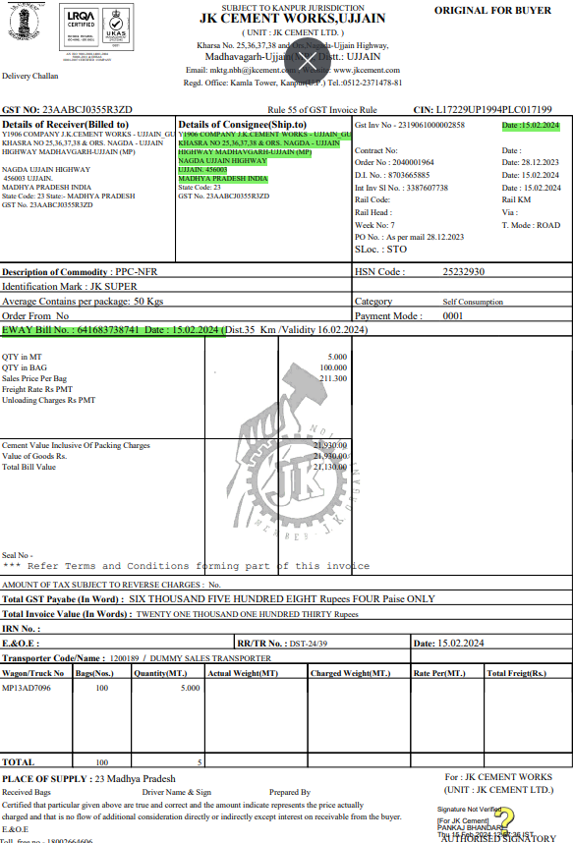

Dispatch Report

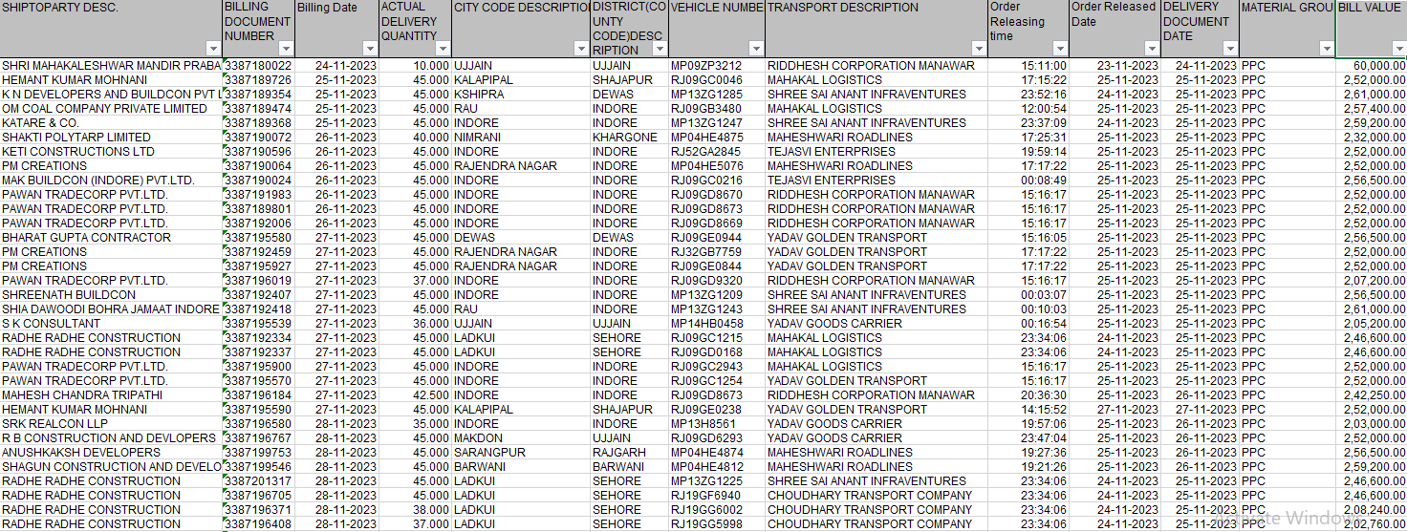

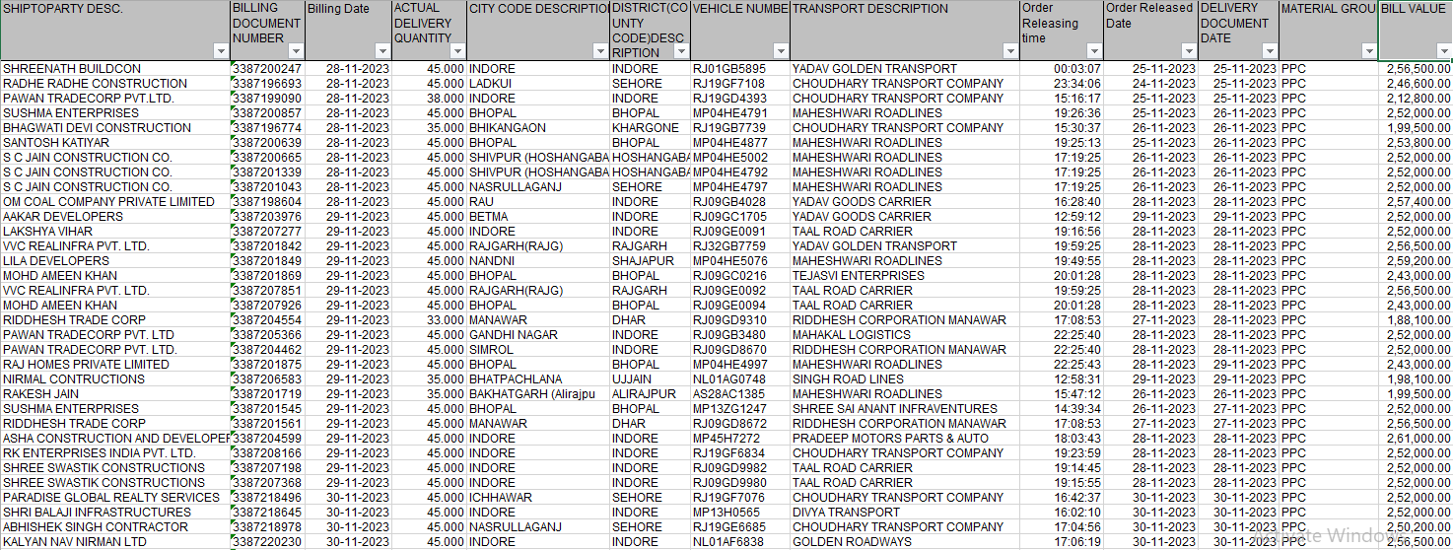

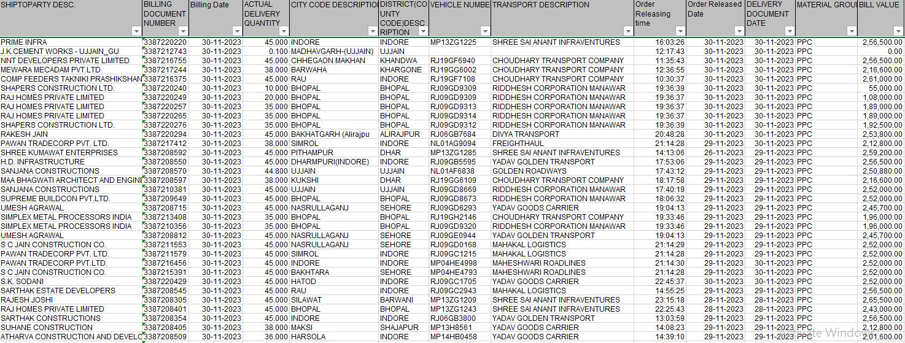

BULK LOADING UNIT
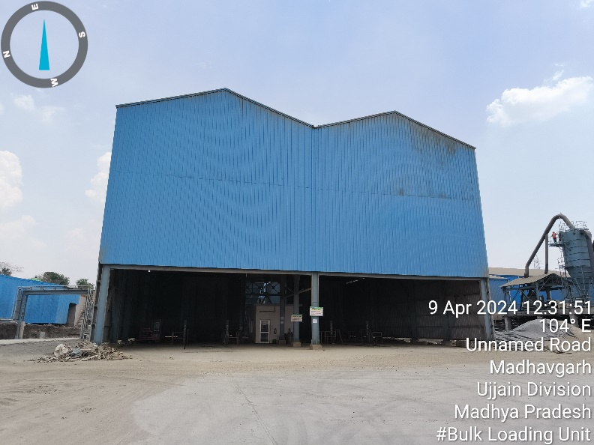 |  |  |  | 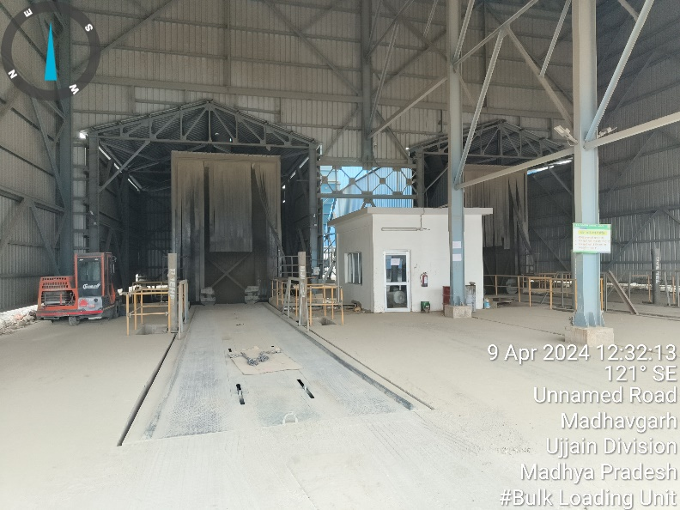
GYPSUM AND POND ASH STORAGE UNIT
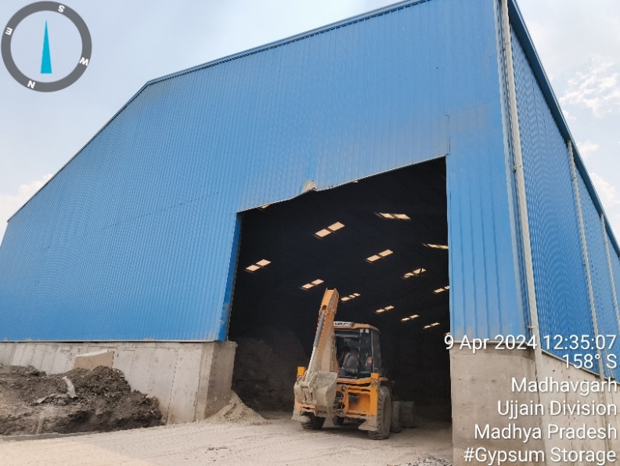 |  |  |  |  | 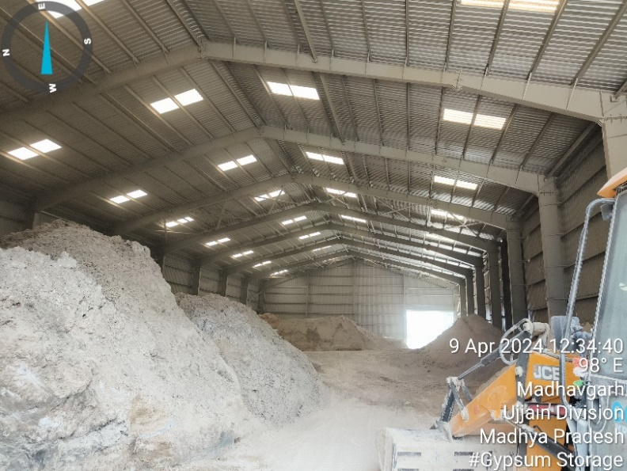
CLINKER SILO
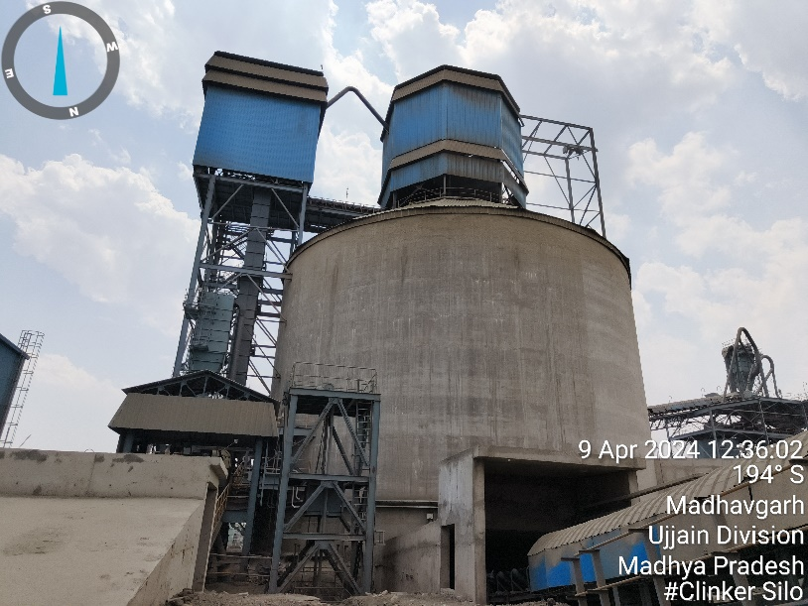 | 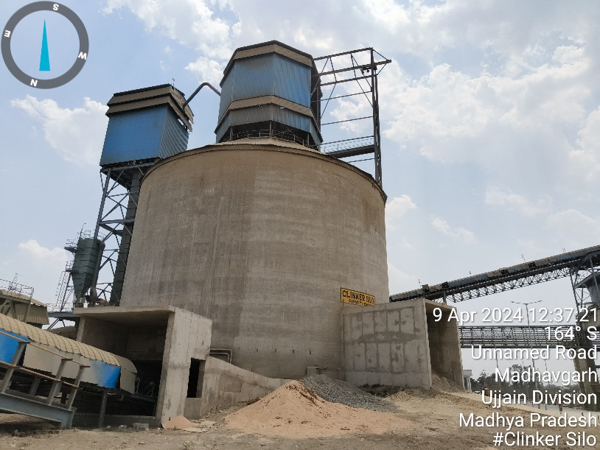
HOPPER
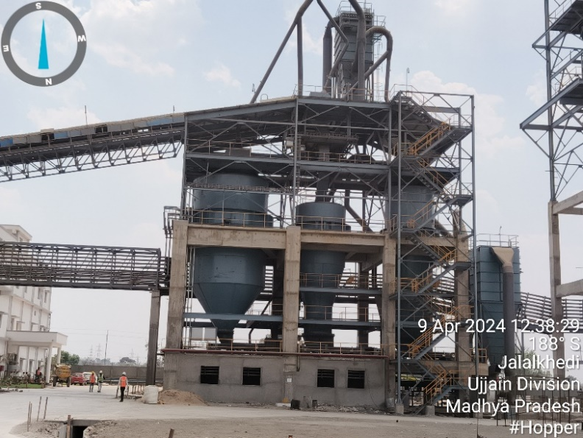 |  |  | 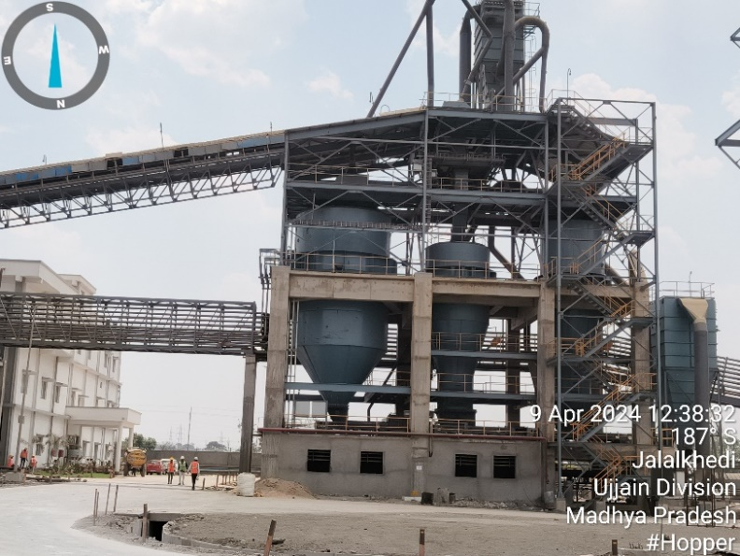
GRINDER UNIT / MILL / VRM
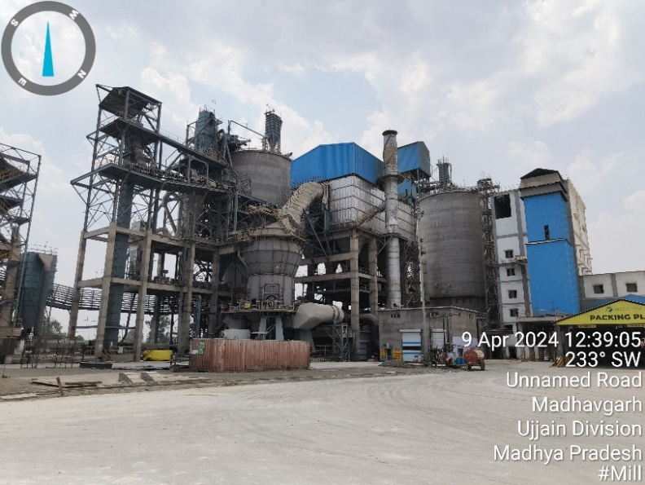 | 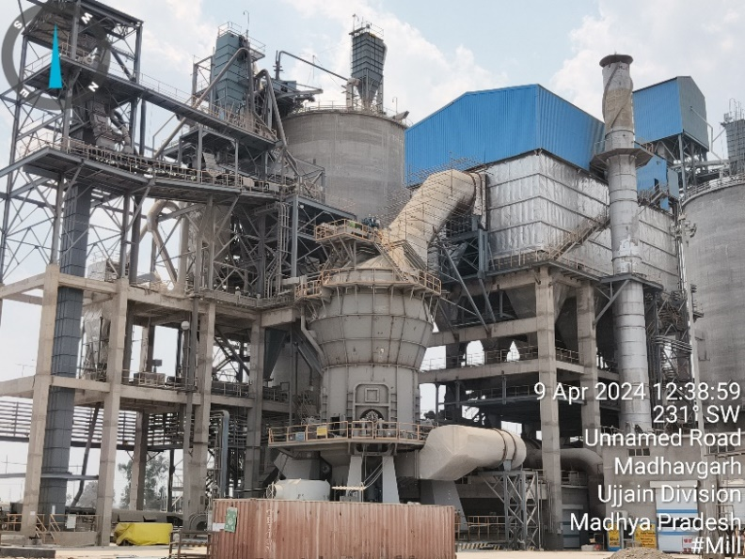
PACKING UNIT
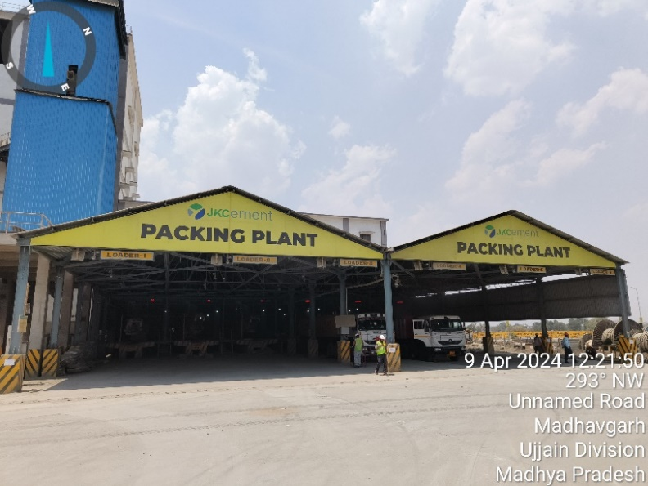 |  | 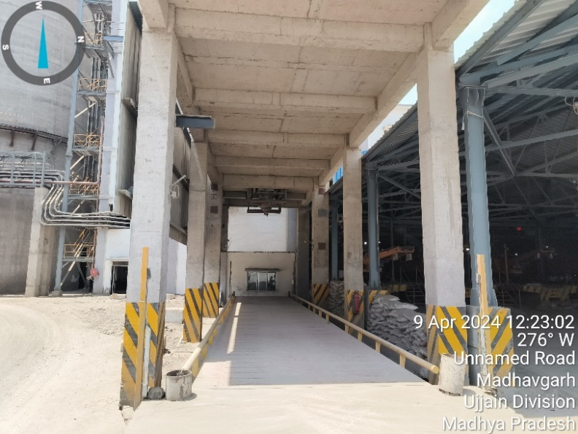
PACKING MACHINE 1 AND 2
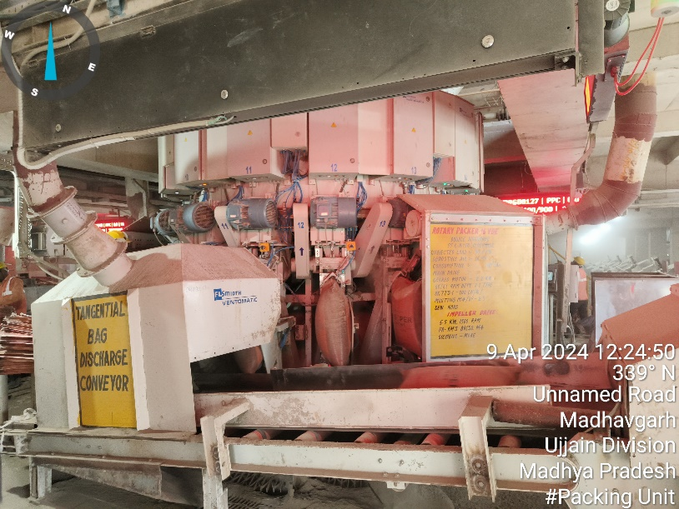 | 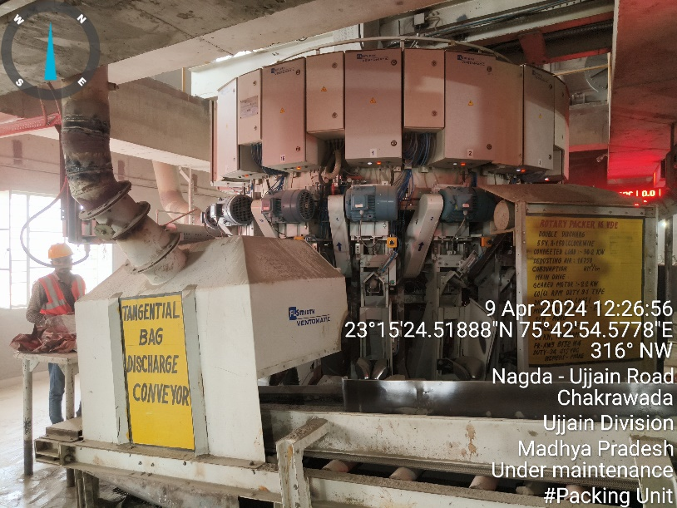
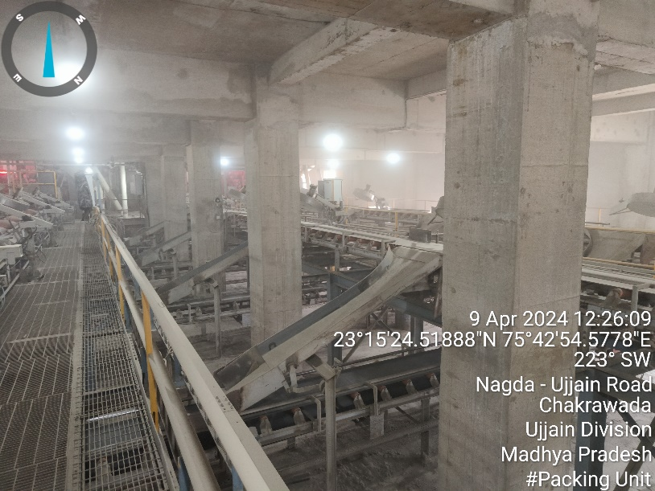 |  |  | 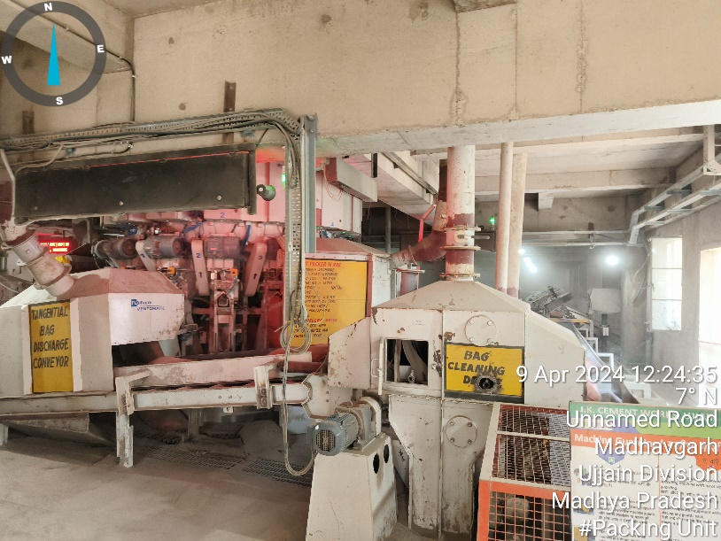
BULK CONTAINER LOADING
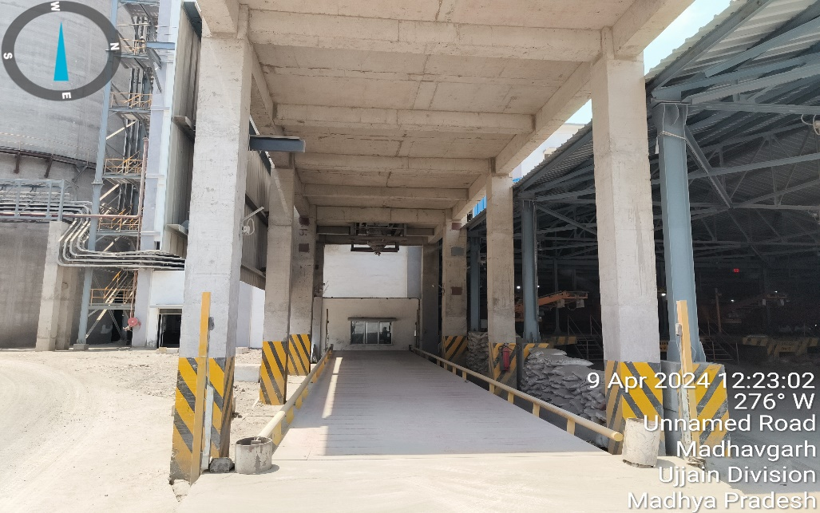
CEMENT SILO 1 AND 2
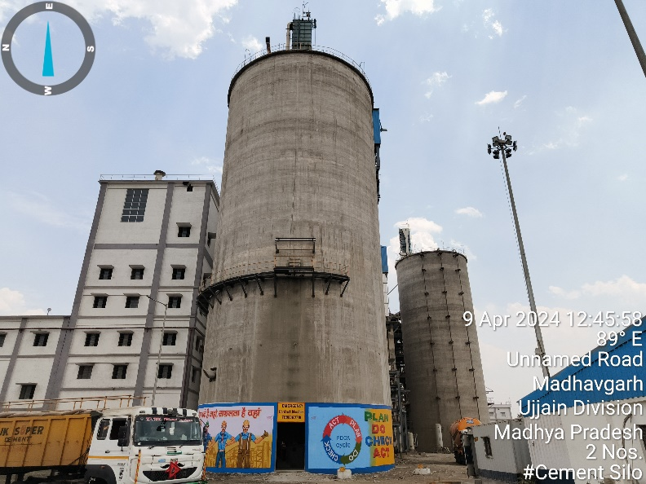 |  |  | 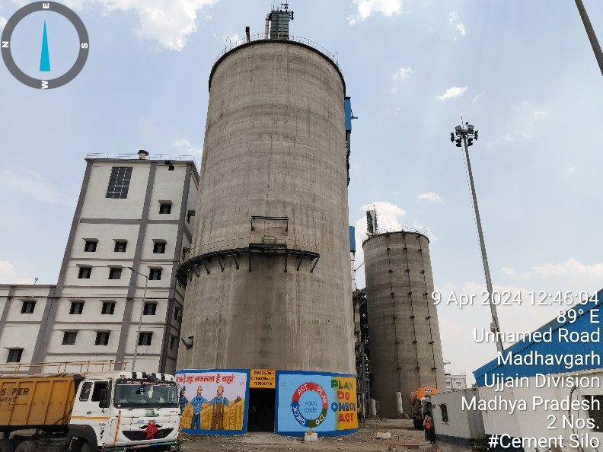
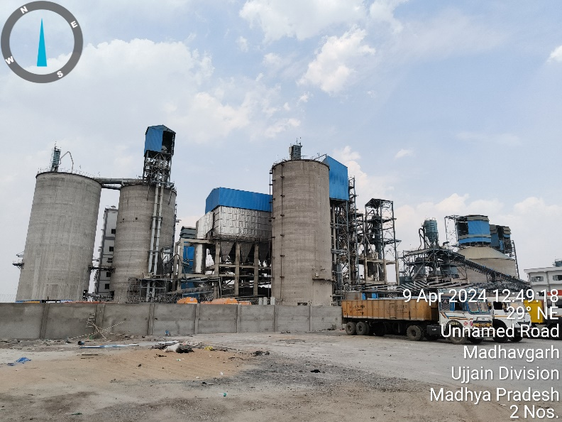 |  |  | 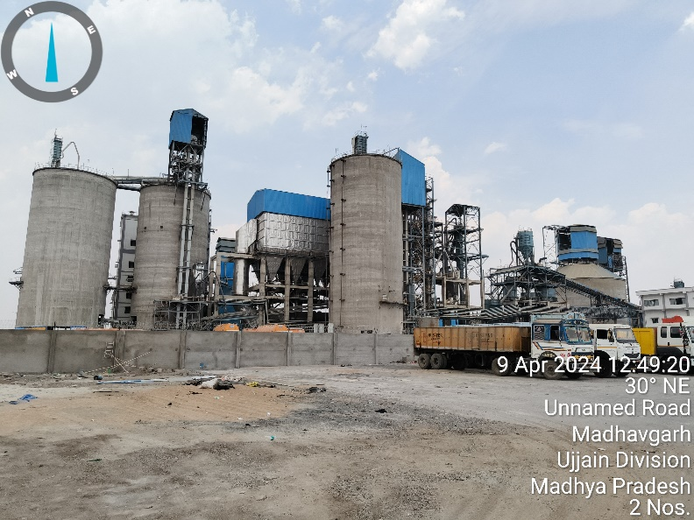
TRANSPORT OFFICE |  |  | CANTEEN
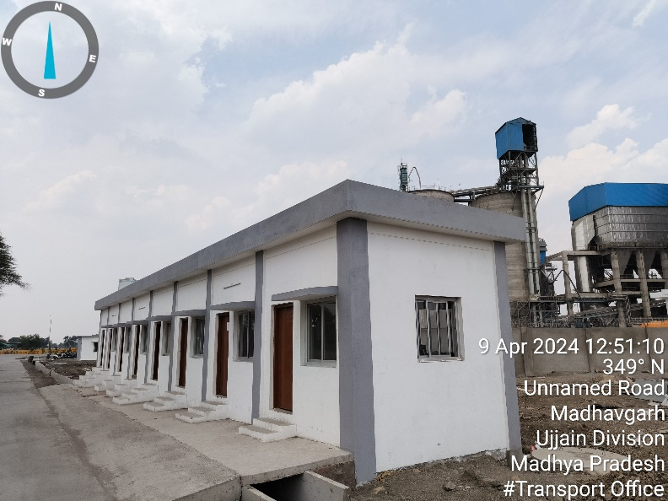 |  |  | 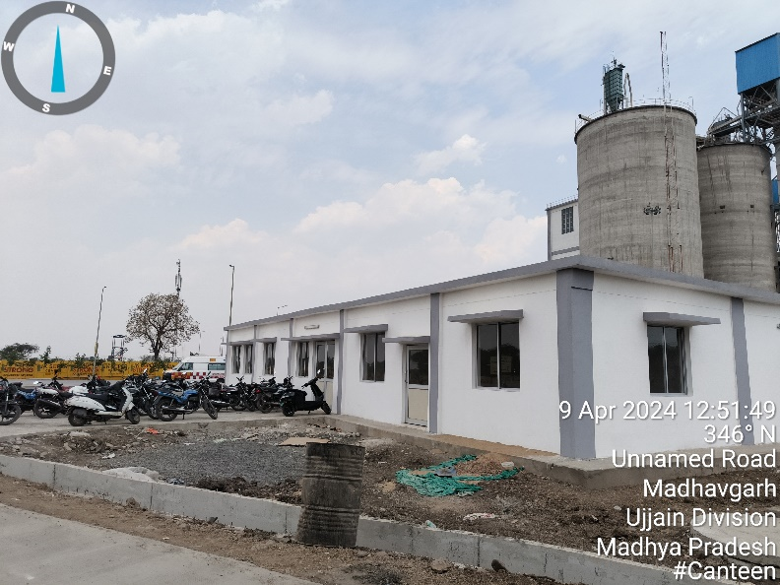

CENTRAL CONTROL UNIT(CCU)
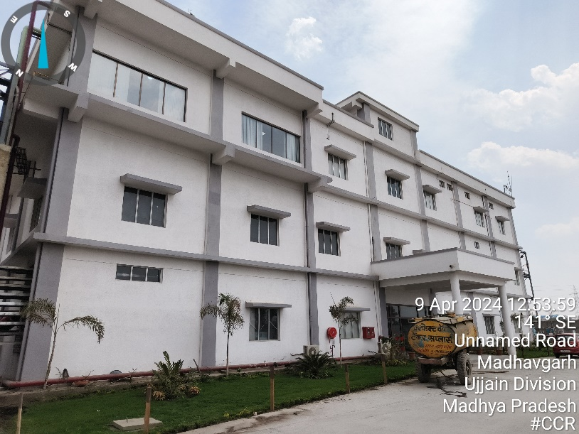 | 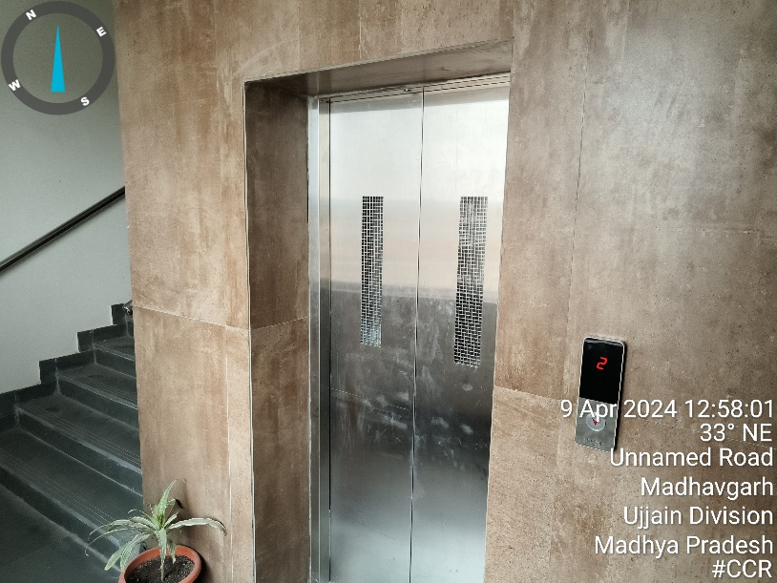
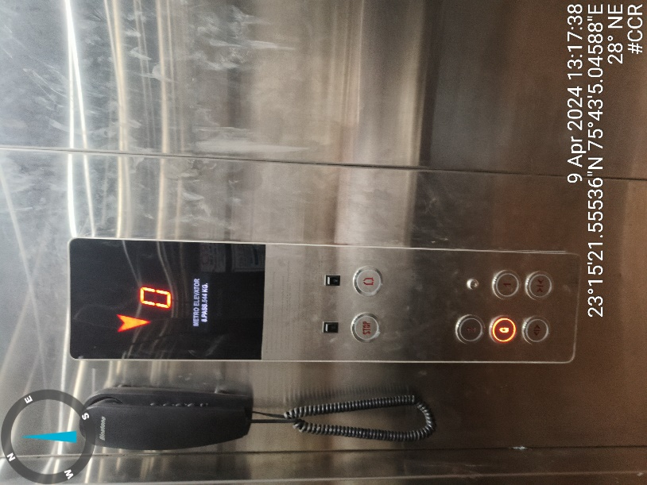 | 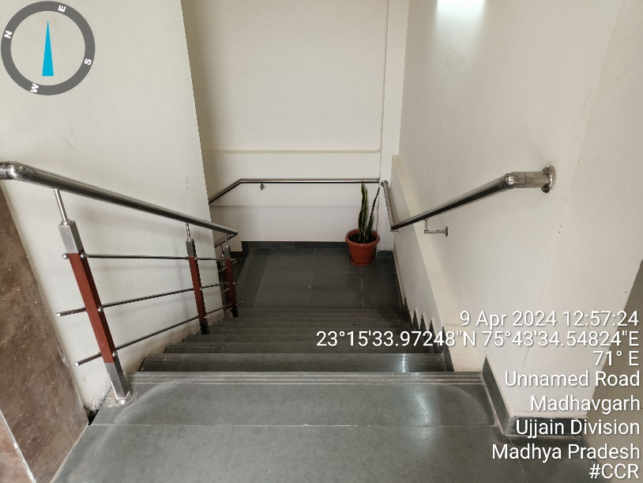
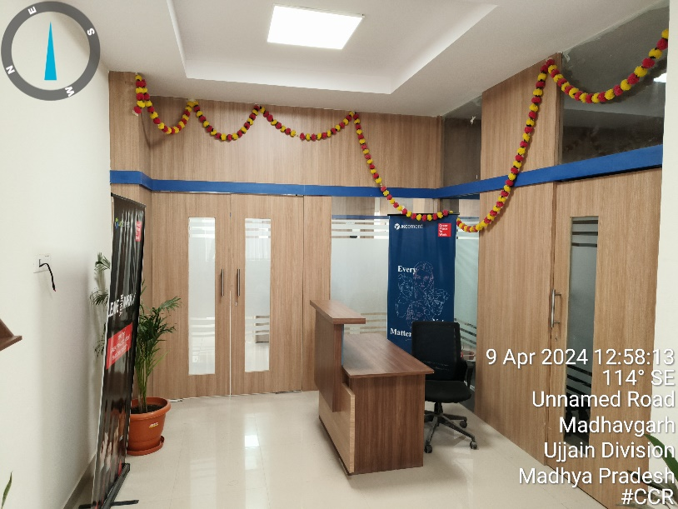 | 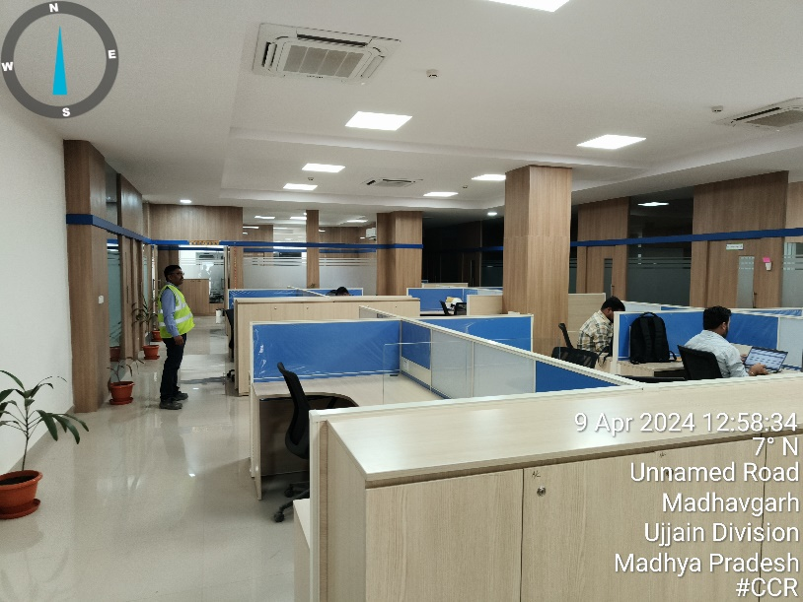

ROAD AND DEVELOPMENT
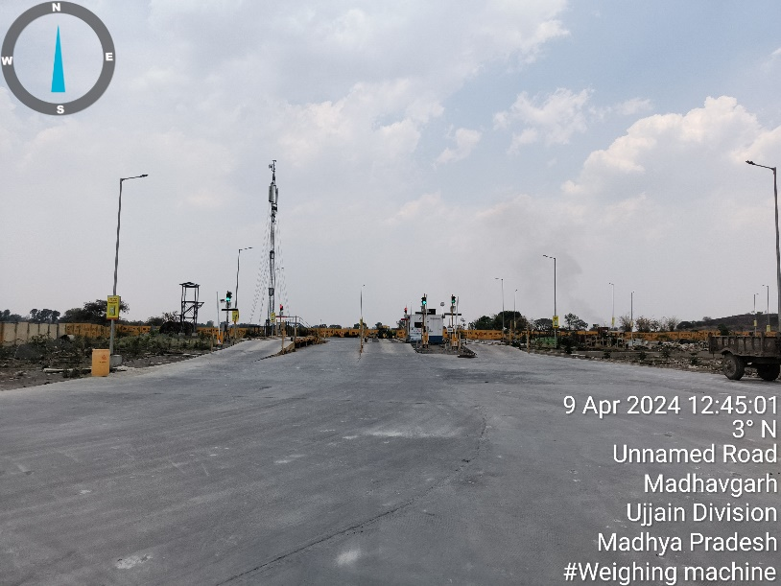 | 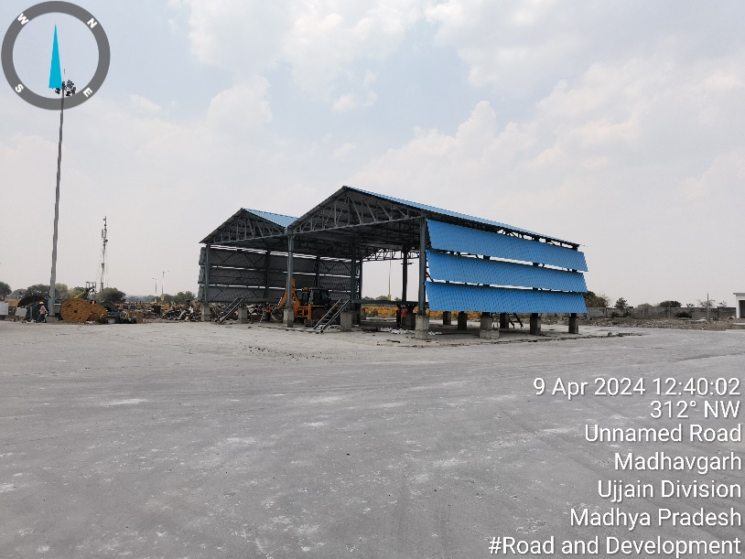
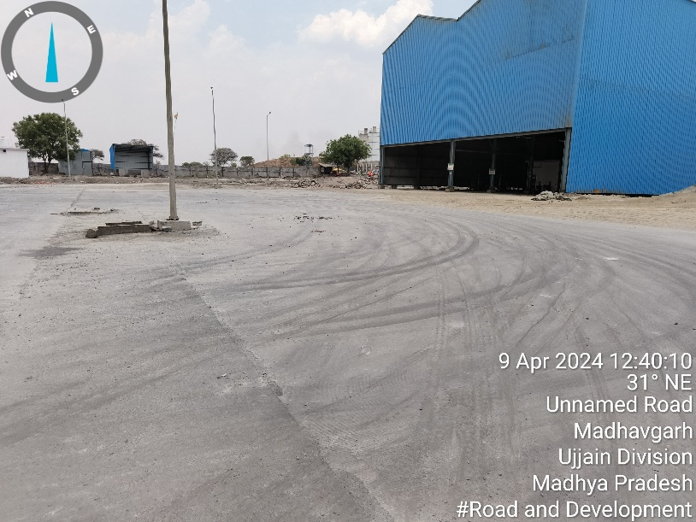 | 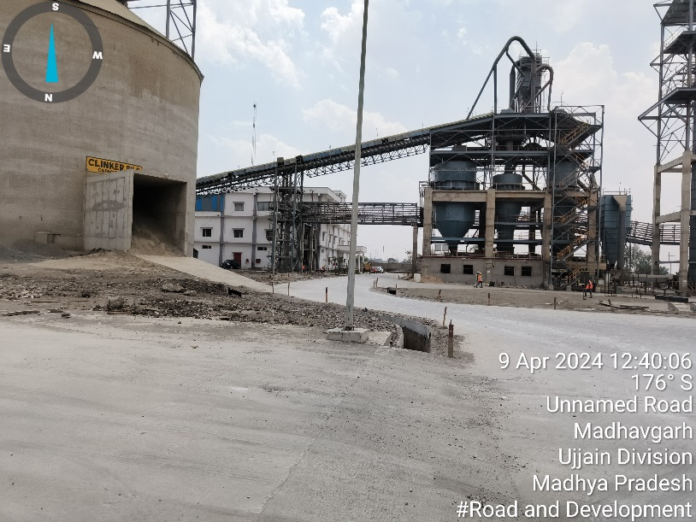
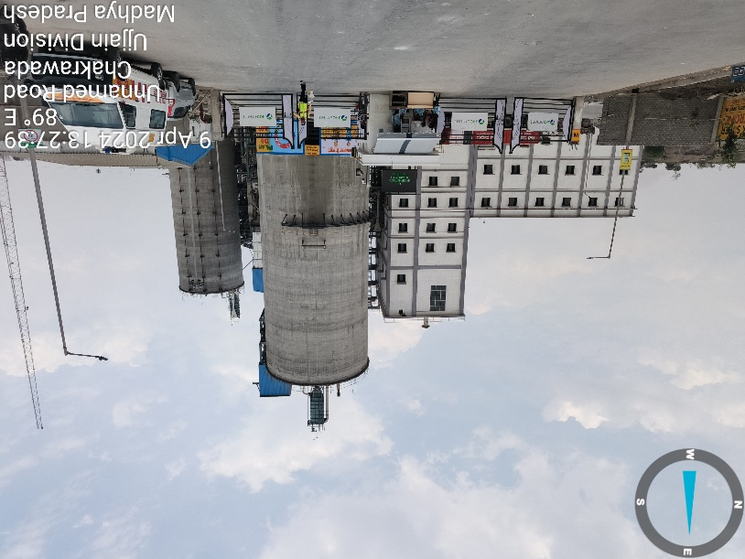 | 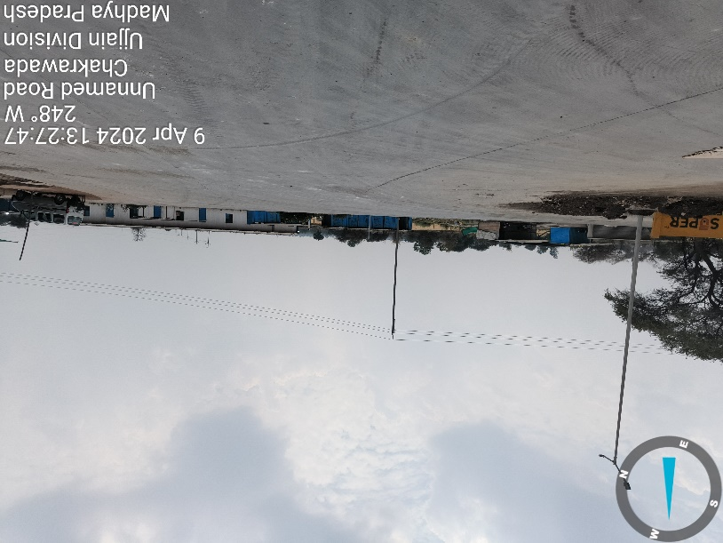
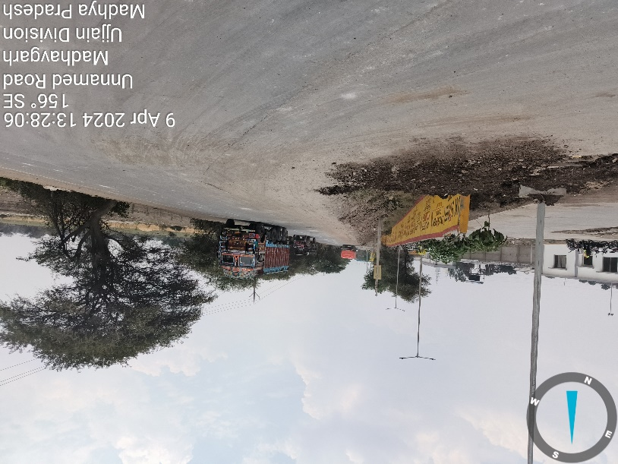 | 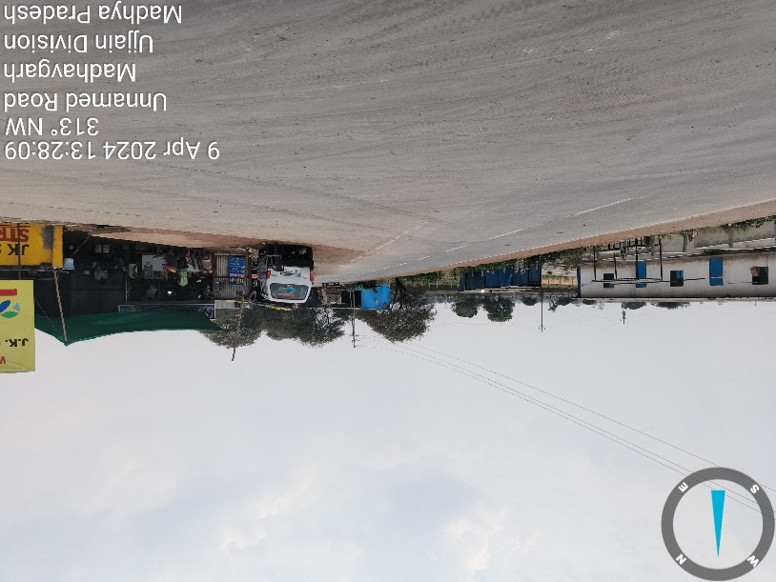
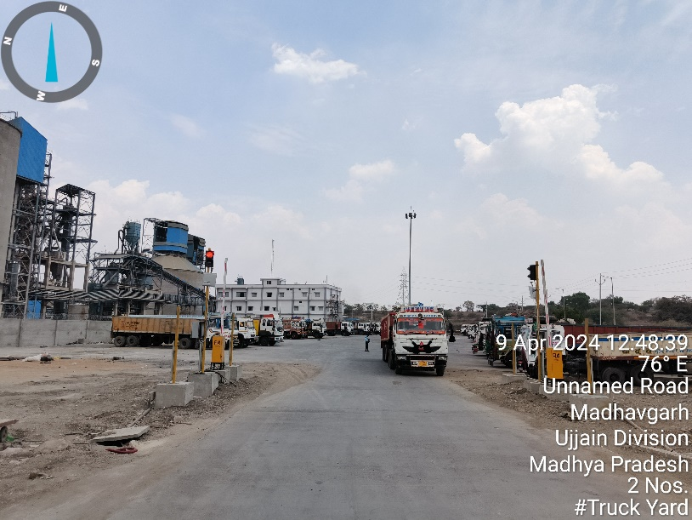 | 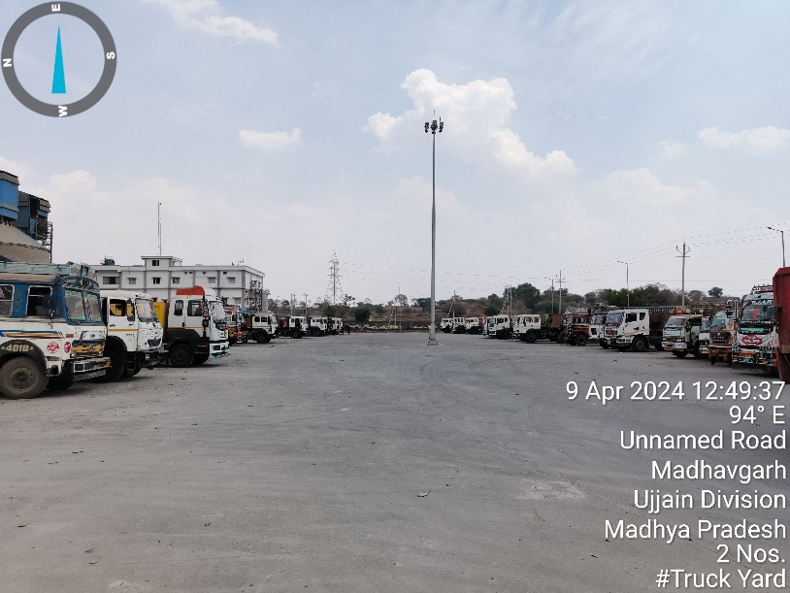
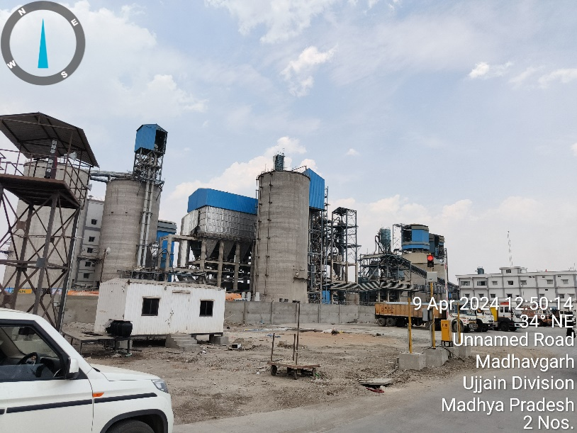 | 