**File No.: VIS (2023-24)-PL645-548-865 Dated: 12.02.2024**

**LENDER’S INDEPENDENT ENGINEER REPORT (2ND)**

**(FOR QUARTER ENDING DECEMBER 2023)**

**OF**

**5 TPD BIOMASS TO COMPRESSED BIOGAS (CBG)**

**PLANT (PHASE-I)**

****

**SITUATED AT**

**VILLAGE SHAHPUR DANDI, TEHSHIL: BAHERI, DISTRICT: BAREILLY.**

**IMPLEMENTED BY**

**M/S. CARBON CIRCLE PRIVATE LIMITED**

**REPORT PREPARED FOR**

**STATE BANK OF INDIA, SME RUDRAPUR.**

***\*\*Important - In case of any query/ issue or escalation you may please contact Incident Manager at le@rkassociates.org. We will appreciate your feedback in order to improve our services.***

***NOTE: As per IBA Guidelines please provide your feedback on the report within 15 days of its submission after which report will be considered to be correct.***

|  |  |  |
| --- | --- | --- |
| **TABLE OF CONTENTS** | | |
| **SR. NO.** | **DESCRIPTION** | **PAGE NO.** |
| **PART A** | **Report Summary** | **03** |
| **PART B** | **Introduction** | **05** |
|  | 1. The Assignment | **05** |
|  | 1. Project Overview | **05** |
|  | 1. Project Location | **08** |
|  | 1. Scope of the Work During Assignment Duration | **09** |
|  | 1. Purpose of the Report | **09** |
|  | 1. Methodology Adopted | **09** |
| **PART C** | **Plant Infrastructure Sections & Facility Details with Actual Progress** | **10** |
|  | 1. Land and Land Development | **10** |
|  | 1. Building and Civil Works | **10** |
|  | 1. Plant Machinery and Equipment | **12** |
| **PART D** | **Project Consultants, Contractors & Suppliers** | **16** |
| **PART E** | **Project Cost and Means of Finance** | **17** |
|  | 1. Cost of Project | **17** |
|  | 1. Cost Expenditure Analysis | **18** |
|  | 1. Sources of Finance & Utilization of Funds | **25** |
| **PART F** | **Statutory & Regulatory Approvals, Clearances & NOC** | **26** |
| **PART G** | **Project Schedule & Current Status** | **27** |
| **PART H** | **Disclaimer** | **28** |
| **PART I** | **Enclosure** | **32** |
| **PART J** | **Photograph** | **38** |

# 

***IMPORTANT NOTICE***

***COPYRIGHT FORMAT:*** *This report is prepared on the copyright format of R.K Associates, to serve our clients with the best available information and analysis to facilitate them to take rational business decisions. Legally no one can copy or distribute this format without prior approval from R.K Associates. It is meant only for the advisory/ reference purpose for the organization/s as mentioned on the cover page of this report. Distribution or use of this format by any organization or individual other than R.K Associates will be seen as unlawful act and necessary legal action can be taken against the defaulters.*

*This report is intended for the sole use of the intended recipient/s and contain material that is STRICTLY CONFIDENTIAL AND PRIVATE.*

***DEFECT LIABILITY PERIOD:*** *- In case of any query/ issue or escalation you may please contact Incident Manager: le@rkassociates.org. We try our level best to ensure correctness in the calculations done, rates adopted and various other data points & information mentioned in the report but still can’t rule out typing, human errors or any other mistakes. In case you find any such mistake or inaccuracy in any data point of the report please help us by bringing all such points into our notice immediately or within 15 days of the report delivery in writing, to rectify these timely failing after which R.K Associates won’t be held responsible for any such inaccuracy in any manner. We would highly appreciate your feedback in order to improve our services.*

|  |  |
| --- | --- |
| **PART A** | **REPORT SUMMARY** |

|  |  |  |
| --- | --- | --- |
| **1.** | **Name of Project:** | Carbon Circle Private Limited (CCPL) is establishing a Compressed Biogas (CBG) plant with a total capacity of 10 Tons Per Day (TPD) in Baheri Tehsil, Bareilly District, and Uttar Pradesh. The project will be executed in two phases, Phase –I and Phase-II, with each phase setting up a 5 TPD plant. |
| **2.** | **Project Location:** | Village Shahpur Dandi, Tehshil: Baheri, District: Bareilly, State: Uttar Pradesh, India. |
| **3.** | **Name of the Borrower:** | M/S. Carbon Circle Private Limited. |
| **4.** | **Director’s/Partner’s:** | Mr. Guru Inder Mohan Singh |
| **5.** | **Prepared for Bank:** | State Bank of India SME Branch, Rudrapur, Uttarakhand |
| **6.** | **LIE Consultant Firm:** | M/s. R.K. Associates Valuers & Techno Engineering Consultants (P) Ltd. |
| **7.** | **Date of Survey:** | 31st of January 2024 |
| **8.** | **Date of Report:** | 12th of February 2024 |
| **9.** | **Purpose of the Report:** | To provide fair detailed analysis report to the Bank based on the “in-scope points” mentioned below to know the current status of the Project. |
| **10.** | **Scope of the work provided by the Lender:** | 1. Periodic Project physical status review 2. Periodic review of expenditure of the Project based on the invoices/ bills submitted by the client |
| **11.** | **Documents perused for Proposal:** | 1. Brief description of the project. 2. Detailed Project Report. 3. CA Certificate 4. SBI’s TEV Report 5. Amendment Letter or Purchase Order for machines to be installed. 6. Other approvals. 7. Site/Plot Plan 8. Property Title Documents 9. Plant Layout |
| **12.** | **Annexure with the report:** | 1. Copies of Project Statutory approvals 2. CA Certificate 3. DPR 4. Site/Plot Plan |

|  |  |
| --- | --- |
| **PART B** | **INTRODUCTION** |

1. **ABOUT THE ASSIGNMENT:**

2nd LIE Report for the period (Quarter ending December 2023) of Compressed Biogas (CBG) plant being established at Baheri Tehsil, Bareilly District, and Uttar Pradesh. **M/S. Carbon Circle Private Limited** (CCPL) is establishing a Compressed Biogas (CBG) plant with a total capacity of 10 Tons per Day (TPD) in Baheri Tehsil, Bareilly District, and Uttar Pradesh. The project is executed in two phases, Phase –I and Phase-II, with each phase setting up a 5 TPD plant for which bank has appointed M/S R.K Associates Valuers & Techno Engineering Consultants (P) Ltd. for periodic review of physical & expenditure status of the project.

Although the report is for period Quarter ending December 2023, however the physical status in the report is reported of the date of survey which is 31st January 2024 but incurred expenses are considered between the period Oct. – Dec.’23.

1. **PROJECT OVERVIEW:**

**M/S. Carbon Circle Private Limited (CCPL**) is establishing a Compressed Biogas (CBG) plant in Baheri Tehsil, Bareilly District, Uttar Pradesh, with an aggregate capacity of 10 Tons per Day (TPD). The project will be implemented in two sequential phases, Phase-I and Phase-II, each dedicated to setting up a 5 TPD plant. This phased approach is designed to facilitate the efficient development and scaling of the CBG plant.

Whereas as per CA Certificate the appraised Project cost considered is Rs.40.40 Cr. which includes Land development, Building, Plant & Machinery etc. Detailed breakup of the same is available in later section of the report. Further the Project was independently appraised by Consultancy Services Cell of SBI. As per Consultancy Services Cell of SBIthe appraised cost is Rs. 39.50 crores, the difference on the same is observed in IDC value. **Further in this report, only the appraised hard cost by SBI is taken into consideration. Soft cost such as IDC etc. is not covered in the part of report. This report covers only Phase-I of the Project i.e. 5 TPD Plant.**

As per MCA, M/s Carbon Circle Private Limited (CCPL) was incorporated on 29/10/2021. Company is formed by Mr. Guru Inder Mohan Singh who has experience of implementing and scaling solar energy businesses. As per information provided to us, he started his career in Power Finance Corporation Ltd. (PFC) where he was involved in extending credit to biomass based and bagasse-based cogeneration power projects. Thereafter, he worked as executive in AES Corporation, a Fortune 500 company and Azure Power, a NYSE listed solar power company.

As per Project appraisal report, Phase-I of the Project is scheduled to be completed by June, 2024. As per the site inspection report, the Project work started in January 2023.

The Project is executed through the package route, i.e appointment of different contractors / suppliers for different works and not through EPC route.

**Current Status of Implementation as on 31/01/2024:**

1. **Land:** Company has purchased total of the land admeasuring 2.74 hectares (equivalent to 6.8 acres) as per the sale deed provided to us. However on the site total land admeasuring is 3.11 Hectare/ 7.68 Acre. Total land CLU obtained is of 2.74 Hectare/ 6.8 Acre. The assessment of land has not been done in this report same as the previous assessment.
2. **Civil Works/Land Development**: The project has made good progress if compared to the progress in previous visit done on 17-10-2023.

For a comprehensive overview of the current status of the civil work and project progress, please refer to the table below that provides a breakdown of these advancements.

**Table No: 1**

|  |  |  |
| --- | --- | --- |
| **As on site visit dated-31-01-2024** | | |
| **Particular** | **Status** | **Remarks** |
| Bagging Unit | The major civil shed works have been completed. | Refer PART C for detailed status. |
| Sun Drying Unit | Footing structure work done till plinth level and P.C.C. flooring completed. | Refer PART C for detailed status. |
| Biogas Up gradation Plant Unit | All the Civil work is finished, only soil filling and flooring work is due. | Refer PART C for detailed status. |
| Main Control Room and Office Room | Structure work is complete and brickwork is in progress. | Refer PART C for detailed status. |
| Raw Water Unit | Construction Work Is Complete | Refer PART C for detailed status. |
| Hot Water Treatment Plant | Major work is completed, 20-30 % of GI shed roof covering is due. | Refer PART C for detailed status. |
| Mixer Plant | Only the final finishing and testing is left, rest of the work is complete. | Refer PART C for detailed status. |
| Digester 1 | Only the final finishing and testing is left, rest of the work is complete. | Refer PART C for detailed status. |
| Digester 2 | Only the final finishing and testing is left, rest of the work is complete. | Refer PART C for detailed status. |
| Lagoon | Structure/Construction work in progress | Refer PART C for detailed status. |
| Guard Rooms | One guard room is completed and finishing work in the other guard room is in progress | Refer PART C for detailed status. |
| Internal Road and drain work | Work in progress | Refer PART C for detailed status. |

1. **Plants/Machines/ Equipment’s:**

In the subject unit, M/S Carbon Circle Private Limited has proposed to install following Plant/ Machines as listed below:-

**Table No: 2**

|  |  |  |  |
| --- | --- | --- | --- |
| **As on site visit dated-31-01-2024** | | | |
| **S. No** | **Particulars** | **Supplier/Vendor** | **Status/Remarks** |
| 1 | Digester | Planet Biogas Global GMBH | Work of the same is completed. |
| 2 | Biogas Up gradation Plant | Biogas Engineering India Private Limited | Major parts of the setup has arrived on site. |
| 3 | Hot Water Generator | HME Boilers Pvt. Ltd. | Arrived on site and installation is in progress |
| 4 | Mixer | Planet Biogas Global GMBH | Work of the same is completed. |

1. **Electrical Power Requirement:**

The proposed Compressed Biogas (CBG) plant has a continuous operating load requirement of approximately 660 KW. To meet this demand, the plant will source its power from the Riccha Substation, which operates at 11 KV and is situated about 2 kilometres away from the plant. To step down the voltage from 11 KV to the required 415V, a 1.6 MVA, 11/0.433kV distribution transformer will be installed. For the incoming power supply arrangement from the substation, a pole structure arrangement will be established at the 11 KV switchboard. In addition to the grid-based power supply, a separate 125 KVA DG (Diesel Generator) set is being planned to serve as a backup power source, ensuring uninterrupted operation of the plant in case of emergencies. As per status on 31.01.2024, Transformer has arrived on the site. Electric Poles and cabling work is pending.

1. **PROJECT LOCATION:**

Details about Location of Unit is as below:

**Table No: 3**

|  |  |
| --- | --- |
| **Particulars** | **Description** |
| **Postal Address** | |
| Village- Shahpur Dandi, Tehhshil- Baheri, District-Bareilly, State-Uttar Pradesh, India | |
| **Location** | |
| The location is in rural part of village area, nearby lands are mostly agricultural area. | |
| **Google Coordinates** | |
| Latitude | 28°42'35.9"N |
| Longitude | 79°29'20.1"E |
| **Connectivity Systems** | |
| Road | Baheri is around 45-50 km from Bareilly city through SH 37. The project site is currently accessible via a non-metallic road of ~15-20 feet wide, which runs parallel to the railway track. |
| Rail | The Nearest Railway station to the subject locality is Richha Railway Station which is about approximately 0.5 Km from the Subject Project. |
| Air | The nearest airport to subject location, i.e, Bareilly Airport, is located approximately 40 kilometres away. |
| **Geographical Conditions On The Site** | |
| Temperature | The maximum temperature is around 104°F while the minimum is 41°F. |
| Rainfall | The average annual rainfall of this area is about 970 mm. |
| Seismic Zone | The above plant site area falls in Seismic Zone III. |

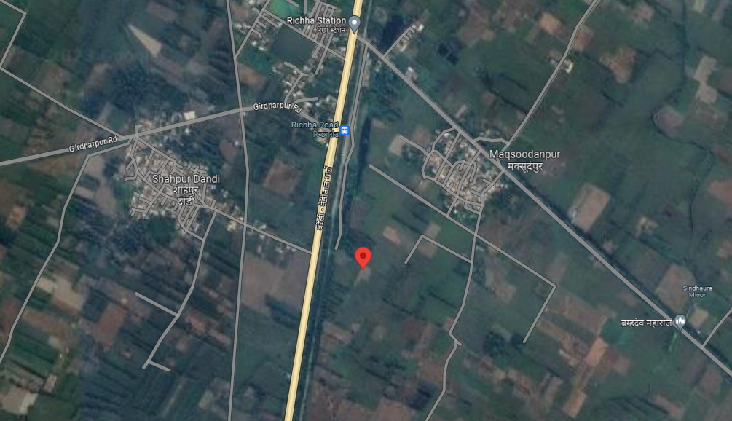

**Source: Google Map**

**Figure: Location of CBG Plant**

1. **SCOPE OF WORK DURING PROJECT DURATION:**
2. Periodic Project physical status review
3. Periodic review of expenditure of the Project.
4. **PURPOSE OF THE REPORT:** To provide fair detailed analysis report to the Bank based on the “in-scope points” mentioned above for facilitating them to know the current status of the Project.
5. **METHODOLOGY ADOPTED:**
6. Study of Project Planning documents/ reports to know about the Project.
7. Additional information, data, documents collection from the borrower.
8. Site Inspection.
9. Review and analysis of the documents and information obtained from the borrower and corroborating it with the site inspection status.
10. Information compilation, analysis and reporting.
11. Expenditure assessment of the civil works has been done as per the physical observation during site survey and by taking benchmark cost of the respective items.
12. Verification of the bills & invoices have not been done on our end.

|  |  |
| --- | --- |
| **PART C** | **PLANT INFRASTRUCTURE SECTIONS & FACILITY DETAILS WITH**  **ACTUAL PROGRESS** |

1. **LAND AND LAND DEVELOPMENT:** For the purpose of the Project**,** company has purchased2.74 hectares (equivalent to 6.8 acres) of land at Rs.1,35,51,400/- as per the sale deed provided to us. However, during the site survey and based on the information provided, additional demarcated land was observed beyond the initial document. As per demarcated boundaries total land area is admeasuring approx. 7.68 Acres.

**Table No: 4**

|  |  |  |  |  |  |
| --- | --- | --- | --- | --- | --- |
| **S. No.** | **Gata No.** | **Area in (Hectares)** | **Sale Price** | **Stamp Duty** | **Total** |
| 1 | 391 | 1.0715 | 42,38,000 | 2,20,300 | 44,58,300 |
| 2 | 161 | 0.18575 | 7,34,000 | 36,700 | 7,70,700 |
| 3 | 161 | 0.18575 | 8,82,000 | 44,100 | 9,26,100 |
| 4 | 388 | 0.225 | 19,58,000 | 98,000 | 20,56,000 |
| 5 | 391 | 1.0715 | 50,86,000 | 2,54,300 | 53,40,300 |
| **Total** |  | **2.7395** | **1,28,98,000** | **6,53,400** | **1,35,51,400** |

1. **BUILDING & CIVIL WORKS:** For setting up/ development of below listed sections and other civil works, Carbon Circle Private Limited has estimated Rs.8.74 crore as per SBI appraisal report out of total project cost amounting to Rs.39.50 Crore. Same is considered in C.A. Certificate dated 31st December 2023.

The Physical progress is considered based on observation during our visit on 31st January 2024 of the subject Plant. During the Course of our visit to the subject Project Site following observations were made:

**Table No: 5**

|  |  |  |  |
| --- | --- | --- | --- |
| **Sr. No.** | **Description** | **Previous Report Status**  **(Date of Survey – 17/10/2023)** | **Current Status/ Progress**  **(Date of Survey – 31/01/2024)** |
| 1. | Bagging Unit | * Construction progress from the foundation to the plinth level has been successfully completed, and any necessary soil filling has also been carried out. * Necessary land levelling or filling to prepare the construction site has been finished. This includes adding or removing soil to achieve the desired ground level and ensure a stable foundation for the building. | * The major civil work including P.C.C flooring and shed works have been completed. |
| 2. | Sun Drying Area | * Construction progress from the foundation to the plinth level has been successfully completed, and any necessary soil filling has also been carried out. * Necessary land levelling or filling to prepare the construction site has been finished. This includes adding or removing soil to achieve the desired ground level and ensure a stable foundation for the building. | * The footing structure work till plinth level is and P.C.C. flooring work is completed |
| 3. | Biogas Up gradation Plant | * The footing work is in progress up to the plinth level. | * The major structure works has been completed. * The soil filling work in the following structure is due. |
| 4. | Master control room and Office room | * The footing/foundation work has been completed | * Structure work (Pillar, column work) is completed up to 2nd floor. * Slab work completed up to 1st Floor. 2nd slab casting is done, de-shuttering work is to be done. * Brick work is in progress on Ground and First floor. |
| 5. | Raw water Storage | * The construction of structure work is in progress and major task of the structure has been achieved. | * Construction of structure work is completed. |
| 6. | Hot Water Treatment Plant | * The construction of the reinforced concrete (RCC) base for the hot water generator has not yet commenced. | * Major structure work along with shed work is completed, only 20-30% of shed roof covering is due. |
| 7. | Mixer | * The structure work for the mixer has been completed. * The completion of the structure work typically involves creating a secure and stable foundation for the mixer, which is essential for its proper functioning and safety, the same has been achieved by the company. | * All civil construction completed * Final finishing and testing work of the same is due. |
| 8. | Anaerobic Digester 1 & 2 | * The structure work of anaerobic digesters has been completed. * The next steps may involve installing the necessary equipment, such as gas collection and processing systems, monitoring and control systems, and safety measures to ensure the efficient and safe operation of the anaerobic digesters, which has not started yet. | * All civil construction completed. * Outer insulation work is completed. * Final finishing and testing work of the same is due. |
| 9. | Liquid Digest lagoon | * The construction of structure work is in progress. | * Same status as reported in last report. |
| 10. | Guard Rooms | * All the civil work of the structure has been completed and currently in use. | * One guard room civil work is completed as before. Finishing not achieved yet. * Other guard room civil work is completed and plaster is in progress. |
| 11. | Internal Road | * Not commented in last report | * Some RCC road & drainage work is completed. |

***Note****: The Physical progress captured in the report is based on the approximate observations of the structures found during site during site inspection.*

**The percentage completion of the civil work executed is shown in chart form below:**

1. **PLANTS/ MACHINERIES & OTHER EQUIPMENTS AND UTILITIES:** The total amount envisaged against the purchase of Plant and Machinery amounts to Rs.26.16 cr. out of which as per CA Certificate having UDIN No. 24519826BKARMT6028 expenditure incurred till 31st December 2023 is 24.50 cr.

**Brief description of the machineries involved in the plant process is shown below:**

**Table No: 6**

|  |  |  |  |  |
| --- | --- | --- | --- | --- |
| **S. No** | **Particulars** | **Supplier/Vendor** | **Previous Report Status**  **(Date of Survey – 31-10-2023)** | **Current Status/ Progress**  **(Date of Survey – 31-01-2024)** |
| **Plant & Machinery** | | | | |
|  | Digester | Planet Biogas Global Gmbh | Purchase Order raised | Rotatory fan & peddle is installed and testing is due |
|  | Biogas Up gradation Plant | Biogas Engineering India Private Limited | Purchase Order raised | Few machines have been arrived |
|  | Mixer | Planet Biogas Global Gmbh | Not ordered yet | Rotatory fan & peddle is installed and testing is due |
| **Utilities** | | | | |
|  | Compressor | **Kirloskar Pneumatic Comp.** | No information available | **Arrived on site** |
|  | Hot Water Treatment Plant | **HME Boilers Pvt Ltd.** | No information available | **Assembly of components of hot water treatment Plant is in progress. Generator is yet to come.** |
|  | Water Treatment Plant | --- | No information available | **Not to be commissioned in Phase-I** |
|  | Transformer | **Voltamp Transformers Ltd.** | No information available | **Arrived on site** |
|  | HT/LT Panels | Electro Control Systems | No information available | **Installation has been done, testing of the same is due** |
|  | Bagging Unit | --- | No information available | No information available |
|  | Weigh bridge | **Eagle Scale Manufacturing Works** | No information available | **Yet to arrive on site** |
|  | DG Set | **Sterling Generators Pvt. Ltd** | No information available | **Yet to arrive on site** |

The information for production of Compressed Bio Gas from Press mud and organic solid waste produced from sugar industry during cane juicing processing- and etc.is shown below:

1. **Press Mud**:
   * Initial Biomass Input
2. **Mixing Tank**:
   * Preparation and Mixing
3. **Digester**:
   * Anaerobic Digestion
   * Production of Raw Biogas
   * Production of Digestate (Solid Residue)
4. **Digestate Handling System**:
   * Handling and Processing of Digestate
5. **Raw Biogas Storage**:
   * Storage of the Produced Raw Biogas
6. **Biogas Upgrading Unit**:
   * Biogas Purification
   * Removal of Impurities and Carbon Dioxide
7. **Purified Biogas Compression**:
   * Compression of Purified Biogas
8. **Issuing (Pipe Grid) System**:
   * Distribution of Compressed Biogas through a Pipe Grid

**Technical details and aspect of the above plant/machineries and equipment’s is shown below:**

1. **Digester:**

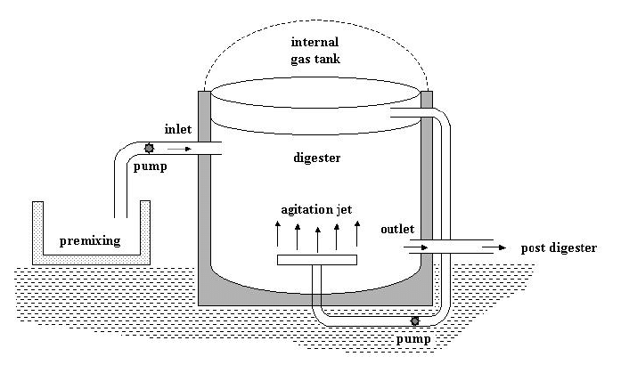

1. **Biogas Up Gradation Plant:**

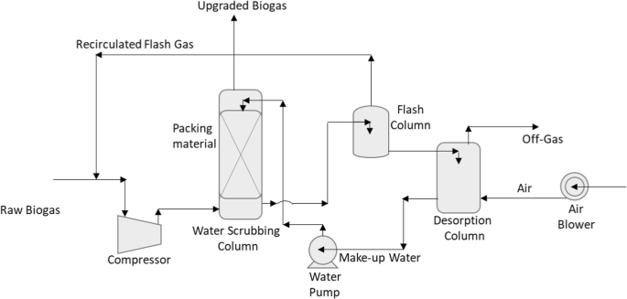

1. **Hot Water Generator:**

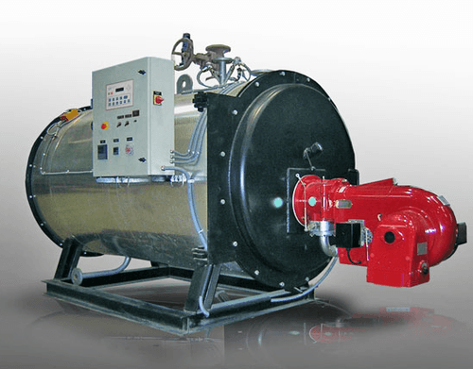

A hot water generator is integrated into the system to utilize the compressed biogas for heating purposes. The hot water generator essentially transfers the heat energy from the compressed biogas to water, producing hot water as an output.

1. **Mixer:** Mixers are employed for various purposes, starting with feedstock mixing, where they homogenize and blend diverse organic materials used as the feedstock for the anaerobic digestion process.

**Note:**

1. The total amount envisaged against the purchase of Plant, Machinery and equipment’s amounts to Rs.26.16 cr., according to the documents provided.

|  |  |
| --- | --- |
| **PART D** | **PROJECT CONSULTANTS, CONTRACTORS & SUPPLIERS** |

As of now mentioned below are the list of Contractors/ Suppliers/ Consultants which have been currently engaged in the Project.

**Table No: 7**

|  |  |
| --- | --- |
| Contractors/ Suppliers/ Consultants | Nature of Work |
| M/s Avant grade System and Controls Pvt. Ltd. (AGSCPL) | Engineering Consultants |
| M/s Makin Developers Pvt. Ltd. | Building/Civil Works |
| M/S Planet Biogas Global GMBH (PlanET) | Providing and installation of digester |
| M/S Biogas Engineering India Pvt. Ltd. (BGEI) | Biogas Up-gradation machines |
| M/S Kirloskar Pneumatic Company Limited. | Compressor |
| New Consultants added in the reported period (Oct. - Dec.23) | |
| M/S Fabking Solutions Pvt Ltd. | Portable cabin container |
| M/S Steeline Buildcon Pvt Ltd. | PEB Shed |
| M/s Flowmore Ltd. | Pumps |
| M/S Ceasefire Industries Pvt. Ltd. | Fire Fighting System |
| M/S HME Boilers Pvt Ltd. | Hot water Generator |
| M/S Tata Bluescope Steel Pvt. Ltd. / Infinite Build Foam | Cladding Sheet / Insulation Material |
| M/S Tharayali Engineering Pvt. Ltd. | Erection, Commissioning & Quality |
| M/S UPPCL | Bay at 132 KV @ Richha S/s |
| M/S Electro Control Systems | Plant Electricals |
| M/S ARC Electro Enterprises | Electric Meter ( Supply & Services) |
| M/S Eagle Scale Manufacturing Works | Weigh machine |
| M/S Gandhi Automations Pvt Ltd. | Main Gate |

Source: The above Information/Data is taken from the project progress report provided by the client.

|  |  |
| --- | --- |
| **PART E** | **PROJECT COST & MEANS OF FINANCE** |

1. **TOTAL PROJECT COST & STATUS OF EXPERNDITURE:** M/s Carbon Circle Private Limited has estimated the total Project Cost amounting to Rs.40.40 Cr. out of which Rs.39.69 Cr. has been spent till 31st December 2023 as per CA Certificate dated 31st December 2023 with UDIN No. 24519826BKARMT6028.

Tabular and chart representation of the same is shown below:

**Table No: 8**

***Amount in crores***

|  |  |  |  |  |
| --- | --- | --- | --- | --- |
| **Particulars** | **Project Cost as Budgeted**  ***(As per SBI appraisal Report)*** | **Project Cost as Budgeted**  ***(As per CA Certificate)*** | **Expenditure Incurred Till 31st December 2023**  ***(As per CA Certificate)*** | **Expenditure Incurred Till Date 31st January 2024**  ***(LIE Assessment)*** |
| Land including land developments | 1.15 | 1.15 | 1.63 | 1.35 |
| Building & Civil works | 8.74 | 8.74 | 9.67 | 9.21 |
| Plant Machinery | 26.16 | 26.16 | 24.5 | 20.46 |
| Preoperative Expenses | 1.75 | 1.75 | 3.28 | --- |
| Interest During Construction | 1.50 | 2.40 | 0.61 | --- |
| Margin Money for Working Capital | 0.20 | 0.20 | 0.00 | --- |
| **Total** | **39.50** | **40.40** | **39.69** | **31.02** |

1. **COST EXPENDITURE ANALYSIS:** A detailed comparison between the actual construction expenses and the company's reported costs, as certified by a Chartered Accountant (CA), is presented below. Alongside this, a cost assessment based on a site survey is also provided:

**Table No: 9**

|  |  |  |  |  |  |  |
| --- | --- | --- | --- | --- | --- | --- |
| **S.NO.** | **PARTICULARS** | **ESTIMATED COST *(Rs. In Cr.)*** | **AMOUNT SHOWN BY THE COMPANY *(UPTO 30.08.23)  (As Per C.A. Certificate)*** | **AMOUNT SHOWN BY THE COMPANY *(UPTO 31.12.23)  (As Per C.A. Certificate)*** | **AMOUNT INCURRED IN LAST QUARTER**  ***(DIFFERENCE OF LAST CA CERTIFICATE AND CURRENT CA CERTIFICATE)*** | **REMARKS** |
| 1 | Land including land developments | 1.15 | 1.44 | 1.63 | 0.19 | 1. Rs.1.35 crores is spent in land purchase with stamp duty (as per the value mentioned in the sale deed). 2. Balance Rs. 28 lacs company has informed to have spent in soil filling & land levelling which is reasonable since site is around 7.68 acres and mud levelling has been done on the site. 3. However no Bills/ Invoices were provided for the same to us. |
| 2 | Building and other civil works. | 8.74 | 5.26 | **9.67** | 4.41 | 1. The cost assessment for building and civil works is done in accordance with the benchmark or market cost, as per the percentage of work completed. For detailed calculation please refer to Table No. 10 below. 2. Material/ Inventory lying at site is not considered in this cost. 3. Any advances paid to the parties for which work is not done is not captured which may have been included in the CA Certificate and this is why some difference may come between our assessment and CA certificate. 4. Bills/ Invoices shown of Makin Developers Pvt Ltd. who is civil contractor is Rs.10.15 cr and Steeline Buildcon Pvt Ltd. who is PEB shed contractor is Rs.2.04 cr is amounting to Rs.12.19 cr as shown to us mentioned in Table No. 11 below. Makin Developers is also providing some P&M items also as viewed from the Invoice so entire amount of Makin can’t be attributed to civil works. |
| 3 | Plant, Machinery and equipment. | 26.16 | 12.54 | 24.5 | 11.96 | 1. In last quarter as per survey done on 17-10-2023 no machine was arrived but in this quarter as on date of survey on 31-01-2024 significant machine installation work is done as shown in Table No. 6. 2. Due to confidentiality company has not shared with us P&M Invoices. On their request our team went to their office to check the Invoices/ Bills. Company has shown Invoices/ Bills of several parties which tabulated in the Table No. 12 & 13 below amounting of Rs.20.46 crores.   However copies of the same was not made available to us. If copies of the Bills/ Invoices are made available to the Bank, then Bank is advised to tally it from the Table 12 & 13 below to cross verify its correctness. |
| 4 | Pre-operative Expenses | 1.75 | 2.86 | 3.28 | 0.42 | Since breakup was not available therefore we were unable to verify its cost as of now and thus have not commented on this item. |
| 5 | Interest During Construction | 2.4 | 0.06 | 0.61 | 0.55 | Can be referred directly from CA certificate as out of Engineering purview. Not in scope of LIE. |
| 6 | Margin Money for Working Capital | 0.2 | 0 | 0 | 0 | Can be referred directly from CA certificate as out of Engineering purview. Not in scope of LIE. |

**Table No: 10**

|  |  |  |  |  |  |  |
| --- | --- | --- | --- | --- | --- | --- |
| ***Building and other civil work Assessment*** | | | | | | |
| **SR.**  **NO.** | **Particular** | **Type of Structure** | **Unit** | **Area/Qty** | **Rate** | **Amount**  **(Rs. In Cr)** |
|  | Bagging Unit | G.I. Shed | Sq. Ft | 8,611 | 1,000 | 86,11,120 |
| 1. 2 | Sun Drying Unit | Concrete Platform | Sq. Ft | 10,463 | 550 | 57,54,381 |
| 1. 3 | Biogas Upgradation Plant | G.I. Shed | Sq. Ft | 13,950 | 1,000 | 1,39,50,014 |
| 1. 4 | Master Control Room and Office Room | R.C.C. Structure | Sq. Ft | 11,044 | 950 | 1,04,91,573 |
| 1. 5 | Raw Water | R.C.C. Structure | Sq. Ft | 5,038 | 1,000 | 50,37,505 |
| 1. 6 | Hot Water Treatment Plant | G.I Shed | Sq. Ft | 5,038 | 875 | 44,07,817 |
| 1. 7 | Mixer | R.C.C. Structure | Cum | 160 | 9,500 | 15,20,000 |
| 1. 8 | Digester 1 | R.C.C. Structure | Cum | 850 | 9,600 | 81,60,000 |
| 1. 9 | Digester 2 | R.C.C. Structure | Cum | 850 | 9,600 | 81,60,000 |
| 1. 10 | Lagoon | R.C.C. Structure | Sq. Ft | 7,976 | 900 | 71,78,445 |
| 1. 11 | Guard Room 1 | R.C.C. Structure | Sq. Ft | 180 | 1,250 | 2,25,000 |
| 1. 12 | Guard Room 2 | R.C.C. Structure | Sq. Ft | 180 | 1,000 | 1,80,000 |
| 1. 13 | Boundary Wall | Pre Cast | Sq. Ft | 21,643 | 140 | 30,30,046 |
| 1. 14 | Column for support of fire pipe | R.C.C. Structure | Cum | 33 | 10,357 | 3,42,907 |
| Steel | Kg | 2,599 | 89 | 2,31,314 |
| 1. 15 | Road | R.C.C. Road | Cum | 759 | 10,357 | 78,60,963 |
| 1. 16 | Drain | Brick Work and plaster | R.M. | 550 | 3,000 | 16,50,000 |
| 1. 17 | Extra Work  (Site development and other miscellaneous works) | --- | --- | --- | --- | 53,11,000 |
| **TOTAL** | | | | | | **9,21,02,087** |

**Table No: 11**

**INVOICES/ BILLS SEEN IN OFFICE FOR CIVIL WORKS**

|  |  |  |  |  |  |  |
| --- | --- | --- | --- | --- | --- | --- |
| **Name of the Package** | **Name of the Vendor – PO awarded** | **Total Contract Value (Rs. In Lacs)** | **Remarks** | **% allocation in Phase-1** | **Phase-1 Amount** | **Bills/ Invoices Seen (Rs. In cr)** |
| **Civil Works Contractor** | Makin Developers Pvt Ltd. | 1,221.06 | --- | 100% | 1221.06 | 10.15 |
| **PEB shed** | Steeline Buildcon Pvt Ltd. | 204.41 | (for ultimate capacity of 10 TPD) | 50% | 102.205 | 2.04 |
| **TOTAL** |  | **1,425.47** |  |  | **1323.265** | **12.19** |

*\*Copies of Bills/ Invoices not provided*

**Table No: 12**

**INVOICES BILLS SEEN IN OFFICE FOR PLANT & MACHINERY**

|  |  |  |  |  |  |  |
| --- | --- | --- | --- | --- | --- | --- |
| **Name of the Package** | **Name of the Vendor – PO awarded** | **Total Contract Value (Rs. In Lacs)** | **Remarks** | **% allocation in Phase-1** | **Phase-1 Amount** | **Bills/ Invoices Seen (Rs. In cr)** |
| **Digester vendor** | PlanET(incl. Customs duty + CHA charges) | 1,547.75 | --- | 100% | 1547.75 | 10.735 |
| **Biogas Upgradation Plant (BUP) Vendor** | Biogas Engineering India Pvt Ltd. | 929.95 | (for ultimate capacity of 10 TPD) | 50% | 464.975 | 7.83 |
| **Product Gas Compressor Supplier** | Kirloskar Pneumatic Company Limited | 113 | (for ultimate capacity of 10 TPD) | 50% | 56.5 | -- |
| **Portable Cabin Container Supplier** | Fabking Solutions Pvt Ltd. | 5.47 | --- | 100% | 5.47 | -- |
| **Bay at 132 KV @ Richha S/s** | UPPCl | 45.45 | (for ultimate capacity of 10 TPD) | 50% | 22.725 | -- |
| **Cladding Sheet/ Insulation Material** | Tata Bluescope Steel Pvt Ltd. / Infinite Build Foam | 73.9 | --- | 100% | 73.9 | -- |
| **Air Compressor** | Kirloskar Pneumatic Company Limited | 12.39 | --- | 100% | 12.39 | -- |
| **Pumps** | Flowmore Ltd. | 9.2 | --- | 100% | 9.2 | -- |
| **Plant Electricals** | Electro control Systems | 421.2 | (for ultimate capacity of 10 TPD) | 50% | 210.6 | 1.89 |
| **Fire Fighting System** | Ceasefire Industries Pvt Ltd. | 123.34 | (for ultimate capacity of 10 TPD) | 50% | 61.67 | -- |
| **Hot Water Generator** | HME Boilers Pvt Ltd. | 56.67 | (for ultimate capacity of 10 TPD) | 50% | 28.335 | -- |
| **Erection, Commissioning & Quality** | Tharayil Engineering Pvt Ltd. | 60.31 | (for ultimate capacity of 10 TPD) | 50% | 30.155 | -- |
| **Electric Meter (Supply & Services)** | ARC Electro Enterprises | 22.86 | (for ultimate capacity of 10 TPD) | 50% | 11.43 | -- |
| **Weigh Machine** | Eagle Scale Manufacturing Works | 14.16 | (for ultimate capacity of 10 TPD) | 50% | 7.08 | -- |
| **Main Gate** | Gandhi Automation Pvt Ltd. | 7.08 | (for ultimate capacity of 10 TPD) | 50% | 3.54 | -- |
| **Odorising, Metering & Pipeline** | Yet to be awarded | --- | (for ultimate capacity of 10 TPD) | 50% | -- | -- |
| **Bagging Unit** | Yet to be awarded | --- | (for ultimate capacity of 10 TPD) | 50% | -- | -- |
| **SCADA** | Yet to be awarded | --- | (for ultimate capacity of 10 TPD) | 50% | -- | -- |
| **Lab** | Yet to be awarded | --- | (for ultimate capacity of 10 TPD) | 50% | -- | -- |
| **TOTAL** |  | **3,442.73** |  |  | **2545.72** | **20.46** |

*\*Copies of Bills/ Invoices not provided*

**Table No: 13**

**WORK WISE SUMMARY OF INVOICES BILLS SEEN IN OFFICE FOR PLANT & MACHINERY**

|  |  |  |
| --- | --- | --- |
| **PLANT & MACHINERY** | | |
| **Particulars** | **Vendor** | **Expenditure verified through bills**  **(In Rs. In Cr.)** |
| Digester | PlanET | 10.74 |
| BUP | BGEI | 7.84 |
| Plant Electricals | Electro Control Systems | 1.89 |
| **TOTAL** | | **Rs. 20.46** |

**Comment/Note:**

1. We have given a general overview of the project based on expenses shown by chartered accountant in their CA certificate as per CA Certificate dated 31st December 2023 with UDIN No. 24519826BKARMT6028 based on the data/ information gathered from client and the observation made during the site survey.
2. Civil work cost expenditure assessment is done considering market rates and rates prescribed by CPWD based on the progress seen during the site visit.
3. In Civil works cost assessment, area/ quantity is supplied by the company.
4. The rates are adopted as per the percentage completion of work.
5. Bills/ Invoices of civil works has not been verified at our end.
6. The copy of invoices/P.O were not provided to us for our records, however some of the invoices/ bills were shown to us at the Carbon Circle head office.
7. 5%-10% variance in measurement should be considered.
8. **SOURCES OF FINANCE & UTILIZATION OF FUNDS:**

The Project cost mentioned above has been planned to be covered from following resources:

**Table No: 14**

|  |  |
| --- | --- |
| (Amount in Rs. Crore) | |
| PARTICULARS |  |
| Promoter’s Contribution in the form of share capital | 10.00 |
| Promoter’s Contribution in the form of interest free unsecured loan | 6.40 |
| Term Loan (Debt) | 24.00 |
| TOTAL | **40.40** |

***Source:*** *As per CA Certificate*

|  |  |
| --- | --- |
| **PART F** | **STATUTORY & REGULATORY APPROVALS, CLEARANCES & NOC** |

**Table No: 15**

|  |  |  |  |  |
| --- | --- | --- | --- | --- |
| Sr. No. | NAME OF LICENSE/ REGISTRATION | PURPOSE | DATE OF ISSUE | CURRENT STATUS |
| **ISSUING AUTHORITY** | **LICENCE NO.** |
|  | Change of Land Use Certificate (CLU) | Change in land use | 29/03/2023 | Obtained  (for 2.74 hectare of Land) |
|  | Building Plan Approval | Approval of building plans | --- | To be obtained |
| 1. 2. | Pollution Certificate | Consent to establish new unit | 02/01/2023 | NOC is obtained by the Company from the competent Authority. |
| Uttar Pradesh Pollution Control Board | 173061/UPPCB |
|  | Electricity Connection | --- | --- | Obtained |
|  | Fire NOC | --- | --- | To be obtained |
| 1. 3. | Application for prior approval of only filling of compressed gas cylinders | Application for the grant to fill compressed gases in cylinders | 16/01/2023 | Obtained |
| PESO | OIN1283802 |
| *Observations & Comments:*  *Above mentioned are the preliminary approvals which are required for the Project. The status mentioned above is as per the documents provided by the client.* | | | | |

|  |  |
| --- | --- |
| **PART G** | **PROJECT SCHEDULE & CURRENT STATUS** |

The timeline and scheduling for the implementation of the "Bio Mass to CBG Plant" is to complete within twelve months from the date of ordering the main packages, specifically the Anaerobic Reactor package and Bio Gas purification package, which are long lead items for the project.

The target was to commission the project and start commercial production by 1st November 2023.

**Table No: 16**

|  |  |  |  |
| --- | --- | --- | --- |
| **AS PER CONSULTANCY SERVICES CELL, LHO NEW DELHI** | | | |
| **Activity** | **Commencement** | **Expected date of completion** | **Current Status** |
| Land Purchased | --- | Purchased | Completed |
| Civil Construction | April 2023 | Sep 2023 | Work in progress. Likely to be completed by March-April 2024 as per present progress. |
| Plant & Machinery | August 2023 | Apr 2024 | Major have arrived but few machines yet to arrive. |
| Trial Run | --- | May 2024 | To be done |
| Commercial Operation | --- | June 2024 | To be done |

**Current Status:**

* During the recent site visit, it was observed that the project's progress is at a good pace as compared to the last site visit.
* Major civil works has been completed or are in the last stage.
* Few machines were found to be arrived but most of the machines are yet to be arrived.
* Further, the company is proactively planning and implementing measures to get the project back on track and aiming to start the commissioning and COD (Commercial Operation Date) by March-April 2024 as informed by the representative on site.

|  |  |
| --- | --- |
| **PART I** | **DISCLAIMER** |

* + - 1. No employee or member of R.K Associates has any direct/ indirect interest in the Project.
      2. This report is prepared based on the copies of the documents/ information which the Bank/ Borrower has provided to us out of the standard checklist of documents sought from them and further based on our assumptions and limiting conditions. The client/owner and its management/representatives warranted to us that the information they supplied was complete, accurate and true and correct to the best of their knowledge. All such information provided to us has been relied upon in good faith and we have assumed that it is true and correct in all respect. I/We shall not be liable for any loss, damages, cost or expenses arising from fraudulent acts, misrepresentations, or wilful default on part of the owner, borrower, its directors, employee, representative or agents. Verification or cross checking of the documents provided to us from the originals or from any Govt. departments/ Record of Registrar has not been done at our end since this is beyond the scope of our work. If at any time in future, it is found or came to our knowledge that misrepresentation of facts or incomplete or distorted information has been provided to us then this report shall automatically become null & void.
      3. Legal aspects for eg. investigation of title, ownership rights, lien, charge, mortgage, lease, sanctioned maps, verification of documents, etc. have not been done at our end and same has to be taken care by legal expert/ Advocate. It is assumed that the concerned Lender/ Financial Institution has satisfied them with the authenticity of the documents, information given to us and for which the legal verification has been already taken and cleared by the competent Advocate before requesting for this report. I/ We assume no responsibility for the legal matters including, but not limited to, legal or title concerns.
      4. This report is a general analysis of the project based on the scope mentioned in the report. This is not an Audit report, Design document, DPR or Techno feasibility study. All the information gathered is based on the facts seen on the site during survey, verbal discussion & documentary evidence provided by the client and is believed that information given by the borrower is true best of their knowledge.
      5. All observations mentioned in the report is only based on the visual observation and the documents/ data/ information provided by the client. No mechanical/ technical tests, measurements or any design review have been performed or carried out from our side during Project assessment.
      6. Bank/FII should ONLY take this report as an Advisory document from the Financial/ Chartered Engineering firm and its specifically advised to the creditor to cross verify the original documents for the facts mentioned in the report which can be availed from the borrowing borrower directly.
      7. In case of any default in loans or the credit facility extended to the borrowing borrower, R.K Associates shall not be held responsible for whatsoever reason may be and any request for seeking any explanation from the employee/s of R.K Associates will not be entertained at any instance or situation.
      8. The documents, information, data provided to us during the course of this assessment by the client is reviewed only up to the extent required in relation to the scope of the work. No document has been reviewed beyond the scope of the work.
      9. This report only contains general assessment & opinion as per the scope of work evaluated as per the information given in the copy of documents, information, data provided to us and/ and confirmed by the owner/ owner representative to us at site which has been relied upon in good faith. It doesn’t contain any other recommendations of any sort including but not limited to express of any opinion on the suitability or otherwise of entering into any transaction with the borrower.
      10. We have relied on data from third party, external sources & information available on public domain also to conclude this report. These sources are believed to be reliable and therefore, we assume no liability for the truth or accuracy of any data, opinions or estimates furnished by others that have been used in this analysis. Where we have relied on data, opinions or estimates from external sources, reasonable care has been taken to ensure that such data has been correctly extracted from those sources and /or reproduced in its proper form and context, however still we can’t vouch its authenticity, correctness or accuracy.
      11. This Report is prepared by our competent technical team which includes Engineers and financial experts & analysts.
      12. This is just an opinion report and doesn’t hold any binding on anyone. It is requested from the concerned Financial Institution which is using this report for taking financial decision on the project that they should consider all the different associated relevant & related factors also before taking any business decision based on the content of this report.
      13. All Pages of the report including annexures are signed and stamped from our office. In case any paper in the report is without stamp & signature then this should not be considered a valid paper issued from this office.
      14. Though adequate care has been taken while preparing this report as per its scope, but still we can’t rule out typing, human errors, over sightedness of any information or any other mistakes. Therefore, the concerned organization is advised to satisfy themselves that the report is complete & satisfactory in all respect. Intimation regarding any discrepancy shall be brought into our notice immediately. If no intimation is received within 15 (Fifteen) days in writing from the date of issuance of the report, to rectify these timely, then it shall be considered that the report is complete in all respect and has been accepted by the client upto their satisfaction & use and further to which R.K Associates shall not be held responsible in any manner.
      15. Defect Liability Period is **15 DAYS**. We request the concerned authorized reader of this report to check the contents, data and calculations in the report within this period and intimate us in writing if any corrections are required or in case of any other concern with the contents or opinion mentioned in the report. Corrections only related to typographical, calculation, spelling mistakes, incorrect data/ figures/ statement will be entertained within the defect liability period. Any new changes for any additional information in already approved report will be regarded as additional work for which additional fees may be charged. No request for any illegitimate change in regard to any facts & figures will be entertained.
      16. R.K Associates encourages its customers to give feedback or inform concerns over its services through proper channel at valuers@rkassociates.org in writing within 15 days of report delivery. After this period no concern/ complaint/ proceedings in connection with the Financial Feasibility Study Services will be entertained due to possible change in situation and condition of the subject Project.
      17. Our Data retention policy is of **ONE YEAR**. After this period, we remove all the concerned records related to the assignment from our repository. No clarification or query can be answered after this period due to unavailability of the data.
      18. This Lender’s Independent Engineer report is governed by our (1) Internal Policies, Processes & Standard Operating Procedures, (2) Information/ Data/ Inputs given to us by the client and (3) Information/ Data/ Facts given to us by our field/ office technical team. Management of R.K Associates never gives acceptance to any unethical or unprofessional practice which may affect fair, correct & impartial assessment and which is against any prevailing law. In case of any indication of any negligence, default, incorrect, misleading, misrepresentation or distortion of facts in the report then it is the responsibility of the user of this report to immediately or at least within the defect liability period bring all such act into notice of R.K Associates management so that corrective measures can be taken instantly.
      19. R.K Associates never releases any report doing alterations or modifications from pen. In case any information/ figure of this report is found altered with pen then this report will automatically become null & void.

|  |  |  |  |
| --- | --- | --- | --- |
| **SURVEY ANALYST** | **ENGINEERING ANALYST** | **L1 REVIEWER** | **L2 REVIEWER** |
| Vishal Singh & Ashil Baby | Deepak Kumar Singh | Vishal Singh | Sr. V.P. Projects |
|  |  |  |  |

**For**

**R.K. Associates Valuers and Techno Engineering Consultants Pvt. Ltd**

**Place: Noida**

**Date: 12th February 2024**

***DEFECT LIABILITY PERIOD - In case of any query/ issue or escalation you may please contact Incident Manager by writing at valuers@rkassociates.org. We ensure 100% accuracy in the Calculations done, Rates adopted and various other data points & information mentioned in the report but still can’t rule out typing, human errors or any other mistakes. In case you find any mistake, variation, discrepancy or inaccuracy in any data point of the report, please help us by bringing all such points into our notice in writing at valuers@rkassociates.org within 30 days of the report delivery, to get these rectified timely, failing which R.K Associates Valuers Techno Engineering Consultants (P) Ltd. won’t be held responsible for any inaccuracy in any manner. Also, if we will not hear back anything from you within 30 days, we will assume that report is correct in all respect and no further claim of any sort will be entertained thereafter. We would welcome and appreciate your feedback & suggestions in order to improve our services.***

***COPYRIGHT FORMAT - This report is prepared on the copyright format of R.K Associates Valuers Techno Engineering Consultants (P) Ltd. to serve our clients in the best possible way. Legally no one can copy or distribute this format without prior approval from R.K Associates. It is meant only for the organization as mentioned on the cover page of this report. Distribution or use of this format other than R.K Associates will be seen as unlawful act and necessary legal action can be taken against the defaulter***

**ENCLOSURE 1: IMPORTANT DOCUMENTS EXHIBIT**

**DOCUMENT-1: CA CERTIFICATE DATED 31/12/2024**

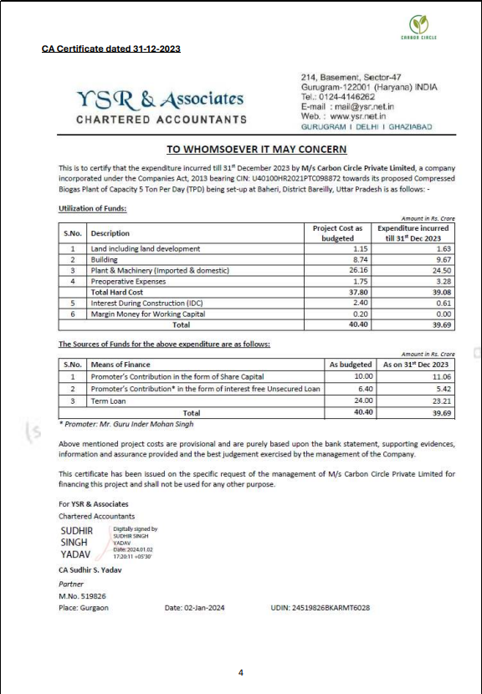

**DOCUMENT- 2: APPROVAL OF FILLING OF COMPRESSED GAS CYLINDERS**

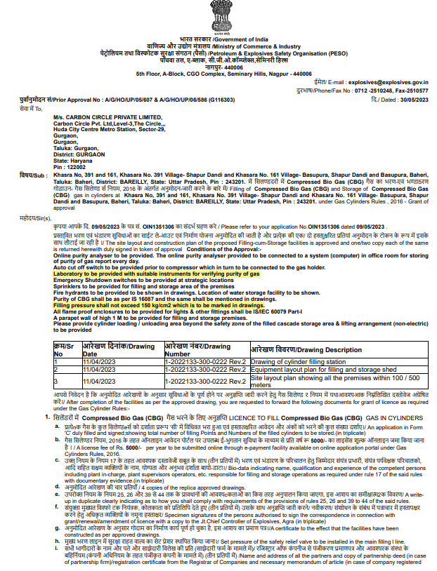

**DOCUMENT-3: POLLUTION CERTIFICATE**

**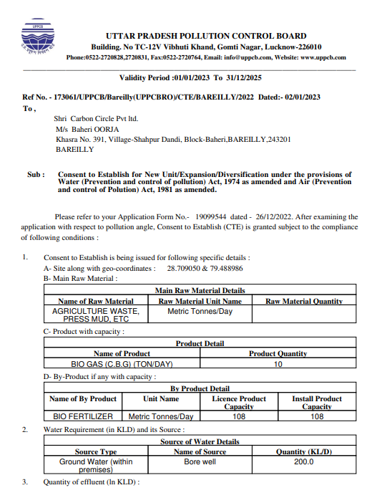**

**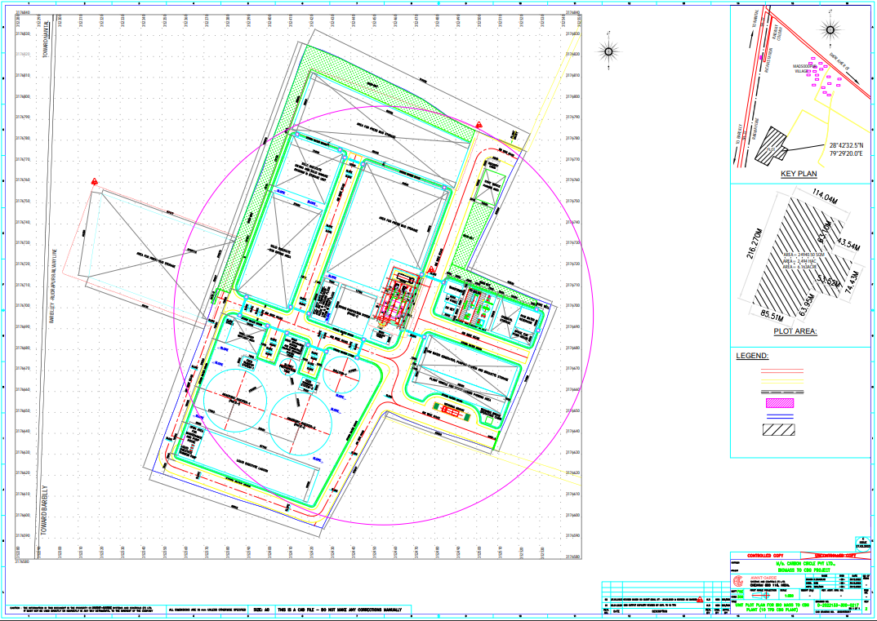DOCUMENT 4: SITE PLAN**

**DOCUMENT 5: CHANGE IN LAND USE**

|  |
| --- |
|  |
|  |

**DOCUMENT 5: ELECTIRCAL CONNECTION CERTIFICATE**

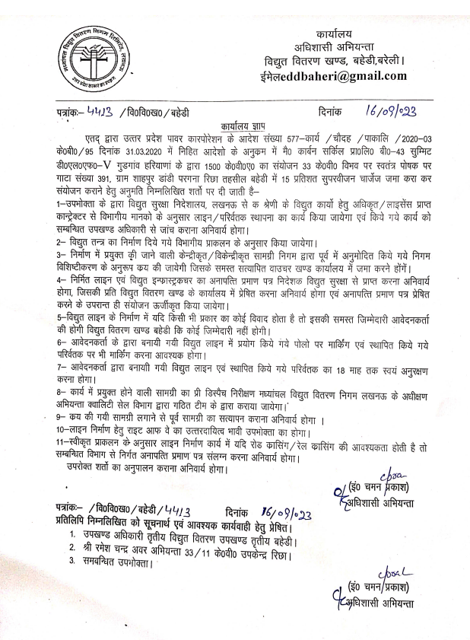

**ENCLOSURE-2: - SITE PHOTOGRAPHS** 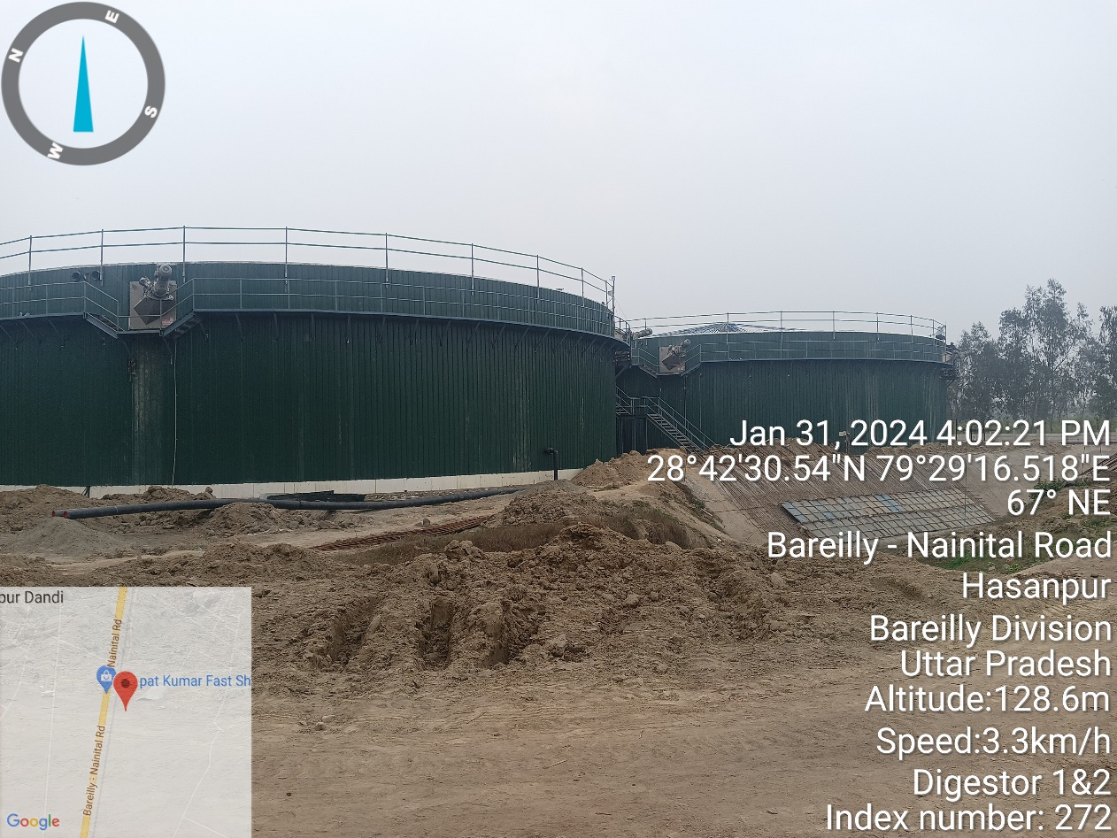

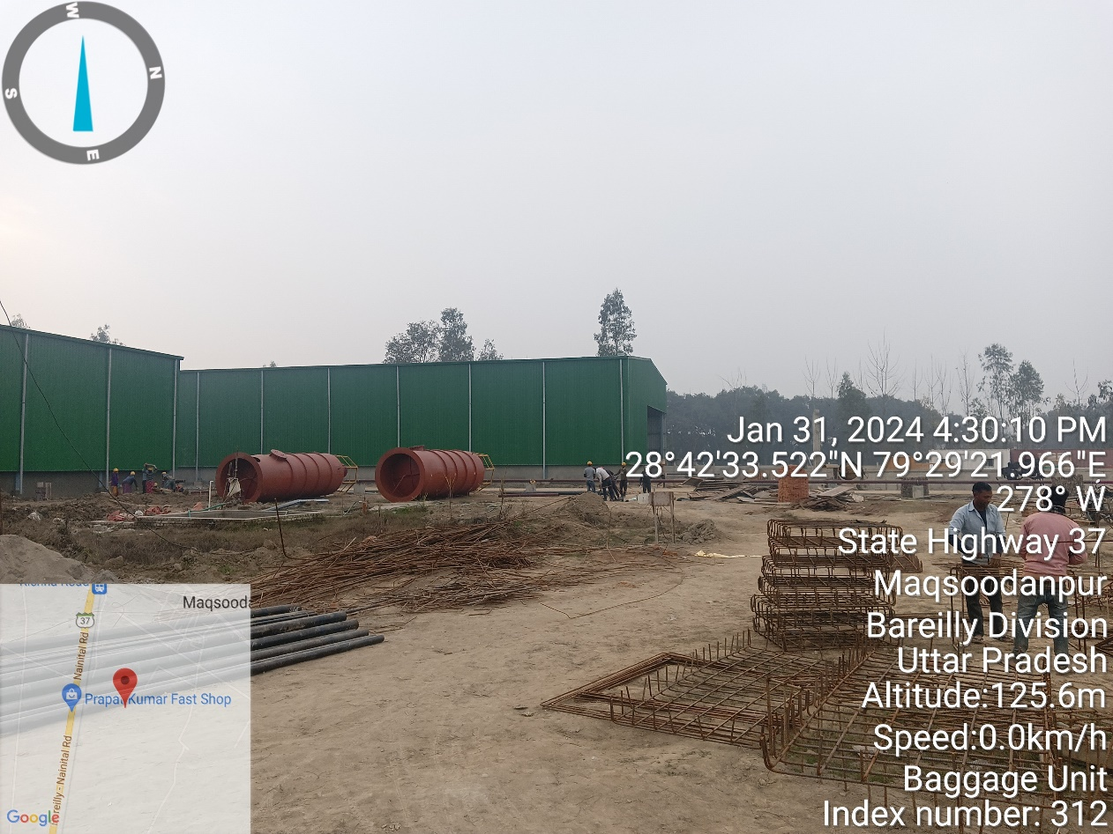

|  |  |
| --- | --- |
|  |  |

**Digester**

|  |  |
| --- | --- |
| **Z:\In Progress Files\Deepak Singh\July to Dec 2023\VIS(2023-24)-PL358-289-457 Carbon Circle\uploads\VIS(2023-24)-PL358-289-457\SiteImage\2023-10-18\TimePhoto_20231017_134313.jpg** | Z:\In Progress Files\Deepak Singh\January-Feb 2024\VIS(2023-24)-PL645-548-865 Carbon Circle\uploads\VIS(2023-24)-PL645-548-865\SiteImage\Carbon_Circle_-20240205T065448Z-001\Carbon Circle\TimePhoto_20240131_155715.jpg |

**Lagoon**

|  |  |
| --- | --- |
| **Z:\In Progress Files\Deepak Singh\July to Dec 2023\VIS(2023-24)-PL358-289-457 Carbon Circle\uploads\VIS(2023-24)-PL358-289-457\SiteImage\2023-10-18\TimePhoto_20231017_132702.jpg** | **Z:\In Progress Files\Deepak Singh\January-Feb 2024\VIS(2023-24)-PL645-548-865 Carbon Circle\uploads\VIS(2023-24)-PL645-548-865\SiteImage\Carbon_Circle_-20240205T065448Z-001\Carbon Circle\TimePhoto_20240131_160027.jpg** |

**Biogas Up gradation Plant**

|  |  |
| --- | --- |
| Z:\In Progress Files\Deepak Singh\July to Dec 2023\VIS(2023-24)-PL358-289-457 Carbon Circle\uploads\VIS(2023-24)-PL358-289-457\SiteImage\2023-10-18\TimePhoto_20231017_134229.jpg | Z:\In Progress Files\Deepak Singh\January-Feb 2024\VIS(2023-24)-PL645-548-865 Carbon Circle\uploads\VIS(2023-24)-PL645-548-865\SiteImage\Carbon_Circle_-20240205T065448Z-001\Carbon Circle\TimePhoto_20240131_161421.jpg |

**Master Control Room & Office Room**

|  |  |
| --- | --- |
| **Z:\In Progress Files\Deepak Singh\July to Dec 2023\VIS(2023-24)-PL358-289-457 Carbon Circle\uploads\VIS(2023-24)-PL358-289-457\SiteImage\2023-10-18\TimePhoto_20231017_134340.jpg** | **Z:\In Progress Files\Deepak Singh\January-Feb 2024\VIS(2023-24)-PL645-548-865 Carbon Circle\uploads\VIS(2023-24)-PL645-548-865\SiteImage\Carbon_Circle_-20240205T065448Z-001\Carbon Circle\TimePhoto_20240131_162050.jpg** |

**Machines**

|  |  |
| --- | --- |
| **Z:\In Progress Files\Deepak Singh\January-Feb 2024\VIS(2023-24)-PL645-548-865 Carbon Circle\uploads\VIS(2023-24)-PL645-548-865\SiteImage\Carbon_Circle_-20240205T065448Z-001\Carbon Circle\TimePhoto_20240131_162259.jpg** | **Z:\In Progress Files\Deepak Singh\January-Feb 2024\VIS(2023-24)-PL645-548-865 Carbon Circle\uploads\VIS(2023-24)-PL645-548-865\SiteImage\Carbon_Circle_-20240205T065448Z-001\Carbon Circle\TimePhoto_20240131_162840.jpg** |
| **Z:\In Progress Files\Deepak Singh\January-Feb 2024\VIS(2023-24)-PL645-548-865 Carbon Circle\uploads\VIS(2023-24)-PL645-548-865\SiteImage\Carbon_Circle_-20240205T065448Z-001\Carbon Circle\TimePhoto_20240131_162912.jpg** | **Z:\In Progress Files\Deepak Singh\January-Feb 2024\VIS(2023-24)-PL645-548-865 Carbon Circle\uploads\VIS(2023-24)-PL645-548-865\SiteImage\Carbon_Circle_-20240205T065448Z-001\Carbon Circle\TimePhoto_20240131_162658.jpg** |
| **Z:\In Progress Files\Deepak Singh\January-Feb 2024\VIS(2023-24)-PL645-548-865 Carbon Circle\uploads\VIS(2023-24)-PL645-548-865\SiteImage\Carbon_Circle_-20240205T065448Z-001\Carbon Circle\TimePhoto_20240131_161647.jpg** | **Z:\In Progress Files\Deepak Singh\January-Feb 2024\VIS(2023-24)-PL645-548-865 Carbon Circle\uploads\VIS(2023-24)-PL645-548-865\SiteImage\Carbon_Circle_-20240205T065448Z-001\Carbon Circle\TimePhoto_20240131_161543.jpg** |

**Baggage Unit & Sun Drying Area**

|  |  |
| --- | --- |
| **Z:\In Progress Files\Deepak Singh\July to Dec 2023\VIS(2023-24)-PL358-289-457 Carbon Circle\uploads\VIS(2023-24)-PL358-289-457\SiteImage\2023-10-18\TimePhoto_20231017_131355.jpg** | **Z:\In Progress Files\Deepak Singh\January-Mar 2024\VIS(2023-24)-PL645-548-865 Carbon Circle\2nd LIE December Ending\SiteImage\TimePhoto_20240131_163010.jpg** |

**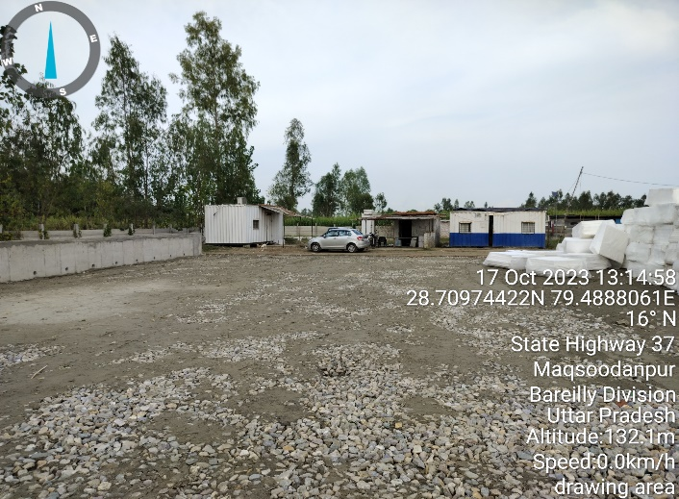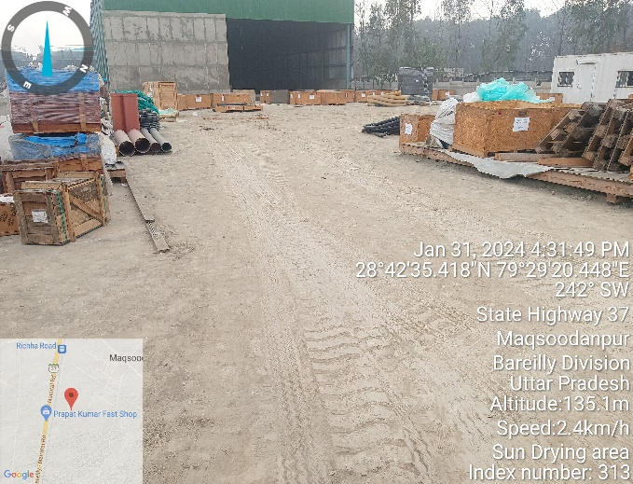**

**Hot water Treatment Plant**

|  |  |
| --- | --- |
| **Z:\In Progress Files\Deepak Singh\July to Dec 2023\VIS(2023-24)-PL358-289-457 Carbon Circle\uploads\VIS(2023-24)-PL358-289-457\SiteImage\2023-10-18\TimePhoto_20231017_133243.jpg** | **Z:\In Progress Files\Deepak Singh\January-Feb 2024\VIS(2023-24)-PL645-548-865 Carbon Circle\uploads\VIS(2023-24)-PL645-548-865\SiteImage\Carbon_Circle_-20240205T065448Z-001\Carbon Circle\TimePhoto_20240131_162154.jpg** |

**Mixer**

|  |  |
| --- | --- |
| **Z:\In Progress Files\Deepak Singh\July to Dec 2023\VIS(2023-24)-PL358-289-457 Carbon Circle\uploads\VIS(2023-24)-PL358-289-457\SiteImage\2023-10-18\TimePhoto_20231017_132003.jpg** | **Z:\In Progress Files\Deepak Singh\January-Feb 2024\VIS(2023-24)-PL645-548-865 Carbon Circle\uploads\VIS(2023-24)-PL645-548-865\SiteImage\Carbon_Circle_-20240205T065448Z-001\Carbon Circle\TimePhoto_20240131_161444.jpg** |

**Other**

|  |  |
| --- | --- |
| **Z:\In Progress Files\Deepak Singh\July to Dec 2023\VIS(2023-24)-PL358-289-457 Carbon Circle\uploads\VIS(2023-24)-PL358-289-457\SiteImage\2023-10-18\TimePhoto_20231017_134523.jpg** | **Z:\In Progress Files\Deepak Singh\January-Feb 2024\VIS(2023-24)-PL645-548-865 Carbon Circle\uploads\VIS(2023-24)-PL645-548-865\SiteImage\Carbon_Circle_-20240205T065448Z-001\Carbon Circle\TimePhoto_20240131_174926.jpg** |