**File No.: VIS (2023-24)-PL668-571-891 Dated: 15.02.2024**

**LENDER’S INDEPENDENT ENGINEER REPORT (1st)**

**(FOR QUARTER ENDING DECEMBER 2023)**

**OF**

**HERITAGE HOSPITALS**

**SITUATED AT**

**PLOT NO. NH-1A, SECTOR 119, NOIDA,**

**GAUTAM BUDH NAGAR, UTTAR PRADESH-201306**

**IMPLEMENTED BY**

**M/S HERITAGE HOSPITALS LIMITED (HHL)**

**REPORT PREPARED FOR**

**BANK OF BARODA, LANKA BRANCH, VARANASI.**

***\*\*Important - In case of any query/ issue or escalation you may please contact Incident Manager at le@rkassociates.org. We will appreciate your feedback in order to improve our services.***

***NOTE: As per IBA Guidelines please provide your feedback on the report within 15 days of its submission after which report will be considered to be correct.***

|  |  |  |
| --- | --- | --- |
| **TABLE OF CONTENTS** | | |
| **SR. NO.** | **DESCRIPTION** | **PAGE NO.** |
| **PART A** | **Report Summary** | **03** |
| **PART B** | **Introduction** | **05** |
|  | 1. The Project | **05** |
|  | 1. About the Borrower | **05** |
|  | 1. Location of the Project | **06** |
|  | 1. Project Overview | **07** |
|  | 1. Scope of the Project During Project Duration | **08** |
|  | 1. Purpose of the Report | **08** |
|  | 1. Methodology Adopted | **08** |
| **PART C** | **Infrastructure Sections & Facility Details with Actual Progress** | **09** |
|  | 1. Land & Building Details | **09** |
|  | 1. Facility Details | **10** |
|  | 1. Renovation And Civil Works | **11** |
|  | 1. Machinery and Equipment | **12** |
| **PART D** | **Project Consultants, Contractors & Suppliers** | **15** |
| **PART E** | **Project Cost and Means of Finance** | **16** |
|  | 1. Cost of Project | **16** |
|  | 1. Current Status and Total Expenditure Incurred Till Date | **17** |
|  | 1. Sources of Finance & Utilization of Funds | **18** |
| **PART F** | **Statutory & Regulatory Approvals, Clearances & NOC** | **19** |
| **PART G** | **Project Schedule & Current Status** | **21** |
| **PART H** | **Disclaimer** | **22** |
| **PART I** | **Enclosure** | **26** |
| **PART I** | **Photographs** | **31-38** |

# 

**IMPORTANT NOTICE**

***COPYRIGHT FORMAT:*** *This report is prepared on the copyright format of R.K Associates, to serve our clients with the best available information and analysis to facilitate them to take rational business decisions. Legally no one can copy or distribute this format without prior approval from R.K Associates. It is meant only for the advisory/ reference purpose for the organization/s as mentioned on the cover page of this report. Distribution or use of this format by any organization or individual other than R.K Associates will be seen as unlawful act and necessary legal action can be taken against the defaulters.*

*This report is intended for the sole use of the intended recipient/s and contain material that is STRICTLY CONFIDENTIAL AND PRIVATE.*

***DEFECT LIABILITY PERIOD:*** *- In case of any query/ issue or escalation you may please contact Incident Manager: le@rkassociates.org. We try our level best to ensure correctness in the calculations done, rates adopted and various other data points & information mentioned in the report but still can’t rule out typing, human errors or any other mistakes. In case you find any such mistake or inaccuracy in any data point of the report please help us by bringing all such points into our notice immediately or within 15 days of the report delivery in writing, to rectify these timely failing after which R.K Associates won’t be held responsible for any such inaccuracy in any manner. We would highly appreciate your feedback in order to improve our services.*

|  |  |
| --- | --- |
| **PART A** | **REPORT SUMMARY** |

|  |  |  |
| --- | --- | --- |
| **1.** | **Name of Project:** | To carry out renovation and customization works in a previously non-functioning 100-bed Multi Specialty Hospital (formerly known as Tripathi Hospital), with the aim of reviving the facilities. |
| **2.** | **Project Location:** | Plot No. NH-1A, Sector 119, Noida, Gautam Budh-Nagar, Uttar Pradesh-201306 |
| **3.** | **Name of the Borrower:** | M/S Heritage Hospitals Limited (HHL). |
| **4.** | **Director’s/Partner’s:** | * Mr. Siddharth Rai * Mr. Manish Anand * Mr. Muktesh Mishra Mohan * Mr. Mool Chandra * Mr. Anshuman Rai   *Source: Ministry of Corporate Affairs* |
| **5.** | **Prepared for Bank:** | Bank of Baroda, Lanka Branch, Varanasi |
| **6.** | **LIE Consultant Firm:** | M/s. R.K. Associates Valuers & Techno Engineering Consultants (P) Ltd. |
| **7.** | **Date of Survey:** | 6th of February 2024 |
| **8.** | **Date of Report:** | 15th of February 2024 |
| **9.** | **Purpose of the Report:** | To provide fair detailed analysis report to the Bank based on the “in-scope points” mentioned below to know Project progress. |
| **10.** | **Scope of the work provided by the Lender:** | 1. Periodic Project physical status review 2. Periodic review of expenditure of the Project based on the expenditure Invoices/ Bills provided by the company |
| **11.** | **Documents perused for Proposal:** | 1. TEV Report 2. CA Certificate 3. Vendor list with machine name and cost 4. Copy of work orders and contract agreements 5. Copy of Invoices for expenses incurred 6. Property Title Documents 7. Building Plan 8. Plan Layout |
| **12.** | **Annexure with the report:** | 1. Copies of Project Statutory approvals 2. CA Certificate |

|  |  |
| --- | --- |
| **PART B** | **INTRODUCTION** |

1. **THE PROJECT: M/S Heritage Hospitals Limited (HHL)** is carrying out renovation and customization works in a present non-functioning 100 bedded Multi Specialty Hospital located at Plot No. NH-1A, Sector 119, Noida. The proposed hospital was earlier known as a Tripathi Hospital, however, due to the increasing debt and improper functioning of the hospital it was further acquired by M/s Heritage Hospitals Limited the same is carrying out renovation and customization works in the above mentioned premise.
2. **ABOUT THE BORROWER: M/S Heritage Hospitals Limited (HHL)** is a public incorporated on 22 October 1991. It is classified as Non-Govt. Company and is registered at Registrar of Companies, Delhi. It is involved in Human health activities. Details of the borrower is shown below:

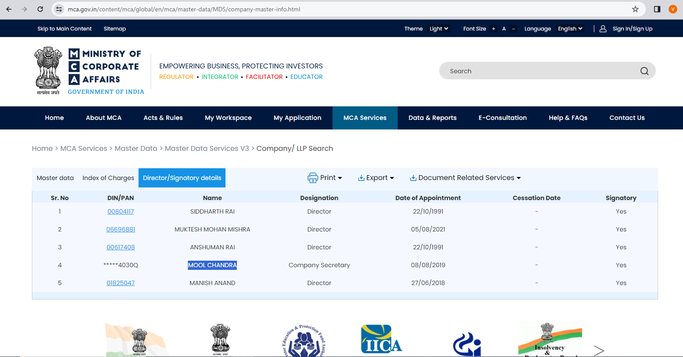

***Source: MCA***

As per the information available in TEV report, HHL has two units namely

* Heritage Hospitals Limited, Lanka, Varanasi.
* Heritage Institute of Medical Sciences (HIMS), Bhadwar, Varanasi.

As per company’s website, HHL is established in the year 1994 and is the first organised corporate multidisciplinary super-speciality hospital and is a known name in Lanka, Varanasi.

Information about the borrowers is just for illustration purpose and not to comment on the borrower’s credibility. Details shown above are taken from MCA, public domain and the TEV report provided to us.

1. **PROJECT LOCATION:**

|  |  |
| --- | --- |
| **Particulars** | **Description** |
| **Postal Address** | |
| Plot No. NH-1A, Sector 119, Noida, Gautam Budh Nagar, Uttar Pradesh-201306 | |
| **Google Coordinates** | |
| 28°35'12.3"N 77°24'03.1"E | |
| **Connectivity Systems** | |
| 1. The subject property is a corner plot property and has roads on two sides of it: 2. Internal Sector Road ~60 ft. wide 3. Internal Sector Road ~40 ft. wide 4. The nearest International airport to the subject project is Indira Gandhi International Airport which is about 40 Km from the subject project. | |

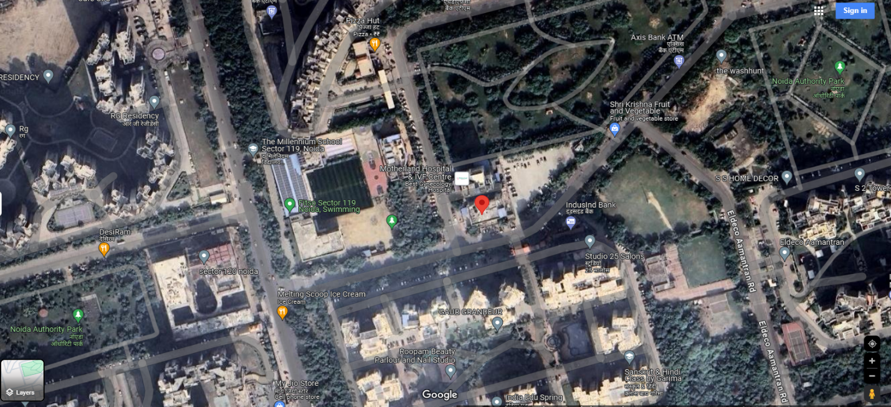

**Figure: Location of Hospital Unit**

1. **PROJECT OVERVIEW:**

* M/s Heritage Hospitals Limited (HHL) is renovating a previously non-functioning 100-bed Multi Specialty Hospital, formerly known as Tripathi Hospital.
* Tripathi Hospital, equipped with 100-bed multi-specialty facilities, faced turmoil leading to its closure.
* M/s Heritage Hospitals Limited acquired the aforementioned hospital premises located at NH-1A, Sector 119, Noida, with the aim of reviving the facility.
* Renovation and customization works have begun at the hospital premises to modernize and refurbish the infrastructure.
* The objective of the renovation is to transform the non-functioning hospital into a fully operational healthcare facility.
* For the periodic project physical status review Bank of Baroda, Lanka Branch, Varanasi has appointed R.K Associates Valuers and Techno Engineering Consultants Private Limited as Lender’s Engineer.

.

The cost of project is estimated to be Rs.76.21 Cr. details of the same has been shown below:

|  |  |
| --- | --- |
| **Particulars** | **Amount** |
| Land and building purchased from UBI | 32.63 Cr. |
| Renovation and civil works | 20.52 Cr. |
| Purchase of Machinery and other fixed assets | 17.98 Cr. |
| Interest during construction | 3.31 Cr. |
| Preliminary and pre-operative expenses | 0.53 Cr. |
| Margin money during construction/renovation | 1.25 Cr. |
| **TOTAL** | **76.21 Cr.** |

***Source: TEV report provided to us.***

Detailed breakup of the same is available in later section of the report.

**Present status of Implementation:**

1. **Purchase of Hospital Building:** As per the transfer deed cum sale certificate executed at Noida dated 11/08/2023 between M/S Union Bank Of India through its authorised signatory Mr. Vinod Kumar Sondhi (TRANSFEROR) and M/S Heritage Hospitals Ltd. (TRANSFEREE) the transferee has taken the possession of aforesaid Institutional Property measuring 1006.20 sq.mt. situated in Sector-119, Noida.
2. **Civil Construction & Renovation:** During the site visit, dated 06/02/2024, only the plaster work on the outer elevation on east side was observed to be in progress.
3. **SCOPE OF WORK DURING PROJECT DURATION:**
4. Periodic Project physical status review.
5. **PURPOSE OF THE REPORT:** To provide fair detailed analysis report to the Bank based on the “in-scope points” mentioned above to know Project progress.
6. **METHODOLOGY ADOPTED:**
7. Study of Project Planning documents/ reports to know about the Project.
8. Additional information, data, documents collection from the borrower.
9. Site Inspection.
10. Review and analysis of the documents and information obtained from the borrower and corroborating it with the site inspection status.
11. Information compilation, analysis and reporting.

|  |  |
| --- | --- |
| **PART C** | **INFRASTRUCTURE & FACILITY DETAILS OF THE PROJECT** |

1. **LAND & BUILDING:** M/s Heritage Hospitals Ltd. has acquired this built-up hospital under SARFAESI sale from M/s Union Bank of India. Earlier this hospital was operated under name of Tripathi Hospital.As per the transfer deed cum sale certificate executed at Noida dated 11/08/2023 between M/s Union Bank Of India through its authorised signatory Mr. Vinod Kumar Sondhi (TRANSFEROR) and M/S Heritage Hospitals Ltd. (TRANSFEREE) the transferee has taken the possession of the aforesaid Institutional Property, built on land measuring 1,006.20 Sq. Mt. situated in Sector-119, Noida. The cost against the building along with land purchase is shown to be 32.63 Cr. under Land & Building head in the TEV report provided. Breakage of the same is shown below:

|  |  |
| --- | --- |
| **Particulars** | **Amount** |
| Cost of Purchase from UBI | 28.10 Cr. |
| Stamp duty | 1.67 Cr. |
| Security Deposit to Noida Authority | 2.84 Cr. |
| **TOTAL** | **32.63 Cr.** |

***Source: TEV report provided to us.***

As per the architect plan and onsite inspection too, the existing super structure of the hospital comprises of the following except ninth floor which is proposed to be added as new in the plan:

|  |  |  |  |  |  |  |
| --- | --- | --- | --- | --- | --- | --- |
| **Sr. No.** | **Floors** | **FSI Areas (sqm)** | **FSI Areas  (sqft.)** | **Height**  **(metre)** | **BUA (sqm)** | **BUA (sqft)** |
| **Plot Area 1,006 Sq. Mt.** | | | | | | |
| **Superstructure** | | | | | | |
|  | GROUND FLOOR | 308 | 3,312 | 4 | 369 | 3,973 |
|  | FIRST FLOOR | 304 | 3,267 | 4 | 381 | 4,102 |
|  | SECOND FLOOR | 297 | 3,200 | 4 | 381 | 4,102 |
|  | THIRD FLOOR | 306 | 3,296 | 4 | 387 | 4,161 |
|  | FOURTH FLOOR | 318 | 3,425 | 4 | 387 | 4,161 |
|  | FIFTH FLOOR | 304 | 3,267 | 4 | 396 | 4,263 |
|  | SIXTH FLOOR | 313 | 3,366 | 4 | 381 | 4,102 |
|  | SEVENTH FLOOR | 347 | 3,735 | 4 | 415 | 4,469 |
|  | EIGTH FLOOR | 347 | 3,735 | 4 | 415 | 4,469 |
|  | NINTH FLOOR ***(proposed)*** | 347 | 3,735 | 4 | 415 | 4,469 |
|  | TERRACE |  |  |  |  |  |
|  | **TOTAL** | **3,190** | **34,338** | **39** | **3,927** | **42,269** |
| **NON FSI/EXEMPT AREA** | | | | | | |
|  | SERVICE FLOOR-1 | 374 | 4,027 | 2 | 374 | 4,027 |
|  | SERVICE FLOOR-2 | 415 | 4,469 | 2 | 415 | 4,469 |
|  | BASEMENT-1 | 679 | 7,311 | 4 | 679 | 7,311 |
|  | BASEMENT-2 | 676 | 7,276 | 4 | 676 | 7,276 |
|  | **TOTAL** | **2,144** | **23,082** | **12** | **2,144** | **23,082** |

1. **FACILITY DETAILS:** M/s Heritage Hospital has proposed to upgrade the existing multi-speciality hospital run as M/s Tripathi Hospital to a new improved multi-speciality hospital comprising of 3 Major Operation Theatres with Hepa Filters and Laminar Flow to cater major surgeries like joint surgeries, Spinal-surgeries, Micro, Neuro, Paediatrics and Laparoscopic Surgeries. The proposed facilities/services in the hospital as planned by the company is given under *(as mentioned in the TEV)*:

|  |  |  |
| --- | --- | --- |
| **S. No.** | **Department** | **Facilities** |
|  | Medicine | * General machine * Chest & TB * Endocrinology |
|  | Support Services | * 24 Hours Accident & Emergency Services * 24 Hours Non-invasive cardiology facility i.e. EGC, Echocardiography, TMT, Stress Echo etc. * 24 Hours invasive cardiology facility i.e. Cath Lab * 24 Hours imaging facility i.e. X-Ray, Ultra Sound etc. * 24 Hours Laboratory facility * 24 Hours Pharmacy * 24 Hours Ambulance Facility (BLS & ACLS) * 100 bedded Hospital – including General Ward, Semi Private Room, Semi Delux room and Private Room. * Fully equipped PICU-4 Bedded, NICU-3 Bedded, ICU-7 Bedded, Medical ICU-5 Bedded * 3 Modular OT with C-Arm Facility * 1 Modular CTVS OT * 2 Labour room with attached level 1&2 NICU * 15 Bedded Dialysis units |
|  | Hospital Services | * Emergency Services * Outpatient Services * Impatient Services |
|  | Diagnostic Facilities | * Radiology department * Sonography * Laboratory Services * Video Endoscopy |

1. **RENOVATION AND CIVIL WORKS:** As per the TEV report, the cost against renovation and civil works is planned to be 20.52 Cr. breakage of the same has been shown below as given by Architects. M/s Incubis Architect dated 20th September, 2023. Certificate from M/s Incubis Architect to this effect is enclosed with the report:

|  |  |  |  |  |
| --- | --- | --- | --- | --- |
| **S. No.** | **Description** | **Area**  **(BUA)** | **Rate/**  **Sq. ft.** | **Amount**  **Rs.** |
|  | Pre enabling incl. As-Built Site Survey, Digitizing of Plans incl. MEP survey, Structural Audit & Testing & Soil test, as applicable | 65,360 | 10 | 6,53,600 |
|  | Structural Strengthening costs, as applicable | 65,360 | 50 | 32,68,000 |
|  | Structural Cost - New Floor Addition - 9th floor | 4,469 | 1,000 | 44,69,000 |
|  | Façade - Remodelling (Partly Glazed, Partly Solid, Upvc Windows) incl. Lighting | 30,320 | 350 | 1,06,12,000 |
|  | Lifts - Refurbishment | LOT |  | 14,00,000 |
|  | Civil works incl. Dismantling, Internal Block work, Plaster, Water proofing etc. Landscape Development incl. Ramps, Boundary wall, Meter Room & gate repairs | 65,360 | 75 | 49,02,000 |
|  | Interiors | 65,360 | 1,100 | 7,18,96,000 |
|  | MEP incl. IT & LAN (Passive), Nurse Call excluding DG (Any re-use of existing MEP not factored in - Shall be considered after MEP audit by others) | 65,360 | 750 | 4,90,20,000 |
|  | BMS+ + Nurse call | 65,360 | 106 | 68,95,480 |
|  | MGPS | 65,360 | 80 | 52,28,800 |
|  | External MEP incl. civil works for Sewerage, Plumbing, Lighting etc. | LOT | LOT | 45,00,000 |
|  | Solar - assuming 5KVA (with battery) | 5 | 1,00,000 | 5,00,000 |
|  | Signage’s | 65,360 | 35 | 22,87,600 |
|  | **Total** |  |  | 16,56,32,480 |
|  | Contingencies - For design development / 3 D Approvals |  | 5.00% | 82,81,624 |
|  | **Total Inclusive Contingency** |  |  | 17,39,14,104 |
|  | **Total Inclusive GST** |  |  | 2,052.19 |
|  | **Total cost Inclusive (Rs. in Cr.)** |  |  | 20.52 |

***Source: TEV report provided to us.***

**Observations:**

1. Revised building Plan approval is yet to be sanctioned.
2. The above cost is shown only for illustration purpose as given by an Architect without going into specifics such as design needs, etc. of it.
3. **MACHINERY, FACILITIES AND OTHER FIXED ASSETS:** Company has proposed to install the following machineries, equipment’s, hospital furniture & fixture, office furniture and other fixed assets in addition to existing if any.

The values of Machineries, Equipment’s, Furniture & Fixture and Other Fixed Assets are shown as per the details provided in the TEV:

|  |  |
| --- | --- |
| **Particulars** | **Amount (In Rs.)** |
| Machinery & Equipment's | 1,004.36 |
| Furniture and other fixed assets | 685.09 |
| Hospital Bed and others | 108.67 |
| **Total (In Rs. In Lakhs)** | 1,798.12 |
| **Total (In Rs. In Crore)** | **17.98** |

1. **Details of Machinery & Equipment's is shown below:**

|  |  |  |  |  |  |
| --- | --- | --- | --- | --- | --- |
| **S. No.** | **Item** | **Qty.** | **Rate** | **Amount** | **Proposed Suppliers** |
|  | Basic 5 Para Monitor | 20 | 85,000 | 17,00,000 | Advance Medical Devices |
|  | 12.1” Monitor | 20 | 1,05,000 | 21,00,000 | Advance Medical Devices |
|  | Syringe Pump | 75 | 45,000 | 33,75,000 | Advance Medical Devices |
|  | Infusion Pump | 50 | 65,000 | 32,50,000 | Advance Medical Devices |
|  | SV300 Ventilator | 10 | 9,50,000 | 95,00,000 | Advance Medical Devices |
|  | SV600 Ventilator | 5 | 15,50,000 | 77,50,000 | Advance Medical Devices |
|  | Defibrillator | 10 | 3,50,000 | 35,00,000 | Advance Medical Devices |
|  | ECG Machine | 15 | 2,50,000 | 37,50,000 | Advance Medical Devices |
|  | Anesthesia Workstation Wato Ex 35 | 6 | 13,50,000 | 81,00,000 | Advance Medical Devices |
|  | Cath lab | 1 | 3,42,00,000 | 3,42,00,000 | Shimadzu Medical(India) Pvt. Ltd. |
|  | Cath Lab Accessories | 1 | 42,50,000 | 42,50,000 | Shimadzu Medical(India) Pvt. Ltd. |
|  | Digital Xray | 1 | 82,00,000 | 82,00,000 | Shimadzu Medical(India) Pvt. Ltd. |
|  |  |  |  | 8,96,75,000 |  |
| **GST@12%** | | | | **Rs. 1,07,61,000** | ---------- |
| **Total** | | | | **Rs.10,04,36,000** | ------------- |
| **Total In Cr.** | | | | **Rs. 10.04** | ------------- |

1. **Furniture and Other Fixed Assets is shown below:**

|  |  |  |  |  |  |
| --- | --- | --- | --- | --- | --- |
| **S. No.** | **Item** | **Qty.** | **Rate** | **Amount** | **Proposed Suppliers** |
|  | Hospital Ancillaries | 1 | 93,50,844 | 93,50,844 | Midmark (India) Pvt. Ltd. |
|  | General Furniture | 1 | 65,16,572 | 65,16,572 | GODREJ & BOYCE Mfg. Co. Ltd. |
|  | Admin office Furniture | 1 | 27,62,999 | 27,62,999 | Urban Ladder |
|  | OT Light HyLED 7 | 3 | 10,64,000 | 31,92,000 | Advance Medical Devices |
|  | OT Light HyLED X | 6 | 16,24,000 | 97,44,000 | Advance Medical Devices |
|  | OT Table HyBase 8500 | 6 | 16,24,000 | 97,44,000 | Advance Medical Devices |
|  | OT Table HyBase 3000 | 3 | 10,64,000 | 31,92,000 | Advance Medical Devices |
|  | Computer & IT | 1 | 1,05,12,320 | 1,05,12,320 | MSM Computer World LLP |
|  | Dialysis Ward | 1 | 1,34,96,000 | 1,34,96,000 | Nipro Medical (India) Pvt. Ltd. |
| **Total including GST** | | | | **Rs.6,85,09,835** | -------------------- |
| **Total In Cr.** | | | | **Rs. 6.85** | -------------------- |

1. **Hospital Bed and Others:**

|  |  |  |  |  |  |
| --- | --- | --- | --- | --- | --- |
| **S. No.** | **Item** | **Qty.** | **Rate** | **Amount** | **Suppliers** |
|  | Basic Semi Fowler Bed, MS Top | 80 | 45,748 | 36,59,840 | Midmark (India) Pvt. Ltd. |
|  | Twin column based fully motorized bed | 20 | 2,77,498 | 55,49,960 | GODREJ & BOYCE Mfg. Co. Ltd. |
| **Total** | | | | **Rs. 92,09,800** | -------------------- |
| **GST@18%** | | | | **Rs.16,57,764** | -------------------- |
| **Total Cost** | | | | **1,08,67,564** | -------------------- |
| **Total In Cr.** | | | | **Rs. 1.09** | -------------------- |

**Note:**

* *The Machineries/ equipment’s mentioned in the above table have not yet arrived on the site as observed during site survey.*
* *As per our visit dated 06/02/2023, we only found one dental use machine/equipment in hospital.*
* *Company is recommended that in case any additional equipment/ machinery is required as per the proposed facilities such as MRI, auxiliary Oxygen cylinders, etc. which is not considered in the above list. Also to adhere to the norms, guidelines, standards for private hospitals as prescribed by Ministry of Health and Family Welfare, Govt. of India and Govt. of Uttar Pradesh.*

|  |  |
| --- | --- |
| **PART D** | **PROJECT CONSULTANTS, CONTRACTORS & SUPPLIERS** |

According to the company representative, and the details obtained from the work orders, there are some contractor appointed for different works. Details of the same has been shown in table below:

|  |  |  |
| --- | --- | --- |
| **PROJECT CONSULTANTS, CONTRACTORS & SUPPLIERS** | | |
| **S. No.** | **Contractor name** | **Work Assigned** |
|  | INCUBIS Consultants (India) Private Limited | External Development, MEP Services |
|  | M.J. Engineering Consultants Private Limited | Consultancy services of Civil, Plumbing and Electrical, Fire Fighting, etc. |
|  | M/S Sri Ram Water Proofing | Strengthening of R.C.C structure, Water proofing & other Civil and miscellaneous works. |
|  | M/S Cortex Construction Solutions Private Ltd. | Structural Audit Consultant Team. |

|  |  |
| --- | --- |
| **PART E** | **PROJECT COST & MEANS OF FINANCE** |

1. **TOTAL PROJECT COST:** M/s Heritage Hospital Limited (HHL) has estimated the Total Project Cost amounting to Rs.76.21 Cr. Breakage of the same has been shown in tabular and graphical form below:

|  |  |
| --- | --- |
| **Particulars** | **Amount** |
| Land and building Purchased | 32.63 Cr. |
| Renovation and civil works | 20.52 Cr. |
| Purchase of Machinery and other fixed assets | 17.98 Cr. |
| Interest during construction | 3.31 Cr. |
| Preliminary and pre-operative expenses | 0.53 Cr. |
| Margin money during construction/renovation | 1.25 Cr. |
| **`TOTAL** | **76.21 Cr.** |

1. **CURRENT STATUS & TOTAL EXPENDITURE INCURRED TILL DATE:** Details of the expenditure in the Table below is recordedfor the expenditure incurred up to 20th September 2023 as per CA Certificate dated 27/09/2023 with UDIN- 23052740BGSJDL4218. .

|  |  |  |  |  |  |
| --- | --- | --- | --- | --- | --- |
| **Sr. No.** | **Particulars** | **Proposed**  **(In Rs. In Cr.)** | **Expenditure shown by company till 20/09/2023**  **As per CA Cert.**  **(In Rs. In Cr.)** | **Amount as per LIE**  **(In Rs. In Cr.)** | **Remarks** |
|  | Land and building purchased from UBI | 32.63 Cr. | 32.63 Cr. | ~32.63 Cr. | Breakup of Rs.32.63 cr. is as follows:   |  |  | | --- | --- | | **Particulars** | **Amount**  **(Rs.)** | | Hospital purchase under SARFAESI from Union Bank | 28,10,00,000/- | | Stamp Duty | 1,68,60,060/- | | Paid to Noida | 2,83,95,255/- | | Total | 32,62,55,315/- |   Relevant reference documents provided to us are annexed with the report. |
|  | Renovation and civil works | 20.52 Cr. | 1.27  (Has been shown as other expenses in CA Certificate Dated 27-09-23) | ----- | Break Up of the renovation and civil works shown is as per the details mentioned by the client over mail.   |  |  | | --- | --- | | **Particulars** | **Amount**  **(Rs In lacs)** | | Salary Expenses | 56.19 | | Administrative Expenses | 12.06 | | Electricity Expenses | 12.03 | | Legal & Professional Fees | 28.57 | | Project Consultancy Fees | 19.06 | | Total | 127.91 |   Since payment receipt/invoices of the same has not been provided to us, therefore same has not been considered at our end. All these expenses are in nature of soft cost, and same may considered referring CA Certificate. |
|  | Purchase of Machinery and other fixed assets | 17.98 Cr. | Nil | Nil | --- |
|  | Interest during construction | 3.31 Cr. | Nil | Nil | --- |
|  | Preliminary and pre-operative expenses | 0.53 Cr. | Nil | Nil | --- |
|  | Margin money during construction/renovation | 1.25 Cr. | Nil | Nil | --- |
|  | **TOTAL** | **Rs.76.21 Cr.** | **~Rs.33.90 Cr.** | **~Rs.32.63 Cr. + soft cost as incurred by the company** | **---** |

**Comments:**

1. Please also refer to CA Certificate dated 27th September 2023 with UDIN No. 23052740BGSJDL4218.
2. **SOURCES OF FINANCE & UTILIZATION OF FUNDS:**

The Project cost mentioned above has been planned to be covered from following resources:

|  |  |
| --- | --- |
| (Amount in Rs. Crore) | |
| PARTICULARS |  |
| Promoter’s Contribution (Equity) | 30.04 |
| Term Loan (Debt) | 46.17 |
| TOTAL | **76.21** |

***Source:*** *As per technical vetting report provided.*

|  |  |
| --- | --- |
| **PART F** | **STATUTORY & REGULATORY APPROVALS, CLEARANCES & NOC** |

|  |  |  |  |
| --- | --- | --- | --- |
| Sr. No. | NAME OF LICENSE/ REGISTRATION | DATE OF ISSUE | CURRENT STATUS |
| **ISSUING AUTHORITY** | **LICENCE NO.** |
|  | Transfer Cum Sale Certificate | ---- | Done |
| Between Union Bank and Heritage Hospital ltd. |
|  | Building Sanction Plan | ---- | Approval yet to be obtained |
| *Noida Authority* |
|  | Consent for Air & Water Pollution | ---- | Approval yet to be obtained |
| *U.P. Pollution Control Board* |
|  | NOC From Fire Department | ---- | Approval yet to be obtained |
| *Fire Department Noida* |
|  | NOC for Generation Reception, Treatment, Storage, Disposal Of Biomedical Wastes | ---- | Approval yet to be obtained |
|  | Agreement For Waste Management | ---- | Approval yet to be obtained |
| *U.P. Pollution Control Board* |
|  | DMHO (District Medical and Health Office) registration | ---- | Approval yet to be obtained |
| *Director of Health, Ministry of Health and Family Welfare, State Government The Clinical Establishments (Registration and Regulation) Act, 2010* |
|  | Radiation License | ---- | Approval yet to be obtained |
| *AERB Registration* |
|  | Radiation Protection & Waste management License | ---- | Approval yet to be obtained |
| *Department of Atomic Energy under Atomic Energy (Radiation Protection) Rules, 2004* |
|  | Pharmacy registration |  | Approval yet to be obtained |
| *Office of the Drug Controller* |
|  | Drugs-Bulk license | ---- | Approval yet to be obtained |
| *Office of the Drug Controller* |
|  | PCPNDT Approval | ---- | Approval yet to be obtained |
| *CMO for Ultrasound* |
|  | GST Registration | ---- | Approval yet to be obtained |
| *Goods and Services Tax, GOI* |
|  | Canteen/ F & B license | ---- | Approval yet to be obtained |
| *Food Safety and Standards Authority of India under the Ministry of Health and Family welfare, Govt. of India.* |
| *Note: The above licenses are only the major licenses and not be considered exhaustive in nature.* | | | |

|  |  |
| --- | --- |
| **PART G** | **PROJECT SCHEDULE & CURRENT STATUS** |

|  |  |  |  |  |
| --- | --- | --- | --- | --- |
| **IMPLEMENTATION SCHEDULE OF M/S HERITAGE HOSPITALS LIMITED (HHL)** | | | | |
| **S. No.** | **Particular** | **Commencement** | **Completion** | **Current Status** | |
|  | Purchase of Hospital Building | Jun-22 | Aug-23 | Done | |
|  | Renovation and Civil work | Sep-23 | Jun-24 | Started | |
|  | Placement of orders for Proposed Equipment’s / Misc. Fixed assets. | Mar-24 | May-24 | Not yet Started | |
|  | Arrival of equipment’s & Miscellaneous Fixed Assets | May-24 | Aug-24 | Not yet Started | |
|  | Installation of Machines | May-24 | Sep-24 | Not yet Started | |
|  | Testing of Equipment | Sep-24 | Sep-24 | Not yet Started | |
|  | Commercial Operation | Oct-24 | | --- | |

|  |  |
| --- | --- |
| **PART H** | **DISCLAIMER** |

* + - 1. No employee or member of R.K Associates has any direct/ indirect interest in the Project.
      2. This report is prepared based on the copies of the documents/ information which the Bank/ Borrower has provided to us out of the standard checklist of documents sought from them and further based on our assumptions and limiting conditions. The client/owner and its management/representatives warranted to us that the information they supplied was complete, accurate and true and correct to the best of their knowledge. All such information provided to us has been relied upon in good faith and we have assumed that it is true and correct in all respect. I/We shall not be liable for any loss, damages, cost or expenses arising from fraudulent acts, misrepresentations, or wilful default on part of the owner, borrower, its directors, employee, representative or agents. Verification or cross checking of the documents provided to us from the originals or from any Govt. departments/ Record of Registrar has not been done at our end since this is beyond the scope of our work. If at any time in future, it is found or came to our knowledge that misrepresentation of facts or incomplete or distorted information has been provided to us then this report shall automatically become null & void.
      3. Legal aspects for eg. investigation of title, ownership rights, lien, charge, mortgage, lease, sanctioned maps, verification of documents, etc. have not been done at our end and same has to be taken care by legal expert/ Advocate. It is assumed that the concerned Lender/ Financial Institution has satisfied them with the authenticity of the documents, information given to us and for which the legal verification has been already taken and cleared by the competent Advocate before requesting for this report. I/ We assume no responsibility for the legal matters including, but not limited to, legal or title concerns.
      4. This report is a general analysis of the project based on the scope mentioned in the report. This is not an Audit report, Design document, DPR or Techno feasibility study. All the information gathered is based on the facts seen on the site during survey for the quarter ending December 2023, verbal discussion & documentary evidence provided by the client and is believed that information given by the borrower is true best of their knowledge.
      5. All observations mentioned in the report is only based on the visual observation and the documents/ data/ information provided by the client. No mechanical/ technical tests, measurements or any design review have been performed or carried out from our side during Project assessment.
      6. Bank/FII should ONLY take this report as an Advisory document from the Financial/ Chartered Engineering firm and its specifically advised to the creditor to cross verify the original documents for the facts mentioned in the report which can be availed from the borrowing borrower directly.
      7. In case of any default in loans or the credit facility extended to the borrowing borrower, R.K Associates shall not be held responsible for whatsoever reason may be and any request for seeking any explanation from the employee/s of R.K Associates will not be entertained at any instance or situation.
      8. The documents, information, data provided to us during the course of this assessment by the client is reviewed only upto the extent required in relation to the scope of the work. No document has been reviewed beyond the scope of the work.
      9. This report only contains general assessment & opinion as per the scope of work evaluated as per the information given in the copy of documents, information, data provided to us and/ and confirmed by the owner/ owner representative to us at site which has been relied upon in good faith. It doesn’t contain any other recommendations of any sort including but not limited to express of any opinion on the suitability or otherwise of entering into any transaction with the borrower.
      10. We have relied on data from third party, external sources & information available on public domain also to conclude this report. These sources are believed to be reliable and therefore, we assume no liability for the truth or accuracy of any data, opinions or estimates furnished by others that have been used in this analysis. Where we have relied on data, opinions or estimates from external sources, reasonable care has been taken to ensure that such data has been correctly extracted from those sources and /or reproduced in its proper form and context, however still we can’t vouch its authenticity, correctness or accuracy.
      11. This Report is prepared by our competent technical team which includes Engineers and financial experts & analysts.
      12. This is just an opinion report and doesn’t hold any binding on anyone. It is requested from the concerned Financial Institution which is using this report for taking financial decision on the project that they should consider all the different associated relevant & related factors also before taking any business decision based on the content of this report.
      13. All Pages of the report including annexures are signed and stamped from our office. In case any paper in the report is without stamp & signature then this should not be considered a valid paper issued from this office.
      14. Though adequate care has been taken while preparing this report as per its scope, but still we can’t rule out typing, human errors, over sightedness of any information or any other mistakes. Therefore, the concerned organization is advised to satisfy themselves that the report is complete & satisfactory in all respect. Intimation regarding any discrepancy shall be brought into our notice immediately. If no intimation is received within 15 (Fifteen) days in writing from the date of issuance of the report, to rectify these timely, then it shall be considered that the report is complete in all respect and has been accepted by the client upto their satisfaction & use and further to which R.K Associates shall not be held responsible in any manner.
      15. Defect Liability Period is **15 DAYS**. We request the concerned authorized reader of this report to check the contents, data and calculations in the report within this period and intimate us in writing if any corrections are required or in case of any other concern with the contents or opinion mentioned in the report. Corrections only related to typographical, calculation, spelling mistakes, incorrect data/ figures/ statement will be entertained within the defect liability period. Any new changes for any additional information in already approved report will be regarded as additional work for which additional fees may be charged. No request for any illegitimate change in regard to any facts & figures will be entertained.
      16. R.K Associates encourages its customers to give feedback or inform concerns over its services through proper channel at valuers@rkassociates.org in writing within 15 days of report delivery. After this period no concern/ complaint/ proceedings in connection with the Financial Feasibility Study Services will be entertained due to possible change in situation and condition of the subject Project.
      17. Our Data retention policy is of **ONE YEAR**. After this period, we remove all the concerned records related to the assignment from our repository. No clarification or query can be answered after this period due to unavailability of the data.
      18. This Lender’s Independent Engineer report is governed by our (1) Internal Policies, Processes & Standard Operating Procedures, (2) Information/ Data/ Inputs given to us by the client and (3) Information/ Data/ Facts given to us by our field/ office technical team. Management of R.K Associates never gives acceptance to any unethical or unprofessional practice which may affect fair, correct & impartial assessment and which is against any prevailing law. In case of any indication of any negligence, default, incorrect, misleading, misrepresentation or distortion of facts in the report then it is the responsibility of the user of this report to immediately or at least within the defect liability period bring all such act into notice of R.K Associates management so that corrective measures can be taken instantly.
      19. R.K Associates never releases any report doing alterations or modifications from pen. In case any information/ figure of this report is found altered with pen then this report will automatically become null & void.

|  |  |  |
| --- | --- | --- |
| **FOR R.K. ASSOCIATES VALUERS AND TECHNO ENGINEERING CONSULTANTS PVT. LTD.** | | |
| **SURVEY ANALYST** | **ENGINEERING ANALYST** | **REVIEWER** |
| Vishal Singh, Deepak Kumar Singh | Vishal Singh | Sr. VP Projects |
|  |  |  |

**Place: Noida**

**Date: 15th Feb 2024**

***DEFECT LIABILITY PERIOD - In case of any query/ issue or escalation you may please contact Incident Manager by writing at valuers@rkassociates.org. We ensure 100% accuracy in the Calculations done, Rates adopted and various other data points & information mentioned in the report but still can’t rule out typing, human errors or any other mistakes. In case you find any mistake, variation, discrepancy or inaccuracy in any data point of the report, please help us by bringing all such points into our notice in writing at valuers@rkassociates.org within 30 days of the report delivery, to get these rectified timely, failing which R.K Associates Valuers Techno Engineering Consultants (P) Ltd. won’t be held responsible for any inaccuracy in any manner. Also, if we will not hear back anything from you within 30 days, we will assume that report is correct in all respect and no further claim of any sort will be entertained thereafter. We would welcome and appreciate your feedback & suggestions in order to improve our services.***

***COPYRIGHT FORMAT - This report is prepared on the copyright format of R.K Associates Valuers Techno Engineering Consultants (P) Ltd. to serve our clients in the best possible way. Legally no one can copy or distribute this format without prior approval from R.K Associates. It is meant only for the organization as mentioned on the cover page of this report. Distribution or use of this format other than R.K Associates will be seen as unlawful act and necessary legal action can be taken against the defaulter***

**ENCLOSURE 1: IMPORTANT DOCUMENTS EXHIBIT**

**DOCUMENT-1: CA CERTIFICATE DATED 27/09/2023**

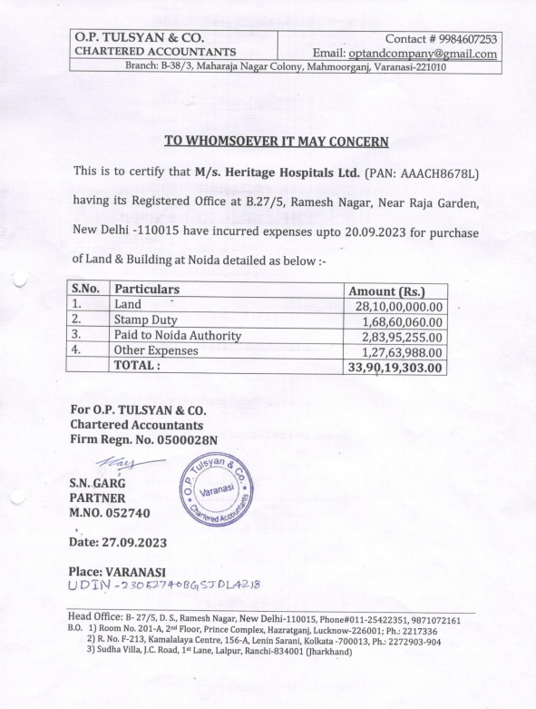

**DOCUMENT- 2: TRANSFER CUM SALE DEED AND OTHER RECIEPTS**

|  |  |
| --- | --- |
|  |  |
|  |  |

|  |  |
| --- | --- |
|  |  |
|  |  |

**DOCUMENT-3: PROJECT TIMELINE**

**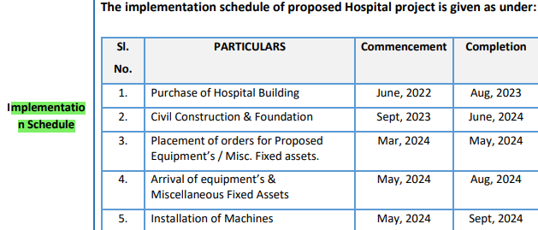**

**DOCUMENT 4: BUILDING PLAN**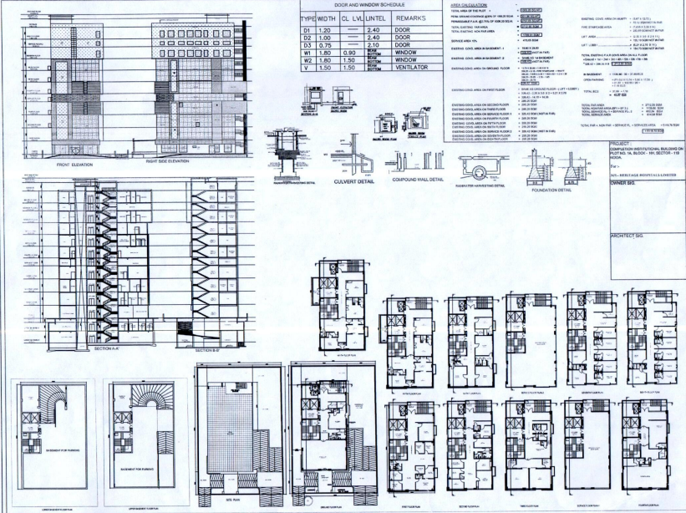

**DOCUMENT 5: COST ESTIMATE BY INCUBIS**

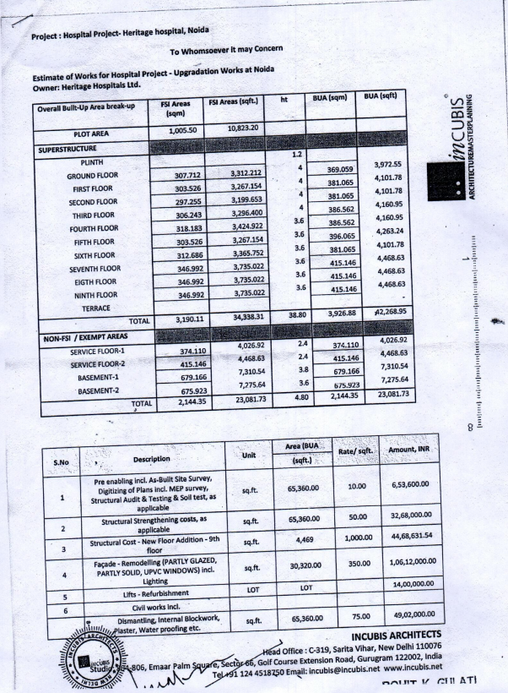

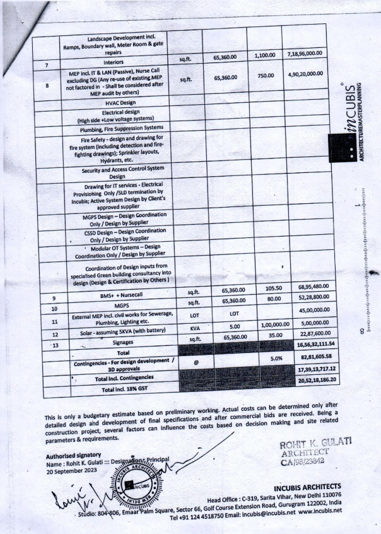

**ENCLOSURE 1: IMPORTANT DOCUMENTS EXHIBIT**

|  |  |
| --- | --- |
| Z:\In Progress Files\Vishal Singh\WIP\VIS(2023-24)-PL668-571-891_Heritage Hospital\Photos\TimePhoto_20240206_143616.jpg | Z:\In Progress Files\Vishal Singh\WIP\VIS(2023-24)-PL668-571-891_Heritage Hospital\Photos\TimePhoto_20240206_142852.jpg |
| Z:\In Progress Files\Vishal Singh\WIP\VIS(2023-24)-PL668-571-891_Heritage Hospital\Photos\TimePhoto_20240206_142945.jpg | Z:\In Progress Files\Vishal Singh\WIP\VIS(2023-24)-PL668-571-891_Heritage Hospital\Photos\TimePhoto_20240206_142958.jpg |
| Z:\In Progress Files\Vishal Singh\WIP\VIS(2023-24)-PL668-571-891_Heritage Hospital\Photos\TimePhoto_20240206_142756.jpg | Z:\In Progress Files\Vishal Singh\WIP\VIS(2023-24)-PL668-571-891_Heritage Hospital\Photos\TimePhoto_20240206_142852.jpg |

|  |  |
| --- | --- |
| Z:\In Progress Files\Vishal Singh\WIP\VIS(2023-24)-PL668-571-891_Heritage Hospital\Photos\TimePhoto_20240206_142612.jpg | Z:\In Progress Files\Vishal Singh\WIP\VIS(2023-24)-PL668-571-891_Heritage Hospital\Photos\TimePhoto_20240206_142612.jpg |
| Z:\In Progress Files\Vishal Singh\WIP\VIS(2023-24)-PL668-571-891_Heritage Hospital\Photos\TimePhoto_20240206_141511.jpg | Z:\In Progress Files\Vishal Singh\WIP\VIS(2023-24)-PL668-571-891_Heritage Hospital\Photos\TimePhoto_20240206_141558.jpg |
| Z:\In Progress Files\Vishal Singh\WIP\VIS(2023-24)-PL668-571-891_Heritage Hospital\Photos\TimePhoto_20240206_141323.jpg | Z:\In Progress Files\Vishal Singh\WIP\VIS(2023-24)-PL668-571-891_Heritage Hospital\Photos\TimePhoto_20240206_141010.jpg |

|  |  |
| --- | --- |
| Z:\In Progress Files\Vishal Singh\WIP\VIS(2023-24)-PL668-571-891_Heritage Hospital\Photos\TimePhoto_20240206_141018.jpg | Z:\In Progress Files\Vishal Singh\WIP\VIS(2023-24)-PL668-571-891_Heritage Hospital\Photos\TimePhoto_20240206_141120.jpg |
| Z:\In Progress Files\Vishal Singh\WIP\VIS(2023-24)-PL668-571-891_Heritage Hospital\Photos\TimePhoto_20240206_140744.jpg | Z:\In Progress Files\Vishal Singh\WIP\VIS(2023-24)-PL668-571-891_Heritage Hospital\Photos\TimePhoto_20240206_140403.jpg |
| Z:\In Progress Files\Vishal Singh\WIP\VIS(2023-24)-PL668-571-891_Heritage Hospital\Photos\TimePhoto_20240206_140358.jpg | Z:\In Progress Files\Vishal Singh\WIP\VIS(2023-24)-PL668-571-891_Heritage Hospital\Photos\TimePhoto_20240206_140240.jpg |

|  |  |
| --- | --- |
| Z:\In Progress Files\Vishal Singh\WIP\VIS(2023-24)-PL668-571-891_Heritage Hospital\Photos\TimePhoto_20240206_140044.jpg | Z:\In Progress Files\Vishal Singh\WIP\VIS(2023-24)-PL668-571-891_Heritage Hospital\Photos\TimePhoto_20240206_140002.jpg |
| Z:\In Progress Files\Vishal Singh\WIP\VIS(2023-24)-PL668-571-891_Heritage Hospital\Photos\TimePhoto_20240206_135814.jpg | Z:\In Progress Files\Vishal Singh\WIP\VIS(2023-24)-PL668-571-891_Heritage Hospital\Photos\TimePhoto_20240206_135538.jpg |
| Z:\In Progress Files\Vishal Singh\WIP\VIS(2023-24)-PL668-571-891_Heritage Hospital\Photos\TimePhoto_20240206_135417.jpg | Z:\In Progress Files\Vishal Singh\WIP\VIS(2023-24)-PL668-571-891_Heritage Hospital\Photos\TimePhoto_20240206_135149.jpg |

|  |  |
| --- | --- |
| Z:\In Progress Files\Vishal Singh\WIP\VIS(2023-24)-PL668-571-891_Heritage Hospital\Photos\TimePhoto_20240206_135121.jpg | Z:\In Progress Files\Vishal Singh\WIP\VIS(2023-24)-PL668-571-891_Heritage Hospital\Photos\TimePhoto_20240206_134924.jpg |
| Z:\In Progress Files\Vishal Singh\WIP\VIS(2023-24)-PL668-571-891_Heritage Hospital\Photos\TimePhoto_20240206_133949.jpg | Z:\In Progress Files\Vishal Singh\WIP\VIS(2023-24)-PL668-571-891_Heritage Hospital\Photos\TimePhoto_20240206_134323.jpg |
| Z:\In Progress Files\Vishal Singh\WIP\VIS(2023-24)-PL668-571-891_Heritage Hospital\Photos\TimePhoto_20240206_133500.jpg | Z:\In Progress Files\Vishal Singh\WIP\VIS(2023-24)-PL668-571-891_Heritage Hospital\Photos\TimePhoto_20240206_133328.jpg |

|  |  |
| --- | --- |
| Z:\In Progress Files\Vishal Singh\WIP\VIS(2023-24)-PL668-571-891_Heritage Hospital\Photos\TimePhoto_20240206_144021.jpg | Z:\In Progress Files\Vishal Singh\WIP\VIS(2023-24)-PL668-571-891_Heritage Hospital\Photos\TimePhoto_20240206_144103.jpg |
| Z:\In Progress Files\Vishal Singh\WIP\VIS(2023-24)-PL668-571-891_Heritage Hospital\Photos\TimePhoto_20240206_144129.jpg | Z:\In Progress Files\Vishal Singh\WIP\VIS(2023-24)-PL668-571-891_Heritage Hospital\Photos\TimePhoto_20240206_144616.jpg |
| Z:\In Progress Files\Vishal Singh\WIP\VIS(2023-24)-PL668-571-891_Heritage Hospital\Photos\TimePhoto_20240206_144353.jpg | Z:\In Progress Files\Vishal Singh\WIP\VIS(2023-24)-PL668-571-891_Heritage Hospital\Photos\TimePhoto_20240206_144411.jpg |

|  |  |
| --- | --- |
| E:\Back-up from engineering\Backup 01-03-2024\WIP\VIS(2023-24)-PL668-571-891_Heritage Hospital\Photos\WhatsApp Image 2024-02-26 at 19.32.48.jpeg | E:\Back-up from engineering\Backup 01-03-2024\WIP\VIS(2023-24)-PL668-571-891_Heritage Hospital\Photos\WhatsApp Image 2024-02-26 at 19.32.48 (1).jpeg |
| E:\Back-up from engineering\Backup 01-03-2024\WIP\VIS(2023-24)-PL668-571-891_Heritage Hospital\Photos\WhatsApp Image 2024-02-26 at 19.32.47.jpeg | E:\Back-up from engineering\Backup 01-03-2024\WIP\VIS(2023-24)-PL668-571-891_Heritage Hospital\Photos\WhatsApp Image 2024-02-26 at 19.32.48 (2).jpeg |

|  |  |
| --- | --- |
| Z:\In Progress Files\Vishal Singh\WIP\VIS(2023-24)-PL668-571-891_Heritage Hospital\Photos\TimePhoto_20240206_143723.jpg | Z:\In Progress Files\Vishal Singh\WIP\VIS(2023-24)-PL668-571-891_Heritage Hospital\Photos\TimePhoto_20240206_143737.jpg |
| Z:\In Progress Files\Vishal Singh\WIP\VIS(2023-24)-PL668-571-891_Heritage Hospital\Photos\TimePhoto_20240206_143643.jpg | Z:\In Progress Files\Vishal Singh\WIP\VIS(2023-24)-PL668-571-891_Heritage Hospital\Photos\TimePhoto_20240206_143631.jpg |
| Z:\In Progress Files\Vishal Singh\WIP\VIS(2023-24)-PL668-571-891_Heritage Hospital\Photos\TimePhoto_20240206_151537.jpg | Z:\In Progress Files\Vishal Singh\WIP\VIS(2023-24)-PL668-571-891_Heritage Hospital\Photos\TimePhoto_20240206_151615.jpg |