REPORT FORMAT: CL-1 | Version: 1.0_2018

FILE No: VIS(2023-24)-PL681-583-903 Date: 20/02/2024

- CERTIFICATE NAME: Cost Vetting Certificate for Metal Fabrication unit installed at Nimbua, Chandigarh.
- PREPARED FOR ORGANIZATION: State Bank of India, SME Branch, Chandigarh.
- BORROWER COMPANY’S NAME: M/s Amit Engineers, Situated at: Nimbua, Derabassi.
- ASSET TYPE: Land and building & Plant and machineries of a metal fabrication unit.
- CURRENT LOCATION OF THE CIVIL WORK: M/s Amit Engineering, Village: Nimbua, Tehsil: Derabassi, Dist: Sas Nagar, Punjab-140507
SL. NO. | PARTICULARS | DESCRIPTION
 | Date of Work Order | Via mail dated 29-01-2024
 | Documents provided for perusal | 1. For Land: Sale deed & CA certificate.  2. For Civil Works.
 | Project Location | M/s Amit Engineering, Village: Nimbua, Tehsil: Derabassi, Dist: Sas Nagar, Punjab-140507
 | Borrowing Company | M/s. Amit Engineering
 | Type of Assessment | Project/Civil work & Plant and machinery cost vetting certificate
 | Scope of Assessment | Cost Vetting of the following items attached below.  S. No. Cost Component Project Cost as per company  Land Rs.1,80,00,000/-  Building Rs.2,90,89,000/-  Plant & Machinery Rs.5,44,11,000/-
 | Nature of Plant | Metal Fabrication Unit
 | Total Project Cost | Rs.10,15,00,000/- (Excluding GST) (including supply and installation as per the List/ quotations / invoices / Cost Estimate provided by the company.)
 | Comment on Project Cost by consultant | Please refer to PART A for detailed analysis.
 | Total number of pages with Annexure. | 11

PART A | PROJECT COST VETTING

EXECUTIVE SUMMARY: M/s Amit Engineering is setting up a metal fabrication unit at Village: Nimbua, Tehsil: Derabassi, Dist: Sas Nagar, Punjab-140507. In this respect, they required financial assistance for construction of civil structure. In respect to financial assistance of this Project, M/s Amit Engineering has approached SBI, SME Branch, and Chandigarh. As per the CA Certificate provided to us, the original project cost of the project as shown by the company is Rs.10.15 Crores (Excluding GST).

- LAND VALUE: For the establishment of a metal fabrication unit, the company has acquired a total of 34,000 square yards of land. The transaction was carried out through two sale deeds, with varying values for the land. Details and a cost assessment of the land values are provided in the table below:

Sl. No. | Registry Date | Land area (sq. yds.) | Consideration Amount as per sale deed in Rs. | Amount as per CA certificate in Rs. | Remarks
1. | 08.07.2021 | 26,000 | 1,40,00,000 | 1,40,00,000 | Exclusive of Stamp Duty
2. | 08.07.2021 | 8,000 | 40,00,000 | 40,00,000 | Exclusive of Stamp Duty
 | TOTAL | 34,000 | 1,80,00,000 | 1,80,00,000

Observation:
1. The cost assessment of the land value is done, based on the purchase cost shown in the sale deed, which is also found to be in line with the CA Cert Dated: 15/12/2023.

- BUILDING & CIVIL WORKS: The cost involved in the construction of existing structures and other civil work has been calculated from our analysis and market research.

During site visit it has been observed that construction of all the building structure has been completed. Only admin building (G+1 Floor) is under construction. Details working of estimated building construction cost has been shown in below table:

Structure Name | Type of Structure | Area  (sq. ft.) | Plinth Area Rate  per sq. ft. | Total Cost  (in Rs.) | Status | As per CA certificate  (in Rs.)
Main Work Shed | Steel Structure | 117257.67 | 800 | 9,38,06,142 | Completed | 2,90,89,000
Gate/Security office | RCC | 875.01 | 1200 | 10,50,020 | Completed
Panel Room | RCC | 756.28 | 1200 | 9,07,547 | Completed
Compressor Room | RCC | 491.45 | 1200 | 5,89,742 | Completed
Toilet 1 & 3 | RCC | 1316.84 | 1200 | 15,80,215 | Completed
Toilet 2 | RCC | 364.73 | 1200 | 4,37,686 | Completed
Admin Block | RCC | 10946.04 | 1200 | - | Under Construction
TOTAL |  | 1,32,008 |  | 11,00,97,120 |  | 2,90,89,000

Note: As per the Invoices and CA certificate shared by the client, the estimated construction cost for the said civil work is Rs.2,90,89,000/-. However, as per our analysis and market research the construction cost of the said civil work should be Rs.11,00,97,120/-.as per above table.

OBSERVATIONS (CIVIL WORKS):
- The estimate of construction is calculated as per Table. The calculated cost appears to be more than the cost shown by the company.
- For ascertaining the estimated cost of civil works, we have referred the approved building map, CA certificate & invoices. Specific item wise quantities as shown in the table above is considered for the purpose of assessment.
- Rates considered in the cost estimate is as per the prevailing market range.
- We have vetted the civil works as per the available documents such as building plan, section drawing, cost estimate etc. The built-up area has been considered from the sanctioned plan provided to us only.
- MACHINERIES: The scope of work in this assignment also includes the vetting of the machines as mentioned in the machine list and invoices provided by the client. The cost involved in the procurement of machines has been calculated independently from our analysis and market research.

During the site survey, it was observed that the plant was operational and these machines are being used for the production. Verification and assessment of machines is given in the table below.

S. No. | Bill No. | Description | Expense  as shown by company  (In Rs.) | Cost as per Prevailing Market rates  (In Rs.)
1 | Bill No. H/22-23/161 | CNC Bending Machine | 27,04,800 | 26,00,000
2 | Bill No. H/22-23/289 | CNC Bending Machine | 25,53,500 | 26,00,000
3 | 6562103395 | Vacuum Pumps | 9,25,000 | 11,25,600
4 | 185 | Transformer + OLTC | 12,25,000 | 10,06,000
5 | JDM20230105 | Hair pin bending machine | 57,09,750 | 52,08,000
6 | JDM20230105 | Vertical Expander M/C-1 | 75,30,250 | 63,00,000
7 | 850 | Auto CNC Punching Machine | 27,00,000 | 27,00,000
8 | JDM20230114 | Auto CNC Tube bending | 32,55,930 | 25,00,000
9 | GST-16131 | Bench Grinder | 12,100 | 11,600
10 | TI/459 | OTE Crane | 9,45,000 | 10,50,000
11 | 946 | Auto spot welding machine | 95,000 | 90,000
12 | I12227025740 | Fork lift | 11,85,000 | 13,00,000
13 | 873 | Robotic TIG welding machine | 72,000 | 62,000
14 | 18418M/23-24/011 | Heating oven | 8,85,000 | 10,00,000
15 | 010/23-24 | Functional testing machine | 5,15,000 | 5,00,000
16 | 61 | Distribution panel | 1,69,447 | 1,50,000
17 | E-02/23-24/0143 | Laser cutting machine | 90,00,000 | 1,20,00,000
18 | JDM20230105, JDM20230114 | Fin press machine | 1,37,83,558 | 1,18,00,000
19 | 487, 550, 526 | Main Panel (LT& HT) | 11,44,393 | 9,00,000
TOTAL |  |  | 5,44,10,728 | 5,29,03,200

OBSERVATIONS (MACHINES):
- We have been provided with the copy of quotations from the market, bills and purchase orders with cost of machines/ equipment by the borrower company.
- As per the information and observation during the site survey, these items are already installed at Village: Nimbua, Tehsil: Derabassi, Dist: Sas Nagar, Punjab-140507.
- We have enquired from the public domain for the current price of the machines and we find that the price provided to us is well within the price range of similar items available in the market and seems to be reasonable.
- In the last few months, the rates of may have changed, so we have considered the range accordingly.
- In this certificate, we have considered the value only for the main machinery while cost for auxiliary items have not been included. Due to this, there can be differences in some items.
- Based on the information provided by the company (M/s. Amit Engineers) and enquiries made by us in the open market and references found in the public domain for similar machines/items, it is certified that total market cost for setting up machinery of similar specifications should be around Rs.5.20 Cr to Rs.5.50 Cr and therefore the total purchase price of Rs.5,44,10,728/- (as per the CA certificates, invoices provided to us by the company) appears to be reasonable.

Disclaimer:
- We have received sample invoices for new construction of civil work.
- The client/ owner and its management/ representatives warranted to us that the information they have supplied was complete, accurate and true and correct to the best of their knowledge. All such information provided to us either verbally, in writing or through documents has been relied upon in good faith and we have assumed that it is true & correct without any fabrication or misrepresentation. I/We shall not be held liable for any loss, damages, cost or expenses arising from fraudulent acts, misrepresentations, or willful default on part of the owner, company, its directors, employee, representative or agents.
- Legal aspects for eg. Investigation of title, ownership rights, lien, charge, mortgage, lease, sanctioned maps, and verification of documents provided to us such as title documents, Map, etc. from any concerned Govt. office etc. have to be taken care by legal expert/ Advocate and same is not done at our end. I/ We assume no responsibility for the legal matters including, but not limited to, legal or title concerns.
- Wherever any details are mentioned in the report in relation to any legal aspect of the property such as name of the owner, leases, etc. is only for illustration purpose and should not be construed as a professional opinion. Legal aspects are out of scope of this report. Details mentioned related to legal aspect are only based on the copy of the documents provided to us and whatever we can interpret as a non-legally trained person. This should be cross validated with a legal expert. We do not vouch any responsibility regarding the same.
- We have relied on the data from third party, external sources & information available on public domain to conclude the valuation. These sources are believed to be reliable and therefore, we assume no liability for the truth or accuracy of any data, opinions or estimates furnished by others that have been used in this analysis. Where we have relied on the data, opinions or estimates from external sources, reasonable care has been taken to ensure that such data is extracted from authentic sources, however we still can’t vouch its authenticity, correctness, or accuracy.
- Documents, information, data including provided to us during the course of this assessment by the client is reviewed only upto the extent required in relation to the scope of the work. No document has been reviewed beyond the scope of the work. These are not reviewed in terms of legal rights for which we do not have expertise. Wherever any information mentioned in this report is mentioned from the documents like owners name, etc., it is only for illustration purpose and may not necessary represent accuracy.
- We can’t comment about the current status of machines whether these are purchased, installed or in transit. This cost vetting is done only on the basis of market research, Bills and CA certificate provided to us by the company and we don’t recommend any sort of recommendation in our Certificate.
- The estimated cost verification of item to item can’t exactly match as per our vetting due to several market consideration. In some of the items it is lower while in some of the items price comes to be higher but on an average the price as per list provided to us falls in the range as confirmed by us.
- There can be variation in the estimated price if the specification & make of any items procured is different from the list provided to us during assessment.
- The estimated cost verification is made based on the third party information which has been replied upon in good faith.
- The estimated price may vary at the time of actual procurement because of change in prices in the market for such kind of machinery/items for which we will not have any control. The cost vetting is only limited to the date of Certificate issued. We do not assume any responsibility in change of prices of the said machinery/items after this date.
- This certificate doesn’t include any work related to drawing, design, sketch plan, procurement of the machines.
- Ownership and other legal point of view in respect of the asset is not considered in this report as same is out of scope of this certificate.
- This certificate is made at the request of the Bank.

For R.K Associates Valuers & Techno FOR INTERNAL USE Engineering Consultants (P) Ltd. TYPED BY: Babul Akhtar Gazi REVIEWED BY: Anil Kumar & Manas Upmanyu

ANNEXURE 1:
PHOTOGRAPHS OF THE BUILDING:
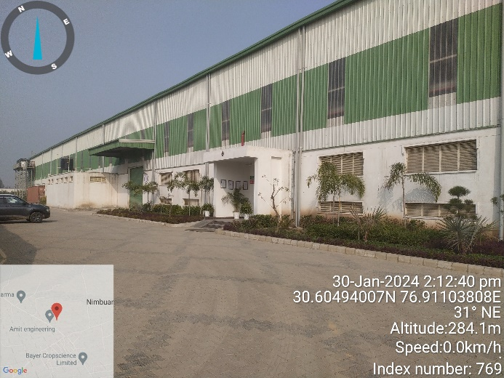 | 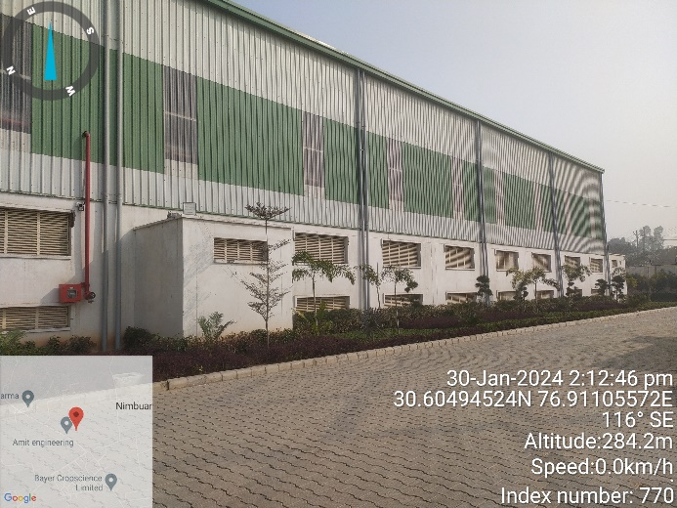
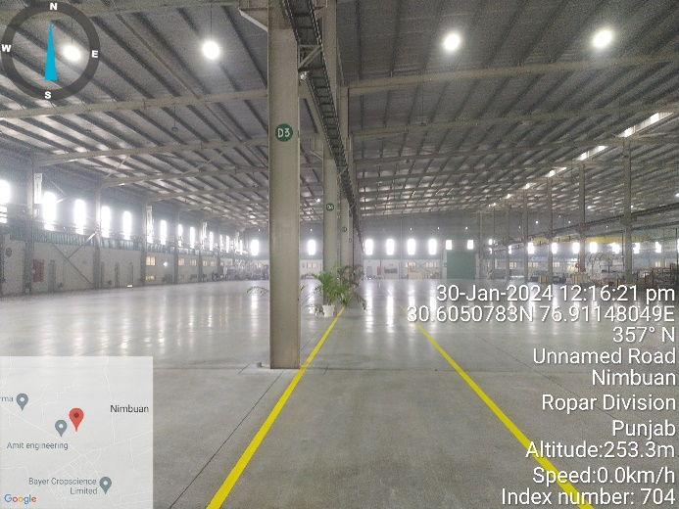 | 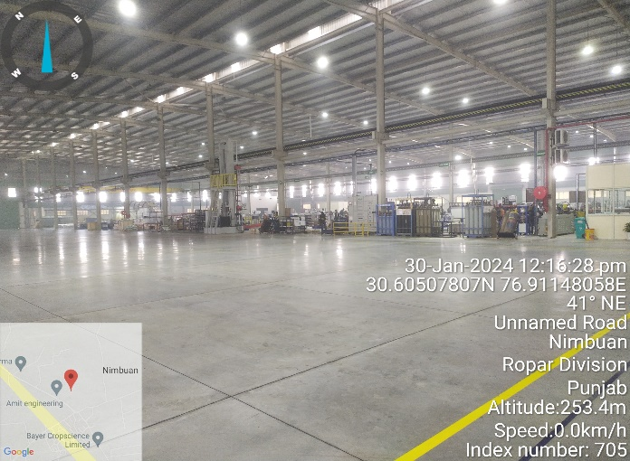
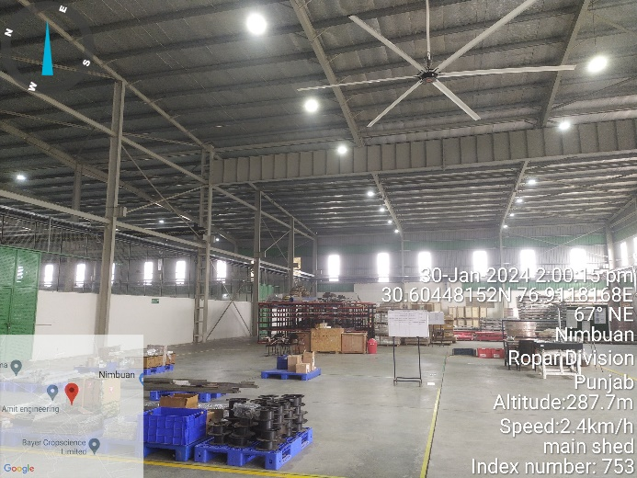 | 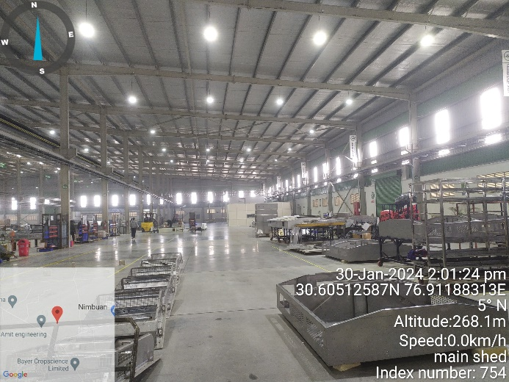

MAIN UNIT SHED

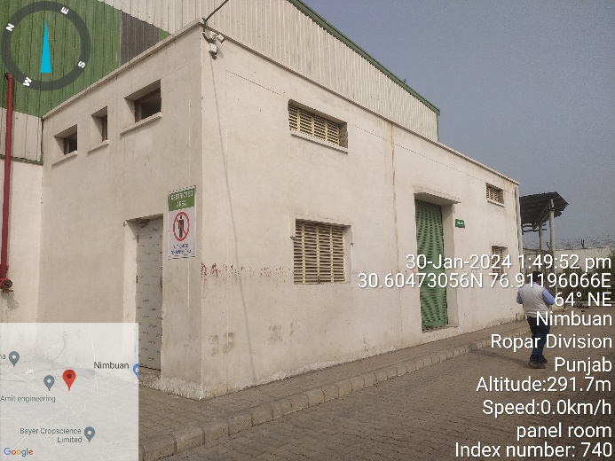 | 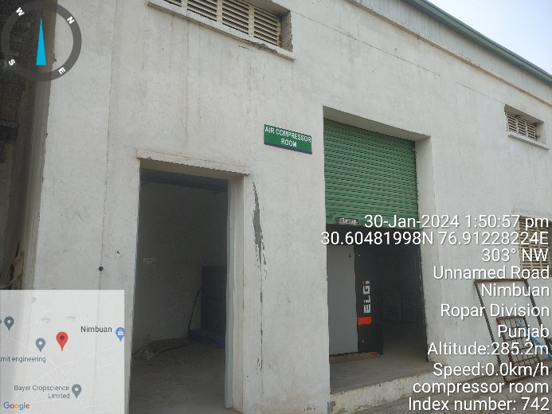
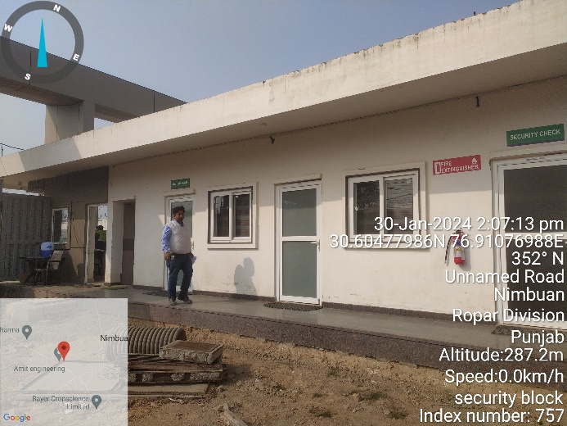 | 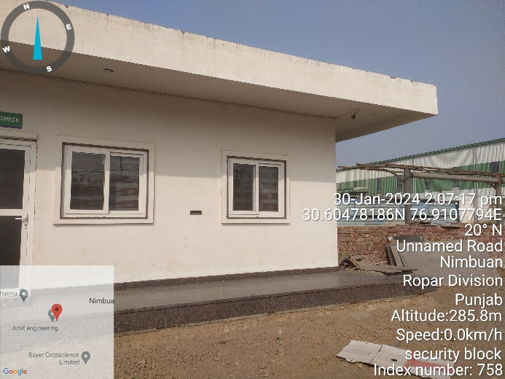
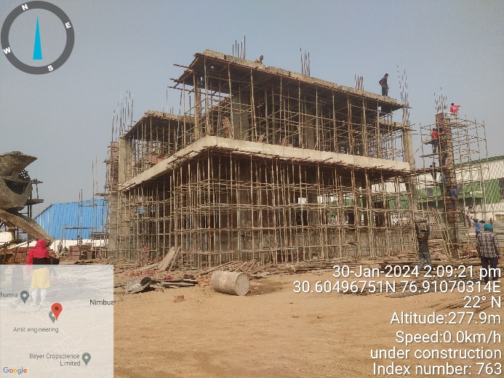 | 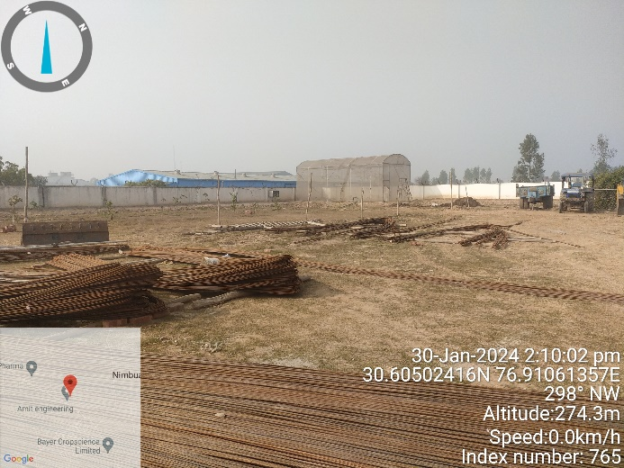

PHOTOGRAPHS OF THE MACHINES:
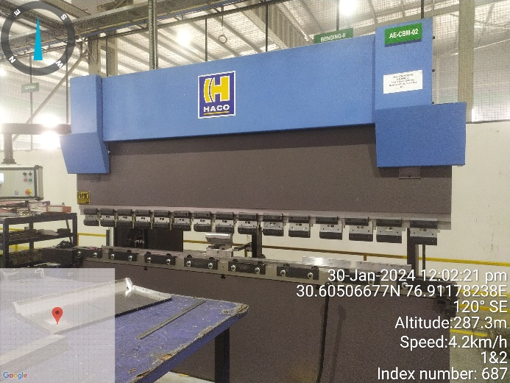  CNC BENDING MACHINE | 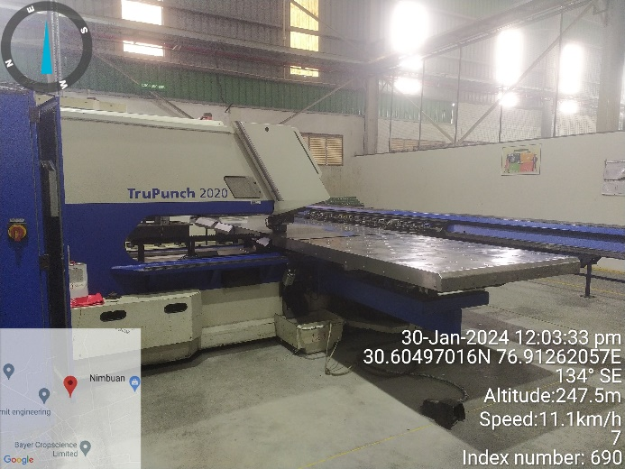  AUTO CNC PUNCHING MACHINE
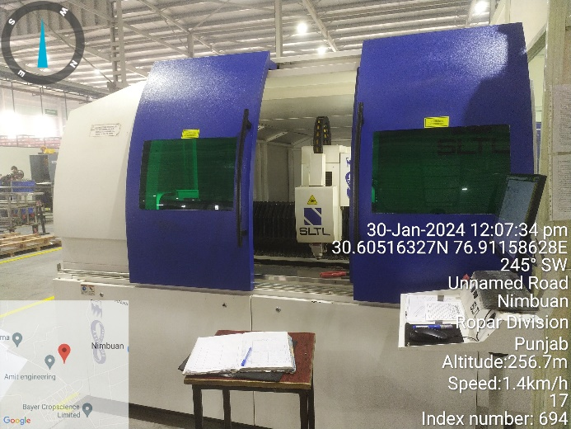  LASER CUTTING MACHINE | 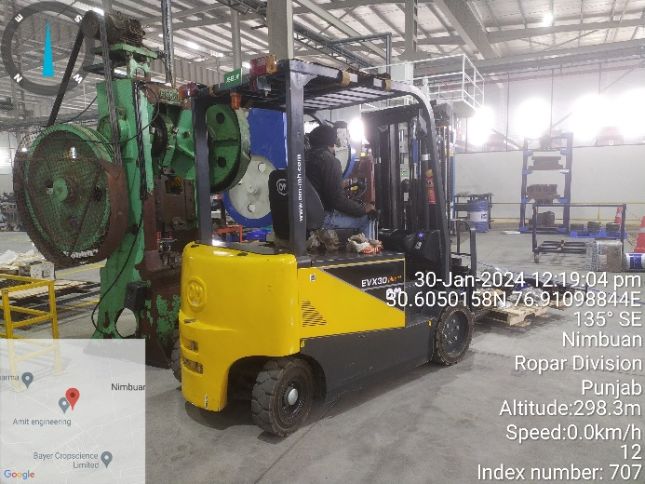  FORK LIFT
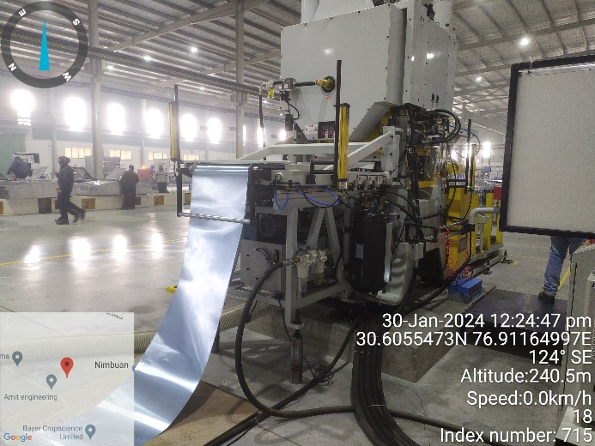  FIN PRESS MACHINE | 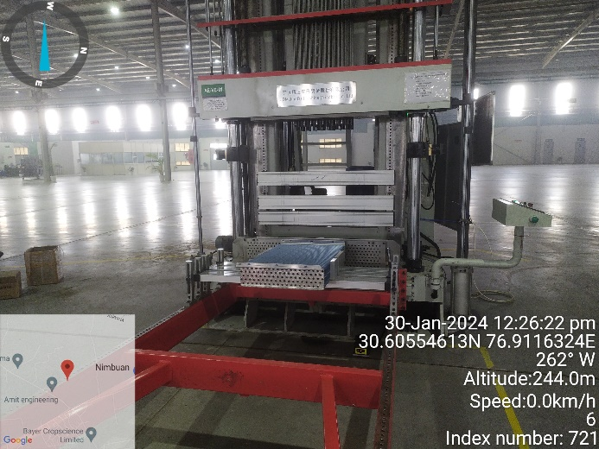  VERTICAL EXPANDER MACHINE

