REPORT FORMAT: V-L2 (Large with P&M - PNB) | Version: 12.0_Nov.2022

CASE NO. VIS(2023-24)-PL689-590-912 Dated: 15.02.2024

FIXED ASSETS VALUATION REPORT

OF

NATURE OF ASSETS | LAND & BUILDING, PLANT & MACHINERY & OTHER MISCELLANEOUS FIXED ASSETS
CATEGORY OF ASSETS | INDUSTRIAL
TYPE OF ASSETS | INDUSTRIAL PLANT

SITUATED AT
VILLAGE DERANG, TEHSIL- KANIHA, DISTRICT- ANGUL, ODISHA

OWNER
M/S. JINDAL INDIA THERMAL POWER LIMITED

REPORT PREPARED FOR
PUNJAB NATIONAL BANK, ZONAL SASTRA, BHIKAJI CAMA PLACE, NEW DELHI

**Important - In case of any query/ issue or escalation you may please contact Incident Manager
at valuers@rkassociates.org. We will appreciate your feedback in order to improve our services.

NOTE: As per IBA & Bank’s Guidelines please provide your feedback on the report within 15 days of its submission after which report will be considered to be correct.
Valuation Terms of Services & Valuer’s Important Remarks are available at www.rkassociates.org for reference.

PART A | SNAPSHOT OF THE ASSET/ PROPERTY UNDER VALUATION

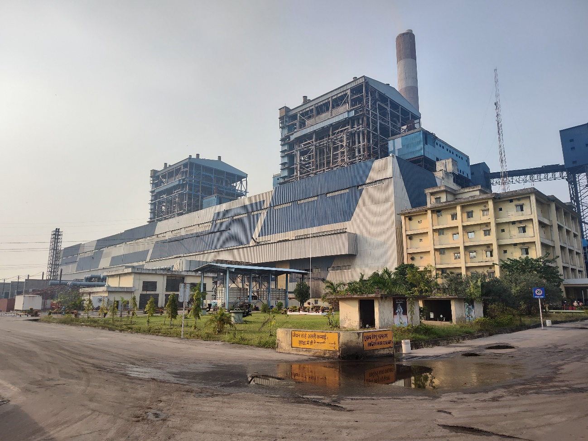
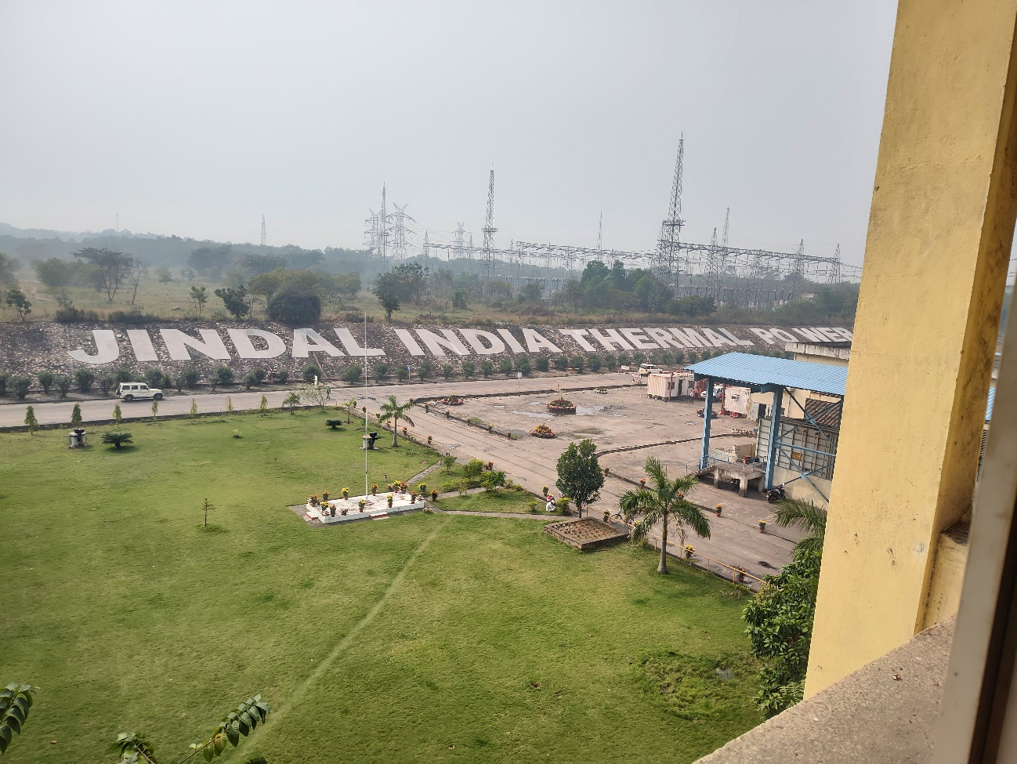

PART B | SUMMARY OF THE VALUATION REPORT

S.NO. | CONTENTS | DESCRIPTION
 | GENERAL DETAILS
 | Report prepared for | Punjab National Bank, Zonal Sastra, Bhikaji Cama Place, New Delhi
 | Name of Borrower unit | M/s. Jindal India Thermal Power Limited [JITPL]
 | Name of Property Owner | M/s. Jindal India Thermal Power Limited [JITPL]
 | Address & Phone Number of the owner | Regd. Office: Plot no.2, Pocket C, 2nd Floor, Nelson Mandela Road, Vasant Kunj, New Delhi- 110070
 | Type of the Property | Thermal Power Plant (Land, Building and Plant & Machinery)
 | Type of Valuation Report | Industrial Land & Building and Plant & Machinery Valuation
 | Report Type | Detailed Asset Valuation
 | Date of Inspection of the Property | 13 February 2024
 | Date of Valuation Assessment | 15 February 2024
 | Date of Valuation Report | 15 February 2024
 | Surveyed in presence of | Company's representative |  | Mr. Vivek Kumar  - +91 95830 40198
 | Purpose of the Valuation | For procuring equity stake in the Project as per restructuring proposal.
 | Scope of the Report | Non Binding Opinion on General Prospective Valuation Assessment of the Property identified by Property owner or through its representative
 | Out-of-Scope of Report | - Verification of authenticity of documents from originals or cross checking from any Govt. deptt. is not done at our end.  - Legal aspects of the property are out-of-scope of this report.  - Identification of the property is only limited to cross verification from its boundaries at site if mentioned in the provided documents.  - Getting Cizra map or coordination with revenue officers for site identification is not done at our end.  - Measurement is only limited up to sample random measurement.  - Measurement of the property as a whole is not done at our end.  - Drawing Map & design of the property is out of scope of the work.
 | Identification of the property |  | Done from the name plate displayed on the property
 | Identification of the property |  | Identified by the Owner's representative

 | VALUATION SUMMARY
 | Total Prospective Fair Market Value | Rs. 4606,00,00,000/-
 | Total Expected Realizable/ Fetch Value | Rs. 3915,10,00,000/-
 | Total Expected Distress/ Forced Sale Value | Rs. 3224,20,00,000/-

 | ENCLOSURES
 | Part A | Snapshot of The Asset/ Property Under Valuation
 | Part B | Summary of the Valuation Report
 | Part C | Introduction
 | Part D | Project NOCs & Statutory Approval Details
 | Part E | PNB format on opinion Report on Valuation
 | Part F | Area Description of The Property
 | Part G | Procedure of Valuation Assessments- Land & Building
 | Part H | Characteristics Description of Plant & Machinery
 | Part I | Procedure of Valuation Assessment – Plant & Machinery
 | Part J | Consolidated Valuation Assessment of The Plant
 | Enclosure I | Google Map Location
 | Enclosure II | References on price trend of the similar related properties available on public domain
 | Enclosure III | Photographs
 | Enclosure IV | Copy of Documents related to Land Rate Important Property Documents Exhibit
 | Enclosure V | Important Property Documents Exhibit
 | Enclosure VI | Declaration
 | Enclosure VII | Model code of conduct for valuers
 | Enclosure VIII | Valuer’s important remarks

In ₹ Crore
Asset-wise Valuation Summary
As per JITPL dated 31-03-2023 |  |  |  | As per RKA dated 15-02-2024
S. No. | Assets | Gross Block | Net Block | Gross Current Replacement Cost | Depreciated Replacement Cost | Fair Value
1 | Land | 160.38 | 146.25 | 703.61 | 703.61 | 527.70
2 | Building | 583.77 | 391.22 | 195.83 | 155.55 | 116.66
3 | Plant & Machinery | 6,422.64 | 4,998.13 | 7,748.28 | 5,264.14 | 3,962.13
Total |  | 7,166.79 | 5,535.60 | 8,647.72 | 6,123.30 | 4,606.49
Per MW Cost in Rs. Crore |  | 5.97 | 4.61 | 7.20 | 5.10 | 3.84

PART C | INTRODUCTION

- NAME OF THE PROJECT: Detailed Asset Valuation of (2 X 600) MW Pulverized Coal Fired Sub-Critical Thermal Power Plant set by Jindal India Thermal Power Limited (JITPL) at Derang Village, Angul District of Odisha, India.
- PURPOSE OF REPORT: R.K Associates has been appointed by Punjab National Bank, Zonal Sastra, Bhikaji Cama Place, New Delhi for carrying out the fixed asset valuation (i.e., valuation of land, building and Plant & Machinery) of the subject property on as-is-where-is basis as mentioned in appointment letter.
- BRIEF DESCRIPTION OF THE PROJECT: M/s. Jindal India Thermal Power Limited has set up a 1200 MW (2 X 600) pulverized coal fired Sub-Critical Thermal Power Plant at Derang Village, Angul District of Odisha, India.
This is a Project Asset Valuation report and comprises of Land & Building and Plant & Machinery Valuation of the Sub-Critical Thermal Power plant located in Derang Village, Angul District of Odisha, India. Details of Land & Building and Plant & Machinery are enumerated in different section of this report.
This Sub-critical thermal Power Plant has been divided into two phases i.e. Phase-I & II. Phase-I & II of the project has been launched comprising of Unit-1 & 2 having power generation capacity of 600 MW each unit. Unit wise commissioning details of the Project is mentioned below:-
Table-2
Sr. No. | Unit No. | COD Achieved Date
1 | Unit No. 01 | 06-June-2014
2 | Unit No. 02 | 12-February-2015

  - Location
The project site is situated in Derang Village, Angul district, Odisha, approximately 35 km away from Talcher. The closest major railway station is Talcher, also located 35 km from the project site. Bhubaneswar Airport, about 175 km away, serves as the nearest airport. The strategic location of the project was initially chosen for its proximity to coal mines. To facilitate transportation, the company has constructed its own access road connecting to NH-23 Site.
🚍 | Talchar Bus Stop [20 km]
🚉 | Angul Railway Station [43 km]
🛪 | Bhubaneswar Airport [170 km]

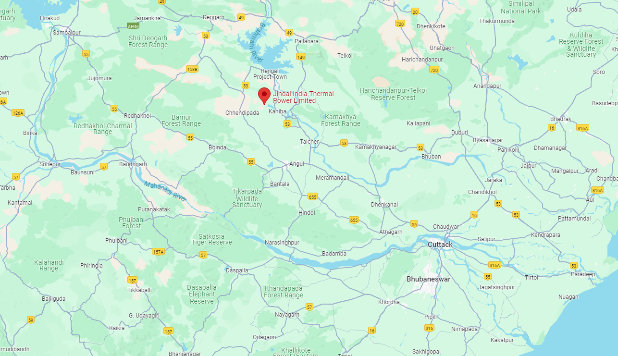
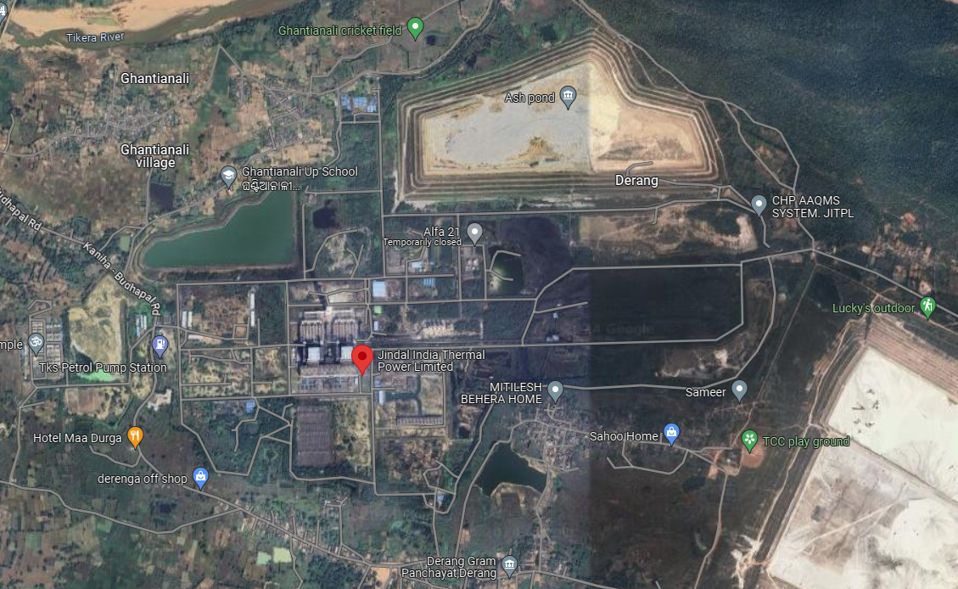

  - Project Cost
The project's initial cost, including the transmission line, was Rs. 5960.71 Crore. for 1200 MW. But after that, the project's cost increased for a number of reasons, including delay in the financial closure, changes to the EPC contractor's scope, increase in the cost of civil work, increase in Interest During Construction (IDC), increase in working capital margin funds, expansion of the project's scope, etc. The project cost increased to Rs. 7061.00 Crore as a result of this cost overrun as enumerated below:
Table-3

  - Land
As per land area statement shared by the company, the total land area underneath the plant at different locations is about 1174.84 acre. However, as per copy of 3 nos. Memorandum of Entry dated 19th May 2016, area mortgaged with the consortium of banks is 1047.43 acre. The majority of this land has been obtained by the Odisha Industrial Infrastructure Development Corporation (IDCO) from local villagers. Subsequently, it has been allotted to the company on a 90-year lease through Lease Deeds for the development of the Power project. This overall land acquisition encompasses the Power Plant area, land designated for the Water Corridor and other associated facilities.

The detailed break-up of the total land acquired/purchased by JITPL is given below:
S. No. | Village Name | Area
S. No. | Village Name | In Acre | In Sqm
1 | Derang | 973.23 | 39,38,506
2 | Uchhaballi | 50.99 | 2,06,348
3 | Tolakbeda | 9.89 | 40,023
4 | Kaniha | 4.23 | 17,118
5 | Masunihata | 4.07 | 16,471
6 | Balarampur | 1.74 | 7,042
7 | Gadasila | 1.58 | 6,394
8 | Takua | 1.11 | 4,492
9 | Karadei | 0.30 | 1,214
10 | Sarathipal | 0.29 | 1,174
Total |  | 1047.43 | 42,38,782

S. No. | Type of Ownership | Area
S. No. | Type of Ownership | In Acre | In Sqm
1 | Lease hold | 1026.4 | 41,53,677
2 | Free hold | 21.03 | 85,105
Total |  | 1,047.43 | 42,38,782

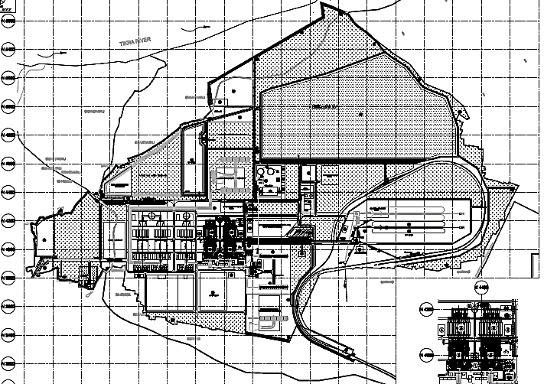
For the valuation assessment, we have considered land area measuring 1047.43 acre.
The land area taken in the Valuation assessment is purely on the basis of the information provided to us by the JITPL. We have not measured the land area on site/cizra map since the land is located in various locations & practically it is not possible to measure each and every land parcel so we have relied upon the information provided to us by the company in good faith.

  - Project Contracts
- BTG Supply and Erection Contracts
Project Company had executed the project under multiple package contract scheme viz. BTG package contract and BOP packages contract. Project Company has awarded the BTG Contract to M/s. Bharat Heavy Electricals Limited (BHEL), India.
The scope of work included design, engineering, manufacture, assembly, testing, packing and forwarding, supply, transportation, arrangement of comprehensive insurance, erection, testing, pre-commissioning and commissioning, conducting performance and guarantee test of Boiler, Turbine and Generator (BTG) along with its auxiliaries, station control and instrumentation, auxiliary boiler and commissioning spares for the two sub-critical units of this Plant.
- BOP Contracts
Project Company has involved multiple contractors for erection of Balance of Plant (BOP) and Civil works of the Project and further company has awarded the major BOP contracts and Non-EPC contractors to various contractors.
Main machinery of the plant include Boiler, Turbine, Generator, Coal Handling Plant, Ash Handling Plant, Water Treatment Plant, Switchyard, Transmission line, Water pipeline system to bring raw water to the plant, and other auxiliary machinery for running the plant.
Table-5
S. No. | Contacts | Name of Supplier | Scope of Work
1 | BTG Civil Work | M/s Shapoorji and M/s Petron | Laying of foundation for Boilers, ESPS, ESP Control Room Construction etc.
2 | General Civil Work | M/s Shapoorji | General Civil works
3 | General Civil Work-2 | M/s Gammon | CW/ACW System Civil Works, CWPH, Tunnels and CW Piping Raw Water Supply & Storage pond water system civil works, Condensate storage Tank, Effluent Treatment Plant, Fire Protection and DG set Building etc.
4 | Ash Handling Plant | M/s Macawber Beekay, M/s BSBK | Design & Engineering, Manufacturing, Inspection, Supply & erection, testing and commissioning of Complete Fly Ash Handling System & Bottom Ash Handing Systems including supply of structural steel and spare
5 | Chimney | M/s Gammon | Construction of Reinforced Concrete Double Flue Chimney
6 | Electrical Works | M/s Siemens | Design, engineering, manufacturing, inspection, supply, erection, testing & commissioning of Electrical Balance of Plant
7 | Transmission Lines | M/s Gammon | Design, engineering, testing, supply of material, for 400 KV Double Circuit Transmission Line
8 | Ash Dyke | M/s GSR Ventures Pvt. Ltd. | Construction of Ash Dyke and Raw Water Reservoir
9 | Water Treatment Plant | M/s Ion Exchange | Supply and Erection, Testing and Commissioning of Water Treatment Plant
10 | Cooling Tower | M/s Paharpur Cooling Towers Ltd. | Erection, testing, start up, commissioning, performance testing at site of 2 Nos. Induced Draft Cooling Towers
11 | BTG Civil Work | M/s BHEL | BTG package
12 | Intake Water System | M/s Raunaq International Ltd. | Erection, testing and commissioning of River Water System and Plant Raw Water System
13 | Township | M/s Gammon India Ltd. | Order for Construction of Township (Site Development Works, Housing Unit Type A, B, C, Community Centre, Water Supply System, Storm Water Drainage System, Sewerage System, Misc. - Temple, Barrack, Etc., Fire Protection System) including Electrical Works

Plant is distributed into different blocks comprising of different buildings as per their utility. These mainly comprise of Industrial Structures consisting of massive steel structural members embedded in RCC base and covered by Industrial heavy duty corrugated steel sheets. Also, some buildings are made out of brickwork and RCC with RCC Roofs.
Main sections of the Plant include Boiler House, ESP Building, ESP Control Room, Turbine Building, Coal bunker, Switchyard Control room, Control Room, Cable Vault, Fly Ash Silos, Chimney among other buildings & sections.
  - Water Requirement
As per the Water Balance Diagram, the consumptive water requirement with closed cooling system is about 3 m³/MWh. Water required is being drawn from Upstream Samal Barrage on Brahamani River, which is at a distance of 12 km from the project site. Water is pumped from the Intake Pump House through dedicated pipelines to the water reservoir situated in the Plant to meet the water requirements of the Plant.
Project Company has executed Agreement with Government of Odisha, Department of Water Resources dated 01st September 2023 for water drawl from Upstream of Samal Barrage from River Brahamani for 25 Cusec for the period started from 01st September 2023 to 31st August 2026 at the rate of Rs. 9.52/- per m³.
Further to it company has constructed a reservoir inside the plant having capacity around 8.50 Lakh m³ which is sufficient for 10 days consumption of the plant.

  - Power Purchase Agreement
During the Financial Year 2022-23, Jindal India Thermal Power Limited entered into several Power Purchase Agreements (PPAs) for the sale of electricity as per details below:
Long Term PPA with Bihar: A 300 MW Long Term PPA was signed with Bihar.
Long Term PPA with GRIDCO: A Long Term PPA was signed with GRIDCO for 12%(~125MW) of the energy sent out. Also, the supply of power to GRIDCO started from April 2022 based on the Hon'ble High Court of Orissa interim order dated 29th April 2022.
Medium Term PPA with NPCL: A 100 MW Medium Term PPA was signed with NPCL. The term will be ended on 31st December 2025.
Medium Term PPA with PTC under Pilot Scheme-II: A 270 MW Medium Term PPA was signed with PTC under Pilot Scheme-II.
Additionally, the company participated in PFC Pilot Scheme-III Tender in the months of January 2023 for the supply of 200 MW under Medium Term (5 years) and is the L-1 bidder under the tender. Balance power is sold by the company through short term PPAs and in the Merchant Market.

  - Fuel Supply Agreements
As per data information provided by the company, the annual coal requirement of the plant is ~7.0 million MT. The company is sourcing coal from Mahanadi Coalfields Ltd. (MCL) under linkage for both long-term Power Purchase Agreements (PPAs) and medium-term PPAs with DISCOMS, and power supply has already commenced under these agreements. Details of FSA are as follows:-
Buyer | Seller | Agreement Date | Period | Annual Contracted Quantity
Jindal India Thermal Power Limited | Mahanadi Coalfield Limited | 12-09-2020 | 19 Year | 6,00,000 Ton
Jindal India Thermal Power Limited | Mahanadi Coalfield Limited | 24-01-2023 | 25 Year | 24,44,323 Ton

For the balance requirement, including short-term sales on Power Exchanges, coal is being sourced under the SHAKTI B (viii) scheme of the Ministry of Coal, Government of India.

  - Power Evacuation Infrastructure
Generated power evacuated from the plant is through the power station’s 400 kV double circuit pooling station at Angul. A Dedicated 400 kV double circuit power transmission lines is constructed from the project site to GRIDCO/PGCIL’s Tulip Power sub-station located at a distance of 77 Km from the site. Further, for transmitting power to utilities located in other states, the company has already entered into a Bulk Power Transmission Agreement (BPTA) for long term open access with PGCIL.

  - Operations and Maintenance Contracts
As per the information provided by the company Operation & Maintenance of the project has been taken care by following contractor under the supervision of JITPL:-
S. No. | System | Contractor
1 | BTG & BOP | M/s Power Mech Projects Ltd.
2 | Coal Handling System | M/s Chennai Radha Engineering Works (P) Ltd.
3 | Ash Handling System | M/s Feedback Power Operation & Maintenance Services Pvt. Ltd.
4 | Transmission Line | M/s Abhishek Contech (I) Pvt. Ltd.

  - Status of Plant during Site Survey
Our engineering team has visited the power plant project site on 13th February 2024. During the site visit, it was observed that Unit-1 was not operational from 08th February due to Turbine Blade Failure. Unit-2 was fully operational and all the machinery and equipment were maintained properly.

- TYPE OF REPORT: Detailed Fixed Asset Valuation of the Project.

- SCOPE OF THE REPORT: To assess & determine current Fair Market Value, Realizable Value & Distress Value of the Physical Assets of the Project for facilitating lenders for procuring equity stake in the Project as per restructuring proposal.

- DOCUMENTS/DATA REFFERED:
Land
- Copy of 03 nos. MOE
- Land Area statement
Building
- Copy of Building area sheet.
- Copy of approvals
Plant & Machinery
- Copy of Fixed Assets Register dated 31-03-2023
- Copy of balance sheet dated 31-03-2023
- Copy fuel supply agreement
- Process flow diagram
- Maintenance record & projected plan
- Copies of approvals and NOCs from various government agencies and departments

PART D | PROJECT STATUTORY APPROVAL & NOCS DETAILS

S. No. | REQUIRED APPROVALS | REFERENCE NO./ DATE | STATUS
 | Consent to operate | No. 4506/IND-I-CON-6351 Dated : 23-03-2023 Valid till 31-03-2025 | Expired
 | MOEF/ CPCB | Consent Order from State Pollution Control Board, Odisha – Valid till 31.03.2025. | Obtained
 | State PCB | Letter No. 4506/IND-I-CON-6351 dated 23-03-2023  Valid till 31-03-2025 | Obtained
 | Environment clearance | Nill dated 29-09-2008 | Obtained
 | Consent to Establish | No. 45065/IND-II-NOC-4604 dated 17-11-2008 | Obtained
 | Height Clearance | No. AAI/20012/287/2008-ARI(NOC) dated 04-08-2008 valid till 07 year | Expired
 | Forest Clearance | No. 5-ORC152/2012-BHU dated 22-11-2012 | Obtained
 | NoC for river water usage | Agreement dated 01-09-2023  Valid till 31-08-2026 | Obtained

OBSERVATIONS: Project meets preliminary necessary compliance statutory approvals unless expired or not shared. However, Height clearance certificate expired and Boiler certificates are not shared with us.

PART E | PNB FORMAT OF OPINION REPORT ON VALUATION

Name & Address of the Branch | Punjab National Bank, Zonal Sastra, Bhikaji Cama Place, New Delhi
Name of Customer (s)/ Borrower Unit | M/s. Jindal India Thermal Power Limited [JITPL]
Work Order No. & Date | Via letter dated 1st February 2024

S.NO. | CONTENTS |  |  |  |  |  | DESCRIPTION
 | INTRODUCTION
 | Name of Valuer |  |  |  |  |  | R.K Associates Valuers & Techno Engg. Consultants (P) Ltd.
 | - Date of Inspection of the Property |  |  |  |  |  | 13 February 2024
 | - Property Shown By |  |  |  |  |  | Name |  |  |  |  |  | Relationship with Owner |  |  |  |  |  |  |  |  |  |  |  | Contact Number
 |  |  |  |  |  |  | Mr. Vivek Kumar |  |  |  |  |  | Maintenance Head |  |  |  |  |  |  |  |  |  |  |  | +91 95830 40198
 | - Title Deed Number and Date |  |  |  |  |  | Refer Part-C Introduction
 | - Date of Valuation Report |  |  |  |  |  | 15 February 2024
 | Purpose of the Valuation |  |  |  |  |  | For procuring equity stake in the Project as per restructuring proposal.
 | Name of the Property Owner  (Details of share of each owner in case of joint and Co-ownership) |  |  |  |  |  | M/s. Jindal India Thermal Power Limited [JITPL]
 | Name & Address of the Branch |  |  |  |  |  | Punjab National Bank, Zonal Sastra, Bhikaji Cama Place, New Delhi
 | Name of the Developer of the Property (in case of developer built properties) |  |  |  |  |  | BTG Contract to M/s. Bharat Heavy Electricals Limited and BOP Contract to various contractors
 | Type of Developer |  |  |  |  |  | Private Contractor and EPC Consultant built
 | Property presently occupied/ possessed by (owner / tenant/ etc.)? |  |  |  |  |  | Owner
 | If occupied by tenant, since how long? |  |  |  |  |  | 2015
 | PHYSICAL CHARACTERISTICS OF THE ASSET
BRIEF DESCRIPTION OF THE PROPERTY UNDER VALUATION

This Valuation Report is prepared for (2 X 600) MW Pulverized Coal Fired Sub-Critical Thermal Power Plant set by Jindal India Thermal Power Limited (JITPL) at Derang Village, Angul District of Odisha, India.

The total land area underneath the plant is 1047.43 acre. This is a Sub-Critical pulverized coal fired Power Plant. The Plant comprises of 2 Units of 600 MW each. Unit #1 has been commissioned & it successfully achieved COD on June 6th, 2014 and Unit #2 has achieved its COD on February 12th, 2015.

Other Project details are already described in ‘Brief description of the Project’ under Part-C Introduction section.

This report only contains general assessment & opinion on the Guideline Value and the indicative, estimated Market Value of the property of which Bank/ customer asked us to conduct the Valuation for the property found on as-is-where basis as shown on the site by the Bank/ customer of which photographs is also attached with the report. No legal aspects in terms of ownership or any other legal aspect is taken into consideration. Even if any such information is mentioned in the report it is only referred from the information provided for which we do not assume any responsibility. Due care has been given while doing valuation assessment, but it doesn’t contain any due-diligence or audit or verification of any kind other than the valuation computation of the property shown to us on site. Information/ data/ documents given to us by Bank/ client have been relied upon in good faith. This report doesn’t contain any other recommendations of any sort.

In case of discrepancy in the address/ property number mentioned in the property documents and the property shown to us at the site due to change in zoning or administrative level at the site or the client misled the valuer by providing the fabricated/ incorrect document or information, the valuation should be considered of the property shown to us at the site by the client of which the photographs are also attached. In case of any doubt, best would be to contact the concerned authority/ district administration/ tehsil level for the identification of the property if the property depicted in the photographs in this report is same with the documents pledged.
 | Location of the property in the city
 | Plot No. / Survey No.  (referred from the copy of the documents provided to us) |  |  |  |  | Multiple survey no. please refer to annexure attached.
 | Door No. |  |  |  |  | ---
 | T.S. No. /Village |  |  |  |  | Village-Derang
 | Ward/ Taluka |  |  |  |  | Angul
 | Mandal/ District |  |  |  |  | Angul
 | Municipal Ward No. |  |  |  |  | ---
 | City/Town |  |  |  |  | Village- Derang
 | Category of Area (Residential/ Commercial/ Industrial/ etc.) |  |  |  |  | Rural Area
 | Classification of the Area (High/Middle/Poor | Metro/Urban/Semi Urban/Rural) |  |  |  |  | Semi Urban
 | - City Categorization |  |  |  |  | Village |  |  |  |  |  |  |  |  |  |  |  | Rural
 | - Characteristics of the locality |  |  |  |  | Average |  |  |  |  |  |  |  |  |  |  |  | Within Remote area
 | - Property location classification |  |  |  |  | Road Facing |  |  |  |  |  | Near to NTPC Plant |  |  |  |  |  |  |  |  |  |  |  |  | Property towards end of the locality
 | Local body jurisdiction (coming Under Corporation Limit/ Village Panchayat/ Municipality) |  |  |  |  | Derang Gram Panchayat
 | Postal Address of the Property (as mentioned in the documents provided) |  |  |  |  | M/s. Jindal India Thermal Power Limited [JITPL], Village-Derang, Angul, Odisha
 | Nearby Landmark |  |  |  |  | Talcher Super Thermal Power Station (NTPC)
 | Google Map Location of the Property (Latitude/ Longitude and coordinates of the site) |  |  |  |  | Enclosed with the Report
 |  |  |  |  |  | Coordinates or URL: 21°07'17.2"N 84°59'21.0"E
 | Area of the Plot/ Land  Also please refer to Part-B Area description of the property. Area measurements considered in the Valuation Report is adopted from relevant approved documents or actual site measurement whichever is less, unless otherwise mentioned. Verification of the area measurement of the property is done only based on sample random checking. |  |  |  |  | 1047.43 acre
 | Layout plan of the area in which the property is located |  |  |  |  | Attached above in Part-C of the report
 | Development of Surrounding area |  |  |  |  | Rural area and most of the nearby land is lying barron
 | Details of the roads abutting the property |  |  |  |  | Village road
 | Main Road Name & Width |  |  |  |  | NH-23 |  |  |  |  |  |  |  |  |  |  |  | Approx. 45 ft. wide
 | Front Road Name & width |  |  |  |  | Village road |  |  |  |  |  |  |  |  |  |  |  | Approx. 12 ft. wide
 | Type of Approach Road |  |  |  |  | Bituminous Road
 | Distance from the Main Road |  |  |  |  | ~05 km
 | Whether covered under any State / Central Govt. enactments (e.g. Urban Land Ceiling Act) or notified under agency area / scheduled area / cantonment area |  |  |  |  | Odisha Industrial Infrastructure Development Corporation (IDCO)
 | In case it is an agricultural land, any conversion to house site plots is contemplated |  |  |  |  | No such information available as per documents provided to us.
 | Boundaries schedule of the Property
 | Are Boundaries Matched |  |  |  |  | Since, The land is spread over a very large area so the boundaries can not be identified easily
 | DIRECTIONS |  |  |  | AS PER SALE DEED/TIR (A) |  |  |  |  |  |  |  |  |  |  |  | ACTUAL FOUND AT SITE (B)
 | North |  |  |  | ---- |  |  |  |  |  |  |  |  |  |  |  | Since, the land is spread over a very large and irregular in shape. Thus land parcel couldn’t be measured.
 | South |  |  |  | ----
 | East |  |  |  | ----
 | West |  |  |  | ----
 | Extent of the site considered for valuation (least of 14 A & 14 B)
- . | Description of adjoining property
- . | Property Facing |  |  | South Facing
- . | North |  |  | ---- |  |  |  |  |  |  |  |  |  |  |  | Vacant Land
- . | South |  |  | ---- |  |  |  |  |  |  |  |  |  |  |  | Derang Shiv Mandir
- . | East |  |  | ---- |  |  |  |  |  |  |  |  |  |  |  | Forest Land and Road
- . | West |  |  | ---- |  |  |  |  |  |  |  |  |  |  |  | Vacant/ Barrel Land
 | Survey No., If any |  |  |  |  | Multiple survey no. please refer to annexure attached.
 | Type of Building (Residential/ Commercial/ Industrial) |  |  |  |  | Industrial. |  |  |  |  |  |  |  |  |  |  |  | Power Plant
 | Details of the building/ buildings and other improvements in terms of area, height, no. of floors, plinth area floor wise, year of construction, year of making alterations/ additional constructions with details, full details of specifications to be appended along with building plans and elevations |  |  |  |  | Please refer to clause ‘Building Valuation in Part-G” Engineering and Technology Aspects section.
 | Plinth area, Carpet area and Saleable area to be mentioned separately and clarified |  |  |  |  | Covered Area |  |  |  |  |  |  |  |  |  |  |  | 90,773 sqm
 | Any other aspect |  |  |  |  | Valuation is done for the property found as per the information given in the copy of documents provided to us and/ or confirmed by the owner/ owner representative to us at site.  Getting cizra map or coordination with revenue officers for site identification is a separate activity and is not covered in this Valuation services.
 | - List of documents produced for perusal (Documents has been referred only for reference purpose as provided. Authenticity to be ascertained by legal practitioner) |  |  |  |  | Documents Requested |  |  |  |  |  | Documents Provided |  |  |  |  |  |  |  |  |  |  |  |  | Documents Reference No.
 |  |  |  |  |  | Documents requested. |  |  |  |  |  | Please refer to Part-C, Page No, 13 |  |  |  |  |  |  |  |  |  |  |  |  | Please refer to Part-C, Page No, 13
 | - Documents provided by |  |  |  |  | Bank
 |  |  |  |  |  | Name |  |  |  |  |  | Relationship with Owner |  |  |  |  |  |  |  |  |  |  |  |  | Contact Number
 |  |  |  |  |  | Rimpi Rawat |  |  |  |  |  | Banks Representative |  |  |  |  |  |  |  |  |  |  |  |  | 7300704982
 | - Identification procedure followed of the property |  |  |  |  |  |  |  | Identified by owner’s representative
 |  |  |  |  |  |  |  |  | Done from the name plate displayed on the property
 | - Type of Survey conducted |  |  |  |  | Full survey (inside-out with approximate measurements & photographs).
 | - Is property clearly demarcated by permanent/ temporary boundary on site |  |  |  |  | Yes demarcated properly
 | - Independent access/ approach to the property |  |  |  |  | Clear independent access is available
 | - Is the property merged or colluded with any other property |  |  |  |  | No. It is an independent single bounded property
 |  |  |  |  |  | -------
 | TOWN PLANNING/ ZONING PARAMETERS
 | Master Plan provisions related to property in terms of Land use |  |  |  |  |  |  |  |  | Industrial
 | - Master Plan Currently in Force |  |  |  |  |  |  |  |  | NA
 | - Any conversion of land use done |  |  |  |  |  |  |  |  | No information available
 | - Current activity done in the property |  |  |  |  |  |  |  |  | Used for Industrial purpose
 | - Is property usage as per applicable zoning |  |  |  |  |  |  |  |  | It is a village area, no zoning regulations defined. However, regularized by IDCO
 | - Street Notification |  |  |  |  |  |  |  |  | Not notified
 | Date of issue and validity of layout of approved map / plan |  |  |  |  |  |  |  |  | IDCO, Odisha
 | Approved map / plan issuing authority |  |  |  |  |  |  |  |  | IDCO, Odisha
 | Whether genuineness or authenticity of approved map / plan is verified |  |  |  |  |  |  |  |  | No, not done at our end. It can be done by a legal practitioner or verification agencies which liaisons with the departments.
 | Any other comments by our empanelled valuers on authenticity of approved plan |  |  |  |  |  |  |  |  | ---
 | Planning area/zone |  |  |  |  |  |  |  |  | ---
 | Developmental controls/ Authority |  |  |  |  |  |  |  |  | IDCO
 | Zoning regulations |  |  |  |  |  |  |  |  | Area not notified under Master Plan
 | FAR/FSI |  |  |  |  |  |  |  |  | ----
 | Ground coverage |  |  |  |  |  |  |  |  | ----
 | Comment on Transferability of developmental rights |  |  |  |  |  |  |  |  | Lease hold, Transferable subject to NOC
 | Provision of Building by-laws as applicable |  |  |  |  |  |  |  |  | PERMITTED |  |  |  |  |  |  |  |  |  |  |  | CONSUMED
 | - Number of floors |  |  |  |  |  |  |  |  | --- |  |  |  |  |  |  |  |  |  |  |  | Refer building area description
 | - Height restrictions |  |  |  |  |  |  |  |  | ---
 | - Front/ Back/Side Setback |  |  |  |  |  |  |  |  | ---
 | Comment on the surrounding land uses & adjoining properties in terms of uses |  |  |  |  |  |  |  |  | Majorly all nearby lands are used for Agriculture purpose
 | Comment on unauthorized construction if any |  |  |  |  |  |  |  |  | No.
 | Comment of Demolition proceedings if any |  |  |  |  |  |  |  |  | No such information came to our knowledge
 | Comment on Compounding/ Regularization proceedings |  |  |  |  |  |  |  |  | No such information came to our knowledge
 | Comment on whether OC has been issued or not |  |  |  |  |  |  |  |  | NA |  |  |  |  |  |  |  |  |  |  |  | NA
 | Any Other Aspect
 | - Any information on encroachment |  |  |  |  |  |  |  |  | No
 | - Is the area part of unauthorized area/ colony |  |  |  |  |  |  |  |  | No (As per general information available)
 | LEGAL ASPECTS OF THE PROPERTY
 | Ownership documents provided |  |  |  |  |  |  |  |  | Memorendum of Entry
 | Names of Owner/s (In case of Joint or Co-ownership, whether the shares are undivided or not?) |  |  |  |  |  |  |  |  | M/s. Jindal India Thermal Power Limited (referred from the copy of the documents provided to us.)
 | Comment on dispute/ issues of landlord with tenant/statutory body/any other agencies, if any in regard to immovable property. |  |  |  |  |  |  |  |  | NA
 | Comment on whether the IP is independently accessible? |  |  |  |  |  |  |  |  | Clear independent access is available
 | Title verification |  |  |  |  |  |  |  |  | Legal aspects or Title verification have to be taken care by competent advocate.
 | Details of leases if any |  |  |  |  |  |  |  |  | N/A
 | Constitution of the Property (Ordinary status of freehold or leasehold including restriction on transfer) |  |  |  |  |  |  |  |  | Free hold, complete transferable rights & Lease hold, have to take NOC in order to transfer
 | Agreement of easement if any |  |  |  |  |  |  |  |  | No
 | Notice of acquisition if any |  |  |  |  |  |  |  |  | No such information came in front of us and could be found on public domain on our general search
 | Notification of road widening if any |  |  |  |  |  |  |  |  | No such information came in front of us and could be found on public domain on our general search
 | Possibility of frequent flooding / sub-merging |  |  |  |  |  |  |  |  | No
 | Special remarks, if any, like threat of acquisition of land for public service purposes, road widening or applicability of CRZ provisions etc. (Distance from sea-coast / tidal level must be incorporated) |  |  |  |  |  |  |  |  | None
 | Heritage restrictions, if any |  |  |  |  |  |  |  |  | No
 | Comment on Transferability of the property ownership |  |  |  |  |  |  |  |  | Lease hold, have to take NOC in order to transfer
 | Comment on existing mortgages/ charges/ encumbrances on the property, if any |  |  |  |  |  |  |  |  | Yes |  |  |  |  |  |  |  |  |  |  | Consortium of Lenders led by PNB
 | Comment on whether the owners of the property have issued any guarantee (personal or corporate) as the case may be |  |  |  |  |  |  |  |  | No information available |  |  |  |  |  |  |  |  |  |  | NA
 | Building plan sanction:
 | - Is Building Plan sanctioned |  |  |  |  |  |  |  |  | Sanctioned by competent authority as per copy of Map provided to us
 | - Authority approving the plan |  |  |  |  |  |  |  |  | IDCO, Odisha
 | - Any violation from the approved Building Plan |  |  |  |  |  |  |  |  | None as per visual observation
 | - Details of alterations/ deviations/ illegal construction/ encroachment noticed in the structure from the original approved plan |  |  |  |  |  |  |  |  | ☐ Permissible Alterations |  |  |  |  |  |  |  |  |  |  | ---
 |  |  |  |  |  |  |  |  |  | ☐ Not permitted alteration |  |  |  |  |  |  |  |  |  |  | ---
 | - Is this being regularized |  |  |  |  |  |  |  |  | No
 | Any other aspect |  |  |  |  |  |  |  |  | This is just an opinion report on Valuation of the property confirmed to us by the owner/ owner representative to us on site. The copy of the documents/ information provided to us by the client has been relied upon in good faith.  Legal aspects, Title verification, Verification of authenticity of documents of the property from originals or from any Govt. deptt. have to be taken care by legal expert/ Advocate or verification of site location from any Govt. deptt. is not done at our end.
 | - Information regarding municipal taxes (property tax, water tax, electricity bill) |  |  |  |  |  |  |  |  | Property Tax |  |  |  |  |  |  |  |  |  | ---
 |  |  |  |  |  |  |  |  |  | Water Tax |  |  |  |  |  |  |  |  |  | ---
 |  |  |  |  |  |  |  |  |  | Electricity Bill |  |  |  |  |  |  |  |  |  | ---
 | - Is property tax been paid for this property |  |  |  |  |  |  |  |  | ---
 | - Property or Tax Id No., if any |  |  |  |  |  |  |  |  | ---
 | - Whether entire piece of land on which the unit is set up / property is situated has been mortgaged or to be mortgaged |  |  |  |  |  |  |  |  | Yes, as informed by owner/ owner representative.
 | - Property presently occupied/ possessed by |  |  |  |  |  |  |  |  | Owner
 | *NOTE: Please see point 6 of Enclosure: VIII – Valuer’s Important Remarks
 | ECONOMIC ASPECTS OF THE PROPERTY
 | Details of ground rent payable |  |  |  |  |  |  |  |  | ---
 | Details of monthly rents being received if any |  |  |  |  |  |  |  |  | ---
 | Taxes and other outgoing |  |  |  |  |  |  |  |  | ---
 | Property Insurance details |  |  |  |  |  |  |  |  | ---
 | Monthly maintenance charges payable |  |  |  |  |  |  |  |  | ---
 | Security charges if paid any |  |  |  |  |  |  |  |  | ---
 | Any other aspect |  |  |  |  |  |  |  |  | ---
 | - Reasonable letting value/ Expected market monthly rental |  |  |  |  |  |  |  |  | ---
 | SOCIO - CULTURAL ASPECTS OF THE PROPERTY
 | Descriptive account of the location of the property in terms of Social structure of the area in terms of population, social stratification, regional origin, age groups, economic levels, location of slums/squatter settlements nearby, etc. |  |  |  |  |  |  |  |  | Rural Area
 | FUNCTIONAL AND UTILITARIAN ASPECTS
 | Description of the functionality & utility of the property in terms of:
 | - Space allocation |  |  |  |  |  |  |  |  | Yes
 | - Storage spaces |  |  |  |  |  |  |  |  | Yes
 | - Utility of spaces provided within the building |  |  |  |  |  |  |  |  | Yes
 | Any other aspect
 | - Drainage arrangements |  |  |  |  |  |  |  |  | Yes
 | - Water Treatment Plant |  |  |  |  |  |  |  |  | Yes
 | - Power Supply arrangements |  | Permanent |  |  |  |  |  |  | Yes
 |  |  | Auxiliary |  |  |  |  |  |  | Yes, D.G sets
 | - HVAC system |  |  |  |  |  |  |  |  | Yes/ in the Admin Building and Service Building
 | - Security provisions |  |  |  |  |  |  |  |  | Yes/ Private security guards
 | - Lift/ Elevators |  |  |  |  |  |  |  |  | Yes in TG Building
 | - Compound wall/ Main Gate |  |  |  |  |  |  |  |  | Yes
 | - Whether gated society |  |  |  |  |  |  |  |  | No
 | - Car parking facilities |  |  |  |  |  |  |  |  | Yes
 | - Balconies |  |  |  |  |  |  |  |  | Yes in the township
 | - Internal development
 | Garden/ Park/ Land scraping | Water bodies |  |  |  |  |  | Internal roads |  |  |  |  |  | Pavements |  |  |  |  |  |  |  |  |  |  |  | Boundary Wall
 | Yes | Yes |  |  |  |  |  | Yes |  |  |  |  |  | Yes |  |  |  |  |  |  |  |  |  |  |  | Yes
 | INFRASTRUCTURE AVAILABILITY
 | Description of Aqua Infrastructure availability in terms of:
 | - Water Supply |  |  |  |  |  |  |  |  | Yes, from Brahmani River through dedicated pipelines
 | - Sewerage/ sanitation system |  |  |  |  |  |  |  |  | Yes
 | - Storm water drainage |  |  |  |  |  |  |  |  | Yes
 | Description of other Physical Infrastructure facilities in terms of:
 | - Solid waste management |  |  |  |  |  |  |  |  | Yes, Self- managed
 | - Electricity |  |  |  |  |  |  |  |  | Yes, self-generated
 | - Road and Public Transport connectivity |  |  |  |  |  |  |  |  | Yes
 | - Availability of other public utilities nearby |  |  |  |  |  |  |  |  | It is a rural area and therefore Transport, Market, Hospital etc. are not available in close vicinity
 | Social Infrastructure in the terms of
 | - Schools |  |  |  |  |  |  |  |  | Yes available in close vicinity
 | - Medical Facilities |  |  |  |  |  |  |  |  | Own medical staff
 | - Recreation facilities in terms of parks and open spaces |  |  |  |  |  |  |  |  | Yes available within township
 | MARKETABILITY ASPECTS OF THE PROPERTY
 | Location attribute of the subject property |  |  |  |  |  |  |  |  | Good |  |  |  |  |  |  |  |  | In a remote area having no development
 | - Any New Development in surrounding area |  |  |  |  |  |  |  |  | No |  |  |  |  |  |  |  |  | N/A
 | - Any negativity/ defect/ disadvantages in the property/ location |  |  |  |  |  |  |  |  | --- |  |  |  |  |  |  |  |  | ---
 | Scarcity |  |  |  |  |  |  |  |  | Ample vacant land available nearby. There is no issue of land availability in this area.
 | Demand and supply of the kind of the subject property in the locality |  |  |  |  |  |  |  |  | Demand of the subject property is in accordance with the current use/ activity perspective only which is currently carried out in the property.
 | Comparable Sale Prices in the locality |  |  |  |  |  |  |  |  | Please refer to Part D: Procedure of Valuation Assessment
 | ENGINEERING AND TECHNOLOGY ASPECTS OF THE PROPERTY
 | Type of construction |  |  |  |  |  |  |  |  | Structure |  |  |  |  | Slab |  |  |  |  |  |  |  |  |  |  |  | Walls
 |  |  |  |  |  |  |  |  |  | Industrial corrugated GI Shed and RCC pillar beam column structures |  |  |  |  | Reinforced Cement Concrete |  |  |  |  |  |  |  |  |  |  |  | Brick walls
 | Material & Technology used |  |  |  |  |  |  |  |  | Material Used |  |  |  |  | Technology used
 |  |  |  |  |  |  |  |  |  | Grade A material |  |  |  |  | RCC Framed structure & Steel columns and trusses framed structure
 | Specifications
 | - Roof |  |  |  |  |  |  |  |  | Floors/ Blocks |  |  |  |  |  |  |  |  |  |  |  |  |  | Type of Roof
 |  |  |  |  |  |  |  |  |  | Refer building area description
 | - Floor height |  |  |  |  |  |  |  |  | Refer building area description
 | - Type of flooring |  |  |  |  |  |  |  |  | Vitrified tiles, Kota stone, PCC
 | - Doors/ Windows |  |  |  |  |  |  |  |  | Aluminum flushed doors & windows, Wooden frame & panel doors
 | - Class of construction/ Appearance/ Condition of structures |  |  |  |  |  |  |  |  | Internal - Good
 |  |  |  |  |  |  |  |  |  | External - Good
 | - Interior Finishing & Design |  |  |  |  |  |  |  |  | POP punning, Simple Plastered Walls, Designer false ceiling in office areas
 | - Exterior Finishing & Design |  |  |  |  |  |  |  |  | Neatly plastered & putty coated walls
 | - Interior decoration/ Special architectural or decorative feature |  |  |  |  |  |  |  |  | Good looking interiors. Medium use of interior decoration.
 | - Class of electrical fittings |  |  |  |  |  |  |  |  | Internal / Normal quality fittings used
 | - Class of sanitary & water supply fittings |  |  |  |  |  |  |  |  | Internal / Normal quality fittings used
 | Maintenance issues |  |  |  |  |  |  |  |  | No maintenance issue, structure is maintained properly
 | Age of building/ Year of construction |  |  |  |  |  |  |  |  | Approx. 8 years |  |  |  |  |  |  |  |  |  |  |  |  | Around year-2015 & 2016
 | Total life of the building |  |  |  |  |  |  |  |  | Approx. 45 & 60 years
 | Extent of deterioration in the structure |  |  |  |  |  |  |  |  | No deterioration came into notice through visual observation
 | Structural safety |  |  |  |  |  |  |  |  | Structure built on RCC technique so it can be assumed as structurally stable. However no structural stability certificate is available
 | Protection against natural disasters viz. earthquakes etc. |  |  |  |  |  |  |  |  | Since this is a RCC structure so should be able to withstand moderate intensity earthquakes. Comments are been made only based on visual observation and not any technical testing.
 | Visible damage in the building if any |  |  |  |  |  |  |  |  | No visible damages in the structure
 | Common facilities viz. lift, water pump, lights, security systems, etc., |  |  |  |  |  |  |  |  | Yes
 | System of air conditioning |  |  |  |  |  |  |  |  | Partially covered with window/ split ACs
 | Provision of firefighting |  |  |  |  |  |  |  |  | Fire Hydrant System
 | ENVIRONMENTAL FACTORS
 | Use of environment friendly building materials, green building techniques if any |  |  |  |  |  |  |  |  | No, regular building techniques of RCC and burnt clay bricks are used
 | Provision of rainwater harvesting |  |  |  |  |  |  |  |  | Yes
 | Use of solar heating and lighting systems, etc. |  |  |  |  |  |  |  |  | No
 | Presence of environmental pollution in the vicinity of the property in terms of industries, heavy traffic, etc. if any |  |  |  |  |  |  |  |  | Yes
 | ARCHITECTURAL AND AESTHETIC QUALITY OF THE PROPERTY
 | Descriptive account on whether the building is modern, old fashioned, etc., plain looking or with decorative elements, heritage value if applicable, presence of landscape elements,  etc. |  |  |  |  |  |  |  |  | Industrial Buildings
 | IN CASE OF VALUATION OF INDUSTRIAL PROPERTY
 | Proximity to residential areas |  |  |  |  |  |  |  |  | ----
 | Availability of public transport facilities |  |  |  |  |  |  |  |  | ---
 | VALUATION OF THE ASSET
 | Procedures adopted for arriving at the Valuation along with detailed analysis and descriptive account of the approaches, assumptions made, basis adopted, supporting data (in terms of comparable sales), reconciliation of various factors, departures |  |  |  |  |  |  |  |  | Please refer to the Part D: Procedure of Valuation Assessment of the report.
 | Summary of Valuation |  |  |  |  |  |  |  |  | For detailed Valuation calculation please refer to Part D: Procedure of Valuation Assessment of the report.
 | - Date of purchase of immovable property |  |  |  |  |  |  |  |  | NA
 | - Purchase Price of immovable property |  |  |  |  |  |  |  |  | NA
 | - Book value of immovable property |  |  |  |  |  |  |  |  | Rs. 55,35,59,97,031/-
 | - Indicative Prospective Estimated Fair Market Value |  |  |  |  |  |  |  |  | Rs. 4606,00,00,000/-
 | - Expected Estimated Realizable Value |  |  |  |  |  |  |  |  | Rs. 3915,10,00,000/-
 | - Expected Forced/ Distress Sale Value |  |  |  |  |  |  |  |  | Rs. 3224,20,00,000/-
 | - Guideline Value (value as per Circle Rates) |  |  |  |  |  |  |  |  | ---
S NO. | ENCLOSED DOCUMENTS |  |  |  |  |  |  |  |  |  | ENCLOSURE NO. |  |  |  |  |  |  |  | REMARKS
 | Declaration |  |  |  |  |  |  |  |  |  | Enclosure - VI |  |  |  |  |  |  |  | Enclosed with the report
 | Model Code of Conduct for Valuers |  |  |  |  |  |  |  |  |  | Enclosure - VII |  |  |  |  |  |  |  | Enclosed with the report
 | Photograph of owner with the property in the background |  |  |  |  |  |  |  |  |  | Enclosure - III |  |  |  |  |  |  |  | Enclosed with the report
 | Google Map Location |  |  |  |  |  |  |  |  |  | Enclosure – I |  |  |  |  |  |  |  | Google Map enclosed with coordinates
 | Layout plan of the area in which the property is located |  |  |  |  |  |  |  |  |  | Enclosed with the report |  |  |  |  |  |  |  | Enclosed with the report
 | Building Plan |  |  |  |  |  |  |  |  |  | Not Available |  |  |  |  |  |  |  | Not Available
 | Floor Plan |  |  |  |  |  |  |  |  |  | Not Available |  |  |  |  |  |  |  | Not Available
 | Any other relevant documents/extracts  (All enclosures & annexures to remain integral part & parcel of the main report) |  |  |  |  |  |  |  |  |  | Refer below. |  |  |  |  |  |  |  | Refer below.
 | - Enclosure Copy of Circle Rate |  |  |  |  |  |  |  |  |  | Enclosure - IV |  |  |  |  |  |  |  | Enclosed with the report
 | - References on Price Trend of the similar related properties available on public domain |  |  |  |  |  |  |  |  |  | Enclosure - II |  |  |  |  |  |  |  | Enclosed with the report
 | - Extracts of important property documents provided by the client |  |  |  |  |  |  |  |  |  | Enclosure - V |  |  |  |  |  |  |  | Enclosed with the report
 | - Valuer’s Important Remarks |  |  |  |  |  |  |  |  |  | Enclosure - VIII |  |  |  |  |  |  |  | Enclosed with the report
 | Total Number of Pages in the Report with enclosures |  |  |  |  |  |  |  |  |  | 76

PART F | AREA DESCRIPTION OF THE PROPERTY

 | Land Area considered for Valuation | 1047.43 acres
 | Area adopted on the basis of | As per land area statement & MOE provided
 | Remarks & observations, if any | Being a large land parcel which is spread in multiple villages, Google Satellite Tool measurement couldn’t be used. Thus, area mentioned in the MOE considered for valuation purpose.
 | Constructed Area considered for Valuation  (As per IS 3861-1966) | Built-up Area | 90,773 sqm
 | Area adopted on the basis of | Property documents & site survey both
 | Remarks & observations, if any | We have been provided building area sheet which was cross-checked during site visit and considered for valuation purpose.

Note:
- Area measurements considered in the Valuation Report pertaining to Land & Building is adopted from relevant approved documents or actual site measurement whichever is less. All area measurements are on approximate basis only.

- Verification of the area measurement of the property is done based on sample random checking only.

- Area of the large land parcels of more than 2500 sq.mtr or of uneven shape, is taken as per property documents verified with digital survey through google which has been relied upon.

- Drawing Map, design & detailed estimation of the property/ building is out of scope of the Valuation services.

PART G | PROCEDURE OF VALUATION ASSESSMENT – LAND & BUILDING

 | GENERAL INFORMATION
 | Important Dates | Date of Appointment |  | Date of Inspection of the Property | Date of Valuation Assessment | Date of Valuation Report
 | Important Dates | 1 February 2024 |  | 13 February 2024 | 15 February 2024 | 15 February 2024
 | Client | Punjab National Bank, Zonal Sastra, Bhikaji Cama Place, New Delhi
 | Intended User | Punjab National Bank, Zonal Sastra, Bhikaji Cama Place, New Delhi
 | Intended Use | To know the general idea on the market valuation trend of the property as per free market transaction. This report is not intended to cover any other internal mechanism, criteria, considerations of any organization as per their own need, use & purpose.
 | Purpose of Valuation | For procuring equity stake in the Project as per restructuring proposal.
 | Scope of the Assessment | Non binding opinion on the assessment of Plain Physical Asset Valuation of the property identified to us by the owner or through his representative.
 | Restrictions | This report should not be referred for any other purpose, by any other user and for any other date other then as specified above. This report is not a certification of ownership or survey number/ property number/ Khasra number which are merely referred from the copy of the documents provided to us.
 | Manner in which the proper is identified |  | Identified by owner’s representative
 | Manner in which the proper is identified |  | Done from the name plate displayed on the property
 | Is property number/ survey number displayed on the property for proper identification? | No. (Name of the Plant is displayed for the identification)
 | Type of Survey conducted | Full survey (inside-out with approximate measurements & photographs).

 | ASSESSMENT FACTORS
 | Valuation Standards considered | Mix of standards such as IVS and others issued by Indian authorities & institutions and improvised by the RKA internal research team as and where it is felt necessary to derive at a reasonable, logical & scientific approach. In this regard proper basis, approach, working, definitions considered is defined below which may have certain departures to IVS.
 | Nature of the Valuation | Fixed Assets Valuation
 | Nature/ Category/ Type/ Classification of Asset under Valuation | Nature |  |  |  |  | Category |  |  |  |  |  | Type
 |  | LAND & BUILDING, PLANT & MACHINERY & OTHER MISCELLANEOUS FIXED ASSET |  |  |  |  | INDUSTRIAL |  |  |  |  |  | THERMAL POWER PLANT
 |  | Classification |  |  |  |  | Income/ Revenue Generating Asset
 | Type of Valuation (Basis of Valuation as per IVS) | Primary Basis |  |  |  | Market Value
 | Type of Valuation (Basis of Valuation as per IVS) | Secondary Basis |  |  |  | On-going concern basis
 | Present market state of the Asset assumed (Premise of Value as per IVS) | Under Normal Marketable State
 |  | Reason: Asset under free market transaction state
 | Property Use factor | Current/ Existing Use |  |  |  |  |  | Highest & Best Use  (in consonance to surrounding use, zoning and statutory norms) |  |  |  |  | Considered for Valuation purpose
 | Property Use factor | Industrial |  |  |  |  |  | Industrial |  |  |  |  | Industrial
 | Legality Aspect Factor | Assumed to be fine as per copy of the documents & information produced to us.  However Legal aspects of the property of any nature are out-of-scope of the Valuation Services. In terms of the legality, we have only gone by the documents provided to us in good faith.  Verification of authenticity of documents from originals or cross checking from any Govt. deptt. have to be taken care by Legal expert/ Advocate.
 | Class/ Category of the locality | Rural Area
 | Property Physical Factors | Shape |  |  |  |  |  |  | Size |  |  |  | Layout
 | Property Physical Factors | Irregular |  |  |  |  |  |  | Very Large |  |  |  | Normal Layout
 | Property Location Category Factor | City Categorization |  |  | Locality Characteristics |  |  |  |  |  | Property location characteristics |  |  | Floor Level
 | Property Location Category Factor | Village |  |  | Average |  |  |  |  |  | None |  |  | Please refer to the sheet attached
 | Property Location Category Factor | Rural |  |  | Average |  |  |  |  |  | Not Applicable |  |  | Please refer to the sheet attached
 | Property Location Category Factor |  |  |  | Within backward village area |  |  |  |  |  | Not Applicable |  |  | Please refer to the sheet attached
 | Property Location Category Factor | Property Facing
 | Property Location Category Factor | South Facing
 | Physical Infrastructure availability factors of the locality | Water Supply |  |  | Sewerage/ sanitation system |  |  |  |  |  | Electricity |  |  | Road and Public Transport connectivity
 | Physical Infrastructure availability factors of the locality | Yes, from the reservoir and nearby river |  |  | Yes |  |  |  |  |  | Yes |  |  | Not easily available
 | Physical Infrastructure availability factors of the locality | Availability of other public utilities nearby |  |  |  |  |  |  |  |  | Availability of communication facilities
 | Physical Infrastructure availability factors of the locality | Transport, Market, Hospital etc. are available in close vicinity |  |  |  |  |  |  |  |  | Major Telecommunication Service Provider & ISP connections are available
 | Social structure of the area (in terms of population, social stratification, regional origin, age groups, economic levels, location of slums/ squatter settlements nearby, etc.) | Rural Area
 | Neighbourhood amenities | Average
 | Any New Development in surrounding area | No new development
 | Any specific advantage in the property | Near to river to provide uninterrupted water supply
 | Any specific drawback in the property | Not as such
 | Property overall usability/ utility Factor | High utility
 | Do property has any alternate use? | No
 | Is property clearly demarcated by permanent/ temporary boundary on site | Demarcated with permanent boundary
 | Is the property merged or colluded with any other property | No
 | Is the property merged or colluded with any other property | Comments: ---
 | Is independent access available to the property | Clear independent access is available
 | Is property clearly possessable upon sale | Yes
 | Best Sale procedure to realize maximum Value (in respect to Present market state or premise of the Asset as per point (iv) above) | Fair Market Value
 |  | Free market transaction at arm's length wherein the parties, after full market survey each acted knowledgeably, prudently and without any compulsion.
 | Hypothetical Sale transaction method assumed for the computation of valuation | Fair Market Value
 |  | Free market transaction at arm's length wherein the parties, after full market survey each acted knowledgeably, prudently and without any compulsion.
 | Approach & Method of Valuation Used | Land |  | Approach of Valuation |  |  |  |  |  |  | Method of Valuation
 | Approach & Method of Valuation Used |  |  | As per the LARR Policy |  |  |  |  |  |  | Under Land Aquisition Act - 2013, as mentioned in the LARR Policy
 | Approach & Method of Valuation Used | Building |  | Cost Approach |  |  |  |  |  |  | Depreciated Replacement Cost Method
 | Type of Source of Information | Level 3 Input (Tertiary)
 | Market Comparable
 | References on prevailing market Rate/ Price trend of the property and Details of the sources from where the information is gathered (from property search sites & local information) | 1. | Name: |  |  |  |  |  |  |  |  | ---
 |  | 1. | Contact No.: |  |  |  |  |  |  |  |  | ---
 |  | 1. | Nature of reference: |  |  |  |  |  |  |  |  | ---
 |  | 1. | Size of the Property: |  |  |  |  |  |  |  |  | ---
 |  | 1. | Location: |  |  |  |  |  |  |  |  | ---
 |  | 1. | Rates/ Price informed: |  |  |  |  |  |  |  |  | ---
 |  | 1. | Any other details/ Discussion held: |  |  |  |  |  |  |  |  | ---
 |  | 2. | Name: |  |  |  |  |  |  |  |  | ---
 |  | 2. | Contact No.: |  |  |  |  |  |  |  |  | ---
 |  | 2. | Nature of reference: |  |  |  |  |  |  |  |  | ---
 |  | 2. | Size of the Property: |  |  |  |  |  |  |  |  | ---
 |  | 2. | Location: |  |  |  |  |  |  |  |  | ---
 |  | 2. | Rates/ Price informed: |  |  |  |  |  |  |  |  | ---
 |  | 2. | Any other details/ Discussion held: |  |  |  |  |  |  |  |  | ---
 |  | 3. | Name: |  |  |  |  |  |  |  |  | ---
 |  | 3. | Contact No.: |  |  |  |  |  |  |  |  | ---
 |  | 3. | Nature of reference: |  |  |  |  |  |  |  |  | ---
 |  | 3. | Size of the Property: |  |  |  |  |  |  |  |  | ---
 |  | 3. | Location: |  |  |  |  |  |  |  |  | ---
 |  | 3. | Rates/ Price informed: |  |  |  |  |  |  |  |  | ---
 |  | 3. | Any other details/ Discussion held: |  |  |  |  |  |  |  |  | ---
 |  | NOTE: The given information above can be independently verified to know its authenticity.
 | Adopted Rates Justification | As per the Rates mentioned in the Land Acquisition Act – 2013 for the corresponding villages, the land rates are mentioned as:  The same has been adopted as the base rate for the purpose of valuation assessment.  Further, some factors have been taken on the base rate (as mentioned later in this section below) to arrive at the fair market value of the land.
NOTE: We have taken due care to take the information from reliable sources. The given information above can be independently verified from the provided numbers to know its authenticity. However due to the nature of the information most of the market information came to knowledge is only through verbal discussion with market participants which we have to rely upon where generally there is no written record.
Related postings for similar properties on sale are also annexed with the Report wherever available.
 | Other Market Factors
 | Current Market condition | Normal
 | Current Market condition | Remarks: ---
 | Current Market condition | Adjustments (-/+): 0%
 | Comment on Property Salability Outlook | Sellability of this property is related to its current use only and therefore limited only to the selected type of buyers involved in such kind of activities.
 | Comment on Property Salability Outlook | Adjustments (-/+): 0%
 | Comment on Demand & Supply in the Market (in terms of land) | Demand |  |  |  |  |  |  |  | Supply
 | Comment on Demand & Supply in the Market (in terms of land) | Moderate |  |  |  |  |  |  |  | Abundantly available
 | Comment on Demand & Supply in the Market (in terms of land) | Remarks: Demand is related to the current use of the property only and only limited to the selected type of buyers
 | Comment on Demand & Supply in the Market (in terms of land) | Adjustments (-/+): 0%
 | Any other special consideration | Reason: ----
 | Any other special consideration | Adjustments (-/+): 0%
 | Any other aspect which has relevance on the value or marketability of the property | NA  Valuation of the same asset/ property can fetch different values under different circumstances & situations. For eg. Valuation of a running/ operational shop/ hotel/ factory will fetch better value and in case of closed shop/ hotel/ factory it will fetch considerably lower value. Similarly, an asset sold directly by an owner in the open market through free market arm’s length transaction then it will fetch better value and if the same asset/ property is sold by any financer or court decree or Govt. enforcement agency due to any kind of encumbrance on it then it will fetch lower value. Hence before financing, Lender/ FI should take into consideration all such future risks while financing.  This Valuation report is prepared based on the facts of the property & market situation on the date of the survey. It is a well-known fact that the market value of any asset varies with time & socio-economic conditions prevailing in the region/ country. In future property market may go down, property conditions may change or may go worse, property reputation may differ, property vicinity conditions may go down or become worse, property market may change due to impact of Govt. policies or effect of domestic/ world economy, usability prospects of the property may change, etc. Hence before financing, Banker/ FI should take into consideration all such future risk while financing.
 |  | Adjustments (-/+): 0%
 | Final adjusted & weighted Rates considered for the subject property | Refer Valuation below
 | Considered Rates Justification | As per the thorough property & market factors analysis as described above, the considered estimated market rates appears to be reasonable in our opinion.
 | Basis of computation & working
- Valuation of the asset is done as found on as-is-where basis on the site as identified to us by client/ owner/ owner representative during site inspection by our engineer/s unless otherwise mentioned in the report.
- Analysis and conclusions adopted in the report are limited to the reported assumptions, conditions and information came to our knowledge during the course of the work and based on the Standard Operating Procedures, Best Practices, Caveats, Limitations, Conditions, Remarks, Important Notes, Valuation TOR and definition of different nature of values.
- For knowing comparable market rates, significant discreet local enquiries have been made from our side based on the hypothetical/ virtual representation of ourselves as both buyer and seller for the similar type of properties in the subject location and thereafter based on this information and various factors of the property, rate has been judiciously taken considering the factors of the subject property, market scenario and weighted adjusted comparison with the comparable properties unless otherwise stated.
- References regarding the prevailing market rates and comparable are based on the verbal/ informal/ secondary/ tertiary information which are collected by our team from the local people/ property consultants/ recent deals/ demand-supply/ internet postings are relied upon as may be available or can be fetched within the limited time & resources of the assignment during market survey in the subject location. No written record is generally available for such market information and analysis has to be derived mostly based on the verbal information which has to be relied upon.
- Market Rates are rationally adopted based on the facts of the property which came to our knowledge during the course of the assessment considering many factors like nature of the property, size, location, approach, market situation and trends and comparative analysis with the similar assets. During comparative analysis, valuation metrics is prepared and necessary adjustments are made on the subject asset.
- The indicative value has been suggested based on the prevailing market rates that came to our knowledge during secondary & tertiary market research and is not split into formal & informal payment arrangements. Most of the deals takes place which includes both formal & informal payment components. Deals which takes place in complete formal payment component may realize relatively less actual transaction value due to inherent added tax, stamp registration liabilities on the buyer.
- Secondary/ Tertiary costs related to asset transaction like Stamp Duty, Registration charges, Brokerage, Commission, Bank interest, Selling cost, Marketing cost, etc. pertaining to the sale/ purchase of this property are not considered while assessing the indicative estimated Market Value.
- This report includes both, Govt. Guideline Value and Indicative Estimated Prospective Market Value as described above. As per the current market practice, in most of the cases, formal transaction takes place for an amount less than the actual transaction amount and rest of the payment is normally done informally.
- Area measurements considered in the Valuation Report pertaining to asset/ property is adopted from relevant approved documents or sample site measurement whichever is less unless otherwise mentioned. All area measurements are on approximate basis only.
- Verification of the area measurement of the property is done based on sample random checking only.
- Area of the large land parcels of more than 2500 sq.mtr or of uneven shape in which there can be practical difficulty in sample measurement, is taken as per property documents which has been relied upon unless otherwise stated.
- Drawing, Map, design & detailed estimation of the property/ building is out of scope of the Valuation services.
- Construction rates are adopted based on the present market replacement cost of construction and calculating applicable depreciation & deterioration factor as per its age, existing condition & specifications based on visual observation only of the structure. No structural, physical tests have been carried out in respect of it. No responsibility is assumed for latent defects of any nature whatsoever, which may affect value, or for any expertise required to disclose such conditions.
- Construction rates are adopted based on the plinth area rates prevailing in the market for the structure as a whole and not based on item wise estimation or Bills of Quantity method unless otherwise stated.
- The condition assessment and the estimation of the residual economic life of the structure are only based on the visual observations and appearance found during the site survey. We have not carried out any structural design or stability study; nor carried out any physical tests to assess structural integrity & strength.
- Any kind of unpaid statutory, utilities, lease, interest or any other pecuniary dues on the asset or on its owners has not been factored in the Valuation.
- This Valuation is conducted based on the macro analysis of the asset/ property considering it in totality and not based on the micro, component or item wise analysis. Analysis done is a general assessment and is neither investigative in nature nor an audit activity.
- Valuation is done for the asset found on as-is-where basis which owner/ owner representative/ client/ bank has shown to us on site of which some reference has been taken from the information/ data given in the copy of documents provided to us which have been relied upon in good faith and we have assumed that it to be true and correct.
 | ASSUMPTIONS
- Documents/ Information/ Data provided by the client/ property owner or his representative both written & verbally is true and correct without any fabrication and has been relied upon in good faith.
- Local verbal enquiries during micro market research came to our knowledge are assumed to be taken on record as true & factual.
- The assets and interests therein have been valued free and clear of any liens or encumbrances unless stated otherwise. No hidden or apparent conditions regarding the subject assets or their ownership are assumed to exist. No opinion of title is rendered in this report and a good title is assumed unless stated otherwise.
- It is assumed that the concerned Lender/ Financial Institution has asked for the valuation of that property after satisfying the authenticity of the documents given to us and for which the legal verification has been already taken and cleared by the competent Advocate before requesting for the Valuation report. I/ We assume no responsibility for the legal matters including, but not limited to, legal or title concerns.
- Payment condition during transaction in the Valuation has been considered on all cash bases which includes both formal & informal payment components as per market trend.
- Sale transaction method of the asset is assumed as Free market transaction without any compulsion unless otherwise mentioned while assessing Indicative & Estimated Fair Prospective Market Value of the asset unless otherwise stated.
- If this Valuation Report is prepared for the Flat/ dwelling unit situated in a Group Housing Society or Integrated Township then approvals, maps of the complete group housing society/ township is out of scope of this report. This valuation report is prepared for the specific unit based on the assumption that complete Group Housing Society/ Integrated Township is approved and complied with all relevant laws and the subject unit is also approved within the Group Housing Society/ Township.
 | SPECIAL ASSUMPTIONS
 | Valuation is determined on ongoing concern basis for the Plant as a whole.
 | LIMITATIONS
 | Unavailability of credible and authentic market information.

3. | VALUATION COMPUTATION OF LAND

- LAND VALUATION ASSESSMENT:
The Valuation of land is carried out in this section of the report, which belongs to Jindal India Thermal Power Limited (JITPL).

As per land area statement shared by the company, total land area underneath the plant and at different locations is about 1174.84 acre. However, as per copy of 3 nos. Memorandum of Entry dated 19th May 2016, area mortgaged with the consortium of banks is 1047.43 acre. The village-wise break-up of the total land acquired/purchased by JITPL is given below:
S. No. | Village Name | Area
S. No. | Village Name | In Acre | In Sqm
1 | Derang | 973.23 | 39,38,506
2 | Uchhaballi | 50.99 | 2,06,348
3 | Tolakbeda | 9.89 | 40,023
4 | Kaniha | 4.23 | 17,118
5 | Masunihata | 4.07 | 16,471
6 | Balarampur | 1.74 | 7,042
7 | Gadasila | 1.58 | 6,394
8 | Takua | 1.11 | 4,492
9 | Karadei | 0.30 | 1,214
10 | Sarathipal | 0.29 | 1,174
Total |  | 1047.43 | 42,38,782

Total land which is mortgaged to the lenders is 1047.43 acres and accordingly the valuation has been carried out for the same.

METHODOLOGY ADOPTED: In this Valuation assessment, the land value is considered based on the Power Project Land only as its best use since the transaction of this land will always remain closely associated with the Project only and separation of it from the Project will be virtually impossible at least up to the complete economic life cycle of this Plant which will be around 25 to 30 years.

In the subject case xx% of the land is acquired by the Govt. and allotted to the Project. Generally also in such kind of Projects, mostly it is acquired by the Govt. and allotted to the Project.

Therefore in the subject case, Land Value assessment is done based on the Land Acquisition Rehabilitation and Resettlement (LARR) Policy approach prescribed by the Govt. prevailing at the time of survey.

Fragmentation sale of a large land may have different values. While assessing the Valuation of the land in this Valuation Report, it is considered on as-is-where-is basis for the purpose it is being used as found at the time of site survey.

Government Guideline Value: The government Guideline Rates of the land is described by Odisha Government and Guideline Value is shown below:

S. No. | Village | Area  (In Acre) | Guideline Rate  (In Rs. per Acre) | Guideline Value  (In Rs.) | Remark
1 | Derang | 973.23 | 16,10,000 | 156,69,00,300 | Refer Annexure for Guideline Rate
2 | Uchhaballi | 50.99 | 3,70,000 | 1,88,66,300 | Refer Annexure for Guideline Rate
3 | Tolakbeda | 9.89 | 44,10,000 | 4,36,14,900 | Refer Annexure for Guideline Rate
4 | Kaniha | 4.23 | 17,85,000 | 75,50,550 | Refer Annexure for Guideline Rate
5 | Masunihata | 4.07 | 10,97,000 | 44,64,790 | Refer Annexure for Guideline Rate
6 | Balarampur | 1.74 | 15,75,000 | 27,40,500 | Refer Annexure for Guideline Rate
7 | Gadasila | 1.58 | 72,00,000 | 1,13,76,000 | Refer Annexure for Guideline Rate
8 | Takua | 1.11 | 10,51,050 | 11,66,666 | Refer Annexure for Guideline Rate
9 | Karadei | 0.30 | 84,00,000 | 25,20,000 | Refer Annexure for Guideline Rate
10 | Sarathipal | 0.29 | 8,55,750 | 2,48,168 | Refer Annexure for Guideline Rate
Total |  | 1,047.43 |  | 165,94,48,173 | Refer Annexure for Guideline Rate

Fair Market Value: Market Value of this Project land would be the value which any new promoters’ company will be spending the amount in procuring the equal measurement of the land parcel if it wants to setup a similar plant today at the same or similar location.
Purchase and congregation of such a large land parcel is a difficult task and can be done only through acquisition and purchase of individual land parcels which is nearly impossible job to do by individual negotiation.
The subject land parcels fall under ‘Angul division’ and are mostly tribal land which can’t be sold or purchase to non-tribal. Therefore, for any Industrial purpose the only way to acquire such lands is RFCTLAR&R Act- 2013 and accordingly the State & District administration acquires the individual land/ plots.
Since for the Industrial development, the land in this area can be acquired only through land acquisition act and which will be applicable to any person, therefore for the purpose of assessing the Market Value of this Project land it is assessed based on the Land acquisition Policy prevailing in the area.
In the procedure of assessment following points are taken into consideration and making rational factors of adjustment on it based on situation & condition of the land:
- No significant recent sales comparable & market rates information of the land were found during the market survey since this land is located at a remote location and the majority of the land is owned by SC/ ST Community for which private transactions doesn’t takes place.
- As per the discussion during the site survey, we came to know that if any new promoter has to come for the development of such kind of project, then they have to apply to Local District Administration for the acquisition of desired land area. After that Local District Administration will notify the land under RFCTLAR&R Act- 2013 and acquire the land from the local villagers after doing proper social impact assessment of the respective village land.
- Normally now a days, for the acquisition of such large size of land parcel for development of the similar large infrastructure project at any location one goes through the land acquisition policy prescribed by the Govt. Hence, for the Valuation assessment of the subject project land, we have considered Land Acquisition Rehabilitation and Resettlement Act- 2013 of the state of Odisha.
- For the valuation assessment, we have taken Guideline Rates as notified by Odisha Government as mentioned above.
- As per the Right to Fair Compensation & Transparency in Land Acquisition, Rehabilitation and Resettlement Act, 2013, market value is considered twice the prescribed Govt. Guidelines rates.
- As per the Right to Fair Compensation & Transparency in Land Acquisition, Rehabilitation and Resettlement Act, 2013, additional 100% Solatium is added on the total cost of the land calculated.
- Additional market value on cost of land @12% per year for two years is considered. As shown below:-
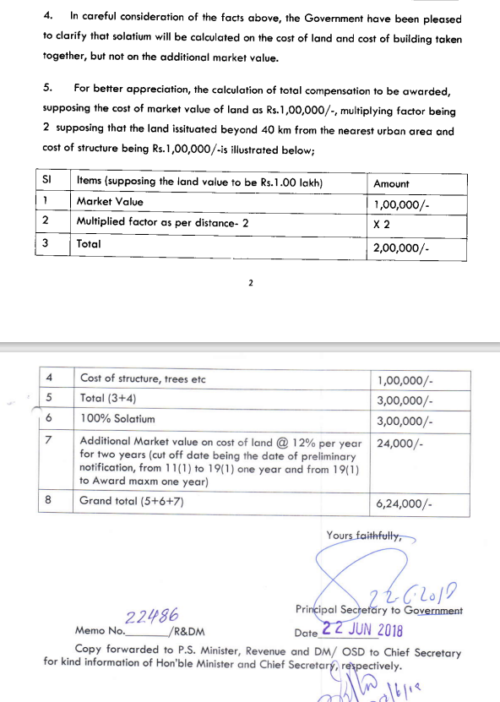
- CALCULATION OF LAND VALUE: The Fair Market Value of the land has been calculated as described below:

VALUATION OF PROJECT LAND
JINDAL INDIA THERMAL POWER LIMITED
VILLAGE DERANG, TEHSIL- KANIHA, DISTRICT- ANGUL, ODISHA
Village | Area  (in Acres) | Circle Rate  (in INR per acre) | Total Value of Land  (in INR)
Derang | 973.23 | 16,10,000 | 1,56,69,00,300
Uchhaballi | 50.99 | 3,70,000 | 1,88,66,300
Tolakbeda | 9.89 | 44,10,000 | 4,36,14,900
Kaniha | 4.23 | 17,85,000 | 75,50,550
Masunihata | 4.07 | 10,97,000 | 44,64,790
Balarampur | 1.74 | 15,75,000 | 27,40,500
Gadasila | 1.58 | 72,00,000 | 1,13,76,000
Takua | 1.11 | 10,51,050 | 11,66,666
Karadei | 0.30 | 84,00,000 | 25,20,000
Sarathipal | 0.29 | 8,55,750 | 2,48,168
Total (A) | 1,047.43 |  | 1,65,94,48,173
Multiplying Factor as per Distance (B) |  | 2 x A | 3,31,88,96,346
Value of Assets attached to land or building (C) |  |  | -
Total (D=B+C) |  |  | 3,31,88,96,346
Add Solatium (100%) (E) |  | 100% of D | 3,31,88,96,346
Total Award Value (F=D+E) |  |  | 6,63,77,92,692
Additional value on cost of land (G) |  | 12% of D | 39,82,67,562
Total Value (H=F+G) |  |  | 7,03,60,60,254

Based on the above calculation the Fair Market Value of Land is calculated as Rs. 703.61 Crore.

4. | VALUATION COMPUTATION OF BUILDING & CIVIL WORKS

- The valuation of building & civil structures is conducted based upon Cost Approach in which the fair market value of the building & civil structures on the valuation date is its cost of reproduction on that date less the depreciation & other deterioration deductions from the date of completion of the building to the date of its valuation.
- For calculating the Gross Replacement Value, Plinth Rate is considered as per the prevailing market rates.
- We have been provided, building area sheet of all civil structures, which were verified randomly during site survey.
- The Total Economic Life of the Plant buildings is considered as 35 years assuming extended life of the Plant after its prescribed economic life to arrive at the Depreciated Replacement Market Value. Township economic life is considered as 60 years as considered for normal building structure.

S. No. | Plant Section | Type of Building | Height (In mtr) | Plinth Area (in Sqft) | Economic Life | Cost of Construction  (In Rs./sqft) | Gross Current Replacement Cost | Depreciated Replacement Cost
1 | ESP control Building -Unit 1 | RCC roof Building | 21.70 | 7,707 | 35 | 1800 | 1,38,72,643 | 1,08,60,298
1 | ESP control Building -Unit 1 | RCC roof Building | 21.70 | 7,707 | 35 | 1800 | 1,38,72,643 | 1,08,60,298
1 | ESP control Building -Unit 1 | RCC roof Building | 21.70 | 7,707 | 35 | 1800 | 1,38,72,643 | 1,08,60,298
1 | ESP control Building -Unit 1 | RCC roof Building | 21.70 | 7,707 | 35 | 1900 | 1,46,43,346 | 1,14,63,648
1 | ESP control Building -Unit 1 | RCC roof Building | 21.70 | 2,045 | 35 | 1900 | 38,85,804 | 30,42,029
2 | ESP control Building -Unit 2 | RCC roof Building | 21.70 | 7,707 | 35 | 1800 | 1,38,72,643 | 1,08,60,298
2 | ESP control Building -Unit 2 | RCC roof Building | 21.70 | 7,707 | 35 | 1800 | 1,38,72,643 | 1,08,60,298
2 | ESP control Building -Unit 2 | RCC roof Building | 21.70 | 7,707 | 35 | 1800 | 1,38,72,643 | 1,08,60,298
2 | ESP control Building -Unit 2 | RCC roof Building | 21.70 | 7,707 | 35 | 1900 | 1,46,43,346 | 1,14,63,648
2 | ESP control Building -Unit 2 | RCC roof Building | 21.70 | 2,045 | 35 | 1900 | 38,85,804 | 30,42,029
3 | ELECTRICAL PANNEL ROOM | RCC roof Building | 4.00 | 1,249 | 35 | 1600 | 19,97,798 | 15,63,991
4 | Air Compressor Building | RCC roof Building | 8.65 | 4,392 | 35 | 1700 | 74,65,910 | 58,44,741
4 | Air Compressor Building | RCC roof Building | 8.65 | 4,392 | 35 | 1700 | 74,65,910 | 58,44,741
5 | Air Washer Building-unit -1 | RCC roof Building | 8.50 | 4,069 | 35 | 1700 | 69,16,946 | 54,14,981
5 | Air Washer Building-unit -1 | RCC roof Building | 8.50 | 4,069 | 35 | 1700 | 69,16,946 | 54,14,981
6 | DG Building | Colour Coated Galvanized Roof  Sheet shed | 5.40 | 4,187 | 35 | 1400 | 58,62,074 | 45,89,167
7 | TG Building unit 1 | Structural structure with deck sheet & RCC roof | 36.00 | 58,061 | 35 | 1600 | 9,28,97,626 | 7,27,25,570
 |  |  |  | 35,780 | 35 | 1600 | 5,72,47,258 | 4,48,16,425
 |  |  |  | 46,285 | 35 | 1700 | 7,86,84,840 | 6,15,98,989
 |  |  |  | 14,521 | 35 | 1700 | 2,46,85,081 | 1,93,24,892
 |  |  |  | 14,521 | 35 | 1800 | 2,61,37,145 | 2,04,61,651
 |  |  |  | 14,521 | 35 | 1800 | 2,61,37,145 | 2,04,61,651
8 | TG Building unit 2 | Structural structure with deck sheet & RCC roof | 36.00 | 58,061 | 35 | 1600 | 9,28,97,626 | 7,27,25,570
 |  |  |  | 35,780 | 35 | 1600 | 5,72,47,258 | 4,48,16,425
 |  |  |  | 46,285 | 35 | 1700 | 7,86,84,840 | 6,15,98,989
 |  |  |  | 14,521 | 35 | 1700 | 2,46,85,081 | 1,93,24,892
 |  |  |  | 14,521 | 35 | 1800 | 2,61,37,145 | 2,04,61,651
 |  |  |  | 14,521 | 35 | 1800 | 2,61,37,145 | 2,04,61,651
9 | Bunker Building-unit 1 | Structural structure with deck sheet & RCC roof | 68.00 | 8,095 | 35 | 1800 | 1,45,70,150 | 1,14,06,346
 |  |  |  | 8,095 | 35 | 1800 | 1,45,70,150 | 1,14,06,346
 |  |  |  | 8,095 | 35 | 1800 | 1,45,70,150 | 1,14,06,346
10 | Bunker Building-unit-2 | Structural structure with deck sheet & RCC roof | 68.00 | 8,095 | 35 | 1800 | 1,45,70,150 | 1,14,06,346
 |  |  |  | 8,095 | 35 | 1800 | 1,45,70,150 | 1,14,06,346
 |  |  |  | 8,095 | 35 | 1800 | 1,45,70,150 | 1,14,06,346
11 | DM Plant and CPU Regeneration area | RCC roof Building | 9.20 | 4,166 | 35 | 1700 | 70,81,636 | 55,43,909
11 | DM Plant and CPU Regeneration area | Colour Coated Galvanized Roof  Sheet shed | 9.20 | 9,709 | 35 | 1500 | 1,45,63,692 | 1,14,01,290
11 | DM Plant and CPU Regeneration area | RCC roof Building | 9.20 | 4,166 | 35 | 1700 | 70,81,636 | 55,43,909
12 | Chemical Building-WTP | RCC roof Building | 11.70 | 4,306 | 35 | 1700 | 73,19,520 | 57,30,139
12 | Chemical Building-WTP | RCC roof Building | 11.70 | 3,692 | 35 | 1700 | 62,76,488 | 49,13,594
13 | Chlorination Building | RCC roof Building | 5.75 | 10,323 | 35 | 1600 | 1,65,16,282 | 1,29,29,889
14 | CW Pump House | Colour Coated Galvanized Roof  Sheet shed | 17.00 | 5,264 | 35 | 1600 | 84,21,754 | 65,93,030
15 | CW Pump House-Switch Gear Room | RCC roof Building | 10.00 | 5,651 | 35 | 1700 | 96,06,870 | 75,20,807
15 | CW Pump House-Switch Gear Room | RCC roof Building | 10.00 | 1,679 | 35 | 1700 | 28,54,613 | 22,34,754
16 | Hydrogen Generation Building | RCC roof Building | 4.70 | 5,339 | 35 | 1600 | 85,42,310 | 66,87,409
17 | Forwarding Pump House | RCC roof Building | 6.80 | 5,920 | 35 | 1600 | 94,72,320 | 74,15,473
18 | FUEL OIL PUMP HOUSE | RCC roof Building | 5.10 | 5,059 | 35 | 1600 | 80,94,528 | 63,36,859
19 | Raw Water Intake Pump House | RCC roof Building | 12.80 | 3,993 | 35 | 1700 | 67,88,855 | 53,14,703
20 | Raw water pump house- Electrical room,  Battery room & Control room | RCC roof Building | 6.45 | 1,894 | 35 | 1600 | 30,31,142 | 23,72,951
20 |  | RCC roof Building | 19.60 | 1,238 | 35 | 1800 | 22,28,148 | 17,44,322
21 | ER-2 | RCC roof Building | 5.75 | 20,699 | 35 | 1600 | 3,31,18,675 | 2,59,27,191
22 | ER-3 | RCC roof Building | 5.75 | 1,787 | 35 | 1600 | 28,58,918 | 22,38,125
23 | EMERGENCY RECLAIM HOPPER | Colour Coated Galvanized Roof  Sheet shed | 6.00 | 1,421 | 35 | 1400 | 19,89,187 | 15,57,249
24 | CRUSHER HOUSE | Structural structure with deck sheet & RCC roof | 42.00 | 8,095 | 35 | 1800 | 1,45,70,150 | 1,14,06,346
 |  |  |  | 8,095 | 35 | 1800 | 1,45,70,150 | 1,14,06,346
 |  |  |  | 6,297 | 35 | 1800 | 1,13,34,492 | 88,73,288
 |  |  |  | 6,297 | 35 | 1800 | 1,13,34,492 | 88,73,288
 |  |  |  | 6,297 | 35 | 1800 | 1,13,34,492 | 88,73,288
 |  |  |  | 6,297 | 35 | 1800 | 1,13,34,492 | 88,73,288
25 | Bull dozer shed | Colour Coated Galvanized Roof  Sheet shed | 6.00 | 1,378 | 35 | 1400 | 19,28,909 | 15,10,060
26 | CHP Control Building | RCC roof Building | 4.20 | 5,399 | 35 | 1600 | 86,38,756 | 67,62,912
27 | Pump House( Near Crusher House) | RCC roof Building | 5.55 | 1,733 | 35 | 1600 | 27,72,806 | 21,70,711
28 | Ash control Building | RCC roof Building | 7.80 | 10,366 | 35 | 1600 | 1,65,85,171 | 1,29,83,820
29 | Ash compressor building Near Boiler | RCC roof Building | 5.40 | 4,758 | 35 | 1600 | 76,12,301 | 59,59,344
30 | Ash Compressor & Control Building Near Ash  silo | RCC roof Building | 7.80 | 6,921 | 35 | 1600 | 1,10,74,003 | 86,69,363
31 | Service Building | RCC roof Building | 21.00 | 9,279 | 35 | 1800 | 1,67,01,422 | 1,30,74,828
31 | Service Building | RCC roof Building | 21.00 | 9,279 | 35 | 1800 | 1,67,01,422 | 1,30,74,828
31 | Service Building | RCC roof Building | 21.00 | 9,279 | 35 | 1800 | 1,67,01,422 | 1,30,74,828
31 | Service Building | RCC roof Building | 21.00 | 9,279 | 35 | 1800 | 1,67,01,422 | 1,30,74,828
31 | Service Building | RCC roof Building | 21.00 | 9,279 | 35 | 1800 | 1,67,01,422 | 1,30,74,828
32 | Canteen Building | RCC roof Building | 4.55 | 8,181 | 35 | 1400 | 1,14,52,896 | 89,65,981
33 | FIRE STATION BUILDING | RCC roof Building | 5.40 | 3,391 | 35 | 1600 | 54,25,056 | 42,47,044
34 | Central Store | RCC roof Building | 5.80 | 33,648 | 35 | 1400 | 4,71,07,570 | 3,68,78,497
35 | Work Shop Building | Colour Coated Galvanized Roof  Sheet shed | 7.80 | 7,696 | 35 | 1400 | 1,07,74,764 | 84,35,101
36 | HYWA shed | Colour Coated Galvanized Roof  Sheet shed | 10.00 | 4,973 | 35 | 1500 | 74,59,452 | 58,39,685
37 | Township | RCC roof Building | 10.00 | 94,938 | 60 | 1800 | 17,08,89,264 | 15,19,49,037
38 | Township | RCC roof Building | 10.00 | 69,751 | 60 | 1800 | 12,55,51,296 | 11,16,36,027
39 | Community Centre | RCC roof Building | 7.00 | 8,599 | 60 | 1800 | 1,54,78,460 | 1,37,62,930
40 | Canteen | RCC roof Building | 4.00 | 2,153 | 60 | 1400 | 30,13,920 | 26,79,877
41 | Hostel | RCC roof Building | 10.00 | 21,313 | 60 | 1600 | 3,41,00,352 | 3,03,20,896
42 | Temple | RCC roof Building | 8.00 | 3,767 | 60 | 2500 | 94,18,500 | 83,74,616
 |  |  |  | 9,77,086 |  |  | 165,90,34,266 | 133,68,93,664

 | VALUATION OF ADDITIONAL AESTHETIC/ INTERIOR WORKS IN THE PROPERTY
S. No. | Particulars | Specifications | Rate | Depreciated Replacement Value
 | Plant Boundary Wall | ~9410 running meter | Rs. 7000/- per RMT | 5,15,66,800
 | Township Boundary Wall | ~2,280 running meter | Rs. 7500/- per RMT | 1,38,51,000
 | Land Development/leveling | ~222.35 acres | Rs. 150/-sqm | 13,49,69,259
 | Plant Road | ~16,913 running meter | Rs. 1800/- per RMT | 1,69,13,000
 | Township Road | ~1,334 running meter | Rs. 1800/- per RMT | 13,34,000
Total |  |  |  | 21,86,34,059

Based on the above calculation the value of Building & Civil Works is calculated as Rs.155.55 Crore.

PART H | CHARACTERISTICS DESCRIPTION OF PLANT & MACHINERY

S.NO. | CONTENTS | DESCRIPTION

 | TECHNICAL DESCRIPTION OF THE PLANT/ MACHINERY
 | Nature of Plant & Machinery | Thermal Power Plant
 | Size of the Plant | - Large scale Plant
 | Type of the Plant | - Fully Automatic
 | Year of Installation/ Commissioning/ COD (Commercial Operation Date) | - Unit-1 : 06-June-2014  - Unit-2 : 12-February-2015
 | Production Capacity | 2 x 600 MW
 | Capacity at which Plant was running at the time of Survey | 49% (only Unit-2 was operational)
 | Number of Production Lines | 2 Turbines & boilers
 | Condition of Machines | Good.
 | Status of the Plant | Partially operational
 | Products Manufactured in this Plant | Electricity
 | Recent maintenance carried out on | Refer to the sheet attached below
 | Recent upgradation, improvements if done any | Refer to the sheet attached below
 | Total Gross Block & Net Block of Assets | Gross Block |  | Net Block
 | Total Gross Block & Net Block of Assets | As on 31/03/2023
 | Total Gross Block & Net Block of Assets | Rs. 6422,63,63,481/- |  | Rs. 4998,12,88,642/-
 | Any other Details if any | As on date site visit, only Unit-2 was operational. Unit-1 was shut on 08-February-2024 due to Turbine Blade Failure. As per information provided, there are some legal issue in between BHEL and company and BHEL has stopped to supply critical spare equipment’s for the plant. Thus, major repair & maintenance related to Turbine & Boiler are done by third party contractor.  Total fuel requirement of the plant is ~7.00 MMTPA as informed by the company. However, company has Fuel Supply Agreement (FSA) for 3.04 MMTPA only with Mahanadi Coalfield Limited (MCL). Rest of the fuel/coal is purchased via open sources/market.  Currently the plant has only 02 nos. of long term PPA of 300MW & ~125MW with Bihar & GRIDCO respectively. Also the plant has 02 nos. of short term PPA of 370MW only.  Due to unavailability of Long Term PPA, FSA & BHEL Legal issues, company is going through financial stress.
 | MANUFACTURING PROCESS
 | 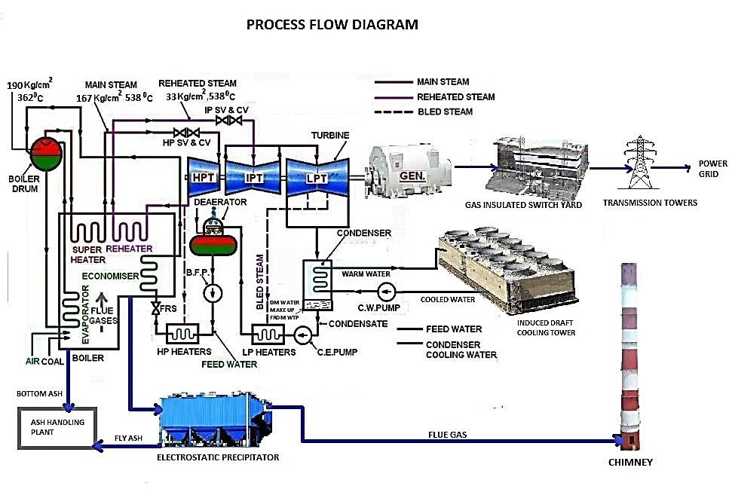
 | AVERAGE PLF COMPARISION
As per Central Electricity Authority (CEA) data, the PLF of thermal power plants in India & JITPL from FY 2018-19 to FY 2022-23:
Particulars | 2018-19 | 2019-20 | 2020-21 | 2021-22 | 2022-23
National | 61.07% | 54.64% | 54.27% | 58.87% | 64.15%
Central | 72.64% | 63.40% | 61.78% | 69.71% | 74.67%
State | 57.81% | 46.23% | 44.68% | 54.50% | 61.85%
Private | 55.24% | 54.51% | 53.37% | 53.62% | 56.63%
JITPL | 40.10% | 49.00% | 56.68% | 81.51% | 74.80%

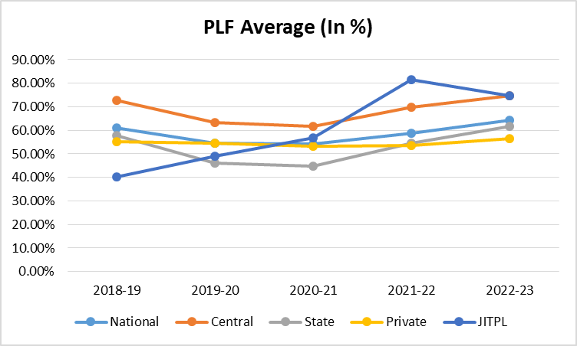

 | DETAILS OF MAINTENANCE EXPENSE
As per details shared by the company, month-wise incurred & planned expenses on major maintenance in year-2023 & year-2024 are as follows:-
Incurred in Past |  | Planned
Month | Amount (In Rs.) | Month | Amount (In Rs.)
Apr-23 | 5,82,32,054 | Feb-24 | 1,67,50,000
May-23 | 4,38,03,359 | Mar-24 | 1,41,53,190
Jun-23 | 94,63,921 | Apr-24 | 1,62,37,600
Jul-23 | 39,00,86,250 | May-24 | 30,47,96,200
Aug-23 | 2,15,59,000 | Jun-24 | 9,32,000
Sep-23 | - | Jul-24 | 2,20,500
Oct-23 | 1,61,95,000 | Aug-24 | 2,45,525
Nov-23 | 30,22,861
Dec-23 | 74,75,790
Jan-24 | 1,32,00,000
Total | 56,30,38,235 | Total | 35,33,35,015

 | TECHNOLOGY TYPE/ GENERATION USED AND TECHNOLOGICAL COLLABORATIONS IF ANY
 | - Technology Type/ Generation Used in this Plant |  | Sub-Critical Technology
 | Technological Collaborations If Any |  | - BHEL Boiler & Turbine
 | Current Technology used for this Industry in Market |  | - Ultra-Super Critical Technology
 | RAW MATERIALS REQUIRED & AVAILABILITY
 | Type of Raw Material |  | Coal and Water
 | Availability |  | Domestic Coal is used, water is being used from river Brahmani.
 | AVAILABILITY & STATUS OF UTILITIES
 | Power/ Electricity |  | Itself a Power plant.
 | Water |  | Available
 | Road/ Transport |  | Road is available, public transport is not easily available.
 | COMMENT ON AVAILABILITY OF LABOUR
 | Availability |  | Appears to be easily & adequately available.
 | Number of Labours working in the Factory |  | ---
 | SALES TRANSACTIONAL PROSPECTS OF SUCH PLANTS/ MACHINERY
 | On-going concern basis
 | Reason: This is a Large Scale Plant and can only be sold only as an Integrated Industry to preserve its value since complete process line & machines are special purpose machines and can't be used in any other Industry. So for fetching maximum value is through strategic sale to the players who are already into same or similar Industry who have plans for expansion or any large conglomefrate who plans to enter into this new Industry.
 | DEMAND OF SUCH PLANT & MACHINERY IN THE MARKET
 | Demand is inline to the sector demand which is presently good in the market.
 | SURVEY DETAILS
 | Plant has been surveyed by our Engineering Team on dated 13/02/2024
 | Site inspection was done in the presence of Owner's representative Mr. Vivek Kumar who was available from the company to furnish any specific detail about the Plant.
 | Our team examined & verified the machines and utilities from the FAR provided by the Company. Only major machinery, process line & equipment has been verified.
 | Photographs have also been taken of all the machines and its accessories installed there.
 | Plant was found operational at the time of survey.
 | Details have been cross checked as per the documents provided to us by the company and what was observed at the site.
 | Condition of the machines is checked through visual observation only. No technical/ mechanical/ operational testing has been carried out to ascertain the condition and efficiency of machines.
 | Site Survey has been carried out on the basis of the physical existence of the assets rather than their technical expediency.
 | As per the overall site visit summary, the plant is appeared to be in good condition.

PART I | PROCEDURE OF VALUATION ASSESMENT – PLANT & MACHINERY

 | GENERAL INFORMATION
 | Important Dates | Date of Inspection of the Property |  | Date of Valuation Assessment | Date of Valuation Report
 | Important Dates | 13 February 2024 |  | 15 February 2024 | 15 February 2024
 | Client | Punjab National Bank, Zonal Sastra, Bhikaji Cama Place, New Delhi
 | Intended User | Punjab National Bank, Zonal Sastra, Bhikaji Cama Place, New Delhi
 | Intended Use | To know the general idea on the market valuation trend of the property as per free market transaction. This report is not intended to cover any other internal mechanism, criteria, and considerations of any organization as per their own need, use & purpose.
 | Purpose of Valuation | For procuring equity stake in the Project as per restructuring proposal.
 | Scope of the Assessment | Non binding opinion on the assessment of Plain Physical Asset Valuation of the property identified to us by the owner or through his representative.
 | Restrictions | This report should not be referred for any other purpose, by any other user and for any other date other then as specified above.
 | Identification of the Assets |  | Cross checked from the name of the machines mentioned in the FAR/ Inventory list name plate displayed on the machine
 | Identification of the Assets |  | Identified by the company's representative
 | Identification of the Assets |  | Due to large number of machines/ inventories, only major production lines & machines have been checked
 | Type of Survey conducted | Full survey (verification & photographs).

 | ASSESSMENT FACTORS
 | Nature of the Valuation | Fixed Assets Valuation
 | Nature/ Category/ Type/ Classification of Asset under Valuation | Nature |  |  | Category |  | Type
 |  | PLANT & MACHINERY |  |  | INDUSTRIAL |  | INDUSTRIAL PLANT & MACHINERY
 |  | Classification |  |  | Income/ Revenue Generating Asset
 | Type of Valuation (Basis of Valuation as per IVS) | Primary Basis |  | Fair Market Value
 | Type of Valuation (Basis of Valuation as per IVS) | Secondary Basis |  | On-going concern basis
 | Present market state of the Asset assumed (Premise of Value as per IVS) | Under Normal Marketable State
 |  | Reason: Asset under free market transaction state
 | Physical Infrastructure availability factors of the locality | Water Supply | Sewerage/ Sanitation system |  |  | Electricity |  | Road and Public Transport connectivity
 | Physical Infrastructure availability factors of the locality | Yes from the reservoir and nearby river | Yes |  |  | Yes |  | Road is available but Public Transport is not easily available
 | Physical Infrastructure availability factors of the locality | Availability of other public utilities nearby |  |  |  | Availability of communication facilities
 | Physical Infrastructure availability factors of the locality | Transport, Market, Hospital etc. are available in close vicinity |  |  |  | Major Telecommunication Service Provider & ISP connections are available
 | Neighborhood amenities | Average
 | Any New Development in surrounding area | None
 | Any specific advantage/ drawback in the plant and machines | Advantages: Near to River & Coal Mines
 | Machines overall usability/ utility Factor | Normal
 | Best Sale procedure to realize maximum Value (in respect to Present market state or premise of the Asset as per point (iv) above) | Fair Market Value
 |  | Free market transaction at arm's length wherein the parties, after full market survey each acted knowledgeably, prudently and without any compulsion.
 | Hypothetical Sale transaction method assumed for the computation of valuation | Fair Market Value
 |  | Free market transaction at arm's length wherein the parties, after full market survey each acted knowledgeably, prudently and without any compulsion.
 | Approach & Method of Valuation Used | Approach of Valuation |  |  |  | Method of Valuation
 | Approach & Method of Valuation Used | Cost Approach |  |  |  | Depreciated Replacement Cost Method
 | Type of Source of Information | Level 3 Input (Tertiary)

 | Any other aspect which has relevance on the value or marketability of the machines | The marketability for the machines depends upon the industry outlook, make, market condition, raw material, maintenance, raw material, usability, capacity.  This Valuation report is prepared based on the facts of the assets & market situation on the date of the survey. It is a well-known fact that the market value of any asset varies with time & socio-economic conditions prevailing in the region/ country. In future assets market may go down, asset conditions may change or may go worse, plant vicinity conditions may go down or become worse, plant market may change due to impact of Govt. policies or effect of domestic/ world economy, usability prospects of the Plant may change, etc. Hence before financing, Banker/ FI should take into consideration all such future risk while financing.
 | Basis of computation & working
Main Basis:

- Basic Methodology: For arriving at fair market value of P&M & other fixed assets our engineering team has rationally applied the mixture of ‘sales comparison approach (market approach)’ and the ‘cost approach (depreciated replacement cost)’. The fair market value of Plant & Machinery on the date of valuation is its cost of reproduction & commissioning on that date less the depreciation & other deterioration deductions (Technological, Economic, Functional obsolescence) or additions for good maintenance from the date of commissioning of the machinery to the date of its valuation.
- Core P&M Asset Valuation is done keeping in mind various factors like technology used, machines availability, its condition, average age, maintenance & service and parts replacement availability of the machines and more importantly demand in the market.
- The main data point for the Valuation of Plant & Machinery is the Fixed Asset Register maintained by the company. Plant & Machinery FAR has been provided by the company which has been relied upon in good faith. Provided FAR included assets in different heads like Land, Building, Plant & Machinery, Electrical equipment’s, Furniture & fittings, Office equipment, etc. Assets under different heads are segregated and are evaluated separately. From the Fixed Asset Register List two key inputs, Date of Capitalization and Cost of capitalization are taken which play vital role in evaluating used Plant & Machinery valuation.
- Provided Capitalization cost include soft cost incurred during the Project establishment like Pre-operative, IDC & Finance cost expenses also. On our request we have not got break-up of hard & soft cost separately hence we have to go by the given figure.
- For calculating Replacement Cost of the machines as on date, Whole Sale Price Index (WPI) is used issued by Department Economic Advisor, Govt. of India.
- For evaluating depreciation, Chart of Companies Act-2013, Central Electricity Commission Guidelines & Industry & institutional standards are used for ascertaining useful life of different types of machines are followed.
- Market & Industry scenario is also explored for demand of such Plants.
- On the Depreciated Replacement Cost (DRC) deduction for obsolescence/ deterioration or addition for good maintenance has been taken to arrive at the estimated Prospective Fair Market Value of the machines.
- Underline assumption for the evaluation of this Plant & Machinery is that it will be sold as an Integrated Plant and not as discrete/ piecemeal machinery basis.
- Valuation of the asset is done as found on as-is-where basis on the site as identified to us by client/ owner/ owner representative during site inspection by our engineer/s unless otherwise mentioned in the report.
- The valuation of the Plant/ Machinery has been done considering the plant as a whole. The indivisual cost for machines shown is for illustration purpose, and may vary from market rates since the valuation is done using cost approach method and finally cross verified from market approach as a whole plant and not individual machine.
- Consolidated valuation sheet of Plant & Machinery and other asset items are mentioned below with depreciated current market value as per different category of the machines/assets cumulated together. Our engineering team has separated the Cost of Equipment’s in the different sections of the plant. The cost of equipment considered from P&M List includes Pre-operative, Finance, and IDC Charges etc. The capitalized/ purchase cost of machinery considered from P&M List consists of final commissioning of machines which includes freight, taxes, insurance, etc.

Other Basis:

- Analysis and conclusions adopted in the report are limited to the reported assumptions, conditions and information came to our knowledge during the course of the work and based on the Standard Operating Procedures, Best Practices, Caveats, Limitations, Conditions, Remarks, Important Notes, Valuation TOR and definition of different nature of values.
- The indicative value has been suggested based on the prevailing market rates that came to our knowledge during secondary & tertiary market research and is not split into formal & informal payment arrangements. Most of the deals takes place which includes both formal & informal payment components. Deals which take place in complete formal payment component may realize relatively less actual transaction value due to inherent added tax, stamp registration liabilities on the buyer.
- Secondary/ Tertiary costs related to asset transaction like Installation, maintenance and Logistics costs pertaining to the sale/ purchase of the assets are not considered separately while assessing the indicative estimated Market Value and is assumed to be included in the Cost of capitalization provided by the client.
- The condition assessment and the estimation of the residual economic life of the machinery and assets are only based on the visual observations and appearance found during the site survey. We have not carried out any physical tests to assess the working and efficiency of the machines and assets.
- Any kind of unpaid statutory, utilities, lease, interest or any other pecuniary dues on the asset or on its owners has not been factored in the Valuation.
- Valuation is done for the asset found on as-is-where basis which owner/ owner representative/ client/ bank has shown to us on site of which some reference has been taken from the information/ data given in the copy of documents provided to us which have been relied upon in good faith and we have assumed that it to be true and correct.
- This is just the fixed asset valuation of the project based on the cost & market approach methodologies considering the utility of the asset for the business & the company as on-ongoing concern basis. This Valuation shall not be construed as the transactional value of the Project which may be determined through Enterprise/ Business Valuation based on Income approach methodologies
 | ASSUMPTIONS
- Documents/ Information/ Data provided by the client/ property owner or his representative both written & verbally is true and correct without any fabrication and has been relied upon in good faith.
- The assets and interests therein have been valued free and clear of any liens or encumbrances unless stated otherwise. No hidden or apparent conditions regarding the subject assets or their ownership are assumed to exist. No opinion of title is rendered in this report and a good title is assumed unless stated otherwise.
- It is assumed that the concerned Lender/ Financial Institution has asked for the valuation of that property after satisfying the authenticity of the documents given to us and for which the legal verification has been already taken and cleared by the competent Advocate before requesting for the Valuation report. I/ We assume no responsibility for the legal matters including, but not limited to, legal or title concerns.
- Payment condition during transaction in the Valuation has been considered on all cash basis which includes both formal & informal payment components as per market trend.
- Sale transaction method of the asset is assumed as Free market transaction without any compulsion unless otherwise mentioned while assessing Indicative & Estimated Fair Prospective Market Value of the asset unless otherwise stated.
 | SPECIAL ASSUMPTIONS
 | Valuation is determined on ongoing concern basis for the Plant as a whole.
 | LIMITATIONS
 | Unavailability of credible and authentic market information.

3. | THERMAL POWER PLANT MARKET ANALYSIS

From past 3 years since 2021-22, power generation through Thermal has witnessed more than 7% of growth, viz, 7.96%, 8.21%, 10.92% (provisional) in 2021-22, 2022-23, 2023-24 respectively. On the similar lines power consumption also grew around 8% in H1 of 2023-24. Peak power demand also touched a record high of 241 GW during April-September 2023. Electricity demand has witnessed sharp growth this year registering 16.3%, 10.3%, 21% in August, September and October 2023 on year-on-year basis.
Although for achieving energy transitioning goals to greener energy for its commitment towards containing carbon emission, as a policy India till 2022 wanted to restrain from developing more thermal power plants run on fossil fuels. However, its growing power demand and peak demand needs requires to add the thermal power capacity which mainly is able to cover the growing peak demand needs of the country. Recently even Power Minister has also given statement for adding additional 80GW thermal capacity by FY32 for meeting growing Power demand. Plant load factors has also increased in F24 in comparison to previous years.
Over the medium term, factors like the increasing industrial operations and several government initiatives to provide electricity throughout the country are likely to drive the Indian thermal power plant market despite of growing market for renewable energy.
Thermal Power sector has transitioned itself to newer and more efficient technologies like supercritical and ultra-supercritical coal power plants, which reduce the amount of pollution, are expected to replace the aging power plants and create several opportunities for the Indian thermal power plant market in the future. All new Power Plants are majorly being setup of supercritical and ultra-supercritical coal power plants.
The Ultra Supercritical Thermal Power Units Market is witnessing robust growth as power generation industries worldwide seek to improve efficiency, reduce emissions, and enhance overall environmental sustainability. The key market drivers include the pressing need to meet rising electricity demand, stringent environmental regulations, and the growing focus on cleaner energy sources. Ultra Supercritical technology offers a significant advantage over conventional power plants by achieving higher thermal efficiency, often surpassing 40%, resulting in reduced fuel consumption and lower CO2 emissions per unit of electricity generated.
The details of the thermal power plants being set-up or proposed to be set-up are shown in the table below:

4. | SUMMARY OF PLANT & MACHINERY VALUATION

All figures are in ₹
As per JITPL FAR Dated 31-03-2023 |  |  | As per RKA
Particulars | Gross Block | Net Block | Gross Current Replacement Cost | Depreciated Replacement Cost
Plant & Machinery | 6381,74,75,326 | 4970,19,43,553 | 7714,98,64,858 | 52,49,94,44,379
Furniture & Fixtures | 39,25,76,976 | 26,45,34,344 | 31,65,97,950 | 12,89,76,348
Computer | 1,05,78,356 | 92,00,794 | 1,06,19,317 | 78,94,364
Vehicles | 31,21,016 | 30,67,301 | 31,21,524 | 27,56,939
Office Equipment | 26,11,807 | 25,42,649 | 26,11,576 | 22,91,509
Total | 6422,63,63,481 | 4998,12,88,642 | 7748,28,15,225 | 52,64,13,63,539
Notes:
      - Assets pertaining to JITPL Plant is only considered for valuation in this report.
      - Asset items of different classes are grouped together and summarized separately. Detailed valuation sheet with calculation can be referred in annexures.
      - The Company has provided us the Fixed Asset Register (FAR) as on 31st March 2023, for the purpose of Valuation.
      - For evaluating useful life for calculation of depreciation, Central Electricity Commission Guidelines, Chart of Companies Act-2013 and finally general practical trend of Power Plants are referred.
      - Useful life of Primary machines of the Plant like Boiler, Turbine, Generator, Coal Handling System etc. is taken as 15-25 years. For other auxiliary machinery & equipment average life varies from 5-25 years.
      - $ Fluctuation is not considered separately in our assessment since the adjustment of this fluctuation in the overall cost of the project is already capitalized by the company in FAR.
      - Our engineering team visited all the sections and manually inspected the machines and equipment on the basis of their physical existence.
      - Final valuation includes Design, erection, procurement, installation & commissioning charges as well.
      - Nowadays, for a large setup, only Ultra Super Critical Thermal Power Plants are being installed. Because the boiler of Ultra Super Critical is more efficient than that of Sub-Critical Boiler. As per our research and technical information available, there is a difference of ~10% in efficiency of these boilers. Thus, further a technological Obsolescence (TO) on Depreciated Replacement Cost is considered to arrive fair value of Plant & Machinery assets.

PART J | CONSOLIDATED VALUATION ASSESSMENT OF THE PLANT

1. | CONSOLIDATED VALUATION ASSESSMENT OF THE ASSET
S. No. | Particulars | Book Value | Indicative & Estimated Prospective Fair Market Value
 | Land Value (A) | Rs. 146,25,21,049/- | Rs. 703,60,60,254/-
 | Total Building & Civil Works (B) | Rs. 391,21,87,340/- | Rs. 155,55,27,723/-
 | Plant & Machinery Value (C) | Rs. 4998,12,88,642/- | Rs. 5264,13,63,539/-
 | Total Add (A+B+C) | Rs. 5535,59,97,031/- | Rs. 6123,29,51,516/-
 | Additional Premium if any | --- | ---
 | Details/ Justification | --- | ---
 | Deductions charged if any | --- | 25%
 | Details/ Justification | We have taken 25% discount for economic obsolescence since this is a revenue generating asset and any buyer will buy it exploiting its economic potential.  - This is a 1200 MW Plant but only have a 425 MW long term PPA.  - Company has 3.04 MMTPA Fuel Supply Agreement with MCL Mines and therefore have to buy coal from open market.  - The subject plant is sub-critical thermal plant. However, currently large scale power plants are being set-up on ultra-supercritical technology having higher efficiency of atleast 10-12% more.  - Capital expenditure of about Rs. 1368.00 Cr. has to be done upto 2026 for the implementation of FGD.  Therefore, discount percentage is averagely taken based on the best case scenario for the maximum revenue potential this Plant can exploit in the long run assessed through economic projections in which above factors have been taken into account, provided operative company has enough working capital to run the plant.
 | Total Indicative & Estimated Prospective Fair Market Value | --- | Rs. 4606,49,44,759/-
 | Rounded Off | --- | Rs. 4606,00,00,000/-
 | Indicative & Estimated Prospective Fair Market Value in words | --- | Rs. 4606,00,00,000/-
 | Expected Realizable Value (@ ~15% less) | --- | Rs. 3915,10,00,000/-
 | Expected Distress Sale Value (@ ~30% less) | --- | Rs. 3224,20,00,000/-
 | Percentage difference between Circle Rate and Fair Market Value | ----
 | Concluding Comments/ Disclosures if any
- This valuation is based on the cost approach and basically shows the current depreciated replacement value of the asset. However, market players may weigh it differently keeping in mind the various macro & micro economic factors and demand & supply of power at the time of actual transaction.
- Total Fair depreciated replacement value of the asset is arrived at Rs. 6008.50 Cr. However, Fair Market Value is given at Rs. 4520.00 Cr. deducting the Economic & Technological obsolescence.
- Realizable Value (RV) & Distress Value (DV) has been considered 85% & 70% respectively of Fair Market value. Although power demand is likely to be robust in next 5 years due to growing economy, but for the subject plant there is no sufficient long term PPA and Fuel Supply Agreement. Therefore, due to these issues in the subject plant, higher on RV & DV is considered.
- This is just core Asset Valuation and not an Enterprise Valuation. This report doesn’t cover any prospective sale value of the Power Plant as a whole which is based on the cash flows of the business.
- Fragmented/ Individual component wise may fetch different values, however this Valuation is prepared based on the ongoing concern and the Values has been applied in totality/ group of assets.
- This valuation exercise has been performed to reach the prospective fair market value using the replacement cost for setting up such Greenfield integrated plants in current scenario. This should not be treated as the transactional value of these assets.
- Secondary/ Tertiary costs related to asset transaction like Stamp Duty, Registration charges, Brokerage, Bank interest etc. pertaining to the sale/ purchase of this property are not considered while assessing the Market Value.
- Fragmented/ Individual component wise may fetch different values, however this Valuation is prepared based on the ongoing concern and the Values has been applied in totality/ group of assets.
- This valuation exercise has been performed to reach the prospective fair market value using the replacement cost for setting up such Greenfield integrated plants in current scenario. This should not be treated as the transactional value of these assets.
- Secondary/ Tertiary costs related to asset transaction like Stamp Duty, Registration charges, Brokerage, Bank interest etc. pertaining to the sale/ purchase of this property are not considered while assessing the Market Value.
- We are independent of client/ company and do not have any direct/ indirect interest in the property.
- This valuation has been conducted by R.K Associates Valuers & Techno Engineering Consultants (P) Ltd. and its team of experts.
- This Valuation is done for the property found on as-is-where basis as shown on the site by the Bank/ customer of which photographs is also attached with the report.
- Reference of the property is also taken from the copies of the documents/ information which interested organization or customer could provide to us out of the standard checklist of documents sought from them and further based on our assumptions and limiting conditions. All such information provided to us has been relied upon in good faith and we have assumed that it is true and correct. However, we do not vouch the absolute correctness of the property identification, exact address, physical conditions, etc. based on the documents provided to us since property shown to us may differ on site Vs as mentioned in the documents or incorrect/ fabricated documents may have been provided to us.
- Legal aspects for eg. investigation of title, ownership rights, lien, charge, mortgage, lease, verification of documents from originals or from any Govt. department, etc. has to be taken care by legal experts/ Advocates and same has not been done at our end.
- The valuation of an asset is an estimate of the worth of that asset which is arrived at by the Valuer in his expert opinion after factoring in multiple parameters and externalities. This may not be the actual price of that asset and the market may discover a different price for that asset.
- This report only contains opinion based on technical & market information which came to our knowledge during the course of the assignment. It doesn’t contain any recommendations.
- This report is prepared following our Standard Operating Procedures & Best Practices and will be subject to Limitations, Conditions, Valuer’s Remarks, Important Notes, Valuation TOS and basis of computation & working as described above.
- The use of this report will become valid only after payment of full fees as per the Payment Terms. Using this report or any part content created in this report without payment of charges will be seen as misuse and unauthorized use of the report.
 | IMPORTANT KEY DEFINITIONS
Fair Value suggested by the competent Valuer is that prospective estimated amount in his expert & prudent opinion of the subject asset/ property without any prejudice after he has carefully & exhaustively evaluated the facts & information came in front of him or which he could reasonably collect during the course of the assessment related to the subject asset on an as-is, where-is basis in its existing conditions, with all its existing advantages & disadvantages and its potential possibilities which is just & equitable at which the subject asset/ property should be exchanged between a willing buyer and willing seller at an arm’s length transaction in an open & unrestricted market, in an orderly transaction after proper marketing, wherein the parties, each acted knowledgeably, prudently without any compulsion on the date of the Valuation.
Fair Value without using the term “Market” in it describes that the value suggested by the Valuer may not mandatorily follow or may not be in complete consonance to the established Market in his expert opinion. It may or may not follow market dynamics. But if the suggested value by the valuer is not within the prevailing Market range or is assessed for an asset is located in an un-established Market then the valuer will give reasonable justification & reasoning that for what reasons the value suggested by him doesn’t follow the prevailing market dynamics.
Fair Market Value suggested by the competent Valuer is that prospective estimated amount in his expert & prudent opinion of the subject asset/ property without any prejudice in consonance to the Market dynamics after he has carefully & exhaustively evaluated the facts & information came in front of him or which he could reasonably collect during the course of assessment related to the subject asset on an as-is, where-is basis in its existing conditions, with all its existing advantages & disadvantages and its potential possibilities which is just & equitable at which the subject asset/ property should be exchanged between a willing buyer and willing seller at an arm’s length transaction in an open & unrestricted market, in an orderly transaction after proper marketing, wherein the parties, each acted knowledgeably, prudently without any compulsion on the date of the Valuation.
Here the words “in consonance to the established Market” means that the Valuer will give opinion within the realms & dynamics of the prevailing market rates after exhaustively doing the micro market research. However due to the element of “Fair” in it, valuer will always look for the factors if the value should be better than the market realms which is just & equitable backed by strong justification and reasoning.
Market Value suggested by the competent Valuer is that prospective estimated amount which is average price of the similar comparable assets prevailing in an open & established market during the near period of the date of valuation at which the subject asset/ property should be exchanged between a willing buyer and willing seller on an as-is, where-is basis in its existing conditions, with all its existing advantages & disadvantages and its potential possibilities at an arm’s length transaction in an open, established & unrestricted market, in an orderly transaction, wherein the parties, each acted without any compulsion on the date of the Valuation.
Using the term “Market Value” without “Fair” omits the elements of proper marketing, acting knowledgeably & prudently.
Market and market participants can be sentimental, inclined towards the transaction without the element of complete knowledge & prudence about facts or due diligence of the asset therefore “each acted knowledgeably, prudently” has been removed from the marker Value definition.
 | Realizable Value is that minimum prospective estimated value of the asset/ property which it may be able to fetch at the time of actual property transaction factoring in the element of discount due to the prospects of deep negotiations between the buyer & seller when the parties in-principally find Fair Market Value reasonable and sits together to close the deal and the transaction across the table. Discount percentage on the Fair Market Value due to negotiation will depend on the nature, size, various salability prospects of the subject asset, the needs of the buyer & the seller and kind of payment terms. In some of the cases Realizable and Fair Market Value may also be equal.
 | Distress Sale Value* is that value when the property is attached with any process such as mortgaged financing, financial or operational dues which is under any stress condition or situation and the stakeholders are under process of finding resolution towards it to save the property from being attached to a formal recovery process. In this type of sale, minimum fetch value assessed will always be less than the estimated Fair Market Value where the discount of percentage will depend upon various circumstances and factors such as nature, size, salability prospects of the property and kind of encumbrance on the property. In this type of sale, negotiation power of the buyer is always more than the seller and eagerness & pressure of selling the property will be more on the seller than the buyer.
 | Liquidation Value is the amount that would be realized when an asset or group of assets are sold due to any compulsion or constraints such as in a recovery process guided by statute, law or legal process, clearance sale or any such condition or situation thereof where the pressure of selling the asset/ property is very high to realize whatever maximum amount can be from the sale of the assets in a limited time for clearance of dues or due to closure of business. In other words, this kind of value is also called as forced sale value.
Difference between Cost, Price & Value: Generally, these words are used and understood synonymously. However, in reality each of these has a completely different meaning, premise and also having different definitions in professional & legal terms. Therefore, it is our professional responsibility to describe the definitions of these words to avoid ambiguity & confusion in the minds of the user of this report.
The Cost of an asset represents the actual amount spend in the construction/ actual creation of the asset.
The Price is the amount paid for the procurement of the same asset.
The Value is defined as the present worth of future rights in the property/ asset and is a hypothetical or notional price that buyers and sellers are most likely to conclude for a good or service. Value is not a fact, but an estimate of the likely price to be paid for a good or service at a given time in accordance with a particular definition of value.
Therefore, in actual for the same asset/ property, cost, price & value remain different since these terms have different usage & meaning.
Enclosures with the Report:

- Enclosure: I- Google Map
- Enclosure: II- References on price trend of the similar related properties available on public domain, if available
- Enclosure: III- Photographs of the property
- Enclosure: IV- Copy of Circle Rate
- Enclosure: V- Important property documents exhibit
- Enclosure: VI- PNB Annexure: VI - Declaration-Cum-Undertaking
- Enclosure: VII- PNB Annexure: VII - Model Code of Conduct for Valuers
- Enclosure: VIII- Part E: Valuer’s Important Remarks

In ₹ Crore
Asset-wise Valuation Summary
As per JITPL dated 31-03-2023 |  |  |  | As per RKA dated 15-02-2024
S. No. | Assets | Gross Block | Net Block | Gross Current Replacement Cost | Depreciated Replacement Cost | Fair Value
1 | Land | 160.38 | 146.25 | 703.61 | 703.61 | 527.70
2 | Building | 583.77 | 391.22 | 195.83 | 155.55 | 116.66
3 | Plant & Machinery | 6,422.64 | 4,998.13 | 7,748.28 | 5,264.14 | 3,962.13
Total |  | 7,166.79 | 5,535.60 | 8,647.72 | 6,123.30 | 4,606.49
Per MW Cost in Rs. Crore |  | 5.97 | 4.61 | 7.20 | 5.10 | 3.84

IMPORTANT NOTES

DEFECT LIABILITY PERIOD - In case of any query/ issue or escalation you may please contact Incident Manager by writing at valuers@rkassociates.org. We try our level best to ensure maximum accuracy in the Calculations done, Rates adopted and various other data points & information mentioned in the report but still can’t rule out typing, human errors, assessment or any other mistakes. In case you find any mistake, variation, discrepancy or inaccuracy in any data point mentioned in the report, please help us by bringing all such points into our notice in writing at valuers@rkassociates.org within 30 days of the report delivery, to get these rectified timely, failing which R.K Associates shouldn’t be held responsible for any inaccuracy in any manner. Also, if we do not hear back anything from you within 30 days, we will assume that the report is correct in all respect and no further claim of any sort will be entertained thereafter. We would welcome and appreciate your feedback & suggestions in order to improve our services.

Our DATA RETENTION POLICY is of ONE YEAR. After this period we remove all the concerned records related to the assignment from our repository. No clarification or query can be answered after this period due to unavailability of the data.

COPYRIGHT FORMAT - This report is prepared on the copyright format of R.K Associates to serve our clients in the best possible way. Legally no one can copy or distribute this format without prior approval from R.K Associates. It is meant only for the organization as mentioned on the cover page of this report. Distribution or use of this format or any content of this report wholly or partially other than R.K Associates will be seen as unlawful act and necessary legal action can be taken against the defaulters.

IF REPORT IS USED FOR BANK/ FIs
NOTE: As per IBA Guidelines in case the valuation report submitted by the valuer is not in order, the banks / FIs shall bring the same to the notice of the valuer within 15 days of submission for rectification and resubmission. In case no such communication is received, it shall be presumed that the valuation report has been accepted.

At our end we have not verified the authenticity of any documents provided to us. Bank is advised to verify the genuineness of the property documents before taking any credit decision.
Valuation Terms of Services & Valuer’s Important Remarks are available at www.rkassociates.org for reference.

SURVEY ANALYST | VALUATION ENGINEER | L1/ L2 REVIEWER
Babul Akhtar Gazi & Abhinav Chaturvedi | Abhinav Chaturvedi | Sr. VP Projects

ENCLOSURE: I – GOOGLE MAP LOCATION

ENCLOSURE: II - REFERENCES ON PRICE TREND OF THE SIMILAR RELATED PROPERTIES AVAILABLE ON PUBLIC DOMAIN

DUE TO NATURE OF THE PROPERTY IN REMOTE AREA REFERENCES OF SIMILAR LAND TRANSACTIONS ARE NOT FOUND ON PUBLIC DOMAIN

ENCLOSURE: III – PHOTOGRAPHS OF THE PROPERTY

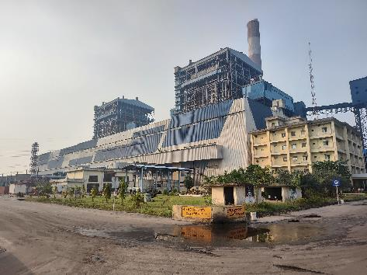 | 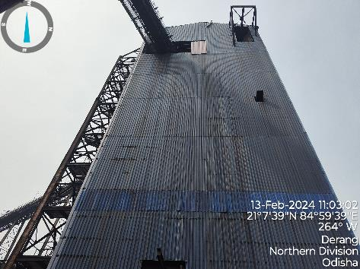
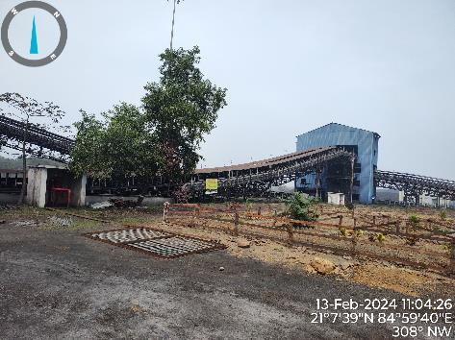 | 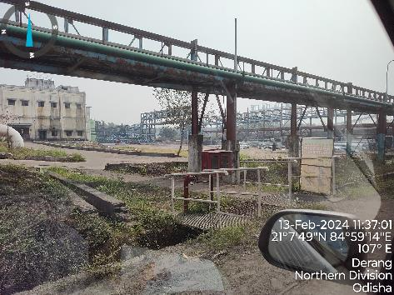
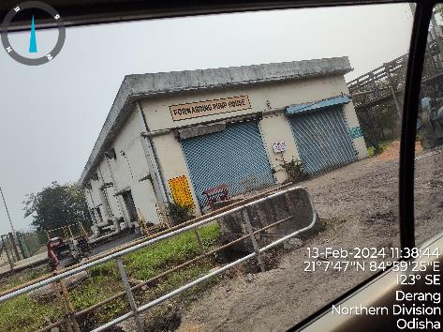 | 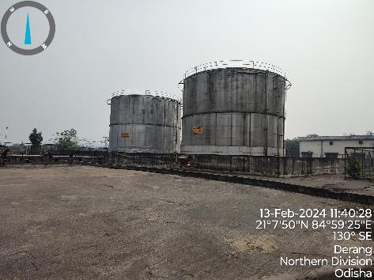

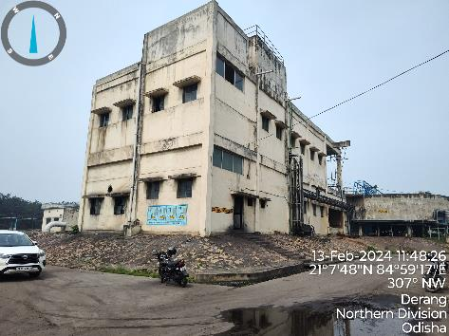 | 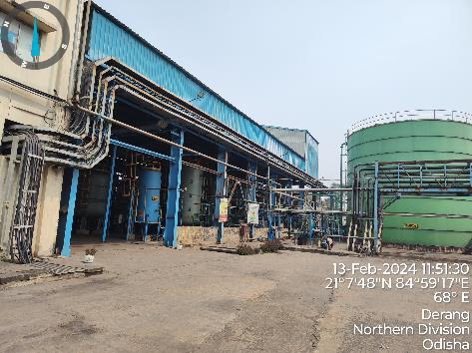
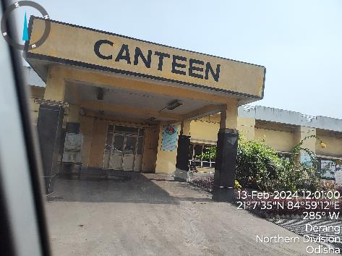 | 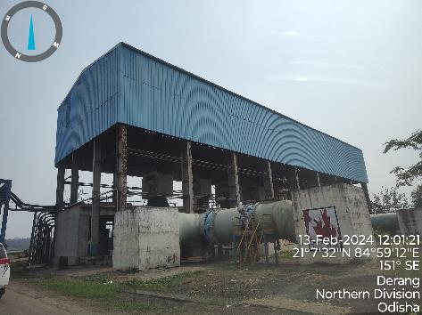
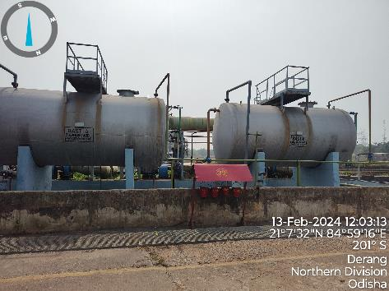 | 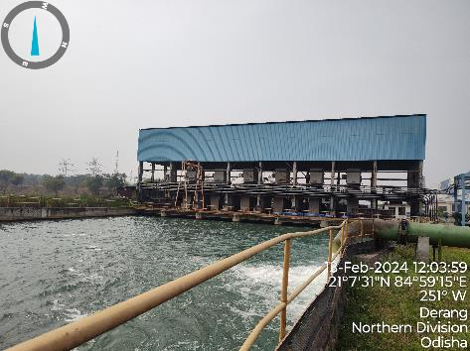

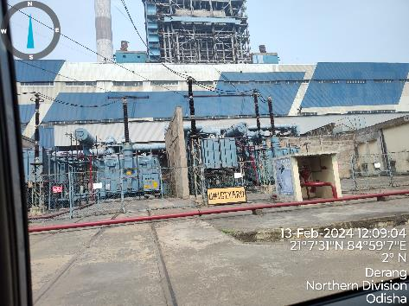 | 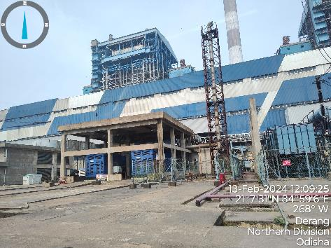
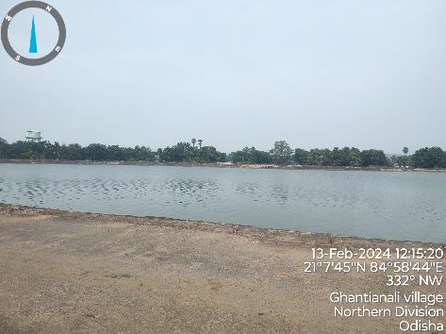 | 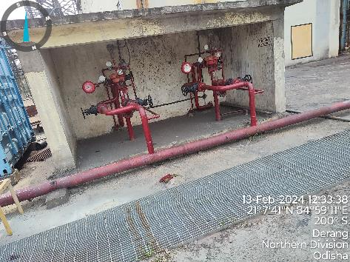
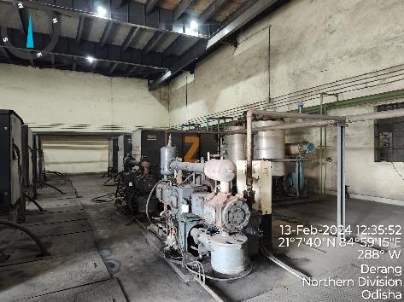 | 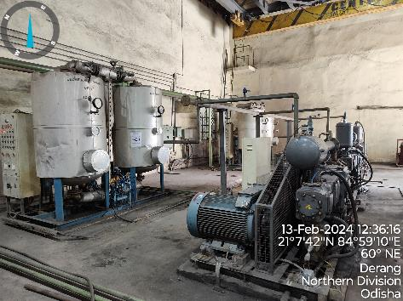

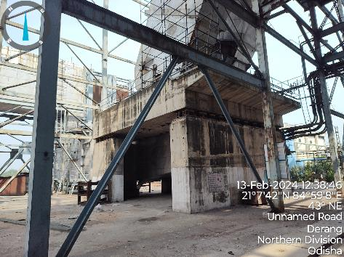 | 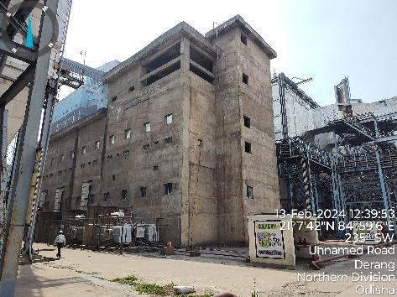
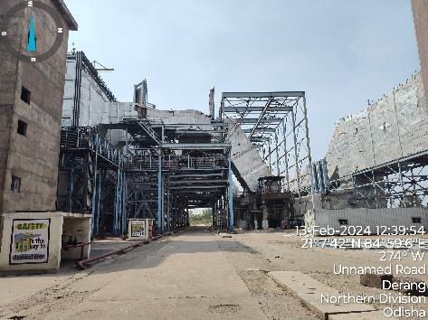 | 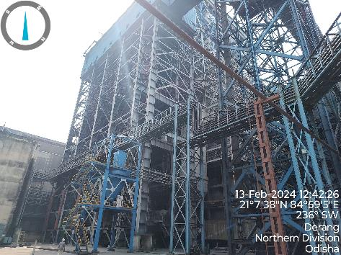
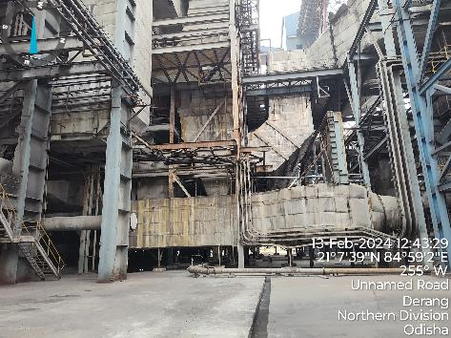 | 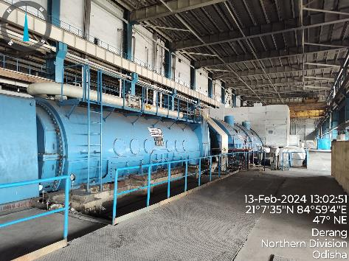

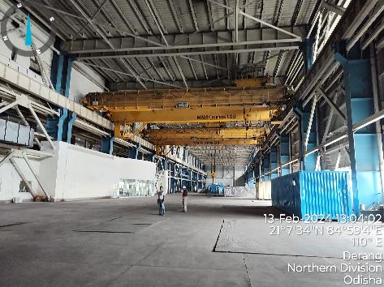 | 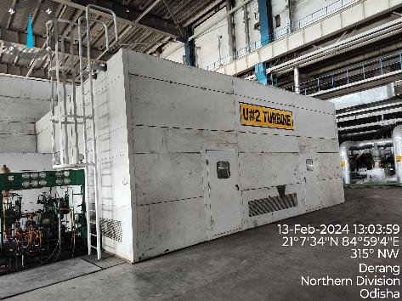
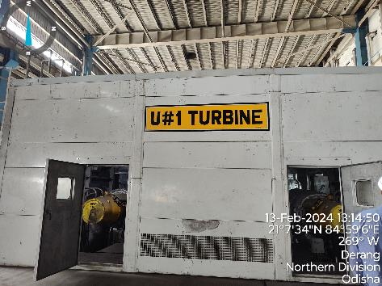 | 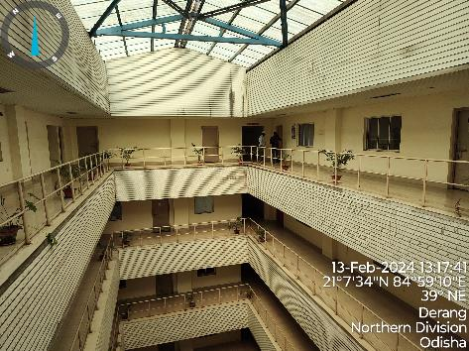
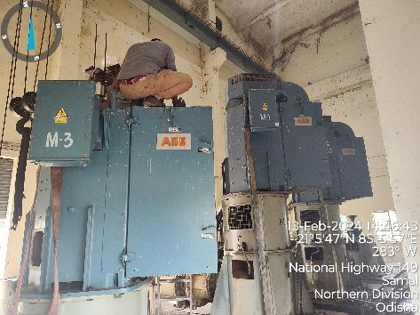 | 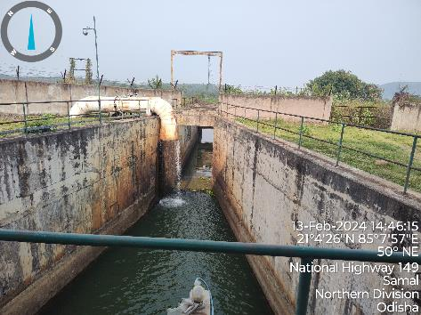

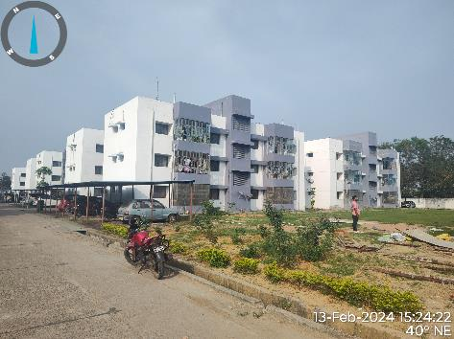 | 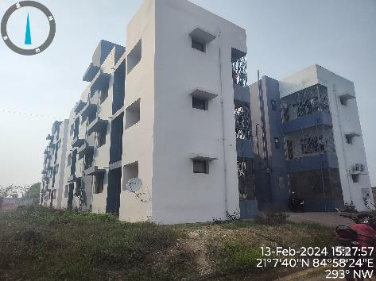
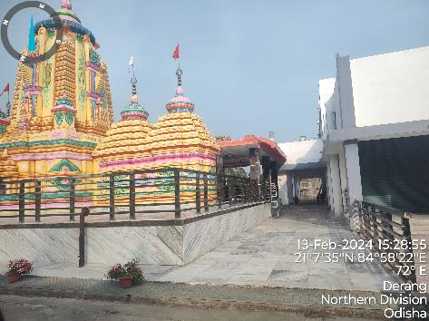 | 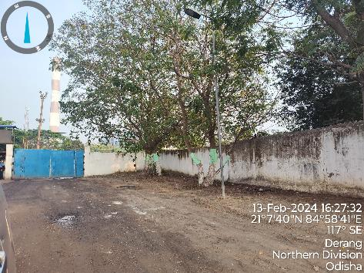
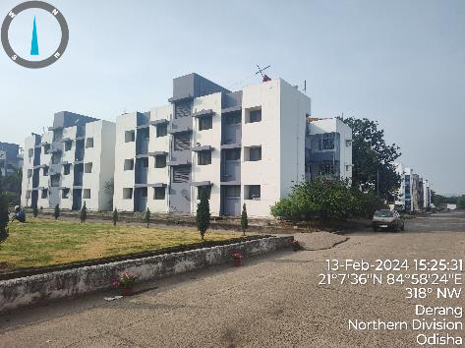 | 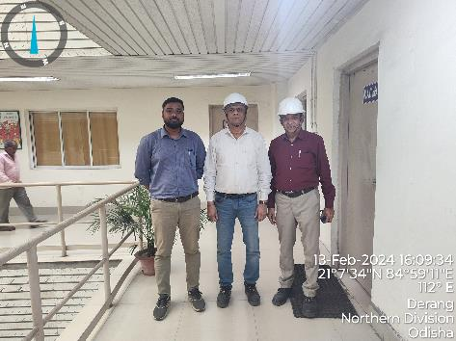

ENCLOSURE: IV – DOCUMENTS RELATED TO LAND RATE

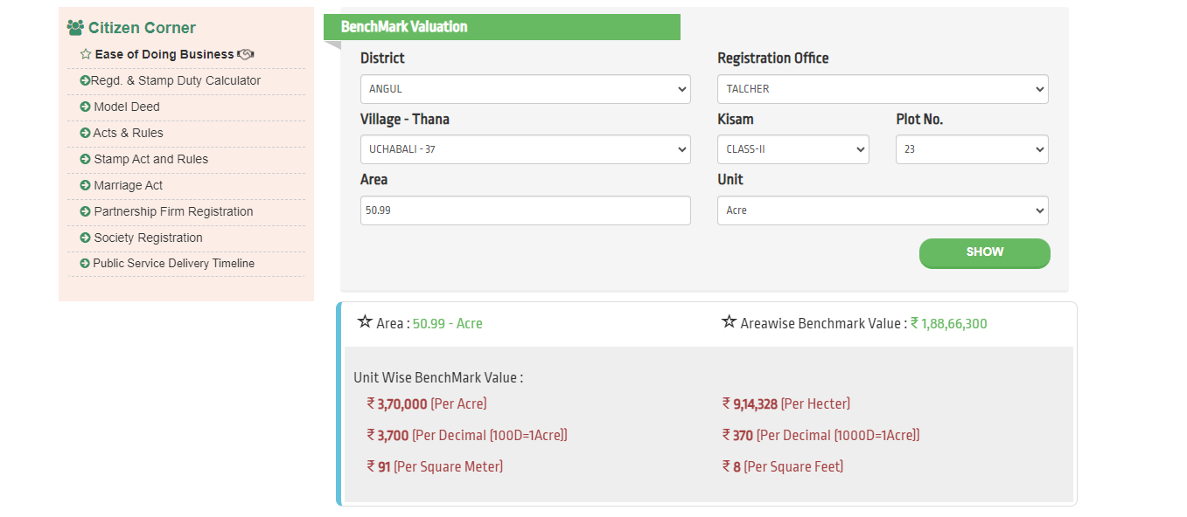
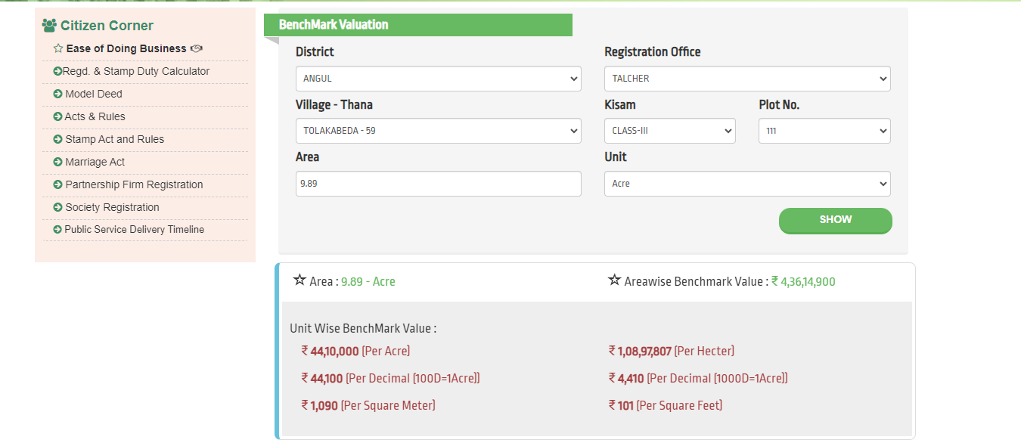
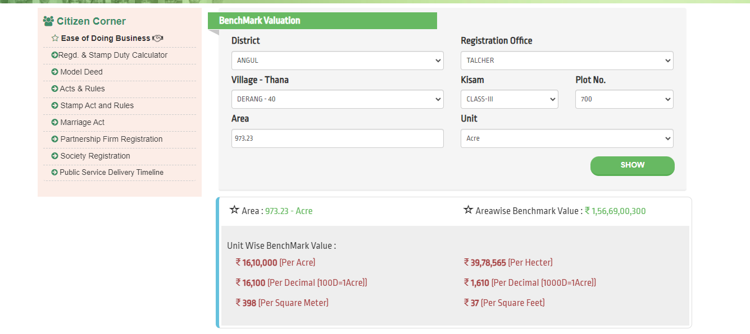
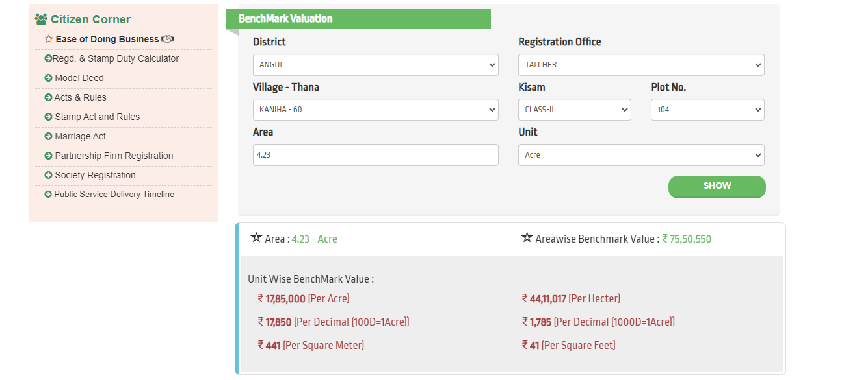
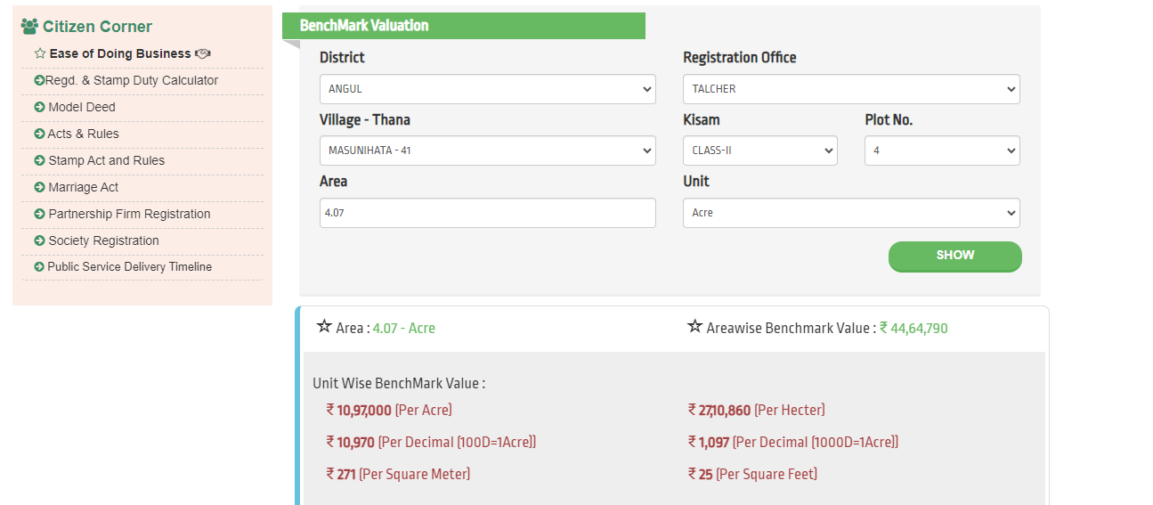
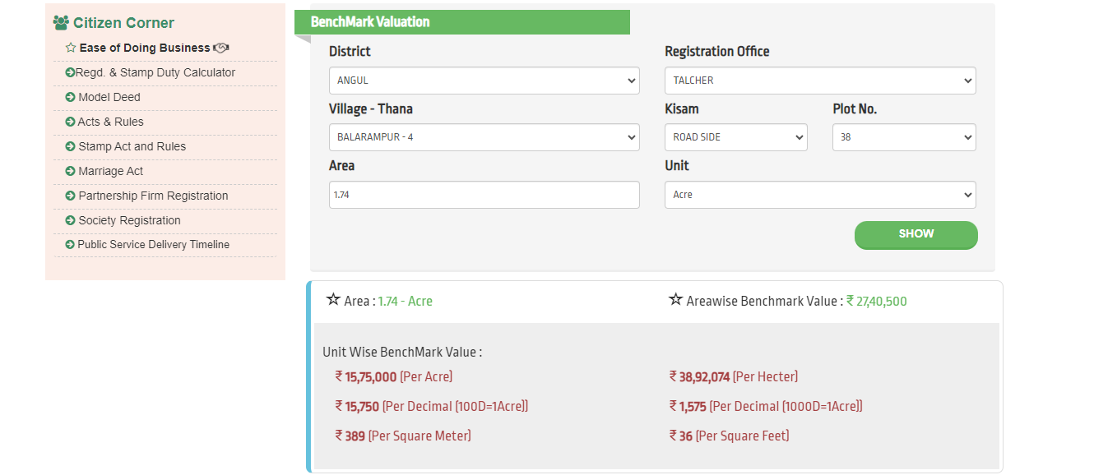
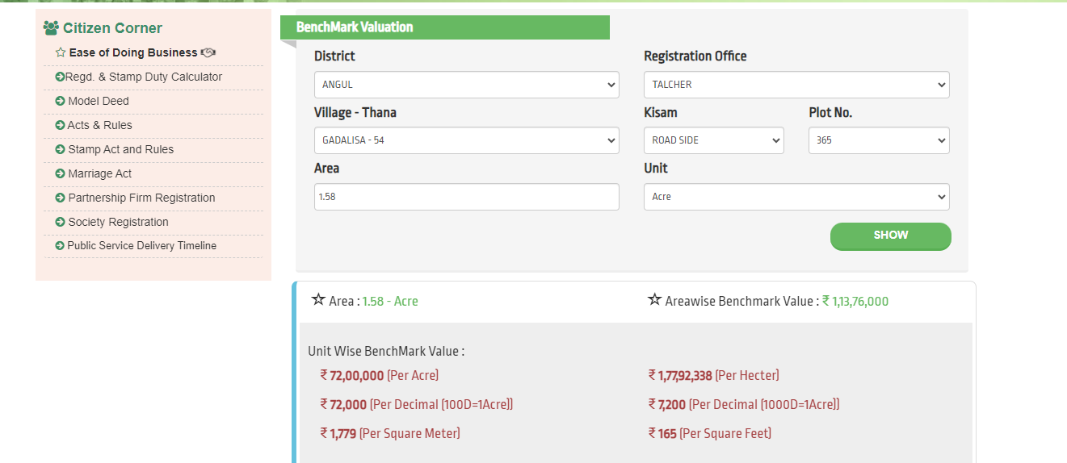
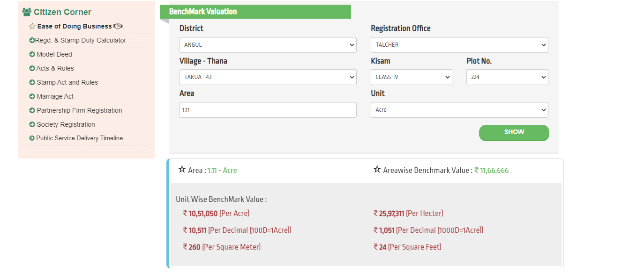
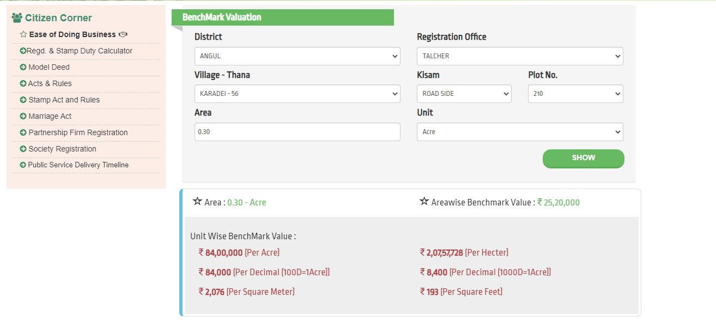
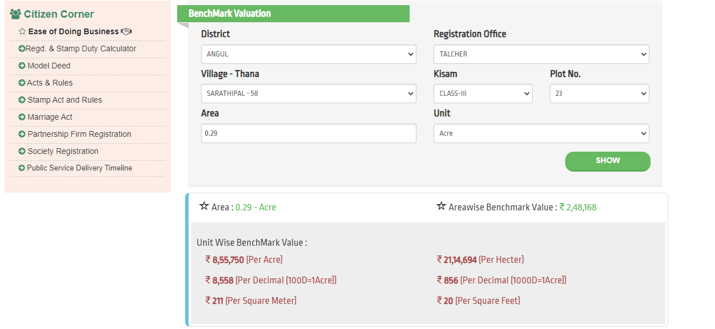

ENCLOSURE: V – IMPORTANT PROPERTY DOCUMENTS EXHIBIT

MOE for 26.12 AACRE

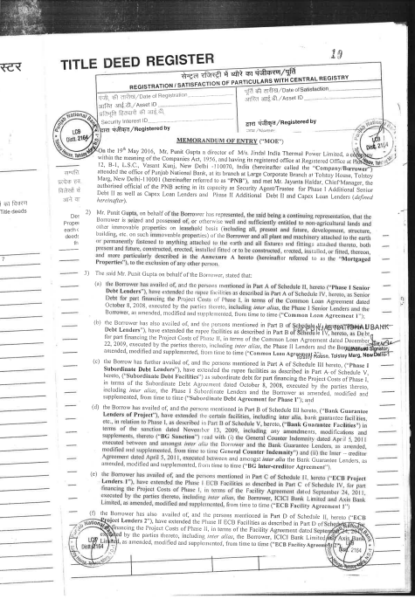

MOE for 26.90 AACRE

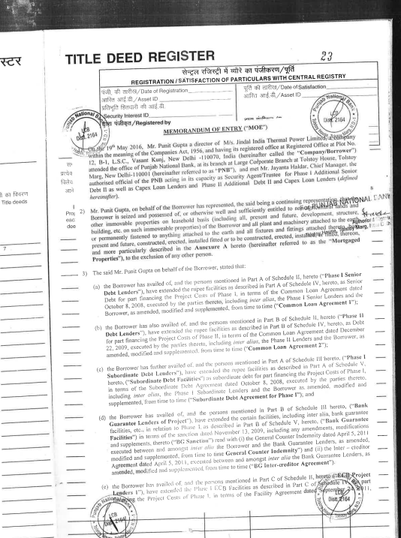

MOE for 994.47 AACRE
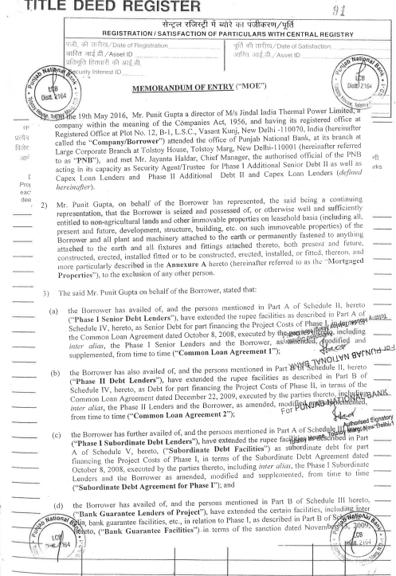

Copy of Insurance
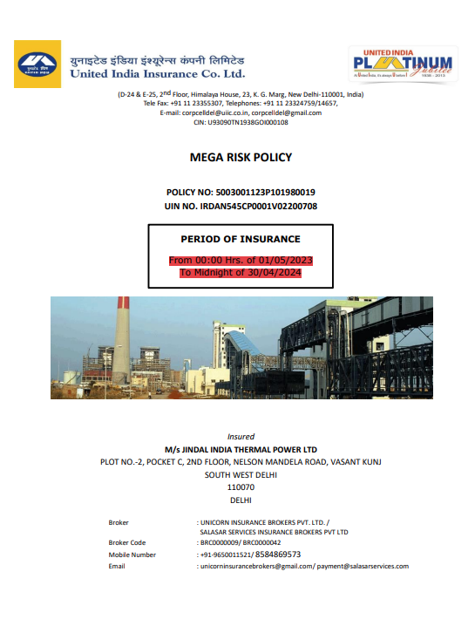

ENCLOSURE VI: ANNEXURE: DECLARATION

- The information furnished in our valuation report dated 15/2/2024 is true and correct to the best of our knowledge and belief and we have made an impartial and true valuation of the property.
- We have no direct or indirect interest in the property valued.
- Our authorized Engineer/ surveyor Mr. Abhinav Chaturvedi & Mr. Babul Akhtar Gazi have personally inspected the property on 13/2/2024 the work is not subcontracted to any other valuer and is carried out by us.
- We have not been convicted of any offence and sentenced to a term of imprisonment.
- We have not been found guilty of misconduct in professional capacity.
- We have read the Handbook on Policy, Standards and procedure for Real Estate Valuation, 2009 of the IBA and has tried to apply the “Standards” enshrined for valuation in the Part-B of the above handbook to the best of our ability as much as practically possible in the limited time available.
- We have read the International Valuation Standards (IVS) and the report submitted to the Bank for the respective asset class and has tried to apply the “Standards” as enshrined for valuation in the IVS in “General Standards” and “Asset Standards” as applicable to the best of our ability as much as practically possible in the limited time available.
- Procedures and standards adopted in carrying out the valuation and is mentioned in Part-D of the report which may have certain departures to the said IBA and IVS standards in order to provide better, just & fair valuation.
- We abide by the Model Code of Conduct for empanelment of valuer in the Bank.
- I am the authorized official of the firm / company, who is competent to sign this valuation report.

S. No. | Particulars | Valuer comment
 | Background information of the asset being valued | This is a 2x600 MW sub-critical thermal power plant located at the aforesaid address having total land area as per the scope of valuation admeasuring 1047.43 acres (as per the land area details and MOE shared by the company) as found on as-is-where basis which owner/ owner representative/ client/ bank has shown/ identified to us on the site physically unless otherwise mentioned in the report of which some reference has been taken from the information/ data given in the copy of documents provided to us and informed verbally or in writing.
 | Purpose of valuation and appointing authority | Please refer to Part-D of the Report.
 | Identity of the experts involved in the valuation | Survey Analyst: Er. Abhinav Chaturvedi & Er. Babul Akhtar Gazi  Valuation Engineer: Er. Abhinav Chaturvedi  L1/ L2 Reviewer: Sr. VP Projects
 | Disclosure of valuer interest or conflict, if any | No relationship with the borrower and no conflict of interest.
 | Date of appointment, valuation date and date of report | Date of Appointment: | 1/2/2024
 | Date of appointment, valuation date and date of report | Date of Survey: | 13/2/2024
 | Date of appointment, valuation date and date of report | Valuation Date: | 15/2/2024
 | Date of appointment, valuation date and date of report | Date of Report: | 15/2/2024
 | Inspections and/ or investigations undertaken | Yes, by our authorized Survey Engineers Abhinav Chaturvedi & Babul Akhtar Gazi on 13/2/2024. Property was shown and identified by Mr. Vivek Kumar ( +91 95830 40198 )
 | Nature and sources of the information used or relied upon | Please refer to Part-D of the Report. Level 3 Input (Tertiary) has been relied upon.
 | Procedures adopted in carrying out the valuation and valuation standards followed | Please refer to Part-D of the Report.
 | Restrictions on use of the report, if any | Value varies with the Purpose/ Date/ Market & Asset Condition & Situation prevailing in the market. We recommend not to refer the indicative & estimated prospective Value of the asset given in this report if any of these points are different from the one mentioned aforesaid in the Report.  This report has been prepared for the purposes stated in the report and should not be relied upon for any other purpose. Our client is the only authorized user of this report and is restricted for the purpose indicated in This report. I/we do not take any responsibility for the unauthorized use of this report.  During the course of the assignment, we have relied upon various information, data, documents in good faith provided by Bank/ client both verbally and in writing. If at any point of time in future it comes to knowledge that the information given to us is untrue, fabricated, misrepresented then the use of this report at very moment will become null & void.  This report only contains general assessment & opinion on the indicative, estimated Market Value of the property for which Bank has asked to conduct the Valuation for the asset which owner/ owner representative/ client/ bank has shown/ identified to us on the site and as found on as-is-where basis unless otherwise mentioned in the report of which some reference has been taken from the information/ data given in the copy of documents provided to us and informed verbally or in writing which has been relied upon in good faith. It doesn’t contain any other recommendations of any sort including but not limited to express of any opinion on the suitability or otherwise of entering into any transaction with the borrower.  This report is not a certification of ownership or survey number/ property number/ Khasra number which are merely referred from the copy of the documents provided to us.
 | Major factors that were taken into account during the valuation | Please refer to Part A, B & C of the Report.
 | Major factors that were not taken into account during the valuation | Please refer to Part A, B & C of the Report.
 | Caveats, limitations and disclaimers to the extent they explain or elucidate the limitations faced by valuer, which shall not be for the purpose of limiting his responsibility for the valuation report. | Please refer to Part D & Part E Valuer’s Important Remarks of the Report enclosed herewith.

Date: 15/2/2024
Place: Noida

Signature

(Authorized Person of R.K Associates Valuers & Techno Engg. Consultants (P) Ltd.)
ENCLOSURE VII: ANNEXURE: MODEL CODE OF CONDUCT FOR VALUERS

Integrity and Fairness

- A valuer shall, in the conduct of his/its business, follow high standards of integrity and fairness in all his/its dealings with his/its clients and other valuers.
- A valuer shall maintain integrity by being honest, straightforward, and forthright in all professional relationships.
- A valuer shall endeavour to ensure that he/it provides true and adequate information and shall not misrepresent any facts or situations.
- A valuer shall refrain from being involved in any action that would bring disrepute to the profession.
- A valuer shall keep public interest foremost while delivering his services.

Professional Competence and Due Care

- A valuer shall render at all times high standards of service, exercise due diligence, ensure proper care and exercise independent professional judgment.
- A valuer shall carry out professional services in accordance with the relevant technical and professional standards that may be specified from time to time
- A valuer shall continuously maintain professional knowledge and skill to provide competent professional service based on up-to-date developments in practice, prevailing regulations/guidelines and techniques.
- In the preparation of a valuation report, the valuer shall not disclaim liability for his/its expertise or deny his/its duty of care, except to the extent that the assumptions are based on statements of fact provided by the company or its auditors or consultants or information available in public domain and not generated by the valuer.
- A valuer shall not carry out any instruction of the client insofar as they are incompatible with the requirements of integrity, objectivity and independence.
- A valuer shall clearly state to his client the services that he would be competent to provide and the services for which he would be relying on other valuers or professionals or for which the client can have a separate arrangement with other valuers.

INDEPENDENCE AND DISCLOUSRE OF INTEREST

- A valuer shall act with objectivity in his/its professional dealings by ensuring that his/its decisions are made without the presence of any bias, conflict of interest, coercion, or undue influence of any party, whether directly connected to the valuation assignment or not.
- A valuer shall not take up an assignment if he/it or any of his/its relatives or associates is not independent in terms of association to the company.
- A valuer shall maintain complete independence in his/its professional relationships and shall conduct the valuation independent of external influences.
- A valuer shall wherever necessarily disclose to the clients, possible sources of conflicts of duties and interests, while providing unbiased services.

- A valuer shall not deal in securities of any subject company after any time when he/it first becomes aware of the possibility of his/its association with the valuation, and in accordance with the Securities and Exchange Board of India (Prohibition of Insider Trading) Regulations, 2015 or till the time the valuation report becomes public, whichever is earlier.
- A valuer shall not indulge in “mandate snatching” or offering “convenience valuations” in order to cater to a company or client’s needs.
- As an independent valuer, the valuer shall not charge success fee (Success fees may be defined as a compensation / incentive paid to any third party for successful closure of transaction. In this case, approval of credit proposals).
- In any fairness opinion or independent expert opinion submitted by a valuer, if there has been a prior engagement in an unconnected transaction, the valuer shall declare the association with the company during the last five years.

Confidentiality

- A valuer shall not use or divulge to other clients or any other party any confidential information about the subject company, which has come to his/its knowledge without proper and specific authority or unless there is a legal or professional right or duty to disclose.

Information Management

- A valuer shall ensure that he/ it maintains written contemporaneous records for any decision taken, the reasons for taking the decision, and the information and evidence in support of such decision. This shall be maintained so as to sufficiently enable a reasonable person to take a view on the appropriateness of his/its decisions and actions.
- A valuer shall appear, co-operate and be available for inspections and investigations carried out by the authority, any person authorised by the authority, the registered valuer’s organisation with which he/it is registered or any other statutory regulatory body.
- A valuer shall provide all information and records as may be required by the authority, the Tribunal, Appellate Tribunal, the registered valuer’s organization with which he/it is registered, or any other statutory regulatory body.
- A valuer while respecting the confidentiality of information acquired during the course of performing professional services, shall maintain proper working papers for a period of three years or such longer period as required in its contract for a specific valuation, for production before a regulatory authority or for a peer review. In the event of a pending case before the Tribunal or Appellate Tribunal, the record shall be maintained till the disposal of the case.

Gifts and hospitality:

- A valuer or his/its relative shall not accept gifts or hospitality which undermines or affects his independence as a valuer.
Explanation. ─ For the purposes of this code the term “relative‟ shall have the same meaning as defined in clause (77) of Section 2 of the Companies Act, 2013 (18 of 2013).
- A valuer shall not offer gifts or hospitality or a financial or any other advantage to a public servant or any other person with a view to obtain or retain work for himself/ itself, or to obtain or retain an advantage in the conduct of profession for himself/ itself.

Remuneration and Costs.

- A valuer shall provide services for remuneration which is charged in a transparent manner, is a reasonable reflection of the work necessarily and properly undertaken, and is not inconsistent with the applicable rules.
- A valuer shall not accept any fees or charges other than those which are disclosed in a written contract with the person to whom he would be rendering service.

Occupation, employability and restrictions.

- A valuer shall refrain from accepting too many assignments, if he/it is unlikely to be able to devote adequate time to each of his/ its assignments.
- A valuer shall not conduct business which in the opinion of the authority or the registered valuer organisation discredits the profession.

Signature of the Authorized Person: ________________
Name of the Valuation company: R.K Associates Valuers & Techno Engg. Consultants (P) Ltd.
Address of the Valuer: D-39, Sector-2, Noida-201301
Date: 15/2/2024
Place: Noida

ENCLOSURE VIII: ANNEXURE: VALUER’S IMPORTANT REMARKS

Valuation is done for the asset found on as-is-where basis which owner/ owner representative/ client/ bank has shown/ identified to us on the site unless otherwise mentioned in the report of which some reference has been taken from the information/ data given in the copy of documents provided to us and informed verbally or in writing out of the standard checklist of documents sought from the client & its customer which they could provide within the reasonable expected time out of the standard checklist of documents sought from them and further based on certain assumptions and limiting conditions. The information, facts, documents, data which has become primary basis of the report has been supplied by the client which has been relied upon in good faith and is not generated by the Valuer.
The client/ owner and its management/ representatives warranted to us that the information they have supplied was complete, accurate and true and correct to the best of their knowledge. All such information provided to us either verbally, in writing or through documents has been relied upon in good faith and we have assumed that it is true & correct without any fabrication or misrepresentation. I/We shall not be held liable for any loss, damages, cost or expenses arising from fraudulent acts, misrepresentations, or willful default on part of the owner, company, its directors, employee, representative or agents.
Legal aspects for eg. Investigation of title, ownership rights, lien, charge, mortgage, lease, sanctioned maps, verification of documents provided to us such as title documents, Map, etc. from any concerned Govt. office etc. have to be taken care by legal expert/ Advocate and same is not done at our end. It is assumed that the concerned Lender/ Financial Institution has asked for the valuation of that property after satisfying the authenticity of the documents given to us for which the legal verification has been already taken and cleared by the competent Advocate before requesting for the Valuation report. I/ We assume no responsibility for the legal matters including, but not limited to, legal or title concerns.
In the course of the valuation, we were provided with both written and verbal information. We have however, evaluated the information provided to us through broad inquiry, analysis and review but have not carried out a due diligence or audit of the information provided for the purpose of this engagement. Our conclusions are based on the assumptions and other information provided to us by the client during the course of the assessment.
Getting cizra map or coordination with revenue officers for site identification is a separate activity and is not part of the Valuation services and same has not been done in this report unless otherwise stated.
Wherever any details are mentioned in the report in relation to any legal aspect of the property such as name of the owner, leases, etc. is only for illustration purpose and should not be construed as a professional opinion. Legal aspects are out of scope of this report. Details mentioned related to legal aspect are only based on the copy of the documents provided to us and whatever we can interpret as a non-legally trained person. This should be cross validated with a legal expert. We do not vouch any responsibility regarding the same.
We have made certain assumptions in relation to facts, conditions & situations affecting the subject of, or approach to this exercise that has not been verified as part of the engagement rather, treated as “a supposition taken to be true”. If any of these assumptions prove to be incorrect then our estimate on value will need to be reviewed.
This is just an opinion report based on technical & market information having general assessment & opinion on the indicative, estimated Market Value of the property for which Bank has asked to conduct the Valuation. It doesn’t contain any other recommendations of any sort including but not limited to express of any opinion on the suitability or otherwise of entering into any transaction with the borrower.
We have relied on the data from third party, external sources & information available on public domain to conclude the valuation. These sources are believed to be reliable and therefore, we assume no liability for the truth or accuracy of any data, opinions or estimates furnished by others that have been used in this analysis. Where we have relied on the data, opinions or estimates from external sources, reasonable care has been taken to ensure that such data is extracted from authentic sources, however we still can’t vouch its authenticity, correctness, or accuracy.
Analysis and conclusions adopted in the report are limited to the reported assumptions, conditions and information came to our knowledge during the course of the work and based on the Standard Operating Procedures, Best Practices, Caveats, Limitations, Conditions, Remarks, Important Notes, Valuation TOR and definition of different nature of values.
Value varies with the Purpose/ Date/ Asset Condition & situation/ Market condition, demand & supply, asset utility prevailing on a particular date/ Mode of sale. The indicative & estimated prospective Value of the asset given in this report is restricted only for the purpose and other points mentioned above prevailing on a particular date as mentioned in the report. If any of these points are different from the one mentioned aforesaid in the Report then this report should not be referred.
Our report is meant ONLY for the purpose mentioned in the report and should not be used for any other purpose. The Report should not be copied or reproduced for any purpose other than the purpose for which it is prepared for. I/we do not take any responsibility for the unauthorized use of this report.
We owe responsibility only to the authority/client that has appointed us as per the scope of work mentioned in the report. We will not be liable for any losses, claims, damages or liabilities arising out of the actions taken, omissions or advice given by any other person. In no event shall we be liable for any loss, damages, cost or expenses arising in any way from fraudulent acts, misrepresentations or willful default on part of the client or companies, their directors, employees or agents.
This report is having limited scope as per its fields & format to provide only the general basic idea of the value of the property prevailing in the market based on the site inspection and documents/ data/ information provided by the client. The suggested indicative prospective estimated value should be considered only if transaction is happened as free market transaction.
The sale of the subject property is assumed to be on an all cash basis. Financial arrangements would affect the price at which the property may sell for if placed on the market.
The actual realizable value that is likely to be fetched upon sale of the asset under consideration shall entirely depend on the demand and supply of the same in the market at the time of sale.
While our work has involved an analysis & computation of valuation, it does not include detailed estimation, design/ technical/ engineering/ financial/ structural/ environmental/ architectural/ compliance survey/ safety audit & works in accordance with generally accepted standards of audit & other such works. The report in this work in not investigative in nature. It is mere an opinion on the likely estimated valuation based on the facts & details presented to us by the client and third party market information came in front of us within the limited time of this assignment, which may vary from situation to situation.
Where a sketched plan is attached to this report, it does not purport to represent accurate architectural plans. Sketch plans and photographs are provided as general illustrations only.
Documents, information, data including title deeds provided to us during the course of this assessment by the client is reviewed only upto the extent required in relation to the scope of the work. No document has been reviewed beyond the scope of the work. These are not reviewed in terms of legal rights for which we do not have expertise. Wherever any information mentioned in this report is mentioned from the documents like owners name, etc., it is only for illustration purpose and may not necessary represent accuracy.
The report assumes that the borrower/company/business/asset complies fully with relevant laws and regulations applicable in its area of operations and usage unless otherwise stated, and that the companies/business/assets is managed in a competent and responsible manner. Further, as specifically stated to the contrary, this report has given no consideration to matters of a legal nature, including issues of legal title and compliance with relevant laws, and litigations and other contingent liabilities that are not recorded/reflected in the documents/ details/ information/ data provided to us.
This valuation report is not a qualification for accuracy of land boundaries, schedule (in physical terms), dimensions & identification. For this land/ property survey report can be sought from a qualified private or Govt. surveyor.
This Valuation report is prepared based on the facts of the property on the date of the survey. Due to possible changes in market forces, socio-economic conditions, property conditions and circumstances, this valuation report can only be regarded as relevant as at the valuation date. Hence before financing, Banker/ FI should take into consideration all such future risk and should loan conservatively to keep the advanced money safe in case of the downward trend of the property value.
Valuation of the same asset/ property can fetch different values under different circumstances & situations. For eg. Valuation of a running/ operational shop/ hotel/ factory will fetch better value and in case of closed shop/ hotel/ factory it will have considerable lower value. Similarly, an asset sold directly by an owner in the open market through free market transaction then it will fetch better value and if the same asset/ property is sold by any financer due to encumbrance on it, will fetch lower value. Hence before financing, Lender/ FI should take into consideration all such future risks while financing and take decision accordingly.

Valuation is done for the property identified to us by the owner/ owner representative. At our end we have just visually matched the land boundaries, schedule (in physical terms) & dimensions of the property with reference to the documents produced for perusal. Method by which identification of the property is carried out is also mentioned in the report clearly. Responsibility of identifying the correct property to the Valuer/ its authorized surveyor is solely of the client/ owner for which Valuation has to be carried out. It is requested from the Bank to cross check from their own records/ information if this is the same property for which Valuation has to be carried out to ensure that owner has not misled the Valuer company or misrepresented the property due to any vested interest. Where there is a doubt about the precision position of the boundaries, schedule, dimensions of site & structures, it is recommended that a Licensed Surveyor be contacted.
In India more than 70% of the geographical area is lying under rural/ remote/ non municipal/ unplanned area where the subject property is surrounded by vacant lands having no physical demarcation or having any display of property survey or municipal number / name plate on the property clearly. Even in old locations of towns, small cities & districts where property number is either not assigned or not displayed on the properties clearly and also due to the presence of multiple/ parallel departments due to which ownership/ rights/ illegal possession/ encroachment issues are rampant across India and due to these limitations at many occasions it becomes tough to identify the property with 100% surety from the available documents, information & site whereabouts and thus chances of error, misrepresentation by the borrower and margin of chances of error always persists in such cases. To avoid any such chances of error it is advised to the Bank to engage municipal/ revenue department officials to get the confirmation of the property to ensure that the property shown to Valuer/ Banker is the same as for which documents are provided.
If this Valuation Report is prepared for the Flat/ dwelling unit situated in a Group Housing Society or Integrated Township then approvals, maps of the complete group housing society/ township is out of scope of this report and this report will be made for the specific unit based on the assumption that complete Group Housing Society/ Integrated Township and the subject unit must be approved in all respect.
Due to fragmented & frequent change in building/ urban planning laws/ guidelines from time to time, different laws/ guidelines between regions/ states and no strict enforceability of Building Bye-Laws in India specially in non-metro and scale b & c cities & Industrial areas, property owners many times extend or make changes in the covered area/ layout from the approved/ applicable limits. There are also situations where properties are decades old when there was no formal Building Bye-Laws applicable the time when the construction must have been done. Due to such discrete/ unplanned development in many regions sometimes it becomes tough for the Valuer to determine the exact lawful situation on ground. Unless otherwise mentioned in the report, the covered area present on the site as per site survey will be considered in the Valuation.
Area of the large land parcels of more than 2500 sq.mtr or of uneven shape in which there can be practical difficulty in sample measurement, is taken as per property documents which has been relied upon unless otherwise stated.

Drawing Map, design & detailed estimation of the property/ building is out of scope of the Valuation services.
Valuation is a subjective field and opinion may differ from consultant to consultant. To check the right opinion, it is important to evaluate the methodology adopted and various data point/ information/ factors/ assumption considered by the consultant which became the basis for the Valuation report before reaching to any conclusion.
Although every scientific method has been employed in systematically arriving at the value, there is, therefore, no indisputable single value and the estimate of the value is normally expressed as falling within a likely range.
Value analysis of any asset cannot be regarded as an exact science and the conclusions arrived at in many cases will, of necessity, be subjective and dependent on the exercise of individual judgment. Given the same set of facts and using the same assumptions, expert opinions may differ due to the number of separate judgment decisions, which have to be made. Therefore, there can be no standard formula to establish an indisputable exchange ratio. In the event of a transaction, the actual transaction value achieved may be higher or lower than our indicative analysis of value depending upon the circumstances of the transaction. The knowledge, negotiability and motivations of the buyers and sellers, demand & supply prevailing in the market and the applicability of a discount or premium for control will also affect actual price achieved. Accordingly, our indicative analysis of value will not necessarily be the price at which any agreement proceeds. The final transaction price is something on which the parties themselves have to agree. However, our Valuation analysis can definitely help the stakeholders to take informed and wise decision about the Value of the asset and can help in facilitating the arm’s length transaction.
This Valuation is conducted based on the macro analysis of the asset/ property considering it in totality and not based on the micro, component, or item wise analysis. Analysis done is a general assessment and is not investigative in nature.
This report is prepared on the RKA V-L1 (Basic) Valuation format as per the client requirement and scope of work. This report is having limited scope as per its fields & format to provide only the general estimated & indicative basic idea of the value of the property prevailing in the market based on the information provided by the client. No detailed analysis, audit or verification has been carried out of the subject property. There may be matters, other than those noted in this report, which might be relevant in the context of the transaction and which a wider scope might uncover.
This is just an opinion report and doesn’t hold any binding on anyone. It is requested from the concerned Client/ Bank/ Financial Institution which is using this report for mortgaging the property that they should consider all the different associated relevant & related factors & risks before taking any business decision based on the content of this report.
All Pages of the report including annexures are signed and stamped from our office. In case any paper in the report is without stamp & signature then this should not be considered a valid paper issued from this office.
As per IBA Guidelines & Bank Policy, in case the valuation report submitted by the valuer is not in order, the banks / FIs shall bring the same to the notice of the valuer within 15 days of submission for rectification and resubmission. In case no such communication is received, it shall be presumed that the valuation report has been accepted.
Defect Liability Period is 15 DAYS. We request the concerned authorized reader of this report to check the contents, data, information, and calculations in the report within this period and intimate us in writing at valuers@rkassociates.org within 15 days of report delivery, if any corrections are required or in case of any other concern with the contents or opinion mentioned in the report. If no intimation is received within 15 (Fifteen) days in writing from the date of issuance of the report, then it shall be considered that the report is complete in all respect and has been accepted by the client up to their satisfaction & use and further to which R.K Associates shall not be held responsible in any manner. After this period no concern/ complaint/ proceedings in connection with the Valuation Services will be entertained due to possible change in situation and condition of the property.
Though adequate care has been taken while preparing this report as per its scope, but still we can’t rule out typing, human errors, over sightedness of any information or any other mistakes. Therefore, the concerned organization is advised to satisfy themselves that the report is complete & satisfactory in all respect. Intimation regarding any discrepancy shall be brought into our notice immediately. If no intimation is received within 15 (Fifteen) days in writing from the date of issuance of the report, to rectify these timely, then it shall be considered that the report is complete in all respect and has been accepted by the client upto their satisfaction & use and further to which R.K Associates shall not be held responsible in any manner.
Our Data retention policy is of ONE YEAR. After this period we remove all the concerned records related to the assignment from our repository. No clarification or query can be answered after this period due to unavailability of the data.
This Valuation report is governed by our (1) Internal Policies, Processes & Standard Operating Procedures, (2) R.K Associates Quality Policy, (3) Valuation & Survey Best Practices Guidelines formulated by management of R.K Associates, (4) Information input given to us by the customer and (4) Information/ Data/ Facts given to us by our field/ office technical team. Management of R.K Associates never gives acceptance to any unethical or unprofessional practice which may affect fair, correct & impartial assessment and which is against any prevailing law. In case of any indication of any negligence, default, incorrect, misleading, misrepresentation or distortion of facts in the report then we request the user of this report to immediately or at least within the defect liability period to bring all such act into notice of R.K Associates management so that corrective measures can be taken instantly.
R.K Associates never releases any report doing alterations or modifications by pen. In case any information/ figure of this report is found altered with pen then this report will automatically become null & void.
We are fully aware that based on the opinion of value expressed in this report, we may be required to give testimony or attend court / judicial proceedings with regard to the subject assets, although it is out of scope of the assignment, unless specific arrangements to do so have been made in advance, or as otherwise required by law. In such event, the party seeking our evidence in the proceedings shall bear the cost/professional fee of attending court / judicial proceedings and my / our tendering evidence before such authority shall be under the applicable laws.
The final copy of the report shall be considered valid only if it is in hard copy on the company’s original letter head with proper stamp and sign on it of the authorized official upon payment of the agreed fees. User shall not use the content of the report for the purpose it is prepared for only on draft report, scanned copy, email copy of the report and without payment of the agreed fees. In such a case the report shall be considered as unauthorized and misused.

Including Intangible Assets (Computer Software) of Rs. 16,90,857/- Net Block.

