**REPORT FORMAT:** V-L11 (Equity Valuation) | Version: 1.0_2018

**File No.: VIS (2023-24)- PL689-590-913 Dated: 15.02.2024**

**EQUITY VALUATION REPORT**

**OF**

**INDIGENOUS COAL FIRED**

**SUB CRITICAL1200 MW (2 X 600 MW) POWER PLANT**

**SITUATED AT**

**VILLAGE DERANG, TEHSIL KANIHA, DISTT. ANGUL, ODISHA, INDIA, 759130**

**OWNER/ PROMOTER**

**A/C: M/S. JINDAL INDIA THERMAL POWER LTD.**

**REPORT PREPARED FOR**

**PUNJAB NATIONAL BANK, ZONAL SASTRA, 1ST FLOOR, BHIKHAIJI CAMA PLACE, NEW DELHI 110066**

***\*\*Important - In case of any query/ issue/ concern or escalation you may please contact Incident Manager @ valuers@rkassociates.org. We will appreciate your feedback in order to improve our services.***

***NOTE: Please provide your feedback on the report within 15 days of its submission after which report will be considered to be accepted & correct. Valuation Terms of Services & Valuer’s Important Remarks are available at*** [***www.rkassociates.org***](http://www.rkassociates.org) ***for reference.***

**IMPORTANT NOTICE**

***COPYRIGHT FORMAT:*** *This report is prepared on the copyright format of R. K. Associates Valuers & Techno Engineering Consultants (P) Ltd. (R. K. Associates) to serve our clients with the best possible information and analysis to facilitate them to take rational business decisions. Legally no one can copy or distribute this format without prior approval from R. K. Associates. It is meant only for the advisory/ reference purpose for the organization/s as mentioned on the cover page of this report. Distribution or use of this format or report or any of its content/ information/ data by any organization or individual other than R.K Associates will be seen as an unlawful act and necessary legal action can be taken against the defaulters.*

*This report is intended for the sole use of the intended recipient/s and contains material that is STRICTLY CONFIDENTIAL AND PRIVATE.*

***DEFECT LIABILITY PERIOD:****In case of any query/ issue or escalation you may please contact Incident Manager at valuers@rkassociates.org. Though adequate care has been taken while preparing this report as per its scope, but still, we can’t rule out typing, human errors, over sightedness of any information or any other mistakes. Therefore, the concerned organization is advised to satisfy themselves that the report is complete & satisfactory in all respect. Intimation regarding any discrepancy shall be brought into our notice immediately. If no intimation is received within 15 (Fifteen) days in writing from the date of issuance of the report, to rectify these timely, then it shall be considered that the report is complete in all respect and has been accepted by the client up to their satisfaction & use and further to which R.K Associates shall not be held responsible in any manner.*

***Part H: R. K. Associates Important Disclaimer and Remarks*** *are integral part of this report and Feasibility assessment is subject to this section. Reader of the report is advised to read all the points mentioned in these sections carefully.*

| **TABLE OF CONTENTS** | | |
| --- | --- | --- |
|  | | |
| **SECTIONS** | **PARTICULARS** | **PAGE NO.** |
| **Part A** | **INTRODUCTION** |  |
| 1. About the Report | 4 |
| 1. Background of the Project | 4 |
| 1. Type of Report | 6 |
| 1. Purpose of the Report | 6 |
| 1. Scope of the Report | 6 |
| 1. Methodology/ Model Adopted | 7 |
| 1. Documents/ Data Referred | 7 |
| **Part B** | **PROJECT COMPANY** |  |
| 1. Brief Description About the Company | 8 |
| 1. Capital Structure | 8 |
| 1. Shareholding Pattern | 8 |
| 1. Snapshot of the Outstanding Debt of the Company | 9 |
| 1. Current Status of the Project Company | 10 |
| 1. Reasons for Financial Stress | 11 |
| **Part C** | **THE PROJECT** |  |
| 1. Brief Description of the Project | 12 |
| 1. Project Location | 12 |
| 1. Land Details | 13 |
| 1. EPC Contracts & Plant Facilities | 13 |
| 1. Water Requirement and Raw Water Intake System | 14 |
| 1. Coal Linkage or Fuel Supply and Transportation | 14 |
| 1. Power Purchase Agreement | 15 |
| 1. Power Evacuation Arrangement | 16 |
| 1. Operations and Maintenance Agreements | 16 |
| **Part D** | **MARKET OVERVIEW ON POWER SECTOR** |  |
| 1. Introduction | 17 |
| 1. Market Size | 17 |
| 1. Government Initiatives | 18 |
| 1. Recent Investments | 19 |
| 1. Way Forward | 20 |
| **Part E** | **FINANCIAL PERFORMANCE** |  |
| 1. Historical Profit & Loss Statement | 21 |
| 1. Key Financial Ratios | 22 |
| 1. Graphical Representation of the Key Financials of the Company | 22 |
| 1. Projected Profit & Loss Statement | 24 |
| 1. Key Financial Ratios | 24 |
| 1. Graphical Representation of the Key Financials of the Company | 25 |
| **Part F** | **VALUATION OF THE COMPANY** |  |
| 1. Methodology/ Model Adopted | 27 |
| 1. Calculation of Free Cash Flow to Firm | 28 |
| 1. Key Inputs used to discount Cash Flows during the Projection Period | 29 |
| 1. Calculation of Enterprise Value | 30 |
| 1. Sensitivity Analysis | 31 |
| 1. Key Assumptions and Workings | 32 |
| **Part G** | **IMPORTANT DEFINITION** | 38 |
| **Part H** | **DISCLAIMER | REMARKS** | 40 |

|  |  |
| --- | --- |
| **PART A** | **INTRODUCTION** |

1. **ABOUT THE REPORT:** Equity Valuation Report of M/s Jindal India Thermal Power Ltd. (JITPL), a 1200 MW (2 x 600 MW) indigenous coal-based sub-critical thermal power plant situated at Derang Village, Angul District in Odisha, 759130.
2. **BACKGROUND OF THE PROJECT:** Jindal India Thermal Power Ltd (JITPL) has set up a 1200 MW capacity coal based thermal power plant in village Derang, Angul District of Odisha State. JITPL has two units each having 600 MW capacity, were fully commissioned and is in operation since 2015. Unit-1 and Unit-2 has achieved COD in June 2014 and February 2015 respectively. JITPL’s 1200 MW Power station is in close proximity to the coal mines. Water requirement of the plant is met from Brahmani River from the upstream of Samal barrage at a distance of 15KM from the plant.

JITPL was promoted by B C Jindal Group. It is one of India’s leading business conglomerates engaged in diverse portfolio of businesses involving manufacture of Packaging Films, Steel Pipes, Pipe fittings, Cold Rolled Steel Strips and Galvanized Sheets. The group expanded in to power generation in the year of 2006, as Jindal India Thermal Power Ltd (JITPL). The group structure of the M/s Jindal India Thermal Power Ltd is shown below:

The basic details of the plant are as below:

|  |  |
| --- | --- |
| **Particulars** | **Details** |
| Plant Capacity - Gross | 2*600MW |
| Plant Technology | Subcritical coal fired thermal power plant |
| PPA Agreement | ~ 125 MW Long term PPA with GRIDCO, 300 MW Long term PPA with State of Bihar, 100 MW medium term PPA with NPCL, balance power is sold by the company through Short Term PPAs and in merchant market. |
| Location | Village-Derang, Tehsil-Kaniha, Distt. -Angul, Odisha |
| Land | JITPL has in possession of Land admeasuring approx. 1,149.32 acres. Out of which, the main Project has been constructed in 1,071 Acres and the balance land has been utilised mainly for dedicated Roads and other associated requirements. |
| Commercial Operation Date | Unit I: June,2014  Unit II: February, 2016 |
| Electric Interconnection | Design, engineering, testing, supply of material, for 400 KV Double Circuit Transmission Line |
| Operational Status | Both units are operational |

**FUEL SUPPLY AGREEMENT:** The Company is getting coal from Mahanadi Coalfields Ltd. (MCL) under linkage for the long-term Power Purchase Agreements (PPA) and medium-term Power Purchase Agreements with DISCOMS against which power supply has already been commenced.

Coal for balance requirement including short-term sale on Power Exchanges is being sourced under SHAKTI B (viii) a scheme of Ministry of Coal, Govt. of India. Further, Special Forward E- auction scheme has been discontinued by Ministry of Coal, Govt. of India and instead a single window auction scheme has been introduced merging all the auctions' windows w.e.f. Mar'2022.

**POWER SALE ARRANGEMENTS:** During the Financial Year 2022-23, Jindal India Thermal Power Limited engaged in several Power Purchase Agreements (PPAs) for electricity sales:

Long Term PPA with Bihar, signed a 300 MW, Long Term PPA with GRIDCO for 12% of the total energy sent out, Medium Term PPA with NPCL, signed a 100 MW, scheduled to end on 31st December 2025, Medium Term PPA with PTC under Pilot Scheme-II, Signed a 270 MW.

JITPL participated in PFC Pilot Scheme-III Tender in January 2023 for the supply of 200 MW under Medium Term (5 years) and emerged as the L-1 bidder. JITPL is awaiting the letter of award for the PFC Pilot Scheme-III tender. Power supply for this tender is expected to commence soon. JITPL sells the balance of its power through short-term PPAs and in the Merchant Market.

The power from the Project is evacuated through a 77 km dedicated 400 KV double circuit transmission line extending till PGCIL/CTUIL Angul pooling station. The water requirement for the plant is 25 Cusec and it is taken through dedicated pipeline from Brahmani River which is located at 15 km from the plant.

We have also appointed for the asset valuation of the company, and our engineering team conducted a site visit from February 13 to February 14, 2024. During this visit, Unit - 01 was offline due to a turbine breakdown on February 8, 2024. Our analysis suggests that it will take approximately 1 to 1.5 months to restart Unit - 01, leading to a temporary revenue loss for the company from this unit.

On the other hand, Unit - 02 was operational, achieving a Plant Load Factor (PLF) of around 98.16% (589 MW out of 600 MW). Unit - 2 was last offline in May 2022.

As per data/information provided by the client, below table shows the historical financial performance of the company from FY 2018-19 to FY 2022-23:

*(Figures in INR Crores)*

|  |  |  |  |  |  |
| --- | --- | --- | --- | --- | --- |
| **Particulars** | **FY 2019 A** | **FY 2020 A** | **FY 2021 A** | **FY 2022 A** | **FY 2023 A** |
| **Revenue From Operations** | 1494.31 | 1908.17 | 2084.26 | 2769.61 | 3131.80 |
| **Other Income** | 15.16 | 39.06 | 60.98 | 63.79 | 36.98 |
| **Total Income** | **1509.47** | **1947.22** | **2145.23** | **2833.40** | **3168.78** |
| **Total Expenses** | **1274.53** | **1536.00** | **1512.47** | **1809.80** | **2060.66** |
| **EBITDA** | **234.94** | **411.22** | **632.77** | **1023.60** | **1108.12** |
| Depreciation & Amortization | 174.56 | 176.55 | 178.48 | 284.75 | 287.21 |
| **EBIT** | **60.38** | **234.67** | **454.28** | **738.85** | **820.92** |
| Finance Cost | 963.91 | 1097.17 | 1184.08 | 264.94 | 161.25 |
| **Profit / (loss) before Exceptional Items and Tax** | **-903.53** | **-862.50** | **-729.80** | **473.91** | **659.67** |
| Exceptional Items ((Income / (Expenses)) | - | - | - | 5884.48 | - |
| **Profit / (loss) before Tax** | **-903.53** | **-862.50** | **-729.80** | **6358.39** | **659.67** |
| **Tax Expense** | -296.55 | 113.02 | -171.53 | 1219.47 | 215.20 |
| **Profit / (loss) after Tax** | **-606.98** | **-975.52** | **-558.27** | **5138.92** | **444.47** |
| EBITDA Margin % | 15.56% | 21.12% | 29.50% | 36.13% | 34.97% |
| EBIT Margin % | 4.00% | 12.05% | 21.18% | 26.08% | 25.91% |
| Net Profit Margin % | -40.21% | -50.10% | -26.02% | 181.37% | 14.03% |
| Revenue Growth Rate (Y.O.Y.) |  | 29.00% | 10.17% | 32.08% | 11.84% |

The Project is operating satisfactorily and has achieved a turnover of Rs. 3,13,180 Lakhs in Financial Year 2022-23 against Rs 2,79,961 Lakhs in Financial Year 2021-22. The company has operated at 74.80% PLF during the FY 2022-23 against 81.43% PLF during previous year.

As per information provided by the client/company officials, the company was announced NPA in 2018 by the lenders and reasons for stress was the external and regulatory factors impacting the Jindal thermal power plant. The company was trying to resolve the stress and finally reached to a resolution with its lenders in the financial year 2021-22 and also signed Master Resolution Agreement (MRA) on 29th May 2021.

**Thus, for procuring equity stake in the company as per restructuring plan, Punjab National Bank (Zonal Sastra Centre Delhi) has assigned R K Associated to assess & determine the Equity Value/Fair Market Value of M/s Jindal India Thermal Power Limited as per scope of work, to execute the appropriate action by the decision makers on this NPA account.**

1. **TYPE OF REPORT:** This report is performed to assess the Equity Value of the project.
2. **PURPOSE OF THE REPORT:** To assess & determine Equity Value of the Project under implementation as a whole as required by the lenders.
3. **SCOPE OF THE REPORT:** To estimate & determine the Equity Value of the Company based on Income Based Approach (Discounted Cash Flow) method.

* *This is just the equity valuation of the project based on the Income generating capacity of the project in future years. This Valuation shall not be construed as the physical asset or should not be related directly to cost approach or Project cost.*
* *This Equity Valuation report doesn't cover vetting of the documents/ financial data/ projections or any other information provided to us by the Bank.*
* *This Valuation only covers the cash flow from operation of the company. It does not cover any transaction with the subject company’s subsidiary/ associate/ Joint Venture Companies, as per the requirement by the lender.*
* *This Valuation is prepared based on the current financial status and projections of the company, financial data/ model, future projections, other facts & information provided by the company/ lender/ Client in writing & verbal discussions held during the course of the assignment and based on independent assessment of certain assumptions which are specifically mentioned in the Valuation section of the Report.*
* *It doesn't contain the principles of physical asset valuation and is not based on the site inspection of the project.*
* *We have assumed that the information provided to us is correct and is not manipulated or distorted.*
* *The Market and Industrial assessment of the given company’s industry/ sector has not been done at our end. So, this valuation doesn’t cover the market & industrial scenario in terms of the product demand & market potential.*

1. **METHODOLOGY/ MODEL ADOPTED:** Income-based Approach (Discounted Cash Flow Model) for the calculation of Equity Value of the Company.
2. **DOCUMENTS / DATA REFFERED:**

* Audited Financial Statements and Notes provided by the Company for last 5 years.
* O&M Contracts for DC line, coal handling plant, BTG & BOP, Ash handling plant and water agreement.
* Fuel Supply Agreements.
* Shareholding patterns of the company.
* Land Deeds.
* Plant Approvals.

|  |  |
| --- | --- |
| **PART B** | **PROJECT COMPANY** |

1. **BRIEF DESCRIPTION ABOUT THE COMPANY:** M/s Jindal India Thermal Power Limited operates an indigenous coal-based sub critical thermal power plant situated at Derang Village, Angul District in Odisha. This is a 1200 MW power project comprising 2 units of 600 MW (2 X 600 MW) each.

Jindal India Thermal Power Limited is incorporated on 05 January 2001. It is classified as non-govt company and is registered at Registrar of Companies, Delhi. As per records from Ministry of Corporate Affairs (MCA), Jindal India Thermal Power Limited's balance sheet was last filed on 31 March 2022.

The incorporation details of the Project Company are provided in the table below:

|  |  |
| --- | --- |
| **INCORPORATION DETAILS OF THE COMPANY** | |
| **Name of the Company** | M/s Jindal India Thermal Power Limited |
| **CIN** | U74999DL2001PLC109103 |
| **Registered office Address** | Habitat India, C-3, Qutab Institutional Area, Katwaria Sarai, New Delhi, South West Delhi, Delhi, 110016 |
| **Constitution** | Non-government company / Limited by Shares |
| **Date of Incorporation** | 5th January 2001 |
| **Authorised Capital** | INR 7,00,00,00,000 |
| **Paid up Capital (Equity)** | INR 6,05,76,66,000 |
| **Last Filed Balance Sheet** | 31st March, 2022 |

1. **DETAILS OF PROMOTERS:** As per information provided by the company/client, below table shows the details of directors/promoters of the company along with their DIN details, designation and date of appointment:

|  |  |  |  |  |
| --- | --- | --- | --- | --- |
| **S. No.** | **Name** | **DIN No.** | **Designation** | **Appointment Date** |
| 1. | Mr. D. Vijayabhaskar Reddy | 06991289 | Whole Time Director | 6th August 2010 |
| 2. | Mr. Sunil Aggarwal | 00449686 | Whole Time Director | 11th March 2010 |
| 3. | Ms. Kaminee Girdhar | 08531963 | Director | 28th September 2019 |
| 4. | Mr. Krishan Kumar Sabharwal | 08148593 | Non-Executive- Independent Director | 30th July 2018 |
| 5. | Mr. Suresh Chander Sharma | 00006394 | Non-Executive- Independent Director | 11th February 2010 |
| 6. | Mr. Raj Kumar Chaudhary | 09708926 | Whole Time Director | 25th August 2022 |

1. **CAPITAL STRUCTURE:** As per provisional financials for FY 2023 shared by the client/company, below table shows the capital structure of the company as on 31st March 2023:

| **Particulars** | **Amount (In INR Crores)** |
| --- | --- |
| Authorized Share Capital | 700.00 |
| Issued, Subscribed and Paid-up Capital | 605.76 |

1. **SHAREHOLDING PATTERN:** As per information shared by the client/company, below are the details of shareholders holding as on 31st December, 2023:

**List of Equity Shareholders**

|  |  |  |  |
| --- | --- | --- | --- |
| **S. No.** | **Name of the shareholder** | **No. of Shares** | **Percentage (%)** |
| 1. | Jindal India Powertech Limited | 59,98,23,300 | 94.06 |
| 2. | B.C. Jindal Group Entities* | 3,58,04,250 | 5.91 |
| 3. | Employees and Associates and Others | 1,39,000 | 0.03 |
|  | **TOTAL** | **60,57,66,550** | **100.00** |

**\*Break up of B.C. Jindal Group Entities:**

|  |  |  |
| --- | --- | --- |
| **S. No.** | **Particulars** | **No. of Shares** |
| 1 | Jindal Photo Limited | 18,66,250 |
| 2 | Consolidated Advest Advisory Pvt. Ltd. | 1,07,38,000 |
| 3 | Consolidated Finvest and Holdings Limited | 2,32,00,000 |

**List of Preference Shareholders**

|  |  |  |  |
| --- | --- | --- | --- |
| **Sr. No.** | **Name of Shareholders** | **Series** | **No. of Shares** |
| 1. | Jindal India Powertech Ltd. | I | 29,00,00,000 |
| 2. | Jindal India Powertech Ltd. | II | 6,00,00,000 |
| 3. | Jindal India Powertech Ltd. | III | 6,00,00,000 |
| 4. | Jindal India Powertech Ltd. | IV | 9,30,00,000 |
| 5. | Jindal India Powertech Ltd. | V | 15,10,00,000 |
| 6. | Jindal India Powertech Ltd. | VI | 7,27,00,000 |
| 7. | Jindal India Powertech Ltd. | VII | 1,84,20,000 |
| 8. | Jindal India Powertech Ltd. | VIII | 2,89,00,000 |
| 9. | Jindal India Powertech Ltd. | IX | 5,00,00,000 |
| 10. | Jindal India Powertech Ltd. | X | 11,53,70,000 |
|  | **Total** |  | **93,93,90,000** |

1. **SNAPSHOT OF THE OUTSTANDING DEBT OF THE COMPANY:** As per the annual report of the company, total amount of current and non-current outstanding debt as on 31st March 2023 is given below:

|  |  |
| --- | --- |
| **Borrowings** | **Amount in Crs.** |
| **Non-Current Secured** |  |
| Term Loan – From Banks | - |
| **Non-Current Unsecured** |  |
| Redeemable Preference Shares (Including Redemption Premium) (at fair value) | 1724.21 |
| Borrowings from Holding Company | 39.88 |
| Borrowings from Other Related Party | 100.00 |
| **Current Secured** |  |
| Term Loan – From Banks | - |
| **Current Unsecured** |  |
| Loans & Advances from Related Party | 78.07 |
| Loans & Advances from Others | 0.25 |
| Current Maturities of Long-Term Debts - Holding Company | 3.00 |
| Current Maturities of Long-Term Debts - Other Related Party | 325.00 |
| **Total** | **2270.41** |

1. **CURRENT STATUS OF THE PROJECT COMPANY AND REASON FOR FINANCIAL STRESS**: M/s Jindal India Thermal Power Limited is incorporated under the provisions of Companies Act applicable in India. The Company was incorporated to engage in the business of generation and sale of power through its power plant of 2 x 600 MW situated at Derang Village, Angul District in Odisha, 759130.

Company was under stress in the past due to various external and regulatory factors and finally reached to a resolution plan with its lenders in May 2021 and also signed Master Resolution Agreement (MRA) on 29th May 2021. The lenders of the Company have agreed to the following Resolution Plan, considering the huge project vendor liabilities of Rs 548.24 crore and contingent liabilities of Rs. 2,111.79 crore as on 31st March 2020 and also that Company has to install Flue Gas Desulphurisation (FGD) equipment as per Ministry of Environment, Forest and Climate change guidelines (MoEF Guidelines) by Dec 2026 having estimated project cost of Rs. 851.37 crores.

As per the information provided in the audited financial statement for FY 2022-23, relief of principal amounting to INR 2767.86 Crs. and interest amounting to INR 4213.63 Crs. has been paid as per the terms of MRA to the lenders on 29th April 2022.

The Company is following up for release of pledged equity shares from lenders on compliance of the above conditions. After release of pledged equity shares by the lenders, the company will transfer 10% equity shares to the lenders from released equity shares. All other security like mortgage, hypothecation, assignment, preference shares etc. will be released to the Company. Further in the event of default with the terms of Resolution Plan, the lenders may terminate the MRA and restore the relief granted.

Also as per information provided by company, as on date Debt outstanding is 78 Crs and Interest outstanding is 52 Crs.

We have also been appointed for the asset valuation of the company and our engineering team has visited the project site from 13th February, 2024 to 14th February, 2024. During the site visit, Unit - 01 was un-operational due to break-down in Turbine on 8th February 2024. Our analysis indicates that it will take approximately 1 to 1.5 months to restart Unit - 01. This temporary shutdown will result in a loss of revenue for the company from Unit - 01.

And Unit - 02 was found operational having a PLF of around 98.16% (589 MW out of 600 MW). Last time Unit – 2 was un-operational in May 2022.

Company is still facing financial stress due to reasons pointed below:

* As per information provided by the company, JITPL had long term linkage of sourcing coal from Mahanadi Coalfields Ltd. (MCL), the same coal could not be utilized for generation for sale other than long term PPA. Coal policy didn’t allow for utilization of linkage coal for generating power and selling in short term markets.
* According to the information provided by the company, Jindal India Thermal Power Limited (JITPL) had already spent 56.30 Crores on maintenance from April 2023 to January 2024, indicating frequent breakdowns in both units. Of this amount, 37.69 Crores were spent only on the boiler of Unit-1. The scheduled maintenance plan provided by the company indicates that JITPL will spend an additional 35.33 Crores from February 2024 to October 2024. It's important to note that the scheduled maintenance plan does not include expenses related to breakdowns in the turbine of Unit-2. Therefore, due to frequent breakdowns or technical glitches in the plant's machinery, more working capital will be required.
* Due to limited availability of tenders under long term PPA from State DISCOMs, the Company was unable to tie-up PPA for balance capacity of the plant which resulted in lower operations and losses in the plant.
* During the survey, it was observed that Jindal India Thermal Power Limited (JITPL) transports coal by road. The road connecting the coal supplier to the plant passes through nearby villages. However, due to farmers' agitation and other obstacles, there are instances when coal does not reach the plant on time, resulting in delays in power production.

**Hence, Punjab National Bank (Zonal Sastra Centre Delhi) has appointed R.K. Associates to determine the Fair Market Value/Equity Value of the Business/Company to take appropriate course of action on this stressed account.**

|  |  |
| --- | --- |
| **PART C** | **THE PROJECT** |

1. **BRIEF DESCRIPTION OF THE PROJECT****:** M/s. Jindal India Thermal Power Limited (hereinafter referred to as JITPL), is setting up a 1200 MW (2x600) pulverized coal fired Sub- Critical Thermal Power Plant at Derang village in the Angul District, Odisha, India.

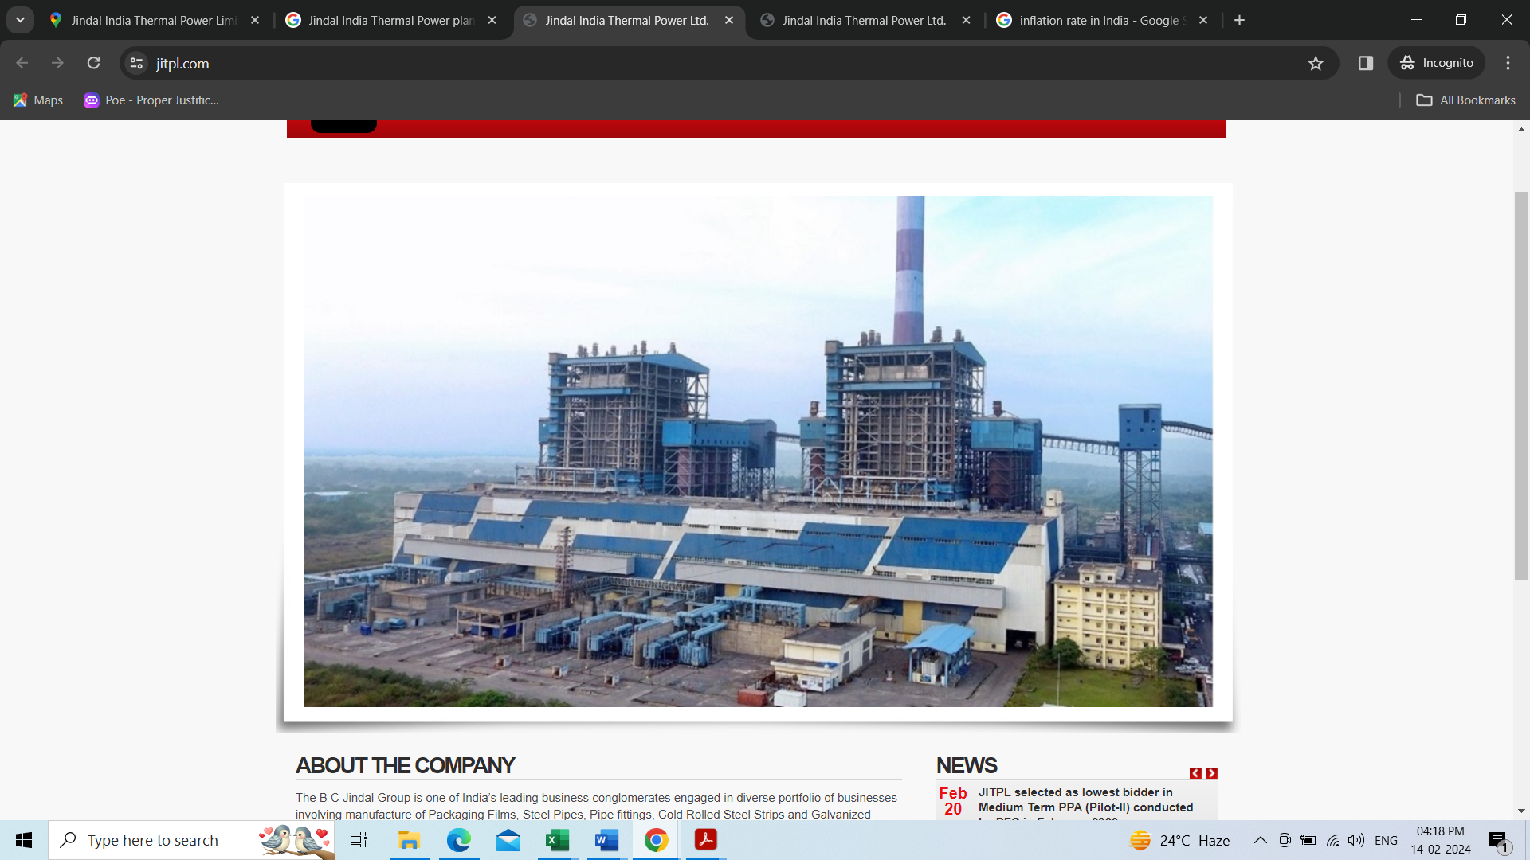

Unit wise commissioning details of the Project is mentioned below -

|  |  |  |
| --- | --- | --- |
| **Sr. No.** | **Unit No.** | **COD Achieved Date** |
| 1 | Unit No. 01 | 06-June-2014 |
| 2 | Unit No. 02 | 12-February-2015 |

1. **PROJECT LOCATION:** The Project site is located at Derang Village of Angul district, Odisha and is at a distance of around 35 km from Talcher. The nearest major railway station is Talcher, at a distance of 45 km from the Project site. The nearest airport is Bhubaneswar Airport which is about 180 km from the Project site. The project site was strategically developed very close to the coal Mines but due to non-availability of coal in Kaniha mine, the project company has transported the coal from the Talcher mine which is around 36 km away from the plant. The company has developed its own access road of 4 km, connecting NH-23. The nearest port is Paradip, at a distance of 230KM from the site and is connected by road.

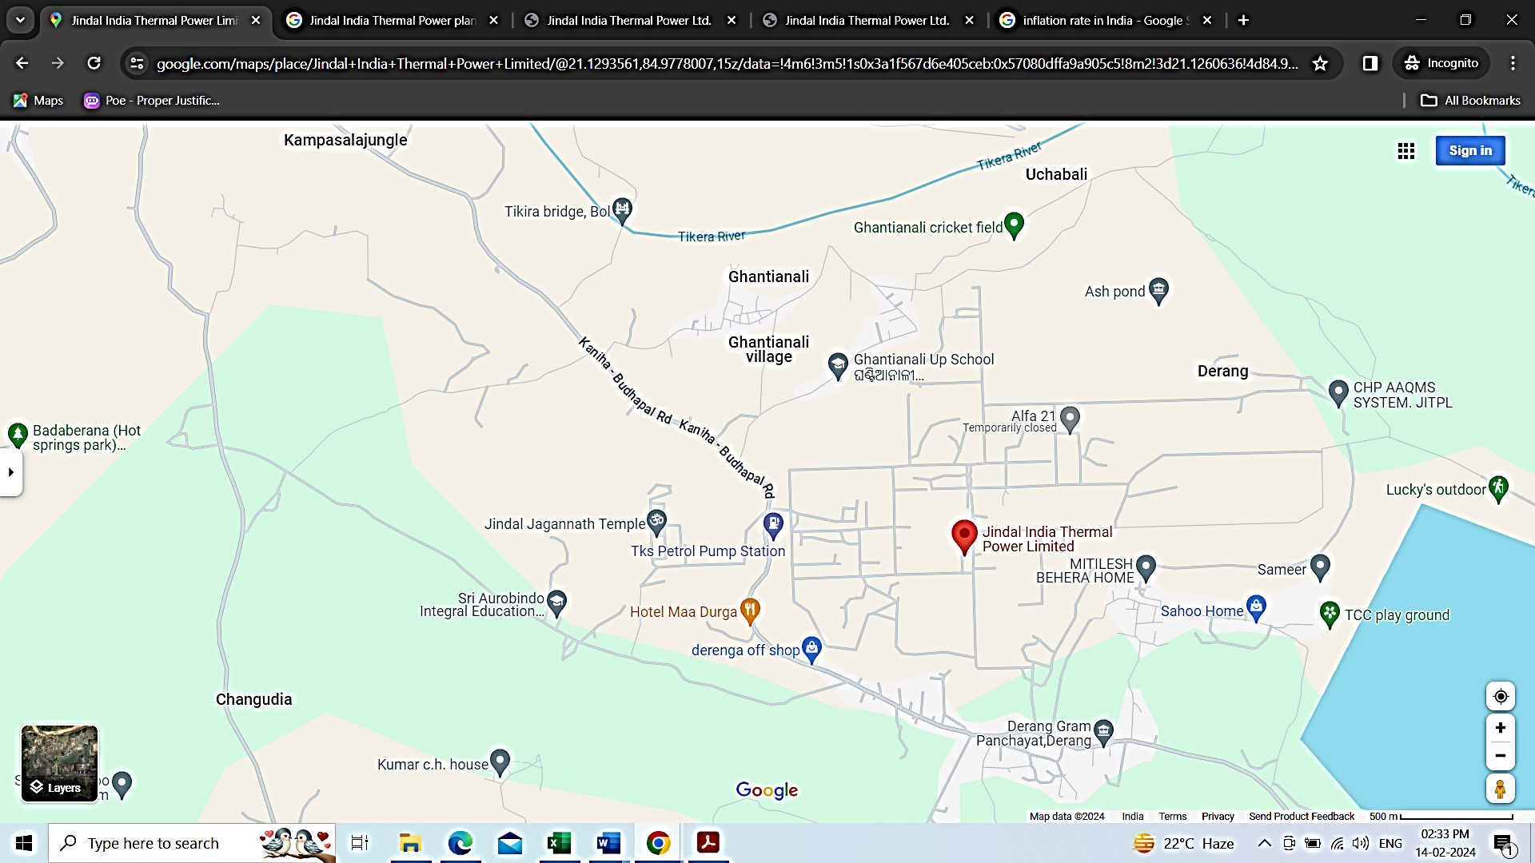

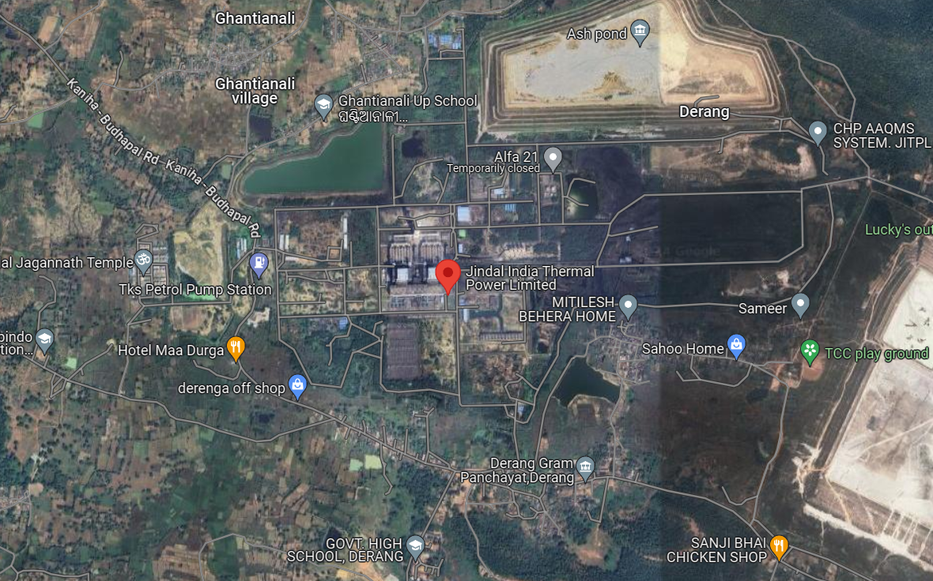

1. **LAND DETAILS:** JITPL has in possession of Land admeasuring approx. 1,149.32 acres. Out of which, the main Project has been constructed in 1,071 Acres and the balance land has been utilized mainly for constructing dedicated Roads and other associated requirements. The plant has its own access Road connecting NH 23 from where all movements of Coal and other essentials are being made to the Project Site.
2. **BTG SUPPLY AND ERECTION CONTRACTS:** Project Company had executed the project under multiple package contract scheme viz. BTG package contract and BOP packages contract. Project Company has awarded the BTG Contract to M/s. Bharat Heavy Electricals Limited (BHEL), India.

The scope of work included design, engineering, manufacture, assembly, testing, packing and forwarding, supply, transportation, arrangement of comprehensive insurance, erection, testing, pre-commissioning and commissioning, conducting performance and guarantee test of Boiler, Turbine and Generator (BTG) along with its auxiliaries, station control and instrumentation, auxiliary boiler and commissioning spares for the two sub-critical units of this Plant.

1. **EPC CONTRACTS & PLANT FACILITIES:** The Project Company has involved multiple contractors for erection of Balance of Plant (BOP) and Civil works of the Project and further company has awarded the major BOP contracts and EPC contractors to various contractors. Following are the major suppliers and contractors:

|  |  |  |
| --- | --- | --- |
| **S. No.** | **Contracts** | **Name of Supplier** |
| 1. | BTG Package | EPC by Bharat Heavy Electricals Ltd. |
| 2. | Cooling Towers | M/s Paharpur Cooling Towers |
| 3. | Ash handling System | M/s Macawber Beekay |
| 4. | Coal Handling System | M/s Tecpro |
| 5. | CW System | M/s KBL |
| 6. | Water Treatment System | M/s Ion Exchange |
| 7. | Switchyard | M/s Siemens |
| 8. | Transmission line | M/s Gammon India |
| 9. | Major civil works | M/s Shapoorji & Pallonji |

Main machinery of the plant includes Boiler, Turbine, Generator, Coal Handling Plant, Ash Handling Plant, Water Treatment Plant, Switchyard, Transmission line, Water pipeline system to bring raw water to the plant, and other auxiliary machinery for running the plant.

1. **WATER REQUIREMENT:** As per the Water Balance Diagram, the consumptive water requirement with closed cooling system is about 3 m³/MWh. The water required is being drawn from Upstream Samal Barrage on Brahmani River, which is at a distance of 12 km from the project site. The water is pumped from the Intake Pump House through dedicated pipelines to the water reservoir situated in the Plant to meet the water requirements of the Plant.

The Project Company has executed Agreement with Government of Odisha, Department of Water Resources for water drawl from Upstream of Samal Barrage from River Brahmani for 25 Cusec for the period started from September-2023 to August 31st August 2026.

Further to it company has constructed a reservoir inside the plant having capacity around 8.50 Lakh m3 which is sufficient for 10 days consumption of the plant.

1. **COAL LINKAGE OR FUEL SUPPLY AND TRANSPORTATION:** As per data information available on company’s web site and the information provided by the company, the annual coal requirement of the plant is around 7.0 million MT. The company is sourcing coal from Mahanadi Coalfields Ltd. (MCL) under linkage for both long-term Power Purchase Agreements (PPAs) and medium-term PPAs with DISCOMS, and power supply has already commenced under these agreements.

For the balance requirement, including short-term sales on Power Exchanges, coal is being sourced under the SHAKTI B (viii) scheme of the Ministry of Coal, Government of India.

Additionally, the Special Forward E-auction scheme has been discontinued by the Ministry of Coal, Government of India, and instead, a single window auction scheme has been introduced, merging all the auction windows, effective from March 2022.

1. **POWER PURCHASE AGREEMENT:** During the Financial Year 2022-23, Jindal India Thermal Power Limited entered into several Power Purchase Agreements (PPAs) for the sale of electricity:

**Long Term PPA with Bihar:** A 300 MW Long Term PPA was signed with the state of Bihar.

**Long Term PPA with GRIDCO:** A Long Term PPA was signed with GRIDCO for 12% of the energy sent out. Also, the supply of power to GRIDCO started from April 2022 based on the Hon'ble High Court of Orissa interim order dated 29th April 2022.

**Medium Term PPA with NPCL:** A 100 MW Medium Term PPA was signed with NPCL. The term will be ended on 31st December 2025.

**Medium Term PPA with PTC under Pilot Scheme-II:** A 270 MW Medium Term PPA was signed with PTC under Pilot Scheme-II.

Additionally, the company participated in PFC Pilot Scheme-III Tender in the months of January 2023 for the supply of 200 MW under Medium Term (5 years) and is the L-1 bidder under the tender. The company is awaiting the letter of award for the PFC Pilot Scheme-III tender. Power supply is expected to start for the PFC Pilot Scheme-III tender soon. Balance power is sold by the company through short term PPAs and in the Merchant Market.

1. **POWER EVACUATION ARRANGEMENT:** Generated power evacuated from the plant is through the power station’s 400 kv double circuit pooling station at Angul. A Dedicated 400 kV double circuit power transmission lines is constructed from the project site to GRIDCO/PGCIL’s Tulip Power sub-station located at a distance of 77 Km from the site. Further, for transmitting power to utilities located in other states, the company has already entered into a Bulk Power Transmission Agreement (BPTA) for long term open access with PGCIL.
2. **OPERATIONS AND MAINTENANCE (O&M) AGREEMENTS:** As per the information provided by the company Operation & Maintenance of the project has been taken care by following contractor under the supervision of JITPL.

|  |  |  |  |
| --- | --- | --- | --- |
| **List of contractors** | | | |
| **S. No.** | **O&M Contracts** | **Name of Supplier** | **Scope of Work** |
| 1. | DC Line | Abhisek Contech (India) Pvt. Ltd. | For O&M of 400 KV D/C line of length approx. 72 km for JITPL |
| 2. | Coal Handling Plant | Chennai Radha Engineering Works Pvt. Ltd. | For extension of O&M Coal Handling Plant of JITPL |
| 3. | BTG & BOP | Power Mech Projects Limited (Orisha) | For extension of O&M of BTG and BOP of JITPL |
| 4. | Ash Handling Plant | Precision Engineering (Angul Odisha) | For Operation and Maintenance of Ash Handing Plant of JITPL |

|  |  |
| --- | --- |
| **PART D** | **MARKET OVERVIEW ON POWER SECTOR** |

1. **INTRODUCTION:** Indian economy is continuously moving on a higher trajectory since last 2 decades. In last 10 years India has continuously maintained GDP growth rate in the range of 5.5% to 8%. In Union Budget 2023-24, the government allocated US$ 885 million (Rs. 7,327 crore) for the solar power sector including grid, off-grid, and PM-KUSUM projects.

Power is one of the most critical components of infrastructure, crucial for the economic growth and welfare of nations. The existence and development of adequate infrastructure is essential for sustainable growth of the Indian economy.

Electricity demand in the country has increased rapidly and is expected to rise further in the years to come. From past 3 years since 2021-22, power generation through Thermal, has witnessed more than 7% of growth, viz, 7.96%, 8.21%, 10.92% (provisional) in 2021-22, 2022-23, 2023-24 respectively. On the similar lines power consumption also grew around 8% in H1 of 2023-24. Peak power demand also touched a record high of 241 GW during April-September 2023. Electricity demand has witnessed sharp growth this year registering 16.3%, 10.3%, 21% in August, September and October 2023 on year-on-year basis.

The country's significant share of energy comes from coal-fired power plants. Factors such as rapidly increasing industrialization and urbanization are expected to drive the Indian thermal power plant market. Different government schemes, such as "Power for All", are expected to increase the country's power surge and again drive the thermal power plant market.

1. **MARKET SIZE:** India is the third-largest producer and consumer of electricity worldwide, with an installed power capacity of 416.59 GW as of April 30, 2023. As of Jan 2024, India has a total thermal installed capacity of 240.43 GW of which 208.18 GW is the installed capacity of Coal and the rest from Lignite, Diesel, and Gas.

India's power generation witnessed its highest growth rate in over 30 years in FY23. Power generation in India increased by 8.87% to 1,624.15 billion kilowatt-hours (kWh) in FY23. According to data from the Ministry of Power, India's power consumption stood at 130.57 BU in April, 2023. The peak power demand in the country stood at 226.87 GW in April, 2023.

The coal plants registered a PLF of 73.7% for the first nine-months period in FY23 compared to 68.5% in FY22 for the same period. Thermal power plant load is estimated to improve by 65% in FY24, fuelled by strong demand growth along with subdued capacity addition in the sector.

In 2021, India's total coal energy consumption was 20.09 exajoules, which was higher than the country's consumption in 2015, i.e., 16.55 exajoules. The increased consumption of coal exhibits the growing usage of coal in the country. The power-generating companies use coal widely, as it is abundant and economical for the country.

A surge in demand for coal-fired energy has led the central government to order that power utilities not retire coal-fired power plants until 2030. In January 2023, the Union Power Ministry published a notice, just two years after committing to reduce fuel usage. Hence, owing to such factors, the coal segment will likely dominate the Indian thermal power plant market in near future.

1. **GOVERNMENT INITIATIVES:** The Government of India has identified power sector as a key sector of focus to promote sustained industrial growth. These initiatives aim to address various challenges faced by the sector, promote efficiency, and ensure sustainable growth. Some key policy initiatives include:

* Ultra Mega Power Projects (UMPPs): The government launched the UMPP program to facilitate the development of large-scale, efficient, and environmentally sustainable thermal power projects. These projects are awarded through competitive bidding and are designed to achieve economies of scale and reduce tariffs.
* National Solar Mission: While not directly related to thermal power, the National Solar Mission aims to promote the development of solar energy in India. This initiative is part of the government's efforts to diversify the energy mix and reduce reliance on fossil fuels.
* Rajiv Gandhi Grameen Vidyutikaran Yojana (RGGVY): This scheme aims to provide electricity access to rural households and promote the electrification of rural areas. It includes provisions for strengthening the distribution network and promoting off-grid solutions, which can complement thermal power generation.
* Integrated Power Development Scheme (IPDS): The IPDS aims to strengthen the power distribution infrastructure in urban areas. It includes provisions for upgrading sub-transmission and distribution networks, as well as metering and IT enablement.
* Ujwal DISCOM Assurance Yojana (UDAY): UDAY is a financial restructuring scheme for state-owned power distribution companies (discoms). It aims to improve the financial health of discoms through measures such as reducing the cost of power, improving operational efficiency, and reducing losses.
* National Electricity Plan (NEP): The NEP outlines the government's vision for the development of the power sector in India. It includes targets for capacity addition, fuel mix, and efficiency improvement, which are relevant for the thermal power sector.
* Environmental Regulations: The government has introduced various regulations to reduce the environmental impact of thermal power plants. This includes norms for emission control, water usage, and fly ash management, which aim to promote cleaner and more sustainable thermal power generation.

Other initiatives include:

* 100% FDI allowed in the power sector has boosted FDI inflow in this sector.
* As of November 2022, over 51.62 lakh smart metres have been deployed under the National Smart Grid Mission (NSGM), with a further 61.13 lakh to be deployed.
* Under the Union Budget 2022-23, the government announced the issuance of sovereign green bonds, as well as conferring infrastructure status to energy storage systems.
* As of November 2022, over 51.62 lakh smart metres have been deployed under the National Smart Grid Mission (NSGM), with a further 61.13 lakh to be deployed.

1. **RECENT INVESTMENTS:** Total FDI inflow in the power sector reached US$ 16.57 billion between April December 2022. Some major investments and developments in the Indian power sector are as follows:

* The country plans to commission the Uppur Thermal Power Project, located in Ramanathapuram, Tamil Nadu, with a capacity of 1,600 MW by 2024. The project is owned by Tamil Nadu Generation and Distribution Corporation Ltd. (TANGEDCO) and has an investment cost of USD 1.7 billion.
* The Union power ministry has planned a whooping 91 GW of coal-based thermal power generation capacity entailing an investment of Rs 7.28 lakh crore over the next few years. This planned investment includes 27 GW under construction and around 31 GW of coal-based thermal capacity, which is at an advanced stage of implementation.
* NTPC Group capacity crosses 71 GW with successful completion of the trial operation of first unit of 660 MW North Karanpura Super Thermal Power Project, Jharkhand (3x660 MW).
* In February 2023, Tata Power inaugurated ‘Divyang’ a managed customer relations centre in Mumbai, which is a first among Indian power utilities.
* REC Limited and Power Finance Corporation Limited (PFC) ink MoA with SJVN Thermal Private Ltd. (STPL) for financing Buxar Thermal Power Plant with project cost of INR 12,172.74 Cr.

1. **WAY FORWARD:** In the current decade, the Indian electricity sector is likely to witness a major transformation with respect to demand growth, energy mix and market operations. Future investments will benefit from strong demand fundamentals, policy support and increasing government focus on infrastructure.

India is firmly on a growth path and government’s focus on infrastructure, housing, manufacturing bodes well for the electricity demand in the country in the long run. To reinvigorate the ailing DISCOMS, government has introduced UDAY scheme and most of the states have already joined it. The DISCOMS should be able to gradually improve their performance if they continue to pursue the prescribed operational reforms.

India thermal PLF level will swell to 65.1% in FY2024, a rise from 64.2% in FY2023, thanks to the healthy uptick in thermal PLF and a drop in the dues of state power distribution companies (discoms), following the roll-out of the Late Payment Surcharge (LPS) scheme. Despite this, the power distribution sector remains bearish, given the nominal tariff increases approved for discoms in FY2024.

Demand growth forecast for FY2024 sits modestly at 5.0-5.5%, trailing the GDP growth projection for the same period (6.0%). Unseasonal rains have curbed demand in recent months, but a bounce back is expected to commence from late May 2024. Also, the potential for an El Nino event in FY2024 could give electricity demand a fillip.

|  |  |
| --- | --- |
| **PART E** | **FINANCIAL PERFORMANCE** |

As per the audited financial statements provided by the company/client, below table shows the historical performance of the company.

1. **HISTORICAL PROFIT & LOSS STATEMENT:**

*(Figures in INR Crores)*

|  |  |  |  |  |  |
| --- | --- | --- | --- | --- | --- |
| **Particulars** | **FY 2019 A** | **FY 2020 A** | **FY 2021 A** | **FY 2022 A** | **FY 2023 A** |
| Revenue From Operations | 1494.31 | 1908.17 | 2084.26 | 2769.61 | 3131.80 |
| Other Income | 15.16 | 39.06 | 60.98 | 63.79 | 36.98 |
| **Total Income** | **1509.47** | **1947.22** | **2145.23** | **2833.40** | **3168.78** |
| Fuel Consumption | 767.23 | 984.92 | 986.90 | 1293.28 | 1552.41 |
| Purchases of Energy | 5.41 | 12.97 | 10.93 | 17.61 | 22.03 |
| Employee Benefit Expenses | 42.30 | 44.17 | 46.45 | 50.91 | 63.86 |
| Other Expenses | 459.59 | 493.94 | 468.18 | 448.00 | 422.37 |
| **Total Expenses** | **1274.53** | **1536.00** | **1512.47** | **1809.80** | **2060.66** |
| **EBITDA** | **234.94** | **411.22** | **632.77** | **1023.60** | **1108.12** |
| Depreciation & Amortization Expenses | 174.56 | 176.55 | 178.48 | 284.75 | 287.21 |
| **EBIT** | **60.38** | **234.67** | **454.28** | **738.85** | **820.92** |
| Finance Cost | 963.91 | 1097.17 | 1184.08 | 264.94 | 161.25 |
| **Profit / (loss) before Exceptional Items and Tax** | **-903.53** | **-862.50** | **-729.80** | **473.91** | **659.67** |
| Exceptional Items (Income / Expenses) | - | - | - | 5884.48 | - |
| **Profit / (loss) before Tax** | **-903.53** | **-862.50** | **-729.80** | **6358.39** | **659.67** |
| Tax Expense | -296.55 | 113.02 | -171.53 | 1219.47 | 215.20 |
| **Profit / (loss) after Tax** | **-606.98** | **-975.52** | **-558.27** | **5138.92** | **444.47** |
| Remeasurement of post-employment benefit obligations | 0.03 | 0.13 | 0.16 | 0.34 | 0.12 |
| Income tax on above | -0.01 | -0.03 | -0.04 | -0.09 | -0.03 |
| **Other Comprehensive Income, Net of Tax** | **0.02** | **0.10** | **0.12** | **0.25** | **0.09** |
| **Total Comprehensive Income/(Loss)** | **-606.96** | **-975.42** | **-558.15** | **5139.18** | **444.56** |

|  |  |  |  |  |  |  |
| --- | --- | --- | --- | --- | --- | --- |
| **Particulars** | **UOM** | **FY2019 A** | **FY2020 A** | **FY2021 A** | **FY2022 A** | **FY2023 A** |
| **PLF** | **%** | 40.10 | 49.00 | 56.68 | 81.51 | 74.80 |
| **SHR** | **Kcal/KWH** | 2374 | 2367 | 2328 | 2315 | 2336 |

1. **KEY FINANCIAL RATIOS:**

|  |  |  |  |  |  |
| --- | --- | --- | --- | --- | --- |
| Particulars | FY2019 A | FY2020 A | FY2021 A | FY2022 A | FY2023 A |
| EBITDA Margin % | 15.56% | 21.12% | 29.50% | 36.13% | 34.97% |
| EBIT Margin % | 4.00% | 12.05% | 21.18% | 26.08% | 25.91% |
| Net Profit Margin% | -40.21% | -50.10% | -26.02% | 181.37% | 14.03% |
| Revenue Growth (Y.O.Y.) |  | 29.00% | 10.17% | 32.08% | 11.84% |

1. **GRAPHICAL REPRESENTATION OF THE KEY FINANCIALS OF THE COMPANY:**

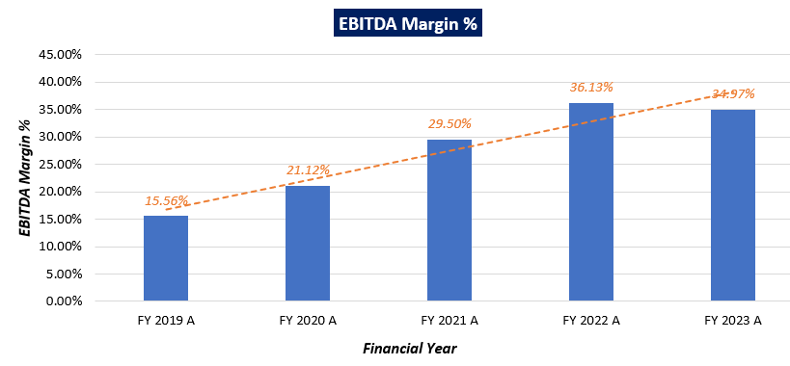

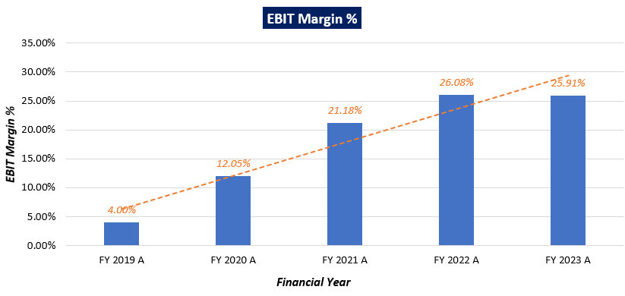

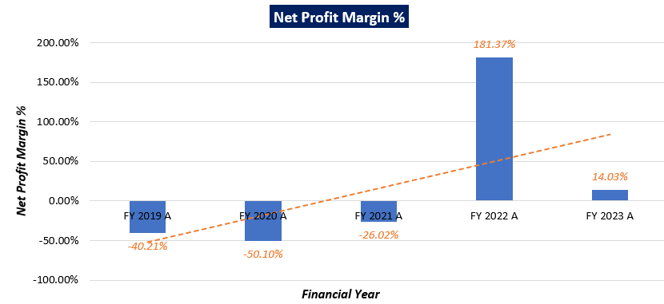

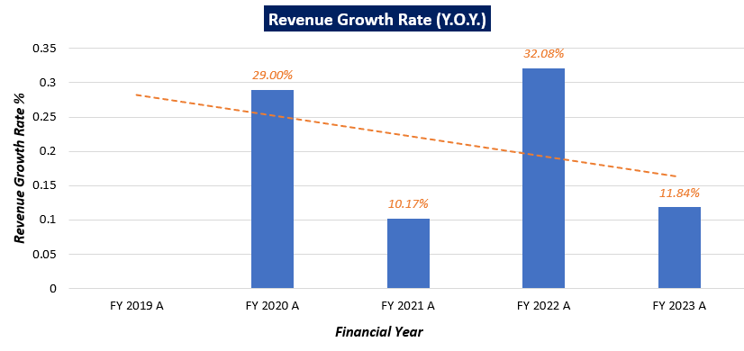

***Notes:*** As per the historical analysis, it is observed that EBITDA Margin of the company is showing an upward trend as it has gone up from 15.56% in FY 2018-19 to 34.94% in FY 2022-23. EBIT Margin is also showing an upward trend as it has gone up from 4.00% in FY 2018-19 to 25.91% in FY 2022-23.

As per the historical analysis, it is observed that Net Profit Margin of the company is rising continuously from -40.21% in FY 2018-19 to 14.03% in FY 2022-23.

Revenue Growth of the company is constantly declining during the past recent years historically Although as per the numbers shared by the company/client, it is growing averagely around 20.77% in last 5 years.

1. **PROJECTED PROFIT & LOSS STATEMENT:**

*(Figures in INR Crores)*

|  |  |  |  |  |  |  |  |  |
| --- | --- | --- | --- | --- | --- | --- | --- | --- |
| **Particulars** | **FY-24** | **FY-25** | **FY-26** | **FY-27** | **FY-28** | **FY-29** | **FY-30** | **FY-31** |
| **Revenue from sale of power** | 3147.46 | 3163.20 | 3179.01 | 3194.91 | 3210.88 | 3226.94 | 3243.07 | 3259.29 |
| Fuel Consumption | 1285.42 | 1307.27 | 1329.49 | 1352.09 | 1375.08 | 1398.46 | 1422.23 | 1446.41 |
| Purchases of Energy | 22.03 | 22.03 | 22.03 | 22.03 | 22.03 | 22.03 | 22.03 | 22.03 |
| Employee Benefit Expenses | 70.83 | 71.18 | 71.54 | 71.89 | 72.25 | 72.62 | 72.98 | 73.34 |
| Other Expenses | 443.48 | 465.66 | 488.94 | 513.39 | 539.06 | 566.01 | 594.31 | 624.03 |
| **Total Expenses** | **1821.76** | **1866.14** | **1912.00** | **1959.41** | **2008.42** | **2059.11** | **2111.55** | **2165.81** |
| **EBITDA** | **1325.70** | **1297.06** | **1267.01** | **1235.50** | **1202.46** | **1167.82** | **1131.52** | **1093.48** |
| Depreciation | 285.12 | 270.58 | 270.94 | 271.13 | 275.57 | 275.73 | 275.82 | 275.82 |
| **EBIT** | **1040.58** | **1026.48** | **996.07** | **964.37** | **926.89** | **892.10** | **855.70** | **817.66** |
| Finance Cost | 44.48 | 59.41 | 0.00 | 0.00 | 0.00 | 0.00 | 0.00 | 0.00 |
| **PBT** | **996.10** | **967.07** | **996.07** | **964.37** | **926.89** | **892.10** | **855.70** | **817.66** |
| Tax | 348.04 | 337.89 | 348.03 | 336.95 | 323.86 | 311.70 | 298.98 | 285.69 |
| **PAT** | **648.07** | **629.18** | **648.04** | **627.42** | **603.04** | **580.40** | **556.72** | **531.97** |

*(Figures in INR Crores)*

|  |  |  |  |  |  |  |  |  |  |
| --- | --- | --- | --- | --- | --- | --- | --- | --- | --- |
| **Particulars** | **FY-32** | **FY-33** | **FY-34** | **FY-35** | **FY-36** | **FY-37** | **FY-38** | **FY-39** | **FY-40** |
| **Revenue from sale of power** | 3275.58 | 3291.96 | 3308.42 | 3324.96 | 3341.59 | 3358.29 | 3375.09 | 3391.96 | 1810.99 |
| Fuel Consumption | 1471.00 | 1496.00 | 1521.43 | 1547.30 | 1573.60 | 1600.35 | 1627.56 | 1655.23 | 894.29 |
| Purchases of Energy | 22.03 | 22.03 | 22.03 | 22.03 | 22.03 | 22.03 | 22.03 | 22.03 | 11.70 |
| Employee Benefit Expenses | 73.71 | 74.08 | 74.45 | 74.82 | 75.20 | 75.57 | 75.95 | 76.33 | 40.75 |
| Other Expenses | 655.23 | 687.99 | 722.39 | 758.51 | 796.43 | 836.25 | 878.07 | 921.97 | 514.29 |
| **Total Expenses** | **2221.96** | **2280.10** | **2340.30** | **2402.66** | **2467.26** | **2534.21** | **2603.61** | **2675.56** | **1461.03** |
| **EBITDA** | **1053.62** | **1011.86** | **968.12** | **922.30** | **874.32** | **824.08** | **771.48** | **716.40** | **349.96** |
| Depreciation | 275.82 | 276.05 | 276.05 | 276.05 | 282.06 | 276.13 | 276.25 | 282.92 | 150.30 |
| **EBIT** | **777.80** | **735.81** | **692.07** | **646.25** | **592.27** | **547.96** | **495.22** | **433.48** | **199.65** |
| Finance Cost | 0.00 | 0.00 | 0.00 | 0.00 | 0.00 | 0.00 | 0.00 | 0.00 | 0.00 |
| **PBT** | **777.80** | **735.81** | **692.07** | **646.25** | **592.27** | **547.96** | **495.22** | **433.48** | **199.65** |
| Tax | 271.76 | 257.09 | 241.81 | 225.80 | 206.94 | 191.46 | 173.03 | 151.46 | 69.76 |
| **PAT** | **506.03** | **478.72** | **450.26** | **420.45** | **385.33** | **356.50** | **322.19** | **282.02** | **129.89** |

1. **KEY FINANCIAL RATIOS:**

|  |  |  |  |  |  |  |  |  |
| --- | --- | --- | --- | --- | --- | --- | --- | --- |
| **Particulars** | **FY-24** | **FY-25** | **FY-26** | **FY-27** | **FY-28** | **FY-29** | **FY-30** | **FY-31** |
| **EBITDA Margin %** | 42.12% | 41.00% | 39.86% | 38.67% | 37.45% | 36.19% | 34.89% | 33.55% |
| **EBIT Margin %** | 33.06% | 32.45% | 31.33% | 30.18% | 28.87% | 27.65% | 26.39% | 25.09% |
| **Net Profit Margin %** | 20.59% | 19.89% | 20.39% | 19.64% | 18.78% | 17.99% | 17.17% | 16.32% |

|  |  |  |  |  |  |  |  |  |  |
| --- | --- | --- | --- | --- | --- | --- | --- | --- | --- |
| **Particulars** | **FY-32** | **FY-33** | **FY-34** | **FY-35** | **FY-36** | **FY-37** | **FY-38** | **FY-39** | **FY-40** |
| **EBITDA Margin %** | 32.17% | 30.74% | 29.26% | 27.74% | 26.16% | 24.54% | 22.86% | 21.12% | 19.32% |
| **EBIT Margin %** | 23.75% | 22.35% | 20.92% | 19.44% | 17.72% | 16.32% | 14.67% | 12.78% | 11.02% |
| **Net Profit Margin %** | 15.45% | 14.54% | 13.61% | 12.65% | 11.53% | 10.62% | 9.55% | 8.31% | 7.17% |

1. **GRAPHICAL REPRESENTATION OF THE KEY FINANCIALS OF THE COMPANY:**

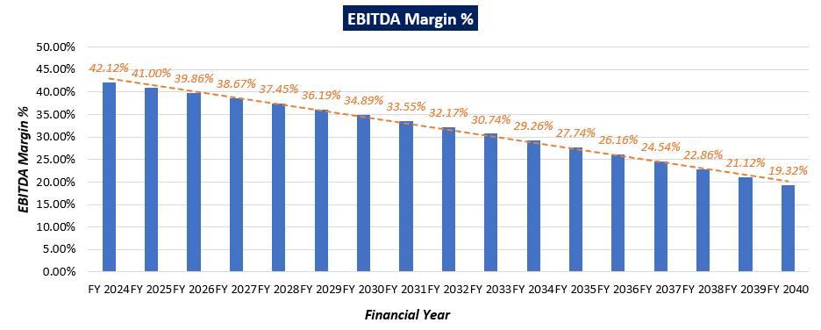

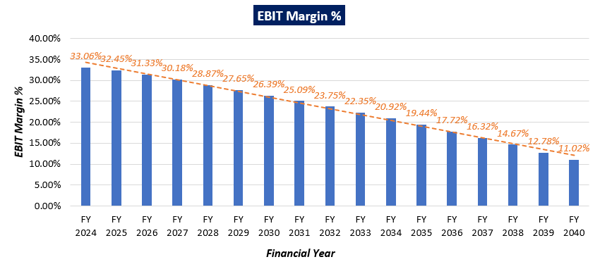

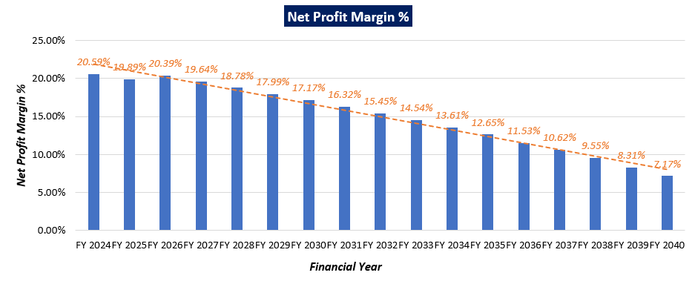

***Notes:***

The EBITDA of a thermal power plant in India can vary significantly depending on factors such as capacity, efficiency, fuel costs, electricity prices, operational performance, and regulatory environment.

We can see from above forecasting that in initial years, EBITDA is higher, which indicate a period of growth for the business, due to increased sales, improved operational efficiency and market opportunities, assuming that company will achieve financial stability in future. However, the subsequent decrease in EBITDA could suggest that the business is reaching a point of saturation in its market and facing increased competition, leading to lower profitability. Similar trend is shown by EBIT margin and Net Profit Margin.

|  |  |
| --- | --- |
| **PART F** | **VALUATION OF THE COMPANY** |

1. **METHODOLOGY/ MODEL ADOPTED:** Out of the various models & theories available, we have adopted the most widely used & acceptable approach to calculate the Equity Value of the Company, which is, Income based approach (Discounted Cash Flow Model).
2. The free cash flow method is similar to the method used for public companies.
3. FCFF is more practical when substantial capital changes are expected because weighted average cost of capital (WACC) is less sensitive to the cost of equity.
4. In this method, we calculate the free cash flow to firm (FCFF) for the projected period.
5. Finally, we calculate the present value of future cash flows by using a required rate of return based on the riskiness of the project, which we determine by using the Weighted Average Cost of Capital (WACC).

**RATIONALE FOR USING DCF METHOD FOR EQUITY VALUATION:**

1. The three broadly used approaches of the company/Business Valuations are – Income based approach (Discounted Cash Flow Model), Asset Based Approach (Net Asset Value Method) and Relative Valuation Approach (Market Multiple method).
2. Asset Based Model is inappropriate as the Company is a going concern and the model is unable to capture the Value of the company.
3. Market Multiple Approach is also not suitable as the company is not listed and no proper similar recent comparable transactions are available.
4. Instead, DCF method is used which determines the value of a business based on its ability to generate desired economic benefit/ cash flows for the owners. Thus, considering the nature of business, we have used DCF method for valuing the Company.
5. The DCF Model gives us a variety of input options to use while calculating the Value of the firm - Dividend, Free Cash Flow to the Firm, Free Cash Flow to Equity, Capitalized Cash Flows and Residual Earnings.
6. Dividends cannot be used as the Company has no history of paying dividends and we don’t foresee any dividend payments to occur in the future due to the high leverage of the firm.
7. The best method input option for the PV Model in the case of M/s Jindal India Thermal Power Limited will be FCFF as it represents the benefits accruable to all the stakeholders in the Business enterprise.

**FCFF Model Formula and Key Inputs:**

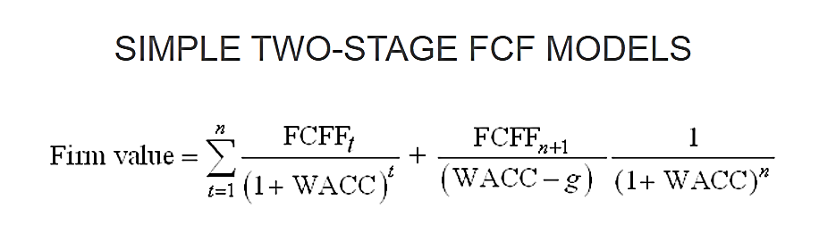

* **Free Cash Flow to Firm (FCFF):** FCFF is the [cash](http://www.investinganswers.com/node/5011) available to pay investors after a company pays its costs of doing business, invests in short-term assets like [inventory](http://www.investinganswers.com/node/2474), and invests in assets like property, plants and equipment.

*FCFF = Net Income + Non-Cash Charges + Interest (1 - tax rate) – Working Capital Investment – Fixed Capital Investment.*

* **Weighted Average Cost of Capital (WACC):**The weighted average cost of capital (WACC) is the rate that a company is expected to pay on average to all its security holders to finance its assets. The WACC is commonly referred to as the firm’s cost of capital. WACC is used as the discount rate to discount FCFF.

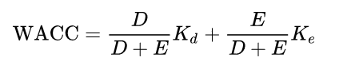

Where D is the total debt, E is the shareholders equity and Kd and Ke are the cost of debt and cost of equity, respectively.

1. **CALCULATION OF FREE CASH FLOW TO FIRM:**

(Value in INR Crores)

|  |  |  |  |  |  |  |  |  |
| --- | --- | --- | --- | --- | --- | --- | --- | --- |
| **Particulars** | **Mar-24** | **Mar-25** | **Mar-26** | **Mar-27** | **Mar-28** | **Mar-29** | **Mar-30** | **Mar-31** |
| Total revenue | 3,147.46 | 3,163.20 | 3,179.01 | 3,194.91 | 3,210.88 | 3,226.94 | 3,243.07 | 3,259.29 |
| Total Expenses | 1,821.76 | 1,866.14 | 1,912.00 | 1,959.41 | 2,008.42 | 2,059.11 | 2,111.55 | 2,165.81 |
| **EBITDA** | 1,655.30 | 1,627.04 | 1,537.95 | 1,506.63 | 1,478.03 | 1,443.55 | 1,407.34 | 1,369.30 |
| Depreciation | 285.12 | 270.58 | 270.94 | 271.13 | 275.57 | 275.73 | 275.82 | 275.82 |
| **EBIT** | 1,370.18 | 1,356.47 | 1,267.01 | 1,235.50 | 1,202.46 | 1,167.82 | 1,131.52 | 1,093.48 |
| Less: Taxes | 478.74 | 473.95 | 442.69 | 431.68 | 420.14 | 408.04 | 395.35 | 382.06 |
| **NOPAT** | 891.44 | 882.52 | 824.32 | 803.82 | 782.32 | 759.79 | 736.17 | 711.42 |
| Add: Depreciation | 285.12 | 270.58 | 270.94 | 271.13 | 275.57 | 275.73 | 275.82 | 275.82 |
| Less: Capex | 0.06 | 425.85 | 425.74 | 1.46 | 0.05 | 0.03 | 0.00 | 0.00 |
| Less: Change in WC | -135.39 | 1.59 | 0.61 | 0.59 | -0.40 | 1.53 | 0.54 | 0.52 |
| **Unlevered Free Cash Flow (UFCF)/ FCFF** | **1,311.89** | **725.65** | **668.91** | **1,072.89** | **1,058.23** | **1,033.96** | **1,011.45** | **986.72** |
| **FCFF for Remaining Year** | **161.30** | **725.65** | **668.91** | **1,072.89** | **1,058.23** | **1,033.96** | **1,011.45** | **986.72** |

(Value in INR Crores)

|  |  |  |  |  |  |  |  |  |  |
| --- | --- | --- | --- | --- | --- | --- | --- | --- | --- |
| **Particulars** | **Mar-32** | **Mar-33** | **Mar-34** | **Mar-35** | **Mar-36** | **Mar-37** | **Mar-38** | **Mar-39** | **Mar-40** |
| Total revenue | 3,275.58 | 3,291.96 | 3,308.42 | 3,324.96 | 3,341.59 | 3,358.29 | 3,375.09 | 3,391.96 | 1,810.99 |
| Total Expenses | 2,221.96 | 2,280.10 | 2,340.30 | 2,402.66 | 2,467.26 | 2,534.21 | 2,603.61 | 2,675.56 | 1,461.03 |
| **EBITDA** | 1,329.44 | 1,287.91 | 1,244.17 | 1,198.35 | 1,156.38 | 1,100.21 | 1,047.73 | 999.33 | 500.26 |
| Depreciation | 275.82 | 276.05 | 276.05 | 276.05 | 282.06 | 276.13 | 276.25 | 282.92 | 150.30 |
| **EBIT** | 1,053.62 | 1,011.86 | 968.12 | 922.30 | 874.32 | 824.08 | 771.48 | 716.40 | 349.96 |
| Less: Taxes | 368.13 | 353.54 | 338.26 | 322.25 | 305.49 | 287.93 | 269.55 | 250.31 | 122.28 |
| **NOPAT** | 685.48 | 658.32 | 629.86 | 600.05 | 568.84 | 536.15 | 501.92 | 466.09 | 227.68 |
| Add: Depreciation | 275.82 | 276.05 | 276.05 | 276.05 | 282.06 | 276.13 | 276.25 | 282.92 | 150.30 |
| Less: Capex | 0.07 | 0.00 | 0.00 | 0.00 | 0.10 | 0.04 | 2.20 | 0.00 | 0.00 |
| Less: Change in WC | -0.48 | 1.46 | 0.46 | 0.44 | -0.56 | 1.38 | 0.38 | 0.36 | -169.46 |
| **Unlevered Free Cash Flow (UFCF)/ FCFF** | **961.71** | **932.91** | **905.45** | **875.66** | **851.35** | **810.85** | **775.61** | **748.66** | **547.45** |
| **FCFF for Remaining Year** | **961.71** | **932.91** | **905.45** | **875.66** | **851.35** | **810.85** | **775.61** | **748.66** | **547.45** |

1. **KEY INPUTS USED TO DISCOUNT CASH FLOWS DURING THE PROJECTION PERIOD:**

|  |  |
| --- | --- |
| **Inputs** | |
| **Valuation Date** | **15th February 2024** |
| **Discount Rate** | **14.01 %** |
| **Discount Rate Change** | **1%** |
| **Tax Rate** | **34.94 %** |

**Calculation of WACC for M/s JITPL**

|  |  |
| --- | --- |
| **Weighted Average Cost of Capital** | |
| **Cost of Debt** | 9.50% |
| **Cost of Equity** | 11.42% |
| **Risk Free Rate of Return (Rf)** | 7.10% |
| **Market Risk Premium (Rm-Rf)** | 4.90% |
| **Expected Market Return (Rm) Nifty Fifty 10-year return 2024** | 12.00% |
| **Beta** | 0.88 |
| **WACC** | 10.51% |
| **Company Risk Premium** | 3.50% |

***Note:*** *Discount Rate Change of 1% is used to calculate the Sensitivity of the Enterprise Valuation with +/- changes in discount rate.*

1. **CALCULATION OF ENTERPRISE VALUE:**

(Value in INR Crores)

|  |  |  |  |  |  |  |  |  |
| --- | --- | --- | --- | --- | --- | --- | --- | --- |
| **Particulars** | **Mar-24** | **Mar-25** | **Mar-26** | **Mar-27** | **Mar-28** | **Mar-29** | **Mar-30** | **Mar-31** |
| Period | 0.12 | 1.12 | 2.12 | 3.12 | 4.12 | 5.12 | 6.12 | 7.12 |
| Discount Factor | 0.98 | 0.86 | 0.76 | 0.66 | 0.58 | 0.51 | 0.45 | 0.39 |
| Terminal Value | - | - | - | - | - | - | - | - |
| **PV of FCFF** | **158.72** | **626.30** | **506.38** | **712.40** | **616.32** | **528.19** | **453.20** | **387.79** |
| **PV of FCFF + PV of TV** | **158.72** | **626.30** | **506.38** | **712.40** | **616.32** | **528.19** | **453.20** | **387.79** |

|  |  |  |  |  |  |  |  |  |  |
| --- | --- | --- | --- | --- | --- | --- | --- | --- | --- |
| **Particulars** | **Mar-32** | **Mar-33** | **Mar-34** | **Mar-35** | **Mar-36** | **Mar-37** | **Mar-38** | **Mar-39** | **Mar-40** |
| Period | 8.12 | 9.12 | 10.12 | 11.12 | 12.12 | 13.12 | 14.12 | 15.12 | 16.12 |
| Discount Factor | 0.34 | 0.30 | 0.27 | 0.23 | 0.20 | 0.18 | 0.16 | 0.14 | 0.12 |
| Terminal Value | - | - | - | - | - | - | - | - | 486.80 |
| **PV of FCFF** | **331.51** | **282.07** | **240.12** | **203.69** | **173.70** | **145.10** | **121.74** | **103.07** | **66.11** |
| **PV of Terminal Value** | - | - | - | - | - | - | - | - | **58.78** |
| **PV of FCFF + PV of TV** | **331.51** | **282.07** | **240.12** | **203.69** | **173.70** | **145.10** | **121.74** | **103.07** | **124.89** |

Thus, based on the above factors, assumptions, Enterprise value of M/s Jindal India Thermal Power Limited is arrived at INR 5,715.19 Crores.

|  |
| --- |
| **ENTERPRISE VALUE OF M/S JINDAL THERMAL POWER LIMITED** |
| **INR FIVE THOUSAND SEVEN HUNDRED FIFTEEN CRORES AND NINTEEN LAKHS**  **(INR 5,715.19 CRORES)** |

|  |  |
| --- | --- |
| **Enterprise Value of the Firm** | **5,715.19** |
| Debt and Debt equivalents | 546.20 |
| Redeemable Preference Shares | 1,724.21 |
| Cash and Cash Equivalents | 228.45 |
| **Equity Value of the Firm** | **3673.23** |

Thus, M/s Jindal India Thermal Power Limited is having an Enterprise Value of INR **5,715.19** Crores and Equity value of INR **3,673.23** Crores, while all the assumptions according to company’s financials have been considered. To calculate per share value, we need diluted number of shares on 31st march 2023, i.e. 60,57,66,550 shares (as per FY 2022-23). Hence per share price of JITPL is:

|  |
| --- |
| **PER SHARE PRICE OF M/S JITPL** |
| **INR SIXTY RUPEES AND SIXTY-FOUR PAISE (INR 60.64)** |

***NOTE:***

* *The valuation is done based on the historical financials, Industry trend and our experience within the sector.*
* *The enterprise valuation of the project is just the reflection of the present value of its cash flow generating capacity in future years.*
* *We have not considered any contingent Dues / Liability/ Payables / Receivables / Pendency on or of the company in future years, which should be assessed separately by the parties, wanting to enter in the transaction, unless otherwise mentioned.*
* *Currently, the company has signed PPAs of ~425 MW out of the installed capacity of 1200 MW and the prospective buyer/investor/company can benefit from signing additional PPAs to use its full installed capacity.*
* *While calculating enterprise value, we have also considered FGD cost, as per revised Environmental norms company needs to install & commission FGD system by December 2026, as JITPL falls under Category-C of the revised norms.*
* *While forecasting interest and debt, we take into account the outstanding details of interest and debt based on the current status of JITPL and information provided by JITPL.*
* *In absence of the present operational details of the plant, we have relied upon the historical data to forecast the financial projections as per the industry standards.*
* *We are of the viewpoint that the power industry growth and demand for the power consumption will be higher in the future years, which will increase the demand for the thermal power generation plants as a result of it.*

1. **SENSITIVITY ANALYSIS:**
2. **WACC** is the key input which has strong impact on the firm’s value with respect to percentage change. We have considered a change of **1%** to perform the sensitivity analysis.

|  |  |
| --- | --- |
| **Scenario** | **WACC** |
| **Optimistic Case** | 13.01% |
| **Base Case** | **14.01%** |
| **Pessimistic Case** | 15.01% |

1. **ENTERPRISE VALUE OF THE FIRM IN THE DIFFERENT SCENARIO:**

|  |  |  |
| --- | --- | --- |
| **Scenario** | **Discount Rate** | **Enterprise Value (INR Cr.)** |
| **Optimistic Case** | 13.01% | 6027.25 |
| **Base Case** | **14.01%** | **5715.19** |
| **Pessimistic Case** | 15.01% | 5428.64 |

1. **SHARE PRICE OF THE FIRM IN THE DIFFERENT SCENARIO:**

|  |  |  |
| --- | --- | --- |
| **Scenario** | **Enterprise Value (INR Cr)** | **Share Price (INR)** |
| **Optimistic Case** | 6027.25 | 65.79 |
| **Base Case** | **5715.19** | **60.64** |
| **Pessimistic Case** | 5428.64 | 55.91 |

Thus, in the base case scenario, M/s JITPL is having the Enterprise Value **INR 5,715.19 Crores** and it may vary up to **INR 6,027.25 Crores** as optimistic case and **INR 5,428.64 Crores** as the pessimistic case. However, as per sensitivity analysis, the final transaction price will be dependent on the bargaining power of market participants to reach out to a successful outcome for all the concerned parties.

Similarly, in the base case scenario, M/s JITPL is having the share price of **INR 60.64** and it may vary up to **INR 65.79** as optimistic case and **INR 55.91** as a pessimistic case.

Hence, using two-stage DCF Model, considering as a base case the Enterprise Value of “M/s Jindal India Thermal Power Limited” is being calculated as **INR 5,715.19 Crores**, subject to the current assumptions and inputs used during the forecasted period, as well as the revenue growth and WACC used to calculate the EV.

*This is only a general assessment of the Enterprise/Business Value of the firm based on the data/input Company officials could provide to us against our questions/ queries and information available in the public domain. In no manner this should be regarded as an audit activity/ report and NO micro analysis or detailed or forensic audit/ scrutiny of the financial transactions or accounts of any kind has been carried out at our end.*

1. **KEY ASSUMPTIONS AND WORKINGS:** Assumptions in the Valuation assessment have been taken based on data/ information/ documents shared by the Company, Operating History of the Plant, Annual Reports of the company, Market & Industry analysis. Assumptions have been considered after thoroughly reviewing their feasibility.
2. **KEY INPUTS CONSIDERED:** Details of key inputs/assumption during the building of projection are as follows shown in the below table:

|  |  |  |  |
| --- | --- | --- | --- |
| **Coastal Energen Private Limited Details** | | | |
| **Particular** | **Unit** | **Unit-1** | **Unit-2** |
| **Life of Plant** | Years | 25 | 25 |
| **Installed Capacity** | MW | 600 | 600 |
| **COD of the Project** | Date | 6th June 2014 | 12th February 2015 |

1. **PROJECTION PERIOD:** The enterprise value and equity value of the company are calculated based on a projection period of 17 years from FY 2023-24 to FY 2039-40. This period aligns with the 25-year economic life of the plant, as per CERC guidelines.
2. **REVENUE PROJECTIONS:** We have considered revenue and cost-based model while making the future financial projection, the projections are forecasted for next seventeen years up to FY 2040. JITPL historical trend for revenue growth is very uncertain. As per information provided by the client/company, JITPL is having long term PPA only for ~425 MW out of 1200 MW. As the major source of revenue for Jindal India Thermal Power Plant is through electricity sales. Hence, for higher revenue generation JITPL have to make a strategy for more long term PPAs.

In order to predict revenue accurately, it is essential to have access to tariff rates, the Plant Load Factor (PLF) factor, and detailed unit-wise revenue information, in accordance with industry best practices. Without relevant information such as Power Purchase Agreements (PPAs) and unit-wise details, we are unable to proceed with this approach. As a result, we have adopted an alternative approach based on our tertiary research.

As per information available on public domain, the Indian thermal power plant market is expected to register a CAGR of more than 2.3%, although the market was affected by COVID-19 in 2020, currently it has recovered and reached pre-pandemic levels.

On the other hand, the growing share of renewable energy in total energy generation is expected to restrain the market. However, new and efficient technologies like supercritical and ultra-supercritical coal power plants, which reduce the amount of pollution, are expected to replace the aging power plants and create several opportunities for the Indian thermal power plant market in the future. Therefore, to be on the conservative side we have considered the growth in the revenue at the rate of 0.50% Y-O-Y for forecasted years from FY 2023-24 to FY 2039-40.

1. **PLANT LOAD FACTOR (PLF):** As per information provided by the client/company, below table shows the historical PLF factor for JITPL:

|  |  |
| --- | --- |
| Financial Years | PLF Factor |
| 2018-19 | 40.10% |
| 2019-20 | 49.00% |
| 2020-21 | 56.68% |
| 2021-22 | 81.51% |
| 2022-23 | 74.80% |

As per information provided by the client/company, JITPL is having long term PPA only for ~425 MW out of 1200 MW. To calculate PLF factor, we have considered the historical of last 4 years, the calculated the average PLF. Below tables shows PLF data over the forecasted term:

|  |  |  |  |  |  |  |  |  |
| --- | --- | --- | --- | --- | --- | --- | --- | --- |
| **Particulars** | **Mar-24** | **Mar-25** | **Mar-26** | **Mar-27** | **Mar-28** | **Mar-29** | **Mar-30** | **Mar-31** |
| PLF % | 65% | 67% | 68% | 69% | 70% | 71% | 72% | 74% |

|  |  |  |  |  |  |  |  |  |  |
| --- | --- | --- | --- | --- | --- | --- | --- | --- | --- |
| **Particular** | **Mar-32** | **Mar-33** | **Mar-34** | **Mar-35** | **Mar-36** | **Mar-37** | **Mar-38** | **Mar-39** | **Mar-40** |
| PLF% | 75% | 76% | 78% | 79% | 80% | 82% | 83% | 84% | 85% |

1. **EXPENSES PROJECTIONS:** As per information available in the audited financial statements major expenses includes Fuel expense, employees benefit expenses and other operating and maintenance expenses.

* **Fuel Expenses**: As per data information provided by client / company, JITPL consume indigenous coal as fuel for power generation. Coal prices in India vary widely based on the type and quality of coal, transportation costs, and other factors. In the absence of relevant information available to us, we first calculated the operating expenses during the projected period as the average of historical expenses with respect to operating revenue, following best practices in the industry. However, while analyzing the projected fuel expenses, we found them very high.

Therefore, we have adopted another approach, using Tons per MW per annum for JITPL as per CEA guidelines provided for grade coal and the current status of the company. According to the data/information provided by the company, JITPL is using G10 to G12 grade coal for electricity generation. To calculate the coal price, we have considered grade-specific (G10) coal prices, required coal in tons per MW, PLF factor, transportation charges, and applicable taxes, which aligns with industry standards.

* **Employee Benefit Expenses**: Employee benefit expenses are estimated based on previous years' expenses during the projected period and calculated as the average of historical expenses with respect to operating revenue, following industry best practices. This results in an annual expected growth rate of 2.25% for the projections.
* **Other Expenses**: Other expenses consist of various components. Major amount of other expenses covered under O&M expenses, repairs and maintenance of plant & machinery and building/roads, transmission charges, water charges, etc.

According to the breakdown details provided by the company, repairs and maintenance expenses for last 3 years were 2526.37 MU in FY 21-22, 2612.25 MU in FY 22-23, and 1234.33 MU in FY 23-24 until January 2024 due to generation loss caused by plant breakdowns.

Based on the last one-year major maintenance record, JITPL spent INR 56.30 Crs on the maintenance of the plant and machinery. Also, the estimated cost for major maintenance planned in the near future provided by JITPL is INR 35.33 Crs.

Therefore, after considered above mentioned facts and the effect of inflation, to calculate other expenses conservatively, an 5% escalation rate has been considered year-on-year for the forecasted period, in the FY 2022-23 data.

1. **TAXATION:** Corporate tax rate is 34.94%.
2. **DEPRECIATION:** Depreciation rate has been considered as per the Companies Act 2013, which seems to be reasonable to keep a mark-up for future market & economic risks in the Project.
3. **CAPITAL EXPENDITURE**: CAPEX has been considered as per the Companies Act 2013, and it also include FGD plant installation (by December 2026) cost, which seems to be reasonable to keep a mark-up for future market & economic risks in the Project.
4. **FGD Cost:** According to the revised Environmental norms and the implementation timeline, the company needs to install & commission FGD system by December 2024 (further extended to December 2026) as JITPL falls under Category-C of the revised norms and company is in process of Commercial negotiations and estimated project cost will be around ~ 851.37 crores. Below are the estimated FGD cost details provided by company:

|  |  |  |
| --- | --- | --- |
| **S. No.** | **Break Down** | **Cost in Rs. Crores** |
| **1.** | Plant & Equipment |  |
|  | Limestone Handling system including limestone slurry preparation system | 64.72 |
|  | Flue gas Ducting and Booster Fan System | 76.00 |
|  | Absorber Spray System | 151.38 |
|  | Gypsum Dewatering System | 34.00 |
|  | Electrical and C&I | 70.00 |
|  | HVAC, Fire Fighting, ACW system including civil works | 32.00 |
|  | Wet chimney with Borosilicate Lining | 93.00 |
|  | **Sub Total** | **521.10** |
| **2.** | Erection & Commissioning | 78.17 |
| **3.** | Tax & Duties @18% | 107.87 |
| **4.** | Contingency @ 5% | 35.36 |
| **5.** | **Capital Cost** | **742.49** |
| **6.** | Interest During Construction (IDC) | 92.14 |
| **7.** | Financing Charges (FC) | 5.24 |
| **8.** | Working Capital Margin (WCM) | 11.51 |
| **9.** | **Capital cost including IDC, FC & WCM** | **851.37** |

For the ease of operations and to lower the financial burden of the FGD cost on the cash flows of the company. We have distributed the expenses related to the installation of FGD in between the two financial years.

1. **COST OF EQUITY:** We have used CAPM formula to evaluate JITPL’s cost of equity i.e. 11.42%. Formula used to calculate cost of equity is mentioned below:

**Cost of Equity = Risk-Free Rate of Return + Beta * (Market Rate of Return – Risk-Free Rate of Return)**

* For risk free rate of return, we have considered 10 years government bond yield i.e. 7.10%.
* To calculate Beta, we have used, group of comparable companies within the same industry. For all the comparable companies we have un-lever each one’s beta, take the median of the set, and then re-lever it based on JITPL’s capital structure, hence beta calculated beta is 0.88.
* For market rate of return, we have considered the Nifty Fifty 10-Year Return i.e. 12%.

1. **BETA:** To calculate the beta of M/s Jindal India Thermal Power Limited, we have followed the “Pure-Play Method”. Calculating beta using the pure-play method involves the following four steps:

Step 1: Find a comparable company.

Step 2: Estimate the average beta of the comparable companies.

Step 3: Calculate unlevered beta of the companies.

Step 4: Level the beta for the company's (M/s. JITPL) financial risk.

|  |  |  |  |  |
| --- | --- | --- | --- | --- |
| **Companies** | **Market Capitalisation (INR crores as on 15th February 2024)** | **Beta** | **5 years Average D/E** | **Unlevered Beta** |
| NTPC | 306269 | 0.96 | 1.342 | 0.51 |
| Tata Power | 1,15,527 | 1.1 | 1.448 | 0.57 |
| Reliance Power | 9,966 | 1.4 | 0.638 | 0.99 |
| Adani Power | 2,16,702 | 1.45 | 2.598 | 0.54 |
| NLC India | 29,639 | 1.49 | 0.904 | 0.94 |
|  |  |  |  | **0.56** |

|  |  |
| --- | --- |
| **Beta Calculation** | |
| Unlevered Beta | 0.56 |
| D/E Ratio | 0.90 |
| Beta | **0.88** |

1. **COST OF DEBT:** As per information provided by client/company, for FY 2022-23, interest rate for outstanding debt will be 9.50%.
2. **COMPANY RISK PREMIUM:** As per the information shared by the company, the holding company has been declared NPA, which restricts JITPL to expand its operations. The historical performance of the company is also under stress as per the details shared by the client/company, which makes this thermal plant a risky prospect for any prospective investor. Due to these reasons, we have assumed a company-wide risk premium of ~3.5%, which covers all the associated expected risks.

**Hence, the calculated Enterprise Value and share price of Jindal India Thermal Power Limited are INR 5,715.19 Crores and INR 60.64 respectively, subject to the current micro & macro-economic assumptions, market, industry trends and inputs used during the forecasted period.**

|  |  |  |
| --- | --- | --- |
| **Declaration** | 1. *Since this is Equity Valuation hence no site inspection was carried out by us.* 2. *The undersigned does not have any direct/indirect interest in the above property.* 3. *The information furnished herein is true and correct to the best of our knowledge.* 4. *This valuation work is carried out by our Financial Analyst team on the request from Punjab National Bank, Zonal Sastra, 1st Floor, Bhikhaiji Cama Place, New Delhi 110066* 5. *We have submitted Valuation report to the Client.* | |
| **Name & Address of Valuer company** | | **Signature of the authorized person** |
| M/s R.K. Associates Valuers & Techno Engineering Consultants Pvt. Ltd.  D-39, Second Floor, Sector-2, Noida, UP-201301, India. | |  |
| **Number of Pages in the Report** | | **49** |
| **Financial Analyst Team worked on the report** | | ***PREPARED BY: Mrs. Chhavi Toshan*** |
| ***REVIEWED BY: Mr. Rachit Gupta*** |

**For R.K Associates Valuers & Techno Place: Noida**

**Engineering Consultants (P) Ltd. Engineering Consultants (P) Ltd. Date:15th February 2024**

**(Authorized Signatory)**

**Valuations**

|  |  |
| --- | --- |
| **PART G** | **IMPORTANT DEFINITION** |

***Definitions:***

* ***Enterprise Value:*** *Enterprise value (EV) is the corporate valuation of a company, determined by using market capitalization and total debt. Market cap comprises preference stocks, common stocks, and minority interest; total debt comprises short-term and long-term liabilities of the company. Enterprise value (EV) refers to the overall valuation—equity, debt, cash, and cash equivalents. In other words, it is the cost of acquiring a firm. The EV/EBITDA is an enterprise multiple. It correlates EV with earnings before interest, taxes, depreciation, and amortization. The metric determines whether the firm is undervalued or overvalued.*

*EV is computed using the following formula: EV = (Market Capitalization + Market Value of Debt – Cash and Equivalents).*

* ***Fair Market Value****suggested by the competent Valuer is that prospective estimated amount in his expert & prudent opinion of the subject asset without any prejudice after he has carefully & exhaustively evaluated the facts & information came in front of him related to the subject asset at which the subject asset should be exchanged between a willing buyer and willing seller at an arm’s length transaction in an open & unrestricted market, after proper marketing, wherein the parties, each acted knowledgeably, prudently and without any compulsion on the date of the Valuation.*

*Forced, under compulsion & constraint, obligatory sales transactions data doesn’t indicate the Fair Market Value.*

* ***Realizable Value*** *is the minimum prospective estimated value of the Company which it may be able to realize at the time of actual transaction factoring in the potential prospects of deep negotiations carried out between the buyer & seller for ultimately finalizing the transaction across the table. Realizable value may be 10-20% less than the Fair Market Value depending on the various salability prospects of the subject asset and the needs of the buyer & the seller.*
* ***Forced/ Distress Sale Value*** *is the value when the company has to be sold due to any compulsion or constraint like financial encumbrances, dispute, as a part of a recovery process, legal issues or any such condition or situation. In this type of sale, minimum fetch value is assessed which can be 15-25% less than the estimated Fair Market Value. In this type of sale, negotiation power of the buyer is always more than the seller and eagerness & pressure of selling the asset is more than buying it. Therefore, the Forced/ Distress Sale Value will always fetch significantly less value compare to the estimated Fair Market Value.*
* ***Liquidation Value*** *is the amount that would be realized when an asset or group of assets are sold on a piecemeal basis that is without consideration of benefits (or detriments) associated with a going-concern business. Liquidation value can be either in an orderly transaction with a typical marketing period or in a forced transaction with a shortened marketing period.*
* ***Difference between Costs, Price & Value:*** *Generally, these words are used and understood synonymously. However, in reality each of these has a completely different meaning, premise and also have different definitions in the professional & legal terms. Therefore, to avoid confusion, it is our professional responsibility to describe the definitions of these words to avoid ambiguity & confusion in the minds of the user of this report.*
* *The* ***Cost*** *of an asset represents the actual amount spend in the construction/ actual creation of the asset.*
* *The* ***Price*** *is the amount paid for the procurement of the same asset.*
* *The* ***Value*** *is defined as the present worth of future rights in the asset and depends to a great extent on combination of various factors such as demand and supply, market situation, purpose, situation & needs of the buyer & seller, salability outlook, usability factor, market perception & reputation. Needs of the buyer & seller, salability outlook, usability factor, market perception & reputation.*
* *Therefore, in actual for the same asset, cost, price & value remain different since these terms have different usage & meaning.*

|  |  |
| --- | --- |
| **PART H** | **DISCLAIMER | REMARKS** |

* + - 1. No employee or member of R.K Associates has any direct/ indirect interest in the Project.
      2. This is just an opinion report on Valuation based on the copy of the documents/ information provided to us by the client which has been relied upon in good faith and the assessment and assumptions done by us.
      3. This report is prepared based on the copies of the documents/ information which the Bank/ Company has provided to us out of the standard checklist of documents sought from them and further based on our assumptions and limiting conditions. The client/owner and its management/representatives warranted to us that the information they supplied was complete, accurate and true and correct to the best of their knowledge. All such information provided to us has been relied upon in good faith and we have assumed that it is true and correct in all respect. I/We shall not be liable for any loss, damages, cost or expenses arising from fraudulent acts, misrepresentations, or willful default on part of the owner, company, its directors, employee, representative or agents. Verification or cross checking of the documents provided to us from the originals or from any Govt. departments/ Record of Registrar has not been done at our end since this is beyond the scope of our work. If at any time in future, it is found or came to our knowledge that misrepresentation of facts or incomplete or distorted information has been provided to us then this report shall automatically become null & void.
      4. This Valuation is prepared based on the current financial status of the company, financial data, other facts & information provided by the client in writing & during verbal discussion during the course of the assignment and based on certain assumptions which are specifically mentioned in the Valuation section of the Report.
      5. Key assumptions in the report are taken based on data, information, inputs, financial statements etc. provided by the client to us during the course of the assessment and on the basis of the assessment done by us and we have assumed that all such information is true & factual to the best of the knowledge of the promoter company.
      6. Sale transaction method of the asset is assumed as free market transaction while assessing Prospective Fair Market Value of the asset.
      7. Legal aspects for e.g., investigation of title, ownership rights, lien, charge, mortgage, lease, sanctioned maps, verification of documents, etc. have not been done at our end and same has to be taken care by legal expert/ Advocate. It is assumed that the concerned Lender/ Financial Institution has satisfied them with the authenticity of the documents, information given to us and for which the legal verification has been already taken and cleared by the competent Advocate before requesting for this report. I/ We assume no responsibility for the legal matters including, but not limited to, legal or title concerns.
      8. All observations mentioned in the report is only based on the visual observation and the documents/ data/ information provided by the client. No mechanical/ technical tests, measurements or any design review have been performed or carried out from our side during Project assessment.
      9. Bank/FII should ONLY take this report as an Advisory document from the Financial/ Chartered Engineering firm and its specifically advised to the creditor to cross verify the original documents for the facts mentioned in the report which can be availed from the borrowing company directly.
      10. In case of any default in loans or the credit facility extended to the borrowing company, R.K Associates shall not be held responsible for whatsoever reason may be and any request for seeking any explanation from the employee/s of R.K Associates will not be entertained at any instance or situation.
      11. We have relied on data from third party, external sources & information available on public domain also to conclude this report. These sources are believed to be reliable and therefore, we assume no liability for the truth or accuracy of any data, opinions or estimates furnished by others that have been used in this analysis. Where we have relied on data, opinions or estimates from external sources, reasonable care has been taken to ensure that such data has been correctly extracted from those sources and /or reproduced in its proper form and context, however still we can’t vouch its authenticity, correctness or accuracy.
      12. This Report is prepared by our competent technical team which includes financial experts & analysts. This report is a general analysis of the project based on the scope mentioned in the report. This is not an Audit report, Design document, DPR or Techno feasibility study. All the information gathered is based on the facts seen on the site during survey, verbal discussion & documentary evidence provided by the client and is believed that information given by the company is true best of their knowledge.
      13. Value varies with the Purpose/ Date/ Condition of the market. This report should not to be referred if any of these points are different from the one mentioned aforesaid in the Report.
      14. Analysis and conclusions adopted in the report are limited to the reported assumptions, conditions and information came to our knowledge during the course of the work.
      15. This report is having limited scope as per its fields to provide only the general indication of the Value of Equity of the companies prevailing in the market based on the documents/ data/ information/ financial statements provided by the client and the assessment and assumption taken by us. The suggested value should be considered only if transaction is happened as free market transaction.
      16. Secondary/ Tertiary costs related to transaction like Stamp Duty, Registration charges, Brokerage, etc. pertaining to the sale/ purchase of the company are not considered while assessing the Market Value.
      17. Appropriate methodology & assumptions are rationally adopted based on the facts of the case came to our knowledge during the course of the assignment considering many factors like nature of Industry, current market situation and trends.
      18. Valuation is a subjective field and opinion may differ from consultant to consultant. To check the right opinion, it is important to evaluate the methodology adopted and various factors/ basis considered during the course of assessment before reaching to any conclusion.
      19. At the outset, it is to be noted that Value analysis cannot be regarded as an exact science and the conclusions arrived at in many cases will, of necessity, be subjective and dependent on the exercise of individual judgment. Given the same set of facts and using the same assumptions, expert opinions may differ due to the number of different factors, which have to be made. Therefore, there can be no standard formulae to establish an indisputable exchange ratio. In the event of a transaction, the actual transaction value achieved may be higher or lower than our indicative analysis of value depending upon the circumstances of the transaction. The knowledge, negotiability and motivations of the buyers and sellers and the applicability of a discount or premium for control will also affect actual price achieved. Accordingly, our indicative analysis of value will not necessarily be the price at which any agreement proceeds. The final transaction price is something on which the parties themselves have to agree. However, our Valuation analysis can definitely help the stakeholders to make them informed and wise decision about the Value of the asset and can help in facilitating the arm’s length transaction.
      20. This report is prepared on the Equity Valuation format as per the client requirement. This report is having limited scope as per its fields to provide only the indicative Fair value of the company based on the current financial position, future prospects & current Industry trends. The Valuation assessed in this Valuation Report should hold well only if transaction is happened as per free market transaction. No detailed analysis or verification of the information is carried upon pertaining to the value of the shares of the subject companies. No claim for any extra information will be entertained whatsoever be the reason. For any extra work over and above the fields mentioned in the report will have an extra cost which has to be borne by the customer.
      21. As per the scope of the report no site survey has been carried out by us and no thorough vetting of the documents/ information provided to us has been done at our end.
      22. This is just an opinion report and doesn’t hold any binding on anyone. It is requested from the concerned stakeholder which is using this report that they should consider all the different associated relevant & related factors also before taking any business decision based on the content of this report.
      23. Though adequate care has been taken while preparing this report as per its scope, but still, we can’t rule out typing, human errors, over sightedness of any information or any other mistakes. Therefore, the concerned organization is advised to satisfy themselves that the report is complete & satisfactory in all respect. Intimation regarding any discrepancy shall be brought into our notice immediately. If no intimation is received within 15 (Fifteen) days in writing from the date of issuance of the report, to rectify these timely, then it shall be considered that the report is complete in all respect and has been accepted by the client up to their satisfaction & use and further to which R.K Associates shall not be held responsible in any manner.
      24. This Valuation report is prepared based on the facts of the companies provided to us during the course of the assignment. However, in future the assumptions taken may change or may go worse due to impact of Govt. policies or effect of World economy, Industry/ market scenario may change, etc. Hence before taking any business decision the user of this report should take into consideration all such future risk.
      25. The documents, information, data provided to us during the course of this assessment by the client is reviewed only up to the extent required in relation to the scope of the work. No document has been reviewed beyond the scope of the work.
      26. In case of any default in repayment of credit facility extended to the borrowing company, as estimated by us, R.K Associates shall not be held responsible for whatsoever reason may be and any request for seeking any explanation from the employee/s of R.K Associates will not be entertained at any instance or situation.
      27. This report only contains general assessment & opinion as per the scope of work evaluated and based on technical & market information which came to knowledge during course of the assignment as per the information given in the copy of documents, information, data provided to us and/ and confirmed by the owner/ owner representative to us at site which has been relied upon in good faith. It doesn’t contain any other recommendations of any sort including but not limited to express of any opinion on the suitability or otherwise of entering into any transaction with the borrower.
      28. This Valuation is conducted based on the macro analysis of the asset/ property and operations of the companies and not based on the micro, component or item wise analysis. Analysis done is a general assessment and is not investigative in nature.
      29. This report is prepared following our Standard Operating Procedures & Best Practices, Limitations, Conditions, Remarks, Important Notes, Valuation TOR.
      30. Valuation is done based on the industry wide general accepted norms and based on the international standards & best practices for equity valuations.
      31. Any kind of unpaid statutory, utilities, lease, interest or any other pecuniary dues on the asset has not been factored in the Valuation.
      32. All Pages of the report including annexures are signed and stamped from our office. In case any paper in the report is without stamp & signature then this should not be considered a valid paper issued from this office.
      33. Defect Liability Period is **15 DAYS**. We request the concerned authorized reader of this report to check the contents, data and calculations in the report within this period and intimate us in writing if any corrections are required or in case of any other concern with the contents or opinion mentioned in the report. Corrections only related to typographical, calculation, spelling mistakes, incorrect data/ figures/ statement will be entertained within the defect liability period. Any new changes for any additional information in already approved report will be regarded as additional work for which additional fees may be charged. No request for any illegitimate change in regard to any facts & figures will be entertained.
      34. R.K Associates encourages its customers to give feedback or inform concerns over its services through proper channel at valuers@rkassociates.org in writing within 15 days of report delivery. After this period no concern/ complaint/ proceedings in connection with the Financial Feasibility Study Services will be entertained due to possible change in situation and condition of the subject Project.
      35. Our Data retention policy is of **ONE YEAR**. After this period, we remove all the concerned records related to the assignment from our repository. No clarification or query can be answered after this period due to unavailability of the data.
      36. This Equity Valuation report is governed by our (1) Internal Policies, Processes & Standard Operating Procedures, (2) R.K Associates Quality Policy, (3) Valuation & Survey Best Practices Guidelines formulated by management of R.K Associates, (4) Information input given to us by the customer and (4) Information/ Data/ Facts given to us by our field/ office technical team. Management of R.K Associates never gives acceptance to any unethical or unprofessional practice which may affect fair, correct & impartial assessment and which is against any prevailing law. In case of any indication of any negligence, default, incorrect, misleading, misrepresentation or distortion of facts in the report then it is the responsibility of the user of this report to immediately or at least within the defect liability period bring all such act into notice of R.K Associates management so that corrective measures can be taken instantly.
      37. R.K Associates never releases any report doing alterations or modifications from pen. In case any information/ figure of this report is found altered with pen then this report will automatically become null & void.
      38. If this report is prepared for the matter under litigation in any Indian court, no official or employee of R.K Associates will be under any obligation to give in person appearance in the court as a testimony. For any explanation or clarification, only written reply can be submitted on the additional payment of charges.